
Signature:©PolJRadiol,2010;75(3):55-60
CASEREPORT
Itraorbitalorganicforeignbody–radiologicalmethods
Received:2009.11.04
Accepted:2010.06.12
indiagnosis–casereport
AgnieszkaShein-Filipowicz1,RadosławKaźmierczak1,BogusławKostkiewicz2,JoannaSempińska-Szewczyk1,ArturSankowski3
1DepartmentofOphthalmologyCSKMSWiA,Warsaw,Poland2DepartmentofNeurosurgeryCSKMSWiA,Warsaw,Poland
3DepartmentofRadiology,CSKMSWiA,Warsaw,Poland

Author’saddress:RadosławKaźmierczak,DepartmentofOphthalmologyCSKMSWiA,Wołoska137Str.,Warsaw,Poland,e-mail:radekkazmierczak@interia.pl
Summary
Intraorbitalforeignbodies,especiallynon-metallicones,remainanimportantdiagnosticandtherapeuticproblem.Organicforeignbodiescontainlargequantitiesofbacterialfloracontributingtorapidonsetofinflammationwhichmaypromptlydamagetheopticnerve.Furtherprogressionof inflammation mayinvolvethestructuresofcentralnervoussystem.US examinationisapreliminary,commonlyavailablediagnosticmethod,althoughitisnotalwayssuccessfulinvisualizingforeignbodies.CTscanremainsastandardinvestigationusedtovisualizeintraorbitalforeignbodies,althoughwithorganicforeignbodies,itsresultsmaybeinconclusive.MRIallowsforvisualizationandpreciseidentificationofforeignbodies,whichisvitalforsurgery.Theissueofintraorbitalforeignbodiesisaninterdisciplinaryproblemrequiringtheco-operationbetweenophthalmologistsandneurosurgeons.
Keywords:
foerignbody•wood•orbit•computedtomography•magneticresonanceimaging
PDFfile:
http://www.polradiol.com/fulltxt.php?ICID=881151
AimofReport
lesionsinandaroundleftorbit.Havingreceivedaproperwounddressingthepatientwasdischargedfromhospitalwithrecommendedcheck-upvisitatsurgicaloutpatientclinic.
The aim of this report is to present diagnostic managementandtreatmentofapatientwithintraorbitalforeignbody.
CaseReport
Twodaysaftertheinjurythepatientattendedsurgicalcheck-upvisit,complainingofconsiderableexacerbationofvisioninthelefteye(hereportedthathecouldonlyseeasmuchasahandinfrontofhiseye)andgrowingpainintheorbitalarea.Systemicantibiotictherapywasstar-ted.Despitethistreatment,furthervisionimpairmentandseverepaininandaroundlefteyepersistedfortwomoredays.Apartfromthesesymptoms,patient’sgeneralconditiondeterioratedandhehadfever.Persistentvisionimpairment,progressingedemaofleftorbitaltissuesandfeverupto39.5°CmadethepatientseekmedicalattentionatemergencyunitoftheDepartmentofOphthalmologyatCSKMSWiAhospitalinWarsaw.
InMay2008,a32-year-oldmanreportedtotheemergencyunitoftheDepartmentofOphthalmologyatCSKMSWiAhospitalinWarsaw.Themanpresentedwithgrowingedemaoforbitaltissuesandlefteyeexophthalmos.Thesesymptomsco-existedwithimpairedvisionandpaininlefteyeaswellasaccumulationofconsiderableamountsofpussinconjunctivalsacoflefteye.
Medicalhistoryrevealedthatthepatientsufferedaninjuryofleftorbitalareaintheprecedingweekandhadapene-tratingwoundoflowereyelidasaconsequenceoffal-lingonwoodenbrancheslyingontheground.Thepatientreportedtohisregionalhospital,wherehewasseenbyasurgeon.Cranialx-raydidnotrevealanypathological
Onthedayofadmissionpatient’sgeneralconditionwasmoderateandhehadfever.Physicalexaminationrevealed
55

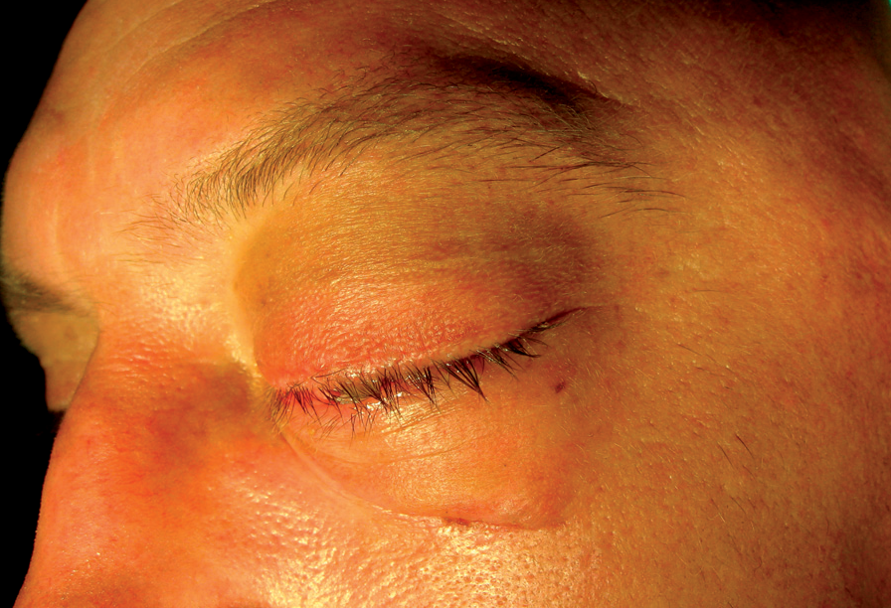
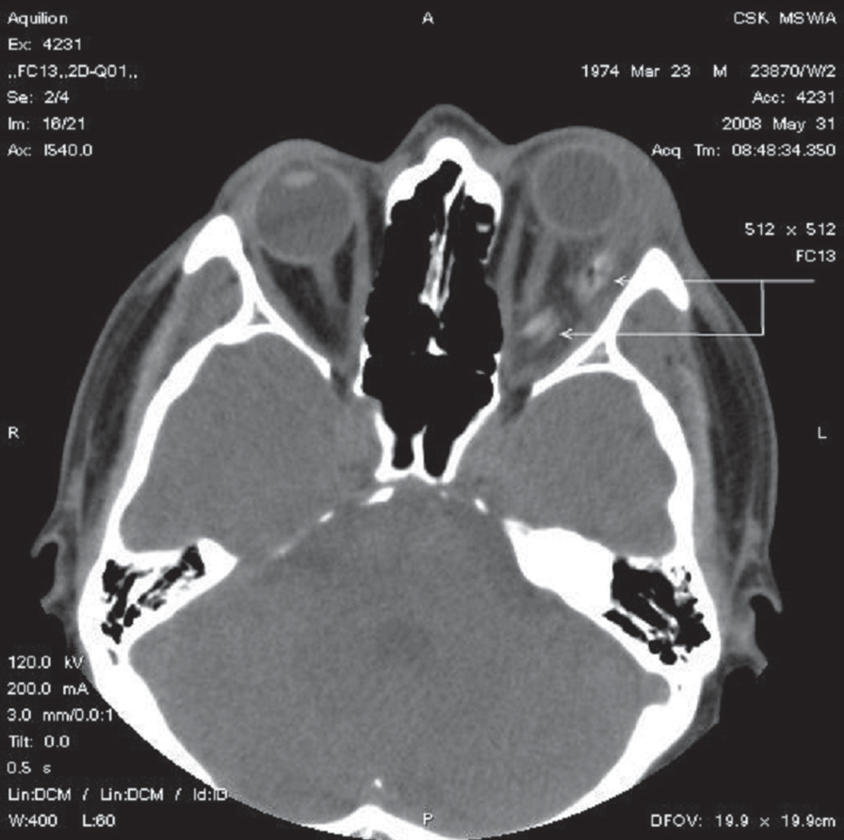
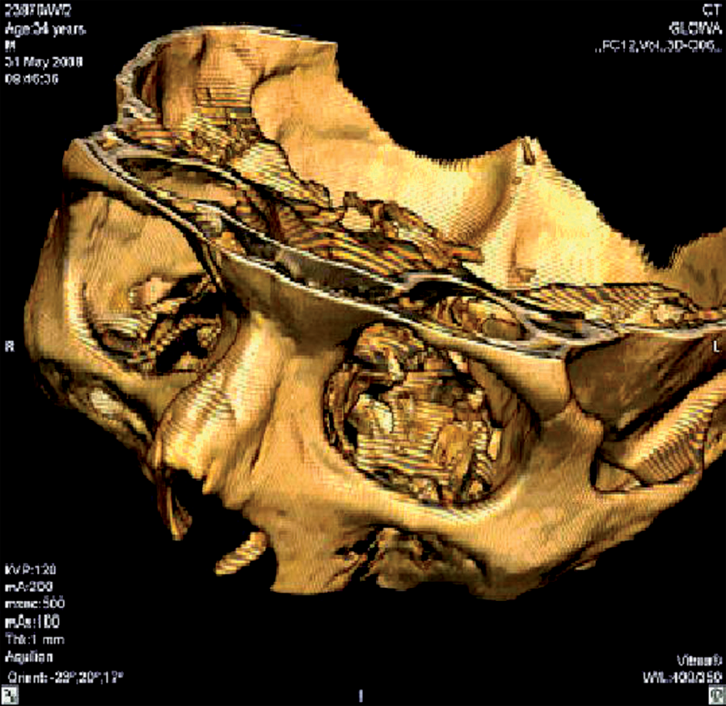
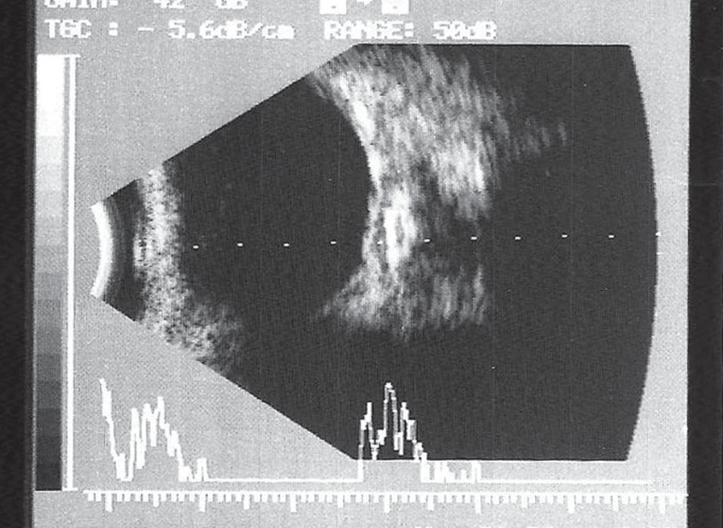
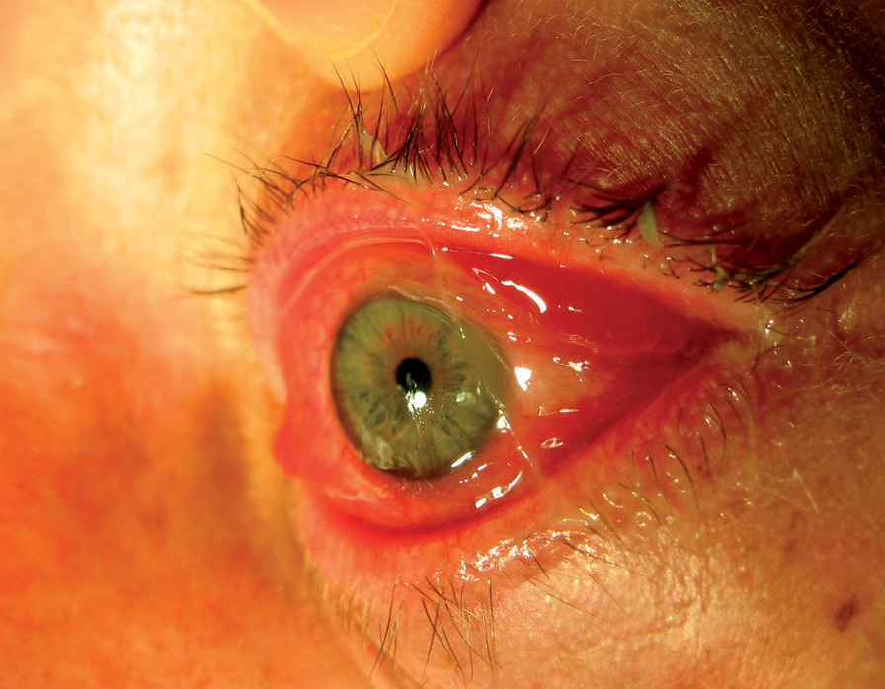
CaseReport
©PolJRadiol,2010;75(3):55-60
Figure1.Theleftorbitimagewithlowerlidlinewound.
Figure4.Horizontalplaincomputertomographyoforbits:suspectedforeignbodyinleftorbit.
Figure2.Theexophthalmosleftorbitimagewithconjuctivialoedemaandinjection.
Figure5.Orbits3Dreconstructiondoesnotrevealanyforeignbodiesintheleftorbit.
Eyeballmotilitywasmarkedlyrestrictedinalldirections.Lefteyelidsfailedtoclosecompletelyandtherewasacon-siderableciliaryandconiunctivalinjectionandconjuncti-valedemawithitsfoldprotrudingbeyondlidslitandcon-siderableamountsofpussinconjunctivalsacaswellasontheeyelashes(Figure2).Thecorneawasclear,anteriorchamberwas ofmedium depth, withoutexudates,thepupilwasround,ofmediumwidth,withsluggishdirectandnor-malindirectpapillaryresponsetolight.Intraocularpressu-rewas15mmHgintherighteyeand23mmHginthelefteye.
Figure3.B-scan/T5ultrasoundofthelefteye:Hyperechogenicstructurebehindtheeyeball.
best visualacuities was20/20 inthe righteye; Handmove-mentandinabilitytoreadSnellenchartwithlefteye.Wedidnotobserveanydeviationsintheexaminationoflids,orbitandanteriorsegmentofrighteye.Dominantfeatu-resintheimageoflefteyeincludedexophthalmusandconsiderableinflammatoryinfiltrationintheorbit,whichwashardonpalpation.Furthermore,attheborderlineoflowereyelidandcheek,therewasasuppuratingentranceof wound,leadingintheuppertemporaldirection,possiblydeeperintolateralintraorbitalspace(Figure1).
ThefindingsofindirectophthalmoscopywithVolklens:
- righteye:normalimageoftheeyefundus,
- lefteye:paleopticdisc,withclear-cutborders,foldedmacularretina,otherwise,thepictureofeyefunduswasnormal.
56

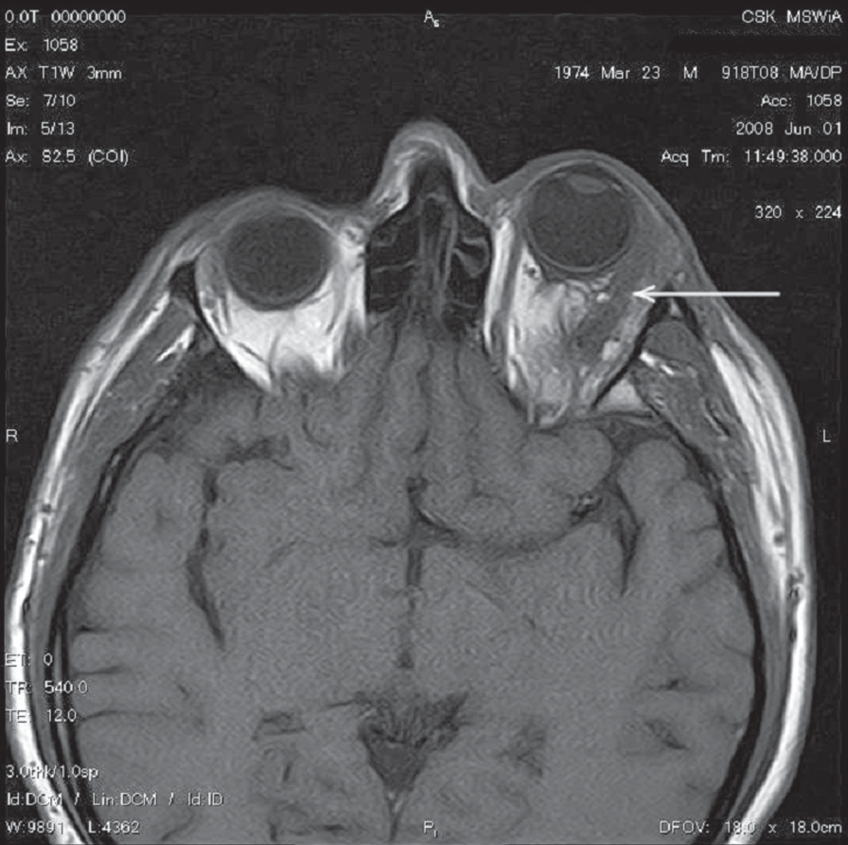
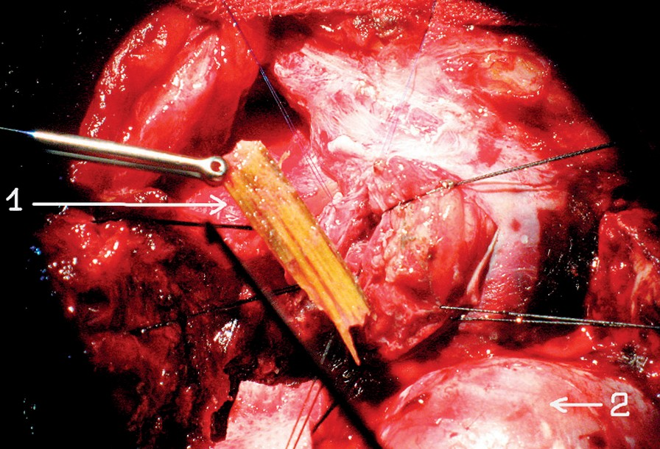
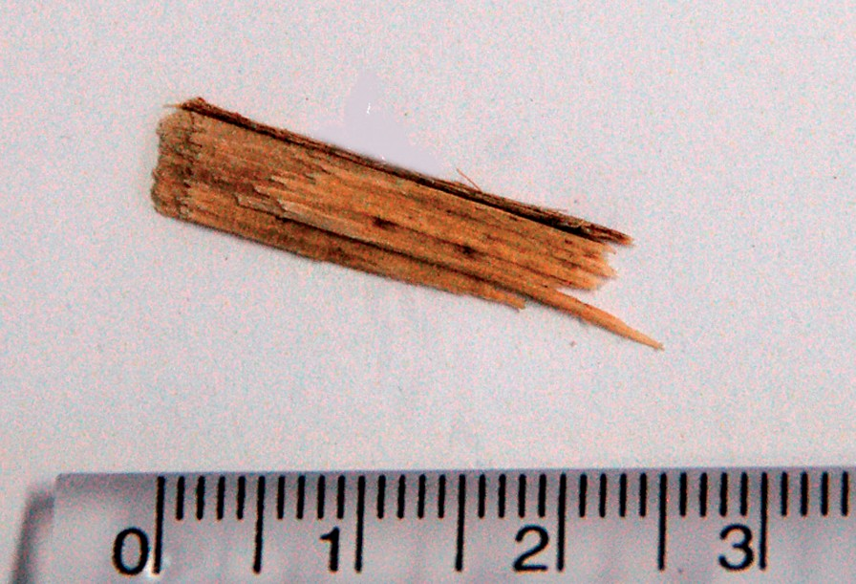
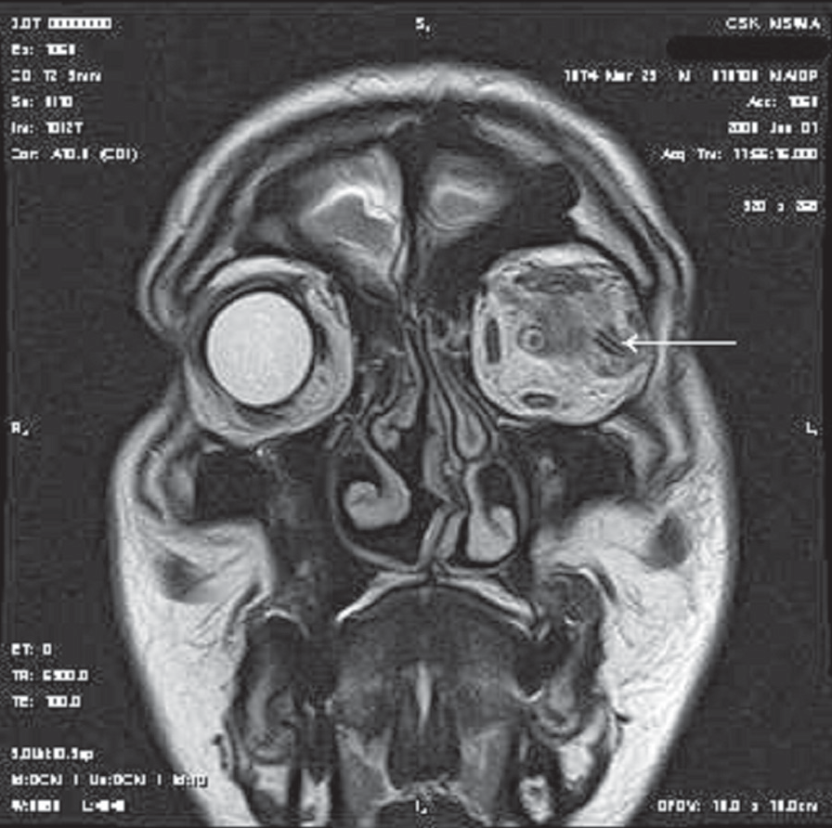
©PolJRadiol,2010;75(3):55-60
Shein-FilipowiczAetal–Itraorbitalorganicforeignbody–radiological…
Figure8.Leftorbitintrasurgeryview:1.Splinterno.12.Poleofbrain’sleftfrontal lobe.
Figure6.Horizontalplainmagneticresonanceoforbits:leftorbitforeignbody.
Figure9.Leftorbitforeignbody:splinterno.1.
dailyintotheconjunctivalsacoflefteye.Thistherapyresultedintheimprovementofpatient’sgeneralconditionandnormalbodytemperature.
Afterconsultationwithneurosurgeon,thepatientwasqualifiedforurgentsurgicalremovalofintraorbitalforeignbody.
Preoperativemanagementincludedtheidentificationofpatient’sbloodtype,bloodcount,ionogram,coagulogram,urealevels,creatininelevels,CRPandthepreparationoftwounitsofpackedredbloodcellspre-testedforserologi-calcompatibility.
Figure7.Orbitalmagneticresonance:afrontalplainimageshowingleftorbitforeignbody.
B-scanwithoverlappingA-scanUSimageoftheleftorbitandlefteyeindicatedpossibleintraorbitalforeignbody(Figure3).
ThepatientingoodgeneralconditionandwithoutfeverwastransferredtotheDepartmentofNeurosurgeryatCSKMSWiAhospitalinWarsaw,wherehewasinformedofnecessarysurgicaltreatmentandpossiblecomplications.Theremovalofforeignbodywaspossibleusingtheaccessthroughleftfronto-orbito-zygomaticcraniotomy.
Diagnosticimagingwasextendedwithorbit-targetedCTscanofthehead.HorizontalplainCTscansofleftorbitsuggestedthepresenceofintraorbitalforeignbody(Figure4),whichwasnotconfirmedin3Dreconstructionoftheorbits(Figure5).ToverifythesefindingsthepatientunderwentMRIexaminationoftheorbits(Figures6,7).
Duringsurgery,twooblongwoodenforeignbodieswereremovedfromtheleftorbit.Theirsizeswere27×5mm(Figures8,9)and45×5mm(Figures10,11).Distalendsoftheseforeignbodiespushedagainstmuscularconeandleftopticnerve.Purulentsecretionwasfoundintheorbit.Duetothisfactaswellasconsiderabletightnessofintraorbi-talstructuresboneflapwasnotrestoredtoitsanatomicallocation;instead,itwastemporarilysewedinthesubcuta-neouspocketofleftiliacfossa.
Followingthedetectionofinorganicforeignbodyinleftorbit,systemicbroad-spectrumantibiotictherapywasstartedwiththefollowingagents:ceftriaxone2×1000mgi.v.,clindamycin2×600mgi.v.andfluconazole1×200mg
i.v.Topicaltreatmentwasalsointroducedwithlevofloxa-cinedrops5timesadayandgentamycinointmenttwice
57

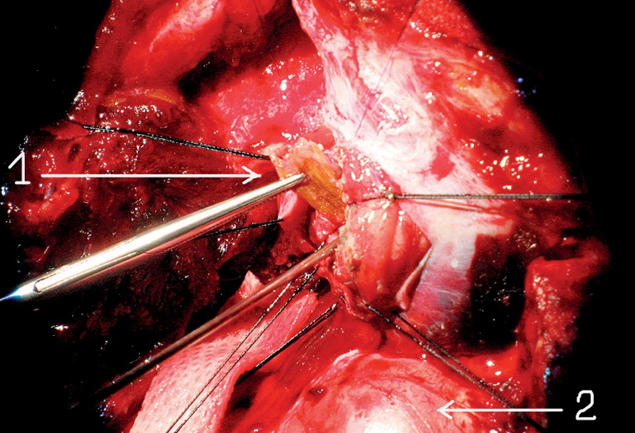
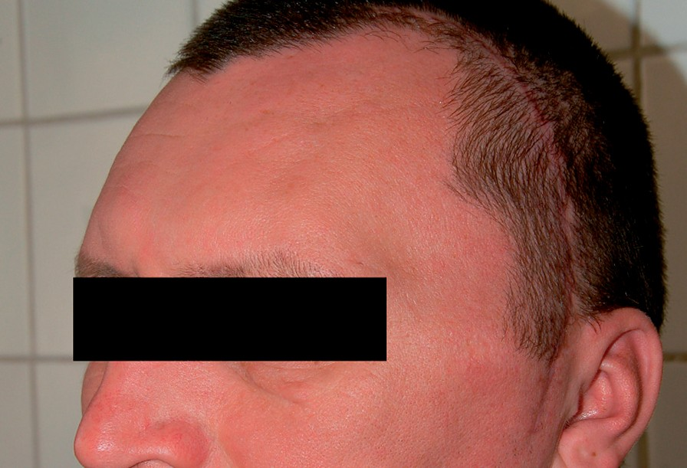
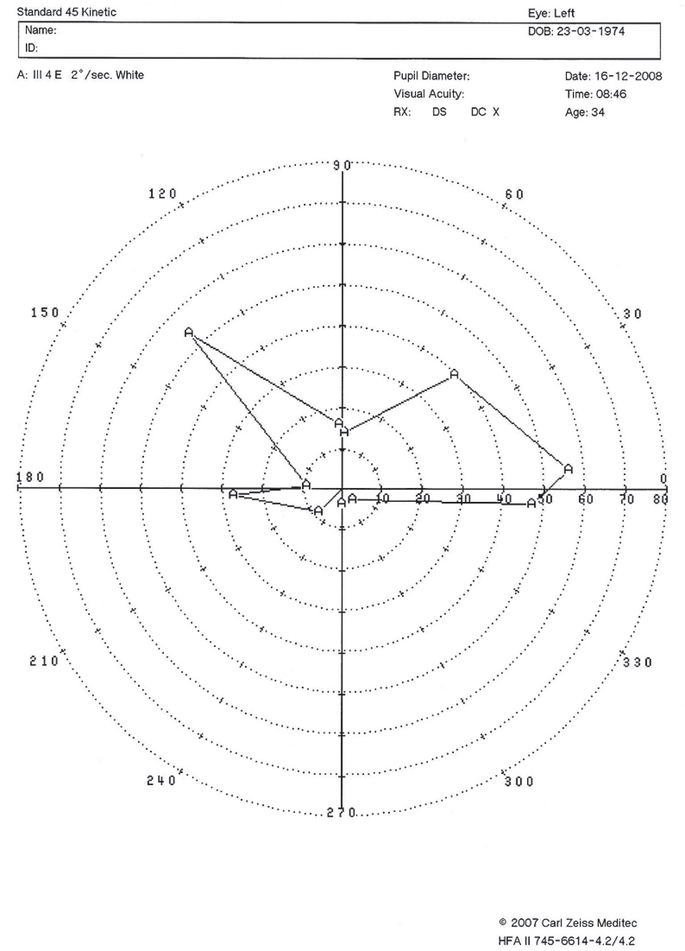
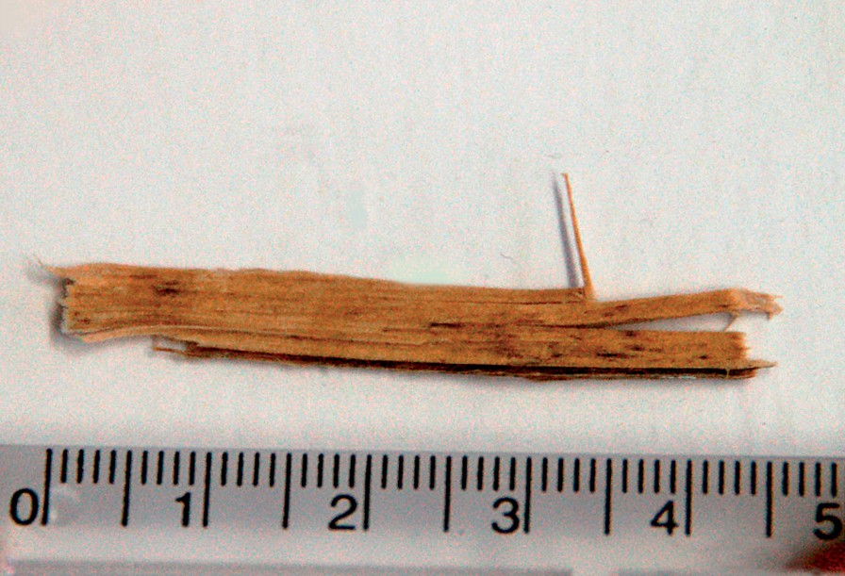
CaseReport
©PolJRadiol,2010;75(3):55-60
Figure10.Leftorbitintrasurgeryview:1.Splinterno.22.Poleofbrain’sleftfrontal lobe.
Figure12.Cosmeticeffectaftertherestorationoftheremovedboneflaptotheanatomicallocation.
Figure11.Leftorbitforeignbody:splinterno.2.
Onpost-operativeday2,check-upophthalmologicalexami-nationrevealed:
- righteyestatusasonthedayofadmission;
- lefteyevisualacuity–distancevision2/50withfor-cedheadpositionandinabilitytoreadSnellenchartforneardistance.Normaleyeballmotilityinalldirections.Sluggishdirectandnormalindirectpapillaryresponsetolightinthelefteye.Anteriorsegmentoftheeyewithminorsuperficialinjection, lenswithslightposteriorsubcapsularopacification.
IndirectophthalmoscopywiththeuseofVolklensrevealed:
- righteye:normalpictureofeyefundus;
- lefteye:opticdiscwithclear-cutborderatfunduslevel,lightpinkinitsmedialpartandpalegreyinitslateralparts,absenceofmacularreflex,normalbloodvesselsandothereyefundusstructures.
Figure13.Visualfieldlefteye.
Discussion
Orbitalforeignbodiesremainaseriousdiagnosticproblem,despiteswiftdevelopmentofdiagnosticimagingtechni-ques.ManypatientswithinjuriesoforbitalareareporttomedicalcenterswhichdonothaveCTorMRIequipmentattheirdisposal.Non-metallicorbitalforeignbodywillnotbedetectedinroutinex-ray.Woodaccountsforapprox.6%ofintraorbitalforeignbodies[1].Penetratinginjuryoftheorbitisaseriouslife-threateningcondition,aspiercingforeignbodypassingthroughorbitalfissuremaydamagethebrainandcavernoussinus.Thesetypesofinjuriesareassociatedwith25%mortalityandtherefore,everywoundwithinorbitalarearequiresthoroughdiagnosticexamina-tiontoexcludeintraorbitalforeignbody[2].
Sixmonthslaterthepatientreportedforsurgicalrestora-tionofboneflapintoitsanatomicallocation.Goodfunctio-nalandcosmeticeffectswereobtained(Figure12).
On check-upexamination9monthsaftertheinjury,lefteyedistancevisualacuitywas0.1,noinjectionwasfoundinlefteyeball,otherwise,theconditionofeyeswasjustasthatonpost-operativecheck-upexamination.Kineticperi-metryshowednarrowedvisualfieldoflefteyewithpar-tiallyretainedmacularvision(Figure13).
58

©PolJRadiol,2010;75(3):55-60
Shein-FilipowiczAetal–Itraorbitalorganicforeignbody–radiological…
Apartfrompatient’shistory,thesymptomssuggestiveofintraorbitalforeignbodyoftenincludeeyeballdislocation,limitedeyemotility,doublevision,hematomaandinflam-mationoforbitaltissues[3].
MRI,however,remainslessavailableandmorecostlythanCTanditisnotalwaysfaultless,asitwasinthiscase(detectingoneorganicforeignbodyinsteadoftwo)(Figures6,7).
Diagnostic difficulties are related particularly to thosefore-ignbodieswhichpenetratetheorbitwithrelativelysmallwound[1,4,5].Insuchcases,woundentrancemaybehar-dlyvisible[6],whileforeignbodyisnoteasilydetectedonpalpation,especiallywhensurroundingtissuesareswollen.
Surgicaltreatmentofbothintraorbitalforeignbodiesanditraorbitaltumorsliesinthecompetenceofvario-usspecialistsincludingneurosurgeons,laryngologists,oralandmaxillofacialsurgeonsandplasticsurgeons[19].Intraorbitalforeignbodiesandtumorsaremostcommonlydiagnosedbyophthalmologists,buttheyaccountforcon-siderableproportionofneurosurgicalprocedures.Thedia-gnosisofintraorbitalforeignbodyrequiresurgentneuro-surgicalinterventioninordertopreventthedevelopmentofinflammatorycomplicationsandtosavepatient’slife.Surgicaltreatmentmaybeperformedwithvariousaccesstechniquesincludingfronto-temporal-subtemporalcranio-tomy,fronto-orbito-temporal-zygomaticcraniotomy,fron-to-orbitalcraniotomy,frontalcraniotomywithsuperiororbitectomy,lateralorbitotomy,anteriororbitotomy,oste-oplasticsupraorbitalorbitotomy,maxillotomy,lateralrhi-notomy[19–22].
Leavinganon-metallicforeignbody,especiallyorganicone,intheorbitwithitsrichbacterialfloraleadstoquickdeve-lopmentofinflammationoforbitaltissues,abscesses,con-sequentintraorbitaltightnessresultinginthedamageofopticnerveandlossofsight.Itisalsoalife-threateningconditionduetoclosevicinityofcentralnervoussystem[2,4,5].Themostimportantissueispromptdiagnosis[1,5,7]andappropriatetreatment.
Diagnosticimagingmayconfirmthepresenceofintraorbi-talforeignbodies,definetheirnumberanddetecttheirpre-ciselocationagainstotheranatomicalstructuresaswellasvisualizetheconsequencesoftheirpenetration,thedamageofeyeball,orbitalwallsandoculomotormuscles.
Inthecasereportedhere,fronto-orbito-zygomaticcranio-tomywaschosentakingintoaccountthelocationoffore-ignbody.Thisapproachallowedforbestvisualizationofthestructuresoflateralpartoftheorbit,includingopticcanal[20].Onintraoperativeexaminationitturnedoutthatthereweretwosplintersintheleftorbit,locatedclosetoeachother(Figures8–11),whileonlyoneofthemwasdetectedinMRI(Figures6,7).
Ultrasoundbeinganon-invasiveandcommonlyavailablemethodmaybeapreliminaryexamination.Unfortunately,itisnotalwayscapableofvisualizingaforeignbodyandits location is not precise. On theother hand, US may detectpossiblecomplicationofforeignbodypenetrationsuchasintraocularorintraorbitalhematoma,vitreousexudateandretinaldetachment.
Theaccessthroughfronto-orbito-zygomaticcraniotomyissafeandallowsforsurgicaltreatmentofforeignbodiesandtumorsirrespectiveoftheirlocationrelativetoopticnerve,oculomotormuscles,bloodvesselsandotherintraorbitalnerves[22].Fronto-orbito-zygomaticcraniotomyhasgoodcosmeticeffect,whichisacceptableforpatients(Figure12).
Nowadays,computedtomographyisastandardmethodusedfortheidentificationofintraorbitalforeignbodies.Itishighlyeffectiveindepictingforeignbodiesofconsidera-bledensitysuchasmetallicforeignbodies,glassorstone,butitmayfailtodetectorganicforeignbodies[8,9].WoodischaracterizedbyvaryingdensityinCTscan,dependingonitswatercontent,hardnessofparticularwoodtypeandthetimeitremainsintissues[10].
Conclusions
- Magneticresonanceimagingisaprimaryexaminationinpatientswithsuspectednon-metallicforeignbodywithinorbitalstructures.
- Woodasintraorbitalorganicforeignbodyshouldbecon-sideredalife-threateningcondition.
- Despiteabsenceofwoundentranceoritssmallsizeinthelids,oneshouldtakeintoaccountpossiblepresenceofintraorbitalforeignbody.
- Itisonlypromptsurgicalinterventionthatallowsforthemaintenanceofvisualfunction.
- Unfortunately,despitecharacteristicclinicalsymptoms,patientsoftenreporttospecialistophthalmologicandneurosurgicalcentersratherlate.
- Extendingtheco-operationbetweenaneurosurgeonandanophthalmologistimprovestheeffectivenessofsurgi-caltreatmentofpathologicalconditionswithintheorbit.
- Fronto-orbito-zygomaticcraniotomyhasverygoodcosmeticeffectandisassociatedwithminimumopera-tingrisk.
DrywoodishypodenseandresemblesgasinCTscan(Figure4),whichisoftenfoundinorbitaltissuesafterinju-ries[1,11–13]withcoexistentsinusdamage.Freshwoodalsoposesadiagnosticproblem,asitisisodensewithfat[8,11,14].Woodremainingintheorbitforalongtime(severalmonths)isalsoisodenseasaresultofitsincreasedwatercontentaswellasbeingsurroundedbyinflammato-rygranulation[8].
Magneticresonanceimagingisthemosteffectiveinve-stigationusedinthediagnosisofintraocularandintra-orbitalnon-metallicforeignbodies[14].Therefore,MRIshouldbeaprimaryinvestigationinallcaseswherenon-metallicforeignbodyissuspectedwithinorbitalstructu-res[2,8,15–18].Precisedetectionofinterrelationsbetwe-enforeignbodyandtheinsideoftheorbitisfacilitativeorevennecessarytostartneurosurgicaltreatment.
59

CaseReport
©PolJRadiol,2010;75(3):55-60
References:
- KamathMP,BhojwaniKM,HegdeMCetal:Interestingcaseofintraorbitalforeignbody.IJOHNS,2004;56(2):115–17
- RobaeiD,FernandoGT,BranleyMGetal:Orbitocranialpenetrationbyafragmentofwood.MJA,2004;181(6):329–30
- KumarD,SaxenaS,GoelU:Retainedwoodenforeignbodiesintheorbit:Acasereport.IndianJOphthalmol,1995;43:195–96
- PecoldK,KrawczyńskiM:BasicandClinicalScienceCourse,część7:Oczodół,powiekiiukładłzowy.Urban&Partner,Wyd.I,Wrocław,2003;111
- RubinPAD,PophamJK,GrahamK:18yearoldmanwithdecreaseinvisionODafterbeingstruckwithatreebranch.DJO,1998;4(24):23–28
- BanerjeeA,DasA,AgarwalPKetal:Latespontaneousextrusionofawoodenintraorbitalforeignbody.IndianJOphthalmology,2003;51:83–84
- HoVT,McGuckin JFJr,SmergelEM: Intraorbitalwooden foreignbodyCTandMRappearance.AJNR,1996;17:134–36
- UchinoA,KatoA,TakaseYetal:IntraorbitalwoodenandbambooforeignbodiesCT.Neuroradiology,1997;39:213–15
- MutlukanE, FleckBW,Cullen JFet al: Case of penetratingorbitocranialinjurycausedbywood.BrJOphthalmol,1991;75:374–76
- YamashitaK,NoguchiT,MiaraFetal:Anintraorbitalwoodenforeignbody:descriptionofacaseandavarietyofCTappearances.EmergRadiol,2007;14:41–43
- CzarnowskaM,StudniarekD,Socha-KorybalskaDetal:Ciałoobce
woczodole–trudnościdiagnostyczne–opisprzypadku.PolJRadiol,2005;70(3):86–89
- BhavsarAR,FongDS,KermanBetal:Intarorbitalairsimulatinganintraocularforeignbody.AmJOphthalmol,1997;123(6):835–37
- AdesanyaOO,DawkinsDM:Intraorbitalwoodenforeignbody(IOFB):MimickingaironCT.EmergRadiol,2007;14:45–49
- SpechtCS,VargaJH,Jalali MM et al:Orbitocranial wooden foreignbodydiagnosedbymagneticresonanceimaging.Drywoodcanbeisodensewithairandorbitalfatbycomputedtomography.SurvOphthalmol,1992;36(5):341–44
- TsaloumasMD,PotamitisT,KritzingerEE:Twocasesofretentionofwoodenforeignbodiesinorbitofeye.BMJ,1998;316:1363–64
- LakshmananA,BalaS,Evans-BelferKF:IntraorbitalOrganicForeignBody–A DiagnosticChallenge. Orbit,2008; 27(2):131–33
- NagulićM,IlićB,NikolićI:Intraorbitalwoodenforeignbody,diagnosedbyNMRandultrasonography,andextirpationbycranio-orbitalapproach.VojnosanitPregl.,2005;62(2):155–59
- JohnSS,RehmanTA,JohnD,RajuRS:Misseddiagnosisofawoodenintra–orbitalforeignbody.IndianJOphthalmol,2008;56:322–24
- JanuszW,KamieniakP,TrojanowskiT:Guzyoczodołu.Chirurgiapodstawyczaszkiizastosowanieminimalnieinwazyjnychtechnikwneurochirurgii.Atext,Wyd.I,Gdańsk,1998;58–60
- HendrykS,PojdaS,MrówkaR:Własnedoświadczeniawoperacyjnymleczeniuguzówoczodołuzdostępuczołowo-oczodołowegowzespoleneurochirurg-okulista.Chirurgiapodstawyczaszkiizastosowanieminimalnieinwazyjnychtechnikwneurochirurgii.Atext,Wyd.I,Gdańsk1998;53–57
- JanickiW,KowalikS, ŚlósarekJetal: Neurochirurgiczneiszczękowotwarzoweaspektyleczeniachirurgicznegoprocesów
ekspansywnychoczodołu.Chirurgiapodstawyczaszkiizastosowanieminimalnieinwazyjnychtechnikwneurochirurgii.Atext,Wyd.I,Gdańsk,1998;69–74
- KasprzakHA,ŚniegockiM:Operacyjneleczenieguzówoczodołu.Chirurgiapodstawyczaszkiizastosowanieminimalnieinwazyjnychtechnikwneurochirurgii.Atext,Wyd.I,Gdańsk1998;78–79
60

