Chapter 4

Environmental and anthropogenic factors affecting
water chemistry in the Polish Tatra Mountains

Joanna P. Siwek, Mirosław Żelazny
Department of Hydrology, Institute of Geography and Spatial Management,
Jagiellonian University in Kraków, Poland, joanna.siwek@uj.edu.pl
Abstract: The aim of the chapter is to analyze the environmental and anthropogenic factors affecting
groundwater, stream water and lake water chemistry in the Polish Tatra Mountains. Geology is the
most important environmental factor determining water chemistry in the Polish Tatra Mountains.
In the crystalline portion of the Tatra Mountains formed of poorly soluble granite and gneiss rocks, the
total dissolved solids and concentration of main cations and anions are many times lower than that in
the sedimentary portion of the Tatra Mountains formed of highly soluble carbonate rocks. Hydrologic
factor (changes in discharge) drives stream water and spring water chemistry changes in the course
of the year and during rainfall and snowmelt events. Soil cover properties such as their thickness
and chemistry are additional environmental factors affecting water chemistry in the Tatra Mountains.
Anthropogenic factors influencing water chemistry in the Tatra Mountains include acid rain, deforest-
ation, and tourist traffic.
Key words: groundwater, streams, lakes, geology, lithology, human impact

introduction
The chemistry of both surface water and groundwater
is affected by many different environmental and an-
thropogenic factors. The most important environmen-
tal factors are usually lithology, soil cover, vegetation,
and hydrology, while the most important anthropo-
genic factors are wastewater discharge and fertilizer
use (Hem 1985). The Tatra Mountains are located
within the borders of a large national park in Poland
and Slovakia and are an area experiencing relatively
little human pressure. Therefore, this region provides
favorable conditions for the identification of natural
factors controlling water chemistry. However, water in
this region remains under the strong impact of tourist
traffic and the impact of long-distance air pollutants
(Rzychon, Worsztynowicz 2008). The identification of
factors controlling water chemistry in high mountains
in the broadly defined Baltic Sea region, for example in
the Tatra Mountains, is an important issue because of
the crucial role of mountains in the water chemistry of
rivers flowing further downstream.

Geology
Groundwater, stream water and lake water chemistry
varies across the Polish Tatra Mountains (Fig. 2.5).
This is the result of large geologic variation in the
region. The southern part of the Tatra Mountains is
made of poorly soluble crystalline rocks: metamorphic
rocks (mainly gneiss and crystalline shale) and alaskite
in the Western Tatra Mountains, and granitoids (gran-
odiorites) in the High Tatra Mountains. The northern
part of the Tatra Mountains is formed of well-soluble
sedimentary rocks: dolomitic limestone, limestone,
dolomite, sandstone, shale, and conglomerates (Pas-
sendorfer 1996). Total dissolved solids (TDS) and the
concentration of main ions in groundwater, stream
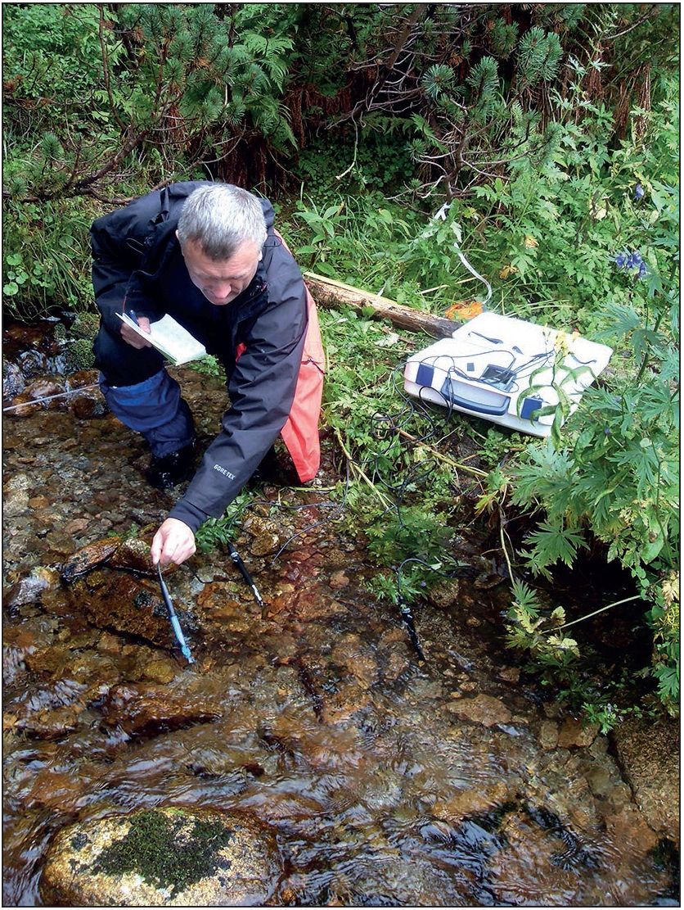
42
water and lake water are very low in the crystalline
part of the Tatra Mountains (Małecka 1989; Oleksy-
nowa; Komornicki 1996; Żelazny 2012; Sajdak et al.
2018 a). For example, the mean TDS of spring water
(n = 489) across this part of the Tatra Mountains is only
33.7 mg-dm-3 (Żelazny 2012). TDS and the concen-
tration of main ions in the crystalline Western Tatra
Mountains are about twice as high as in the crystal-
line High Tatra Mountains (Photo 4.1). This is due
to the slightly better solubility of crystalline rocks in
the Western Tatra Mountains than in the High Ta-
tra Mountains. In the northern sedimentary part of
the Polish Tatra Mountains, TDS and the concentra-
tions of main ions of groundwater and stream water
are distinctly higher than in the southern crystalline
part of the Tatra Mountains. For example, accord-
ing to Żelazny (2012), the mean TDS of spring water
in this part of the Tatra Mountains is 245.1 mg • dm-3
(Fig. 4.1). According to Małecka (1989) and Małecka
et al. (2007), the chemistry of precipitation affects
ap. 90% of groundwater and stream water chemis-
try at high elevations in the southern parts of the
Tatra Mountains where the solubility of crystalline
rocks is very low. The effect of precipitation on wa-
ter chemistry did not exceed 30% at lower elevations
in the sedimentary part of the Tatra Mountains.
Photo. 4.1. Field measurements of physical properties of
water in the Tatra Mountains (Photo. J. Pociask-Karteczka).
Spatial diversity of water chemistry in the Tatra
Mountains are determined by local geology and have
been used thus far as the basis for the hydrochemical
regionalization of the Polish Tatra Mountains. The first
regionalization was performed by Oleksynowa (1970)
who identified three hydrochemical regions: (1) crys-
talline Tatra Mountains area, (2) transitional region
of crystalline and sedimentary rocks, (3) sedimentary
Tatra Mountains area. Another regionalization was
done by Małecka (1989) who identified three hydro-
chemical regions characterized by a belt-type pat-
tern related to the tectonic and geologic structure in
the Polish Tatra Mountains. The first region includes
areas formed of both crystalline rocks and quartzite
sandstone. The second region includes areas formed
of the High-Tatric Units sedimentary rocks - mainly
limestone. The third region includes areas formed of
the Sub-Tatric Units sedimentary rocks - mostly con-
glomerates, dolomitic limestone, as well as nummu-
lites of the Eocene. There is a newest hydrochemical
regionalization developed by Żelazny (2012), who
used multidimensional analysis of variances in spring
water chemistry. He recognized two main hydrogeo-
chemical environments associated with (Fig. 4.2):
- sedimentary rocks,
- crystalline rocks.
For the studied sedimentary rock environment, he
identified three distinct sub-types: (1) dolomite-lime-
stone, (2) dolomite-limestone-sulfate, (3) limestone.
For the crystalline rock environment, he distinguished
two sub-types: (1) granitoid environment, (2) meta-
morphic environment (Fig. 4.2). Spring water in the
Tatra Mountains may be placed in 15 hydrochemical
categories. The most common water categories are
HCO3-Ca2+-Mg2+ (45.4%) and HCO3-Ca2+ (24.3%).
The degree of hydrochemical variation is greater in
the crystalline core (13 types) versus the sedimentary
core (9 types). The most common components of the
crystalline core are SO^-(53.2%), quite frequently Mg2+
(41.3%), and less frequently Na+ (14.1%). On the other
hand, the most common component of the sedimenta-
ry rocks is Mg2+ (74.7%), and to a much lesser extent,
SO42- (8.1%). Spring hydro-geochemical types follow
a mosaic-type spatial pattern that is linked closely to
lithologic determinants (Żelazny 2012).

Soils
Soil properties such as their thickness, texture and
chemistry usually control the ion influx to lakes and
streams (e.g. Mulder et al. 1995; Seibert et al. 2009;
McDowell, Liptzin 2014). According to Sajdak et al.
(2018b), the high concentration of Ca2+, Mg2+, HCO-,
Cl- and NO 3- in the stream water in crystalline part
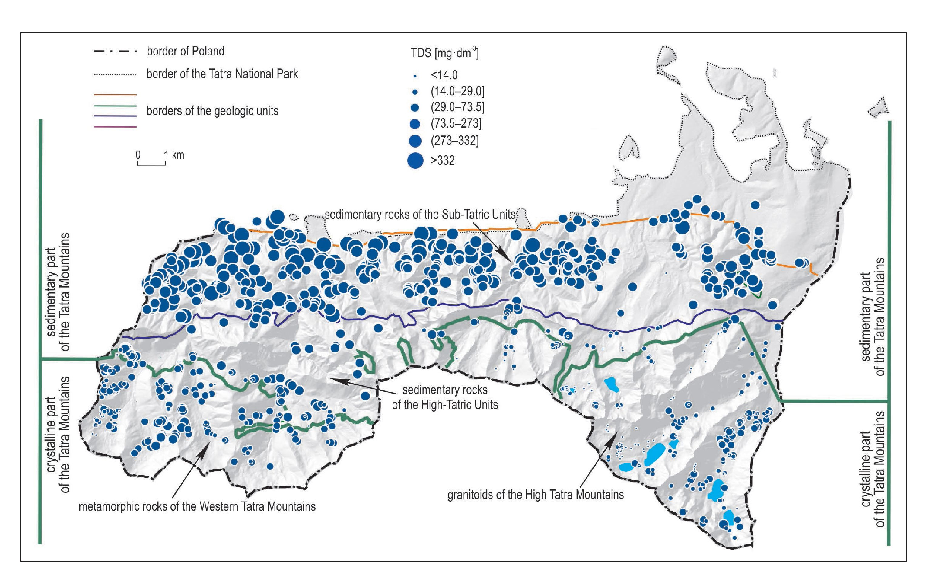
Fig. 4.1. Total dissolved solids (TDS) of spring water in the Polish Tatra Mountains (Żelazny 2012, modified).
43
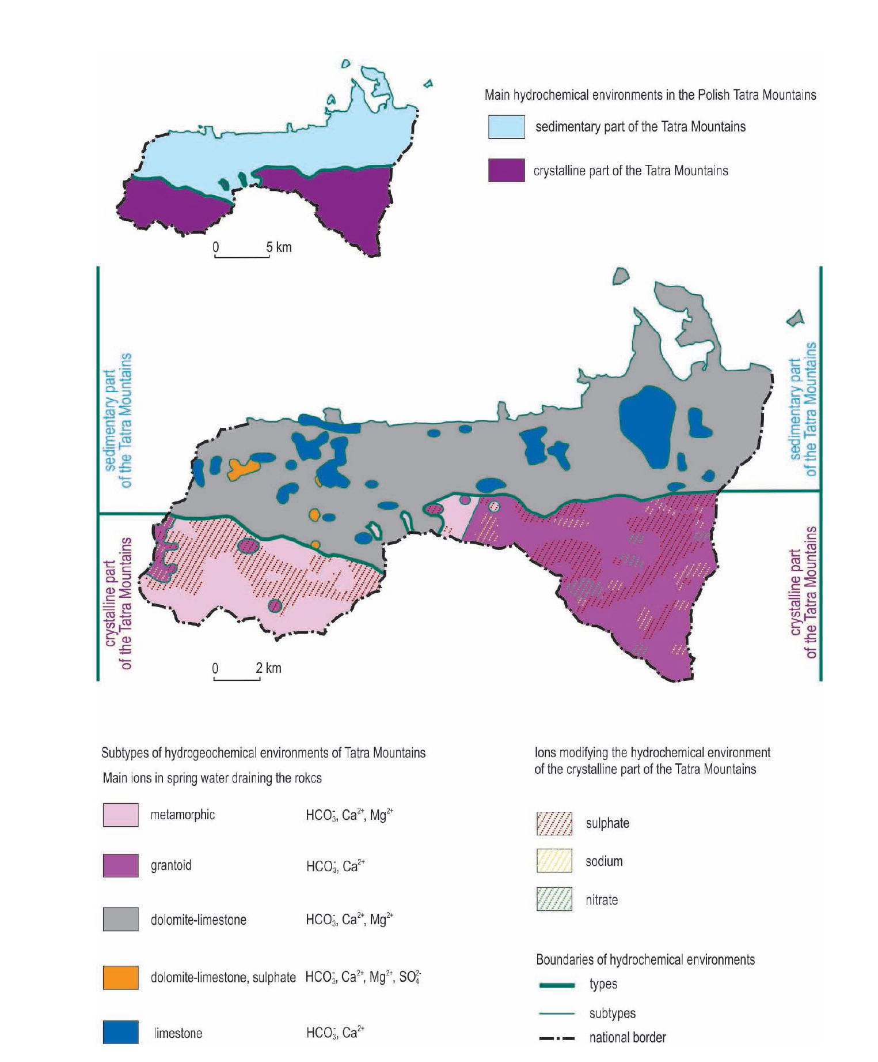
44
of the Tatra Mountains at the beginning of rain-on-
snow events results from ion leaching from shallow
soils: Regosols, Entic Podzols, Leptic Podzols, Folic
Leptosols, and Haplic Podzols. However, Kopacek
et al. (2004a) found no significant correlation between
soil chemistry and the concentration of some main
ions and nutrients in Tatra lakes. They found a cor-
relation between organic matter concentration in soils
and nutrient (C, N, and P) concentrations in lakes.
The amount of soil and soil exchangeable base ca-
tion capacity determines the sensitivity of Tatra lakes
to acidification (Kopacek et al. 2004b; Stuchlik et al.
2006). Lakes draining catchments with a large amount
of soil and high soil exchangeable base cation capacity
are more resistant to acidification than lakes draining
catchments with a small amount of soil and low soil
exchangeable base cation capacity. A small amount
of soil results in a low ability of catchments to retain
acidic nitrogen derived from atmospheric deposi-
tion, thus leading to a high concentration of NO- in
lake water. Low soil exchangeable base cation capacity
results in a low acid neutralizing capacity of lakes and
low pH of lake water (Kopacek et al. 2004b).

Hydrology
Changes in discharge over the course of the year are
the most important factor controlling the seasonal
variation of stream water and spring water chemistry
in the Tatra Mountains. The influx of snowmelt water
in the spring and rainwater in the summer is charac-
terized by low TDS and a low concentration of most
main ions, which results in a decrease of these para-
meters in stream water and spring water with increasing
discharge. The rate of seasonal change in spring water
chemistry depends on the amount of rainfall as well as
Fig. 4.2. Hydro-geochemical environments in the Polish Tatra Mountains (Żelazny 2012, 2015c, modified).
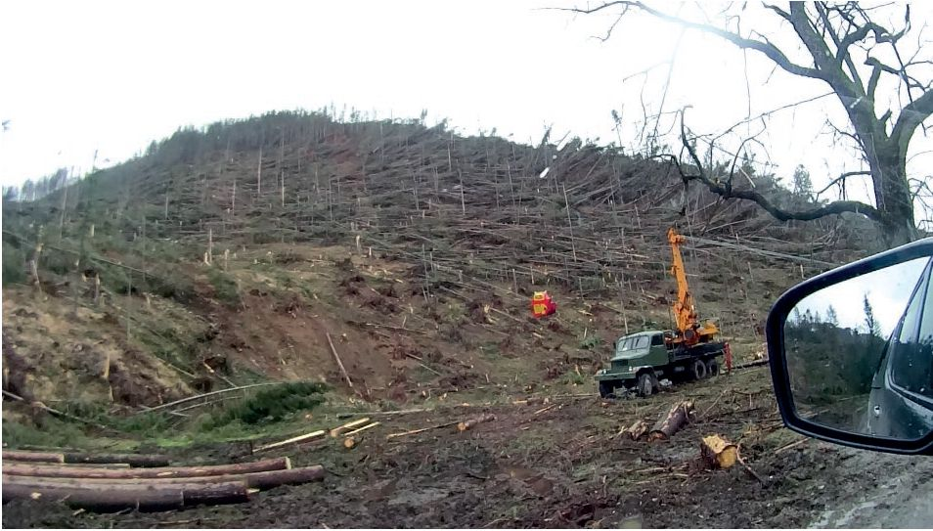
45
the thickness, density, and melting rate of snow cover
(Wolanin, Żelazny 2010; Wójcik 2012; Żelazny 2012;
Wolanin 2014; Sajdak et al. 2018a). There are two types
of stream hydrochemical regimes in the Tatra Moun-
tains:
- high mountain regime,
- middle mountain regime.
For both regimes, the lowest TDS and concentration
of most main ions occur during the spring snowmelt
season. However, in streams characterized by a high
mountain regime, the lowest TDS, lowest conducti-
vity, and lowest ion concentrations occur later than in
streams characterized by a middle mountain regime.
This is due to the snowmelt season occurring later and
lasting longer at higher elevations than at lower eleva-
tions (Żelazny 2012).
The most dynamic changes in stream water chemis-
try in the Tatra Mountains occurred during rainfall and
snowmelt events. Streams are supplied by groundwater
alike throughflow and overland flow. Throughflow and
overland flow water are characterized by a distinctly
lower concentration of most main ions than ground-
water due to less contact time with parent material.
Hence, dilution is the main factor controlling stream
water chemistry during events in the Tatra Mountains
(Sajdak et al. 2018b). Changes in some ion concentra-
tions triggered mainly by dilution sometimes are also
affected by other processes. For example, an unexpec-
tedly large increase in HCO3- at the beginning of
a rain-on-snow event in the mountain creek may be
triggered by a rapid influx of pre-event (“old”) water
from the local karst system (Sajdak et al. 2018b).

Acid rain
There is a decline in the concentration of main cat-
ions in some lakes in the High Tatra Mountains (Zie-
lony Staw lake and Długi Staw lake) due to the long-
term acidification of precipitation in the area. The pH
of bulk precipitation ranged from 4.39 to 5.16 and an
increasing trend in the pH of atmospheric precipi-
tation occurred in the Tatra Mountains in the years
1992-2005 (Rzychoń, Worsztynowicz 2008). Acid rain
pollution originates mostly in locations far away from
the mountain range. There are seasonal fluctuations in
precipitation acidity: lower pH was noted during the
winter than during the summer. This was explained
by unique meteorologic conditions in winter causing
an inflow of industrial pollution from faraway loca-
tions and higher local sulfur deposition in the heat-
ing season (Grodzińska-Jurczak 1995). The lowest
pH of snow occurs near cities such as Zakopane and
Kościelisko, and near tourist lodges (Żelazny, Kasina
2009).

Deforestation by windfalls
and bark beetle outbreaks
Forests in the Tatra Mountains are artificially domi-
nated by spruce monocultures (Grodzki, Guzik
2009). Spruce monocultures occupy nearly 80% of
the lower montane zone while natural mixed beech-
fir forest occupy less than 10% of the zone (Mirek
1996). The spruce monocultures are characterized
by low resistance to summer drought, heavy winds,
bark beetle infestation, and fungus expansion (Małek
et al. 2012, 2014). Hillslope deforestation triggered
by hurricane-force winds in 2013 (Photo 4.2) and
tree stand decline due to bark beetle infestation has
led to significant changes in the water chemistry of
springs and streams in the mountain stream catch-
ment in the West Tatra Mountains (Żelazny et al.
2017a, b). Research conducted one and a half years
Photo. 4.2. The Western Tatra after windfall in December
2013 (Photo M. Żelazny).
after deforestation revealed that the mean concentra-
tion of NO) in water in areas deforested by winds was
15.44 mg-dm-3, in areas deforested by bark beetle in-
festation - 6.17 mg-dm-3 while in forested areas - only
3.26 mg-dm-3. Hence, the increase of NO3- concen-
tration in stream water and spring water caused by
deforestation was more than fivefold (Żelazny et al.
2017a). The mean water concentration of NO- on de-
forested hillslopes continued to increase over time. In
the period 2015-2016 the mean concentration of NO-
in stream water and spring water in areas deforested
by winds equaled 16.53 mg • dm-3, in areas deforested
by bark beetle infestation 6.69 while in forested areas
3.06 mg-dm-3 (Żelazny et al. 2017b). Such a large
increase in the concentration of NO3 - in defo-
rested areas results in a change in the position of NO-3
in the sequence of anions from the natural sequence
occurring in forested carbonate-type catchments
(HCO- > SO4- > NO- > Cl-) to the now predominant
sequence HCO3- > SO24- > NO3- > Cl - (Żelazny et al.
2017a, b).
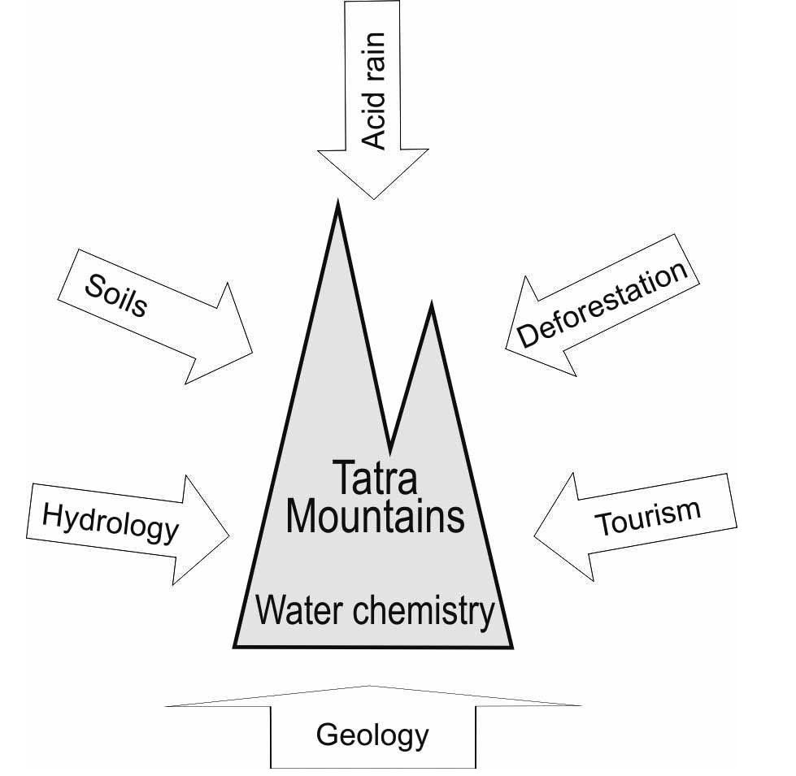
46

Tourism
The number of visitors in Tatra National Park has re-
mained at about 2.5 million per year for the last two
decades (Siwek, Biernacki 2016). The impact of tourist
traffic on the natural environment in the Tatra Moun-
tains is distinctly larger than that in other mountain
national parks in Europe. For instance tourist traffic
in Berchtes gaden National Park in the German Alps
equals 57,000 tourists per hectare per year, in Swiss
National Park and Hohe Tauern National Park in the
Austrian Alps - 9000, while in Tatra National Park -
120,000 tourists per hectare per year (Kurek 2007).
Borowiak et al. (2006) found that the water chemistry
of some Tatra Mountains lakes located close to moun-
tain lodges is strongly affected by tourist traffic. The
shores of these lakes are used as a stopover for many
people. Tourist lodges are a major threat to stream
water quality via their frequent release of wastewa-
ter into local streams (Siwek, Biernacki 2015, 2016).
Wastewater produced by the mountain lodges in the
years 2008 -2009 caused significant changes in the
concentrations of some nutrients found in streams
into which the wastewater was released: the concen-
tration of NH 4+ in stream water downstream of the
wastewater release site was roughly 200 times great-
er than the concentration upstream of that site, while
PO3- concentrations were 30 times greater. The NO-
content increased substantially also. The largest loads
of nutrients were released into streams in the summer
season when the discharge of streams is very low. This
causes serious ecological threat to stream water quali-
ty due to weak wastewater dilution. Wastewater rele-
ases from tourist lodges into streams and stream wa-
ter pollution have been a leading problem in the Tatra
National Park for many years. The wastewater mana-
gement situation in the Tatra National Park has im-
proved markedly since 2009. In 2010 and 2011 waste-
water treatment plants at the Murowaniec Lodge and
Polana Chochołowska Lodge were fully modernized
(Fig. 5.2). In 2011 a new treatment plant was opened
at the lodge in the Valley of Five Polish Lakes (Siwek,
Biernacki 2015).

Conclusions
The chemical composition of water in the Tatra Moun-
tains has been controlling both by environmental
and anthropogenic factors. Complex geology has
a crucial significance. For example, the total dissolved
solids of spring water in the crystalline part of the
Tatra Mountains formed of poorly soluble granite and
gneiss rocks is many times smaller than that in the
sedimentary portion of the Tatra Mountains formed
of highly soluble limestones and dolomites. Other fac-
tors, apart from geology, affect water chemistry in the
Tatra Mountains to some extent (Fig. 4.3).
Hydrologic factor - changes in discharge - is re-
sponsible for seasonal stream water and spring water
chemistry changes as well as changes during rainfall
and snowmelt events. The influx of meltwater and
rain water results in a decrease of TDS and con-
centration of most main ions in stream water and
spring water according to increasing discharge. Soils
are an additional environmental factor influencing
water chemistry in the Tatra Mountains. Some ions
are flushed out of the soil at the beginning of rain-
fall and snowmelt events. The amount of soil and
Fig. 4.3. Factors controlling water chemistry in the Tatra
Mountains.
soil exchangeable base cation capacity determines
the sensitivity of lakes to acidification. The Tatra
Mountains have been affected by acidic pollution
of long-distance transport. The impact of acid rain
on water chemistry in the Tatra Mountains results
in a decline of main cations concentration. The de-
cline of spruce monocultures in the Tatra Moun-
tains results mostly in substantial increasing of NO-
concentrations - even one and a half years after de-
forestation. Wastewater released from tourist lodges
affects stream water chemistry leading to excessive
nitrogen and phosphorus concentration. The quality
of water in the Tatra Mountains has improved since
2009 owing to modernization wastewater treatment
plants in mountain lodges.

