PHYSICAL REVIEW D 94, 032011 (2016)

Measurement of exclusive yy ^ W +W- production and search for
exclusive Higgs boson production in pp collisions at a/s = 8 TeV
using the ATLAS detector
*
M. Aaboud et al.
(ATLAS Collaboration)
(Received 14 July 2016; published 31 August 2016)
Searches for exclusively produced W boson pairs in the process pp(yy) ^ pW+ W-p and an exclusively
produced Higgs boson in the process pp(gg) ^ pHp have been performed using e±pT final states. These
measurements use 20.2 fb-1 of pp collisions collected by the ATLAS experiment at a center-of-mass
energy yT = 8 TeV at the LHC. Exclusive production of W+W- consistent with the Standard Model
prediction is found with 3.Off significance. The exclusive W+W- production cross section is determined to
be o(yy ^ W+ W- ^ e±gTX) = 6.9 ± 2.2(stat) ± 1.4(sys) fb, in agreement with the Standard Model
prediction. Limits on anomalous quartic gauge couplings are set at 95% confidence level as
-1.7 x 10-6 < «WM2 < I.7 x 10-6 GeV-2 and -6.4 x 10-6 < a'W/A2 < 6.3 x 10-6 GeV-2. A 95%
confidence-level upper limit on the total production cross section for an exclusive Higgs boson is set
to 1.2 pb.
DOI: 10.1103/PhysRevD.94.032011

I. INTRODUCTION
In the Standard Model (SM) of particle physics, the
interactions between electroweak gauge bosons are
described by the non-Abelian SU(2) x U(1) structure of
the electroweak sector. Measurement of the strengths of the
trilinear (VVV, where V = y, W, or Z) and quartic (VVVV)
gauge couplings represent an important test of the SM, as
deviations from SM predictions would indicate new phys-
ics. The discovery of a Higgs boson [1,2] at the Large
Hadron Collider (LHC) has taken a major step toward
confirming the mechanism of electroweak symmetry break-
ing. Anomalous quartic gauge couplings (aQGCs) provide
a window to further probe possible new physics extensions
of electroweak theory. Exclusive production of W boson
pairs, pp(yy) ^ pW+W-p, provides an opportunity to
study yy ^ W+W- aQGC couplings [3,4].
In pp collisions, exclusive W +W- events are produced
when each proton emits a photon and the two photons
annihilate, either via t- and w-channel W-exchange dia-
grams involving trilinear gauge couplings or via a quartic
gauge coupling diagram, to create a W +W- pair. Figure 1
shows the exclusive production of a W+W- pair, where the
blobs represent the t-channel, w-channel, and quartic
diagrams. After the collisions, either both protons remain
intact as shown in Fig. 1(a) (referred to as elastic hereafter),
only one proton remains intact as in Fig. 1(b) (single
*Full author list given at the end of the article.
Published by the American Physical Society under the terms of
the Creative Commons Attribution 3.0 License. Further distri-
bution of this work must maintain attribution to the author(s) and
the published article’s title, journal citation, and DOI.
dissociation, SD), or both protons dissociate as in Fig. 1(c)
(double dissociation, DD). In all three cases the trajectories
of the protons or their remnants deviate only slightly from
their initial directions so that they never enter the accep-
tance of the ATLAS detector. On the other hand, inclusive
processes are produced with accompanying activity such as
initial- and final-state radiation and additional scattering in
the same pp collision. The accompanying activity is
collectively called the underlying event and emits particles
into the acceptance of the ATLAS detector.
Photon scattering in hadron colliders can be described in
quantum electrodynamics (QED) by the equivalent-photon
approximation (EPA) [5,6]. In this framework the exclusive
W+W- cross section can be written as
°fp%y )^ppW+W- = JJ f(x1)f(x2)ffrr^W+W-
(1)
where f(xi), for i e {1,2g, is the number of equivalent
photons carrying a fraction of the proton’s energy, xi, that
are emitted, while mYY is the two-photon center-of-mass
energy. This approach has been used to describe similar
exclusive processes in the CDF [7], STAR [8], and CMS
[9,10] experiments.
Exclusive W+W- pair production is particularly sensi-
tive to new physics that may be described by aQGC of the
form WWyy [4,11]. The dimension-6 operators in Ref. [3]
are the lowest-dimension operators that give rise to anoma-
lous WWyy couplings, «W/A2 and aJW/A2, where A is the
scale of new physics. A procedure adopted by previous
measurements [12-14] uses a dipole form factor to preserve
unitarity at high mYY. The couplings «W/A2 and aW/A2
then become
2470-0010/2016/94(3)/032011(32)
032011-1
© 2016 CERN, for the ATLAS Collaboration
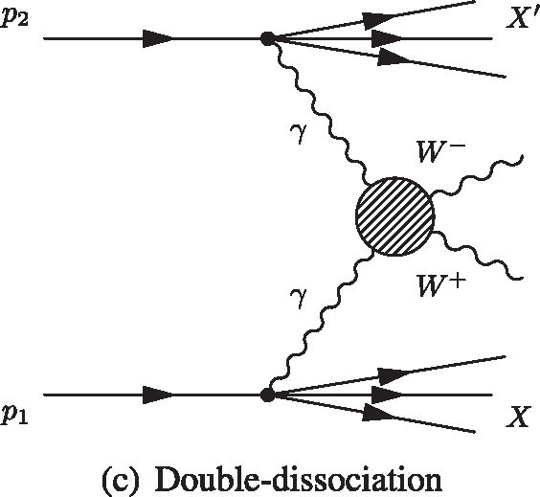
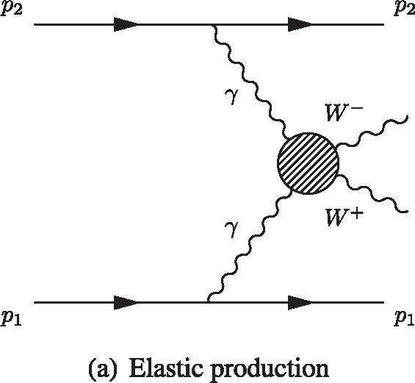
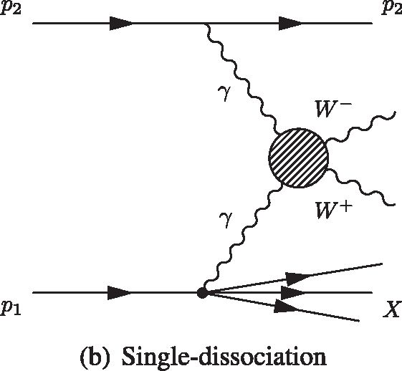
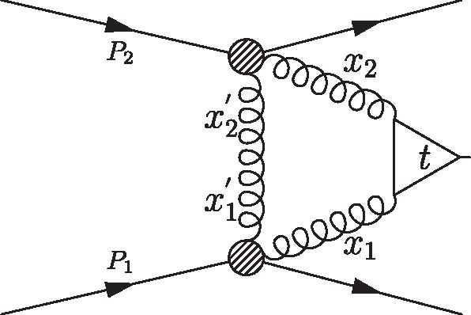
M. AABOUD et al. PHYSICAL REVIEW D 94, 032011 (2016)
FIG. 1. Diagrams for the exclusive yy ^ W+ W- production representing the (a) elastic process, (b) single-dissociation where one
initial proton dissociates (SD) and (c) double dissociation where both protons fragment (DD). The symbols X and X' denote any
additional final state created.
7W
l0,C
/A2
aw
A,c
1
A2
(1 + Ar~ )
(2)
where Acutoff defines the scale of possible new physics, and
the term containing it ensures that unitarity is preserved.
Anomalous triple gauge couplings (aTGCs) could also
produce similar effects, but the sensitivity of this study to
aTGC is not competitive compared with other processes
[4], so these are taken to be zero.
More recent parametrizations of aQGC are of dimension
8. The parametrizations of the dimension-8 couplings,
fM,0,1,2,3 = A4, in Ref. [15] are linearly related to the
aWC/A2 as follows:
,w
1
/m.c
A4 _ A2 g2v2
/M,1
A4
,w
1
A2 g2v2 ’
(3)
where g = e/ sin(#W) and v is the Higgs boson vacuum
expectation value. Also, with this parametrization, fM 2 =
2 x fM,0 and fM,3 = 2 x fM,1.
In addition to the discovery of the Higgs boson, several
of its properties—such as mass, coupling strengths to
various final-state particles, and branching ratios of its
decay—have been determined [1,16] using Higgs boson
candidates from inclusive production. Higgs boson candi-
dates from the exclusive production (pp ^ pggp ^ pHp)
would have lower systematic uncertainties due to their
cleaner production environment [17-20]. Since measure-
ments using these Higgs boson candidates would have
better precision, they could be used to improve knowledge
of the Higgs boson sector. It is therefore interesting to
determine the cross section for exclusive Higgs boson
production and examine the feasibility of using exclusive
Higgs boson candidates for Higgs boson property mea-
surements. This interest is reflected in the inclusion of the
exclusive Higgs boson process studies as part of the physics
program of forward proton-tagging detectors [21-23] that
extend the ATLAS and CMS coverage for LHC runs
at 13 TeV.
Unlike exclusive W +W- production, exclusive Higgs
boson production proceeds through a quantum chromody-
namics (QCD) process involving at least three gluons, as
shown in Fig. 2. Two gluons from the colliding protons
interact through a top-quark loop to produce a Higgs boson,
while additional gluon exchange between the colliding
protons keeps the protons color-neutral and allows the
protons to remain intact after the collision. The proton
trajectories deviate slightly after the collision. One W boson
from Higgs boson decays must be off shell so the event
selection for that study needs to be different than the
exclusive W +W- event selection, and the samples are
largely orthogonal.
The exclusive Higgs boson production cross section can
be written as [24]
app(gg)^ppH a 6(gg ^ H)
x
'do?
Q4
/g(x1 ,x1,Q2)/g (x2,x2,Q2) (4)
where 6(gg ^ H) is the cross section for the gluon fusion
process that produces the Higgs boson. The functions fg
[25] are the generalized gluon densities for the finite proton
H
FIG. 2. The lowest-order Feynman diagram for the exclusive
Higgs boson production. The variables x1 and x2 are the fractions
of the momenta carried by the gluons that contribute to the
production of the Higgs boson, with respect to the momenta of
the protons P1 and P2. The variables xj and x2, on the other hand,
are the fractions of the momentum carried by the exchanged third
gluon with respect to the momenta of the protons P1 and P2.
2
032011-2
MEASUREMENT OF EXCLUSIVE ...
size, which take into account the impact parameter. The
variables x1 and x2 are the fractions of the momenta carried
by the gluons that contribute to the production of the Higgs
boson, with respect to the momenta of the protons P1 and
P2. The variables xj and x2 are the fractions of the
momentum carried by the exchanged third gluon with
respect to the momenta of the protons P1 and P2 as shown
in Fig. 2. These gluon densities are integrated over the
exchanged (third) gluon transverse momentum Qt. This
formalism, used in several theoretical calculations, predicts
cross sections that vary by over an order of magnitude
[24,26]. This wide disparity in predictions is an additional
motivation for this measurement. While either proton could
dissociate, the predictions presented here are for elastic
production only and could underestimate the cross section
by an order of magnitude [24].
This paper describes searches for exclusive W+W- and
H ^ W+W- production using e±^T final states. Events
where a W boson decays to a t lepton that subsequently
decays to an electron or muon are also included. This final
state is denoted e^X, where X represents the neutrinos.
Section II describes the experimental setup. Section III
describes the data set and simulation tools used to model
signal and background processes. Initial selection of
electron, muon, jet and track candidates is discussed in
Sec. IV. Section V introduces a new approach to separate
exclusive from inclusive production processes. Section VI
describes the event selections including signal regions for
both the exclusive W+W- and Higgs boson processes.
Section VII outlines studies of the exclusive event selection
and underlying-event models using samples of same-flavor
opposite-sign lepton pairs in pyyp ^ p1+1-p candidates
(l = ^ or e) to validate modeling and selection criteria. In
Sec. VIII, data control regions designed to test and correct
physics and detector modeling are described. Systematic
uncertainties are summarized in Sec. IX, and the results of
the study are described in detail in Sec. X. Section XI
summarizes the findings.

II. THE ATLAS DETECTOR
ATLAS [27] is a multipurpose cylindrical detector1 that
consists of an inner detector surrounded by a superconduct-
ing solenoid, a calorimeter system, and a muon spectrom-
eter that includes superconducting toroidal magnets. The
inner detector system consists of three subsystems: a pixel
detector, a silicon microstrip detector, and a transition
1The ATLAS experiment uses a right-handed coordinate system
with its origin at the nominal interaction point (IP) in the center of
the detector and the z axis along the beam direction. The x axis
points from the IP to the center of the LHC ring and the y axis
points upward. Cylindrical coordinates (r <p) are used in the
transverse (x, y) plane, <p being the azimuthal angle around
the z axis. The pseudorapidity is defined in terms of the
polar angle 0 as n = — lntan(0=2). The angular di stance AR in
the n — ^ space is defined as AR = \J(An)2 + (A^)2.
PHYSICAL REVIEW D 94, 032011 (2016)
radiation tracker. Immersed in a 2 T magnetic field
provided by the superconducting solenoid, these three
subsystems enable the inner detector to accurately recon-
struct the trajectories of charged particles in a pseudor-
apidity range |n| < 2.5 and measure their momenta and
charges. The inner detector is surrounded by high-granu-
larity lead/liquid-argon (LAr) sampling electromagnetic
calorimeters covering the pseudorapidity range |n| < 3.2.
A steel/scintillator tile calorimeter provides hadronic
energy measurements in the pseudorapidity region
|n| < 1.7. In the regions 1.5 < |n| < 4.9 the hadronic
energy measurements are provided by two end-cap LAr
calorimeters using copper or tungsten as absorbers. The
calorimeters are surrounded by a muon spectrometer that
provides muon tracking beyond the calorimeters in the
range |n| < 2.7, and improves muon momentum resolu-
tion, charge measurements, and identification including
triggering.
Events are selected using a three-level trigger system
- . A hardware-based level-1 trigger uses a subset of
detector information to reduce the event rate to 75 kHz or
less. The rate of accepted events is then reduced to about
400 Hz by two software-based trigger levels, level-2 and
the event filter. These events are then stored for later offline
reconstruction and analysis.

III. DATA AND SIMULATED EVENT SAMPLES
This analysis uses a data set of pp collisions collected at
a center-of-mass energy ^fs = 8 TeV during 2012 under
stable beam conditions. After applying data quality require-
ments, the data set has a total integrated luminosity of
- ± 0.4 fb—1 [29].
The exclusive SM yy ^ W+W— signal sample is gen-
erated using the herwig++[30] Monte Carlo (MC) gen-
erator, while yy ^ W+W— signal samples with both the SM
and non-SM aQGC predictions are generated by FPMC
- . These two generators use the EPA formalism with a
standard dipole parametrization [32] of the proton electro-
magnetic form factors to produce an equivalent photon flux
in pp collisions. FPMC is used in these studies to generate
pp ^ pggp ^ pHp events. None of these exclusive
W+W— and Higgs boson generators supports the case
where one or both of the initial protons dissociate.
Produced via a mechanism similar to that for the
exclusive W+ W— signal, exclusive t+t— production is an
irreducible background when the two t leptons decay to an
e±^T final state. Elastic yy ^ t+t—, yy ^ ^+^— and yy ^
e+e— backgrounds are generated using herwig++. Single-
and double-dissociative yy ^ ^+^— and yy ^ e+e— back-
grounds are produced using LPAIR 4.0 [33], while PYTHIA8
- is used to produce single-dissociative yy ^ t+t—
candidates. Double-dissociative yy ^ t+t— samples are
not available, but their contribution is small. This paper
refers to the t processes described in this paragraph as the
032011-3
M. AABOUD et al.
PHYSICAL REVIEW D 94, 032011 (2016)
TABLE I. A list of the simulated samples used for estimating the expected contributions to the exclusive W +W- signal region and
exclusive Higgs boson signal region. The exclusive W+W- production is treated as background in the exclusive Higgs boson channel.
Similarly, the exclusive Higgs boson production is a background to exclusive W+W- signal.
Process | MC generator
Exclusive W+W- signal
yy ^ W+ W- ^ f+vf- v (l, f = e, p, t) | HERWIG++
aQGC signal
yy ^ W+ W- ^ f+vf- v with «WC/ A2 f 0 | FPMC
Exclusive Higgs boson signal
Exclusive gg ^ H ^ W+W- ^ f+vf -v | FPMC
Exclusive dilepton
yy ^ f+f- (f = e, p, t) | Herwig++, LPAIR, Pythia8
Inclusive W+ W-
W+W- ^ f+vf -v (f, f = e, p, t) | Powheg+Pythia8, gg2ww+Herwig
Inclusive gg ^ H ^ W+W- ^ f+vf -v | Powheg+Pythia8
Vector-boson fusion W+W- ^ f+vf-v | Sherpa
Non-W+W- diboson (Other-VV diboson)
WZ, ZZ | Powheg+Pythia8
Other background
W + jets | Alpgen+Pythia6
Z + jets | Alpgen+Pythia6, Alpgen+Herwig
tt, single top-quark, Wt | Powheg+Pythia6, AcerMC+Pythia6, MC@NLO+Herwig
exclusive background. In the exclusive Higgs boson search,
exclusive W+W- production is an additional background.
Inclusive W +W- production is a dominant background
and has similar final states to the signal process, except that
it is usually accompanied by additional charged particles
from the underlying event. The inclusive W +W- back-
ground is the sum of nonresonant qq ^ W+W- events,
gg ^ W +W- events from nonresonant direct production,
and resonant production and decay of the 125 GeV Higgs
boson. The qq ^ W+W- and H ^ W+W- samples are
generated using the powheg-box [35-39] generator (here-
after referred to as powheg) interfaced to PYTHIA8
(powheg+pythia8) for parton showering, hadronization,
and underlying-event simulation. The AU2 [40] parameter
set (“tune”) is used for the underlying event. For the
nonresonant gg ^ W+W- sample, the GG2WW [41] pro-
gram is used and the showering, hadronization, and under-
lying event are simulated using HERWIG [42] and JIMMY
- , with the AUET2 [44] tune. The CT10 PDF set [45] is
employed for all of these samples. The contribution from
vector-boson fusion production of W+W- events, gener-
ated with sherpa [46] with CT10 PDFs, is also included. In
all regions of phase space, a normalization factor of 1.2 is
applied to inclusive W+W- background as a correction to
the cross section as described in Sec. VIIIC.
Other backgrounds such as W/Z + jets are easier to
reject than inclusive W +W- production, because, in addi-
tion to being produced with extra charged particles, their
final-state topologies are also different. However, their
contribution is non-negligible due to their several orders
of magnitude higher cross section. Both W/Z + jets
processes are modeled with alpgen [47] interfaced to
PYTHIA6 [48] (alpgen+pythia6) using the CTEQ6L1 PDF
set [49] and Perugia 2011C [50] tune. Diboson processes
such as WZ and ZZ2 are also sources of background if
exactly two charged lepton candidates are reconstructed
and identified. The WZ and ZZ samples are generated
using POWHEG+PYTHIA8 [51] with the AU2 tune and the
CT10 PDF set. Other diboson processes (Wy and Zy) are
also considered, but their contributions are found to be
negligible. The powheg generator interfaced to PYTHIA6
with the CT10 PDF set is used to simulate tt background.
Single-top-quark production through the t-channel is mod-
eled with acerMC [52] interfaced to PYTHIA6 with the
CTEQ6L1 PDF set, while s-channel and Wt single-top-
quark backgrounds are simulated using MC@NLO [53]
interfaced to herwig and jimmy with the CT10 PDF set
and AUET2 tune. The underlying event AUET2B [44] tune
is employed for the tt and t-channel single-top-quark
backgrounds. A summary of the processes and simulation
tools used in this paper are given in Table I.
The same background samples are used for the exclusive
Higgs boson search, except for Z + jets, which is modeled
with alpgen interfaced to herwig and jimmy (alpgen
+herwig) and top-quark background whose contribution to
the exclusive Higgs boson signal region is negligible. The
CTEQ6L1 PDF set is employed for the alpgen+herwig
Z + jets samples. Two more sets of Z + jets samples,
generated using powheg+pythia8 and sherpa with
CT10 PDF set, are used for additional background studies.
2The symbol Z in WZ and ZZ is used here for both Z and y*
production decaying to a lepton pair.
032011-4
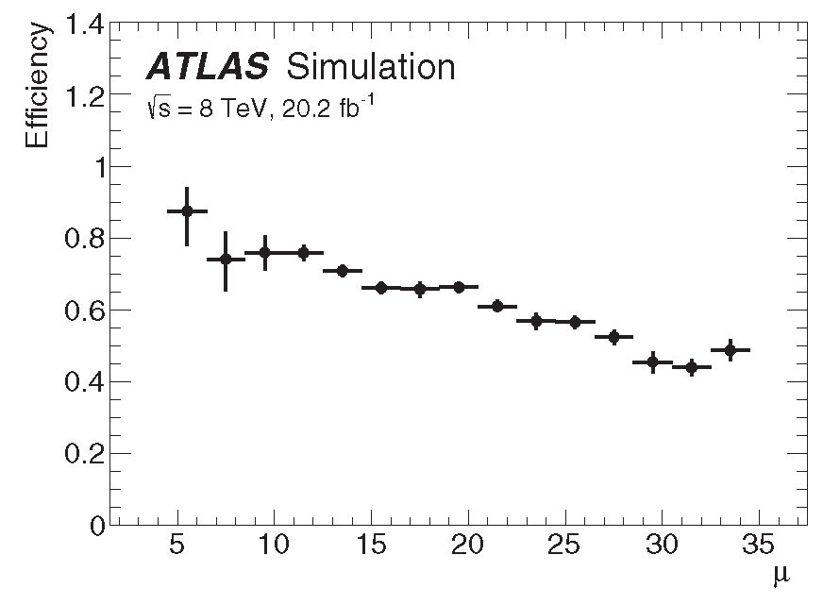
MEASUREMENT OF EXCLUSIVE
PHYSICAL REVIEW D 94, 032011 (2016)
All the background samples mentioned above are proc-
essed through a simulation of the ATLAS detector [54]
based on GEANT4 [55]. The signal samples are processed
through the fast detector simulation program ATLFAST2
- . The effect of the multiple pp collisions, which is
referred to as pileup throughout this paper, is also simulated
by overlaying minimum-bias events generated using
PYTHIA8 and corrected to agree with data.

IV. SELECTION OF LEPTONS, JETS,

AND CHARGED PARTICLES
Selection criteria are applied to the data and simulated
samples to identify events that have good quality electron
and muon candidates. Electron candidates are reconstructed
from clusters of energy deposited in the electromagnetic
calorimeter that are matched to tracks in the inner detector.
They are required to have transverse momentum pT >
10 GeV and be within a pseudorapidity range |n| < 2.47,
excluding the region 1.37 < |n| < 1.52. Also, they satisfy
shower shape and track selection criteria that make up the
“very tight” likelihood criteria [57] defined by a multivari-
ate likelihood algorithm. Electrons are required to be
isolated based on tracking and calorimeter information.
Efficiencies for very tight electron identification range from
60% to 70%. Muon candidates with pT > 10 GeV are
reconstructed from tracks in the inner detector matched to
tracks in the muon spectrometer. Muon candidates are
required to be within a pseudorapidity range |n| < 2.5
and must satisfy the criteria outlined in Ref. [58],
providing muon identification efficiencies of up to 95%.
The tracking and calorimeter isolation criteria for muon
and electron candidates are the same as those used
in Ref. [59].
Jets with |n| < 4.5 are reconstructed from energy clusters
in the calorimeter using the anti-kt algorithm [60] with a
radius parameter of 0.4. To suppress jets from pileup, only
jets with pT > 25 GeV are considered. Missing transverse
momentum p!JPss with magnitude Em“s is reconstructed as
the magnitude of the negative vector sum of the momentum
of reconstructed physics objects—e, ^, photons, and jets—
and remaining calorimeter clusters that are not associated
with any hard objects are also included with the proper
calibration [61].
Charged particle tracks having pT > 0.4 GeV and |n| <
2.5 reconstructed by the inner detector are used in this
paper to reject nonexclusive production. They are required
to leave at least one hit in the pixel detector and at least four
hits in the silicon microstrip detector.

V. EXCLUSIVITY SELECTION
Exclusive candidates are characterized by large rapidity
gaps [62,63] between the protons and the system of interest
—a W+W- pair or Higgs boson. A signature for this, in the
ATLAS detector, is an absence of tracks, other than tracks
from the W+W- pair or Higgs boson decay products.
Inclusive candidates, in contrast, are produced with extra
particles that originate from the emission and hadronization
of additional gluons, and the underlying event. These extra
particles usually produce tracks in the inner detector. This
analysis takes advantage of the absence of additional
charged particle tracks to separate exclusive from inclusive
(color processes) production.
In exclusive Higgs boson and W+W- production, no
further charged particles are produced apart from the two
final-state leptons. So in order to select exclusive events,
the distance between the z0 of the leptons is required to be
less than 1 mm, where z0 is the z coordinate at the point of
closest approach of a lepton (or track) to the beam line in
the r-^ plane. Then the average z0 of the two leptons, z0v, is
taken as the event vertex and is referred to as the lepton
vertex. In this paper, an exclusivity selection is applied,
which requires zero additional tracks with pT > 0.4 GeV
near z0v with |z0rack — z0v| < Az0so. To improve the effi-
ciency for exclusive events whose leptons have more than
one associated track (due to bremsstrahlung for example),
candidate tracks considered for this selection are required
to be unmatched to either of the final-state leptons.
Therefore, a candidate track within an angular distance
AR < 0.01 and within 1 mm in z0 of either of the final-state
leptons is considered matched and is ignored. The value
Azi0so is optimized using exclusive Higgs boson and
exclusive W+W— simulated samples. A value of
Az0so = 1 mm is chosen for all results in this paper. The
exclusivity selection efficiency is found to be 58% and is
largely process independent as is discussed in Sec. VIII A.
In Fig. 3 the exclusivity efficiency is extracted from
exclusive Higgs boson signal simulated by FPMC, plotted
against the average number of interactions per beam
crossing ^. For the data set used in this study, (^) is 20.7.
FIG. 3. Efficiency of the exclusivity selection, extracted from
the exclusive Higgs boson signal simulation, is plotted against the
average number of interactions per beam crossing ^. The average
is 20.7 for the current data set.
032011-5
M. AABOUD et al.
PHYSICAL REVIEW D 94, 032011 (2016)
TABLE II. Single-lepton and dilepton triggers are used to select
event candidates. Single-lepton triggers require either of the
leptons to satisfy the specified pT criterion, while dilepton
triggers have two specific pT criteria.
Trigger | Lepton pT criteria [GeV]
Single electron | pT > 24
Single muon | pT > 24
Symmetric dielectron | pT1 > 12, pT2 > 12
Asymmetric dimuon | pT1 > 18, pT2 > 8
Electron-muon | pT > 12, pT > 8

VI. EVENT SELECTION
Events are required to satisfy at least one of the single-
lepton and dilepton triggers in Table II. They are further
categorized into ee, pp, and ep final states. A combination
of single-lepton and different-flavor dilepton triggers is
used to select the signal events, while the same-flavor
dilepton triggers are used to select ee and pp events for
validation and control regions.
For both the exclusive W+ W- and Higgs boson channels,
this analysis selects candidates consistent with leptonic
decays of W-boson pairs into oppositely charged differ-
ent-flavor leptons. Additional kinematic requirements reject
background while retaining as much of the signal as
possible. Exclusive W+W- production is a large back-
ground in the exclusive Higgs boson search, while the
exclusive Higgs boson contribution to the exclusive W +W~
signal is negligible. So the kinematic requirements for the
two channels differ slightly. Table III summarizes the
selection criteria for both channels.

A. Exclusive W +W- candidate selection
For the exclusive W+W~ channel, requiring oppositely
charged e±p^ leptons rejects same-flavor lepton events
from Drell-Yan and exclusive dilepton processes. The
invariant mass of the dilepton system is required to be
greater than 20 GeV. This rejects a significant fraction of the
remaining background in which jets have nonprompt or fake
electron and/or muon signatures. The lepton with the higher
pT is referred to as the leading lepton (11), and the other, the
subleading lepton (12). The pT requirement on the leading
lepton is chosen to be higher than the single-lepton trigger
threshold, resulting in different leading and subleading
leptons requirements: pT1 > 25 GeV and pT2 > 20 GeV,
respectively. These selection criteria define preselection.
To reduce yy ^ t+t~ and Zfy* ^ t+t~ contamination,
the magnitude of the transverse momentum of the dilepton
system (pT) is required to be greater than 30 GeV. The
exclusivity requirement rejects most of the remaining
inclusive background. After applying these selection cri-
teria, 70% of the predicted background is due to inclusive
W+W~ production, while yy ^ t+t~ contributes 15% and
the contributions from other categories are negligible.
The limits on aQGCs are extracted from the region with
pT > 120 GeV. This requirement considerably reduces
the SM contribution.

B. Exclusive Higgs boson candidate selection
The Higgs boson decays to W+W~ give one on-shell and
one off-shell W boson. Thus, the subleading lepton mini-
mum pT is lowered to 15 GeV. For the same reason, the mep
threshold is lowered to 10 GeV. The other requirements in
the preselection are the same as for the exclusive W +W-
sample. In contrast to the W+W~ topology, the zero spin of
the Higgs boson implies that the final-state leptons have
small angular separation. Therefore, the angular separation
of the leptons in the transverse plane (A<pep) and the
dilepton mass (mep) are two good discriminating variables
against the remaining exclusive W +W~ background, which
has a wider angular separation and relatively higher
dilepton mass. Thus, mep and A^ep selection criteria are
further imposed in the Higgs boson search. The transverse
mass of the Higgs boson system, mT, is defined as

mT = ^(ET + ET)2 - IpT + Pi'iss|2- (5)
where ETp = \J\pT|2 + m2ep and [pîpiss I = ETss. Requiring
mT < 140 GeV further reduces both the inclusive and
TABLE III. Selection criteria for the two analysis channels.
 | W+W selection | Higgs boson selection
Preselection | Oppositely charged ep final states
Preselection | pT11 > 25 GeV and pT12 > 20 GeV | pT11 > 25 GeV and pT12 > 15 GeV
Preselection | mep > 20 GeV | mep > 10 GeV
 | pT > 30 GeV
 | Exclusivity selection, Az0so
aQGC signal | pT > 120 GeV
Spin-0 Higgs boson |  | mep < 55 GeV  A$ep < 1.8  mT < 140 GeV
032011-6
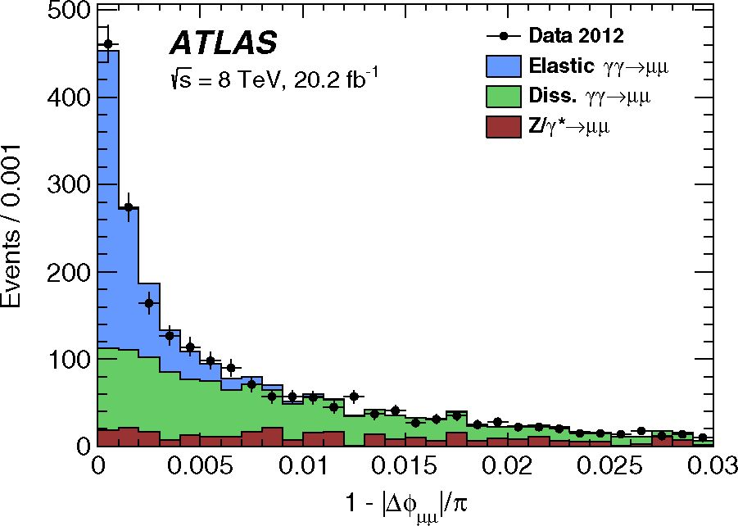
MEASUREMENT OF EXCLUSIVE ...
exclusive W+W— backgrounds and improves the signal
significance by 20% (see Fig. 15). The exclusivity selection
uses Az0so = 1 mm here as well.
- PILEUP AND EXCLUSIVITY VALIDATION
WITH yy ^ 1+1— EVENTS
The selection strategy described in Sec. V represents a
new approach to extract exclusive processes without using
the usual vertex reconstruction [64]. This section describes
two studies designed to validate this technique. The first
one demonstrates how the Az0so selection gives results
comparable to those of previous strategies employed by the
ATLAS Collaboration in a related measurement at y/s =
7 TeV [65], and the second one shows how simulation of
pileup and modeling of underlying event activity are
verified. Except for possible nonstandard couplings, the
exclusive production of W+W- and that of 1+1— are
similar. Exclusive dilepton candidates are therefore used
in both studies because elastic yy ^ 1+1— production
can be separated from SD and DD production using
dilepton transverse momentum pT11 and acoplanarity
(1 — |A$ii|/n) of the dilepton system, where A^n is
the dilepton azimuthal separation. The yy ^ p+p— candi-
dates are used for these studies, while yy ^ e+e— candi-
dates are used for cross-checks.
First, a measurement is made of the correction factor,
fEL, defined as the ratio of observed elastic yy ^ p+p—
candidates to the herwig++ prediction based on the EPA
formalism. This factor is expected to be lower than 1.0 due
to the finite size effects of the proton [66]. Alternative
formulations give similar results [67]. Candidates are
required to have two muons with pT > 20 GeV, invariant
mass 45 < m^ < 75 GeV or mm > 105 GeV and pass the
exclusivity selection (Az0so = 1 mm). The Drell-Yan
Z/y* ^ p+p— process is the dominant background, while
contributions from other backgrounds are negligible. The
elastic yy ^ p+p— signal is enhanced by selecting the low-
plTl region with an upper limit on plTl varied between
3 GeV and 5 GeV to study systematic uncertainties.
The value of fEL is extracted from template fits in
acoplanarity. Some of the contributing processes have
similar acoplanarity shapes; in particular, the Drell-Yan
and DD backgrounds are not distinguishable. Two fitting
strategies are pursued. The first template strategy attempts
to distinguish three shapes: elastic, SD, and combined DD
plus background. The relative weighting of DD and back-
ground is varied to estimate the associated systematic
uncertainty. The second template strategy uses the elastic
and combined SD and DD shapes, with the background
yield constrained to the simulation’s prediction. These two
fitting strategies give consistent results and are stable at the
level of 10% under the variation of pT and Az0so selections,
the four different Drell-Yan generators, bin width, and fit
range. These variations reflect mismodeling of pT and
systematic uncertainties related to shape correlations and
PHYSICAL REVIEW D 94, 032011 (2016)
FIG. 4. Dimuon acoplanarity distributions after applying the
exclusivity selection and requiring pT < 3 GeV. The expected
Drell-Yan shape and the elastic and combined SD and DD
(dissociative) shapes normalized from the fit are stacked. This fit
determines the factor f EL.
signal strength. The effect of these variations is much larger
than the 3% combined effect of the systematic uncertainties
discussed in Ref. [65], which can then be ignored. The best-
fit value is fEL = 0.76 ± 0.04(stat) ± 0.07(sys), where the
systematic uncertainty covers the spread of fit values, and
Fig. 4 shows the acoplanarity distribution compared to SM
expectation normalized by the factors determined in this fit.
An additional uncertainty of 10% related to pileup is
discussed in the following paragraph. A similar study using
yy ^ e+e— candidates yields a consistent correction factor
but with lower precision; thus, the final value for fEL is taken
from the yy ^ p+p— sample. This correction factor is used to
correct the number of yy ^ t+t— candidates predicted by
simulation in both the exclusive W +W— and the exclusive
Higgs boson signal regions. Similar suppression is expected
- and observed [65] in dissociative events, so the fEL
factor is applied to dissociative events as well.
In the second study, the impact of pileup on the signal
efficiency and accuracy of the modeling in the simulation is
evaluated. A kinematic selection is defined to enhance the
fraction of elastic events. Events with pT < 3 GeV and
acoplanarity < 0.0015 are studied with both the nominal
exclusivity selection criteria and by demanding exactly one
extra track within Azi0so = 3 mm. In the case of exclusive
signal, when there is one extra track, the extra track is from
pileup and its Az0 = |z0rack — z0v| has a locally constant
distribution, while for any inclusive background, the track
originates from the same vertex and the Az0 distribution
peaks at zero, as can be seen in Fig. 5. A normalization
factor, the background-subtracted ratio of observed exclu-
sive events to the predicted sum of elastic, SD, and DD, is
determined for both selections. For nominal (zero track)
exclusivity this normalization factor is 0.73 ± 0.03(stat)±
- 01 (sys). The one-track selection, illustrated in Fig. 5,
gives a factor of 0.70 ± 0.06(stat) ± 0.03(sys) where the
systematic uncertainties result from the uncertainty in the
032011-7
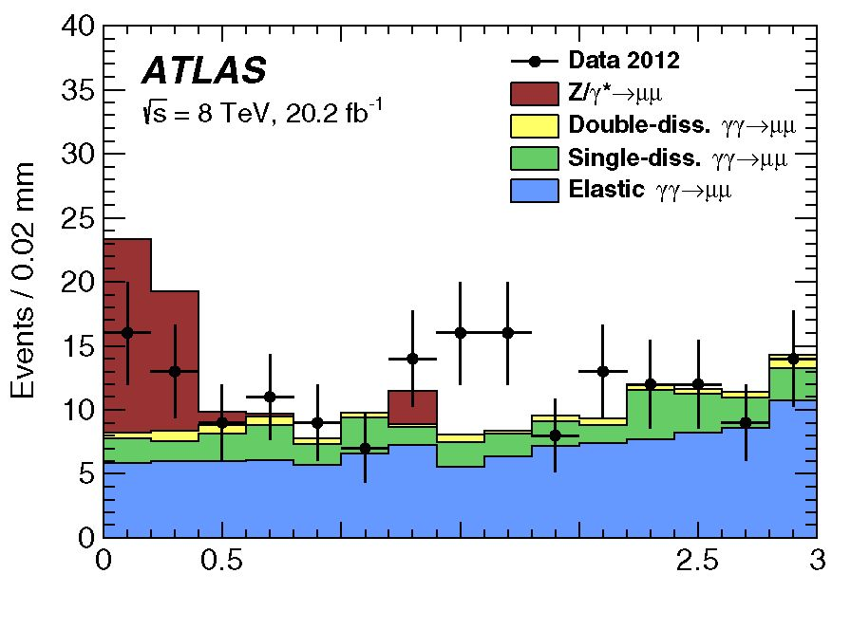
M. AABOUD et al.
1 1.5 2
Az0 [mm]
FIG. 5. Absolute Az0 of the extra track to the lepton vertex in
the region defined by acoplanarity < 0.0015. The exclusivity
requirement was changed to select exactly one extra track within
3 mm. The exclusive predictions are scaled by a factor of 0.70.
background normalization factor. The zero-track and one-
track normalization factors are consistent at the level of
10%, which is taken to be a measure of the accuracy of the
pileup simulation in predicting signal efficiency.
The value of fEL with the additional ±10% relative
systematic uncertainty for signal efficiency added in
quadrature with the previous systematic uncertainty
/el = 0.76 ± 0.04(stat) ± 0.10(sys)
(6)
is consistent with the value of 0.791 ± 0.041 (stat) ±
0.026(sys) ± 0.013(theory) obtained in an earlier analysis
using data from pp collisions at = 7 TeV [65]. This
value is also consistent with the theoretical estimate of
/el 0.73-0.75, related to the proton size effects in the
probed region of dimuon mass [66].
VIII. SIGNAL AND BACKGROUND
CONTROL REGIONS
Several control regions are established to use data events
to cross-check simulations in areas where they are known to
be less reliable. The ratio of elastic to dissociative con-
tributions is extracted from one control region, since a
simulation for yy ^ W+W- dissociative events is not
available. Another set of control regions is used to study
the proximity of small numbers of extra tracks to the lepton
vertex. This is another regime where the underlying-event
models have not been thoroughly tested, so relying on the
data is preferred. Finally a control region is established for
inclusive W+W- production, a predominant background.
This control region has a different exclusivity requirement,
one to four extra tracks, in order to increase the fraction of
inclusive W +W- events. The inclusive W+W- contribution
to the exclusive W+ W- signal region is estimated using a
data-driven method. Based on the number of events
observed in this control region, this method makes some
PHYSICAL REVIEW D 94, 032011 (2016)
assumptions about the rejection of background when going
from the control (one to four tracks) to the nominal (zero
tracks) exclusivity requirement, and derives an estimate for
the background from inclusive W+W-, Drell-Yan,
W + jets, and top-quark production. The latter three proc-
esses collectively have a smaller contribution and are
referred to as other background. Other contributions to
the background are derived from Monte Carlo simulation
and are found to be negligible.

A. Single-dissociative and double-dissociative
contributions
Without detecting the outgoing protons, the elastic yy ^
W+W- events are indistinguishable from SD and DD
candidates. However, simulations are only available for
the elastic yy ^ W+W- process; predictions for dissocia-
tive production of W+W- are not available. Following the
strategy in Ref. [68], a normalization factor f is deter-
mined. This factor is used to correct the prediction for
elastic yy ^ W+ W- to account for dissociative events. It is
computed from data using yy ^ p+p- candidates that
satisfy the exclusivity selection with Az0so = 1 mm, pT^ >
20 GeV and m^ > 160 GeV (~2mW). The factor fY is
defined as the ratio of observed dimuons in data to the
herwig++ prediction for elastic dimuon production:
/y =
Data
npowheg
Background
NHERWIG++
Elastic
= 3.30 ± 0.22(stat) ± 0.06(sys),
(7)
where NData is the number of candidates in the data,
POWHEG
Background
is
the expected number of background
events, and NHERWIG++ is the expected number of elastic
yy ^ p+p- candidates directly from herwig++, i.e, the
unscaled EPA prediction. Drell-Yan processes are the main
sources of background, whereas inclusive and exclusive
W+W- processes contribute less than 10%. The uncertainty
is predominantly statistical but also contains a systematic
component estimated by varying the powheg+pythia8
Drell-Yan correction factor by ±20%, as is discussed in
Sec. VIIIB. Predictions for this ratio are becoming
available [69].
The dilepton invariant mass distributions for the p+p-
and e+e- final states are shown in Fig. 6. The elastic
contribution is scaled by /el = 0.76, and the SD contri-
bution is normalized so that the sum of the elastic and SD
contributions corresponds to /y x NHERWG++. The shapes
of the SD and DD samples are quite similar, so the SD
shape is used to describe both the SD and DD processes.
The data are well described by the simulation over the full
mass range. While the range of > 160 GeV was
chosen to correspond to the threshold mWW > 2mW, the
value of /y is in fact rather insensitive to the choice of this
threshold. The W+W- sample tends to have higher mWW
mpp>160 GeV
032011-8
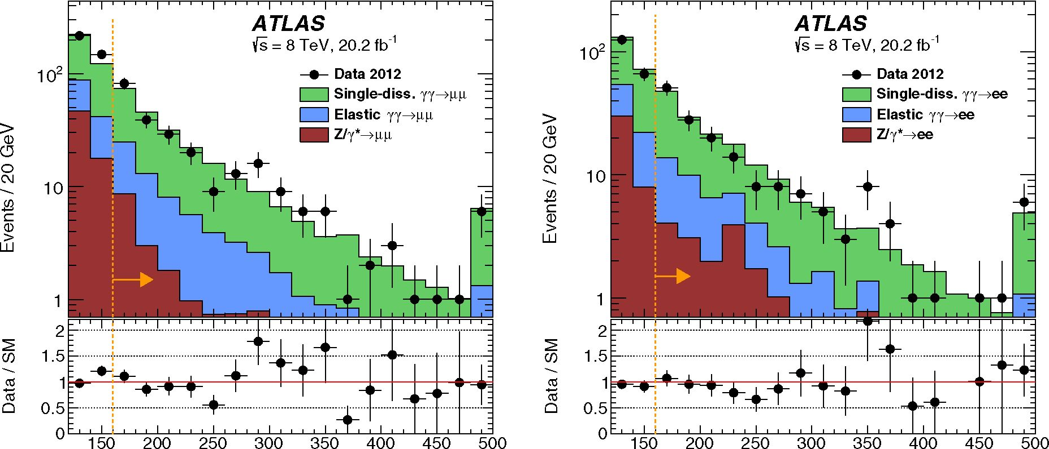
MEASUREMENT OF EXCLUSIVE
PHYSICAL REVIEW D 94, 032011 (2016)
mw [GeV] mee [GeV]
FIG. 6. The dilepton invariant mass distribution for muon candidates (left) and electron candidates (right). The elastic yield is scaled
by /el = 0.76, and the SD distribution is scaled to bring the sum of the elastic and SD contributions to the HERWIG++ prediction for the
elastic process multiplied by the /y factor in the mass region above 160 GeV. The last bin includes overflow.
than these dilepton control samples m^. The mee distri-
bution in Fig. 6 shows that / is also valid for the electron
channel. Therefore, the total expected yy ^ W+W- event
yield in both the exclusive W+W- and the exclusive Higgs
boson channels is taken to be the product of f times the
herwig++ prediction for elastic yy ^ W+W- production.
The dimuon signal sample with mass above 160 GeV is
also used to determine the signal efficiency for exclusivity,
which is 0.58 ± 0.06, where the 10% uncertainty arises
from pileup modeling as described in Sec. VII. Other signal
samples give compatible results.

B. Track multiplicity modeling
In pp collisions, inclusive Drell-Yan, W +W-, if, and
many other events are initiated by quarks or gluons.
Through hard radiation and the accompanying underlying
event, such events are produced with several additional
charged particles. The exclusivity selection is designed to
reject such inclusive candidates that have additional tracks
near the dilepton vertex. To estimate inclusive backgrounds
from Drell-Yan production of t+t- and inclusive W +W-
production, the track multiplicity modeling of low-multi-
plicity candidates is studied with a high-purity Z boson
sample and scaled with appropriate correction factors.
Drell-Yan candidates are selected by requiring exactly
two muons with pT > 20 GeV and |n| < 2.4, and
satisfying m^ > 45 GeV. The Z-resonance region,
80 < m^ < 100 GeV, is used to measure the efficiency
of the exclusivity selection in both the data and simulation.
The contributions from non-Z processes are subtracted
before and after the exclusivity selection for both the data
and simulated samples. This non-Z contribution is
estimated from the sideband regions 70 < mpp <
80 GeV and 100 < mpp < 110 GeV. The efficiency of
the exclusivity selection for inclusive Z events in data is
found to be 0.004. This was compared to efficiencies
for simulated Drell-Yan samples from four generators:
ALPGEN+PYTHIA6, ALPGEN+HERWIG, POWHEG+PYTHIA8,
and sherpa. In general, the exclusivity criterion rejects
more Z/y ^ p+p~ candidates in the data than in the
simulation. The study was repeated for events with one
to four additional tracks.
Correction factors are defined as the ratio of the
exclusivity selection efficiency in data to the one in the
simulation. They are reported in Table IV and denoted by
/nTradss, where sim is P for powheg+pythia8, AH for
ALPGEN+HERWIG, and AP for ALPGEN+PYTHIA6, and
nTracks is the number of additional tracks. These correc-
tion factors are used to scale the Monte Carlo prediction for
the inclusive processes considered in the paper. The back-
ground event tuning for simulation of low multiplicity in
8 TeV data is seen to vary widely.
TABLE IV. Ratio of exclusivity efficiencies for Z ^ pp pro-
duction in data and simulation for different generators after
sideband subtraction of nonresonant contributions. The efficiency
ratios /n™acks are shown for exclusive selection (n = 0) as well as
for a relaxed selection with one to four additional tracks
(n = 1-4).
 |  | Alpgen | Alpgen
Number of extra | Powheg | +HERWIG | +Pythia6
tracks | +Pythia8 /n | fAH  n | fAP  n
n = 0 | 0.58 | 0.21 | 0.69
n = 1-4 | 0.88 | 0.39 | 0.85
032011-9
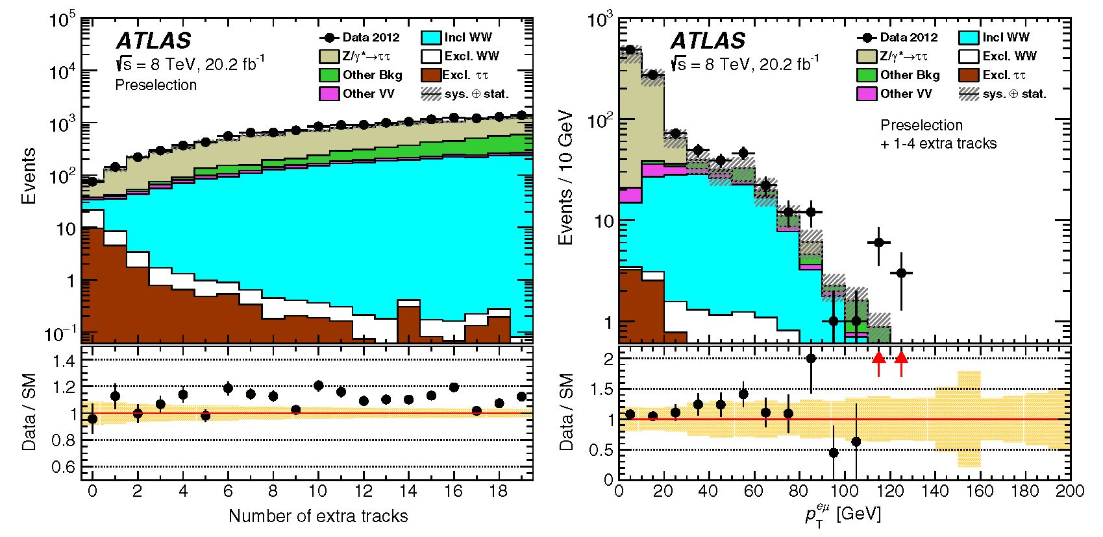
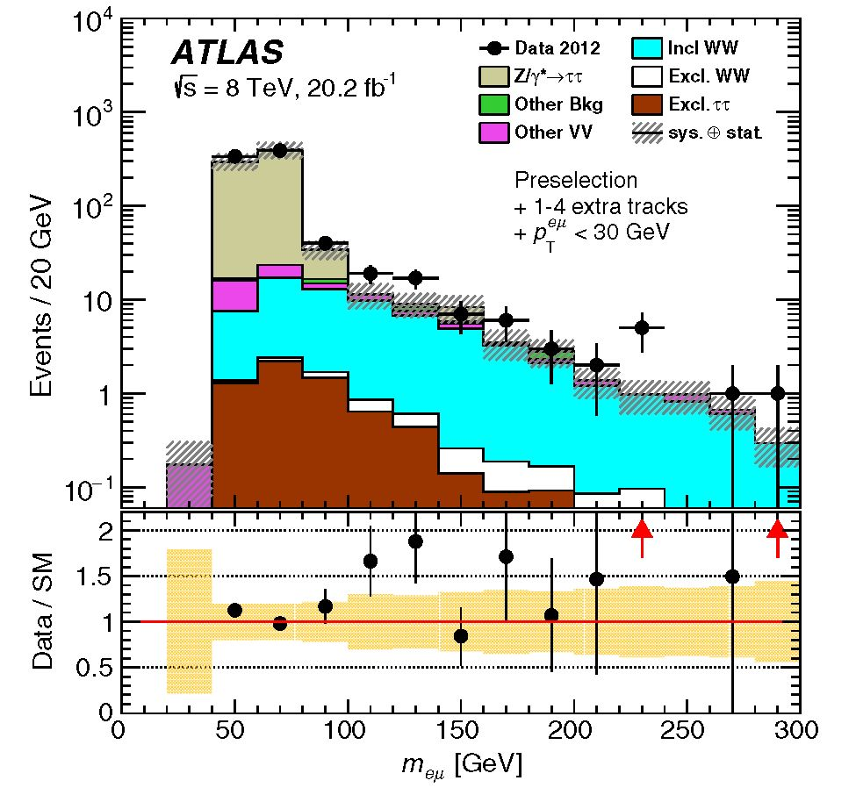
M. AABOUD et al.
PHYSICAL REVIEW D 94, 032011 (2016)
FIG. 7. Distribution of track multiplicities after requiring the exclusive W+W— preselection (left) with no number of track-dependent
correction, and the pT distribution of candidates that have 1-4 extra tracks (right), with the simulation including all appropriate
correction factors such as /nTiacks (Table IV) for Drell-Yan and inclusive W+ W— production. The enriched inclusive W+W— control
region is the 1-4 extra-track region above pT > 30 GeV. The band around the Data/SM ratio of one illustrates the systemic
uncertainties. The upward red arrows indicate ratios outside the plotting range.
The uncertainties in these correction factors are esti-
mated from the variation of the exclusive efficiency as a
function of m^ of the various generators. To check the
consistency of the predictions of evolution of underlying
event multiplicity as a function of mass, ratios of the
predictions of the three generators to the one by SHERPA are
listed in Table . These are normalized such that the
average over the full mass range is 1. The variations are
typically within 20%, which is taken as the systematic
uncertainty in extrapolating the /Tucks correction factors.
To validate the correction factors /Tucks, an e^T
sample was defined. Figure 7 (left) shows the distribution
of the number of additional tracks after applying the
W+W— preselection as defined in Table III. Applying a
relaxed exclusivity selection to select e^T candidates with
one to four extra tracks yields a sample that has low enough
statistical uncertainties and is dominated by Drell-Yan
events for pT < 30 GeV as illustrated in Fig. 7 (right).
Selecting me[ < 90 GeV further rejects non-Drell-Yan
contamination as shown in Fig. 8. The correction factor
for alpgen+PYTHIA6 Drell-Yan, computed in the region
defined by pT < 30 GeV and me[ < 90 GeV, is found to
be 0.90 ± 0.11, in good agreement with /Ap = 0.85 found
above for Z ^ [—.
- Inclusive W+W— normalization
Inclusive W+W— production is a significant background
in both the exclusive Higgs boson and exclusive W +W—
channels. From previous measurements [59,70], it known
that the NLO prediction for the qq ^ W+W— process as
provided by powheg+pythia8 underestimates the observed
W+W— event yield. It is therefore necessary to understand
the simulation of this background before requiring the
exclusivity selection. A region close in phase space to the
exclusive Higgs boson signal region is chosen, referred to
here as the Higgs-specific inclusive W+W— control region.
It has the same definition except for the following:
A/^ < 2.6 to reduce Drell-Yan
55 < me[ < 110 GeV
FIG. 8. The me[ distribution after requiring 1-4 extra tracks
within Az0so = 1.0 mm and pT < 30 GeV. The Drell-Yan and
inclusive W+ W— samples are scaled by the factors /Ap and /p-4,
respectively. The other samples are normalized as mentioned in
the text. In the Data/SM ratio plot, the color band illustrates the
systematic uncertainties, and the red upward arrows indicate
ratios outside the plotting range.
032011-10
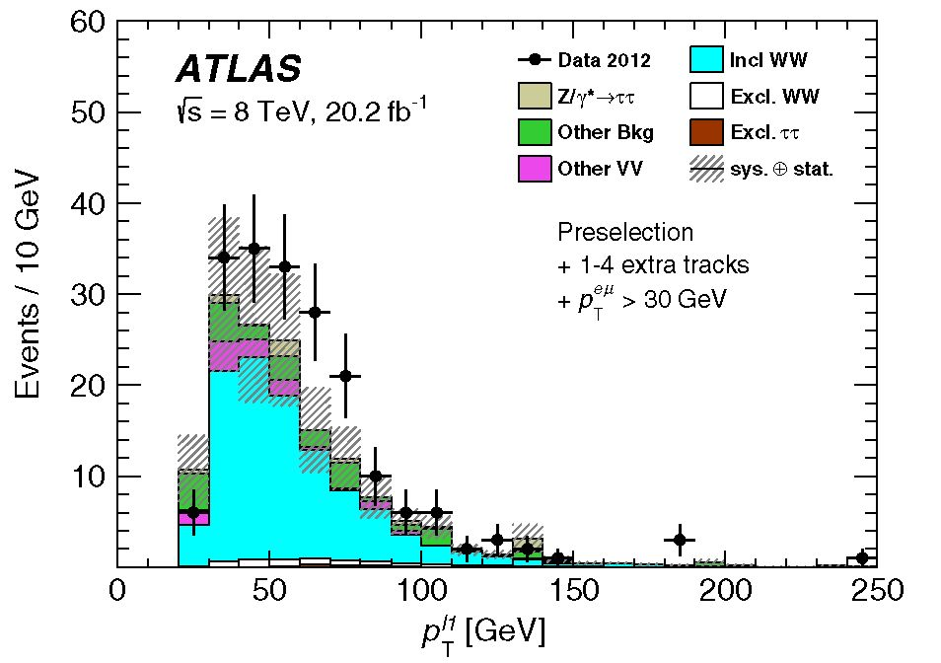
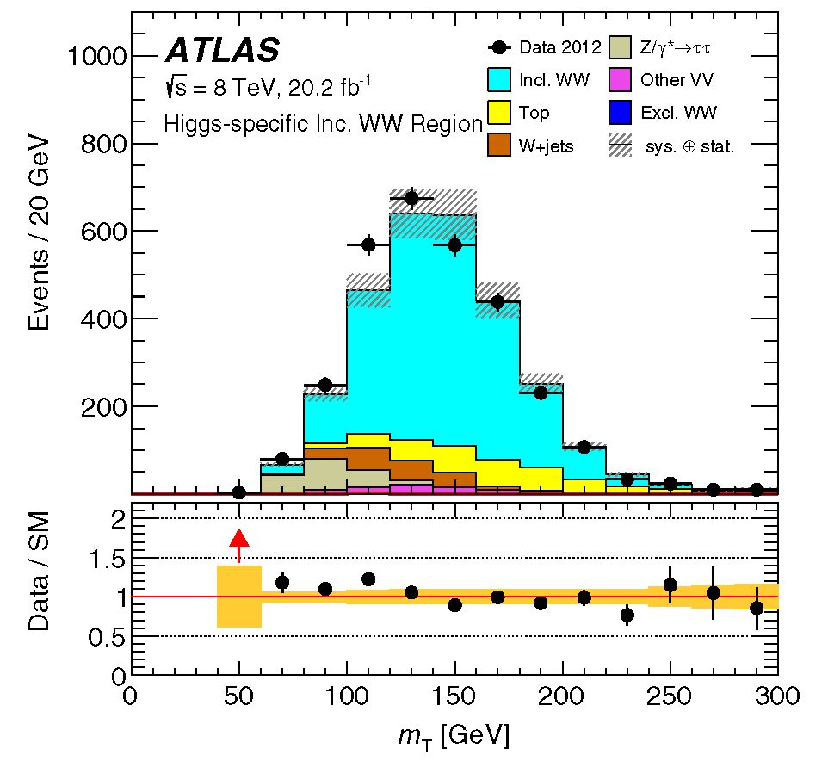
measurement of exclusive
PHYSICAL REVIEW D 94, 032011 (2016)
TABLE V. Ratio of the exclusivity selection efficiency in Drell-
Yan p+p- production as a function of dimuon mass of different
generators to SHERPA. A common normalization factor is applied
to each column to obtain an average ratio of 1. Only statistical
uncertainties are shown. The statistical uncertainty from SHERPA
is included and contributes 2.9%, 0.8%, 0.7% and 5.7% in the
four mass regions.
Mass  [GeV] | ALPGEN  +HERWIG | ALPGEN  +PYTHIA6 | POWHEG  +PYTHIA8
44-60 | 0.81 ± 0.02 | 0.84 ± 0.03 | 0.99 ± 0.09
60-90 | 1.04 ± 0.02 | 0.98 ± 0.03 | 1.01 ± 0.02
90-116 | 1.00 ± 0.01 | 1.02 ± 0.02 | 1.00 ± 0.02
116-200 | 0.89 ± 0.10 | 1.04 ± 0.19 | 0.76 ± 0.10
background, no jets to reduce ttt background, and no
requirement on exclusivity. This region is dominated by
inclusive W+W- production and has a purity of 60%. After
subtracting the predicted backgrounds from data, (20 ±
5)% more data is observed than is predicted by powheg
+pythia8. A normalization factor of 1.20 ± 0.05(stat) is
therefore taken as a correction to the cross section and
applied to the inclusive W+W- prediction in all regions of
phase space studied here, as done in Ref. [59]. The
transverse mass mT distributions in the Higgs-specific
inclusive W+W- control region after applying the normali-
zation factor to the powheg+pythia8 prediction is shown
in Fig. 9.

D. Sum of inclusive W + W- and other background
An estimate of the sum of inclusive W+W- background
and smaller contributions from Drell-Yan, W + jets, and
FIG. 9. The mT distributions in the Higgs-specific inclusive
W+W- control region that is used to determine the scaling for the
powheg+pythia8 inclusive W+W- prediction. In the Data/SM
ratio plot, the color band illustrates systematic uncertainties, and
the red upward arrow indicates a ratio outside the plotting range.
top-quark production (collectively referred to as other
background) is performed using an inclusive W+W--
enriched control region defined with the same criteria as
the exclusive W+W- signal region, except the exclusivity
selection requires 1-4 extra tracks within Az0so = 1 mm.
This control region is shown in Fig. 7 (right) in the region
above pT > 30 GeV. It is dominated by the inclusive
W+W- process and also has small contributions of exclu-
sive events, non-W+W- (other-VV) dibosons, and other
background.
Figure 10 shows the leading lepton pfT1 distribution in
this control region. The prediction is systematically lower
than the data. The processes contributing to this control
region can be found in Table VI, and the total SM
expectation is compared to the data. The data exceed the
simulation by 2a. This discrepancy is attributed to a
component from jets faking leptons that is unreliably
simulated. Events produced with jets such as W + jets,
Z + jets, and top-quark production, particularly jets faking
leptons, are more easily rejected by the exclusivity selec-
tion, while other-VV and Drell-Yan (without accompany-
ing jets) processes are likely to extrapolate from the 1 -4
extra-track control region to the zero-track region with a
scale factor similar to that for inclusive W+W- back-
ground. Therefore, this control region is used to constrain
the inclusive W+W- plus other background involving fake
leptons.
For the purpose of estimating the contribution of
inclusive W +W- events and other background in the
zero-track region, the number of these events in the 1 -4
extra-track control region is bracketed by the number of
observed events in the data, after subtracting the exclusive
and other-VV contributions, as an upper bound and by the
predicted number of inclusive W +W- obtained from
powheg+pythia8 as a lower bound. To obtain the con-
tribution for the exclusive W+W- signal region, the two
FIG. 10. The leading-lepton p1T1 distribution in the inclusive
W +W~ control region. The simulation includes all appropriate
correction factors such as /p-J for Drell-Yan and /p_4 for
inclusive W+W~ production.
032011-11

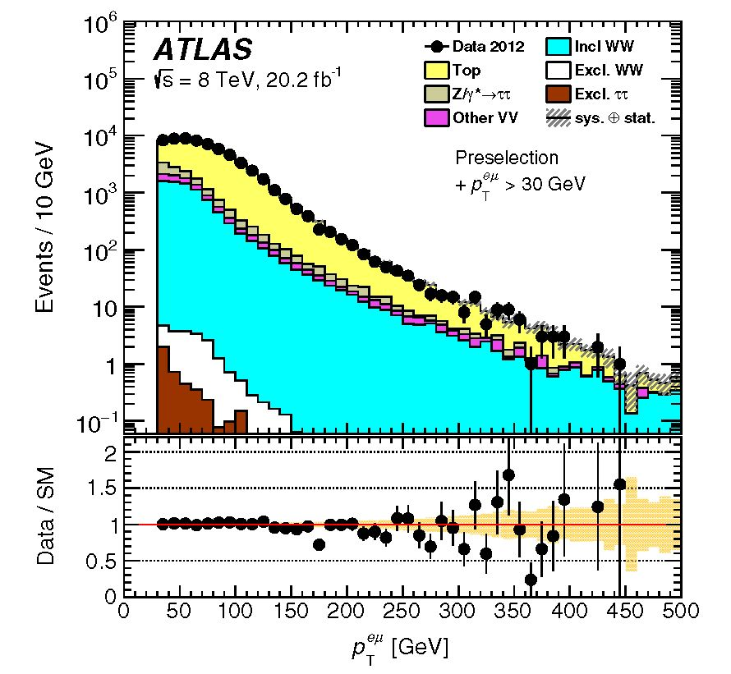
M. AABOUD et al.
PHYSICAL REVIEW D 94, 032011 (2016)
TABLE VI. Event yields in the inclusive W+W control region.
The uncertainties quoted are statistical and systematic.
Processes | Inclusive W+W
Inclusive W+W- | 102 ± 20
Exclusive W+W- | 5.5 ± 0.4
Exclusive t+t- | 1.2 ± 0.2
Other diboson | 10.9 ± 2.2
Other background | 27.4 ± 6.2
Total SM | 147 ± 21
Data | 191
TABLE VII. Sources of uncertainty for the measured exclusive
W+ W- cross section. “All other” includes other efficiencies,
acceptance, luminosity, and lepton scales and resolution.
Source of uncertainty | Uncertainty [%]
Statistics | 33%
Background determination | 18%
Exclusivity signal efficiency | 10%
All other | < 5%
Total | 39%
estimates are extrapolated from the 1-4 extra-track control
region to the zero-track signal region. In this framework,
the lower bound corresponds to the optimistic case where
the other background contribution is completely rejected by
the zero-track exclusivity requirement, while the upper
bound corresponds to the case where all observed candi-
dates in the control region are suppressed by the same
factor as the inclusive W+W- process. Finally, the average
of the two estimates (after extrapolation) is taken as the
contribution for the signal region.
The extrapolation is achieved by multiplying the esti-
mates by the ratio of the predicted numbers of inclusive
W+W- events:
■Estimated
= N
Estimated
1-4
N
X
Predicted
WW,0
A/predicted ‘
JVWW,1-4
(8)
where N0Estimated and N1E-st4imated are the estimates for the
lower bound or upper bound mentioned above, and
NWrWdi0ted and NWWn-4 are, respectively, the number of
inclusive W+ W- events predicted by powheg+pythias for
the zero-track and 1 -4 extra-track regions. This ratio is
found to be 0.048 ± 0.014, where the uncertainty is
dominated by the 20% systematic uncertainties taken to
be uncorrelated between the fp and fp-4 factors that are
included in the predicted numbers of events. As mentioned
above, the small exclusive and other-VV contributions are
subtracted before the extrapolation. So for inclusive W+ W-
and Drell-Yan processes, the expected number of events in
the zero-track region is 20 times less than the prediction for
the 1 -4 extra-track control region.
As mentioned above, the inclusive W+W- and other
background contributions to the signal region are taken as
the average of the two estimates. Half the difference is
included as an additional contribution to the uncertainty in
this determination. This results in a final estimate of 6.6 ±
2.5 background candidates for the exclusive W+W- signal
region.
This background estimate, 6.6 ± 2.5 events in the
exclusive W+W- signal region, corresponds to scaling
the powheg+pythias W+ W- prediction by a normalization
factor of 0.79. This factor is used to estimate the inclusive
W+W- and other background contamination in the Higgs
boson and aQGC signal regions.
IX. SYSTEMATIC UNCERTAINTIES
The main sources of systematic uncertainty are related
to the exclusivity selection and the background determi-
nation. The uncertainty in the efficiency of the exclusive
signal selection contributes 10% to the exclusive W+W-
and Higgs boson signal yields, as estimated in Sec. VII
from the ratios of dimuon event yields without extra tracks
and those with exactly one extra track. The prediction of the
exclusive W+W- process uses the f factor as described in
Sec. VIIIA and thus carries the 7% uncertainty in fY. The
YY ^ t+t- background has an uncertainty of 14% that is
propagated from the fEL factor. As described in Sec. VII,
the fEL uncertainty includes 10% related to the exclusive
signal selection and another 10% that results from acopla-
narity fits. There is a 38% uncertainty in the inclusive
W+W- background, as discussed in Sec. VIIID. This 38%
uncertainty contains a component from the ±20% uncer-
tainty in Drell-Yan background described in Sec. VIIIB.
The contributions from these systematic uncertainties to
the measured exclusive W+W- cross section can be found
FIG. 11. The pT distribution before exclusivity, i.e., after
requiring pT > 30 GeV. The main backgrounds at this stage
are top-quark production, inclusive W+W- and Drell-Yan. In the
Data/SM ratio plot, the color band illustrates systematic uncer-
tainties.
032011-12

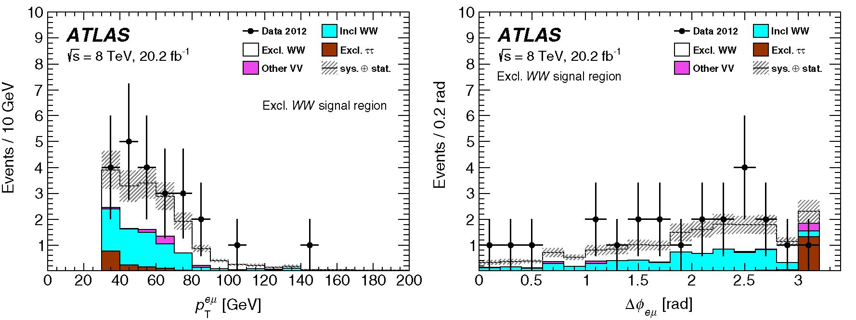
MEASUREMENT OF EXCLUSIVE ... PHYSICAL REVIEW D 94, 032011 (2016)
TABLE VIII. The event yield at different stages of the selection. The expected signal (yy ^ W+W—) is compared to the data and total
background. The SM-to-data ratio (SM/Data) gives the level of agreement between prediction and data. The product of efficiency and
acceptance (eA) for the signal is computed from the yy ^ W+ W— ^ e±pT MC generator. The statistical and systematic uncertainties
are added in quadrature. For the background, the uncertainties are only shown for the yields after exclusivity selection, where they are
relevant for the measurement.
 | Expected signal | Data | Total bkg. | Incl. W+W- | Excl. TT | Other-VV Other bkg. SM/Data |  |  | eA (signal)
Preselection | 22.6 ± 1.9 | 99424 | 97877 | 11443 | 21.4 | 1385 | 85029 | 0.98 | 0.254
pf > 30 GeV | 17.6 ± 1.5 | 63329 | 63023 | 8072 | 4.30 | 896.3 | 54051 | 1.00 | 0.198
Azoso requirement | 9.3 ± 1.2 | 23 | 8.3 ± 2.6 | 6.6 ± 2.5 | 1.4 ± 0.3 | 0.3 ± 0.2 |  | 0.77 | 0.105 ± 0.012
aQGC signal region
pl1 > 120 GeV | 0.37 ± 0.04 | 1 0.37 ± 0.13 |  | 0.32 ± 0.12 | 0.05 ± 0.03 | 0 |  | 0.74 | 0.0042 ± 0.0005
in Table VII. The overall background contribution is 18%,
predominantly from uncertainty in the extrapolation from
the 1-4 track control region. In addition to the systematic
uncertainty from the exclusivity selection (10%), other
systematic uncertainties (lepton selection efficiencies and
acceptance, luminosity and lepton scales and resolution)
contribute less than 5%. The statistical uncertainty domi-
nates the uncertainties in the cross section.

X. RESULTS
This paper presents three main results: the exclusive
W+W- production cross section, limits on possible aQGCs,
and a limit from a search for exclusive Higgs boson
production. Each is summarized in the following. The
exclusive W+W- signal is the sum of elastic and single-
and double-dissociative events through the fY factor dis-
cussed in Sec. VIII A.

A. Standard Model exclusive W+W- production
Before the exclusivity selection, good agreement
between data and background prediction is observed. In
the ep final state, the overall event yield agrees to within
2%, and after requiring pT > 30 GeV, it agrees to within
- 5%. The pT distribution before the exclusivity require-
ment is shown in Fig. 11.
The numbers of candidates at various stages of the
analysis are listed in Table VIII, and the uncertainties
quoted include both the statistical and systematic uncer-
tainties. Top-quark and Drell-Yan Z/y* ^ t+t- processes
are the dominant backgrounds before exclusivity, while after
requiring exclusivity their contributions are less than 0.5
events. These two backgrounds, along with W + jets, are
grouped together as other background (Table VIII). The
inclusive W+W- estimate (described in Sec. VIIID) already
includes these three processes; thus, the other background
contribution after requiring exclusivity is not added to the
total background. Non-W+W- (other-VV) diboson proc-
esses are also highly suppressed by the exclusivity selection:
They contribute 0.3 ± 0.2 events. Diffractive W+W- pro-
duction was considered as a background and found to be
insignificant. The expected signal yield is 9.3 ± 1.2 events,
including the dissociative contributions (f Y factor) discussed
in Sec. VIII A. The total predicted background is 8.3 ± 2.6,
while 23 candidates are observed in the data.
Figure 12 shows the pTf and A^ep distributions after
applying all selection criteria. The shapes of the signal and
the inclusive W+W- distributions are similar. The
FIG. 12. The pT (left) and A<^ep (right) distributions in the exclusive W+W signal region. The inclusive W+W estimate includes
small contributions from other backgrounds (Drell-Yan, W + jets, and top-quark production).
032011-13
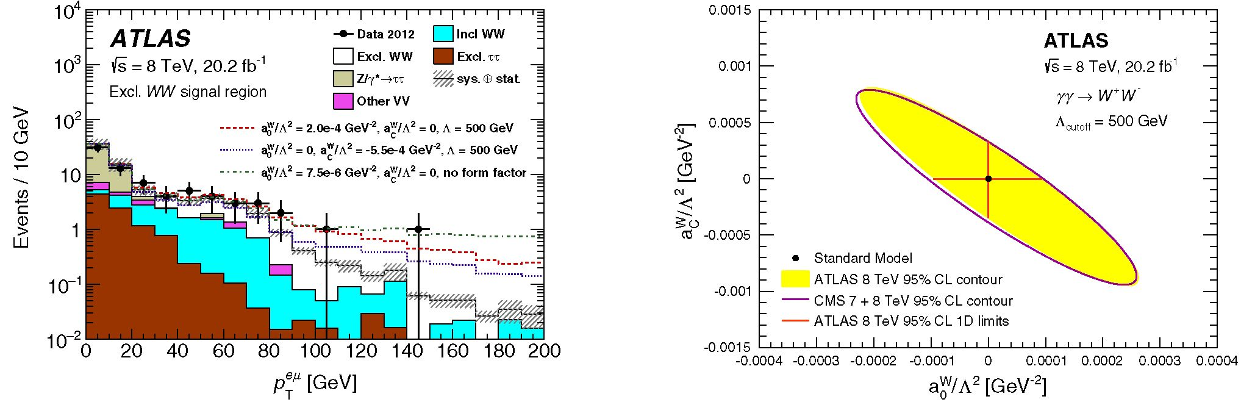
M. AABOUD et al.
PHYSICAL REVIEW D 94, 032011 (2016)
FIG. 13. The pT distribution for data compared to the SM
prediction for events satisfying all the exclusive W+W- selection
requirements apart from the one on pT itself. Also shown are
various predictions for aQGC parameters aJ,C.
FIG. 14. The observed log-likelihood 95% confidence-level
contour and 1D limits for the case with a dipole form factor with
Acutoff = 500 GeV. The CMS combined 7 and 8 TeV result [14]
is shown for comparison.
remaining t+t- background has an azimuthal opening
angle close to A^e* ~ n; i.e., the leptons are back-to-back.
No further requirement is applied to A^e* to reject this
background, as the aQGC signal also has an enhancement
for A^e* ~ n.
- yy ^ W+W- cross section
The full phase-space cross section predicted by herwig++
is tfHERWIG++ = 41.6 fb. This number is well defined, but
yy^w+w
~20% corrections similar to those for the EPA dilepton
prediction are expected, as discussed with Eq. (6) above. The
branching ratio of the W+W- pair decaying to e±p^X is
BR(W+W- ^ e±p*X) = 3.23% [71] (including the lep-
tonic decays of t leptons). Therefore, the predicted cross
section corrected for BR(W+W- ^ e±p^X) and including
the dissociative contributions through the normalization
fY = 3.30 ± 0.23 becomes
TABLE IX. The observed allowed ranges for «W /A2 and
«W/A2, for a dipole form factor with Acutoff = 500 GeV and
without a form factor (Acutoff ^ to). The regions outside the
quoted ranges are excluded at 95% confidence level.
Coupling | Acutoff | Observed allowed  range [GeV-2] | Expected allowed  range [GeV-2]
a0W/A2 | 500 GeV | [-0.96 x 10-4,  0.93 x 10-4] | 1  P P  00 \o  -J o  X X  - o  i i  1 A*.
«W/A2 | 500 GeV | [-3.5 x 10-4,  3.3 x 10-4] | [-3.3 x 10-4,  3.1 x 10-4]
flcT / A2 | TO | [-1.7 x 10-6,  1.7 x 10-6] | [-1.5 x 10-6,  1.6 x 10-6]
aW/A2 | TO | [-6.4 x 10-6,  6.3 x 10-6] | [-5.9 x 10-6,  5.8 x 10-6]
--,VX = fY • CRWGV br(w+w ^e*,*i)
= 4.4 ±0.3 fb, (9)
which corresponds to the prediction of NPredicted = 9.3 ±
  - signal events, quoted in Table VIII. The number of
candidates observed in the data is NData = 23, while the
predicted background is NBackground = 8.3 ± 2.6 events. So
the observation exceeds the prediction by a ratio:
R (NData — NBackground)/NPredicted I.57 ± 0.62. (10[)
The uncertainty in R results from propagation of the
uncertainties of each of the numbers that go into the
calculation. The uncertainty in the factor fY contributes 7%.
The measured cross section is determined in the
exclusive W+W- region and extrapolated to the full
W+ W- ^ e±pT + X phase space:
TABLE X. The allowed ranges for dimension-8 coupling
values derived from the «W and «W parameters, for a dipole
form factor with Acutoff = 500 GeV and without a form factor.
The regions outside the quoted ranges are excluded at 95% con-
fidence level. The limits on fM,2,3/A4 can be determined using
the relations fM3 = 2 x fM,0 and fM3 = 2 x fM3.
Coupling | Acutoff | Observed allowed  range [GeV-4] | Expected allowed  range [GeV-4]
/m,0/a4 | 500 GeV | [-3.7 x 10-9, | [-3.5 x 10-9,
 |  | 3.6 x 10-9] | 3.4 x 10-9]
/m,1/a4 | 500 GeV | [-13 x 10-9, | [-12 x 10-9,
 |  | 14 x 10-9] | 13 x 10-9]
/m,0/a4 | TO | [-6.6 x 10-11, | [-5.8 x 10-11,
 |  | 6.6 x 10-11] | 6.2 x 10-11]
fM,1/A4 | TO | [-24 x 10-11, | [-23 x 10-11,
 |  | 25 x 10-11] | 23 x 10-11]
032011-14
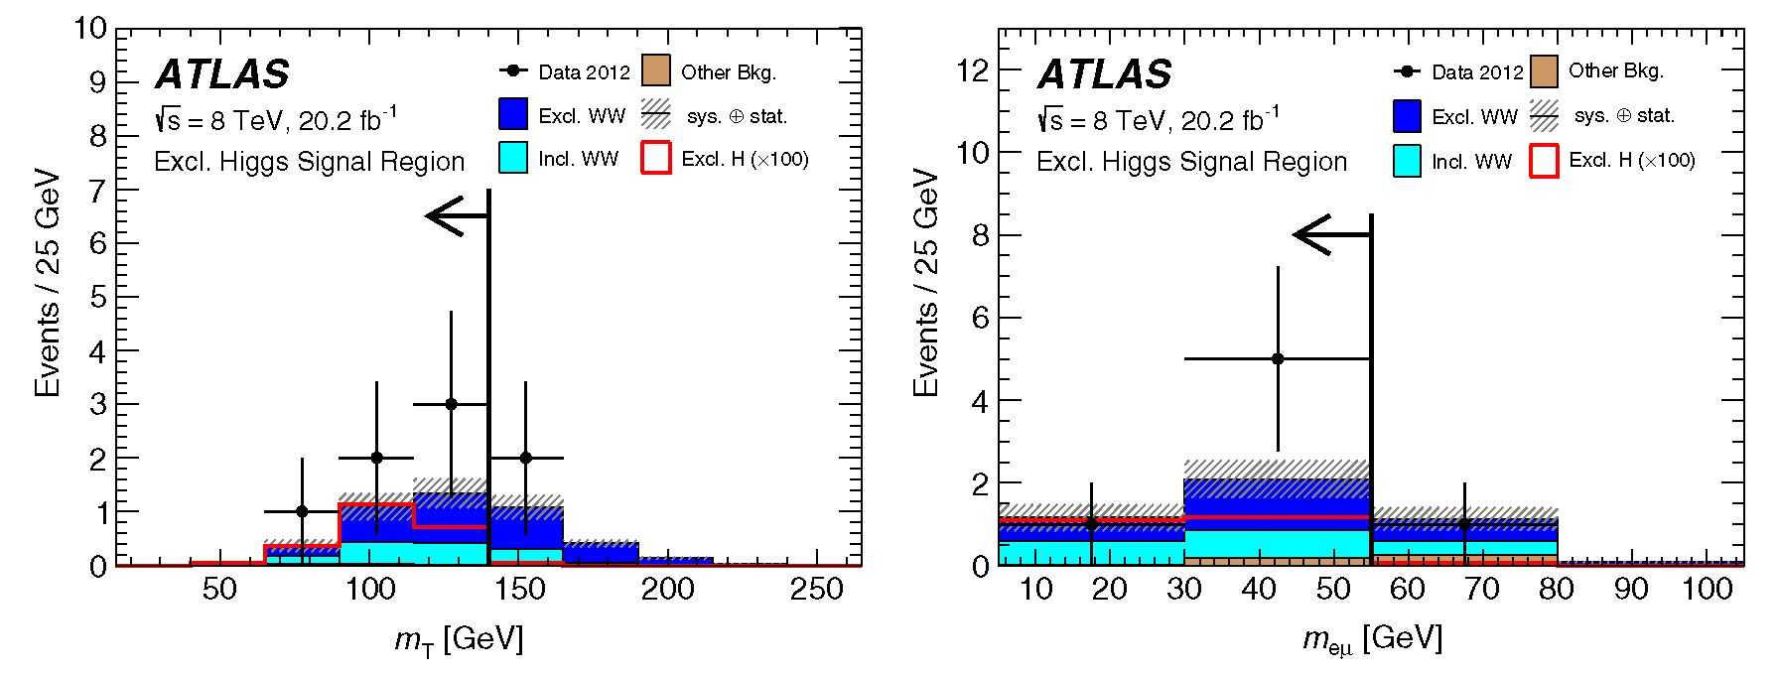
MEASUREMENT OF EXCLUSIVE
PHYSICAL REVIEW D 94, 032011 (2016)
TABLE XI. Summary of signal and background yields at different stages of the Higgs boson event selection. Only major background
sources are listed explicitly. All the other background sources are summed up in the “Other” category. For the background, the
uncertainties are only shown for the yields after exclusivity selection, where they are relevant for the measurement. They include the
systematic and statistical components, added in quadrature.
 | Excl. H signal | Data | Total bkg. | Incl. W+W- | Excl. W+ W- | Other bkg.
Preselection  pT" > 30 GeV, me" < 55 GeV, A^ < 1.8  Az0so requirement  mT < 140 GeV [signal region] | 0.065 ± 0.005  0.043 ± 0.004  0.023 ± 0.003  0.023 ± 0.003 | 129018  18568  8  6 | 120090  17060  4.7 ± 1.3  3.0 ± 0.8 | 12844  2026  1.4 ± 0.5  1.0 ± 0.4 | 43  5.7  3.1 ± 1.3  1.8 ± 0.8 | 107200  15030  0.2 ± 0.1  0.2 ± 0.1
= (NData — Aground)/(LA)
= 6.9 ± 2.2(stat) ± 1.4(sys) fb, (11)
where L = 20.2 ± 0.4 fb-:. The acceptance (A) is the ratio
of the number of simulated events passing the kinematic
requirements in Table III to the total number of events
generated. The efficiencies (e) account for the detector
efficiencies due to lepton identification and reconstruction,
triggering, and pileup. Both A and e are computed using
the herwig++ prediction for the elastic yy ^ W +W—
process. At the end of the event selection, the acceptance
is A = 0.280 ± 0.001 and the efficiency, which includes
the exclusivity selection efficiency, is e = 0.37 ± 0.04.
The efficiency of the exclusivity selection is 0.58 ± 0.06.
The elastic, SD, and DD predicted acceptances can be
compared using yy ^ "+"— events with m^ > 160 GeV,
and they are found to be the same within 3%. Therefore, the
measurement of the cross section can be performed with the
acceptances for elastic yy ^ W+W— events. The products
of acceptance and efficiencies (eA) at different stages of the
event selection are given in Table VIII.
The sources of uncertainty are given in Table VII. The
statistical uncertainty dominates. The contribution from
intermediate t leptons to the accepted signal MC is
determined using the herwig++ generator to be 9.1%.
The background-only hypothesis has a p-value of about
- 0012, corresponding to a significance of 3.0^.
- Limits on anomalous quartic gauge couplings
The aQGC limit setting was performed using the region
pT" > 120 GeV where the aQGC contributions are
expected to be important and Standard Model backgrounds
are suppressed. The pT" distribution is shown in Fig. 13
for data compared to the Standard Model prediction and
various aQGC scenarios. The aQGCs enhance the exclu-
sive signal at high pT", while the background is negligible
with pT" > 80 GeV. The 95% CL limits on the couplings
aW/A2 and aW/K2 are extracted with a likelihood test using
the one observed data event as a constraint.
To extract one-dimensional (1D) limits, one of the
aQGCs is set to zero. The 95% CL allowed ranges for
the cases with a dipole form factor defined in Eq. (2) with
Kcutoff = 500 GeV and without a form factor (Kcutoff ^ to)
are listed in Table IX. The uncertainties in the yields
are included in the likelihood test as nuisance parameters.
Also, limits on the two aQGC parameters are shown in
Fig. 14 for the case with a dipole form factor with
Kcutoff = 500 GeV. The region outside the contour is ruled
out at 95% confidence level. The limits are comparable to
the CMS combined 7 and 8 TeV results [14].
FIG. 15. Distributions in the exclusive Higgs boson signal region, without including the selection on the variable plotted. The
dominant processes are inclusive and exclusive W+W- production. The expected signal is scaled by a factor of 100 for visibility. The
arrows denote the selection.
032011-15
M. AABOUD et al.
The 95% CL limits on the dimension-8 /m,0,i,2,3/A4
couplings are given in Table X for the cases with and
without a form factor. They are derived from the aWc/^2
couplings using Eq. (3).

B. Limits on exclusive Higgs boson production
As described in Sec. III, exclusive production of Higgs
bosons is simulated using the FPMC generator. Exclusive
W+W— contamination in the exclusive Higgs boson signal
region is estimated by using herwig++ samples that are
scaled by /y = 3.30 to account for single-dissociative and
double-dissociative processes. The predicted background
from exclusive W+W— is derived from the observed cross
section in the exclusive W+W— signal region (Sec. XA).
As discussed in Secs. VIIIB-VIIID, the estimate for
inclusive W+W— and minor contributions of Z/y* ^
t+t— and W + jets is obtained from the inclusive W+W—
samples scaled by a factor of 0.79. The contribution from
inclusive Higgs production is expected to be negligible.
Exclusive dileptons are not scaled by /y because LPAIR
simulates SD and DD processes as discussed in Sec. VII,
except for yy ^ t+t— production of which only SD is
simulated. The rest of the background sources are scaled
by their respective correction factors to account for the
mismodeling of the underlying event. Six candidates are
observed in the data, while 3.0 ± 0.8 events are predicted
from background and 0.023 ± 0.003 from signal. The
quoted uncertainty is the sum in quadrature of systematic
uncertainties. Table XI summarizes expected and observed
yields in the signal region and at earlier selection points in
the selection criteria summarized in Table III. The exclusive
Higgs boson prediction quoted here is from elastic con-
tribution only. Observed data reasonably agree with pre-
dictions. Figure 15 shows kinematic distributions in the
signal region.
Yields summarized in the preceding paragraph are
converted to upper limits on the exclusive Higgs boson
total production cross section using the CLS technique [72].
The branching ratio BR(H ^ W+W—) used to compute
these limits is (21.5 ± 0.9)% [73]. Table XII shows a
summary of the 95% CL upper limits on the exclusive
Higgs boson total production cross section. The observed
upper limit is 1.2 pb, which is 1. 1 o higher than the expected
upper limit of 0.7 pb. The statistical uncertainty in the
predicted background dominates the uncertainty involved
in calculating this upper limit, while systematic uncertain-
ties worsen the upper limits by at most 10%. This upper
TABLE XII. Upper limits on oH [pb] at 95% CL. The ±1o and
±2o uncertainties quoted here are on the expected upper limit.
+2o | +1o | Expected | — 1o | —2o | Observed
[pb] | [pb] | [pb] | [pb] | [pb] | [pb]
1.6 | 1.0 | 0.7 | 0.5 | 0.4 | 1.2
PHYSICAL REVIEW D 94, 032011 (2016)
limit value is 400 times the cross section predicted [24].
However, the limit would not change if the model pre-
diction, which is for elastic production only, increased by
an order of magnitude. This limit calculation inherently
assumes that the acceptance and efficiency for dissociative
events is not significantly different than for elastic
events; hence, the associated systematic uncertainty is
insignificant.

XI. CONCLUSION
A measurement of the exclusive W+W— production cross
section and a search for exclusive Higgs boson production
via diffraction using e±pA final states are presented using a
data sample that corresponds to 20.2 fb—1 of LHC pp
collisions at p = 8 TeV collected with the ATLAS
detector. A track-based technique for selecting exclusive
candidates was developed and validated in the p+p— final
state, resulting in a ratio of data to the EPA prediction
for the exclusive yy ^ 1+1— process of /el =
- 76 ± 0.04(stat) ± 0.10(sys) in agreement with previous
ATLAS measurements at p = 7 TeV. For exclusive
W+W— production, the cross section is determined to be
o(yy ^ W+W— ^ e±pAX) = 6.9 ± 2.2(stat) ± 1.4(sys) fb
from 23 observed candidates with 8.3 ± 2.6 predicted
background events. While evidence of SM exclusive
W+W— production is at the 3.0o level, no evidence for
an excess was seen in the kinematic region that would be
enhanced by anomalous quartic gauge couplings. Rather,
independent limits are placed on anomalous quartic gauge
couplings that are more stringent than earlier published
results from the OPAL, D0, and CMS experiments. Six
candidates consistent with exclusive Higgs boson produc-
tion are observed in the data, with an expected SM
background of 3.0 ± 0.8 events. This result corresponds
to an upper limit at 95% CL on the total production cross
section of the exclusive Higgs boson of 1.2 pb, whereas the
expected limit is 0.7 pb.

ACKNOWLEDGMENTS
We thank CERN for the very successful operation of the
LHC, as well as the support staff from our institutions
without whom ATLAS could not be operated efficiently.
We acknowledge the support of ANPCyT, Argentina;
YerPhI, Armenia; ARC, Australia; BMWFW and FWF,
Austria; ANAS, Azerbaijan; SSTC, Belarus; CNPq and
FAPESP, Brazil; NSERC, NRC and CFI, Canada; CERN;
CONICYT, Chile; CAS, MOST and NSFC, China;
COLCIENCIAS, Colombia; MSMT CR, MPO CR and
VSC CR, Czech Republic; DNRF and DNSRC, Denmark;
IN2P3-CNRS, CEA-DSM/IRFU, France; GNSF, Georgia;
BMBF, HGF, and MPG, Germany; GSRT, Greece; RGC,
Hong Kong SAR, China; ISF, I-CORE and Benoziyo
Center, Israel; INFN, Italy; MEXT and JSPS, Japan;
CNRST, Morocco; FOM and NWO, Netherlands; RCN,
032011-16
measurement of exclusive ...
Norway; MNiSWand NCN, Poland; FCT, Portugal; MNE/
IFA, Romania; MES of Russia and NRC KI, Russian
Federation; JINR; MESTD, Serbia; MSSR, Slovakia;
ARRS and MIZS, Slovenia; DST/NRF, South Africa;
MINECO, Spain; SRC and Wallenberg Foundation,
Sweden; SERI, SNSF and Cantons of Bern and Geneva,
Switzerland; MOST, Taiwan; TAEK, Turkey; STFC,
United Kingdom; DOE and NSF, USA. In addition,
individual groups and members have received support
from BCKDF, the Canada Council, CANARIE, CRC,
Compute Canada, FQRNT, and the Ontario Innovation
Trust, Canada; EPLANET, ERC, FP7, Horizon 2020 and
Marie Sklodowska-Curie Actions, European Union;
Investissements d’Avenir Labex and Idex, ANR, Région
Auvergne and Fondation Partager le Savoir, France; DFG
PHYSICAL REVIEW D 94, 032011 (2016)
and AvH Foundation, Germany; Herakleitos, Thales and
Aristeia programmes co-financed by EU-ESF and the
Greek NSRF; BSF, GIF and Minerva, Israel; BRF,
Norway; Generalitat de Catalunya, Generalitat
Valenciana, Spain; the Royal Society and Leverhulme
Trust, United Kingdom. The crucial computing support
from all WLCG partners is acknowledged gratefully, in
particular, from CERN, the ATLAS Tier-1 facilities at
TRIUMF (Canada), NDGF (Denmark, Norway, Sweden),
CC-IN2P3 (France), KIT/GridKA (Germany), INFN-
CNAF (Italy), NL-T1 (Netherlands), PIC (Spain), ASGC
(Taiwan), RAL (UK), BNL (USA), the Tier-2 facilities
worldwide and large non-WLCG resource providers.
Major contributors of computing resources are listed
in Ref. [74].
- ATLAS Collaboration, Observation of a new particle in the
search for the Standard Model Higgs boson with the ATLAS
detector at the LHC, Phys. Lett. B 716, 1 (2012).
- CMS Collaboration, Observation of a new boson at a mass
of 125 GeV with the CMS experiment at the LHC, Phys.
Lett. B 716, 30 (2012).
- G. Belanger and F. Boudjema, yy ^ WW and yy ^ ZZ as
tests of novel quartic couplings, Phys. Lett. B 288, 210
(1992).
- E. Chapon, C. Royon, and O. Kepka, Anomalous Quartic
WWyy, ZZyy, and trilinear WWy couplings in two-photon
processes at High Luminosity at the LHC, Phys. Rev. D 81,
074003 (2010).
- M.-S. Chen, I. J. Muzinich, H. Terazawa, and T. P. Cheng,
Lepton pair production from two-photon processes, Phys.
Rev. D 7, 3485 (1973).
- V. M. Budnev, I. F. Ginzburg, G. V. Meledin, and V. G.
Serbo, The process pp ^ yy; pp ^ e+e~ and the possibil-
ity of its calculation by means of quantum electrodynamics
only, Nucl. Phys. B63, 519 (1973).
- A. Abulencia et al. (CDF Collaboration), Observation of
Exclusive Electron-Positron Production in Hadron-Hadron
Collisions, Phys. Rev. Lett. 98, 112001 (2007).
- J. Adams et al. (STAR Collaboration), Production of
e+e~ pairs accompanied by nuclear dissociation in ultra-
peripheral heavy ion collisions, Phys. Rev. C 70, 031902
(2004).
- CMS Collaboration, Exclusive yy ^ p+p~ production in
proton-proton collisions at p = 7 TeV, J. High Energy
Phys. 01 (2012) 052.
- CMS Collaboration, Search for exclusive or semi-exclusive
YY production and observation of exclusive and semi-
exclusive e+e~ production in pp collisions at
P = 7 TeV, J. High Energy Phys. 11 (2012) 080.
- O. Kepka and C. Royon, Anomalous WWy coupling in
photon-induced processes using forward detectors at the
LHC, Phys. Rev. D 78, 073005 (2008).
- D. H. Adams (OPAL Collaboration), Constraints on
anomalous quartic gauge boson couplings from vvyy and
qqyy events at CERNLEP2, Phys. Rev. D 70,032005 (2004).
- V. M. Abazov et al. (D0 Collaboration), Search for anoma-
lous quartic WWyy couplings in dielectron and missing
energy final states in pp collisions at p = 1.96 TeV, Phys.
Rev. D 88, 012005 (2013).
- CMS Collaboration, Evidence for exclusive gamma-gamma
to W+ W- production and constraints on anomalous quartic
gauge couplings at p = 7 and 8 TeV, arXiv:1604.04464.
- C. Degrande et al., Monte Carlo tools for studies of non-
standard electroweak gauge boson interactions in multi-boson
processes: A Snowmass White Paper, arXiv:1309.7890.
- ATLAS Collaboration, Study of (W/Z)H production and
Higgs boson couplings using H ^ WW* decays with the
ATLAS detector, J. High Energy Phys. 08 (2015) 137.
- S. Heinemeyer, V. A. Khoze, M. G. Ryskin, W. J. Stirling,
M. Tasevsky, and G. Weiglein, Studying the MSSM Higgs
sector by forward proton tagging at the LHC, Eur. Phys. J. C
53, 231 (2008).
- B. E. Cox, F. K. Loebinger, and A. D. Pilkington, Detecting
Higgs bosons in the bb decay channel using forward proton
tagging at the LHC, J. High Energy Phys. 10 (2007) 090.
- M. Tasevsky, Review of central exclusive production of the
Higgs boson beyond the standard model, Int. J. Mod. Phys.
A 29, 1446012 (2014).
- B. E. Cox, A. De Roeck, V. A. Khoze, T. Pierzchala, M. G.
Ryskin, I. Nasteva, W. J. Stirling, and M. Tasevsky,
Detecting the standard model Higgs boson in the WW
decay channel using forward proton tagging at the LHC,
Eur. Phys. J. C 45, 401 (2006).
- C. Royon and N. Cartiglia, The AFP and CT-PPS projects,
Int. J. Mod. Phys. A 29, 1446017 (2014).
- L. Adamczyk et al., Technical Report No. CERN-LHCC-
2015-009, 2015, http://cds.cern.ch/record/2017378.
- V. Berardi et al., Technical Report No. CERN-LHCC-2004-
002, 2002, http://cds.cern.ch/record/704349.
032011-17
M. AABOUD et al.
- V. Khoze, A. Martin, and M. Ryskin, Prospects for new
physics observations in diffractive processes at the LHC and
Tevatron, Eur. Phys. J. C 23, 311 (2002).
- A. D. Martin and M. Ryskin, Unintegrated generalized
parton distributions, Phys. Rev. D 64, 094017 (2001).
- J. R. Cudell, A. Dechambre, O. F. Hernández, and I. P.
Ivanov, Central exclusive production of dijets at hadronic
colliders, Eur. Phys. J. C 61, 369 (2009).
- ATLAS Collaboration, The ATLAS experiment at the CERN
Large Hadron Collider, J. Instrum. 3, S08003 (2008) .
- ATLAS Collaboration, Performance of the ATLAS Trigger
System in 2010, Eur. Phys. J. C 72, 1849 (2012).
- ATLAS Collaboration, Luminosity determination in pp
collisions at ps = 8 TeV using the ATLAS detector at the
LHC, arXiv:1608.03953 [Eur. Phys. J. C (to be published)].
- M. Bahr et al., Herwig++ physics and manual, Eur. Phys. J.
C 58, 639 (2008).
- M. Boonekamp et al., FPMC: A generator for forward
physics, arXiv:1102.2531.
- V. M. Budnev, I. F. Ginzburg, G. V. Meledin, and V. G.
Serbo, The two photon particle production mechanism.
Physical problems. Applications. Equivalent photon
approximation, Phys. Rep. 15, 181 (1975).
- J. Vermaseren, Two-photon processes at very high energies,
Nucl. Phys. B229, 347 (1983).
- T. SjÖstrand, S. Mrenna, and P. Z. Skands, A brief intro-
duction to PYTHIA 8.1, Comput. Phys. Commun. 178, 852
(2008).
- S. Alioli, P. Nason, C. Oleari, and E. Re, A general
framework for implementing NLO calculations in shower
Monte Carlo programs: The POWHEG BOX, J. High
Energy Phys. 06 (2010) 043.
- S. Alioli, P. Nason, C. Oleari, and E. Re, NLO Higgs boson
production via gluon fusion matched with shower in
POWHEG, J. High Energy Phys. 04 (2009) 002.
- P. Nason, A new method for combining NLO QCD with
shower Monte Carlo algorithms, J. High Energy Phys. 11
(2004) 040.
- S. Frixione, P. Nason, and C. Oleari, Matching NLO
QCD computations with parton shower simulations:
The POWHEG method, J. High Energy Phys. 11 (2007)
070.
- S. Alioli, P. Nason, C. Oleari, and E. Re, NLO vector-boson
production matched with shower in POWHEG, J. High
Energy Phys. 07 (2008) 060.
- ATLAS Collaboration, Report No. ATL-PHYS-PUB-2012-
003, 2012, http://cds.cern.ch/record/1474107.
- T. Binoth, M. Ciccolini, N. Kauer, and M. Krämer, Gluon-
induced W-boson pair production at the LHC, J. High
Energy Phys. 12 (2006) 046.
- G. Corcella, I. G. Knowles, G. Marchesini, S. Moretti, K.
Odagiri, P. Richardson, M. H. Seymour, and B. R. Webber,
HERWIG 6: An event generator for hadron emission
reactions with interfering gluons (including supersymmetric
processes), J. High Energy Phys. 01 (2001) 010.
- J. M. Butterworth, J. R. Forshaw, and M. H. Seymour,
Multiparton interactions in photoproduction at HERA, Z.
Phys. C 72, 637 (1996).
- ATLAS Collaboration, Report No. ATL-PHYS-PUB-2011 -
009, 2011, http://cds.cern.ch/record/1363300.
PHYSICAL REVIEW D 94, 032011 (2016)
- H.-L. Lai, M. Guzzi, J. Huston, Z. Li, P. M. Nadolsky, J.
Pumplin, and C.-P. Yuan, New parton distributions for
collider physics, Phys. Rev. D 82, 074024 (2010).
- T. Gleisberg, S. Hoche, F. Krauss, M. Schonherr, S.
Schumann, F. Siegert, and J. Winter, Event generation with
SHERPA 1.1, J. High Energy Phys. 02 (2009) 007.
- M. L. Mangano, F. Piccinini, A. D. Polosa, M. Moretti, and
R. Pittau, ALPGEN, a generator for hard multiparton
processes in hadronic collisions, J. High Energy Phys. 07
(2003) 001.
- T. Sjostrand, S. Mrenna, and P. Z. Skands, PYTHIA 6.4
physics and manual, J. High Energy Phys. 05 (2006) 026.
- J. Pumplin, D. R. Stump, J. Huston, H.-L. Lai, P. Nadolsky,
and W.-K. Tung, New generation of parton distributions
with uncertainties from global QCD analysis, J. High
Energy Phys. 07 (2002) 012.
- P. Z. Skands, Tuning Monte Carlo generators: The perugia
tunes, Phys. Rev. D 82, 074018 (2010).
- T. Melia, P. Nason, R. Rontsch, and G. Zanderighi, W+W-,
WZ and ZZ production in the POWHEG BOX, J. High
Energy Phys. 11 (2011) 078.
- B. P. Kersevan and E. Richter-Was, The Monte Carlo event
generator AcerMC versions 2.0 to 3.8 with interfaces to
PYTHIA 6.4, HERWIG 6.5 and ARIADNE 4.1, Comput.
Phys. Commun. 184, 919 (2013).
- S. Frixione, F. Stoeckli, P. Torrielli, and B. R. Webber, NLO
QCD corrections in Herwig++ with MC@NLO, J. High
Energy Phys. 01 (2011) 053.
- ATLAS Collaboration, The ATLAS simulation infrastruc-
ture, Eur. Phys. J. C 70, 823 (2010).
- S. Agostinelli et al., Geant4—A simulation toolkit, Nucl.
Instrum. Methods Phys. Res., Sect. A 506, 250 (2003).
- ATLAS Collaboration, Report No. ATL-PHYS-PUB-2010-
013, 2010, http://cds.cern.ch/record/1300517.
- ATLAS Collaboration, Report No. ATLAS-CONF-2014-
032, 2014, http://cdsweb.cern.ch/record/1706245.
- ATLAS Collaboration, Measurement of the muon
reconstruction performance of the ATLAS detector using
the 2011 and 2012 LHC proton-proton collision data, Eur.
Phys. J. C 74, 3130 (2014).
- ATLAS Collaboration, Observation and Measurement of
Higgs Boson Decays to WW* with the ATLAS Detector,
Phys. Rev. D 92, 012006 (2015).
- M. Cacciari and G. P. Salam, Dispelling the N3 myth for the
jet-finder, Phys. Lett. B 641, 57 (2006).
- ATLAS Collaboration, Performance of missing transverse
momentum reconstruction in proton-proton collisions at
7 TeV with ATLAS, Eur. Phys. J. C 72, 1844 (2012).
- ATLAS Collaboration, Dijet production in ps = 7 TeV pp
collisions with large rapidity gaps at the ATLAS experi-
ment, Phys. Lett. B 754, 214 (2016).
- ATLAS Collaboration, Rapidity gap cross sections mea-
sured with the ATLAS detector in pp collisions at
pS = 7 TeV, Eur. Phys. J. C 72, 1926 (2012).
- ATLAS Collaboration, Report No. ATLAS-CONF-2012-
042, 2012, http://cdsweb.cern.ch/record/1435196.
- ATLAS Collaboration, Measurement of exclusive
YY ^ 1+1- production in proton-proton collisions at
Ps = 7 TeV with the ATLAS detector, Phys. Lett. B
749, 242 (2015).
032011-18

MEASUREMENT OF EXCLUSIVE ...
- M. Dyndal and L. Schoeffel, The role of finite-size
effects on the spectrum of equivalent photons in proton-
proton collisions at the LHC, Phys. Lett. B 741, 66 (2015).
- L. A. Harland-Lang, V. A. Khoze, and M. G. Ryskin, Ex-
clusive physics at the LHC with SuperChic 2, Eur. Phys. J. C
76, 9 (2016).
- CMS Collaboration, Study of exclusive two-photon pro-
duction of W+W- in pp collisions at y/s = 7 TeV and
constraints on anomalous quartic gauge couplings, J. High
Energy Phys. 07 (2013) 116.
- L. A. Harland-Lang, V. A. Khoze, and M. G. Ryskin, The
photon PDF in events with rapidity gaps, Eur. Phys. J. C 76,
255 (2016).
PHYSICAL REVIEW D 94, 032011 (2016)
- ATLAS Collaboration, Measurement of total and differ-
ential W+W- production cross sections in proton-proton
collisions at y/s = 8 TeV with the ATLAS detector and
limits on anomalous triple gauge-boson couplings, ar-
Xiv:1603.01702.
- K. A. Olive, Review of particle physics, Chin. Phys. C 38,
090001 (2014).
- A. L. Read, Presentation of search results: The CL(s)
technique, J. Phys. G 28, 2693 (2002.
- S. Dittmaier et al., Handbook of LHC Higgs cross sections:
- Differential distributions, arXiv:1201.3084.
- ATLAS Collaboration, Report No. ATL-GEN-PUB-2016-
002, 2016, http://cds.cern.ch/record/2202407.
M. Aaboud,135d G. Aad,86 B. Abbott,113 J. Abdallah,64 O. Abdinov,12 B. Abeloos,117 R. Aben,107 O. S. AbouZeid,137
N. L. Abraham,149 H. Abramowicz,153 H. Abreu,152 R. Abreu,116 Y. Abulaiti,146a’146b B. S. Acharya,163a’163b’b
L. Adamczyk,40a D. L. Adams,27 J. Adelman,108 S. Adomeit,100 T. Adye,131 A. A. Affolder,75 T. Agatonovic-Jovin,14
J. Agricola,56 J. A. Aguilar-Saavedra,126a’126f S. P. Ahlen,24 F. Ahmadov,66’c G. Aielli,133a’133b H. Akerstedt,146a’146b
T. P. A. Äkesson,82 A. V. Akimov,96 G. L. Alberghi,22a22b J. Albert,168 S. Albrand,57 M. J. Alconada Verzini,72 M. Aleksa,32
- N. Aleksandrov,66 C. Alexa,28b G. Alexander,153 T. Alexopoulos,10 M. Alhroob,113 B. Ali,128 M. Aliev,74a’74b
- Alimonti,92a J. Alison,33 S. P. Alkire,37 B. M. M. Allbrooke,149 B. W. Allen,116 P. P. Allport,19 A. Aloisio,104a104b
A. Alonso,38 F. Alonso,72 C. Alpigiani,138 M. Alstaty,86 B. Alvarez Gonzalez,32 D. Alvarez Piqueras,166
M. G. Alviggi,104a104b B. T. Amadio,16 K. Amako,67 Y. Amaral Coutinho,26a C. Amelung,25 D. Amidei,90
S. P. Amor Dos Santos,126a126c A. Amorim,126a126b S. Amoroso,32 G. Amundsen,25 C. Anastopoulos,139 L. S. Ancu,51
N. Andari,19 T. Andeen,11 C. F. Anders,59b G. Anders,32 J. K. Anders,75 K. J. Anderson,33 A. Andreazza,92a 92b V. Andrei,59a
S. Angelidakis,9 I. Angelozzi,107 P. Anger,46 A. Angerami,37 F. Anghinolfi,32 A. V. Anisenkov,109’d N. Anjos,13
A. Annovi,124a’124b C. Antel,59a M. Antonelli,49 A. Antonov,98’a F. Anulli,132a M. Aoki,67 L. Aperio Bella,19 G. Arabidze,91
Y. Arai,67 J. P. Araque,126a A. T. H. Arce,47 F. A. Arduh,72 J-F. Arguin,95 S. Argyropoulos,64 M. Arik,20a A. J. Armbruster,143
L. J. Armitage,77 O. Arnaez,32 H. Arnold,50 M. Arratia,30 O. Arslan,23 A. Artamonov,97 G. Artoni,120 S. Artz,84 S. Asai,155
N. Asbah,44 A. Ashkenazi,153 B. Äsman,146a’146b L. Asquith,149 K. Assamagan,27 R. Astalos,144a M. Atkinson,165
N. B. Atlay,141 K. Augsten,128 G. Avolio,32 B. Axen,16 M. K. Ayoub,117 G. Azuelos,95’e M. A. Baak,32 A. E. Baas,59a
M. J. Baca,19 H. Bachacou,136 K. Bachas,74a’74b M. Backes,148 M. Backhaus,32 P. Bagiacchi,132a’132b P. Bagnaia,132a’132b
Y. Bai,35a J. T. Baines,131 O. K. Baker,175 E. M. Baldin,109 d P. Balek,171 T. Balestri,148 F. Balli,136 W. K. Balunas,122
- Banas,41 Sw. Banerjee,172 f A. A. E. Bannoura,174 L. Barak,32 E. L. Barberio,89 D. Barberis,52a 52b M. Barbero,86
T. Barillari,101 M-S Barisits,32 T. Barklow,143 N. Barlow,30 S. L. Barnes,85 B. M. Barnett,131 R. M. Barnett,16 Z. Barnovska,5
A. Baroncelli,134a G. Barone,25 A. J. Barr,120 L. Barranco Navarro,166 F. Barreiro,83 J. Barreiro Guimaraes da Costa,35a
R. Bartoldus,143 A. E. Barton,73 P. Bartos,144a A. Basalaev,123 A. Bassalat,117 R. L. Bates,55 S. J. Batista,158 J. R. Batley,30
M. Battaglia,137 M. Bauce,132a132b F. Bauer,136 H. S. Bawa,143 g J. B. Beacham,111 M. D. Beattie,73 T. Beau,81
P. H. Beauchemin,161 P. Bechtle,23 H. P. Beck,18h K. Becker,120 M. Becker,84 M. Beckingham,169 C. Becot,110
A. J. Beddall,20e A. Beddall,20b V. A. Bednyakov,66 M. Bedognetti,107 C. P. Bee,148 L. J. Beemster,107 T. A. Beermann,32
M. Begel,27 J. K. Behr,44 C. Belanger-Champagne,88 A. S. Bell,79 G. Bella,153 L. Bellagamba,22a A. Bellerive,31
M. Bellomo,87 K. Belotskiy,98 O. Beltramello,32 N. L. Belyaev,98 O. Benary,153 D. Benchekroun,135a M. Bender,100
K. Bendtz,146a146b N. Benekos,10 Y. Benhammou,153 E. Benhar Noccioli,175 J. Benitez,64 D. P. Benjamin,47 J. R. Bensinger,25
S. Bentvelsen,107 L. Beresford,120 M. Beretta,49 D. Berge,107 E. Bergeaas Kuutmann,164 N. Berger,5 J. Beringer,16
S. Berlendis,57 N. R. Bernard,87 C. Bernius,110 F. U. Bernlochner,23 T. Berry,78 P. Berta,129 C. Bertella,84 G. Bertoli,146a146b
- Bertolucci,124a124b I. A. Bertram,73 C. Bertsche,44 D. Bertsche,113 G. J. Besjes,38 O. Bessidskaia Bylund,146a146b
M. Bessner,44 N. Besson,136 C. Betancourt,50 A. Bethani,57 S. Bethke,101 A. J. Bevan,77 R. M. Bianchi,125 L. Bianchini,25
M. Bianco,32 O. Biebel,100 D. Biedermann,17 R. Bielski,85 N. V. Biesuz,124a124b M. Biglietti,134a J. Bilbao De Mendizabal,51
T.R. V. Billoud,95 H. Bilokon,49 M. Bindi,56 S. Binet,117 A. Bingul,20b C. Bini,132a132b S. Biondi,22a22b T. Bisanz,56
032011-19
M. AABOUD et al.
PHYSICAL REVIEW D 94, 032011 (2016)
D.M. Bjergaard,47 C. W. Black,150 J. E. Black,143 K.M. Black,24 D. Blackburn,138 R. E. Blair,6 J.-B. Blanchard,136
T. Blazek,144a I. Bloch,44 C. Blocker,25 W. Blum,84 a U. Blumenschein,56 S. Blunier,34a G. J. Bobbink,107
V. S. Bobrovnikov,109d S. S. Bocchetta,82 A. Bocci,47 C. Bock,100 M. Boehler,50 D. Boerner,174 J. A. Bogaerts,32
D. Bogavac,14 A. G. Bogdanchikov,109 C. Bohm,146a V. Boisvert,78 P. Bokan,14 T. Bold,40a A. S. Boldyrev,163a163c
M. Bomben,81 M. Bona,77 M. Boonekamp,136 A. Borisov,130 G. Borissov,73 J. Bortfeldt,32 D. Bortoletto,120
V. Bortolotto,61a’61b’61c K. Bos,107 D. Boscherini,22a M. Bosman,13 J. D. Bossio Sola,29 J. Boudreau,125 J. Bouffard,2
E. V. Bouhova-Thacker,73 D. Boumediene,36 C. Bourdarios,117 S. K. Boutle,55 A. Boveia,32 J. Boyd,32 I. R. Boyko,66
J. Bracinik,19 A. Brandt,8 G. Brandt,56 O. Brandt,59“ U. Bratzler,156 B. Brau,87 J. E. Brau,116 H. M. Braun,174'“
W. D. Breaden Madden,55 K. Brendlinger,122 A. J. Brennan,89 L. Brenner,107 R. Brenner,164 S. Bressler,171 T. M. Bristow,48
- Britton,55 D. Britzger,44 F. M. Brochu,30 I. Brock,23 R. Brock,91 G. Brooijmans,37 T. Brooks,78 W. K. Brooks,34b
J. Brosamer,16 E. Brost,108 J. H Broughton,19 P. A. Bruckman de Renstrom,41 D. Bruncko,144b R. Bruneliere,50 A. Bruni,22a
G. Bruni,22a L. S. Bruni,107 BH Brunt,30 M. Bruschi,22a N. Bruscino,23 P. Bryant,33 L. Bryngemark,82 T. Buanes,15
Q. Buat,142 P. Buchholz,141 A. G. Buckley,55 I. A. Budagov,66 F. Buehrer,50 M. K. Bugge,119 O. Bulekov,98 D. Bullock,8
- Burckhart,32 S. Burdin,75 C. D. Burgard,50 B. Burghgrave,108 K. Burka,41 S. Burke,131 I. Burmeister,45 J. T. P. Burr,120
- Busato,36 D. Büscher,50 V. Büscher,84 P. Bussey,55 J. M. Butler,24 C. M. Buttar,55 J. M. Butterworth,79 P. Butti,107
W. Buttinger,27 A. Buzatu,55 A. R. Buzykaev,109 d S. Cabrera Urban,166 D. Caforio,128 V. M. Cairo,39a39b O. Cakir,4a
N. Calace,51 P. Calafiura,16 A. Calandri,86 G. Calderini,81 P. Calfayan,100 G. Callea,39a39b L. P. Caloba,26a
S. Calvente Lopez,83 D. Calvet,36 S. Calvet,36 T. P. Calvet,86 R. Camacho Toro,33 S. Camarda,32 P. Camarri,133a133b
- Cameron,119 R. Caminal Armadans,165 C. Camincher,57 S. Campana,32 M. Campanelli,79 A. Camplani,92a92b
A. Campoverde,141 V. Canale,104a,104b A. Canepa,159a M. Cano Bret,35e J. Cantero,114 R. Cantrill,126a T. Cao,42
M. D. M. Capeans Garrido,32 I. Caprini,28b M. Caprini,28b M. Capua,39a,39b R. Caputo,84 R. M. Carbone,37 R. Cardarelli,133a
- Cardillo,501. Carli,129 T. Carli,32 G. Carlino,104a L. Carminati,92a 92b S. Caron,106 E. Carquin,34b G. D. Carrillo-Montoya,32
J. R. Carter,30 J. Carvalho,126a126c D. Casadei,19 M. P. Casado,13 i M. Casolino,13 D. W. Casper,162 E. Castaneda-Miranda,145a
R. Castelijn,107 A. Castelli,107 V. Castillo Gimenez,166 N. F. Castro,126aj A. Catinaccio,32 J. R. Catmore,119 A. Cattai,32
J. Caudron,23 V. Cavaliere,165 E. Cavallaro,13 D. Cavalli,92a M. Cavalli-Sforza,13 V. Cavasinni,124a,124b F. Ceradini,134a,134b
L. Cerda Alberich,166 B. C. Cerio,47 A. S. Cerqueira,26b A. Cerri,149 L. Cerrito,133a133b F. Cerutti,16 M. Cerv,32 A. Cervelli,18
S. A. Cetin,20d A. Chafaq,135a D. Chakraborty,108 S. K. Chan,58 Y. L. Chan,61a P. Chang,165 J. D. Chapman,30
- G. Charlton,19 A. Chatterjee,51 C. C. Chau,158 C. A. Chavez Barajas,149 S. Che,111 S. Cheatham,73 A. Chegwidden,91
S. Chekanov,6 S. V. Chekulaev,159a G. A. Chelkov,66k M. A. Chelstowska,90 C. Chen,65 H. Chen,27 K. Chen,148 S. Chen,35c
S. Chen,155 X. Chen,35f Y. Chen,68 H. C. Cheng,90 H. J Cheng,35a Y. Cheng,33 A. Cheplakov,66 E. Cheremushkina,130
R. Cherkaoui El Moursli,135e V. Chernyatin,27 a E. Cheu,7 L. Chevalier,136 V. Chiarella,49 G. Chiarelli,124a124b G. Chiodini,74a
- S. Chisholm,19 A. Chitan,28b M. V. Chizhov,66 K. Choi,62 A. R. Chomont,36 S. Chouridou,9 B. K. B. Chow,100
V. Christodoulou,79 D. Chromek-Burckhart,32 J. Chudoba,127 A. J. Chuinard,88 J. J. Chwastowski,41 L. Chytka,115
- Ciapetti,132a,132b A. K. Ciftci,4a D. Cinca,45 V. Cindro,76 I. A. Cioara,23 C. Ciocca,22a,22b A. Ciocio,16 F. Cirotto,104a,104b
Z.H. Citron,171 M. Citterio,92a M. Ciubancan,28b A. Clark,51 B. L. Clark,58 M.R. Clark,37 P.J. Clark,48 R. N. Clarke,16
- Clement,146a,146b Y. Coadou,86 M. Cobal,163a,163c A. Coccaro,51 J. Cochran,65 L. Colasurdo,106 B. Cole,37 A. P. Colijn,107
J. Collot,57 T. Colombo,32 G. Compostella,101 P. Conde Muino,126a126b E. Coniavitis,50 S. H. Connell,145b I. A. Connelly,78
V. Consorti,50 S. Constantinescu,28b G. Conti,32 F. Conventi,104a l M. Cooke,16 B. D. Cooper,79 A. M. Cooper-Sarkar,120
K. J. R. Cormier,158 T. Cornelissen,174 M. Corradi,132a132b F. Corriveau,88 m A. Corso-Radu,162 A. Cortes-Gonzalez,32
G. Cortiana,101 G. Costa,92a M.J. Costa,166 D. Costanzo,139 G. Cottin,30 G. Cowan,78 B.E. Cox,85 K. Cranmer,110
S.J. Crawley,55 G. Cree,31 S. Crepe-Renaudin,57 F. Crescioli,81 W. A. Cribbs,146a146b M. Crispin Ortuzar,120
M. Cristinziani,23 V. Croft,106 G. Crosetti,39a,39b A. Cueto,83 T. Cuhadar Donszelmann,139 J. Cummings,175 M. Curatolo,49
J. Cuth,84 H. Czirr,141 P. Czodrowski,3 G. D’amen,22a22b S. D’Auria,55 M. D’Onofrio,75
M. J. Da Cunha Sargedas De Sousa,126a126b C. Da Via,85 W. Dabrowski,40a T. Dado,144a T. Dai,90 O. Dale,15 F. Dallaire,95
- Dallapiccola,87 M. Dam,38 J. R. Dandoy,33 N. P. Dang,50 A. C. Daniells,19 N. S. Dann,85 M. Danninger,167
M. Dano Hoffmann,136 V. Dao,50 G. Darbo,52a S. Darmora,8 J. Dassoulas,3 A. Dattagupta,62 W. Davey,23 C. David,168
T. Davidek,129 M. Davies,153 P. Davison,79 E. Dawe,89 I. Dawson,139 R. K. Daya-Ishmukhametova,87 K. De,8
R. de Asmundis,104a A. De Benedetti,113 S. De Castro,22a 22b S. De Cecco,81 N. De Groot,106 P. de Jong,107 H. De la Torre,83
- De Lorenzi,65 A. De Maria,56 D. De Pedis,132a A. De Salvo,132a U. De Sanctis,149 A. De Santo,149
032011-20
MEASUREMENT OF EXCLUSIVE
PHYSICAL REVIEW D 94, 032011 (2016)
J. B. De Vivie De Regie,117 W. J. Dearnaley,73 R. Debbe,27 C. Debenedetti,137 D. V. Dedovich,66 N. Dehghanian,3
- Deigaard,107 M. Del Gaudio,39a,39b J. Del Peso,83 T. Del Prete,124a124b D. Delgove,117 F. Deliot,136 C. M. Delitzsch,51
- Dell’Acqua,32 L. Dell’Asta,24 M. Dell’Orso,124a124b M. Della Pietra,104al D. della Volpe,51 M. Delmastro,5 P. A. Delsart,57
D. A. DeMarco,158 S. Demers,175 M. Demichev,66 A. Demilly,81 S. P. Denisov,130 D. Denysiuk,136 D. Derendarz,41
J. E. Derkaoui,135d F. Derue,81 P. Dervan,75 K. Desch,23 C. Deterre,44 K. Dette,45 P. O. Deviveiros,32 A. Dewhurst,131
S. Dhaliwal,25 A. Di Ciaccio,133a133b L. Di Ciaccio,5 W. K. Di Clemente,122 C. Di Donato,132a132b A. Di Girolamo,32
- Di Girolamo,32 B. Di Micco,134a134b R. Di Nardo,32 A. Di Simone,50 R. Di Sipio,158 D. Di Valentino,31 C. Diaconu,86
M. Diamond,158 F. A. Dias,48 M. A. Diaz,34a E. B. Diehl,90 J. Dietrich,17 S. Diglio,86 A. Dimitrievska,14 J. Dingfelder,23
P. Dita,28b S. Dita,28b F. Dittus,32 F. Djama,86 T. Djobava,53b J. I. Djuvsland,59a M. A. B. do Vale,26c D. Dobos,32 M. Dobre,28b
- Doglioni,82 J. Dolejsi,129 Z. Dolezal,129 M. Donadelli,26d S. Donati,124a124b P. Dondero,121a121b J. Donini,36 J. Dopke,131
- Doria,104a M. T. Dova,72 A. T. Doyle,55 E. Drechsler,56 M. Dris,10 Y. Du,35d J. Duarte-Campderros,153 E. Duchovni,171
G. Duckeck,100 O. A. Ducu,95 n D. Duda,107 A. Dudarev,32 A. Chr. Dudder,84 E. M. Duffield,16 L. Duflot,117 M. Dührssen,32
M. Dumancic,171 M. Dunford,59a H. Duran Yildiz,4a M. Düren,54 A. Durglishvili,53b D. Duschinger,46 B. Dutta,44
M. Dyndal,44 C. Eckardt,44 K. M. Ecker,101 R. C. Edgar,90 N. C. Edwards,48 T. Eifert,32 G. Eigen,15 K. Einsweiler,16
T. Ekelof,164 M. El Kacimi,135c V. Ellajosyula,86 M. Ellert,164 S. Elles,5 F. Ellinghaus,174 A. A. Elliot,168 N. Ellis,32
J. Elmsheuser,27 M. Elsing,32 D. Emeliyanov,131 Y. Enari,155 O. C. Endner,84 J. S. Ennis,169 J. Erdmann,45 A. Ereditato,18
- Ernis,174 J. Ernst,2 M. Ernst,27 S. Errede,165 E. Ertel,84 M. Escalier,117 H. Esch,45 C. Escobar,125 B. Esposito,49
- I. Etienvre,136 E. Etzion,153 H. Evans,62 A. Ezhilov,123 F. Fabbri,22a 22b L. Fabbri,22a 22b G. Facini,33 R. M. Fakhrutdinov,130
S. Falciano,132a R. J. Falla,79 J. Faltova,32 Y. Fang,35a M. Fanti,92a,92b A. Farbin,8 A. Farilla,134a C. Farina,125
- M. Farina,121a121b T. Farooque,13 S. Farrell,16 S. M. Farrington,169 P. Farthouat,32 F. Fassi,135e P. Fassnacht,32
- Fassouliotis,9 M. Faucci Giannelli,78 A. Favareto,52a52b W. J. Fawcett,120 L. Fayard,117 O. L. Fedin,123’“ W. Fedorko,167
S. Feigl,119 L. Feligioni,86 C. Feng,35d E. J. Feng,32 H. Feng,90 A. B. Fenyuk,130 L. Feremenga,8 P. Fernandez Martinez,166
S. Fernandez Perez,13 J. Ferrando,55 A. Ferrari,164 P. Ferrari,107 R. Ferrari,121“ D. E. Ferreira de Lima,59b A. Ferrer,166
- Ferrere,51 C. Ferretti,90 A. Ferretto Parodi,52a52b F. Fiedler,84 A. Filipcic,76 M. Filipuzzi,44 F. Filthaut,106
M. Fincke-Keeler,168 K. D. Finelli,150 M. C. N. Fiolhais,126a126c L. Fiorini,166 A. Firan,42 A. Fischer,2 C. Fischer,13
J. Fischer,174 W. C. Fisher,91 N. Flaschel,44 I. Fleck,141 P. Fleischmann,90 G. T. Fletcher,139 R. R. M. Fletcher,122 T. Flick,174
- Floderus,82 L. R. Flores Castillo,61a M. J. Flowerdew,101 G. T. Forcolin,85 A. Formica,136 A. Forti,85 A. G. Foster,19
- Fournier,117 H. Fox,73 S. Fracchia,13 P. Francavilla,81 M. Franchini,22a22b D. Francis,32 L. Franconi,119 M. Franklin,58
M. Frate,162 M. Fraternali,121a121b D. Freeborn,79 S. M. Fressard-Batraneanu,32 F. Friedrich,46 D. Froidevaux,32
J. A. Frost,120 C. Fukunaga,156 E. Fullana Torregrosa,84 T. Fusayasu,102 J. Fuster,166 C. Gabaldon,57 O. Gabizon,174
- Gabrielli,22a22b A. Gabrielli,16 G. P. Gach,40a S. Gadatsch,32 S. Gadomski,51 G. Gagliardi,52a52b L. G. Gagnon,95
P. Gagnon,62 C. Galea,106 B. Galhardo,126a126c E. J. Gallas,120 B.J. Gallop,131 P. Gallus,128 G. Galster,38 K.K. Gan,111
J. Gao,35b’86 Y. Gao,48 Y. S. Gao,143,g F. M. Garay Walls,48 C. García,166 J. E. García Navarro,166 M. Garcia-Sciveres,16
R. W. Gardner,33 N. Garelli,143 V. Garonne,119 A. Gascon Bravo,44 K. Gasnikova,44 C. Gatti,49 A. Gaudiello,52a52b
- Gaudio,121a L. Gauthier,95 I. L. Gavrilenko,96 C. Gay,167 G. Gaycken,23 E. N. Gazis,10 Z. Gecse,167 C. N. P. Gee,131
Ch. Geich-Gimbel,23 M. Geisen,84 M. P. Geisler,59a C. Gemme,52a M. H. Genest,57 C. Geng,35b,p S. Gentile,132a,132b
- Gentsos,154 S. George,78 D. Gerbaudo,13 A. Gershon,153 S. Ghasemi,141 H. Ghazlane,135b M. Ghneimat,23 B. Giacobbe,22a
S. Giagu,132a132b P. Giannetti,124a124b B. Gibbard,27 S. M. Gibson,78 M. Gignac,167 M. Gilchriese,16 T. P. S. Gillam,30
- Gillberg,31 G. Gilles,174 D. M. Gingrich,3 e N. Giokaris,9 M. P. Giordani,163a163c F. M. Giorgi,22a F. M. Giorgi,17
P. F. Giraud,136 P. Giromini,58 D. Giugni,92a F. Giuli,120 C. Giuliani,101 M. Giulini,59b B. K. Gjelsten,119 S. Gkaitatzis,154
- Gkialas,154 E. L. Gkougkousis,117 L. K. Gladilin,99 C. Glasman,83 J. Glatzer,50 P. C. F. Glaysher,48 A. Glazov,44
M. Goblirsch-Kolb,25 J. Godlewski,41 S. Goldfarb,89 T. Golling,51 D. Golubkov,130 A. Gomes,126a126b126d R. Gongalo,126a
J. Goncalves Pinto Firmino Da Costa,136 G. Gonella,50 L. Gonella,19 A. Gongadze,66 S. González de la Hoz,166
- Gonzalez Parra,13 S. Gonzalez-Sevilla,51 L. Goossens,32 P. A. Gorbounov,97 H. A. Gordon,27 I. Gorelov,105 B. Gorini,32
- Gorini,74a 74b A. Gorisek,76 E. Gornicki,41 A. T. Goshaw,47 C. Gössling,45 M. I. Gostkin,66 C. R. Goudet,117
- Goujdami,135c A. G. Goussiou,138 N. Govender,145b q E. Gozani,152 L. Graber,56 I. Grabowska-Bold,40a P. O. J. Gradin,57
P. Grafström,22a,22b J. Gramling,51 E. Gramstad,119 S. Grancagnolo,17 V. Gratchev,123 P. M. Gravila,28e H. M. Gray,32
- Graziani,134a Z. D. Greenwood,80r C. Grefe,23 K. Gregersen,79 I. M. Gregor,44 P. Grenier,143 K. Grevtsov,5 J. Griffiths,8
- A. Grillo,137 K. Grimm,73 S. Grinstein,13s Ph. Gris,36 J.-F. Grivaz,117 S. Groh,84 J. P. Grohs,46 E. Gross,171
032011-21
M. AABOUD et al.
PHYSICAL REVIEW D 94, 032011 (2016)
J. Grosse-Knetter,56 G. C. Grossi,80 Z. J. Grout,79 L. Guan,90 W. Guan,172 J. Guenther,63 F. Guescini,51 D. Guest,162
O. Gueta,153 E. Guido,52a52b T. Guillemin,5 S. Guindon,2 U. Gul,55 C. Gumpert,32 J. Guo,35e Y. Guo,35bp R. Gupta,42
S. Gupta,120 G. Gustavino,132a132b P. Gutierrez,113 N. G. Gutierrez Ortiz,79 C. Gutschow,46 C. Guyot,136 C. Gwenlan,120
- B. Gwilliam,75 A. Haas,110 C. Haber,16 H. K. Hadavand,8 N. Haddad,135e A. Hadef,86 S. Hageböck,23 Z. Hajduk,41
- Hakobyan,176 a M. Haleem,44 J. Haley,114 G. Halladjian,91 G. D. Hallewell,86 K. Hamacher,174 P. Hamal,115
K. Hamano,168 A. Hamilton,145“ G. N. Hamity,139 P. G. Hamnett,44 L. Han,35b K. Hanagaki,67 t K. Hanawa,155 M. Hance,137
- Haney,122 S. Hanisch,32 P. Hanke,59a R. Hanna,136 J. B. Hansen,38 J. D. Hansen,38 M. C. Hansen,23 P. H. Hansen,38
K. Hara,160 A. S. Hard,172 T. Harenberg,174 F. Hariri,117 S. Harkusha,93 R. D. Harrington,48 P. F. Harrison,169 F. Hartjes,107
N. M. Hartmann,100 M. Hasegawa,68 Y. Hasegawa,140 A. Hasib,113 S. Hassani,136 S. Haug,18 R. Hauser,91 L. Hauswald,46
M. Havranek,127 C. M. Hawkes,19 R. J. Hawkings,32 D. Hayakawa,157 D. Hayden,91 C. P. Hays,120 J. M. Hays,77
- S. Hayward,75 S.J. Haywood,131 S.J. Head,19 T. Heck,84 V. Hedberg,82 L. Heelan,8 S. Heim,122 T. Heim,16
- Heinemann,16 J. J. Heinrich,100 L. Heinrich,110 C. Heinz,54 J. Hejbal,127 L. Helary,32 S. Hellman,146a146b C. Helsens,32
J. Henderson,120 R. C. W. Henderson,73 Y. Heng,172 S. Henkelmann,167 A. M. Henriques Correia,32 S. Henrot-Versille,117
- H. Herbert,17 V. Herget,173 Y. Hernández Jiménez,166 G. Herten,50 R. Hertenberger,100 L. Hervas,32 G. G. Hesketh,79
N. P. Hessey,107 J. W. Hetherly,42 R. Hickling,77 E. Higón-Rodriguez,166 E. Hill,168 J. C. Hill,30 K. H. Hiller,44 S. J. Hillier,19
- Hinchliffe,16 E. Hines,122 R. R. Hinman,16 M. Hirose,50 D. Hirschbuehl,174 J. Hobbs,148 N. Hod,159a M. C. Hodgkinson,139
P. Hodgson,139 A. Hoecker,32 M. R. Hoeferkamp,105 F. Hoenig,100 D. Hohn,23 T. R. Holmes,16 M. Homann,45 T. M. Hong,125
- H. Hooberman,165 W. H. Hopkins,116 Y. Horii,103 A. J. Horton,142 J-Y. Hostachy,57 S. Hou,151 A. Hoummada,135a
J. Howarth,44 M. Hrabovsky,115 I. Hristova,17 J. Hrivnac,117 T. Hryn’ova,5 A. Hrynevich,94 C. Hsu,145c P. J. Hsu,151u
S.-C. Hsu,138 D. Hu,37 Q. Hu,35b S. Hu,35e Y. Huang,44 Z. Hubacek,128 F. Hubaut,86 F. Huegging,23 T.B. Huffman,120
- W. Hughes,37 G. Hughes,73 M. Huhtinen,32 P. Huo,148 N. Huseynov,66 c J. Huston,91 J. Huth,58 G. Iacobucci,51
- Iakovidis,271. Ibragimov,141 L. Iconomidou-Fayard,117 E. Ideal,175 Z. Idrissi,135e P. Iengo,32 O. Igonkina,107 v T. Iizawa,170
Y. Ikegami,67 M. Ikeno,67 Y. Ilchenko,11’* D. Iliadis,154 N. Ilic,143 T. Ince,101 G. Introzzi,121a’121b P. Ioannou,9’a M. Iodice,134a
K. Iordanidou,37 V. Ippolito,58 N. Ishijima,118 M. Ishino,155 M. Ishitsuka,157 R. Ishmukhametov,111 C. Issever,120 S. Istin,20a
- Ito,160 J. M. Iturbe Ponce,85 R. Iuppa,133a,133b W. Iwanski,41 H. Iwasaki,67 J. M. Izen,43 V. Izzo,104a S. Jabbar,3
- Jackson,122 P. Jackson,1 V. Jain,2 K. B. Jakobi,84 K. Jakobs,50 S. Jakobsen,32 T. Jakoubek,127 D. O. Jamin,114 D. K. Jana,80
- Jansen,79 R. Jansky,63 J. Janssen,23 M. Janus,56 G. Jarlskog,82 N. Javadov,66,c T. Javurek,50 F. Jeanneau,136 L. Jeanty,16
J. Jejelava,53a,x G.-Y. Jeng,150 D. Jennens,89 P. Jenni,50,y C. Jeske,169 S. Jézéquel,5 H. Ji,172 J. Jia,148 H. Jiang,65 Y. Jiang,35b
S. Jiggins,79 J. Jimenez Pena,166 S. Jin,35a A. Jinaru,28b O. Jinnouchi,157 P. Johansson,139 K. A. Johns,7 W. J. Johnson,138
K. Jon-And,146a,146b G. Jones,169 R. W. L. Jones,73 S. Jones,7 T. J. Jones,75 J. Jongmanns,59a P.M. Jorge,126a,126b
J. Jovicevic,159a X. Ju,172 A. Juste Rozas,13,s M. K. Köhler,171 A. Kaczmarska,41 M. Kado,117 H. Kagan,111 M. Kagan,143
S. J. Kahn,86 T. Kaji,170 E. Kajomovitz,47 C. W. Kalderon,120 A. Kaluza,84 S. Kama,42 A. Kamenshchikov,130 N. Kanaya,155
S. Kaneti,30 L. Kanjir,76 V. A. Kantserov,98 J. Kanzaki,67 B. Kaplan,110 L. S. Kaplan,172 A. Kapliy,33 D. Kar,145c
K. Karakostas,10 A. Karamaoun,3 N. Karastathis,10 M. J. Kareem,56 E. Karentzos,10 M. Karnevskiy,84 S. N. Karpov,66
Z. M. Karpova,66 K. Karthik,110 V. Kartvelishvili,73 A. N. Karyukhin,130 K. Kasahara,160 L. Kashif,172 R. D. Kass,111
- Kastanas,15 Y. Kataoka,155 C. Kato,155 A. Katre,51 J. Katzy,44 K. Kawagoe,71 T. Kawamoto,155 G. Kawamura,56
V. F. Kazanin,109d R. Keeler,168 R. Kehoe,42 J. S. Keller,44 J. J. Kempster,78 K Kentaro,103 H. Keoshkerian,158 O. Kepka,127
- P. Kersevan,76 S. Kersten,174 R. A. Keyes,88 M. Khader,165 F. Khalil-zada,12 A. Khanov,114 A. G. Kharlamov,109,0
T. J. Khoo,51 V. Khovanskiy,97 E. Khramov,66 J. Khubua,53b,z S. Kido,68 C. R. Kilby,78 H. Y. Kim,8 S. H. Kim,160
Y. K. Kim,33 N. Kimura,154 O. M. Kind,17 B. T. King,75 M. King,166 S. B. King,167 J. Kirk,131 A. E. Kiryunin,101
T. Kishimoto,155 D. Kisielewska,40a F. Kiss,50 K. Kiuchi,160 O. Kivernyk,136 E. Kladiva,144b M. H. Klein,37 M. Klein,75
U. Klein,75 K. Kleinknecht,84 P. Klimek,108 A. Klimentov,27 R. Klingenberg,45 J. A. Klinger,139 T. Klioutchnikova,32
- -E. Kluge,59a P. Kluit,107 S. Kluth,101 J. Knapik,41 E. Kneringer,63 E. B. F. G. Knoops,86 A. Knue,55 A. Kobayashi,155
- Kobayashi,157 T. Kobayashi,155 M. Kobel,46 M. Kocian,143 P. Kodys,129 N. M. Koehler,101 T. Koffas,31 E. Koffeman,107
T. Koi,143 H. Kolanoski,17 M. Kolb,59b I. Koletsou,5 A. A. Komar,96 a Y. Komori,155 T. Kondo,67 N. Kondrashova,44
K. Köneke,50 A. C. König,106 T. Kono,67 aa R. Konoplich,110bb N. Konstantinidis,79 R. Kopeliansky,62 S. Koperny,40a
L. Köpke,84 A. K. Kopp,50 K. Korcyl,41 K. Kordas,154 A. Korn,79 A. A. Korol,109,d I. Korolkov,13 E. V. Korolkova,139
O. Kortner,101 S. Kortner,101 T. Kosek,129 V. V. Kostyukhin,23 A. Kotwal,47 A. Kourkoumeli-Charalampidi,121a121b
- Kourkoumelis,9 V. Kouskoura,27 A.B. Kowalewska,41 R. Kowalewski,168 T.Z. Kowalski,40a C. Kozakai,155
032011-22
MEASUREMENT OF EXCLUSIVE ... PHYSICAL REVIEW D 94, 032011 (2016)
W. Kozanecki,136 A. S. Kozhin,130 V. A. Kramarenko,99 G. Kramberger,76 D. Krasnopevtsev,98 M. W. Krasny,81
A. Krasznahorkay,32 A. Kravchenko,27 M. Kretz,59c J. Kretzschmar,75 K. Kreutzfeldt,54 P. Krieger,158 K. Krizka,33
K. Kroeninger,45 H. Kroha,101 J. Kroll,122 J. Kroseberg,23 J. Krstic,14 U. Kruchonak,66 H. Krüger,23 N. Krumnack,65
A. Kruse,172 M. C. Kruse,47 M. Kruskal,24 T. Kubota,89 H. Kucuk,79 S. Kuday,4b J. T. Kuechler,174 S. Kuehn,50 A. Kugel,59c
- Kuger,173 A. Kuhl,137 T. Kuhl,44 V. Kukhtin,66 R. Kukla,136 Y. Kulchitsky,93 S. Kuleshov,34b M. Kuna,132a132b T. Kunigo,69
A. Kupco,127 H. Kurashige,68 Y. A. Kurochkin,93 V. Kus,127 E. S. Kuwertz,168 M. Kuze,157 J. Kvita,115 T. Kwan,168
- Kyriazopoulos,139 A. La Rosa,101 J. L. La Rosa Navarro,26d L. La Rotonda,39a’39b C. Lacasta,166 F. Lacava,132a’132b
J. Lacey,31 H. Lacker,17 D. Lacour,81 V.R. Lacuesta,166 E. Ladygin,66 R. Lafaye,5 B. Laforge,81 T. Lagouri,175 S. Lai,56
S. Lammers,62 W. Lampl,7 E. Lançon,136 U. Landgraf,50 M. P. J. Landon,77 M. C. Lanfermann,51 V. S. Lang,59a J. C. Lange,13
A. J. Lankford,162 F. Lanni,27 K. Lantzsch,23 A. Lanza,121a S. Laplace,81 C. Lapoire,32 J. F. Laporte,136 T. Lari,92a
- Lasagni Manghi,22a 22b M. Lassnig,32 P. Laurelli,49 W. Lavrijsen,16 A. T. Law,137 P. Laycock,75 T. Lazovich,58
M. Lazzaroni,92a92b B. Le,89 O. Le Dortz,81 E. Le Guirriec,86 E. P. Le Quilleuc,136 M. LeBlanc,168 T. LeCompte,6
- Ledroit-Guillon,57 C. A. Lee,27 S. C. Lee,151 L. Lee,1 B. Lefebvre,88 G. Lefebvre,81 M. Lefebvre,168 F. Legger,100
- Leggett,16 A. Lehan,75 G. Lehmann Miotto,32 X. Lei,7 W. A. Leight,31 A. Leisos,154 cc A. G. Leister,175 M. A. L. Leite,26d
R. Leitner,129 D. Lellouch,171 B. Lemmer,56 K. J. C. Leney,79 T. Lenz,23 B. Lenzi,32 R. Leone,7 S. Leone,124a124b
- Leonidopoulos,48 S. Leontsinis,10 G. Lerner,149 C. Leroy,95 A. A. J. Lesage,136 C. G. Lester,30 M. Levchenko,123
J. Levêque,5 D. Levin,90 L. J. Levinson,171 M. Levy,19 D. Lewis,77 A. M. Leyko,23 M. Leyton,43 B. Li,35bp C. Li,35b H. Li,148
- L. Li,33 L. Li,47 L. Li,35e Q. Li,35a S. Li,47 X. Li,85 Y. Li,141 Z. Liang,35a B. Liberti,133a A. Liblong,158 P. Lichard,32
K. Lie,165 J. Liebal,23 W. Liebig,15 A. Limosani,150 S. C. Lin,151dd T. H. Lin,84 B. E. Lindquist,148 A. E. Lionti,51
- Lipeles,122 A. Lipniacka,15 M. Lisovyi,59b T. M. Liss,165 A. Lister,167 A. M. Litke,137 B. Liu,151ee D. Liu,151 H. Liu,90
- Liu,27 J. Liu,86 J. B. Liu,35b K. Liu,86 L. Liu,165 M. Liu,47 M. Liu,35b Y. L. Liu,35b Y. Liu,35b M. Livan,121a121b A. Lleres,57
J. Llorente Merino,35a S. L. Lloyd,77 F. Lo Sterzo,151 E. Lobodzinska,44 P. Loch,7 W. S. Lockman,137 F. K. Loebinger,85
- E. Loevschall-Jensen,38 K. M. Loew,25 A. Loginov,175’“ T. Lohse,17 K. Lohwasser,44 M. Lokajicek,127 B. A. Long,24
J. D. Long,165 R. E. Long,73 L. Longo,74a74b K. A. Looper,111 L. Lopes,126a D. Lopez Mateos,58 B. Lopez Paredes,139
- Lopez Paz,13 A. Lopez Solis,81 J. Lorenz,100 N. Lorenzo Martinez,62 M. Losada,21 P. J. Lösel,100 X. Lou,35a A. Lounis,117
J. Love,6 P. A. Love,73 H. Lu,61a N. Lu,90 H. J. Lubatti,138 C. Luci,132a132b A. Lucotte,57 C. Luedtke,50 F. Luehring,62
W. Lukas,63 L. Luminari,132a O. Lundberg,146a146b B. Lund-Jensen,147 P. M. Luzi,81 D. Lynn,27 R. Lysak,127 E. Lytken,82
V. Lyubushkin,66 H. Ma,27 L. L. Ma,35d Y. Ma,35d G. Maccarrone,49 A. Macchiolo,101 C. M. Macdonald,139 B. Macek,76
J. Machado Miguens,122,126b D. Madaffari,86 R. Madar,36 H. J. Maddocks,164 W. F. Mader,46 A. Madsen,44 J. Maeda,68
S. Maeland,15 T. Maeno,27 A. Maevskiy,99 E. Magradze,56 J. Mahlstedt,107 C. Maiani,117 C. Maidantchik,26a A. A. Maier,101
T. Maier,100 A. Maio,126a’126b’126d S. Majewski,116 Y. Makida,67 N. Makovec,117 B. Malaescu,81 Pa. Malecki,41
V. P. Maleev,123 F. Malek,57 U. Mallik,64 D. Malon,6 C. Malone,143 S. Maltezos,10 S. Malyukov,32 J. Mamuzic,166
- Mancini,49 B. Mandelli,32 L. Mandelli,92a I. Mandic,76 J. Maneira,126a126b L. Manhaes de Andrade Filho,26b
J. Manjarres Ramos,159b A. Mann,100 A. Manousos,32 B. Mansoulie,136 J. D. Mansour,35a R. Mantifel,88 M. Mantoani,56
S. Manzoni,92a,92b L. Mapelli,32 G. Marceca,29 L. March,51 G. Marchiori,81 M. Marcisovsky,127 M. Marjanovic,14
- E. Marley,90 F. Marroquim,26a S. P. Marsden,85 Z. Marshall,16 S. Marti-Garcia,166 B. Martin,91 T. A. Martin,169
V. J. Martin,48 B. Martin dit Latour,15 M. Martinez,13 s V. I. Martinez Outschoorn,165 S. Martin-Haugh,131 V. S. Martoiu,28b
A. C. Martyniuk,79 M. Marx,138 A. Marzin,32 L. Masetti,84 T. Mashimo,155 R. Mashinistov,96 J. Masik,85
- L. Maslennikov,109,4 I. Massa,22a,22b L. Massa,22a,22b P. Mastrandrea,5 A. Mastroberardino,39a,39b T. Masubuchi,155
P. Mättig,174 J. Mattmann,84 J. Maurer,28b S.J. Maxfield,75 D. A. Maximov,109,d R. Mazini,151 S. M. Mazza,92a,92b
N.C. Mc Fadden,105 G. Mc Goldrick,158 S. P. Mc Kee,90 A. McCarn,90 R.L. McCarthy,148 T.G. McCarthy,101
L. I. McClymont,79 E. F. McDonald,89 J. A. Mcfayden,79 G. Mchedlidze,56 S. J. McMahon,131 R. A. McPherson,168,m
M. Medinnis,44 S. Meehan,138 S. Mehlhase,100 A. Mehta,75 K. Meier,59a C. Meineck,100 B. Meirose,43 D. Melini,166
- R. Mellado Garcia,145c M. Melo,144a F. Meloni,18 A. Mengarelli,22a,22b S. Menke,101 E. Meoni,161 S. Mergelmeyer,17
P. Mermod,51 L. Merola,104a,104b C. Meroni,92a F. S. Merritt,33 A. Messina,132a,132b J. Metcalfe,6 A. S. Mete,162 C. Meyer,84
- Meyer,122 J-P. Meyer,136 J. Meyer,107 H. Meyer Zu Theenhausen,59a F. Miano,149 R. P. Middleton,131 S. Miglioranzi,52a 52b
L. Mijovic,48 G. Mikenberg,171 M. Mikestikova,127 M. Mikuz,76 M. Milesi,89 A. Milic,63 D. W. Miller,33 C. Mills,48
- Milov,171 D. A. Milstead,146a,146b A. A. Minaenko,130 Y. Minami,155 I. A. Minashvili,66 A. I. Mincer,110 B. Mindur,40a
M. Mineev,66 Y. Ming,172 L. M. Mir,13 K. P. Mistry,122 T. Mitani,170 J. Mitrevski,100 V. A. Mitsou,166 A. Miucci,51
032011-23
M. AABOUD et al.
PHYSICAL REVIEW D 94, 032011 (2016)
P. S. Miyagawa,139 J. U. Mjörnmark,82 T. Moa,146a’146b K. Mochizuki,95 S. Mohapatra,37 S. Molander,146a’146b
R. Moles-Valls,23 R. Monden,69 M. C. Mondragon,91 K. Mönig,44 J. Monk,38 E. Monnier,86 A. Montalbano,148
J. Montejo Berlingen,32 F. Monticelli,72 S. Monzani,92a92b R. W. Moore,3 N. Morange,117 D. Moreno,21 M. Moreno Lläcer,56
P. Morettini,52a D. Mori,142 T. Mori,155 M. Morii,58 M. Morinaga,155 V. Morisbak,119 S. Moritz,84 A. K. Morley,150
- Mornacchi,32 J. D. Morris,77 S. S. Mortensen,38 L. Morvaj,148 M. Mosidze,53b J. Moss,143 K. Motohashi,157 R. Mount,143
- Mountricha,27 S.V. Mouraviev,96’a E.J.W. Moyse,87 S. Muanza,86 R.D. Mudd,19 F. Mueller,101 J. Mueller,125
R. S. P. Mueller,100 T. Mueller,30 D. Muenstermann,73 P. Mullen,55 G. A. Mullier,18 F. J. Munoz Sanchez,85
J. A. Murillo Quijada,19 W. J. Murray,169’131 H. Musheghyan,56 M. Muskinja,76 A. G. Myagkov,130’ff M. Myska,128
- P. Nachman,143 O. Nackenhorst,51 K. Nagai,120 R. Nagai,67,aa K. Nagano,67 Y. Nagasaka,60 K. Nagata,160 M. Nagel,50
- Nagy,86 A. M. Nairz,32 Y. Nakahama,103 K. Nakamura,67 T. Nakamura,155 I. Nakano,112 H. Namasivayam,43
R. F. Naranjo Garcia,44 R. Narayan,11 D. I. Narrias Villar,59a I. Naryshkin,123 T. Naumann,44 G. Navarro,21 R. Nayyar,7
- A. Neal,90 P. Yu. Nechaeva,96 T. J. Neep,85 A. Negri,121a,121b M. Negrini,22a S. Nektarijevic,106 C. Nellist,117 A. Nelson,162
S. Nemecek,127 P. Nemethy,110 A. A. Nepomuceno,26a M. Nessi,32,gg M. S. Neubauer,165 M. Neumann,174 R. M. Neves,110
P. Nevski,27 P.R. Newman,19 D.H. Nguyen,6 T. Nguyen Manh,95 R.B. Nickerson,120 R. Nicolaidou,136 J. Nielsen,137
A. Nikiforov,17 V. Nikolaenko,130^ I. Nikolic-Audit,81 K. Nikolopoulos,19 J. K. Nilsen,119 P. Nilsson,27 Y. Ninomiya,155
A. Nisati,132a R. Nisius,101 T. Nobe,155 L. Nodulman,6 M. Nomachi,118 I. Nomidis,31 T. Nooney,77 S. Norberg,113
M. Nordberg,32 N. Norjoharuddeen,120 O. Novgorodova,46 S. Nowak,101 M. Nozaki,67 L. Nozka,115 K. Ntekas,10 E. Nurse,79
- Nuti,89 F. O’grady,7 D. C. O’Neil,142 A. A. O’Rourke,44 V. O’Shea,55 F. G. Oakham,31e H. Oberlack,101 T. Obermann,23
J. Ocariz,81 A. Ochi,68 I. Ochoa,37 J. P. Ochoa-Ricoux,34a S. Oda,71 S. Odaka,67 H. Ogren,62 A. Oh,85 S. H. Oh,47
- C. Ohm,16 H. Ohman,164 H. Oide,32 H. Okawa,160 Y. Okumura,155 T. Okuyama,67 A. Olariu,28b L. F. Oleiro Seabra,126a
S. A. Olivares Pino,48 D. Oliveira Damazio,27 A. Olszewski,41 J. Olszowska,41 A. Onofre,126a126e K. Onogi,103
P. U. E. Onyisi,11w M. J. Oreglia,33 Y. Oren,153 D. Orestano,134a134b N. Orlando,61b R. S. Orr,158 B. Osculati,52a52b
R. Ospanov,85 G. Otero y Garzon,29 H. Otono,71 M. Ouchrif,135d F. Ould-Saada,119 A. Ouraou,136 K. P. Oussoren,107
Q. Ouyang,35a M. Owen,55 R. E. Owen,19 V. E. Ozcan,20a N. Ozturk,8 K. Pachal,142 A. Pacheco Pages,13
L. Pacheco Rodriguez,136 C. Padilla Aranda,13 M. Pagäcovä,50 S. Pagan Griso,16 F. Paige,27 P. Pais,87 K. Pajchel,119
- Palacino,159b S. Palazzo,39a39b S. Palestini,32 M. Palka,40b D. Pallin,36 E. St. Panagiotopoulou,10 C. E. Pandini,81
J. G. Panduro Vazquez,78 P. Pani,146a146b S. Panitkin,27 D. Pantea,28b L. Paolozzi,51 Th. D. Papadopoulou,10
K. Papageorgiou,154 A. Paramonov,6 D. Paredes Hernandez,175 A. J. Parker,73 M. A. Parker,30 K. A. Parker,139
- Parodi,52a 52b J. A. Parsons,37 U. Parzefall,50 V. R. Pascuzzi,158 E. Pasqualucci,132a S. Passaggio,52a Fr. Pastore,78
- Päsztor,31hh S. Pataraia,174 J. R. Pater,85 T. Pauly,32 J. Pearce,168 B. Pearson,113 L. E. Pedersen,38 M. Pedersen,119
S. Pedraza Lopez,166 R. Pedro,126a126b S.V. Peleganchuk,109d O. Penc,127 C. Peng,35a H. Peng,35b J. Penwell,62
- S. Peralva,26b M. M. Perego,136 D. V. Perepelitsa,27 E. Perez Codina,159a L. Perini,92a92b H. Pernegger,32
S. Perrella,104a104b R. Peschke,44 V. D. Peshekhonov,66 K. Peters,44 R. F. Y. Peters,85 B. A. Petersen,32 T. C. Petersen,38
- Petit,57 A. Petridis,1 C. Petridou,154 P. Petroff,117 E. Petrolo,132a M. Petrov,120 F. Petrucci,134a134b N. E. Pettersson,87
A. Peyaud,136 R. Pezoa,34b P. W. Phillips,131 G. Piacquadio,143 E. Pianori,169 A. Picazio,87 E. Piccaro,77 M. Piccinini,22a22b
M. A. Pickering,120 R. Piegaia,29 J. E. Pilcher,33 A. D. Pilkington,85 A. W. J. Pin,85 M. Pinamonti,163a163c ii J. L. Pinfold,3
- Pingel,38 S. Pires,81 H. Pirumov,44 M. Pitt,171 L. Plazak,144a M.-A. Pleier,27 V. Pleskot,84 E. Plotnikova,66 P. Plucinski,91
- Pluth,65 R. Poettgen,146a146b L. Poggioli,117 D. Pohl,23 G. Polesello,121a A. Poley,44 A. Policicchio,39a 39b R. Polifka,158
- Polini,22a C. S. Pollard,55 V. Polychronakos,27 K. Pommes,32 L. Pontecorvo,132a B.G. Pope,91 G. A. Popeneciu,28c
- S. Popovic,14 A. Poppleton,32 S. Pospisil,128 K. Potamianos,16 I. N. Potrap,66 C. J. Potter,30 C. T. Potter,116 G. Poulard,32
J. Poveda,32 V. Pozdnyakov,66 M. E. Pozo Astigarraga,32 P. Pralavorio,86 A. Pranko,16 S. Prell,65 D. Price,85 L. E. Price,6
M. Primavera,74a S. Prince,88 K. Prokofiev,61c F. Prokoshin,34b S. Protopopescu,27 J. Proudfoot,6 M. Przybycien,40a
- Puddu,134a134b M. Purohit,27 jj P. Puzo,117 J. Qian,90 G. Qin,55 Y. Qin,85 A. Quadt,56 W. B. Quayle,163a163b
M. Queitsch-Maitland,85 D. Quilty,55 S. Raddum,119 V. Radeka,27 V. Radescu,120 S. K. Radhakrishnan,148 P. Radloff,116
P. Rados,89 F. Ragusa,92a 92b G. Rahal,177 J. A. Raine,85 S. Rajagopalan,27 M. Rammensee,32 C. Rangel-Smith,164
M. G. Ratti,92a92b F. Rauscher,100 S. Rave,84 T. Ravenscroft,55 I. Ravinovich,171 M. Raymond,32 A. L. Read,119
N. P. Readioff,75 M. Reale,74a74b D. M. Rebuzzi,121a121b A. Redelbach,173 G. Redlinger,27 R. Reece,137 K. Reeves,43
L. Rehnisch,17 J. Reichert,122 H. Reisin,29 C. Rembser,32 H. Ren,35a M. Rescigno,132a S. Resconi,92a O. L. Rezanova,109 d
P. Reznicek,129 R. Rezvani,95 R. Richter,101 S. Richter,79 E. Richter-Was,40b O. Ricken,23 M. Ridel,81 P. Rieck,17
032011-24
MEASUREMENT OF EXCLUSIVE
PHYSICAL REVIEW D 94, 032011 (2016)
- J. Riegel,174 J. Rieger,56 O. Rifki,113 M. Rijssenbeek,148 A. Rimoldi,121a121b M. Rimoldi,18 L. Rinaldi,22a B. Ristic,51
- Ritsch,32 I. Riu,13 F. Rizatdinova,114 E. Rizvi,77 C. Rizzi,13 S. H. Robertson,88 m A. Robichaud-Veronneau,88
- Robinson,30 J. E. M. Robinson,44 A. Robson,55 C. Roda,124a124b Y. Rodina,86 A. Rodriguez Perez,13
- Rodriguez Rodriguez,166 S. Roe,32 C. S. Rogan,58 O. R0hne,119 A. Romaniouk,98 M. Romano,22a22b
S. M. Romano Saez,36 E. Romero Adam,166 N. Rompotis,138 M. Ronzani,50 L. Roos,81 E. Ros,166 S. Rosati,132a
K. Rosbach,50 P. Rose,137 O. Rosenthal,141 N.-A. Rosien,56 V. Rossetti,146a,146b E. Rossi,104a,104b L. P. Rossi,52a
J. H. N. Rosten,30 R. Rosten,138 M. Rotaru,28b I. Roth,171 J. Rothberg,138 D. Rousseau,117 C. R. Royon,136 A. Rozanov,86
Y. Rozen,152 X. Ruan,145c F. Rubbo,143 M. S. Rudolph,158 F. Rühr,50 A. Ruiz-Martinez,31 Z. Rurikova,50 N. A. Rusakovich,66
A. Ruschke,100 H. L. Russell,138 J. P. Rutherfoord,7 N. Ruthmann,32 Y. F. Ryabov,123 M. Rybar,165 G. Rybkin,117 S. Ryu,6
- Ryzhov,130 G. F. Rzehorz,56 A. F. Saavedra,150 G. Sabato,107 S. Sacerdoti,29 H. F-W. Sadrozinski,137 R. Sadykov,66
- Safai Tehrani,132a P. Saha,108 M. Sahinsoy,59a M. Saimpert,136 T. Saito,155 H. Sakamoto,155 Y. Sakurai,170
- Salamanna,134a134b A. Salamon,133a133b J. E. Salazar Loyola,34b D. Salek,107 P. H. Sales De Bruin,138 D. Salihagic,101
A. Salnikov,143 J. Salt,166 D. Salvatore,39a,39b F. Salvatore,149 A. Salvucci,61a A. Salzburger,32 D. Sammel,50
- Sampsonidis,154 A. Sanchez,104a104b J. Sánchez,166 V. Sanchez Martinez,166 H. Sandaker,119 R. L. Sandbach,77
- G. Sander,84 M. Sandhoff,174 C. Sandoval,21 R. Sandstroem,101 D. P. C. Sankey,131 M. Sannino,52a 52b A. Sansoni,49
- Santoni,36 R. Santonico,133a,133b H. Santos,126a I. Santoyo Castillo,149 K. Sapp,125 A. Sapronov,66 J. G. Saraiva,126a,126d
- Sarrazin,23 O. Sasaki,67 Y. Sasaki,155 K. Sato,160 G. Sauvage,5,a E. Sauvan,5 G. Savage,78 P. Savard,158,e N. Savic,101
- Sawyer,131 L. Sawyer,80,r J. Saxon,33 C. Sbarra,22a A. Sbrizzi,22a,22b T. Scanlon,79 D. A. Scannicchio,162 M. Scarcella,150
V. Scarfone,39a39b J. Schaarschmidt,171 P. Schacht,101 B.M. Schachtner,100 D. Schaefer,32 L. Schaefer,122 R. Schaefer,44
J. Schaeffer,84 S. Schaepe,23 S. Schaetzel,59b U. Schäfer,84 A. C. Schaffer,117 D. Schaile,100 R. D. Schamberger,148
V. Scharf,59a V. A. Schegelsky,123 D. Scheirich,129 M. Schernau,162 C. Schiavi,52a,52b S. Schier,137 C. Schillo,50
M. Schioppa,39a39b S. Schlenker,32 K. R. Schmidt-Sommerfeld,101 K. Schmieden,32 C. Schmitt,84 S. Schmitt,44 S. Schmitz,84
- Schneider,159a U. Schnoor,50 L. Schoeffel,136 A. Schoening,59b B. D. Schoenrock,91 E. Schopf,23 M. Schott,84
J. Schovancova,8 S. Schramm,51 M. Schreyer,173 N. Schuh,84 A. Schulte,84 M. J. Schultens,23 H.-C. Schultz-Coulon,59a
- Schulz,17 M. Schumacher,50 B. A. Schumm,137 Ph. Schune,136 A. Schwartzman,143 T. A. Schwarz,90 H. Schweiger,85
Ph. Schwemling,136 R. Schwienhorst,91 J. Schwindling,136 T. Schwindt,23 G. Sciolla,25 F. Scuri,124a124b F. Scutti,89
J. Searcy,90 P. Seema,23 S. C. Seidel,105 A. Seiden,137 F. Seifert,128 J. M. Seixas,26a G. Sekhniaidze,104a K. Sekhon,90
S. J. Sekula,42 D. M. Seliverstov,123,a N. Semprini-Cesari,22a,22b C. Serfon,119 L. Serin,117 L. Serkin,163a,163b M. Sessa,134a,134b
R. Seuster,168 H. Severini,113 T. Sfiligoj,76 F. Sforza,32 A. Sfyrla,51 E. Shabalina,56 N. W. Shaikh,146a,146b L. Y. Shan,35a
R. Shang,165 J. T. Shank,24 M. Shapiro,16 P. B. Shatalov,97 K. Shaw,163a,163b S. M. Shaw,85 A. Shcherbakova,146a,146b
- Y. Shehu,149 P. Sherwood,79 L. Shi,151kk S. Shimizu,68 C. O. Shimmin,162 M. Shimojima,102 M. Shiyakova,66,0
A. Shmeleva,96 D. Shoaleh Saadi,95 M. J. Shochet,33 S. Shojaii,92a92b S. Shrestha,111 E. Shulga,98 M. A. Shupe,7 P. Sicho,127
A.M. Sickles,165 P.E. Sidebo,147 O. Sidiropoulou,173 D. Sidorov,114 A. Sidoti,22a22b F. Siegert,46 Dj. Sijacki,14
J. Silva,126a,126d S. B. Silverstein,146a V. Simak,128 Lj. Simic,14 S. Simion,117 E. Simioni,84 B. Simmons,79 D. Simon,36
M. Simon,84 P. Sinervo,158 N. B. Sinev,116 M. Sioli,22a,22b G. Siragusa,173 S. Yu. Sivoklokov,99 J. Sjölin,146a,146b
M. B. Skinner,73 H. P. Skottowe,58 P. Skubic,113 M. Slater,19 T. Slavicek,128 M. Slawinska,107 K. Sliwa,161 R. Slovak,129
V. Smakhtin,171 B.H. Smart,5 L. Smestad,15 J. Smiesko,144a S. Yu. Smirnov,98 Y. Smirnov,98 L. N. Smirnova,99’mm
O. Smirnova,82 M.N.K. Smith,37 R.W. Smith,37 M. Smizanska,73 K. Smolek,128 A.A. Snesarev,96 S. Snyder,27
R. Sobie,168 m F. Socher,46 A. Soffer,153 D. A. Soh,151 G. Sokhrannyi,76 C. A. Solans Sanchez,32 M. Solar,128
- Yu. Soldatov,98 U. Soldevila,166 A. A. Solodkov,130 A. Soloshenko,66 O. V. Solovyanov,130 V. Solovyev,123 P. Sommer,50
- Son,161 H. Y. Song,35b,nn A. Sood,16 A. Sopczak,128 V. Sopko,128 V. Sorin,13 D. Sosa,59b C. L. Sotiropoulou,124a,124b
R. Soualah,163a,163c A. M. Soukharev,109,d D. South,44 B. C. Sowden,78 S. Spagnolo,74a,74b M. Spalla,124a,124b
M. Spangenberg,169 F. Spano,78 D. Sperlich,17 F. Spettel,101 R. Spighi,22a G. Spigo,32 L. A. Spiller,89 M. Spousta,129
R. D. St. Denis,55 a A. Stabile,92a R. Stamen,59a S. Stamm,17 E. Stanecka,41 R. W. Stanek,6 C. Stanescu,134a
M. Stanescu-Bellu,44 M. M. Stanitzki,44 S. Stapnes,119 E. A. Starchenko,130 G. H. Stark,33 J. Stark,57 P. Staroba,127
P. Starovoitov,59a S. Stärz,32 R. Staszewski,41 P. Steinberg,27 B. Stelzer,142 H. J. Stelzer,32 O. Stelzer-Chilton,159a
- Stenzel,54 G. A. Stewart,55 J. A. Stillings,23 M. C. Stockton,88 M. Stoebe,88 G. Stoicea,28b P. Stolte,56 S. Stonjek,101
- R. Stradling,8 A. Straessner,46 M. E. Stramaglia,18 J. Strandberg,147 S. Strandberg,146a,146b A. Strandlie,119 M. Strauss,113
P. Strizenec,144b R. Ströhmer,173 D. M. Strom,116 R. Stroynowski,42 A. Strubig,106 S. A. Stucci,27 B. Stugu,15 N. A. Styles,44
032011-25
M. AABOUD et al. PHYSICAL REVIEW D 94, 032011 (2016)
- Su,143 J. Su,125 S. Suchek,59a Y. Sugaya,118 M. Suk,128 V. V. Sulin,96 S. Sultansoy,4c T. Sumida,69 S. Sun,58 X. Sun,35a
J. E. Sundermann,50 K. Suruliz,149 G. Susinno,39a’39b M. R. Sutton,149 S. Suzuki,67 M. Svatos,127 M. Swiatlowski,33
- Sykora,144a T. Sykora,129 D. Ta,50 C. Taccini,134a’134b K. Tackmann,44 J. Taenzer,158 A. Taffard,162 R. Tafirout,159a
N. Taiblum,153 H. Takai,27 R. Takashima,70 T. Takeshita,140 Y. Takubo,67 M. Talby,86 A. A. Talyshev,109’d K. G. Tan,89
J. Tanaka,155 M. Tanaka,157 R. Tanaka,117 S. Tanaka,67 B. B. Tannenwald,111 S. Tapia Araya,34b S. Tapprogge,84 S. Tarem,152
- F. Tartarelli,92a P. Tas,129 M. Tasevsky,127 T. Tashiro,69 E. Tassi,39a’39b A. Tavares Delgado,126a’126b Y. Tayalati,135e
- C. Taylor,105 G. N. Taylor,89 P. T. E. Taylor,89 W. Taylor,159b F. A. Teischinger,32 P. Teixeira-Dias,78 K. K. Temming,50
- Temple,142 H. Ten Kate,32 P. K. Teng,151 J. J. Teoh,118 F. Tepel,174 S. Terada,67 K. Terashi,155 J. Terron,83 S. Terzo,101
M. Testa,49 R. J. Teuscher,158 m T. Theveneaux-Pelzer,86 J. P. Thomas,19 J. Thomas-Wilsker,78 E. N. Thompson,37
P. D. Thompson,19 A. S. Thompson,55 L. A. Thomsen,175 E. Thomson,122 M. Thomson,30 M. J. Tibbetts,16
R. E. Ticse Torres,86 V. O. Tikhomirov,96’°° Yu. A. Tikhonov,109,6 S. Timoshenko,98 P. Tipton,175 S. Tisserant,86
K. Todome,157 T. Todorov,5 a S. Todorova-Nova,129 J. Tojo,71 S. Tokär,144a K. Tokushuku,67 E. Tolley,58 L. Tomlinson,85
M. Tomoto,103 L. Tompkins,143pp K. Toms,105 B. Tong,58 E. Torrence,116 H. Torres,142 E. Torro Pastor,138 J. Toth,86qq
- Touchard,86 D. R. Tovey,139 T. Trefzger,173 A. Tricoli,27 I. M. Trigger,159“ S. Trincaz-Duvoid,81 M. F. Tripiana,13
W. Trischuk,158 B. Trocme,57 A. Trofymov,44 C. Troncon,92a M. Trottier-McDonald,16 M. Trovatelli,168 L. Truong,163a163c
M. Trzebinski,41 A. Trzupek,41 J. C-L. Tseng,120 P. V. Tsiareshka,93 G. Tsipolitis,10 N. Tsirintanis,9 S. Tsiskaridze,13
V. Tsiskaridze,50 E. G. Tskhadadze,53a K. M. Tsui,61a 1.1. Tsukerman,97 V. Tsulaia,16 S. Tsuno,67 D. Tsybychev,148 Y. Tu,61b
A. Tudorache,28b V. Tudorache,28b A. N. Tuna,58 S. A. Tupputi,22a,22b S. Turchikhin,66 D. Turecek,128 D. Turgeman,171
R. Turra,92a,92b A. J. Turvey,42 P. M. Tuts,37 M. Tyndel,131 G. Ucchielli,22a,22b I. Ueda,155 M. Ughetto,146a,146b F. Ukegawa,160
- Unal,32 A. Undrus,27 G. Unel,162 F. C. Ungaro,89 Y. Unno,67 C. Unverdorben,100 J. Urban,144b P. Urquijo,89 P. Urrejola,84
- Usai,8 A. Usanova,63 L. Vacavant,86 V. Vacek,128 B. Vachon,88 C. Valderanis,100 E. Valdes Santurio,146a,146b
N. Valencic,107 S. Valentinetti,22a,22b A. Valero,166 L. Valery,13 S. Valkar,129 J. A. Valls Ferrer,166 W. Van Den Wollenberg,107
P. C. Van Der Deijl,107 H. van der Graaf,107 N. van Eldik,152 P. van Gemmeren,6 J. Van Nieuwkoop,142 I. van Vulpen,107
M. C. van Woerden,32 M. Vanadia,132a,132b W. Vandelli,32 R. Vanguri,122 A. Vaniachine,130 P. Vankov,107 G. Vardanyan,176
R. Vari,132a E. W. Varnes,7 T. Varol,42 D. Varouchas,81 A. Vartapetian,8 K. E. Varvell,150 J. G. Vasquez,175 F. Vazeille,36
T. Vazquez Schroeder,88 J. Veatch,56 V. Veeraraghavan,7 L. M. Veloce,158 F. Veloso,126a,126c S. Veneziano,132a
A. Ventura,74a,74b M. Venturi,168 N. Venturi,158 A. Venturini,25 V. Vercesi,121a M. Verducci,132a,132b W. Verkerke,107
J. C. Vermeulen,107 A. Vest,46’^' M. C. Vetterli,142,e O. Viazlo,82 I. Vichou,165,a T. Vickey,139 O. E. Vickey Boeriu,139
- H. A. Viehhauser,120 S. Viel,16 L. Vigani,120 M. Villa,22a22b M. Villaplana Perez,92a92b E. Vilucchi,49 M. G. Vincter,31
V. B. Vinogradov,66 C. Vittori,22a,22b I. Vivarelli,149 S. Vlachos,10 M. Vlasak,128 M. Vogel,174 P. Vokac,128 G. Volpi,124a’124b
M. Volpi,89 H. von der Schmitt,101 E. von Toerne,23 V. Vorobel,129 K. Vorobev,98 M. Vos,166 R. Voss,32 J. H. Vossebeld,75
N. Vranjes,14 M. Vranjes Milosavljevic,14 V. Vrba,127 M. Vreeswijk,107 R. Vuillermet,32 I. Vukotic,33 Z. Vykydal,128
P. Wagner,23 W. Wagner,174 H. Wahlberg,72 S. Wahrmund,46 J. Wakabayashi,103 J. Walder,73 R. Walker,100 W. Walkowiak,141
- Wallangen,146a,146b C. Wang,35c C. Wang,35d,86 F. Wang,172 H. Wang,16 H. Wang,42 J. Wang,44 J. Wang,150 K. Wang,88
R. Wang,6 S. M. Wang,151 T. Wang,23 T. Wang,37 W. Wang,35b X. Wang,175 C. Wanotayaroj,116 A. Warburton,88 C. P. Ward,30
- R. Wardrope,79 A. Washbrook,48 P. M. Watkins,19 A. T. Watson,19 M. F. Watson,19 G. Watts,138 S. Watts,85
- M. Waugh,79 S. Webb,84 M. S. Weber,18 S. W. Weber,173 J. S. Webster,6 A. R. Weidberg,120 B. Weinert,62 J. Weingarten,56
- Weiser,50 H. Weits,107 P. S. Wells,32 T. Wenaus,27 T. Wengler,32 S. Wenig,32 N. Wermes,23 M. Werner,50 M. D. Werner,65
P. Werner,32 M. Wessels,59a J. Wetter,161 K. Whalen,116 N. L. Whallon,138 A. M. Wharton,73 A. White,8 M. J. White,1
R. White,34b D. Whiteson,162 F. J. Wickens,131 W. Wiedenmann,172 M. Wielers,131 P. Wienemann,23 C. Wiglesworth,38
L. A. M. Wiik-Fuchs,23 A. Wildauer,101 F. Wilk,85 H. G. Wilkens,32 H. H. Williams,122 S. Williams,107 C. Willis,91
S. Willocq,87 J. A. Wilson,19 I. Wingerter-Seez,5 F. Winklmeier,116 O. J. Winston,149 B. T. Winter,23 M. Wittgen,143
J. Wittkowski,100 T.M.H. Wolf,107 M.W. Wolter,41 H. Wolters,126a,126c S.D. Worm,131 B.K. Wosiek,41 J. Wotschack,32
M. J. Woudstra,85 K. W. Wozniak,41 M. Wu,57 M. Wu,33 S. L. Wu,172 X. Wu,51 Y. Wu,90 T. R. Wyatt,85 B. M. Wynne,48
S. Xella,38 D. Xu,35a L. Xu,27 B. Yabsley,150 S. Yacoob,145a D. Yamaguchi,157 Y. Yamaguchi,118 A. Yamamoto,67
S. Yamamoto,155 T. Yamanaka,155 K. Yamauchi,103 Y. Yamazaki,68 Z. Yan,24 H. Yang,35e H. Yang,172 Y. Yang,151 Z. Yang,15
W-M. Yao,16 Y. C. Yap,81 Y. Yasu,67 E. Yatsenko,5 K. H. Yau Wong,23 J. Ye,42 S. Ye,27 I. Yeletskikh,66 A. L. Yen,58
- Yildirim,84 K. Yorita,170 R. Yoshida,6 K. Yoshihara,122 C. Young,143 C. J. S. Young,32 S. Youssef,24 D. R. Yu,16 J. Yu,8
J. M. Yu,90 J. Yu,65 L. Yuan,68 S. P. Y. Yuen,231. Yusuff,30,ss B. Zabinski,41 R. Zaidan,35d A. M. Zaitsev,130,ff N. Zakharchuk,44
032011-26
MEASUREMENT OF EXCLUSIVE
PHYSICAL REVIEW D 94, 032011 (2016)
J. Zalieckas,15 A. Zaman,148 S. Zambito,58 L. Zanello,132a132b D. Zanzi,89 C. Zeitnitz,174 M. Zeman,128 A. Zemla,40a
J. C. Zeng,165 Q. Zeng,143 K. Zengel,25 O. Zenin,130 T. Zenis,144a D. Zerwas,117 D. Zhang,90 F. Zhang,172 G. Zhang,35bnn
- Zhang,35c J. Zhang,6 L. Zhang,50 R. Zhang,23 R. Zhang,35b tt X. Zhang,35d Z. Zhang,117 X. Zhao,42 Y. Zhao,35d Z. Zhao,35b
A. Zhemchugov,66 J. Zhong,120 B. Zhou,90 C. Zhou,47 L. Zhou,37 L. Zhou,42 M. Zhou,148 N. Zhou,35f C. G. Zhu,35d
- Zhu,35a J. Zhu,90 Y. Zhu,35b X. Zhuang,35a K. Zhukov,96 A. Zibell,173 D. Zieminska,62 N. I. Zimine,66 C. Zimmermann,84
S. Zimmermann,50 Z. Zinonos,56 M. Zinser,84 M. Ziolkowski,141 L. Zivkovic,14 G. Zobernig,172 A. Zoccoli,22a22b
M. zur Nedden,17 and L. Zwalinski32
(ATLAS Collaboration)
1 Department of Physics, University of Adelaide, Adelaide, Australia
2Physics Department, SUNY Albany, Albany, New York, USA
2Department of Physics, University of Alberta, Edmonton AB, Canada
4aDepartment of Physics, Ankara University, Ankara, Turkey
4bIstanbul Aydin University, Istanbul, Turkey
4cDivision of Physics, TOBB University of Economics and Technology, Ankara, Turkey
5LAPP, CNRS/IN2P3 and Université Savoie Mont Blanc, Annecy-le-Vieux, France
6High Energy Physics Division, Argonne National Laboratory, Argonne, Illinois, USA
1 Department of Physics, University of Arizona, Tucson, Arizona, USA
8Department of Physics, The University of Texas at Arlington, Arlington, Texas, USA
9Physics Department, University of Athens, Athens, Greece
10Physics Department, National Technical University of Athens, Zografou, Greece
11 Department of Physics, The University of Texas at Austin, Austin, Texas, USA
12Institute of Physics, Azerbaijan Academy of Sciences, Baku, Azerbaijan
13Institut de Física d’Altes Energies (IFAE), The Barcelona Institute of Science and Technology,
Barcelona, Spain
14Institute of Physics, University of Belgrade, Belgrade, Serbia
15Department for Physics and Technology, University of Bergen, Bergen, Norway
16Physics Division, Lawrence Berkeley National Laboratory and University of California, Berkeley,
California, USA
11Department of Physics, Humboldt University, Berlin, Germany
18Albert Einstein Center for Fundamental Physics and Laboratory for High Energy Physics,
University of Bern, Bern, Switzerland
19School of Physics and Astronomy, University of Birmingham, Birmingham, United Kingdom
20aDepartment of Physics, Bogazici University, Istanbul, Turkey
20bDepartment of Physics Engineering, Gaziantep University, Gaziantep, Turkey
20dIstanbul Bilgi University, Faculty of Engineering and Natural Sciences, Istanbul, Turkey
20eBahcesehir University, Faculty of Engineering and Natural Sciences, Istanbul, Turkey
21Centro de Investigaciones, Universidad Antonio Narino, Bogota, Colombia
22aINFN Sezione di Bologna, Italy
22hDipartimento di Fisica e Astronomia, Université di Bologna, Bologna, Italy
23Physikalisches Institut, University of Bonn, Bonn, Germany
^Department of Physics, Boston University, Boston, Massachusetts, USA
25
Department of Physics, Brandeis University, Waltham, Massachusetts, USA
26aUniversidade Federal do Rio De Janeiro COPPE/EE/IF, Rio de Janeiro, Brazil
266>Electrical Circuits Department, Federal University of Juiz de Fora (UFJF), Juiz de Fora, Brazil
26cFederal University of Sao Joao del Rei (UFSJ), Sao Joao del Rei, Brazil
26dInstituto de Fisica, Universidade de Sao Paulo, Sao Paulo, Brazil
21Physics Department, Brookhaven National Laboratory, Upton, New York, USA
28aTransilvania University of Brasov, Brasov, Romania
28bNational Institute of Physics and Nuclear Engineering, Bucharest, Romania
28cNational Institute for Research and Development of Isotopic and Molecular Technologies,
Physics Department, Cluj Napoca, Romania
28dUniversity Politehnica Bucharest, Bucharest, Romania
28eWest University in Timisoara, Timisoara, Romania
29Departamento de Física, Universidad de Buenos Aires, Buenos Aires, Argentina
30Cavendish Laboratory, University of Cambridge, Cambridge, United Kingdom
032011-27
M. AABOUD et al.
PHYSICAL REVIEW D 94, 032011 (2016)
31 Department of Physics, Carleton University, Ottawa ON, Canada
32CERN, Geneva, Switzerland
33Enrico Fermi Institute, University of Chicago, Chicago, Illinois, USA
34aDepartamento de Física, Pontificia Universidad Católica de Chile, Santiago, Chile
34bDepartamento de Física, Universidad Técnica Federico Santa María, Valparaíso, Chile
35aInstitute of High Energy Physics, Chinese Academy of Sciences, Beijing, China
35bDepartment of Modern Physics, University of Science and Technology of China, Anhui, China
35cDepartment of Physics, Nanjing University, Jiangsu, China
35dSchool of Physics, Shandong University, Shandong, China
35eDepartment of Physics and Astronomy, Shanghai Key Laboratory for Particle Physics and Cosmology,
Shanghai Jiao Tong University, Shanghai; (also affiliated with PKU-CHEP), China
35f
Physics Department, Tsinghua University, Beijing 100084, China
36Laboratoire de Physique Corpusculaire, Clermont Université and Université Blaise Pascal and
CNRS/IN2P3, Clermont-Ferrand, France
31Nevis Laboratory, Columbia University, Irvington, New York, USA
38Niels Bohr Institute, University of Copenhagen, Kobenhavn, Denmark
39aINFN Gruppo Collegato di Cosenza, Laboratori Nazionali di Frascati, Italy
399> Dipartimento di Fisica, Università della Calabria, Rende, Italy
40aAGH University of Science and Technology, Faculty of Physics and Applied Computer Science,
Krakow, Poland
40bMarian Smoluchowski Institute of Physics, Jagiellonian University, Krakow, Poland
41 Institute of Nuclear Physics Polish Academy of Sciences, Krakow, Poland
42Physics Department, Southern Methodist University, Dallas, Texas, USA
43Physics Department, University of Texas at Dallas, Richardson, Texas, USA
44DESY, Hamburg and Zeuthen, Germany
45Institut für Experimentelle Physik IV, Technische Universität Dortmund, Dortmund, Germany
46Institut für Kern- und Teilchenphysik, Technische Universität Dresden, Dresden, Germany
41Department of Physics, Duke University, Durham, North Carolina, USA
48SUPA - School of Physics and Astronomy, University of Edinburgh, Edinburgh, United Kingdom
49INFN Laboratori Nazionali di Frascati, Frascati, Italy
50Fakultät für Mathematik und Physik, Albert-Ludwigs-Universität, Freiburg, Germany
51Section de Physique, Université de Genève, Geneva, Switzerland
52aINFN Sezione di Genova, Italy
52bDipartimento di Fisica, Università di Genova, Genova, Italy
53aE. Andronikashvili Institute of Physics, Iv. Javakhishvili Tbilisi State University, Tbilisi, Georgia
53bHigh Energy Physics Institute, Tbilisi State University, Tbilisi, Georgia
54II Physikalisches Institut, Justus-Liebig-Universität Giessen, Giessen, Germany
55SUPA - School of Physics and Astronomy, University of Glasgow, Glasgow, United Kingdom
56II Physikalisches Institut, Georg-August-Universität, Göttingen, Germany
51Laboratoire de Physique Subatomique et de Cosmologie, Université Grenoble-Alpes, CNRS/IN2P3,
Grenoble, France
58
Laboratory for Particle Physics and Cosmology, Harvard University, Cambridge, Massachusetts, USA
59aKirchhoff-Institut für Physik, Ruprecht-Karls-Universität Heidelberg, Heidelberg, Germany
59bPhysikalisches Institut, Ruprecht-Karls-Universität Heidelberg, Heidelberg, Germany
59cZITI Institut für technische Informatik, Ruprecht-Karls-Universität Heidelberg, Mannheim, Germany
60Faculty of Applied Information Science, Hiroshima Institute of Technology, Hiroshima, Japan
61aDepartment of Physics, The Chinese University of Hong Kong, Shatin, N.T., Hong Kong, China
61bDepartment of Physics, The University of Hong Kong, Hong Kong, China
61cDepartment of Physics, The Hong Kong University of Science and Technology, Clear Water Bay,
Kowloon, Hong Kong, China
62Department of Physics, Indiana University, Bloomington, Indiana, USA
63Institut für Astro- und Teilchenphysik, Leopold-Franzens-Universität, Innsbruck, Austria
64University of Iowa, Iowa City, Iowa, USA
65Department of Physics and Astronomy, Iowa State University, Ames, Iowa, USA
66Joint Institute for Nuclear Research, JINR Dubna, Dubna, Russia
61KEK, High Energy Accelerator Research Organization, Tsukuba, Japan
68Graduate School of Science, Kobe University, Kobe, Japan
69Faculty of Science, Kyoto University, Kyoto, Japan
10Kyoto University of Education, Kyoto, Japan
11 Department of Physics, Kyushu University, Fukuoka, Japan
032011-28
MEASUREMENT OF EXCLUSIVE
PHYSICAL REVIEW D 94, 032011 (2016)
12Instituto de Física La Plata, Universidad Nacional de La Plata and CONICET, La Plata, Argentina
13Physics Department, Lancaster University, Lancaster, United Kingdom
14aINFN Sezione di Lecce, Italy
14bDipartimento di Matematica e Fisica, Universita del Salento, Lecce, Italy
15Oliver Lodge Laboratory, University of Liverpool, Liverpool, United Kingdom
16Department of Physics, Jozef Stefan Institute and University of Ljubljana, Ljubljana, Slovenia
11 School of Physics and Astronomy, Queen Mary University of London, London, United Kingdom
18Department of Physics, Royal Holloway University of London, Surrey, United Kingdom
19Department of Physics and Astronomy, University College London, London, United Kingdom
80Louisiana Tech University, Ruston, Los Angeles, USA
81 Laboratoire de Physique Nucléaire et de Hautes Energies, UPMC and Université Paris-Diderot and
CNRS/IN2P3, Paris, France
82Fysiska institutionen, Lunds universitet, Lund, Sweden
83Departamento de Fisica Teorica C-15, Universidad Autonoma de Madrid, Madrid, Spain
84Institut für Physik, Universität Mainz, Mainz, Germany
85School of Physics and Astronomy, University of Manchester, Manchester, United Kingdom
86CPPM, Aix-Marseille Université and CNRS/IN2P3, Marseille, France
81Department of Physics, University of Massachusetts, Amherst, Massachusetts, USA
88Department of Physics, McGill University, Montreal QC, Canada
89School of Physics, University of Melbourne, Victoria, Australia
90Department of Physics, The University of Michigan, Ann Arbor, Michigan, USA
91Department of Physics and Astronomy, Michigan State University, East Lansing, Michigan, USA
92aINFN Sezione di Milano, Italy
92b'Dipartimento di Fisica, Universita di Milano, Milano, Italy
93B.I. Stepanov Institute of Physics, National Academy of Sciences of Belarus, Minsk, Republic of Belarus
94National Scientific and Educational Centre for Particle and High Energy Physics,
Minsk, Republic of Belarus
95Group of Particle Physics, University of Montreal, Montreal QC, Canada
96P.N. Lebedev Physical Institute of the Russian Academy of Sciences, Moscow, Russia
91 Institute for Theoretical and Experimental Physics (ITEP), Moscow, Russia
98National Research Nuclear University MEPhI, Moscow, Russia
99D.V. Skobeltsyn Institute of Nuclear Physics, M.V. Lomonosov Moscow State University, Moscow, Russia
100Fakultät für Physik, Ludwig-Maximilians-Universität München, München, Germany
1101 Max-Planck-Institut für Physik (Werner-Heisenberg-Institut), München, Germany
102Nagasaki Institute of Applied Science, Nagasaki, Japan
103Graduate School of Science and Kobayashi-Maskawa Institute, Nagoya University, Nagoya, Japan
104aINFN Sezione di Napoli, Italy
104bDipartimento di Fisica, Universita di Napoli, Napoli, Italy
105Department of Physics and Astronomy, University of New Mexico, Albuquerque, New Mexico, USA
106Institute for Mathematics, Astrophysics and Particle Physics, Radboud University Nijmegen/Nikhef
Nijmegen, Netherlands
101Nikhef National Institute for Subatomic Physics and University ofAmsterdam, Amsterdam, Netherlands
108Department of Physics, Northern Illinois University, DeKalb, Illinois, USA
109Budker Institute of Nuclear Physics, SB RAS, Novosibirsk, Russia
110Department of Physics, New York University, New York, New York, USA
111Ohio State University, Columbus, Ohio, USA
112Faculty of Science, Okayama University, Okayama, Japan
113Homer L. Dodge Department of Physics and Astronomy, University of Oklahoma,
Norman, Oklahoma, USA
114Department of Physics, Oklahoma State University, Stillwater, Oklahoma, USA
115 Palacky University, RCPTM, Olomouc, Czech Republic
116Center for High Energy Physics, University of Oregon, Eugene, Oregon, USA
nlLAL, Univ. Paris-Sud, CNRS/IN2P3, Université Paris-Saclay, Orsay, France
118Graduate School of Science, Osaka University, Osaka, Japan
119Department of Physics, University of Oslo, Oslo, Norway
120Department of Physics, Oxford University, Oxford, United Kingdom
121aINFN Sezione di Pavia, Italy
121b'Dipartimento di Fisica, Universita di Pavia, Pavia, Italy
122Department of Physics, University of Pennsylvania, Philadelphia, Pennsylvania, USA
032011-29
M. AABOUD et al.
PHYSICAL REVIEW D 94, 032011 (2016)
123National Research Centre “Kurchatov Institute" B.P.Konstantinov Petersburg Nuclear Physics
Institute, St. Petersburg, Russia
124aINFN Sezione di Pisa, Italy
124b'Dipartimento di Fisica E. Fermi, Université di Pisa, Pisa, Italy
125Department of Physics and Astronomy, University of Pittsburgh, Pittsburgh, Pennsylvania, USA
126aLaboratório de Instrumentaçâo e Física Experimental de Partículas - LIP, Lisboa, Portugal
126bFaculdade de Ciencias, Universidade de Lisboa, Lisboa, Portugal
126cDepartment of Physics, University of Coimbra, Coimbra, Portugal
126dCentro de Física Nuclear da Universidade de Lisboa, Lisboa, Portugal
126eDepartamento de Fisica, Universidade do Minho, Braga, Portugal
126Departamento de Fisica Teorica y del Cosmos and CAFPE, Universidad de Granada,
Granada, Spain
126gDep Fisica and CEFITEC of Faculdade de Ciencias e Tecnologia, Universidade Nova de Lisboa,
Caparica, Portugal
127Institute of Physics, Academy of Sciences of the Czech Republic, Praha, Czech Republic
128Czech Technical University in Prague, Praha, Czech Republic
129Faculty of Mathematics and Physics, Charles University in Prague, Praha, Czech Republic
130State Research Center Institute for High Energy Physics (Protvino), NRC KI, Russia
131Particle Physics Department, Rutherford Appleton Laboratory, Didcot, United Kingdom
132aINFN Sezione di Roma, Italy
132bDipartimento di Fisica, Sapienza Université di Roma, Roma, Italy
133aINFN Sezione di Roma Tor Vergata, Italy
133bDipartimento di Fisica, Université di Roma Tor Vergata, Roma, Italy
134aINFN Sezione di Roma Tre, Italy
ï34bDipartimento di Matematica e Fisica, Université Roma Tre, Roma, Italy
135aFaculté des Sciences Ain Chock, Réseau Universitaire de Physique des Hautes Energies - Université
Hassan II, Casablanca, Morocco
135bCentre National de l’Energie des Sciences Techniques Nucleaires, Rabat, Morocco
135cFaculté des Sciences Semlalia, Université Cadi Ayyad, LPHEA-Marrakech, Morocco
135dFaculté des Sciences, Université Mohamed Premier and LPTPM, Oujda, Morocco
135eFaculté des sciences, Université Mohammed V, Rabat, Morocco
136DSM/IRFU (Institut de Recherches sur les Lois Fondamentales de l’Univers),
CEA Saclay (Commissariat é l’Energie Atomique et aux Energies Alternatives), Gif-sur-Yvette, France
137Santa Cruz Institute for Particle Physics, University of California Santa Cruz,
Santa Cruz, California, USA
138Department of Physics, University of Washington, Seattle, Washington, USA
139Department of Physics and Astronomy, University of Sheffield, Sheffield, United Kingdom
140Department of Physics, Shinshu University, Nagano, Japan
141 Fachbereich Physik, Universität Siegen, Siegen, Germany
142Department of Physics, Simon Fraser University, Burnaby BC, Canada
143SLAC National Accelerator Laboratory, Stanford, California, USA
144aFaculty of Mathematics, Physics & Informatics, Comenius University, Bratislava, Slovak Republic
144bDepartment of Subnuclear Physics, Institute of Experimental Physics of the Slovak Academy of
Sciences, Kosice, Slovak Republic
145aDepartment of Physics, University of Cape Town, Cape Town, South Africa
145bDepartment of Physics, University of Johannesburg, Johannesburg, South Africa
145cSchool of Physics, University of the Witwatersrand, Johannesburg, South Africa
146aDepartment of Physics, Stockholm University, Sweden
146bThe Oskar Klein Centre, Stockholm, Sweden
147Physics Department, Royal Institute of Technology, Stockholm, Sweden
148Departments of Physics & Astronomy and Chemistry, Stony Brook University,
Stony Brook, New York, USA
149Department of Physics and Astronomy, University of Sussex, Brighton, United Kingdom
150School of Physics, University of Sydney, Sydney, Australia
151 Institute of Physics, Academia Sinica, Taipei, Taiwan
152Department of Physics, Technion: Israel Institute of Technology, Haifa, Israel
153Raymond and Beverly Sackler School of Physics and Astronomy, Tel Aviv University, Tel Aviv, Israel
154Department of Physics, Aristotle University of Thessaloniki, Thessaloniki, Greece
155International Center for Elementary Particle Physics and Department of Physics,
The University of Tokyo, Tokyo, Japan
032011-30
MEASUREMENT OF EXCLUSIVE
PHYSICAL REVIEW D 94, 032011 (2016)
156Graduate School of Science and Technology, Tokyo Metropolitan University, Tokyo, Japan
157Department of Physics, Tokyo Institute of Technology, Tokyo, Japan
158Department of Physics, University of Toronto, Toronto ON, Canada
159aTRIUMF, Vancouver BC, Canada
159bDepartment of Physics and Astronomy, York University, Toronto ON, Canada
160Faculty of Pure and Applied Sciences, and Center for Integrated Research in Fundamental Science and
Engineering, University of Tsukuba, Tsukuba, Japan
161 Department of Physics and Astronomy, Tufts University, Medford, Massachusetts, USA
162Department of Physics and Astronomy, University of California Irvine, Irvine, California, USA
163aINFN Gruppo Collegato di Udine, Sezione di Trieste, Udine, Italy
163bICTP, Trieste, Italy
163cDipartimento di Chimica, Fisica e Ambiente, Universita di Udine, Udine, Italy
Department of Physics and Astronomy, University of Uppsala, Uppsala, Sweden
165Department of Physics, University of Illinois, Urbana, Illinois, USA
166Instituto de Fisica Corpuscular (IFIC) and Departamento de Fisica Atomica, Molecular y Nuclear and
Departamento de Ingeniería Electrónica and Instituto de Microelectrónica de Barcelona (IMB-CNM),
University of Valencia and CSIC, Valencia, Spain
161 Department of Physics, University of British Columbia, Vancouver BC, Canada
168Department of Physics and Astronomy, University of Victoria, Victoria BC, Canada
169Department of Physics, University of Warwick, Coventry, United Kingdom
110Waseda University, Tokyo, Japan
171Department of Particle Physics, The Weizmann Institute of Science, Rehovot, Israel
112Department of Physics, University of Wisconsin, Madison, Wisconsin, USA
173Fakultät für Physik und Astronomie, Julius-Maximilians-Universität, Würzburg, Germany
174Fakultät für Mathematik und Naturwissenschaften, Fachgruppe Physik,
Bergische Universität Wuppertal, Wuppertal, Germany
175Department of Physics, Yale University, New Haven, Connecticut, USA
116Yerevan Physics Institute, Yerevan, Armenia
177Centre de Calcul de l’Institut National de Physique Nucléaire et de Physique des Particules (IN2P3),
Villeurbanne, France
aDeceased.
bAlso at Department of Physics, King’s College London, London, United Kingdom.
cAlso at Institute of Physics, Azerbaijan Academy of Sciences, Baku, Azerbaijan.
dAlso at Novosibirsk State University, Novosibirsk, Russia.
eAlso at TRIUMF, Vancouver BC, Canada.
fAlso at Department of Physics & Astronomy, University of Louisville, Louisville, Kentucky, USA.
gAlso at Department of Physics, California State University, Fresno, California, USA.
hAlso at Department of Physics, University of Fribourg, Fribourg, Switzerland.
'Also at Departament de Fisica de la Universitat Autonoma de Barcelona, Barcelona, Spain.
jAlso at Departamento de Fisica e Astronomia, Faculdade de Ciencias, Universidade do Porto, Portugal.
kAlso at Tomsk State University, Tomsk, Russia.
l Also at Universita di Napoli Parthenope, Napoli, Italy.
mAlso at Institute of Particle Physics (IPP), Canada.
nAlso at National Institute of Physics and Nuclear Engineering, Bucharest, Romania.
oAlso at Department of Physics, St. Petersburg State Polytechnical University, St. Petersburg, Russia.
pAlso at Department of Physics, The University of Michigan, Ann Arbor, Michigan, USA.
qAlso at Centre for High Performance Computing, CSIR Campus, Rosebank, Cape Town, South Africa.
rAlso at Louisiana Tech University, Ruston, Los Angeles, USA.
sAlso at Institucio Catalana de Recerca i Estudis Avancats, ICREA, Barcelona, Spain.
tAlso at Graduate School of Science, Osaka University, Osaka, Japan.
uAlso at Department of Physics, National Tsing Hua University, Taiwan.
vAlso at Institute for Mathematics, Astrophysics and Particle Physics, Radboud University Nijmegen/Nikhef, Nijmegen,
Netherlands.
wAlso at Department of Physics, The University of Texas at Austin, Austin Texas, USA.
xAlso at Institute of Theoretical Physics, Ilia State University, Tbilisi, Georgia.
yAlso at CERN, Geneva, Switzerland.
zAlso at Georgian Technical University (GTU),Tbilisi, Georgia.
aa Also at Ochadai Academic Production, Ochanomizu University, Tokyo, Japan.
bbAlso at Manhattan College, New York, New York, USA.
032011-31
M. AABOUD et al.
PHYSICAL REVIEW D 94, 032011 (2016)
ccAlso at Hellenic Open University, Patras, Greece.
ddAlso at Academia Sinica Grid Computing, Institute of Physics, Academia Sinica, Taipei, Taiwan.
eeAlso at School of Physics, Shandong University, Shandong, China.
ffAlso at Moscow Institute of Physics and Technology State University, Dolgoprudny, Russia.
ggAlso at Section de Physique, Université de Genève, Geneva, Switzerland.
hhAlso at Eotvos Lorand University, Budapest, Hungary.
“Also at International School for Advanced Studies (SISSA), Trieste, Italy.
jjAlso at Department of Physics and Astronomy, University of South Carolina, Columbia, South Carolina, USA.
^Also at School of Physics and Engineering, Sun Yat-sen University, Guangzhou, China.
llAlso at Institute for Nuclear Research and Nuclear Energy (INRNE) of the Bulgarian Academy of Sciences, Sofia, Bulgaria.
mmAlso at Faculty of Physics, M.V.Lomonosov Moscow State University, Moscow, Russia.
mAlso at Institute of Physics, Academia Sinica, Taipei, Taiwan.
ooAlso at National Research Nuclear University MEPhI, Moscow, Russia.
ppAlso at Department of Physics, Stanford University, Stanford, California, USA.
qqAlso at Institute for Particle and Nuclear Physics, Wigner Research Centre for Physics, Budapest, Hungary.
nAlso at Flensburg University of Applied Sciences, Flensburg, Germany.
ssAlso at University of Malaya, Department of Physics, Kuala Lumpur, Malaysia.
“Also at CPPM, Aix-Marseille Université and CNRS/IN2P3, Marseille, France.
032011-32

