


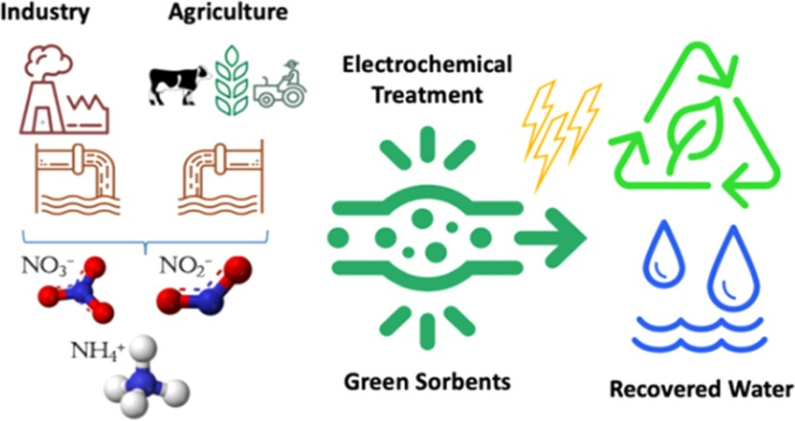
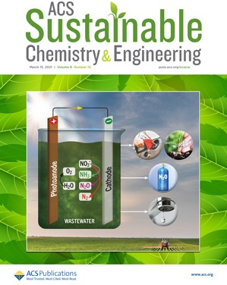





pubs.acs.org/journal/ascecg
Combining Electrocatalysts and Biobased Adsorbents for Sustainable Denitriﬁcation
Zili Ma, Matthias Klimpel, Serhiy Budnyk, Anna Rokicinśka, Piotr Kust́rowski, Richard Dronskowski, Aji P. Mathew, Tetyana Budnyak,* and Adam Slabon*
Cite This: ACS Sustainable Chem. Eng. 2021, 9, 3658−3667
Read Online
ACCESS
*sı
Metrics & More
Article Recommendations
Supporting Information
ABSTRACT: Eﬃcient treatment of domestic and industrial wastewater is one of the major challenges of the 21st century. Among the inorganic pollutants, nitrogen species are signiﬁcant contaminants and the manage- ment of the nitrogen cycle is one the most crucial parts of wastewater puriﬁcation. Herein, we report an integrated method that minimizes the amount of chemicals used, can be empowered by renewable energy, uses renewables materials for ammonia recovery, and is scalable. Complete denitriﬁcation of wastewater was achieved by combining electrochemical and adsorption treatment for real wastewater samples from the Stockholm water pilot plant. About 98% of nitrate was selectively converted to ammonia over abundant copper electrocatalysts in the presence of Na₂SO₄-
supporting electrolyte at −0.6 V vs reversible hydrogen electrode (RHE) within 3 h. The valorized nitrate in the form of ammonia could be recovered by means of cheap kraft lignin-SiO₂ sorbents to achieve total denitriﬁcation. The presented method is economically feasible, scalable, and contributes to sustainable recycling within a circular economy.
KEYWORDS: Green chemistry, electrocatalysis, adsorption, nitrate, ammonia production, circular economy, water puriﬁcation
■
nitrate concentration in surface and ground waters.¹⁰ High levels of nitrate concentration can overfertilize the soil or change the pH value in the long term or cause eutrophication of water bodies.¹¹ Nitrate can be also reduced to nitrite in living organisms, which may cause methemoglobinemia, liver damage, or even cancer.¹²⁻¹⁴ Hence, the removal of nitrate from water has become a topic of great environmental concern. Although there have been several commercial denitriﬁcation technologies developed, such as reverse osmosis, ion exchange, and bacterial denitriﬁcation,¹⁵ these solutions are inevitably connected to high costs of post-treatment, harsh operation conditions, and complicated technological processes.
The need for a cost-eﬀective and sustainable denitriﬁcation method from discharged eﬄuents has inspired the search for abundant low-cost materials and eﬀective remediation strategies.^{16,17} In the past few decades, electrochemical technologies have been explored extensively for addressing environmental problems.¹⁸⁻²⁰ The biggest advantage within the environmental perspective is the substitution of chemical reagents with the electric current empowered from renewable
INTRODUCTION
The presence of complex types of contamination in domestic and industrial wastewater is considered as one of the major environmental issues.^{1,2} Organic and biologic residues, nutrients, pesticides, detergents, metals, and suspended solids are very common pollutants.³ Traces of medications⁴ and drugs are also detected frequently in the wastewater.^{5,6} Untreated or improperly treated wastewater can eventually cause diseases and threats to humans and animals. These issues have become critical in many parts of the world and will continue to be important for future wastewater management. The wastewater generated from various, both industrial and domestic, activities has to be puriﬁed before reutilization or returning the water back into its natural cycle. Conventional treatment technologies available for wastewater management include physical, chemical, and biological routes. Generally, more than one type of method has to be applied to purify the water depending on the nature of the pollutants.⁸
Among the inorganic pollutants, nitrogen-based compounds such as nitrates and nitrites are a serious concern and need to be addressed. The outﬂowing water from a water plant is controlled continuously because the purity must meet various guidelines. According to the European legislation, the Nitrate Directive determines that the maximum concentrations of nitrate, nitrite, and ammonium cannot exceed 50, 0.1, and 0.5 mg·L⁻¹, respectively.⁹ Nowadays, detrimental impacts on the environment have occurred with considerably increasing
© 2021 The Authors. Published by American Chemical Society
7
https://dx.doi.org/10.1021/acssuschemeng.0c07807
ACS Sustainable Chem. Eng. 2021, 9, 3658−3667
3658
Downloaded via UNIWERSYTETU JAGIELLONSKIEGO on November 3, 2021 at 10:49:25 (UTC). See https://pubs.acs.org/sharingguidelines for options on how to legitimately share published articles.

Research Article
Received: October 25, 2020
Revised: February 2, 2021
Published: March 4, 2021

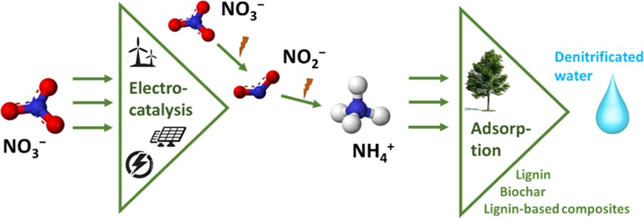
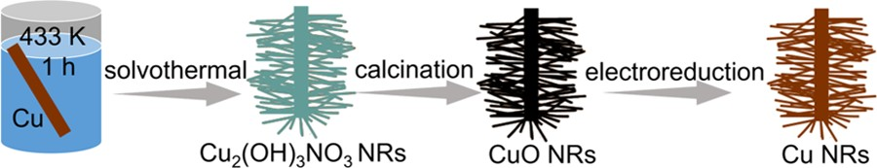
ACS Sustainable Chemistry & Engineering
pubs.acs.org/journal/ascecg
Research Article
resources.²¹ Copper is a prospective electrocatalyst
Scheme 2. Preparation of Cu NR Electrodesª
for the
reduction of nitrogen-containing compounds because it has a
relatively low activity for the hydrogen evolution reaction (HER);^{22,23} it also exhibits low toxicity for mammals.²⁴ This renders copper as the metal of choice for electrochemical reduction of nitrate.²⁵
In a circular economy, the desired reduction product of nitrate is ammonia because it could reduce the amount of the latter produced by the energy-consuming Haber−Bosch process.²⁶ Although the electrochemical reduction of nitrate and nitrite to dinitrogen can be performed by electrocatalysis on simulated wastewater samples that contain no other impurities, real wastewater has a complex composition that makes it easier to control the further reduction process to ammonia. Interestingly, ammonia as an industrial chemical can be easily reclaimed from its aqueous solution via regenerated resins or biobased adsorbent.²⁷⁻³² The tailoring of sorbent materials with respect to their surface charge and kinetics oﬀers opportunities for eﬃcient removal of charged compounds from solutions.^{33,34} The disadvantage of electrocatalytic nitrate reduction is the applicability of the method to very low concentrations because the required reaction time would meaningfully increase the process costs.
We were interested to develop an eﬃcient and sustainable strategy that minimizes the application of chemicals for the complete removal of nitrate by combining electrocatalysts and sorbent materials (Scheme 1). We demonstrate the application
aA Cu wire is used as a substrate for the fabrication of CuO NRs via annealing of Cu₂(OH)₃NO₃ nanostructures produced by the solvothermal method. Cu NRs are obtained by means of in situ electrochemical reduction of CuO NRs.
Characterization. Powder X-ray diﬀraction (XRD) patterns were recorded on an STOE STADI-P diﬀractometer (Cu Kα₁ radiation) equipped with a DECTRIS Mythen 1K detector in the transmission mode. X-ray photoelectron spectroscopy (XPS) was performed with a Prevac photoelectron spectrometer equipped with a hemispherical analyzer (VG Scienta R3000) and a low-energy ﬂood gun (FS40A- PS). The spectra were recorded using a monochromatized aluminum source Al Kα (E = 1486.6 eV). Scanning electron microscopy (SEM) images of the Cu wire were recorded on a Leo Supra 35VP SMT (Zeiss).
Electrochemical Denitriﬁcation. The electrochemical experi- ments were performed in a batch reactor with the conventional three- electrode setup. The working electrode was the Cu NR catalyst, whereas a platinum wire and 1 M Ag/AgCl electrode were used as a counter electrode and a reference electrode, respectively. All potentials were recorded vs 1 M Ag/AgCl and converted vs reversible
hydrogen electrode (RHE) according to (V) =
ERHE
E1MAg/AgCl
+
(0.059 × pH). A potentiostat (SP-150, BioLogic) operating with the
EC Lab Software package and Interface 1010T Workstation (Gamry) was used for all electrochemical experiments. The outﬂowing wastewater from the Stockholm water plant with or without 0.1 M Na₂SO₄ was used in the electrolyte. Cyclic voltammetry (CV) measurements were performed at a scan rate of 10 mV/s in static solutions. Chronoamperometry (CA) measurements were carried out at given potentials.
Quantitative Analysis. The concentrations of nitrates, nitrites, and ammonia in solutions were determined spectrophotometrically using a Biochrom WPA S800⁺ Visible Spectrophotometer. In the case of nitrate analysis, the nitration of salicylic acid was considered.³⁶ The Griess reaction³⁷ (Merck Spectroquant 114773 and Merck MColortest 114658) was used for the determination of nitrites in solutions. The indophenol method^{38,39} (Merck MColortest 114423) and the reaction with the Nessler reagent in the presence of potassium sodium tartrate were used for the quantitative determination of ammonium ions.
Adsorption Denitriﬁcation. The post-treatment adsorption of ammonia, as well as trace nitrate and nitrite, was carried out using biochar (Bionaturplus, Germany), kraft lignin (dealkaline, TCI), lignosulfonate-silica (LS-SiO₂), kraft lignin-silica (CF-SiO₂) compo- sites, and the ion-exchange resin Lewatit (Lewatit K-265, Fluka). Biochar, kraft lignin, and Lewatit were used as received without any additional treatment. The LS-SiO₂ composite was synthesized by crosslinking lignosulfonate on the silica gel (0.075−0.250 mm, 15 nm; Acros Organics, Belgium). The CF-SiO₂ composite was synthesized by the sol−gel method via tetraethoxysilane hydrolysis in the activated lignin solution by 3-aminopropyltriethoxysilane. For the synthesis of the composites, lignosulfonic acid sodium salt (LS) (Sigma Aldrich) and membrane-ﬁltered kraft lignin (CF) (CleanFlowBlack, Clean Flow AB, Sweden) were used. The lignin concentrations in LS-SiO₂ and CF-SiO₂ composites were 17 and 680 mg·g⁻¹. The detailed
Scheme 1. Schematic Illustration of the Combined Electrocatalytic and Adsorption Process for Sustainable Nitrate-to-Ammonia Conversion from Wastewater
of Cu nanorods (NRs) as electrocatalysts in an environ- mentally friendly Na₂SO₄ electrolyte and subsequent collection of the ﬁnal ammonia product by adsorbents. For the post- treatment, several biobased adsorbents including biochar, original kraft lignin, lignosulfonate-, and kraft lignin−silica composites were employed to adsorb the remaining ammonia
and traces of nitrate and nitrite.
■
EXPERIMENTAL SECTION
Preparation of Electrodes. A changed solvothermal method
reported by Wang et al.³⁵ was employed to grow Cu₂(OH)₃NO₃ NRs on the Cu substrate. Prior to use, a Cu wire of 0.2 cm in diameter was cleaned for 15 min in an ultrasonic bath of acetone, 1 M diluted HCl (Sigma) solution, and water, respectively. The pristine Cu was added into a 15 mL solution of 2-propanol (>99.7%, Fisher Scientiﬁc) solution of 0.12 g copper(II) nitrate trihydrate (Cu(NO₃)₂·3H₂O,
>99%, Sigma) in an autoclave at 433 K for 1 h. After cooling to room temperature, the autoclave was opened and the sample was rinsed with ethanol and water. The dried Cu wire was annealed at 483 K for 4 h under a N₂ atmosphere to yield the CuO NR coating on the bulk Cu wire. Epoxy resin as insulation to deﬁne the geometric area for electrochemical experiments. The Cu NRs were obtained by in situ electrochemical CuO NRs in the electrolyte. The fabrication process is summarized in Scheme 2.
synthetic pathway for LS-SiO ³⁴ and CF-SiO ^{40,41} and character-
2
2
ization of composites have been described in our previous works. The adsorption capacity of the applied materials was calculated using the following equation
(c₀ − c_{eq})
×
V
qeq =
m
(1)
S
3659
https://dx.doi.org/10.1021/acssuschemeng.0c07807
ACS Sustainable Chem. Eng. 2021, 9, 3658−3667

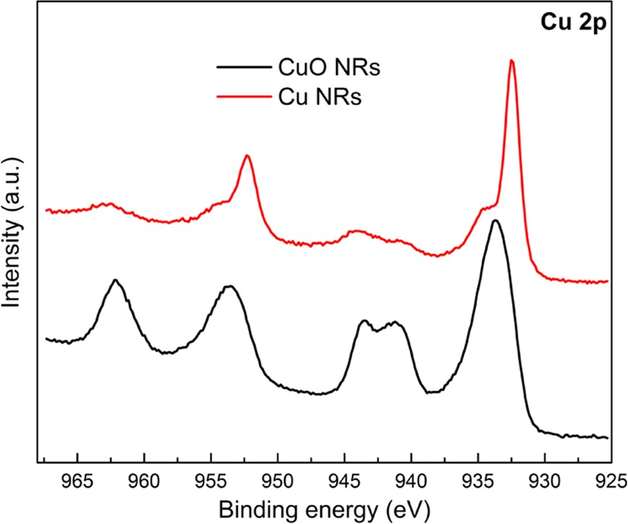
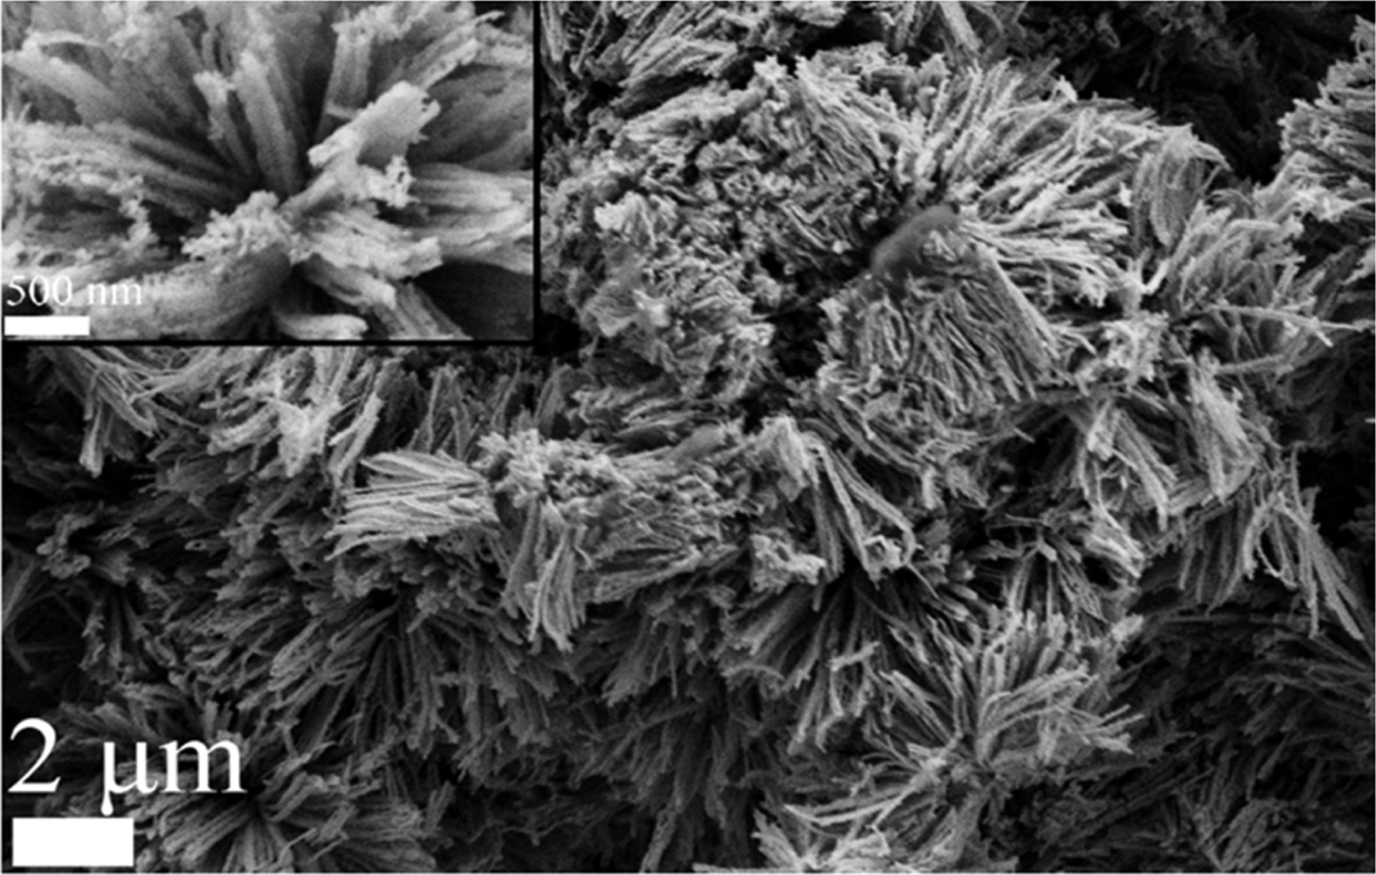
ACS Sustainable Chemistry & Engineering
pubs.acs.org/journal/ascecg
Research Article
where q_{eq} is the amount of ions adsorbed per gram of the sorbent (mg·g⁻¹) at equilibrium, c₀ and c_{eq} are the initial and equilibrium ion concentrations (mg·L⁻¹) in the solution, V is the volume (L) of the initial ion solution, and m_{S} is the weight of the sorbent (g).
In order to study the eﬀect of phase contact time on the adsorption capacity of sorbents, the following conditions were applied: initial concentration of ammonium ions, 5 mg·L⁻¹; volume solutions, 25 mL, and the equilibrium concentrations were measured after 5−90 min. The kinetics of the adsorption process of ammonium ions in various sorbents was investigated using pseudo-ﬁrst-, pseudo-second- order equations, and the intraparticle diﬀusion model.
The pseudo-ﬁrst-order equation is given by^{42,43}
kt
Cu₂(OH)₃NO₃ phase (COD No. 1538408). After annealing at
483 K under a N ﬂow, the Cu (OH) NO converted to CuO
2
2 3 3
through a topotactic reaction (SEM of CuO, Figure S3). The conversion to CuO was conﬁrmed by means of powder XRD (Figure S4). Subsequently, the CuO NRs were in situ converted to Cu NRs by electrochemical reduction at a constant negative potential of −0.9 V vs RHE for 10 min. The formation of Cu NRs was conﬁrmed by means of XRD and XPS. The XRD patterns (Figure S4) indicate that the product had the face-centered cubic (fcc) structure of Cu (COD No. 4313207). The reﬂection peaks at 43.3, 50.8, 74.7, 90.7, and
95.9° correspond to the diﬀractions of (111), (200), (202),
(311), and (222) planes, respectively. Figure 1 presents the
log(qe − qt) = log qe −
(2)
2.303
The pseudo-second-order equation is given as^{44,45}
t = 1 + t
qt k₂q ² qe
(3)
e
where q_{e} and q_{t} are the amounts of ions adsorbed (mg·g⁻¹) at the equilibrium time and at any instant of time t, respectively, K₁ (1· min⁻¹) is the rate constant of the pseudo-ﬁrst-order adsorption, and K₂ (g·mg⁻¹·min⁻¹) is the pseudo-second-order rate constant.
The Weber and Morris equation⁴⁶ was applied in order to understand the possibility of intraparticle diﬀusion
qt = KIPDt 0.5 + C
(4)
where K_{IPD} is the intraparticle diﬀusion rate (mg·g⁻¹·min^{−0.5}) and C is a constant.
Adsorption isotherms were obtained by varying the initial ammonium ion concentration between 0.5 and 80 mg·L⁻¹. The sorption equilibrium data was applied to the Langmuir, Freundlich, and Temkin models.
The linear form of the Langmuir model is⁴⁷
Figure 1. XPS spectra of CuO NRs and Cu NRs.
c_{e} c_{e}
+ 1
=
qe q0 K_{L}q0
(5)
XPS spectra of CuO NRs and Cu NRs. In the case of the
where c_{e} is the equilibrium concentration of ions (mg·L⁻¹), q_{e} is the
former, it can be conﬁrmed that the Cu
2p3/2
characteristic
amount of the adsorbed ions (mg·g⁻¹), and q and K are adsorption
0 L
peak at 933.7 eV with the satellite peaks corresponds to Cu²⁺.
capacity (mg· −1
g ) and the Langmuir isotherm constant (L·mg⁻¹),
After the electroreduction step, the characteristic peak shifted to 932.5 eV and became sharper, while the satellite peaks disappeared. This shift clearly conﬁrms the presence of metallic copper in the surface region.
The morphologies of pristine Cu and Cu NRs were compared via SEM. Only several small bulges and shallow pits can be observed on the pristine Cu surface (Figure S5), while the oxide-derived Cu NRs of irregular shape are approximately 50−100 nm in diameter and 2−4 μm long (Figure 2).
respectively.
The Freundlich model is⁴⁸
1
log qe = log K_{F} + × log c_{e}
(6)
n
where K_{F} and n are the Freundlich constants related to the sorption capacity and sorption intensity, respectively.
The Temkin model of isotherm can be expressed as follows
c = RT ln(K ) + RT ln c
s
T
eq
b_{T}
b_{T}
(7)
where c_{s} is the concentration of ions in the solid phase (mol·g⁻¹), b_{T} is the heat of adsorption (kJ·mol⁻¹), K_{T} is the model constant (L·g⁻¹), R is the gas constant (8.314 J·mol⁻¹·K⁻¹), T represents the absolute temperature (K), and c_{eq} denotes the equilibrium concentration of
ions (mol·L⁻¹) in the aqueous phase.⁴⁹
■
RESULTS AND DISCUSSION
Structural Characterization. SEM was ﬁrst carried out to
analyze the morphology of the prepared Cu catalyst. After the
solvothermal procedure, several micrometer-level clusters were successfully grown on a Cu wire substrate (Figure S1). The high-magniﬁcation image (Figure S1, inset) reveals that the clusters were assembled with uniform NR arrays that were 50− 100 nm in diameter and 2−5 μm long. The XRD patterns (Figure S2) indicate that the NRs were of the monoclinic
Figure 2. SEM images of Cu NRs. Inset: high-magniﬁcation image.

https://dx.doi.org/10.1021/acssuschemeng.0c07807
ACS Sustainable Chem. Eng. 2021, 9, 3658−3667
3660

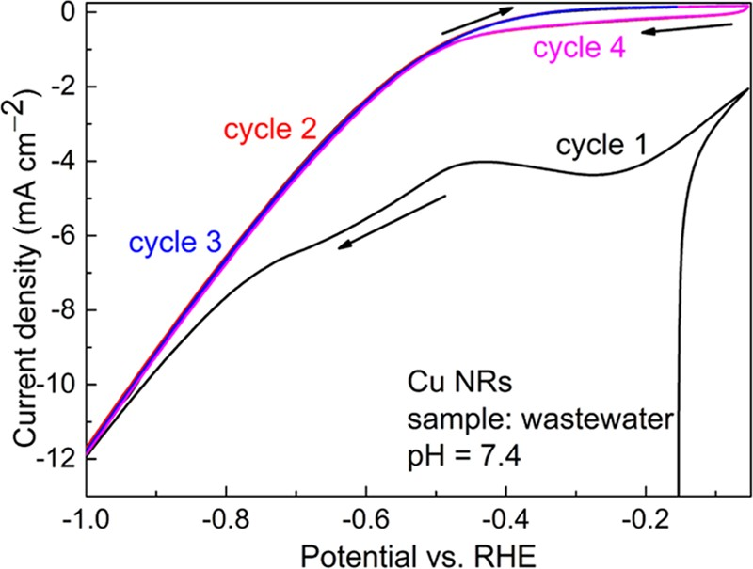
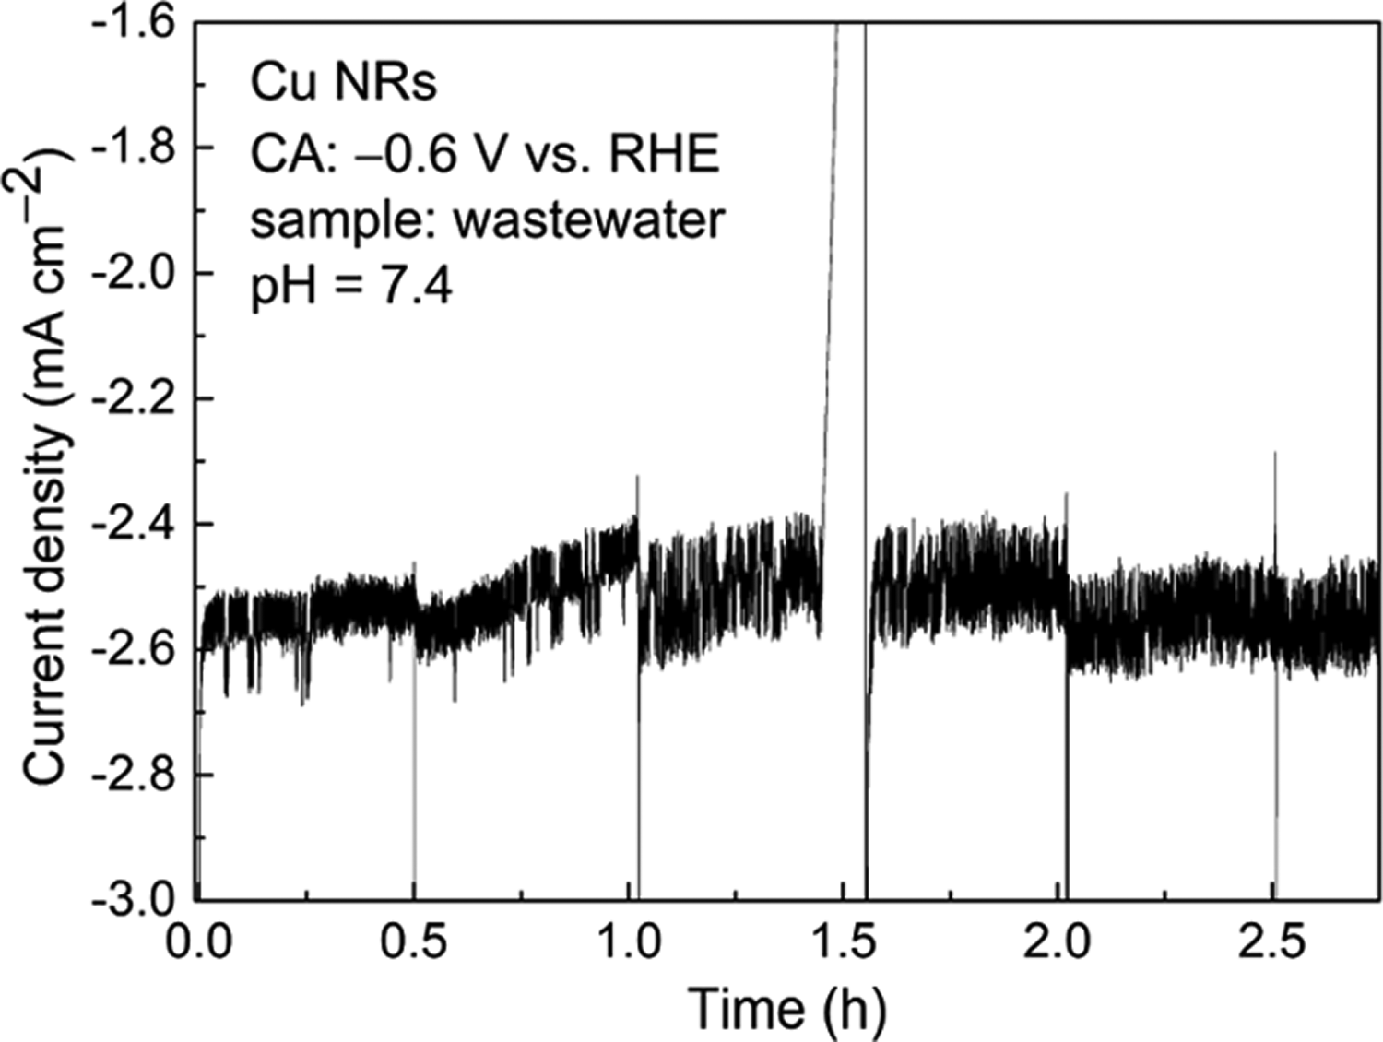
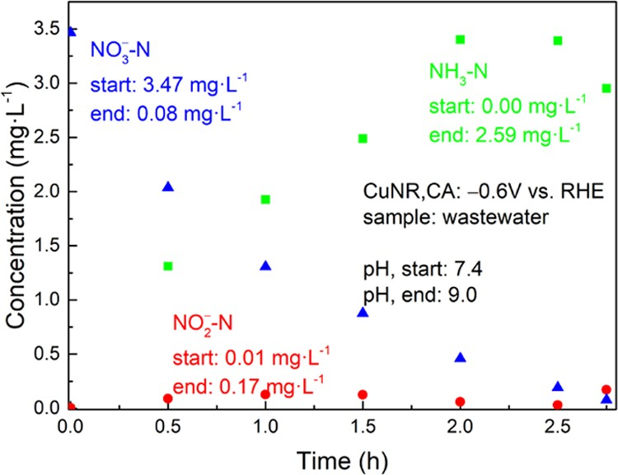
ACS Sustainable Chemistry & Engineering
pubs.acs.org/journal/ascecg
Research Article
Electrochemical Denitriﬁcation. For the sake of clarity,
summarized in Figure 5. A signiﬁcant decrease (98%) of the nitrate was achieved after approximately 2.5 h long CA.
all concentrations of diﬀerent ions, i.e., NO₃⁻, NO ⁻, and NH ,
2
3
are based on the nitrogen mass and given an ending “−N”. Excess of Na₂SO₄ was employed as an environmentally friendly electrolyte for electrochemical denitriﬁcation of real waste- water samples. This provides a near-neutral environment for the analysis of executable N-containing ions although the pH can change upon production of ammonia. CV was ﬁrst conducted using the as-prepared Cu NR electrode with a surface area of 9.14 cm2 in the Na₂SO₄ electrolyte. The ﬁrst cycle of CV curves exhibits a reduction peak of CuO, which was formed when the electrode was stored in air (Figure 3). In
Figure 5. Concentration of nitrate, nitrite, and ammonia vs the electrolysis duration. Electrode surface area A = 9.14 cm²; applied potential = −0.6 V vs RHE, and 0.1 M Na₂SO₄ supporting electrolyte.
Notably, the ammonia concentration was increased consid- erably, revealing that the Cu NRs are selective in the nitrate-to- ammonia conversion. The electrolyte had consequently a more basic pH value owing to the formation of ammonia. A similar behavior of the nitrate electroreduction on copper in an alkaline solution (pH 13) has been previously reported by Reyter et al.,⁵⁰ where nitrate was only reduced to nitrite at a potential of −0.9 V vs Hg/HgO. When the applied potential shifted to −1.4 V vs Hg/HgO, nitrate-to-ammonia took place. Nitrite was only formed as an intermediate with very low concentrations. This is in agreement with our observation and the change in the concentration decay of nitrate as a function of time indicates a typical ﬁrst-order reaction.⁵¹
Although Na₂SO₄ is an environmentally friendly electrolyte and can be recovered by adsorption, it is essential to evaluate the applied electrochemical method with respect to an eﬃcient and economic process for an industrial water puriﬁcation plant. Within the scope of Green Chemistry, the amount of related additives has to be minimized to achieve an eﬃcient atom economy.^{52,53}
We, therefore, investigated electrochemical nitrate reduction on Cu NR electrodes for wastewater without the addition of Na₂SO₄ as a supporting electrolyte. It should be noted that experiments were not performed on simulated wastewater samples based on deionized water but on real wastewater samples, which contain a higher conductivity. In the absence of the electrolyte, the developed current density dropped by a factor of 7 (Figure 6) and the CA at −0.6 V vs RHE developed a cathodic current density of 0.45 mA·cm⁻² (Figure 7). The complementary quantitative analysis showed that the nitrate concentration was only decreased by 39% and the ammonia yield was 1.05 mg·L−1 after 3 h (Figure 8). This result indicates that Na₂SO₄ is required as a supporting electrolyte for realistic application. Although one may reduce the nitrate concen- tration by extending the CA duration, it is inevitably connected to higher energy costs and extremely long electrolysis time. The quantitative analysis in Figure 8 shows that even 14 h was not enough to achieve the nitrate concentration below 1 mg· L−1.
Adsorption Experiment. Although 98% nitrate in waste- water has been reduced in 3 h by means of electroreduction,
the ammonia has to be subsequently removed before being discharged. This necessitates an integrated process for

https://dx.doi.org/10.1021/acssuschemeng.0c07807
ACS Sustainable Chem. Eng. 2021, 9, 3658−3667
Figure 3. CV curves of Cu NRs with a surface area of 9.14 cm² for the wastewater sample in 0.1 M Na₂SO₄ electrolyte at a scan rate of 10 mV/s. The current density relates to the geometric current density.
the second cycle, this cathodic current density disappears in the same potential range. For more cathodic potentials, the current density increases owing to the reduction reactions. Another important phenomenon is that the CV does not show any distinct reduction peaks even up to −1.0 V vs RHE. In the present case, the nitrate and the related intermediate nitrite reduction peaks are overlaid with each other and the competitive HER.
Although the dominant HER occurs at relatively negative potentials, high nitrate and nitrite reduction reactions can be expected. Figure 4 depicts the CA curve recorded at −0.6 V vs RHE with Na₂SO₄-supporting electrolyte. The product concentration after CA for 3 h at −0.6 V vs RHE is
Figure 4. CA of the Cu NRs with a surface area of 9.14 cm² in the wastewater sample potential of −0.6 V vs RHE in 0.1 M Na₂SO₄ electrolyte. The interruption at 1.5 h is due to a short contacting problem of the working electrode.
3661

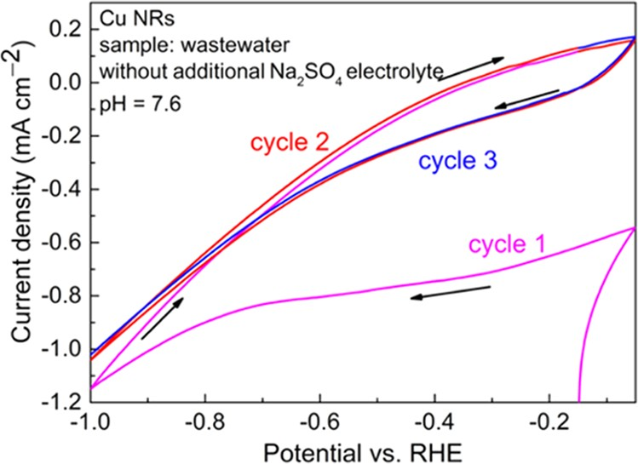
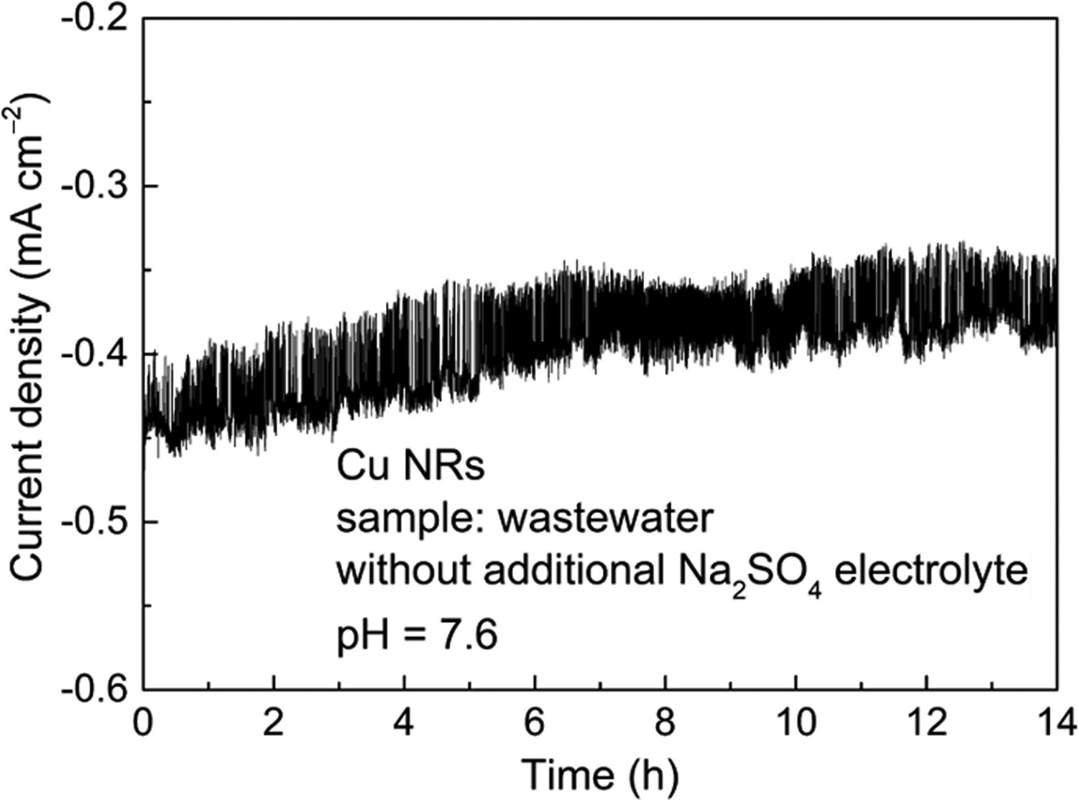
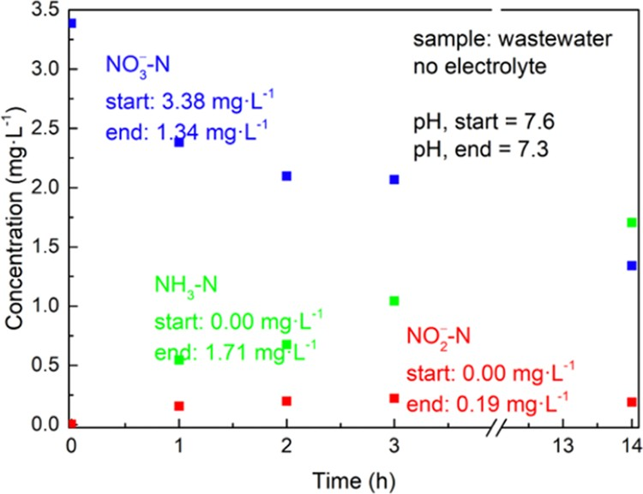
ACS Sustainable Chemistry & Engineering
pubs.acs.org/journal/ascecg
Research Article
organics from the resin, bacterial and chlorine contamination, as well as calcium sulfate and iron fouling. In this regard, there is an urgent need for eﬀective and environmentally friendly sorbents. Lignin is a macromolecule from the wood biomass but still underutilized in comparison to cellulose. Lignin has a unique set of functional groups that can be further chemically modiﬁed to yield eﬃcient adsorption. We elucidated therefore lignin and lignin−silica composites based on lignin sulfonate (LS-SiO₂) and kraft lignin (CF-SiO₂) for ammonia removal. We also compared these sorbents with the untreated biochar and with the synthetic cationic ion-exchange resin Lewatit. Since the goal was to develop an integrated system together with electrocatalytic reduction, the adsorption experiments were carried out in the presence of 0.1 M Na₂SO₄ and the most promising systems were compared with the ones without electrolyte.
Figure 6. CV of Cu NRs with a surface area of 9.14 cm² for the wastewater sample without a supporting electrolyte.
The determination of
pHpzc
showed that pure KL and
Lewatit are negatively charged in the studied initial pH range
from 2 to 12 (pH_{pzc} = 2.0), whereas the biochar and lignin− silica composites are characterized by pH_{pzc} at 6.3, 8.0, and 8.3, respectively (Figure 9a). The study of the inﬂuence of the initial concentration of ammonium ions on the adsorption capacity of the studied materials showed that all selected sorbent materials showed adsorption activity toward ammo- nium ions in the presence of sodium sulfate (Figure 9b). It can be seen from Figure 9b that the lignin-based composites and Lewatit resins are eﬀective in the low range of initial concentrations (≤7.5 mg·L⁻¹) of ammonium ions in the presence of the electrolyte. The adsorption capacities, determined from isotherms, were found to be 4.5 mg·L⁻¹ for CF-SiO₂, 4.9 mg·L⁻¹ for biochar, 5.5 mg·L⁻¹ for KL, 5.3 mg· L⁻¹ for LS-SiO_{2,} and 10.6 mg·L⁻¹ for Lewatit (Figure 9b). The comparison of removal eﬃciency of ammonium ions by all studied materials showed that pure KL and biochar are not eﬃcient for adsorption of low concentrations of ammonium ions from the aqueous solutions. When increasing the initial concentration of ammonium ions, the removal eﬃciency of original KL and biochar drastically increased to 47−72 and 29−61% for the systems with initial concentrations of ammonium ions ranging from 10 to 20 mg·L⁻¹ in the presence of Na₂SO₄.
The characteristic parameters were calculated from the Langmuir, Freundlich, and Temkin isotherm models and are summarized in Table 1. Based on the Langmuir isotherm model, the capacity of the monolayer was found to be 8.99, 4.84, and 5.20 mg·g⁻¹ for LS-SiO₂, CF-SiO₂, and KL, respectively. The favorability of the adsorption of ammonium
Figure 7. CA of the Cu NRs with a surface area of 9.14 cm² for the wastewater sample without a supporting electrolyte. Applied potential
= −0.6 V vs RHE.
Figure 8. Concentrations of nitrate, nitrite, and ammonia vs the electrolysis duration. Electrode surface area A = 9.14 cm²; applied potential = −0.6 V vs RHE, and without a supporting electrolyte.
ions was conﬁrmed by the positive R values in the range 0 ≤
L
R ≤ 1. The calculated K
·
F was highest for LS-SiO₂ (3.03 mg
L
g−1)
and the Lewatit resin (2.98 mg·g⁻¹). The heat of
ammonia recovery from the solution to achieve overall circular nitrogen management. Adsorption is an eﬀective method for the removal of variable ions from aqueous solutions. The possibility to run adsorption in near-neutral conditions and to use biomaterials as adsorbents along with preserving the high eﬃciency of the process renders adsorption as a sustainable method for water puriﬁcation. A variety of sorbent and membrane materials have been previously studied for ammonium removal.⁵⁴⁻⁵⁶ Ion-exchange resins were found to be eﬀective because of their good kinetics, capacity, and the possibility to reuse.⁵⁷⁻⁵⁹ However, nowadays, synthetic ion- exchangers are of concern owing to certain disadvantages associated with their usage, e.g., secondary contamination by
adsorption of ammonium ions was found to be in the range
0.57−1.326 kJ·mol−1 for Lewatit, biochar, and LS-SiO₂ with the highest binding energy (K_{T}) for biochar (3.638 L·g⁻¹). The highest correlation coeﬃcients (R2) for all models were found for lignin-based composites (Figure S6).
According to the higher eﬃciency of lignin-based composites in the range of low concentrations of ammonium ions and their sustainability of initial components, we focused on LS-SiO₂ and CF-SiO₂ composites in our following detailed investigation of the adsorption process.
As a result of the diﬀerent pulping processes for initial lignins that were used for the synthesis of the composites, LS lignin is characterized by the presence of sulfonic groups in

https://dx.doi.org/10.1021/acssuschemeng.0c07807
ACS Sustainable Chem. Eng. 2021, 9, 3658−3667
3662

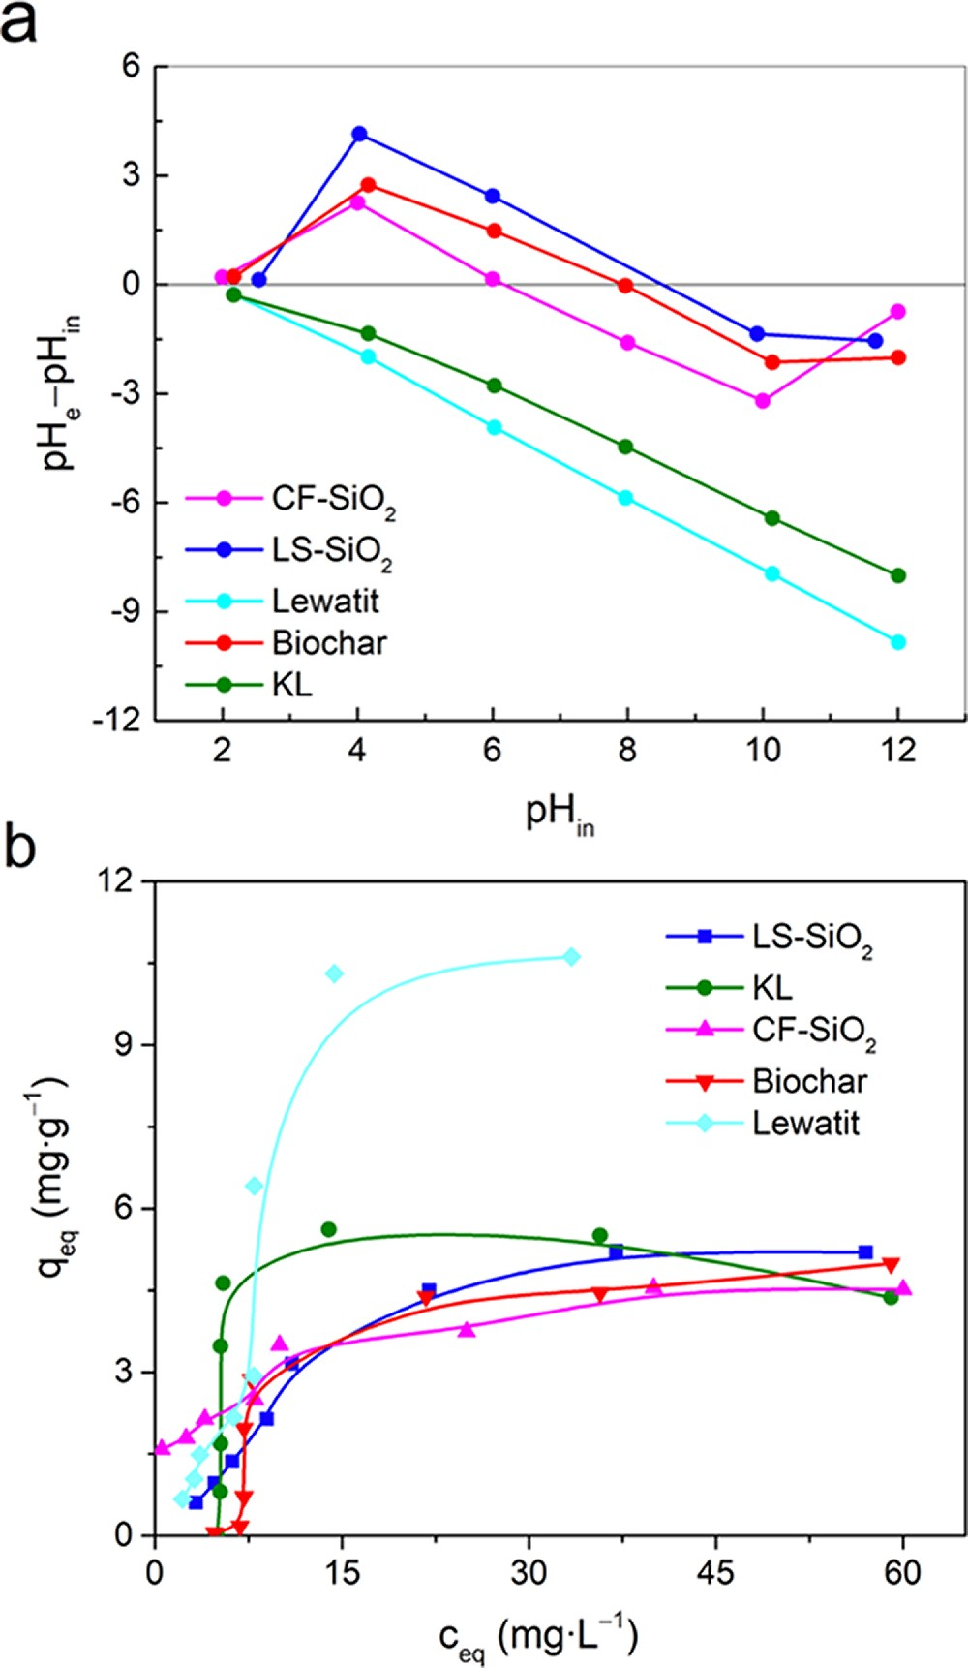
ACS Sustainable Chemistry & Engineering
pubs.acs.org/journal/ascecg
Research Article
Table 1. Isotherm Model Parameters Obtained for Ammonium Ion Adsorption onto LS-SiO₂, CF-SiO₂, KL, Biochar, and Lewatit at 22 °C in the Presence of 0.1 M Na₂SO₄ Electrolyteª
Langmuir
q_{m} (mg·g−1) K_{L} (L·mg−1) R_{L} (L·mg−1) R2
Freundlich
K_{F} (mg·g−1) 1/n
R2
Temkin
b_{T} (kJ·mol⁻¹) K_{T} (L·g−1) R2
8.99
0.031
0.139
0.802
4.84
0.223
0.082
0.989
5.20
0.174
0.035
0.771
8.40
0.029
0.462
0.466
0.001
3.03
0.771
0.893
1.64
0.256
0.923
1.10
0.472
0.361
26.27
1.357
0.539
2.98
1.116
0.877
1.326
2.527
0.959
22.25
20.62
0.344
1.797
1.071
0.394
1.234
3.638
0.822
0.570
2.43
0.841
aTime of contact: 2 h; initial concentration of ammonium ions: 5−80 mg·L⁻¹; sorbents dosage: 4 g·L⁻¹, shaking rate: 180 rpm; and temperature: 22 °C.
ions; and (vi) adsorption of the ammonium equilibrium form to the protonated adsorption sites.
In order to understand the mechanism leading to ammonium adsorption and to determine the adsorption rate- controlling step, a kinetic study was conducted.⁶¹ The study of the inﬂuence of contact time between phases on the adsorption showed that for LS-SiO₂ the adsorption capacity increased with time and the minimum required time was 15 min. In the case of the CF-SiO₂ composite, the highest extent of removal of ammonium ions was reached after 5 min of contact of the composite with the adsorbate solution at a chosen concen- tration (Figure S8). The kinetic parameters were obtained from the applied experimental data to the pseudo-ﬁrst-order, pseudo-second-order equations, and the intraparticle diﬀusion model; also summarized in Table 2. The kinetic model ﬁtting plots are presented in Figure S9. It was found that the adsorption kinetics for both composites could be well described by the pseudo-second-order equation according to high values of R2, which were found to be 0.997 and 0.978 for LS-SiO₂ and CF-SiO₂, respectively. The equilibrium sorption
Figure 9. (a) Determination of pH and (b) comparison of
pzc
adsorption isotherms of ammonium ions by LS-SiO₂, CF-SiO₂, Lewatit resin, biochar, and KL in the presence of electrolyte ions (time of contact: 2 h; initial concentration of ammonium ions: 5−80 mg·L⁻¹; sorbents dosage: 4 g·L⁻¹; shaking rate: 180 rpm; temper- ature: 22 °C).
capacity
(qe,cal)
and the pseudo-second-order rate constant
addition to the set of hydroxyl and carboxyl groups present in the structure of CF lignin. The selected lignin-based sorbents are characterized by diﬀerent concentrations of lignin in the
Table 2. Kinetic Parameters for the Adsorption of Ammonium Ions on LS-SiO₂ and CF-SiO₂ Composites in the Presence of 0.1 M Na₂SO₄ Electrolyteª
composite: 17 mg·g⁻¹ for LS-SiO and 680 mg·g⁻¹ for CF-SiO
2
2
according to thermal analysis (Figure S7). Higher content of
silica in the LS-SiO₂ composite results in the higher Brunauer− Emmett−Teller (BET) speciﬁc surface area (S_{BET}) compared
pseudo-ﬁrst order
q , (mg·g−1)
3.60
0.007
0.449
0.27
1.664
0.997
0.03
0.062
0.567
1.29
0.001
0.378
0.01
12.92
0.978
0.02
0.184
0.561
to that in the CF-SiO . Thus, the S values were 240 m2·g−1
e cal
−1
K₁ (1·min )
R2
2
BET
2 −1
34
and 92 m ·g for LS-SiO₂ and CF-SiO₂, respectively.
As described earlier by Bernal and Lopez-Real,⁶⁰ there are a
q , (mg·g−1)
pseudo-second order
e cal
number of numerous individual processes that could mean- ingfully inﬂuence the ammonium ion adsorption on charged surfaces. These include (i) diﬀusion of ammonia into or from the atmosphere into the solution; (ii) intraparticle diﬀusion of
K₂ (g·mg−1·min−1)
R2
K_{IPD} (mg·g−1·min−0.5)
C R2
intraparticle diﬀusion model
ammonia in the gaseous phase; (iii) adsorption of ammonia gas on the solid surface including pores; (iv) equilibrium between the ammonia gas and ammonia in the solution; (v) chemical equilibrium between ammonia and the ammonium
aInitial concentration of ammonium ions: 5 mg·L⁻¹; sorbents dosage: 8 g·L⁻¹; shaking rate: 180 rpm; and temperature: 22 °C.
https://dx.doi.org/10.1021/acssuschemeng.0c07807
ACS Sustainable Chem. Eng. 2021, 9, 3658−3667
3663
parameter symbol LS-
kinetics model (unit) SiO₂ CF-SiO₂
isotherm model/ LS-
parameter SiO₂ CF-SiO₂ KL biochar Lewatit

ACS Sustainable Chemistry & Engineering
pubs.acs.org/journal/ascecg
(K₂) were determined from the slope and intercept of the linear relationship t/q_{t} vs t (Figure S9b). It was found that K₂ is higher for the CF-SiO₂ composite (12.92 g·mg⁻¹·min⁻¹). According to the nonlinear plots q_{t} vs (Figure S9b), the chemical reaction controls mainly the rate of adsorption and diﬀusion to a smaller degree. The obtained results based on the kinetic study are in line with the previously published data concerning the adsorption of ammonium ions; however, the inﬂuence of the presence of Na₂SO₄ electrolyte solution in the system results in the competition of the Na+ ions with the
Despite the fact that the short time of phase contact was found to be beneﬁcial for the system CF-SiO₂/Na₂SO₄ and longer time for the system LF-SiO₂/Na₂SO₄, it was decided to conduct the equilibrium study for both composites with a short time of contact. This is more convenient for large-scale applications where dynamic sorption is more convenient. The obtained isotherms of adsorption were compared with the ones with a longer-phase contact time (24 h) with or without the presence of an electrolyte. It can be seen from Figure 10 that
The Langmuir, Freundlich, and Temkin isotherm models were applied to analyze the obtained data. The characteristic parameters for each isotherm were determined from the ﬁtting plots (Figure S10) and are summarized in Table 3. The
t0.5
Table 3. Isotherm Model Parameters Obtained for Ammonium Ion Adsorption onto LS-SiO₂ and CF-SiO₂ at 22 °Cª
NH + ions.
4
Langmuir
q_{m} (mg·g−1) K_{L} (L·mg−1) R_{L} (L·mg−1) R2
Freundlich
K_{F} (mg·g−1) 1/n
R2
Temkin
0.69
1.610
0.003
0.906
2.01
0.135
0.035
0.999
12.9
0.179
0.034
0.547
5.22
0.341
0.018
0.708
10.36
1.142
0.017
0.093
3.23
0.474
0.772
1.47
0.267
0.144
1.52
0.7174
0.836
1.24
0.54
0.828
3.46
0.55
0.800
b_{T}
14.393
2.985
2.367
3.124
1.982
−1
(kJ·mol ) K_{T} (L·g−1) R2
8.089
0.897
1.28
0.869
21.40
0.671
12.45
0.811
53.45
0.683
aInitial concentration of ammonium ions: 0.5−25 mg·L⁻¹; sorbents dosage: 4 g·L⁻¹; and shaking rate: 180 rpm.
experimental data obtained for the systems LS-SiO₂/Na₂SO₄/ 24 h and LS-SiO₂/Na₂SO₄/20 min could be described well by the monolayer Langmuir adsorption isotherm model (R2 = 0.906−0.999). The monolayer capacity (q_{m}) was found to be
0.69 for the system with a short contact time (20 min) and
2.01 mg·g⁻¹ for a long contact time (24 h). The favorability of the adsorption was conﬁrmed by the R_{L} values ranging between 0 and 1. The systems CF-SiO₂/Na₂SO₄/5 min, CF- SiO₂/H₂O/24 h, and LS-SiO₂/H₂O/24 h could be described by the Freundlich isotherm model conﬁrming more complex multilayer adsorption, with a nonuniform distribution of adsorption heat and aﬃnities over the heterogeneous surface (R2 ≥ 0.8). K_{F} was found to be 1.24−3.46 mg·g⁻¹. The heats of adsorption (b_{T}) of ammonium ions on the studied composites were found to be in a range from 1.982 to 14.393 kJ·mol⁻¹. The binding energy for the interactions between the adsorbents/adsorbates were 1.28−21.40 L·g⁻¹ for LS-SiO₂
Figure 10. Adsorption isotherms of ammonium ions with 0.1 M Na₂SO₄ or deionized H₂O at 22 °C (initial concentration of ammonium ions: 0.5−25 mg·L⁻¹; sorbent dosage: 4 g·L⁻¹; shaking rate: 180 rpm) with varying contact times.
the capacity of composites is higher for the systems without the addition of an electrolyte: 7.7 mg·g⁻¹ for the system LS- SiO₂/H₂O/24 h and 9.5 mg·g⁻¹ for CF-SiO₂/H₂O/24 h. With the addition of Na₂SO₄ to the system, the adsorption capacity decreased. This eﬀect could be connected to the change in the ionic strength of the solution and to the competition of Na⁺ ions with the NH₄+ ions for the negatively charged adsorption sites of the composite: −COOH and −OH of the lignin and silica, respectively
During the ﬁrst 5 min of contact with ammonium ions and in the presence of the electrolyte salt in the system, it is possible to remove 4.6 mg of ammonia by 1 g of the CF-SiO₂ composite. Increasing the time of adsorption leads to sodium ions occupying the adsorption sites of the composite material and the adsorption of ammonium ions decreased. For the systems with LS-SiO₂ in the presence of Na₂SO₄, longer time resulted in a higher capacity of the composite toward ammonium ions (2.1 mg·g⁻¹ after 24 h of contact); however, during the 20 min of contact, it is possible to remove 0.62 mg of ammonia by 1 g of the LS-SiO₂ composite.
and 12.45−53.45 L·g⁻¹ for CF-SiO₂. However, the
R2
coeﬃcient was found to be low for the Temkin isotherm model (0.671−0.897).
In summary, the conducted adsorption study reveals that the composites based on lignin and silica (LS-SiO₂ and CF-SiO₂) are prospective sorbent materials for ammonium ions removal from low to high concentrations in the presence of an electrolyte with a short contact time, which is a crucial value for dynamic sorption on an industrial scale. The adsorption activity of LS-SiO₂ is comparable to the synthetic resin Lewatit in the range of low initial concentrations of ammonium ions, whereas at low concentrations an adsorption capacity of the CF-SiO₂ material is much higher than for the resin even after the addition of the supportive electrolyte to the system. This allows us to assume that lignin-based sorbents are promising alternatives to synthetic ion-exchangers. The CF-SiO₂
https://dx.doi.org/10.1021/acssuschemeng.0c07807
ACS Sustainable Chem. Eng. 2021, 9, 3658−3667
3664
Research Article

LS-SiO₂
Na₂SO₄ Na₂SO₄ H₂O
isotherm model/
parameter (20 min) (24 h) (24 h)
CF-SiO₂
Na₂SO₄ H₂O

(5 min) (24 h)

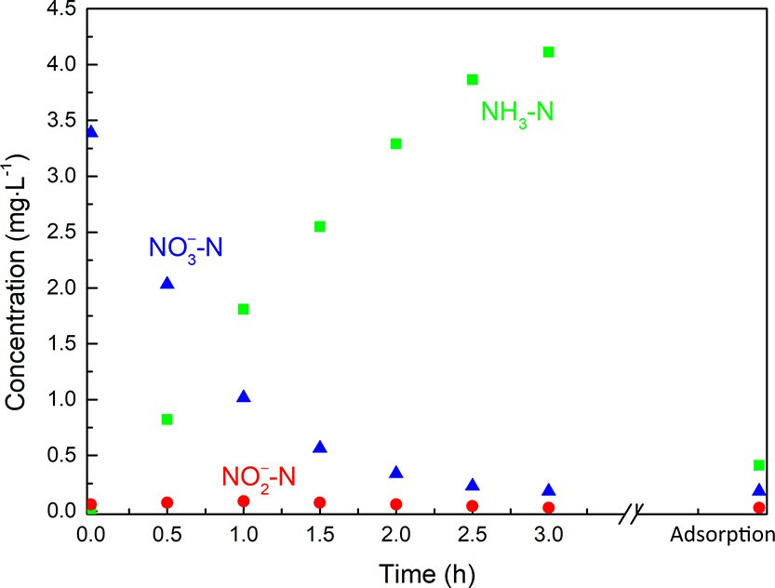
ACS Sustainable Chemistry & Engineering
pubs.acs.org/journal/ascecg
Research Article
SiO₂; inﬂuence of phase contact time on the ammonium ion adsorption (PDF)
adsorbent was employed to adsorb the ammonia after electrochemical treatment of real wastewater solutions containing nitrates and nitrites. The adsorption of up to 87% of ammonia was observed (Figure 11).
■
AUTHOR INFORMATION
Corresponding Authors
Tetyana Budnyak − Department of Materials and Environmental Chemistry, Stockholm University, 106 91 Stockholm, Sweden; AquaBioSolve Stockholm AB, 186 55 Vallentuna, Sweden; orcid.org/0000-0003-2112-9308; Email: tetyana.budnyak@mmk.su.se
Adam Slabon − Department of Materials and Environmental Chemistry, Stockholm University, 106 91 Stockholm, Sweden; orcid.org/0000-0002-4452-1831;
Email: adam.slabon@mmk.su.se
Authors
Zili Ma − Institute of Inorganic Chemistry, RWTH Aachen University, 52056 Aachen, Germany; orcid.org/0000- 0001-7975-9201
Matthias Klimpel − Department of Materials and Environmental Chemistry, Stockholm University, 106 91 Stockholm, Sweden
Serhiy Budnyk − AC2T research GmbH, 2700 Wiener Neustadt, Austria
Anna Rokicińska − Faculty of Chemistry, Jagiellonian University, 30-387 Kraków, Poland; orcid.org/0000- 0001-8397-4422
Piotr Kust́rowski − Faculty of Chemistry, Jagiellonian University, 30-387 Kraków, Poland
Richard Dronskowski − Institute of Inorganic Chemistry, RWTH Aachen University, 52056 Aachen, Germany; Hoﬀmann Institute of Advanced Materials, Shenzhen Polytechnic, Shenzhen 518055, China; orcid.org/0000- 0002-1925-9624
Aji P. Mathew − Department of Materials and Environmental Chemistry, Stockholm University, 106 91 Stockholm, Sweden; orcid.org/0000-0001-8909-3554
Figure 11. Concentrations of nitrate, nitrite, and ammonia after combined electrocatalysis and adsorption. It should be noted that this graph represents a new experiment with the adsorption step being performed after the end of the CA.
■
CONCLUSIONS
The electrochemical treatment of nitrate-containing real wastewater has been demonstrated to reduce the concentration
below 1 mg·L−1 and selectively convert nitrate to ammonia at
−0.6 V vs RHE in 3 h with Cu NRs as electrocatalyst in the presence of the Na₂SO₄ electrolyte. During the reduction process, nitrite was only formed as an intermediate at a very low concentration. Control experiments revealed that the supporting electrolyte is essential to reduce nitrate electro- chemically. Ammonia could be removed up to 87% from the solution by the CF-SiO₂ adsorbent. However, more experi- ments are needed to obtain higher proﬁtability such as the optimization of Na₂SO₄ or the NH₃ adsorption procedure, including sorbent recycling. The recycling of the sulfate, which could be realized by a cationic adsorbent, is also an additional possibility. The biobased materials such as cellulose, chitin, and chitosan have already shown promising results with other anions.⁶²⁻⁶⁴
In conclusion, total denitriﬁcation of wastewater has been realized by the combination of electroreduction and adsorption. The materials used in this method are cheap and abundant, and this easily scalable method enables the use of electric current, which can be generated from renewable resources, to reduce the amount of chemicals. This work not only oﬀers us an economic method to realize total denitriﬁcation but also provides an exciting new orientation toward the design of practical routes for wastewater treatment
Complete contact information is available at: https://pubs.acs.org/10.1021/acssuschemeng.0c07807
Author Contributions
The manuscript was written through contributions of all authors.
Notes
The authors declare no competing ﬁnancial interest.
■
ACKNOWLEDGMENTS
A.S. and A.P.M. thank the Swedish Foundation for Strategic Environmental Research (Mistra: project Mistra SafeChem, project no. 2018/11) for ﬁnancial support. The authors thank Birgit Hahn for acquiring SEM images. The XPS measure- ments were carried out with the equipment purchased with the ﬁnancial support of the European Regional Development Fund in the framework of the Polish Innovation Operational Program (contract no. POIG.02.01.00-12-023/08). Z.M. would like to thank the China Scholarship Council for a Ph.D. scholarship. M.K. acknowledges the ﬁnancial support from Erasmus+ for his research stay at MMK. The authors also thank IVL for providing us wastewater samples from their pilot plant, and Olena Sevastyanova and Mikael Lindström for providing us the membrane-ﬁltered kraft lignin as a raw material.

https://dx.doi.org/10.1021/acssuschemeng.0c07807
ACS Sustainable Chem. Eng. 2021, 9, 3658−3667
with respect to circular nitrogen management.
■
ASSOCIATED CONTENT
Supporting Information
*sı
The Supporting Information is available free of charge at https://pubs.acs.org/doi/10.1021/acssuschemeng.0c07807.
SEM images of Cu₂(OH)₃NO₃ NRs; powder XRD patterns of Cu₂(OH)₃NO₃; SEM images of CuO NRs; SEM image of pristine Cu; ﬁtting of isotherm and kinetics models, thermal analysis for LS-SiO₂ and CF-
3665

ACS Sustainable Chemistry & Engineering
pubs.acs.org/journal/ascecg
Research Article
■
REFERENCES
Electrochemical Wastewater Treatment. ACS Sustainable Chem. Eng.
2018, 6, 3135−3142.
- Worrell, E.; Reuter, M. A. Handbook of Recycling; Elsevier, 2014.
- van Beers, D.; Kapur, A.; Graedel, T. E. Copper and Zinc Recycling in Australia: Potential Quantities and Policy Options. J. Cleaner Prod. 2007, 15, 862−877.
- Flemming, C. A.; Trevors, J. T. Copper Toxicity and Chemistry in the Environment: A Review. Water, Air, Soil Pollut. 1989, 44, 143− 158.
- Reyter, D.; Bélanger, D.; Roué, L. Nitrate Removal by a Paired Electrolysis on Copper and Ti/IrO₂ Coupled Electrodes − Influence of the Anode/Cathode Surface Area Ratio. Water Res. 2010, 44, 1918−1926.
- Rosca, V.; Duca, M.; de Groot, M. T.; Koper, M. T. M. Nitrogen Cycle Electrocatalysis. Chem. Rev. 2009, 109, 2209−2244.
- Ali, I.; Gupta, V. K. Advances in Water Treatment by Adsorption Technology. Nat. Protoc. 2006, 1, 2661−2667.
- Zhang, M.; Zhang, H.; Xu, D.; Han, L.; Niu, D.; Tian, B.;
Zhang, J.; Zhang, L.; Wu, W. Removal of Ammonium from Aqueous Solutions Using Zeolite Synthesized from Fly Ash by a Fusion Method. Desalination 2011, 271, 111−121.
- Wang, X.; Lü, S.; Gao, C.; Feng, C.; Xu, X.; Bai, X.; Gao, N.;
Yang, J.; Liu, M.; Wu, L. Recovery of Ammonium and Phosphate from Wastewater by Wheat Straw-Based Amphoteric Adsorbent and Reusing as a Multifunctional Slow-Release Compound Fertilizer. ACS Sustainable Chem. Eng. 2016, 4, 2068−2079.
- Budnyak, T. M.; Slabon, A.; Sipponen, M. H. Lignin−Inorganic
Interfaces: Chemistry and Applications from Adsorbents to Catalysts and Energy Storage Materials. ChemSusChem 2020, 13, 4344−4355.
- Ray, H.; Perreault, F.; Boyer, T. H. Ammonia Recovery from
Hydrolyzed Human Urine by Forward Osmosis with Acidified Draw Solution. Environ. Sci. Technol. 2020, 54, 11556−11565.
- Jantarakasem, C.; Kasuga, I.; Kurisu, F.; Furumai, H.
Temperature-Dependent Ammonium Removal Capacity of Biological Activated Carbon Used in a Full-Scale Drinking Water Treatment Plant. Environ. Sci. Technol. 2020, 54, 13257−13263.
- Piątek, J.; de Bruin-Dickason, C. N.; Jaworski, A.; Chen, J.;
Budnyak, T.; Slabon, A. Glycine-Functionalized Silica as Sorbent for Cobalt(II) and Nickel(II) Recovery. Appl. Surf. Sci. 2020, 530, No. 147299.
- Budnyak, T. M.; Modersitzki, S.; Pylypchuk, I. V.; Piątek, J.; Jaworski, A.; Sevastyanova, O.; Lindström, M. E.; Slabon, A. Tailored Hydrophobic/Hydrophilic Lignin Coatings on Mesoporous Silica for Sustainable Cobalt(II) Recycling. ACS Sustainable Chem. Eng. 2020, 8, 16262−16273.
- Wang, Z.; Su, F.; Madhavi, S.; Lou, X. W. CuO Nanostructures
Supported on Cu Substrate as Integrated Electrodes for Highly Reversible Lithium Storage. Nanoscale 2011, 3, 1618−1623.
- Robarge, W. P.; Edwards, A.; Johnson, B. Water and Waste Water Analysis for Nitrate via Nitration of Salicylic Acid. Commun. Soil Sci. Plant Anal. 1983, 14, 1207−1215.
- Miranda, K. M.; Espey, M. G.; Wink, D. A. A Rapid, Simple
Spectrophotometric Method for Simultaneous Detection of Nitrate and Nitrite. Nitric Oxide 2001, 5, 62−71.
- Verdouw, H.; Van Echteld, C. J. A.; Dekkers, E. M. J. Ammonia
Determination Based on Indophenol Formation with Sodium Salicylate. Water Res. 1978, 12, 399−402.
- Hoffmann, I.; Nagy, B.; Schneider, J. Methode Zur Bestimmung Des Ammoniakstickstoffes in Gewas̈sern. Acta Hydro- chim. Hydrobiol. 1984, 12, 645−651.
- Budnyak, T. M.; Aminzadeh, S.; Pylypchuk, I. V.; Riazanova, A. V.; Tertykh, V. A.; Lindström, M. E.; Sevastyanova, O. Peculiarities of Synthesis and Properties of Lignin−Silica Nanocomposites Prepared by Sol-Gel Method. Nanomaterials 2018, 8, 950−967.
- Budnyak, T. M.; Piątek, J.; Pylypchuk, I. V.; Klimpel, M.; Sevastyanova, O.; Lindström, M. E.; Gun’ko, V. M.; Slabon, A. Membrane-Filtered Kraft Lignin−Silica Hybrids as Bio-Based Sorbents for Cobalt(II) Ion Recycling. ACS Omega 2020, 5, 10847−10856.

https://dx.doi.org/10.1021/acssuschemeng.0c07807
ACS Sustainable Chem. Eng. 2021, 9, 3658−3667
(1) Nguyen, T. M. H.; Suwan, P.; Koottatep, T.;
Beck, S. E.
Application of a Novel, Continuous-Feeding Ultraviolet Light Emitting Diode (UV-LED) System to Disinfect Domestic Wastewater for Discharge or Agricultural Reuse. Water Res. 2019, 153, 53−62.
- Köhler, A.; Hellweg, S.; Escher, B. I.; Hungerbühler, K. Organic
Pollutant Removal versus Toxicity Reduction in Industrial Waste- water Treatment: The Example of Wastewater from Fluorescent Whitening Agent Production. Environ. Sci. Technol. 2006, 40, 3395−
3401.
- Von Sperling, M. Wastewater Characteristics, Treatment and Disposal; IWA Publishing, 2007; Vol. 45.
- Kolpin, D. W.; Furlong, E. T.; Meyer, M. T.; Thurman, E. M.; Zaugg, S. D.; Barber, L. B.; Buxton, H. T. Pharmaceuticals, Hormones, and Other Organic Wastewater Contaminants in U.S. Streams, 1999−2000: A National Reconnaissance. Environ. Sci. Technol. 2002, 36, 1202−1211.
- Zuccato, E.; Chiabrando, C.; Castiglioni, S.; Bagnati, R.; Fanelli,
R. Estimating Community Drug Abuse by Wastewater Analysis.
Environ. Health Perspect. 2008, 116, 1027−1032.
- Irvine, R. J.; Kostakis, C.; Felgate, P. D.; Jaehne, E. J.; Chen, C.; White, J. M. Population Drug Use in Australia: A Wastewater Analysis. Forensic Sci. Int. 2011, 210, 69−73.
- Patwardhan, A. D. Industrial Waste Water Treatment; PHI
Learing, 2017.
- Martínez-Huitle, C. A.; Ferro, S. Electrochemical Oxidation of Organic Pollutants for the Wastewater Treatment: Direct and Indirect Processes. Chem. Soc. Rev. 2006, 35, 1324−1340.
- Martínez, J.; Ortiz, A.; Ortiz, I. State-of-the-Art and Perspectives
of the Catalytic and Electrocatalytic Reduction of Aqueous Nitrates.
Appl. Catal., B 2017, 207, 42−59.
- Ford, C. L.; Park, Y. J.; Matson, E. M.; Gordon, Z.; Fout, A. R. A Bioinspired Iron Catalyst for Nitrate and Perchlorate Reduction. Science 2016, 354, 741−743.
- Johnston, A. E.; Goulding, K. W. T.; Poulton, P. R. Soil
Acidification during More than 100 Years under Permanent Grassland and Woodland at Rothamsted. Soil Use Manage. 1986, 2, 3−10.
- Hill, M. J.; Hawksworth, G.; Tattersall, G. Bacteria, Nitros- amines and Cancer of the Stomach. Br. J. Cancer 1973, 28, 562−567.
- Bartsch, H.; Montesano, R. Relevance of Nitrosamines to Human Cancer. Carcinogenesis 1984, 5, 1381−1393.
- Fewtrell, L. Drinking-Water Nitrate, Methemoglobinemia, and Global Burden of Disease: A Discussion. Environ. Health Perspect. 2004, 112, 1371−1374.
- Duca, M.; Koper, M. T. M. Powering Denitrification: The Perspectives of Electrocatalytic Nitrate Reduction. Energy Environ. Sci. 2012, 5, 9726.
- Ma, Z.; Chen, J.; Luo, D.; Thersleff, T.; Dronskowski, R.;
Slabon, A. Structural Evolution of CrN Nanocube Electrocatalysts during Nitrogen Reduction Reaction. Nanoscale 2020, 12, 19276−
19283.
- Onwumere, J.; Piaţek, J.; Budnyak, T.; Chen, J.; Budnyk, S.; Karim, Z.; Thersleff, T.; Kust́rowski, P.; Mathew, A. P.; Slabon, A. CelluPhot: Hybrid Cellulose−Bismuth Oxybromide Membrane for Pollutant Removal. ACS Appl. Mater. Interfaces 2020, 12, 42891− 42901.
- Dash, B. P.; Chaudhari, S. Electrochemical Denitrificaton of Simulated Ground Water. Water Res. 2005, 39, 4065−4072.
- Chen, G. Electrochemical Technologies in Wastewater Treatment. Sep. Purif. Technol. 2004, 38, 11−41.
- Szewczyk, I.; Rokicinśka, A.; Michalik, M.; Chen, J.; Jaworski,
A.; Aleksis, R.; Pell, A. J.; Hedin, N.; Slabon, A.; Kust́rowski, P. Electrochemical Denitrification and Oxidative Dehydrogenation of Ethylbenzene over N-Doped Mesoporous Carbon: Atomic Level Understanding of Catalytic Activity by NMR Spectroscopy. Chem. Mater. 2020, 32, 7263−7273.
(21) Cid, C. A.; Jasper, J. T.; Hoffmann, M. R. Phosphate Recovery
from Human Waste via the Formation of Hydroxyapatite during
15N
3666

ACS Sustainable Chemistry & Engineering
pubs.acs.org/journal/ascecg
Research Article
- Derylo-Marczewska, A.; Miroslaw, K.; Marczewski, A. W.; Sternik, D. Studies of Adsorption Equilibria and Kinetics of O-, m-, p- Nitro- and Chlorophenols on Microporous Carbons from Aqueous Solutions. Adsorption 2010, 16, 359−375.
- Marczewski, A. W. Application of Mixed Order Rate Equations to Adsorption of Methylene Blue on Mesoporous Carbons. Appl. Surf. Sci. 2010, 256, 5145−5152.
- Simonin, J. P. On the Comparison of Pseudo-First Order and
Pseudo-Second Order Rate Laws in the Modeling of Adsorption Kinetics. Chem. Eng. J. 2016, 300, 254−263.
- Ho, Y. S.; McKay, G. Pseudo-Second Order Model for Sorption Processes. Process Biochem. 1999, 34, 451−465.
- Lagergren, S. Zur Theorie der Sogenannten Adsorption Gelöster Stoffe. K. Sven. Vetenskapsakad. Handl. 1898, 24, 1−39.
- Langmuir, I. The Constitution and Fundamental Properties of Solids and Liquids. Part I. Solids. J. Am. Chem. Soc. 1916, 38, 2221−
- Freundlich, H. Über Die Adsorption in Lösungen. Z. Phys. Chem. 1906, 57U, 385−490.
- Foo, K. Y.; Hameed, B. H. Insights into the Modeling of Adsorption Isotherm Systems. Chem. Eng. J. 2010, 156, 2−10.
- Reyter, D.; Bélanger, D.; Roué, L. Study of the Electroreduction of Nitrate on Copper in Alkaline Solution. Electrochim. Acta 2008, 53, 5977−5984.
- Atkins, P.; de Paula, J. Atkins’ Physical Chemistry; Oxford
University Press, 2018.
- Anastas, P.; Eghbali, N. Green Chemistry: Principles and Practice. Chem. Soc. Rev. 2010, 39, 301−312.
- Zimmerman, J. B.; Anastas, P. T.; Erythropel, H. C.; Leitner, W. Designing for a Green Chemistry Future. Science 2020, 367, 397−400.
- Alshameri, A.; He, H.; Zhu, J.; Xi, Y.; Zhu, R.; Ma, L.; Tao, Q.
Adsorption of Ammonium by Different Natural Clay Minerals: Characterization, Kinetics and Adsorption Isotherms. Appl. Clay Sci. 2018, 159, 83−93.
- Hu, X.; Zhang, X.; Ngo, H. H.; Guo, W.; Wen, H.; Li, C.;
Zhang, Y.; Ma, C. Comparison Study on the Ammonium Adsorption of the Biochars Derived from Different Kinds of Fruit Peel. Sci. Total Environ. 2020, 707, No. 135544.
- Vaicǐukyniene,̇D.; Mikelioniene,̇A.; Baltusňikas, A.; Kantautas,
A.; Radzevicǐus, A. Removal of Ammonium Ion from Aqueous Solutions by Using Unmodified and H₂O₂-Modified Zeolitic Waste. Sci. Rep. 2020, 10, No. 352.
- Al-Sheikh, F.; Moralejo, C.; Pritzker, M.; Anderson, W. A.;
Elkamel, A. Ammonia Removal from Real Wastewater Using a LEWATIT S 108 H Resin: A Batch Process and Fixed-Bed Column. Sep. Sci. Technol. 2020, 55, 2869−2878.
- Wołowicz, A.; Hubicki, Z. The Use of the Chelating Resin of a
New Generation Lewatit MonoPlus TP-220 with the Bis-Picolylamine Functional Groups in the Removal of Selected Metal Ions from Acidic Solutions. Chem. Eng. J. 2012, 197, 493−508.
- Al-Sheikh, F.; Moralejo, C.; Pritzker, M.; Anderson, W. A.;
Elkamel, A. Batch Adsorption Study of Ammonia Removal from Synthetic/Real Wastewater Using Ion Exchange Resins and Zeolites. Sep. Sci. Technol. 2021, 56, 462−473.
- Bernal, M. P.; Lopez-Real, J. M. Natural Zeolites and Sepiolite as Ammonium and Ammonia Adsorbent Materials. Bioresour. Technol. 1993, 43, 27−33.
- Yi, X.; Xu, Z.; Liu, Y.; Guo, X.; Ou, M.; Xu, X. Highly Efficient
Removal of Uranium(VI) from Wastewater by Polyacrylic Acid Hydrogels. RSC Adv. 2017, 7, 6278−6287.
- Zghida, H.; Baouab, M. H. V.; Gauthier, R. Sorption of Chromium Oxy-Anions onto Cationized Ligno-Cellulosic Material. J. Appl. Polym. Sci. 2003, 87, 1660−1665.
- Chassary, P.; Vincent, T.; Guibal, E. Metal Anion Sorption on
Chitosan and Derivative Materials: A Strategy for Polymer Modification and Optimum Use. React. Funct. Polym. 2004, 60, 137−149.
(64) Sundaram, C. S.; Viswanathan, N.; Meenakshi, S. Fluoride Sorption by Nano-Hydroxyapatite/Chitin Composite. J. Hazard. Mater. 2009, 172, 147−151.
2295.
3667
https://dx.doi.org/10.1021/acssuschemeng.0c07807
ACS Sustainable Chem. Eng. 2021, 9, 3658−3667

