Vol. 51 (2020) Acta Physica Polonica B No 1

INVESTIGATIONS ON PHYSICAL AND BIOLOGICAL
RANGE UNCERTAINTIES IN KRAKÓW PROTON BEAM THERAPY CENTRE∗
A. Rucinskia, J. Barana, G. Battistonib,c, A. Chrostowskad
- Durantee,f , J. Gajewskia, M. Garbacza, K. Kisielewiczd
- Krahg, V. Paterah, M. Pawlik-Niedźwieckaa,i, I. Rinaldij
  - Rozwadowska-Boguszd, E. Scifonic, A. Skrzypeka
    - Tommasinoc,k, A. Schiavih, P. Moskali
aInstitute of Nuclear Physics Polish Academy of Sciences, Kraków, Poland
bINFN, Milan, Italy
cTIFPA, Trento, Italy
dOncology Center Maria Skłodowska-Curie Memorial Institute Kraków Branch, Poland
eBiophysics Department, GSI Helmholtzzentrum für Schwerionenforschung Darmstadt, Germany
f Technische Universität Darmstadt, Institut für Festkörperphysik Darmstadt, Germany
gUniversity Lyon, CNRS, CREATIS UMR 5220, Centre Leon Berard Lyon, France
hSapienza University of Rome, Rome, Italy
iM. Smoluchowski Institute of Physics, Jagiellonian University, Kraków, Poland
jZonPCT/Maastro clinic, Maastricht, The Netherlands
kUniversity of Trento, Trento, Italy
(Received November 18, 2019)
Physical and biological range uncertainties limit the clinical potential of Proton Beam Therapy (PBT). In these proceedings, we report on two research projects, which we are conducting in parallel and which both tackle the problem of range uncertainties. One aims at developing soft- ware tools and the other at developing detector instrumentation. Regard- ing the first, we report on our development and pre-clinical application of a GPU-accelerated Monte Carlo (MC) simulation toolkit Fred. Concerning the letter, we report on our investigations of plastic-scintillator-based PET detectors for particle therapy delivery monitoring. We study the feasibility of Jagiellonian-PET detector technology for proton beam therapy range monitoring by means of MC simulations of the β+ activity induced in a phantom-by-proton beams and present preliminary results of PET image reconstruction. Using a GPU-accelerated Monte Carlo simulation toolkit Fred and plastic-scintillator-based PET detectors, we aim at improving the patient treatment quality with protons.
DOI:10.5506/APhysPolB.51.9

∗ Presented at the 3rd Jagiellonian Symposium on Fundamental and Applied Subatomic Physics, Kraków, Poland, June 23–28, 2019.

(9)

Introduction
The increasing numbers of proton facilities and successful proton treat- ments [1] indicate that the relevance of Proton Beam Therapy (PBT) as a technique for tumor radiation therapy is rapidly growing. Kraków proton facility has been in clinical operation since October 2016 and more than 10 patients a day are currently treated.
Range uncertainties, i.e. uncertainty of the distance that protons travel inside patient body, currently represent one of the biggest caveats for the ex- ploitation of the full potential of proton therapy treatments [2]. The proton- beams range is particularly affected by biological and physical uncertain- ties in a heterogeneous patient body. Therefore, to assure target coverage, medical physicists currently apply up to about 1 cm safety margins around the tumor volume, which lead to the unwanted irradiation of the healthy tissues surrounding the tumor [2].
The biological dose, DRBE expressed in Gy(RBE), delivered to the pa- tient is the actual quality of clinical interest. It is calculated as DRBE = D RBE, where D is the physical dose expressed in Gy and RBE is the Relative Biological Effectiveness. By definition, in conventional therapy with photons RBE = 1.0, therefore, physical and biological doses are equal and correlated with clinical response. Protons have an increased biological ef- fectiveness compared to photons, i.e. RBE is larger than one. Currently, in clinical routine, the RBE of protons is assumed to be constant and equal to 1.1 [3]. This convention neglects complex, often nonlinear dependency of the RBE on such parameters as penetration depth, Linear Energy Transfer (LET), dose, fractionation scheme, tissue type and endpoint, cell cycle phase or oxygenation level. These dependencies might affect the effective proton range, i.e., introduce biological range uncertainty and thus affect the dose to the surrounding tissue and Organs at Risk (OAR). Modification of proton physical dose by RBE, which is an uncertain weighting factor, makes the correlation of proton biological dose and clinical effect of tumor irradiation uncertain, and unification of clinical studies comparing the effectiveness of different radiation modalities challenging.
×
An improvement resulting from the correctly applying radiobiological assumptions in PBT could be achieved only under the condition that the physical dose is accurately delivered to the patient. In fact, physical range uncertainties, occurring due to patient mispositioning or Computed Tomog- raphy (CT) scanner calibration introducing Hounsfield Unit (HU) to stop- ping power conversion, could cause differences between treatment plan and treatment delivery. Monte Carlo simulations and range monitoring meth- ods are essential in PBT to guarantee that the physical dose is accurately delivered and, therefore, to reduce the biological and physical range uncer- tainties in a patient body.

Figure 1 illustrates which role could play each of the two topics reported in this manuscript in the clinical treatment workflow.
Plan veriﬁcation:
Dose
measurements
+
Treatment 20-35 fractions
fail
pass
veriﬁcation
Independent MC dose computation
Treatment planning
Beam model
MC based PET activity prediction
β+ activity measurement
Clinical diagnosis

Fig. 1. Diagram of the standard patient treatment protocol (light gray/blue colors) along with activities of our group (dark gray/orange color) aiming to improve PBT quality. We incorporate advanced nuclear physics computational and experimental methods to predict physical and biological dose in patient more accurately and to monitor proton beam range in patient by means of PET imaging.
Computed tomography
CT calibration

Monte Carlo simulations to address physical and biological range uncertainties of proton beams
It is recognized that Monte Carlo (MC) methods can offer improved dose calculation accuracy in heterogeneous media and, therefore, predict more accurately therapeutic dose distributions in patients compared to the analytical algorithms that are typically employed in the Treatment Plan- ning Systems (TPS) used in clinical routine [2]. Nowadays, the use of a variable RBE is being discussed among the PBT scientific community. We perform biological dose calculations with variable RBE and investigate bio- logical range uncertainties by means of MC simulations of patient CT images exploiting the MC dose calculation tool Fred [4, 5]. Fred offers a unique combination of features: accuracy of an MC code including biological dose computation, flexibility of a research tool, and high-dose calculation speed due to GPU-acceleration. These characteristics are impossible to achieve with the currently available commercial TPS and general purpose MC codes such as Geant4/FLUKA [6, 7].
We have successfully implemented in Fred the proton beam model used
clinically for patient treatment in the Kraków facility. The Integrated Depth Dose (IDD) profiles of single proton pencil beams in water simulated with Fred MC code for different energies are in excellent agreement with the IDDs obtained during the commissioning measurements (see Fig. 2, left), showing differences of less than 2%.
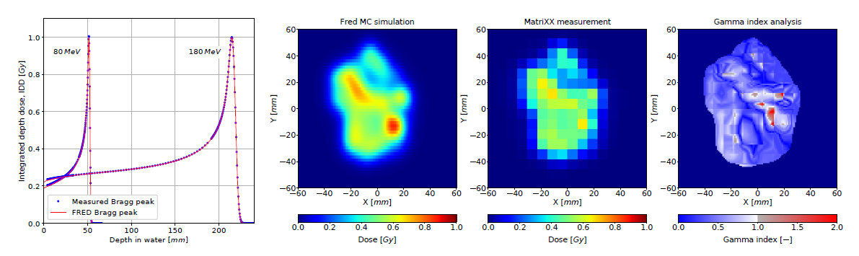
Fig. 2. Integrated depth dose distributions of proton pencil beams simulated in Fred and obtained experimentally during the facility commissioning (left), an ex- ample of transversal 2D dose distribution in isocentre plane obtained from Fred MC simulations (middle left), measured with MatriXX detector in water (middle right) and a GI map computed from simulation and measurement using GI (3%/2 mm) method (right). GI passing rate is 98.64%.
The emittance model, describing lateral beam propagation in air, was im- plemented in Fred, in accordance with the clinical system. The longitudinal and lateral pencil beam shapes are modeled in Fred MC with a submillimeter precision.
We validated the beam model experimentally using the transversal pa- tient treatment plan verification measurements. Such measurements are routinely performed by medical physicists for treatment plan quality assur- ance with an array of 1020 ionization chambers (MatriXX IBA) placed in a water phantom. A transversal dose plane extracted from Fred MC and the dose distribution measured with the MatriXX detector at the same depth in water, as well as the Gamma Index (GI) map obtained from GI test are presented in Fig. 2. The GI passing rate (3%/2 mm criteria) greater than 98% was obtained for 182 dose planes measurements for 10 patients. Based on these results, we can assure that dose distributions of clinical treatment plans can be recalculated accurately.
We are currently performing treatment planning studies to quantify the biological range uncertainties exploring various biological models with vari- able RBE and clinical data of patients treated in Kraków.
An example of a selected Head and Neck (H&N) patient is presented in Fig. 3, where the radiobiological dose distributions computed with con- stant and variable RBE using Fred as well as corresponding Dose Volume Histograms (DVHs) are shown. The MC calculation time for this case was about 10 min (9 108 primary protons, 2 106 p+ tracking rate). The mean dose to Planning Target Volume (PTV), calculated with Fred using variable RBE model proposed by Carabe [8], is increased with respect to the clini- cally applied constant RBE = 1.1 assumption of about 3 Gy(RBE), whereas the maximum dose to the brain stem OAR increases by about 4 Gy(RBE). Our results show that incorporation of the variable RBE model in patient
s
× ×

dose calculation increases the dose in PTV and OAR with respect to con- stant RBE assumption. This is especially important when OARs are very close to or overlap with the PTV as it occurs frequently in H&N patients. Considering variable RBE hypothesis in the proton therapy clinic could be essential as the increased biological dose deposited to OARs that exceeds clinical dose constraints can be potentially associated with the increased normal tissue complication probability and, therefore, an increased risk of necrosis or secondary cancer.
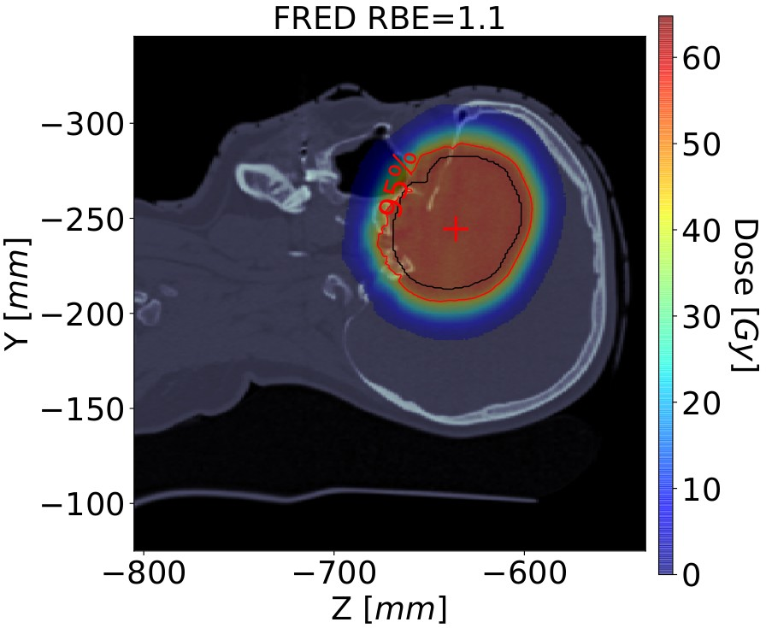
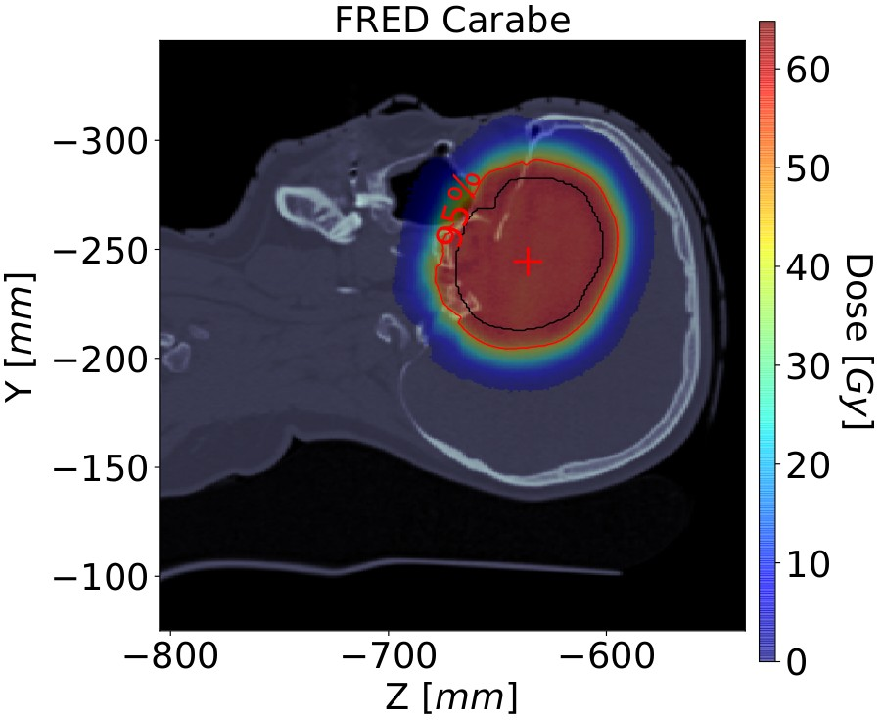
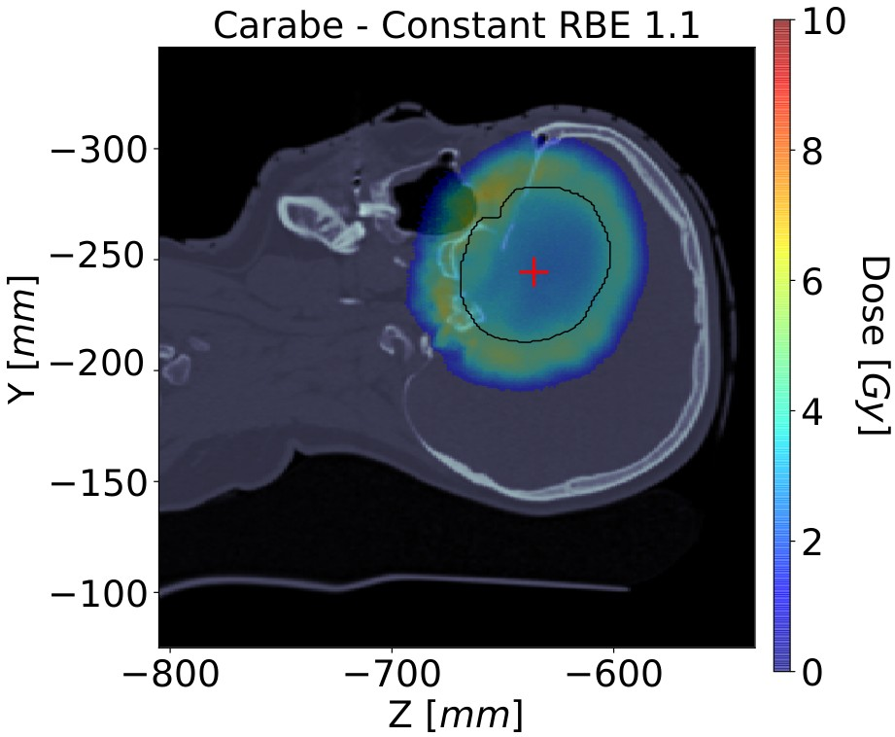
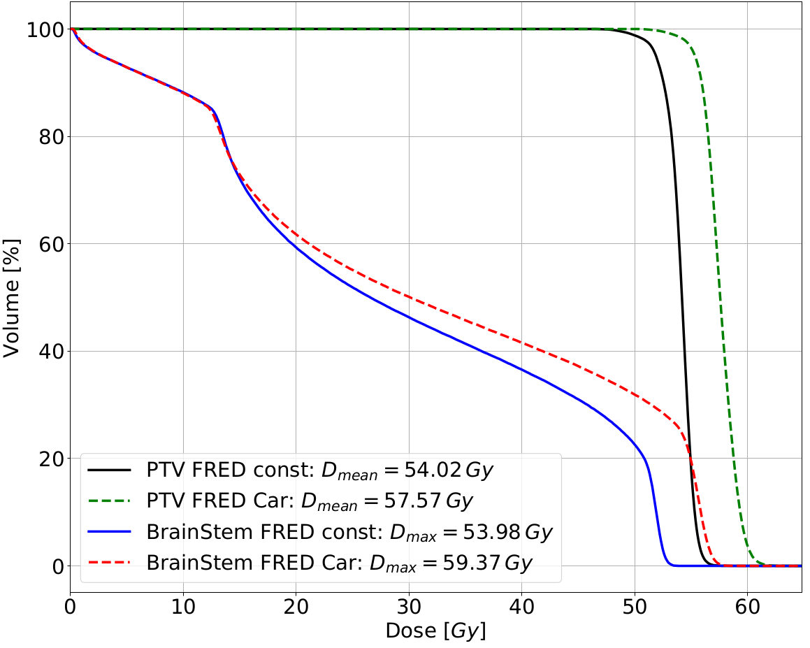
Fig. 3. Left: the RBE-weighted dose with constant RBE = 1.1, middle-left: the RBE-weighted dose with variable RBE (Carabe model [8]), middle-right: dose difference between constant and variable RBE. DVH for constant and variable RBE for PTV and brain stem.
The use of the fast MC dose computation tool Fred for physical and bi- ological dose recalculation of patient treatment plans (retrospectively and prospectively) can provide additional clinical information for medical physi- cists and medical doctors, and can potentially prevent inaccuracies in patient treatment.

J-PET detector to address physical range uncertainties
of proton beams
The proton interactions with patient tissues allow range monitoring dur- ing or just after the treatment detecting emitted secondary radiation. Track- ing of prompt-gamma, PET-gamma, and secondary protons and neutrons are examples [9–11]. Prototype systems for prompt-gamma and PET-gamma range monitoring were tested clinically and obtained satisfying precision of Bragg peak position monitoring on-line in the PBT treatment room [12–14]. At the Jagiellonian University in Kraków, a novel solution for diagnostic PET imaging, Jagiellonian-PET (J-PET) is being developed [15–18].
A single detection unit of the J-PET scanner [19] consists of a 50 cm long and 6 24 mm2 intersection size scintillator strip. The light pulses produced in the strip by 511 keV back-to-back photons propagate to its edges, where they are converted into electrical signals by photomultipliers (PMT). The interaction position of the photon with the detector is estimated from the time difference between the PMT signals located at the ends of the strip.
×

A J-PET module consists of 13 scintillator strips read-out through a sin- gle front-end electronics and an FPGA-based DAQ system. A modular, lightweight and portable design of J-PET enables flexibility in detector con- figuration and easy installation. Increasing the number of J-PET detector layers, increases the detection efficiency of the system.
We performed comprehensive MC simulations using the GATE toolkit [20] and reconstructions of 3D β+ activity distributions using the CASTOR soft- ware [21]. The aim was to characterize the sensitivity of the J-PET for proton beam range detection. We investigated single and multi-layer cylin- drical and dual-head configurations of the J-PET modules that can be pos-
sibly applied for the in-room range monitoring. The list-mode TOF-MLEM reconstruction (5 iterations with 500 ps TOF resolution without regulariza- tion) takes into account random events, scatter, attenuation and normaliza- tion corrections. Eventually, the reconstructed PET-activity profiles can be correlated with the position of dose distal fall-off (Fig. 4, right) and used for proton beam range monitoring.



-200 -150 -100 -50 0 50 100 150
 |  |  |  | 1.0 | 1.0 |  |  |  |  |  |  |  | Deposited dose | 1.0
 |  |  |  | 0.8 | 0.8 |  |  |  |  |  |  |  |  | 0.8
-200 -150 -100 -50 0  Phantom positi | 50 100 150  on [mm] |  |  | 0.6  0.4  0.2 | 0.6  0.4  0.2  0.0 |  |  |  |  |  |  |  |  | 0.6  0.4  0.2  0.0

Phantom position [mm]
0.0
100 75 50 25 0 25 50 75 100
Phantom position [mm]
Dose [A.U.]
 |  | Rec  Prod | onstruct  uced + | ed + ac  activity | tivity

Activity [A.U.]
Fig. 4. The results of MC simulations. Top left: 2D distribution of dose deposited by 150 MeV proton beam in PMMA phantom; bottom left: β+ activity distribution detected in J-PET and reconstructed with CASTOR software; right: dose, β+ production in PMMA, reconstructed signal from β+ activity detected with J-PET.

In this manuscript, we present preliminary results for one of the investi- gated setup configurations, i.e. a single layer J-PET barrel (Fig. 5). Figure 4 illustrates a cross section through the centre of the beam of 3D dose distribu- tion deposited in a 5 5 20 cm3 PMMA phantom by 108 protons of nominal energy 150 MeV (top left) and the same cross section of reconstructed 3D distribution of β+ activity produced by the beam in the phantom (bot- tom left). The activity map was reconstructed in the 5 5 5 mm3 voxel grid. The scintillator strips’ detection efficiency is taken into account in MC simulations. The expected spatial and time resolutions of J-PET with wavelength-shifting strips (WLS) [22] is taken into account through plastic length discretization used in the simulations and image reconstruction.
× ×
× ×

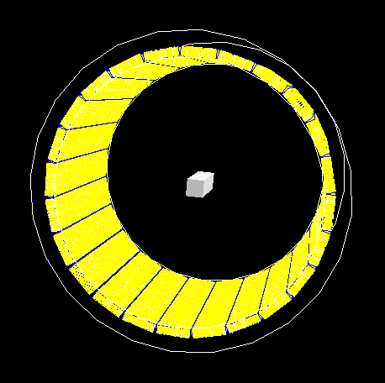
Fig. 5. Single-layer modular J-PET barrel with isocentrically positioned PMMA phantom.

Figure 4 (right) presents the MC simulated profiles of: (i) proton dose deposition in the PMMA phantom, (ii) β+ activity produced in the phan- tom, and (iii) actual signal detected by J-PET barrel from β+ activity. The results show that the J-PET detector is feasible to acquire the β+ activity produced during proton therapy treatment and that the offline 3D recon- struction of PET activity images is possible using the CASTOR toolkit. The characterization of J-PET sensitivity for proton beam range detection is currently an ongoing research activity.

Summary
Within the research projects conducted in the Institute of Nuclear Physics Polish Academy of Sciences in Kraków, we investigate physical and biological range uncertainties of proton beams through positron emission tomography (PET) based solutions and Monte Carlo (MC) simulations. Taking advan- tage of the Fred accuracy and time performance possible due to the GPU acceleration, we aim at improving quality assurance and treatment planing in Kraków PBT facility. A Monte Carlo study of J-PET detector feasibility performed in the frame of the project suggests that this technique might be considered as a novel proton beam therapy range monitoring approach.

The authors acknowledge the Dosimetry and Quality Control Laboratory of CCB for supporting project activities. The Fred Monte Carlo project is carried out within the Reintegration programme of the Foundation for Polish Science co-financed by the European Union under the European Regional Development Fund grant No. POIR.04.04.00-00-2475/16-00. The project on range monitoring with J-PET detector is funded by the National Cen-

tre for Research and Development (NCBiR), grant No. LIDER/26/0157/L- 8/16/NCBR/2017. M.G. and J.B. acknowledge the support within Inter- DokMed programme, project No. POWR.03.02.00-00-I013/16. P.M. ac- knowledges the Foundation for Polish Science for support within TEAM programme, project No. TEAM POIR.04.04.00-00-4204/17. We acknowl- edge the support of NVIDIA Corporation with the donation of the GPU used for this research. A.R. acknowledges Prof. Reinhard Schulte from the Loma Linda University, CA, USA for mentoring and support.

REFERENCES

- M. Durante, R. Orecchia, J.S. Loeffler, Nat. Rev. Clin. Oncol. 14, 483 (2017).
- H. Paganetti, Phys. Med. Biol. 57, 99 (2012).
- H. Paganetti et al., Int. J. Radiat. Oncol. Biol. Phys. 53, 407 (2002).
- A. Schiavi et al., Phys. Med. Biol. 62, 7482 (2017).
- M. Garbacz et al., Proton therapy treatment plan verification in CCB Kraków using Fred Monte Carlo TPS tool, in: IFMBE Proceedings, vol. 68, 2019.
- S. Agostinelli et al., Nucl. Instrum. Methods Phys. Res. A 506, 250 (2013).
- G. Battistoni et al., AIP Conf. Proc. 896, 31 (2007).
- A. Carabe-Fernandez, M. Moteabbed, N. Depauw, H. Paganetti, Phys. Med. Biol. 57, 1159 (2012).
- J. Bauer et al., Radiat. Oncol. 107, 218 (2013).
- J. Krimmer, D. Dauvergne, J.M. Létang, É. Testa, Nucl. Instrum. Methods Phys. Res. A 878, 58 (2018).
- P. Moskal, B. Jasińska, E.Ł. Stępień, S.D. Bass, Nature Rev. Phys. 1, 527 (2019).
- V. Ferrero et al., Sci. Rep. 8, 4100 (2018).
- C. Richter et al., Radiath. Oncol. 118, 232 (2016).
- F. Hueso-González et al., Phys. Med. Biol. 63, 185019 (2018).
- P. Moskal et al., Nucl. Instrum. Methods Phys. Res. A 764, 317 (2014).
- S. Niedźwiecki et al., Acta Phys. Pol. B 48, 1567 (2017).
- P. Moskal et al., Phys. Med. Biol. 61, 2025 (2016).
- P. Moskal et al., Phys. Med. Biol. 64, 055017 (mar 2019).
- P. Kowalski et al., Phys. Med. Biol. 63, (2018).
[20] D. Sarrut et al., Med. Phys. 41, 64301 (2014).
- T. Merlin et al., Phys. Med. Biol. 63, (2018).
- J. Smyrski et al., Nucl. Instrum. Methods Phys. Res. A 851, 39 (2017).

