Acta Poloniae Pharmaceutica ñ Drug Research, Vol. 69 No. 6 pp. 1043ñ1047, 2012
ISSN 0001-6837
Polish Pharmaceutical Society
BINDING OF 1-[3-(4-TERT-BUTYL-PHENOXY)PROPYL]PIPERIDINE, A NEW NON IMIDAZOLE HISTAMINE H₃ RECEPTOR ANTAGONIST TO BOVINE SERUM ALBUMIN
JOANNA SZYMURA-OLEKSIAK1*, AGATA KRYCZYK1, MA£GORZATA SZAFARZ1, WOJCIECH JAWIE—1, DOROTA £AØEWSKA2 and KATARZYNA KIE∆-KONONOWICZ2
1Department of Pharmacokinetics and Physical Pharmacy 2Department of Technology and Biotechnology of Drugs, Faculty of Pharmacy, Jagiellonian University Medical College, Medyczna 9, 30-688 KrakÛw, Poland
Abstract: The degree of binding of a drug to plasma proteins has a significant effect on its distribution, elimi- nation, and pharmacological effect since only the unbound fraction is available for distribution into extra-vas- cular space. The binding of DL76 (1-[3-(4-tert-butyl-phenoxy)propyl]piperidine) to bovine serum albumin (BSA) was studied in vitro by equilibrium dialysis at 37OC and pH 7.4 over the concentration range of 0.32ñ317.18 μM and at a physiological protein concentration of 602 μM. Drug concentrations were determined by validated LC/MS/MS method. Nonlinear regression analyses of the data pointed to a single class of binding sites (m = 1) with a dissociation constant of DL76 equal 49.20 μM. Scatchard plot concave-down curve might indicate positive cooperativity, which was confirmed by the Hill plot with the slope higher than one.
Keywords: protein binding, equilibrium dialysis, DL76, bovine serum albumin
Binding to plasma proteins, playing a pivotal role in distribution, elimination and therapeutic effectiveness of drugs, has long been considered as one of their most important physicochemical char- acteristics. This is because only free (unbound) drug can pass through cell membranes and reach the tar- get site in the body such as an appropriate receptor, transporter or enzyme. Moreover, a knowledge of drugs protein binding properties has become an important issue for understanding pharmacokineti- cally relevant binding phenomena such as displace- ment reaction between different drugs or the signif- icant alteration of plasma protein binding of some drugs during certain pathophysiological states (1). For these reasons, the plasma protein binding parameters should be estimated at the early stage of drug discovery as one of the selection criterion for new drug candidates (2).
Compound 1-[3-(4-tert-butyl-phenoxy)prop- yl]piperidine (DL76) is an example of new non-imi- dazole histamine H3 antagonist. In preliminary phar- macological studies it shows good affinity for H3
receptors (hKi equal 22 ± 3 nM; iodoproxyfan bind- ing assay at human H3 receptor stably expressed in CHO-K1 cells) and ED50 equals 2.8 ± 0.4 mg/kg (central histamine H3 receptor assay in vivo after p.o. administration to mice) (3).
Blockade of the H3 autoreceptors by antago- nists interrupts the negative feedback mechanism and leads to increased levels of histamine and other neurotransmitters. These effects suggest a potential therapeutic role of H3 receptor antagonists in the treatment of several diseases and neurological disor- ders, such as schizophrenia, depression, sleep-wake disorders, dementia or epilepsy (4). A lack of the imidazole moiety in the structure of DL76 may improve its pharmacokinetic profile and increase safety of administration comparing to the imidazole H3 antagonist (5).
Although there are many plasma components
capable of binding drugs (e.g., acid α1-glycoprotein, lipoproteins, globulins, erythrocytes), albumin is present in the highest quantities and is able to bind to a broad variety of drugs with an affinity sufficient
* Corresponding author: e-mail: mfszymur@cyf-kr.edu.pl
1043

1044
JOANNA SZYMURA-OLEKSIAK et al.
to have a significant effect on their pharmacokinetic profile and action (6, 7).
The aim of this study was to evaluate the bind- ing rate of DL76 to bovine serum albumin and to determine its binding parameters such as number of binding sites and affinity constants.
acetate was added. The mixture was shaken on a mechanical shaker for 20 min and centrifuged at 3,000 rpm for 15 min. The organic layer (0.5 mL) was transferred into conical tubes and evaporated to dryness at 37OC under the stream of nitrogen gas in the TurboVap evaporator (Zymark, Hopkinton, MA, USA). The dry residue was reconstituted with 100
μL of acetonitrile/water (50/50, v/v) and aliquot of
10 μL was injected onto the LC/MS/MS system. Extraction recovery of DL76 from buffered protein solutions was high (100%). The limit of detection in the SRM mode was found to be 18.15 nM and the limit of quantification was 36.3 nM. The precision and accuracy for both intra- and inter-day determi- nation of DL76 ranged from 1.65 to 15.09% and from 88.74 to 113.43%, respectively. The linear detection response was observed in the range 36.3 nM ñ 7.27 µM and therefore, the samples with expected higher concentrations were diluted. The concentration of DL76 in the PBS was measured by direct injection into an analytical system without prior purification of the sample.
EXPERIMENTAL
Chemicals
1-[3-(4-tert-Butyl-phenoxy)propyl]piperidine as a monobasic oxalate was supplied from The Department of Technology and Biotechnology of Drugs (Faculty of Pharmacy, Jagiellonian University Medical College, KrakÛw, Poland). Pentoxifylline (3,7-dimethyl-1-(5-oxohexyl)-3,7- dihydro-1H-purine-2,6-dione, PTX), used as an internal standard and bovine serum albumin (BSA) BioChemika (fraction V, = 96%) were obtained from Sigma Aldrich (St. Louis, MO, USA) and a molecular weight of 66430 g/mol for the BSA was assumed. HPLC grade acetonitrile, water, formic acid and ethyl acetate were purchased from Merck (Darmstadt, Germany). The phosphate buffer solu- tion 0.067 M (PBS) was adjusted to the desired pH (7.4 ± 0.05) by an addition of hydrochloric acid or sodium hydroxide.
Binding study
The binding of DL76 to BSA was determined by equilibrium dialysis method using Fast Micro- Equilibrium Dialyzer consisting of two chambers with compartment volume of 500 μL each, separat- ed by semi permeable regenerated cellulose dialysis membrane with a molecular weight cut-off of 10,000 Da (Harvard Apparatus, Holliston, MA, USA). One chamber contained various initial con- centrations of DL76 (range 0.32ñ317.18 mM) dis- solved in isotonic phosphate buffer (pH 7.4) and the other buffered isotonic solution of physiological concentration of BSA (602 μM). The dialysis was performed for 3 h (time to equilibrium ) at 37OC under a constant stirring at 100 rpm. After comple- tion of dialysis, the concentrations of DL76 were measured in both chambers using analytical method described above. Time to achieve the equilibrium state was determined experimentally during prelim- inary studies by analyzing the concentration of DL76 in both chambers of the dialyzer (DL76 in buffer against BSA in buffer) at increasing time periods. When no change in the concentration of DL76 in both chambers was detected between sev- eral time points, an equilibrium state was assumed to be reached. Assays were repeated three to five times, and the average values of concentrations were used to calculate binding data.
In order to eliminate some of the possible experimental errors, drug stability and its adsorption to the dialysis system were tested. The stability of
DL76 concentration assay
The quantitative measurement
of DL76 in
albumin and buffer solution was made by validated LC/MS/MS method, according to the procedure described previously (8). The method was adopted to the modified matrices. LC/MS/MS system con- sisted of high performance liquid chromatograph Agilent 1100 (Agilent Technologies, Waldbronn, Germany) and triple quadrupole mass spectrometer API 2000 (Applied Biosystems MDX Sciex, Concorde, Ontario, Canada) equipped with an elec- trospray ionization interface (ESI). ESI ionization was performed in the positive ion mode. The mass spectrometer was operated in selected reactions monitoring mode (SRM) monitoring the transition of the protonated molecular ions m/z 276 to 98 for DL76 and 279 to 181 for internal standard (PTX). Chromatographic separation was carried out with a XBridgeôC18 (2.1 ◊ 30 mm, 3.5 µm, Waters, Ireland) analytical column. The mobile phase con- sisted of acetonitrile/water (v/v) with an addition of 0.1% of formic acid, was set at the flow rate of 300
µL/min and the gradient elution was used. A 100 μL aliquot of phosphate buffered saline containing BSA and unknown concentration of DL76 was briefly mixed with the 10 μL of IS and then 1 mL of ethyl
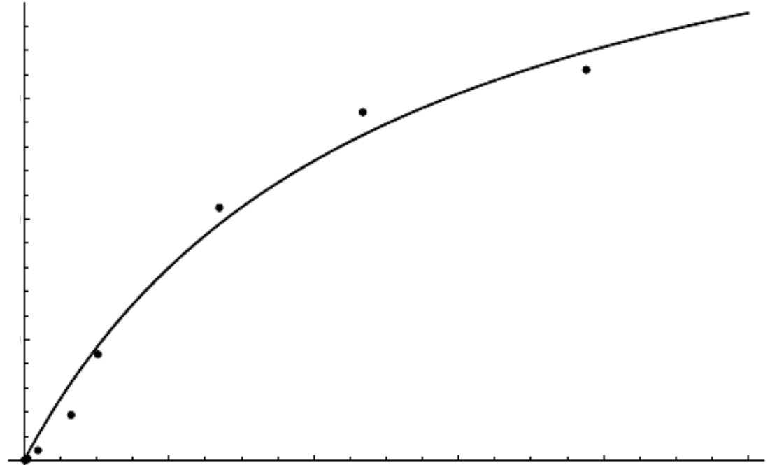
1045
Binding of 1-[3-(4-tert-butylphenoxy)propyl]piperidine, a new non imidazole...
ni ∑ Cu
DL76 was tested for 6 h at temperature of 37OC at the low (0.79 μM) and high (237 μM) concentra- tions. The study was based on the determination of the concentration of DL76 in the freshly prepared samples and after 6 h of incubation at 37OC. The sta- bility was expressed as a percentage ratio of the con- centrations of incubated sample/freshly prepared sample. The DL76 was considered to be stable if less than 5% difference in concentration was observed. The possibility of adsorption of the inves- tigated compound to the dialysis system and mem- brane was determined by comparing the amount of DL76 added to one chamber before dialysis to the one calculated based on the concentrations meas- ured post-dialysis (buffer with DL76 against buffer) on both sides of the dialysis membrane .
m
r = Σ ñññññññññ
(3)
Kdi + Cu
i=1
where r = number of moles of drug bound per mole of protein (Cb/Pt; Pt is a total protein concentration); m = number of independent classes of binding sites; Kdi = dissociation constant for the i-th class and ni = number of binding sites in the i-th class.
In the regression analysis several factors were taken into consideration such as possible presence of one or two classes of binding sites as well as non- specific binding (NSB). The final model used for description of albumin binding characteristics of DL76 was selected based on goodness-of-fit criteria such as Akaike Information Criterion (AIC) value.
The binding data of DL76 were also analyzed using Scatchard transformation where a curve was produced by plotting r/Cu versus r.
Data analysis
The fraction of DL76 bound to BSA (fb) was determined by the following equation:
RESULTS AND DISCUSSION
fb = (Ct ñ Cu)/Ct
(1)
DL76 is a new compound, therefore, its protein binding parameters have not been reported previ- ously. To evaluate the binding characteristics of this compound to the main plasma protein i.e., albumin, the equilibrium dialysis method was used. This method is considered to be the reference method from among all the other techniques used for the determination of protein binding (9). Time to reach the equilibrium state is one of the most important variables in the equilibrium dialysis and in this experiment it was quite short and equals 3 h at the
where Ct = total concentration of drug in the albu- min solution at equilibrium and Cu = unbound drug concentration in the chamber without albumin at equilibrium.
The bound drug concentration was calculated using a formula:
Cb = Ct ñ Cu
(2)
Binding parameters were determined by non-
linear
regression
method
using
Wolfram
Mathematica 7 to fit the data to equation:
Figure 1. Binding plot of mean (n = 3ñ5) bound (C_{b}) versus mean free (C_{u}) concentration values of DL76 to bovine serum albumin (phys- iological concentration of 602 μM) estimated at 37OC by equilibrium dialysis technique. The experiment was carried out over the DL76 concentration range of 0.32ñ317.18 μM at pH 7.4
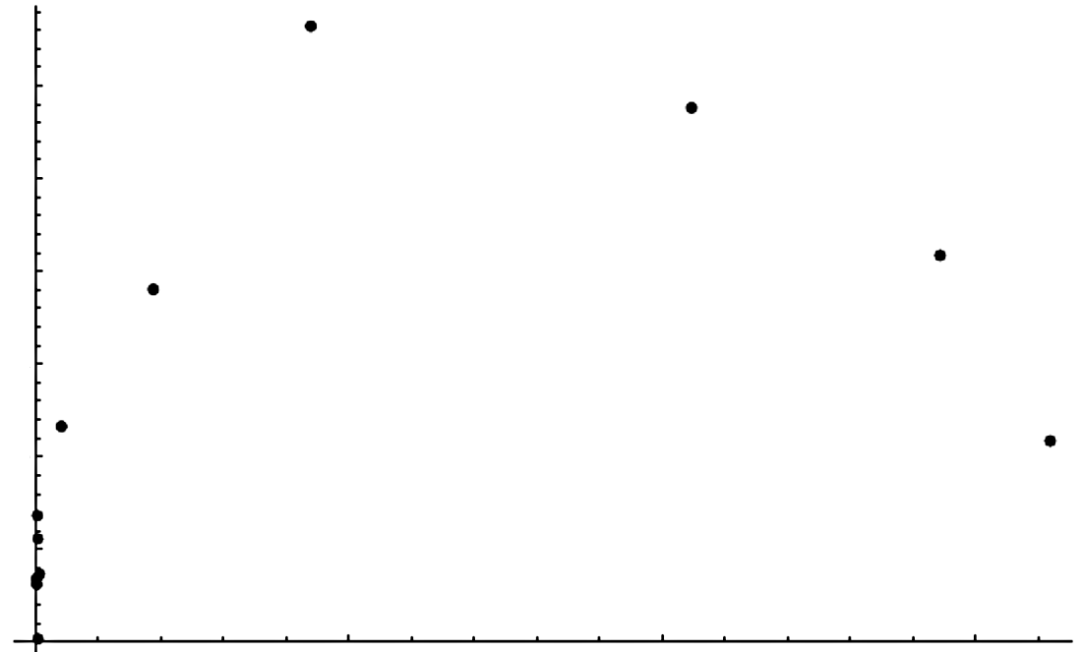
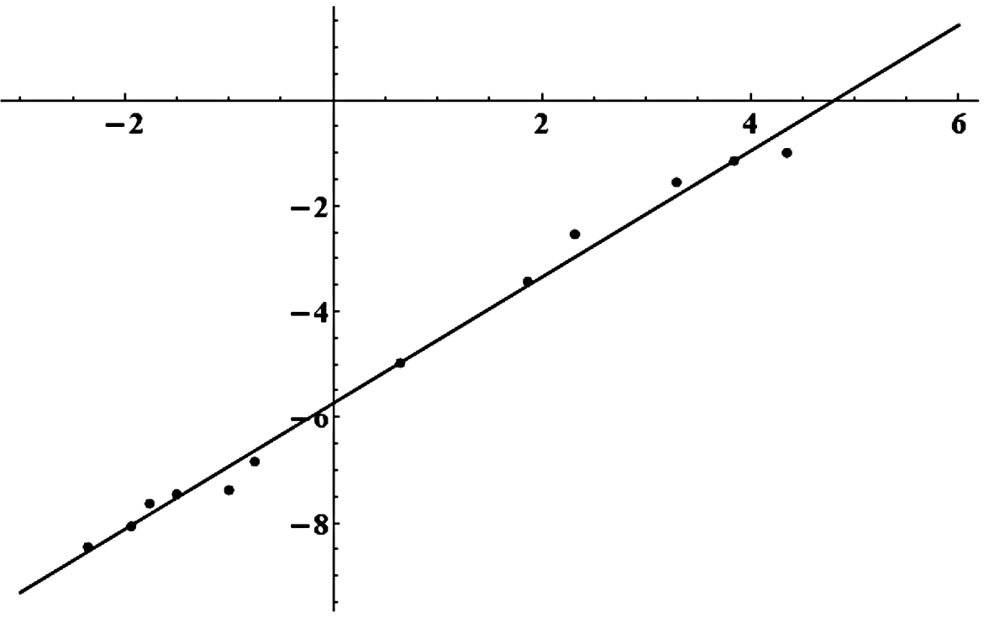
1046
JOANNA SZYMURA-OLEKSIAK et al.
temperature of 37OC. DL76 was determined to be stable during the whole experiment and its adsorp- tion to the dialysis system was below 3%.
The binding plot of DL76 to BSA (602 μM) is presented in Figure 1. The plot was obtained by sub- sequent iterations using one class of binding sites with or without nonspecific binding site or two classes of binding sites. The AIC values for these
three models of DL76 albumin binding were ñ70.66; ñ68.66 and ñ66.66, respectively. The lowest value of AIC indicates the best fitting of data to the one class of binding sites (m = 1) with Kd value equal
49.20 μM and n equal 0.459.
The binding association constant of DL76 (Ka) with BSA being a reciprocal of Kd equals 2.03 ◊∑104 M-1. It was found that the highest percentage of albu-
Figure 2. Scatchard plot for binding of DL76 to BSA (602 μM). The results are the mean of 3ñ5 measurements. The concave downwards curve is characteristic of positive cooperativity binding. Abbreviations and symbols: C_{u} ñ unbound compound concentration, C_{b} ñ bound compound concentration
Figure 3. Hill plot for binding between DL76 and BSA. A value of Hill coefficient (slope) above 1 indicates the presence of positive coop- erativity in the binding of DL76 to BSA. Abbreviations and symbols: C_{u} ñ unbound compound concentration, C_{b} ñ bound compound con- centration, P_{t} ñ protein concentration (602 μM)

1047
Binding of 1-[3-(4-tert-butylphenoxy)propyl]piperidine, a new non imidazole...
min protein binding of DL76 near the saturation level calculated from the equation (1) was about 80%. These data may indicate that DL76 with its physicochemical characteristics (basic with pKa =
9.15 and lipophilic with logP = 4.97) belongs to the group of compounds that highly bind to the BSA with moderate affinity in a typical range of 02ñ104 M-1 (10).
The results of Scatchard analysis of the bind- ing data are presented in Figure 2. A concave- down curve may indicate the presence of positive cooperativity, which takes place when the binding of a ligand at one site increases the affinity of a separate ligand molecules for binding at another site (11). One the mechanisms of this phenomenon may be an allosteric communication between binding sites (12).
One of the methods used for the differentiation of cooperativity (positive or negative) is the Hill slope analysis presented in Figure 3. The Hill curve was produced by plotting ln (Cb/(Pt ñ Cb)) versus ln Cu. A value of Hill coefficient above 1 confirms the presence of positive cooperativity (13). This coeffi- cient also expresses the average number of interact- ing sites. In presented study, value of the Hill slope was determined to be 1.19, which verifies the posi-
in approximately 80%, and that there is a positive cooperativity (Hill slope above 1) in the binding process between DL76 and BSA. Using non linear regression analysis, the lowest value of AIC indi- cates the best fitting of data to the one class of bind- ing sites (m = 1) with moderate protein binding of DL76 (Kd value equal 49.20 μM and n equal 0.459). The received results give an important infor- mation about DL76 compound and can help in the interpretation of some pharmacological and pharma- cokinetic data. They also may be a source of useful information for scientists seeking new compounds
in this chemical group.
REFERENCES
1.
Schmidt S., Gonzalez D., Derendorf H.: J. Pharm. Sci. 99, 1107 (2010).
Wan H., Bergstrˆm F.: J. Liq. Chromatogr. Relat. Technol. 30, 681 (2007).
£aøewska D., Ligneau X., Schwartz J.C., Schunack W., Stark H., Kiec-Kononowicz K.: Bioorg. Med. Chem. 14, 3522 (2006).
Gemkow M.J., Davenport A.J., Harich S., Ellenbroek B.A., Cesura A., Hallett D.: Drug Discov. Today 14, 509 (2009).
Stark H., Kathmann M., Schlicker E., Schunack W., Schlegel B., Sippl W.: Mini Rev. Med. Chem. 4, 965 (2004).
Otagiri M.: Drug Metab. Pharmacokinet. 20, 309 (2005).
Maruyama K., Nishigori H., Iwatsuru M.: Chem. Pharm. Bull. 34, 2989 (1986).
Szafarz M., Szymura-Oleksiak J., Lazewska D., Kiec-Kononowicz K.: Chromatographia 73, 913 (2011).
Vuignier K., Schappler J., Veuthey J.L., Carrupt P.A., Martel S.: Anal. Bioanal. Chem. 398, 53 (2010).
Wright J.D., Boudinot F.D., Ujhelyi M.R.: Clin. Pharmacokinet. 30, 445 (1996).
Flether J.E.: J. Phys. Chem. 81, 2374 (1977).
Whitty A.: Nat. Chem. Biol. 4, 435 (2008).
Whitehead E.P.: Biochem. J. 171, 501 (1978).
Ferrell J.E. Jr.: J. Biol. 8, 53 (2009).
Notides A.C., Lerner N., Hamilton D.E:. Proc. Natl. Acad. Sci. USA 78, 4926 (1981).
Maitre M., Rumigny J.F., Mandel P.: Neurochem. Res. 8, 113 (1983).
Cook R.A., Koshland D.E. Jr.: Biochemistry 9, 3337 (1970).
2.
3.
4.
tive cooperativity and, in addition, indicates existence of two binding sites interacting in process of binding DL76 to BSA.
the the
5.
The classic example of positive cooperativity is oxygen binding to hemoglobin (14). This kind of reciprocal action was proven to exist also in other biological systems. It is suggested in the estrogen receptor α-estradiol interaction at high level of receptor concentration or for interaction of γ- hydroxybutyric acid with the membrane of rat brain (15, 16). Moreover, positive and negative coopera- tivity was found in an analysis of binding of nicotin- amide-adenine dinucleotide to yeast glyceralde- hyde-3-phosphate dehydrogenase (17).
Based on these examples is can be concluded that phenomenon of positive cooperativity may play an important role not only in the plasma protein binding of different compounds but also in their interaction with other proteins e.g., receptors and enzymes.
6.
7.
8.
9.
10.
11.
12.
13.
14.
15.
CONCLUSIONS
16.
The presented study reports the plasma albu- min binding characteristics of DL76 compound. From the obtained data it can be concluded that investigated compound binds to the plasma albumin
17.
Received: 04. 08. 2011

