

Availableonlineatwww.sciencedirect.com
ScienceDirect

EnergyProcedia59(2014)418–424

EuropeanGeosciencesUnionGeneralAssembly2014,EGU2014

Impactofgasstorageonreservoirrocks–long-termstudytoinvestigatetheeffectsonmineralcontentandfluidchemistry

MonikaKasinaa,b,DariaMorozovaa,MarekMichalikb,DieterPudloc,
HilkeWuerdemanna*

aGermanResearchCentreforGeosciencesGFZ,Section4.5Geomicrobiology,14473Potsdam,Germany
bInstituteofGeologicalScience,JagiellonianUniversity,30-063Krakow,Poland
cFriedrich-Schiller-UniversityJena,InstituteofGeosciences,Burgweg11,D-07749Jena,Germany

Abstract

Tostudytheeffectsofgasstorage,long-termautoclaveexperimentswithrockcoresoriginatingfromanaturalgasreservoirandbrinestakenfromagaswellwereconductedat40barand80oCinaCO2atmosphere.WhilethemainmineralcompositionofthesandstoneswasnotaffectedduetoCO2exposureoveraperiodof31months,thedissolutionofrock-formingmineralssuchasfeldspar,quartzorpore-fillinganhydriteandcalcitewasnoted.Changesinthebrinecompositionwerealsodetected.Areleaseofironandtotalorganiccarbon(TOC)fromtherocksamplestothesalinefluidwasobserved.Temporarychangesintheaceticacidconcentrationmighthavecontributedtothedissolutionprocesses.Precipitationanddissolutionofmineralsinsandstonesweremostlyrelatedtodiageneticfluid-rockreactionsandCO2exposure,butingeneraltheimpactofCO2onrockcompositionwasonlyminor.

©2014TheAuthors.PublishedbyElsevierLtd.
Peer-reviewunderresponsibilityoftheAustrianAcademyofSciences.

©2014TheAuthors.PublishedbyElsevierLtd.ThisisanopenaccessarticleundertheCCBY-NC-NDlicense(http://creativecommons.org/licenses/by-nc-nd/3.0/).
Peer-reviewunderresponsibilityoftheAustrianAcademyofSciences

Keywords:CO2storage;mineral-brineinteraction;mineraldissolutionandprecipitation.

*Correspondingauthor.Tel.:+493312881516;fax:+493312300662.
E-mailaddress:wuerdemann@gfz-potsdam.de

1876-6102©2014TheAuthors.PublishedbyElsevierLtd.ThisisanopenaccessarticleundertheCCBY-NC-NDlicense(http://creativecommons.org/licenses/by-nc-nd/3.0/).
Peer-reviewunderresponsibilityoftheAustrianAcademyofSciencesdoi:10.1016/j.egypro.2014.10.397

Introduction

ThetransitionoftheenergysupplyfromnuclearandCO2-emittingpowerplantstorenewableenergyisfundamentalforsustainableenergygenerationinthefutureandimportantformitigatingclimatechangesduetogreenhousegasemissions[1].Atransitiontorenewableenergysourcesrequireslarge-scaleenergystoragecapacitiesduetofluctuationinenergysupply.Newstoragetechnologiesarenecessarytomakethistransitionsuccessful.Onepossiblemethodofstoringexcessenergyistotransferittohydrogenormethane,whichcansubsequentlybeinjectedandstoredinsubsurfaceporousrockformationslikedepleted-gasreservoirsandpresentlyusedgasstoragesites[2].Thisallowsthestorageoflargeamountsofenergy.However,processessuchasthemigrationofreservoirfluidstotheupperformations,possibleleakagesofinjectedgases,groundwatercontaminationandgeochemicalaswellasbiologicalchangesarepossible[3].Thereforeitisnecessarytounderstandandpredictprocessesthatmightaffectstorageefficiencyandtheenvironment.
Inordertoinvestigatethefeasibilityofhydrogenstorageinthesubsurface,thecollaborativeprojectH2STORE(“hydrogentostore”)wasinitiated[2].Inthescopeofthisproject,potentialreactionsbetweenmicroorganisms,fluidsandrocksinducedbythestoredgasarestudied.Ingasstorage,CO2canbeusedasapillowgas,thereforeitisimportanttoincreasetheknowledgeconcerningtheeffectsofCO2onthereservoirrocksandthechemicalcompositionofreservoirfluids.Potentialgeologicalreservoirsforgasstoragecontaincomplexgeochemicalsystems,includingabroaddiversityofmineralsandbrines.Changesinthereservoirconditionsarisingfromthestorageprocessmayinfluencetheefficiencyaswellasthelong-termsafetyofgasstorageinthesubsurface.
InordertostudythechangesinthemineralcompositionandthefluidchemistryundertheinfluenceofCO2exposure,long-termlaboratoryexperimentswereperformed.TheaimofthestudyistomonitortheeffectsofCO2exposureonmineralsandreservoirbrinesusingchemicalanalyses,scanningelectronmicroscopywithenergydispersivespectrometer(SEM-EDS)andX-Raydiffractionanalyses.

MaterialsandMethods

  - Studyareaandsampling

ThestudieddepletednaturalgasreservoirsiteislocatedintheNorthGermanBasinatadepthofabout3500
m.Thebrineischaracterizedbyasalinityofupto420gL-1.Thereservoirpressureis200barandthetemperaturevariesbetween120and130°C.ItconsistsofRotliegendsedimentaryrockscomposedoflaminatedclaystones,siltstonesandsandstones[4].
Thesandstonesamplesfromthereservoirwerecollectedfromthecorerepository.Adetaileddescriptionofthesandstonesisgivenby[5]and[6].Theexperimentsamplesweremilledtoasizeof0.5cm.Freshbrinesampleswerecollectedfromthereservoirbydownholesampling(Erdöl-ErdgasWorkoverGmbH)atdepthsbetween3000and3500m.Adetaileddescriptionofthefluidsamplingprocedureisavailablein[7].Thefluidsweretransferredasepticallyintosterilizedglassvials,refrigeratedto4°Candimmediatelytransferredtothelaboratory.Chemicalanalysesofthereservoirbrinewereperformedpriortothelong-termexperimentsandaresummarizedin[7].

  - Set-upoftheexperiment

Milledrocksamplesandreservoirfluidswereincubatedincorrosion-resistanthigh-pressurevesselstoapplyelevatedtemperaturesandpressureconditions.Thepressurevesselswerecleanedwitharinsingagentandpurewateranddriedovernightat105°Cinanoven.Priortotheexperiment,pressurevesselsweredisinfectedwitha1%NaOClsolution.Incubationwasperformedat80°Candapressureof40barwith150mLofreservoirfluidand100gofrock.Afteranequilibrationperiodofthreemonthswiththesalinefluids,themilledsampleswereexposedtoCO2for2.5years.OnesamplewasexposedtopureN2asacontrol.Twosamplingserieswereperformed,after11and31monthsofCO2exposure.Fromeachvessel10mLoffluidand5gofrockpiecesweresampledforchemicalandmineralogicalanalysesrespectively.

  - Analyticalmethods

    - Chemicalanalysesofthebrine

Cationsandanionsinthesalinefluidsweredetectedusinginductivelycoupledplasma–massspectrometer(ICP-MS)andinductivelycoupledplasmaoptical–emissionspectrometry(ICP-OES)methods.Theorganicacidconcentrationwasmeasuredusingagaschromatographymassspectrometry(GC/MS),andtheTOCwasanalyzedusingacarbonanalyzer(DIMATECGmBH,Essen,Germany)accordingtotheDINEN1484-H3norm.

    - Mineralogicalanalyses

Priortotheanalyses,thesampleswerewashedusingdistilledwaterinordertoremovesaltfromtherocksurfaceandsubsequentlydriedintheovenat50°Candcrushed.Inaddition,forx-raypowderdiffraction,samplesweremilledinanagatemilltothefraction<0.02mm.
ToidentifythemainmineralcomponentsbeforeandafterCO2exposurex-raypowderdiffraction(XRD)wasused.AdiffractometerBruker-axsD5000with2Thetagoniometerwasapplied.Theanalyticalrangeusedforanalyseswas15–65ș,VWHSwidth0.02°,andthetime1s/step,XVLQJD&X.ĮUDGLDWLRQ.Forphaseidentification,theDIFFRACplussoftwarewasused.Sampleswerepressedintoanalyticalcuvettes.
Tocharacterizethestructureandthespatialrelationshipbetweenrockcomponentsaswellasthemineralphasesandtheirchemicalcompositionascanningelectronmicroscope(SEM)HitachiS-4700wasused.Quantitativeanalysesofthechemicalcompositionofthemineralswereperformedusinganenergydispersivespectrometer(EDS).ToidentifyelementstheanalyticalsoftwareNSS2.2wasapplied,whichprovidedspotanalysisofthechemicalcompositionofthesamplesandadistributionofelements.Resultswererecalculatedto100%accordingtothestandardlessquantificationprocedureusingtheoptionofautomaticormanualsearchofelements.Thesandstonepieceswerecarboncoatedandexaminedwithascanningelectronmicroscopeoperatingatanacceleratingvoltageof20kV,usingthesecondaryelectron(SE)signals.

Results

  - Changesinchemicalcompositionofthebrine

After31monthsofincubationat40barand80oC,changesintheconcentrationofsomemajorandminorelementsinthebrinewerenotedinallvesselsexposedtoCO2.However,mostofthechangeswereintherangeoftheaccuracyofthemethods,e.g.forthemajorityofheavymetals.Asanexampleforsuchminorvariationinmajorelementcontent,Fig.1showsthevariationsofcalciumconcentrationsmeasuredafter11and31months.Adistinctincreaseinironconcentrationsinthesalinefluidwasobservedinmostofthevessels(Fig.1).Whiletheironincreasewasinaverage30%after11monthsofCO2exposure,theconcentrationwasonlyabout20%higherreferringtothebaselineafter31months,exceptforvessel6.Forvessel6,weobservedadecreaseof25%referringtothebaseline.Inthecontrolvesselexposedtonitrogen(N2)adecreaseinironconcentrationof30%wasdetectedinbothsamplings.Theconcentrationofaceticacidincreasedtemporarilyinmostofthevessels,exceptno.5and7,andafter31monthsitdecreasedtothelevelbeforeCO2exposure.Thetotalorganiccarbon(TOC)concentrationincreasedbyafactorofthreeafter11monthsandremainedonthisleveluntiltheendoftheexperiment,exceptforvessel1.However,inthecontrolvesseltheTOCconcentrationincreasedbyafactorof10after11monthsofexposureandbyafactorof40after31months(Fig.1).ThepHremainedat5.5duringthewholeexperimentinallvessels.

600
80000

400
Iron[mgL-1]

348
60000

40000
Calcium[mgL-1]

53900

200

20000

0

-1
Control
0

1 2 3 4 5 6 7
0
Control

-1
0

1 2 3 4 5 6 7

8
N2 CO2CO2CO2CO2CO2CO2CO2
N2 CO2CO2CO2CO2CO2CO2CO2

3500

8
150

1000
Totalorganiccarbon[mgCL-1]

750

100 96
Aceticacid[mgCL-1]

500
50

250

0

-1
Control
0

1 2 3 4 5 6 7
79,2

0

-1
Control
0

1 2 3 4 5 6 7

8
N2 CO2CO2CO2CO2CO2CO2CO2
N2 CO2CO2CO2CO2CO2CO2CO2

Fig.1.Iron(red);calcium(violet);totalorganiccarbon(TOC)(green)andaceticacid(brown)concentrations

8
-----beforeexperiment,after11months(cubes)andafter31months(filledcubes)

  - MineralcompositionofsandstonesbeforeandafterCO2exposure.

ThemainmineralsdeterminedinsandstonesusingXRDarequartz,albite,K-feldspar,calcite,dolomiteandanhydrite.Thecompositiondidnotchangeduringthe31monthsofCO2exposure(Fig.2).However,somechangeswerenotedintherelativepeakintensities,mostprobablyindicatingsomedissolutionandcrystallizationofminerals.SEManalysisshowedexamplesofdissolutionofK-feldspar(Fig.3a)andpore-fillinganhydriteaswellastheprecipitationofsecondaryalbite(Fig.3b),quartzandclaymineralsintheporespacesandontheauthigenicminerals.

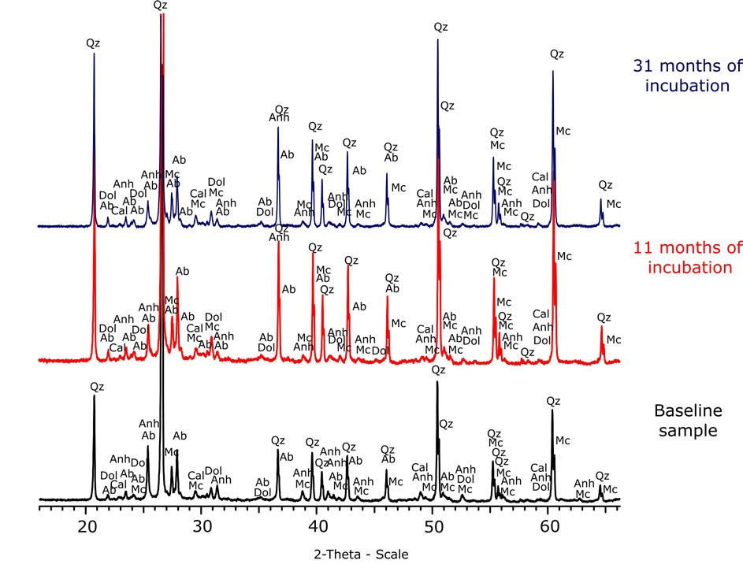

Fig.2.X-Raydiffractionpatterns.Qz–quartz,Ab–albite,Mc–microcline,Anh–anhydrite,Cal–calcite,Dol–dolomite.Verticalscaleisrelative.Lin(counts)intherangeofdozensofthousandscounts

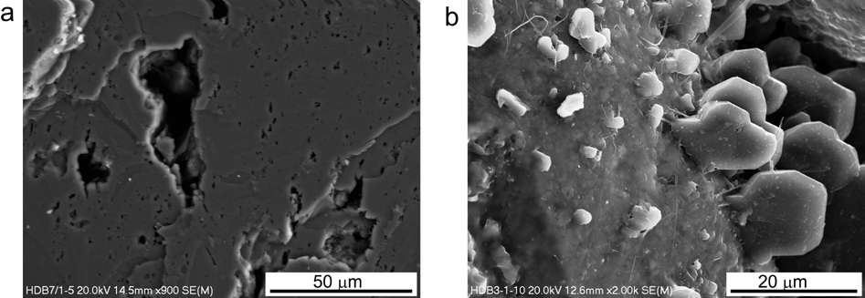

Fig.3.SEM-SEpicturesofdissolutionpitsinK-feldspar(a);newlyprecipitatedalbite(b);

Discussion

Long-termCO2exposureatatemperatureof80ºCandapressureof40bardidnotaffectthemainmineralcomponentsofthesandstonesoveraperiodof31months.However,slightchangesinXRDpeakintensityindicatetheinitialdissolutionofsilicateslikefeldsparandquartzandcementssuchasanhydrite,calciteanddolomiteaswellastheprecipitationofsecondaryphasessuchasalbiteorquartz.TheseresultswereconsistentwiththeSEM-EDSanalyses.Partialdissolutionofsilicateswasalsonotedby[8]afterinjectionofCO2.Furthermore,temporaryincreaseofaceticacidconcentration,observedafter11monthsofCO2exposure,mighthavecontributedthedissolutionofaluminosilicatesorquartzassuggestedby[9].
Thedistinctincreaseinironconcentrationmighthaveresultedfromthedissolutionofcarbonates(iron-containingdolomite),orotherironrichminerals(chlorite,ironoxides).Thedissolutionofcarbonatecementswasalsoobservedinotherstudies[9,10,11].Assuggestedby[8],iron(hydro)oxidesdissolveinaCO2atmosphereandatacidicpH.Similarobservationsweremadeby[12].Theyrelatedtheincreaseinirontothedissolutionofiron(hydro)oxides.Accordingto[13]lowpH(5,5)inthepresenceofCO2caninducemineraldissolutionandthus,metalmobilizationincludingheavymetalsandpotentiallytoxicelements.However,inourstudyonlyslightchangesforheavymetalsandtoxicelementsintherangeoftheaccuracyofthemethodwereobserved.

Conclusionandoutlook

Ingeneral,31-monthsincubationofrocksamplesandreservoirbrineswithCO2at80oCand40bardidnotaffectthesystemstrongly.Precipitationofsecondaryphasesanddissolutionofrockformingmineralsandcementsweremainlyrelatedtofluid-rockreactionsthatwereenhancedbyCO2exposure.Asacontinuationoftheseexperiments,samplesarebeingexposedtoahydrogenatmospheretostudytheeffectsonthereservoirrocks.

Acknowledgements

ThisstudyispartoftheH2STOREprojectsponsoredbytheGermanFederalMinistriesofEducationandResearch(BMBF)andtheCLEANprojectsponsoredbytheGermanFederalMinistryofEducationandResearch(BMBF)withintheframeworkof“"GEOTECHNOLOGIEN”thegeoscientificresearchanddevelopmentprogram.TheauthorswanttothankGDFSUEZE&PDEUTSCHLANDGMBHforprovidingsamplesfortheanalyses.WethanktheVereinfürKernverfahrenstechnikundAnalytik(VKTA)Rossendorfe.V.forprovidingresultsofchemicalanalysesofthesalinefluid.SpecialthankstoMarenWandreyforsetupoftheexperimentandAnneKleyböckerandSebastianTeitzforhelpfulcomments.

References

[1]IEA(InternationalEnergyAgency)(2013)WorldEnergyOutlookSpecialReport2013:RedrawingtheEnergyClimateMap.OECD/IEA,
Paris
[2]PudloD,GanzerL,HenkelH,KühnM,LiebscherA,DeLuciaM,PanfilovM,PilzP,ReitenbachV,AlbrechtD,WürdemannH,Gaupp
R.TheH2STOREproject:Hydrogenundergroundstorage-afeasiblewayinstoringelectricalpoweringeologicalmedia?2013;6:395-
412.In:HouMZ,XieH,WereP.(eds.):CleanEnergySystemsintheUnderground:Production,StorageandConversion–Proceedingsofthe3rdSino-GermanConference"UndergroundStorageofCO2andEnergy",Goslar,Germany,21-23May2013
[3]BauerS,BeyerC,DethlefsenF,DietrichP,DuttmannR,EbertM,FeeserV,GörkeU,KöberR,WürdemannH,DahmkeA.Impactsoftheuseofthegeologicalsubsurfaceforenergystorage:aninvestigationconcept.-EnvironEarthSci2013;70:3935-3943
[4]LüdersV,PlessenB,RomerRL,WeiseSM,BanksDA,HothP,DulskiP,SchettlerG.ChemistryandisotopiccompositionofRotliegend
andUpperCarboniferousformationwatersfromtheNorthGermanBasin.ChemGeol2010;276:198-208.
[5]PudloD,AlbrechtD,GanzerL,GauppR,KohlheppB,MeyerR,ReitenbachV,WienandJ.Petrophysical,faciesandmineralogical-geochemicalinvestigationsofRotliegendSandstonesfromtheAltmarknaturalgasFieldincentralGermany.EnergyProcedia2011;4:4648-4655
[6]PudloD,ReitenbachV,AlbrechtD,GanzerL,GernertU,WienandJ,KohlheppB,GauppR.Theimpactofdiageneticfluid-rockreactionsonRotliegendsandstonecompositionandpetrophysicalproperties(Altmarkarea,centralGermany).EnvironEarthSci

2012;67:369-384
[7]MorozovaD,WandreyM,AlawiM,ZimmerM,ViehtA,ZettlitzerM,WürdemannH,andCO2SINKGroup.MonitoringofthemicrobialcommunitycompositioninsalineaquifersduringCO2storagebyfluorescenceinsituhybridisation.IntJGreenhGasCon2010;4:981-989.
[8]WigandM,CareyJW,SchüttH,SpangenbergE,ErzingerJ.GeochemicaleffectsofCO2sequestrationinsandstonesundersimulatedinsituconditionsofdeepsalineaquifers.ApplGeochem2008;23:2735-2745
[9]HuangWH,KellerWD.Dissolutionofrock-formingsilicatemineralsinorganicacids:Simulatedfirst-stageweatheringoffreshmineralsurfaces.AmerMiner1970;55:2076-2904.
[10]PokrovskyOS,GolubevSV,SchottJ.Dissolutionkineticsofdolomiteandmagnesiteat25°Cand0to50atmpCO2.ChemGeol2005;217:239-255.
[11]Pudlo,D.,Henkel,S.,Enzmann,F.,Heister,K.,Werner,L.,Ganzer,L.,Reitenbach,V.,Albrecht,D.,Gaupp,R.Therelevanceofmineralmobilizationand–dissolutiononthereservoirqualityofsandstonesinCO2storagesites.EnergyProcedia,EGU2014,submitted.
[12]KharakaYK,ColeDR,HovorkaSD,GunterWD,KnaussKG,FreifeldBM.Gas–water–rockinteractionsinFrioformationfollowingCO2injection:implicationsforthestorageofgreenhousegasesinsedimentarybasins.Geology2006;34:577-580.
[13]VaradharajanCh,TinnacherRM,PughJD,TrautzRC,ZhengL,SpycherNF,BirkholzerJT,Castillo-MichelH,EspositoRA,NicoPS.A
laboratorystudyoftheinitialeffectsofdissolvedcarbondioxide(CO2)onmetalreleasefromshallowsediments.IntJGreenhGasCon2013;19:183-211.

