Stroke rehabilitation conducted by PNF method,
with and without the application of botulinum toxin
- case reports

Rehabilitacja poudarowa metodą PNF, z zastosowaniem
i bez zastosowania toksyny botulinowej - opisy przypadków

Szymon Pasiut#, Marta Banach*, Krystyna Longawa*, Filip Windak*
Key words
spasticity, therapy, locomotion, amplitude, gait
Summary
One of the most common diseases of the nervous system is stroke. Its most frequently occuring kinetic symptoms are paresis or paral-
ysis accompanied by an increase in muscular tension called spasticity. For patients and their carers these disturbances become a prob-
lem in many aspects of their everyday life, especially in locomotion. New ways need to be looked for to create therapies that could
decrease or remove spasticity and restore the function which was disrupted. Therapy by botulinum toxin has been used as a meth-
od of decreasing spasticity to treat children with cerebral palsy having equines-varus foot, and it proves to be a breakthrough in the
treatment of diseases with increased muscular tension. Owing to it, a range of mobility increases, for example in an ankle and knee
joints, which facilitates locomotion. This improvement is caused by both pharmacological action, and assisted kinesitherapy. Propro-
ceptive Neuromuscular Facilitation (PNF) is considered to be especially effective rehabilitation method based on neuro-physiological
mechanisms. This method in the therapy of adults, along with the application of botulinum toxin, seems to facilitate physical activity
of the patient after stroke, which may be very important for secondary stroke prevention. The aim of the research was to assess the
influence of the therapy by PNF method associated with a botulinum toxin application on the patients after stroke with spasticity in
lower limbs. During gait the patients had the flexion of ankle and knee joints measured by means of VICON system with the special
focus on the amplitude of angular values. All patients presented in this description of cases showed an improvement in most of the
measured parameters, in both a four-week and a three-month period after the therapy. The results show a necessity to carry out fur-
ther randomized control studies of larger groups.
Słowa kluczowe
spastyczność, terapia, lokomocja, amplituda, chód
Streszczenie
Jedną z częściej spotykanych chorób układu nerwowego jest udar mózgu. Do najczęstszych objawów ruchowych należą niedowłady
bądź porażenia kończyn, z towarzyszącym wzrostem napięcia mięśniowego, zwanym spastycznością. Dla pacjentów oraz ich opiekunów
zaburzenia te stają się problemem w wielu aspektach życia codziennego, między innymi w lokomocji. Wymaga to poszukiwania
nowych dróg w tworzeniu terapii mogących zmniejszyć bądź znieść spastyczność i przywrócić zaburzoną funkcję. Terapia toksyną
botulinową jako metoda obniżająca spastyczność, jest stosowana do tej pory w terapii dzieci z mózgowym porażeniem dziecięcym
ze stopą końsko-szpotawą i przynosi przełom w leczeniu schorzeń przebiegających z nadmiernym napięciem mięśniowym. Uzysku-
je się poprawę zakresu ruchomości, miedzy innymi w stawie skokowym, a poprzez to ułatwia lokomocję. Poprawa ta uzyskiwana
jest zarówno poprzez oddziaływanie farmakologiczne, jak i prowadzoną równolegle kinezyterapię. Szczególnie skuteczne wydają się
metody rehabilitacyjne oparte na mechanizmach neurofizjologicznych. Jedną z takich metod jest PNF. Zastosowanie terapii metodą
PNF połączone z zastosowaniem toksyny botulinowej u dorosłych wydaje się ułatwiać aktywność ruchową pacjenta po udarze mózgu,
co może być bardzo ważne w profilaktyce wtórnej udau mózgu. Celem pracy było przedstawienie możliwości połączenia i wpływu
terapii metodą PNF skojarzoną z podaniem toksyny botulinowej u pacjentów po udarze mózgu ze spastyczną kończyna dolną. Do-
konano w trakcie chodu pomiaru kąta ugięcia w stawie skokowym i kolanowym biorąc pod uwagę amplitudę ruchu, wykorzystując
system VICON. U wszystkich przebadanych w niniejszym doniesieniu pacjentów odnotowano poprawę większości analizowanych
parametrów, zarówno w okresie czterotygodniowym, jak i czteromiesięcznym. Przeprowadzone pomiary wskazują na konieczność
wykonania randomizowanych, kontrolowanych badań na dużych grupach.
Article from the Faculty of Rehabilitation, Chair of Clinical Rehabilitation, Academy of Physical Education in Cracow#, and the Institute of Neurology,
Jagiellonian University Medical College*, Cracow, Poland
Received 17.01.2005; accepted 11.04.2005
Medical Rehabilitation 2005, Vol. 9, Nr 1 REHABILITACJA 15
mmm
forming this exercise, muscles of
the lower body part were strength-
ened; balance and coordination of
pelvic girdle muscles were also ex-
ercised.
- Combination of shoulder-blade and
pelvis movement patterns - involv-
ing simultaneous raising the shoul-
der-blade and lowering the pelvis
on the exercised side. In the second
phase - the opposite movement is
performed. This exercise serves as
a preparation of the patient for the
alternating effort of the shoulder
and the pelvic girdles, used during
gait;
- From the sitting position on the
couch, the feet resting on the floor
- a movement of the body for-
wards, with separation of the but-
tocks from the coach. Therapist’s
arms initially assisted this move-
ment, however, resisted it subse-
quently, stimulating patient’s anti-
gravitation muscles to a more in-
tensive effort. During returning to
the sitting position, eccentric inhi-
bition by anti-gravitation muscles
was exercised.
- Stabilisation of the erect posture
by approximation of the iliac crest.
Therapist’s arms exert a compres-
sion (approximation) to stimulate
proprioception within the joints of
the lower extremity, which induc-
es an increased activity of the low-
er limb extensor muscles.
- Shifting of the body weight during
taking a step (balance). By load-
ing the paretic extremity, its sta-
bility was trained and thus it was
getting prepared for its supportive
role during walking.
- Walking forwards and backwards
- by means of this exercise, cor-
rectness of particular gait phases
was trained in the patient. Appro-
priate resistance exerted by thera-
pist’s arms aided or stimulated the
effort of the pelvis.
- Walking on steps. The patient was
taught to correctly climb the steps,
which also resulted in a stimulation
of muscles of the lower limb up to
the elevation phase and the sup-
porting phase. It is important that
the therapist constantly secures the
patient from below.
- Walking using the tripod - which
the patient was taught the correct
support-assisted locomotion with.
During this exercise, attention
was paid to a proper movement
sequence (moving the tripod for-
wards, subsequent step with the pa-
retic limb, finally - a step with the
non-affected limb). Taking possibly
greatest advantage of the previous-
ly trained elements is important in
this activity: loading and moving
the paretic extremity.
The rehabilitation was conducted by
certified PNF therapists.

ASSESSMENT METHODS
The movement amplitude of the low-
er extremities and the angular chang-
es in the knee joint and the ankle joint
occurring during movement were as-
sessed by means of a three-dimensional
motion capture system VICON 250A.
The VICON 250 system is used for
spatial measurement and analysis of
the motion of markers attached to the
body of the evaluated subject at sites
corresponding to characteristic bone
points and joint axes. The device con-
sists of five cameras linked to a com-
puter - database. Each camera emits
and receives the light of a visible-in-
frared borderline wavelength captur-
ing a flat image of the marker, at a fre-
quency of 120 Hz (possible regulation
from 60 to 250 Hz). The computer
generates a three-dimensional image
and enables analysis of the collected
study material using appropriate soft-
ware. For the three-dimensional lo-
cation of the markers, each of them
has to be simultaneously captured by
at least two cameras. Measurement
space encompasses the space located
within the cameras’ fields of view. For
capturing patients’ gait, the length of
this space was 10 metres. Each trial
was repeated three times, both during
the gait with the elbow crutch and the
independent gait. The measurements
were taken during barefoot walking.
The most accurate of successively per-
formed measurements were used for
the description of each patient.
The testing procedures began with
patient’s preparation involving the at-
tachment of the retro-reflective mark-
ers directly onto the skin at the fol-
lowing sites (marker symbols are giv-
en in parentheses):
- on the level of the upper border of
the sacral bone (SACR),
- on both anterior superior iliac
spines (LASI and RASI),
- at the lower 1/3, lateral surface of
the thigh (LTHI and RTHI),
- on the lateral aspect of the rim
of the knee joint (LKNEE and
RKNEE),
- at the lower 1/3, lateral surface of
the tibia (LTIB and RTIB),
- at the level of the ankle (talocrural)
joint (LANK and RANK),
- at the level of the calcaneal tuber
(LHEE and RHEE),
- at the level of the first metatarsal
bone (LTOE and RTOE),
- at the level of the fifth metatarsal
bone head (LMT5 and RMT5).
The testing was performed three
times:
- prior to the therapy initiation,
- after termination of the four-week
therapy,
- three months after therapy termi-
nation.
Given that lower limb spasticity can
be the main cause of gait disturbanc-
es in the evaluated patients, motion of
only the following markers: LASI and
RASI, LKNEE and RKNEE, LANK
and RANK and LTOE and RTOE,
used for measurement of angular
changes occurring during successive
testing procedures in the ankle and
knee joints, was subjected to the fi-
nal analysis.
Data analysis was conducted in two
phases. Preliminary preparation of the
results and establishing the markers’
trajectories were performed using the
Work Station module®. Then, subse-
quent data processing was performed
using the Body BuilderC software. An-
gular changes were plotted again us-
ing the Work Station programme.
A System Vicon 250 - manufactured by Oxford Metrics Limited, 14 Minns Estate West Way / Minns Business Park West Way, Oxford OX2 0JB, United Kingdom
B Work Station - a system enabling conversion of images from infrared cameras and their presentation in a form of points moving within a space. Manufac-
turer: Oxford Metrics Limited, 14 Minns Estate West Way / Minns Business Park West Way, Oxford OX2 0JB, United Kingdom
C Body Builder - a computer programme enabling creation of mathematical models of human motor system and biomechanical analysis of the data obtained
using the Work Station system. Oxford Metrics Limited, 14 Minns Estate West Way / Minns Business Park West Way, Oxford OX2 0JB, United Kingdom
18

INTRODUCTION
Despite constantly increasing knowl-
edge, cerebrovascular diseases are still
one of the leading causes of disability
and also mortality1. The life of a per-
son after stroke, as well as the life of
his family and closest friends, chang-
es dramatically because of disabili-
ty of various degrees resulting from
disturbed movement control and al-
tered muscle tone. These phenome-
na, resulting from the upper motor
neurone lesion, induce impairment
of gait, development of pathologi-
cal movement patterns and persistent
contractures and joint deformations.
Pathologically increased, spastic mus-
cle tone, typical for the paretic (para-
lysed) body side, is present, thus lead-
ing to difficulties in performance of
activities of daily living, locomotor ac-
tivity, and in an independent self-ser-
vice. Increased muscle tone is also as-
sociated with a more intense activity
of the non-affected side undertaken to
compensate for the loss of function.
Functional problems are associated
with the following domains: psycho-
logical, intellectual and social, and af-
fect patient’s quality of life to a great-
est extent2,3. The multitude of prob-
lems requires multi-directional thera-
py and rehabilitation.
Physiotherapy is one of the com-
ponents constituting the therapeutic
process. Its role should involve limi-
tation of movement deficits that oc-
curred in the patient, including basic
and complex motor functioning and
self-service4. First of all, physiother-
apy should be directed towards im-
proving patients’ quality of activities
of daily living and patients’ independ-
ence. Important component of such
therapy should involve determining,
in common effort with the patient,
goals adequate to patient’s abilities
and current needs. Patients’ problems
occurring during post-stroke rehabil-
itation, e.g. the dynamics of spasticity
changes, prompt to modify the ther-
apy being carried out, to search for
new paths, as well as to combine ther-
apeutic concepts.
The presented case reports refer to
a problem of combining two methods
used in neurological rehabilitation -
kinesitherapy using the PNF meth-
od and application of the botulinum
toxin. In the presented paper, thera-
py during the late post-stroke period
is described.
The PNF (Proprioceptive Neu-
romuscular Facilitation) is a method
used in post-stroke treatment, where
the functional therapy is a process of
gradual restitution of patient’s mo-
tor abilities5,6,7. It is a method of neu-
romuscular dysfunction treatment,
primarily by means of facilitating the
flow of information, mainly by the
stimulation of proprioceptors8. Resto-
ration of normal movement based on
movement patterns, basic principles
and techniques is directed towards
normalisation of muscle tone9.
Botulinum toxin therapy is a new
pharmacological approach used in the
treatment of spasticity. It is a method
enabling, via direct effects on the spas-
tic muscle, selective reduction of the
increased muscle tone without occur-
rence of undesirable effects character-
istic for oral myorelaxants. Botulinum
toxin is frequently used in the thera-
py of children with cerebral palsy with
talipes equinovarus10,11; however, it is
more and more frequently applied in
the adults in the treatment of diseas-
es with muscular hypertonia12,13,14,15.
In particular, persons in the late post-
stroke period, with increasing mus-
cle tone, require a search for both
pharmacologic and physiotherapeu-
tic methods16 that can help to elimi-
nate the strategy of compensation by
the non-affected side and facilitate the
functional rehabilitation of the paret-
ic side. Reduction of spasticity in the
foot and calf is an important domain
of spasticity treatment in the adults17.
The aim of botulinum toxin therapy is
to achieve the improvement in quali-
tative parameters of gait by the elimi-
nation of pathological patterns18.
One of possible modifications of
the rehabilitation programme in the
late post-stroke period is a combina-
tion of the PNF method with botu-
linum toxin therapy. Periodic reduc-
tion of muscle tone, resulting from the
application of the preparation, should
make the performance of motor ex-
ercises and tasks and maintenance of
therapy effects easier for the therapist
and the patient, and help in restora-
tion of the correct movement pattern.
The achievement of these goals may
have a significant influence on the re-
duction of patient’s problems in func-
tioning.
Although theoretical premises for
the combination of the PNF method
with botulinum toxin application in
the rehabilitation of post-stroke pa-
tients do exist, the information per-
taining to the efficacy of such therapy
is lacking in the literature on this top-
ic. There are no descriptions of such
management either.
In this study, cases of rehabilitation
of four post-stroke patients are pre-
sented. In two of them, the PNF ther-
apy with botulinum toxin application
into the spastic muscles of the lower
extremity was conducted, and in an-
other two patients, the PNF method
was used without concomitant botu-
linum toxin application.

REHABILITATION CONDUCTED
ACCORDING TO THE PNF
CONCEPT
Kinesitherapy in all four patients com-
prised a period of four weeks. The re-
habilitation programme in each pa-
tient included exercises performed for
45 minutes 5 times a week. All per-
sons came for the exercises indepen-
dently, as outpatients.
The rehabilitation was conducted
individually and adjusted to current
needs and abilities of each of the pa-
tients. The therapeutic regime was the
same for all participants.
It comprised the following elements
(Table 1):
- initial position,
- basic principles,
- techniques,
- movement patterns.
The rehabilitation also included the
introduction of additional activities
such as:
- Stabilisation of the sitting position
- using the “feedback stabilisation”
technique; trunk muscles responsi-
ble for the maintenance of the body
in vertical position were stimulated
and strengthened;
- Asymmetrical movements of the
pelvis back and forward, in the sit-
ting position - the so-called “walk-
ing on buttocks”, where the patient
approaches the edge of the couch
and then moves backwards. By per-
16
Table 1
Elements of therapy conducted by PNF method
Initial position | Basic principles |  | Techniques | Movement patterns
1. lying on the healthy | - | manual contact | - rhythmic movement initia- | - | posterior lowering of the scapula
side | - | verbal contact | tion | - | anterior lowering of the pelvis
 | - | manual resistance
 | - | movement patterns
2. supine | - | manual contact | - rhythmic movement initia- | - | flexion, abduction, external rotation
 | - | verbal contact | tion |  | (upper limb)
 | - | manual resistance |  | - | extension, abduction, external rotation
 | - | movement patterns |  |  | (upper limb)
3. supine | - | manual contact | - movement reproduction | - | flexion, abduction, external rotation
 | - | verbal contact |  |  | (upper limb)
 | - | visual contact |  | - | extension, abduction, external rotation
 | - | manual resistance |  |  | (upper limb)
 | - | irradiation
 | - | movement patterns
 | - | diagonal movement
4. lying on the healthy | - | manual contact | - movement reproduction | - | posterior lowering of the scapula
side | - | verbal contact |  | - | anterior lowering of the pelvis
 | - | visual contact
 | - | manual resistance
 | - | irradiation
 | - | movement patterns
 | - | diagonal movement
5. supine | - | summation of stimuli | - combination of isotonic | - | flexion, abduction, external rotation
 | - | manual resistance | contractions |  | (upper limb)
 | - | movement patterns |  | - | extension, abduction, external rotation
 |  |  |  |  | (upper limb)
6. lying on the healthy | - | summation of stimuli | - combination of isotonic | - | posterior lowering of the scapula
side | - | manual resistance | contractions | - | anterior lowering of the pelvis
 | - | movement patterns
7. supine | - | manual contact | - rhythmic movement initia- | - | flexion, abduction, internal rotation
 | - | verbal contact | tion |  | (lower limb)
 | - | manual resistance |  | - | extension, abduction, internal rotation
 | - | movement patterns |  |  | (lower limb)
8. supine | - | manual contact | - movement reproduction | - | flexion, abduction, internal rotation
 | - | verbal contact |  |  | (lower limb)
 | - | manual resistance |  | - | extension, abduction, internal rotation
 | - | movement patterns |  |  | (lower limb)
9. supine | - | manual contact | - combination of isotonic | - | flexion, abduction, internal rotation
 | - | verbal contact | contractions |  | (lower limb) (emphasizing the effort of
 | - | manual resistance |  |  | the foot using stronger components)
 | - | movement patterns |  | - | extension, abduction, internal rotation
 | - | change of normal move- |  |  | (lower limb) (foot effort reversal)
 |  | ment sequence
10. sitting on a chair | - | manual contact | - combination of isotonic | - | flexion, abduction, external rotation
or couch | - | verbal contact | contractions |  | (upper limb)
 | - | manual resistance |  | - | extension, abduction, external rotation
 | - | irradiation |  |  | (upper limb)
11. sitting on a chair | - | manual contact | - feedback stabilisation | - | maintenance of the correct sitting
or couch | - | verbal contact |  |  | position
 | - | approximation |  | - | emphasizing scapular and pelvic
 | - | manual resistance |  |  | patterns exercised in a low position
12. standing | - | approximation | - rhythmic movement initia- | - | learning to transfer from the sitting to
 | - | manual resistance | tion |  | standing position
 | - | visual contact | - movement reproduction
13. standing | - | approximation | - feedback stabilisation | - | exercises performed in order to
 | - | manual resistance |  |  | emphasise the correct position
 | - | visual contact |  |  | assumed by the patient
14. standing | - | manual contact | - rhythmic movement initia- | - | learning to move the limb up during
 | - | verbal contact | tion |  | walking
 | - | visual contact | - movement reproduction | - | learning to load the limb during walking
 | - | manual resistance
 | - | irradiation
 | - | summation of stimuli
15. standing | - | manual contact | - feedback stabilisation | - | learning to stably load the affected limb
 | - | verbal contact |  |  | (primarily during the phase of full load.)
 | - | approximation
 | - | manual resistance
17
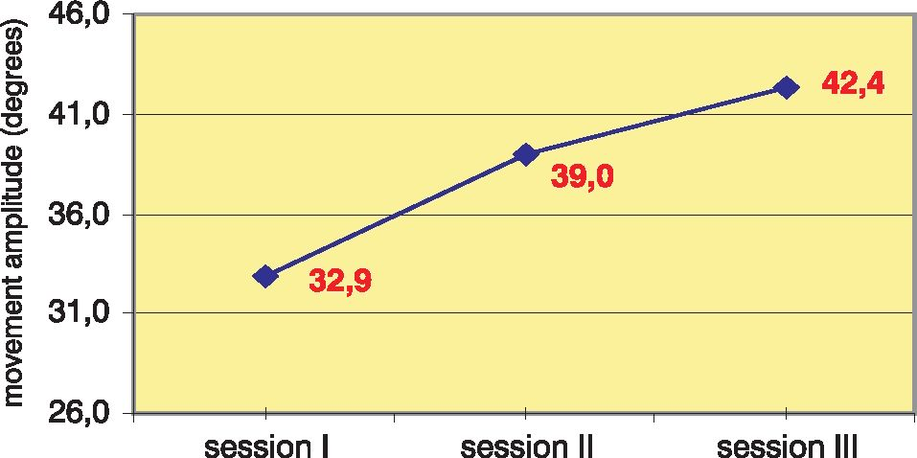
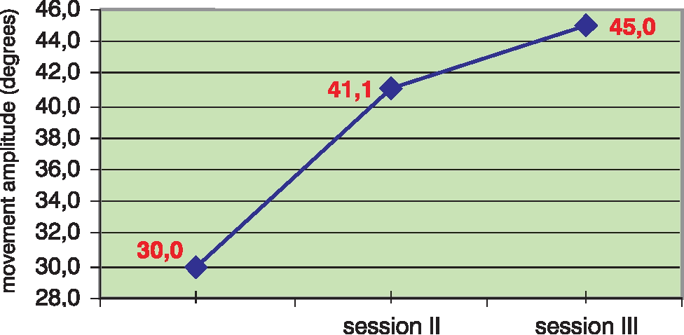

CASE REPORTS
Patient 1
A 60-year old man had a history of
left hemisphere intracerebral haem-
orrhage. Non-systematically treat-
ed arterial hypertension had been re-
ported previously. Early rehabilitation
was started in the neurological ward
on the 2nd day after the disease on-
set. Prior to the initiation of, during
and after the four-week PNF + botu-
linum toxin therapy programme, the
patient attended another rehabilita-
tion centre, where physiotherapy was
conducted by means of standard reha-
bilitation methods (active exercises of
the lower limbs, active exercises dur-
ing upper right and lower right limbs
relief, active-passive exercises of the
upper right extremity, exercises of the
lower limbs using the rotor).
The rehabilitation according to the
PNF concept with concomitant botu-
linum toxin application was conduct-
ed 1.5 years after the haemorrhagic
stroke. Neurological examination per-
formed before the four-week therapy
revealed:
- right-sided spastic hemiparesis and
the talipes equinovarus,
- right upper limb paresis of large de-
gree,
- moderate right lower limb paresis,
- right-sided central facial weak-
ness,
- slight sensorimotor aphasia,
- right lower limb spasticity within
plantar flexors of the foot - grade 3
in the modified Ashworth scale19.
The patient was independent; how-
ever, gait disturbances were present
- the patient complained about prob-
lems with walking up and down the
stairway. Sporadically, he used the el-
bow crotch.
Botulinum toxin was given with the
aid of electromyographic identifica-
tion of muscles’ motor points. A to-
tal of 1500 units of Dysport were ad-
ministered. The preparation was ap-
plied into the following muscles: gas-
trocnemius - 1000 units (4 injections),
tibialis posterior - 300 units (2 injec-
tions), tibialis anterior - 200 units (2
injections). The patient received the
BTX A for the first time in his life.
No undesirable effects occurred. The
relaxation effect was maintained for
four months following administration
of the medicinal product. The reha-
bilitation was started on the follow-
ing day after botulinum toxin appli-
cation. During the four-week kinesi-
therapy, a slight decrease in the paretic
lower limb muscle tone was observed
beginning with the 8th day of exer-
cises, which enabled performance of
the planned motor tasks with a great-
er range of motion. An improvement
in patient’s gait, both on a flat sur-
face and on a stairway was observed.
The patient began trials of walking on
a stairway with an alternating gait.

Results of the testing
Knee joint range of motion (Figure 1)
In the first testing, performed before
therapy initiation, the amplitude of
angular changes in the joint was:
- 32.9° (50.6% of the physiological
range of motion during gait) dur-
ing unsupported gait,
- 30.0° (46.2% of the physiological
range of motion during gait) dur-
ing supported gait,
These results indicate a significant re-
duction of the active movement in the
knee joint.
In the second testing, the amplitude
of angular changes was:
- 39.0° (60% of the physiological
range of motion during gait) dur-
ing unsupported gait - an increase
by 18.5% as compared to the first
testing,
- 41.1° (63.2% of the physiological
range of motion during gait) during
supported gait - an increase by 37%
as compared to the first testing.
Use of the combined therapy was
therefore associated with an improve-
ment in the range of motion.
In the third testing, further increase
in the amplitude of angular changes
was observed:
- 42.4° (65.2% of the physiological
range of motion during gait) dur-
ing unsupported gait - an increase
by 9.5% as compared to the second
testing and by 28.7% in compari-
son to the first testing,
- 45.0° (69.2% of the physiological
range of motion during gait) dur-
ing supported gait - an increase by
9.5% as compared to the second
testing and by 50% in comparison
to the first testing.
During capturing the unsupported gait,
the patient showed great hesitation
during moving the limb up, where-
as using the elbow crotch support al-
lowed the patient to move according to
the learned motion pattern.
Ankle joint range of motion (Figure 2)
In the first testing, performed before
therapy initiation, the amplitude of
angular changes in the joint was:
- 18° (60% of the physiological
range of motion during gait) dur-
ing unsupported gait,
movement amplitude of right knee joint
(measurment without crutch)
movement amplitude of right knee joint
(measurment with crutch)
session I
Figure 1
Results of measurements based on amplitude of angular changes in knee joint - Patient 1
19
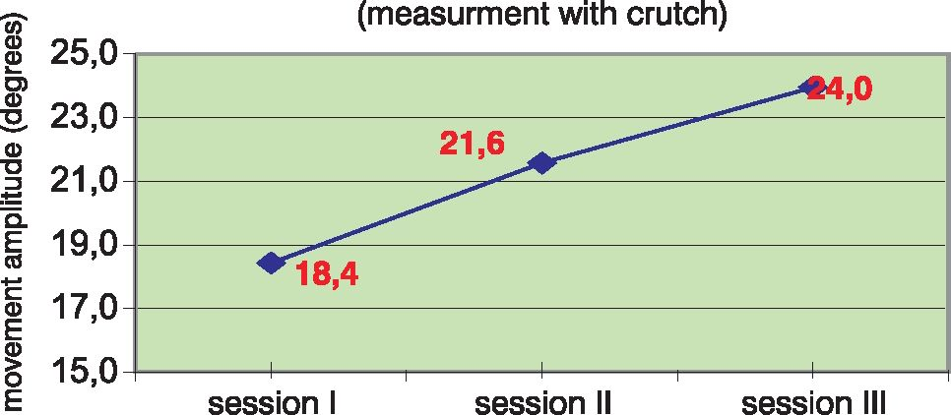
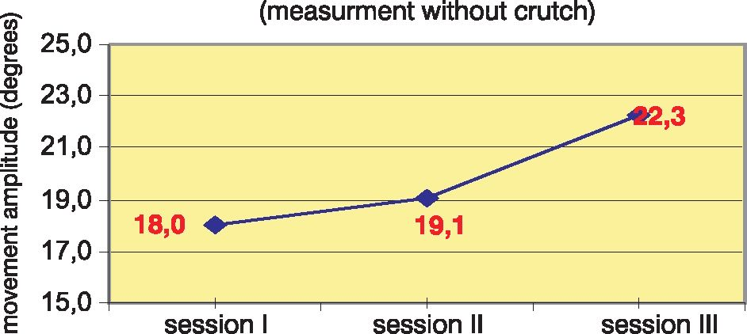
movement amplitude of right ankle joint movement amplitude of right ankle joint
Figure 2
Results of measurements based on amplitude of angular changes in ankle joint - Patient 1
- 18.4° (61.3% of the physiological
range of motion during gait) dur-
ing supported gait.
In the second testing, the amplitude of
angular changes was:
- 19.1° (63.7% of the physiological
range of motion during gait) during
unsupported gait - an increase by
6.1% as compared to the first test-
ing,
- 21.6° (72% of the physiological
range of motion during gait) dur-
ing supported gait - an increase
by 17.4% as compared to the first
testing.
Use of the therapy was associated with
a slight improvement in the range of
motion.
In the third testing, further increase
in the amplitude of angular changes
was observed:
- 22.3 ° (74.3% of the physiological
range of motion during gait) during
unsupported gait - an increase by
16.8% as compared to the second
testing and an increase by 23.9% in
comparison to the first testing,
- 24° (80% of the physiological
range of motion during gait) dur-
ing supported gait - an increase by
- 1% as compared to the second
testing and an increase by 30.4% in
comparison to the first testing.

Patient 2
A 67-year old man had a history of
ischaemic stroke in the territory of the
right middle cerebral artery; and a his-
tory of paroxysmal atrial fibrillation,
prostatic hypertrophy, and glaucoma.
Early rehabilitation was started in the
neurological ward on the 2nd day after
the disease onset. Prior to commenc-
ing the four-week PNF + botulinum
toxin therapy programme, and after
its termination, the patient was irreg-
ularly subjected to rehabilitation ac-
cording to standard methods (active
exercises of the relieved left lower
limb, exercises of the lower extrem-
ities using the rotor, assisted exercis-
es during upper limbs relief, active-
passive exercises of the paretic limbs).
During the four weeks of therapy, the
patient did not have any rehabilitation
treatment in other centres.
The rehabilitation according to the
PNF concept with concomitant botu-
linum toxin administration was con-
ducted 2 years after the ischaemic
stroke. Neurological examination per-
formed before the four-week therapy
revealed:
- left-sided spastic hemiparesis,
- left upper limb paresis of large de-
gree,
- slight left lower limb paresis with
talipes equinovarus,
- significant disturbances within the
shoulder and elbow joints due to
contractures induced by spasticity
and pain,
- left lower limb spasticity within plan-
tar flexors of the foot - grade 2.5 in
the modified Ashworth scale19.
The patient was independent, using
the elbow crotch during walking. Dur-
ing the maximum limb-loading phase
of the gait, hyperextension in the knee
joint was present.
Botulinum toxin was administered
with electromyography-assisted iden-
tification of muscles’ motor points.
A total of 1500 units of Dysport were
administered. The preparation was ap-
plied into the following muscles: gas-
trocnemius - 1000 units (4 injections),
tibialis posterior - 300 units (2 injec-
tions), tibialis anterior - 200 units (2
injections). The patient received the
BTX A for the first time in his life.
No undesirable effects were present.
The relaxation effect was maintained
for four months following administra-
tion of the preparation. The rehabil-
itation was started on the following
day after botulinum toxin application.
During the four-week kinesitherapy,
a slight decrease in spasticity of the
paretic lower limb was observed be-
ginning with the 12th day of exercises.
The dorsal flexion of the paretic foot
was facilitated. Patient’s gait was im-
proved both on a flat surface and on
a stairway. The hyperextension of the
paretic limb in the knee joint was still
present during the maximum limb-
loading phase.

Results of the testing
Knee joint range of motion (Figure 3)
In the first testing, performed before
therapy initiation, the amplitude of
angular changes in the joint was:
- 28.8° (44.3% of the physiological
range of motion during gait) dur-
ing unsupported gait,
- 24.8° (38.2% of the physiological
range of motion during gait) dur-
ing supported gait,
The results indicate a significant re-
duction of the active movement in the
knee joint.
In the second testing, the amplitude
of angular changes was:
- 31.6° (48.6% of the physiological
range of motion during gait) dur-
ing unsupported gait - an increase by
9.7% as compared to the first testing,
- 29.2° (44.9% of the physiological
range of motion during gait) dur-
ing supported gait - an increase
by 17.7% as compared to the first
testing
During the therapy, gait-associated
motion range improved.
20
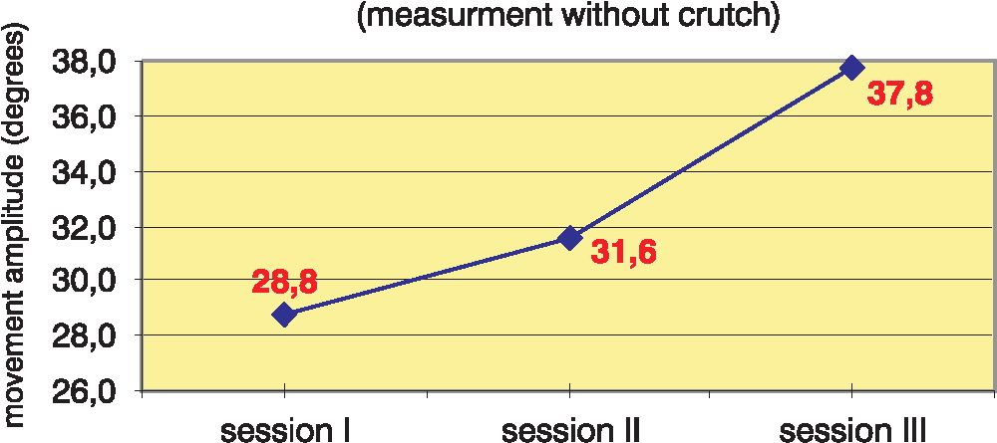
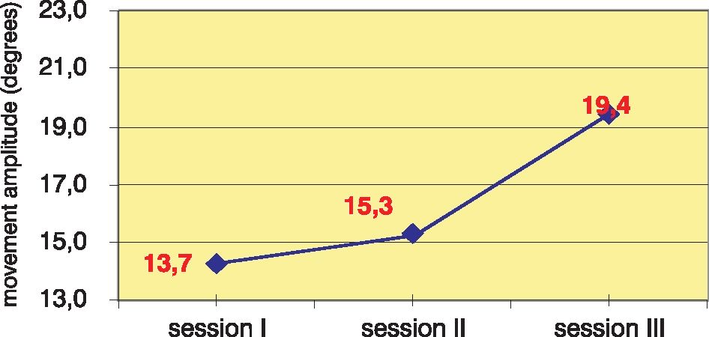
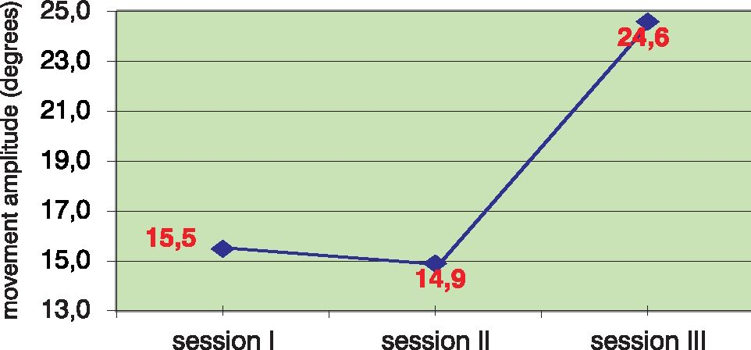
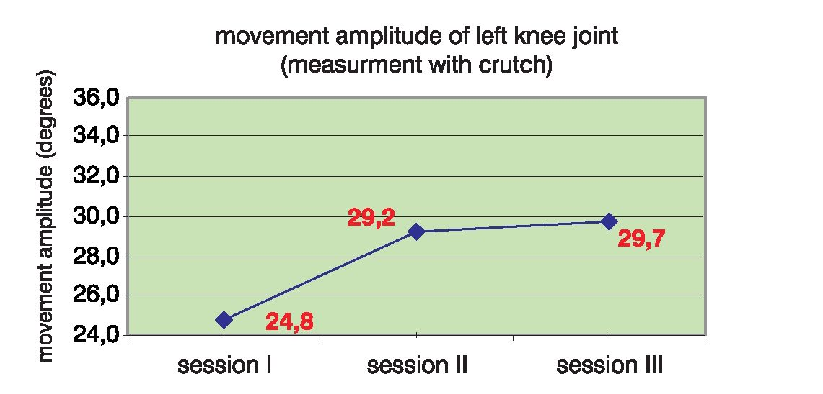
movement amplitude of left knee joint
Figure 3
Results of measurements based on amplitude of angular changes in knee joint - Patient 2
In the third testing, further increase
in the amplitude of angular changes
was observed:
- 37.8° (58.2% of the physiological
range of motion during gait) during
unsupported gait - an increase by
19.6% as compared to the second
testing and an increase by 31.3% in
comparison to the first testing,
- 29.7° (45.7% of the physiological
range of motion during gait) dur-
ing supported gait - an increase by
- 7% as compared to the second
testing and an increase by 19.8%
in comparison to the first testing.
Ankle joint range of motion (Figure 4)
In the first testing, performed before
therapy initiation, the amplitude of
angular changes in the joint was:
- 13.7° (45.7% of the physiological
range of motion during gait) dur-
ing unsupported gait,
- 15.5° (51.7% of the physiological
range of motion during gait) dur-
ing supported gait.
In the second testing, the amplitude of
angular changes was:
- 15.3° (51% of the physiological
range of motion during gait) dur-
ing unsupported gait - an increase
by 11.7% as compared to the first
testing,
- 14.9° (49.7% of the physiological
range of motion during gait) dur-
ing supported gait - a decrease by
3.9% as compared to the first test-
ing.
In the third testing, a significant in-
crease in the amplitude of angular
changes was observed:
- 19.4° (64.7% of the physiological
range of motion during gait) during
unsupported gait - an increase by
26.8% as compared to the second
testing and an increase by 41.6% in
comparison to the first testing,
- 24.6° (82% of the physiological
range of motion during gait) dur-
ing supported gait - an increase by
65.1% as compared to the second
testing and an increase by 58.7% in
comparison to the first testing.

Patient 3
A 67-year old man had a history of
ischaemic stroke in the territory of
the right middle cerebral artery; and
a history of paroxysmal atrial fibrilla-
tion and arterial hypertension. Reha-
bilitation was started in the neurolog-
ical ward on the 1st day of the disease.
Prior to the initiation of the four-week
PNF therapy, the patient had physio-
therapy in a rehabilitation ward (a
four-week hospitalisation) accord-
ing to standard rehabilitation meth-
ods (self-assisted exercises, exercis-
es during relief, passive exercises, ac-
tive-passive exercises, learning to walk
with the tripod), and subsequently, he
had a periodic rehabilitation accord-
ing to the PNF concept conducted at
patient’s home. After termination of
the four-week therapy, the rehabilita-
tion was continued at patient’s home
according to the principles of the PNF
method. During the four weeks of the
therapy, the patient did not attend
other rehabilitation centres.
The four-week PNF rehabilitation
cycle was started 9 months after the
ischaemic stroke. Botulinum toxin
was not used. Neurological examina-
tion before the initiation of the four-
week therapy revealed:
- left-sided spastic hemiparesis,
- severe distal spasticity in the left
upper limb,
movement amplitude of right ankle joint
(measurment without crutch)
movement amplitude of right ankle joint
(measurment with crutch)
Figure 4
Results of measurements based on amplitude of angular changes in ankle joint - Patient 2
21
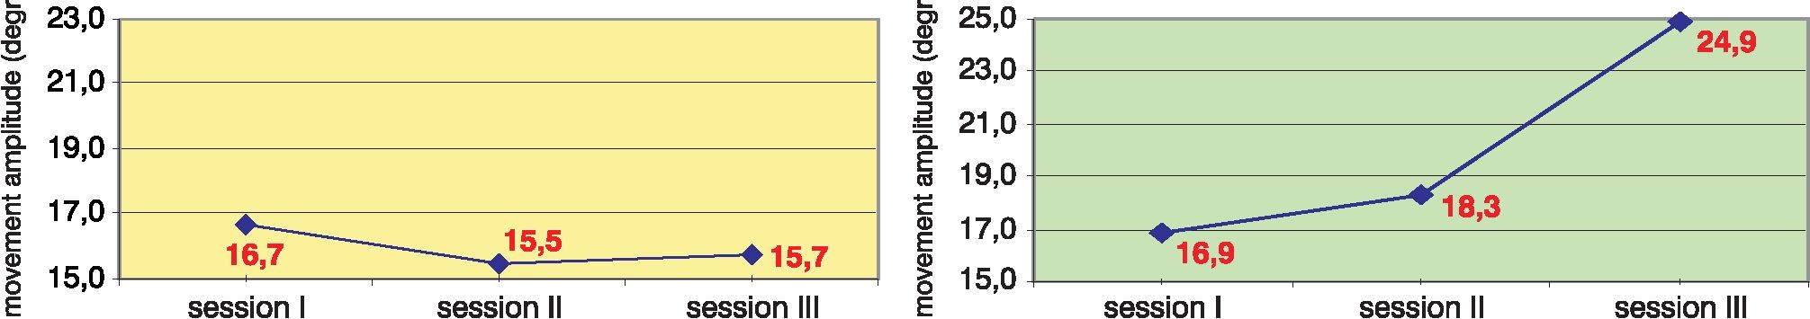
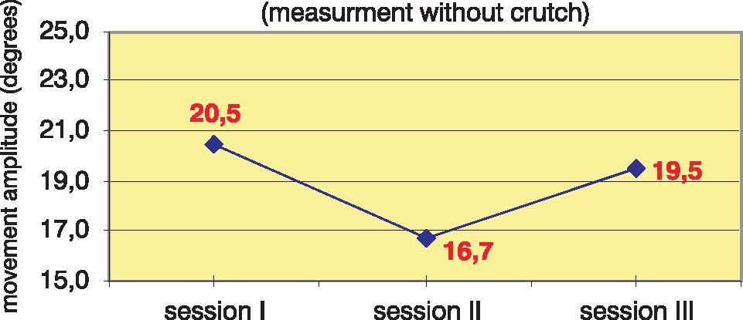
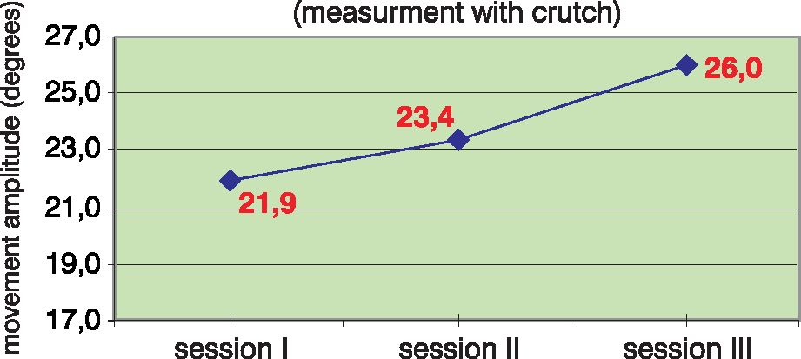
„ movement amplitude of left knee joint „ movement amplitude of left knee joint
I (measurment without crutch) § (measurment with crutch)
Figure 5
Results of measurements based on amplitude of angular changes in knee joint - Patient 3
- left upper limb paresis of large de-
gree,
- moderate left lower limb paresis,
- aggravated spasticity within the
plantar flexors of the toes, particu-
larly during walking,
- left lower limb spasticity within
plantar flexors of the foot - grade 3
in the modified Ashworth scale19.
The patient was independent, using
the elbow crotch during walking.
The foot was secured from drop-
ping by means of the DAFOD device.
Most pronounced gait disturbanc-
es were observed in the patient dur-
ing the phase of moving the paretic
limb up.

Results of the testing
Knee joint range of motion (Figure 5)
In the first testing, performed before
therapy initiation, the amplitude of
angular changes in the joint was:
- 16.7° (25.7% of the physiological
range of motion during gait) dur-
ing unsupported gait,
- 16.9° (26% of the physiological
range of motion during gait) dur-
ing supported gait.
In the second testing, the amplitude
of angular changes was:
- 15.5° (23.8% of the physiological
range of motion during gait) during
unsupported gait - a decrease by 7.2%
as compared to the first testing,
- 18.3° (28.2% of the physiological
range of motion during gait) during
supported gait - an increase by 8.3%
as compared to the first testing.
In the third testing, the amplitude of
angular changes was:
- 15.7° (24.2% of the physiological
range of motion during gait) dur-
ing unsupported gait - an increase
by 1.3% as compared to the sec-
ond testing and a decrease by 6%
in comparison to the first testing,
- 24.9° (38.3% of the physiological
range of motion during gait) dur-
ing supported gait - an increase by
36.1% as compared to the second
testing and an increase by 47.3% in
comparison to the first testing.
Trials performed when the patient
was using crotch support, demonstrat-
ed the highest increment in the knee
joint range of motion.
Ankle joint range of motion (Figure 6)
In the first testing, performed before
therapy initiation, the amplitude of
angular changes in the joint was:
- 20.5° (68.3% of the physiological
range of motion during gait) dur-
ing unsupported gait,
- 21.9° (73% of the physiological
range of motion during gait) dur-
ing supported gait.
In the second testing, the amplitude of
angular changes was:
- 16.7° (55.7% of the physiological
range of motion during gait) dur-
ing unsupported gait - a decrease
by 18.5% as compared to the first
testing,
- 23.4° (78% of the physiological
range of motion during gait) during
supported gait - an increase by 6.8%
as compared to the first testing.
In the third testing, an improvement
was observed and the amplitude of an-
gular changes was:
- 19.5° (65% of the physiological
range of motion during gait) dur-
ing unsupported gait - an increase
by 16.8% as compared to the sec-
ond testing and a decrease by 4.9%
in comparison to the first testing,
- 26° (87% of the physiological
range of motion during gait) dur-
ing supported gait - an increase by
- 1% as compared to the second
testing and an increase by 18.7% in
comparison to the first testing.
movement amplitude of left ankle joint movement amplitude of left ankle joint
Figure 6
Results of measurements based on amplitude of angular changes in ankle joint - Patient 3
D DAFO device - a polypropylene shell preventing foot drop, used as a shoe insert
22
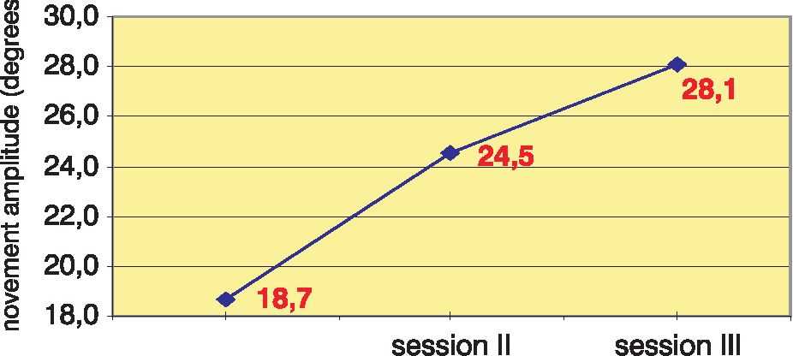
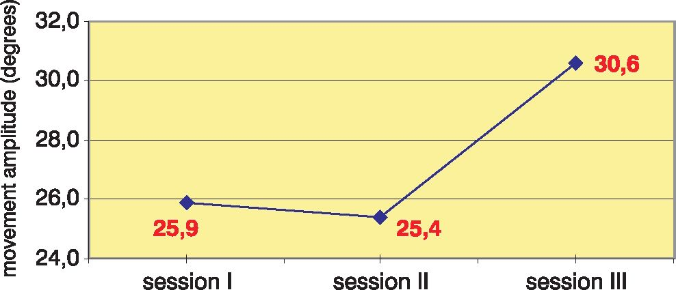

Patient 4
A 43-year old man with a history of
surgery due to a DNT (dysembryo-
blastic neuroepithelial tumour) brain
tumour of the left temporal lobe, com-
plicated by an ischaemic stroke in the
territory of the left anterior choroid
artery. He also had a history of com-
plex partial seizures. Early rehabilita-
tion was started in a hospital ward on
the 1st day of the disease. Rehabilita-
tion was conducted according to the
NDT-Bobath and the PNF concepts.
Prior to commencing the four-week
PNF therapy programme, the patient
had had physiotherapy in a private re-
habilitation office 3 times a week ac-
cording to the PNF concept. After
termination of the four-week thera-
py, the rehabilitation was continued
in a rehabilitation ward and in an out-
patient clinic. During this period of
time, elements of the PNF and classi-
cal methods (exercises in relief, self-as-
sisted exercises, active-passive exercis-
es, manipulation exercises of the up-
per extremity) were used in the thera-
py. During the four weeks of the ther-
apy, the patient did not have rehabili-
tation in other centres.
The four-week cycle of the PNF re-
habilitation was started 6 months after
the ischaemic stroke. Botulinum toxin
was not used. Neurological examina-
tion performed before the initiation of
the four-week therapy revealed:
- right-sided spastic hemiparesis,
- moderate paresis of the upper
limb,
- voluntary movement attempt-induced
spasticity aggravation in the hand,
- slight paresis of the lower limb,
- right lower limb spasticity within
plantar flexors of the foot - grade 2
in the modified Ashworth scale19.
The patient was hardly able to dorsi-
flex his paretic foot. Periodically, he re-
ported occurrence of increased spas-
ticity within the plantar flexors of the
foot. He was able to walk independent-
ly. When assisted by an accompanying
person, the patient was able to walk on
a stairway with an alternating gait. Hy-
perlordosis was observed during gait,
and excessive flexion of the paretic limb
in the knee joint was seen during the
maximum limb-loading phase.
During the measurements, the pa-
tient was moving without the crotch
all the time.

Results of the testing
Knee joint range of motion (Figure 7)
In the first testing, performed before
therapy initiation, the amplitude of
angular changes in the joint was:
- 18.7° (28.8% of the physiological
range of motion during gait) dur-
ing unsupported gait.
In the second testing, the amplitude of
angular changes was:
- 24.5° (37.7% of the physiological
range of motion during gait) during
unsupported gait - an increase by
31% as compared to the first testing.
In the third testing, further improve-
ment of the motion range was ob-
served:
- 28.1° (43.2% of the physiological
range of motion during gait) during
unsupported gait - an increase by
14.7% as compared to the second
testing and an increase by 50.3% in
comparison to the first testing.
Ankle joint range of motion (Figure 8)
In the first testing, performed before
therapy initiation, the amplitude of
angular changes in the joint was:
- 25.9° (86.3% of the physiological
range of motion during gait) dur-
ing unsupported gait.
- 21.9° (73% of the physiological
range of motion during gait) dur-
ing supported gait.
In the second testing, the amplitude of
angular changes did not change signif-
icantly in comparison to the previous
measurement and was:
- 25.4° (84.7% of the physiological
range of motion during gait) dur-
ing unsupported gait - a decrease
by 1.9% as compared to the first
testing.
In the third testing, the amplitude of
angular changes was:
- 30.5° (102% of the physiological
range of motion during gait) during
unsupported gait - an increase by
20.5% as compared to the second
testing and an increase by 18.1% in
comparison to the first testing,

DISCUSSION
Dur ing the t he rap y, re-educati on
of patients’ gait was especially em-
phasised. Using the PNF method,
an attempt was made to achieve the
planned effect via a reduction of spas-
ticity and an improvement in move-
ment coordination. Additionally, two
patients were given botulinum tox-
in injections. In the conducted eval-
uations, we tried to determine sim-
ple markers that could enable esti-
mation of therapy effectiveness both
immediately after termination of re-
habilitation and after a longer peri-
od of time following particular ther-
apeutic actions. The recorded chang-
es in the range of motion in the lower
limb joints during walking may serve
as a parameter of gait quality evalua-
tion. It was observed that gait quali-
ty expressed as amplitude of angular
changes in the knee and ankle joints,
obtained during the four-week PNF
movement amplitude of right knee joint
movement amplitude of right ankle joint
session I
Figure 7, 8
Results of measurements based on amplitude of angular changes in knee joint - Patient 4
23
therapy programme, was maintained
on a similar level or increased during
3 months following the therapy. This
may be indicative of an educational
effect of the conducted rehabilitation,
thanks to which patients were able to
introduce the skills learnt during the
programme to their every-day activi-
ties thus achieving an improvement in
their locomotion.
In other studies5,20,21,22, improve-
ment of gait was demonstrated by
means of such factors as gait speed,
relative step length or symmetry in-
dex, apart from the angular changes in
the articulations. In this study, to esti-
mate patient’s functional disturbances
and to assess the effects of the meth-
ods aimed at reducing muscle tone
and improving coordination, we fo-
cused on the quality and correctness
of gait mechanics, whereas gait veloc-
ity and step length receded into the
background. The elbow crotch-sup-
ported gait was also compared to the
unsupported gait because of a possi-
ble influence of pathological motion
patterns, occurring with a greater ac-
tivity of the non-affected side, on pa-
tient’s locomotion.
For a more complete picture of
changes occurring as a result of the
PNF therapy and the combined ther-
apy with concomitant botulinum tox-
in injection, other markers of patients’
functional status, such as e.g. the Bar-
thel index, as well as muscle tone
scales such as the modified Ashworth
scale10,19,23 should also be considered.
In this study, a possibility of com-
bining the botulinum toxin and the
PNF therapies was presented. Nor-
mal course of patients’ rehabilita-
tion process and a gradual improve-
ment in the range of motion in the
knee and ankle joints was present-
ed. There were no marked differenc-
es across the case reports. Unequivo-
cal effects of the combination of the
methods were not observed. Theo-
retical data allow assumption that the
combination of botulinum toxin ad-
ministration and the PNF method is
a plausible management9,12,13. Applica-
tion of the combined therapies is sup-
posed to facilitate patient’s and thera-
pist’s efforts towards the re-education
of the lost motor function via a tem-
porary reduction in spasticity. Expec-
tations associated with the combina-
tion of these therapies include mainly
the possibility to maintain and con-
solidate the effect of rehabilitation in-
volving reproduction of normal mo-
tion patterns, reduction of patholog-
ical movements induced by spasticity
of the paretic limbs, and an improve-
ment in patients’ quality of life by re-
ducing disturbances of functioning.
As there are no clinical studies on
the effects of the combined PNF and
botulinum toxin therapy on the adult
post-stroke patients’ rehabilitation
process, in the future, it is necessary
to plan large, randomised, controlled
clinical studies, comparing patients
subjected to the PNF method with pa-
tients in a similar neurological state
treated with the botulinum toxin, and
the patients, in whom both methods
were used concomitantly. Clinical tri-
als, conducted according to the above
assumptions, can allow unequivocal
evaluation of and drawing conclu-
sions from such therapy, as well as
determine a rehabilitation model that
would be of use in comprehensive
therapy of stroke sequelae.
Based on the reported cases, con-
clusions regarding the efficacy of the
combined PNF and botulinum toxin
therapy cannot be drawn; however,
the performed observations may fa-
cilitate planning clinical studies on the
effects of these methods on the reha-
bilitation process during the late post-
stroke period.
References
- Europejskie Spotkania w Sprawie Ustale-
nia Wspólnego Stanowiska Dotyczącego
Postępowania w Udarze Mózgu. Helsing-
born, Szwecja 8-10 listopada 1995. Neur.
Neurochir. Pol. 1997; 31 (Supl.1)
- Seniów J., Członkowska A.: Poznawcze
i emocjonalne konsekwencje udaru mózgu
w aspekcie procesu rehabilitacji. Rehabilit-
acja Medyczna, 2003; 7(1): 9-14
- Associazione Italiana, Amici di Raoul
Follereau: Usprawnienie po udarze mózgu.
Elipsa-Jaim, Kraków 2002
- Krawczyk M., Sidaway M.: Clinical effects of in-
tensive physiotherapy in stroke patients Neurol
Neurochir Pol. 2002; 36(Suppl 1): 41-60
- Paprocki G.: Próba spojrzenia na proprio-
ceptywne nerwowo-mięśniowe ułatwienie
(PNF) z pominięciem wzorców ruchowych.
Fizjoterapia, 1999; 7(3): 42-49
- Kraft G.H., Fitts S.S., Hammond M.C.: Tech-
niques to improve function of the arm and
hand in chronic hemiplegia Arch Phys Med
Rehabil. 1992; 73(3): 220-227
- Luke C., Dodd K.J., Brock K.: Outcomes of
the Bobath concept on upper limb recovery
following stroke Clin Rehabil. 2004; 18(8):
888-898
- Kokosz M., Saulicz E., Żmudzka-Wilczek E.,
Saulicz M.: Możliwość wykorzystania stymu-
lacji oraz technik specjalnych w metodzie
PNF. Fizjoterapia, 1998; 6(3): 20-27
- Krawczyk M.: Nieprawidłowe napięcie
mięśniowe jako jeden z głównych prob-
lemów w usprawnianiu. Fizjoterapia. 1995:
3(3)
- Sławek J.: Rola toksyny botulinowej typu
A w leczeniu spastyczności w przebiegu
mózgowego porażenia dziecięcego. Klinika
Pediatryczna, 2000; 8(4): 481-488
- Kalinowski Z.: Toksyna botulinowa A w lecze-
niu stanów spastycznych u dzieci z mózgow-
ym porażeniem dziecięcym. Ocena wstępna
Neurologia Dziecieca 1998; 7(14):
- Barnes M.: Management of spasticity. Age
and Ageing. 1998; 27: 239-245
- Hesse S.: Botulinum Toxin A Treatment of
Adult Upper and Lower Limb Sasticity. Drugs
& Aging 2001; 18(4) 255-262
- Cardoso E., Rodrigues B., Lucena R., Olivei-
ra IR, Pedreira G., Melo A.: Botulinum toxin
type A for the treatment of the upper limb
spasticity after stroke: a meta-analysis. Arq
Neuropsiquiatr. 2005; 63(1): 30-33
- Suputtitada A.: Local botulinum toxin type
A injections in the treatment of spastic toes.
Am J Phys Med Rehabil. 2002; 81(10): 770-
775
- Hesse S., Werner C.: Poststroke motor dys-
function and spasticity: novel pharmacologi-
cal and physical treatment strategies. CNS
Drugs. 2003; 17(15): 1093-1107
- Voller B., Foldy D., Hefter H., Auff E., Schnid-
er P.: Treatment of the spastic drop foot with
botulinum toxin type A in adult patients. Wien
Klin Wochenschr. 2001; 113(Suppl 4): 25-29
- Hesse S., Krajnik J., Luecke D.: Ankle mus-
cle activity before and after botulinum toxin
therapy for lower limb extensor spasticity in
chronic hemiparetic patients. Stroke. 1996;
27: 455-460
- Blackburn M., Van Vliet P., Mockett S.: Re-
liability of measurements obtained with the
Modified Ashworth Scale in the lower ex-
tremities of people with stroke. Phys Ther.
2002;82: 25-34
- Laborde A., Caillet F., Eyssette M., Boisson
D.: 3D preliminary analysis gait in stroke pa-
tients: knee flexion in compensatory strate-
gies. Ann Readapt Med Phys. 2003; 46(3):
132-137
- Kwolek A.: Wykorzystanie platformy do
ćwiczeń równowagi z zastosowaniem bio-
logicznego sprzężenia zwrotnego u chorych
po udarze mózgu Fizjoterapia 1999; 7(3):
- Kwolek A.: Prędkość chodu i wskaźnik
symetryczności obciążenia kończyn dol-
nych w ocenie efektów rehabilitacji pacjentów
z niedowładem połowiczym Fizjoterapia 1998;
6(3)
- Katz R.: Objective quantification of spastic
hipertonia: correlation with clinical findings
Arch Phys Med Reh. 1992; 73: 339-347
Address for correspondence
Szymon Pasiut, MS
Chair of Clinical Rehabilitation Academy
of Physical Education in Cracow
Al. Jana Pawła II 78
31-579 Kraków, Poland
e-mail: szymon.spain@interia.pl
Translated from Polish
to English language:
Marcin Tutaj, MD
24

