

Geological Quarterly, 2004, 48 (1): 77-82

Cretaceous-Paleogene boundary problem in Libya: the occurrence of the
foraminiferal species Abathomphalus mayaroensis (Bolli) in the Western Sirt Basin
Sefau Omar TSHAKREEN and M. Adam GASIŃSKI

Tshakreen S. O. and Gasiński M. A. (2004) — Cretaceous-Paleogene boundary problem in Libya: the occurrence of the foraminiferal
species Abathomphalus mayaroensis (Bolli) in the Western Sirt Basin. Geol. Quart., 48 (1): 77-82. Warszawa.
The position of the K/P boundary in wells in the Western Sirt Basin of Libya is problematic. The biostratigraphic definition of the K/P
boundary in the subsurface is based on the extinction of the eponymous taxon of the standard latest Maastrichtian foraminiferal
Abathomphalus mayaroensis Zone. We have unambiguously recognised this taxon from the Sirt Basin subsurface sections for the first
time. All the latest Maastrichtian foraminiferal assemblages are dominated by planktonic foraminiferids. Some of specimens are
pyritised, indicating organic flux to the basin floor, causing oxygen deficiency in the depositional environment. The occurrence of char-
acteristic bathypelagic and some epipelagic species indicates that the environment of deposition is outer shelf-middle continental slope.
Sefau Omar Tshakreen, Petroleum Research Centre (National Oil Corporation), Tripoli, Libya; M. Adam Gasiński, Jagiellonian Uni-
versity, Institute of Geological Sciences, Oleandry 2a, PL-30-063 Kraków, Poland; e-mail: gasinski@geos.ing.uj.edu.pl (received:
September 5, 2003; accepted: December 6, 2003).
Key words: Libya, Western Sirt Basin, Cretaceous/Paleogene (K/P), foraminiferids, palaeobathymetry, oxygen deficiency deposits.
INTRODUCTION
Identification of the Cretaceous/Paleogene (K/P) boundary
in the subsurface and its correlation with the surface of the west-
ern margin of the Sirt Basin was recognised as an important
problem in the 1960’s (cf. the discussion between A. Desio and
E. P. Lehmann in: Lehmann, 1964). Despite many attempts
(Jordi and Lonfat 1963; Lehmann, 1964; Barr and Berggren,
1980; Tmalla, 1992) the exact position of the Cretaceous-Ter-
tiary boundary in the Sirt Basin remains uncertain. This was due
largely to the absence of Abathomphalus mayaroensis (Bolli),
the eponymous taxon of the standard latest Maastrichtian
foraminiferal zone in the Sirt Basin (Tmalla, 1992, 1996). This
absence has made the correlation of the open marine deposits of
the basin with the world stratigraphic standards for the K/P
boundary insecure. Shallow marine deposits of the western mar-
gin of the Sirt Basin also contain fossil records too scarce to pre-
cisely establish a boundary. Moreover, neither the iridium anom-
aly nor any other symptom of a catastrophic event at the K-T
boundary has been found in the deposits of the Sirt Basin studied
to date (Eliagoubi and Powell, 1980).
Identification of the K/P boundary has been one of the pur-
poses of the Western Sirt Basin project (WSB Project no.
2383), carried out by Petroleum Research Centre of Libya and
Teknica Petroleum Services Ltd. of Calgary, Canada. This pa-
per summarises the attempt to establish the position of the K/P
boundary in wells located in the Western Sirt Basin (Fig. 1).
Biostratigraphic definition of the K/P boundary in the
subsurface is based on the presence and extinction of the epon-
ymous taxon of the standard latest Maastrichtian foraminiferal
Abathomphalus mayaroensis Zone. The K/P boundary in the
Sirt Basin is a Type 1 sequence boundary (Jerzykiewicz et al.,
2002), making it extremely useful for stratigraphic correlation
across the basin. An attempt at such high-resolution correlation
is presented in this paper.
Preliminary results of the Late Cretaceous of the Western
Sirt Basin (Tshakreen et al, 2002) indicated that foraminiferids
from the samples studied are abundant, diverse and relatively
well preserved. The most recent studies of the Sirt Basin re-
veals the presence of earliest Paleocene deposits.
K/P BOUNDARY IN LIBYA
The Cretaceous-Paleogene boundary has been recognised
in Libya as one of the most important stratigraphic boundaries
as early as in 1960’s (Jordi and Lonfat, 1963; Lehmann, 1964).
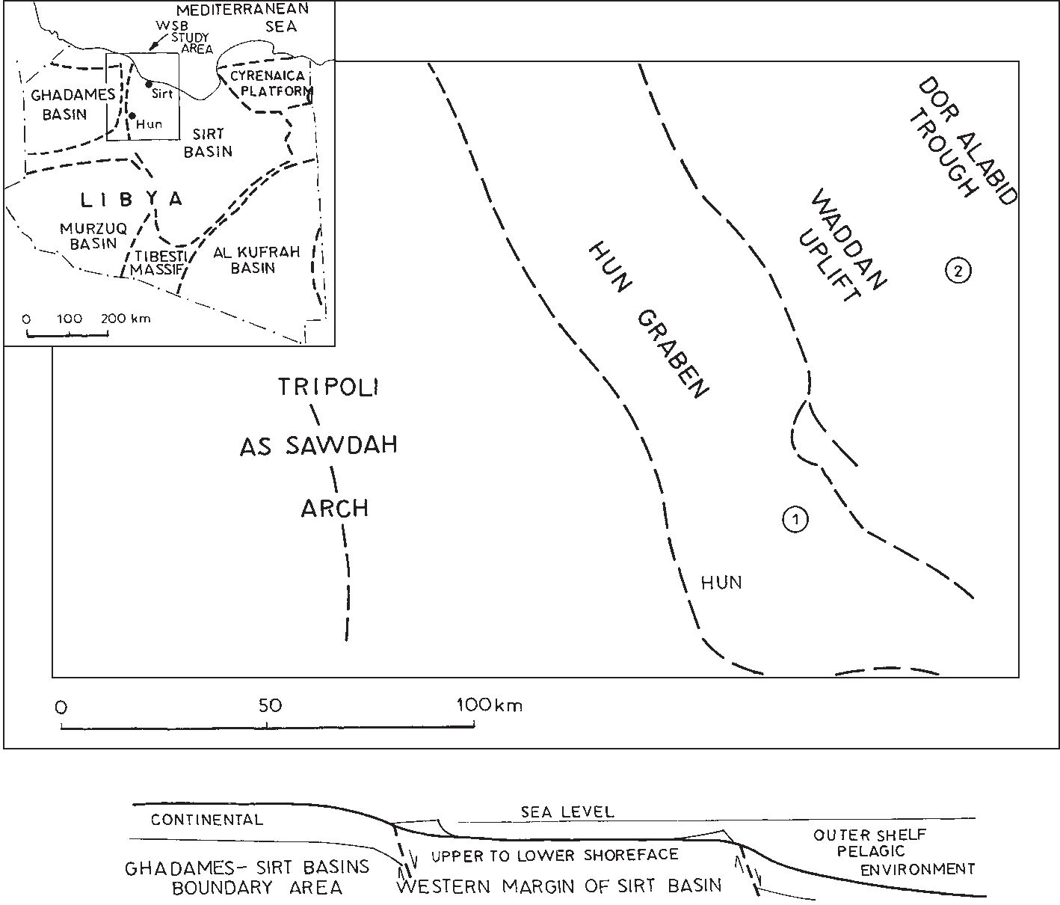
78
Sefau Omar Tshakreen and M. Adam Gasiński

Fig. 1. A location of hinterland and open marine environments within the Western Sirt Basin
Upper left corner — the position of the study area in relation to the major sedimentary basins in Libya; 1,2
— location of the studied wells; below — the depositional environments which developed on the
eastwards sloping margin of the Western Sirt Basin. The subaerial environment (hinterland) developed on
the emergent margin of the basin. Further eastward, the environment of deposition changes to a tid-
ally-dominated inner shelf followed eastwards by outer shelf and then to the distal part of the basin marked
by pelagic facies (partly after Jerzykiewicz et al., 2002)
Subsequently, Barr and Berggren (1980) and Tmalla (1992)
discussed the problem of the K/P boundary and established its
approximate position.
Barr and Berggren (1980) placed the Cretaceous/Tertiary
(Maastrichtian/Danian) contact at the base of the Socna Mollusc
Bed in surface exposures, along the western margin of the Sirt
Basin (i.e. between the Lower and the Upper Tar members of the
Zmam Formation). According to them, the microfossils from the
western margin of the basin indicate that there was a marked
shallowing of the seas at the end of Maastrichtian time but no
break in deposition has been postulated. Moreover, the K/P
boundary in the deeper parts of the Sirt Basin is marked by an
abrupt lithological change, reflecting a widespread and sudden
shift in depositional environment. According to Barr (1972) this
change is the result of shallowing of the Late Maastrichtian seas
and a subsequent strong transgressive surge at the beginning of
the Danian. However, such changes may result from global
eustatic fluctuations as well as local tectonic events (Gasiński,
1997; Arenillas et al., 2000; Dupuis et al., 2001). Accordingly,
the Maastrichtian/Danian boundary in the subsurface of Sirt Ba-
sin has been placed at the boundary between the Kalash Lime-
stone and the Hagfa Shale (cf. Barr and Weegar, 1972).
Tmalla (1996) questioned the correctness of placing the
K/P boundary at the contact between the Kalash Limestone and
the Hagfa Shale in the Northern Sirt Basin (well A1a-NC29A).
In absence of Abathomphalus mayaroensis, Tmalla used other
planktonic species to establish the position of the K/P bound-
ary. He proposed a local Eoglobigerina minutula Zone for the
earliest Paleogene biostratigraphic interval which lies between
the Cretaceous-Tertiary boundary and the Subbotina
pseudobulloides Zone. As a result, Tmalla (1996) concluded
that the K/P boundary should be placed within the uppermost
part of the Kalash Limestone.
According to Tmalla (1992, 1996) Abathomphalus
mayaroensis is virtually absent from subsurface sections in
Libya. This fact makes the correlation of the open marine de-
posits of the basin with the world stratigraphic standards for the
K/P boundary problematic.
GEOLOGICAL SETTING
The geology of the Western Sirt Basin has been
summarised by Shakoor and Shagroni (1984) as well as by
Gumati and Kanes (1985) and Gundobin and Yevdokimov
(1985). Most recently, the geology of Sirt Basin has been de-
scribed by Jerzykiewicz et al. (2002).
About 200 samples collected from ditch cuttings of two wells
located in the Western Sirt Basin (Fig. 1) have been examined in
the interval between 685-1203 m depth (Fig. 2). Stratigraphically,
these sediments belong to the Kalash Limestone and the Hagfa
Cretaceous-Paleogene boundary problem in Libya: the occurrence of the foraminiferal species Abathomphalus mayaroensis (Bolli)
79
Shale (Barr and Weegar 1972; see above) and are composed of
black and grey marlstones, marly shales and shales (Fig. 2).
METHODS
Sample disintegration by heating and freezing in Glaubert
salt was applied. Some, very soft samples were only washed.
The residue was washed through a set of sieves (100-65 pm in
diameter). Specimens were identified under stereoscopic and
SEM microscopes. All laboratory analyses were undertaken at
the Micropalaeontological Laboratory of the Institute of Geo-
logical Sciences of the Jagiellonian University. Studied speci-
mens of A. mayaroensis are housed at the Jagiellonian Univer-
sity Geological Museum (coll. WSB/ING UJ/2001).
MICROPALAEONTOLOGICAL PART
Description of the nominal species:
Abathomphalus mayaroensis (Bolli, 1951)
(Fig. 3a-e)
Globotruncana mayaroensis Bolli, 1951, pp. 190, 198, pl. 35, figs. 10-12.
Abathomphalus mayaroensis (Bolli), Bolli, Loeblich and Tappan, 1957, p. 43,
pl. 11, figs. 1a-c.
Holotype. — Subsurface section in the Guayaguayare
area, County of Mayaro, Southeastern Trinidad.
Remarks. — Specimens of A. mayaroensis resembling
Bolli’s holotype were found in the Sirt Basin (Fig. 3a, b). These
forms possess the beaded keel structure (Fig. 3d, e), character-
istic flat morphology of the test and spinose/rugose surface.
Rugosities are arranged in parallel rows (Fig. 3e). The diame-
ters of the forms studied are similar to the holotype from Trini-
dad. However, some specimens have been identified as “cf.”
because they possess features of Abathomphalus mayaroensis
as well as of Globotruncana arca (“intermediate forms”?; Fig.
3f-h). These specimens of A. mayaroensis are quite similar to
those recently described from the Polish Carpathians (Gasiński
et al., 2001).
This species is rare in the studied samples; they only some-
times exceed of 2% of the total planktonic assemblages. In gen-
eral, planktonic associations constitute about 80% of the whole
foraminiferal assemblages.
Following Postuma (1971, pp. 50-51), A. mayaroensis has
two beaded keels; the primary apertures are interiomarginal,
umbilical, covered by a tegillum. Barr (1972, pp. 26-27, pl. 5,
figs. 1-2) noted that A. mayaroensis chambers on the umbilical
side are ornamented by short irregular radial costae. According
to him, this species is never abundant in Libya, although rare
specimens have been found from the Upper Maastrichtian
chalk in a number of wells in the N-Sirt Basin and from out-
crops in N Cyrenaica.
Robaszynski et al. (1984, p. 274, pl. 45, figs. 5, 6, 9, pl. 46,
figs. 4-5) characterise A. mayaroensis as having: an extraum-
bilical-umbilical primary aperture, chamber surfaces orna-
mented with rugosities arranged in a meridional pattern. The
spiral side shows chambers gradually increasing in size as
added. In lateral view, this species has a very low trochospire
and two keels composed of radially arranged rugosities. Ac-
cording to these authors, this species differs from the Late
Maastrichtian Abathomphalus intermedius (Bolli) in the pres-
ence of two keels on all chambers.
Caron (1985, p. 42, fig. 21.10-11) noted that A. mayaro-
ensis posses two peripheral keels which are composed of short,
radially oriented costellae. This species differs from A.
intermedius (Bolli) in the presence of a double keel on all
chambers of the last whorl.
Hart etal. (in: Jenkins and Murray, 1989, p. 308) characterise
this species by its “bow-tie” morphology and ornamentation.
Lybian micropalaeontologists have attempted to describe
this species. Ashour (1996) illustrated (pl. 2, fig. 2) A.
mayaroensis from the Sirt Basin, but this specimen do not re-
semble Abathomphalus mayaroensis (the illustrated specimen
has a solid keel and does not indicate any traces of the charac-
teristic test ornamentation of A. mayaroensis).
Tmalla (1996) mentioned that A. mayaroensis had never
been encountered in the well A1a-NC29A. Hence, he adapted
the G. conica Zone of Eliagoubi and Powell (1980) as the
equivalent of the A. mayaroensis Zone in the latest
Maastrichtian. He also noted the scarcity of A. mayaroensis in
the El Kef section (following cited authors). According to
Eliagoubi and Powell (1980), A. mayaroenis has never been re-
covered from any of the localities studied by them in Libya.
Therefore, they established the Globotruncana contusa
Subzone (within the G. conica Assemblage Zone) as the
biostratigraphical equivalent of the A. mayaroensis standard
Zone.
Shakoor and Shagroni (1984) did not list A. mayaroensis
within the Maastrichtian foraminiferal assemblages of Libya.
Most recently, Arenillas et al. (2000) and Dupuis et al.
(2001), describing the K/P boundary in Tunisia (Ain Settara
section), noted the scarcity or absence of A. mayaroensis in
high latitude sections, including also El Kef, which is the K/P
type section (cf. Keller et al., 1995; MacLeod, 1996). Accord-
ing to them this is related to bathymetry, i.e. a shallow-water
environment. Therefore, following other authors, they used
Plummerita hantkeninoides (Bronnimann) as a Late
Maastrichtian marker. Following Ion (1993), Keller et al.
(1995), Molina et al. (1996), Arenillas et al. (2000) and others,
they established the P. hantkeninoides Biozone as a zone above
the A. mayaroensis Zone in the latest Maastrichtian.
Caron (1985) and Robaszynski and Caron (1995) do not
mention P. hantkeninoides either as taxa or biozone. However,
Dupuis et al. (2001) used the P. hantkeninoides zone as a Total
Range Zone because of the scarcity of A. mayaroensis in the
Ain Settara section in Tunisia. Following the stratigraphic
range of P. hantkeninoides given by Robaszynski et al. (1984)
it is evident that the stratigraphical range of this taxa is greater
than that of A. mayaroensis (FO — before FO of A.
mayaroensis and LO similar to A. mayaroensis).
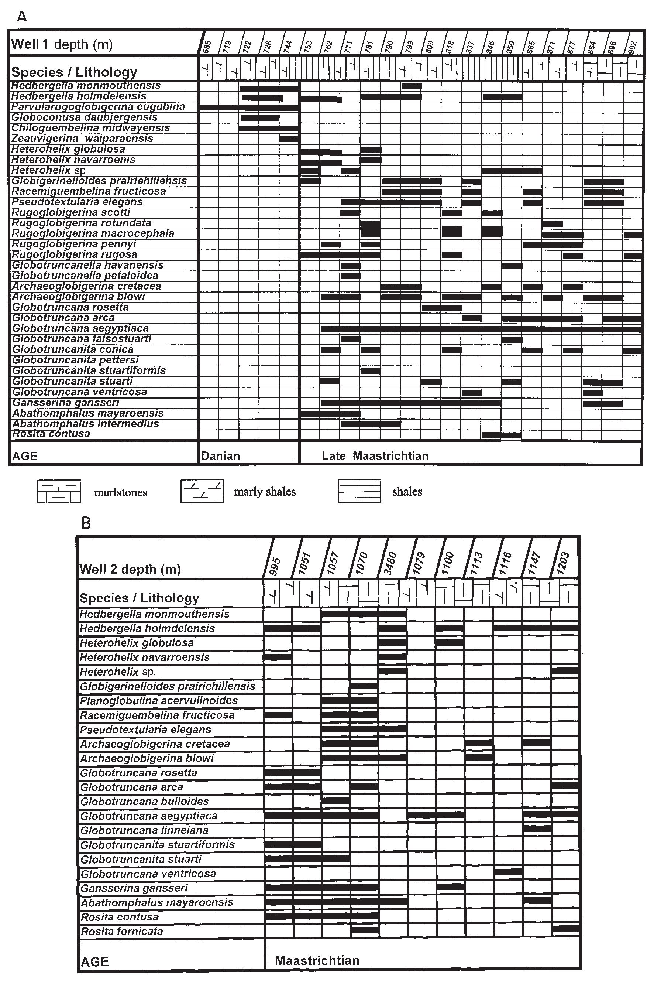
80
Sefau Omar Tshakreen and M. Adam Gasiński

Fig. 2. Summarised biostratigraphic chart of planktonic foraminiferids
A — well 1; B — well 2
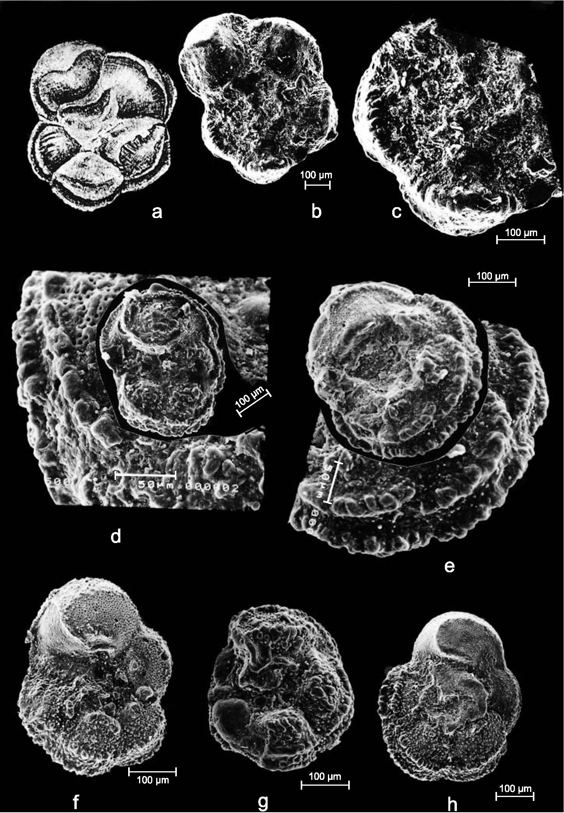
Cretaceous-Paleogene boundary problem in Libya: the occurrence of the foraminiferal species Abathomphalus mayaroensis (Bolli)
81
LATEST MAASTRICHTIAN
FORAMINIFERAL
ASSEMBLAGES
The following foraminiferids
are typical taxa accompanying A.
mayaroensis: keeled-taxa: Globo-
truncana aegyptiaca Nakkady,
Globotruncana arca (Cushman),
Globotruncana ventricosa White,
Globotruncana rosetta (Carsey),
Gansserina gansseri (Bolli), Globo-
truncana bulloides Vogler, Globo-
truncanita stuarti (de Lapparent),
Globotruncanita stuartiformis (Dal-
biez), Rosita contusa (Cushman),
Rosita fornicata (Plummer), and
non-keeled taxa: Hedbergella holm-
delensis Olsson, Hedbergella
monmouthensis (Olsson), Hetero-
helix globulosa (Ehrenberg),
Heterohelix navarroensis Loeblich,
Globigerinelloides prairiehillensis
Pessagno, Archaeoglobigerina
cretacea (d’Orbigny), Archaeo-
globigerina blowi Pessagno,
Pseudotextularia elegans (Rzehak),
Planoglobulina acervulinoides
(Egger), Racemiguembelina fructi-
cosa Egger (Fig. 2). All the latest
Maastrichtian foraminiferal assem-
blages are dominated by planktonic
foraminiferids.
Benthic assemblages are scarce
and dominated by calcareous speci-
mens. Agglutinated forms are very
rare. Some of the infauna and
semi-infauna forms in the
foraminiferal assemblages are
pyritised, indicating organic flux to
the basin floor, which caused oxy-
gen deficiency in the depositional
environment. The occurrence of
species such as A. mayaroensis and
other keeled Globotruncana taxa
along with some epipelagic
(non-keeled, r-strategists) taxa such
as: Heterohelix, Pseudotextularia,
Hedbergella, Archaeoglobigerina, Rugoglobigerina,
Globigerinelloides indicates that the environment of deposition
is outer shelf-middle continental slope.
CONCLUSIONS

Fig. 3. a — Globotruncana mayaroensis Bolli, holotype from Guayaguayare area, Trinidad, (reprinted from
Caron, 1985) x 60 (?); b-e — Abathomphalus mayaroenis (Bolli); all specimen magnifications x 150-200
(see bars): b, c —well no. 1, c x 250 visible structure of keels, composed of radially arranged rugosities, d —
well no. 1, e — well no. 1; f-h — Abathomphalus cf. mayaroensis (“intermediate”? forms between G. arca
and A. mayaroensis): f, h — well no. 2, g — well no. 1
Western Sirt Basin in samples collected from 744 m depth in
well 1 and above 995 m in well 2.
Foraminiferal assemblages indicated outer shelf-upper
slope of the latest Maastrichtian studied sediments influenced
by organic flux to the basin floor, which caused oxygen defi-
ciency in the depositional environment
Acknowledgements. Our warm thanks go to Dr. M.
The latest Maastrichtian zonal marker Abathomphalus Elazezi (Petroleum Research Centre, Libya), coordinator of
mayaroensis (Bolli) has been recognised in two wells of the Western Sirt Basin project, for allowing us to publish these
82
Sefau Omar Tshakreen and M. Adam Gasiński
data. Sincere thanks are also extended to the management of
Petroleum Research Centre in Tripoli for their valuable contri-
bution. Special thanks are extended to Dr. Tom Jerzykiewicz
for introducting us to geology of the Sirt Basin and his helpful
and constructive remarks and to Mr. Al Jenik (both from
Teknica Petroleum Services Ltd., Calgary, Canada) for his sup-
port. Prof. Francis Robaszynski (Mons Technical University),
Prof. Malcolm B. Hart (University of Plymouth), Dr.
Eustoquio Molina (Zaragoza University), Dr. Jozef Michalik
(Slovak Academy of Sciences) and an anonymous reviewer are
greatly acknowledged for valuable remarks, corrections and
suggestions. Studies were undertaken within the Western Sirt
Basin Project, WSB no. 2383.
REFERENCES
ARENILLAS I., ARZ J. A., MOLINA E. and DUPUIS C. (2000) — The
Cretaceous/Paleogene (K/P) boundary at Ain Settara, Tunisia: sudden
catastrophic mass extinction in planktic Foraminifera. J. Foraminiferal
Res., 30: 202-218.
ASHOUR M. M. (1996) — Microbiostratigraphical analysis of the
Campanian-Maastrichtian strata in some wells in Sirt Basin. In: The
Geology of Sirt Basin (eds. M. J. Salem, A. J. Mouzughi and O. S.
Hammuda): 243-264.
BARR F. T. (1972) — Cretaceous biostratigraphy and planktonic
Foraminfera of Libya. Micropaleontology, 18: 1-46.
BARR F .T. and BERGGREN W. A. (1980) — Lower Tertiary
biostratigraphy and tectonics of Northeastern Libya. In: The Geology
of Libya (eds. M. J. Salem and M. T. Busrewil ), 1: 163-191.
BARR F. T. and WEEGAR A. A. (1972) — Stratigraphic nomenclature of
the Sirt Basin, Libya. Petrol. Explor. Soc. Libya.
BOLLI H. M. (1951) — The genus Globotruncana in Trinidad. B.W. I. J.
Palaeont., 25: 187-199.
BOLLI H. M., LOEBLICH A. and TAPPAN H. (1957) — Planktonic
foraminiferal families Hantkeninidae, Orbulinidae, Globorotaliidae
and Globotruncanidae. U. S. Nat. Mus. Bull., 215: 3-50.
CARON M. (1985) — Cretaceous planktic Foraminifera. In: Plankton
Stratigraphy (eds. H. M. Bolli, J. B. Saunders and K. Perch-Nielsen):
17-86. Cambridge University Press.
DUPUIS Ch., STEURBAUT E., MOLINA E., RAUSCHER R.,
TRIBOVILLARD N., ARENILLAS I., ARZ J. A., ROBASZYNSKI
F., CARON M., ROBIN E., ROCCHIAR. and LEFEVRE I. (2001) —
The Cretaceous-Paleogene (K/P) boundary in the Ain Settara section
(Kalaat Senan, Central Tunisia): lithological, micropalaeontological
and geochemical evidence. Bull. Inst. Royal Sc. Nat. Belgique, 71:
169-190.
ELIAGOUBI B. A. and POWELL J. D. (1980) — Biostratigraphy and
palaeoenvironment of Upper Cretaceous (Maastrichtian) foraminifera
of North-central and Northwestern Libya. In: The Geology of Libya
(eds. M. J. Salem and M. T. Busrewil), 1: 137-153.
GASIŃSKI M. A. (1997) — Tethyan-Boreal connection: influence on the
evolution of mid-Cretaceous planktonic foraminiferids. Cret. Res., 18:
505-514.
GASIŃSKI M. A., LEŚNIAK T. and PIOTROWSKI M. (2001) — Latest
Maastrichtian foraminiferal Abathomphalus mayaroensis Zone in the
Subsilesian Unit (Polish Outer Carpathians). Bull. Pol. Acad. Sc. Earth
Sc., 49 (2): 89-97.
GUMATI Y. D. and KANES W. H.(1985) — Early Tertiary subsidence and
sedimentary facies — Northern Sirt Basin, Libya. Amer. Ass. Petrol.
Geol. Bull., 69:39-52.
GUNDOBIN V. M. and YEVDOKIMOV S. V. (1985) — Geological Map
of Libya 1: 250 000, Sheet Qasr Ash Shwayrif, NH 33-10, and Explan-
atory Booklet. Industrial Research Centre. Tripoli.
ION J. (1993) — Upper Cretaceous planktonic foraminiferal
biostratigraphy from the Carpathians and northern Dobrogea (Roma-
nia) related to macropalaeontological zonation. Rom. J. Strat., 75:
41-53.
JENKINS D. G. and MURRAY J. W. (eds.) (1989) — Stratigraphical Atlas
of Fossil Foraminifera (2nd edition). Ellis Horwood Ltd. Chichester.
JERZYKIEWICZ T., EDWARDS K., ELAZEZI M., HICKEY P. and
CZARNECKI M. (2002) — Geological history of the Ghedari Fault
Zone in Western Sirt Basin, Libya. Diamont Jubilee Convention
CSPG. Canada.
JORDI H. A. and LONFAT F. (1963) — Stratigraphic subdivision and
problems in Upper Cretaceous-Lower Tertiary deposits in Northwest-
ern Libya. Rev. Inst. Franc. Petrol, 18 (10): 1428-1436.
KELLER G., LI L. and MACLEOD N. (1995) — The Cretaceous-Tertiary
boundary stratotype section at El Kef, Tunisia: how catastrophic was
the mass extinction? Palaeogeogr., Palaeoclim., Palaeoecol., 119:
221-254.
LEHMANN E. P. (1964) — Tertiary-Cretaceous boundary facies in the
Sirt Basin, Libya. In: IGC Report of The Twenty-Second Session in In-
dia (eds. M. V. A. Sastry and S. B. Bhatia). Cretaceous-Tertiary
boundary including volcanic activity, 3: 56-73.
MACLEOD N. (1996) — Testing patterns of Cretaceous-Tertiary plank-
tonic foraminiferal extinction at El Kef (Tunisia). In: The Creta-
ceous-Tertiary Event and Other Catastrophes in Earth History (eds. G.
Ryder, D. Fastovsky and S. Gartner). Geol. Soc. Amer. Spec. Pap.,
307: 287-302.
MOLINA E., ARENILLAS I. and ARZ J. A. (1996) — The Creta-
ceous/Tertiary boundary mass extinction in planktic Foraminifera at
Agost, Spain. Rev. Micropaléont., 39: 225-243.
POSTUMA J. A. (1971) — Manual of Planktonic Foraminifera. Elsev.
Publ. Co.
ROBASZYNSKI F., CARON M. GONZALEZ J. M. and WONDERS A.
A. H. (1984) — Atlas of Late Cretaceous globotruncanids. Rev.
Micropaléont., 26: 145-305.
ROBASZYNSKI F. and CARON M. (1995) — Foraminiféres
planctoniques du Crétacé: commentaire de la zonation Eu-
rope-Méditerranée. Bull. Soc. Géol. France, 6: 681-692.
SHAKOOR A. and SHAGRONI Y. (1984) — Geological Map of Libya
1:250 000, Sheet Hun NH 33-11 and Explanatory Booklet. Industrial
Research Centre. Tripoli.
TMALLA A. F. A. (1992) — Stratigraphic position of the Cretaceous-Ter-
tiary boundary in the Northern Sirt Basin, Libya. Mar. Petrol. Geol., 9
(5): 542-552.
TMALLA A. F. A. (1996) — Latest Maastrichtian to Paleogene planktonic
foraminiferal biostratigraphy of well A1a-NC29A, Northern Sirt Ba-
sin. Libya. In: The Geology of Sirt Basin (eds. M. J. Salem, A. J.
Mouzughi and O. S. Hammuda ), 2: 195-232.
TSHAKREEN S. O., GASIŃSKI M. A. and JERZYKIEWICZ T. (2002) —
Late Cretaceous and Early Paleogene foraminiferids of the Western
Sirt Basin (WSB, Libya). In: ESSEWECA Conference,
Paleogeographical, Paleoecological, Paleoclimatical Development of
Central Europe (eds. J. Michalik et al. ): 83-84.

