

©PolJRadiol2018;83:e407-e414
DOI:https://doi.org/10.5114/pjr.2018.79205
Received:21.04.2018
Accepted:24.05.2018
Published:3.09.2018
http://www.polradiol.com
Originalpaper
Riskfactorsofpneumothoraxandchesttubeplacementafter
computedtomography-guidedcoreneedlebiopsyoflunglesions:asingle-centreexperiencewith822biopsies
KeremOzturk1A,B,C,D,E,F,EsraSoylu2B,C,D,E,F,GokhanGokalp1D,E,G,UgurTopal1A,B,D,E,F,G
1UludagUniversityFacultyofMedicine,Turkey
2CekirgeStateHospital,Turkey
Abstract
Purpose:Todeterminetheriskfactorsofpneumothoraxandchesttubeplacementaftercomputedtomography-guidedcoreneedlelungbiopsy(CT-CNB).
Materialandmethods:Variablesthatcouldincreasetheriskofpneumothoraxandchesttubeplacementwereretro-spectivelyanalysedin822CT-CNBsconductedwith18-gaugenon-coaxialCT-CNBin813patients(646menand167women;range:18-90years;mean:59.8years).Predictorvariableswereage,gender,patientposition,severityofpulmonaryemphysema,lesionsizeandlocalisation,contour characteristics,presenceofatelectasis,pleuraltagandfissureintheneedle-tract,lengthoftheaeratedlungparenchymacrossedbytheneedle,needleentryangle,numberofpleuralpunctures,experienceoftheoperator,andprocedureduration.Allvariableswereinvestigatedby×2testandlogisticregressionanalysis.
Results:Theoverallincidenceofpneumothoraxwas15.4%(127/822).Chesttubeplacementwasrequiredfor22.8%(29/127)ofpneumothoraxes.Thesignificantindependentvariablesforpneumothoraxwerelesionssmallerthan3cm(p=0.009),supineandlateraldecubituspositionduringtheprocedure(p<0.001),greaterlesiondepth(p=0.001),severityofpulmonaryemphysema(p<0.001),needlepathcrossingthefissure(p<0.001),andapaththatskipstheatelectasis(p<0.001)orpleuraltag(p<0.001);thoseforchesttubeplacementwereproneposition(p<0.001),lessexperiencedoperator(p=0.001),severityofpulmonaryemphysema(p<0.001),andgreaterlesiondepth(p=0.008).
Conclusions:Thesupineandlateraldecubitusposition,aneedlepaththatcrossesthefissure,andapaththatskipstheatelectasisorapleuraltagarenovelpredictorsforthedevelopmentofpneumothorax.
Keywords:computedtomography(CT),CT-guidedcoreneedlelungbiopsy(CT-CNB),pneumothorax,chesttube,pulmonarylesion.
Severalpreviousstudiessuggestedthatvariousvaria-
blescouldaffecttheincidenceofpneumothoraxandchesttubeplacement,withsomeconflictingresultsforthevar-iablesofneedleentryangle,numberofpleuralpunctures,durationoftheprocedure,locationofthelesionwithinthelung,emphysemaaroundthelesion,anddepthfrompleura tothelesion[4-6].
Recognisingthepredictivevariablesissubstantialtoreducecertainrisksfortheprocedure[7].Therefore,the
Introduction
Computedtomography-guidedcoreneedlelungbiopsy
(CT-CNB)isawell-knownmethodtodiagnosepulmonarylesions,withadiagnosticaccuracyof64-97%[1];neverthe-less,pneumothoraxisacommoncomplication,occurringin8-69%ofpatients[2].Mostly,pneumothoraxregressesspontaneouslywithoutanintervention;however,asmallgroupofpatientsmayrequire chesttubeplacement [3].
Correspondenceaddress:
Prof.UgurTopal,DepartmentofRadiology,UludagUniversityFacultyofMedicine,GorukleSt.,16059,Bursa,Turkey,e-mail:utopal@uludag.edu.tr
Authors’contribution:
AStudydesign∙BDatacollection∙CStatisticalanalysis∙DDatainterpretation∙EManuscriptpreparation∙FLiteraturesearch∙GFundscollection
©PolJRadiol2018;83:e407-e414
e407

KeremOzturk,EsraSoylu,GokhanGokalp,UgurTopal
purposeofourstudyistodeterminethepredictorvaria-
blesofpneumothoraxandchesttubeplacementfollowingtheCT-CNBinasinglecentrewithalargepatientpop-ulation.
fashiontoobtainthespecimen.Specimenacquisitionwas
repeateduntiltheradiologistconsidereditsufficient,duetotheabsenceofanon-sitepathologist.Cutting-needlebiopsieswereperformedusing18-gaugenon-coaxialsys-tem(MeditechInc.,Watertown,MA02172,USA).
Immediatelyaftertheprocedure,aCTscanwasob-tainedtodeterminethepresenceofthepneumothorax.Patientswereplacedonastretcherwiththepuncturesitedownandwerefollowedupfor2h.Thepatientswereinstructedtobreathecalmlyandabstainfromtalking,coughing,andforcedbreathing.
Chestradiographs wereobtainedattheendofthe2-hperiod.Ifpneumothoraxwasnotpresent,thepatientwassenthomewithinstructions.Ifpneumothoraxwasdetect-edinthecontrolchestradiographs,thepatientreceivedoxygenviaafacialmaskfor2hifhe/shewasasymptomat-ic.Placementofachestcatheterortubewasconsideredifthepatientbecamesymptomaticorifthepneumothoraxwasprogressive.
Materialandmethods
Patients
TheprotocolofthisretrospectivestudywasapprovedbytheInstitutionalReviewBoard.Written,informedconsentwasnotrequiredbecauseoftheretrospectivenatureofthestudy.
Atotalof872patientsunderwentCT-CNBbetweenJan-uary2001andOctober2006inourdepartment.Twenty-onemediastinallesionswereexcludedbecausetheydidnotrequiretheneedlepathtotraversethroughtheaeratedlungs.Thirty-eightpatientsundergoingonlyaneedleaspira-tionbiopsywerealsoexcluded.Theremaining813patientswhounderwentaCT-CNBwithan18-gaugenon-coaxialneedle(646menand167women;agerange:18-90years;av-erageage:59.8years)wereevaluated.Sevenpatientsunder-wentrepeatedbiopsies.Repeatedbiopsies(fivepatientshadtwobiopsies,andtwopatientshadthreeneedlebiopsies)wereconsideredtobenewproceduresbecausetheselectedvariablesweredifferentineachprocedure.
Datacollection
Patient-andprocedure-relateddatawerecollectedusingastandardiseddataform.Individualdatawereenteredintoanexcelsheetonthecomputer.Datathatweremiss-ingfromornotmentionedinthestandardiseddataformwereconsideredtobenotpresent.
Patient-, lesion-,and procedure-relatedvariables wereacquiredtodeterminetheriskfactorsofpneumothoraxandchesttubeplacement.Theriskfactorsincluded:
(a)patient-relatedriskfactorssuchasgender,age,andpatientposition(supine,prone,orlateraldecubitus)dur-ingthe procedureand severity ofpulmonary emphysemaaroundthelesion;(b)lesion-relatedriskfactorssuchassize,locationwithinthelung(upper,middle,orlowerlungregions),andcontourcharacteristicsonCT(smooth,blurred,orspiculated);and(c)procedure-relatedriskfac-torssuchaspresenceofatelectasis,pleuraltagsandfis-suresintheneedletract,lengthoftheaeratedlungparen-chymacrossedbytheneedle,needleentryangle,numberofpleuralpunctures,experienceleveloftheoperator,anddurationoftheprocedure.
Thedistancefromthepulmonarylesiontothepleurawas estimated astheshortestdistanceonaxialCTscans.Thedepthwasconsideredtobe0cminlesionsdirectlyincontactwiththepleura.Theneedleentryanglewastheacuteanglebetweentheneedleandthepleuralsurface.Thelungwasarbitrarilydividedintothreeequal zones:upper,middle,andlower.ThedurationoftheprocedurewasdefinedastheintervalbetweenthefirstCTimageobtainedtodeterminepleuralpassingandthefirstCTimageobtainedtocheckthepresenceofthepneumotho-rax.Emphysemaaroundthelesionwasscoredasgrade1,2,or3usingtheGoddardclassification[8],whichisavisualscaleinwhichtheareasshowingvasculardis-ruptionandlowattenuationvaluesarescoredforslices
Technique
AllprocedureswereperformedpercutaneouslyunderCT(SomatomEmotion;SiemensHealthcare,Forchheim,Germany)guidancebyjuniorresidentswithameanex-perienceoffivebiopsiesandseniorresidentswithameanexperienceof25biopsies,underthesupervisionofachestradiologistwith20years’experience,whoalsoperformedsomebiopsies.
Ourexclusioncriteriawerelunglesions5mmingreatestdiameter,patientswhocouldnotfollowverbalorvisualinstruction,andpatientsorfamilymemberswhocouldnotaccepttheprocedure-relatedrisks.
Thepatientswereplacedinthesupine,prone,orlat-eralpositions,andCTscanswereobtainedtotargetthelesion.Ifpossible,needlepathswerechosentonotcrossvisiblebronchi,interlobularfissures,largevessels,bullae,andemphysematouslungtissue.
LocalisationoftheneedleentryutilisedCTimageswithlaserlightingandskinmarkers.Afterabriefexpla-nationofthestepsinvolvedinpercutaneousneedlelungbiopsy,thepatientswereinstructedtostaycalm,tobreathshallowly,andtoabstainfromtalkingduringtheproce-dureandduringtheobservationperiod.Noconscioussedationwasused.Allpatientsreceivedlocalanaesthesiawithsubcutaneousinjectionsofprilocainehydrochlorate(Citanest2%,AstraZeneca,Sweden).
Aftertheadministrationofalocalanaesthetic,thenon-coaxialcoreneedlewasadvanceddirectlyinastep
e408
©PolJRadiol2018;83:e407-e414

RiskfactorsofpneumothoraxafterCT-CNB
includingthelesion.Emphysemaaroundthelesionwas
consideredgrade1for≤25%,grade2for25-50%,and
grade3for>50%.
pleuratothelesionwas10±15mm(range:0-70mm).
Themeanneedlepathanglewas76±13.8°(range:10-90°).Atotalof127/822biopsies(15.4%)hadpneumo-thoraxafterCT-CNB(Figure1);ofthose,29/127proce-dures(22.8%)with pneumothoracesrequiredachest tubeplacement.Fromtheresultsofunivariateanalyses,thesignificantvariablesofpneumothoraxweresmallerlesionsize(p=0.003),supineandlateraldecubitusposition(p<0.001),greaterlesiondepth(p<0.001),severityofpulmonaryemphysemaaroundthelesion(p=0.001),nee-dleentryanglegreaterthan75°(p=0.009),needlepathcrossingthefissure(p<0.001),andapaththatskippedtheatelectasis(p<0.001)orpleuraltag(p<0.001).Fromtheresultsofmultivariateanalysis,thesignifi-cantindependentriskfactorsweresmallerlesionsize(OR=1.75;95%CI:1.28-1.98;p=0.009),supineand
lateraldecubitusposition(OR=2.42;95%CI:1.93-2.67;
p<0.001),greaterlesiondepth(OR=1.93;95%CI:1.54-2.24;p=0.001),severityofpulmonaryemphysemaaroundthelesion(OR=2.51;95%CI:2.10-2.76;p<0.001),needlepathcrossingthefissure(OR=4.12;95%CI:3.05-4.88;p<0.001),andapaththatskippedtheatelectasis(OR=2.86;95%CI:2.16-3.05;p<0.001)orpleuraltag(OR=2.22;
95%CI:1.87-2.49;p<0.001)(Tables1-3).
Fromtheresultsofunivariateanalyses,thesignifi-cantriskfactorsforchesttubeplacementwerepronepo-sition(p<0.001),lessexperiencedoperator(p<0.001),severityofpulmonaryemphysemaaroundthelesion(p<0.001),spiculatedcontourofthelesion(p=0.012),andgreaterlesiondepth (p=0.001).Fromtheresultsofmul-tivariateanalysis,thesignificant independentriskfactorswerethepronepositionduringtheprocedure(OR=2.82;95%CI:2.18-3.22;p<0.001),lessexperiencedoper-
ator(OR=1.94;95%CI:1.57-2.21;p=0.001),severity
ofpulmonaryemphysemaaroundthelesion(OR=2.30;95%CI:1.98-2.51;p<0.001),andgreaterlesiondepth(OR=1.71;95%CI:1.39-2.04;p=0.008)(Tables1-3).
Emphysemawasnotdetected(grade 0)in 615ofthelesions.Of those,64(10%)were complicatedbypneu-mothorax.Pneumothoraxdevelopedin27%ofthegrade1(34/126),in35%ofgrade2(17/49),andin37%ofgrade3(12/32)emphysema.Achesttubewasplacedineightpatientswithgrade0emphysema(12%),eightpatientswithgrade1(23%),eightpatientswithgrade2(47%),andfivepatientswithgrade3emphysema(42%).Weidentifiedonlyonecaseofpneumothoraxwhenat-electasis(1/18)waspresent,andtwocasesofpneumotho-raxwhenthepleuraltag(2/22)was presentintheneedletrajectory(p<0.001).However,thepneumothoraxwassignificantly higher when the needlepassed through thefissure(14/22)(p<0.001)(Table3).Thelesioncontour,gender,age,locationofthelesion,proceduretime,num-berofpleuralpunctures,andneedleentryanglewerenotrelatedtotheincreasedriskofpneumothoraxandchest
tubeplacement(p>0.05).
Statisticalanalysis
AllstatisticalcomparisonsrelatedtotheriskfactorsofpneumothoraxandchesttubeplacementwereperformedbyusingthesoftwareofStatisticalPackagefortheSocialSciences(SPSS,version23.0;SPSS,Chicago,Ill).Receiveroperatingcharacteristics(ROC)analysiswasperformedbyusingananalysisprogram(MedCalcforWindows,Os-tend,Belgium).Descriptivestatisticsweregivenasmean
±standarddeviationforcontinuousvariableandcountasapercentageforthecategoricalvariable.GenderwascomparedbyusingPearson’sc2test,andStudent’st-testwasusedforthepatients’ages.TheROCanalysiswasuti-lisedtoassesstheoptimalcut-offvalueforthenumericalvariablessuchasage,lesionsize,lengthoftheaeratedlungparenchymacrossedbytheneedle,theneedleentryangle,numberofpleuralpunctures,andproceduretime(min-imalfalse-negativeandfalse-positiveresults)fortheriskofpneumothorax.
Theriskfactorsofpneumothoraxandchesttubeplacementwereestimatedbyutilisingthelesionsasa sampling unit.Atotalof822lesionswerecategorisedintotwogroupsrelatedtothepresenceofthepneumo-thorax.Then,thepneumothoracesweredividedintotwosubgroupsaccordingtowhetherachesttubewasinserted.Thevariableswerecomparedbetweenthegroupsusingunivariateanalysiswiththetwo-sidedStudent’st-testfornumericvaluesandthechi-squaretestorFisher’sexacttestforcategoricalvalues.Afterward,thevariablesthatwerefoundtobesignificantlydifferentbyunivari-ateanalyseswere testedformultivariatelogisticregres-sionanalysistoinvestigatetheindependentriskfactorsforthepneumothoraxandthosefortherequirementofchesttubeplacement.Anoddsratio(OR)>1.00indicat-edahigherriskofpneumothoraxortherequirementforchesttubeplacement.Apvalue<0.05wasconsideredtobestatisticallysignificant.
Results
FromJanuary2001toOctober2006,813patients(646
menand167women;range:18-90years;mean:59.8years)werereferredtoundergoCT-CNB.Fivepatientswerereferredforbiopsiestwice,andtwopatientswerereferredforthreebiopsies.Consequently,thehospitalre-cordsandimagesof813consecutivecasesofCT-CNBswereretrospectivelyanalysed.
Thelesionswereintheupperlunglobein501patients(60.9%),middlelunglobein37patients(4.5%),andlow-erlunglobein284patients(34.5%).Themeansizewas52±25.7mm(range:8-150mm).Theaveragedepthfrom
©PolJRadiol2018;83:e407-e414
e409

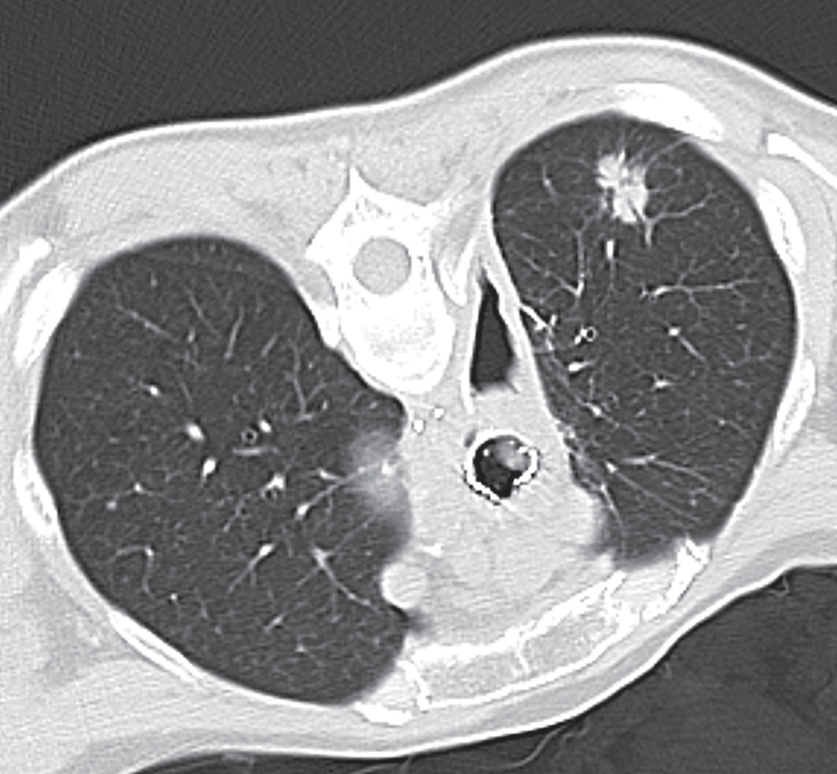
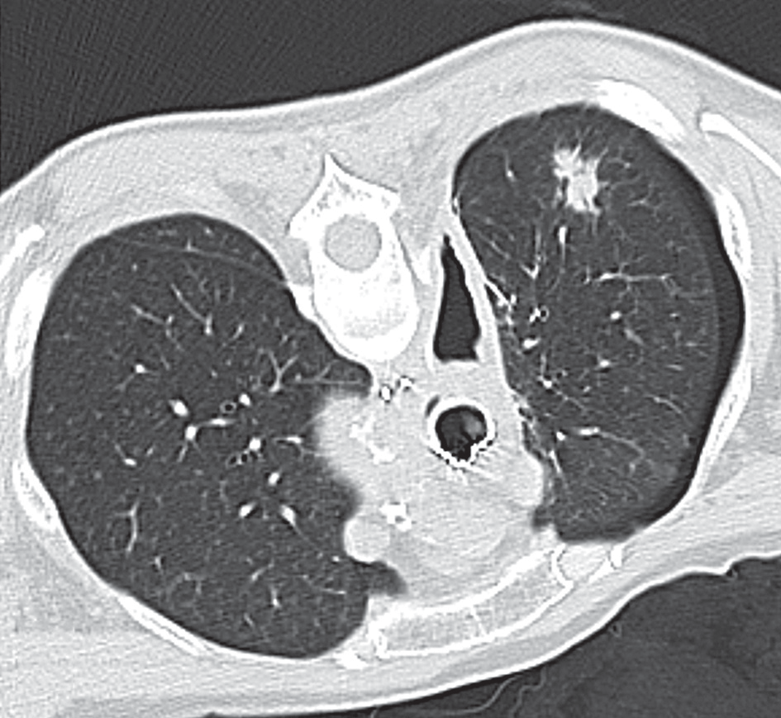
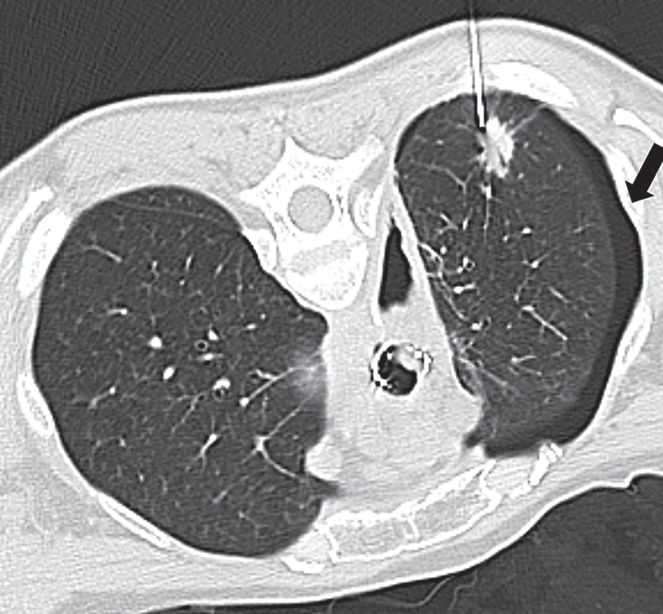
KeremOzturk,EsraSoylu,GokhanGokalp,UgurTopal
A
B
C
Figure1.Computedtomography-guidednon-coaxiallungbiopsyofasol-itarysuspectedlesion(A)showedthebiopsyneedleinsertedwithinthelesionandtheassociatedpresenceofpneumothorax(arrow)(B).Computedtomographyimageafterremovalofthebiopsyneedleshowedthepersis-tenceofpneumothorax(C)
Table1.Correlationofpneumothoraxandchest tubeplacementwithpatient-relatedvariables
e410
©PolJRadiol2018;83:e407-e414
Variables Pneumothoraxrate(%) P-value Chesttubeplacementrate(%) P-value
Age

>0.05

>0.05

<60
60/386(15%)

12/60(20%)

≥60
67/436(15%)

17/67(25%)

Gender

>0.05

>0.05

Male
104/655(16%)

24/104(23%)

Female
23/167(14%)

5/23(22%)

Patientposition

<0.001

<0.001

Supine
83/253(32%)

6/83(7%)

Prone
27/484(5%)

19/27(70%)

Lateraldecubitus
17/85(20%)

4/17(23%)

Emphysemaaroundthelesion

<0.001

<0.001

0
64/615(10%)

8/64(12%)

1
34/126(27%)

8/34(23%)

2
17/49(35%)

8/17(47%)

3
12/32(37%)

5/12(42%)

RiskfactorsofpneumothoraxafterCT-CNB
Table2.Correlationofpneumothoraxand chest tubeplacementwithlesion-relatedvariables
Table3.Correlationofpneumothoraxandchest tubeplacementwithprocedure-related variables
No.–number,NA–notapplicable.
requiringchesttubeplacementrangingfrom1.6%to28%
[11].Inourstudythepneumothoraxratewas15.4%,andachesttubewasplacedin22.8%ofpneumothoraces,whichcorrelatedwellwithpreviouslyreportedstudies[12].
Inourseries,supineandlateral-dependentpositionduringtheprocedurestronglycorrelatedwithahigherpneumothoraxrateandinverselycorrelatedwithchest
Discussion
CT-guidedcoreneedle biopsyisareliablemethodtodis-
tinguishbenignfrommalignantpulmonarylesionsandisawidelyacceptedtechniquewithlowcomplicationrates[9,10].Pneumothoraxisthemostcommoncomplicationofpercutaneouslungbiopsy,witharateofpneumothorax
©PolJRadiol2018;83:e407-e414
e411
Variables Pneumothoraxrate(%) P-value Chesttubeplacementrate(%) P-value
Entryangle

>0.05

>0.05

<75
35/302(12%)

7/35(20%)

≥75
92/520(18%)

20/92(21%)

No.ofpleuralpunctures

>0.05

>0.05

≤2
102/669(15%)

20/102(20%)

>2
25/153(16%)

7/25(28%)

Proceduretime(minute)

>0.05

>0.05

<2.5
67/485(14%)

18/67(27%)

≥2.5
60/337(18%)

9/60(20%)

Lesiondepth(cm)

0.001

0.008

0
10/401(2%)

0

0.5-3
65/212(31%)

13/65(20%)

>3
52/209(25%)

15/52(29%)

Operator

>0.05

0.001

Juniorresident
30/218(14%)

10/30(33%)

Seniorresident
66/420(16%)

14/66(21%)

Chestradiologist
31/184(17%)

3/31(9%)

Others

<0.001

NA

Presenceofatelectasis 1/18(6%)

0

Presenceoffissure 14/22(63%)

3/14(21%)

PresenceofpleuralTag 2/22(9%)

0

Variables Pneumothoraxrate(%) P-value Chesttubeplacementrate(%) P-value
Size(cm)

0.009

>0.05

<3
19/68(28%)

4/19(21%)

≥3.1
108/754(14%)

25/108(23%)

Localisation

>0.05

>0.05

Upper
69/501(14%)

17/69(24%)

Middle
8/37(21%)

2/8(25%)

Lower
50/284(18%)

10/50(20%)

Contourcharacteristics

>0.05

>0.05

Smooth
34/238(14%)

5/34(15%)

Blurred
58/407(14%)

12/58(21%)

Spiculated
35/177(20%)

12/35(34%)

KeremOzturk,EsraSoylu,GokhanGokalp,UgurTopal
tubeplacementrate.Pronepositionduringtheproce-
duresignificantlydecreasedthepneumothoraxratein-dependently.Differencesinpneumothoraxratewiththepositionofthepatientcouldbeexplainedbythedis-crepanciesofchestwallmotionsduringrespiration.Theanteriorandlateralchestwallscouldhaveanincreasedmotionduringrespirationincomparisonwiththeposte-riorchestwall,anditmayberelatedtotheincreasedlungparenchymal-pleuraldisruptionduetoincreasedneedlemovement[13].Anotherfactorthatmayhavecontributedtothelowrateofpneumothoraxobservedinthepresentserieswastheplacementofthepatientinapuncture-side-downpositionafterthebiopsy.Suchapositionhasbeenshowntosignificantlydecreasethenumberofpneumo-thoracesandtherateofchesttubeplacement[14,15].Re-ductionofairdeliverytothepuncturesitemighthelptopreventpneumothoraxdevelopment.Asamatteroffact,ifpneumothoraxdevelopedafterthe firstpleural punctureinthepronepositionduringtheprocedure,theriskofpneumothoraxprogressionandthechesttubeplacementratecouldbehigher,andconsequentlythe repeatedpleu-ralpuncturescouldbemoredangerousfortheprogres-sion ofpneumothorax.Toourknowledge,theimportanceofpositioningduringtheprocedurehasnotbeeninves-tigatedspecificallyforthepuncture-site-downtechnique,althoughMilleretal.[16]demonstratedahigherpneu-mothoraxratewithananteriorneedleapproachinsixof50biopsiesandKoetal.[13]revealedahigherpneumo-thoraxratewithsupineposition.
Therewasastrongcorrelationbetweenthepneumo-thoraxriskandneedletrajectorythatcrossesamajorlungfissure(14/22)(p<0.001).Inourseries,pneumothoraxde-velopedinoneof18proceduresinwhichtheneedlepassedthroughatelectasisandintwoof22proceduresinwhichtheneedlepassedthroughapleuraltag.Generally,apaththatskipslungfissuresorneedletrajectorythatcrosses anatelectatic lungtissue/pleuraltag couldbepreferredtode-creasethedevelopmentofthepneumothorax[17].
Thelengthofaeratedlungparenchymacrossedbyaneedlewasfoundtobeasignificantvariable(p=0.001)forpneumothorax.Therewere401lesionsindirectcon-tactwiththepleura.Ofthose,pneumothoraxdevelopedinonly10(2%) patients.Thepneumothoraxrateincreasedwithalongerdistancebetweenthelesionandpleuralsur-face.Hence,itcouldbepreferabletoplananeedletra-jectorytobeasshortas possible.However,thereisstillsubstantialconflictaboutthecorrelationofpneumotho-raxrateandlengthofintrapulmonarybiopsypathintheliterature[13].Someofthestudiesdemonstratedthatanincreasedintrapulmonarybiopsypathcouldbeassociatedwithahigherrateofpneumothorax[18].AsreportedbyKinoshitaetal.[19],alongerlengthoftheaeratedlungparenchymacrossedbyneedlecouldhaveagreaterchancetotearlungparenchymaduetothespontaneousrespira-torymotion.Incontrast,Yeowetal.[20]demonstratedthatsubpleurallesionscouldbeassociated with ahigher
rateofpneumothoraxthanthosefartherfromthepleura,
duetoshallowanchoringandneedledislodgementtothepleura.Theneedlemanoeuvrescouldbemoredifficultforthedeeperlesions.Consequently,moreneedlemanoeuvresmaybeneeded,whichcouldresultinpleuralandparen-chymaldisruption.Inourstudy,pneumothoraces(n=10)developedinsomelesionshavingcontactwiththepleura.Thisfindingcouldbeexplained bythe factthatthedepthoflesionfromthepleuralsurfacewasnotgatheredaccu-ratelydueto the5-mmslicethicknessofourCTscanner,whichmightpreventareliableestimationofpleura-lesiondistanceiflessthan1cm.
Therewasalsoasignificantcorrelationbetweenthepneumothoraxandseverityoftheemphysemaaroundthelesion(p<0.001).Itwasobservedthattheseverityofemphysemaaroundthelesionmightincreasetheriskofpneumothoraxtwo-tothree-fold.Ourdataconfirmthatthedegreeofhyperinflationcouldbeanadversefactorforthedevelopmentof pneumothorax.Thehyperinflationmayindicatealveolardestruction.Thedisruptionofthesedilatedalveolicouldincreaseairleakageintothepleu-ralspaceandcouldpreventrapidsealingofthedamagedlungtissue.Consistentairleakagerequiringchesttubeplacementmayalsobeexpoundedbyanincreasedairwaypressureintheemphysematouslungtissue.Althoughtheincreasedpneumothoraxriskdoes notprecludetheuse ofpercutaneousneedlebiopsy,itmayhelpustobepreparedforthepotentialriskofpneumothorax.
Inourstudy,lungfunctiontests(LFTs)werenotobtainedbefore thebiopsy,andinsteadweused avisualscoringontheCTslices.TherearesomereportsusingvisualscoringonCTfortheevaluationofthe emphyse-ma.InthestudyofCoxetal.[21]theemphysemawasassessed particularlyaroundthelesion,anditwasfoundthattheemphysemawasstronglycorrelatedwiththepneumothoraxdevelopment.ButinthestudyofLaurentetal.[22]theseverityoftheemphysemaaroundthelesionwasgradedvisuallyonCTimageswithoutanycorrela-tionwiththedevelopmentofpneumothorax.WebelievethatthegradingoftheemphysemavisuallyonCTslicesaroundthelesioncouldbeusefultopredicttheriskofpneumothoraxdevelopment.
Smallerlesionsizewasanothersignificantriskfactorforpneumothorax.Therewasaslight increaseintheriskofpneumothorax withsmallerlung lesions.The highestpneumothoraxrateof33% wasseeninlunglesions lessthan3cmindiameter.Thismightbeexplainedbymoredifficultneedleredirectionsto targetlunglesions.Anin-creasedneedlemanoeuvretobiopsyasmall lesionmaycauseagreaterriskofdisruptingnormallungparenchy-mawithahigherpneumothoraxrate.
Ourresultsshowednosignificantdifferenceinpro-ceduretimesbetweenCT-CNBscomplicatedbypneu-mothoracesandthosewithoutpneumothoraces.OurfindingscorrelatedwellwiththestudyofLaurentetal.[22],whichdemonstratednosignificantdifferenceinpro-
e412
©PolJRadiol2018;83:e407-e414

RiskfactorsofpneumothoraxafterCT-CNB
ceduretimesbetweenpatientswithorwithoutpneumo-
thorax.Proceduredurationsinourstudywerebetween15and1140seconds,butmostwerearound110-150sec-onds.Longerproceduredurationprobablyresultedfromalarger numberofpleuralpasses[17].Longerproceduredurationwasnotcorrelatedwithincreasedpneumothoraxrateinourseriesandthusshouldnotinfluencethedeci-siontoacquire morebiopsy samples.
Somepreviousstudiesdemonstratedthatthelevelofoperatorexperiencedidnotaffectthepneumothoraxrisk[21].Inthisstudy,weincludedallroutineproceduresthatwereperformedbyexperiencedthoracicradiologistsaswell as thebiopsiesthatwereutilisedbyseniorandjun-iorresidentsinourcentre.Thepneumothoraxwasdevel-opedin30(14%)of218proceduresperformedbyajuniorresident,andin66(16%)of420proceduresperformedbyaseniorresident.Therateofpneumothoraxinproce-duresthatwereperformedbyachestradiologistwas17%(31/184).Inmultivariateanalysis,nosignificantdifferencewasfoundbetweenthegroups(p>0.05).Thisresultwas
contrarytothestudyofYeowetal.[20],whichdemonstrat-
edasignificantcorrelationbetweentheexperienceleveloftheoperatorandpneumothoraxrate.However,thechesttubeplacementratewassignificantlylowerinproceduresperformedbyachestradiologist(p<0.001).Thisfindingcouldbeexplainedpartlybyalowerneedlemovementinproceduresperformedbyanexperiencedradiologist,whichmightberelatedtodecreasedlungtissuedamage.
Recently,someinvestigatorsappliedthecoaxialtech-niqueforCT-CNBs[23].Inourstudy,wedidnotadoptthecoaxial technique.Therefore,the numberof punctures
coulddirectlyaffectthepneumothoraxandchesttube
placementrate.Inaddition,wedidnotfindanycorrela-tionbetweenthepneumothoraxorchesttubeplacementratewithregardtoneedleentryangle.Thisfindingappar-entlyconflictedwiththeresultsobtainedbySajietal.[24]andKoetal.[13], who reportedan increasedpneumotho-raxrateinprocedureswithaneedlepleuralangle<80°.
Therewassomelimitationinthisstudy.Thisstudywasaretrospectivewithanunknownbias.Thepulmo-naryfunctiontestswerenotperformedroutinelybeforetheprocedures.Wealsoobtainedtheproceduredurationinsteadofthedwelltime.Acquiringthedwelltimeinsteadoftheproceduredurationmaychangetheresultinregardtopneumothoraxandchesttubeplacementrisk.Despitesomelimitations,webelieveourdatacouldbeusedtopreventsomepotentialcomplicationsincutting-needlebiopsies.
Conclusions
Webelievethatthepronepositionduringtheprocedure
andpuncture-site-downpositioninthefollow-upperiodareappropriatetodecreasethepneumothoraxrate.Theneedlepaththatcrossesafissureandapaththatskipstheatelectasisorapleuraltagmayprovidea“protectiveeffect”forthedevelopmentofclinicallysignificantpost-biopsypneumothorax.
Conflictofinterest
Theauthorsdeclarethattheyhavenoconflictofinterest.
References
1.
MathersC.Theglobalburdenofdisease:2004update.WorldHealth
Organization,Geneva2008.
BoskovicT,StanicJ,Pena-KaranS,etal.Pneumothoraxaftertran-sthoracicneedlebiopsyoflunglesionsunderCTguidance.JThoracDis2014;6:S99.
WuCC,MaherMM,ShepardJA.ComplicationsofCT-guidedper-cutaneousneedlebiopsyofthechest: preventionandmanagement.AJRAmJRoentgenol2011;196:678-682.
CoveyAM,GandhiR,BrodyLA,etal.Factorsassociatedwithpneumothoraxandpneumothoraxrequiringtreatmentafterper-cutaneouslungbiopsyin443consecutivepatients.JVascIntervRadiol2004;15:479-483.
HirakiT,MimuraH,GobaraH,etal.IncidenceofandriskfactorsforpneumothoraxandchesttubeplacementafterCTfluorosco-py-guidedpercutaneouslungbiopsy:retrospectiveanalysisoftheproceduresconductedovera9-yearperiod.AJRAmJRoentgenol2010;194:809-814.
AsaiN,KawamuraY,YamazakiI,etal.Isemphysemaariskfactorfor
pneumothoraxinCT-guidedlungbiopsy?SpringerPlus2013;2:196.
7.
HeerinkWJ,deBockGH,deJongeGJ,etal.Complicationrates
ofCT-guided transthoracic lungbiopsy:meta-analysis.EurRadiol2017;27:138-148.
GoddardPR,NicholsonEU,LaszloG,etal.Computedtomographyinpulmonaryemphysema.ClinRadiol1982;33:379-387.
BirchardKR.Transthoracicneedlebiopsy.SeminInterventRadiol2011;28:87-97.
TakeshitaJ,MasagoK,KatoR,etal.CT-guidedfine-needleaspira-tionandcoreneedlebiopsiesofpulmonarylesions:asingle-centerexperiencewith750biopsiesinJapan.AJRAmJRoentgenol2015;204:29-34.
KhanMF,StraubR,MoghaddamSR,etal.VariablesaffectingtheriskofpneumothoraxandintrapulmonalhemorrhageinCT-guidedtransthoracicbiopsy.EurRadiol2008;18:1356-1363.
TopalU,EdizB.Transthoracicneedlebiopsy:factorseffectingriskofpneumothorax.EurJRadiol2003;48:263-267.
KoJP,ShepardJA,DruckerEA,etal.Factorsinfluencingpneumo-
thoraxrateatlungbiopsy:aredwelltimeandangleofpleuralpunc-turecontributingfactors?Radiology2001;218:491-496.
2.
8.
3.
9.
10.
4.
11.
5.
12.
13.
6.
©PolJRadiol2018;83:e407-e414
e413

KeremOzturk,EsraSoylu,GokhanGokalp,UgurTopal
14.
DellingerRP,FrancoisD,SavagePJ,etal.Effectofpatientposi-
tioningonpneumothoraxratefollowingfineneedlelungaspiration(letter).AmRevRespirDis1983;28:210.
MooreEH,LeBlancJ,MontesiSA,etal.Effectofpatientpositioningafterneedleaspirationlungbiopsy.Radiology1991;181:385-387.MillerKS,FishGB,StanleyJH,etal.Predictionofpneumothoraxrateinpercutaneousneedleaspirationofthelung.Chest1988;93:742-745.YankelevitzDF,VazquezM,HenschkeCI.Specialtechniquesintransthoracicneedlebiopsyofpulmonarynodules.RadiolClinNorthAm2000;38:267-279.
KazerooniEA,LimFT,MikhailA,etal.RiskofpneumothoraxinCT-guidedtransthoracicneedleaspirationbiopsyofthelung.Ra-diology1996;198:371-375.
KinoshitaF,KatoT,SugiuraK,etal.CT-guidedtransthoracicneedle
biopsyusingapuncturesite-downpositioningtechnique.AJRAmJRoentgenol2006;187:926-932.
20.
YeowKM,SuIH,PanKT,etal.Riskfactorsofpneumothoraxand
bleeding:multivariateanalysisof660CT-guidedcoaxialcuttingneedlelungbiopsies.Chest2004;126:748-754.
CoxJE,ChilesC,McManusCM,etal.Transthoracicneedleaspira-tionbiopsy:variablesthataffectriskofpneumothorax.Radiology1999;212:165-168.
LaurentF,LatrabeV,VergierB,etal.CT-guidedtransthoracicneedlebiopsyofpulmonarynodulessmallerthan20mm:resultswithanauto-mated20-gaugecoaxialcuttingneedle.ClinRadiol2000;55:281-287.LimCS,TanLE,WangJY,etal.Riskfactorsofpneumothoraxaf-terCT-guidedcoaxialcuttingneedlelungbiopsythroughaeratedversusnonaeratedlung.JVascIntervRadiol2014;25:1209-1217.Saji H,NakamuraH,TsuchidaT,etal. The incidenceandthe riskofpneumothoraxandchesttubeplacementafterpercutaneousCT-guidedlungbiopsy:theangleofneedletrajectoryisanovel
predictor.Chest2002;121:1521-1526.
15.
21.
16.
22.
17.
23.
18.
24.
19.
e414
©PolJRadiol2018;83:e407-e414

