
Signature:©PolJRadiol,2010;75(3):7-16
ORIGINALARTICLE
PostradiotherapeuticchangesandtheirevolutioninMRI
Received:2009.08.23
Accepted:2010.08.09
inchildrenwithaggressivesofttissuetumors
MałgorzataJastrzębska,MonikaBekiesińska-Figatowska,
AnnaRomaniuk-Doroszewska,HannaBrągoszewska,BeataIwanowska,MariaUliasz,SylwiaSzkudlińska-Pawlak,JarosławMądzik

DepartmentofDiagnosticImaging,InstituteofMotherandChild,Warsaw,Poland
Author’saddress:MałgorzataJastrzębska,DepartmentofDiagnosticImaging,InstituteofMotherandChild,Kasprzaka17A,01-211Warsaw,Poland,e-mail:jastrzebska_m@yahoo.com
Summary
Magneticresonanceimagingisacommonlyusedmethodofmonitoringofsofttissuetumours.Theaimoftheworkwastodescribepreciselythetypicalchangeswithinsofttissuesandbonesoccurringafterradiotherapyinchildrentreatedforsarcomasandothersofttissuetumours.Withtime,thechangesundergoevolutionandtheircharacteristicsandcomparisonwithpreviousexaminationshelpinadifficultdifferentiationbetweentumourlesionsandposttherapeuticchanges.
Fifteenchildrenandyoungadolescents(9boysand6girls)agedbetween2and22years(meanageof13.4years)withdiagnosedaggressivesofttissuetumours,weretreatedwithradiotherapy.Therewere102MRIexaminationsanalysedintheperiodfromFebruary2004toFebruary2008.Theexaminationswereperformedwitha1.5TMRIscannerinthefollowingsequences:SET1,SET1+fatsat,beforeandaftergadoliniumadministration(Gd),FSET2andSTIRinthreeplanes,and,insomeselectedcases,adynamicgadolinium-enhanced(DCEMRI)examinationwithFAMEsequence.
Histopathologicalexaminationsshowed:rhabdomyosarcoma(RMS)in8cases,synovialsarcoma–3,agressivedesmoidfibroma–3,mesenchymomamal.–1.MRIexaminationswereperformedatdifferentpostradiotherapeuticstages,severaltimesinonepatient(12timesatthemost).
Everypostirradiationstage revealeda typicalpicture ofposttherapeutic changes.Wedistinguishedfourstagesanddescribedchangesindifferentsequenceswithinsofttissuesandbones,aswellasfeaturesofcontrastenhancementandenhancementcurvesinadynamicstudy.Thestagesincluded:Istage–early,upto3monthsafterrth,IIstage–chronic,from3monthsto12monthsafterrth,withsomedifferencesbetweenthefollowingperiods:•3–9months;9–12months;IIIstage–late,from1to3yearsafterrth,IVstage–distant,morethan3yearsafterrth.
Intheearlystage,therewere2caseswithasuspicious,equivocalimageofpostradiotherapeuticchanges.Inthechronicstage,therewasonerecurrenceandonecaseofincreasingchangesafterthetherapy.However,thechangesresolvedinsubsequentexaminations.Inthedistantstage,wefoundtwocasesofalocalrecurrence.
1.MRIisamethodofchoiceinthemonitoringoftreatmentofaggressivesofttissuetumoursandindiagnosisofrecurrence.2.Tointerprettheexaminationresults,itisveryimportanttoknowtheMRIcharacteristicsofchangesafterradiotherapyandtheirevolutionwithtime.3.InterpretationofMRIimagesanddifferentiationbetweenpostradiotherapeuticandneoplasticchangesisdifficult,especiallyatanearlypostradiotherapeuticstage.4.AdynamicMRIexaminationmaybeusefulinthedifferentiationbetweenpostradiotherapeuticandneoplasticchangesbutitmaybeunreliableatanearlypostradiotherapeuticstage.5.Wheninterpretingtheresults,itisveryimportanttocomparetheimagewiththepreviousones.ItisthereforeindicatedtocarryoutabaselineMRIintheearlypostradiotherapeuticstage,andthenfurtherfollow-upimages,atseveral-monthintervals.
Background:
Material/Methods:
Results:
Conclusions:
Keywords:
softtissuesarcomas•magneticresonanceimaging(MRI)•radiotherapy(rth)
PDFfile:
http://www.polradiol.com/fulltxt.php?ICID=881142
7

OriginalArticle
©PolJRadiol,2010;75(3):7-16
Background
administration(Gd)inthedoseof0.2mg/kgofbodymassand,insomeselectedcases,adynamicexaminationafterGdenhancementwiththeuseofFAMEsequence.Threeplaneswereused:coronal,sagittal,andaxial,selecteddependingonthevisualisedbodyarea.
Softtissuesarcomasconstituteapprox.1%ofmalignanciesandrequireacombinedtreatmentincludingchemotherapy,surgeryandradiotherapy.Theirprognosis(despitesuchanaggressivetherapy)isuncertain.Morethanahalfofthelesionsresultinalocalrecurrence[1,2].Therefore,itisextremelyimportanttomonitorthepatientsconstantlyandtofindsuchimagingmethodsthatwouldhelpustodistin-guishbetweenpostradiotherapeuticchangesandrecurrentlesions.Inpatientswhounderwentanaggressivecourseoftherapy,oftenafewsurgeries,chemo-orradiotherapy,thedetectionoftherecurrenceamongpostradiotherapeu-ticchangesisverydifficult[2].Ultrasonography(US)andmagneticresonance(MRI)arerenownedimagingmethodsusedinmonitoringofpatientswithsofttissuetumours.Incaseofchangesafterseveralsurgeriesandthoseafterradiotherapy,especiallyintheearlyposttherapeuticstage,ultrasoundevaluationmaybedifficultandunreliable.Thatiswhy,themethodofchoiceisheretheMRI[3].Evaluationofchangesintheearlyposttherapeuticperiod(first3–6months),evenwithMRI,isfrequentlyambiguous.Thatiswhyitisnowattemptedtofindsuchimagingmethodsandsequencesthatwouldfacilitatethisdifferentiation.OneoftheappliedmethodsisthedynamicMRIexaminationaftercontrastenhancement(DCEMRI),which,onthebasisofthecharacteristicsofenhancementcurvechangingwithtime,allowsfordifferentiationbetweenneoplasticlesionsandpostradiotherapeuticchanges[4,5].
MRIexaminationswereperformedatdifferenttreatmentstages:beforetreatment,afterinitialchemotherapy,aftersurgery,aftersurgeryandradiotherapy,andafterseveralsurgeriesandradiotherapy.Allbutonepatientafterradio-therapyunderwentsurgeriesoftumourresection.
MRIexaminationsafterradiotherapy(n=80)wereper-formedatdifferentpost-irradiationstagesandweredivid-edintothefollowinggroups:
III
stage–early,upto3monthsafterrth(n=11),
stage–chronic,from3monthsto12monthsafterrth,
a. 3–9months(n=10),b.9–12months(n=11,)
- stage–late,from1to3 yearsafterrth(n=11),
- stage–distant,morethan3yearsafterrth(n=37).
TheMRIexaminationswereassessedforlocalrecurrencesandthepresenceofresidualtumours.Thecharacteristicsofchangesandtheirtime-dependentposttherapeuticevo-lutionwasassessedaswell.
Results
TheMRIimageofpostradiotherapeuticchangeswaschar-acteristicforeverypostirradiationperiod.ThechangeswerepresentedinTable1.
Postradiotherapeuticchangeswithinsofttissuesareverycharacteristicandevolvewithtime[6].
Theaimofthisworkwastodefinepreciselythecharac-teristicsofchangesfollowingradiotherapyinsubsequentposttherapeuticstages,indifferentMRIsequences,withevaluationof changeswithin soft tissuesand bones,assess-mentofevolutionofcontrastenhancementofthosechang-es and evaluationofMRIefficiencyinthedetectionofrecurrencesamongpostirradiationchangesandotherpost-therapeuticchanges.
MRIimageintheearlystage(upto3monthsafterrth)wasthemostdifficulttointerpret.Sometimesitwasunclearduetothepresenceofasignificantlyincreasedsig-nalinT2-weightedimages(FSET2andSTIR)andastrongandrapidcontrastenhancement.In2/11cases,theimagesuggestedapotentialneoplasm.However,inbothcases,furtherfollow-upexaminationsshowedregressionofthelesionsandrevealedfeaturesofpostradiotherapeuticchanges.
MaterialandMethod
Intheearly,stagewemayobserveadiffuse,generalisedsignalincreaseinSTIRandFSET2sequences,bothwithinthesubcutaneousandsofttissues(oedema,postirradiationinflammatoryreaction).Therearethickenedintermuscularsepta.Intheexaminationaftergadoliniumadministration,therefollowsarapidandstrongcontrastenhancement.IntheDCEMRIexaminationperformed3weeksafterrth,theenhancementcurvewas typicalof aneoplasticlesion (afastriseandplateau).Recurrencewassuspected.
Thestudygroupincluded15childrenandyoungadoles-cents(9boysand6girls)agedfrom2to22years(meanageof13.4years)withdiagnosedaggressivesofttissuetumourstreatedattheInstituteofMotherandChildinWarsawandsubjectedtoradiotherapy.
Histopathologicaldiagnosisincluded:rhabdomyosarcoma(RMS)–8cases,synovialsarcoma–3,agressivedesmoidfibroma–3,mesenchymomamalignum–1.Therewere102MRIexaminationsanalysedintheperiodfromFebruary2004toFebruary2008.Theexaminationswereperformedseveraltimesineverypatient,indifferenttreatmentstag-es. The analysed tests included 80examinationsperformedafterradiotherapy.Theexaminationswere carried out witha1.5TMRIscanner(GESigna)attheInstituteofMotherandChildinWarsaw.
Inthechronicstage(3–12monthsafterrth)thereisaslowdecreaseinsignalintensityinT2-weightedimages.However,increasingchangesarealsopossible.Increaseinthenumberofpostirradiationchangesispossiblewithin6–9monthsfollowingrth.Thatiswhythelatestagewassubdividedintotwostages:3–9monthsafterrthand9–12monthsafterrth.Inoneofthepatients,inthestagelast-inguntil9monthsfollowingrth,thethicknessofthesinalmucosawasincreasingandthemastoidprocesswasair-lessintheirradiatedarea.Tumourregrowthwasalso
Thefollowingsequenceswereused:SET1,SET1+fatsat,FSET2,STIR,SET1andSET1+fatsatafteri.v.gadolinium
8

©PolJRadiol,2010;75(3):7-16
JastrzębskaMetal–Postradiotherapeuticchangesandtheirevolution…
Table1.ChangesofsignalintensityandenhancementinMRIexaminationsaftercontrastmediumadministration,atdifferentpostirradiationstages.
Stageafterrth
Signal/softtissues
Signal/bones
Aftergadolinium
I–early0–3months
�T2,�STIR,oedemaofthesubcutaneoustissueandsofttissues
Slow�T1
�T2(oedema)
Strong,earlyenhancement
II–chronic
a.3–9months
Distinct�T1–fattydegenerationofthebonemarrow
Changesmayincrease,slow¯T2andSTIR
Weakerenhancement
II–chronic
b.9–12months
�T1,possibilefocci¯T1ordiffuse
¯T1(reconversion)
Distinctregression�T2,�STIR
Weak,slowenhancement
III–late12–36months
Fattydegenerationofthebonemarrow(�T1)
Residual�STIR,muscularatrophy,�fat
Weakornoenhancement
IV–distant
>36months
Stable image,muscularatrophy,preservedchanges
Preserved,ofdifferentdegree
�T1
Noenhancement
Table2.DiagnosticsoftumourrecurrencewithMRIexaminationsanddiagnosisconfirmationdependingonthepostradiotherapeuticstage
Stageafterrth
NumberofMRIs
MRI/recurrence
MRI/suspected
Histopathol.orfollow-up
1–changesaftertherapy1*–changesaftertherapy
I(0–3months)
11
1
1*
1–recurrence
1*–changesaftertherapy
II(3–12months)
21
1
1*
III(12–36months)
11
1
–
1–recurrence
IV(>36months)
37
2
–
2×recurrence
suspectedbutallthechangesdidnotprogressfurtherandwithtimeevenregressed.Contrastenhancementatthatstageisweakerandthecharacteristicsoftheenhance-mentcurvechangeinthedynamicexamination.Thereisaslowincreaseintheenhancementcurve,typicalofbenignlesions.Characteristicforthatstagearedistinctpostirra-diationchangeswithinthebonemarrow,intheformofanincreasedsignal inT1-weighted images,dueto fattydegen-erationofthebonemarrow.Theremayappearregionsofdecreasedsignalintensityinthebonemarrowwithverynon-homogeneousimageofthatstructure.Thesefocicor-respondtoareasofbonemarrowdestructionandgelati-noustransformation[7].Theremayaswellappeardiffuseregionsofdecreasedsignalintensityinthelaterpostther-apeuticstage,correspondingtobonemarrowreconver-sion.Asfarassofttissuesareconcerned,thereisoedemaregressioninthesubcutaneoustissueandmusclesandanincreasingmuscularatrophy.
muscles,nocontrastenhancement,differentdegreeoffattydegenerationofthebonemarrow.
Successfuldetectionoflocalrecurrencesofsofttissuetumoursdependsonthetimethatpassedfromthecomple-tionoftherth.TheresultsofMRIexaminationsindicatingarecurrenceorasuspectedrecurrence,confrontedwiththefinaldiagnosis(histopathologicalexaminationorobser-vation),atdifferentpostradiotherapeuticstages,werepre-sentedinTable2.
Inthemostdifficult(first)yearafterrth,therewere3casesofanincorrectsuspicionordiagnosisof tumourrecurrencewhichturnedouttobepostradiotherapeuticchanges.
Discussion
Themainaimofimagingexaminationsinthemanagementofpatientswithsarcomasandotheraggressivesofttissuetumoursisthedetectionofalocalrecurrenceordiseasedissemination.
Inthelatestage,i.e.fromoneyearto3yearsafterradio-therapy,theimageundergoesaslowstabilisation.TheremaybesomeresidualsignalincreaseintheSTIRsequence,adistinctmuscularatrophy,increaseintheamountoffattytissue,thickenedmuscularseptaandfascia.Thebonemar-rowmayrevealfeaturesoffattydegenerationwhichmayregressatadifferentrate.Contrastenhancementisveryweakandslowlyincreasingorabsent.
MRIiscurrentlyabasicmonitoringmethodincaseofsuchpatients.Normally,thesearepatientsafteracombinedtreatmentincludingsurgeryandchemo-andradiotherapy.
ItisextremelyimportanttodefinetheusefulnessoftheMRIexaminationinthedetectionofrecurrencesamongpostradiotherapeuticchangesandintheirdifferentiation.
Distantstage,i.e.morethan3yearsfollowingrth,ischar-acterisedbyastableimage,fixedatrophicchangesofthe
9

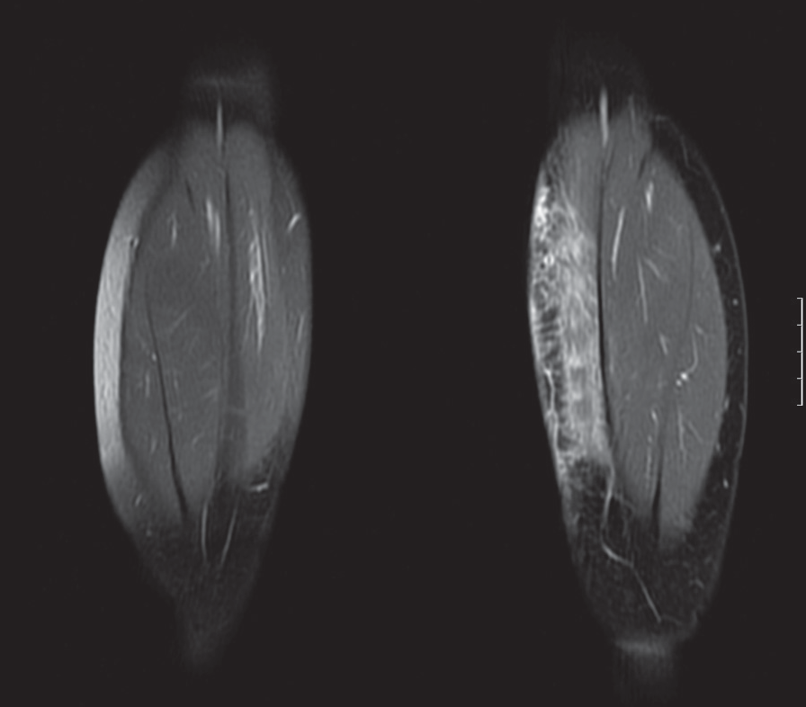
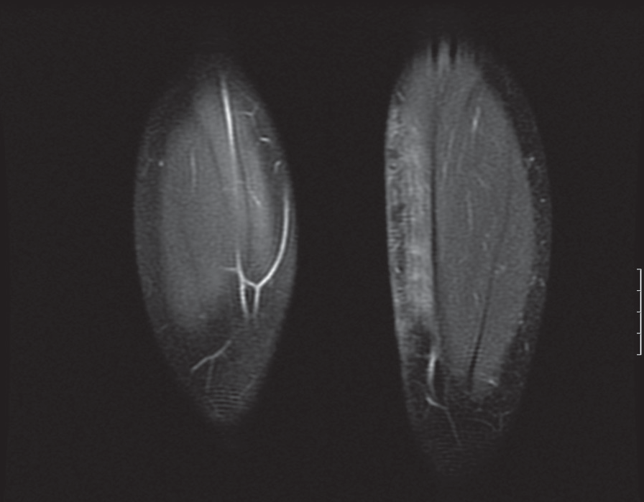
OriginalArticle
©PolJRadiol,2010;75(3):7-16
strongandearlycontrastenhancement.Thecurvewastyp-icalofmalignancies.Therefore,inaveryearlypostradio-therapeuticstage,conclusionsbasedontheenhancementcurveshouldbedrawnwithmuchcaution,astheexamina-tionisnotfullyreliable.
Inthelaterpostradiotherapeuticstage(3–12months),inthedynamicexamination,therewasalate,weakcontrastenhancement,typicalofbenignlesions,indicatingpost-therapeuticchanges.
ImageofpostradiotherapeuticchangesandtheirevolusioninthetumoursofsofttissueswaspresentedbyRichardsonetal.in1996[6].TheyobservedanincreaseinsignalintensityinT2-weightedimagesandsuggestedthatthechangesincreaseuntilthesixthmonthafterthetherapyandthenregressbetweenthesecondandthethirdyearfollowingrth.
Inourmaterial,anextremelydifficultforevaluationimagewasobtainedduringthefirst3monthsfollowingrth.Postirradiationchangesinthatperiodrevealasignifi-cantlyincreasedsignalintheSTIRandFSET2sequence,aswellasarapidandfastcontrastenhancement,i.e.fea-turessimilartoaneoplastictissue(Figure1A,B).Intheearlypostradiotherapeuticstage,theremayappear–apartfrominflammatoryandoedematouschanges–seromacol-lectionsorhaematomasthatareeasytodetectowingtothetypicalsignalproducedintheMRI.Thatsoonafterthetreatmentandaftersurgery(inmostofthecases),therecurrenceisunlikely,especiallyanextensiveone,involv-ingthewholepostirradiationarea.Itisverydifficulttodetectaresidualtumouramongearlypostirradiationchanges.ThereweresomecasesofoverinterpretationoftheMRIsinthematerialanalysedatthatstage.Therearealsootherauthors[5,6]thatpointtothedifficultieswiththeassessmentanddifferentiationofchangesintheearlyposttherapeuticperiod.Insuchcases,itishelpfultousepreviousMRIresultsforcomparison.Althoughtheimageisdifficulttointerpretatthatstage(duetomassiveinflam-matoryandoedematouschanges),itseemsrecommendedtoperformabaselineMRIintheearlypostradiotherapeu-ticperiod,forcomparisonswithfurtherfollow-upexami-nations,inthelaterposttherapeuticperiod.
Figure1.RMS.(A)SET1+Ccor,3weeksafterrth:strongcontrastenhancementin theskinand subcutaneoustissue,inDCEMRI:fastandstrongcontrastenhancement.(B)SET1+Ccor,3monthsafterrth:distinctlyweakercontrastenhancement,slowlyincreasing.
AnoptimalprotocoloftheMRIexaminationandtimeintervalsbetweensubsequentfollow-upsshouldbedefinedaswell.
Intherecentyears,manyauthorshavecommentedontheroleofthedynamicMRIinthedifferentiationbetweenneoplasticlesionsandpostradiotherapeuticchanges[2,4,5].Rijsvijketal.[4]distinguished5typesofcurvesofcontrastenhancementinthedynamicMRIexaminationanddeter-minedthattypeIVandV,i.e.rapidenhancementinthefirstminutefollowedbyplateauorwash-outofthecon-trastmedium,speakforamalignancy.TypeIIorIII,i.e.aslowincreaseintheenhancementcurve,followedornotbyaplateau,suggestsbenignlesions.CurveoftypeIiscon-nectedwithnocontrastenhancement.
ContrastenhancementandsignalincreaseinT2-weightedimages,especiallySTIR,typicaloftheearlypostthera-peuticperiod,resolvewithtime.Huang[8],inhisanimalstudies,evaluatedboththeMRIimagesandhistopatho-logicalchangesinthefirstweeksfollowingradiothera-pyandfoundadecreasedsignalintensityandcontrastenhancementstartingwiththefourthpostoperativeweek.Histologically,atthebeginningofthefirst3weeks,thereweresomeoedematouschanges,damagedvesselsand,atthesametime,anincreasingfattydegenerationofthebonemarrow,startingwiththethirdpostradiotherapeuticweek.
Vaneletal.[2]foundthatlatecontrastenhancementinthedynamicstudysuggestsinflammatoryposttherapeuticchanges.Insuchcases,thelesionmaybejustobservedandnotsubjectedtobiopsy.
Richardsonetal.[6]foundthatinmostoftheMRIexam-inationsfollowingrth,therewerenochangeswithinthebonemarrow.Thisremainsincontrasttoourresults:asignificantincreaseinsignalintensityinT1-weightedimagesofthebonemarrowofallpatients.Thechangesappearedandprogressedinthefirstfewmonthsfollowing
Inourmaterial,thedynamicexaminationperformedataveryearlypostradiotherapeuticstage(3weeks)showeda
10
A

B

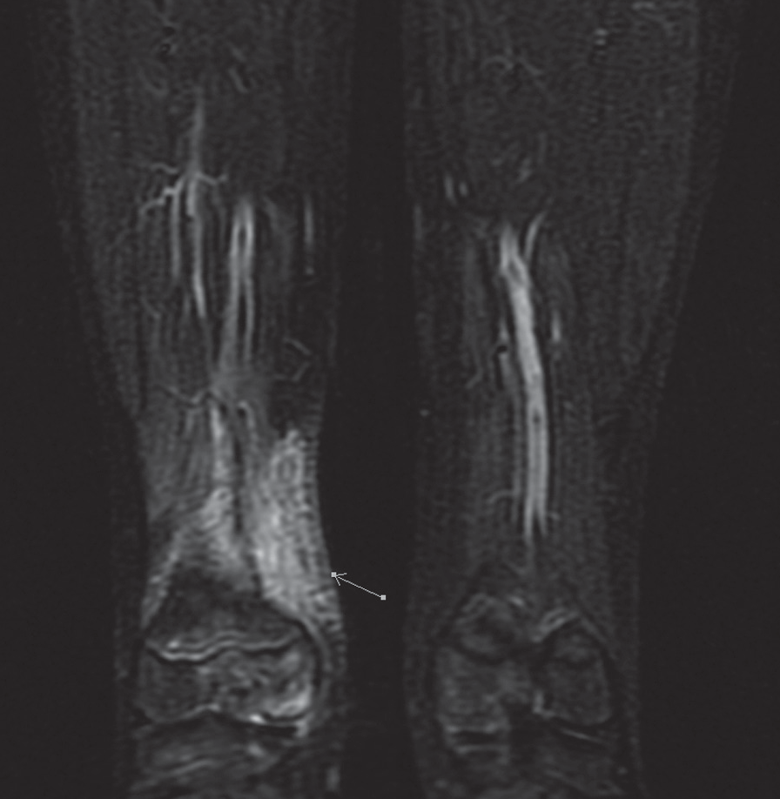
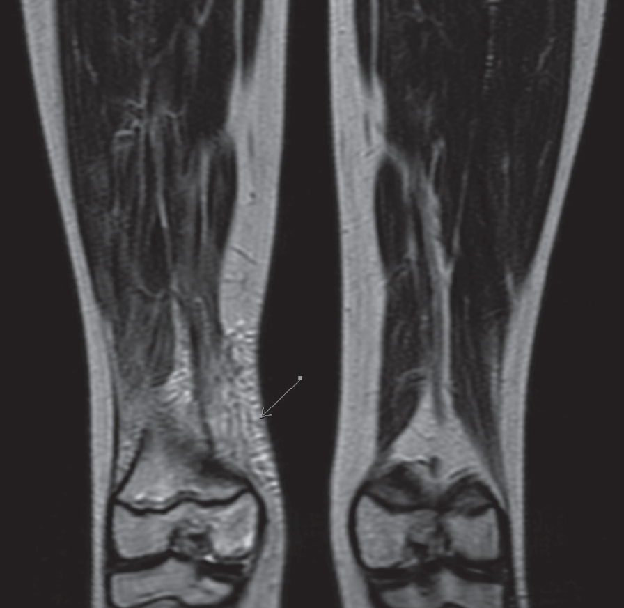
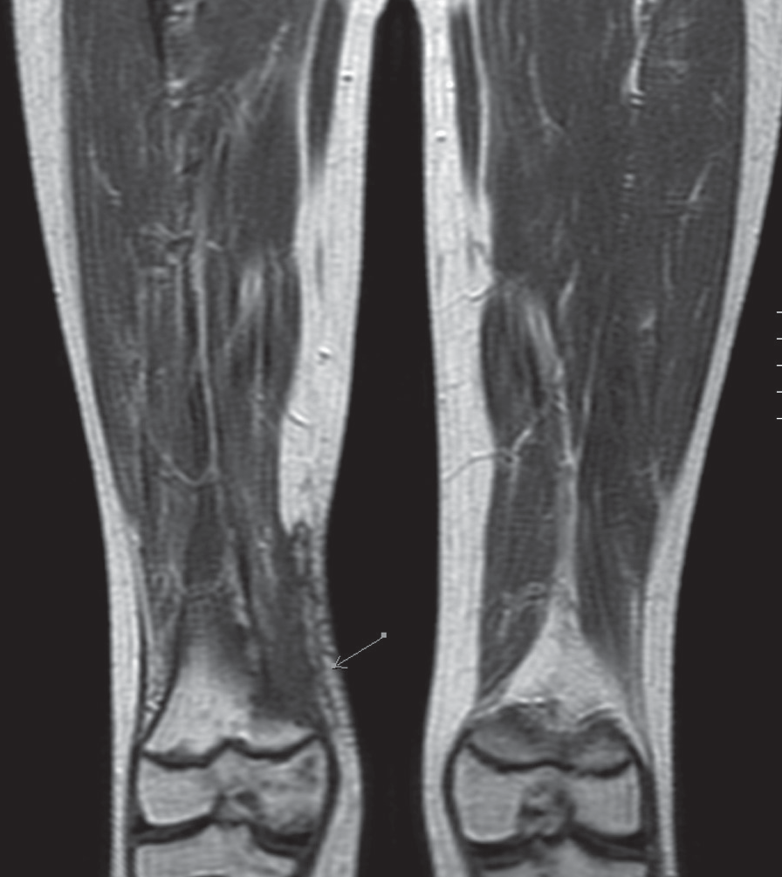
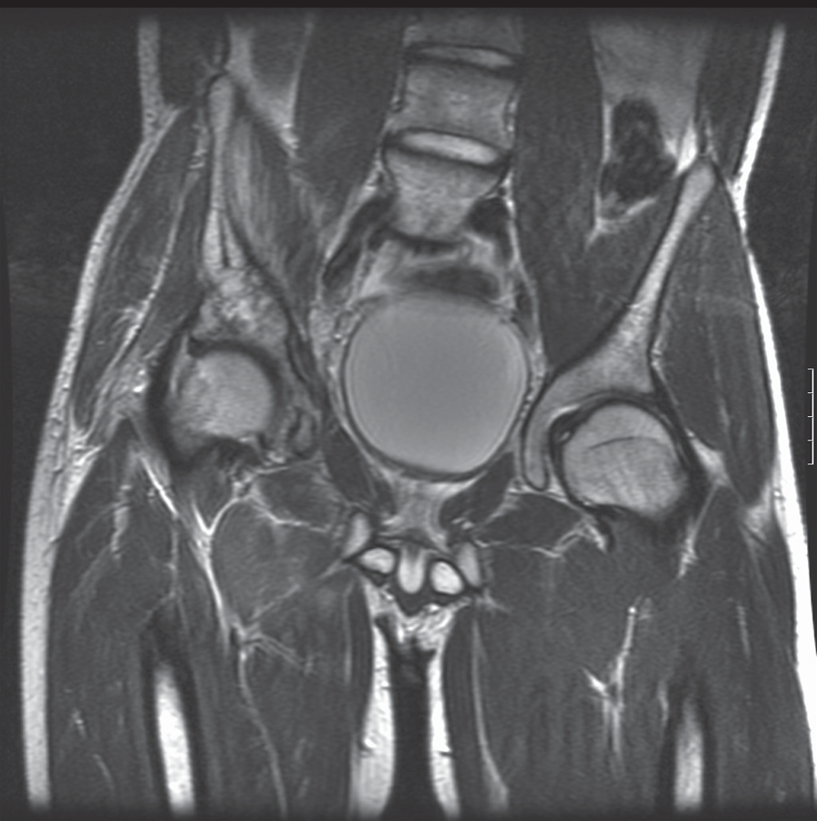
©PolJRadiol,2010;75(3):7-16
JastrzębskaMetal–Postradiotherapeuticchangesandtheirevolution…
Figure2.Sarcomasynoviale,6monthsafterrth.(A)STIRcor,anincreasedsignalintheregionofthepostoperativescarandafterrth.(B)FSET2cor,ahighsignalfromthescarandmusclesintheirradiatedregion.(C)SET1+Ccor,weakcontrastenhancementintheregionofthescarandanincreasedsignalfromthebonemarrow–fattydegeneration.
radiotherapyandremainedorpartiallydisappeareddur-ingthefirstyearsfollowingradiotherapy.Thesedifferencesmayresultfromthefactthatourmaterialincludedmost-lychildren.Theirbonemarrowisredandthusthefattytransformationofthebonemarrowfollowingradiotherapywasmuchmorevisibleinsuchcases(Figures2C,5B).
Postirradiationchangesinsofttissuesatmorethan3monthsfollowingrthareverycharacteristicandevolvewithtime.Thereisanincreasingmuscularatrophy,increaseinfattissuevolume,andfibrosisintheformofthickenedintermuscularsepta(Figure3)[6].Inourmate-rial,thepostradiotherapeuticchangeswitnessedanincreasingprogressuntilapprox.9monthsfollowingther-apy.Accordingtootherauthors,thatwasevenuntil1–1.5yearafterthetherapy[5,6].Then,someofthechangesmayregressandtheirimagebecomespreservedandcon-solidatedwithinthesecond–thirdposttherapeuticyear,untilafullstabilisation.Inthelatestage,muscularatro-phyisstillpresent(Figure6)whilethethickeningofinter-muscularseptaandmucousmembranes,aswellasfatty
Figure3.RMSafteraradicalrth,withoutsurgery–totalregressionFSET2,cor,anincreasedsignalfromthemuscles,thickenedsepta.
degenerationofthebonemarrowmayregressatadifferentrate,foruptothreeyearsfollowingtherapy.
Adistantperiod,aftermorethan3yearsfollowingtherapy,ischaracterisedbyafixedandstableimageofthechang-es.Inourmaterial,therewasapatientafterearrthduetoRMS,withathickeningofsinalmucosaandanairless
11

C

A

B

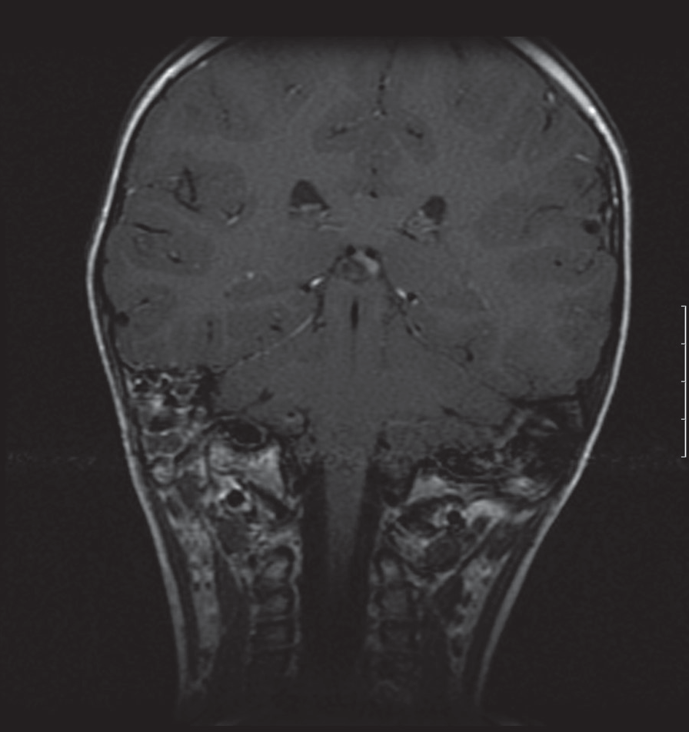
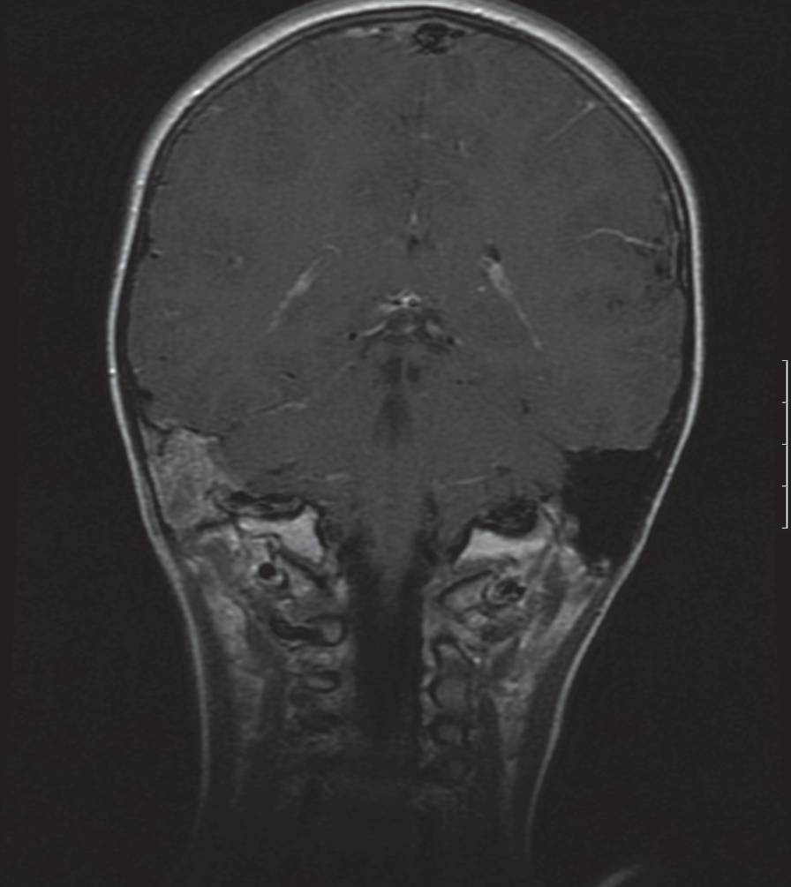
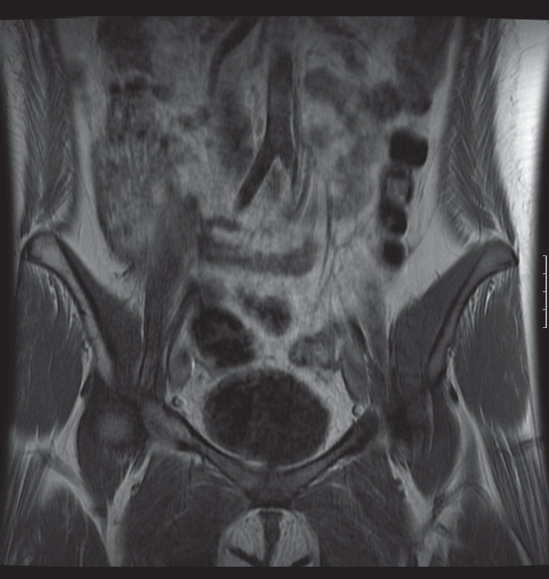
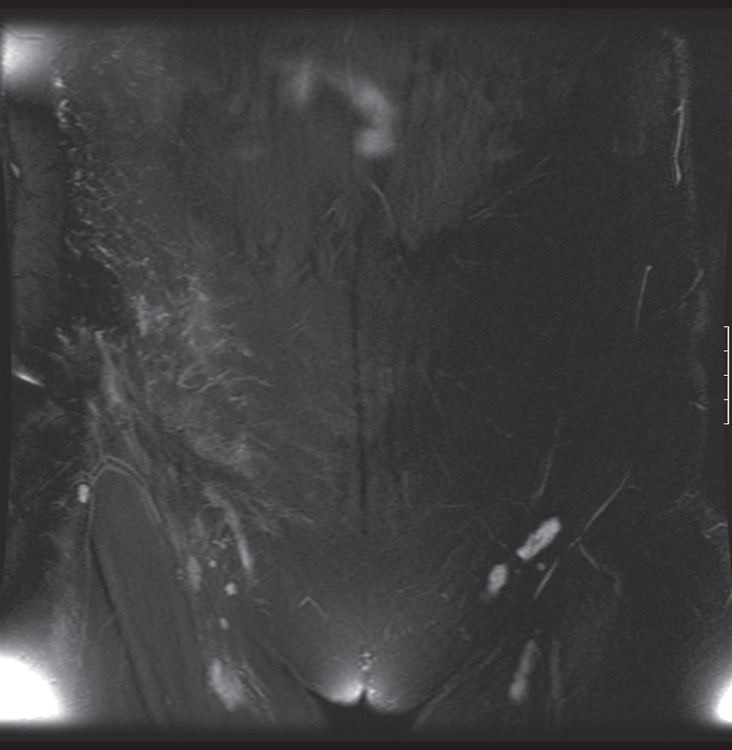
OriginalArticle
©PolJRadiol,2010;75(3):7-16
Figure5.Sarcomasynoviale,9monthsafterrth.(A)FSET2+fatsatcor.–slightlyincreasedsignalintheirradiatedregion.(B)SET1cor.–fattydegenerationofthebonemarrowintherightileum.
Figure4.RMSoftheearafteranon-radicalsurgeryandradiotherapy.
(A)SET1+Ccor,1monthafterrth,mucosaloedemaintherightmastoidprocess,contrastenhancement.(B)SET1+Ccor,15months afterrth,airlessmastoidprocess, slightlyincreasedchanges.
in67%,limitationoflimbmobilityin40%,anddamageofperipheralnervesfollowingradiotherapyin13%.
mastoidprocessattheirradiatedside.Thechangeswereprogressingfor9monthsfollowingtherapy,asrevealedbysubsequentfollow-ups.Afterwards,theybecamestable(Figure4A,B).AccordingtoRavivetal.changesinsinusesfollowingradiotherapymaypersistorevenprogressfor30months[9].
Distantcomplicationsfollowingradiotherapyincludeinteralia.:asecondtumourintheirradiatedregionin20%ofpatients.Thishighincidenceshowsthatpatientmonitor-ingisrequiredformanyyearsafterradiotherapy,notonlybecauseofpotentialrecurrences.
Inthemonitoringofpatientsinthelaterpostoperativestage,itisessentialtoexclude:
- Localrecurrence,
- Metastases,especiallytothebonemarrow,
- Secondtumour.
LateanddistantchangesandcomplicationsfollowingradiotherapyofsarcomasinthelimbsofchildrenwerepresentedbyPaulino[10].Hefoundmuscularatrophyandfibrosisin80%ofpatients,disturbancesoflimbgrowth
12
A

B

A

B

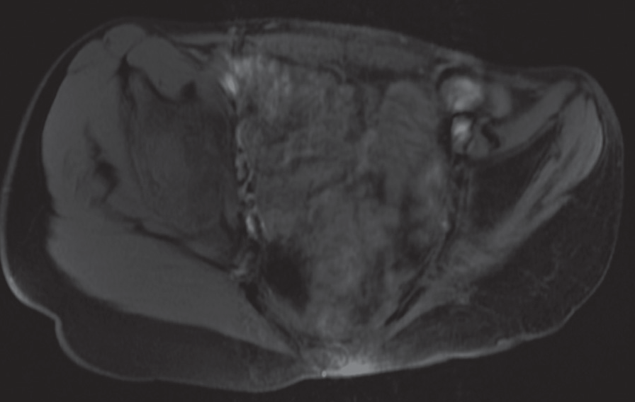
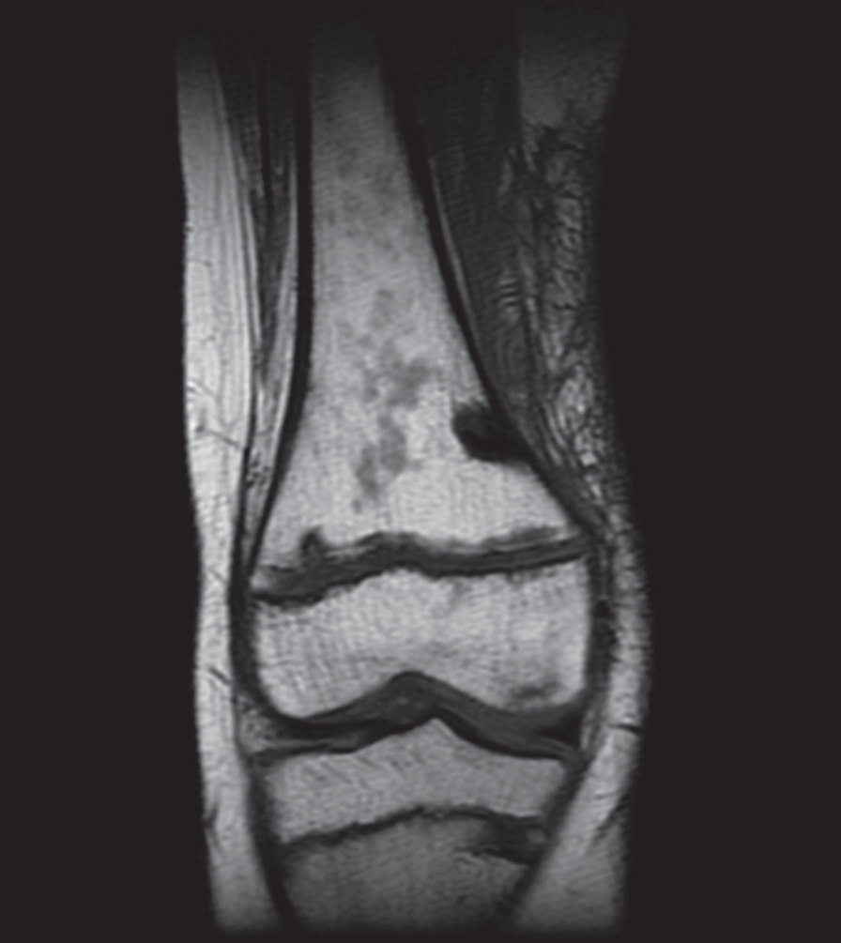
©PolJRadiol,2010;75(3):7-16
JastrzębskaMetal–Postradiotherapeuticchangesandtheirevolution…
Figure6.Fibromatosisagressivaaftermultiplesurgeriesandradiotherapyseveralyearsago,SET1+fatsatax.muscularatrophyinthepelvis,ontheleft,andreplacementofthosemuscleswithfat.
SchepperetalsuggestedadiagnosticalgorithmofMRIinthemonitoringofpatientswithsofttissuetumoursfollow-ingtherapy[1].
First,itisnecessarytoperformtheFSET2+fatsatorSTIRsequence:
- ifthereisnopathologicalmassorifthereisonebutoflowsignalintensity,therecurrenceisimprobableandmonitoringmaybecontinued(Figures5A,8D),
- ifthereisahyperintensemass,thentheSET1andcon-trast-enhancedSET1sequenceshouldbeintroduced(Figure8A,B).
Figure7.Sarcomasynoviale12monthsafterradiotherapy,imageofthebonemarrowinSET1cor.–inhomogeneoussignalintensity,confluent hypointense focisuggestiveofbonemarrowreconversion.
Adifficulttaskistheevaluationofchangeswithinthebonemarrowfollowingradiotherapy.Itwasfoundthatafterradiotherapy,thebonemarrowundergoesfattydegener-ationbuttheremayalsoappearfociofalteredsignal:inT1-weightedimages:signalofdecreasedintensity(betweentheoneofsignalfrommusclesandfromfat),andinT2-weightedimages:signalofincreasedintensity(betweentheoneofsignalfrommusculartissueandfromfluid).Thesechangesundergocontrastenhancement,evolvewithtime,andmaygrow.Suchanimagemaycorrespondtobonemarrowdamageinthefirstmonths(gelatinousdegen-erationafterradiotherapy),andthentoreconversiontotheredbonemarrowinthelaterstage[15].Inourmaterial,therewereareasofalteredsignalwithinthebonemarrowwhichunderwentevolutionwithtimeandcorrespondedtochanges after radiotherapy andbone marrow reconversion(Figure7).
Ifthetumourmassbecomesenhancedaftercontrastadministration,thentherecurrenceiswellprobableandadynamiccontrast-enhancedexaminationshouldbeintro-duced,asitcandifferentiatebetweentherecurrenceandthe inflammatorytumour.
In caseofdistantfollow-ups,thisprotocolis justified.
OurpatientsunderwentroutineT2-weighted
and
T1-weightedimaging before and after gadoliniumadminis-tration,and,insomeselectedcases,adynamicMRI.
ThedynamicMRIisamethodofchoiceforthedifferen-tiationbetweeninflammatorychangesfollowingrthandrecurrences.Itslateandslowlyincreasingcontrastenhancementallowsforfurtherobservationofposththera-peuticchangesandresignationfromdiagnosticbiopsies(Figure9A,B)[2,11].
Itisdifficulttodifferentiatebetweensuchchangesand bonemarrowmetastasesthatproduceasimilarlydecreasedsignalinT1-weightedimagesandanincreasedone inT2-weighted images.Metastases arenormally bettercircumscribed,oval,produceinT1-weightedimagessignalsofalowerintensitythanthemusculartissue,andundergoastrongercontrastenhancement[16].
InterpretationoftheMRIresultsfollowingsurgeryandradiotherapyisdifficultandsometimesonlyadetailedanalysisandcomparisonofseveralexaminationsallowsfordrawingproperconclusions.FromourexperiencesandtheliteraturedataitfollowsthatabaselineMRIwithin4–6weeksfollowingradiotherapyandsubsequentfollow-upsevery3–6monthsduringthefirstposttherapeuticyearsareindicated [3].Sometimes, onlyon thebasisof acomparisonwithpreviousexaminationresultsandknowledgeonthetypeandevolutionofpostirradiationchangeswithtime,itispossibletodecidewhethertheimagecorrespondstoposttherapeuticchangesorwhetherthereisrecurrencesuspicion,requiringmicroscopicverification.
Intheassessmentofchangesafterradiotherapyonly,itisimportanttoevaluatereactionstotreatmentanddegreeoftumourregression.ThestaticMRIstudyaftergadoliniumadministrationdoesnotgiveusanswertothequestioninhowfarthetumourisaliveandinhowfarthereisanecro-sisinsideit.Assessmentofthetumoursizeisnotareliableindicatorofresponsetotreatmenteither[12].Attemptsatdifferentiationofalivingtumourfromnecrosiswereunder-takenwiththeapplicationofdiffusionimaging[13,14].
13

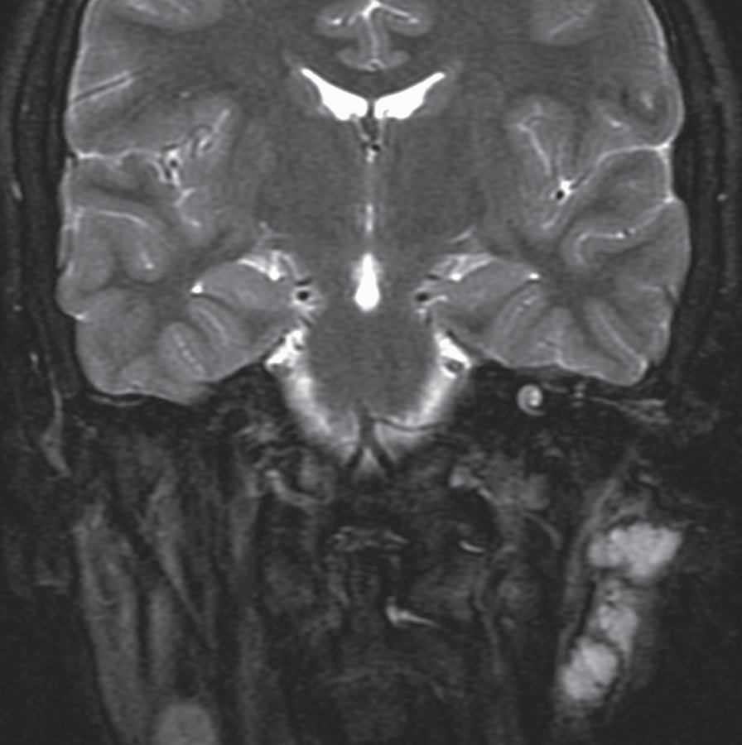
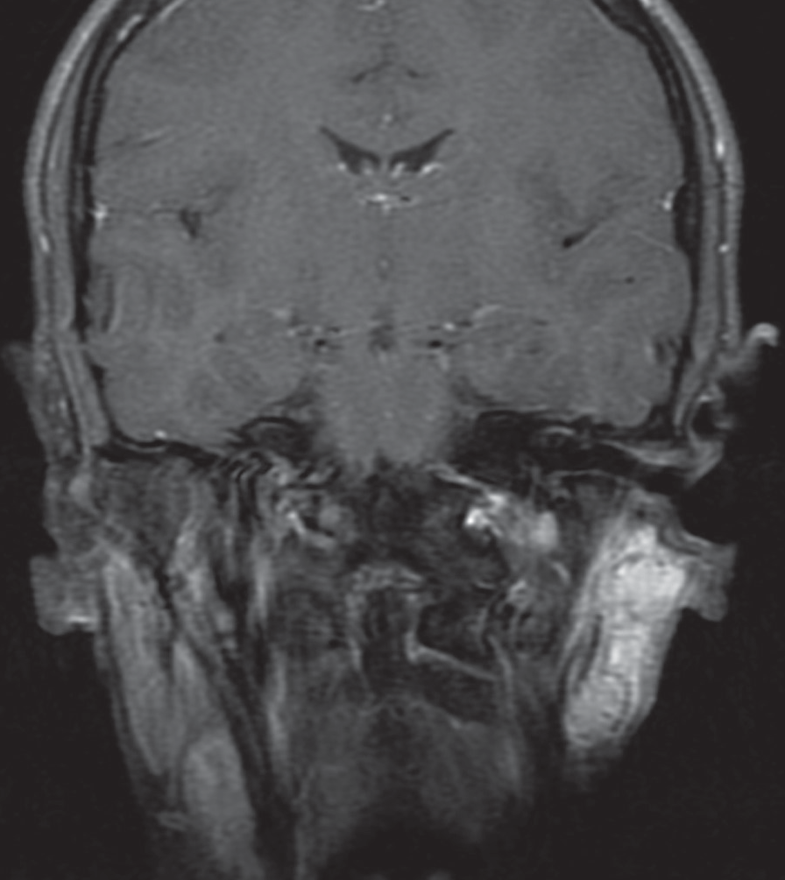
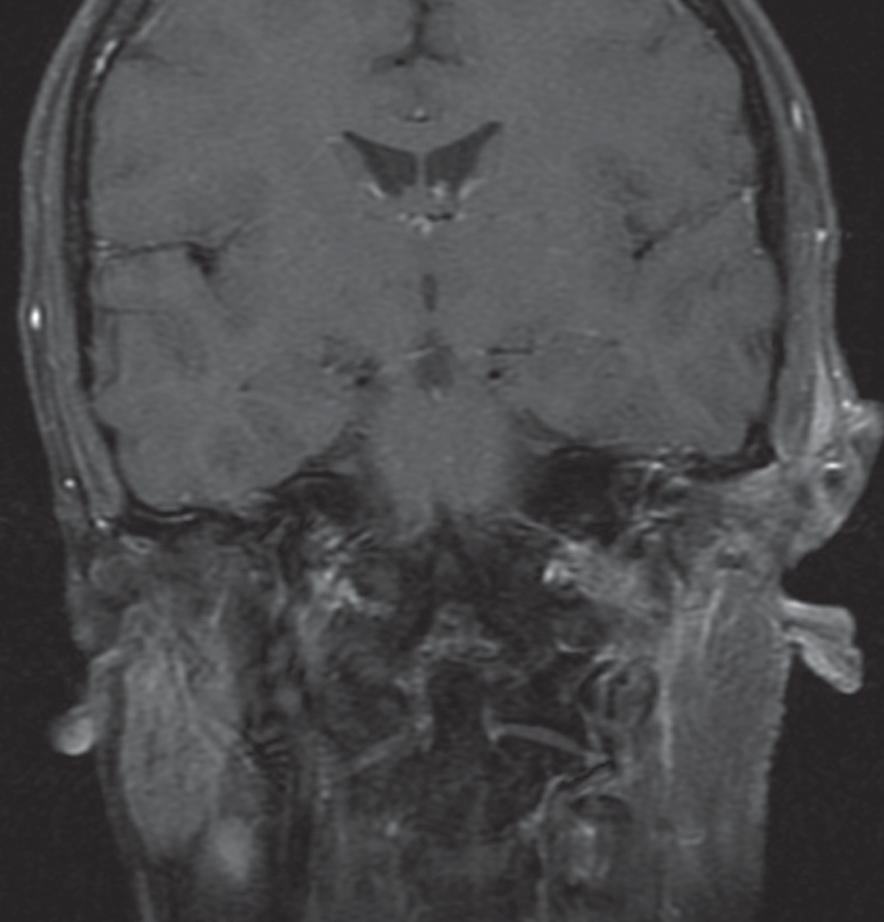
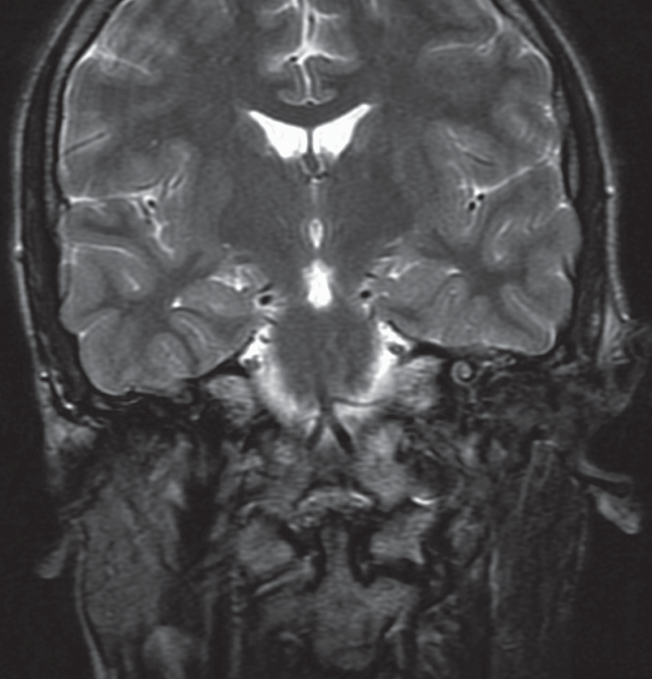
OriginalArticle
©PolJRadiol,2010;75(3):7-16
Figure8.RMSoftheleftcheekaftersurgeryandrth.(A)SET1+C+fatsatcor,7monthsafterrth,contrastenhancementintheregionoftheleftparotidgland–localrecurrence.(B)FSET2+fatsatcor,7monthsafterrth,highsignalintensitywithinthetumourrecurrence.
(C)SET1+C+fatsatcor,2yearsaftersurgeryoftumourrecurrenceandintraoperativeradiotherapy,slightcontrastenhancementintheirradiatedregion.(D)FSET2+fatsatcor,2yearsaftersurgeryandrthoftherecurrence,noenhancedsignalintensityintheregionofchangesaftertreatmentexcludestumourrecurrence.
Incaseofnecrosis,thereisadamageofcellmembranes,whichcausesanincreaseddiffusionofwaterparticleswith-inanecroticpartofthetumour.ThismanifestsitselfwithanincreasedsignalindiffusionimagingandadecreasedsignalinADCimages.Alivingtumour,ontheotherhand,revealsadecreaseddiffusionrateandischaracterisedbyalowsignalintensityindiffusionimagingandahighsig-nalinADCmaps.InT2-weightedimages,boththelivingtumourandthenecrosisproduceahighersignalandthereisnopossibilityoftheirunambiguousdifferentiation[13].Diffusion-weightedimagingmayconstituteanalternativeforgadolinium-enhanceddynamicMRIintheassessmentoftreatmentefficiency.Therewerealsostudiesconcerning
theusefulnessofthisimagingmethodinthedifferentia-tionoftumoursandposttherapeuticchanges[13,14].Itwasrevealedthatintheareaofirradiatedtissues,duetotissuefibrosis,thediffusionratedecreasesandthesignalintensityincreasesinADCmaps,whichcauseschangeofsignalsimi-lartotheoneinthenervoustissue[14].DWIisanimagingtechniquethatrequiresfurtherstudiesanditsvaluehasnotbeenyetwelldefined.However,itisnowbeingevaluatedinmultipleclinicalstudies.Duetonoappropriatetechnicalcapabilitiesofourscanner,wedidnotperformDWIinourpatients,butinthenearestfutureweplantointroducethissequencetoaroutinestudyprotocolusedincaseofmoni-toringoftherapy inpatientswithsofttissuetumours.
14
C

D

A

B

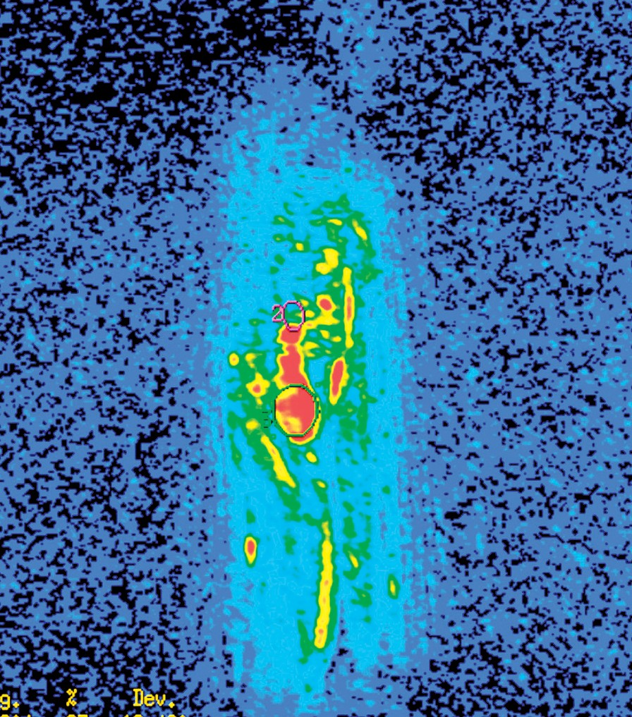
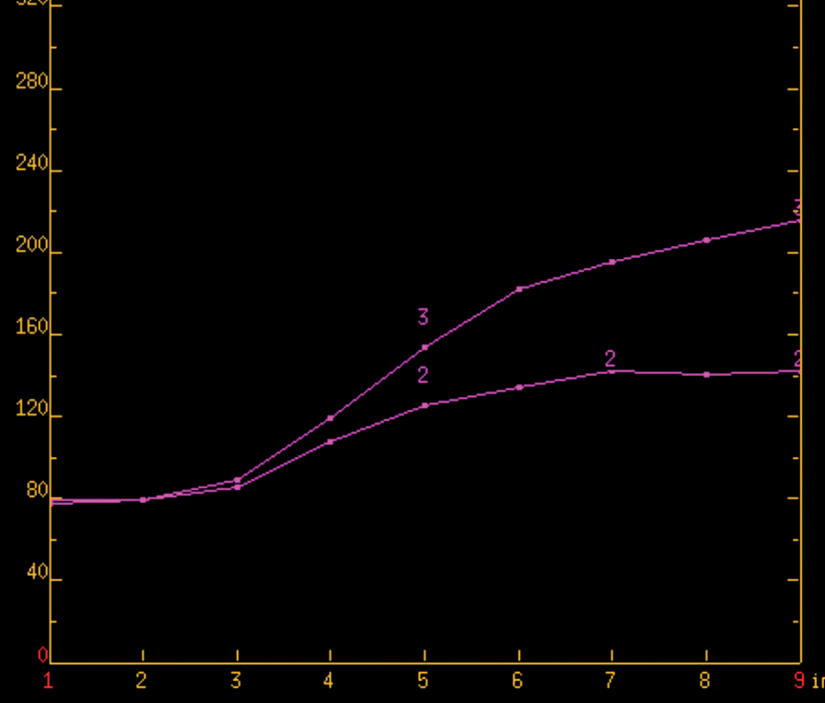
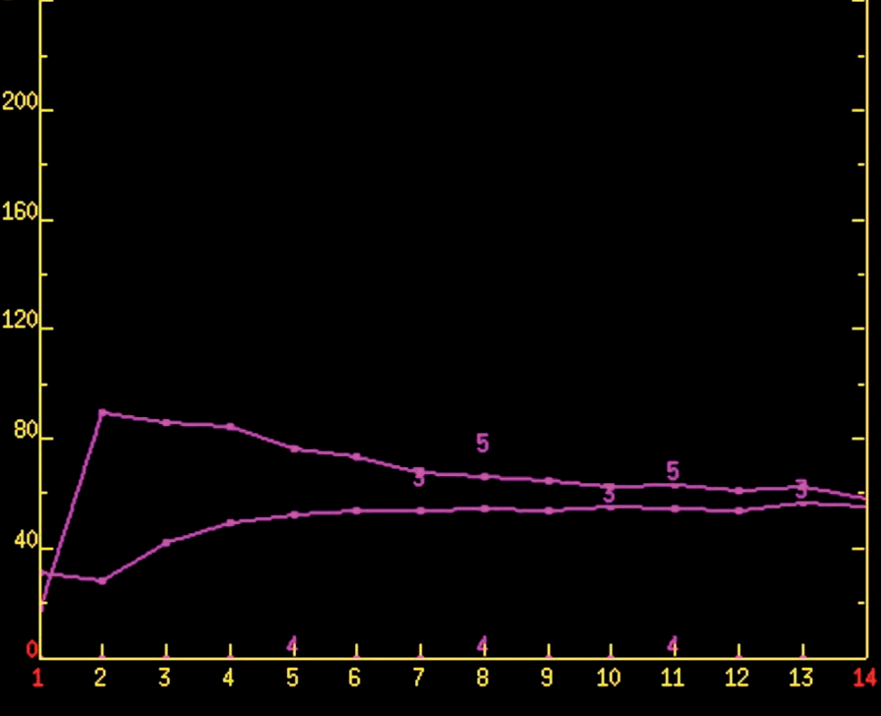
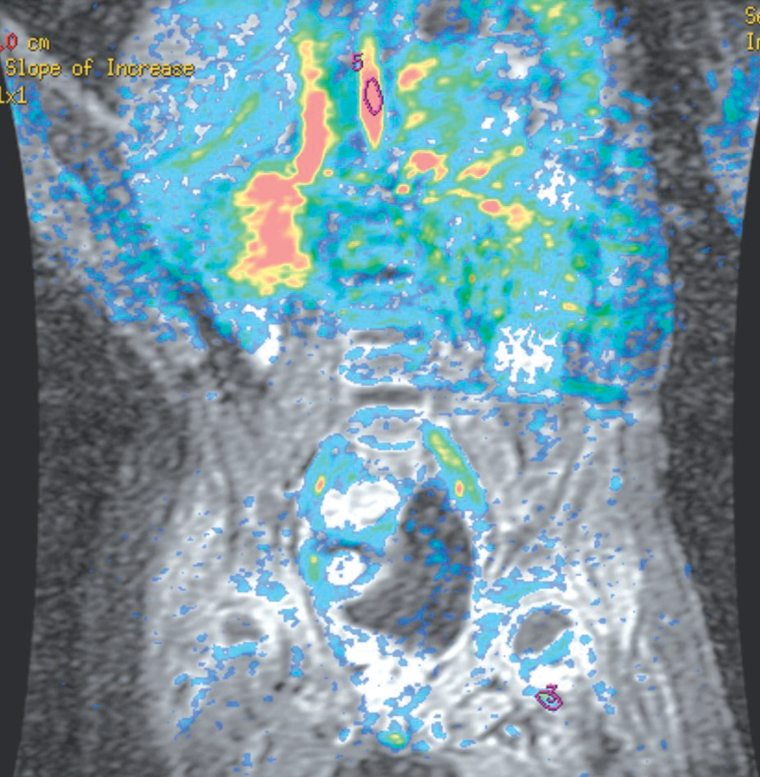
A
©PolJRadiol,2010;75(3):7-16
JastrzębskaMetal–Postradiotherapeuticchangesandtheirevolution…
Figure9.DynamicMRI,sarcomasynovialeintheregionoftheleftileumaftersurgeryandrth.(A)Markedregionsofinterestwithinthevessel–5(aorta)andintheposttherapeuticregion–3.(B)Curvesofcontrastenhancement:•Curve
5–inthevesselthereisarapidandstrongenhancement(typicalalsoformalignancies),•Curve3–intheposttherapeuticregionthereisaweakandslowlyincreasingenhancementtypicalofposttherapeuticchanges.
Figure10.DynamicMRI,desmoidfibromaoftheforearm,recurrenceaftertreatment.(A)Lesionwithastrongenhancementaftergadoliniumadministration,markedregionsofinterest.(B)Curvesofcontrast enhancementnottypicalformalignancies(aslowlyincreasingenhancement).
Conclusions
- AdynamicMRIexaminationmaybeusefulinthedif-ferentiationbetweenpostradiotherapeuticandneoplasticchanges.
- ForacorrectassessmentofpostradiotherapeuticMRIchanges,itisusefulto:
  - Applyauniformstudyprotocol,
  - Carryoutabaselineexaminationat4–6weeksfollow-ingrthandintroduceregularfollow-ups,
  - Drawcomparisonswithpreviousexaminationresults.
- MRIisamethodofchoiceintheassessmentofchang-esandmonitoringoftreatmentofaggressivesofttissuetumours.
- TointerprettheMRIresultsproperly,itisveryimpor-tanttoknowtheMRIcharacteristicsofchangesafterradiotherapyandtheirevolutionwithtime.
- Interpretationofpostradiotherapeuticchangesisdiffi-cult,especiallyatanearlypostradiotherapeuticstage.
15

B

A

B

OriginalArticle
©PolJRadiol,2010;75(3):7-16
References:
- SchepperAM,DeBeukeleerL,VandevenneJetal:Magneticresonanceimagingofsofttissuesarcomas.Eur.Radiol,2000;10:213–22
- VanelD,ShapeeroLG,TardivonAetal:Dynamiccontrast-enhancedMRIwithsubtractionofaggressivesofttissuetumorsafterresection.SleketalRadiol,1998;27:505–10
- ChoiH,VarmaD,FornageBetal:Soft-TissueSarcoma:MRimagingvsSonographyforDetectionofLocalRecurrenceAfterSurgery.AJR,1991;157:353–35
- RijswijkC,GeirnaerdtM,HegendoornPetal:Soft-tissuetumors:ValueofstaticanddynamicGadopentetateDimeglumine-enhancedMRimaginginpredictionodmalignancy.Radiology,2004;233:493–502
- KarnsdorfMJ,MurpheyMD:SoftTissueTumors:Post-TreatmentImaging.RadiolClinNAm,2006;44:463–72
- RichardsonML,Zink-BrodyGC,PattenRMetal:MRcharaterisationofpost-irradiationsofttissueedema.SkeletalRdiol,1996;25:537–43
- HwangS,LefkowitzR,LandaJetal:LocalchangesinbonemarrowatMRIaftertreatmentofextremitysofttissuesarcoma.SkeletalRadiol,2009; 38: 11–19
- HuangW,YangY,SunZ:Earlyradiation-inducedbonemarrowinjury:serialMRimagingduringinitial4weeksafterirradiation.AcadRadiol,2009;16:733–38
- RavivJ,DowningL,HwangP:Radiographicassessmentofsinusesinpatientstreatedfornasopharyngealcarcinoma.AmJRhinol,2008;22(1):64–67
- PaulinoAC:Lateeffectsofradiotherapyforpediatricextremitysarcomas.IntJRadiationOncologyBiolPhys,2004;60(1):265–74
- ShapeeroLG,DeVisscherePJ,VerstraeteKL:Post-treatmentcomplicationsofsofttussuetumours.EurJRadiol,2009;69:209–21
- EinarsdottirH,WejdeJ,BauerH:Assessmentofresponsebystaticpost-contrastMRimagingcomparedtohistopathology.ActaRadiologica,2001;421:1–5
- LangP,WendlandMF,SaeedM:Osteogenicsarcoma:Noninvasiveinviwoassessmentoftumornecrosiswithdiffusion-weightedMRimaging.Radiology,1998;206: 227–35
- EinarsdottirH,KarlssonM,WejdeJ:Diffusion-weihgtedMRIofsofttissuetumours.Eur.Radiol,2004;14:959–63
- HwangS,PanicekDM:Magneticresonanceimaginginbonemarrowinoncology.SkeletalRadiol,2007;36:913–20
- IlaslanH,SundaramM:AdvancesinMusculoskeletalTumorImaging.OrthopClinNAm,2006;37:375–91
16

