
Signature:©PolJRadiol,2010;75(1):29-36
ORIGINALARTICLE
Comparison of post-surgical MRI presentation of the
Received:2009.08.19
Accepted:2009.11.26
pituitaryglandanditshormonalfunction
JoannaBladowska1,ViolettaSokolska2,TomaszSozański3,GrażynaBednarek-Tupikowska4,MarekSąsiadek2
1DepartmentofRadiology,WrocławMedicalUniversity,Wrocław,Poland
2DepartmentofGeneralRadiology,InterventionalRadiologyandNeuroradiology,ChairofRadiology,WrocławMedical
University,Wrocław,Poland
3DepartmentofPharmacology,WrocławMedicalUniversity,Wrocław,Poland
4DepartmentofEndocrinology,Diabetology,andIsotopeTreatment,WrocławMedicalUniversity,Wrocław,Poland

Author’saddress:JoannaBladowska,DepartmentofRadiology,WrocławMedicalUniversity,M.Curie-Skłodowskiej68Str.,50-369Wrocław,Poland,e-mail:mbladow@wp.pl
Summary
Post-surgicalevaluationofthepituitaryglandinMRIisdifficultbecauseofachangeofanatomicalconditions.Itdependsalsoonnumerousotherfactors,including:sizeandexpansionofatumourbeforesurgery,typeofsurgicalaccess,qualityandvolumeoffillingmaterialusedandtimeofitsresorption.The aim of the studywas to compare MR imageof the pituitary gland aftersurgery withclinicalfindingsand toestablisha correlationbetweenMRI presentationofsparedpituitary anditshormonalfunction.
124 patients afterresection ofpituitary adenomas –409 MRIresults in total– werestudied.Witha1.5-Tunit,T1-weightedsagittalandcoronal,enhancedandunenhancedimageswereobtained.
ThepituitaryglandseemedtobenormalinMRIin11patients,8ofthemhadcompletelyregularpituitaryfunctionbutin3ofthemwenoticedapartialhypopituitarism.In99patientsonlyapartofthepituitaryglandwasrecognised,53ofthemhadhypopituitarismbut46ofthemwereendocrinologicallyhealthy.14patientsseemedtohavenopersistentpituitaryglandinMRI,incomparisontohormonalstudies:therewaspanhypopituitarismin6andhypopituitarismin8cases.
MRIpresentationofpost–surgicalpituitaryglanddoesn'tnecessarilycorrelatewithitshormonalfunction–therewasasignificantstatisticaldifference.Somepatientswithpartialpituitaryseemsnormalhormonalfunction.In somecasesthepituitary seemnormalinMRI butthesepatientshavehormonaldisordersandneedsubstitutiontherapy.
Background:
Material/Methods:
Results:
Conclusions:
Keywords:
pituitarytumours•MRI•surgery•hormonalfunction
PDFfile:
http://www.polradiol.com/fulltxt.php?ICID=878430
Background
(MRI),andofmodernmethodsofneurosurgeryandphar-macotherapyrevolutioniseddiagnosticsandtherapyofpitu-itarytumours.Currently,magneticresonanceisamethodofchoiceforimagingofthepituitaryglandandtheperisellararea,andadvancedMRItechniques–spectroscopyanddif-fusionandperfusion–areincreasinglyapplied[1,6–15].
Pituitarytumoursconstituteapproximately10to15%ofallprimaryintracranialcarcinomas[1–4]andarethemostcommoncausesofpituitaryfunctiondisordersandfieldofvisionloss [5,6]. Therefore,early diagnosis andtherapy is aseriousclinicalproblem.
IfpituitarytumourpresentationinMRIwasdescribedindetailsandusuallydoesnotpresentanydiagnosticdif-ficulties,post-surgicalevaluationofthepituitarygland
Introductionofmodernimagingtechniques,includingcom-putedtomography(CT)andmagneticresonanceimaging
29

OriginalArticle
©PolJRadiol,2010;75(1):29-36
Table1.Typesofpituitarytumoursintheanalysedmaterial.
Table3.NumberofanalysedMRIexaminationspost-surgicallyinindividualpatients.

No.ofpatients
Typesoftumours
NumberofperformedMRIexaminations
Numberofexaminedpatients
Ratio
Pituitarymacroadenomas
103
1examinationpost-surgically
22
17.74%
Adenomas
Pituitarymicroadenomas
14
2examinationspost-surgically
27
21.17%
Intra-sellarylocatedcraniopharyngioma
3
3examinationspost-surgically 24 17.26%
4examinationspost-surgically
18
14.51%
Intra-sellarylocatedRathke'spouchcyst
1
5examinationspost-surgically
19
15.32%
Othertumours
Pituitarycolloidcyst
1
6examinationspost-surgically
6
4.83%
Pituitaryabscess
1
7examinationspost-surgically
6
4.83%
hamartomalocalisedinthepituitarygland
8examinationspost-surgically
2
1.61%
1

Total:409examinations
Total:124patientsTotal:100%
Total
124
PurposeofthisstudywastocompareMRIimagesofapar-tialpituitaryglandleftafterasurgerywithevaluationofitshormonalfunction.
Table2.Typeofdiagnosedpituitaryadenomasinindividualpatients.
No.ofcases
Lp.
Typeofpituitaryadenoma
Ratio(%)
MaterialandMethods
Growthhormone(GH)secretingadenoma
Thestudygroupconsistedof124patientswiththefollow-ingdiagnoses:pituitaryadenoma(117cases),colloidcyst(1case),pituitaryabscess(1case),Rathke'spouchcyst(1case),intra-sellarylocatedcraniopharyngioma(3cases)andhamartoma(1case).Patientsundergoingradiotherapyafterthesurgerywereexcludedfromthestudygroup,inordertoeliminateanadditionalfactorabletoalterstructureandfunctionofthepituitarygland.Typesofpituitarytumoursinthe analysed material are presented in theTable1.TypesofpituitaryadenomasdiagnosedinpatientsundergoingsurgeryarepresentedintheTable2.
1
49
41.88%
2
Prolactin(PRL)secretingadenoma
26
22.22%
3
GHandPRLsecretingadenoma
2
1.70%
Adrenocorticotrophin(ACTH)secretingadenoma
4
9
7.69%
5
Luteotropin(LH)secretingadenoma
1
0.08%
6
Hormonallyinactiveadenoma
30
25.64%
Therewere74women(59.7%)inthestudygroup,agerangingfrom15to70,meanage41.74years;and50men
(40.3%),agerangingfrom16to75,meanage41.46years.Overallageoftheincludedpatientsrangedfrom15to75,meanagewas41.52years.Duetothefactthatthepatientswereobservedprospectively,patient'sageatthetimeofsurgerywasconsidered.
becomescommonlyaseriousproblem.Andsurgicalthera-pyisaprimarytherapeuticmethod,exceptforprolactin-secretingmicroadenomas[3,16–27].InterpretationofMRIimagestakenaftersurgicaltherapyofpituitarytumoursisdifficultbecauseofachangeofanatomicalconditions.Theinterpretationdependsalsoonnumerousotherfac-tors,including:sizeandexpansionofatumourbeforesurgery,typeofsurgicalaccess,qualityandvolumeoffill-ingmaterialusedandtimeofitsresorption[2,28].Properevaluationofpost-surgicalMRIimagesiscrucialfordeterminationofcompletenessoftheresection.Thereforeneuro-radiologistsfacearesponsibleanddifficulttaskofevaluationofstructurespresentinthesurgicalarea,andespeciallyofdifferentiationofresiduetumourfromthefill-ingmaterialusedandfrompost-surgicalchanges(fibrousandcicatricial),orevenfromapartofnormalglandleftatsite.Moreover,monitoringofthepost-surgicalcourseisalsoimportant,especiallyincaseofhormonallyinactivetumours.Diagnosisofaproliferativeprocessrecurrenceinsubsequentcontrolexaminationsplaysacrucialroleforfurthertherapy.
OnetoeightMRIexaminationswereperformedinindi-vidualpatientsaftersurgeryofthepituitarytumour.Oneexaminationwasperformedin22patients(17.74%),andtheremaining102patients(82.26%)wereexaminedmorethanoncepost-surgically.Totalnumberof409examina-tionswereanalysed,consideringalsopreviousexamina-tionsperformedinothercentres.PrecisenumberofMRIexaminationsincludedinthestudyinindividualpatientsispresentedintheTable3.
ImagingwasperformedusingthePickerEdgeEclipse1,5Tequipment.Eachimagingwasstartedfromasinglepilotimageandthreelocalisationimages.
30

©PolJRadiol,2010;75(1):29-36
BladowskaJetal–Comparisonofpost-surgicalMRIpresentation…
Table4.TechnicalparametersofMRIimagesinthepituitaryglandexamination.
Table5.Comparisonofthepost-surgicalpituitaryglandMRIpresentationanditshormonalfunction.
FASTT1-
FASTT1-
MRI
presentationNumber
Sequence
weighted weighted
Pituitaryhormonalfunction
Numberofcases
No.
ofthepituitarygland
ofcases
Plane
Coronal
Sagittal
Repetitiontime–TR(ms) 229 229
Normal
Partialanteriorpituitaryinsufficiency
8
3
1.
Normalsize
11
Echotime–TE(ms)
4.5
4.5
Slicethickness–THICK(mm) 2.5/0.5 2.5/0.5
Normal
PartialanteriorpituitaryinsufficiencyHypopituitaryzmPanhypopituitarism
20
8
6
3
Small,atthebottomofthesella
Numberofacquisitions–NSA
2
2
2.
37
Matrix 256×256 256×256
Fieldofview–FOV(cm)
17.0
18.0
Normal
PartialanteriorpituitaryinsufficiencyHypopituitaryzmPanhypopituitaryzm
16
9
6
2
Acquisitiontime(s) 01:57 02:18
Afragmentontheleftsideofthe sella
3.
33
Then,properT1-weighetdimagesweretaken,incoro-nalandsagittalplanes,usingtheFASTsequence(Fourieracquiredsteady-statesequence).TechnicalparametersofthoseimagesarepresentedintheTable4.
Normal
PartialanteriorpituitaryinsufficiencyHypopituitarism
Afragmentontherightsideofthe sella
8
8
7
4.
23
Paramagneticcontrastmediumwasadministeredintrave-nouslytoeachpatient,atdoseof0.1ml/kgBW,andfur-therT1-weightedimagesweretakenincoronalandsagittalplanes.
Normal
PartialanteriorpituitaryinsufficiencyHypopituitarism
1
2
2
Afragmentontheupperpartofthesella
5.
5
Pituitaryglandfunctionwasevaluatedinallpatients.Anteriorpituitaryfunctionwasevaluatedbydetermina-tionoftrophichormoneslevels–somatotrophin(GH),fol-liculostimmuline(FSH),luteotrophin(LH),prolactin(PRL),thyreotrophin(TSH),adrenocorticotrophin(ACTH),aswellasdailyprofileofcortisolanddailyeliminationoffreecor-tisolwithurine,andfreetyroxine(fT4),estradiol(E2),tes-tosteron(T)anddehydroepiandrosteronsulphate(DHEA-S)levelsinbloodserum.Incasesdoubtfulforevaluationoftheadrenocorticotrophicaxisfunction,apost-insulinehypoglycaemiatestwasperformed,withdeterminationofglucose,ACTHandcortisollevels.Posteriorpituitaryfunctionwasevaluatedperformingdiagnosticsfordiabe-tesinsipdus.Pituitaryfunctionwasdeterminedcompletelynormalifconcentrationsoftestedhormoneswereregular,andnosymptomsofdiabetesinsipiduswerenooted.Partialinsufficiencyoftheanteriorpituitarywasdiagnosedifoneormoretrophicaxesweredisorderd.Disorderofalltro-phicaxeswasdeterminedascompletefailureoftheante-riorpituitary–hypopituitarism.Completefailureofante-riorandposteriorpituitary–panhypopituitarism–wasdiagnosed if hypopituitarismwas accompanied bydiabetesinsipidus.
Afragmentontheposteriorpartofthesella
6.
1
Normal
1
HypopituitarismPanhypopituitarism
8
6
7.
Invisible
14
withMRI,in110thewholeglandoritspartwasvisible.Intheremaining14MRIdidnotshowedpresenceofthepituitarygland.Among110patientswithsparedpituitarytissue,in11sizeoftheglandwasregular.Inthatgroup,properfunctionoftheglandwasfoundin8cases,andpar-tialinsufficiencywasfoundinother3cases,inwhichanincompletehormonalsubstitutionwasnecessary.
Existenceofafragmentofnormalpituitarywasshownin99patients.Thatwasassociatedtopituitaryfunc-tionimpairmentin53cases.In46patientsinwhomMRIshowedexistenceofapartialgland,itsfunctionwascom-pletelynormal.
Among14patientsinwhomnopituitaryglandwasfound,in6caseshormonaltestsindicatedacompletefailureoftheanteriorandposteriorlobe(panhypopituitarism),andin8casesonlyanteriorpituitaryinsufficiencywasfound.
McNemar'stestg2ofarelationshipbetweentworelatedfeatureswasusedfordeterminationofthereisacorrela-tionbetweenpost-suricalpresentationofthepituitaryobtainedfromMRIandthegland'shormonalfunction.
ResultsofMRIofthepituitaryglandandofitshormonalfunctionanalysisispresentedinTable5.Resultsofstatisti-calanalysisofarelationshipbetweenMRIpresentationofthepituitaryglandanditshormonalfunctioninpatientspostneuro-surgicalproceduresispresentedintheTable6.
Results
Among124patientspostneurosurgicalprocedureofatumourlocatedinahypothalamic-pituitaryareaexamined
31

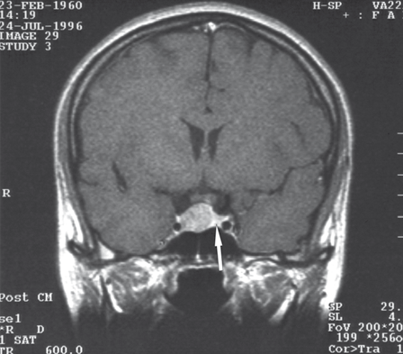
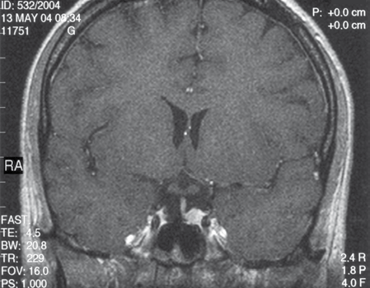
OriginalArticle
©PolJRadiol,2010;75(1):29-36
Table6.Resultsofanalysisofrelationshipbetweenpost-surgicalMRIpresentationofthepituitaryglandanditshormonalfunction.
MRIpresentationofthepituitarygland
Pituitaryhormonalfunction
Numberofcases
Normalfunction
8
Regularsizeofthegland(N=11)
Impairedfunction
3
Normalfunction 46
Visiblefragment(N=99)
Impairedfunction
53
Normalfunction
0
Invisiblepituitary(N=14)
Impairedfunction
14
124
Figure1A.AT1-weightedimageafterconstrastmediumadministration,coronalplane: the adenoma isvisible,compressingandshiftingthepituitaryglandtotheleftside.Thearrowindicatesthecompressedpituitary.
P=0.00000000197
Asignificantstatisticaldifferencewasfoundbetweenpost-surgicalMRIpresentationoftheglandanditshormonalfunction(p=0.00000000197).
Fourrepresentativecasesandcorrespondingimagingresultsarepresentedinordertoillustratedatapresentedabove.
Case1
A35-y.o.femalewasadmittedtotheDepartmentofEndocrinology,Diabetology,andIsotopeTreatmentattheWroclawMedicalUniversity.Awomenreportedmen-struationdisorderswithgalactorrhoeaforthelast5years.Laboratorytestsindicatedsignificanthyperprolac-tinaemia,andMRIshowedexistenceofpituitaryadeno-masizedapprox.1.5×1.3cm.Thetumourwaslocalisedintra-sellary,shiftedtowardstherightside,compressingandrelocatingthepituitaryglandtotheleft(Figure1A).Hypothalamicinfundibulumwasalsoshiftedtotheleft.Pharmacotherapywasattempted,butdespiteapplicationofvariouspossibleregimensthepatientcouldnotusethembecauseofnumeroussideeffects.Thepatientwasoperatedon,viathesphenoidsinusaccess.ControlMRIperformed12monthsafterthetumourresectionshowednoresiduesoftheadenomaorsignsofitsrecurrence.Sparedpartofthepituitaryglandwaslocatedontheleftsideofthesella,withdiameterofupto7mm.Apost-surgicaldefectwasvisibleontherightsidewithinthesella.Thehypothalamicinfundibulumwaspositionedaxially.Presentationoftheoptic chiasmwas normal.Laboratory testsofpituitaryhor-moneslevel,cortisolprofileandfreetyroxinelevelwerenormal.Nodiabetesinsipiduswasfound.Thepatientdidnotrequireanysubstitutivetherapy.AnotherMRIper-formedapproximately7 yearsafterthe surgery(Figure1B)didnot show any significant changes compared to previousimagingresults.
Figure1B.Thesamepatientapprox.7yearsaftertheadenomaresection–aT1-weightedimageaftercontrastmediumadministration,coronalplane:asparedfragmentofthepituitaryglandvisibleontheleftsideofthesella.Thehypothalamicinfundibulumpositionedaxially.Theopticchiasmfree.Thesphenoidsinusnormallyaerated.
visiondiagnosed.LaboratorytestsindicatedincreasedGHlevel,andMRIshowedalarge,sellar-suprasellartumoursizedapprox.3.1×3.0cm.Thetumourcompressedanddislocatedtheopticalchiasmandcompressedthesupra-sellarcisternsandtheIIIventricle.Nosignsofthecav-ernoussinusinfiltrationwerefound.Acromegalyincouseofpituitaryadenomawasdiagnosedbasedonthetypicalclinicalpresentationandresultsoflaboratorytests.Thepatientwasqualifiedforsurgery.InApril1997thetumourwasremovedviathenasalaccessandthesphenoidsinus.Controltestsperoformedafterthesurgeryindicatednor-malGHlevel.Alsoclinicalpresentationsuggestedeffec-tivenessofthesurgery.Moreover,besidesthepre-surgicalprimarythyroidinsufficiency,functionofothertrophicaxesseemednormal.Thepatientdidnotrequireanysub-stitutivetherapy,exceptforapreviouslyusedl-tyroxine.MRIperformedin June 1998(14 months after the surgery)
Case2
A44-y.o.femalewasadmittedtotheDepartmentofOphthalmologyinordertohavetemporallossoffiledof
32

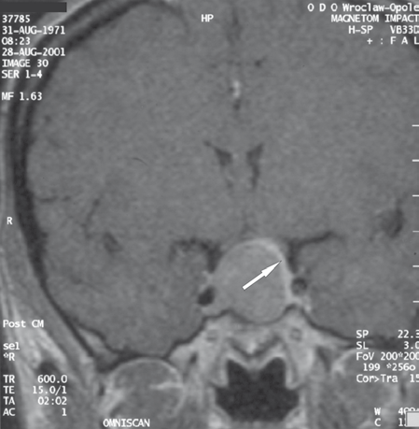
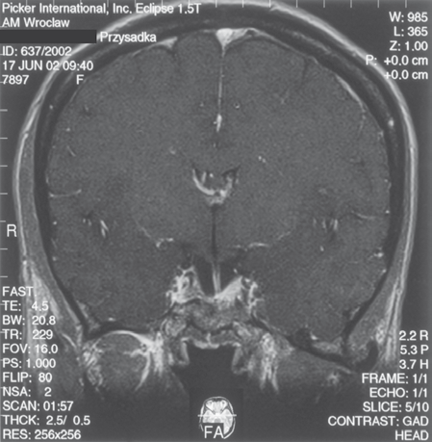
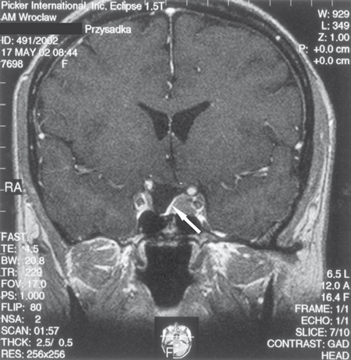
©PolJRadiol,2010;75(1):29-36
BladowskaJetal–Comparisonofpost-surgicalMRIpresentation…
Figure2.Conditionpostpituitaryadenomasurgeryperformed5yearsbefore.AT1-weightedimageaftercontrastmediumadministration,coronalplane: anarrowband of theglandconnectedtothehypothalamicinfundibulumisvisible.Thehypothalamicinfundibulumisslightlyshiftedtotheright.Ontheleftsideofthesellathereisahypointensivestructurevisible,suggestingaresidualtumour.Thearrowpointsataspared,smallfragmentofthepituitarygland.However,lackofprogressionin7-year-longMRIfollow-upalloweddiagnosisofpost-surgicalfibrosis.
Figure3A.AT1-weightedimageaftercontrastmediumadministration,coronalplane;thearrowpoints atanarrowbandofthepituitary,compressedandshifted bythetumour.
revealedahypointensivestructureontheleftsideofthesella.Aresidualtumourwassuspected.Sparedfragmentofthepituitaryglandwasvisualised,informofanarrowbandoftissueconnectedtothethehypothalamicinfun-dibulumandintensivelyenhancedaftercontrastmediumadministration.SubsequentMRIperformedinJune1999,June2000,May2002(Figure2)andJune2004didnotshowanysignificantchangescomparedtothefirstpost-surgicalexaminationinJune1998.Therefore,theMRIpre-sentationhadnotchangedforover7years.Repeatedclini-cal controlhadnot indicatedrecurrenceofactive acromeg-aly.Forthatreason,thehypointensivestructurepresentontheleftsideofthesellawasrecognisedaspost-surgicalfibrouschanges,andthecasewasqualifiedasafalse-posi-tiveforMRIresult.
Figure3B.AT1-weightedimageaftercontrastmediumadministration,coronalplane:ontherightsideofthesellathereisaresidualtumourvisible;ontheleftsideasparedfragmentofthepituitarygland(8monthsafterthesurgery).
Case3
A30-y.o.femalewasadmittedtotheDepartmentofNeurosurgeryattheWroclawMedicalUniversitytobesur-gicallytreatedforpituitaryadenomaassociatedwithsignsofacromegaly.MRIperformedinAugust2001revealedanintrasellar-suprasellartumourofapprox.2.2cmdiam-eter.Thetumouroccupiedtherightcavernoussinus,com-pressedtheopticchiasm,compressedthepituitaryglandand translocated itupwards andto theleft(Figure3A). ThepatientwasoperatedinNovember2001usinganaccessviatherightnostrilandthesphenoidsinus.ControlMRIper-formedinJune2002(8monthsafterthesurgery)showeda residualadenomaon therightside ofthesella andwithintherightcavernoussinus.Afragmentofnormalpituitary
glandwasvisualisedontheleftsideofthesella.Thetis-suehadbecomeslightly“expanded”comparedtotheMRIperformedbefortheresection(Figure3B).Thehypotha-lamicinfundibulumwasslightlyshifterontheleftsideandconnectedtothesparedfragmentofthepituitarygland.Resultsofhormonaltests(increasedGHlevels)suggestednon-radicalresection.Moreover,partialinufficiencyoftheanteriorpituitary(secondaryadrenalandthyroidinsuffi-ciency)wasdiagnosed.Thepatientrequiredsubstitutivetherapywithhydrocortisoneandl-tyroxine.
33

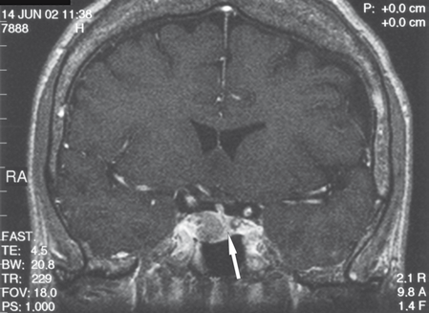
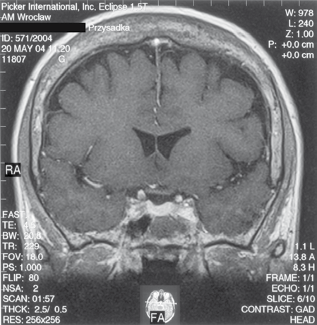
OriginalArticle
©PolJRadiol,2010;75(1):29-36
Figure4A.AT1-weightedimageaftercontrastmediumadministration,coronalplane:ontheleftsideofthesellathereisthecompressedpituitary glandvisible(arrow),connectedtothehypothalamicinfundibulumshiftedtotheleft.
Figure4B.Thesamepatient–conditionapprox.1.5yearsafterthepituitarytumourresection.AT1-weightedimageaftercontrastmediumadministration,coronalplane:normalpituitaryglandvisible,uniformlyenhanced.
Case4
A59-y.o.femalewithclinicalfeaturesofacromegalywasadmittedtotheDepartmentofEndocrinology,Diabetology,andIsotopeTreatmentattheWroclawMedicalUniversity.HormonaltestsshowedincreasedGHlevelnotinhibitedinglucosetest,aswellasassociatedhyperprolactinaemia.Nodisordersinotherpituitarytrophicaxeswerefound.MRIperformedinJune2002showedatumourlocatedintrasel-lary,ontherightside,sizedapprox.1.3x1.1×1.7cm,withweakcontrastenhancement.Thetumouradheredcloselytotherightcavernoussinusandcausedcompressionanddisplacementofthepituitaryglandwiththehypothalamicinfundibulumtotheleft(Figure4A).Theopticchiasmandperisellarstructureswerenormal.Thepatientwasoper-atedinSeptember2002viathetrans-sphenoidaccess.ControlMRIinJanuary2003(4monthsafterthesur-gery),andnextinMay2004(20monthsaftertherecec-tion)didnotshowanyresidualtumour.Normalpituitaryglandwasvisualised,which“expanded”afterthetumourremovalandregaineditsnormalsizeandlocation(Figure4B).Afterintravenouscontrastmediumadministrationtheglandhadbecomeuniformlyenhanced.Thehypotha-lamicinfundibulumwaspositionedaxially.Hormonaltestresultsconfirmedeffectivenessofthesurgery,andGHlevelnormalised.DespiteanormalpresentationofthepituitaryglandintheMRI,insufficiencyoftheanteriorpituitarywasshownwithintheadrenalaxis.Thepatientrequiredsubstitutivetherapyinthatscope.Thepatientwasexam-inedagaininApril2005(31monthsafterthesurgery).MRIimageofthepituitaryglandwasnotchangedcomparedtopreviousexaminations.
over2cmarein78%ofcasesacauseformajorpituitarydeformation. Theglandassumesthenacharacteristic,sick-leshape.Ifatumouroccupiesinitiallyasupra-orinfrasel-lararea(sphenoidsinus)anddoesnotpenetratetheinter-sellararea,ithappensthatthepituitaryglandmaintainsanalmostregularshapeandposition[30].Compressionontheglandismanifestedbyvariouslevelofitsfunctiondisorder[17,29].EvaluationofcompressedpituitarywithMRIbefore a scheduled surgery may preventitsintrasurgi-caldamage,andthereforereducetheriskofpost-surgicalinsufficiencyofthegland[15,29].
Commonly,thepituitaryglandbecomesvisiblebetterinMRIperformedafterthetumourresection,whenreleasedcompressionallowsreturntoitsphysiologicallocation.Theglandbecomes“reexpanded”andrarelyitmayevenreas-sumearegularshapeandsize.Thatsituationisobservedmorefrequentlyinyoungpatientsandwithrelativelysmalltumours[28,29].
Afterthetumourisremoved,thepost-resectiondefectbecomesfilledwithimplantedmaterials.Therefore,resorp-tiontimeofthefillingmaterialanditsquantityareaddi-tionalfactorsinfluencingtheprocessofpost-surgicalrepo-sitioningandreexpansionofthepituitarygland[29].
Inmajorityofcases,thepituitaryglanddoesnotreturntoitsnormalshapeandvolumeafterasurgery,andthatcon-ditionisreflectedbyitsfunctionimpairment.AccordingtoGołkowskietal.[17],post-surgicalpituitaryinsufficiencywasobservedinapprox.31%ofpatients,whohadanormalendocrinefunctionoftheglandbeforethesurgery.Andinapprox.28%ofpatients,intensificationofpreviouslydiag-nosedpre-surgicalinsufficiencywasobserved.Mostcom-monlythehormonedeficiencywasassociatedwithACTH,andtheleastcommonly–withprolactine.Patientswithmacroadenomasdominatedinagroupofpatientswith
Discussion
Pituitarytumours,especiallymacroadenomas,causecom-pression,displacementanddeformationofthegland.Levelofthepituitarydisplacementanddeformationdependsonsize,localisationandexpansionofthetumour[29].Itwasobservedthatmajority(91%ofcases)ofadenomasshow-ingansuprasellargrowthcausethepituitarydisplacementtowardsthesuprasellarspace.Adenomaswithdiameterof
34

©PolJRadiol,2010;75(1):29-36
BladowskaJetal–Comparisonofpost-surgicalMRIpresentation…
postsurgicallyformedorintensifiedpituitaryinsufficiency.Ariskofpituitaryfunctionimpairmentishigherincaseofpatientswhohadhadanirregularpituitaryfunctionbeforeatumourresection,andinpatientswithlargetumours[17].
functiondisorders.Itwasshownthan46patientsofthatgrouphadcompletelynormalpituitaryfunctionanddidnotrequireanysubstitutivetherapy(cases1and2).Only48patientsinwhomeexistenceoffragmentofanormalpituitarywasfound,hadpartialimpairmentoftheglandendocrinefunctionadequateto theMRIpresentation oftheorgan.Fivepatientshadacompletefailureoftheanteriorandposteriorpituitary(panhypopituitaryzm),despitethefactthatMRIindicatedexistenceofasparedfragmentofanormalgland.Inagroupof14patientsinwhichnopitu-itaryglandcouldbevisualisedinMRI,noneshowednor-malfunctionoftheorgan.
Inavailableliterature,radiologists[29]payattentiontopost-surgicalpresentationofthepituitaryglandinMRIandendocrinologists[17]focusonevaluationofthegland'shormonalfunctionandappropriatetherapyofpossiblepost-surgicalinsufficiency.Noanalysisofapossiblerela-tionbetweentheMRIpresentationoftheglandanditshormonalfunction has been attemptedpreviously.Wehavemadethatattemptinthisstudy.
Statisticalanalysisshowedthatthereisnostrictrelation-shipbetweenpost-surgicalpresentationofthepituitaryglandanditshormonalfunction.
Intheanalysedmaterialof124cases,thepituitaryglandwasvisibleintheMRIin110patientsaftersurgicalremov-alofpituitarytumour.Almostregularsizeandshapewasvisualisedin11patients,whichconstitutedonly10%ofallcasesinwhichpresenceofthepituitaryglandwasvisu-alisedinMRI.Among11patientswithnormalMRIpre-sentationofthegland,8showednormalpituitaryfunction,andin3patientsapartialanteriorpituitaryinsufficiencywithinoneaxiswasdiagnosed.Thoseresultsareconsis-tentwithotherliteraturedataindicatingthatthepituitaryglandrarelyregainsitsnormalconfigurationafterasur-gery[28,29].AfactshouldbenotedthatnotallpatientspresentingnormalMRIpresentationofthepituitaryglandhavenormalhormonalfunctionoftheorganpreserved(case4isanexample).
Conclusions
Post-surgicalMRIpresentationofthepituitaryglanddoesnothaveastrictrelationshipwiththegland'shormonalfunction.StatisticallysignificantdifferencebetweenMRIpresentationofthepituitaryglandandendocrinologicalevaluationofitsfunctionwasfoundinthewholegroup.Therefore,evaluationofsurgeryeffectiveness,andeffectonpost-surgicalpituitaryfunctionmustbebasedonbothimagingresultsandahormonalprofile.Itshouldbenotedthatpost-surgicalvisualisationofapartialpituitaryinMRIdoesnotexcludethegland'snormalfunction,andviceversa–determinationofpost-surgicalpresenceofaprop-erlysizedglanddoesnotnecessarilymeanitsnormalfunc-tionandlackofnecessityforhormonalsubstitutioninaparticularpatient.
In99patients,constitutingasmuchas90%ofcases,MRIindicatedexistenceofonlyafragmentofanormalgland.Thatpresentationmaysuggestexistenceofotherpituitary
References:
- EvansonJ:Imagingthepituitarygland.Imaging,2002;14:93–102
- YoonPH,KimDI,JeonPetal:Pituitaryadenomas:earlypostoperativeMRimagingaftertranssphenoidalresection.AJNR,2001;22:1097–104
- BolanowskiM:Guzyprzysadki–możliwościdiagnostyczneiterapeutyczne.Terapia,2001;102:37–39
- ZhangX,HorwitzGA,HeaneyAPetal:Pituitarytumortransforminggene(PTTG)expressioninpituitaryadenomas.JClinEndocrinolMetab,1999;84:761–67
- ZgliczyńskiS,BrzezińskaA:Rozpoznawanieileczenieguzówprzysadki.MedPrakt,1995;3:69–71
- BladowskaJ,SokolskaV,CzapigaEetal:Postępywdiagnostyceobrazowejprzysadkimózgowejiokolicyokołosiodłowej.AdvClinExpMed.2004;13:709–17
- KeoghBP:Recentadvancesinneuroendocrineimaging.CurrOpinEndocrinolDiabetesObes,2008;15(4):371–75
- Portman0,FlemmingS,CoxJPetal:MagneticresonanceimagingofthenormalpituitaryglandusingultrashortTR(UTE)pulsesequences(REV1.0)Neuroradiology,2008;50(3):213–20
- KozicD,Medic-StojanowskaM,OstojnicJetal:ApplicationofMRSpectroscopyandtreatmentapproachesinapatientwithextrapituitarygrowthhormonesecretingmacroadenoma.NeuroEndocrinolLett,2007;28(5):560–64
- ChernovMF,KawamataT,AmanoKetal:Possibleroleofsingle-voxel(1)H-MRSindifferentialdiagnosisofsuprasellartumors.JNeurooncol,2008; (Epubadead of print)
- RennertJ,DoerflerA:Imagingofsellarandparasellarlesions.ClinNeurolNeurosurg,2007;109:111–24
- BonnevilleJF:Pituitaryadenomas:valueofMRimaging.JRadiol,2000;81:939–42
- RodriguezO,MateosB,delaPedrajaRetal:Postoperativefollow-upofpituitaryadenomasaftertranssphenoidalresection:MRIandclinicalcorrelation.Neuroradiology,1996;38:747–54
- EdalAL, SkjodtK,Nepper-RasmussenHJ:SIPAP– a newMRclassificationforpituitaryadenomas.ActaRadiol,1997;38:30–36
- Hald JK,NakstadPH,KollevoldT etal: MR imagingof pituitarymacroadenomasbeforeandaftertranssphenoidalsurgery.ActaRadiol,1992;33:396–99
- HardyJ,CzepkoR:Guzyprzysadki.Zarysneurochirurgii.PZWL,Warszawa1999;83–107
- GołkowskiF,TrofimiukM,HusznoBetal:Ocenaczynnościhormonalnejprzysadkipooperacjigruczolakazdojściaprzezzatokęklinową.PrzegLek,2001;58:825–27
- BonickiW,MichalikR,KrajewskiRetal:Zastosowanietechnikchirurgiipodstawyczaszkiwleczeniugruczolakówprzysadki.NeurolNeurochirPol,2002;36:1121–33
- CzepkoR,DanilewiczB,AnilewiczMetal:Bezpośredniewynikileczeniagruczolakówprzysadkimetodąprzezczaszkowąiprzezklinową.PrzegLek,1999;56:638–43
- JhoH-D,CarrauRL,KoYetal:Endoscopicpituitarysurgery:anearlyexperience.SurgNeurol,1997;47:213–23
- PattersonRH:Theroleoftranscranialsurgeryinthemanagementofpituitaryadenoma.ActaNeurochir(Suppl),1996;65:16–17
- KassamAB,GardnerPA,SnydermanCHetal:Expandedendonasalapproach,afullyendoscopictransnasalapproachfortheresectionofmidlinesuprasellarcraniopharyngiomas:anewclassificationbasedontheinfundibulum.JNeurosurg.2008;108(4):715–28
- LiebertW,SzyfterW,TokarzFetal:Chirurgiczneleczeniegruczolakówprzysadkimózgowejzdojściaprzezzatokęklinową.OtolaryngPol,1994;48: 260–65
35

OriginalArticle
©PolJRadiol,2010;75(1):29-36
- SheehanMT,AtkinsonJLD,KasperbauerJL et al: Preliminarycomparisonoftheendoscopictransnasalvsthesublabialtransseptalapproachforclinicallynonfunctioningpituitarymacroadenomas.MayoClinicProc,1999;74:661–70
- BolanowskiM:Treatmentofpituitarytumours.W:InternationalIntensiveCourseinOncologyERASMUS2000“Recentadvancesintheknowledgeofcancer”.Wrocław,2000;49–54
- WilsonCHB:Surgicalmanagementofpituitarytumors.JClinEndocrinolMetab,1997;82:2381–85
- FahlbushR,HadaniM,PerrinGetal:Neurosurgicaltreatmentofpituitaryadenomas:operativeand/ormedicaltherapy.ActaNeurochir,1995;133:211–38
- SteinerE,KnospE,HeroldChJetal:Pituitaryadenomas:FindingsofpostoperativeMRimaging.Radiology,1992;185:521–27
- SteinerE,MathG,KnospEetal:MR-appearanceofthepituitaryglandbeforeandafterresectionofpituitarymacroadenomas.ClinRadiol,1994;49:524–30
- KurowskaM,TarachJS,ZgliczyńskiWetal:Acromegalyinapatientwithnormalpituitaryglandandsomatototropicadenomalocatedinthesphenoidsinus.EndokrynolPol,2008;59(4):348–51
36

