Annales Societatis Geologontm Poloniae (2000), vol. 70: 261-281

MINERALOGICAL AND GEOCHEMICAL STUDY OF THERMALLY
ALTERED COUNTRY ROCKS OF GRANODIORITE INTRUSION
IN THE BĘDKOWSKA VALLEY NEAR KRAKÓW
(S POLAND)
Ewa KOSZOWSKA & Anna WOLSKA
Department of Mineralogy’ and Petrography, Institute of Geological Sciences, Jagiellonian University,
- 063 Kraków id. Oleandry 2a
Koszowska, E. & Wolska, A., 2000. Mineralogical and geochemical study of thermally altered country rocks of
granodiorite intrusion in the Będkowska Valley near Kraków (S Poland). Annales Societatis Geologontm Poloniae,
70: 261-281.
Abstract: Extensive zone of thermally altered sedimentary rocks occurring in the contact aureole of granodiorite
intrusion has been described from the boreholes in the Będkowska Valley near Kraków. Depending on the
composition of primary rocks and the distance from the intrusion the following metamorphic rocks were formed:
fine-grained cordierite hornfelses, macroscopically spotted andalusite hornfelses, chlorite-bearing spotted rocks,
metaconglomerates, metasandstones and metamudstones. These rocks consist of various neogenic minerals:
cordierite, andalusite, biotite, muscovite, feldspars and corundum. The rocks and neogenic minerals have been
investigated in details using optical and electron microscopy, X-ray diffraction, EDS and chemical methods (1CP,
INAA, XRF).
Characteristic contact metamorphic mineral paragenesis suggests that the most altered rocks in question were
formed within temperature range from 580 to 630°C and pressure about 1-2 kbar under conditions corresponding
to the orthoclase-cordierite hornfels facies of thermal metaniorphism.
Abstrakt: Rozległa strefa przeobrażonych termicznie skal osadowych tworzących aureolę kontaktową dookoła
intruzji granodiorytu została opisana z wierceń (otwory DB-5 i WB-102A) usytuowanych w Dolinie Będkowskiej
(na północny zachód od Krakowa). W zależności od odległości od intruzji oraz pierwotnego składu mineralnego i
chemicznego skał osadowych, podczas metamorfizmu kontaktowego powstały następujące skały: drobnoziarniste
hornfelsy kordierytowe, makroskopowo plamiste homfelsy andaluzytowe, skały plamiste z chlorytem, metazle-
pieńce, metapiaskowce i metamułowce. W badanych skałach stwierdzono występowanie następujących neoge-
nicznych minerałów: kordierytu, andaluzytu, biotytu, muskowitu, skaleni i korundu. Skały przeobrażone termicz-
nie, oraz ich neogeniczne minerały zostały szczegółowo przebadane mikroskopowo (mikroskop polaryzacyjny i
elektronowy), metodą rentgenowską oraz metodami chemicznymi (klasyczna analiza chemiczna, ICP, INAA,
XRF oraz EDS i mikrosonda).
Obecność w badanych skałach paragenez mineralnych charakterystycznych dla facji ortoklazowo-kordiery-
towo-homfelsowej metamorfizmu kontaktowego (według terminologii Winklera) może sugerować zakres tempe-
ratur (580-630°C) i ciśnień (1-2 kbar), w którym doszło do najintensywniejszej termicznej transformacji skał
osadowych.
Key words: metamorphism, thermally altered, spotted hornfels, contact aureole, granodiorite, cordierite. andalu-
site.
Manuscript received 10 December 1999, accepted 17 August 2000

INRODUCTION
Lower Palaeozoic detritic complex (Bukowy & Ślósarz
1968) was found first in the Bębło borehole, situated on the
southern margin of the Silesian-Cracovian monocline, NW
of Kraków. Lower Palaeozoic series and granodiorite intru-
sion were found under Jurassic sequence in the Będkowska
Valley, too (boreholes DB-4, DB-5 WB-55, WB-58, WB-
102, WB-102A - (Harańczyk, 1982, 1984, 1994a, b). In Ha-
rahczyk’s opinion (Harańczyk et ai, 1995, 1996), a tectonic
unit called Jerzmanowice block occurs in the basement of
this area. Its core is formed by plutonie granodiorite intru-
sion, causing large positive magnetic anomaly.
This intrusion (Fig. 1), showing the character of stitch-
ing intrusion, is localized east of sutural deep fault separat-
ing the Lubliniec-Zawiercie-Wieluń terrane from the Mało-
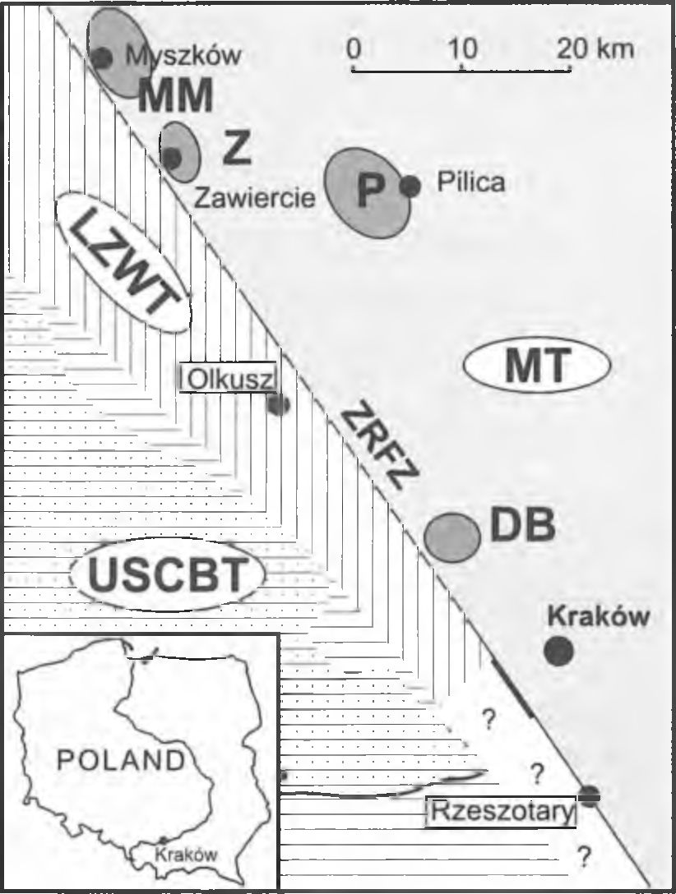
262
E. KOSZOWSKA & A. WOLSKA

Fig. 1. Localization of granodiorite intrusion from Będkowska
Valley (after Harańczyk 1988, 1994 a); LZWT - Lubliniec-
Zawiercie-Wieluń Terrane; USCBT - Upper Silesian Coal Basin
Terrane; MT - Małopolska Temne; ZRFZ - Zawiercie-
Rzeszotary Fault Zone; DB - granodiorite from Będkowska Val-
ley; MM - granodiorite from Myszków-Mrzygłód; Z - monzo-
granite from Zawiercie; P - granodiorite from Pilica
polska Block (Harańczyk et ai, 1995; Unrug et ai, 1999).
In some authors opinion e.g. (Bogacz, 1980; Pożaryski et
ai, 1992; Buła, 1994, 1995; Buła & Kotas, 1994; Bula et
ai, 1996; 1997, Dadlez et ai, 1994; Jachowicz & Moryc,
1995; Żaba, 1995) the Kraków-Lubliniec fault zone, which
most probably represents a fragment of the transcontinental
tectonic Hamburg-Kraków line, is a direct boundary be-
tween the Upper Silesia and Małopolska Blocks. This gra-
nodiorite is one of four intrusions (similarly as those of
Myszków-Mrzygłód, Pilica and Zawiercie) situated within
marginal zone of the Małopolska Block. Numerous com-
mon features suggest that they all represent apical parts of a
larger batholith located in deeper (abyssal) zone (Żaba,
1999).
The age of this intrusion was discussed by numerous
authors. Harańczyk considered granitoid plutonism to be
post-Silurian but pre-Devonian (Harańczyk, 1985; Harań-
czyk et ai, 1980). Similarly, in Piekarski’s (1985) opinion
Devonian ore-bearing magmatism is related with Caledo-
nian cycle. Several authors relate the emplacement of grani-
toids with Variscan magmatism of Upper Carboniferous age
(Bukowy & Cebulak, 1964; Bukowy, 1984, 1994; Kar-
wowski, 1988; Kośnik & Muszyński, 1990; Żaba, 1994,
1995, 1996).
Two boreholes DB-5 and WB-102A, localized in the
Będkowska Valley area, have penetrated a complex of
Cambrian black folded and faulted rocks and gained grano-
diorite intrusion (Fig. 2A & B).
The oldest part of the above tectonic block consists of
Lower Cambrian Będkowska Valley conglomerate forma-
tion and of Middle Cambrian pyrite-bearing black meta-
mudstone formation. They are dated on the base of acri-
tarches and macrospores (Harańczyk, 1994a, b) and consid-
ered to represent flysch deposits related with rifting (Unrug
et ai, 1976). It is composed of six beds of variegated po-
lymictic metaconglomerates, several meters thick, interlay-
ered with black, coarse- and fine-grained metasandstones,
metamudstones and black fine-grained metamudstones sev-
eral hundred meters thick, interlayered with black metape-
lites and medium- and fine-grained black metasandstones.
These clastic rocks are characterized by well preserved sedi-
mentary structures: bedding and lamination (Harańczyk,
1984). Besides, metatuffitic intercalations, showing lower
hardness and grey-greenish coloration and differing from
clastic Cambrian rocks, occur within this formation. The
thickness of Cambrian formation amounts to about 700 m.
At first, the occurrence of biotite-quartz-albite hornfels
from the borehole WB-102A was mentioned by Kośnik &
Muszyński (1990). In individual samples of rocks from the
DB-5 borehole Koszowska & Wolska (1994a, b) have
found cordierite and andalusite (at the depth 888.0 m and
- m) - characteristic contact metamorphic minerals.
Local occurrence of these minerals in rocks from this bore-
hole was reported by Czerny et ai (1997) - at the depth
- m and 1024.7 m..
The aim of this paper is to define the range of contact al-
terations in the rocks surrounding the granodiorite body in
the Będkowska Valley. Consequently, samples of dark
rocks were selected from the zones altereted by thermal
metamorphism, but showing no alterations caused by later
hydrothermal activity. Such secondary, hydrothermal pro-
cesses are observed around numerous veins cutting the
Cambrian rock complex (Harańczyk et ai, 1995; Muszyń-
ski 1991; Czemy et ai, 1997) and are manifested by discol-
oration of the rocks.
Samples of rocks were collected from the boreholes
DB-5 and WB-102A.
The sections of the boreholes DB-5 and WB-102A are
elaborated on the ground of earlier, Harahczyk’s (1984),
Harańczyk et ai, (1995) papers and the present authors de-
tailed examination.

Section of the borehole DB-5 (Fig. 2A)
Cambrian rocks were drilled in the borehole DB-5 at the
depth interval from 103.0 to 1142.7 m. They are Middle
Cambrian (Harańczyk, 1984) clastic deposits represented
by black coarse- and fine-grained metasandstones, meta-
mudstones and metapelites cut by numerous porphyric
dykes (at the depth intervals 232.1-283.1 m, 732.0-737.7 m
and at 899.0 m), and metatuffitic intercalations (at the depth
486.8 m and 903.7 m to 904.2 m). At the depth interval
904.2-1142.7 m there occur coarse-grained Lower Cam-
brian metaconglomerates (Harańczyk, 1984), interlayered at
the depth 1015.4--1035.0 m by metapelite intercalation and
porphyric dyke (1094.0-1133.5 m). The top of granodiorite
intrusion was penetrated at the depth 1142.7 m and till
1414.6 m it was not cut through. This intrusion is cut by nu-
GRANODIORITE INTRUSION IN THE BĘDKOWSKA VALLEY
263
merous porphyry dykes (at the depths: 1229.4-1242.0 m,
- 1256.0 m, 1257.8-1279.0 m, 1283.0-1298.0 m,
- 1305.0 m, 1408.0-1414.6 m).
Section of the borehole WB-102A (Fig.2B)
In this borehole the rocks of the Cambrian complex
were penetrated at the depth interval 171.0-1076.0 m under
Jurassic limestones, variolitic porphyry sheet and Carbonif-
erous Jerzmanowice conglomerate (Harańczyk, 1984). This
complex consists of various clastic rocks as: metaconglom-
erates, coarse- and fine-grained metasandstones and
metapelites, assigned by Harańczyk (1984) to Lower Cam-
brian and Middle Cambrian sequence. They are black, very
hard, massive, sounding when hammering. These rocks are
cut by numerous porphyry dykes (at the depths: 402.0-
- m, 406.0-412.0 m, 602.0-632.0 m, 814.0-823.0 m).
The top of granodiorite body was penetrated at 1092.0 m
and the intrusion was not pierced till 1455.0 m. Between de-
tritic Cambrian rocks and granodiorite there occurs a zone
of brecciated rocks ca. 20 m thick.

ANALYTICAL MATERIALS
AND METHODS
Samples of metamorphosed detritic rocks have been
collected from drill cores preserved in the store of borehole
(DB-5, WB-102A) materials of the Warsaw State Geologi-
cal Institute in Kielniki near Częstochowa.
The depths of sampling sites of Cambrian rocks, pre-
liminarily selected and studied in detail, are marked in both
sections (Fig.2 A, B). The whole Cambrian rocks are cut by
numerous quartz and ore-bearing feldspar veinlets. In the
zones adjacent to the latters we observe discoloration of
rocks and retrogressive, hydrothermal, alteration phenom-
ena. Therefore, the samples studied in detail were collected
from hydrothermally unaltered zones, showing fine-grained
structure and containing no detrital material. Only in such
rocks the thermal alteration processes have lead to the for-
mation of characteristic contact-metamorphic, neogenic
minerals like cordierite and andalusite.
A microscopic study of these rocks was performed with
a AMPLIVAL petrographic optical microscope.
X-ray diffraction patterns of the studied rocks were re-
corded by means of TUR M-62 diffractometer with a
HZG-4 horizontal goniometer, using filtered CuKa radia-
tion. The instrument settings were U=30 kV, 1=30 mA,
scanning speed was l^{c}/min., chart speed 10 mm/min.
Six samples of rocks of the studied complex were ana-
lysed using wet chemical method according to the proce-
dure described by Narębski (1962). Other five samples were
analysed in the Activation Laboratories Ltd. in Canada by
means of the following methods: ICP (major elements),
INAA (trace elements including REE) and XRF (Nb).
The chemical composition of minerals was analysed
with an ARL SEMQ electron microprobe operated at the ac-
celeration potential 20kV and sample current 120-150 pA.
The following spectral lines and standards were used:
NaKa(NaAlSi308), MgKa(MgO), FeKa(FeS2), AlKa-
(KAlSi₃0₈), SiKa(KAlSi₃08), KKa(KAlSi₃0₈), CaKa-
(CaC0₃), MnKa(Mn), TiKa(Ti). Correction ZAF for ab-
sorption, fluorescence and atomic number were calculated.
Moreover, JEOL 5410 electron microscope equipped
with an energy dispersive spectrometer Voyager 3100 (NO-
RAN) was used. Thin section of samples coated were evalu-
ated according to the “standardless” procedure of calcula-
tion in voyager software (i.e using standards from the soft-
ware library supplied by the manufacturer).
Infrared absorption spectra were obtained with Zeiss
UR-20 prismatic spectrometer, using KBr discs.

PETROGRAPHIC CHARACTERISTICS
OF ROCKS
METACONGLOMERATES
Samples of metaconglomerates within Cambrian se-
quence rocks were collected from the borehole DB-5 from
the depths: 906.6 m, 908.0 m, 920.0 m, and 936.8 m. They
are very hard, massive and recrystallized rocks. Macrosco-
pically we observe large, poorly rounded rock fragments,
0.5 to 4 cm in size, representing various rock types (gran-
ites, porphyries, sandstones, mudstones, siliceous rocks,
dolerites, crystalline schists) and grains of detrital quartz,
alkali feldspars and rare plagioclases. Black neogenic ma-
trix is of porous-contact type.
Fragments of the following rock types occur in this con-
glomerate:
- porphyries, containing zonal plagioclase phenocrysts
embedded in fine-grained quartz-feldspar matrix
- trachytes, showing fluidal structure with large alkali
feldspar phenocrysts, surrounded by lathlike feldspar grains
forming the matrix,
- dolerites and diabases, showing ophitic texture,
- granites, displaying coarse-crystalline structure, typi-
cal of plutonie rocks. They consist predominantly of quartz,
often granulated and rarely showing myrmekitic inter-
growths, and alkali feldspar grains. Less abundant are pla-
gioclases and chloritized brown biotites,
- metasandstones, in which fragments of detrital min-
erals (quartz, alkali feldspars, less abundant plagioclases)
show symptoms of corrosion and are 0.3-0.6 mm in size.
Cementing substance of contact type consists of fine brown
biotite flakes (below 0.04 mm in size) showing distinct
pleochroism,
- siliceous rocks, consisting of very small quartz crys-
tals formed by recrystallization of chalcedony,
- metamudstones, composed of fine grains of detrital
minerals: quartz, alkali feldspars and rare plagioclases.
They are cemented by brown biotite flakes, 0.04-0.08 mm
in size.
Moreover, fragments of detrital minerals, up to 0.3 mm
in size, also occur in the study rocks. They are represented
by quartz showing normal and wavy extinction as well as
granulated one, alkali feldspar and rare plagioclases. These
grains show small embayments.
The matrix of metaconglomerates is of porous-contact
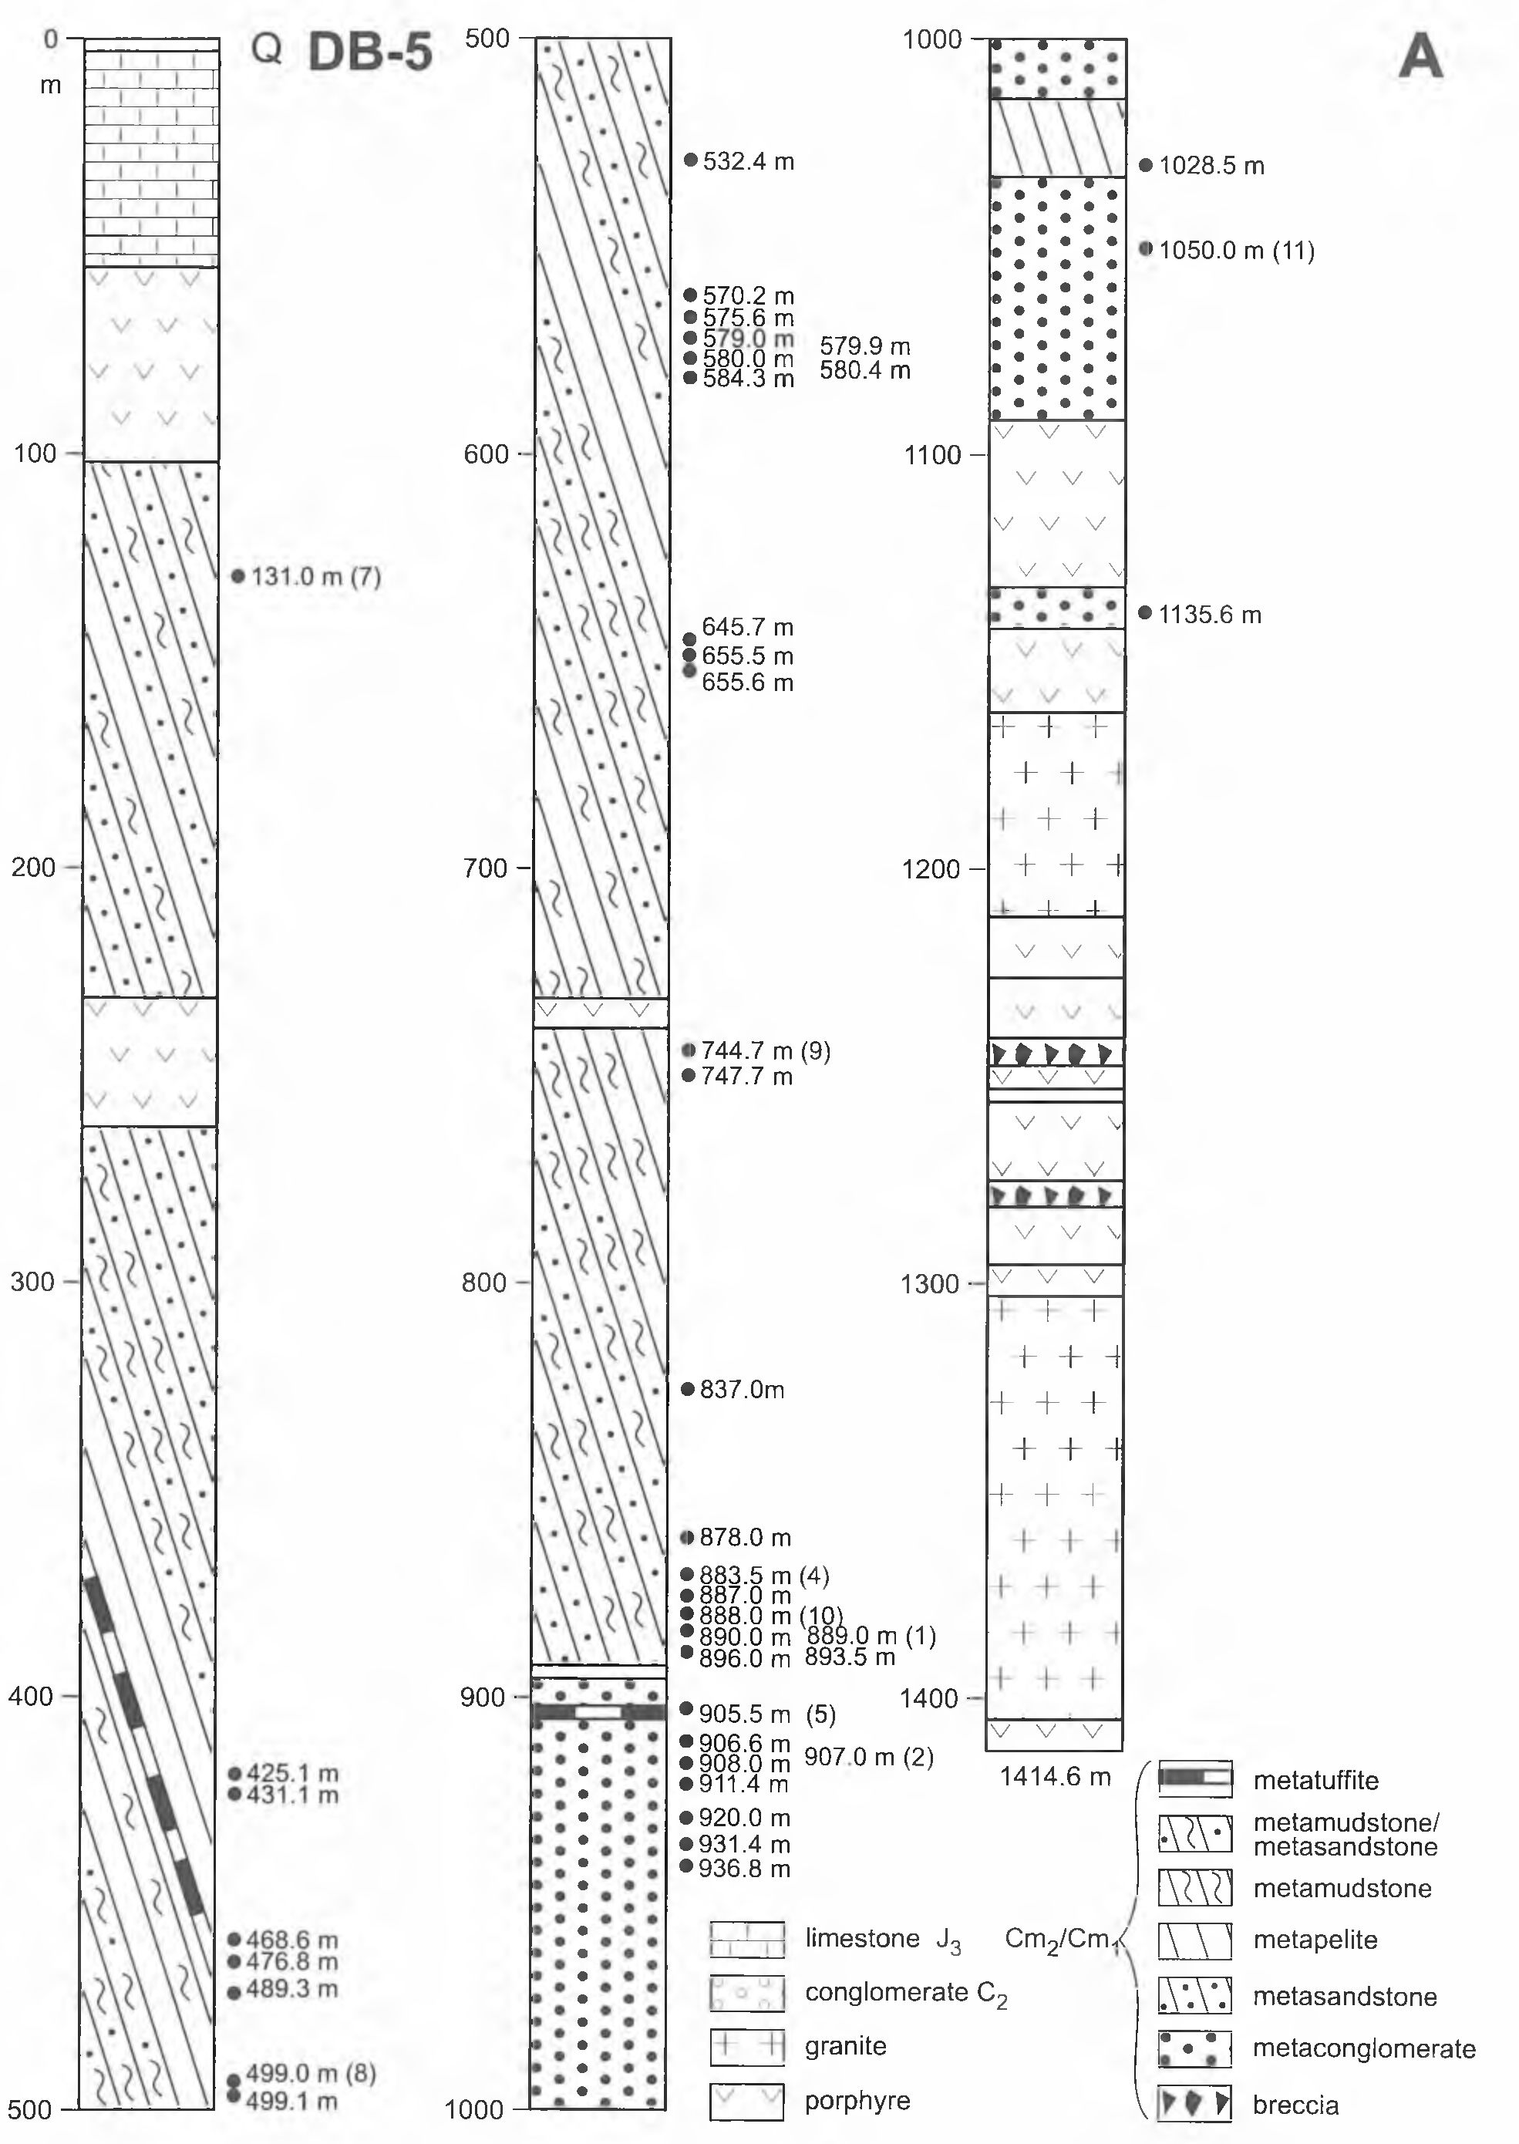
264
E. KOSZOWSKA & A. WOLSKA
Fig. 2. Sections of the boreholes DB-5 (A) and WB-102A (B) after Harańczyk (1984)

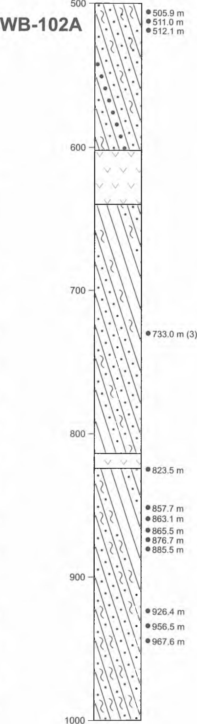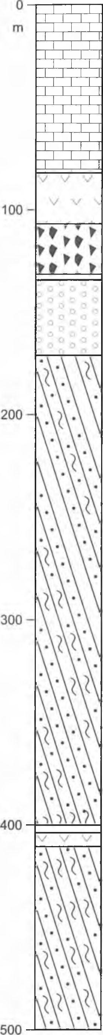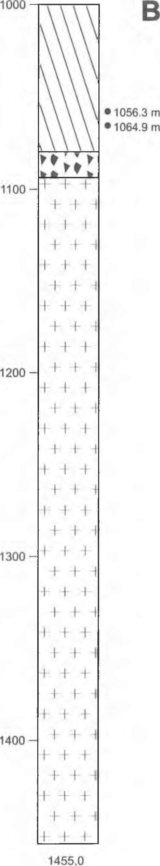
GRANODIORITE INTRUSION IN THE BĘDKOWSKA VALLEY
265

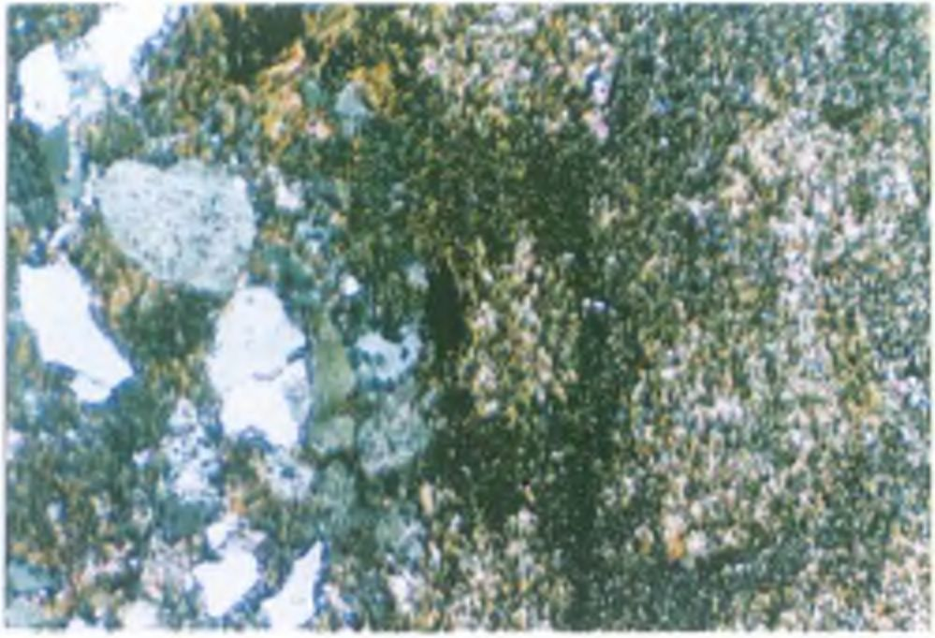
266
E. KOSZOWSKA & A. WOLSKA
type. It consists of brown biotite flakes (0.08-0.21 mm)
showing light green to olive-brown pleochroic colours.
Fragments of rocks and minerals are contacting with each
other. There also occur nests of aggregates of mutually in-
tergrown brown biotite flakes.
Metaconglomerate rocks are often cataclized and cica-
trized by quartz veins containing ore minerals (mainly py-
rite). Besides, there occur mylonitized zones in which detri-
tal material was crushed and alteration process resulted in
retrogressive chloritization of biotite.

METASANDSTONES
Samples of sandstone intercalations occurring within
Cambrian sedimentary sequence were collected in the bore-
hole DB-5 from the depths 575.6 m, 579.0 m, 580.0 m,
- m, 931.4 m, 1050.0 m, 1135.6 m. They represent
sandstones consisting of detrital grains varying from 0.2 to
2 mm in size. Macroscopically they are black rocks with
lighter coloured detrital minerals and rock fragments. They
are strongly recrystallized, massive and hard.
Microscopic observation have shown that detrital frag-
ments of minerals are represented by poorly rounded sharp-
edged grains of detrital quartz, 0.85-1.8 mm in size. The
most abundant quartz pebbles show, in general, normal ex-
tinction but there also occur those exhibiting wavy one, as
well as granulated grains. Alkali feldspar grains, 0.5-1.8
mm in size, rarely display perthitic structure and twinning.
They are often sericitized. Poorly rounded plagioclase
grains, 0.2-0.6 mm in size, show characteristic polysyn-
thetic twinning. Detrital mineral grains show symptoms of
corrosion processes. The discussed sandstones locally con-
tain fragments of various rock types (porphyries, dolerites,
mudstones and siliceous rocks), 0.2-1 mm in size.
The primary matrix was of contact type and it was not
abundant. Now it is corrosional in type and consists of fine-
flaky brown biotite showing distinct pleochroism from light
green to olive-brown tint. Its flakes are 0.01-0.04 mm in
size. They are chaotically distributed, often mutually inter-
grown and even forming aggregate nests. Moreover, anhe-
dral ore minerals (mainly pyrite), 0.03-0.6 mm in size, are
disseminated in study rocks.

METAMUDSTONES
Samples of these rocks were collected from Cambrian
rock complex in the borehole DB-5 from the following
depths: 425.1 m, 499.0 m, 532.4 m, 575.6 m, 579.0 m, 584.3
m, 645.7 m. 655.6 m, 744.7 m, 837.0 m, 878.0 m, 911.4 m,
- m Sandstone samples studied from the borehole
WB-102A were collected from the depths: 857.7 m, 876.7
m, 885.5 m, too. Macroscopically these are black, hard and
massive rocks.
Microscopic studies have shown that these rocks have
preserved their primary sedimentary bedding, expressed by
distribution of interlayering detrital and pelitic material.
Fragments of detrital materials are sharp-edged, poorly
rounded and show symptoms of corrosion. Quartz grains
display normal and wavy extinction, whereby some of them
are granulated. Their grain size in samples from borehole
WB-102A varies from 0.01 to 0.18 mm, while in those from
borehole DB-5 from 0.07 to 0.35 mm. Grains of detrital pla-
gioclases are sharp-edged, show polysynthetic twinning,
and are 0.06-0.15 mm in size. They are often sericitized. Al-
kali feldspar grains, occurring mainly in metamudstones
from the borehole WB-102A, are slightly larger (0.07-0.21
mm in size). They rarely exhibit perthitic structure and dou-
ble twinning. Moreover, sharp-edged fragments of siliceous
rocks 0.07-0.15 mm were found in the rocks studied.
Primary argilliceous fraction of mudstones is com-
pletely transformed and consists of fine-flaky biotite aggre-
gates showing distinct pleochroism (light green to olive-
brown). Biotite flakes are chaotically distributed and are not
oriented concordantly to bedding. Biotite flakes are 0.02-
0.03 mm in size. Locally, there occur larger nests up to 0.2
mm in size, consisting of intergrown biotite flakes.
Metasandstones and metamudstones are cut by pyrite-
bearing quartz-chlorite, quartz-feldspar and quartz-seri-
cite-chlorite veinlets. Besides, chaotically distributed anhe-
dral pyrite grains 0.01-0.08 mm in size occur in these rocks.
Transformation of brown biotite into light green chlorite
showing weak pleochroism and subnormal indigo-brown
interference colours is observed at the margin of veinlets.

FINE-GRAINED CORDIERITE HORNFELSES
Cordierite hornfelses were found in several zones in the
section of the borehole WB-102A. Samples of these rocks
were collected from the depths: 823.5 m, 865.3 m, 876.7 m,
- m, 1056.3 m, 1064.9 m. They occur as intercalations
in metamudstones, several to several tens centimetres thick,
and in metasandstones (Fig. 3). In the borehole DB-5 cord-
ierite hornfelses were found to occur at the following
depths: 468.6 m, 476.8 m, 489.3 m, 499.1 m, 579.9 m, 580.0
m, 580.4 m, 655.5 m, 837.0 m, 878.0 m, 885.0 m, 887.0 m,
- m, 889.0 m, 890.0 m, 1028.5 m.
Cordierite hornfelses are black, hard and massive show-
ing cryptocrystalline structure. These rocks do not differ
from metasandstones and metamudstones. Macroscopically
it is impossible to distinguish individual minerals and to ob-
serve spotted texture. Only in the samples from the borehole

Fig. 3. Sharp boundary between metasandstones and fine-
grained cordierite hornfels. Borehole DB-5, depth 905.3 m;
Crossed polars
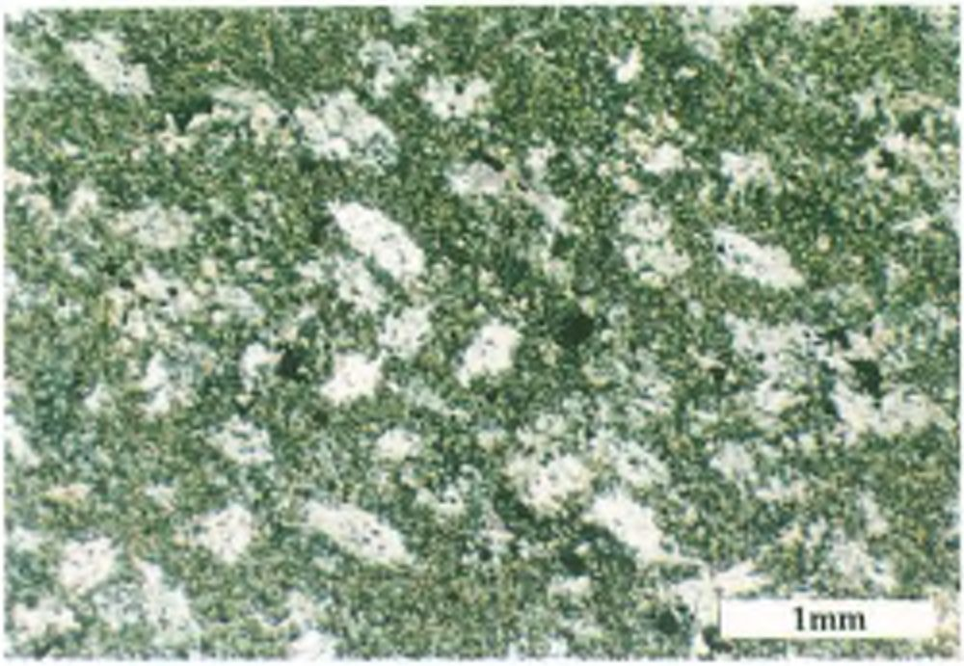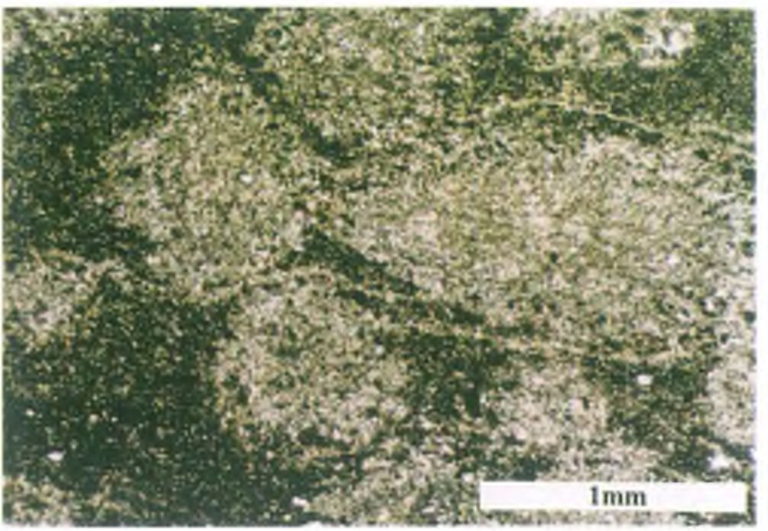
GRANODIORITE INTRUSION IN THE BĘDKOWSKA VALLEY
267

Fig. 4. Cordierite spots in fine-grained cordierite hornfels.
Borehole DB-5, depth 888.0 m; Crossed polars
Fig. 5. Oval and ellipsoidal cordierite spots in fine-grained
cordierite hornfels. Borehole DB-5, depth 905.9 m; Plane-
polarized light

DB-5 collected at depths 878.0 m, 885.0 m, 888.0 m, 889.0
m, 905.3 m, 905.9 m, and from the borehole WB-102A at
depths 926.4 m, 956.5 m, 967.5 m, 1056.3 m, in which the
size of cordierite blasts is in the range 0.6-0.9 mm, the rocks
displays macroscopically spotted texture.
Under the microscope the rocks under consideration
show spotted texture (Fig. 4). Light-coloured spots of differ-
ent shape (circular, oval, rectangular, square) consist of
cordierite (Fig. 5), showing low relief and low birefrin-
gence. Locally, cordierite forms intergrowths with alkali
feldspars. They are covered by numerous submicroscopic
inclusions of opaque minerals and brown biotite flakes (less
than 0.1 mm in size). Consequently, the rocks show sieve
texture, characteristic of hornfelses. The size of these spots
depends on the depth of sampling. The spots from samples
collected in the borehole DB-5 from the depths 460-590 m
are 0.29-0.35 mm in size whilst those in samples situated
closer to the intrusion 870-89 m are larger (0.35-0.50 mm
in size). In the samples from borehole WB-102A these spots
are generally considerably smaller (0.15-0.28 mm) though
in zones closer to intrusion their sizes increase up to 0.90
mm. The matrix between spots consists of chaotically dis-
tributed thin brown biotite flakes (0.01-0.04 mm in size),
showing distinct pleochroism from light green to olive-
brown and very fine blasts of plagioclases.
Identification of cordierite on the ground of optical data
only is often unreliable. However, by means of X-ray pat-
tem, on the base of characteristic reflection corresponding
to interplanar spacing 8.5 A (Fig. 6) it was possible to iden-
tify this mineral.
In these parts of the rock where biotite, sericite or
quartz-chlorite veinlets occur, we observe in marginal zone
the transformation of cordierite blasts into an aggregate of
mutually inteipenetrating minerals: light mica and light
green chlorite. The nests composed of light mica (0.15 mm
in size) occur close to biotite veinlets in the samples from
the depth 905.3 and 905.9 m. Their cores contain anhedral
corundum blasts, 0.07 mm in size, showing distinct spotty
pleochroism from light green to blue. Moreover there occur
chaotically distributed ore minerals (mainly pyrite) 0.01-
0.15 mm in size.

CHLORITE SPOTTED ROCKS
The rocks of this type occur only in the borehole DB-5
at the depth 131.0 m, 214.7 m and 431.1 m. Macroscopi-
cally they do not differ from other rocks of this sequence.
However, microscopic examination revealed them to show
well preserved spotty texture (Fig. 7). The spots are oval in
shape and 0.1-0.14 mm in dimension. They consist of fine
flaky aggregate (individual flakes are less than 0.01 mm) of
light green chlorite showing weak pleochroism and very
low birefringence. The matrix is composed of fine flaky ag-
gregate of neogenic light mica, olive-brown biotite and al-
bite, whereby individual crystals are less than 0.01 mm in
size. Anhedral blasts of opaque minerals of different size
(0.01-0.28 mm) are chaotically distributed in the rock, as
well as scarce poorly rounded detrital quartz grains 0.04
mm in size.

MACROSCOPICALLY SPOTTED ANDALUSITE
HORNFELSES
In both the boreholes examined (DB-5 and WB-102A),
within the Cambrian complex, spotted rocks, distinguishing
by lower hardness, grey-greenish colour and macroscopi-
cally visible spotted texture were found. These rocks occur
as inlayers, several to a dozen centimetres thick. Their sam-
ples were collected from both boreholes at the following
depths: 505.9 m, 511.0 m, 512.1 m, 733.0 m, 863.1 m (bore-
hole WB-102A) and 570.2 m, 883.5 m, 893.5 m, 905.5 m,
- m (borehole DB-5). Oval spots are black, darker from
embedding rock, 1 -3 mm in size, and display distinct con-
centric structure with lighter coloured centres.
As follows from microscopic examination, these spots
consist of fine flaky brown biotite (Fig. 8) showing distinct
pleochroism from light orange to reddish-brown and form-
ing aggregates of mutually intergrown flakes, 0.01-0.03
mm in size. At the margins of the spots the biotite flakes are
larger - up to 0.04 mm. Consequently, these margins are tat-
tered and irregular in shape.
The matrix of these hornfels rocks consists of an aggre-
gate of intergrowing very fine light mica flakes (less than
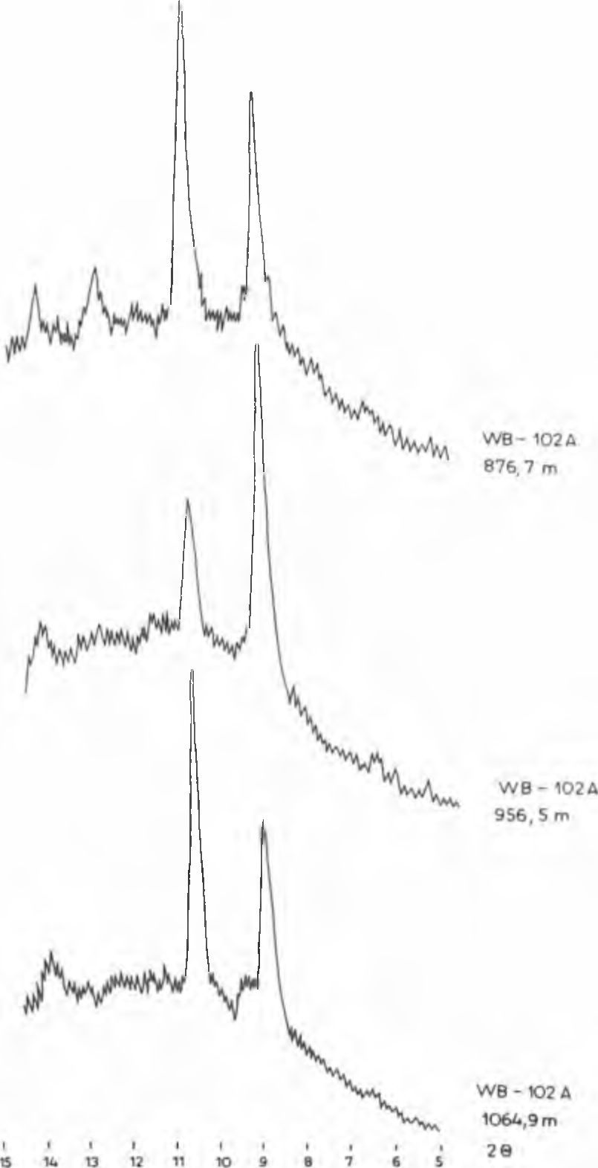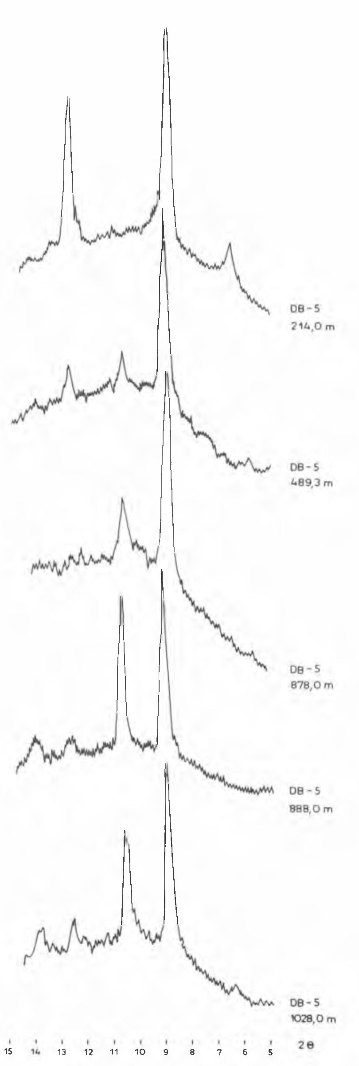
268
E. KOSZOWSKA & A. WOLSKA

Fig. 6. Variability of cordierite, biotite and chlorite amounts on ihe base of the following X-ray reflections 7 A, 14 A for chlorite, 8,5 Ä
for cordierite, and 10 A for biotite
0.01 mm in size). Most probably, this mica is the alteration
product of andalusite. Relicts of andalusite crystals, up to
0.8 mm in size occur in the rock studied. Andalusite is col-
ourless, showing no pleochroism and in the cross-sections
parallel to prismatic faces a cleavage is observed (Fig. 9).
The crystalloblasts of this mineral are often filled with nu-
merous submicroscopic inclusions of opaque minerals.
In the borehole WB-102A fine corundum crystallo-
blasts, about 0.15 mm in size, were found to be embedded in
sericitic matrix of these rocks. They occur in nests com-
posed of light mica flakes, about 0.25 mm in size. On the
other hand, corundum crystalloblasts in samples, collected
from borehole DB-5, are larger - up to 0.5 mm in size and
embedded in significantly larger nests, about 0.7 mm in

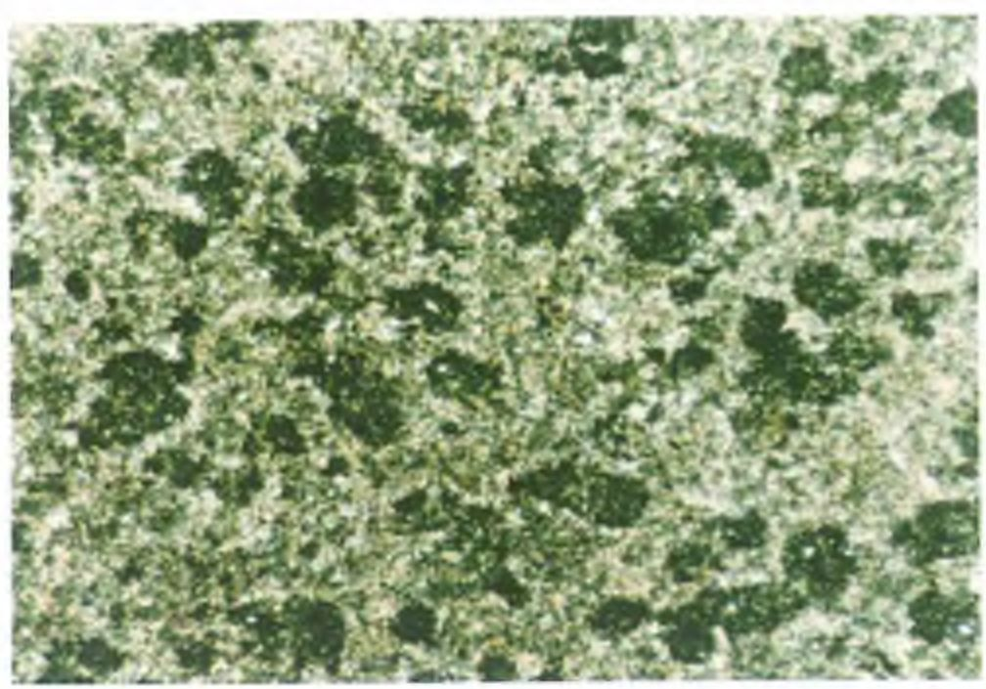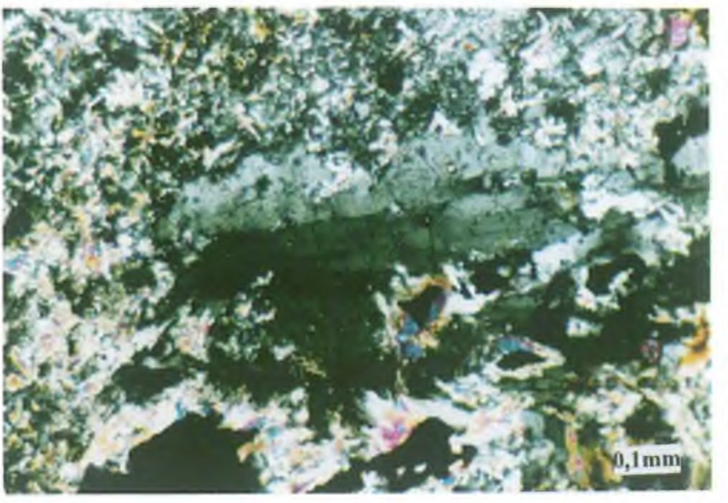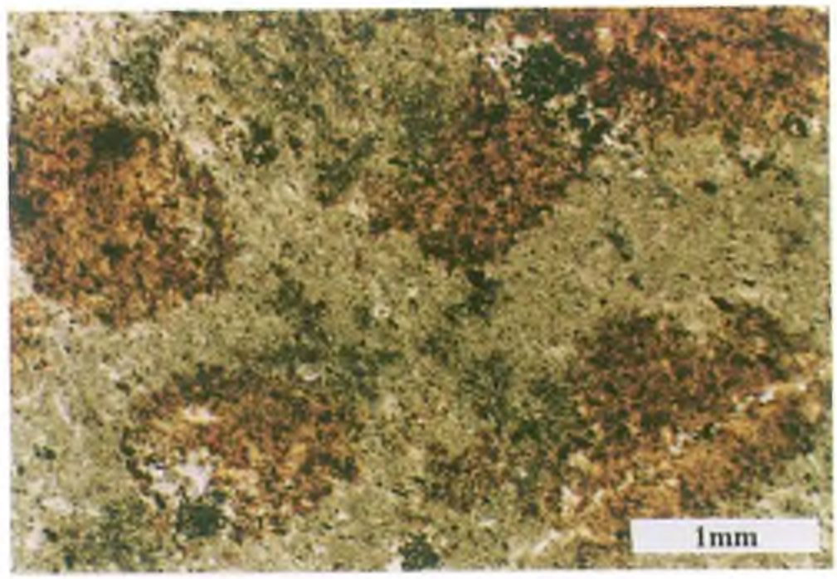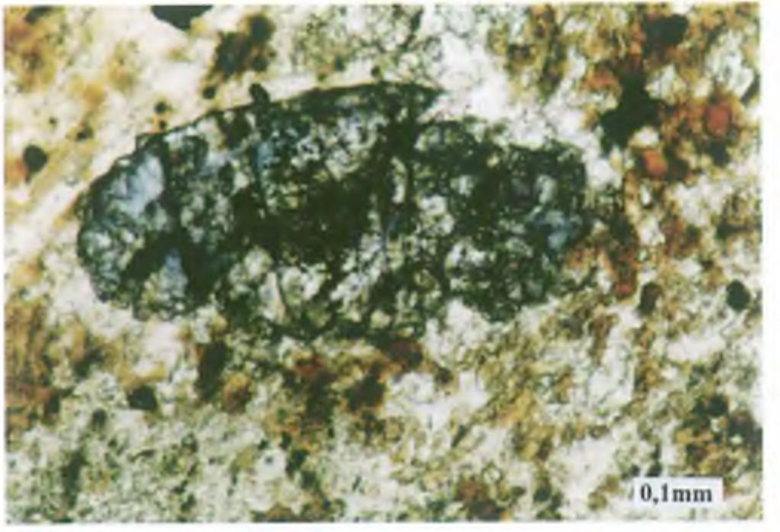
GRANODIORITE INTRUSION IN THE BĘDKOWSKA VALLEY
269

Fig. 7. Chlorite spots in chlorite-bearing spotted rocks. Bore-
hole DB-5, depth 131.0 m; Crossed polars
Fig. 9. Subhedral andalusite in macroscopically spotted andalu-
site hornfels. Borehole DB-5. depth 570.2 m; Crossed polars

Fig. 8. Dark spots containing fine-flaky aggregates of brown
biotite in macroscopically spotted andalusite hornfels. Borehole
DB-5, depth 570.2 m; Plane-polarized light
size. Corundum shows spotty pleochroism from light green
to blue (Fig. 10).
Andalusite hornfelses can contain sulphide minerals
(mainly pyrite) occurring as chaotically distributed grains,
0.2 mm in size. The rocks are cut by numerous pyrite-
bearing quartz-biotite and quartz-chlorite veinlets, as well
as ore-bearing carbonate ones.

NEOGENIC MINERALS

CORDIERITE
Cordierite is the most important mineral related with
thermal metamorphism of the Cambrian rocks complex. Its
occurrence in one of the samples from the borehole BD-5
was reported earlier (Koszowska & Wolska, 1994b; Czerny
et al., 1997). As follows from the present detailed studies
cordierite occurs in this borehole in three zones at the depth
intervals: 460-590 m, 830-910 m and about 1028 m. In the
second borehole situated in the Będkowska Valley (WB-
102 A) cordierite-bearing rocks were found to occur at the
Fig. 10. Blue spotty corundum crystalloblasts displaying charac-
teristic barrel-shaped habit in macroscopically spotted andalusite
hornfels. Borehole DB-5, depth 570.2 m; Plane-polarized light
depth interval 810-1070 m.
Usually this mineral appears in fine-crystalline rocks.
However, when cordierite blasts are 0.6-0.9 mm in size we
can observe even macroscopically, spotted structure of
rocks. As follows from microscope examination, these spots
of different shape are mainly 0.3-0.6 mm in size and consist
predominantly of cordierite locally intergrown with feld-
spars (mainly K-feldspars).
Cordierite grains are grey and not pleochroic and con-
tain fine, black poikilitic inclusions. Some larger inclusions
represent opaque minerals (pyrite, iron oxides). Besides,
there occur small olivaceous-brown biotite flakes within
these blasts. Some crystalloblasts of cordierite in the section
perpendicular to 001 exhibit sectoral twinning, trilling and
sixling (Fig. 11).
As follows from microprobe data, the cordierites stud-
ied are rich in iron replacing magnesium in their crystal lat-
tice. The atomic Mg/Fe ratio varies from 2.0 to 2.2 in them.
Consequently about 1/3 of Mg positions are replaced by Fe.
The iron content in cordierite reflects that in the rocks. In
the sample from the depth 888 m in the borehole DB-5 the
weight ratio MgO/FeO amounts to 1.1 whilst in its cordier-
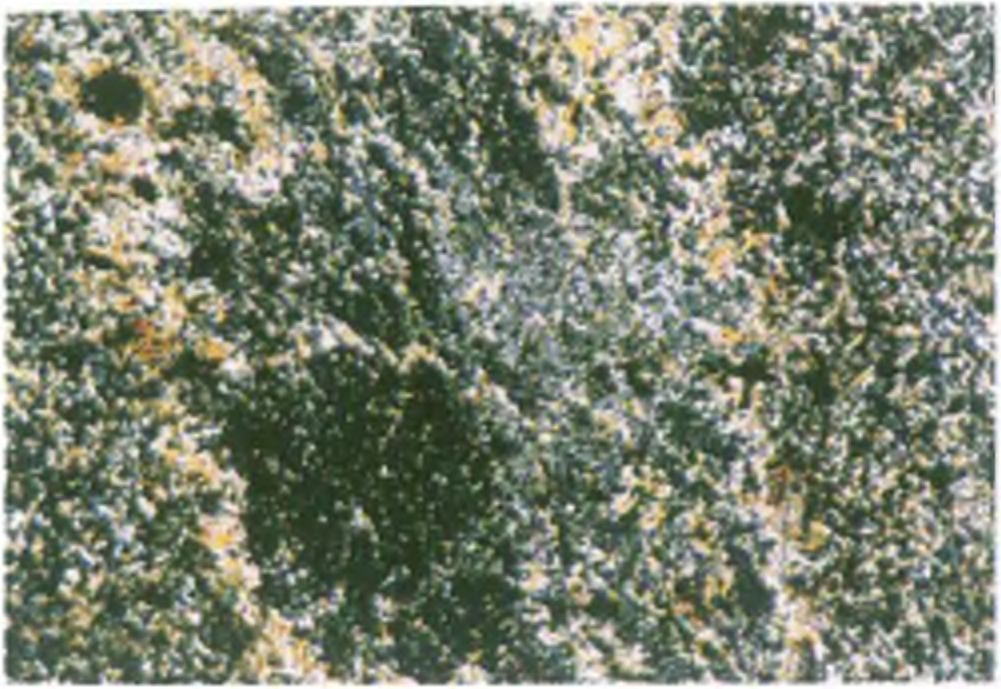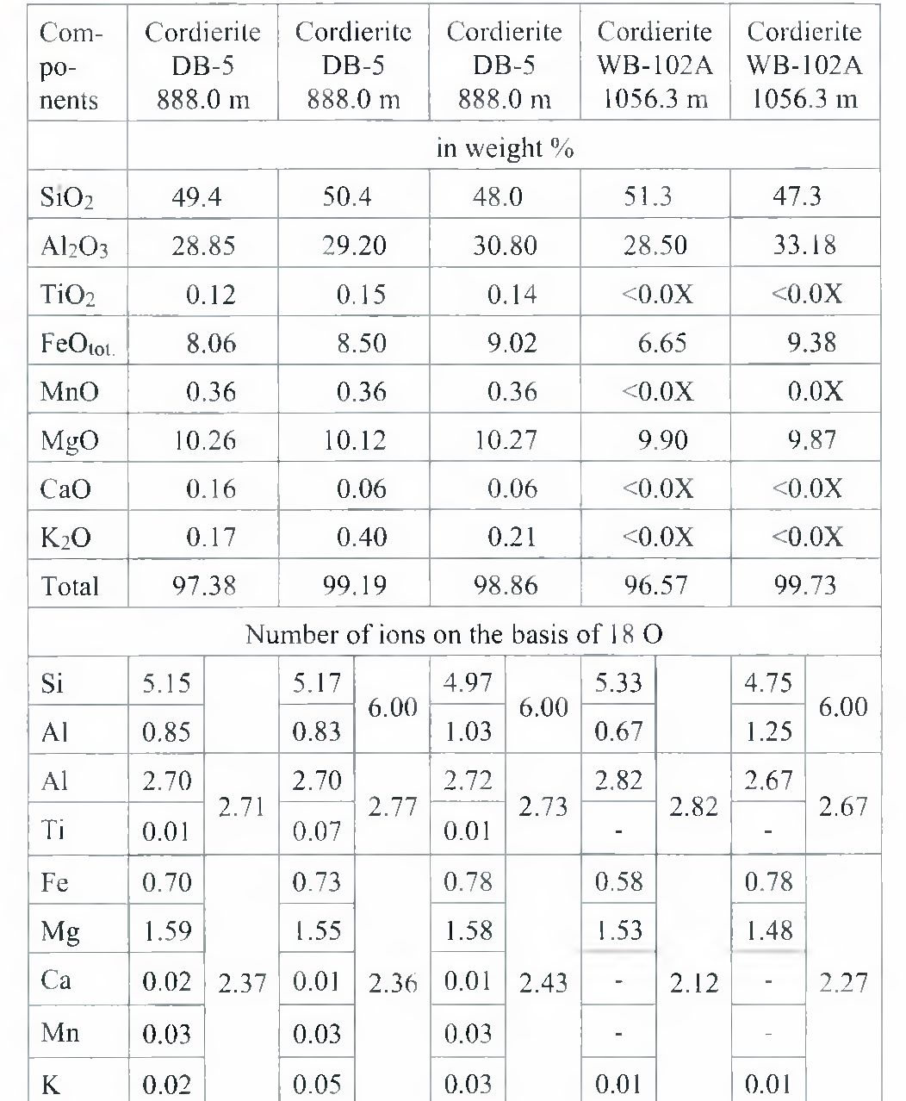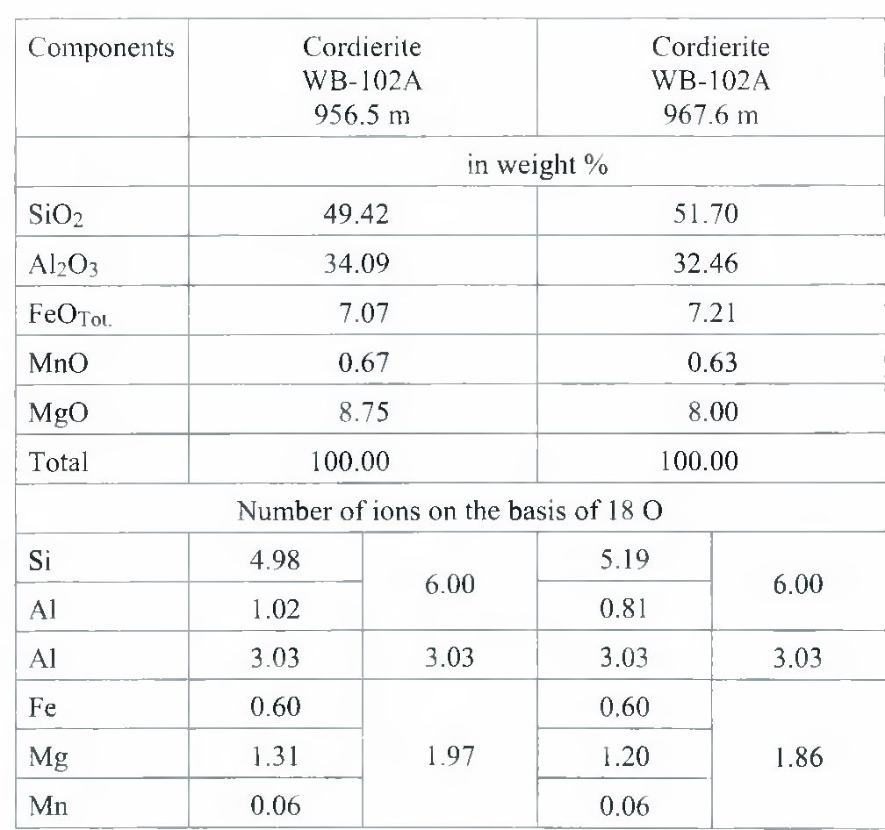
270
E. KOSZOWSKA & A. WOLSKA

Fig. 11. Sector twinning in cordierite with rim consisting of light
micas in fine-grained cordierite hornfels. Borehole DB-5. depth
905.3 m; Crossed polars
ites - varies in the range 1.1-1.3. Ti02 and MnO contents in
cordierite grains are small, and do not exceed 0.13 and 0.40
wt.% respectively (Table 1 & 2).
ANDALUSITE
Andalusite is much less common when compared with
cordierite. Its occurrence was evidenced only in macro-
scopically spotted andalusite hornfelses, distinctly enriched
in alumina (AI2O3 content higher then 25 wt. %). Andalu-
site is only locally preserved, being usually to higher or
lesser degree transformed into muscovite. Subhedral or, less
common euhedral andalusite crystalloblasts are 0.3-0.8 mm
in dimension (Fig. 9). In some crystalloblasts we observe, in
section parallel to 001, the cleavage planes cutting at 90°. In
individual andalusite crystalloblasts accumulations of dark
carbonaceous (graphitic) inclusions occur typical of its vari-
ety called chiastolite.
In thin section andalusite is colourless, nonpleochroic
and only in thicker section we observe spotty pleochroism
ranging from colourless to pale pinkish. Andalusite crystals
are optically positive, biaxial, showing high optic axis an-
gle.
The nature of this mineral was confirmed by X-ray
analysis (Koszowska & Wolska, 1994a). Moreover, micro-
probe data have confirmed the occurrence of andalusite in
the rock studied showing the following formula:
(AI 1.97Feo.03)2.0 [0/SiC>4].

BIOTITE
In spotted andalusite hornfelses, containing macro-
scopically visible spots, biotite occurs in them (Fig. 7) as
mutually intergrown flakes 0.01-0.03 mm in size. Slightly
larger biotite flakes, up to 0.04 mm in size, occur only at
spot margins. This mineral shows distinct pleochroism from
light orange to reddish-brown. Instead, in fine-grained cord-
ierite hornfelses, fine differently oriented biotite flakes
(0.01-0.03 mm in size) occur in the matrix with feldspars,
which is surrounding light spots consisting of cordierite.

Table 1
Electron microprobe analyses of studied cordierites
Table 2
EDS analyses of studied cordierite

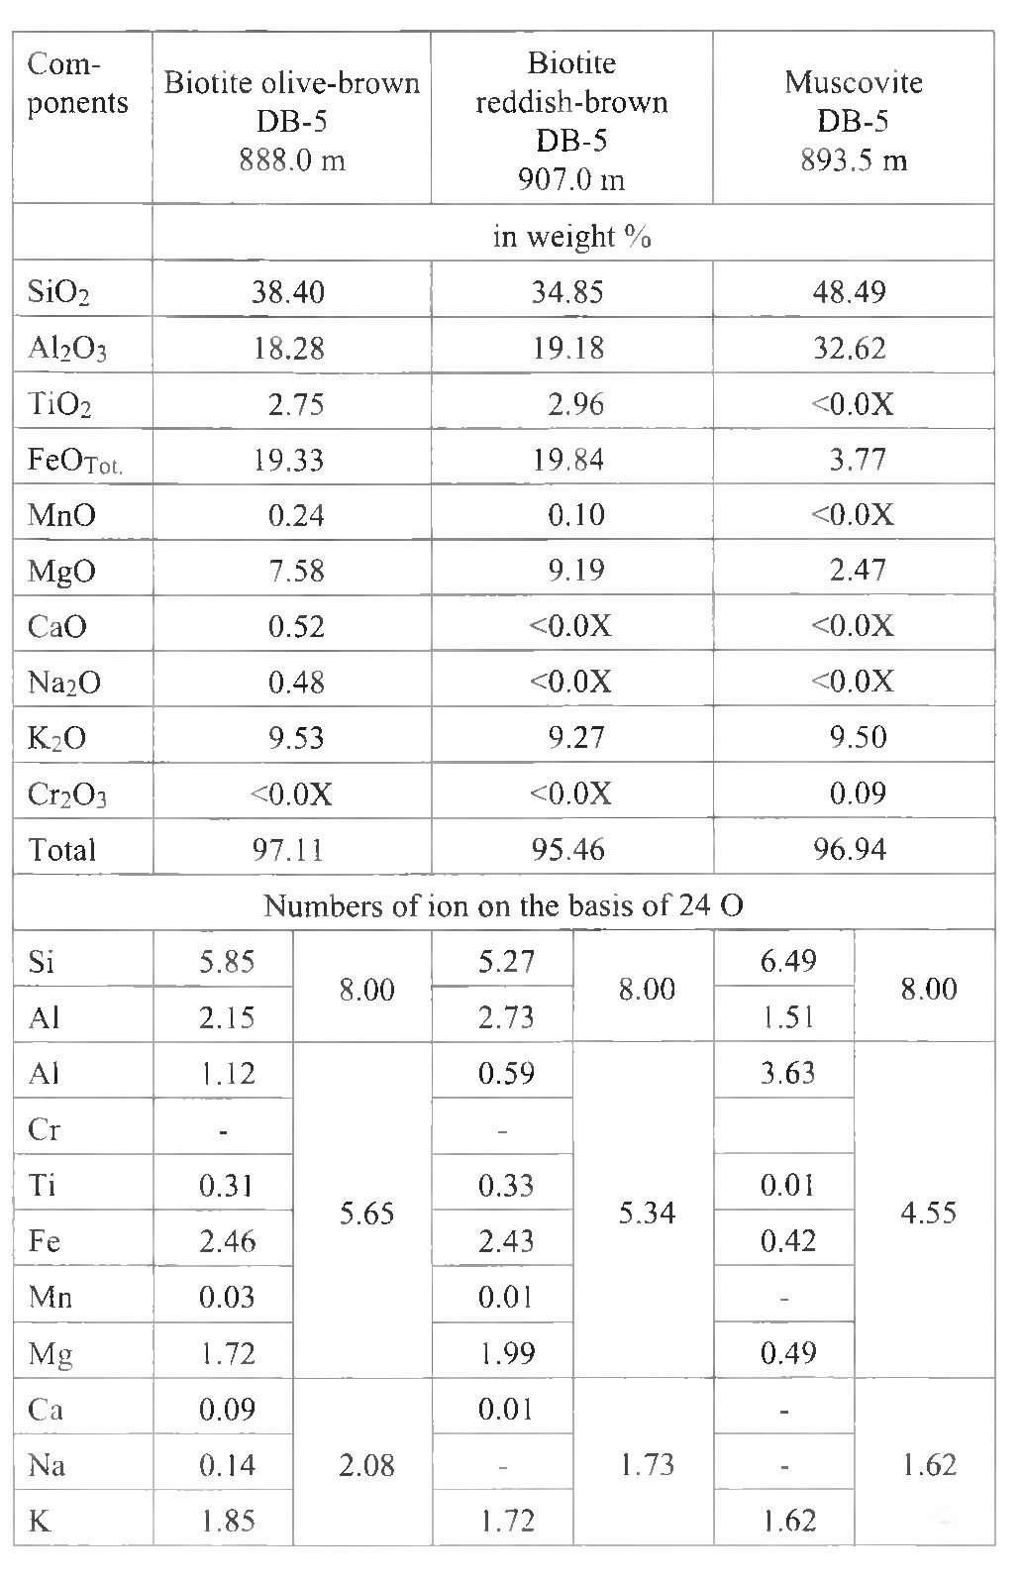
GRANODIORITE INTRUSION IN THE BĘDKOWSKA VALLEY
271
Table 3
Electron microprobe analyses of studied micas
Larger biotite flakes occur but in the contacts with quartz
and feldspars veinlets. Blasthesis related with potassium
metasomatism resulted in the formation of these flakes,
about 0.06 mm in size. In this rock type biotite is dark and
shows distinct pleochroism from light green to olive-brown.
The FeOtot/MgO weight percent ratio in two types bio-
tites varies from 2.5 (fine-grained cordierite homfels-
sample from the depth 888.0 m in the borehole DB-5) to 2.2
(sample of macroscopically spotted andalusite hornfels
from the depth 907.0 m in this borehole) and indicates dis-
tinct prevalence of Fe over Mg. The amount of MgO in bio-
tite from macroscopically spotted andalusite hornfels is
higher then in that from fine-grained cordierite hornfels.
This FeOtot/MgO weight percent ratio reflects mutual ratio
of these elements in the rock, which amounts to 2.6 and 2.3
respectively and indicates the growth of biotite flakes in the
course of thermal metamorphism under isochemical condi-
tions. This conclusion is confirmed by Ti02/FeOtot ratio in
biotites which in various samples is very similar and varies
from 0.14 to 0.15. It corresponds to the ratio of these ele-
ments in rocks, which amounts to the range 0.13-0.18. Con-
siderable content of Ti in biotite (ca. 3 wt.% TiCb) is, to-
gether with high Fe^³ content, the cause of characteristic
reddish-brown coloration of this mineral (Table 3), occurs
in macroscopically spotted andalusite hornfelses.

MUSCOVITE
Fine flakes of white mica are intergrown with fine-flaky
chlorite, and occur as pseudomorphs after cordierite. They
were formed in the neighbourhood of biotite, sericite and
quartz-chlorite veinlets, cutting fine-grained cordierite
hornfelses. Fine flakes of light mica (less than 0.01 mm in
size), intergrown with biotite, occur in the matrix of chlo-
rite-bearing spotted rocks. In some samples of cordierite
hornfelses showing spotted texture it forms nested aggre-
gates, in which light micas flakes are 0.03-0.04 mm in size,
coexisting with corundum and, sometimes, with diasporę
(?). On the other hand, light mica is a major component of
rock in spotted andalusite hornfelses. The flakes of colour-
less muscovite are 0.01-0.02 mm in size. Based on EDS and
microprobe analyses, this mineral is an aluminous mica
(close to the muscovite composition) characterized by low
contents of Fe, Mg and Ti, total content of which does not
exceed 3 wt. %. (Table 3).

CORUNDUM
The occurrence of corundum is limited to the rocks con-
taining macroscopically visible spots (andalusite hornfel-
ses) and, sometimes, to cordierite hornfelses. However,
rocks have to be cut by numerous feldspar veinlets. This
mineral was described first by Koszowska & Wolska (1994
- to occur in a sample from the depth 570.2 m in the bore-
hole DB-5. Though it is not so widespread as other miner-
als, corundum was found in rocks from other depths of the
borehole DB-5 (893.5 m, 907.0 m) and in the neighbouring
one WB-102A at the depths 505.9 m, 511.0 m, 512.4 m,
863.1 m.
Corundum crystalloblasts are usually linearly distrib-
uted along feldspar veinlets. Its individual crystalloblasts or
their aggregates are most often embedded in muscovite
nests. Corundum blasts are 0.15-0.50 mm in dimension. In
general, they are anhedral but locally short prismatic forms
are observed showing hexagonal shape in sections perpen-
dicular to Z axis. Crystals exhibiting characteristic barrel-
shaped habit are rather rare (Fig. 10). This mineral often co-
exists with ilmenite and rutile, forming with the latter ori-
ented intergrowths. It shows very high positive relief and
spotty coloration. Corundum crystalloblasts exhibit distinct
pleochroism e-colourless, light green, light yellow, to-blue-
green, blue or blue-violet. It is uniaxial and optically nega-
tive. In the scanning microscope image characteristic
curved edges typical of barrel-shaped forms are observed.
As follows from microprobe and EDS analysis, Ti and
Fe admixtures, responsible for coloration of this mineral oc-
curs in corundum crystalloblasts in variable amounts:
- 3-2.0 wt. % of titanium oxide and 0.5-1.9 wt. % of iron
oxide.

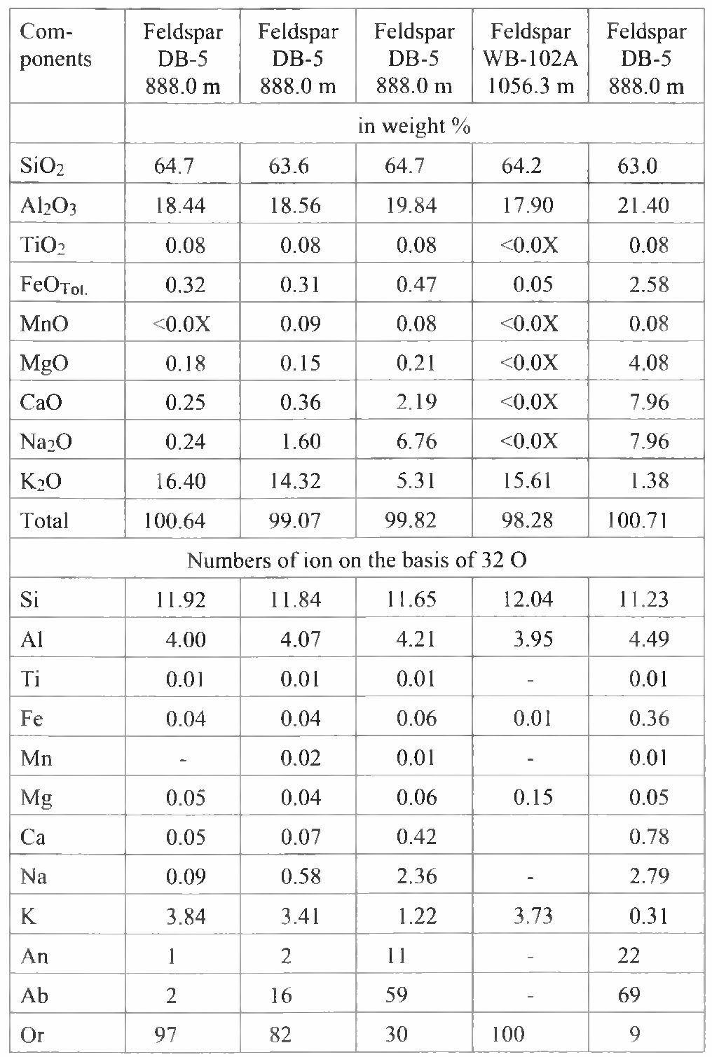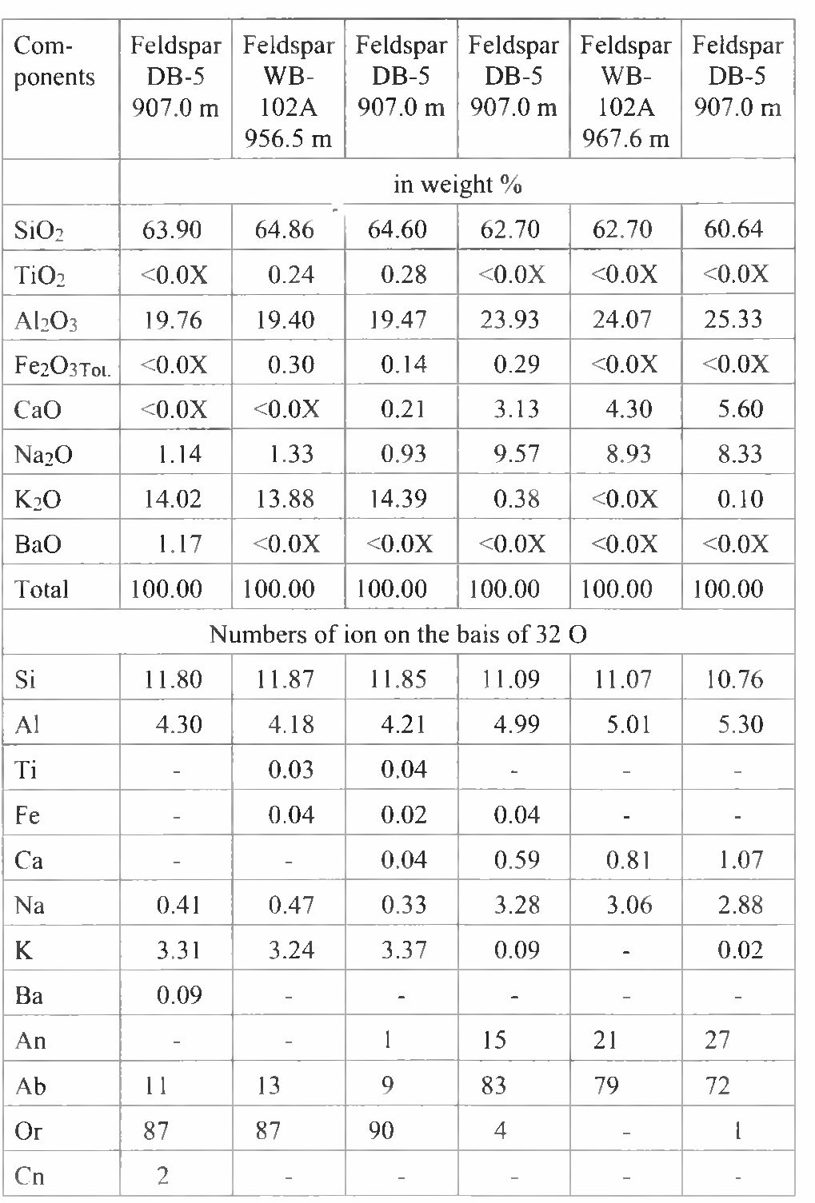
272
E. KOSZOWSKA & A. WOLSKA
Table 4
Electron microprobe analyses of studied feldspars

Table 5
EDS microprobe analyses of studied feldspars

NEOGENIC FELDSPARS
Apart from micas, feldspars are the commonest miner-
als occurring in fine-grained cordierite hornfelses. Because
of very small sizes of grains (below 0.01 mm) their identifi-
cation using optical microscope is difficult since in the ma-
trix they are intergrown with micas. Therefore, the presence
of feldspar was confirmed by X-ray and microprobe analy-
ses (Table 4 & 5). Moreover, plagioclases were identified
on the base of characteristic bands in infrared spectra: 1010
cm"¹, 1105 cm"¹, 1160 cm"¹
Two feldspar varieties occur in the rocks studied:
- plagioclases are represented by crystalloblasts of
variable composition (Table 4, 5) from oligoclase-andesine
(Ab69-59). Oligoclases (Ab83-72) are the commonest. Pla-
gioclase crystalloblasts are below 0.01 mm in size. X-ray
studies have shown them to represent mainly structural
modification of low-temperature albite.
- alkali feldspar (Or too 82 - Table 4 & 5) occurs
within spots as intergrowths with cordierite or as blasts as-
sociated with micas in the matrix.
Moreover, potassium feldspar is the component of nu-
merous feldspar veinlets cutting the rocks studied. Analyti-
cal data indicate that it contains Ba admixture too (Table 5).

ACCESSORY MINERALS
The following accessory minerals were found in the
rocks studied:
Zircon - is not very abundant. It occurs both as rounded
(often metamictized) grains and as euhedral prismatic crys-
tals showing elongation 2:1 and dimension less than 0.01
mm. The latter display very high relief, high birefringence
and straight extinction. The total content of Zr in the rocks
studied amounts to 190-230 ppm (Table 6).
Apatite - is rarely found as short prismatic crystals with
hexagonal shape when cut perpendicularly to Z axis. Its
presence was confirmed by microprobe analysis and chemi-
cal data evidencing that the rocks in question contain
- 09-0.39 wt. % P₂0₅ (Table 6 & 7).
Magnetite - is fairly common opaque mineral. It occurs
as fine, anhedral grains dispersed in the matrix. The content
of magnetite fraction increases in zones containing cordier-
ite (Sapota & Koszowska, 1999).
Ilmenite - occurs in paragenetic association with corun-
dum as opaque grains. In ore microscope it is light grey and

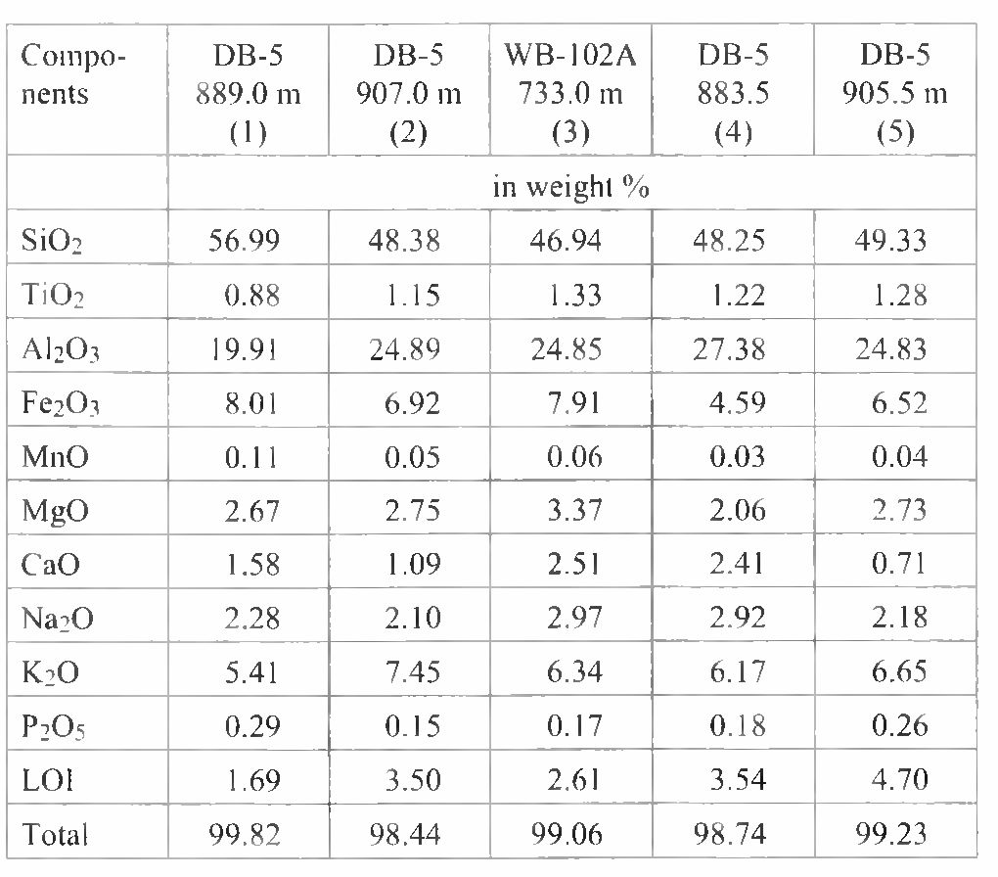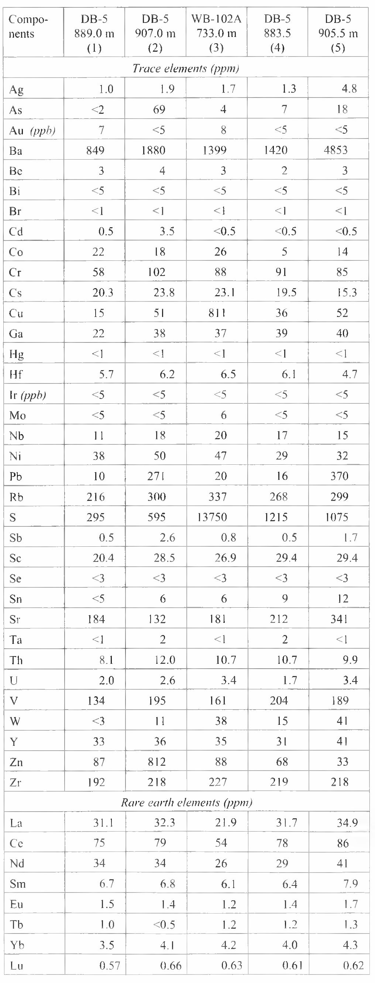
GRANODIORITE INTRUSION IN THE BĘDKOWSKA VALLEY 273
Table 6
Chemical composition of metamorphosed rocks from the Będkowska Valley
shows distinct anisotropy. The identification of this
mineral was confirmed by microprobe examination. It
shows the following formula: (Fe1.99Ti1.93 Mno.io.)4.02 Of,.
Rutile - occurs in association with corundum as euhe-
dral short prismatic crystals with bipiramidal terminations
or as “knee-shaped” twins. Rutile is brown-orange showing
high relief and high birefringence, whereby interference
colours are masked by intense coloration of this mineral. Its
presence was confirmed by X-ray data (Koszowska &W0I-
ska, 1994a).
Moreover, disseminated pyrite and pyrrhotine are com-
mon in the rocks studied.

GEOCHEMICAL INVESTIGATIONS
Various rock types, distinguished in the complex of the
studied rocks, were geochemically analysed. These rocks
are represented by the following samples:
- fine-grained cordierite hornfelses [borehole DB-5,
depths: 889.0 m (1) and 888.0 m (10)]
- macroscopically spotted andalusite hornfelses [bore-
hole WB-102A, depth 733.0 m (3); borehole DB-5, depths:
- m (4), 905.5 m (5) and 907.0 m (2)]
- spotted chlorite rocks [borehole DB-5, depth 131.0
m (7) ]
- metamudstones [borehole DB-4, depth 66.5 m (6),
borehole DB-5, depths: 499.0 m (8) and 744.7 m (9) ]
- coarse-grained metasandstone [borehole DB-5,
depth 1050.0 m (11)]
Four samples of the macroscopically spotted andalusite
hornfelses (samples 2, 3, 4, 5) and for comparison one sam-
ple of fine-grained cordierite hornfels (sample 1) were ana-
lysed for major and trace elements (Table 6). Other samples
(6, 7, 8, 9, 10, 11) were analysed only for major elements
(Table 7).

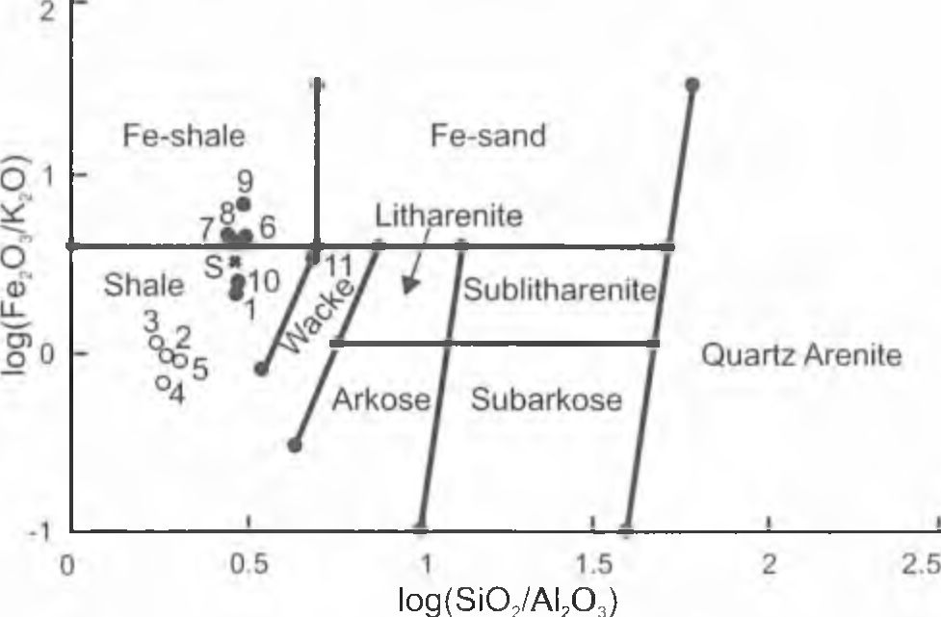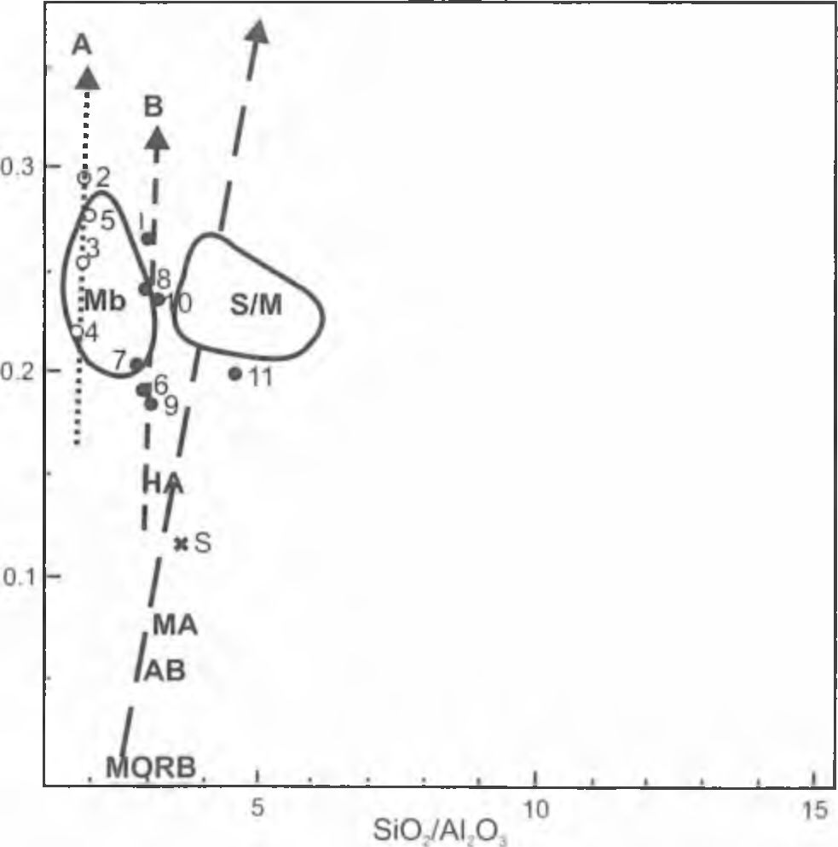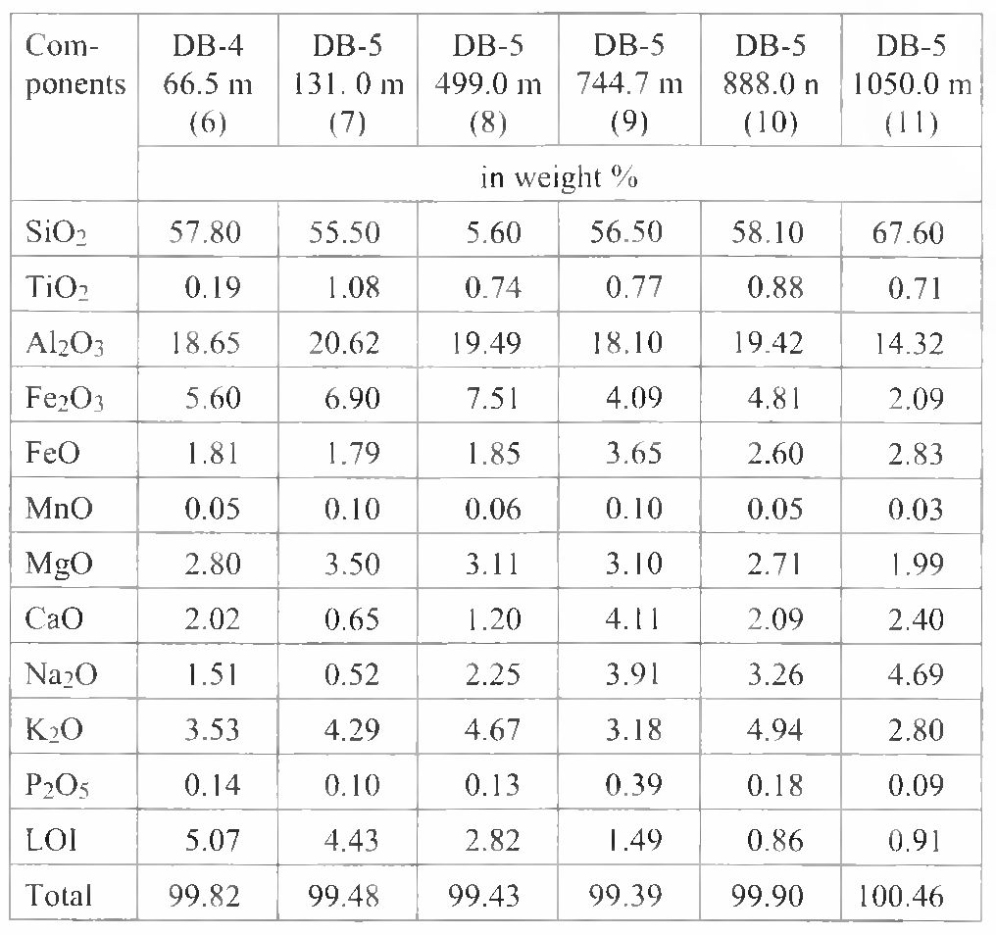
274
E. KOSZOWSKA & A. WOLSKA
Table 7
Chemical composition of metamorphosed rocks
from the Będkowska Valley
The diversity of major elements ratios (SiC>2, AI2O3,
Fe2Ü3, K2O, Na2Ü) in the samples studied is, first of all, re-
lated to variable content of detrital material in them. In Pet-
tijohn’s classification diagrams modified by Herron (fide
Rollinson, 1993) (Fig. 12) all these rocks are plotted in the
fields of shales (samples 1, 10), ferrouginous shales (sam-
ples 6, 7, 8, 9) and at the boundary of shales and wackes
fields (sample 11). When compared with chemical composi-
tion of typical spotted slates from Skiddaw (S) - Mason
(1990), the rocks studied represented by samples 1, 6, 7, 8, 9
and 10 are enriched both in alkalis (Na20 and K2O) and in
CaO. The content of other elements is similar. Macroscopi-
cally spotted andalusite hornfelses (samples 2, 3,4, 5) differ
distinctly in chemical composition from both the other stud-
ied rock types and the spotted slates from Skiddaw (S).
They display low Si02/Al203 ratio resulting from high
AI2O3 content and simultanously lower SiÜ2 content, com-
paring to other rocks studied. On the base of petrographical
observations and discussed above geochemical data, it is
supposed, that macroscopically spotted andalusite homfel-
ses originated from primarily tuffitic rocks. Low Si02, and
higher AI2O3 content can be related with transformation of
primary volcanic material into clay minerals, whereby the
deficit in Si⁴⁺ was equalised by (A1³⁺+K^{T}) (Batchelor &
Weir, 1988).
This geochemically distinct character of macroscopi-
cally spotted andalusite hornfelses is also visible at the
K₂0/Al203-Si02/Al₂03 diagram (Fig. 13), where samples
of these rocks (trend A), originated probably from tuffitic
rocks, are plotting within Dob’s Linn metabentonite field
(Batchelor & Weir, 1988). Originally detrital rocks (cord-
ierite hornfelses and metamudstones - trend B) are plotting
between the fields of Dob's Linn shales and metabentonites.

Fig. 12. Log Fe^Oi/KiO - log SiCb/AhCb diagram after Petti-
john et ai, (1972), (modified after Herron 1988, vide Rollinson
1993). S - Skiddaw (spotted slates); sample numbers: fine-grained
cordierite hornfelses: borehole DB-5, depth 889.0 m (1), borehole
DB-5, depth 888.0 m (10); macroscopically spotted andalusite
hornfelses: borehole WB-102A, depth 733.0 m (3), borehole
DB-5, depth 883.5 m (4), borehole DB-5, depth 905.5 m (5), bore-
hole DB-5, depth 907.0 m (2); chlorite spotted rocks: borehole
DB-5, depth 131.0 m (7); metamudstones: borehole DB-4, depth
66.5 m (6), borehole DB-5, depth 499.0 m (8), borehole DB-5,
depth 744.7 m (9); coarse-grained metasandstone: borehole DB-5,
depth 1050.0 m (11)
Distinct enrichment in SiCb is marked in coarse-grained
metasandstone (sample 11), which is plotting outside these
both trends.
Geochemical data were used to obtain the character of
k,o/ai₂o₃

Fig. 13. K2O/AI2O3 - S1O2/AI2O3 diagram after Batchelor &
Weir 1988); Mb - field of Ordovician metabentonites (Scotland);
S/M - field of Ordovician mudstones and pelites (Scotland); S -
Skiddaw (spotted slates); HA - High-K andesite; MA -
Medium-K andesite; AB - Alkali basalt; MORB - Mid Ocean
Ridge Basalt; sample numbers (1-11) as in Fig. 12

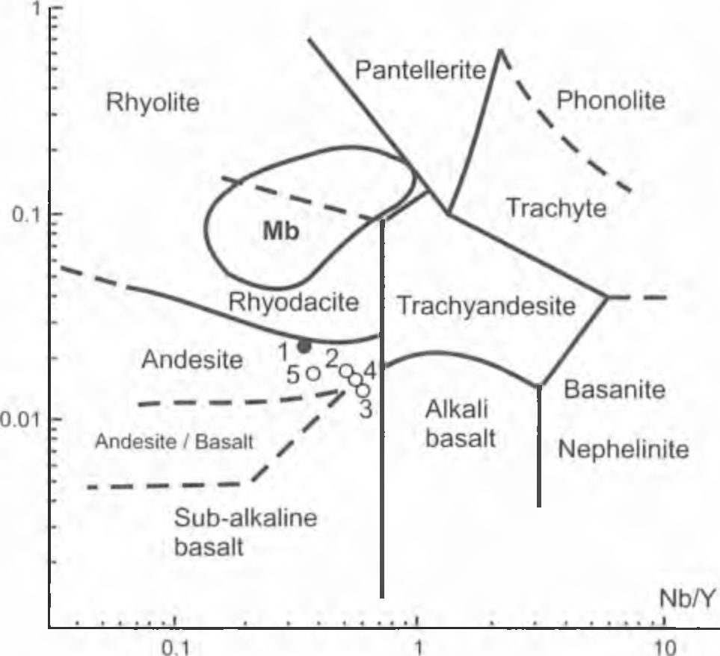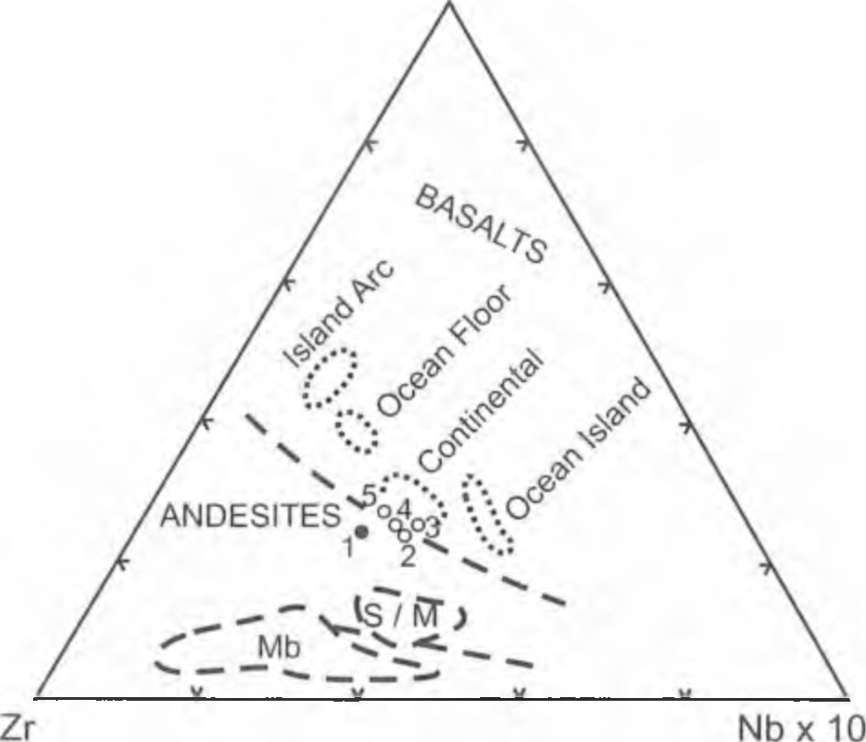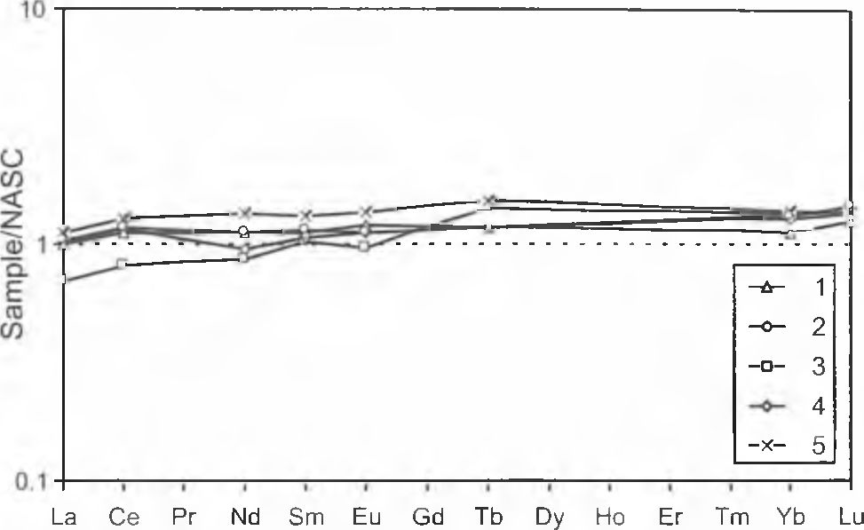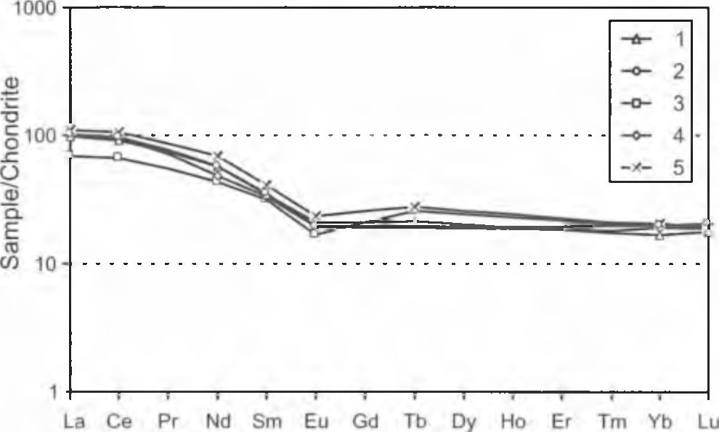
GRANODIORITE INTRUSION IN THE BĘDKOWSKA VALLEY
275
Zr/Ti0₂

o a • b
Fig. 14. Zr/Ti02 - Nb/Y classification diagram after Winchester
& Floyd (1977). Mb - Ordovician metabentonite field; a - macro-
scopically spotted andalusite hornfelses (primarily tuffites): bore-
hole WB-102A. depth 733.0 m (3), borehole DB-5, depth 883.5 m
(4), borehole DB-5, depth 905,5 m (5), borehole DB-5, depth
907.0 m (2); b ■ fine-grained cordierite hornfels (primarily pe-
lites): borehole DB-5, depth 889.0 m (1)
Ti / 100

Fig. 15. Zr - Ti/100 - Nb*10 diagram after Pearce & Cann (1973)
vide Batchelor & Weir (1988); Mb - Ordovician metabentonite
field (Scotland); S/M - field of Ordovician mudstones and pelites
(Scotland); sample numbers (1-5) as in Fig. 14
magma as the source material for pyroclastic rocks. On the
both, Zr/Ti02-Nb/Y diagram (Winchester & Floyd 1977 -
Fig. 14) and Zr- Nb-Ti triangular (Fig. 15), macroscopically
spotted andalusite hornfelses plot within andesite and basalt
fields. It may suggests that mafic magma could be the
source material of tuffogenic rocks. Moreover, according to

Fig. 16. NASC-normalized REE diagram for: fine-grained cord-
ierite hornfels borehole DB-5, depth 889 m. (1); macroscopically
spotted andalusite hornfelses: borehole WB-102A, depth 733 m.
(3), borehole DB-5, depth 883.5 m. (4), borehole DB-5, depth
905.5 nr. (5), borehole DB-5, depth 907 m. (2); NASC - North
American Shale Composite

Fig. 17. Chondrite-normalised REE diagram for: fine-grained
cordierite hornfels borehole DB-5, depth 889 m. (1); macroscopi-
cally spotted andalusite hornfelses (borehole WB-102A, depth 733
m. (3), borehole DB-5, depth 883.5 m. (4), borehole DB-5, depth
905.5 m. (5), borehole DB-5, depth 907 m. (2)
(Batchelor & Weir, 1988), low Ti/V (35^19) and high
10x[Ni/Th] (27—46) ratios in the studied rocks seem to indi-
cate mafic character of parent magmatic material. The ap-
plication of geochemical TAS classification diagram, based
on silica and alkalis contents, gives no reliable results. The
projection points of spotted andalusite hornfelses (samples
2, 3, 4, 5), showing very high alkali content, are plotting
within phonotephrite field. It may be explained by metaso-
matic influx of alkalis. These processes are evidenced by
numerous veinlets containing potassium feldspars, cutting
the rocks studied.
The NASC-normalized REE diagrams (Fig. 16) indi-
cates that spotted andalusite and cordierite hornfelses are
characterized by relatively smooth curves and negligle en-
richment in REE comparing with NASC. The minimal de-
viation from NASC line shows the sample of cordierite
hornfelses (1). Instead, the sample (3) [WB-102A, 733.0
m] shows little deficiencies in LREE. No visible europium
or cerium anomalies are observed. Consequently, the con-
tents of REE in the rocks and in standard North-American
276
E. KOSZOWSKA & A. WOLSKA
shales NASC are nearly identical (Gromet et ai, 1984).
Relative to chondritic meteorites, the studied rocks,
have about 100 times higher LREE and about 20 times
higher HREE content and small, negative Eu anomaly. The
shape of the curves is more similar to sedimentary then
magmatic rocks.
The shape of the patterns and the distribution of anoma-
lies, in chondrite - normalized REE diagrams (Fig. 17), are
more similar to those reported for pyritiferous shales, de-
posited in anoxic regime (Avalon Zone) then the shales
from the Laurentian craton (Fyffe & Pickerill, 1993). In
Harahczyk’s (1994b) opinion the parent terrane of the Cam-
brian rocks studied comes just from this area. These pre-
liminary geochemical do not deny this hypothesis. The in-
dex of anoxic condition is a V/V+Ni ratio (Hatch & Leven-
thal 1992). The high of V/V+Ni ratios (between 0.8 and 0.9)
in the studied rocks reflect anoxic conditions of their sedi-
mentation environment, suggested by Harańczyk (1984,
1994a, b).
On the other hand, the observed similarity of trace ele-
ment concentrations in cordierite hornfelses (sample 1) and
spotted andalusite hornfelses (samples 2, 3, 4, 5) suggest
that the latter rocks could originate from mixed tuffogenic-
detrital material and the contribution of detrital material
could be considerable.
The content of such elements as Cu, Pb and Zn is an-
other geochemical problem. Samples of rocks, which are
cut by veinlets containing sulphide minerals, are enriched in
these elements (Table 6). The sample (3) - [WB-102A,
- m] contains 811 ppm Cu, whilst the average content
of this element in other rocks studied is from 15 to 52 ppm.
This is related to the occurrence of chalcopyrite, resulted in
high concentration of S (13 750 ppm). Similarly, a distinct
enrichment in Pb in the samples (2) - 271 ppm and (5) - 370
ppm, and in Zn in sample (2) - 812 ppm, is connected with
later hydrothermal processes accompanied by precipitation
of galena and sphalerite. The presence of galena within
veinlets (the sample DB-5, 904.3 m) was confirmed by EDS
analysis.
The spotted andalusite and cordierite hornfelses are
characterised by high Rb, Ba and Sr contents, distinctly ex-
ceeding their clarks in clay rocks. Cordierite hornfels con-
tains up to 216 ppm and spotted andalusite hornfelses con-
tain from 270 to 380 ppm Rb whilst its dark for sediments is
up to 150 ppm. In the studied rocks Rb contents are dis-
tinctly correlated with that of K (what can suggest their
common migration during metasomatic processes).
Ba enters predominantly into the crystal lattices of po-
tassium feldspars and micas. The K/Ba ratio in spotted an-
dalusite hornfelses is up to 40-45 whilst cordierite hornfels
is relatively deficient in Ba where this ratio is 64. Distinct
enrichment in Ba (4853 ppm) of the sample (5) - [DB-5,
- m] - is connected with the presence of baryte-bearing
veinlets. The increased contents of Ba and its positive corre-
lation with K are one more argument that potassium metaso-
matism has modified the composition of the rocks studied,
enriching them in alkali metals, especially in potassium.
Strontium, as isomorphic with Ca^² and K , is located
both in crystal lattices of plagioclases and potassium feld-
spars. Therefore, its correlation with K is less pronounced.

DISCUSSION
Metamorphosed Cambrian rock complex, penetrated by
boreholes under Mesozoic cover, consisted of primarily de-
trital sediments (conglomerates, sandstones, mudstones in-
terlayed with claystones). Preliminary data on the presence
of tuffogenic intercalations in this complex were reported
by Harańczyk et al., (1996). In Haranczyk’s (1984, 1994a,
- opinion, the Cambrian rock complex was deposited under
conditions of quiet sedimentation on abyssal planes in an-
oxic regime far from continental border. Some of presented
geochemical data confirm this thesis.
Harańczyk (1994b) suggested that the Palaeozoic
(Cambrian-Ordovician) cover in the area studied was sub-
jected to regional metamorphism at temperature about
450°C. In the northern part of this area (the Mrzygłód-
Myszków region) the conditions of regional metamorphism
were defined as corresponding to biotite zone of the green-
stones facies (Ryka, 1971, 1973, 1978; Łydka, 1973; Szy-
mański & Nehring-Lefeld, 1995; Nehring-Lefeld & Szy-
mański 1998). In several recent papers (Buła & Kotas,
1994; Żaba, 1995, 1999; Belka & Siewniak-Madej, 1996)
regional metamorphic phenomena have influenced only
Vendian-Lower Cambrian (?) rocks complex, whereas
younger Palaeozoic rocks occurring in the zone of thermal
activity of igneous intrusions were subjected to contact
metamorphic alterations.
Within the whole area of marginal zone of the Małopol-
ska Block contact metamorphic phenomena are observed
around granodiorite intrusions in the regions Mysz-
kow-Mrzygłód, Zawiercie, Będkowska Valley and Pilica.
They are evidenced by the occurrence of hornfelses, spotty
schists, skarns and marbles reported in numerous papers:
Ryka (1971, 1973, 1978), Łydka (1971, 1973), Harańczyk
et ai (1980), Harańczyk (1985), Ślósarz (1985, 1994), Kar-
wowski (1988), Muszyński (1991), Heflik & Piekarski
(1992), Czerny et ai (1997). Black massive rocks, showing
sieve texture, consisting of quartz, albite, potassium feld-
spar, biotite, chlorite and sometimes epidote, were reported
by Truszel (1994) to occur in the Myszków-Mrzygłód re-
gion. Biotite-quartz-albite hornfels was mentioned by Koś-
nik & Muszyński (1990) from thermally metamorphosed
cover of granodiorite intrusion in the Będkowska Valley.
Later, in the same area, individual occurrences of character-
istic contact metamorphic rocks - andalusite and cordierite
hornfelses, were described (Koszowska & Wolska, 1994a,
b; Czerny et a!., 1997).
The emplacement of large magmatic body into the clas-
tic rocks in Będkowska Valley resulted in isochemical ther-
mal metamorphism. The type of metamorphic rocks formed
depends on primary chemical and mineral composition of
intruded country rock. Consequently, the effects of thermal
metamorphism in various rocks of the Cambrian complex
were distinctly different. Larger detrital components of me-
taconglomerates, metasandstones and metamudstones were
not altered since feldspars and quartz are stable within the
whole range of temperatures and pressures of thermal meta-
morphism. Therefore, sedimentary structures such as bed-
ding and lamination were preserved in these rocks.
Alteration processes of sedimentary rocks related with
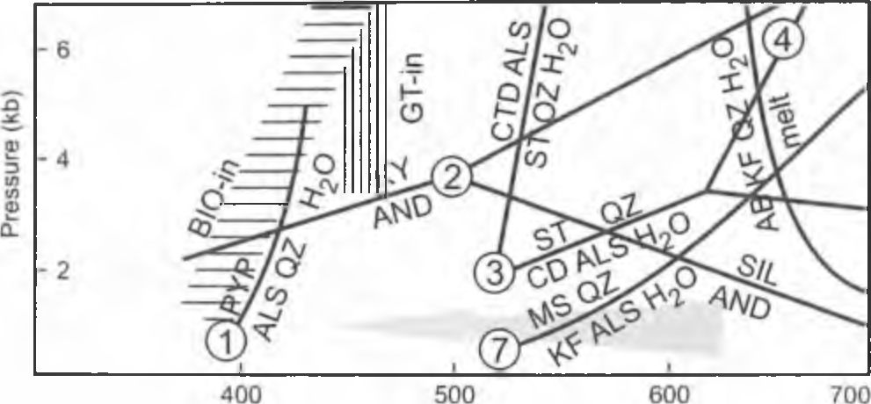
GRANODIORITE INTRUSION IN THE BĘDKOWSKA VALLEY
277
Temperature (°C)
Fig. 18. Suggested PT path of metamorphic conditions of the
hornfelses from Będkowska Valley (on the base of mineral
paragenesis). Data sources for the curves are as follows: I -
Kerrick (1968), 2 - Holdaway (1971), 3 - Richardson (1968), 4 -
Yardley (1981), 7 - Chatterjee & Johannes (1989) - all data after
Yardley (1989); ST = staurolite, CTD = chloritoid, CD =
cordierite, SIL = sillimanite, Ms = muscovite, KF = K-feldspar,
BIO = biotite, PYP = pyrope, ALS = Al-silicate, QZ = quartz, KY
= kyanite, AND = andalusite, AB = albite, GT = garnet
thermal metamorphism resulted in recrystallization of chal-
cedony into quartz in pebbles of siliceous rocks and in the
formation of small corrosional embayments at detrital min-
erals grains. Another evidence of these processes is the
transformation of primary minerals of cementing matrix
into neogenic, fine-flaky aggregates of olivaceous-brown
biotite.
On the other hand, in pelitic intercalations, due to fine-
grained character of primary material, cordierite was
formed as typical mineral of thermal metamorphism, ac-
companied by neogenic olivaceous-brown biotite. Locally,
cordierite hornfelses also contain blasts of corundum.
Cordierite-biotite-corundum paragenesis in these rocks may
suggest the temperature range 510-525°C and the pressures
- 5-2 kbar (Fig. 18) what is characteristic of lower limit of
hornblende-homfels facies (Winkler 1986).
On the contrary, the paragenesis of andalusite and bio-
tite is observed in macroscopically spotted andalusite horn-
felses, originated from primary tuffogenic material enriched
in AI2O3. Andalusite can crystallize already at temperature
about 500°C what corresponds to the boundary of albite-
epidote-homfels and hornblende-homfels facies. This min-
eral is stable even under conditions of orthoclase-cordie-
rite-homfels facies i.e. at temperature 580-630°C and pres-
sure 1-2 kbar (Fig. 18).
In the outermost zones of contact aureole chlorite-
bearing spotted rocks were formed in temperature above
400°C, in which chlorite is stable yet and biotite is already
stable (Winkler 1986).
The thickness of contact aureole which embraced me-
taconglomerates, metasandstones, metamudstones and
fine-grained cordierite hornfelses reaches several hundred
meters, whereby the thickness of cordierite hornfelses
amounts to 250-300 m. Until recent publication the occur-
rence of only initial hornfelses have been reported in the
contact zone of the granodiorite intrusion in the Będkowska
Valley (Harańczyk et at., 1995). The occurrence of andalu-
site and cordierite in the contact aureole of granodiorite in-
trusion suggests the depth of emplacement from 5-10 km
(Carmichael et at., 1974). Instead, small dimensions of neo-
genic minerals indicate a short period of thermally transfor-
mation of the host rocks.
Later transformation related with potassium metasoma-
tism characteristic of porphyry copper deposits formation
resulted in the origin of secondary ore-bearing quartz-feld-
spar veins in thermally metamorphosed rocks. In andalusite
hornfelses there appear large euhedral corundum blasts
along these veins. Contrary to early generation of fine-
blastic corundum in fine-grained cordierite hornfelses, they
were formed during metasomatic influx of potassium by de-
composition of andalusite into light mica. Similar processes
of metasomatic-hydrothermal transformations were de-
scribed in other rock complexes of this type (Rose, 1957;
Wojdak & Sinclair, 1984).

CONCLUSIONS
- In the region of Będkowska Valley thermal action of
granodiorite intrusion resulted in contact metamorphism of
the Cambrian detritic complex within the distance up to
250-300 m. (inner part of the contact aureole). The intensity
of metamorphic alterations was determined, first of all, by
lithology of the country rocks and their distance from the in-
trusion.
- The contact metamorphic rocks studied are repre-
sented by: fine-grained cordierite hornfelses formed at the
expense of pelitic rocks, macroscopically spotted andalusite
hornfelses produced from volcanoclastic rocks and chlorite
spotted rocks generated from pelitic rocks more distant
from the intrusion (outer part of the contact aureole).
In the coarser grained detritic rocks (metaconglomer-
ates and coarse to medium grained metasandstones) the
skeleton grains were resistant to metamorphic alteration,
whereas fine-grained matrix was entirely transformed into
biotite aggregates.
- Metamorphic contact minerals such as: cordierite,
andalusite and corundum were formed only at the expense
of pelitic and volcanoclastic parent rocks.
- The Mg/Feiot and Ti/Feiot ratio of the parent rock
was preserved in the newly crystallized biotites. This indi-
cates the growth of the biotite under isochemical conditions
in the course of thermal metamorphism. An analogous phe-
nomenon appears in cordierite, in which Mg/Fe⁺‘ ratio re-
flects that of the rocks. Fe significantly replaced Mg in the
lattice of cordierite due to high iron content in the rock stud-
ied.
- The occurrence of contact metamorphic minerals in
fine-grained cordierite hornfelses and macroscopically
spotted andalusite hornfelses suggests that these rocks were
formed under conditions corresponding to the orthoclase-
cordierite hornfels facies of thermal metamorphism after
Winkler (1986). Neogenic contact-metamorphic minerals
were formed at 580-630°C and 1-2 kbar according to the
reactions (Winkler, 1986):
muscovite + quartz = K-feldspar + andalusite + H2O
6 muscovite + biotite + 15 quartz = 3 cordierite +
8 K-feldspars + 8H2O
- It is supposed that fine-blastic corundum occurring in
278
E. KOSZOWSKA & A. WOLSKA
fine-grained cordierite hornfelses is the product of transfor-
mations related with contact metamorphism under condi-
tions: temperature 510-525°C and pressure: 0.5-2 kbar
(hornblende hornfels facies), according to the reaction pro-
posed by Winkler (1986):
chlorite + muscovite + quartz = cordierite + biotite +
corundum + H2O
Moreover, chlorite, occurring in chlorite spotted rocks,
associated with muscovite and albite, is stable above 400°C
(albite-epidote hornfels facies).
- The formation of corundum occurring in macroscopi-
cally spotted andalusite hornfelses was due to superposition
of potassium metasomatism on the above processes
(Koszowska & Wolska, 1994a). The decomposition of an-
dalusite into sericite aggregate, stimulated by influx of po-
tassium, resulted in the release of AI2O3 from crystal lattice
and recrystallization of large euhedral corundum crystallo-
blasts at temperature above 400°C and pressure about 0.5
kbar. This process was described by Rose (1957) and Wo-
jdak & Sinclair (1984) to occur in altered rocks of porphyry
copper-molybdenum-type deposits.

ACKNOWLEDGEMENTS
The present study was carried out within the research project
of the Committee lor Scientific Researches (KBN) no. 6 904 002
309.
The authors are grateful to Prof. W. Narębski (Museum of the
Earth, Polish Academy of Sciences, Warsaw) for translation into
English and professional remarks, to Dr M. Rospondek and A.
Lucinska-Anczkiewicz M. Sc. (Department of Mineralogy of the
Institute of Geological Sciences UJ) for critical reading the manu-
script and A. Latkiewicz M.Sc. (Department of Mineralogy of the
Institute of Geological Sciences UJ) for helping in X-ray investi-
gations.

REFERENCES
Batchelor & R. A., Weir, J. A., 1988. Metabentonite geochemistry:
magmatic cycles and graptolite extinctions at Dob’s Linn,
southern Scotland. Transactions of the Royal Society of Edin-
burgh: Earth Science, 79: 19—41.
Belka, Z. & Siewniak-Madej, A., 1996. Thermal maturation of the
Lower Palaeozoic strata in the southwestern margin of the
Małopolska Massif, southern Poland; no evidence for Caledo-
nian regional metamorphism. Geologische Rundschau, 85:
775-781.
Bogacz, K., 1980. Budowa geologiczna paleozoiku dębnickiego.
(In Polish, English summary). Annales Societatis Geologo-
ntm Poloniae, 50: 183-208.
Bukowy, S., 1984. Struktury waryscyjskie regionu śląsko-krakow-
skiego. (In Polish only) Prace Naukowe Uniwersytetu Śląs-
kiego, Geologia, 691: 1-75.
Bukowy, S., 1994. Zarys budowy paleozoiku północno-wschod-
niego obrzeżenia Górnośląskiego Zagłębia Węglowego. (In
Polish only). Przewodnik 65. Zjazdu Polskiego Towarzystwa
Geologicznego w Sosnowcu. Prace Naukowe Uniwersytetu
Śląskiego, 1431: 14-30.
Bukowy, S. & Cebulak, S., 1964. Nowe dane o magmatyźmie an-
tyklinorium śląsko-krakowskiego. (In Polish only). Biuletyn
Instytutu Geologicznego, 184: 41-94.
Bukowy, S. & Slósarz, J., 1968. Wyniki wiercenia Bęblo. (In Pol-
ish. English summary). Biuletyn Instytutu Geologicznego,
212: 7-38.
Bula, Z., 1994. Problemy stratygrafii i wykształcenie osadów
starszego paleozoiku północno-wschodniego obrzeżenia Gór-
nośląskiego Zagłębia Węglowego. (In Polish only). Przewod-
nik 65. Zjazdu Polskiego Towarzystwa Geologicznego w
Sosnowcu. Prace Naukowe Uniwersytetu Śląskiego, 1431:
31-57.
Buła, Z., 1995. Northeastern margin of the Upper Silesian Coal
Basin. Prace Państwowego Instytutu Geologicznego, 148:
134-136.
Bula, Z. & Kotas, A., 1994. Atlas geologiczny Górnośląskiego
Zagłębia Węglowego Cz. 3: Mapy geologiczno-slrukluralne,
1:100 000. (In Polish only). Państwowy Instytut Geologiczny.
Warszawa.
Bula, Z., Habryn, R., Krieger, W., Kurek, S., Markowiak, M. &
Woźniak, P., 1996. Strefa kontaktu bloków górnośląskiego i
małopolskiego - mapa geologiczna paleozoiku bez permu i
utworów młodszych, skala I: 100 000. (In Polish only). Ar-
chiwum Oddziału Górnośląskiego Państwowego Instytutu
Geologicznego, Sosnowiec.
Bula, Z., Jachowicz, M. & Żaba, J., 1997. Principal characteristics
of the Upper Silesian Block and Małopolska Block border
zone (Southern Poland). Geological Magazine, 134: 669-
677.
Carmichael, I. S. E., Turner. F. J. & Verhoogen J., 1974. Igneous
petrology. McGraw-Hill, New York. 739 pp.
Czerny, J., Muszyński, M. & Salamon, W., 1997. Skały paleozoic-
zne podłoża okolicy Bębła ich przeobrażenia i okruszcow-
anie. (In Polish, English summary). Zeszyty Naukowe AGH,
Geologia, 23: 189-210.
Dadlez, R., Kowalczewski Z. & Znosko, J., 1694. Some key prob-
lems of the pre-Permian tectonics of Poland. Geological
Quarterly, 38: 169-190.
Fyffe, L. R. & Pickerill. R. K., 1993. Geochemistry of Upper
Cambrian-Lower Ordovician black shale along a northeastern
Appalachian transect. Bulletin of the Geological Society of
America, 105: 897-910.
Gromet, L. P.. Dymek, R. F., Haskin, L. A. & Krotev, R. L., 1984.
The North American Shale composites: Its compilation, major
and trace elements characteristics. Geochimica Cosmothi-
mica Acta, 48: 2469-2482.
Harańczyk, Cz., 1982. Krakowidy jako górotwór kaledoński. (In
Polish, English summary). Przegląd Geologiczny, 30: 575-
582.
Harańczyk, Cz., 1984. Utwory kambru stref- krakowskiej. (In Po-
lish only). Unpublished, Archiwum Instytutu Geologicznego,
Sosnowiec.
Harańczyk, Cz.. 1985. Paragenezy mineralne w złożach Krakowi-
dów i ich pokrywy. (In Polish, English summary). Annales
Societatis Geologontm Poloniae, 53: 91-126.
Harańczyk, Cz., 1988. Znaczenie suturalnego rozłamu wgłębnego
Zawiercie-Rzeszotary dla powstania i rozmieszczenia miner-
alizacji paleozoicznej i złóż rud Zn-Pb. (In Polish, English
summary). Przegląd Geologiczny, 36: 379-381.
Harańczyk, Cz., 1994a. Znaczenie sutury terranowej Zawiercie-
Rzeszotary dla poznania kaledońskiego transpresyjnego góro-
tworu Krakowidów. (In Polish only). In (ed.) Przewodnik 65.
Zjazdu Polskiego Towarzystwa Geologicznego w Sosnowcu.
Prace Naukowe Uniwersytetu Śląskiego, 1431: 69- 79.
Harańczyk, Cz., 1994b. Kaledońskie Krakowidy jako górotwór
transpresyjny. (In Polish, English summary). Przegląd Geo-
logiczny, 42: 893-901.
Harańczyk, Cz., Gałkiewicz, T., Szostek, L., Kurek. S. & Rogoż,
S., 1980. Porfirowa i skamowa mineralizacja Cu-Mo z Za-
GRANODIORITE INTRUSION IN THE BĘDKOWSKA VALLEY
279
wiercia. Cz. 1. Budowa geologiczna. (In Polish only). Rudy i
Metale Nieżelazne, 11: 484-490.
Harańczyk, Cz., Lankosz, M. & Wolska, A., 1995. Granodioryt
Jerzmanowicki. porfiry i kruszce Cu i Mo. (In Polish only).
Rudy i Metale Nieżelazne, 40: 334-341.
Harańczyk, Cz., Koszowska, E. & Wolska, A., 1996. Przeobra-
żone tufity ze skał dolno-kambryjskich z wierceń w Dolinie
Będkowskiej. (In Polish only). Polskie Towarzystwo Minera-
logiczne - Prace Specjalne, 9: 46-48.
Hatch, J. R. & Leventhal, J. S., 1992. Relationship between in-
ferred redox potential of the depositional environment and
geochemistry of the Upper Pennsylvanian (Missourian) Stark
Shale Member of the Dennis Limestone, Wabannsee Country,
Kansas, U. S. A. Chemical Geology, 99: 65-82.
Heflik, W. & Piekarski, K., 1992. Contact metamorphic rocks
from the vicinity of Myszków (Upper Silesia). Bulletin of the
Polish Academy of Sciences (Earth Sciences), 40: 31-42.
Jachowicz, M. & Moryc. W., 1995. Platformowe utwory dolnego
kambru z wierceń Rajbrot 1 i 2 na południe od Bochni. (In
Polish, English summary). Przegląd Geologiczny, 43: 935—
940.
Karwowski, L., 1988. Ewolucja fluidów minerałotwórczych wary-
scyjskiej formacji miedziowo-porftrowej Krakowidów na
przykładzie rejonu Myszkowa-Mrzygłodu. (In Polish, Eng-
lish summary). Prace Naukowe Uniwersytetu Śląskiego, 929:
1-89.
Koszowska. E. & Wolska. A.. 1994a. Corundum from thermally-
metamorphosed and hydrothermally altered Cambrian tuffa-
ceous rocks. Będkowska Valley, S Poland. Mineralogia Polo-
nica, 25: 29—42.
Koszowska, E. & Wolska, A., 1994b. Cordierite from thermally
metamorphosed Cambrian metasediments drilled in Będ-
kowska Valley - preliminary report. Mineralogia Polonica,
25: 73-81.
Kośnik, I. & Muszyński, M., 1990. Granitoidy z podłoża monok-
liny śląsko-krakowskiej - aktualny stan poznania. (In Polish,
English summary). Zeszyty Naukowe AGH, Geologia, 16: 89-
120.
Łydka, K., 1971. Litostratygrafia dolnego paleozoiku rejonu
Mrzyglodu i Kotowic. (In Polish, English summary). Kwar-
talnik Geologiczny, 15: 708-709.
Łydka, K., 1973. Młodszy prekambr i sylur rejonu Myszkowa. (In
Polish, English summary). Kwartalnik Geologiczny, 17: 700-
712.
Mason, R.. 1990. Petrologv of the metamorphic rocks. 2-nd. ed.
Unwin Hyman Ltd. 230 pp.
Muszyński, M., 1991. Żyły mineralne w skałach poddewońskiego
podłoża monokliny śląsko-krakowskiej. (In Polish, English
summary). Zeszyty Naukowe AGH, Geologia, 52: 5-129.
Narębski, W., 1962. A new scheme of rapid analyses of silicates by
means of complexometry. Bulletin de I’Academie Polonaise
des Sciences, serie des Sciences Geologicjues et Geogra-
pliicjues, 10: 185.
Nehring-Lefeld, M. & Szymański, B., 1998. Ordovician stratigra-
phy in the Żarki-Mysłów area (NE margin of the Upper Sile-
sian Coal Basin). Geological Quarterly, 42: 29-40.
Piekarski, K., 1985. Analiza metalogeniczno-prognostyczna ut-
worów paleozoicznych północno-wschodniego obrzeżenia
Górnośląskiego Zagłębia Węglowego. (In Polish, English
summary). Annales Societatis Geologorum Poloniae, 53:
207-234.
Pożaryski, W., Grocholski, A., Tomczyk, H., Kamkowski, P. &
Moryc, W., 1992. Mapa tektoniczna Polski w epoce warys-
cyjskiej. (In Polish, English summary). Przegląd Geolo-
giczny, 40: 643-651.
Rollinson, H. R., 1993. Using geochemical data: evaluation, pres-
entation, interpretation. Longman Group UK Ltd. 352 pp.
Rose, R., 1957. Andalusite- and corundum-bearing pegmatites in
Yosemite National Park, California. American Mineralogist,
42: 635-647.
Ryka, W., 1971. Przejawy metamorfizmu regionalnego w pół-
nocno-wschodnim obrzeżeniu Górnośląskiego Zagłębia Wę-
glowego. (In Polish, English summary). Kwartalnik Geolo-
giczny, 15: 706-707.
Ryka, W., 1973. Metamorficzne skały kaledońskiego podłoża w
okolicy Zawiercia. (In Polish, English summary). Kwartalnik
Geologiczny, 278: 35-69.
Ryka, W., 1978. Skały metamorficzne. (In Polish, English sum-
mary). Prace Instytutu Geologicznego, 83: 69-71.
Sapota, T. & Koszowska, E., 1999. Heavy minerals of Cambrian
rocks drilled in the Będkowska Valley-a preliminary report.
Mineralogical Society of Poland - Special Papers, 14: 119-
121.
Szymański, B. & Nehring-Lefeld, M., 1995. Opracowanie osadów
starszego paleozoiku w podłożu NE obrzeżenia GZW. (In Pol-
ish only). Archiwum Oddziału Górnośląskiego Państwowego
Instytutu Geologicznego, Sosnowiec.
Slósarz, J., 1985. Stadia i strefowość mineralizacji kruszcowej w
paleozoiku okolic Myszkowa. (In Polish, English summ-
ntary). Annales Societatis Geologorum Poloniae, 53: 267-
288.
Slósarz, J., 1994. Charakterystyka mineralogiczna okruszcowania
miedziowo-molibdenowo-wolframowego. (In Polish only).
Przewodnik 65. Zjazdu Polskiego Towarzystwa Geolo-
gicznego w Sosnowcu. Prace Naukowe Uniwersytetu Śląs-
kiego, 1431: 196-202.
Truszel, M., 1994. Charakterystyka petrograficzna skał metamor-
ficznych starszego paleozoiku (Wyniki badań geologicznych
i złożowych paleozoicznego podłoża w obszarze Myszków-
Mrzygłód). (In Polish only). Przewodnik 65. Zjazdu Pol-
skiego Towarzystwa Geologicznego w Sosnowcu. Prace
Naukowe Uniwersytetu Śląskiego, 1431: 187-191.
Unrug, R., Bielski, M., Jakubowski, Z. & Krysowska-Iwaszkie-
wicz. M., 1976. Opracowanie sedymentologiczno-mineralo-
giczne zlepieńców paleozoicznych z wierceń w rejonie Kra-
kówZawiercie. (In Polish only). Archiwum Przedsiębiorstwa
Geologicznego, Kraków.
Unrug, R., Harańczyk, Cz. & Chocyk-Jantińska, M., 1999. East-
ernmost Avalonian and Armorican-Cadomian terranes of cen-
tral Europe and Caledonian-Variscan evolution of the
polydeformed Kraków mobile belt: geological constraints.
Tectonophvsics, 302: 133-157.
Winchester, J. A. & Floyd, P. A., 1977. Geochemical discrimina-
tion of different magma series and their differentiation prod-
ucts immobile elements. Chemical Geology Including Isotope
Geosciences, 20: 325-343.
Winkler, H. G. S., 1986. Petrogenesis of metamorphic rocks, (ed.)
Springer, Berlin. 348 pp.
Wojdak, P. J. & Sinclair, A. J.. 1984. Equity silver-copper-gold de-
posit alteration and fluid inclusion studies. Economic Geo-
logy, 79: 969-990.
Wronkiewicz, D. J. & Condie, K. C., 1987. Geochemistry of
Archean shales from the Witwatersrand supergroup, South
Africa: Source - area weathering and provenance. Geochi-
mica et Cosmochimica Acta, 51: 2401 -2416.
Yardley, B. W. D., 1989. An introduction to metamorphic petrol-
ogy-. Longman. London. 248 pp.
Żaba, J., 1994. Ewolucja strukturalna paleozoicznych skał krys-
talicznych w rejonie Myszkowa i Mrzygłodu na przykładzie
otworu Pz-10. (In Polish only). Przewodnik 65. Zjazdu Pol-
280
E. KOSZOWSKA & A. WOLSKA
skiego Towarzystwa Geologicznego w Sosnowcu. Prace
Naukowe Uniwersytetu Śląskiego, 1431: 141-154.
Żaba, J., 1995. Uskoki przesuwcze strefy krawędziowej bloków
Górnośląskiego i Małopolskiego. (In Polish, English sum-
mary). Przegląd Geologiczny, 43: 838-842.
Żaba, J., 1996. Późnokarbońska aktywność przesuwcza strefy gra-
nicznej bloków Górnośląskiego i Małopolskiego. (In Polish,
English summary). Przegląd Geologiczny, 44: 173-180.
Żaba, J., 1999. Ewolucja strukturalna utworów dolnopaleozoic-
znych w strefie granicznej bloków Górnośląskiego i Małopol-
skiego. (In Polish, English summary). Prace Państwowego
Instytutu Geologicznego, 166: 5-162.
Streszczenie
MINERALOGICZNE I GEOCHEMICZNE
BADANIA PRZEOBRAŻONYCH TERMICZNIE
SKAŁ OTACZAJĄCYCH INTRUZJĘ GRANODIO-
RYTOWĄ W DOLINIE BĘDKOWSKIEJ KOŁO
KRAKOWA (POŁUDNIOWA POLSKA).
Ewa Koszowska & Anna Wolska
W otworach wiertniczych (DB-5 i WB-102A) usytuowanych
w Dolinie Będkowskiej (na północny zachód od Krakowa) stwier-
dzono, pod utworami jurajskimi, występowanie klastycznych me-
tasedymentów dolnego i środkowego kambru. Są one reprezento-
wane przez fonnację wielobarwnych zlepieńców z Doliny Będ-
kowskiej i przez formację ciemnych pirytonośnych metamułow-
ców. Formacje te były datowane akritarchami i mikrosporami
odpowiednio na kambr dolny i środkowy Harańczyk, 1982, 1994
a, b). Na głębokości 1092,0 m (WB-102A) i 1142,7 m (DB-5)
nawiercono intruzję granodiorytu, której w obu otworach nie prze-
bito. Intruzja ta ma charakter intruzji zszywającej (stitching intru-
sion) (Harańczyk et ai, 1995) i jest związana z suturalnym rozła-
mem wgłębnym.
Kompleks klastycznych metaskał kambryjskich reprezentuje
osady fliszowe związane z procesem tworzenia się ryftu (Unrug et
ai, 1976). Występują w nim metazlepieńce grubo- i średnioziar-
niste, grubo- i średnioziarniste metapiaskowce, metamułowce i
metaiłowce. Skały te są ciemne, prawie czarne i wykazują bardzo
dużą twardość (dźwięczą przy uderzeniu młotkiem). Charaktery-
zują się dobrze zachowanymi strukturami sedymentacyjnymi: la-
minacją i frakcjonalnym uziamieniem. W obrębie skał kompleksu
kambryjskiego występują wkładki jasnozielonych metatufitów o
niższej twardości, które ostro odgraniczają się od skał klastycz-
nych.
Pod wpływem tennicznego oddziaływania dużej intruzji
magmowej, dającej pozytywną anomalię magnetyczną (Harań-
czyk et ai, 1995), skały kompleksu kambryjskiego uległy przeo-
brażeniu w metasedymenty.
Celem pracy było określenie zasięgu aureoli kontaktowej w
skałach osłony granodiorytu, dlatego do badań starano się pobrać
próbki skał, na które nie nałożyły się późniejsze procesy hydroter-
malne rozwijające się w strefach okołożyłowych.
W zależności od odległości od intruzji, ilości składników de-
trytycznych i składu chemicznego spoiwa i matrix, oraz dodat-
kowo w niektórych strefach, od ilości i składu chemicznego
materiału piroklastycznego, skały opisywanego kompleksu uległy
przekształceniu w: drobnoziarniste homfelsy kordierytowe, ma-
kroskopowo plamiste homfelsy andaluzytowe, skały plamiste z
chlorytem, metazlepieńce, metapiaskowce i metamułowce.
W skałach klastycznych (metazlepieńce, metapiaskowce i
metamułowce) składniki detrytyczne, reprezentowane przez
kwarc i skalenie, są trwałe w całym zakresie temperatur opisywa-
nych przemian metamorficznych. W minerałach tych jedynie na
brzegach ziam zaznacza się proces korozji. Natomiast pierwotne
spoiwo ilaste uległo rekrystalizacji w agregaty drobnoblasz-
kowego, oliwkowo-brązowego biotytu.
Pierwotne skały ilaste, zawierające niewielką domieszkę frak-
cji mułowcowej, uległy całkowicie przeobrażeniom termicznym,
stając się drobnoziarnistym hornfelsem kordierytowym. Skały te
wykazują mikroskopowo widoczną strukturę plamistą. Jasne, ow-
alne, elipsoidalne lub o zarysach kwadratowych “plamy” składają
się głównie z kordierytu, który czasami tworzy przerosty ze skale-
niem potasowym (100-82% mol. Or). Ponadto w kordierycie
występują liczne wrostki minerałów nieprzeźroczystych, co nadaje
skale charakter tekstury sitowej. Mineral ten często wykazuje
zbliźniaczenia podwójne, potrójne a nawet sześciokrotne i charak-
teryzuje się przewagą Mg nad Fe”²' Stosunek tych pierwiastków w
kordierycie odzwierciedla ich wzajemną relację w skale. Matrix
pomiędzy “plamami” składa się ze wzajemnie poprzerastanych
blaszek brązowego biotytu, charakteryzującego się pleochroiz-
mem od jasnozielonego do oliwkowo-brązowego i pod względem
chemicznym wyraźną przewagą Fe roi nad Mg oraz blastów pla-
gioklazów (69-59% mol. Ab).
Pierwotne skały tufitowe, zawierające nawet do 25% wag.
AI2O3, uległy całkowicie procesom przeobrażeń termicznych i ut-
worzyły się z nich makroskopowo plamiste homfelsy andaluzy-
towe. Andaluzyt występuje w nich w postaci hipidiomorficznych
kryształów z charakterystyczną łupliwości, oraz jako odmiana chi-
astolitowa. Większość kryształów tego minerału uległa przeobra-
żeniu w drobnoblaszkowy jasny łyszczyk, który wypełnia przes-
trzenie między “plamami”. Owalne “plamy”, widoczne makrosko-
powo, są zbudowane z agregatu bezładnie poprzerastanych bla-
szek czerwono-brązowego biotytu. Skład chemiczny tego łysz-
czyku różni się od składu chemicznego biotytu z drobnoziar-
nistych hornfelsów kordierytowych. Charakteryzuje się on wyższą
zawartością MgO i niższym stosunkiem FeOiofMgO. Jego od-
mienna barwa i pleochroizm mogą być związane z większą ilością
Ti i Fe ^{3H} w strukturze.
W drobnoziarnistych hornfelsach kordierytowych i w makro-
skopowo plamistych hornfelsach andaluzytowych pojawiają się
drobne krystaloblasty korundu o charakterystycznym beczułkowa-
tym pokroju, w przekroju równoległym do osi Z i plamistym pleo-
chroiźmie w barwach od jasnozielonej do ciemnoniebieskofiole-
towej. Zabarwienie to jest związane z obecnością domieszek
tytanu i żelaza w jego strukturze.
Plamiste skały zawierające drobnoblaszkowy chloryt i biotyt
występują w zewnętrznej strefie aureoli kontaktowej granodiorytu.
Badania geochemiczne, obejmujące oznaczenia zawartości
pierwiastków głównych i śladowych (w tym REE) w metaskałach
klastycznych i tufitowych, wykazały różnice w ich składzie
chemicznym. Metaskały powstałe ze skał osadowych są wzboga-
cone w Na2Ü i K2O, jak również w CaO. Skały pochodzenia tufo-
genicznego charakteryzują się niskim stosunkiem Si02/Al203
wynikającym z podwyższonej zawartości AI2O3 i na diagramie
Batchelor’a & Weir a (1988)- fig. 13 znalazły się w polu metaba-
zytów, natomiast skały powstałe z pierwotnych skał osadowych w
polu łupków. Na podstawie zawartości pierwiastków śladowych
określono pochodzenie skał tufitowych z magmy bazaltowej lub
pośredniej bazaltowo-andezytowej - fig. 14. Niski stosunek Ti/Y i
wysoki Ni/Th wskazuje na maficzny charakter źródłowej magmy.
Odrębnym zagadnieniem jest podwyższona zawartość w niektó-
rych próbkach Cu, Pb i Zn, związana z występowaniem w omawi-
anym kompleksie skał żył z późniejszą mineralizacją kruszcową.
Wysoka zawartość Ba i Sr w makroskopowo plamistych homfel-
sach andaluzytowych świadczy również o późniejszym rozwoju w
omawianych skałach, procesów metasomatozy potasowej.
Stwierdzono, że wysoko temperaturowe zmiany termiczne
GRANODIORITE INTRUSION IN THE BĘDKOWSKA VALLEY
281
zaznaczyły się w skałach omawianego kompleksu paleozoicznego
na przestrzeni ok. 250-300 m (wewnętrzna część aureoli kontak-
towej). Szacunkowo określony zasięg zmian termicznych wydaje
się być prawdopodobny, gdyż przyjmuje się na podstawie badań
geofizycznych, że intruzja granodiorytu była intruzją średniej
wielkości (Harańczyk et al., 1995)
Obecność paragenezy skaleń potasowy-kordieryt-biotyt może
sugerować, że zmiany termiczne, prowadzące do powstania hom-
felsów kordierytowych zachodziły w temperaturze 580-630°C,
przy ciśnieniu 1-2 kbar, co odpowiada facji ortoklazowo-kordiery-
towo-hornfelsowej metamorfizmu termicznego wg. klasyfikacji
Winklera.
Natomiast andaluzyt może krystalizować już w temperaturze
ok. 500°C i jest stabilny nawet w warunkach facji ortoklazowo-
kordierytowo-homfelsowej. Tak więc zakres trwałości obu mine-
rałów obejmuje interwał temperatur 580-630°C charakterystyczny
dla dolnego zakresu facji ortoklazowo-kordieiytowo-hornfelsowej
(Fig. 18).
Osobnym zagadnieniem jest obecność krystaloblastów ko-
rundu w opisywanych hornfelsach. Sporadyczne wystąpienia ko-
rundu w drobnoziarnistych hornfelsach kordierytowych i utworze-
nie się paragenezy kordieryt-biotyt-korund może sugerować prze-
obrażenia w temp. 510-525°C i ciśnieniu 0,5-2 kbar, co wg. Win-
klera (1986) jest charakterystyczne dla dolnej granicy homblen-
dowo-homfelsowej facji metamorfizmu termicznego. Natomiast
pojawienie się dużych krystaloblastów korundu występujących
wzdłuż żył kwarcowo-skaleniowych w makroskopowo plamistym
hornfelsie andaluzytowym może sugerować, że powstawał on
podczas metasomatycznego przeobrażenia, przy dopływie potasu,
pierwotnego andaluzytu w jasny łyszczyk. Tego rodzaju proces
wtórnego przeobrażania skał zmienionych termicznie był opisy-
wany w skałach związanych z mineralizacją typu złóż porfirowych
Cu-Mo (Rose, 1957, Wojdak & Sinclair, 1984).

