J Therm Anal Calorim (2013) 113:335–342 DOI 10.1007/s10973-013-3225-x
Fe3+
Effectof
ions present in the structure of poly(acrylic acid)/
montmorillonite composites on their thermal decomposition
PiotrNatkan´ski•PiotrKus´trowski•
Anna Białas•Janusz Surman
Received: 16 October 2012 / Accepted: 26 April 2013 / Published online: 21 May 2013
©The Author(s) 2013. This article is published with open access at Springerlink.com
Abstract Poly(acrylic acid)/montmorillonite (MMT)compositeswithvariouspolymercontentsweresynthesized by in situ polymerization technique. The structure of obtained materials was characterized by powder X-ray dif- fractionandinfraredspectroscopy(FTIR).Itwasfoundthat only a limited amount of hydrogel could beintroduced betweentheclaylayers.Theremainingpartofpolymerwas deposited on the external surface of clay particles.The introductionofthepolymermodifiersignificantlyincreased the adsorption capacity of MMT in the elimination of Fe^{3?}ions from aqueous solution. The thermal behavior of the samples before and after the Fe^{3?}adsorption was examined by thermogravimetry and differential thermal analysis. Moreover, the composition of gaseous products evolved during decomposition was determined by FTIR. The mate- rials after Fe^{3?}adsorption exhibited different thermal sta- bility in oxidizing atmosphere than the fresh samples. Fe^{3?}cations, forming FeO_{x}species during thermal treatment, appeared to be effective catalysts of polymeroxidation.
nanocomposite fillers, thickeners in paints, oil-base drilling mud, adsorbents of heavy metals, and organic pollutants as well as catalysts (e.g., for Fischer–Tropsch synthesis, cata- lytic cracking, Friedel–Crafts reaction, combustion of vola- tile organic compounds, oxidation of H₂S) [1–10].
Oneofthemostofteninvestigatedandabundantlayered aluminosilicate is montmorillonite (MMT), belonging to the smectite group. In the MMT structure, the sheet con-tainingAl^{3?}inoctahedralcoordinationwithO²⁻andOH⁻ions is sandwiched between two sheets with Si^{4?}intetra-
O2-
hedral coordination with
ions. The layers are inter-
connectedbysharingO²⁻atpolyhedralcornersandedges
Al3?
[11]. The partial substitution of
cations by lower
valency ions (mainly Mg^{2?}) leads to the generation of
negative charge on the clay layers, which is neutralized by
hydrated, exchangeable cations (e.g., Ca^{2?},
Mg^{2?},
Na?,
K?) located in the interlayer spaces. Such a structure
causes that the interlamellar space of the natural clay can be functionalized through the replacement of interlayer ions by other species, for instance transition metal cations (orclusters),cationicsurfactants,ormonomers[12–15].
MMT can be used as a component of polymer–clay nanocomposites, which exhibit interesting functional and structural properties [16]. Superabsorbent composites are one group of such materials, in which the polymer matrix consists of hydrophilic polymers, mainly of poly(acrylic acid) (PAA) [17] and its salts [18], poly(acrylamide) [19,20], 2-methylpropane sulfonic acid (AMPS), and their copolymers [21,22]. These hybrid materials, due to their functional groups, are efficient adsorbents of heavymetals
Keywords Polymer–clay composites·Montmorillonite·
Cation adsorption·Thermal stability
Introduction
Modification of clay structure has attracted great attention duetothepossibilityofobtainingpromisingmaterialstonew applications. Various materials based on clay minerals, are extensively used in many fields of life and industryas
cations (e.g., Pb^{2?},
Cd^{2?},
Cu^{2?}) or dyes [22–24] often
tested in water purification.
The aim of this article was the synthesis and character- ization of PAA/MMT composites designed as metal adsor- bents. The influence of hydrogel content in a composite on
P.Natkan´ski·P.Kus´trowski(&)·A.Białas·J.Surman
Faculty of Chemistry, Jagiellonian University, Ingardena 3,30-060Krako´w,Poland
e-mail:kustrows@chemia.uj.edu.pl
13

P.Natkan´skietal.
336
Fe3?
(30 kV, 10 mA) with Cu anode (k=0.15406 nm) at room temperature. The patterns were collected in the 2h range of 2–50°with step size of 0.02°and scan rate of 1 s.
The structure of composites and raw MMT was addi- tionallyinvestigatedusingaThermoScientificNicolet6700 FTIR spectrometer equipped with a DRIFT (EasyDiff)accessoryandaMCT-Adetector.Thedriedsamplesofclay and composites were ground with dried potassium bromide powder (10 mass%). FTIR spectra were recorded from 650to4,000cm⁻¹collecting200scanswith2cm⁻¹resolution.
the
adsorption capacity as well as the effect of the
presence of iron species on the thermal stability of the syn- thesized materials were investigated. Since clays modified withFeturnedouttobeactivecatalystsofvariousprocesses (e.g., selective reduction of NO with ammonia [25], oxida- tion of phenol [26], alkylation of arenes [27], and dehydro- genationofalkanes[28]),thehydrogel/claycompositeswith adsorbed Fe^{3?}are expected to be a novel type of catalyst precursors for the mentioned reactions. Therefore, investi- gation into their thermal behavior is crucial to optimize the conditions of calcination, which could result in obtaining Fe-doped aluminosilicate materials with highly dispersed transition metal oxide phase.
Fe3?
The kinetics of
cations adsorption from aqueous
solution was examined in batch experiments. Each sample (1 g) was immersed in 300 mL of 0.01 M iron(III) nitrate solution. The solutions were stirred at 303 K for 27 h with an agitation rate of 200 rpm. During the adsorption tests, pH of a solution was maintained at 2.5 using 0.1 M HNO₃and 0.1 M KOH. The changes in the metal ion concen- tration were determined by means of a Merck Spectroquant Pharo 100 VIS spectrophotometer using thiocyanate
Experimental
Materials
Wyoming MMT with cation exchange capacity (CEC) of 90 meq/100 g and the chemical composition as follows: 47.8 % O, 32.3 % Si, 13.6 % Al, 2.5 % Fe, 1.9 % Mg,
0.9 % Na, 0.7 % Ca, 0.2 % K, was used to the synthesis. Acrylic acid (AA) was purchased from Arkema (France).Ammoniumpersulfate(APS)andN,N⁰-methylenebis-acrylamide (MBA) were supplied by Sigma-Aldrich. Iro-n(III) nitrate nonahydrate and potassium thiocyanate, used in adsorption studies, were purchased from POCh(Poland).
method with measurements of absorbance at
kmax=
480 nm. The amount of adsorbed metal ions was calculated from the following equation,
ðC₀-C_{t}Þ
q_{t}¼
- V
m
whereq_{t}istheamountofFe^{3?}cationsadsorbedbyaunitamountofcompositeaftertimet(mgg⁻¹),C₀andC_{t}aretheconcentrationsofFe^{3?}ionsintheinitialsolutionbeforeadsorptionandaftertimet,respectively(mmolmL⁻¹),VisthevolumeofthesolutioncontainingFe^{3?}cations(mL), andmis the mass of composite(g).
Thermal stability studies of dry samples before and after
Synthesis of composites
TheseriesofPAA/MMTcompositeswaspreparedbyinsitu polymerization.TheAAmonomerwasdissolvedindeionized watertoobtain10mass%solution.Inthepreparedsolution, variousamountsofclayweredispersed.MMTwasintroduced at MMT/AA mass ratios of 1.0, 1.5, 2.3, and 4.0. Subse- quently, the MBA crosslinking agent was added at a MBA/ monomer molar ratio of 0.01. The mixture was stirred at 400rpmatroomtemperaturetoobtainhomogenoussuspen- sion.Theslurrywaspurgedwithargonfor10mintoremove oxygenandthentheAPSinitiator(ataAPS/monomermolar ratioof0.01)wasadded.Themixturewasheatedto338Kand keptatthistemperaturefor3huntilthecompletepolymeri- zationofmonomers.Suchobtainedmaterialwascuttosmall pieces,driedat333Kandgroundtofinepowder.Thecom- posites were denoted as MMT-PAA-20,MMT-PAA-30, MMT-PAA-40,andMMT-PAA-50,wherethenumberindi- cates the polymer content incomposite.
Fe3?
adsorption of
ions were performed by means of a
TA Instruments SDT Q600 thermoanalyzer in the tem- perature range of 303–1,273 K at a heating rate of10Kmin⁻¹usingadryairpurgeataflowrateof 100mLmin⁻¹(or20mLmin⁻¹inthecaseofTG–FTIRstudy). The initial sample mass was about 20 mg in each run. The FTIR spectral maps of evolving gaseous products were measured with a Nicolet 6700 FTIR (Thermo Sci- entific) spectrometer equipped with a FTIR–TG (ThermoScientific)accessory.Spectrawererecordedwith4cm⁻¹resolutioncollecting8scansforeachspectrum.
Results and discussion
Structure of PAA/montmorillonite composites
Methods
The structure of clay and PAA/clay composites was investigated by XRD. The XRD patterns are shown in the Fig.1. The basal spacing in raw clay and composites was calculated according to the Bragg equation based on the
X-ray diffraction (XRD) analysis was performed by means of a Bruker D2 Phaser X-ray powder diffractometer
13

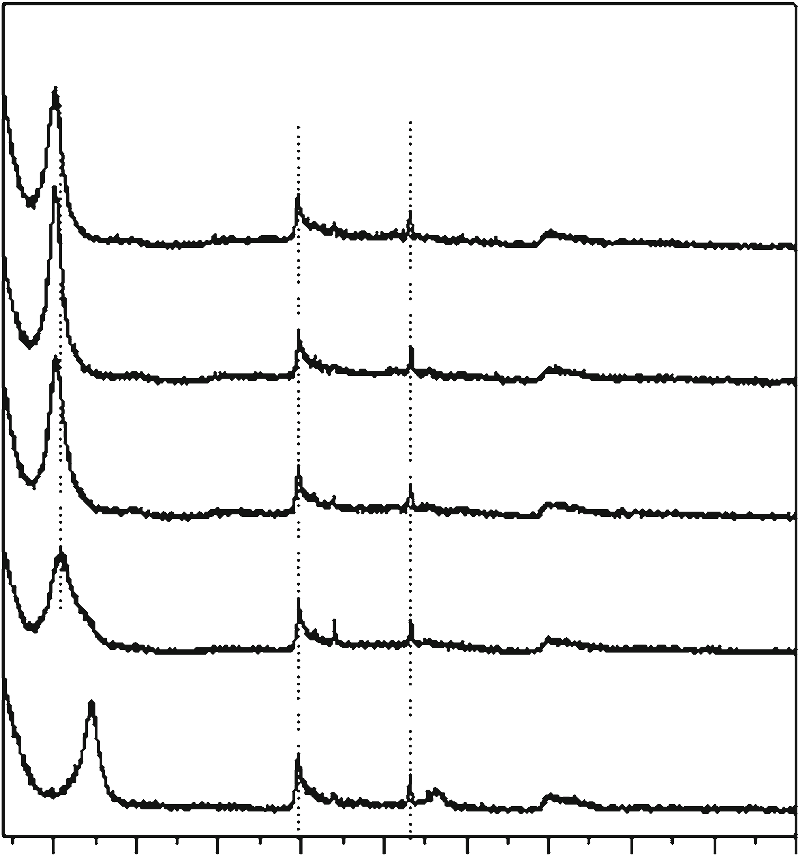
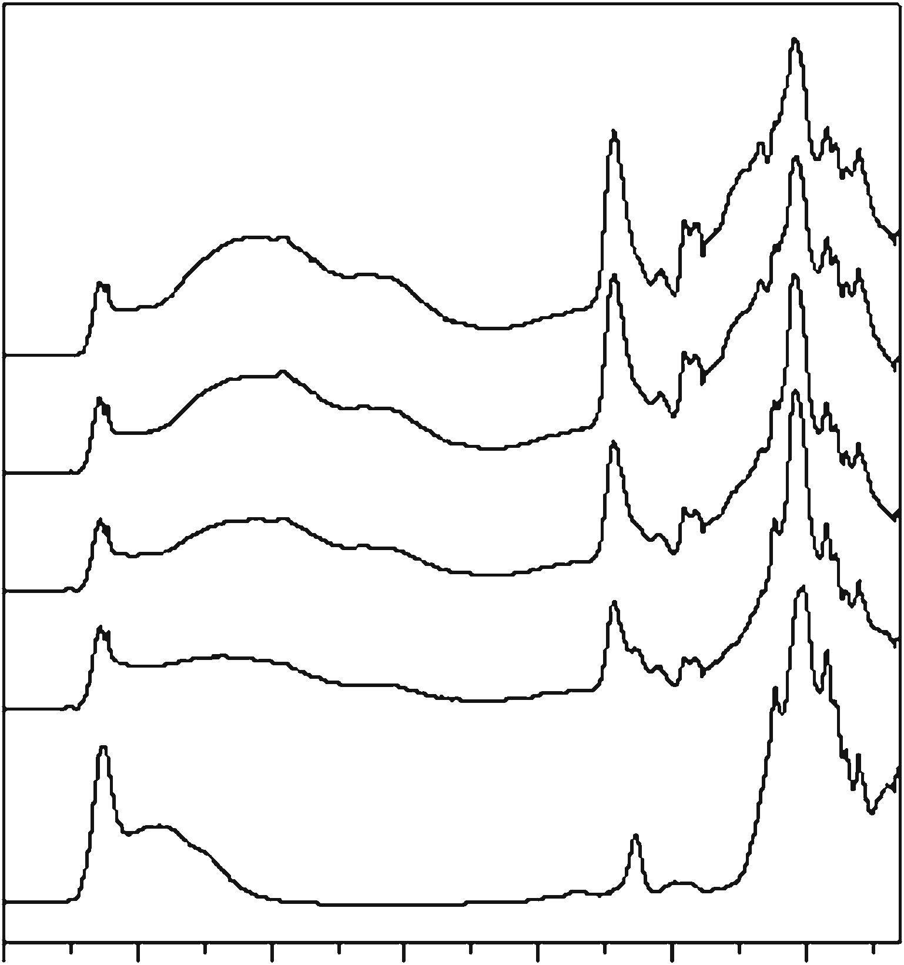
Effect of Fe^{3?}ions in the PAA/MMT composites
337
Al–Mg–OH(844cm⁻¹).Furthermore,Si–OstretchingofSiO₂admixture phase (most probably quartz detected byXRD)appearsat798cm⁻¹[29].
Beside the characteristic bands of MMT, absorption bands attributed to the PAA part are found in the FTIRspectraofcomposites.Thepeaksat2,945–2,950cm⁻¹
position of (001) diffraction peak. The (001) interplanar distance of raw MMT was 1.22 nm. After the modification with various amounts of PAA the lamellar structure of starting mineral was retained. Moreover, the (001) peak was shifted to the lower 2h angles (5.08°–5.37°). This
indicates an increase in the
d001
spacing of the clay by
cm-1
about 0.43–0.52 nm. For the MMT-PAA-20 sample con-
(CH₂stretching), 1,453
(CH₂deformation), and
1,316cm⁻¹(C–Cstretching)areassociatedwithacarbon
taining the lowest amount of polymer, the
d001
spacing
increased to a lesser degree (1.64 nm) compared to other composites, which resulted from the intercalation of the lower amount of polymer into the interlayer space. In the case of the materials with higher content of PAA, the differences in the distance between the layers slightly varied (in the range of 1.72–1.74 nm). Thus, one can conclude that only limited amount of hydrogel can be intercalated into the interlayer gallery of MMT. The remaining part of polymer probably forms on the external surface of MMT particles.
The deeper insight into the structure of MMT and PAA/ clay composites was possible due to FTIR measurements. The FTIR spectra of these materials are presented in Fig.2. In the spectrum of MMT, characteristic absorption peak of
backbone chain. Other three distinct peaks at 1,717, 1,540,and1,410cm⁻¹canbeassignedtotheC=Ostretchingmode in the protonated carboxylate group as well as to the asymmetric and symmetric C–O stretching modes in theCOO⁻ions,respectively[30].Forallthecomposites,thewide absorption band observed between 2,700 and3,500cm⁻¹indicatesasignificantamountofabsorbedwater. The presence of undissociated COOH groups is confirmed by the maximum between 2,500 and2,600cm⁻¹,attributedtohydrogenbondsinvolvingpoly-meric species[31].
Simultaneous thermogravimetric (TG) and differential thermal analyses (DTA) were performed in order to study the mechanism of thermal decomposition of the polymer part present in the MMT structure. In the case of the MMT sample, only two mass loss effects are observed. The first one (up to 433 K) is attributed to the dehydration of the material and the next one (above 823 K) to dehydroxyla- tion of MMT layers. The results obtained for the MMT- PAA composites are presented in Fig.3. As seen, thephysically adsorbed and interlayer water was removed to443 K. Above this temperature, the complex decomposi- tion of organic matrix is observed. At first, the carboxyl side groups underwent decomposition to 588–600 K which
Al3?
hydroxyl group bound with
cations is observed at
3,630cm⁻¹.Thestretchingandbendingvibrationsofthe
hydroxylgroupsofwatermoleculespresentintheclaycanbenoticedat3,430and1,645cm⁻¹,respectively.Themostintensivebandat1,015cm⁻¹isattributedtoSi–Oin-planestretching,whiletheshoulderat1,115cm⁻¹comesfromSi–O out-of-plane stretching vibrations. The three peaksbelow1,000cm⁻¹originatefrombendingvibrationsof
Al–Al–OH(920cm⁻¹),Al–Fe–OH(887cm⁻¹),
and
MMT (001)
MMT (100)
Qz (011)
MMT-PAA-50
MMT-PAA-50
MMT-PAA-40
MMT-PAA-40
MMT-PAA-30
MMT-PAA-30
MMT-PAA-20
MMT-PAA-20
MMT (001)
MMT
MMT
5
10 15 20
25 30
2θ/°
35
40
45
50
4000 3500 3000 2500 2000 1500 1000
Wavenumber/cm–1
Fig. 1 XRD patterns of raw montmorillonite poly(acrylic acid)/montmorillonite composites
and
the
series
of
Fig. 2 DRIFT spectra of clay and PAA/MMT composites
13
Intensity/a.u.
Kubelka-Munk function/a.u.

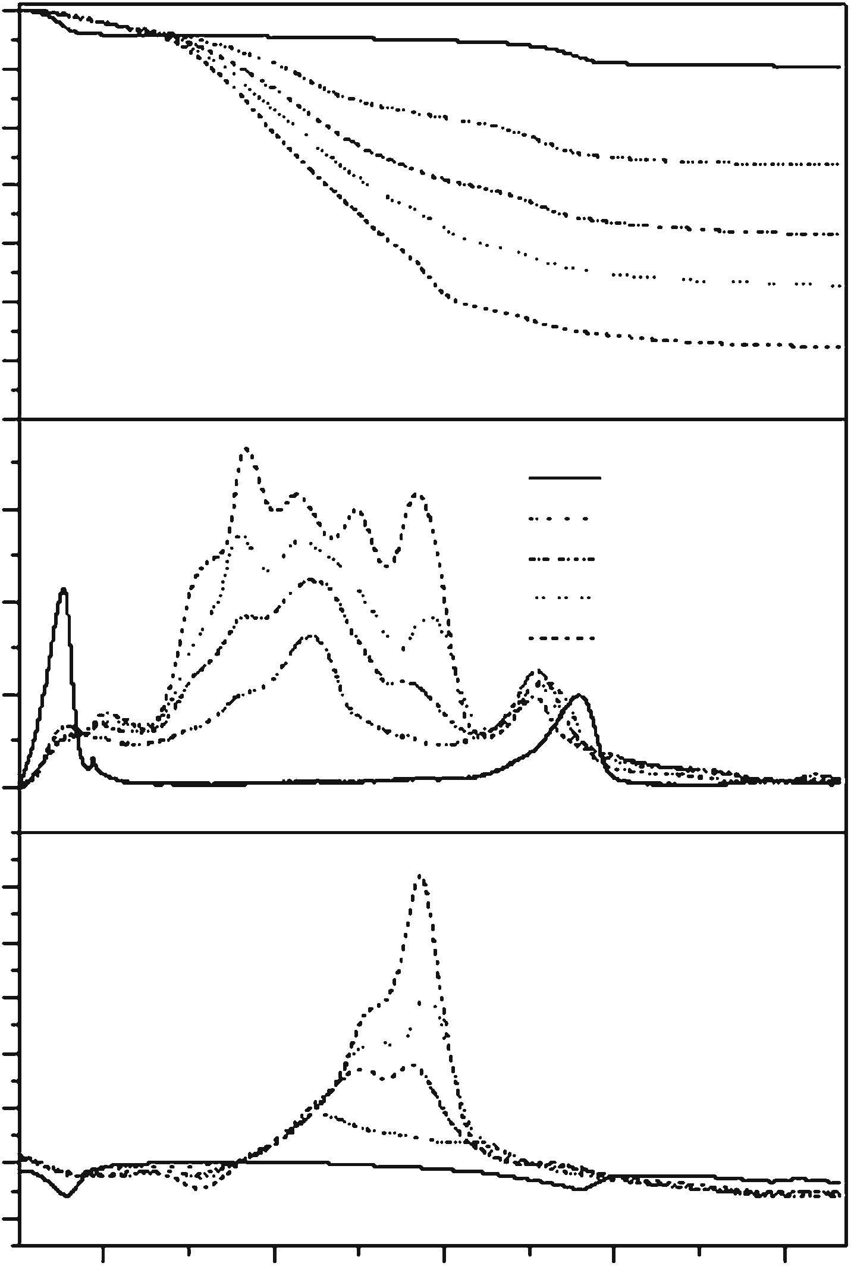
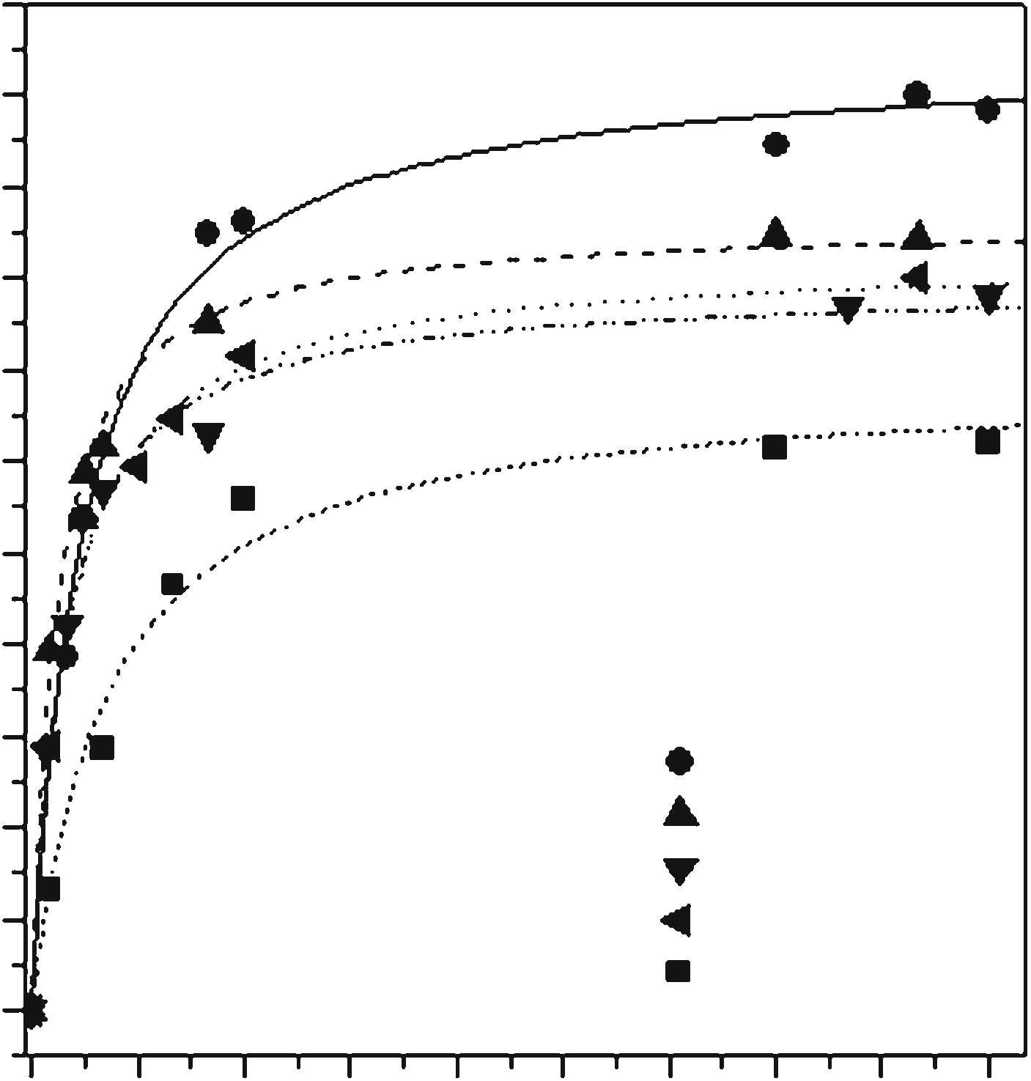
P.Natkan´skietal.
338
100
90
80
70
60
50
40
30
2.2
2.0
1.8
1.6
1.4
1.2
1.0
0.8
MMT
MMT-PAA-20 MMT-PAA-30 MMT-PAA-40 MMT-PAA-50
1.5
1.0
0.6
0.4
0.2
0.0
MMT-PAA-50 MMT-PAA-40 MMT-PAA-30 MMT-PAA-20 MMT
0.5
0.0
10
8
6
4
2
0
–2
0
3
6
9 12 15 18 21 2427
Time/h
Fig. 4 Adsorption kinetics of Fe^{3?}ions for raw montmorillonite and composites
mechanism. The experimental data were fitted using the pseudo-first-order kinetic equation [32]:
lnðq_{e}-q_{t}Þ ¼lnq_{e}-k_{f}t
wherek_{f}is the adsorption rate constant for the first-order
400
600
800
1000
1200
Temperature/K
Fig. 3
TG, DTG, and DTA curves recorded for raw montmorillonite
andtheseriesofPAA/MMTcompositesbeforeFe^{3?}ionsadsorption
adsorption,q_{t}(mmolg⁻¹)istheamountof
Fe3?
cations
adsorbedattimet,andq_{e}(mmolg⁻¹)istheamountof
was detected in the DTG curves as mass loss effects and in the DTA curves as endothermic peaks. A further increase in temperature resulted in oxidation of carbon backbone chains, confirmed by two step exothermic maximum in the temperature range of 600–900 K [20]. Above 900 K, the dehydroxylation of MMT was observed. The evaluated mass losses attributed to the polymer part in composites (comparedinTable1)areclosetotheintendedvalues.
Fe3?
ions adsorbed at equilibrium; and pseudo-second-
order kinetic equation [33]:
t 1 t
¼
þ
q kq q
2
t se e
wherek_{s}is the adsorption rate constant for the second- order adsorption.
The experimentalq_{t}values collected during the mea- surements are presented in Fig.4, and the calculated kinetic parameters are collected in Table1. The kinetic results of adsorption of Fe^{3?}ions suggest that in the case of composite materials the adsorption occurred according to the model of pseudo-second-order, whereas for the MMT sample the pseudo-first-order kinetic model describes bet- terthisprocess.Itcanbenoticedthatanincreaseinthe
Adsorption capacity of PAA/montmorillonite
The efficiency of raw MMT and composites in the
Fe3?
adsorption of
cations from aqueous solution was
studied. Adsorption kinetics was examined to determine the adsorption capacity and to explain theadsorption
Table 1
Comparison of adsorption parameters of the raw montmorillonite and the PAA/MMT composites
Sample
Polymer content/mass%
Pseudo-first-order kinetic model
Pseudo-second-order kinetic model
k_{f}/h⁻¹
q_{e}/mmolg⁻¹
R2
k_{s}/gmmol⁻¹h⁻¹
q_{e}/mmolg⁻¹
R2
1
2
MMT
MMT-PAA-20 MMT-PAA-30 MMT-PAA-40 MMT-PAA-50
– 18.9
28.9
38.7
48.6
0.346
0.646
0.765
0.928
0.533
1.24
1.48
1.47
1.61
1.91
0.995
0.976
0.972
0.968
0.990
0.339
0.599
0.713
0.857
0.332
1.38
1.64
1.58
1.72
2.09
0.985
0.998
0.994
0.997
0.995
13
DTG/% min–1
Mass/%
DTA/K
qt/mmol g–1

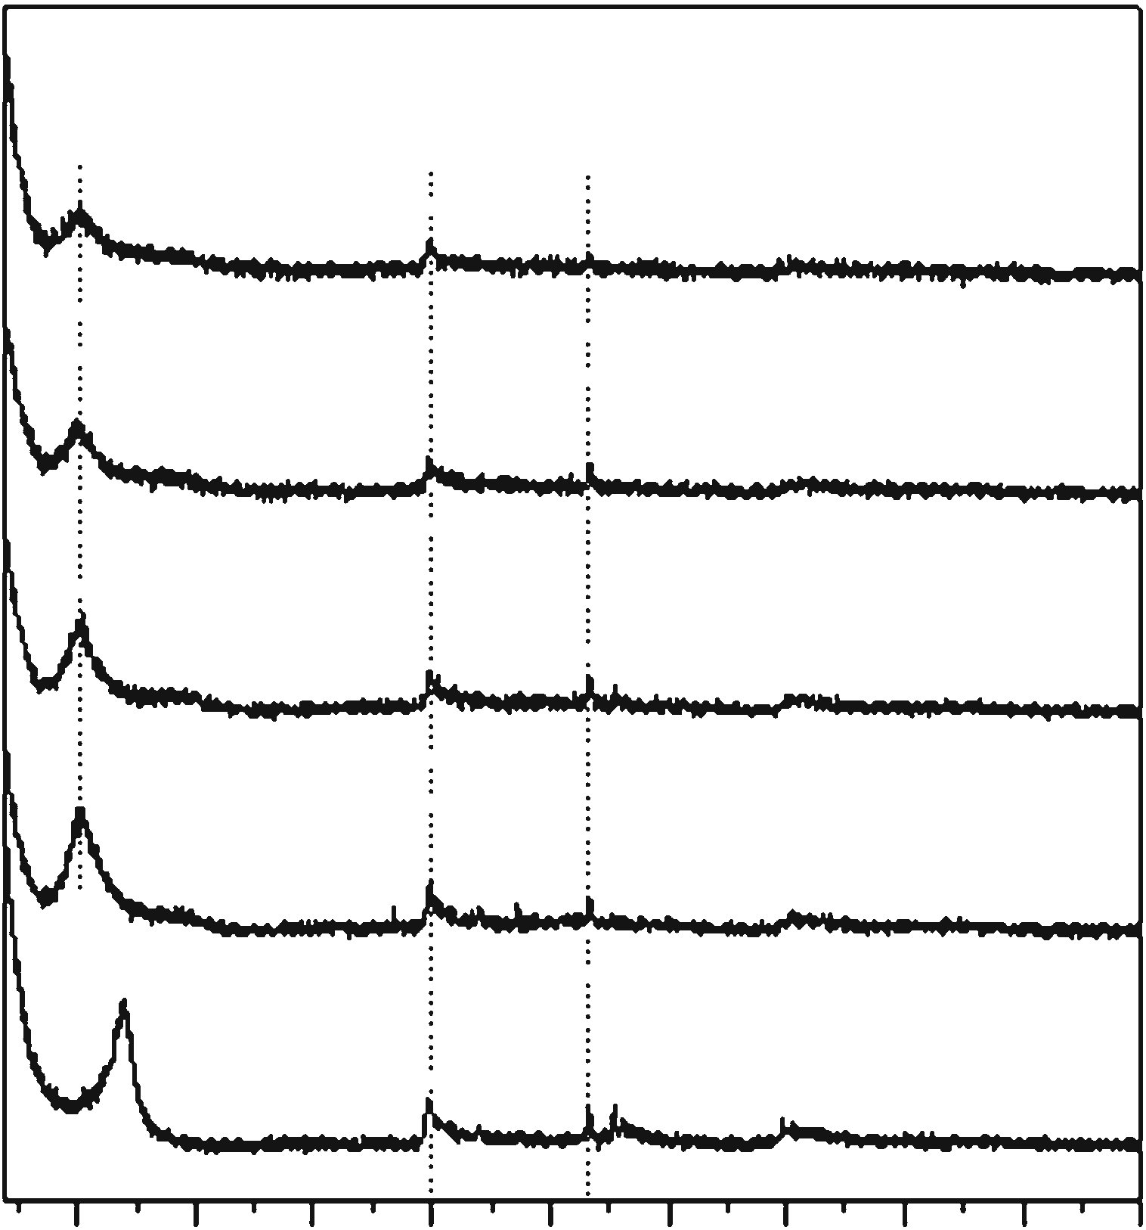
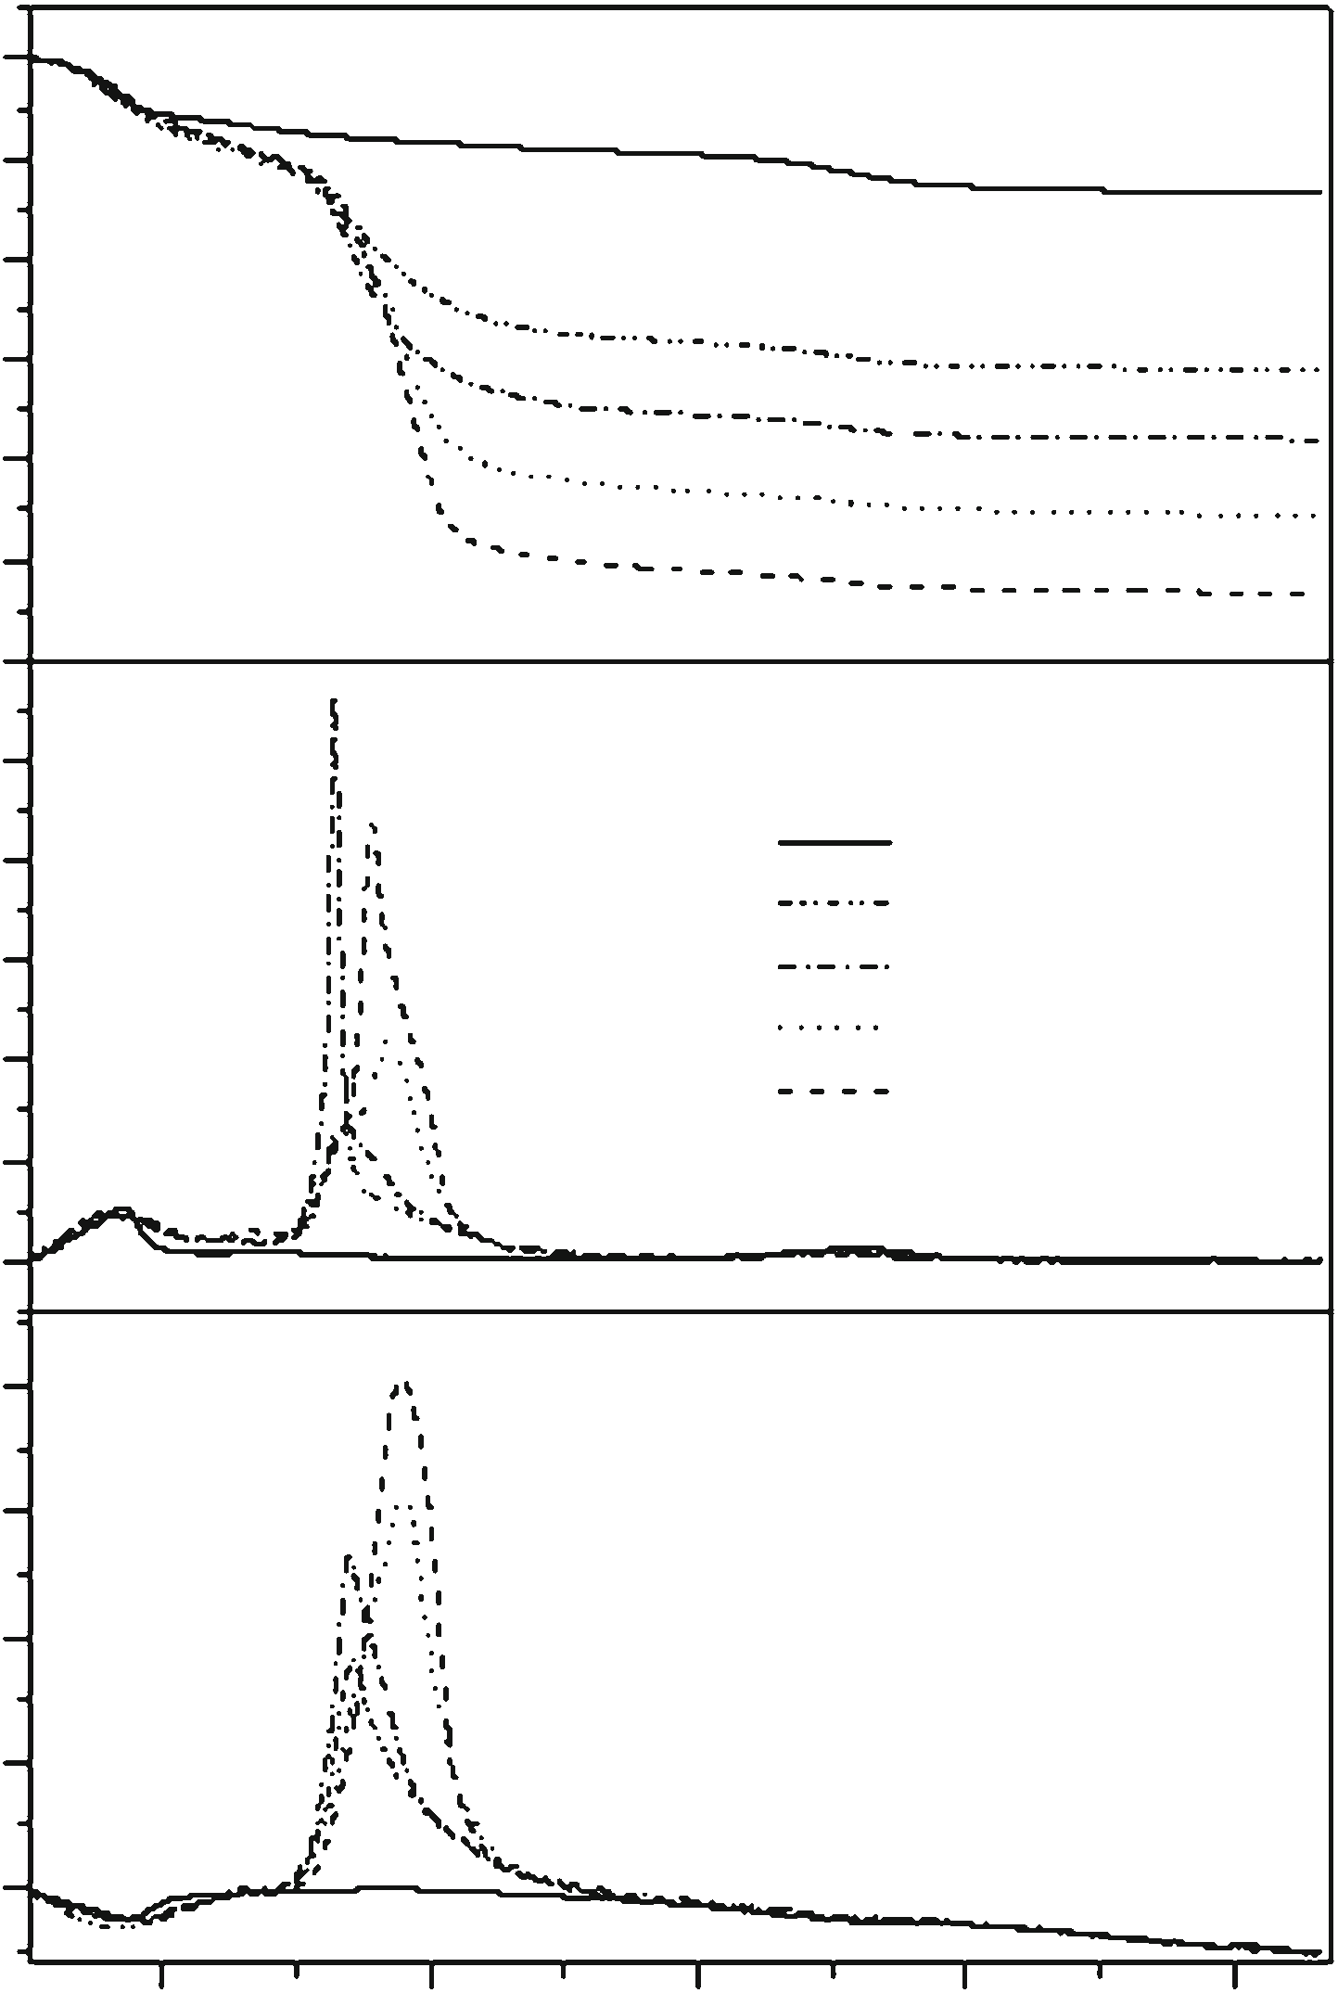
Effect of Fe^{3?}ions in the PAA/MMT composites
339
100
90
80
70
60
50
40
10
8
6
4
2
0

20
MMT (001)
MMT (100)
Qz (011)
MMT-PAA-50-Fe
MMT-PAA-40-Fe
MMT-PAA-30-Fe
MMT
MMT-PAA-20-Fe MMT-PAA-30-Fe MMT-PAA-40-Fe MMT-PAA-50-Fe
MMT-PAA-20-Fe
MMT (001)
MMT-Fe
15
5
10 15 20
25 30 35 40
2θ/°
45
50
10
5
Fig. 5 XRD patterns of raw
montmorillonite and
the
series of
Fe3?
poly(acrylic acid)/montmorillonite composites after adsorption
cations
0
400
600
800
1000
1200
Temperature/K
Table 2 Position ofd₀₀₁diffraction peak and basal spacing of the clay and the PAA/MMT composites before and after adsorption of Fe^{3?}ions as well as amounts of Fe^{3?}ions eliminated by adsorption
Fig. 6 TG, DTG, and DTA curves recorded for the series of PAA/ MMT composites and montmorillonite containing Fe^{3?}cations
Sample
Amount of adsorbed Fe^{3?}cations/mgg⁻¹
Structural properties

all examined materials before and after the adsorption of Fe cations as well as amounts of adsorbed metal ionsare
3?
Before Fe^{3?}sorption
After Fe^{3?}sorption
Fe3?
presented in Table2. The
ions’ content in samples
was calculated based on the results of adsorption experi- ments. After adsorption the insignificant changes in thed₀₀₁spacing of all materials were observed which resulted from the introduction of metal ions into the interlayer spaces. Furthermore, a decrease in the intensity of (001) diffractionlinewastheresultofpartialdelaminationof
Position
d001
spacing/
Position
d001
spacing/
ofd₀₀₁
ofd₀₀₁
line/°2h nm line/°2h nm

MMT
MMT-PAA-20 MMT-PAA-30 MMT-PAA-40
MMT-PAA-50
69.3
91.6
88.2
96.1
116.7
7.26
5.37
5.13
5.10
5.08
1.22
1.64
1.72
1.73
1.74
6.95
5.11
5.07
5.02
4.99
1.27
1.73
1.74
1.76
1.77
Fe3?
clay structure caused by adsorption of between aluminosilicate layers.
cations
TheeffectofFe^{3?}ionspresentinthestructureofPAA/
MMT composites on the mechanism of their thermal decomposition was studied using thermal analysis tech- niques. The TG, DTG, and DTA curves recorded for the
content of PAA in composite has a positive impact on the
Fe3?
adsorption capacity of
cations. This effect can be
Fe3?
attributedtothehighefficiencyofcarboxylgroupsinthe adsorption of Fe^{3?}cations by ion exchange withprotons.
composite materials with adsorbed
cations are pre-
sented in Fig.6. The example results of TG–FTIR exper- iments, testing thermal decomposition of the MMT-PAA- 30 sample before and after adsorption of Fe^{3?}cations, are shown in Fig.7.
In the case of the iron-free material, the elimination of carboxyl groups in the temperature range of 460–640 K was the first step of PAA decomposition. It was confirmedbytwopeaksat1,765and1,136cm⁻¹attributedtovibrations of C=O and C–O bonds, respectively [34].From
505 to 1,030 K, two intensive and wide bands (at2,250–2,400and670–750cm⁻¹)originatingfromcarbon
Structural characterization and thermal stability of PAA/montmorillonite composites after Fe^{3?}adsorption
The structure of the studied materials after adsorption of Fe^{3?}cations was examined using XRD analysis. The dif- fraction patterns of the clay and the composite materials containing Fe^{3?}ions are presented in Fig.5. Theposition ofmain(001)diffractionpeakandbasalspacing(d₀₀₁)for
13
Intensity/a.u.
DTG/%min–1
Mass/%
DTA/K

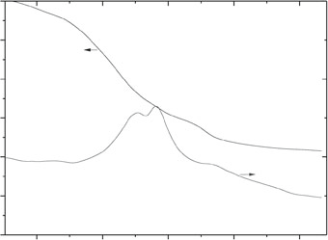
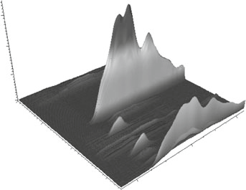
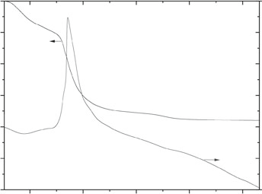
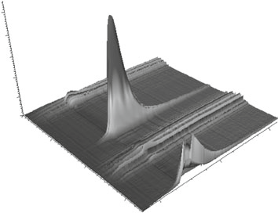
Wavenumber/cm
–1
Wavenumber/cm
–1
Absorbance/a.u.
Absorbance/a.u.
Time/min
Time/min
P.Natkan´skietal.
340
100
200
MMT-PAA-30
0.30
MMT-PAA-30
90
150
0.20
100
80
0.10
70
50
–0.00
4000
3000
0
60
90.0
–50
50
50.0
2000
40
–100
1000
400
600
800
1000
1200
10.0
Temperature/K
200
100
MMT-PAA-30-Fe
MMT-PAA-30-Fe
0.50
0.40
0.30
0.20
0.10
–0.00
4000
3000
90
150
80
100
70
50
60
0
90.0
–50
50
50.0
2000
–100
40
400
600
800
1000
1200
1000
10.0
Temperature/K
Fig. 7 TG–FTIR results for MMT-PAA-30 composite before and after adsorption of Fe^{3?}cations
dioxide indicate the combustion of carbon backbone. In this temperature range, three exothermic maxima are observed on the DTA curves. The first peak (505–720 K)is most likely connected with the thermal decomposition of polymer deposited on external surface of clay particles, while the second effect (735–890 K) is related to the oxi- dation of polymer located in the interlayer spaces. The last low intensive peak (above 890 K) can be attributed to the removal of carbon deposit formed between layers during the incomplete oxidation of hydrogel. The formation of the carbon deposit is confirmed by characteristic bands of carbon monoxide observed on the FTIR maps at2,110–2,220cm⁻¹inthetemperaturerangeof596–968K.Moreover, this last stage of the polymerdecomposition overlaps with the dehydroxylation process starting at 900 K. The bands in the wavenumber ranges of3,400–3,750and1,250–2,000cm⁻¹,attributedtowaterformed during the oxidation of hydrogel, are observed in the temperature rangeof 500–1,010 K.
products of this process formed in the temperature ranges of 533–673 and 505–795 K were water and carbondioxide, respectively. The position of the maximum of this exo- thermic effect is different and depends on the PAA content and its location in the composite structure. In the case of the composites containing to 30 mass% of PAA, the Fe^{3?}cations are mainly adsorbed by hydrogel introduced betweenclaylayers.Inthiscase,thehighconcentrationof
Fe3?
in the interlayer gallery causes that during thermal
Fe3?
treatment
oxide particles are easily formed, which
catalyze the oxidation of polymer. For the composites with 40 and 50 mass% of PAA, the decomposition temperature of hydrogel part is 30–35 K higher than for other materials. This effect can be explained by higher dispersion of adsorbed Fe^{3?}cations in PAA deposited on both external and internal surface of MMT. Thus, the formation of Fe oxide species, responsible for faster polymer oxidation, requires higher temperature than for the MMT-rich composites.
Fe3?
For the material after
adsorption,
the starting of polymer
temperature of the thermal decomposition
matrix did not change, however the temperature range of this process is narrower—from 443 to 760 K. Moreover, in the DTA curve only one exothermic peak is visible, which indicates fast oxidation of organic matrix. The gaseous
Conclusions
PAA can be introduced into the MMT structure by in situ polymerization. Only limited amount of PAA is
13
Mass/%
Mass/%
Heat flow/mW
Heat flow/mW

Effect of Fe^{3?}ions in the PAA/MMT composites
341
intercalated between the clay layers. The excess of the formed polymer is deposited on the external surface of theclay particles. PAA/MMT composites are effective adsor- bents of metal cations from aqueous solution. The modi- fication of the MMT structure with hydrogel significantly
- Bineesh KV, Kim SY, Jermy BR, Park DW. Synthesis, charac- terization and catalytic performance of vanadia-doped delami- nated zirconia-pillared montmorillonite clay for the selective catalytic oxidation of hydrogen sulfide. J Mol Catal A. 2009;308:150–8.
- Tyagi B, Chudasama CD, Jasra RV. Determination of structuralmodification in acid activated montmorillonite clay byFT-IRspectroscopy. Spectrochim Acta A.2006;64:273–8.
- BiaG, De Pauli CR, Borgnino L. The role of Fe(III) modified montmorillonite on fluoride mobility: adsorption experimentsandcompetitionwithphosphate.JEnvironManag.2012;100:1–9.
- Malla PB, Ravindranathan P, Kornarneni S, Roy R. Intercalation of copper metal clusters in montmorillonite. Nature. 1991;351: 555–7.
- Janova´kL,VargJ,Keme´nyL,De´ka´nyI.Swellingpropertiesof
copolymer hydrogels in the presence of montmorillonite and al- kylammonium montmorillonite. Appl Clay Sci. 2009;43:260–70.
- SinhaRay S, Okamoto M. Polymer/layered silicate nanocom- posites: a review from preparation to processing. Prog PolymSci.2003;28:1539–641.
- Pinnavaia TJ, Beall AG. Polymer-clay nanocomposites. New York: Wiley;2002.
- Molu ZB, Seki Y, Yurdakoc K. Preparation and characterizationof poly(acrylic acid)/pillared clay superabsorbent composite. Polym Bull.2010;64:171–83.
- Santiago F, Mucientes AE, Osorio M, Rivera C. Preparation ofcomposites and nanocomposites based on bentonite and poly(- sodium acrylate). Effect of amount of bentonite on the swelling behavior. Eur Polym J.2007;4:1–9.
- Helvacıog˘luE,AydınV,NugayT,NugayN,UluocakBG,S¸enS.High strength poly(acrylamide)-clay hydrogels. J Polym Res. 2011;18:2341–50.
- Zhang J, Wang A. Study on superabsorbent composites. IX:synthesis, characterization and swelling behaviors of polyacryl- amide/clay composites based on various clays. React Funct Polym.2007;67:737–45.
- Zhou M, Zhao J, Zhou L. Utilization of starch and montmoril- lonite for the preparation of superabsorbent nanocomposite. Appl Polym Sci.2011;121:2406–12.
- Kas¸go¨zH,Durmus¸A,Kas¸go¨zA.Enhancedswellingandadsorption properties of AAm-AMPSNa/clay hydrogel nano- composites for heavy metal ion removal. Polym Adv Technol. 2008;19:213–20.
- BulutY,Akc¸ayG,ElmaD,SerhatlıIE.Synthesisofclay-basedsuperabsorbent composite and its sorption capability. J Hazard Mater.2009;171:717–23.
- Kaplan M, Kasgoz H. Hydrogel nanocomposite sorbents for removalofbasicdyes.PolymBull.2011;67:1153–68.
- Chmielarz L,Kus´trowskiP, Dziembaj R, Cool P, Vansant EF. Selective catalytic reduction of NO with ammonia over porous clay heterostructures modified with copper and iron species.Catal Today.2007;119:181–6.
- Carriazo JG, Molina R, Moreno S. A study on Al and Al–Ce–Fe pillaring species and their catalytic potential as they aresupported onabentonite.ApplCatalA.2008;334:168–72.
- Sathyamoorthy A, Raj P, Gupta NM, Samant SD. Effect of preparation conditions on the characteristics of Fe^{3?}–K10 clay catalysts. Catal Lett. 2002;81:97–100.
- Perez G, De Stefanis A, Tomlinson AAG. Pillared layered structures vs. zeolites as sorbents and catalysts Part 3. Compari- son between some alumina-PILCs in ethylbenzene conversions to diethylbenzeneandtostyrene.JMaterChem.1997;7:351–6.
- Sposito G, Prost R, Gaultier JP. Infrared spectroscopic study of adsorbed water on reduced-charge Na/Li-montmorillonites. Clay Clay Miner.1983;31:9–16.
Fe3?
increases the adsorption capacity of
ions. The
adsorbed metal cations strongly influence the thermal sta- bility of the composite. During heating, iron oxide species form, which catalyze the oxidation of polymer and it is decomposed much faster than in the iron-free material. Therefore, for complete transformation of PAA/MMT composite into a final oxide-type catalyst, thermal treat- ment at a temperature even below 700 K can be considered.
Acknowledgments This study was supported by the Polish National Science Centre under the Grant No. N N507 217640, and by the European Regional Development Fund in the framework of thePolish Innovation Economy Operational Program (Contract No. POIG.02.01.00-12-023/08), which financed the purchase of researchequipment.PiotrNatkan´skiwishestothankforthefinancialsupportfrom DOCTUS scholarship co-founded by the European SocialFund.
Open Access This article is distributed under the terms of the Creative Commons Attribution License which permits any use, dis- tribution, and reproduction in any medium, provided the original author(s) and the sourceare credited.
References
- Lapides I, Borisover M, Yariv S. Thermal analysis of hex- adecyltrimethylammonium–montmorillonites. J Therm Anal Calorim.2011;105:921–9.
- de Paiva LB, Morales AR,ValenzuelaD´ıazFR. Organoclays:
properties, preparation and applications. Appl Clay Sci. 2008;42: 8–24.
- Wang G-W, Hao Q-Q, Liu Z-T, Liu Z-W. Fischer–Tropsch synthesis over Co/montmorillonite—insights into the role of interlayerexchangeablecations.ApplCatalA.2011;405:45–54.
- Mills GA, Holmes J, Cornelius EE. Acid activation of some bentonite clay. J Phys Chem.1950;54:1170–85.
- Kloprogge JT, Duong LV, Frost RL. A review of the synthesis and characterization of pillared clays and related porousmaterials for cracking of vegetable oils to produce biofuels. Environ Geol. 2005;47:967–81.
- Phukan A, Ganguli JN, Dutta DK. ZnCl₂-Zn^{2?}-montmorillonite composite: efficient solid acid catalyst for benzylation of ben- zene. J Mol Catal A.2003;202:279–87.
- O¨zcelikZ,SoyluGSP,BozI.Catalyticcombustionoftoluene
over Mn, Fe and Co-exchanged clinoptilolite support. Chem Eng J. 2009;155:94–100.
- Chen M, Fan L, Qi L, Luo X, Zhou R, Zheng X. The catalytic combustion of VOCs over copper catalysts supported on cerium- modified and zirconium-pillared montmorillonite. Catal Comm. 2009;10:838–41.
- Nogueira FGE, Lopes JH, Silva AC, Lago RM, Fabris JD, Oli- veira LCA. Catalysts based on clay and iron oxide for oxidation of toluene. Appl Clay Sci.2011;51:385–9.
13

P.Natkan´skietal.
342
- Kirwan LJ, Fawell PD, van Bronswijk W. In Situ FTIR–ATR examination of poly(acrylic acid) adsorbed onto hematite at low pH. Langmuir.2003;19:5802–7.
- Daniliuc L, David C. Intermolecular interactions in blends of poly(vinyl alcohol) with poly(acrylic acid): 2. Correlation between the states of sorbed water and the interactions in ho- mopolymers and their blends. Polymer.1996;37:5219–27.
- Ho YS. Citation review of Lagergren kinetic rate equation on adsorption reactions. Scientometrics.2004;59:171–7.
- Ho YS, Mckay G. Batch lead (II) removal from aqueous solution by peat: equilibrium and kinetics. Trans Inst Chem Eng. 1999;77B:165–73.
- Dong Y, Gui Z, Hu Y, Wu Y, Jiang S. The influence of titanate nanotube on the improved thermal properties and thesmoke
suppression in poly(methyl 2012;209–210:34–9.
methacrylate).
J
Hazard
Mater.
13

