

© Pol J Radiol 2022; 87: e274-e280
DOI: https://doi.org/10.5114/pjr.2022.116637
Received: 17.03.2021
Accepted: 12.08.2021
Published: 23.05.2022
http://www.polradiol.com
Original paper
The role of diffusion-weighted imaging and dynamic contrast-enhanced
magnetic resonance imaging for the diagnosis of diabetic foot osteomyelitis: a preliminary report
Shashank Raj1,A,B,C,D,E,F, Mahesh Prakash1,A,B,C,D,E,F, Ashu Rastogi2,A,B,D,E,F, Anindita Sinha1,A,B,D,E,F,
Manavjit Singh Sandhu1,A,B,D,E,F
1Department of Radiodiagnosis and Imaging, PGIMER, Chandigarh, India
2Department of Endocrinology, PGIMER, Chandigarh, India
Abstract
Purpose: To assess the role of dynamic contrast-enhanced magnetic resonance imaging (DCE-MRI) and diffusion- weighted imaging (DWI) in diagnosing diabetic foot osteomyelitis (DFO).
Material and methods: Twenty-five participants with suspected osteomyelitis were included, who underwent MRI including DCE-MRI and DWI sequences. It was subsequently followed by bone biopsy and microbiological analysis (gold standard). The participants were divided into 2 groups based on biopsy results: DFO-positive or DFO-negative. The semi-quantitative DCE-MRI parameters (SI0, SImax, SIrel, wash-in rate [WIR], and type of curve) and apparent diffusion coefficient (ADC) values were subsequently compared between the 2 groups.
Results: Out of the 25 cases, 19 were DFO-positive and 6 were DFO-negative on bone biopsy. The SI , SI , and WIR
0 max
were significantly higher in DFO-positive cases (p-value 0.050, 0.023, and 0.004, respectively). No difference was
seen in SIrel. 100% negative cases revealed type-I curve, and 94% of positive cases showed type-II curve. SI0 > 143.4 revealed a sensitivity of 94.7% and specificity of 83.3%. SImax had a sensitivity of 89.5% but lower specificity of 67.7% at a cut-off value of 408.35. The most significant difference was seen with WIR; p-value ~0.004. At the cut-off value
of > 1.280, it had a specificity and sensitivity of 100% and 76%, respectively. Also, ADC values below 1.57 × 10-3 had a sensitivity of 88.2% and specificity of 80% for diagnosing DFO.
Conclusions: DWI and DCE-MRI provide non-invasive sequences, which can help to increase the overall specificity and sensitivity of conventional MRI for the diagnosis of osteomyelitis, differentiating it from acute Charcot’s arthropathy.
Key words: diffusion-weighted imaging, Charcot arthropathy, diabetic foot osteomyelitis, dynamic contrast-enhanced MRI.
tions in a startling two-thirds of the patients [2]. There-
fore, timely diagnosis of foot osteomyelitis is vital to initi- ate appropriate medical or surgical treatment to prioritize limb salvage.
Various imaging modalities have been evaluated for the diagnosis of DFO including plain X-rays, magnetic resonance imaging (MRI), nuclear scintigraphy, fluoro- deoxyglucose positron emission tomography (FDG PET/ CT), and labelled white blood cell PET/CT. X-ray is less sensitive for detecting DFO in the first 2-3 weeks [3,4]. Currently, MRI is widely used as the diagnostic moda-
Introduction
Diabetic foot ulcers (DFU) constitute one of the major
complications in individuals with diabetes, with a lifetime risk of around 25% [1]. DFU may be limited to soft tis- sue or involve the foot bones causing foot osteomyelitis (DFO), which may culminate in lower extremity amputa-
Correspondence address:
Mahesh Prakash, PGIMER, Madhya Marg, Sector 12, Chandigarh, 160012, India, e-mail: image73@gmail.com
Authors’ contribution:
A Study design ∙ B Data collection ∙ C Statistical analysis ∙ D Data interpretation ∙ E Manuscript preparation ∙ F Literature search ∙ G Funds collection
This is an Open Access journal, all articles are distributed under the terms of the Creative Commons Attribution-Noncommercial-No Derivatives 4.0
International (CC BY-NC-ND 4.0). License (https://creativecommons.org/licenses/by-nc-nd/4.0/).
e274

The role of DWI and DCE-MRI for the diagnosis of diabetic foot osteomyelitis
lity of choice for an early diagnosis of pedal osteomyelitis
because it gives extensive details of the nature and ex- tent of both bony as well as soft tissue involvement. MRI has good sensitivity for detecting osteomyelitis (90%), but the specificity may range from 70% to 80% or even less [4-7]. The fundamental issue with the conventional T1WI and T2WI sequences is that other causes of mar- row oedema such as acute neuropathic arthropathy and post-procedural changes may give similar MRI signal in- tensity changes, reducing the specificity of the investiga- tion. Similarly, nuclear scintigraphy with 99mTc has a good sensitivity (75%), but it has lower specificity (40%) for diagnosing DFO [8]. The use of labelled leucocyte bone scintigraphy can overcome this limitation because the leukocytes aggregate at the site of osteomyelitis. However, the poor spatial resolution of bone scintigraphy limits the use of this modality. However, an earlier investigation has demonstrated the use of FDG labelled leukocyte PET/CT scan, which has high resolution and specificity (100%) for diagnosing DFO [9].
Research in the field of MRI physics is growing by leaps and bounds, which has led to the introduction of newer sequences that make use of functional imaging to improve the specificity of this modality. Dynamic contrast- enhanced imaging (DCE-MRI) is one such modality that assesses the contrast uptake in any lesion over time. The semiquantitative DCE-MRI parameters used in this study have not been evaluated previously for diagnosing DFO. The DCE-MRI parameters used in this study are simple, easy to calculate, and less time-consuming than the quantitative parameters. The role of diffusion-weighted imaging (DWI) has been extensively investigated in vari- ous pathologies, a few of them including differentiation of various benign and malignant soft tissue and bone tumours, septic arthritis, transient synovitis of the hip joint, and assessment of treatment response in an in- flammatory disorder like rheumatoid arthritis [10-12]. The results in the current study further validate the avail- able literature on the role of DWI in diagnosing DFO and differentiating it from Charcot arthropathy [10,11]. Therefore, this study focuses on the pattern of contrast uptake in patients with diabetic foot ulcers and suspected DFO using semi-quantitative parameters of DCE-MRI se- quence, and also the differences in ADC values between the 2 groups. The use of DCE-MRI and DWI sequences in combination with conventional sequences may assist in an early and accurate diagnosis of osteomyelitis in individu- als with diabetic foot ulcers.
cally suspected of pedal osteomyelitis. The patients were
clinically examined by an experienced foot care specialist who performed a physical examination including a probe to bone (PTB) test. Clinical suspicion of osteomyelitis was based on the presence of ulcers with exposed bone graded as University of Texas grade 3 or grade 2 with the presence of sinus tracts, positive probe to bone test or ulcer > 4 weeks in duration with ulcer area larger than 2 cm2. History of diabetes, microvascular and macrovas- cular complications, duration and cause of ulcer were investigated. A thorough foot examination for the site, size, depth of the ulcer, and adjacent skin condition were noted. The presence of neuropathy was assessed with vibration perception threshold (> 25 mV was consid- ered as loss of protective sensations) and vasculopathy by ankle-brachial index (ABI), with < 0.9 considered as peripheral vascular disease.
Patients having a generalized contraindication to MRI or contrast administration, on antibiotic therapy for the past 72 hours, or not giving consent for the study were ex- cluded from the study. The MRI imaging was done using a 3-Tesla unit (TIM MAGNETOM Verio, Siemens, Ger- many) using the extremity coils. The imaging sequences included T1W spin echo (SE) sagittal, coronal, and axial (fat-suppressed), T2 fat-suppressed (coronal, axial, and sagittal), dynamic contrast-enhanced T1-weighted images using a fast multiplanar spoiled gradient echo technique (VIBE), and T1W SE post-contrast fat-suppressed axial and sagittal sections. DCE-MRI was done in which 12 se- rial axial image sets were obtained at a temporal resolu- tion of 15-16 s over 4-5 minutes post-injection of contrast. A dose of 0.2 mmol/kg of gadolinium chelate (Magnevist) (gadopentate dimeglumine) was administered at a rate of
3.5 ml/s followed by a chaser injection of 20-30 ml of nor- mal saline given at the same rate as the contrast. For DCE- MRI, a VIBE sequence was used having TR and TE of
4.1 and 1.4 ms, respectively. The slice thickness was 3 mm with a field-of-view (FOV) of 17 cm and a voxel size of
0.7 × 0.7 × 0.6 mm. DWI was done using a single-shot echo-planar sequence at b values 0, 600, and 800 mm2/s. TR and TE used were 4100 and 90 ms, respectively, with a slice thickness of 5 mm, having FOV of 25 cm and a vox- el size of 1.7 × 1.3 × 5 mm. The diffusion gradients were applied in 3 orthogonal directions (x, y, and z). Apparent diffusion coefficient (ADC) maps were reconstructed at a commercial workstation with standard software.
Image analysis
The analysis was performed by a single radiologist with more than 10 years’ expertise in musculoskeletal imag- ing, on a dedicated Siemens workstation. The imaging definition for DFO on conventional MR sequences was the presence of focally decreased marrow signal intensity on T1-weighted images, focally increased signal intensity on T2-weighted images, and focal marrow enhancement
Material and methods
This was a prospective study, conducted after approval
from the institutional ethics committee. Written in- formed consent was acquired from all the volunteers. This included participants with diabetes, who presented with foot ulcers in a diabetic foot clinic and were clini-
© Pol J Radiol 2022; 87: e274-e280
e275

Shashank Raj, Mahesh Prakash, Ashu Rastogi et al.
on gadolinium-enhanced fat-suppressed T1-weighted im-
ages. Osteomyelitis was also considered in cases of discor- dant marrow signal intensity (i.e. absence of focal decrease of marrow signal intensity on T1-weighted images and presence of hyperintensity on T2-weighted images with post-contrast enhancement). The region of interest (ROI, measuring 0.15-0.40 mm2) was drawn using an electronic cursor over the bone showing altered signal intensity with the suspicion of osteomyelitis. Care was taken to avoid the adjacent area around the lesions to exclude the effect of partial volume averaging.
DWI sequences were used to calculate the ADC values from ADC T1 fusion maps for the corresponding ROIs. The ADC values were expressed in 10–3 mm2/s.
The following values were calculated for the above ROI from the DCE-MRI sequence:
- SI0 = tissue signal intensity on unenhanced T1 images;
- SImax = maximum absolute contrast enhancement;
- maximum relative SI [SIrel] = (SImax – SI0)/SI0 × 100;
- wash in rate [WIR] = (SImax – SI0)/time to peak in sec- onds;
- time to peak (T) = time taken to reach the maximum signal intensity in seconds.
The mean time-intensity curve (TIC) of the lesion was also analysed to characterize the lesion. Three patterns of the TIC were considered, type 1 – progressive increase in signal intensity over the entire dynamic study (the per- sistent pattern), type 2 – rapid initial peak followed by a relative constant enhancement (the plateau pattern), and type 3 – sharp uptake of contrast followed by a decrease in enhancement over time (the washout pattern).
All participants underwent bone-biopsy from the suspicious site of bone involvement (as detailed earlier) and were sent for microbiological and histopathological analysis after MRI. The results of the bone-biopsy were considered the gold standard for the diagnosis of DFO. Specimens with bone-biopsy positive for DFO were con- sidered true positives and the absence of DFO on bone biopsy as true negatives.
of DFO keeping bone biopsy as the gold standard. All the
tests were 2-sided and were performed at a significance level of α = 0.05. The analysis was conducted using IBM SPSS STATISTICS (Version 22.0).
Results
Patient characteristics
A total of 25 participants were included in the study, of these 8 (32%) were female and 17 were male. Nine pa- tients were excluded, out of which, 5 were on antibiotics, 3 had underlying renal failure, and 1 withdrew consent. The mean age of the participants was 52.5 ± 7.4 years, and the duration of diabetes was 9.9 ± 7.2 years. There were 24 participants with type 2 diabetes and 1 participant had type 1 diabetes. The baseline parameters of the study population are shown in Table 1. The forefoot was the most common suspected site of DFO (17 participants), midfoot tarsal bones in 4, and calcaneal involvement in the other 4 participants. Bone biopsy from 19 par- ticipants was suggestive of DFO on microbiological and histopathological examination (true-positive), where- as biopsy was not suggestive of DFO in 6 participants (true-negative). Amongst the biopsy-positive cases, the first metatarsal was the most commonly involved bone (8 participants). The head of the first metatarsal was in- volved in 7 out of 8 participants and the body of the first metatarsal bone in 1 participant with prior amputation of the great toe. The bones involved in the remaining par- ticipants were proximal phalanx of the great toe (3), fifth metatarsal head (2), navicular (1), cuneiform (2), and calcaneum in 3 participants.
Table 1. Baseline characteristics in participants with suspected foot bone osteomyelitis
Statistical analysis
All the bone-biopsy samples were divided into 2 groups based on biopsy results as “osteomyelitis positive” if the bone biopsy was suggestive of DFO (both on histopatho- logy and microbiology) and negative otherwise. The data were tested by the Kolmogorov Smirnov test for normal- ity. For the categorical data like type of curve, numbers and percentages were calculated. The numerical data like SImax, SI0, and WIR are presented as mean with standard deviation (normal distribution), or median and inter- quartile range (skewed distribution). Subsequently, the maximum cut-off value of each parameter was calcu- lated using the ROC curve and plotting the area under the curve (AUC). The sensitivity and specificity of each of the above parameters were calculated for the diagnosis
e276
© Pol J Radiol 2022; 87: e274-e280
Parameters n = 25
Age (years)
52.6 ± 7.4
BMI (kg/m2)
25.7 ± 4.4
Duration of diabetes (years)
9.9 ± 7.2
Duration of ulcer (weeks)
3.0 ± 2.6
Wagner grade
2.8 ± 0.6
HbA1c (%)
9.0 ± 2.9
Creatinine (mg/dl)
1.4 ± 0.8
eGFR (ml/min/1.73 m2)
66.8 ± 32.1
24-hour urine protein (mg/24 hours)
1560.2 ± 953.8
Neuropathy (%)
95.2
Nephropathy (%)
28.6
Retinopathy (%)
61.9
Cardiovascular events (%)
13.3
Hypertension (%)
71.4

The role of DWI and DCE-MRI for the diagnosis of diabetic foot osteomyelitis
The conventional MR sequences, i.e. T1WI and T2WI
sequences, were suggestive of DFO in all the 19 biopsy- proven cases of DFO. However, these sequences addi- tionally suggested a diagnosis of osteomyelitis in 3 of the 6 biopsy-negative cases (false-positive).
16 participants (94.1%) revealed the type II curve, and
1 case (5.9%) showed the type I curve. The curve could not be drawn in 2 cases due to motion artifacts. The type II curve was strongly associated with osteomyelitis in diabetic- foot patients. The time to peak in all the negative cases was 260 s compared to 142.35 s in DFO-positive cases (p < 0.01). Table 2 summarizes the key findings for the DWI and DCE-MRI parameters for differentiating biopsy-proven
DFO cases from acute Charcot patients.
Additionally, a statistical comparison of the AUC val- ues of all the parameters was done. The area under the curve of WIR was significantly different from that of all the other parameters with a p-value < 0.05. No difference was, however, observed between the AUC values of the rest of the parameters.
Diffusion-weighted images
The mean ADC value in positive cases of DFO was 1.35 ± 0.24 × 10-3 mm2/s and 1.64 ± 0.14 × 10-3 mm2/s
in bone-biopsy negative cases (p = 0.023). In 2 out of the
19 cases, the ADC value could not be calculated because of the excessive artifact as the bones involved were smaller in size and were located in the forefoot region. Drawing the ROC curve with the selection of ADC value cut-off of 1.57 × 10-3 mm2/s revealed a sensitivity of 88.2 ± 10.3% and specificity of 80.0 ± 19.4% with an AUC of 0.882
± 0.078 for the diagnosis of DFO.
Discussion
The present study aimed at deducing objective param-
eters of DWI and DCE-MRI sequences on MRI for an early and accurate diagnosis of diabetic foot osteomyelitis. We observed that ADC values on DWI and SI0, SImax, SIrel, WIR parameters, and type of curve on DCE-MRI images improve the specificity of conventional MRI sequences for the diagnosis of osteomyelitis in patients with a diabetic foot ulcer.
The first metatarsal head was the most frequently af- fected bone followed by the calcaneum and fifth meta- tarsal head, as they are the predominant pressure areas susceptible to recurrent trauma, making them suscep- tible to osteomyelitis. Previously, the 5th metatarsal and 1st metatarsal were implicated as the most frequent bones involved, because of the presence of concomitant varus deformity that altered the biomechanical forces, leading to skin ulceration [5].
An early diagnosis of osteomyelitis in diabetic foot is essential for the initiation of bone-culture-specific antibi- otics to prevent amputation. Therefore, various radiologi- cal modalities including MRI are used for the assessment of bone involvement in diabetic foot ulcers. The suspected sites of bone involvement on conventional MRI sequences in the present study showed reduced T1 signal with a cor- responding high signal on T2WI with significant post- contrast enhancement. Also, secondary signs of DFO, for
Dynamic contrast-enhancement images
The mean SI0 value in DFO-positive cases was 199.45
± 33, which was significantly higher compared to SI0
of 132.68 ± 44 (p = 0.040) in biopsy-negative cases.
A SI0 value cut-off of 143.3 had a sensitivity of 94.7 ± 5.1% and specificity of 83.2 ± 16.1% with AUC of 0.833 ± 0.121 for the diagnosis of DFO.
SImax was 470.5 ± 34 and 376.01 ± 86 (p = 0.023) in osteomyelitis-positive and -negative groups, respectively. The SImax cut-off value of 408.35 had 89.5 ± 9.5% sensitiv- ity and 67.7 ± 28.8% specificity to diagnose osteomyelitis with AUC of 0.772 ± 0.124.
The mean value of SIrel was 155.12 and 193.88 in osteo- myelitis-positive and -negative cases, respectively, and was not significantly different (p = 0.211).
The mean value of WIR in osteomyelitis-positive cases was 2.08 ± 0.4 and was significantly higher than in osteo- myelitis-negative cases with a mean value of 0.932 ± 0.2 (p = 0.004). A cut-off WIR value of 1.210 had a sensitivity of 82.0 ± 13.9% and specificity of 83.3 ± 16.1% with AUC of 0.897 ± 0.075 for diagnosing DFO. WIR could not be calculated in 2 patients due to motion artifacts of the foot.
Type of curve: All the DFO negative cases showed
a type I curve. Amongst the biopsy-positive cases of DFO,
Table 2. Mean and cut-off values along with sensitivity and specificity of various diffusion-weighted imaging and dynamic contrast-enhanced magnetic resonance imaging parameters for differentiating diabetic foot osteomyelitis (DFO) from acute Charcot
© Pol J Radiol 2022; 87: e274-e280
e277
Parameter Biopsy (+) cases (19), Biopsy (–) cases (6), Cut-off value Sensitivity (%) Specificity (%) mean values mean values for diagnosing DFO
ADC (mm2/s)
1.35 ± 0.24 × 10-3
1.64 ± 0.14 × 10-3
< 1.57 × 10-3
88.2
80.0
SI0
199.45 ± 33.00
132.68 ± 44.00
> 143.30
94.7
83.2
SImax
470.50 ± 34.00
376.01 ± 86.00
> 408.35
89.5
67.7
WIR
2.08 ± 0.40
0.93 ± 0.20
> 1.21
82.0
83.3
Type of curve
Type II (94.1%)
Type I (100%)

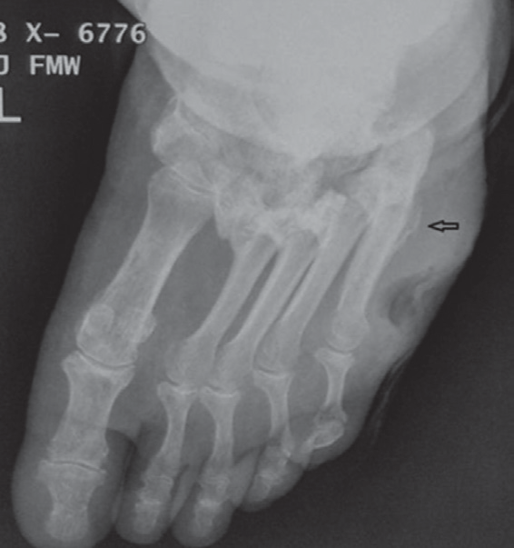
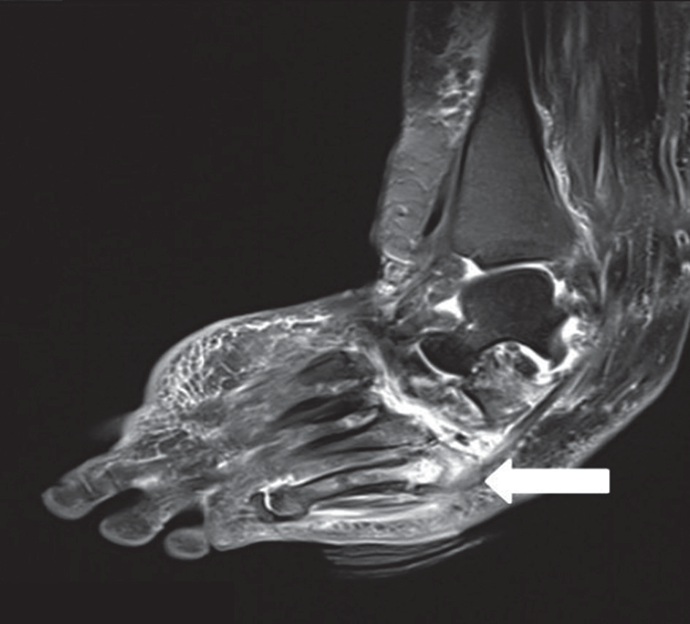
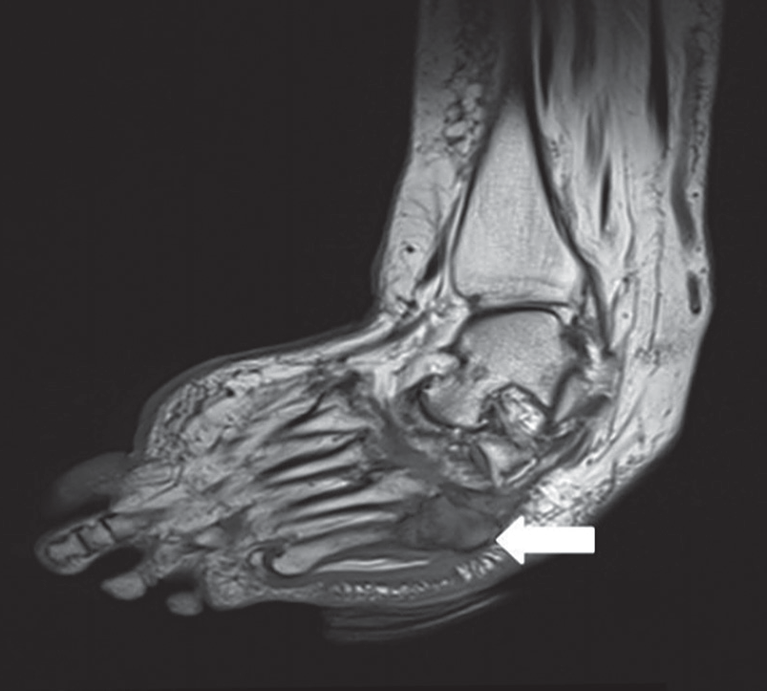
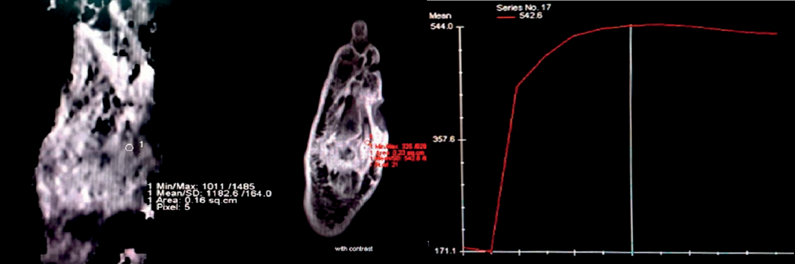
Shashank Raj, Mahesh Prakash, Ashu Rastogi et al.
example the presence of an adjoining ulcer, sinus tract,
cellulitis, collection, gangrene, etc., were present in most of the cases in the present study, which aided in the diag- nosis of DFO, as also observed by previous studies [12-20]. Collins et al. have also shown a high signal on T2 sequence in the affected bone, which approached the signal inten- sity of joint fluid corresponding to true positivity of 91.5% for DFO, but also significant false positivity of 61.9% [13]. We observed a significant (50%) false positivity with the conventional T1W and T2W sequences that may lead to undue treatment with antibiotics. The false positivity of conventional MRI sequences may be due to its depen- dence on bone marrow signal changes, which may be due to reactive marrow oedema, neuropathic arthropathy, stress reaction, or even altered weight-bearing. Therefore, it is pertinent to differentiate reactive marrow oedema from osteomyelitis to determine relevant treatment. Besides, these conditions may coexist with osteomyelitis, which in turn further complicates the ability to make an accurate diagnosis.
The sensitivity of MRI for DFO can be improved with the addition of DCE-MRI along with conventional MRI sequences. We studied the wash-in rate that provides in- formation about the rate of contrast uptake in a lesion and observed a significantly higher WIR amongst the biopsy-
positive DFO cases compared to biopsy-negative cases.
WIR was significantly higher in osteomyelitis owing to the hyperaemia and vascularity that is characteristic of infection. Vasodilation because of various inflammatory cytokines increases transudation across the capillaries and may have contributed to the rapid contrast uptake and higher WIR observed in patients with osteomyelitis in our study. In negative cases, the extent of inflammatory me- diators released is less, thus resulting in relatively reduced vasodilation and a decrease in wash-in rate. Thus, as com- pared to osteomyelitis, in the case of acute Charcot, the inflammation and hyperaemia are relatively low, produc- ing a different contrast uptake pattern. However, Char- cot neuroarthropathy sometimes mimics the increased contrast uptake and WIR. Nonetheless, WIR combined with the conventional non-contrast MRI sequences can improve the diagnostic accuracy of MRI for osteomyeli- tis. The AUC of WIR was significantly different from the rest of the parameters and may be considered the most important DCE-MRI parameter in differentiating DFO from acute Charcot.
The values of other DCE-MRI parameters like SI0 and SImax were observed to be significantly higher in the biopsy- positive cases as compared to the negative cases (Figure 1).
A higher SI0 and SImax observed from the involved bone was
A
B
C
D
E
Figure 1. A 55-year-old diabetic female with non-healing ulcerations on the lateral aspect of the foot. Biopsy from the base of the 5th metatarsal revealed osteomyelitis. A) X-ray shows mild cortical irregularity with a solid periosteal reaction involving the base of the 5th metatarsal bone. B) Sagittal T2WI show- ing hyperintense signal involving the base of the 5th metatarsal (thick white arrow) with inflammatory changes in underlying soft tissue. C) Sagittal T1WI showing hypointense signal in the corresponding location. D) ADC map showing ADC value of 1.18 × 10-3 mm2/s (ROI drawn over the base of 5th metatarsal).
E) Dynamic post-contrast enhancement showing type II curve, SI0 – 171.1, SImax – 544
e278
© Pol J Radiol 2022; 87: e274-e280

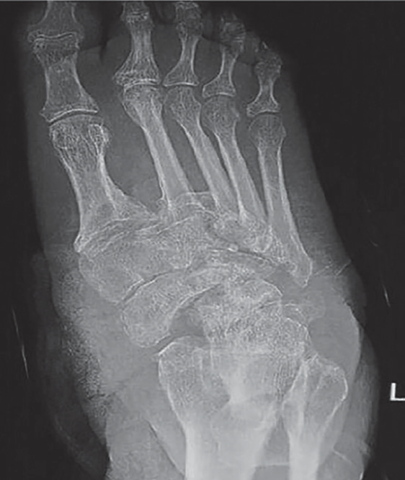
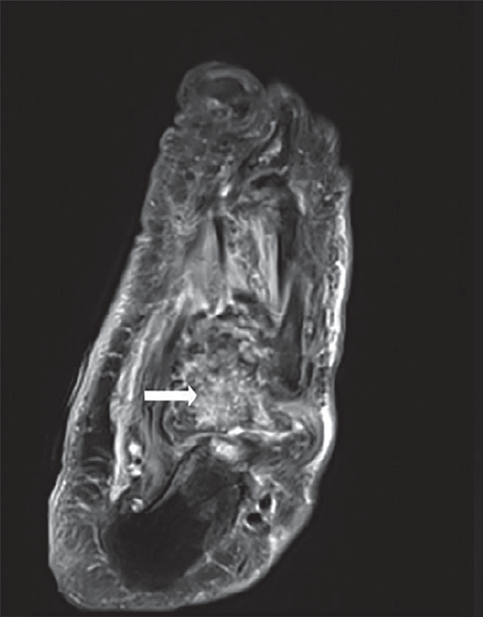
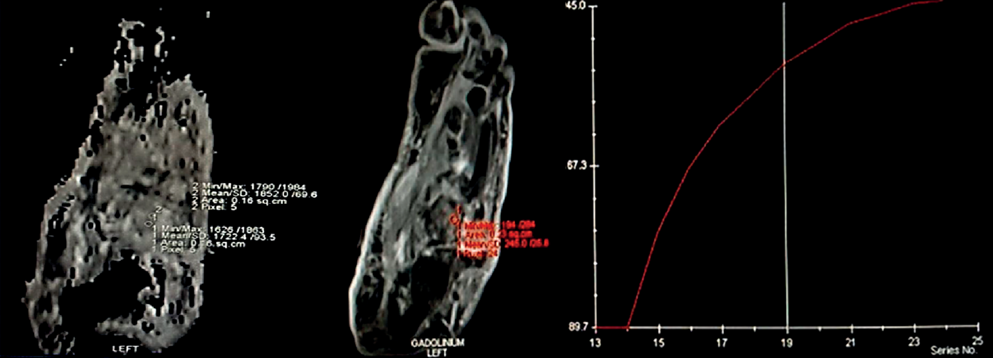
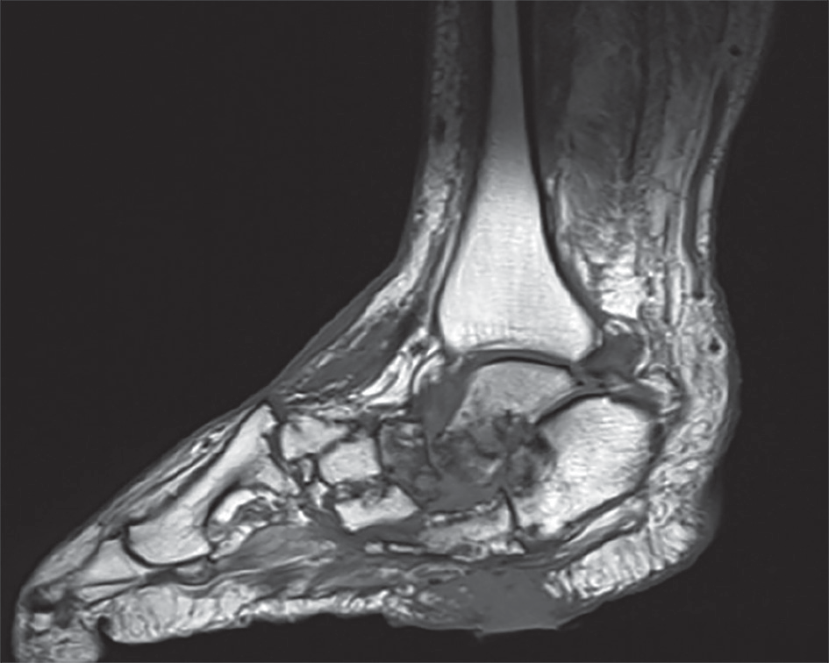
The role of DWI and DCE-MRI for the diagnosis of diabetic foot osteomyelitis
C
A
B
E
D
Figure 2. A 57-year-old male patient presented with chronic ulceration on the ventral aspect of the foot involving the hindfoot. The biopsy was done from the suspected site of infection. However, it turned out to be sterile. The patient was managed conservatively and showed improvement on follow-up.
- X-ray AP view shows cortical irregularity and sclerosis involving the bones of the mid and hindfoot along with associated intertarsal joint irregularities.
- Axial T2 fat sat image shows heterogeneously increased T2 signal involving multiple bones of the midfoot predominantly involving the cuboid (white arrow) along with bony irregularity, irregular joint spaces, and altered bony alignment. C) Sagittal T1 image showing altered bony signal and ulcer on the ventral aspect of the foot. D) ADC map shows ADC value of 1.7 × 10-3 mm2/s with ROI drawn in the cuboid bone. E) Dynamic curve analysis reveals type 1 curve. SImax – 245.0, SI0 – 89.7
likely due to greater inflammatory cells and hyperaemia
secondary to infection. Conversely, SIrel was not found to be different amongst biopsy-positive or -negative cases in the present study. SIrel indirectly gives information about the microvessel density (MVD) and perfusion normalized to cardiac output. It may be presumed that there is no sig- nificant difference in the MVD between the 2 groups, and increased inflammatory mediators in DFO predominantly cause more severe vasodilation and increased permeability without having a significant effect on MVD.
The time-intensity curves were also plotted over time af- ter contrast administration. All the DFO-negative cases dem- onstrated a type I curve (Figure 2), which indicated gradual progressive enhancement; whereas, 94.1% of the positive cases showed a type II curve. We observed that the MRI parameters did not depend on the type of bone involved. There was no significant difference between the DWI and DCE-MRI parameters obtained from tarsals or metatarsals. Non-contrast diffusion-weighted parameters like ADC, which depend upon the diffusivity of the water molecules between the intracellular and extracellular compartment, have been explored to identify malignant and infectious
conditions [10,11,21-24]. It was observed that there is dif-
fusion restriction in the infected area, as also observed in the current study. The biopsy-proven positive cases of DFO showed significantly more diffusion restriction and lower ADC values as compared to the biopsy-negative cases. The ADC value below 1.57 × 10-3 mm2/s had a sensitivity of 88.2% and specificity of 80% for diagnosing bone in- fection. Razek et al. determined an ADC value of 1.04
× 10-3 mm2/s, which had a sensitivity of 93% and speci-
ficity of 96% for DFO [10]. Another study showed lower ADC values (0.75 × 10-3 mm2/s) in the infected bone com- pared to normal bone (1.15 × 10-3 mm2/s) or surrounding soft tissue (0.90 × 10-3 mm2/s) [11]. Both of these studies were performed on 1.5-T machines with slightly different parameters. This could be the reason for the absolute dif- ference in the ADC values from our study. The increased cellularity attributed to inflammatory cells, pus cells, and dead organisms in addition to the cellular swelling, which narrows the extracellular space in infectious areas, reduce the diffusivity and the ADC values.
There are some limitations to this study, including the utilization of semi-quantitative variables. These variables
© Pol J Radiol 2022; 87: e274-e280
e279

Shashank Raj, Mahesh Prakash, Ashu Rastogi et al.
are sensitive to variations between different acquisition
protocols and various other factors like hardware settings, the amount of contrast injected, contrast agent proper- ties, etc. Nevertheless, the semi-quantitative analysis of the DCE-MRI is straightforward, unlike compartmen- tal or quantitative analysis, which is complex and time- consuming. Secondly, the values of the MRI parameters assessed in the present study should be compared to those of isotope studies, which are currently extensively used to diagnose pedal osteomyelitis. A multicentre study with larger sample size is required to assess the role of DCE- MRI to reliably distinguish between the various causes of an acute swollen foot in a diabetic patient.
Conclusions
Non-contrast diffusion-weighted sequences help to in-
crease the overall specificity of conventional MRI for the diagnosis of pedal osteomyelitis. It is specifically beneficial in this population of patients who commonly have asso- ciated deranged renal parameters. The dynamic contrast enhancement parameters SI0, SImax, WIR, and type of curve also help in the detection of DFO, with WIR and type II curve being most advantageous for diagnosing osteomy- elitis. It can help in increasing the overall sensitivity and specificity of MRI in differentiating DFO from acute Char- cot arthropathy, thus alleviating the diagnostic dilemma.
Conflicts of interest
The authors report no conflict of interest.
- Unger E, Moldofsky P, Gatenby R, et al. Diagnosis of osteomyelitis
by MR imaging. AJR Am J Roentgenol 1988; 150: 605-610.
- Collins MS, Schaar MM, Wenger DE, et al. T1-weighted MRI charac- teristics of pedal osteomyelitis. AJR Am J Roentgenol 2005; 185: 386-393.
- Pugmire BS, Shailam R, Gee MS. Role of MRI in the diagnosis and treatment of osteomyelitis in pediatric patients. World J Radiol 2014; 6: 530-537.
- Morrison WB, Schweitzer ME, Bock GW, et al. Diagnosis of osteo- myelitis: utility of fat-suppressed contrast-enhanced MR imaging. Radiology 1993; 189: 251-257.
- Moore TE, Yuh WT, Kathol MH, et al. Abnormalities of the foot in patients with diabetes mellitus: findings on MR imaging. AJR Am J Roentgenol 1991; 157: 813-816.
- Ledermann HP, Morrison WB, Schweitzer ME. Pedal abscesses in patients suspected of having pedal osteomyelitis: analysis with MR imaging. Radiology 2002; 224: 649-655.
- Johnson PW, Collins MS, Wenger DE. Diagnostic utility of T1-weight- ed MRI characteristics in evaluation of osteomyelitis of the foot. Am J Roentgenol 2009; 192: 96-100.
- Howe BM, Wenger DE, Mandrekar J, et al. T1-weighted MRI imag- ing features of pathologically proven non-pedal osteomyelitis. Acad Radiol 2013; 20: 108-114.
- Duryea D, Bernard S, Flemming D, Walker E, French C. Outcomes in diabetic foot ulcer patients with isolated T2 marrow signal abnor- mality in the underlying bone: should the diagnosis of “osteitis” be changed to “early osteomyelitis”? Skeletal Radiol 2017; 46: 1327-1333.
- Subhawong TK, Jacobs MA, Fayad LM. Diffusion-weighted MR imaging for characterizing musculoskeletal lesions. Radiographics 2014; 34: 1163-1177.
- Pui MH, Mitha A, Rae WI, et al. Diffusion-weighted magnetic reso- nance imaging of spinal infection and malignancy. J Neuroimaging 2005; 15: 164-170.
- Herneth AM, Friedrich K, Weidekamm C, et al. Diffusion weighted imaging of bone marrow pathologies. Eur J Radiol 2005; 55: 74-83.
- Chan JH, Peh WC, Tsui EY, et al. Acute vertebral body compression
fractures: discrimination between benign and malignant causes us- ing apparent diffusion coefficients. Br J Radiol 2002; 75: 207-214.
References
- Donovan A, Schweitzer ME. Use of MR imaging in diagnosing dia-
betes-related pedal osteomyelitis. Radiographics 2010; 30: 723-736.
- Leone A, Cassar-Pullicino VN, Semprini A, et al. Neuropathic os- teoarthropathy with and without superimposed osteomyelitis in patients with a diabetic foot. Skeletal Radiol 2016; 45: 735-754.
- Shults DW, Hunter GC, McIntyre KE, et al. Value of radiographs and bone scans in determining the need for therapy in diabetic patients with foot ulcers. Am J Surg 1989; 158: 525-529; discussion 9-30.
- Short DJ, Zgonis T. Medical imaging in differentiating the diabetic Charcot foot from osteomyelitis. Clin Podiatr Med Surg 2017; 34: 9-14.
- Ledermann HP, Morrison WB, Schweitzer ME. MR image analysis of pedal osteomyelitis: distribution, patterns of spread, and frequen- cy of associated ulceration and septic arthritis. Radiology 2002; 223: 747-755.
- Marcus CD, Ladam-Marcus VJ, Leone J, et al. MR imaging of osteo- myelitis and neuropathic osteoarthropathy in the feet of diabetics. Radiographics 1996; 16: 1337-1348.
- Ertugrul MB, Baktiroglu S, Salman S, et al. The diagnosis of osteo- myelitis of the foot in diabetes: microbiological examination vs. mag- netic resonance imaging and labelled leucocyte scanning. Diabet Med 2006; 23: 649-653.
- Censullo A, Vijayan T. Using nuclear medicine imaging wisely in diagnosing infectious diseases. Open Forum Infect Dis 2017; 4: ofx011.
- Rastogi A, Bhattacharya A, Prakash M, et al. Utility of PET/CT with fluorine-18-fluorodeoxyglucose-labeled autologous leukocytes for diagnosing diabetic foot osteomyelitis in patients with Charcot’s neuroarthropathy. Nucl Med Commun 2016; 37: 1253-1259.
- Abdel Razek AAK, Samir S. Diagnostic performance of diffu- sion-weighted MR imaging in differentiation of diabetic osteoar- thropathy and osteomyelitis in diabetic foot. Eur J Radiol 2017; 89: 221-225.
- Eren MA, Karakas E, Torun AN, et al. The clinical value of diffu- sion-weighted magnetic resonance imaging in diabetic foot infec-
tion. J Am Podiatr Med Assoc 2019; 109: 277-281.
e280
© Pol J Radiol 2022; 87: e274-e280

