

Splenic melanosis in agouti and black mice*

Dominika Michalczyk-Wetula, Justyna Wieczorek and Przemysław M. Płonka*
Department of Biophysics, Faculty of Biochemistry, Biophysics and Biotechnology, Jagiellonian University, Kraków, Poland
An interesting example of extradermal deposition of
melanin in vertebrates, notably in mammals, is splenic
melanosis. In particular, if the phenomenon of splenic
melanosis is correlated with hair or skin pigmentation,
it must reflect the amount and perhaps the quality of
pigment produced in hair follicle melanocytes. The pre-
sent paper is our first study on splenic pigmentation in
mice of phenotype agouti. We used untreated mixed
background mice C57BL/6;129/SvJ (black — a/a, agou-
ti — A/a, A/A), and as a control — black C57BL/6 and
agouti fur from 129/SvJ mice, Mongolian gerbils (Meri-
ones unguiculatus) and golden hamsters (Mesocricetus
auratus). After euthanasia skin and spleen was evaluated
macroscopically, photographed and collected for further
analysis using Fontana-Masson and hematoxylin-eosin
staining and electron paramagnetic resonance (EPR) at
X-band. Spleens of the agouti mice revealed splenic mel-
anosis but were slightly weaker pigmented than their
black counterparts, while the presence of pheomelanin
was difficult to determine. The fur of both phenotypes
was of similar melanin content, with the same tendency
as in the spleens. The contribution of pheomelanin in
the agouti fur was on the border of detectability by EPR.
Histological and EPR analysis confirmed the presence of
melanin in the melanotic spleens. The shape of the EPR
signal showed a dominance of eumelanin in fur and in
melanized spleens in both phenotypes of mice. There-
fore, splenic melanosis does reflect the hair follicle pig-
mentation not only in black, but also in agouti mice.
Key words: agouti, EPR, hair cycle, melanin, spleen
Received: 13 April, 2015; revised: 05 May, 2015; accepted: 21 May,
2015; available on-line: 20 August, 2015
INTRODUCTION
From the point of view of contemporary biochemistry
melanin is a very interesting biopolymer — it is produced
by polymerization of amino acids or their derivatives, it
reveals a very complicated and so far not well under-
stood micro- and mesoscopic structure (Meredith & Sar-
na, 2006), yet there is no information about the primary
structure (sequence of amino acids) of melanin coded in
the genomes of melanin-producing organisms. Obvious-
ly, and unlike proteins, there is no RNA for melanin in
the transcryptome, as melanin is synthesized beyond the
translation-related pathway of synthesis of proteins. Con-
sequently, while still being a close relative of proteins, it
reserves a very special place in the metabolome, close to,
but apart from the proteome.
Despite this unique position, there are many melano-
genesis-related genes, which encode mainly the responsi-
ble enzymes, their transcription factors (e.g. microphthal-
mia transcription factor — MiTF; Vachtenheim & Boro-
vansky, 2010), and proteins which regulate the structure
and functioning of melanosomes (Slominski et al, 2004,
2005b, Schallreuter et al, 2008). Therefore, the melanin
functions are indirectly encoded in the genome. Among
them the most important is their function as a pigment
responsible for coloration of the body (skin and its ap-
pendages), camouflage and signaling (Wood et al, 1999;
Plonka et al., 2009). And despite the majority of the mel-
anogenesis-related reactions running non-enzymatically
(Land et al, 2004), the body coloration still depends on
many genes (in mice their number is estimated at more
than 150 alleles encrypted in over 90 loci; Slominski et
al, 2005b).
Agouti protein is an antagonist and a reverse-agonist
of the melanocyte-stimulating hormone (MSH) recep-
tor type 1 (MC1R) (Ollmann et al, 1998). Its binding
to the receptor strongly inhibits the process of melanin
synthesis (Slominski et al, 2004, 2005b), and most prob-
ably switches it on pheomelanogenesis (Oyehaug et al,
2002). As a consequence, if acting periodically in a hair
follicle (secreted by the dermal papilla fibroblasts, Mil-
liar et al., 1995), it causes a typical “band” coloration of
the hair shaft and a cryptic coloration of the whole hair
coat called “agouti” (Sakurai et al, 1975). The “agouti”
phenotype is commonly called the “wild” phenotype of
the coloration (Oyehaug et al 2002, Slominski et al, 2004,
2005b).
Splenic melanosis discovered in black C57BL/6 mice
(Weissman, 1967), and so far attributed almost exclu-
sively to the black mice (Linden et al, 2012) is an in-
triguing phenomenon related to the mammalian melano-
genesis (van der Heijden et al, 1995). It is probably a
manifestation of extradermal melanogenesis observed in
visceral organs of various vertebrates (Zieri et al, 2015).
We have suggested that in mice it may be somehow re-
lated to the skin melanogenesis and hair cycling (Plonka
et al., 2005; Michalczyk et al., 2009; Michalczyk-Wetula et
al, 2013). Perhaps a part of melanin synthesized in the
follicular melanocytes is transferred to the spleen, where
e-mail: przemyslaw.plonka@uj.edu.pl
*Preliminary report of this work was presented by J.W. at 42nd Win-
ter School of the Faculty of Biochemistry, Biophysics and Biotech-
nology of the Jagiellonian University "From Genome to Proteome”
February 10-14, 2015, Zakopane, Poland
Abbreviations: 129/SvJ, inbred mouse strain developed from
129 strains by LC Stevens, originating from the Jackson Labora-
tory's Colony; AHP, aminohydroxyphenylalanine; C57BL/6, Cross
57th-generation female x 52nd-genertion male black, 6th sub-
strain (inbred mouse strain); dopa, 3,4-dihydroxyphenylalanine;
DPPH, 1,1-diphenyl-2-picrylhydrazyl; EPR, electron paramagnetic
resonance; ESR, electron spin resonance; FM, Fontana-Masson; HE,
hematoxylin and eosin; MC1R, melanocyte-stimulating hormone
receptor type 1; MiTF, microphthalmia transcription factor; MSH,
melanocyte-stimulating hormone; PTCA, pyrrole-2,3,5-tricarboxylic
acid
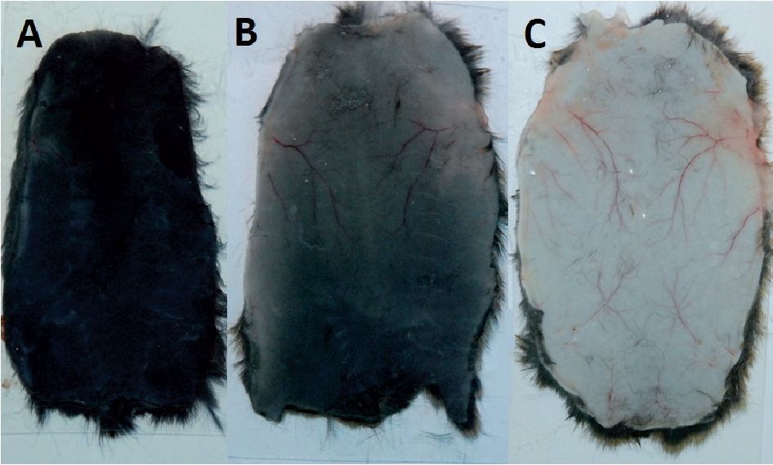
458
D. Michalczyk-Wetula and others
2015
it may undergo a slow degradation. Interestingly, black
mice reveal genotype a/a in locus agouti, and do not pro-
duce agouti protein (Bultman et aL, 1991; Slominski et aL,
2005a).
We have shown that in C57BL/6 mice the degree of
melanosis depends on the age of mice (Michalczyk et aL,
2009), and that in the young mice (below 6 months of
life) it is synchronized with the hair cycle (Plonka et al,
2005; Michalczyk-Wetula et al., 2013). The hair cycle is a
very interesting physiological phenomenon of a periodi-
cal remodeling of tissues producing the hair shaft along
with its pigments, which in young mice reveals a wave-
like, locally synchronized character (Dry 1926; Chase &
Eaton, 1959). It is regulated with a strong support from
the immunological system (Paus et al., 1999), thus it is
not surprising that the actual state of the spleen and the
actual stage of the hair cycle are interdependent (Slomin-
ski et al., 1997). Further study on the relation between
spleen, hair cycle and the immune system may reveal
new facts on the systemic effects of hair growth. Among
them, the splenic melanosis remains an important target
for the research.
So far, almost all the studies concerned black mice.
While only in one case the authors checked other phe-
notypes, which were reported almost exclusively not to
manifest splenic melanosis (Crichton et al., 1978), there
exists a general claim that the phenomenon is typical of
black mice (Linden et al., 2012). The intricate activity of
agouti protein and the related regulators towards various
types of MSH receptors in the central nervous system
are manifested by systemic effects, such as obesity or di-
abetes (Kaelin et al., 2008). Therefore, to determine other
systemic effects of the agouti protein it is important to
learn whether the phenomenon of splenic melanosis de-
pends on the genotype in locus agouti. If it is the case,
it will confirm the hair pigmentation-dependent charac-
ter of splenic melanosis. In the present paper we have
analyzed splenic melanosis in the mice revealing the wild
phenotype, therefore of A/a or A/A genotype in locus
agouti, and we compare the amount and quality of splenic
melanin to the black mice of a/a genotype.

MATERIAL AND METHODS
Animals. C57BL/6;129/SvJ mixed background mice
(Linder, 2003) with two phenotypes of fur color —
black (locus agouti genotype a/a) and agouti (locus agouti
genotype A/a and A/A) (Threadgill et al., 1997), in the
age of 1—107 weeks, males and females were obtained
from the local animal breeding facility of the Faculty of
Biochemistry, Biophysics, and Biotechnology of the Jag-
iellonian University. All the mice were untreated, came
from the breeding herd, and were not used for further
reproduction. Mice were housed under conventional
conditions in community cages and 12 h day/night re-
gime with continuous access to food — standard labora-
tory rodent chow (Labofeed B provided by Morawski,
Kcynia, Poland) and drinking water. The animals were
handled with full respect to the ethical and legal stand-
ards and rules being in force during the observations.
The mice were weighed, euthanized (cervical disloca-
tion in a deep anesthesia, xylazine — Sedazin®, Biowet
Puławy Sp. z o.o. Puławy, Poland, and ketamine — Ve-
taKetam®, VetAgro, Lublin, Poland) whereupon the bio-
logical material was evaluated, photographed and collect-
ed. Biological material was harvested over almost four
years (2007-2010).
Agouti fur of Mongolian gerbils Meriones unguiculatus
(Milne-Edwards, 1867) and golden hamsters Mesocricetus
auratus (Waterhouse, 1839), and of the 129/SvJ agouti
mice came from the local collection of furs of the De-
partment of Biophysics, Kraków, Poland (see Plonka et
al., 2003; Slominski et al., 2005a; 2005b; Plonka 2009).
Analysis of spleen. The harvested spleens were pho-
tographed with a Nikon digital camera D80 equipped
with Nikkor 18-70mm 1:3,5-4,5G ED AF-S DX lenses
(Nikon DX SWM ED IF Asphencal ^67) (Nikon Cor-
poration, Tokyo, Japan), weighed and carefully examined
for macroscopic evidence of melanosis. If melanin was
present, the area of melanosis was estimated as a per-
centage of the total spleen area. In the end of the ob-
servations the percentage of melanotic spleens per a giv-
en experimental group of mice was calculated. Selected
spleens were fixed in buffered 5% formalin (phosphate
buffer, pH = 7.4) and embedded in paraffin for histo-
logical analysis. The fixed spleens were cut into 5 gm
slices and stained with hematoxylin and eosin (HE) and
according to Fontana-Masson (FM) procedure for mela-
nin. Images of stained tissues were taken by a reverse
Eclipse Ti microscope (Nikon) equipped with the Nis
elements F 3.0 imaging software (Nikon). For details see
Michalczyk-Wetula et al., 2013. Another part of spleens
selected randomly from the group with melanosis was
analysed by EPR spectroscopy.
Analysis of skin and fur. After euthanasia the back
skin of each animal was separated on the level of sub-
cutis, cut out, spread on a piece of transparent foil and
photographed from the subcutis side using the Nikon
digital camera D80 (see above). The important point is
to keep the fur coat dry during photographing, because
wet fur adheres to the upper skin surface and strongly
affects its coloration seen from below. We found it to
be a convenient way of a rough distinguishing between
the whole back skin in telogen, in anagen and the skin
in parts in various stages of the hair cycle, on the base
of the back skin color from below (see Fig. 1). Next the
skin was fixed in buffered 5% formalin (phosphate buff-
er, pH = 7.4). A part of black and agouti animals were
shaved and the fur was collected for electron paramag-
netic (spin) resonance (EPR, ESR) analysis.
Model substances. A powder sample of dopa mela-
nin and cysteinyldopa melanin served as a standard to
compare the EPR spectra of eu- and pheomelanin, re-
spectively. For details see Wolnicka-Glubisz et al., 2012.
EPR analysis. EPR spectra of melanins in spleens
and fur were recorded by an E-3 spectrometer (Varian,
Sunnyvale, LA, USA) in a Wilmad finger quartz Dewar
WG-816-B (Rototec-Spintec GmbH, Griesheim, Germa-
Figure 1. Mice back skin photographed from below.
100% anagen 6 (A), during anagen-catagen-telogen transition (B),
100% telogen (C).
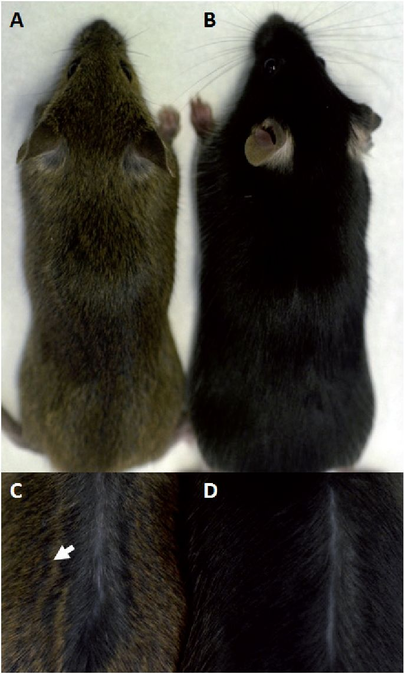
Vol. 62
Splenic melanosis in agouti mice
459
ny), in liquid nitrogen (77 K) or at ambient temperature
(fur, quantitative comparison) at X-band (ca. 9.2 GHz),
1 mW microwave power, 5 (synthetic melanin) or 10 Gs
modulation amplitude, receiver gain 5 x 103—2x10‘3, 300 s
scan time and 0.3 s time constant. For qualitative analy-
sis, to avoid signal distorsion, we used modulation am-
plitude 0.5—1 Gs and microwave power 0.5 mW. Each
spectrum of spleen was averaged 10 times, otherwise
the gain and averaging were adjusted to particular needs.
The fur samples weighed 20 (quantitative measurements)
or 30 (qualitative measurements) ± 1 mg, and the pow-
der melanin samples — 8.2 ± 0.1 mg. For quantitative
comparisons the amplitudes or integral intensities of sig-
nals were standardized per the same receiver gain. The
signals of spleens were not standardized per constant
mass, so their intensities (expressed as the EPR signal
amplitudes) directly represent the absolute amount of
melanin in the spleen.
Statistical evaluation of the data. Altogether we
evaluated 884 mice (193 with black and 691 with agouti
fur). As the breeding herd was primarily used for other
purposes, the number of mice per a given time point
(weeks after birth) was difficult to keep constant and
to predict in the described study (1—20 black, and 1—63
agouti mice per a time period, on average about 6 black
and 24 agouti mice per a time point). For the same rea-
son, as well as because of the “yes-or-no” character of
splenic melanosis, we were unable to systematically com-
pare the melanization at every week post birth using sta-
tistic tools. In this case we were, however, able to show
the linear trend lines for changing the percentage of
melanotic spleens, and for changing the average area of
melanosis in the melanotic spleens, with time. To exhibit
the pooled results of the average area of melanosis we
used the whole population of melanotic spleens (n=38
for black and 83 for agouti mice). For the quantitative
EPR comparisons we used n=15 spleens for black and
n=15 for agouti mice (randomly selected from the group
of the strongest pigmentation), n=4 samples of 129/SvJ
agouti and n=8 of C57BL/6 black mice fur. We test-
ed the statistical significance of the differences between
variances with the F Snedecor test whereupon — the
significance of the differences between the mean values
with the independent, two-tail Student’s ¿-test for groups
of equal or non-equal variances.
RESULTS AND DISCUSSION
Spleens of agouti mice are melanotic
In our previous works we suggested that the phenom-
enon of splenic melanosis in mice is a reflex of mel-
anogenesis in the skin (Plonka et al, 2005, Michalczyk
et al, 2009, Michalczyk-Wetula et al, 2013). In mice, the
skin melanin production is almost exclusively limited to
the anagen hair follicles (Chase, 1955; Slominski & Paus
1993; Slominski et al., 1994). Consequently, if there ex-
ists such a correlation, it must be somehow coupled
with the hair cycle and hair pigmentation. And indeed,
we have found that the efficiency of splenic melanosis
in C57BL/6 mice is depended on normal, depilation-
induced, and dystrophic hair cycle (Michalczyk-Wetula et
al., 2013), and limited to the time period when the type
of hair cycling is wave-like (i.e. ca. the first 6 months
of life; Michalczyk et al, 2009). The differences in bio-
physical properties of melanin may suggest that the
splenic pigment is heterogeneous and in general — more
degraded that the one in the hair shafts (Plonka et al.,
Figure 2. C57BL/6;129/SvJ mixed background mice with agouti
(A) and black (B) fur color phenotype. The yellow "band" (ar-
row) close to the black tip of the hair shafts becomes visible af-
ter parting the agouti (C), but not black (D) back hair.
2005). Perhaps, spleen is the organ of ultimate melanin
deposition and/or utilization or recycling.
Here we have found that the same phenomenon ex-
ists in the mice revealing the agouti phenotype. The mice
in Fig. 2 possess the typical agouti fur coat (Fig. 2A),
which is apparently brighter from the black phenotype
(Fig. 2B), due to a break in the intensive eumelanogen-
esis which in black mice maintains its intensity during
the whole anagen 6 (Plonka et al., 1995). This break is
not a period totally devoid of melanogenesis, as then
pheomelanogenesis dominates over eumelanogenesis,
which results in a yellow “band” close to the black tip
of the hair shaft (compare Fig. 2C and D; Sakurai et al.,
1975; Oyehaug et al., 2002; Slominski et al., 2005a).
The pictures in Fig. 3 represent the spleens derived
from agouti (Fig. 3A, B) and black (Fig. 3C) mice. The
respective histological sections (FM and HE staining) are
shown in Fig. 3D—IK This panel shows that the phe-
nomenon in both phenotypes possesses a “yes-or-no”
character, which has been many times reported before
for black mice (Weissman, 1967; Plonka et al., 2005;
Michalczyk et al., 2009; Michalczyk-Wetula et al., 2013). It
also reveals that from the histological point of view, the
phenomenon manifests itself similarly in the both mice
phenotypes.
EPR characteristics of melanotic spleens of agouti and
black mice
Figure 4 represents the X-band EPR spectra of the
analyzed materials. All of them revealed a singlet signal
around g=2.004 which indicates a free radical-like para-
magnetism typical of melanins (Commoner et al., 1954;
Meredith & Sarna, 2006; Plonka, 2009). Pheomelanins
are known for revealing the 14N hyperfine splitting, as a
consequence of semiquinonimine-like paramagnetic cen-
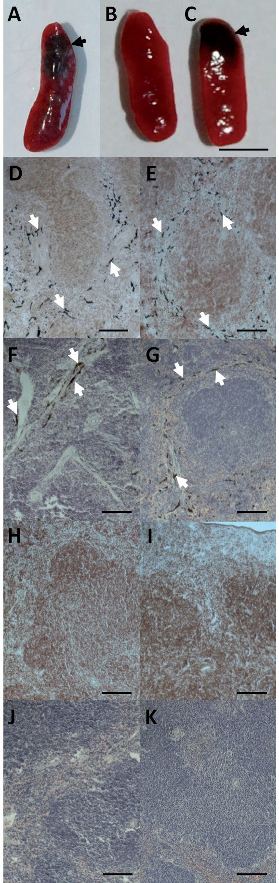
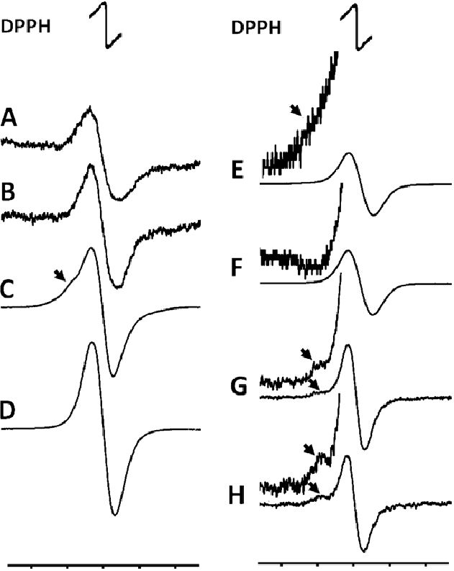
460
D. Michalczyk-Wetula and others
2015
Figure 3. Macroscopic demonstration of representative melano-
sis (arrows) in spleens of agouti (A) and black (C) C57BL/6;129/
SvJ mixed background mice.
Some spleens in both groups were not pigmented (B). Histologi-
cal manifestation of splenic melanosis in agouti (D, F), and black
(E, G) C57BL/6;129/SvJ mixed background mice, and lack of mela-
nin in spleens without melanosis in agouti (H, J), and black (I, K)
mice. F, G, J, K — HE staining, D, E, H, I — FM staining. White ar-
rows — melanin (D-G) in the melanotic (A, C) regions. Scale bars
— 0.5 cm (A-C), 100 pm (D-K).
tres present in this polymer of benzothiazine-derivatives
(Fig. 4C). Eumelanins do not contain nitrogen in the vi-
cinity of unpaired electrons (the semiquinone-like para-
magnetic centres), which results in the lack of the hy-
perfine splitting of the EPR signal (Fig. 4D) (Sealy et al.,
1982). There are also other differences in the spectro-
scopic properties of the pigments (pheomelanin reveals
a slightly wider signal and the g-value is slightly moved
towards higher values; Sealy et al, 1982; Slominski et al,
2005a; Chikvaidze et al., 2014) but the hyperfine splitting
is the most direct and easy to note feature of the EPR
signal, characteristic for pheomelanins (see Fig. 4C, E,
G, H). It must also be emphasized that the natural pig-
ments usually are co-polymers of eu- and pheomelanin,
and they often contain only admixture of pheomelanin-
like centres (Ito & Fujita, 1985). However, such admix-
ture, if big enough, can be detected with EPR as a peak
on the low-field side of the singlet (Vsevolodov et al.,
3270 3280 3290 3300 3310 3270 3280 3290 3300 3310
Magnetic Field [Gs] Magnetic Field [Gs]
Figure 4. Representative EPR spectra of melanotic spleens, fur
and synthetic pigments.
(A, B) melanized spleens of agouti (A) and black mice (B),
cysteinyldopa (C), and dopa melanin (D) powder samples, agouti
(E), and black (F) mice fur, agouti hamster fur (G), and agou-
ti gerbil fur (F). DPPH — the free radical standard signal. The
pheomelanin component of the signals (arrow) was detectable
only under high receiver gain (E-H — insets). The spectra were
analyzed at 77 K, at X-band (9.28 GHz), and variable receiver
gain: 2 x 106 (A, B), 5 x 104 (C), 1 x 104 (D-F), 4 x 105 (G, H); insets:
1.5 x 105 (E) and 1.5 x 106 (F-H); other parameters — see "Material
and Methods”.
1992; Hill et al, 1997; Plonka et al, 2003; Slominski et al,
2005b; Wolnicka-Glubisz et al, 2012).
The best method to detect and measure the content
of eu- and pheomelanin-like constituents of a biologi-
cal samples is based on the degradation of the mate-
rial and detection of AHP (aminohydroxyphenylalanine)
and PTCA (pyrrole-2,3,5-tricarboxylic acid) by HPLC
(Ito & Fujita, 1985). This method, however, reveals its
limitations, though it has been shown to well correlate
with EPR (Vsevolodov et al, 1991). EPR is easy to use
when a big number of samples is studied, and it has
turned out particularly suitable to measure melanins in
hair (Ozeki et al, 1995; Plonka 2009; Chikvaidze et al,
2014). In the case of pre-domination of eumelanin, the
strong singlet may mask the weak hyperfine features of
the pheomelanin signal (Vsevolodov et al., 1991, Plon-
ka 2009). But neither of the method is able to answer
whether the material contains a co-polymer, or is just
a mosaic of regions containing different proportions of
eu-/and pheomelanin.
Material derived of agouti mice contains low
contribution of pheomelanin
In our materials a clear contribution of pheomelanin
could be detected only in the agouti fur of golden ham-
sters and Mongolian gerbils (Fig. 4G, H). In the back
fur of the agouti mice only a trace of pheomelanin could
be found in some samples (cf. Fig. 4E — inset), which
reveals that the contribution of pheomelanin must be
very low, however, higher than in the black murine fur
(Fig. 4F). The same tendency is visible in the line widths
(4.79 ± 0.07 Gs for black and 4.80 ± 0.08 Gs for agouti
mice). This stays in agreement with the data obtained
from the same material analyzed by HPLC preceded by
chemical degradation (Ozeki et al., 1995; 1996; Ito &
Wakamatsu, 2003).
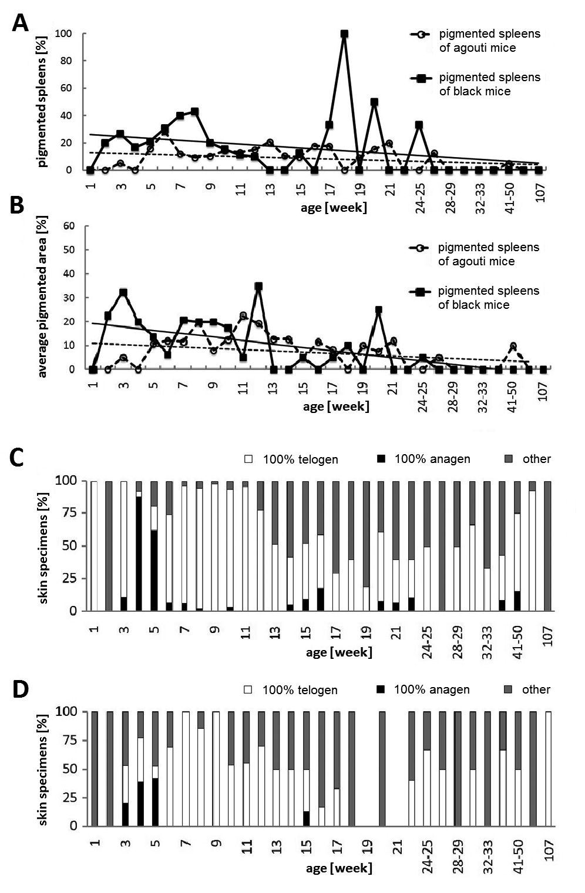
Vol. 62
Splenic melanosis in agouti mice
461
The quality of the splenic melanin does not allow for
an unequivocal statement that it does contain pheomela-
nin (Fig. 4A). The intensity of the splenic signals is in
general low even in the black animals (Fig. 4B). Because
of other free radical signals resulting from the mito-
chondrial oxygen metabolism of the tissue (Davies &
Hochstein, 1982; Elas et al, 2008), or originating from
blood infiltrating the spleen (Kubiak et al, 2013) and
overlapping the melanin signal, the exact EPR measure-
ment of splenic melanosis contains a considerable error.
For this reason we expressed the splenic EPR signal in-
tensity as the peak-to-peak amplitude, and we resigned
from comparing the linewidths. While in some samples
of spleens a trace of a low-field peak could be detected,
the amelanotic spleens also revealed a wide and weak
EPR signal (Michalczyk-Wetula et al, 2013; here — not
shown), therefore the only conclusion that can be driven
from the EPR results is that the melanotic spleens from
the agouti mice tend to reveal a weaker EPR signal than
the ones of black mice. This, however, quantitatively
correlates well with the results of the EPR measure-
ments of fur.

Spleens of agouti mice tend to be weaker pigmented
than of black mice
Figure 5 contains the pooled results of the long-term
observations of splenic melanosis in agouti and black an-
imals. We have measured the percentage of macroscopi-
cally pigmented spleens in various experimental groups
(these were particular groups of animals of similar age
which were selected not to be bred any more). We were
also able to estimate the pigmented area of each mel-
anotic spleen (see Plonka et al, 2005; Michalczyk et al,
2009; Michalczyk-Wetula et al, 2013).
Both the percentage of the melanotic spleens and
the average area of pigmented spots tended to be
lower in the agouti mice (Fig. 5A, B — the lines of
trend. Note that in the beginning, i.e. for young mice,
the trend for agouti mice starts at the half of the ini-
tial value for the black mice — Fig. 5A). This cor-
relates with the pooled quantitative data from spleens
and fur (Fig. 6A—C), including the results of EPR
measurements of spleens (Fig. 6B). Taking into con-
sideration the age of animals, we have checked the
splenic index and the absolute weights of the mice
and the spleens. The splenic melanosis did not af-
fect the spleen weight, nor the splenic index in any
of the mice phenotypes (not shown). We also did not
observe any difference between the average mass or
splenic index between the age-matched mice of vari-
ous fur phenotypes (not shown). Therefore, we decid-
ed not to standardize the EPR signal amplitudes per
a stable mass of spleens, and our quantitative results
represent the total amount of melanin in a spleen.
We also calculated the total percentage of pigmented
spleens in agouti (12%) and in black mice (19.7%). Such
comparison is only in part useful, because starting from
ca. 20th-25th week of life, the spleens become amelanotic
(Fig. 5A,B); but the tendency is preserved anyway.
We expected a stronger difference in pigmentation
of the materials delivered from the agouti and black
mice, but the objective, physical method — EPR, de-
spite apparently brighter superficial coloration of the
fur coat (Fig. 2), unexpectedly revealed that the agouti
fur of mice contains only insignificantly lower amount
of melanin than the black fur. The same observation
was made with HPLC/chemical degradation method
(Ozeki et al., 1995; 1996; Ito & Wakamatsu 2003). The
Figure 5. Pigmentation of spleens on subsequent weeks of life,
and the corresponding stage of hair cycle in the back skin in
agouti and black mice.
(A) percentage of melanotic spleens in a given age group. (B) cor-
responding average area of melanosis in the melanotic spleens.
(C, D) percentage of mice with the whole back skin in anagen VI,
whole back skin in telogen, or with the back skin in various stages
of the hair cycle (anagen-catagen or telogen-anagen transition or
black spots in telogen skin), in agouti (C) or black mice (D). Open
circles and dashed line — agouti, solid squares and solid line —
black mice. The linear trend lines are also shown.
actual bright band is maintained only near to the sur-
face of the fur coat, while the deeper parts of the hair
remain black. This can be seen when parting delicately
the hair until the skin is visible (see Fig. 2C). If this
tendency is preserved also for spleens, only long-time
observations would make us possible to catch the
weak difference in pigmentation between agouti- and
black-mice-derived spleens (Fig. 5A, B — the lines of
trends).
We were not able to find any statistical significance
between the average pigmentation of agouti and black
mice, their spleens nor fur. However, the data obtained
by several independent methods and observables, based
on different physical rationales, and the trends, reveal
the same tendency. Therefore, the results entitle us to
draw the conclusion that the splenic melanosis in agouti
mice is slightly weaker, as compared to the black coun-
terparts. This is another argument for the thesis that the
splenic melanosis correlates well with the fur pigmenta-
tion in mice.
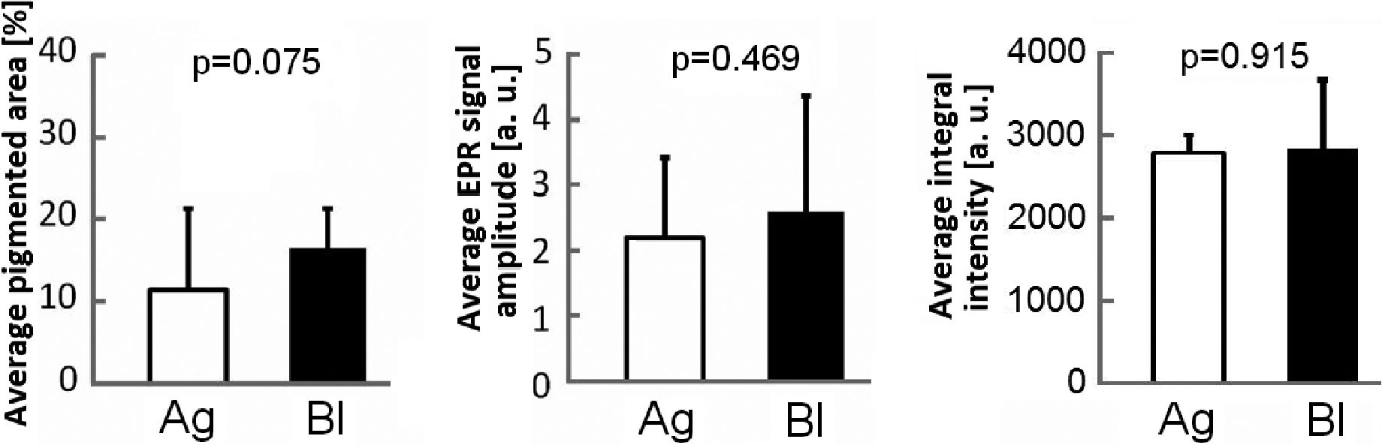
462
D. Michalczyk-Wetula and others
2015

ABC
Figure 6. Pooled results concerning pigmentation.
(A) average area of splenic melanosis, (B) average EPR signal amplitude of spleens, (C) average integral EPR signal intensity of fur. Empty
bars — 129/SvJ agouti mice, solid bars — C57BL/6 black mice. The means of n=38 (black mice ) or n=93 (agouti mice) melanotic spleens
(A), n=15 spleens (each phenotype, spleen EPR signal — B), n=4 (agouti mice) and n=8 (black mice) fur samples (A) ± S.D. (B) receiver
gain — 1 x 106 , (C) receiver gain 1.25 x 104; other details concerning the EPR measurements — see "Material and Methods”.
Correlation of splenic melanosis with hair cycle is
difficult to detect for spontaneous hair cycling
We tried to correlate the splenic melanosis with the
stages of the hair cycle, which we roughly determined
on the base of the bottom surface of the back skin re-
moved from the animals (Fig. 1). This is the first paper
in which we report such mode of determining the area
and the progress of hair cycle in mice. It is very quick,
and allows one to use the skin for other purposes, but
of course, it does not replace the histomorphometry,
which delivers detailed information on the percentage of
hair follicles in a given stage of hair cycle (Michalczyk
et aL, 2009). Nevertheless, we could not find any sharp,
and systematic differences between melanosis of the
mice sacrificed on subsequent weeks after birth (Fig. 5C,
D), as we did previously (Plonka et aL, 2005; Michalc-
zyk-Wetula, 2013). The shape of the curves in Fig 5A, B
were only roughly correlated with each other, and only
in a very general way reflected the previous findings.
This can be, however explained by the fact that here the
spontaneous cycle was investigated in randomly assem-
bled groups of mice (which did not came from the same
nests, as in the paper by Plonka et aL, 2005). In young
mice the mode of hair cycling is wave-like, but the onset
of the subsequent anagen stages is quite random within
some limits (Dry 1926; Chase & Eaton, 1959; Militzer
2001; Plonka et al, 2008).
CONCLUSIONS
Splenic melanosis does appear in the agouti mice, but,
like the fur pigmentation, it is only slightly weaker than
in the black mice. It seems, consequently, to accurately
reflect the hair coat melanization in the both pheno-
types of mice. The agouti phenotype is the basic, cryptic
phenotype of small wild mammals, like rodents, which
serves for them as a perfect camouflage (Wood et aL,
1999). While there are numerous exceptions of this ten-
dency, it seems convincing that the hair pigmentation-
related splenic melanosis is not an exotic peculiarity ob-
served only in some inbred strains of the animals bred in
laboratories, but a phenomenon which must take place
in the wild nature, perhaps on a pan-mammalian scale.
Acknowledgements
The authors are grateful to Professors Joanna Cichy
and Krystyna Urbańska for their kind support, and to
Norbert Wolan for his help at performing EPR meas-
urements. Faculty of Biochemistry, Biophysics and Bio-
technology of Jagiellonian University is a partner of the
Leading National Research Center (KNOW) supported
by the Ministry of Science and Higher Education.
Conflict of Interest
The authors declare no conflict of interest.
REFERENCES
Bultman S, Michaud E, Woychik R (1992) Molecular characterization
of the mouse agouti locus. Cell 71: 1195—1204.
Chikvaidze EN, Partskhaladze TM, Gogoladze TV (2014) Electron
spin resonance (ESR/EPR) of free radicals observed in human red
hair: a new, simple empirical method of determination of pheomela-
nin/eumelanin ratio in hair. Magn Reson Chem 52: 377—382.
Commoner B, Townsend J, Pake GW (1954) Free radicals in biological
materials. Nature 174: 689—691.
Chase HB (1954) Growth of the hair. Physiol Rev 34: 113—126.
Chase HB, Eaton GJ (1959) The growth of hair follicles in waves. Ann
N Y Acad Sci 83: 365-368.
Crichton DN, Busuttil A, Price WH (1978) Splenic lipofuscinosis in
mice. J Pathol 126: 113-120.
Davies KJA, Hochstein P (1982) Ubisemiquinone radicals in liver: im-
plications from a mitochondrial Q cycle in vivo. Biochem Biophys Res
Commun 107: 1292-1299.
Dry FW (1926) The coat of the mouse (Mus musculus). J Genet 16: 281-
340.
Elas M, Bielanska J, Pustelny K, Plonka PM, Drelicharz L, Skorka T,
Tyrankiewicz U, Wozniak M, Heinze-Paluchowska S, Walski M,
Wojnar L, Fortin D, Ventura-Clapier R, Chlopicki S (2008) De-
tection of mitochondrial dysfunction by EPR technique in mouse
model of dilated cardiomyopathy. Free Radic Biol Med 45: 321-328.
Hill HZ, Hill GJ, Cieszka K, Plonka PM, Mitchell DL, Meyehoffer
MF, Xin P, Boissy RE (1997) Comparative action spectrum for ul-
traviolet light killing of mouse melanocytes from different genetic
coat color backgrounds. Photochem Photobiol 65: 983-989.
Ito S, Fujita K (1985) Microanalysis of eumelanin and pheomelanin in
hair and melanomas by chemical degradation and liquid chromatog-
raphy. Anal Biochem 144: 527-536.
Vol. 62
Splenic melanosis in agouti mice
463
Ito S, Wakamatsu K (2003) Quantitative analysis of eumelanin and
pheomelanin in humans, mice, and other animals: a comparative re-
view. Pigment Cell Red 16: 523—531.
Kaelin CB, Candille SI, Yu B, Jackson P, Thompson DA, Nix MA,
Binkley J, Millhauser GL, Barsh GS (2008) New ligands for melano-
cortin receptors. Int J Obesity 32: S19—S27.
Kubiak T, Krzyminiewski R, Dobosz B (2013) EPR study of paramag-
netic centers in human blood. Curr Top Biophys 36: 7—13.
Land EJ, Ramsden CA, Riley PA (2004) Quinone chemistry and mel-
anogenesis. Methods Engymol 378: 88—109.
Linden M, Ward JM, Cherian S (2012) Hematopoietic and lymphoid
tissues. In Comparative anatomy and histology. A mouse and human atlas.
Treuting MP, Dintzis SM, eds. pp 309—338. Academic Press @ El-
sevier, Amsterdam, Boston, Heidelberg, London, New York, Ox-
ford, Paris, San Diego, San Francisco, Singapore, Sydney, Tokyo.
Linder CC (2003) Mouse nomenclature and maintenance of genetically
engineered mice. Comp Med 53: 119—125.
Meredith P, Sarna T (2006) The physical and chemical properties of
eumelanin. Pigment Cell Res 19: 572—594.
Michalczyk D, Popik M, Salwinski A, Plonka PM (2009) Extradermal
melanin transfer? Lack of macroscopic spleen melanization in old
C57BL/6 mice with de-synchronized hair cycle. Acta Biochim Pol 56:
343-353.
Michalczyk-Wetula D, Salwinski A, Popik M, Jakubowska M, Plonka
PM (2013) Splenic melanosis during normal murine C57BL/6 hair
cycle and after chemotherapy. Acta Biochim Pol 60: 313-321.
Militzer K (2001) Hair growth pattern in nude mice. Cells Tissues Organs
168: 285-294.
Millar SE, Miller MW, Stevens ME, Barsh GS (1995) Expression and
transgenic studies of the mouse agouti gene provide insight into the
mechanisms by which mammalian coat color patterns are generated.
Development 121: 3223-3232.
Ollmann MM, Lamoreux LL, Wilson BD, Barsh GS (1998) Interaction
of Agouti protein with the melanocortin 1 receptor in vitro and in
vivo. Gene Dev 12: 316-330.
Oyehaug L, Plahte E, Vage, DI, Omholt SW (2002) The regulatory
basis of melanogenic switching. J Theor Biol 215: 449-468.
Ozeki H, Ito S, Wakamatsu K, Hirobe T (1995) Chemical characteriza-
tion of hair melanins in various coat-color mutants of mice. J Invest
Dermatol 105: 361-366.
Ozeki H, Ito S, Wakamatsu K, Thody AJ (1996) Spectrophotometric
characterization of eumelanin and pheomelanin in hair. Pigment Cell
Res 9: 265-270.
Paus R, Christoph T, Müller-Röver S (1999) Immunology of the hair
follicle: a short journey into terra incognita. J Investig Dermatol Sjmp
Proc 4: 226-234.
Plonka PM (2009) Electron paramagnetic resonance as a unique tool
for skin and hair research. Methods review. Exp Dermatol 18: 472-
484.
Plonka PM, Michalczyk D, Popik M, Handjiski B, Slominski A, Paus R
(2005) Splenic eumelanin differs from hair eumelanin in C57BL/6
mice. Acta Biochim Pol 52: 433-441.
Plonka PM, Michalczyk D, Popik M, Handjiski B, Paus R (2008) Elec-
tron paramagnetic resonance (EPR) spectroscopy for investigating
murine telogen skin after a spontaneous or depilation-induced hair
growth. J Dermatol Sci 49: 227-240.
Plonka PM, Passeron T, Brenner M, Tobin D, Shibahara S, Thomas A,
Slominski A, Kadekaro AL, Hershkovitz D, Peters E, Nordlund JJ,
Abdel-Malek Z, Takeda K, Paus R, Ortonne JP, Hearing VJ, Schall-
reuter K (2009) What are melanocytes really doing all day long...?
Exp Dermatol 18: 799-819.
Plonka P, Plonka B, Paus R (1995) Biophysical monitoring of melano-
genesis as a tool for pigment and hair research. Arch Dermatol Res 287:
687-690.
Plonka PM, Slominski AT, Pajak S, Urbanska K (2003) Transplantable
melanomas in gerbils (Meriones unguiculatus). II — Melanogenesis. Exp
Dermatol 12: 356—364.
Sakurai T, Ochiai H, Takeuchi T (1975). Ultrastructural change of mel-
anosomes associated with agouti pattern formation in mouse hair.
Dev Biol 47: 466^71.
Schallreuter KU, Kothari S, Chavan B, Spencer JD (2008) Regulation
of melanogenesis — controversies and new concepts. Exp Dermatol
17: 395—404.
Sealy RC, Hyde JS, Felix CC, Menon IA, Prota G, Swartz HM, Persad
S, Haberman HF (1982) Novel free radicals in synthetic and natu-
ral pheomelanins: distinction between dopa melanins and cysteinyl-
dopa melanins by ESR spectroscopy. Proc Natl Acad Sci USA 79:
2885—2889.
Slominski A, Goodman-Snitkoff G, Maurer M, Paus R (1997) Hair
cycle-associated changes in splenocyte proliferation. In Vivo 11:
101—102.
Slominski A, Paus R (1993) Melanogenesis is coupled to murine an-
agen: towards new concepts for the role of melanocytes and the
regulation of melanogenesis in hair growth. J Invest Dermatol 101:
90S—97S.
Slominski A, Paus R, Plonka P, Chakraborty A, Maurer M, Pruski D,
Lukiewicz S (1994) Melanogenesis during the anagen-catagen-telo-
gen transformation of the murine hair cycle. J Invest Dermatol 102:
862—869.
Slominski A, Plonka PM, Pisarchik A, Smart JL, Tolle V, Wortsman
J, Low MJ (2005 a) Preservation of eumelanin hair pigmentation in
proopiomelanocortin-deficient mice on a nonagouti (a/a) genetic
background. Endocrinology 146: 1245—1253.
Slominski A, Tobin D J, Shibahara S, Wortsman J (2004) Melanin pig-
mentation in mammalian skin and its hormonal regulation. Physiol
Rev 84: 1155—1228.
Slominski A, Wortsman J, Plonka PM, Schallreuter KU, Paus R, Tobin
DJ (2005b) Hair follicle pigmentation. J Invest Dermatol 124: 13—21.
Threadgill DW, Yee D, Matin A, Nadeau JH, Magnuson T (1997) Ge-
nealogy of the 129 inbred strains: 129/SvJ is a contaminated inbred
strain. Mamm Genome 8: 390—393.
Vachtenheim J, Borovansky J (2010) “Transcription physiology” of pig-
ment formation in melanocytes: central role of MITF. Exp Dermatol
19: 617—627.
van der Heijden A, van Dijk JE, Lemmens AG, Beynen AC (1995)
Spleen pigmentation in young C57BL mice caused by accumulation
of melanin. Labor Anim 29: 459^-63.
Vsevolodov EB, Ito S, Wakamatsu K, Kuchina II, Latypov IF (1991)
Comparative analysis of hair melanins by chemical and electron spin
resonance methods. Pigment Cell Res 3: 30—34.
Weissman I (1967) Genetic and histochemical studies on mouse spleen
black spots. Nature 215: 315.
Wolnicka-Glubisz A, Pecio A, Podkowa D, Kolodziejczyk LM, Plonka
PM (2011) Pheomelanin in the skin of Hymenochirus boettgeri (Am-
phibia: Anura: Pipidae). Exp Dermatol 21: 537—540.
Wood JM, Jimbow K, Boissy RE, Slominski A, Plonka PM, Slawinski J,
Wortsman J, Tosk J (1999) What is the use of generating melanin?
Exp Dermatol 8: 153—164.
Zieri R, Franco-Belussi L, de Souza Santos LR, Taboga SR, de Oliveira
C (2015) Sex hormones change visceral pigmentation in Eupemphix
nattereri (Anura): effects in testicular melanocytes and hepatic mela-
nomacrophages. Anim Biol 65: 21—32.

