Annals of Agricultural and Environmental Medicine 2012, Vol 19, No 4, 732-737
www.aaem.pl
ORIGINAL ARTICLE

Comparative studies on promotion of health and
life style of hospital staff in Sweden and Poland

Jerzy T. Marcinkowski1, Anna Edbom-Kolarz2, Anna Bajek3, Andrzej Wojtyła1,4, Jerzy Leppert5,
Paweł Zagożdżon6, Emilia Kolarzyk7, Wiesław Bryl8, Karolina Hoffmann8
- Chair of Social Medicine, Department of Hygiene, University of Medical Sciences, Poznan, Poland
- Vrinnevi Hospital, Department of Ophthalmology Syncentralen, Norrkoping, Sweden
- District Hospital, Kalisz, Poland
- Department of Mother and Child Health, University of Medical Sciences, Poznan, Poland
- Centre for Clinical Research - Uppsala University, Central Hospital Vasteras, Vasteras, Sweden
- Department of Hygiene and Epidemiology, Medical University, Gdansk, Poland
- Department of Hygiene and Dietetics, Jagiellonian University, Krakow, Poland
- Department of Internal Medicine, Metabolic Disorders and Arterial Hypertension, University of Medical Sciences,
Poznan, Poland
Marcinkowski JT, Edbom-Kolarz A, Bajek A, Wojtyła A, Leppert J, Zagożdżon P, Kolarzyk E, Bryl W, Hoffmann K. Comparative studies on
promotion of health and life style of hospital staff in Sweden and Poland. Ann Agric Environ Med. 2012; 19(4): 732-737.
I Abstract
Introduction. Recently, an increase has been observed in the number of patients suffering from diseases which are the
consequence of an anti-health life style; therefore it is necessary to undertake proper actions in this area, including those
addressed to hospital staff.
Objectives. 1) Comparison of self-reported state of health and life style between hospital staff in Sweden and Poland, and
the motivation of these employees to change the to-date life style for one that is more health promoting. 2) Presentation,
based on Swedish experiences in the field of health promotion in hospitals, of the possibilities to implement these changes
in Polish conditions.
Material and method. The study covered the staff from the following hospitals: 1) hospitals in Ostergotland County, Sweden,
and 2) the Ludwik Perzyna Regional Polyclinical Hospital in Kalisz, Poland. The studies were conducted in parallel in Sweden
and in Poland during the fourth quarter 2010. The research instrument was a questionnaire form.
Results. The following measures should be undertaken by the staff of Polish hospitals: an increase in the consumption of
fruit and vegetables, physical activity, organization of workshops aimed at the shaping of skills of coping with stress and
relieving stress, assistance in reducing body weight and increasing physical activity. Obligatory breaks at work should be
introduced for the consumption of meals and intake of beverages, including water, promotion of fluid replacement would
reduce fatigue. An obligatory lunchtime would allow each employee to consume a decent meal, and consequently have
respite away from one's own work activities. In order to have a well-functioning staff an employer should, in his/her own
interest, decrease potential sick absenteeism, provide incentives for motor activity, e.g. by the organization of groups,
reduction of weekly working time on behalf of documented physical activity, or financial support for the purchase of tickets
for various forms of physical exercises. Promotion of collective exercise, e.g. common nordic walking for 30 min. during
lunch, competition in the largest number of steps made. Promotion of healthy nutrition by the preparation of recipes for
meals, several exemplary healthy meals in the form of a healthy alternative breakfast. During this event, a basket of fruit is
provided, instead of cakes and sweets.
Conclusions. 1) The life style of the staff of health care facilities is more health promoting in Sweden than in Poland. 2) It is
possible to change the life style of employees of health care facilities into one that is more health promoting. Changes in
this area have been made in Sweden with a great success; therefore, it is worthwhile implementing in Poland these Swedish
experiences which may function also in Polish conditions. 3) The foundations of health promotion in enterprises have been
known for a long time; however, considering the fact that the comparative studies show that these foundations are more
advanced in Sweden, it is necessary that Polish employers devote more attention to this problem, and become interested
in Swedish experiences in this area.
I Key words
health promotion, life style, hospitals, hospital staff, physical activity, healthy diet
INTRODUCTION
Considering the fact that an increase has been observed
in the number of patients who suffer from diseases which
result from an anti-health life style, proper actions in this area
Address for correspondence: Jerzy T. Marcinkowski, Chair of Social Medicine,
Department of Hygiene, University of Medical Sciences, 5C Rokietnicka, 60-806
Poznań, Poland.
E-mail: jtmarcin@gmail.com
Received: 28 April 2012; accepted: 14 October 2012
should be urgently undertaken [1], including those addressed
to hospital staff. This concerns, among other things, the
development of actions in the field of health promotion in
enterprises. Therefore, the following questions arise:
- To what extent does the life style of health care staff differ
between Sweden and Poland, especially the life style of
employees of hospitals?
- What actions are undertaken, and at what level, on behalf
of an improvement of life style of hospital staff to be more
health promoting?

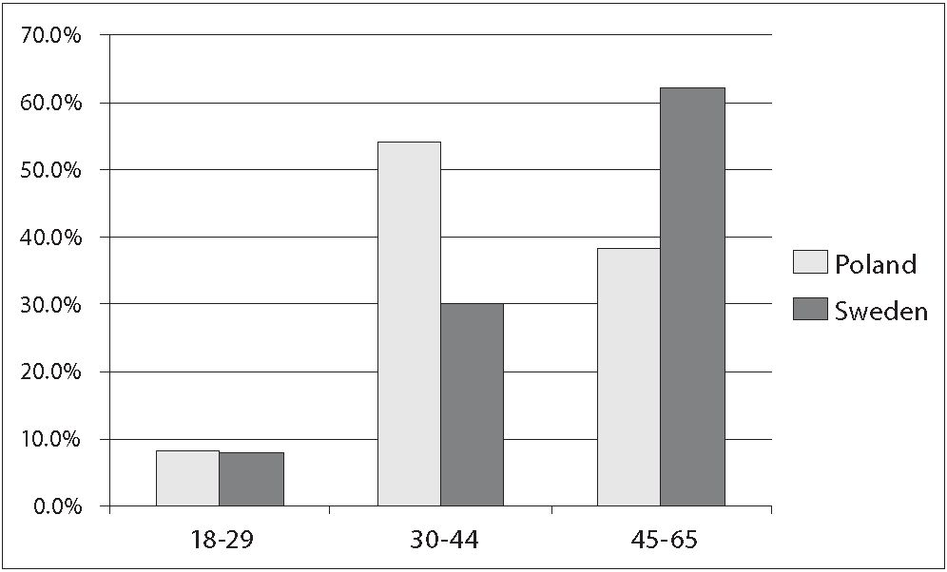
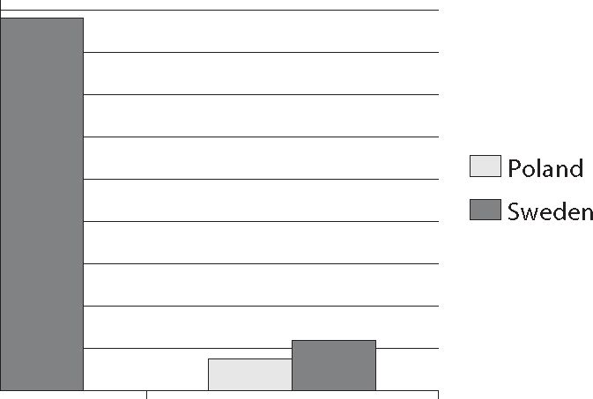
Annals of Agricultural and Environmental Medicine 2012, Vol 19, No 4 733
Jerzy T. Marcinkowski, Anna Edbom-Kolarz, Anna Bajek, Andrzej Wojtyła, Jerzy Leppert, Paweł Zagożdżon et al. Comparative studies on promotion of health and life style...
Many studies show that medical staff frequently ignore a
health promoting life style, including diet and body mass, and
physical activity - perhaps due to a false conviction that they
are sufficiently protected by their own medical knowledge.
Physicians may not even perceive (diagnose) that they are
overweight or even obese [2].
The results of some studies are surprising, according to
which health promoting behaviours of the general population
were better than those of physicians [3, 4].

OBJECTIVES
- Comparison of the state of health and life style between
the staff of Swedish and Polish hospitals, and subsequently,
the motivation of these employees to change their to-date
life style for one more health promoting.
- Presentation, based on Swedish experiences in the field
of health promotion in hospitals, of the possibilities of
implementation of these experiences in Polish conditions.
psychologists, custodians) - this group of employees is the
oldest. For the above-mentioned reason, there will be a
lack of these specialists in the near future. The national
health services in Sweden are threatened by the shortage
of specialists; however, it is also evident that this group is
occupationally-active and would like to continue working.
This also evidences their satisfactory health and physical
condition.

MATERIALS AND METHOD
The study covered the staff from the following hospitals:
- hospitals in Ostergotland County in Sweden, and 2) the
Ludwik Perzyna Regional Polyclinical Hospital in Kalisz,
Poland. The studies were conducted in parallel in Sweden
and in Poland during the fourth quarter of 2010.
The research instrument was a questionnaire form
designed in the LEO electronic works in Sweden for the
council of the Ostergotland County in such a way that each
employee performed self-evaluation of own state of health
and life style, and then reported if he had, and if ‘Yes’ what
motivations to change the to-date life style into one that
would be more health promoting. The questionnaire form
consisted of 23 items concerning the respondents’ life style,
self-reported state of health, and 7 socio-demographic
questions, concerning gender, age, occupation performed
and period of employment.
The questionnaire was sent by electronic mail to all
staff members of hospitals in the Ostergotland County.
This questionnaire was translated into Polish and used in
studies in the hospital in Kalisz. Firstly, consent for the study
was obtained from the manager of the hospital in Kalisz,
and subsequently the surveyors personally contacted the
respondents and explained the justification for carrying
out the study.

RESULTS
The differences between hospital staffs in Sweden and
Poland was that in Poland there were more middle-aged
employees (30-44), whereas in Sweden the largest group
were the oldest employees (45-65) (Fig. 1). Both in Poland
and Sweden the majority of respondents were women (Fig.
- . Polish women are occupationally-active until the age of
60, whereas in Sweden they retire at the age of 65, therefore
this group was larger in Sweden. In Sweden, there is a lack
of specialists in health care, and it is clearly observable
that the group of employees at pre-retirement age are
specialists (specialized surgical and other nurses, physicians,
Figure 1. Characteristics of respondents in Poland and Sweden according to age
100.0%
90.0%
80.0%
70.0%
60.0%
50.0%
40.0%
30.0%
20.0%
10.0%
0.0%
females males
Figure 2. Characteristics of respondents in Poland and Sweden according to gender
Unfortunately, a clear domination of women employed
in health care - clearly noted in both countries (Fig. 2) -
carries many conflicts at work (mobbing, etc.), as the group
consisting merely of women does not function well. It is
also unfavourable when a large group of women occupy
managerial positions. The best situation is a balance in the
number of employees of both genders.
A comparative analysis of respondents in both countries
reveals fundamental differences. Hospital staff in Sweden
almost three times as frequently as in Poland described
their state of health and very good or excellent, twice as
often evaluated their nutritional habits as good, twice as
often consumed meals 5-7 times a week according to the
recommended principle of the division of food portions.
As many as 91% of hospital staff in Sweden considered their
time for the consumption of a meal at work as sufficient,
compared to only 36% of respondents in Poland. This is due
to the obligatory break for lunch in Sweden, not counted
into the working time, which is from 30 min. - 1 hour. Due
to this meal commonly consumed at the workplace the staff
is better off at work and regain strength after having a rest.
This meal consists of 3 dishes and a large amount of water.
The regular consumption of water throughout the workday
also results in better general wellbeing.
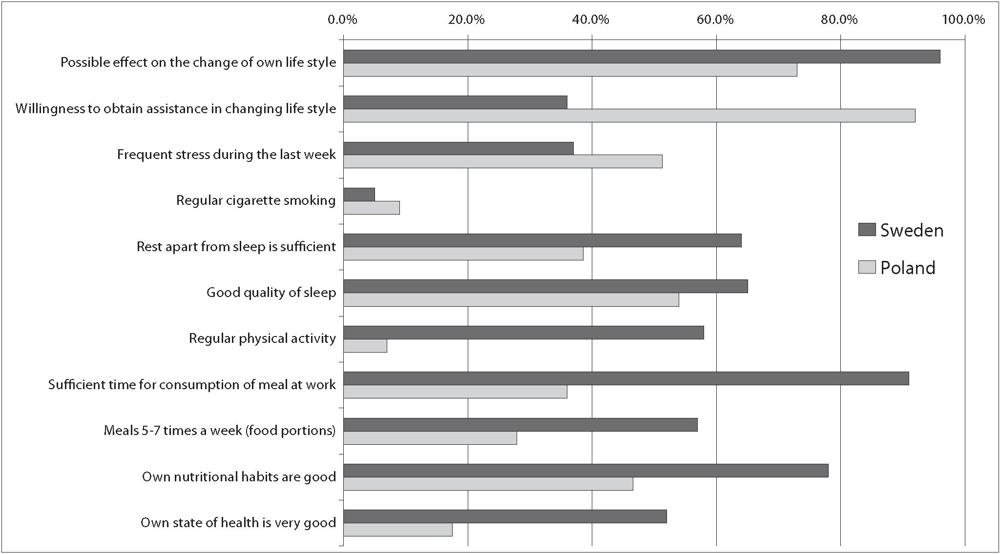
734 Annals of Agricultural and Environmental Medicine 2012, Vol 19, No 4
Jerzy T. Marcinkowski, Anna Edbom-Kolarz, Anna Bajek, Andrzej Wojtyła, Jerzy Leppert, Paweł Zagożdżon et al. Comparative studies on promotion of health and life style...
Figure 3. Comparison of self-reported state of health, life style, and readiness to change this life style for one that is more health-promoting between respondents in
Poland and Sweden.
(Possible effect on the change of own life style; willingness to obtain assistance in changing life style; frequent stress during the last week; regular cigarette smoking;
rest, apart from sleep is sufficient; good quality of sleep; regular physical activity; sufficient time for consumption of a meal at work; consumption of meals 5-7 times a
week acc. to division into food portions; own nutritional habits are good; own state of health is very good)
The difference between regular physical activity is most
striking, this activity being more than a dozen times higher
among Swedish than Polish hospital staff - 58% and only 7%,
respectively (Fig. 3). Such a good result obtained in Sweden
is due to a many-year programme of activities on behalf
of an increase in the physical activity of employees. Also,
Swedish staff more often than Polish employees evaluated
the quality of their sleep and leisure while awake in positive
terms, although the differences were not as high as those
mentioned above. Here, it should be mentioned that the
quality of sleep is greatly affected by: quality of beds, regular
physical activity and adequate nutrition, e.g. no consumption
of meals after 18:00. Regular cigarette smoking was not
frequently observed; however, the percentage of smokers was
higher in Poland, similar to the percentage of employees who
often felt stressed. Polish employees significantly more often
declared willingness to obtain assistance in changing their
life style, which mainly results from the fact that in Poland
offers in this area were considerably more modest. In Poland,
actions in the field of health promotion at workplaces are also
more modest compared to Sweden. Probably for this reason,
in Sweden, the number of hospital staff who reported that
they had an effect on changing their life style for one that is
more health promoting was larger, which confirms a higher
social knowledge of this problem.

DISCUSSION
The results of own studies may serve as guidelines for the
creation of prophylactic and information programmes. It
is clearly noted that daily health promotion in enterprises
carried out by the creation of possibilities of free use of
various programmes supporting a change of life style for a
more health promoting one brings about clear results [5]. The
employees should be provided the possibility to use various
forms of support, free or with partial cost reimbursement,
in order to evoke their motivation to change the to-date,
not always adequate, life style, i.e. greater physical activity,
struggle with own habits, improvement of habits with respect
to diet, hygiene, as well as rest and sleep. The route towards
an improvement and maintenance of both physical and
psychological condition, especially nowadays, when the
prolongation of the period of employment is proposed, is
extremely important. A healthy worker is more effective and
more rarely uses sick leave [6]. Here, it should be mentioned
that in Sweden health promoting programmes were created
due to an increase in sick absenteeism. In addition, a
healthy employee willingly participates in various forms of
improvement courses and occupational self-education, which
is positively manifested in interpersonal relationships in a
family and the society [7].
The objective of actions in the area of health promotion
at workplaces is the elimination of unfavourable social
behaviours and habits, and changing them into more health
promoting ones - through individual and group programmes
[8]. Care of the health status of health care staff will certainly
bring about favourable results in a longer time perspective [9].
These were the goals in the organization of health promoting
activities for the staff of the hospital in Norrkoping - in
order to decrease an occupational burnout syndrome [10],
sick absenteeism, and over a longer period of time, also a
change in life style. In this hospital, among other things,
were organized slimming groups, groups exercising various
forms of recreation associated with physical activity, regular
walking in the forests, skiing with a leader of a group, or tour
Annals of Agricultural and Environmental Medicine 2012, Vol 19, No 4 735
Jerzy T. Marcinkowski, Anna Edbom-Kolarz, Anna Bajek, Andrzej Wojtyła, Jerzy Leppert, Paweł Zagożdżon et al. Comparative studies on promotion of health and life style...
skating through canals and lakes under the care of a guide.
For example, common racing in spring over a distance of
5 km, those capable of running do so, while the reminder
may walk this 5 km distance. Families are also invited to
participate, including family members aged from 7-70 and
over; they take rucksacks with food. With respect to skating,
group activity is important, because skating individually is
very risky, as one may fall into the water and be threatened
by the lack of rescue.
The above-mentioned groups for exercising physical
activity are on various levels of advancement, bearing in
mind that each employee could adjust a suitable group to
individual expectations and capabilities. For this type of
activity, the hospital in Norrkoping allocates the sum of 1,500
crowns/1 employee/year; which may be used for exercising
any physical activity, according to preferences, e.g. ticket for
swimming pool or horse riding.
In almost all Swedish hospitals the pedagogue for physical
activity (Swed. halsopedagog) has a gymnastics hall at his/
her disposal, where motor activity is organized of various
degrees of advancement, for example, gymnastics and motor
activity groups are undertaken. Such halls are equipped
with fitness devices for training particular groups of
muscles (athletics). In general, each Swedish hospital has
a swimming pool for rehabilitation purposes, which is also
available for its staff. Nordic walking, bicycle riding, and
running routes are popular. Training of this type is held
every day, at various hours, primarily from 16.00 - 19.00,
therefore they are available for all staff members who make
an appointment for a specified hour and the programme
which suits them best. The training groups are at various
ages and levels of advancement. Sauna, showers, massage and
weighing scales are also available. However, weighing is not
frequently performed in order not to cause discouragement
and loss of motivation for a longer, programme change of
life style. Commuting to work by bicycle is encouraged,
e.g. competitions are organized for those who commute by
bicycle, ending with the sponsoring of tours abroad.
In Poland, nordic walking, jogging and walking have only
now begun to develop as forms of activity and have as yet
few fans. For this reason, sometimes unjustified comments
may be heard of the type: ‘They have nothing better to do,
they should rather have a rest’. But the fact is that any form
of active leisure is beneficial [11]. Each individually adjusted
form of physical activity strengthens the nervous system,
relaxes and helps the achievement of metabolic balance, thus
exerting a therapeutic effect [12].
In some Polish hospitals there function rehabilitation
wards and rehabilitation outpatient rooms. Unfortunately,
the waiting time for a visit to a rehabilitation consultation
room is currently about 6 months. Many rehabilitation
rooms did not obtain an extension of an agreement with
the National Health Insurance Fund for the current year.
In these facilities there is a full payment for the procedures,
which is relatively high. Meanwhile, the studies conducted
among hospital staff in Kalisz showed that many employees
have health problems and would eagerly use such a form of
assistance at their workplace if they were offered such an
opportunity.
In the hospital in eastern Sweden (Vrinnevisjukhus,
Norrkoping, Ostergotland) a ‘free time pedagogue’ is
employed (Swed. fritispedagog), who deals with the whole
of health promotion for the hospital staff, for example, with
adequate nutrition, including slimming for those with obesity
or overweight - by group training consisting in weekly
meetings for self-control of the group. Each group member
registers his/her initial body weight, diet, and amount of daily
physical activity, and subsequently report this in a group. The
programme covers daily adequate consumption of meals -
5-6 times. Such a frequent nutrition is beneficial. Weighing
is planned not more often than once in 4-6 weeks in order
not to stress the group members, because this programme
of slimming is based on a long-term change of life style, and
not on rapid weight loss. Frequent weighing often caused
frustration due to low weight loss. Three slimming groups
were organized of various levels of advancement. After several
months, each of these groups covering 10-12 people, jointly
lost approximately 100 kg through changing nutritional
habits. Pharmacotherapy oriented towards slimming is not
recommended, but instead adequate nutrition and regular
control of body weight. These slimming groups have become
so very popular that the ‘free time pedagogue’ (halsopedagog)
literarily cannot keep up with servicing all those who are
willing to participate.
Changes in nutrition are supported by ‘healthy nutrition
weeks’. During these weeks adequate nutrition is popularized
through common meals prepared by specialists. Also, proper
recipes are recommended for the preparation of meals, or
even the possibility of buying the necessary ingredients
(products).
In Poland, a high percentage of overweight and obese
population is observed [13]. Some of them have already
become accustomed to their own unfavourable appearance;
nevertheless, others undertake various types of activities
in order to reduce their body weight. They visit a dietician;
however, it is difficult to observe the recommendations, and
a frequent lack of being systematic is clearly noted, while
others obtain information concerning diet from magazines
and the Internet. It should be mentioned that this is not a
good method, because each diet should be properly adjusted,
primarily with respect to age, gender, and type of occupation
performed [14]. In Poland, there is a lack of group actions
in this area.
In Sweden, prophylactic actions in the field of nutrition
cover also children, e.g. sweets can be given to children
only on Saturdays, it is better to provide pure water and not
water with flavour additives, e.g. orangeade. Polish women
constantly feed their children with chips and sweets, and
are generally unable to prepare health promoting meals,
etc. [15]. This is due, among other thing, to the aggressive
advertising of food products not recommended in health
promoting nutrition.
Daily motor activity of a minimum 30 min. is recommended
in various forms, e.g. fast walking, riding a bicycle or
swimming - it is important to train the habit of everyday
physical activity.
Swedish society is group-based. A group, psychology of
its existence and functioning, has accompanied the Swedes
from their youngest years. As early as in the nursery school,
group classes are considered to be superior to the individual.
Briefly speaking, an average Swedish person strives to come
into being as a member of a group, rather than remaining
an individual. For this reason, even slimming, prophylactic
actions and any social actions are group-based. Thus, much
attention is devoted to the analysis of the functioning of a
group and its psychology. In the case of Swedish society, this
736 Annals of Agricultural and Environmental Medicine 2012, Vol 19, No 4
Jerzy T. Marcinkowski, Anna Edbom-Kolarz, Anna Bajek, Andrzej Wojtyła, Jerzy Leppert, Paweł Zagożdżon et al. Comparative studies on promotion of health and life style...
has not only many benefits, but also unfavourable effects.
For example, basing education from elementary school to
university not on individual questioning but on group work
leads to a decrease in the level of education, which today
exerts a negative effect on the entire society. A decline has
been noted in architecture, level of education, and young
physicians becoming frustrated when realizing that their
contemporaries from other countries possess much higher
theoretical knowledge.
Swedish society is characterized by a high rate of
participation in prophylactic health check-up examinations.
This is due to the fact that, to a high degree, the mass media
shape positive social opinion with respect to a health
promoting life style and, as a result, the education of society
in this area is good, probably better than in Poland.
In Poland, changes are necessary on behalf of the
behaviours in society which would be more health promoting,
including the participation in prophylactic examinations.
To-date, participation in free prophylactic health check-
ups of the cardiovascular system [16, 17], or mammography
[18], has been unsatisfactory. Actions should be undertaken
primarily on behalf of: 1) increasing participation rates in
these prophylactic health check-ups, and 2) observance by
patients of medical orders. If such social changes in the field
of health are to be achieved in Poland, it is necessary to start
from the foundations. It is desirable to pattern the Swedish
experiences - e.g. with respect to group actions on behalf of
own health. Group pressure is important in order to change
the attitudes for health promoting, and change in bad habits,
e.g. with respect to nutrition.
Health promotion in enterprises should be an important
element of actions addressed to the employees. The scope
and character of these actions may be varied and very broad,
starting from passing on the principles of health promoting
life style to the staff. It is explained to the employees that
health is their capital, which would allow them to achieve
life goals, give satisfaction and fulfilment in life. While
performing this task, the employees are equipped with
knowledge and skills to improve their health status, and
become mobilized to observe the principles of health
promoting life style [19]. Here, life without habits is most
important, especially free from cigarette smoking [20, 21,
22], proper comprehension and understanding of health [23],
maintenance of many-faceted physical activity for proper
physical and psychological fitness, adequate nutrition [24],
toughening-up of oneself, developing the skills of coping
with stress [25], kindness towards others (a socially healthy
individual is the one who does good, is kind with respect
to others, knows the value of the concepts: tolerance and
compromise, and applies these concepts in practice, being
at the same time, assertive), maintenance of an encouraging
attitude (Eng. coping - to contend with difficulties in life;
being a life optimist, perceived by others as a successful
person - due to this, being an individual attractive to others,
possessing many friends, with which it is simply easier to
live). It is very important to promote a healthy life style at
workplaces in an attractive way, active and full of humour.
The objective of these actions for the enterprises is clear and
obvious - healthier employees will work longer and more
effectively. Such attitudes and behaviours are shaped at home
and at school [26, 27, 28, 29].
The results of the presented comparative studies indicate
what and in which way the life style of the staff of health care
facilities in Sweden and in Poland should be changed. This
knowledge is very important for the employers, who, based
on these results, are provided with the premises to develop
proper health promotion in their enterprises.
It is known that many factors are distinguished which
condition the state of health of the population; therefore,
the comparative results of Swedish-Polish studies should be
viewed from this aspect.

SUMMING-UP
Based on the results of studies carried out among the staff
of the hospital in Kalisz, the following are recommended:
- the staff members of the hospital in Kalisz should increase
their consumption of fruits and vegetables, as well as
physical activity;
- it is necessary to organize workshops aimed at the shaping
of the skill of coping with stress and relieving stress;
- the employees of the hospital would like to obtain assistance
in the area of the reduction of body weight and increase
in physical activity;
- obligatory breaks at work should be introduced for the
consumption of meals and beverages, including water,
promotion of fluids replacement would decrease stress
during the workday. An obligatory discounting of the
time for lunch would allow everyone the consumption
of a decent meal and simultaneously rest, while having a
respite from one’s duties;
- an employer, in his best interest, should provide incentives
for physical activity to possess a well-functioning staff
by, e.g. the organization of groups, reduction of weekly
working time on behalf of well-documented physical
activity, or financial support for the purchase of tickets
for various forms of physical exercises. Promotion of group
physical activity, e.g. common nordic walking for 30 min.
during lunch, competition in the greatest number of steps.
- promotion of a healthy diet by the preparation of recipes
for meals and several exemplary healthy meals in the form
of a healthy alternative breakfast. During celebrations, a
basket of fruit is provided instead of sweets.

CONCLUSIONS
- The life style of the staff of health care facilities is more
health promoting in Sweden than in Poland.
- A change of life style of the staff of health care facilities for
one that is more health promoting is possible. In Sweden,
changes in this area have taken place with great success.
Therefore, it is worthwhile implementing in Poland the
Swedish experiences which might also function in Polish
conditions.
- The fundamental of health promotion in enterprises have
been known for a long time; however, considering the fact
that the comparative studies show that these foundations
are more advanced in Sweden, it is necessary that Polish
employers devote more attention to this problem, and
become interested in the Swedish experiences in this area.
Annals of Agricultural and Environmental Medicine 2012, Vol 19, No 4 737
Jerzy T. Marcinkowski, Anna Edbom-Kolarz, Anna Bajek, Andrzej Wojtyła, Jerzy Leppert, Paweł Zagożdżon et al. Comparative studies on promotion of health and life style.

REFERENCES
- Pappachan MJ. Increasing prevalence of lifestyle diseases: high time
for action. Med Res. 2011 Aug; 134(2): 143-5.
- Ziemska B. Stan zdrowia pracowników Uniwersytetu Medycznego
im. Karola Marcinkowskiego w Poznaniu. Rozprawa doktorska
(promotor: J.T. Marcinkowski). Uniwersytet Medyczny im. Karola
Marcinkowskiego w Poznaniu, Poznań 2012. (State of health of the
staff of Karol Marcinkowski Hospital in Poznań. Doctor’s dissertation-
Tutor J.T. Marcinkowski, Medical University in Poznań, Poznań 2012)
(in Polish).
- Dubnov-Raz G, Berry EM, Shemer O, Constantini NW. Who will
take care of the caretaker? Lifestyle recommendations for physicians.
Harefuah. 2011 Jul; 150(7): 583-7, 617.
- Gacek M. Zachowania żywieniowe i aktywność fizyczna w grupie
lekarzy (Nutritional behaviours and physical activity in a group of
physicians). Prob Hig Epidemiol. 2011; 92(2): 254-259.
- Tinati T, Lawrence W, Ntani G, Black C, Cradock S, Jarman M, et
al. Implementation of new Healthy Conversation Skills to support
lifestyle changes - what helps and what hinders? Experiences of Sure
Start Children’s Centre staff. Health Soc Care Community. 2012 Mar
27; 20: 430-437. doi: 10.1111/j.1365-2524.2012.01063.x.
- Speroni KG, Earley C, Seibert D, Kassem M, Shorter G, Ware CC, Kosak
E, Atherton M. Effect of Nurses Living Fit™ Exercise and Nutrition
Intervention on Body Mass Index in Nurses. J Nurs Adm. 2012 Apr;
42(4): 231-238.
- Byczkowska Z, Dawydzik L. Medycyna pracy w praktyce lekarskiej.
(Occupational medicine in medical practice). Oficyna Wydawnicza
Instytutu Medycyny Pracy, Łódź 1998.
- Kulik TB, Latalski M. Zdrowie publiczne. Podręcznik dla studentów
i absolwentów wydziałów pielęgniarstwa i nauk o zdrowiu akademii
medycznych. (Handbook for students and graduates of departments
of nursing and health sciences at medical universities). Wydawnictwo
Czelej, Lublin 2002.
- Andruszkiewicz A, Banaszkiewicz M. (Ed.). Zakład pracy promujący
zdrowie. Zdrowe miejsce pracy. (Enterprise promoting health. healthy
workplace) [In]: Promocja zdrowia dla studentów studiów licencjackich
kierunku pielęgniarstwo i położnictwo, vol. 1, Wydawnictwo Czelej,
Lublin 2008.
- Fearon C, Nicol M. Strategies to assist prevention of burnout in nursing
staff. Nurs Stand. 2011 Dec 7-13 ;26(14): 35-9.
- Tuszyńska-Bogucka V, Bogucki J. (Ed.). Styl życia a zdrowie - wybrane
zagadnienia. (Life style and health - selected problems) Wydawnictwo
Czelej, Lublin 2005: 42-52.
- Karski J.B (Ed.). Promocja zdrowia, Wydawnictwo Ignis, Warszawa
1999.
- Pilecka W. (Ed.). Psychologia zdrowia dzieci i młodzieży. Perspektywa
kliniczna. (Psychology of health of children and adolescents. Clinical
perspective) Wydawnictwo Uniwersytetu Jagiellońskiego, Kraków 2011.
- Pilch W, Janiszewska R, Makuch R, Mucha D, Pałka T. Racjonalne
odżywianie i jego wpływ na zdrowie. (Rational nutrition and its effect
on health). Hygeia Public Health 2011; 46(2): 244-248.
- Majcher A, Czerwonogrodzka-Senczyna A, Bielecka-Jasiocha J,
Rumińska M, Witkowska-Sędek E. Rozwój otyłości we wczesnym
dzieciństwie - obserwacje własne. (Development of obesity in early
childhood - own observations) Probl Hig Epidemiol. 2011; 92(2):
241-246.
- Majewicz A, Marcinkowski JT. Epidemiologia chorób układu
krążenia. Dlaczego w Polsce jest tak małe zainteresowanie istniejącymi
programami profilaktycznymi? (Epidemiology of cardiovascular
diseases. Why in Poland there is such a little interest in the existing
prophylactic programmes?). Probl Hig Epidemiol. 2008; 89(3): 322-325.
- Sawicka K, Szczyrek M, Jastrzębska I,Prasał M, Zwolak A, Daniluk J.
Hypertension - The Silent Killer. J Pre-Ciln Clin Res. 2011; 5(2): 43-46.
- Dyzmann-Sroka A, Marcinkowski JT, Kubiak A, Trojanowski M.
Kto powinien zajmować się promocją skriningowego Populacyjnego
Programu Wczesnego Wykrywania Raka Piersi? (Who should deal
with promotion of the screening Population Programme for Early
Breast cancer Detection). Probl Hig Epidemiol. 2009; 90(4): 621-626.
- Gniazdowski A. Promocja zdrowia w miejscu pracy. Promocja zdrowia.
(Health promotion at a workplace. Health promotion). Nauki Społ
Med. 1994; 1-2: 70-80.
- Cekiera C, Zatoński W. Palenie tytoniu - wolność czy zniewolenie?
(Tobacco smoking - freedom or enslavement?). Wydawnictwo Naukowe
Katolickiego Uniwersytetu Lubelskiego, Lublin 2001.
- Preisler E. Tytoń a zdrowie i sprawność fizyczna. (Tobacco and health
and physical efficacy). Polskie Towarzystwo Przeciwtytoniowe, Poznań
1991; XVI.
- Zatoński W, Przewoźniak K. Palenie tytoniu w Polsce, podstawy,
następstwa zdrowotne, profilaktyka. (Tobacco smoking in Poland,
fundamentals, health consequences, prophylaxis) Państwowe Zakłady
Wydawnictw Lekarskich, Warszawa 2006.
- Nowicki G, Ślusarska B. Determinanty społeczno-demograficzne
wartościowania zdrowia wśród pracujących osób dorosłych. (Socio-
demographic determinants of valuation of health among occupationally
active adults). Hygeia Public Health 2011; 46(2): 280-285.
- Gawęcki J, Mossor-Pietraszewska T (ed.): Kompendium wiedzy o
żywności, żywieniu i zdrowiu. (Compendium of knowledge about food,
nutrition and health) Wydawnictwo Naukowe PWN, Warszawa 2004.
- Marczyńska A. Jak promować zdrowie w miejscu pracy? Program
radzenia sobie ze stresem. (How to promote health at workplace.
Programme of coping with stress). Instytut Medycyny Pracy, Łódź 1998.
- Jacennik B. Strategie dla zdrowia. Kształtowanie zachowań zdrowotnych
przez środowisko. (Health strategies. Shaping health behaviours by the
environment) Wizja Press, & IT, Warszawa 2008.
- Karski JB. Postępy w promocji zdrowia, Przegląd międzynarodowy.
(Procedings in health promotion. International review) Wydawnictwo
CeDeWu, Warszawa 2007.
- Sheridan Ch, Radmacher SA. Psychologia Zdrowia. (Psychology
of health) Instytut Psychologii Zdrowia, Polskie Towarzystwo
Psychiatryczne, Warszawa 1998.
- Woynarowska B. Zdrowie i szkoła. (Health and school) Wydawnictwo
Lekarskie PZWL, Warszawa 2000.

