Łukasz Wordliczek

CONTINUITY OR CHANGE? A DOCTRINAL FACET
OF THE U. S. FOREIGN POLICY
Doctrine: that which is taught or laid down as true concerning a particular subject or department of knowledge, as religion, politics, science, etc.; a belief, theoretical opinion; a dogma, tenet.
Oxford English Dictionary1
If things are going to remain the same around here, there are going to have to be some changes made.
Italian maxim
The question of continuity and change is one of the most stimulating issues in political science. This is particularly true in the context of foreign policy. In internal affairs, in spite of such crucial events as World War II, one may, surprisingly, deal with elements of continuity, while in foreign affairs-with elements of change. 2 Therefore, the issue of continuity and change seems to occur as a core question in U. S. politics, especially in its external dimension. Analysing this topic allows as to answer some vital questions. Among the most important are: (1) What components constitute the politics of “continuity” and what of “change”? (2) When do we deal with periods of continuity and when with periods of change? (3) What premises may be anticipated based on this analysis?
U. S. foreign policy seems to be one of the most promising areas for the study of the above-mentioned questions. The doctrines of Monroe, Hoover and Stimson, Truman, Eisenhower, Nixon, Reagan, and currently Bush, give us clues that help us observe the elements of change and continuation in the formulation and implementation of foreign policy since the 1820s till now. In dealing with the doctrines, the analysis would potentially lack the biases caused by using a structural realist approach. Although “the realist explanation. [... ] demonstrates how the international environment shapes the realm of the possible in American foreign-policy doctrines, ” still, an approach focusing on the role of leaders, leadership and ideology is used in this paper. 3
1 Oxford English Dictionary Online, Oxford University Press, 2004.
2 J. G. Heinberg, Continuity and Change in European Governments, “Journal of Politics, ” vol. 8, no. 3, 1946, pp. 392-404.
3 For further debate on structural realist approach see: M. P. Lagon, The International System and the Reagan Doctrine: Can Realism Explain Aid to "Freedom Fighters"?, “British Journal of Political Science, ” vol. 22, no. 1, 1992, pp. 39-70.

54
Łukasz Wordliczek
Naturally, the above-mentioned doctrines are not a complete set of American doctrines. For pragmatic reasons, the doctrines that contain essentially new elements were chosen. Therefore, the Kennedy doctrine and the Carter doctrine were rejected as being only “geographical” modifications of the Truman doctrine and the Eisenhower doctrine. 4 Clinton doctrine was also omitted, as having mostly an economic dimension.
The doctrines we are going to deal with are already well known to researchers. Therefore, for this analysis it is enough only to recall their basic premises.

The Monroe Doctrine
The first part of the 19th century is called a “continental” era in the history of US foreign policy. Territorial strengthening was the main priority for the young republic. The doctrine announced by President James Monroe on December 2, 1823 served this purpose. 5 The roots of the doctrine were in European affairs, or, more precisely, European colonies in North America. The United States realised that the weakening influence of Spain might cause the interest of other European powers towards Spanish territories. Not wishing to become a passive player, the U. S. decided to join the game. According to President Monroe, the United States did not have to meddle in the European powers’ internal matters. On the other hand, it was essential to keep friendly relations with Europe, especially in economic relations. The U. S. would not call into question the European powers’ rights to already established colonies in the Western Hemisphere. But any attempts to broaden the colonies’ boundaries would be treated as a threat to vital American interests. Therefore, the Monroe Doctrine “led the United States to be the policeman of the [Western] hemisphere. ”6 It served the purpose of strengthening the position of the United States on the American continent.
Although the Monroe Doctrine is often referred to as “isolationism, ” it has to be mentioned that this term carries some simplification. If one uses the notion “isolationism, ” it should be pointed out that it does not automatically mean complete passivity in international relations. The doctrine contains activity, though in a limited area (Western Hemisphere) and limited sphere (political affairs). Keeping in mind this meaning of isolationism, we may conclude that the United States could afford it: America was - literally and metaphorically speaking - far from Europe and its balance of power.
4 Cf. with S. E. Ambrose, The Presidency and Foreign Policy, “Foreign Affairs, ” vol. 70, no. 5, Winter 1991/92.
5 The co-author of the doctrine was John Quincy Adams, then-secretary of state. Surprisingly, the origins of the doctrine are British; for further details see: J. W. Fawcett, The Origin and Text of the Famous Monroe Doctrine, “Congressional Digest, ” March 1939, pp. 74-77.
6 W. I. Cohen, B. Perkins, W. LaFeber, A. Iriye, The Cambridge History of American Foreign Relations: The Creation of a Republican Empire, 1776-1865, vol. I, Cambridge: Cambridge University Press, 1993, p. 73.

Continuity or Change? A Doctrinal Facet of the U. S. Foreign Policy
55

The Hoover - Stimson Doctrine
We must move to the 20th century to say anything about the next doctrine. In the 20th century the U. S. A, became an ambitious, although still rather provincial, player on the international scene. The region, itself, to which the doctrine was applied - China - clearly shows how American aspirations had changed.
Because of Japanese activity in East Asia, some countries - including the United States
- felt anxious about it. On January 7, 1932 the U. S. secretary of state - Henry Stimson - submitted a diplomatic note to Japan and China. It was declared that the United States did not recognise any activities violating China’s territorial integrity and sovereignty. It is symptomatic that there were no sanctions provided for violating the note’s provisions. The Hoover - Stimson Doctrine represents a pacifist, idealistic attitude towards international relations between Word War I and Word War II. The Briand-Kellog Pact serves as proof of this.
Implementation of the Hoover - Stimson Doctrine occurred only one month later, when the Japanese army landed in the port of Shanghai. This activity did not cause any decisive reaction from any countries, including the U. S. Therefore, the Hoover-Stimson Doctrine only kept up appearances of American activity.

The Truman Doctrine
Similar to the two doctrines above, the Truman Doctrine is also ascribed to the secretary of state (Dean Acheson). The Truman Doctrine was the first which expressed the U. S. ’ attitude towards communism. On March 12, 1947, in a message delivered to both chambers of Congress, President Harry Truman expressed the fear that a void after collapsing British Empire might have been filled with Soviet influences. Thus, the bipolar system was emerging. In one part of the world the way of life was based upon “terror and oppression, a controlled press and radio, fixed elections, and the suppression of personal freedoms. ”7 The rest of the world was the so-called “free world” with its “free institutions, representative government, free elections, guarantees of individual liberty, freedom of speech and religion, and freedom from political oppression. ”8 Particular tasks for the U. S. followed such a diagnosis.
The key question in fighting against communism was - according to President Truman
- supporting “free peoples who are resisting attempted subjugation by armed minorities or by outside pressures. ”9 Although at that time it mainly concerned Greece and Turkey, the United States’ active policy became the determinant of its attitude towards world communism sponsored by the Kremlin.
7 Cit. in: http: //www. presidency. ucsb. edu/site/docs/pppus. php? admm=033&year=1947&id=56 (June 23, 2007).
8 Ibidem.
9 Ibidem.

56
Łukasz Wordliczek

The Eisenhower Doctrine
On January 5, 1957, in a special message to Congress, President Dwight Eisenhower presented his vision of constraining communist influences. This time, the Middle East was the focus of attention. The president suggested a three-level approach. First, it was necessary to co-operate with countries of that region in their economic transformation in order to keep them independent from communist threats. Secondly, military assistance would be provided for those countries that asked for it. And, thirdly, in such a necessity, it would be possible to enter American troops into the Middle East. Congress agreed to such a scenario. 10 It was implemented in the middle of 1958 when the United States decided to intervene in Lebanon.

The Nixon Doctrine
The main author of the American foreign policy of Nixon’s time was Henry Kissinger. Formally National Security Advisor, he was a crucial person in the bureaucracy of U. S. foreign affairs. Naturally, the Nixon Doctrine followed the Vietnam War. Because of the lack of any perspectives for finding a solution to the Vietnamese knot, President Richard Nixon and his advisors decided to re-formulate the main Vietnam policy issues. During the press conference on July 25, 1969, in Guam, R. Nixon declared that the U. S. would actively fulfil its obligations, but that the means would change. According to the presidential declaration, the United States should “assist, but not dictate. ”11 Therefore the main military effort would have to be carried out by engaged countries. The term “vietnamization” was proposed.
The Nixon Doctrine clearly indicated the limits of American power. In the face of difficulties with fighting against communist forces, the United States developed the policy of adapting, and reacting, but not creating, or shaping, the situation.

The Reagan Doctrine
On February 6, 1985, President Ronald Reagan delivered an address before a joint session of the Congress on the State of the Union. Most of the speech dealt with social and economic security, whereas foreign policy played a minor role. Almost at the end, in five laconic sentences, the plan - later called “the Reagan Doctrine” - was introduced. The essence of it was: “to support the democratic forces whose struggle is tied to our own security. ”12 This time Central America (Nicaragua) was the focus. Following this declara
10 On March 9, 1957, the President signed the “Resolution promoting peace and stability in the Middle East” (PL 85-7).
11 Cit. in: http: //www. presidency. ucsb. edu/site/docs/pppus. php? admin=037&year=1969&id=279 (June 23, 2007).
12 Cit. in: Public Papers of Ronald Reagan. Washington, D. C.: Federal Register Division, National Archives and Records Service, 1985, http: //www. reagan. utexas. edu/resource/speeches/1985/20685e. htm (July 4, 2007).

Continuity or Change? A Doctrinal Facet of the U. S. Foreign Policy
57
tion, the United States backed up local forces in their fight against communist guerrillas. As for Nicaragua, such support was offered to contras as early as 1981. So, the Reagan Doctrine may be summed by the popular saying: “our enemy’s enemy is our friend. ”

The Bush Doctrine
The Bush Doctrine is the last included in this analysis. It was formally expressed in the “National Security Strategy of the United States of America” (NSS) - a report released by the White House on September 20, 2002. Its importance results from the significance of the American foreign policy agenda in the post-9/11 world order. The significance of the NSS will probably be as huge as the famous NSC-68 report released in 1950.
According to official assessment, the Bush Doctrine contains four main elements: the pre-emptive use of military force, military domination, so-called “multilateralism” (international institutions and alliances) and the “export” of democracy. 13
The most controversial postulate - pre-emption - may be expressed very briefly: “our best defense is a good offense. ”14 The pre-emptive actions are planned in response to contemporary threats, with terrorism and weapons of mass destruction (WMD) at the forefront.
Reacting to these threats requires having commensurate military capabilities. According to the NSS it has to guarantee the maintenance of American democratic values and “to create a balance of power that favors human freedom: conditions in which all nations and all societies can choose for themselves the rewards and challenges of political and economic liberty. ”15
The third aspect is the “new multilateralism. ” It should be understood as activity based on effectively operating international institutions such as UNO, WTO, NATO, and O. A. S. On the other hand, the NSS states that if it is necessary “we will not hesitate to act alone. ”16
The last postulate contained in the National Security Strategy concerns the promotion of democracy worldwide. Obviously, this is the traditional, American, Jeffersonian version of democracy. These activities are devoted to promoting “free and open societies on every continent [... ] free markets, and free trade to every comer of the world. ”17
13 See: K. A. Lieber, R. J. Lieber, The Bush National Security Strategy, “U. S. Foreign Policy Agenda. An Electronic Journal of the U. S. Department of State, ” vol. 7, no. 4, Dec. 2002, http: //usinfo. state. gov/journals/ itps/1202/ijpe/pj7-41ieber. htm (June 26, 2007). On the other hand, according to Z. J. Pietras, the Bush Doctrine contains of messianism, unilateralism, militarism and pre-emption; see: Z. J. Pietras, George W. Bush s Doctrine and the Structure of Global International Order, “The Polish Quarterly of International Affairs, ” vol. 13, no. 3, 2004, pp. 11-16. Cf. with R. Jervis, Understand the Bush Doctrine, “Political Science Quarterly, ” vol. 118, no. 3, pp. 365-88.
14 The National Security Strategy of the United States of America, http://www.whitehouse.gov/nsc/nssall.html (June 26,2007). For a discussion of the concepts of prevention, pre-emption and anticipatory military action see e.g. F. Heisbourg, A Work in Progress. The Bush Doctrine and Its Consequences, “Washington Quarterly,” vol. 26, no. 2, 2003, pp. 75-88.
15 The National Security Strategy of the United States of America, http://www.whitehouse.gov/nsc/nssall.html (June 26, 2007).
16 Ibidem.
17 Ibidem. Further explanation of the doctrine goals can be found in: C. L. Powell, A Strategy of Partnerships, “Foreign Affairs,” vol. 83, no. 1, January/February 2004.

58
Łukasz Wordliczek

Continuity or change?
The above-mentioned doctrines allow us to draw some conclusions.
Firstly, generally speaking we can observe continuity in the essence, objectives, goals of American foreign policy. If any changes are indicated, they rather apply to terminology, to the application of new names to familiar phenomena. Defining communism and terrorism as a threat serves this purpose. For some observers, the idea of changes in foreign policy is attributable to changes in the premises of power and rather not to changes in the concept of the nation’s basic purposes.18 The concept of power seems to be very appealing in that matter. According to president Lyndon Johnson “to protect the life of our nation, to preserve the liberty of our citizens, and to pursue the happiness of our people”19 are the basic premises of the U.S. foreign policy. But these premises are nothing especially new to any of world leaders. Without taking a risk, such goals may be attributed to all of statesmen. But as for the United States it must be emphasised that they posses some measures to meet these challenges, and power is in the centre of that.
Secondly, there are constant factors in the United States’ foreign policy. The idea of democracy, a free market economy, a belief system with an American sense of uniqueness20 and the concept of a collective security system are merely the best-known examples.21 Generally speaking, these universal ideas are ever-present elements of American history. Their premises may be found as early as Washington’s “Farewell Address” (September 17, 1796). The question for further debate is how America perceives these fundamental purposes.22
Thirdly, the change in American foreign policy is connected with its means, tools, not its essence. As for its means, the United States try to find a balance between isolationism and interventionism. It should be mentioned that even the Monroe Doctrine - generally treated as a synonym for “isolationism” - assumed the possibility of intervention in the Western Hemisphere.
To a great extent, the dispute over the roles of idealism and realism overlaps the dispute over isolationism and interventionism (see Fig. 1). Idealism - often called “Wilsonism” - is characterised through the activity of multilateral organisations, through faith in the good intentions of other countries, and the belief that war is an undeserving means for human beings.23 On the other hand, realism may amount to Reagan’s comment “trust, but
18 S. Brown, The Faces of Power: Constancy and Change in United States Foreign Policy from Truman to Johnson, New York: Columbia University Press, 1969, p. 2.
19 Address by President Johnson to The Associated Press, April 21,1965.
20 On this topic see: G. Lundestad, Uniqueness and Pendulum Swings in US Foreign Policy, “International Affairs,” vol. 62, no. 3, pp. 405-21.
21 Not to mention such non-controversial factors as physical survival, liberty, the American way of life and the economic well-being of American society. For further reading see: S. Brown, op.cit., pp. 7-9.
22 See e.g.: R. D. Asmus, Rebuilding the Atlantic Alliance, “Foreign Affairs,” vol 82, no. 5, September/ October 2003 and D. Moisi, The Real Crisis Over the Atlantic, “Foreign Affairs,” vol 80, no. 4, July/August 2001.
23 See the Bush Doctrine credo: “The aim of this strategy is to help make the world not just safer but better” in: Overview of America s International Strategy, U.S. Foreign Policy Agenda. An Electronic Journal of the U.S. Department of State, vol. 7, no. 4, December 2002, http://usinfo.state.gov/journals/itps/1202/ijpe/pj 7-4overview.htm (July 4,2007).

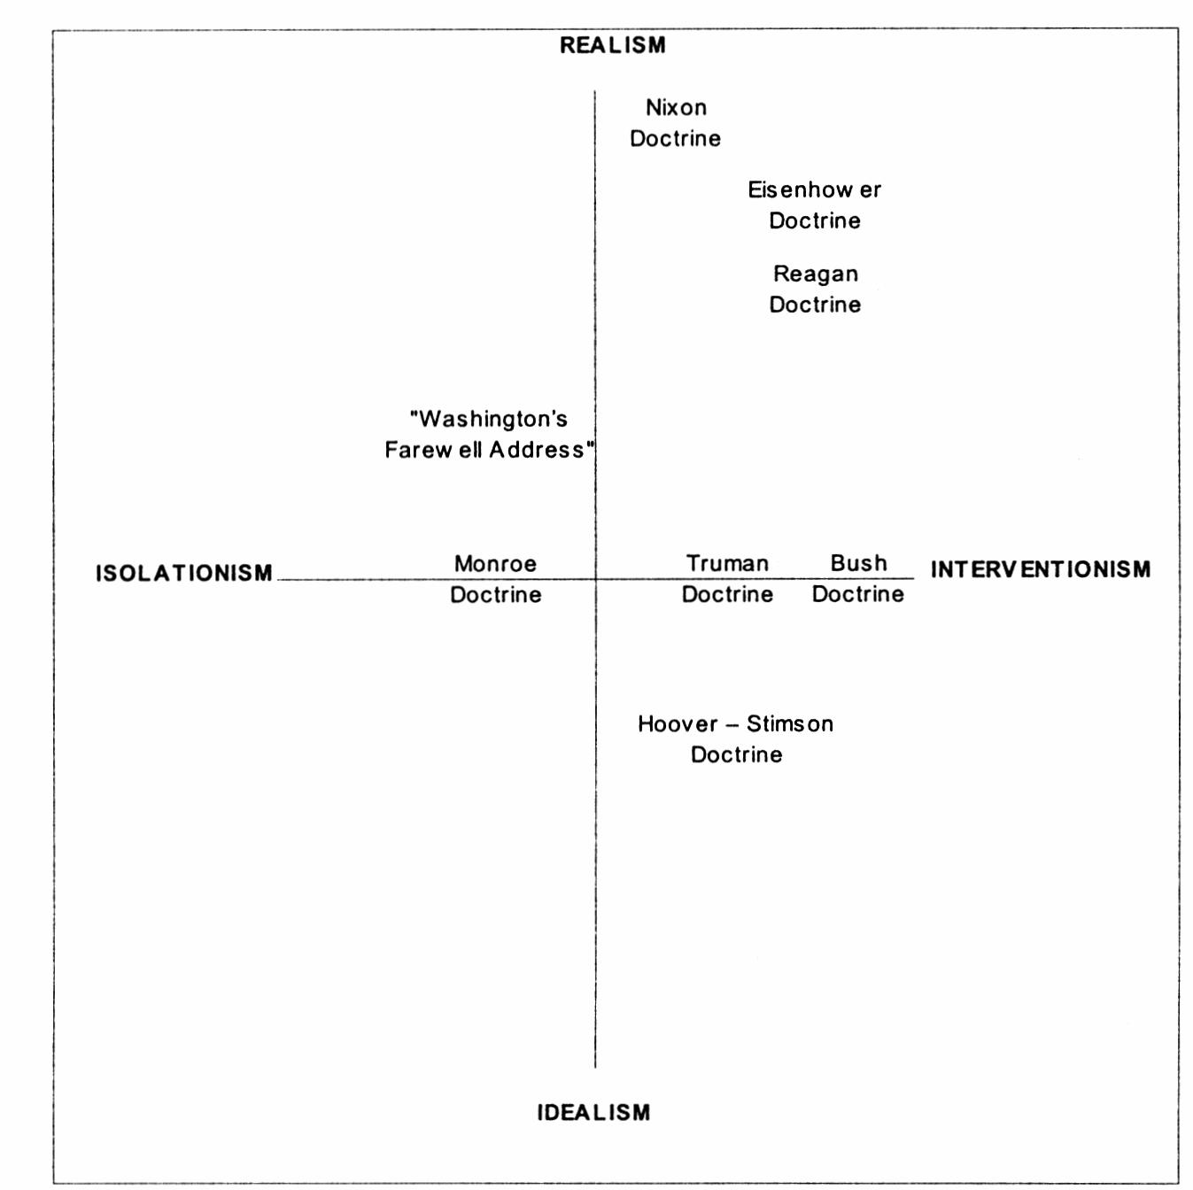
Continuity or Change? A Doctrinal Facet of the U.S. Foreign Policy 59
verify.”24 Just as isolationism and interventionism are in fact complementary concepts,25 idealism and realism can be connected with each other. The Wilsonian idealistic premises that allowed the U.S.A, to enter World War I were backed up by a realistic view. President Woodrow Wilson was aware that only those countries that took part in the war would be able to shape the post-war world order.
Fig. 1. Idealism/realism and isolationism/interventionism
The dispute also concerns many types of detailed activity - e.g. pre-emption. According to some researchers this has already occurred in US history, while others claim it is a postulate without a precedent.26
24 For realist explanation of the Reagan Doctrine see: M. P. Lagon, The International System and the Reagan Doctrine, “British Journal of Political Science,” vol. 22, no. 1, 1992, pp. 39-70.
25 See e.g.: W. Schneider, ‘‘Rambo’’ and Reality: Having it Both Ways [in:] K. A. Oye et al., Eagle Resurgent? The Reagan Era in American Foreign Policy, Boston: Little, Brown, 1987.
26 For further argumentation see respectively: K. A. Lieber, R. J. Lieber, The Bush National Security Strategy, and R. F. Grimmett, U.S. Use of Preemptive Military Force. CRS Report for Congress, September 18,2002, “U.S. Foreign Policy Agenda. An Electronic Journal of the U.S. Department of State,” vol. 7, no. 4, December 2002, http://usinfo.state.gov/joumals/itps/1202/ijpe/pj7-4grimmett.htm (June 26,2007).

60
Łukasz Wordliczek
To conclude, the above-analysed doctrines show that we may observe continuity in the goals of American foreign policy. These goals are identified with the American version of democracy. The question that remains is whether these premises are implemented effectively, or even legally. As for change, it may be easily observed in the range of military interventions in the Pax Americana region, the attempt to influence China’s policy, the containment of communism, the preventing the outbreak of a Third World War, “Vietnamization,” supporting contras, and pre-emption.
As was shown above, each doctrine contains elements of continuation and change that may be called a “structural regularity.” But the doctrines have a “historical regularity,” too. As Fig. 2 shows, they form specific phases of continuity and change. This phenomenon is determined by the American raison d’etat. If there is a threat to vital interests, there is a swing towards internationalism. On the other hand, when there is a lack of danger, politics turn towards an isolationistic trend. The Nixon Doctrine stands as the only exception.
Since “every President has his own foreign policy,”27 one should expect to deal with a new approach with every new President. Having analysed this topic we can view this judgement as a serious oversimplification. In spite of changes in the White House we still observe continuity in the doctrinal aspect of U.S. foreign policy. What is more, the above- -described processes will probably not be changed by the serious challenges we have faced in recent years. Continuity and change will for sure be perceptible in their structural and historical dimensions. The most obvious explanation is that it is because of the continuity in “institutional structures and in social and political values”28 in the United States. But history teaches us that continuity in institutional, social and political dimensions within one country are not always comprehensive, or even sufficient, explanations. An international system has its own role to play. It is one of the factors - like social and political values - that influence the formulation of a country’s politics in a continuous manner. Therefore, just like other pairs of values in U.S. politics,29 continuity and change are complementary concepts. This is why American foreign policy should be defined in terms of continuity and change, not continuity or change. This conclusion is particularly striking if we place a “black-or-white dichotomy” of the American perception of world affairs at the centre of analysis.30
27 G. Lundestad, op.cit., p. 417.
28 M. H. Hunt, Ideology and U.S. Foreign Policy, New Heaven, London: Yale University Press, 1987, p. 13.
29 For a discussion of other pairs see: K. Krakau, American Foreign Relations: a National Style?, “Diplomatic History,” vol. 8, no. 3, 1984, pp. 253-72.
30 Compare this with the opinion that a “dichotomy of black-or-white would appear to be an important explanation for the violent shifts of moods in the United States,” G. Lundestad, op.cit., p. 421.

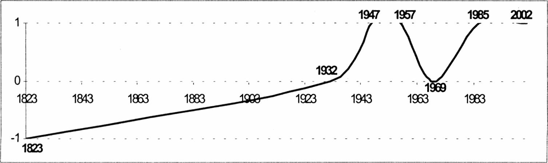
Continuity or Change? A Doctrinal Facet of the U.S. Foreign Policy
61
Fig. 2. Isolationism (-1) and interventionism (1) in the United States foreign policy
Łukasz Wordliczek is associate professor at the Institute of American Studies and Polish Diaspora, Jagiellonian University, Ph.D. in political science (the dissertation The United States Foreign Policy: An Evolving Presidential Perspective was published in Polish in 2003). Dr. Ł.Wordliczek specializes in the United States political system, analytical perspectives in the U.S. foreign policy and some issues within theory of democracy. His current interest is focused on the continuity and change issues in politics and attempts toward assessing the quality of democracy. He is the author of numerous articles in Polish and English concerning mostly the United States political system and Central/Eastem European politics.



