Annales Societatis Geologonim Poloniae (2000), vol. 70: 219-229.

ANASTOMOSING SYSTEM OF THE UPPER NAREW RIVER,
NE POLAND
Ryszard GRADZIŃSKI¹, Janusz BARYŁA¹, Władysław DANOWSKI², Marek DOKTOR¹,
Dariusz GMłJR¹, Michał GRADZIŃSKI³, Artur KĘDZIOR¹, Mariusz PASZKOWSKI¹, Roman SOJA⁴,
Tomasz ZIELIŃSKI⁵ & Sławomir ŻUREK⁶
¹ Institute of Geological Sciences (Cracow Research Centre), Polish Academy of Sciences,
ul. Senacka I, 31-002 Kraków, Poland; E-mail: ndgradzin@cyf-kr.edu.pl
" ul. Helclów 23, 31-148 Kraków’, Poland
' Institute of Geological Sciences, Jagiellonian University, ul. Oleandry 2a, 30-063 Kraków, Poland
⁴ Institute of Geography and Spatial Organization, Polish Academy of Sciences, ul. św. Jana 22, 30-018 Kraków, Poland
⁵ Faculty of Earth Sciences, University of Silesia, ul. Będzińska 60, 41-200 Sosnowiec, Poland
⁶ Geographical Institute, Pedagogic University, ul. Konopnickiej 15, 25-406 Kielce, Poland
Gradziński, R., Baryła, J., Danowski, W., Doktor, M., Gmur, D., Gradziński, M., Kędzior, A., Paszkowski, M., Soja,
R., Zieliński, T. & Żurek, S., 2000. Anastomosing system of the upper Narew river, NE Poland. Annales Societatis
Geologonim Poloniae, 70: 219-229.
Abstract: The studied section of the upper Narew river is an example of an anastomosing system. It consists of a
network of interconnected channels and interchannel areas covered with peat-forming rush and reed vegetation.
The channels have low longitudinal gradient, are laterally stable, relatively deep, they have sandy bed and strongly
overgrown banks. There are no natural levees built of clastic sediment. Straight-type channels dominate in the
channel system. Meandering reaches lack discernible point bar topography. Vegetation plays an important role in
the evolution of the anastomosing system of the Narew.
Abstrakt: Badany odcinek Narwi jest przykładem systemu rzeki anastomozującej. Składa się on z sieci rozdziela-
jących się i ponownie łączących się koryt oraz z obszarów pozakorytowych, porośniętych rolinnością torfo-
twórczą. Koryta mają mały spadek, są stosunkowo głębokie i lateralnie stabilne, a ich brzegi są silnie zarośnięte.
Większość koryt ma stosunkowo niewielką krętość, ale podrzędnie występują także odcinki kręte, typu meandru-
jącego, pozbawione jednak dostrzegalnych łuków przyrostowych, charakterystycznych dla topografii odsypów
meandrowych. Brak jest wyraźnie rozwiniętych wałów przykorytowych zbudowanych z materiału klastycznego.
Roślinność odgrywa znaczącą rolę w rozwoju omawianego systemu.
Key words: anastomosing river, depositional system, Holocene.
Manuscript received 29 September 2000, accepted 18 October 2000

INTRODUCTION
The term anastomosing river has been used in its pres-
ent sense for twenty years only (Smith & Smith, 1980).
Apart from the previously known three major types of rivers
the braided, meandering and straight ones (Leopold &
Woolman, 1957), the anastomosing rivers are now regarded
as a separate group (see Rust, 1978; Knighton & Nanson,
1993; Nason & Knighton, 1996; Miall, 1996; Makaske,
1998). The latter also appear to represent a distinct deposi-
tional system, that has been little studied thus far.
The Narew is the best modern example of an anasto-
mosing river in Poland. A selected part of this system has
been studied by an interdisciplinary team since 1998. This
paper presents a general description of the Narew river an-
astomosing system and preliminary results of studies on
sedimentary processes operating within it.

GENERAL GEOLOGICAL AND
GEOMORPHOLOGICAL BACKGROUND
The Narew river has its origin in Belarus from which it
flows through NF, Poland (Fig. 1). The middle course of the
upper Narew is generally meridional. It flows there over
Pleistocene sediments, up to 150 m thick, mainly glacial
clays and glacifluvial sands. The upper part of these sedi-
ments is related to the Middle-Poland Glaciation.
The anastomosing section of the river, preserved in its
almost pristine form, extends in the wetland area from Suraż
to Rzędziany (Fig. 2). It is ca. 35 km long and lies within the
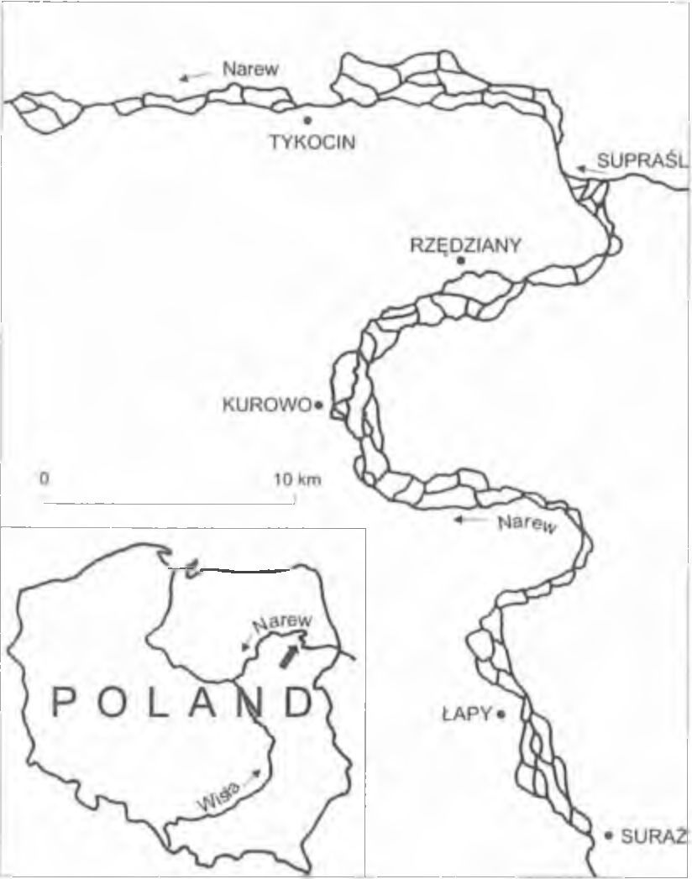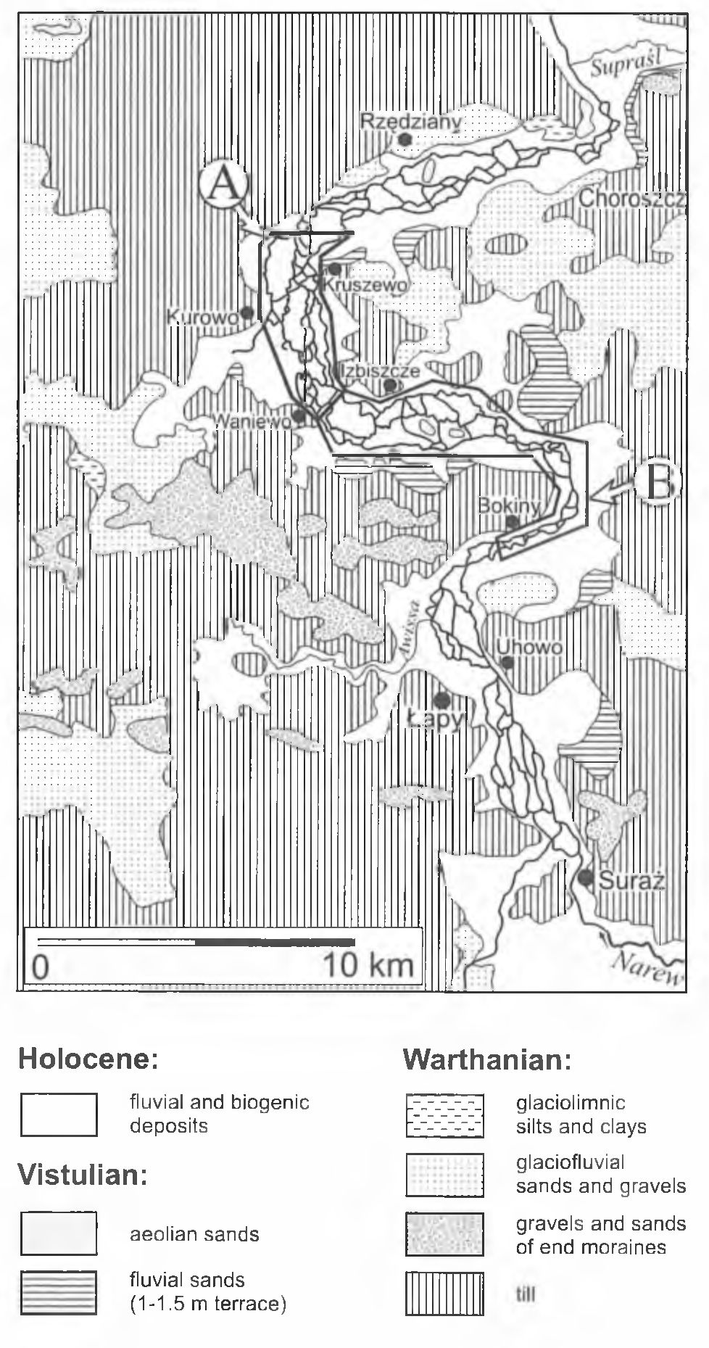
220
R. GRADZIŃSKI ET AL.

CLIMATE AND HYDROLOGY
The studied area has a humid continental climate and it
lies in the coldest part of north Poland. The average annual
number of days with maximum temperature below 0°C is
between 80 and 87 days, the average yearly precipitation is
550-560 mm. Rates of precipitation are highest in the June
to August period.
The hydrological regime of the upper Narew features
one period of water-level rise, related to snow melting in the
spring and one period of low-water level, from July to Octo-
ber. The mean annual discharge of the river at the Suraż
gauging station is 13.3 m³/sec, the maximum recorded dis-
charge being 250 m³/sec.
The winter ice cover usually forms in the beginning of
December and lasts until the middle of March. As a mean, it
is ca. 30 cm thick.
Fig. 1. The upper Narew river between Suraż and Tykocin. The
channel network in the section downstream from Rzędziany is
shown as before drainage works
Narew National Park (NNP). Until recently, the river was
anastomosing for another 35 km downstream, but that part
of the valley has been strongly altered by drainage works.
Our studies have been carried out over a section ca. 20 km
long, situated in the central part of NNP, mainly near Ku-
rowo (Fig. 2).
Within the NNP area, the Narew river valley has a flat
bottom. It is bordered by gentle slopes of low hills built
mostly of glacial clays (Fig. 2). The width of the valley var-
ies markedly from narrows of ca. 1 km to the so-called “ba-
sins” of 2-4 km.
A few available borehole sections demostrate that the
valley follows a depression in the top of glacial clays. The
depression is fdled with a series of sands, 15-25 m thick, lo-
cally enriched in gravels (Churski, 1973; Banaszuk, 1996).
The origin of this depression in not quite clear; it has been
explained by presence of dead ice seperated from ice-sheet
which slowly melted in the present-day “basins” (Falkow-
ski, 1970). There is no direct evidence for the age of the
mentioned sand series; it may be either of Late Pleistocene
or Early Holocene age.
The valley bottom is almost completely covered with a
few metres thick only layer of organic deposits, described as
"peat” in the literature (Churski, 1973: Banaszuk, 1996),
dated at Late Holocene (see Okruszko & Oświt, 1973).
Over the whole area of the NNP, from Suraż to Rzę-
dziany, the river frequently branches and rejoins, creating a
typical anastomosing pattern (see Figs 2, 3). The longitudi-
nal gradient of the valley bottom is ca. 0.22 m/km, the gradi-
ents in transverse sections are minimal and difficult to
measure.
Fig. 2. Geological map of the middle section of the upper
Narew valley (after Baluk, 1973, simplified). A - area of detailed
study; B - area of reconnaisance studies

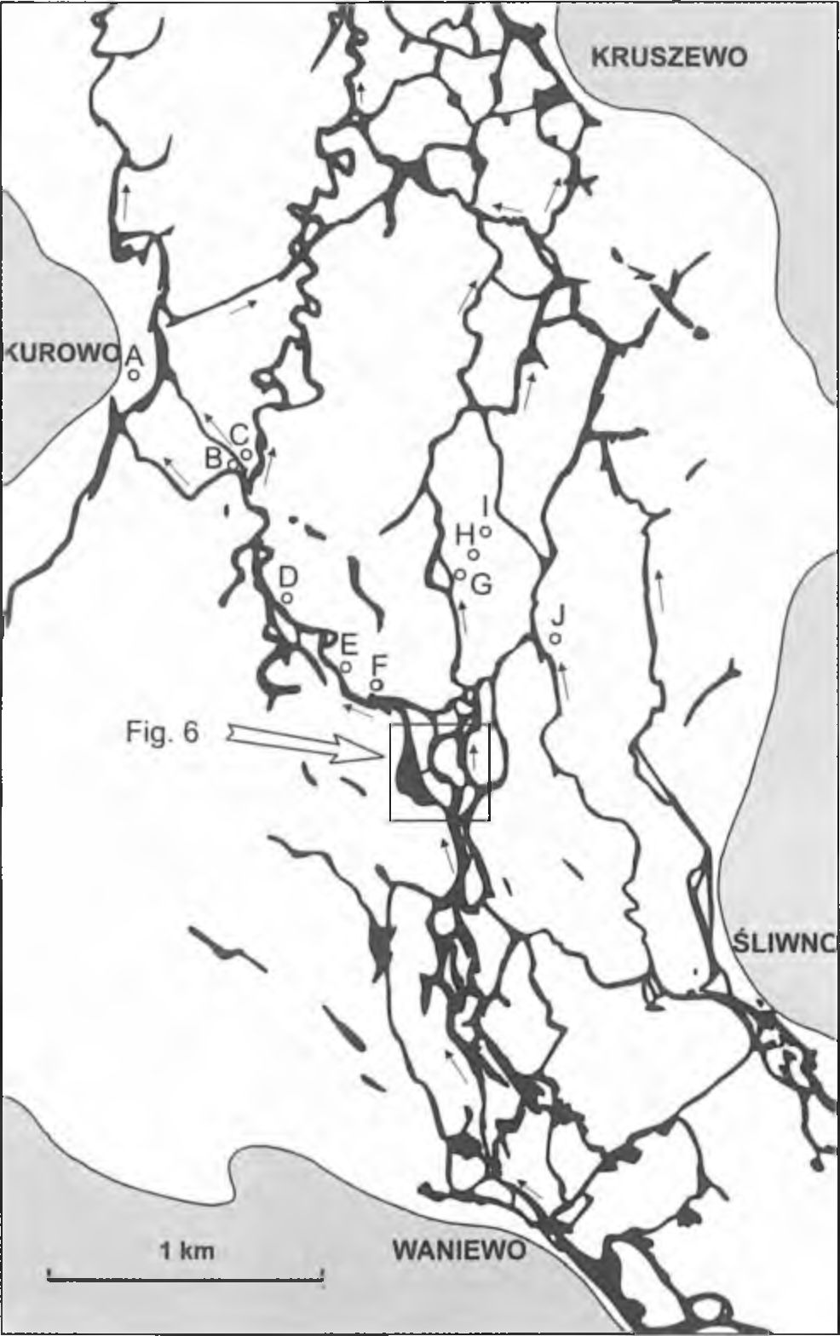
ANASTOMOSING SYSTEM OF THE UPPER NAREW RIVER
221

Fig. 3. The Narew valley between Waniewo and Kruszewo (cf.
Fig. 2). Interchannel areas are white, elevations bordering the val-
ley are grey; lettered points (A-J) correspond to locations of se-
lected boreholes (cf. Figs 12, 13)
In the studied area, the surface of the interchannel areas
is only slightly elevated over the mean water level, so the
normal flow may be described as bankful discharge. The in-
terchannel areas are often flooded for a few weeks or more
when the water level rises.

METHODS
Our studies involved mainly sedimentological, but also
botanical (J. Baryła), and hydrological (R. Soja) aspects of
the river valley. Peat was studied by S. Żurek. Large inflat-
able boats were the main means of transport and a scuba
diver supported investigation of channels. About 150 cores
(up to 5 m long) were taken from the channel bottoms and
from interchannel areas, using self-designed plexiglas-tube
corer; 25 boreholes (up to 6 m deep) were made in inter-
channel areas using Eijkelkamp hand-auger set with peat-
sampler. Additional samples of sediments with undisturbed
structure were taken using wedge-shaped samplers and im-
pregnated with epoxy resin (cf. Fig. 11; see Chudzikiewicz
etal., 1979).
Transverse sections of channels were usually made us-
ing traditional methods, and the longitudinal ones - using an
electronic acoustic bottom profiler. Differences in altitude
and water level over short distances were measured with an
accuracy of up to 0.5 cm with a self-designed instrument.
Specially adapted closed-circuit TV instruments were used
for underwater observations.
Radiocarbon dating (17 analyses thus far) was done in
the Institute of Geological Sciences of the Academy of Sci-
ences of Belarus in Minsk.
Field work was carried out in June and September of
1998 and 1999, each time by a team of 10-14 people. Ob-
servations and photographs from the air were done from a
helicopter, at elevations of 50 to 200 m.

CHANNEL NETWORK
The described anastomosing system consists of numer-
ous channels interconnected in an irregular network. Nodes
of this network are the places of bifurcation or coalescence
of channels. The density of channels and the density of
nodes differ between various fragments of the valley (see
Figs 3-6). The distances between the nodes vary from a few
tens to several hundred metres.
The network consists of channels of various size. Some
of them show markedly larger dimensions and higher dis-
charge than the others, and may thus be considered the main
channels. Their course, in most cases, is approximately par-
allel to the valley axis. The number of the main channels
varies between the individual cross sections of the valley.
Some of the main channels loose a major part of their water
to the smaller channels, thus they gradually loose the attrib-
utes of a main channel. An opposite situation occurs if a
main channel is formed by confluence of smaller ones.
Most channels show a relatively low sinuosity, though
tight bends ocasionally occur. Some short sections of the
channels resemble in shape regular meanders (see Fig. 3).
Sporadically, there occur longer sections of high-sinuosity
channels which follow a typical meandering course, how-
ever they lack a distinctive point-bar topography (Fig. 5).
Such channels are often accompanied by oxbow lakes. The
low-sinuosity channels (with sinuosity index <1.3) are de-
scribed below as straight (cf. Makaske, 1998), and those of
higher sinuosity - as meandering ones.
It should be stressed that a more precise determination
of the sinuosity index (SI, sensu Brice, 1964) is possible
only for the meandering channels, as only there axis of a
meander belt can be determined. For the straight channnels,
their axis may be determined only approximately and arbi-
trarily.
Fragments of abandoned channels of various length and
shape (Fig. 3) are locally preserved at the valley bottom.
They are partly or completely isolated from the active chan-
nels. Some parts of the channel network have a form of rela-
tively shallow lakes, often of irregular amoeboid shapes.
Longitudinal gradient of water surface in individual
channels is low, usually from 16.5 to 20 cm/km, depending
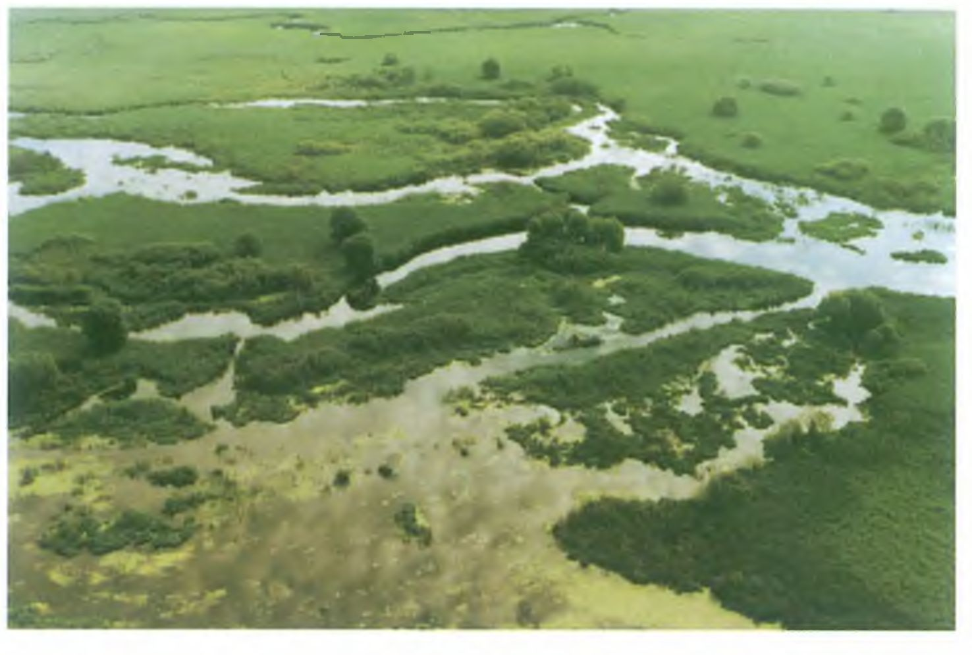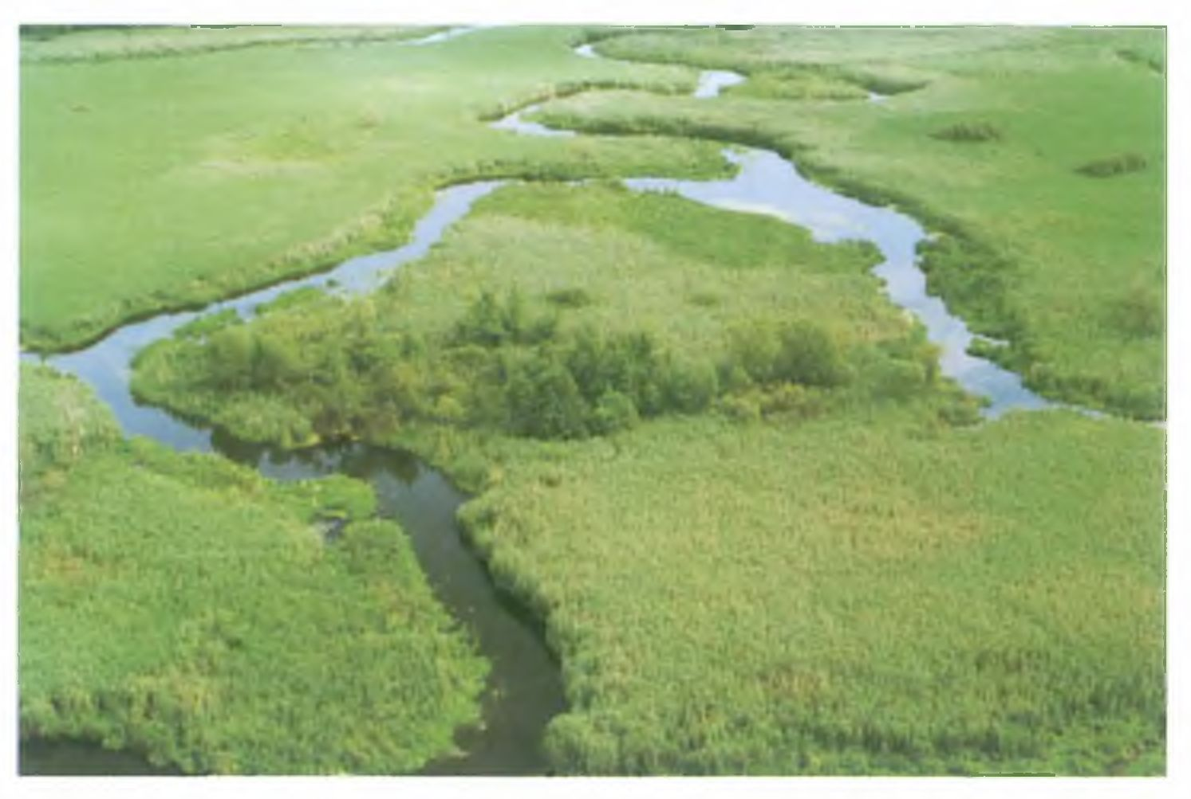
222
R. GRADZIŃSKI ET AL.
Fig. 4. A fragment of the dense channel-network in the middle part of the valley between Waniewo and Kurowo (cf. Fig. 6). In front, an
overgrowing lake
Fig. 5. A fragment of highly sinuous main channel near Kurowo
on the channel sinuosity. Active channels are in most cases
relatively deep, 5 to 35 nr wide (Fig. 7). Their width/depth
ratio usually falls between 2.5 and 10. The larger channels
are typically 3-4 m, locally up to 6 m deep.
Cross sections of active channels are usually canal-like,
steep-sided, with a flat bottom (Fig. 8). Such cross-sections
are observed both along straight sections and at many
bends. At some bends, the cross-sections are distinctly
asymmetric, their convex bank sloping more gently. A pre-
cise determination of the channel margins is usually impos-
sible because of the prevailing grill-like nature of the mar-
gins (see section Vegetation).
Only a few fragments of the channel network are not
natural. These are, in the first place, short fragments cut-off
through the meander necks in the main channels, probably
made in order to facilitate local navigation or wood-rafiting
in the past centuries. Largely artificial is also a canal that
connects both sides of the valley near Waniewo, moreover
two straight canals near Sliwno (see Fig. 3).
Maximum flow velocity observed in the active channels
at a mean water level is relatively low. In the main channels
it varies between 10 and 30 cm/sec, thus the stream power is
generally low. Exceptionally high velocities, ca. 70 cm/s,
were measured in two narrow, short channels that connect

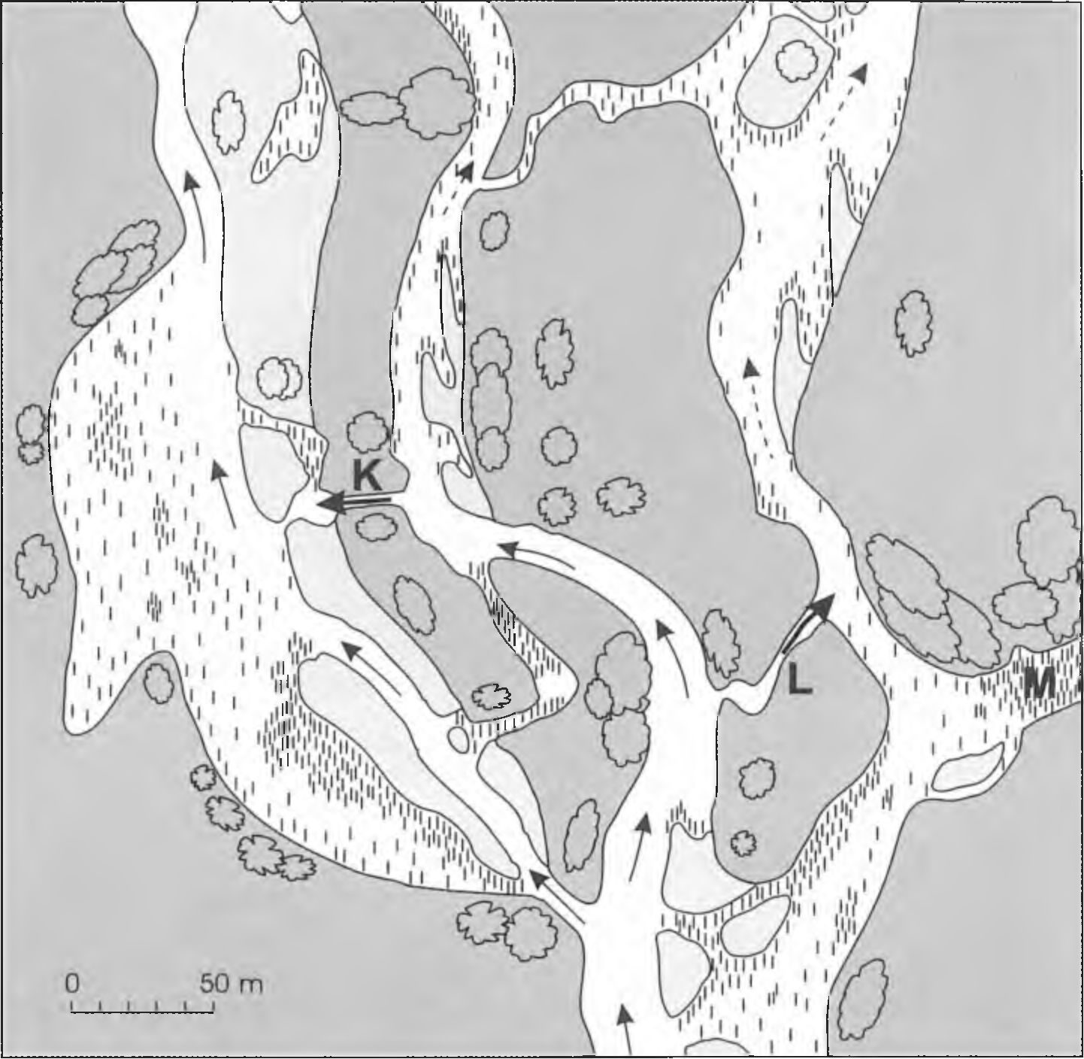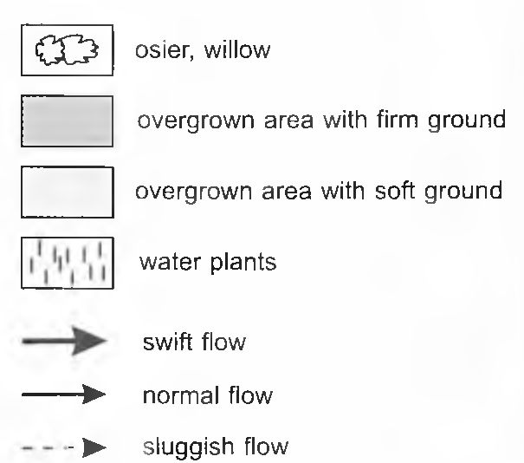
ANASTOMOSING SYSTEM OF THE UPPER NAREW RIVER
223

Fig. 6. Sketch-map of dense channel-network (for location, see Fig. 3). K and L - short channels described in text; M - plant jam
larger ones (see Fig. 6). Longitudinal gradient of water sur-
face in these short channels is 0.13 cm/m. It should be also
noted that both channels exist in their present shape at least
from 1966.

INTERCHANNEL AREAS
The term interchannel areas is used herein in a broad
meaning, encompassing not only the islands but also the
other parts of the flat valley bottom, adjacent to its margins.
These areas are densely vegetated marshy grounds, mostly
covered with peat-forming rushes and reeds; they are being
flooded at high water levels. Some fragments of the inter-
channel areas are so watery and spongy that they are acces-
sible only when frozen.
Nowhere in the studied area have the authors found
clearly marked natural levees built of clastic sediments.
Strongly permeable “levees” composed of loose litter debris
of reed, which profusely grows along the channels, are lo-
cally present. Only rarely they rise up to 15 cm above the
water level in a channel.

VEGETATION
Interchannel areas are occupied mostly by rush and reed
communities, dominated by common reed (Phragmites aus-
tralis). Smaller areas are occupied by sedges Carex elata
and C. acuta (= C. gracilis), canary grass (Phalaris arundi-
nacea) and floating sweet-grass (mostly Glyceria fluitans).
Locally, there occur small patches of osier community
(Salicetum pentadro-cinereae) and single, arborescent wil-
lows. In some areas, rows of willow indicate limits of
former areas exploited for crops of rushes. Subordinate are
alder carr and dry-ground forest (Tilio-Carpinetum). The
latter occupies isolated small hills in the valley bottom near
Izbiszcze, rising to 6 m above the valley bottom; most likely
these are stabilised dunes, older than peat.
No plants rooted in the bottom are present in active
channels deeper than 2 m, though they are common in shal-
lower channels with slack flow. The first species to settle in
the course of a channel shallowing is arrowhead (Sagittaria
sagittifolia) with tape-like leaves, then yellow water-lily
(Nuphar lutea f. submersa - a form with submerged leaves).
With further slowing of the current and shallowing of the
channel, other species appear which are rooted in the bot-
tom, suspended in water or floating on the surface. Many
tens of species of water plants grow in the inactive or
sluggish-water channels and in lakes. Individual sites differ

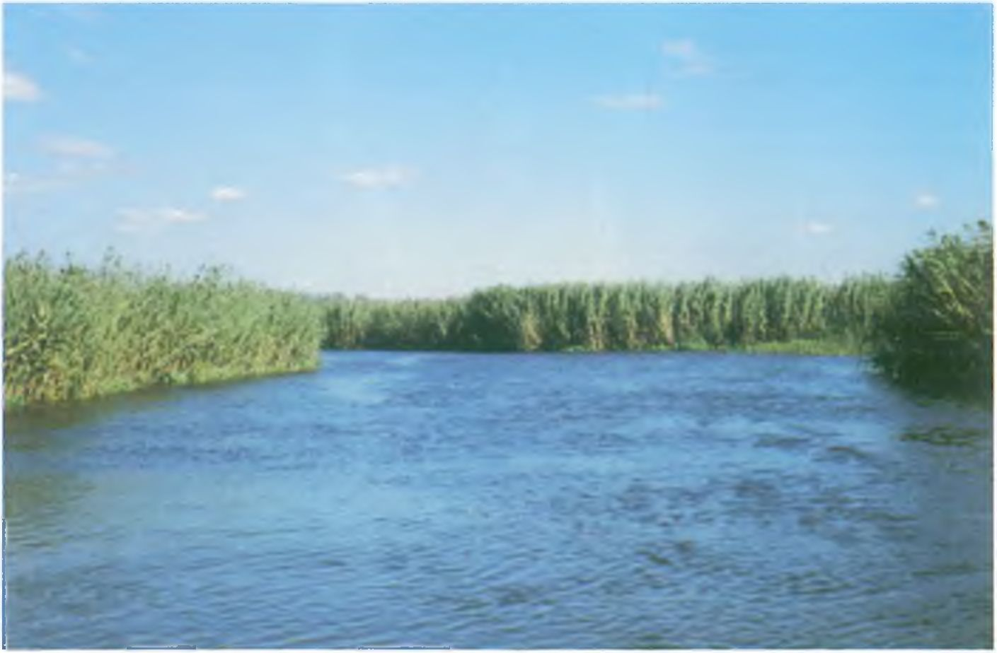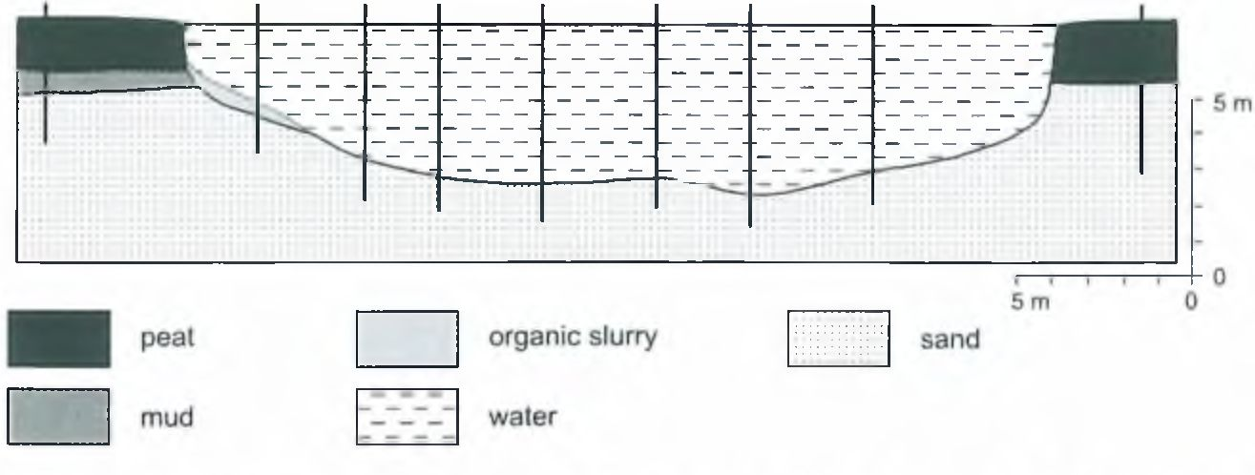
224
R. GRADZIŃSKI ET AL.

Fig. 7. A view of a main active reed-lined channel (reeds are ca. 3 nr high)
in their species composition and belong to various plant as-
sociations.
Dense patches of floating plants are characteristic of the
studied fragment of the valley bottom. They consist mostly
ofcowbane (Cicuta virosa) and great yellow-cress (Rorippa
amphibia), accompanied by a few other species. The plants
in the patches are not rooted in the bottom; they float freely
as “floating islands”. One of the main mechanisms produc-
ing such islands is winter freezing of plant patches into ice,
setting free and drifting away during spring floods. A later
stabilization of such floating islands favours formation of
plant jams, which locally block the flow in the channels
(Fig. 9).
The channel margins usually have a very specific char-
acter: they are here termed the grill-like margins. They are
formed by a belt of reed whose stems grow from the channel
bottom in water up to I m or less (Fig. 10B). Such a belt,
where water flows between the stems, may be up to a few
metres wide. Where the current slows down, a narrow,
dense mat consisting of floating plants extends adjacent to
the reed of the grill-like margin (Fig. IOC). This mat is
formed of the same species that form floating islands and
plant jams described above.
The plants that colonise the bars on the inner or outer
banks of some bends, include: bur-reed (Sparganium sp.)
and great yellow-cress (Rorippa amphibia) close to the
channel, and grasses (Agostis sp., Alopecunis sp.) and rush
(Juncus sp.) in drier places.

DEPOSITS
Predominance of sandy bedload is characteristic of the
Narew river. Its suspended load, sometimes rich in organic
material, is small. The beds of active channels are usually
sandy. The sand varies in grain-size: it is mostly medium- or
coarse-grained, moderately sorted, in some cases with an
admixture of granule. Clasts of peat occur occasionally at
the bottom of larger channels; the largest clasts are several
tens of centimetres in size (see Figs 11 and 14). Where flow
velocities are very low, a layer of dark, organic slurry and
accumulations of larger plant debris form above the sandy
bottom.
The sand deposited in channels usually is horizontally
laminated or lacks mesoscopically discernible depositional
structures. Locally present is large-scale cross-stratification,
and in fine-grained sand also ripple lami-
nation. Some sections include subordi-
nate intercalations of dark-coloured
fine-grained sand, often with a marked
proportion of finer sediment, enriched in
organic matter.
A few cm thick layer of dark slurry
composed mainly of organic remains
spreads over bottoms of lakes, relict
channels and inactive fragments of chan-
nels. It is often underlain by a layer sev-
eral centimetres thick of mud rich in or-
ganic material.
The interchannel areas are, as a rule,

Fig. 8. Cross-section through a canal-like channel, boreholes marked with vertical
lines
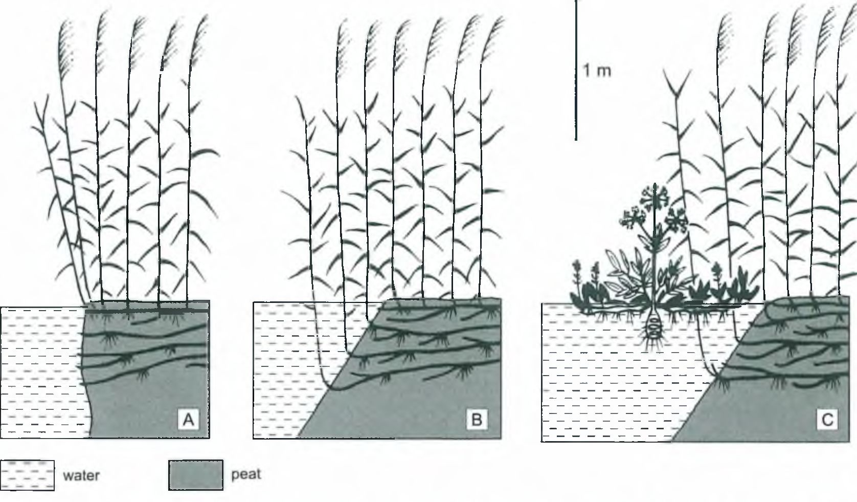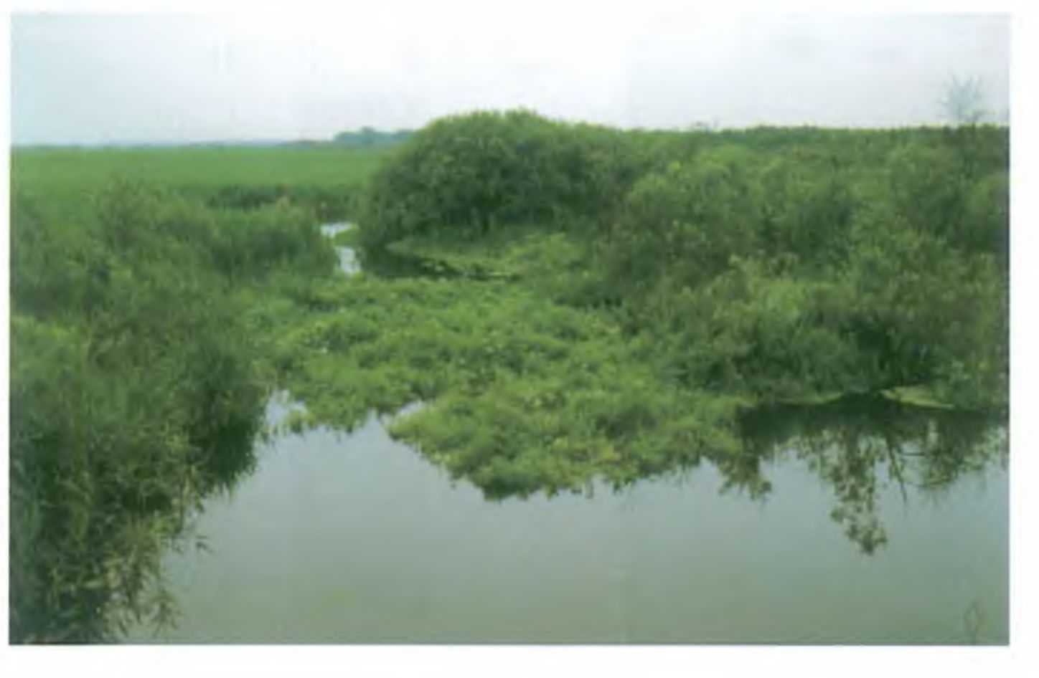
ANASTOMOSING SYSTEM OF THE UPPER NAREW RIVER
225

Fig. 1(1. A scheme of various types of bank overgrown with reed. A reed stems not submerged; B - grill-like margin: C grill-like mar-
gin with floating plant mat
directly underlain by a layer or organic-rich deposit. For the
sake of simplicity, this layer is here termed the peat layer. It
consists mainly of peat, usually rich in sand and finer elas-
tics. The peat belongs to various types: mostly sedge peat
and reed peat, less commonly - osier peat and sedge-reed
one (see Fig. 12). Locally, the peat layer contains thin inter-
calations of sand or mud. The thickness of the described
peat layer usually is between 1 and 2 m, only exceptionally
exceeds 4 m (Fig. 13). Basal surface of the peat layer is un-
even, in some cases even over very short distances.
The substratum of the peat layer was penetrated by
drilling to various depths below the peat-layer base, from a
few tens of centimetres down to 1.7 m. The sequence and li-
thology of the clastic sediments under the peat layer are dif-
ferent in each borehole. The most common sediment en-
countered directly beneath the peat is a several tens of centi-
metres thick layer of mud, often rich in organic debris, occa-
sionally including subordinate intercalations of sand. This
layer is underlain by sand, usually fine-grained, occasion-
ally with subordinate thin intercalations of peat-like sedi-
ment or gyttja. The lowermost parts of some borehole sec-
tions show medium- and coarse-grained sand whose charac-
teristics are similar to those of the channel deposits. In some
cases such sands directly underlie the peat layer (Figs 12,
13).

Fig. 9. One of smaller channels with floating plant jam

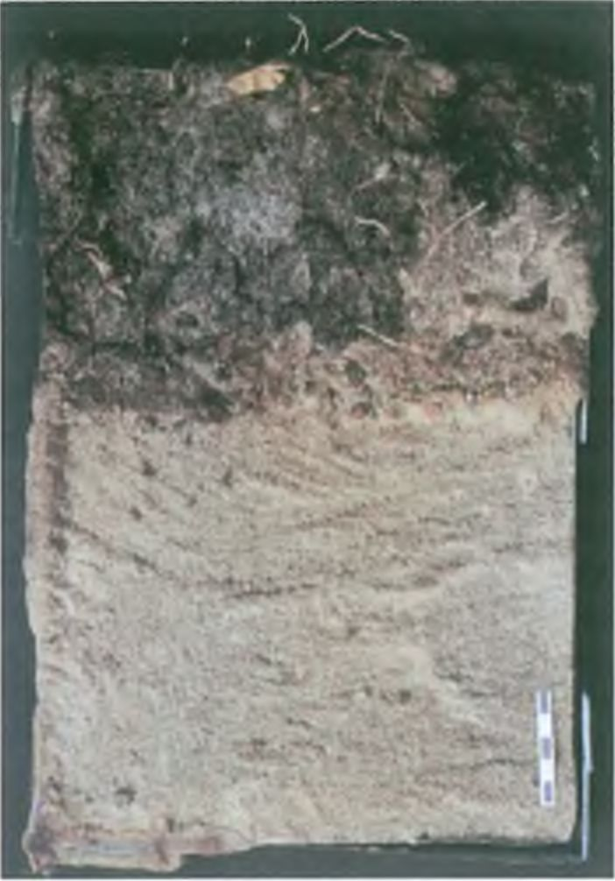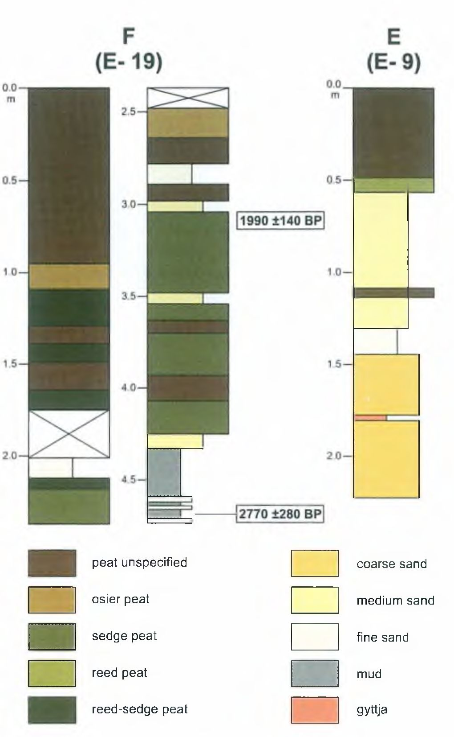
226
R. GRADZIŃSKI ET AL.

Fig. 11. Channel sand from the bottom of a main channel, peat
clasts in the upper part. Vertical sample taken using wedge-shaped
sampler, impregnated with epoxy resin; scale in cm

SEDIMENT AGE AND SEDIMENTATION
RATES
Radiocarbon ages of the basal parts of the peat layer,
and of the directly underlying organic-rich muds vary
widely within, mostly between 3,200 ± 90 BP and 1,340 ±
50 BP, locally even less. Only two dates are distinctly older:
7,080 ± 80 BP and 4,800 ± 300 BP. These dates indicate that
accumulation of the peat layer began at different time in
various parts of the valley, generally during the late Subbo-
real Period, and mainly in the Subatlantic Period.
Long-term sedimentation rates calculated for the inter-
channel peat-layer range between 0.33 and 1.78 mm/yr,
though most are bracketed within 1-1.5 mm/yr. These dif-
ferences seem to be attributable to varying proportions of
peat matter to clastic sediment, variations in rate of peat ac-
cumulation, and variable compaction rates of different types
of peat.

LATERAL STABILITY OF CHANNELS
The actual channel network is very similar in planform
to that recorded on old maps (the oldest, at a scale 1:84,000,
based on a survey of 1886; the newer ones at 1:100,000
from 1915 and 1931). The apparent changes include disap-
pearance of some channels, isolation of relic channels and
diminishing of lake sizes.
More detailed comparisons are possible using a series
of successive aerial photographs of the studied area, from
1966, 1980, 1989 and 1999, at scales 1:25,000 and
1:10,000: no change has been discerned in the position of
channels, including the highly sinuous reaches; a progress is
visible in overgrowing and isolation of inactive channels.
Fig. 12. Detailed logs of two selected boreholes (F and E). For
location, see Fig. 3
and diminishing of the lake sizes.
There is no doubt that the lateral stability of the chan-
nels is directly related to the general lack of erosion at their
banks. At the small gradient and low stream power, the sub-
merged plants of the grill-like margins create a zone which
strongly reduces the erosive power of the current. Another
contributing factor is the low erodibility of the banks built
of peat and covered with a mat of rhizomes and roots (see
Smith, 1976).
On the other hand, presence of peat clasts on sandy bot-
toms of channels indicates that erosion of peat banks occurs,
however occasionally. There are only a few places in the
studied area (between Izbiszcze and Kurowo), where this
happens. Such places are situated on outer sides of bends
where the grill-like margin is poorly developed or absent. In
such places our scuba diver found erosional niches in the
submerged parts of the steep bank, extending up to 1.7 m
into the bank (Fig. 14). Blocks of peat partly detached from
the main mass and deflected from their original position
were visible nearby, as well as loose blocks lying on the bot-
tom. It may be supposed that the erosional retreat of the
banks are being quickly restored by progradation of the rush
and reeds towards the axis of the channel.

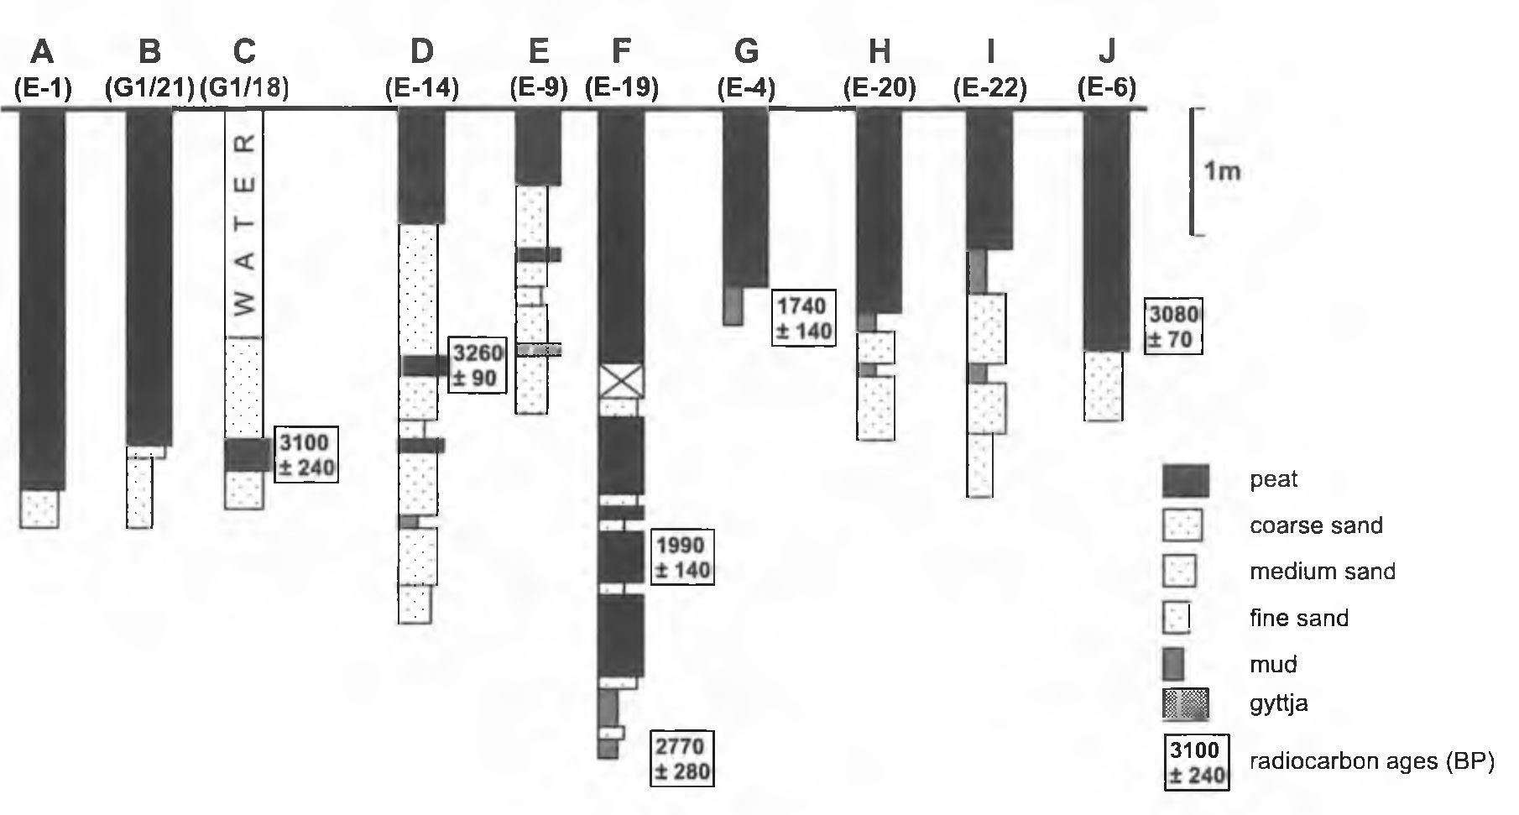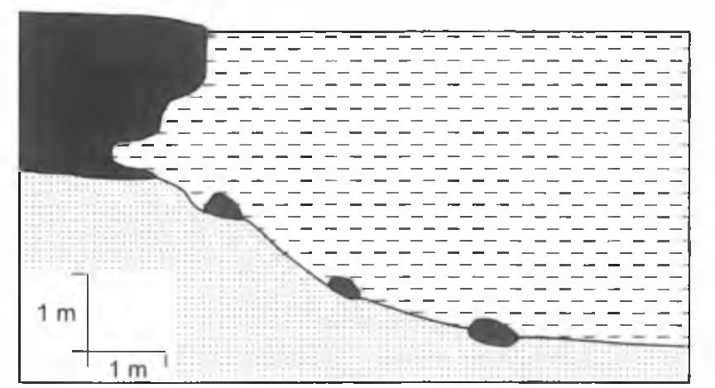
ANASTOMOSING SYSTEM OF THE UPPER NAREW RIVER
227
Fig. 13. Logs of selected boreholes. For location, see Fig. 3

AVULSION
A study of a series of air photographs of the investi-
gated area from the last 34 years did not reveal any newly
formed long sections of channels. A few new sections of
channels which formed during that period are barely a few
tens of metres long. They are situated between neighbouring
smaller channels.

DISCUSSION AND CONCLUSIONS
The studied section of the Narew valley displays many
characteristics considered typical of the anastomosing flu-
vial systems (cf. Knighton & Nanson, 1993; Miall, 1996;
Makaske, 1998): the presence of a network of intercon-
nected channels, low gradient, relatively deep and laterally
stable channels, and general aggradation. The Narew dif-
fers, however, from most anastomosing rivers in its lack of
natural levees built of clastic sediments; in this respect it is
similar only to the Okawango (Stanistreet et ai, 1993).
- Similarly, as is the case with the other anastomosing
systems, avulsion is the main cause of the existence and
evolution of the Narew system, here described. The pro-
cesses of avulsion are favoured by vertical aggradation and
low gradient of the valley bottom (cf. Makaske, 1998), and
flatness and small elevation of the interchannel areas over
the mean water level in the channels. The principal triggers
of avulsion in the Narew are plant jams in active channels
(cf. Ellery et ai, 1995), possibly also ice-floe jams. Pre-
ferred sites for new channels are probably beaver or elk
paths or others zones of less dense rushes and reeds.
- Vegetation is also one of the factors of lateral chan-
nel stability in the Narew valley. It contributes to the growth
of the layer of peat, relatively resistant to erosion. Addition-
ally, vegetation on the channel banks forms a protective
zone in the form of grill-like margins, it also invades chan-
nels, constricting them. Similar role is played by rushes in
the Okawango delta (Stanistreet et ai, 1993; McCarthy et
ai, 1996a, b).
- In our opinion, the development of the Narew anas-
tomosing system is closely related to the growth of peat-
forming vegetation in the valley. The sediment sequences
and radiocarbon dates from the base of peat indicate that the
accumulation of peat began at different times in different
places of the valley bottom. It seems then, that the develop-
ment of the anastomosing system was gradual and only dur-
ing the late Holocene a dense network of channels had
formed, similar in planform to the modem one.
- The anastomosing system of the Narew is domi-
nated by low-sinuosity channels. The subordinate strongly
sinuous, “meandering” reaches lacking any visible features
of point bar topography, suggest that they may represent
fragments of an earlier meandering fluvial system. These
fragments became stabilised by the development of peat-
forming vegetation and included into the anastomosing
channel network.
- The Narew system is distinct from the examples of
anastomosing rivers described in literature (cf. Nanson &
Knighton, 1993; Makaske, 1998) by its predominance of
bed load in the total load. It resembles with this respect the

Fig. 14. An example of eroded peat bank
228
R. GRADZIŃSKI ET AL.
Okawango where the presence of straight and meandering
reaches is also ascribed to the influence of rushes (Stanis-
treet et ah, 1993).
- The relatively high rate of sedimentation in the in-
terchannel areas is caused mainly by the accumulation of
peat. The accumulation is accompanied by vertical accre-
tion of channel sediments. The rate of this accretion is diffi-
cult to detennine as all deeper channels are incised in older
sands, similar to the modem channel deposits.
- Very rapid overgrowing of the lakes seems to be the
result of increased supply of nutrients derived from fertilis-
ers used in agriculture.
Acknowledgements
The sludy has been funded by State Committee for Scientific
Research (grant No 6 P04E 020 14, 1998-2000). Bogusław
Deptuła, the Director of the Narew National Park and other mem-
bers of the Park staff have rendered great help during the field
work. Extremely helpful was the co-operation of Maciej Tomaszek
as the scuba-diver. The authors thank also Piotr Banaszuk, Michał
Banaś, Maciej Chilmanowicz, Piotr Gębica, Michał Gruszczyński,
Jerzy Maciejczuk and Bolesław Wajsprych for their participation
in the field work. Our technician Piotr Wal has made the necessary
self-designed equipment. Iwona Bieleś and Józef Halama have
rendered constant help during the field work. Special thanks go to
Krzysztof Birkenmajer and Grzegorz Haczewski for their help in
the preparation of the final version of this paper.

REFERENCES
Baluk, A., 1973. Geological map of Poland 1:200,000. sheet
Łomża. Wydawnictwa Geologiczne, Warszawa.
Banaszuk, H., 1996. Palaeogeography, natural and anthropogenic
transformations of the Upper Narew River valley (In Polish,
English summary). Wydawnictwo Ekonomia i Środowisko,
Białystok, 213 pp.
Brice, J. C., 1964. Channel patterns and terraces of the Loup Riv-
ers in Nebrasca. U. S. Geological Survey Profesional Paper,
442-D: Dl-D-41.
Chudzikiewicz, L., Doktor, M., Gradziński, R., Haczewski, G.,
Leszczyński, S., Łaptaś, A., Pawelczyk, J., Porębski, S., Ra-
chocki, A. & Turnau, E., 1979. Sedimentation of modem
sandy delta in Lake Płociczno (West Pomerania), (In Polish,
English summary). Studia Geologica Polonica, 62: 1-61.
Churski, T., 1973. Outline of geomorphology of swampy sector of
the upper Narew valley (In Polish, English summary). Zeszyty
Problemowe Postępów Nauk Rolniczych, 134: 11-30.
Ellery, W. N., Ellery, K., Rogers, K. H. & McCarthy, T. S., 1995.
The role of Cyperuspapyrus L. in channel blockage and aban-
doment in the norteastem Okawango Delta, Botswana. Afri-
can Journal of Ecology, 33: 25^19
Falkowski, E., 1870. History and prognosis for the development of
bed configurations of selected sections of Polish lowland riv-
ers (In Polish, English summary). Biuletyn Geologiczny Uni-
wersytetu Warszawskiego. 12: 5-121.
Knighton, D. & Nanson, G. C., 1993. Anastomosis and the contin-
uum of channel pattern. Earth Surface Processes and Land-
fonns, 18: 613-625.
Leopold, L. B. & Woolman, M. G., 1957. River channael patterns;
braided, meandering, and straight. U. S. Geological Survey
Profesional Paper, 282-B: 1-85.
Makaske, B., 1998. Anastomosing rivers - form, processes and
sediments. Nederlandse Geografische Studies, 249, 287 pp.
McCarthy, T. S., Ellery, W. N., Cairncross, B., Ellery, K. & Gro-
bicki, T. S. A., 1988. Features of channel margins in the Oka-
wango Delta. Palaeoecology of Africa, 19: 3-14.
McCarthy, T. S., Ellery, W. N., Rogers, K. H., Cairncross, B. & El-
lery, K., 1986. The roles of sedimentation and plant growth in
changing flow patterns in the Okawango Delta, Botswana.
Suid-Afrikacmse Tydskrift vir Weteskap, 82: 579-584.
Miall, A. D., 1996. The geology of fluvial deposits. Springer, Ber-
lin, 582 pp.
Nanson, G. C. & Knighton A. D., 1996. Anabranching rivers: their
cause, character and classification. Earth Surface Processes
andLandforms, 21: 217-239.
Okruszko, H. & Oświt, J., 1973. Natural characteristics of swampy
upper Narew valley as a basis for its reclamation (In Polish,
English summary). Zeszyty Problemowe Postępów Nauk Rol-
niczych, 134: 31-99.
Rust, B, R.. 1978. A classification of alluvial channel systems. In:
Miall, A. D. (ed.), Fluvial Sedimentology. Canadian Society
of Petroleum Geologists, Memoir, 5: 187-198.
Smith, D. G.. 1976. Effect of vegetation on lateral migration of an-
astomosed channels of a glacier meltwater river. Geological
Society of America. Bulletin, 87: 857-860.
Smith. D. G. & Smith, N. D.. 1980. Sedimentation in anastomosed
river systems: examples from alluvial valleys near Banff, Al-
berta. Journal of Sedimentary Petrology, 50: 157-164.
Stanistreet, 1. G., Cairncross, B. & McCarthy, T. S., 1993. Low
sinuosity and meandering bedload rivers of the Okawangi
Fan: channel confinement by vegetated levees without fine
sediment. Sedimentaty Geolog\ 85: 135-156.
Streszczenie
ANASTOMOZUJĄCY SYSTEM GÓRNEJ NARWI,
NE POLSKA
Ryszard Gradziński, Janusz Baryła. Władysław Danowski,
Marek Doktor, Dariusz Gnntr, Michał Gradziński,
Artur Kędzior, Mariusz Paszkowski, Roman Soja,
Tomasz Zieliński & Sławomir Żurek
Omawiany odcinek górnej Narwi (Fig. 1, 2) dostarcza najlep-
szego w Polsce przykładu systemu rzeki anastomozującej i znaj-
duje się w granicach Narwiańskiego Parku Narodowego. Rzeka
płynie tutaj wieloma korytami, które rozdzielają się i ponownie
łączą tworząc nieregularną sieć (Fig. 3-6). Składa się ona z koryt
różnej wielkości i różnej krętości, których spadek jest nieznaczny.
Oprócz koryt aktywnych występują koryta znajdujące się w róż-
nych stadiach zamierania, a miejscami płytkie na ogól, zarastające
jeziora. Charakterystyczną cechą aktywnych koryt jest ich stosun-
kowo duża głębokość w porównaniu z szerokością i przeważnie
“kanałowy" kształt przekrojów (Fig. 8).
Płaskie obszary pozakorytowe, w tym liczne wyspy, wznoszą
się jedynie nieznacznie nad poziom wody w korytach w warun-
kach przeciętnego stanu, a podczas wyższych stanów bywają zale-
wane na dłuższy czas. Obszary te sązabagnione i silnie zarośnięte
roślinnością torfotwórczą, głównie trzciną i turzycami (Fig. 4-7).
Podłoże obszarów pozakorytowych tworzy warstwa złożona w
przewadze z utworów organogenicznych, głównie z torfów,
zwykle silnie zapiaszczonych, zawierająca podrzędne wkładki
osadów klastycznych (Fig. 12, 13). Warstwa ta, przeważnie o
miąższości 1-2 m, sporadycznie do 4 m, rozwijać się zaczęła w
różnym czasie w różnych miejscach doliny, na ogół począwszy od
ANASTOMOSING SYSTEM OF THE UPPER NAREW RIVER
229
późnego subboreału, a głównie w subatlantyku (Fig. 12, 13).
Swierdzona lateralna stabilność koryt, charakterystyczna dla
rzek anastomozujących, w przypadku Narwi tłumaczona jest przez
autorów przede wszystkim warunkami hydrodynamicznymi
(stosunkowo niewielkie prędkości, niska moc przepływu), obec-
nością torfów i maty korzeni oraz kłączy w brzegach, oraz pospoli-
tym występowaniem "ażurowych” brzegów, które na skraju koryt
tworzą strefę chroniącą brzegi przed boczną erozją (Fig. 7, 10).
W obciążeniu Narwi zdecydowanie dominuje materiał piasz-
czysty, klastyczna zawiesina odgrywa całkowicie podrzędną rolę.
Dno aktywnych koryt jest piaszczyste, osady korytowe złożone są
na ogół z średnio- i gruboziarnistego piasku (Fig. 11).
Rozwój anastomozującego systemu Narwi związany jest
rn.in. z warunkami generalnej agradacji, rozwojem pokrywy roś-
linności torfotwórczej i wielokrotnie zachodzącą awulsją. Bez-
pośrednimi przyczynami awulsji były przede wszystkim zatory
roślinne (Fig. 9), a zapewne również zatory lodowe.

