
PLOS ONE
RESEARCH ARTICLE
Slight dependence of temperate-forest herbaceous plants, Geum urbanum and Senecio ovatus, on arbuscular mycorrhizal fungi (AMF) enables them to colonise soils with a low level of AMF abundance
Katarzyna Rożek *, Kaja Rola, Szymon Zubek
Institute of Botany, Faculty of Biology, Jagiellonian University, Krako´ w, Poland
* katarzyna.rozek@doctoral.uj.edu.pl
Abstract
While numerous studies have revealed that arbuscular mycorrhizal fungi (AMF) enhance plant performance, the influence of these symbionts on temperate-forest herbaceous spe- cies in relation to soil physical and chemical properties has been left largely unexplored.
Therefore, two perennial herbs, Geum urbanum (Rosaceae) and Senecio ovatus (Astera- ceae), were examined in a laboratory pot experiment to determine whether AMF influenced their growth, photosynthetic performance index, and N and P contents in biomass. The treatments, involving three widespread AMF species, were prepared in the soils of two habi- tats colonised by both plants, namely beech and riparian forests, as follows: (1) control— soils without AMF, (2) Claroideoglomus claroideum, (3) Funneliformis geosporus, and (4) Funneliformis mosseae. Neither shoot mass nor photosynthetic performance index of G. urbanum and S. ovatus was enhanced by AMF. Senecio ovatus root mass was increased compared to control only by F. geosporus. Inconsistent effects were observed in N and P contents in shoots and roots of both species. The direction and magnitude of these responses were dependent on the fungal species and soil type. Although the plant species belong to families whose representatives are usually regularly colonised by and highly responsive to AMF, our study indicates that AMF had only a slight impact on the perfor- mance of G. urbanum and S. ovatus at the early stages of their development. The plants being slightly dependent on AMF are thus adapted to colonise temperate-forest soils with a
low level of availability of AMF propagules.

OPEN ACCESS
Citation: Rożek K, Rola K, Zubek S (2021) Slight dependence of temperate-forest herbaceous plants, Geum urbanum and Senecio ovatus, on arbuscular mycorrhizal fungi (AMF) enables them to colonise soils with a low level of AMF abundance. PLoS ONE 16(10): e0258862. https:// doi.org/10.1371/journal.pone.0258862
Editor: Luigimaria Borruso, Free University of Bozen-Bolzano, ITALY
Received: May 16, 2021
Accepted: October 6, 2021
Published: October 26, 2021
Copyright: © 2021 Rożek et al. This is an open access article distributed under the terms of the Creative Commons Attribution License, which permits unrestricted use, distribution, and reproduction in any medium, provided the original author and source are credited.
Data Availability Statement: The data that support the findings of this study are openly available online at Mendeley Data: 10.17632/jk7y5jy4rc.1.
Funding: Yes. S.Z. National Science Centre of Poland, project 2017/27/B/NZ9/01297, https:// www.ncn.gov.pl/. S.Z. Institute of Botany, Faculty of Biology, Jagiellonian University in Cracow, N18/ DBS/000002, http://www.ib.uj.edu.pl/. No, funders did not play any role in the study design, data
Introduction
Arbuscular mycorrhiza (AM) is one of the ubiquitous symbioses that frequently result in the enhancement of plant performance through nutritional and non-nutritional mechanisms [1]. However, the impact of arbuscular mycorrhizal fungi (AMF) on their partners is varied and
PLOS ONE | https://doi.org/10.1371/journal.pone.0258862 October 26, 2021
1 / 19

PLOS ONE
Dependence of forest herbaceous plants, Geum urbanum and Senecio ovatus, on arbuscular mycorrhizal fungi
collection and analysis, decision to publish, and preparation of the manuscript.
may also be neutral or negative. It has been shown that AM enhances nutrient absorption and
growth [2], competitiveness in communities [3, 4], and resistance to unfavourable environ- mental conditions [5–8] of certain species of plants. In other studies, AM had no effect, or a negative effect, on plant nutrition, growth, and diversity, because the cost of maintaining fun- gal partners exceeded the benefits resulting from this symbiosis [8–11]. In any case, in these relationships, environmental factors, physical and chemical properties of soil, and, most importantly, fungus and plant species identities were of significance [8, 12].
Previous studies on interactions between mycorrhizal fungi and plants in temperate forests focused overwhelmingly on ectomycorrhizas; however, the presence of endomycorrhizas, including AM, has been observed among forest overstorey and understorey plant species [13]. Studies focused on the impact of AMF on the herbaceous layer of forest ecosystems have shown that AMF are physically and functionally selective in terms of partners [14, 15], as well as being influenced by soil properties and plant diversity [16] and by habitat filtering processes [17]. Moreover, Moora et al. [18], using multispecies soil inocula, found that the influence of AMF on the growth, nutrient status, and AMF colonisation of understorey species is site-spe- cific. Similarly, based on field observations of degrees of AMF root colonisation, it was sug- gested that AMF may play a role in supplying P to understorey species in sites characterised by the scant presence of this element [19]. Inconsistent effects of AMF soil inocula from young and old forest ecosystems on the growth of understorey plant species were found [20, 21]. On one hand, the were no differences between the effects of both AMF soil inocula on shoot and/ or root mass [20]; on the other hand, they varied, with positive effects of AMF from old forests being linked with intensity of use and the impact thereof on AMF community composition [21]. However, heretofore no studies have focused on the impact of particular AMF species on the performance of herbaceous plants present in forests located in temperate climate zones in relation to soil physical and chemical properties. Therefore, two perennial herbs, Geum urba- num L. and Senecio ovatus (P. Gaertn., Mey. & Scherb.) Willd., were chosen in order to deter- mine whether AMF influenced their performance. In laboratory conditions, we tested their response to inoculation with three widespread AMF species present in forest ecosystems around the world in soils of beech and riparian forests, which are colonised by both plant species.
The specific questions addressed in the present study are as follows: (1) Are the plants dependent on AMF for their performance? (2) To what extent do different AMF species affect plant mass, photosynthetic performance index, and N and P contents in biomass? (3) What is the relationship between degree of mycorrhizal colonisation and plant variables? (4) Are these interactions dependent on soils which differ in physical and chemical properties? Given func- tional diversity in AM symbioses, which is also affected by soil physical and chemical proper- ties [8, 14], we expected that the effects of inoculation would differ between plant species, AMF species, and types of soil.
Competing interests: The authors have declared that no competing interests exist.
Materials and methods
Soils
Soils were collected from two localities in southern Poland: a beech forest adjacent to the Pazurek Nature Reserve near Olkusz (50˚20´40.3˝ N, 19˚38´24.7˝ E) and the riparian Łęgowski Forest in Cracow (50˚03´07.0˝ N, 20˚02´03.8˝ E). These habitats were selected because they are colonised by both G. urbanum and S. ovatus [19, 22]. The soils were collected to the depth of 20 cm, mixed and sieved, using mesh (2 cm). Three randomly chosen samples of each soil were passed through mesh (2 mm) and then analysed for physical and chemical properties, as specified in [23]. The properties of these soils are presented in Table 1. The soils were sterilised
PLOS ONE | https://doi.org/10.1371/journal.pone.0258862 October 26, 2021
2 / 19

PLOS ONE
Dependence of forest herbaceous plants, Geum urbanum and Senecio ovatus, on arbuscular mycorrhizal fungi
Table 1. Physical and chemical properties (mean ± SD; N = 3) of beech and riparian soils used in the experiment.
Significant differences (p < 0.05) between soil types according to the Mann-Whitney U test are marked with
asterisks.
https://doi.org/10.1371/journal.pone.0258862.t001
twice (121 ˚C; 2 h; one-week interval). Both localities are unprotected areas thus no permits
for sampling of soils were required.
Fungi
Three globally widespread AMF species present in temperate forests in Europe [19, 24] were used: (1) Claroideoglomus claroideum (N.C. Schenck & G.S. Sm.) C. Walker & A. Schu¨ßler [Glomus claroideum N.C. Schenck & G.S. Sm.], (2) Funneliformis geosporus (T.H. Nicolson & Gerd.) C. Walker & A. Schu¨ßler [Glomus geosporum (T.H. Nicolson & Gerd.) C. Walker], and
(3) Funneliformis mosseae (T.H. Nicolson & Gerd.) C. Walker & A. Schu¨ßler [Glomus mosseae (T.H. Nicolson & Gerd.) Gerd. & Trappe]. Inocula of C. claroideum, F. geosporus, and F. mos- seae were prepared in plastic pots (11 cm × 12 cm; 1400 ml in volume). Reference monoculture substrata (30 g) of BEG 23, BEG 11 and BEG 12 were softly mixed with sterile substratum (sand:expanded garden rock:rock phosphate; 3:1:50 g/L). Pots were planted with ca 50 seeds of Plantago lanceolata L. as a host plant [24]. The seeds were supplied by Herbador, Bydgoszcz, Poland. After 6 months, mixture of P. lanceolata roots (mycorrhizal frequency parameter was ca 50%), mycelia, and spores (ca 75 spores per 50 g), were used as AMF inocula. For the con- trol treatment, P. lanceolata was grown in the same substratum without AMF [25]. No AMF mycelia were present in this material. The fungal species were derived from fungi collection of the Institute of Botany at the Jagiellonian University in Cracow. No permits for their use were required.
PLOS ONE | https://doi.org/10.1371/journal.pone.0258862 October 26, 2021
3 / 19
Soil properties

Soil type

beech
riparian
Soil texture

Sand (%)
67.00±0.00
22.33±0.58
�
Silt (%)
28.67±0.58
64.00±0.00
�
Clay (%)
4.33±0.58
13.67±0.58
�
pH
5.56±0.22
6.93±0.16
�
Total content

C (%)
1.55±0.08
2.28±0.11
�
N (%)
0.13±0.01
0.24±0.00
�
P (mg kg-1)
139.50±21.80
252.00±7.15
�
K (mg kg-1)
900.11±60.86
6311.42±100.05
�
Mg (mg kg-1)
779.86±54.70
6023.45±206.01
�
Ca (mg kg-1)
1548.49±68.41
3399.90±86.16
�
Exchangeable content (mg kg-1)

K
59.80±0.42
110.24±3.99
�
Mg
29.74±0.20
231.35±5.26
�
Ca
902.89±31.65
2954.69±80.18
�
N-NH4+
3.57±1.21
3.49±1.33

N-NO3-
3.58±0.17
20.58±1.09
�
S-SO4
0.39±0.21
0.63±0.04

PLOS ONE
Dependence of forest herbaceous plants, Geum urbanum and Senecio ovatus, on arbuscular mycorrhizal fungi
Plants
Two herbaceous plant species were used in the experiment. Geum urbanum (wood avens) is a perennial herb which reproduces via rhizomes and seeds [26]. Senecio ovatus (wood ragwort) represents the same life form and reproduces via seeds [27]. These plants are present in several forest ecosystems [22], including beech and riparian forests of southern Poland. Seeds were collected in 2018 at two sites, 49˚27´20.6˝ N, 20˚43´02.2˝ E and 49˚28´26.2˝ N, 20˚43´14.9˝ E, in the Beskid Sądecki mountain range, near Piwniczna-Zdro´j, for G. urbanum and S. ovatus, respectively, and stored in a refrigerator (2 months). Subsequently the seeds were surface-steri- lised in 1% sodium hypochlorite solution for 15 minutes [28] and germinated in autoclaved sand in plastic pots (9 × 12.5 cm; 500 ml in volume) placed in closed Sun bags (Sigma-Aldrich), at 22 ˚C with 345 μmol PAR photons m−2 s−1, in a 12/12 h light regime. Both plants are unpro- tected species thus no permits for seed collections were required.
Experimental setup
To the centre part of pots (9 × 12.5 cm; 500 ml in volume) with autoclaved soils (440 ml) of both types (Table 1) AMF inocula were added (30 g), as specified in Majewska et al. [25]. The controls were substratum (30 g) with non-mycorrhizal roots of P. lanceolata. Two seedlings (14 days old) of G. urbanum and S. ovatus were planted in the central part of each pot. After 14 days, from each pot, one individual was eliminated. The treatments in two soil types comprised
(1) control, i.e. soil with no AMF, (2) C. claroideum, (3) F. geosporus, and (4) F. mosseae. In order to align bacterial compositions between the treatments, an aqueous filtrate of a triple inoculum mixture was added (4 ml; 20% suspension; w/v) as specified in Jansa et al. [29] and Majewska et al. [25]. For each treatment, we used eleven replicates, for a total of 176 pots (2 plant species × 2 types of soil × 4 treatments × 11 replicates). The pots were positioned ran- domly in the plant growth chamber and kept in closed Sun bags to avoid contamination (22
˚C; 345 μmol PAR photons m−2 s−1; 12/12 h light regime). The plants were watered once a
week by 50 ml of sterile water per pot.
Plant harvesting
After 75 days experiment was finished to estimate plant performance at the early stages of development. In order to evaluate photosynthetic parameters, chlorophyll a fluorescence were measured. Following this procedure, all plants were harvested, cleansed of soil particles in tap water, and washed twice in distilled water. Each specimen was divided into shoots and roots. One-fifth of the roots of each individual plant was cut and stained in order to observe AMF structures and to calculate degree of colonisation. The shoots and the remainder of the roots were dried at 22 ˚C and weighed with an analytical balance (Radwag, WPA 60/c/1; 0.0001 g precision level) in order to evaluate mass. The shoots and roots were also used for measure- ments of nitrogen (N) and phosphorus (P) contents.
Chlorophyll a fluorescence measurements
Chlorophyll a fluorescence was measured by a fluorimeter Handy PEA (Hansatech Instru- ments Ltd., King’s Lynn, Norfolk, UK) in accordance with Strasser et al. [30] and Tsimilli- Michael and Strasser [31]. From each pot three intact and mature leaves of G. urbanum and S. ovatus were dark-adapted for 30 min prior measurements For each sample average OJIP fluo- rescence transients were calculated in accordance with the JIP test [30] with Biolyzer software (Laboratory of Bioenergetics, University of Geneva, Switzerland). The performance index (PIABS), which estimate the overall photosynthetic performance [31], was presented.
PLOS ONE | https://doi.org/10.1371/journal.pone.0258862 October 26, 2021
4 / 19

PLOS ONE
Dependence of forest herbaceous plants, Geum urbanum and Senecio ovatus, on arbuscular mycorrhizal fungi
Determination of degree of AMF root colonisation
Roots were stained in accordance with the method of Phillips and Hayman [32], with modifi- cations [33]. Thirty randomly selected fragments (1 cm) of fine roots were placed on slides in glycerol:lactic acid (1:1; v/v) and squashed using cover slides. The chemicals used, of pure qual- ity for analysis, were produced by Chempur, Poland. AMF colonisation was calculated in accordance with the method of Trouvelot et al. [34], using a Nikon Eclipse 80i light micro- scope with Nomarski interference contrast. The analysed parameters comprised mycorrhizal frequency (F), relative mycorrhizal root length (M), and relative arbuscular richness (A) [34].
Measurement of nitrogen and phosphorus contents in shoots and roots
Shoots and roots of G. urbanum and S. ovatus were dried at 80 ˚C and then milled with a Pul- verisette 14 variable-speed rotor mill (Fritsch, Germany). The contents of N (%) in shoots and roots were measured using the Kjeldahl method. Samples were digested in H2SO4 with Kjel-
tabs (K2SO4 + CuSO4 � 5H2O; Foss Tecator Digestor Auto) followed by distillation on a Foss
Tecator Kjeltec 2300 Digestion Analyzer Unit (Foss Tecator; AN 300 v. 4.0). Contents of P
(mg kg–1) in shoots and roots were measured colourimetrically with a Hach Lange DR 3800 using the vanadate-molybdate method [35]. The samples were digested in a hot concentrated mixture of HNO3 and HClO4 (4:1; Foss Tecator Digestor Auto). These suprapure-grade nitric (69–70%) and perchloric (70–72%) acids were produced by J.T. Baker and Merck, respectively. Analytical grade sulphuric acid (95–97%) was produced by J.T. Baker. In the case of S. ovatus, due to an insufficient mass of roots, only P contents were measured.
Calculations and statistical analyses
The mycorrhizal dependency (Md) of G. urbanum and S. ovatus, an indicator of the degree of dependence of plants on AMF for maximum growth, was calculated according to the equation: Md = [1 − (mean total biomass of plants without AMF/ total biomass of each plant inoculated with AMF)] × 100% [36, 37]. Similarly, we used the Md parameter in conjunction with the contents of N and P in biomass (shoots and roots) to calculate the degree of dependence of plants on AMF for acquisition of nutrients: Md = [1 − (mean total contents of N or P in bio- mass of plants without AMF / total contents of N or P in biomass of each plant inoculated with AMF)] × 100%.
A non-parametric Mann-Whitney U test was performed to test the significance of differ- ences in soil physical and chemical properties between the two soil types.
Two-way analysis of variance, followed by Tukey’s (HSD) test, with fungal species and soil type as categorical predictors was performed to test the differences in mycorrhizal parameters (F, M, and A) across AMF-inoculated treatments, as well as mass of shoots and roots, PIABS, N and P contents in shoots and roots, mycorrhizal dependency for total biomass (shoots and roots), and N and P contents in total biomass across all treatments, for G. urbanum and S. ova- tus, separately. Prior to the analysis, the assumption of normality was verified using the Lillie- fors corrected Kolmogorov-Smirnov test. Levene’s test was used to assess homogeneity of variance.
Since three mycorrhizal parameters were strongly correlated with each other (Pearson’s
R > 0.9), only relative mycorrhizal root length (M) was included in further analyses. The rela- tionships between the M parameter and mass of shoots and roots, the PIABS parameter, and N/ P contents in shoots and roots were tested with Pearson’s correlation coefficients, separately for G. urbanum and S. ovatus, AMF inocula, and soil types.
Plant parameters (M, root and shoot mass, PIABS, N and P contents in shoots and roots) were also investigated with principal component analysis (PCA) to identify the relationships
PLOS ONE | https://doi.org/10.1371/journal.pone.0258862 October 26, 2021
5 / 19

PLOS ONE
Dependence of forest herbaceous plants, Geum urbanum and Senecio ovatus, on arbuscular mycorrhizal fungi
among these parameters and to recognize whether samples are grouped according to different
soil types and fungal treatments. The analysis was based on the correlation matrix and per- formed separately for G. urbanum and S. ovatus.
All treatments involved 11 replicates. Two replicates of S. ovatus planted on riparian soil
and inoculated with F. geosporus were excluded from the analysis. Due to the lack of data for the N content in S. ovatus roots, analyses concerning this parameter and the mycorrhizal dependency for the total N content in the biomass for S. ovatus was not performed. In the case of single missing data for the N content in G. urbanum roots and S. ovatus shoots, Tukey’s (HSD) test for unequal sample sizes was applied. The analyses were performed using STATIS- TICA 10 (StatSoft, Tulsa, Oklahoma, USA) and PAST 3.22 [38].
Results
AMF root colonisation
In general, the level of AMF colonisation of G. urbanum, represented by the three mycorrhizal parameters (mycorrhizal frequency—F, relative mycorrhizal root length—M, and relative arbuscular richness—A), was low in the case of all treatments. Higher levels of mycorrhizal col- onisation were found in S. ovatus (Fig 1). Two-way ANOVA revealed that, in both soils, the F, M, and A parameters of G. urbanum were higher in C. claroideum and F. mosseae treatments than in F. geosporus (significant fungus effect; Table 2). In contrast, significant fungus × soil effects were found for all mycorrhizal parameters in S. ovatus (Table 2). The highest level of colonisation in plants in beech soil treatments was found for C. claroideum, in riparian soil treatments for F. mosseae. The level of colonisation of F. geosporus was the lowest in both soils (Fig 1).
Plant growth
Neither fungus nor soil had a significant effect on the shoot mass of both plant species. On the other hand, we found that both factors had a significant effect on the mass of roots (significant fungus and soil effects; Table 2). The mass of roots was on average 40.6% higher in beech soil treatments compared to riparian soil treatments (significant soil effect). As regards fungus effect, F. geosporus treatments were characterised by a significantly greater mass of G. urbanum roots than C. claroideum treatments for both soil types. In the case of S. ovatus, F. geosporus treatments were characterised by a significantly greater root mass compared to the remaining treatments (Fig 2).
Photosynthetic performance index
For G. urbanum, no significant effects were found. The value of PIABS of S. ovatus was signifi- cantly lower only in C. claroideum treatment in riparian soil compared to control treatment in riparian soil and all treatments in beech soil (Table 2; Fig 2).
Nitrogen and phosphorus contents in shoots and roots
N contents in shoots of G. urbanum differed significantly only between soil types (significant soil effect; Table 2), being higher on riparian soil. For S. ovatus, significant fungus × soil inter- action was revealed (Table 2). Control treatment in beech soil was characterised by signifi- cantly lower N content in shoots compared to F. mosseae in beech soil and C. claroideum and control treatment in riparian soil (Fig 3).
PLOS ONE | https://doi.org/10.1371/journal.pone.0258862 October 26, 2021
6 / 19

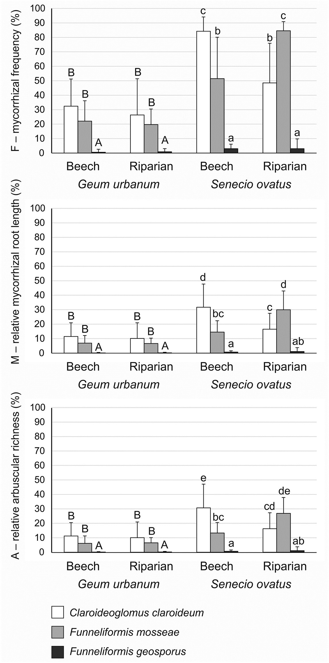
PLOS ONE
Dependence of forest herbaceous plants, Geum urbanum and Senecio ovatus, on arbuscular mycorrhizal fungi
Fig 1. Mycorrhizal colonisation (percentages; mean ± SD) of Geum urbanum and Senecio ovatus grown in beech and riparian soils. Mycorrhizal parameters: mycorrhizal frequency (F); relative mycorrhizal root length (M); relative arbuscular richness (A). Within each plant species, lowercase letters above the bars indicate statistically significant interaction between fungus and soil effects; uppercase letters indicate the significant main effect of fungus; different letters above the bars indicate statistically significant differences; for each, p < 0.05. See Table 2 for details on the main effects and interactions.
https://doi.org/10.1371/journal.pone.0258862.g001
PLOS ONE | https://doi.org/10.1371/journal.pone.0258862 October 26, 2021
7 / 19

Table 2. Results of two-way ANOVA for the effects of fungal species, soil types, and their interaction on Geum urbanum and Senecio ovatus parameters; the effects in bold are statistically sig- nificant (p < 0.05).
No measurements of nitrogen content in roots of S. ovatus were conducted due to the small mass of roots.
https://doi.org/10.1371/journal.pone.0258862.t002
PLOS ONE
Dependence of forest herbaceous plants, Geum urbanum and Senecio ovatus, on arbuscular mycorrhizal fungi
PLOS ONE | https://doi.org/10.1371/journal.pone.0258862 October 26, 2021
8 / 19
Plant parameters

Geum urbanum

Senecio ovatus

Fungus
Soil
Fungus × Soil
Error
Fungus
Soil
Fungus × Soil
Error
F
p
df
F
p
df
F
p
df
df
F
p
df
F
p
df
F
p
df
df
Mycorrhizal parameters

F—mycorrhizal frequency (%)
21.87

<0.001

2

0.57

0.455

1

0.26

0.774

2

60

92.97

<0.001

2

0.04

0.837

1

21.51

<0.001

2

58

M—relative mycorrhizal root length
15.42

<0.001

2

0.11

0.742

1

0.08

0.925

2

60

32.17

<0.001

2

0.01

0.922

1

12.17

<0.001

2

58

A—relative arbuscular richness
15.18

<0.001

2

0.02

0.890

1

0.09

0.918

2

60

30.89

<0.001

2

0.00

0.965

1

10.90

<0.001

2

58

Shoot mass (g)
0.30
0.823
3
0.43
0.516
1
1.79
0.155
3
80
1.59
0.199
3
0.00
0.951
1
1.87
0.141
3
78
Root mass (g)
5.03
0.003
3
30.09
<0.001
1
0.30
0.823
3
80
5.94
0.001
3
5.77
0.019
1
1.76
0.161
3
78
PIABS—photosynthetic performance index
2.07
0.111
3
0.05
0.831
1
1.04
0.379
3
80
3.87
0.012
3
17.83
<0.001
1
3.25
0.026
3
78
Nitrogen content in shoots (%)
1.50
0.220
3
34.02
<0.001
1
1.48
0.225
3
80
2.04
0.116
3
12.77
0.001
1
3.95
0.012
3
72
Nitrogen content in roots (%)
22.39
<0.001
3
27.25
<0.001
1
8.59
<0.001
3
74

Phosphorus content in shoots (mg kg-1)
9.52
<0.001
3
8.25
0.005
1
0.15
0.931
3
80
1.64
0.186
3
6.07
0.016
1
3.42
0.021
3
78
Phosphorus content in roots (mg kg-1)
18.60
<0.001
3
40.72
<0.001
1
4.41
0.006
3
80
11.99
<0.001
3
34.10
<0.001
1
4.00
0.011
3
78
Mycorrhizal dependency—biomass (%)
0.11
0.898
2
0.05
0.831
1
1.29
0.283
2
60
2.60
0.083
2
0.09
0.769
1
1.93
0.154
2
58
Mycorrhizal dependency—N in biomass (%)
10.06
<0.001
2
0.01
0.946
1
6.21
0.004
2
57

Mycorrhizal dependency—P in biomass (%)
22.85
<0.001
2
14.10
<0.001
1
2.67
0.078
2
60
15.39
<0.001
2
43.24
<0.001
1
0.09
0.913
2
58

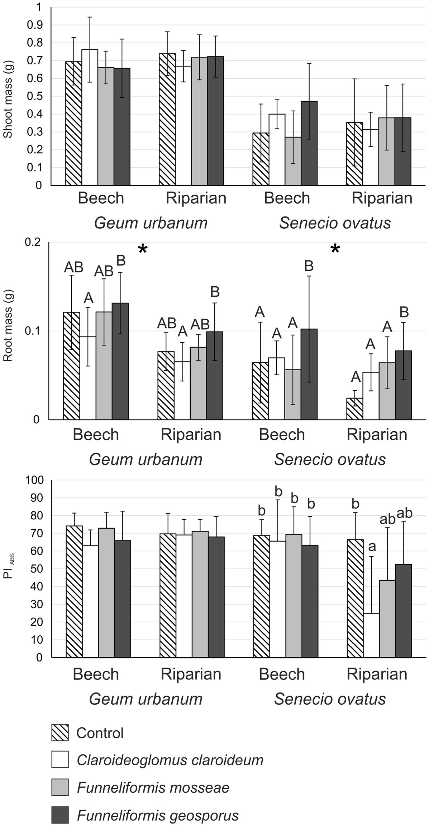
PLOS ONE
Dependence of forest herbaceous plants, Geum urbanum and Senecio ovatus, on arbuscular mycorrhizal fungi
Fig 2. Shoot and root dry mass (grams; mean ± SD) and photosynthetic performance index (PIABS; mean ± SD) of Geum urbanum and Senecio ovatus grown in beech and riparian soils. Within each plant species, lowercase letters above the bars indicate statistically significant interaction between fungus and soil effects; uppercase letters indicate the significant main effect of fungus; different letters above the bars indicate statistically significant differences; the asterisk (�) indicates the significant main effect of soil; for each, p < 0.05. See Table 2 for details on the main effects and interactions.
https://doi.org/10.1371/journal.pone.0258862.g002
PLOS ONE | https://doi.org/10.1371/journal.pone.0258862 October 26, 2021
9 / 19

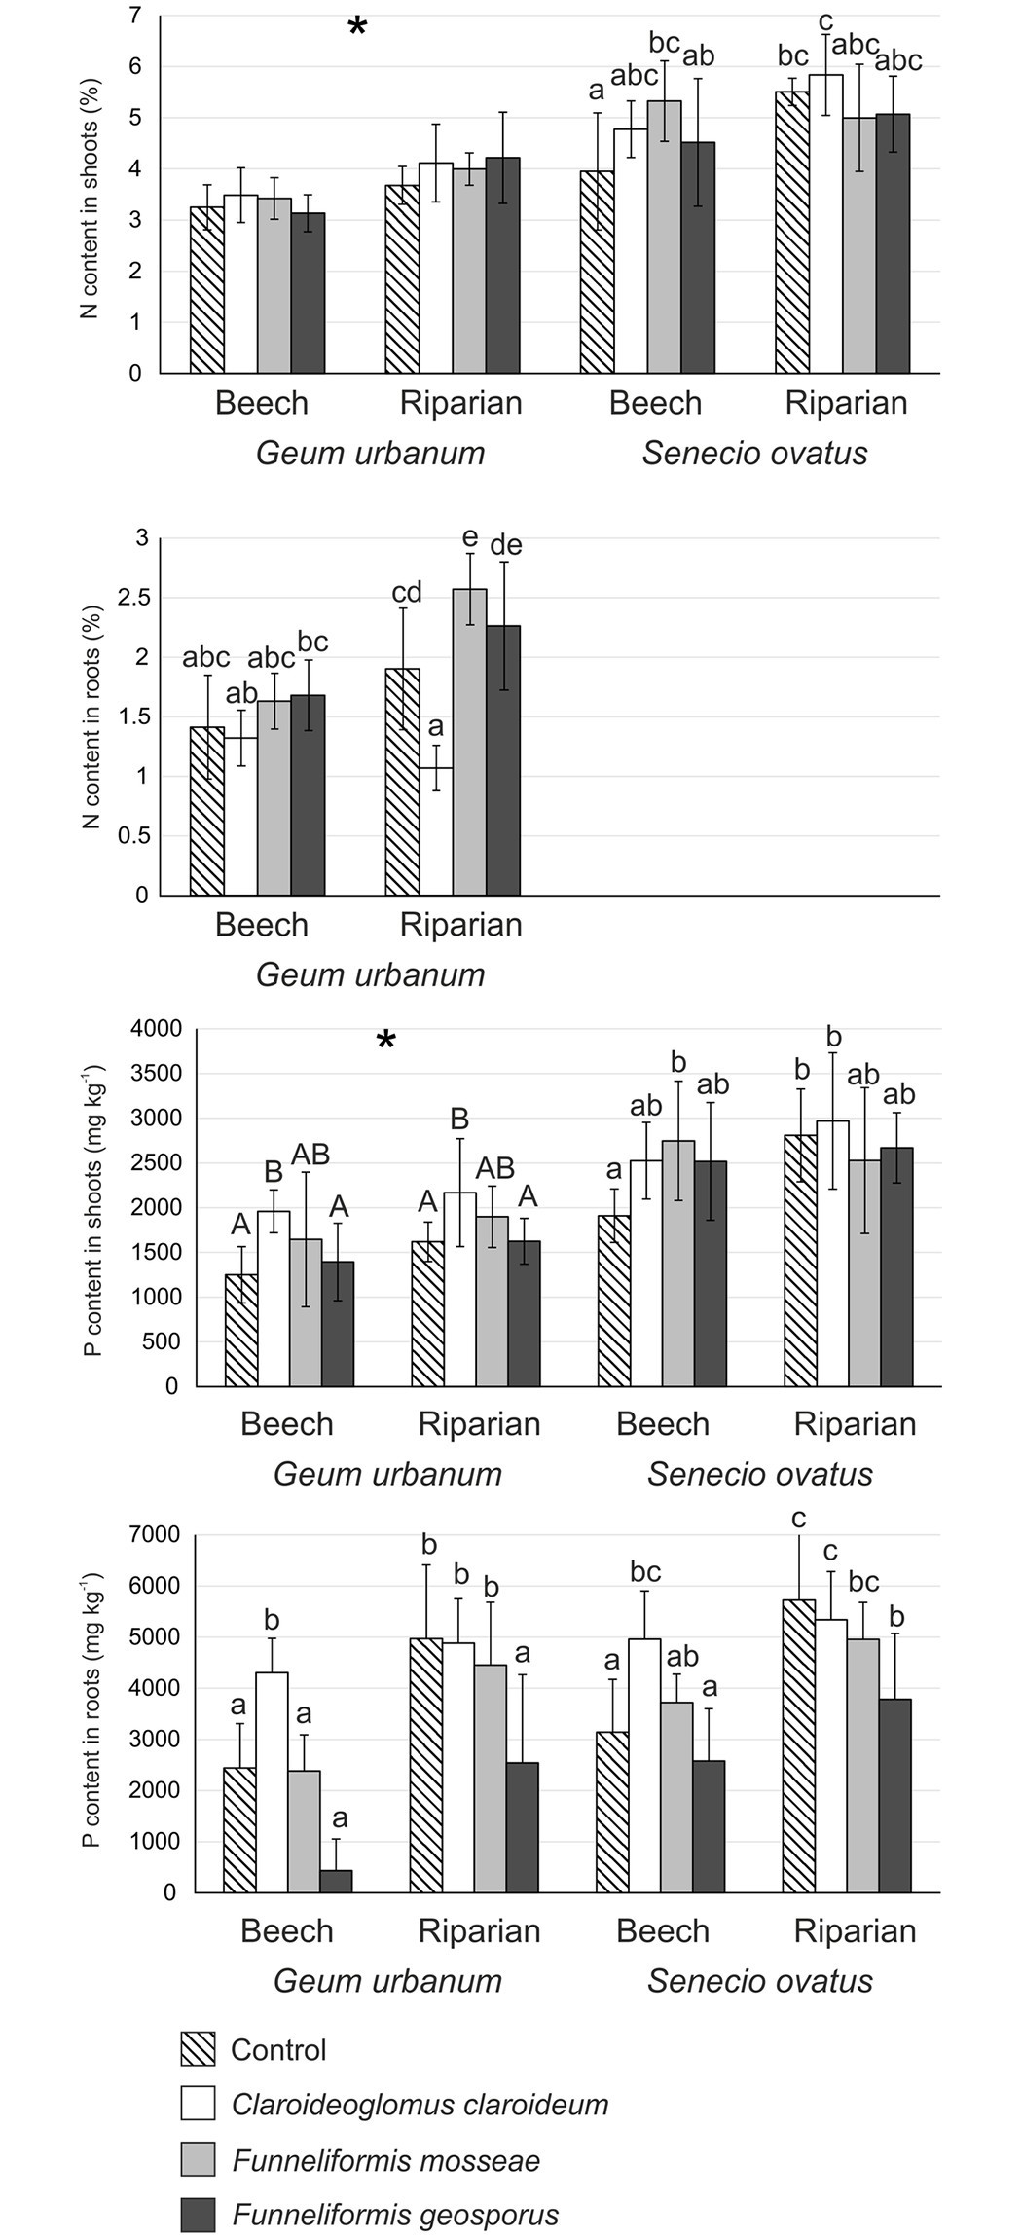
PLOS ONE
Dependence of forest herbaceous plants, Geum urbanum and Senecio ovatus, on arbuscular mycorrhizal fungi
Fig 3. Contents of nitrogen and phosphorus (milligrams per kilogram dry weight; mean ± SD) in the shoots and roots of Geum urbanum and/or Senecio ovatus grown in beech and riparian soils. Within each plant species, lowercase letters above the bars indicate statistically significant interaction between fungus and soil effects; uppercase letters indicate the significant main effect of fungus; different letters above the bars indicate statistically significant differences; the asterisk (�) indicates the significant main effect of soil; for each, p < 0.05. See Table 2 for details on the main effects and interactions.
https://doi.org/10.1371/journal.pone.0258862.g003
PLOS ONE | https://doi.org/10.1371/journal.pone.0258862 October 26, 2021
10 / 19

PLOS ONE
Dependence of forest herbaceous plants, Geum urbanum and Senecio ovatus, on arbuscular mycorrhizal fungi
N content in roots of G. urbanum was influenced by both fungal species and soil type (sig- nificant fungus × soil interaction; Table 2). F. mosseae was most effective in the enhancement of N root content in riparian soil (Fig 3).
Significant effects of both fungus and soil on P contents were noted in shoots of G. urbanum (Table 2). In the case of both soil types, C. claroideum was most effective in the enhancement of P shoot contents. Nevertheless, lower values of this parameter were recorded in shoots of plants in beech soil in comparison with riparian soil (Fig 3). As regards S. ovatus, two-way ANOVA revealed significant fungus × soil interaction (Table 2). Plants from the control treat- ment and inoculated with C. claroideum in riparian soil as well as those inoculated with F. mos- seae and planted in beech soil showed increased contents of P in shoots compared to control treatment in beech soil (Fig 3).
Significant fungus × soil interaction in P contents in roots was noted for both plant species (Table 2). C. claroideum was most effective in the enhancement of contents of this element in beech soil, differing significantly from all other treatments for G. urbanum as well as from con- trol and F. geosporus for S. ovatus. In riparian soil, higher contents of P in roots of G. urbanum were recorded for control, C. claroideum, and F. mosseae than for F. geosporus. In the case of S. ovatus, control and C. claroideum treatments differed from F. geosporus (Fig 3).
Mycorrhizal dependency in relation to plant growth and N and P
acquisition
The mycorrhizal dependency of G. urbanum and S. ovatus in relation to biomass was very low, rarely exceeding zero (Fig 4). The results of two-way ANOVA indicated no significant effects of fungus or soil in the case of either plant species (Table 2).
Mycorrhizal dependency related to N and P contents in biomass of G. urbanum and S. ova- tus was also low. Their values did not exceed 0.5, and, in the cases of several treatments, were less than zero (Fig 4).
For G. urbanum, mycorrhizal dependency related to N contents in biomass were signifi- cantly lower in C. claroideum in riparian soil than in F. geosporus in riparian soil and F. mos- seae in both soil types (significant fungus × soil interaction; Table 2, Fig 4).
Both fungus and soil had a significant effect on mycorrhizal dependency related to P con- tents in biomass in both plant species (Table 2). Treatments of C. claroideum and F. mosseae showed significantly higher values than those inoculated with F. geosporus in both soil types and plant species. Significantly lower values were recorded for riparian soil compared to beech soil treatments (Fig 4).
Relationships between degree of AMF colonisation, shoot and root mass,
photosynthetic performance index, and contents of N and P
The relationship of mycorrhizal colonisation intensity, expressed as the relative mycorrhizal root length parameter (M), with shoot and root mass and N and P contents differed between AMF species and soil types, although in only a few parameters. A significant positive correla- tion was found between M values and N content in the shoots of G. urbanum inoculated with
C. claroideum in riparian soil. F. geosporus significantly increased N content in G. urbanum
roots, but also significantly reduced P contents in shoots; this effect was observed only in ripar- ian soil. As regards S. ovatus, significant correlations were recorded only for F. mosseae. P con- tents in roots increased along with increasing mycorrhizal colonisation of this species in beech soil treatments. The same effect was observed for P contents in shoots in riparian soil treat- ments (Table 3).
PLOS ONE | https://doi.org/10.1371/journal.pone.0258862 October 26, 2021
11 / 19

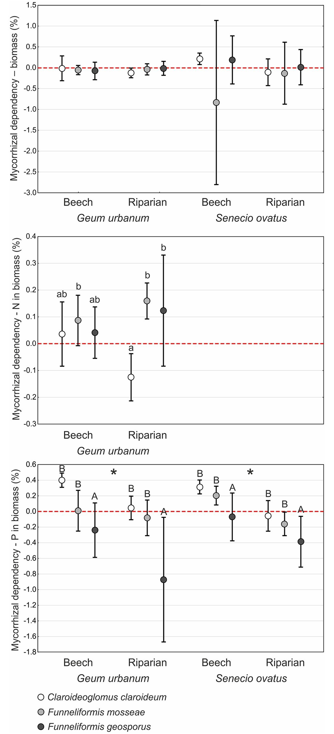
PLOS ONE
Dependence of forest herbaceous plants, Geum urbanum and Senecio ovatus, on arbuscular mycorrhizal fungi
Fig 4. Mycorrhizal dependency parameters (percentages; mean ± SD) of values of mass of shoots and roots as well as of nitrogen and phosphorus contents in shoots and roots of Geum urbanum and/or Senecio ovatus grown in beech and riparian soils. Within each plant species, lowercase letters above the bars indicate statistically significant interaction between fungus and soil effects; uppercase letters indicate the significant main effect of fungus; different letters above the bars indicate statistically significant differences; the asterisk (�) indicates the significant main effect of soil; for each, p < 0.05. See Table 2 for details on the main effects and interactions.
https://doi.org/10.1371/journal.pone.0258862.g004
PLOS ONE | https://doi.org/10.1371/journal.pone.0258862 October 26, 2021
12 / 19

PLOS ONE
Dependence of forest herbaceous plants, Geum urbanum and Senecio ovatus, on arbuscular mycorrhizal fungi
Table 3. Pearson’s correlation coefficients between relative mycorrhizal root length and mass of shoots and roots, photosynthetic performance index, and contents of phosphorus and nitrogen in Geum urbanum and Senecio ovatus for particular arbuscular mycorrhizal fungi species treatments and soil types.
Significant correlations (p < 0.05) are shown in bold. No measurements of nitrogen content in roots of S. ovatus were conducted due to the small mass of roots.
https://doi.org/10.1371/journal.pone.0258862.t003
Principal component analysis (PCA) revealed patterns in the plant parameters across all
samples (Fig 5). In the case of G. urbanum, PCA axis 1 was most influenced by root mass and P contents in shoots and roots, PCA axis 2 by N content in roots and PIABS. The scatterplot showed separation of particular treatments involving the two soil types along the first axis, with the exception of C. claroideum in beech soil. Higher root mass and lower P contents in shoots and roots of plants in beech soil were most responsible for this pattern. A similar ten- dency was observed for S. ovatus. Plants in beech soil, which tended to be located on the left side of the diagram, were characterised by higher values of root mass and PIABS, those in ripar- ian soil by increased N content and P contents.
Discussion
We have shown, for the first time, that the herbaceous plants Geum urbanum and Senecio ova- tus growing in beech and riparian soils were slightly dependent on AMF for their performance, and that both herbs were able to grow well without the presence of AM. The direction and magnitude of the responses of both plant species to AMF were related to fungal species and soil types.
The level of AMF colonisation of G. urbanum was low; in the case of F. geosporus it was near zero. Although higher F values were noted in S. ovatus inoculated with C. claroideum and
F. mosseae, the M and A parameters fluctuated around low values; similarly as in the case of G. urbanum, F. geosporus colonisation rates were negligible. The relatively low level of intensity of AMF colonisation of both species is in accordance with rates found among forest herbaceous plants in the field, though higher levels were found in some species [19]. Carrenho et al. [39] found that various AMF species colonised their hosts with different degrees of intensity. The level of colonisation was also impacted by the type of soil involved [39–42]. This may be due to the incompatibility of a particular species or strain of AMF with plant partners in a given soil type [14, 18].
Compared with control, AMF did not enhance shoot mass or photosynthetic performance index, and very few AMF effects on root mass of both plant species were noted. Moreover, no clear trends were observed regarding enhancement of N and P acquisition due to AMF. Earlier studies on the effects of inoculation with AMF on several species from Rosaceae indicated that their growth responses could be negative, neutral, or positive. On one hand, a study by Sudova´
PLOS ONE | https://doi.org/10.1371/journal.pone.0258862 October 26, 2021
13 / 19
Plant parameters

Geum urbanum
Senecio ovatus
Claroideoglomus claroideum
Funneliformis mosseae
Funneliformis geosporus
Claroideoglomus claroideum
Funneliformis mosseae
Funneliformis geosporus
Beech
Riparian
Beech
Riparian
Beech
Riparian
Beech
Riparian
Beech
Riparian
Beech
Riparian
Shoot mass (g)
0.00
0.23
0.19
0.26
0.26
0.54
-0.02
-0.04
0.45
-0.51
0.37
-0.28
Root mass (g)
-0.32
-0.48
0.15
-0.24
-0.17
-0.38
-0.29
-0.50
0.26
-0.31
-0.18
-0.08
PIABS—photosynthetic performance index
-0.02
0.27
-0.27
0.30
-0.12
0.42
0.37
-0.11
-0.07
-0.25
-0.06
0.04
Nitrogen content in shoots (%)
-0.07
0.73
0.25
0.24
0.23
0.44
-0.59
-0.31
0.12
-0.29
-0.15
0.55
Nitrogen content in roots (%)
0.07
-0.04
-0.33
0.29
-0.03
0.66

Phosphorus content in shoots (mg kg-1)
0.36
0.51
-0.38
0.55
-0.31
-0.63
0.44
-0.21
-0.19
0.64
0.00
0.50
Phosphorus content in roots (mg kg-1)
0.42
0.20
-0.21
0.57
-0.13
-0.07
-0.05
0.06
0.60
-0.48
-0.16
-0.44

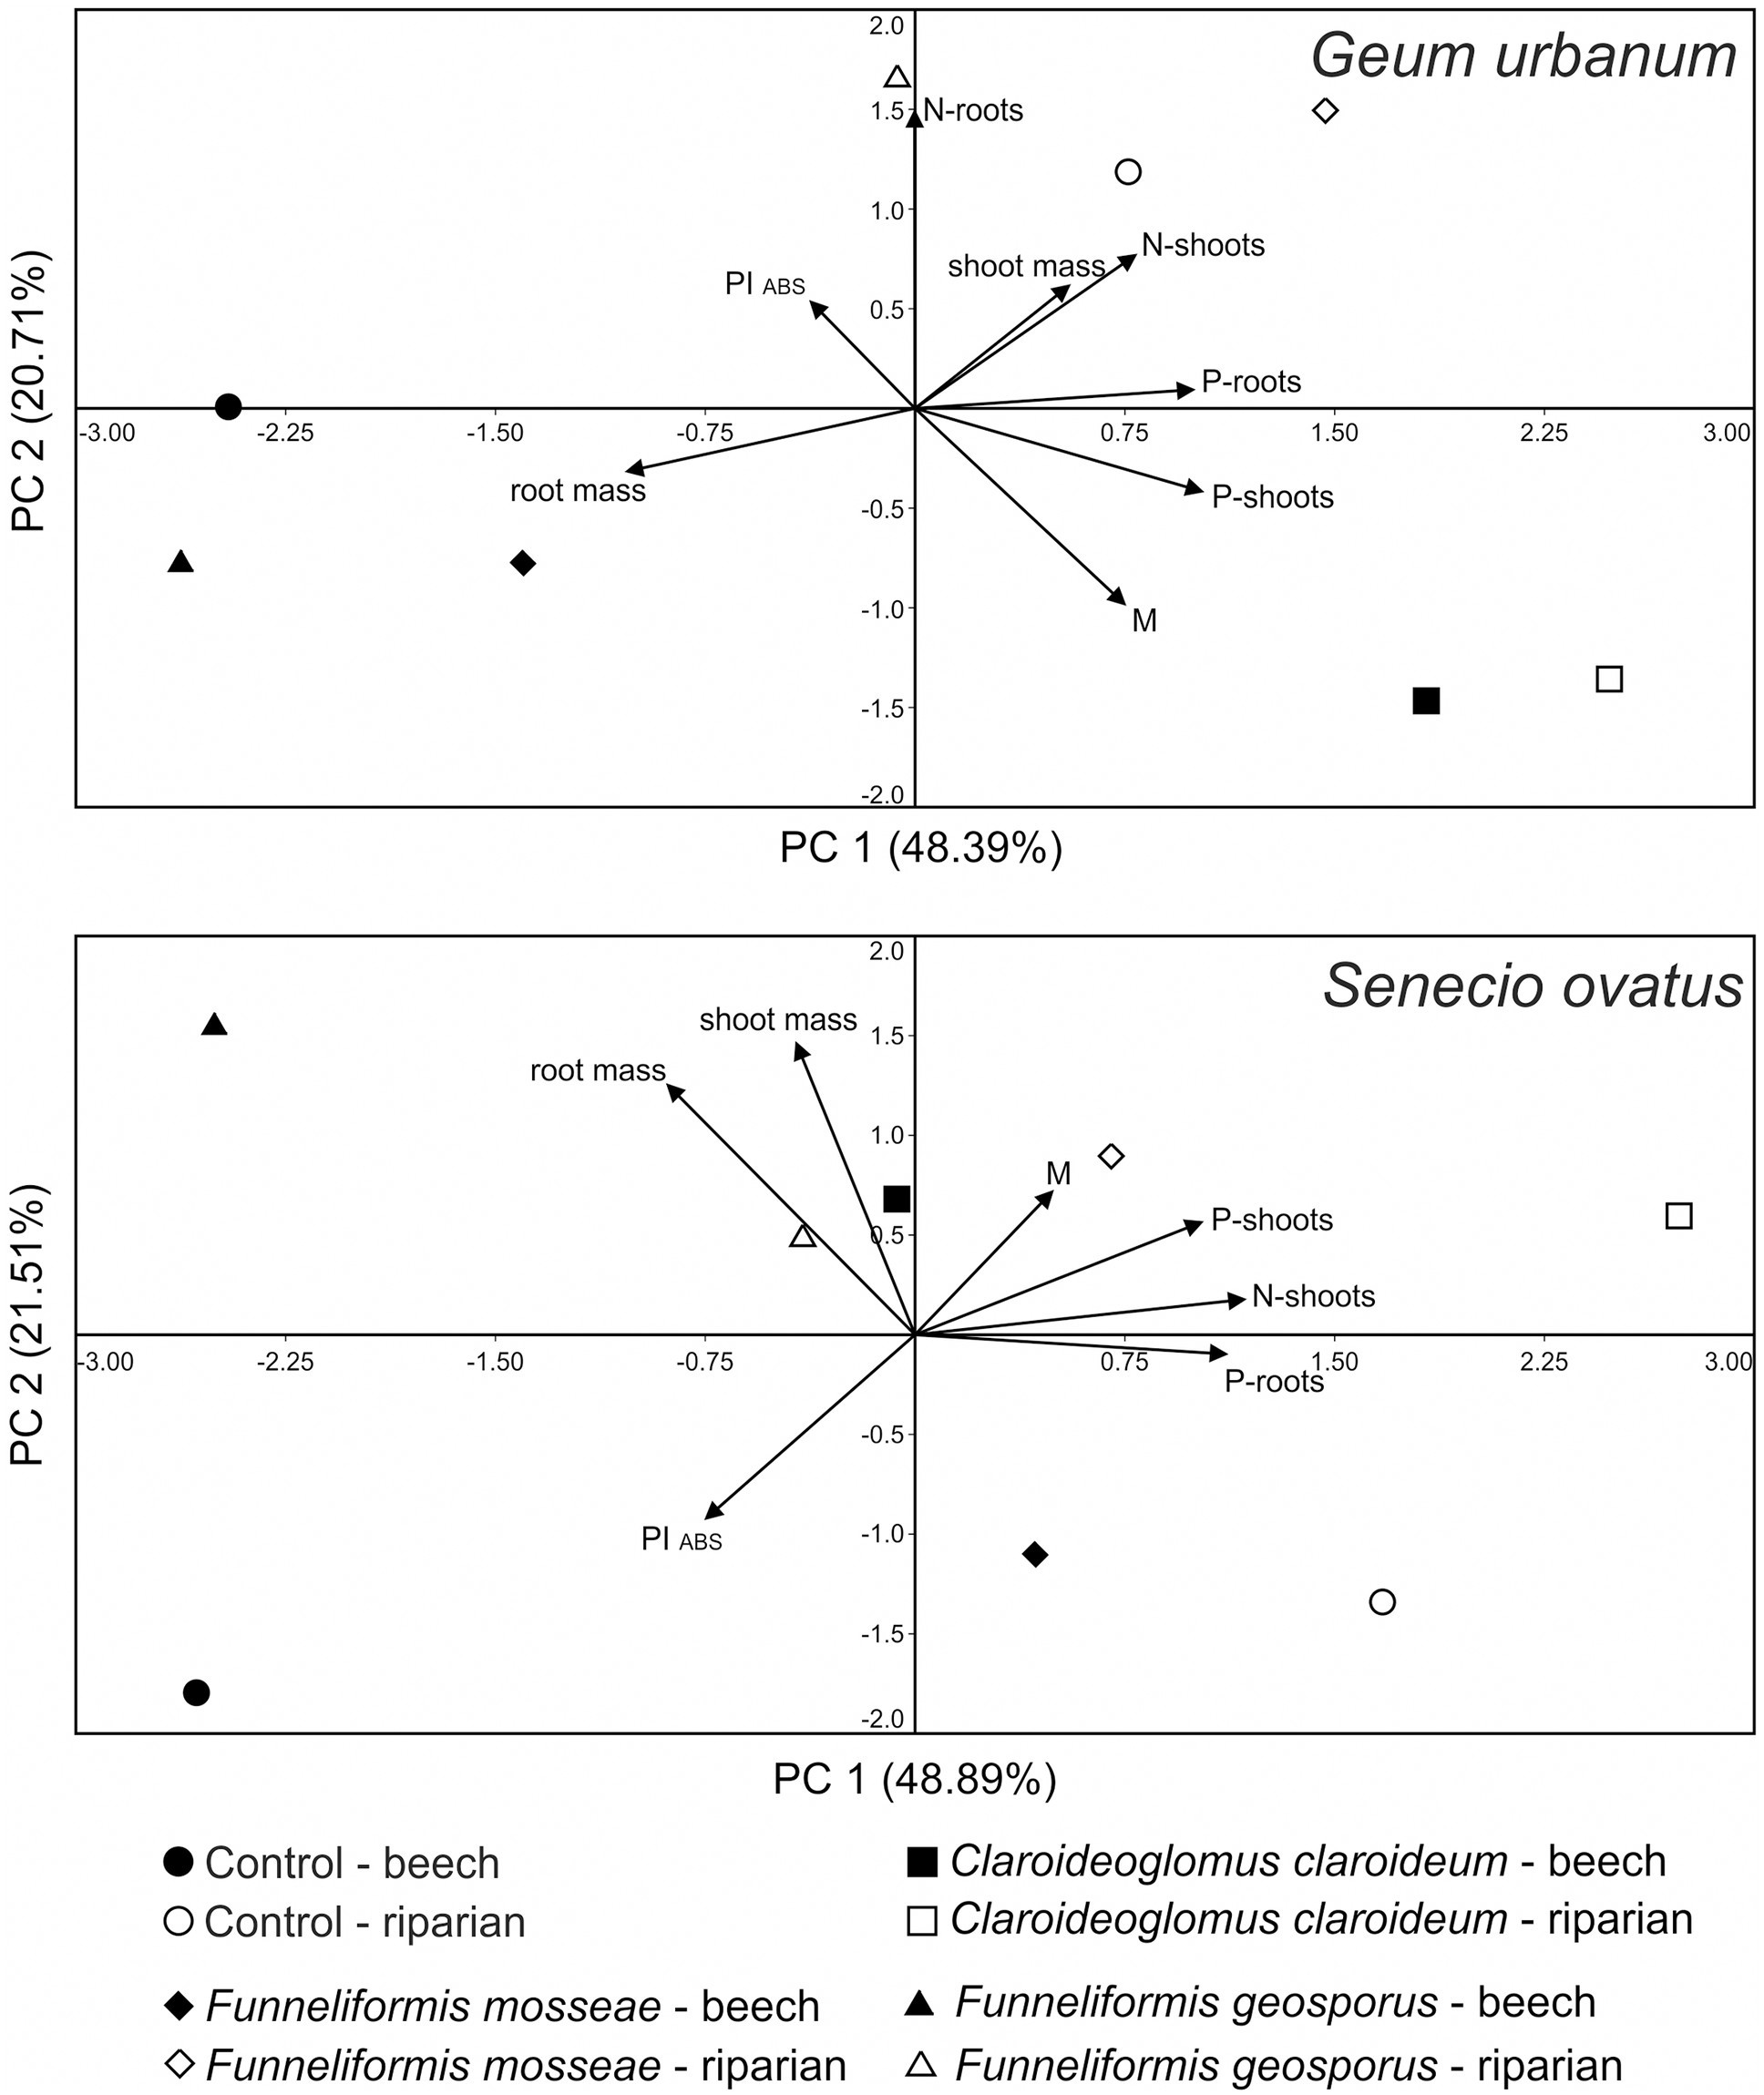
PLOS ONE
Dependence of forest herbaceous plants, Geum urbanum and Senecio ovatus, on arbuscular mycorrhizal fungi
Fig 5. Principal component analysis ordination diagram (PC 1 vs PC 2) of Geum urbanum and Senecio ovatus parameters (M—relative mycorrhizal root length, shoot and root mass, N and P contents in shoots and roots, PIABS) for samples of the two soil types and four fungal treatments. The percentage of total variance, as explained by each axis, is shown.
https://doi.org/10.1371/journal.pone.0258862.g005
PLOS ONE | https://doi.org/10.1371/journal.pone.0258862 October 26, 2021
14 / 19

PLOS ONE
Dependence of forest herbaceous plants, Geum urbanum and Senecio ovatus, on arbuscular mycorrhizal fungi
and Vosa´tka [10] on the inoculation of Fragaria moschata and Potentilla reptans by three AMF species, including F. mosseae, showed negative growth response. However, AMF were effective in supplying P. Nevertheless, higher P content in shoots of both species were not associated with stimulation of their growth, indicating that N rather than P content is the governing fac- tor in these specific interactions [10]. Similarly, Zobel and Moora [9] noted the absence of any growth response of Fragaria vesca to AMF. On the other hand, an experiment carried out by Mark and Cassells [43] on the inoculation of F. vesca with C. claroideum revealed a positive growth response. Studies on the effects of AMF on numerous species from Asteraceae showed, in most cases, positive plant response. The following results have been noted: enhanced growth of Centaurea jacea following inoculation with AMF soil inocula [9]; increased biomass and enhanced photosynthetic performance index of Senecio umbrosus following inoculation with, among others, C. claroideum and F. geosporus [44]; and enhanced biomass, but not PIABS, in Inula ensifolia, Rudbeckia laciniata, and Solidago gigantea following inoculation with several AMF species [25, 45].
Mycorrhizal dependency of G. urbanum and S. ovatus concerning growth and N and P acquisition was near zero in both soils, but varied between AMF species in terms of elements. This indicates that neither species is dependent on AMF in this respect. This observation con- tradicts studies of other species from Asteraceae and Rosaceae, where the level of mycorrhizal dependency for growth was found to be high. Osteomeles anthyllidifolia (Rosaceae), inoculated with six AMF species simultaneously, achieved values of mycorrhizal dependency between 46% and 76%. Nevertheless, these values were related to P content in soils, being higher in soils with lower P content [46]. In the case of representatives of Asteraceae, mycorrhizal dependency of R. laciniata was 88% and 63% and for S. gigantea 90% and 82% for two soil types involved, respectively [25]. Similarly, Bidens sandvicencis was rated by Gemma et al. [47] as a highly AMF-dependent species, as it achieved values of mycorrhizal dependency up to 88% after being inoculated with Rhizophagus aggregatus. These effects were also linked with P content in soil. These studies did not focus on distinctions between the impacts of particular AMF species; however, van der Heijden et al. [37] showed that mycorrhiza-dependent plant species respond differently to different AMF species.
The effects of AMF on plant species can be multidirectional and may vary in different envi- ronmental conditions. Literature data confirm that numerous interacting factors, both abiotic and biotic, have an influence on soil microbial properties and related response of plants. For example, in natural forest ecosystems, the co-existence of trees and herbaceous species, which differ in the formation of AM, ectomycorrhiza or are non-mycorrhizal, affect the abundance of AMF propagules in soils, and thus influence the intensity of AMF colonisation degree of plants in particular sites [19, 48, 49]. Moreover, it was observed that in the restoration of degraded areas, higher AMF species richness enhanced inoculum effectiveness. The positive response from plants increased from multiple species to whole soil inoculum [50]. However, ecologists also signalise that since AMF show functional diversity and their effects are within mutualism and parasitism spectrum [51–53], the key point is to select single effective AMF species than focus on species richness [54]. No without significance in plant-AMF relation- ships are also other factors, like soil physical and chemical properties [46, 47, 55] as well as presence of biotic and abiotic stresses. It was reported that AMF can have positive effects on plants in the presence of stressors, such as salinity and heavy metal toxicity [56–59], by both nutritional and non-nutritional mechanisms [57, 58, 60, 61]. The formation of AM may impact on resistance of plants for pathogens and herbivores by stimulations of bacteria in soils as well as by modifications of secondary metabolite synthesis in plants [62]. Therefore, other parameters, not measured in the present study, should be examined in future in order to iden- tify complete spectrum of G. urbanum and S. ovatus response to AMF in forest ecosystems.
PLOS ONE | https://doi.org/10.1371/journal.pone.0258862 October 26, 2021
15 / 19

PLOS ONE
Dependence of forest herbaceous plants, Geum urbanum and Senecio ovatus, on arbuscular mycorrhizal fungi
In conclusion, our investigation included three AMF species and soils of two forest habitats,
thus enabling us to draw strong inferences on the effect of AMF on G. urbanum and S. ovatus. We report, for the first time, that neither species is dependent on AMF for its growth and pho- tosynthetic performance index. Moreover, we found only slight effects of AMF on N and P acquisition for both plant species, whose direction and magnitude were dependent on fungal species and soil identities. Thus, G. urbanum and S. ovatus are adapted to grow in temperate- forest soils, which can be characterised by a low level of availability of AMF propagules in com- parison to other ecosystems [19, 49, 63]. This is further supported by the fact that G. urbanum is also found in habitats with disturbed soil [64] which are usually characterised by low levels of AMF abundance [65, 66].
Author Contributions
Conceptualization: Katarzyna Rożek, Szymon Zubek.
Data curation: Katarzyna Rożek. Formal analysis: Szymon Zubek. Funding acquisition: Szymon Zubek. Investigation: Katarzyna Rożek.
Methodology: Katarzyna Rożek.
Project administration: Szymon Zubek.
Resources: Katarzyna Rożek.
Software: Kaja Rola. Supervision: Szymon Zubek. Validation: Szymon Zubek. Visualization: Kaja Rola.
Writing – original draft: Katarzyna Rożek, Kaja Rola.
Writing – review & editing: Szymon Zubek.
References
1.
Almeida C de L, Sawaya ACHF, Lo´ pez de Andrade SA. Mycorrhizal influence on the growth and bioac- tive compounds composition of two medicinal plants: Mikania glomerata Spreng. and Mikania laevigata Sch. Bip. ex Baker (Asteraceae). Bra J Bot. 2018; 41: 233–240.
Ortas I, Iqbal MT. Mycorrhizal inoculation enhances growth and nutrition of cotton plant. J Plant Nutr. 2019; 42: 2043–2056.
Fitter AH. Influence of mycorrhizal infection on competition for phosphorus and potassium by two grasses. New Phytol. 1977; 79: 119–125.
Allen EB, Allen MF. Competition between plants of different successional stages: mycorrhizae as regu- lators. Can J Bot. 1984; 62: 2625–2629.
Stahl RR, Smith WK. Effects of different geographic isolates of Glomus on the water relations of Agro- phyron smithii. Mycologia. 1984; 76: 261–267.
Dehn B, Schu¨ epp H. Influence of VA mycorrhiza on the uptake and distribution of heavy metals in plants. Agr Ecosyst Environ. 1989; 29: 79–83.
Griffioen WAJ, Ernst WHO. The role of VA mycorrhiza in the heavy metal tolerance of Agrostis capillar- ies L. Agr Ecos Environ. 1989; 29: 173–177.
Smith SE, Read DJ. Mycorrhizal symbiosis. Third edition. Academic Press, London; 2008.
2.
3.
4.
5.
6.
7.
8.
PLOS ONE | https://doi.org/10.1371/journal.pone.0258862 October 26, 2021
16 / 19

PLOS ONE
Dependence of forest herbaceous plants, Geum urbanum and Senecio ovatus, on arbuscular mycorrhizal fungi
9.
Zobel M, Moora M. Interspecific competition and arbuscular mycorrhiza—importance for the coexis- tence of 2 calcareous grassland species. Folia Geobot Phytotax. 1995; 30: 223–230.
Sudova´ R, Vosa´ tka M. Effects of inoculation with native arbuscular mycorrhizal fungi on clonal growth of
Potentilla reptans and Fragaria moschata (Rosaceae). Plant Soil. 2008; 308: 55–67.
Wang X-X, Wang X, Sun Y, Cheng Y, Liu S, Chen X, et al. Arbuscular mycorrhizal fungi negatively affect nitrogen acquisition and grain yield of maize in a N deficient soil. Front Microbiol. 2018; 9: 418. https://doi.org/10.3389/fmicb.2018.00418 PMID: 29568292
Castillo CG, Borie F, Oehl F, Sieverding E. Arbuscular mycorrhizal fungi biodiversity: prospecting in Southern-Cental zone of Chile. A review. J Soil Sci Plant Nut. 2016; 16: 400–422.
Wang B, Qiu YL. Phylogenetic distribution and evolution of mycorrhizas in land plants. Mycorrhiza. 2006; 16: 299–363. https://doi.org/10.1007/s00572-005-0033-6 PMID: 16845554
Helgason T, Merryweather JW, Denison J, Wilson P, Young JPW, Fitter AH. Selectivity and functional diversity in arbuscular mycorrhizas of co-occurring fungi and plants from a temperate deciduous wood- land. J Ecol. 2002; 90: 371–384.
Helgason T, Merryweather JW, Young JPW, Fitter AH. Specificity and resilience in the arbuscular mycorrhizal fungi of a natural woodland community. J Ecol. 2007; 95: 623–630.
Gerz M, Guillermo Bueno C, Zobel M, Moora M. Plant community mycorrhization in temperate forests and grasslands: relations with edaphic properties and plant diversity. J Veg Sci. 2016; 27: 89–99.
Saks U¨ , Davison J, O¨ pik M, Vasar M, Moora M, Martin M. Root-colonizing and soil-borne communities of arbuscular mycorrhizal fungi in a temperate forest understorey. Botany. 2014; 92: 277–285
Moora M, O¨ pik M, Sen R, Zobel M. Native AMF communities differentially influence the seedling perfor- mance of rare and common Pulsatilla species. Funct Ecol. 2004; 18: 554–562.
Rożek K, Rola K, Błaszkowski J, Zubek S. Associations of root-inhabiting fungi with herbaceous plant species of temperate forests in relation to soil chemical properties. Sci. Total Environ. 2019; 649: 1573–1579. https://doi.org/10.1016/j.scitotenv.2018.08.350 PMID: 30308925
Uibopuu A, Moora M, Saks U¨ , Daniell T, Zobel M, O¨ pik M. Differential effect of arbuscular mycorrhizal fungal communities from ecosystems along management gradient on the growth of forest understorey plant species. Soil Biol Biochem. 2009; 41: 2141–2146.
Uibopuu A, Moora M, O¨ pik M, Zobel M. Temperate forest understorey species performance is altered by local arbuscular mycorrhizal fungal communities from stands of different successional stages. Plant Soil. 2012; 356: 331–339.
Witkowska-Żuk L. Flora Polski. Atlas roślinności laso´ w. Warszawa, MULTICO Oficyna Wydawnicza; 2012.
Chmolowska D, Nobis M, Nowak A, Maslak M, Kojs P, Rutkowska J, et al. Rapid change in forms of inorganic nitrogen in soil and moderate weed invasion following translocation of wet meadows to reclaimed post-industrial land. Land Degrad Dev. 2019; 30: 964–978.
Błaszkowski J. Glomeromycota. Krako´w, W. Szafer Institute of Botany, Polish Academy of Sciences; 2012.
Majewska ML, Rola K, Zubek S. The growth and phosphorus acquisition of invasive plants Rudbeckia laciniata and Solidago gigantea are enhanced by arbuscular mycorrhizal fungi. Mycorrhiza. 2017; 27: 83–94. https://doi.org/10.1007/s00572-016-0729-9 PMID: 27581153
Taylor K. Geum urbanum L. J Ecol. 1977; 85: 705–720.
Graumann S, Gottsberger G. Reproductive strategies in allogamous andautogamous Senecio species. Lagascalia. 1988; 15: 673–679.
Trigiano RN, Gray DJ. Plant tissue culture, development, and biotechnology. 2nd ed. Boca Raton, Lon- don, New York, CRC Press, Taylor & Francis Group; 2011.
Jansa J, Smith FA, Smith SE. Are there benefits of simultaneous root colonization by different arbuscu- lar mycorrhizal fungi? New Phytol. 2007; 177: 779–789. https://doi.org/10.1111/j.1469-8137.2007.
02294.x PMID: 18042204
Strasser RJ, Tsimilli-Michael M, Srivastava A. Analysis of the chlorophyll a fluorescence transient. In: Papageorgiou GC, Govindjee, editors. Chlorophyll a fluorescence: a signature of photosynthesis, vol 19, Advances in photosynthesis and respiration series, Govindjee, series editor. Rotterdam, Kluwer Academic Publishers; 2004. p. 321–362.
Tsimilli-Michael M, Strasser RJ. In vivo assessment of plants’ vitality: applications in detecting and eval- uating the impact of mycorrhization on host plants. In: Varma A, editor. Mycorrhiza: state of the art, genetics and molecular biology, eco-function, biotechnology, ecophysiology, structure and systematics. 3rd ed. New York, Springer; 2008. p. 679–703.
Phillips J, Hayman DS. Improved procedures for clearing roots and staining parasitic and vesicular- arbuscular mycorrhizal fungi for rapid assessment of infection. T Brit Mycol Soc. 1970; 55: 158–161.
10.
11.
12.
13.
14.
15.
16.
17.
18.
19.
20.
21.
22.
23.
24.
25.
26.
27.
28.
29.
30.
31.
32.
PLOS ONE | https://doi.org/10.1371/journal.pone.0258862 October 26, 2021
17 / 19

PLOS ONE
Dependence of forest herbaceous plants, Geum urbanum and Senecio ovatus, on arbuscular mycorrhizal fungi
33.
Zubek S, Nobis M, Błaszkowski J, Mleczko P, Nowak A. Fungal root endophyte associations of plants endemic to the Pamir Alay Mountains of Central Asia. Symbiosis. 2011; 54: 139–149. https://doi.org/ 10.1007/s13199-011-0137-z PMID: 22207783
Trouvelot A, Kough JL, Gianinazzi-Pearson V. Mesure du taux de mycorhization VA d’un systeme radi- culaire. Recherche de methodes d’estimation ayant une signification fonctionnelle. In: Gianinazzi-Pear- son V. and Gianinazzi S, editors. Physiological and genetical aspects of mycorrhizae. Paris, INRA; 1986. p. 217–221. https://www2.dijon.inra.fr/mychintec/Protocole/Workshop_Procedures.html#1.5
Nowosielski O. Metody oznaczania potrzeb nawożenia. Państwowe Wydawnictwo Rolnicze i Leśne, Warszawa; 1974.
van der Heijden MGA, Boller T, Wiemken A, Sanders IR. Different arbuscular mycorrhizal fungal spe- cies are potential determinants of plant community structure. Ecology. 1998; 79: 2082–2091.
van der Heijden MGA. Arbuscular mycorrhizal fungi as determinant of plant diversity: in search for underlying mechanisms and general principles. In: van der Heijden MGA, Sanders IR, editors. Mycor- rhizal ecology. Berlin, Springer; 2002. p. 243–266.
Hammer Ø, Harper DAT, Ryan PD. PAST: Paleontological Statistics Software Package for Education and Data Analysis. Palaeontol Electron. 2001; 4: 1–9.
Carrenho R, Trufem SFB, Bononi VLR, Silva ES. The effect of different soil properties on arbuscular mycorrhizal colonization of peanuts, sorghum and maize. Acta Bot Bras. 2007; 21: 723–730.
Postma J, Olsson PA, Falkengren-Grerup U. Colonisation of arbuscular mycorrhizal, fine and dark sep- tate endophytic fungi in forbs of acid deciduous forests. Soil Biol Biochem. 2007; 39: 400–408.
Zubek S, Błaszkowski J, Delimat A, Turnau K. Arbuscular mycorrhizal and dark septate endophyte colo- nisation along altitudinal gradients in the Tatra Mountains. Arct Antarct Alp Res. 2009; 41: 272–279.
Ouzounidou G, Skiada V, Papadopoulou KK, Stamatis N, Kavvadias V, Eleftheriadis E, et al. Effects of soil pH and arbuscular mycorrhiza (AM) inoculation on growth and chemical composition of chia (Salvia hispanica L.) leaves. Bra J Bot. 2015; 38: 487–495.
Mark GL, Cassells AC. Genotype-dependence in the interaction between Glomus fistulosum, Phy- tophthora fragariae and the wild strawberry (Fragaria vesca). Plant Soil. 1996; 185: 233–239.
Zubek S, Turnau K, Tsimilli-Michael M, Strasser RJ. Response of endangered plant species to inocula- tion with arbuscular mycorrhizal fungi and soil bacteria. Mycorrhiza. 2009; 19: 113–123. https://doi.org/ 10.1007/s00572-008-0209-y PMID: 19011910
Zubek S, Stojakowska A, Anielska T, Turnau K. Arbuscular mycorrhizal fungi alter thymol derivative contents of Inula ensifolia L. Mycorrhiza. 2010; 20:497–504. https://doi.org/10.1007/s00572-010-0306- 6 PMID: 20177715
Koske RE, Gemma JN. Arbuscular mycorrhizae effects on growth of two Hawaiian species: indigenous Osteomeles anthyllidifolia (Rosaceae) and invasive Psidium cattleianum (Myrtaceae). Pac Sci. 2006; 60: 471–482.
Gemma JN, Koske RE, Habte M. Mycorrhizal dependency of some endemic andendangered Hawaiian plant species. Am J Bot. 2002; 89: 337–345. https://doi.org/10.3732/ajb.89.2.337 PMID: 21669742
Veresoglou SD, Wulf M, Rillig MC. Facilitation between woody and herbaceous plants that associate with arbuscular mycorrhizal fungi in temperate European forests. Ecol Evol. 2017; 7: 1181–1189. https://doi.org/10.1002/ece3.2757 PMID: 28303188
Zubek S, Rożek K, Stefanowicz AM, Błaszkowski J, Stanek M, Gielas I, et al. The impact of beech and riparian forest herbaceous plant species with contrasting traits on arbuscular mycorrhizal fungi abun- dance and diversity. Forest Ecol Manage. 2021; 492: 119245.
Hoeksema JD, Chaudhary VB, Gehring CA, Johnson NC, Karst J, Koide RT et al. A meta-analysis of context-dependency in plant response to inoculation with mycorrhizal fungi. Ecol Lett. 2010; 13: 394– 407. https://doi.org/10.1111/j.1461-0248.2009.01430.x PMID: 20100237
Johnson NC, Graham JH, Smith FA. Functioning of mycorrhizal associations along the mutualism para- sitism continuum. New Phytol. 1997; 135: 575–586.
Klironomos JN. Variation in plant response to native and exotic mycorrhizal fungi. Ecology. 2003; 84: 2292–2301.
Smith SE, Smith FA. Roles of arbuscular mycorrhizas in plant nutrition and growth: new paradigms from cellular to ecosystems scales. Annu Rev Plant Biol. 2011; 63: 227–250. https://doi.org/10.1146/ annurev-arplant-042110-103846 PMID: 21391813
Asmelash F, Bekele T, Birhane E. The potential role of arbuscular mycorrhizal fungi in the restoration of degraded lands. Front Microbiol. 2016; 7: 1095. https://doi.org/10.3389/fmicb.2016.01095 PMID:
27507960
34.
35.
36.
37.
38.
39.
40.
41.
42.
43.
44.
45.
46.
47.
48.
49.
50.
51.
52.
53.
54.
PLOS ONE | https://doi.org/10.1371/journal.pone.0258862 October 26, 2021
18 / 19

PLOS ONE
Dependence of forest herbaceous plants, Geum urbanum and Senecio ovatus, on arbuscular mycorrhizal fungi
55.
Bainard LD, Bainard JD, Hamel C, Gan Y. Spatial and temporal structuring of arbuscular mycorrhizal communities is differentially influenced by abiotic factors and host crop in a semi-arid prairie agroeco- system. FEMS Microbiol. Ecol. 2014; 88: 333–344. https://doi.org/10.1111/1574-6941.12300 PMID:
24527842
Leyval C, Turnau K, Haselwandter K. Effect of heavy metal pollution on mycorrhizal colonization and function: physiological, ecological and applied aspects. Mycorrhiza. 1997; 7: 139–153.
Hildebrandt U, Regvar M, Bothe H. Arbuscular mycorrhiza and heavy metal tolerance. Phytochemistry. 2007; 68: 139–146. https://doi.org/10.1016/j.phytochem.2006.09.023 PMID: 17078985
Soares CRFS, Siqueira JO. Mycorrhiza and phosphate protection of tropical grass species against heavy metal toxicity in multi-contaminated soil. Biol Fert Soils. 2008; 44: 833–841.
Al-Karaki GN. The role of mycorrhiza in the reclamation of degraded lands in arid environments. In: Sha- hid SA, Taha FK, Abdelfattah MA, editors. Developments in soil classification, land use planning and policy implications: innovative thinking of soil inventory for land use planning and management of land resources. Dordrecht, Springer Science + Business Media; 2013. p. 823–836.
Larcher W. Physiological plant ecology. Berlin, Springer-Verlag; 1995.
Marschner H. Mineral nutrition of higher plants. Second edition. London, Academic Press; 1995.
Yang H, Dai Y, Wang X, Zhang Q, Zhu L, Bian X. Meta-analysis of interactions between arbuscular mycorrhizal fungi and biotic stressors of plants. Sci World J. 2014; 1–7.
Bouffaud ML, Creamer RE, Stone D, Plassart P, van Tuinen D, Lemanceau P, et al. Indicator species and co-occurrence in communities of arbuscular mycorrhizal fungi at the European scale. Soil Biol Bio- chem. 2016; 103: 464–470.
Stefańska-Krzaczek E, Podgo´ rna K. Florystyczne i fitocenotyczne wskaźniki stanu zachowania laso´ w zalewowych w miejskiej dolinie rzecznej. Sylwan. 2015; 159: 82–88.
Stahl PD, Williams SE, Christensen M. Efficacy of native vesicular-arbuscular mycorrhizal fungi after severe soil disturbance. New Phytol. 1988; 110: 347–354.
Nobis A, Błaszkowski J, Zubek S. Arbuscular mycorrhizal fungi associations of vascular plants confined to river valleys: towards understanding the river corridor plant distribution. J Plant Res. 2015; 128: 127– 137. https://doi.org/10.1007/s10265-014-0680-9 PMID: 25421921
56.
57.
58.
59.
60.
61.
62.
63.
64.
65.
66.
PLOS ONE | https://doi.org/10.1371/journal.pone.0258862 October 26, 2021
19 / 19

