Acta Geologica Polonica, Vol. 65 (2015), No. 3, pp. 319-344
DOI: 10.1515/agp-2015-0014
DE
G
DE GRUYTER
OPEN

Where was the Magura Ocean?
NESTOR OSZCZYPKO¹, ANDRZEJ ŚLĄCZKA¹, MARTA OSZCZYPKO-CLOWES¹
and BARBARA OLSZEWSKA²
¹Jagiellonian University, Institute of Geological Sciences, Oleandry 2a, 30-063 Kraków, Poland;
²Polish Geological Institute, Carpathian Branch, Skrzatów 1, 31-560 Kraków, Poland;
nestor.oszczypko@uj.edu.pl; a.slaczka@uj.edu.pl, m.oszczypko-clowes@uj.edu.pl
ABSTRACT:
Oszczypko, N., Slqczka, A., Oszczypko-Clowes, A. and Olszewska, B. 2015. Where was the Magura Ocean. Acta
Geologica Polonica, 65 (3), 319-344. Warszawa.
In the Late Jurassic to Early Cretaceous palaeogeography of the Alpine Tethys the term Ocean is used for dif-
ferent parts of these sedimentary areas: eg. Ligurian - Piedmont and Penninic, Magura, Pieniny, Valais and
Ceahlau-Severins oceans. The Magura Ocean occupied the more northern position in the Alpine-Carpathian arc.
During the Late Cretaceous-Paleogene tectono-sedimentary evolution the Magura Ocean was transformed into
several (Magura, Dukla, Silesian, sub-Silesian and Skole) basins and intrabasinal source area ridges now in-
corporated into the Outer Western Carpathians.
Key words: Cenozoic, Outer Western Carpathians; Palaeogeography; Intrabasinal ridges;
Basin development.
INTRODUCTION
The term Magura Ocean, understood as the east-
ern prolongation of the Ligurian - Piedmont and Pen-
ninic Ocean (eg. Puglisi 2009; 2014), is often used in
the palaeogeographic and palaeotectonic reconstruc-
tions of the Outer Western Carpathians (Channell and
Kozur 1997). More often the Magura Ocean is con-
sidered as the eastern extension of the Valais Ocean /
North Pennic domain (Schmid et al. 2004; Sand-
ulescu 2009; Ustaszewski et al. 2008; Schmid et al.
2008), although the presence of the Valais Ocean is
also debatable (see Schmid et al. 2004). The concept
of the Magura Ocean is usually used in reference to
the Late Jurassic and Early Cretaceous (Birkenmajer
1986), but it is also used for the Late Cretaceous and
even for the Paleogene (Frontzheim et al. 2008;
Plasienka 2014; Kovac et al. in press). At the same
time, terms such as the Magura Basin, Magura Nappe
or the Magura Superunit are commonly used. Some-
times, the Magura Ocean and the Magura Basin are
used interchangeably, causing confusion of their con-
cepts. Whereas the terms Magura Basin and Magura
Nappe are sufficiently well-defined, the spatial and
temporal coverage of the Magura Ocean has not been
defined in more detail.
The southern margin of the Magura Ocean is des-
ignated as the northern boundary of the Pieniny Klip-
pen Belt (PKB), which separates the Central Western
Carpathians (CWC, Cretaceous accretionary wedge)
from the Outer Western Carpathias (OWC, Paleo-
gene-Early Miocene accretionary wedge). The PKB is
a 650 km long suture zone, but only a few kilometres
wide (Text-figs 1A, B). Within the PKB, the northern
edge of the CWC belonged to the Czorsztyn Unit
(Ridge), while the Grajcarek Unit represented the
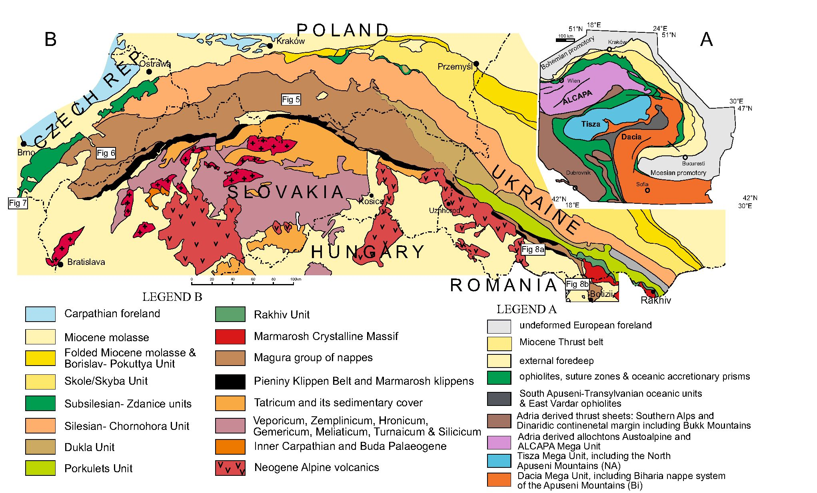
320
NESTOR OSZCZYPKO ET AL
Text-fig. 1. A - Tectonic sketch-map of the Alpine-Carpathian-Pannonian area (after Schmid et al. 2008); B - Tectonic sketch-map of the Western Carpathians and adja-
cent Ukrainian Carpathians with location oflithostratigraphic logs ofthe Magura Nappe in Poland, Western Slovakia and Czech Republik (based on Oszczypko et al. 2005b)
southern, transitional (to the PKB basin), margin of
the Magura Basin (Ocean). The aim of this study is to
discuss what the Magura Ocean was and its location
in space and time. As a benchmark, we chose the
Małe Pieniny Mts in the Polish Outer Carpathians,
where the transition zone between the Magura and
PKB basins (Birkenmajer 1977, 1986) was first well-
documented. In the study, we used our observations
from the Outer Carpathians, from the Rhenodanu-
bian Flysch Zone, as well as our recent results from
the studies of the PKB.
GRAJCAREK UNIT OF THE MAŁE PIENINY MTS
(POLAND)
The Małe Pieniny Mts of the Polish Western
Carpathians are located between the Dunajec River Val-
ley to the west and the Polish/Slovak state boundary to
the east (Text-fig. 2). In this area, the PKB is composed
(from north to south) of the Grajcarek Unit and the
Czorsztyn, Niedzica-Czertezik, Branisko and Pieniny
klippen units of the PKB (Text-fig. 3). The Jurassic-
Lower Cretaceous klippen units have a common mid-
Upper Cretaceous sedimentary cover (Birkenmajer
1970, 1977, 1986).
The lower part of the Grajcarek succession (Text-
fig. 4) is represented by manganiferous as well as red
and green radiolarites, as known from the Szczawnica
sections (Sikora 1971a, b). In these radiolarites, Nowak
(1971) recognized two microfossil assemblages: (1) an
older one, with Nannoconus ex gr. steinmanni Kampt-
ner (late Tithonian) without lower Tithonian
stomiosphaerids and calpionellids; and (2) a younger
one (?Valanginian-Hauterivian), with Nannoconus
div. sp. and Cadosina aff. olzae Nowak. Birkenmajer
(1977, 1979, 2001) included the radiolarites into the
Sokolica and Czajakowa formations (Bathonian-Ox-
fordian), followed by (very condensed) red Aptychus
Marls of the Czorsztyn Formation (Kimmeridgian-
Tithonian), cherty limestones of the Pieniny Formation
(Tithonian-Barremian), spotty marls of the Kapusnica
Formation, and black marly shales of the Wronine
Formation (Aptian-Cenomanian). Our recent studies
(Oszczypko et al. 2012a; Oszczypko and Oszczypko-
Clowes 2014, and references therein), based on
foraminifers, documented that the Szczawnica-Za-
baniszcze Upper Jurassic-Lower Cretaceous con-
densed deposits are overlain by the black flysch of the
Szlachtowa Formation (Aptian-Albian). Completely
different opinions are represented by Birkenmajer et al.
(2008, and reference therein) and Gedl (2013, and ref-

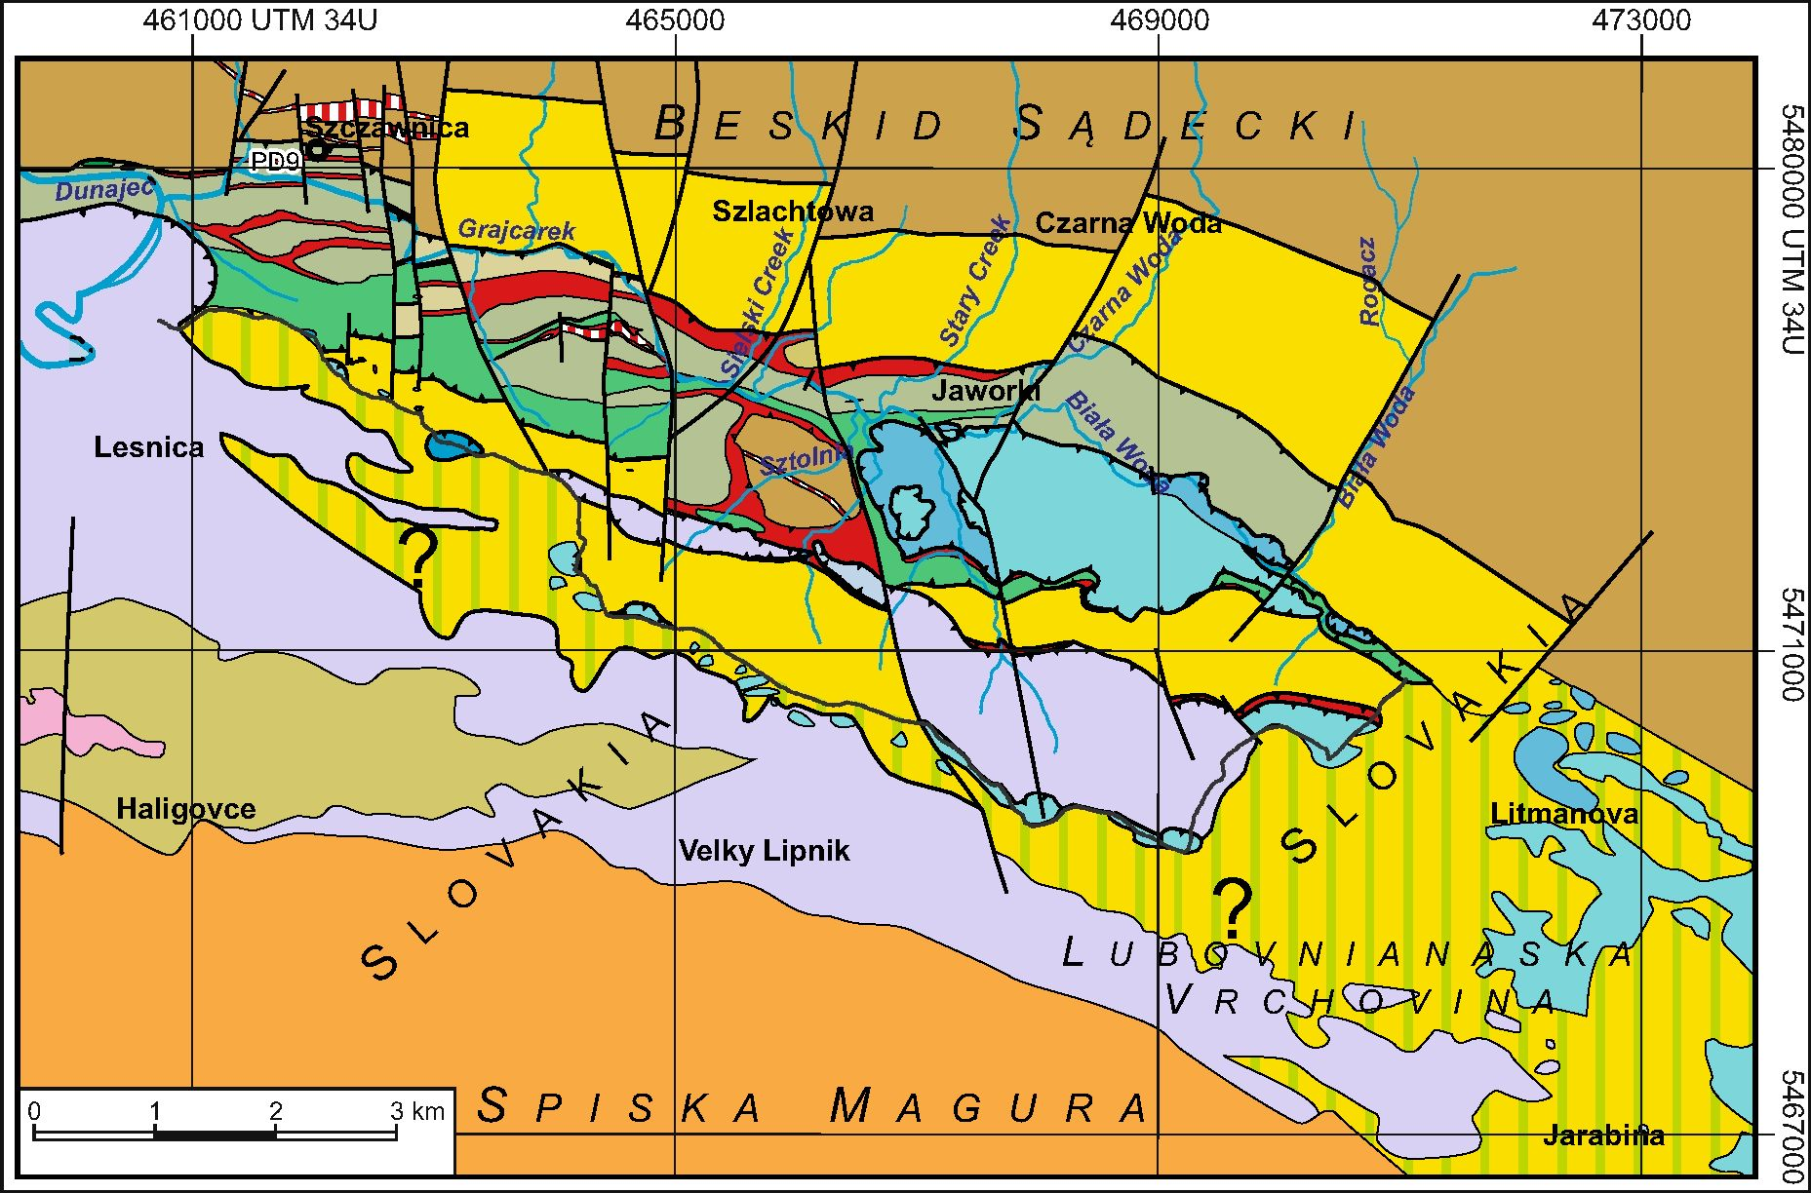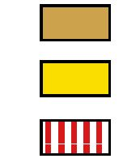
321
WHERE WAS THE MAGURA OCEAN?
erences therein) who consider the Szlachtowa Forma-
tion as of Toarcian-Bajocian age.
The total thickness of the Szlachtowa Formation is
up to 220 m (Birkenmajer 1977; Birkenmajer at al.
2008), but in the PD-9 borehole, in Szczawnica (Birken-
majer et al. 1979), the partial thickness of the “Black
Flysch” was about 310 m (120 m and 190 m of the
Szlachtowa and Bryjarka formations, respectively). The
Szlachtowa Formation is composed of turbiditic sand-
stones with intercalations of black and dark grey marly
mudstones and shales. It is overlain by10 to 16 m thick
packets of light grey spotty shales and marls with pyrite
concretions and sideritic limestone intercalations be-
longing to the Opaleniec Formation of Albian-Ceno-
manian age (Oszczypko et al. 2004, 2012a).
Between the Opaleniec and Malinowa formations,
Oszczypko et al. (2012a) recognized red and green ra-
diolarites followed by spotty limestones and marls
with rare Late Albian calcdinocysts (Colomisphaera
aff. pokornyi Rehanek, Oszczypko et al. in prepara-
tion) with intercalations of black and green shales fol-
lowed by 1 m thick red and green shales (Bonarelli
Horizon, Uchman et al. 2013). These strata, 3-10 m
thick, were previously described by Sikora (1962,
1971a, b) as the “Cenomanian Key Horizon” (CKH)
(Text-fig. 4).

borehole
CENTRAL CARPATHIAN PALEOGENE
Text-fig. 2. Geological sketch-map of the Małe Pieniny Mts and Lubovnianska Vrchovina Range with location oflithostratigraphic logs (based on Oszczypko et al. 2010
and Oszczypko and Oszczypko-Clowes 2014)

MAGURA NAPPE
Paleogene of the Krynica Zone
Kremna and Zlatne formations (Oligo-Miocene)
Neogene andésites
PIENINY KLIPPEN BELT
GRAJCAREK THRUST-SHEETS
Jurassic to Early Cretaceous "Black flysch”
Malinowa Formation (Cenomanian - Campanian)
Jarmuta Formation (Maastrichtian - Peleocene)
?Proc - Jarmuta formation (Paleocene - Eocene)
3ranisko and Pieniny successions
Upper Cretaceous and Paleogene of Myjava Zone
Haligovce klippen
PIENINY NAPPE si
SUB-PIENINY (CZORSZTYN) NAPPE
Czorsztyn succesion
Miedzica and Czertezik succession
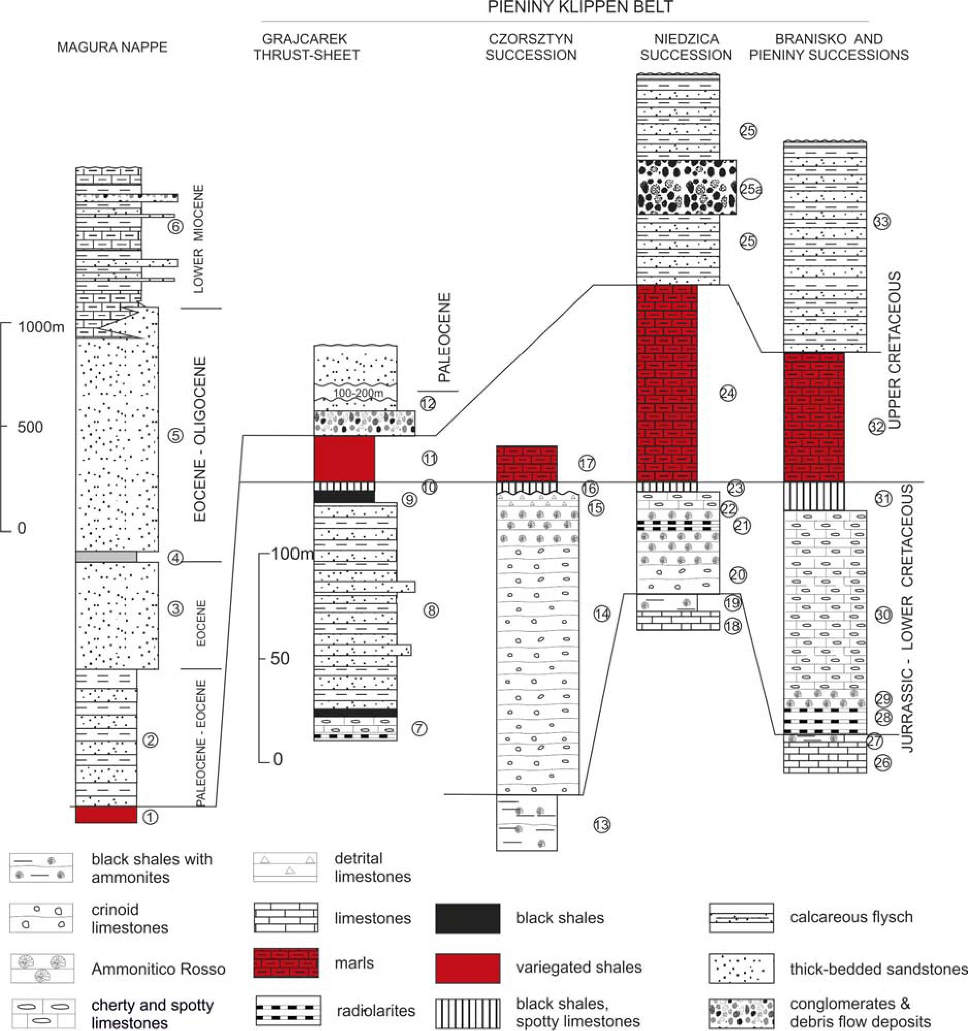
322
NESTOR OSZCZYPKO ETAL.
In Małe Pieniny, except for the Upper Jurassic/
Lower Cretaceous radiolarites and limestones of the Szcza-
wnica section, there are several sections with radiolarites
and cherty limestones without clear stratigraphical position.
The majority of them have been interpreted (Birkenmajer
1977,1979; Birkenmajer and Pazdrowa 1968) as tectonic
blocks of Jurassic radiolarites, and of Tithonian-
Barremian cherty limestone ofthe Pieniny Limestone type.
derived from the Branisko Unit of the PKB. Our studies
document that part of these small klippens belongs to the

Text-fig. 3. Lithostratigraphic log of the Małe Pieniny Mts (based on Oszczypko and Oszczypko-Clowes 2014). Magura Nappe: (1) Malinowa Shale Formation.
- Szczawnica and Zarzecze formations, Magura Formation; (3) Piwnicza Ss. Member, (4) Mniszek Shale Member, (5) Poprad Ss. Member, (6) Kremnâ Formation;
Grajcarek thrust-sheets: (7) Czajakowa and Sokolica Rad. formations, Czorsztyn and Pieniny lms. formations, and Kapuśnica and Wronine formations, (8) Szlachtowa
Formation, (9) Opaleniec Formation, (10) Cenomanian Key Horizon, (11) Malinowa Shale Formation, (12) Jarmuta Formation; Klippen successions (partly after Birken-
majer, 1977): Czorsztyn Succession: (13) Skrzypne Sh. Formation, (14) Smolegowa Lm. Formation and Krupianka Lm. Formation, (15) Czorsztyn, Dursztyn, Lysa and
Spis limestones formations, (16) Chmielowa and Pomiedznik formations, (17) Jaworki Marls; Niedzica Succession: (18) ?Krempachy Marl Formation, (19) ?Skrzypne
Shale Formation, (20) Smolegowa, Krupianka and Niedzica limestones formations, (21) Czajakowa Rad. Formation, (22) Czorsztyn and Dursztyn Limestone forma-
tions, Pieniny Limestone Formation, (23) Kapuśnica Formation, (24) Jaworki Marl Formation, (25) Sromowce Formation, (25 a) Bukowiny Gravelstone Member;
Branisko and Pieniny successions: (26) ?Krempachy Marl Formation, (27) ?Skrzypny Shale Formation, (28) Czajakowa and Sokolica Rad. formatios, (29) Czorsztyn
Lm. Formation, (30) Pieniny Limestone Formation, (31) Kapuśnica Formation, (32) Jaworki Marl Formation, (33) Sromowce Formation
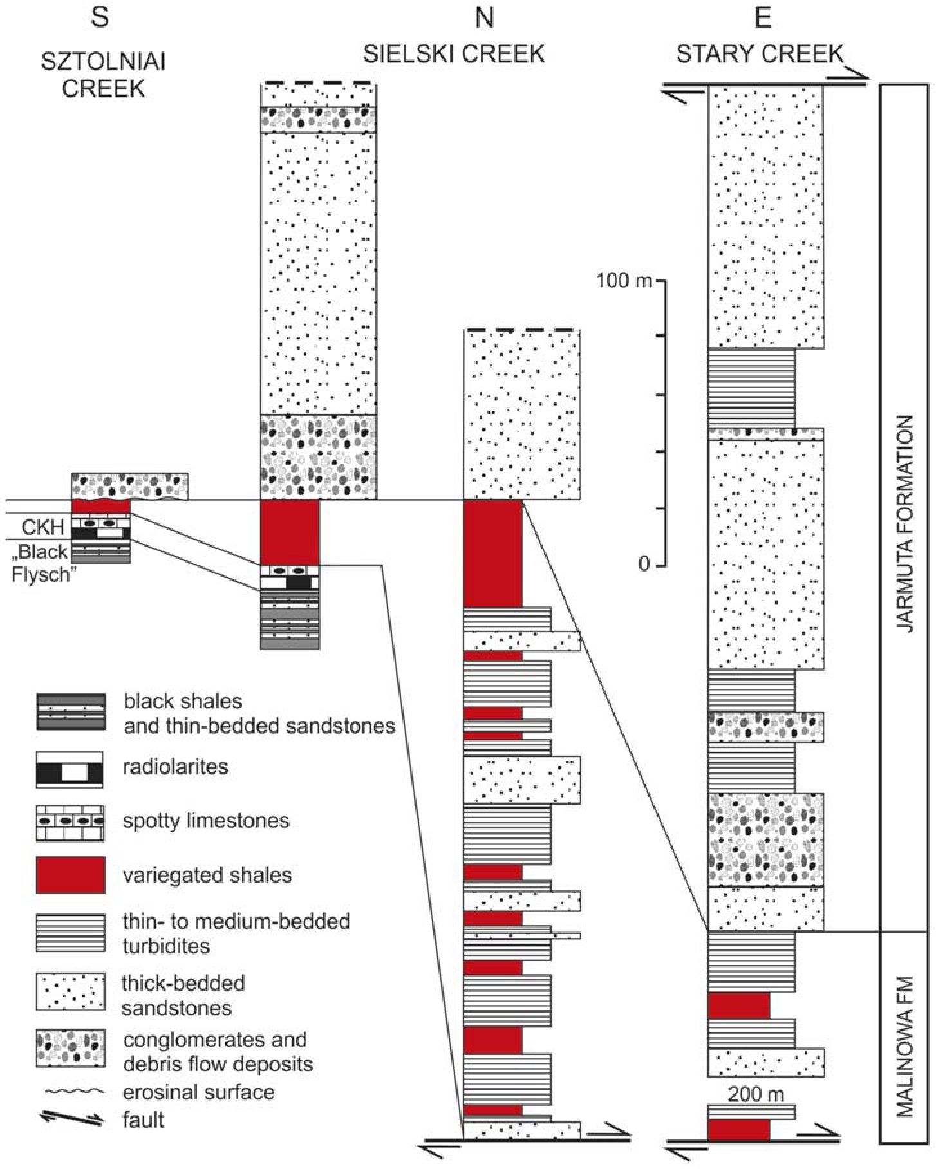
323
WHERE WAS THE MAGURA OCEAN?
CKH of the Grajcarek Unit (Oszczypko et al. 2012a;
Oszczypko and Oszczypko-Clowes 2014).
The CKH passes upwards into the Malinowa For-
mation (Text-fig. 4), composed of non-calcareous red
and green argillaceous shales, sometimes replaced by
massive red marls (in the Sztolnia sections; Oszczypko
et al. 2012a). The thickness of the Malinowa Forma-
tion varies from a few metres on the southern slope of
the Jarmuta Mt., 20-70 m in the Grajcarek Creek sec-
tions, up to 220-250 m in the Sielski and Stary creeks
(Text-fig. 4). This formation, of Turonian-Campanian
age (Oszczypko et al. 2012a), was deposited beneath
the CCD level, at a depth of around 4 km (Uchman et
al. 2006).
The Malinowa Formation is overlain by coarse-
clastic deposits of the Jarmuta Formation (Birkenmajer
1977, see also Text-figs 2-4), distributed along the
northern edge of the PKB. Locally the variegated shales
are intercalated with Jarmuta-type sandstones and con-
glomerates. The typical Jarmuta Formation is repre-
sented by thick-bedded turbidites (0.5-5 m thick), con-
glomerates and sandstones with subordinate
intercalations of grey marly shales. In the mouth of the
Sielski and Grajcarek creeks and along the lower
reaches of Czarna Woda Creek (Oszczypko et al. 2012a)
the basal portion of the Jarmuta Formation contains de-
bris flow paraconglomerates with clasts of red shales,
and blocks oflimestones and radiolarites. Fine-grained

Text-fig. 4. Lithostratigraphic logs of the Grajcarek Unit in the Małe Pieniny Mts (based on Oszczypko and Oszczypko-Clowes 2014)
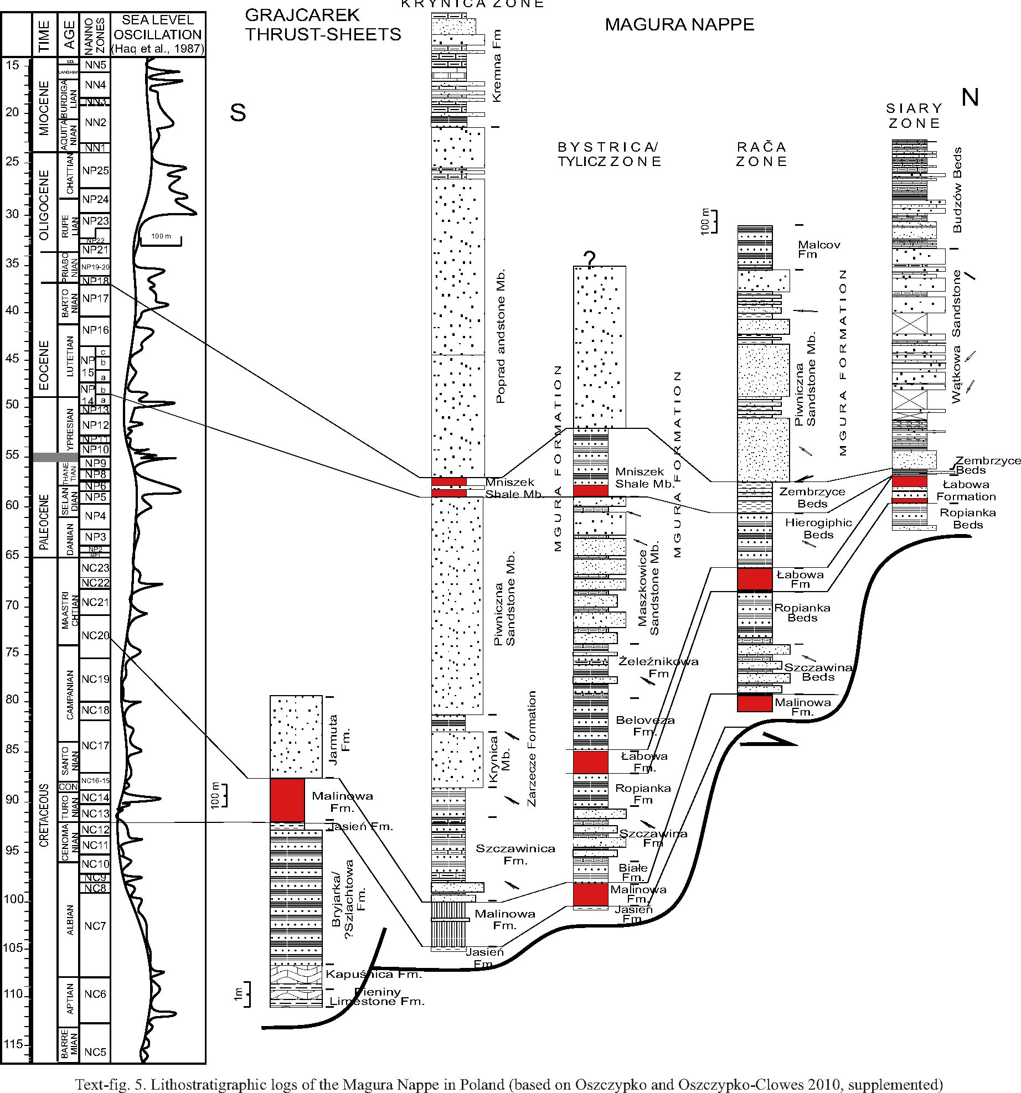
324
NESTOR OSZCZYPKO ETAL.

conglomerates comprise clusters of dark ?Upper Creta-
ceous limestones as well as of Triassic and Jurassic
dark organodetrital limestones.
An extremely rich set of clasts of Mesozoic rocks
of the PKB is known from exposures near the church
in Jaworki (Birkenmajer 1979, 2001). These rocks
can be correlated with coarse-grained mass-flow de-
posits with huge slide block of the Milpos Breccia of
the Saris (Grajcarek) Unit in the Litmanova-Jarabina
area (Text-fig. 2; see Plasienka and Mikus 2010;
Plasienka 2012).
According to Birkenmajer and Wieser (1990), the
Jarmuta conglomerates from the Biała Woda section
are dominated by volcanic rocks and carbonates as
well as sedimentary clastics. In the Szczawnica and Bi-
ała Woda sections, heavy mineral assemblages of the
Jarmuta Formation contain a relatively high content of
chromian spinels of ophiolite provenance (Oszczypko
and Salata 2005). The thickness of the formation varies
widely from about 100 metres north of the Grajcarek
Valley, to several tens of metres in the Grajcarek Val-
ley, and up to 400 metres north of this valley. The Jar-
rmuta Formation is regarded as of Maastrichtian-Mid-
dle Paleocene age (Birkenmajer 1977; Birkenmajer et
325
WHERE WAS THE MAGURA OCEAN?
al. 1987). Palaeocurrent analysis of the Jarmuta For-
mation turbidites shows the supply of clastic material
to have come from the SE, whereas the clasts of the de-
bris flow conglomerates came directly from the PKB
erosion (Laramian uplift).
THE MAGURA NAPPE (POLAND)
The Magura Nappe is the biggest and innermost
tectonic unit of the Outer Western Carpathians. The
width of the Magura Nappe in Poland is around 50
km. Its northern boundary is erosional and its south-
ern boundary, along the PKB, is tectonic. The Magura
Nappe, completely uprooted from its basement, is
thrust sub-horizontally over the more external flysch
units, which also appear in tectonic windows. The am-
plitude of the overthrust is not less than 55 km. The
Magura Nappe, up to 2 km thick, is composed mainly
of Maastrichtan-Paleogene siliciclastic flysch de-
posits (Text-figs 3, 5). This nappe is sub-divided into
five facies/tectonic sub-units. From south to north,
these are: the Krynica, Sącz (Bystrica), Raca and
Siary sub-units (Text-fig. 5). The basal portion of the
Magura Nappe consists of Turonian-Campanian red
and green shales of the Malinowa Formation, equiv-
alent of the Malinowa Formation of the Grajcarek
Unit. In the Polish sector of the Magura Nappe, de-
posits older than the Turonian, represented by 5-10 m
thick green and black shales (? Albian-Cenomanian),
are known only from a few places, located mainly
around the Mszana Dolna tectonic windows (Os-
zczypko et al. 2005a).
The youngest deposits of the Magura Nappe are
Oligocene to Early Miocene flysch (Oszczypko-Clowes
and Oszczypko 2004). Associated facially with the
Magura succession is the succession of the southern
Fore-Magura scale, exposed in front of the Magura
Nappe, west ofŻywiec (Burtan and Sokołowski 1956).
This scale, only several hundred metres wide, was in-
cluded by Książkiewicz (1977) in the Magura Nappe.
The same facies development is also shown in the so-
called Łużna and Harklowa outliers, near the town of
Gorlice. Consequently, they are regarded as a prolon-
gation of the Fore-Magura Unit.
THE MAGURA NAPPE (WESTERN SLOVAKIA
AND CZECH REPUBLIC)
Towards the west, the width of the Magura Nappe
oscillates around 40-50 km. Only at the meridian of
Zilina is it reduced to 25 km. Similarly as in Poland,
several flysch facies-tectonic units, uprooted from
their basement, are distinguished within the Magura
Nappe. From south to north these are the Bile Karpaty,
Orava-Krynica, Bystrica and Raca units (Lexa et al.
2000; Picha et al. 2006; Kovac in print, and referer-
ences therein). The Bile Karpaty Unit is located at the
front of the PKB (Text-figs 1B, 6a). The oldest de-
posits of this unit are known as the the Hluk Forma-
tion (Barremian-Albian), not less than 120 metres
thick (Lexa et al. 2000; Picha et al. 2006). There are
carbonate turbidites (T_{ab}) occuring in 30-30 cm beds
with intercalation of black shales. Upward in the suc-
cession, there are dark green shale formations of the
Gault Formation (Aptian / Albian) with a thickness of
about 200 m. The uppermost part of this succession is
represented by red and green shales intercalated with
fine-grained, thin sandstones of the Kaumberg For-
mation (Cenomanian-Turon), variegated marls of the
Puchov (Gbely) Formation (Campanian-Maastricht-
ian), thick-bedded sandstones and conglomerates of
the Svodnica Formation (Paleocene) with fragments
of granites, phyllites and volcanic rocks of diabase
type (Potfaj 1993), the Niwnice Formation (thin- and
medium-bedded turbidites) and the Kuzelov Member
(Cuisian), dominated by variegated shales with thin-
bedded sandstones. The inclusion of the Puchov For-
mation into the Bile Karpaty succession is debatable
(see Bubik 1995; Svabenicka et al. 1997; Picha et al.
2006). The palaeocurrent analysis shows that clastic
material was derived from the south, probably from
the Central Carpathians (Potfaj 1993). Facies devel-
opment and age of the Bile Karpaty succession sug-
gest its more external position in the basin relative to
the Grajcarek succession. The Bile Karpaty Unit is
thrust over the Oligocene deposits of the Bystrica
Unit.
In the more external units (Krynica / Orava, Bystrica
and Raca), the basal detachment of the Magura Nappe
is usually located within the Lower Cretaceous (Al-
bian) flysch, followed by red and variegated shales of
the Kaumberg / Malinowa Formation (Turonian-Cam-
panian) and Upper Cretaceous / Paleogene (up to
Oligocene) flysch (Text-figs 6b-d).
Additionally known from the Raca Unit (Picha et
al. 2006) are other Late Jurassic and Early Cretaceous
sediments: the Kurovice limestones (Oxfordian / Ti-
thonian), dark Tlumacov Marls (Tithonian / Berria-
sian), and the Rajnochovice black flysch (Barremian /
Albian). In the Fore-Magura Unit of northern
Moravia, deposits older than Paleocene-Eocene are
unknown. In this unit the block of ophicalcites with
neptunian dykes of Jurassic limestones (Sotak et al.
2002) was found.
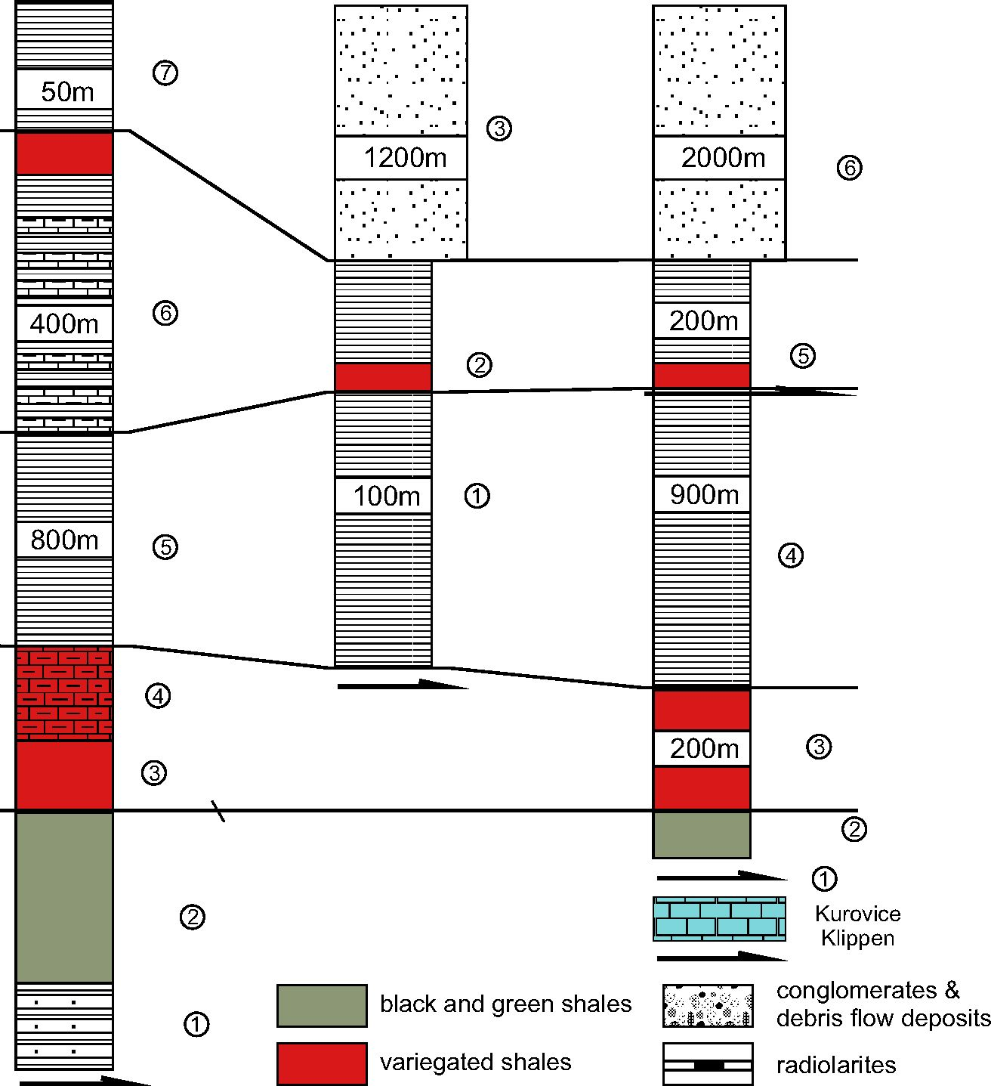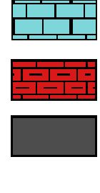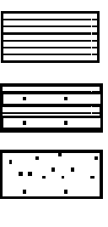
326
NESTOR OSZCZYPKO ETAL.
RHEN OD ANUBI AN FLYSCH ZONE (LOWER
AUSTRIA)
The Rhenodanubian Flysch Zone (RdFZ) of
Lower Austria is widely considered to be a direct
western prolongation of the Magura Nappe (Text-fig.
1A) of the Outer Western Carpathians (Elias et al.
1990; Lexa et al. 2000; Froitzheim et al. 2008; Us-
taszewski et a/.200S). However, correlation of fa-
cies / tectonic units of the Magura Nappe (Raca,
Bystrica, Krynica, Bile Karpaty) and nappes of the
RdFZ is still under discussion (Prey 1979; Faupl and
Wagreich 1992; Faupl 1996; Oberhauser 1995; Schn-
abel 1997, 2002; Trautwein et al. 2001; Mattern and
Wang 2000; Picha et al. 2006; Egger and Wessely
2014).
BILE KARPATY UNIT
a
BYSTRICA UNIT
b
RACA UNIT
C
N

klippen
succesion
maris
black shales
thin- to medium-bedded
turbidites
calcareous flysch
voulcanites
cristaline and
metamorphic rocks
palaeocurent
direction
tectonic
detachment
Text-fig. 6. Lithostratigraphic logs of the Magura Nappe in Western Slovakia and Czech Republic (based on Lexa et al. 2000 and Picha et al. 2006); a - Bile
Karpaty Unit: (1) Hluk Formation (Barremian-Albian), (2) Gault Flysch (Albian), (3) Kaumberg Formation (Cenomanian-Campanian), (4) Puchov Marls (Maas-
trichtian), (5) Svodnice Formation (Maastrichtian-Paleocene), (6) Nivnice Formation (Paleocene), (7) Kużelov Formation (Eocene); b - Bystrica Unit: (1) Solan
Formation (Maastrichtian-Paleocene), (2) Beloveza Formation (Eocene), (3) Bystrica Formation (Eocene); c - Raca Unit: (1) Kurovice Klippen (Jurassic-Lower
Cretaceous), (2) Gault Flysch (Albian), (3) Kaumberg Formation (Cenomanian-Campanian), (4) Solan Formation (Maastrichtian-Paleocene), (5) Beloveza
Formation (Paleocene-Eocene), (6) Zlin Formation (Eocene-Oligocene)

basalts
tiick-bedded sandstones
327
WHERE WAS THE MAGURA OCEAN?
The RdFZ is located between the European Palaeo-
zoic Platform to the north and the front of the North-
ern Calcareous Alps (NCA) to the south. It is generally
10 km in width, reaching up to 20 km only in the area
of Vienna and Salzburg. The Rhenodanubian flysch is
overthrust by the NCA, and thrust over the Helvetic
Zone and the North Alpine Molasse Basin.
The RdFZ is divided into several major lithostrati-
graphic units (Oberhauser 1968, 1995) with partially dif-
ferent characters of sedimentary successions of deep-
water deposits. They are regarded as the eastern part of
the Penninicum and generally represent the time span
from the Early Cretaceous up through the Middle
Eocene. Part of the Rhenodanubian flysch was de-
posited on a platform composed of Upper Triassic con-
tinental quarzites (St Veit Klippen Zone). The southern
part of the RdFZ was deposited on the Late Jurassic
oceanic crust, as preserved in the Ybbsitz Klippen Zone
(Decker 1990; Schnabel 1992; Voigt and Wagreich et al.
2008; Slqczka et al. 2014).
The Ybbsitz Klippen Zone (YbKZ) has a special po-
sition within the RdFZ where the sedimentary sequence
is floored by ultrabasic rocks. This sequence is some-
times considered as a prolongation of the Grajcarek
Unit (Schnabel 1992). The oldest deposits in this area
are exposed on both sides ofthe river Ybbs. On the right
side of the river the exposures are located in the place
known as “Wald Kappelen” (WP 62: N47 56 25.9 E14
54 15.9, Text-fig. 7.1a), below the thrust of the the
Frankenfeld Nappe of the Northern Calcareous Alps
(NCA). These rocks are represented by YbKZ pillow-
lava beds with sedimentary breccia, with quartz and
feldspar, overlain by red and green radiolarites and dark
grey and reddish-pink Kimmeridgian limestones with a
mass occurrence of Globochaete alpina and numerous
Saccocoma sp. These limestones belong to the well
known Lombardian Ammonitico Rosso biofacies. The
top of the section is terminated by Upper Cretaceous red
shales of the Ybbsitz Formation (WP 63: N47 56 31.8’
E14 54 36.2’).
The basal portion of the YbKZ is also known from
the Reidl Quarry (Text-fig. 7), on the left side of the
Ybbs valley, 3 km W of Ybbsitz. The lowest part of the
succession is represented by a 3-m thick package of
green and red shales with manganese concretions and
tuffite intercalations. Higher up, the succession is com-
posed of: green and red radiolarites (9 m), red biotur-
bated marls (2 m), spotty Globochetae / Aptychus mi-
critic limestones (our sample WP 68: N47 56 17.2’ E14
51 47.1’), pale pink and greenish limestones (1 m), and
sedimentary breccia of green and red radiolarites (0.5
m), covered by 5 m of cherty limestones. Sample WP 68
contains calpionellids [Crassicollaria sp., Calpionella
alpina Lorenz, Tintinnopsella cf. longa Colom], and cal-
careous dinocysts [Colomisphaera carpathica (Borza),
Schizosphaerella minutissima Colom], which indicate a
Late Tithonian-?Berriasian age. Above the micritic
limestones, with a break in exposures, Upper Cretaceous
red shales of the Ybbsitz Formation are exposed. This
section is really very similar to the basal portion of the
Grajcarek Unit (Szczawnica / Zabaniszcze section,
Poland, see Birkenmajer 1977, 1979; Oszczypko et al.
2012a).
In the village of Ederlehen, the micritic Calpionella
limestones (Rotenberg Beds, 20 m thick) are intruded by
a 2 m thick basaltic sill with thermal contacts (poly-
metallic mineralization). The Calpionella limestones
are followed (Homayoun and Faupl 1992) by a set of
deep-water marly limestones, calcareous sandstones
and grey and dark grey shales and marls (Glosbach
Formation, c. 250 m thick).
The succeeding Albian sediments are represented by
a sequence of anoxic black siliceous shales and grey
marls with intercalations of calcareous and siliceous
sandstones and sporadic fine-graded calcirudites (Hasel-
graben Formation, c. 130 m thick). Heavy mineral as-
semblages are represented mainly by garnet, zircon,
tourmaline, apatite and a small amount of chromium
spinel. The Haselgraben Formation is followed by a
complex of thick-bedded, massive sandstones in-
terbedded by laminated calcareous sandstones and red
and green shales (Ybbsitz Formation, ?Cenomanian-
Coniacian; Schnabel 1979; Homayoun and Faupl 1992).
Observed paleocurrent directions are from W to E.
Heavy minerals are represented by garnet, zircon, tour-
maline and apatite. Chromium spinel content ranges
from 0 up to 12 %. The Ybbsitz succession is terminated
by the Kahlenberg Formation.
From the north to the south, the RdFZ is composed
of the Northern Zone (Tulbingerkogel Schuppe),
Greifenstein Nappe, Kahlenberg Nappe with the St.
Veit Klippen at the base, Laab Nappe and the Ybbsitz
Klippen Zone (Schnabel 1997, 2002; Egger and Wessely
2014). The Laab and Kahlenberg nappes disappear to-
wards the west, and the Greifenstein Nappe continues as
the Main Nappe.
The Rhenodanubian flysch successions (Text-fig. 7
a2-d) begin generally with carbonate turbidites (Wolf-
passing and Tristel formations) followed by Albian
black shales and siliciclastic, glauconitic turbidites
(Gault, ?Rehbreingraben? formations, Glosbach For-
mation). Intercalation of hemipelagic claystones, oc-
curring in the majority of successions, indicate deposi-
tion below the local calcite compensation depth,
probably at >3000 m (Wagreich et al. 2008). Locally in-
tercalations appear of sedimentary breccias (slump de-
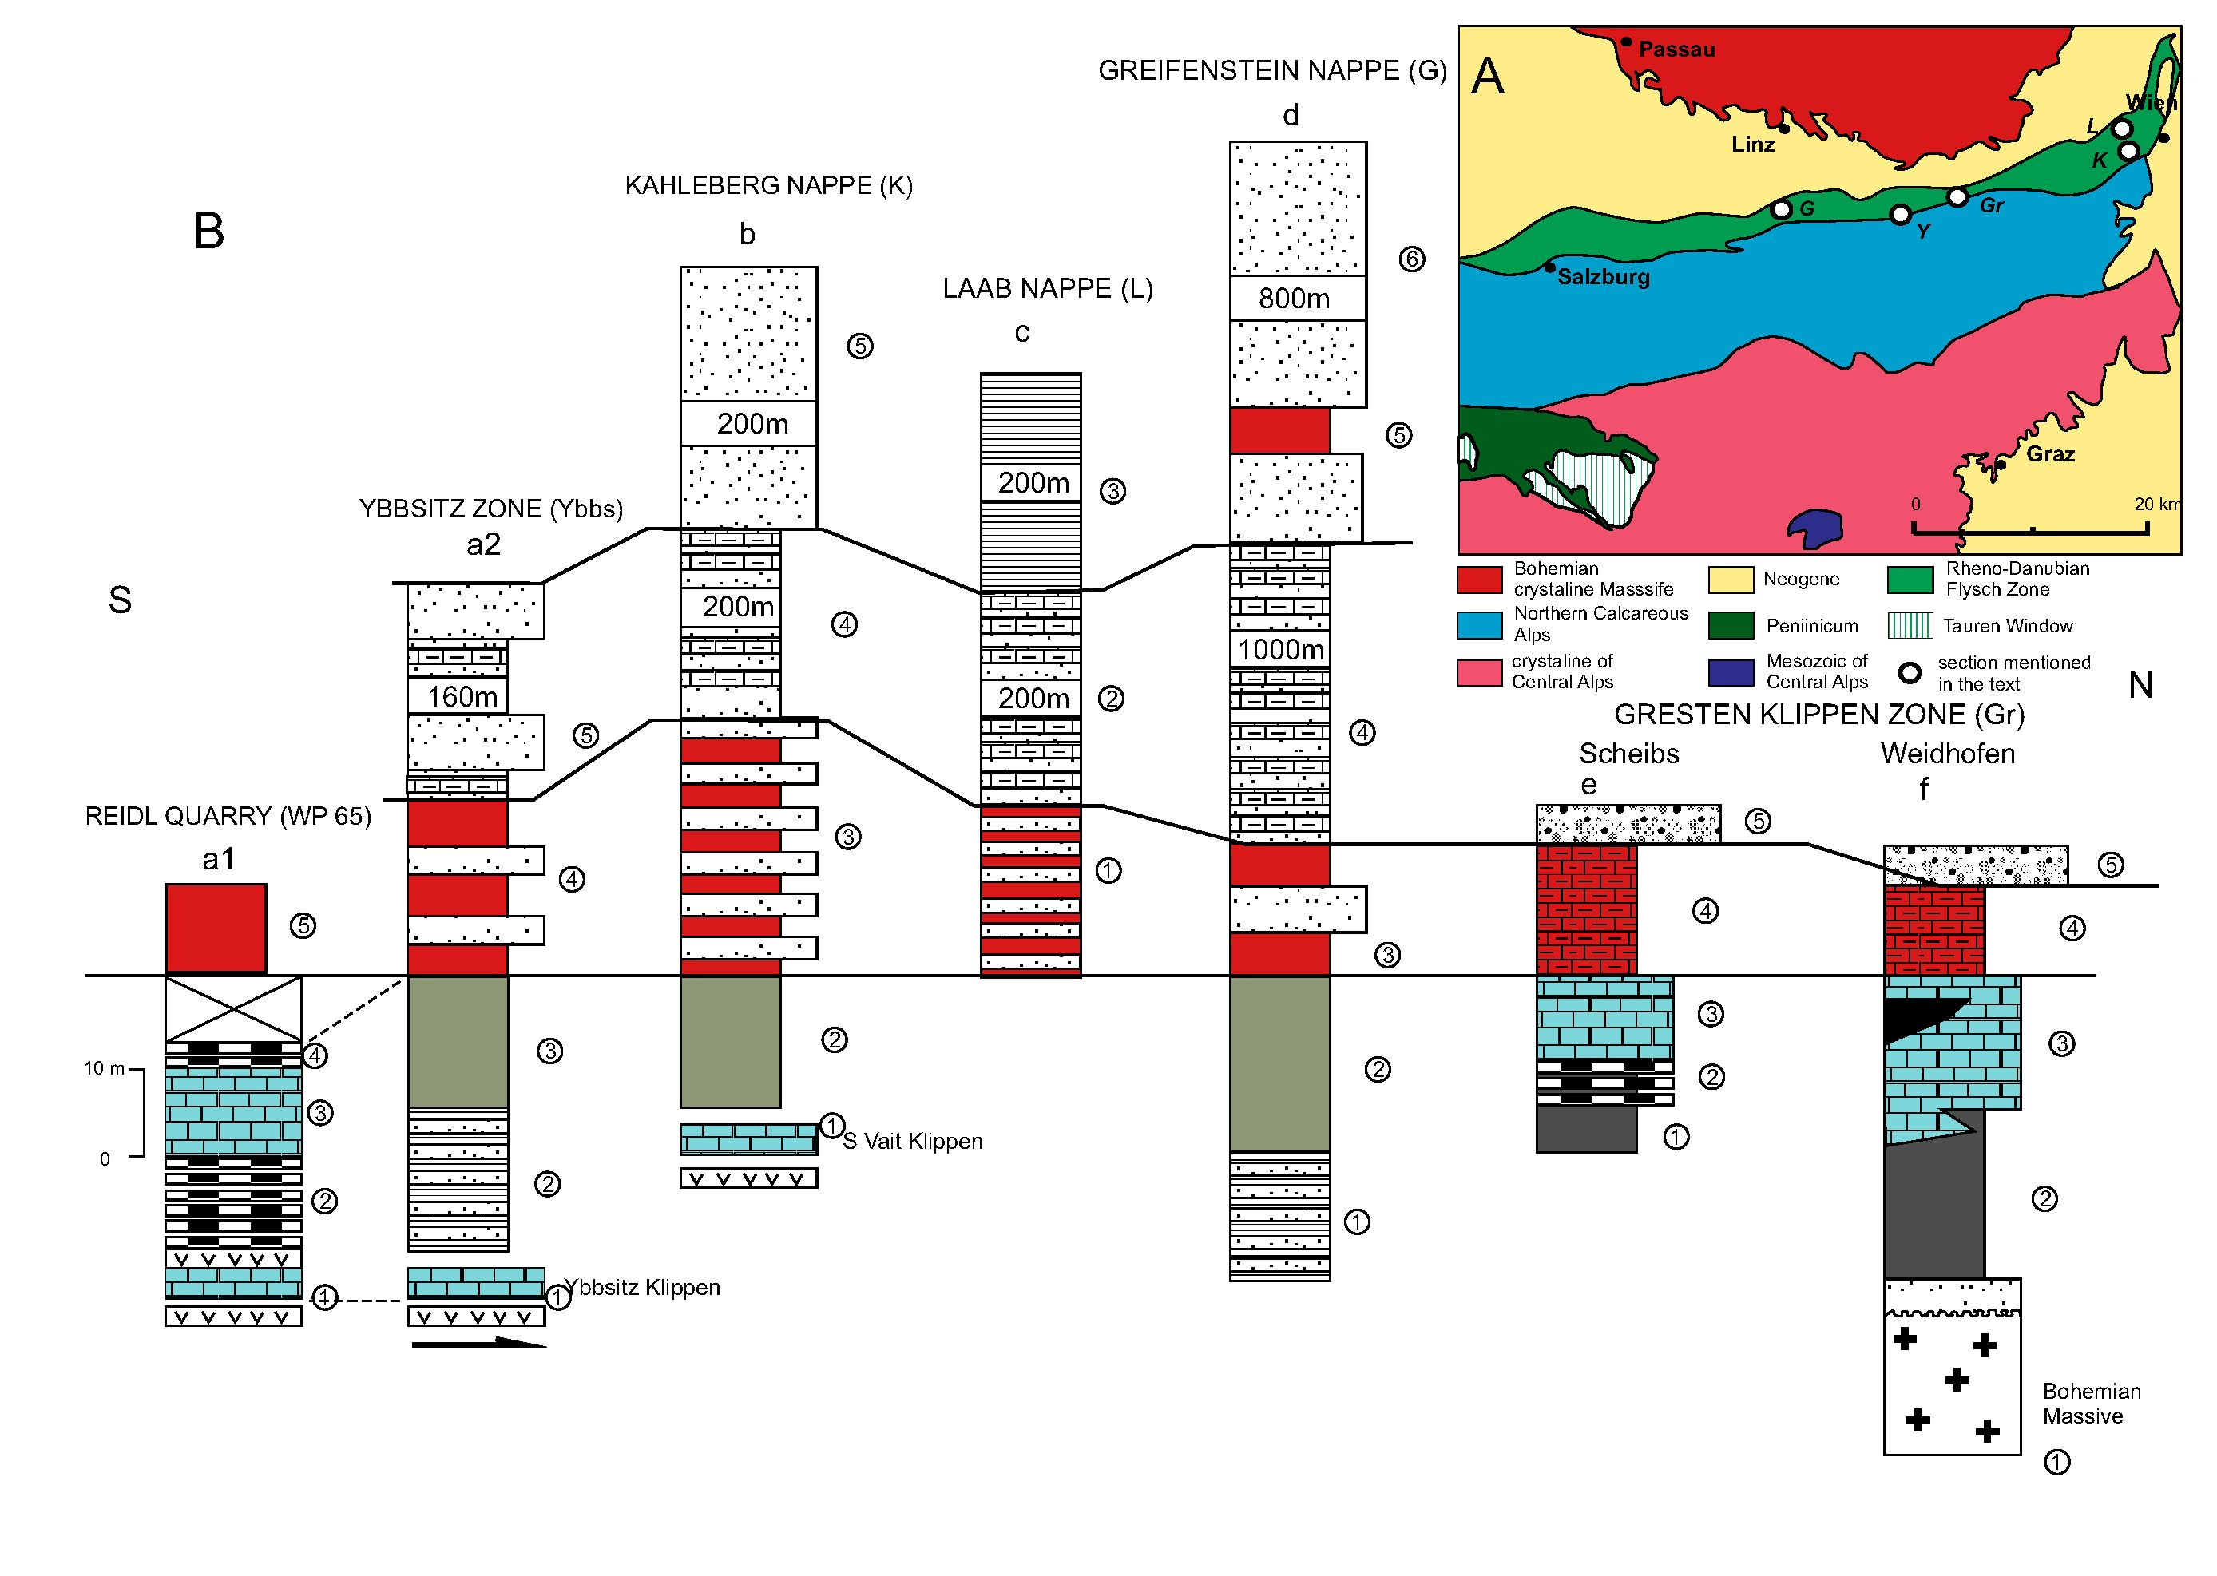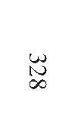

329
WHERE WAS THE MAGURA OCEAN?
posits) with blocks of variegated limestones, mica-
schists, phyllites, and quartzites. North of Salzburg
(Haunsberg Wildflysch Formation) there is an olis-
tostrome within Early Cretaceous sediments, which
contain blocks of granitoids, crystalline schists, lower
Permian conglomerates with melaphyre pebbles, ?Tri-
assic grey dolomites, and Jurassic-Neocomian deep
and shallow water limestones derived from the NEP
(Frasl 1987
Big blocks of serpentinites occur within the Wol-
passing Formation, in the vicinity of the village ofKilb
(Prey 1977). Chromium spinels, which occur in the
serpentinites, indicate their derivation from a mantle
peridotite of harzburgite character (Cieszkowski et al
2006)
Sedimentation of variegated shales and marls, with
intercalations of sandstones (Seisenburg Formation,
Lower Variegated Marls, Kaumberg Formation, Hut-
teldorfFormation, Reiselsberg Formation), started in the
Cenomanian and lasted till the Early Campanian. In the
Cenomanian sandstones of the St. Veit Klippen Zone pi-
crites has been recognized.
The Early to Middle Campanian part is dominated
by turbiditic calcareous sandstones and calcturbidites
(Zementmergel Beds, Kahlenberg Formation, lower
part of the Hois Formation; Text-fig. 7b-d).
The higher part of the Cretaceous and the Lower Pa-
leogene are represented by several thick-bedded com-
plexes of turbiditic sandstones (Altlengbach and
Greifenstein formations, Kahlenberg and Sievering for-
mations, upper part of the Hois Formation; Text-fig. 7).
Sedimentation terminated by complexes of thin- and
medium-bedded sandstones and shales during the early
Eocene (Irenental Formation and Agsbach Formation).
The primary positions of the above-described nappes
are still debatable. According to Prey (1979), Faupl and
Wagreich (1992) and Faupl (1996) the Laab Nappe, re-
garded as the prolongation of the Bile Karpaty Unit
(Elias et al. 1990), was situated originally between the
Greifenstein and Kahlenberg Nappes. However, other
authors (Oberhauser 1995; Trautwein et al. 2002 and
Mattern and Wang 2008) state that the Laab Nappe was
originally north ofthe Greifenstein Nappe. Recently, Eg-
ger (in Egger and Wessely 2014) included the Kahlen-
berg Nappe in the Greifenstein Nappe as the Kahlenberg
and Satzberg digitations (?recumbent folds) and the
Northern Zone (Tulbingerkogel unit), similarly to Grün
et al. 1972, he regarded as a marginal part of that nappe
(Egger and Wessely 2014). Schnabel (2002) connected
the Northern Zone with the Kahlenberg Nappe (Schn-
abel 2002). Also debatable is the position of the St. Veit
Klippen Zone. It was variously regarded as a substratum
ofa part of the the Kahlenberg flysch succession (Schn-
abel 1997) or of the Greifenstein one (Egger and Wes-
sely 2014), but Wagreich et al (2012) state that it was not
established beyound doubt. The St. Veit Klippen Zone
is also considered to be an eastern continuation of the
Ybbsitz Zone (Faupl and Wagreich 2000; Wagreich et
al. 2008; Egger and Wessely 2014) and Lexa et al.
(2000) consider it as a prolongation of the Pieniny Klip-
pen Belt with affinities to the Lower Austroalpine-Fa-
tric elements (Wagreich et al. 2012).
Yet another structural division of the NCA foreland
has been presented by Voigt and Wagreich et al. (2008).
These authors distinguished: the Middle and South
Pennic Zone: Metamorphic Pennic Bündnerschiefer of
the Tauern Window, Middle Pennic Tasna and Sulzfluh
nappes, Arosa Zone; Rhenodanubian Flysch: Ybbsitz
Zone and Kahlenberg Nappe; Greifenstein and main
nappe; Helvetic units: Ultrahelvetic Gresten Klippen
Zone, Helvetic units; Washberg Zone.
HELVETICUM (AUSTRIA)
During the Mesozoic and Paleogene the Helvetic
palaeogeographic domain developed on the southern
border ofthe Western European Platform (WEP). In this
domain, the Late Jurassic pelagic carbonates are fol-
lowed by shallow water carbonates of the Early Creta-
ceous, and higher by characteristic variegated pelagic
and hemipelagic marls and shales (Buntmergel Serie) of
Cenomanian-Middle Eocene age.
The southern slope of the WEP and base-of-slope
zone (the Ultra-Helvetic domain) are represented by the
Gresten Klippen Zone and the Main Klippen Zone. The
Text-fig. 7. A - Geological sketch-map of the Rhenodanubian Flysch Zone and adjacent areas (based on Beck-Mannagetta 1960, simplified); B - Lithostratigraphic
logs of the Rhenodanubian Flysch in Lower Austraia (based on Schnabel 1992 and Lexa et al. 2000): al - Reidl Qurry: (1) green and red shales, (2) green and red ra-
diolarites, (3) spotty limestones, (4) cherty limestones, (5) Ybbsitz Formation); a2 - Ybbsitz Zone: (1) Ybbsitz Klippen (Middle Jurassic-Valanginian), (2) Neocomian
Flysch (Valanginian-Aptian), (3) Gault Flysch (Albian), (4) Ybbsitz Formation (Cenomanian-Santonian), (5) Zement marl Formation (Campanian); b - Kallenberg
Nappe: (1) St.Veit Klippen, (2) Gault Flysch (Albian), (3) Ybbsitz Formation (Cenomanian-Santonian), (4) Kahlenberg Formation (Campanian-Maastrichtian), (5) Siev-
ering Formation (Mastrichtian-Paleocene); c - Laab Nappe: (1) Kaumberg Formation (Companian-Maastrichtian), (2) Hois Formation (Paleocene), (3) Aggsbach For-
mation (Eocene); d - Greifenstein (Main) Nappe: (1) Neocomian Flysch (Barremian-Aptian), (2) Gault Flysch (Albian), (3) Kaumberg Formation
(Cenomanian-Maastrichtian), (4) Zementmergiel Formation, (5) Uppermost variegated shales, (6) Atlenbach and Greifenstein formations; Gresten Klippen; e - Scheibs
facies: (1) Middle Jurassic clastics, (2) Radiolarites (Malm), (3) Tithonian/Neocomian limestones, (4) Late Cretaceous/ Paleogene - variegated marls, (5) Paleogene con-
glomerates; f - Waidhoffen facies: (1) Bohemian crystalline Massif, (2) Jurassic conglomerates, sandstones and mudstones, (3) Jurassic-Early Cretacecous limestones.
- Late Cretaceous/Paleogene variegated marls, (5) Paleogene conglomerates. Lithology explained on Fig 6.
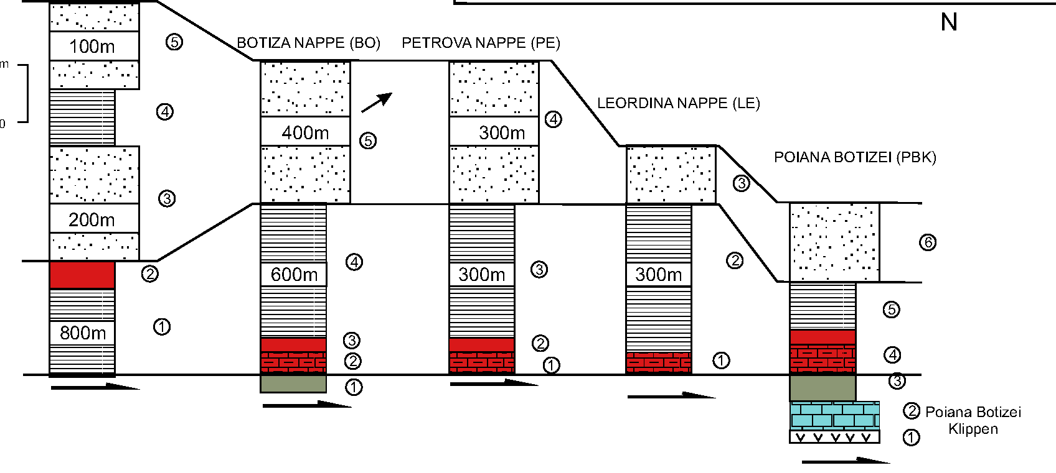
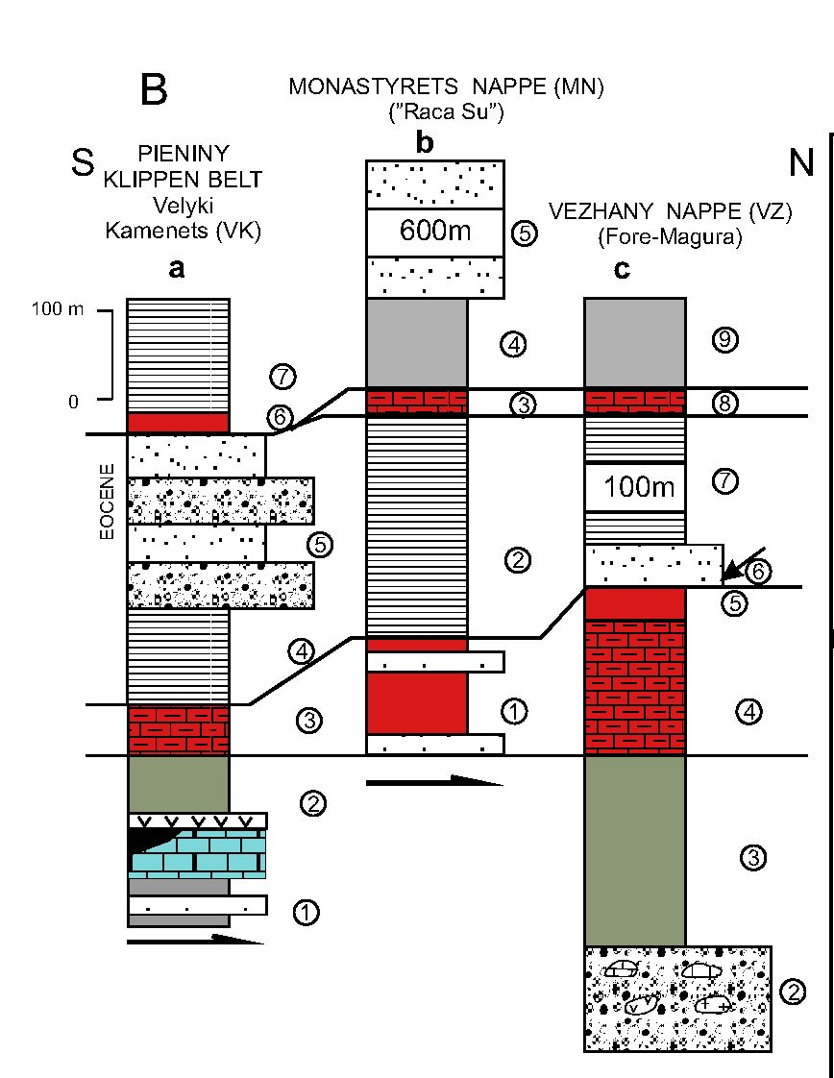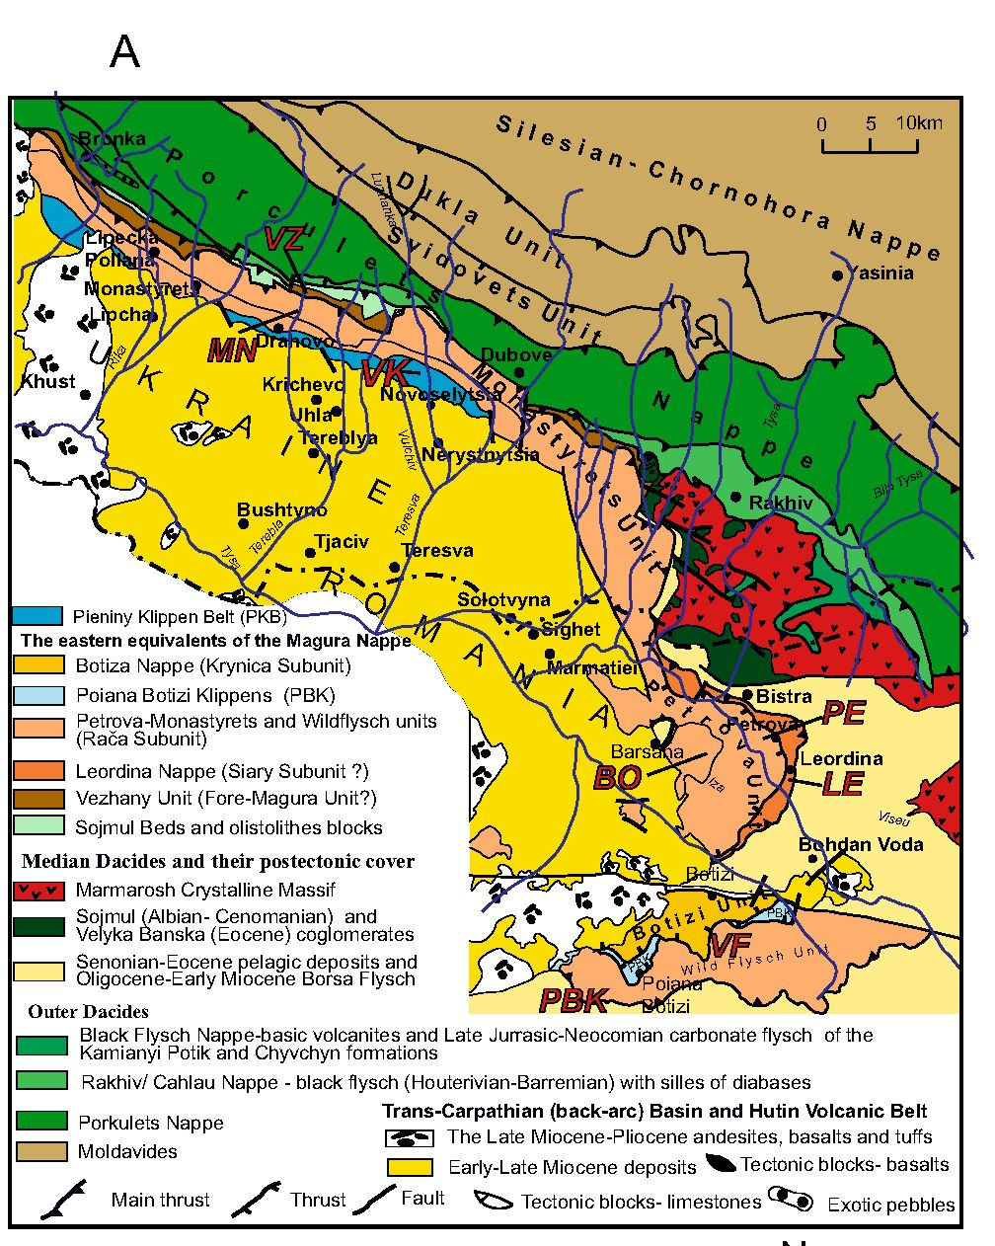
330
NESTOR OSZCZYPKO ET AL
Marmarosh
^ Klippen
©
WILDFLYSCH NAPPE (WF)
S
Text-fig. 8. A - Geological sketch-map of the Eastern Carpathians (PKB and Marmarosh Flysch Zone, Transcarpathian Ukraine and Romania, based on Oszczypko et
al. 2005b. supplemented); B - Lithostratigraphic logs of the PKB and Marmarosh Flysch Zone (Magura Nappe) of the Trancarpathian Ukraine: a)Velyki Kamenets
and Vilchovchyk section of the PKB (based on Oszczypko et al. 2012): (1) Aalenian, (2) Bajocian-Early Cretaceous Czorsztyn/Niedzica carbonate sequence, (3) Pu-
chov Marls (Turonian-Campanian), (4) “Jarmuta beds” (Maastrichtian-Paleocene), (5) Vilchovchic conglomerates (Eocene), (6) Red shales (Eocene), (7) ?Malcov beds
(Oligocene), b) Monastyrets Unit (Raca Zone of the Magura Nappe): (1) Kalyna beds (Late Cretaceous/Paleocene), (2) Schopurka beds (Eocene), (3) ? Sub-Menilite
Globigrina Marls (Late Eocene-Oligocene), (4) Dusina Marls (Oligocene), (5) Drahovo Sandstone ? Oligocene), c) Vezhany (Fore-Magura) Unit:
- Marmarosh Klippens (Triassic-Early Cretaceous), (2) Sojmul Conglomerates (? Albian), (3) Sojmul Beds (Albian-Cenomanian), (4) Red marls of Puchov type (Tur-
onian-Santonian), (5) Red shales of the Malinowa Fm type (Campanian), 6) “Jarmuta” type conglomerate sandstones (Maastrichtian/Paleocene), (7) Metove beds
(Eocene), (8) Sub-Menilite Globigerina Marls (Late Eocene/ Oligocene, (9) Łuh beds (Oligocene). Lithology explained on Fig 6; C - Lithostratigraphic logs ofthe North-
ern Maramuresh flysch Units / Magura Nappe (Romania), (based on Aroldi 2001; Żytko 1999: a) Wild Flysch Nappe: (1) Roaia Fm. (Lutetian-Priabonian).
- Red shales, (3) Magura-Perciu-Pintenul Sandstone (Rupelian-Chattian), (4) Thin-bedded flysch, (5) Magura-Perciu-Pintenul Sandstone (Rupelian-Chattian),
b) Botiza Nappe: (1) Scaglia Cinerea (Albian/Cenomanian), (2) Red marls (Late Cretaceous), (3) Red shales (Paleocene), 4) Tocila Formation (Ypresian-Lutetian).
- Secu Sandstone (Lutetian-Bartonian), c) Petrova Nappe: (1) Red marls (Late Cretaceous), (2) Red shales (Paleocene), (3) Petrova Formation (Lutetian-Early Pri-
abonian), (4) Stramtura Sandstone (Priabonian), d) Leordnina Nappe: (1) Red marls (Late Cretaceous), (2) Rozleva Formation (Thanetian-Early Rupelian), 3) Veron-
icu Sandstone (Middle Rupelian-Chattian), e) Poiana Botizei Klippen, (1) Jurassic-Early Cretaceous carbonate sequence, 2) Scaglia Cinerea (Albian-Cenomanian),
- Red Marls (Late Cretaceous), (4) Red Shales (Paleocene), (5) Hieroglyphic beds (Eocene), (6) Secatura sandstone (Oligocene). Lithology explained on Fig 6

331
WHERE WAS THE MAGURA OCEAN?
Gresten succession is divided into the “Klippen” and the
“Envelopes” (Text-fig. 7e, f). The former consists of
continental to marine sediments ranging in age from
Early Jurassic to Early Cretaceous (Widder 1988; Hoeck
et al. 2005). The “Envelope” is developed as varie-
gated marls (Buntmergel) ranging from the Late Creta-
ceous to the Eocene.
Also regarded as part of the Ultra-Helvetic Domain
are successions with mafic rocks (diabase, gabbro, ser-
pentine, ophicalcite) associated with Kimmeridgian-
Tithonian radiolarites and variegated limestones, known
from the tectonic windows of Strobl and St.Gilgen
(Plochinger 1964; 1982). These successions show that
a rift zone developed also along part of the northern mar-
gin of the Penninic Ocean
TRANSCARPATHIAN UKRAINE
In the Ukrainian Carpathians, the PKB runs as a dis-
continuous belt, with a width up to 5 km, from the
vicinity of Uzhhorod in the west to the Tereblia-Teresva
rivers in the east (Text-fig. 1B); separate klippens are lo-
cated at Perechyn (NE ofUzhhorod), near Svaliava, Pri-
borzhavske and Drahovo-Novoselytsia. It is trangres-
sively overlain from the south by the Miocene of the
Transcarpathian Basin (Text-figs 1B, 8A). NE from
Uzhhorod, it was overthrust at a low angle onto the
Magura Nappe, and, farther to the east, onto the
Monastyrets’-Petrova thrust-sheet of the Marmarosh
Klippen Zone Nappe (see Oszczypko et al. 2005b).

Velyki Kamenets section
The easternmost exposure of the PKB is known
from the Velykyi Kamenets’ quarry (GPS
N48°10’48,9”, E3°44’05,4”), located near the village of
Novoselytsia in Trans-Carpathian Ukraine (Text-fig.
8A, Ba). In this area the PKB, up to 3 km wide, is com-
posed of Jurassic through to Upper Cretaceous pelagic
deposits, transgressively overlain by the Paleocene/
Eocene Vilkhivchyk conglomerates (Smirnov 1973).
Towards the north, the PKB is thrust at a low angle over
the Drahovo Sandstones of the Monastyrets Unit
(Smirnov 1973; Kruglov in Sl^czka et al. 2006). To the
south these klippens contact with the Neogene deposit
of the Transcarpathian Depression (Oszczypko et al.
2005b; 2012b).
Recently, the Velyki Kamenets has been intensively
studied (Krobicki et al. 2003; Lewandowski et al. 2005;
Rehakova et al. 2011; Oszczypko et al. 2012b. The 80-
m thick succession of the Kamenets quarry is repre-
sented by the Czorsztyn/Niedzica type of lithofacies
(Rehakova et al. 2011). The succession begins with
Gresten-type conglomerates and sandstones, up to 28 m
thick, followed by a 55 m thick sequence ofBajocian to
Middle Berriasian limestones with a 6 m thick basaltic
lava flow at the top.
Additionally a 6-9 m thick pyroclastic breccia in the
lower Tissalo beds (? Albian-Cenomanian) was recog-
nised in the old, Malyi Kamenets’ quarry, and in the sec-
tion ofthe Vilkhivchyk Stream. The rocks are typical of
oceanic island arc alkali basalts and pyroclastics be-
longing to intraplate volcanism (Oszczypko et al.
2012b). Higher up in the succession, these are followed
by variegated marls of the Puchov Formation (Turon-
ian-Campanian), by the Jarmuta Formation (Maas-
trichtian/Paleocene) and the Vilkhivchyk Formation
(Lower-Middle Eocene, Smirnov 1973). In the Puntski
Brook in Novoselytsia, the Vilchivchyk conglomerates
transgressively overlie the Puchov Marls. The Vil-
chovchyk Formation, up to 300 m thick, represents a fin-
ing- and thining-upwards sequence, from fan delta
coarse conglomerates, through thick and thin turbidites
to hemipelagic red shales.

Marmarosh Klippen Zone (Ukraine)
Monastyrets Unit
The oldest deposits of the Monastyrets Unit (Text-
fig. 8A, 8B, b) belong to Upper Cretaceous red and var-
iegated shales, equivalent of the Malinowa Formation
(Oszczypko et al. 2005b), followed by Upper Creta-
ceous-Paleocene thin- to medium-bedded turbidites
overlain by Eocene variegated shales and thin bedded
fysch of the Shopurka beds. The upper part of this suc-
cession belongs to the Drahovo thick-bedded sand-
stone, up to 1 km thick. These sandstones are not older
than Late Eocene (Oszczypko et al. 2005b). The
Vezhany Unit is overthrust by the Monastyrest Unit,
which contacts the PKB along a sub-vertical fault. The
Vezhany and Monastyrest units can be correlated with
the Fore-Magura (Grybow) Unit and the Raca Unit of
the Magura nappe respectively (Oszczypko et al. 2005;
see also Zytko 1999).

Vezhany Unit
The Vezhany Unit is well exposed in the Terebla
river section, between the Zabrid in the north and Dra-
hovo in the south (Text-figs 8A, 8B, c). The basal (Al-
bian), 100-200 m thick, portion of the Vezhany suc-
cession belongs to an olistostrome, composed ofblocks
of Urgonian limestones, serpentinites, basal volcanites,
granitoids and metamorphic rocks (Smirnov 1973; Os-
332
NESTOR OSZCZYPKO ETAL.
zczypko et al. 2005b). This portion is overlain by a 200
m thick unit of Cenomanian grey marly mudstones.
with intercalation of thin-bedded sandstones, of the So-
jmul Beds (Dabagyan e al. 1989; Oszczypko et al.
2005b), followed by a 180 m thick succession of Tur-
onian-Campanian red marls of the “Puchov Beds”
(Dabagyan et al. 1989; Sotak 2004; Oszczypko et al.
2005b). In the Polish Carpathians this type of deposit is
known from the Sub-Silesian and Fore-Magura units
(Burtan and Sokołowski 1956) and the PKB (Birken-
majer 1977). In the Terebla section the variegated marls
pass upwards into 30 m thick red and green shales of
Maastrichtian age (Dabagyan e al. 1989).
The Paleogene begins with thick-bedded sandstones
of the lower Metove beds, 100 m thick, with intercala-
tions of Paleocene-Early Eocene grey and red marls
(Smirnov 1973). The upper 70-80 m thick part of these
beds is represented by grey and red marls ofEarly-Late
Eocene age (Smirnov 1973). The uppermost, up to 150
m thick, part of the succession in the Zabrid section is
represented by Early Oligocene medium- to thick-bed-
ded sandstones with intercalations of dark massive
marls ofthe “Dusino type” (NN 23-24 Zone, Oszczypko
et al. 2005b). A similar succession is also known from
Poland, from the northern thrust-sheet of the Fore-
Magura Unit near Żywiec (Burtan and Sokołowski
1956), the Grybów Unit (Oszczypko-Clowes and
Slączka 2006), and from the Fore-Magura Unit in
Moravia (Czech Republic; Picha et al. 2006).
Observations from the Terebla valley clearly indicate
that before the Paleogene the Marmarosh flysch / Fore
Magura flysch zone was a part of the Magura Basin,
which continued at least to the Latorica valley of Tran-
scarpathian Ukraine. The separation of these sub-basins
into the Krosno and Magura lithofacies took place prob-
ably in the Late Eocene. Further extension of the northern
edge of the Magura Basin to the west is almost completely
obliterated by younger Eocene-Oligocene sediments.
FLYSCH OF THE NORTHERN MARAMURESH
(ROMANIA)
In the Maramures (Romania) area between the Mid-
dle Dacides (Marmarosh Massif, Ukraine) and the In-
ner Dacides (Bihor Unit) there occurs a tectonic group
of several units: the Botiza, Petrova, Leordina and Wild-
flysch, belonging to the Magura Nappe (Sandulescu et
al. 1981; Bombita et al. 1992: Aroldi 2001; Żytko
1999). According to Żytko (1999), the Monastyrets-
Petrova and Leordina nappes are prolongations of the
Raca sub-Unit, the Botiza Nappe is an equivalent of the
Bystrica sub-Unit, and the Wildflysch Nappe is a pro-
longation of the Krynica sub-Unit. The original position
of the Wildflysch Nappe within the Magura Basin is still
hotly debated (see different opinions of Żytko 1999
and Aroldi 2001). The differences stem from different
interpretations of the position of the Poiana Botizii
Klippen, which according to Żytko (1999) were situated
at the northern edge of the Magura Basin (see also
Bombita et al. 1992; Oszczypko et al. 2005), and which
according to Aroldi (2001) were a prolongation of the
PKB (see also Schmid et al. 2008).
According to Żytko (1999), the Wild Flysch succes-
sion (Text-fig. 8C, Wf), is the equivalent of the Krynica
facies zone of the Magura Nappe, and was deposited in
the southernmost part of the Magura Basin. In the cur-
rent tectonic situation both the PBK and the Wildflysch
Nappe are situated south ofthe Bohdan Woda strike-slip
fault (BVF) and both are overthrust backward upon the
paraautochthonous strata of the Median Dacides. The
Wild Flysch Nappe, up to 2000 m thick (8C, WF), is
composed of Middle Eocene to Oligocene thin- to
medium-bedded flysch with massive turbidite sand-
stones (Text-figs 8C, WF). The basal portion of the suc-
cession is represented by up to 800 m thick (Aroldi
2001), fine- to medium-grained, thin- to medium-bed-
ded, coarsening- upward, turbidites of the Roaia For-
mation (Rupelian-Priabonian). The Roaia Formation is
followed by the at least 800-1000 m thick, thick-bedded
Magura Perciu-Pentenul Sandstone (Rupelian-Chatt-
ian). The Wild Flysch Nappe is thrust southward over the
post-tectonic Miocene cover of the Median Dacides
(Text-fig. 8A). Jankowski et al. (2009) regarded the
Wild Flysch deposits as the Podhale type of Eocene /
Oligocene post-tectonic cover of the Median Dacides
The succession of the Botiza Nappe, up to 800 m
thick (Text-fig. 8C, BO), begins with the Lower Creta-
ceous Scaglia Cinerea, followed by Upper Cretaceous
marls (ca 50 m), and Paleocene variegated shales. The
upper part of the succession is dominated by a coars-
ening-upwards turbiditic sequence (Ypresian-Priabon-
ian), up to 1200 m thick. The flysch sequence is termi-
nated by Oligocene calcareous flysch, up to 600 m
thick (Żytko 1999; Aroldi 2001).
The up to 1000 m thick Petrova-Monastyrets Nappe,
the largest flysch nappe of the Northern Maramuresh
(Text-figs 8A, 8CF, PE), is located north ofthe BVF and
along the Ukrainian - Romanian boundary (Żytko 1999;
Aroldi 2001). The basal portion of the successsion, sim-
ilarly as in the Botiza Nappe, consists of red marls of the
Dumbrowa Formation (“Puchov” marls) (Upper Creta-
ceous), and Paleocene-Lower Eocene variegated shales.
Higher in the succession, the Petrova Formation, up to
600 m thick, is represented by thin-bedded flysch (Lutet-
ian-Early Priabonian). The upper part of the succession
333
WHERE WAS THE MAGURA OCEAN?
is represented by thick-bedded sandstones (up to 500 m)
of the Stramtura Sandstone (Priabonian). The lower
and thinner tectonic units of the North Maramuresh
flysch succesion are represented by the Leordina Nappe,
distributed north ofthe BVF (Żytko 1999; Aroldi 2001).
This succession begins (Text-figs 8A, 8C, LE) with the
Dumbrava marls Formation (Upper Cretaceous) fol-
lowed by the 500 m thick Rozlava Formation (Thanet-
ian-Early Rupelian) and the ca. 100 m thick Veroniciu
Sandstone (Middle Rupelian).

Poiana Botizii Klippen (NE Maramuresh, Romania)
In the middle of the 20th century, several small out-
crops of Tithonian-Neocomian Pieniny type limestones
were found near the village ofPoiana Botizii (Bombita et
al. 1992, and references therein), along the northern mar-
gin of the Transylvanian Basin. Initially, these klippens
were recognized as equivalents of the Grajcarek Unit of
the PKB in Poland (Bombita and Pop 1991; see also San-
dulescu at al. 1981; Aroldi 2001, and references therein).
Subsequent studies (Bombita et al. 1992) showed, how-
ever, that the Poiana Botizii rocks form two successions
(Text-figs 8A, 8C, PBK). The lower succession is com-
posed of the following units: Callovian blocks of red vi-
olet pyroclastics and cinerites/sandstones with basaltic
and andesitic clasts, Callovian/Oxfordian striped green-
ish-red radiolarites, Oxfordian detrital turbiditic lime-
stones with ophiolitic grains and light grey limestones
(Petricea Formation); Kimeridgian-Lower Tithonian
(Varastina Formation) spotty and cherty limestones,
lenticular breccia, red Aptychus shales with intercalation
of nodular calcarenites, Ammonitico Rosso-type lime-
stones, and Lower Tithonian/Upper Berriasian Biancone
(Maiolica) limestones. The upper succession consists of
Hauterivian, Barremian and Lower Aptian black pelites
of the Scaglia Cinerea type (Poiana Botizi Formation, 40-
50 thick), previously regarded as the Tissalo Beds, and of
Lower Cenomanian-Lower Paleocene, up to100 m
thick red marls of the Piatra Rosie Formation (Couches
Rouges type), with a tuffite horizon at the base. These are
followed by Eocene flysch of the Tocila/Petrova forma-
tions. The lack ofUpper Albian deposits is interpreted as
a result of the Austrian tectogenesis.
Bombita et al. (1992) concluded that the Poiana
Botizi succession represents the basement of the Magura
Basin, located in an external position with respect to the
Grajcarek succession. It means that during the Early
Cretaceous the Grajcarek and Poiana Botizi succes-
sions were located on opposite banks of the Magura
Basin. The opinion of Bombita et al (1992) was sup-
ported by the NW thrust of the Magura Nappe over the
Poiana Botizi Klippen, which at the same time are thrust
over the Middle Dacides (Marmarosh Massif) and its
post-tectonic cover. This suggests that the position of the
Poiana Botizii Klippen is more or less the same as the
position of the Marmarosh Klippen in Ukraine, located
between the Marmarosh Massif to the north and the
Magura Nappe and the PKB to the south (Oszczypko et
al. 2005b).
PRESENT BOUNDARIES OF THE MAGURA
NAPPE

Southern Boundary
The southern boundary of the Magura Nappe is tec-
tonic. In Lower Austria this boundary is marked by the
thrust of the Northern Calcareous Alps over the Rhen-
odanubian Flysch Zone (Text-fig. 1A). Farther to the
east (Czech Republic, Western Slovakia, Poland and
Eastern Slovakia), the Magura Nappe contacts the Cen-
tral Carpathians to the south through a narrow zone of
the Pieniny Klippen Belt (Żytko et al. 1989).
The tectonic slices of the Magura Succession, incor-
porated in the Polish PKB, are known as the Hulina
(Sikora 1971a, 1974) or Grajcarek Unit (Birkenmajer
1977, 1986). The best exposures of this unit are located
in the Małe Pieniny Mts. In the East Slovakian PKB the
southern boundary of the Magura Nappe is marked by the
Faklovka Unit (Oszczypko et al. 2010) or the Saris Unit
(PlasienkaandMikus 2010; Plasienka2012; Plasienka et
al. 2012). The Klippen units and the Saris Unit of the
PKB continue to the vicinity ofPresov. Farther to the east,
the Jurassic and Lower Cretaceous rocks disappear and
the Saris Unit is represented by the Late Cretaceous Pu-
chov Marls and the Paleogene Jarmuta-Proc formations
(Lexa et al. 2000).
In the Ukrainian PKB the Grajcarek / Saris Unit has
not been documented, albeit isolated Jurassic and Lower
Cretaceous rocks of the PKB are known from Perechyn
(NE of Uzhhorod), from near Svaliava, Priborzhavske,
Drahovo and Novoselytsia in the Teresva valley; these
approximately mark the southern boundary of the for-
mer Magura Ocean.
Northern boundary
The northern boundary of the Magura Nappe is di-
rectly defined by its flat thrust over its foreland. In the
Austrian sector, west of Vienna, it is manifested by the
Greifenstein Unit of the RdFZ which overthrust the
marly deposits of the Helveticum or the Allochthonous
Molasse. To the north of Vienna, the direct foreland of
the Magura Nappe belongs to the Washberg and Zdanice
334
NESTOR OSZCZYPKO ETAL.
units. To the east the foreland of the Magura Nappe is
occupied by the sub-Silesian Unit, Silesian Unit (Czech
Republic and Poland) and, south of Gorlice (E Poland),
the Dukla units, and the Fore-Magura Zone and Vezhany
Unit in the Ukraine.
The northern boundary of the Magura Nappe in the
Ukrainian Carpathians is represented by a tectonic contact
between the Monastyrets and Vezhany units in the Terebla
River valley. This boundary is traced westward up to the
Latorica River. West of the Latorica River, the Monastyrets
Unit of the Magura Nappe disappears. Its position is oc-
cupied by the Paleogene beds of the Vezhany Unit (Dusino
Formation and variegated marls of of the Fore-Magura
Unit). A very narrow beltof the Magura Nappe still appears
c. 30 km east of the Slovakian - Ukrainian boundary.
Westward of the Polish - Slovakian border the Magura
Nappe expands and contacts the Fore-Magura (Grybów)
Unit or the Dukla unit (Lexa et al. 2000). West of Gorlice,
to the town of Zlin (Northern Moravia, Czech Republic),
the Magura Nappe commonly contacts directly with the
youngest deposits of the Silesian Nappe, less commonly,
through a narrow band of the Fore-Magura Unit (eg. Ży-
wiec area (Burtan and Sokołowski 1956). West of Vienna,
the equivalent of the Magura Nappe is the thrust of the
Greifenstein [Nappe?] over the marly deposits of the Hel-
veticum or the thrust of the Ultra-Helveticum (Hauptklip-
pen Zone) over the Allochthonous Molasse. To the westof
Vienna, Greifenstein Nappe as the equivalent of the
Magura is thrust over the marl deposits belonging to Hel-
veticum, Ultra - Heveticum (Haupklippen Zone) or di-
rectly over the Allochtchonous Molasse.
GEOMETRY OF THE MAGURA NAPPE
The Magura Nappe and the RdFZ (its western pro-
longation) stretches nearly 800 km from Salzburg in
Austria to the valley of the Terebla River in Tran-
scarpathian Ukraine (Text-fig. 1). The Magura Nappe is
widest in Poland and in Western Slovakia, where it
reaches 50-55 km. Westward (in Austria) it is 10 to 20
km wide, and in the Ukrainian Carpathians it narrows to
several kilometres and locally disappears completely
(Text-fig. 1). The reasons for this changing width can be
both the primary nature of the basin and its association
with bending of the lower plate and the amplitude of the
thrusting. In general, in the Magura Nappe there are no
major tectonic thrusts or repetitions, with the exception
of its western and eastern terminations. During the
Oligocene-?Early Miocene nappe movements, the
Magura Nappe has the largest tectonic reduction in the
Austrian and Ukrainian sectors and, to a lesser extent,
in the Czech, West Slovakian and Polish sectors. At the
time of nappe movements, the Magura Nappe was
deeply uprooted in the Austrian and Czech sectors and
shallowest in the the Polish and Ukrainian sectors.
In the palinspastic reconstructions of Nemcok et al.
(2006) and Gągała et al. (2012), based on the balanced
cross-sections Kraków-Nowy Targ and Przemysl-Uzh-
horod, the original width of the Magura Basin was esti-
mated at85 and 116 km respectively. These estimates do
not take into account that Lower Peninic units, equiva-
lents of the Magura Nappe, occur in the Hohe Tauern and
Rechnitz tectonic windows of the NCA (Text-fig. 7A, see
also Schmid et al. 2004; Ustaszewski et al. 2008). In this
case, the width of the Rhenodanubian (North Peninic
units) can be estimated at c. 80 km. A similar conclusion
can be drawn for the eastern end of the Magura flysch
(Ukraine and Romania), where the width of the Magura
nappe is reduced to a few km. Taking into account the
tectonic windows of the Uzhhorod (Text-fig. 8A,
Ukraine) and Baja Mare (Romania), the reconstructed
width of the Magura Nappe will be at least 60 km
(Bombtita et al. 1992; Żytko 1999; Sandulescu 2012).
These are values close to those obtained from the bal-
anced cross-sections in the Outer Western Carpathians.
FROM THE MAGURA OCEAN TO THE MAGURA
BASIN
The time of the opening of the Magura Ocean is
still under discussion. Traditionally an Early-Middle
Jurassic age is accepted (Birkenmajer 1986; Os-
zczypko 1992, 1999; Golonka et al. 2000, and refer-
ences therein) that is essentially coeval with the open-
ing of the South-Penninic-Piedmont-Ligurian Ocean
(Schmid et al. 2004). Alternatively, Plasienka (2002)
suggests an Early Cretaceous opening for the Magura
Ocean (Text-fig. 9). According to this scenario, the
Early Cretaceous opening of the Magura Ocean was
accompanied (?) by thermal uplift of the Czorsztyn
Ridge and post-rift thermal subsidence of the Magura
Ocean, resulting in uniform deposition of pelagic and
hemipelagic shales below the Calcium Compensation
Depth (CCD). The latter scenario is compatible with
the concepts of Schmid et al. (2005, 2008) that link
opening of the Magura Ocean with the Late Jurassic-
Early Cretaceous opening of the Valais-Rhenodanubian
(North Penninic) oceanic Basin.
In several palaeogeographic reconstructions, the
Magura Ocean opened during the Tithonian-Berriasian
times, as a NE prolongation of the Ligurian-Piedmont
Ocean (Chanel and Kozur 1997; Golonka et al. 2000,
2006; Sl^czka et al. 2014, and references therein).
Schmid et al. (2008) correlated the Valais Ocean
335
WHERE WAS THE MAGURA OCEAN?
with the Rhenodanubian Flysch, accreted to the Alpine
nappes during the Eocene. Its equivalent in the Outer
Western Carpathians would be the Magura Flysch, ac-
creted to the Central Carpathians during the Oligocene-
Miocene. Taking into account the much larger size of the
Magura Nappe in comparison to the Rhenodanubian
Flysch Zone, we believe that the term Magura Ocean is
fully justified (Text-fig. 9).
For the Early Cretaceous, the term Magura Ocean is
sometimes attributed to all Outer Carpathian basins (cf.
Chanel and Kozur 1997; Puglisi 2009, 2014). Accord-
ingly, the Magura Ocean was limited by the European
shelf to the north and it passed into the Ceahlau-Severin
Ocean towards the SE. To the south it was bordered by
the Northern Calcareous Alps in the west, and by the
Czorsztyn Ridge, separated from the Central Carpathi-
ans by the Pieniny Ocean, in the east (Text-fig. 9).
The following ophiolites, marking the suture zones
of Alpine Tethys were distinguished in the Carpathian
sedimentary system (Ustaszewski et al. (2008) (Text-fig.
1A): (1) Ceahlau-Severin, (2) Valais, (3) Rhenodanu-
bian-Magura, and (4) Pieniny Klippen Belt.
The opening of the Magura Ocean in the Late Juras-
sic was accompanied by submarine volcanism. Traces of
that volcanism have been preserved at both the southern
and northern edges of the Ocean. At the southern edge,
pillow-lava beds, overlain by red and green radiolarites,
followed by Kimmeridgian Globochaete / Saccocoma
limestones, are known from Ybbsitz KZ (Wald Kapelen
and Reildl Quarry, Text-fig. 7a1), and from the Grajcarek
Succession. In Eastern Slovakia serpentinitic sandstone
has been recognized in the Krichevo-Sambrone Zone
(Sotak and Bebej 1996). At the northern edge, the mafic
rocks (diabase, gabbro, serpentine, ophicalcite) occur
within the radiolarites and Kimmeridgian-Tithonian var-
iegated limestones of the Strobl and St.Gilgen (Wolf-
gangseefenster) tectonic windows. These rocks known
from the Ultra-Helvetic Domain (Plochinger 1964) and
Fore-Magura Unit in Moravia (Sotak et al. 2002) were
developed in the rift zone, along the southern margin of
the North European Platform (Text-fig. 7e, f).
In the Ukrainian sector of the Eastern Carpathians
Jurassic volcanism is known from the northern margin
of the the Marmarosh Klippen Zone. The Callovian-
Oxfordian radiolarites are intruded by diabase, and ter-
minal ophiolitic volcanism took place during the latest
Jurassic (Chernov 1972). In the Romanian sector of
Maramuresh Jurassic volcanism is known from the
Poiana Botizi Klippens (Text-figs 8A, 9; Bombita et al.
1992). In this area, violet pyroclastics and basaltic/ an-
desitic clasts have been recognized in the sandstones at
the the base of the Callovian-Oxfordian green and red
radiolarites.
In the valley of the Terebla River at the front of the
Marmarosh Klippen Zone and Marmarosh Massif, the
Rakhiv and Porkulets (Burkut) nappes are distinguished.
These units are thrust over Lower Cretaceous flysch of
the Charnohora Nappe (Kruglov and Cypko, 1988).
The Rakhiv and Porkulets Nappes contain blocks of vol-
canic rocks and Upper Jurassic limestones (Rogoziński
and Krobicki 2006). Farther to the west these nappes
disappear at the front of the Magura Nappe. The Rakhiv
and Porkulets nappes of the Ukrainian Carpathians are
correlated with the Black Flysch Nappe of Romania
(Kruglov and Cypko 1988; Sandulescu 2009). Accord-
ing to Sandulescu (op. cit) the Black Flysch Nappe of
the Romanian Maramuresh shows similarity to the Gra-
jcarek Unit in Poland. In our interpretation the Grajcarek
Unit was derived from the southern edge of the Magura
Basin (Ocean), while the Black Flysch Unit of Roma-
nia and the Rakhiv and Porkulets (Burkut) nappes of
Ukraine were derived from the Ceahlau / Severin
oceanic domain, connected to the west with the north-
ern edge of the Magura Basin (Ocean).
Early Cretaceous volcanism is known both from
the southern and northern margin of the Magura Ocean.
At the southern margin, alkali basalts and pyroclastics,
typical of an oceanic island arc, have been recognized
in the Ukrainian sector of the PKB (Oszczypko at al.
2012b) and in the Slovakian sector of the PKB (Spisiak
et al. 2011). It is also known from sedimentary blocks
in the Grajcarek succession in Poland (Birkenmajer and
Wieser 1990; Oszczypko et al. 2012b) where it repre-
sents intraplate volcanism (Oszczypko et al. 2012b). At
the northern margin of the Magura Nappe (RdFZ and
the Gresten Klippens - Text-figs 7, 8), Early Creta-
ceous volcanism is distributed much wider than the
Late Jurassic volcanism. Basalts, long known as
teschenites, occur in the Silesian Nappe of Poland and
the Czech Republic (Golonka et al. 2000; Lucińska-An-
czkiewicz et al. 2002; Grabowski et al. 2004). The
teschenite-picrite dating of the main magmatic phase in
the Silesian Nappe (Poland and Czech Republik) indi-
cated 128-120 Ma (Barremian-Aptian). In this area
Tithonian pillow lavas are also known.
Estimations of the pre-orogenic width of the Polish
sector of the Outer Carpathian Basin vary. According to
palaeogeographic reconstruction it was estimated as
175 km by Książkiewicz (1956), however, Sikora
(1976), based on plate tectonic concepts, estimated the
Late Cretaceous-Paleocene width of the basin as 700-
1000 km. Birkenmajer (1985, 1988) claimed that the
Early Cretaceous Magura Basin (Ocean), the precursor
of subsequent Outer Carpathian basins, was up to 400
km wide (300 km according to the Channel and Kozur
1997 estimation). Golonka et al. (2006) and Ślączka et
336
NESTOR OSZCZYPKO ETAL.
al. (2014) estimated the width of the Early Cretaceous
Outer Carpathian Basin as 1000 km, with a 200 km
width suggested for the Magura sub-Basin.
According to palaeomagnetic measurements, the
northern edge of the PKB Basin (Czorsztyn Ridge) (=
southern edge of the Magura Basin), at the meridian of
Kraków, was located at the palaeolatitudes 22°
(Grabowski et al. 2008) and 27.3 ° ± 1.3 ° (Marton et al.
2013) in the Late Jurassic and the late Cretaceous, re-
spectively. This gives a 5.3° (= ca. 580 km) northward
tectonic shift of the PKB during the interval. So in the
Late Cretaceous, the southern edge ofthe Magura Basin
could thus have been 12° (ca. 1400 km) south of the
palaeo-position ofKraków. This allows estimation of the
width of the Late Cretaceous Outer Carpathian basin as
1000-1300 km, values which correspond to those given
by Sikora (1974; see also Golonka et al. 2014).
The Outer Western Carpathians form a curved arc to
the north, and their tectonic units reach the front of the
orogen obliquely (Text-fig. 1). As a consequence, higher
and higher tectonic units join the Outer Western Carpathi-
ans frontal zone from east to west. This phenomenon has
been described by Nowak (1927) as tectonic discrepan-
tion, and can be explained as shifting of orogenic folding
from south to north and from west to east. The higher tec-
tonic units, occurring to the south and west, were folded
and uplifted earlier than the lower units, which gradually
joined the front of the Carpathians, as a result of sub-
duction of the foreland plate beneath the flysch nappes.
During the Late Jurassic-Early Cretaceous the
palaeobathymetrically variable Magura Ocean was
dominated by carbonate sedimentation. In the eastern
part of the Magura Ocean (Marmarosh) the Early/Mid-
dle Jurassic was manifested by folding and coastal up-
lift (Chernov 1972). Marine sedimentation was renewed
during the Callovian, and continued to the Hauterivian.
Sedimentation started with the Callovian-Kimeridgian
radiolarites and cherty limestones followed by the
Tithonian-Hauterivian flysch. After the Late Hauteriv-
ian folding the southern part of the basin was occupied
by Late Barremian barrier reef limestones and clastic
sediments. At the same time, the NE part of the Mar-
marosh area was uplifted into the Marmarosh Ridge,
which was a source area of clastic material to the East
Carpathian flysch basins (Chernov 1972; Smirnov
1973). South of the ridge, the coastal conglomerates of
the Sojmul Formation (Aptian/Cenomanian) were de-
posited initially, followed by the Puchov Marls (Ceno-
manian-Maastrichtian) and Paleogene flysch of the
Vezhany and Monastyrest units.
Sedimentation proceeded differently in the western
part of the Magura Ocean. In this area, the Late Juras-
sic-Early Cretaceous is characterized by deep water
radiolarites, cherty limestones and calcareous flysch, fol-
lowed by dark-green pelitics ofthe Gault Formation (Al-
bian, Text-figs 6, 7).
In the Voigt et al. (2008) model, during the Early
Cretaceous and up to the Early Campanian, only one
deepwater (Magura/Silesian) basin existed in the Outer
Western Carpathian domain (Text-fig, 9a, b). This basin
was bounded by the Bohemian Massif shelf to the north
and the submerged Czorszyn Ridge to the south. Ac-
cording to these authors, the Aptian-early Campanian
sedimentation in this basin was controlled by the rising
sea level and the greenhouse climate.
In the Polish sector of the basin, significant deep-
ening ofthe basin (to 3.5-4.0 km), took place during the
Albian-Cenomanian (Uchman et al. 2006). This is doc-
umented almost throughout the area, occupied by the
Cenomanian green manganese clays correlated with
the OA2 Bonarelli level (Oszczypko et al. 2012a; Uch-
man et al. 2013), followed by Turonian-Campanian
red and variegated shales. Such deep-water sediments,
deposited below the local CCD, are known today from
oceanic basins.
At the beginning of the Cretaceous, the Outer West-
ern Carpathian sedimentary area was transformed from
a remnant oceanic basin into a collision-related foreland
basin (Oszczypko 1999).
In the Late Cretaceous-Paleocene, the palaeogeog-
raphy of the Magura Ocean (Text-fig. 9c) was modified
significantly (Oszczypko 1999; 2006). According to
Plasienka (2014), these changes could have been caused
by folding and thrusting of the Central Carpathians and
PKB over the southern edge ofthe Magura Ocean. Fol-
lowing these tectonic movements, the southern part of
the Magura Basin found itself in the foreland position,
at the front of the Central Western Carpathian accre-
tionary wedge. The frontal, uplifted part of the oro-
genic wedge was represented by the PKB, with the
Grajcarek/Saris Unit at the base (Plasienka 2014; Os-
zczypko and Oszczypko-Clowes 2014). The material
eroded from the PKB accumulated as the Jarmuta /
Proc conglomerates (Paleocene/Middle Eocene). Under
the load of the thrusting accretionary wedge ofthe Cen-
tral Carpathians the European Plate underwent sagging
and migration of foreland basin towards the north. In our
opinion Plasienka’s (2014) model may also explain the
uplift of the intrabasinal ridges (e.g., Silesian, Mar-
marosh) as foreland fore-bulges. As a result of these tec-
tonic movements during the Campanian/Paleocene the
Magura Ocean was transformed into several Outer
Western Carpathian basins (Text fig. 9c).
These basins differed in size and bathymetry. Also
variable was the tectonic activity of their source areas.
According to Unrug (1968, 1979), the Sub-Silesian

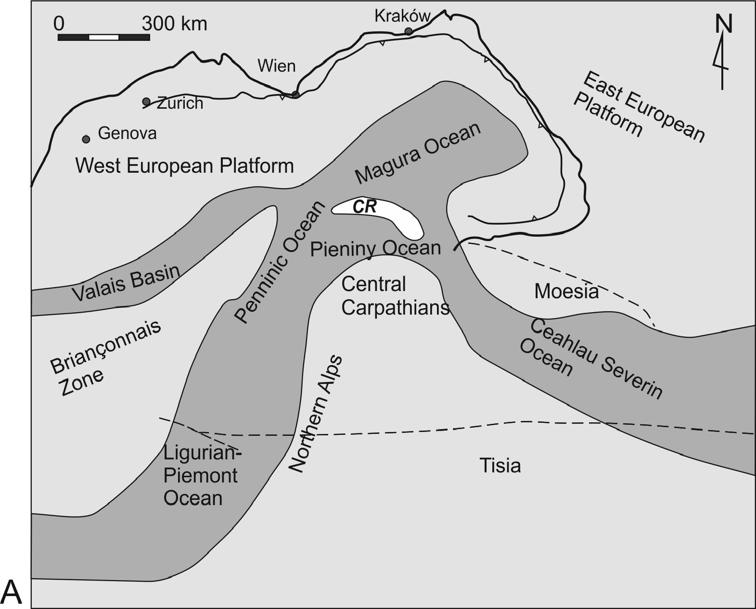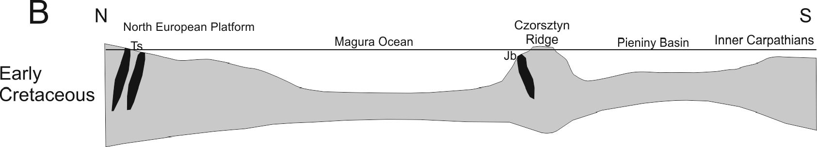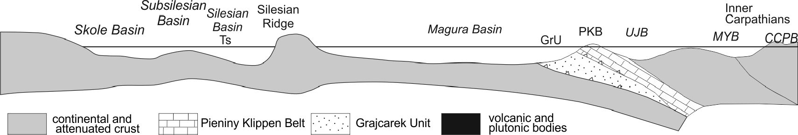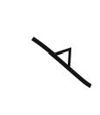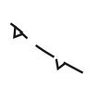
337
WHERE WAS THE MAGURA OCEAN?

major continental
and epicontinental
areas
Alpine-Carpathian
orogenic front
major basinal and
oceanic areas
northern boundary of the
Alpine molasse basin
major subduction
zone
major tectonic
suture

Early
Eocene

Text-fig. 9. A - Early Cretaceous palaeogeography of the of the Alpine/Carpathian system (based on Chanel and Kozur 1997, Schmid et al. 2008, Uchman et al.
20013, supplemented). B - Early Cretaceous palinspastic model of the Magura Ocean and Pieniny Basin (based on Oszczypko 2006, modified). Abbreviations:
Ts - teschenites, Jb - Jaworki basalts. C - Paleoecene/ Early Eocene palinspastic model of the Western Carpathians, not to scale (based on Oszczypko 2006,
modified). Abbreviations: CCPB - Central Carpathian Paleogene Basin, UJB - Ujak Basin, MYB - Myjava Basin, PKB - Pieniny Klippen Belt

338
NESTOR OSZCZYPKO ETAL.
Basin, located on the slope of the European continent,
passed southwards into the Silesian Basin separated
from the Magura Basin by the “Silesian Cordillera”
(Ksiażkiewicz 1956), the source of the clastic material
for both the Silesian and the Magura basins. The prob-
lem of the southern margin of the Magura Basin is still
not clear. The concept of the Czorsztyn Ridge of the PKB
as its southern source area has never been supported by
provenance analyses (no traces of PKB clasts in the Pa-
leocene/Eocene formation in the Krynica facies zone).
The post-Late Cretaceous Magura Basin was the
eastern prolongation ofthe Rhenodanubian basin system.
South-east of the Western Outer Carpathians, the Magura
Basin was limited to the north by the Marmarosh Palaeo-
Ridge, now represented by the Marmarosh Klippen Zone
(Smirnov 1973; Żytko 1999; Oszczypko et al. 2005b).
The southern extension ofthe Magura Basin in the east-
ern part of the Transcarpathian Depression is still under
discussion. This up to 20 km wide depression is filled
with an up to 2.5 km thick cover ofMiocene deposits. In
this area in both Ukranian and Romanian sites, the Al-
bian-‘Senonian’ marls and limestones of the Inacovce /
Krichevo Formation underlying the Miocene are known
from several boreholes (Smirnov 1981; Sotak and Bebej
1996; Żytko 1999; Sotak et al. 2000, 2002; Aroldi 2001).
Farther south, in direct contact with the Inner Dacides,
the „basic and ultrabasic eruptive rocks of ophiolitic
complex, covered by carbonate oceanic rocks and pelitic
sediments of Jurassic age“ have been found in drillings
(see Aroldi 2001). This ophiolite sequence is associated
with the Main Tethynian Suture ofthe Late Cretaceous-
Miocene Pienides composed of the Babesti Tjachevo,
Botiza, Krichevo, PKB and Magura flysch ofthe Petrova
(Monastyrets)-Leordina (Vezhany) and Wildflysch
nappes (Text-figs 8B, 8C, 10 ). In the Transcarpathian
Ukraine and Northern Maramush area (Romania), the
Magura Basin formed a bay bordered from the east by
the Marmarosh Massive and from the south by the north-
ern tip of the Tisza block (Text-fig. 9). Towards the
south, the Magura Basin contacted, via the PKB and the
Inacovce-Krichevo Zone, with the Sava-Szolnok Basin.
Between the Silesian Ridge to the west and Marmarosh
Ridge to the east, the northern margin of the Magura
Basin was related to the Fore-Magura sub-Marine High
(Text-fig. 10, see also Oszczypko et al. 2005b; Slączka
et al. 2006).

Position of source areas
The Outer Carpathian marine basins were supplied
with clastic material from the coastal lands and uplifted
submarine ridges that appeared at the surface as is-
lands.
During the Late Cretaceous and Paleogene, the
Magura Basin was supplied with clastic material from
source areas located along the NW and SE margins of
the basins (in their present-day geographic position).
In the NW, the Silesian Ridge is commonly re-
garded as a source area, whereas the position of the SE
source area is still under disscussion (Oszczypko and
Oszczypko-Clowes 2006). In the Outer Carpathian sed-
imentary basin system the most important internal
source area was the “Silesian Ridge” (Cordillera)
(Ksi^zkiewicz 1965; Unrug 1968; Golonka et al. 2000;
Picha et al, 2005). According to Unrug (1968), the Sile-
sian Ridge “paralleled the long axis of the flysch trough”
and separated the northern Silesian Basin from the
southern Magura Basin. The Silesian Ridge could be
structurally linked with the Bohemian Massif. In the
Eastern Carpathians direct prolongation of the Silesian
Ridge is not clear due to the different arangment of the
basins. However, the prolongation of its northern part
could be the Bukowiec Ridge situated between the Sile-
sian and Dukla basins (Sl^czka 2005). In the Eastern
Outer Carpathians the position ofthe Silesian Ridge was
occupied by the Marmarosh Massive and Marmarosh
Klippen Zone and separated the Magura Basin from the
Dukla, Porkulets and Outer Dacides basins.
During the Late Cretaceous-Paleocene the Fore-
Magura succession (supplied from the north) was a part of
the Magura Basin, whereas during the Late Eocene and
Oligocene this succession was a part of the Silesian Basin,
supplied from the south (see Unrug 1968; Oszczypko
2006). During the Late Campanian, inversion-related up-
lift of the Silesian Ridge affected the northern part of the
Magura Basin by the onset of intensive clastic flysch dep-
osition. The “exotic” pebbles derived from the Silesian
Ridge into the Silesian, Dukla and Magura (Raca Subunit)
basins document a Variscan age of the plutonic and meta-
morphic rocks (Oszczypko 2006). During the Late Cre-
taceous to Eocene, the clastic material was supplied to the
Dukla Basin from the NW (Silesian Ridge). At the end of
the Eocene a new source area, which supplied material of
the Krosno Menilite series from the SE (Bukowiec Ridge,
see Sl^czka 1971) was revealed.
Since the Early Eocene, a deep-water submarine
fan began to develop in the southern part ofthe Magura
Basin. This is documented by the occurrence of chan-
nel-lobe turbidites supplied from SE sources (Krynica
succession). The Eocene deposits of the Krynica Zone
of the Magura Basin contain fragments of crystalline
rocks, derived from a continental crust, and numerous
clasts of Mesozoic deep and shallow-water limestones
(Olszewska and Oszczypko 2010). In these deposits
there are no traces of material derived from erosion of
the Czorsztyn Ridge. According to Misik et al. (1991)
339
WHERE WAS THE MAGURA OCEAN?
exotic material was derived not from the PKB, but from
“the basement of the Magura Basin”. According to
Smirnov (1973), during the Late Cretaceous and Pale-
ocene the Transcarpathian area was ocupied by a rela-
tively shallow marine bay of the Magura Basin. This
basin was separated to the south and north by the South
Pieniny and Marmarosh and submerged ridges respec-
tively. During the Late Cretaceous/Paleocene, varie-
gated marls (Turonian-Campanian) followed by con-
glomerates and sandstones of the Jarmuta Formation
(Maastrichtian/Paleocene) were deposited in the Mar-
marosh (Magura) Basin.
During the Early Eocene the Marmarosh Ridge was
uplifted and became a source area of metamorphic ma-
terial (quartzites, sericite/ quartz, muscovite / quartz
schists, muscovitic gneisses) to both the Magura-Dukla
(Lesko and Samuel 1968; Oszczypko et al. 2005b) and
the Charnohora / Silesian basins. The Middle Eocene
deepening of the basin caused reduction in the supply of
material from the Marmarosh Ridge and deposition of
variegated shales and thin-bedded flysch. The trans-
gression covered the Maramuresh and Northern Tran-
silvania basins with non-flysch Welyka Bania and Pris-
lop sandstones and conglomerarates, composed of
metamorphic rocks, Mesozoic carbonates and subordi-
nate amounts of volcanic rocks. During the Oligocene,
significant unification of sedimentary conditions (black
marls and curbiocortical flysch) took place in the Mar-
marosh Basin (Text-fig. 11). During that time the Mar-
marosh Basin was merged with the Dukla Basin (“dis-
odyl marls” and “curbiocortical fysch”).

Relationship of the Dukla Basin to Magura Basin
In the Polish sector of the Magura Basin its north-
ern margin is well marked by the Silesian Ridge. In the
Dukla Unit the Late Cretaceous black flysch of the Ma-
jdan Formation displays NE-SW palaeotransport di-
rection, suggesting a source area located between the
Dukla and Silesian basins (Slqczka and Winkler 1992;
Slqczka 2005). At the same time in the Flysch Belt of
Eastern Slovakia the activity of the Silesian Ridge is not
descernible at all (Korab and Durkovic 1978). Since the
Late Cretaceous to the Late Eocene, both the Dukla and
Magura sub-basins of the latter area were characterized
by the same depositional pattern (Inoceramian facies,
Beloveza and lower Zlin formations), with material
supply by the same SE to NW longitudinal palaeocur-
rent system (Lesko and Samuel 1968; Korab and
Durkovic 1978). At the end of the Eocene, the unifica-
tion of sedimentary condition in the Dukla and Silesian
basins took place; the sediments of the Menilite /Krosno
formation were deposited and the pattern continued up
to the end of the Oligocene. In Transcarpathian Ukraine,
an analogue of the Silesian Ridge was the Marmarosh
Ridge (Żytko 1999; Oszczypko et al. 2005; Ślączka et
al. 2006). A shallow isthmus, connecting the Magura
Basin and the Outer Dacides and Moldavides Basins,
could have existed between the Marmarosh Massive and
the Silesian Ridge.
CONCLUSIONS
- In the Late Jurassic-Early Cretaceous Alpine Tethys
there were several large marine basins (so-called
remnant oceans) such as: Ligurian- Piedmont, Pen-
ninic, Pieniny (Vahicum), Valais, Magura and
Ceahlau-Severins.
- The Magura Ocean was the eastern extension of the
Valais Ocean. This up to 1000 km wide (ca 10°)
ocean was limited to the north by the West European
Platform. Towards the west and east it was connected
with the Valais Ocean (North Pennic Ocean) and the
Ceahlau / Severin Ocean respectively. To the south
the Magura Ocean was bounded by the NW-SE ori-
ented Czorsztyn Ridge.
- The opening and expansion of the Magura Ocean was
accompanied by Late Jurassic and Early Cretaceous
volcanism, located along its southern and northern
boundaries.
- The Late Jurassic Magura Ocean was a site of deep
water condensed deposition: radiolarites and pelagic
limestones followed by Early Cretaceous calcareous
and dark distal flysch with the Cenomanian Bonarelli
horizon at the top.
- During the Turonian-Early Campanian this ocean
was dominated by deep-water well- oxygenated sed-
iments (known as Oceanic Red Beds). These were
mainly red and variegated siltstones deposited below
the CCD and red and variegated marls in coastal ar-
eas
- In the course of the Late Campanian-Paleocene
tectono-sedimentary evolution, the Magura Ocean
was transformed into the several flysch sub-basins:
Magura (Rhenodanubian), Dukla, Silesian, Sub-Sile-
sian and Skole / Skyba / Tarcau.
- This transformation from the remnant Magura Ocean
into collision-related foreland basins was coeval with
reduction in the southern oceanic space and subsi-
dence of the foreland platform in the north, at the front
of the overriding orogen.
- These newly created basins were supplied with clas-
tic material derived from intrabasinal source areas
(ridges) and coastal lands, now incorporated into the
Outer Western Carpathians.
340
NESTOR OSZCZYPKO ETAL.
Acknowledgements
The comments and corrections of the journal referees,
which markedly improved the final version fo this paper, are
warmly acknowledged.
REFERENCES
Aroldi, C. 2001. Thie Pienides in Maramures (Eastern
Carpathians-Northern Romania), pp. 1-156. Cluj Uni-
versity Press.
Beck-Mannagetta, P. 1960. Geologische Übersichtskarte
der Republik Österreich. Geologische Bundesanstalt;
Wien.
Birkenmajer, K. 1970. Pre-Eocene fold structures in the Pieniny
Klippen Belt (Carpathians) of Poland. Studia Geologica
Polonica, 31, 1-77. [In Polish with English summary]
Birkenmajer, K. 1977. Jurassic and Cretaceous lithostrati-
graphic units of the Pieniny Klippen Belt, Carpathians,
Poland. Studia Geologica Polonica, 45, 1-159.
Birkenmajer, K. 1979. Pieniny Klippen Belt - geological gu-
ide, pp. 1-237. Wydawnictwa Geologiczne; Warszawa. [In
Polish]
Birkenmajer, K. 1986. Stages of structural evolution of the
Pieniny Klippen Belt, Carpathians. Studia Geologica
Poloniae, 88, 7-32.
Birkenmajer, K. 2001. Pieniny Klippen Belt. In: Carpathian
Paleogeography and Geodynamics, a multidisciplinary
approach. 12th Meeting Association of European Geo-
logical Societies, 10-15 September 2001 Kraków Field
trip guide, In: K. Birkenmajer and M. Krobicki (Eds), pp.
99-141. Polish Geological Institute.
Birkenmajer, K. and Pazdro, O. 1968. On the so-called “Sz-
tolnia beds” in the Pieniny Klippen Belt of Poland. Acta
Geologica Polonica, 18, 325-365. [In Polish with English
summary]
Birkenmajer, K. and Wieser, T. 1990. Exotic rock fragments
from Upper Cretaceous deposits near Jaworki, Pieniny
Klippen Belt, Carpathians, Poland. Studia Geologica Po-
lonica, 97, 7-68.
Birkenmajer, K. Dudziak, J. and Jednorowska, A. 1979. Sub-
surface geologial structure of the northern boundary fault
zone of the Pieniny Klippen Belt at Szczawnica. Studia
Geologica Polonica, 61, 7cc36. [In Polish with English
summary]
Birkenmajer, K. Dudziak, J., Jednorowska, A. and Kutyba, J.
1987. Foraminiferal -nannoplankton evidence for Maas-
trichtian and Paleocene ages ofthe Jarmuta Formation: its
bearing on dating the Laramian orogeny in the Pieniny
Klippen Belt (Carpathians). Bulletin Polish Academy of
Sciences, Earth Sciences, 35, 287-298.
Birkenmajer, K., Gedl, P., Myczyński, R. and Tyszka, J. 2008.
“Cretaceous black flysch” in the Pieniny Klippen Belt,
West Carpathians: a case of geological misinterpretation.
Cretaceous Research, 29, 535-549.
Bombita, G. and Pop, G. 1991. Mesozoic formations from
Poiana Botizii area, Pieniny Klippen Belt of Romania.
Geologica Carpathica, 42, 139-146.
Bombita, G., Antonecu, E., Ion, J., Malata, E., Müller, C. and
Neagu, T. 1992. Pieniny-type Mesozoic formations from
Maramures, Romania (second part). Acta Geologica. Hun-
garica, 35, 117-144.
Burtan, J. and Sokołowski, S. 1956. New investigation on re-
lation between the Magura and Krosno regions in the
Western Beskids. Przegląd Geologiczny, 4, 457-458. [In
Polish with English summary]
Channell, J.E.T. and Kozur, H.W. 1997. How many oceans?
Meliata, Vardar, and Pindos oceans in Mesozoic Alpine
paleogeography. Geology, 25, 183-186.
Cieszkowski, M., Dziubińska, B. and Slączka, A. 2006. Ser-
pentinite of Kilb (Northern Zone, Austria): a new insight
into its mineralogy. In: Proceedings XVIIth Congress of
the Carpathian Balkan Geological Association. September
3-6, 2006 Belgrade, Serbia, pp. 68-71. Belgrad.
Dabagyan, N.V., Savitskaya, N.A. and Smirnov, S.E. 1989. Pa-
leontological characteristic of the Upper Cretaceous de-
posits on the Terebla River (Marmarosh Zone). Paleon-
tologicheskiy Sbornik, Lvov, 26, 58-65. [In Russian]
Decker, K. 1990. Plate tectonics and pelagic facies: Late
Jurassic to Early Cretaceous deep sea sediments of the
Ybbsitz ophiolite unit (Eastern Alps, Austria). Sedimentary
Geology, 67, 85-99.
Egger, H. and Wessely, G. 2014. Wienerwald, Geologie, Stra-
tigraphie, Landschaft und Exkursionen, pp. 1-202. Born-
traeger Gebrueder; Wien.
Egger, H. Heilmann-Clausen, C. and Schmitz, B. 2009. From
shelfto abyss: Record ofthe Paleocene/Eocene-boundary
in the Eastern Alps (Austria). Geologica Acta, 7, 215-227.
Elias, M. Schnabel, W. and Stranik, Z. 1990. Comparison ofthe
Flysch Zone ofthe Eastern Alps and the Western Carpathi-
ans based on recent observations. In: D. Minarikova and H
Lobitzer (Eds), Thirty years of geological cooperation be-
tween Austria and Czechoslovakia. Vienna Federal Geo-
logical Survey; Prague, Geological Survey, pp. 78-83.
Faupl, P. and Wagreich, M. 1999. Late Jurassic to Eocene
palaeogeography and geodynamic evolution of the East-
ern Alps. In: F. Neubauer and V. Hock (Eds), Aspects of
geology in Austria. Mitteilungen der Österreich Geolo-
gische Gesellschaft, 92, 79-94.
Frasl, G. 1987. Clasts from the Haunsberg Wildflysch (N of
Salzburg) - Implication on the Northern Border Zone of
the Rhenodanubian Flysch Trough. In: H.W. Flügel and P.
Faupl (Eds), Geodynamics of the Eastern Alps, pp. 70-84.
Deuticke; Vienna.
Froitzheim, N., Plasienka, D. and Schuster, R. 2008. Alpine
tectonics of the Alps and Western Carpathians. In: T. Mc-
341
WHERE WAS THE MAGURA OCEAN?
Cann (Ed.): The Geology of Central Europe. Volume 2:
Mesozoic and Cenozoic. Geological Society Publishing
House, London, pp. 1141-1232.
Gągała, Ł., Verges, J., Saura, E., Malata, T., Ringenbach, J.C.,
Werner, P. and Krzywiec, P. 2012. Architecture and oro-
genic evolution of the northeastern Outer Carpathians
from cross-section balancing and forward modeling.
Tectonophysics, 532-535, 223-241.
Gedl, P. 2013. Dinoflagellate cysts from the Szlachtowa For-
mation (Jurassic) and adjacent deposits (Jurassic-Creta-
ceous) of the Grajcarek Unit at Szczawnica-Zabaniszcze
(Pieniny Klippen Belt, Carpathians, Poland). Geological
Quarterly, 57, 485-502.
Golonka, J., Oszczypko, N. and Slączka, A. 2000. Late Car-
boniferous-Neogene geodynamic evolution and paleo-
geography of the Circum-Carpathian region and adjacent
areas. Annales Societatis Geologorum Poloniae, 70, 107-
136.
Grabowski, J., Krobicki, M. and Sobień, K. 2008. New palaeo-
magnetic results from the Polish part of the Pieniny Klip-
pen Belt,Carpathians - evidence for the palaeogeographic
position of the Czorsztyn Ridge in the Mesozoic. Geo-
logical Quarterly, 52, 31-44.
Grün, W., Kitler, G., Laur, G., Papp, A. and Schnabel, W. 1972.
Studien in der Unterkreide des Wienerwaldes. Jahrbuch
der Geologischen Bundesanstalt, 113, 103-186.
Homayoun, M. and Faupl, P. 1992. Unter- und Mittelkreide
flysch der Ybbsitzer Klippenzone (Niederösterreich). Mit-
teilungen der Gesellschaft der Geologie und Bergbaustu-
denten in Österreich, 38, 1-20.
Höck, V., Slączka A., Gasiński M.A. and Bąk, M. 2005. Kon-
radsheim Limestone of the Gresten Klippen Zone (Aus-
tria): New insight into its stratigraphic and paleogeo-
graphic setting. Geologica Carpathica, 56, 237-244.
Jankowski, L., Kopciowski, R. and Ryłko, W. (Eds) 2007. Ge-
ological map of the Outer Carpathians; borderlaand of
Ukraine and Romania, 1: 200 000. Polish Geological In-
stitute; Warsaw.
Korab, T. and Durko vie, T. 1978. Geology of Dukla Unit
(East-Slovakian Flysch), pp. 1-194. Geologicky Ustav D.
Stura; Bratislava. [In Slovak with English summary]
Kovac,’M., Plasienka, D., Sotak, J., Vojtko, R., Oszczypko, N.,
Less, G. and Krälikovä, S. (submitted). Western Carpathi-
ans Palaeogene paleogeography and basin development:
a case study within the scope of the ALCAPA terrane.
Earth and Planetary Letters.
Krobicki, M. and Olszewska, B. 2005. Urgonian-type micro-
fossils in exotic pebbles of the Late Cretaceous and Pale-
ogene gravelstones from the Sromowce and Jarmuta for-
mations. In: Tyszka J., Oliwkiewicz-Miklasińska, M.,
Gedl, P. and Kamiński M.A. (Eds), Methods and appli-
cations in micropalaeontology. Studia Geologica Polonica
124, 53-66.
Krobicki, M., Kruglov, S.S., Matyja, B.A., Wierzbowski, A.,
Aubrecht, R., Bubniak, A. and Bubniaak, I. 2003. Relation
between Jurassic klippen successions in the Polish and
Ukrainian parts of the Pieniny Klippen Belt. Mineralia
Slovaca, 35, 56-58.
Kruglov, S.S. and Cypko, A.K. 1988. Tectonics ofUkraine, pp.
1-253. Nedra; Moskva. [In Russian]
Kruglov, S.S. and Smirnov, S.E. 1966. The conglomerates of
the Sojmul Formation of the Transcarpathians and their
palaeogeographic value. Geological Transaction of the
Lvov Geological Society, 10, 122-129. [In Russian]
Książkiewicz, M. 1965. Les Cordillères dans les mers créta-
cées et paleogenes des Carpthes du Nord. Bulletin de la
Société Géologique de France, 7, 443-455.
Książkiewicz, M. 1977. The tectonics of the Carpathians. In:
W. Pożaryski (Ed.), Geology of Poland, Volume 4. Tec-
tonics, 476-699. Wydawnictwa Geologiczne; Warszawa.
Lesko, B. and Samuel, O. 1968. The geology of the East Slo-
vakian flysch, 1-245. Vydavatelstvo Slovenskej Akademie
Vied; Bratislava. [In Slovak with English summary]
Lewandowski, M., Krobicki, M., Matyja, B.A. and Wierz-
bowski A. 2005. Palaeogeographic evolution of the
Pieniny Klippen Basin using stratigraphic and palaeo-
magnetic data from the Velykyi Kamenets section
(Carpathians, Ukraine). Palaeogeography Palaeoclima-
tology Palaeoecology, 216, 53-72.
Lexa, J., Bezak, V., Elecko, M., Mello, J., Polak, M., Potfaj,
M. and Vozar, J. (Eds) 2000. Geological map of Western
Carpathians and adjacent areas. Geological Survey of
Slovak Republic; Bratislava.
Märton, E., Grabowski, J., Plasienka, D., Tunyi, I., Krobicki,
M., Haas, J. and Pethe, M. 2013. New paleomagnetic re-
sults from the Upper Cretaceous red marls of the Pieniny
Klippen Belt, Western Carpathians: Evidence for general
CCW rotation and implications for the origin of the struc-
tural arc formation. Tectonophysics, 592, 1-13.
Misik, M., Sykora, M., and Jablonsky, J. 1991. Strihovske
zlepence a Juhomagurska Kordilera. Zapadne Karpaty,
Serie Geologicke, 14, 7-72.
Mattem, F. and Wang, P.J. 2008. Out-of-sequence thrusts and
paleogeography of the Rhenodanubian Flysch Belt (East-
ern Alps) revisited. International Journal of Earth Sci-
ences (Geologische Rundschau), 97, 821-833.
Nowak, W. 1971. The results of microfacial studies of the
Szczawnica-Zabaniszcze section. Guide-book of XLIIII
Annual Meeting of Polish Geological Society, Kraków 12-
14. IX 1971, pp. 215-224. Wydawnictwa Geologiczne;
Warszawa. [In Polish]
Oberhauser, R. 1995. Zur Kenntnis der Tektonik und der Pa-
läogeographie des Ostalpenraumes zur Kreide- Paleozän-
und Eozänzeit. Jahrbuch der Geologischen Bundesanstalt,
138, 369-432.
Olszewska B. and Oszczypko, N. 2010. The geological posi-
342
NESTOR OSZCZYPKO ETAL.
tion, sedimentary record and composition of the Tylicz
Conglomerate (Late Eocene-Oligocene): stratigraphical
and paleogeographical implications (Magura Nappe, Pol-
ish Outer Carpathians). Geologica Carpathica, 61, 39-54.
Oszczypko, N. 1992. Late Cretaceous through Paleogene
evolution of Magura Basin. Geologica Carpathica, 43,
333-338.
Oszczypko, N. 1999. From remnant oceanic basin to collision-
related foreland basin - a tectonic history of the Outer
Western Carpathians. Geologica Carpathica, special issue,
50, 161-163.
Oszczypko, N. 2006. Late Jurassic-Miocene evolution of the
Outer Carpathian fold-and thrust belt and its foredeep
basin (Western Carpathians, Poland).Geological Quar-
terly, 50, 169-194.
Oszczypko, N. and Oszczypko-Clowes, M. 2006. Evolution
of the Magura Basin. In : N. Oszczypko, A. Uchman and
E. Malata (Eds), Palaeotectonic evolution of thr Outer
Carpathians and Pieniny Klippen Belt basins, pp. 133-
164.Institute of Geological Sciences, Jagiellonian Uni-
versity; Kraków. [In Polish with English summary]
Oszczypko, N. and Oszczypko-Clowes, M. 2009. Stages in the
Magura Basin: a case study of the Polish sector (Western
Carpathians). Geodinamica Acta, 22, 83-100.
Oszczypko, N. and Oszczypko-Clowes M. 2014. Geological
structure and evolution ofthe Pieniny Klippen Belt to the
east of the Dunajec River - a new approach (Outer West-
ern Carpathians, Poland). Geological Quarterly, 58, 737-
758, doi: 10.7306/gq.1177
Oszczypko, N. and Salata, D. 2005. Provenance analyses of
the Late Cretaceous Palaeocene deposits of the Magura
Basin (Polish Western Carpathians) - evidence from a
study of the heavy minerals. Acta Geologica. Polonica,
55, 237-276.
Oszczypko, N., Malata, E., Bąk, K., Kędzierski, M. and
Oszczypko-Clowes, M. 2005a. Lithostratigraphy and
Biostratigraphy of the Upper Albian-Lower/ Middle
Eocene Flysch deposits in the Bystrica and Raca Subunits
of the Magura Nappe; Western Carpathians (Beskid
Wyspowy and Gorce ranges, Poland). Annales Societatis
Geologorum Poloniae, 75, 7-69.
Oszczypko, N., Malata, E., Svabenicka, L., Golonka, J. and
Marko, F. 2004. Jurassic-Cretaceous controversies in the
Western Carpathian Flysch: „black flysch“ case study. Cre-
taceous Research, 25, 89-113.
Oszczypko, N., Olszewska, B. and Malata, E. 2012a. Creta-
ceous (Aptian/Albian-?Cenomanian) age of “black fly-
sch”and adjacent deposits of the Grajcarek thrust-sheets
in the Male Pieniny Mts. (Pieniny Klippen Belt, Polish
Outer Carpathians). Geological Quarterly, 56, 411-440.
Oszczypko, N., Oszczypko-Clowes, M., Golonka, J. and Kro-
bicki M. 2005. Position of the Marmarosh Flysch (East-
ern Carpathians) and its relation to the Magura Nappe
(Western Carpathians). Acta Geologica Hungarica, 48,
259-282.
Oszczypko, N., Plasenka, D. and Jurewicz, E. 2010. Tecton-
ics of the Klippen Belt and Magura Nappe in the Eastern
Part ofthe Pieniny Mts. (Western Carpathians, Poland and
Slovakia)-new approches and results. In: G. Christofides,
N. Kantiranis, D.S Kostopoulos and A. Chatzipetros
(Eds), Proceedings XIX Congress of the Carpathian-
Balkan Geological Association, Thessaloniki, Greece,
- 26 September 2010. Scientific Annales of the School
of Geology, Aristotle University of Thessaloniki, Faculty
of Sciences, Special Volume 100, 221-230.
Oszczypko, N., Salata, D. and Krobicki, M. 2012b. Early
Cretaceous intra-plate volcanism in the Pieniny Klippen
Belt - a case study of the Velykyi Kamenets/Vilkhivchyk
(Ukraine) and Biała Woda (Poland) sections. Geological
Quarterly, 56, 629-648.
Oszczypko-Clowes, M. and Oszczypko, N. 2004. The position
and age of the youngest deposits in the Mszana Dolna and
Szczawa tectonic windows (Magura Nappe, Western
Carpathians, Poland). Acta Geologica Polonica, 54, 339-
367.
Oszczypko-Clowes, M. and Slączka, A. 2006. Nannofossil
biostratigraphy of the Oligocene deposits in the Grybów
tectonic window (Grybów Unit, Western Carpathians,
Poland), Geologica Carpathica, 57, 473-482.
Picha, F. J., Stranik, Z. and Kreci, O. 2006. Geology and hy-
drocarbon resources of the Outer West Carpathians and
their foreland, Czech Republic. In: J. Golonka and F.J.
Picha (Eds), The Carpathians and their Foreland: Geology
and Hydrocarbon Resources. Memoir of American Asso-
ciation of Petroleum Geologists, 84, 49-176.
Plasienka, D. 2002. Origin and growth of the West Carpathian
orogenic edge during the Mesozoic. Geologica Car-
pathica, 94, 132-135.
Plasienka, D. 2012. Early stages ofstructural evolution ofthe
Carpathian Klippen Belt (Slovakian Pieniny sector). Min-
eralia Slovaca, 44, 1-16.
Plasienka, D. 2014. Meso-Alpidic evolution of the Klippen
Belt Area (Western Carpathians, Slovakia: tectonic con-
trols over the coupled foredeep-wedge basin system Bule-
tini i Shoqerise Shqiptare Gjeologjik, 2/2014-Special Is-
sue, Proocedings ofXX CBGA Congress, Tirana, Albania,
- 26 September 2014, 26-29.
Plasienka, D. 2014. The Saris Unit in the structure and evo-
lution of the Pieniny Klippen Belt (Western Carpathi-
ans). In: J. Bucova and E. Puskelova (Eds), Conference of
Environmental, Structural, and Stratigraphic Evolution
of the Western Carpathians 5-7. 11.2014 Abstract Book
of 9th ESSEWECA. Prirodovedecka fakulta Univerzity
Komenskeho, pp. 49-51. Bratislava.
Plasienka, D. and Mikus, V. 2010. Geological setting of the
Pieniny and Saris sectors ofthe Klippen Belt between Lit-
343
WHERE WAS THE MAGURA OCEAN?
manova and Drienica villages in the Eastern Slovakia.
Mineralia Slovaca, 42, 155-178.
Plasienka, D., Sotak, J., Jamrichova, M., Halasova, E., Pivko,
D., Jozsa, S., Madzin, J. and Mikus, V. 2012. Structure and
evolution ofthe Pieniny Klippen Belt demonstrated along
a section between Jarabina and Litmanova villages in the
Eastern Slovakia. Mineralia Slovaca, 44, 17-38.
Potfaj, M. 1993. Position and role of the Biele Karpaty Unit
in the flysch Zone of the West Carpathians. Geologicke
Prace, 98, 55-78. [In Slovakian with Englisch summary]
Plöchinger, B. 1964. Die tektonische Fenster von St. Gilgen
und Strobl am Wolgangsee (Salzburg, Östereich). Jahr-
buch Geologische Bundesanstalt, 107, 11-69.
Prey, S. 1977. Der Serpentin von Kilb in der Glysch Mittel-
kreide am Nordrand der Flyschzone (Niederösterreich).
Verhandlungen Geologische Bundesanstalt, 1977, 271-
277.
Puglisi, D. 2009. Early Cretaceous flysch from Betic-Maghre-
bian and Europe Alpine Chains (Gibraltar Strait to the
Balkans): comparison and palaeotectonic implications.
Geologica Balcanica, 38, 15-22.
Puglisi, D. 2014. Tectonic evolution of the Sicilian Maghre-
bian Chain inferred from stratigraphic and petrographic
evidence of the Early Cretaceous and Oligocene Flysch.
Geologica Carpathica, 65, 293-305.
Rehakova, D., Matyja, B., Wierzbowski, A., Schlegl, J., Kro-
bicki, M. and Barski, M. 2011. Stratigraphy andn micro-
facies ofthe Jurassic and lowermost Cretaceous of the Ve-
lyki Kamenets section (Pieniny Klippen Belt, Carpathians,
Ukraine). Volumina Jurassica, 9, 61-104.
Rogoziński, B. and Krobicki, M. 2006. The geology of the
Eastern slopes of the Petrus in the Czarnohora Range
(The Ukrainian Carpathian Mountains). In: M. Troll (Ed.),
The Charnohora-the nature and men, pp. 17-26. Instytut
Geografii i Gospodarki Przestrzennej Uniwersytetu Ja-
giellońskiego; Kraków. [In Polish with English Sumary]
Sandulescu, M. 2009. The Black Flysch Nappe of the Mara-
mures East Carpathians - a “Valaisenne-type” tectonic unit
? Procedings of Romanian Academy. Series B, 1, 45-51.
Sandulescu, M. 2012. The Ujgorod tectonic window - a his-
torical comment. Romanian Journal of Geology, 56, 71-77.
Sandulescu, M., Krautner, H.G., Balintoni, I., Russo-Sand-
ulescu, D. and Micu, M. 1981. The structure of the East
Carpathians. Guide de excursion B1 (Moldova-Mara-
muresh area). Carpatho-Balkan Geological Association,
XII Congress, pp. 76-82. Bucuresti.Sikora, W. 1962.
New data on the geology of the Pieniny Klippen Belt.
Bulletin Polish Academy of Sciences, Earth Sciences,
10, 203-211.
Sikora, W. 1971a. Esquisse de la tectogenese de la zone des
Klippes des Pieniny en Pologne d’apres de nouvelles
donnees geologiques. Annales Societatis Geologorum
Poloniae, 41, 221-239. [In Russian, French summary]
Sikora, W. 1971b. Excursion D2. Guide to 43rd Annual Meet-
ing of the Polish Geological Society, pp. 208-215. Insty-
tut Geologiczny; Warszawa. [In Polish]
Sikora, W. 1976. Cordillieres of the Western Carpathians in the
light of the plate tectonics. Przegląd Geologiczny, 6,
336-349. [In Polish with English sumaty]
Schmid, S.M., Bernoulli, D., Fügenschuh, B., Matenco, L.,
Schuster, R., Schefer, S., Tischler, M. and Ustaszewski, K.
2008. The Alpine-Carpathian-Dinaridic orogenic system:
correlation and evolution of tectonic units. Swiss Journal
of Geosciences, 101, 139-183.
Schmid, S.M., Fügenschuh, B., Kissling, E. and Schuster, R.
2004. Tectonic map and overall architecture of the Alpine
orogen. Eclogae Geologicae Helvetiae - Swiss Journal of
Geosciences, 97, 93-117.
Schmid S., Fügenschuh, B. and Ustaszewski, K. 2005. The
Alps-Dinarides-Carpathians connection: a compilation of
tectonic units as a first step for retrodeforming the pre-
Miocene configuration. Geolines, 19, 101-103.
Schnabel, W. 1992. New data on the Flysch zone of the East-
ern Alps in the Austrian sector and new aspects concern-
ing the transition of the Flysch Zone of the Carpathians.
Cretaceous Research, 13, 405-419.
Slączka, A. 2005. Bukowiec Ridge: a cordillera in front of the
Dukla Basin. Mineralia Slovaca, 37, 255-256.
Slączka, A. and Winkler, W. 1992. Sediment dispersal and
provenance in the Silesian, Dukla and Magura flysch
nappes (Outer Carpathians, Poland). Geologische Rund-
schau, 81, 371-382.
Slączka, A., Golonka, J., Oszczypko, N., Cieszkowski, M.,
Słomka, T. and Matyasik, I. 2014. Occurrence of the Up-
per Jurassic-Lower Cretaceous black organic rich pelitic
sediments as targets for unconventional hydrocarbon ex-
ploration in the Outer Carpathians and adjacent part of the
Alps: DOI: 10.1306/02211413049
Slączka, A., Kruglov, S., Golonka, J., Oszczypko, N. and Po-
padyuk, I. 2006. Geology and Hydrocarbon Resources of
the Outer Carpathians, Poland, Slovakia, and Ukraine:
General Geology. In: J. Golonka and F.J. Picha (Eds), The
Carpathians and their foreland: Geology and hydrocarbon
resources, AAPG Memoir, 84, 221-258.
Smirnov, S.E. 1973. Paleogene ofthe Marmarosh and Pieniny
zones of the Ukrainian Carpathians, pp. 1-120. Nedra;
Moscow. [In Russian]
Sotak, J. 2004. Foraminiferova biozonacia vrchnokriedovych
cervrnych suvrstvi v profiloch na Ukrajinie (Tissalo, Dra-
govo). In: A. Zlinska (Ed.), 5. Paleontologicka Konfe-
rencia, Bratislava, jun 2004, Zbornik Abstraktov, pp. 98.
Statny geologicky ustav Dionyza Stura; Bratislava.
Sotâk, J. and Babej, J. 1996. Serpentinic sandstones from the
Tertiary collisional zone in the Eastern Slovakia (Sam-
bron-Kamenica Zone). Geologica Carpathica, 47, 227-
238.
344
NESTOR OSZCZYPKO ETAL.
Sotâk, J., Biroń, A., Prokesova. R. and Spisiak, J. 2000. De-
tachment control of core complex exhumation and back-
arc extension in the East Slovakian Basin. Slovak Geo-
logical Magazine, 6, 130-132.
Sotâk, J., Biroń, A. and Spisiak, J. 2002. The blocky accu-
mulation of ophicalcites in the front of the Magura Unit
(Moravia): their fabrics and possible origin from deep-
floor oceanization. Geologica Carpathica, 53 (special is-
sue), 48.
Spisiak, J., Plasienka, D., Bucovâ, J., Mikus, T. and Uher, P.
- Petrology and palaeotectonic setting of Cretaceous
alkaline basaltic volcanism in the Pieniny Klippen Belt
(Western Carpathians, Slovakia). Geological Quarterly.
55, 27-48.
Svabenicka, L., Bubik, M., Kreci O. and Stranik. Z. 1997.
Stratigraphy of Cretaceous sediments of the Magura Fly-
sch in Moravia (Czech Republik), Geologica Carpathica,
48, 179-191.
Szopa, K., Włodyka, R. and Chew, D. 2014. La-Icp-Ms U-Pb
apatite dating ofLower Cretaceous rocks from teschenite-
picrite association in the Silesian Unit (Southern Poland).
Geologica Carpathica, 65, 273-284.
Trautwein, B., Dunkl, I., Kuhlemann, J. and Frisch, V. 2002.
Cretaceous-Tertiary Rhenodanubian flysch wedge (East-
ern Alps): clues to sediment supply and basin configura-
tion from zircon fission-track data. Terra Nova, 13,
DOI: 10.1046/j.1365-3121.2001.00372.
Trautwein, B., Dunkl, I., Kuhlemann, J. and Frisch, V. 2002.
Cretaceous-Tertiary Rhenodanubian flysch wedge (East-
ern Alps): clues to sediment supply and basin configura-
tion from zircon fission-track data. Terra Nova, 13,
DOI: 10.1046/j.1365-3121.2001.00372.
Uchman, A., Malata, E., Olszewska, B. and Oszczypko, N.
2006. Palaeobathymetry of the Outer Carpathian basins,.
In: N. Oszczypko, A. Uchman and E. Malata (Eds),
Palaeotectonic evolution of the Outer Carpathians and
Pieniny Klippen Belt, 85-102. Instytut Nauk Geologicz-
nych Uniwersytetu Jagiellońskiego. [In Polish with Eng-
lish Sumary]
Uchman, A., Rodriguez-Tovar, F.J. and Oszczypko, N. 2013.
Eceptionally favourable life conditions for macrobenthos
during the Late Cenomanian OAE-2 event: Ichnological
record from the Bonarelli Level in the Grajcarek Unit, Pol-
ish Carpathians. Cretaceous Research, 46, 1-10.
Unrug, R. 1968. The Silesian cordilliera as the source of clas-
tic material of the Flysch sandstone of the Beskid Sląski
and Beskid Wysoki ranges (Polish Western Carpathians)
Annales Societatis Geologorum Poloniae, 38, 81-164.
Unrug, R. 1979. Palinspastic reconstruction of the Carpathians
arc before the Neogene tectogenesis. Annales Societatis
Geologorum Poloniae, 49, 3-21.
Ustaszewski, K., Schmid, S.M., Fügenschuh, B., Tischler,
M., Kissling, E. and Spakman, W. 2008. A map-view re-
storation of the Alpine-Carpathian-Dinaridic system for
the Early Miocene. Swiss Journal of Geosciences (Sup-
plementary Issue 1), 101, 273-294.
Voigt, S., Wagreich, M., Surlyk, F., Walaszczyk, I., Ulicny, D.,
Cech, S., Voigt, T., Wiese, F., Wilmsen, M., Niebuhr, B.,
Reich, M., Funk, H., Michalik, J., Jagt, J.M., Felder, P.J.
and Schulp, A. S. 2008. Cretaceous. In: T. McCan (Ed.),
The Geology of Central Europe. Vol. 2: Mesozoic and
Cenozoic, Published by The Geological Society, 923-
998.
Wagreich M., Lukeneder, A. and Egger, H. 2008. Cretaceous
history of Austria. 1st International Meeting on Correla-
tion of Cretaceous Micro-and Macrofossils Vienna 16th-
18th April, 2008, Berichte der Geologischen Bunde-
sanstalt, ISSN 1017- 8880, Band 74, Wien.
Wagreich, M., Pfersmann, C., Aubrecht, R. and Plasienka, D.
- In: The westernmost end of the Pieniny Klippen belt
in Austria - the St. Veit Klippenzone and its correlation
into the Carpathians. In: S. Josza, S. Rehakova, D. and R.
Vojtko. (Eds), Environmental, Structural and Stratigraph-
ical Evolution of the Western Carpathians. Abstract Book,
pp. 53. Bratislava.
Wessely, G. 2006. Geologie der Österreichischen Bundeslän-
der - Niederösterreich, pp. 1-413. Geologische Bundes-
anstalt; Wien.
Widder, R.W. 1988. Zur Stratigraphie, Fazies und Tektonik der
Grestener Klippenzone zwischen Maria Neustift und
Pechgraben /O.Ö. Mitteilungen der Gesellschaft der .
Geologie und Bergbaustudenten in Österreich, 34, 79-
133.
Żytko, K. 1999. Correlation of the main structural units ofthe
Western and the Eastern Carpathians. Prace Państwo-
wego Instytutu Geologicznego, 168, 135-165. [In Polish
with English Sumary]
Żytko, K., Gucik, S., Ryłko, W., Oszczypko, N., Zajac,
R., Garlicka, I., Nemcok, J., Elias, M., Mencik, E.,
Dvorak, J., Stranik, Z., Rakus, M. and Matejovska, O.
1989. Geological map of the Outer Western Carpathians
and their foreland without Quaternary forma-tions
(1:500 000). In: D. Poprawa and J. Nemcok (Eds), Ge-
ological Atlas of the Outer Western Carpathians and
their Foreland. Państwowy Instytut Geologiczny;
Warszawa.
Manuscript submitted: 2nd January 2015
Revised version accepted: 15th August 2015

