Acta Geologica Polonica, Vol. 58 (2008), No. 1, pp. 75-86

Trace fossil Artichnus pholeoides igen. nov. isp. nov.
in Eocene turbidites, Polish Carpathians: possible
ascription to holothurians
GUOCHENG ZHANG¹, ALFRED UCHMAN², RAFAŁ CHODYŃ² & RICHARD. G. BROMLEY³
¹Department af Resources and Environmental Engineering, Henan Polytechnic University, 454100,
Jiaozuo City, Henan Province, PR China
E-mail: zhanggc@hpii.edu.cn
² Institute of Geological Sciences, Jagiellonian University, Poland
E-mail: alfred.uchman@uj.edu.pl; rafal.chodyn@uj.edu.pl
³ Geological Museum, 0ster Voldgade 5-7, DK-1350 Copenhagen K, Denmark
E-mail: rullard@geol. ku. dk
ABSTRACT:
Zhang, G., Uchman, A., Chodyń, R. & Bromley, R.G. 2008. Trace fossil Artichnus pholeoides igen. nov. isp.
nov. in Eocene turbidites, Polish Carpathians: possible ascription to holothurians. Acta Geologica Polonica, 58
(1), 75-86. Warszawa.
A hitherto unknown trace fossil was found in some abundance in turbidites of the Polish Outer Carpathians.
The occurrence is within the Hieroglyphic Beds of the Silesian Nappe, within the Szczyrzyc Synclinorium, of
Middle Eocene age. The trace fossil is a wide, J-shaped structure having a narrow, upward tapering shaft as a
connection to the seafloor. The distal end also tapers, to a blind tennination. The burrow lumen is surrounded
by an irregular spreite structure. The trace fossil is compared with the work of burrowing holothurians, which
show some comparative feamres that suggest a tracemaker belonging to the Apodida.
Key words: Artiehnus pholeoides, Holothuroidea, Apodida, Turbidites, Carpathians,
Poland, Eocene.
INTRODUCTION
Holothurians (sea cucumbers) are common bur-
rowing organisms in different marine sediments. In
some deep-sea areas they are dominant macrofauna
(e.g., Kitchell & al. 1978; Gage & Tyler 1991), but
surprisingly very few trace fossils have been attributed
to them. Ginsburg & al. (1966, text-fig. 12) illustrated
a fragment of core from young unconsolidated sedi-
ments showing an eccentric, thickly lined burrow at-
tributed to holothurians, which in cross section is 20-30
mm wide, with a 4-8 mm wide lumen and jagged mar-
gin. Książkiewicz (1977b) interpreted Subphyllochorda
Gotzinger & Becker, 1932 (now Scolicia de Qua-
TREFAGES, 1849) as a holothurian burrow on the basis of
its trilobate underside referred to the trilobate ventral
side of some holothurians. This view, however, is not
followed because production of Scolicia by irregular
echinoids is well documented (e.g., Bromley & As-
GAARD 1975; Smith & Crimes 1983; Asgaard &
Bromley 2007).
Some modem surface traces, such as faecal coils,
are attributed to elasipod and aspidochirote holothurians
(Heezen & Hollister 1971; Hollister & al. 1975),
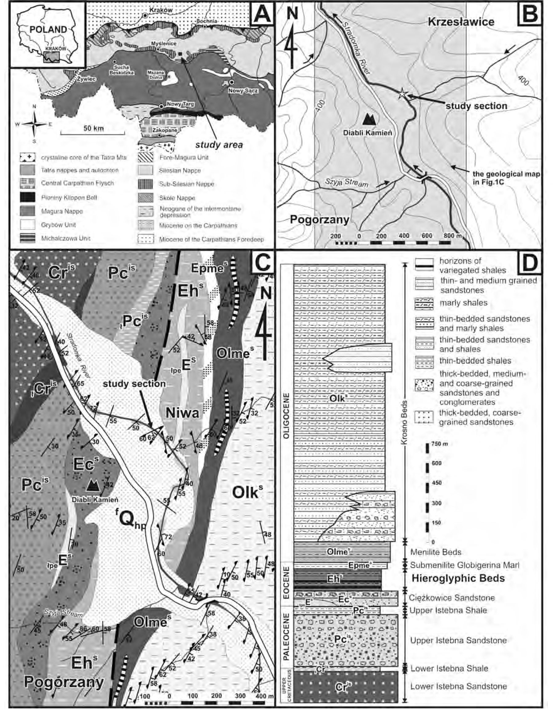
76
GUOCHENG ZHANG & al
Fig. 1. Location maps and the Palaeoegene-Upper Cretaceous lithostratigraphy. A — Structural map of the western part of the Polish Carpathians,
indicating the study area. B — Topographic map showing the study section and location of the geological map in C. C — Geological map in the
vicinity of the studied section (after Chodyń 2006). D — Maastrichtian-Palaeogene lithostratigraphy of the Silesian unit in the study area. Expla-
nation for symbols in C-D: Cr^{ls} - Lower Istebna Sandstone; jCC - Lower Istebna Shale; Pc^{1S} - Upper Istebna Sandstone; jPc^{IS} - Upper Istebna Shale;
jp_{e}E^{s} - Variegated Shale; Ec^{s}- Ciężkowice Sandstone; Eh^{s} - Hieroglyphic Beds; Epme^{s} - Submenilite Globigerina Marl; 01me^{s} - Menilite Beds; 01k^{s}
- Krosno Beds

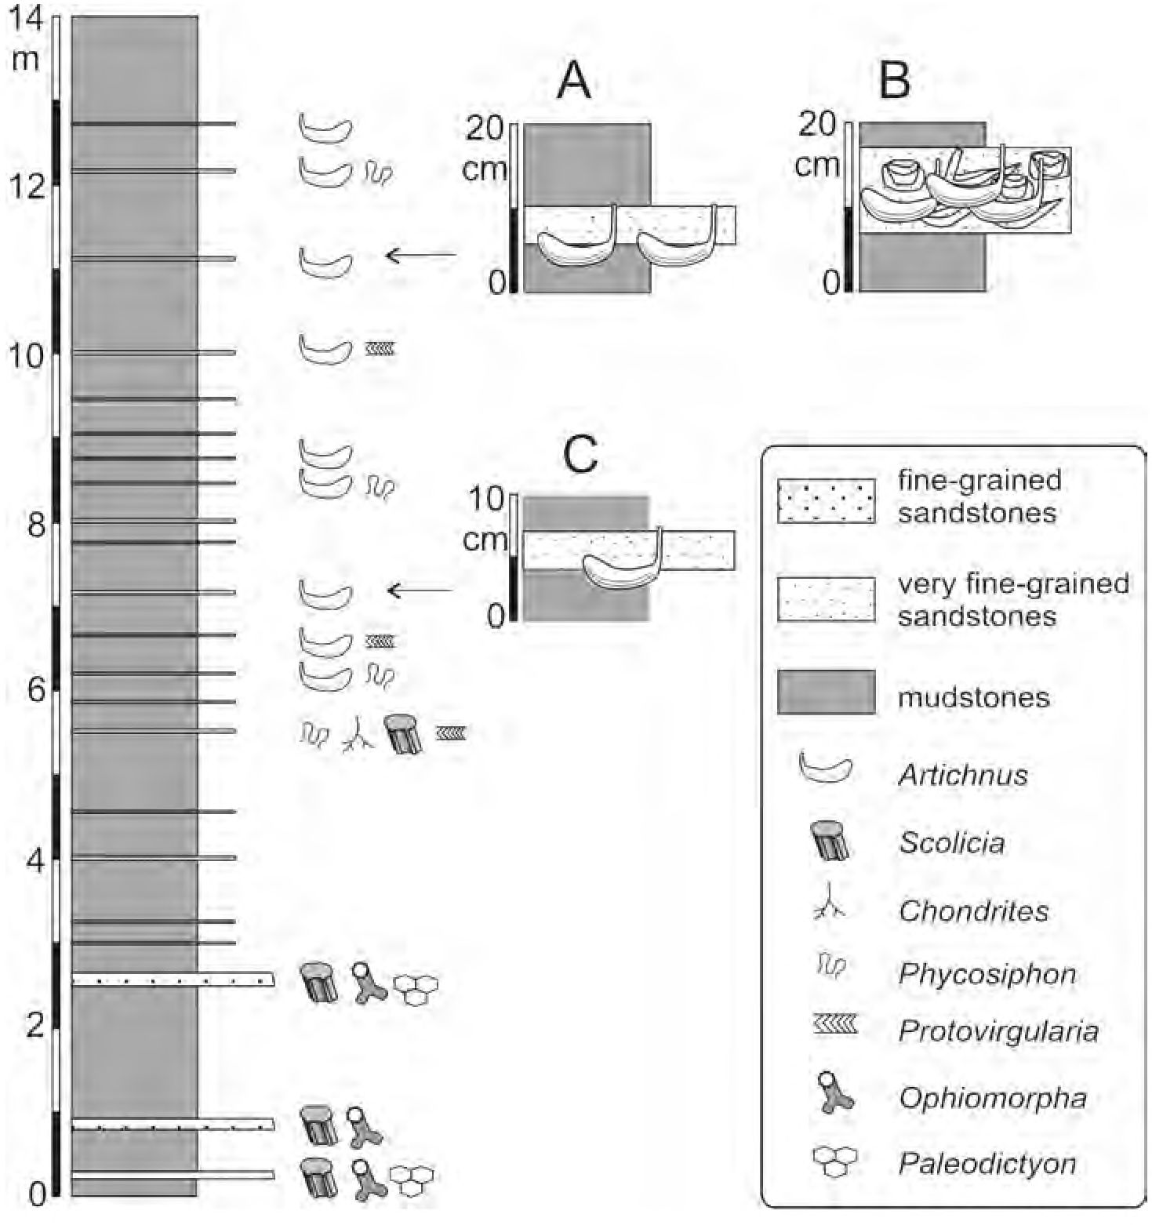
NEW EOCENE TRACE FOSSIL ARTICHNUS PHOLEOIDES
11
smooth ploughing traces to aspidochirote (e.g., Pseu-
dostichopus) holothurians (Heezen & Hollister 1971;
Young & al. 1985), surface patterned trails by elasipod
holothurians (e.g. Penagone, Psychropotes) (Hollis-
ter & al. 1975), or conical mounds and pits to molpa-
did holothurians (e.g. the ubiquitous Molpadia blakei)
(Young & al. 1985; Gage & Tyler 1991, text-figs
14.6, 14.9a, table 14.1). Subsurface traces of Thyone
briarens (Leseur) have been studied by Pearse (1908),
Howard (1968) and Bromley (1996). Some worm-like
holothurians are facile, deposit-feeding burrowers that
cause much bioturbation, e.g., the apodate Trochodota
dendyl of New Zealand (Morton & Miller 1968).
In Eocene turbiditic deposits of the Hieroglyphic
Beds in the Polish Carpathians, post-depositional, wide
J-shaped, turbinate trace fossils have been found. They
are dissimilar to other flysch trace fossils and can be at-
tributed to the work of holothurians, corresponding in
many respects to the lebensspuren produced by Thyone,
Their description and interpretation is the main aim of
this paper. The material is housed in the collections of
the Institute of Geological Sciences of the Jgiellonian
University (INGUJ).
Geological setting
The described trace fossil comes from the Hiero-
glyphic Beds, which is a lithostratigraphic unit of the
Silesian Nappe in the middle part of the Polish Outer
Carpathians. The area is located in the region of the
Szczyrzyc Synclinorium (Chodyń 2002), which also
was called the “Synclinal Basin” by Książkiewicz
(1977a) (Text-fig. 1 A). The Szczyrzyc Synclinorium
consists of the Szczyrzyc Depression (Kuźniar 1924,
1935) and the Ciecień-Grodzisko Monocline (Burtan
1974, 1978,1984).
The synclinorium is filled with Lower Cretaceous to
Fig. 2. Lithological log of the study section with indication of trace fossils. A-C are sections of the beds in the main column. A and B refer to the
same bed but at different places

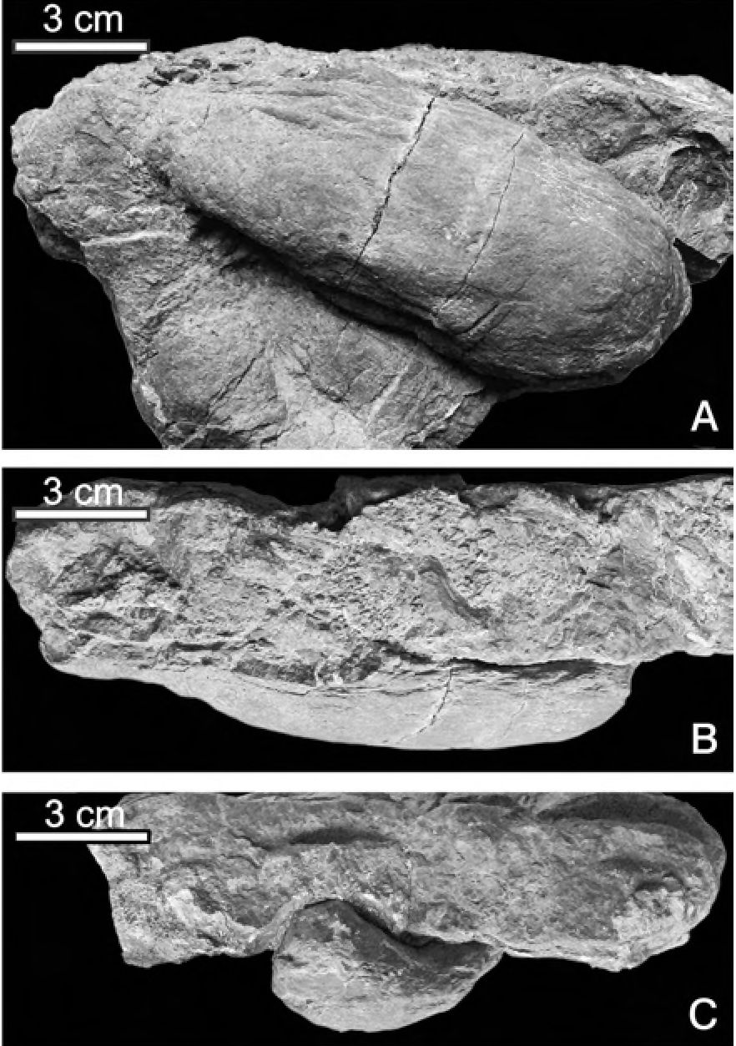
78
GUOCHENG ZHANG & al
Oligocene flysch sediments. The Palaeogene lithostrati-
graphic units include the Upper Istebna Beds
(Palaeocene), Ciężkowice Sandstones (Palaeocene to
Middle Eocene), Variegated Shales (Paleocene), Hiero-
glyphic Beds (Middle to Upper Eocene), Submenilite
Globigerina Marls (Late Eocene to Early Oligocene),
Menilite Beds (Lower Oligocene) and Krosno Beds
(Lower to Middle? Oligocene) (Text-fig. 1C).
The Hieroglyphic Beds are about 120-150 m thick
in the research area. Their lower and middle parts crop
out in discontinuous exposures along the Stradomka
stream between the villages Krzeslawice and
Pogorzany (Text-fig. IB). The Hieroglyphic Beds con-
sist of thin- and medium-bedded sandstones interbed-
ded with non-calcareous greyish-green and dark-brown
clayey shales. They contain numerous thin bentonite
layers that are similar to those described from the
nearby Wiśniowa Tectonic Window (Sałata & al.
2001) or the Żegocina zone (Waśkowska-Oliwa &
Leśniak2002). The Hieroglyphic Beds are dated to the
Middle to Late Eocene on the basis of benthic
foraminifers, which indicate the Glomospira div. sp.,

Fig. 3. Artichnus pholeoides holotype, INGUJ 181P01, hypichnial
lull relief. A - Bottom view showing the slight narrowing toward
the shaft and the local longitudinal striation. B - Side view, the ver-
tical shaft becomes thinner upward. C -Hie bent-up, narrowing shaft
Saccamminoides caipathicns, Reticulophragniiiim am-
plectens, Prasphaerammina subgaleata and Ammodis-
cns latus zones (Chodyń & Waśkowska-Oliwa 2006).
The foraminiferal zones were distinguished on the basis
of the deep-sea Carpathian foraminiferal assemblages
(Morgiel & Olszewska 1981; Geroch & Nowak
1984; Olszewska 1997).
The studied trace fossil occurs in a 13.7 m-thick,
shale-dominated interval in the lowermost part of the
Hieroglyphic Beds (Middle Eocene) cropping out on
the western bank of the Stradomka stream (Text-fig. 1)
about 85 m down-stream from the foot-bridge over the
stream (GPS co-ordinates:N49‘>48’16.5” E020<T0’22.3”;
± 5 m). Azimuth of the bed strike is 30° and dip al-
most vertical. The shales are grey and greenish-grey
non-calcareous mudstones intercalated with thin, fine-
grained, commonly ferruginous sandstone beds (Text-
fig. 2). Only two medium-grained sandstone beds
occur in the lower part. The trace fossils occur in eight
thin sandstone beds, which represent very' distal tur-
bidite, probably fan-fringe facies. Associated trace
fossils include Phycosiphon incertum FlSCHER-
Ooster 1858, Protovirgidaria isp. and Scolicia
strozzii (Savi & Meneghini 1850). In the underlying
turbiditic sandstones, Paleodictyon strozzii Savi &
Meneghini 1850, Ophiamorpha annulata (Książ -
KiEWicz 1977b) and Chondrites targionii (Brong-
niart 1828) occur. Below the section, an about 15 m-
thick interval of red, grey and greenish-grey shales
contains very few, thin sandstone beds.
DESCRIPTION OF THE TRACE FOSSIL
Artichnus igen. nov.
TYPE ICHNOSPECIES: Artichnus pholeoides isp.
nov. (in this study).
DERIVATION OF NAME: arter - felt shoe in Greek,
corresponding to the overall shape; ichnus, latinized
Greek ikhnos - trace.
DIAGNOSIS: Wide J-shaped, generally cylindrical
structure, turbinate in the distal part towards the blind
termination, and tapering in the proximal part. The
proximal part comprises a steeply upward bent, nar-
rowing shaft, tapering upwards. The burrow lumen lies
within a thickly laminated, short, vertical, mostly retru-
sive spreite, which is best developed in the lower part of
the structure. The outer margin is longitudinally striated
in some specimens.
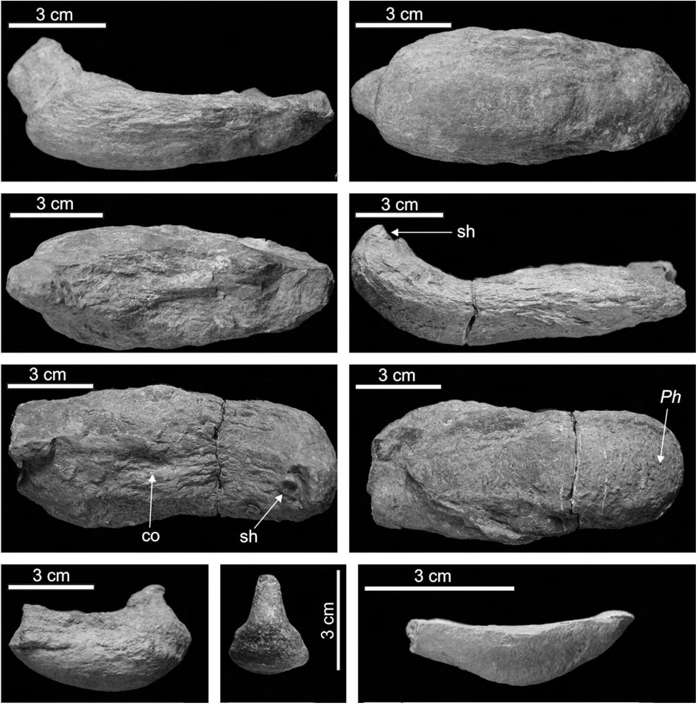
NEW EOCENE TRACE FOSSIL ARTICHNUS PHOLEOIDES
79
REMARKS: The only ichnospecies, Artichnus
pholeoides, is similar to Pholeus abomasoformis FlEGE
1944, but the latter displays a thin, vertical shaft pro-
truding from the distal part (Knaust 2002). It is also
similar to Macanopsis platanifonnis MuSrz & May-
oral 2001, which may belong to Artichnus, but the
type ichnospecies of Macanopsis Macsotay 1967, M.
pagueyi Macsotay 1967, displays a shaft associated
with a basal chamber (HAntzschel 1975). Further-
more, Artichnus pholeoides displays a vertically
stacked spreite structure in the basal part, somewhat
similar to that in Teichichmis Seilacher 1955, but its
type ichnospecies, T. rectus SEILACHER 1955, displays
a much thicker spreite structure, which dominates the
trace fossil, without lateral swellings. The same con-
cerns other Teichichmis ichnospecies (e.g., Fillion &
PlCKERILL 1990; SCHLIRF 2000; SCHLIRF & BROMLEY
2007). But in Artichnus, the spreite wraps around the
lumen and continues thinly above it. The basal part of
Diplocraterion parallelum var. arcum Ekdale &

Fig. 4. Artichnus pholeoides, endichnial full reliefs. A-C - Paratype, INGUJ 181P02; side, bottom and top views, respectively. D-F - Specimen
INGUJ 181P08, side, top and bottom views, respectively; the shaft (sh) in D and E, collapsed lumen (co) in E, Phycosiphon incertum (.Ph) appears
as irregularities on the surface in F. G — Paratype, INGUJ 181P49, side view. H - Specimen INGUJ 181P58, a view of the narrowing shaft.
I - Specimen INGUJ 181P48, the smallest Artichnus pholeoides
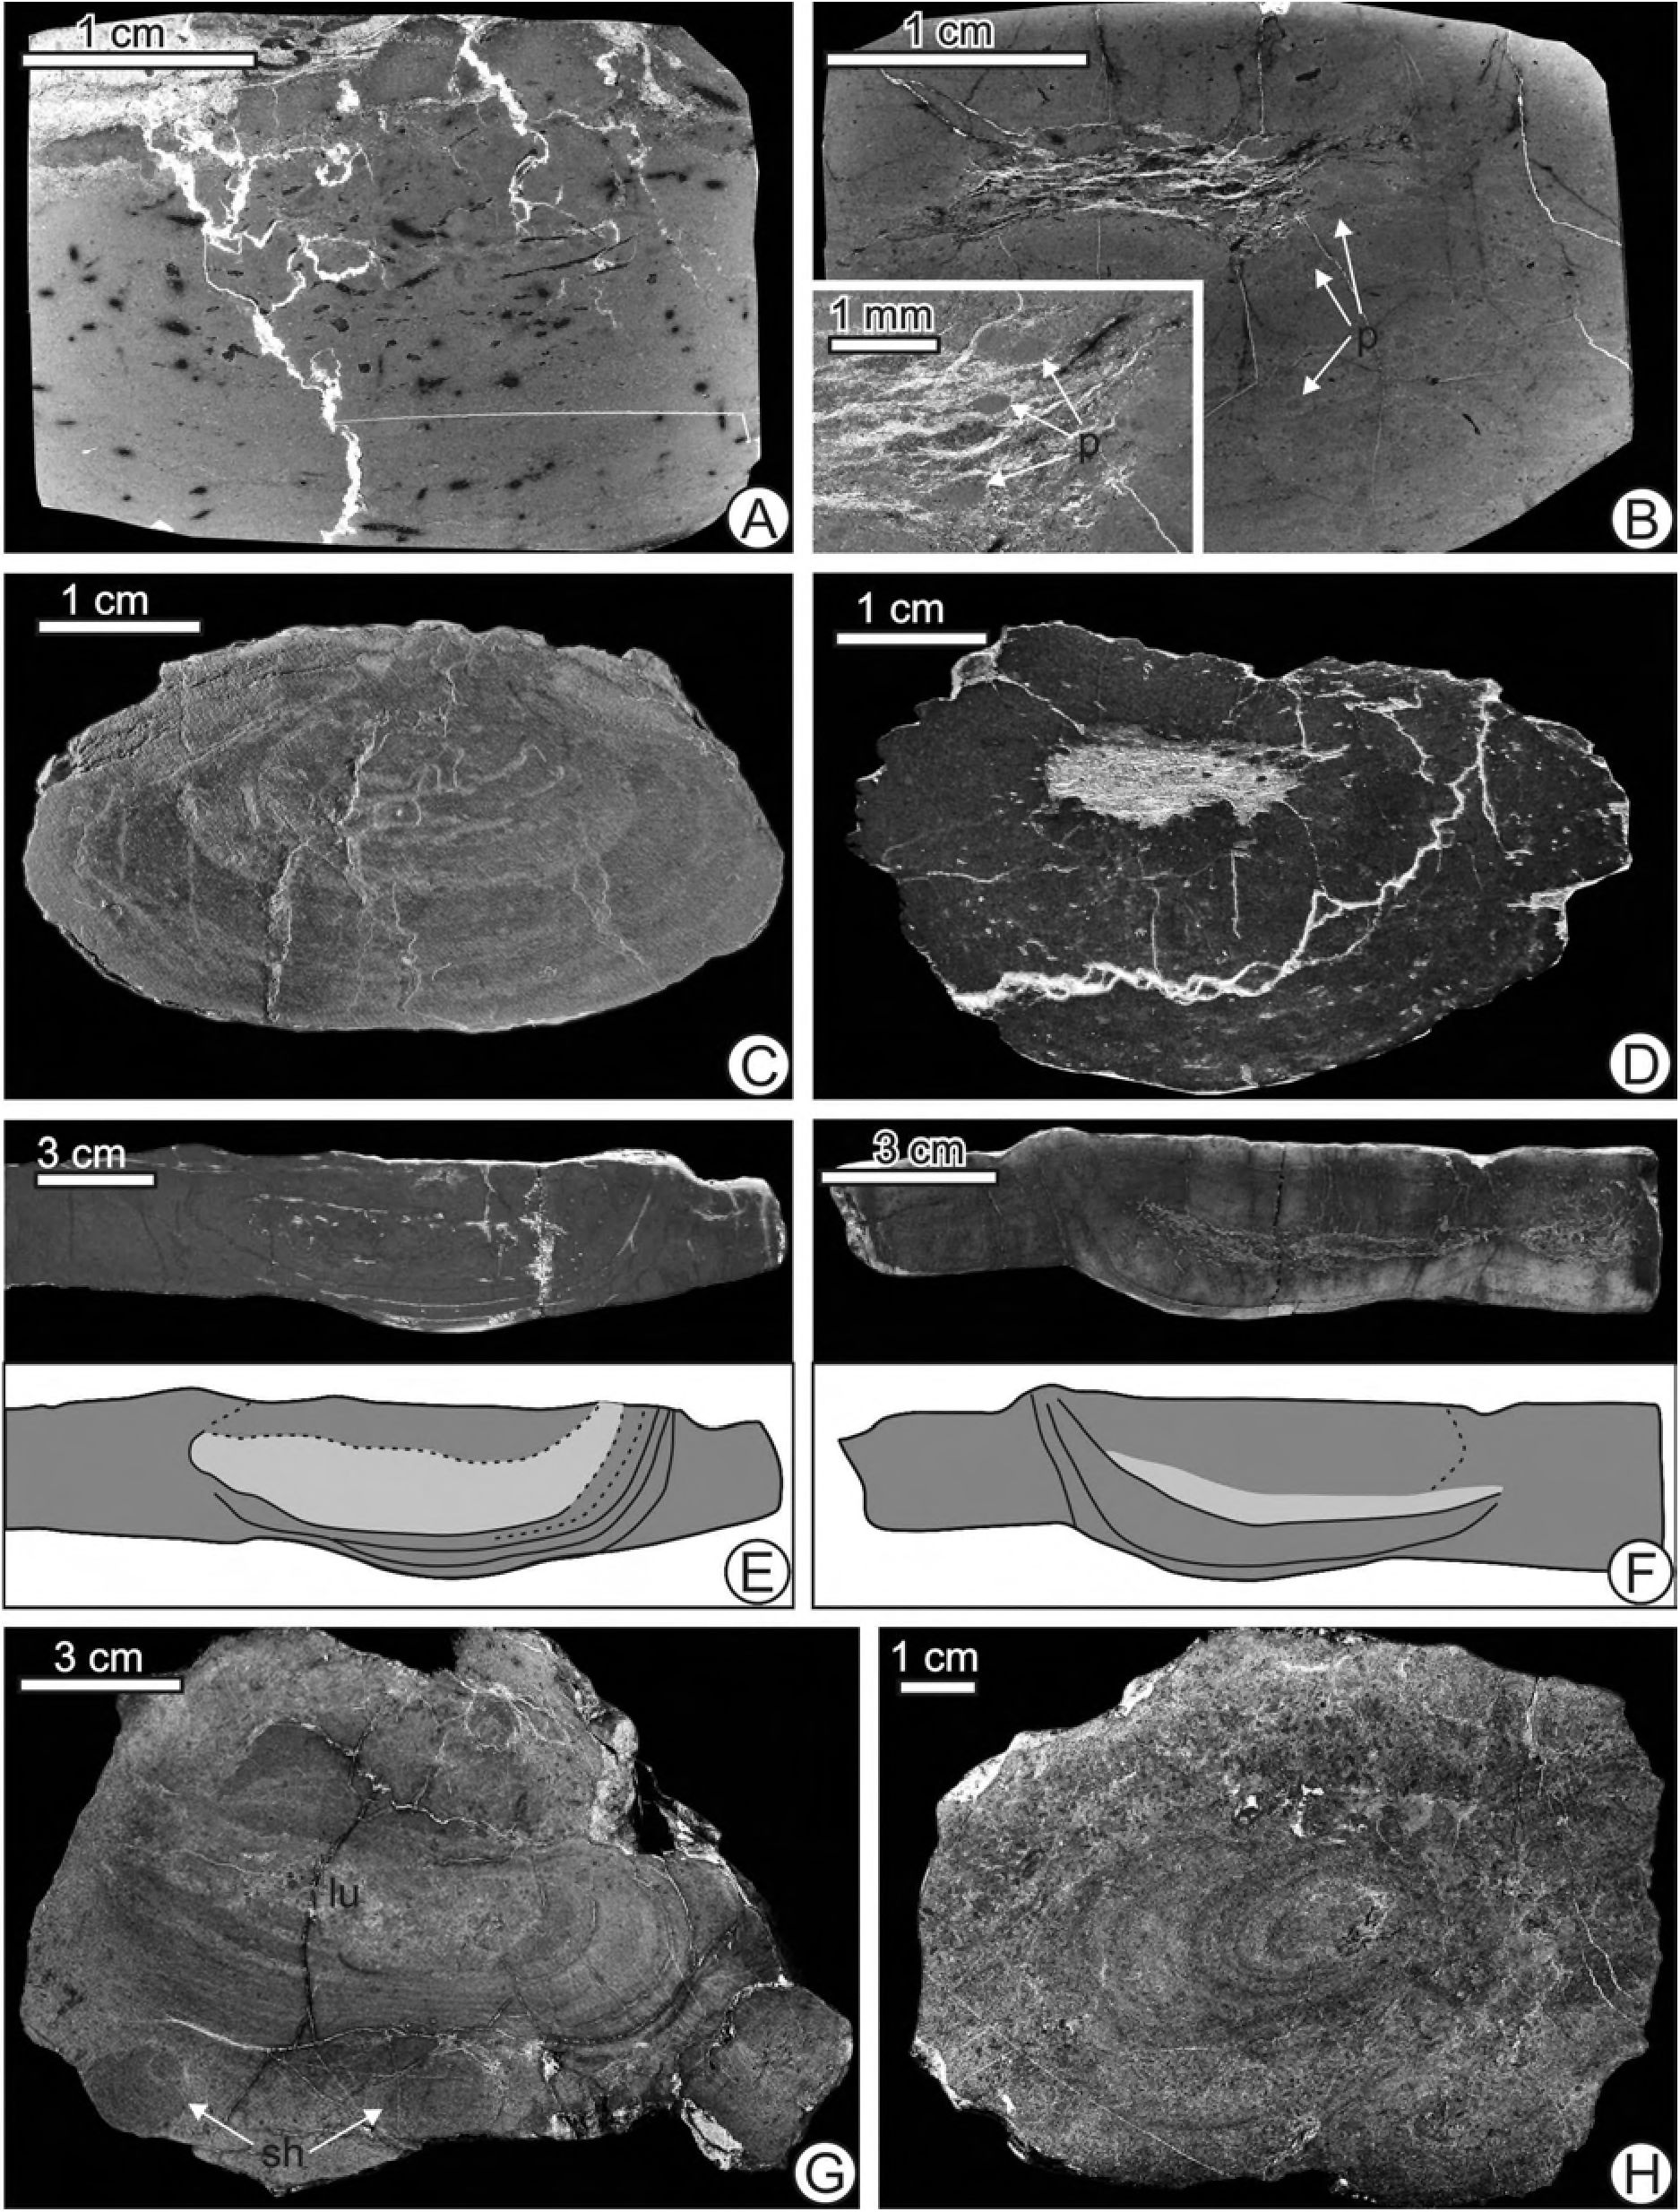
80
GUOCHENG ZHANG & al
Lewis (1991, text-fig. 10) displays some similarities to tichnus differs from other similar ichnogenera in many
Artichnus by its turbinate shape and spreite around a important features allowing its separation at the ichno-
lumen but it is a deep U-shaped structure. Thus, Ar- generic level.

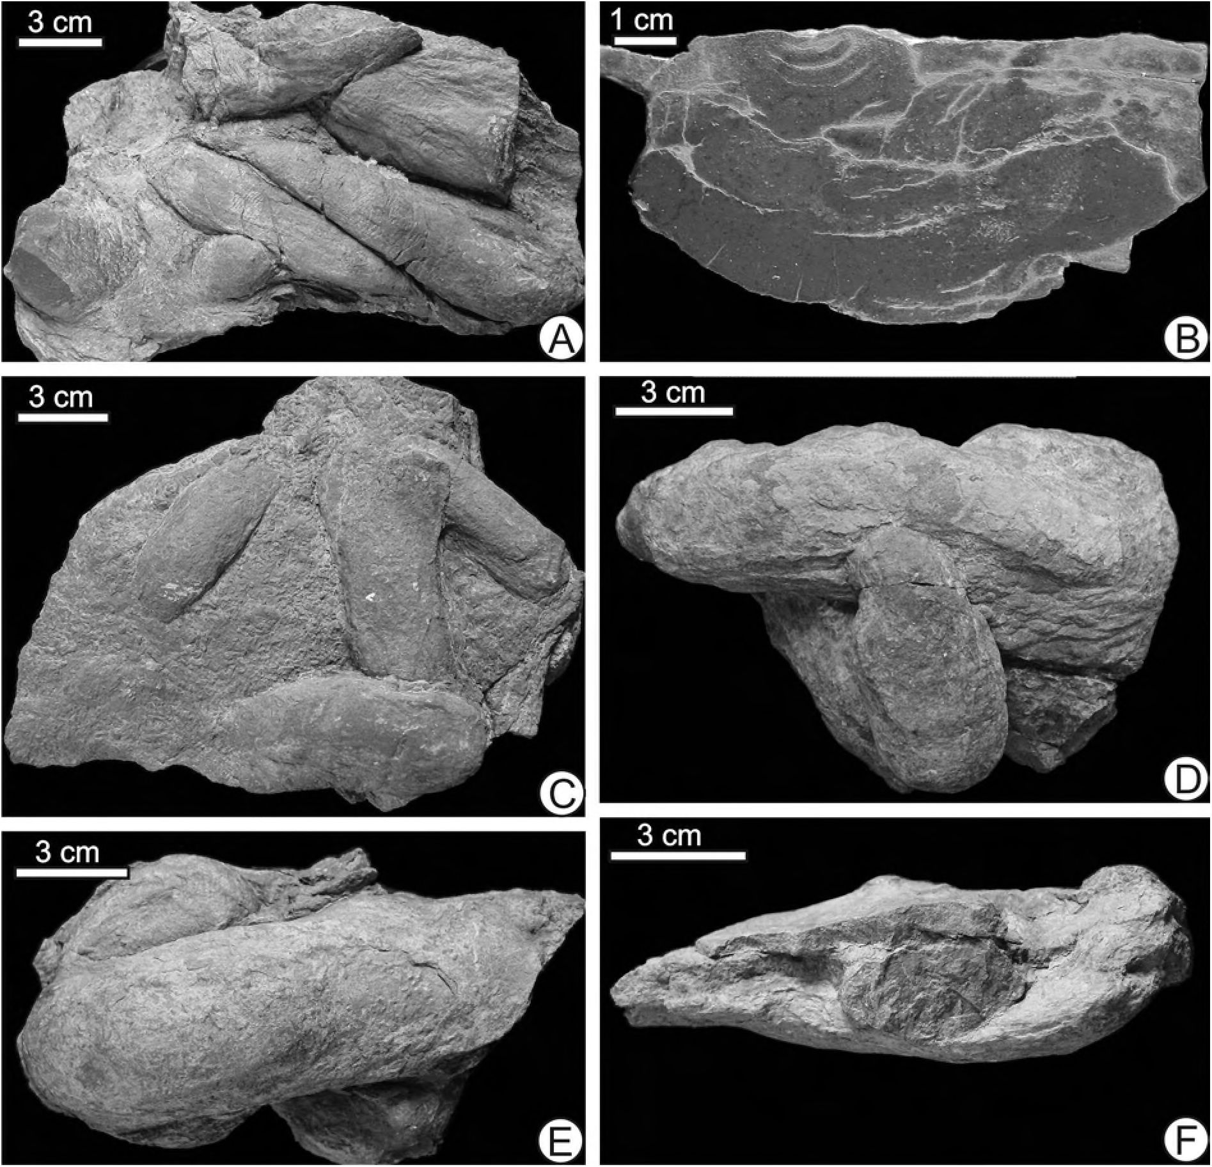
NEW EOCENE TRACE FOSSIL ARTICHNUS PHOLEOIDES
81

Fig. 6. Gregarious occurrences and intersections m. Artichnus pholeoides. A- Preferred directional arrangement and intersections; longitudinal wrin-
kles in the upper right, specimen INGUJ 18IP 16. B - Polished cross section, specimen INGUJ 181P53. C - Random intersections, bottom view;
specimen INGUJ 181P15. D - Perpendicular intersection of two A. pholeoides, bottom view; specimen INGUJ 181P22. E - Oblique intersection,
bottom view; specimen INGUJ 181P26. F - Perpendicular intersection; side view; specimen INGUJ 181P45
Fig. 5. Details of sectioned Artichnus pholeoides. A- Thin section perpendicular to the main axis of the trace fossil. Faint lamination in the lower part
and the black spots of irregularly oriented Phycosiphon incertum, specimen INGUJ 181P54. B - Thin section perpendicular to the main axis of the
trace fossil. Faint lamination in the lower part. The collapsed burrow lumen in the centre is filled with dolomitic and calcareous mud and sparse elon-
gated pellets (p). Diagenetic compaction has flattened the lumen and caused radial fractures, specimen INGUJ 181P55. The insert shows more pellets
(p). C - Polished section perpendicular to the main axis of the trace fossil showing the eccentric spreite lamellae, specimen INGUJ 181P54. D - Pol-
ished section perpendicular to the main axis of the trace fossil showing the collapsed lumen and related fractures inside and the uneven top and side
margin; sideritic Phycosiphon incertum can be seen as white spots; specimen INGUJ 181P55. E - Longitudinal polished section and corresponding
sketch; the pale zone in the sketch is the collapsed lumen containing calcium carbonate, specimen INGUJ 181P51. F - As in E, specimen INGUJ
181P61a. G - Horizontal cross section showing the collapsed lumen (lu) surrounded by spreite laminae; the spreite laminae cut through another spec-
imen to the upper left; two sectioned shafts (sh) in the lower part; specimen INGUJ 181P30. H - Horizontal cross section showing the proximal part
of the burrow surrounded by spreite laminae; the surrounding sediment totally bioturbated with Phycosiphon incertum; specimen INGUJ 181P62
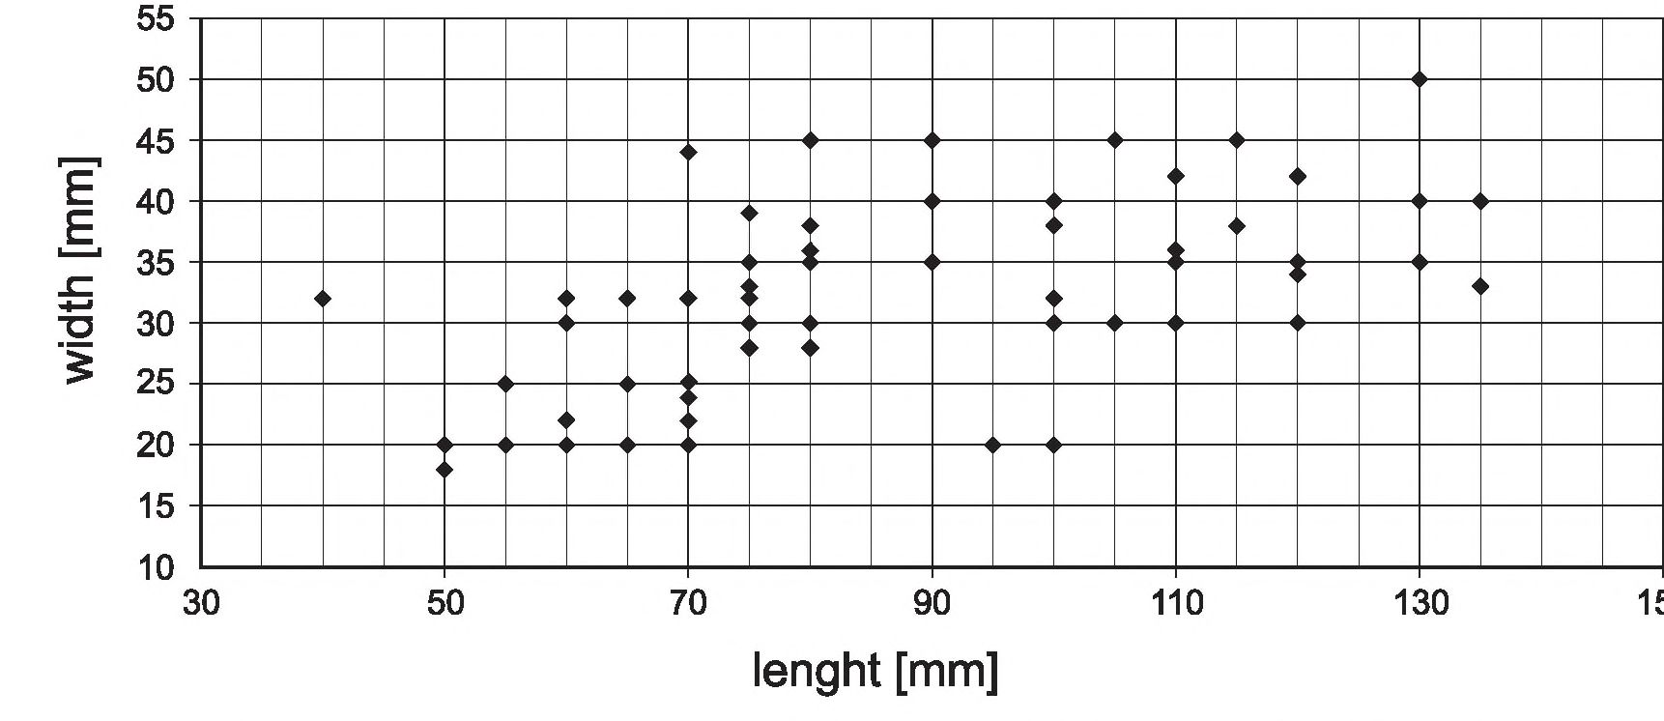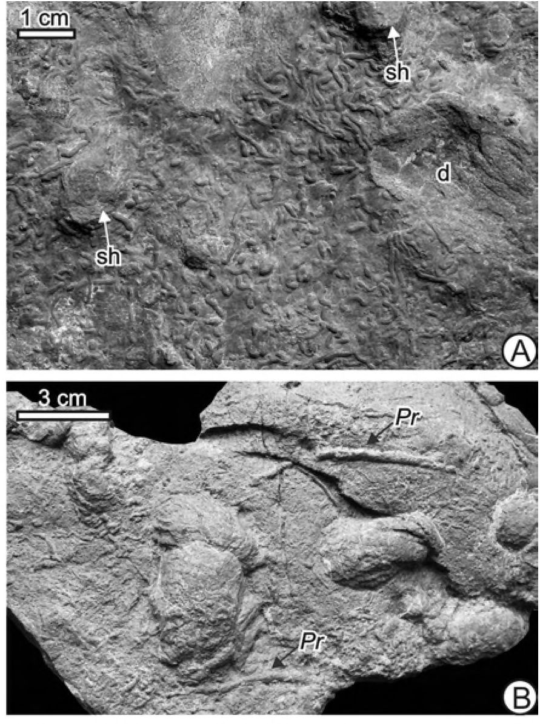
82
GUOCHENG ZHANG & al
Artichnus pholeoides isp. nov.
(Text-figs 3-8)
DERIVATION OF NAME: having a similarity with the
general shape of the ichnogenus Pholeus FlEGE 1944.
Fig. 7. Diagram of the mean length and width of Artichnus pholeoides (data summarized in Table 1)
tion no. 18IPO 1 to 181P60. Additionally, many field
observations.
TYPES: holotype INGUJ 181P01 (Text-fig. 2A-C);
paratypes INGUJ 181P02-04, 08, 09, 47.
TYPE HORIZON AND LOCALITY: Lowermost part
of the Hieroglyphic Beds (Middle-Late Eocene), Sile-
sian Nappe, Polish Carpathians (Text-figs 1, 2) at
Krzeslawice along the Stradomka River.
DESCRIPTION: Hypichnial or endichnial, wide, J-
shaped cylindrical or sub-cylindrical, turbinate struc-
tures, asymmetrical along their longer axis. They taper
distally and display a gently upward bent and then ver-
tical shaft in the proximal part, connecting the main part
of the trace fossil and host bed upper surface (Text-figs
3, 4). Length of the structure varies between 55 and 135
mm, commonly 70 to 100 mm (Table 1, Text-fig. 7).
The burrow is up to 20-50 mm wide in the distal part,
becoming narrower towards both ends. The shaft (Text-
figs 4H, 5G, 8B) is commonly short but in some spec-
imens it attains 50 mm. Its outlet ranges between 6 and
9 mm in diameter and its filling commonly projects
above the upper bedding plane (Text-fig. 8A). Some
Length <55 56-70 71-85 86-100 101-115116-130 >131
(mm)
Number of 5 16 23 20 10 8 2
specimens
Table 1. Morphometric data of 84 individuals of Artichnus pholeoides
Fig. 8. Associated trace fossils. A-Phycosiphon incertum on the upper
bedding plane with shafts (sh) of Artichnus pholeoides. The depression
(d) is probably after an. Artichnus pholeoides that was emplaced in the
overlying shale and impressed into the upper sandstone surface; spec-
imen INGUJ 18 IP 15 (its lower surface is shown in Fig. 6C). B -
Lower bedding surface with Artichnus pholeoides, Phycosiphon
incertum and Protovirgularia isp. (Pr); specimen INGUJ 181P52

DIAGNOSIS: As for the ichnogenus.
MATERIAL: 60 slabs preserving over 80 specimens,
housed in the Institute of Geological Sciences, Jagiel-
lonian University', Kraków, Poland, trace fossil collec-

NEW EOCENE TRACE FOSSIL ARTICHNUS PHOLEOIDES
83
specimens display a local, weak, longitudinal striation
(Text-figs 4A, E, 6A). In longitudinal cross-section,
spreite structures (lamellae) can be seen, mostly in the
lowest part, below the collapsed lumen (Text-fig. 5C-F).
The lumen rarely occurs at the very top of the spreite,
but usually at a short distance beneath the top. Com-
monly, the lumen is vertically flattened to some degree
or even completely compressed (Text-fig. 5B). In hor-
izontal sections, the lumen is surrounded by spreite
lamellae. The lamellae also occur around the shaft
(Text-fig. 5G, H).
In thin sections, the compactional effect can be seen:
the lumen is collapsed and radial cracking runs toward
the burrow margins (Text-fig. 4B). The collapsing effect
is also seen on the surface of the burrow as a longitudi-
nal depression (Text-fig. 4E). The contents of the lumen
may include rare ovoid pellets, probable broken spicules
and dolomitic and calcareous mud (Text-figs 4A, B, 5E,
F). The pellets have the same grain size as the surround-
ing sediment. Pellets are also present in the spreite but
are here less visible on account of some iron diagenesis.
A. pholeoides is quite abundant on the lower bed-
ding surfaces and the specimens commonly intersect
(Text-figs 6, 7). Two weakly perpendicularly preferred
orientations are seen, though random occurrence is
common (Text-figs 6A-F, 8B). The intersecting speci-
mens are commonly coated with a muddy film.
REMARKS: A.pholeoides has undergone some com-
pactional diagenesis that has led to distortion of the
spreite and collapse of the burrow lumen. Flowever, the
underside of the spreite commonly has a smooth central
region that appears to represent the original width and
forms the basal part of the burrow.
A. pholeoides occurs commonly together with post-
depositional Phycosiphon incertum in muddy turbidites.
It is cut by P. incertum (Text-figs 4F, 5A, D, G, FI, 8B)
but the reverse intersection pattern also is present (Text-
fig. 8B). In sandier turbidites, A. pholeoides is com-
monly associated with post-depositional Proto-
virgularia isp. (Text-fig. 8B), which probably occupy
the same tier. In other beds of the Flieroghyphic Beds in
the surrounding section, Chondrites isp., Ophiomorpha
anmdata and Paleodictyon strozzii occur.
DISCUSSION
General form of the burrow
The trace fossil is a complex structure based on a
wide, J-formed morphology. The central lumen, al-
though diagenetically compacted to various degrees, in-
dicates a more or less horizontal, tubular form, having
a single near-vertical shaft, which tapers slightly up-
ward. Surrounding this is a laminated, thick envelope of
sediment representing a spreite. There is only the one
connection with the sea floor. The structure suggests the
stationary, long-term abode of a deposit- or suspension-
feeding, worm-like animal.
Probable holothurian tracemaker
Sea cucumbers are common in shallow seas today,
but they are the largest and most numerous invertebrate
animals on the deep-sea floor (FIyman 1955; Hansen
1956, 1975; Heezen & Hollister 1971; Gage &
Tyler 1991). Both sea-depth and morphology encour-
age comparison of Artichnus pholeoides with the bur-
rows of sea cucumbers.
However, in contrast to most of the holothurians,
observations on burrowing species are extremely
sparse, for two reasons. First, these echinoderms react
to disturbance by evisceration (expelling their internal
organs) and autotomy (breaking into several pieces).
This renders them highly unsuitable subjects for aquar-
ium studies (Hyman 1955; Ricketts & Calvin 1962).
Second, the group of holothurians we know least about
are the deep-sea endobenthic species, because deep-sea
sampling most usually is by benthic sledges, which take
epibenthic organisms almost exclusively. Benthic
sledges are relatively cheap and easy to use, and cover
large areas quickly; not so with box-corers (Gage &
Billett 1986). In the published collections of deep-sea
floor photographs, endobenthic life is represented by
burrow openings and faecal cones (e.g., Heezen &
Hollister 1971; Lemche & al. 1976).
An exception to this is the classic study on the shal-
low-water dendrochirotan holothurian Thyone briareus
by Pearse (1908). This careful work was later backed
up by X-radiographs of the burrowing sea cucumber by
Howard (1968). This species makes a vertical U-bur-
row in soft sediments, exposing its feeding tentacles at
one aperture and its anus at the other. The burrower re-
mains more or less stationary' in the burrow, collecting
planktonie food with its tentacles. On the whole,
holothurians are sluggish animals, often remaining in
one place for long periods of time if conditions are suit-
able. Several dendrochirotes and aspidochirotes are
known to live in U-burrows, suspension feeding like
Thyone, or deposit feeding by brushing the tentacles
over the surrounding seafloor (Hyman 1955), but de-
tails are less well recorded.
These sea cucumbers need to have the anus in con-
tact with seawater because they respire by pumping
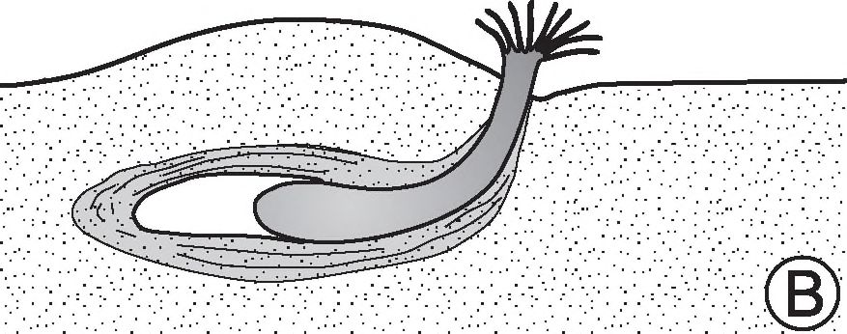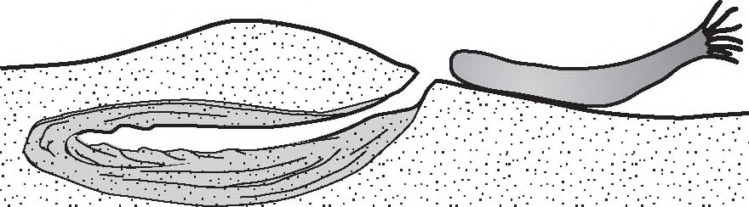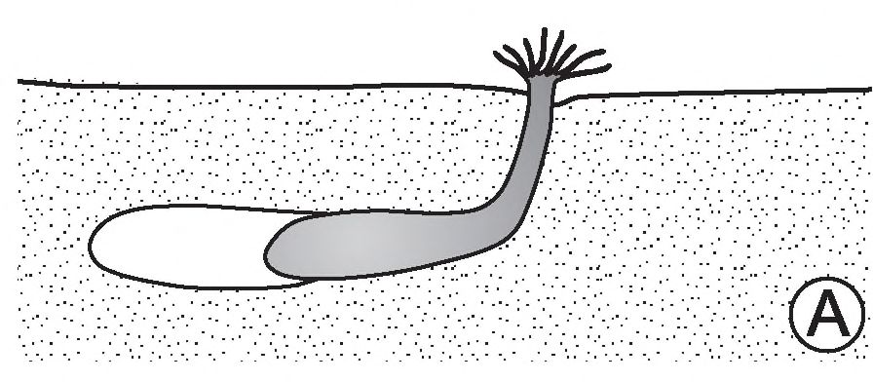
84
GUOCHENG ZHANG & al
water in and out of large structures called “respiratory
trees” within their body. However, one of the five orders
of the Holothuroidea, the Apodida, lacks respiratory'
trees, respiring instead directly through the surface skin.
These worm-like apodeans are the most active burrow-
ers among the holothurians and, furthermore, are most
abundant in the deep sea.
On this basis, we may envisage the following sce-
nario for Artichnus pholeoides (Text-fig. 9). The tubu-
lar lumen of the burrow corresponds well to a
worm-like apodid holothurian burrower. The single en-
trance is available for the tentacle crown to pass through
during feeding periods, when either suspension feeding
or surficial deposit feeding was undertaken. This would
be withdrawn into the burrow at other times for protec-
tion. Faecal matter would be deposited within the bur-
row as a laminar deposit (Text-fig. 5) around and
especially beneath the inhabitant, forming the spreite.
Remaining organic material in this sediment would at-
tract the Phycosiphon incertum producer.
Concerning the presence of ovoid pellets in the
spreite sediment, holothurians do not have gut mor-
phology' that allows pellet formation. These pellets must
have an earlier date of origin, having been collected out-
side the burrow by the sea cucumber, thereby indicating
detritus or deposit feeding rather than suspension feed-
ing. Since the fill of the burrow and spreite are consid-

Fig. 9. Reconstruction of the holothurian producing Artichnus
pholeoides. A, B, C refer to following stages of the burrow formation
ered to represent sediment that has passed through the
gut of the burrower, the pellets must have been firm to
hard in order to have survived this passage intact.
As food supplies were depleted, and further com-
paction of excreted sediment was becoming difficult,
the sea cucumber would have left the burrow, squeez-
ing out of the shaft, and produced a new burrow nearby,
as suggested by the crowded and intersecting A.
pholeoides (Text-fig. 6).
Stationary' feeding suggests abundance of food. In
general, one expects to find a greater proportion of mo-
bile than stationary types of trace fossil when food re-
sources (i.e., organic carbon content of the sediment)
are low (e.g.. Young & al. 1985). The unusual occur-
rence of A. pholeoides in the thin sand turbidites sug-
gests an origin for this sediment in, for example,
shallow, organically productive areas.
CONCLUSIONS
A new, wide, J-shaped, post-depositional spreite
trace fossil was found in Eocene turbiditic deposits of
the Hieroglyphic Beds of the Silesian Nappe (Middle
Eocene) of the Polish Outer Carpathians.
The trace fossil is named Artichnus pholeoides
igen.et isp. nov.
Morphology and structure suggest a likely trace-
maker in the echinoderm class Holothuroidea (sea cu-
cumbers), possibly order Apodida.
Acknowledgements
ZG’s visit to Poland was supported by the scholarship of
the Henan Province, China. Additional support was provided
by the Jagiellonian University' (DS funds). Luis A. Buatois
(Saskatoon, Canada) and Eduardo Mayoral (Huelva, Spain),
the journal referees, provided helpful reviews of the paper.
REFERENCES
Asgaard, U. & Bromley, R.G. 2007. Co-occurrence of
schizasterid echinoids and the trace fossil Scolicia, Pleis-
tocene, Greece: facts, myths and fascioles. In: R.G.
Bromley, L.A. Buatois, M.G. Mangano, J.F. Genise, &
R.N. Melchor (Eds), Sediment-Organism Interactions:
A Multifaceted Ichnology. SEPM Special Publications,
88, 85-94.
Bromley, R.G. 1996. Trace Fossils: Biology, Taphonomy and
Applications, pp. 1-361. Chapman & Hall; London,
Bromley, R.G. & Asgaard, U. 1975. Sediment structures

NEW EOCENE TRACE FOSSIL ARTICHNUS PHOLEOIDES
85
produced by a spatangoid echinoid: a problem of preser-
vation. Bulletin of the Geological Society of Denmark, 24,
261-281.
Brongniart, A.T. 1828. Histoire des Vegetaux Fossiles ou
Recherches Botaniques et Geologiques sur les Vegetaux
Renfermes dans les Diverses Couches du Globe, Voliune
1, pp. 1-136. G. Dufour & E. d’Ocagne; Paris.
Burtan, J. 1974. Szczegółowa Mapa Geologiczna Polski, 1:
50 000, Ark. Mszana Dolna. Wydawnictwa Geologiczne',
Warszawa. [In Polish]
- 1978. Objaśnienia do Szczegółowej Mapy Geologicznej
Polski, 1: 50 000, Ark. Mszana Dolna, pp. 1-70 Wydaw-
nictwa Geologiczne', Warszawa. [In Polish]
- 1984. Tektonika Karpat fliszowych na południe od Wie-
liczki. Biuletyn Instytutu Geologicznego, 340, 7-22. [In
Polish with English summary]
Chodyń, R. 2002. Szczyrzyc Synclinorium in the Silesian
Unit, Outer Carpathians, Poland-case study. In: Ex-
tended Abstracts, Proceedings of the XVII. Congress
of Carpathian-Balkan Geological Association, Brati-
slava, September 1st - 4*, 2002, Extended Abstracts.
Geologtca Carpathica, Special Issue, 53. [Electronic
version]
- 2006. Lithostratigraphy and tectonics of the Silesian
Nappe on the area of Szczyrzyc depression. Unpublished
PhD Thesis, Institute of Geological Sciences of the Jagiel-
lonian University; Cracow, 189 pp. [In Polish]
Chodyń, R. & Waśkowska-Oliwa, A. 2006. Lithostratigra-
phy and bio stratigraphy of the Paleocene-Early Oligocene
Flysch sediments in the western part of the Szczyrzyc
Synclinorium, Silesian Nappe (Polish Outer Carpathians).
Proceedings XVHIth Congress of the Carpathian-Balkan
Geological Association, September 3-6, 2006 Belgrade,
Serbia, Abstracts Book, 57-60.
Ekdale, A.A. & Lewis, D.W. 1991. Trace fossils and pale-
oenvironmental control of ichnofacies in a late Quater-
nary gravel and loess fan delta complex, New Zealand.
Palaeogeography, Palaeoclimatology, Palaeoecology,
81,253-279.
FlEGE, K. 1944. Lebensspuren aus dem Muschelkalk Nord-
westdeutschland s. Neues Jahrbuch fur Mineralogie, Geo-
logie, Paldontologie,Abhandlungen B, 88, 401-426.
Fillion, D. & Pickerill, R.K. 1990. Ichnology of the Upper
Cambrian? to Lower Ordovician Bell Island and Wabana
groups of eastern Newfoundland, Canada. Palaeonto-
graphica Canadiana, 7, 1-119.
Fischer-Ooster, C. 1858. Die fossilen Fucoiden der Schwei-
zer-Alpen, nebst Erorterungen iiber deren geologisches
Alter, pp. 72. Huber, Bern.
Gage, J.D. & Billett, D.S.M. 1986. The family Myriotro-
cliidae Dieel (Echinodermata: Holothuroidea) in the deep
northeast Atlantic Ocean. Zoological Journal of the Lin-
naean Society, 88, 229-276.
Gage, J.D. & Tyler, P.A. 1991. Deep-sea Biology: ANatu-
ral History of Organisms at the Deep-sea Floor, pp. 1 -504.
Cambridge University Press', Cambridge.
Geroch, S. & Nowak, W. 1984. Proposal of zonation for the
Late Tithonian - Late Eocene based upon arenaceous
foraminifera from the Outer Carpathians, Poland. In: H.
Oertli (Ed.), Benthos ’83; 2nd International Symposium
on Benthic Foraminifera Pan (France), April 11-15 1983,
pp. 225-239. ElfAquitaned, ESSO REP and TOTAL CFP;
Pau-Bordeaux.
Ginsbtjrg, R.N., Bernard, H.A., Moody, R.A. & Daigle,
E.E. 1966. The Shell method of impregnation cores of un-
consolidated sediments. Journal of Sedimentary Petrol-
ogy, 36 (4), 1118-1125.
Gotzingbr, G. & Becker, H. 1932. Zur geologischen Glie-
derung des Wienerwaldflysches (Neue Fossilfunde).
Jahrbuch der Geologische Bundesanstalt, 82, 343-396.
Hansen, B. 1956. Holothurioidea from depths exceeding
6000 meters. Galithea Report, 2, 33-54.
- 1975. Systematics and biology of the deep-sea holothuri-
ans. Part 1. Elasipoda. Galithea Report, 13, 262 pp.
HANTZSCHEL, W. 1975. Trace fossils andproblematica. In: C.
Teichert (Ed.), Treatise on Invertebrate Paleontology,
part W, Miscellanea, Supplement 1, pp. W1-W269. Geo-
logical Society of America, Boulder, Colorado and Uni-
versity of Kansas; Lawrence - Kansas.
Heezen, B.C. & Hollister, C.D. 1971. The Face of the Deep,
pp. 659. Oxford University Press; New York - London -
Toronto.
Hollister, C.D., Heezen, B.C. & Nafe, K.E. 1975. Animal
traces on the deep-sea floor, in: RW. Frey (Ed.), The
Study of Trace Fossils, pp. 493-510. Springer; New
York.
Howard, J.D. 1968. X-ray radiography for examination of
burrowing in sediments by marine invertebrate organ-
isms. Sedimentology, 11, 249-258.
Hyman, L.H. 1955. Die Invertebrates 4 - Echinodennata, Die
Coelomate Bilateria. pp. 763, McGraw-Hill; New York.
Kitchell, J.A., Kitchell, J.E., Johnson, G.L, & Hunkins,
K.L, 1978. Abyss traces and megafauna: comparison of
productivity, diversity and density in the Arctic and
Antarctic. Paleobiology, 4, 171-180.
Knatjst, D. 2002. Ichnogenus Pholeus Fiege, 1944, revisited.
Journal of Paleontology, 76, 882-891.
Książkiewicz, M. 1977a. The tectonics of the Carpathians.
In: Geology of Poland. Volume 4. Tectonics, Part. 3, pp.
476-620. Wydawnictwa Geologiczne; Warszawa.
- 1977b. Trace fossils in the Flysch of the Polish Carpatlii-
ans. PalaeontologiaPolonica, 36,1-208.
KUŹNIAR, C. 1924. Sprawozdanie z badań geologicznych na
arkuszu Wieliczka-Myślenice (Compte-rendu des re-
cherches geologiques pour la revision de la feuille Wie-
liczka-Myślenice de 1’Atlas geol. de la Galicie).
86
GUOCHENG ZHANG & al
Posiedzenia Naukowe Państwowego Instytutu Geologii
(Comptes-Rendus des Seances du Sendee Geologique de
Pologne), 7, 4-5. [In Polish with Flench title]
1935. Sprawozdanie z badań na obszarze arkusza Wieliczka,
wykonanych w r. 1934 (Compte-rendu des recherches
executees sur le feuille Wieliczka en 1934). Posiedzenia
Naukowe Państwowego Instytutu Geologii (Comptes-
Rendus des Seances du Sendee Geologique de Pologne),
41, 7. [In Polish with French title]
Lemche, H„ Hansen, B., Madsen, F.J., Tendal, O.S. &
WOLFF, T. 1976. Hadal life as analyzed from photographs.
Videnskabelige Meddelelser fra Dansk Naturhistorisk
Forming, 139, 263-336.
Macsotay, O. 1967. Huellas problematicas y su valor pale-
oecologico en Venezuela. Gios, 16, 7-39.
Morgiel, J. & Olszewska, B. 1981 Bio stratigraphy of the
Polish External Carpathians based on agglutinated
foraminifera. Micropaleontology, 27, 1-30.
Morton, J. & Miller, M. 1968. Die New Zealand Sea Shore,
pp. 638. Collins; London - Auckland.
MuNiz, F. & Mayoral, E. 2001. Macanopsis plataniformis
nov. ichnosp. from the Lower Cretaceous and upper
Miocene of the Iberian Peninsula. Geobios, 34 (1), 91-98.
OLSZEWSKA, B. 1997. Foraminiferal stratigraphy of the Polish
Outer Carpathians: a record of basin geohistory. Annales
Societatis Geologorum Poloniae, 67, 325-337.
Pearse, A.S. 1908. Observations on the behavior of the
holothurian, Thyonebriateus (Leseur). Biological Bulletin
of the Marine Biological Laboratory, Woods Hole, 15,
259-288.
Quatrefages, de, M.A. 1849. Note sur la Scolicia prisca (A.
de Q.) annelide fossile de la Craie. Annales des Sciences
Naturalles, 3 sirie, Zoologie, 12, 265-266.
Ricketts, E.F. & Calvin, J. 1962. Between Pacific Tides, 3rd
Edition, pp. 516. Stanford University Press; Stanford.
Sałata, D., Waśkowska-Oliwa, A., Cieszkowski, M.
2001. Analysis of small foraminifera assemblages and
clay minerals from bentonite-like layers within Czer-
win beds (Subsilesian Unit, Polish Flysch Carpathians)-
preliminary results. Slovak Geological Magazine, 7 (1),
43-44.
Savi, P. & Meneghini, G. 1850. Osservazioni stratigraphiche
e paleontologiche concerned la geologia della Toscana e
dei paessi limitrofi. Appendix in R.I Murchison, Memo-
ria sulla Structtura Geologica delle Alpi, degli Apennini
e dei Carpazi, pp. 1-249. Stamperia Grandiducale;
Firenze.
ScHLiRF, M. 2000. Upper Jurassic trace fossils from the
Boulonnais (northern France). Geologica et Palaeonto-
logica, 34, 145-213.
ScHLiRF, M. & Bromley, R.G. 2007. Teichichmis duplex n.
isp., new trace fossil from the Cambrian and the Triassic.
Beringeria, 37,133-141.
SEILACHER, A. 1955. Spuren und Fazies im Unterkambrium.
In: O.H. Schindewolf & A. Seilacher, Beitriige zur
Kenntnis des Kambriums in der Salt Range (Pakistan).
Akademie der Wissenschaften und der Literatur in Mainz.
Abhandlungen der mathematisch-naturwissenschaftli-
chen Klasse, 10, 373-399.
Smith, A.B. & Crimes, T.P. 1983. Trace fossils formed by
heart urchins - a smdy of Scolicia and related traces.
Lethaia, 16, 79-92.
Waśkowska-Oliwa, A., Leśniak, T. 2002. Lower Eocene
ńiffites in the Żegocina zone (Polish Flysch Carpathians).
In: Proceedings of the XVII. Congress of Carpathian-
Balkan Geological Association, Bratislava, September 1st-
4*, 2002, Extended Abstracts. Geologica Carpathica,
Special Issue, 53, 45-47.
Young, D.K., Jahn, W.H., Richardson, M.D. & Lohanick,
A.W. 1985. Photographs of deep-sea Lebensspuren: a
comparison of sedimentary provinces in the Venezuela
Basin, Carribean Sea. Marine Geology, 68, 269-301.
Manuscript submitted: Iff¹' October 2007
Revision version accepted: 25th January 2008

