
4th Symposium on Prospects in the Physics of Discrete Symmetries (DISCRETE2014) IOP Publishing
Journal of Physics: Conference Series 631 (2015) 012042 doi:10.1088/1742-6596/631/1/012042

Study of Ks semileptonic decays and CPT test with
the KLOE detector

Daria Kamińska on behalf of the KLOE-2 Collaboration
The Marian Smoluchowski Institute of Physics, Jagiellonian University
Łojasiewicza 11, 30-348 Krakow, Poland
E-mail: daria.kaminska@doctoral.uj.edu.pl
Abstract. Study of semileptonic decays of neutral kaons allows to perform a test of discrete
symmetries, as well as basic principles of the Standard Model. In this paper a general review
on dependency between charge asymmetry constructed for semileptonic decays of short- and
long-lived kaons and CPT symmetry is given. The current status of determination of charge
asymmetry for short-lived kaon, obtained by reconstruction of about 105 Ks ^ nev decays
collected at DATNE with the KLOE detector is also reviewed.

1. Introduction
Discrete symmetries of nature such as charge conjugation (C), parity (P) or time reversal (T)
do not lead to new conserved quantities. Nevertheless, all of the mentioned symmetries plays
an important role in particle physics, especially in calculations of the cross sections and decay
rates. Weak interaction does not conserve the C, P, T or combined CP symmetry. However,
up to now, there is no indication of CPT symmetry violation [1], which would also imply the
break of Lorentz symmetry [2]. A special role in CPT violation searches plays a neutral kaon
system which, due to a sensitivity to a variety of symmetry violation effects, is one of the best
candidates for such kind of studies. One of the possible tests is based on comparison between
semileptonic asymmetry in KS decays (AS) and the analogous asymmetry in KL decays (AL).

2. Test of CPT symmetry violation through semileptonic decays in neutral kaon
system
  - Semileptonic decays in neutral kaon system
Neutral kaons are the lightest particles which contain a strange quark. Observed short-lived KS
and long-lived Kl are linear combinations of strange eigenstates (K0 and K0):
IKl) = /2(1?| 12, o + T lK°> - 0 - £l) Ik°>) .
V2(1 + M2) (1)
|Ks> = /on 1 I ,2, ((1 + ) | K°) + (1 - CS) |K°)) .
V2(1 + 1 CS 12)
Content from this work may be used under the terms of the Creative Commons Attribution 3.0 licence. Any further distribution
of this work must maintain attribution to the author(s) and the title of the work, journal citation and DOI.
Published under licence by IOP Publishing Ltd
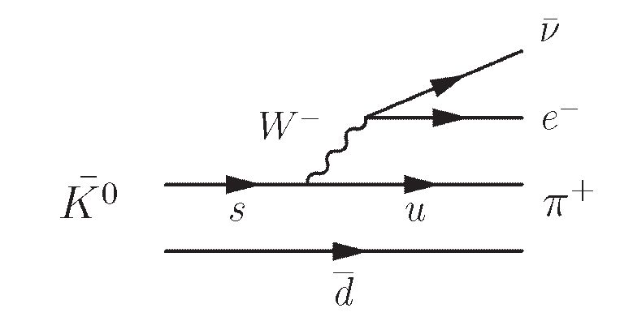
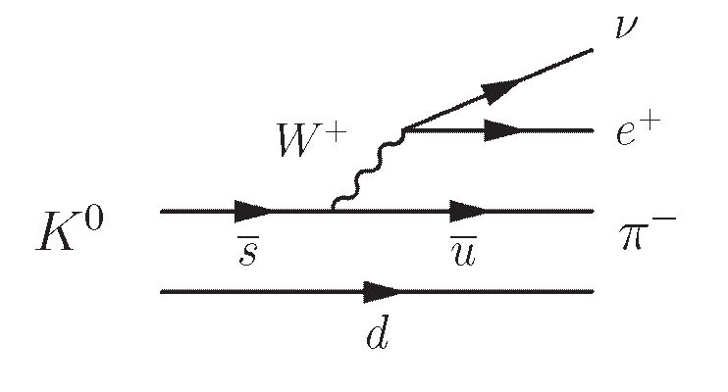
4th Symposium on Prospects in the Physics of Discrete Symmetries (DISCRETE2014) IOP Publishing
Journal of Physics: Conference Series 631 (2015) 012042 doi:10.1088/1742-6596/631/1/012042
where introduced small parameters eL and es can be rewritten to separate CP and CPT violation
parameters eK and óK, respectively:
es = €K + SK, (2)
eL — eK — $K.
In this paper a particular emphasis will be given to semileptonic decays of K-short and K-long
states (Ks/l ^ nev). According to Eq. 1, only the four possible decays of strange eigenstates
should be considered:
K° ^ n_e+v, K0 ^ n+e_x,
+ - + (3)
K0 ^ n+e x, K0 ^ n e+v.
However, in the Standard Model the decay of K0 (or K0) state is associated with the transition
of the s quark into U quark (or s into u) and emission of the charged boson. Change of
strangeness (AS) implies the corresponding change of electric charge (AQ) (see Figure 1). This
is so called AS — AQ rule. Therefore, decays of K0 ^ n_e+v and AT0 ^ n+e_x are present
but K0 ^ n+e_x and AT0 ^ n_e+v are forbidden by if AQ — AS.
Figure 1. Feynman diagrams for K0 and A'0 semileptonic decay.
Decay amplitudes for semileptonic decays of states |K0} and | A'0) can be written as follows [3]:
<n_e+v| Hweak |K0) — A+, <n+e_x| Hweak |K0} — A_, (^)
<n+e_x| Hweak |K0) — A-, <n_e+v| Hweak |kK0} — A+,
where the Hweak is the term of Hamiltonian corresponding to the weak interaction and
A+, A_, A-, A+ parametrize the semileptonic decay amplitudes.
It is useful to introduce the following notation:
A+ ( A_ X A*_ -A+
X — , X — , y — —,
A+ V A_ J A_ + A+ (5)
x±x* i rA+ , (a_yi ()
x± — 2 — 2 A+ VA_J .
For further considerations, rules for applying symmetry operators to amplitudes of two spin zero
systems A and B (and corresponding anti-systems A and B) could be summarized as:
<TB| THwk T_1 |TA) — «B| THwk T_1 |A})*
(CP B | CP Hwk CP _11 CP A) — <B | CP Hwk CP _11A} (6)
<CPTB|CPTHwkCPT_ |CPTA) — (<B^PTHwkCPT_1|A})*
One obtains the relation between the semileptonic amplitudes and conservation of a particular
symmetry by applying the presented above rules to the states presented in Eq. 4. These
considerations are summarized in Table 1.
2
4th Symposium on Prospects in the Physics of Discrete Symmetries (DISCRETE2014)
IOP Publishing
Journal of Physics: Conference Series 631 (2015) 012042 doi:10.1088/1742-6596/631/1/012042
Table 1. Relations between discrete symmetries and semiletponic amplitudes
Conserved quantity | Required relation
AS _ AQ rule  CPT symmetry  CP symmetry  T symmetry | x _ x _ 0  x _ X*, y _ 0  x _ X, y _ Im(y)  y _ Re(y)
  - Charge asymmetry
Charge asymmetry can be defined for semileptonic decays of Ks and Kl mesons in the
following way:
a _ r(Ks,L ^ n-e+v) - T(Ks,l ^ n+e-P)
S,L r(KS,L ^ n-e+v) + r(KS,L ^ n+e-v) ( )
and can be rewritten in terms of parameters introduced in Eq. 5:
As,l _ 2 [Re (ex) ± Re (5k) — Re(y) ± Re(x-)]. (8)
In that case, sum and difference of the AS and AL allow to search for the CPT symmetry
violation, either in the decay amplitudes through the parameter y or in the mass matrix through
the parameter 5k:
As + Al _ 4Re(e) — 4Re (y), (9)
AS — Al _ 4Re(5K) + 4Re (x-).
  - Experimental verification
The measurement based on 1.9 millions Kl ^ nev decays produced in collisions of proton beam
with a BeO target performed by KTeV Collaboration allowed to determine AL values [4]:
Al _ (3.322 ± 0.058stat ± 0.047syst) x 10-3. (10)
At present most accurate measurement of Ks charge asymmetry was conducted by KLOE
experiment. Measurement of As was performed with 0.41 fb-1 total luminosity data sample
and the result is [5]:
As _ (1.5 ± 9.6stat ± 2.9syst) x 10-3. (11)
Obtained charge asymmetry for Ks decays is consistent in error limits with charge asymmetry for
Kl decays. However, the inaccuracy of Ks determination is more than two orders of magnitude
bigger than this of the AL and the error of AS is dominated by a statistical uncertainty, which
is three times larger then systematical one. Therefore, in this work a new measurement of As
based on around four times bigger data sample collected by means of the KLOE detector in
2004 and 2005, is presented.

3. The K LOng Experiment at DATNE
KLOE was mounted at DATNE collider in 1999 and collected data during two campaigns in 2001-
2002 and 2004-2005. The gathered data sample corresponds to the total luminosity of 2.5 fb-1.
Energy of colliding beams (e- and e+) was set to the mass of 0 meson. DATNE collider produce
~ 1300 kaon pairs per second which corresponds to the luminosity 5 x 1032 cm-2s-1. In order
to obtain efficient detection of the Kl mesons the KLOE detector was constructed with a view
to properties of neutral kaon system. A schematic cross-section side view of the KLOE detector
is shown in Figure 2. The main components of KLOE are the cylindrical drift chamber and the
3
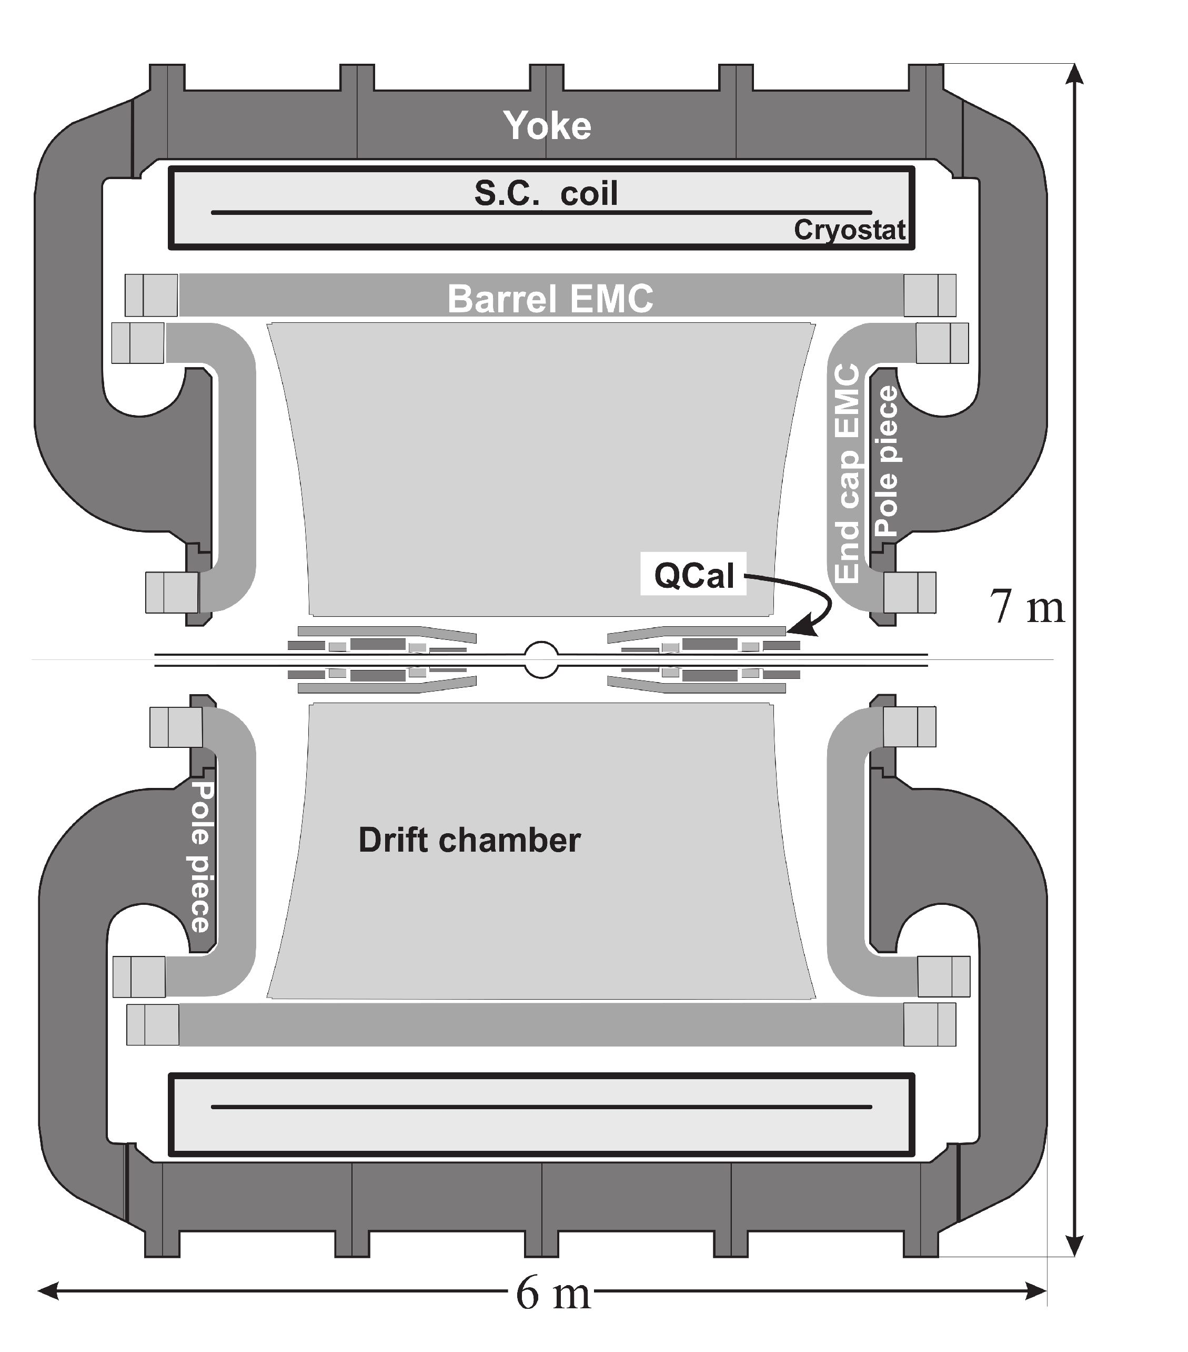
4th Symposium on Prospects in the Physics of Discrete Symmetries (DISCRETE2014) IOP Publishing
Journal of Physics: Conference Series 631 (2015) 012042 doi:10.1088/1742-6596/631/1/012042
Figure 2. Scheme of the KLOE detector system. Drift chamber in the central part of the
KLOE detector is surrounded by the electromagnetic calorimeter. Both detectors are inserted
in a magnetic field. Figure adapted from [6].
calorimeter, both surrounding the beam pipe. All elements are immersed in a 0.52 T magnetic
field created by superconducting coils that are placed along the beam axis.
The KLOE drift chamber (DC) is a 3.3 m long cylinder with an internal and external radii
of 25 cm and 2 m, respectively, which allows to register about 40% of KL decays inside the
chamber while the rest reach the electromagnetic calorimeter. Between the endplates around
12500 sense wires are streched and allows to obtain: a spatial resolution in the r, ^ plane better
than 200 ^m, a resolution along the z axis of ^ 2 mm and on the resolution of the decay
vertex determination of ^ 1 mm. Moreover, the curvature of the reconstructed tracks allows to
determine the particle momentum with a relative accuracy of 0.4 %. The drift chamber allows to
reconstruct information about charged particles while the calorimeter enables recording of both
charged and neutral particles. The KLOE calorimeter has been designed to have an excellent
accuracy of energy determination and time resolution:
in order to register the hits of neutral particles and provide a possibility of the Time of Flight
(TOF) measurement.
4
a(E) _ 5.4%
~ _ Zp (12)
54 ps
at _ — © 140 ps
* vEcevj p
4th Symposium on Prospects in the Physics of Discrete Symmetries (DISCRETE2014) IOP Publishing
Journal of Physics: Conference Series 631 (2015) 012042 doi:10.1088/1742-6596/631/1/012042
- Registration of the 0 ^ KlKs ^ K^nev processes at KLOE
Ą.I. Preselection
Due to the conservation of quantum numbers during decay of 0 meson the neutral kaons are
produced in pairs. In general case it is an entangled anti-symmetric state, which properties
allows to perform a fundamental tests of Quantum Mechanics and Lorentz symmetry [7]:
|0) = ^ +i!S|2>(1 +7^ <|K'l®> |Ks(-P)) - |Ks(P)) |KL(-p)>) (13)
v 2(1 - £S£L>
where p is a momentum in the 0 meson rest frame. However, when one of the kaon is detected
at time t >> ts, the state in Eq. 13 factorizes and the system behaves as if the initial state was a
mixture of |KL(p)> |KS(—p)> and |KS(p)> |KL(-p)>. Hence the detection of KL at large distance
from Interaction Point tags KS state in the opposite direction. Measurement described in this
paper is based on identification of Ks through the detection of Kl interaction in the calorimeter.
A sketch of typical signal event is shown in Figure 3(left). Selection of KL candidates takes into
account only clusters with high energy deposition and requires that the cluster is not close to
any track reconstructed in the drift chamber. Also, velocity of neutral particle that deposits
energy in this cluster must be close to the theoretical value of KL meson velocity in the 0 meson
rest frame (0 0.22).
In the next step, candidates for KS meson decays are selected by selection of two oppositely
charged particles with tracks forming a vertex close to the interaction point (IP):
pvtx < 15 cm, (14)
| Zvtx | < 10 cm,
where pvtx = y/x2tx + y2tx. Obtained distribution is shown in Figure 3(right). Then, the
rejection of main source of background (KS ^ n+n-) is conducted by applying the following
cuts:
- 70° < a < 175°
where a is an angle between charged secondaries in KS rest frame. Obtained a distribution
is shown at the left side of Figure 4. In case of three body decay (KS ^ nev) it is spanned
over a large angle range.
- 300 < Minv < 490 MeV
an invariant mass Minv is calculated using momenta of the particles which tracks form
a vertex assuming that both particle were pions. Obtained Minv distribution is shown at
the right side of Figure 4.
Both tracks reconstructed in the drift chamber must be associated with neighbouring clusters
in calorimeter in order to use Time-of-Flight technique.
- KS ^ nev events identification
The Time of Flight technique aims at rejection of the background, which at this stage of analysis
is due to KS ^ n+n- events, and at identification of the final charge states (n±eT). For each
particle, the difference St between the measured time of associated cluster (tc1) and expected
time of flight is calculated assuming a given mass hypothesis, mx:
dt(mx) = tc; —-,
C P(mx) ’ (15)

0(mx) = TPTSI'
5
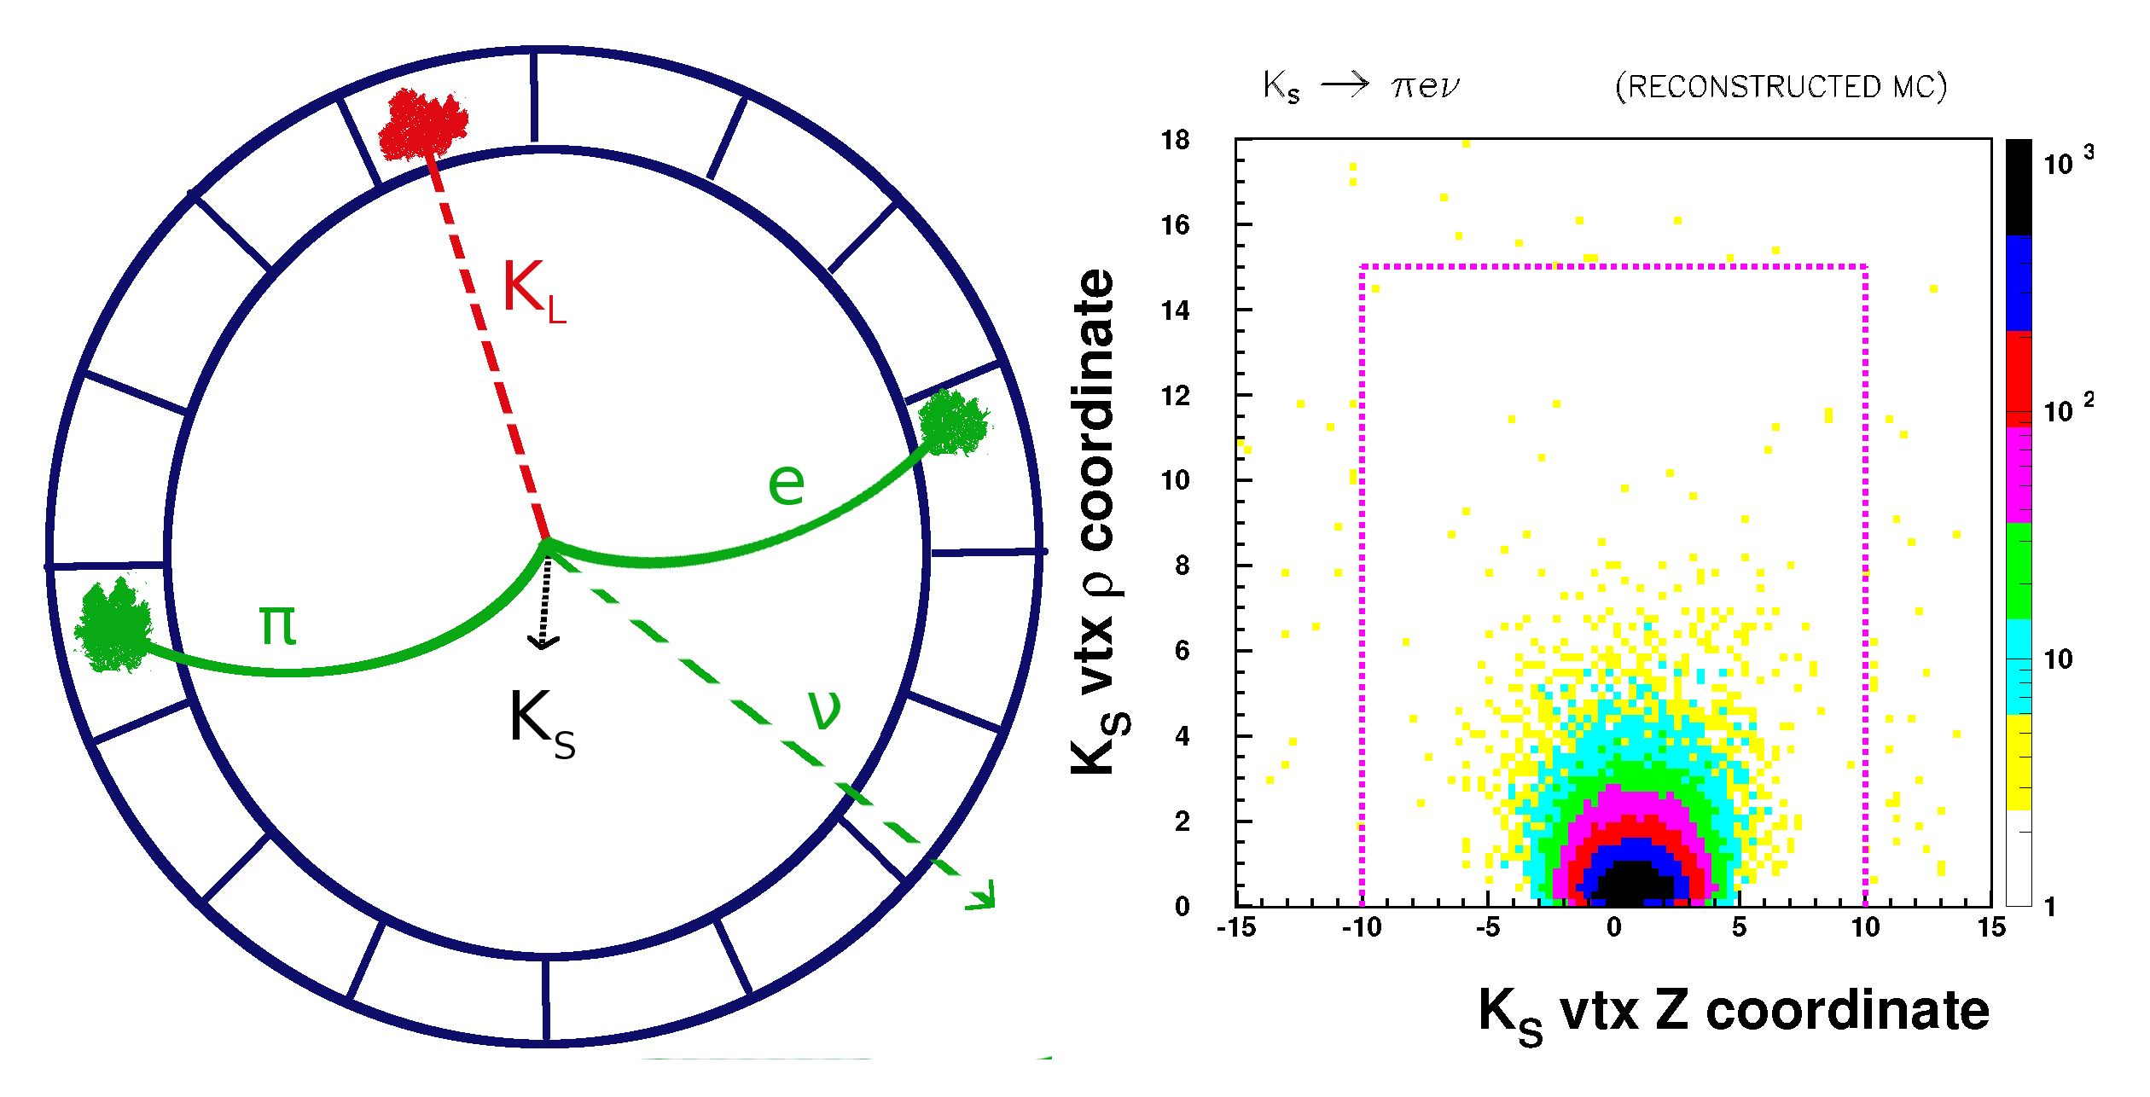
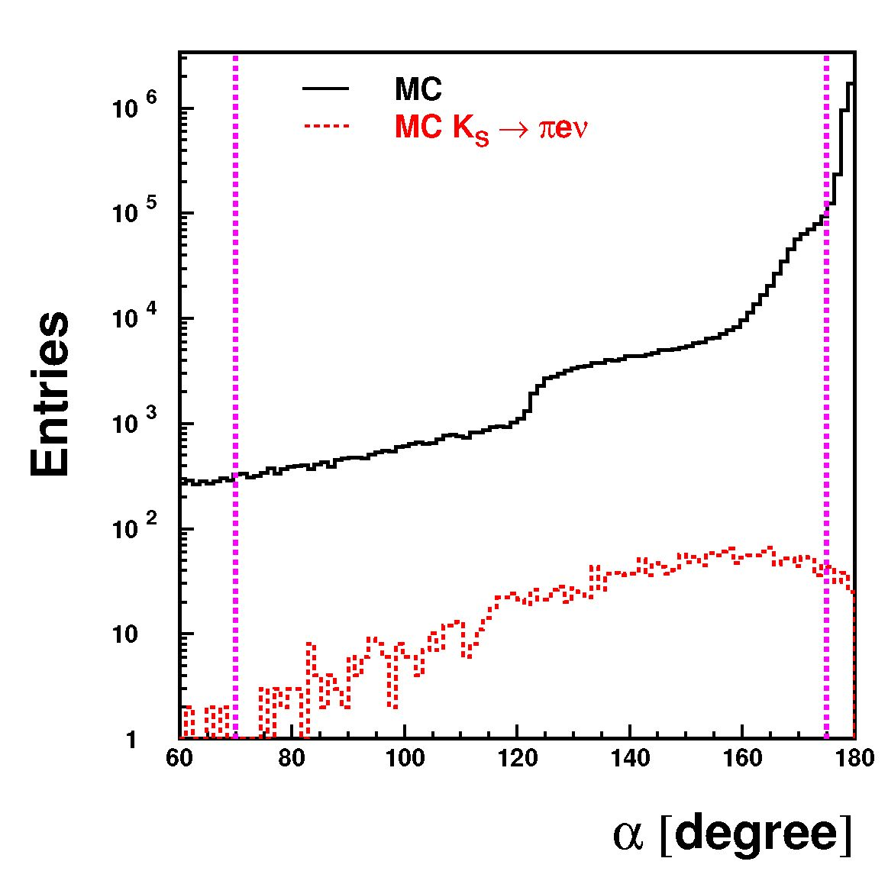
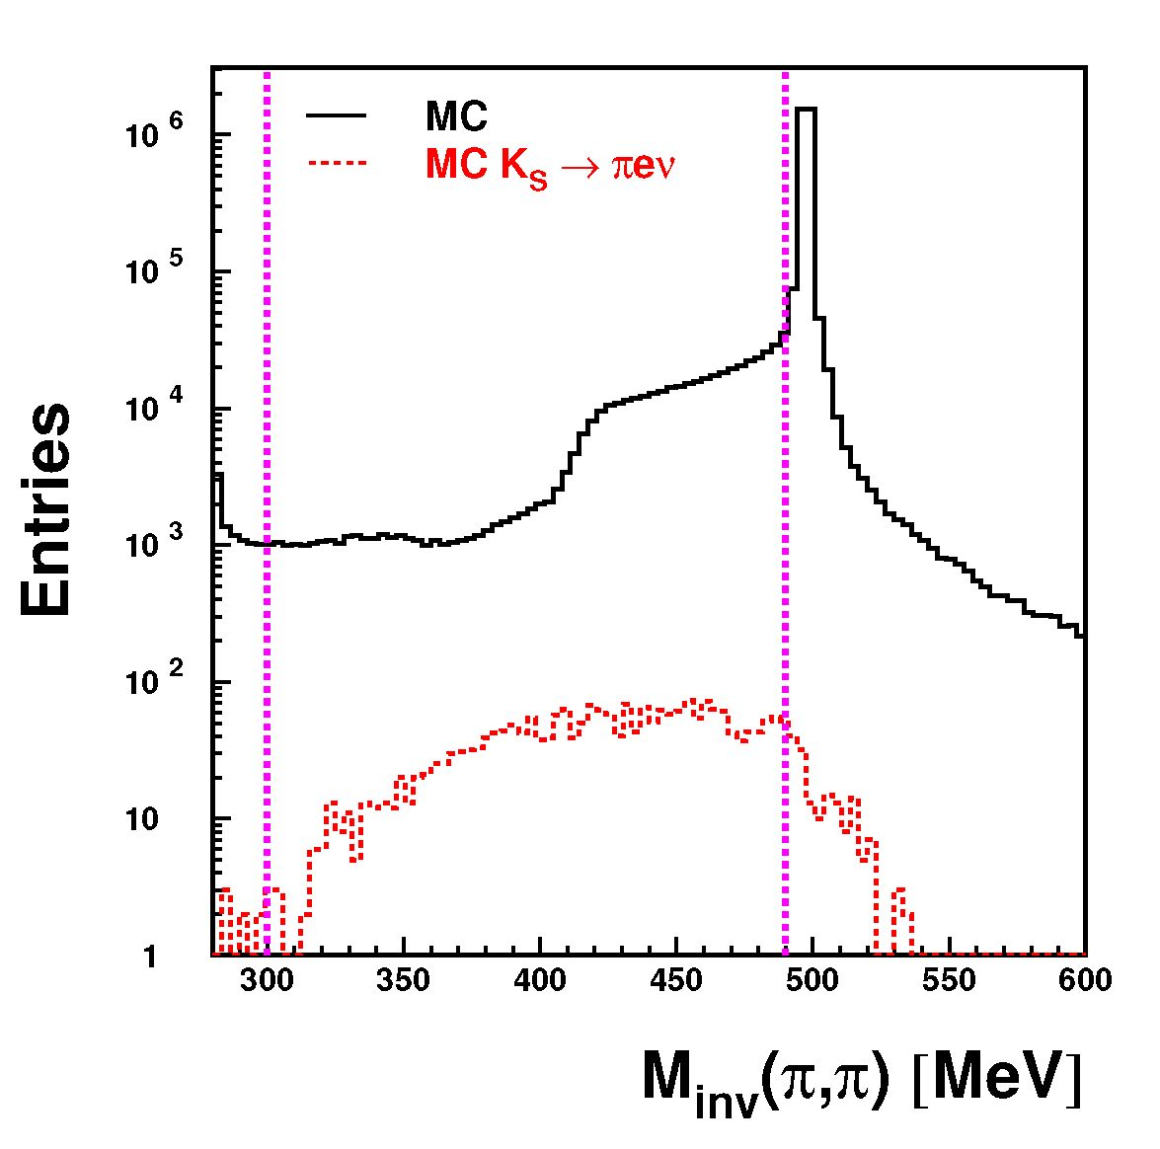
4th Symposium on Prospects in the Physics of Discrete Symmetries (DISCRETE2014) IOP Publishing
Journal of Physics: Conference Series 631 (2015) 012042 doi:10.1088/1742-6596/631/1/012042
Figure 3. Left: Transverse view of exemplary signal event. The Ks is identified using the
Kl interaction in the calorimeter. In the next step two oppositely charged particle tracks are
selected which form a vertex near the interaction point. Both tracks must be associated with the
colorimeter clusters. Right: Monte Carlo simulation of transversal and longitudinal coordinates
of vertex position for Ks ^ nev events. Dashed line represents applied cuts which preserves
^ 95% of the signal.
Figure 4. Left: Simulated distribution of angle between charged secondaries in Ks rest frame.
Right: Simulated distribution of invariant mass calculated under assumption that both registered
particles were pions. In both figures solid and dashed histograms represents all events and
semileptonic decays, respectively. Vertical dashed lines represent cuts described in text.
where L is a total length of particle trajectory and P is particle momentum. For further
consideration it is useful to introduce the difference of 5t (ma) and 5t (mb):
d5t,ab _ 5t(ma)i — 5t(m6)2. (16)
6
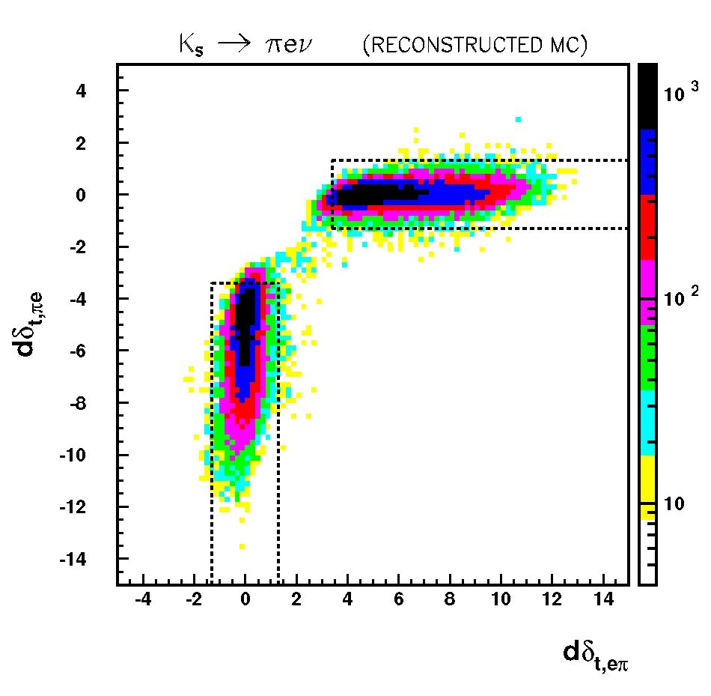
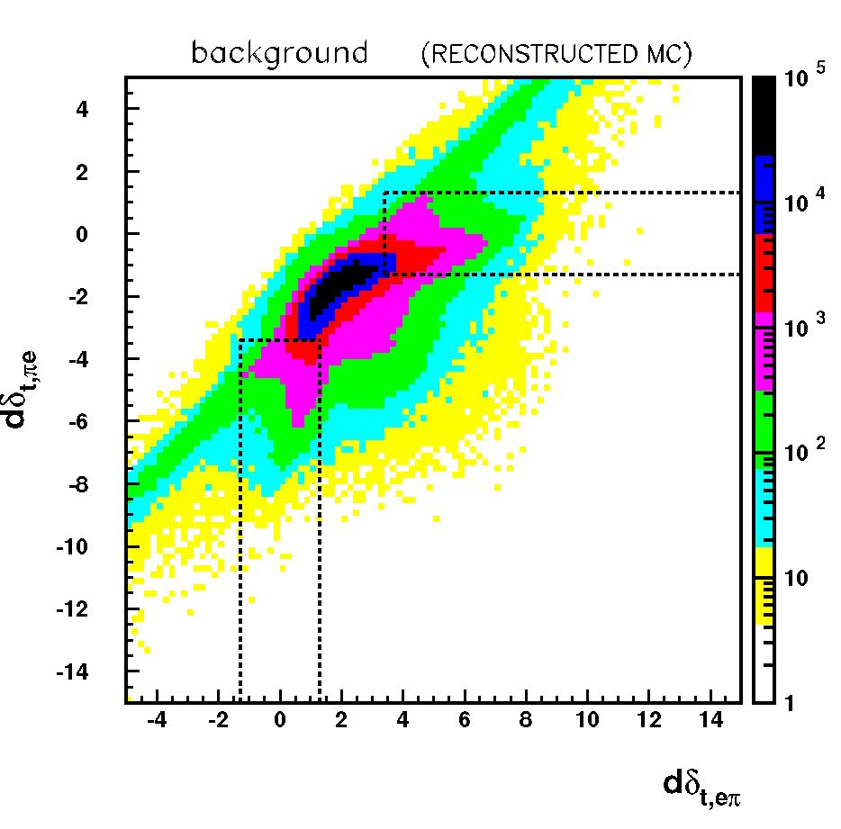
4th Symposium on Prospects in the Physics of Discrete Symmetries (DISCRETE2014) IOP Publishing
Journal of Physics: Conference Series 631 (2015) 012042 doi:10.1088/1742-6596/631/1/012042
Figure 5. Simulated distributions of time differences dót,ne vs dót,en defined in Eq. 18 for
KS ^ nev events (left) and background events (right), once the St,nn cut has been applied. The
regions delimits by the dashed lines are selected. In case of en (ne) the dót,en (dSt,ne) variable
acquires value close to zero.
where suffix 1 and 2 refers to the first and second particle according to the ordering determined
by the reconstruction procedure.
Two cuts are further applied. For the first cut, both particles are assumed to be pions and
d6t,nn is calculated. For KS ^ nn events this value is around zero and this fraction of events
could be rejected by requiring:
|d5t,nn I > 1.5 ns. (17)
Then, for surviving events, the pion-electron hypothesis is tested:
dót,ne = St(m-K)i - St(me)2. (18)
d5t,en = ^t(me)i - 5t(mn)2.
If a mass assumption is correct then one of the variables above should be close to zero. The
obtained Monte Carlo distributions for KS ^ n±eTv and background events are presented in
Figure 5. Hence, the following cut is applied:
Id5t,en I < 1.3 ns A d5t,ne < -3.4 ns
or (19)
d6t,en > 3.4 ns A |d£t,ne| < 1.3 ns
The above requirement ensures that the possibility of misidentification of charged particles from
signal events is equal to 10-4 only.
Obtained distributions for simulated data and experimental KLOE data are shown in Figure 6
(top). The Monte Carlo simulation indicates the signal position around the point (0,0) while
the background location is spread at the corners of the obtained distribution. Due to that
an additional TOF cut is applied by selecting events within the circle in the St(e) vs St(n)
7
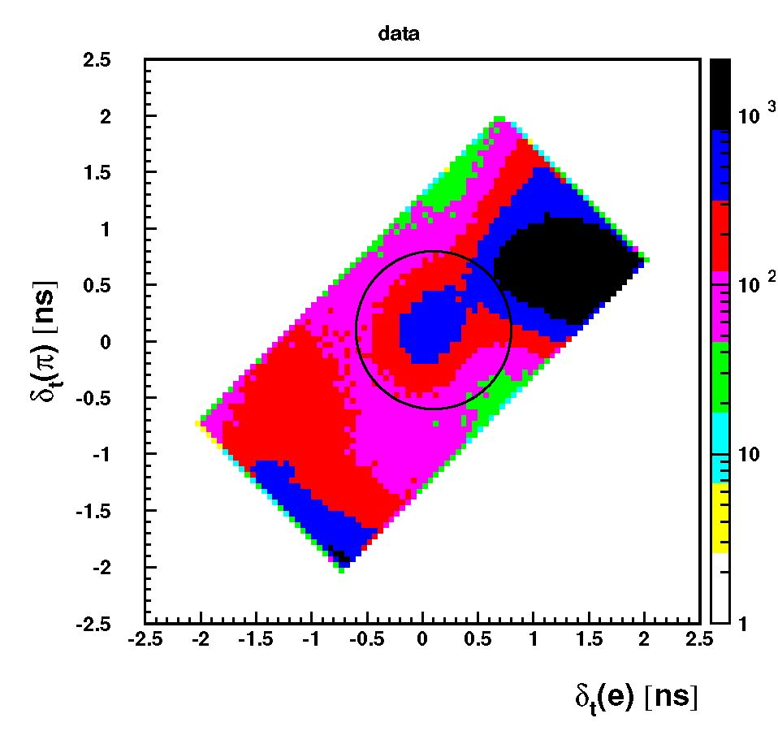
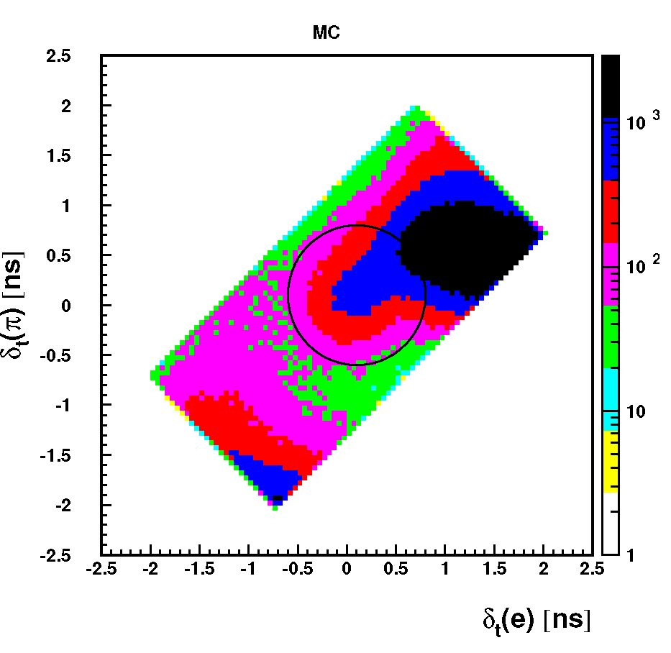
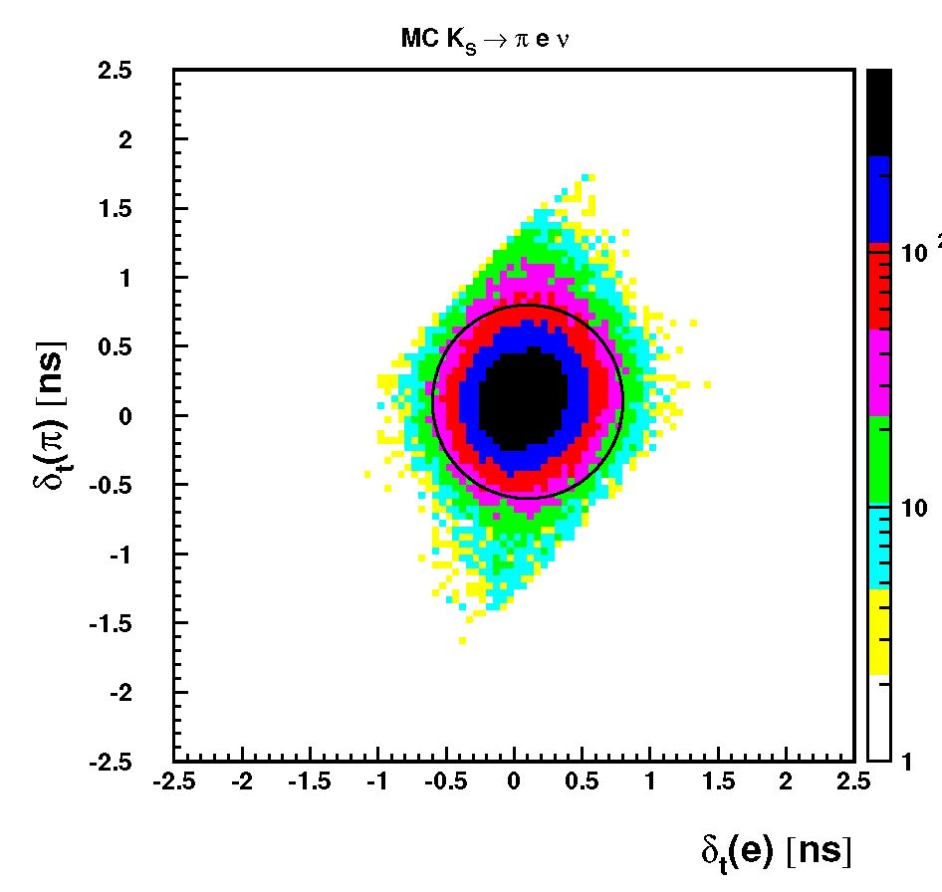
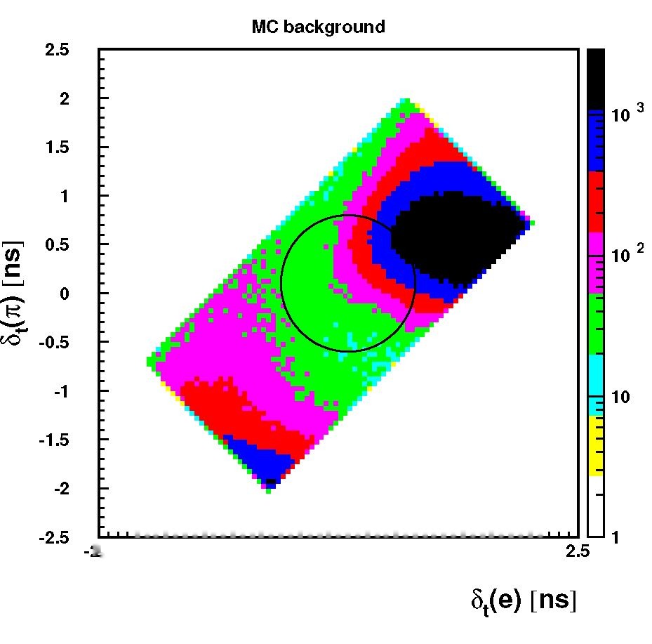
4th Symposium on Prospects in the Physics of Discrete Symmetries (DISCRETE2014) IOP Publishing
Journal of Physics: Conference Series 631 (2015) 012042 doi:10.1088/1742-6596/631/1/012042

>.5 -2 -1.5 -1 -0.5 0 0.5 1 1.5 2
Figure 6. Distributions of the time difference for pion mass hypothesis (%(n)) versus the time
difference for electron mass hypothesis (5t(e)) for experimental data (top-left), total MC events
(top-right), MC KS ^ nev events (bottom-left) and MC background events (bottom-right).
Events within the circle are retained for further analysis.
plane, as shown in Figure 6. This cut allows to preserve 94% of the remaining signal and
control the number of selected background events for normalization. The distribution of
the difference between the missing energy and momentum (AE(n,e)) shows the remaining
background components (see Figure 7). Based on an integrated luminosity of 1.7fb-1 around
105 of KS ^ nev decays were reconstructed and will be used to determine the charge asymmetry
and branching ratio for Ks semileptonic decays. A preliminary analysis shows a potential of
reaching a two times better statistical error determination with a sample four times bigger than
the previous KLOE analysis. The analysis is still in progress and preliminary results will be
available soon.
8
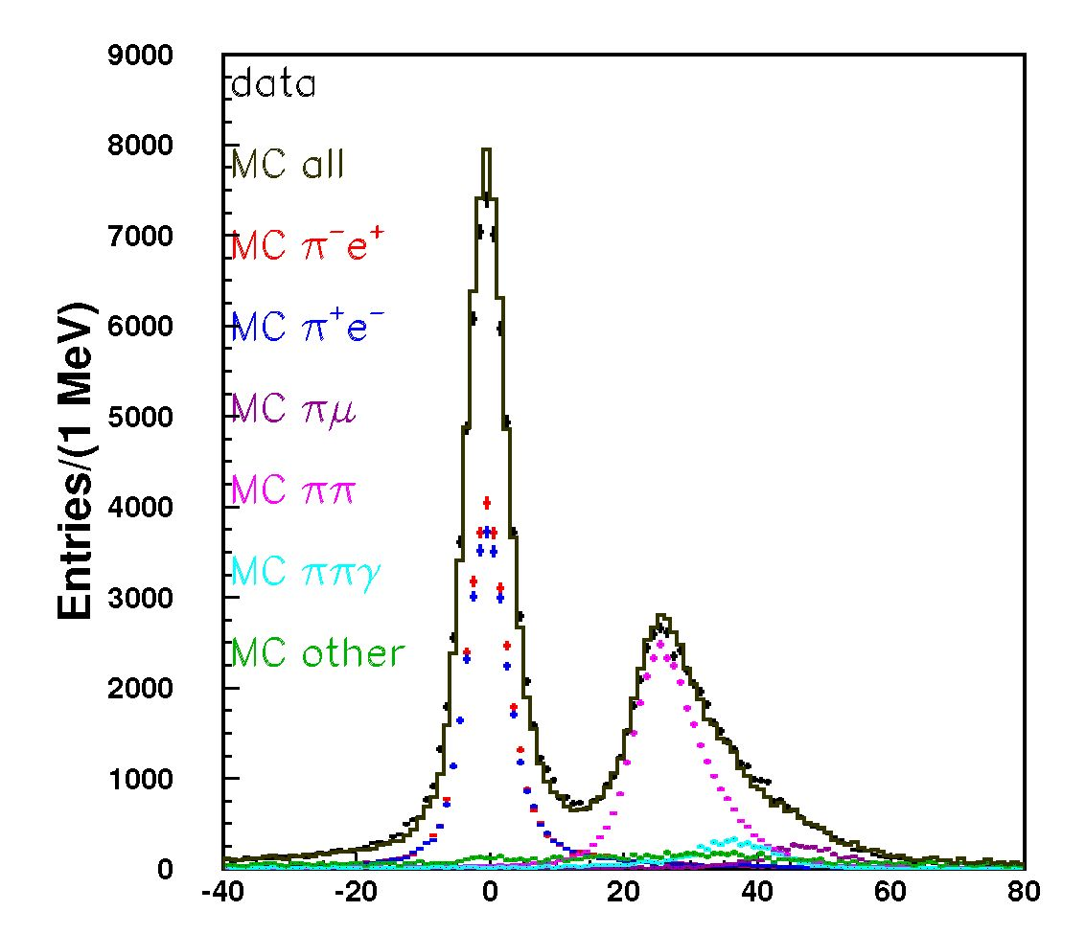
4th Symposium on Prospects in the Physics of Discrete Symmetries (DISCRETE2014) IOP Publishing
Journal of Physics: Conference Series 631 (2015) 012042 doi:10.1088/1742-6596/631/1/012042
AE(n,e)[MeV]
Figure 7. Distribution of AE(n, e) — Emiss — pmiss for all selected events after normalization
procedure.
- KLOE-2 Project
DATNE collider in previous years was adapted to increased delivered luminosity by installation
of the new interaction region based on the Crabbed Waist compensation together with large
Piwinski angle [10]. Those changes should increase by factor of three the amount of the delivered
luminosity with respect to the performance reached before. Together with the upgrade of the
KLOE detector this will allow to collect by KLOE-2 project the order of 10 fb_1 of integrated
luminosity. The detector itself was equipped with crystal (CCALT) [11] and tile (QCALT) [12]
calorimeters which covers the low polar angles and improve the detection of the photons that
are coming from Kl decays in the drift chamber, respectively. Also, there were mounted the
two pairs of small angle tagging devices that allows to detect the low (Low Energy Tagger [13])
and high (High Energy Tagger [14]) energy e+e_ originated from e+e_ ^ e+e_X reactions.
However, the especially important for studies of CPT symmetry violation through semileptonic
decays in neutral kaons is precise reconstruction of tracks momenta and vertex reconstruction
close to the Interaction Point. This will be provided by Inner Tracker detector made out in
a novel GEM technology [15]. Those upgrades will also improve the sensitivity of CPT and
Lorentz invariance tests, which were presented by the KLOE experiment and became the most
precise measurement of the CPT violating parameters Aa^ for neutral kaons in the Standard
Model Extension (SME) [16]. Measured values of Aa^ currently have a precision of 10_18 GeV
and are proportional to the parameter óK [17, 18, 19].
It should be emphasised that KLOE-2 aims to significantly improve the sensitivity of tests of
discrete symmetries, through studies of Ks charge asymmetry or quantum interferometry effects
in the kaon decays, beyond the presently achieved results.
9
4th Symposium on Prospects in the Physics of Discrete Symmetries (DISCRETE2014) IOP Publishing
Journal of Physics: Conference Series 631 (2015) 012042 doi:10.1088/1742-6596/631/1/012042
Acknowledgments
We warmly thank our former KLOE colleagues for the access to the data collected during
the KLOE data taking campaign. We thank the DA$NE team for their efforts in
maintaining low background running conditions and their collaboration during all data
taking. We want to thank our technical staff: G.F. Fortugno and F. Sborzacchi for their
dedication in ensuring efficient operation of the KLOE computing facilities; M. Anelli for
his continuous attention to the gas system and detector safety; A. Balla, M. Gatta, G.
Corradi and G. Papalino for electronics maintenance; M. Santoni, G. Paoluzzi and R.
Rosellini for general detector support; C. Piscitelli for his help during major maintenance
periods. This work was supported in part by the EU Integrated Infrastructure Initiative
Hadron Physics Project under contract number RII3-CT- 2004-506078; by the European
Commission under the 7th Framework Programme through the ‘Research Infrastructures’ action
of the ‘Capacities’ Programme, Call: FP7-INFRASTRUCTURES-2008-1, Grant Agreement
No. 227431; by the Polish National Science Centre through the Grants No. DEC-
2011/03/N/ST2/02641, 2011/01/D/ST2/00748, 2011/03/N/ST2/02652, 2013/08/M/ST2/0
0323, DEC-2014/12/S/ST2/00459, 2013/11/B/ST2/04245 and by the Foundation for Polish
Science through the MPD programme and the project HOMING PLUS BIS/2011-4/3.
References
- V. A. Kostelecky, N. Russell, Rev. Mod. Phys. 83 (2011), 11
- O. W. Greenberg, Phys. Rev. Lett. 89 (2002), 231602
- L. Maiani, G. Pancheri, N. Paver, INFN-LNF (1995)
- A. Alavi-Harati et al. (KTeV Collaboration), Phys. Rev. Lett. 88 (2002), 181601
- F. Ambrosino et al. (KLOE Collaboration), Phys. Lett. B636 (2006), 173
- G. Vignola, M. Bassetti, M. E. Biagini, C. Biscari, R. Boni, Conf. Proc. C960610 (1996), 22
- G. Amelino-Camelia et al., Eur. Phys. J. C68 (2010), 619
- Adinolfi, M. et al., (KLOE Collaboration), Nucl. Instrum. Meth. A461 (2001), 25
- Adinolfi, M. et al., (KLOE Collaboration), Nucl. Instrum. Meth. A482 (2002), 364
- Milardi, C. er al., (DA$NE Collaboration), CERN-2008-006 (2008), 1
- M. Cordelli et al., Nucl. Instrum. Meth. A718 (2013), 81
- A. Balla et al., Nucl. Instrum. Meth. A718 (2013), 95
- M. Adinolfi et al., (KLOE Collaboration), Nucl. Instrum. Meth. A617 (2010), 81
- M. Adinolfi et al., (KLOE Collaboration), Nucl. Instrum. Meth. A617 (2010), 266
- G. Morello et al., JINST 9 (2013), C01014
- D. Babusci et al., (KLOE Collaboration), Phys. Lett B730 (2014), 89
- D. Colladay and V. A. Kostelecky, Phys. Rev. D55, (1997) 6760
- D. Colladay and V. A. Kostelecky, Phys. Rev. D58, (1998) 116002
- V. A. Kostelecky and R. Potting, Phys. Rev. D51, (1995) 3923
10

