






International Journal of
MolecularSciences
Article
Melatonin and Its Metabolites Ameliorate
UVR-Induced Mitochondrial Oxidative Stress in Human MNT-1 Melanoma Cells
KonradKleszczyn´ski1,*,†,BernadettaBilska2,†,AgathaStegemann1,DamianJozefFlis3,WieslawZiolkowski3,Elz˙bietaPyza2,ThomasA.Luger1,RusselJ.Reiter4,MarkusBöhm1and AndrzejT.Slominski5,6,*
1
DepartmentofDermatology,UniversityofMünster,Von-Esmarch-Str.58,48149Münster,Germany;agathastegemann@gmail.com(A.S.);thomas.luger@ukmuenster.de(T.A.L.);
bohmm@uni-muenster.de(M.B.)
Department of Cell Biology and Imaging, Institute of Zoology and Biomedical Research, Jagiellonian University, Gronostajowa 9, 30-387 Kraków, Poland;bernadetta.bilska@doctoral.uj.edu.pl(B.B.);elzbieta.pyza@uj.edu.pl(E.P.)
DepartmentofBioenergeticsandNutrition,Gdan´skUniversityofPhysicalEducationandSport,
GórskiStr.1,80-336Gdan´sk,Poland;damian.flis@awf.gda.pl(D.J.F.);wieslaw.ziolkowski@awf.gda.pl(W.Z.)Department of Cellular and StructuralBiology,UT Health Science Center, San Antonio, TX 78229, USA;reiter@uthscsa.edu(R.J.R.)
Department of Dermatology, Comprehensive Cancer Center, University of Alabama at Birmingham, Birmingham, AL 35294, USA
Pathology and Laboratory Medicine Service, VA Medical Center, Birmingham, AL 35249, USACorrespondence:konrad.kleszczynski@ukmuenster.de(K.K.);aslominski@uabmc.edu(A.T.S.);
Tel.: +49-251-83-56523 (K.K.); +1-205-934-5245 (A.T.S.); Fax: +49-251-83-58646 (K.K.); +1-205-996-0302 (A.T.S.)
These authors contributed equally to this work.
2
3
4
5
6
*
†
check for
updates
Received: 10 October 2018; Accepted: 21 November 2018; Published: 28 November 2018
Abstract:Melatonin(Mel)isthemajorbiologicallyactivemoleculesecretedbythepinealgland.Mel and its metabolites, 6-hydroxymelatonin (6(OH)Mel) and 5-methoxytryptamine (5-MT), possess a variety of functions, including the scavenging of free radicals and the induction of protective or reparative mechanisms in the cell. Their amphiphilic character allows them to cross cellular membranes and reach subcellular organelles, including the mitochondria. Herein, the action of Mel, 6(OH)Mel, and 5-MT in humanMNT-1melanoma cells against ultraviolet B (UVB) radiation was investigated. The dose of 50 mJ/cm2caused a significant reduction of cell viability up to 48%, while investigated compounds counteracted this deleterious effect. UVB exposure increased catalase activity and led to a simultaneous Ca++influx (16%), while tested compounds prevented thesedisturbances.Additionalanalysisfocusedonmitochondrialrespirationperformedinisolated mitochondriafromtheliverofBALB/cJmicewhereMel,6(OH)Mel,and5-MTsignificantlyenhanced the oxidative phosphorylation at the dose of 10−6M with lower effects seen at 10−9or 10−4M. In conclusion, Mel, 6(OH)Mel and 5-MT protectMNT-1cells, which express melatonin receptors (MT1andMT2)againstUVB-inducedoxidativestressandmitochondrialdysfunction,includingthe uncoupling of oxidativephosphorylation.
Keywords:metabolitesofmelatonin; melanoma cells; mitochondria; catalase; oxidative phosphorylation; calcium homeostasis; ultraviolet radiation
Int.J.Mol.Sci.2018,19,3786;doi:10.3390/ijms19123786
www.mdpi.com/journal/ijms

Int. J. Mol. Sci.2018,19, 3786
2 of 19
1. Introduction
Melatonin (N-acetyl-5-methoxytryptamine) is a ubiquitous physiological mediator that is found throughout the evolutionary scale of animals and is also in plants and unicellular organisms [1–5]. In mammals, it is characterized as a natural neurohormone synthesized in the pineal gland, which is involved in the regulation of circadian rhythms [4]. In addition, many other tissues and cells, including bone marrow [6], lymphocytes [7], retina [8], astrocytes [9], thymus [10], skin [11–13], and female reproductive organs (granulosa cells, cumulus cells, and oocytes) [14], can synthesize melatonin. There is also evidence that melatonin is present in follicular fluid [15], and that it can be synthesized by oocytes [16,17].Chemically,melatonin can function as an endogenous free radical scavenger and a broad spectrum antioxidant, and it can easily reach all cellular compartments because of its well-described amphiphilic nature [18–20]. Indeed, melatonin is ubiquitously localized in the cytosolic, membranous, mitochondrial, and nuclear compartments of the cell [21,22]. Interestingly, the highest melatonin concentrations are found in mitochondria [23], raising the possibility of the functional significance for this targeting with involvement in mitochondrial activities. For instance, most apoptotic signals originate in the mitochondria, and melatonin has well-known anti-apoptotic [24–26], anti-inflammatory [27] and prodifferentiation effects [28–30]. Mitochondria are also the organelles with the highest production rate of reactive oxygen/nitrogen species (ROS/RNS), which are attenuated by melatonin [31] through stimulation of the activity of anti-oxidative enzymes such as catalase(CAT),glutathione peroxidase (GPx), superoxide dismutase (SOD) [32], heme oxygenase-1 (HO-1),γ-glutamylcysteine synthetase (γ-GCS), and NADPH:quinone dehydrogenase-1 (NQO-1), which were induced via activation of nuclear erythroid 2-related factor (Nrf2) [26,33]. UVB itself affects Nrf2 and suppresses Nrf2-dependent gene expression in human skin [34]. It is recognized that mitochondria are the main target of the environmental stress factors, one of them represented by ultraviolet radiation (UVR). Exposure of the skin to UVB induces direct DNA damage [35] such as cyclobutane pyrimidine dimers (CPD) and pyrimidine photoproducts (6-4-PPs) [36–39] with the additional production of reactive oxygen species (ROS) induced byUVA[40,41]. Collectively, these changes have detrimental effects that include carcinogenesis, cell senescence, and other skin pathologies [42]. Many melatonin actions are mediated through its interaction with membrane bound type 1 and 2 (MT1 and MT2) receptors or through receptor-independent mechanisms [30,43]. However, the metabolites of melatonin can also function as antioxidants [26,33,44], and according to some authors as pro-oxidants[45].
Since melatonin interacts with lipid bilayers, herein on one hand, we investigated the action of melatonin and its selected metabolites under UVR-induced stress conditions. On the other hand, we tested the effect of compounds themselves on the bioenergetics of native isolated mitochondria evaluatingtheirrespiratorycapacitytounderstanda“realface”ofmelatonin’scapabilitytostabilize mitochondrialhomeostasis.
2. Results
2.1. Melatonin and Its Metabolites Mitigate UVB-Induced Cell Death
UVB induces serious intracellular disturbances such as DNA damage and the production of ROS, leading to cell mortality or carcinogenesis.Firstly,we assessed the effect of UVB on the viability ofMNT-1cells, and noticed a decrease in cell viability of approximately 52% (p< 0.001) comparedtothesham-irradiatedcontrols,whilemelatoninaswellasitsmetabolitesthemselvesdid notaffectthesurvivalrateofMNT-1cells,evenatthehighesttestedconcentration(10−3M)(Figure1, insert). Subsequently, the dose-dependent (10−11–10−3M) analysis was performed for melatonin (Mel)(Figure1A),6-hydroxymelatonin(6(OH)Mel)(Figure1CE)underultravioletB(UVB)exposure. Pre-incubationwithallthreeagentsprotectedUVB-irradiatedcellsatthephysiologicrangeofdayand nightplasmalevels,i.e. aconcentrationof10−11Mby8%(p<0.05;Mel),24%(p<0.001;6(OH)Mel), and 19% (p< 0.001; 5-MT) or by 6% (p< 0.05; Mel), 13% (p< 0.01; 6(OH)Mel), and 13% (p<0.05;
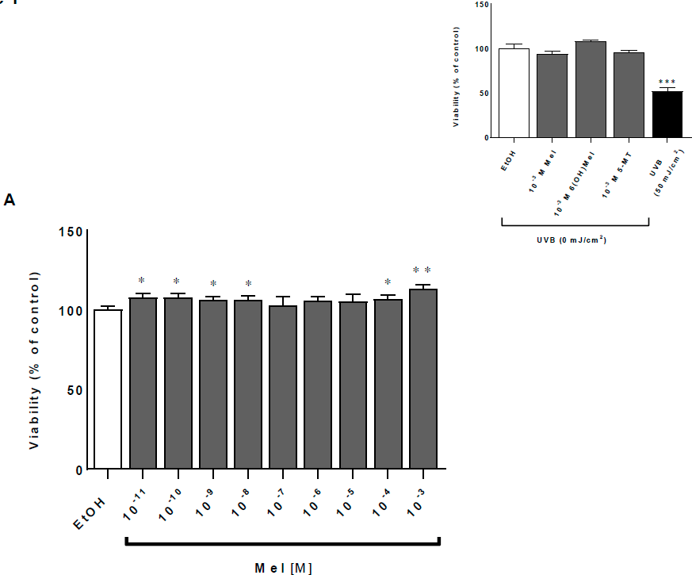
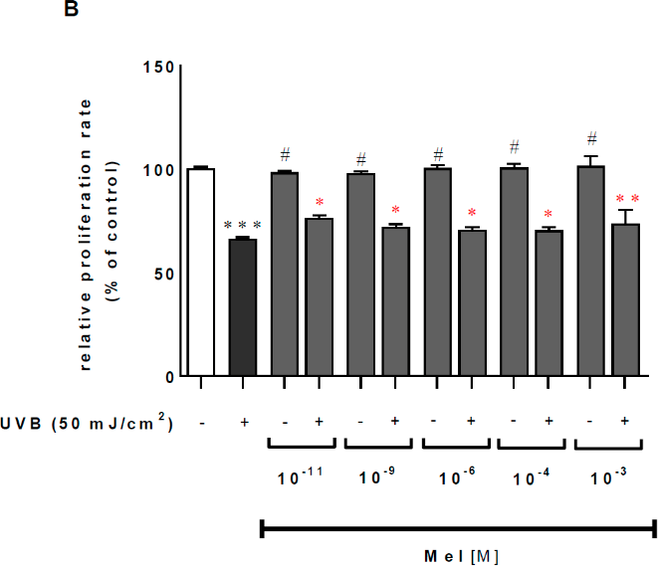
Int. J. Mol. Sci.2018,19, 3786
3 of 19
5-MT)for10−9M.Middle-rangedoses(10−8–10−6M)stillrevealedtheprotectiveactionofthetested compounds; however, significant differences were moderate or none (10−6M) in all of the cases.Finally,thepharmacologicaldoses(10−4or10−3M)amelioratedadecreaseincellviabilitycompared totheUVR-treatedcellsby13%(p<0.01;Mel),12%(p<0.01;6(OH)Mel),and9%(p<0.05;5-MT)for 10−3M. These data were also supported by crystal violet assessment, where UVB caused a dramatic dropofMNT-1proliferationratioby34%(p<0.001)comparedtothecontrolcells,andpre-incubation withMel(Figure1B),6(OH)Mel(Figure1D),or5-MT(Figure1F)significantlycounteractedthiseffect.
Figure 1.Cont.
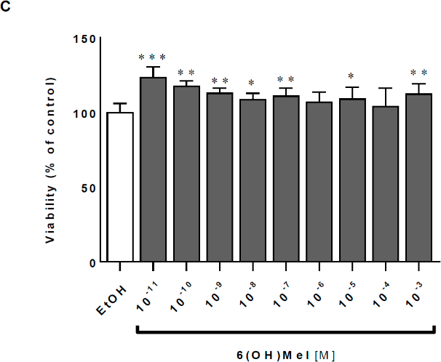
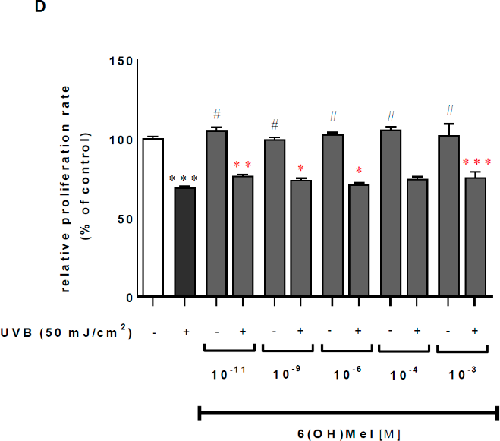
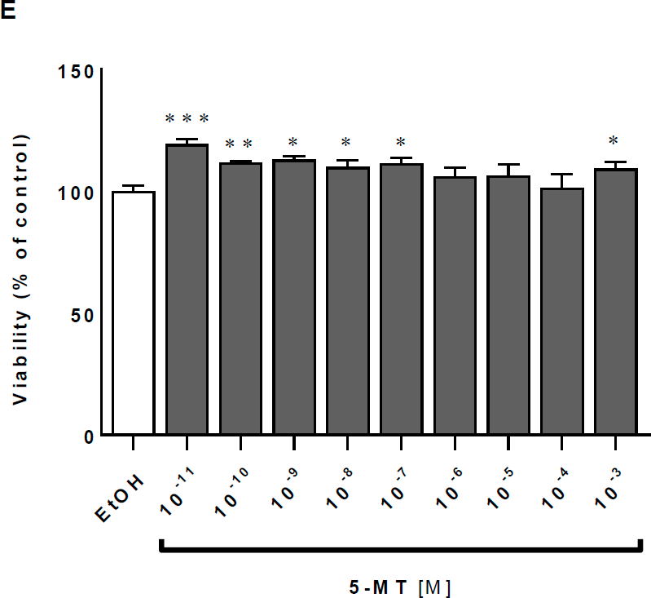
Int. J. Mol. Sci.2018,19, 3786
4 of 19
Figure 1.Cont.
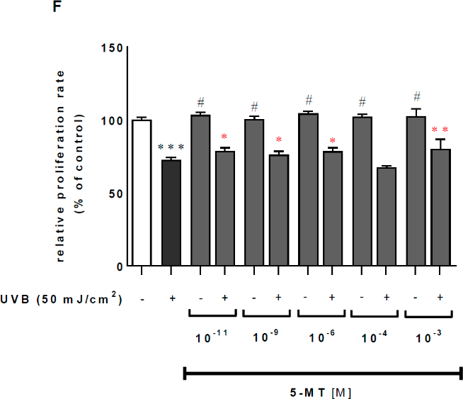
Int. J. Mol. Sci.2018,19, 3786
5 of 19
Figure 1.Ultraviolet radiation (UVR)-mediated reduction of viability is attenuated by melatonin, 6-hydroxymelatonin (6(OH)Mel), and 5-methoxytryptamine (5-MT) in MNT-1 melanoma cells. Ultraviolet B (UVB)-irradiated (50 mJ/cm2) and non-irradiated cells (presented as inserts) were treated with graded concentrations of melatonin and its selected metabolites for 1 h prior to UVR. Viabilitywasdetermined48hpost-UVRbyMTTassay(A,C,E)andcrystalvioletassessment(B,D,F),
as described in the Section4. Values were expressed as a percentage of the UVR-irradiated (50 mJ/cm2)
or sham-irradiated sample (insert). Statistically significant differences versus control were indicated as *p< 0.05, **p< 0.01, ***p< 0.001; with (#p< 0.001) indicating a significant difference between sham-irradiated cell and UVR-exposed samples at particular concentrations. Red labeling indicates the effectofpresenceoftestedcompoundscomparedtoUV-treatedcells.
2.2.MelatoninandItsMetabolitesProtectMNT-1CellsfromUVB-InducedOxidativeStressandDisturbancesin CalciumHomeostasis
Cellsexposedto50mJ/cm2UVBshowedatwofoldincrease(p<0.001)ofcatalaseactivity(CAT)activity compared to sham-irradiated samples (Figure2; insert). Additionally, comparativeanalysis of melatonin actions revealed the strongest enhancing effect at a concentration of 10−3M Mel by 28%(p<0.001)comparedtothecontrol.Atlowerconcentrations,thisimpactwaslesspronounced, e.g., 11% (10−4M), 13% (10−6M) (p< 0.01), and 9% (10−9M; not significant). The presence of metabolites of melatonin enhanced significantlyCATactivity by 11% (10−9M;p< 0.01) or by 9% (10−3M;p<0.01)for6(OH)Meland5-MT,respectively(Figure2).UVBirradiationinducedamassive calcium influx with 16% (p< 0.001) more calcium inside the cell compared to the non-irradiated cells (Figure3; insert). Pre-incubation for 1 h with melatonin or its metabolites counteracted these effects modestly by 8% (10−9M Mel;p< 0.01); 6% (10−9M 6(OH)Mel;p< 0.05), and 4% (10−9M5-MT;notsignificant).Thehighestconcentration(10−3M)ofthecompoundshowedasimilarpattern of regulation arresting calcium influx by 6%, 5%, and by 8%, respectively, for melatonin (p< 0.05), 6(OH)Mel, and 5-MT (p< 0.05) (Figure3).
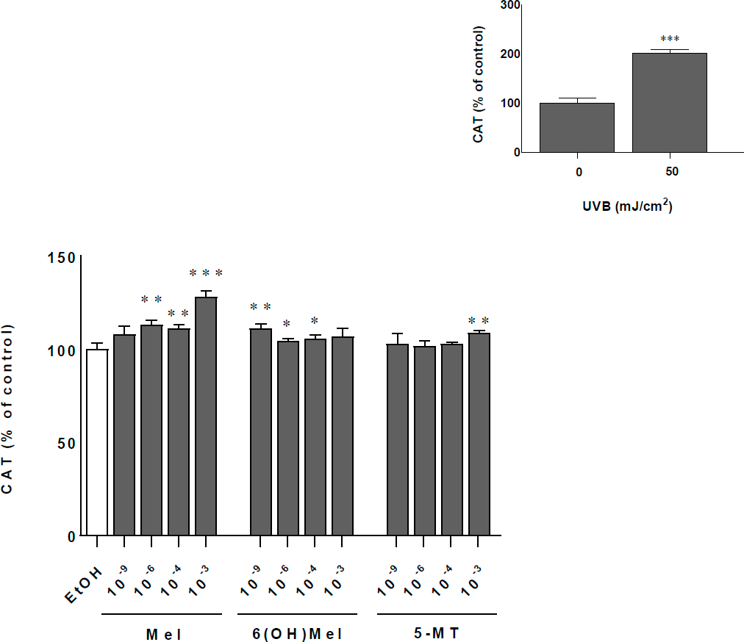
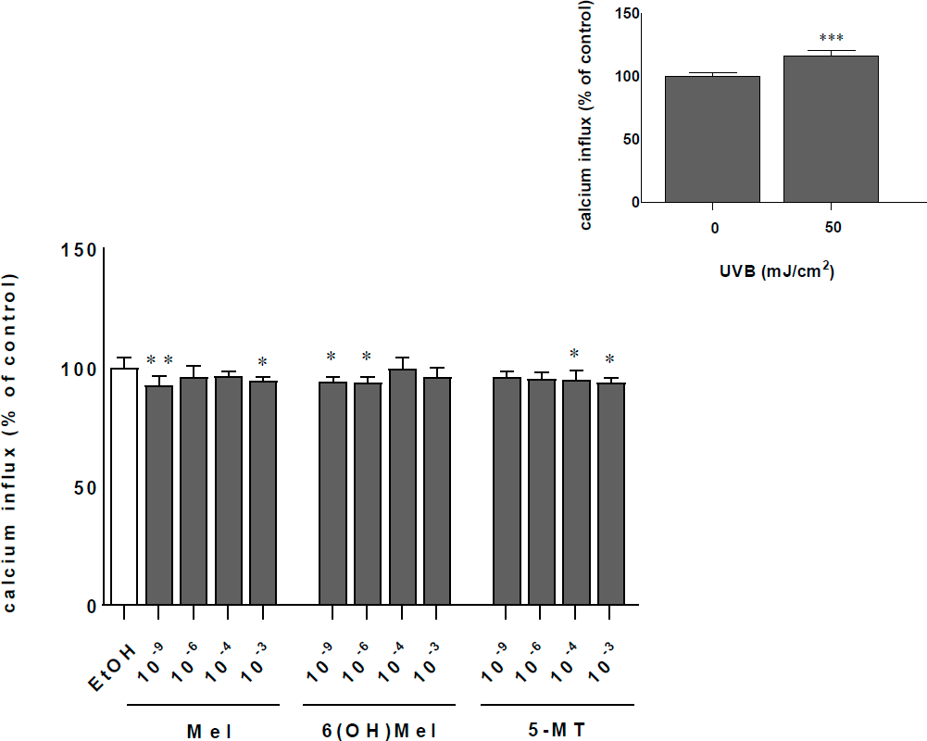
Int. J. Mol. Sci.2018,19, 3786
6 of 19
Figure 2.Melatonin, 6(OH)Mel, and 5-MT affect catalase activity (CAT) under UVR-induced stress
condition in MNT-1 cells. Ultraviolet B (UVB)-irradiated (50 mJ/cm2) cells were pre-treated with gradedconcentrationsofmelatoninanditsselectedmetabolitesfor1hpriortoUVR.CATactivitywas determined48hpost-UVRbythecolorimetricassayasdescribedintheSection4.Valueswereexpressed
as percentage of the UVR-irradiated (50 mJ/cm2) or sham-irradiated sample (insert). Statistically
significant differences were indicated as *p< 0.05, **p< 0.01, ***p< 0.001.
Figure 3.UVR-mediated disturbances in Ca++homeostasis are attenuated by melatonin, 6(OH)Mel, or 5-MT in MNT-1 cells. UVB-irradiated (50 mJ/cm2) were pre-treated with graded concentrations of melatonin and its selected metabolites for 1 h prior to UVR. Calcium influx was determined 48h post-UVR by the colorimetricassay,as it was described in the Section4.Valueswere normalized andexpressedasapercentageoftheUVR-irradiated(50mJ/cm2)orsham-irradiatedsample(insert). Statisticallysignificantdifferenceswereindicatedas*p<0.05,**p<0.01,***p<0.001.
Int. J. Mol. Sci.2018,19, 3786
7 of 19
2.3. Melatonin and Its Metabolites Maintain Mitochondrial Function
Since melatonin penetrates very easily through cellular membranes reaching numerous intracellular organelles, we assessed the influence of melatonin and its selected metabolites on mitochondrial function (Figure4;Table1). These analysis identified Mel, 6(OH)Mel, and 5-MT as the compounds enhancing markedly (p< 0.01) oxidative phosphorylation at the dose of 10−6M with subtle (not significant) differences at 10−9or 10−4M. Surprisingly, the highest dose of 10−3M for all tested substances decreased prominently the OXPHOS coupling efficiency (p< 0.001 orp< 0.01). Evaluation of the mitochondrial metabolic states(Table1) showed that in “native” conditions (without stress), lower concentrations (10−9or 10−6M) of Mel, 6(OH)Mel, and 5-MT are more optimal than the pharmacological ones for maintenance of the mitochondrial homeostasis.MNT-1cells express enzymes that play key roles in the synthesis of melatonin, including tryptophan-5-hydroxylase (TPH), and hydroxyindole-O-methyl transferase (HIOMT), and show the presence of MT1 and MT2 (Figure5). This is consistent with previous reports on the capability of human melanoma cells to produce and metabolize melatonin [46] and the expression of TPH1 in human melanoma skin biopsies [47] and rodent melanomas[48,49].
Table 1.
Effect of melatonin and its metabolites on the bioenergetics of mitochondria.
Non-phosphorylating LEAK respiration (state NL), OXPHOS capacity (state NP), integrity of the outer mitochondrial membrane: (state NC), and NADH and succinate (NS)-linked OXPHOS capacity (stateNSP)weremeasuredinlivermitochondriaincubatedwithoutorinpresenceofmelatonin(Mel),
6(OH)Mel,or5-MT.Resultsarepresentedasthemean±SEM.Statisticallysignificantdifferences
compared to mitochondria without tested compounds (control) were presented as follows: *p< 0.05, **
p< 0.01, ***p< 0.001.
10−9M
10−6M
10−4M
10−3M
EtOH (control)
State NL
Melatonin
6-OH-melatonin5-MT
12.87±0.84*
12.76±1.25 *
14.60±0.94
18.13±1.03
14.95±0.50
15.31±0.70
14.40±0.54
16.45±0.65
18.97±0.97
12.80±0.39**
11.97±0.32**
16.91±0.48
24.25±0.88**
State NP
Melatonin
6-OH-melatonin5-MT
64.90±2.34*
74.19±2.85
73.84±3.50
64.56±3.16*
79.04±2.34
91.75±1.02*
88.82±2.75*
76.72±2.55
50.27±1.79**
62.16±2.52**
74.67±0.81
81.61±2.14
75.62±1.72
State NC(% of corresponding state NP)
Melatonin
6-OH-melatonin5-MT
123.80±1.15
116.30±0.73
119.10±1.83
112.80±1.27
121.10±2.01
118.30±0.74
125.20±2.44
150.60±1.61 ***
203.60±15.11**
124.80±1.68
115.20±4.27
119.60±0.93
116.00±0.93
State NSP
248.90±8.65*
262.00±8.30
267.30±12.61
266.10±9.90
Melatonin
6-OH-melatonin5-MT
300.00±9.64
327.10±3.51*
328.00±3.95**
368.90±5.22 ***
311.60±9.66
260.00±9.53
280.60±3.97
313.30±1.30
295.90±3.41

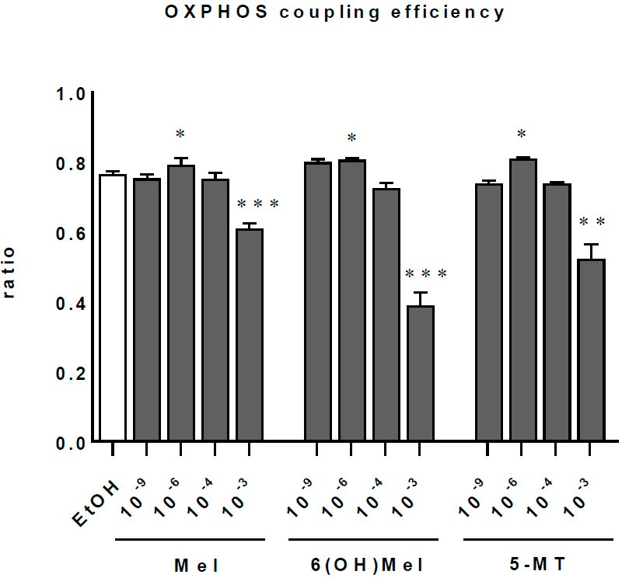
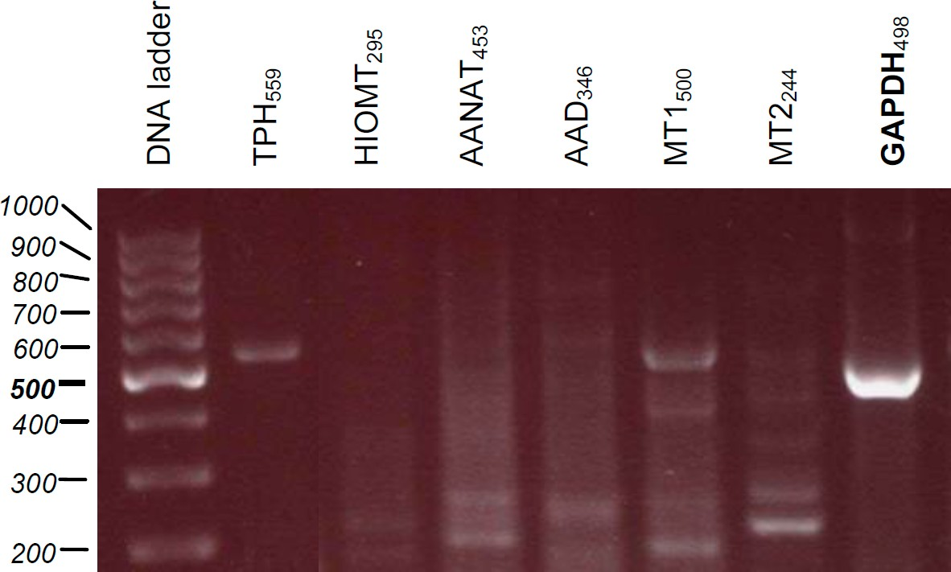
Int. J. Mol. Sci.2018,19, 3786
8 of 19
Figure 4.Effect of melatonin and its selected metabolites on bioenergetics. Parallel analysis of mitochondrial coupling efficiency (OXPHOS coupling efficiency) measured in liver mitochondria incubated without (control) or in presence of Mel, 6(OH)Mel,5-MT.Results are presented as the means+SEM.Statisticallysignificantdifferencescomparedtomitochondriawithouttestedcompounds (control) are as follows: *p< 0.05, **p< 0.01, ***p<0.001.
Figure5.Evaluationofexpressionofenzymesregulatingcutaneousmelatoninbiosyntheticpathway (tryptophan-5-hydroxylase (TPH1) and hydroxyindole-O-methyl transferase (HIOMT)) as well as melatonin membrane receptors (MT1 and MT2) in parallel to housekeeping gene glyceraldehyde phosphate dehydrogenase (GAPDH) in intact MNT-1 cells using specific primers(Table2).
3. Discussion
Cutaneous cells are under the constant influence of multiple environmental stressors[50],includingUVR,whichisthemainsourceofgenerationofreactiveoxygen/nitrogenspecies(ROS/RNS),leadingtodeleteriousoxidativeskindamage[40,42,51]thatincludescellsenescence,photoaging,carcinogenesis,orinflammation.Thus,searchingforthesundamage-preventingnaturalcompoundsthatcancounteractUVB-inducedincreaseinlevelsofROS/RNSisstronglydesired.Oneofsuch compoundsismelatonin,whichpossessesenhancingcapacitiesregardingskinprotectionagainstUVR[29,32,52].Itiscommonlyknownasafreeradicalscavenger[53,54];itdetoxifiesNO[55],H₂O₂,O₂−[56,57],andOH[58].Todate,studieshaveshownthepotentialbeneficialeffectsofmelatonin inthetreatmentofmanychronicdiseases,whileitexhibitsloworabsenttoxicity[59].Additionally,it exhibits Nrf2-mediated protective effects in animal models [23] or cutaneous cells [27,33]. Apart fromitssignificantanti-oxidativeproperties,melatoninalsopreservesmitochondrialfunctionindifferentinvitroandinvivomodels[23,60–62].Previousreports[63,64]claimthatmelatoninshouldbe
Int. J. Mol. Sci.2018,19, 3786
9 of 19
consideredasacriticalmodulatorofmitochondrialintegrityandphysiologyinskincells[26],andthis function can be also assigned to its metabolites [65]. This assumption has been substantiated inseveral mitochondrial-related disorders such as murine models of Parkinson’s disease [66–68], and thedirectactionofmelatoninandmetabolitesonmitochondrialhomeostasis[69,70].Thisexperimental evidenceidentifiesmitochondriaasalikelysiteofmelatoninsynthesis[71],placingthiscompoundasa strategicmoleculeduringtheevolutionofaerobiceukaryotes[72].Ourdataconfirmedthatmelatonin and its selected metabolites can protect cells from UVB-mediated oxidative stress by enhancing the activityofcatalase,decreasingCa++influx,andmaintainingmitochondrialfunction.Itshouldbestill noted that melatonin, 6(OH)Mel, or5-MT,particularly at pharmacological doses (10−3M), seem to affect mitochondrial function in the absence of any exogenous stressors (Figure4). Interestingly, these concentrations were found to be the most protective under UVB treatment. Thus, we assume that in normal conditions at higher concentrations (10−3/10−4M), the mitochondrial fission couldoccur,but this hypothesis remains to be clarified. On the other hand, we propose that melatonin may act as a sort of “standby molecule” or “cellular guardian” whose anti-oxidative capacities are activated in case of cell stress. Indeed, it was reported in rat heart mitochondria that melatonin inhibits stress-induced mitochondrial permeability transition pore (mPTP) opening and release of cytochrome c [73,74]. It is also known that treatment with melatonin at a pharmacological dose (10−3M) affects mitochondrial function [75,76], which is consistent with our results performed on isolatedmitochondria.Moreover,Odinokovaetal.[77]showedthatmelatonindrasticallydecreases the expression of complex I subunit, which is accompanied by the suppression of ROS production and the inhibition of mPTP opening. As we noticed here, the mechanism of action of melatonin is complexed,andGprotein-coupledmelatonintype1andtype2receptors(MT1andMT2)aswellas key enzymes (TPH1 and HIOMT) for its synthesis are expressed inMNT-1cells. According to the earlierdetections,melatoninreceptorshavebeenreportedinmelanocytes(normalandmalignant),keratinocytes(normal),ordermalfibroblasts[30,78–81].TheexpressionofbothMT1andMT2receptorsinMNT-1melanomacellssuggeststhattheymightbeinvolvedinaregulationofcalciumhomeostasis in this cell line under stress conditions. However, it is well described that calmodulin is another melatonin-binding protein, which may be physiologically relevant to affinity after Ca++binding and interaction with calmodulin-controlled enzymes, including calmodulin kinase II (CaMKII) and calcineurin(Cn),whichregulateintracellularcalciumhomeostasis[11,82].Theseobservationsmay partiallyexplaintheroleofmelatoninanditsmetabolitesintheendoplasmicreticulumstressresponse, as well as the regulation of apoptosis,autophagy,and mitochondrial function [83]. In addition, Martinetal.[62]observedthatmelatoninarrestedrutheniumred(RR)-mediatedoxidativestressand mitochondrialuncouplingwhereRRisamoleculethatinhibitsthemitochondrialCa++uniporter.Also, our previous experiments [28,84] showed that melatonin in the skin is rapidly metabolized and/or degraded through both indolic and kynuric pathways. The indolic pathway produces 6(OH)Mel as the main product and 5-MT as a minor one, and these two metabolites of melatonin are produced in skin cells [28]; similar effects are also observed in thekidney.Thus, the predominant pathway of melatoninmetabolisminallofthemainskincellpopulations(humannormalepidermalkeratinocytes andmelanocytes,humannormaldermalfibroblasts)andmalignantmelanomacellsissimilartothat described at the systemic level, in which 6(OH)Mel is the main degradation product[65].
Asmentionedabove,mitochondriaareoneofthemaintargetorganellesformelatoninandplay
thekeyroleindiseaseinitiationand/orprogression.Althoughrestoringmitochondrialfunctionand redoxbalance/signalingisnotastraightforwardprocess,mitochondriacanconvertexternalstimuli intoalterationsinantioxidantdefensemechanismsandenergeticdemands,makingcellsresistantto stress. This phenomenon is known as mitohormesis, and is detrimental for restoringmitochondrial function and control/regulation in non-physiological mtROS production. Since melatonin and its metabolites over the years have been described as effective anti-inflammatory, anti-oxidative and anti-apoptotic agents, also under UVR conditions (Figure6), the development of novel mitochondria-targetedmulti-functionalantioxidantsbasedonmelatoninareofgreatinterestinskin
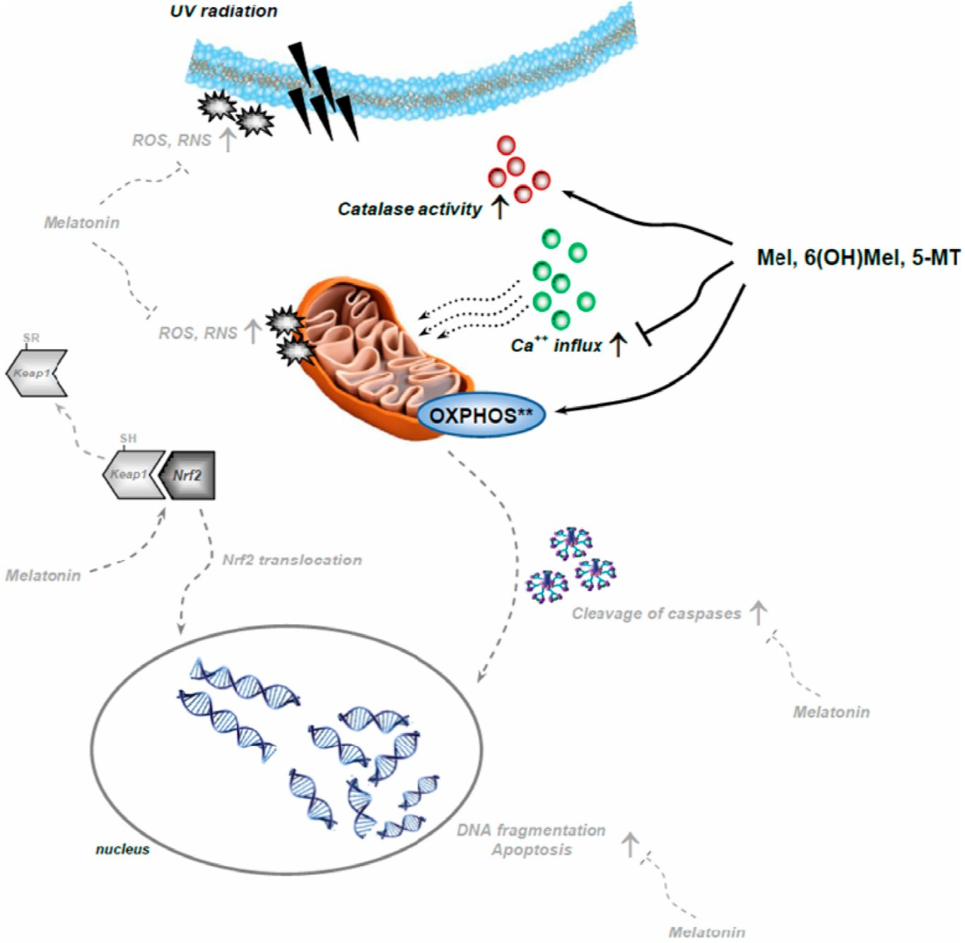
Int. J. Mol. Sci.2018,19, 3786
10 of19
biologyandphysiology[11,26].Thesecompoundsmaintainingmitochondrialhomeostasisbydirect scavenging mtROS can increase cell resistance to stress and viability; therefore, it should be taken under consideration as possible future drugs to improve mitochondrial health in primary and/or secondary mitochondrial-relateddiseases.
Figure 6.Schematic diagram of the complex mechanisms of inductive (arrows) and inhibiting (T line) action of melatonin counteracting UVR-induced intracellular alterations based on earlierreports [25,27,28,32,33,44] (labeled in grey and dashed lines) with modification based on the presenteddata (labeled in black). ** - experiments conducted in isolated mitochondria (without UV exposure). UVR,reportedasoneofthemaindeleteriousenvironmentalskinstressors,isprominentlycounteracted and/or modulated by melatonin in the context of a complex intracutaneous melatoninergic anti-oxidative system with UVR-enhanced or UVR-independent melatonin metabolites [29,52]. Therefore, endogenous intracutaneous melatonin production, together with topically applied exogenousmelatoninormetaboliteswouldbeexpectedtorepresentanti-oxidativedefensesystems against the UVB-induced skin damages [13,52]. Insummary,a key question is whether melatonin maintaining mitochondrial homeostasis can be exploited therapeutically as a protective agent, as a general “skin survival factor” or as a “defender” of the genome and cellular integrity with clinical applications in UVR-induced pathology, including carcinogenesis and skinaging.
4. Materials and Methods
4.1. Reagents
Dulbecco’s modified Eagle’s medium (DMEM) with high glucose (4500 mg/L), 1% penicillin-streptomycin solution (10,000 units of penicillin and 10 mg of streptomycinin
1 mL 0.9% NaCl), EGTA, ethanol, HEPES (1 M), isopropanol, KH₂PO₄, mannitol, MgCl₂·6H₂O, MTT,
non-essential amino acids (NEAA) (100×),L-glutamic acid,L-malic acid, potassium lactobionate,
sodium pyruvate, sodium pyruvate solution (100 mM), succinic acid, and taurine were purchased
Int. J. Mol. Sci.2018,19, 3786
11 of19
fromSigma(St.Louis,MO,USA).Fetalbovineserum,0.05%trypsin/0.53mMEDTAsolution,1×PBS
(pH7.4),L-glutamine(200mM)weresuppliedbyThermoFisherScientific(Waltham,MA,USA).
4.2. Cell Culture
MNT-1humanmelanoticcellswereacquiredasagiftfromDr.CédricDelevoye(InstituteCurie, Paris, France). Cells were maintained inT-75orT-175flasks in DMEM medium supplemented with20%(v/v)heat-inactivatedfetalbovineserum,2mMofL-glutamine,10mMofHEPES,1mM ofsodiumpyruvate,1%(v/v)NEAA,and1%(v/v)streptomycin-penicillinsolutionat37◦Cina humidifiedatmosphereof5%CO₂inair.Cellsinthelogarithmicgrowthphasewereusedinalloftheexperiments, while 80–90% monolayers of confluentMNT-1cells were harvested with a mixture of0.05% trypsin–EDTAsolution.
4.3. Pre-incubation with Melatonin, Its Metabolites, and UV Irradiation
Priortothestartoftheexperimentaltreatments,cellswereculturedinnormalmediumfor24h in order to attach to the bottom of the culture dish. Thereafter, culture medium was replaced with mediumcontainingMel,6(OH)Mel,5-MT,orsolvent(control)(Sigma).Compoundsweredissolvedin
absolute ethanol and further diluted with phosphate-buffered saline (1×PBS, pH 7.4) to yield 10−2M
stock solution, then diluted 1:10 with culture medium to yield a final wide concentration range of powers of 10 from 10−3to 10−11M for cell culture pre-incubation. Melatonin-free, 6(OH)Mel-free, or 5-MT-free medium served as controls. After 1 h pre-incubation with test compounds, cells were
washed twice with 1×PBS to remove remnants of medium, and fresh 1×PBS was added prior to
UVRexposure.IrradiationwasperformedusinganirradiationbankconsistingofsixUVbulbs(TL12, Philips, The Netherlands) that emit most of their energy within the UVB range (280–320 nm) with an emission peak of 313 nm. UVB doses of 0 and 50 mJ/cm2were used, and UVR-treated cells were examined 48 h post-UVR. Sham-irradiated samples (0 mJ/cm2) were prepared using a culture dish coveredwithaluminumfoilandwereconsideredasthecontrolvalue.AfterUVRexposure,cellswere cultured and then subjected to the particularmeasurements.
4.4. MTT Viability Assay
Testedcellswereseededon96-wellplatesatthedensityof0.15×105cells/wellintheculture
medium, and thereafter grown to subconfluence (as judged from light microscopy). Following the
pre-incubation with tested compounds, cells were UV-irradiated in presence of 100µL of pre-warmed
1×PBS, and then cultured until the desired time end-point. Cell viability was evaluated by MTT assay
based on the protocol described earlier by Carmichael et al. [85]. MTT (5 mg/mL) was dissolved in
1×PBS,sterilizedbyfiltrationthrougha0.22-µMMillipore®filterandstoredat4◦C.Aftertreatment
as described above, cells were washed twice with 1×PBS; then, 100µL of MTT solution in culture
medium (the final dilution, 1:10) was added to each well. The cells were subsequentlyincubated for 3 h at 37◦Cto allow MTT metabolism. The formazan produced was dissolved in 100µL of isopropanol/0.04NHCl,andabsorbancewasmeasuredat595nmusingaBioTekELx808™microplate
reader (BioTek Instruments, Inc., Winooski, VT, USA).
4.5. Crystal Violet Assessment
The proliferation of MNT-1 cells was assessed using ready-to-use crystal violet (CV) solution
(CellBiolabs,Inc.,SanDiego,CA,USA).Cellswereseededonsix-wellplates(0.4–0.5×106cells/cm2)
and experiments were performed when cultures reached 70–80% confluence. At the desired times,
cells were washed twice with 1×PBS, stained with 0.1% CV solution in 10% ethanol for 1 min,
and remnants were washed again with 1×PBS. Plates were photographed and the quantification of
cellswasperformedusingImageJ1.51fsoftware(NationalInstituteofHealth,Bethesda,MD,USA).
Int. J. Mol. Sci.2018,19, 3786
12 of19
4.6. Catalase Activity Assay
Evaluation of catalase (CAT) activity was conducted by colorimetric assays (BioVision Research Products, Inc., Mountain View, CA, USA). Briefly, cells were seeded on six-well plates at the density and cultured until reached confluency as described in point 4.5. At the desired times, cells were lysed with
catalaseassaybufferandthencentrifugedfor15minat10,000×gat4◦C.Resultantsupernatantwas
proceededforcatalasereactionwithonemMofH₂O₂for30minat25◦C,andarrestedsubsequently with a stop solution. Catalase activity was determined by incubation at room temperature (RT) for 15 min with a develop mix containing catalase assaybuffer,OxiRed™ Probe, and HRP solution. Theabsorbanceoftestedsampleswasmeasuredat595nmusingaBioTekELx808™microplatereader(BioTekInstruments, Inc., Winooski,VT,USA).
4.7. Calcium Assay
Intracellular calcium homeostasis was assessed by colorimetric assay supplied by BioVision ResearchProducts,Inc.Afterreachingdesiredconfluency,cellswerelysedandcentrifugedforfivemin
at16,000×gat4◦C.Theresultantsupernatantwasmixedwiththechromogenicreagent,calciumassay
buffer,and then incubated atRTfor 15 min protecting from light. The absorbance of tested samples wasmeasuredat595nmusingaBioTekELx808™microplatereader(BioTekInstruments,Inc.)
4.8. Animals and Isolation of Liver Mitochondria
All of the experimental procedures were performed in accordance with the principles of the Europeananimalresearchlaws(EuropeanCommunitiesCouncilDirective2010/63/EU).Wild-type femaleBALB/cJmice(n=8;weight:20–25g)werekeptinanenvironmentallycontrolledroom
(23±1◦Cwitha12-hlight-darkcycle)receivingstandardmicechowandwateradlibitum.Themice
wereeuthanizedbycervicaldislocation.Thelivermitochondriawereisolated,aspreviouslydescribed by Broekemeier et al. [86] with slight modification [87]. The liver was rapidly removed, weighed, and placed in ice-cold mitochondrial buffer A (230 mM of mannitol, 70 mM of sucrose, three mM of HEPES, 0.1 mM ofEGTA;pH 7.4), and subsequently rinsed three times with buffer A. The liver was mincedwithscissorsandhomogenizedusingaTeflonpestlehomogenizerinbufferA(20mL/1gof
liver). The homogenate was centrifuged at 800×gfor 10 min; then, the supernatant was decanted
andcentrifugedat4000×gfor10min.Thepelletwasresuspendedin30mLofsuspensionbufferB
(230 mM of mannitol, 70 mM of sucrose, 3 mM of HEPES), and centrifuged again at 7000×gfor 10 min.
This step was repeated twice. The final mitochondrial pellet was resuspended in 0.5 mL of buffer B. All of the steps were performed at 4◦C.Totalprotein concentration (20 to 30 mg of mitochondrial proteinpermL)wasdeterminedwiththeBradfordreagent(Bio-RadLaboratories,Inc.,Hercules,CA, USA)[88].
4.9. High-Resolution Respirometry
Respiration was measured at 37 under constant stirring (750 rpm), which ensured a homogenous oxygen distribution in the medium in a high-resolution respirometer using an Oxygraph-2k(O2k,OroborosInstruments,Innsbruck,Austria),amodularsystemforhigh-resolution
◦C
respirometry (HRR) according to Volani et al. [89]. Oxygen concentration (µM) and oxygen flux
per mass(pmolO₂ s−1·mg−1)wererecordedinreal-time,whileobtaineddatawereevaluated
usingDatLabsoftware(OroborosInstruments,Innsbruck,Austria).Briefly,mitochondrialrespiration wasmeasuredinMiR05(mitochondrialrespirationmediumcontaining0.5mMofEGTA,3mMof
MgCl₂·6H₂O, 60 mM of potassium lactobionate, 20 mM of taurine, 10 mM of KH₂PO₄, 20 mM of
HEPES,110mMofsucrose,and1g/LofBSAfattyacid-free(pH7.1)(MiR05;OroborosInstruments, Innsbruck, Austria). Freshly isolated liver mitochondria (0.1 mg of mitochondrial protein per each 2-mLchamber)usedforrespirationmeasurementwerefirstincubatedfor5mininthemediumwithout
(control)orinpresenceofMel,6(OH)Mel,or5-MT.
Int. J. Mol. Sci.2018,19, 3786
13 of19
For the assessment of mitochondrial respiration, the following protocol was used:
(1)
Non-phosphorylating LEAK respiration was assessed by injecting 10 mM of sodium pyruvate, 10 mM ofL-glutamic acid (neutralized with KOH) and 2 mM ofL-malic acid (neutralized with KOH) as NADH (N)-linked substrates: state NL;
OXPHOScapacitywasinducedbyadding1.25mMofADPatsaturatingconcentration:stateNP; 10µM of cytochrome c was added to test the integrity of the outer mitochondrial membrane: stateNC;
NADH and succinate (NS)-linked OXPHOS capacity was measured by adding 10 mM of succinic acid (neutralized with KOH): stateNSP.
(2)
(3)
(4)
4.10. Mitochondrial Quality and Control
The OXPHOS coupling efficiency was calculated as measures of mitochondrial quality and control. OXPHOS couplingefficiency,calculated with the formula (1)—(state NL)/(state NP), reflects the coupling of respiration supported by electron transferring flavoprotein (ETF) with pyruvate, glutamate, and malate as substrates before (state NL) and after the addition of ADP (state NP). The OXPHOS coupling efficiency (OCE) can be compared with the respiratory control ratio (RCR). The formula ofOCEcould be rewrittenas:
(
\
1
RCR
OCE= 1−
(1)
TheOCEis noted between 0 and 1, while theRCRcould be from 0 to infinite. A lower value ofOCEmeans lesser coupling of the oxidation and phosphorylation after the addition of ADP. As theOCEdecreases, it is therefore less coupled [90].
4.11. RNA Isolation, cDNA Synthesis, and PCR
RNAfromMNT-1cellpellet(5×106cells)wasextractedaccordinglytothemanufacturer’s
instructions using the innuPREP RNA Mini Kit (Analytik Jena, Berlin, Germany). The amount of
RNA was determined using BioPhotometer (Eppendorf, Hamburg, Germany). cDNA synthesis was conducted using RevertAid™ First Strand cDNA Synthesis Kit (Thermo Fisher Scientific, Waltham, MA, USA) in the presence of oligo(dT) primers as follows: 65◦C for 5 min, 42◦C for 60 min, 70◦C for
5mininThermomixer(Eppendorf),andtheresultantcDNAwasstoredat−20◦CpriortoPCRreaction.
ReactionswerecarriedoutbyGoTaq®PCRMasterMix(PromegaGmbH,Mannheim,Germany)in thepresenceofsequencesofprimers(Table2).Amplificationwasperformedusing10minofinitial denaturationat95◦Cfollowedbythree-step39-cyclingof60sat95◦C(denaturation),60sat60◦C(annealing),and60sat72◦C(extension).PCRproductswereseparatedon1.8%agarosegelcontainingRedSafe™ Nucleic Acid Staining solution (iNtRON Biotechnology, Sangdaewon-Dong, Korea), andafterwardsvisualizedusingtheFusion-FX7UVtransilluminator(VilberGmbH,Eberhardzell, Germany).Sampleswerestandardizedbyamplificationofthehousekeepinggeneglyceraldehyde phosphatedehydrogenase(GAPDH)[12].DNA-standardO’GeneRuler™100bpDNALadderMix from Fermentas International (Burlington, ON, Canada) wasused.
4.12. Statistical Analysis
Data were expressed as pooled means (at leastn= 3)±standard error of the mean (SEM). The
datawereanalyzedusingt-Test(fortwogroups)orwithone-wayANOVA(formultiplegroups)with
GraphPad Prism 7.05 software (La Jolla, CA, USA). Obtained data for MTT viabilityassay,crystal violetassessment,CATactivity,orCa++homeostasiswerenormalizedandexpressedasapercentage of the control value i.e., sham-irradiated sample (0 mJ/cm2, inserts) or UVB-exposed samples. The resultsofmitochondrialmetabolismwerepresentedinarbitraryunits.Ap-valueoflessthan0.05was considered statisticallysignificant.

Int. J. Mol. Sci.2018,19, 3786
14 of19
Table 2.The primers used for PCR, oriented 5’→3’.
Gene
Primer Sequences
Product Size (bp)
F: TTCCAGGAAGGGGATTTCT R:GAAGCCAGCAGAAGAGAGGA
HIOMT
295
F: GCGTCCTCATCTTCACCATC R: GACGAGGAAGTGGAAAACCA
MT1
500
F: TATCACTGCCATCGCCATTA R: GAGGAGGAAGTGGATGACCA
MT2
244
F: GACAACGTCCCCCATACTCT R: CATAGCCAAGTCCGCAAAAT
TPH
559
F: AAGGTCATCCCTGAGCTGAA R: CCCCTCTTCAAGGGGTCTAC
GAPDH
498
AuthorContributions:K.K.conceived,designedandwithsupportofB.B.performedtheexperiments,analyzed obtaineddata,andthenK.K.wrotethemanuscript.A.S.supportedwithPCRanalysisanddescribedthem.
D.J.F.together withW.Z.carried out mitochondrial experiments and analyzed data.E.P.andA.T.S.analysed the data and they together with T.A.L., M.B., R.J.R., K.K. revised the final version of the manuscript.
Funding:ThepresentstudywasmainlysupportedbythegrantoftheGermanResearchFoundation(Deutsche Forschungsgemeinschaft (DFG)); grant number: KL2900/2-1 (K.K.) with partial funding from the Jagiellonian University Research Grant,Kraków,Poland (K/ZDS/008070/2018)(E.P.),the Ministry of Science and HigherEducationofPoland,Gdan´sk,Poland(DSRiK/2018)(W.Z.),inpartbygrants1R01AR056666-01A2,andtosomedegree 1R01AR073004-01A1 and 1RO1AR071189-01A1 from NIH (A.T.S.).
Acknowledgments:The authors would like to express their gratitude to Dr. Cédric Delevoye (Structure and Membrane Compartments, Institute Curie, Paris Sciences & Lettres Research University, Centre National de la Recherche Scientifique, UMR144, Paris, France) for kind gift of MNT-1 cells.
Conflicts of Interest:The authors declare no conflict of interest.
Abbreviations
5-MT
6(OH)MelCAT DMEM HIOMT HRR
Mel mPTPOCERCRRNS ROS
TEMTPH UVR
5-Methoxytryptamine6-Hydroxymelatonin Catalase
Dulbecco’s modified Eagle’s mediumHydroxyindole-O-methyl transferaseHigh-resolution respirometry Melatonin
MitochondrialpermeabilitytransitionporeOXPHOS couplingefficiency
Respiratory control ratio Reactive nitrogen species Reactive oxygen species
Transmission electron microscopy Tryptophan-5-hydroxylase Ultraviolet radiation
References
1.
Hardeland, R.; Fuhrberg, B. Ubiquitous melatonin—Presence and effects in unicells, plants and animals.
Trends Comp. Biochem. Physiol.1996,2, 25–45.
Kolar,J.; Machackova, I. Melatonin in higher plants: Occurrence and possible functions.J. Pineal Res.2005,
39, 333–341. [CrossRef] [PubMed]
Paredes,S.D.;Korkmaz,A.;Manchester,L.C.;Tan,D.X.;Reiter,R.J.Phytomelatonin:Areview.J.Exp.Bot.
2009,60, 57–69. [CrossRef] [PubMed]
2.
3.

Int. J. Mol. Sci.2018,19, 3786
15 of19
4.
Reiter, R.J. Pineal melatonin: Cell biology of its synthesis and of its physiological interactions.Endocr.Rev.
1991,12, 151–180. [CrossRef] [PubMed]
Tan,D.X.; Hardeland, R.;Manchester,L.C.; Paredes, S.D.; Korkmaz, A.; Sainz, R.M.; Mayo, J.C.;Fuentes-Broto, L.;Reiter,R.J. The changing biological roles of melatonin during evolution: From an antioxidanttosignalsofdarkness,sexualselectionandfitness.Biol.Rev.Camb.Philos.Soc.2010,85,607–623.[CrossRef][PubMed]
Tan,D.X.; Manchester, L.C.;Reiter,R.J.; Qi,W.B.;Zhang, M.; Weintraub,S.T.;Cabrera, J.; Sainz, R.M.; Mayo, J.C. Identification of highly elevated levels of melatonin in bone marrow: Its origin andsignificance.Biochim. Biophys. Acta1999,1472, 206–214.[CrossRef]
Carrillo-Vico, A.; Calvo, J.R.; Abreu,P.;Lardone,P.J.;García-Mauriño, S.; Reiter, R.J.; Guerrero, J.M. Evidence ofmelatoninsynthesisbyhumanlymphocytesanditsphysiologicalsignificance:Possibleroleasintracrine,autocrine, and/or paracrine substance.FASEBJ.2004,18, 537–539. [CrossRef][PubMed]
Iuvone, P.M.; Tosini, G.; Pozdeyev, N.; Haque, R.; Klein, D.C.; Chaurasia, S.S. Circadian clocks, clock networks, arylalkylamineN-acetyltransferase, and melatonin in the retina.Prog. Retin. Eye Res.2005,24,433–456. [CrossRef] [PubMed]
Liu, Y.J.; Zhuang, J.; Zhu, H.Y.; Shen, Y.X.; Tan, Z.L.; Zhou, J.N. Cultured rat cortical astrocytes synthesizemelatonin: Absence of a diurnal rhythm.J. Pineal Res.2007,43, 232–238. [CrossRef] [PubMed]
Naranjo, M.C.; Guerrero, J.M.; Rubio, A.; Lardone, P.J.; Carrillo-Vico, A.; Carrascosa-Salmoral, M.P.; Jiménez-Jorge, S.; Arellano, M.V.; Leal-Noval, S.R.; Leal, M.; et al. Melatonin biosynthesis in the thymus ofhumans and rats.Cell. Mol. Life Sci.2007,64, 781–790. [CrossRef] [PubMed]
Slominski,A.T.;Hardeland, R.; Zmijewski, M.A.; Slominski, R.M.; Reiter, R.J.; Paus, R. Melatonin: A cutaneous perspective on its production, metabolism, and functions.J. Investig. Dermatol.2018,138,490–499. [CrossRef][PubMed]
Slominski, A.; Pisarchik, A.; Semak, I.; Sweatman, T.; Wortsman, J.; Szczesniewski, A.; Slugocki, G.; McNulty, J.; Kauser, S.; Tobin, D.J.; et al. Serotoninergic and melatoninergic systems are fully expressed inhuman skin.FASEB J.2002,16, 896–898. [CrossRef] [PubMed]
Slominski, A.; Tobin, D.J.; Zmijewski, M.A.; Wortsman, J.; Paus, R. Melatonin in the skin: Synthesis,metabolism and functions.Trends Endocrinol. Metab.2008,19, 17–24. [CrossRef] [PubMed]
Reiter, R.J.;Tamura,H.;Tan,D.X.; Xu,X.Y.Melatonin and the circadian system: Contributions to successfulfemale reproduction.Fertil. Steril.2014,102, 321–328. [CrossRef] [PubMed]
Shi, J.M.; Tian, X.Z.; Zhou, G.B.;Wang,L.; Gao, C.; Zhu, S.E.; Zeng, S.M.;Tian,J.H.; Liu, G.S. Melatonin exists in porcine follicular fluid and improves in vitro maturation and parthenogenetic development of porcineoocytes.J. Pineal Res.2009,47, 318–323. [CrossRef][PubMed]
El-Raey,M.; Geshi, M.; Somfai,T.;Kaneda, M.; Hirako, M.; Abdel-Ghaffar, A.E.; Sosa, G.A.; El-Roos,M.E.;Nagai,T.Evidenceofmelatoninsynthesisinthecumulusoocytecomplexesanditsroleinenhancingoocytematurationinvitroincattle.Mol.Reprod.Dev.2011,78,250–262.[CrossRef][PubMed]
Sakaguchi, K.; Itoh, M.T.; Takahashi, N.; Tarumi, W.; Ishizuka, B. The rat oocyte synthesises melatonin.
Reprod. Fertil. Dev.2013,25, 674–682. [CrossRef] [PubMed]
Allegra, M.; Reiter, R.J.; Tan, D.X.; Gentile, C.; Tesoriere, L.; Livrea, M.A. The chemistry of melatonin’s interaction with reactive species.J. Pineal Res.2003,34, 1–10. [CrossRef] [PubMed]
Rodriguez,C.;Mayo,J.C.;Sainz,R.M.;Antolin,I.;Herrera,F.;Martín,V.;Reiter,R.J.Regulationofantioxidantenzymes: A significant role for melatonin.J. Pineal Res.2004,36, 1–9. [CrossRef][PubMed]
Tan,D.X.; Reiter, R.J.; Manchester, L.C.;Yan,M.T.;El-Sawi, M.; Sainz, R.M.; Mayo, J.C.; Kohen, R.; Allegra, M.; Hardeland,R.Chemicalandphysicalpropertiesandpotentialmechanisms:Melatoninasabroadspectrumantioxidant and free radical scavenger.Curr.Top.Med. Chem.2002,2, 181–197. [CrossRef] [PubMed] Menendez-Pelaez,A.;Reiter,R.J.Distributionofmelatonininmammaliantissues:Therelativeimportanceof nuclear versus cytosolic localization.J. Pineal Res.1993,15, 59–69. [CrossRef][PubMed]
Costa, E.J.; Shida, C.S.; Biaggi, M.H.; Ito, A.S.; Lamy-Freund,M.T.How melatonin interacts with lipidbilayers: A study by fluorescence and ESR spectroscopies.FEBS Lett.1997,416, 103–106. [CrossRef] Martín, M.; Macías, M.; Escames, G.; León, J.; Acuña-Castroviejo, D. Melatonin but not vitamins C and E maintains glutathione homeostasis in t-butyl hydroperoxide-induced mitochondrial oxidative stress.FASEBJ.2000,14, 1677–1679. [CrossRef][PubMed]
5.
6.
7.
8.
9.
10.
11.
12.
13.
14.
15.
16.
17.
18.
19.
20.
21.
22.
23.
Int. J. Mol. Sci.2018,19, 3786
16 of19
24.
Andrabi, S.A.; Sayeed, I.; Siemen, D.; Wolf, G.; Horn, T.F. Direct inhibition of the mitochondrial permeability transition pore: A possible mechanism responsible for anti-apoptotic effects of melatonin.FASEB J.2004,18,869–871. [CrossRef] [PubMed]
Janjetovic, Z.; Nahmias, Z.P.; Hanna, S.; Jarrett, S.G.; Kim, T.K.; Reiter, R.J.; Slominski, A.T. Melatonin and its metabolites ameliorate ultraviolet B-induced damage in human epidermal keratinocytes.J. Pineal Res.2014,57, 90–102. [CrossRef] [PubMed]
Slominski,A.T.;Zmijewski, M.A.; Semak, I.; Kim,T.K.;Janjetovic, Z.; Slominski, R.M.; Zmijewski,J.W.Melatonin, mitochondria, and the skin.Cell. Mol. Life Sci.2017,74, 3913–3925. [CrossRef] [PubMed]Kleszczyn´ski,K.;Zillikens,D.;Fischer,T.W.MelatoninenhancesmitochondrialATPsynthesis,reducesreactive oxygen species formation, and mediates translocation of the nuclear erythroid 2-related factor 2 resultinginactivationofphase-2antioxidantenzymes(γ-GCS,HO-1,NQO1)inultravioletradiation-treated
normal human epidermal keratinocytes (NHEK).J. Pineal Res.2016,61, 187–197. [PubMed]
Kim,T.K.;Kleszczyn´ski,K.;Janjetovic,Z.;Sweatman,T.;Lin,Z.;Li,W.;Reiter,R.J.;Fischer,T.W.;Slominski,A.T.Metabolismofmelatoninandbiologicalactivityofintermediatesofmelatoninergicpathwayin human skin cells.FASEBJ.2013,27, 2742–2755. [CrossRef][PubMed]
Slominski,A.T.;Kleszczyn´ski,K.;Semak,I.;Janjetovic,Z.;Zmijewski,M.A.;Kim,T.K.;Slominski,R.M.;Reiter,R.J.;Fischer,T.W.Localmelatoninergicsystemastheprotectorofskinintegrity.Int.J.Mol.Sci.2014,15, 17705–17732. [CrossRef][PubMed]
Slominski, R.M.; Reiter, R.J.; Schlabritz-Loutsevitch, N.; Ostrom, R.S.; Slominski, A.T. Melatonin membrane receptors in peripheral tissues: Distribution and functions.Mol. Cell. Endocrinol.2012,351, 152–166.[CrossRef] [PubMed]
Reiter,R.J.;Tan,D.X.;Cabrera,J.;D’Arpa,D.Melatoninandtryptophanderivativesasfreeradicalscavengersand antioxidants.Adv.Exp. Med. Biol.1999,467, 379–387.[PubMed]
Fischer,T.W.;Kleszczyn´ski,K.;Hardkop,L.H.;Kruse,N.;Zillikens,D.Melatoninenhancesantioxidativeenzyme gene expression(CAT,GPx, SOD), prevents their UVR-induced depletion, and protects against the formation of DNA damage (8-hydroxy-2t-deoxyguanosine) in ex vivo human skin.J. Pineal Res.2013,54,303–312. [CrossRef] [PubMed]
Janjetovic, Z.; Jarrett, S.G.; Lee,E.F.; Duprey,C.; Reiter, R.J.; Slominski,A.T.Melatonin and its metabolites protect human melanocytes against UVB-induced damage: Involvement of NRF2-mediated pathways.Sci. Rep.2017,7, 1274. [CrossRef][PubMed]
Kokot, A.; Metze, D.; Mouchet, N.; Galibert, M.D.; Schiller, M.;Luger, T.A.;Böhm, M.α-Melanocyte- stimulatinghormonecounteractsthesuppressiveeffectofUVBonNrf2andNrf-dependentgeneexpressionin human skin.Endocrinology2009,150, 3197–3206. [CrossRef][PubMed]
Wondrak, G.T.; Roberts, M.J.; Cervantes-Laurean, D.; Jacobson, M.K.; Jacobson, E.L. Proteins of the extracellular matrix are sensitizers of photo-oxidative stress in human skin cells.J. Investig. Dermatol.2003,121, 578–586. [CrossRef] [PubMed]
Ahmed, N.U.; Ueda, M.; Nikaido, O.; Osawa, T.; Ichihashi, M. High levels of 8-hydroxy-2t-deoxyguanosine
appear in normal human epidermis after a single dose of ultraviolet radiation.Br. J. Dermatol.1999,140, 226–231. [CrossRef] [PubMed]
Gilchrest,B.A.;Bohr,V.A.Agingprocesses,DNAdamage,andrepair.FASEBJ.1997,11,322–330.[CrossRef] [PubMed]
Mouret, S.; Baudouin, C.; Charveron, M.; Favier, A.; Cadet, J.; Douki,T.Cyclobutane pyrimidine dimers are predominantDNAlesionsinwholehumanskinexposedtoUVAradiation.Proc.Natl.Acad.Sci.USA2006,103, 13765–13770. [CrossRef][PubMed]
Pfeifer, G.P.; Besaratinia, A. UV wavelength-dependent DNA damage and human non-melanoma andmelanoma skin cancer.Photochem. Photobiol. Sci.2012,11, 90–97. [CrossRef] [PubMed]
Heck, D.E.; Vetrano, A.M.; Mariano, T.M.; Laskin, J.D. UVB light stimulates production of reactive oxygenspecies: Unexpected role for catalase.J. Biol. Chem.2003,278, 22432–22436. [CrossRef] [PubMed]
Swalwell,H.;Latimer,J.;Haywood,R.M.;Birch-Machin,M.A.InvestigatingtheroleofmelanininUVA/UVB-and hydrogen peroxide-induced cellular and mitochondrial ROS production and mitochondrial DNAdamage in human melanoma cells.Free Radic. Biol. Med.2012,52, 626–634. [CrossRef] [PubMed] Slominski,A.T.;Zmijewski, M.A.; Plonka,P.M.;Szaflarski,J.P.;Paus, R. How UV light touches the brain and endocrinesystemthroughskin,andwhy.Endocrinology2018,159,1992–2007.[CrossRef][PubMed]
25.
26.
27.
28.
29.
30.
31.
32.
33.
34.
35.
36.
37.
38.
39.
40.
41.
42.
Int. J. Mol. Sci.2018,19, 3786
17 of19
43.
Lee, S.; Jin, J.X.; Taweechaipaisankul, A.; Kim, G.A.; Lee, B.C. Stimulatory effects of melatonin on porcinein vitro maturation are mediated by MT2 receptor.Int. J. Mol. Sci.2018,19, 1581. [CrossRef] [PubMed]Skobowiat,C.;Broz˙yna,A.A.;Janjetovic,Z.;Jeayeng,S.;Oak,A.S.W.;Kim,T.K.;Panich,U.;Reiter,R.J.;Slominski,A.T.Melatonin and its derivatives counteract the ultraviolet B radiation-induced damage inhuman and porcine skin ex vivo.J. Pineal Res.2018,65, e12501. [CrossRef][PubMed]
Gurer-Orhan,H.;Suzen,S.Melatonin,itsmetabolitesanditssyntheticanalogsasmulti-facetedcompounds: Antioxidant, prooxidant and inhibitor of bioactivation reactions.Curr.Med. Chem.2015,22, 490–499.[CrossRef][PubMed]
Slominski, A.; Semak, I.; Pisarchik, A.; Sweatman,T.;Szczesniewski, A.; Wortsman, J. Conversion ofL-tryptophan to serotonin and melatonin in human melanoma cells.FEBS Lett.2002,511, 102–106. [CrossRef]Slominski, A.; Pisarchik, A.; Johansson, O.; Jing, C.; Semak, I.; Slugocki, G.; Wortsman, J. Tryptophanhydroxylase expression in human skin cells.Biochim. Biophys. Acta.2003,1639, 80–86. [CrossRef] Slominski,A.;Pisarchik,A.;Semak,I.;Sweatman,T.;Szczesniewski,A.;Wortsman,J.Serotoninergicsystemin hamster skin.J. Investig. Dermatol.2002,119, 934–942. [CrossRef][PubMed]
Slominski, A.; Pisarchik, A.; Semak, I.; Sweatman, T.; Wortsman, J. Characterization of the serotoninergicsystem in the C57BL/6 mouse skin.Eur. J. Biochem.2003,270, 3335–3344. [CrossRef] [PubMed]
Slominski,A.T.;Zmijewski, M.A.; Skobowiat, C.; Zbytek, B.; Slominski, R.M.; Steketee, J.D. Sensing the environment:Regulationoflocalandglobalhomeostasisbytheskin’sneuroendocrinesystem.Adv.Anat.Embryol. Cell Biol.2012,212,1–115.
Bickers, D.R.; Athar, M. Oxidative stress in the pathogenesis of skin disease.J. Investig. Dermatol.2006,126,2565–2575. [CrossRef] [PubMed]
Slominski, A.; Wortsman, J.; Tobin, D.J. The cutaneous serotoninergic/melatoninergic system: Securing aplace under the sun.FASEB J.2005,19, 176–194. [CrossRef] [PubMed]
Galano,A.;Tan,D.X.;Reiter,R.J.Onthefreeradicalscavengingactivitiesofmelatonin’smetabolites,AFMKand AMK.J. Pineal Res.2013,54, 245–257. [CrossRef][PubMed]
Reiter, R.J.; Melchiorri, D.; Sewerynek, E.; Poeggeler, B.; Barlow-Walden, L.; Chuang, J.; Ortiz, G.G.; Acuña-Castroviejo,D.Areviewoftheevidencesupportingmelatonin’sroleasanantioxidant.J.PinealRes.1995,18, 1–11. [CrossRef][PubMed]
Blanchard, B.; Pompon, D.; Ducrocq, C. Nitrosation of melatonin by nitric oxide and peroxynitrite.
J. Pineal Res.2000,29, 184–192. [CrossRef] [PubMed]
Tan,D.X.; Manchester, L.C.; Reiter, R.J.; Plummer,B.F.;Limson, J.; Weintraub,S.T.;Qi,W.Melatonin directly scavenges hydrogen peroxide: A potentially new metabolic pathway of melatonin biotransformation.Free Radic. Biol. Med.2000,29, 1177–1185.[CrossRef]
Tan,D.X.; Manchester, L.C.;Terron,M.P.;Flores, L.J.; Reiter, R.J. One molecule, many derivatives: A never-endinginteractionofmelatoninwithreactiveoxygenandnitrogenspecies?J.PinealRes.2007,42, 28–42. [CrossRef][PubMed]
Tan,D.X.;Chen,L.D.;Poeggeler,B.;Manchester,L.C.;Reiter,R.J.Melatonin:Apotent,endogenoushydroxylradical scavenger.Endocr. J.1993,1,57–60.
Rondanelli, M.; Faliva, M.A.; Perna, S.; Antoniello, N. Update on the role of melatonin in the prevention of cancertumorigenesisandinthemanagementofcancercorrelates,suchassleep-wakeandmooddisturbances:Review and remarks.Aging Clin. Exp. Res.2013,25, 499–510. [CrossRef][PubMed]
Jou, M.J.; Peng, T.I.; Yu, P.Z.; Jou, S.B.; Reiter, R.J.; Chen, J.Y.; Wu, H.Y.; Chen, C.C.; Hsu, L.F. Melatoninprotects against common deletion of mitochondrial DNA-augmented mitochondrial oxidative stress andapoptosis.J. Pineal Res.2007,43, 389–403. [CrossRef] [PubMed]
León, J.; Acuña-Castroviejo, D.; Escames, G.; Tan, D.X.; Reiter, R.J. Melatonin mitigates mitochondrialmalfunction.J. Pineal Res.2005,38, 1–9. [CrossRef] [PubMed]
Martín, M.; Macías, M.; Escames, G.;Reiter,R.J.; Agapito,M.T.;Ortiz, G.G.; Acuña-Castroviejo, D. Melatonin-inducedincreasedactivityoftherespiratorychaincomplexesIandIVcanpreventmitochondrialdamage induced by ruthenium red in vivo.J. Pineal Res.2000,28, 242–248. [CrossRef] [PubMed] Hardeland,R.;Coto-Montes,A.;Poeggeler,B.Circadianrhythms,oxidativestress,andantioxidativedefensemechanisms.Chronobiol. Int.2003,20, 921–962. [CrossRef][PubMed]
León, J.; Acuña-Castroviejo, D.; Sainz, R.M.; Mayo, J.C.; Tan, D.X.; Reiter, R.J. Melatonin and mitochondrial function.Life Sci.2004,75, 765–790. [CrossRef] [PubMed]
44.
45.
46.
47.
48.
49.
50.
51.
52.
53.
54.
55.
56.
57.
58.
59.
60.
61.
62.
63.
64.
Int. J. Mol. Sci.2018,19, 3786
18 of19
65.
Slominski,A.T.;Semak,I.;Fischer,T.W.;Kim,T.K.;Kleszczyn´ski,K.4;Hardeland,R.;Reiter,R.J.Metabolismof melatonin in the skin: Why is it important?Exp. Dermatol.2017,26, 563–568. [CrossRef] [PubMed] Antolín, I.; Mayo, J.C.; Sainz, R.M.; del Brío, M.A.; Herrera,F.;Martín,V.;Rodríguez, C. Protective effect of melatonininachronicexperimentalmodelofParkinson’sdisease.BrainRes.2002,943,163–173.[CrossRef] Mayo, J.C.; Sainz, R.M.;Tan,D.X.; Antolín, I.; Rodríguez, C.;Reiter,R.J. Melatonin and Parkinson’s disease.Endocrine2005,27, 169–178.[CrossRef]
Tapias,V.;Escames, G.; López, L.C.; López, A.; Camacho, E.; Carrión, M.D.; Entrena, A.; Gallo, M.A.; Espinosa, A.; Acuña-Castroviejo, D. Melatonin and its brain metaboliteN1-acetyl-5-methoxykynuramine prevent mitochondrial nitric oxide synthase induction in Parkinsonian mice.J. Neurosci. Res.2009,87,3002–3010. [CrossRef][PubMed]
Semak, I.; Naumova, M.; Korik, E.; Terekhovich, V.; Wortsman, J.; Slominski, A. A novel metabolic pathwayof melatonin: Oxidation by cytochrome c.Biochemistry2005,44, 9300–9307. [CrossRef] [PubMed]
Semak, I.; Korik, E.; Antonova, M.; Wortsman, J.; Slominski, A. Metabolism of melatonin by cytochromeP450s in rat liver mitochondria and microsomes.J. Pineal Res.2008,45, 515–523. [CrossRef] [PubMed] Ahluwalia, A.; Brzozowska, I.M.; Hoa, N.; Jones, M.K.; Tarnawski, A.S. Melatonin signaling in mitochondria extendsbeyondneuronsandneuroprotection:Implicationsforangiogenesisandcardio/gastroprotection.Proc. Natl. Acad. Sci. USA2018,115, E1942–E1943. [CrossRef][PubMed]
Tan,D.X.; Manchester, L.C.; Liu, X.; Rosales-Corral, S.A.; Acuña-Castroviejo, D.; Reiter, R.J. Mitochondria and chloroplasts as the original sites of melatonin synthesis: A hypothesis related to melatonin’sprimaryfunction and evolution in eukaryotes.J. Pineal. Res.2013,54, 127–138. [CrossRef][PubMed]
Petrosillo, G.; Colantuono, G.; Moro, N.; Ruggiero,F.M.;Tiravanti, E.; diVenosa,N.; Fiore,T.;Paradies, G. Melatonin protects against heart ischemia-reperfusion injury by inhibiting mitochondrial permeabilitytransition pore opening.Am. J. Physiol. Heart Circ. Physiol.2009,297, 1487–1493. [CrossRef] [PubMed] Suofu,Y.;Li,W.;Jean-Alphonse,F.G.;Jia, J.; Khattar, N.K.; Li, J.;Baranov,S.V.;Leronni, D.; Mihalik, A.C.;He,Y.;et al. Dual role of mitochondria in producing melatonin and driving GPCR signaling to blockcytochrome c release.Proc. Natl. Acad. Sci. USA2017,114, E7997–E8006. [CrossRef] [PubMed] Cheshchevik,V.T.;Dremza, I.K.; Lapshina, E.A.; Zabrodskaya,S.V.;Kujawa, J.; Zavodnik, I.B. Corrections by melatoninoflivermitochondrialdisordersunderdiabetesandacuteintoxicationinrats.CellBiochem.Funct.2011,29, 481–488. [CrossRef][PubMed]
Petrosillo, G.; diVenosa,N.; Pistolese, M.; Casanova, G.; Tiravanti, E.; Colantuono, G.; Federici, A.;Paradies, G.; Ruggiero,F.M.Protective effect of melatonin against mitochondrial dysfunction associatedwith cardiac ischemia-reperfusion: Role of cardiolipin.FASEBJ.2006,20, 269–276. [CrossRef] [PubMed] Odinokova, I.; Baburina,Y.;Kruglov,A.; Fadeeva, I.; Zvyagina, A.; Sotnikova, L.;Akatov,V.;Krestinina, O. Effect of melatonin on rat heart mitochondria in acute heart failure in aged rats.Int. J. Mol. Sci.2018,19,1555. [CrossRef][PubMed]
Slominski, A.; Pisarchik, A.; Zbytek, B.; Tobin, D.J.; Kauser, S.; Wortsman, J. Functional activity of serotoninergic and melatoninergic systems expressed in the skin.J. Cell. Physiol.2003,196, 144–153. [CrossRef] [PubMed]
Cabrera, J.; Negrín, G.; Estévez,F.;Loro, J.; Reiter, R.J.; Quintana, J. Melatonin decreases cell proliferation andinducesmelanogenesisinhumanmelanomaSK-MEL-1cells.J.PinealRes.2010,49,45–54.[CrossRef] [PubMed]
Slominski, A.; Chassalevris, N.; Mazurkiewicz, J.;Maurer,M.; Paus, R. Murine skin as a target for melatoninbioregulation.Exp. Dermatol.1994,3, 45–50. [CrossRef] [PubMed]
Slominski,A.;Pisarchik,A.;Wortsman,J.Expressionofgenescodingmelatoninandserotoninreceptorsinrodent skin.Biochim. Biophys. Acta.2004,1680, 67–70. [CrossRef][PubMed]
León, J.; Macías, M.; Escames, G.; Camacho, E.;Khaldy,H.; Martín, M.; Espinosa, A.; Gallo, M.A.; Acuña-Castroviejo,D.Structure-relatedinhibitionofcalmodulin-dependentneuronalnitric-oxidesynthaseactivitybymelatoninandsynthetickynurenines.Mol.Pharmacol.2000,58,967–975.[CrossRef][PubMed] Fernández, A.; Ordóñez, R.; Reiter, R.J.; González-Gallego, J.; Mauriz, J.L. Melatonin and endoplasmicreticulumstress:Relationtoautophagyandapoptosis.J.PinealRes.2015,59,292–307.[CrossRef][PubMed] Slominski, A.;Baker,J.; Rosano,T.G.;Guisti,L.W.;Ermak, G.; Grande, M.; Gaudet, S.J. Metabolism of serotonintoN-acetylserotonin,melatonin,and5-methoxytryptamineinhamsterskinculture.J.Biol.Chem.1996,271, 12281–12286. [CrossRef][PubMed]
66.
67.
68.
69.
70.
71.
72.
73.
74.
75.
76.
77.
78.
79.
80.
81.
82.
83.
84.

Int. J. Mol. Sci.2018,19, 3786
19 of19
85.
Carmichael, J.; DeGraff,W.G.;Gazdar,A.F.;Minna, J.D.; Mitchell, J.B. Evaluation of a tetrazolium-based semiautomatedcolorimetricassay;assessmentofchemosensitivitytesting.CancerRes.1987,47,936–942.[PubMed]
Broekemeier, K.M.; Schmid, P.C.; Schmid, H.H.; Pfeiffer, D.R. Effects of phospholipase A2 inhibitors onruthenium red-induced Ca2+release from mitochondria.J. Biol. Chem.1985,260, 105–113. [PubMed]
Flis, D.J.; Olek, R.A.; Kaczor, J.J.; Rodziewicz, E.; Halon, M.; Antosiewicz, J.;Wozniak,M.; Gabbianelli, R.; Ziolkowski,W.Exercise-induced changes in caveolin-1, depletion of mitochondrial cholesterol, and the inhibitionofmitochondrialswellinginratskeletalmusclebutnotintheliver.Oxid.Med.Cell.Longev.2016,2016, 3620929. [CrossRef][PubMed]
Bradford, M.M. A rapid and sensitive method for the quantitation of microgram quantities of proteinutilizing the principle of protein-dye binding.Anal. Biochem.1976,72, 248–254. [CrossRef]
Volani,C.; Doerrier, C.; Demetz, E.; Haschka, D.; Paglia, G.; Lavdas, A.A.; Gnaiger, E.;Weiss,G. Dietaryiron loading negatively affects liver mitochondrial function.Metallomics.2017,9, 1634–1644. [CrossRef][PubMed]
Van Schaardenburgh, M.; Wohlwend, M.; Rognmo, Ø.; Mattsson, E.J.R. Exercise in claudicants increase or decrease walking ability and the response relates to mitochondrial function.J. Transl. Med.2017,15, 130. [CrossRef] [PubMed]
86.
87.
88.
89.
90.
©2018bytheauthors.LicenseeMDPI,Basel,Switzerland.Thisarticleisanopenaccess articledistributedunderthetermsandconditionsoftheCreativeCommonsAttribution (CC BY) license(http://creativecommons.org/licenses/by/4.0/).

