

European Journal of Medicinal Chemistry 203 (2020) 112529
Contents lists available at ScienceDirect

European Journal of Medicinal Chemistry

journal homepage: http://www.elsevier.com/locate/ejmech

Research paper


Chlorine substituents and linker topology as factors of 5-HT6R activity for novel highly active 1,3,5-triazine derivatives with procognitive properties in vivo
Sylwia Sudoł a, Katarzyna Kucwaj-Brysz a, b, Rafał Kurczab b, Natalia Wilczyn,ska c, Magdalena Jastrze˛ bska-Wie˛ sek c, Grzegorz Satała b, Gniewomir Latacz a,
Monika Głuch-Lutwin d, Barbara Mordyl d, Ewa Z_ esławska e, Wojciech Nitek f,
Anna Partyka c, Kamila Buzun a, g, Agata Doroz-Płonka a, Anna Wesołowska c,
Anna Bielawska g, Jadwiga Handzlik a, *
a Department of Technology and Biotechnology of Drugs, Faculty of Pharmacy, Jagiellonian University, Medical College, Medyczna 9, PL 30-688, Krako,w,
Poland
b Department of Medicinal Chemistry, Maj Institute of Pharmacology, Polish Academy of Sciences, Sme˛ tna 12, PL 31-343, Krako,w, Poland c Department of Clinical Pharmacy, Faculty of Pharmacy, Jagiellonian University, Medical College, Medyczna 9, PL 30-688, Krako,w, Poland d Department of Pharmacobiology, Faculty of Pharmacy, Jagiellonian University, Medical College, Medyczna 9, PL 30-688, Krako,w, Poland e Institute of Biology, Pedagogical University of Cracow, Podchora˛ z_ ych 2, PL 30-084, Krako,w, Poland
f Faculty of Chemistry, Jagiellonian University, Gronostajowa 2, PL 30-387, Krako,w, Poland
g Deparmtent of Biotechnology, Medical University of Białystok, PL 15-222, Białystok, Poland

a r t i c l e i n f o

Article history:
Received 6 April 2020 Received in revised form 14 May 2020
Accepted 1 June 2020
Available online 6 July 2020

Keywords: Serotonin receptors 5-HT6 antagonist 1,3,5-Triazine Docking QPLD Procognitive Halogen bonds
a b s t r a c t

In the light of recent lines of evidence, 5-HT6R ligands are a promising tool for future treatment of memory impairment. Hence, this study has supplied highly potent 5-HT6R agents with procognitive effects, which represent an original chemical class of 1,3,5-triazines, different from widely studied sul- fone and indole-like 5-HT6R ligands. The new compounds were rationally designed as modiﬁcations of lead, 4-(1-(2-chlorophenoxy)ethyl)-6-(4-methylpiperazin-1-yl)-1,3,5-triazin-2-amine (1), involving an introduction of: (i) two chlorines at benzene ring and (ii) varied linkers joining the triazine ring to ar- omatic ethers. Synthesis, in vitro and in vivo biological tests and computer-aided SAR analysis for 19 new compounds were carried out. Most of the new triazines displayed high afﬁnity (Ki < 100 nM) and selectivity towards 5-HT6R, with respect to 5-HT2AR, 5-HT7R and D2R. The crystallography-supported docking studies, including quantum-polarized ligand docking (QPLD), indicated that chlorine atoms may be involved in different type of halogen bonding, however, the linker properties seem to pre- dominately affect the 5-HT6R afﬁnity. 4-[1-(2,5-Dichlorophenoxy)propyl]-6-(4-methylpiperazin-1-yl)- 1,3,5-triazin-2-amine (9), which displayed: the highest afﬁnity (Ki ¼ 6 nM), very strong 5-HT6R antag-
onistic action (KB ¼ 27 pM), procognitive effects in vivo in novel object recognition (NOR) test in rats, a
very good permeability in PAMPA model and satisfying safety in vitro, was identiﬁed as the most potent 1,3,5-triazine agent so far, useful as a new lead for further research.
© 2020 The Author(s). Published by Elsevier Masson SAS. This is an open access article under the CC BY-
NC-ND license (http://creativecommons.org/licenses/by-nc-nd/4.0/).

- Introduction

The serotoninergic 5-HT6 receptor was discovered in 1993 as one of the latest members of serotoninergic system [1], being

* Corresponding author.
E-mail address: j.handzlik@uj.edu.pl (J. Handzlik).
structurally and pharmacologically different from other subtypes [2]. As typical G-protein coupled receptor, it stimulates activity of adenylyl cyclase, which results with cyclic AMP increase. The attractiveness of this receptor as therapeutic target has been growing up since many preclinical studies conﬁrmed an efﬁcacy of the 5-HT6R ligands in serious central nervous system (CNS) dys- functions, such as: depression [3], Alzheimer’s disease (AD) [4,5], schizophrenia [6] and obesity [7,8]. Additionally, very recent

https://doi.org/10.1016/j.ejmech.2020.112529
0223-5234/© 2020 The Author(s). Published by Elsevier Masson SAS. This is an open access article under the CC BY-NC-ND license (http://creativecommons.org/licenses/by- nc-nd/4.0/).

research indicated that 5-HT6R antagonism may be a useful tool in treatment of irritable bowel syndrome (IBS) [9]. Importantly, both the 5-HT6R antagonist and agonist, were able to improve memory impairment in novel object recognition- (NOR), social recognition- (SRT), Y-maze continuous spontaneous alternation- (Y-CAT) and Morris water maze (MWM) tests in rats [10,11]. This makes 5-HT6 receptor an intriguing protein target, demanding in-depth research that leads to elucidation of its mechanism of action.
Despite of a number of already synthesized and pharmacologi- cally evaluated 5-HT6R ligands, none has been approved as new drug in pharmaceutical market. Several 5-HT6R agents have reached clinical trials (Fig. 1) [12e17] but, for the time being, the clinical experiments have not conﬁrmed clearly either signiﬁcant procognitive effects in patients with mild to severe AD or anxiolytic ones in patients with schizophrenia, thus highlighting a need of further studies on 5-HT6R-mediated mechanisms of action. Worth noting, the majority of previously found 5-HT6R ligands, belongs
mainly to two chemical classes, i.e.: indole-derivatives or sulfones
[18]. Given all the mentioned-above facts, a further search for chemically original 5-HT6R agents, which could be translated into efﬁcacy in clinical trials, seems to be relevant in terms of rational strategy for new potential treatment of CNS disorders.
On the other hand, halogen atoms are substituents very widely used in medicinal chemistry as their introduction into molecules often results in an improvement of metabolic stability [19], blood- brain barrier (BBB) penetration [20] or other biological membrane permeability [21]. Moreover, their presence may provide higher activity thanks to ability to form non-covalent interactions, so- called halogen bonding (XB), thus stabilizing protein-ligand com- plex [22]. The importance of this phenomena has been already conﬁrmed in search for 5-HT6R antagonists [23], but also for ligands
of other GPCRs (e.g. 5-HT1A [24], 5-HT2BR [25], 5-HT7R [26], D2R,
D4R [27]). Taking into account aforementioned facts, halogen sub- stituents can be considered as those of the ﬁrst order in pharma- comodulation of novel biologically active small molecules.
Intending to explore a new chemical space for 5-HT6R ligands, our recent research was concentrated on design, synthesis and pharmacological characteristics of novel, non-indole and non- sulfone, family of 1,3,5-triazine derivatives to give a group of new 5-HT6R agents with high afﬁnity (Ki < 100 nM) and selectivity for 5- HT6 receptor [28e31]. The structure-activity relationship (SAR) analysis for those 1,3,5-triazine 5-HT6R ligands showed a
signiﬁcant role of their linker and a linker-dependent substitution in the aromatic system. Thus, the lipophilic substituent in meta position was conducive to activity in the series of 1,3,5-triazines with the methylene linker [31]. In the case of the cyclic moiety in the linker, para substitution was the most advantageous [29], while compounds containing an ether linker were found as the most interesting group, giving broad possibilities for further modiﬁca- tions [28,30,32]. In that last group, compound MST4, containing alkyl substituents at both, 2- and 5-positions of benzene, was the most active derivative found so far (Ki 11 nM, Fig. 2) [32]. It is worth to underline, that alkyl mono-substituted (at the benzene ring) analogues of MST4 were signiﬁcantly less active (Ki 87e235 nM), while better results were observed for some chlorine mono-substituted derivatives. Among them, compound WA-13 (1, Fig. 2), containing o-chlorobenzene and the methyl branching linker took our special attention, as displaying both potent (Ki 23 nM) and selective action on 5-HT6R as well as satisfying CNS-druglike properties. Furthermore, antidepressant effect of 1 was conﬁrmed in the forced swim test (FST) in rats [28]. In this context, the compound 1 was selected as an appropriate lead structure for further chemical modiﬁcations.
Therefore, this study was focused on design, synthesis and biological evaluation of novel derivatives of the lead 1, where the main chemical modiﬁcations concerned a variety of chlorine di-
¼
¼
¼
substitutions at the phenyl aromatic ring (R1). Furthermore, mod-
iﬁcations of the linker, i.e. length (n) and branching (R2), were carried out (Fig. 2). In term to complete SAR analysis, one com- pound with the unsubstituted phenyl ring, but branched linker, was under consideration.
For this purpose, synthesis of 19 new derivatives of WA-13 (2e20, Fig. 2) has been performed. Whole the series (2-20) was tested for the afﬁnity and selectivity towards 5-HT6R in the radio- ligand binding assay (RBA). Selected active compounds have been evaluated in extended screening, including: (i) their intrinsic ac- tivity in functional assays, (ii) ADMETox properties in vitro as well as (iii) behavioral tests in vivo. In order to perform comprehensive SAR analysis, crystal structures for two representative members with different length of linkers have been carried out, followed by molecular modelling, including quantum-polarized ligand docking (QPLD), with special emphasize on role of halogen bond in ligand- receptor complexes.

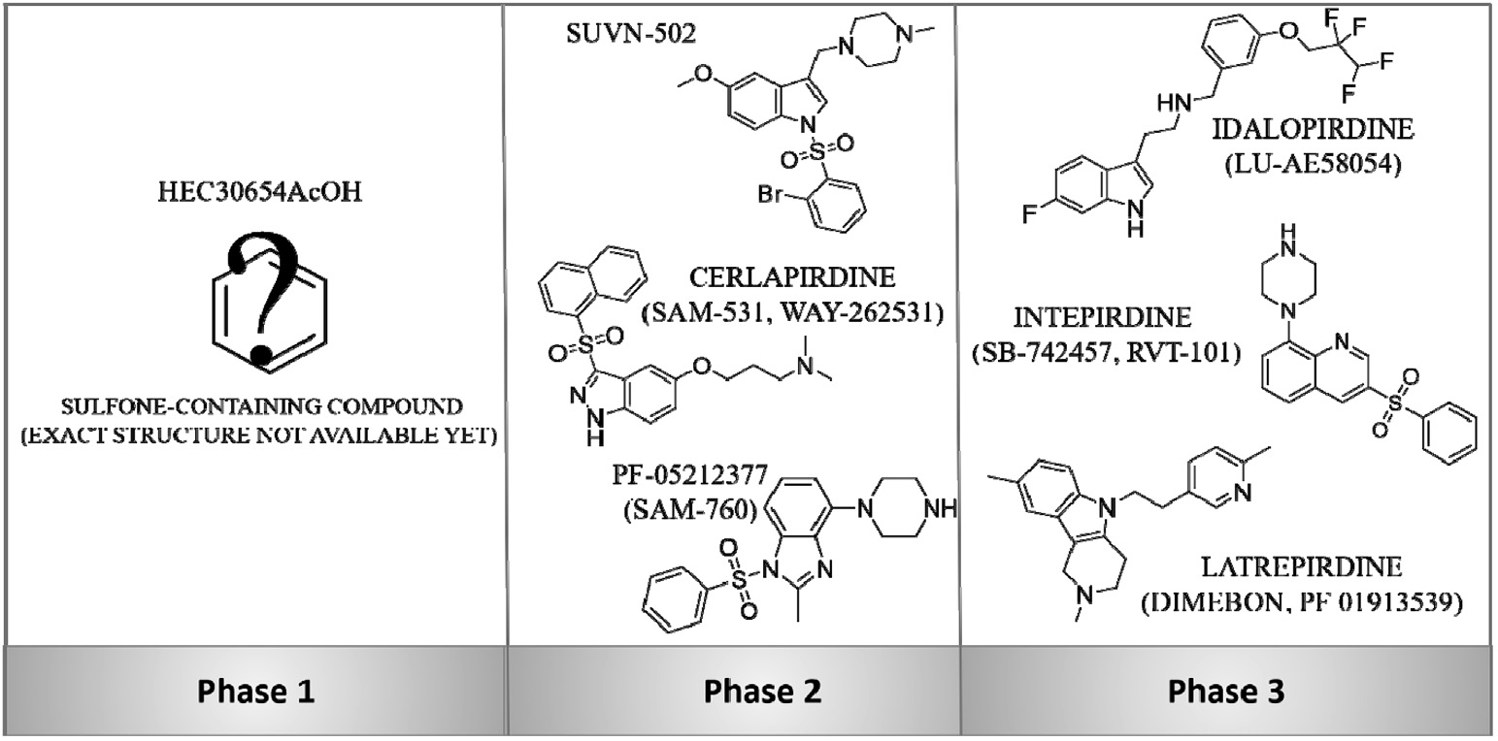

Fig. 1. The 5-HT6R antagonists, which reached clinical trials.

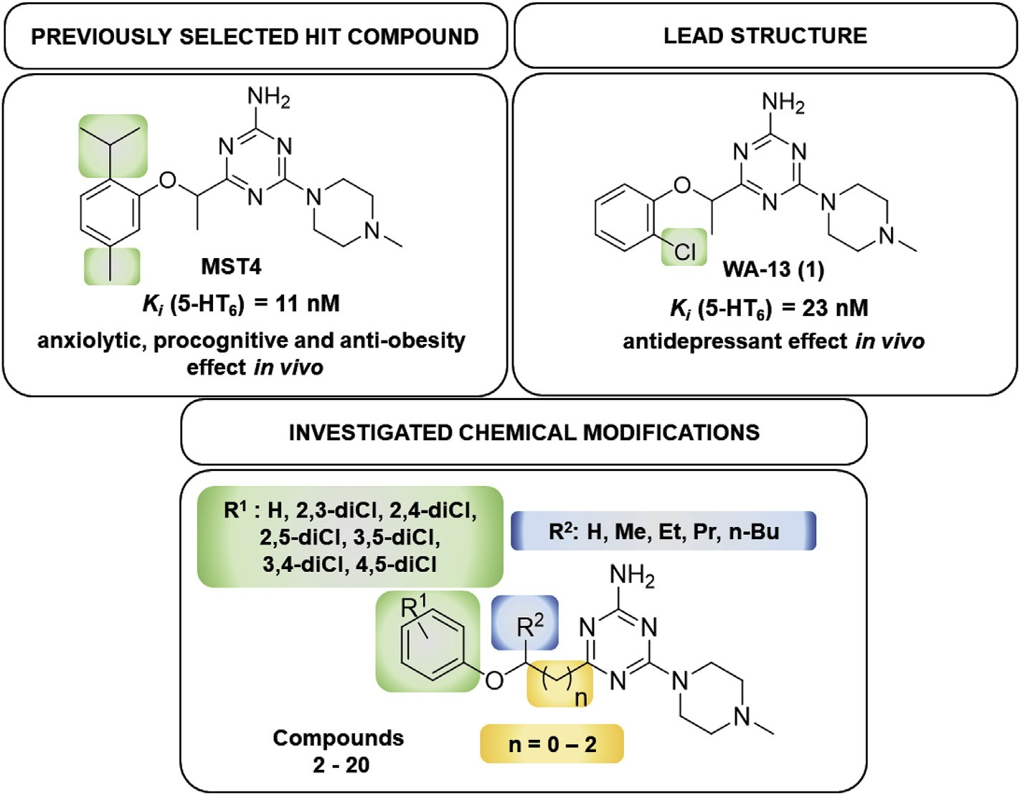

Fig. 2. The previously reported hit compound (MST4), the lead structure (WA-13, 1) and its chemical modiﬁcations investigated within this study.

- Results

  - Synthesis

The compounds (2 20) were obtained within 2-step synthesis pathways, elaborated on the basis of procedures described for previous 1,3,5-triazines [13]. In the ﬁrst step, O-alkylation of com- mercial (dichloro)phenols with appropriate bromoesters was used
-
to give aromatic ethers (22e40). Then, the cyclic condensation of 4- methylpiperazin-1-yl biguanide dihydrochloride (21) with the adequate ester (22e40) was carried out to form a 1,3,5-triazine ring resulting in ﬁnal products 2e20 (Scheme 1). As the racemic mix- tures of bromoesters were applied for the synthesis of the aromatic ethers (22e26, 28e31, 33, 34, 36e39), consequently racemic mix- tures of the ﬁnal compounds (2e6, 8e11, 13, 14, 16e19) were obtained.

Scheme 1. Synthetic route for compounds 2e20. Reagents and conditions: (i) BuOH, reﬂux, yield: 86%; (ii) acetonitrile, K2CO3, reﬂux, 2e16 h, yield: 36e90%; (iii) absolute methanol, Na, reﬂux 15e30 h, yield: 13e52%.

Table 1
Radioligand binding assays results for the newly synthesized compounds 2e20.

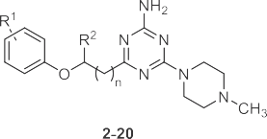
2.2.2. Functional assays towards 5-HT6 receptor
Selected active compounds (3, 8, 9, 11 and 16) were tested in the functional assays, in order to study their intrinsic activity towards 5-HT6R. During the experiments, the level of cAMP was measured (Table 2).
None of the tested derivatives showed agonistic mechanism, while four out of them showed strong antagonistic action in the low nanomolar- (3, 8, 16) or even picomolar range in the case of 9
(pKB ¼ 10.57, i.e. KB ¼ 27 pM, Table S3, Supplementary).
Compound R1 R2 n Ki [nM]a

 |  |  |  | 5-HT6 | 5-HT2A | 5-HT7 | D2
Lead 1 | 2-Cl | Me | 0 | 23 | 1830 | 38730 | 1001
2 | H | Et | 0 | 21 | 5047 | 19940 | 1506
3 | 2,3-diCl | Me | 0 | 16 | 268 | 12550 | 432
4 | 2,3-diCl | Et | 0 | 6 | 209 | 5202 | 421
5 | 2,3-diCl | Pr | 0 | 23 | 310 | 13420 | 495
6 | 2,3-diCl | n-Bu | 0 | 73 | 470 | 5265 | 506
7 | 2,3-diCl | H | 2 | 274 | 649 | 8592 | 206
8 | 2,5-diCl | Me | 0 | 13 | 355 | 15050 | 375
9 | 2,5-diCl | Et | 0 | 6 | 484 | 5706 | 320
10 | 2,5-diCl | Pr | 0 | 12 | 382 | 12470 | 229
11 | 2,5-diCl | n-Bu | 0 | 17 | 431 | 6263 | 103
12 | 2,5-diCl | H | 2 | 470 | 1457 | 7924 | 413
13 | 3,4-diCl | Me | 0 | 95 | 576 | 5928 | 754
14 | 3,4-diCl | Et | 0 | 86 | 696 | 5098 | 580
15 | 3,4-diCl | H | 2 | 1061 | 906 | 4879 | 356
16 | 3,5-diCl | Me | 0 | 27 | 412 | 9398 | 157
17 | 3,5-diCl | Et | 0 | 11 | 463 | 9483 | 368
18 | 3,5-diCl | Pr | 0 | 26 | 488 | 19850 | 377
19 | 3,5-diCl | n-Bu | 0 | 51 | 839 | 10880 | 270
20 | 2,4-diCl | H | 2 | 999 | ntc | 1904 | ntc
Refb | e | e | e | 7 |  |  | 9
a The standard deviation values are reported in Supplementary materials, Table S2.
b Olanzapine.
c nt e not tested.

  - Pharmacology in vitro

    - Radioligand binding assays
The binding afﬁnities for all the newly synthesized 1,3,5-triazine derivatives 2e20 towards the 5-HT6 receptor and competitive ones,
i.e. serotoninergic receptors 5-HT2A, 5-HT7 and dopaminergic D2
receptor, have been assessed in radioligand binding assays (Table 1).
Serotonin 5-HT2AR and dopaminergic D2R were chosen as pro- tein off-targets in order to control interactions which might be responsible for undesired side effects. According to literature,
activation of 5-HT2AR leads to hallucinations [33], whereas inter- action with D2R is associated with extrapyramidal symptoms (e.g.
acute dystonia and parkinsonian symptoms) [34]. Additionally, studies on animal models showed that 5-HT7R ligands may cause procognitive effects [35], similarly as 5-HT6R agents. In order to clarify, if herein investigated procognitive effects are a result of interaction with 5-HT6R, the 5-HT7R was also selected as compet- itive protein target.
According to results obtained, most of the triazine compounds (2e6, 8e11, 13, 14 and 16e19) showed high afﬁnity for 5-HT6R (Ki < 100 nM) and signiﬁcant selectivity, with respect to other
GPCR’s. Ten compounds were more potent than lead structure WA-
13 (Ki < 23 nM). Compounds 4 and 9 turned out to have the highest 5-HT6R afﬁnity (Ki ¼ 6 nM), in 2-fold more potent than the most active triazine 5-HT6R ligand described so far (MST4, Ki 11 nM) [18]. Compound 2 demonstrated the most signiﬁcant selectivity
¼
towards 5-HT6R, with respect to the rest of considered receptors (5- HT2AR: 240-fold, 5-HT7R: 950-fold, D2R: 72-fold).
  - Drug-likeness in vitro

    - Permeability
For active representatives of the novel triazine derivatives, 8 and 9, permeability was tested using Parallel Artiﬁcial Membrane Permeability Assay (PAMPA). The test is based on compounds’ passive penetration through the bilayer artiﬁcial membranes. This membrane may imitate barriers for compound absorption from the intestines with a good correlation to in vivo conditions. The assay was performed in accordance to previously described methods [36e40]. Both tested ligands (8 and 9) had a high permeability coefﬁcient (Pe), higher than that for MST4 [32] and compared to Pe estimated for caffeine, the reference high-permeable compound (Table 3).

    - Metabolic stability
The metabolic stability was investigated in vitro by using rat liver microsomes (RLMs) and supported with MetaSite 6.01 soft- ware. The most probable structures of metabolites were deter- mined. In silico predicted sites of metabolism for both compounds 8 and 9 were speciﬁed for N-methylpiperazine moiety and para po- sition of the chlorine di-substituted aromatic ring (Fig. 3).
The incubation with RLMs for 120 min resulted in the formation of six (9) or seven (8) metabolites, and more than 90% of each compound was biotransformed (Table S1; Fig. 4A and B). Obtained results indicated rather low metabolic stability for both com- pounds, lower than that for MST4 [32,41], while 9 was almost in 3- fold more stable than 8 (8.93% of 9 vs.3.17% of 8, remained in the reaction mixture).
These studies allowed us to predict the most probable metabolic pathway, i.e. the hydroxylation at the phenyl ring (the metabolite M1), while other probable metabolic pathways included deme- thylation and hydroxylation of piperazine ring, which were found for both the 5-HT6R ligands (8, 9) by MS analyses (Table S1; Figs. S1AeG, Figs. S2AeF, Supplementary).

    - Toxicity
The safety proﬁle of the 1,3,5-triazine derivatives (8, 9) was estimated in the hepatotoxicity assay in vitro using hepatoma HepG2 cell line, according to the protocol reported earlier [37e40]. Both tested compounds 8 and 9 demonstrated a weak hepatotox- icity effect compared to the used reference toxins (doxorubicin and 3-chlorophenyl-hydrazone). The statistically signiﬁcant decrease in cells viability was observed only at the highest applied concen- tration of compound 8 (100 mM, Fig. 5). Compound 9, due to partial precipitation at 50 and 100 mM, could be correctly tested only at lower concentrations, showing no toxicity up to 10 mM, inclusively. Hence, both compounds (8, 9) displayed a satisﬁed safety in the level corresponding to the best derivatives of 1,3,5-triazines tested previously [28,31,32,38].

  - Behavioral studies in vivo

Taking into account that various previously studied 5-HT6 re- ceptor ligands, especially antagonists, exhibited beneﬁcial effects

Table 2
The results from functional assays for compounds 3, 8, 9, 11 and 16.
Compound | Binding afﬁnity pKia | Antagonist mode pK b ± SEM | Agonist mode
 |  |  | Emax [%]c ± SEM
SEROTONIN | e | N.C.d | 100 ± 2.0
SB258585 | e | 8.68 ± 0.055 | 4 ± 0.5
MIANSERIN | e | 6.28 ± 0.023 | 4 ± 0.0
3 | 7.80 | 8.24 ± 0.317 | 4 ± 0.0
8 | 7.89 | 8.44 ± 0.138 | 6 ± 0.5
9 | 8.22 | 10.57 ± 0.065 | 4 ± 0.0
11 | 7.77 | 6.36 ± 0.031 | 4 ± 0.0
16 | 7.57 | 8.78 ± 0.332 | 11 ± 0.5

B

a Calculated according to the data from Table 1.
b Results were normalized as percentage of reference antagonist (SB258585 10-5 M).
c Results were normalized as percentage of maximal agonist response (serotonin 10-5 M); Emax is the maximum possible effect.
d N.C. - not calculable. The full data with standard deviation values are presented in Supplementary materials, Table S3.

Table 3
Permeability coefﬁcient of compounds 8 and 9.

Compound Pea [10-6 cm/s] ± SD

8 18.0 ± 1.2
9 18.9 ± 0.9
MST4 12.3 ± 2.0
Reference Caffeine 15.1 ± 0.4

a tested in triplicate.

on cognition in animal models [39], the most active 5-HT6R antagonist in this study, compound 9, has been investigated in two models of the memory impairment tests, i.e. NOR and NOL (Novel Object Location) tests. Compound SB-742457, the potent 5-HT6R antagonist with the conﬁrmed ability to reverse MK-801-induced memory impairment in NOR test after both, acute and chronic administrations [10] was used as reference (Fig. 6). The compound 9 dose-depend ameliorated the memory impairment induced by MK-801 (0.1 mg/kg), in the statistically signiﬁcant manner at the dose of 3 mg/kg (Fig. 6a). The obtained data of discrimination index for the triazine derivative 9 at the dose of 3 mg/kg are comparable with those for the reference SB-742457 at the same dose used (Fig. 6a). Despite, we did not observe any activity of this compound
(9) in the NOL test (Fig. 6b).
Thus, the improvement of memory was observed only in the case of the memory for objects (what) in the NOR but not in the spatial location (where) in the NOL test. A deﬁcit in episodic memory is one of the well-established cognitive deﬁcits in schizophrenic patients and it is the most profound and earliest
cognitive deﬁcit in AD [42]. The improved novel object recognition task, but not the novel location place object preference task, demonstrates dissociation between the effects of the investigated compound in a spatial location (NOL test) and the object recogni- tion (NOR test) version of animal model of episodic memory task. As this dissociation was obtained using identical stimulus types, arena, and identical retention delays of 1 h, it cannot be accounted for by differences in the response requirements of the procedures or attentional or motivational processes. At this stage of our research, it is difﬁcult to explain this loss of activity of compound 9 in NOL test. We can only suppose that this compound at the range of doses used, may possesses ability rather to reverse memory impairment in recognition than in spatial memory components of episodic memory, but it needs extended investigations in the future.

  - The computer-aided structure-activity relationship analysis

In order to support structure-activity relationship discussion, in-depth inside into 3D-structure of the investigated compounds (2 20) and their interactions with target 5-HT6R protein in the molecular level were performed, including both experimental crystallography and molecular modelling.
-

    - Crystallographic studies
Crystallographic analyses for compounds, representing either the shortest (9) or the longest (20) linker structural category, were carried out giving a starting point to ﬁnd active conformations for the whole series (2-20) within molecular modelling studies.

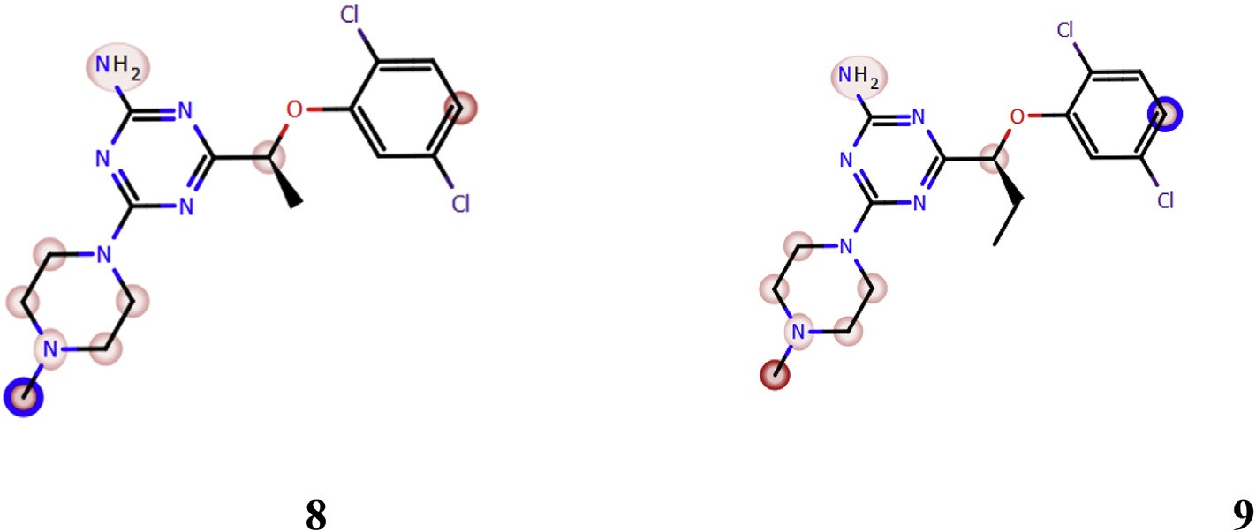

Fig. 3. In silico prediction of the sites of metabolism by MetaSite 8.0.1 for 8 and 9. Blue circle marked on the functional group structures indicates the highest biotransformation probability. The fading red color shows the decreasing of the metabolism probability. (For interpretation of the references to color in this ﬁgure legend, the reader is referred to the Web version of this article.)

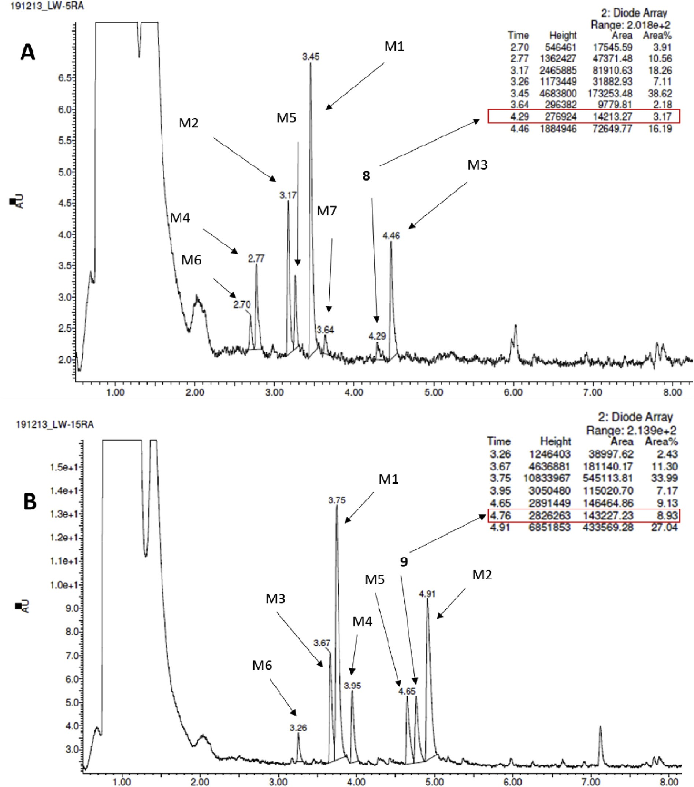

Fig. 4. The UPLC spectra of 8 (A) and 9 (B) and metabolites obtained after 120 min reaction with RLMs.

The overall shapes of the 9 and 20 molecules with the atom- numbering schemes are presented in Fig. 7. Both molecules are isomers possessing the 2-amine-4-(40-methylpiperazin-10-yl)- 1,3,5-triazine moiety, as well as a di-substituted aromatic ring (2,5- dichloro for 9 and 2,4-dichloro for 20) connected with the triazine ring by the ethylmetoxylene linker for 9 and the propoxylene linker for 20. In both molecules the piperazine ring adopts chair confor- mation with equatorial position of the methyl group. However, the substituent at the N2 atom is not in a typical equatorial position with a torsion angle C4eN2eC7eC8 of about 180o. The values of this angle are 111.1(1)o and 133.8(1)o for 9 and 20, respectively. These values are lower than in other three crystal structures
containing the 2-amine-4-(40-methylpiperazin-10-yl)-1,3,5-triazine moiety [43,44] but similar to one observed in the crystal structure of the 2-amine-6-(5-chloro-2-methoxyphenyl)-4-(40-methylpiper- azin-10-yl)-1,3,5-triazine [43], as well as similar to these observed in the crystal structures of 2-(4-methylpiperazin-1-yl)-1H-imida- zol-5(4H)-one derivatives [45]. The mutual orientation of three rings differs in presented crystal structures. The interplanar angles between triazine and piperazine rings are 43.30(5)o and 28.65(5)o, while between triazine and aromatic rings are 81.50(4)o and 76.62(3)o for 9 and 20, respectively.
The intermolecular interactions are similar in both structures. The main motif of interactions is based on the NeH/N hydrogen

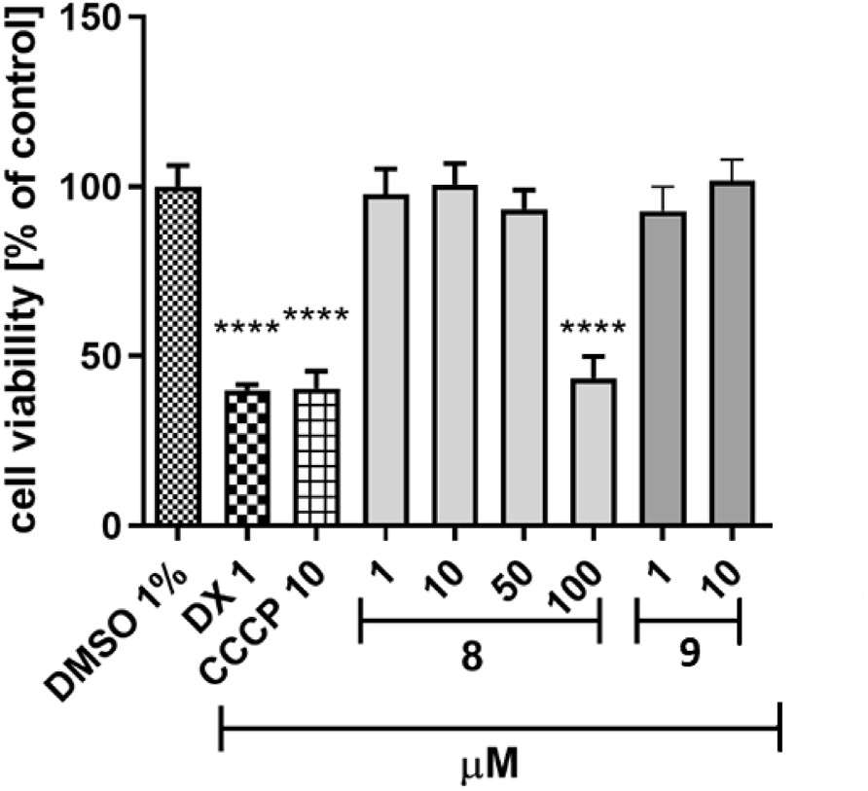

Fig. 5. The effect of tested compounds 8, 9 and references: doxorubicin (DX, 1 mM), mitochondrial toxin carbonyl cyanide 3-chlorophenyl-hydrazone (CCCP, 10 mM) on hepatoma HepG2 cell line viability. Compound 9 partly precipitated at 50 and 100 under assay conditions. 1% DMSO in cell growth media was used as a negative control. GraphPad Prism 8.0.1 was used to calculate the statistical signiﬁcances by one-way ANOVA, followed by Bonferroni’s comparison test (****p < 0.0001, **p < 0.01).

bonds (Fig. 8). These interactions lead to formation of the dimers. In addition, the crystal structures are stabilized by NeH/Cl and CeH$$$p contacts.

    - Molecular modelling
The molecular docking study for the newly synthesized de- rivatives 2e20 to 5-HT6 receptor homology models showed coherent binding mode with the previously reported 1,3,5-triazine derivatives [28e31,41]. The crucial interactions are the salt bridge between protonated methylpiperazine nitrogen and negatively charged D3.32 side chain, an aromatic CH...p or p...p interaction
with F6.52 and/or F6.51, and hydrogen bond between NH2 group of 1,3,5-triazine ring and carbonyl oxygen of V3.33 and/or A5.42. Substituted aromatic fragment linked with the 1,3,5-triazine ring interacted with the hydrophobic cavity formed by transmembrane domains (TM) 3e5 and extracellular loop 2 (ECL2), moreover, its positioned into this cavity is caused by the tetrahedral conforma- tion of the linker. In the light of the molecular docking results, the comparison of the most active derivative 9 with the lead structure 1 (Fig. 9A) showed a retaining of a common binding mode. However, elongation of the linker caused a decrease of activity, which is in line with the molecular docking study. For instance, a comparison of binding modes (Fig. 9A) of compound 9 (Ki ¼ 6 nM) vs. 12
(Ki 470 nM) showed that too long linker may lead to destabili-
¼
zation of the complex and breaking some key interactions (e.g. with A5.42/V3.33).
The branching of the linker showed increase of the afﬁnity in order methyl < ethyl, but decrease in order propyl > butyl for each of the compared series. Molecular docking indicated (Fig. 9B) that the branching alkyl group was placed into a small binding cavity formed by helices 5 and 6, which increased the stability of the resulting ligandereceptor complexes for shorter, and destabilized the complexes (perhaps because of the overﬁlling of this pocket) for the longer branching group.
In term to investigate the role of different substitution of chlo- rine atoms in the phenyl fragment, the docking procedure involves quantum-polarized ligand docking (QPLD) and the MM/GBSA al- gorithm was used. This procedure showed better performance in reproducing the X-ray geometries of proteineligand complexes with halogen bonding than classical docking approach [46], and was also used to the study of the halogen bonding with privileged amino acids as an important factor modulating the activity to 5-HT6 receptor [29,47]. The disubstituted series, including: 2,3-diCl (4), 3,5-diCl (17), 2,5-diCl (9), and 3,4-diCl (14) derivatives, and also the unsubstituted analog (2) in the phenyl fragment (Fig. 9C), was selected.
It was possible to calculate the changes in the LeR binding free energy resulting from the substitution of halogen atoms in this fragment (DDG). Analysis of the binding modes showed that

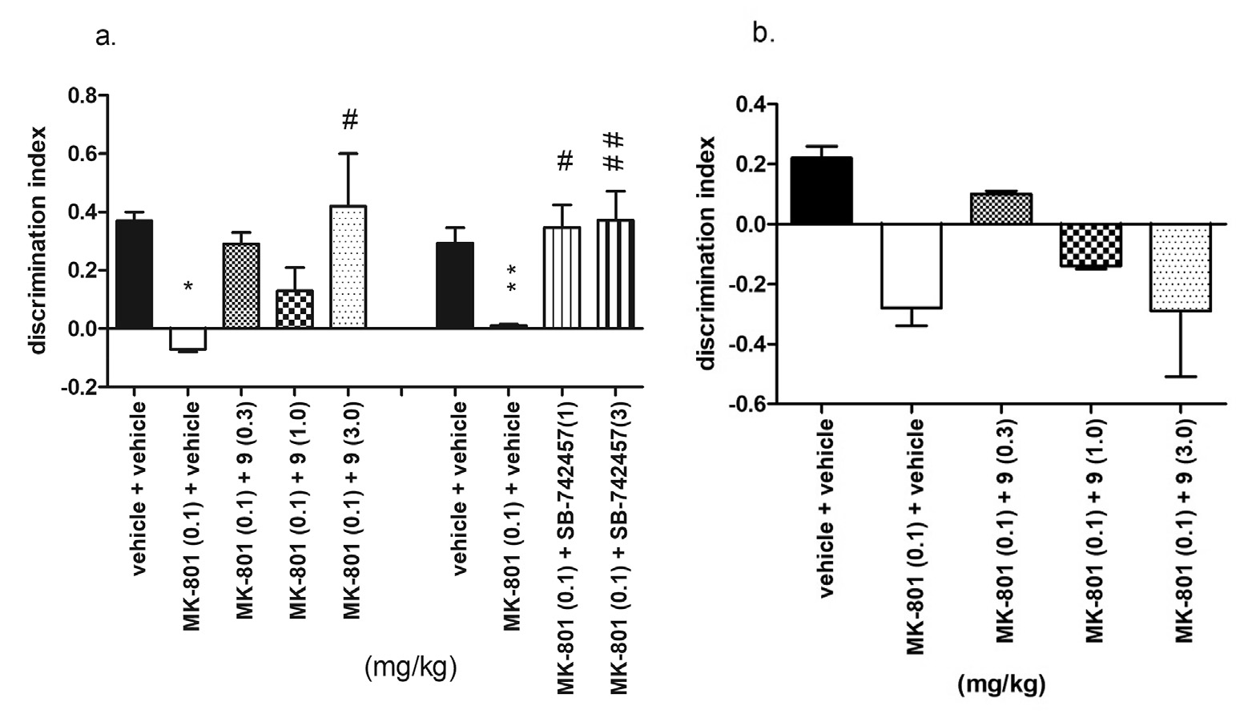

Fig. 6. Effects of compound 9 on the memory impairment induced by MK-801 in NOR (a) and NOL (b) tests. Compound 9 and SB-742457 were administered i.p. 60 min, while MK- 801 30 min before the T1 session. The animals were observed for 5 min. The data are presented as the mean ± SEM of 6e8 rats. The data were statistically evaluated by one-way ANOVA followed by Bonferroni’s post-hoc test,*p < 0.05,**p < 0.01 vs respective vehicle-treated group, and #p < 0.05, ##p < 0.01 vs respective MK-801-treated group. (one-way ANOVA for discrimination index for NOR test: F(4,30) ¼ 3.99, p < 0.01 (for compound 9) and F(3,40) ¼ 6.78, p < 0.001 (for SB-742457); and for NOL test: F(4,29) ¼ 2.82, p < 0.05).

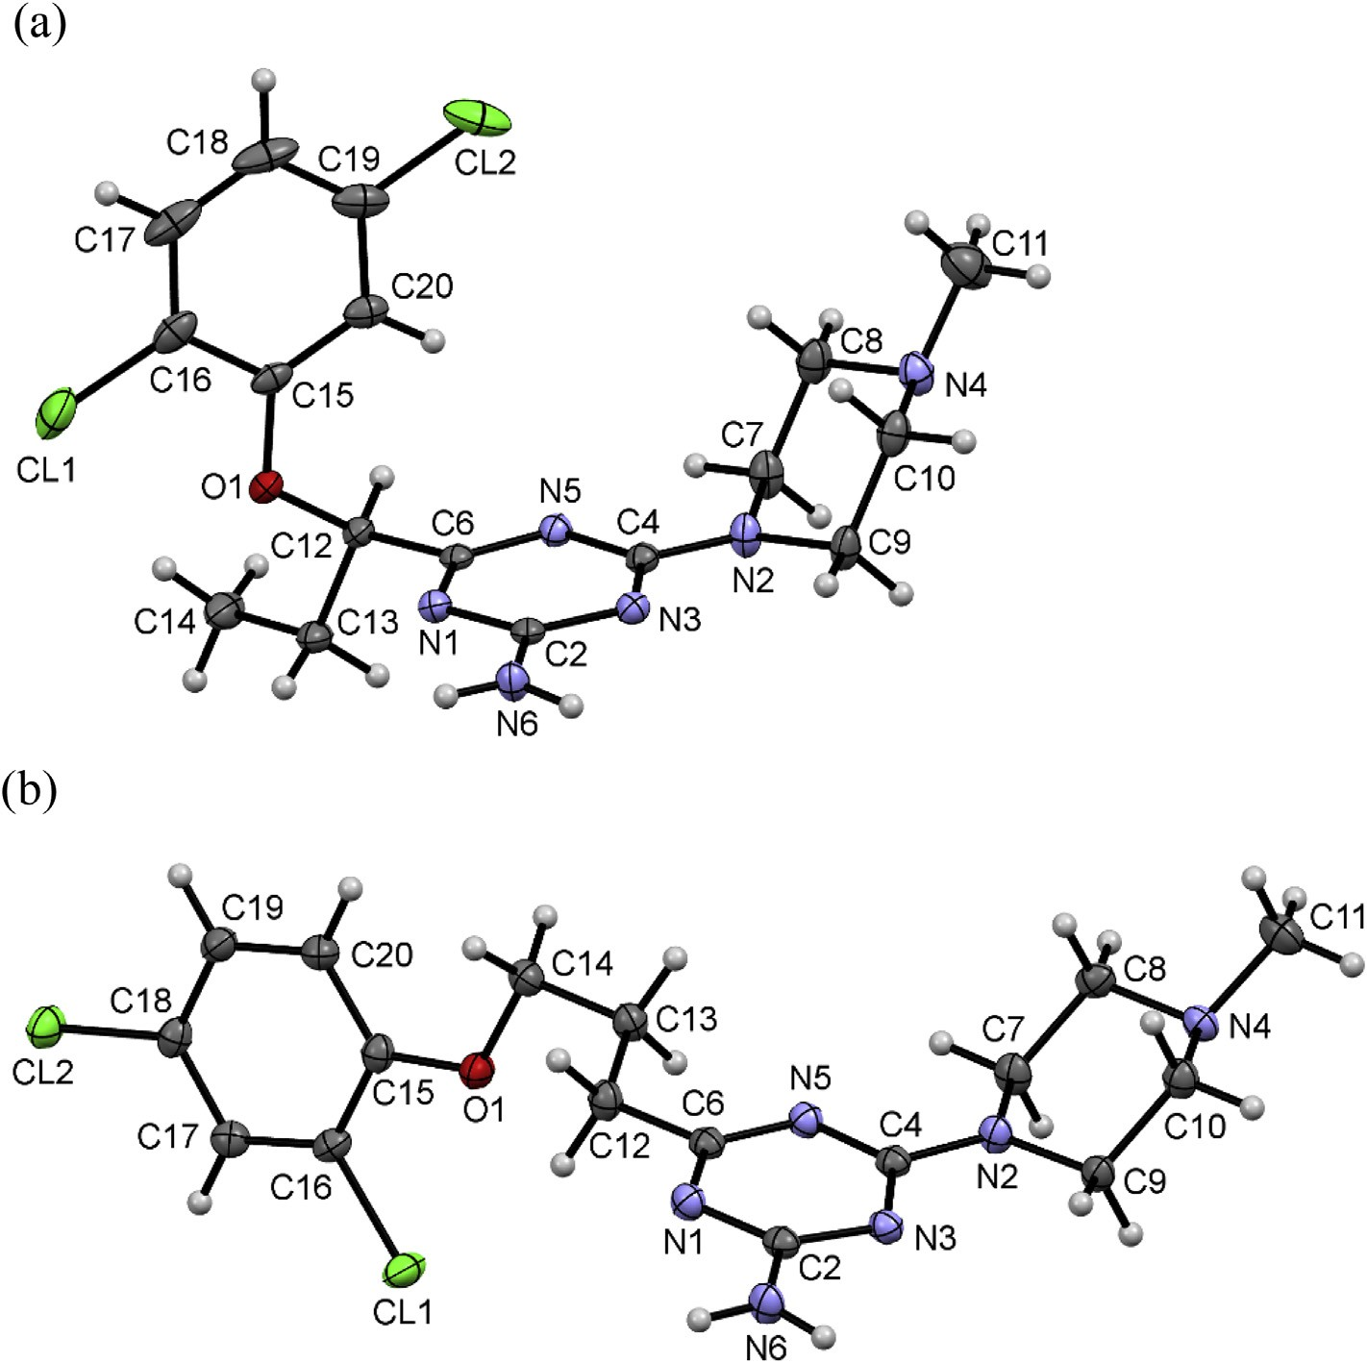

Fig. 7. The molecular structures of (a) 9 and (b) 20, showing the atom-numbering schemes. Displacement ellipsoids are drawn at the 50% probability level.

chlorine atoms were involved in the formation of different types of halogen bonds (all with backbone carbonyl oxygen), which were also visible in the change of binding free energy and activity of a given derivative. The highest increase of the binding free energy was noted for the most active derivatives 4 and 9 (Ki ¼ 6 nM). The
ﬁrst analogue (2,3-diCl) showed DDG ¼ -2.89 kcal/mol and two
halogen bonds with P4.60 (XB distance ¼ 4.1 Å, s-hole angle 165o) and A4.56 (XB distance 3.0 Å, s-hole angle 141o, with chlorine in position 2). The second derivative (2,5-diCl) dis- played DDG ¼ -1.96 kcal/mol and halogen bonds with A4.56 (XB distance 2.8 Å, s-hole angle 148o) formed by chlorine in po- sition 2, and surprisingly, with L162 from extracellular loop 2 (XB distance 2.7 Å, s-hole angle 162o). The 3,5-diCl analogue 17 showed only slightly lower increase of binding free energy compared to 2,5-diCl (DDG 1.78 kcal/mol), for which two halogen bonds were found as well e with S4.57 (XB distance ¼ 3.8 Å, s-hole angle ¼ 161o), and with L162 (XB distance 2.9 Å, s-hole angle 152o) formed by chlorine in po- sition 5 (as in the 2,5-diCl derivative). The last derivative 14 (3,4- diCl) showed the lowest increase of binding free energy equal -0.73 kcal/mol, and only one halogen bond was formed be- tween chlorine in position 3 with S4.57 (XB distance ¼ 3.0 Å, s-hole angle 172o), whereas the chlorine at position 4 did not show any speciﬁc interaction with the binding site. This analysis demon- strated that chlorine atoms may be involved in the formation of halogen bonding, additionally stabilizing the LeR complex, but their contribution is rather moderate (the highest improvement in activity after chlorine substitution is approximately 4-fold).
¼
¼ ¼
¼ ¼
¼ -
¼ ¼
¼ ¼ ¼
    - General SAR discussion
The chemical modiﬁcations of the lead 1 were introduced to analyze an inﬂuence on the afﬁnity towards 5-HT6R of two following structural factors: (i) dichloro-substitution at phenyl ring and (ii) the diverse (un)branched linker. The results obtained within this study allow us to perform comprehensive structure- activity relationship discussion.
Sixteen out of nineteen newly synthesized compounds demonstrated a high afﬁnity for 5-HT6R, with Ki values lower than 100 nM. The best pharmacological activity proﬁle was observed for 2,5- and 2,3-dichlorophenoxy 1,3,5-triazine derivatives with a short but branched alkoxy linker, i.e. compounds 4 (Ki ¼ 6 nM) and
9 (Ki 6 nM). Both compounds had higher afﬁnity for 5-HT6R than
¼
reference olanzapine as well as the strong picomolar antagonistic action, found for the 2,5-dichlorophenyl derivative 9 (KB 0.027 nM), is worth emphasizing. Among the series of ana- logues with chlorine atoms at the same positions of phenyl ring, a change of branching in linker, from methyl to ethyl group, increased the 5-HT6R afﬁnity, simultaneously maintaining signiﬁcant selec- tivity. However, further elongation of branching did not improve activity, giving the least beneﬁcial effects for the butyl group, which
¼
is consistent with molecular docking results. The mentioned-above results, together with the high 5-HT6R afﬁnity (Ki 21 nM) of the compound unsubstituted at the aromatic ring (2), indicate that the type of linker is the predominant structural factor for the 5-HT6R activity of the compounds investigated within this study. This conclusion may be also supported by previous results, in which the unbranched analogue of 2 displayed signiﬁcantly lower afﬁnity for
¼

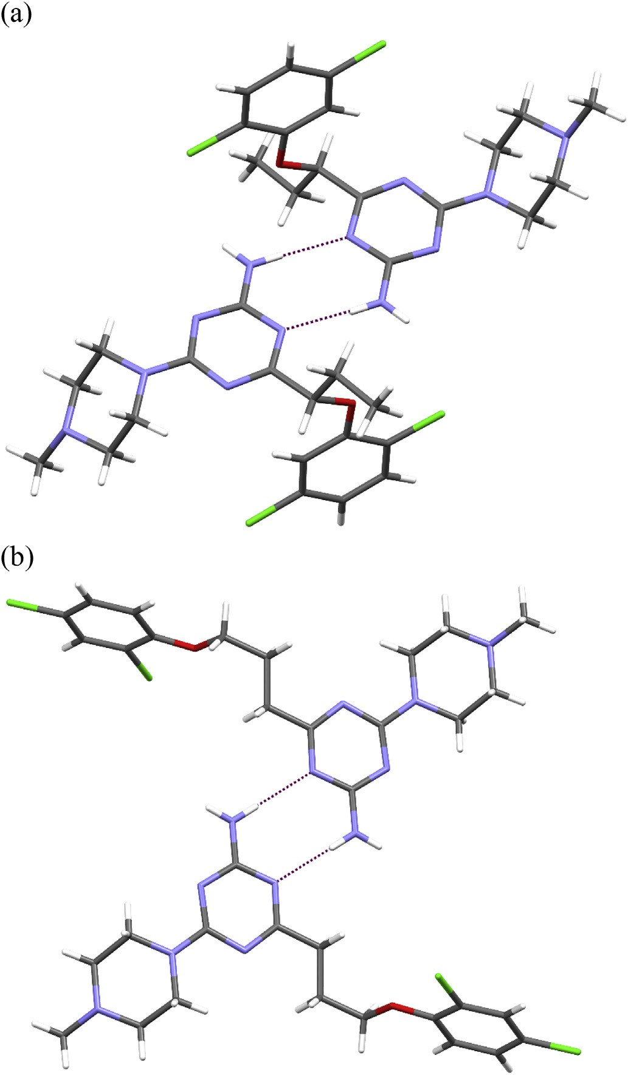

Fig. 8. The dimers in the crystal structure of 9 (a) and 20 (b). Dashed lines indicates the hydrogen bonds.

the 5-HT6R target (Ki 507 nM) [29]. Additionally, molecular modelling studies conﬁrmed that chlorine atoms might be involved in stabilization of LeR complex through the different type of
¼
halogen bonds, however, their effect on the activity improvement is moderate. These results allow to fully explain the high and little- varied activity of branched derivatives ortho-, meta- or unsub- stituted at the phenyl ring.
On the other hand, the presence of two chlorine substituents at the phenyl ring was found as proﬁtable also for “drug-like” prop- erties of the explored 1,3,5-triazines due to an increase of lip- ophilicity. The higher lipophilicity seems to be desirable to penetrate membrane barriers, including BBB, which is especially important in the case of compounds destined to act on CNS. The
representative 2,5-dichlorophenyl derivatives tested (8, 9) demonstrated high permeability (Pe about 18 10-6 cm/s) and rather low risk of hepatotoxicity in the studies in vitro.
x
Despite the low metabolic stability in vitro, the signiﬁcant pro- cognitive effect of the 2,5-dichlorophenyl derivative 9 in vivo was observed in the NOR test in rats. Furthermore, the active dose of 9 was corresponding to that of compounds MST4 tested previously,

although the metabolic stability of MST4 was in 6-fold higher (59.25% vs. 8.93%), and the 5-HT6R afﬁnity only slightly weaker (11 nM vs. 6 nM) [32]. The observed procognitive action of com- pound 9 in vivo seems to be a result of combined factors, i.e. (i) the beneﬁcial effects of both the highly potent 5-HT6R-antagonistic action and a putative very good blood-brain barrier penetration
(high permeability conﬁrmed in PAMPA test) on one hand, but (ii) an unfavorable low metabolic stability effect, on the other. In this context, the resultant effect indicates a distinctly greater impact of those favorable factors. Otherwise, the signiﬁcant activity in the behavioral test (NOR) could be also caused by synergistic procog- nitive action of either the compound 9 or the metabolites formed. However, these hypotheses need wider pharmacological and ADMET considerations to be enough conﬁrmed.

- Conclusions

The described herein novel series of 1,3,5-triazine derivatives enlarged the original family of highly potent 5-HT6R antagonists, structurally different from widely investigated sulfone and indole- like compounds. In particular, the systematic modiﬁcations of o- chloro substituted lead (1), via the addition of one more chlorine substituent and changes within the ether linker, resulted in two the strongest 5-HT6R agents (4 and 9), in 2-fold more active than MST4, the most potent triazine 5-HT6R ligand described so far. Further- more, the performed elimination of the chlorine-substituent from the lead 1 gave a potent and highly selective ligand (2), displaying selectivity for 5-HT6R in the range of 71e867, with respect to 5- HT2A, 5-HT7 and D2 dopamine receptors. SAR studies supported by crystallography and extended molecular modelling indicated that (i) the short linker branched with ethyl chain and (ii) the dichloro-substituted phenyl ring at positions ortho and meta are the most favorable structural factors for strong interaction with the target 5-HT6R, but the role of the ﬁrst one is predominant.
The performed study allows to ﬁnd the new “hit’, i.e. 4-[1-(2,5-
dichlorophenoxy)propyl]-6-(4-methylpiperazin-1-yl)-1,3,5-
triazin-2-amine (9), which displayed extremely high 5-HT6R antagonistic action in the functional assays, signiﬁcant procognitive effects in vivo in rats, very good permeability in PAMPA model and a satisfying safety in vitro. However, the disadvantageous weak metabolic stability of 9 and its methyl-branched analogue (8) was indicated in vitro, which requires a further pharmacomodulation.
Apart from compound 9, its 2,3-dichlorophenyl analogue (4), found as the equally active 5-HT6R agent, as well as the most se- lective phenyl-unsubstituted compound 2 seem to be worth of wider considerations, too. Thus, the presented results set the new lead structures for further studies concerning search for 5-HT6R agents, which may be a useful tool for future treatment of cognitive impairment associated with Alzheimer Disease.

- Experimental

  - Chemical synthesis

Melting points (mp) were determined using MEL-TEMP II apparatus and are uncorrected. 1H NMR and 13C NMR spectra were
recorded on a Varian Mercury-VX 400 MHz PFG instrument or FT- NMR JEOL (JNM-ECZR500 RS1 v. ECZR) 500 MHz instrument (13C
NMR for 3e20) in DMSO-d6 (for almost all compounds, except from compound 2e400 MHz) at ambient temperature using the solvent signal as an internal standard: the values of the chemical shifts expressed as d values in (ppm) and the coupling constants (J) in Hz. Data are reported as follows: chemical shift, multiplicity (s, singlet; br. s, broad singlet; d, doublet; t, triplet; dd, doublet of doublet, q, quintet, m, multiplet), coupling constant J, number of protons,

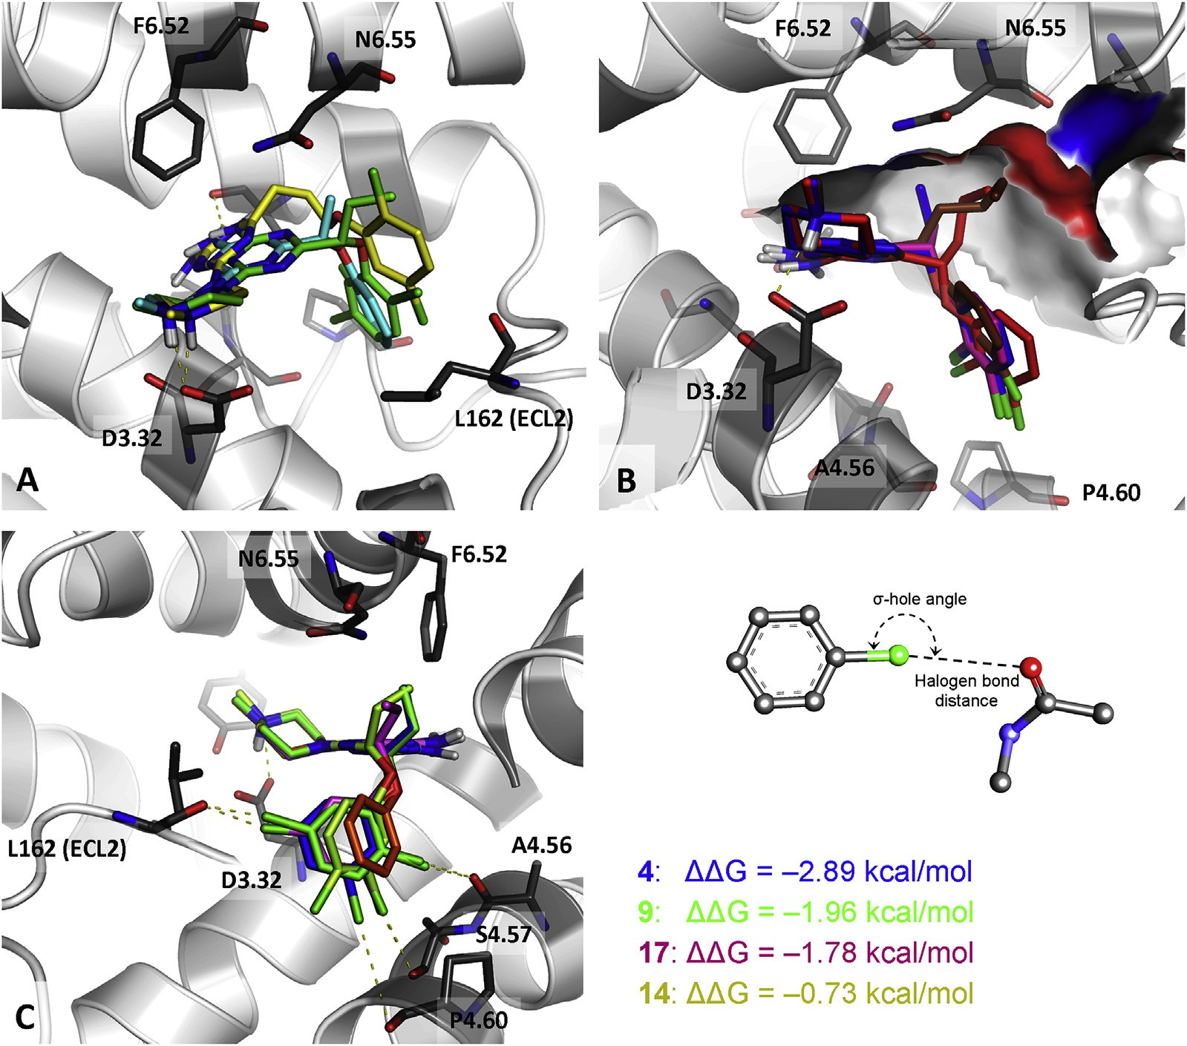

Fig. 9. Illustration of the binding modes of selected 1,3,5-triazine derivatives with 5-HT6 receptor. (A) Comparison of the docking poses for compounds 9 (green), 12 (yellow), and the lead structure 1 (cyan). (B) Binding modes of analogues with methyl (3epink), ethyl (4eblue), propyl (5ered), and butyl (6ebrown) linker branch. (C) Comparison of the binding modes of unsubstituted 2 (orange) with its differently disubstituted of chlorine atoms derivatives, namely: 2,3-diCl (4eblue), 3,5-diCl (17eviolet), 2,5-diCl (9egreen), and 3,4-diCl (14elimon). Amino acids that are crucial for the binding of the presented compounds are shown as thick dark-grey sticks. (For interpretation of the references to color in this ﬁgure legend, the reader is referred to the Web version of this article.)

protons position (Pip-piperazine, Ph-phenyl). Mass spectra recor- ded on a UPLCeMS/MS system consisted of a Waters ACQUITY® UPLC® (Waters Corporation, Milford, MA, USA) coupled to a Waters TQD mass spectrometer (electrospray ionization mode ESI-tandem quadrupole). The UPLC/MS purity of all the ﬁnal compounds was conﬁrmed to be higher than 95% (except 14). Retention time values (tR) are given in minutes. Thin-layer chromatography (TLC) was performed on pre-coated Merck silica gel 60 F254 aluminum sheets (Hex/EtOAc 4:1, DCM/MeOH 95:5). The reactions at ﬁxed temper- ature were carried out using a magnetic stirrer with a contact thermometer Heidolph MR 2001. Intermediates (22e40) were synthesized based on previous methods [28e31], and used in a crude form (purity 54e99%) for synthesis of the ﬁnal compounds (2 20). Details of their synthesis and chemical characterization are provided in Supplementary.
-

    - General procedure for the synthesis of ﬁnal compounds (2 20)
-
Sodium (10 mmol) was dissolved in 10 ml of absolute methanol, then 4-methylpiperazine-1-yl biguanide hydrochloride (21) (5 mmol) and a proper ester (22e40, 5 mmol) was added. The re- action mixture was reﬂuxed for 15e30 h. After cooling to room temperature, the residue was washed with water (10 ml), stirred for 30 min at room temperature. The precipitated product was isolated by ﬁltration and crystallized from methanol to give the desire ﬁnal
products as solids (method A). In case of lack of desirable precipi- tate, ﬁnal product was converted into hydrochloric salt form using solution of HCl in diethyl ether (method B).

      - (RS)-4-(4-methylpiperazin-1-yl)-6-(1-phenoxypropyl)-1,3,5- triazin-2-amine (2). Ester 22, reaction time: 16 h. Method A. White solid. Yield 38%, LC/MSþ purity: 96,4%, tR ¼ 3.29, mp ¼ 112e114 oC, C17H24N6O (MW ¼ 328.42). 1H NMR (400 MHz, DMSO-d6) d [ppm]: 0.97 (t, J ¼ 7.4 Hz, 3H, CH3), 1.84e1.93 (m, 2H, CH2), 2.17 (s, 3H, NeCH3), 2.27 (br. s, 4H, Pip-3,5-H), 3.66 (br. s, 4H, Pip-2,6-H), 4.63 (t, J 6.5 Hz, 1H, OeCH), 6.77e6.89 (m, 4H, Ph-2,3,5,6-H), 7.00 (br. s, 1H, Ph-4-H), 7.18e7.24 (m, 2H, NH2). 13C NMR (101 MHz, DMSO-d6) d [ppm]: 10.50, 27.90, 42.86, 46.22, 54.70, 81.40, 115.56, 120.84,
¼
129.78, 158.82, 164.94, 167.41, 176.51.

      - (RS)-4-[1-(2,3-dichlorophenoxy)ethyl]-6-(4-methylpiperazin- 1-yl)-1,3,5-triazin-2-amine (3). Ester 23, reaction time: 15 h. Method A. White solid. Yield 24%, LC/MSþ purity: 100%, tR ¼ 4.15, mp ¼ 187e189 oC, C16H20Cl2N6O (MW ¼ 383.28). 1H NMR (500 MHz, DMSO-d6) d [ppm]: 1.54 (d, J ¼ 5.73 Hz, 3H, CH3) 2.13 (s, 3H, NeCH3), 2.21 (br. s, 4H, Pip-3,5-H), 3.60 (br. s, 4H, Pip-2,6-H), 5.00 (d, J 6.30 Hz, 1H, OeCH), 6.68e6.99 (m, 2H, NH2), 6.87e6.89 (d def., 1H, Ph-6-H), 7.09e7.10 (m, 1H, Ph-5-H), 7.16 (t, J 7.20 Hz, 1H, Ph-4-H). 13C NMR (126 MHz, DMSO-d6) d [ppm]: 20.72, 43.02, 46.25, 54.72, 77.63, 113.86, 120.93, 122.40, 128.67, 132.83, 155.71,
¼
¼

164.90, 167.49, 176.25.

    - 3. (RS)-4-[1-(2,3-dichlorophenoxy) propyl]-6-(4 -
methylpiperazin-1-yl)-1,3,5-triazin-2-amine (4). Ester 24, reaction time: 21 h. Method A. White solid. Yield 40%, LC/MSþ purity: 100%, tR ¼ 4.73, mp ¼ 174e176 oC, C17H22Cl2N6O (MW ¼ 397.30). 1H NMR (500 MHz, DMSO-d6) d [ppm]: 1.02 (t, J ¼ 7.4 Hz, 3H, CH3), 1.97 (p,
J ¼ 7.3 Hz, 2H, CH2), 2.16 (s, 3H, NeCH3), 2.25 (br. s, 4H, Pip-3,5-H),
3.63 (br. s, 4H, Pip-2,6-H), 4.80 (t, J ¼ 6.3 Hz, 1H, OeCH), 6.86e6.89
(m, 1H, Ph-6-H), 7.01 (br. s, 2H, NH2), 7.13e7.16 (m, 1H, Ph-5-H), 7.19e7.23 (m, 1H, Ph-4-H). 13C NMR (126 MHz, DMSO-d6) d [ppm]:
10.38, 27.90, 46.26, 54.73, 82.57, 113.76, 120.91, 122.35, 128.75,
132.79, 155.93, 164.83, 167.41, 175.53.

4.1. 1. 4. (RS)-4-[1-(2,3-dichlorophenoxy)butyl ]-6-(4-
methylpiperazin-1-yl)-1,3,5-triazin-2-amine (5). Ester 25, reaction time: 18 h. Method A. White solid. Yield 18%, LC/MSþ purity: 100%, tR ¼ 5.20, mp ¼ 186e188 oC, C18H24Cl2N6O (MW ¼ 411.33). 1H NMR (500 MHz, DMSO-d6) d [ppm]: 0.89 (t, J ¼ 6.8 Hz, 3H,CH3), 1.36e1.57 (m, 2H, CH2), 1.78e1.98 (m, 2H, CH2), 2.12 (s, 3H, NeCH3), 2.21 (s,
2H, Pip-3,5-H), 2.46 (s, 2H, Pip-3,5-H), 3.59 (s, 4H, Pip-2,6-H),
4.76e4.88 (m, 1H, OeCH), 6.77e6.91 (m, 2H, NH2), 6.98 (br. s, 1H,
Ph-5-H), 7.07e7.23 (m, 2H, Ph-4,6-H). 13C NMR (126 MHz,
DMSO-d6) d [ppm]: 14.23, 18.81, 36.69, 46.26, 54.71, 81.17, 113.67,
120.86, 122.35, 128.76, 132.80, 155.91, 164.83, 167.41, 175.75.

      - . (RS)-4-[1 -(2,3 -dichlorophenoxy)penthyl]-6-(4- methylpiperazin-1-yl)-1,3,5-triazin-2-amine (6). Ester 26, reaction time: 19 h. Method A. White solid. Yield 52%, LC/MSþ purity: 98,5%, tR ¼ 5.41, mp ¼ 150e152 oC, C19H26Cl2N6O (MW ¼ 425.36). 1H NMR (500 MHz, DMSO-d6) d [ppm]: 0.81 (t, J ¼ 7.16 Hz, 3H, CH3), 1.26e1.31 (q def., 2H, CH2), 1.37e1.48 (m, 2H, CH2), 1.85e1.95 (m, 2H, CH2), 2.11 (s, 3H, NeCH3) 2.20 (s, 4H, Pip-3,5-H), 3.31 (s, 4H, Pip- 2,6-H), 4.78e4.81 (d def., 1H, OeCH), 6.82 (d, J ¼ 7.45 Hz, 1H, Ph-6- H), 6.99e7.01 (m, 2H, NH2), 7.09e7.10 (m, 1H, Ph-5-H), 7.14e7.15 (m, 1H, Ph-4-H). 13C NMR (126 MHz, DMSO-d6) d [ppm]: 14.42, 22.40, 27.68, 34.30, 43.20, 46.26, 54.72, 81.45, 113.68, 120.89, 122.35,
128.74, 132.81, 155.92, 164.84, 167.42, 175.73.

      - 4-[3-(2,3-dichlorophenoxy)propyl]-6-(4-methylpiperazin-1- yl)-1,3,5-triazin-2-amine (7). Ester 27, reaction time: 20 h. Method
A. White solid. Yield 42%, LC/MSþ purity: 100%, tR 4.18,
¼
1
time: 20 h. Method A. White solid. Yield 47%, LC/MSþ purity: 100%, tR ¼ 4.60, mp ¼ 163e165 oC, C17H22Cl2N6O (MW ¼ 397.30). 1H NMR (500 MHz, DMSO-d6) d [ppm]: 0.94 (t, J ¼ 7.45 Hz, 3H, CH3), 1.91 (q,
J ¼ 7.16 Hz, 2H, CH2), 2.11 (s, 3H, NeCH3), 2.21 (br. s, 4H, Pip-3,5-H),
3.61 (br. s, 4H, Pip-2,6-H), 4.77 (t, J ¼ 6.30 Hz, 1H, OeCH), 6.84e6.90
(m, 2H, NH2), 6.90e6.93 (d def., 1H, Ph-6-H), 7.02e7.05 (d def., 1H,
Ph-4-H), 7.36 (d, J ¼ 8.59 Hz, 1H, Ph-3-H). 13C NMR (126 MHz,
DMSO-d6) d [ppm]: 10.25, 27.60, 43.11, 46.23, 54.74, 82.69, 115.66,
121.11, 121.66, 131.41, 132.39, 155.01, 164.79, 167.49, 175.23.

4.1. 1. 9. (RS)- 4 -[ 1-(2 ,5 -dichlorophenoxy) bu t yl ]- 6-(4 -
methylpiperazin-1-yl)-1,3,5-triazin-2-amine (10). Ester 30, reaction time: 22 h. Method A. White solid. Yield 54%, LC/MSþ purity: 96,7%, tR ¼ 5.13, mp ¼ 143e145 oC, C18H24Cl2N6O (MW ¼ 411.33). 1H NMR (500 MHz, DMSO-d6) d [ppm]: 0.92 (t, J ¼ 7.4 Hz, 3H, CH3), 1.37e1.55 (m, 2H, CH2), 1.83e2.00 (m, 2H, CH2), 2.16 (s, 3H, NeCH3), 2.25 (br. s,
4H, Pip-3,5-H), 3.57e3.74 (m, 4H, Pip-2,6-H), 4.88 (dd, J1 ¼ 8.2 Hz,
J2 ¼ 4.9 Hz, 1H, OeCH), 6.90e6.94 (m, 1H, NH2), 6.96e6.98 (m, 1H,
Ph-6-H), 7.05 (d, J 2.3 Hz, 1H, Ph-4-H), 7.06e7.09 (m, 1H, NH2), 7.41e7.44 (m, 1H, Ph-3-H). 13C NMR (126 MHz, DMSO-d6) d [ppm]:
¼
175.43, 167.46, 164.77, 154.97, 132.37, 131.47, 121.70, 121.05, 115.60,
81.24, 54.74, 46.27, 36.38, 18.70, 14.25.

      - . ( RS)-4-[1-(2,5-dichlorophenoxy)penthyl]-6-(4 - methylpiperazin-1-yl)-1,3,5-triazin-2-amine (11). Ester 31, reaction time: 25 h. Method A. White solid. Yield 33%, LC/MSþ purity: 98,8%, tR ¼ 5.34, mp ¼ 143e145 oC, C19H26Cl2N6O (MW ¼ 425.36). 1H NMR (500 MHz, DMSO-d6) d [ppm]: 0.80 (t, J ¼ 7.16 Hz, 3H, CH3), 1.24e1.32 (m, 2H, CH2), 1.35e148 (m, 2H, CH2), 1.85e1.96 (m, 2H, CH2), 2.11 (s, 3H, NeCH3), 2.20 (br. s, 4H, Pip-3,5-H), 3.61 (br. s, 4H, Pip-2,6-H), 4.80e4.83 (m, 1H, OeCH), 6.84e6.92 (m, 2H, NH2), 6.90e6.92 (m, 1H, Ph-6-H), 7.01 (d, J 2.29 Hz, 1H, Ph-4-H), 7.36 (d, J 8.02 Hz, 1H, Ph-3-H). 13C NMR (126 MHz, DMSO-d6) d [ppm]: 14.39, 22.42, 27.58, 34.02, 43.02, 46.23, 54.75, 81.56, 115.60, 121.08,
¼
¼
121.65, 131.41, 132.40, 154.98, 164.79, 167.50, 175.41.

      - 4-[3-(2,5-dichlorophenoxy)propyl]-6-(4-methylopiperazin- 1-yl)-1,3,5-triazin-2-amine (12). Ester 32, reaction time: 16 h. Method A. White solid. Yield 28%, LC/MSþ purity: 98,8%, tR ¼ 3.71, mp ¼ 126e128 oC, C17H22Cl2N6O (MW ¼ 397.30). 1H NMR (500 MHz, DMSO-d6) d [ppm]: 2.05e2.06 (m, 2H, CH2), 2.12 (br. s, 3H, NeCH3), 2.21 (br. s, 4H, Pip-3,5-H), 2.50 (t, J ¼ 7.16 Hz, 2H, CH2),
mp ¼ 84e86 oC, C17H22Cl2N6O (MW ¼ 397.30). H NMR (500 MHz,
3.62 (br. s, 4H, Pip-2,6-H), 4.09 (t, J ¼ 6.01 Hz, 2H, OeCH2), 6.70 (br.
DMSO-d6) d [ppm]: 2.08 (d, J ¼ 6.30 Hz, 2H, CH2), 2.12 (br. s, 3H,
NeCH3), 2.21 (br. s, 4H, Pip-3,5-H), 2.53 (t, J ¼ 6.59 Hz, 2H, CH2),
3.61 (br. s, 4H, Pip-2,6-H), 4.09 (br. s, 2H, OeCH2), 6.74 (br. s, 2H,
NH2), 7.05 (d, J 8.02 Hz, 1H, Ph-4-H), 7.14 (d, J 8.02 Hz, 1H, Ph-6- H), 7.23 (t, J 7.73 Hz, 1H, Ph-5-H). 13C NMR (126 MHz, DMSO-d6) d [ppm]: 26.58, 34.89, 42.85, 46.30, 54.85, 69.24, 112.69, 120.61,
¼
¼ ¼
122.34, 128.98, 132.77, 155.99, 164.96, 167.30, 177.16.

4.1.1.7. (RS)-4-[1-(2,5-dichlorophenoxy)ethyl]-6-(4-methylpiperazin- 1-yl)-1,3,5-triazin-2-amine (8). Ester 28, reaction time: 22 h. Method A. White solid. Yield 43%, LC/MSþ purity: 96,4%, tR ¼ 4.02, mp ¼ 153e155 oC, C16H20Cl2N6O (MW ¼ 383.28). 1H NMR (500 MHz, DMSO-d6) d [ppm]: 1.53 (d, J ¼ 6.87 Hz, 3H, CH3), 2.12 (s, 3H, NeCH3), 2.21 (br. s, 4H, Pip-3,5-H), 3.61 (br. s, 4H, Pip-2,6-H), 5.01 (q, J 6.68 Hz, 1H, OeCH), 6.70e6.94 (m., 2H, NH2) 6.92e6.94 (d def., 1H, Ph-4-H), 7.06 (s, 1H, Ph-6-H), 7.37 (d, J 8.02 Hz, 1H, Ph- 3-H). 13C NMR (126 MHz, DMSO-d6) d [ppm]: 20.43, 43.09, 46.25, 54.75, 77.65, 115.77, 121.05, 121.74, 131.46, 132.38, 154.76, 164.82,
¼
¼
167.53, 175.91.

    - 8. (RS)-4-[1-(2,5-dichlorophenoxy) propyl]-6-(4 -
methylpiperazin-1-yl)-1,3,5-triazin-2-amine (9). Ester 29, reaction
s, 2H, NH2), 6.94e6.96 (m, 1H, Ph-4-H), 7.16 (s, 1H, Ph-6-H), 7.37 (d, J 8.59 Hz, 1H, Ph-3-H). 13C NMR (126 MHz, DMSO-d6) d [ppm]: 26.56, 34.81, 42.87, 46.31, 54.86, 69.14, 114.50, 120.80, 121.58, 131.32,
132.94, 155.14, 164.97, 167.30, 177.14.
¼

      - 12 . ( RS)-4-[1-(3,4-dichlorophenoxy)ethyl]-6 -(4- methylopiperazin-1-yl)-1,3,5-triazin-2-amine hydrochloride (13). Ester 33, reaction time: 30 h. Method B. White solid. Yield 13%, LC/
MSþ purity: 100%, tR ¼ 4.28, mp ¼ 258e260 oC, C16H20Cl2N6O (MW ¼ 383.11). 1H NMR (500 MHz, DMSO-d6) d [ppm]: 1.55 (d, J 6.87 Hz, 3H, CH3), 2.70 (br. s, 3H, NeCH3), 3.03 (br. s, 4H, Pip-3,5-
¼
H), 4.55e4.63 (m, 4H, Pip-2,6-H), 5.31 (d, J 6.30 Hz, 1H, OeCH),
¼
7.06e7.08 (m, 1H, Ph-6-H), 7.38e7.39 (m, 1H, Ph-2-H), 7.48e7.49
(m, 1H, Ph-5-H), 8.18e8.36 (m, 2H, NH2), 11.85 (br. s, 1H, NHþ). 13C NMR (126 MHz, DMSO-d6) d [ppm]: 19.67, 42.44, 51.69, 51.91, 74.69, 116.98, 118.55, 123.87, 131.49, 132.01, 156.82, 162.80.

      - . ( RS)-4-[1-(3,4-dichlorophenoxy)propyl]-6-(4- methylopiperazin-1-yl)-1,3,5-triazin-2-amine (14). Ester 34, reac- tion time: 20 h. Method A. White solid. Yield 50%, LC/MSþ purity: 91,4%, tR ¼ 4.61, mp ¼ 126e128 oC, C17H22Cl2N6O (MW ¼ 397.30). 1H NMR (500 MHz, DMSO-d6) d [ppm]: 0.90 (t, J ¼ 7.45 Hz, 3H, CH3),

1.84 (q, J ¼ 6.70 Hz, 2H, CH2), 2.11 (s, 3H, NeCH3), 2.21 (br. s, 4H, Pip-
3,5-H), 3.61 (br. s, 4H, Pip-2,6-H), 4.67 (t, J ¼ 6.30 Hz, 1H, OeCH),
6.82e6.84 (m, 1H, Ph-6-H), 6.82e7.00 (m, 2H, NH2), 7.12 (s, 1H, Ph-
2-H), 7.40 (d, J ¼ 9.16 Hz, 1H, Ph-3-H). 13C NMR (126 MHz, DMSO-d6)
d [ppm]: 10.34, 27.64, 43.11, 46.26, 54.73, 81.99, 116.52, 117.74,
122.80, 131.36, 131.81, 158.35, 164.85, 167.42, 175.57.

4.1.1.14. 4-[3-(3,4-dichlorophenoxy)propyl]-6-(4-methylopiperazin- 1-yl)-1,3,5-triazin-2-amine (15). Ester 35, reaction time: 18 h. Method A. White solid. Yield 45%, LC/MSþ purity: 99,2%, tR ¼ 3.91, mp ¼ 90e92 oC, C17H22Cl2N6O (MW ¼ 397.30). 1H NMR (500 MHz, DMSO-d6) d [ppm]: 2.01e2.03 (m, 2H, CH2), 2.12 (s, 3H, NeCH3), 2.20 (br. s, 4H, Pip-3,5-H), 2.46e2.47 (m, 2H, CH2), 3.61 (br. s, 4H, Pip-2,6-H), 3.98 (t, J 6.01 Hz, 2H, OeCH2), 6.74 (br. s, 2H, NH2), 6.86e6.89 (m, 1H, Ph-6-H), 7.12 (d, J 2.29 Hz, 1H, Ph-2-H), 7.42 (d, J 9.16 Hz, 1H, Ph-3-H). 13C NMR (126 MHz, DMSO-d6) d [ppm]:
¼
¼
¼
26.60, 34.85, 42.85, 46.29, 54.84, 68.40, 115.89, 116.80, 122.72,
131.40, 132.09, 158.62, 164.94, 167.29, 177.19.

4.1. 1. 15 . ( RS)-4-[1-(3, 5-dichlorophenoxy)ethyl]-6-(4- methylopiperazin-1-yl)-1,3,5-triazin-2-amine (16). Ester 36, reac- tion time: 20 h. Method A. White solid. Yield 29%, LC/MSþ purity: 100%, tR ¼ 4.33, mp ¼ 180e182 oC, C16H20Cl2N6O (MW ¼ 383.28).
1H NMR (500 MHz, DMSO-d6) d [ppm]: 1.48 (d, J ¼ 6.30 Hz, 3H, CH3), 2.12 (s, 3H, NeCH3), 2.21 (s, 4H, Pip-3,5-H), 3.31 (s, 4H, Pip-
2,6-H), 4.96 (q, J ¼ 6.30 Hz, 1H, OeCH), 6.88 (br. s, 2H, NH2), 6.93 (d,
J ¼ 1.72 Hz, 2H, Ph-2,6-H), 7.03 (s, 1H, Ph-4-H). 13C NMR (126 MHz,
DMSO-d6) d [ppm]: 20.40, 42.90, 46.25, 54.74, 77.03, 115.13, 120.74,
134.86, 160.00, 164.86, 167.50, 176.09.

4.1.1.16 . ( RS)-4-[ 1 -(3,5-dichlorophenoxy)propyl]-6-(4- methylpiperazin-1-yl)-1,3,5-triazin-2-amine (17). Ester 37, reaction time: 16 h. Method A. White solid. Yield 48%, LC/MSþ purity: 100%, tR ¼ 4.90, mp ¼ 124e126 oC, C17H22Cl2N6O (MW ¼ 397.30). 1H NMR (500 MHz, DMSO-d6) d [ppm]: 0.95 (t, J ¼ 7.4 Hz, 3H, CH3), 1.88e1.95 (m, 2H, CH2), 2.16 (s, 3H, NeCH3), 2.25 (br. s, 4H, Pip-3,5-H), 3.54e3.76 (br. s, 4H, Pip-2,6-H), 4.77 (t, J ¼ 6.5 Hz, 1H, OeCH), 6.91 (br. s, 1H, NH2), 6.97 (d, J ¼ 1.8 Hz, 2H, Ph-2,6-H), 7.03 (br. s, 1H, NH2), 7.10 (t, J ¼ 1.8 Hz, 1H, Ph-4-H). 13C NMR (126 MHz, DMSO-d6) d [ppm]: 10.29, 27.48, 46.27, 54.76, 82.09, 115.16, 120.74, 134.85,
160.33, 164.81, 167.42, 175.35.

      - 17 . ( RS)-4 -[1-(3 , 5 - dichlorophenox y)butyl]-6-(4- methylpiperazin-1-yl)-1,3,5-triazin-2-amine (18). Ester 38, reaction time: 21 h. Method A. White solid. Yield 46%, LC/MSþ purity: 98,3%, tR ¼ 5.26, mp ¼ 164e166 oC, C18H24Cl2N6O (MW ¼ 411.33). 1H NMR (500 MHz, DMSO-d6) d [ppm]: 0.90 (t, J ¼ 7.3 Hz, 3H, CH3), 1.31e1.49 (m, 2H, CH2), 1.79e1.91 (m, 2H, CH2), 2.16 (s, 3H, NeCH3), 2.25 (br. s,
4H, Pip-3,5-H), 3.63 (br. s, 4H, Pip-2,6-H), 4.83 (dd, J1 ¼ 7.8 Hz,
J2 5.2 Hz, 1H, OeCH), 6.91 (br. s, 1H, NH2), 6.94e6.97 (m, 2H, Ph-
¼
2,6-H), 7.03 (br. s, 1H, NH2), 7.07e7.10 (m, 1H, Ph-4-H). 13C NMR (126 MHz, DMSO-d6) d [ppm]: 175.57, 167.42, 164.81, 160.30, 134.86, 120.75, 115.12, 80.65, 54.73, 46.26, 36.34, 18.72, 14.21.

      - . ( RS)-4-[1-(3, 5-dichlorophenoxy)pentyl]-6-(4- methylpiperazin-1-yl)-1,3,5-triazin-2-amine (19). Ester: 39, reaction time: 22 h. Method A. White solid. Yield 44%, LC/MSþ purity: 99,5%, tR ¼ 5.70, mp ¼ 154e156 oC, C19H26Cl2N6O (MW ¼ 425.36). 1H NMR (500 MHz, DMSO-d6) d [ppm]: 0.86 (t, J ¼ 5.4 Hz, 3H, CH3), 1.25e1.46 (m, 4H, CH2eCH2), 1.84e1.93 (m, 2H, CH2), 2.16 (s, 3H, NeCH3), 2.25 (s, 4H, Pip-3,5-H), 3.64 (s, 4H, Pip-2,6-H), 4.79e4.84 (m, 1H, OeCH), 6.91 (br. s, 1H, NH2), 6.95e6.98 (m, 2H, Ph-2,6-H), 7.04 (br. s, 1H, NH2), 7.08e7.11 (m, 1H, Ph-4-H). 13C NMR (126 MHz, DMSO-d6) d [ppm]: 14.40, 22.42, 27.55, 33.98, 46.21, 54.74, 80.90, 115.12,
120.75, 134.86, 160.29, 164.80, 167.43, 175.55.
4.1.1.19. 4-[3-(2,4-dichlorophenoxy)propyl]-6-(4-methylpiperazin-1- yl)-1,3,5-triazin-2-amine (20). Ester 40, reaction time: 17 h. Method
- White solid. Yield 43%, LC/MSþ purity: 100%, tR ¼ 4.09, mp ¼ 150e152 oC, C17H22Cl2N6O (MW ¼ 397.30). 1H NMR (500 MHz, DMSO-d6) d [ppm]: 2.06e2.07 (m, 2H, CH2), 2.12 (br. s, 3H, NeCH3), 2.21 (br. s, 4H, Pip-3,5-H), 2.52 (br. s, 2H, CH2), 3.62 (br. s, 4H, Pip-2,6-H), 4.06 (br. s, 2H, OeCH2), 6.73 (br. s, 2H, NH2), 7.10 (br. s, 1H, Ph-6-H), 7.29 (br. s, 1H, Ph-5-H), 7.49 (br. s, 1H, Ph-3-H). 13C NMR (126 MHz, DMSO-d6) d [ppm]: 26.56, 34.84, 42.85, 46.30, 54.86, 69.04, 115.46, 122.91, 124.75, 128.58, 129.73, 153.57, 164.97,
167.30, 177.15.

  - X-ray crystallographic studies

Crystals suitable for an X-ray structure analysis for both com- pounds were obtained from methanol by slow evaporation of the solvent at room temperature.
Data for single crystals were collected using the XtaLAB Synergy-S diffractometer, equipped with the Cu (1.54184 Å) Ka radiation source and graphite monochromator. The phase problem was solved by direct methods using SIR-2014 [48] and all non-
hydrogen atoms were reﬁned anisotropically using weighted full- matrix least-squares on F2. Reﬁnement and further calculations were carried out using SHELXL [49]. The hydrogen atoms bonded to
carbons were included in the structure at idealized positions and were reﬁned using a riding model with Uiso(H) ﬁxed at 1.5 Ueq(C) for methyl groups and 1.2 Ueq(C) for the other hydrogen atoms. Hydrogen atoms attached to nitrogen atoms were found from the difference Fourier map and reﬁned without any restraints. For molecular graphics MERCURY [50] program was used.
Crystallographic data for 9: C17H22Cl2N6O, Mr ¼ 397.30, wavelength 1.54184 Å, crystal size ¼ 0.13 x 0.18 x 0.60 mm3,
triclinic, space group P-ı, a ¼ 8.6624(3) Å, b ¼ 9.8661(4) Å, c ¼ 12.2609(5) Å, a ¼ 70.529(4)o, b ¼ 77.394(3)o, g ¼ 86.601(3)o,
V ¼ 964.02(7) Å3, Z ¼ 2, T ¼ 100(2) K, 25842 reﬂections collected, 3867 unique reﬂections (Rint ¼ 0.0301), R1 ¼ 0.0314, wR2 ¼ 0.0777 [I > 2s(I)], R1 ¼ 0.0325, wR2 ¼ 0.0786 [all data].
Crystallographic data for 20: C17H22Cl2N6O, Mr ¼ 397.30, wavelength 1.54184 Å, crystal size ¼ 0.08 x 0.15 x 0.39 mm3,
monoclinic, space group P21/n, a ¼ 15.5045(1) Å, b ¼ 6.4311(1) Å, c ¼ 18.8146(5) Å, b ¼ 94.185(1)o, V ¼ 1871.02(3) Å3, Z ¼ 4,
T ¼ 100(2) K, 56835 reﬂections collected, 3876 unique reﬂections (Rint 0.0391), R1 0.0276, wR2 0.0727 [I > 2s(I)], R1 0.0285,
¼ ¼ ¼ ¼
wR2 0.0733 [all data].
¼
CCDC 1980289 and 1980290 contain the supplementary crys- tallographic data. These data can be obtained free of charge from The Cambridge Crystallographic Data Centre via www.ccdc.cam.ac. uk/data_request/cif.

  - Molecular modelling

    - Molecular docking
The procedure of 5-HT6R homology models generation (b2 adrenergic receptor template), its use for analysis of the binding mode of our other 1,3,5-triazine derivatives (to support structure- activity relationship analyses) was described previously [31]. In order to select the relevant subset of the 5-HT6 receptor confor- mations, the newly synthesized compounds (2¡20) were docked and analyzed. Only models showing coherent binding mode to the previously described 1,3,5-triazine derivatives, and explaining the main structure-activity relationships were used.
The three-dimensional structures of the synthesized com- pounds were prepared using LigPrep [51], and the appropriate ionization states at pH 7.4 ± 1.0 were assigned using Epik [52]. Protein Preparation Wizard was used to assign the bond orders,

check for steric clashes and assign appropriate amino acid ioniza- tion states for each receptor model. The receptor grids were generated (OPLS3 force ﬁeld [53]) by centering the grid box with a size of 12 Å on the D3.32 residue. Docking was performed by quantum-polarized ligand docking (QPLD) procedure [54] involves the QM-derived ligand atomic charges in the protein environment at the B3PW91/ccpVTZ level. Only the best ten poses per ligand returned by the procedure were considered.

    - Binding free energy calculations
MM/GBSA (Generalized-Born/Surface Area) was used to calcu- late the binding free energy based on the ligandereceptor com- plexes generated by the QPLD procedure. The ligand poses were minimized using the local optimization feature in Prime, the ﬂex- ible residue distance was set to 6.0 Å from a ligand pose, and the ligand charges obtained in the QPLD stage were used. The energies of complexes were calculated with the OPLS3e force ﬁeld and Generalized-Born/Surface Area continuum solvent model. To assess the inﬂuence of a given substituent on the binding, the DDG was calculated as a difference between binding free energy (DG) of unsubstituted at phenyl ring and dichlorinated analogues.

  - Evaluation of 5-HT6R, 5-HT2AR, 5-HT7R, D2R afﬁnities

    - Cell culture and preparation of cell membranes for radioligand binding assays
HEK293 cells with stable expression of human 5-HT6, 5-HT7b and D2L receptors (prepared with the use of Lipofectamine 2000) or CHOeK1 cells with plasmid containing the sequence coding for the
human serotonin 5-HT2A receptor (Perkin Elmer) were maintained at 37 oC in a humidiﬁed atmosphere with 5% CO2 and grown in Dulbecco’s Modiﬁer Eagle Medium containing 10% dialyzed fetal bovine serum and 500 mg/ml G418 sulfate. For membrane prepa- ration, cells were subcultured in 150 cm2 ﬂasks, grown to 90% conﬂuence, washed twice with prewarmed to 37 oC phosphate
buffered saline (PBS) and pelleted by centrifugation (200 g) in PBS containing 0.1 mM EDTA and 1 mM dithiothreitol. Prior to mem- brane preparation, pellets were stored at -80 oC.
x
    - Radioligand binding assays
Cell pellets were thawed and homogenized in 10 vol of assay buffer using an Ultra Turrax tissue homogenizer and centrifuged twice at 35,000 g for 15 min at 4 oC, with incubation for 15 min at 37 oC in between. The composition of the assay buffers was as follows: for 5-HT2AR: 50 mM Tris HCl, 0.1 mM EDTA, 4 mM MgCl2
and 0.1% ascorbate; for 5-HT6R: 50 mM Tris HCl, 0.5 mM EDTA and 4 mM MgCl2, for 5- HT7bR: 50 mM Tris HCl, 4 mM MgCl2, 10 mM pargyline and 0.1% ascorbate; for dopamine D2LR: 50 mM Tris HCl, 1 mM EDTA, 4 mM MgCl2, 120 mM NaCl, 5 mM KCl, 1.5 mM CaCl2
and 0.1% ascorbate. All assays were incubated in a total volume of 200 mL in 96-well microtitre plates for 1 h at 37 oC, except 5-HT2AR which were incubated at 27 oC. The process of equilibration was
terminated by rapid ﬁltration through Uniﬁlter plates with a 96- well cell harvester and radioactivity retained on the ﬁlters was quantiﬁed on a Microbeta plate reader (PerkinElmer, USA). For
displacement studies the assay samples contained as radioligands (PerkinElmer, USA): 1 nM [3H]-ketanserin (53.4 Ci/mmol) for 5- HT2AR; 2 nM [3H]-LSD (83.6 Ci/mmol) for 5-HT6R; 0.8 nM [3H]-5-
CT (39.2 Ci/mmol) for 5-HT7R or 2.5 nM [3H]-raclopride (76.0 Ci/
mmol) for D2LR. Non-speciﬁc binding was deﬁned with 10 mM of 5- HT in 5-HT7R binding experiments, whereas 20 mM of mianserin, 10 mM of methiothepine or 10 mM of haloperidol were used in 5-
HT2AR, 5-HT6R and D2L assays, respectively. Each compound was tested in triplicate at 7 concentrations (10-10-10-4 M). The inhibi-
tion constants (Ki) were calculated from the Cheng-Prusoff
equation [55]. Results were expressed as means of at least two separate experiments.

  - Functional assays for 5-HT6 receptor

Test and reference compounds were dissolved in dimethyl sulfoxide (DMSO) at a concentration of 10 mM. Serial dilutions were prepared in 96-well microplate in assay buffer and 8 to 10 concentrations were tested. For the 5-HT6, adenylyl cyclase activity were monitored using cryopreserved 1321N1 cells with expression of the human serotonin 5-HT6 receptor (Perkin Elmer, USA). Thawed cells were resuspended in stimulation buffer (HBSS, 5 mM
HEPES, 0.5 IBMX, and 0.1% BSA at pH 7.4) at 3 x 105 cells/ml. The
same volume (10 ml) of cell suspension was added to tested com- pounds. Samples were loaded onto a white opaque half area 96- well microplate. The antagonist response experiment was per- formed with 22 nM serotonin as the reference agonist for 5-HT6 receptor. The agonist and antagonist were added simultaneously. Cell stimulation was performed for 30 min at room temperature. After incubation, cAMP measurements were performed with ho- mogeneous TR-FRET immunoassay using the LANCE Ultra cAMP kit (PerkinElmer, USA). 10 ml of EucAMP Tracer Working Solution and 10 ml of ULight-anti-cAMP Tracer Working Solution were added, mixed, and incubated for 1 h. The TR-FRET signal was read on an EnVision microplate reader (PerkinElmer, USA). IC 50 and EC 50 were determined by nonlinear regression analysis using GraphPad Prism 7.0 software.

  - Drug-likeness

    - References
The following references used in ADMETox studies in vitro: caffeine (CFN), carbonyl cyanide 3-chlorophenylhydrazone, (CCCP) and doxorubicin (DX) were provided by Sigma-Aldrich (St. Louis, MO, USA).

    - Permeability
Pre-coated PAMPA Plate System Gentest™ was used for esti- mation of compounds passive transport through cell membranes and was provided by Corning (Tewksbury, MA, USA). The assay was performed in accordance to the manufacturer recommendations and was previously described by our research group [32,34e38]. The concentrations in apical and basolateral wells were estimated using the LC/MS method with an internal standard. The perme- ability coefﬁcient Pe was calculated according to the formulas described in the literature [33] and compared to the high perme- able reference CFN.

    - Metabolic stability
The in vitro evaluation of metabolic pathways was performed by
120 min incubation of compounds with rat liver microsomes (RLMs) at 37 oC according the described previously procedures [32,34,35,37,38]. RLMs were provided by (Sigma-Aldrich, St. Louis, MO, USA). The LC/MS analyses were performed to determine the most probable structures of 5-HT6R ligands’ metabolites.
The in silico prediction of the most probable sites of metabolism
was performed by MetaSite 6.0.1. Software provided by Molecular Discovery Ltd (Hertfordshire, UK).

    - Toxicity
Hepatoma HepG2 (ATCC® HB-8065™) cells were used for hep- atotoxicity assessment. All assays and growth conditions were applied as we described before [37e40]. Tested compounds were added to the cells and incubated for 72 h in the four concentrations: 1, 10, 50 and 100 e�M. The reference toxins CCCP and DX were added

at 10 mM and 1 mM, respectively. The cells’ viability was determined by CellTiter 96® AQueous Non-Radioactive Cell Proliferation Assay (MTS) provided by Promega (Madison, WI, USA). The absorbance was measured using a microplate reader EnSpire (PerkinElmer, Waltham, MA USA) at 490 nm.

  - In vivo studies

    - Animals
The experiments were performed on male Wistar rats (230e260 g) obtained from an accredited animal facility at the Jagiellonian University Medical College, Poland. The animals were housed in group of four in controlled environment (ambient tem- perature 21 ± 2 oC; relative humidity 50e60%; 12-h light/dark cy- cles (lights on at 8:00). Standard laboratory food (LSM-B) and ﬁltered water were freely available. Animals were assigned randomly to treatment groups. All the experiments were per- formed by two observers unaware of the treatment applied be-
tween 9:00 and 14:00 on separate groups of animals. All animals were used only once. Procedures involving animals and their care were conducted in accordance with current European Community and Polish legislation on animal experimentation. Additionally, all efforts were made to minimize animal suffering and to use only the number of animals necessary to produce reliable scientiﬁc data. The experimental protocols and procedures described in this manu- script were approved by the I Local Ethics Commission in Cracow (no 309/2019) and complied with the European Communities Council Directive of 24 November 1986 (86/609/EEC) and were in accordance with the 1996 NIH Guide for the Care and Use of Lab- oratory Animals.

    - Drugs
All compounds were suspended in 1% Tween 80 immediately before administration in a volume of 2 ml/kg. Compounds were administered intraperitoneally (i.p.) 60 min while MK-801 was given i.p. 30 min before testing. Control animals received vehicle (1% Tween 80) according to the same schedule.

    - Behavioral procedures in rats
      - Novel object recognition (NOR) test and Novel Object Location (NOL) test. Five days before the experiment, the rats were trans- ferred to the laboratory, labeled and, thereafter, left to acclimate to the new environment. The animals were handling every ﬁve days
before experiments to minimize the stress reaction. The protocol was adapted from the original work [56,57]. The test session comprising of two trials separated by an inter-trial interval (ITI) of 1 h was carried out on after two day of training session.
During the ﬁrst trial (familiarization, T1) two identical objects (A1 and A2) were presented in the opposite corners of the open ﬁeld, approximately 10 cm from the walls.
In the NOR test procedure:
During the second trial (recognition, T2) one of the A objects was replaced by a novel object B, so that the animals were pre- sented with the A familiar and B novel objects. Both trials lasted for 3 min and the animals were returned to their home cages after T1.
¼ ¼
In the NOL test procedure:
During the second trial (recognition, T2) one of the A objects was replaced to another place B, so that the animals were presented with the A familiar location and B novel location of objects. Both trials lasted for 3 min and the animals were returned to their home cages after T1.
¼ ¼
The objects used were the metal Coca-Cola cans and the glass jars ﬁlled with the sand. The heights of the objects were compa- rable (~12 cm) and the objects were heavy enough not to be
displaced by the animals. The sequence of presentations and the location of the objects was randomly assigned to each rat. After each measurement, the ﬂoor was cleaned and dried.
The animals explored the objects by looking, licking, snifﬁng or touching the object but not when leaning against, standing or sitting on the object. Any rat exploring the two objects for less than
- s within 3 min of T1 or T2 was eliminated from the study. Exploration time of the objects was measured by blind experi- menter. Based on exploration time (E) of two objects during T2, discrimination index (DI) was calculated according to the formula: DI (EBeEA)/(EA AB). Using this metric, scores approaching zero reﬂects no preference while positive values reﬂect preference for the novel object (or novel location of object) and negative numbers reﬂect preference for the familiar.
¼ þ
MK-801, used to attenuate learning, was administered at the dose of 0.1 mg/kg (i.p.) 30 min before familiarization phase (T1), while investigated compounds were given 60 min before T1 session.

    - Statistical analysis
The data of behavioral studies were evaluated by an analysis of variance one-way ANOVA followed by Bonferroni’s post hoc test (statistical signiﬁcance set at p < 0.05).

Declaration of competing interest

The authors declare that they have no known competing ﬁnancial interests or personal relationships that could have appeared to inﬂuence the work reported in this paper.

Acknowledgments

Authors thank very much Ms. Luiza Wardzała, the master stu- dent for her effective participation in the synthesis within the Student Medicinal Chemistry Scientiﬁc Group at the Department of Technology and Biotechnology of Drugs, JU MC (Studenckie Koło Chemii Medycznej, UJCM). This study was supported by the Na- tional Science Center (Poland) Grant No. UMO-2018/31/B/NZ7/ 02160. The paper was written during doctoral studies of Ms. Kamila
Buzun under the project No POWR.03.02.00-00-I051/16 co-funded
from European Union funds, POW ER 2014e2020.

Appendix A. Supplementary data

Supplementary data to this article can be found online at https://doi.org/10.1016/j.ejmech.2020.112529.

References

      - M. Ruat, E. Traiffort, J.M. Arrang, J. Tardivellacombe, J. Diaz, R. Leurs,
J.C. Schwartz, A novel rat serotonin (5-HT6) receptor: molecular cloning, localization and stimulation of cAMP accumulation, Biochem. Biophys. Res. Commun. 193 (1993) 268e276, https://doi.org/10.1006/bbrc.1993.1619.
      - D. Marazziti, S. Baroni, A. Pirone, G. Giannaccini, L. Betti, G. Testa, L. Schmid,
  - Palego, F. Borsini, F. Bordi, I. Piano, C. Gargini, M. Castagna, M. Catena- Dell’Osso, A. Lucacchini, Serotonin receptor of type 6 (5-HT6) in human pre- frontal cortex and hippocampus post-mortem: an immunohistochemical and immunoﬂuorescence study, Neurochem. Int. 62 (2013) 182e188, https:// doi.org/10.1016/j.neuint.2012.11.013.
      - A. Wesołowska, Potential role of the 5-HT 6 receptor in depression and anx- iety: an overview of preclinical data, Pharmacol. Rep. 62 (2010) 564e577, https://doi.org/10.1016/S1734-1140(10)70315-7.
      - K. Wicke, A. Haupt, A. Bespalov, Investigational drugs targeting 5-HT6 re- ceptors for the treatment of Alzheimers disease, Expet Opin. Invest. Drugs 24 (2015) 1515e1528, https://doi.org/10.1517/13543784.2015.1102884.
      - B. Benhamú, M. Martín-Fontecha, H. V,azquez-Villa, L. Pardo, M.L. Lo,pez-
Rodríguez, Serotonin 5-HT6receptor antagonists for the treatment of cogni- tive deﬁciency in Alzheimer’s disease, J. Med. Chem. 57 (2014) 7160e7181, https://doi.org/10.1021/jm5003952.
      - S.E. Shortall, O.H. Negm, M. Fowler, L.C. Fairclough, P.J. Tighe, P.M. Wigmore,

M.V. King, Characterization of behavioral, signaling and cytokine alterations in a rat neurodevelopmental model for schizophrenia, and their reversal by the 5-HT6 receptor antagonist SB-399885, Mol. Neurobiol. 55 (2018) 7413e7430, https://doi.org/10.1007/s12035-018-0940-0.
[26] R. Kurczab, V. Canale, G. Satała, P. Zajdel, A.J. Bojarski, Amino acid hot spots of halogen bonding: a combined theoretical and experimental case study of the 5-HT7 receptor, J. Med. Chem. 61 (2018) 8717e8733, https://doi.org/10.1021/ acs.jmedchem.8b00828.
      - M. Kotan,ska, K. Lustyk, A. Bucki, M. Marcinkowska, J.
S,niecikowska,
[27] R. Kurczab, K. Kucwaj-Brysz, P. S,liwa, The signiﬁcance of halogen bonding in
  - Kołaczkowski, Idalopirdine, a selective 5-HT6 receptor antagonist, reduces food intake and body weight in a model of excessive eating, Metab. Brain Dis. 33 (2018) 733e740, https://doi.org/10.1007/s11011-017-0175-1.
- A. Frassetto, J. Zhang, J.Z. Lao, A. White, J.M. Metzger, T.M. Fong, R.Z. Chen, Reduced sensitivity to diet-induced obesity in mice carrying a mutant 5-HT6 receptor, Brain Res. 1236 (2008) 140e144, https://doi.org/10.1016/ j.brainres.2008.08.012.
- S.M. Hagsa€ter, A. Lisinski, E. Eriksson, 5-HT6 receptor antagonism reduces defecation in rat: a potential treatment strategy for irritable bowel syndrome with diarrhea, Eur. J. Pharmacol. 864 (2019) 172718, https://doi.org/10.1016/ j.ejphar.2019.172718.
- J. Rychtyk, A. Partyka, J. Gdula-Argasin,ska, K. Mysłowska, N. Wilczyn,ska,
M. Jastrze˛ bska-Wie˛ sek, A. Wesołowska, 5-HT6 receptor agonist and antago- nist improve memory impairments and hippocampal BDNF signaling alter- ations induced by MK-801, Brain Res. 1722 (2019) 146375, https://doi.org/ 10.1016/j.brainres.2019.146375.
- A.M. Bokare, M. Bhonde, R. Goel, Y. Nayak, 5-HT6 receptor agonist and antagonist modulates ICV-STZ-induced memory impairment in rats, Psycho- pharmacology (Berlin) 235 (2018) 1557e1570, https://doi.org/10.1007/ s00213-018-4866-z.
- The Study of a Selective 5-ht6 Receptor Antagonist, HEC30654AcOH,in Healthy Subjects - Full Text View - ClinicalTrials.gov, n.d, https://clinicaltrials. gov/ct2/show/NCT03655873?term=5-HT6&draw=2&rank=1. (Accessed 23 January 2020).
- T. Fullerton, B. Binneman, W. David, M. Delnomdedieu, J. Kupiec, P. Lockwood,
J. Mancuso, J. Miceli, J. Bell, A Phase 2 clinical trial of PF-05212377 (SAM-760) in subjects with mild to moderate Alzheimer’s disease with existing neuro- psychiatric symptoms on a stable daily dose of donepezil, Alzheimer’s Res. Ther. 10 (2018) 38, https://doi.org/10.1186/s13195-018-0368-9.
- Study evaluating intepirdine (RVT-101) in subjects with mild to moderate Alzheimer’s disease on donepezil: MINDSET study - full text view - Clinical- Trials.gov, n.d, https://clinicaltrials.gov/ct2/show/NCT02585934?term=SB- 742457&draw=2&rank=7. (Accessed 23 January 2020).
- Study evaluating the Safety,Tolerability, PK and PD of SAM-531 in the subjects with mild to moderate Alzheimer’s disease - full text view - ClinicalTrials.gov, n.d, https://clinicaltrials.gov/ct2/show/NCT00481520?term=SAM- 531&draw=2&rank=7. (Accessed 23 January 2020).
- Long-term safety and tolerability of idalopirdine (Lu AE58054) as adjunctive treatment to donepezil in patients with mild-moderate Alzheimer’s disease - full text view - ClinicalTrials.gov, n.d, https://clinicaltrials.gov/ct2/show/ NCT02079246?term=LU-AE58054&draw=2&rank=8. (Accessed 23 January 2020).
- A safety and efﬁcacy study of oral dimebon in patients with mild-to-moderate Alzheimer’s disease - full text view - ClinicalTrials.gov, n.d, https:// clinicaltrials.gov/ct2/show/NCT00675623? term=PF+01913539&draw=3&rank=11. (Accessed 23 January 2020).
- Y.A. Ivanenkov, A.G. Majouga, M.S. Veselov, N.V. Chufarova, S.S. Baranovsky,
  - Filkov, Computational approaches to the design of novel 5-HT6R ligands, Rev. Neurosci. 25 (2014) 451e467, https://doi.org/10.1515/revneuro-2014- 0030.
- A.K. Chatterjee, Cell-based medicinal chemistry optimization of high- throughput screening (HTS) hits for orally active antimalarials. part 1: chal- lenges in potency and absorption, distribution, metabolism, excretion/phar- macokinetics (ADME/PK), J. Med. Chem. 56 (2013) 7741e7749, https:// doi.org/10.1021/jm400314m.
- C.L. Gentry, R.D. Egleton, T. Gillespie, T.J. Abbruscato, H.B. Bechowski,
  - Hruby, T.P. Davis, The effect of halogenation on blood-brain barrier permeability of a novel peptide drug, Peptides 20 (1999) 1229e1238, https:// doi.org/10.1016/s0196-9781(99)00127-8.
- G. Gerebtzoff, X. Li-Blatter, H. Fischer, A. Frentzel, A. Seelig, Halogenation of drugs enhances membrane binding and permeation, Chembiochem 5 (2004) 676e684, https://doi.org/10.1002/cbic.200400017.
- L. Mendez, G. Henriquez, S. Sirimulla, M. Narayan, Looking back, looking forward at halogen bonding in drug discovery, Molecules 22 (2017) 22e25, https://doi.org/10.3390/molecules22091397.
- J.A. Gonza,lez-Vera, R.A. Medina, M. Martín-Fontecha, A. Gonzalez, T. De La Fuente, H. Va,zquez-Villa, J. García-Ca,rceles, J. Botta, P.J. McCormick,
B. Benhamú, L. Pardo, M.L. Lo,pez-Rodríguez, A new serotonin 5-HT 6 receptor antagonist with procognitive activity - importance of a halogen bond inter- action to stabilize the binding, Sci. Rep. 7 (2017), https://doi.org/10.1038/ srep41293.
- K. Marciniec, R. Kurczab, M. Ksia˛ z_ ek, E. Be˛ benek, E. Chrobak, G. Satała,
A.J. Bojarski, J. Kusz, P. Zajdel, Structural determinants inﬂuencing halogen bonding: a case study on azinesulfonamide analogs of aripiprazole as 5-HT1A, 5-HT7, and D2 receptor ligands, Chem. Cent. J. 12 (2018), https://doi.org/ 10.1186/s13065-018-0422-5.
- Y. Zhou, Y. Wang, P. Li, X.P. Huang, X. Qi, Y. Du, N. Huang, Exploring halogen bonds in 5-hydroxytryptamine 2B receptor-ligand interactions, ACS Med. Chem. Lett. 9 (2018) 1019e1024, https://doi.org/10.1021/ acsmedchemlett.8b00300.
ligandereceptor interactions: the lesson learned from molecular dynamic simulations of the D4 receptor, Molecules 25 (2019) 91, https://doi.org/ 10.3390/molecules25010091.
- W. Ali, M. Wie˛ cek, D. Łaz_ ewska, R. Kurczab, M. Jastrze˛ bska-Wie˛ sek, G. Satała,
K. Kucwaj-Brysz, A. Lubelska, M. Głuch-Lutwin, B. Mordyl, A. Siwek,
M.J. Nasim, A. Partyka, S. Sudoł, G. Latacz, A. Wesołowska, K. Kie,c-Kononowicz,
J. Handzlik, Synthesis and computer-aided SAR studies for derivatives of phenoxyalkyl-1,3,5-triazine as the new potent ligands for serotonin receptors 5-HT6, Eur. J. Med. Chem. 178 (2019) 740e751, https://doi.org/10.1016/ j.ejmech.2019.06.022.
- R. Kurczab, W. Ali, D. Łazewska, M. Kota,nska, M. Jastrzebska-Wiesek, G. Satała,
M. Wiecek, A. Lubelska, G. Latacz, A. Partyka, M. Starek, M. Dabrowska,
A. Wesołowska, C. Jacob, K. Kie,c-Kononowicz, J. Handzlik, Computer-aided studies for novel arylhydantoin 1,3,5-triazine derivatives as 5-HT6 serotonin receptor ligands with antidepressive-like, anxiolytic and antiobesity action in vivo, Molecules 23 (2018) 2529, https://doi.org/10.3390/ molecules23102529.
- D. Łaz_ ewska, R. Kurczab, M. Wie˛ cek, G. Satała, K. Kie,c-Kononowicz,
J. Handzlik, Synthesis and computer-aided analysis of the role of linker for novel ligands of the 5-HT 6 serotonin receptor among substituted 1,3,5- triazinylpiperazines, Bioorg. Chem. 84 (2019) 319e325, https://doi.org/ 10.1016/j.bioorg.2018.11.046.
- D. Łaz_ ewska, R. Kurczab, M. Wie˛ cek, K. Kamin,ska, G. Satała, M. Jastrze˛ bska- Wie˛ sek, A. Partyka, A.J. Bojarski, A. Wesołowska, K. Kie,c-Kononowicz,
J. Handzlik, The computer-aided discovery of novel family of the 5-HT6 se- rotonin receptor ligands among derivatives of 4-benzyl-1,3,5-triazine, Eur. J. Med. Chem. 135 (2017) 117e124, https://doi.org/10.1016/ j.ejmech.2017.04.033.
- G. Latacz, A. Lubelska, M. Jastrze˛ bska-Wie˛ sek, A. Partyka, M.A. Mar,c, G. Satała,
D. Wilczyn,ska, M. Kotan,ska, M. Wie˛ cek, K. Kamin,ska, A. Wesołowska, K. Kie,c- Kononowicz, J. Handzlik, The 1,3,5-triazine derivatives as innovative chemical family of 5-HT6 serotonin receptor agents with therapeutic perspectives for cognitive impairment, Int. J. Mol. Sci. 20 (2019) 1e21, https://doi.org/10.3390/ ijms20143420.
- J.F. Lo,pez-Gime,nez, J. Gonza,lez-Maeso, Hallucinogens and serotonin 5-HT2A receptor-mediated signaling pathways, in: Curr. Top. Behav. Neurosci, Springer Verlag, 2018, pp. 45e73, https://doi.org/10.1007/7854_2017_478.
- D.A. Sykes, H. Moore, L. Stott, N. Holliday, J.A. Javitch, J.R. Lane, S.J. Charlton, Extrapyramidal side effects of antipsychotics are linked to their association kinetics at dopamine D2 receptors, Nat. Commun. 8 (2017) 1e11, https:// doi.org/10.1038/s41467-017-00716-z.
- N. Zareifopoulos, C. Papatheodoropoulos, Effects of 5-HT-7 receptor ligands on memory and cognition, Neurobiol. Learn. Mem. 136 (2016) 204e209, https:// doi.org/10.1016/j.nlm.2016.10.011.
- X. Chen, A. Murawski, K. Patel, C.L. Crespi, P.V. Balimane, A novel design of artiﬁcial membrane for improving the PAMPA model, Pharm. Res. (N. Y.) 25 (2008) 1511e1520, https://doi.org/10.1007/s11095-007-9517-8.
- G. Latacz, A. Lubelska, M. Jastrze˛ bska-Wie˛ sek, A. Partyka, A. Sobiło, A. Olejarz,
K. Kucwaj-Brysz, G. Satała, A.J. Bojarski, A. Wesołowska, K. Kie,c-Kononowicz,
J. Handzlik, In the search for a lead structure among series of potent and selective hydantoin 5-HT 7 R agents: the drug-likeness in vitro study, Chem. Biol. Drug Des. 90 (2017) 1295e1306, https://doi.org/10.1111/cbdd.13106.
- G. Latacz, A. Lubelska, M. Jastrze˛ bska-Wie˛ sek, A. Partyka, K. Kucwaj-Brysz,
  - Wesołowska, K. Kie,c-Kononowicz, J. Handzlik, MF-8, a novel promising arylpiperazine-hydantoin based 5-HT 7 receptor antagonist: in vitro drug- likeness studies and in vivo pharmacological evaluation, Bioorg. Med. Chem. Lett 28 (2018) 878e883, https://doi.org/10.1016/j.bmcl.2018.02.003.
- K. Socała, S. Mogilski, M. Piero,g, D. Nieoczym, M. Abram, B. Szulczyk,
  - Lubelska, G. Latacz, U. Doboszewska, P. Wla,z, K. Kamin,ski, KA-11, a novel pyrrolidine-2,5-dione derived broad-spectrum anticonvulsant: its anti- epileptogenic, antinociceptive properties and in vitro characterization, ACS Chem. Neurosci. 10 (2019) 636e648, https://doi.org/10.1021/ acschemneuro.8b00476.
- G. Latacz, A.S. Hogendorf, A. Hogendorf, A. Lubelska, J.M. Wieron,ska,
M. Wo,zniak, P. Cie,slik, K. Kie,c-Kononowicz, J. Handzlik, A.J. Bojarski, Search for a 5-CT alternative. In vitro and in vivo evaluation of novel pharmacological tools: 3-(1-alkyl-1H-imidazol-5-yl)-1H-indole-5-carboxamides, low-basicity 5-HT7 receptor agonists, Medchemcomm 9 (2018) 1882e1890, https:// doi.org/10.1039/c8md00313k.
- A. Lubelska, G. Latacz, M. Jastrze˛ bska-Wie˛ sek, M. Kotan,ska, R. Kurczab,
  - Partyka, M.A. Mar,c, D. Wilczyn,ska, A. Doroz-Płonka, D. Łazewska,
A. Wesołowska, K. Kie,c-Kononowicz, J. Handzlik, Are the hydantoin-1,3,5- triazine 5-HT6R ligands a hope to a ﬁnd new procognitive and anti-obesity drug? Considerations based on primary in vivo assays and ADME-tox proﬁle in vitro, Molecules 24 (2019), https://doi.org/10.3390/molecules24244472.
- N.M.W.J. de Bruin, J. Prickaerts, A. van Loevezijn, J. Venhorst, L. de Groote,
P. Houba, O. Reneerkens, S. Akkerman, C.G. Kruse, Two novel 5-HT6 receptor antagonists ameliorate scopolamine-induced memory deﬁcits in the object recognition and object location tasks in Wistar rats, Neurobiol. Learn. Mem. 96 (2011) 392e402, https://doi.org/10.1016/j.nlm.2011.06.015.

- D. Łazewska, M. Wie¸ cek, J. Ner, K. Kamin,ska, T. Kottke, J.S. Schwed,
M. Zygmunt, T. Karcz, A. Olejarz, K. Kuder, G. Latacz, M. Grosicki, J. Sapa,
J. Karolak-Wojciechowska, H. Stark, K. Kie,c-Kononowicz, Aryl-1,3,5-triazine derivatives as histamine H4 receptor ligands, Eur. J. Med. Chem. 83 (2014) 534e546, https://doi.org/10.1016/j.ejmech.2014.06.032.
- K. Kamin,ska, J. Ziemba, J. Ner, J.S. Schwed, D. Łazewska, M. Wie˛ cek, T. Karcz,
  - Olejarz, G. Latacz, K. Kuder, T. Kottke, M. Zygmunt, J. Sapa, J. Karolak- Wojciechowska, H. Stark, K. Kie,c-Kononowicz, (2-Arylethenyl)-1,3,5-triazin- 2-amines as a novel histamine H4 receptor ligands, Eur. J. Med. Chem. 103 (2015) 238e251, https://doi.org/10.1016/j.ejmech.2015.08.014.
- E. Z_ esławska, W. Nitek, W. Tejchman, J. Handzlik, Inﬂuence of 3-{5-[4-
(diethylamino)benzylidene]rhodanine}propionic acid on the conformation of 5-(4-chlorobenzylidene)-2-(4-methylpiperazin-1-yl)-3H-imidazol-4(5H)-one, Acta Crystallogr. Sect. C Struct. Chem. 74 (2018) 1427e1433, https://doi.org/ 10.1107/S2053229618013980.
- R. Kurczab, The evaluation of QM/MM-driven molecular docking combined with MM/GBSA calculations as a halogen-bond scoring strategy, Acta Crys- tallogr. Sect. B Struct. Sci. Cryst. Eng. Mater. 73 (2017) 188e194, https:// doi.org/10.1107/S205252061700138X.
- K. Grychowska, R. Kurczab, P. S,liwa, G. Satała, K. Dubiel, M. Matłoka,
R. Moszczyn,ski-Pe˛ tkowski, J. Pieczykolan, A.J. Bojarski, P. Zajdel, Pyrroloqui- noline scaffold-based 5-HT6R ligands: synthesis, quantum chemical and molecular dynamic studies, and inﬂuence of nitrogen atom position in the scaffold on afﬁnity, Bioorg. Med. Chem. 26 (2018) 3588e3595, https://doi.org/ 10.1016/j.bmc.2018.05.033.
- M.C. Burla, R. Caliandro, B. Carrozzini, G.L. Cascarano, C. Cuocci, C. Giacovazzo,
M. Mallamo, A. Mazzone, G. Polidori, Crystal structure determination and reﬁnement via SIR2014, J. Appl. Crystallogr. 48 (2015) 306e309, https:// doi.org/10.1107/S1600576715001132.
- G.M. Sheldrick, Crystal structure reﬁnement with SHELXL, Acta Crystallogr.
Sect. C Struct. Chem. 71 (2015) 3e8, https://doi.org/10.1107/ S2053229614024218.
- C.F. Macrae, P.R. Edgington, P. McCabe, E. Pidcock, G.P. Shields, R. Taylor,
M. Towler, J. van de Streek, Mercury IUCr, Visualization and analysis of crystal structures, J. Appl. Crystallogr. 39 (2006) 453e457, https://doi.org/10.1107/ S002188980600731X.
- n.d, Schro€dinger Release 2019-4, LigPrep, Schro€dinger, LLC, New York, NY, 2019.
- n.d, Schro€dinger Release 2019-4, Epik, Schro€dinger, LLC, New York, NY, 2019.
- E. Harder, W. Damm, J. Maple, C. Wu, M. Reboul, J.Y. Xiang, L. Wang,
D. Lupyan, M.K. Dahlgren, J.L. Knight, J.W. Kaus, D.S. Cerutti, G. Krilov,
W.L. Jorgensen, R. Abel, R.A. Friesner, OPLS3: a force ﬁeld providing broad coverage of drug-like small molecules and proteins, J. Chem. Theor. Comput. 12 (2016) 281e296, https://doi.org/10.1021/acs.jctc.5b00864.
- Schro€dinger Release 2019-4: QM-Polarized Ligand Docking Protocol, Glide,
Schro€dinger, LLC, New York, NY, 2019. Jaguar, Schro€dinger, LLC, New York, NY, 2019; QSite, Schro€dinger, LLC, New York, NY, 2019., (n.d.).
- Y. Cheng, W.H. Prusoff, Relationship between the inhibition constant (K1) and the concentration of inhibitor which causes 50 per cent inhibition (I50) of an enzymatic reaction, Biochem. Pharmacol. 22 (1973) 3099e3108.
- A. Ennaceur, J. Delacour, A new one-trial test for neurobiological studies of memory in rats. 1: behavioral data, Behav, Brain Res. 31 (1988) 47e59, https://doi.org/10.1016/S0166-4328(05)80315-8.
- P. Zajdel, T. Kos, K. Marciniec, G. Satała, V. Canale, K. Kamin,ski, M. Hołuj,
T. Lenda, R. Koralewski, M. Bednarski, L. Nowin,ski, J. Wo,jcikowski,
W.A. Daniel, A. Nikiforuk, I. Nalepa, P. Chmielarz, J. Ku,smierczyk, A.J. Bojarski,
P. Popik, Novel multi-target azinesulfonamides of cyclic amine derivatives as potential antipsychotics with pro-social and pro-cognitive effects, Eur. J. Med. Chem. 145 (2018) 790e804, https://doi.org/10.1016/j.ejmech.2018.01.002.

