Protein Engineering, Design & Selection vol. 25 no. 1 pp. 15 -25, 2012
Published online November 25, 2011 doi:10.1093/protein/gzr055

Fusing two cytochromes b of Rhodobacter capsulatus
cytochrome bcusing various linkers defines a set
of protein templates for asymmetric mutagenesis
Monika Czapla, Arkadiusz Borek, Marcin Sarewicz
and Artur Osyczka1
Department of Molecular Biophysics, Faculty of Biochemistry, Biophysics
and Biotechnology, Jagiellonian University, 30-387 Krakow, Poland
1rTo whom correspondence should be addressed.
E-mail: artur.osyczka@uj.edu.pl
Received July 26, 2011; revised November 1, 2011;
accepted November 2, 2011
Edited by Lars Baltzer
Cytochrome bc1 (mitochondrial complex III), one of the
key enzymes of biological energy conversion, is a func-
tional homodimer in which each monomer contains three
catalytic subunits: cytochrome c1, the iron-sulfur subunit
and cytochrome b. The latter is composed of eight trans-
membrane a-helices which, in duplicate, form a hydro-
phobic core of a dimer. We show that two cytochromes b
can be fused into one 16-helical subunit using a number
of different peptide linkers that vary in length but all
connect the C-terminus of one cytochrome with the N-
terminus of the other. The fusion proteins replace two
cytochromes b in the dimer defining a set of available
protein templates for introducing mutations that allow
breaking symmetry of a dimer. A more detailed compari-
son of the form with the shortest, 3 amino acid, linker to
the form with 12 amino acid linker established that both
forms display similar level of structural plasticity to ac-
commodate several, but not all, asymmetric patterns of
mutations that knock out individual segments of cofactor
chains. While the system based on a fused gene does not
allow for the assessments of the functionality of electron-
transfer paths in vivo, the family of proteins with fused
cytochrome b offers attractive model for detailed investi-
gations of molecular mechanism of catalysis at in vitro/
reconstitution level.
Keywords: cytochrome bc1/fusion membrane protein/
homodimer/linker/mutagenesis

Introduction
Purple photosynthetic bacteria, such as Rhodobacter (Rb.)
sphaeroides or Rb.capsulatus, have traditionally been used in
studies aiming at elucidating the mechanism of energy conver-
sion supported by components of electron transport chains. Of
those components, the photosynthetic reaction center and cyto-
chrome bcj (Gennis et al., 1993; Cooley et al., 2004; Berry
et al., 2009) have drawn a particular attention, as they form a
simple cyclic electron-transfer system suitable for experimen-
tal investigations on several levels. It is amenable for structural
alterations through genetic manipulations (Atta-Asafo-Adjei
and Daldal, 1991) and the availability of light-activatable chro-
matophore vesicles makes it convenient for kinetic studies of
function (Dutton and Prince, 1978; Crofts et al., 1983; Ding
et al., 1995). In addition, the membranous components can be
extracted from the membranes and obtained in the isolated
forms (Robertson et al., 1993; Valkova-Valchanova et al.,
1998). This makes them convenient for several enzymological
and spectroscopic studies. The architecture of the catalytic
core and the mechanism of its action are highly conserved
through the evolution (Berry et al., 2004; Kramer et al., 2009);
therefore, the results obtained with the bacterial system
provide important insights into the functioning of all cyto-
chromes bcj, including mitochondrial complex III—a counter-
part of bacterial cytochrome bc1.
In Rb.capsulatus, cytochrome bci has its simplest compos-
ition and consists of just the three subunits: cytochrome b,
cytochrome c1 and the iron-sulfur (FeS) subunit (Darrouzet
et al., 2004). They form the catalytic core that embeds all
redox cofactors necessary for the operation of the two catalytic
quinone oxidation/reduction sites. Cytochrome c1 and the FeS
subunit have water-soluble domains anchored into the mem-
brane with transmembrane a-helix. The domain of cytochrome
c1 embeds heme cj, while that the FeS subunit 2-iron-2-sulfur
cluster. Cytochrome b is composed of eight transmembrane
a-helices connected by loop regions. First four helices form at-
tachment site for two hemes b (bL and bH).
Cytochrome bc1 is a homodimer in which each monomer
contains all three catalytic subunits just described. Two cyto-
chromes b face each other and form a hydrophobic core of a
dimer. In recent study, we have shown that two cytochromes
b of Rb.capsulatus cytochrome bci can be fused into one
16-helical subunit that assembled with other subunits of the
complex (Swierczek et al., 2010). The fusion was achieved
by introducing a linker made of 12 amino acids that con-
nected the C-terminus of one cytochrome b with the
N-terminus of the other. With such system we were able to
break the symmetry of the dimer by introducing strategically
positioned point mutations that selectively eliminated indi-
vidual segments of the dimer in various combinations. Even
though not all possible combinations of mutations were toler-
ated, with those that were, we were able to test all major
electron-transfer paths within the dimer. This revealed funda-
mental principles of its operation demonstrating that elec-
trons move freely within and between monomers, crossing an
electron-transfer bridge between two hemes in the core of
© The Author 2011. Published by Oxford University Press.
This is an Open Access article distributed under the terms of the Creative Commons Attribution Non-Commercial License (http://
creativecommons.org/licenses/by-nc/2.5), which permits unrestricted non-commercial use, distribution, and reproduction in any 15
medium, provided the original work is properly cited.
Downloaded from https://academic.oup.eom/peds/article-abstract/25/1/15/1474088 by Jagiellonian University user on 25 February 2019
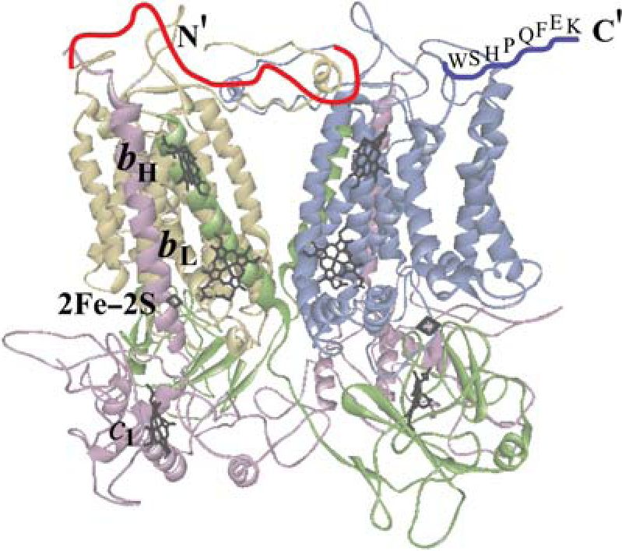
M.Czapla et al.
dimer (Swierczek et al., 2010). The so formed H-shaped
electron-transfer system distributes electrons between four
quinone catalytic sites at the corners of the dimer within the
millisecond timescale of catalytic turnover.
Other bacterial systems that allow breaking symmetry of
homodimeric cytochrome bc1 have also been recently
described (Castellani et al., 2010; Lanciano et al., 2011).
They are based on parallel expression of two plasmids and
isolations of heterodimers with a use of two different tags.
With the help of those systems, one study has shown that
cytochrome bc1 with only one quinone oxidation site is as
active as the native enzyme with two active sites (Castellani
et al., 2010), while the other study has implied that the inter-
monomer electron transfer is able to support the growth of
bacterial cells (Lanciano et al., 2011).
Clearly, the experimental accessibility to the asymmetric
forms of cytochrome bc1 now becomes highly desirable in
studies on mechanism of its operation. From this perspective,
in this work we explore possibilities to use other linker
sequences for fusing two cytochromes b (see Fig. 1) in
attempt to increase a number of available protein templates
suitable for asymmetric mutagenesis within the complex.
Materials and methods

Bacterial strains and plasmids
Rb.capsulatus and Escherichia (E.) coli (HB101, DH5a)
were grown in liquid or solid mineral-peptone-yeast extract
(MPYE) at 30°C and Luria-Bertani at 37°C media,
A-S-I-A-G-G-R-T-P-V-A-G-A-S-G-P
A-S-I-A-G-G-R-T-A-S-G-P
A-G-G-R-T-A-S-G-P
A-G-G-R-T-A
A-A-A
Fig. I. Schematic structural model of fusion protein B-B. Cytochrome bb, a
fusion of two cytochromes b (yellow and blue), forms a hydrophobic core of
the complex. The remaining subunits, cytochrome ci and the FeS subunit,
are shown in violet and green, respectively. Cofactors are overlaid in black.
The red line indicates a linker connecting the C-terminus of one cytochrome
b with the N-terminus of the other. Above the line, possible amino acid
compositions of the linker are shown. Blue line and the letters above it
indicate Strep-tag and its amino acid composition. Note that the red and blue
lines are just schematic visualizations and do not correspond to a real
conformation of the linker and Strep-tag peptides. The figure was generated
using the crystal structure of Rb.capsulatus cytochrome bci (Berry et al.,
2004) (protein Data Bank ID:1ZRT).
respectively, supplemented with appropriate antibiotics as
needed. Respiratory growth of Rb.capsulatus strains was
achieved at 30°C in the dark under semiaerobic conditions.
The cells were grown on plates for 3 days and in liquid
medium no >3 days in three steps of 2 ml, 25 ml and 1 l
cultures. Photosynthetic growth abilities of Rb.capsulatus
strains carrying the fusion B-B form (engineered cytochrome
bc1-like complex with two cytochrome b subunits fused
together) was tested on MPYE plates using anaerobic jars
(GasPak™ EZ Anaerobe Container System, BD) at 30°C
under continuous light. The Rb.capsulatus strains
(Atta-Asafo-Adjei and Daldal, 1991) used were pMTS1/
MT-RBC1 which overproduces wild-type cytochrome bc1
from the expression vector pMTS1 (contains a copy of
petABC operon coding for all three subunits of cytochrome
bcj), and MT-RBC1 which is a petABC—operon deletion
background. The mutagenized pMTS1 derivatives were intro-
duced to Rb.capsulatus MT-RBC1 via triparental crosses as
described (Atta-Asafo-Adjei and Daldal, 1991). Plasmid
pPET1 (a derivative of pBR322 containing a wild-type copy
of petABC) was used as a template for polymerase chain
reaction (PCR) and in some of the subcloning procedures.

Construction of plasmids for expression of B-B with different
linkers
The strategy of constructing plasmids for expression of B-B
follows the general approach described in Swierczek et al.
(2010). The plasmid pPET1-BL containing Notl restriction
site at the 3' end of petB was created by PCR using
QuikChange Site-Directed Mutagenesis Kit (Stratagene) and
the mutagenic oligonucleotides, EndNotl-F: 5'-CAC TAC
GGC AAT CCG GCG GCC GCC GGA AAG GAA CCG
AC-3' and EndNotl-R: 5'-CGG TTC CTT TCC GGC GGC
CGC CGG ATT GCC GTA GTG GC-3' (Fig. 2A). The
plasmid pUC-BLST containing Notl restriction site at the 5'
end of petB and a sequence encoding Strep-tag added to its
3' end was constructed in several steps summarized in
Fig. 2B. First, ~1.4 kb DNA fragment (petB and 111bp of
petC) from pPET1 was PCR-amplified using primers
StartNotl-F: 5' -GCG GCC GCC TCC GGA ATT CCG CAC
GAC CAT TAC G-3' and Asull-R: 5'-GCC GAA GAT CCC
TTC GAA GCT GAA GGC GTG-3' and then inserted into
pCR-Blunt II-TOPO (from Invitrogen). This created plasmid
TOPO1-StartNot. Next, the Xbal/Kpnl fragment of
TOPO1-StartNot was cloned into pUC19 to create pUC-BL.
Finally, XmaI/SfuI fragment of pUC-BL was exchanged with
its counterpart in pPET1-ST (derivative of pPET1 in which
petB was extended with a sequence encoding Strep-tag II
inserted between GAG coding for C-terminal E437 and TGA
stop codon) which created pUC-BLST (Fig. 2B).
The plasmids pPET1-BL and pUC-BLST and their deriva-
tives were used to construct a family of plasmids
pMTS1-BLBST (where L denotes sequences encoding linkers
shown in Table I) as summarized in Fig. 2C. Generally, the
NotI/SfuI fragment of pPET1-BL was exchanged with NotI/
SfuI fragment of pUC-BLST to create pPET1-BLBST
plasmid containing petBLBST gene flanked by original petA
and petC genes. Then, the BstXI/SfuI fragment of
pPET1-BLBST was exchanged with its counterpart in pMTS1
to create the expression vector pMTS1-BLBST. Without add-
itional steps this created pMTS1-BLBST with the sequence
coding for the linker composed of three amino acids (Table I).
16
Downloaded from https://academic.oup.eom/peds/article-abstract/25/1/15/1474088 by Jagiellonian University user on 25 February 2019
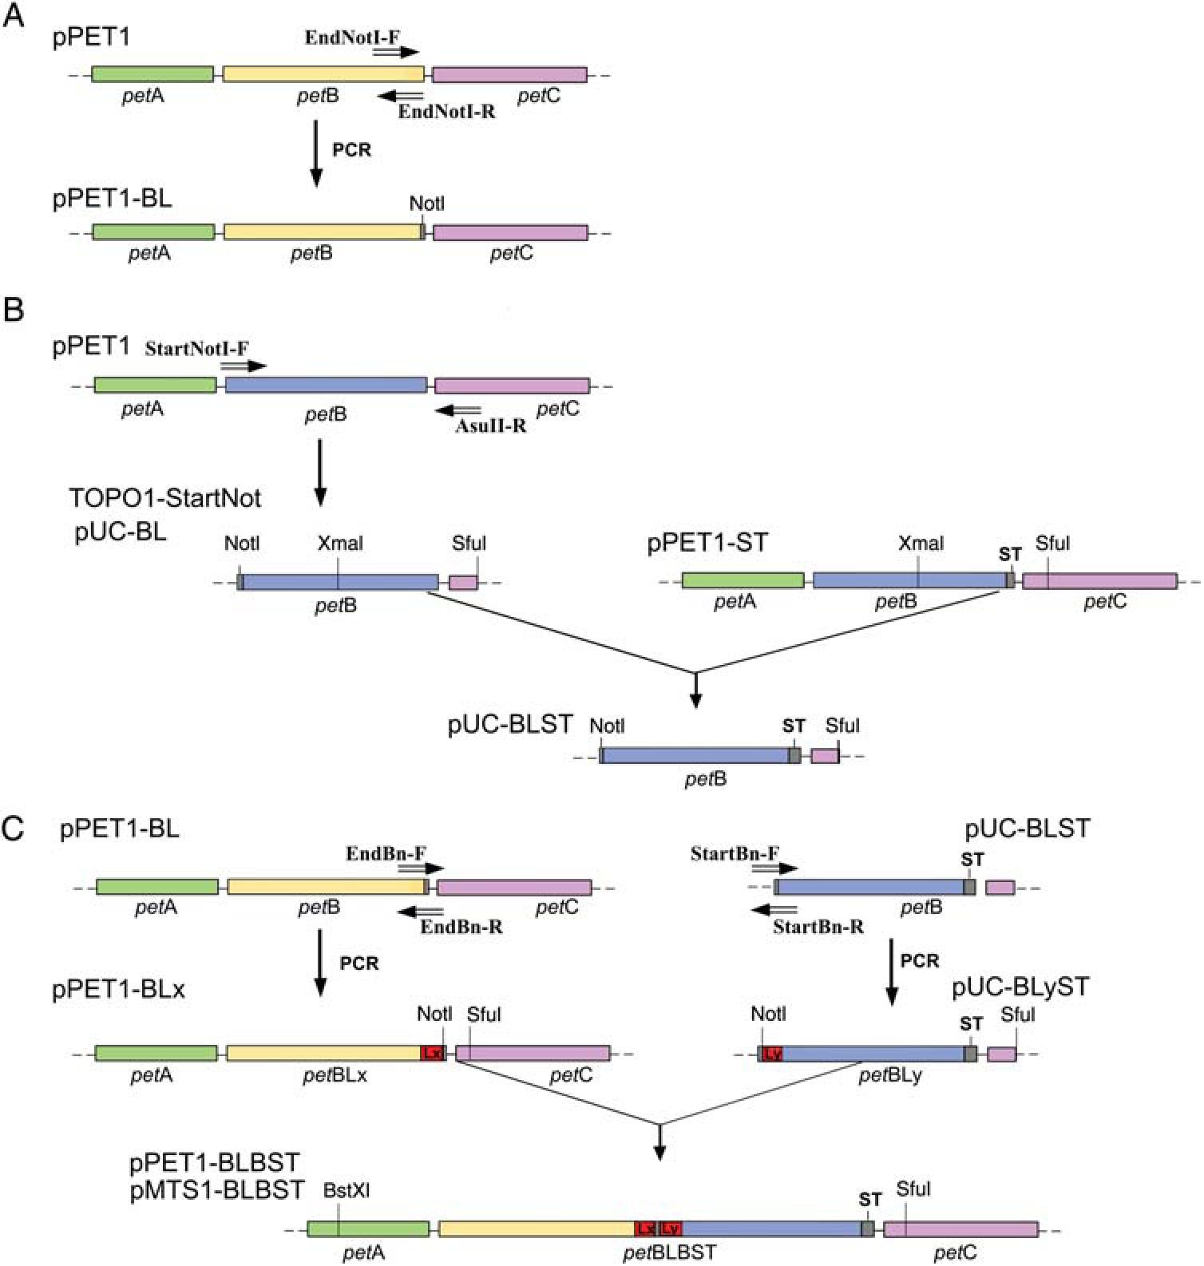
Fused cytochrome b and asymmetric mutagenesis
Fig. 2. Scheme of plasmid family pMTSl-BLBST construction. (A) Introducing Notl restriction site into 3' end of petB gene by PCR. The pPETl plasmid
contains operon encoding cytochrome bc1 subunits: petA encoding FeS protein (green), petB encoding cytochrome b (yellow) and petC encoding cytochrome
c1 (violet). Positions of mutagenic primers are indicated with horizontal arrows. (B) Steps of construction of pUC-BLST plasmid with Notl restriction site to
the 5' end site of petB and sequence encoding Strep-tag (ST) attached to the 3' end of petB. Positions of mutagenic primers and restriction sites used for
plasmid construction are indicated with horizontal arrows and vertical lines, respectively. (C) Final steps of construction of pMTSl-BLBST: introducing parts
of linker by PCR performed on pPETl-BL using primers EndBn-F, EndBn-R and on pUC-BLST using primers StartBn-F, StartBn-R (n in the primer names
marks varying number of nucleotides); inserting Notl/Sful fragment of pUC-BLyST into pPETl-BLx. Red boxes denote parts of added sequences (Lx, Ly)
that together form sequences of the linkers.
Table I. Assembly of B-B constructed using various linkers
Name of fusion protein | Length of linkera | Amino acid composition of linkers | Assembly of fusion protein
B-B[3] | 3 | A-A-A | +
B-B[6] | 6 | A-G-G-R-T-A | +
B-B[9] | 9 | A-G-G-R-T-A-S-G-P | +
B-B[12] | 12 | A-S-I-A-G-G-R-T-A-S-G-P | +
B-B[16] | 16 | A-S-I-A-G-G-R-T-P-V-A-G-A-S-G-P | +
B-B[20] | 20 | A-S-V-G-S-G-I-A-G-G-R-T-P-V-A-G-A-S-G-P | -
“The length of the linker corresponds to all amino acid residues that were changed and added between the fused C and N termini before the Notl ligation step
and as a result are flanked by the following amino acid sequences: G-N-P435 from the C terminus and 1S-G-I from the N terminus of cytochrome b.
To create pMTSl-BLBST with sequences encoding longer
linkers (Table I) additional PCR steps were performed. In
those steps sets of primers EndBn-F, EndBn-R for pPETl-BL
and StartBn-F, StartBn-R for pUC-BLST were used to create
pPETl-BLx and pUC-BLyST, respectively (Fig. 2C). Those
plasmids were then used in NotI/SfuI and BstXI/Sful insertion
steps, which created a family of pPETl-BLBST and
pMTSl-BLBST containing Lx and Ly sequences connected
together to form sequences encoding for desired linkers (in
the scheme of Fig. 2C, Lx and Ly denote sequences that were
progressively elongated in consecutive steps of PCRs; x and y
mark varying number of added/replaced nucleotides).
17
Downloaded from https://academic.oup.eom/peds/article-abstract/25/1/15/1474088 by Jagiellonian University user on 25 February 2019
M.Czapla et al.

Introducing point mutations to the petBLBST template
Plasmids pMTSl-BLBST containing various combinations
of point mutations corresponding to G158W and H212N in
cytochrome b were generated in the following way. First,
mutations were introduced to pPETl-BL or pUC-BLST
using a PCR-based mutagenesis (QuickChange from
Stratagene) and/or appropriate restriction cuts and ligations
(as described in Swierczek et al., 2010) and then pPETl-BL
(mutated or non-mutated) was ligated with NotI/SfuI frag-
ment of pUC-BLST (mutated or non-mutated) to create
pPETl-BLBST variant containing desired combinations of
mutations (as depicted in Table II). Finally, the BstXI/SfuI
fragment of pPETl-BLBST was exchanged with its counter-
part in pMTSl to create the expression vector
pMTSl-BLBST. With this strategy we obtained plasmids
used to express a family of B-B[3] (B-B with linker made of
three amino acids) forms containing Gl58W and/or H2l2N
mutations in various combinations. Similar strategy was
adopted to obtain a respective family of B-B[l2] (B-B with
linker made of l2 amino acids) described in Swierczek et al.
(20l0) in which case mutations were introduced to the deri-
vatives of pPETl-BL or pUC-BLST (pPETl-BLx and
pUC-BLyST containing appropriate Lx and Ly extensions).
DNA sequence and correct size of all constructs were veri-
fied both at the stage of preparing the constructs and after
the re-isolation of plasmids from Rb.capsulatus strains and
appropriate cloning procedures (DNA sequence of
petBLBST for B-B and all mutant forms listed in Table II
was verified from two parts of pMTSl-BLBST that were
separated by its digestion with XmaI followed by cloning of
the XmaI-XmaI insert into pUCl9 and self-ligation of the
remaining part of pMTSl-BLBST). Re-isolation of plasmids
from Rb.capsulatus strains was followed by the amplification
step in the E.coli HBl0l strain.

Isolation, electrophoresis and western blot of various
B-B forms
The chromatophore membranes of WT (native form of cyto-
chrome bcl) and the B-B derivatives were prepared from
semiaerobically grown cultures of Rb.capsulatus as described
(Valkova-Valchanova et al., l998; Swierczek et al., 20l0).
During isolations, special care was taken to use a mixture of
inhibitors phenylmethylsulfonyl fluoride, benzamidine and 6-
Table II. Assembly of fusion protein B-B[3] and B-B[l2] containing add-
itional mutations W and/or N in various combinations
Mutation Assembly of fusion protein
patterna
B-B[3] B-B[l2]
wB-B | + | +
B-Bw | + | +
WB-BW | - | -
nb-b | + | +
b-bn | + | -
nb-bn | - | -
WB-BN | + | +
NB-BW | - | -
NWB-B | - | +
B-BNW | + | +
aW and N refer to Gl58W and H2l2N point mutations in cytochrome b.
18
aminocaproic acid (Lee et al., 2008). Membranes were
diluted to a final protein concentration 10 mg/ml and solubi-
lized with n-dodecyl-b-D-maltoside (DDM) (1 mg pro-
tein:1.3mg detergent) by 30 min at 4°C. The mixture was
ultracentrifuged (45 min 45 000 g) and the supernatant was
loaded onto a DEAE-Biogel (Bio-rad) or Strep-tag column
(IBA-Biotechnology). All purification steps were performed
at 4°C.
The native form of cytochrome bci was purified using
DEAE-Biogel column according to the protocol described
(Valkova-Valchanova et al., 1998). To purify B-B forms,
special care was taken to limit the whole isolation procedure
(starting from membrane solubilization) to 1 day and the fol-
lowing modifications were introduced. Appropriate amounts
of DDM-solubilized membranes were loaded onto 5-7 ml
DEAE-Biogel column pre-equilibrated with a Tris buffer
(50 mM Tris pH 8, 100 mM NaCl, 1 mM ethylenediaminete-
traacetic acid (EDTA), 20% glycerol, 0.01% DDM). Then
the column was washed with two to three column volumes
of the equilibration buffer. In the next step, the column
was washed with two to three column volumes of Tris buffer
containing 150 mM NaCl. B-B proteins were eluted in Tris
buffer containing 400 mM NaCl.
To purify B-B forms by affinity chromatography, we fol-
lowed the protocol for Strep-tag purification supplied by the
manufacturer (IBA), with the following modifications.
Typically, 3-5 ml of DDM-solubilized membranes were
loaded onto the 1 ml Strep-tag sepharose column (IBA) pre-
equilibrated with a Washing Buffer (100 mM Tris-Cl, pH
8.0, 150 mM NaCl, 1 mM EDTA) containing additionally
20% glycerol and 0.01% DDM (Buffer WG). In order to
remove unbound proteins and photosynthetic pigments the
column was washed with two to three column volumes of
Buffer WG. The absorbed proteins were eluted with three
column volumes of Buffer WG containing 2,5 mM
desthiobiotin.
Sodium dodecyl sulfate polyacrylamide gel electrophoresis
(SDS-PAGE) was performed as described (Osyczka et al.,
2001). Samples of protein were incubated under reducing
conditions at 60°C for 5 min prior to the loading on gels (4%
stacking gel and 15% linear separating gel was used). The
gels were stained with Coomassie blue.
The western blot against Strep-tag was performed accord-
ing to the protocol supplied by IBA with HRP-streptactin
used for detection of Strep-tag.
For each protein sample, the cells growth, and all steps of
membrane and protein preparation and analysis were repeated
several times.
Optical and electron paramagnetic resonance (EPR)
spectroscopy and enzymatic activity measurements
Optical spectra for b- and c-type cytochromes were recorded
using a Shimadzu UV-2450 spectrophotometer. The optical
spectra of purified protein were obtained with samples that
were first oxidized by an addition of a potassium ferricyan-
ide, and then reduced by using either sodium ascorbate or a
minimal amount of solid sodium dithionite. EPR and enzym-
atic activities measurements of membranes were performed
as described in Sarewicz et al. (2009) and Swierczek et al.
(2010).
Downloaded from https://academic.oup.eom/peds/article-abstract/25/1/15/1474088 by Jagiellonian University user on 25 February 2019
Fused cytochrome b and asymmetric mutagenesis

Guarding against reversions
Because of the risk of reversions (see Results and discus-
sion), special care was taken each time when preparing a
new batch of membranes and/or proteins to ensure that it is
homogenous and suitable for kinetic analysis. This included
the following steps: (i) the colonies only from freshly pre-
pared plates originated directly from — 80°C stock were
taken to inoculate liquid cultures for preparative purposes,
(ii) the cultivation of the cells in liquid media was kept to
minimum and did not exceeded 3 days (1 day for each of the
2 ml, 25 ml and 1 l cultures), (iii) the integrity of the fused
gene was verified at the final cultivation stage (1 l culture),
(iv) the content of membranes was analyzed electrophoretic-
ally by western blots (using antibodies against Strep-tag) and
by SDS-PAGE of complexes isolated from membranes with
two parallelly applied methods, ion-exchange DEAE-Biogel
or affinity Strep-tag chromatography, which comprehensively
identified all bc-type complexes present in membranes, (v)
spectroscopic properties of complexes in membranes were
analyzed by optical and EPR spectroscopy, to verify struc-
tural asymmetry of all forms with asymmetrically introduced
mutations. Only the samples that met all the purity criteria
related to points (iii)—(v) (see Results and discussion) were
considered as suitable for further kinetic and functional ana-
lysis (for the forms denoted as ‘ + ’ in Tables I and II, occa-
sional preparations that contained elevated levels of reverted
forms of proteins were discarded).
Results

Fusion proteins with linkers of different length
The N- and C-termini of the eight-transmembrane a-helical
cytochrome b subunit of cytochrome bc1 protrude at the
cytoplasmic side of the membrane. As shown previously
the C-terminus of one cytochrome can be joined with the
N-terminus of the other if a linker made of 12 amino acids is
used (Swierczek et al., 2010). This creates a fusion protein
(cytochrome bb) which in a dimer replaces two separate
cytochromes b (creating an engineered cytochrome bc1-like
complex, named B-B). Adopting similar strategy, we tested
several linkers of different length for successful fusion.
Figure 2 summarizes steps of construction of plasmids con-
taining the operon coding for cytochrome bc1 in which the
gene encoding cytochrome b was extended with the second
copy of the same gene containing Strep-tag at its C-terminus.
The extension procedures described in Fig. 2 yielded con-
structs containing sequences coding for the gene with the
linkers of length between 3 and 20 amino acids. In all cases,
the other two genes of the operon, encoding the FeS subunit
and cytochrome c1, were left unchanged.
In designing the sequences of the linkers the following
points were considered. We aimed for the sequence that
maintained similarity with motifs already present in the loop
regions of native cytochrome b. Bulky and hydrophobic resi-
dues were avoided to secure polarity and flexibility of the
linker. The proline residues were intentionally incorporated
at the end and/or in the middle of longer linkers to minimize
the probability of creation of the ordered secondary structure.
One constraint in the amino acid composition came from the
presence of the NotI restriction site in the nucleotide se-
quence necessary for creation of the fused gene.
Table I shows the sequences of the tested linkers and sum-
marizes the results of expression of the respective plasmids
in Rb.capsulatus cells. The assembly of B-B was examined
at the level of membranes and isolated complexes. The size
of cytochrome bb was verified by western blots on mem-
branes and the subunit composition of B-B was analyzed by
SDS-PAGE of complexes isolated by ion-exchange (DEAE)
and affinity (Strep-tag) chromatography. Figure 3A compares
blots for membranes containing B-B complexes containing
cytochrome bb made with 3-, 6-, 9-, 12- or 16-amino acid
liker (B-B[3], B-B[6], B-B[9], B-B[12] and B-B[16], respect-
ively). Figure 3B and C compares electrophoretic profiles of
those forms.
It is clear that in all cases cytochrome bb replaces cyto-
chrome b subunits present in the native cytochrome bc1
dimer. This cytochrome is two times larger than cytochrome
b, as expected for the size of fusion protein, and is accom-
panied by the two remaining catalytic subunits of cyto-
chrome bcp. cytochrome c1 and the FeS subunit. While in
the case of native cytochrome bc1, affinity and ion exchange
chromatographies yield samples of similar purities (Fig. 3B
and C, line 1), in the case of B-B, ion exchange allows only
for partial purification (Fig. 3C, lines 2-6) and pure com-
plexes can be obtained using affinity chromatography
(Fig. 3B, lines 2-6). The spectroscopic properties of B-B
forms (optical spectra of hemes b and c and EPR spectra of
the FeS cluster) in membranes were similar to those of native
cytochrome bcj and B-B[12] reported in Swierczek et al.
(2010). The B-B forms isolated by either ion exchange or af-
finity chromatography retained the native-like optical spectra
as exemplified by a comparison for the wild-type bc1 and
B-B[12] as shown in Fig. 4. We note a slight increase in the
heme b to heme c absorption ratio in the spectrum of
complex isolated by Strep-tag which reflects an increased
probability of dissociation of subunits not-containing
Strep-tag during the purification using the affinity chroma-
tography (this holds also for native cytochrome bcj).
Enzymatic activities of the B-B forms measured at the
level of membranes were similar to the wild type (not
shown).
It can be concluded that the connection provided by the
3-, 6-, 9- and 16-amino acid linker in cytochrome bb
allows for successful fusion and assembly of B-B (Fig. 1),
as reported earlier for B-B[12] (Swierczek et al., 2010). On
the other hand, our attempts to obtain B-B containing two
cytochromes b fused with longer (20 amino acids) linker
failed. In this case, during the crossing procedure, only few
single colonies appeared on selective plates within the
characteristic 3 days time. The remaining colonies (that cor-
responded in number to the typical yield of the crossing
procedure) appeared with 1-day delay. Further analysis of
the plasmid DNA isolated from these cells showed the
presence of the short version of the gene (corresponding in
size to a single copy of petB) in addition to a fusion gene
(Fig. 5). Although the reason of this phenomenon is
unknown, we speculate that B-B[20] might not have been
inert to the cells ( perhaps improperly folded fusion protein
affected integrity of the membrane), which by impeding the
growth of the cells advanced efficient selection toward the
non-fused form from the early stages of the plasmid acqui-
sition (see further discussion on this issue in the following
paragraphs).
19
Downloaded from https://academic.oup.eom/peds/article-abstract/25/1/15/1474088 by Jagiellonian University user on 25 February 2019
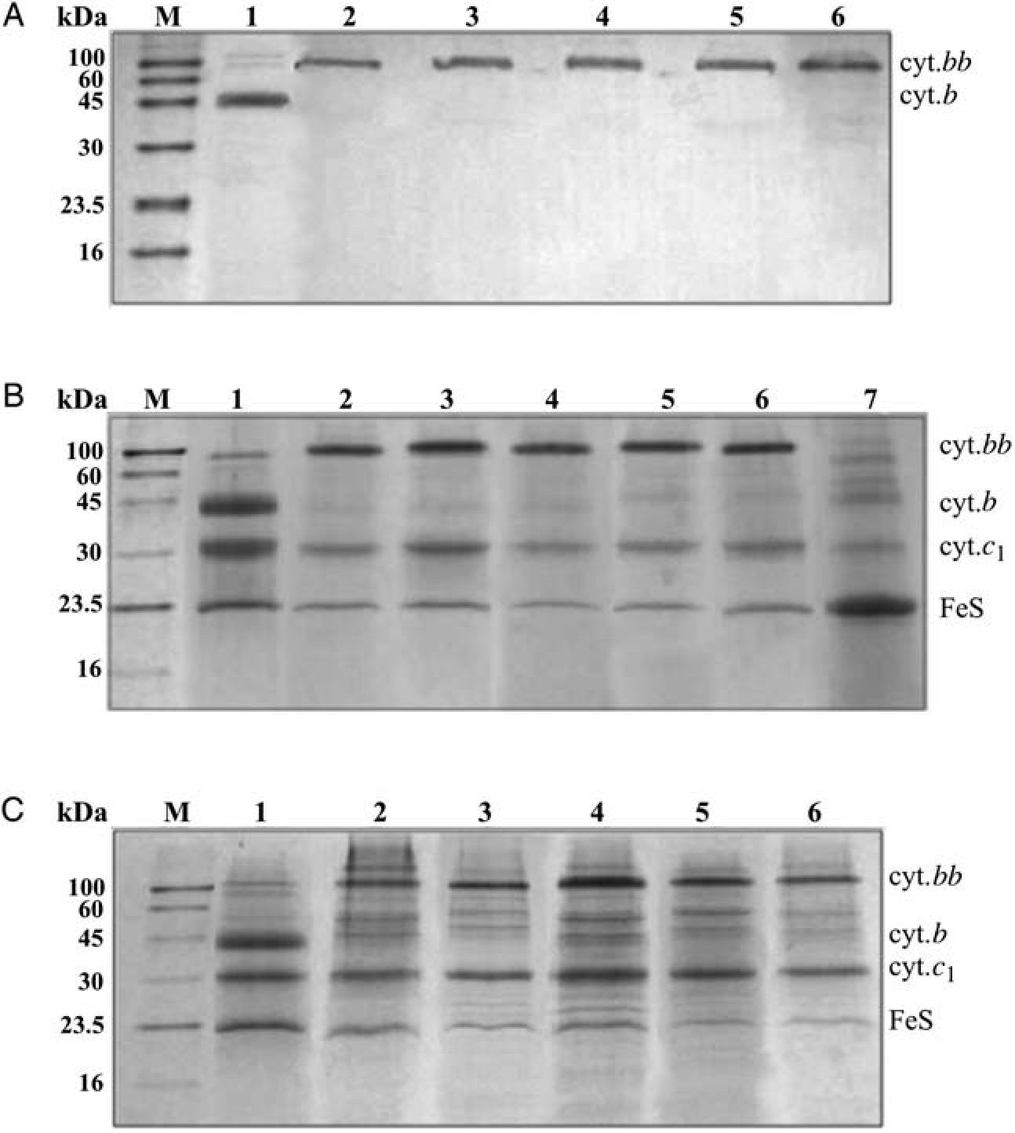
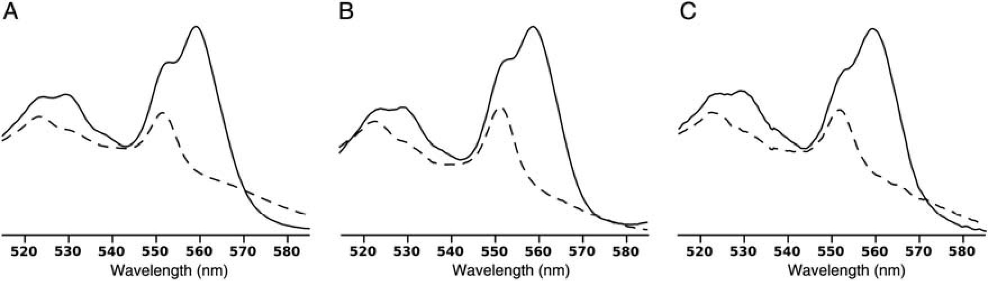
M.Czapla et al.
Fig. 3. Western blot and SDS-PAGE analyses of B-B containing cytochrome bb fused with various linkers. (A) Western blot against Strep-tag II of
chromatophore membranes. (B) SDS-PAGE analysis of B-B complexes isolated using affinity chromatography (Strep-tag). (C) SDS-PAGE analysis of B-B
complexes isolated using ion-exchange chromatography (DEAE Bio-gel). Lines: M marker (IBA); l, native form of cytochrome bcl; 2, B-B[3]; 3, B-B[6]; 4,
B-B[9]; 5, B-B[l2]; 6, B-B[l6]. For comparison, line 7 in B shows electrophoretic profile of an engineered cytochrome bcl-like complex that misses
cytochrome b subunit (this is purified by Strep-tag b6Cl complex where petB is split into two parts, reminiscent of cytochrome b6 and subunit IV present in
cytochrome bf as described in Saribas et al., l999).
Fig. 4. Optical absorption spectra of hemes in purified complexes. (A) Native form of cytochrome bci isolated by ion-exchange chromatography. (B) B-B[12]
purified by ion-exchange chromatography. (C) B-B[12] purified by affinity chromatography. Solid and dashed lines indicate dithionite-reduced and
ascorbate-reduced spectra, respectively.

Incompetence of fusion protein to support photosynthetic
growth
Photosynthetic growth of Rb.capsulatus depends on functional
cytochrome bc1, thus testing photosynthetic phenotype of the
cells carrying mutated genes coding for cytochrome bc1 provides
a simple way to verify functionality of the mutated complexes in
vivo. Such tests, done for B-B[3] and B-B[12] indicated lack of
photosynthetic competence of cells carrying genes coding for
the fusion protein. Furthermore, when cells grown semiaerobi-
cally were transferred on plates for photosynthetic growth, rever-
sions to Ps + (photosynthetic growth) occured. Further
restriction analysis of the plasmid DNA isolated from these cells
revealed that only the short version of the gene was present (its
size corresponded to a single copy of petB).
20
Downloaded from https://academic.oup.com/peds/article-abstract/25/1/15/1474088 by Jagiellonian University user on 25 February 2019
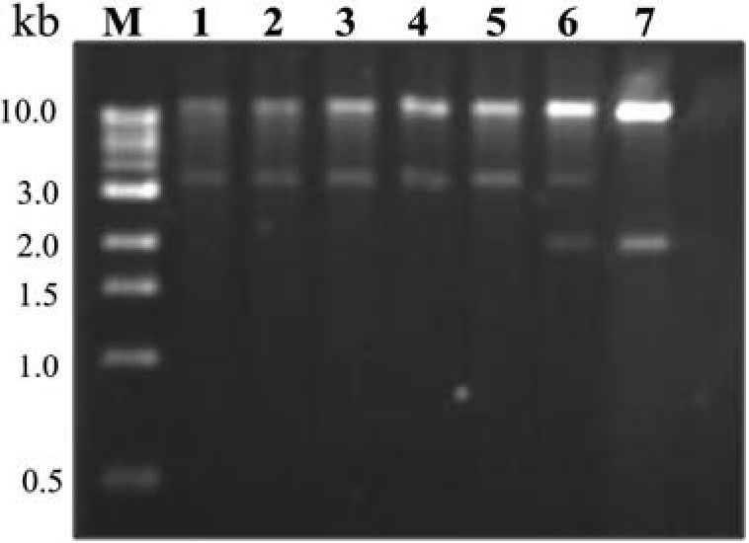
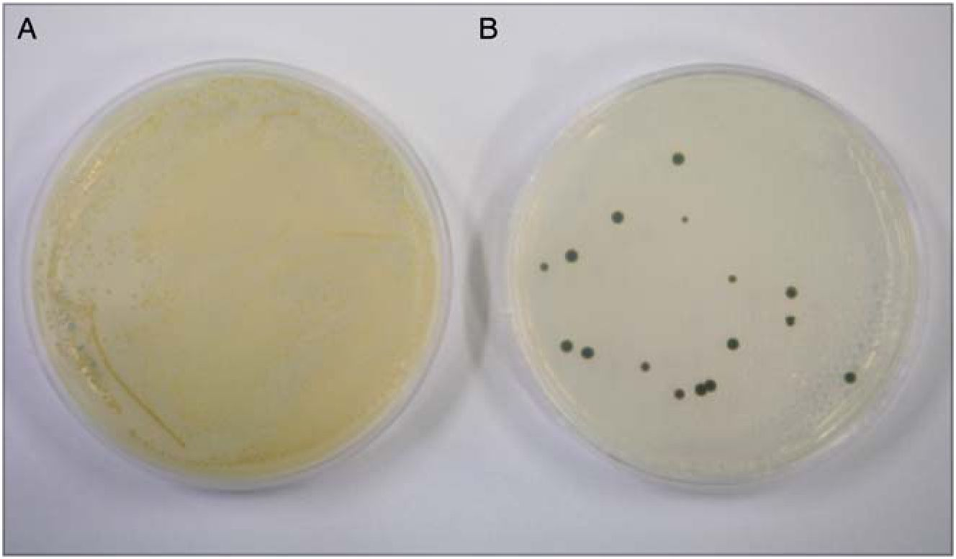
Fused cytochrome b and asymmetric mutagenesis
The typical serial dilutions experiment, in which the
number of colonies that gain Ps + phenotype were compared
to the number of all cells that grow under aerobic conditions
at a given concentration of cells (see example in Fig. 6), pro-
vided an estimation of l0_3-l0_4 for the frequency of re-
version. We note that additional 2-3 days of cultivation
under Ps + conditions were necessary before any of the Ps +
colonies appeared visible on the photosynthetic plates (com-
pared with the characteristic 3-day time required for growth
of single colonies on those plates). We also note that this fre-
quency level was maintained at all stages of cultivation (i.e.
2 ml, 25 ml and l l cultures).
The reason of the inability of the cells expressing B-B to
grow photosynthetically is currently unknown. One possibil-
ity is that the energetic cost of incorporation of cytochrome
bb into membrane and its assembly with the remaining parts
of the complex is so high that it results in the overall failure
Fig. 5. Restriction analysis of pMTS1-BLBST plasmids isolated from
various Rb.capsulatus strains. Plasmids were digested with BstXI and SfuI
restriction enzymes. The presence of ~3.3 kb DNA fragment indicates that
plasmid bears the fusion gene petBLBST, while the ~2 kb DNA fragment
corresponds to the native form of petB gene. Plasmids are visualized on
ethidiumbromide-stained 1% agarose gel. Lines: M—marker, plasmids
isolated from the strains transformed with pMTS1-BLBST plasmids that
encoded for the following forms: 1, B-B[3]; 2, B-B[6]; 3, B-B[9]; 4,
B-B[12]; 5, B-B[16]; 6, B-B[20]; 7, control plasmid (pMTS1 containing
native operon).
of B-B to support growth when cells absolutely depend on it
( photosynthetic conditions). This could, for example, be
associated with an altered stoichiometry of gene product vs.
subunit composition. Because an assembly of B-B requires
two cytochromes cl and two FeS proteins per one cyto-
chrome bb, the expression of the whole operon containing
petBLBST leads to an excess of cytochrome bb which in the
cells cannot be maintained as individual subunit and repre-
sents a possible case of energetic extravagance that the cells
cannot afford when their growth absolutely depends on cyto-
chrome bcl function.
The reversions observed under photosynthetic conditions
raise an issue of a genetic stability of the system. This issue
requires particular attention in all cases when two copies of
the same gene are parallelly introduced to the cells. In our
case, careful examination of the samples originating from the
semiaerobically grown cells (when the growth does not
depend on cytochrome bcl function) performed at the level
of DNA, membranes and isolated proteins confirmed that
B-B can stably be maintained in the cells during the period
of cultivation under those conditions at such level that the
reversions, if occur, are below a threshold of detection for
the biochemical and spectroscopic methods used.
We emphasize, however, that because of this risk of the
reversions, a special care must be taken to carefully examine
the samples every time a new batch of membranes and/or
proteins is prepared so that for further functional/kinetic ana-
lysis are taken only the samples that meet the criteria applied
in Swierczek et al. (20l0): the integrity of petBLBST isolated
from the cells, the positive results from western blots on
membranes and from SDS electrophoresis of complexes iso-
lated using ion exchange and affinity chromatography
showing the presence of only the fusion protein, and the
proper spectroscopic properties of the complexes (optical and
EPR). As certain point mutations are known to change spe-
cifically the spectral properties of cytochrome bcl, the spec-
tral analysis of the asymmetrically mutated forms (see
below) offers additional level of verification whether both
parts of cytochrome bb are properly incorporated and inte-
grated with the remaining subunits. In such case, the
Fig. 6. The comparison of heterotrophic and photosynthetic growth of Rb.capsulatus strain transformed with genes coding for B-B[l2]. The same amount of
bacterial cells deriving from the semiaerobic liquid culture were transferred onto the agar plates and placed under aerobic conditions in dark (A) or anaerobic
conditions in light (B). Few colonies in B represent the revertants that gain PS + phenotype by losing part of petBLBST gene.
21
Downloaded from https://academic.oup.com/peds/article-abstract/25/1/15/1474088 by Jagiellonian University user on 25 February 2019

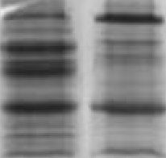
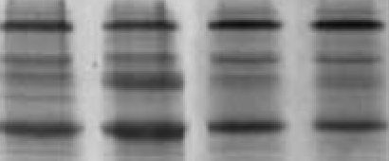
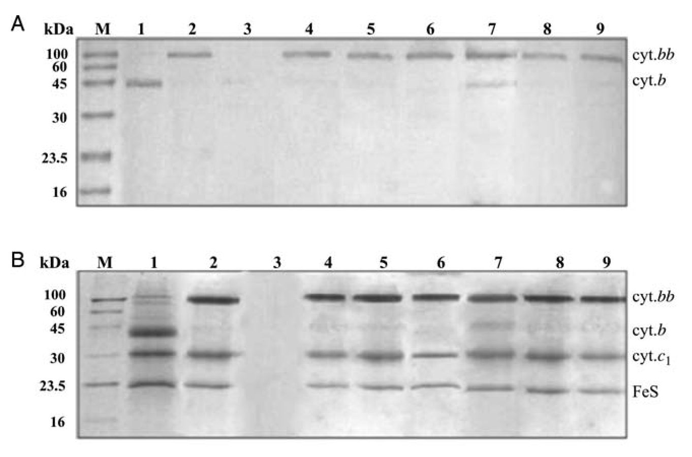
M.Czapla et al.
spectrum of asymmetric form is a combination of that of the
native and the mutant form, as described in Swierczek et al.
(2010).
We also emphasize that cultivation of cells for periods
longer than a 3-day propagation involving three stages of
2 ml, 25 ml and 1 l cultures (described under ‘Materials and
methods’) should be avoided and samples of membranes/pro-
teins should always be prepared from freshly grown cultures
originating directly from — 80°C stocks.
Tolerance to asymmetric and symmetric mutations patterns
Since the native operon coding does not differentiate
between the monomers of cytochrome bc1, the system based
on a fusion of two cytochromes b was specifically designed
to enable introducing individual point mutations at the level
of dimer that would break its symmetry. Permutations of just
two strategically positioned point mutations knocked-out
individual segments of the dimer in such a way that all
major electron-transfer paths were exposed for kinetic exam-
ination. Those mutations included H212N (denoted as N)
which caused a loss of one heme b rendering the Qj site
(quinone reduction site) non-functional (Osyczka et al.,
2004), and G158W (denoted as W) which distorted the
quinone binding pocket rendering the Qo site (quinol oxida-
tion site) non-functional (Ding et al., 1995).
As individual mutation can be introduced either to the
first or the second copy of the fused gene, each variant can,
in principle, have its mirror form (for example, for single
W it can be either WB-B or B-BW). However, studies with
B-B[12] show that not all possible variants can be obtained
(Table II), as reported in Swierczek et al. (2010). Figure 7
summarizes western blots of membranes and SDS-PAGE
profiles of complexes purified from the cells carrying
petBLBST genes with various combinations of asymmetric
mutations. Within a group of single mutants, it was possible
to obtain both variants containing W (WB-B, B-BW)
(Fig. 7, lines 4 and 5), but only one variant with N (NB-B)
assembled as fusion protein (line 2). In the case of B-BN,
the fusion protein was absent in the cells and the complexes
containing fragments shorter than cytochrome bb could
have been isolated only using ion-exchange chromatography
(line 3) (clearly, the second portion of the protein ending
with the Strep-tag was missing). Within the group of
double mutants, both combinations containing W and N on
the same side (WB-B, B-BW) were tolerated (lines 8 and 9),
while only one combination containing mutations across
was expressed as a fusion protein (WB-BN) (line 6). In the
case of NB-BW, the cells expressed significant amount of
complexes containing non-fused cytochome b, which
co-purified with B-B (line 7). Thus, even though NB-BW is
seen in the form of the complex with fused cytochrome bb,
the presence of non-fused cytochrome b precludes the usage
of NB-BW for further kinetic/functional analysis (this is an
example not meeting criteria described in proceeding para-
graph). We note that a comparison of electrophoretic pro-
files of complexes purified independently by the ion
C kDa M 1
10«
60
45
30
23.5
16
cyt.frfr
cyt.fr
cyt.c,
FeS
Fig. 7. Western blot and SDS-PAGE analyses of B-B[12] containing additional mutations W and/or N in various combinations. (A) Western blot against
Strep-tag II of chromatophore membranes. (B) and (C) SDS-PAGE analysis of B-B[12] complexes isolated using affinity chromatography (Strep-tag) and
exchange chromatography (DEAE Bio-gel), respectively. Lines: M marker (IBA); 1, native form of cytochrome bc 1; 2, NB-B; 3, B-BN; 4, wB-B; 5, B-Bw;
D DN. "7 ND D . O ND d. n D DN
ion
6, wB-B
;7,nB-Bw; 8, WB-B; 9, B-BW
22
Downloaded from https://academic.oup.eom/peds/article-abstract/25/1/15/1474088 by Jagiellonian University user on 25 February 2019
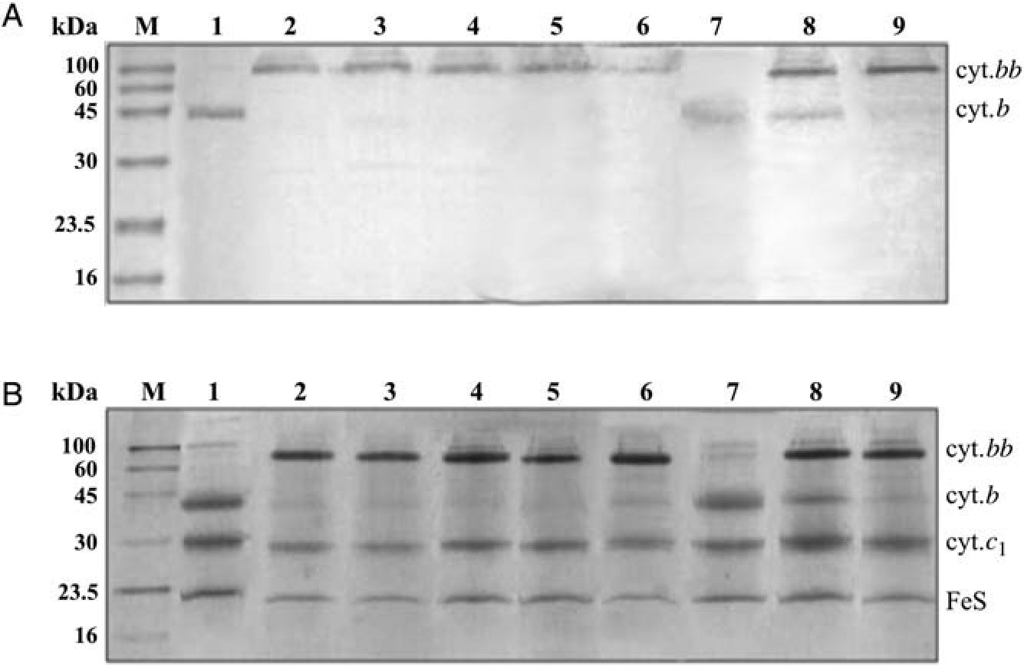
Fused cytochrome b and asymmetric mutagenesis
Fig. 8. Western blot and SDS-PAGE analyses of B-B[3] containing additional mutations W and/or N in various combinations. (A) Western blot against
Strep-tag II of chromatophore membranes. (B) SDS-PAGE analysis of B-B[3] complexes isolated using affinity chromatography (Strep-tag). Lines: M marker
(IBA); numbering as in Fig. 7.
exchange (isolates all complexes) or affinity chromatog-
raphy (isolates Strep-tagged complexes) shown in Fig. 7
identifies comprehensively all the forms of bc-type com-
plexes present in membranes. This is best visualized by the
examples of lines 3 and 7.
For asymmetric variants that assembled as fusion protein,
the reversion frequency was checked adopting similar strat-
egy as described above for B-B[3] and B-B[12]. The rever-
sion frequency was estimated to be at 10_3-10_4 at all
stages of cell cultivation, which was within a similar range
as found for B-B[3] or B-B[12].
To explain the inability to obtain some forms of the fusion
protein, we suggest that there is less of structural flexibility
in the overall assembly of one 16-helical subunit in B-B than
it is in the assembly of two 8-helical cytochromes b in the
native dimer. Consequently, B-B might experience more dif-
ficulty in accommodating structural changes enforced by add-
itional mutations even to the point that if the fusion protein
does assemble, it bears significant structural alterations. If
such alterations are not inert to the cell and impede the
growth ( for example, by affecting the integrity of the mem-
brane), a selection toward the non-fused form advances more
or less effectively during the cultivation period depending on
how much the presence of a given type of fused protein
affects physiological functions.
To test whether and how this sensitivity to mutational
change depends on the linker itself, we examined the effect
of introducing point mutations to B-B[3] repeating the per-
mutation pattern of W and N used for B-B[12]. The results
are summarized in Table II and Fig. 8. Both variants contain-
ing single W (WB-B, B-BW), or single N (NB-B, B-BN)
assembled as fusion protein. From the combinations of W
and N across, only WB-BN assembled as fusion protein.
From the combinations of W and N on the same side, only
B-BNW was tolerated, while in the case of NWB-B, cells also
expressed a significant amount of non-fused cytochrome b.
These results demonstrate that in the case of B-B[3], like in
B-B[12], there are some asymmetric mutation patterns that
end up effectively advancing selection toward the non-fused
form during the cultivation period. However, specific pat-
terns causing these effects do not necessarily have to be the
same.
A separate case of mutation patterns that cannot be accom-
modated by any of the fusion protein tested in this work (this
regards all templates described in Table II) are symmetric
nB-Bn and wB-Bw. For those mutants, introducing the corre-
sponding genes to the cells resulted in the similar type of
phenomenon as described earlier for the B-B[20]. During the
crossing procedure, few single colonies appeared on selective
plates with 1 day of delay to the characteristic 3 days time.
The remaining colonies (that corresponded in the number to
the typical yield of the crossing procedure) appeared with a
2- to 3-day delay. Further restriction analysis of the plasmid
DNA isolated from these cells revealed that only the short
version of the gene was present (its size corresponded to a
single copy of petB). We follow the same reasoning as dis-
cussed for the B-B[20] and consider these results as an indi-
cation that the presence of nB-Bn or wB-Bw might
somehow be damaging to the cells (improperly folded
protein affects integrity of the membrane), and the resulting
growth impediment advances efficient selection toward the
non-fused form from the early stages of the plasmid
acquisition.
Discussion
Our study shows that successful fusion of two cytochromes b
and an integration of the fused protein with other subunits of
the cytochrome bc1 of Rb.capsulatus can be achieved with
variety of linkers that connect the C-terminus of one cyto-
chrome b with the N-terminus of the other (Fig. 1). This
indicates that the termini have significant conformational
flexibility in accommodating specific structural constrains
imposed by the presence of an individual linker. Spectral
properties and subunit composition of modified complexes
indicate that under these circumstances the overall assembly
23
Downloaded from https://academic.oup.eom/peds/article-abstract/25/1/15/1474088 by Jagiellonian University user on 25 February 2019
M.Czapla et al.
of the 16-helical construct resembles an assembly of two
8-helical cytochromes b in the dimer. Such resemblance
requires a preservation of the attachment sites for four hemes
B, a formation of four quinone binding sites, and retention of
specificity in interactions with other subunits, cytochrome c1
and the FeS subunit. The competent versions of B-B listed in
Table I come thus as remarkable examples of the overall
structural plasticity of cytochrome bc1 complex and its
hydrophobic core built by cytochromes b.
The B-B complex, however, should not be treated as exact
replica of the native cytochrome bc1. The two major differ-
ences should be emphasized. First, cells expressing B-B,
despite high enzymatic and electron-transfer activity of B-B
(as reported by flash-induced and steady-state kinetic mea-
surements (Swierczek et al., 2010)), are not able to grow
photosynthetically. Second, B-B exhibits less engineering
tolerance for further mutagenic changes, which manifested
itself in the apparent difficulty of B-B to accommodate
certain mutation patterns (understood as specific combina-
tions of point mutations introduced to the first, or the second,
or both halves of the fused protein). These two sets of condi-
tions (i.e. the photosynthetic growth conditions or the pres-
ence of certain mutations) effectively advance selection
toward the pseudo-native form containing non-fused cyto-
chrome b. As proposed in the Results, in the first case, this
may be because of the too costly energetically biosynthesis
and incorporation of B-B to the membrane, while in the
second case, this may be due to the non-inert for the cells
presence of somewhat ‘distorted’ B-B. Keeping with this
proposal, one may expect that a degree of negative impact of
the non-inert forms will depend on the level of structural dis-
tortion experienced by individual type of B-B. This could
very well be at roots of the observed differences in the time
needed for the selection of revertants: in more severe cases
(symmetric NB-BN and WB-BW) the effective selection mani-
fests itself at initial stages of cell cultivation, while in less
severe cases (for example asymmetric NB-BW on B-B[12]
template, or WB-B on B-B[3] template), it takes place at later
stages.
Table II indicates that in some cases a success in an as-
sembly of B-B with asymmetric mutations depended on
whether a particular mutation was placed in the first or the
second halve of the fusion protein. For example, with
B-B[12], wB-Bn assembled, but NB-BW failed to do so. This
points to the fact that the linker itself and/or C-terminal
somewhat lowers the degree of symmetry intrinsic to the
homodimeric structure of native cytochrome bc1.
Consequently, B-B might experience difficulty in accommo-
dating certain changes associated with additional structural
modifications, which could be one of the reasons of the
observed increase in sensitivity of B-B to point mutations in
comparison with native cytochrome bc1.
While this increased sensitivity holds with all linkers
tested, irrespective of their length, a set of specific mutation
patterns not tolerated may differ depending on the type of
linker used (Table II). For example, NWB-B is tolerated in
B-B[12] but not in B-B[3]. Clearly, the forms with various
linkers may, in certain cases, differently respond to the ne-
cessity to accommodate mutational changes. Considering all
cases of failure listed in Table II it is also clear that there is
no distinction between the first or second halve of the fused
protein in terms of the origin of failure, i.e. mutations
located either in the first or the second halve can result in a
failure.
Nevertheless, our results indicate that B-B does accommo-
date several asymmetric mutational patterns that can be
maintained in the cells during the cultivation period under
semiaerobic conditions when the growth of cells does not
depend on cytochrome bc1. Furthermore, the presence of the
fusion protein is easily verifiable, providing us with effective
means to control the status of the membrane and protein
samples at every experimental step. This also includes means
to confirm the presence of desired mutation(s) (like N or W
used here) at appropriate position(s) within cytochrome bb
verified at the level of DNA sequence of plasmids isolated
from the Rb.capsulatus cells. We believe that this type of
control is important for any genetic system based on two
copies of the same gene which face recombination
possibilities.
This system thus provides an attractive way to break struc-
tural symmetry of dimer to expose individual electron-transfer
paths for kinetic testing. Those types of experiments can be
performed at the level of membranes isolated from the semi-
aerobically grown cells (flash-induced electron-transfer
kinetics, enzymatic activities) as described in Swierczek et al.
(2010), or purified complexes (manuscript in preparation).
They have already proven valuable in discerning mechanistic
principles of the operation of dimer of cytochrome bcj. It is
noteworthy that till now, this system appears to be the only
one to provide the experimental access to certain
electron-transfer paths (such as those exposed by B-B with
single asymmetric mutation N or W, or double-mutations N
and W placed on the same side) for flash-induced
electron-transfer kinetic analysis at the level of membranes.
This system also has its limitations which relate to the dis-
cussed earlier observation that a duplication of a gene imple-
mented to construct a fusion protein, as might have been
expected, is prone to reversions. This is an undesirable
feature that must be taken into account when using the system
and preparing the samples for kinetic analysis. This means
experimental rigor at all stages of sample preparation and
analysis implemented to obtain membranous fractions that
contain almost exclusively the assembled B-B complexes
containing the fusion protein. In such cases, a comprehensive
chromatographic analysis (using independently ion exchange
and affinity chromatography) must show just the presence of
the B-B complexes, while spectroscopic analysis (optical and
EPR) of the forms containing asymmetric mutations must
confirm structural asymmetry. Applying those analyses
among others, described in detail in Materials and methods
and Results, provides criteria for clear recognition and separ-
ation of the cases where the level of undesired background of
reverted forms of proteins would compromise further kinetic
analysis. We documented several of such cases here.
Because of the photosynthetic incompetence of B-B and
associated with it reversions, the other limitation of this
system is that it cannot be used to asses functionality of indi-
vidual electron-transfer paths in vivo. It can only be used as
a model for in vitro/reconstitution measurements. In this
context, the recently described system based on parallel ex-
pression of two plasmids and isolations of heterodimers with
a use of two different tags offered an attractive way to test
one of the paths in vivo (Lanciano et al., 2011). This path
has always been of particular interest from the mechanistic
24
Downloaded from https://academic.oup.eom/peds/article-abstract/25/1/15/1474088 by Jagiellonian University user on 25 February 2019
Fused cytochrome b and asymmetric mutagenesis
point of view as it involves the electron transfer across the
dimer engaging the centrally located two-heme bridge (see
discussions in Osyczka et al., 2004; Shinkarev and Wraight,
2007; Crofts et al., 2008; Castellani et al., 2010; Swierczek
et al., 2010; Lanciano et al., 2011). Clearly, the availability
of those two alternative systems for asymmetric mutagenesis
opens now new avenues of investigations and it can be
anticipated that they will complement each other in providing
new insights into the mechanisms of cytochrome bcj action.
In literature, several cases of successful fusion of proteins
have been described, including the closely related to our
study fusion of two membrane-anchored cytochromes c in
Rb.capsulatus (Lee et al., 2008); for other examples see
Hanada et al. (1987), Sahin-Toth et al. (1994) and Arai et al.
(2001). From the protein engineering point of view, however,
our cytochrome bc1-like complexes represent an interesting
and rare example of multisubunit protein complex where two
transmembranous cytochromes (containing attachment sites
for hemes and binding sites for quinones) can be fused to
one subunit that assembles with other subunits
(membrane-anchored proteins) of the catalytic core of the
enzyme. It is thus interesting to contemplate the fusion
protein from the perspective of biogenesis of cytochrome
bc1. This process, despite several studies with bacterial and
eukaryotic systems (Thony-Meyer, 1997; Sanders et al.,
2010; Conte and Zara, 2011), remains largely unknown. In
particular, it is not certain, at which stage and how the
dimeric structure is assembled. The assembly of the complex
containing cytochrome bb makes it tempting to speculate
that it is an assembly of dimeric cytochrome b core (reminis-
cent of cytochrome bb) that acts to nucleate formation of the
entire complex by attracting the remaining subunits, cyto-
chrome c1 and the FeS subunit, and enforcing the specific
ternary binding alignment.
The fused protein system developed to break the symmetry
of cytochrome bc1 dimer originally utilized 12 amino acid
linker for fusion. From the present study it is clear that the
employment of other linkers offers additional possibilities to
expand the family of asymmetric variants for further kinetic
and structural investigations.
While this paper was under review, Daldal and collabora-
tors raised concerns about the risk of heterogeneity that
might limit the fusion protein system for studies of heterodi-
meric cytochromes bcj (Khalfaoui-Hassani et al., 2011). The
present work complements our earlier work (Swierczek
et al., 2010) to remove these concerns by demonstrating that
the fusion system enables us to obtain biochemically and
spectrosopically homogenous samples of asymmetric forms
of B-B suitable for kinetic analysis.
References
Arai,R., Ueda,H., Kitayama,A., Kamiya,N. and Nagamune,T. (2001) Protein
Eng, 14, 529-532.
Atta-Asafo-Adjei,E. and Daldal,F. (1991) Proc Natl Acad Sci USA, 88,
492-496.
Berry,E.A., Huang,L.-S., Saechao,L.K., Pon,N.G., VaLkova-Valchanova,M.B.
and Daldal,F. (2004) Photosynth Res, 81, 251-275.
Berry,E.A., Lee,D.-W., Huang,L.-S. and Daldal,F. (2009) In Hunter,N.,
Daldal,F., Thurnauer,M.C. and Beatty,J.T. (eds), The Purple Phototrophic
Bacteria. The Netherlands: Springer pp. 425-450.
Castellani,M., Covian,R., Kleinschroth,T., Anderka,O., Ludwig,B. and
Trumpower,B.L. (2010) J Biol Chem, 285, 502-510.
Conte,L. and Zara,V. (2011) Bioinorg Chem Appl, 2011, 363941.
Cooley,J.W., Darrouzet,E. and Daldal,F. (2004) In Zannoni,D. (ed),
Respiration in Archaea and Bacteria. Norwell, MA: Kluwer Academic
Publishers, pp 41 -55.
Crofts,A.R., Holland,J.T., Victoria,D., Kolling,D.R.J., Dikanov,S.A.,
Gilbreth,R., Lhee,S., Kuras,R. and Guergova Kuras,M. (2008) Biochim
Biophys Acta, 1777, 1001-1009.
Crofts,A.R., Meinhardt,S.W., Jones,K.R. and Snozzi,M. (1983) Biochim
Biophys Acta, 723, 202-218.
Darrouzet,E., Cooley,J.W. and Daldal,F. (2004) Photosynth Res, 79, 25-44.
Ding,H., Moser,C.C., Robertson,D.E., Tokito,M.K., Daldal,F. and
Dutton,P.L. (1995) Biochemistry, 34, 15979-15996.
Dutton,P.L. and Prince,R.C. (1978) In Clayton,R.K. and Sistrom,W.S. (eds),
The Photosynthetic Bacteria. New York: Plenum Press pp. 525 -570.
Gennis,R.B., Barquera,B., Hacker,B., Van Doren,S.R., Arnaud,S.,
Crofts,A.R., Davidson,E., Gray,K.A. and Daldal,F. (1993) J Bioenerg
Biomembr, 25, 195-209.
Hanada,K., Yamato,I. and Anraku,Y. (1987) J Biol Chem, 262,
14100-14104.
Khalfaoui-Hassani,B., Lanciano,P., Lee,D.-W., Darrouzet,E. and Daldal,F.
(2011) FEBS Lett, doi:10.1016/j.febslet.2011.08.032.
Kramer,D.M., Nitschke,W. and Cooley,J.W. (2009) In Hunter,N., Daldal,F.,
Thurnauer,M.C. and Beatty,J.T. (eds), The Purple Phototrophic Bacteria.
The Netherlands: Springer, pp 451-473.
Lanciano,P., Lee,D.-W., Yang,H., Darrouzet,E. and Daldal,F. (2011)
Biochemistry, 50, 1651-1663.
Lee,D.-W., Ozturk,Y., Osyczka,A., Cooley,J.W. and Daldal,F. (2008) J Biol
Chem, 283, 13973-13982.
Osyczka,A., Dutton,P.L., Moser,C.C., Darrouzet,E. and Daldal,F. (2001)
Biochemistry, 40, 14547-14556.
Osyczka,A., Moser,C.C., Daldal,F. and Dutton,P.L. (2004) Nature, 427,
607-612.
Robertson,D.E., Ding,H., Chelminski,P.R., Slaughter,C., Hsu,J.,
Moomaw,C., Tokito,M., Daldal,F. and Dutton,P.L. (1993) Biochemistry,
32, 1310-1317.
Sahin-Toth,M., Lawrence,M.C. and Kaback,H.R. (1994) Proc Natl Acad Sci
USA, 91, 5421 -5425.
Sanders,C., Turkarslan,S., Lee,D.-W. and Daldal,F. (2010) Trends Microbiol,
18, 266-274.
Sarewicz,M., Dutka,M., Froncisz,W. and Osyczka,A. (2009) Biochemistry,
48, 5708-5720.
Saribas,A.S., Mandaci,S. and Daldal,F. (1999) J Bacteriol, 181, 5365-5372.
Shinkarev,V.P. and Wraight,C.A. (2007) FEBS Lett, 581, 1535-1541.
Swierczek,M., Cieluch,E., Sarewicz,M., Borek,A., Moser,C.C., Dutton,P.L.
and Osyczka,A. (2010) Science, 329, 451-454.
Thony-Meyer,L. (1997) Microbiol Mol Biol Rev, 61, 337-376.
Valkova-Valchanova,M.B., Saribas,A.S., Gibney,B.R., Dutton,P.L. and
Daldal,F. (1998) Biochemistry, 37, 16242-16251.
Acknowledgements
This work was supported by The Wellcome Trust International Senior
Research Fellowship (WT076488 to AO). M.C. and A.B. would like to ac-
knowledge the Foundation for Polish Science (START Programme for
Young Scientist) for support of this research.
Funding
Funding to pay the Open Access publication charges for this
article was provided by The Wellcome Trust.
25
Downloaded from https://academic.oup.com/peds/article-abstract/25/1/15/1474088 by Jagiellonian University user on 25 February 2019

