Anal Bioanal Chem (2013) 405:5191–5200 DOI 10.1007/s00216-013-6943-9
A high-throughput method for the quantification of iron saturation in lactoferrin preparations
Grzegorz Majka&KlaudynaŚpiewak&Katarzyna Kurpiewska&Piotr Heczko&Grażyna Stochel&Magdalena Strus&Małgorzata Brindell
Received:21January2013/Revised:14March2013/Accepted:25March2013/Publishedonline:21April2013
#The Author(s) 2013. This article is published with open access at Springerlink.com
Abstract Lactoferrin is considered as a part of the innate immune system that plays a crucial role in preventing bac- terial growth, mostly via an iron sequestration mechanism. Recent data show that bovine lactoferrin preventslate-onset sepsis in preterm very low birth weight neonates byserving as an iron chelator for some bacterial strains; thus, it isvery important to control the iron saturation level during diet supplementation. An accurate estimation of lactoferrin iron saturation is essential not only because of its clinical appli- cations but also for a wide range of biochemical experi- ments. A comprehensive method for the quantification of iron saturation in lactoferrin preparations was developed to obtainacalibrationcurveenablingthedeterminationofiron saturation levels relying exclusively on the defined ratio of absorbances at 280 and 466 nm (A_{280/466}).Toachieve this goal,selectedtechniquessuchasspectrophotometry,ELISA,
GrzegorzMajkaandKlaudynaŚpiewakcontributedequallytothiswork.
andICP-MSwerecombined.Theabilitytoobtainsamplesof lactoferrinwithdeterminationofitsironcontentinasimple andfastwayhasbeenproventobeveryuseful.Furthermore,a similarapproachcouldeasilybeimplementedtofacilitatethe determinationofironsaturationlevelforothermetalloproteins inwhichmetalbindingresultsintheappearanceofadistinct band in the visible part of thespectrum.
Keywords Lactoferrin.Iron saturation.Absorption ratio.ICP-MS
Introduction
Lactoferrin(Lf),aproteinbeingamemberofthetransferrin family,ishighlyabundantincolostrumandmilk,butisalso present in other extracellular excretions. This glycoprotein bears remarkable resemblance to transferrin—both proteins haveamolecularweightofabout80kDaandtheirstructure comprisestwolobes,eachonecapableofbindingoneferric ion. The most important difference is lactoferrinpossessing theabilitytobindironmoretightly(bindingconstantsof
∼10²²–10²⁴and 10²⁰–10²¹M⁻¹for lactoferrin and transfer- rin, respectively, were reported) [1–3] and retain it at much
lowerpHvalues[4]thanserotransferrin.Anotherlactoferrin-specific feature is a highly basic N-terminal re- gion that allows interaction with negatively charged mole- cules such as lipopolysaccharide [5] orglycosaminoglycans [6]. Those two properties grant its ability to act as an antimicrobialagentandaffectingimmuneresponsebybind- ing to receptors on targetcells.
Lactoferrin undergoes glycosylation in various species, but the number and location of glycosylation sites vary dependingontheproteinorigin.HumanlactoferrinhasthreepotentialN-glycosylation sites (Asn137, Asn478,and
Electronic supplementary material The online version of this article (doi:10.1007/s00216-013-6943-9)contains supplementary material, which is available to authorized users.
G.Majka:K.Śpiewak:G.Stochel:M.Brindell(*)
Department of Inorganic Chemistry, Faculty of Chemistry, Jagiellonian University, Ingardena 3,
30-060 Krakow, Poland
e-mail:brindell@chemia.uj.edu.pl
G.Majka:K.Śpiewak:P.Heczko:M.Strus(*)
Chair of Microbiology, Jagiellonian University Medical College, Czysta 18,
31-121 Krakow, Poland
e-mail:magdalena.strus@uj.edu.pl
K. Kurpiewska
Department of Crystal Chemistry and Crystal Physics, Faculty of Chemistry, Jagiellonian University, Ingardena 3,
30-060 Krakow, Poland
RESEARCH PAPER

5192
G. Majka et al.
Asn623);cow,goat,andsheeplactoferrinhasfive(Asn233, Asn281, Asn368, Asn476, and Ans545) [7]. Folding of human lactoferrin does not depend on the numberandlocation of bound glycan chains, and the role of glycosyla- tion has not been elucidated sofar.Several studies revealed thatdeglycosylationofhumanlactoferrindoesnotaffectthe binding of iron and other molecules, but decreases the proteolyticresistanceoflactoferrin[8].However,ithasbeen reported that the glycosylation of camel lactoferrin influ- encestheproteinstructureandironbindingmodewithinthe cleft of the C-lobe. Supposedly, localization of the glyco- sylation site in the C-lobe inhibits the domain closer and weakensironbinding[9].Lactoferrinisabasicproteinwith an isoelectric point of 8.7.Toour knowledge, there are no data showing the influence of glycosylation or iron satura- tion on protein pIvalue. Basing on results reported fortransferrin glycoforms (pentasialotransferrin,pI=5.2;tetrasialotransferrin,pI=5.4;trisialotransferrin,pI=5.6;and disialotransferrin, pI=5.7)[10], it should be expected that glycosylation should decrease the observed protein isoelec- tric point as a consequence of increasing the number of glycosylatedarginineresidues.NoticeablechangesofthepIvaluesshouldbeanticipateduponsaturationoflatoferrinwith iron (pIof 5.2 and 5.6 were reported for Fe₂-Tf and Fe-Tf, respectively) [11].Thenatural microheterogeneityoflactoferrin (different glycosylation status and iron satu-ration levels) makes lactoferrin isoforms difficulttoseparate.
Since nearly all living organisms need iron to live, iron scavengers—such as lactoferrin—might have a static effect on the growth of microorganisms in the gastrointestinal tract. The antimicrobial activity of lactoferrin has been fre- quently reported—its influence on bacterial, viral, protozo-an,andfungal pathogengrowth has beennumerouslyreviewed [12–14]. However, very little attention has been paid to the iron saturation level of lactoferrin used in those studies. The iron content of lactoferrin preparations is an aspect somewhat neglected in the literature—only a few groups investigated the more accurate determination of the percentage saturation of lactoferrin with ferric ions and differentiationbetweentheeffectsoftheapoandholoforms onthestudiedpathogenspeciesortargethumancells.Ithas been shown that iron-free and iron-saturated lactoferrin af- fects human enterocytes in a different way [15,16]. Fur- thermore, apolactoferrin has been described as more potentinreducingthegrowthofnumerous bacterialstrains[17–20].
Neither accurate determination of Lf iron content northe preparationofapo-andhololactoferrinisatrivialissue.The simplest way of calculating the iron content in the prepara- tion is based on spectrophotometric measurement. Total protein concentration can be determined using the absorp- tioncoefficientat280nm,whiletheconcentrationofthe
holo form can be estimated by employing molar absorption coefficient at 466 nm. The band in the visible part of spectrum with maximum approx. 470 nm is characteristic of iron-saturated lactoferrin. In the literature, severaldiffer- entabsorptioncoefficientsweredescribedforbothapo-and hololactoferrin; some of them are presented in electronic supplementary material (ESM) TableS1.However,theapplication of absorption coefficients to calculatetheprotein concentration is limited to the situation when only the apo or the holo form is present in solution. When the preparation is a mixture of both forms, the use of this method can lead to substantial deviations.Toimprove the accuracy of protein content determination, some groups applied ELISA [21], the method of Lowry [22], or the method of Dumas using a nitrogen–protein analyzer [23,24]. Calculation of the iron content using the spectrophotometricmethodfacesaproblemrelatedwiththe coexistence of diferric and monoferric lactoferrin forms. About 47–58 % of human serum transferrin is monoferric, while 16–52 % is in the apo form and differric transferrin accounts for 2–31 % depending on the origin of the blood samples[25].Toourknowledge,therearenoanalogousdata reported for lactoferrin. Human lactoferrin was found to be saturated in 20 % [26], while bovine lactoferrin is saturated withironin15–19%[27,28].Thesimilarityofproteinsofthe lactoferrin family suggests that a significant percentage of lactoferrin may be in the monoferric form. The iron content oflactoferrinpreparationscanbeaccuratelydeterminedusing inductively coupled plasma–mass spectrometry (ICP-MS) [29,30]oropticalemissionspectrometry[31,32]aswellas atomic absorption spectrometry techniques. Recently, the commercially available iron/TIBC kit was also applied for the determination of iron saturation levels in apo- and holotransferrin, with no data for lactoferrinavail-able yet[33].
The most convenient and easily accessible way of determining the iron content in a lactoferrin preparation, which is valuable not only for biomedical research but also for drug development sector, would be the usage oftheratioofabsorbancesat280 and 466nm. Suchapproach has been described several times in the litera- ture. In the early 1980s, the value of 27–28 was pro- posed for the bovine lactoferrin fully saturated with iron[34], while quite recently,thevalueof22wassuggested for fully saturated non-glycosylated human serum transferrin [35]. However, there is no information about using this parameter for lactoferrin only partially saturatedwithiron.Toaddresstheaforementionedprob-
lems, we have combined several techniques such spectrophotometry, ELISA, and ICP-MS in order prepare the calibration curve enabling determination
as to of
the iron saturation level of bovine lactoferrin relying
solely on the
A280/466
ratio.

Quantification of iron saturation in lactoferrin preparations
5193
Materials and methods
Resaturation of apolactoferrin
Materials
Theapolactoferrinpreparedbydialyzingasampleoftheorig- inallactoferrintocitratebuffer(100mM,pH2.0,3.0,and4.0)atroomtemperatureasdescribed abovewasresaturated withironionsinordertoevaluateitschelation.Lfwasincubated(1h,roomtemperature)withferricnitratesaltinthepresenceof nitrilotriaceticacidat aLf/Fe/NTAratioof1:4:4.
Bovine lactoferrin was purchased from DMV International (estimated purity, 95 %; Veghel, the Netherlands) and the
reference sample from Sigma-Aldrich Co. (≥85 % pure;St. Louis,MO,USA)andstoredat4°C.Citricacid,aceticacid,
andsodiumchloridewereanalyticalgradereagentssupplied by POCH S.A. (Gliwice, Poland). Bovineβ-lactoglobulin, lysozyme from chicken egg, ribonuclease A from bovine pancreas,bovineserumalbumin,ferritinfromequinespleen type I (saline solution),β-galactosidase fromEscherichiacoli, and other chemicals were of analytical grade and pur- chased from Sigma-Aldrich Co. Buffers and reagents in all experiments were prepared using Milli-Qwater.
FPLC procedures
ThechromatographicsystemÄKTAPurifier10(GEHealthcare,LifeSciences),withaninjectionloopof50μL, fraction collector FRAC-901, and UV/VIS(MonitorUV-900,GE Pharmacia) as well as conductivity (Monitor pH/C-900, GE Pharmacia) detectors were applied for pro-teinseparation.
Electrophoresis:SDS-PAGE
Size exclusion chromatography
The abundance of different protein species was examined using 10 % polyacrylamide gel electrophoresis under dena- turing conditions [36]. Gels were stained with Coomassie Brilliant Blue and documented using GelDoc-It™310 Im- aging System (Upland, CA, USA).
ASuperdex20010/300GLcolumn(10 ×300-mmID,13-μm particle diameter; Tricorn, GE Healthcare Life Sci- ence) was equilibrated with phosphate buffer (50mM,150 mM NaCl, pH 8.4) at a flow rate of 0.5 mL/min andwas kept at 20 °C. All buffers before use in fast protein liquid chromatography (FPLC) system were degassed and filtered through a 0.45-μm filter. Calibration of the column wasachievedbyusingthefollowingmolecularmassmarkers:ribonucleaseA(13.7 kDa),lysozyme(14.3kDa),β-lactoglobulin(35.0kDa),bovineserumalbumin(66kDa), ferritin(440kDa),andβ-galactosidase(465kDa).Thesample of lactoferrin (DMV International or Sigma-Aldrich) was diluted in the samebuffer,filtered through a 0.22-μm mem- branefilter,and subsequently loaded into a 50-μl loop and injectedintothecolumn.Aftersampleintroduction,thepro- tein was eluted with the aforementionedbuffer.Detection wavelength was set at 280nm.
Preparation of bovine apo- and hololactoferrins
Lactoferrin suppliedbythe manufacturerswasused without furtherpurification.Forapolactoferrin,preparationcontaining50mg/mLproteinwasdissolvedinwateranddialyzedexten- sively against100 mMcitrate bufferfor 24 h,followedby dialysis against distilled water for 24 h [37]. Temperature (4and20°C)andbufferpH(2.0–5.0)weremodifiedinordertomonitor theirimpactoniron desaturation. Iron saturation was calculated basedontheA₂₈₀/A₄₆₆ratio accordingto thecalibrationcurvepresentedin“Resultsanddiscussion.”Wedefinetheironsaturationleveloflactoferrinasthepercentageofiron-bindingsites occupied by ferric ions assuming that 2molofiron(III) ionsisboundper 1 mol ofprotein. Thus, the givenvaluesrefertothepercentageofdifferic lactoferrin.Forsomeofthesesamples,theICP-MSandELISAtestswere carriedoutandwereusedtoprepareacalibrationcurve.
Hololactoferrinwaspreparedbythereactionof50mg/mL
Ion exchange chromatography
A MonoS 5/50 GL column(5×50-mm ID, 10-μm particle diameter; Tricorn, GE Healthcare, Life Science) was used for CIEX separation.Variousconditions of the separation (different eluent compositions, pH, gradients, and flow rates) were applied to achieve the separation of three forms oflactoferrin:apo-,holo-,andmonoferric.Finally,toobtain a homogenous Lf preparation, solutions of 50 mM potassi- um phosphate (pH 7.5), A, and 50 mM potassium phos- phate, 1.5 M potassium chloride (pH 7.5), B, were used as eluents. The column was equilibrated at 1 mL/min with buffer A. Separation was monitored spectrophotometrically at 280 nm as well as by conductivity measurement, while thetemperatureofthecolumnwaskeptat21°C.Lactoferrin
lactoferrin
solution
in
50
mM
Tris–HCl, 150 mM NaCl
(pH7.4) withferric nitratesaltinthepresenceofnitrilotriaceticacid(NTA)aswellasdifferentconcentrations ofsodiumbicarbonate[24].Afterincubation,excessironwas removedbydialysisagainstthesamebuffersolutionwithout ferricsaltsfor24handagainstwaterforanother24h.Variousincubationtimes,temperatures,aswellasratiosofLf/Fe/NTAwere employed to examine their effect on iron saturation efficiency;detailedconditionsaredepictedinthecaptionsof figures.

5194
G. Majka et al.
solution (10 mg/mL; DMV International) was diluted in buffer A, filtered through a 0.22-μm membrane filter, and subsequently loaded into a 1-mL loop and injected into the column. After sample application, the column was washed with 5 column volumes at a flow rate of 2 mL/min with A. Lactoferrin adsorbed on the column was eluted with a step gradient—from0to25%Bandfrom25to75%Bataflow rateof1mL/min—afterwhichthecolumnwaswashedwith 5columnvolumeswithB.Fractionsof1mLwerecollected during the chromatographic run. As a result of several purifications, no separation of peaks corresponding to the different iron-saturated lactoferrins was achieved. In order todiscriminatetheeffectofglycosylationfromthoseofiron saturationonproteinseparation,thefractionthatwaspooled from the central part of the major peak identified as a non- glycosylated form of Lf (Fig.2) was lyophilized and mod- ified to obtain both apo- and hololactoferrins, as described in“Preparation of bovine apo- and hololactoferrins.”The preparednon-glycosylatedapo-andhololactoferrinsamples were loaded separately into a 50-μl loop, injected into theMonoS column,andchromatographic separationwasperformed by utilizing the procedure describedabove.
A MonoQ5/50GLseparation column was also usedfor AEXseparation. Our attempts—involving usageofvarious conditions forthe ionexchange chromatographicmethod—toisolate peaks correspondingtodifferentiron-saturatedlactoferrinswereunsuccessful (resultsnotshown).
bLfstandardwithconcentration rangingfrom10to140 ng/mL. The tested samples were diluted 500,000 and 1,000,000 times in a sample diluent buffer and the test performed according to the manufacturer’s protocol.ELISA plates were read usingTecanInfinite 200 Reader plate at 450 nm to determine Lf concentration. Measurement at 630 nm was performed for background subtraction.Testswere performed for the samples with the lowestA₂₈₀/A₄₆₆ratio as well as partially saturated lactoferrin samples, with the results used for calibration curvepreparation.
Inductively coupled plasma–massspectrometry
The total iron content in lactoferrin was measured by theapplicationofICP-MS.ForICP-MSmeasurements,lactoferrin samples with the lowest values ofA₂₈₀/A₄₆₆and partiallysaturatedlactoferrinpreparationswerechosen.Prior to the determination of iron content, 100μL of the samples wasdilutedwith6mLofconcentratedHNO₃andmineralized usingMicrowaveDigestionSystem:Multiwave3000(Anton Paar)byemploying1,000-Wpower,15-minramp,followed
by a 20-min hold with a rate of 0.4 bar s⁻¹up to 50 bar, at 213–230 °C. Iron concentration was determined in these
sampleswiththeICP-MStechniqueperformedwithanELAN DRCe Perkin Elmerspectrometer,employing thefollowing
conditions:plasmagas(Ar),15Lmin⁻¹;Rfpower,1,270W;nebulizergasflow,0.99Lmin⁻¹; auxiliarygasflow,
1.20Lmin⁻¹.The⁵⁷Feisotopewasusedforthequantification
of iron content in samples.
Spectroscopic measurements
UV/VIS spectra were recorded usingaPerkin Elmer Lambda35spectrophotometer,with photometric accuracy ±0.010A(measured for potassium dichromate) and photometric repro- ducibility<0.001A.Sampleswereappropriatelydilutedwhennecessarytoobtain absorbance below1. TheobtainedA₂₈₀/A₄₆₆ratioswere subsequently usedtodeterminetheiron saturationoflactoferrin preparations applyingthecalibration curvepresentedin“Resultsanddiscussion.”Measurementsofcirculardichroism(CD)spectrawereconductedwithaJASCO J-710 spectropolarimeter (JASCO,Tokyo,Japan).Therangeofmeasurement (250–187nm)was selected after sample test scan.Measurementswerecarriedoutforlactoferrinpurchased fromDMVInternationalandSigma-Aldrichas well as theapo-andhololactoferrinsobtainedbypurification(usingcation exchangechromatography)andironsaturation/desaturationofcommerciallyavailableproducts.Allsampleswerepreparedin50 mMTris–HClbuffer(pH7.4).
Results and discussion
Purity check
In order to verify the information provided by the manufac- turers concerning the purity of lactoferrin preparations, two complementarytechniqueswereexploited.First,denaturing electrophoresisinpolyacrylamidegelwasperformed,yield- ing one distinct band of molecular weight approx. 80 kDa (Fig.1a) for the DMV International and Sigma lactoferrinsamples.Fewlower-molecular-weight bands werealsodetected for both commercially available lactoferrin prepa-rations.Thepresenceofthese bands waspreviouslyreported[38]andidentifiedasdegradedformsoflactoferrin. ThepurityoflactoferrinsuppliedbyDMVInternationalwas densitometrically estimated as over 90 % and was higherthan the purity of Lf preparation purchased from Sigma- Aldrich. The second approach involved thechromatograph- ic separation of lactoferrin preparations on the gel filtration column. In order to overcome the problem of theunspecificbindingofproteintothe dextran resin observedwhenperforming separation at pH ranging from 7.0 to 8.0,a
Enzyme-linked immunosorbent assay
ELISAwasconductedusingbovinelactoferrin(bLf)ELISA kit(AlphaDiagnosticInternational,SanAntonio,TX,USA).Astandardcurvewaspreparedwiththesupplied

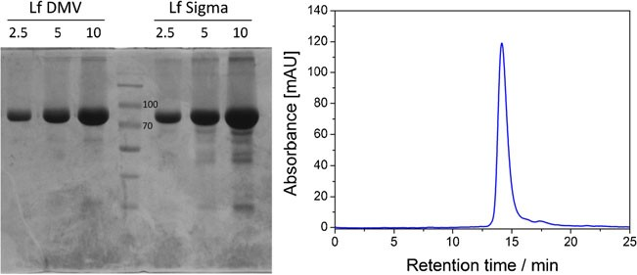
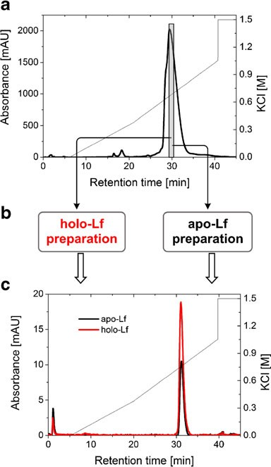
Quantification of iron saturation in lactoferrin preparations
5195
Fig. 1 a SDSpolyacrylamidegelelectrophoresisof DMVInternational (left) and Sigma-Aldrich (right)bovinelactoferrin preparations.Lanes wereloadedwith2.5,5,and10μgofprotein.Centrallanewasloaded
withamolecularweightmarker(twobandsof70and100kDadenotedontheelectropherogram).bSECelutionprofileofDMVInternational lactoferrinobtainedusingtheSuperdex20010/300GLcolumn
highervalueofpH8.4andincreasedsaltconcentrationwere used during the final size exclusion chromatography (SEC) separation. The main peak corresponding to the protein of molecular weight of approx. 80 kDa along with the minor peaks from smaller proteins were observed, which is con- sistent with electrophoretic analysis (Fig.1b). Both ap- proaches confirmed the high purity of DMV lactoferrin preparation. Therefore, DMV International’s preparation was used for further experiments; no additionalpurification procedures were performed in the followingexperiments.
The starting preparation of lactoferrin from DMV Inter- national contains approx. 10 % of holo-lactoferrin; there- fore, the analytical cation exchange chromatography using MonoS was performed to separate apolactoferrin from its holo form according to the protocol described by Makino and Nishimura [39].Weobserved that Lf was consistently eluted as one asymmetric peak. As a result of the first purification step, the major peak was observed at 0.63 M KCl and corresponds to a non-glycosylated form of Lf, whereas the small shoulder eluted at 0.53 M KCl contains protein with an N-linked glycan at the Asn281 position (Fig.2a). Our results proved previous findings that N- linked glycosylation of bovine lactoferrin affects its elution from MonoS [40], but we have not been able to reproduce theobservationofMakinoandNishimura[39]thatapo-and iron-saturated lactoferrins are eluted at different positions from a MonoS column that allows their separation.Toobtain homogeneous lactoferrin preparation, the MonoS elution fraction containing the non-glycosylated variant oflactoferrinwaspooled, iron-saturated/desaturated,andsubjected to re-chromatography (Fig.2c).
MonoS chromatography of the non-glycosylated iron-saturatedbovinelactoferrin(>65 %)showednosignificantchangesintheelutionprofilewhencomparedwithitsapoform(<2%),indicatingthatironsaturationdoesnotaffectbovineLf bindingandelutionLffrom the MonoScolumn. During thesecondchromatographicstep,homogenousapo-andhololactoferrins consistently elutedat 0.76 MKClin asingle
symmetricpeak.Ourresultsareinlinewithearlierreportsthatapo-andiron-saturatedhumanLfbindequallywelltoanionic ligandsandexhibitthesameprofileonMonoS[8,41,42].Itispossiblethatanextraordinary charge asymmetryencountered
Fig. 2 Evaluation of the resolution properties of the MonoS 5/50 GL columnusedtoseparatebovinelactoferrininatwo-steppurification.a MonoSchromatographyofDMVInternationallactoferrin(thecollect- ed fraction highlighted ingray bar). b Fraction obtained from the first ion exchange separation was modified using the methods described in experimentalsectiontogetiron-saturatedandiron-depletedlactoferrin forms. c Elution profiles of apo- and hololactoferrins from theMonoS column from the second separation: apo-Lf (black), holo-Lf(red)

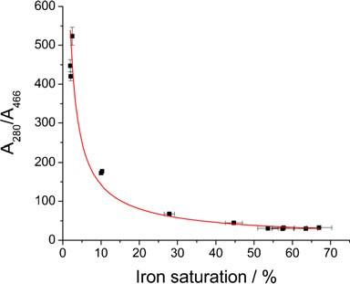
5196
G. Majka et al.
inlactoferrinprotein(theN-terminusofthisproteinhasstrong cationic peptide regions)isthe maindrivingforce forelectro- static interactions.Thedegreeofironsaturation, which proba-blyalters lactoferrinpIandconformation, seemsto beless importantfor ionexchangechromatography.
Method for the estimation of iron saturation in lactoferrin preparation
As mentioned before, employment of spectrophotometric measurements as a simple and rapid method for the estima- tion of iron content in the starting material as well as in the processed samples might not yield reliable and accurate results.Thisismainlyduetothehighdiversityofabsorption coefficients for apo- and holo-Lf that can be found in the literature (seeTableS1), which arise from the difficulty in thepreparationofstandards.Wehaveshownthatchromato- graphic separation between these two species ischallenging and that no satisfactory results were obtained. Furthermore, mostoften,lactoferrinpreparationisamixtureofvariousLf species (apo, holo, monoferric N-domain, and monoferric C-domain forms), and using just one coefficient does not reflect their complexity.Toovercome the problems associ- ated with spectrophotometric measurements, a calibration curve for the estimation of iron content was prepared by the combination of two analytical methods. ELISA was employed for accurate and specific quantitation of Lf in the samples and ICP-MS served as a method for determin- ing iron content.Westill used UV/VIS spectrophotometry for the rapid and inexpensive screening of procedures lead- ing to obtaining apo- and hololactoferrin preparations. Our goal was to show the relationship between the obtained ratios ofA₂₈₀/A₄₆₆(values that do not involve the applica- tion of molar absorption coefficients) and precise iron con-tentin Lfsamples determined usingELISA/ICP-MStandem. The obtained data are presented in Fig.3.
There is a nonlinear correlation between the measured absorbance ratios and iron saturation levels calculated from the values obtained with ELISA and ICP-MS measure- ments.Thiscanbeexplainedbythevastdifferencebetween theabsorptioncoefficientsforbandsat280and466nm.Theobtained data imply the power relationship shown in Eq.1for which the best fit was achieved (Fig.3).
Fig. 3 Correlation between theA₂₈₀/A₄₆₆ratios and lactoferrin iron saturation calculated from ELISA and ICP-MS measurements
of approx. 22 found for non-glycosylated human serum transferrin [35]. It must be noted that very smalldifferences intheA₂₈₀/A₄₆₆ratioforthehighlysaturatedlactoferrinprep- arationsgivealargechangeintheironsaturationquantity;the inaccuracyofthecalculatedvaluescanbeashighas10–15%. Thepreparationofapolactoferrinwithironsaturationbelow 2 % is characterized by the value ofA₂₈₀/A₄₆₆higher than approx.530.Accordingtotheresultspresentedinthiswork,a relativelylargevariationinthevalueofA₂₈₀/A₄₆₆atverylow ironsaturationgivesonlyasmallcontributiontothechanges inironcontent,whileaccuracyofthemeasurementofabsor-banceat466nmisdecreasing.Thus,fortheprecisedetermi- nation of iron content when saturation is below 2 %, the applicationofELISA/ICP-MStandemisrecommended.Iron saturation for the bovine lactoferrin acquired from DMV Internationalcalculatedusingthepresentedcalibrationcurve was found to be 7.72±0.97 %, while the two independent measurements using ELISA and ICP-MS methods gave a valueof10.2±0.2%.Ourresultsprovideaneffectivemethod foraquickandsimpleestimationoftheironsaturationlevels inbovinelactoferrinpreparations.However,ifthereisaneed foraveryaccuratedeterminationofironconcentration,only theapplicationofELISA/ICP-MStandemcanyieldreliable results.
Apolactoferrinpreparation
In acidic solutions (pH below 5), lactoferrin eagerly adopts more flexible and open conformation, which facilitates the release of ferric ion [7,43]. Following the literature recom- mendation, we used citrate as an efficient mediator of iron transport from transferrins [37]. The efficiency of iron re- moval from Lf in citrate buffer was tested in a pH range of 2–5 (Fig.4). Iron removal was carried out at room temper- ature (approx. 20 °C) since it was found that this process is slightly more efficient than at 4 °C. It is very likely that the protein structure becomes more flexible with temperature, which increases the probability of iron release. The optimal
A280A
b
¼aðironsaturationÞ
ð1Þ
466
wherea¼933:0±47;b¼-0:817±0:056
To our best knowledge, there have been no reports in the
literature enabling the utilization of theA₂₈₀/A₄₆₆ratio for the estimation of the iron content in lactoferrin preparation in a wide range of saturation. Based on the proposedfitting, the calculated value for 100 % hololactoferrin would be approx. 22, which is in very good agreement with thevalue

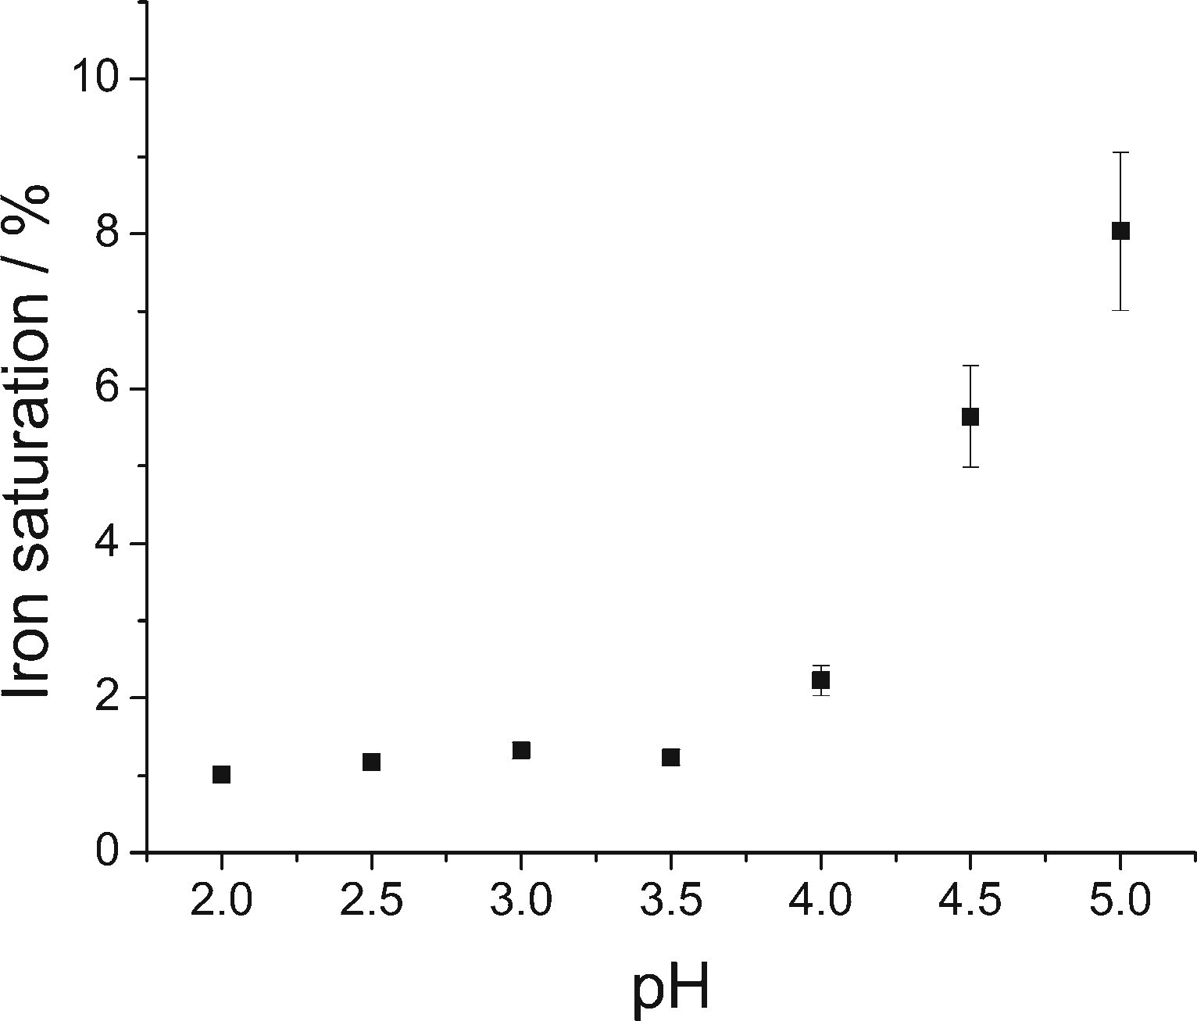
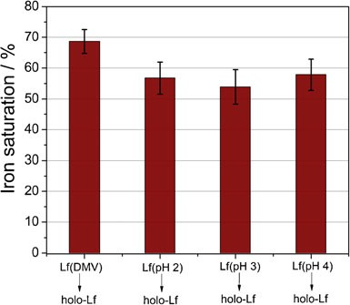
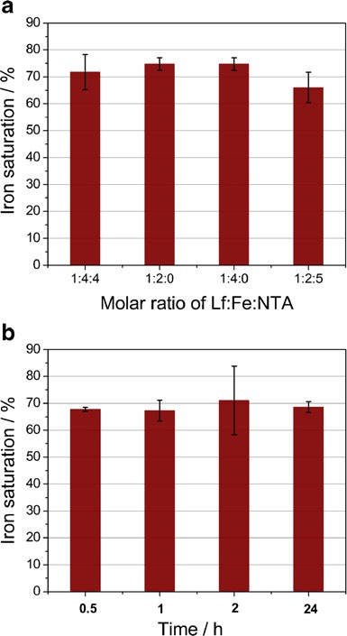
Quantification of iron saturation in lactoferrin preparations
5197
obtaining those species of lactoferrin do not interrupt the secondarystructureoftheproteinand,mostprobably,donot influence its functions.
It seems surprising that effective resaturation occursalso forapolactoferrinpreparationsobtainedatlowpH2.0and3.0. It was shown that at these pH values, apo-Lf undergoes thermal denaturation at room temperature [31], and onecan expect a substantially lower iron binding.However,we ob- served a lower protein concentration for these conditions, which suggests that, indeed, a part of the protein molecules is denatured, but saturation with iron is only marginally influenced.Therefore,theuseofpH4providesacompromise between preserving lactoferrin in a non-denatured state and productive iron release from theprotein.
Fig. 4 Effect of citrate buffer pH during dialysis at room temperature onlactoferrinironsaturation.Datawereobtainedthroughthemeasure- ment ofabsorbance ratioat 280 and 466 nm andconvertedtolactoferrin iron saturation using the calibration curve described in previoussection
Hololactoferrinpreparation
Toobtainiron-saturatedlactoferrin,reactionofLfwithferric salts in neutral pHbuffer(50 mMTris–HCl,150 mMNaCl, pH 7.4) was utilized to provide optimal conditions for an effective iron uptake. An iron chelator—nitrilotriaceticacid
pH value for iron desaturation (obtaining <2 % of differic lactoferrin) was≤3.5. Previous publications show similar results,whichindicatethatbetweenpH2and3,ironrelease from lactoferrin reaches a plateau [31,44]. It hasbeen
shown that apolactoferrin, upon dialysis at pH 4, exhibits iron saturation of 2–2.5 % [24,31].
Onceretainingtheabilityofefficientferricionbindingby thepreparationofapolactoferrin,whichiscrucial,theapo-Lf sample was saturated with iron according to the procedure described in“Materials and methods.”Wehave observedan effective resaturation with ferric ions for the proteinsample obtained at different pH values (Fig.5), which supports the assumption that apolactoferrin preparation does not affect protein function—lactoferrin was proven to still be capable of binding iron. Moreover, the CD spectra of the original lactoferrin preparation and both apo- (pH 4) and holo-Lfdo notdiffer(ESMFig.S1).Therefore,proceduresleadingto
Fig. 6 Analysis of lactoferrin iron saturation under different condi- tions.aInfluenceoftheLf/Fe/NTAratioontheironsaturationprocess carried out overnight. b Effect of saturation period on the overall efficiency of this process. Lf/Fe/NTA was kept as1:4:4
Fig.5Comparisonofironsaturationoftheoriginallactoferrinprepara- tion (Lf DMV International) andhololactoferrins(holo-Lf)preparedby resaturationwithferricionsofLfDMVInternationalaswellasapo-Lf obtained at various pHvalues

5198
G. Majka et al.
(NTA)[45]—wasemployedtopreventunspecificbindingof ferricionstoproteinmolecules.NTAformsthe2:1coordina-
Conclusions
tion complex with iron(III), Fe(NTA)₂,
with a
pKML2
of
Weproposed in this article the simple, rapid, and high-throughputmethod forobtainingahigh-quality,substantially pure,structurallyintact,andbiologicallyfunctionalsamplesof lactoferrin with its iron content determined. The suggestedprotocolcan beemployedforfurther studies aimedatverifi- cationofthe biological/medicinalpropertiesoftheapo andholo formsoflactoferrin.Apolactoferrin has been attributed withmultifunctionalproperties,includingitspotentialtoact as a promising antibacterial agent that couldefficientlyde- prive bacteria of iron and inhibit their growth.However,it seemsessentialtoretainitsabilitytobindferricionswithhigh affinity—use of pH 4 seems a fine compromise between preservinglactoferrinfunctionandobtainingitsapoformwith ironsaturationlevelsofapprox.2%.Nevertheless,whether apolactoferrin prepared in such a manner is truly an iron- depletedformforbacterialpathogensisaninterestingques- tion requiring furtherinvestigation.
approx. 8 [46]. Therefore, it is a much weaker chelatorthan the lactoferrin binding pocket, however strong enough to shieldtheproteinagainstironbindinginanonspecificman-ner.A few different ratios ofprotein/iron/NTAwere used, yielding comparable results measured by the percentage of ironsaturationofLf(Fig.6a).OnlywhentheexcessofNTAwaspresentin thesolutionwas anoticeable decreaseintheironsaturationofLfobserved.Nevertheless,lactoferrinaffinityforironisstrongenoughtosequesterironfromtheFe(NTA)₂
complex.Forallfollowingprocedures, theprotein/iron/NTAratioof1:4:4wasutilized.Similarconditionswerealsoappliedbyotherresearchers[8,24].Thebindingofironbylactoferrininvolvesthecoordinationofasynergisticcarbonateanionthatiscoordinatedin abidentate manner [47]. Previous studies have proved thatotherions suchascitrateoroxalatecanalso substitute carbonateion[48].Ourstudies have shown thatinthe absenceof theexternal added sodium bicarbonateaswellas in itspresenceinthe range 0.1–1.0M,the extentofiron saturationisverysimilar(resultsnotshown).Evenwithoutthe
Acknowledgments This research was carried out with equipmentpurchasedwithfinancial supportfrom theEuropean Regional Develop-ment Fund within the framework of the Polish Innovation EconomyOperational Program (contractno.POIG.0 2.01.00-12-0 23/08). G.M.acknowledges the financial support from the project Interdisciplinary PhD Studies“Molecular sciences for medicine”(co-financed by theEuropeanSocialFundwithintheHumanCapitalOperationalProgramme).Halina Mrowiec is kindly acknowledged for performing the ICP-MSmeasurements.
additionofsodium bicarbonate,CO²⁻canstillbeemployed
3
as asynergisticion due to thehydrationof CO₂dissolvedinaqueous solution. The engagementofnitrilotriacetateincoor-dinationofironin thelactoferrin pocketisunlikely,asshownbyother studies[49].
Another factor examinedwas thetime requiredfor thefullsaturation of the iron binding pockets of lactoferrin. Thechangein thecolorofnative lactoferrin was observed imme- diatelyupon theadditionof a mixture offerric saltandNTA.Theundergoingreactionwasexamined employing stopped-flowspectroscopicmeasurements.Allobtainedresultspointto afastandeffective processof Lfiron saturation, reachingitsplateauafterapprox.10 s(ESM Fig.S2).This finding is in good agreement with previously reported data, which suggests that most of theironuptake bylactoferrinoccurs within a few seconds, followed by a very slowreaction giving only smallchanges inabsorptionat 466 nm [50]. In order to obtain a fully saturated protein, prolonged saturation periods were tested. However, no significantdifferencewasobservedasaresultoftheapplica- tion of longer timescales (Fig.6b). These observations con-firm thatlactoferrin actsasathermodynamicallyandkineticallyefficientchelator for iron(III)ion.
Despite changing the saturation conditions, the lowest
Open Access This article is distributed under the terms of theCreative CommonsAttributionLicensewhichpermitsanyuse,distribution,and reproduction in any medium, provided the original author(s) and the source arecredited.
References
- AisenP,LeibmanA(1972)Lactoferrinandtransferrin:acompara- tivestudy.BiochimBiophysActa—ProteinStruct257(2):314–323
- BakerEN(1994)Structureandreactivityoftransferrins.In:Sykes AG(ed)Advancesininorganicchemistry,vol.41.Academic,SanDiego, pp389–463
- AisenP,Leibman A, Zweier J (1978) Stoichiometric and site characteristics of the binding of iron to human transferrin. J BiolChem253(6):1930–1937
- Mazurier J, Spik G (1980) Comparative study of the iron-binding properties of human transferrins: I. Complete and sequential ironsaturationanddesaturationof thelactotransferrin. BiochimBiophys Acta—Gen Subjects629(2):399–408
- AppelmelkBJ,AnYQ,GeertsM,Thijs BG,deBoerHA,MacLaren DM, de Graaff J, Nuijens JH (1994) Lactoferrin is alipid A-binding protein. Infect Immun62(6):2628–2632
- El Yazidi-Belkoura I, Legrand D, Nuijens J, Slomianny M-C, van BerkelP,Spik G (2001) The binding of lactoferrin to glycosami-noglycansonenterocyte-like HT29-18-C1 cellsismediatedthroughbasicresidueslocatedintheN-terminus.BiochimBiophysActa—Gen Subjects1568(3):197–204
- BakerEN,BakerHM(2009)Astructuralframeworkforunderstand-ingthemultifunctionalcharacteroflactoferrin.Biochimie91(1):3–10
ratio for
A280/466
was 26, which corresponds to approx.
80 % of differic lactoferrin form. In the literature, an absor- bance ratio between 27 and 29 was accepted as a fully saturated lactoferrin [51]. However, our findings point out that a ratio of 22 must be reached in order to obtain 100 % saturation, in agreement with other studies performed for transferrin [35].

Quantification of iron saturation in lactoferrin preparations
5199
- vanBerkel PH, Geerts ME, vanVeenHA, Kooiman PM, PieperFR,deBoerHA,NuijensJH(1995)Glycosylatedandunglycosylated human lactoferrins both bind iron and show iden- ticalaffinitiestowardshumanlysozymeandbacteriallipopolysac-charide,but differintheirsusceptibilities towardstrypticproteolysis. Biochem J312(1):107–114
- Khan JA,KumarP,ParamasivamM,YadavRS,SahaniMS,SharmaS,SrinivasanA,SinghTP(2001)Camellactoferrin,atransferrin-cum- lactoferrin:crystalstructureofcamelapolactoferrinat2.6Åresolu-tionandstructuralbasisofitsdualrole.JMolBiol309(3):751–761
- deJongG,vanEijkHG(1988)Microheterogeneityofhumanserum transferrin:abiologicalphenomenonstudiedbyisoelectricfocusinginimmobilizedpHgradients.Electrophoresis9(9):589–598
- Hovanessian AG,AwdehZL (1976) Gel isoelectric focusing ofhuman-serum transferrin. Eur J Biochem/FEBS68(2):333–338
- Jenssen H, Hancock REW (2009) Antimicrobial properties of lactoferrin. Biochimie91(1):19–29
- YenC-C, Shen C-J, HsuW-H,ChangY-H,LinH-T,Chen H-L, Chen C-M (2011) Lactoferrin: an iron-binding antimicrobial pro-tein againstEscherichia coliinfection. Biometals24(4):585–594
- BerluttiF,PantanellaF,NataliziT,Frioni A, Paesano R, Polimeni A,ValentiP (2011) Antiviral properties of lactoferrin—a naturalimmunity molecule. Molecules16(8):6992–7018
- Jiang R, LopezV,Kelleher SL, Lönnerdal B (2011) Apo- and holo-lactoferrin are both internalized by lactoferrin receptor viaclathrin-mediated endocytosis but differentially affectERK-signaling and cell proliferation in Caco-2 cells. J Cell Physiol226(11):3022–3031
- Jiang R, Lönnerdal B (2012) Apo-and holo-lactoferrin stimulate proliferation of mouse crypt cells but through different cellularsignaling pathways. Int J Biochem Cell B44(1):91–100
- Arnold RR, Brewer M, Gauthier JJ (1980) Bactericidal activity of human lactoferrin: sensitivity of a variety of microorganisms. Infect Immun28(3):893–898
- Arnold RR, Russell JE, Champion WJ, Brewer M, Gauthier JJ (1982) Bactericidal activity of human lactoferrin: differentiation from the stasis of iron deprivation. Infect Immun35(3):792–799
- EllisonRT,Giehl TJ, LaForce FM (1988) Damage of the outer membrane of enteric Gram-negative bacteria by lactoferrin andtransferrin. Infect Immun56(11):2774–2781
- Crosa JH (1989) Genetics and molecular biology of siderophore-mediated iron transport in bacteria. Microbiol Rev53(4):517–530
- SuiQ,RoginskiH,WilliamsRPW,WoosterTJ,VersteegC,WanJ (2010)Effectoftheionicstrengthofpulsedelectricfieldtreatment medium on the physicochemical and structural characteristics oflactoferrin. J Agric Food Chem58(22):11725–11731
- Soo Nam M, K-I S, Kumura H, Lee KK,YuDY (1999) Charac- terization of Korean native goat lactoferrin. Comp BiochemPhys-iol Part B: Biochem Mol B123(2):201–208
- BrissonG,BrittenM,PouliotY(2007)Effectofironsaturationon the recovery of lactoferrin in rennet whey coming from heat-treated skim milk. J Dairy Sci90(6):2655–2664
- Brisson G, Britten M, Pouliot Y (2007) Heat-induced aggregation of bovine lactoferrin at neutral pH: effect of iron saturation. IntDairy J17(6):617–624
- Leibman A, Aisen P (1979) Distribution of iron between the bindingsitesoftransferrininserum:methodsandresultsinnormalhuman subjects. Blood53(6):1058–1065
- LimaMF,KierszenbaumF(1987)Lactoferrineffectsofphagocyt- ic cell function. II. The presence of iron is required for the lactoferrin molecule to stimulate intracellular killing by macro- phages but not to enhance the uptake of particles and microorgan-isms. J Immunol139(5):1647–1651
- Indyk HE, Filonzi EL (2005) Determination of lactoferrin in bo- vine milk, colostrum and infant formulas by optical biosensor analysis. Int Dairy J/Int Dairy F15(5):429–438
- SteijnsJM, van Hooijdonk AC (2000) Occurrence, structure, bio- chemicalpropertiesandtechnologicalcharacteristicsoflactoferrin.Br J Nutr84(1):S11–S17
- VoldenJ, Jørgensen CE, Rukke E-O, Egelandsdal B (2012) Oxi- dative properties of lactoferrins of different iron-saturation in an emulsion consisting of metmyoglobin and cod liver oil. FoodChem132(3):1236–1243
- HaradaK,KuniyasuA,NakayamaH,NakayamaM,MatsunagaT,UjiY,Sugiuchi H, Okabe H (2002) Separation of human serum transferrinswithdifferentiron-bindingstatesbyhigh-performance liquid chromatography using a pyridinium polymer column. JChromatogr B767(1):45–51
- Sreedhara A, Flengsrud R, PrakashV,Krowarsch D, LangsrudT,KaulP,DevoldTG,VegarudGE(2010)Acomparisonofeffectsof pHonthethermalstabilityandconformationofcaprineandbovinelactoferrin. Int Dairy J20(7):487–494
- SreedharaA,FlengsrudR,LangsrudT,KaulP,PrakashV,VegarudG(2010)Structuralcharacteristic,pHandthermalstabilitiesofapo and holo forms of caprine and bovine lactoferrins. Biometals23(6):1159–1170
- KansalRG, Aziz RK, KotbM(2005) Modulationofexpressionofsuperantigensbyhumantransferrinandlactoferrin:anovelmechanisminhost–Streptococcusinteractions.JInfectDis191(12):2121–2129
- Brown EM, Parry RM (1974) Spectroscopic study of bovinelactoferrin. Biochemistry (Mosc)13(22):4560–4565
- MasonAB,HalbrooksPJ,LaroucheJR, BriggsSK,Moffett ML, RamseyJE,ConnollySA,SmithVC,MacGillivrayRTA(2004) Expression, purification,andcharacterizationofauthentic monoferricandapo-humanserumtransferrins.ProteinExprPurif36(2):318–326
- LaemmliUK(1970) Cleavageofstructural proteins duringtheas-semblyoftheheadofbacteriophageT4.Nature227(5259):680–685
- Wakabayashi H,YamauchiK, KobayashiT,YaeshimaT,Iwatsuki K,YoshieH (2009) Inhibitory effects of lactoferrin on growthand biofilm formation ofPorphyromonas gingivalisandPrevotellaintermedia. Antimicrob Agents Chemother53(8):3308–3316
- Nuijens JH, van Berkel PH, Schanbacher FL (1996) Structureand biologicalactionsoflactoferrin.JMammaryGlandBiolNeoplasia1(3):285–295
- MakinoY,Nishimura S (1992) High-performance liquid chro- matographic separation of human apolactoferrin and monoferricand diferric lactoferrins. J Chromatogr B579(2):346–349
- AndersonBF,Baker HM, Norris GE, RiceDW,Baker EN (1989) Structure of human lactoferrin: crystallographic structure analysisand refinement at 2.8 Å resolution. J Mol Biol209(4):711–734
- van Berkel PH, Geerts ME, vanVeenHA, Mericskay M, de Boer HA, Nuijens JH (1997) N-terminal stretch Arg2, Arg3, Arg4 and Arg5 of human lactoferrin is essential for binding to heparin, bacteriallipopolysaccharide,humanlysozymeandDNA.BiochemJ328(1):145–151
- vanVeenHA, Geerts MEJ, van Berkel PHC, Nuijens JH (2002) Analytical cation-exchange chromatography to assess theidentity,purity,andN-terminal integrityofhuman lactoferrin. AnalBiochem309(1):60–66
43. Grossmann
JG, Neu
M,
Pantos
E,
Schwab
FJ, Evans
RW,
Townes-Andrews E, Lindley PF, Appel H, Thies W-G, Hasnain
SS (1992) X-ray solution scattering reveals conformational changes upon iron uptake in lactoferrin, serum and ovo-transferrins. J Mol Biol 225(3):811–819
- StowellKM,RadoTA,FunkWD,TweedieJW(1991)Expressionofcloned human lactoferrininbaby-hamster kidneycells.Biochem J276(2):349–355
- BatesGW,Billups C, Saltman P (1967) The kinetics and mecha- nismofiron(III)exchangebetweenchelatesandtransferrin.JBiolChem242(12):2810–2815
- Motekaitis RJ, Martell AE (1994) The iron(III) and iron(II) com- plexes of nitrilotriacetic acid. J Coord Chem31(1):67–78

5200
G. Majka et al.
- SaponjaJA,VogelHJ(2011)Quadrupolarcentraltransition(QCT)and NMRcompetition studiesofmetalionbindingtoovotransferrin. Can J Chem89(7):779–788
- BakerHM,AndersonBF,BrodieAM,ShongweMS,SmithCA,BakerEN(1996)Anionbindingbytransferrins: importanceofsecond-shelleffects revealedbythecrystal structureofoxalate-substituteddiferric lactoferrin. Biochemistry (Mosc)35(28):9007–9013
- Abdallah FB, El Hage Chahine J-M (2000) Transferrins: ironrelease from lactoferrin. J Mol Biol303(2):255–266
- Pakdaman R, Chahine J-MEH (1996) A mechanism for iron up-take by transferrin. Eur J Biochem236(3):922–931
- SalmonV,Legrand D, Georges B, Slomianny M-C, CoddevilleB, SpikG(1997)Characterizationofhumanlactoferrinproducedinthebaculovirusexpressionsystem.ProteinExprPurif9(2):203–210
13C

