www.impactjournals.com/oncotarget/
Oncotarget, Vol. 6, No. 31

Constitutive activation of MET signaling impairs myogenic
differentiation of rhabdomyosarcoma and promotes its
development and progression

Klaudia Skrzypek1*, Anna Kusienicka1*, Barbara Szewczyk1, Tomasz Adamus1,
Ewa Lukasiewicz1, Katarzyna Miekus2, Marcin Majka1
’Department of Transplantation, Polish-American Institute of Pediatrics, Jagiellonian University Medical College, 30-663
Krakow, Poland
2
Department of General Biochemistry, Faculty of Biochemistry, Biophysics and Biotechnology, Jagiellonian University, 30-387
Krakow, Poland
*
These authors have contributed equally to this work
Correspondence to:
Marcin Majka, e-mail: mmajka@cm-uj.krakow.pl
Keywords: MET, rhabdomyosarcoma (RMS), mesenchymal stem cells (MSC), differentiation, metastasis
Received: July 13, 2015 Accepted: August 27, 2015 Published: September 08, 2015

ABSTRACT
Rhabdomyosarcoma (RMS) is a soft tissue sarcoma, which may originate
from impaired differentiation of mesenchymal stem cells (MSC). Expression of MET
receptor is elevated in alveolar RMS subtype (ARMS) which is associated with worse
prognosis, compared to embryonal RMS (ERMS). Forced differentiation of ARMS cells
diminishes MET level and, as shown previously, MET silencing induces differentiation
of ARMS. In ERMS cells introduction of TPR-MET oncogene leads to an uncontrolled
overstimulation of the MET receptor downstream signaling pathways. In vivo,
tumors formed by those cells in NOD-SCID mice display inhibited differentiation,
enhanced proliferation, diminished apoptosis and increased infiltration of neutrophils.
Consequently, tumors grow significantly faster and they display enhanced ability to
metastasize to lungs and to vascularize due to elevated VEGF, MMP9 and miR-378
expression. In vitro, TPR-MET ERMS cells display enhanced migration, chemotaxis
and invasion toward HGF and SDF-1. Introduction of TPR-MET into MSC increases
survival and may induce expression of early myogenic factors depending on the
genetic background, and it blocks terminal differentiation of skeletal myoblasts. To
conclude, our results suggest that activation of MET signaling may cause defects in
myogenic differentiation leading to rhabdomyosarcoma development and progression.

INTRODUCTION
Rhabdomyosarcoma (RMS) is a soft-tissue sarcoma
that is thought to originate from a defective differentiation
of muscle progenitor cells or oncogenic transformation
of mesenchymal stem cells [1]. It affects mainly children
and adolescents and rarely occurs in adults. Based on
histological and pathological features of RMS, two major
subtypes can be distinguished: embryonal (ERMS) and
alveolar (ARMS) [2]. ARMS tumor is usually associated
with worse prognosis due to presence of t(2;13) or less
common t(1;13) translocations, which result in presence
of either PAX3-FKHR or PAX7-FKHR fusion genes [3].
High aggressiveness of ARMS subtype is also
associated with increased levels of MET receptor,
a member of tyrosine kinase receptors family (RTK) [2],
[4]. The aberrant MET signaling is observed in many
tumor types [5]. MET receptor responds to only one
ligand - hepatocyte growth factor (HGF, also known as
scatter factor, SF). MET receptor overexpression is one of
the mechanisms that can induce tumor invasive behavior.
Increased MET expression can originate from MET
proto-oncogene amplification [6], enhanced transcription
triggered by other oncogenes like RAS [7] and can be also
induced by hypoxia [8]. Overexpressed receptors dimerize
spontaneously and undergo activation even in the absence
www.impactjournals.com/oncotarget
31378
Oncotarget
of HGF [6]. For example, excessive MET expression can
be observed in some lung cancer cell lines [9] and may be
used as a prognostic feature in prediction of primary colon
cancer invasiveness [10].
Interestingly, MET receptor was first discovered
as the product of TPR-MET oncogene in human
osteogenic sarcoma cell line. The genetic translocation
involves translocated promoter region (TPR) encoding
leucine zipper motif and the MET kinase domain
with sequence encoding C-terminus [11]. The fusion
TPR-MET oncoprotein (65 kDa) locates in cytoplasm
and is constitutively active due to the TPR leucine zipper
interactions with MET kinase domain. This interaction
is responsible for dimerization and ligand-independent
oncogenic activity of TPR-MET [12]. As a consequence,
the transgenic expression of TPR-MET can cause
mammary tumors [13].
In vivo, HGF is produced mainly by cells of
mesenchymal origin while MET receptor is expressed
mostly on epithelial cells [14]. Nevertheless, cells of
mesenchymal origin may acquire aberrant expression of
MET receptor, what activates downstream MET signaling
pathways and may lead to tumorigenesis [15,16]. This
mechanism has been demonstrated for liposarcoma [17]
or leiomyoma [18]. Increased level of the MET receptor
in tumors of mesenchymal origin is usually associated
with higher aggressiveness. For example in RMS tumors
more aggressive ARMS cells display higher expression
of MET than ERMS cell lines [19]. Increased level
of the MET receptor in RMS may be explained by the
defects in posttranscriptional regulation of its expression
by miR-206 [20, 21].
Recently, we have demonstrated that downregu-
lation of MET receptor in ARMS diminishes tumor
growth, metastasis [22] and induces myogenic differ-
entiation [23]. The aim of this study was to investigate
which of the molecular mechanisms associated with
constitutive activation of MET signaling are respon-
sible for rhabdomyosarcoma development and malig-
nancy. Therefore we constitutively activated MET
signaling pathway in ERMS tumors, mesenchymal stem
cells (MSC) and skeletal myoblasts by introduction of
TPR-MET oncogene.

RESULTS
Activation of MET signaling pathways
blocks myogenic differentiation of embryonal
rhabdomyosarcoma and promotes tumor growth
Our previous study [19] and current analysis of
new rhabdomyosarcoma tumor samples demonstrated
that expression of MET mRNA is lower in embryonal
(ERMS) than in alveolar (ARMS) subtype (Figure 1A),
which is usually associated with more malignant
phenotype [3]. Moreover, in those samples MET
level positively correlated with MyoD expression
(Supplementary Table 1), suggesting association of
MET with a defect in myogenic differentiation in those
tumors. Accordingly in SMS-CTR and RD ERMS cell
lines expression of MET was lower than in CW9019,
RH18, RH28 and RH30 alveolar cell lines (Figure 1B).
We have previously demonstrated that downregulation of
MET receptor in ARMS RH30 cell line induces myogenic
differentiation [22]. In vitro differentiation of several
ARMS cell lines such as RH30, CW9019 and RH28,
diminished MET receptor level on the surface of the
cells (Figure 1C). These results suggest that MET is an
important factor in myogenic differentiation of RMS.
To determine if activation of MET signaling
pathways may be responsible for activation of oncogenic
and metastatic pathways in rhabdomyosarcoma
development, we transduced SMS-CTR cells
using lentiviral vectors harboring TPR-MET oncogene.
TPR-MET was used as a model for constitutive activation
of downstream MET signaling pathways independent
of HGF ligand binding. We choose SMS-CTR cell line
due to its low basal levels of MET receptor (Figure 1B).
As controls we used SMS-CTR cells transduced with
GFP. Development of stable cell lines was confirmed
by incorporation of TPR-MET transgene to genomic
DNA (Figure 2A) and by expression of TPR-MET
mRNA (Figure 2B). Accordingly, in TPR-MET cells
downstream MET signaling pathways were activated, as
shown by constitutive phosphorylation of AKT kinases,
regardless of HGF treatment. HGF also further potentiated
phosphorylation of AKT kinases in TPR-MET cells
(Figure 2C). Nevertheless, in vitro SMS-CTR cells with
TPR-MET did not proliferate faster than control cells both
in standard culture conditions (Figure 2D) and in starving
conditions nor in hypoxia (Figure 2E). There was also
no significant effect of TPR-MET on morphology of the
cells. SMS-CTR cells poorly differentiated in vitro, when
cultured in DMEM medium with 2% horse serum (data
not shown). However, when those cells were cultured in
Matrigel in medium supplemented with 2% horse serum,
significant morphological changes appeared. Control cells
acquired elongated shape, whereas SMS TPR-MET cells
formed rounded colonies, which resembled colonies,
formed by ARMS RH30 cells displaying high basal MET
level (Figure 2F).
To investigate this phenomenon further, in vivo
experiments were performed. Subcutaneous implantation
of the cells into NOD-SCID immunodeficient mice results
in their differentiation. The tumor cells acquire a spindle
shape, which is a feature characteristic for muscle fibers
(Figure 3A). This effect coincides with upregulation
of factors regulating myogenic differentiation, such as
myocyte enhancer factor 2A (MEF2A), myogenin and
myostatin in tumors in vivo compared to cells in vitro
(Figure 3B). Similar effect is seen in SMS-CTR cells
cultured in DMEM medium with 2% horse serum, but
www.impactjournals.com/oncotarget
31379
Oncotarget
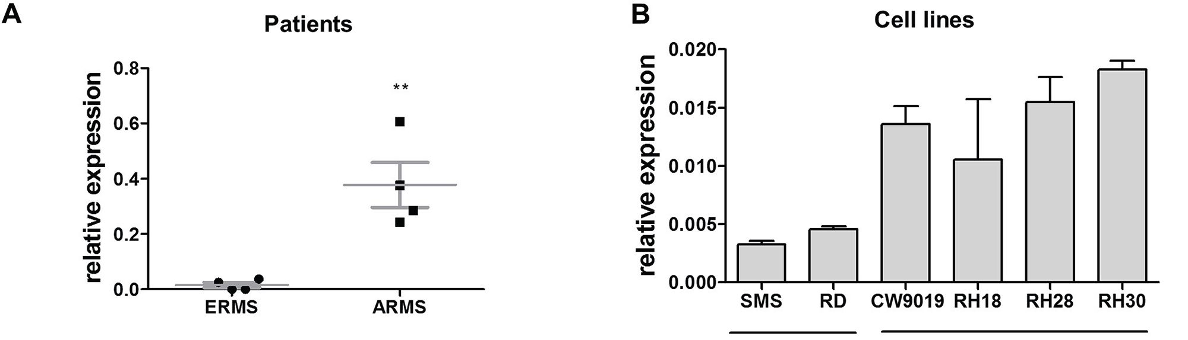
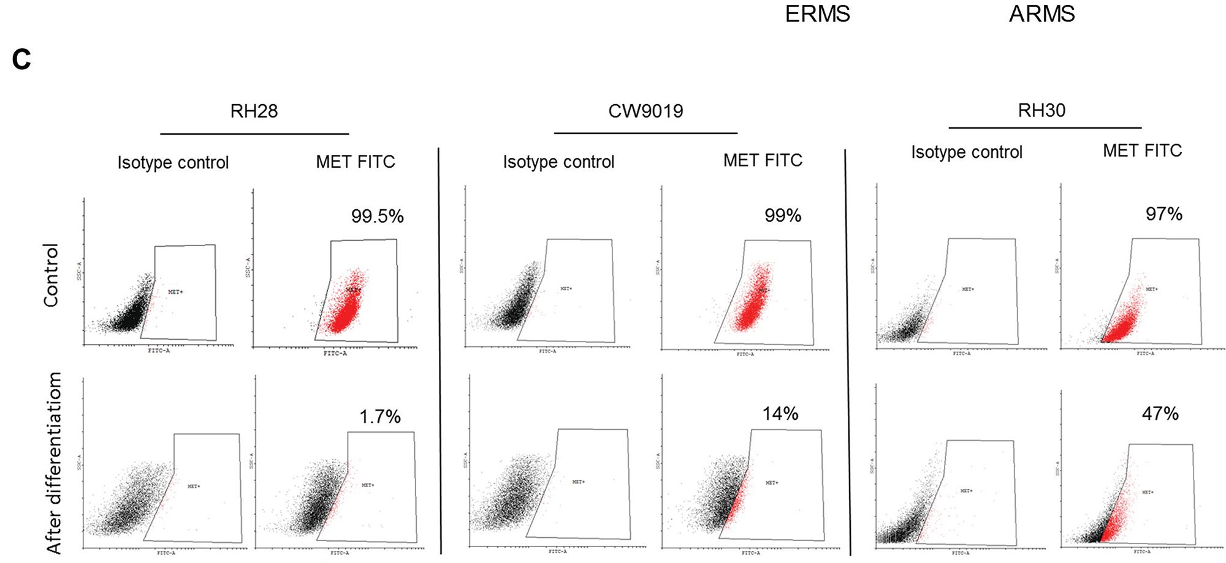
Figure 1: Expression of MET receptor is higher in ARMS than in ERMS and it decreases when ARMS cells are
differentiated. A. Relative expression of MET mRNA compared to GAPDH mRNA was evaluated by qPCR in samples isolated from
paraffin embedded RMS specimens from patients; n = 4, **p < 0.01. B. Relative expression of MET mRNA compared to GAPDH mRNA
was evaluated by qPCR in samples from RMS cell lines, n = 3. C. MET receptor level was evaluated by flow cytometry in RH28, CW9019
and RH30 ARMS cells undifferentiated and differentiated for 7-10 days in DMEM with 2% HS and TPA. Data show one representative
experiment. Data in graphs are represented as mean +/- SEM.
it is less potent (Supplementary Figure 1). Interestingly,
in rhabdomyosarcoma samples, MEF2A level positively
correlated with myogenin expression, whereas myogenin
level also positively correlated with myosin heavy chain 2
(MYH2A), a marker of late differentiation (Supplementary
Table 1). In our model constitutive activation of MET
signaling pathways blocked differentiation of the
tumor cells in vivo, as TPR-MET tumors were formed
by pleomorphic cells that did not shape into muscle
fiber-like structures and were characterized by more
undifferentiated morphology (Figure 3A). This effect may
be explained by inhibition of expression of myogenic
markers, such as MEF2A, myogenin and myostatin in
tumors formed by SMS-CTR cells with constitutively
active MET signaling (Figure 3C). It also turned out that
this effect is independent of myomiRs, such as miR-1,
miR-133a, miR-133b and miR-206, as TPR-MET did
not regulate them in vivo nor in vitro (Supplementary
Figure 2A and 2B).
Anaplastic morphology of TPR-MET ERMS tumors
resembled the morphology of ARMS tumors formed by
RH30 cells displaying high basal MET level ( Figure 4A).
Tumors with the constitutively activated MET signaling
were not only less differentiated than control ERMS
tumors, but they were also bigger (Figure 4B). They grew
faster (Figure 4C) and after four weeks they weighed
more than control tumors (Figure 4D) but less than tumors
formed by ARMS RH30 cells displaying high basal MET
level, probably because other genes besides MET are also
responsible for higher ARMS invasiveness. The effect
of TPR-MET on tumor growth coincided with enhanced
proliferation, what was demonstrated by staining for Ki67
in non-necrotic areas of tumors sections (Figure 5A). The
staining also revealed that the areas in control tumors with
www.impactjournals.com/oncotarget
31380
Oncotarget
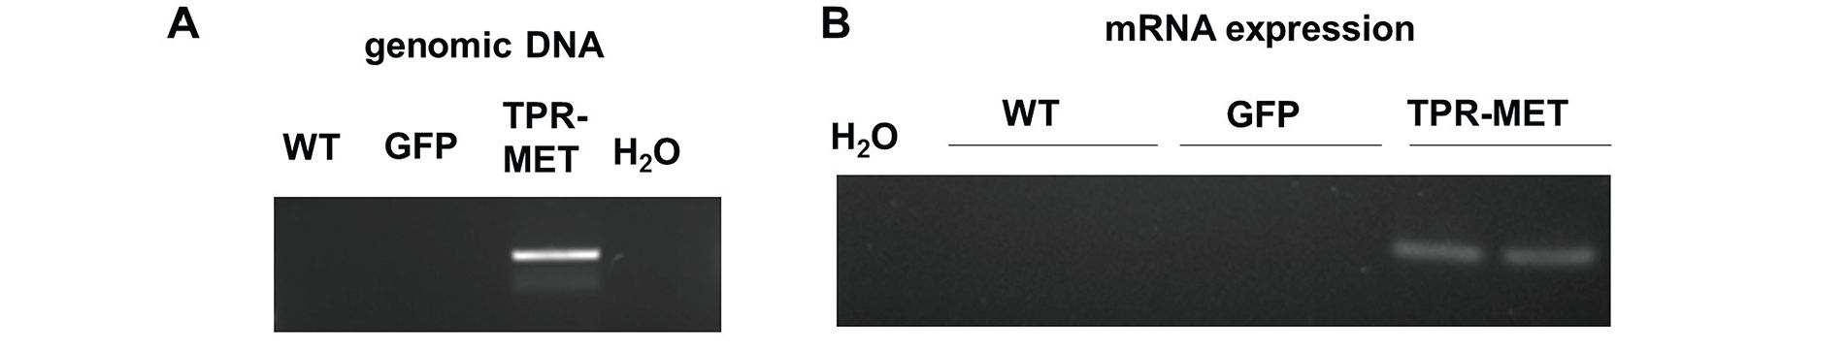

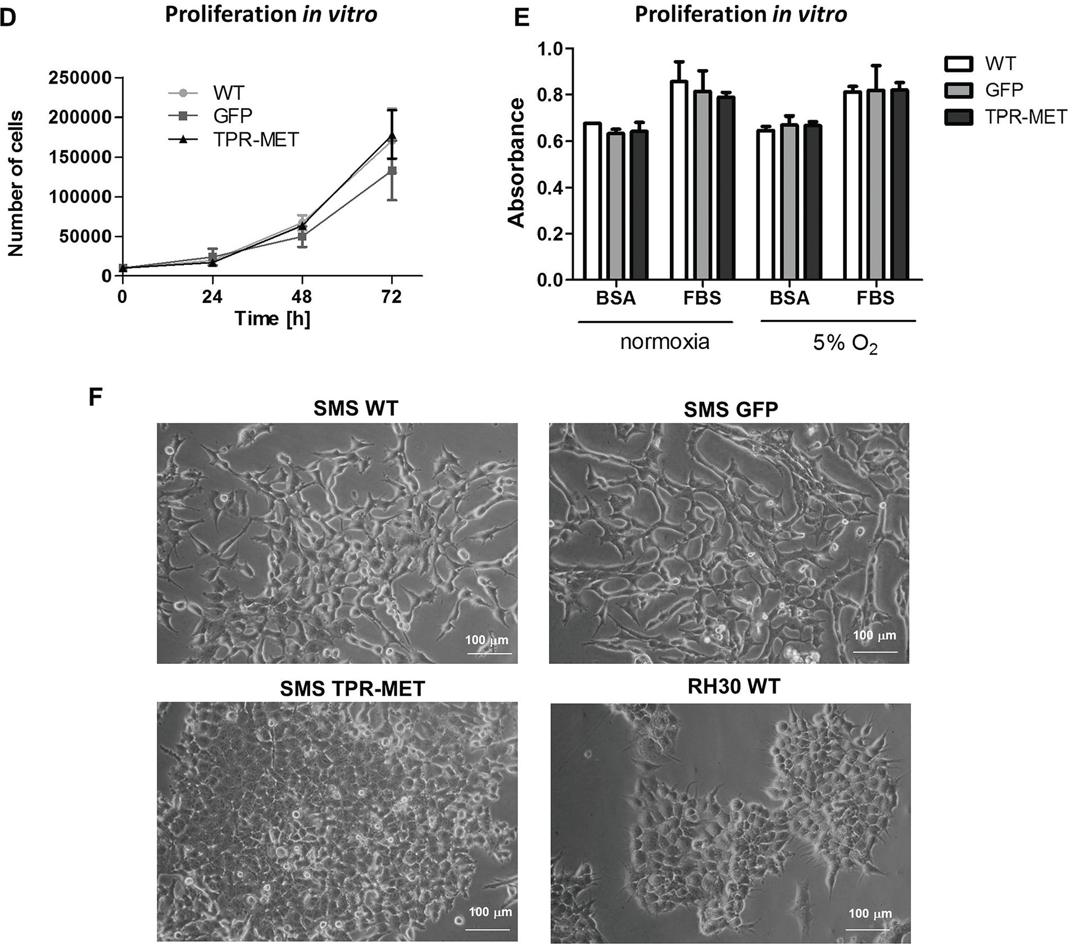
Figure 2: Introduction of TPR-MET oncogene to SMS-CTR ERMS cells constitutively activates downstream MET
signaling pathways. A. Incorporation of TPR-MET transgene to genomic DNA was validated by PCR. The picture shows one
representative experiment. B. Expression of TPR-MET mRNA was estimated by PCR, n = 2. C. Increased phosphorylation of AKT kinases
regardless of HGF (20 ng/ml) treatment in TPR-MET cells was demonstrated by Western blotting. The picture shows one representative
experiment. D. Proliferation of the cells in standard cell culture conditions was calculated by counting of the cells in Burker chamber,
n = 2. E. Proliferation was estimated with MTT assay in cells cultured in normoxia and at 5% O2 level, 10% FBS and 0.5% BSA, n = 2.
F. TPR-MET SMS-CTR ERMS cells and RH30 ARMS cells form rounded colonies in Matrigel in medium supplemented with 2% HS in
contrast to WT and GFP SMS-CTR cells which acquire an elongated phenotype. Data in graphs are represented as mean +/- SEM.
www.impactjournals.com/oncotarget
31381
Oncotarget
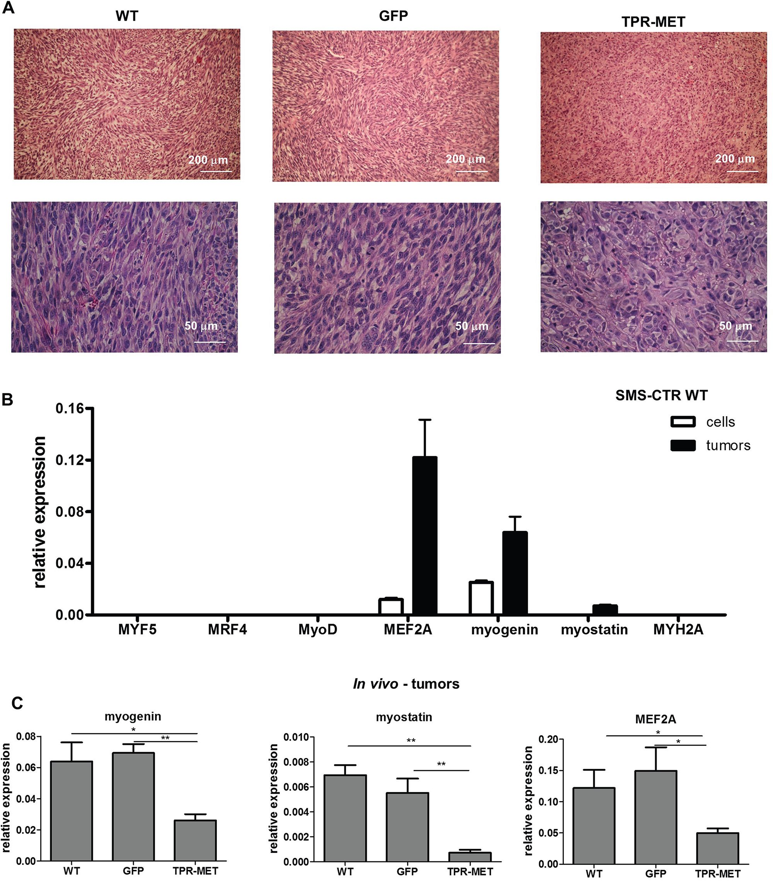
Figure 3: Activation of MET signaling in SMS-CTR ERMS blocks myogenic differentiation of tumors in vivo.
A. Hematoxylin-eosin staining showed anaplastic morphology of tumors formed by SMS-CTR cells expressing TPR-MET four weeks after
subcutaneous implantation of the cells to immunodeficient NOD-SCID mice, whereas control tumors were formed by cells resembling
muscle fibers. B. Expression of myogenic differentiation markers was evaluated at mRNA level by qPCR in SMS-CTR wild-type cells
and in paraffin-embedded specimens from tumors formed by SMS-CTR cells after subcutaneous implantation of the cells, n = 4-5.
C. Constitutive activation of MET signaling in SMS-CTR tumors in NOD-SCID mice inhibits myogenin, myostatin and MEF2A level,
qPCR, n = 4-5. *p < 0.05, **p < 0.01. Data in graphs are represented as mean +/- SEM.
www.impactjournals.com/oncotarget
31382
Oncotarget
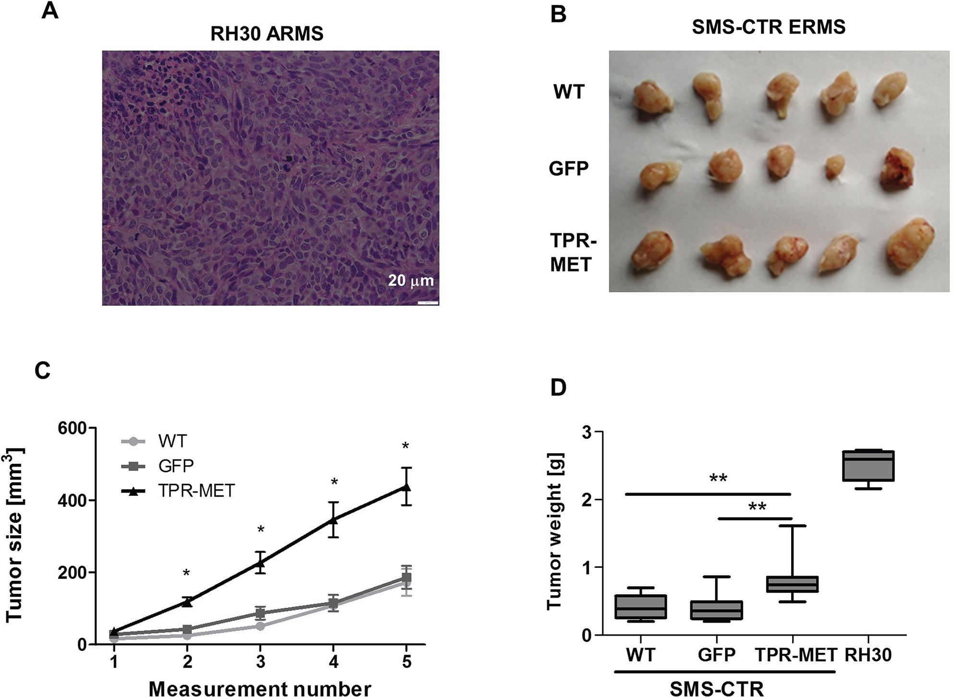
Figure 4: Activation of MET signaling in SMS-CTR ERMS cells enhances tumor growth in vivo. A. Hematoxylin-eosin
staining showed anaplastic morphology of tumors formed by RH30 ARMS cells with high basal MET level after subcutaneous implantation
of the cells to immunodeficient NOD-SCID mice. B. Photograph of tumors formed by SMS-CTR cells isolated four weeks after subcutaneous
implantation of the cells into NOD-SCID mice shows their differences in size. C. Tumor size was measured with caliper in different time
points, n = 7-9. D. SMS-CTR and RH30 tumor weight was evaluated at the end of experiment, n = 4-9. Data in graphs are represented as
mean +/- SEM.
the elongated cells resembling muscle fibers displayed
decreased proliferation (Figure 5A). The opposing
effect was visible for the apoptotic cells. Staining for
cleaved PARP (cPARP) revealed its presence in more
elongated control cells (Figure 5B). Enhanced growth of
TPR-MET tumor may be explained not only by the
increased proliferation and decreased apoptosis, but also
by infiltration of murine neutrophils to those tumors, what
is demonstrated by Ly6G/6C staining of tumor sections
(Figure 5C). What is also interesting, due to enhanced
growth rate, TPR-MET tumors displayed also big necrotic
areas in the central region of tumors (Supplementary
Figure 3). Those results suggest that the enhanced tumor
growth may be associated with inhibition of differentiation
in vivo and with additional signals provided by tumor
microenvironment. Accordingly, our previous studies
demonstrated that RH30 ARMS cells with silenced
MET level displayed diminished tumor growth and
metastasis [22, 23].
Activation of MET signaling pathways induces
angiogenesis, migration and metastasis of
rhabdomyosarcoma
Hematoxylin-eosin staining of paraffin-embedded
tumor sections enabled to visualize blood vessels
containing erythrocytes. It turned out that constitutive
activation of MET signaling in SMS-CTR cells promoted
development of capillaries inside tumors, whereas in
tumors formed by ARMS RH30 cells with decreased
MET expression (RH30 shMET) after subcutaneous
implantation into NOD-SCID mice the number of
capillaries was diminished compared to control RH30
cells (Figure 6A). Staining for CD31 - a marker of blood
vessels additionally confirmed that TPR-MET tumors
display higher number of CD31-positive capillaries
compared to control tumors (Figure 6B).
Similarly, in vitro TPR-MET SMS-CTR cells
conditioned media increased the number of junctions,
www.impactjournals.com/oncotarget
31383
Oncotarget
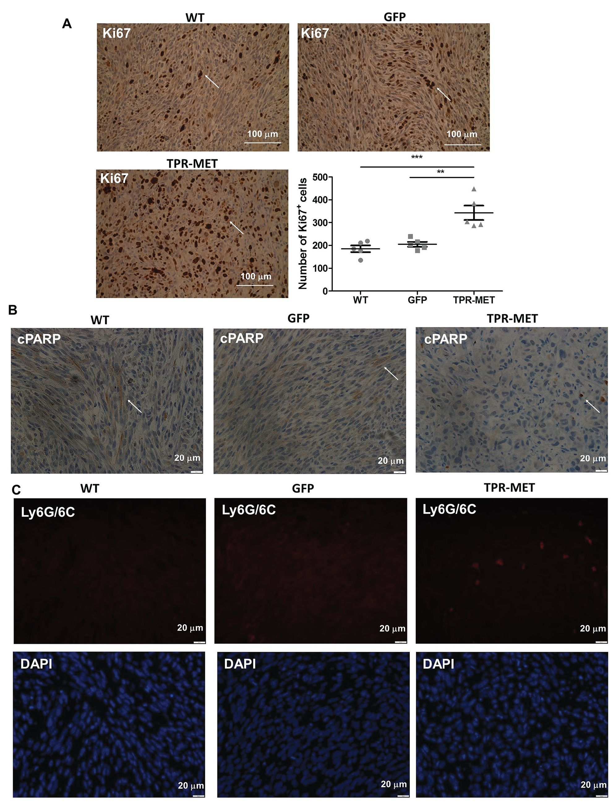
Figure 5: Activation of MET signaling in SMS-CTR ERMS cells enhances tumor proliferation, decreases tumor apoptosis
and induces infiltration of neutrophils in vivo. A. Representative images of the staining for Ki67 in tumor sections show areas of
tumor cells proliferation. Number of Ki67 positive cells was calculated in non-necrotic areas of tumor specimens, n = 5. Arrows indicate Ki67
positive cells. B. Representative images of the staining for cleaved PARP demonstrate decreased apoptosis in TPR-MET SMS-CTR tumors.
C. Representative images of the staining for neutrophils (Ly6G/6C) show infiltration of murine neutrophils to TPR-MET SMS-CTR tumors.
*p < 0.05, **p < 0.01, ***p < 0.001. Data in graphs are represented as mean +/- SEM. Arrows indicate cPARP positive cells.
www.impactjournals.com/oncotarget
31384
Oncotarget
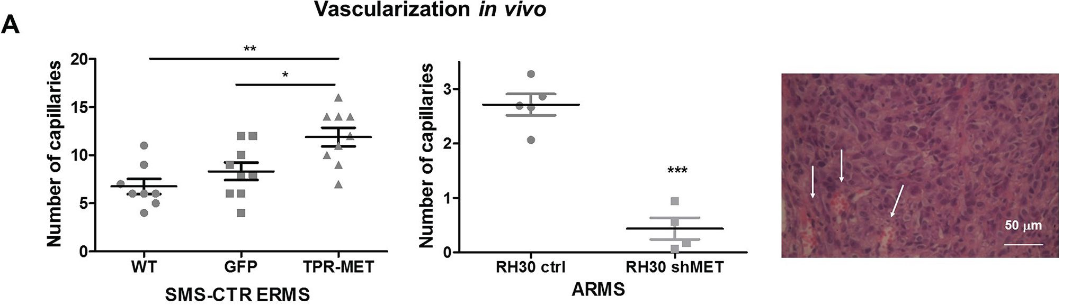
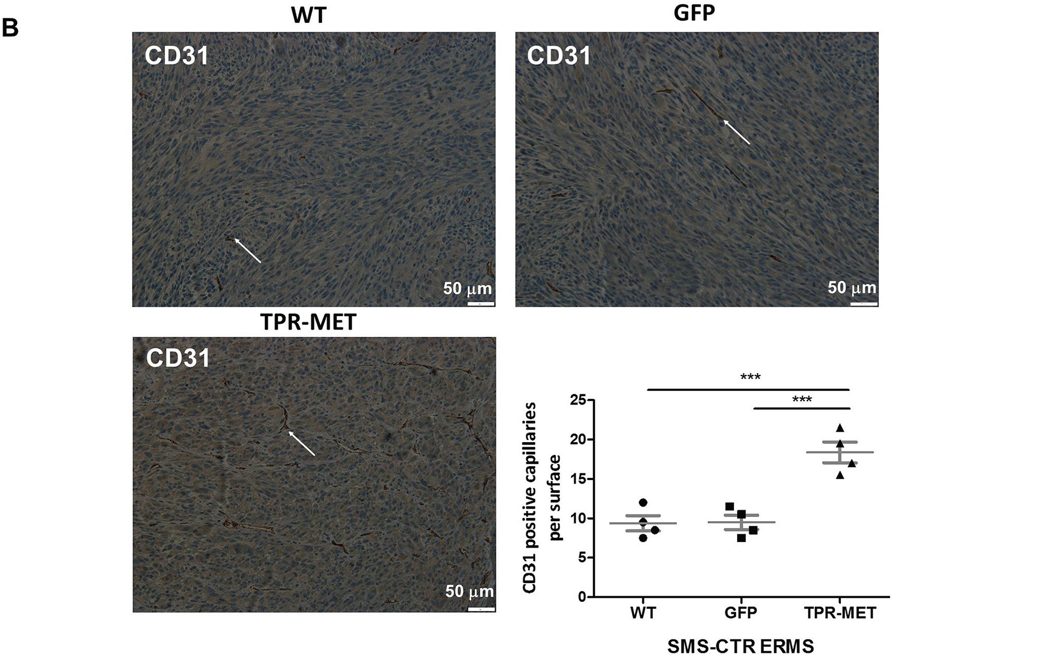
Figure 6: Activation of MET signaling in SMS-CTR ERMS enhances tumor vascularization in vivo, whereas MET
silencing in RH30 ARMS exerts the opposite effects. A. Activated MET signaling increases number of capillaries in tumors formed
by SMS-CTR ERMS and RH30 ARMS cells after subcutaneous implantation to NOD-SCID mice. Capillaries with erythrocytes were
counted after staining of tumor sections for hematoxylin-eosin, n = 7-9. B. Representative images of the staining for CD31 demonstrates
increased number of capillaries in TPR-MET SMS-CTR tumors in vivo. Number of CD31 positive capillaries was calculated in
non-necrotic areas of tumor specimens, n = 4. *p < 0.05, **p < 0.01, ***p < 0.001. Data in graphs are represented as mean +/- SEM.
Arrows indicate the capillaries.
nodes and meshes formed by HUVEC cells in Matrigel
angiogenic assay (Figure 7A). Those proangiogenic effects
may be explained by enhanced expression of miR-378a,
MMP9 and VEGF in SMS-CTR cells expressing TPR-
MET, whereas antiangiogenic capabilities of ARMS cells
with silenced MET level may be explained by decreased
expression of those factors (Figure 7B). Moreover,
inhibition of miR-378a with anti-miR-378a inhibitor
reversed the effect of TPR-MET on VEGF mRNA and
protein level (Figure 7C). Those results demonstrate for
the first time that one of the proangiogenic mediators of
the MET action may be miR-378.
Enhanced vascularization of TPR-MET tumors
was accompanied by the induction of metastasis to lungs
(Figure 8A). Higher metastatic potential may be explained
by the enhanced migratory capabilities of SMS-CTR cells,
what was shown in a scratch assay in vitro - migration
in starving conditions in medium with 0.5% BSA was
www.impactjournals.com/oncotarget
31385
Oncotarget
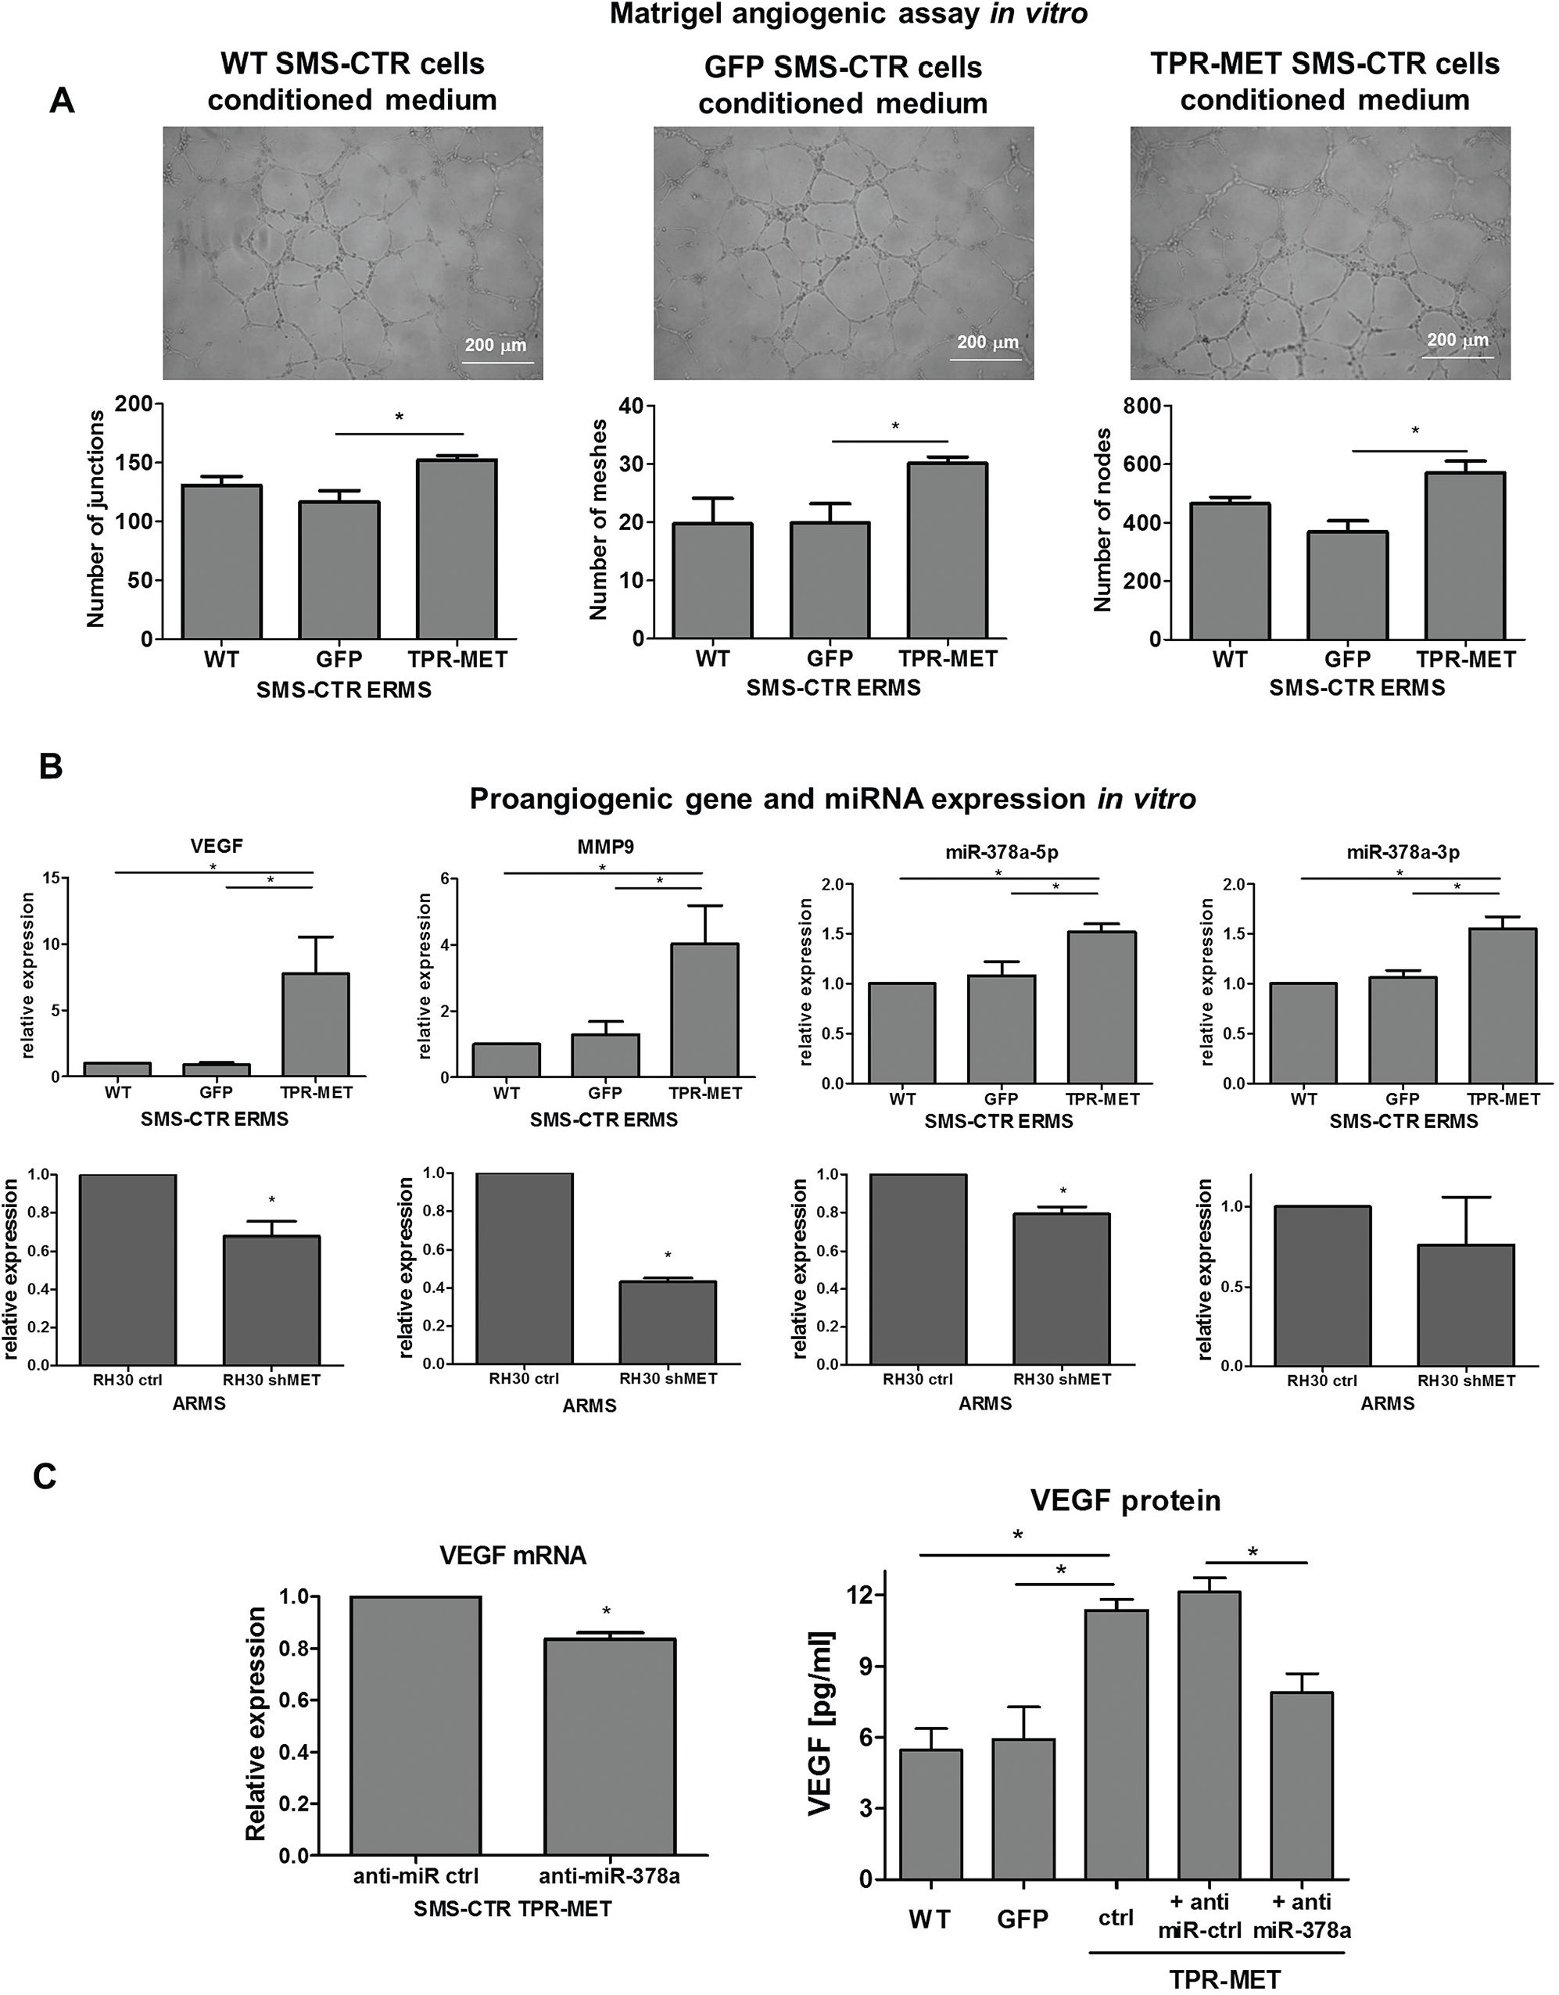
Figure 7: Activation of MET signaling in SMS-CTR ERMS cells induces proangiogenic effects in vitro by upregulation
of miR-378, VEGF and MMP9, whereas MET silencing in RH30 ARMS exerts the opposite effects. A. TPR-MET
SMS-CTR cells conditioned media increase the amount of junctions, nodes and meshes formed by HUVEC cells in Matrigel angiogenesis
assay in vitro, n = 4. B. Expression of VEGF, MMP9, miR-378a-5p and miR-378-3p is increased in SMS-CTR ERMS cells expressing
TPR-MET and downregulated in shMET RH30 ARMS cells in vitro, qPCR, n = 2-4. C. Inhibition of miR-378a with anti-miR sequences
reverses the effect of TPR-MET on VEGF mRNA and protein, n = 2-4. *p < 0.05, **p < 0.01, ***p < 0.001. Data in graphs are represented
as mean +/- SEM.
www.impactjournals.com/oncotarget
31386
Oncotarget
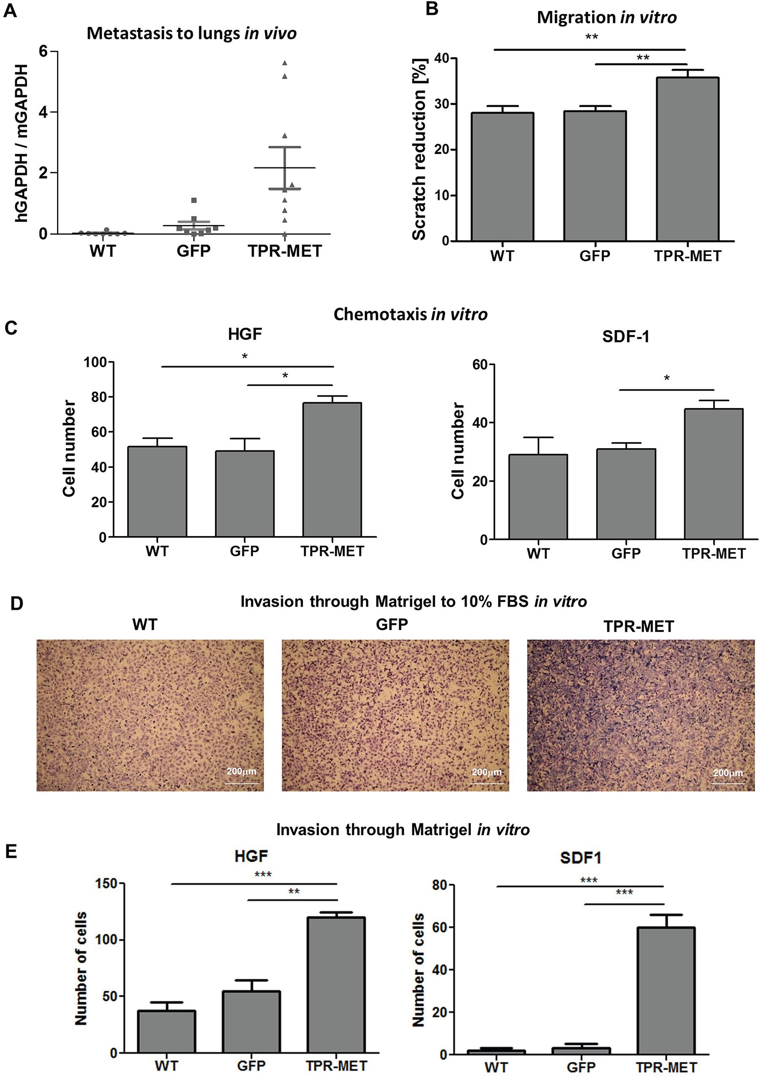
Figure 8: Activation of MET signaling in SMS-CTR ERMS induces metastasis to lungs in vivo and enhances migratory
and invasive capabilities of the cells in vitro. A. Enhanced metastasis to lungs of SMS-CTR subcutaneous xenotransplants in
NOD-SCID mice was demonstrated by evaluation of human GAPDH to murine GAPDH mRNA ratio by qPCR, n = 7-9. B. TPR-MET
expressing cells closed the gap in a scratch assay slightly faster, n = 3. C. In a chemotactic assay TPR-MET expressing cells displayed
enhanced migration toward HGF (20 ng/ml) and SDF-1 (100 ng/ml), n = 3. D. Representative images of invasion of SMS-CTR cells through
Matrigel to 10% FBS in vitro show enhanced invasive capabilities of TPR-MET cells. E. TPR-MET SMS-CTR cells display enhanced
invasion through Matrigel to HGF and SDF1, n = 3. *p < 0.05, **p < 0.01, ***p < 0.001. Data in graphs are represented as mean +/- SEM.
www.impactjournals.com/oncotarget
31387
Oncotarget
enhanced in TPR-MET cells (Figure 8B). Due to enhanced
migratory capabilities those cells displayed also enhanced
chemotaxis toward gradients of both human HGF and
SDF-1 in vitro (Figure 8C). Not only chemotaxis, but
also invasion through Matrigel to FBS (Figure 8D), HGF
and SDF-1 (Figure 8E) in vitro was strongly enhanced in
TPR-MET cells.
Activation of MET signaling in mesenchymal
stem cells induces prolonged survival and may
drive an oncogenic transformation, and it blocks
terminal differentiation of skeletal myoblasts
Because one of the hypotheses underlying
rhabomyosarcoma development states that it may
originate from a differentiation defect of mesenchymal
stem cells (MSC), we introduced TPR-MET with viral
vectors into MSC to constitutively activate MET signaling
pathways (Figure 9A). Control cells were modified with
vector harboring GFP. Positive cells were selected with
blasticidin and cultured for several passages. Control cells
survived in culture only until the 5th passage and then they
started to die, whereas TPR-MET MSC survived in culture
for more than 5 passages (Figure 9B). Surprisingly, in
MSC expressing TPR-MET, which survived in culture for
several months, we observed an induction of expression
of myogenic markers, such as PAX3, PAX7, MYF5,
MyoD and MRF4 (Figure 9C). MYF5 was the most
potently upregulated early myogenic factor. Expression of
osteoblastic RUNX2 and adipogenic PPARG2 negatively
correlated with SNAI1 expression (Figure 9C). Those
results suggest that MSC cells expressing MYF5 and
PAX7 started to differentiate into muscle progenitors.
Nevertheless, there was no spontaneous differentiation
towards myoblasts and mature muscle fibers, what
suggests that those cells were kept in an early stage of
myogenic differentiation. On the other hand, introduction
of TPR-MET to human myoblasts (Figure 10A) changed
their morphology, induced cytotoxicity and blocked
formation of mature myotubes (Figure 10B), what
coincided with inhibition of expression of late myogenic
factors, such as myostatin, myogenin, myosin heavy chain
and also MEF2A (Figure 10C). Those results indicate that
for proper terminal differentiation of myoblasts activation
of MET should be diminished. Our results suggest
that constitutive activation of MET signaling induces
prolonged survival of MSC in vitro and may induce early
myogenic differentiation. Nevertheless, in the future
more detailed studies are required to demonstrate the
mechanisms of that process.

DISCUSSION
The salient finding of the present study is that
constitutive activation of MET signaling by expression
of TPR-MET oncogene induces rhabdomyosarcoma
development by blocking myogenic differentiation and
enhancing proliferation, migration and angiogenesis.
We have chosen TPR-MET as a model of constitutive
activation of MET downstream signaling pathways, which
is independent of HGF ligand binding. Our group [22]
and others [4] have previously shown that downregulation
of MET receptor diminishes RMS growth and promotes
myogenic differentiation of the tumor. In development
of skeletal muscles MET receptor plays a similar role.
Constitutive activation of MET signaling by introduction
of TPR-MET leads to myotube breakdown and muscle
atrophy [24]. It is in accordance to our studies: activation
of MET signaling in differentiating human myoblasts was
cytotoxic, what indicates that in proper terminal myogenic
differentiation it should be diminished. Moreover, HGF
and MET are co-localized in activated satellite cells
in regions of muscle repair [25]. When myoblasts stop
proliferation and differentiate both MET receptor and HGF
are downregulated. Introduction of either TPR-MET or
both HGF and MET receptor inhibits myogenesis at both
morphological and biochemical levels, as myogenin and
MyoD levels are diminished [26]. Similarly, in our current
studies we demonstrated that differentiation of ARMS
decreases MET receptor levels. In RMS tumors expressing
TPR-MET we also observed downregulation of myogenic
markers, such as myogenin, myostatin and MEF2A, what
explains morphological changes in those tumors. The
effects of TPR-MET are also independent of myomiRs,
miRNAs regulating myogenesis, which have previously
been demonstrated to regulate rhabdomyosarcoma
development [27].
The significant role of MET signaling pathway in
RMS differentiation was observed in experiments in vivo,
whereas in vitro SMS-CTR cells poorly differentiated. One
of the crucial factors responsible for differentiation in vivo
may be three dimensional tumor microenvironment. When
SMS-CTR cells were cultured in a differentiating medium
in Matrigel instead of conventional two dimensional cell
culture on plastic dishes, strong effect on morphological
features was observed. Control SMS-CTR cells became
more elongated, whereas TPR-MET cells formed rounded
colonies similar to colonies formed by RH30 ARMS cells,
which display higher basal MET level. The morphology of
those cells resembled the morphology of the cells forming
tumors in mice. It has been previously shown that RMS
differentiate in spheroids and accumulate the differentiated
myotube-like cells in the center [28]. Another important
factor affecting tumor growth and differentiation is
tumor microenvironment. Murine neutrophils infiltrating
TPR-MET tumors may modulate both processes. Tumor-
associated neutrophils are usually recruited by tumor in
response to IL-8 and they have been previously shown
to function against the host and usually they confer a
poor prognosis, because they may promote enhanced
metastasis and vascularization [29]. However, MET
receptor is expressed not only by cancer cells but also by
www.impactjournals.com/oncotarget
31388
Oncotarget
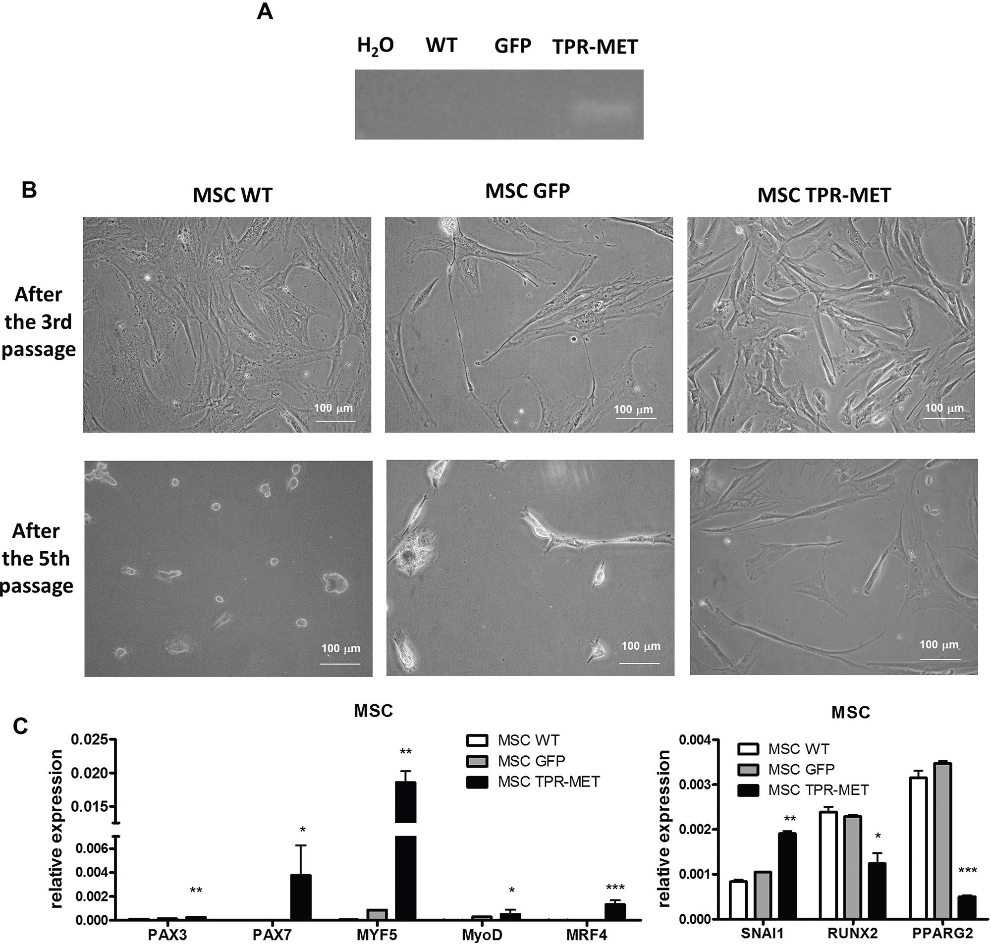
Figure 9: Activation of MET signaling in human mesenchymal stem cells induces prolonged survival and expression of
myogenic markers. A. MSC were transduced with viral vectors encoding GFP and TPR-MET and selected with blasticidin. Expression
of TPR-MET transgene at mRNA level was verified by PCR. The picture shows one representative experiment. B. Representative photos
show morphology of MSC after 3 and 5 passages. After 5 passages control MSC are senescent, whereas TPR-MET MSC still grow.
C. When TPR-MET MSC were cultured for several months, expression of myogenic factors, such as PAX3, PAX7, MYF5, MyoD
and MRF4, was induced, whereas expression of osteoblastic RUNX2 and adipogenic PPARG2 factors decreases, what coincided with
upregulation of SNAI1, qPCR, n = 2. *p < 0.05. Data in graphs are represented as mean +/- SEM.
tumor-associated stromal cells and it is required for the
recruitment of anti-tumor neutrophils in response to HGF.
It has been previously shown that MET deletion in mouse
neutrophils enhances tumor growth and metastasis [30].
Block of differentiation of RMS tumors by
constitutive activation of MET receptor signaling may
explain an enhanced proliferation of the tumors, what
was demonstrated by staining for Ki67 and observation
of tumor growth. Similarly, in satellite cells MET
activation inhibits the exit from the cell cycle and
delays myogenic differentiation [25]. Accordingly MET
activation diminished apoptosis of tumor cells in vivo, as
demonstrated by staining for cleaved PARP. Proliferation,
cell motility and cell survival are regulated by MET via
AKT pathway [31]. Aberrant phosphorylation of AKT
kinases was observed in SMS-CTR tumors expressing
TPR-MET. Constitutive activation of MET signaling
pathway led to formation of tumors with morphology
www.impactjournals.com/oncotarget
31389
Oncotarget
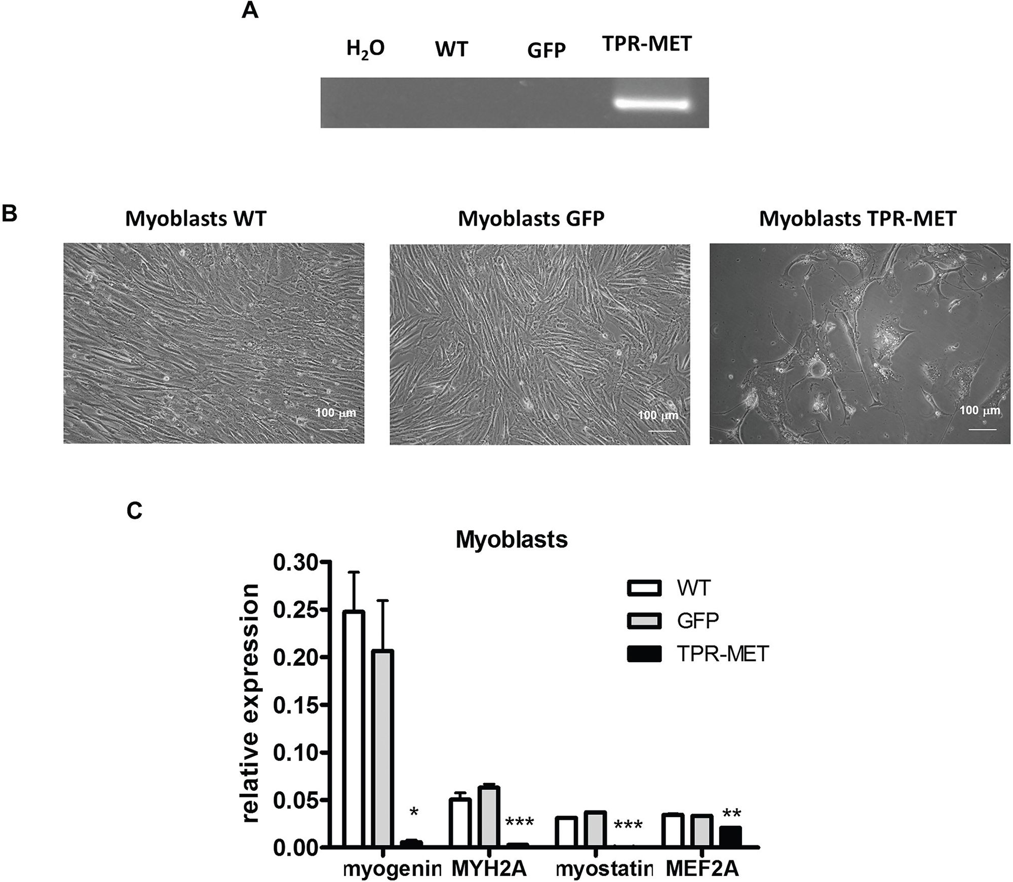
Figure 10: Activation of MET signaling in human skeletal myoblasts blocks their growth and terminal differentiation.
A. Human skeletal myoblasts were transduced with viral vectors encoding GFP and TPR-MET and selected with blasticidin. Expression of
TPR-MET transgene at mRNA level was verified by PCR. The picture shows one representative experiment. B. Representative photos show
morphology of human myoblasts after 4 passages. Introduction of TPR-MET induces cytotoxicity, blocks myoblasts growth and terminal
differentiation. C. TPR-MET myoblasts display decreased expression of late myogenic factors, such as myogenin, myosin heavy chain,
myostatin and MEF2A, qPCR, n = 2. *p < 0.05, **p < 0.01. Data in graphs are represented as mean +/- SEM.
resembling ARMS. Nevertheless, ARMS tumors were
bigger, probably because besides MET also other crucial
genes may play a role in higher invasiveness, such as
PAX3-FKHR [3].
In both physiological and pathological conditions
MET regulates not only proliferation, but also migration
of the cells toward HGF gradient. In MET deficient
mice myogenic precursors are unable to migrate from
the somites to the limbs [32]. Similarly, in pathological
RMS conditions MET receptor downregulation decreases
ability of ARMS cells to metastasize [23]. The metastatic
behavior of RMS cells is regulated by both HGF and
SDF-1 [33]. Our current studies revealed that constitutive
activation of MET signaling increased metastasis to lungs
in murine model, probably due to enhanced migratory
capabilities of ERMS cells. In vitro, chemotaxis
and invasion through Matrigel to both human HGF and
SDF-1 were also elevated. Increased chemotaxis of the
tumor cells with activated MET signaling may be relevant
to RMS metastasis in patients.
Tumor progression and dissemination requires the
development of new blood vessels [34]. In TPR-MET
ERMS tumors we observed an enhanced vascularization,
whereas in ARMS with decreased MET level the effect
was opposite. One of the proangiogenic mediators in
this process may be VEGF. Upregulation of VEGF by
www.impactjournals.com/oncotarget
31390
Oncotarget
HGF-MET has been demonstrated in previous studies in
different cell types [11]. We hypothesize that miR-378 may
be one of the mediators of proangiogenic and oncogenic
actions of MET. miR-378 can promote VEGF expression
by competing with miR-125a for the same seed region
in the VEGF 3'UTR [35]. In our studies inhibition of
miR-378a with anti-miR sequences reversed the effect of
TPR-MET on VEGF level. miR-378 has been previously
demonstrated to induce progression and vascularization
of many tumor types, both of epithelial and mesenchymal
origin, such as, glioblastoma [36], non-small cell lung
carcinoma [37] or breast cancer [38]. In case of sarcomas
miR-378* has been shown to be downregulated in
osteosarcoma tumor compared to normal osteoblasts [39].
In contrary, in rhabdomyosarcoma tumors miR-378 family
members were demonstrated to be downregulated [40] and
miR-378 was shown to induce myogenic differentiation
by increasing the transcriptional activity of MyoD, in part
by repressing an antagonist MyoR [41]. In our studies we
have observed only the influence of miR-378 on tumor
vascularization and no effect on myogenic differentiation,
probably because our SMS-CTR cell model does not
display high MyoD expression. Our studies revealed also
that MMP9 may be an important mediator of the MET
signaling pathway in RMS development. MMP9 plays
a central role inangiogenesis, stromal remodeling, and
consequently metastasis of different tumor types [42].
RMS is a soft tissue tumor, which derives either
from a defective differentiation of muscle progenitor
cells or mesenchymal stem cells (MSC) [1]. It has
been shown previously that expression of TPR-MET in
differentiating muscles resulted in muscle wasting, but did
not cause development of musculoskeletal tumors [24].
Our current studies demonstrated that introduction of
MET induces prolonged survival of MSC in cell culture
in vitro. Moreover, in those cells we detected expression
of early myogenic factors, such as PAX7, MYF5, MyoD
and MRF4. Analysis of a hierarchy of transcription factors
regulating progression through the myogenic lineage [43]
revealed that those cells resembled rather satellite stem
cells due to the high level of early myogenic markers, such
as MYF5 and PAX7. However, we did not observe any
spontaneous differentiation of those cells into myoblasts or
mature myofibers. This suggests that constitutive activation
of MET signaling may drive an oncogenic transformation
toward sarcoma tumors, but the effect might be dependent
on genetic background. The hypothesis is strengthen by
the fact that MSC exposed to pro-longed treatment with
HGF start to express the markers of the first stages of
muscle differentiation, whereas they concomitantly loose
stem cell markers [44]. On the other hand, silencing of
MET with shRNA impairs MSC differentiation into
the osteoblastic and chondrogenic lineages [45]. In our
studies, concomitantly with upregulation of myogenic
markers, we also observed downregulation of osteoblastic
RUNX2 and adipogenic PPARG2 marker, probably due
to upregulation of SNAI1. SNAI1 has been previously
shown to be a regulator of osteoblastic and adipogenic
differentiation. MSC cells with silenced SNAI1 level
prematurely differentiate to osteoblasts or adipocytes [46].
During osteoblast differentiation SNAI1 regulates RUNX2
expression [47], whereas during adipocyte differentiation
SNAI1 is a regulator of PPARy expression [48]. Our
current studies suggest that rhabdomyosarcoma may
derive from the impaired differentiation of mesenchymal
stem cells. We have demonstrated for the first time that
constitutive activation of MET signaling pathway induces
early myogenic differentiation of MSC. However,
for development of skeletal muscles and late steps of
differentiation this signaling needs to be downregulated.
We suggest that impairment in those differentiation
steps may lead to RMS development. This hypothesis is
additionally supported by the fact that transgenic mice
overexpressing HGF are also predisposed to develop
RMS with high expression of MET receptor and elevated
MET kinase activity [49, 50]. Those results strongly
suggest that autocrine MET signaling broadly promotes
RMS tumorigenesis. The statement is additionally
supported by the fact that HGF-MET axis maintains
cancer stem cells functions in different tumor types,
such as glioblastoma [51], head and neck squamous
cell carcinoma [52], pancreatic [53], colon cancer [54]
or cervical carcinoma [55]. However, additional, more
detailed studies are required to demonstrate the precise
mechanism of RMS development. It has to be taken into
consideration that this effect might be strongly dependent
on genetic background of the cells. The cooperation of
TPR-MET with the existing mutations may be crucial
for induction of myogenic differentiation of MSC and
possible interactions should be investigated in the future.
This hypothesis is additionally supported by previous
studies on MSC tumorigenesis. For example it has been
shown previously that mouse mesenchymal stem cells
expressing PAX3-FKHR fusion gene form alveolar
rhabdomyosarcomas by cooperating with secondary
mutations [56]. There is also an evidence that deficiency
of different cell cycle regulators, such as p53, may trigger
a transformation process in mouse MSC resulting in the
generation of sarcoma [57].
Taken together, constitutive activation of the MET
receptor signaling blocks myogenic differentiation of
RMS and enhances tumor proliferation, vascularization
and metastasis (Figure 11A). Additionally we postulate
that aberrant activation of MET signaling may be
responsible for impairment of myogenic differentiation
of MSC and as a consequence may lead to oncogenic
transformation towards ERMS development (Figure 11B).
In the literature it is postulated that RMS may derive
from a differentiation defect of either MSC or myogenic
progenitors [1]. We postulate that origin of RMS may be
dependent on a subtype of the tumor. ARMS is usually
associated with presence of PAX3/FKHR or PAX7/FKHR
www.impactjournals.com/oncotarget
31391
Oncotarget
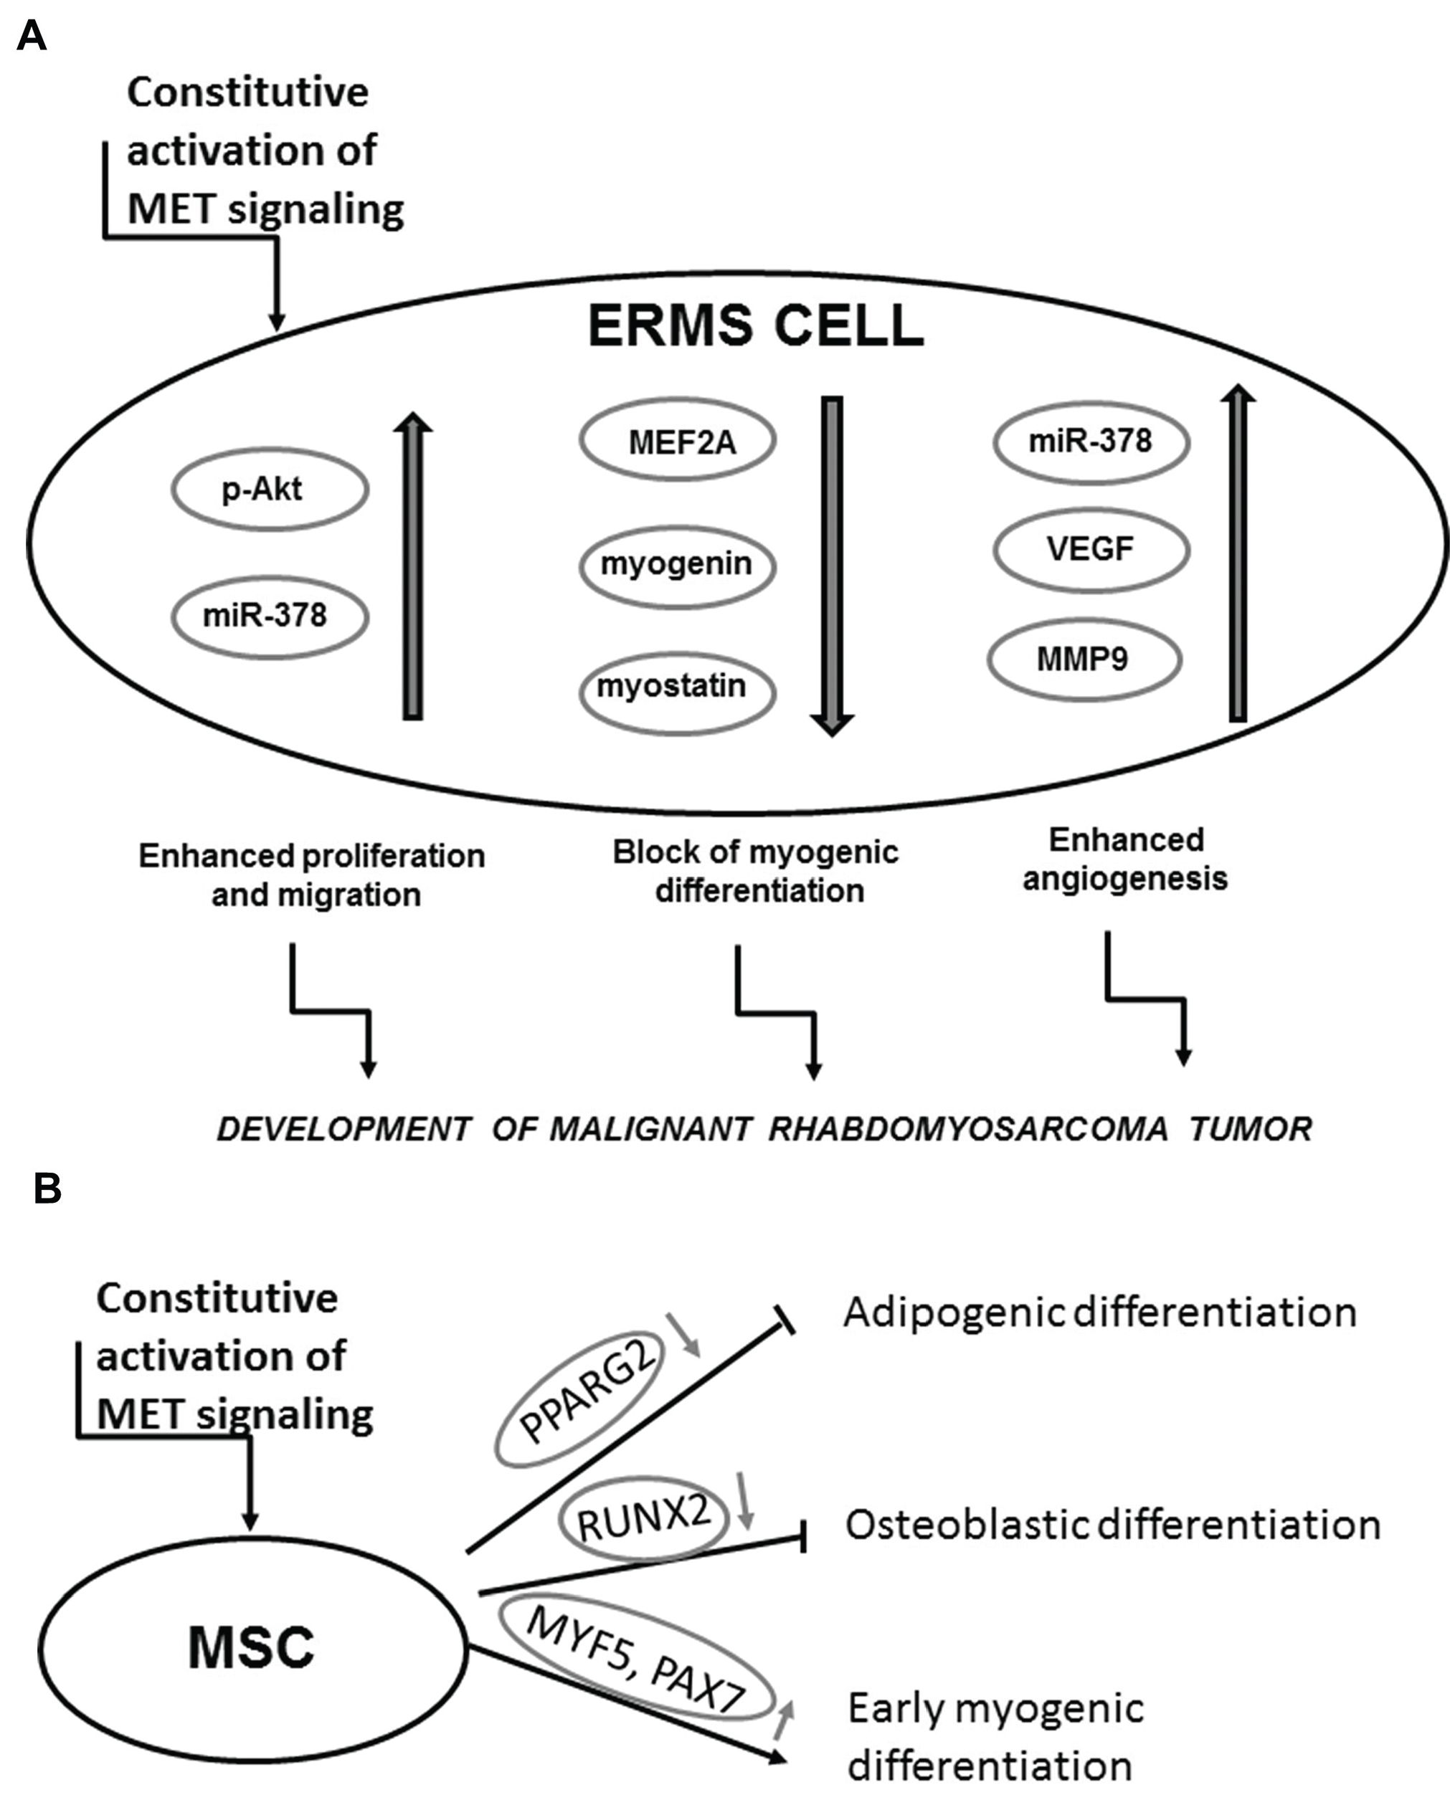
Figure 11: Activation of MET signaling blocks myogenic differentiation and promotes rhabdomyosarcoma development,
angiogenesis and malignancy. A. Mechanism of a development of malignant tumor by the constitutive activation of the MET receptor
signaling in ERMS. B. Mechanism of the effect of the aberrant MET receptor activation leading to myogenic differentiation.
fusion genes [3], whereas ERMS does not display their
expression. Based on our results and on the fact that PAX3
and PAX7 transcription factors are expressed in satellite
stem cells [43], we suggest that ERMS may be derived
from impaired differentiation of MSC. Nevertheless, in the
future more detailed studies are required to convincingly
verify our statement.

MATERIALS AND METHODS
Cell culture
RMS cell lines (SMS-CTR, RD, CW9019,
RH30, RH28, RH18) have been kindly provided
by Dr. PJ Houghton (Center for Childhood Cancer,
Columbus, OH, USA) or have been ordered from
American Type Culture Collection (ATCC, Manassas,
VA, USA) and they were cultured in DMEM high
glucose medium (PAA Laboratories GmbH, Pasching,
Austria / Lonza Group Ltd., Basel, Switzerland)
supplemented with 10% FBS (PAA / EURx, Gdansk,
Poland), 50 pg/ml gentamicin (Lonza) at 37°C, 5% CO2
and 95% humidity. RMS cell lines were differentiated
in DMEM low glucose medium (PAA / Lonza)
supplemented with 2% horse serum (HS) (Gibco, BRL
Grand Island, NY, USA) and 100 nM TPA (Sigma-
Aldrich, St. Louis, MO, USA) for 7-10 days, as described
previously [23]. For RMS cell culture in Matrigel the
12-well plate was covered with Matrigel (Corning Life
Sciences - PZ HTL SA, Warsaw, Poland) and mixed
with DMEM medium with 2% HS in proportion 1:1.
Subsequently, 10 000 cells were seeded in Matrigel
www.impactjournals.com/oncotarget
31392
Oncotarget
mixed with medium (with 2% HS) in proportion 1:4 and
covered with medium with 2% HS. Cells were cultured
for 7 days and medium was changed every 2-3 days.
Morphology of the cells was assessed using microscope.
Adipose tissue derived mesenchymal stem
cells (MSC) were isolated by us and characterized as
described previously [58]. They were cultured in DMEM
LG (PAA / Lonza) supplemented with 10% FBS for
mesenchymal stem cells (STEMCELL Technologies
Inc. Vancouver, BC, Canada), EGF (R&D Systems,
Minneapolis, MN, USA), PDGF (Becton Dickinson, San
Jose, CA, USA) and gentamicin.
Human myoblasts were isolated by us and
characterized as described previously [59]. They were
cultured in DMEM/F12 (Lonza) supplemented with
dexamethasone, insulin (both from Sigma-Aldrich) 18%
FBS, EGF (R&D Systems, Minneapolis, MN, USA), FGF
(R&D) and HGF (R&D).
Human umbilical vein endothelial cells (HUVEC)
have been ordered from Becton Dickinson Biosciences.
They were cultured in M199 medium with HEPES
(Invitrogen, Carlsbad, CA, USA) supplemented with
10% FBS (EURx), endothelial cell growth supplement
(Sigma-Aldrich), heparin (Sigma-Aldrich) and gentamicin
(Lonza).
Production of viral vectors and
transduction of cells
Plasmid encoding full length TPR-MET sequence
was obtained from Addgene (Cambridge, MA, USA)
and described previously [60]. Viral particles encoding
GFP (GFP@pLenti6/UbC) and TPR-MET (TprMET@
pLenti6/UbC) were produced using Vira Power Lentiviral
Expression System (Invitrogen, Carlsbad, CA, USA),
as described previously [61]. SMS-CTR cells and MSC
were transduced with lentiviral vectors (at MOI = 10
and 20 respectively) in presence of 6 gg/ml polybrene
(Sigma-Aldrich) and subsequently after 72 hours they
were selected with 2.5 gg/ml blasticidin (InvivoGen,
Toulouse, France) for two weeks. RH30 ARMS cells were
transduced with lentiviral vectors encoding shMET and
shLacZ, as described previously [22], [23].
Transfection of cells with anti-miRs
SMS-CTR cells were transfected with 30 nM
anti-miR miRNA Inhibitors (Ambion Inc., Austin,
TX, USA) against miR-378a-5p and miR-378a-3p and
negative control using Lipofectamine 2000 (Invitrogen)
according to the manufacturer’s instructions 72 h before
the experiments. Subsequently RNA was isolated, as
described below and cell culture media were collected
from the cells cultured between 48 and 72 hours after the
transfection.
Treatment of the cells
SMS-CTR, RH30, RH28 and CW9019 cells were
subjected to differentiation in DMEM (Lonza) with
2% horse serum (HS) (Gibco BRL) and with or without
100 nM TPA (Sigma-Aldrich) [23]. For evaluation of the
phosphorylation level of AKT kinases, the SMS-CTR cells
were seeded at density of 120 000 cells per well on 6-well
plate. After 24 hours medium was changed for DMEM with
0.5% BSA. Next day, the cells were treated with 20 ng/
ml HGF in fresh starving medium for 10 minutes at 37°C.
Subsequently, protein was isolated, as described below.
Flow cytometry
For evaluation of MET receptor level RMS cells were
stained with monoclonal FITC-labeled anti-human HGFR/
c-MET antibody, clone 95106 (R&D) or mouse IgG1
isotype control (R&D) and the results were analyzed using
FACS Canto cytometer (Becton Dickinson) FACS Diva
software (Becton Dickinson), as described previously [23].
DNA and RNA isolation and reverse
transcription
Genomic DNA was isolated using QIAmp DNA
Blood Mini Kit (Qiagen, Hilden, Germany) according
to vendor’s protocol. The total RNA was extracted using
Universal RNA purification Kit (EURx), according to
vendor’s protocol. For analysis of miRNA expression,
total RNA was isolated with mirVana miRNA Isolation Kit
(Ambion Inc., Austin, TX, USA). Total RNA from paraffin
embedded tumor samples was isolated with RecoverAll™
Total Nucleic Acid Isolation Kit (Ambion). The reverse
polymerase transcription of mRNA was performed using
MMLV reverse transcriptase (Promega, Madison, WI,
USA) according to the manufacturer’s protocol. Reverse
transcription of miRNA was performed with NCode VILO
miRNA cDNA Synthesis Kit (Invitrogen), according to the
vendor’s protocol.
PCR
Incorporation of TPR-MET transgene into
genomic DNA was validated by PCR with a forward
primer 5'-TGGACAATGATGGCAAGAAA-3' and a
reverse primer 5'-GAAGTGGATGGCTTTGGAAA-3'
using Taq PCR Master Mix (EURx), according to
vendor’s protocol. Expression of TPR-MET mRNA
was evaluated by PCR with a forward primer
5'-GAGCCAATTTACAAGAACAAAGGA-3' and reverse
primer 5'-ATACTGCACTTGTCGGCATGAA-3'.
Quantitative real-time PCR
Gene expression was determined by qRT-PCR
analysis on ABI PRISM 7300 Sequence Detection
www.impactjournals.com/oncotarget
31393
Oncotarget
System (Applied Biosystems, Foster City, CA, USA)
using Blank qPCR Master Mix (EURx) and the following
Taq-Man probes (Applied Biosystems): human:
GAPDH (Hs99999905_m1), MET (Hs01565589_m1),
VEGF (Hs00173626_m1), MMP9 (Hs00234579_m1),
MYF5 (Hs00271574_m1), MYOD (Hs00159528_m1),
MRF4 (Hs01547104_g1), MEF2A (Hs01050409_m1),
MYOSTATIN (Hs00976237_m1), MYOGENIN
(Hs01032275_m1), MYH2 (Hs00430042_m1), PAX3
(Hs00240950_m1), PAX7 (Hs00242962_m1), SNAI1
(Hs00195591_m1), RUNX2 (Hs00231692_m1),
PPARG2 (Hs01115513_m1) and mouse: GAPDH
(Mm99999915_g1).
For evaluation of miRNA expression by quantitative
real-time PCR Sybr Green qPCR Master MIX (EURx)
and universal reverse primer from NCode VILO miRNA
cDNA Synthesis Kit (Invitrogen) were used with the
following forward primers:
U6 snRNA: 5-CGCAAGGATGACACGCAAA
TTC-3'
miR-1: 5'-GCTGGAATGTAAAGAAGTATGT
ATAA-3'
miR-206: 5-TGGAATGTAAGGAAGTGTGTGG-3'
miR-133a-5p: 5-GCAGCTGGTAAAATGGAACCA
AAT-3'
miR-133a-3p: 5'-TGGTCCCCTTCAACCAGCTG-3'
miR-133b: 5'-TTTGGTCCCCTTCAACCAGCTA-3'
miR-378a-5p: 5'-CCTGACTCCAGGTCCTGTGT-3'
miR-378a-3p: 5'-ACTGGACTTGGAGTCAG
AAGG-3'
The mRNA expression level for all samples was
normalized to the housekeeping gene GAPDH, whereas
miRNA level was normalized to the housekeeping
U6 snRNA level. Expression levels of miRNA and genes
were quantified employing the 2 -AACt calculation or
2 -ACt using U6 snRNA or GAPDH a housekeeping
controls.
Analysis of protein (Western blotting and ELISA)
Protein was isolated with M-PER lysing buffer
(Pierce, Rockford, IL, USA) and Western blot was
done with anti-GAPDH rabbit mAb (Cell Signaling),
anti-phospho-Akt (Ser473) rabbit mAb (Cell Signaling,
Danvers, MA, USA), as described previously [22, 23].
ELISA for VEGF (R&D Systems) in media collected
from the transfected cells was performed according to the
vendor’s protocol.
Migration, chemotaxis and invasion
through Matrigel
Confluent SMS-CTR cells were treated with DMEM
medium with 0.5% BSA for 24 hours. Subsequently, a
scratch was generated with a pipette tip. Starving medium
was replaced every day. Photographs were analyzed
using ImageJ software (National Institute of Health).
Chemotaxis of cells to 20 ng/ml HGF (R&D System)
and 100 ng/ml SDF-1 (Peprotech, Rocky Hill, NJ, USA)
was evaluated using modified Boyden’s chamber with
8 gm pore polycarbonate membrane inserts (Transwell;
Corning Life Sciences - PZ HTL SA, Warsaw, Poland),
as described previously [23]. 0.5% BSA DMEM medium
was used as a negative control, whereas 10% FBS as a
positive control. Similarly invasion of SMS-CTR cells
through growth factor reduced Matrigel invasion inserts
(Corning Life Sciences - PZ HTL SA, Warsaw, Poland)
to 10% FBS, 20 ng/ml HGF, 100 ng/ml SDF-1, 0.5% BSA
was also investigated, as described previously [23], using
density of 5.0 x 104 in 0.5 ml per one insert. Invasion of
the cells treated with 20 ng/ml HGF was also investigated.
Proliferation and mitochondrial activity
SMS-CTR cells were seeded on 24-well plates at
density of 10 000 cells per well. After 24 hours medium
was changed and 24, 48 and 72 hours later cells counted
in a Burker hemocytometer chamber. To examine
mitochondrial activity of the cells MTT test was done.
2000 of SMS-CTR cells were seeded on 96-well plates.
After 24 hours medium was changed for either a medium
with 10% FBS or 0.5% BSA and cells were incubated
either in normoxia (21% O2 level) or at 5% O2 level for 24
hours. Afterwards mitochondrial activity of the cells was
estimated with CellTiter 96® AQueous One Solution assay
(Promega), according to vendor’s protocol.
Angiogenic Matrigel assay in vitro
SMS-CTR cell lines were cultured on six-
well-plates for 24 h in DMEM media with 2% FBS
at 5% O2 level. Subsequently, the conditioned media
were collected, and they were mixed with M199 medium
with 2% FBS in a proportion of 1:1. For Matrigel assay,
50 gl of growth factor reduced Matrigel (BD Biosciences)
was plated in a 96-well plate and incubated at 37°C for
30 min. HUVEC were detached, counted, and single-cell
suspensions at a density of 10,000 cells per well in 200 gl
of conditioned media and proper controls were plated on
the Matrigel. Subsequently, endothelial tube formation
was photographed 6 h after seeding. Formation of tubule-
like structures was analyzed with Angiogenesis Analyzer
for ImageJ (Carpentier G., Angiogenesis Analyzer for
ImageJ (2012) available online: http://imagej.nih.gov/ij/
macros/toolsets/Angiogenesis%20Analyzer.txt).
Microscopy
Microscopic images were visualized with Oympus
IX70 or Olympus BX51 microscopes (Olympus
Corporation, Tokyo, Japan) and Canon EOS1100D digital
photo camera (Canon Inc., Tokyo, Japan) or Olympus
XC50 camera.
www.impactjournals.com/oncotarget
31394
Oncotarget
In vivo experiments
5 x 106 SMS-CTR and RH30 cells were injected
subcutaneously into 6-8 weeks old NOD-SCID mice.
Each experimental group comprised 4-5 animals and all
the experiments were repeated two times. Tumor size was
evaluated two times per week with a caliper and tumor
volume was estimated with a formula V=D * d2 x 0.5 (V is
the tumor volume, D is the biggest dimension; d is the
smallest dimension). After 4 weeks the mice were killed
and their tumors and bone marrow cells were harvested.
After evaluation of tumor weight, they were fixed in
formalin. Tumor sections were stained with hematoxylin-
eosin to visualize tumor morphology and capillaries
with erythrocytes inside them and after deparaffinization
they were stained immunohistochemically, as described
previously [23], with anti-Ki67 primary mouse monoclonal
antibody to evaluate tumor proliferation (clon MIB-1;
1 : 75, DakoCytomation, Denmark, UK), anti-cleaved
PARP (1:100, Abcam, Cambridge UK; ab32064) to
visualize apoptosis and anti-CD31 antibody to visualize
tumor vascularization (1:50, Abcam, ab28364). The
sections were also stained immunofluorescently with anti-
Ly6G/6C primary antibody to visualize murine neutrophils
infiltrating tumor (clone RB6-8C5, 1:100, Biolegend, San
Diego, California, USA) and subsequently with secondary
goat anti-rat antibody conjugated with Alexa Fluor 555
(1:300, Life Technologies, Warsaw, Poland) and finally
the slides were mounted in Vectashield Mounting Medium
with DAPI (Vector Laboratories, Inc, Burlingame, CA,
USA) The metastasis of SMS-CTR cells to the bone
marrow was evaluated by real-time PCR using human
GAPDH specific primers-probe set (Hs99999905_m1;
Applied Biosystems) compared to murine GAPDH
(Mm99999915_g1; Applied Biosystems). Expression of
genes and miRNAs was evaluated in paraffin-embedded
tumor samples, as described in previous section.
Ethics statement
Human experiments were approved by the Local
Bioethical Committee of the Collegium Medicum
of the Jagiellonian University in Krakow, Poland
(no. KBET/32/B/2014). Biopsies of rhabdomyosarcoma
tumors were collected during routine surgery for
preparation of paraffin-embedded samples and analysis
of gene expression. Animal experiments were approved
by I Local Ethics Committee in Krakow (no. 89/2009,
23/2013).
Statistical analysis
Unless stated otherwise, results show mean +/- SEM
of at least 2-4 independent experiments. Statistical analysis
was performed by one-way ANOVA with Tukey post-test
or student’s t-test. Differences with a value of p < 0.05 were
considered statistically significant. Correlations between
genes in patients were calculated as Pearson’s correlations.
Supplementary information
Supplementary Information accompanies the paper
on the website.

ACKNOWLEDGMENTS
We would like to acknowledge Aleksandra Ulman
for her help in RNA isolation, Grazyna Drabik for
histopathological analysis of tumors and Elzbieta
Trzesniowska-Popiel for her technical assistance in
immunohistochemical staining. KS is a researcher in
OMICRON project at the Jagiellonian University Medical
College in Krakow, founded by the European Union’s
Seventh Framework Programme and a recipient of the
Foundation for Polish Science’s START scholarship for
outstanding young scientists and the Polish Ministry
of Science and Higher Education’s scholarship for
outstanding young scientists. The project was financed
by the research grants from the Ministry of Science and
Higher Education in Poland to MM: N N401 229734 and
to KM: N N401 054839 and from the National Science
Centre in Poland to MM: 2013/09/B/NZ5/00769. The
publication cost was financed by the Leading National
Research Center (KNOW) programme supported by the
Ministry of Science and Higher Education.

CONFLICTS OF INTEREST
The authors declare no competing financial interests
in relation to the work described.

Editorial note
This paper has been accepted based in part on peer-
review conducted by another journal and the authors’
response and revisions as well as expedited peer-review
in Oncotarget.

REFERENCES
- Charytonowicz E, Cordon-Cardo C, Matushansky I,
Ziman M. Alveolar rhabdomyosarcoma: Is the cell of origin
a mesenchymal stem cell? Cancer Letters. 2009; 279:126-36.
- Diomedi-Camassei F, McDowell HP, De Ioris MA,
Uccini S, Altavista P, Raschellà G, Vitali R, Mannarino O,
De Sio L, Cozzi DA, Donfrancesco A, Inserra A, Callea F,
et al. Clinical significance of CXC chemokine receptor-4
and c-Met in childhood rhabdomyosarcoma. Clin Cancer
Res. 2008; 14: 4119-27.
- Keller C, Hansen MS, Coffin CM, Capecchi MR. Pax3:Fkhr
interferes with embryonic Pax3 and Pax7 function: implica-
tions for alveolar rhabdomyosarcoma cell of origin. Genes
Dev. 2004; 18:2608-13.
www.impactjournals.com/oncotarget
31395
Oncotarget
- Taulli R, Scuoppo C, Bersani F, Accornero P, Forni PE,
Miretti S, Grinza A, Allegra P, Schmitt-Ney M, Crepaldi T,
Ponzetto C. Validation of met as a therapeutic target in
alveolar and embryonal rhabdomyosarcoma. Cancer Res.
2006; 66:4742-9.
- Gherardi E, Birchmeier W, Birchmeier C, Vande Woude G.
Targeting MET in cancer: rationale and progress. Nat Rev
Cancer. 2012; 12:89-103.
- Corso S, Comoglio PM, Giordano S. Cancer therapy: Can
the challenge be MET? Trends in Molecular Medicine.
2005; 11:284-92.
- Ivan M, Bond JA, Prat M, Comoglio PM, Wynford-Thomas D.
Activated ras and ret oncogenes induce over-expression of
c-met (hepatocyte growth factor receptor) in human thyroid
epithelial cells. Oncogene. 1997; 14:2417-23.
- Pennacchietti S, Michieli P, Galluzzo M, Mazzone M,
Giordano S, Comoglio PM. Hypoxia promotes invasive
growth by transcriptional activation of the met protoonco-
gene. Cancer Cell. 2003; 3:347-61.
- Lutterbach B, Zeng Q, Davis LJ, Hatch H, Hang G,
Kohl NE, Gibbs JB, Pan B-S. Lung cancer cell lines
harboring MET gene amplification are dependent on Met
for growth and survival. Cancer Res. 2007; 67:2081-8.
- Takeuchi H, Bilchik A, Saha S, Turner R, Wiese D,
Tanaka M, Kuo C, Wang H-J, Hoon DSB. c-MET expres-
sion level in primary colon cancer: a predictor of tumor
invasion and lymph node metastases. Clin Cancer Res.
2003; 9:1480-8.
- Peschard P, Park M. From Tpr-Met to Met, tumorigenesis
and tubes. Oncogene. 2007; 26:1276-85.
- Rodrigues GA, Park M. Dimerization mediated through a
leucine zipper activates the oncogenic potential of the met
receptor tyrosine kinase. Mol Cell Biol. 1993; 13:6711-22.
- Liang TJ, Reid AE, Xavier R, Cardiff RD, Wang TC.
Transgenic expression of tpr-met oncogene leads to devel-
opment of mammary hyperplasia and tumors. J Clin Invest.
1996; 97:2872-7.
- Sonnenberg E, Meyer D, Weidner KM, Birchmeier C.
Scatter factor/hepatocyte growth factor and its receptor,
the c-met tyrosine kinase, can mediate a signal exchange
between mesenchyme and epithelia during mouse develop-
ment. J Cell Biol. 1993; 123:223-35.
- Peruzzi B, Bottaro DP. Targeting the c-Met signaling
pathway in cancer. Clin Cancer Res. 2006; 12:3657-60.
- Lesko E, Majka M. The biological role of HGF-MET axis
in tumor growth and development of metastasis. Front
Biosci. 2008; 13:1271-80.
- Negri T, Virdis E, Brich S, Bozzi F, Tamborini E,
Tarantino E, Jocolle G, Cassinelli G, Grosso F,
Sanfilippo R, Casalini P, Greco A, Pierotti MA, et al.
Functional mapping of receptor tyrosine kinases in myxoid
liposarcoma. Clin Cancer Res. 2010; 16:3581-93.
- Yu L, Saile K, Swartz CD, He H, Zheng X, Kissling GE,
Di X, Lucas S, Robboy SJ, Dixon D. Differential expression
of receptor tyrosine kinases (RTKs) and IGF-I pathway
activation in human uterine leiomyomas. Mol Med. 2008;
14:264-75.
- Püsküllüoglu M, Lukasiewicz E, Miekus K, Jarocha D,
Majka M. Differential expression of Snaill transcription
factor and Snaill-related genes in alveolar and embryonal
rhabdomyosarcoma subtypes. Folia Histochem Cytobiol.
2010; 48:671-7.
- Taulli R, Bersani F, Foglizzo V, Linari A, Vigna E,
Ladanyi M, Tuschl T, Ponzetto C. The muscle-specific
microRNA miR-206 blocks human rhabdomyosarcoma
growth in xenotransplanted mice by promoting myogenic
differentiation. J Clin Invest. 2009; 119:2366-78.
- Yan D, Dong XDE, Chen X, Wang L, Lu C, Wang J,
Qu J, Tu L. MicroRNA-1/206 targets c-Met and inhibits
rhabdomyosarcoma development. J Biol Chem. 2009;
284:29596-604.
- Lukasiewicz E, Miekus K, Kijowski J, Drabik G, Wilusz M,
Bobis-Wozowicz S, Majka M. Inhibition of rhabdomyo-
sarcoma’s metastatic behavior through downregulation of
MET receptor signaling. Folia Histochem Cytobiol. 2009;
47:485-9.
- Miekus K, Lukasiewicz E, Jarocha D, Sekula M, Drabik G,
Majka M. The decreased metastatic potential of rhab-
domyosarcoma cells obtained through MET receptor
downregulation and the induction of differentiation. Cell
Death Dis. 2013; 4:e459.
- Crepaldi T, Bersani F, Scuoppo C, Accornero P, Prunotto C,
Taulli R, Forni PE, Leo C, Chiarle R, Griffiths J, Glass DJ,
Ponzetto C. Conditional activation of MET in differentiated
skeletal muscle induces atrophy. J Biol Chem. 2007;
282:6812-22.
- Tatsumi R, Anderson JE, Nevoret CJ, Halevy O, Allen RE.
HGF/SF is present in normal adult skeletal muscle and
is capable of activating satellite cells. Dev Biol. 1998;
194:114-28.
- Anastasi S, Giordano S, Sthandier O, Gambarotta G,
Maione R, Comoglio P, Amati P. A natural hepatocyte
growth factor/scatter factor autocrine loop in myoblast cells
and the effect of the constitutive Met kinase activation on
myogenic differentiation. J Cell Biol. 1997; 137:1057-68.
- Cieśla M, Dulak J, Józkowicz A. MicroRNAs and
epigenetic mechanisms of rhabdomyosarcoma develop-
ment. Int J Biochem Cell Biol. 2014; 53C:482-92.
- Karbach U, Gerharz CD, Groebe K, Gabbert HE,
Mueller-Klieser W. Rhabdomyosarcoma spheroids with
central proliferation and differentiation. Cancer Res. 1992;
52:474-7.
- Gregory AD, Houghton AM. Tumor-associated neutrophils:
new targets for cancer therapy. Cancer Res. 2011;
71:2411-6.
- Finisguerra V, Di Conza G, Di Matteo M, Serneels J,
Costa S, Thompson AAR, Wauters E, Walmsley S,
Prenen H, Granot Z, Casazza A, Mazzone M. MET is
required for the recruitment of anti-tumoural neutrophils.
Nature. 2015; 522: 349-53.
www.impactjournals.com/oncotarget
31396
Oncotarget
- Birchmeier C, Birchmeier W, Gherardi E, Vande
Woude GF. Met, metastasis, motility and more. Nat Rev
Mol Cell Biol. 2003; 4:915-25.
- Bladt F, Riethmacher D, Isenmann S, Aguzzi A,
Birchmeier C. Essential role for the c-met receptor in the
migration of myogenic precursor cells into the limb bud.
Nature. 1995; 376:768-71.
- Kucia M, Jankowski K, Reca R, Wysoczynski M,
Bandura L, Allendorf DJ, Zhang J, Ratajczak J,
Ratajczak MZ. CXCR4-SDF-1 signalling, locomotion,
chemotaxis and adhesion. J Mol Histol. 2004; 35:233-45.
- Collet G, Skrzypek K, Grillon C, Matejuk A, El Hafni-
Rahbi B, Lamerant-Fayel N, Kieda C. Hypoxia control
to normalize pathologic angiogenesis: potential role for
endothelial precursor cells and miRNAs regulation. Vascul
Pharmacol. Elsevier B.V. 2012; 56:1-10.
- Hua Z, Lv Q, Ye W, Wong C-KA, Cai G, Gu D, Ji Y,
Zhao C, Wang J, Yang BB, Zhang Y. MiRNA-directed
regulation of VEGF and other angiogenic factors under
hypoxia. PLoS One. 2006; 1:e116.
- Lee DY, Deng Z, Wang C-H, Yang BB. MicroRNA-378
promotes cell survival, tumor growth, and angiogenesis by
targeting SuFu and Fus-1 expression. Proc Natl Acad Sci
U S A. 2007; 104:20350-5.
- Skrzypek K, Tertil M, Golda S, Ciesla M, Weglarczyk K,
Collet G, Guichard A, Kozakowska M, Boczkowski J,
Was H, Gil T, Kuzdzal J, Muchova L, et al. Interplay
between heme oxygenase-1 and miR-378 affects non-small
cell lung carcinoma growth, vascularization, and metastasis.
Antioxid Redox Signal. 2013; 19:644-60.
- Feng M, Li Z, Aau M, Wong CH, Yang X, Yu Q. Myc/
miR-378/TOB2/cyclin D1 functional module regulates
oncogenic transformation. Oncogene. 2011; 30:2242-51.
- Novello C, Pazzaglia L, Cingolani C, Conti A, Quattrini I,
Manara MC, Tognon M, Picci P, Benassi MS. miRNA
expression profile in human osteosarcoma: role of miR-1
and miR-133b in proliferation and cell cycle control.
Int J Oncol. 2013; 42:667-75.
- Megiorni F, Cialfi S, McDowell HP, Felsani A, Camero S,
Guffanti A, Pizer B, Clerico A, De Grazia A, Pizzuti A,
Moles A, Dominici C. Deep Sequencing the microRNA
profile in rhabdomyosarcoma reveals down-regulation of
miR-378 family members. BMC Cancer. 2014; 14:880.
- Gagan J, Dey BK, Layer R, Yan Z, Dutta A. MicroRNA-378
targets the myogenic repressor MyoR during myoblast
differentiation. J Biol Chem. 2011; 286:19431-8.
- Farina AR, Mackay AR. Gelatinase B/MMP-9 in Tumour
Pathogenesis and Progression. Cancers (Basel). 2014;
6:240-96.
- Bentzinger CF, Wang YX, Rudnicki MA. Building muscle:
molecular regulation of myogenesis. Cold Spring Harb
Perspect Biol. 2012; 4.
- Forte G, Minieri M, Cossa P, Antenucci D, Sala M,
Gnocchi V, Fiaccavento R, Carotenuto F, De Vito P,
Baldini PM, Prat M, Di Nardo P. Hepatocyte growth factor
effects on mesenchymal stem cells: proliferation, migration,
and differentiation. Stem Cells. 2006; 24:23-33.
- Rosová I, Link D, Nolta JA. shRNA-mediated decreases in
c-Met levels affect the differentiation potential of human
mesenchymal stem cells and reduce their capacity for tissue
repair. Tissue Eng Part A. 2010; 16:2627-39.
- Batlle R, Alba-Castellón L, Loubat-Casanovas J,
Armenteros E, Franci C, Stanisavljevic J, Banderas R,
Martin-Caballero J, Bonilla F, Baulida J, Casal JI,
Gridley T, García de Herreros A. Snaill controls TGF-P
responsiveness and differentiation of mesenchymal stem
cells. Oncogene. 2013; 32:3381-9.
- De Frutos CA, Dacquin R, Vega S, Jurdic P, Machuca-
Gayet I, Nieto MA. Snaill controls bone mass by regulating
Runx2 and VDR expression during osteoblast differentia-
tion. EMBO J. 2009; 28:686-96.
- Lee Y, Kim SH, Lee YJ, Kang ES, Lee B-W, Cha BS,
Kim JW, Song DH, Lee HC. Transcription factor Snail is
a novel regulator of adipocyte differentiation via inhibiting
the expression of peroxisome proliferator-activated recep-
tor y. Cell Mol Life Sci. 2013; 70:3959-71.
- Takayama H, LaRochelle WJ, Sharp R, Otsuka T,
Kriebel P, Anver M, Aaronson SA, Merlino G. Diverse
tumorigenesis associated with aberrant development in mice
overexpressing hepatocyte growth factor/scatter factor. Proc
Natl Acad Sci U S A. 1997; 94:701-6.
- Sharp R, Recio JA, Jhappan C, Otsuka T, Liu S, Yu Y,
Liu W, Anver M, Navid F, Helman LJ, DePinho RA,
Merlino G. Synergism between INK4a/ARF inactivation
and aberrant HGF/SF signaling in rhabdomyosarcomagen-
esis. Nat Med. 2002; 8:1276-80.
- De Bacco F, Casanova E, Medico E, Pellegatta S, Orzan F,
Albano R, Luraghi P, Reato G, D’Ambrosio A, Porrati P,
Patane M, Maderna E, Pollo B, et al. The MET oncogene
is a functional marker of a glioblastoma stem cell subtype.
Cancer Res. 2012; 72:4537-50.
- Lim YC, Kang HJ, Moon JH. C-Met pathway promotes
self-renewal and tumorigenecity of head and neck squamous
cell carcinoma stem-like cell. Oral Oncol. 2014; 50:633-9.
- Li C, Wu J-J, Hynes M, Dosch J, Sarkar B, Welling TH,
Pasca di Magliano M, Simeone DM. c-Met is a marker
of pancreatic cancer stem cells and therapeutic target.
Gastroenterology. 2011; 141:2218-27.e5.
- Vermeulen L, De Sousa E Melo F, van der Heijden M,
Cameron K, de Jong JH, Borovski T, Tuynman JB,
Todaro M, Merz C, Rodermond H, Sprick MR, Kemper K,
Richel DJ, et al. Wnt activity defines colon cancer stem
cells and is regulated by the microenvironment. Nat Cell
Biol. 2010; 12:468-76.
- Miekus K, Pawlowska M, Sekuła M, Drabik G, Madeja Z,
Adamek D, Majka M. MET receptor is a potential
therapeutic target in high grade cervical cancer. Oncotarget.
2015; 6:10086-101.
www.impactjournals.com/oncotarget
31397
Oncotarget
- Ren Y-X, Finckenstein FG, Abdueva DA, Shahbazian V,
Chung B, Weinberg KI, Triche TJ, Shimada H, Anderson MJ.
Mouse mesenchymal stem cells expressing PAX-FKHR
form alveolar rhabdomyosarcomas by cooperating with
secondary mutations. Cancer Res. 2008; 68:6587-97.
- Rodriguez R, Rubio R, Menendez P. Modeling
sarcomagenesis using multipotent mesenchymal stem cells.
Cell Res. 2012; 22:62-77.
- Bobis-Wozowicz S, Miekus K, Wybieralska E,
Jarocha D, Zawisz A, Madeja Z, Majka M. Genetically
modified adipose tissue-derived mesenchymal stem
cells overexpressing CXCR4 display increased motility,
invasiveness, and homing to bone marrow of NOD/SCID
mice. Exp Hematol. 2011; 39:686-96.e4.
www.impactjournals.com/oncotarget 31398 Oncotarget
- Jarocha D, Stangel-Wojcikiewicz K, Basta A, Majka M.
Efficient myoblast expansion for regenerative medicine use.
Int J Mol Med. 2014; 34:83-91.
- Gupta PB, Kuperwasser C, Brunet J-P, Ramaswamy S,
Kuo W-L, Gray JW, Naber SP, Weinberg RA. The
melanocyte differentiation program predisposes to
metastasis after neoplastic transformation. Nat Genet. 2005;
37:1047-54.
- Adamus T, Konieczny P, Sekuła M, Sułkowski M,
Majka M. The strategy of fusion genes construction
determines efficient expression of introduced transcription
factors. Acta Biochim Pol. 2014; 61:773-8.

