

Cytotechnology (2019) 71:989-1002
https://doi.org/10.1007/s10616-019-00341-2
ORIGINAL ARTICLE

A novel in vitro model of metastasis supporting passive
shedding hypothesis from murine pancreatic cancer Panc-02

M. P. Krzykawski • R. Krzykawska • M. Paw • J. Czyz • J. Marcinkiewicz
Received: 19 January 2019/Accepted: 21 August 2019/Published online: 9 September 2019
© The Author(s) 2019
Abstract Cancer metastasis is believed to happen
through active intravasation but there might be also
another way to metastasize. According to passive
shedding hypothesis, proposed by Munn et al., tumor
cells detach from the tumor mass and passively shed to
blood stream through leaky blood vessels. We propose
a novel In Vitro Migrational Selection (IVMS) assay
that enables the pre-selection of invasive pancreatic
cancer Panc-02 cells and create a model of passive
shedding. We established invasive sub-cell line of
murine pancreatic cancer Panc-02 cells (refered to as
Panc02-RS), which exhibited higher metastatic poten-
tial in vivo and at the same time decrease in vitro
migratory skills, comparing to the initial Panc-02 cell
line. In in vitro cell cultures Panc-02 spontaneously
detached from the cell culture surface and later
reattached and colonized new areas. We believe it
can mimic the new way of metastasis, namely passive
shedding. We concentrated on Panc-02 model but
believe that IVMS might be used to create sub cell
lines of many solid tumors to model passive shedding.
Our results support the passive shedding hypothesis.
M. P. Krzykawski (H) • J. Marcinkiewicz
Department of Immunology, Jagiellonian University
Medical College, Krakow, Poland
e-mail: krzykawski.marcin@gmail.com
R. Krzykawska • M. Paw • J. Czyz
Department of Cell Biology, Faculty of Biochemistry,
Biophysics and Biotechnology, Jagiellonian University,
Krakow, Poland
Keywords passive sheding mechanism • Panc-02 •
Pancreatic cancer metastasis • Cancer model • In vitro
metastatic selection

Introduction
Lethality of pancreatic cancer is determined by its
metastases, however the mechanism(s) that governs
the metastatic cascade of pancreatic cancer are still
obscure (Vanharanta and Massague 2013). This pro-
cess is triggered and maintained by complex intercel-
lular communication systems, constituted by humoral
factors, intercellular exchange of mechanical stimuli
and gap junctional intercellular communication (Fey-
genzon et al. 2017). Cells evoke secular and perma-
nent phenotypic shifts, such as EMT (epithelial-
mezenchymal transition) that increase the predilection
of cancer cells to colonize the distant organs. Cells that
undergo EMT seem to be preparing for migration: they
change to more spindle shaped morphology, produce
more ECM degrading enzymes and increase the
resistance to apoptosis (Kalluri and Neilson 2003).
On the molecular level EMT is primarily described by
loss of E-cadherin, a protein responsible for cell-cell
adhesion (Ramis-Conde et al. 2009). Equally impor-
tant is N-cadherin upregulation. N-cadherin provides
an important skill for metastatic cells (Nakajima et al.
2004). After reaching a narrow blood vessel a

990
Cytotechnology (2019) 71:989-1002
metastatic cell can attach to the blood vessel wall
where N-cadherin undergo phosphorylation necessary
for adjacent endothelial cells and allow the cancer cell
to enter the tissue (Ramis-Conde et al. 2009). Precise
elucidation of the mechanisms that determine pancre-
atic cancer progression depends on the establishment
of experimental models that would enable the estab-
lishment and phenotypic characterization of invasive
cells in strictly controlled conditions.
Cancer metastasis is a multi step process. In our
study we concentrate only on the initial steps when
cancer cell needs to find a way to leave the primary
tumor. Today metastasis is mostly understood as a
process of active migration (Keleg et al. 2003). By
active migration we understand all sorts of active
chemotactic attraction of a cancer cell towards more
oxygenated and nourished region of the tumor closer
to blood vessels. In contrast to active migration,
passive shedding is a process in which cells detach
from the startum and other cells and can remain in
suspension for a period of time. If these suspended
cells will be pushed out out of the tumor by body fluids
they will reach the blood steam and migrate outside of
the tumor, see Fig. 10. We want to show evidence
supporting the hypothesis of passive metastasis and
propose a new research model. As discussed by Munn
et al. active migration is important in later extravasa-
tion stages but passive intravasation may be more
important at the beginning of the metastatic process
(Bockhorn et al. 2007). Butler and Gullino as well as
Liotta et al. showed that millions of potentially
metastatic cells are shed from the tumor every day
(Liotta et al. 1976; Butler and Gullino 1975). It has not
been well studied because there were no models
allowing researchers to investigate this type of
metastasis. We propose a method to research this
mechanism and call it IVMS (in vitro metastatic
selection).
Generation of metastatic cancer cell subpopulations
in vitro is based on microdissection and repeated
micro-invasion assay, where cancer cell populations
are enriched with invasive cells by the collection-
reseed cycles or Matrigel- and/or endothelium-coated
microporeous membranes (Albini 2016; Liu 2010).
These approaches are based on active adhesion-
dependent mechanism of cancer cell invasion (Bruns
et al. 1999; Xie et al. 2001; Shi et al. 1999). For
example, repeated injection of COLO 357 cells into a
pancreas resulted in the propagation of malignant cell
lineage (Bruns et al. 1999). Application of in vitro
models eliminates the bias between syngenic and
xenogenic models because immune system plays an
essential role in selecting cells with acceptable immu-
nity of the surface markers.
To establish metastatic cancer cell populations
in vivo, one has to repeat transfer of metastatic cells
between animals. Xiangdong et al. produced a cell
sub-line Panc02-H7 characterized by higher meta-
static potential than a wild type Panc-02 cells. The
drawback of most common in vivo approaches
towards pre-selection of invasive cells is the pressure
of immune system (Xie et al. 2001).
Our results support the concept of passive shedding.
Theoretical concept proposed by Munn et al. has been
omitted due to lack of evidence supporting that idea
and methods necessary to investigate it (Bockhorn
et al. 2007). In this work we want to revive that
concept by adding a research method necessary for
research as well as by adding direct arguments that
such a process an important metastatic factor. IVMS is
a new method to create new models that can shed new
light on the passive shedding mechanism.

Materials and methods
Cell line and cell culture
Murine pancreatic adenocarcinoma Panc-02 cell line
has been purchased from DTP, DCTD Tumor Repos-
itory, originally isolated by Corbett et al. (1984) from
C57BL/6 murine tumor. Cells were cultured in RPMI
(Lonza, Basel, Switzerland) supplemented with 10%
FBS (Euro Clone) at standard conditions.
IVMS—in vitro migrational selection assay
We describe one cycle of metastatic selection. Every
stage of the procedure will be repeated many times. To
achieve the full selection it is necessary to repeat this
process until an expected spindle-shape phenotype is
obtained. In order to obtain more spindle shape cell
line with the increased number of freely floating cells
it is advised to repeat the procedure 12-14 times. As a
result, Panc02-RS invasive population contained both
suspended and adherent cell sub-populations. For
IVMS assay 75 cm2 cell culture flasks were used.

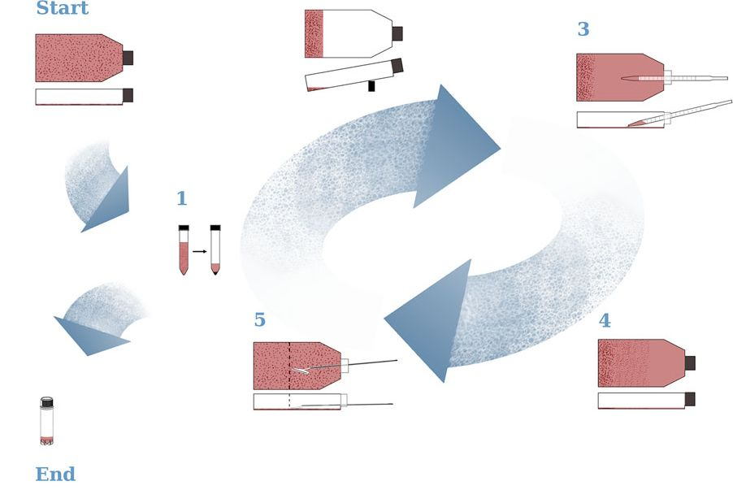
Cytotechnology (2019) 71:989-1002
991
The ‘‘Start’’ stage of IVMS begins with cells
growing equally allover the flask, with 90-95%
confluence. Collect the cell culture media and preserve
it. Add 3 ml of cell culture media to the flask,
mechanically remove cells (with cell scraper) and
collect the cells into the used cell culture media. It is
recommended to split cells in half, freeze one portion
for later, to use it as reference. Use the second half for
IVMS in Stage 1. shown in Fig. 1 Start.
Stage 1: Centrifuge cells for 10 min, at 1000RPM
to obtain a pellet. Remove the supernatant and add
2 ml of fresh culture media. Shown in Fig. 1(1)
Stage 2: Pipette cells with fresh media to re-suspend
the pellet and pour cells into a new cell culture flask.
Keep the new cell culture flask on the back side (as
shown in Fig. 1(2)) and pour the cells suspension
precisely at the end of the flask, so that cells could
grow only on one side of the bottle. Remember to keep
the flask tilted to same a degree. It is necessary not to
drop the cells in any other place than the back end of
the flask and keep it all the time on a slope. Place it in
the incubator keeping it on the slope for 24 h.
Stage 3: After 24 h remove medium from the end
side of the flask. Flask should be kept in leaning
position. Cells should be attached to the cell culture
flask only at one side of the bottle as shown in

IVMS: In vitro migrational selection
2
Fig. 1 Schematic visualization of the IVMS (In Vitro
Metastatic Selection) procedure. IVMS is a procedure devel-
oped to preselect metastatic cells in vitro. ‘‘Start’’ stage begins
with any adhesive cell culture and in stage ‘‘1’’ enters the cycle.
Cycle can be repeated many times to obtain expected result for
example higher number of cells in suspension. Stage’’1’’ is also
a moment to exit the cycle and prepare banks for further research
or continue directly with experiments. See text for the details of
the procedure
Fig. 1(3). Add 10 ml of culture media and place the
flask back into the incubator, let it lay flat. You should
see full confluence of growing cells at the side of the
flask and no cells should be growing at the area close to
the cap.
Stage 4: Within 3-5 days you will start observing
cells showing up on the cap side as shown in Fig. 1(4).
Stage 5: The day when you will see cells with
confluence of about 80-90% at the cap side you should
mechanically remove cells from half of the bottle,
normally it took about 3 days to grow cells allover the
bottle, see Fig. 1(5). When repeating this process
remember to scrape the cells from the cap side of the
bottle where no cells were seeded at the beginning. If
you wish to continue the IVMS selection repeat the
process from stage 1 and use freshly scraped cells. If
you have not obtained expected results yet but you are
interested in the mechanism behind the process you
are researching at this stage you may also collect the
second half of cells and preserve by banking.
If expected results have been obtained, stage 5 is the
moment to stop the procedure and turn to the ‘‘End’’
stage.
Stage ‘‘End’’: Collect the cells from the entire bottle
and centrifuge. Preserve cells by deep freezing for
further research.
Additional information: to obtain more informa-
tion, stage 4 can be done in a fixed number of days later
at stage 5 a cell count of the scraped cells and the
suspended cells will show an increase in numbers.
In vivo metastatic assay
C57BL/6 is a mice purchased from Jackson Labora-
tory (Bar Harbor, Maine, USA). Male mice used in this
study were 8-12 week old, housed at controlled
condition (21 °C; 12 h/12 h dark/light cycle) and
had free access to food and water. Procedures
approved by the University’s Animal Ethic Commit-
tee (Decision No: 140/2015; 94/2014). For the anal-
yses of Panc-02: Panc-02 and Panc02-RS metastatic
potential, 0.5 x 10 cells in 100 ul aqueous suspension
(Cell Culture Grade) (Krzykawski et al. 2015) were
implanted on the back s.c. The total number of 18 mice
were used in this experiment, 6 mice for Panc-02 cell
line and 12 mice for Panc02-RS cell line. Volumetric
measurements of primary tumor size (from three
diameters) were made using caliper. Mice were mildly
anesthetized by inhaled isoflurane for 20 s. Tumor
992
Cytotechnology (2019) 71:989-1002
growth was measured every week for 7 weeks. Mice
were euthanized by cervical dislocation after isofurane
inhalation for 60 s. Metastatic potential of Panc-02
and Panc02-RS sub-populations was measured by the
number of the metastatic tumor lesions in various
organs.
Invasive potential in vitro
For the time-lapse videomicroscopic analyses of cell
migration, the cells were plated into the 24-well
culture plates. After 24 or 48 h, cell movement was
recorded with a Leica DMI6000B time-lapse system
equipped with a temperature/CO2 chamber, IMC
contrast optics and a cooled, digital DFC360FX
CCD camera. The cell trajectories were constructed
from a sequence of cell centroid positions recorded at
420 s time intervals using a dry 20x , NA-0.75
objective. Total length of cell trajectory (qm), total
length of cell displacement (i.e. the distance from the
starting point directly to the cell’s final position; qm),
average speed of cell movement, i.e. the total length of
cell trajectory/time of recording (qm/min) and the
average rate of cell displacement, i.e. the distance
from the starting point directly to the cell’s final
position/time of recording (qm/min) were quantified
from the trajectories of > 60 cells per each condition
with the Hiro program (written by W. Czapla).
Cell transmigrational potential
Cells were seeded on the transwell inserts in 24-well
plates at 10,000 cells/well. After 24 h of cultures, the
insert was transferred to another well for the next 24 h.
This step was repeated five times and cells were
counted. The results were shown as the ratio of cell
numbers per well to the number of cells in referrence
well taking into account the cell proliferation time.
Cell motility analysis
Circular diagrams show single cell trajectories starting
with the initial point at the origin of the plot registered
for 6 h or 8 h; N > 50). Results are representative of
three independent experiments *p < 0.05 (tested with
Annova, followed by Bonferroni test). Square graphs
show a correlation of a total length of trajectory
compared to displacement. It shows how much of the
cell movement is directed and how much is just a
random walk. Low Density (LD) = 25% confluence;
High Density (HD) = 90% confluence; Average speed
[um/min]; Average displacement [um], *p < 0.05.
For the cell motility of Panc-02 and Panc02-RS
cells in High Density (HG) and Low Density (LD)
cells were seeded with the density of 5 x 103 and 30 x
103 cells in LD and HD respectively (Fig. 6). Cells
were cultured for 24 h before the experiment. Cells
were measured for about 6 h, 50 frames, each frame
every 7 min. Each measurement included 60 cells.
For the cell motility of Panc-02 and Panc02-RS cell
lines across different selection cycles (before the
selection, after 5 selection cycles, after 9 selection
cycles, after the entire selection—12 cycles) cells
were seeded on a 12 well plate, 4 x 103 cells/cm2
(Fig. 7). Cells were cultured for about 8 h and
observed with 70 frames, 1 frame every 7 min. Each
measurement included 60 cells.
Cell proliferation analyses
Cells were seeded at a density of 3000 cells per well
into the 48-well plates and cultured with RPMI
supplemented with 10% FBS for 9 days. Every 24 h,
adherent and suspended cells were collected and
counted in triplicates from 3 different wells. Percent-
age of living cells were determined by trypan blue
staining.
Conditioned media experiment and preparation
of conditioned mediated
Conditioned media from Panc-02 and Panc02-RS cell
were prepared. Cells were seeded in a 75 cm2 culture
flask at full density. After 3 days cell culture media
were collected, centrifuged to remove cells and
supernatant (conditioned media) was frozen.
For the analyses of the effect of cell secretome on
cell motility, cells were seeded at a density of 5000
cells per cm in a standard culture medium in a 12-well
plates. After 24 h medium were replaced on the
mixture of fresh and conditioned culture medium at
the ratio 1:3, 1:1 and 3:1. After 24 h of stimulation,
non-adherent cells in each well were counted.
Gap junctional intercellular coupling (GIJC)
Cells were seeded at a density of 30,000/cm2. After
24 h, calcein/DiI-loaded donor cells (Life
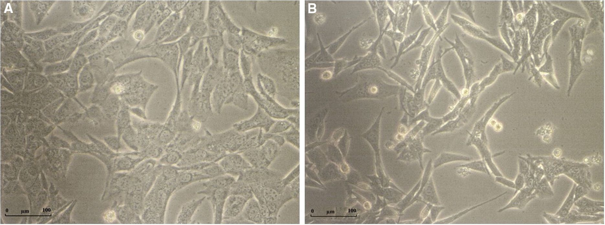
Cytotechnology (2019) 71:989-1002
993
Technologies Corp.) were plated on the monolayers of
acceptor cells grown in Petri dishes at a density of 20
000 per dish and the number of donors, calceine-
transferred cells and acceptors was measured by the
BD LSR Fortessa X-20 flow cytometer (BD Bio-
sciences) and the results of gap junctional coupling
were expressed as the ratio of acceptor cell numbers to
donor cell numbers. Statistical analysis has been done
with t-Student test.
Graphics
All graphical work has been done in GIMP 2.8.10.
Statistical analyses
Values was shown as mean ± SEM. Statistical sig-
nificance of the differences was estimated with the
t-student test (*p < 0.05), in vivo tumor growth were
tested with one-way ANOVA.

Results and discussion
IVMS enabled us to establish a subpopulation of
Panc02-RS cells, which in contrast to their flattened
and strongly attached Panc-02 counterparts, were
more of a spindle shape-type and less attached to the
substrate (Fig. 2). Such cellular shape is characteristic
for the cells constituting the invasive front of cancer.
IVMS assay was at the beginning designed to select
faster migrating cells. We assumed that cells will
migrate on the surface to the empty end of the culture
flask (shown in Fig. 1—IVMS assay). Within three
days we already observed some cells on the cap side of
the flask. It would mean that cells could migrate at a
speed of about 3 cm per day what is impossible. Cells
can migrate with a speed of up to few micrometers per
minute (Baumann 2015). It meant that cells migrated
another way. We observed some cells in suspension of
Panc-02 cell culture, normally those suspended cells
are described as dead or apoptotic. To test cells
suspended in the culture media we took the culture
media with suspended cells and poured it into a new
flask. Next day we found some cells growing in the
new flask. It meant that some of the living cells had
been at least partially suspended in the culture media.
It explained the way how these cells migrated so
quickly during the IVMS assay. IVMS is built out of
repeatable cycles and after about 10-12 cycles we
could observe a growing number of cells in suspension
(data not shown). Apparently, these cells are able to
transiently detach from the substratum and to colonize
the empty spaces of the flask. Later we have also
observed higher number of Panc02-RS cells in
suspension.
As shown in Fig. 3 Panc02-RS cells started divid-
ing earlier what may be an argument supporting the
idea that Panc02-RS cells have an ease to accommo-
date to new environment. We did not observe accel-
erated proliferation of Panc02-RS cells. These cells
however were more efficient to recover from the lag
phase after seeding (Fig. 3), grew to a higher total
Fig. 2 Morphological heterogeneity of cells before (Panc-02) and after IVMS (Panc02-RS). a Panc-02. b Panc02-RS. Panc02-RS cells
underwent IVMS, resemble more spindle shaped cells and are less attached to the surface comparing to Panc-02

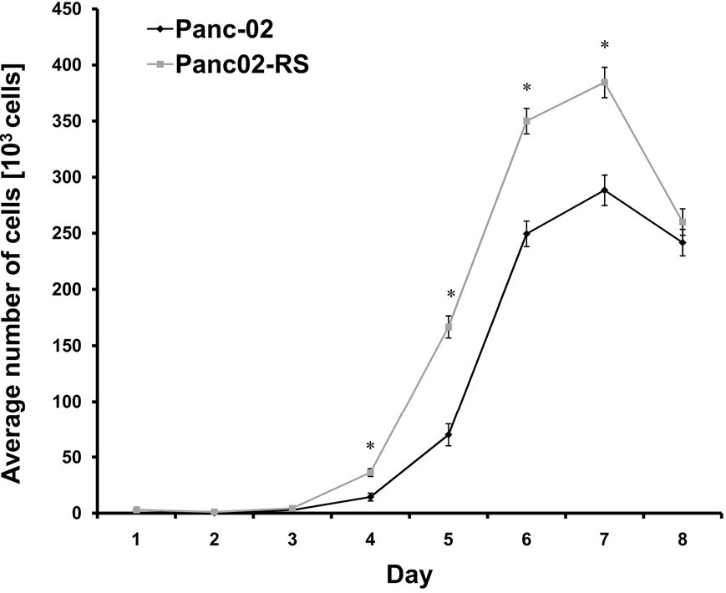
994
Cytotechnology (2019) 71:989-1002
Fig. 3 Comparison of growth between Panc-02 and Panc02-
RS. Cells that underwent IVMS grew faster and reached a higher
number of cells per well and higher cell culture density,
* p < 0.05
number of cells probably due to high number of living
cells in suspension.
Next we wanted to find out if this in vitro process
could influence the in vivo migration/metastasis?
The invasive morphology of Panc02-RS cells was
correlated with their metastatic potential in vivo.
Figure 4D clearly shows that Panc02-RS cells tend to
generate more metastases than their wild type coun-
terparts. Wild-type Panc-02 cells did not produce
metastases in mice (except one animal), whereas 9 out
of 12 mice injected with Panc02-RS cells developed
macroscopic metastases. These data show that IVMS
procedure enables the isolation of invasive sub-
population(s) of Panc02-RS cells. Panc02-RS estab-
lished a detectable tumor sooner and kept growing
faster throughout the experiment (Fig. 4c).
In Fig. 4c one can see the comparison of growth
between Panc-02 and Panc02-RS tumors. Panc02-RS
cells started dividing earlier and produced larger
tumors than Panc-02. Figure 4d shows that Panc02-RS
cells were also more metastatic in the same time
period. Note that spindle shape of Panc02-RS cells
(Fig. 2b) correlates with their invasive potential
in vivo.
While working with the animal models we have
made further observations and interestingly for the
further research we have also seen that mice carrying
Panc02-RS tumors had locally thinned fur (see
Fig. 4a, b). Also the visual appearance of Panc02-RS
derived tumors has been more gross. We have not
measured this observation.
Did we select a more aggressive metastatic Panc-
02 sub-cell line?
We wanted to find out if the observed differences in
numbers of suspended cells between Panc-02 and
Panc02-RS come from some intracellular mechanism
or from cell culture media. We added media from
Panc02-RS to Panc-02 in three proportions: 25%, 50%
and 75% and found an increasing number of cells
suspended in cell culture media what is a hallmark of
Panc02-RS cell and connects it to EMT (Fig. 5a).
Similarly the addition of the same proportions of
media from Panc-02 to Panc02-RS decreased the
number of freely floating cells (Fig. 5b).
These data indicate the existence of paracrine loops
established between Panc-02 cell sub-populations.
Panc02-RS cells release humoral factors that stimulate
phenotypic shifts of Panc-02 cells towards a more non-
adherent phenotype. Although, these hypothetical
factors remain to be identified, they induce phenotypic
shifts in Panc-02 cells that transiently attenuate their
adhesiveness and facilitate their passive movement
across the invasive front of Panc-02 cells during IVMS
assay.
As an alternative to IVMS one can make several
clones and testing for higher metastatic potential. It is
often seen as an option but we assumed that there are
also inter-cellular processes that influence metastasis
and wanted to maintain as much of the cellular
physiology. We believe that the balance and cell
communication play a crucial role in the physiology of
metastasis. As shown in Fig. 5, the observed process is
not based on single mutated cell phenotype but rather
on dynamic interactions of humoral factors. Details of
this process are yet to be uncovered.
Ok, so we have a cell line that grows faster
as a tumor and produces more metastasis but how it
happenes?
Is it only by detachment from the surface or is it for
example due to faster active migration? To answer this
question we have measured the speed of migration of
Panc-02 and Panc02-RS cells.
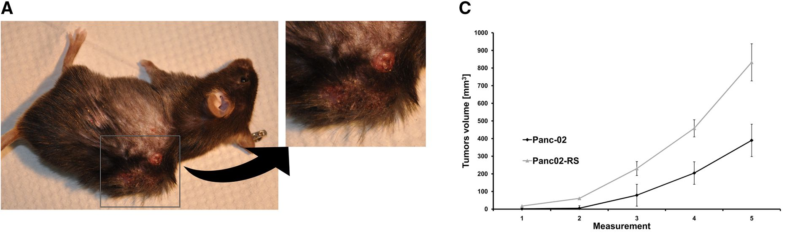
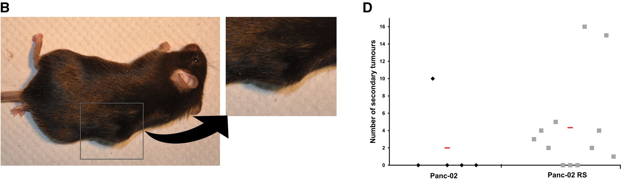
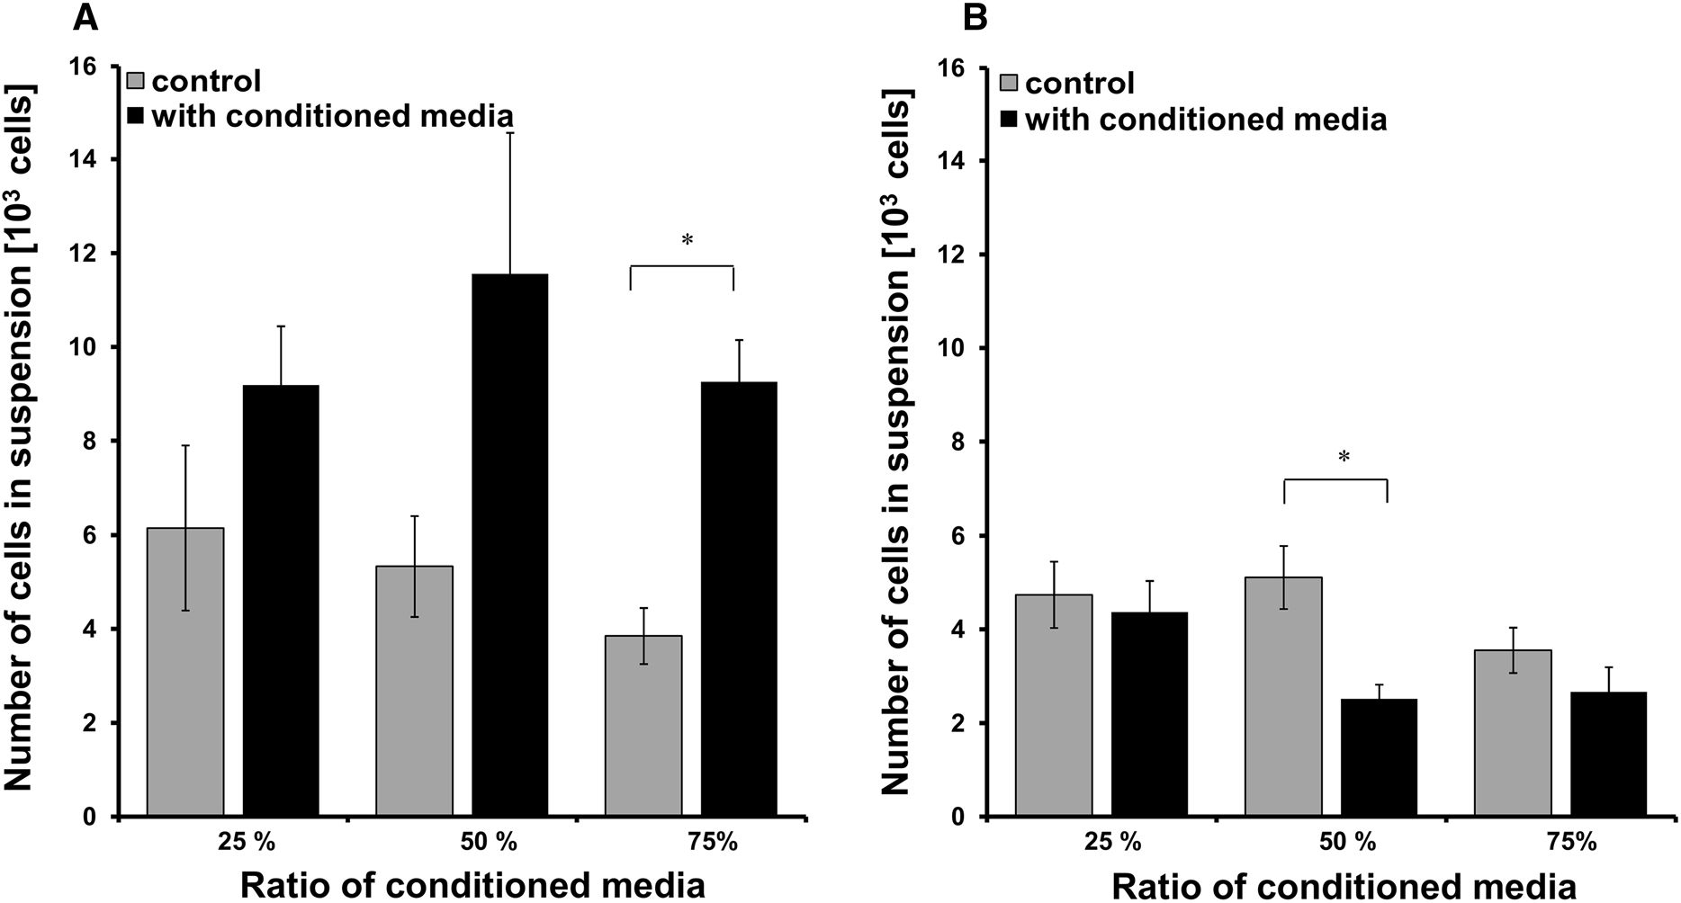

Cytotechnology (2019) 71:989-1002
995
Fig. 4 In vivo tumor growth and metastasis of Panc-02 and
Panc02-RS cell lines. a Mouse bearing Panc-02RS tumor.
b Mouse bearing Panc02 tumor. c Comparisons of tumors from
Panc-02 and Panc02-RS cell lines, p < 0.05. d Number of
metastases (visible by eye) combined from all organs mainly
lungs, analyzed 7 weeks after injection
Fig. 5 Panc-02 and Panc02-RS cells stimulation with condi-
tioned media. a Panc-02 cells were stimulated with culture
media conditioned by culturing in Panc02-RS cell, compared to
control after 24 h, *p < 0.05. b Panc02-RS cells were
stimulated with culture media conditioned by Panc-02 cells,
compared to control after 24 h, *p < 0.05
996
Cytotechnology (2019) 71:989-1002
We expected to see an increase in migration
potential of Panc02-RS comparing to the Panc-02
cells because were preselected to become more
metastatic what was shown by in in vivo experiments.
Surprisingly Panc-02 migration has been decreased in
tests like total cell displacement and speed of migra-
tion. Panc02-RS cells didn’t migrate faster but actually
migrated slower by almost 50% as shown in Fig. 6.
During the selection process after cycles: 5 and 9
we preserved consecutive cell subpopulations. In
Fig. 7b we see that subsequent cycles clearly lowered
the speed of migration.
Each selection cycle decreased an average dis-
placement and between cycles 5 and 9 we observed a
sudden decrease in cell motility. IVMS proved it self
to be a procedure giving very stable increase in the
transition towards EMT.
Our expectation to observe higher migratory poten-
tial in Panc02-RS cells comparing to Panc-02 cells has
not been fulfilled. We thought that may be the in vivo
observation comes from the ease of Panc02-RS cell
line to enter blood stream by migrating through the
blood vessel wall. We tested this hypothesis using cell
transmigration assay in a transwell.
Again a transwell test surprisingly showed that
Panc-02 cell line has a greater potential for transmi-
gration than Panc02-RS cell line as shown in Fig. 8. It
is a visible trend but it has become clear after 96 h and
168 h that significantly more Panc-02 cells migrated
through the membrane compared to Panc02-RS. It
means that IVMS decreased the transmigrational
potential. This observation indicates that nanome-
chanical elasticity is not a pre-requisite for the
metastatic behavior of pancreatic cancer cells. In case
of transmigration we need to keep in mind that it is not
only a question of cell motility but also the stiffness of
cells that have to squeeze to pass through the
membrane (Nguyen et al. 2016). Note that spindle
shape of Panc02-RS cells does not correlate with the
transmigration potential in vitro but was already
shown to correlate with the invasive potential in vivo.
Molecular aspects of the observed processes
Until this moment we concentrated on the functional
aspects of the investigated process. Everything we
have seen so far has to be reflected by the molecular
mechanism. As described above, IVMS led to the pre-
selection of spindle-shaped Panc-02 cells, therefore
we asked whether the microevolution of their meta-
static sub-populations is related to EMT. EMT is a
physiological process that plays an important role in
embriogenesis and wound healing (Barriere et al.
2015). It is one of the decisive steps during the
metastatic cascade of pancreatic cancer. We have
observed slightly decreased E-cadherin and slightly
increased N-cadherin levels were seen in Panc02-RS
cells, when compared to wild type Panc-02 cells (data
not shown). A ‘‘cadherin shift’’ i.e. a decrease of
E-cadherin and an increase of N-cadherin expression
is one of the hallmarks of EMT, therefore these
observations may illustrate the involvement of EMT in
Panc-02 heterogeneity (Nakajima et al. 2004).
Following these results we decided to investigate
the direct cell to cell communication. Neighboring
cells can communicate through gap junctions that
connect the cells interiors. This mechanism can be
investigated as a passive transport of calceine from a
donor to an acceptor cell and a result is presented as a
ratio of a number of acceptor cells to the donor cells on
a time dependent scale, see Fig. 9.
We have shown that Panc02-RS cell line has a
decreased communication level comparing to Panc-
02. It seems that Panc02-RS has less contacts with
neighboring cells what fits to the previous result
showing less vinculin in Panc02-RS cell line. On the
other hand, Panc02-RS cells were characterized by a
lower intensity of GJIC [gap junction intercellular
communication] that their wild type counterparts
(Fig. 9a), GJIC is a passive intercellular transfer of
small metabolites (Holder et al. 1993). Cells well
attached to the surface create more contact points with
other cells. Panc-02 wild type cells have a stronger
bond with the surface compared to the Panc02-RS
cells. Since the cell division causes cells to partially
detach from the surface and become more round this
result complies with the growth curve in Fig. 3. EMT
is often correlated with the Cx43 up-regulation and
GJIC induction in cancer cell populations, therefore
this observation may indicate a type III (incomplete)
EMT (Kalluri and Weinberg 2009). We did not
observe any differences in Snail-1 and Cx43 expres-
sion levels between Panc-02 and Panc02-RS cells
(data not shown). Concomitantly, vinculin was pref-
erentially recruited into focal contacts of Panc-02
cells, whereas a more diffuse distribution was seen in
Panc02-RS cells. Most importantly, Panc02-RS cells
displayed a considerably lower (50%) motile activity

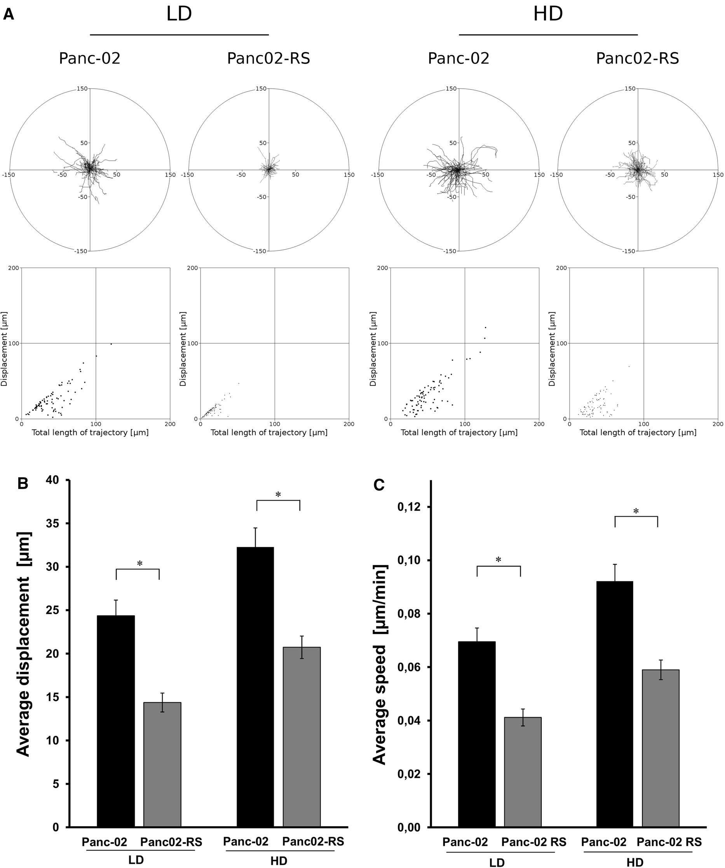

Cytotechnology (2019) 71:989-1002
997
Fig. 6 Density dependent cell motility of Panc-02 and Panc02-
RS cell lines; a 6 h time lapse video microscopy observation at
the LD (Low Density) and HD (High Density). b Graph showing
a displacement comparing Panc-02 and Panc02-RS cell lines in
LD and HG, * p < 0.05. c Graph C is showing a speed of
migration comparing Panc-02 to Panc02-RS cell lines in LD and
HG,* p< 0.05

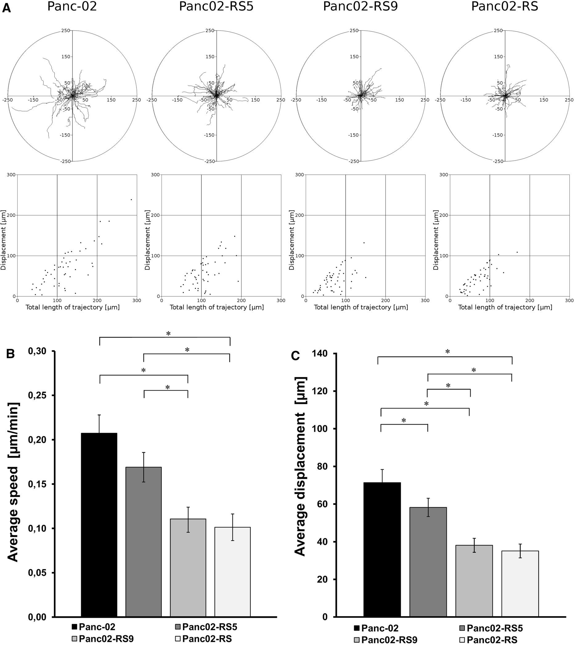

998
Cytotechnology (2019) 71:989-1002
Fig. 7 Cell motility of Panc-02 and Panc02-RS cell lines across
different selection cycles. a 8 h time lapse video microscopy
observation. b Graph showing average displacement through
successive rounds of selection starting from Panc-02 wild type,
continued with selection cycles 5 and 9 and finishing with
Panc02-RS cell line, * p < 0.05. c Graph showing a speed of
migration through successive rounds of selection starting from
Panc-02 wild type, continued with selection cycles 5 and 9 and
finishing with Panc02-RS cell line, * p< 0.05
than their wild type counterparts (Figs. 6 and 7). These experiment showing relatively high metastatic poten-
data stay in contrast with the outcome of in vivo tial. Because the involvement of EMT in cancer

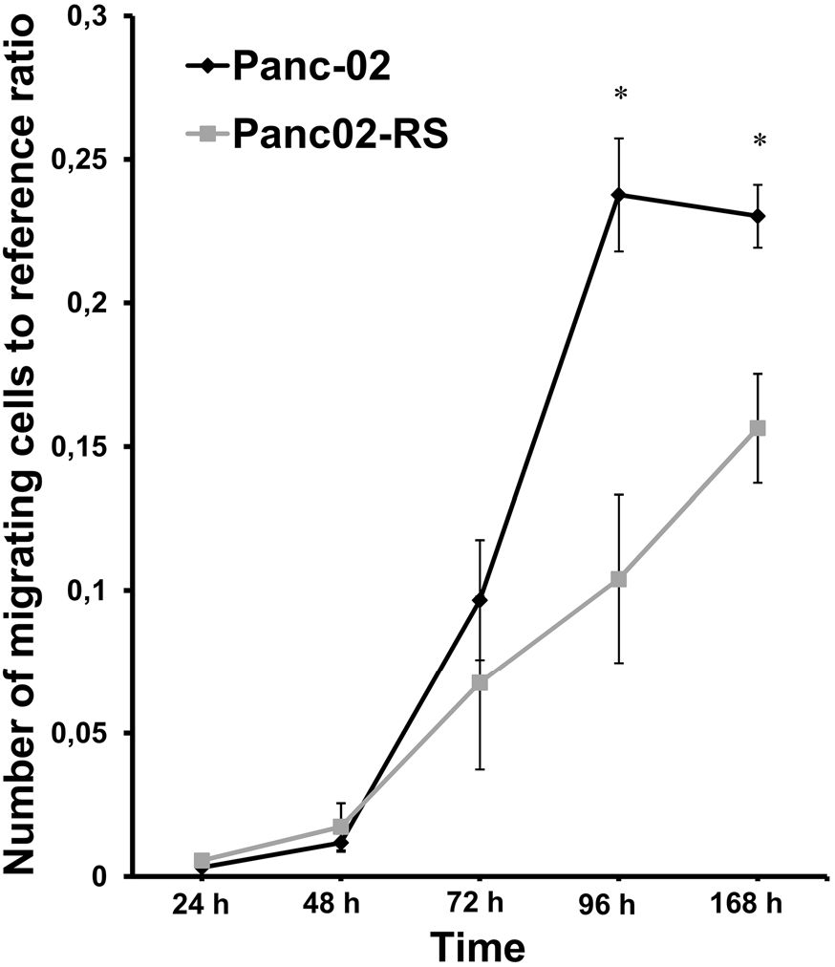
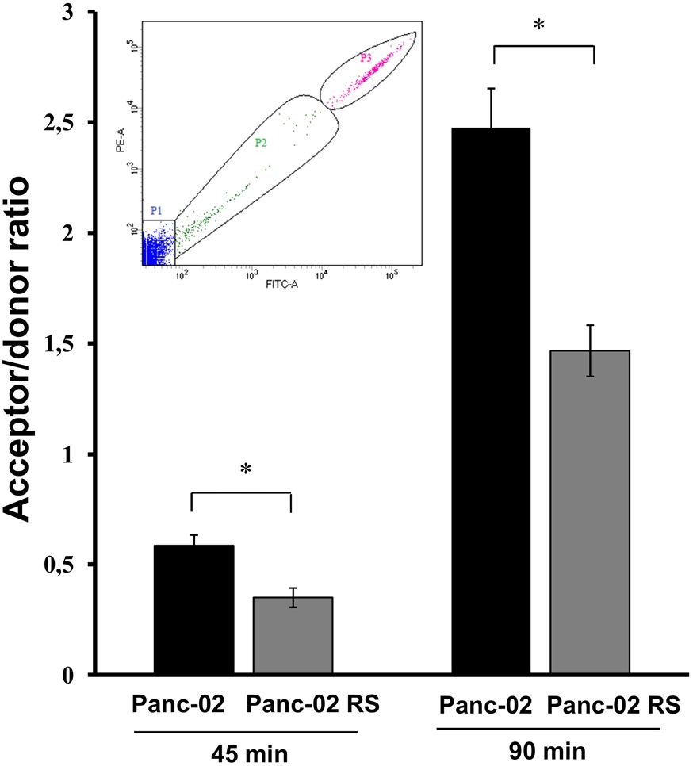

Cytotechnology (2019) 71:989-1002
999
Fig. 8 Invasive properties of Panc-02 and Panc02-RS cells on
transwell invasion potential assay. Graph comparing the
transmigrational potential of Panc-02 and Panc02-RS cell lines
within 5 days time frame,* p < 0.05
progression is related to the induction of cancer cell
motility, these data indicate that neither EMT nor cell
motility account for relatively high metastatic poten-
tial of Panc-02 cells. One of the hallmarks of EMT is a
decrease E-cadherin and an increase N-cadherin
which we observed together with a decrease in the
vinculin expression (data not shown). Immunocytoflu-
orescence is not a quantitative method but qualita-
tively showed a trend towards EMT (data not shown).
These data show that the formation of pancreatic
cancer invasive front is governed by paracrine signal-
ing that affects cell invasiveness in a manner inde-
pendent of cell motility. They also demonstrate the
suitability of the novel IVMS assay for in vitro
modeling of pancreatic cancer progression and passive
shedding hypothesis investigation.

Conclusions
Our results support the hypothesis of passive shedding
suggested by Munn et al. (Bockhorn et al. 2007). We
have shown that despite much lower motility Panc02-
RS cells had much greater metastatic potential in vivo
Fig. 9 Gap junction intracellular communication (GJIC) in
Panc-02 and Panc02-RS cell populations analyzed with flow
cytometry. Upper left corner shows the gates used for
flowcytometry measurements: P1: acceptor cells; P2: stain
accepting cells; P3: donor cells. Graph shows an acceptor/donor
ratio. Panc02-RS have shown a significant decrease in cell
communication comparing to Panc-02 after 45 and 90 min, *
p < 0.05
comparing to wild type Panc-02 cells. We conclude
that passive shedding may be a second path to
metastasis and that the paradigm of metastasis should
be broadend and include also passive shedding
mechanisms as proposed in Fig. 10.
Espetially for long distances hematogenous dis-
semination (Wong and Hynes 2006) where blood flow
play a crutial role, passive shedding can explain the
biological processes behind the fact that 3-4 x 10
malignant cells/day per gram of the tumor enter into
the blood stream (Butler and Gullino 1975). Passive
shedding can be described as a passive process where
cell enters into a anabiosis (caused by hypoxia, acidity,
tumor overgrowth, lack of nutrients etc.). In our
experiments we observed growing number of living
cells in suspension with increased cell culture density.
Those cells were resistant to apoptosis caused by cell
detachment. Unlimited tumor growth leads to high
density of cancer cells and pathological tumor vascu-
larisation. Tumor vasculature is unable to ‘‘feed’’ all
cancer cells and similar things happend to cells
observed in the lab, namely overgrowth of the tumor

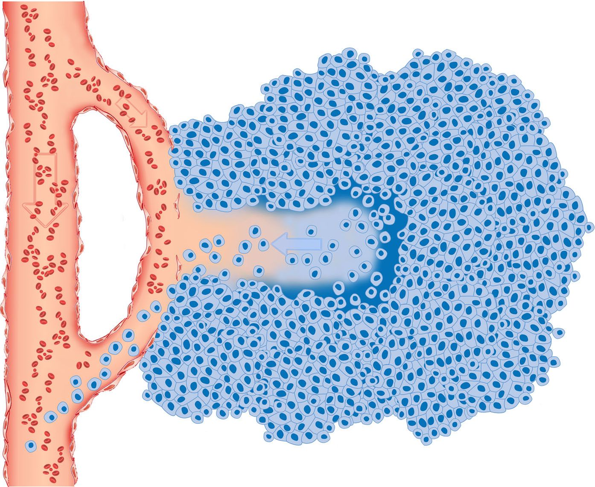
1000
Cytotechnology (2019) 71:989-1002
Fig. 10 Passive shedding as an open gate for metastatic cells.
Tumor growth requires blood supply. Blood vessels grow into
tumor or existing blood vessels can be overtaken by growing
tumor. Eventually those vessels become leaky due to apoptosis
in hypoxic environment as well as due to tumor growth and
mechanical distending. According to the suggested mechanism
of passive shedding in the same hostile environment, with little
oxygen, insufficient nutrient supply and constantly growing cell
populations, cancer cells instead of apoptosis choose a sort of
anergy when they roundup and detach from the stratum. If this
mechanism will occur in a close proximity to the leaky blood
vessel it becomes a way to passively migrate out of the tumor.
Additionally this process is supported by the increased
hydrostatic pressure from inside to outside of the tumor that
can push metastatic cancer cells out into the blood stream
colony followed by an increased number of suspended
cells. Pathological vasculature results in the vessels
discontinuity and leakage. Additionally increased
apoptosis and necrosis of endothelial cells enlarges
the gaps in blood vessels. Panc-02 is known for its
blood vessels leakiness (Krzykawski et al. 2015).
Our preliminary experiments on other cell lines and
produced similar results. We decided to broaden the
spectrum of experiments on single cell line rather that
testing multiple cell lines. We saw it as more important
to have deeper understanding of the process in stead of
proving the very basic experiments on the single cell
line. Eventually these results will have to be repeated
and broaden by independent laboratories.
We have developed IVMS as a new technique
imitating metastasis. IVMS increases metastatic
potential of a pancreatic cancer cell line, Panc-02.
This way we omit evolutionary pressure of the
immune system using only simple laboratory tech-
niques and concentrate on the cellular processes.
In vivo the pathophysiological influence of immune
system is extremely important but in this study we
decided to concentrate on the creation of a research
model for passive shedding. During the selection,
immune system would force additional selective
pressure.
So lets connect the facts. We propose that due to
high cell density many cancer cells enter into freely
floating state. At the same time blood vessels flushing
the tumor become leaky. It makes an open gate for
freely floating metastatic cancer cells to shed into the
blood stream as shown in Fig. 10. There is a gap in
understanding how cells that clearly resemble low
metastatic capabilities in vitro, seem to be more
metastatic in vivo. Our results fill the gap and show
that increased metastatic potential can corelate with
Cytotechnology (2019) 71:989-1002
1001
decreased motility as long as it correlates with
resistance to transient detachment. This way large
number of cells can enter blood vessels and some of
them will metastasise to distant organs. Additionally
intratumoral pressure is a force that will push
metastatic freely floating cells into the blood stream
(Pesonen et al. 2011). IVMS is a technique facilitating
the observation of passive shedding by increasing
number of cells in suspension.
Passive shedding hypothesis may be usefull in
searching for new diagnostic and therapeutic markers.
In clinical conditions an observation of suspended
cancer cells in a blood stream may be a significant
information to determine the stage of tumor develop-
ment (Wong and Hynes 2006). Detached cells may
express different surface markers that could be usefull
to determine cancer virulence but may also be used as
therapeutic markers.
Acknowledgements This study was funded by the project
operated within the Foundation for Polish Science VENTURES
Programme (VENTURES/2010-6/5) co-financed by the
European Regional Development Fund, Operational Program
Innovative Economy 2007-2013 and additionally supported by
the Foundation for Polish Science Inter award co-financed by
the European Social Fund within the Human Capital
Operational Programme (174/UD/SKILLS/2012).
Compliance with ethical standards
Conflict of interest The authors declare that they have no
conflict of interest.
Open Access This article is distributed under the terms of the
Creative Commons Attribution 4.0 International License (http://
creativecommons.org/licenses/by/4.0/), which permits unre-
stricted use, distribution, and reproduction in any medium,
provided you give appropriate credit to the original
author(s) and the source, provide a link to the Creative Com-
mons license, and indicate if changes were made.

References
Albini A (2016) Extracellular matrix invasion in metastases and
angiogenesis: commentary on the Matrigel &quot;Che-
moinvasion Assay&quot. Cancer Res 76:4595-4597.
https://doi.org/10.1158/0008-5472.CAN-16-1971
Barriere G, Fici P, Gallerani G, Fabbri F, Rigaud M (2015)
Epithelial mesenchymal transition: a double-edged sword.
Clin Transl Med 4:14. https://doi.org/10.1186/s40169-015-
0055-4
Baumann K (2015) Speed and persistence. Nat Rev Mol Cell
Biol 16:267. https://doi.org/10.1038/nrm3990
Bockhorn M, Jain RK, Munn LL (2007) Active versus passive
mechanisms in metastasis: do cancer cells crawl into ves-
sels, or are they pushed? Lancet Oncol 8:444-448. https://
doi.org/10.1016/S1470-2045(07)70140-7
Bruns CJ, Harbison MT, Kuniyasu H, Eue I, Fidler IJ (1999)
In vivo selection and characterization of metastatic variants
from human pancreatic adenocarcinoma by using ortho-
topic implantation in nude mice. Neoplasia 1:50-62.
https://doi.org/10.1038/SJ.NEO.7900005
Butler TP, Gullino PM (1975) Quantitation of cell shedding into
efferent blood of mammary adenocarcinoma. Cancer Res
35:512-516
Corbett TH, Roberts BJ, Leopold WR et al (1984) Induction and
chemotherapeutic response of two transplantable ductal
adenocarcinomas of the pancreas in C57BL/6 mice. Cancer
Res 44:717-726
Feygenzon V, Loewenstein S, Lubezky N et al (2017) Unique
cellular interactions between pancreatic cancer cells and
the omentum. PLoS ONE 12(6):e0179862. https://doi.org/
10.1371/journal.pone.0179862
Holder JW, Elmore E, Barrett JC (1993) Gap junction function
and cancer. Cancer Res 53:3475-3485. http://cancerres.
aacrjournals.org/content/canres/53/15/3475.full.pdf.
Accessed 15 July 2018
Kalluri R, Neilson EG (2003) Epithelial-mesenchymal transi-
tion and its implications for fibrosis. J Clin Invest
112:1776-1784. https://doi.org/10.1172/JCI20530
Kalluri R, Weinberg RA (2009) The basics of epithelial-mes-
enchymal transition. J Clin Invest 119:1420-1428. https://
doi.org/10.1172/JCI39104
Keleg S, Büchler P, Ludwig R, Biichler MW, Friess H (2003)
Invasion and metastasis in pancreatic cancer. Mol Cancer
2:14. https://doi.org/10.1186/1476-4598-2-14
Krzykawski MP, Krzykawska-Serda M, Jasińska K, Marcin-
kiewicz J (2015) Pan_02 murine pancreatic cancer model.
Folia Med Cracov 55:15-24
Liotta LA, Saidel MG, Kleinerman J (1976) The significance of
hematogenous tumor cell clumps in the metastatic process.
Cancer Res 36:889-894
Liu A (2010) Laser capture microdissection in the tissue
biorepository. J Biomol Technol 21:120-125
Nakajima S, Doi R, Toyoda E et al (2004) N-cadherin expres-
sion and epithelial-mesenchymal transition in pancreatic
carcinoma. Clin Cancer Res 10:4125-4133. https://doi.org/
10.1158/1078-0432.ccr-0578-03
Nguyen AV, Nyberg KD, Scott MB et al (2016) Stiffness of
pancreatic cancer cells is associated with increased inva-
sive potential. Integr Biol (Camb) 8:1232-1245. https://
doi.org/10.1039/c6ib00135a
Pesonen S, Kangasniemi L, Hemminki A (2011) Oncolytic
adenoviruses for the treatment of human cancer: focus on
translational and clinical data. Mol Pharm 8:12-28. https://
doi.org/10.1021/mp100219n
Ramis-Conde I, Chaplain MAJ, Anderson ARA, Drasdo D
(2009) Multi-scale modelling of cancer cell intravasation:
the role of cadherins in metastasis. Phys Biol 6:016008.
https://doi.org/10.1088/1478-3975/6/1/016008
Shi Q, Abbruzzese JL, Huang S, Fidler IJ, Xiong Q, Xie K
(1999) Constitutive and inducible interleukin 8 expression
by hypoxia and acidosis renders human pancreatic cancer
1002
Cytotechnology (2019) 71:989-1002
cells more tumorigenic and metastatic. Clin Cancer Res
5:3711-3721
Vanharanta S, Massague J (2013) Origins of metastatic traits.
Cancer Cell 24:410-421. https://doi.org/10.1016/jxcr.
2013.09.007
Wong SY, Hynes RO (2006) Lymphatic or hematogenous dis-
semination: how does a metastatic tumor cell decide? Cell
Cycle 5:812-817. https://doi.org/10.4161/cc.5.8.2646
Xie K, Wang B, Shi Q, Abbruzzese JL, Xiong Q, Le X (2001)
Mouse models of metastatic pancreatic adenocarcinoma.
Int J Gastrointest Cancer 29:25-36. https://doi.org/10.
1385/IJGC:29:1:25
Publisher’s Note Springer Nature remains neutral with
regard to jurisdictional claims in published maps and
institutional affiliations.

