


Journal of Molecular Structure 1261 (2022) 132931
Ion pair charge-transfer salts based on protonated bipyridines and
[W(CN)6(bpy)]2- anion-structure and properties
Anna Jurowska∗, Janusz Szklarzewicz, Maciej Hodorowicz
Faculty of Chemistry, Jagiellonian University, Gronostajowa 2, Kraków 30-387, Poland
a r t i c l e
i n f o
a b s t r a c t
Article history:
Received 26 January 2022
Revised 4 March 2022
Accepted 24 March 2022
Available online 25 March 2022
The series of salts with [W(CN)6 (bpy)]2− and protonated 2,2, -bpy (1), 4,4, -bpy (2), 4,4,-dimethyl-2,2,- bpy (4), 5,5,-dimethyl-2,2, -bpy (5), 6,6,-dimethyl-2,2, -bpy (6), and dq (3) as cations (where bpy - bipyri-
dine, dq - diquat dication = 1,1, -ethylene-2,2, -bipyridylium ion) were synthesized and characterized. The
single-crystal X-ray crystal structures of ﬁve salts were determined and described. In the case of unsub- stituted bipyridines, the structural studies have shown the presence of only one doubly protonated cation. In turn, the syntheses with the use of dimethyl substituted bipyridines gave salts with two monoproto- nated cations. We found that two methyl substituents, increase the hydrophobic properties of cation and convert 2D structure into 3D one. The spectral characteristic (IR and UV-Vis) is presented and the IPCT
transitions are discussed and compared with those observed for analogous [W(CN)8 ]4− ion salts. The band
shift changes were correlated with the N(anion) -N(cation) distances found in the structures.
© 2022 The Authors. Published by Elsevier B.V. This is an open access article under the CC BY license (http://creativecommons.org/licenses/by/4.0/)
Keywords: Tungsten Cyanides Polypyridines Structure
Uv–vis spectroscopy
1. Introduction
of the electronic spectra, but we also found the low-energy bands, above 1000 nm, responsible for thermal electron transfer. The ion-
pair charge transfer complexes with 4,4,-bipyridinium and other
counter ions, due to their photochemical and photophysical prop- erties, were extensively studied [14]. These type of IPCT com- pounds can potentially be used in solar cells [15], catalytic reac- tions [16] optical storage and switching technologies [17].
The IPCT transitions and thermal electron transfer are con- nected with the oxidation of anion metal center to W(V) state. As the only stable cyanido complex of W(IV), other than [W(CN)8 ]4−
one, is the [W(CN)6 (bpy)]2− ion, we decided to check how the an-
ion change affects the intensity and position of the IPCT transi- tions. In this paper, we compared how the increase of redox po- tential of anion center (from 0.510 V to 0.845 V in [W(CN)8 ]4− and
[W(CN)6 (bpy)]2−, respectively) [18,19] inﬂuences the IPCT transi-
tions. We present the synthesis, structure and properties of analo- gous to [W(CN)8 ]4− ion pair salts with [W(CN)6 (bpy)]2− anion and
such polypyridine cations as 2,2,-bpy, 4,4,-bpy, dq2+ and dimethyl
substituted 2,2,-bpy.
Octacyanidometallates [M(CN)8 ]n− (M = W, Mo or Nb) with
transition 3d-metal cation have a potential application for mag- netism, photomagnetism and molecule-based electronics [1]. Sys-
tems based on the [W(CN)6 (bpy)]−/2- ion are a smaller group of compounds, but also well characterized in relation to the cyanido bridged systems which, for example, form antiferromagnetic and ferromagnetic chains or show single-molecule magnet behavior [2,3]. Lastly, [W(CN)6 (bpy)]−/2- ions were used in synthesis with simple mono-positive cations as Li+, Na+, K+, Rb+ and previ- ously Cs+ [4–8]. In these systems the layered polymer struc- tures that arise, regardless of the cation used, were observed. The [W(CN)8 ]4- ions can also be used in formation of ion-pair salt with anion-cation charge transfer transitions accompanied by thermal electron transfer from metal center exclusively in a solid state. For [W(CN)8 ]4− such charge transfer complexes are known
with protonated 2,2,-bpy, 4,4,-bpy and dq2+ (where bpy = bipyri-
dine C10 H8 N2 , dq2+ = diquat, 1,1, -ethylene-2,2,-bipyridylium ion,
C12 H12 N22+)
[9–12]. Lastly, we extended this group on the se-
ries of salts with substituted polypyridines (as derivatives of 2,2,- bipiridyne and 1,10-phenantroline) [13]. In these studies, the ion- pair formation was not only accompanied by anion-cation charge-
2. Experimental
2.1. Materials and methods
transfer bands (IPCT, ion-pair charge transfer) in the visible part
(PPh4 )2 [W(CN)6 (bpy)]•4H2 O was synthesized according to the literature methods [7,9,19]. The only difference was, that in syn- thesis of (PPh4 )2 [W(CN)6 (bpy)]•4H2 O we used (PPh4 )Cl and not
∗ Corresponding author.
E-mail address: jurowska@chemia.uj.edu.pl (A. Jurowska).
https://doi.org/10.1016/j.molstruc.2022.132931
0022-2860/© 2022 The Authors. Published by Elsevier B.V. This is an open access article under the CC BY license (http://creativecommons.org/licenses/by/4.0/)
Contents lists available at ScienceDirect

Journal of Molecular Structure

journal homepage: www.elsevier.com/locate/molstr

A. Jurowska, J. Szklarzewicz and M. Hodorowicz
Journal of Molecular Structure 1261 (2022) 132931
(AsPPh4 )Cl as cation source, the product was identical with that described in literature [7]. All other chemicals were of analytical grade (Aldrich) and were used as supplied. The cation exchange resin Amberlite IR 120 was used to synthesize the form of [W(CN)6 (bpy)]2− anion. Microanalyses of carbon, hydrogen and ni- trogen were performed using Elementar Vario MICRO Cube ele-
mental analyzer. IR spectra were recorded on a Nicolet iS5 FT-IR spectrophotometer. Diffuse reﬂectance spectra were measured in BaSO4 pellets with BaSO4 as a reference on Shimadzu 3600 spec- trophotometer equipped with an ISR-240 integrating sphere at- tachment. Thermogravimetric measurements were performed on a TGA/SDTA 851e Mettler Toledo Microthermogavimeter at scan speed 10 o/min in the 25–700 or 1000 °C range under Ar atmo- sphere.
2.2.5. (H2 B2)0.5 (HB2)[W(CN)6 (bpy)]•0.5B2•5H2 O (5)
The same procedure as for 1, but the 5,5,-dimethyl-2,2,-bpy (B2) was used. Anal. Calcd. for C40 H44 N12 O5 W: C, 50.22; H, 4.64; N, 17.57%. Found: C, 50.67; H, 4.36; N, 17.69%. FT-IR (ATR, cm−1):
3377 (vs), 3372 (w), 3102 (w), 2137 (w), 2121 (vs), 2113 (w), 1651
(m), 1621 (w), 1606 (m), 1596 (m), 1572 (w), 1549 (m), 1520 (w),
1476 (m), 1456 (w), 1439 (m), 1383 (w), 1322 (w), 1281 (w), 1254
(w), 1226 (w), 1170 (w), 1154 (w), 1140 (w), 1112 (w), 1089 (w),
1050 (w), 1012 (w), 998 (w), 927 (w), 838 (w), 792 (w), 764 (m),
723 (m), 638 (w), 547 (w), 475 (w), 462 (w), 430 (w), 410 (w).
H+
2.2.6. (HB3)2 [W(CN)6 (bpy)]•6H2 O (6)
The same procedure as for 1, but the 6,6,-dimethyl-2,2,-bpy (B3) was used. Anal. Calcd. for C40 H46 N12 O6 W: C, 49.29; H, 4.76; N, 17.24%. Found: C, 49.04; H, 4.59; N, 17.08%. FT-IR (ATR, cm−1):
3425 (s), 3361 (s), 3265 (s), 3105 (w), 2138 (w), 2123 (vs), 1655
(m), 1614 (m), 1597 (m), 1570 (w), 1519 (w), 1495 (w), 1479 (w),
1456 (m), 1443 (m), 1407 (w), 1385 (w), 1319 (w), 1283 (m), 1253
(w), 1229 (w), 1168 (w), 1114 (w), 1087 (w), 1050 (w), 1013 (w),
996 (w), 925 (w), 794 (m), 767 (m), 723 (m), 692 (w), 547 (w),
466 (w), 429 (w), 412 (w).
2.2. Syntheses
2.2.1. (bpyH2 )[W(CN)6 (bpy)]•3H2 O (1)
The (PPh4 )2 [W(CN)6 (bpy)]•4H2 O complex (100 mg, 0,08 mmol), dissolved in minimal (ca. 5 mL) amount of MeCN-H2 O (1:1, v/v) mixture, was passed through Amberlite IR 120 ion exchange resin
in the form. To the resulting solution 2,2,-bpy and 2 drops
H+
of 2 M HCl were added and the mixture was left for crystalliza- tion. The products were ﬁltrated, washed with acetone (Me2 CO), and dried in air. The yield was almost quantitative, in all cases
2.3. Crystallographic data collection and structure reﬁnement
The crystals suitable for single X-ray measurements were taken directly from crystallization solution. Diffraction intensity data for single crystals of two compounds (2, 3) were collected at 130 K on a SuperNova (Rigaku) diffractometer with graphite-
monochromated Mo Kα radiation by the multi-scan mode, for 1,
5 and 6 at 100 K on the Rigaku XtaLAB Synergy-S diffractome- ter with mirror-monochromated Mo Kα (for 1, 5) and Cu Kα (6) radiation. Cell reﬁnement and data reduction were performed us- ing CrysAlisPro ﬁrmware [20]. Positions of all of non-hydrogen atoms were determined by direct methods using SHELXT-2014/4 [21]. All non-hydrogen atoms were reﬁned anisotropically using weighted full-matrix least-squares on F2. Reﬁnement and further calculations were carried out using SHELXL-2016/6 [22]. All hydro- gen atoms joined to carbon atoms were positioned with idealized geometries and reﬁned using a riding model with Uiso (H) ﬁxed at
1.2 Ueq (Carom). The ﬁgures were made using Diamond ver. 4.6.1 software [23]. The crystal data and structure reﬁnement parame- ters for complexes 1–3, 5 and 6 are collected in Table 1.
CCDC 2,113,367, 2,107,846, 2,107,831, 2,122,642 and 2,154,145
contain the supplementary crystallographic data for 1–3, 5 and 6, respectively. These data can be obtained free of charge from The Cambridge Crystallographic Data center viawww.ccdc.cam.ac. uk/data_request/cif.
Polycrystalline sample of compound 4 was prepared using the method described previously (due to the very small amount of the sample). The XRD powder diffractogram of the material (crys- tallinity test) was recorded at 100 K on a Rigaku XtaLAB Synergy-S diffractometer with mirror-monochromated CuKα radiation using the default procedure included in the CrysAlisPro ﬁrmware [20]. These results are supported in the Supplementary Materials.
was ca. 95±2%. Anal. Calcd. for C26 H24 N10 O3 W: C, 44.08; H, 3.41;
N, 19.77%. Found: C, 44.25; H, 3.32; N, 19.28%. FT-IR (ATR, cm−1):
3519 (w), 3374 (vs), 3128 (w), 3100 (m), 3077 (w), 3062 (m), 3040
(m), 2144 (w), 2130 (m), 2120 (vs), 2110 (vs), 1169 (w), 1645 (m),
1607 (m), 1549 (w), 1491 (w), 1475 (s), 1428 (m), 1398 (w), 1318
(m), 1284 (w), 1257 (m), 1228 (w), 1179 (w), 1165 (m), 1075 (m),
1016 (w), 980 (m), 919 (w), 805 (w), 780 (s), 771 (s), 727 (m), 620
(w), 605 (m), 544 (w), 485 (m), 474 (m), 446 (w), 419 (w).
2.2.2. (4,4, -bpyH2 )[W(CN)6 (bpy)]•4H2 O (2)
The same procedure as for 1, but with the use of 4,4,-bpy in- stead of bpy. Anal. Calcd. for C26 H26 N10 O4 W: C, 42.95, H, 3.58; N, 19.27%. Found: C, 42.29; H, 3.30; N, 18.95%. FT-IR (ATR, cm−1):
3446 (s), 3370 (vs), 3201 (w), 3129 (s), 3097 (vs), 2129 (w), 2112
(vs), 2106 (s), 1639 (m), 1593 (s), 1531 (w), 1476 (s), 1435 (m),
1321 (w), 1281 (w), 1232 (m), 1175 (w), 1163 (w), 1114 (w), 1094
(w), 1074 (w), 1033 (w), 1013 (w), 971 (w), 897 (w), 833 (w), 777
(s), 727 (m), 664 (w), 621 (w), 550 (w), 475 (w).
2.2.3. (dq)[W(CN)6 (bpy)]•4H2 O (3)
The same procedure as for 1, but dqBr2 was used as cation. Anal. Calcd. for C28 H28 N10 O4 W: C, 44.70; H, 3.75; N, 18.62%. Found: C, 44.53; H, 3.57; N, 18.70%. FT-IR (ATR, cm−1): 3464 (w), 3410 (s),
3098 (m), 3078 (m), 3064 (m), 3034 (w), 3014 (w), 2126 (w), 2111
(s), 1649 (w), 1633 (w), 1616 (m), 1583 (m), 1532 (w), 1498 (m),
1474 (m), 1433 (m), 1325 (w), 1286 (m), 1255 (w), 1232 (m), 1196
(m), 1174 (m), 1113 (w), 1073 (w), 1036 (w), 1008 (w), 775 (vs),
725 (m), 710 (m), 649 (w), 601 (w), 537 (w), 520 (w), 467 (s), 463
(m), 403 (m).
2.2.4. (H2 B1)0.5 (HB1)[W(CN)6 (bpy)]•2.5B1•6H2 O (4)
The same procedure as for 1, but the 4,4,-dimethyl-2,2,-bpy (B1) was used. Anal. Calcd. for C64 H70 N16 O6 W: C, 57.23; H, 5.25; N, 16.68%. Found: C, 57.37; H, 4.95; N, 16.81%. FT-IR (ATR, cm−1):
3428 (w), 3361 (vs), 3266 (w), 3105 (w), 2994 (w), 2137 (w), 2121
(vs), 2113 (w), 1649 (w), 1635 (w), 1605 (w), 1592 (s), 1565 (w),
1553 (w), 1519 (w), 1491 (w), 1480 (w), 1457 (m), 1440 (m), 1381
(w), 1322 (w), 1303 (w), 1280 (w), 1251 (w), 1229 (w), 1166 (w),
1113 (w), 1103 (w), 1068 (w), 1046 (w), 1011 (w), 992 (w), 971 (w),
926 (w), 914 (w), 825 (m), 794 (w), 772 (m), 725 (w), 670 (w), 513
(w), 467 (w), 432 (w), 418 (w).
3. Results and discussion
3.1. General remarks to the complexes 1–6
We have isolated six salts with polypyridines cations, which formulas are presents in Fig. S1 in the Supplementary Materials. For ﬁve of them the crystals were of suitable quality and the sin- gle crystal X-ray structures were determined. For one of the com-
pounds (4), with the B1 cation (4,4-dimethyl-2,2,-bipyridine), due
to the formation of very small crystals, only the PXRD measure- ment was performed, the result of which is included in the Supple-
2
A. Jurowska, J. Szklarzewicz and M. Hodorowicz
Journal of Molecular Structure 1261 (2022) 132931
Table 1
Crystal data and structure reﬁnement for 1–3, 5 and 6.
1
2
3
5
6
Empirical formula Formula weight Temperature [K]
Wavelength [A˚ ]
Crystal system Space group
Unit cell dimensions
C26 H24 N10 O3 W 708.40
100(2)
0.71073
Triclinic P-1 8.4781(2)
10.4245(3)
15.4215(4)
95.852(2)
96.789(2)
99.178(2)
1325.88(6)
2
1.774
4.406
696
C26 H18 N10 O4 W 718.35
131(2)
0.71073
Monoclinic P 21/n 14.9475(3)
8.8242(2)
21.0496(5)
90
98.582(2)
90
2745.35(11)
4
1.738
4.260
1400
C28 H22 N10 O4 W 746.40
130(2)
0.71073
Monoclinic P 21/n 15.1419(2)
14.5751(2)
14.9156(2)
90
112.390(2)
90
3043.63(8)
4
1.629
3.846
1464
C34 H38 N11 O5 W 864.60
100(2)
0.71073
Triclinic P-1
10.3399(2)
13.4124(3)
15.6916(3)
93.778(2)
97.536(2)
110.325(2)
2008.45(8)
2
1.430
2.927
866
C40 H40 N12 O6 W 968.69
100(2)
1.54184
Monoclinic I 2/a 26.1540(3)
10.8409(1)
30.6640(3)
90
107.569(1)
90
8288.70(15)
8
1.553
5.677
3888
a [A˚ ]
b [A˚ ]
c [A˚ ]
α [°]
β [°]
γ [°]
Volume [Ǻ3 ] Z
Density (calculated) [Mg/m3 ] Absorption coeﬃcient [mm−1 ] F(000)
Crystal size [mm3 ] Crystal color Crystal shape
Theta range for data collection [o ] Index ranges
0.10 × 0.10 × 0.10
0.20 × 0.20 × 0.10
0.15 × 0.12 × 0.10
0.10 × 0.05 × 0.03
0.30 × 0.05 × 0.01
red plate
2.536 to 30.714
−11 ≤ h ≤ 12
-14 ≤ k ≤ 14
dark red prism
3.210 to 77.064
−19 ≤ h ≤ 18
-11 ≤ k ≤ 11
red prism
2.751 to 28.623
−20 ≤ h ≤ 19
-19 ≤ k ≤ 18
red plate
2.313 to 30.786
−13 ≤ h ≤ 14
-19 ≤ k ≤ 19
blue plate
3.023 to 75.150
−31 ≤ h ≤ 32
-12 ≤ k ≤ 13
-21 ≤ l ≤ 21
-27 ≤ l ≤ 28
-19 ≤ l ≤ 19
-22 ≤ l ≤ 21
-38 ≤ l ≤ 37
Reﬂections collected Independent reﬂections
38,026
7112
11,858
6193
26,834
7233
62,776
10,858
111,020
8309
[Rint = 0.0736]
[Rint = 0.0364]
[Rint = 0.0364]
[Rint = 0.0648]
[Rint = 0.0948]
Completeness to theta [%] Reﬁnement method
99.8
Full-matrix
least-squares on F2 7112/0/393
1.021
R1 = 0.0280
wR2 = 0.0596
R1 = 0.0327
wR2 = 0.0611
1.221 and −2.207
99.8
Full-matrix
least-squares on F2 6193/2/388
1.078
R1 = 0.0422
wR2 = 0.1002
R1 = 0.0524
wR2 = 0.1057
2.777 and −1.689
99.8
Full-matrix
least-squares on F2 7233/3/396
1.071
R1 = 0.0300
wR2 = 0.0679
R1 = 0.0446
wR2 = 0.0745
2.151 and −0.845
99.6
Full-matrix
least-squares on F2 10,858/14/499
1.082
R1 = 0.0381
wR2 = 0.0951
R1 = 0.0452
wR2 = 0.0983
2.775 and −2.335
100.0
Full-matrix
least-squares on F2 8309/3/554
1.053
R1 = 0.0432
wR2 = 0.1174
R1 = 0.0462
wR2 = 0.1222
2.969 and −2.518
Data / restraints / parameters Goodness-of-ﬁt on F2
Final R indices [I>2sigma(I)]
R indices (all data)
Largest diff. peak and hole [e•Ǻ−3 ]
mentary Materials (Fig. S2). For all compounds, the TG was mea- sured and the results are summarized in the Figs. S3–S8. Simi- larly to the previously studied [W(CN)8 ]4− salts with polypyridines
cations [13], two main decomposition steps are observed. The ﬁrst
one is the water molecules release, which starts above 50 °C and the calculated mass loss correlates with the complexes formulas. The next processes are a mixture of cation decomposition, bpy and cyanido ligands release. It is diﬃcult to assign mass losses to the stoichiometric amount, because the processes overlap at this stage.
1, that all cyanido ligands participate in hydrogen bonds, except C15N15 (which has, after C18N18 one of the longest W-N distance of 3.317 A˚ ). This was never observed earlier in literature [4]. Ligand
C13N13 interacts with two water molecules, while ligand C14N14 is directed toward the proton at bpy cation.
The asymmetric part of the unit cell of (4,4,-
bpyH2 )[W(CN)6 (bpy)]•4H2 O (2) contains [W(CN)6 (bpy)]2− anion, one diprotonated 4,4,-bipyridinium cation and four H2 O molecules
(Fig. 1b). Unfortunately, based on the differential Fourier map, it was not possible to assign hydrogen atoms to any water molecule. The tungsten atom, which is the central atom of the anionic complex, shows disorder. Modeling of the disorder of this atom is a consequence of large residual peaks in the differential Fourier map, but they are not the result of classical dynamic disorder, but rather the result of an incorrect spherical description of large atoms. The bipyridyl ligand molecule, the structure of which is based on two pyridyl rings, is twisted, and the angle between the planes formed by these rings is 26.09°. The very interesting is the bpy-bpy positions in the structure of 2 – the cation are arranged in
one line with H+ protons directed toward H+ proton of next bpy cation. The N-N distance of 5.008 A˚ and H-H calculated distance
of 2.938 A˚ indicate on relatively strong repulsion forces between cations, thus such arrangement must be forced by intermolecular interaction of the whole complex components including water molecules.
The asymmetric part of the unit cell of complex 3, with the for-
mula (dq)[W(CN)6 (bpy)]•4H2 O (where dq is a diquat cation), con- tains six molecules: one complex anion [W(CN)6 (bpy)]2−, one di- quat (dq2+) cation and four solvent molecule i.e. water (Fig. 1c).
3.2. Crystal structures
The molecular structures of 1- 3, 5 and 6 are shown in Fig. 1. Selected bond lengths and angles are summarized in Table S1 in the Supplementary Materials.
The symmetrically independent part of the unit cell of (bpyH2 )[W(CN)6 (bpy)]•3H2 O (1) is composed of the one dipro-
tonated molecule of 2,2,-bipyridinium as cation, [W(CN)6 (bpy)]2−
unit as counterion and three water molecules (Fig. 1a). The an- gle, 35.2°, between the ring planes in 2,2,-bipyridinium cation
molecule clearly indicates the double protonation of this molecule, while the lengths of bonds between atoms and the angles between them show typical values for this type of cation.
The observations made regarding the complex anion [W(CN)6 (bpy)]2− conﬁrm the exceptional geometrical stability of this anion and the negligible susceptibility of its geometry to
the inﬂuence of the cation type as observed earlier [4–8]. This anion structural stability is a very desirable property from a crystal engineering point of view. What is very interesting in structure of
3

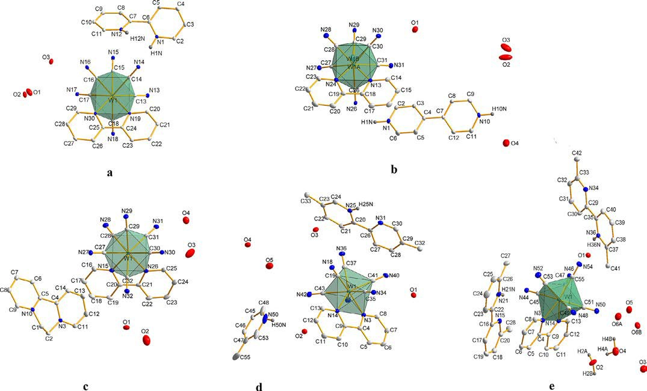
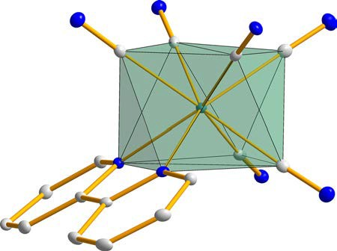
A. Jurowska, J. Szklarzewicz and M. Hodorowicz
Journal of Molecular Structure 1261 (2022) 132931
Fig. 1. The asymmetric part of the unit cell of 1 (a), 2 (b), 3 (c), 5 (d) and 6 (e) with the adopted numbering scheme. All H atoms except those which protonate the bpy molecules are omitted for clarity. All non-hydrogen atoms are represented at 30% probability thermal ellipsoids.
Unfortunately, similarly to structure 2, it was a problem with hy- drogen atoms localization and for only one water molecule (O1) the hydrogen atoms were determined.
The
asymmetric
entity
of
the unit
cell of
(H2 B2)0.5 (HB2)[W(CN)6 (bpy)]•0.5B2•5H2 O (5) consists of two parts: anionic comprising [W(CN)6 (bpy)]2− and the cationic part containing two diprotonated B2 (5,5,-dimethyl-2,2,-bipyridine)
molecules. In addition, the asymmetric part of unit cell contains ﬁve crystallization water molecules (Fig. 1d).
In the structure of compound 5, based on Fig. 1d, it can be seen that the ratio of cations to anion [W(CN)6 (bpy)]2− is 1.5: 1 and it appears to be downright strange, although the charge in the asym-
metric part of the unit cell is balanced and is (2+):(2-). Half of
the bpy molecule (C45-C46-C47-C48-N50-C53-C55) and the other bpy molecule (the one with the C20-C21-C22-C23-C24-N25 ring), are protonated with site occupancy equal 1 (at N50 and N25 ni- trogen atoms, respectively). However, in the asymmetric part of the unit cell there are actually two complete bpy molecules, of which the quantitative complement to that with a 0.5 occupancy is a fragment of the third unprotonated bpy molecule (also with a
0.5 occupancy). Unfortunately, due to the fact that the latter, the third bpy molecule is highly disordered, it was not possible to rea- sonably model the disorder of this molecule and it was decided to remove the electron density fragment related to this molecule based on the SQUEED procedure implemented in the PLATON software.
The symmetrically independent part of the unit cell of (HB3)2 [W(CN)6 (bpy)]•6H2 O (6) is composed of the two proto-
nated molecules of B3 (6,6,-dimethyl-2,2,-bipyridie) as cations,
[W(CN)6 (bpy)]2− unit as counterion and ﬁve water molecules (Fig. 1e). The geometry of the [W(CN)6 (bpy)]2− ion does not dif- fer from that observed in the previously described structures.
Fig. 2. The symmetry of the anion showing antiprismatic arrangement of ligands around tungsten center.
In all complexes, the geometry of the anion [W(CN)6 (bpy)]2− essentially does not differ from those observed in the previ- ously described structures [4–6] and adopts a typical slightly dis- torted antiprismatic coordination environment of the structure C6 N2 with bpy and two cyanido ligands in one square plane and four other cyanido ligands in the second plane (Fig. 2). The lengths of the W-Nbpy bonds within the experimental error are almost
identical, on average they are 2.221 long, which is consistent with the lengths (2.220 A˚ ) of the analogous bonds observed in
A˚
(PPh ) [W(CN) (bpy)]•4H O [24]. The two W-C bonds, which are
4 2
6
2
opposite to the bpy ligand, are slightly shorter in length than the other four W-C bonds, however the difference is not signiﬁcant,
4
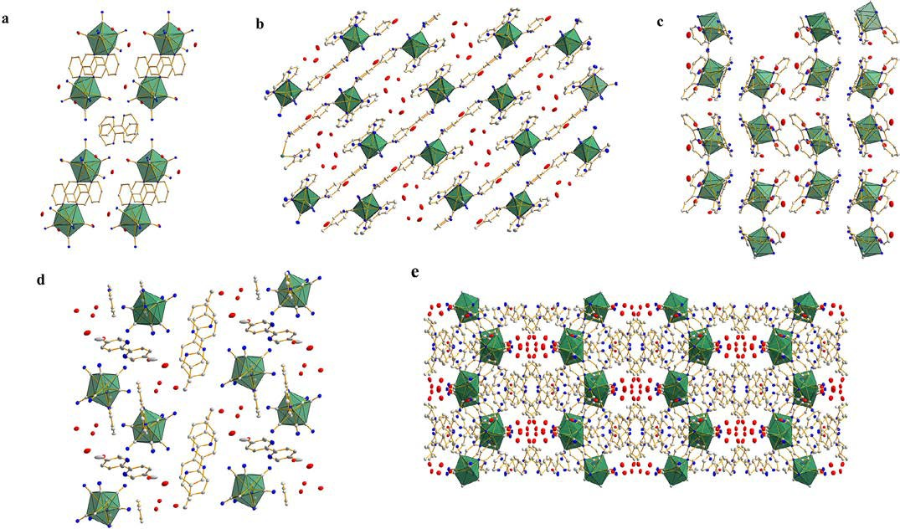
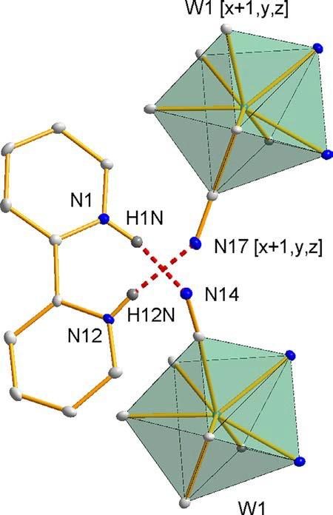
A. Jurowska, J. Szklarzewicz and M. Hodorowicz
Journal of Molecular Structure 1261 (2022) 132931
Fig. 3. The crystal packing of 1 (a), 2 (b), 3 (c), 5 (d) and 6 (e) in direction [010] for 1 and 2, [001] for 3 and [100] for 5 and 6.
and the mean W-C distance is 2.143 A˚ . In all the described struc-
tures, the W-Ncyanido bond distances are very close to those found in (4,4,-bpyH2 )2 [W(CN8 )]•4.5H2 O, in which the average W-Ncyanido
distance is 3.304 A˚ [11].
In the crystal lattices of all the discussed compounds, the an- ionic units [W(CN)6 (bpy)]2− are well isolated from each other (Fig. 3), but they are involved in numerous hydrogen interactions between nitrogen atoms of cyanido ligands and molecules of crys- tallization water (Table S2).
It should also be noted that the molecules of polypyridyl cations (including diquat molecule) also form extensive networks of hydrogen interactions. In structure 1, the hydrogen interac- tions of the bpyH2 molecule (N1-H1N...N14 and N12-H12N...N17
[x + 1,y,z] are very interesting. The protonated bipyridyl molecule,
through the acidic hydrogen atoms, links two neighbouring coor- dination anions [W(CN)6 (bpy)]2− forming coordinating chains run- ning in the [100] direction (Fig. 4).
In structure 2, the 4,4,-bpyH2 moiety also acts as a linker that
links as many as four symmetrically dependent coordination an- ions [W(CN)6 (bpy)]2− through two bifurcated hydrogen interac- tions (Fig. 5).
In compound 3, the structure-binding function is performed by a motif of eight water molecules, with a classical hexagonal ar- rangement of water molecules, that binds as many as 6 coordi- nation anions of [W(CN)6 (bpy)]2− through hydrogen interactions. Unfortunately, the interactions shown in Fig. 6 were not included in Table S2, due to the fact that for several water molecules the po- sition of hydrogen atoms could not be determined from diffraction studies.
In structure 5, the more stable bpy (HB2) conformer, i.e. trans is observed, it has a lower energy than the cis one, observed in structure of 1, although the barrier for cis/trans interconversion is small and amounts to about 6 kJ mol−1 [25]. Also in this structure,
Fig. 4. The hydrogen interactions of the bpy molecule in 1.
5
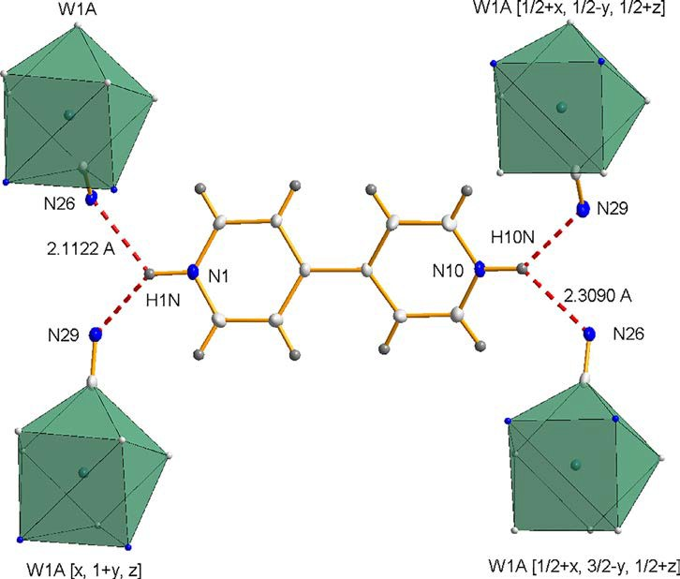
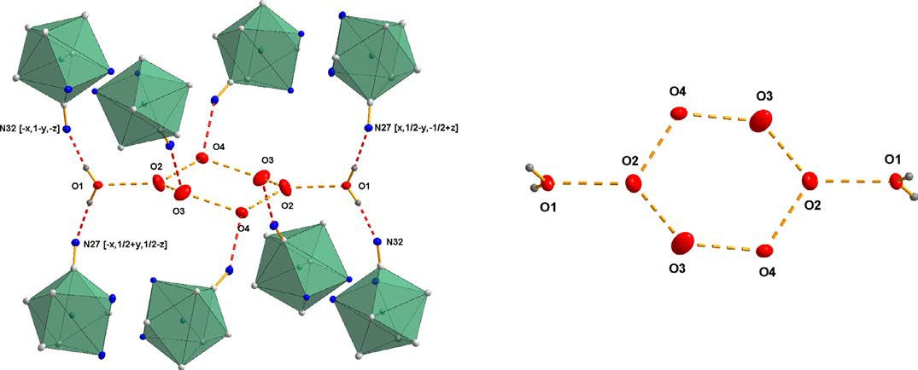
A. Jurowska, J. Szklarzewicz and M. Hodorowicz
Journal of Molecular Structure 1261 (2022) 132931
Fig. 5. The hydrogen interactions of the 4,4, -bpyH2 molecule in 2.
Fig. 6. The hexagonal arrangement of water molecules in 3.
as in 1, the HB2 molecule acts as a linker, joining two adjacent coordination anions into a dimeric system (Fig. 7).
[W(CN)6 (bpy)]2− anion molecule. In the packing of structure 6 (Fig. 3e) channels, running in the direction [100], containing sol- vent molecules are visible.
Moreover, cation molecules are also involved in interactions of the π ...π type and interactions with cyanido ligands, interactions of the C-N...π type are present in all the structures (Tables S3 and
S4).
In Table 2 we put together the selected bond and plane angles for complexes 1–3 and 5 with alkali metals salts from our previ- ous studies [8]. Values of angles in [W(CN)6 (bpy)]2− anion for the obtained compounds are similar to those present in alkali metal
There are no unusual intermolecular interactions molecules are involved in the formation of classical
in 6. B3 hydrogen
bonds of the N-H...N or N-H...O type (Table S2). These molecules also participate in the formation of numerous π ... π (Table S3) in- teractions, also with the bipyridine ligand of the [W(CN)6 (bpy)]2−
anion. The water molecules present in the structure form an ex- tensive network of mutual interactions, but the most important structural role is played by the O1 water molecule (Fig. 8), which, through hydrogen interactions, connects the B3 molecule with the
6
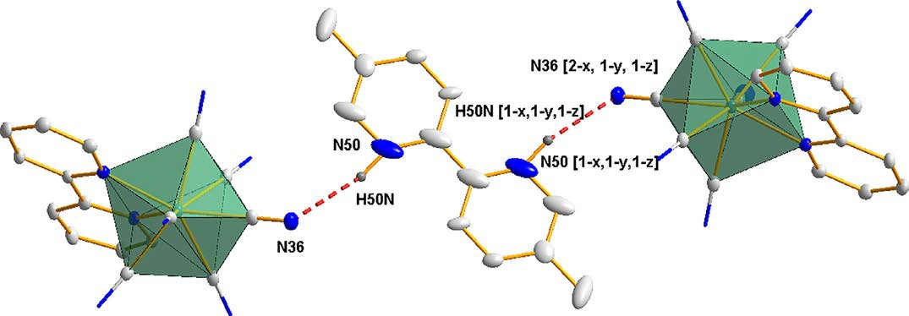
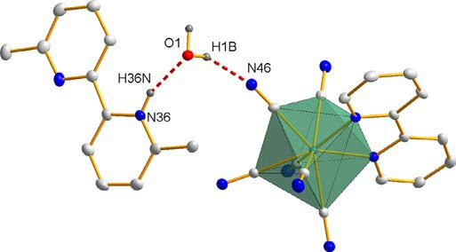
A. Jurowska, J. Szklarzewicz and M. Hodorowicz
Journal of Molecular Structure 1261 (2022) 132931
Fig. 7. The hydrogen interactions in 5.
Table 2
Selected bond and plane angles for complexes 1–3, 5 and 6 compared to alkali metals salts from ref. [8]. The atom numbering and the angles A, B and C between two planes are in accordance with Fig. 2 in Ref. [8].
Angle [o ] A
Complex
B
C
1-W-6
2-W-3
4-W-5
2-W-6
3-W-6
4-W-6
5-W-6
[W(CN)6 (Lbipy)]2−
Li Na Na K
Rb Cs 1
2
3
5
6
88.91
89.37
88.50
88.48
89.84
88.71
89.51
89.85
88.47
89.99
89.52
89.40
3.44
1.59
8.62
5.99
11.54
10.53
2.67
5.60
8.57
8.30
3.12
1.70
3.20
2.27
10.73
5.90
9.23
10.11
5.31
5.05
9.51
7.67
4.10
2.40
115.60
117.53
110.05
111.36
109.69
114.93
116.08
114.27
113.31
115.96
115.04
113.72
71.16
70.51
69.47
70.68
69.58
71.10
70.87
71.61
72.43
70.87
70.63
70.86
108.15
106.77
114.09
112.66
112.49
109.20
107.67
109.64
113.31
109.90
108.74
108.80
75.76
75.38
79.90
74.61
78.28
76.90
76.78
74.60
77.29
76.04
77.11
75.74
75.12
75.75
75.66
78.60
78.69
74.88
75.50
75.60
73.98
76.36
77.48
77.96
70,09
70.80
68.10
71.14
70.49
71.50
70.55
70.88
71.06
70.66
70.94
70.30
71.45
70.90
71.17
69.19
69.03
69.74
70.20
70.29
71.76
71.20
71.18
69.62
Table 3
The closest anion-cation distances in [W(CN)8 ]4− and [W(CN)6 (bpy)]2− salts with polypyridines cations.
bond distance [A˚ ]
anion
cation
N(anion) -N(cation)
[W(CN)8 ]4−
bpyH2
4,4, -bpyH2 dq2+ bpyH2
4,4, -bpyH2
dq2+
N2-N3 N4-N10 N3-N11 N14-N1 N29-N1 N31-N10
3.426
3.306
3.025
2.646
2.935
3.291
[W(CN)6 (bpy)]2−
and, as bipyridine, affects the distance between the ion pair. What
is surprising, these distances are shorter within [W(CN)6 (bpy)]2- - cation ion pair, except for the dq2+ cation.
In all alkali metals salts of [W(CN)6 (bpy)]2− layered structure
was observed, with a 2D layer composed of three separated layers: anion-cation-anion ones connected by intermolecular interactions. The thickness of such inorganic layers, compared to the previously studied alkali metals salts, are collected in Table 4. The bpy lig- and molecules, in the anion, are located outside of the layers and the observed distance between them is so-called “bpy layer”. In this layer no interactions (as hydrogen bonds or ion-cation electro- static attractions) are present. In 1–3 similar situation is observed, but here the “inorganic” layer is composed of cation protonated bpy molecules instead of alkali metals cations. As can be seen, such an exchange make the “inorganic” layer being thinner, com- pared to alkali metals one, in case of 2 and 3, while for 1 is much
Fig. 8. The hydrogen interactions in 6.
salts. As can be seen, the presence of a polypyridyl cation, which is a relatively large molecule, does not change the angles within an anion.
We also found the shortest distances between anion and cation in 1–3 and we compered these data with that found in [W(CN)8 ]4− analogues [10–12] (Table 3). To be precise, we were taken the dis-
tance between nitrogen atom from cyanido ligand and nitrogen
ligand from polypyridine molecule. The anion-cation distances for [W(CN)8 ]4- salts changed in the order bpyH2 2+ > 4,4,-bpyH22+ >
dq2+, while for the [W(CN)6 (bpy)]2- the order is reversed –
the
dq2+
longest distance is for the
cation and the shortest is for
bpyH2 2+. The presence in the anion of a relatively large organic lig-
7

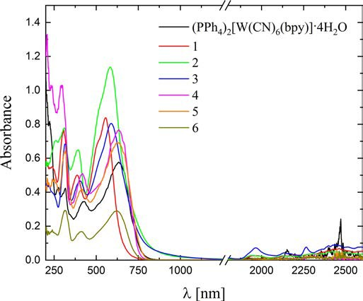
A. Jurowska, J. Szklarzewicz and M. Hodorowicz
Journal of Molecular Structure 1261 (2022) 132931
Table 4
Thickness of the inorganic (A) and bpy (B) layers in 1–3 compared to the structures of alkali metal salts [A˚ ].
layer
Li [4]
K [6]
Rb [6]
Cs [7]
1
2
3
Inorganic layer A bpy (organic) layer B A + B [A˚ ]
6.936
6.320
13.256
7.278
7.049
14.327
6.791
6.525
6.777
6.964
7.582
14.545
9.000
6.197
15.197
6.416
6.586
13.002
6.234
7.767
14.001
13.316 (13.302)
sitions were observed, both in solution and in solid state. Com- pared to intensity of the 420 nm d-d band (120 M−1cm−1 range) the intensities of the IPCT transitions, in [W(CN)8 ]4− ion salts, were also low (in ca. 200–400 M−1cm−1 range). In [W(CN)6 (bpy)]2− ion pairs, the d-d transitions are hidden under the very intense MLCT
transitions (metal-to ligand CT). On the other hand, the MLCT tran- sitions must be inﬂuenced by the IPCT transitions, as charge shift to bpy ligand is more diﬃcult if strong cation-anion interactions move electrons from metal center to cation. This behavior is clearly seen in Fig. 9. For the salts with very short M-H+ distances (1, 2 and 3), strong shift of the MLCT band toward higher energy is ob- served. The band shift changes in order 1 > 2 > 3 what is in direct correlation with the M-cation distances found in the structure. The salts with lower charge (monoprotonated substitute polypyridines, 4–6), thus much longer cation-anion distances, found in X-ray crys- tal structure of 5 and 6, have MLCT bands almost at the same po- sition as in (PPh4 )2 [W(CN)6 (bpy)] salt.
For the ion-pair complexes of [W(CN)8 ]4− anion with polipyri- dine cations the low energy transitions observed much above
1500 nm, were attributed to the observed thermal electron trans- fer (exclusively in a solid state). In Fig. 9, for salts 1–3, an increase of absorption in similar region is observed, while spectra for other three salts 4–6 are almost identical with those of PPh4 + cation salt. For salts of [W(CN)8 ]4− analogous to 1–3 there are no spectra measured above 1000 nm, therefore there are no data to compare. But for salts 4–6 and for their [W(CN)8 ]4− analogues, the spectra in this range were measured [13]. For [W(CN)8 ]4− analogues the intense bands above 1000 nm were observed [13], while for 4–6 bands in those region are not observed as seen in Fig. 9. As ther- mal electron transfer is connected with formal oxidation of W(IV) to W(V) the lack of those bands is expected, as the high increase of redox potential from 0.510 V (in [W(CN)8 ]4-/3−]) [18] to 0.845 V
[19] (in [W(CN)6 (bpy)]2-/−) is observed, making oxidation of tung- sten much less probable.
Fig. 9. The reﬂectance spectra of 1–6 and PPh4 [W(CN)6 (bpy)]·4H2 O after Kubelka- Munk transformation. BaSO4 used as an internal white reference.
thicker. This is probably a result of greater ﬂattening of organic cations, compared to alkali metals surrounded by water molecules
and possessing high coordination number. In case of much less ﬂat bpyH2 2+ cation the layer is much thicker. Contrary, in 1, the anion bpy ligands interlock with each other and the “organic” layer is the
thinner one. The total thickness of both layers changes in order 1
> 3 > 2, but experimental values are very close to that found in Li-Cs salts (Table 4).
3.3. Spectral analysis
IR spectra of 1–6 are supported in the Supplementary Materials (Figs. S9 and S10) while the band positions are listed in the ex-
perimental part. The νCN bands are observed in a 2100–2150 cm−1
range. Their position and number depend on the interactions like hydrogen bonds formation that were discussed in the structural part. Rest of the spectra are dominated by the bands associated
with the water molecules and polypyridines cations. The spectral range ca. 1400–1600 cm−1 is associated with stretching vibrations of pyridyl rings and for the band at ca. 1060 cm−1 of the pyridyl in-plane bendings.
4. Conclusions
The structural data presented in the manuscript is the result of ongoing work aimed at demonstrating the suitability of the little- known anionic complex in crystal engineering as a stable and pre- dictable building block, the geometry of which is not signiﬁcantly inﬂuenced by the structural environment. So far, studies indicate
that only the [W(CN)6 (bpy)]2− ion packing system is strongly de-
pendent on the type of cation, but some preferences can be ob- served. In the case of cations like Li+, Na+, Rb+ and Cs+ [4– 7] they promote the formation of strong bridging, "end-on" and
"side-on" intermolecular interactions that direct the cyanide lig- ands as close as possible to the cations. These interactions, how- ever, are tuned by bpy ligands, which, as the hydrophobic part of the molecule, form separate connecting layers, so that the struc-
The
UV-Vis
reﬂectance spectra of
1–6 and
range 200–
(PPh4 )2 [W(CN)6 (bpy)]·4H2 O were measured in a
2600 nm (Fig. 9). In the UV region two bands at ca. 310 and
400 nm are observed and can be assigned to bpy molecules, both of anion and cation. The bands at 555, 584, 590, 635, 635 and 625 nm (for 1–6, respectively) can be assigned to the metal-ligand-charge-transfer transition. For the analogous salts, but with [W(CN)8 ]4− ion, the bands were observed at 587 (for
2,2,-H2 bpy2+), 700 (for 4,4,-H2 bpy2+) and 709 nm (for dq2+) ion
and assigned to the ion-pair-charge-transfer transition [9].
In described earlier ion pair complexes with [W(CN)8 ]4− anion, possessing in visible part only the low intensity d-d transitions, the formation of new bands of low intensity attributed to IPCT tran-
ture of Me2 [W(CN)6 (bpy)] (Me = Li or Cs) is like that of graphite,
with only with weak π ...π interactions between layers.
When anions are surrounded by hydrophobic particles (such as PPh4 +, AsPh4 +, Et4 N+, Pr4 N+ or Bu4 N+), the hydrophobic interac-
tion appears to modify the crystal lattice architecture of the com- pounds in which they are present and 3D structures are observed. Thus must be a weak balance between 2D and 3D structures, cation dependent. For compounds 1–3, their layered structures are
8

A. Jurowska, J. Szklarzewicz and M. Hodorowicz
Journal of Molecular Structure 1261 (2022) 132931
similar to that of alkali metals while that of 5 is similar to previ- ously published structures containing ammonium cations [26], in the sense that no layered structure is observed. This is a very in- teresting that it is enough to add two methyl substituents, increas- ing the hydrophobic properties of cation to convert 2D structure into 3D one. It may indicates that 2D and 3D structures, at least in case of studied system, has similar energy and probably structural changes can be caused by other small changes in systems stud- ied (for example by crystallization form other solvent or at differ- ent temperatures). Due to the very high changes in molecules ar- rangement it seems that 2D-3D transformation cannot be caused by phase transition on temperature change and we did not ob- served such a transformation yet.
Contrary to the structures of alkali metal salts, the cation-anion system is obviously held together by strong electrostatic interac- tions, but also by numerous weak intermolecular interactions. On the basis of published data, in the context of previously pub- lished systems, it clearly follows that heteroleptic tungsten com- plexes are much more interesting, but also more predictable sys- tems than octacyanides, on the basis of which complex structures controlled not only by ion-ion interactions can be built, but also
π -π and other hydrophobic intermolecular interactions. Compar-
- S.W. Choi, D.W. Ryu, J.W. Lee, J.H. Yoon, H.C. Kim, H. Lee, B.K. Cho, C.S. Hong, One-dimensional cyanide-bridged MnIII WV bimetallic complexes: metamag- netism, spontaneous resolution, and slow magnetic relaxation, Inorg. Chem. 48 (2009) 9066–9068.
- J.H. Yoon, J.H. Lim, H.C. Kim, C.S. Hong, Cyanide-bridged single-molecule mag- net constructed by an octacoordinated [W(CN)6 (bpy)]− anion, Inorg. Chem. 45 (24) (2006) 9613–9615.
- M. Hodorowicz, J. Szklarzewicz, A. Jurowska, The versatility of lithium cation coordination modes in salts with [W(CN)6 (bpy)]2− anion, CrystEngComm 22 (2020) 3991–3998.
- M. Hodorowicz, A. Jurowska, J. Szklarzewicz, Unusual structure changes going from Li+ to Cs+ in [W(CN)6 (bpy)]2− ion salts. The Na+ case, CrystEngComm 23 (2021) 4301–4311.
- M. Hodorowicz, A. Jurowska, J. Szklarzewicz, X-ray crystal structures of K+ and Rb+ salts of [W(CN)6 (bpy)]2− ion. The unusual cation-anion interactions and structure changes going from Li+ to Cs+ salts, CrystEngComm 23 (2021) 1207–1217.
- J. Szklarzewicz, J. Fawcett, D.R. Russell, Synthesis and X-ray crystal structures of Cs2 [W(bpy)(CN)6 ]•2H2 O and (AsPh4 )2 [W(bpy)(CN)6 ]•3•5H2 O, Transit. Met. Chem. 29 (2004) 56–60.
- M. Hodorowicz, A. Jurowska, J. Szklarzewicz, Structures of alkali metal salts with [W(CN)6 (bpy)]− ion. Comparative studies to W(IV) analogues, Polyhedron 207 (2021) 115369.
- J. Szklarzewicz, A. Samotus, A novel cyano complex of tungsten(IV) with 2,2, -bipyridyl, Transit. Met. Chem. 13 (1988) 69–71.
- J. Szklarzewicz, A. Samotus, B. Nowicka, J. Burgess, J. Fawcett, D.R. Russell, Structure and properties of the ion pair charge-transfer complex of octacyan- otungstate (IV) with the 2, 2, -bipyridinium dication, Transit. Met. Chem. 24 (1999) 177–182.
- N.W. Alcock, A. Samotus, J. Szklarzewicz, Charge-transfer interactions between bipyridinium ions and octacyano-molybdates and-tungstates, J. Chem. Soc. Dal- ton Trans. 6 (1993) 885–889.
- B. Nowicka, A. Samotus, J. Szklarzewicz, J. Burgess, J. Fawcett, D.R. Russell, Syntheses and X-ray crystal structure of (dq)2 [M(CN)8 ]•5H2 O (M = Mo, W;
ing all known salts of [M(CN)8 ]4− ions (M = Mo or W) with
[W(CN)6 (bpy)]2−, it can be seen that due to the high charge of the octacyanido complexes, their structure is modiﬁed almost ex- clusively by electrostatic anionic-cationic interactions. In the case of the less charged [W(CN)6 (bpy)]2− ion and the presence of an organic molecule, there is a balance between cation-ionic interac- tions and hydrophobic organic molecules. This very promising sys- tem and interesting is now under intense study.
dq = diquat), Polyhedron 17 (1998) 3167–3174.
- A. Jurowska, M. Hodorowicz, K. Kruczała, J. Szklarzewicz, Anion-cation interac- tions in a series of salts with substituted Hphen, Hbpy and H2 bpy cations and
[W(CN)8 ]4− anion: polymer with a “super-short” N-H•••N hydrogen bridges containing exclusively anions and H+ , Dalton Trans. 50 (2021) 17981–17987.
- F. Ito, T. Nagamura, Photochemical and photophysical properties of ion-pair charge transfer complexes for all-optical information processing, J. Photochem. Photobiol. C 8 (2007) 174–190.
- Q. Zhang, T. Wu, X. Bu, T. Tran, P. Feng, Ion pair charge-transfer salts based on metal chalcogenide clusters and methyl viologen cations, Chem. Mater. 20 (2008) 4170–4172.
- R. Sun, X. Yang, Y. Ge, J. Song, X. Zheng, M. Yuan, R. Li, H. Chen, H. Fu, Vis- ible-light-induced oxazoline formations from N-vinyl amides catalyzed by an ion-pair charge-transfer complex, ACS Catal. 11 (2021) 11762–11773.
- T. Nagamura, Optical memory by novel photoinduced electrochromism, Mol. Cryst. Liq. Cryst. 224 (1993) 75–83.
- J. Szklarzewicz, A. Samotus, A. Kanas, Preparation and characterization of octacyanomolybdates(IV and V) and octacyanotungstates(IV and V) with
2,2, -bipyridylium cation, Polyhedron 5 (1986) 1733–1740.
- J. Szklarzewicz, New cyano complex of W(V), (AsPh4 )[W(bpy)(CN)6 ]: reversible redox system W(bpy)(CN)−/W(bpy)(CN)6 2−, Inorganica Chim. Acta 205 (1993) 85–89.
- Rigaku Oxford DiffractionCrysAlisPro, Version. 1.171.36.20. Rigaku Oxford Diffraction, Yarnton, Oxfordshire, England, 2015.
- G.M. Sheldrick, Crystal structure reﬁnement with SHELXL, Acta Crystallogr. Sect. C Struct. Chem. 71 (2015) 3–8.
- G.M. Sheldrick, SHELX2017, Programs for Crystal Structure Determination, Uni- versität Göttingen, Germany, 2017.
- H. Putz, K. Brandenburg, Diamond - Crystal and Molecular Structure Visualiza- tion Crystal Impact, GbR, Kreuzherrenstr. 102, D–53227 Bonn.
- J. Szklarzewicz, R. Podgajny K. Lewin´ ski, B. Sieklucka, Szklarzewicz, basked wave-like 2-D coordination polymer generated by the self-assembly of [Mn(H2 O)6]2+ and geometrically anisotropic [W(CN)6 bpy]2– precursors, Crys-
tEngComm 4 (2002) 199–201.
- S.T. Howard, Conformers, energetics, and basicity of 2,2, -bipyridine, J. Am. Chem. Soc. 118 (1996) 10269–10274.
- M. Hodorowicz, J. Szklarzewicz, A. Jurowska, M. Mikuriya, R. Mitsuhashi,
D. Yoshioka, Anion-cation versus weak intermolecular interactions in struc- tures of Et4 N+ , Pr4 N+ and Bu4 N+ cation salts with [W(CN)6 (bpy)]2− anion, J. Struct. Chem. 62 (2021) 905–917.
Supplementary materials
Figs. S1–S10
Tables S1–S4
Declaration of Competing Interest
The authors declare that they have no known competing ﬁnan- cial interests or personal relationships that could have appeared to inﬂuence the work reported in this paper.
Supplementary materials
Supplementary material
associated with
this article can be
found, in the online version, at doi:10.1016/j.molstruc.2022.132931.
CRediT authorship contribution statement
Anna Jurowska: Investigation, Data curation, Visualization, Writing – original draft, Writing – review & editing. Janusz Szk- larzewicz: Supervision, Writing – original draft. Maciej Hodorow- icz: Investigation, Writing – original draft.
References
[1] S. Chora˛z˙ y, J.J. Zakrzewski, M. Magott, T. Korzeniak, B. Nowicka, D. Pinkow- icz, R. Podgajny, B. Sieklucka, Octacyanidometallates for multifunctional molecule-based material, Chem. Soc. Rev. 49 (2020) 5945–6001.
9

