
Vol. 67, No 3/2020
303–308
https://doi.org/10.18388/abp.2020_5356
Regular paper
Influence of the reporter vector backbone on 2-deoxyglucose dependent promoter activation*
Aleksandra Solecka, Aleksandra Wielento, Joanna Jurczak, Weronika Sowińska, Mateusz Wawro and Aneta Kasza✉
Department of Cell Biochemistry, Faculty of Biochemistry, Biophysics and Biotechnology, Jagiellonian University, Kraków, Poland
Reporter vectors are very often used to investigate mechanisms responsible for regulation of promoter ac- tivity. Since their first generation, many new variants were constructed to increase sensitivity and reduce background signal. However, these tools are still imper- fect and can generate false results. We have found that depending on the backbone of the reporter vector, pGL3 or pGL2, different results are obtained for a eukaryotic promoter’s activation by metabolic changes. These ob- servations were done in the course of investigation of the MMP2 (matrix metalloproteinase-2) promoter regula- tion in response to inhibition of glycolysis.
Key words: reporter vector, gene expression, metalloproteinase 2, 2-deoxyglucose
Received: 26 April, 2020; revised: 03 June, 2020; accepted: 07 June,
2020; available on-line: 04 September, 2020
includes determining factors that need to be controlled to eliminate alternative interpretations of the results. In plasmid-based experiments, typically the transfection effi- ciency control, as well as negative and positive controls, are of crucial importance (Schenborn & Groskreutz, 1999; Liu et al., 2009). Elements present in the report- er vector that can affect expression of the reporter gene include signals of polyadenylation and introns. Polya- denylation signals are nucleotide sequences within the 3’UTR that direct binding of the polyadenylation protein complex. The complex contains an endonuclease that cleaves mRNA about 14 to 30 nucleotides downstream of the A[A/U]UAAA sequence and a polymerase that post-transcriptionally synthesizes a string of about 100 to 200 adenine nucleotides (poly-A tail). Polyadenyla- tion has been shown to increase mRNA stability and translation in mammalian cells (Weill et al., 2012; Neve et al., 2017). Many reporter genes come from bacterial genomes that do not contain introns. For this reason, in- trons were added to the vectors, making reporter genes more reminiscent of the pattern of exons and introns in mammalian genes. Presence of an intron in the vector sequence has been shown to increase the level of report- er protein synthesis after transfection of the plasmid into mammalian cells (Nott et al., 2003).
Reporter vectors are also used in studies focusing on the influence of metabolism on e regulation of gene ex- pression. Metabolites, such as acetyl-CoA, α-ketogluta- rate, β-hydroxybutyrate, butyrate, crotonyl-CoA, FAD+, fumarate, 2-hydroxyglutarate, nicotinamide, nicotinamide mononucleotide, S-adenosyl-methionine, and succinate are involved in chromatin remodeling (van der Knaap & Verrijzer, 2016). One of the interesting issues concerning interaction between the pattern of gene expression and cell physiology, is the influence of changes in the glucose metabolism on activation/repression of promoters. Glu- cose is metabolized via glycolysis to pyruvate, which can be metabolized to CO2 in the tricarboxylic acid (TCA) cy-
cle to generate large amounts of ATP through the process
of oxidative phosphorylation (OXPHOS). Pyruvate can be also reduced to organic acids (e.g., lactate) in a pro- cess called fermentation (Lunt & Vander Heiden, 2011). Fast-growing cells primarily rely on glucose fermentation even under oxygen-rich conditions. This phenomenon was described almost 100 years ago by Otto Warburg and is called aerobic glycolysis or the “Warburg effect”. Warburg observed that cancer cells rather utilize a high rate of gly- colysis followed by lactic acid fermentation in the cytosol, than a low rate of glycolysis followed by OXPHOS in mi- tochondria, regardless of the oxygen availability. Aerobic glycolysis is not caused by a defect in mitochondrial respi- ration since respiration is not impaired in most cancer cells (Zu & Guppy, 2004; Fantin et al., 2006; Moreno-Sánchez
✉e-mail: aneta.kasza@uj.edu.pl
*Presented at the XLVII Winter School of the Faculty of Biochem- istry, Biophysics and Biotechnology of the Jagiellonian University “Molecules, Pathways, and Games”, February 8–12, 2020, Zako- pane, Poland.
Acknowledgments of Financial Support: This work was funded by the Ministry of Science and Higher Education, Poland (MNiSW, Fac- ulty Competition for Research Projects of Young Scientists and PhD Students 2019, N19/MNS/000006).
Abbreviations: 2-DG, 2-deoxyglucose; MMP, metalloproteinase; IER, immediate-early response protein
INTRODUCTION
Reporter vectors are very often used as tools to inves- tigate gene expression and intracellular reactions related to transcriptional activity in cells. Typically, a reporter gene is controlled by the examined promoter and after transfection of cells, the amount of a reporter protein, its enzymatic activity, or the amount of mRNA of a report- er gene is assessed. The ideal reporter system is charac- terized by high sensitivity and reproducibility. Important- ly, the reporter protein is not endogenously expressed in the recipient cells. This feature enables the use of the reporter protein for monitoring for transfection efficien- cy, recombination, and studying protein-protein inter- actions or protein localization in the cells. Besides ele- ments required for all expression vectors, there are a few things to keep in mind when designing reporter vectors used in studies concerning regulation of gene expression. The ideal reporter vector should not contain transcrip- tion factor binding sites or regulatory sequences other than those inserted by the researcher. Presence of un- known control elements may lead to nonspecific results, such as increased or decreased synthesis of the reporter protein. The planning part of the experiment, therefore,

304
A. Solecka and others
2020
et al., 2007). It is now well understood that aerobic glycol- ysis is an adaptation to facilitate uptake and incorporation of nutrients into the biomass needed by fast-growing or proliferating cells (Vander Heiden & DeBerardinis, 2017). Proliferating cells produce lactate to regenerate NAD+, however, lactate generation may have secondary benefits for tumor cells. The resulting acidification of the extra- cellular microenvironment promotes survival, growth and invasive behavior of cancer cells via suppression of anti- cancer T-cell immune response and upregulation of metal- loproteinase activity (Fischer et al., 2007; Gillies & Gaten- by, 2007; Gatenby & Gillies, 2008; López-Lázaro, 2008). Matrix metalloproteinases (MMPs) are enzymes capable of extracellular matrix degradation that are overexpressed during metastasis (Hanahan & Weinberg, 2011). Un- der physiological conditions, they play an important role in wound healing, embryonic growth and development, morphogenesis, regulation of the inflammatory response, angiogenesis, and apoptosis. Under pathological condi- tions, such as rheumatoid arthritis, cardiovascular diseases or tumors, MMPs are overexpressed and activated (Fan- jul-Fernández et al., 2010; Kessenbrock, Wang, & Werb, 2015). Matrix metalloproteinase 2 (MMP-2) belongs to a group of gelatinases. It is constitutively expressed in differ- ent cell types and has a broad spectrum of substrates, in- cluding gelatin, collagen, elastin, pro-TNFα (tumor necro- sis factor type alpha) and TGFβ (tumor growth factor type β) (Fanjul-Fernández et al., 2010; Kessenbrock et al., 2015). MMP-2 has been associated with progression of many cancers, including stomach, esophagus, breast, prostate, lungs, bladder, and ovaries cancer. It is particularly im- portant for the invasiveness of gliomas (Ramachandran et al., 2017). Since inhibition of glycolysis is considered as one of the strategies for the treatment of gliomas (Wicks et al., 2015), we decided to study the influence of metabol- ic changes on expression of MMP-2 in a human glioblas- toma cell line.
During our studies, we have discovered that the type of the chosen reporter vector gravely impacts the ob- tained results. The pattern of promoter activation regula- tion through cellular metabolism depends on the type of the reporter vector selected for the study.
mRNA level in each sample
was analyzed in duplicate,
and results were normalized to the reference gene (TBP).
The relative level of transcripts was calculated using the
ΔΔCT method (Pfaffl, 2001).
Gelatin zymography. U-251 MG cells were seeded in 24-well plates at a density of 5×104 cells/well. The next day, the culture medium was exchanged to FBS-depleted medium and 2-deoxy-d-glucose (Cayman Chemical) was added (12.5 mM) for 24 hours. After that, media were collected, cellular debris was removed by centrifugation and samples for SDS-PAGE were prepared by addition of the loading buffer (5×: 312.5 mM Tris·HCl, 50% (v/v) glycerol, 10% (w/v) SDS, 0.05% (w/v) bromophe- nol blue, pH=6.8) to the prepared media. The electro- phoresis was carried out in a Laemmli system (Laemmli, 1970) (5% stacking gel, 10% separation gel with 0.1% (w/v) gelatin). After electrophoresis, the gel was washed and incubated overnight in 2.5% (v/v) Triton X-100. The following day, the gel was washed and incubated for 48 hours at 37°C with incubation buffer (10 mM CaCl2, 0.15 M NaCl, 50 mM TRIS, pH 7.5, 0.01% (v/v)
NaN3). Next, the gel was washed with distilled water and stained with a Coomassie Brillant Blue solution (0.1%
(w/v) Coomassie Brillant Blue R-250, 50% (v/v) meth- anol, 10% (v/v) acetic acid). The staining solution was removed and the gel was left in the destaining solution (40% (v/v) methanol, 10% (v/v) acetic acid) until dis- colored bands were observed. The image was recorded using the Fusion FX5 system (Vilber Lourmat).
Cell migration assay, time-lapse video micros- copy. U-251 MG cells were seeded in 24-well plates at the density of 1.5×104 cells/well. The following day, the cells were treated with 2-deoxyglucose (12.5 mM) for 24 hours. After that, the cell movement was re- corded with a Leica DMI6000B time-lapse system equipped with interference modulation contrast optics, a cooled, digital DFC360FX CCD camera and a cham- ber maintaining temperature and the CO2 level. Cell
trajectories were constructed from the sequence of cell
centroid positions recorded at 5-minute intervals for
8 hours. The distance from the starting point directly to the cell’s final position (i.e. displacement) were quantified with the Hiro program (Baran et al., 2009).
Cell transfection. U-251 MG cells were seeded in 24- well plates at a density of 5 x 104 cells/well. The next day, the cells were transfected with reporter vectors us- ing PEI MAX 40000 (Polysciences) reagent at a reagent to DNA weight ratio of 3:1. A total amount of 500 ng DNA per well was used, containing 495 ng of the lu- ciferase encoding plasmid and 5 ng of pEF/myc-His/ LacZ (control) vector. The medium was exchanged 4 hours post-transfection. The efficiency of transfection was around 60–70% in all experiments.
Construct generation. The pGL3-MMP-2 construct was prepared by cloning the MMP-2 (NG_008989.1) promoter region from position –3000 to +110. PCR product was prepared from genomic DNA (gDNA) using Hot Start Q5 Polymerase (NEB). The following primers were used:
forward: TCAGCTAGCTATTGCATGTGCTCACCAACAAGC, reverse: ATAAAGCTTCAGGTCCTGGCAATCCCTTTG.
PCR products were separated by gel electrophoresis, excised, purified (Gel/PCR ME Mini Kit, Syngen), cleaved with NheI and HindIII (NEB) restriction enzymes and purified after enzymatic reaction completion. Thus ob- tained PCR product was inserted into pGL3-Basic plas- mid linearized with NheI and HindIII restriction enzymes and ligated using T4 DNA ligase (ThermoFisher). DEL1
MATERIALS AND METHODS
Cell culture. Human astrocytoma U-251 MG cell line was cultured in Dulbecco’s Modified Eagle Medium (DMEM) with 4.5 g/L D-glucose (BioWest) supplement- ed with 10% (v/v) Fetal Bovine Serum (BioWest), at
37°C in a humified atmosphere with 5% CO .
2
RNA isolation and reverse transcription
. To-
tal RNA was isolated from U-251 MG cells using
Sac-
the
modified Chomczynski method (Chomczynski &
chi, 1987). RNA concentration was measured using the NanoDrop ND-1000 spectrophotometer (ThermoFisher Scientific). cDNA was obtained from 1 µg of RNA in a reverse transcription reaction using MML-V Reverse Transcriptase (Promega) and 500 ng of oligo(dT)15 (Ge-
nomed) according to the manufacturer’s protocol.
Real-Time PCR. Real-time PCR was performed using SYBR- A RT HS-PCR Mix (A&A Biotechnology) and primers specific to the analyzed transcripts (Genomed):
MMP-2-forward: GTGACGGAAAGATGTGGTG, MMP-2-reverse: GGTGTAGGTGTAAATGGGTG IER3-forward: GGGCTCCGGTCCTGAGATCTTCA, IER3-reverse: GAAGCCTTTTGGCTGGGTTCGGT TBP-forward: GCCAGCTTCGGAGAGTTCTGGGATT TBP-reverse: CGGGCACGAAGTGCAATGGTCTTTA

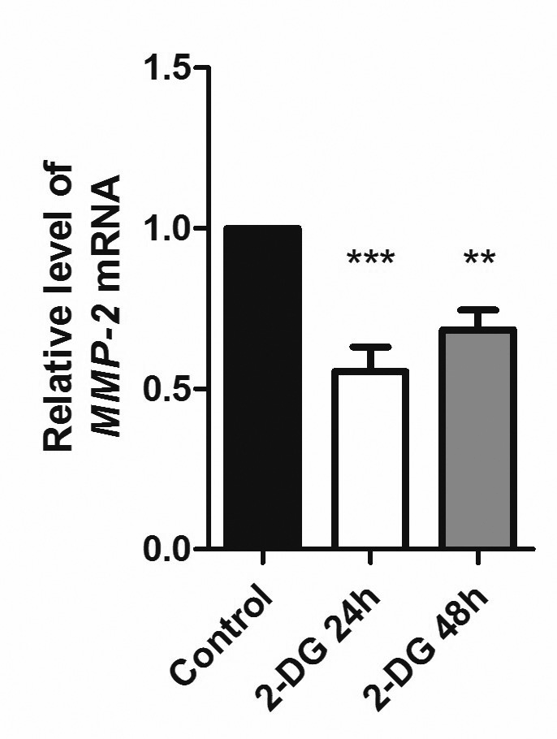
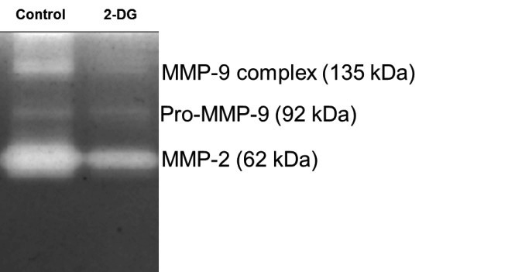
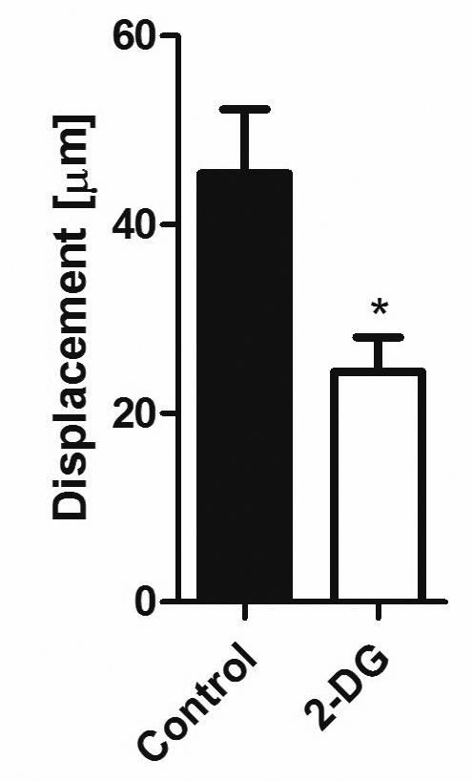
Vol. 67
305
Influence of the reporter vector backbone on 2-deoxyglucose
Table 1. Primer pairs used to obtain deletion variants of the MMP-2 promoter.
Promoter variant
Primers
Forward: ATAGCTAGCAAACTGACTCTGGAAAGTCAGAGCAC Reverse: ATAAAGCTTCAGGTCCTGGCAATCCCTTTG
DEL 1
Forward: ATAGCTAGCGAAGCAACCTGGGACCTTCC Reverse: ATAAAGCTTCAGGTCCTGGCAATCCCTTTG
DEL3
Forward: ATAGCTAGCGACGAGGTCGTGCACTGAG Reverse: ATAAAGCTTCAGGTCCTGGCAATCCCTTTG
DEL4
Forward: ATAGCTAGCAGTGGAGGAGGGCGAGTAGG Reverse: ATAAAGCTTCAGGTCCTGGCAATCCCTTTG
DEL5
Forward: ATAGCTAGCGACGAGGTCGTGCACTGAG Reverse: ATAAAGCTTAGGGCAGCCGCCAGATGTAG
DEL6
and DEL 3 to DEL6 MMP-2 promoter variants were pre- pared as described above with primers listed in Table 1. DEL1 was prepared from gDNA, DEL3 to DEL6 from pGL3-MMP-2-DEL1.
pGL3-MMP-2-DEL2 was prepared by cleaving pGL3- MMP-2-DEL1 with EcoRI and SacI (NEB) restriction enzymes. Cleavage products were separated by gel elec- trophoresis, excised and purified, blunted with T4 poly- merase (NEB) and ligated with T4 DNA ligase.
pGL3-MMP-2-DEL7 was generated using Q5 Site-Di- rected Mutagenesis Kit (NEB) according to the manu- facturer’s protocol, pGL3-MMP-2 was used as a tem- plate and specific primers were as follows:
forward: CCCTTGTTTCCGCTGCAT reverse: ACCCCACTTGCCTCTCTC.
pGL2-MMP-2 and pGL3-IER3 were obtained by cleavage of pGL3-MMP-2 and pGL2-IER3 (described previously, Kochan et al., 2014) plasmids with KpnI and HindIII (NEB) restriction enzymes. After gel electro- phoresis, the products were excised and purified. Then, plasmid backbones were dephosphorylated using rSAP (NEB) according to the manufacturer’s protocol. MMP-2 promoter and IER3 promoter were ligated with linear- ized and dephosphorylated pGL2 and pGL3 plasmids, respectively.
Obtained constructs were verified by restriction analy- sis and Sanger sequencing (Genomed).
Analysis of luciferase activity. After transfection and 2-DG treatment, the cells were lysed with Passive Lysis Buffer (Promega). The activity of Firefly luciferase was assessed using the Luciferase Assay System (Prome- ga). The activity of β-galactosidase expressed from the pEF/myc-His/LacZ vector was measured using the Be- ta-Glo Assay System (Promega) and served as control of transfection efficiency.
Sequence analysis. Prediction of transcription fac- tor binding sites was done using the AliBaba2.1 soft- ware available online [http://gene-regulation.com/pub/ programs/alibaba2/] and LASAGNA-Search 2.0 (Lee & Huang, 2013) [https://biogrid-lasagna.engr.uconn.edu/].
Statistics and graphs. Statistical analysis and graphs were done using Graph Pad Prism (v. 5.0, GraphPad Software Inc.). Statistical analysis was performed using the following tests: One-way ANOVA with Tukey’s multi- ple comparison (Fig. 1A) and paired t-test (other figures),
*p<0.05, **p<0.01, ***p<0.001. Schemes of MMP-2 pro-
Figure 1. Influence of glycolysis inhibition on expression of MMP-2 (A, B) and cell motility (C).
U-251 MG cells were treated with 2-DG (12.5 mM) for 24 h or
48 h. A. RNA was isolated from cell lysates, then the mRNA level was assessed using RT-PCR; One-way ANOVA with Tuk- ey’s multiple comparison test was used. The plot shows mean results from three independent experiments (n=3) ± S.D.,
**p<0.01, ***p<0.001. B. Culture medium from control and 2-DG treated cells was collected and put into analysis using gelatin zymography. White bands indicate the proteolytic ac- tivity of MMPs. C. Cell motility was visualized by time-lapse microscopy and analyzed with the Hiro program (written by W. Czapla). The plot shows mean results from three in- dependent experiments (n=3) ± S.D., *p<0.05. The paired t-test was used. In each experiment, trajectories of 50 cells were analyzed.
A
B
C

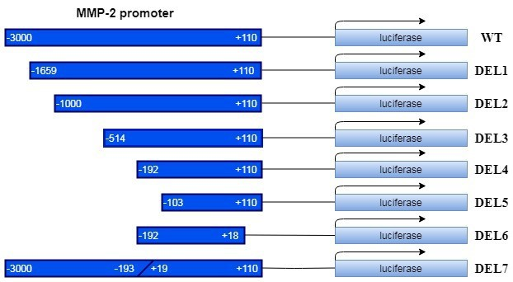
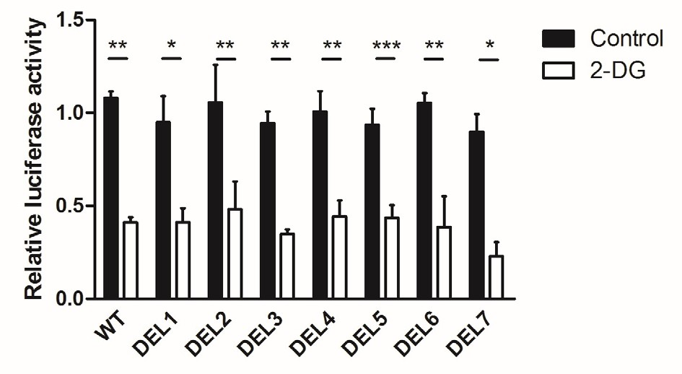
306
A. Solecka and others
2020
moter variants were prepared using a free diagram soft- ware – diagrams.net [www.draw.io].
A
RESULTS
Inhibition of glycolysis affects the MMP-2 mRNA level and activity, as well as cell motility
2-deoxy-d-glucose (2-DG) is a glucose analog that acts as an inhibitor of glucose metabolism. It enters cells via GLUT1 transporters and is phosphorylated by hexokinase to 2-DG-P. 2-DG-P cannot be further me- tabolized and blocks glycolysis (Pelicano et al., 2006). Using 2-DG we examined the influence of the inhibi- tion of glycolysis on the MMP-2 mRNA level in the U251-MG astrocytoma cell line. The results indicate that 2-DG treatment leads to a decrease in the level of MMP-2 transcript (Fig. 1A). To verify the obtained re- sults we examined the activity of the matrix metallopro- teinases by zymography (Fig. 1B). This method allows for assessing the proteolytic activity of MMPs in a po- lyacrylamide gel containing gelatin which is a substrate for MMP-2 and MMP-9. Distinction between these two proteins is possible due to differences in their molecular weights. Changes in metabolism induced by the 2-DG treatment resulted in the decreased activity of both de- tected MMPs. It is well documented that inhibition of MMP-2 or MMP-9 leads to a decrease in cell migra- tion (Webb et al., 2017). To confirm that the observed changes in the activity and mRNA level of MMP-2 have a physiological effect, we applied a time-lapse video mi- croscopy. The obtained results indicate that cells pre- treated with 2-DG show lower ability to displace (Fig. 1C). Taken together, our results suggest that inhibition of glycolysis leads to the decrease in MMP-2 activity, its mRNA level, and reduced mobility of glioblastoma cells.

Analysis of MMP-2 promoter activity after 2-DG treatment
Changes observed at the mRNA level may result from alterations in the promoter activity or mRNA half-life. We decided to start with the examination of MMP-2 promoter activity following 2-DG treatment. For this purpose, we prepared a series of reporter vectors con- taining the Firefly luciferase gene under control of differ- ent deletion variants of the MMP-2 promoter (Fig. 2A). U251-MG cells were transiently transfected with the plasmids generated, and treated with 2-DG. Individual vectors (DEL1 – DEL6) that were used for transfection contain deletions of increasingly larger fragments of the promoter sequence, however, treatment of the cells with 2-DG led to a similar, significant decrease in luciferase activity for each of the used constructs. Based on the obtained results, we selected a potential regulatory region of the MMP-2 promoter (–192 to +18) responsible for the regulation in response to inhibition of glycolysis. Im- portantly, this region contains a consensus binding site for the SP1 transcription factor, which is necessary for constitutive expression of MMP-2 in human glioblastoma cells (Qin, Sun, & Benveniste, 1999). To verify the im- portance of this region in 2-DG-dependent regulation of MMP-2 expression, we removed it from the wild type promoter, thus creating the DEL7 construct. Howev- er, MMP-2 promoter without the investigated fragment (–192 to +18 bp) still responded to 2-DG in a similar way as the wild-type promoter (Fig. 2B). Since further shortening of the MMP-2 promoter could lead to the re-
B
Figure 2. Response of different MMP-2 promoter fragments to the 2-DG treatment in pGL3-based vector series.
A. Scheme of the pGL3-based reporter vector constructs contain- ing the firefly luciferase gene under the control of various frag- ments of MMP-2. B. Response of the constructs shown in (A) to 2-DG. U251-MG cells were transfected with plasmids contain- ing the reporter gene under MMP-2 promoter control. 24 h after transfection, the cells were treated with 2-DG (12.5 mM) or left untreated for 24 h. The following day, the cells were lysed and luciferase and β-galactosidase activity were measured. The plot shows mean results from three independent experiments (n=3)
± S.D., *p<0.05, **p<0.01, ***p<0.001. The paired t-test was used.
moval of the minimal promoter region, we decided to discontinue this approach.

Analysis of MMP-2 promoter activity in response to glycolysis inhibition using different types of reporter vectors
Due to the failure to identify regulatory elements in the MMP-2 promoter responsible for the observed 2-DG-dependent inhibition, we decided to examine the response to 2-DG treatment of the vector itself. To do this, we re-cloned the wild type MMP-2 promoter into another reporter vector – pGL2-Basic, thus obtaining pGL2-MMP-2 vector. In contrast to the results obtained for the pGL3-MMP-2 vector, there were no significant differences in luciferase activity measured in the lysates from cells transfected with the pGL2-MMP-2 vector af- ter 2-DG treatment, in comparison to the control (un- treated) cells (Fig. 3A). To further investigate the influ- ence of the vector itself on the 2-DG-dependent pro- moter activity, we employed two constructs containing the immediate early response 3 (IER3) promoter, namely pGL2-IER3 and pGL3-IER3. Since IER3 is not down- regulated by 2-DG (Fig. 3B), both vectors should not re- spond to 2-DG treatment, similarly to the pGL2-MMP2 and pGL3-MMP2 vectors. However, the luciferase ac- tivity in the cells transfected with the pGL3-IER3 con- struct was significantly decreased after 2-DG treatment, mimicking the pattern of regulation observed for the MMP-2 promoter (pGL3-MMP-2 construct). Simultane- ously, we didn’t observe such a decrease in luciferase ac-

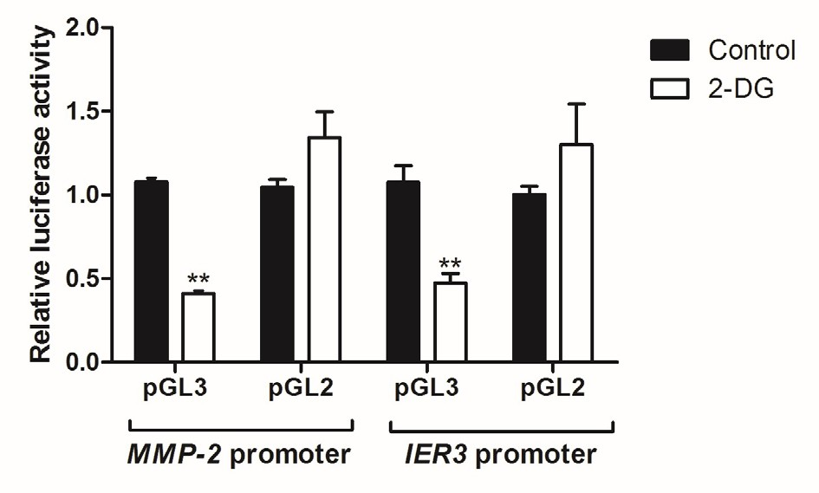
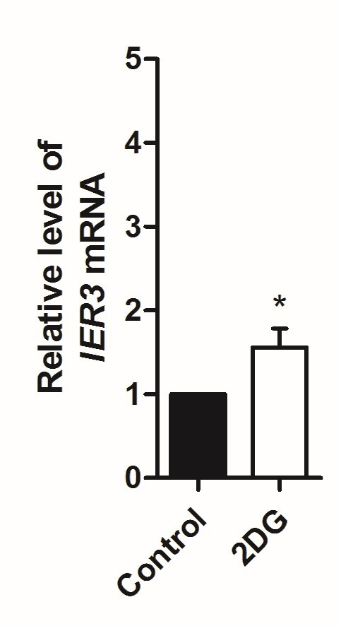
Vol. 67
307
Influence of the reporter vector backbone on 2-deoxyglucose
A
above MCS to limit non-specific transcription that can be initiated within the vector backbone (Enriquez-Harris et al., 1991; Levitt et al., 1989); 3) the small T antigen intron has been removed to prevent a decreased expres- sion of the reporter gene due to cryptic RNA splicing (Evans & Scarpulla, 1989; Huang & Gorman, 1990); 4) optimal Kozak consensus sequence was inserted to in- crease the efficiency of luciferase gene translation initia- tion (Kozak, 1989). In addition, the pGL3 vector carries a modified gene encoding Fireflyluciferase (luc +). The main modifications that distinguish the luc + gene from the native luciferase gene include: 1) removal of the C- terminal tripeptide to eliminate peroxisome targeting; 2) improving the use of codons for expression in plant and animal cells; 3) removal of two potential N-glycosylation sites; 4) DNA sequence changes to remove internal re- striction sites and eliminate consensus sequences rec- ognized by regulatory proteins (Promega Corporation, 2008b; Sherf & Wood, 1994). Bioinformatics prediction of transcription binding sites using AliBaba2.1 software showed that the pGL3-Basic plasmid contains 370 rec- ognition sites for transcription factors, whereas there are 446 such sites in the pGL2-Basic sequence.
Our work is part of a series of studies on the ef- fect of metabolism on gene expression regulation. In 2013, Chang et al. showed that aerobic glycolysis is en- gaged in posttranscriptional regulation of specific cel- lular functions. T cells fully supported by oxidative phosphorylation have a severe defect in IFN-γ (in- terferon γ) production. This effect is due to a block in translation (Chang et al., 2013). Independently, in the same year, Tannahill et al. described the influ- ence of glycolysis on expression of interleukin 1β (IL-1β) in mouse macrophages. Inhibition of glyco- lysis results in suppression of LPS (lipopolysaccharide) induced transcription of the IL-1β gene. This effect is caused by changes in the stability of the transcription factor HIF-1α (hypoxia-inducible factor 1α) which par- ticipates in stimulation of IL-1β expression. Expression of TNF in investigated cells was not regulated by glyco- lysis (Tannahill et al., 2013).
In this study, we made an attempt to iden- tify the mechanisms underlying downregulation of MMP-2 expression after glycolysis inhibition. Originally, our results suggested that the observed regulation of MMP-2 by 2-DG occurs at the promoter level. How- ever, despite preparation of a series of promoter deletion variants, we were not able to identify a sequence that could play a significant role in response to the 2-deoxy- glucose treatment. All constructs, containing wild type and deletion variants of the MMP-2 promoter, and gen- erated using the pGL3 vector as a backbone were down- regulated in response to the 2-DG treatment. To verify whether the pGL3-based system is a proper experimental setup, we prepared a construct containing the wild-type MMP-2 promoter using a different reporter vector back- bone, the pGL2-Basic vector. Surprisingly, the previously observed 2-DG induced down-regulation was no longer visible in cells transfected with the pGL2-based vec- tor. Moreover, we detected a similar pattern of vector- backbone dependent regulation by 2-DG for the IER3 promoter, while IER3 expression is not down-regulated by this compound. Thus, the originally observed 2-DG- dependent regulation of MMP-2 expression at the pro- moter level didn’t rely on the sequences present in the investigated promoter but was due to the presence of regulatory elements in the pGL3 plasmid that was used.
Considering the reduction in recognition sites for tran- scription factors in pGL3-Basic backbone in comparison
B
Figure 3A. Influence of the reporter vector backbone on the re- sponse of the construct to 2-DG.
U251-MG cells were transfected with plasmids containing the reporter gene under MMP-2 or IER3 promoter control. 24 h after transfection, the cells were treated with 2-DG (12.5 mM) or left untreated for 24 h. The following day, the cells were lysed and lu- ciferase and β-galactosidase activity were measured.
Figure 3B. IER3 mRNA level after inhibition of glycolysis.
U251-MG cells were stimulated with IL-1β (10 ng/ml) for 2h to in- duce IER3 expression and then treated with 2-DG (12.5 mM) or left untreated (control). RNA was isolated from cell lysates and then the mRNA level was assessed using RT-PCR. The plots show mean results from three independent experiments (n=3) ± S.D., *p<0.05,
**p<0.01. The paired t-test was used
tivity in lysates from cells transfected with pGL2-IER3 (Fig. 3A). The obtained results clearly indicate that the originally observed down-regulation of the MMP-2 pro- moter activity in response to inhibition of glycolysis by 2-DG was an effect of the response of the regulatory elements present in the originally used pGL3-Basic vec- tor backbone rather than the elements present in the MMP-2 promoter itself.
DISCUSSION
Our study reveals the importance of the type of re- porter vector used in research focused on investigation of the effect of metabolic changes on promoter activation. We have analyzed the outcome of the use of the pGL3 and pGL2 vectors for such studies. The pGL3 vector is one of Promega’s next generation expression vectors. In comparison to pGL2, its backbone has been altered to increase the luciferase expression (Promega Corporation, 2008a, 2008b). Four major modifications of the vector backbone were introduced: 1) the early poly(A) SV40 signal was replaced with a late signal to increase tran- scription termination efficiency and polyadenylation of luciferase transcripts (Carswell & Alwine, 1989); 2) syn- thetic poly(A) and a transcription pause site were placed

308
A. Solecka and others
2020
to the pGL2-Basic backbone (370 versus 446, respective- ly), one would expect a lower influence of the plasmid sequence on the investigated promoter activation. How- ever, our data suggest that the use of the pGL3 vector leads to a false decrease in activation of the investigated promoters in response to 2-DG. This study raises the problem of choosing the right model for experiments based on reporter vectors.
The authors declare no conflict of interest.
Kozak M (1989) The scanning model for translation: An update. J. Cell Biol. 108: 229–241. https://doi.org/10.1083/jcb.108.2.229
Laemmli UK (1970) Cleavage of structural proteins during the assem- bly of the head of bacteriophage T4. Nature 227: 680–685. https:// doi.org/10.1038/227680a0
Lee C, Huang CH (2013) LASAGNA-search: An integrated web tool for transcription factor binding site search and visualization. Biotech- niques 54: 141–153. https://doi.org/10.2144/000113999
Levitt N, Briggs D, Gil A, Proudfoot NJ (1989) Definition of an ef- ficient synthetic poly(A) site. Genes Dev. 3: 1019–1025. https://doi. org/10.1101/gad.3.7.1019
Liu AMF, New DC, Lo RKH, Wong YH (2009) Reporter gene as- says. Methods Mol. Biol. 486: 109–123. https://doi.org/10.1007/978- 1-60327-545-3_8
López-Lázaro M (2008) The warburg effect: why and how do cancer cells activate glycolysis in the presence of oxy- gen? Anticancer. Agents Med. Chem. 8: 305–312. https://doi. org/10.2174/187152008783961932
Lunt SY, Vander Heiden MG (2011) Aerobic glycolysis: meet- ing the metabolic requirements of cell proliferation. Annu. Rev. Cell Dev. Biol 27: 441–464. https://doi.org/10.1146/annurev-cell- bio-092910-154237
Moreno-Sánchez R, Rodríguez-Enríquez S, Marín-Hernández A, Saave- dra E (2007) Energy metabolism in tumor cells. FEBS J. 274: 1393– 1418. https://doi.org/10.1111/j.1742-4658.2007.05686.x
Neve J, Patel R, Wang Z, Louey A, Furger AM (2017) Cleavage and polyadenylation: Ending the message expands gene regulation. RNA Biol. 14: 865–890. https://doi.org/10.1080/15476286.2017.1306171
Nott A, Meislin SH, Moore MJ (2003) A quantitative analysis of intron effects on mammalian gene expression. RNA 9: 607–617. https:// doi.org/10.1261/rna.5250403
Pelicano H, Martin DS, Xu RH, Huang P (2006) Glycolysis inhibi- tion for anticancer treatment. Oncogene 25: 4633–4646. https://doi. org/10.1038/sj.onc.1209597
Pfaffl MW (2001) A new mathematical model for relative quantification in real-time RT-PCR. Nucleic Acids Res. 29: https://doi.org/10.1093/ nar/29.9.e45
Promega Corporation (2008a) pGL2 Luciferase Reporter Vectors Technical Manual. 1–30.
Promega Corporation (2008b) pGL3 Luciferase Reporter Vectors Technical Manual. 1–30.
Qin H, Sun Y, Benveniste EN (1999) The transcription factors Sp1, Sp3, and AP-2 are required for constitutive matrix metalloprotein- ase-2 gene expression in astroglioma cells. J. Biol. Chem. 274: 29130– 29137. https://doi.org/10.1074/jbc.274.41.29130
Ramachandran RK, Sørensen MD, Aaberg-Jessen C, Hermansen SK, Kristensen BW (2017) Expression and prognostic impact of ma- trix metalloproteinase-2 (MMP-2) in astrocytomas. PLoS One 12: e0172234. https://doi.org/10.1371/journal.pone.0172234
Schenborn E, Groskreutz D (1999) Reporter gene vectors and assays. Appl. Biochem. Biotechnol. – Part B Mol. Biotechnol. 13: 29–44. https:// doi.org/10.1385/MB:13:1:29
Sherf BA, Wood KV (1994) Firefly Luciferase Engineered for Im- proved Genetic Reporting. [WWW document]. Promega Notes Mag. 14–21.
Tannahill GM, Curtis AM, Adamik J, Palsson-Mcdermott EM, Mc- Gettrick AF, Goel G, Frezza C, Bernard NJ, Kelly B, Foley NH, Zheng L, Gardet A, Tong Z, Jany SS, Corr SC, Haneklaus M, Caf- frey BE, Pierce K, Walmsley S, Beasley FC et al. (2013) Succinate is an inflammatory signal that induces IL-1β through HIF-1α. Nature 496: 238–242. https://doi.org/10.1038/nature11986
Webb AH, Gao BT, Goldsmith ZK, Irvine AS, Saleh N, Lee RP, Len- dermon JB, Bheemreddy R, Zhang Q, Brennan RC, Johnson D, Steinle JJ, Wilson MW, Morales-Tirado VM (2017) Inhibition of MMP-2 and MMP-9 decreases cellular migration, and angiogenesis in in vitro models of retinoblastoma. BMC Cancer 17: https://doi. org/10.1186/s12885-017-3418-y
Weill L, Belloc E, Bava FA, Méndez R (2012) Translational control by changes in poly(A) tail length: Recycling mRNAs. Nat. Struct. Mol. Biol. 19: 577–585. https://doi.org/10.1038/nsmb.2311
Wicks RT, Azadi J, Mangraviti A, Zhang I, Hwang L, Joshi A, Bow H, Hutt-Cabezas M, Martin KL, Rudek MA, Zhao M, Brem H, Ty- ler BM (2015) Local delivery of cancer-cell glycolytic inhibitors in high-grade glioma. Neuro. Oncol. 17: 70–80. https://doi.org/10.1093/
REFERENCES
REFERENCES
Baran B, Bechyne I, Siedlar M, Szpak K, Mytar B, Sroka J, łaczna E, Madeja Z, Zembala M, Czyz J (2009) Blood monocytes stimulate migration of human pancreatic carcinoma cells in vitro: The role of tumour necrosis factor – alpha. Eur. J. Cell Biol. 88: 743–752. https://doi.org/10.1016/j.ejcb.2009.08.002
Carswell S, Alwine JC (1989) Efficiency of utilization of the simian vi- rus 40 late polyadenylation site: effects of upstream sequences. Mol. Cell. Biol. 9: 4248–4258. https://doi.org/10.1128/mcb.9.10.4248
Chang CH, Curtis JD, Maggi LB, Faubert B, Villarino AV, O’Sullivan D, Huang SCC, Van Der Windt GJW, Blagih J, Qiu J, Weber JD, Pearce EJ, Jones RG, Pearce EL (2013) Posttranscriptional control of T cell effector function by aerobic glycolysis. Cell 153: 1239– 1251. https://doi.org/10.1016/j.cell.2013.05.016
Chomczynski P, Sacchi N (1987) Single-step method of RNA isola- tion by acid guanidinium thiocyanate-phenol-chloroform extraction. Anal. Biochem. 162: 156–159. https://doi.org/10.1016/0003-
2697(87)90021-2
Enriquez-Harris P, Levitt N, Briggs D, Proudfoot NJ (1991) A pause site for RNA polymerase II is associated with termi- nation of transcription. EMBO J. 10: 1833–1842. https://doi. org/10.1002/j.1460-2075.1991.tb07709.x
Evans MJ, Scarpulla RC (1989) Introns in the 3’-untranslated region can inhibit chimeric CAT and β-galactosidase gene expression. Gene 84: 135–142. https://doi.org/10.1016/0378-1119(89)90147-9
Fanjul-Fernández M, Folgueras AR, Cabrera S, López-Otín C (2010) Matrix metalloproteinases: Evolution, gene regulation and function- al analysis in mouse models. Biochim. Biophys. Acta – Mol. Cell Res. 1803: 3–19. https://doi.org/10.1016/j.bbamcr.2009.07.004
Fantin VR, St-Pierre J, Leder P (2006) Attenuation of LDH-A expres- sion uncovers a link between glycolysis, mitochondrial physiology, and tumor maintenance. Cancer Cell 9: 425-434. [published correc- tion appears in Cancer Cell (2006) 10: 172] https://doi.org/10.1016/j. ccr.2006.07.011
Fischer K, Hoffmann P, Voelkl S, Meidenbauer N, Ammer J, Edinger M, Gottfried E, Schwarz S, Rothe G, Hoves S, Renner K, Timis- chl B, Mackensen A, Kunz-Schughart L, Andreesen R, Krause SW, Kreutz M (2007) Inhibitory effect of tumor cell-derived lactic acid on human T cells. Blood 109: 3812–3819. https://doi.org/10.1182/ blood-2006-07-035972
Gatenby RA, Gillies RJ (2008) A microenvironmental model of car- cinogenesis. Nat. Rev. Cancer 8: 56–61. https://doi.org/10.1038/ nrc2255
Gillies RJ, Gatenby RA (2007) Hypoxia and adaptive landscapes in the evolution of carcinogenesis. Cancer Metastasis Rev. 26: 311–317. https://doi.org/10.1007/s10555-007-9065-z
Hanahan D, Weinberg RA (2011) Hallmarks of cancer: The next gener- ation. Cell 144: 646–674. https://doi.org/10.1016/j.cell.2011.02.013
Vander Heiden MG, DeBerardinis RJ (2017) Understanding the inter- sections between metabolism and cancer biology. Cell 168: 657–669. https://doi.org/10.1016/j.cell.2016.12.039
Huang MT, Gorman CM (1990) The simian virus 40 small-t intron, present in many common expression vectors, leads to aberrant splicing. Mol. Cell. Biol. 10: 1805–1810. https://doi.org/10.1128/ mcb.10.4.1805
Kessenbrock K, Wang CY, Werb Z (2015) Matrix metalloproteinas- es in stem cell regulation and cancer. Matrix Biol. 44–46: 184–190. https://doi.org/10.1016/j.matbio.2015.01.022
van der Knaap JA, Verrijzer CP (2016) Undercover: Gene control by metabolites and metabolic enzymes. Genes Dev. 30: 2345–2369. https://doi.org/10.1101/gad.289140.116
Kochan J, Wawro M, Kolka A, Maczuga P, Kasza A (2014) Transcrip- tion factor Elk-1 participates in the interleukin-1β-dependent reg- ulation of expression of immediate early response gene 3 (IER3). Cytokine 70: 120–125. https://doi.org/10.1016/j.cyto.2014.06.021
neuonc/nou143
Zu (2004) Cancer metabolism: Facts, fantasy, and fic-
XL, Guppy M
tion. Biochem. Biophys. Res. Commun. 313: 459–465. https://doi. org/10.1016/j.bbrc.2003.11.136

