
Vol. 59, No 1/2012
101–103
on-line at: www.actabp.pl
Regular paper
Violaxanthin and diadinoxanthin de-epoxidation in various model lipid systems*
Dariusz Latowski1, Reimund Goss2, Monika Bojko1 and Kazimierz Strzałka1
1Department of Plant Physiology and Biochemistry, Jagiellonian University, Kraków, Poland; 2Institute of Biology I, Plant Physiology, University of Leipzig, Leipzig, Germany
The xanthophyll cycle is an important photoprotective process functioning in plants. One of its forms, the vio- laxanthin (Vx) cycle, involves interconversion between: Vx, antheraxanthin (Ax) and zeaxanthin (Zx). Another kind of the xanthophyll cycle is the diadinoxanthin (Ddx) cycle in which interconversion between Ddx and diatoxanthin (Dtx) occurs. In this study an information on molecular mechanism and regulation of these two types of the xanthophyll cycle is presented. The influ- ence of lipids on the de-epoxidation of the xanthophyll cycle pigments was investigated, with special focus put on the significance of physical properties of the aggre- gates formed by inverted lipid micelles, which are nec- essary for activity of the xanthophyll cycle enzymes. In particular, thickness of the hydrophobic fraction of the aggregates, size of the inverted micelles, suggested by mathematical description of the structures and solubil- ity of Vx and Ddx in various kind of lipids were studied. Obtained results show that the rate of de-epoxidation is strongly dependent on the physicochemical properties of the lipids used. The key role for enzyme activation play non-bilayer lipids and the parameters of inverted micelles such as thickness, fluidity of hydrophobic core and their diameter. The presented results show that MGDG and other non-lamellar lipids like different forms of phosphatidylethanolamine are necessary for the Vx and Ddx de-epoxidation because they provide the three- dimensional structures, which are needed for the bind- ing of de-epoxidases and for the accessibility of Vx and Ddx to these enzymes.
Key words: violaxanthin cycle, diadinoxanthin cycle, de-epoxidation, lipids
Received: 17 October, 2011; accepted: 01 March, 2012;
available on-line: 17 March, 2012
several algal groups (diatoms, phaeophytes, dinophytes and haptophytes). The most known representatives of these groups are Phaeodactylum tricornutum and Cyclotella me- neghiniana. DDE catalyses de-epoxidation of monoepox- ide diadinoxanthin (Ddx) to diathoxanthin (Dtx) (Stran- sky & Hager, 1970). Although DDE has substantially higher pH optimum than VDE it is known that both types of the xanthophyll cycle are similar on molecular level (Grouneva et al., 2006). In both of them the reduc- ing agent needed for de-epoxidation is ascorbate (Asc) (Hager, 1969, Yamamoto 1979, Grouneva et al., 2006) and additionally, as we showed previously, reverse hex- agonal phase forming lipids (monogalactosyldiacylglycer- ol — MGDG, phosphatidylethanolamine — PE) are in- dispensible for this reaction (Latowski et al., 2002, 2004, Goss et al., 2005, 2007).
Both VDE and DDE are water soluble lumenal pro- teins that undergo a conformational change when pH drops due to formation of the light-driven proton gra- dient across the thylakoid membrane (Pfündel & Bilg- er, 1994, Jakob et al., 2001, Hager & Holocher, 1994). The change in enzyme conformation is accompanied by the functional binding of the enzymes to the thylakoid membrane, where the substrates: Vx or Ddx are located.
MATeRIAls AND MeThODs
VDE was isolated from 7-day old wheat plants (Triti- cum aestivum) (Hager & Holocher, 1994; Goss et al., 2005) and Vx was extracted from daffodil (Narcissus poeti- cus) petals (Frommolt et al., 2001). DDE and Ddx were prepared from thylakoid membranes of C. meneghiniana (strain 1020-1a). C. meneghiniana was obtained from the Sammlung von Algenkulturen Goettingen (SAG) and was grown as a batch culture in silica enriched ASP (Provasoli et al., 1957; Lohr & Wilhelm, 2001). Reaction assay contained 0.33 µM Vx or Ddx, different concen- tration of MGDG or one of the different types of PE varying in the acyl residues and 5% ethanol (v/v) in 40 mM MES, pH 5.2, with 10 mM KCl and 5 mM MgCl2.
Reaction was started by Asc addition (final conc. 30
INTRODUCTION

Violaxanthin and diadinoxanthin de-epoxidation are photo-protective reactions enagaged in process called xanthophyll cycle. There are few variants of the xantho- phyll cycle (Latowski et al., 2011). In the most common variant of this process, known also as the violaxanthin cycle, under strong light conditions, enzyme violaxanthin de-epoxidase (VDE) catalyses de-epoxidation of violax- anthin (Vx) to zeaxanthin (Zx) via antheraxanthin (Ax) as an intermediate product. This type of the cycle exists in higher plants, ferns, mosses and some group of algae (Stransky & Hager, 1970; Adamska, 1997). Another de- epoxidase, called diadinoxanthin de-epoxidase (DDE) is one of the enzymes of another kind of xanthophyll cycle known as diadinoxanthin cycle. This cycle functions in
e-mail: dariuszlatowski@gmail.com
*Presented at the 16th International Symposium on Carotenoids, 17–22 July, 2011, Kraków, Poland
Abbreviations: Asc, ascorbate; Ax, antheraxanthin; DDE, diadino- xanthin de-epoxidase; Ddx, diadinoxanthin; DGDG, digalactosyl- diacylglycerol; Dtx, diatoxanthin; DPH, diphenylhexatriene; MGDG, monogalactosyldiacylglycerol; PC, phosphatidylcholine; PE, phos- phatidylethanolamine; PE1, 1,2-dioleoyl-sn-glycero-3-phosphatidyl- ethanolamine; PE2, 1,2-dilinoleoyl-sn-glycero-3-phosphatidyletha- nolamine; PE3, 1,2-dilinoleinoyl-sn-glycero-3-phosphatidylethanol- amine; PE-C16, 1,2-dipalmitoyloleoyl-sn-glycero-3-phosphatidyl- ethanolamine; VDE, violaxanthin de-epoxidase; Vx, violaxanthin; ZE, zeaxanthin epoxidase; Zx, zeaxanthin.

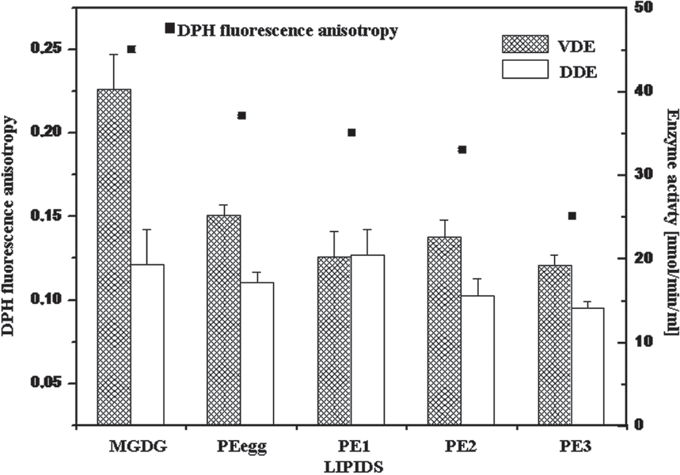
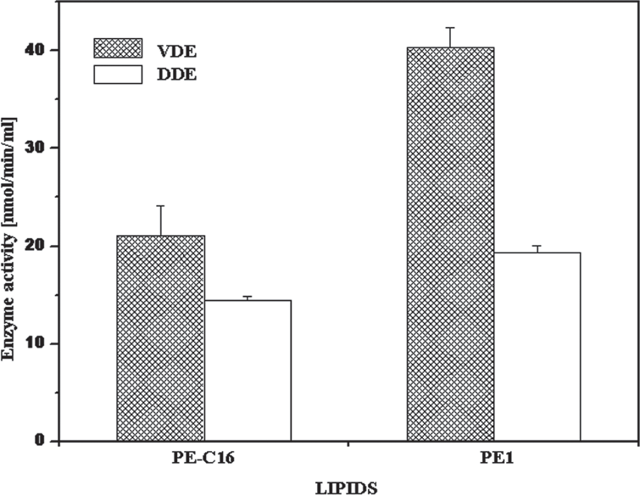
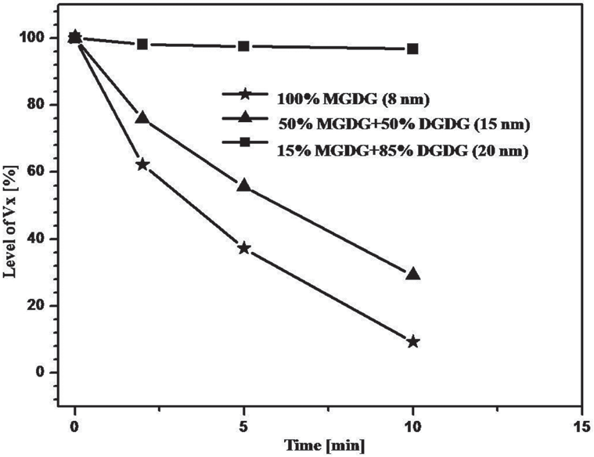
102
D. Latowski and others
2012
mM) and samples were collected at 0, 2, 5 and 10 min. Reaction was stopped by mixing 700 ml of assay mixture with 50 ml of 1 M KOH, then centrifuged. Pellets, con- taining pigments, were analyzed by reverse phase HPLC column (Nucleosil C-18) as describe by Latowski et al. (2002). Fluidity of hydrophobic fraction of aggregates of inverted micelles composed of one of the following lipids: MGDG, PE from eggs, 1,2-dioleoyl-sn-glycero-3 phosphatidylethanolamine (PE1) or 1,2-dilinoleoyl-sn- glycero-3-phosphatidylethanolamine (PE2) or 1,2-dilin- oleinoyl-sn-glycero-3-phosphatidylethanolamine (PE3) was assessed by by measuring steady-state fluorescence polarization anisotropy of diphenylhexatriene (DPH) with lipid:DPH ratio of 500. Final lipid concentration was 0.5 mM, emission and excitation wavelengths 425 nm and 355 nm respectively.
Figure 1. effect of fluidity of hydrophobic fraction of inverted micelles composed of different types of lipids on VDe and DDe activity.
Fluidity was estimated by measuring DPH fluorescence anisotro- py. DDE, diadinoxanthin de-epoxidase; DPH, diphenylhexatriene; MGDG, monogalactosyldiacylglycerol; PE1, 1,2-dioleoyl-sn-glyce- ro-3-phosphatidylethanolamine; PE2, 1,2-dilinoleoyl-sn-glycero- 3-phosphatidylethanolamine; PE3, 1,2-dilinoleinoyl-sn-glycero- 3-phosphatidylethanolamine; VDE, violaxanthin de-epoxidase.
ResUlTs AND DIsCUssION

Obtained results show that the activity both of VDE and DDE are strongly dependent not only on the pres- ence of non-lamellar lipids (Latowski et al., 2004; Goss et al., 2005; Goss et al., 2007) but also on physicochemi- cal parameters of inverted micelles created by these lip- ids. These parameters are: fluidity of hydrophobic core (Fig. 1), its thickness (Fig. 2) and diameter of micelles created by the tested lipids (Fig. 3 and 4).
The dependence between the conversion of Vx into Ax and Zx as well as Ddx to Dtx and fluidity of the hy- drophobic fraction of inverted micelles, showed that the highest activity was observed in the case of PE1, PE2 and MGDG for VDE and DDE, respectively, although fluidity of structures formed by these lipids was relatively low (Fig. 1).
Studies on the effect of thickness of the hydropho- bic core of the aggregates on VDE and DDE activity revealed that DDE activity was about 25% lower in PE- C16 comparing PE1 micelles while activity of VDE in PE-C16 micelles was lower by 50% comparing the mi- celles composed of PE1. PE1 and PE-C16 are esterified with fatty acids having one double bond but differing in their length. PE1 is about 6 Å longer than PE-C16.
These results suggest that both VDE and DDE need special value of membrane fluidity and thickness of the hydrophobic core of the tested lipid structures that pro- vides optimum conditions for the de-epoxidation. When the fluidity of lipids is too high, their arrangement be- comes disordered and this enables more possible orien- tations the epoxy-xanthophylls, resulting in a decrease in number of molecules having orientation ensuring acces- sibility by de-epoxidising enzymes.
Similarly, the membrane thickness influences the posi- tion of pigment molecules. When the thickness of the membrane is lower than the length of the xanthophyll molecule, the angle of pigment molecules in relation to the membrane plane changes to guarantee of beta ionon rings’ interaction with polar head of lipids. The change of pigments orientation in the membrane is likely pre- venting efficient penetration of these molecules into ac- tive site of the enzyme.
Another parameter studied was the size of the invert- ed micelles. Diameter of the micelles was about 7 to 9 nm, when they were created by MGDG only, and about
15 nm and 20 to 21 nm when mixtures of MGDG and DGDG (50:50 and 85:15, respectively) were used (Sprague & Staehelin, 1984). As Figs. 3 and 4 show, the larger the diameter of the micelles the smaller rate of de-epoxidation both for VDE and DDE. These results
Figure 2. effect of the thickness of the hydrophobic fraction of inverted hexagonal structures on VDe and DDe activity.
Hydrophobic fraction of the inverted hexagonal structures com- posed by PE1 is about 1.2 nm broader than hydrophobic struc- tures created by PE-C16. DDE, diadinoxanthin de-epoxidase; PE1, 1,2-dioleoyl-sn-glycero-3-phosphatidylethanolamine; PE-C16, 1,2-dipalmitoyloleoyl-sn-glycero-3-phosphatidylethanolamine; VDE, violaxanthin de-epoxidase.
Figure 3. effect of diameter of inverted hexagonal micelles on violaxanthin de-epoxidation.
DGDG, digalactosyldiacylglycerol; MGDG, monogalactosyldiacylg- lycerol.

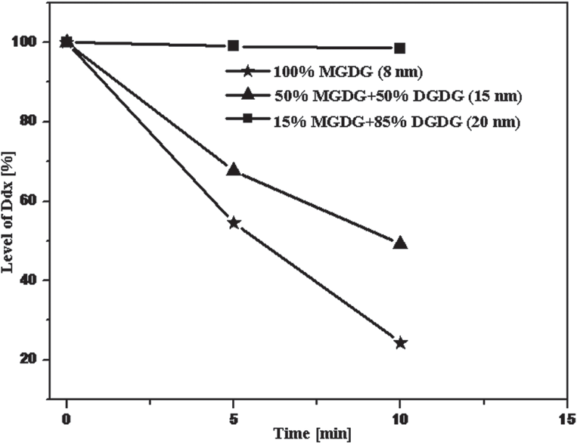
Vol. 59
Xanthophylls de-epoxidation in lipid systems
103
composition of the natural thylakoid membrane. Biochim Biophys Acta
1768: 67–75.
Goss R, Lohr M, Latowski D, Grzyb J, Vieler A, Wilhelm C, Strzałka K (2005) Role of hexagonal structure forming lipids in diadinoxan- thin and violaxanthin solubilization and de-epoxidation. Biochemistry 44: 4028–4036.
Grouneva I, Jakob T, Wilhelm C, Goss R (2006) Influence of ascor- bate and pH on the activity of the diatom xanthophyll cycle-enzyme diadinoxanthin de-epoxidase. Physiol Plant 126: 205–211.
Hager A (1969) Lichtbedingte pH-Erniedrigung in Einem Chloro- plastenkompartiment als Ursache der Enzymatischen Violaxanthin- Zeaxanthin-Umwandlung; Beziehungen zur Photophosphorylierung. Planta 89: 224–243.
Hager A, Holocher K (1994) Localization of the xanthophyll-cycle enzyme violaxanthin de-epoxidase within the thylakoid lumen and abolition of its mobility by a (light-dependent) pH decrease. Planta 192: 581–589.
Jakob T, Goss R, Wilhelm C (2001) Unusual pH-dependence of diadi- noxanthin de-epoxidase activation causes chlororespiratory induced accumulation of diatoxanthin in the diatom Phaeodactylum tricornutum. J Plant Physiol 158: 383–390.
Latowski D, Akerlund HE, Strzałka K (2004) Violaxanthin de-epoxi- dase, the xanthophyll cycle enzyme, requires lipid hexagonal struc- tures for its activity. Biochemistry 43: 4417–4420.
Latowski D, Kruk J, Burda K, Skrzynecka-Jaskier M, Kostecka-Gugała A, Strzałka K (2002) Kinetics of violaxanthin de-epoxidation by violaxanthin de-epoxidase, a xanthophyll cycle enzyme, is regulated by membrane fluidity in model lipid bilayers. Eur J Biochem 269: 4656–4665.
Latowski D, Kuczyńska P, Strzałka K (2011) Xanthophyll cycle — a mechanism protecting plants against oxidative stress. Redox Rep 16: 78–90.
Lohr M, Wilhelm C (2001) Xanthophyll synthesis in diatoms: quantifi- cation of putative intermediates and comparison of pigment conver- sion kinetics with rate constants derived from a model. Planta 212: 382–391.
Pfündel EE, Bilger W (1994) Regulation and possible function of the violaxanthin cycle. Photosynth Res 42: 89–109.
Provasoli L, McLaughlin JJA, Droop MR (1957) The development of
artificial media for marine algae. Arch Mikrobiol 25: 392-428.
Sprague GS, Staehelin LA (1984) Effect of reconstitution method on the structural organization of isolated chloroplast membrane lipids. Biochim Biophys Acta 777: 306–322.
Stransky H, Hager A (1970) The carotenoid pattern and the occurrence of the light-induced xanthophyll cycle in various classes of algae.
VI. Chemosystematic study. Arch Mikrobiol 73: 315–323.
Yamamoto HY (1979) Biochemistry of the violaxanthin cycle in high- er-plants. Pure Appl Chem 51: 639–648.
Figure 4. effect of diameter of inverted hexagonal micelles on diadinoxanthin de-epoxidation.
DGDG, digalactosyldiacylglycerol; MGDG, monogalactosyldiacylg- lycerol.
may be explained assuming the larger the diameter of the micelles the longer is the way the epoxy-xanthophyll molecules have to diffuse to reach the de-epoxidising en- zymes bound to the lipid micelles, hence smaller rate of de-epoxidation.
Obtained results suggest that mutual orientation of enzymes and substrates as well as solubilization and di- lution of pigments by lipids are the main factors con- trolling molecular mechanism of de-epoxidation both Vx and Ddx.
ReFeReNCes
Adamska I (1997) ELIPs-light-induced stress proteins. Review. Physiol Plant 100: 794–805.
Frommolt R, Goss R, Wilhelm C (2001) The de-epoxidase and epoxi- dase reactions of Mantoniella squamata (Prasinophyceae) exhibit dif- ferent substrate-specific reaction kinetics compared to spinach. Planta 213: 446–456.
Goss R, Latowski D, Grzyb J, Vieler A, Lohr M, Wilhelm C, Strzałka K (2007) Lipid dependence of diadinoxanthin solubilization and de-epoxidation in artificial membrane systems resembling the lipid

