



Article

Preparation and Characterization of Fish Skin Collagen
Material Modified with p-Glucan as Potential Wound Dressing
Marta Michalska-Sionkowska 1,ł, Oliwia Warzynska b Beata Kaczmarek-Szczepafiska 2 , Krzysztof Łukowicz 3,
Anna Maria Osyczka 3 and Maciej Walczak 1
- Department of Environmental Microbiology and Biotechnology, Faculty of Biological and Veterinary Sciences,
Nicolaus Copernicus University in Toruń, 87-100 Toruń, Poland; oliwia.warzynska@vp.pl (O.W.);
walczak@umk.pl (M.W.)
- Department of Biomaterials and Cosmetics Chemistry, Faculty of Chemistry, Nicolaus Copernicus University
in Toruń, 87-100 Toruń, Poland; beata.kaczmarek@umk.pl
- Department of Biology and Cell Imaging, Faculty of Biology, Institute of Zoology and Biomedical Research,
Jagiellonian University, 30-387 Kraków, Poland; krzysztof.lukowicz@uj.edu.pl (K.Ł.);
anna.osyczka@uj.edu.pl (A.M.O.)
* Correspondence: mms@umk.pl
Citation: Michalska-Sionkowska, M.;
Warzynska, O.; Kaczmarek-
Szczeparnska, B.; Łukowicz, K.;
Osyczka, A.M.; Walczak, M.
Preparation and Characterization of
Fish Skin Collagen Material Modified
with в-Glucan as Potential Wound
Dressing. Materials 2021, 14, 1322.
https://doi.org/10.3390/ma14061322
Academic Editor: Maurice N. Collins
Received: 26 January 2021
Accepted: 7 March 2021
Published: 10 March 2021
Abstract: Collagen possesses unique properties, e.g., biocompatibility, biodegradability, and non-
toxicity. However, collagen material degrades too quickly and has low mechanical properties. One of
the methods of polymers' modification is mixing them to obtain blends. In this study, the influence
of |3-glucan for collagen material was analyzed. The interaction between the functional groups of
the polymer was analyzed by ATR-FTIR (attenuated total reflection-fourier transform infrared) spec-
troscopy. The influence of |3-glucan on mechanical properties was evaluated. The surface properties
of materials were assessed using contact angle measurements and the topography of materials was
evaluated by AFM (atomic force microscope). The structure of materials was analyzed according
to SEM (scanning electron microscopy) pictures. Moreover, the DPPH-free radicals' scavenging
ability and biocompatibility against erythrocytes and HaCaT cells were evaluated. Collagen and
P-glucan were bound together by a hydrogen bond. |3-glucan addition increased the roughness of
the surface of the film and resulted in a more rigid character of the materials. A small addition of
|3-glucan to collagen provided a more hydrophilic character. All the materials could swell in in vitro
conditions and showed antioxidant activity. Materials do not cause erythrocyte hemolysis. Finely,
our cytotoxicity studies indicated that |3-glucan can be safely added at small (10% or less) quantity to
collagen matrix, they sufficiently support cell growth, and the degradation products of such matrices
may actually provide some beneficial effects to the surrounding cells/tissues.
Keywords: collagen; |3-glucan; HaCaT cells; wound dressing; natural polymers
Publisher's Note: MDPI stays neutral
with regard to jurisdictional claims in
published maps and institutional affil-
iations.
1. Introduction
Collagens are a group of major structural proteins. Currently, 28 types of collagen are
known. The type of collagen depends on its structure, function, and tissue distribution [1].
Collagen (Coll) type I is the most abundant collagen in the mammalian body and constitutes
the main component of the connective tissue, bone, skin, and tendons [2]. So far, the main
sources of collagen for industrial applications are bovine and pig's skins and bones [3].
However, their application has been restricted due to the outbreak of some diseases,
such as foot and mouth disease (FMD) and bovine spongiform encephalopathy (BSE),
which may be transferred to humans [4]. Moreover, those sources of collagen are not
acceptable in research by some cultures [5]. By-products and leftovers generated by the
seafood processing may be valuable sources of macromolecules, e.g., proteins, lipids, and
polysaccharides. Therefore, fish collagen is of great interest to the cosmetic, pharmaceutical,
and medical industries. Fish skin may be a promising source of collagen. The use of
Materials 2021,14,1322. https://doi.org/10.3390/ma14061322
https://www.mdpi.com/joumal/materials
Copyright: © 2021 by the authors.
Licensee MDPI, Basel, Switzerland.
This article is an open access article
distributed under the terms and
conditions of the Creative Commons
Attribution (CC BY) license (https://
creativecommons.org/licenses/by/
4.0/).
Materials 2021,14,1322
2 of 17
by-products from a local fish industry may decrease collagen cost and it allows to mitigate
environmental problems [6]. On average, solid waste from fish processing comprises 50%
of raw original material (depending on the level of processing and type of fish) [7]. The
skin and bones comprise 30% of these wastes [8]. Fish skins and bones may be successfully
used to isolate collagen with a 36-54% recovery rate [9]. Moreover, collagen isolated
from fish waste fulfils religious requests like halal and kosher [10]. Collagen, due to its
characteristics, is applied as a biomaterial for tissue engineering and wound dressings [11].
It was found that fish collagen induced keratinocyte differentiation, which is required for
the formation of integrated epidermis, probably by the synergetic effects of the amino
acids on stimulating the HaCaT cells' differentiation [12]. To improve the properties of
collagen-based materials, it can be mixed with other polymers [13].
Glucans are polysaccharides built of glucose units linked by a- (alpha) and p (beta)-
type glycosidic bonds [14]. Their biological activity depends on the primary structure,
molecular weight, source, and extraction method [15]. p-glucan may be isolated from
different sources, like yeast, fungi, algae, edible mushrooms, and cereal grains such as oats,
barley, wheat, and rye. For extraction of p-glucan from natural sources, water extraction,
alkaline extraction, acid extraction, and enzymatic extraction may be used. The yield
and purity of p-glucan depend on the methods employed for the extraction [16]. It was
shown that p-glucan enhances wound healing by stimulating tissue granulation, human
dermal fibroblast collagen biosynthesis and deposition, and, finally, re-epithelialization [17].
Moreover, p-glucan (BG) is known to stimulate macrophages in the inflammation phase
of healing, enhancing their phagocytosis and secretion of chemokines and promoting the
formation of new tissue [18]. p-glucan can form a crosslinking network by hydrogen bonds,
increasing rigidity or gelling properties [19].
Wound dressing materials (Brennan Medical, Inc, St. Paul, MN, USA) with collagen
and p-glucan were already studied by Delatte et al. in 2001 [18]. However, the authors
studied commercially available wound dressing BGC MATRIX®and its effect on patients'
health. They showed that this commercial wound dressing simplifies wound care and
significantly decreases post-injury pain. In our research, we prepared polymeric sheets
based on collagen obtained from fish skin and modified by p-glucan and characterized
their physicochemical and biological properties for potential wound dressing.

2. Materials and Methods
- Collagen Isolation
Collagen was obtained in our laboratory from Hypophthalmichthys nobilis skin. The
skins were sourced as by-products from the local fish industry—they are waste. Collagen
was obtained using the method described in our previous publication [20]. First, soft tissue
was removed from the skin. The skins were cut into 2 cm x 2 cm squares and cleaned
with distilled water. The skin was extracted with 0.1 M NaOH for 4 days to remove non-
collagenous proteins. Then, fat was extracted with 10% butyl alcohol for 1 day and washed
with distilled water. The insoluble matter was extracted with 0.5 M acetic acid for 2 days
and protein was salted out by adding NaCl (to a final concentration of 2 M). Precipitated
collagen was centrifuged (Rotina 38R, Hettich, Tuttlingen, Germany) at 10,000 rpm for
30 min. The resulting precipitate was dissolved in 0.5 M acetic acid, dialyzed (MWCO =
12-14 kDa, Serva, Heidelberg, Germany) against 0.1 M acetic acid for 5 days, changing the
solution every 24 h. Then, the solution was frozen (-18 °C) and lyophilized (ALPHA 1-2
LD plus, CHRIST, Osterode am Harz, Germany). Collagen was stored at -18 °C.
- Materials Preparation
One percent (1%) (w/v) collagen solution was prepared with 0.1 M acetic acid as a
solvent, and 5% p-glucan (oat 1-3 p-glucan, cosmetics ingredient) solution was prepared
in deionized water and heat in a water bath without boiling. The solutions were mixed
together in collagen/p-glucan ratios of: 100/0, 90/10, 70/30, and 50/50 (w/w). The
materials were obtained by the solvent casting method.
Materials 2021,14,1322
3of 17
- ATR-FTIR (Attenuated Total Reflection-Fourier Transform Infrared) Spectroscopy
The structure of collagen and p-glucan as well as the interaction between them were
confirmed by attenuated total reflection infrared spectroscopy using Nicolet iS10 equipment
(Shimadzu, Kyoto, Japan). All the spectra were recorded by absorption mode at 4 cm-1
intervals and 64-times scanning [21].
- Mechanical Properties
Mechanical properties of films were tested by using the Zwick and Roell testing
machine (Ulm, Germany). Materials were cut into bog-bone shapes of initial dimensions
of 50 mm in length and 4 mm in width. The thickness of the samples was determined
using an ultra-meter type A-91 (producer: Manufacture of Electronic Devices, Warsaw,
Poland). Parameters of the testing program: 200 mm/min speed starting position, 0.1
MPa initial force, and 5 mm/min the speed of the initial force. For each kind of film, at
least five samples were tested. Results were prepared as average values with standard
deviation (SD).
- Surface Properties
The topographic structure of the polymeric films was observed using an atomic force
microscope (AFM, Veeco Metrology, Inc., Santa Barbara, CA, USA). Images were obtained
using a multimode scanning probe microscope with a Nanoscope IIIa controller (Digital
Instruments, Santa Barbara, CA, USA) operating in the tapping mode, in air, at room
temperature. Surface images were acquired at fixed resolution (512 x 512 data points) with
a scan rate of 1.97 Hz. Silicon tips with spring constant of 2-10 N/m were used. Roughness
parameters were calculated from a 10 gm x 10 gm scanned area using Nanoscope software
(v6.11, Bruker Optoc GmbH, Ettlingen, Germany) [22].
- Scanning Electron Microscopy (SEM)
The cross-section of the materials was imaged using a Scanning Electron Microscope
(LEO Electron Microscopy Ltd., Cambridge, UK), and the samples were covered by gold
particles. Images were recorded at 2500 times of magnification and the voltage used for the
acquisition was 300 kV.
- Contact Angle Measurements
For this analysis, the materials were prepared on microscopic slides. Contact angle
measurements were performed using a goniometer equipped with a system of drop shape
analysis (DSA 10 Control Unit, Krüss, Hamburg, Germany) for two measurement liquids.
Because the prepared materials swell in water, glycerol was used as a hydrophilic liquid.
Diiodomethane was chosen as a hydrophobic liquid. Surface free energy and its polar and
dispersive components were calculated using the Owens-Wendt method [22].
- Antioxidant Properties
To assess the antioxidant properties of the prepared materials, DPPH reagent (2,2-
Diphenyl-1-picrylhydrazyl, free radical, 95%) (Alfa Aesar, Kandel, Germany) was used.
For the reaction, 250 gM of DPPH in methanol was prepared. The materials were cut
into 1 cm2 pieces and placed in a 24-well plate filled with 1500 gL of DPPH. The samples
were incubated at room temperature without access to light for 1 h. The absorbance was
measured using a spectrophotometer (Hitachi U-1900, Tokyo, Japan) at a wavelength of
517 nm. The antioxidant ratio was calculated using the equation:
. .. ., . .. ro/1 AbsDPPH - Abssample 1Г1_
Antioxidant ratio |%| = -¡ — * 100
AbsDPPH
where AbsDPPH is an absorbance of DPPH solution, and Abssample is an absorbance of DPPH
solution after incubation with the materials.
Materials 2021,14,1322
4 of 17
The analysis was performed in triplicate. The results were presented as mean values
with standard deviation.

2.9. Swelling Properties
Swelling properties were evaluated according to the method described by Zare-Gachi
et al. with small modifications [23]. Dried and weighed films were soaked in PBS (phos-
phate buffered saline) buffer (pH = 7.4) for 1 h at 37 °C. After incubation, the films were
carefully taken out and excess of fluids was removed on the filter paper, and then weighed
until constant weight. The swelling ratio (Sw) was calculated by using the equation:

—S-—D
Sw= —- x 100%
WD
where —S is the weight of the swollen film and —- is the weight of the dried film.
The films were analyzed in four repetitions and the results are presented as mean
values with standard deviation.

2.10. Color Change
Each sample was cut into 2 cm x 2 cm squares and placed in a 12-well plastic holder.
The droplets of three liquids were applied on their surface: 2 mol/L HCl, 2 mol/L NaOH,
and deionized water. Variations of color were measured after 1 h using a colorimeter
(Corneometer CL 400, Courage, Khazaka, Koln, Germany). The color parameter L (which
describes the sample lightness), a (along the X axis red (+) to green (—)), b (along the Y
axis yellow (+) to blue (—)) were evaluated [24]. Each sample was analyzed in triplicate
and mean values were used for calculation of the total color difference (AE). The total color
difference (AE) was then calculated using the equation:
AE = (A L2 + Aa2 + Ab2)a5
where AL = L — L0, Aa = a — a0, Ab = b — b0, and Lo, ao, bo are color values of the control.

2.11. In Vitro Blood Biocompatibility
The direct contact method was used to evaluate blood biocompatibility of the prepared
materials using the methodology described by Zhou et al., with a small modification [25].
Anticoagulated whole sheep blood was used to determine the effect of materials on red
blood cell hemolysis. Sheep blood (0.2 mL) was added to the physiological saline solution
(10 mL) containing different specimens (1 cm2 area). The tubes were incubated at 37 ° C for
60 min. Then, the suspension was centrifuged at 10,000 rpm for 10 min and the absorbance
of the supernatants was measured by microplate reader Multiscan FC (Thermo Fisher
Scientific, Waltham, MA, USA) at 540 nm. Positive and negative samples were prepared by
adding 0.2 mL of blood to distilled water and physiological saline, respectively. Samples
were prepared in triplicates. Hemolysis rate was calculated using the following equation:
_ , ... , . rn,1 —Dspecimen —Dnegative

Rate of hemolysis [%] = — D ———5
ODpositive —Dnegative

2.12. Cytocompatibility Studies
Unless stated otherwise, human keratynocytes cell line HaCaT [26] and cell culture
reagents were purchased from Thermo Fisher Scientific (Waltham, Massachusetts, USA).
For cytocompatibility studies, the material sheets were cut into round disks fitting the
bottom of individual wells of 24-well tissue culture plates. The disks were sterilized by
soaking in 70% ethanol (water solution), then they were washed briefly with phosphate-
buffered saline (PBS) to remove ethanol traces, exposed to UV (ultraviolet) light (10 min
each side), and left overnight under a laminar flow to dry. A separate set of sterilized
materials was used for direct cell culture and another set for the preparation of material
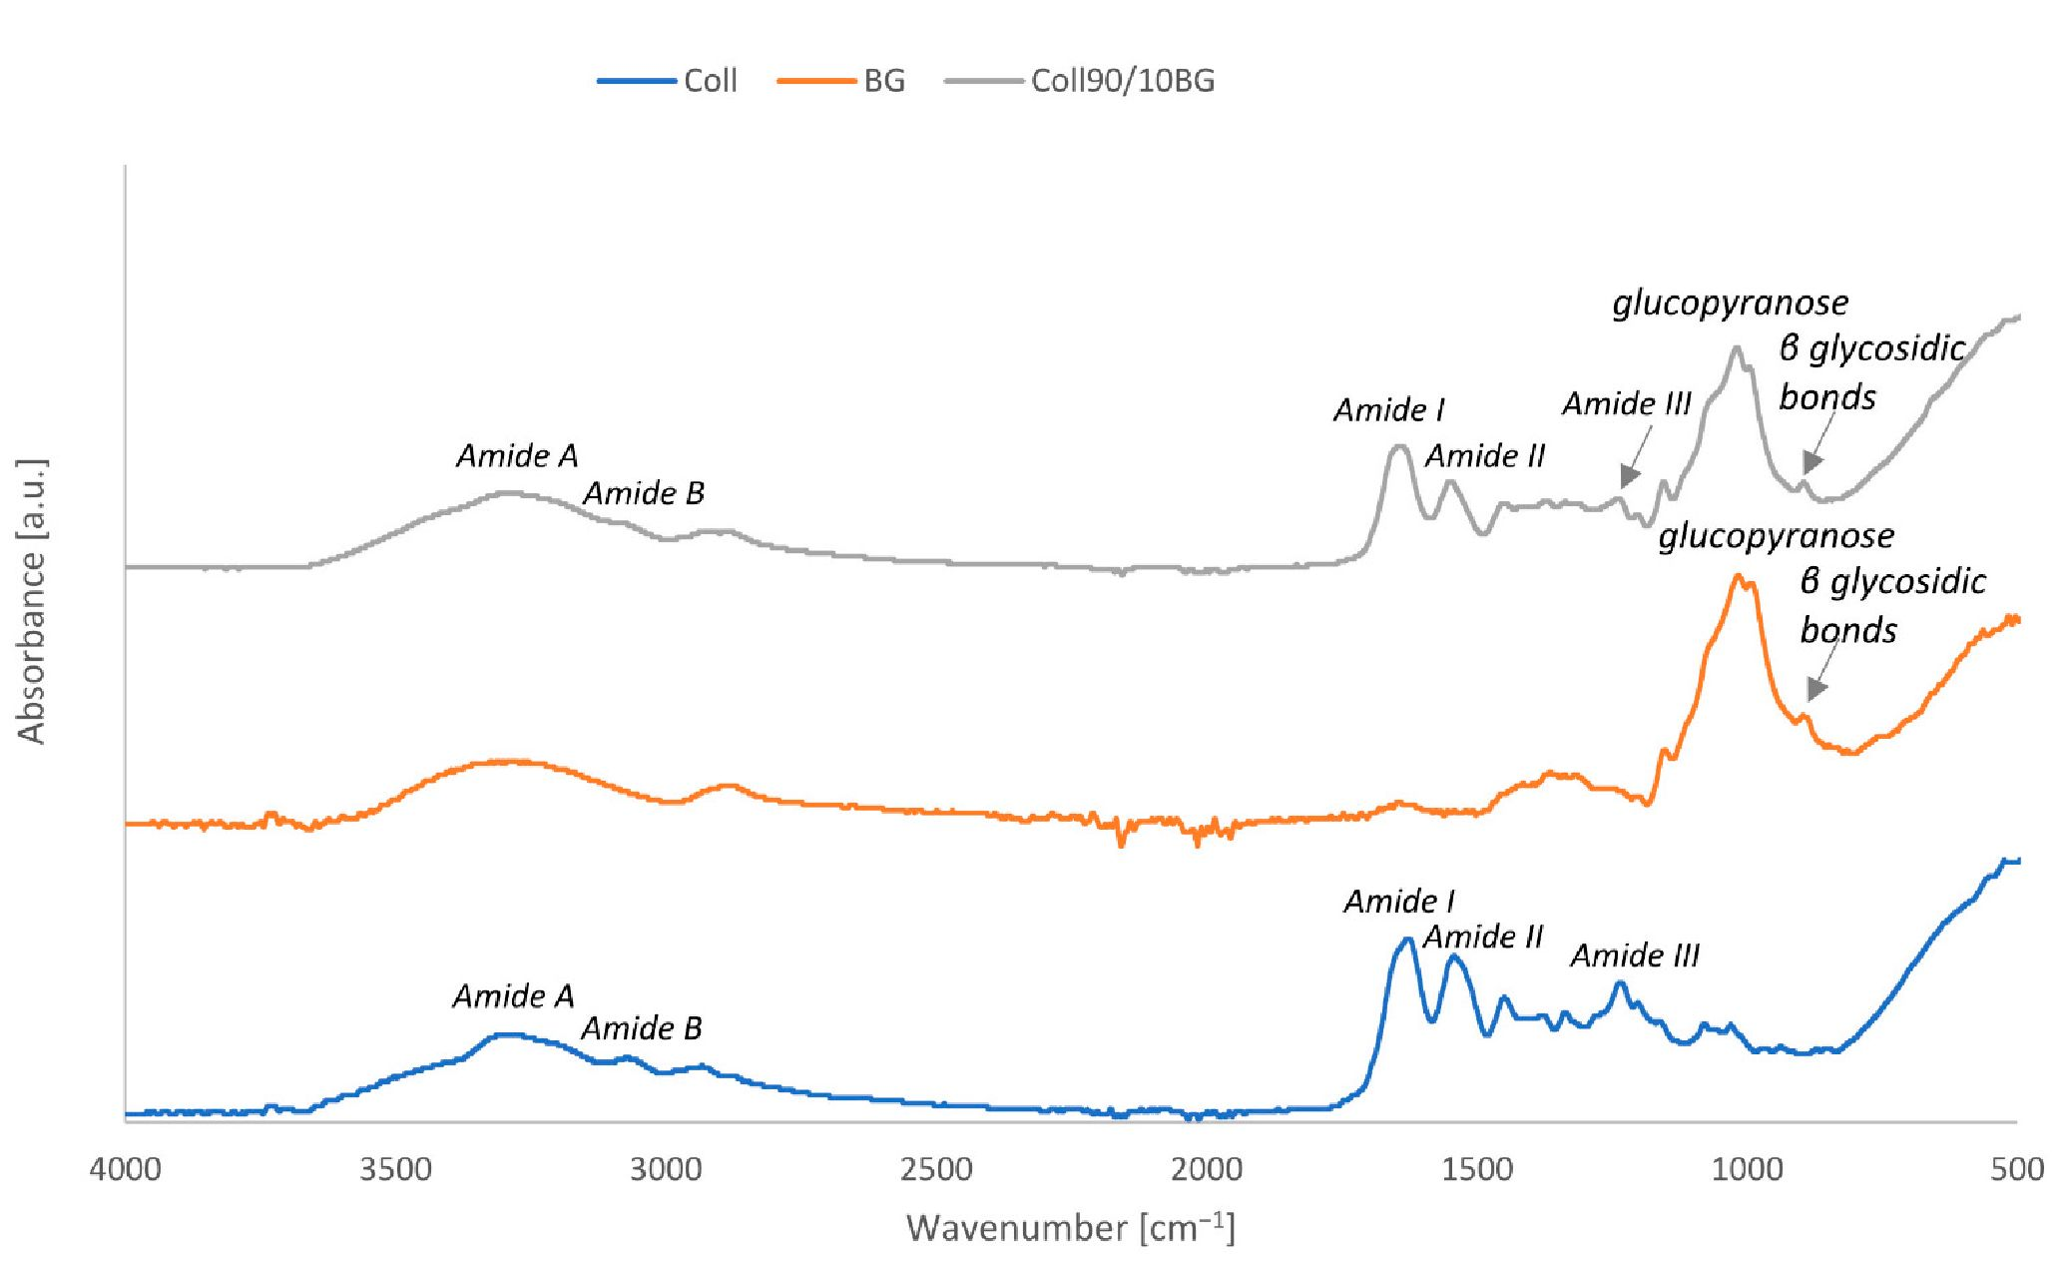
Materials 2021,14,1322
5 of 17
extracts. The latter were prepared by 24 h incubation of materials in a growth medium (1
mL/well) composed of alpha-minimum essential medium (aMEM) supplemented with
10% fetal bovine serum (FBS) and antibiotics (penicillin/streptomycin 1% solution). Cells
were either seeded directly on the material surface or on tissue culture plastic (TCP) at the
density of 2 x 104 cells/cm2. The cells seeded directly on the materials were assessed for
the viability after 24 h culture. Cells seeded on TCP were cultured for 24 h, then exposed to
material extracts for an additional 24 h and assessed for viability. The material set that was
used to prepare material extracts was used to culture cells for 72 h. To assess cell viability,
cultures were washed with PBS, and 0.2 mL rolution of 10% MTS (3-(4,5-dimethyithiazol-
2-yl)-5-(3-carboxymethoxyphenyl)-2-(4-sulfophenyl)-2H-tetrazolium, inner salt) reagent
(CellTiter96Aqueous One Solutien Cell I3roliferation Aseay; Pr omega) in phenohfree alpho-
MEM veas; added to individual wells. Cells cultured on TCP without any stimulation
were considered as a general referente material. The plates; were incubated at 37 °C uneil
apparent change of color from yellow to brownish. Then, the media were transferred to
individual wells in 96-well plates and the tbsorbance was recorded at 492 nm using a plate
reader. Data were analyzed by one-way analysis of variance (ANOVA) using Tukey's post
hoc eests (p < 0.05).

3. Results
  - ATRtFTIR Saectroscopy
ATR-FTIR spectroscopy wes performed to confirm p-glucan present in collagen film as
well as to assess the interaction between those polymers. "The results obtained for cnllagen,
p-glucan powder, and Сoll9a/10BG are presented in Figure 1 and ossignments of trine major
frequencies are shown In Table i.
Figure 1. ATR-FTIR spectra collected for collagen, fi-glucan, and collagen/fi-glucan material.
Materials 2021,14,1322
6 of 17
Table 1. Assignments of the major frequencies of collagen, в-glucan, and collagen/P-glucan material.
Specimen | Assignments | Wavenumber (cm-1)
 | Amide A | 3315
 | Amide B | 3049
Coll | Amide I | 1618
 | Amide II | 1527
 | Amide III | 1225
 | C-C, C=O | 928-1200
BG | C-O-C | 1014
 | P glycosidic bonds | 896
 | Amide A | 3292
 | Amide B | 2928
 | Amide I | 1634
Coll90/10BG | Amide II | 1531
 | Amide III | 1222
 | C-O-C | 1007
 | P glycosidic bonds | 898
The main bonds recorded for collagen correspond to wavenumbers: 3315,3049,1618,
1527, and 1225 cm-1 respectively, and they are characteristic for collagenous samples.
The absorption characteristics of Amide A, commonly associated with N-H stretching
vibration, occurs in the wavenumber range of 3300-3440 cm-1 [13]. The maximum of the
absorption peak of our collagen was found at 3315 cm-1. Amide B peak was found at 3049
cm-1. The maximum peaks found at 1618 and 1527 cm-1 were assigned to Amide I and
Amide II, respectively. The peak at 1225 cm-1 corresponds to Amide III. For the analyzed
p-glucan spectrum, the characteristic peak was observed at 1015 cm-1. The FTIR peak in
the region of 928-1200 cm-1 (mainly due to C-C and C=O stretching vibrations) indicates
the presence of polysaccharides [27]. The adsorption at 1014 cm-1 indicates the presence
of glucopyranose moiety in oat p-glucan. The adsorption peak at 896 cm-1 is characteristic
of p-linked glycosidic bonds [28]. Moreover, no adsorption near 840 cm-1 showed the
absence of a-linked glycosidic bonds [29]. On Coll90/10BG spectra, all the described peaks
are visible, both for collagen and p-glucan. It confirms that both polymers are present
in the material sheet. Hydrogen bonds between collagen and p-glucan are formed by
interaction with the hydroxyl group from the collagen chain. No additional peaks were
observed, which allows to assume that covalent bonds between collagen and p-glucan
were not formed. The shift of Amide A (N-H), Amide B (O-H), and Amide I (C=O) is
noticed when compared to Coll with and without BG. It suggests that those groups are
included in the hydrogen bond formation.

3.2. Mechanical Properties
During mechanical testing of the samples, data on maximum tensile force at break
were collected. The obtained results are presented in Figure 2.
The maximum tensile force needed to break the collagen film was 3.1 N. p-glucan
addition into collagen films increases the tensile force: 10% of p-glucan into collagen
materials increases maximum tensile force up to 4.4 N. Higher addition of p-glucan en-
hances tear-resistance and causes an increase of tensile force approximately 6.5 times. The
difference between the results obtained for Coll70/30BG and Coll50/50BG was only 1 N.
BG addition caused increase of the strength and reduction of the flexibility of the materials.
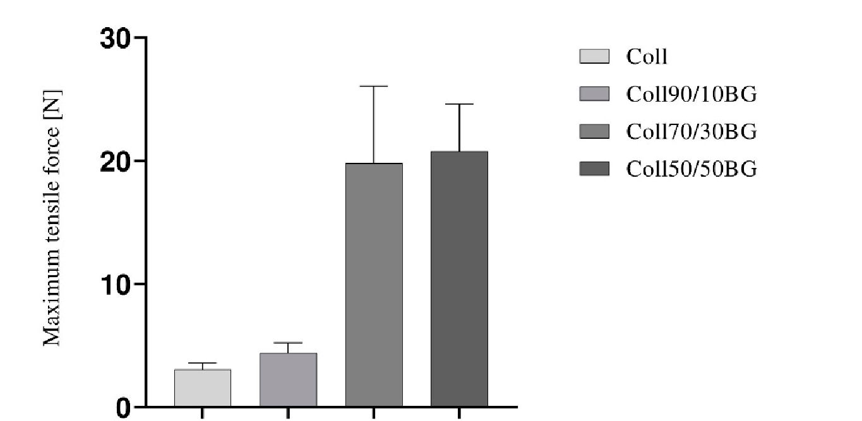
Materials 2021,14,1322
7 of 17
Figure 2. Maximum tensile force at break for the films based on collagen and P-glucan in the weight
ratios: 100/00, 90/10, 70/30, and 50/50.
- Roughness Parameters
Hie morphology of Coll/BG materials was visualized using AFM analysis. Pictures
in two- and three-dimensional (2D and 3D) form are presented in Figure 3. Additional
information about the roughness of the prepared materials can be found in Table 2, where
the Rq and Ra values are presented. Rq is a root mean square roughness and represents
the standard deviation of the distribution of surface heights. Ra is an arithmetic average
height parameter defined as the average absolute deviation of the roughness irregularities
from the mean line: over one sampling length [22].
Table 2. Surface roughness parameters for different kinds of films.
Sperimen | Ret (nm) | Ra (nm)
Coll | 33.4 | 26 .2
Coll90/10BG | 36.5 | 29.2
Coll70/30BG | 59.0 | 47.8
Coll50/50BG | 125 | 100
To determine the p-glucan impact on collagen material, a collagen film was chosen
as a control sample. The topography of the prepared materials is homogenous. Collagen
triple helical steuctures are not easy to detect, due to their smtil l size compared to the high
roughness of collagen [30]. It can be seen that all kinds of films are compact and non-poroes.
Films obtained from colla^n and сollagen with 10% BG addition heve smoother rurface
compared to materials with 30% and 50%o BG addition. On the surface of Coll7(V30BG
end Coll50/50BG, one can see micro-folds' formation. Rq and Ra parameters increase wiih
tire increasing amount of p-glucan in the materials. Both parameters increase almost 4
times for Coll50/50BG compared to pure collagen. In Figure 3, especially for Coll90/10BG
material, the random distribution of fiber-like estructure was observed.
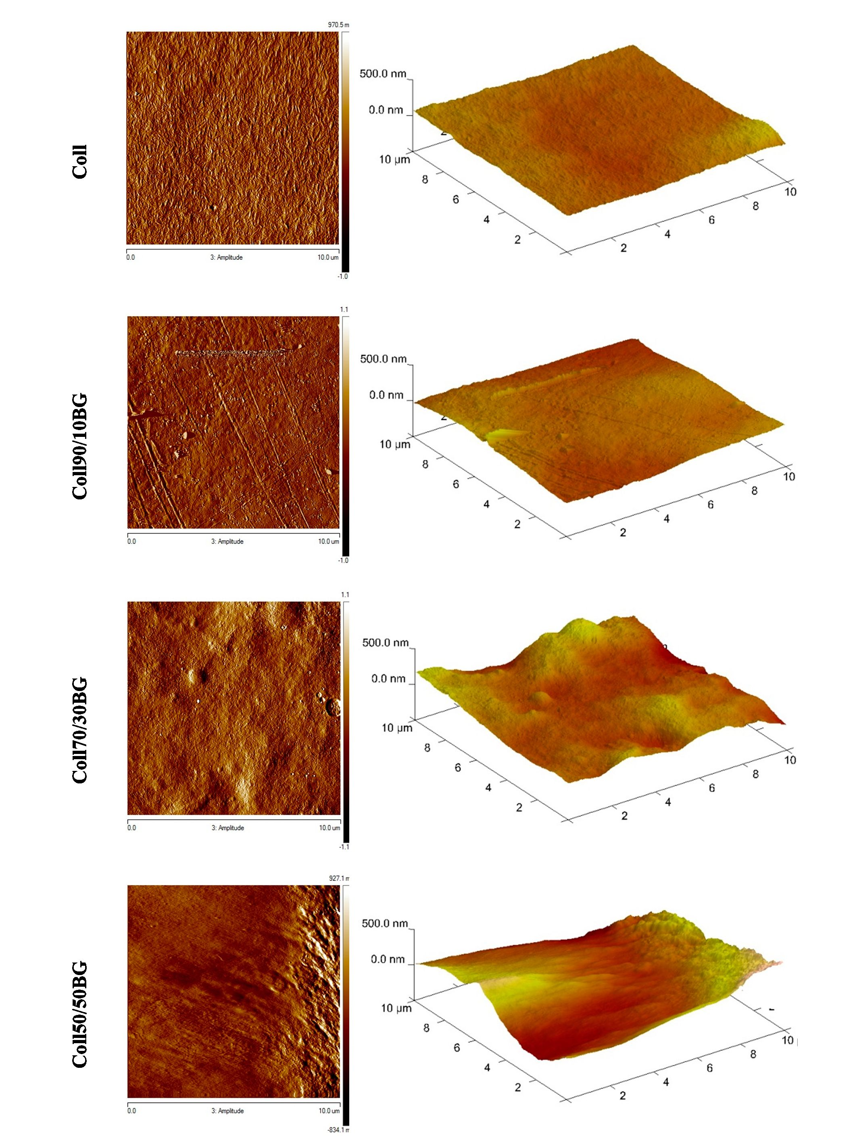
Materials 2021, 14, 1322
8 of 17
Figure 3. Pictures of structure morphology of collagen and collagen/(3-glucan films.
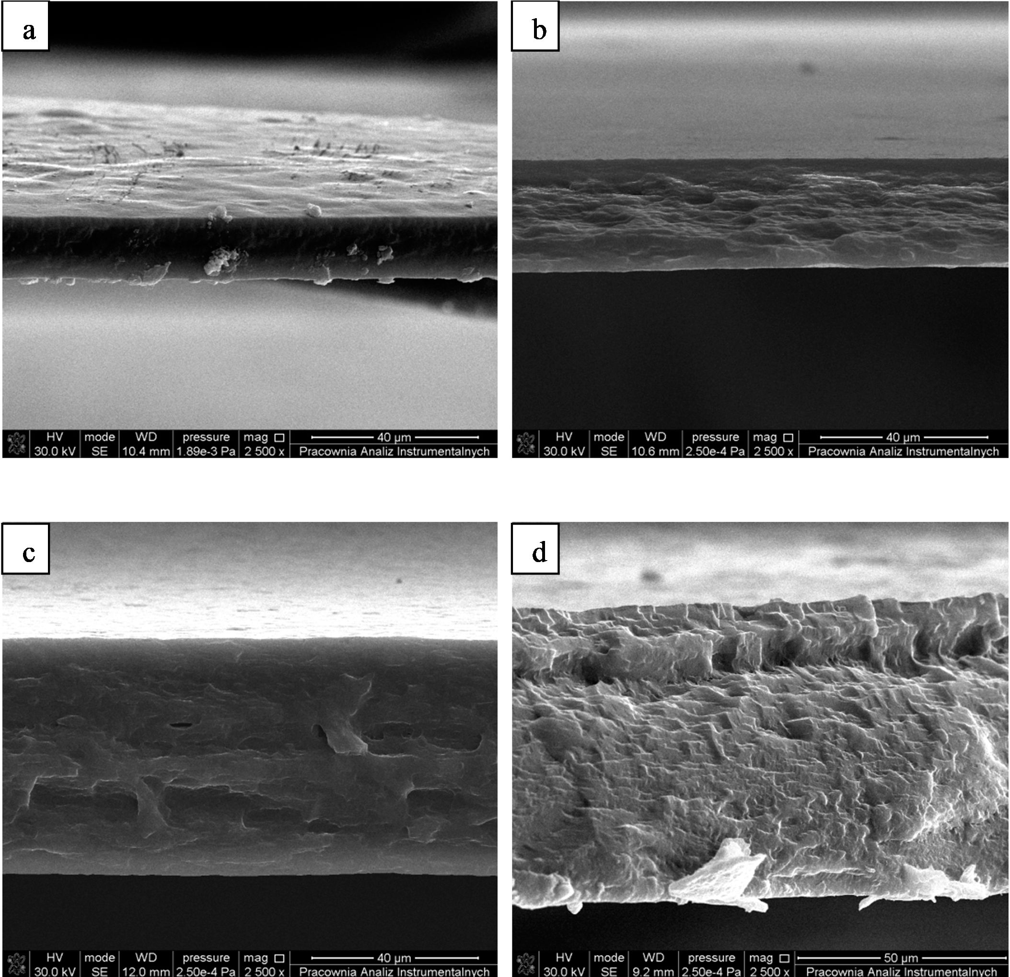
Materials 2021,14, 1322
9 of 17
  - Scanning Electron Microscopy
Scanning electron microscopy (SEM) images of a cross-section of collagen and collagen/13-
glucan materials are presented in Figure 4. Based on SEM images, dense morphology of
collagen/ |3-glucan materials was observed. 'Thee materials were compact and non-porous
structure was visible. Moreover, the blends of those two polymers were homogeneous.
Layered structure and precipitation were not observed. The cross-section st-ucture was a
result of fractoring the materials.
Figure 4. Scanning electron microscopy (SEM) images of materials' cross-section: (a) Coll, (lb) Coll90/10BG, (c) Coll70/30BG,
(d) Coll50/50BG.
  - Contact Angle
For polymer materials, the Owens-Wendt method is otten uted to catculate the surface
free energy and its polar and dispersion components. Free surface energy determines the
potential application of the material, and its components provide more detailed information
Materials 2021,14,1322
10 of 17
about the studied surface [31]. The results of contact angle measurements are shown in
Table 3.
Table 3. Surface free energy (y) and its polar (ydp) and dispersive (yds) components for collagen materials modified with
P-glucan.
Specimen | 0Q (°) | 0D (°) | Y (mJ/m2) | Ydp (mJ/m2) | Yds (mJ/m2) | Ydp/Yds
Coll | 61.90 ± 1.15 | 57.43 ± 0.98 | 36.51 ± 0.37 | 14.46 ± 0.17 | 22.05 ± 0.20 | 0.65
Coll90/10BG | 53.33 ± 0.90 | 54.43 ± 0.59 | 41.61 ± 0.26 | 19.41 ± 0.14 | 22.20 ± 0.12 | 0.87
Coll70 / 30BG | 59.58 ± 0.70 | 54.70 ± 0.18 | 38.33 ± 0.13 | 15.11 ± 0.08 | 23.22 ± 0.04 | 0.65
Coll50/50BG | 59.60 ± 0.10 | 54.54 ± 0.28 | 38.36 ± 0.09 | 15.03 ± 0.03 | 23.33 ± 0.06 | 0.64
The surface free energy for collagen film was 36.5 mJ/m2. Addition of 10% of p-
glucan increased the у value to 41.6 mJ/m2. However, a higher amount of p-glucan
incorporated into matrices, compared to Coll90/10BG, decreased surface free energy to
38.3 mJ/m2. Surface free energy values were the same for 30% and 50% BG addition. The
same situation may be observed for the values of the polar component. ydp for collagen
was 14.5 mJ/m2 and increased for Coll90/10BG to 19.4 mJ/m2. However, the value of
this parameter decreased to approximately 15 mJ/m2 for materials with a higher amount
(>10%) of this polysaccharide. The highest polarity among the selected materials was
for Coll90/10BG because it has the highest polar component of its surface free energy.
The values of dispersive components were similar for all the samples (22-23 mJ/m2).
Calculation of the ydp/Yds ratio makes it easy to tell which material is more hydrophilic.
Materials were characterized by the same value of ydp/Yds ratio, except for Coll90/10BG,
which was the most hydrophilic.

3.6. Antioxidant Properties
DPPH assay is an electron transfer-based method which measures the capacity of
an antioxidant (hydrogen donator) in the reduction of an oxidant. The DPPH method is
frequently used as it allows for quick evaluation of antioxidant properties of samples [32].
The dark purple color of the solution changes to yellow when free radical scavengers exist.
Therefore, the antioxidant activity of samples may be evaluated using a spectrophotometer.
The ability of materials to scavenge DPPH-free radicals is presented in Table 4. After 1 h of
contact, the antioxidant ratio of collagen samples was assessed as 17.7%. For materials with
p-glucan, the antioxidant ratio decrease, and values were within the range 12.7-14.5%.
Table 4. Antioxidant ratio of collagen material modified with P-glucan.
Specimen | Antioxidant Ratio (%)
Coll | 17.7 ± 1.5
Coll90/10BG | 14.5 ± 1.3
Coll70/30BG | 13.8 ± 0.7
Coll50/50BG | 12.7 ± 0.4
Phosphorylated (1^3)-p-D-glucan could scavenge DPPH radicals in the dose-effect
relationship [32]. Hussain et al. noticed that the dose depended on an increase in DPPH
scavenging for gamma-irradiated p-glucan [29]. The antioxidant ratio of yeast p-glucan
was 17.3% and after irradiation of p-glucan, the DPPH scavenging increased with the
irradiation dose [33].

3.7. Swelling Properties
The swelling ratios of collagen materials modified with p-glucan addition are pre-
sented in Table 5. Collagen material without p-glucan addition swelled intensively and the
swelling ratio was 425%. The swelling ratio decreases as p-glucan addition increases. The
lowest swelling ratio was observed for Coll50/50BG and it reached 232%.
Materials 2021,14,1322
11 of 17
Table 5. Swelling ratio of collagen materials with P-glucan addition.
Specimen | Swelling Ratio (%)
Coll | 425.3 ± 41.1
Coll90/10BG | 315.2 ± 33.4
Coll70/30BG | 237.8 ± 33.8
Coll50/50BG | 232.8 ± 5.8
  - Color Change
The parameter L (lightness) for the control sample was higher than that for the tested
film after contact with media (negative values). Prepared materials become darker after
contact with liquids. However, the change is not visible with the naked eye. The ISO
11664-4:2008 standard states that ДЕ > 5 is noticed as a color change. No change of color
was thereby noticed for Coll90/10BG film after NaOH treatment (Table 6). The other
materials change color after liquid application.
Table 6. Color parameters (L—lightness, a—red (+) to green (—), b—yellow (+) to blue (—b), and
ДЕ—total color difference) of the materials.
Specimen |  |  | Solutions
Specimen |  | HCl | NaOH | Water
 | L | -10.48 ± 2.11 | -7.91 ± 1.78 | -9.09 ± 0.92
 | A | 0.41 ± 0.09 | 0.70 ± 0.14 | 1.52 ± 0.19
Coll | B | 2.97 ± 0.73 | 1.84 ± 0.25 | 2.97 ± 0.47
 | ДЕ | 10.90 ± 1.03 | 8.15 ± 0.92 | 9.68 ± 0.37
 | L | -7.82 ± 0.32 | -3.36 ± 0.19 | -12.18 ± 1.23
 | A | 0.73 ± 0.11 | 0.37 ± 0.07 | 1.41 ± 0.09
Coll90/10BG | B | 1.53 ± 0.28 | 2.72 ± 0.16 | 3.49 ± 0.38
 | ДЕ | 7.99 ± 0.32 | 4.33 ± 0.06 | 12.75 ± 0.59
 | L | -12.07 ± 1.07 | -10.06 ± 0.71 | -12.76 ± 1.41
 | A | 1.14 ± 0.09 | 1.25 ± 0.04 | 0.51 ± 0.08
Coll70/30BG | B | 2.10 ± 0.17 | 4.74 ± 0.62 | 2.29 ± 0.71
 | ДЕ | 12.30 ± 0.54 | 11.18 ± 0.36 | 12.97 ± 0.66
 | L | -13.00 ± 1.26 | -12.00 ± 0.92 | -10.24 ± 1.02
 | A | 1.08 ± 0.12 | -0.40 ± 0.02 | 1.26 ± 0.03
Coll50/50BG | B | 3.26 ± 0.22 | 4.40 ± 0.77 | 2.41 ± 0.71
 | ДЕ | 13.44 ± 0.63 | 12.79 ± 0.48 | 10.59 ± 0.51
  - In Vitro Blood Biocompatibility
The in vitro blood biocompatibility is commonly used to evaluate the effect of mate-
rials on the integrity of the red blood cells (erythrocytes). Damaged erythrocytes release
hemoglobin, therefore spectroscopic measurements can be used to detect this [34]. Accord-
ing to the ASTM F756-00 standard, materials with the hemolytic ratio between 0% and 2%
are classified as non-hemolytic, while materials with 2-5% are slightly hemolytic and <5%
are classified as hemolytic [22]. Based on the above, all the tested materials were classified
as non-hemolytic. Collagen showed 0.69% of hemolysis ratio, and with increasing addition
of p-glucan into materials, the hemolysis ratio decreased (Table 7). For Coll50/50BG, the
recorded absorbance value was lower than for the negative control. Therefore, we believe
that Coll50/50BG material may positively affect the stability of blood cells and reduce their
disintegration.
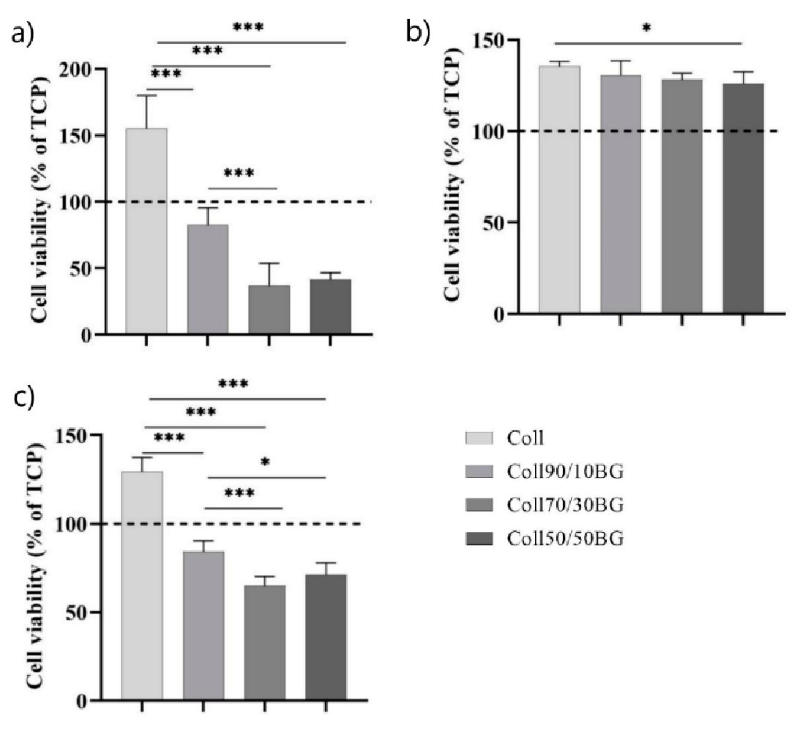
Materials 2021,14,1322
12 of 17
Table 7. Hemolysis ratio calculated for collagen and collagen/P-glucan films.
Specimen | Hemolysis Ratio (%)
Coll | 1.69 ± 0.03
Coll90/10BG | 1.20 ± 0.09
Coll70/30BG | 1.19 ± 0.04
Coll50/50BG | 0*
* measured values of absorbance for tine material were lower thanfor the negative control.

3.10. Cytocompatibility Studies
The cell viability obove 70% is acceptable to regard maCerials as non-cytotoxic/
cytocompatible [35]. Culturing cells for 24 1c directly on the figh skin collagen (Coll)
thereased the “viability of HaCaT cells compared to TCP control (Tigure 5a). The addition of
10% p-glucan lo collagen matrices de crea sed cell viab ility vs. pure collagen matrix, but the
viability of (sells remained close to that on TCP control. In contrast, the addition of higher
concentrations of p-glucan (BG) (30% and 50%) to collagen matrices resultad in cmarked
5ecrecse of cells' viability (36-41% vs. TCP). Notably, all examined material extracts in-
crecse5 cells' viability vs. TCI3 control (Figure fib), probably due to some collagen-related
material degradation products. Cell viablitty was comparable for all studied extracts except
cor cells treated with the extracts from Collo(V50BG, suggesttng that 50% or higher BG
content in the collagen matrix may result in degredation products inhibiting cell growth.
Longer 72 h cultures on pee-incubated materiale (Figure 5c) showed a eimilar trend to
that obtatned after 24 h culture. Direct: culture on the BG-enriched materials significantly
decreased ceh viability. vs. pure collagen matrix, but again, viability of cells cultured for
72 hi on matrices enriched wcth 10% hG was cloce co sha! on TCP control, wharees higher
rantert of BG in collagen matrix resulted in cell viability below 70% vs. TCP oontrol.
Overall, these results suggest that small (i. e., 10%) BG addition to c ollagen matrix is safe
and should 3l(ow cellc to survive a! suffkient number on direct contact with this material.
Moreover, the material dissolution products are certainly not taxic and may actually have
come beneficial effecte on cells.
Figure 5. Viabiitty of HaCaT eells (a) aftea 24 h direct culture on tire materials, (1c) dter 24 is exposure
to the material extracts, and (c( after 72 h direcr culture on the materials that were epre-conaitioned"
for 24 h “with culture medium. 5p m 0.05; *** p < 0.001.
Materials 2021,14,1322
13 of 17

4. Discussion
The mechanical properties of collagen materials improve within the p-glucan concen-
tration. The improvement of mechanical properties after the p-glucan addition was noticed
also for other polysaccharides, such as, e.g., starch and arabinoxylans. Starch was mixed
with p-glucan in ratios of 75/25,50/50, and 25/75, and thin films were prepared from the
obtained mixture [36]. The increase of maximum tensile force has also been noticed for
films with p-glucan addition compared to arabinoxylans-based materials [37]. The increase
of mechanical parameters is related to the glucan ability to absorb water, which enhances
the material flexibility. It is an important factor which results in the improvement of the
properties of the obtained films for their application as wound dressings.
The topography of the prepared materials is homogenous, non-porous, and with the
random collagen fiber distribution. The same situation was observed on SEM pictures by
Jana et al., where aggregated collagen fibers were observed on cross-linked fish collagen [38].
Also, Kozłowska et al. noticed banded collagen fibrils with 67 nm diameter on the surface
of Northern pike collagen film. The topography of their films was much smoother, with
Ra = 5.4 nm [39]. Smoother collagen surface was also observed for rat tail tendon collagen
films, Ra = 3.64 nm and Rq = 4.59 nm [40]. Tang et al. analyzed the structure of tilapia skin
collagen films. They noticed compact, smooth, and homogeneous surface on the upper
side of the film, however fibrous structure was observed on the lower surface [41]. Novák
et al. prepared one-component p-glucan (isolated from Sacharomyces cerevisiae) films [42].
They observed a granular-like structure with a height of the granular particles of about
100 nm. Moreover, as in this work, the material was non-porous. The porous structure is
a crucial feature of materials with biomedical applications. However, they noticed that
p-glucan allows for water and wound exudates to pass through the material, so porosity, in
this case, is not crucial. p-1,3-glucan films were also prepared by Klimek et al. by using the
thermal method and by dialysis [43]. The structure of the material prepared by the thermal
method was smooth, and on the surface of p-glucan material after the dialysis process,
randomly distributed precipitates were observed. Therefore, the process of preparing
materials influences the surface structure.
The results obtained for contact angle measurements suggest that there are fewer
interactions between the reactive groups of those polymers. Thus, the polar groups of
collagen have been hidden below the surface of the film. After the addition of p-glucan
into the matrices, the decrease of contact angle for glycerol was observed. Collagen has
two types of hydrophilic groups—amine and hydroxyl ones. Also, p-glucan has hydroxyl
groups in the structure. The p-glucan addition to collagen results in hydrogen interactions
between their functional groups. The addition of a small amount of p-glucan improves the
film hydrophilicity as more hydroxyl groups are present compared to pure collagen. The
number of interactions increases with an increasing amount of p-glucan. As a result, those
groups are blocked and the decrease of polar components, as well as surface free energy,
is observed. Lewandowska et al. showed that the addition of chitosan (polysaccharide)
into collagen/hyaluronic acid films decreases the contact angle for glycerol [44]. Also,
chitosan mixed with collagen increased the contact angle for glycerol compared to collagen
alone [40]. Surface free energy calculated by other researchers for collagen films from
different sources of collagen were between 31.4 to 38.6 mJ/m2. The values of surface free
energy were similar to our result (36.5 mJ/m2) [31,39,40].
In the case of inflammatory healing, leukocytes in the process of phagocytosis cleanse
the wound of dead and damaged cells as well as pathogens. This process leads to the
overproduction of free radicals, e.g., peroxide anion, hydrogen peroxides, and hydroxyl
anion [45]. The oxygen balance of the cell is maintained by means of enzymes and non-
enzymes to maintain the advancement level. However, if the amount of reactive formed
is greater than the natural ability to eliminate them, it is said to be an oxidative stress.
Excessive levels of free radicals disrupt the control of oxidant/antioxidant cells and cause
enzyme inactivation, DNA nuisance, and lipid peroxidation. It leads to the formation of
damage to the visible skin wound and prolongs its healing process [46]. The antioxidant
Materials 2021,14,1322
14 of 17
properties of carbohydrates are relatively low [47]. Moreover, free-radical scavenging
depends on the molecule's solubility [48]. Sun et al. did not observe the antioxidant
properties of oat p-glucan and suggested that poor solubility of p-glucan was the reason
for low DPPH scavenging [49]. We think that lower DPPH scavenging after p-glucan
addition may be related to the occupation of active hydroxyl groups (hydrogen donors) by
hydrogen binding with the -NH2 collagen group.
Currently, it is believed that wound dressings should provide a moist wound en-
vironment and remove the excess wound exudate [50]. The swelling ratio decreases as
p-glucan addition increases. The opposite situation was observed by Sionkowska et al.,
where after 1 h of incubation in PBS buffer, collagen materials swelled by about 228%, and
after 25% polysaccharide addition (chitosan) into materials composition, the swelling ratio
increased to 572% [51]. The authors observed the highest swelling ratio after crosslinking
collagen/chitosan material with tannic acid (1358%). Collagen scaffold (from fish scale)
cross-linked with glutaraldehyde swelled rapidly by about 380% after 30 min of incubation
in PBS buffer and continued to swell until 410% was achieved [52]. Khan et al. showed
that, depending on the extraction source of p-glucan, swelling properties differed [53].
The p-glucan powder extracted from different species of mushrooms, Agaricus bisporus,
Pleurotus ostreatus, and Coprinus attrimentarious, swelled 345%, 374%, and 449%, respectively.
However, the methodology used in that article was different than ours [54].
The transparent materials allow continuous visualization of the wound bed without
removing the dressing [55]. Therefore, the color change after contact with liquids with
different pH was performed. Materials change color after HCL and water application,
NaOH treatment does not change the color of films. Although an adequate explanation
should appear on the packaging, the color change should not hinder the visual inspection
of the wound. The significant color change was noticed by Chang after the p-glucan
addition to polysaccharide in the form of pullulan [54]. Similar results were obtained by
Kurek, where p-glucan was added to the starch [56]. The decrease of the L parameter was
noticed as the increase of a and b parameters. It has been assumed that the presence of
interactions between polymers and p-glucan plays an important role. We observed that
the presence of hydrogen interactions between collagen and p-glucan results in the form of
a more yellowish film.
We noticed that blood compatibility of materials with p-glucan was slightly better
compared to collagen alone. Tan et al. observed better blood compatibility of collagen
after dialdehyde carboxymethyl cellulose addition [57]. They suggest that the lower
hemolysis ratio was achieved due to reducing the active group (-NH2) by the crosslinking
effect. Culturing cells on the Hypophthalmichthys nobilis-isolated collagen increased the
proliferation of HaCaT cells after 24 h compared to the control (TCP). Zhou et al. showed
that the tilapia collagen nanofibers promoted cell adhesion and proliferation, increasing
the proliferation rate of HaCat cells to 114% [12]. Hydrogel based on p-glucan allow
for drug release and show no cytotoxicity against L929 cells. Furthermore, compared to
traditional materials (like gauze, bandages), materials based on p-glucan can provide the
moist environment of the wound bed and accelerate the healing process [19]. An in vivo
study shows that p-glucan increased the epithelialization and wound contraction in the
modified diabetic male mice [58]. In our study, the best biological properties were found for
collagen material with cell viability ca. 160% compared to TCP control after 24 h incubation.
This is not surprising, as collagen is a natural component of the extracellular matrix of
several tissues and enhances cells' attachment, spreading, and growth. BG addition to such
collagen matrix may affect cell growth compared to pure collagen film, but our results
show that small BG content is not toxic to the cells on direct contact with such BG-enriched
matrices and the degradation products from such BG-enriched materials have similar
to pure collagen matrix and beneficial effects on the cells. Thus, Coll90/10BG display
optimum parameters to be used for further study as potential drug carriers.
Materials 2021,14,1322
15 of 17

5. Conclusions
Collagen from fish can be mixed with p-glucan and prepared in the form of thin films
by using the solvent casting method. We have determined that p-glucan and collagen were
bound together by a hydrogen bond. It is assumed that the hydrogen bond between the
hydroxyl group of p-glucan and amine group of collagen protects materials from showing
hemolytic activity. Also, due to this type of bonding, the antioxidant properties of films
slightly decrease. p-glucan addition increased roughness of material surfaces and resulted
in a more rigid character of the materials. All the materials could swell in vitro, and a small
addition of p-glucan provided a more hydrophilic character of the surfaces. Finally, our
cytotoxicity studies indicated that BG can be safely added at small (10% or less) quantities
to collagen matrix, they sufficiently support cell growth, and the dissolution products of
such matrices may actually provide some beneficial effects to the surrounding cells/tissues.
Author Contributions: Conceptualization: M.M.-S.; conceptualization of biological studies: A.M.O.;
investigation: M.M.-S., B.K.-S., K.Ł. and O.W., writing—original draft preparation: M.M.-S.; writing—
review and editing: B.K.-S., K.Ł., M.W. and A.M.O.; supervision: M.W. and A.M.O.; funding acquisi-
tion: M.M.-S. and A.M.O.; comments to revision: M.M.-S., A.M.O., B.K.-S., K.Ł. and O.W. All authors
have read and agreed to the published version of the manuscript.
Funding: This research was funded by the National Science Centre, Poland, Grant Nos. 2018/31/N
/ST8/01509 (M.M.-S.) and 2016/21/B/NZ5/00217 (A.M.O.).
Institutional Review Board Statement: Ethical review and approval were waived for this study, due
to these fish skins involved in this study are by-products from food production-they are waste, and
the human keratynocytes cell line HaCaT was provided by commercial source and the manufacturer
information has been added.
Informed Consent Statement: Not applicable.
Data Availability Statement: The data presented in this study are available on request from the
corresponding author.
Conflicts of Interest: The authors declare no conflict of interest.

References
- Silvipriya, K.; Kumar, K.; Bhat, A.; Kumar, B.; John, A.; Lakshmanan, P. Collagen: Animal Sources and Biomedical Application. J.
Appl. Pharm. Sci. 2015, 5,123-127. [CrossRef]
- Makuszewska, M.; Bonda, T.; Cieślińska, M.; Bialuk, I.; Winnicka, M.M.; Skotnicka, B.; Hassmann-Poznańska, E. Expression of
collagens type I and V in healing rat's tympanic membrane. Int. J. Pediatr. Otorhinolaryngol. 2019,118, 79-83. [CrossRef] [PubMed]
- Arumugam, G.K.S.; Sharma, D.; Balakrishnan, R.M.; Babu, J.; Ettiyappan, P. Extraction, optimization and characterization of
collagen from sole fish skin. Sustain. Chem. Pharm. 2018, 9,19-26. [CrossRef]
- Ahmed, R.; Getachew, A.T.; Cho, Y.J.; Chun, B.S. Application of bacterial collagenolytic proteases for the extraction of type I
collagen from the skin of bigeye tuna (Thunnus obesus). LWT 2018, 89, 44-51. [CrossRef]
- Tan, Y.; Chang, S.K.C. Isolation and characterization of collagen extracted from channel catfish (Ictalurus punctatus) skin. Food
Chem. 2018, 242,147-155. [CrossRef]
- Bruno, S.F.; Ekorong, F.J.A.A.; Karkal, S.S.; Cathrinea, M.S.B.; Kudre, T.G. Green and innovative techniques for recovery of
valuable compounds from seafood by-products and discards: A review. Trends Food Sci. Technol. 2019, 85,10-22. [CrossRef]
- Kumar, K.K.; Singh, S.; Chakraborthy, S.; Das, J.; Bajaj, M.; Hemanth, V.; Nair, M.; Thota, L.; Banerjee, P. Recycling fish skin for
utilization in food industry as an effective emulsier and foam stabilizing agent. Turk. J. Biochem. 2019, 44, 332-343. [CrossRef]
- Wasswa, J.; Tang, J.; Gu, X. Utilization of Fish Processing By-Products in the Gelatin Industry. Food Rev. Int. 2007, 23,159-174.
[CrossRef]
- Jayathilakan, K.; Sultana, K.; Radhakrishna, K.; Bawa, A.S. Utilization of byproducts and waste materials from meat, poultry and
fish processing industries: A review. Food Sci. 2012, 49, 278-293. [CrossRef]
- Tayel, A.A.; Ghanem, R.A.; Moussa, S.H.; Fahmi, M.; Tarjam, H.M.; Ismail, N. Skin protectant textiles loaded with fish collagen,
chitosan and oak galls extract composite. Macromolecules 2018,117, 25-29. [CrossRef]
- Moura, L.I.F.; Dias, A.M.A.; Suesca, E.; Casadiegos, S.; Leal, E.C.; Fontanilla, M.R.; Carvalho, L.; de Sousa, H.C.; Carvalhoa, E.
Neurotensin-loaded collagen dressings reduce inflammation and improve wound healing in diabetic mice. Biochim. Biophys. Acta
Mol. Basis Dis. 2014,1842, 32-43. [CrossRef]
- Zhou, T.; Wang, N.; Xue, Y.; Ding, T.; Liu, X.; Mo, X.; Sun, J. Electrospun tilapia collagen nanofibers accelerating wound healing
via inducing keratinocytes proliferation and differentiation. Colloids Surf. B 2016,143, 415-422. [CrossRef]
Materials 2021,14,1322
16 of 17
- Sionkowska, A.; Lewandowska, K.; Michalska, M.; Walczak, M. Characterization of silk fibroin 3D composites modified by
collagen. J. Mol. Liq. 2016,215, 323-327. [CrossRef]
- Khan, A.A.; Gani, A.; Khanday, F.A.; Masoodi, F.A. Biological and pharmaceutical activities of mushroom в-glucan discussed as
a potential functional food ingredient. Bioact. Carbohydr. Diet. Fibre 2018,16,1-13. [CrossRef]
- Grip, J.; Engstad, R.E.; Skjmveland, I.; Skalko-Basnet, N.; Holsmter, A.M. Sprayable Carbopol hydrogel with soluble beta-1,3/1,6-
glucan as an active ingredient for wound healing-Development andin-vivoevaluation. Eur. J. Pharm. Sci. 2017, 107,24-31.
[CrossRef] [PubMed]
- Maheshwari, G.; Sowrirajan, S.; Joseph, B. Extraction and isolation of p-glucan from grain Sources—A Review. J. Food Sci. 2017,
82,1535-1545. [CrossRef]
- Hosary, R.E.; El-Mancy, S.M.; El Deeb, K.S.; Eid, H.H.; Tantawy, M.E.E.; Shams, M.M.; Samir, R.; Assar, N.H.; Sleem, A.A. Efficient
wound healing composite hydrogel using Egyptian Avena sativa L. polysaccharide containing p-glucan. Int. J. Biol. Macromol.
2019,149,1331-1338. [CrossRef]
- Delatte, S.J.; Evans, J.; Hebra, A.; Adamson, W.; Othersen, H.B.; Tagge, E.P. Effectiveness of beta-glucan collagen for treatment of
partial-thickness burns in children. J. Pediatr. Surg. 2001, 36,113-118. [CrossRef] [PubMed]
- de Jesus, L.I.; Smiderle, F.R.; Ruthes, A.C.; Vilaplana, F.; Dal'Lin, F.T.; Maria-Ferreira, D.; Werner, M.F.; Van Griensven, L.J.L.D.;
Iacomini, M. Chemical characterization and wound healing property of a P-D-glucan from edible mushroom Piptoporus betulinus.
Int. J. Biol. Macromol. 2018,117,1361-1366. [CrossRef] [PubMed]
- Sionkowska, A.; Kozłowska, J.; Skorupska, M.; Michalska, M. Isolation and characterization of collagen from the skin of Brama
australis. Int. J. Biol. Macromol. 2015, 80, 605-609. [CrossRef]
- Michalska-Sionkowska, M.; Walczak, M.; Sionkowska, A. Antimicrobial activity of collagen material with thymol addition for
potential application as wound dressing. Polym. Test. 2017, 63, 360-366. [CrossRef]
- Walczak, M.; Michalska-Sionkowska, M.; Kaczmarek, B.; Sionkowska, A. Surface and antibacterial properties of thin films based
on collagen and thymol. Mater. Today Commun. 2020,22,100949. [CrossRef]
- Zare-Gachi, M.; Daemi, H.; Mohammadi, J.; Baei, P.; Bazgir, F.; Hosseini-Salekdeh, S.; Baharvand, H. Improving anti-hemolytic,
antibacterial and wound healing properties of alginate fibrous wound dressings by exchanging counter-cation for infected
full-thickness skin wounds. Mater. Sci. Eng. C 2020,107,110321. [CrossRef] [PubMed]
- Sun, J.; Jiang, H.; Wu, H.; Tong, C.; Pang, J. Multifunctional bionanocomposite films based on konjac glucomannan/chitosan with
nano-ZnO and mulberry anthocyanin extract for active food packaging. Food Hydrocoll. 2020,107,105942. [CrossRef]
- Zhou, H.Y.; Zhang, Y.P.; Zhang, W.F.; Chen, X.G. Biocompatibility and characteristics of injectable chitosan-based thermosensitive
hydrogel for drug delivery. Carbohydr. Polym. 2011, 83,1643-1651. [CrossRef]
- Boukamp, P.; Petrussevska, R.T.; Breitkreutz, D.; Hornung, J.; Markham, A.; Fusening, N.E. Normal keratirnzation in a sponta-
neously immortalized aneuploid human keratinocyte cell line. J. Cell Biol. 1988,106, 761-771. [CrossRef]
- Upadhyay, T.K.; Fatima, N.; Sharma, D.; Saravanakumar, V.; Sharma, R. Preparation and characterization of P-glucan particles
containing a payload of nanoembedded rifabutin for enhanced targeted delivery to macrophages. EXCLI J. 2017,16, 210-228.
[PubMed]
- Sun, C.; Jin, L.; Cai, Y.; Zheng, X.; Yu, T. (1^3)-P-D-glucan from yeast cell wall: Characteristic and potential application in
controlling postharvest disease of pear. Postharvest Biol. Technol. 2019,154,105-114. [CrossRef]
- Hussain, P.R.; Rather, S.A.; Suradkar, P.P. Structural characterization and evaluation of antioxidant, anticancer and hypoglycemic
activity of radiation degraded oat (Avena sativa) p-glucan. Radiat. Phys. Chem. 2018,144, 218-230. [CrossRef]
- Sionkowska, A. Interaction of collagen and poly(vinyl pyrrolidone) in blends. Eur. Polym. J. 2003, 39, 2135-2140. [CrossRef]
- Skopmska-Wismewska, J.; Sionowska, A.; Kaminska, A.; Kaznica, A.; Jachimiak, R.; Drewa, T. Surface characterization of
collagen/elastin based biomaterials for tissue regeneration. Appl. Surf. Sci. 2009, 255, 8286-8292. [CrossRef]
- Mei, X.; Tang, Q.; Huang, G.; Long, R.; Huang, H. Preparation, structural analysis and antioxidant activities of phosphorylated
(1^3)-p-d-glucan. Food Chem. 2020, 30,125791. [CrossRef]
- Khan, A.A.; Gania, A.; Masoodi, F.A.; Amin, F.; Wani, I.A.; Khanday, F.A.; Gani, A. Structural, thermal, functional, antioxidant
& antimicrobial properties of P-d-glucan extracted from baker's yeast (Saccharomyces cereviseae)—Effect of y-irradiation.
Carbohydr. Polym. 2016,140, 442-450. [PubMed]
- Soares, E.; Cordeiro, R.; Faneca, H.; Borges, O. Polymeric nanoengineered HBsAg DNA vaccine designed in combination with
P-glucan. Int. J. Biol. Macromol. 2019,122, 930-939. [CrossRef] [PubMed]
- Gamez-Herrera, E.; Garcia-Salinas, S.; Salido, S.; Sanchelo-Albero, M.; Andreu, V.; Perez, M.; Lujan, L.; Irusta, S.; Arruebo, M.;
Mendoza, G. Drug-eluting wound dressings having sustained release of antimicrobial compounds. Eur. J. Pharm. Biopharm. 2020,
152, 327-339. [CrossRef] [PubMed]
- Sagnelli, D.; Kirkensgaard, J.J.K.; Giosafatto, C.V.L.; Ogrodowicz, N.; Kruczała, K.; Mikkelsen, M.S.; Maigret, J.E.; Lourdin, D.;
Mortensen, K.; Blennow, A. All-natural bio-plastics using starch-betaglucan composites. Carbohydr. Polym. 2017,172, 237-245.
[CrossRef] [PubMed]
- Ying, R.; Rondeau-Mouroa, C.; Barron, C.; Mabille, F.; Perronnet, A.; Saulnier, L. Hydration and mechanical properties of
arabinoxylans and p-d-glucans films. Carbohydr. Polym. 2013, 96, 31-38. [CrossRef] [PubMed]
Materials 2021,14,1322
17 of 17
- Jana, P.; Mitra, T.; Selvaraj, T.K.R.; Gnanamani, A.; Kundu, P.P. Preparation of guar gum scaffold film grafted with ethylenediamine
and fish scale collagen, cross-linked with ceftazidime for wound healing application. Carbohydr. Polym. 2016, 153, 573-581.
[CrossRef]
- Kozlowska, J.; Sionkowska, A.; Skopmska-Wismewska, J.; Piechowicz, K. Northern pike (Esox lucius) collagen: Extraction,
characterization and potential application. Int. J. Biol. Macromol. 2015, 81, 220-227. [CrossRef]
- Kaczmarek, B.; Sionkowska, A.; Skopinska-Wisniewska, J. Influence of glycosaminoglycans on the properties of thin films based
on chitosan/collagen blends. J. Mech. Behav. Biomed. 2018, 80,189-193. [CrossRef]
- Tang, L.; Chen, S.; Su, W.; Weng, W.; Osako, K.; Tanaka, M. Physicochemical properties and film-forming ability of fish skin
collagen extracted from different freshwater species. Process. Biochem. 2015, 50,148-155. [CrossRef]
- Novák, M.; Synytsya, A.; Gedeon, O.; Slepicka, P.; Procházka, V.; Synytsya, A.; Blahovec, J.; Hejlová, A.; Copíková, J. Yeast
|3(1-3),(1-6)-d-glucan films: Preparation and characterization of some structural and physical properties. Carbohydr. Polym. 2012,
87, 2496-2504. [CrossRef]
- Klimek, K.; Przekora, A.; Benko, A.; Niemiec, W.; Blazewicz, M.; Ginalska, G. The use of calcium ions instead of heat treatment
for |3-1,3-glucangelation improves biocompatibility of the |3-1,3-glucan/HA bone scaffold. Carbohydr. Polym. 2017,164,170-178.
[CrossRef] [PubMed]
- Lewandowska, K.; Sionkowska, A.; Grabska, S.; Kaczmarek, B. Surface and thermal properties of collagen/hyaluronic acid blends
containing chitosan. Int. J. Biol. Macromol. 2016, 92, 371-376. [CrossRef] [PubMed]
- Agyare, C.; Dwobeng, A.S.; Agyepong, N.; Boakye, Y.D.; Mensah, K.B.; Ayande, P.G.; Adarkwa-Yiadom, M. Antimicrobial,
antioxidant, and wound healing properties of kigelia africana (Lam.) Beneth and Strophanthus hispidus DC. Adv. Pharmacol. Sci.
2013, 2013,1-10.
- He, J.; Liang, Y.; Shi, M.; Guo, B. Anti-oxidant electroactive and antibacterial nanofibrous wound dressings based on poly(e-
caprolactone)/quaternized chitosan-graft-polyaniline for full-thickness skin wound healing. Chem. Eng. Trans. 2020, 385,123464.
[CrossRef]
- Kagimura, F.Y.; da Cunha, M.A.A.; Theis, T.V.; Malfatti, C.R.M.; Dekker, R.F.H.; Barbosa, A.M.; Teixeira, S.D.; Salomé, K.
Carboxymethylation of (1^6)-|3-glucan (lasiodiplodan): Preparation, characterization and antioxidant evaluation. Carbohydr.
Polym. 2015,127, 390-399. [CrossRef] [PubMed]
- Ker, Y.B.; Chen, K.C.; Chyau, C.C.; Chen, C.C.; Guo, J.H.; Hsieh, C.L.; Wang, H.E.; Peng, C.C.; Chang, C.H.; Peng, R.Y. Antioxidant
capability of polysaccharides fractionated from submerge-cultured Agaricus blazei mycelia. J. Agric. Food Chem. 2005, 53, 7052-7058.
[CrossRef] [PubMed]
- Sun, T.; Li, J.; Qin, Y.; Xie, J.; Xue, B.; Li, X.; Gan, J.; Bian, X.; Shao, Z.H. Rheological and functional properties of oat b-glucan with
different molecular weight. J. Mol. Struct. 2020,1209,127944. [CrossRef]
- Hu, S.; Cai, X.; Qu, X.; Yu, B.; Yan, C.; Yang, J.; Li, F.; Zheng, Y.; Shi, X. Preparation of biocompatible wound dressings with
long-term antimicrobial activity through covalent bonding of antibiotic agents to natural polymers. Int. J. Biol. Macromol. 2019,
123,1320-1330. [CrossRef] [PubMed]
- Sionkowska, A.; Kaczmarek, B.; Lewandowska, K. Modification of collagen and chitosan mixtures by the addition of tannic acid.
J. Mol. Liq. 2014,199, 318-323. [CrossRef]
- Pal, P.; Srivas, P.K.; Dadhich, P.; Das, B.; Maity, P.P.; Moulik, D.; Dhara, S. Accelerating full thickness wound healing using collagen
sponge of mrigal fish (Cirrhinus cirrhosus) scale origin. Int. J. Biol. Macromol. 2016, 93,1507-1518. [CrossRef] [PubMed]
- Khan, A.A.; Gani, A.; Masoodi, F.A.; Mushtaq, U.; Naik, A.S. Structural, rheological, antioxidant, and functional properties
of в-glucan extracted from edible mushrooms Agaricus bisporus, Pleurotus ostreatus and Coprinus attrimentarius. Bioact.
Carbohydr. Diet. Fibre. 2017,11, 67-74. [CrossRef]
- Chang, J.; Li, W.; Liu, Q.; Zhou, Y.; Chen, X.; Lyu, Q.; Liu, G. Preparation, properties, and structural characterization of
в-glucan/pullulan blend films. Int. J. Biol. Macromol. 2019,140,1269-1276. [CrossRef] [PubMed]
- Tabaii, M.J.; Emtiazi, G. Transparent nontoxic antibacterial wound dressing based on silver nano particle/bacterial cellulose nano
composite synthesized in the presence of tripolyphosphate. J. Drug Deliv. Sci. Technol. 2018, 44, 244-253. [CrossRef]
- Kurek, M.A.; Moczkowska, M.; Pieczykolan, E.; Sobieralska, M. Barley |3-d-glucan—Modified starch complex as potential
encapsulation agent for fish oil. Int. J. Biol. Macromol. 2018,120, 596-602. [CrossRef]
- Tan, H.; Wu, B.; Li, C.; Mu, C.; Li, H.; Lin, W. Collagen cryogel cross-linked by naturally derived dialdehyde carboxymethyl
cellulose. Carbohydr. Polym. 2015,129,17-24. [CrossRef] [PubMed]
- Huang, M.H.; Yang, M.C. Evaluation of glucan/poly(vmyl alcohol) blend wound dressing using rat models. Int. J. Pharm. 2008,
346, 38-46. [CrossRef]

