PHYSICAL REVIEW D 91, 112016 (2015)

Search for massive supersymmetric particles decaying to many jets
using the ATLAS detector in pp collisions at y/s = 8 TeV
*
- Aad et al.
(ATLAS Collaboration)
(Received 19 February 2015; published 29 June 2015)
Results of a search for decays of massive particles to fully hadronic final states are presented. This search
uses 20.3 fb-1 of data collected by the ATLAS detector in y/s = 8 TeV proton-proton collisions at the
LHC. Signatures based on high jet multiplicities without requirements on the missing transverse
momentum are used to search for R-parity-violating supersymmetric gluino pair production with
subsequent decays to quarks. The analysis is performed using a requirement on the number of jets, in
combination with separate requirements on the number of b-tagged jets, as well as a topological observable
formed from the scalar sum of the mass values of large-radius jets in the event. Results are interpreted in the
context of all possible branching ratios of direct gluino decays to various quark flavors. No significant
deviation is observed from the expected Standard Model backgrounds estimated using jet counting as well
as data-driven templates of the total-jet-mass spectra. Gluino pair decays to ten or more quarks via
intermediate neutralinos are excluded for a gluino with mass mg < 1 TeV for a neutralino mass
o = 500 GeV. Direct gluino decays to six quarks are excluded for mg < 917 GeV for light-flavor
final states, and results for various flavor hypotheses are presented.
DOI: 10.1103/PhysRevD.91.112016 PACS numbers: 12.60.Jv, 11.30.Pb, 12.38.Qk, 13.87.-a

I. INTRODUCTION
Supersymmetry (SUSY) [1-9] is a theoretical extension
of the Standard Model (SM) which fundamentally relates
fermions and bosons. It is an alluring theoretical possibility
given its potential to solve the naturalness problem [10-15]
and to provide a dark-matter candidate [16,17]. Partially as
a result of the latter possibility, most searches for SUSY
focus on scenarios such as a minimal supersymmetric
standard model (MSSM) in which R-parity is conserved
(RPC) [18-21]. In these models, SUSY particles must be
produced in pairs and must decay to a stable lightest
supersymmetric particle (LSP). With strong constraints
now placed on standard RPC SUSY scenarios by the
experiments at the Large Hadron Collider (LHC), it is
important to expand the scope of the SUSY search program
and explore models where R-parity may be violated and the
LSP may decay to SM particles, particularly as these
variations can alleviate to some degree the fine-tuning
many SUSY models currently exhibit [22].
In R-parity-violating (RPV) scenarios, many of the
constraints placed on the MSSM in terms of the allowed
parameter space of gluino (g) and squark (q) masses are
relaxed. The reduced sensitivity of standard SUSY searches
to RPV scenarios is due primarily to the high missing
*Full author list given at the end of the article.
Published by the American Physical Society under the terms of
the Creative Commons Attribution 3.0 License. Further distri-
bution of this work must maintain attribution to the author(s) and
the published article’s title, journal citation, and DOI.
transverse momentum (Rm^8) requirements used in the
event selection common to many of those searches. This
choice is motivated by the assumed presence of two weakly
interacting and therefore undetected LSPs. Consequently,
the primary challenge in searches for RPV SUSY final
states is to identify suitable substitutes for the canonical
large £mss signature of RPC SUSY used to distinguish
signals from background processes. Common signatures
used for RPV searches include resonant lepton pair
production [23-25], exotic decays of long-lived particles,
and displaced vertices [26-29].
New analyses that do not rely on £mss are required in
order to search for fully hadronic final states involving RPV
gluino decays directly to quarks or via ;~0 neutralinos as
shown in the diagrams in Fig. 1. Cases in which pair-
produced massive new particles decay directly to a total
of six quarks, as well as cascade decays with at least ten
quarks, are considered. Three-body decays of the type
shown in Fig. 1 are given by effective RPV vertices allowed
by the baryon-number-violating X" couplings as described
in Sec. II with off-shell squark propagators. This analysis is
an extension of the search conducted at s = 7 TeV for
the pair production of massive gluinos, each decaying
directly into three quarks [30].
The diagrams shown in Fig. 1 represent the benchmark
processes used in the optimization and design of the
search presented in this paper. The extension to considering
cascade decays of massive particles creates the potential
for significantly higher hadronic final-state multiplicities
and motivates a shift in technique with respect to previous
searches. Therefore, the analysis is extended to look
1550-7998/2015/91(11)/112016(37)
112016-1
© 2015 CERN, for the ATLAS Collaboration
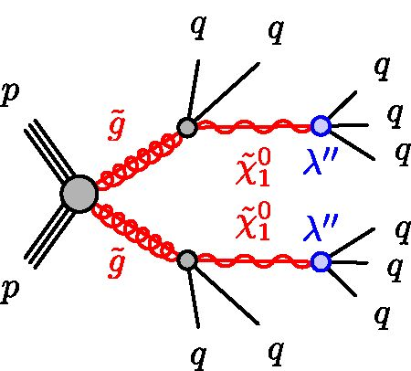
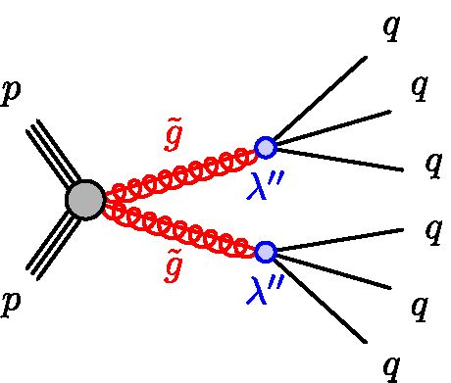
G. AAD et al.
FIG. 1 (color online). Diagrams for the benchmark processes
considered for this analysis. The solid black lines represent
Standard Model particles, the solid red lines represent SUSY
partners, the gray shaded circles represent effective vertices that
include off-shell propagators (e.g. heavy squarks coupling to a
neutralino and a quark), and the blue shaded circles represent
effective RPV vertices allowed by the baryon-number-violating
X00 couplings with off-shell propagators (e.g. heavy squarks
coupling to two quarks).
for events characterized by much higher reconstructed jet
multiplicities as well as with event topologies representa-
tive of these complex final states. Two complementary
search strategies are thus adopted: a jet-counting analysis
that searches for an excess of >6-jet or >7-jet events, and a
data-driven template-based analysis that uses a topological
observable called the total jet mass of large-radius (large-R)
jets. The former exploits the predictable scaling of the
number of n-jet events (n = 6,7) as a function of the
transverse momentum (pT) requirement placed on the nth
leading jet in pT for background processes. This analysis is
sensitive to the models presented here because this scaling
relation differs significantly between the signal and the
background. The latter analysis uses templates of the event-
level observable formed by the scalar sum of the four
leading large-R jet masses in the event, which is signifi-
cantly larger for the signal than for the SM backgrounds.
This paper is organized as follows: Sec. II describes the
motivation and theoretical underpinnings of the benchmark
processes used in this analysis. Section III and Sec. IV
present details of the detector, the data collection and
selection procedures, and the Monte Carlo (MC) simulation
samples used for this search. The physics object definitions
used to identify and discriminate between signal and
background are described in Sec. . The details of the
methods are separated for the two analyses employed.
The jet-counting analysis is presented in Sec. VI, while the
total-jet-mass analysis using more advanced observables is
presented in Sec. VII. The combined results of this search
and the final sensitivity to the benchmark processes are then
described in Sec. VIII. The results using the total-jet-mass
analysis are presented first, in Sec. VIII A, as they only
apply to the ten-quark final states. The jet-counting analysis
additionally yields interpretations across the flavor struc-
ture allowed by the X" couplings. This comprehensive set of
results is presented in Sec. VIIIB. Comparisons between
the two analyses are then made in Sec. VIIIC.
PHYSICAL REVIEW D 91, 112016 (2015)

II. R-PARITY-VIOLATING SUPERSYMMETRY
AND BARYON-NUMBER VIOLATION
The benchmark model used to interpret the results of
the search for high multiplicity hadronic final states is the
baryon-number-violating RPV SUSY scenario. The RPV
component of the generic supersymmetry superpotential
can be written as [31,32]
WRp = 2 XijkLiLjEk + XijkLiQjDk
+ 2 AjkUiDjDk + KiLiH2, (1)
where i, j, k = 1,2, 3 are generation indices. The gener-
ation indices are sometimes omitted in the discussions that
follow if the statement being made is not specific to any
generation. The first three terms in Eq. (1) are often referred
to as the trilinear couplings, whereas the last term is
bilinear. The Li, Qi represent the lepton and quark
SU(2)l doublet superfields, whereas H2 is the Higgs
superfield. The Ej, Dj, and Uj are the charged lepton,
down-type quark, and up-type quark SU(2)L singlet super-
fields, respectively. The Yukawa couplings for each term
are given by X, X0, and X", and k is a dimensionful mass
parameter. In general, the particle content of the RPV
MSSM is identical to that of the RPC MSSM but with the
additional interactions given by Wr .
Generically, the addition of Wr into the overall SUSY
superpotential allows for the possibility of rapid proton
decay. The simultaneous presence of lepton-number-
violating (e.g. X0 ^ 0) and baryon-number-violating oper-
ators (X00 ^ 0) leads to proton decay rates larger than
allowed by the experimental limit on the proton lifetime
unless, for example [33],
X1ik • 510-23 (iStGy)2, (2)
where is the typical squark mass. As a result, even when
considering this more generic form of the SUSY super-
potential by including Wr , it is still necessary to impose an
ad hoc, albeit experimentally motivated, symmetry to
protect the proton from decay. It is generally necessary
that at least one of X, X0, X00 be exactly equal to zero.
Consequently, it is common to consider each term in Eq. (1)
independently. In the case of nonzero X and X0, the typical
signature involves leptons in the final state. However, for
Xijk ^ 0, the final state is characterized by jets, either from
direct gluino decay or from the cascade decay of the gluino
to the lightest neutralino (~2), as also considered here.
Because of the structure of Eq. (1), scenarios in which only
Xijk ^ 0 are often referred to as UDD scenarios.
Current indirect experimental constraints [34] on the
sizes of each of the UDD couplings Xi0jk from sources other
112016-2
SEARCH FOR MASSIVE SUPERSYMMETRIC PARTICLES
PHYSICAL REVIEW D 91, 112016 (2015)
than proton decay are valid primarily for low squark
masses, as suggested by Eq. (2). Those limits are driven
by double nucleon decay [35] (for X012), neutron oscil-
lations [36] (for X/1/13), and Z boson branching ratios [37].
Hadron collider searches are hindered in the search for
an all-hadronic decay of new particles by the fact that the
SM background from multijet production is very high.
Nonetheless, searches have been carried out by several
collider experiments. The CDF Collaboration [38]
excluded gluino masses up to 240 GeV for light-flavor
models. The CMS Collaboration [39] excludes such
gluinos up to a mass of 650 GeV and additionally sets
limits on some heavy-flavor UDD models. The ATLAS
Collaboration [30] has also previously set limits in a search
for anomalous six-quark production, excluding gluino
masses up to 666 GeV for light-flavor models. The search
presented here uniquely probes the flavor structure of the
UDD couplings and employs new techniques both in
analysis and theoretical interpretation.

III. THE ATLAS DETECTOR
The ATLAS detector [40] provides nearly full solid
angle coverage around the collision point with an inner
tracking system covering the pseudorapidity1 range
|n| < 2.5, electromagnetic (EM) and hadronic calorime-
ters covering |n| < 4.9, and a muon spectrometer
covering |n| < 2.7.
The ATLAS tracking system is composed of a silicon
pixel tracker closest to the beam line, a microstrip silicon
tracker, and a straw-tube transition radiation tracker. These
systems are layered radially around each other in the central
region. A thin solenoid surrounding the tracker provides an
axial 2 T field enabling measurement of charged-particle
momenta.
The calorimeter, which spans the pseudorapidity range
up to |n| = 4.9, is comprised of multiple subdetectors with
different designs. The high granularity liquid argon electro-
magnetic calorimeter system includes separate barrel
(|n| < 1.475), end cap (1.375 < |n| < 3.2), and forward
subsystems (3.1 < |n| < 4.9). The tile hadronic calorimeter
(|n| < 1.7) is composed of scintillator tiles and iron
absorbers. As described below, jets used in the analyses
presented here are typically required to have |n| < 2.8 such
that they are fully contained within the barrel and end cap
calorimeter systems.
A three-level trigger system is used to select events to
record for off-line analysis. The level-1 trigger is
1ATLAS uses a right-handed coordinate system with its origin
at the nominal interaction point (IP) in the center of the detector
and the z-axis along the beam pipe. The x-axis points from the IP
to the center of the LHC ring, and the y-axis points upward.
Cylindrical coordinates (r, <p) are used in the transverse plane,
<p being the azimuthal angle around the beam pipe. The
pseudorapidity is defined in terms of the polar angle 0 as
n = — lntan(0/2).
implemented in hardware and uses a subset of detector
information to reduce the event rate to a design value of at
most 75 kHz during 2012. This is followed by two
software-based triggers, level-2 and the event filter (col-
lectively called the high-level trigger), which together
reduce the event rate to a few hundred Hz. The primary
triggers used in this analysis collected the full integrated
luminosity of the 8 TeV data set with good efficiency for
the event selections described in this paper.

IV. DATA AND MONTE CARLO SAMPLES
The data used in this analysis correspond to 20.3 ±
- 6 fb—1 [41,42] of integrated luminosity taken during
periods in which the data satisfied baseline quality criteria.
Further details of the event selections applied, including the
ATLAS data quality criteria and trigger strategy, are given
in Sec. V. The primary systems of interest in these studies
are the electromagnetic and hadronic calorimeters and the
inner tracking detector. The data were collected with
triggers based on either single-jet or multijet signatures.
The single-jet trigger selection has a transverse momen-
tum threshold of 360 GeV using a large-R anti-kt jet
definition [43] with a nominal radius of R = 1.0 within
the high-level jet trigger. The multijet trigger selection
requires at least six anti-kt R = 0.4 jets with a nominal pT
threshold of 45 GeV in the high-level trigger. Data
collected using several additional multijet requirements
(from three to five jets) are also used for background
estimation studies.
Multiple simultaneous proton-proton (pp) inter-
actions, or pileup, occur in each bunch crossing at the
LHC. The additional collisions occurring in the same and
neighboring bunch crossings with respect to the event of
interest are referred to as in-time and out-of-time pileup,
respectively, and are uncorrelated with the hard-scattering
process.
The benchmark RPV SUSY signal processes of both the
six-quark and ten-quark models (see Sec. I) were simulated
using herwig++ 6.520 [44] for several gluino and neu-
tralino mass hypotheses using the parton distribution
function (PDF) set CTEQ6L1 [45,46]. For both models,
all squark masses are set to 5 TeV and thus gluinos decay
directly to three quarks or to two quarks and a neutralino
through standard RPC couplings. In the ten-quark cascade
decay model, the neutralinos each decay to three quarks via
an off-shell squark and the RPV UDD decay vertex with
coupling X". In this model, the neutralino is the lightest
supersymmetric particle.
Samples are produced covering a wide range of both mg~
and m~0. In the six-quark direct gluino decay model, the
gluino mass is varied from 500 to 1200 GeV. In the case of
the cascade decays, for each gluino mass (400 GeV to
1.4 TeV), separate samples are generated with multiple
neutralino masses ranging from 50 GeV to 1.3 TeV. In each
112016-3
G. AAD et al.
case, m~~0 < mg. In order to ensure the result has minimal
sensitivity to the effects of initial state radiation (ISR),
which could be poorly modeled in the signal samples,2
the region with (mg — m~0) < 100 GeV is not considered.
Due to the potentially large theoretical uncertainty on the
non-SM color flow given by UDD couplings, results are
presented for a single model of radiation and no
systematic uncertainty is assigned for this effect, further
justifying the unevaluated region described above. All
possible Xi0jk flavor combinations given by the structure of
Eq. (1) are allowed to proceed with equal probability. As
discussed in Sec. VIII, the analysis maintains approx-
imately equal sensitivity to all flavor modes. All samples
are produced assuming that the gluino and neutralino
widths are narrow and that their decays are prompt.
Cross-section calculations are performed at next-to-
leading order in the strong coupling constant, adding
the resummation of soft gluon emission at next-to-
leading-logarithmic accuracy (NLO + NLL) [47-51].
Dijet and multijet events, as well as top quark pair
production processes, were simulated in order to study the
SM contributions and background estimation techniques.
In the case of the vastly dominant background from SM jet
production, several MC simulations were compared with
data for the suitability of their descriptions of jet and
multijet kinematic observables and topologies. For signal
region selections that use b-tagging (the identification of
jets containing B-hadrons), other backgrounds such as tt,
single top, and W=Z + jets become significant as well.
These other backgrounds are estimated directly from the
simulation.
In order to develop the data-driven background esti-
mation techniques for multijet events from QCD proc-
esses, comparisons are made among various generators
and tunes. In the case of the jet-counting analysis, the
ATLAS tune AUET2B LO** [52] of pythia 6.426 [53] is
used in estimating the rate of n-jet events (where n = 6,7)
as a function of the jet-pT requirement on the nth jet. For
the total-jet-mass analysis, sherpa 1.4.0 [54] is used to
develop and test the method. For the SHERPA multijet
samples, up to three partons are included in the matrix-
element calculation and no electroweak processes are
included. Heavy (c and b) quarks are treated as massive.
The next largest background after multijets is fully
hadronic tt production, which is also simulated with
sherpa 1.4.0 and is used to estimate any background
contamination in the control and signal regions defined in
the analysis.
The jet-counting and total-jet-mass analyses use different
multijet generators because of the different approaches to
2herwig++, which is used for signal simulation, is not
expected to model additional energetic jets from ISR well
because the leading-order evaluation of the matrix element is
only performed for the 2 ^ 2 particle scattering process.
PHYSICAL REVIEW D 91, 112016 (2015)
the background estimation employed by each analysis.
The low-to-high jet-multiplicity extrapolation of the jet-
counting analysis, described in Sec. VIA, favors a gen-
erator that treats the production of an additional jet in a
consistent manner, such as PYTHIA, rather than a generator
that treats the multileg matrix element separately from the
additional radiation given by a separate parton shower
model. In contrast, the total-jet-mass analysis uses the
multijet simulation only to test the background estimation
method and optimize the analysis as described in
Sec. VIIA and Sec. VIIB, and uses sherpa as it provides
a better description of jet substructure variables, such as the
jet mass used in this analysis.
The ATLAS simulation framework [55] is used to
process both the signal and background events, including
a full geant4 [56] description of the detector system. The
simulation includes the effect of both in-time and out-of-
time pileup and is weighted to reproduce the observed
distribution of the average number of collisions per bunch
crossing in the data.

V. PHYSICS OBJECTS AND
EVENT PRESELECTION

A. Data quality criteria
The data are required to have met criteria designed to
reject events with significant contamination from detector
noise, noncollision beam backgrounds, cosmic rays, and
other spurious effects. The selection related to these quality
criteria is based upon individual assessments for each
subdetector, usually separated into barrel, forward and
end cap regions, as well as for the trigger and for each
type of reconstructed physics object (i.e. jets).
To reject noncollision beam backgrounds and cosmic
rays, events are required to contain a primary vertex
consistent with the LHC beamspot, reconstructed from
at least two tracks with transverse momenta
pTack > 400 MeV. Jet-specific requirements are also
applied. All jets reconstructed with the anti-kt algorithm
using a radius parameter of R = 0.4 and a measured pT >
20 GeV are required to satisfy the “looser” requirements
discussed in detail in Ref. [57]. This selection requires that
jets deposit at least 5% of their measured total energy in the
EM calorimeter as well as no more than 99% of their
energy in a single calorimeter layer.
The above quality criteria selections for jets are
extended to prevent contamination from detector noise
through several detector-region-specific requirements.
Jets with spurious energy deposits in the forward
hadronic end cap calorimeter are rejected and jets in
the central region (|n| < 2.0) that are at least 95%
contained within the EM calorimeter are required not
to exhibit any electronic pulse shape anomalies [58].
Any event with a jet that fails the above requirements is
removed from the analysis.
112016-4
SEARCH FOR MASSIVE SUPERSYMMETRIC PARTICLES ..

B. Object definitions
Jets are reconstructed using the anti-kt algorithm with
radius parameters of both R = 0.4 and R = 1.0. The former
are referred to as standard jets and the latter as large-R jets.
The inputs to the jet reconstruction are three-dimensional
topological clusters [59]. This method first clusters together
topologically connected calorimeter cells and classifies
these clusters as either electromagnetic or hadronic. The
classification uses a local cluster weighting calibration
scheme based on cell-energy density and longitudinal
depth within the calorimeter [60]. Based on this classi-
fication, energy corrections derived from single-pion MC
simulations are applied. Dedicated corrections are derived
for the effects of noncompensation, signal losses due to
noise-suppression threshold effects, and energy lost in
noninstrumented regions. An additional jet energy calibra-
tion is derived from MC simulation as a correction relating
the calorimeter response to the true jet energy. In order to
determine these corrections, the identical jet definition used
in the reconstruction is applied to particles with lifetimes
greater than 10 ps output by MC generators, excluding
muons and neutrinos. Finally, the standard jets are further
calibrated with additional correction factors derived in situ
from a combination of y + jet, Z + jet, and dijet balance
methods [60].
No explicit veto is applied to events with leptons or £??iss.
This renders the analysis as inclusive as possible and leaves
open the possibility for additional interpretations of the
results. There is no explicit requirement removing identi-
fied leptons from the jets considered in an event.
Calorimeter deposits from leptons may be considered as
jets in this analysis given that the data quality criteria
described in Sec. VA are satisfied. A further consequence
of these requirements is that events containing hard isolated
photons, which are not separately identified and distin-
guished from jets, have a high probability of failing to
satisfy the signal event selection criteria. For the signals
considered, typically 1% of events fail these quality
requirements.
The standard jet-pT requirement is always chosen to be
at least 60 GeV in order to reside in the fully efficient region
of the multijet trigger. For the jet-counting analysis selec-
tion (Sec. VI), a requirement of p/ > 80 GeV is imposed
for each jet in most of the background control regions, and
a higher requirement is used for the majority of the signal
regions of the analysis. All jets used in this analysis are
required to have |n| < 2.8. The effect of pileup on jets is
negligible for the kinematic range considered, and no
selection to reduce pileup sensitivity is included.
In order to constrain specific UDD couplings to heavy
flavor quarks, b-tagging requirements are also applied to
some signal regions. In these cases, one or two standard jets
are required to satisfy b-tagging criteria based on track
transverse impact parameters and secondary vertex iden-
tification [61]. In simulated tt events, this algorithm yields a
PHYSICAL REVIEW D 91, 112016 (2015)
70% (20%) tagging efficiency for real b-(c-)jets and an
efficiency of 0.7% for selecting light quark and gluon jets.
The b-tagging efficiency and misidentification are cor-
rected by scale factors derived in data [61]. These jets are
additionally required to lie within the range |n| < 2.5.
The topological selection based on the total mass of
large-R jets (Sec. VII) employs the trimming algorithm
- . This algorithm takes advantage of the fact that
contamination from the underlying event and pileup in
the reconstructed jet is often much softer than the outgoing
partons from the hard scatter. The ratio of the pT of small
subjets (jets composed of the constituents of the original
jet) to that of the jet is used as a selection criterion. The
procedure uses a kt algorithm [63,64] to create subjets with
a radius Rsub = 0.3. Any subjets with PTi/pT* < /cut are
removed, where pTi is the transverse momentum of the Zth
subjet, and /cut = 0.05 is determined to be an optimal
setting [65]. The remaining constituents form the trimmed
jet, and the mass of the jet is the invariant mass of the
remaining subjets (which in turn is the invariant mass of the
massless topological clusters that compose the subjet).
Using these trimming parameters, the full mass spectrum is
insensitive to pileup.
The total-jet-mass analysis uses a sample from the high-
pT* single-jet triggers. A requirement that the leading large-
R jet have pp > 500 GeV is applied to ensure that these
triggers are fully efficient.

VI. JET-COUNTING ANALYSIS

A. Method and techniques
The jet-counting analysis searches for an excess of
events with >6 or >7 high-pT jets (with at least
80 GeV), with >0, >1, or >2 b-jet requirements added
to enhance the sensitivity to couplings that favor decays to
heavy-flavor quarks. The number of jets, the pT require-
ment that is used to select jets, and the number of b-tagged
jets are optimized separately for each signal model taking
into account experimental and theoretical uncertainties.
The background yield in each signal region is estimated
by starting with a signal-depleted control region in data and
extrapolating its yield into the signal region using a factor
that is determined from a multijet simulation, with correc-
tions applied to account for additional minor background
processes. This can be expressed as
ZNMC \
N . = (Ndata — NMC ) x n~jet |
JVn-jet (JV m-jet v m-jet, OtherBGs) I nMC I
VN m-jet/
+ NMjCt,OtherBGs (3)
where the number of predicted background events with n
jets (Nn_jet) is determined starting from the number of
events in the data with m jets (Nmjt). The extrapolation
112016-5
- AAD et al.
NMC
factor, Nm?, is determined from multijet simulation and
m-jet
validated in the data. This procedure is performed in
exclusive bins of jet multiplicity. Since the simulation is
not guaranteed to predict this scaling perfectly, cross-
checks in the data and a data-driven determination of
systematic uncertainties are performed as described in
Sec. VIC. It is assumed here that the simulation used
for this extrapolation given by pythia 6.426 predicts the
relative rate of events with one additional order in the
strong coupling constant in a consistent way across jet-
multiplicity regions. This assumption comes from the
behavior of the parton shower model used by PYTHIA to
obtain configurations with more than two partons and is
shown to be consistent with data in the measurement of
multijet cross sections [66]. Other models were studied and
are discussed in Sec. VIC.
Small corrections from other backgrounds (it, single top,
and W/Z + jet events) are applied based on estimates from
the simulation. Without b-tagging, the contribution of
events from these other backgrounds is less than 1%.
Including two b-tagged jets increases this relative contri-
bution to as much as 10%.

B. Signal and control region definitions
Control regions are defined with m < 5, for which the
background contribution is much larger than the expected
signal contributions from the benchmark signal processes.
Extrapolation factors with n, m < 5 are used to validate the
background model and to assign systematic uncertainties.
For n > 5, the expected signal contributions can become
significant and an optimization is performed to choose the
best signal region definitions for a given model. Signal
regions are chosen with simultaneous optimizations of the
jet-multiplicity requirement (>6 or >7 jets), the associated
transverse momentum requirement (80-220 GeV in
20 GeV steps), and the minimum number of b-tagged jets
(>0, >1, or >2) for a total of 48 possible signal regions.
Alternative control regions are constructed from some n> 5
regions when the signal significance is expected to be low
as described in Sec. VIC. Such regions are then excluded
from the list of allowed signal regions. For a given signal
model, the signal region deemed most effective by this
optimization procedure is used for the final interpretations.
The signal regions chosen by the optimization procedure
tend to pick regions with signal acceptances as low as 0.5%
and as high as roughly 20%.
Although other choices are also studied to determine
background yield systematic uncertainties from the data,
the background contributions are estimated in the final
signal regions using extrapolations across two jet-
multiplicity bins (n = m + 2). This choice leads to negli-
gible signal contamination in the control regions used for
this nominal prediction.
PHYSICAL REVIEW D 91, 112016 (2015)

C. Validation and systematic uncertainties
Since the 3-, 4-, and 5-jet-multiplicity bins have minimal
expected signal contamination they are used to validate the
background model based on the MC simulation. The initial
validation of the background prediction is performed by
extrapolating the background from either the m = 3 or
m = 4 jets control region into the n = 5 jets control region
and comparing with the data. This comparison is presented
in Fig. 2, which shows the number of events passing a given
jet-pT requirement with a 5-jet requirement. This procedure
is shown to be accurate in the extrapolations to the 5-jet bin
in data, both with and without the requirement of b-tagging.
The conclusion of this validation study is that Eq. (3) can be
used with no correction factors, but a systematic uncertainty
on the method is assigned to account for the discrepancies
between data and the prediction in the control regions. This
systematic uncertainty is assigned to cover, per pp bin, the
largest discrepancy that is observed between data and the
prediction when extrapolating from either the 3-jet or 4-jet
bins into the 5-jet control region, as well as from extrap-
olations to higher jet multiplicity as discussed below.
Alternative MC models of extra-jet production such as
those given by sherpa, herwig++, and additional param-
eter tunes in pythia were studied and either did not satisfy
the criterion that the model be consistent through control
and signal regions (e.g. the model must not describe the
control regions with a matrix-element calculation and the
signal regions with a parton shower model giving unreli-
able projections) or disagreed significantly with the data in
the validations presented here. The internal spread of
predictions given by each of these background models in
various extrapolations is considered when assigning sys-
tematic uncertainties. In all cases, this spread is consistent
with the systematic uncertainties obtained using pythia in
the manner described above.
In addition to the extrapolation factor described by
Eq. (3), it is possible to also study the extrapolation along
the jet-pT degree of freedom. In this case, the n-jet event
yield for a given high jet-pT selection is predicted using
extrapolation factors from lower jet-pT selections deter-
mined from MC simulation. This method is tested exclu-
sively in a low n-jet region for the high jet-pT requirement
and the spread is compared to the baseline systematic
uncertainty, which is increased in case of disagreement
larger than this baseline.
Additional control regions can be constructed from
exclusive 6-jet regions with low jet-pT requirements.
Any region with an expected signal contribution less than
10% for the mg = 600 GeV six-quark model is used as
additional control region in the evaluation of the back-
ground systematic uncertainties. These regions are used to
ensure that the jet-multiplicity extrapolation continues to
accurately predict the event rate at higher jet multiplicities,
as shown in Fig. 3(a), without looking directly at possible
signal regions. This procedure allows the exclusive 6-jet,
112016-6
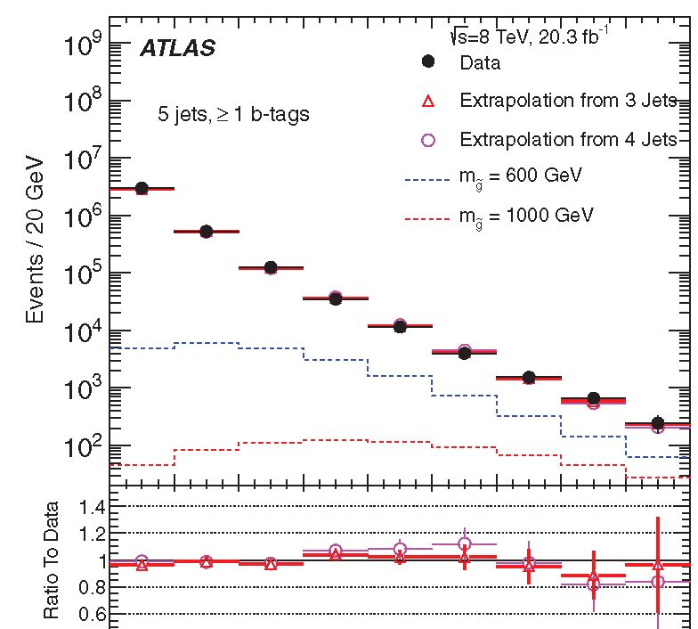
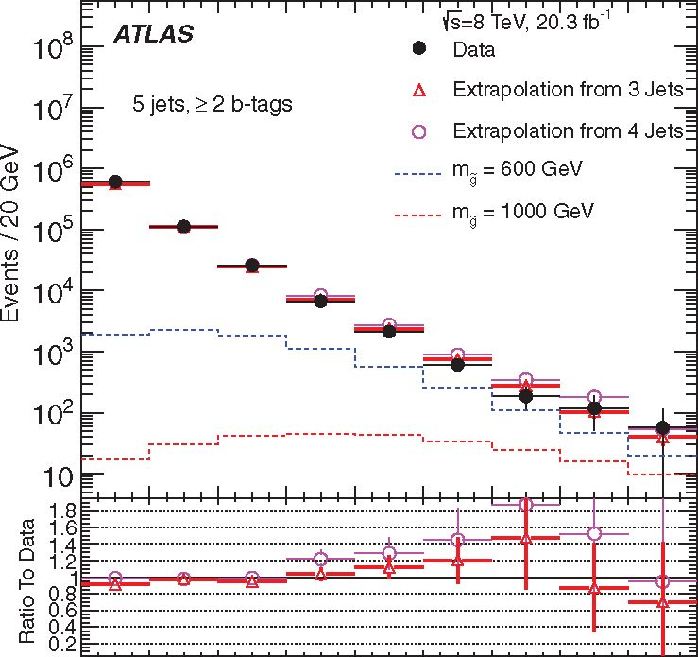
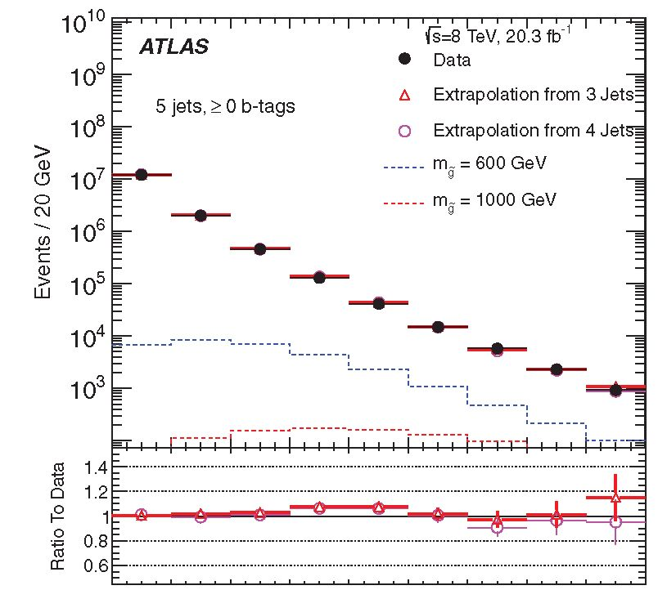
SEARCH FOR MASSIVE SUPERSYMMETRIC PARTICLES ..
PHYSICAL REVIEW D 91, 112016 (2015)
60 80 100 120 140 160 180 200 220 240
Jet p Requirement [GeV]
(a)
60 80 100 120 140 160 180 200 220 240
Jet p Requirement [GeV]
(b)
60 80 100 120 140 160 180 200 220 240
Jet p Requirement [GeV]
(c)
FIG. 2 (color online). The number of observed events in the 5-jet bin is compared to the background expectation that is determined by
using pythia to extrapolate the number of events in data from the low jet-multiplicity control regions. The contents of the bins represent
the number of events with 5-jets passing a given jet-pT requirement. These bins are inclusive in jet pT. Results with various b-tagging
requirements are shown. (a) >0 b-tagged jets required. (b) >1 b-tagged jets required, and (c) >2 b-tagged jets required.
low jet-pT region to be probed and shows that the jet-
multiplicity extrapolations continue to provide accurate
predictions at higher jet multiplicities.
To extend this validation, a requirement that the average
jet pseudorapidity (|n|) > 1.0 is applied to create a high-
pseudorapidity control region to reduce the signal contribu-
tion to a level of less than approximately 10% while retaining
a reasonable number of events. Results of these extrapola-
tions are shown for the exclusive 7-jet bin in Fig. 3(b). The
largest deviations from the expected values are found to be a
few percent larger than for the 5-jet extrapolations.
The uncertainty due to any mismodeling of contributions
from backgrounds such as tt, single top, and W/Z + jet
processes is expected to be small and is covered by the
procedure above since these contributions are included in
the extrapolation. Therefore, any mismodeling of these
sources results in increased systematic uncertainty on the
entire background model in this procedure.
Distributions for data in the inclusive >6-jet and >7-jet
signal regions are shown in Figs. 4-6 compared with
background predictions determined using extrapolations
from three different jet-multiplicity bins. In each case, the
distributions representing the extrapolations across two jet-
multiplicity bins (i.e. 4 ^ 6 and 5 ^ 7) are used as the final
background prediction whereas the other extrapolations are
simply considered as additional validation. Contributions
from higher jet-multiplicity regions are summed to con-
struct an inclusive sample. The systematic uncertainty is
112016-7
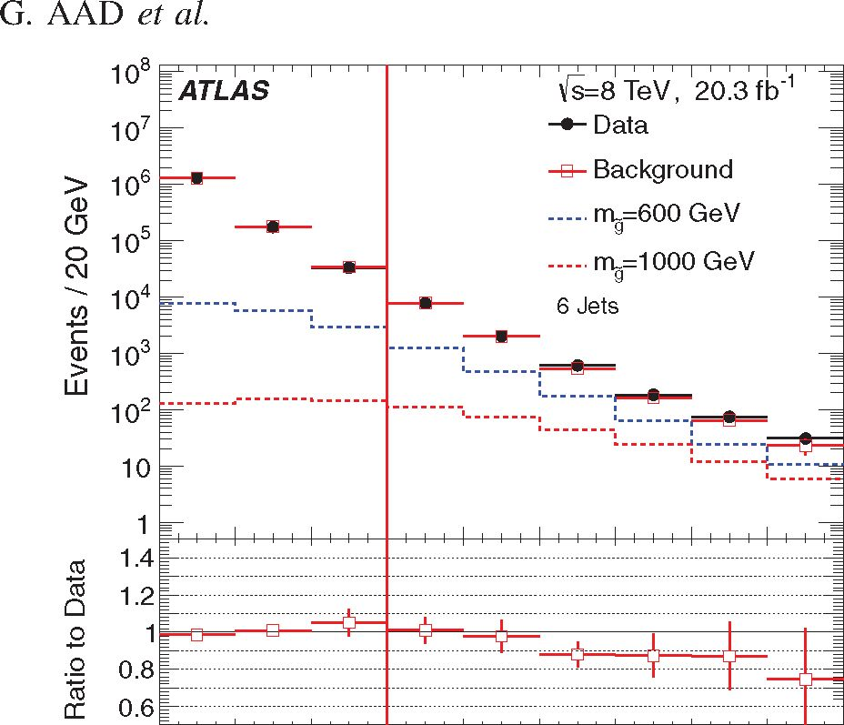
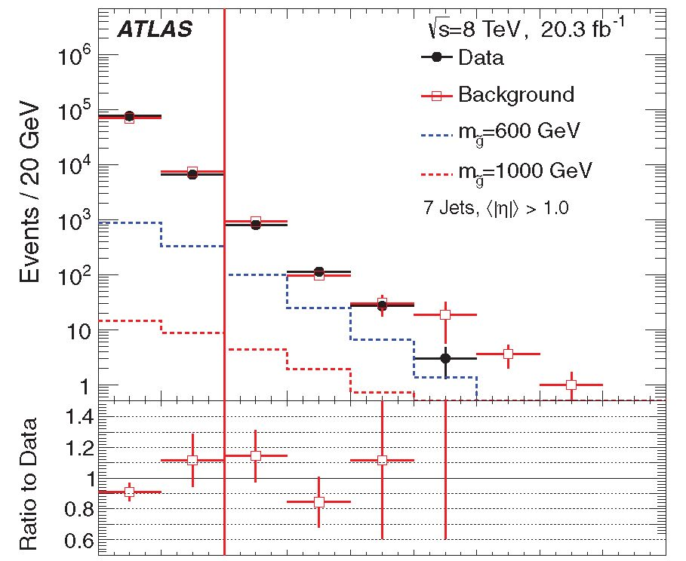
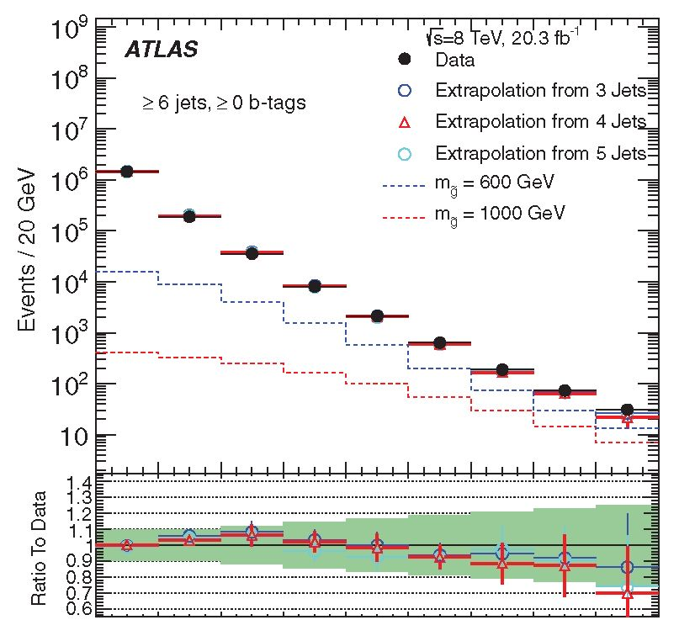
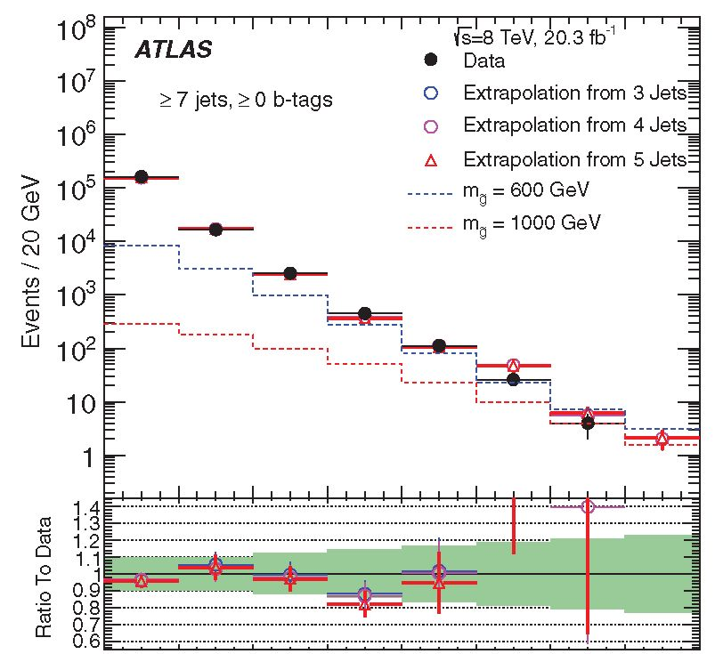
PHYSICAL REVIEW D 91, 112016 (2015)
60 80 100 120 140 160 180 200 220 240
Jet pT Requirement [GeV]
(a)
60 80 100 120 140 160 180 200 220 240
Jet pT Requirement [GeV]
(b)
FIG. 3 (color online). The data are compared with the
expected background shapes in the exclusive 6- and 7-jet bins
before b-tagging. The contents of the bins represent the number
of events with the given number of jets passing a given jet-pT
requirement. The bins with less than 10% expected signal
contamination are control regions that are considered when
assigning systematic uncertainties to the background yield.
These control regions are the bins to the left of the vertical red
lines in the plots. (a) shows the 6-jet region, and (b) shows the
7-jet region with (|n|) > 1.0.
60 80 100 120 140 160 180 200 220 240
Jet p Requirement [GeV]
(a)
60 80 100 120 140 160 180 200 220
Jet p Requirement [GeV]
(b)
FIG. 4 (color online). The number of observed events in the
inclusive >6-jet (a) and >7-jet (b) signal regions compared with
expectations using the pythia extrapolations from low jet-
multiplicity control regions, as a function of the jet-pT require-
ment. The distributions representing the extrapolations across
two units in jet multiplicity (red triangles) are used as the final
background prediction in each case, while the other extrapola-
tions are treated as cross-checks. >0 b-tagged jets are required. In
the ratio plots the green shaded regions represent the background
systematic uncertainties.
constructed from the maximum deviation given by the
various validations and for most signal regions is domi-
nated by the baseline uncertainty obtained from the n < 5
jet regions. Results using the three b-tagging selections
(>0, >1, >2 b-tagged jets) are shown in Figs. 4-6. The
background systematic uncertainties determined from the
control regions in the data are shown as the green shaded
region in the ratio plots of these figures. This procedure
results in a background systematic uncertainty in the
Pt > 120 GeV, >7-jet region of 14%, 15%, and 40%
for >0, >1, >2 b-tagged jets, respectively.
The bins in these distributions that were not assigned as
control regions represent possible signal regions, which
may be chosen as a signal region for a particular model
under the optimization procedure described in Sec. VIIIB.
112016-8
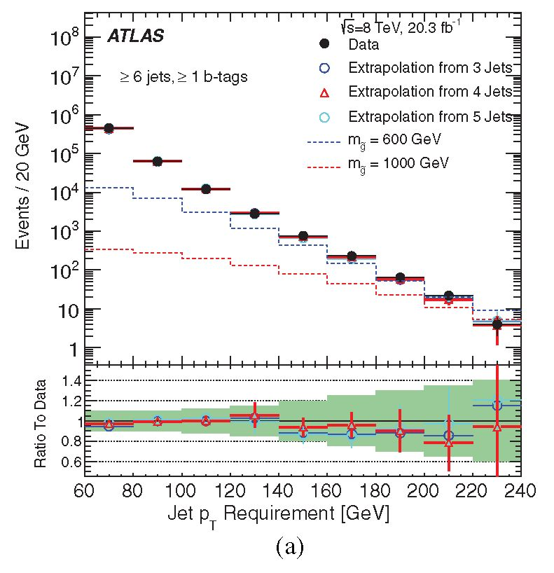
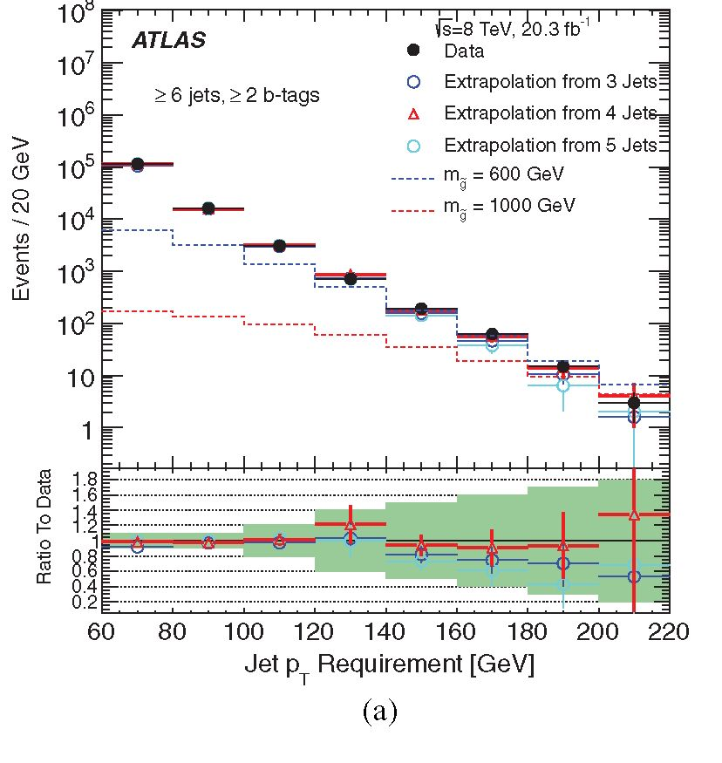
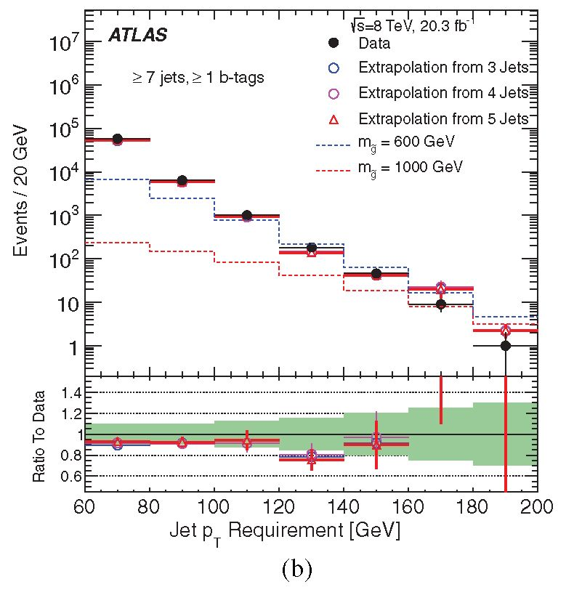
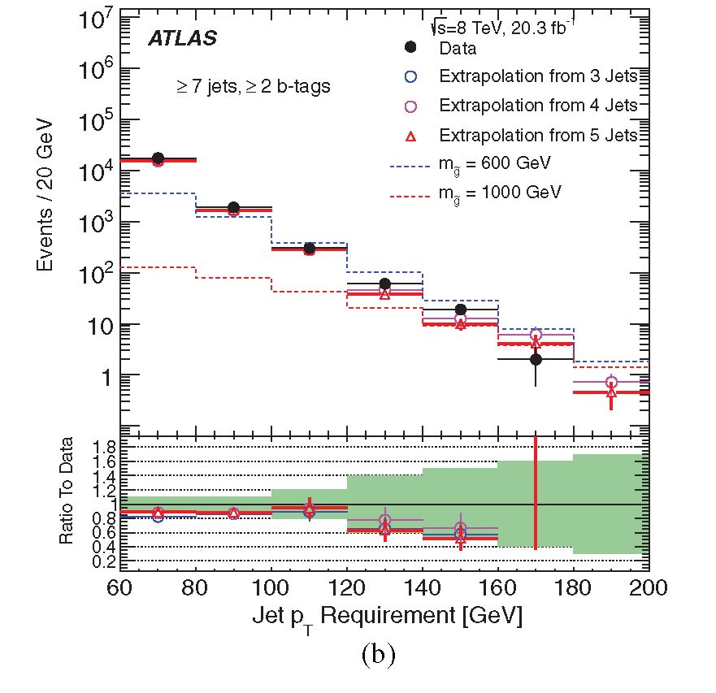
SEARCH FOR MASSIVE SUPERSYMMETRIC PARTICLES ..
PHYSICAL REVIEW D 91, 112016 (2015)
FIG. 5 (color online). Distributions shown here are as in Fig. 4
but with (a) >6-jet and (b) >7-jet >1 b-tagged jets required.
The level of disagreement between the expectation and data
is shown in Fig. 7 for the >0 b-tagged jets control and
signal regions. In the b-tagged signal regions similar
agreement is observed between data and the predicted
background, within the assigned uncertainties. In practice,
it is seen that for most signals, the >7-jet bin is preferred by
the optimization procedure as a signal region. The data in
each distribution show good agreement with background
predictions within uncertainties.
Systematic uncertainties on the jet-counting background
estimation using the extrapolation method are determined
directly from the data as part of the background validation
and, by design, account for all uncertainties on the
technique and on the reference model used in the projec-
tion. In contrast, systematic uncertainties on the signal
predictions are determined from several sources of model-
ing uncertainties. The largest systematic uncertainties
are those on the background yield, the jet energy scale
FIG. 6 (color online). Distributions shown here are as in Fig. 4
but with (a) >6-jet and (b) >7-jet >2 b-tagged jets required.
uncertainties on the signal yield (10%-20% for most signal
regions), and the uncertainty in b-tagging efficiencies for
many signal regions that require the presence of b-tagged
jets (between 15%-20% for signal regions requiring at least
two b-tags).
An additional systematic uncertainty is included in these
estimates in order to cover possible contamination of signal
in the control regions for the extrapolation. The analysis is
repeated with signal injected into the control regions and
the backgrounds are recomputed. The resulting bias
depends on the signal model and is found to be less than
5% in all cases.
Given the good agreement between the data and the
predictions from the jet-counting background estimation,
there is no evidence of new physics.
112016-9
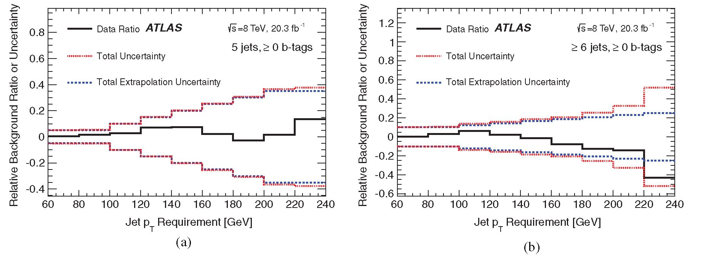
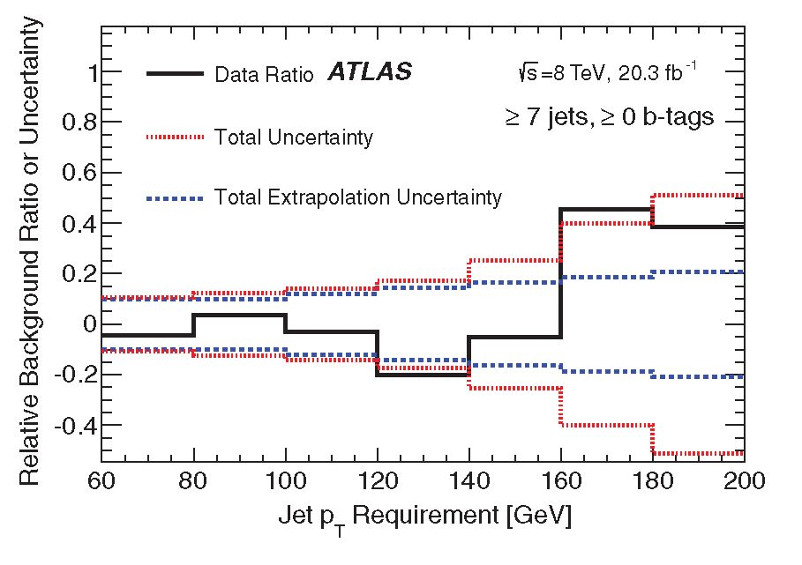
G. AAD et al.
PHYSICAL REVIEW D 91, 112016 (2015)
(c)
FIG. 7 (color online). Comparisons of the deviation between data and expectations in the control and signal regions without b-
tagging requirements are shown, as a function of the jet-pT requirement. The solid black line shows the relative difference
between the observed data and the predicted background. The coarsely dashed blue distribution shows the relative systematic
uncertainty on the background estimation. The finely dashed red distribution shows the total uncertainty on the comparison
between background and data, including the background systematic uncertainty and all sources of statistical uncertainty from the
data and simulation. (a) Exactly 5 jets, >0 b-tagged jets, (b) >6-jets >0 b-tagged jets, and (c) >7-jets >0 b-tagged jets.

VII. TOTAL-JET-MASS ANALYSIS

A. Method and techniques
The total-jet-mass analysis uses a topological observable
Mf as the primary distinguishing characteristic between
signal and background. The observable Mf [67-69] is
defined as the scalar sum of the masses of the four leading
large-R jets reconstructed with a radius parameter R = 1.0,
pT > 100 GeV and |n| < 2.5,
4
Mf = E mjet. (4)
PT>100 GeV
l|2.5
This observable was used for the first time in the yT =
8 TeV search by the ATLAS Collaboration for events with
many jets and missing transverse momentum [70] and
provides significant sensitivity for very high-mass gluinos.
Four-jet (or more) events are used as four large-R jets cover
a significant portion of the central region of the calorimeter,
and are very likely to capture most signal quarks within
their area. This analysis focuses primarily on the ten-quark
models mentioned in Sec. I.
Simulation studies show that Mf provides greater
sensitivity than variables such as HT, the scalar sum of
jet pT: the masses contain angular information about the
events by definition, whereas a variable like HT simply
describes the energy (or transverse momentum) in the
event. A large MJf implies not only high energy, but also
rich angular structure. Previous studies at the Monte Carlo
event generator level have demonstrated the power of the
MJf variable in the high-multiplicity events that this
analysis targets [67,68].
Figure 8 presents examples of the discrimination that the
MJf observable provides between the background (repre-
sented here by SHERPA multijet MC simulation) and several
signal samples, as well as the comparison of the data to
the SHERPA multijet background. Three signal samples,
each with m^o = 175 GeV and several gluino masses m~ in
the range 0.6-1.4 TeV are shown. In each case, the
112016-10
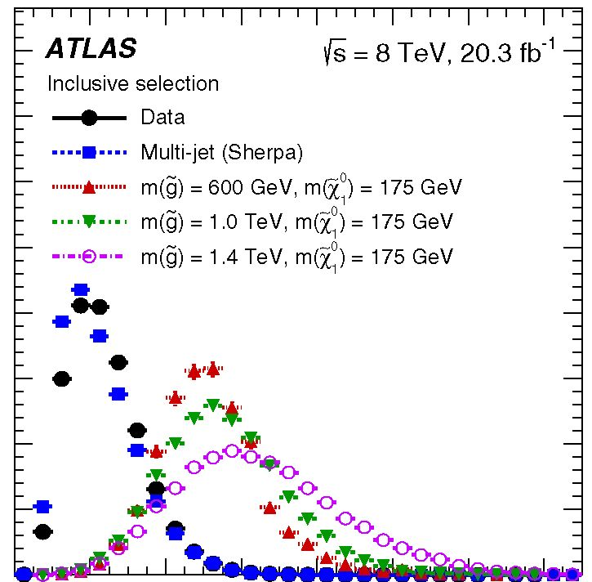
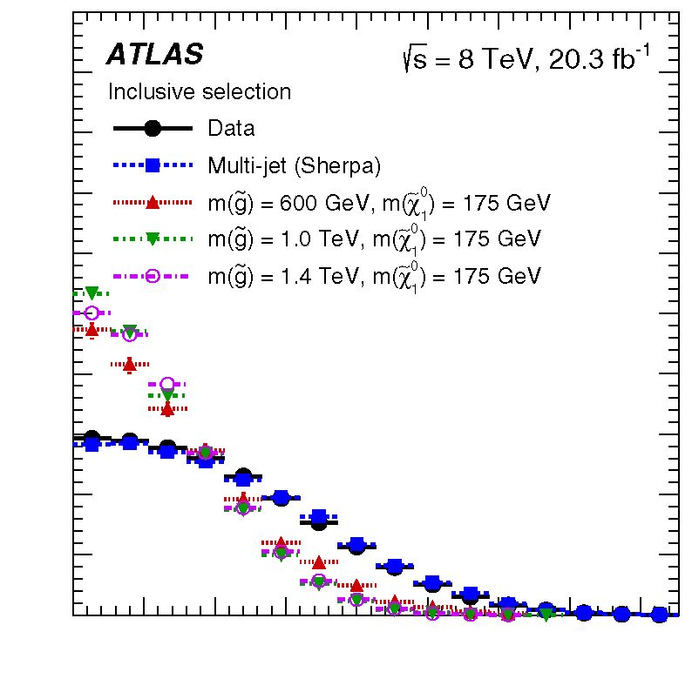
SEARCH FOR MASSIVE SUPERSYMMETRIC PARTICLES
discrimination in the very high Mf region is similar and is
dictated primarily by the gluino mass, but is also sensitive
to the mass splitting, mg — m^o. Larger mg results in larger
Mf, as expected. However, for the same mg, Mf is largest
for m^o « mg/2. This is due to the partitioning of the energy
in the final state. For very large m^o, with m^o < mg, the two
quarks from the decay of the g are very soft and the partons
from the decay of the are relatively isotropic, slightly
reducing the efficacy of the approach. For very low mxo,
A o
m^o ^ mg, the opposite occurs: the two quarks from the
gluino decay have very high pT and the neutralino is
Lorentz boosted, often to the point that the decay products
merge completely, no longer overlapping with quarks from
other parts of the event, and the mass of the jet is
substantially reduced.3 In both cases, although the sensi-
tivity of Mf is reduced, the overall approach still maintains
good sensitivity.
Another discriminating variable that is independent of
Mf is necessary in order to define suitable control regions
for the analysis. As in the jet-counting analysis, the signal is
characterized by a considerably higher rate of central jet
events as compared to the primary multijet background.
This is expected due to the difference in the production
processes that is predominantly s-channel for the signal,
while the background can also be produced through w- and
i-channel processes. Figure 8 additionally shows the
distribution of the pseudorapidity difference between the
two leading large-R jets, |An|. The discrimination between
the signal samples and the background is not nearly as
significant for | An | as for Mf. However, the lack of
significant correlation (Pearson linear correlation coeffi-
cient of approximately 1%) between the two observables
makes | An| effective as a means to define additional control
regions in the analysis. It is also observed that the shape of
the distribution is relatively independent of the g and
masses and mass splittings.
The ability of several other observables to discriminate
between signal and background was also tested. In par-
ticular, the possibility of using more detailed information
about the substructure of jets (e.g. the subjet multiplicity or
observables such as N-subjettiness, t32 [71,72]) was
investigated. Although some additional discrimination is
possible using more observables, these significantly com-
plicate the background estimation techniques and only
marginally increase the sensitivity of the analysis.
3While the complete merging of the decay products of a into
a single jet may suggest that the most effective variable at low mgj
might be the jet mass itself, typically only the lightest have
enough pT to be strongly collimated. Such jets thereby have very
low jet masses. These low jet masses are similar to what is
expected from QCD radiation, making discrimination very
difficult, and so the nominal total-jet-mass technique is main-
tained even in these regions.
PHYSICAL REVIEW D 91, 112016 (2015)
0.4
0.35
0.3
.■2 0.25
c
13
0.2
| 0.15
0.1
0.05
0
0 0.2 0.4 0.6 0.8 1 1.2 1.4
Total jet mass, Mf4 [TeV]
(a)
0.5
0.45
0.4
0.35
0.3
C
0.25
ef
cs
0.2
.0
<
0.15
0.1
0.05
0
0 0.5 1 1.5 2 2.5 3 3.5 4
!4n(jet1, jet2)l
(b)
FIG. 8 (color online). Comparison between signal and back-
ground for (a) the scalar sum of the masses of the four leading
large-R jets Mf and (b) the difference in pseudorapidity
between the two leading large-R jets | An |. Several typical
signal points are shown, as well as the distributions obtained
from the data. All distributions are normalized to the same area.
The selection requires four or more jets, similar to the 4j regions
but inclusive in |An|.
The use of Mf in this analysis provides significant
sensitivity as well as the opportunity to complement the jet-
counting analysis described in Sec. VI with a fully data-
driven background estimation that does not require any
input from MC simulation. A template method is adopted in
which an expected Mf distribution is constructed using
individual jet mass templates. Single-jet mass templates are
extracted jet-by-jet from a signal-depleted 3-jet control
region (3jCR), or training sample. These jet mass templates
are binned in jet pT and n, which effectively provides a
112016-11
G. AAD et al.
probability density function that describes the relative
probability for a jet with a given pT and n to have a
certain mass. This template is randomly sampled 2500
times for a single jet pT and n, and a precise predicted
distribution of possible masses for the given jet is formed.4
For an event with multiple jets, the jet mass templates are
applied to each jet and the resulting predicted mass
distributions are combined to predict the total jet mass
Mj for that ensemble of jets.
Jet mass templates are applied to jets in events in
orthogonal regions, typically with at least four large-R
jets—the control (4jCR), validation (4jVR), and signal
regions (4jSR)—but also in the 3jCR to test the method.
Samples used in this way are referred to as the kinematic
samples. The only information used is the jet pT and n,
which are provided as inputs to the templates. The result is
referred to as a dressed sample, which provides a SM
prediction of the individual jet mass distributions for the
jets in the kinematic sample. A SM prediction for the total
jet mass can then be formed by combining the individual
dressed jet mass distributions. The normalization of the Mj
prediction—the dressed sample—is preserved such that the
total expected yield is equal to the number of events in the
kinematic sample. The procedure can be summarized
as [69]
- Define a control region to obtain the training
sample from which jet mass templates are to be
constructed;
- Derive a jet mass template binned in jet n and pT
using a smoothed Gaussian kernel technique;
- Define a kinematic sample as either another control
region or the signal region;
- Convolve the jet mass template with the kinematic
sample using only the jet pT and n;
- Obtain a sample of dressed events which provides
the data-driven background estimate of Mj.
The key assumption in this approach is that the jet
kinematics factorize and are independent of the other
jets in the event. Deviations from this approximation
may occur due to effects that are not included in the
derivation of the jet mass templates. In particular, the
composition of quarks and gluons can vary across
different samples [73], and quark and gluon jets have
been observed to have different radial energy distribu-
tions [74]. Other experimental affects, arising from
close-by or overlapping jets, can also have an effect.
For this reason, extensive tests are performed in the
4jCR and 4jVR, as defined in Sec. VIIB, to estimate
the size of the correction factors needed to account for
any sample dependence, and to assess systematic
uncertainties. The entire procedure is tested first in
sherpa multijet MC simulation, which shows minimal
42500 times was found to be the best balance between the
precision of the result and computational time.
PHYSICAL REVIEW D 91, 112016 (2015)
differences between the template prediction and
observed mass spectrum.

B. Signal and control region definitions
The Mj and |An| observables form the basis for the
signal region definition for the analysis, where |An| is
used to define control regions for testing the background
estimation in data. A requirement of |An| < 0.7 is found
to have the best signal sensitivity over the entire plane of
(mg, m^). In this optimization, the background contri-
bution is modeled by multijet events simulated with
SHERPA.
An optimization study indicated that when using a single
Mj selection, Mj > 625 GeV provides the best sensitivity
to many signal hypotheses, and gives the best expected
sensitivity at high mg. A single-bin signal region (SR1) is
therefore defined with Mj > 625 GeV and a 250 GeV pT
threshold applied to the third leading in pT large-R jet. This
region has an acceptance of 0.26% for the mg = 600 GeV,
m^o = 50 GeV signal point. This acceptance grows rapidly
with gluino mass to 11% for the point mg = 1000 GeV,
m^o = 600 GeV, and is only weakly dependent on the
neutralino mass.
A second set of signal regions is used to further improve
the power of the analysis by making use of the shape of
the Mj distribution. Two selections on the third leading jet
in pT (pT) are used, pT > 100 GeV (SR100) and pT >
250 GeV (SR250). This provides better sensitivity to the
full range of gluino masses considered, compared to SR1.
The lower pT region, SR100, has better sensitivity for
lower gluino masses, whereas SR250 has improved sensi-
tivity for higher masses. All other selections are unchanged.
In this case, a lower threshold of Mj > 350 GeV is used
and the observed data are compared to the template
predictions in bins of Mj. The improvements in the
TABLE I. Control (CR), validation (VR), and signal regions
(SR) used for the analysis. pT and pT represent the transverse
momentum of the third and fourth jet in pT, respectively.
Region  Name | njet | |An| | pT  [GeV] | pT  [GeV] | Mf [GeV]
Pi Pi  U U  tp? Pp | jt = 3  njet — 4 | >1.40 | >100 | >100
4jVR | Al  sf | 1.0-1.40 | >250  >100 | >100
SR1  SR100 | Al  sT | < 0.7 | >250  >250  >100 | >100 | >625  >350
SR250 | Al  sT |  | >250 |  | (binned)  >350  (binned)
112016-12
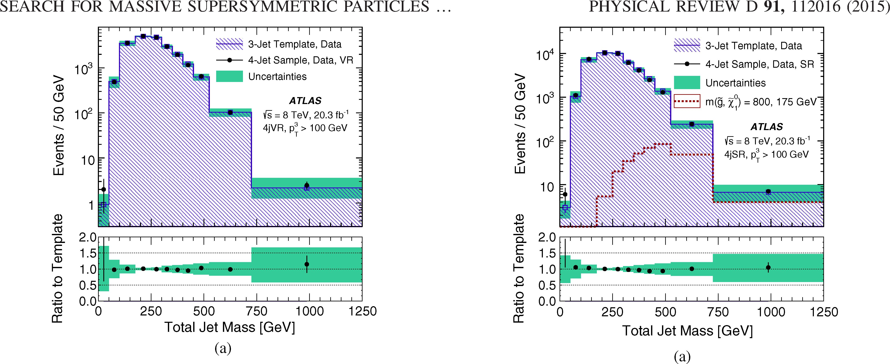
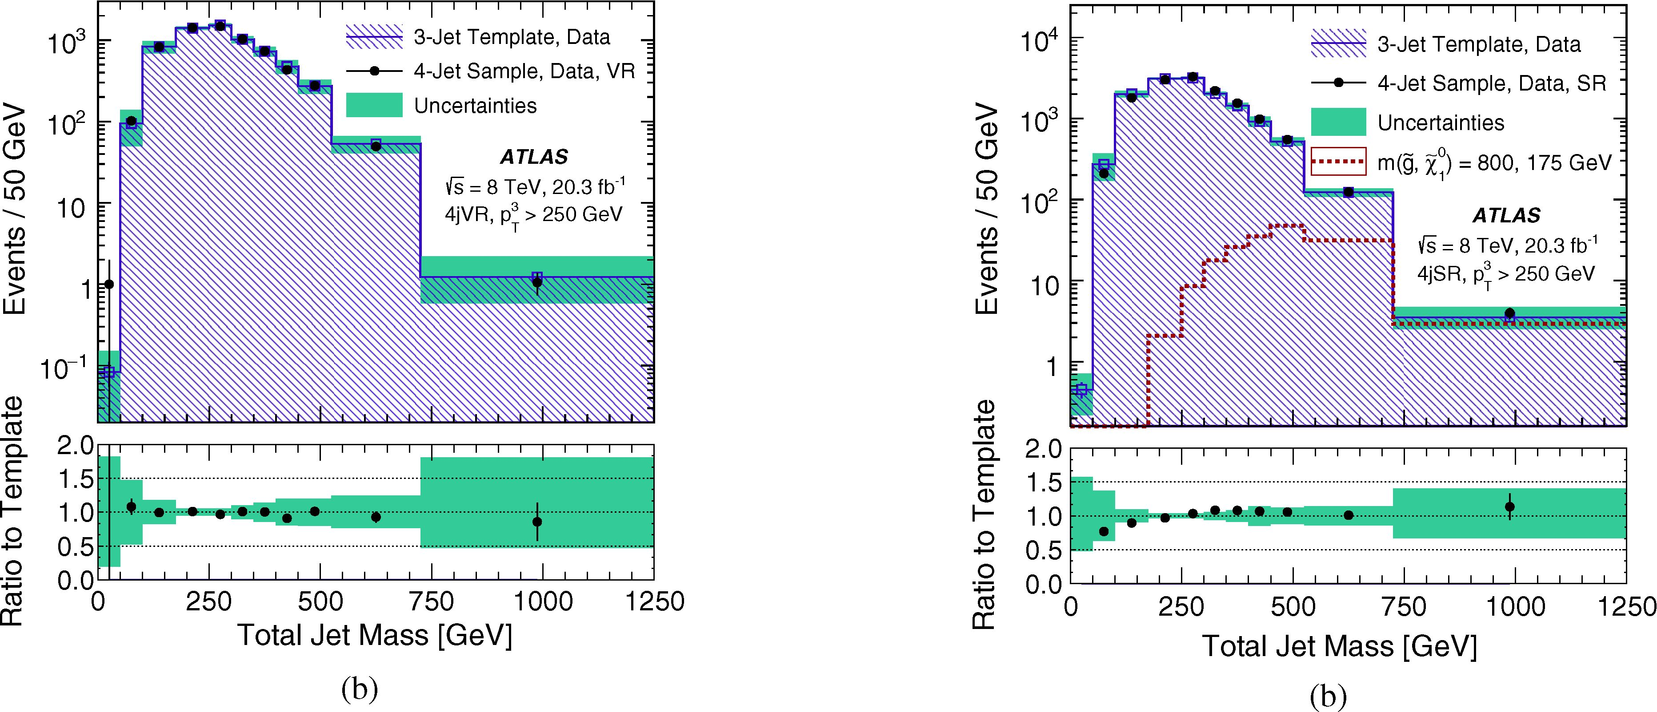
FIG. 9 (color online). (a) Total jet mass in the 4jVR with
pT > 100 GeV. The reweighted template is shown in the hatched
blue histogram. (b) Total jet mass in the 4jVR with
pT > 250 GeV. The 4jVR Mf spectra are shown in the open
black squares. The total systematic uncertainty due to the
smoothing procedure, finite statistics in control regions, and
the difference between template prediction and the data observed
in the 4jCR is shown in green.
FIG. 10 (color online). Total jet mass in the 4jSR (a) using
pT > 100 GeV (SR100) and (b) using pT > 250 GeV (SR250).
For the SR100 selection, the reweighted template (built in the
3jCR, and reweighted jet by jet in the 4jCR) is shown in the
hatched blue histogram. The total systematic uncertainty due to
the smoothing procedure, finite statistics in control regions, and
the difference between template prediction and the data observed
in the 4jCR is shown in green.
sensitivity obtained by adding these additional signal
regions and using the shape of the Mf spectrum are
described below. The full set of selection criteria is listed
in Table I.
The jet multiplicity and |Ap| are used to define the
control regions. The 3jCR, with exactly three jets, is used
to train the background templates previously discussed. In
the remaining control and validation regions, each requir-
ing >4 jets, the |Ap| selection suppresses the signal
contribution and is used to define the 4jCR and 4jVR.
In the >4-jet regions, the |Ap| selection value for the
control regions is chosen to be larger than an inversion of
the signal region selection, resulting in the selections
presented in Table I. These control region definitions
permit studies of the full Mf spectrum as well as compar-
isons of data and SM predictions without significant signal
contamination.
- Validation and systematic uncertainties
Many tests are performed using the 3jCR as both the
training sample and the kinematic sample in order to
112016-13

G. AAD et al.
PHYSICAL REVIEW D 91, 112016 (2015)
TABLE II. Table showing the predicted in the SM and observed number of events in SR1 as well as three representative signal
scenarios. Acceptances (including efficiency) of the various signals are listed in parentheses. The background uncertainties are displayed
as statistical + systematic; the signal uncertainties are displayed as statistical + systematic + theoretical.
 |  |  | Summary yield table for SR1
Mf Bin | Expected SM | Observed | mg = 600 GeV  m^ = 50 GeV | mg = 1 TeV  mX0 = 600 GeV | mg = 1.4 TeV  mX0 = 900 GeV
>625 GeV | 160 ± 9.7+44 | 176 | 70 ± 4.2 ± 25 ± 30 (0.26%) | 55 ± 0.51 ± 8.6±14 (11%) | 6.3 ± 0.07 ± 0.46±2.5 (35%)
TABLE III. Table showing the predicted in the SM and observed number of events in SR100 as well as three representative signal
scenarios. The background uncertainties are displayed as statistical + systematic; the signal uncertainties are displayed as
statistical + systematic + theoretical.
Summary yield table for SR100
Mf Bin | Expected SM | Observed | mg = 600 GeV  mX0 = 50 GeV | mg = 1 TeV  mX0 = 600 GeV | mg = 1.4 TeV  mX0 = 900 GeV
350-400 GeV | 4300 ± 78+5,10 | 5034 | 200 ± 7.2 ± 22 ± 35 | 5.8 ± 0.17 ± 1.3 ± 1.5 | 0.19 ± 0.01 ± 0.04 ± 0.07
400-450 GeV | 2600 ± 49+380 | 2474 | 200 ± 7.1 ± 9.5 ± 35 | 9.7 ± 0.21 ± 2.2 ± 2.5 | 0.31 ± 0.02 ± 0.07 ± 0.12
450-525 GeV | 2100 ± 42+33660 | 1844 | 280 ± 8.4 ± 13 ± 49 | 26 ± 0.35 ± 4.3 ± 6.7 | 0.88 ± 0.03 ± 0.14 ± .34
525-725 GeV | 960 ± 25+300° | 1070 | 280 ± 8.4 ± 57 ± 49 | 77 ± 0.60 ± 3.2 | 3.6 ± 0.05 ± 0.36 ± 1.4
>725 GeV | 71 ± 7.0+22 | 79 | 35. ± 2.9 ± 18 ± 6.0 | 35 ± 0.40 ± 9.9 ± 9.0 | 4.8 ± 0.06 ± 0.61 ± 1.9
TABLE IV. Table showing the predicted in the SM and observed number of events in SR250 as well as three representative signal
scenarios. The background uncertainties are displayed as statistical + systematic; the signal uncertainties are displayed as
statistical + systematic + theoretical.
Summary yield table for SR250
mg = 600 GeV mg = 1 TeV mg = 1.4 TeV
Mf Bin Expected SM Observed m^o = 50 GeV m^o = 600 GeV m^o = 900 GeV
350-400 GeV | 1400 | ± | 35+120  35 —134 | 1543 | 83 ± 4.6 ± 15 ± 14 | 3.3 ± 0.12 ± 0.78 | ± | 0.85 | 0.17 | ± | 0.01 | ± | 0.03 | ± | 0.07
400-450 GeV | 920 | ± | 33+140  33—140 | 980 | 92 ± 4.8 ± 11 ± 16 | 5.6 ± 0.16 ± 1.5 | ± | 1.5 | 0.27 | ± | 0.01 | ± | 0.07 | ± | 0.11
450-525 GeV | 780 | ± | 33+94  33—94 | 823 | 140 ± 5.8 ± 15 ± 23 | 17 ± 0.28 ± 3.3 | ± | 4.4 | 0.79 | ± | 0.02 | ± | 0.13 | ± | 0.31
525-725 GeV | 490 | ± | 24+67 | 495 | 160 ± 6.2 ± 30 ± 27 | 56 ± 0.51 ± 4.1 | ± | 15 | 3.3 | ± | 0.05 | ± | 0.34 | ± | 1.3
>725 GeV | 37 | ± | 5.5—+1126 | 42 | 22 ± 2.3 ± 9.1 ± 3.9 | 27 ± 0.36 ± 7.4 | ± | 7.0 | 4.4 | ± | 0.06 | ± | 0.56 | ± | 1.7
determine the robustness of the method. The selection
requires that there be exactly three large-R jets in the
event, as described in Table I. The dependence of the
template on the jet in question (leading, subleading, etc.)
is tested, as well as the dependence of the template on the
jet kinematics. It is determined that it is optimal to define
separate templates for each of the three jet categories
(leading, subleading, and third jet) and to bin the
templates according to the jet pT and n 5 In the 4-jet
regions, the fourth jet uses the template derived for the
third jet in the 3jCR: tests in the 4jCR and 4jVR indicate
very good agreement between this template and the
5It is observed that the difference between the leading and
subleading jet templates is minimal, but that the third jet exhibits
qualitatively different masses as a function of the jet pT.
112016-14
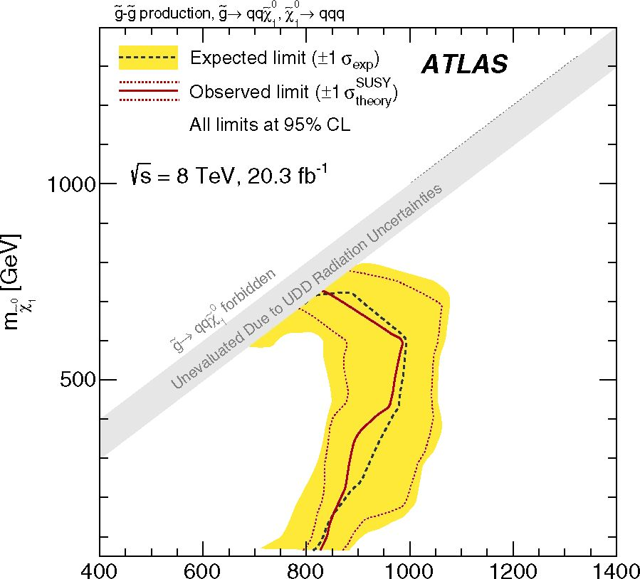
SEARCH FOR MASSIVE SUPERSYMMETRIC PARTICLES
mg [GeV]
FIG. 11 (color online). Expected and observed exclusion
limits in the (mg, ) plane for the ten-quark model given
by the total-jet-mass analysis. Limits are obtained by using the
signal region with the best expected sensitivity at each point.
The dashed black lines show the expected limits at 95% CL,
with the light (yellow) bands indicating the 1 a excursions due
to experimental and background-only theory uncertainties.
Observed limits are indicated by medium dark (maroon)
curves, where the solid contour represents the nominal limit,
and the dotted lines are obtained by varying the signal cross
section by the renormalization and factorization scale and PDF
uncertainties.
observed spectrum. As a first test, the Mf template
constructed from the 3-jet kinematic sample is compared
to the actual Mf distribution in 3-jet events, and very
good agreement is observed.
There are two intrinsic sources of systematic uncertainty
associated with the template procedure: the uncertainty due
to finite statistics in the 3jCR training sample (the vari-
ance), and the uncertainty due to the smoothing procedure
in the template derivation (the bias). The former is
estimated by generating an ensemble of Mf templates
and taking the ±1a deviations (defined as the ±34%
quantile) with respect to the median of those variations
as the uncertainty, bin by bin. The systematic uncertainty
due to the smoothing procedure is determined using the fact
that a Gaussian kernel smoothing is applied to the template.
The full difference between the nominal template and a
template constructed using a leading-order correction for
the bias, derived analytically in Ref. [69], is taken as the
systematic uncertainty. The systematic uncertainty due to
finite control region statistics is chosen to be larger (by
setting the size of the kernel smoothing) than that due to the
smoothing procedure since the former is more accurately
estimated.
PHYSICAL REVIEW D 91, 112016 (2015)
A small level of disagreement (between 5% to 15%) is
observed when comparing the observed mass to the
predicted mass in the 4jCR: a reweighting derived in
the 4jCR (as a function of each individual jet mass) is
then applied to the individual jet masses prior to the
construction of the Mf for each event. After the reweight-
ing the agreement is substantially improved at high total
jet mass. Figure 9 presents the total jet mass Mf in the
4jVR using pT > 100 GeV. The reweighted template
agrees very well with the observed Mf distribution in
the 4jVR—a sample completely independent from where
the reweighting was derived—validating both the tem-
plate method and the reweighting. The full magnitude of
the reweighting on the total-jet-mass distribution is taken
as a systematic uncertainty of the method. The total
systematic on the background prediction therefore
includes both the intrinsic systematic uncertainty given
by the variance and the bias, as well as the difference
observed in the 4jCR. The Mf distribution is also shown
for the 4jVR for the case in which pT > 250 GeV. No
reweighting is required when using the significantly
higher pT selection since the observed effects due to
topological differences in the training sample compared
to the kinematic sample are suppressed. In order to
account for any remaining disagreement, the difference
between the data and template prediction in the 4jCR is
applied as a further systematic. The total uncertainty
therefore includes again both the intrinsic background
estimation uncertainties and the disagreement observed in
the 4jCR.
One possible concern for the template technique is that it
assumes that the same mechanism is responsible for
generating the individual jet masses in both the control
and signal regions. In order to test the extent to which a
different composition of processes may affect the derived
templates, the assumption that multijet events are the only
background in the 3jCR and 4j regions is modified by
injecting separately a sample of sherpa it MC simulation
events (assuming SM cross sections) into the full pro-
cedure. The resulting background estimates are fully
consistent with the prediction without the injection—
indicating that the technique is not sensitive to contami-
nation from top quark production—and thus no additional
systematic uncertainty is assessed for the potential presence
of specific background processes. A similar procedure is
performed for signal processes (assuming standard g
production cross-sections) and again no impact of signal
contamination on the constructed background templates is
observed.
Figure 10 shows the total jet mass in the 4jSR compared
to the template prediction. For both SR100 and SR250,
the total systematic error on the template method is also
shown in the ratio plot in the lower panel of each
distribution. The template predictions are clearly consistent
112016-15
G. AAD et al.
PHYSICAL REVIEW D 91, 112016 (2015)
TABLE V. Requirements as optimized for the six-quark model under a variety of gluino mass hypotheses when the RPV vertex has
various branching ratio combinations corresponding to respective RPV terms given by being nonzero. The optimized signal region
selection requirements are shown along with the resulting background and signal expectations and the number of observed data events.
The nominal signal acceptance (including efficiency) is also shown for each result. Quoted errors represent both the statistical and
systematic uncertainties added in quadrature.
Sample mg [GeV] Jet-pT requirements [GeV] Number of jets |  |  | Number of b-tags | Signal (acceptance) | Background | Data
500 | (BR(i), BR(b), BR(c)) = (0%, 0%, 0%)  120 7 0 |  |  | 600 ± 230 (0.7%) | 370 ± 60 | 444
600 | 120 | 7 | 0 | 410 ± 100 (1.5%) | 370 ± 60 | 444
800 | 180 | 7 | 0 | 13 ± 4 (0.4%) | 6.1 ± 2.2 | 4
1000 | 180 | 7 | 0 | 6.8 ± 2.3 (1.4%) | 6.1 ± 2.2 | 4
1200 | 180 | 7 | 0 | 2.7 ± 0.5 (3.0%) | 6.1 ± 2.2 | 4
(BR(i), BR(b), BR(c))  500 | = (0%, 100%, 0%)  80 | 7 | 2 | 1900 ± 400 (2.1%) | 1670 ± 190 | 1560
600 | 120 | 7 | 1 | 300 ± 60 (1.1%) | 138 ± 26 | 178
800 | 120 | 7 | 1 | 131 ± 25 (4.1%) | 138 ± 26 | 178
1000 | 180 | 7 | 1 | 4.4 ± 1.0 (0.9%) | 2.3 ± 1.0 | 1
1200 | 180 | 7 | 1 | 1.86 ± 0.31 (2.1%) | 2.3 ± 1.0 | 1
(BR(i), BR(b), BR(c))  500 | = (100%, 0%, 0%)  80 | 7 | 1 | 4600 ± 800 (5.0%) | 5900 ± 700 | 5800
600 | 100 | 7 | 1 | 940 ± 190 (3.5%) | 940 ± 140 | 936
800 | 120 | 7 | 1 | 108 ± 18 (3.4%) | 138 ± 26 | 178
1000 | 120 | 7 | 1 | 42 ± 6 (8.5%) | 138 ± 26 | 178
1200 | 180 | 7 | 1 | 1.3 ± 0.4 (1.5%) | 2.3 ± 1.0 | 1
(BR(i), BR(b), BR(c))  500 | = (100%, 100%, 0%)  80 | 7 | 2 | 3600 ± 600 (3.9%) | 1670 ± 190 | 1560
600 | 80 | 7 | 2 | 2300 ± 400 (8.6%) | 1670 ± 190 | 1560
800 | 120 | 7 | 2 | 94 ± 15 (3.0%) | 38 ± 17 | 56
1000 | 120 | 7 | 2 | 37 ± 6 (7.5%) | 38 ± 17 | 56
1200 | 140 | 7 | 2 | 5.5 ± 1.0 (6.2%) | 10 ± 5 | 18
with the observed data. Thus there is no indication of new
physics in these results.
Systematic uncertainties associated with the scale and
resolution of large-R jet mass and energy [65] are
significantly reduced by the use of a data-driven back-
ground estimate: residual effects may remain due to
differences between the 3jCR and the 4j regions, and
these are reflected in the systematic uncertainties
assessed by the difference between the template pre-
diction and observed spectrum in the 4jCR. The uncer-
tainties due to the background estimation method are
dominated by propagation of the statistical uncertainty
from the 3jCR: these are typically 5%-10%, except in
the highest Mj bins of SR100 and SR250, where they
can extend to 20%-40%. In addition, the observed
difference systematic uncertainty from the 4jCR varies
from 5% to 15%. Signal reconstruction—both in terms
of selection efficiency and the Mj spectrum predicted
for a given mg, m~0 combination—is sensitive to the
kinematic uncertainties associated with the final-state
jets in the analysis. The impacts of these systematic
uncertainties are directly assessed by varying the kin-
ematics within the uncertainties and reported in
Sec. VIII. Jet mass scale uncertainties have the largest
effect, which for SR1 range from 30% for very low mg to
15% for very high mg. In the cases of SR100 and SR250,
the impact of the jet mass scale uncertainty also
dominates, and varies across the MJj spectrum from
10%-20% at lower Mj up to 50% for the very highest
Mj bin in the spectrum for low mg. The luminosity
uncertainty of 3% also affects the signal only.

VIII. RESULTS AND INTERPRETATIONS
As no significant excess is observed in data in either
analysis, a procedure to set limits on the models of
interest is performed. A profile likelihood ratio combin-
ing Poisson probabilities for signal and background is
computed to determine the confidence level (CL) for
consistency of the data with the signal-plus-background
hypothesis (CLs+b). A similar calculation is performed
for the background-only hypothesis (CLb). From the
ratio of these two quantities, the confidence level for the
presence of signal (CLs) is determined [75]. Systematic
uncertainties are treated via nuisance parameters assum-
ing Gaussian distributions. In all cases, the nominal
112016-16
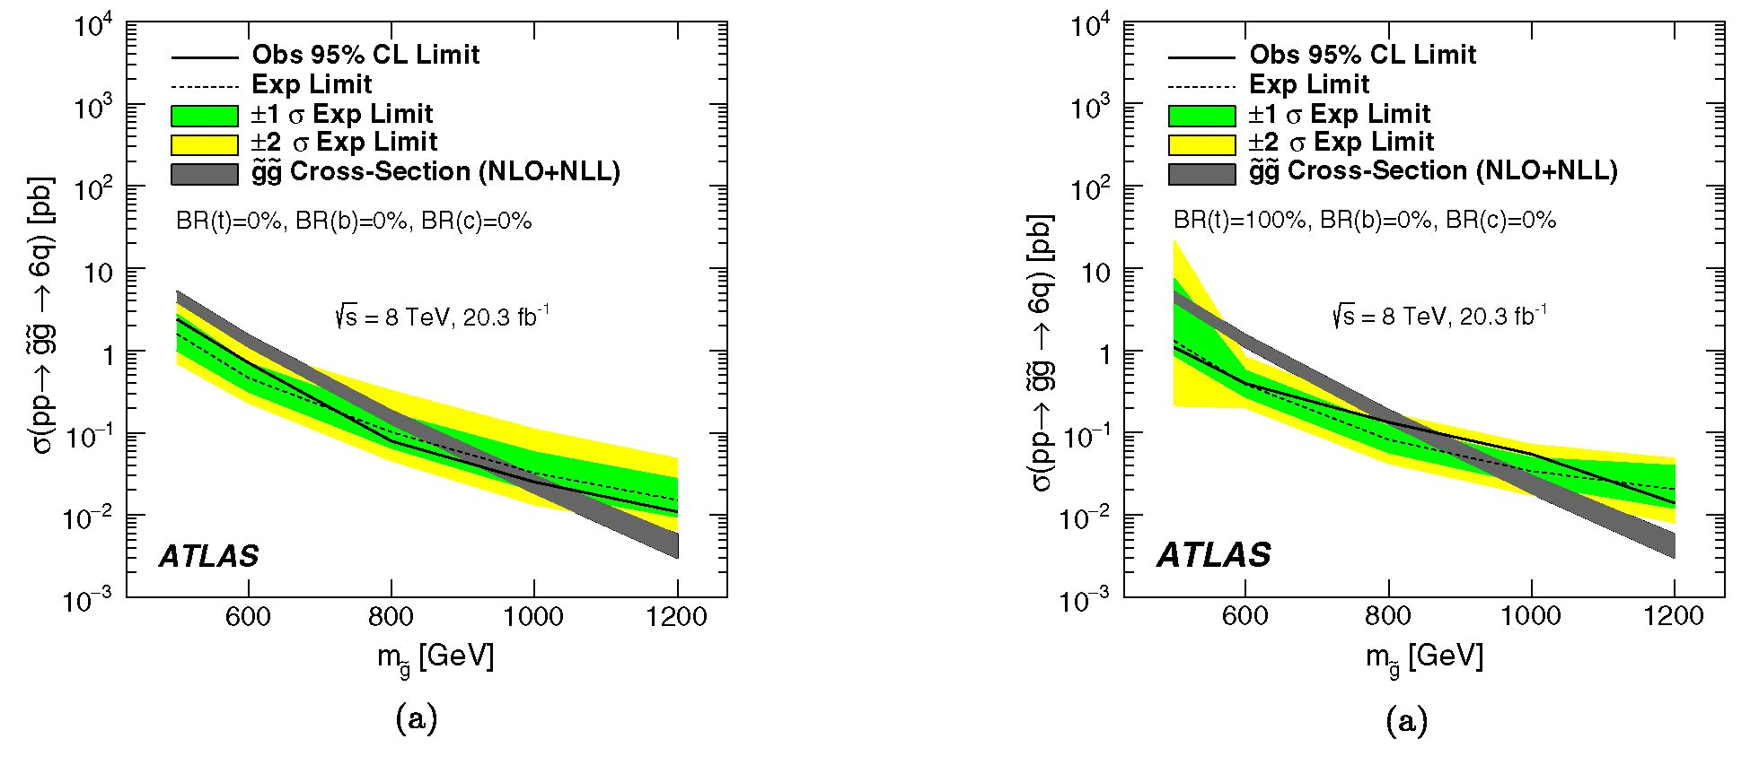
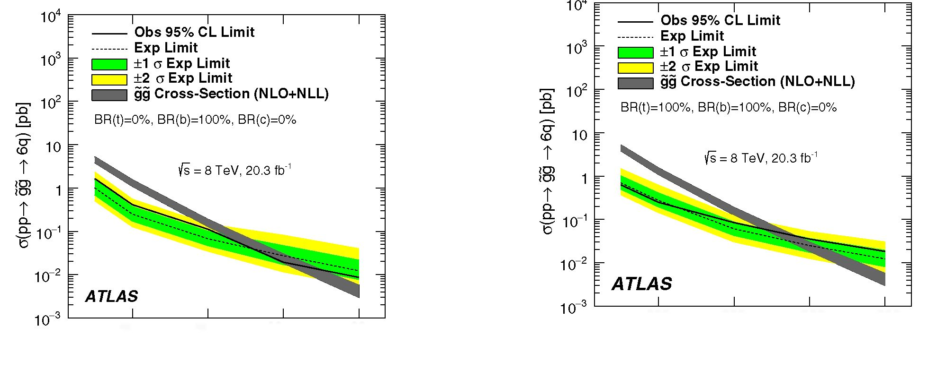
SEARCH FOR MASSIVE SUPERSYMMETRIC PARTICLES ..
PHYSICAL REVIEW D 91, 112016 (2015)
600 800 1000 1200
mg [GeV]
(b)
FIG. 12 (color online). Expected and observed cross-section
limits for the six-quark gluino models for (a) the case where no
gluinos decay into heavy-flavor quarks, and (b) the case where
every gluino decays into a b-quark in the final state.
600 800 1000 1200
mg [GeV]
(b)
FIG. 13 (color online). Expected and observed cross-section
limits for the six-quark gluino models for (a) the case where
each gluino is required to decay into a top quarks, and (b)
the case where every gluino decays into a b-quark and a top
quark.
signal cross section and uncertainty are taken from an
envelope of cross-section predictions using different
PDF sets and factorization and renormalization scales,
as described in Ref. [76]. As discussed in Sec. IV, the
region with (mg — m^o) < 100 GeV is not considered in
this analysis in order to ensure that the results are
insensitive to the effects of ISR, since the uncertainties
cannot be assessed for the UDD decays considered
here.
The total-jet-mass analysis is designed to be agnostic to
the flavor composition of the signal process and to remove
any reliance on MC simulations of these complex hadronic
final states. The jet-counting analysis provides the
opportunity to enhance sensitivity to specific heavy-flavor
compositions in the final state and to explore various
assumptions on the branching ratios of the benchmark
signal processes studied in this paper. The results obtained
from the total-jet-mass analysis in the inclusive final state
are presented first, and then the specific sensitivity provided
by the jet-counting analysis to the full branching ratio space
is presented.

A. Total-jet-mass analysis
The observed and expected event yields are presented in
Tables II, III, and IV for the three signal regions SR1,
SR100 and SR250 respectively. The single-bin signal
112016-17

G. AAD et al.
PHYSICAL REVIEW D 91, 112016 (2015)
pp^gg^6q, BR(c)=0%
All limits at 95% CL (s = 8 TeV, 20.3 fb-1
ATLAS
BR(b) [%]
(a)
pp^gg^6q, BR(c)=0%
All limits at 95% CL = 8 TeV, 20.3 fb-1
cr
100 | 788 | 802 | 811 | 829 | 874
75 | 763 | 773 | 802 | 816 | 872
50 | 666 | 817 | 780 | 809 | 831
25 | 680 | 681 | 759 | 810 | 863
0 | 917 | 890 | 734 | 794 | 929
 | 0 | 25 | 50 | 75 | 100
1000
950
900
850
800
750
700
650
ATLAS
BR(b) [%]
(b)
pp^gg^6q, BR(c)=50%
All limits at 95% CL = 8 TeV, 20.3 fb-1
100 | 881 | 896 | 906 | 917 | 938 | - | ~v| ~v| 05 00 CD CO  O 01 O 01 O 01  o o o o o o  Expected Mass Exclusion Limit [GeV] | 50 | 847 | 876 | 893 | 907 | 924
75 | 857 | 878 | 894 | 906 | 925
£Lj
25
cr
m
BR(t) [%]  oi  o | 814 | 849 | 878 | 897 | 913 |  |  | £Lj  25  cr  m | 814 | 852 | 878 | 895 | 913
25 | 794 | 823 | 862 | 891 | 907 | -
0 | 853 | 832 | 852 | 898 | 921 | - |  | 0 | 851 | 834 | 869 | 899 | 914
 |  |  |  |  |  |  | 650
 | 0 | 25 | 50 | 75 | 100 |  | 650 |  | 0 | 25 | 50 | 75 | 100
FIG. 14. (a) Expected and (b) observed mass exclusions at the
95% CL in the BR(t) vs BR(b) space for BR(c) = 0%. Each
point in this space is individually optimized and fit. Masses below
these values are excluded in the six-quark model. Bin centers
correspond to evaluated models.
ATLAS
BR(b) [%]
(a)
pp^gg^6q, BR(c)=50%
All limits at 95% CL (s = 8 TeV, 20.3 fb-1
50
25
cr
m
0
ATLAS
25 50 75
BR(b) [%]
(b)
1
1000
950
900
850
800
750
700
650
725 | 776 | 806 | 820 | 874
675 | 743 | 788 | 810 | 822
896 | 881 | 890 | 810 | 879
1
100
1000
950
-900
-850
-800
-750
-700
-650
FIG. 15. (a) Expected and (b) observed mass exclusions at the
95% CL in the BR(i) vs BR(b) space for BR(c) = 50%. Each
point in this space is individually optimized and fit. Masses below
these values are excluded in the six-quark model. Bin centers
correspond to evaluated models.
0
region selection (SR1) is reported in addition to the binned
Mj results in SR100 and SR250 in order to provide yields
that can be easily reinterpreted for other signal hypotheses.
In the case of the binned Mj signal regions, a binned fit
(where the number and size of the bins were optimized) is
performed that takes into account the predictions for each
Mj range. This approach provides greater sensitivity to
small deviations from the template predictions. The corre-
lation of the uncertainties in the bins of the Mj spectrum
are accounted for by evaluating the full correlation matrix.
The result leads the analysis to treat the different bins as
fully uncorrelated for the variance, which is the largest
component of the background uncertainties. All other
uncertainties treat the bins of the Mj spectrum as fully
correlated.
Figure 11 shows both the expected and observed
95% CL limits in the (mg, m^o) mass plane when the
signal region that provides the best expected exclusion is
used for each mass combination. The dashed black line
shows the expected exclusion limits, and the yellow band
represents the experimental uncertainties on this limit. The
solid line shows the observed limit, with the finely dashed
lines indicating the ilc variations due to theoretical
uncertainties on the signal production cross section given
by renormalization and factorization scale and PDF uncer-
tainties. All mass limits are reported conservatively assum-
ing the — l^Sheoi-y signal production cross section. At low
m£o, the region with gluino mass mg < 750 GeV is
excluded. Excluded mg masses rise with increasing m^o,
112016-18
SEARCH FOR MASSIVE SUPERSYMMETRIC PARTICLES
PHYSICAL REVIEW D 91, 112016 (2015)
TABLE VI. Requirements as optimized for the ten-quark model under a variety of mass hypotheses when all X" couplings are nonzero
and equal and ¿-tagging requirements are considered as part of the optimization procedure. The optimized signal region selection
requirements are shown along with the resulting background and signal expectations and the number of observed data events. The
nominal signal acceptance (including efficiency) is also shown for each result. Quoted errors represent both the statistical and systematic
uncertainties added in quadrature.
 | Jet-pT | Number | Number of | Signal
Sample (mg) | requirements [GeV] | of jets | b-tagged jets | (acceptance) | Background | Data
(400 GeV, 50 GeV) | 80 | 7 | 2 | 1900 ± 400 (0.5%) | 1670 ± 190 | 1558
(400 GeV, 300 GeV) | 80 | 7 | 2 | 2500 ± 600 (0.7%) | 1670 ± 290 | 1558
(600 GeV, 50 GeV) | 120 | 7 | 1 | 180 ± 40 (0.7%) | 138 ± 26 | 178
(600 GeV, 300 GeV) | 80 | 7 | 2 | 2200 ± 350 (8.3%) | 1670 ± 200 | 1558
(800 GeV, 50 GeV) | 120 | 7 | 1 | 95 ± 16 (3.0%) | 138 ± 26 | 178
(800 GeV, 300 GeV) | 120 | 7 | 1 | 172 ± 28 (5.4%) | 138 ± 26 | 178
(800 GeV, 600 GeV) | 120 | 7 | 1 | 150 ± 23 (4.7%) | 138 ± 26 | 178
(1000 GeV, 50 GeV) | 220 | 6 | 1 | 7.0 ± 1.3 (1.4%) | 3.8 ± 3.0 | 5
(1000 GeV, 300 GeV) | 120 | 7 | 1 | 67 ± 8 (14%) | 138 ± 26 | 178
(1000 GeV, 600 GeV) | 120 | 7 | 1 | 101 ± 13 (20%) | 138 ± 26 | 178
(1000 GeV, 900 GeV) | 120 | 7 | 1 | 33 ± 4 (6.7%) | 138 ± 26 | 178
(1200 GeV, 50 GeV) | 220 | 6 | 1 | 3.8 ± 0.7 (4.3%) | 3.8 ± 3.0 | 5
(1200 GeV, 300 GeV) | 180 | 7 | 1 | 2.01 ± 0.32 (2.3%) | 2.3 ± 1.0 | 1
(1200 GeV, 600 GeV) | 140 | 7 | 1 | 18.9 ± 2.3 (21%) | 41 ± 12 | 45
(1200 GeV, 900 GeV) | 140 | 7 | 1 | 12.6 ± 1.5 (14%) | 41 ± 12 | 45
up to a maximum exclusion of approximately mg <
870 GeV at m~o = 600 GeV. No models with mxo >
A\ A]
650 GeV are excluded.

B. Jet-counting analysis
In order to set limits on individual branching ratios, it is
necessary to refer to the structure of the couplings that are
allowed. From Eq. (1), it is clear that each RPV decay
produces exactly two down-type quarks of different flavor
and one up-type quark. Since the cross section for gluino
production is not dependent upon the parameters, it is
not possible to directly probe or set limits upon any
individual parameter. Instead, results are categorized
based upon the probability for a RPV decay to produce a
t-quark, a b-quark, or a c-quark. These branching ratios are
denoted by BR(t), BR(b), and BR(c), respectively. These
branching ratios are partially constrained. The branching
ratios for decays including u-, c-, and t-quarks (all given by
the flavor index i in the Xijk couplings) must sum to one and
must therefore satisfy BR(t) + BR(c) < 1. The branching
ratios to decays including each down-type quark (as given
by the flavor indices j and k in the Xijk couplings) are
independent of the up-type branching ratios. At most,
one b-quark can be produced in such a RPV decay.
Simultaneous nonzero Xijk values can result in nontrivial
branching ratio combinations.
Results using the jet-counting analysis are determined
for different hypotheses on the branching ratios of RPV
decays to t, b, c, and light-flavor quarks. The selection
requirements for the signal regions are optimized separately
for each of these hypotheses. When running the optimiza-
tion, the full limit-setting procedure is performed under
the assumption that the expected number of background
events is observed in the data, taking all statistical and
systematic uncertainties into account. The results of this
optimization are provided in Table . The first portion
of Table V shows the optimization results and the
comparison of the data with background predictions for
the six-quark signal models under the assumption that
(BR(t),BR(b), BR(c)) = (0%, 0%, 0%). In this simple
model, it is equivalent to say that only the term given
by Xj/12 is nonzero. Explicitly, this flavor hypothesis forces
the RPV decays to result only in light quarks. Below this,
the table shows the same comparisons under the
assumption that (BR(t),BR(b),BR(c)) = (0%, 100%,0%)
corresponding to only RPV terms given by ij'13 and X'123.
The second half of Table V is analogous to the first, only
with BR(t) = 100%. The signal acceptance is largely
affected by BR(t) and BR(b) due to the presence of signal
regions with b-tagged jets. Because this search requires
many high-pT jets, increased BR(t) results in a lower
acceptance from larger energy sharing in a higher multi-
plicity of final-state objects. For this reason, the corners of
the BR(t) vs BR(b) space are shown here. Since the
sensitivity to increased BR(c) comes from b-tagging
configurations that are designed to efficiently select
b-jets, the effect on the signal acceptance is dominated
by BR(b). For this reason, the focus of this discussion is on
the BR(b) degree of freedom. However, several results with
various values of BR(c) are presented below.
112016-19
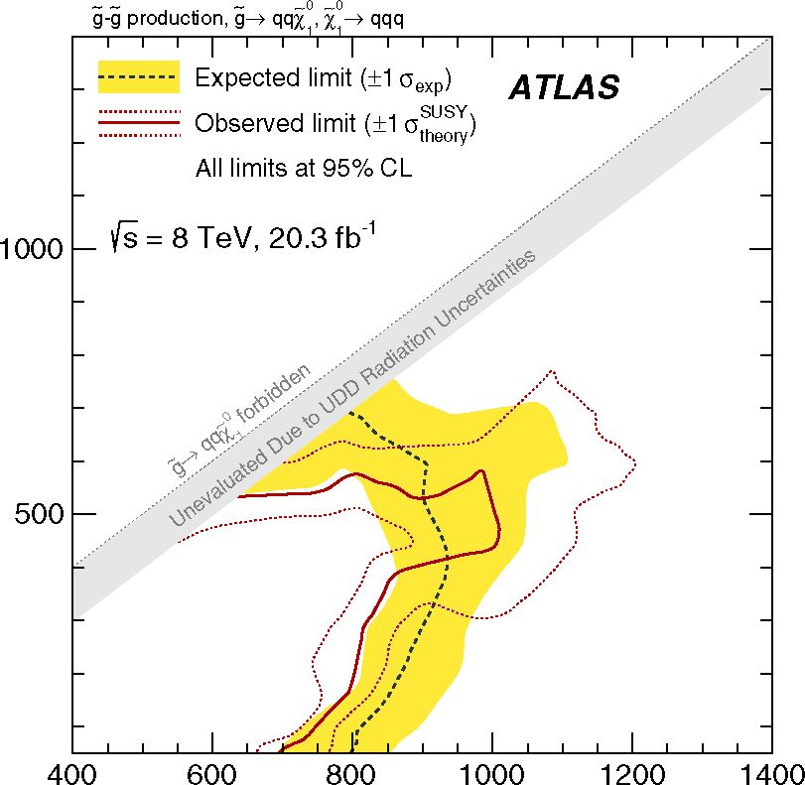
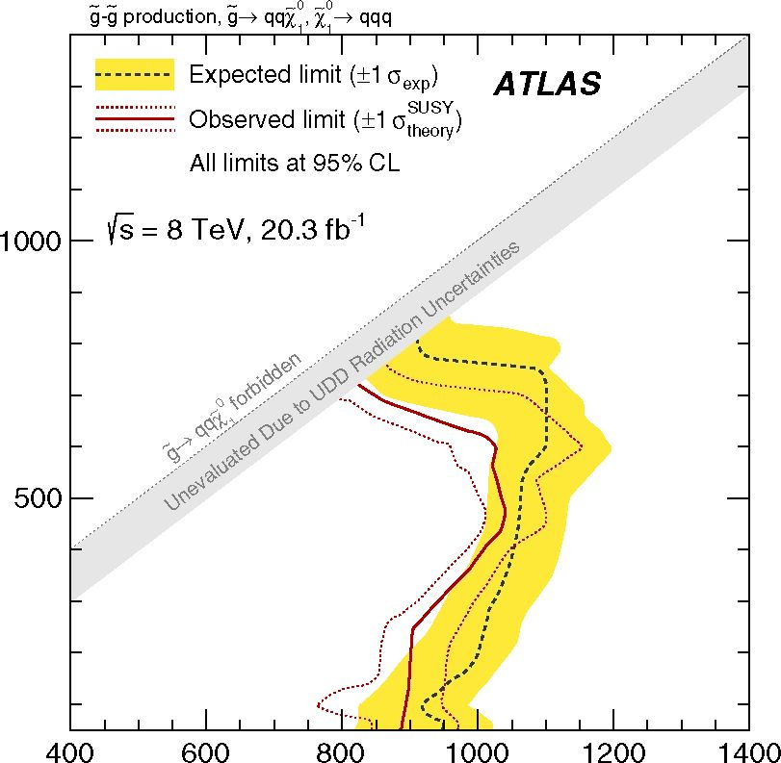
G. AAD et al.
m, [GeV]
(a)
m [GeV]
(b)
FIG. 16 (color online). Expected and observed exclusion limits
in the (mg, m^o) plane for the ten-quark model given by the jet-
counting analysis. (a) shows the results when the branching ratios
for the RPV decay are considered inclusively, without any b-
tagging requirements applied. This figure is analogous to Fig. 11.
(b) shows the exclusion results when b-tagging requirements are
allowed to enter into the optimization procedure, improving
limits significantly.
The results of performing the limit-setting procedure on
the data in the signal regions are shown in Figs. 12 and 13
for various flavor branching ratio hypotheses as a function
of gluino mass for the six-quark model. These results show
both the expected and observed cross-section limits in
comparison to the predicted cross section from the theory.
Under the assumption that all RPV decays are to light-
flavor quarks (BR(b) = BR(t) = BR(c) = 0%), gluino
PHYSICAL REVIEW D 91, 112016 (2015)
masses of mg < 853 GeV (expected) and mg < 917 GeV
(observed) are excluded at the 95% CL. Alternatively for
the scenario where BR(b) = 100% while the other heavy-
flavor branching ratios are zero, exclusions of mg <
921 GeV (expected) and mg < 929 GeV (observed) are
found. Similarly, for the case where BR(b) = BR(t) =
100%, exclusions of mg < 938 GeV (expected) and mg <
874 GeV (observed) are found. More generally, excluded
masses as a function of the branching ratios of the decays
are presented in Figs. 14 and 15 where each bin shows the
maximum gluino mass that is excluded for the given
decay mode.
The event selection is optimized separately for the ten-
quark model. Table VI shows the results for the ten-quark
model with all UDD couplings allowed, as in the total-jet-
mass analysis, when the number of b-tagged jets is also
used as a variable in the optimization procedure. For the
flavor-agnostic model where all couplings are equal,
Fig. 16(a) shows both the expected and observed limits
in the (mg, m^ ) mass plane when the signal region that
provides the best expected exclusion is used for each mass
point, not including signal regions containing b-tagged jets.
The shapes of the contours are given by discontinuous
changes in the optimized signal regions and fluctuations
well within the given uncertainties. At mX0 ~ 100 GeV,
A 1
models with mg < 700 GeV are excluded. Figure 16(b)
shows the exclusion when signal regions with b-tagged jets
are considered as part of the optimization and increase the
sensitivity up to mg < 1 TeV for moderate mg — m~0 mass
splittings. In the ten-quark model, there is a significant
probability that the cascade decays of the gluinos produce
at least one b- or t-quark, and so the requirement of a
b-tagged jet improves the sensitivity of the analysis.

C. Comparisons
Model-independent upper limits on non-SM contribu-
tions are derived separately for each analysis, using the SR1
signal region for the total-jet-mass analysis. A set of generic
signal models, each of which contributes only to the
individual signal region, is assumed and no experimental
or theoretical signal systematic uncertainties are assigned
other than the luminosity uncertainty. A fit is performed in
the signal regions to determine the maximum number of
signal events which would still be consistent with the
background estimate. The resulting limits on the number of
non-SM events and on the visible signal cross section are
shown in the rightmost columns of Table VII. The visible
signal cross section (tfvis) is defined as the product of
acceptance (A), reconstruction efficiency (e) and produc-
tion cross section (tfprod); it is obtained by dividing the
upper limit on the number of non-SM events by the
integrated luminosity. The results of these fits are provided
in Table VII.
112016-20
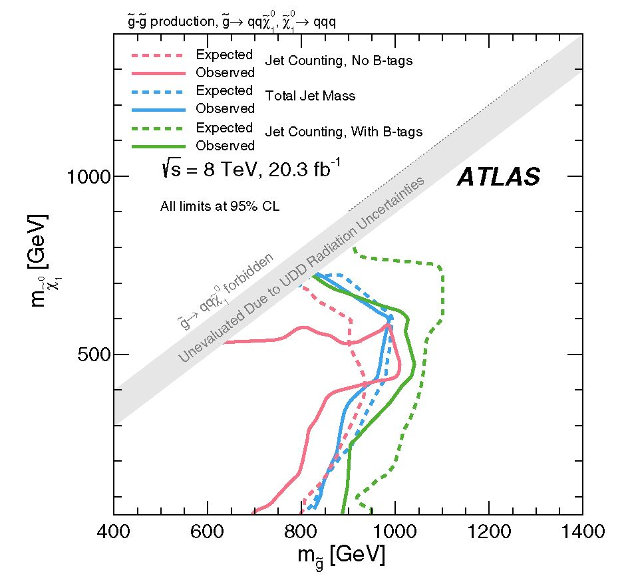
SEARCH FOR MASSIVE SUPERSYMMETRIC PARTICLES
PHYSICAL REVIEW D 91, 112016 (2015)
TABLE VII. Table showing upper limits on the number of events and visible cross sections in various signal regions. Columns two and
three show the expected and observed numbers of events. The uncertainties on the expected yields represent systematic and statistical
uncertainties. Column four shows the probabilities, represented by the p0 values, that the observed numbers of events are compatible
with the background-only hypothesis (the p0 values are obtained with pseudoexperiments). Columns five and six show respectively the
expected and observed 95% CL upper limit on non-SM events (Nnon-SM), and columns seven and eight show respectively the 95% CL
upper limit on the visible signal cross section (<7vis = <7prod x A x e = Nnon-SM/L). In the case where Nexpected exceeds Nobserved, p0 is set
to >0.5.
Signal Region |  | Expected | Observed | P0 | Nnon-SM  Expected | Nnon-SM  Observed | ffvis [fb]  Expected | ffvis [fb]  Observed
SR1 (Mf ) |  | 16024° | 176 | 0.39 | 49 | 64 | 2.4 | 3.2
(njet; pT ; nb-tagsy | = (7; 120 GeV; 0) | 370 ± 60 | 444 | 0.12 | 44 | 38 | 2.2 | 1.9
(njet; pT ; nb-tagsy | = (7; 180 GeV; 0) | 6.1 ± 2.2 | 4 | >0.5 | 19 | 10 | 0.9 | 0.5
(njet; pT ; nb-tagsy | = (7; 120 GeV; 1) | 138 ± 26 | 178 | 0.09 | 56 | 42 | 2.8 | 2.1
(njet; pT ; nb-tagsy | = (7; 180 GeV; 1) | 2.3 ± 1.0 | 1 | >0.5 | 4 | 4 | 0.2 | 0.2
(njet; pT ; nb-tagsy | = (7; 80 GeV; 2) | 1670 ± 190 | 1560 | >0.5 | 38 | 38 | 1.9 | 1.9
(njet; pT ; nb-tagsy | = (7; 120 GeV; 2) | 38 ± 17 | 56 | 0.17 | 36 | 52 | 1.8 | 2.6
The interpretations of the results of the jet-counting and
total-jet-mass analyses are displayed together in Fig. 17 for
the ten-quark model. This figure allows for the direct
comparison of the results of the various analyses. Without
b-tagging requirements, the jet-counting analysis sets
slightly lower expected limits than the total-jet-mass
analysis. With b-tagging requirements, the limits are
stronger for the jet-counting analysis. The observed limits
from the total-jet-mass analysis and jet-counting analysis
with b-tagging requirements are also comparable.
FIG. 17 (color online). Expected and observed exclusion limits
in the (mg, m^) plane for the ten-quark model for the jet-counting
analysis (with and without b-tagged jets) and the total-jet-mass
analysis.

IX. CONCLUSIONS
A search is presented for heavy particles decaying
into complex multijet final states using an integrated
luminosity of 20.3 ± 0.6 fb-1 of p = 8 TeV pp colli-
sions with the ATLAS detector at the LHC. Two
strategies are used for both background estimation
and signal discrimination. An inclusive data-driven
analysis using the total jet mass with a template method
for background estimation is performed as well as a jet-
counting analysis that includes exclusive heavy-flavor
signal regions and provides limits on different branching
ratios for the benchmark SUSY RPV UDD decays. For
the ten-quark model, results from both analyses are
presented with comparable conclusions. When the jet-
counting analysis includes sensitivity to heavy flavor
given by b-tagging requirements, mass exclusions are
further increased.
Exclusion limits at the 95% CL are set extending up to
mg = 917 GeV in the case of pair-produced gluino decays
to six light quarks and up to mg = 1 TeV in the case of
mxo mass
cascade decays to ten quarks for moderate mg~
splittings. Limits are also set on different branching ratios
by accounting for all possible decay modes allowed by the
2"-k couplings in full generality in the context of R-parity-
violating supersymmetry. These results represent the first
direct limits on many of the models considered as well as
the most stringent direct limits to date on those models
previously considered by other analyses.

ACKNOWLEDGMENTS
We thank CERN for the very successful operation of the
LHC, as well as the support staff from our institutions
without whom ATLAS could not be operated efficiently.
112016-21
G. AAD et al.
We acknowledge the support of ANPCyT, Argentina;
YerPhI, Armenia; ARC, Australia; BMWFW and FWF,
Austria; ANAS, Azerbaijan; SSTC, Belarus; CNPq
and FAPESP, Brazil; NSERC, NRC and CFI, Canada;
CERN; CONICYT, Chile; CAS, MOST and NSFC,
China; COLCIENCIAS, Colombia; MSMT CR, MPO
CR and VSC CR, Czech Republic; DNRF, DNSRC and
Lundbeck Foundation, Denmark; EPLANET, ERC and
European Union Seventh Framework ProgrammeNSRF,
European Union; IN2P3-CNRS, CEA-DSM/IRFU,
France; GNSF, Georgia; BMBF, DFG, HGF, MPG and
AvH Foundation, Germany; GSRT and NSRF, Greece;
RGC, Hong Kong SAR, China; ISF, MINERVA, GIF,
I-CORE and Benoziyo Center, Israel; INFN, Italy; MEXT
and JSPS, Japan; CNRST, Morocco; FOM and NWO,
Netherlands; BRF and RCN, Norway; MNiSW and NCN,
- H. Miyazawa, Baryon number changing currents, Prog.
Theor. Phys. 36, 1266 (1966).
- P. Ramond, Dual theory for free fermions, Phys. Rev. D 3,
2415 (1971).
- Y. A. Gol’fand and E. P. Likhtman, Extension of the algebra
of Poincare group generators and violation of p invariance,
Pis’ma Zh. Eksp. Teor. Fiz. 13, 452 (1971) [JETP Lett. 13,
323 (1971)].
- A. Neveu and J. H. Schwarz, Factorizable dual model of
pions, Nucl. Phys. B31, 86 (1971).
- A. Neveu and J. H. Schwarz, Quark model of dual pions,
Phys. Rev. D 4, 1109 (1971).
- J. Gervais and B. Sakita, Field theory interpretation of
supergauges in dual models, Nucl. Phys. B34, 632 (1971).
- D. V. Volkov and V. P. Akulov, Is the neutrino a Goldstone
particle?, Phys. Lett. 46B, 109 (1973).
- J. Wess and B. Zumino, A Lagrangian model invariant under
supergauge transformations, Phys. Lett. 49B, 52 (1974).
- J. Wess and B. Zumino, Supergauge transformations in four-
dimensions, Nucl. Phys. B70, 39 (1974).
- S. Dimopoulos and H. Georgi, Softly broken supersym-
metry and SU(5), Nucl. Phys. B193, 150 (1981).
- E. Witten, Dynamical breaking of supersymmetry, Nucl.
Phys. B188, 513 (1981).
- M. Dine, W. Fischler, and M. Srednicki, Supersymmetric
technicolor, Nucl. Phys. B189, 575 (1981).
- S. Dimopoulos and S. Raby, Supercolor, Nucl. Phys. B192,
353 (1981).
- N. Sakai, Naturalness in supersymmetric guts, Z. Phys. C
11, 153 (1981).
- R. Kaul and P. Majumdar, Cancellation of quadratically
divergent mass corrections in globally supersymmetric
spontaneously broken gauge theories, Nucl. Phys. B199,
36 (1982).
- H. Goldberg, Constraint on the Photino Mass from
Cosmology, Phys. Rev. Lett. 50, 1419 (1983).
PHYSICAL REVIEW D 91, 112016 (2015)
Poland; GRICES and FCT, Portugal; MNE/IFA,
Romania; MES of Russia and ROSATOM, Russian
Federation; JINR; MSTD, Serbia; MSSR, Slovakia;
ARRS and MIZS, Slovenia; DST/NRF, South Africa;
MINECO, Spain; SRC and Wallenberg Foundation,
Sweden; SER, SNSF and Cantons of Bern and
Geneva, Switzerland; NSC, Taiwan; TAEK, Turkey;
STFC, the Royal Society and Leverhulme Trust, U.K.;
DOE and NSF, U.S. The crucial computing support from
all WLCG partners is acknowledged gratefully, in par-
ticular from CERN and the ATLAS Tier-1 facilities at
TRIUMF (Canada), NDGF (Denmark, Norway, Sweden),
CC-IN2P3 (France), KIT/GridKA (Germany), INFN-
CNAF (Italy), NL-T1 (Netherlands), PIC (Spain),
ASGC (Taiwan), RAL (UK) and BNL (USA) and in
the Tier-2 facilities worldwide.
- J. Ellis, J. Hagelin, D. Nanopoulos, K. Olive, and M.
Srednicki, Supersymmetric relics from the big bang, Nucl.
Phys. B238, 453 (1984).
- ATLAS Collaboration, Search for squarks and gluinos using
final states with jets and missing transverse momentum with
the ATLAS detector in ps = 7 TeV proton-proton colli-
sions, Phys. Lett. B 710, 67 (2012).
- ATLAS Collaboration, Search for supersymmetry in final
states with jets, missing transverse momentum and one
isolated lepton in P? = 7 TeV pp collisions using 1 fb-1 of
ATLAS data, Phys. Rev. D 85, 012006 (2012).
- ATLAS Collaboration, Searches for supersymmetry with
the ATLAS detector using final states with two leptons and
missing transverse momentum in Ps = 7 TeV proton-
proton collisions, Phys. Lett. B 709, 137 (2012).
- ATLAS Collaboration, Search for new phenomena in final
states with large jet multiplicities and missing transverse
momentum using s = 7 TeV pp collisions with the
ATLAS detector, J. High Energy Phys. 11 (2011) 099.
- A. Arvanitaki, M. Baryakhtar, X. Huang, K. van Tilburg,
and G. Villadoro, The last vestiges of naturalness, J. High
Energy Phys. 03 (2014) 022.
- ATLAS Collaboration, Search for a Heavy Particle
Decaying intoffiffian Electron and a Muon with the ATLAS
Detector in ps = 7 TeV pp Collisions at the LHC, Phys.
Rev. Lett. 106, 251801 (2011).
- ATLAS Collaboration, Search for a heavy neutral particle
decaying into an electron and a muon using 1 fb-1 of
ATLAS data, Eur. Phys. J. C 71, 1809 (2011).
- ATLAS Collaboration, Search for lepton flavour violation
in the emu continuum with the ATLAS detector in
ps = 7 TeV pp collisions at the LHC, Eur. Phys. J. C
72, 2040 (2012).
- ATLAS Collaboration, Search for stable hadronising
squarks and gluinos with the ATLAS experiment at the
LHC, Phys. Lett. B 701, 1 (2011).
112016-22
SEARCH FOR MASSIVE SUPERSYMMETRIC PARTICLES ..
- ATLAS Collaboration, Search for heavy long-lived charged
particles with the ATLAS detector in pp collisions at
PS = 7 TeV, Phys. Lett. B 703, 428 (2011).
- ATLAS Collaboration, Search for displaced vertices arising
from decays of new heavy particles in 7 TeV pp collisions
at ATLAS, Phys. Lett. B 707, 478 (2012).
- ATLAS Collaboration, Search for decays of stopped, long-
lived particles from 7 TeV pp collisions with the ATLAS
detector, Eur. Phys. J. C 72, 1965 (2012).
- ATLAS Collaboration, Search for pair production of mas-
sive particles decaying into three quarks with the ATLAS
detector in s = 7 TeV pp collisions at the LHC, J. High
Energy Phys. 12 (2012) 086.
- H. K. Dreiner, An introduction to explicit R-parity violation,
Pramana 51, 123 (1998).
- B. Allanach, A. Dedes, and H. Dreiner, R-parity violating
minimal supergravity model, Phys. Rev. D 69, 115002
(2004).
- I. Hinchliffe and T. Kaeding, B- and L-violating couplings
in the minimal supersymmetric standard model, Phys. Rev.
D 47, 279 (1993).
- B. Allanach, A. Dedes, and H. K. Dreiner, Bounds on
R-parity violating couplings at the weak scale and at the
GUT scale, Phys. Rev. D 60, 075014 (1999).
- M. Sher and J. Goity, Bounds on AB = 1 couplings in the
supersymmetric standard model, arXiv:hep-ph/9503472.
- F. Zwirner, Observable AB = 2 transitions without nucleon
decay in a minimal supersymmetric extension of the
standard model, Phys. Lett. 132B, 103 (1983).
- G. Bhattacharyya, A brief review of R-parity violating
couplings, arXiv:hep-ph/9709395.
- T. Aaltonen et al. (CDF Collaboration), First Search for
Multijet Resonances in ps = 1.96 TeV pp Collisions,
Phys. Rev. Lett. 107, 042001 (2011).
- CMS Collaboration, Searches for light- and heavy-flavour
three-jet resonances in pp collisions at ps = 8 TeV, Phys.
Lett. B 730, 193 (2014).
- ATLAS Collaboration, The ATLAS experiment at the
CERN Large Hadron Collider, J. Instrum. 3, S08003 (2008).
- ATLAS Collaboration, Luminosity determination in pp
collisions at s = 7 TeV using the ATLAS detector at
the LHC, Eur. Phys. J. C 71, 1630 (2011).
- ATLAS Collaboration, Report No. ATLAS-CONF-2011-
116, http://cdsweb.cern.ch/record/1376384.
- M. Cacciari, G. P. Salam, and G. Soyez, The anti-kt jet
clustering algorithm, J. High Energy Phys. 04 (2008) 063.
- M. Bahr et al., Herwig++ physics and manual, Eur. Phys. J.
C 58, 639 (2008).
- J. Pumplin, D. Robert Stump, J. Huston, H.-L. Lai, P.
Nadolsky, and W.-K. Tung, New generation of parton
distributions with uncertainties from global QCD analysis,
J. High Energy Phys. 07 (2002) 012.
- P. M. Nadolsky, H.-L. Lai, Q.-H. Cao, J. Huston, J. Pumplin,
D. Stump, W.-K. Tung, and C.-P. Yuan, Implications of
CTEQ global analysis for collider observables, Phys. Rev. D
78, 013004 (2008).
- W. Beenakker, R. Hopker, M. Spira, and P. Zerwas, Squark
and gluino production at hadron colliders, Nucl. Phys.
B492, 51 (1997).
PHYSICAL REVIEW D 91, 112016 (2015)
- A. Kulesza and L. Motyka, Threshold Resummation for
Squark-Antisquark and Gluino-Pair Production at the LHC,
Phys. Rev. Lett. 102, 111802 (2009).
- A. Kulesza and L. Motyka, Soft gluon resummation for the
production of gluino-gluino and squark-antisquark pairs at
the LHC, Phys. Rev. D 80, 095004 (2009).
- W. Beenakker, S. Brensing, M. Krämer, A. Kulesza, E.
Laenen, and I. Niessen, Soft-gluon resummation for squark
and gluino hadroproduction, J. High Energy Phys. 12
(2009) 041.
- W. Beenakker, S. Brensing, M. Krämer, A. Kulesza, E.
Laenen, L. Motyka, and I. Niessen, Squark and gluino
hadroproduction, Int. J. Mod. Phys. D 26, 2637 (2011).
- ATLAS Collaboration, Report No. ATLAS-PHYS-PUB-
2011-009, http://cdsweb.cern.ch/record/1363300.
- T. Sjostrand, S. Mrenna, and P. Z. Skands, PYTHIA 6.4
physics and manual, J. High Energy Phys. 05 (2006) 026.
- T. Gleisberg, S. Höche, F. Krauss, M. Schönherr, S.
Schumann, F. Siegert, and J. Winter, Event generation with
SHERPA 1.1, J. High Energy Phys. 02 (2009) 007.
- ATLAS Collaboration, The ATLAS simulation infrastruc-
ture, Eur. Phys. J. C 70, 823 (2010).
- S. Agostinelli et al. (GEANT4 Collaboration), GEANT4: A
simulation toolkit, Nucl. Instrum. Methods Phys. Res., Sect.
A 506, 250 (2003).
- ATLAS Collaboration, Report No. ATLAS-CONF-2012-
020, http://cdsweb.cern.ch/record/1430034.
- ATLAS Collaboration, Monitoring and data quality assess-
ment of the ATLAS liquid argon calorimeter, J. Instrum. 9,
P07024 (2014).
- W. Lampl et al., Report No. ATL-LARG-PUB-2008-002,
http://cdsweb.cern.ch/record/1099735.
- ATLAS Collaboration, Jet energy measurement and its
systematic uncertainty in proton-proton collisions at Ps =
7 TeV with the ATLAS detector, Eur. Phys. J. C 75, 1
(2015).
- ATLAS Collaboration, Report No. ATLAS-CONF-2014-
046, http://cds.cern.ch/record/1741020.
- D. Krohn, J. Thaler, and L.-T. Wang, Jet trimming, J. High
Energy Phys. 10 (2010) 084.
- S. D. Ellis and D. E. Soper, Successive combination jet
algorithm for hadron collisions, Phys. Rev. D 48, 3160
(1993).
- S. Catani, Y. L. Dokshitzer, M. Seymour, and B. Webber,
Longitudinally invariant Kt clustering algorithms for hadron
hadron collisions, Nucl. Phys. B406, 187 (1993).
- ATLAS Collaboration, Performance of jet substructure
techniques for large-R jets in proton-proton collisions at
PS = 7 TeV using the ATLAS detector, J. High Energy
Phys. 09 (2013) 076.
- ATLAS Collaboration, Measurement of multi-jet cross
sections in proton-proton collisions at a 7 TeV center-of-
mass energy, Eur. Phys. J. C 71, 1763 (2011).
- A. Hook, E. Izaguirre, M. Lisanti, and J. G. Wacker, High
multiplicity searches at the LHC using jet masses, Phys.
Rev. D 85, 055029 (2012).
- S. El Hedri, A. Hook, M. Jankowiak, and J. G. Wacker,
Learning how to count: A high multiplicity search for the
LHC, J. High Energy Phys. 08 (2013) 136.
112016-23

G. AAD et al.
- T. Cohen, M. Jankowiak, M. Lisanti, H. K. Lou, and J. G.
Wacker, Jet substructure templates: Data-driven QCD back-
grounds for fat jet searches, J. High Energy Phys. 05 (2014)
005.
- ATLAS Collaboration, Search for new phenomena in final
states with largeffiffijet multiplicities and missing transverse
momentum at y/s = 8 TeV proton-proton collisions using
the ATLAS experiment, J. High Energy Phys. 10 (2013)
130; Erratum: Search for new phenomena in final states with
large jet multiplicities and missing transverse momentum at
y/s = 8 TeV proton-proton collisions using the ATLAS
experiment, J. High Energy Phys. 01 (2014) 109(E).
- J. Thaler and K. Van Tilburg, Identifying boosted objects
with N-subjettiness, J. High Energy Phys. 03 (2011) 015.
PHYSICAL REVIEW D 91, 112016 (2015)
- J. Thaler and K. Van Tilburg, Maximizing boosted top
identification by minimizing N-subjettiness, J. High Energy
Phys. 02 (2012) 093.
- J. Gallicchio and M. D. Schwartz, Pure samples of quark
and gluon jets at the LHC, J. High Energy Phys. 10 (2011)
103.
- ATLAS Collaboration, Light-quark and gluon jet discrimi-
nation in pp collisions at -y/s = 7 TeV with the ATLAS
detector, Eur. Phys. J. C 74, 3023 (2014).
- A. L. Read, Presentation of search results: The CL(s)
technique, J. Phys. G 28, 2693 (2002).
- M. Kramer et al., Supersymmetry production cross
sections in pp collisions at = 7 TeV, arXiv:
1206.2892.
- Aad,85 B. Abbott,113 J. Abdallah,152 S. Abdel Khalek,117 O. Abdinov,11 R. Aben,107 B. Abi,114 M. Abolins,90
O. S. AbouZeid,159 H. Abramowicz,154 H. Abreu,153 R. Abreu,30 Y. Abulaiti,147a,147b B. S. Acharya,165a’165b’b
L. Adamczyk,38a D. L. Adams,25 J. Adelman,108 S. Adomeit,100 T. Adye,131 T. Agatonovic-Jovin,13
J. A. Aguilar-Saavedra,126a,126f M. Agustoni,17 S. P. Ahlen,22 F. Ahmadov,65,c G. Aielli,134a,134b H. Akerstedt,147a,147b
T. P. A. Äkesson,81 G. Akimoto,156 A. V. Akimov,96 G. L. Alberghi,20a,20b J. Albert,170 S. Albrand,55
M. J. Alconada Verzini,71 M. Aleksa,301. N. Aleksandrov,65 C. Alexa,26a G. Alexander,154 T. Alexopoulos,10 M. Alhroob,113
- Alimonti,91a L. Alio,85 J. Alison,31 B. M. M. Allbrooke,18 L. J. Allison,72 P. P. Allport,74 A. Aloisio,104a104b A. Alonso,36
- Alonso,71 C. Alpigiani,76 A. Altheimer,35 B. Alvarez Gonzalez,90 M. G. Alviggi,104a’104b K. Amako,66
Y. Amaral Coutinho,24a C. Amelung,23 D. Amidei,89 S. P. Amor Dos Santos,126a126c A. Amorim,126a126b S. Amoroso,48
N. Amram,154 G. Amundsen,23 C. Anastopoulos,140 L. S. Ancu,49 N. Andari,30 T. Andeen,35 C. F. Anders,58b G. Anders,30
K. J. Anderson,31 A. Andreazza,91a’91b V. Andrei,58a X. S. Anduaga,71 S. Angelidakis,9 I. Angelozzi,107 P. Anger,44
- Angerami,35 F. Anghinolfi,30 A. V. Anisenkov,109’d N. Anjos,12 A. Annovi,124a’124b M. Antonelli,47 A. Antonov,98
J. Antos,145b F. Anulli,133a M. Aoki,66 L. Aperio Bella,18 G. Arabidze,90 Y. Arai,66 J. P. Araque,126a A. T. H. Arce,45
- A. Arduh,71 J-F. Arguin,95 S. Argyropoulos,42 M. Arik,19a A. J. Armbruster,30 O. Arnaez,30 V. Arnal,82 H. Arnold,48
M. Arratia,28 O. Arslan,21 A. Artamonov,97 G. Artoni,23 S. Asai,156 N. Asbah,42 A. Ashkenazi,154 B. Äsman,147a,147b
L. Asquith,150 K. Assamagan,25 R. Astalos,145a M. Atkinson,166 N. B. Atlay,142 B. Auerbach,6 K. Augsten,128
M. Aurousseau,146b G. Avolio,30 B. Axen,15 M. K. Ayoub,117 G. Azuelos,95’e M. A. Baak,30 A. E. Baas,58a C. Bacci,135a’135b
- Bachacou,137 K. Bachas,155 M. Backes,30 M. Backhaus,30 P. Bagiacchi,133a133b P. Bagnaia,133a133b Y. Bai,33a T. Bain,35
J. T. Baines,131 O. K. Baker,177 P. Balek,129 T. Balestri,149 F. Balli,84 E. Banas,39 Sw. Banerjee,174 A. A. E. Bannoura,176
- S. Bansil,18 L. Barak,30 S. P. Baranov,96 E. L. Barberio,88 D. Barberis,50a 50b M. Barbero,85 T. Barillari,101
M. Barisonzi,165a165b T. Barklow,144 N. Barlow,28 S. L. Barnes,84 B. M. Barnett,131 R. M. Barnett,15 Z. Barnovska,5
- Baroncelli,135a G. Barone,49 A. J. Barr,120 F. Barreiro,82 J. Barreiro Guimaraes da Costa,57 R. Bartoldus,144 A. E. Barton,72
P. Bartos,145a A. Bassalat,117 A. Basye,166 R. L. Bates,53 S. J. Batista,159 J. R. Batley,28 M. Battaglia,138 M. Bauce,133a133b
- Bauer,137 H. S. Bawa,144 f J. B. Beacham,111 M. D. Beattie,72 T. Beau,80 P. H. Beauchemin,162 R. Beccherle,124a124b
P. Bechtle,21 H. P. Beck,17g K. Becker,120 S. Becker,100 M. Beckingham,171 C. Becot,117 A. J. Beddall,19c A. Beddall,19c
V. A. Bednyakov,65 C. P. Bee,149 L. J. Beemster,107 T. A. Beermann,176 M. Begel,25 K. Behr,120 C. Belanger-Champagne,87
P. J. Bell,49 W. H. Bell,49 G. Bella,154 L. Bellagamba,20a A. Bellerive,29 M. Bellomo,86 K. Belotskiy,98 O. Beltramello,30
O. Benary,154 D. Benchekroun,136a M. Bender,100 K. Bendtz,147a147b N. Benekos,10 Y. Benhammou,154 E. Benhar Noccioli,49
J. A. Benitez Garcia,160b D. P. Benjamin,45 J. R. Bensinger,23 S. Bentvelsen,107 L. Beresford,120 M. Beretta,47 D. Berge,107
E. Bergeaas Kuutmann,167 N. Berger,5 F. Berghaus,170 J. Beringer,15 C. Bernard,22 N. R. Bernard,86 C. Bernius,110
- U. Bernlochner,21 T. Berry,77 P. Berta,129 C. Bertella,83 G. Bertoli,147a147b F. Bertolucci,124a124b C. Bertsche,113
- Bertsche,113 M. I. Besana,91a G. J. Besjes,106 O. Bessidskaia Bylund,147a’147b M. Bessner,42 N. Besson,137 C. Betancourt,48
S. Bethke,101 A. J. Bevan,76 W. Bhimji,46 R. M. Bianchi,125 L. Bianchini,23 M. Bianco,30 O. Biebel,100 S. P. Bieniek,78
M. Biglietti,135a J. Bilbao De Mendizabal,49 H. Bilokon,47 M. Bindi,54 S. Binet,117 A. Bingul,19c C. Bini,133a,133b
112016-24
SEARCH FOR MASSIVE SUPERSYMMETRIC PARTICLES
PHYSICAL REVIEW D 91, 112016 (2015)
- W. Black,151 J. E. Black,144 K. M. Black,22 D. Blackburn,139 R. E. Blair,6 J.-B. Blanchard,137 J. E. Blanco,77 T. Blazek,145a
- Bloch,42 C. Blocker,23 W. Blum,83a U. Blumenschein,54 G. J. Bobbink,107 V. S. Bobrovnikov,109,4 S. S. Bocchetta,81
A. Bocci,45 C. Bock,100 M. Boehler,48 J. A. Bogaerts,30 A. G. Bogdanchikov,109 C. Bohm,147a V. Boisvert,77 T. Bold,38a
V. Boldea,26a A. S. Boldyrev,99 M. Bomben,80 M. Bona,76 M. Boonekamp,137 A. Borisov,130 G. Borissov,72 S. Borroni,42
J. Bortfeldt,100 V. Bortolotto,60a’60b’60c K. Bos,107 D. Boscherini,20a M. Bosman,12 J. Boudreau,125 J. Bouffard,2
E. V. Bouhova-Thacker,72 D. Boumediene,34 C. Bourdarios,117 N. Bousson,114 S. Boutouil,136d A. Boveia,30 J. Boyd,30
- R. Boyko,65 I. Bozic,13 J. Bracinik,18 A. Brandt,8 G. Brandt,15 O. Brandt,58“ U. Bratzler,157 B. Brau,86 J. E. Brau,116
- M. Braun,176,a S. F. Brazzale,165a,165c K. Brendlinger,122 A. J. Brennan,88 L. Brenner,107 R. Brenner,167 S. Bressler,173
K. Bristow,146c T. M. Bristow,46 D. Britton,53 D. Britzger,42 F. M. Brochu,28 I. Brock,21 R. Brock,90 J. Bronner,101
G. Brooijmans,35 T. Brooks,77 W. K. Brooks,32b J. Brosamer,15 E. Brost,116 J. Brown,55 P. A. Bruckman de Renstrom,39
- Bruncko,145b R. Bruneliere,48 A. Bruni,20a G. Bruni,20a M. Bruschi,20a L. Bryngemark,81 T. Buanes,14 Q. Buat,143
P. Buchholz,142 A. G. Buckley,53 S. I. Buda,26a I. A. Budagov,65 F. Buehrer,48 L. Bugge,119 M. K. Bugge,119 O. Bulekov,98
- Burckhart,30 S. Burdin,74 B. Burghgrave,108 S. Burke,131 I. Burmeister,43 E. Busato,34 D. Büscher,48 V. Büscher,83
P. Bussey,53 C. P. Buszello,167 J. M. Butler,22 A. I. Butt,3 C. M. Buttar,53 J. M. Butterworth,78 P. Butti,107 W. Buttinger,25
A. Buzatu,53 S. Cabrera Urban,168 D. Caforio,128 O. Cakir,4a P. Calafiura,15 A. Calandri,137 G. Calderini,80 P. Calfayan,100
L. P. Caloba,24a D. Calvet,34 S. Calvet,34 R. Camacho Toro,49 S. Camarda,42 D. Cameron,119 L. M. Caminada,15
R. Caminal Armadans,12 S. Campana,30 M. Campanelli,78 A. Campoverde,149 V. Canale,104a’104b A. Canepa,160a
M. Cano Bret,76 J. Cantero,82 R. Cantrill,126a T. Cao,40 M. D. M. Capeans Garrido,30 I. Caprini,26a M. Caprini,26a
M. Capua,37a37b R. Caputo,83 R. Cardarelli,134a T. Carli,30 G. Carlino,104a L. Carminati,91a91b S. Caron,106 E. Carquin,32a
G. D. Carrillo-Montoya,8 J. R. Carter,28 J. Carvalho,126a126c D. Casadei,78 M. P. Casado,12 M. Casolino,12
E. Castaneda-Miranda,146b A. Castelli,107 V. Castillo Gimenez,168 N. F. Castro,126ah P. Catastini,57 A. Catinaccio,30
J. R. Catmore,119 A. Cattai,30 G. Cattani,134a’134b J. Caudron,83 V. Cavaliere,166 D. Cavalli,91a M. Cavalli-Sforza,12
V. Cavasinni,124a124b F. Ceradini,135a135b B. C. Cerio,45 K. Cerny,129 A. S. Cerqueira,24b A. Cerri,150 L. Cerrito,76 F. Cerutti,15
M. Cerv,30 A. Cervelli,17 S. A. Cetin,19b A. Chafaq,136a D. Chakraborty,108 I. Chalupkova,129 P. Chang,166 B. Chapleau,87
J. D. Chapman,28 D. Charfeddine,117 D. G. Charlton,18 C. C. Chau,159 C. A. Chavez Barajas,150 S. Cheatham,153
A. Chegwidden,90 S. Chekanov,6 S. V. Chekulaev,160a G. A. Chelkov,65 i M. A. Chelstowska,89 C. Chen,64 H. Chen,25
K. Chen,149 L. Chen,33dj S. Chen,33c X. Chen,33f Y. Chen,67 H. C. Cheng,89 Y. Cheng,31 A. Cheplakov,65
E. Cheremushkina,130 R. Cherkaoui El Moursli,136e V. Chernyatin,25 a E. Cheu,7 L. Chevalier,137 V. Chiarella,47
J. T. Childers,6 A. Chilingarov,72 G. Chiodini,73a A. S. Chisholm,18 R. T. Chislett,78 A. Chitan,26a M. V. Chizhov,65
K. Choi,61 S. Chouridou,9 B. K. B. Chow,100 V. Christodoulou,78 D. Chromek-Burckhart,30 M. L. Chu,152 J. Chudoba,127
- J. Chuinard,87 J. J. Chwastowski,39 L. Chytka,115 G. Ciapetti,133a133b A. K. Ciftci,4a D. Cinca,53 V. Cindro,75 A. Ciocio,15
Z. H. Citron,173 M. Ciubancan,26a A. Clark,49 P. J. Clark,46 R. N. Clarke,15 W. Cleland,125 C. Clement,147a147b Y. Coadou,85
M. Cobal,165a’165c A. Coccaro,139 J. Cochran,64 L. Coffey,23 J. G. Cogan,144 B. Cole,35 S. Cole,108 A. P. Colijn,107 J. Collot,55
T. Colombo,58" G. Compostella,101 P. Conde Muino,126a126b E. Coniavitis,48 S. H. Connell,146b I. A. Connelly,77
S. M. Consonni,91a’91b V. Consorti,48 S. Constantinescu,26a C. Conta,121a’121b G. Conti,30 F. Conventi,104a’k M. Cooke,15
- D. Cooper,78 A. M. Cooper-Sarkar,120 K. Copic,15 T. Cornelissen,176 M. Corradi,20a F. Corriveau,874 A. Corso-Radu,164
- Cortes-Gonzalez,12 G. Cortiana,101 G. Costa,91a M. J. Costa,168 D. Costanzo,140 D. Côté,8 G. Cottin,28 G. Cowan,77
- E. Cox,84 K. Cranmer,110 G. Cree,29 S. Crépé-Renaudin,55 F. Crescioli,80 W. A. Cribbs,147a147b M. Crispin Ortuzar,120
M. Cristinziani,21 V. Croft,106 G. Crosetti,37a 37b T. Cuhadar Donszelmann,140 J. Cummings,177 M. Curatolo,47 C. Cuthbert,151
- Czirr,142 P. Czodrowski,3 S. D’Auria,53 M. D’Onofrio,74 M. J. Da Cunha Sargedas De Sousa,126a126b C. Da Via,84
W. Dabrowski,38a A. Dafinca,120 T. Dai,89 O. Dale,14 F. Dallaire,95 C. Dallapiccola,86 M. Dam,36 J. R. Dandoy,31
A. C. Daniells,18 M. Danninger,169 M. Dano Hoffmann,137 V. Dao,48 G. Darbo,50a S. Darmora,8 J. Dassoulas,3
- Dattagupta,61 W. Davey,21 C. David,170 T. Davidek,129 E. Davies,120’“ M. Davies,154 P. Davison,78 Y. Davygora,58a
E. Dawe,1431. Dawson,140 R. K. Daya-Ishmukhametova,86 K. De,8 R. de Asmundis,104a S. De Castro,20a20b S. De Cecco,80
N. De Groot,106 P. de Jong,107 H. De la Torre,82 F. De Lorenzi,64 L. De Nooij,107 D. De Pedis,133a A. De Salvo,133a
U. De Sanctis,150 A. De Santo,150 J. B. De Vivie De Regie,117 W. J. Dearnaley,72 R. Debbe,25 C. Debenedetti,138
- V. Dedovich,65 I. Deigaard,107 J. Del Peso,82 T. Del Prete,124a,124b D. Delgove,117 F. Deliot,137 C. M. Delitzsch,49
M. Deliyergiyev,75 A. Dell’Acqua,30 L. Dell’Asta,22 M. Dell’Orso,124a124b M. Della Pietra,104ak D. della Volpe,49
M. Delmastro,5 P. A. Delsart,55 C. Deluca,107 D. A. DeMarco,159 S. Demers,177 M. Demichev,65 A. Demilly,80
112016-25
G. AAD et al.
PHYSICAL REVIEW D 91, 112016 (2015)
S. P. Denisov,130 D. Derendarz,39 J. E. Derkaoui,136d F. Derue,80 P. Dervan,74 K. Desch,21 C. Deterre,42 P. O. Deviveiros,30
A. Dewhurst,131 S. Dhaliwal,107 A. Di Ciaccio,134a134b L. Di Ciaccio,5 A. Di Domenico,133a133b C. Di Donato,104a104b
A. Di Girolamo,30 B. Di Girolamo,30 A. Di Mattia,153 B. Di Micco,135a135b R. Di Nardo,47 A. Di Simone,48 R. Di Sipio,159
- Di Valentino,29 C. Diaconu,85 M. Diamond,159 F. A. Dias,46 M. A. Diaz,32a E. B. Diehl,89 J. Dietrich,16 S. Diglio,85
A. Dimitrievska,13 J. Dingfelder,21 F. Dittus,30 F. Djama,85 T. Djobava,51b J. I. Djuvsland,58a M. A. B. do Vale,24c D. Dobos,30
M. Dobre,26a C. Doglioni,49 T. Dohmae,156 J. Dolejsi,129 Z. Dolezal,129 B. A. Dolgoshein,98a M. Donadelli,24d
S. Donati,124a124b P. Dondero,121a121b J. Donini,34 J. Dopke,131 A. Doria,104a M. T. Dova,71 A. T. Doyle,53 E. Drechsler,54
M. Dris,10 E. Dubreuil,34 E. Duchovni,173 G. Duckeck,100 O. A. Ducu,26a 85 D. Duda,176 A. Dudarev,30 L. Duflot,117
L. Duguid,77 M. Dührssen,30 M. Dunford,58a H. Duran Yildiz,4a M. Düren,52 A. Durglishvili,51b D. Duschinger,44
M. Dwuznik,38a M. Dyndal,38a K. M. Ecker,101 W. Edson,2 N. C. Edwards,46 W. Ehrenfeld,21 T. Eifert,30 G. Eigen,14
K. Einsweiler,15 T. Ekelof,167 M. El Kacimi,136c M. Ellert,167 S. Elles,5 F. Ellinghaus,83 A. A. Elliot,170 N. Ellis,30
J. Elmsheuser,100 M. Elsing,30 D. Emeliyanov,131 Y. Enari,156 O. C. Endner,83 M. Endo,118 R. Engelmann,149 J. Erdmann,43
A. Ereditato,17 D. Eriksson,147a G. Ernis,176 J. Ernst,2 M. Ernst,25 S. Errede,166 E. Ertel,83 M. Escalier,117 H. Esch,43
C. Escobar,125 B. Esposito,47 A. I. Etienvre,137 E. Etzion,154 H. Evans,61 A. Ezhilov,123 L. Fabbri,20a20b G. Facini,31
R. M. Fakhrutdinov,130 S. Falciano,133a R.J. Falla,78 J. Faltova,129 Y. Fang,33a M. Fanti,91a91b A. Farbin,8 A. Farilla,135a
T. Farooque,12 S. Farrell,15 S. M. Farrington,171 P. Farthouat,30 F. Fassi,136e P. Fassnacht,30 D. Fassouliotis,9
A. Favareto,50a50b L. Fayard,117 P. Federic,145a O. L. Fedin,123n W. Fedorko,169 S. Feigl,30 L. Feligioni,85 C. Feng,33d
E. J. Feng,6 H. Feng,89 A. B. Fenyuk,130 P. Fernandez Martinez,168 S. Fernandez Perez,30 S. Ferrag,53 J. Ferrando,53
- Ferrari,167 P. Ferrari,107 R. Ferrari,121“ D. E. Ferreira de Lima,53 A. Ferrer,168 D. Ferrere,49 C. Ferretti,89
- Ferretto Parodi,50a50b M. Fiascaris,31 F. Fiedler,83 A. Filipcic,75 M. Filipuzzi,42 F. Filthaut,106 M. Fincke-Keeler,170
K. D. Finelli,151 M. C. N. Fiolhais,126a126c L. Fiorini,168 A. Firan,40 A. Fischer,2 C. Fischer,12 J. Fischer,176 W. C. Fisher,90
E. A. Fitzgerald,23 M. Flechl,481. Fleck,142 P. Fleischmann,89 S. Fleischmann,176 G. T. Fletcher,140 G. Fletcher,76 T. Flick,176
- Floderus,81 L. R. Flores Castillo,60a M. J. Flowerdew,101 A. Formica,137 A. Forti,84 D. Fournier,117 H. Fox,72 S. Fracchia,12
P. Francavilla,80 M. Franchini,20a20b D. Francis,30 L. Franconi,119 M. Franklin,57 M. Fraternali,121a121b D. Freeborn,78
S. T. French,28 F. Friedrich,44 D. Froidevaux,30 J. A. Frost,120 C. Fukunaga,157 E. Fullana Torregrosa,83 B. G. Fulsom,144
J. Fuster,168 C. Gabaldon,55 O. Gabizon,176 A. Gabrielli,20a20b A. Gabrielli,133a133b S. Gadatsch,107 S. Gadomski,49
- Gagliardi,50a50b P. Gagnon,61 C. Galea,106 B. Galhardo,126a126c E. J. Gallas,120 B. J. Gallop,131 P. Gallus,128 G. Galster,36
K. K. Gan,111 J. Gao,33b’85 Y. Gao,46 Y. S. Gao,144f F. M. Garay Walls,46 F. Garberson,177 C. García,168
J. E. García Navarro,168 M. Garcia-Sciveres,15 R. W. Gardner,31 N. Garelli,144 V. Garonne,30 C. Gatti,47 G. Gaudio,121a
- Gaur,142 L. Gauthier,95 P. Gauzzi,133a133b I. L. Gavrilenko,96 C. Gay,169 G. Gaycken,21 E. N. Gazis,10 P. Ge,33d Z. Gecse,169
- N. P. Gee,131 D. A. A. Geerts,107 Ch. Geich-Gimbel,21 C. Gemme,50a M. H. Genest,55 S. Gentile,133a,133b M. George,54
S. George,77 D. Gerbaudo,164 A. Gershon,154 H. Ghazlane,136b N. Ghodbane,34 B. Giacobbe,20a S. Giagu,133a133b
V. Giangiobbe,12 P. Giannetti,124a,124b F. Gianotti,30 B. Gibbard,25 S. M. Gibson,77 M. Gilchriese,15 T. P. S. Gillam,28
- Gillberg,30 G. Gilles,34 D. M. Gingrich,3,e N. Giokaris,9 M. P. Giordani,165a,165c F. M. Giorgi,20a F. M. Giorgi,16
P. F. Giraud,137 P. Giromini,47 D. Giugni,91a C. Giuliani,48 M. Giulini,58b B. K. Gjelsten,119 S. Gkaitatzis,1551. Gkialas,155
- L. Gkougkousis,117 L. K. Gladilin,99 C. Glasman,82 J. Glatzer,30 P. C. F. Glaysher,46 A. Glazov,42 M. Goblirsch-Kolb,101
J. R. Goddard,76 J. Godlewski,39 S. Goldfarb,89 T. Golling,49 D. Golubkov,130 A. Gomes,126a126b126d R. Gongalo,126a
J. Goncalves Pinto Firmino Da Costa,137 L. Gonella,21 S. González de la Hoz,168 G. Gonzalez Parra,12 S. Gonzalez-Sevilla,49
L. Goossens,30 P. A. Gorbounov,97 H. A. Gordon,251. Gorelov,105 B. Gorini,30 E. Gorini,73a73b A. Gorisek,75 E. Gornicki,39
- T. Goshaw,45 C. Gössling,43 M. I. Gostkin,65 M. Gouighri,136a D. Goujdami,136c A. G. Goussiou,139 H. M. X. Grabas,138
L. Graber,54 I. Grabowska-Bold,38a P. Grafström,20a20b K-J. Grahn,42 J. Gramling,49 E. Gramstad,119 S. Grancagnolo,16
V. Grassi,149 V. Gratchev,123 H. M. Gray,30 E. Graziani,135a Z. D. Greenwood,79’“ K. Gregersen,78 I. M. Gregor,42
P. Grenier,144 J. Griffiths,8 A. A. Grillo,138 K. Grimm,72 S. Grinstein,12p Ph. Gris,34 Y. V. Grishkevich,99 J.-F. Grivaz,117
J. P. Grohs,44 A. Grohsjean,42 E. Gross,173 J. Grosse-Knetter,54 G. C. Grossi,134a134b Z. J. Grout,150 L. Guan,33b
J. Guenther,128 F. Guescini,49 D. Guest,177 O. Gueta,154 E. Guido,50a50b T. Guillemin,117 S. Guindon,2 U. Gul,53
- Gumpert,44 J. Guo,33e S. Gupta,120 P. Gutierrez,113 N. G. Gutierrez Ortiz,53 C. Gutschow,44 N. Guttman,154 C. Guyot,137
- Gwenlan,120 C. B. Gwilliam,74 A. Haas,110 C. Haber,15 H. K. Hadavand,8 N. Haddad,136e P. Haefner,21 S. Hageböck,21
Z. Hajduk,39 H. Hakobyan,178 M. Haleem,42 J. Haley,114 D. Hall,120 G. Halladjian,90 G. D. Hallewell,85 K. Hamacher,176
P. Hamal,115 K. Hamano,170 M. Hamer,54 A. Hamilton,146a S. Hamilton,162 G. N. Hamity,146c P. G. Hamnett,42 L. Han,33b
112016-26
SEARCH FOR MASSIVE SUPERSYMMETRIC PARTICLES
PHYSICAL REVIEW D 91, 112016 (2015)
K. Hanagaki,118 K. Hanawa,156 M. Hance,15 P. Hanke,58a R. Hanna,137 J. B. Hansen,36 J. D. Hansen,36 P. H. Hansen,36
K. Hara,161 A. S. Hard,174 T. Harenberg,176 F. Hariri,117 S. Harkusha,92 R. D. Harrington,46 P. F. Harrison,171 F. Hartjes,107
M. Hasegawa,67 S. Hasegawa,103 Y. Hasegawa,141 A. Hasib,113 S. Hassani,137 S. Haug,17 R. Hauser,90 L. Hauswald,44
M. Havranek,127 C. M. Hawkes,18 R. J. Hawkings,30 A. D. Hawkins,81 T. Hayashi,161 D. Hayden,90 C. P. Hays,120
J. M. Hays,76 H. S. Hayward,74 S. J. Haywood,131 S. J. Head,18 T. Heck,83 V. Hedberg,81 L. Heelan,8 S. Heim,122 T. Heim,176
- Heinemann,15 L. Heinrich,110 J. Hejbal,127 L. Helary,22 M. Heller,30 S. Hellman,147a147b D. Hellmich,21 C. Helsens,30
J. Henderson,120 R. C. W. Henderson,72 Y. Heng,174 C. Hengler,42 A. Henrichs,177 A. M. Henriques Correia,30
S. Henrot-Versille,117 G. H. Herbert,16 Y. Hernández Jiménez,168 R. Herrberg-Schubert,16 G. Herten,48 R. Hertenberger,100
L. Hervas,30 G. G. Hesketh,78 N. P. Hessey,107 J. W. Hetherly,40 R. Hickling,76 E. Higón-Rodriguez,168 E. Hill,170 J. C. Hill,28
K. H. Hiller,42 S.J. Hillier,18 I. Hinchliffe,15 E. Hines,122 R. R. Hinman,15 M. Hirose,158 D. Hirschbuehl,176 J. Hobbs,149
N. Hod,107 M. C. Hodgkinson,140 P. Hodgson,140 A. Hoecker,30 M. R. Hoeferkamp,105 F. Hoenig,100 M. Hohlfeld,83
- Hohn,21 T. R. Holmes,15 T. M. Hong,122 L. Hooft van Huysduynen,110 W. H. Hopkins,116 Y. Horii,103 A. J. Horton,143
J-Y. Hostachy,55 S. Hou,152 A. Hoummada,136a J. Howard,120 J. Howarth,42 M. Hrabovsky,115 I. Hristova,16 J. Hrivnac,117
T. Hryn’ova,5 A. Hrynevich,93 C. Hsu,146c P. J. Hsu,152 q S.-C. Hsu,139 D. Hu,35 Q. Hu,33b X. Hu,89 Y. Huang,42 Z. Hubacek,30
- Hubaut,85 F. Huegging,21 T. B. Huffman,120 E. W. Hughes,35 G. Hughes,72 M. Huhtinen,30 T. A. Hülsing,83
N. Huseynov,65 c J. Huston,90 J. Huth,57 G. Iacobucci,49 G. Iakovidis,25 I. Ibragimov,142 L. Iconomidou-Fayard,117
- Ideal,177 Z. Idrissi,136e P. Iengo,30 O. Igonkina,107 T. Iizawa,172 Y. Ikegami,66 K. Ikematsu,142 M. Ikeno,66 Y. Ilchenko,31r
- Iliadis,155 N. Ilic,159 Y. Inamaru,67 T. Ince,101 P. Ioannou,9 M. Iodice,135a K. Iordanidou,9 V. Ippolito,57 A. Irles Quiles,168
C. Isaksson,167 M. Ishino,68 M. Ishitsuka,158 R. Ishmukhametov,111 C. Issever,120 S. Istin,19a J. M. Iturbe Ponce,84
R. Iuppa,134a’134b J. Ivarsson,81 W. Iwanski,39 H. Iwasaki,66 J. M. Izen,41 V. Izzo,104a S. Jabbar,3 B. Jackson,122 M. Jackson,74
P. Jackson,1 M. R. Jaekel,30 V. Jain,2 K. Jakobs,48 S. Jakobsen,30 T. Jakoubek,127 J. Jakubek,128 D. O. Jamin,152 D. K. Jana,79
- Jansen,78 R. W. Jansky,62 J. Janssen,21 M. Janus,171 G. Jarlskog,81 N. Javadov,65’c T. Javurek,48 L. Jeanty,15 J. Jejelava,51a’s
- -Y. Jeng,151 D. Jennens,88 P. Jenni,48 t J. Jentzsch,43 C. Jeske,171 S. Jézéquel,5 H. Ji,174 J. Jia,149 Y. Jiang,33b
J. Jimenez Pena,168 S. Jin,33a A. Jinaru,26a O. Jinnouchi,158 M. D. Joergensen,36 P. Johansson,140 K. A. Johns,7
K. Jon-And,147a147b G. Jones,171 R. W. L. Jones,72 T. J. Jones,74 J. Jongmanns,58a P. M. Jorge,126a126b K. D. Joshi,84
J. Jovicevic,148 X. Ju,174 C. A. Jung,43 P. Jussel,62 A. Juste Rozas,12’p M. Kaci,168 A. Kaczmarska,39 M. Kado,117 H. Kagan,111
M. Kagan,144 S.J. Kahn,85 E. Kajomovitz,45 C.W. Kalderon,120 S. Kama,40 A. Kamenshchikov,130 N. Kanaya,156
M. Kaneda,30 S. Kaneti,28 V. A. Kantserov,98 J. Kanzaki,66 B. Kaplan,110 A. Kapliy,31 D. Kar,53 K. Karakostas,10
- Karamaoun,3 N. Karastathis,10’107 M. J. Kareem,54 M. Karnevskiy,83 S.N. Karpov,65 Z. M. Karpova,65 K. Karthik,110
V. Kartvelishvili,72 A. N. Karyukhin,130 L. Kashif,174 R. D. Kass,111 A. Kastanas,14 Y. Kataoka,156 A. Katre,49 J. Katzy,42
K. Kawagoe,70 T. Kawamoto,156 G. Kawamura,54 S. Kazama,156 V. F. Kazanin,109 d M. Y. Kazarinov,65 R. Keeler,170
R. Kehoe,40 M. Keil,54 J. S. Keller,42 J. J. Kempster,77 H. Keoshkerian,84 O. Kepka,127 B. P. Kersevan,75 S. Kersten,176
R. A. Keyes,87 F. Khalil-zada,11 H. Khandanyan,147a147b A. Khanov,114 A. Kharlamov,109 A. Khodinov,98 T. J. Khoo,28
- Khoriauli,21 V. Khovanskiy,97 E. Khramov,65 J. Khubua,51b,u H. Y. Kim,8 H. Kim,147a,147b S. H. Kim,161 Y. Kim,31
N. Kimura,155 O. M. Kind,16 B. T. King,74 M. King,168 R. S. B. King,120 S. B. King,169 J. Kirk,131 A. E. Kiryunin,101
T. Kishimoto,67 D. Kisielewska,38a F. Kiss,48 K. Kiuchi,161 E. Kladiva,145b M. H. Klein,35 M. Klein,74 U. Klein,74
K. Kleinknecht,83 P. Klimek,147a147b A. Klimentov,25 R. Klingenberg,43 J. A. Klinger,84 T. Klioutchnikova,30 P. F. Klok,106
- -E. Kluge,58a P. Kluit,107 S. Kluth,101 E. Kneringer,62 E. B. F. G. Knoops,85 A. Knue,53 D. Kobayashi,158 T. Kobayashi,156
M. Kobel,44 M. Kocian,144 P. Kodys,129 T. Koffas,29 E. Koffeman,107 L. A. Kogan,120 S. Kohlmann,176 Z. Kohout,128
T. Kohriki,66 T. Koi,144 H. Kolanoski,16 I. Koletsou,5 A. A. Komar,96,a Y. Komori,156 T. Kondo,66 N. Kondrashova,42
K. Köneke,48 A. C. König,106 S. König,83 T. Kono,66 v R. Konoplich,110 w N. Konstantinidis,78 R. Kopeliansky,153
S. Koperny,38a L. Köpke,83 A. K. Kopp,48 K. Korcyl,39 K. Kordas,155 A. Korn,78 A. A. Korol,109 d I. Korolkov,12
- V. Korolkova,140 O. Kortner,101 S. Kortner,101 T. Kosek,129 V. V. Kostyukhin,21 V. M. Kotov,65 A. Kotwal,45
- Kourkoumeli-Charalampidi,155 C. Kourkoumelis,9 V. Kouskoura,25 A. Koutsman,160a R. Kowalewski,170
T. Z. Kowalski,38a W. Kozanecki,137 A. S. Kozhin,130 V. A. Kramarenko,99 G. Kramberger,75 D. Krasnopevtsev,98
M. W. Krasny,80 A. Krasznahorkay,30 J. K. Kraus,21 A. Kravchenko,25 S. Kreiss,110 M. Kretz,58c J. Kretzschmar,74
K. Kreutzfeldt,52 P. Krieger,159 K. Krizka,31 K. Kroeninger,43 H. Kroha,101 J. Kroll,122 J. Kroseberg,21 J. Krstic,13
U. Kruchonak,65 H. Krüger,21 N. Krumnack,64 Z. V. Krumshteyn,65 A. Kruse,174 M. C. Kruse,45 M. Kruskal,22 T. Kubota,88
- Kucuk,78 S. Kuday,4c S. Kuehn,48 A. Kugel,58c F. Kuger,175 A. Kuhl,138 T. Kuhl,42 V. Kukhtin,65 Y. Kulchitsky,92
112016-27
G. AAD et al. PHYSICAL REVIEW D 91, 112016 (2015)
S. Kuleshov,32b M. Kuna,133a,133b T. Kunigo,68 A. Kupco,127 H. Kurashige,67 Y. A. Kurochkin,92 R. Kurumida,67 V. Kus,127
- S. Kuwertz,148 M. Kuze,158 J. Kvita,115 T. Kwan,170 D. Kyriazopoulos,140 A. La Rosa,49 J. L. La Rosa Navarro,24d
L. La Rotonda,37a,37b C. Lacasta,168 F. Lacava,133a,133b J. Lacey,29 H. Lacker,16 D. Lacour,80 V. R. Lacuesta,168 E. Ladygin,65
R. Lafaye,5 B. Laforge,80 T. Lagouri,177 S. Lai,48 L. Lambourne,78 S. Lammers,61 C. L. Lampen,7 W. Lampl,7 E. Lançon,137
U. Landgraf,48 M. P. J. Landon,76 V. S. Lang,58a A. J. Lankford,164 F. Lanni,25 K. Lantzsch,30 S. Laplace,80 C. Lapoire,30
J. F. Laporte,137 T. Lari,91a F. Lasagni Manghi,20a,20b M. Lassnig,30 P. Laurelli,47 W. Lavrijsen,15 A. T. Law,138 P. Laycock,74
- Le Dortz,80 E. Le Guirriec,85 E. Le Menedeu,12 T. LeCompte,6 F. Ledroit-Guillon,55 C. A. Lee,146b S. C. Lee,152 L. Lee,1
- Lefebvre,80 M. Lefebvre,170 F. Legger,100 C. Leggett,15 A. Lehan,74 G. Lehmann Miotto,30 X. Lei,7 W. A. Leight,29
- Leisos,155 A. G. Leister,177 M. A. L. Leite,24d R. Leitner,129 D. Lellouch,173 B. Lemmer,54 K.J. C. Leney,78 T. Lenz,21
- Lenzen,176 B. Lenzi,30 R. Leone,7 S. Leone,124a,124b C. Leonidopoulos,46 S. Leontsinis,10 C. Leroy,95 C. G. Lester,28
M. Levchenko,123 J. Levêque,5 D. Levin,89 L. J. Levinson,173 M. Levy,18 A. Lewis,120 A. M. Leyko,21 M. Leyton,41
Ti t * 33b,x ^ x • 85 TT x • 149 xx T x • 31 x x • 45 x x • 33e ri x • 45 -\r x • 33c,y r-j x • 138 xx x • 34 x-) x 134a * x \ 159
- Li, B. Li, H. Li, H. L. Li, L. Li, L. Li, S. Li, Y. Li, Z. Liang, H. Liao, B. Liberti, A. Liblong,
P. Lichard,30 K. Lie,166 J. Liebal,21 W. Liebig,14 C. Limbach,21 A. Limosani,151 S. C. Lin,152z T. H. Lin,83 F. Linde,107
- E. Lindquist,149 J. T. Linnemann,90 E. Lipeles,122 A. Lipniacka,14 M. Lisovyi,42 T. M. Liss,166 D. Lissauer,25 A. Lister,169
* i* y *,.1 138 D T • 152 ^ T • 152 TT • 85 T D T • 33b v T • 85 T T • 89 ^ T • 45 ^ T • 33b v T • 33b T • 121a,121b
A. M. Litke, B. Liu, D. Liu, J. Liu, J. B. Liu, K. Liu, L. Liu, M. Liu, M. Liu, Y. Liu, M. Livan,
- Lleres,55 J. Llorente Merino,82 S. L. Lloyd,76 F. Lo Sterzo,152 E. Lobodzinska,42 P. Loch,7 W. S. Lockman,138
- K. Loebinger,84 A. E. Loevschall-Jensen,36 A. Loginov,177 T. Lohse,16 K. Lohwasser,42 M. Lokajicek,127 B. A. Long,22
J. D. Long,89 R. E. Long,72 K. A. Looper,111 L. Lopes,126a D. Lopez Mateos,57 B. Lopez Paredes,140 I. Lopez Paz,12
J. Lorenz,100 N. Lorenzo Martinez,61 M. Losada,163 P. Loscutoff,15 P. J. Lösel,100 X. Lou,33a A. Lounis,117 J. Love,6
P. A. Love,72 N. Lu,89 H. J. Lubatti,139 C. Luci,133a133b A. Lucotte,55 F. Luehring,61 W. Lukas,62 L. Luminari,133a
O. Lundberg,147a147b B. Lund-Jensen,148 M. Lungwitz,83 D. Lynn,25 R. Lysak,127 E. Lytken,81 H. Ma,25 L. L. Ma,33d
- Maccarrone,47 A. Macchiolo,101 C. M. Macdonald,140 J. Machado Miguens,122’126b D. Macina,30 D. Madaffari,85
R. Madar,34 H. J. Maddocks,72 W. F. Mader,44 A. Madsen,167 S. Maeland,14 T. Maeno,25 A. Maevskiy,99 E. Magradze,54
K. Mahboubi,48 J. Mahlstedt,107 S. Mahmoud,74 C. Maiani,137 C. Maidantchik,24a A. A. Maier,101 T. Maier,100
- Maio,126a’126b’126d S. Majewski,116 Y. Makida,66 N. Makovec,117 B. Malaescu,80 Pa. Malecki,39 V. P. Maleev,123 F. Malek,55
U. Mallik,63 D. Malon,6 C. Malone,144 S. Maltezos,10 V. M. Malyshev,109 S. Malyukov,30 J. Mamuzic,42 G. Mancini,47
- Mandelli,30 L. Mandelli,91a I. Mandic,75 R. Mandrysch,63 J. Maneira,126a126b A. Manfredini,101
L. Manhaes de Andrade Filho,24b J. Manjarres Ramos,160b A. Mann,100 P. M. Manning,138 A. Manousakis-Katsikakis,9
- Mansoulie,137 R. Mantifel,87 M. Mantoani,54 L. Mapelli,30 L. March,146c G. Marchiori,80 M. Marcisovsky,127
- P. Marino,170 M. Marjanovic,13 F. Marroquim,24a S. P. Marsden,84 Z. Marshall,15 L. F. Marti,17 S. Marti-Garcia,168
- Martin,90 T. A. Martin,171 V.J. Martin,46 B. Martin dit Latour,14 H. Martinez,137 M. Martinez,12p S. Martin-Haugh,131
V. S. Martoiu,26a A. C. Martyniuk,78 M. Marx,139 F. Marzano,133a A. Marzin,30 L. Masetti,83 T. Mashimo,156
R. Mashinistov,96 J. Masik,84 A. L. Maslennikov,109’4 I. Massa,20a’20b L. Massa,20a’20b N. Massol,5 P. Mastrandrea,149
- Mastroberardino,37a,37b T. Masubuchi,156 P. Mättig,176 J. Mattmann,83 J. Maurer,26a S. J. Maxfield,74 D. A. Maximov,109,d
R. Mazini,152 S. M. Mazza,91a,91b L. Mazzaferro,134a,134b G. Mc Goldrick,159 S. P. Mc Kee,89 A. McCarn,89
R. L. McCarthy,149 T. G. McCarthy,29 N. A. McCubbin,131 K. W. McFarlane,56 a J. A. Mcfayden,78 G. Mchedlidze,54
S. J. McMahon,131 R. A. McPherson,170,l M. Medinnis,42 S. Meehan,146a S. Mehlhase,100 A. Mehta,74 K. Meier,58a
- Meineck,100 B. Meirose,41 C. Melachrinos,31 B. R. Mellado Garcia,146c F. Meloni,17 A. Mengarelli,20a,20b S. Menke,101
- Meoni,162 K. M. Mercurio,57 S. Mergelmeyer,21 N. Meric,137 P. Mermod,49 L. Merola,104a,104b C. Meroni,91a
- S. Merritt,31 H. Merritt,111 A. Messina,133a,133b J. Metcalfe,25 A. S. Mete,164 C. Meyer,83 C. Meyer,122 J-P. Meyer,137
J. Meyer,107 R. P. Middleton,131 S. Miglioranzi,165a,165c L. Mijovic,21 G. Mikenberg,173 M. Mikestikova,127 M. Mikuz,75
M. Milesi,88 A. Milic,30 D. W. Miller,31 C. Mills,46 A. Milov,173 D. A. Milstead,147a,147b A. A. Minaenko,130 Y. Minami,156
- A. Minashvili,65 A. I. Mincer,110 B. Mindur,38a M. Mineev,65 Y. Ming,174 L. M. Mir,12 G. Mirabelli,133a T. Mitani,172
J. Mitrevski,100 V. A. Mitsou,168 A. Miucci,49 P. S. Miyagawa,140 J. U. Mjörnmark,81 T. Moa,147a,147b K. Mochizuki,85
S. Mohapatra,35 W. Mohr,48 S. Molander,147a,147b R. Moles-Valls,168 K. Mönig,42 C. Monini,55 J. Monk,36 E. Monnier,85
J. Montejo Berlingen,12 F. Monticelli,71 S. Monzani,133a133b R. W. Moore,3 N. Morange,117 D. Moreno,163
M. Moreno Llacer,54 P. Morettini,50a M. Morgenstern,44 M. Morii,57 V. Morisbak,119 S. Moritz,83 A. K. Morley,148
- Mornacchi,30 J. D. Morris,76 A. Morton,53 L. Morvaj,103 H. G. Moser,101 M. Mosidze,51b J. Moss,111 K. Motohashi,158
R. Mount,144 E. Mountricha,25 S.V. Mouraviev,96“ E. J. W. Moyse,86 S. Muanza,85 R. D. Mudd,18 F. Mueller,101
112016-28
SEARCH FOR MASSIVE SUPERSYMMETRIC PARTICLES ... PHYSICAL REVIEW D 91, 112016 (2015)
J. Mueller,125 K. Mueller,21 R. S. P. Mueller,100 T. Mueller,28 D. Muenstermann,49 P. Mullen,53 Y. Munwes,154
J. A. Murillo Quijada,18 W. J. Murray,171,131 H. Musheghyan,54 E. Musto,153 A. G. Myagkov,130,aa M. Myska,128
O. Nackenhorst,54 J. Nadal,54 K. Nagai,120 R. Nagai,158 Y. Nagai,85 K. Nagano,66 A. Nagarkar,111 Y. Nagasaka,59
K. Nagata,161 M. Nagel,101 E. Nagy,85 A. M. Nairz,30 Y. Nakahama,30 K. Nakamura,66 T. Nakamura,156 I. Nakano,112
- Namasivayam,41 G. Nanava,21 R. F. Naranjo Garcia,42 R. Narayan,58b T. Nattermann,21 T. Naumann,42 G. Navarro,163
R. Nayyar,7 H. A. Neal,89 P.Yu. Nechaeva,96 T. J. Neep,84 P. D. Nef,144 A. Negri,121a,121b M. Negrini,20a S. Nektarijevic,106
- Nellist,117 A. Nelson,164 S. Nemecek,127 P. Nemethy,110 A. A. Nepomuceno,24a M. Nessi,30,bb M. S. Neubauer,166
M. Neumann,176 R. M. Neves,110 P. Nevski,25 P. R. Newman,18 D. H. Nguyen,6 R. B. Nickerson,120 R. Nicolaidou,137
- Nicquevert,30 J. Nielsen,138 N. Nikiforou,35 A. Nikiforov,16 V. Nikolaenko,130,aa I. Nikolic-Audit,80 K. Nikolopoulos,18
J. K. Nilsen,119 P. Nilsson,25 Y. Ninomiya,156 A. Nisati,133a R. Nisius,101 T. Nobe,158 M. Nomachi,118 I. Nomidis,29
T. Nooney,76 S. Norberg,113 M. Nordberg,30 O. Novgorodova,44 S. Nowak,101 M. Nozaki,66 L. Nozka,115 K. Ntekas,10
- Nunes Hanninger,88 T. Nunnemann,100 E. Nurse,78 F. Nuti,88 B. J. O’Brien,46 F. O’grady,7 D. C. O’Neil,143 V. O’Shea,53
- G. Oakham,29,e H. Oberlack,101 T. Obermann,21 J. Ocariz,80 A. Ochi,67 I. Ochoa,78 S. Oda,70 S. Odaka,66 H. Ogren,61
- Oh,84 S. H. Oh,45 C. C. Ohm,15 H. Ohman,167 H. Oide,30 W. Okamura,118 H. Okawa,161 Y. Okumura,31 T. Okuyama,156
- Olariu,26a S. A. Olivares Pino,46 D. Oliveira Damazio,25 E. Oliver Garcia,168 A. Olszewski,39 J. Olszowska,39
- Onofre,126a,126e P. U. E. Onyisi,31,r C. J. Oram,160a M. J. Oreglia,31 Y. Oren,154 D. Orestano,135a,135b N. Orlando,155
- Oropeza Barrera,53 R. S. Orr,159 B. Osculati,50a,50b R. Ospanov,84 G. Otero y Garzon,27 H. Otono,70 M. Ouchrif,136d
- A. Ouellette,170 F. Ould-Saada,119 A. Ouraou,137 K. P. Oussoren,107 Q. Ouyang,33a A. Ovcharova,15 M. Owen,53
R. E. Owen,18 V. E. Ozcan,19a N. Ozturk,8 K. Pachal,120 A. Pacheco Pages,12 C. Padilla Aranda,12 M. Pagácová,48
S. Pagan Griso,15 E. Paganis,140 C. Pahl,101 F. Paige,25 P. Pais,86 K. Pajchel,119 G. Palacino,160b S. Palestini,30 M. Palka,38b
- Pallin,34 A. Palma,126a,126b Y. B. Pan,174 E. Panagiotopoulou,10 C. E. Pandini,80 J. G. Panduro Vazquez,77 P. Pani,147a,147b
S. Panitkin,25 L. Paolozzi,134a,134b Th.D. Papadopoulou,10 K. Papageorgiou,155 A. Paramonov,6 D. Paredes Hernandez,155
M. A. Parker,28 K. A. Parker,140 F. Parodi,50a,50b J. A. Parsons,35 U. Parzefall,48 E. Pasqualucci,133a S. Passaggio,50a
- Pastore,135a,135b,a Fr. Pastore,77 G. Pásztor,29 S. Pataraia,176 N. D. Patel,151 J. R. Pater,84 T. Pauly,30 J. Pearce,170
- Pearson,113 L. E. Pedersen,36 M. Pedersen,119 S. Pedraza Lopez,168 R. Pedro,126a,126b S. V. Peleganchuk,109 D. Pelikan,167
- Peng,33b B. Penning,31 J. Penwell,61 D. V. Perepelitsa,25 E. Perez Codina,160a M. T. Pérez García-Estañ,168 L. Perini,91a,91b
- Pernegger,30 S. Perrella,104a,104b R. Peschke,42 V. D. Peshekhonov,65 K. Peters,30 R. F. Y. Peters,84 B.A. Petersen,30
T. C. Petersen,36 E. Petit,42 A. Petridis,147a,147b C. Petridou,155 E. Petrolo,133a F. Petrucci,135a,135b N. E. Pettersson,158
R. Pezoa,32b P. W. Phillips,131 G. Piacquadio,144 E. Pianori,171 A. Picazio,49 E. Piccaro,76 M. Piccinini,20a,20b
M. A. Pickering,120 R. Piegaia,27 D. T. Pignotti,111 J. E. Pilcher,31 A. D. Pilkington,78 J. Pina,126a126b126d
M. Pinamonti,165a,165c,cc J. L. Pinfold,3 A. Pingel,36 B. Pinto,126a S. Pires,80 M. Pitt,173 C. Pizio,91a,91b L. Plazak,145a
M.-A. Pleier,25 V. Pleskot,129 E. Plotnikova,65 P. Plucinski,147a,147b D. Pluth,64 R. Poettgen,83 L. Poggioli,117 D. Pohl,21
- Polesello,121a A. Policicchio,37a,37b R. Polifka,159 A. Polini,20a C.S. Pollard,53 V. Polychronakos,25 K. Pommes,30
L. Pontecorvo,133a B. G. Pope,90 G. A. Popeneciu,26b D. S. Popovic,13 A. Poppleton,30 S. Pospisil,128 K. Potamianos,15
- N. Potrap,65 C. J. Potter,150 C. T. Potter,116 G. Poulard,30 J. Poveda,30 V. Pozdnyakov,65 P. Pralavorio,85 A. Pranko,15
S. Prasad,30 S. Prell,64 D. Price,84 J. Price,74 L. E. Price,6 M. Primavera,73“ S. Prince,87 M. Proissl,46 K. Prokofiev,60c
- Prokoshin,32b E. Protopapadaki,137 S. Protopopescu,25 J. Proudfoot,6 M. Przybycien,38a E. Ptacek,116 D. Puddu,135a,135b
- Pueschel,86 D. Puldon,149 M. Purohit,25,dd P. Puzo,117 J. Qian,89 G. Qin,53 Y. Qin,84 A. Quadt,54 D. R. Quarrie,15
W. B. Quayle,165a,165b M. Queitsch-Maitland,84 D. Quilty,53 A. Qureshi,160b V. Radeka,25 V. Radescu,42
S. K. Radhakrishnan,149 P. Radloff,116 P. Rados,88 F. Ragusa,91a,91b G. Rahal,179 S. Rajagopalan,25 M. Rammensee,30
- Rangel-Smith,167 F. Rauscher,100 S. Rave,83 T. C. Rave,48 T. Ravenscroft,53 M. Raymond,30 A. L. Read,119
N. P. Readioff,74 D. M. Rebuzzi,121a,121b A. Redelbach,175 G. Redlinger,25 R. Reece,138 K. Reeves,41 L. Rehnisch,16
- Reisin,27 M. Relich,164 C. Rembser,30 H. Ren,33a A. Renaud,117 M. Rescigno,133a S. Resconi,91a O. L. Rezanova,109,d
P. Reznicek,129 R. Rezvani,95 R. Richter,101 S. Richter,78 E. Richter-Was,38b M. Ridel,80 P. Rieck,16 C. J. Riegel,176
J. Rieger,54 M. Rijssenbeek,149 A. Rimoldi,121a,121b L. Rinaldi,20a B. Ristic,49 E. Ritsch,62 I. Riu,12 F. Rizatdinova,114
- Rizvi,76 S. H. Robertson,87,l A. Robichaud-Veronneau,87 D. Robinson,28 J. E. M. Robinson,84 A. Robson,53
- Roda,124a,124b L. Rodrigues,30 S. Roe,30 O. Rphne,119 S. Rolli,162 A. Romaniouk,98 M. Romano,20a,20b
S. M. Romano Saez,34 E. Romero Adam,168 N. Rompotis,139 M. Ronzani,48 L. Roos,80 E. Ros,168 S. Rosati,133a
K. Rosbach,48 P. Rose,138 P. L. Rosendahl,14 O. Rosenthal,142 V. Rossetti,147a,147b E. Rossi,104a,104b L. P. Rossi,50a
112016-29
G. AAD et al.
PHYSICAL REVIEW D 91, 112016 (2015)
R. Rosten,139 M. Rotaru,26a I. Roth,173 J. Rothberg,139 D. Rousseau,117 C. R. Royon,137 A. Rozanov,85 Y. Rozen,153
X. Ruan,146c F. Rubbo,144 I. Rubinskiy,42 V. I. Rud,99 C. Rudolph,44 M. S. Rudolph,159 F. Rühr,48 A. Ruiz-Martinez,30
Z. Rurikova,48 N. A. Rusakovich,65 A. Ruschke,100 H. L. Russell,139 J. P. Rutherfoord,7 N. Ruthmann,48 Y. F. Ryabov,123
M. Rybar,129 G. Rybkin,117 N. C. Ryder,120 A. F. Saavedra,151 G. Sabato,107 S. Sacerdoti,27 A. Saddique,3
- F-W. Sadrozinski,138 R. Sadykov,65 F. Safai Tehrani,133a M. Saimpert,137 H. Sakamoto,156 Y. Sakurai,172
- Salamanna,135a135b A. Salamon,134a M. Saleem,113 D. Salek,107 P. H. Sales De Bruin,139 D. Salihagic,101 A. Salnikov,144
J. Salt,168 D. Salvatore,37a’37b F. Salvatore,150 A. Salvucci,106 A. Salzburger,30 D. Sampsonidis,155 A. Sanchez,104a’104b
J. Sánchez,168 V. Sanchez Martinez,168 H. Sandaker,14 R. L. Sandbach,76 H. G. Sander,83 M. P. Sanders,100 M. Sandhoff,176
- Sandoval,163 R. Sandstroem,101 D. P. C. Sankey,131 A. Sansoni,47 C. Santoni,34 R. Santonico,134a134b H. Santos,126a
- Santoyo Castillo,150 K. Sapp,125 A. Sapronov,65 J. G. Saraiva,126a’126d B. Sarrazin,21 O. Sasaki,66 Y. Sasaki,156 K. Sato,161
- Sauvage,5’“ E. Sauvan,5 G. Savage,77 P. Savard,159’e C. Sawyer,120 L. Sawyer,79’“ J. Saxon,31 C. Sbarra,20a A. Sbrizzi,20a’20b
T. Scanlon,78 D. A. Scannicchio,164 M. Scarcella,151 V. Scarfone,37a’37b J. Schaarschmidt,173 P. Schacht,101 D. Schaefer,30
R. Schaefer,42 J. Schaeffer,83 S. Schaepe,21 S. Schaetzel,58b U. Schäfer,83 A.C. Schaffer,117 D. Schaile,100
R. D. Schamberger,149 V. Scharf,58a V. A. Schegelsky,123 D. Scheirich,129 M. Schernau,164 C. Schiavi,50a’50b C. Schillo,48
M. Schioppa,37a’37b S. Schlenker,30 E. Schmidt,48 K. Schmieden,30 C. Schmitt,83 S. Schmitt,58b S. Schmitt,42
- Schneider,160a Y. J. Schnellbach,74 U. Schnoor,44 L. Schoeffel,137 A. Schoening,58b B.D. Schoenrock,90 E. Schopf,21
A. L. S. Schorlemmer,54 M. Schott,83 D. Schouten,160a J. Schovancova,8 S. Schramm,159 M. Schreyer,175 C. Schroeder,83
N. Schuh,83 M. J. Schultens,21 H.-C. Schultz-Coulon,58a H. Schulz,16 M. Schumacher,48 B. A. Schumm,138 Ph. Schune,137
- Schwanenberger,84 A. Schwartzman,144 T. A. Schwarz,89 Ph. Schwegler,101 Ph. Schwemling,137 R. Schwienhorst,90
J. Schwindling,137 T. Schwindt,21 M. Schwoerer,5 F. G. Sciacca,17 E. Scifo,117 G. Sciolla,23 F. Scuri,124a124b F. Scutti,21
J. Searcy,89 G. Sedov,42 E. Sedykh,123 P. Seema,21 S. C. Seidel,105 A. Seiden,138 F. Seifert,128 J. M. Seixas,24a
- Sekhniaidze,104a S. J. Sekula,40 K. E. Selbach,46 D. M. Seliverstov,123’a N. Semprini-Cesari,20a’20b C. Serfon,30 L. Serin,117
L. Serkin,54 T. Serre,85 R. Seuster,160a H. Severini,113 T. Sfiligoj,75 F. Sforza,101 A. Sfyrla,30 E. Shabalina,54 M. Shamim,116
L. Y. Shan,33a R. Shang,166 J. T. Shank,22 M. Shapiro,15 P. B. Shatalov,97 K. Shaw,165a,165b A. Shcherbakova,147a,147b
- Y. Shehu,150 P. Sherwood,78 L. Shi,152 ee S. Shimizu,67 C. O. Shimmin,164 M. Shimojima,102 M. Shiyakova,65
- Shmeleva,96 D. Shoaleh Saadi,95 M. J. Shochet,31 S. Shojaii,91a’91b S. Shrestha,111 E. Shulga,98 M. A. Shupe,7
S. Shushkevich,42 P. Sicho,127 O. Sidiropoulou,175 D. Sidorov,114 A. Sidoti,20a’20b F. Siegert,44 Dj. Sijacki,13 J. Silva,126a’126d
Y. Silver,154 D. Silverstein,144 S. B. Silverstein,147a V. Simak,128 O. Simard,5 Lj. Simic,13 S. Simion,117 E. Simioni,83
- Simmons,78 D. Simon,34 R. Simoniello,91a’91b P. Sinervo,159 N. B. Sinev,116 G. Siragusa,175 A.N. Sisakyan,65’a
S.Yu. Sivoklokov,99 J. Sjölin,147a’147b T. B. Sjursen,14 M. B. Skinner,72 H. P. Skottowe,57 P. Skubic,113 M. Slater,18
T. Slavicek,128 M. Slawinska,107 K. Sliwa,162 V. Smakhtin,173 B. H. Smart,46 L. Smestad,14 S.Yu. Smirnov,98 Y. Smirnov,98
L. N. Smirnova,99’ff O. Smirnova,81 M. N. K. Smith,35 M. Smizanska,72 K. Smolek,128 A. A. Snesarev,96 G. Snidero,76
S. Snyder,25 R. Sobie,170’l F. Socher,44 A. Soffer,154 D. A. Soh,152’ee C. A. Solans,30 M. Solar,128 J. Solc,128 E.Yu. Soldatov,98
U. Soldevila,168 A. A. Solodkov,130 A. Soloshenko,65 O. V. Solovyanov,130 V. Solovyev,123 P. Sommer,48 H. Y. Song,33b
N. Soni,1 A. Sood,15 A. Sopczak,128 B. Sopko,128 V. Sopko,128 V. Sorin,12 D. Sosa,58b M. Sosebee,8 C. L. Sotiropoulou,155
R. Soualah,165a’165c P. Soueid,95 A. M. Soukharev,109’d D. South,42 S. Spagnolo,73a’73b M. Spalla,124a’124b F. Spano,77
W. R. Spearman,57 F. Spettel,101 R. Spighi,20a G. Spigo,30 L. A. Spiller,88 M. Spousta,129 T. Spreitzer,159 R. D. St. Denis,53,a
S. Staerz,44 J. Stahlman,122 R. Stamen,58a S. Stamm,16 E. Stanecka,39 C. Stanescu,135a M. Stanescu-Bellu,42
M. M. Stanitzki,42 S. Stapnes,119 E. A. Starchenko,130 J. Stark,55 P. Staroba,127 P. Starovoitov,42 R. Staszewski,39
P. Stavina,145a’a P. Steinberg,25 B. Stelzer,143 H. J. Stelzer,30 O. Stelzer-Chilton,160a H. Stenzel,52 S. Stern,101 G. A. Stewart,53
J. A. Stillings,21 M. C. Stockton,87 M. Stoebe,87 G. Stoicea,26a P. Stolte,54 S. Stonjek,101 A. R. Stradling,8 A. Straessner,44
M. E. Stramaglia,17 J. Strandberg,148 S. Strandberg,147a’147b A. Strandlie,119 E. Strauss,144 M. Strauss,113 P. Strizenec,145b
R. Ströhmer,175 D. M. Strom,116 R. Stroynowski,40 A. Strubig,106 S. A. Stucci,17 B. Stugu,14 N. A. Styles,42 D. Su,144 J. Su,125
R. Subramaniam,79 A. Succurro,12 Y. Sugaya,118 C. Suhr,108 M. Suk,128 V. V. Sulin,96 S. Sultansoy,4d T. Sumida,68 S. Sun,57
X. Sun,33a J. E. Sundermann,48 K. Suruliz,150 G. Susinno,37a’37b M. R. Sutton,150 Y. Suzuki,66 M. Svatos,127 S. Swedish,169
M. Swiatlowski,144 I. Sykora,145a T. Sykora,129 D. Ta,90 C. Taccini,135a’135b K. Tackmann,42 J. Taenzer,159 A. Taffard,164
R. Tafirout,160a N. Taiblum,154 H. Takai,25 R. Takashima,69 H. Takeda,67 T. Takeshita,141 Y. Takubo,66 M. Talby,85
- A. Talyshev,109’d J. Y. C. Tam,175 K. G. Tan,88 J. Tanaka,156 R. Tanaka,117 S. Tanaka,132 S. Tanaka,66 A. J. Tanasijczuk,143
- B. Tannenwald,111 N. Tannoury,21 S. Tapprogge,83 S. Tarem,153 F. Tarrade,29 G. F. Tartarelli,91a P. Tas,129 M. Tasevsky,127
112016-30
SEARCH FOR MASSIVE SUPERSYMMETRIC PARTICLES
PHYSICAL REVIEW D 91, 112016 (2015)
rji rji *• 68 T-< r-p • 37a,37b * rr-i -r-v -i i 126a,126b -\r rr-i i .• 136d < rji -t 94 -\t rji -t 88 wt rp -t 160b
T. Tashiro, E. Tassi, A. Tavares Delgado, Y. Tayalati, F. E. Taylor, G. N. Taylor, W. Taylor,
- A. Teischinger,30 M. Teixeira Dias Castanheira,76 P. Teixeira-Dlas,77 K. K. Temming,48 H. Ten Kate,30 P. K. Teng,152
J. J. Teoh,118 F. Tepel,176 S. Terada,66 K. Terashi,156 J. Terron,82 S. Terzo,101 M. Testa,47 R. J. Teuscher,1594 J. Therhaag,21
T. Theveneaux-Pelzer,34 J. P. Thomas,18 J. Thomas-Wilsker,77 E. N. Thompson,35 P. D. Thompson,18 R. J. Thompson,84
A. S. Thompson,53 L. A. Thomsen,36 E. Thomson,122 M. Thomson,28 R. P. Thun,89 a F. Tian,35 M. J. Tibbetts,15
R. E. Ticse Torres,85 V. O. Tikhomirov,96 gg Yu.A. Tikhonov,109,4 S. Timoshenko,98 E. Tiouchichine,85 P. Tipton,177
S. Tisserant,85 T. Todorov,5a S. Todorova-Nova,129 J. Tojo,70 S. Tokär,145a K. Tokushuku,66 K. Tollefson,90 E. Tolley,57
L. Tomlinson,84 M. Tomoto,103 L. Tompkins,144 hh K. Toms,105 E. Torrence,116 H. Torres,143 E. Torro Pastor,168 J. Toth,85 ii
- Touchard,85 D. R. Tovey,140 H. L. Tran,117 T. Trefzger,175 L. Tremblet,30 A. Tricoli,30 I. M. Trigger,160a
S. Trincaz-Duvoid,80 M. F. Tripiana,12 W. Trischuk,159 B. Trocme,55 C. Troncon,91a M. Trottier-McDonald,15
M. Trovatelli,135a135b P. True,90 M. Trzebinski,39 A. Trzupek,39 C. Tsarouchas,30 J. C-L. Tseng,120 P. V. Tsiareshka,92
- Tsionou,155 G. Tsipolitis,10 N. Tsirintanis,9 S. Tsiskaridze,12 V. Tsiskaridze,48 E. G. Tskhadadze,51a 1.1. Tsukerman,97
V. Tsulaia,15 S. Tsuno,66 D. Tsybychev,149 A. Tudorache,26a V. Tudorache,26a A. N. Tuna,122 S. A. Tupputi,20a,20b
S. Turchlkhln,99’ff D. Turecek,128 R. Turra,91a,91b A. J. Turvey,40 P.M. Tuts,35 A. Tykhonov,49 M. Tylmad,147a,147b
M. Tyndel,131 I. Ueda,156 R. Ueno,29 M. Ughetto,147a,147b M. Ugland,14 M. Uhlenbrock,21 F. Ukegawa,161 G. Unal,30
A. Undrus,25 G. Unel,164 F. C. Ungaro,48 Y. Unno,66 C. Unverdorben,100 J. Urban,145b P. Urquijo,88 P. Urrejola,83 G. Usai,8
A. Usanova,62 L. Vacavant,85 V. Vacek,128 B. Vachon,87 C. Valderanis,83 N. Valencic,107 S. Valentinetti,20a,20b A. Valero,168
L. Valery,12 S. Valkar,129 E. Valladolid Gallego,168 S. Vallecorsa,49 J. A. Valls Ferrer,168 W. Van Den Wollenberg,107
P. C. Van Der Deijl,107 R. van der Geer,107 H. van der Graaf,107 R. Van Der Leeuw,107 N. van Eldik,153 P. van Gemmeren,6
J. Van Nieuwkoop,143 I. van Vulpen,107 M. C. van Woerden,30 M. Vanadia,133a,133b W. Vandelli,30 R. Vanguri,122
A. Vaniachine,6 F. Vannucci,80 G. Vardanyan,178 R. Vari,133a E. W. Varnes,7 T. Varol,40 D. Varouchas,80 A. Vartapetian,8
K. E. Varvell,151 F. Vazeille,34 T. Vazquez Schroeder,54 J. Veatch,7 F. Veloso,126a126c T. Velz,21 S. Veneziano,133a
- Ventura,73a,73b D. Ventura,86 M. Venturi,170 N. Venturi,159 A. Venturini,23 V. Vercesi,121a M. Verducci,133a,133b
W. Verkerke,107 J. C. Vermeulen,107 A. Vest,44 M. C. Vetterli,143,e O. Viazlo,81 I. Vichou,166 T. Vlckey,146cjj
O. E. Vickey Boeriu,146c G. H. A. Viehhauser,120 S. Viel,15 R. Vigne,30 M. Vllla,20a’20b M. Villaplana Perez,91a 91b
- Vilucchi,47 M. G. Vincter,29 V. B. Vinogradov,65 I. Vivarelli,150 F. Vives Vaque,3 S. Vlachos,10 D. Vladoiu,100
M. Vlasak,128 M. Vogel,32a P. Vokac,128 G. Volpl,124a’124b M. Volpi,88 H. von der Schmitt,101 H. von Radziewski,48
- von Toerne,21 V. Vorobel,129 K. Vorobev,98 M. Vos,168 R. Voss,30 J. H. Vossebeld,74 N. Vranjes,13
M. Vranjes Milosavljevic,13 V. Vrba,127 M. Vreeswljk,107 R. Vuillermet,30 I. Vukotlc,31 Z. Vykydal,128 P. Wagner,21
W. Wagner,176 H. Wahlberg,71 S. Wahrmund,44 J. Wakabayashi,103 J. Walder,72 R. Walker,100 W. Walkowiak,142 C. Wang,33c
- Wang,174 H. Wang,15 H. Wang,40 J. Wang,42 J. Wang,33a K. Wang,87 L.-T. Wang,31 R. Wang,6 S. M. Wang,152 T. Wang,21
X. Wang,177 C. Wanotayaroj,116 A. Warburton,87 C. P. Ward,28 D. R. Wardrope,78 M. Warsinsky,48 A. Washbrook,46
- Wasicki,42 P. M. Watkins,18 A. T. Watson,18 I. J. Watson,151 M. F. Watson,18 G. Watts,139 S. Watts,84 B. M. Waugh,78
S. Webb,84 M. S. Weber,17 S. W. Weber,175 J. S. Webster,31 A. R. Weidberg,120 B. Weinert,61 J. Weingarten,54 C. Weiser,48
- Welts,107 P. S. Wells,30 T. Wenaus,25 D. Wendland,16 T. Wengler,30 S. Wenig,30 N. Wermes,21 M. Werner,48 P. Werner,30
M. Wessels,58a J. Wetter,162 K. Whalen,29 A. M. Wharton,72 A. White,8 M. J. White,1 R. White,32b S. Whlte,124a,124b
- Whiteson,164 D. Wicke,176 F. J. Wlckens,131 W. Wiedenmann,174 M. Wlelers,131 P. Wienemann,21 C. Wlglesworth,36
L. A. M. Wiik-Fuchs,21 A. Wlldauer,101 H. G. Wilkens,30 H. H. Williams,122 S. Williams,107 C. Willis,90 S. Willocq,86
A. Wilson,89 J. A. Wilson,18 I. Wingerter-Seez,5 F. Winklmeier,116 B. T. Winter,21 M. Wittgen,144 J. Wittkowski,100
S. J. Wollstadt,83 M. W. Wolter,39 H. Wolters,126a,126c B. K. Wosiek,39 J. Wotschack,30 M. J. Woudstra,84 K. W. Wozniak,39
M. Wu,55 M. Wu,31 S. L. Wu,174 X. Wu,49 Y. Wu,89 T. R. Wyatt,84 B. M. Wynne,46 S. Xella,36 D. Xu,33a L. Xu,33b,kk
- Yabsley,151 S. Yacoob,146b’ll R. Yakabe,67 M. Yamada,66 Y. Yamaguchi,118 A. Yamamoto,66 S. Yamamoto,156
T. Yamanaka,156 K. Yamauchl,103 Y. Yamazaki,67 Z. Yan,22 H. Yang,33e H. Yang,174 Y. Yang,152 L. Yao,33a W-M. Yao,15
Y. Yasu,66 E. Yatsenko,42 K. H. Yau Wong,21 J. Ye,40 S. Ye,25 I. Yeletskikh,65 A. L. Yen,57 E. Yildirim,42 K. Yorita,172
R. Yoshlda,6 K. Yoshihara,122 C. Young,144 C. J. S. Young,30 S. Youssef,22 D. R. Yu,15 J. Yu,8 J. M. Yu,89 J. Yu,114 L. Yuan,67
A. Yurkewicz,1081. Yusuff,28’mm B. Zabinski,39 R. Zaidan,63 A. M. Zaltsev,130,aa J. Zalleckas,14 A. Zaman,149 S. Zamblto,23
L. Zanello,133a133b D. Zanzl,88 C. Zeltnitz,176 M. Zeman,128 A. Zemla,38a K. Zengel,23 O. Zenln,130 T. Zenls,145a
- Zerwas,117 D. Zhang,89 F. Zhang,174 J. Zhang,6 L. Zhang,152 R. Zhang,33b X. Zhang,33d Z. Zhang,117 X. Zhao,40
Y. Zhao,33d117 Z. Zhao,33b A. Zhemchugov,65 J. Zhong,120 B. Zhou,89 C. Zhou,45 L. Zhou,35 L. Zhou,40 N. Zhou,164
112016-31
G. AAD et al.
PHYSICAL REVIEW D 91, 112016 (2015)
- G. Zhu,33d H. Zhu,33a J. Zhu,89 Y. Zhu,33b X. Zhuang,33a K. Zhukov,96 A. Zibell,175 D. Zieminska,61 N. I. Zimine,65
- Zimmermann,83 R. Zimmermann,21 S. Zimmermann,48 Z. Zinonos,54 M. Zinser,83 M. Ziolkowski,142 L. Zivkovic,13
- Zobernig,174 A. Zoccoli,20a’20b M. zur Nedden,16 G. Zurzolo,104a’104b and L. Zwalinski30
(ATLAS Collaboration)
1 Department of Physics, University of Adelaide, Adelaide, Australia
2Physics Department, SUNY Albany, Albany, New York, USA
3Department of Physics, University of Alberta, Edmonton, Alberta, Canada
4aDepartment of Physics, Ankara University, Ankara, Turkey
4cIstanbul Aydin University, Istanbul, Turkey
4dDivision of Physics, TOBB University of Economics and Technology, Ankara, Turkey
5LAPP, CNRS/IN2P3 and Université Savoie Mont Blanc, Annecy-le-Vieux, France
6High Energy Physics Division, Argonne National Laboratory, Argonne, Illinois, USA
1 Department of Physics, University of Arizona, Tucson, Arizona, USA
8Department of Physics, The University of Texas at Arlington, Arlington, Texas, USA
9Physics Department, University of Athens, Athens, Greece
10Physics Department, National Technical University of Athens, Zografou, Greece
11 Institute of Physics, Azerbaijan Academy of Sciences, Baku, Azerbaijan
12Institut de Física d’Altes Energies and Departament de Física de la Universitat Autónoma de Barcelona,
Barcelona, Spain
13Institute of Physics, University of Belgrade, Belgrade, Serbia
14Department for Physics and Technology, University of Bergen, Bergen, Norway
15Physics Division, Lawrence Berkeley National Laboratory and University of California,
Berkeley, California, USA
16Department of Physics, Humboldt University, Berlin, Germany
17Albert Einstein Center for Fundamental Physics and Laboratory for High Energy Physics,
University of Bern, Bern, Switzerland
18School of Physics and Astronomy, University of Birmingham, Birmingham, United Kingdom
19aDepartment of Physics, Bogazici University, Istanbul, Turkey
19bDepartment of Physics, Dogus University, Istanbul, Turkey
19cDepartment of Physics Engineering, Gaziantep University, Gaziantep, Turkey
20aINFN Sezione di Bologna, Italy
220a Dipartimento di Fisica e Astronomia, Università di Bologna, Bologna, Italy
21Physikalisches Institut, University of Bonn, Bonn, Germany
22Department of Physics, Boston University, Boston MA, USA
23Department of Physics, Brandeis University, Waltham MA, USA
24aUniversidade Federal do Rio De Janeiro COPPE/EE/IF, Rio de Janeiro, Brazil
24bElectrical Circuits Department, Federal University of Juiz de Fora (UFJF), Juiz de Fora, Brazil
24cFederal University of Sao Joao del Rei (UFSJ), Sao Joao del Rei, Brazil
24dInstituto de Fisica, Universidade de Sao Paulo, Sao Paulo, Brazil
25
Physics Department, Brookhaven National Laboratory, Upton, New York, USA
26aNational Institute of Physics and Nuclear Engineering, Bucharest, Romania
26bNational Institute for Research and Development of Isotopic and Molecular Technologies,
Physics Department, Cluj Napoca, Romania
26cUniversity Politehnica Bucharest, Bucharest, Romania
26dWest University in Timisoara, Timisoara, Romania
27Departamento de Física, Universidad de Buenos Aires, Buenos Aires, Argentina
28Cavendish Laboratory, University of Cambridge, Cambridge, United Kingdom
29Department of Physics, Carleton University, Ottawa, Ontario, Canada
30CERN, Geneva, Switzerland
31Enrico Fermi Institute, University of Chicago, Chicago, Illinois, USA
32aDepartamento de Física, Pontificia Universidad Católica de Chile, Santiago, Chile
32bDepartamento de Física, Universidad Técnica Federico Santa María, Valparaíso, Chile
33aInstitute of High Energy Physics, Chinese Academy of Sciences, Beijing, China
33bDepartment of Modern Physics, University of Science and Technology of China, Anhui, China
33cDepartment of Physics, Nanjing University, Jiangsu, China
33dSchool of Physics, Shandong University, Shandong, China
112016-32
SEARCH FOR MASSIVE SUPERSYMMETRIC PARTICLES
PHYSICAL REVIEW D 91, 112016 (2015)
33eDepartment of Physics and Astronomy, Shanghai Key Laboratory for Particle Physics and Cosmology,
Shanghai Jiao Tong University, Shanghai, China
33fPhysics Department, Tsinghua University, Beijing 100084, China
34Laboratoire de Physique Corpusculaire, Clermont Université and Université Blaise Pascal and CNRS/
IN2P3, Clermont-Ferrand, France
35
Nevis Laboratory, Columbia University, Irvington, New York, USA
36Niels Bohr Institute, University of Copenhagen, Kobenhavn, Denmark
37aINFN Gruppo Collegato di Cosenza, Laboratori Nazionali di Frascati, Italy
31h Dipartimento di Fisica, Università della Calabria, Rende, Italy
38aAGH University of Science and Technology, Faculty of Physics and Applied Computer Science,
Krakow, Poland
38bMarian Smoluchowski Institute of Physics, Jagiellonian University, Krakow, Poland
35Institute of Nuclear Physics Polish Academy of Sciences, Krakow, Poland
40Physics Department, Southern Methodist University, Dallas, Texas, USA
41Physics Department, University of Texas at Dallas, Richardson, Texas, USA
42DESY, Hamburg and Zeuthen, Germany
43Institut für Experimentelle Physik IV, Technische Universität Dortmund, Dortmund, Germany
44Institut für Kern- und Teilchenphysik, Technische Universität Dresden, Dresden, Germany
45Department of Physics, Duke University, Durham, North Carolina, USA
46SUPA - School of Physics and Astronomy, University of Edinburgh, Edinburgh, United Kingdom
41INFN Laboratori Nazionali di Frascati, Frascati, Italy
448Fakultät für Mathematik und Physik, Albert-Ludwigs-Universität, Freiburg, Germany
49Section de Physique, Université de Genève, Geneva, Switzerland
50aINFN Sezione di Genova, Italy
50bDipartimento di Fisica, Università di Genova, Genova, Italy
51aE. Andronikashvili Institute of Physics, Iv. Javakhishvili Tbilisi State University, Tbilisi, Georgia
51bHigh Energy Physics Institute, Tbilisi State University, Tbilisi, Georgia
52II Physikalisches Institut, Justus-Liebig-Universität Giessen, Giessen, Germany
53
SUPA - School of Physics and Astronomy, University of Glasgow, Glasgow, United Kingdom
54II Physikalisches Institut, Georg-August-Universität, Göttingen, Germany
55Laboratoire de Physique Subatomique et de Cosmologie, Université Grenoble-Alpes,
CNRS/IN2P3, Grenoble, France
56Department of Physics, Hampton University, Hampton, Virginia, USA
51Laboratory for Particle Physics and Cosmology, Harvard University, Cambridge, Massachusetts, USA
58aKirchhoff-Institut für Physik, Ruprecht-Karls-Universität Heidelberg, Heidelberg, Germany
58bPhysikalisches Institut, Ruprecht-Karls-Universität Heidelberg, Heidelberg, Germany
58cZITI Institut für technische Informatik, Ruprecht-Karls-Universität Heidelberg, Mannheim, Germany
59Faculty of Applied Information Science, Hiroshima Institute of Technology, Hiroshima, Japan
60aDepartment of Physics, The Chinese University of Hong Kong, Shatin, N.T., Hong Kong, China
60bDepartment of Physics, The University of Hong Kong, Hong Kong, China
60cDepartment of Physics, The Hong Kong University of Science and Technology, Clear Water Bay,
Kowloon, Hong Kong, China
61Department of Physics, Indiana University, Bloomington, Indiana, USA
62Institut für Astro- und Teilchenphysik, Leopold-Franzens-Universität, Innsbruck, Austria
63University of Iowa, Iowa City, Iowa, USA
64Department of Physics and Astronomy, Iowa State University, Ames, Iowa, USA
65Joint Institute for Nuclear Research, JINR Dubna, Dubna, Russia
66KEK, High Energy Accelerator Research Organization, Tsukuba, Japan
61Graduate School of Science, Kobe University, Kobe, Japan
68Faculty of Science, Kyoto University, Kyoto, Japan
69Kyoto University of Education, Kyoto, Japan
10Department of Physics, Kyushu University, Fukuoka, Japan
llInstituto de Física La Plata, Universidad Nacional de La Plata and CONICET, La Plata, Argentina
12Physics Department, Lancaster University, Lancaster, United Kingdom
13aINFN Sezione di Lecce, Italy
13bDipartimento di Matematica e Fisica, Università del Salento, Lecce, Italy
14Oliver Lodge Laboratory, University of Liverpool, Liverpool, United Kingdom
15Department of Physics, Jozef Stefan Institute and University of Ljubljana, Ljubljana, Slovenia
16School of Physics and Astronomy, Queen Mary University of London, London, United Kingdom
11Department of Physics, Royal Holloway University of London, Surrey, United Kingdom
112016-33
G. AAD et al.
PHYSICAL REVIEW D 91, 112016 (2015)
78Department of Physics and Astronomy, University College London, London, United Kingdom
19Louisiana Tech University, Ruston LA, USA
80Laboratoire de Physique Nucléaire et de Hautes Energies, UPMC and Université Paris-Diderot and
CNRS/IN2P3, Paris, France
81Fysiska institutionen, Lunds universitet, Lund, Sweden
82Departamento de Fisica Teorica C-15, Universidad Autonoma de Madrid, Madrid, Spain
83Institut für Physik, Universität Mainz, Mainz, Germany
84School of Physics and Astronomy, University of Manchester, Manchester, United Kingdom
85CPPM, Aix-Marseille Université and CNRS/IN2P3, Marseille, France
86Department of Physics, University of Massachusetts, Amherst MA, USA
81 Department of Physics, McGill University, Montreal QC, Canada
88School of Physics, University of Melbourne, Victoria, Australia
89Department of Physics, The University of Michigan, Ann Arbor, Michigan, USA
90Department of Physics and Astronomy, Michigan State University, East Lansing, Michigan, USA
91aINFN Sezione di Milano, Italy
91bDipartimento di Fisica, Universita di Milano, Milano, Italy
92B.I. Stepanov Institute of Physics, National Academy of Sciences of Belarus, Minsk, Republic of Belarus
93National Scientific and Educational Centre for Particle and High Energy Physics,
Minsk, Republic of Belarus
94Department of Physics, Massachusetts Institute of Technology, Cambridge, Massachusetts, USA
95Group of Particle Physics, University of Montreal, Montreal, Québec, Canada
96P.N. Lebedev Institute of Physics, Academy of Sciences, Moscow, Russia
91 Institute for Theoretical and Experimental Physics (ITEP), Moscow, Russia
98National Research Nuclear University MEPhI, Moscow, Russia
99D.V. Skobeltsyn Institute of Nuclear Physics, M.V. Lomonosov Moscow State University, Moscow, Russia
100Fakultät für Physik, Ludwig-Maximilians-Universität München, München, Germany
1101 Max-Planck-Institut für Physik (Werner-Heisenberg-Institut), München, Germany
102Nagasaki Institute of Applied Science, Nagasaki, Japan
103Graduate School of Science and Kobayashi-Maskawa Institute, Nagoya University, Nagoya, Japan
104aINFN Sezione di Napoli, Italy
104b'Dipartimento di Fisica, Universita di Napoli, Napoli, Italy
105Department of Physics and Astronomy, University of New Mexico, Albuquerque, New Mexico, USA
106Institute for Mathematics, Astrophysics and Particle Physics, Radboud University Nijmegen/Nikhef
Nijmegen, Netherlands
101Nikhef National Institute for Subatomic Physics and University ofAmsterdam, Amsterdam, Netherlands
108Department of Physics, Northern Illinois University, DeKalb, Illinois, USA
109Budker Institute of Nuclear Physics, SB RAS, Novosibirsk, Russia
110Department of Physics, New York University, New York, New York, USA
111Ohio State University, Columbus, Ohio, USA
112Faculty of Science, Okayama University, Okayama, Japan
113Homer L. Dodge Department of Physics and Astronomy, University of Oklahoma,
Norman, Oklahoma, USA
114Department of Physics, Oklahoma State University, Stillwater, Oklahoma, USA
115Palacky University, RCPTM, Olomouc, Czech Republic
116Center for High Energy Physics, University of Oregon, Eugene, Oregon, USA
nlLAL, Université Paris-Sud and CNRS/IN2P3, Orsay, France
118Graduate School of Science, Osaka University, Osaka, Japan
119Department of Physics, University of Oslo, Oslo, Norway
120Department of Physics, Oxford University, Oxford, United Kingdom
121aINFN Sezione di Pavia, Italy
121b'Dipartimento di Fisica, Universita di Pavia, Pavia, Italy
122Department of Physics, University of Pennsylvania, Philadelphia, Pennsylvania, USA
123Petersburg Nuclear Physics Institute, Gatchina, Russia
124aINFN Sezione di Pisa, Italy
124bDipartimento di Fisica E. Fermi, Universita di Pisa, Pisa, Italy
125
Department of Physics and Astronomy, University of Pittsburgh, Pittsburgh, Pennsylvania, USA
126aLaboratorio de Instrumentacao e Fisica Experimental de Particulas - LIP, Lisboa, Portugal
126bFaculdade de Ciencias, Universidade de Lisboa, Lisboa, Portugal
126cDepartment of Physics, University of Coimbra, Coimbra, Portugal
126dCentro de Física Nuclear da Universidade de Lisboa, Lisboa, Portugal
112016-34
SEARCH FOR MASSIVE SUPERSYMMETRIC PARTICLES
PHYSICAL REVIEW D 91, 112016 (2015)
126eDepartamento de Fisica, Universidade do Minho, Braga, Portugal
126fDepartamento de Fisica Teorica y del Cosmos and CAFPE, Universidad de Granada,
Granada, Spain
126gDep Fisica and CEFITEC of Faculdade de Ciencias e Tecnologia, Universidade Nova de Lisboa,
Caparica, Portugal
127Institute of Physics, Academy of Sciences of the Czech Republic, Praha, Czech Republic
128Czech Technical University in Prague, Praha, Czech Republic
129Faculty of Mathematics and Physics, Charles University in Prague, Praha, Czech Republic
130State Research Center Institute for High Energy Physics, Protvino, Russia
131Particle Physics Department, Rutherford Appleton Laboratory, Didcot, United Kingdom
132Ritsumeikan University, Kusatsu, Shiga, Japan
133aINFN Sezione di Roma, Italy
133bDipartimento di Fisica, Sapienza Università di Roma, Roma, Italy
134aINFN Sezione di Roma Tor Vergata, Italy
134bDipartimento di Fisica, Università di Roma Tor Vergata, Roma, Italy
135aINFN Sezione di Roma Tre, Italy
135bDipartimento di Matematica e Fisica, Università Roma Tre, Roma, Italy
136aFaculté des Sciences Ain Chock, Réseau Universitaire de Physique des Hautes Energies - Université
Hassan II, Casablanca, Morocco
136bCentre National de l’Energie des Sciences Techniques Nucleaires, Rabat, Morocco
136cFaculté des Sciences Semlalia, Université Cadi Ayyad, LPHEA-Marrakech, Morocco
136dFaculté des Sciences, Université Mohamed Premier and LPTPM, Oujda, Morocco
136eFaculté des sciences, Université Mohammed V-Agdal, Rabat, Morocco
131DSM/IRFU (Institut de Recherches sur les Lois Fondamentales de l’Univers),
CEA Saclay (Commissariat à l’Energie Atomique et aux Energies Alternatives), Gif-sur-Yvette, France
138Santa Cruz Institute for Particle Physics, University of California Santa Cruz,
Santa Cruz, California, USA
139Department of Physics, University of Washington, Seattle, Washington, USA
140Department of Physics and Astronomy, University of Sheffield, Sheffield, United Kingdom
141 Department of Physics, Shinshu University, Nagano, Japan
142Fachbereich Physik, Universität Siegen, Siegen, Germany
143Department of Physics, Simon Fraser University, Burnaby, British Columbia, Canada
144SLAC National Accelerator Laboratory, Stanford, California, USA
145aFaculty of Mathematics, Physics & Informatics, Comenius University, Bratislava, Slovak Republic
145bDepartment ofSubnuclear Physics, Institute of Experimental Physics of the Slovak Academy of Sciences,
Kosice, Slovak Republic
146aDepartment of Physics, University of Cape Town, Cape Town, South Africa
146bDepartment of Physics, University of Johannesburg, Johannesburg, South Africa
146cSchool of Physics, University of the Witwatersrand, Johannesburg, South Africa
147aDepartment of Physics, Stockholm University, Sweden
147bThe Oskar Klein Centre, Stockholm, Sweden
148Physics Department, Royal Institute of Technology, Stockholm, Sweden
149Departments of Physics & Astronomy and Chemistry, Stony Brook University,
Stony Brook, New York, USA
150Department of Physics and Astronomy, University of Sussex, Brighton, United Kingdom
151School of Physics, University of Sydney, Sydney, Australia
152Institute of Physics, Academia Sinica, Taipei, Taiwan
153Department of Physics, Technion: Israel Institute of Technology, Haifa, Israel
154Raymond and Beverly Sackler School of Physics and Astronomy, Tel Aviv University, Tel Aviv, Israel
155Department of Physics, Aristotle University of Thessaloniki, Thessaloniki, Greece
156International Center for Elementary Particle Physics and Department of Physics,
The University of Tokyo, Tokyo, Japan
157Graduate School of Science and Technology, Tokyo Metropolitan University, Tokyo, Japan
158Department of Physics, Tokyo Institute of Technology, Tokyo, Japan
159Department of Physics, University of Toronto, Toronto ON, Canada
160aTRIUMF, Vancouver BC, Canada
160bDepartment of Physics and Astronomy, York University, Toronto, Ontario, Canada
161Faculty of Pure and Applied Sciences, University of Tsukuba, Tsukuba, Japan
162Department of Physics and Astronomy, Tufts University, Medford, Massachusetts, USA
163Centro de Investigaciones, Universidad Antonio Narino, Bogota, Colombia
112016-35
G. AAD et al.
PHYSICAL REVIEW D 91, 112016 (2015)
164Department of Physics and Astronomy, University of California Irvine, Irvine, California, USA
165aINFN Gruppo Collegato di Udine, Sezione di Trieste, Udine, Italy
165bICTP, Trieste, Italy
165cDipartimento di Chimica, Fisica e Ambiente, Université di Udine, Udine, Italy
166Department of Physics, University of Illinois, Urbana, Illinois, USA
167Department of Physics and Astronomy, University of Uppsala, Uppsala, Sweden
168Instituto de Física Corpuscular (IFIC) and Departamento de Física Atómica, Molecular y Nuclear and
Departamento de Ingeniería Electrónica and Instituto de Microelectrónica de Barcelona (IMB-CNM),
University of Valencia and CSIC, Valencia, Spain
169Department of Physics, University of British Columbia, Vancouver, British Columbia, Canada
170Department of Physics and Astronomy, University of Victoria, Victoria, British Columbia, Canada
111 Department of Physics, University of Warwick, Coventry, United Kingdom
112Waseda University, Tokyo, Japan
113Department of Particle Physics, The Weizmann Institute of Science, Rehovot, Israel
114Department of Physics, University of Wisconsin, Madison, Wisconsin, USA
115Fakultät für Physik und Astronomie, Julius-Maximilians-Universität, Würzburg, Germany
116Fachbereich C Physik, Bergische Universität Wuppertal, Wuppertal, Germany
117Department of Physics, Yale University, New Haven, Connecticut, USA
118Yerevan Physics Institute, Yerevan, Armenia
119Centre de Calcul de l’Institut National de Physique Nucléaire et de Physique des Particules (IN2P3),
Villeurbanne, France
aDeceased.
bAlso at Department of Physics, King’s College London, London, United Kingdom.
cAlso at Institute of Physics, Azerbaijan Academy of Sciences, Baku, Azerbaijan.
dAlso at Novosibirsk State University, Novosibirsk, Russia.
eAlso at TRIUMF, Vancouver, British Columbia, Canada.
fAlso at Department of Physics, California State University, Fresno, California, USA.
gAlso at Department of Physics, University of Fribourg, Fribourg, Switzerland.
hAlso at Departamento de Fisica e Astronomia, Faculdade de Ciencias, Universidade do Porto, Portugal.
'Also at Tomsk State University, Tomsk, Russia.
jAlso at CPPM, Aix-Marseille Université and CNRS/IN2P3, Marseille, France.
kAlso at Università di Napoli Parthenope, Napoli, Italy.
lAlso at Institute of Particle Physics (IPP), Canada.
mAlso at Particle Physics Department, Rutherford Appleton Laboratory, Didcot, United Kingdom.
nAlso at Department of Physics, St. Petersburg State Polytechnical University, St. Petersburg, Russia.
oAlso at Louisiana Tech University, Ruston, Louisiana, USA.
pAlso at Institucio Catalana de Recerca i Estudis Avancats, ICREA, Barcelona, Spain.
qAlso at Department of Physics, National Tsing Hua University, Taiwan.
rAlso at Department of Physics, The University of Texas at Austin, Austin, Texas, USA.
sAlso at Institute of Theoretical Physics, Ilia State University, Tbilisi, Georgia.
tAlso at CERN, Geneva, Switzerland.
uAlso at Georgian Technical University (GTU),Tbilisi, Georgia.
vAlso at Ochadai Academic Production, Ochanomizu University, Tokyo, Japan.
wAlso at Manhattan College, New York, New York, USA.
xAlso at Institute of Physics, Academia Sinica, Taipei, Taiwan.
yAlso at LAL, Université Paris-Sud and CNRS/IN2P3, Orsay, France.
zAlso at Academia Sinica Grid Computing, Institute of Physics, Academia Sinica, Taipei, Taiwan.
aaAlso at Moscow Institute of Physics and Technology State University, Dolgoprudny, Russia.
bbAlso at Section de Physique, Université de Genève, Geneva, Switzerland.
ccAlso at International School for Advanced Studies (SISSA), Trieste, Italy.
ddAlso at Department of Physics and Astronomy, University of South Carolina, Columbia, South Carolina, USA.
eeAlso at School of Physics and Engineering, Sun Yat-sen University, Guangzhou, China.
ffAlso at Faculty of Physics, M.V.Lomonosov Moscow State University, Moscow, Russia.
ggAlso at National Research Nuclear University MEPhI, Moscow, Russia.
^Also at Department of Physics, Stanford University, Stanford, California, USA.
“Also at Institute for Particle and Nuclear Physics, Wigner Research Centre for Physics, Budapest, Hungary.
112016-36
SEARCH FOR MASSIVE SUPERSYMMETRIC PARTICLES ... PHYSICAL REVIEW D 91, 112016 (2015)
jjAlso at Department of Physics, Oxford University, Oxford, United Kingdom.
kkAlso at Department of Physics, The University of Michigan, Ann Arbor, Michigan, USA.
llAlso at Discipline of Physics, University of KwaZulu-Natal, Durban, South Africa.
mmAlso at University of Malaya, Department of Physics, Kuala Lumpur, Malaysia.
112016-37

