
Epub: No 2017_2542
Vol. 65, 2018
https://doi.org/10.18388/abp.2017_2542
Regularpaper
Pharmacologicalversusgenetic inhibition of heme oxygenase-1
– the comparison of metalloporphyrins, shRNA and CRISPR/Cas9 system
OlgaMucha1*,PaulinaPodkalicka1*,MariaCzarnek2,AnnaBiela1,MateuszMieczkowski1, Neli Kachamakova-Trojanowska1, Jacek Stepniewski1, Alicja Jozkowicz1, Jozef Dulak1,3#andAgnieszkaLoboda1#*
1DepartmentofMedicalBiotechnology,FacultyofBiochemistry,BiophysicsandBiotechnology,JagiellonianUniversity,Kraków,Poland;2Depart-
mentofCellBiochemistry,FacultyofBiochemistry,BiophysicsandBiotechnology,JagiellonianUniversity,Kraków,Poland;3Kardio-MedSilesia, Zabrze,Poland
Inhibition of heme oxygenase-1 (HO-1, encoded byHMOX1), a cytoprotective, anti-apoptotic andanti-inflam- matory enzyme, may serve as a valuable therapy in vari- ous pathophysiological processes, including tumorigene- sis. We compared the effect of chemical inhibitors – met- alloporphyrins, with genetic tools – shRNA and CRISPR/ Cas9 systems, to knock-down (KD)/knock-out (KO) HO-1 expression/activity. 293T cells were incubated with met- alloporphyrins, tin and zinc protoporphyrins(SnPPIX and ZnPPIX, respectively) or were either transduced with lentiviral vectors encoding different shRNA sequences against HO-1 or were modified by CRISPR/Cas9 system targetingHMOX1.Metalloporphyrins decreased HO ac- tivity but concomitantly strongly induced HO-1 mRNA and protein in 293T cells. On the other hand, only slight basal HO-1 inhibition in shRNA KD 293T cell lineswas confirmed on mRNA and protein level with no signifi- cant effect on enzyme activity. Nevertheless, silencing effect was much stronger whenCRISPR/Cas9-mediated knock-out was performed. Most of the clones harbor- ing mutations withinHMOX1locus did not express HO-1 protein and failed to increase bilirubin concentration after hemin stimulation. Furthermore, CRISPR/Cas9-me- diated HO-1 depletion decreased 293T viability, growth, clonogenicpotentialandincreasedsensitivitytoH2O2
treatment. In summary, we have shown that not all tech-
nologies can be used for inhibition of HO activityin vitrowith the same efficiency. In our hands, the most potentand comprehensible results can be obtained using ge- netic tools, especially CRISPR/Cas9 approach.
Key words: CRISPR/Cas9, shRNA, inhibitors, heme oxygenase-1, HO- 1, off-target
Received: 08 December, 2017; revised: 19 January, 2018; accepted:
07 March, 2018; available on-line: 25 April, 2018
(CO), ferrous ion (Fe2+), and biliverdin. Besides its an- tioxidant function (Stocker, 1990), HO-1 is considered as a regulator of cellular homeostasis, a modulator of inflammatory response and angiogenesis. Unfortunately, all of potentially beneficial properties of HO-1 can con- tribute to pathophysiological processes, such asdiabetes, hypertension or tumorigenesis (Deshaneet al.,2005). Indeed, a growing body of evidence suggests an impor- tant role of HO-1 in various types of cancer (Lobodaetal.,2015). Therefore, inhibition of HO-1 can potentially serve as an anticancertherapy.
Several approaches for HO-1 silencing are used in experimental settings; however, due to the off-target ef- fects,theirexperimentalandpossiblytherapeuticapplica- tion, at least in some cases, is strongly limited. Pharma- cological agents, like commonly used metalloporphyrins might, apart from targeting HO, modulate the activity ofnitricoxidesynthase(NOS),solubleguanylatecyclase (sGC) and cytochrome P450 (Lobodaet al.,2015). The most commonly used genetic tools for specific HO-1 inhibition are small interfering RNA (siRNA) or short hairpin RNA (shRNA) that bind to a complementary se- quence in targeted mRNA and predominantly induce its cleavage (Raoet al.,2009).In vitro, decreased levels of HO-1 achieved by RNAi resulted in increase in apopto- sisoflungcancercells(Kimetal.,2008)andaugmented sensitivitytoanticancertherapyinpancreaticcancercells (Berberatetal.,2005).Moreover,siRNA-mediatedHO-1 downregulation led to diminished growth of tumoursinvivoin the orthotopic model of hepatocellular carcinoma (Sasset al.,2008). Although the RNAi approach is very useful in experimental settings, its potential therapeutic applicationremainslimited.Majorobstaclesincludeinef- ficient delivery of the genetic material, variable knock- down efficiencies, poor stability due to the degradation by RNases present in body fluids and, in some cases, the possible induction of immune response (Reynoldset al.,2006; Aagaard & Rossi, 2007). Additionally, siRNAand shRNA sequences can exhibit off-target effects byinhib- iting undesired genes (Qiuet al.,2005).
CRISPR/Cas9 system was adopted from bacterial im- mune defense system against foreign DNA and modi- fied for the purpose of genome engineering. In this ap- proach, Cas9 promotes genome editing by stimulating a double-strandbreaks(DSB)formationatatargetgenom- ic locus. DSB can be repaired either bynon-homologous end joining (NHEJ) or homology-directed repair(HDR). DSB repair by NHEJ often results in small insertionsor
*e-mail:agnieszka.loboda@uj.edu.pl
*equally contributed as the first authors
#equally contributed as senior authors
Abbreviations: CRISPR, clustered regularly interspaced short pal- indromic repeats; HO-1, heme oxygenase-1; KD, knock-down; SnPPIX,tinprotoporphyrin;ZnPPIX,zincprotoporphyrin
INTRODUCTION
Heme oxygenase-1 (HO-1, encoded byHMOX1), first characterized in 1968 (Tenhunenet al.,1968), is an enzyme responsible for the degradation of pro-oxidant heme,whichleadstothereleaseofcarbonmonoxide

2
O. Mucha and others
2018
deletions (indels) and, if DSB occurred within codingre- gion of a gene, indel mutations can change the mRNA reading frame leading to the introduction of prema- ture stop codon and, as a consequence, gene knock-out (Hendrikset al.,2016). CRISPR/Cas9 has provided an easy and efficient genome editing tool in cultured hu- mancells(Choetal.,2013;Congetal.,2013;Malietal.,2013),Drosophila(Gratzet al.,2013), zebrafish (Hwangetal.,2013), or plants (Xie & Yang 2013) and currently is a widely used approach for generation of knock-out ani- malmodels,duetoitssimplicity,efficiency,andspecific- ity (Housdenet al.,2017). As a new and still developing method, its advantages, drawbacks, and applications still need to bedetermined.
The aim of the present study was to compare the ef- fectiveness of both pharmacological and genetic inhibi- tion of HO-1 in a model cell line, human embryonic kidney 293T cells, and to identify the possible benefits and limitations of the used methods.
shRNAs againstHMOX1(shHO-1 A-D) in the presence of 5 μg/mL polybrene (Sigma-Aldrich, St. Louis, MO, USA). Multiplicity of infection (MOI) of 20 was used and after 72 h the GFP positive cells were sorted using MoFlo XDP cell sorter (Beckman-Coulter).
Knock-out293Tgeneration.ForthegenerationofHO-1 deficient 293T cells pX330-Pac-Cerplasmidthat encode sgRNA targeting humanHMOX1locusoranemptyvector(controlcells)hasbeenusedasdescribedpreviously(Czarnek&Bereta,2017).Cellclonescon-tainingmutationsinHMOX1locus(assessedbyCELImismatchdetectionassay)wereusedforfurtheranalyses.Colonyformationassay.1000cellswereseed-edon12-wellplatesandgrownfor7days.Afterwardscellswerefixedwithcold(–20°C),100%methanolfor20minutesoniceandstainedwith0.05%(w/v)crys-talviolet(BioShop,Burlington,Ontario,Canada)in20%methanolfor20minutesatroomtemperature.Crystalvioletwasthencompletelyremovedandpicturesoftheplates were taken using Fusion FX5 XTcamera(Vilber).MTT viability assay. To assess viabilityofcells,MTT (3-(4,5-dimethylthiazol-2-yl)-2,5-diphenyltetrazoli-umbromide)(Sigma-Aldrich,St.Louis,MO,USA)assaywasused.After24hstimulationwithH2O2,cellswere
incubated with 1 mg/mL MTT in medium for 2 h at
37°C. Then, formazan crystals were dissolved in 100
µL/well of lysis buffer consisting of 0.6% (v/v) acetic acid and 10% (w/v) SDS in DMSO and absorbance at 570 nm with the reference value of 690 nm was mea- sured using Infinite M200 microplate reader (Tecan).
Cell proliferation. To determine cell growth over the time,CyQUANTCellProliferationAssay(ThermoFish- erScientific,WalthamMA,USA)wasperformedaccord- ing to the manufacturer’sinstructions.
Heme oxygenase activity assay. Heme oxygenase activity was determined in cell lysates according to the method previously described (Forestiet al.,1997) with slight modification regarding the source of biliverdin reductase (BVR). BVR was produced in BL21(DE3) RIL competent bacteria after transformation using pET24a+:rBVRplasmidwithkanamycinresistance.Bac- teria were cultured in LB with 30 µg/mL kanamycin at 37°C until optical density (OD600) reached values be- tween0.6–0.8.InductionofrBVRexpressionwascarried out by addition of 0.1 mM Isopropyl β-d-1-thiogalacto- pyranoside (IPTG) for 5 h at 30°C. Bacteria pellet was dissolved in buffer containing 20 mM imidazol, 300mM NaCl and 20 mM Tris/HCl, pH 7.4 in ratio: 1 g of the bacteria to 5 mL of the buffer and lysed by sonification. After centrifugation (7500 rpm, 5 minutes), purification of the rBVR was performed by loading the supernatant on a column packed with Ni Sepharose HighPerfor- mance resin. Elution of the rBVR was carried out by us- ing buffer with 500 mM imidazol, 300 mM NaCl and 20 mM Tris/HCl pH 7.4. After elution protein was dialyzed for 18 h at 4°C against 300 mM NaCl and 20 mM Tris/ HCl pH 7.4 buffer. Subsequently protein was condensed to about 10 mg/mL concentration, glycerol was add- edtofinal50%concentrationandrBVRwasfrozenat
–20°C. 25 µg/ml BVR was used for HO activity assay.
In brief, after 6 h stimulation with 50 μM hemin cells were scraped in 100 mM phosphate buffer with 2 mM
MATERIALS AND METHODS
Cell culture. Human embryonic kidney 293T cells (kindly obtained from dr Maciej Wiznerowicz from WielkopolskieCentrumOnkologii,Poznan,Polska)were
cultured under standard conditions (37°C, 5% CO ) in
2
high glucose (4.5 g/L) Dulbecco’s Modified Eagle’sme- dium–DMEM(Lonza,Basel,Switzerland),supplement- ed with 10% fetal bovine serum (FBS, Biowest, Nuaillé, France/EURx, Gdansk, Polska) and antibiotics: 100 U/ mL penicillin and 100 μg/mL streptomycin (Lonza, Ba- sel,Switzerland).
Cells stimulation. Cells growing in 96-well plates(3000or 5 000/well), 48-well plates (50000/well), 24- well plates (200 000/well), 6-well plates (650000/well) or 10 cm dishes (2.0 × 106/dish) were stimulated for cellviabilityorproliferation,immunofluorescence,RNA isolation, protein analysis and HO activity, respectively. SnPPIX and ZnPPIX (Frontier Scientific, Logan, UT, USA,dissolvedinDMSO)wereusedat0.5–25µMfor
6 h or 24 h, whereas hemin (Calbiochem, San Diego, CA, USA), was dissolved in phosphate buffer with 10 mM NaOH and added at 50 µM for 6 h or at 10 µM for 24 h. Hydrogen peroxide (H2O2) at 0.05–0.5 mM concentration was used for 24 h stimulation. The control cells received the appropriatesolvent.
Production of lentiviral vectors encoding shRNA sequences againstHMOX1. Four 29-mer shRNA con- structs (shHO-1 A-D) against humanHMOX1and one 29-mer non-targeting shRNA (scrambled shRNA) in pGFP-C-shLenti vectors were purchased from OriGene (Rockville, MD, USA). 293T cells were transfectedwith plasmids of interest and two helper plasmids: pMD2.G and psPAX2as described previously (Szulcet al.,2006) using polyethylenimine – PEI (Polysciences, Inc., War- rington, PA, USA) as a transfection reagent. The plas- midswereagiftfromDidierTrono(Addgeneplasmids
#12259 [pMD2.G] and #12260 [psPAX2]). Transfec- tion efficiency was monitored under fluorescent micro- scope by the assessment of GFP positive cells. 48 h and 72 h after transfection, media containing lentiviral vectorswerecollectedandpooled.Thevectortiterswere determined by transduction of 293T cells with lentiviral vectors and subsequent analysis of the fraction of GFP positive cells using flow cytometer (BDFortessa).
Stable transduction with lentiviral vectors. 293T cells were transduced with lentiviral vectors encoding either scrambled shRNA (control cells) or one of four
MgCl . After three cycles of freeze (in liquid nitrogen)
2
and thaw (at 37°C) cell lysate was added to a reaction mixture containing NADPH, glucose-6-phosphate, glu- cose-6-phosphate dehydrogenase (Sigma-Aldrich, St. Louis, MO, USA), BVR and the substrate hemin. After 1 h incubation of the above mixture in the dark at 37°C thereactionwasterminatedbytheadditionofchloro-

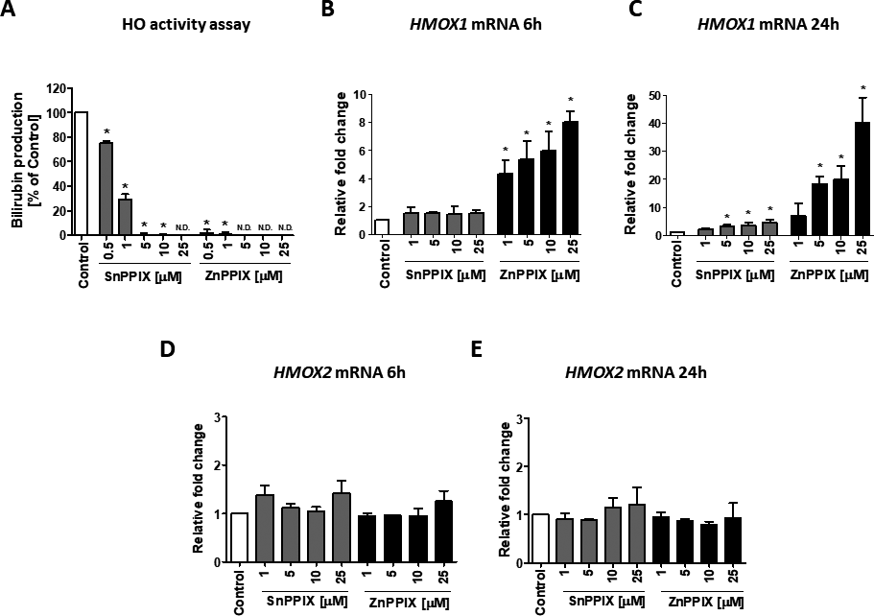
Vol. 65
Comparison of different tools for HO-1 inhibition
3
form (POCH, Gliwice, Polska). Followed vigorous vor- texing (extraction) and centrifugation (phaseseparation), the concentration of extracted bilirubin was measuredby the difference in absorbance between 464 nm and 530 nm(ε=40mM–1cm–1)andcalculatedaspicomoleofbil- irubinformedpermilligramproteinperhour.
Quantitative RT-PCR. RNA was isolated from cul- tured cells using Fenozol (A&A Biotechnology, Gdynia, Polska) with modified Chomczynski and Sacchi method (Chomczynski & Sacchi, 1987). RNA concentration and purity were determined using NanoDrop 1000 (Thermo FisherScientific,WalthamMA,USA).Reversetranscrip- tion was performed with SuperScript polymerase (In- vitrogen, Carlsbad, CA, USA) according to instructions supplied by the manufacturer. Obtained cDNA was used as a template for quantitative real-time PCR with SybrGreen Mix (Sigma-Aldrich, St. Louis, MO, USA) and specific primers (HMOX1F:5’-TTCTTCACCTTC- CCCAACATT-3’, R: 5’-CAGCTCCTGCAACTCCT- CAAA-3’;HMOX2:F: 5’-GATCGTGGAGGAGGC-CAACA-3’, R: 5’-TAGAAAGGGCATTTACGCAT-3’;EEF-2F: 5’-GAGATCCAGTGTCCAGAGCAG-3’; R:5’-CTCGTTGACGGGCAGATAGG-3’).EEF2(en-
coding eukaryotic translation elongation factor 2, EF-2) was used for gene expression normalization. The reac- tion was performed using a StepOnePlus TM Real-time PCR Systems (Applied Biosystems).
Western blot. Cultured cells were lysed with RIPA buffer and 25–30 µg of protein lysates were loaded on 12% SDS-PAGE gel followed by electrophoresis and wet transfer of proteins to nitrocellulose membrane (30 V/overnight). Membranes were blocked with5%
non-fatmilkinTBS(Tris-bufferedsaline,BioShop,Bur- lington, Ontario, Canada) + 0.1% (v/v) Tween-20 (Bio- Shop, Burlington, Ontario, Canada) for 1.5 h at room temperature.Primaryantibodiesdilutedinblockingsolu- tion: rabbit anti-HO-1 (ADI-SPA-894, Enzo Life Sci- ence, Farmingdale, NY, USA, 1:500), mouse anti-α-tu- bulin(CP06,Calbiochem,SanDiego,CA,USA,1:1000) were used for overnight incubation at 4°C. Next day, membranes were washed and incubated with secondary antibodies conjugated with HRP: goat anti-mouse (BD Pharmingen, San Diego, CA, USA,1:10000)and goat anti-rabbit (Cell Signaling Technology, Danvers, MA, USA, 1:5 000) for 1 h at room temperature. After series ofwashings,luminescentsubstrateforHRPactivity(Im- mobilonChemiluminescentHRPSubstrate,MerckMilli- pore,Billerica,MA,USA)wasaddedfor10minutesand membranes were manually developed on X-rayfilm.
Immunofluorescence. Cells were fixed in 4% para- formaldehyde for 10 minutes, permeabilized with 0.05% (v/v) TritonX-100 for 5 minutes and incubated for 30 minutesin0.25%(w/v)glycineinPBS.Afterwards,cells were blocked in 10% (v/v) goat serum (Sigma-Aldrich, St. Louis, MO, USA) in PBS for 1 h at room tempera- ture followed by incubation (overnight at 4°C) with pri- mary antibody rabbit anti-HO-1 (ADI-SPA-894, Enzo Life Science, Farmingdale, NY, USA) diluted 1:200 in 1% (v/v) goat serum in PBS. Next day, cells were in- cubated with secondary antibody goat anti-rabbit Alexa Fluor 488 or 568 (Thermo Fisher Scientific, Waltham MA, USA) diluted 1:500 in 1% (v/v) goat serum to- gether with 10 µg/mL Hoechst (Sigma-Aldrich, St. Lou- is,MO,USA)for2hatroomtemperature,visualized
Figure 1. Inhibition of HO activity using SnPPIX and ZnPPIX affectsHMOX1but notHMOX2mRNA level in 293T cell line.
HO activity after 6 h stimulation with SnPPIX/ZnPPIX shown as the percentage of control (mean ± SD)(A).HMOX1andHMOX2mRNA after 6 h(B, D,respectively) and after 24 h(C, E,respectively) stimulation with 1-25 µM SnPPIX/ZnPPIX calculated as relative fold changevs.control (mean ± S.D.).

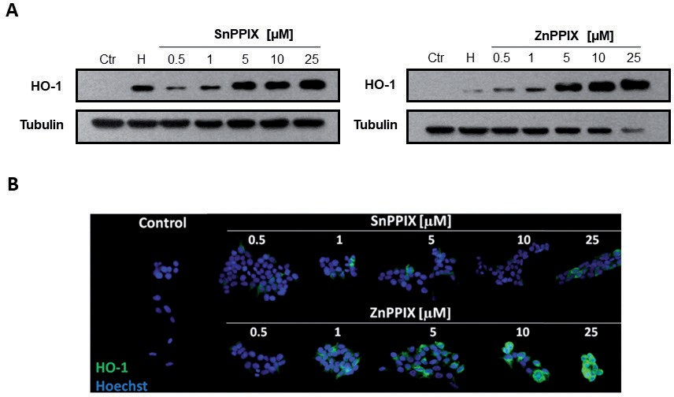
4
O. Mucha and others
2018
underfluorescentmicroscopeandanalyzedusingImageJ
program.
Statistical analysis. All experiments were performed in duplicates or triplicates and were repeated twoor three times. Results are presented as a mean ± S.D. (standarddeviation).Statisticalanalysiswasperformedin GraphPad Prism Software using Student’st-test or one- way ANOVA. Results were considered statistically sig- nificant atp<0.05
the efficiency of the transduction was monitored using fluorescent microscope and flow cytometer (Fig. 3A). After sorting GFP+cells, HO-1 expression was evalu- ated. We observed a decrease in basalHMOX1mRNA in cells transduced with three out of four tested shR- NAs (sequences B-D, Fig. 3B); however, 6 hstimulation with hemin, HO-1 inducer, caused potent induction ofHMOX1in cells transduced either with scrambled shR- NA or all shHO-1 (Fig. 3C).HMOX2mRNA was af- fected neither by shHO-1 transduction (Fig. 3D) nor by hemin treatment (Fig. 3E). Moreover, basal HO-1 pro- tein level was decreased in cells transduced withshHO-1 B-D sequences (Fig. 4A, B). Hemin-induced HO-1 up- regulation was observed in shHO-1 KD cells but it was not as potent as in control cells, as shown by immuno- fluorescentstaining(Fig.4A)andWesternblot(Fig.4B). Finally, HO activity was not significantly changed inba- sal conditions (Fig. 4C). In accordance with the mRNA and protein results after hemin stimulation, all shHO- 1 cells showed increase in HO activity similar to cells transduced with scrambled shRNA (Fig.4D).

CRISPR/Cas9-mediated gene editing ofHMOX1locus results in HO-1 deficiency
In order to obtain HO-1 knock-out cells, 293T cells were transiently transfected with vectors coding for two distinct sgRNAs that target second exon of hu- manHMOX1locus (Fig. 5A). We chose second exon because it encodes histidine 25, which is prerequisite for HO-1 catalytic activity and plasmids may be used in future to create mutant clones with catalytically inac- tive HO-1 instead ofHMOX1knock-out clones. Upon transfection, the cells were selected with puromycin for 24 h and seeded on 96-well plate to obtain single cell-derived clones. After further amplification of cells, DNA was isolated and CELI mismatch detection assay was performed to evaluate the presence of mutations inHMOX1amongsttheobtainedclones(Fig.5B).Of
RESULTS
Protoporphyrins inhibit HO activity but upregulate HO-1 mRNA and protein
Protoporphyrins, SnPPIX and ZnPPIX are widely used inhibitors of HO activity. In our hands, 6 h stim- ulation with either inhibitor led to potent decrease in bilirubin production by 293T cells, with much stronger effect of ZnPPIX (Fig. 1A). Nonetheless, already 6 h stimulation with ZnPPIX resulted in significant induc- tion ofHMOX1mRNA (Fig. 1B). After longer time (24 h), the stimulatory effect of SnPPIX onHMOX1expression was also visible (Fig. 1C), but was not as pronounced as after ZnPPIX treatment which was even further increased in comparison to 6 h stimulation (Fig. 1C). Noteworthy, 6 h (Fig. 1D) and 24 h (Fig. 1E) treatment with protoporphyrins had no significant effect on the mRNA expression of constitutive form of HO,HMOX2. The induction of HO-1 protein by protopor- phyrins was confirmed by Western blot (Fig. 2A) and immunofluorescent staining (Fig.2B).

shHO-1 fail to abolish HO activity induction upon hemin treatment
293T cells were transduced with lentiviral vectors en- coding shRNA against HO-1 (shHO-1 A-D) and scram- bled shRNA (further referred to as control cells) and
Figure 2. Pharmacological inhibitors of HO activity potently increase HO-1 protein level.
Western blot analysis of HO-1 protein after 24 h stimulation with inhibitors (0.05–25 µM) and 10 µM hemin (H)(A).Immunofluorescent detection of HO-1 protein (green) after 24 h stimulation with protoporphyrins (0.05–25 µM), counterstained with Hoechst(B).*p<0.05vs.control.

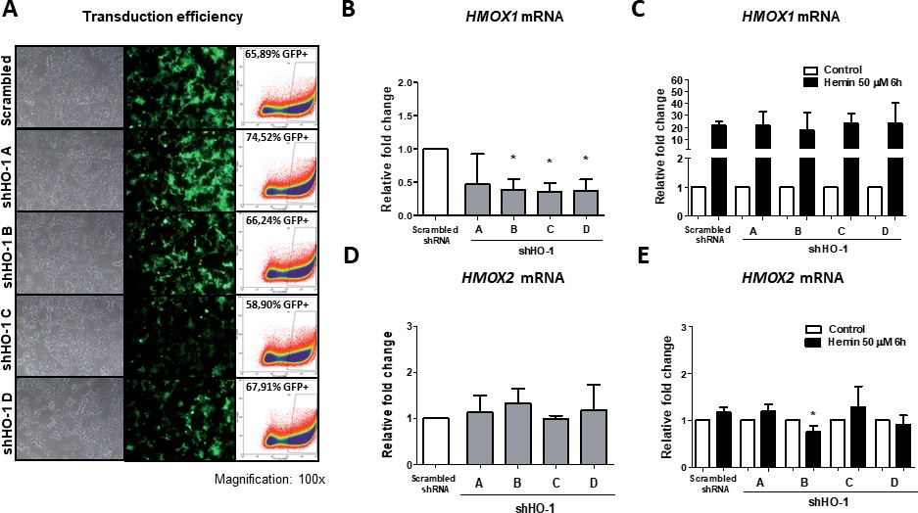
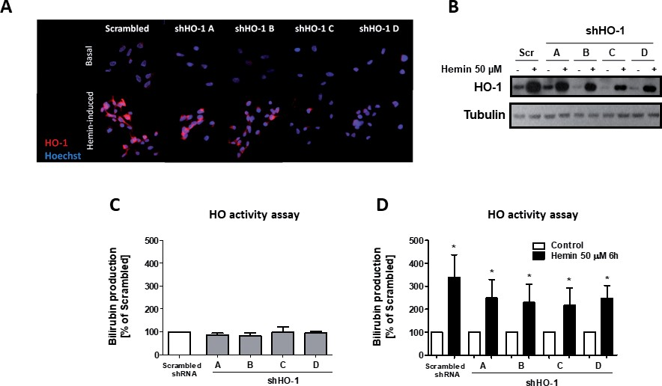
Vol. 65
Comparison of different tools for HO-1 inhibition
5
Figure 3. shRNA-mediatedHMOX1silencing fails to abolishHMOX1induction after hemin treatment.
Representative pictures of cells transduced with lentiviral vectors encoding shRNA againstHMOX1(100x) and percentage of GFP+cells(A).HMOX1andHMOX2(B, D,respectively) expression after transduction with shHO-1 A-D and scrambled shRNA, presented as relative fold changevs.control (mean± S.D.).
note, among 31 tested clones, 18 harbored mutations in
HMOX1locus (Fig. 5C).
Due to CRISPR/Cas9-mediated introduction of pre- mature stop codons and subsequent degradation of de- fective transcripts in nonsense-mediated decay process,
we observed diminished level ofHMOX1transcript in several clones harboring mutations inHMOX1lo- cus. The most pronounced difference was detected in clones4.4,4.8andtoalesserextentinclones4.14and
4.20 (Fig. 6A). Hemin-inducedHMOX1expression was
Figure 4. shRNA-mediated silencing ofHMOX1partially decreases basal and hemin-induced protein level, with no effect on HO-1 activity level.
HO-1 protein level assessed in basal and hemin-induced (6 h stimulation) conditions by immunofluorescent staining (red) counterstained with Hoechst(A)and by Western blot(B).HO activity under basal(C)and hemin-stimulated (6 h) conditions(D). HO activity under basal conditions is shown as percentage of control and at hemin-induced conditions as percentage of basal conditions for appropriate cell line (mean ± S.D.). *p<0.05 vs.control.

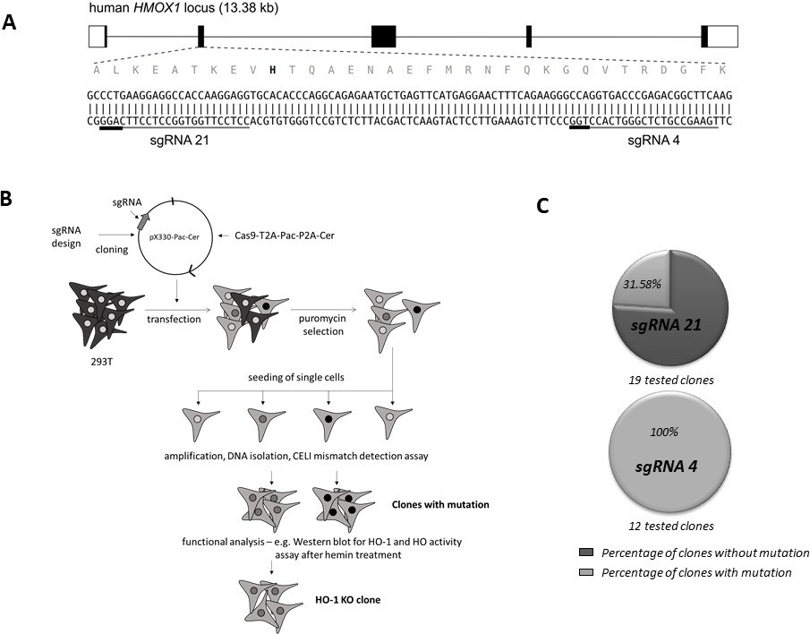
6
O. Mucha and others
2018
Figure 5. Efficient CRISPR/Cas9-mediated introduction of mutations inHMOX1in 293T cell line.
Schematic representation of humanHMOX1locus showing the location ofHMOX1-targeting sgRNAs (grey lines; PAM sequences are shown in black). Black lines represent introns and rectangles represent exons. DNA sequence of fragment of exon 2 is shown below; sequence of the protein translated from this fragment is given immediately above the nucleotide sequence; H25 is shown in bold(A).Designed sgRNAs were further utilized to generate HO-1 knockout clones of 293T cells according to general scheme of CRISPR/Cas9- mediated gene editing(B).Efficient introduction of mutations inHMOX1in derived clones was confirmed using CELI mismatch detection assay(C).The results are presented as percentage of clones with detected mutations upon utilization of two sgRNAs sequences.
blunted in several clones, in comparison to hemin-stim- ulated control cells (Fig. 6B). BasalHMOX2mRNA level was not affected in majority of clones (Fig. 6C) whereas some inhibition was detected in hemin-stim- ulated cells (Fig. 6D). Both basal and hemin-induced HO-1 protein level was potently decreased mostly in clones 4.4, 4.8, 4.10 and 4.14 (Fig. 7A, 7B). Most prob- ably, those clones harbor frameshift mutation in allHMOX1loci. HO activity, which is a combined activ- ity of HO-1 and HO-2, was not changed in basal con- ditions (Fig. 7C) (except for the clone 4.8), but most importantly, lack of response to hemin stimulation (as the result of blocked HO-1 activity) in all clones was observed (Fig.7D).

CRISPR/Cas9-mediated HO-1 depletion affects 293T cells viability and growth
HO-1 depletion in 293T cells caused slight, but sig- nificant drop in the cell growth in clones 4.8, 4.10, 4.14, as checked by CyQUANT analysis (Fig. 8A). Furthermore, tested clones (4.8 and 4.10) exhibited decreased viability in basal conditions and significant-
DISCUSSION
Due to the growing body of evidence suggesting the relevance of HO-1 inhibition as a possible therapeu- tic strategy, especially in tumour biology, we decided to provide a comprehensive comparison of pharmacologi- cal and genetic approaches of HO-1 silencing in a model cell line, human embryonic kidney cells293T.
Experimental and medical application of metallopor- phyrins is limited mostly due to their poor specificity, low bioavailability, and the modulation of pathways not directly related to HO (Grundemar & Ny, 1997; Schulzet al.,2012). Accordingly, ZnPPIX has been demon- strated to regulate the indoleamine-2,3-dioxygenases activity (Metzet al.,2010), cyclin D1 expression (Rah- manet al.,2009), and Wnt/β-catenin pathway (Wangetal.,2013). We have previously shown that SnPPIX and ZnPPIX may oppositely regulate the activity of induc- ible nitric oxide synthase (iNOS), as SnPPIX augmented whereas ZnPPIX decreased production of NO in vascu- lar smooth muscle cells as well as in macrophages and those effects were HO-1 independent (Jozkowicz & Du- lak 2003).
As reported in the present study, both SnPPIX and ZnPPIX almost completely abolished total HO activity, emphasizing their unspecificity towards HO isoforms. At the same time, we observed strong upregulation of HO-1 both at mRNA and protein levels. This effectwas
ly higher susceptibility to 0.5 mM H O stimulation
2 2
in comparison to control cells (Fig. 8B). Additionally, clonogenic potential of 293T cell line was significantly impaired by HO-1 depletion in comparison to control cells (Fig. 8C).

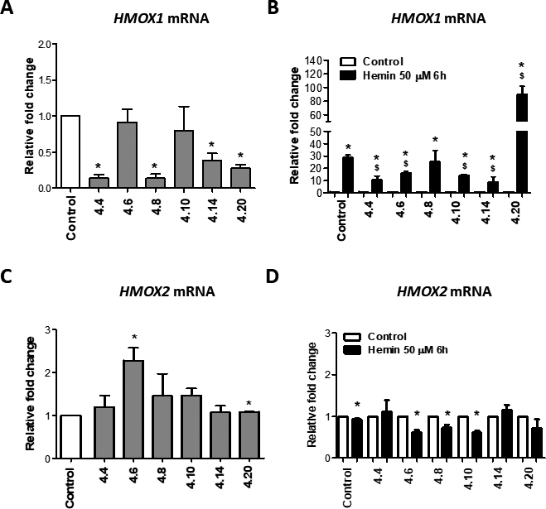
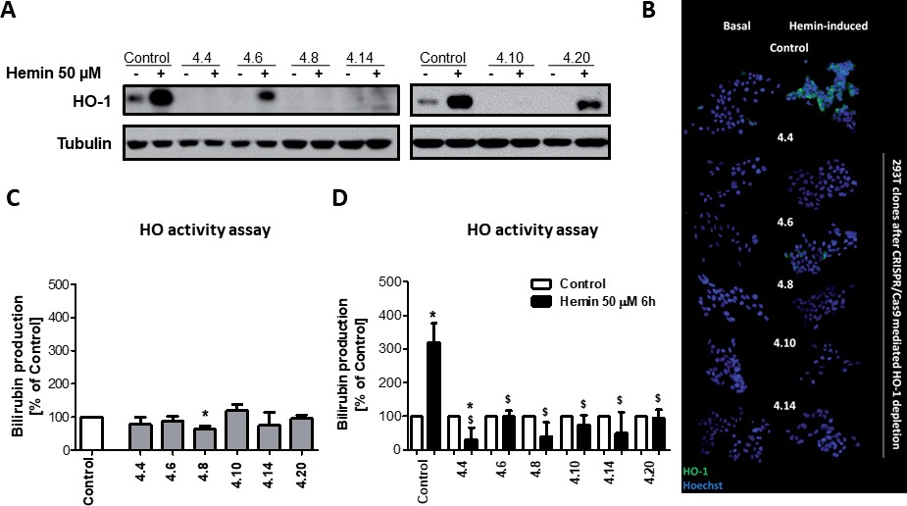
Vol. 65
Comparison of different tools for HO-1 inhibition
7
Figure 6. Genetic inhibition ofHMOX1in 293T using CRISPR/Cas9 system significantly decreasesHMOX1but notHMOX2mRNA level both under basal and hemin-induced conditions.
HMOX1andHMOX2expression in control clone and in clones after CRISPR/Cas9-mediated HO-1 excision in basal(A, C,respectively)and in hemin-induced conditions(B, D,respectively).Basal level was calculated as relative fold changevs.control whereas hemin-inducedHMOX1expressionisshownasrelativefoldchangevs.basalconditionsforeachclone(mean±S.D.).
also reported in other cell types and tissues (Lobodaetal.,2015). It has been proposed that such a dual action might be related to the fact that metalloporphyrins, act- ing as the analogues of heme, could remove transcrip-
tional Bach1 repressor, induceHMOX1transcription through Nrf2 activation, and simultaneously inhibit its activity by binding to the catalytic pocket of HO-1 (Ogawaetal.,2001).Additionally,itwasreportedthat
Figure 7. Genetic inhibition ofHMOX1in 293T using CRISPR/Cas9 system leads to potent decrease in HO-1 protein level both under basal and hemin-induced conditions as well as on activity level after treatment with hemin.
Inhibition of HO-1 protein level by CRISPR/Cas9-mediated HO-1 excision checked by immunofluorescent staining(A)and Western Blot
(B)both under basal conditions and after 6 h stimulation with 50 μM hemin.HO activity in basal conditions(C)and after 6 h stimulation
with 50 μM hemin(D).HO activity at basal conditions shown as percentage of control and hemin treatment as percentage of basal con-
ditions for appropriate clone (mean ± S.D.).*p<0.05vs. control;$p<0.05vs.control cells treated with hemin.

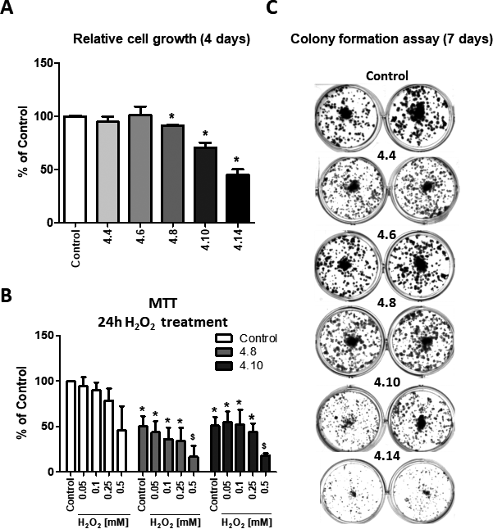
8
O. Mucha and others
2018
Figure 8. The effect ofHMOX1inhibition by CRISPR/Cas9 system on viability, proliferation and clonogenic potential of 293T cell line.
CyQUANT assay to estimate relative growth rate was performed after 4 days from seeding. The results are presented as percentage of
control(mean±S.D.)(A).MTTanalysisoncellsstimulatedwithH2O2(0.05-0.5mM)for24handcalculatedaspercentageofcontrol(mean
± S.D.)(B). Clonogenic potential checked 7 days after seeding – representative pictures(C).*p<0.05vs.control;$p<0.05vs.control cells of eachclone.
ZnPPIX mediates binding of early growth response-1 (Egr-1) to the promoter of HO-1, which then induces its expression(Yangetal.,2001).Summarizing,duetoHO- independent, unspecific effects, results obtained using metalloporphyrins should be analysed with caution and the involvement of the HO-1 pathway should be always confirmed by more specificmethods.
Despite high transduction efficiency in 293T cells obtained in the shRNA approach, most of the tested shRNA sequences decreasedHMOX1mRNA level only to about 35% of that in control. This partial effect can be cell type-specific but also connected to some internal protective mechanism in cells. The increase in MOI of used vectors would be one option to augment the effectiveness; however, it might also lead to tox- icity and off-target effects. Moreover, it appeared im- portant to test few different shRNA sequences, since the efficacy of each of them can vary (Alaoui-Jamalietal.,2009). It was also clearly visible in our hands that shHO-1 sequence A only slightly diminishedHMOX1expression with no changes on protein level. Fortu- nately, none of tested sequences influencedHMOX2transcript, which suggests specificity regarding HO iso- forms. This also explains the lack of the effect on basal HO activity, which probably reflects mostly the activ- ity of HO-2, the isoform predominant in physiological conditions, rather than HO-1. Furthermore, significant induction ofHMOX1mRNA, protein, and activity in response to hemin stimulation was still visible and can be related to insufficient inhibition of newly transcribedHMOX1mRNA by shRNA. The lack of possibility to inhibit the increase in HO activity in response to the stimuliisanimportantandmajordrawbackofthisap-
proach as HO-1 is easily-inducible enzyme (Ferrandiz & Devesa2008).
In the present study we have clearly shown the advan- tage of CRISPR/Cas9 technology over shRNA method. Although we observed differences in efficiency of HO-1 depletion between tested clones which can be related to naturalvariabilitybetweencellsorsomepitfallsofCRIS- PR/Cas9 technology (Penget al.,2016) and emphasize the need for careful selection of clones used for further studies, our data clearly demonstrate the usefulness of this method. It has to be stressed that despite the fact thatHMOX1transcript which is most probably mu- tated, can be still present in cell clones transfected with CRISPR/Cas9 targetingHMOX1, the functionality of the protein is lost. HO-1 protein level in CRISPR/Cas9- derived cell clones was diminished, both in basal and hemin-induced conditions and, what is most important, no increase in HO activity upon stimulation with potent inducer of HO-1, hemin, was observed. This reflects the necessity of validation of the obtained results not only at mRNA or protein levels, but essentially based on the bi- ological functionality, which in our case is a real indica- tor of the effectiveness of the CRISPR/Cas9approach.
Importantly, the lack of HO-1 in 293T cells exerts seriousbiologicalconsequences,includingdecreasedclo- nogenic potential and cell proliferation as well as dimin- ishedcellviability.Moreover,cellswithHO-1deficiency are more susceptible to H2O2stimulation, which is con- nected to the cytoprotective role of HO-1 against stress- ful conditions. Therefore, HO-1 may be a good antican-
cer target. Indeed, a growing body of evidence suggests the emergent role of HO-1 in various types of cancer, includingmelanoma,renalcellcarcinoma,pancreaticcan-

Vol. 65
Comparison of different tools for HO-1 inhibition
9
cer, and many others. Elevated levels of HO-1 in cancer cellsincomparisontocellsfromhealthytissueshasbeen associatedwithdifferentaspectsoftumourbiology,lead- ing to progression of the disease (Lobodaet al.,2015). Furthermore, expression of HO-1 can be induced upon anticancertreatment,whichoftenresultsindecreasedef- fectiveness. Nonetheless, the exact role of HO-1 in tu- mourbiologyismultifaceted,sincetheopposite,antican- cer activity of HO-1 was described, for example, in the case of breast or prostate cancer. Thus, although HO-1 might be considered as a therapeutic target, it has to be taken into account that inhibition of HO-1 not in every cancer cell type will be desired. Even more complicated is the fact that contradictory results were obtainedwithin the same type of cancer, which might be at leastpartially related to different experimental settings. Especially in the case of metalloporphyrins, caution has to be taken in the interpretation of obtained results, since they might not be directly related to the activity of HO-1. Moreo- ver, when considering the shRNA approach, off-target effects may result in the misinterpretation of observed results (Lobodaet al.,2015). Thus, we do believe that CRISPR/Cas9 technology may represent the most reli- able tool to study specific gene function. Moreover, to our best knowledge, depletion of HO-1 by CRISPR/ Cas9 technology has not been studied so far, and here we report that it can provide an alternative method to study biological effect of HO-1 inhibition in many areas of research, including tumour biology, which is now ex- tensively studied by ourgroup.
Conflict of interest statement
The authors declare that there is no conflict of inter- ests.
Acknowledgements
SzymonCzaudernaisacknowledgedforhelpindesign of CRISPR/Cas9components.
Acknowledgements of Financial Support
This work was supported by the grants from the National Science Centre (2016/21/B/NZ1/00293 and 2014/14/M/NZ1/00010) (AL and JD, respectively) and National Centre for Research and Development (PBS2/ B7/15/2014). Faculty of Biochemistry, Biophysics and Biotechnology of Jagiellonian University is a partner of the Leading National Research Center (KNOW) sup- ported by the Ministry of Science and Higher Education.
Cong L, Ran FA, Cox D, Lin S, Barretto R, Habib N, Hsu PD, Wu X, Jiang W, Marraffini LA, Zhang F (2013) Multiplex genome en- gineering using CRISPR/Cas systems.Science339: 819–823. doi: 10.1126/science.1231143
Czarnek M, Bereta J (2017) SmartFlares fail to reflect their targettran- scripts levels.Sci Rep7: 11682. doi: 10.1038/s41598-017-11067-6 DeshaneJ,WrightM,AgarwalA(2005)Hemeoxygenase-1expression
in disease states.Acta Biochim Pol52: 273–284
Ferrandiz ML, Devesa I (2008) Inducers of heme oxygenase-1.CurrPharm Des14: 473–486
Foresti R, Clark JE, Green CJ, Motterlini R (1997) Thiol compounds interact with nitric oxide in regulating heme oxygenase-1 induction in endothelial cells. Involvement of superoxide and peroxynitrite anions.J Biol Chem272: 18411–18417
Gratz SJ, Cummings AM, Nguyen JN, Hamm DC, Donohue LK, Har- rison MM, Wildonger J, O’Connor-Giles KM (2013) Genomeengi- neering of Drosophila with the CRISPR RNA-guided Cas9 nucle- ase.Genetics194:1029–1035.doi:10.1534/genetics.113.152710
Grundemar L, Ny L (1997) Pitfalls using metalloporphyrins in carbon monoxide research.Trends Pharmacol Sci18: 193–195
Hendriks WT, Warren CR, Cowan CA (2016) Genome Editing in Hu- manPluripotentStemCells:Approaches,Pitfalls,andSolutions.CellStem Cell18: 53–65. doi:10.1016/j.stem.2015.12.002
Housden BE, Muhar M, Gemberling M, Gersbach CA, Stainier DY, Seydoux G, Mohr SE, Zuber J, Perrimon N (2017)Loss-of-function genetic tools for animal models: cross-species and cross-platform differences.NatRevGenet18:24–40.doi:10.1038/nrg.2016.118
Hwang WY, Fu Y, Reyon D, Maeder ML, Tsai SQ, Sander JD, Pe- terson RT, Yeh JR, Joung JK (2013) Efficient genome editing in zebrafishusingaCRISPR-Cassystem.NatBiotechnol31:227–229. doi:10.1038/nbt.2501
JozkowiczA,DulakJ(2003)Effectsofprotoporphyrinsonproduction of nitric oxide and expression of vascular endothelial growth factor invascularsmoothmusclecellsandmacrophages.ActaBiochimPol50: 69–79. doi: 035001069
Kim HR, Kim S, Kim EJ, Park JH, Yang SH, Jeong ET, Park C, Youn MJ, So HS, Park R (2008) Suppression of Nrf2-driven heme oxygenase-1 enhances the chemosensitivity of lung cancer A549 cells toward cisplatin.Lung Cancer60: 47–56. doi: 10.1016/j.lung- can.2007.09.021
Loboda A, Jozkowicz A, Dulak J (2015) HO-1/CO system in tu- mor growth, angiogenesis and metabolism – Targeting HO-1 as ananti-tumortherapy.VasculPharmacol74:11–22.doi:10.1016/j. vph.2015.09.004
Mali P, Yang L, Esvelt KM, Aach J, Guell M, DiCarlo JE, Norville JE,ChurchGM(2013)RNA-guidedhumangenomeengineeringvia Cas9.Science339: 823–826. doi:10.1126/science.1232033
Metz R, Duhadaway JB, Rust S, Munn DH, Muller AJ, Mautino M, Prendergast GC (2010) Zinc protoporphyrin IX stimulates tumor immunitybydisruptingtheimmunosuppressiveenzymeindoleamine2,3-dioxygenase.Mol Cancer Ther9: 1864–1871. doi: 10.1158/1535-7163.MCT-10-0185
Ogawa K, Sun J, Taketani S, Nakajima O, Nishitani C, Sassa S, Hayashi N, Yamamoto M, Shibahara S, Fujita H, Igarashi K (2001) Heme mediates derepression of Maf recognition element through direct binding to transcription repressor Bach1.EMBO J20: 2835– 2843. doi: 10.1093/emboj/20.11.2835
PengR,LinG,LiJ(2016)PotentialpitfallsofCRISPR/Cas9-mediated genomeediting.FEBSJ283:1218–1231.doi:10.1111/febs.13586
Qiu S, Adema CM, Lane T (2005) A computational study of off-target effects of RNA interference.Nucleic Acids Res33: 1834–1847.doi: 10.1093/nar/gki324
Rahman MN, Vlahakis JZ, Vukomanovic D, Szarek WA, Nakatsu K, Jia Z (2009) X-ray crystal structure of human heme oxyge-nase-1 with(2R,4S)-2-[2-(4-chlorophenyl)ethyl]-2-[(1H-imidazol-1-yl) methyl]-4[((5-trifluorom ethylpyridin-2-yl)thio)methyl]-1,3-dioxolane:a novel, inducible binding mode.J Med Chem52: 4946–4950. doi: 10.1021/jm900434f
Rao DD, Vorhies JS, Senzer N, Nemunaitis J (2009) siRNAvs. shR- NA: similarities and differences.Adv Drug Deliv Rev61: 746–759. doi: 10.1016/j.addr.2009.04.004
Reynolds A, Anderson EM, Vermeulen A, Fedorov Y, Robinson K, Leake D, Karpilow J, Marshall WS, Khvorova A (2006) Induction of the interferon response by siRNA is cell type- and duplexlength- dependent.RNA12: 988–993. doi:10.1261/rna.2340906
Sass G, Leukel P, Schmitz V, Raskopf E, Ocker M, Neureiter D, Meissnitzer M, Tasika E, Tannapfel A, Tiegs G (2008) Inhibition ofhemeoxygenase1expressionbysmallinterferingRNAdecreases orthotopic tumor growth in livers of mice.Int J Cancer123: 1269– 1277. doi:10.1002/ijc.23695
Schulz S, Wong RJ, Vreman HJ, Stevenson DK (2012) Metal- loporphyrins – an update.Front Pharmacol3: 68. doi: 10.3389/ fphar.2012.00068
Stocker R (1990) Induction of haem oxygenase as a defence against oxidative stress.Free Radic Res Commun9: 101–112
REFERENCES
Aagaard L, Rossi JJ (2007) RNAi therapeutics: principles, prospects and challenges.Adv Drug Deliv Rev59: 75–86. doi: 10.1016/j. addr.2007.03.005
Alaoui-Jamali MA, Bismar TA, Gupta A, Szarek WA, Su J, Song W, Xu Y, Xu B, Liu G, Vlahakis JZ, Roman G, Jiao J, Schipper HM (2009)Anovelexperimentalhemeoxygenase-1-targetedtherapyfor hormone-refractoryprostatecancer.CancerRes69:8017–8024.doi: 10.1158/0008-5472.CAN-09-0419
Berberat PO, Dambrauskas Z, Gulbinas A, Giese T, Giese N, Kunzli B,AutschbachF,MeuerS,BuchlerMW,FriessH(2005)Inhibition of heme oxygenase-1 increases responsiveness of pancreatic cancer cells to anticancer treatment.Clin Cancer Res11: 3790–3798. doi: 10.1158/1078-0432.CCR-04-2159
Cho SW, Kim S, Kim JM, Kim JS (2013) Targeted genome engineer- ing in human cells with the Cas9 RNA-guided endonuclease.NatBiotechnol31: 230–232. doi: 10.1038/nbt.2507
ChomczynskiP,SacchiN(1987)Single-stepmethodofRNAisolation byacidguanidiniumthiocyanate-phenol-chloroformextraction.AnalBiochem162: 156–159. doi:10.1006/abio.1987.9999

10
O. Mucha and others
2018
SzulcJ,WiznerowiczM,SauvainMO,TronoD,AebischerP(2006)A versatile tool for conditional gene expression and knockdown.NatMethods3: 109–116. doi:10.1038/nmeth846
Tenhunen R, Marver HS, Schmid R (1968) The enzymatic conversion ofhemetobilirubinbymicrosomalhemeoxygenase.ProcNatlAcadSciUSA61:748–755
Wang S, Avery JE, Hannafon BN, Lind SE, Ding WQ (2013) Zinc protoporphyrinsuppressescancercellviabilitythroughahemeoxy- genase-1-independentmechanism:theinvolvementoftheWnt/be-
ta-catenin signaling pathway.Biochem Pharmacol85: 1611–1618. doi:10.1016/j.bcp.2013.03.011
Xie K, Yang Y (2013) RNA-guided genome editing in plants using a CRISPR-Cas system.Mol Plant6: 1975–1983. doi: 10.1093/mp/ sst119
Yang G, Nguyen X, Ou J, Rekulapelli P, Stevenson DK, Dennery PA (2001) Unique effects of zinc protoporphyrin on HO-1 induction and apoptosis.Blood97: 1306–1313

