REPLY OF J. BADURA ET AL.
TO COMMENTS OF J. DON AND J. WOJEWODA
PUBLISHED
IN THIS SPECIAL ISSUE

Acta Geodyn. Geomater.Vol.1, No.3 (135), 183-193, 2004

POST-ALPINE TECTONICS OF THE UPPER NYSA KŁODZKA GRABEN: A REPLY
Janusz BADURA ^{J)}*, Bogusław PRZYBYLSKI Witold ZUCHIEWICZ ²⁾, Jan FARBISZ ³⁾,
Dariusz KRZYSZKOWSKI ⁴⁾, Waldemar SROKA⁵⁾ and Olgierd JAMROZ⁶⁾
¹ Lower Silesian Branch, Polish Geological Institute, al. Jaworowa 19, 50-122 Wrocław
²² Institute of Geological Sciences, Jagiellonian University, ul. Oleandry 2A, 30-063 Kraków
³³ Geophysical Exploration Company, Wrocław Branch, al. Jaworowa 19, 50-122 Wrocław
⁴⁴ Pomeranian Academy, Słupsk, corresp. Krucza 7/8, 53-409 Wrocław
⁵⁵ Institute of Geological Sciences, University of Wrocław, pl. M. Borna 9, 50-204 Wrocław
⁶⁶ Wrocław Agricultural University, Chair of Geodesy and Photogrammetry, ul. Grunwaldzka 53,
50-357 Wrocław
*Corresponding author‘s e-mail: janusz.badura@pgi.gov.pl
(Received July 2004, accepted September 2004)
Abstract
The paper aims to answer the critical remarks presented by Don and Wojewoda (in this issue) related to our papers published
in Acta Montana (Badura et al., 2002, Badura et al., 2003). Answering those we have noticed that the terms brachysyncline
and brachyanticline are improper with regard to the young Alpine rebuilding of the Upper Nysa Kłodzka Graben. In this paper
we present the basic reasons for our hypothesis of young tectonic movements in the studied area more widely. Our
morphotectonic analyses are based on the digital elevation models (DEM) and the electroresistance survey of the researched
area located near Kamienna and north of Długopole Zdrój. The results of our research show that despite of the long history of
the geological studies - longer than 100 years, the region is still a very challenging research area. In this paper we point out
that application of the DEM and electroresistivity methods gives the new important results. Those should definitely be taken
into consideration together with palaeontological research and geological mapping. We really wonder that the authors of the
critical paper unequivocally negate the results of our studies and suggest that the continuation of such research and geodetic
survey in the area is aimless.
KEYWORDS: neotectonics, digital terrain models, Upper Nysa Kłodzka Graben, Kamienna Graben
INTRODUCTION
The paper contains a reply to comments by Don
and Wojewoda (2004) on our previous papers
published in Acta Montana vol. 20 and 24 (Badura et
al., 2002, 2003).
Our distinguished Adversaries have been so kind
to express their opposition to the proposed by us new
t erminology of traditional tectonic units, as well as
t heir lithostratigraphic logs. They have also
questioned the presence of faults and tectonic blocks
we proposed, and critically commented on the
description of one of our figures. At the same time,
they have totally rejected the ideas presented in our
two papers, recently published in Acta Montana,
although the subject of discussion refers only to one
of these articles (Badura et al., 2003), and a part of
another one (Badura et al., 2002). The aim of the first
paper was to propose to cover the Upper Nysa
Kłodzka Graben (UNKG) by detailed geodetic and
neotectonic studies. Moreover, our Adversaries' paper
rejects all the results obtained due to realisation of the
Polish Committee for Scientific Research (KBN)
grant no. 8 T12B 025 20 (which has recently been
evaluated as an outstanding one), without any single
attempt at getting in touch with its results. Critical
comments, being restricted to those papers (or their
fragments) which concentrate on the Kłodzko Basin
area, appear to reflect Authors' willingness to surface
on an international forum the discussions presented
during local meetings like, e.g., those of the
Geological Society of Poland held in Wrocław. We
have frequently proposed to our Adversaries both the
discussion and field presentation of new results that
would lead to novel interpretations of older ideas, but
they have persistently refused to join a common field
inspection.
Contrary to the opinion of our opponents, we do
claim that numerous neotectonic, geomorphic, and
morphotectonic problems still remain to be solved,
and that it is definitely not true that all geological
puzzles of the area in question have been successfully
described. This statement is confirmed even by the
sole shooting of three short geoelectrical resistivity
sounding profiles, accompanied by the results of a few
field inspections that disturb the good mood of our
Adversaries. Moreover, a few deep hydrogeological
wells drilled in the UNKG area (not described by the
stratigraphers), cannot be a convincing argument in
184
J. Badura et al.
favour of the supposedly “good” coverage of the area
by drillings, and particularly in the region in question,
wherein we do not have any single stratigrapically
investigated well, and from among the others, the
deepest one is less than 100 m deep. As far as the
UNKG area is concerned, nearly 30 wells and
prospection boreholes for mineral waters have been
drilled, most of them not exceeding a depth of 20-30
m. No stratigraphic studies accompanied drilling of
these wells. We are of the opinion that data obtained
from single wells cannot be extrapolated for large
areas of such a complicated tectonic setting.
Explanations to geological maps of the Sudetes
published in the 1980s clearly show that no
stratigraphic studies accompanied mapping, and that
all stratigraphic conclusions have been drawn basing
on previously published papers. For instance, the
Bystrzyca Kłodzka quadrangle (Wroński, 1983) is
largely based on an earlier sketch-map by Don and
Don (1960), what can easily be verified in the Central
Geological Archive of the Polish Geological Institute
in Wrocław. Therefore, the map in question cannot
support our Adversaries' thesis that it represents an
Independent confirmation of the Don and Don's
(1960) results.
TERMINOLOGICAL PROBLEMS
The terms “Długopole brachysyncline” and
“Idzików brachyanticline” have been used on purpose,
contrary to their nearly one hundred year old
nomenclature. We intended to show that these terms
have been introduced at the time when the Late Alpine
fault tectonics has been poorly recognised. This is
confirmed, i.a., by Fig. 3 published by Wojewoda
(1997), whereon rotated blocks of Turonian strata are
portrayed. This figure explains why we presently see
“brachyanticlinal” attitude of beds, which is not a
primary feature, but results from block rotation and
subsequent erosion. On the other hand, both Don
(1996) and Wojewoda (1997) interpret the position of
Coniacian strata as a monoclinal one, although these
strata taper out already at a distance of 2 km away
from the eastern border of the UNKG. A question then
arises, whether we are dealing with a monocline or a
brachysyncline. In the Don's (1996) paper one can
also find another concept that the structure is a
tectonic half-graben, asymmetrically rotated during
Ihe the uplift of the Śnieznik Massif. We are of the
opinion that the terms related to fold tectonics are now
only of historical value and that they explain neither
t he situation of the primary sedimentary basin, nor its
Late Cretaceous-Palaeogene modification, nor
influences exerted by the Plio-Pleistocene uplift. The
problem of inadequate terminology has already been
louched upon by Radwański (1961). Further reference
t o an old concept that the Turonian strata exposed near
Bystrzyca Kłodzka and Długopole build a brachy-
anticline, and those at Idzików a brachysyncline, is
not justified.
In this place we would like to remark that the
sole term “Upper Nysa Kłodzka Graben” refers to its
Cenomanian-Turonian stage of development, and not
to the graben that originated some 89 Ma in the
Coniacian (Don, 1993, 1996). If it is a younger graben
superimposed on the older one, why our Adversaries
do not mark erosional-tectonic boundaries between
the Turonian and Coniacian strata, but maintan that
the latter are in stratigraphic sequence? According to
Don (1996), an asymmetric half-graben was formed at
the end the Late Cretaceous, being filled by strata that
taper out towards the west. If this half-graben
originated only in the second (Don, 1996) stage of
development, one should explain its spatial relation to
the graben filled with Cenomanian and Turonian
sediments. Below the Coniacian strata, the thickness
of Turonian and Cenomanian rocks is strongly
reduced. Figure 1 published in Don’s (1996) paper
clearly shows the graben axis wherein the thickness of
the Idzików strata should be the greatest. In fact, this
axis merely shows the lowest-situated place within a
rotated block or - more precisely - a series of blocks.
The basin axis could have been placed, for instance,
within the subsequently uplifted Śnieżnik Massif.
We would like to kindly remind our Adversaries
in this place that the term “flexure” refers to steep
dipping of strata bent due to tectonic movements,
whereas the term “fault” describes a surface along
which the strata have been displaced (e.g., Dadlez and
Jaroszewski, 1994). The term “Eastern Flexure”
cannot be applied to gneisses, which, in part, are
overthrust upon the Upper Cretaceous strata. The
terms “Eastern Flexure” and “Wilkanów Fault” are
not contradictory, but form a logical entity. Our
opponents’ remark is even stranger, since the term
“Wilkanów Fault” has commonly been accepted in the
existing literature (cf. Sroka, 1997).
GENERAL REMARKS
It is difficult to comment on general remarks
comprised in the paper by Don and Wojewoda (2004),
since our opponents have not specified the subject of
discussion, and because their comments refer mainly
to the ideas expressed by J. Śebesta (see Batik et al.,
1996). One of our papers (Badura et al., 2002) was
devoted to the applicability of geophysical techniques
in detection of fault zones buried under fluvial and/or
deluvial sediments, and did not aim at solving local
stratigraphy or giving an extensive overview of the
existing hypotheses on the development of the
southern Kłodzko Basin. Our intention was to pin-
point faults hitherto not detected by traditional
cartographic methods, and to test a measuring
technique that uses both closely-spaced (50 m)
electrodes, instead of traditionally applied 250 m or
500 m spacing, and electric-resistivity tomography.
We do think that this task has been successfully
fulfilled and that such a procedure may be of some use
in future studies. In our papers we did document the
POST-ALPINE TECTONICS OF THE UPPER NYSA KŁODZKA GRABEN: A REPLY
185
presence of new fault zones; therefore, we presented
facts and not speculations. Moreover, we are strongly
convinced that the results of our studies should be
taken into account in further research of a regional
extent, instead of being discredited.
The papers published by our predecessors,
starting from the 19th century, have had little
tnfluence upon our new tectonic findings. We do think
that any discussion should be restricted to the
structural evolution of the two regions situated within
the UNKG. Unfortunately, papers quoted by our
Adversaries, do not contain adequate explanation to
the existing problems. Moreover, our opponents
carefully avoid quotations of those papers that critisize
their own opinions, except for one article by J.
Śebesta (in: Batik et al., 1996). It means that they
consider their conclusions as the only correct ones.
Critical comments addressed to our second paper
(Badura et al., 2003) are even less understandable.
The paper was not meant as a field documentation,
monograph, or synthesis, but aimed at presenting
geological constraints that confirm the need to
embrace the area by a network of geodetic surveys,
extremely helpful in a study of recent tectonic
mobility. We are deeply astonished, because a team of
geodesists from the Wrocław Agricultural University
has been consulting Prof. J. Don in this matter since a
long time, trying to obtain his help in a proper placing
of necessary benchmarks in the UNKG area.
KAMIENNA GRABEN
The Kamienna Graben (Badura et al., 2003),
i ndeed, has been earlier given an unfortunate name
“Waliszów Graben” (Badura et al., 2002). This name
has subsequently been changed due to its impresise
meaning: in the northern part of the graben
distinguished by us, a village called Nowy Waliszów,
and not Waliszów, is located. The Kamienna Graben,
In turn, is situated in the NE part of the Upper Nysa
Kłodzka Graben (Fig. 1). It is a 4.9-km-long and 500-
m-wide structure, striking N-S, whose bottom is
towered versus the eastern margin of the Śnieżnickie
Mts. by 150-200 m, and by 20-30 m versus the
Pasterskie Skałki tors on the western margin (cf. Figs.
1 and 3 in: Badura et al., 2002; and Fig. 2 in: Badura
et al., 2003). The graben is bordered in the north by
the Krowiarki Massif, and in the south by the Pławna
River which flows along a morphotectonic scarp. The
present-day outline of the graben has been shaped in
several stages, the last one being associated with the
youngest, Plio-Pleistocene, episode of tectonic
mobility. The proper identification of the youngest
displacements will make it possible to reconstruct the
earlier-formed structures, i.e., in the Middle Miocene,
Late Oligocene - Early Miocene, and at the turn of the
Late Cretaceous and Palaeogene. Copying a Late
Cretaceous structure to the present-day one is a
simplification, frequently adopted by geologists
working in this area. Difficulties in indentification of
tectonic style of the entire UNKG region are easily
readable not only from the papers of our Adversaries,
but also from the existing geological maps. Lines of
geological cross-sections carefully avoid “difficult
places” like, for instance, those shown on the
Bystrzyca Kłodzka and Stronie Śląskie quadrangles,
whereupon the Idzików sandstones and conglomerates
are exposed (Wroński, 1983; Cwojdziński, 1983).
Only synthetic profiles do show a more or less clear
situation (cf. Fig. 1 in: Don and Wojewoda, 2004).
A concept of distinguishing the young, Pliocene-
Pleistocene, Kamienna Graben stems from four
constraints: rejection of the idea of erosional origin of
the depression, an analysis of digital elevation model,
geomorphic observations, and the results of
geoelectrical-resistivity soundings.
As has already been mentioned, one of our
papers (Badura et al., 2002) aimed solely at presenting
the results of geophysical soundings, so we have not
referred to the results of other studies. Let us present
now a broader context of our hypotheses. It used to to
be accepted in the past that a depression near
Kamienna originated due to fluvial erosion (Pachucki,
1959; Don and Don, 1960). It is highly unlikely that
the inferred river valley of a width comparable to that
of the present-day Nysa Kłodzka or Biała Lądecka
River valleys ceased to exist abruptly. This
hypothetical river left no sediments at all, and neither
cut wide depressions in the mountainous parts, from
which it should have been originated. Therefore, we
have decided to look for another explanation. Since
the paper by Don and Wojewoda (2004) does not
contain any idea on the origin of this landform, we
assume that this problem is not interesting to them, or
that they uphold the unverifiable “fluvial” hypothesis.
The digital elevation model (Fig. 2 in: Badura et
al., 2003) has been constructed by digitizing 1:10,000
topographic maps, system 65. Cartographic represent-
ations of this type are commonly considered as most
useful for geological analyses, including neotectonic
ones. Contrary to the suggestions of our Adversaries,
we did not have any other type of data at our disposal.
We are of the opinion that a digital map is as
important as a topographic map used for geological
mapping. However, the DEM itself represents a
valuable tool only after including geological data.
Geomorphic observations have shown that the
graben bottom is divided into three parts. The longest
segment is situated between Nowy Waliszów and
Kamienna, south of Kamienna a transversal ridge does
occur, and, still farther south, a flat surfaces appears
sloping gently towards the Pławna River valley. We
propose to call these segments as the northern, central,
and southern ones, although this division is not
exactly compatible with the geometry of the structure.
The bottom of the northern graben segment slopes to
the NW. All the streams draining the slopes of the
Śnieżnik Massif are deflected to the NNW, whereas a
stream draining the Krowiarki Ridge flows south-
westwards. At the mouths of valleys draining the
mountainous massif, alluvial fans passing into terraces
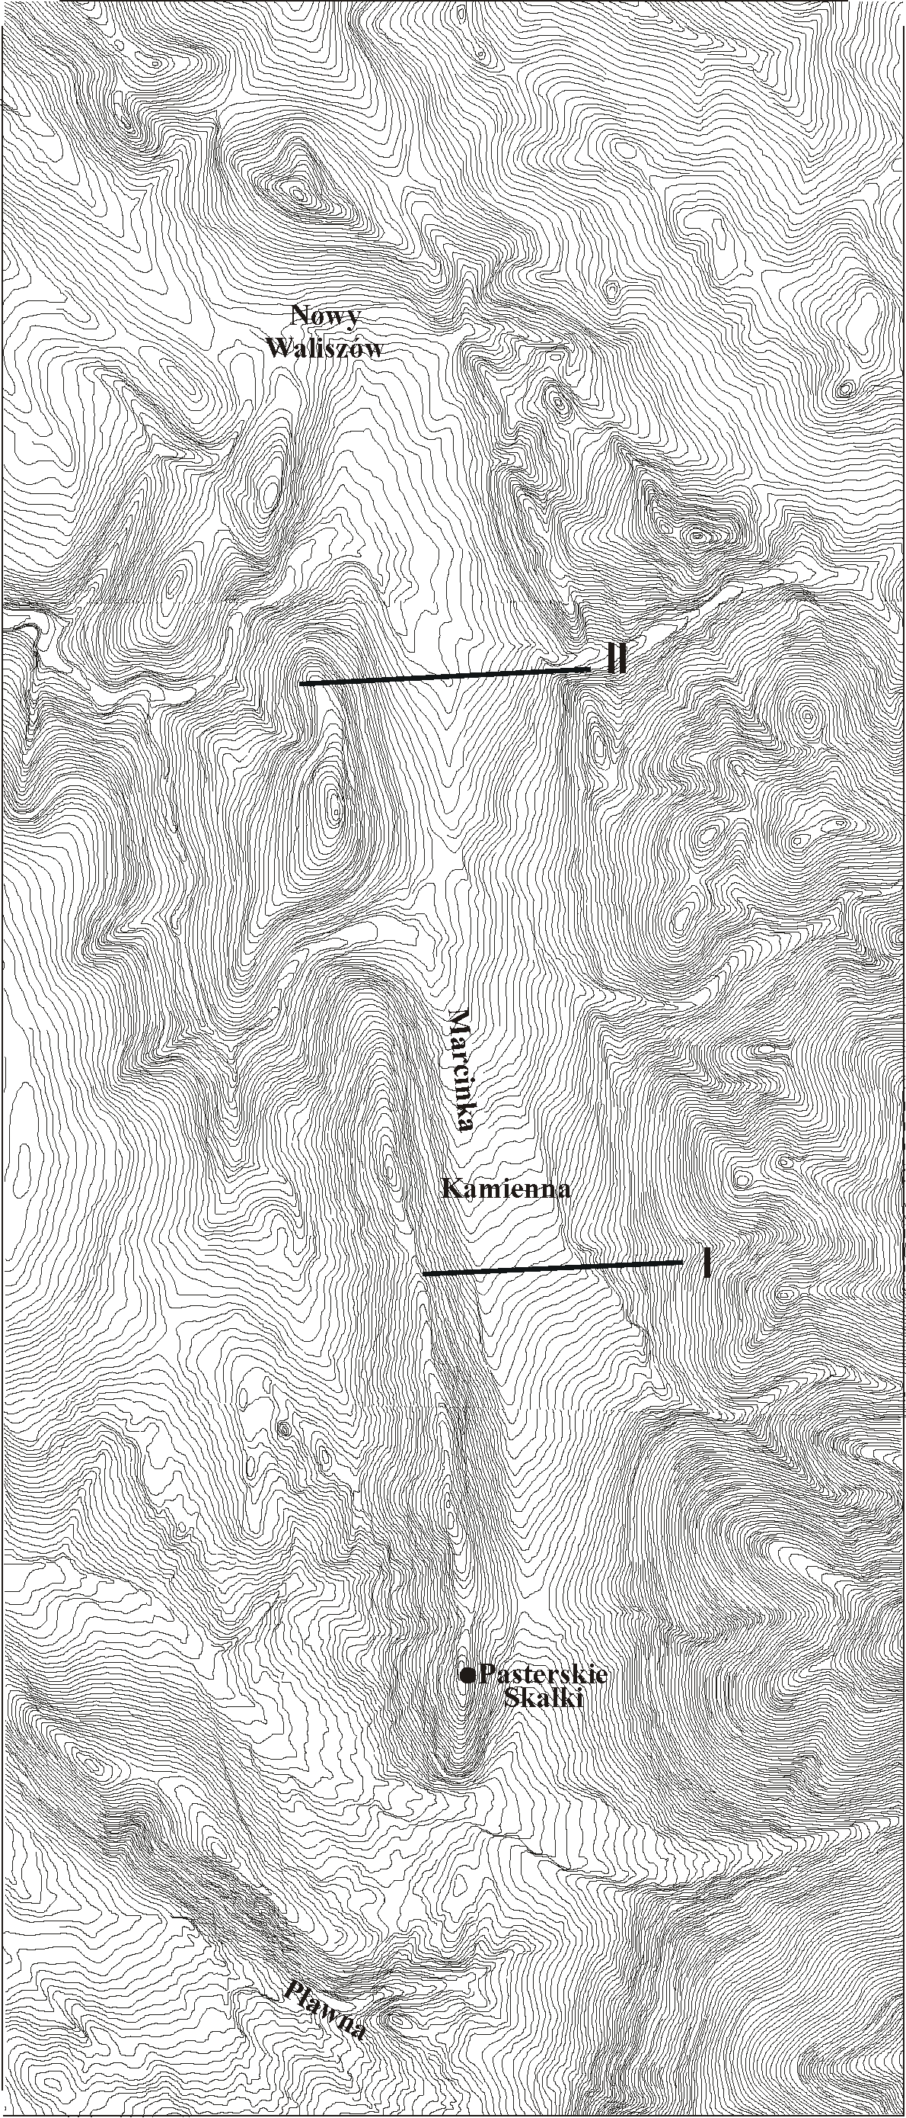
186
J. Badura et al.
477
707
710
470
477
707
3 km
710
470
Fig. 1 Location of geoelectrical resistivity profiles versus contour map of the Kamienna Graben, based on
1:10,000 topographic map, system 65
POST-ALPINE TECTONICS OF THE UPPER NYSA KŁODZKA GRABEN: A REPLY
187
can be seen. The streams dissect the graben bottom
and flow farther northwards along an escarpment,
above which the Idzików sandstones and conglo-
merates are exposed. The belt of exposures of the
Idzików strata is truncated at two places by river
valleys that form water gaps. The meandering pattern
of these rivers, as well as their course within the
Waliszów Graben indicate that these are antecedent
gorges, and not those formed due to headward
erosion. The occurrence of rapids within the river
valley bottoms (Phot. 1) can suggest that the area
undergoes recent uplift. The conclusion about recent
uplift of the western margin of the Kamienna Graben
is also supported by the presence of overhanging
tributary valleys (Phot. 2). A vertical character of the
boundaries between tectonic blocks is clearly
portrayed on geoeletrical resistivity profiles,
whereupon such boundaries cut both high- and low-
resistivity complexes (Fig. 2a, b). Our Adversaries
would be right, should the high-resistivity strata were
underlain by low-resistivity ones. However, the results
of geoelectrical soundings clearly indicate the
presence of (sub) vertical boundaries between rocks of
variable resistivity (Fig. 2a, b).
An examination of dip directions of the Idzików
marls clearly shows that in the Kamienna Graben the
bedding becomes increasingly gentler from the east to
the west (Don and Don, 1960; Cwojdziński, 1983;
Wroński, 1983). The bedding becomes steeper again
within the conglomerates (Phot. 1 and 3). Structural
data should have already caught the attention of
geologists working in this area to the presence of
another tectonic zone that is buried under slope
sediments (Fig. 2 in: Don and Wojewoda, 2004).
The transversal ridge, forming the so-called
central segment of the Kamienna Graben, is not a
watershed erosional remnant (as suggested on Fig. 2
by Don and Wojewoda, 2004), but represents a 3rd-,
or even 4th-order tectonic unit. The beds dip here both
to the east and west (Wroński, 1983).
Another debatable question is the origin and age
of the Idzików conglomerates. Since their bordering
fault has not been identified by our predecessors, they
have assumed that the Idzików sandstones, con-
glomerates, and marls of Early Coniacian age are in
stratigraphic sequence. However, the geoelectric
resistivity profile points to a discordance inbetween
these rocks. Taking into account that this portion of
the UNKG lacks palaeontologically studied sites, we
have decided to adopt another stratigraphic concept by
assigning the low-resistivity rocks to the Turonian,
and not Coniacian, clays. We consider the lower
Coniacian strata as enriched in numerous sandstone
intercalations, hence, their specific resistivity should
be of the order of 70-150 Omm. Such resistivity
values occur below the high-resistivity conglomerates
(Fig. 2a, b).
Moreover, we are not at all certain about the
hitherto-accepted structural position and origin of the
Idzików conglomerates. The latter build a few metres-
wide belt of exposures, orientated roughly N-S, whose
southern part of occupied by a group of tors, called the
Pasterskie Skałki tors. These rocks are composed of
0.5-3.0-m-thick layers of polymictic conglomerates
which are flexurally bent, and dip westwards at 70° to
90°. In some of the tors, overturning of beds can be
seen (Phot. 3). Such a strong fold-like bending of the
conglomerates must have occurred before the uplift of
the western graben margin, or taken place at the
contact with the Śnieżnik Massif gneisses (cf.
Jerzykiewicz, 1971). Nearly vertical bedding is also to
be seen in the Marcinka (Panna, cf. Radwański, 1960)
River gorge (Phot. 1). The vertical position of the
Idzików sandstones within the valley bottom has been
marked neither in a paper by Don and Don (1960), nor
on a geological map by Wroński (1983). Don and Don
(1960) accepted that the dip of conglomerates exposed
in the Pastedskie Skałki tors is lower by 35° in respect
to the real one. They based their conclusion on
observations carried out on one of the upper sandstone
beds near Idzików, and copied it to the lowest-situated
conglomerate layer (see Figs. 2 and 3 in: Don and
Don, 1960). The presence of numerous slickensides,
and an impression that Fig. 3 is a compilation of field
photograph and author's interpretation, and not
genuine field observation, lead us to uphold a
conclusion that the Pasterskie Skałki tors are built up
of vertical and, at places, overturned, beds. One
cannot compare situation shown on Fig. 1 by Don and
Don (1960), portraying sediments deposited in a quiet
environment, with that existing during high-energetic,
turbulent deposition of conglomerates that build the
Pasterskie Skałki tors. Tectonic conclusions presented
by Don and Don (1960) were not confirmed by
Radwański (1961).
Our Adversaries conclude that we are not
familiar with abundant literature references pertaining
to the stratigraphy of the study area. It has to be
pointed out that in the area close to the fault described
by us, no stratigraphically-investigated sites exist,
being situated farther westwards. Our hypothesis of
another, possible stratigraphic sequence of the strata
in question resulted, i.a., from discrepancies observed
between the geoelectrical resistivity profiles and the
hitherto-published maps. Such a situation is very well
protrayed by Phot. 2 on Plate I by Don and Don
(1960). The sandstones and conglomerates build
exclusively the topmost part of the so-called "Idzików
brachysyncline". Nearly half of the cuesta (op. cit.) is
built up of the Coniacian clays. On the other hand, in
the Marcinka River water gap, sandstones and
conglomerates do occur in the river bed, i.e., at the
base of the scarp (Phot. 1). Should the referred to map
view were correct, at dips ranging between 40° and
55°, the geoelectrical resistivity profiles would reveal
low-resistivity complexes occurring below the high-
resistivity ones, and the boundary between them
would have run diagonally, dipping westwards instead
of being vertical. Another indication of the presence
of a fault between the clays and sandstones are

0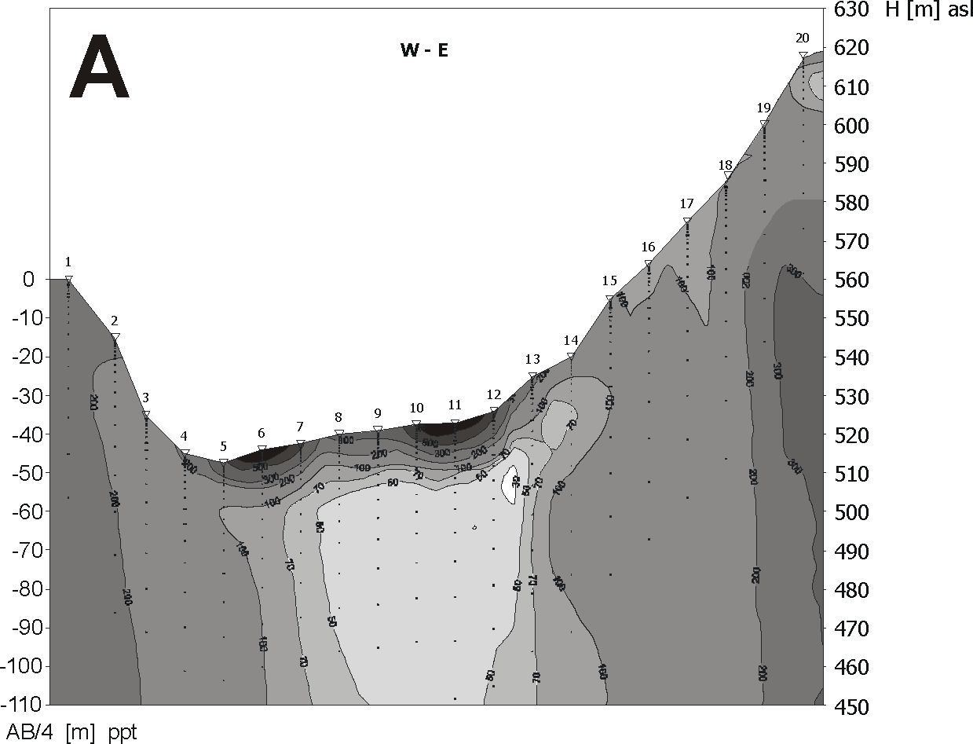
188
J. Badura et al.
Kamienna Graben - I

Kamienna Graben - II
W - E
-10
-20
-30 |  | 1- \6  Y 7
-40  -50 |  | I ' | \ 8  9
-60 | - \ 1 |  | ■ a:  • / •
-70 | ■ ' ■ ' \ |  | : :
-80  -90 | a  ■ \. |  | ■I'  'I
100 | . \ |  | L \
110
120
130 |  |  | i
AB/4 [m] ppt
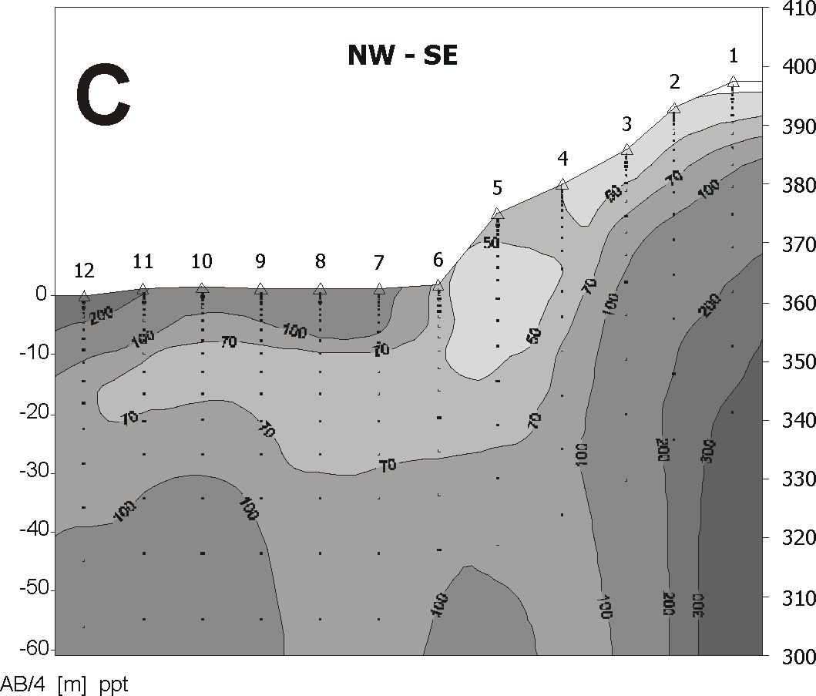
B
10 1 12
: O'
530 H [m] asl
520
510 r—
500
490 f~
480 L
470
460
450
440
430
420
410
400
390
380
370
Długopole

Fig. 2 Geoelectrical resistivity profiles: A - Kamienna Graben I (southern portion), B - Kamienna Graben II
(northern portion), C - Długopole Zdrój. Sounding spacing amounts to 50 m; ppt - below groundsurface
19 20
18
16
14
13
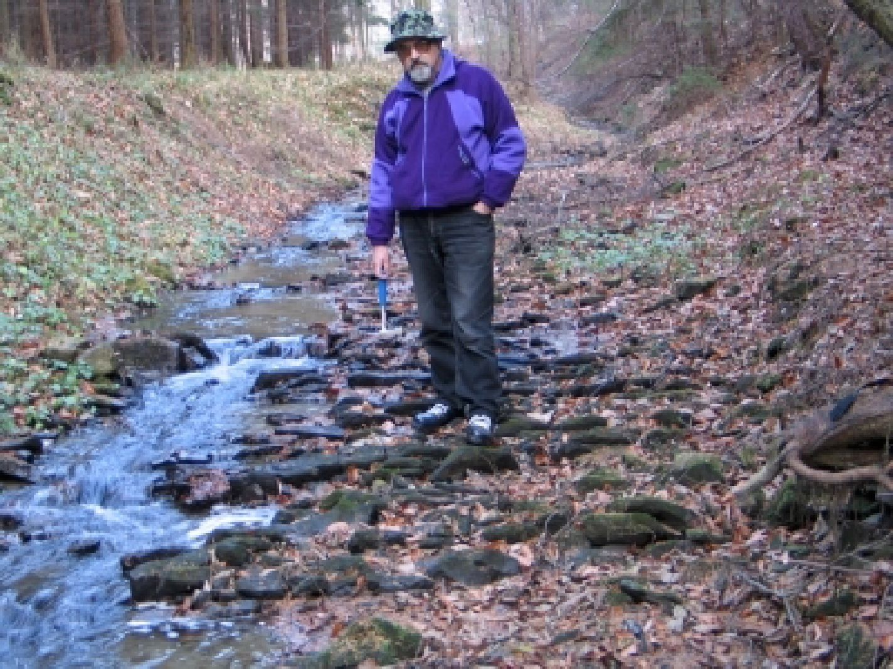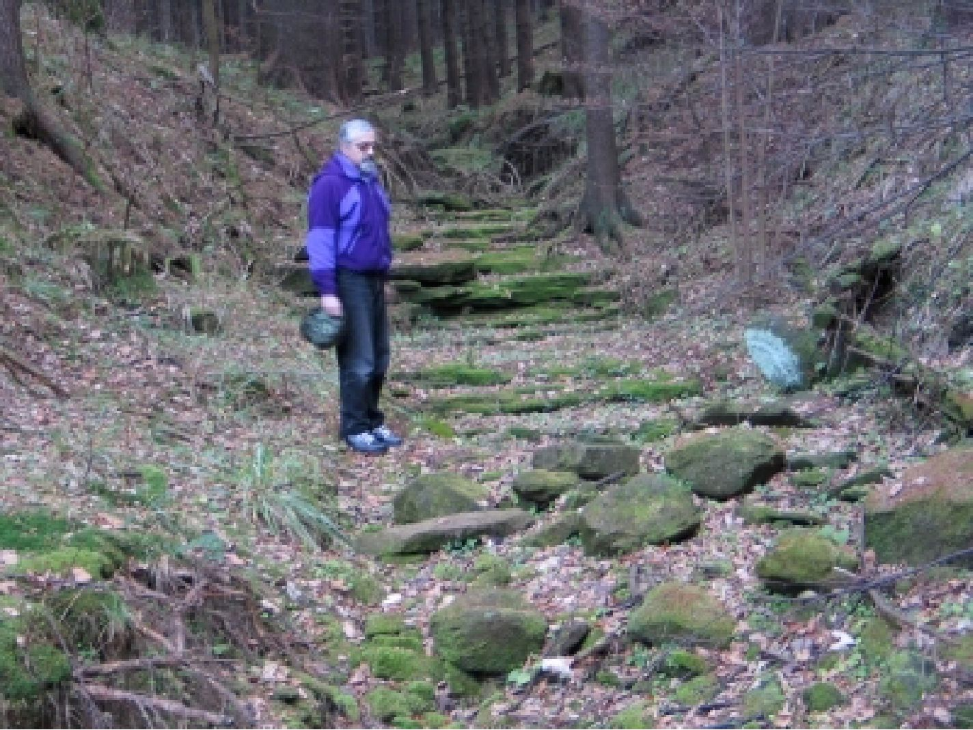
POST-ALPINE TECTONICS OF THE UPPER NYSA KŁODZKA GRABEN: A REPLY
189

Photo 1 Rapids within the water-gap segment of the Marcinka River bed

Photo 2 Overhanging valley of a tributary of the Marcinka River valley, in its gap
segment cut into the Idzików sandstones
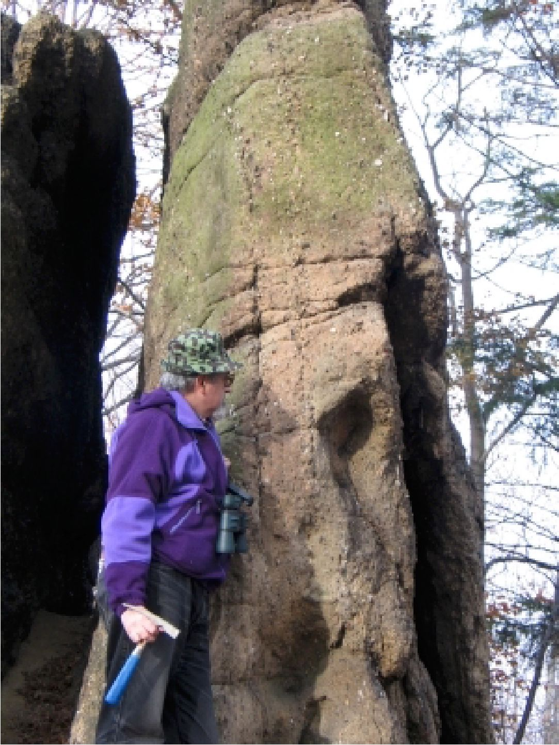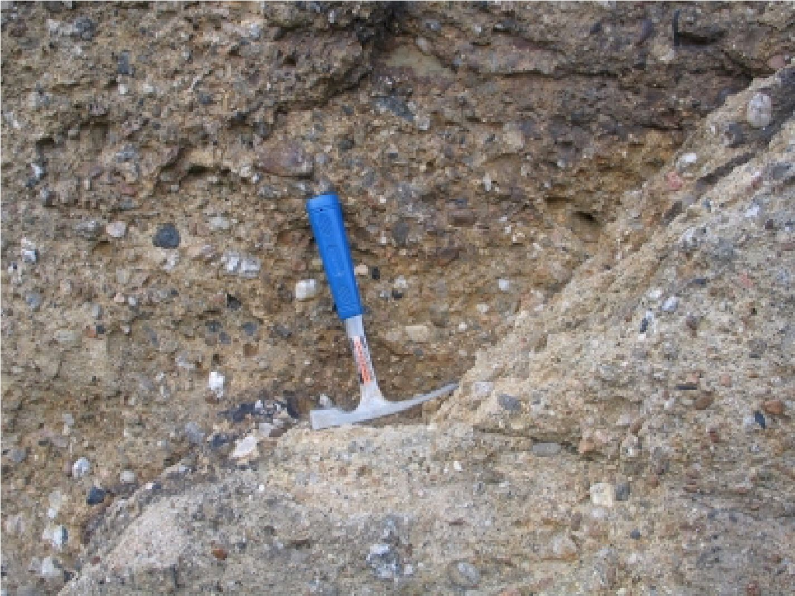
190
J. Badura et al.

Photo 3 Vertical attitude of conglomerates in the Pasterskie
Skałki tors

Photo 4 Polymictic conglomerates exposed in the Pasterskie Skałki tors
POST-ALPINE TECTONICS OF THE UPPER NYSA KŁODZKA GRABEN: A REPLY
191
bedding attitudes shown on the Stronie Śląskie
quadrangle (Cwojdziński, 1983). The lower Coniacian
clayey-sandy complex appears to dip eastwards, i.e.,
similarly as indicated by geophysical profiles.
The critical comments to our papers contain as
well references to the petrography of the Idzików
conglomerates. However, the articles quoted by our
Adversaries do not present a full petrographic analysis
of the clasts in question. The presence of a relatively
high share of gneisses does not necessarily indicate
deposition at the present-day contact between the
Śnieżnik Massif and the UNKG. For unknown
reasons, the provenance of other rock types and their
possible transport routes have not been mentioned.
The petrographic and size differentiation of
conglomerates building the Pasterskie Skałki tors are
well portrayed on Phot. 4. Such a petrographic
composition suggests delivery of the bulk of the
material from the north and the northern part of the
Śnieżnik Massif. The former drainage basin could
have embraced porphyries of the Kłodzxko region and
the Intrasudetic Basin margins, as well as greywackes
of the Bardo Mts. Large quartz and lidyte clasts could
have even originated from the Palaeozoic cover of the
northern part of the Praded Massif. Such an extensive
alimentary area was certainly functioning in
Cenomanian times, at the beginning of the Late
Cretaceous marine transgression. In the Coniacian,
block tectonics affecting the northern and eastern
margins of the UNKG restricted the alimentary area to
the Krowiarki and Śnieżnik Massifs, i.e., the area
referred to by Don and Wojewoda (2004). At the end
of the Late Cretaceous, there were few possibilities of
eroding crystalline basement, due to the presence of
relatively thick cover of the Upper Cretaceous marine
strata. We assume, therefore, that we are dealing here
with another tectonic zone that cuts the "Eastern
Flexure". We have assumed in our interpretation that
the Idzików conglomerates are underlain by a
relatively shallow, previously unrecognised, block of
the crystalline basement. The Idzików conglomerates
represent the Cenomanian transgressive marine strata
which are thrust upon the Turonian clays, and form
another tectonic zone whose strike is parallel to that of
the “Eastern Flexure”. A similar interpretation can be
fould in a paper by Grocholska and Grocholski
(1958). The results of other geophysical surveys
performed in the UNKG area do also confirm strong
tectonic dismembering of its bottom (cf. Jodłowski,
1999), as do independent geomorphic analyses,
recently presented by Ranoszek (1999, 2001).
DŁUGOPOLE ZDRÓJ AREA
Judging from a description related to the
Długopole area, one should infer that our Adversaries
try strongly to show that the geophysical cross-section
(Fig. 2c) has been shot in an unknown place and that
its authors confabulate on the flexure and an unknown
to them exposure. One should expect that such good
specialists should have read from our sketch (Fig. 3,
in: Badura et al., 2002) that the location shown by us
determines the place situated close to the northern
exposures of crystalline rocks near Długopole Zdrój.
We are also astonished by the fact that such ex-
perienced geologists, so well familiar with this area
and related literature, have not realised that the
questioned site and its tectonic interpretation have
already been described by Leppla (1900). His map
shows in this place a well-documented fault. On the
other hand, a description of a quarry completely
irrelevant to tectonic problems, and suggesting that in
this area tectonic disturbances do not exist at all, is a
total nonsence. In this way, one can easily negate the
presence of, for instance, the Sudetic Marginal Fault.
We cannot comment on the other remarks by our
opponents, since they bring nothing new to the
existing state of knowledge. Our adversaries have
equally seriously treated both the really important
subjects, and the less important ones as, e.g.
geological sketches. The latter ones' aim is to show
the reader the general position of the study object and
its geological context. The important research has
been done on detailed maps and other source
materials.
SUMMARY
Detailed structural and stratigraphic observations
carried out both in the UNKG, and in the areas of
occurrence of the Upper Cretaceous strata in the
Czech Republic, frequently verify the results of
previous studies or present interpretations entirely
different from those accepted by Don and Wojewoda
(2004) (see, for instance, Batik et al., 1996; Grygar
and Jelinek, 2003; Kozdrój and Cymerman, 2003),
what confirms once again that solving geological
problems requires different attitudes. It should also be
remembered that the truth lies inbetween and that
every scientist has his share in solving the problem,
irrespectively of the hypothesis he proposes.
Confrontation of different views leads to a new
hypothesis; provided that every participant shows a
willingness to join the discussion.
Judging from previous discussions, mainly held
with Dr. Jurand Wojewoda, and careful reading of our
Adversaries’ paper, we infer that its Authors are not
really interested in solving geological problems. All
the above-listed questions could have easily been
resolved even on one phone call. The lack of
willingness of a direct dialogue, and simultaneous
eagerness to carry it via the Editorial Board of Acta
Montana, we do interpret as a desire of media-centred
presence. We are deeply astonished by such a strong
opposition to carry our further research in the UNKG
area, and by supporting this attitude by literature
references, supposedly confirming that all the
debatable questions have already been solved.
Perhaps, our adversaries try to contest in this way that
geologists of different field experience and using other
methods of research obtained - relatively quickly -
different results and posed new working hypotheses.
192
J. Badura et al.
In general, we consider the remarks pertaining to
our papers as completely unjustified, and not
conformable with the reliability of university workers.
The research program realized in our proposal
included: morphotectonic and morphometric analyses,
experimental geophysical soundings, drillings,
digging artificial cuts, and a broad range of
petrographic and heavy mineral analyses, as well as
age determination and geochemical studies of young
basalts. All these tasks have been totally discretided,
without any single attempt at getting in touch with the
source data and their interpretation. It should be
reminded in this place that the results of our team
have been presented at numerous national and
international conferences, and have been published in
refereed journals, including altogether 20 items.
Since the decisively strong critical comments
have been addressed to the Polish Committee for
Scientific Research (Komitet Badań Naukowych)
before waiting for our reply, we conclude that the
Authors abused the freedom of speech by drawing
their conclusions without close examination of the
existing facts; a procedure contradictory to a sound
scientific discussion. Our feeling is that the Advers-
aries, lacking adequately strong scientific arguments,
decided to use Acta Montana as a forum to critisize
the procedures applied by the Committee for
Scientific Research (KBN) by sending - in this strange
way - a report that looks like a message addressed to
the secret police department. Insinuations contained in
our Adversaries’ paper are humiliating to our team
and to those geologists who reviewed and finally
evaluated this research proposal, as well as they cast a
shadow on the Editorial Board of Acta Montana and
anonymous Referees of our papers.
REFERENCES
Badura, J., Przybylski, B., Krzyszkowski, D.,
Zuchiewicz, W., Farbisz, J. and Sroka, W.: 2002,
Morphotectonic properties of the Sudetic
Marginal Fault and Kłodzko Basin faults, SW
Poland, in the light of geoelectrical resistivity
studies, Acta Montana IRSM AS CR, Ser. A, 20
(124), 57-65.
Badura, J., Jamroz, O. and Zuchiewicz, W.: 2003,
Recent crustal mobility of the Upper Nysa
Kłodzka Graben, SW Poland, Acta Montana
IRSM AS CR, Ser. A, 24 (131), 65-71.
Batik, P., Doktór, S., Graniczny, M. and Śebesta, J.:
1996, Role of disjunctive tectonics in relief
formation of the Śnieżnik Massif, (in Polish), In:
A. Jahn, S. Kozłowski and M. Pulina (Eds.),
Masyw Śnieżnika - zmiany w środowisku
przyrodniczym, Publ. House PAE S. A.,
Warszawa, 27-33.
Cwojdziński, S.: 1983, Detailed geological map of the
Sudetes, Stronie Śląskie quadrangle (in Polish),
Wyd. Geol., Warszawa.
Dadlez, R. and Jaroszewski, W.: 1994, Tectonics (in
Polish), Publ. House Wyd. Nauk. PWN,
Warszawa, 744.
Don, B. and Don, J.: 1960, Notes on the origin of the
Nysa Graben (in Polish with English summ.),
Acta Geol. Polon., 10 (1), 78-106.
Don, J.: 1993, Metamorphic rocks of the Śnieżnik
Massif and the Upper Cretaceous Nysa Graben
versus block uplift of the Sudetes (in Polish), In:
H. Chmal & A. Traczyk (Eds.), Morfologia gór
średnich, II Zjazd Stowarzyszenia Geomorfo-
logów Polskich, Lądek Zdrój, 4-7 października
1993, 9-11.
Don, J.: 1996, The Late Cretaceous Nysa Graben:
implications for Mesozoic-Cenozoic fault-block
tectonics of the Sudetes, Zeitschrift für
geologische Wissenschaften, 24 (3/4), 317-324.
Don, J. and Wojewoda, J.: 2004, Tectonics of the
Upper Nysa Kłodzka Graben: Contentious
issues, Acta geodynamica et geomaterialia
(formerly Acta Montana, Ser. A) No. 3 (135),
173-179.
Grocholska, J. and Grocholski, A.: 1958, Tectonics of
the north-eastern part of the Nysa Graben (in
Polish), Przegląd Geologiczny, 8-9, 351-353.
Grygar, R. and Jelinek, J.: 2003, The Upper Morava
and Nysa pull-apart grabens - the evidence of
neotectonic dextral transpression on the Sudetic
fault system, Acta Montana IRSM AS CR, Ser.
A, 24 (131), 51-59.
Jerzykiewicz, T.: 1971, A flysch/littoral succession in
the Sudetic Upper Cretaceous, Acta Geol.
Polon., 21, 165-199.
Jodłowski, A.: 1999, The Cretaceous and underlying
beds of Kłodzko valley - geophysical
investigations. I. Trough of the Upper Nysa
Kłodzka (in Polish with English summ.),
Szczeliniec, 3, 21-40.
Kozdrój, W. and Cymerman, Z.: 2003, Alpine tectonic
inversion - principal mechanism of the Variscan
basement uplift and exumation in the Sudety
Mts., GeoLines, 16, 59-60.
Leppla, A.: 1900, Geologisch-hydrographische
Beschreibung des Niederschlagsgebietes der
Glatzer Neiße (oberhalb der Steine Mündung)
mit geologischer Übersichtskarte 1:50 000,
Abhandlungen des Preußischen Geologischen
Landes-Amt, N. F., 32, X, maps.
Pachucki, C.: 1959, Über die Stratigraphie und
Lithologie der Kreide im Neissegraben (in Polish
with German summ.), Annales Universitatis M.
Curie-Skłodowska, Sectio B, 12, 1-55.
Radwański, S.: 1961, Delta deposits of the Coniacian
in the region of Idzików (in Polish with English
summ.), Kwartalnik Geologiczny, 5, 108-122.
Ranoszek, W.: 1999, The application of different
morphometric methods in the analysis of fault
escarpments - the example of the mountain front
in the western part of the Śnieżnik Massif,
POST-ALPINE TECTONICS OF THE UPPER NYSA KŁODZKA GRABEN: A REPLY
193
Sudetes (in Polish with English summ.),
Przegląd Geologiczny, 47 (11), 1027-1031.
Ranoszek, W.: 2001, Tectonically-controlled morpho-
logical escarpments in the Sudetes in the light of
numerical parameters (in Polish), Unpublished
Ph. D. thesis, Faculty of Natural Sciences,
University of Wrocław, 200 ms. pp.
Sroka, W.: 1997, Morphotectonic evolution of the
Sudetes in the Kłodzko Basin in the light of the
morphometric-statistical analysis (in Polish with
English summ.), Acta Universitatis Wratisla-
viensis, 1939, Prace Geol.- Miner., 58, 239-249.
Wojewoda, J.: 1997, The Upper Cretaceous littoral-to-
shelf succession in the Intrasudetic Basin and
Nysa Trough, Sudety Mts. (in Polish), In: J.
Wojewoda (Ed.), Obszary źródłowe: zapis w
osadach. VI Krajowe Spotkanie Sedymento-
logów, Materiały, Wrocław, 98-129.
Wroński, J.: 1983, Detailed geological map of the
Sudetes, Bystrzyca Kłodzka quadrangle (in
Polish), Wyd. Geol., Warszawa.
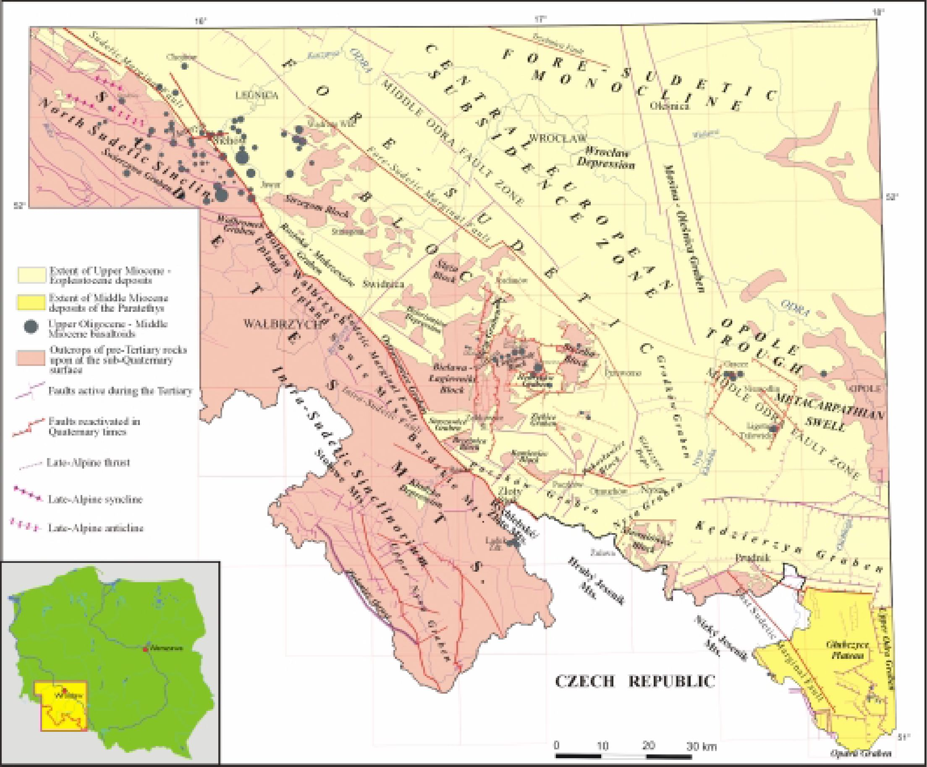
J. Badura et al.: CAINOZOICEVOLUTION OFLO WER SILESIA, SWPOLAND: A NEW.

Fig. 1 Fault pattern and tectonic units in SW Poland
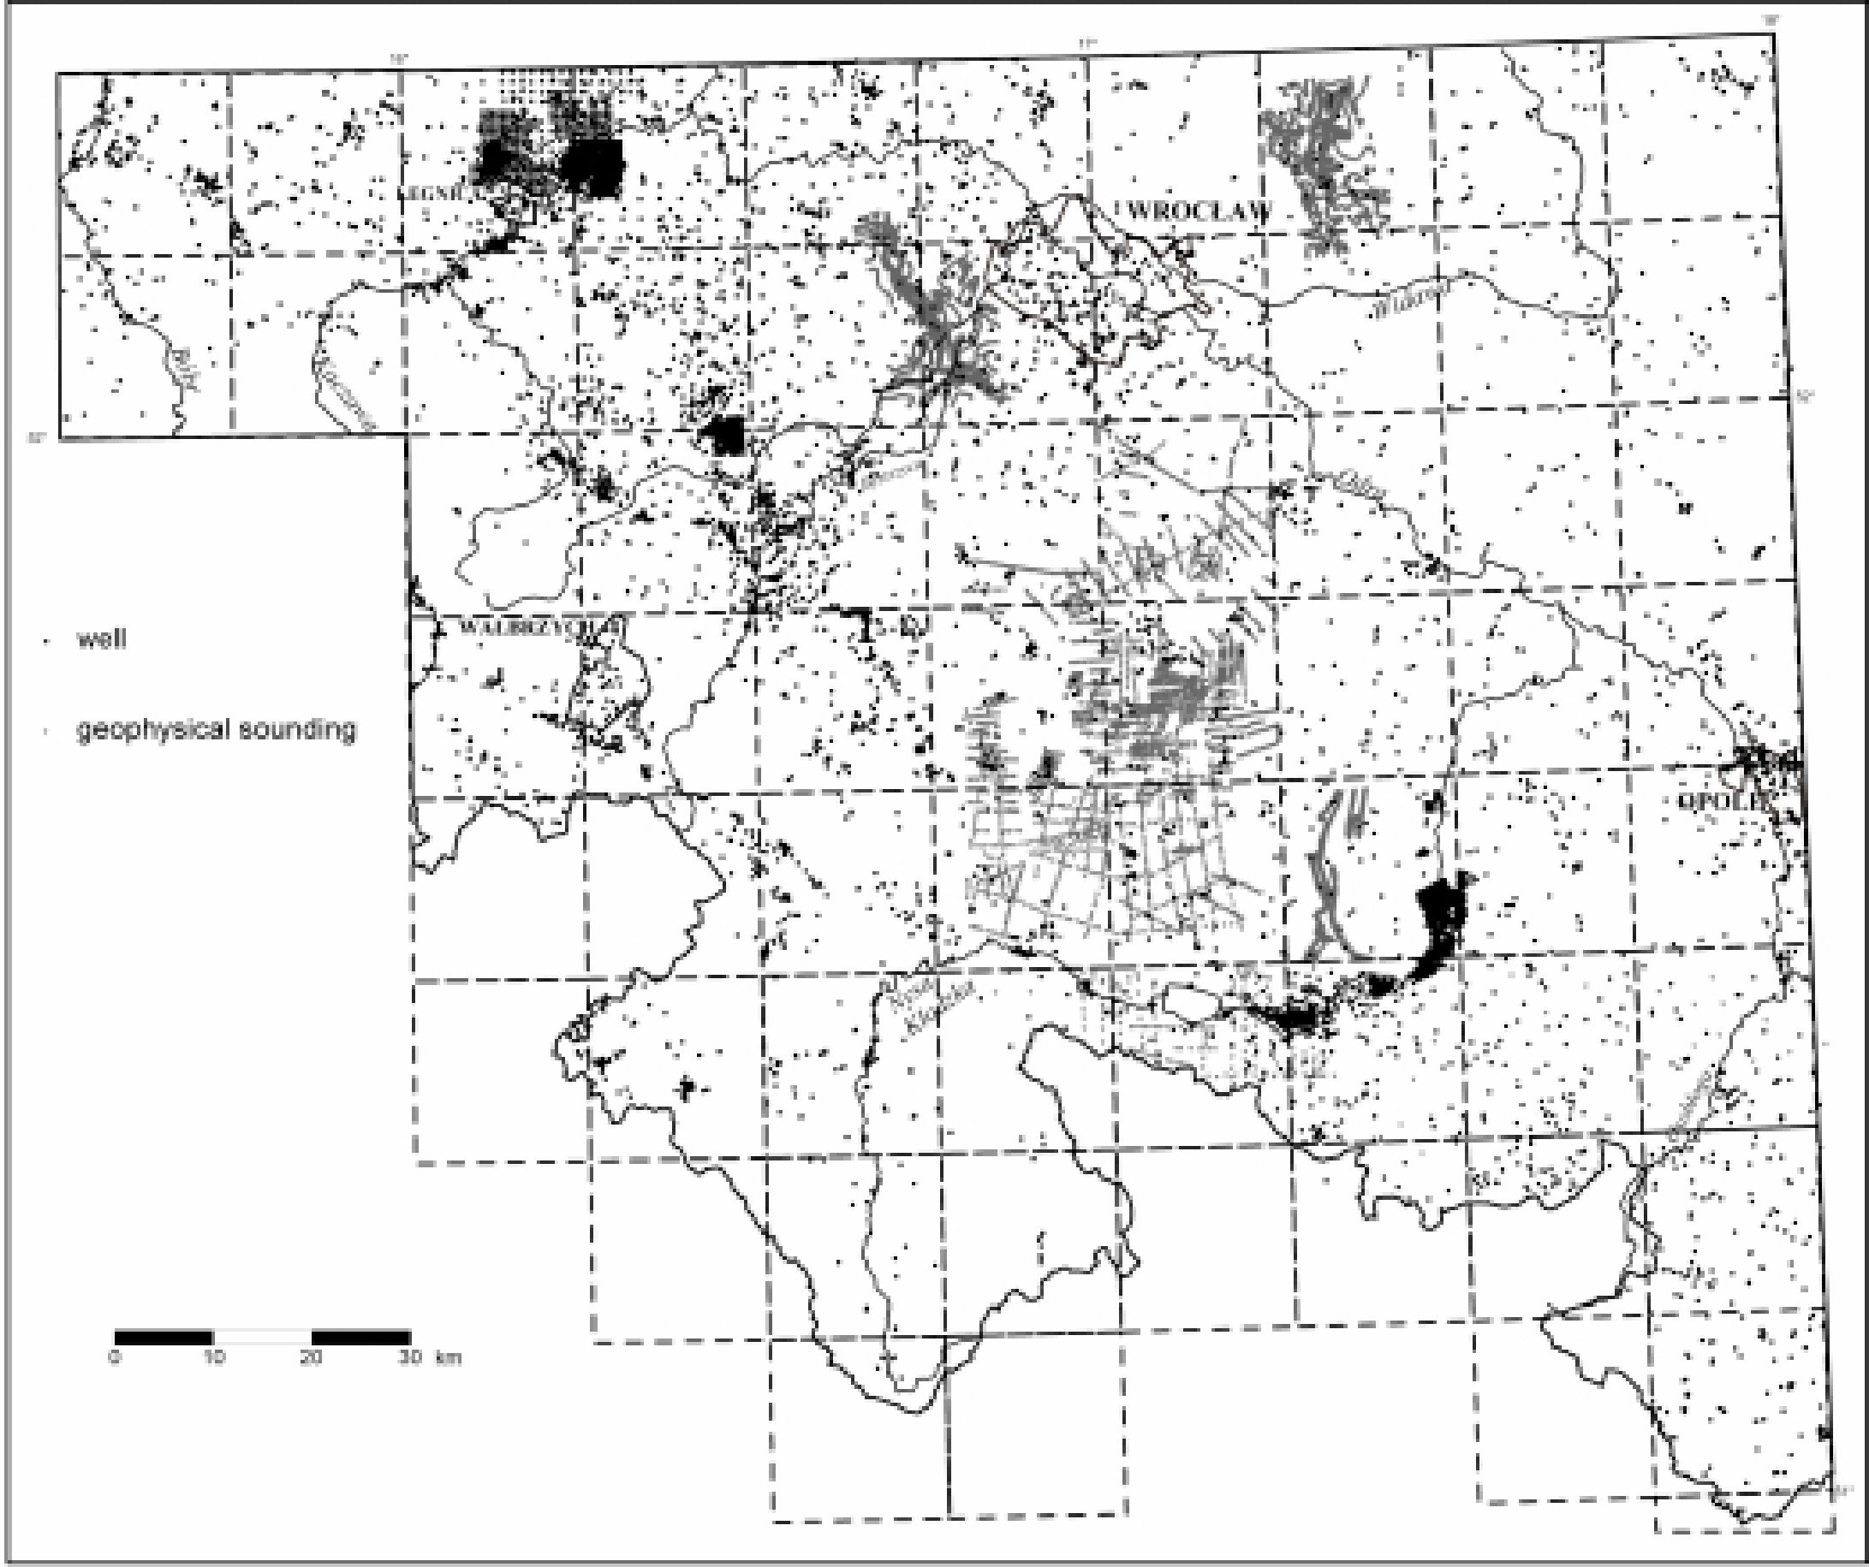
J. Badura et al.: CAINOZOIC EVOL UTION OF LO WER SILESIA, SW POLAND: A NEW.

Fig. 2 Map showing location of wells and geophysical sounding profiles used in this study


