


RESEARCH ARTICLE

Circadian clock regulates the shape and
content of dendritic spines in mouse barrel
cortex
Citation: Jasinska M, Jasek-Gajda E, Woznicka O,
Lis GJ, Pyza E, Litwin JA (2019) Circadian clock
regulates the shape and content of dendritic spines
in mouse barrel cortex. PLoS ONE 14(11):
e0225394. https://doi.org/10.1371/journal.
pone.0225394
Editor: Xiangming Zha, University of South
Alabama, UNITED STATES
Received: August 7,2019
Accepted: November 2,2019
Published: November 15,2019
Copyright: © 2019 Jasinska et al. This is an open
access article distributed under the terms of the
Creative Commons Attribution License, which
permits unrestricted use, distribution, and
reproduction in any medium, provided the original
author and source are credited.
Data Availability Statement: All relevant data are
within the paper and its Supporting Information
files.
Funding: The research was supported by statutory
grant (N41/DBS/000064) from the Jagiellonian
University Medical College to MJ. The funders had
no role in study design, data collection and
analysis, decision to publish, or preparation of the
manuscript.
Competing interests: The authors have declared
that no competing interests exist.
Małgorzata Jasinskan?1*, Ewa Jasek-Gajda1, Olga Woznicka2, Grzegorz J. Lis1,
Elżbieta Pyza2, Jan A. Litwin1
1 Department of Histology, Jagiellonian University Medical College, Krakow, Poland, 2 Department of Cell
Biology and Imaging, Institute of Zoology and Biomedical Research, Jagiellonian University, Krakow, Poland
* malgorzata.m.iasinska@ui.edu.pl

Abstract
Circadian rhythmicity affects neuronal activity induced changes in the density of synaptic
contacts and dendritic spines, the most common location of synapses, in mouse somato-
sensory cortex. In the present study we analyzed morphology of single- and double-synapse
spines under light/dark (12:12) and constant darkness conditions. Using serial electron
micrographs we examined the shape of spines (stubby, thin, mushroom) and their content
(smooth endoplasmic reticulum, spine apparatus), because these features are related to the
maturation and stabilization of spines. We observed significant diurnal and circadian
changes in the shape of spines that are differentially regulated: single-synapse spines
remain under circadian clock regulation, while changes of double-synapse spines are driven
by light. The thin and mushroom single-synapse spines, regardless of their content, are
more stable comparing with the stubby single-synapse spines that show the greatest diver-
sity. All types of double-synapse spines demonstrate a similar level of stability. In light/dark
regime, formation of new mushroom single-synapse spines occurs, while under constant
darkness new stubby single-synapse spines are formed. There are no shape preferences
for new double-synapse spines. Diurnal and circadian alterations also concern spine con-
tent: both light exposure and the clock influence translocation of smooth endoplasmic reticu-
lum from dendritic shaft to the spine. The increasing number of mushroom single-synapse
spines and the presence of only those mushroom double-synapse spines that contain spine
apparatus in the light phase indicates that the exposure to light, a stress factor for nocturnal
animals, promotes enlargement and maturation of spines to increase synaptic strength and
to enhance the effectiveness of neurotransmission.

Introduction
Maturation of a dendritic spine, associated with the level of its stability, is reflected in the
shape of spine and/or in the content of spine organelles [1-5]. Precursors of dendritic spines,
responsible for creating new synapses, filopodia [5-7] transform into stubby-shaped spines
PLOS ONE | https://doi.ora/10.1371/iournal.pone.0225394 November 15, 2019
1 /21
OPEN ACCESS

Circadian clock and dendritic spines
(stubby spines) [2,8]. Stubby spines are immature dendritic spines [2] and they do not have
distinct neck and head compartments [9]. Stubby spines are transformed successively into
thin-shaped spines (thin spines) and then into mushroom-shaped spines (mushroom spines)
[2,10]. Thin and mushroom spines belong to the mature spines characterized by distinct heads
and necks [2]. However, some disappearing mushroom spines pass through the stage of stubby
shape [10]. It means that stubby spines may appear at the beginning as well as at the end of the
spine lifetime. This process is more complex, because even mature spines could also arise de
novo from dendritic shaft in response to neuronal activity and they might be formed irrespec-
tively of the previously existing synapses in that area of the shaft [5,8,11].
Due to a small diameter of heads, thin spines belong to the category of small spines in con-
trast to large mushroom spines [12,13]. Mushroom spines contain more glutamate receptors
than small ones [14,15]. The density of glutamate receptors in the spine membrane (mainly
AMPA receptors in the neocortex) is positively correlated with the spine stability [ 15-17].
Indeed, thin spines have significantly fewer AMPA receptors than mushroom spines [ 14].
However, shapes of spines located close to each other (on the same dendritic segment) might
be functionally more important than the shape of a single spine [18,19].
The available data also suggest a direct link between spine shape and its function. Thin
spines (with narrow necks) show high mobility-they can be rapidly modified by neuronal
activity changes (“write-enabled” spines) [20,21] and they are associated with learning new
information (‘learning spines’) [2]. Mushroom spines (with large heads and relatively wide
necks) are most stable spines (“write-protected” spines) [10,15,20-22] and they are considered
to be involved in memory formation (‘memory spines’) [2].
The content of spines-membranous organelles: smooth endoplasmic reticulum (sER) and
spine apparatus (SA), is also associated with the stability of spines. SA is built of a stack of sER
cisternae separated by electron-dense material [23] containing synaptopodin, a SA-specific
actin-binding protein [24]. SA is involved in the regulation of calcium storage and release [25-
27], as well as in actin-dependent changes in the spine cytoskeleton, including stabilization of
actin filaments and support of actin polymerization [28,29], i.e. in processes participating in
synaptic plasticity (for review see: [30]). The absence of synaptopodin, which results in the lack
of SA, causes long-term potentiation deficits and impaired learning [24,30]. Moreover, SA/
synaptopodin in cooperation with polyribosomes present in spines, participate in local protein
synthesis [31,32], being responsible for its induction and contributing to post-translational
modifications of proteins [33]. The presence of SA in dendritic spine seems to result in spine
head enlargement, increased accumulation of postsynaptic AMPA receptors and enhancement
of synaptic strength [26,30,34].
Spines containing SA are most stable and sER/SA-free spines are most transient ones
[4,15,35]. Mushroom spines contain SA more often than the other spine types and thin spines
usually are sER/SA-free [12,36]. It confirms the existence of a continuum of spine maturation
and stability also reflected by a sequence of spine content (no membranous structures-sER-
SA), with small and large spines representing the two extremes.
The majority of earlier observations regarding dendritic spines have concerned the experi-
ence-dependent plasticity or neuropathological processes, and there are no studies investigat-
ing dendritic spine morphology in the cerebral cortex under different light conditions during
24 h. Some authors reported spine modifications associated with sleep [37,38] but as far as the
clock-induced changes are concerned, it is significant to note that the rest phase of mice is not
synonymous with sleep and during the activity phase the animals are not in permanent wake-
fulness (arousal) [39]. A study of Ikeda et al. [40] presented changes in the number of hippo-
campal spines, categorized according to the size of their heads, under light/dark regime, but it
PLOS ONE | https://doi.org/10.1371/iournal.pone.0225394 November 15, 2019
2/21
Circadian clock and dendritic spines
did not include a similar analysis in constant darkness which would allow to draw conclusions
concerning the influence of the biological clock on the observed changes.
We have previously found that the circadian clock differentially regulates the number of
single-synapse spines (spines with a single excitatory synapse) and double-synapse spines
(spines with two different synapses-one excitatory and the other one inhibitory) in mouse
somatosensory cortex [41]. Although single-synapse spines increase in the number during the
day (light/dark 12 : 12 -LD12:12)/subjective day (constant darkness-DD), double-synapse
spines are more numerous during the night (LD12:12)/subjective night (DD). Interestingly,
the inhibitory synapses are strongly regulated by the clock, while excitatory synapses were
more driven by the light exposure in LD 12:12 conditions [41].
The changes in the density of dendritic spines are often accompanied by their morphologi-
cal modifications reflecting stability, maturation level and functionality of the spines. There-
fore, in the present study we examined morphological changes of the spines including their
shape and content in LD 12:12 and DD conditions. We observed diurnal and circadian rhyth-
micity in morphological modifications of different spine types.

Materials and methods

Animals
Sixteen male C57BL6/cmdb mice aged 5-6 weeks (Center of Experimental Medicine, Medical
University of Bialystok, strain imported from The Jackson Laboratory) were used in the study.
The experiments were carried out in accordance with the Council Directive 2010/63EU of the
European Parliament and the Council of 22 September 2010 on the protection of animals used
for scientific purposes and approved by the Animal Care and Use Committee of the Jagiello-
nian University in Krakow, Poland.

Analysis of locomotor activity
All animals were kept for 10-14 days at LD 12:12 (light 60 lx), 25°C and 50% humidity to
accommodate to standard light conditions. Next, mice were divided into LD (n = 8) and DD
(n = 8) groups. The LD mice were kept for the next 10-14 days under LD 12:12 and DD mice-
under constant darkness. The animals were fed a standard diet and water ad libitum.
From the beginning of experiments mice were kept singly in cages with free access to a run-
ning wheel coupled with a 16-channel electromagnetic pulse counter (MIKI1; Autel; Krakow,
Poland). The number of wheel rotations per minute was continuously recorded, transferred to
PC computer by RS232 interface and saved using RealTerm software (RealTerm: Serial/TCP
Terminal 2.0.0.70; realterm.sf.net). The obtained data were analysed using NIH ImageJ Acto-
gramJ software (http://rsb.info.nih.gov/ij/).
All mice showed locomotor rhythmicity under LD conditions (Fig 1) and were used for fur-
ther experiments. The intensity of locomotor activity within the 24h period did not differ
between animals kept in LD and DD conditions [41]. Eight mice were sacrificed 2 h after the
beginning of the light phase of LD 12:12 or the subjective day of DD (n = 4 per LD REST and
DD REST) and 8 mice were sacrificed 2 h after the beginning of the dark phase (LD 12:12) or
the subjective night (DD; n = 4 per LD ACTIVE and DD ACTIVE). The above-mentioned
time points—2 hours after the beginning of the rest or activity phases were chosen to make
sure that the results reflect the effect of the analyzed phase and are not a consequence of the
earlier phase. Moreover, in our previous study we found clear differences in the density of syn-
apses and spines between the same two time points [41]. Hence, their repetition gives us the
opportunity to check whether the quantitative changes observed in the earlier study are
accompanied by morphological changes.
PLOS ONE | https://doi.org/10.1371/iournal.pone.0225394 November 15, 2019
3/21

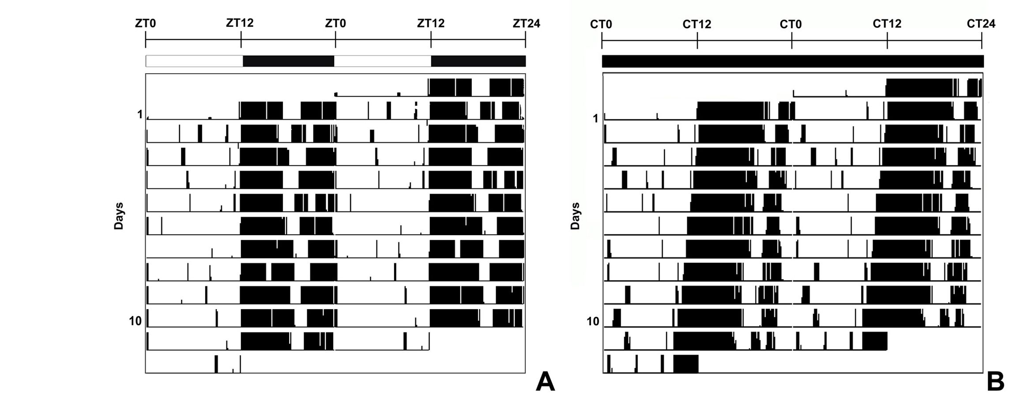
Circadian clock and dendritic spines
Fig 1. Representative double-plotted actograms of the running-wheel locomotor activity of mice. Animals showed locomotor rhythmicity under
light/dark 12:12 (A) and constant darkness conditions (B). ZT-Zeitgeber time, CT-circadian time.
https://doi.ora/10.1371/journal.pone.0225394.a001

Transmission electron microscopy
Mice were anesthetized with Morbital (25-30 mg/kg b.w.; Biowet, Pulawy, Poland) and
perfused through the heart with 20 ml of rinse buffer (0.2% glutaraldehyde and 2% paraformal-
dehyde in 0.1 M phosphate buffer, pH 7.4) followed by 100-150 ml of fixative (2.5% glutaralde-
hyde and 2% paraformaldehyde in 0.1 M phosphate buffer, pH 7.4). Immediately after
perfusion, the brains were removed and left in the same fixative for 24 h at 4°C.
Next, after washing in 0.1 M phosphate buffer (pH 7.4), 60 pm tangential vibratome sec-
tions were cut from the barrel cortex region and examined under a stereomicroscope (Nikon
Optiphot, Japan). Only sections containing the barrel field cortex were collected for further
processing. The sections were washed in 0.1 M cacodylate buffer (pH 7.4), postfixed twice with
1% osmium tetroxide in 0.1 M cacodylate buffer, pH 7.4 (two times for 1 h, the first change
containing 1.5% potassium ferrocyanide), washed in 70% ethanol containing 1% uranyl ace-
tate, and after dehydration in graded series of ethanol, embedded in Epon (Polysciences, USA)
between two silicon-coated glass slides.
The region of B2 barrel was identified according to the procedure described previously
[42]. The embedded slices were trimmed into blocks and series of 10-15 successive ultrathin
sections (65-75 nm thick) were cut from each sample. The sections were collected on formvar-
coated copper-palladium slot grids and contrasted with 1% lead citrate.
Synapses and spines were defined according to Knott et al. [43]. Synapses were character-
ized by two apposed, thickened membranes with an identifiable cleft in between and a presyn-
aptic component containing vesicles. The assessment of synapse type (excitatory or inhibitory)
was based on the symmetry of synaptic membranes (asymmetric/symmetric) and on the
appearance of synaptic vesicles (round/ovoidal). The accordance of excitatory and inhibitory
synapse morphology with glutamate and GABA synaptic markers was previously verified by
immunocytochemistry [42]. Dendritic spines (seen in the several adjacent micrographs) were
identified by their small size relative to the larger dendrite, the unique features of their profiles
and the absence of microtubules and mitochondria.
PLOSONE | https://doi.org/10.1371/iournal.pone.0225394 November 15, 2019 4/21
Circadian clock and dendritic spines
For examination of dendritic spine morphology, from each mouse 3-5 series of electron
micrographs (10-15 serial micrographs each) of the B2 barrel central area in which cell bodies
are sparse, were taken at 30 K under a JEOL JEM 2100 transmission electron microscope
(JEOL, Japan). The micrographs were aligned using Adobe Photoshop CS software and stacks
of serial images were prepared.

Morphological analysis of single- and double-synapse spines
Only the spines fully located within each stack of images were selected for examination. Images
of 171 single-synapse spines and 89 double-synapse spines from both groups were chosen for
morphological measurements and 3D reconstruction (single synapse-spines-LD REST: 42, LD
ACTIVE: 37, DD REST: 51, DD ACTIVE: 41; double synapse-spines-LD REST: 18, LD
ACTIVE: 25, DD REST: 20, DD ACTIVE: 26; 16 ± 3 spines/animal).
The shapes of spines were defined according to [44] and divided into three categories: with
the use of the following criteria: stubby-shaped spines (l« dn, where l is the length of spine
and dn is the diameter of spine neck), thin-shaped spines (l > 3 x dn and dh « dn, where dh is
the diameter of spine head), and mushroom-shaped spines (dh > 2.5 x dn; Fig 2A-2C; [44,45]).
Some spines showed intermediate features (Fig 2D). This group included spines with shapes
intermediate between the basic categories: stubby/thin (l = 2-3 x dn and dh « dn) and thin/
mushroom spines (l > 3 x dn and 2.5 x dn >dh > 1.5 x dn). Generally, intermediate spines con-
stituted about 30% and 16% of single-synapse and double-synapse spines, respectively. Because
of large number of intermediate spines, they were treated as separate spine shapes in addition
to stubby, thin and mushroom spines. Using serial electron micrographs of spines, their con-
tent was identified and according to that criterion spines were divided into three types: spines
containing smooth ER (sER; Fig 2E), spines containing spine apparatus (SA; Fig2F) and spines
without these structures (sER-free). In case of intermediate spines, separate statistical analysis
of their content in the two subgroups was impossible because of high variability of parameters
within the subgroups and/or the absence of some spine variants, therefore stubby/thin and
thin/mushroom spines were combined into one group of intermediate spines for this analysis.

Statistical analysis
All measurements were performed using NIH ImageJ software (Analyze-Measure, Cell
Counter Plugin; http://rsb.info.nih.gov/ij/).
The counting was done blind-the observer did not know whether the micrographs were
taken from LD or DD and ACTIVE or REST groups.
All data were analysed using GraphPad Prism 5.01 software (GraphPad Software Inc., La
Jolla, CA, USA).
Differences in the sampling area across the experimental groups were analyzed by Kolmogo-
rov-Smirnov normality test and homogeneity Bartlett’s test for equal variances, followed by one-
way ANOVA test with post hoc Tukey’s test. To compare the combined effect of light conditions
and spine content on the morphological data across the experimental groups, two-way ANOVA
with post hoc Bonferroni test preceded by Kolmogorov-Smirnov normality test was used. In the
Results section and in figures, data are presented as means ± SD and means ± SEM, respectively.

Results

Sampling areas
Dendritic spines were selected from samples with the following total tissue volumes: LD REST
group- 554.64 ± 6.93 pm3 (mean volume per animal 138.66 ± 4.16 pm3), LD ACTIVE group-
PLOSONE | https://doi.org/10.1371/iournal.pone.0225394 November 15, 2019
5 / 21
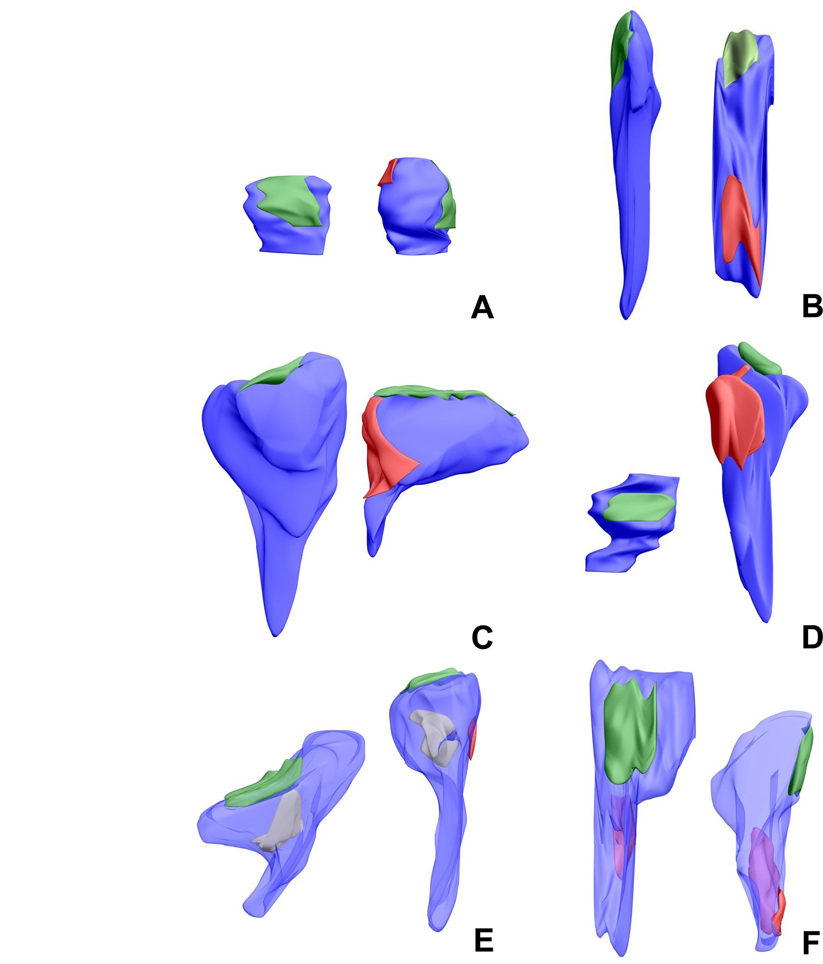

PLOSONE I https://doi.org/10.1371/iournal.pone.0225394 November 15, 2019
6 / 21
Circadian clock and dendritic spines
Circadian clock and dendritic spines
Fig 2. 3D reconstructions of single- and double-synapse spines. Pictures show different spine shapes: stubby (A), thin (B),
mushroom (C), intermediate (D) and different contents: sER (white, E) and SA (red, F). Excitatory and inhibitory synapses are
marked in green and red, respectively.
https://doi.ora/10.1371/journal.pone.0225394.a002
567.85 ± 7.10 pm3 (mean volume per animal 141.96 ± 4.26 pm3), DD REST group- 541.44 ±
6.77 pm3 (mean volume per animal 135.36 ± 4.06 pm3), DD ACTIVE group- 607.47 ±
7.59 pm3 (mean volume per animal 151.87 ± 4.56 pm3). The volume of samples did not signifi-
cantly differ across the groups (F(3,12) = 0.189, p = 0.901, one-way ANOVA).

Shape of spines
Single-synapse spines. In the LD group, stubby/thin single-synapse spines were absent in
the subgroup REST (Fig 3A, S1 Table). Mushroom single-synapse spines were more numerous
as compared to thin single-synapse spines (REST-threefold, t = 4.400, p < 0.001; ACTIVE-
twice, t = 2.848, p < 0.05), stubby/thin single-synapse spines (REST-stubby/thin: absent,
t = 6.748, p < 0.001; ACTIVE-sevenfold, t = 4.896, p < 0.001) and stubby single-synapse
spines (REST-fivefold, t = 5.349, p < 0.001; ACTIVE-twice, t = 3.675, p < 0.01; F(4, 30) =
20.06, p < 0.0001, two-way ANOVA; Figs 2 and 3A). Thin/mushroom single-synapse spines
were more frequent than stubby/thin single synapse spines irrespective of the activity phases of
animals (REST-t = 4.400, p < 0.001; ACTIVE-fourfold, t = 2.892, p < 0.05; F(4, 30) = 20.06,
p < 0.0001, two-way ANOVA; Fig 3A). Moreover, thin/mushroom single-synapse spines were
threefold more numerous when compared with stubby single-synapse spines in the subgroup
REST (t = 3.001, p < 0.05; F(4, 30) = 20.06, p < 0.0001, two-way ANOVA; Fig 3A). However,
there were no differences in single-synapse spines of the same shape between the subgroups
REST and ACTIVE (F(4, 30) = 0.72, p = 0.585, two-way ANOVA; Fig 3A).
In the DD group, mushroom shape predominated in single-synapse spines in the subgroup
ACTIVE and mushroom single-synapse spines were twice as numerous as thin/mushroom
single-synapse spines (t = 8.093, p < 0.001), nine times more numerous than thin single-syn-
apse spines (t = 12.550, p < 0.001), seventeen times more frequent than stubby/thin single-syn-
apse spines (t = 13.250, p < 0.001), and almost threefold more frequent than stubby single-
synapse spines (t = 9.242, p < 0.001; F(4, 30) = 59.13, p < 0.0001, two-way ANOVA; Fig 3B).
Additionally, stubby and thin/mushroom single-synapse spines were more numerous compar-
ing with stubby/thin and thin single-synapse spines in the subgroup ACTIVE (stubby vs
stubby/thin: sixfold, t = 4.007, p < 0.001; stubby vs thin: threefold, t = 3.304, p < 0.01; thin/
mushroom vs stubby/thin: sevenfold, t = 5.156, p < 0.001; thin/mushroom vs thin: almost
fourfold, t = 4.453, p < 0.001; F(4, 30) = 59.13, p < 0.0001, two-way ANOVA; Fig 3B). In the
subgroup REST, mushroom, thin/mushroom and stubby single-synapse spines were similarly
numerous and fourfold more frequent than the other two types of single-synapse spines
(mushroom vs thin: t = 4.590, p < 0.001; mushroom vs stubby/thin: t = 5.663, p < 0.001; thin/
mushroom vs thin: t = 5.406, p < 0.001; thin/mushroom vs stubby/thin: t = 6.480, p < 0.001;
stubby vs thin: t = 4.376, p < 0.001; stubby vs stubby/thin: t = 5.450, p < 0.001; F(4, 30) =
59.13, p < 0.0001, two-way ANOVA; Fig 3B). Generally, stubby/thin and thin spines were the
rarest single-synapse spines regardless of the activity phase of animals. Moreover, mushroom
single-synapse spines were almost twice more frequent in the subgroup ACTIVE when com-
pared to REST (t = 6.696, p < 0.001; F(4, 30) = 14.39, p < 0.0001, two-way ANOVA; Fig 3B).
Double-synapse spines. In the LD group, stubby/thin double-synapse spines were absent
in the subgroup REST (Fig 3C, S2 Table). Thin and thin/mushroom spines were the predomi-
nant populations of double-synapse spines (each group twice as numerous comparing with
stubby and mushroom spines) in the subgroup REST (thin vs stubby: t = 4.204, p < 0.001; thin
PLOSONE | https://doi.org/10.1371/iournal.pone.0225394 November 15, 2019
7 / 21
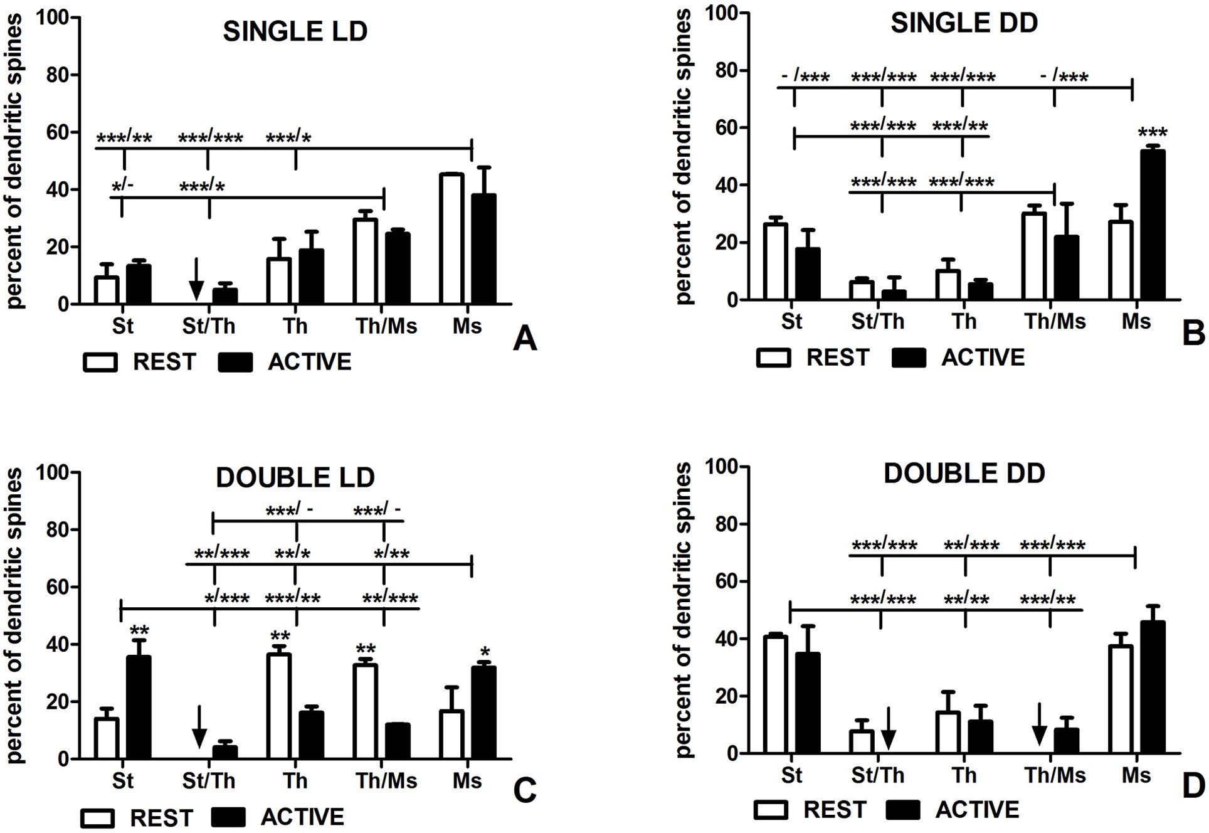

Circadian clock and dendritic spines
Fig 3. Shapes of dendritic spines in groups REST and ACTIVE under LD and DD conditions. Shape changes of single-synapse and double-
synapse spines are driven by circadian clock and light, respectively. (A) Shapes of single-synapse spines under LD conditions. (B) Shapes of
single-synapse spines under DD conditions. (C) Shapes of double-synapse spines under LD conditions. (D) Shapes of double-synapse spines
under DD conditions. The graphs show means ± SEM (two-way ANOVA; *** p < 0.001, ** p < 0.01, * p < 0.05). Arrows indicate the absence of
spines. The asterisks above the bars indicate significant differences in the percentage of spines of the same shape between activity phases (REST vs
ACTIVE), while the asterisks above lines show significant differences between spines of different shapes for the corresponding REST / ACTIVE
phase. St-stubby; St/Th-stubby/thin; Th-thin; Th/Ms-thin/mushroom; Ms-mushroom.
https://doi.ora/10.1371/journal.pone.0225394.a003
vs mushroom: t = 3.716, p < 0.01; thin vs stubby/thin: t = 6.844, p < 0.001; thin/mushroom vs
stubby: t = 3.510, p < 0.01; thin/mushroom vs mushroom: t = 3.022, p < 0.05; thin/mushroom
vs stubby/thin: t = 6.150, p < 0.001; F(4,30) = 14.40, p < 0.0001, two-way ANOVA), and they
were also more frequent when compared with the subgroup ACTIVE (thin: twice, t = 3.805,
p < 0.01; thin/mushroom: twice, t = 3.891, p < 0.01; F(4,30) = 13.71, p < 0.0001, two-way
ANOVA; Figs 2 and 3C). Significant differences were also found between stubby as well as
mushroom and stubby/thin double-synapse spines in the subgroup REST (stubby: t = 2.640,
p < 0.05; mushroom: t = 3.127, p < 0.01; F(4,30) = 14.40, p < 0.0001, two-way ANOVA; Fig
3C). In the subgroup ACTIVE, stubby and mushroom double-synapse spines were more fre-
quent comparing with stubby/thin, thin, and thin/mushroom double-synapse spines (stubby
vs stubby/thin: eightfold, t = 5.906, p < 0.001; stubby vs thin: twice, t = 3.649, p < 0.001; stubby
vs thin/mushroom: almost threefold, t = 4.429, p < 0.001; mushroom vs stubby/thin: seven-
fold, t = 5.210, p < 0.001; mushroom vs thin: almost twice, t = 2.953, p < 0.05; mushroom vs
thin/mushroom: twice, t = 3.733, p < 0.01; F(4,30) = 14.40, p < 0.0001, two-way ANOVA; Fig
3C). The percentage of stubby and mushroom double-synapse spines in the subgroup ACTIVE
were twice as high as in the subgroup REST (stubby: t = 4.049, p < 0.01; mushroom: t = 2.865,
p < 0.05; F(4,30) = 13.71, p < 0.0001, two-way ANOVA; Fig 3C).
PLOSONE | https://doi.org/10.1371/iournal.pone.0225394 November 15, 2019
8/21
Circadian clock and dendritic spines
In the DD group, stubby/thin double-synapse spines as well as thin/mushroom double-syn-
apse spines were absent in the subgroups ACTIVE and REST, respectively (Fig 3D). Stubby
double-synapse spines were twice and threefold as numerous as thin double-synapse spines in
the subgroups REST (t = 3.671, p < 0.01) and ACTIVE, respectively (t = 3.286, p < 0.01; F
(4,30) = 26.05, p < 0.0001, two-way ANOVA; Fig 3D). They were fivefold more frequent when
compared with stubby/thin double-synapse spines in the subgroup REST (t = 4.589, p <
- 001) and fourfold more numerous comparing with thin/mushroom in the subgroup
ACTIVE (t = 3.673, p < 0.01; F(4,30) = 26.05, p < 0.0001, two-way ANOVA; Fig 3D). More-
over, there were significant differences between stubby and stubby/thin double-synapse spines
in the subgroup ACTIVE (t = 4.833; p < 0.001) as well as thin/mushroom double-synapse
spines in the subgroup REST (t = 5.660, p < 0.001; F(4,30) = 26.05, p < 0.0001, two-way
ANOVA; Fig 3D). Similarly, mushroom double-synapse spines were twice and fourfold as
numerous as thin double-synapse spines in the subgroups REST (t = 3.211, p < 0.01) and
ACTIVE, respectively (t = 4.833, p < 0.001), fourfold more frequent than stubby/thin double-
synapse spines in the subgroup REST (t = 4.130, p < 0.001) and fivefold more numerous than
thin/mushroom double-synapse spines in the subgroup ACTIVE (t = 5.220, p < 0.001; F(4,30)
= 26.05, p < 0.0001, two-way ANOVA; Fig 3D). Significant differences were also observed
between mushroom double-synapse spines and stubby/thin double-synapse spines in the sub-
group ACTIVE (t = 6.379, p < 0.01) as well as thin/mushroom double-synapse spines in the
subgroup REST (t = 5.200, p < 0.001; F(4,30) = 26.05, p < 0.0001, two-way ANOVA; Fig 3D).
There were no differences in the percentage of spines, irrespective of their shape, between
activity phases (F(4,30) = 1.190, p = 0.335, two-way ANOVA; Fig 3D).

Shape to content relationship in single-synapse spines
Stubby spines. In the LD group, there were no stubby sER-free single-synapse spines and
spines containing sER in the subgroups REST and ACTIVE, respectively, and it was associated
with significant changes of spine fractions between different activity phases (sER-free:
t = 4.138, p < 0.01; sER:t = 6.207, p < 0.001; F(2,15) = 29.97, p < 0.0001, two-way ANOVA;
Figs 2 and 4A). Consequently, stubby sER-free single-synapse spines were significantly more
numerous than stubby single-synapse spines containing sER in the subgroup ACTIVE
(t = 4.469, p < 0.001), and, conversely, stubby single-synapse spines containing sER as well as
containing SA were more frequent comparing with stubby sER-free single-synapse spines in
the subgroup REST (sER: t = 5.807, p < 0.001; SA: t = 5.807, p < 0.001; F(2,15) = 29.97,
p < 0.0001, two-way ANOVA; Fig 4A). The most numerous stubby single-synapse spines were
spines containing SA in the subgroup ACTIVE (by twofold comparing with sER-free spines;
sER-free: t = 4.471, p < 0.001; sER: t = 8.940, p < 0.001; F(2,15) = 29.97, p < 0.0001, two-way
ANOVA), however, these spines did not show differences in the percentage between activity
phases (t = 2.070, p > 0.05; Fig 4A).
In the DD group, there were no differences in the percentage of stubby sER-free single-syn-
apse spines between the subgroups REST and ACTIVE (t = 0.147, p > 0.05; Fig 4A). Such dif-
ferences were observed in case of stubby single-synapse spines containing sER which were
absent in the subgroup REST (t = 4.562, p < 0.001) and stubby single-synapse spines contain-
ing SA which were twice more frequent in the subgroup REST than ACTIVE (t = 4.415,
p < 0.01; F(2,18) = 20.16, p < 0.0001, two-way ANOVA; Fig 4A). The absence of stubby sin-
gle-synapse spines containing sER caused the appearance of significant differences when these
spines were compared with stubby sER-free single-synapse spines and stubby single-synapse
spines containing SA in the subgroup REST (sER-free: t = 6.182, p < 0.001; SA: t = 7.065,
p < 0.001; F(2,18) = 15.24, p = 0.0001, two-way ANOVA; Fig 4A). Additionally, stubby sER-
PLOSONE | https://doi.org/10.1371/iournal.pone.0225394 November 15, 2019
9 / 21
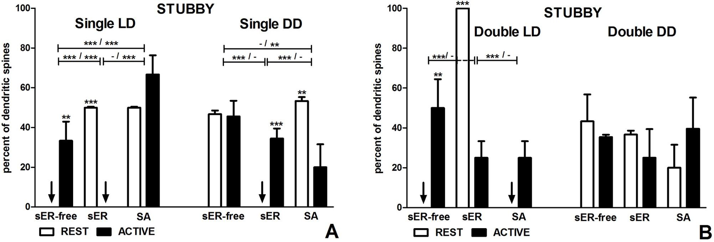
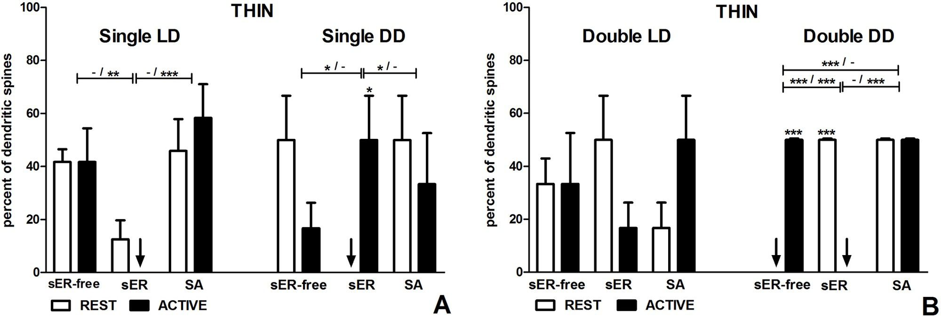

Circadian clock and dendritic spines
Fig 4. Content of stubby spines in groups REST and ACTIVE under LD and DD conditions. Content changes in single-synapse spines are driven
by both light and circadian clock, changes in double-synapse spines are driven exclusively by light. (A) Stubby single-synapse spines. (B) Stubby
double-synapse spines. The graphs show means ± SEM (two-way ANOVA; *** p < 0.001, ** p < 0.01, * p < 0.05). Arrows indicate the absence of
spines. The asterisks above the bars indicate significant differences in the percentage of spines with the same content between activity phases (REST vs
ACTIVE), while the asterisks above lines show significant differences between spines with different contents for the corresponding REST / ACTIVE
phase. sER-free-no membraneous structures; sER-smooth endoplasmic reticulum; SA-spine apparatus.
https://doi.ora/10.1371/journal.pone.0225394.a004
free single-synapse spines were twice as numerous as stubby single-synapse spines containing
SA in the subgroup ACTIVE (t = 3.386, p < 0.01; F(2,18) = 15.24, p = 0.0001, two-way
ANOVA; Fig 4A).
Thin spines. In the LD group, there were no differences in the percentage of thin single-
synapse spines between the subgroups REST and ACTIVE regardless of the spine content (F
(2,15) = 0.95, p = 0.410, two-way ANOVA; Figs 2 and 5A). However, thin sER-free single-syn-
apse spines as well as thin single-synapse spines containing SA were significantly more numer-
ous than thin single-synapse spines containing sER in the subgroup ACTIVE (sER-free:
t = 3.506, p < 0.01; SA: t = 4.908, p < 0.001; F(2,15) = 14.01, p = 0.0004, two-way ANOVA; Fig
Fig 5. Content of thin spines in groups REST and ACTIVE under LD and DD conditions. Content changes in single-synapse spines are driven
mainly by circadian clock, changes in double-synapse spines are driven by both, circadian clock and light. (A) Thin single-synapse spines. (B) Thin
double-synapse spines. The graphs show means ± SEM (two-way ANOVA; *** p < 0.001, ** p < 0.01, * p < 0.05). Arrows indicate the absence of
spines. The asterisks above the bars indicate significant differences in the percentage of spines with the same content between activity phases (REST vs
ACTIVE), while the asterisks above lines show significant differences between spines with different contents for the corresponding REST / ACTIVE
phase. sER-free-no membranous structures; sER-smooth endoplasmic reticulum; SA-spine apparatus.
https://doi.ora/10.1371/journal.pone.0225394.a005
PLOSONE | https://doi.org/10.1371/journal.pone.0225394 November15, 2019
10 / 21

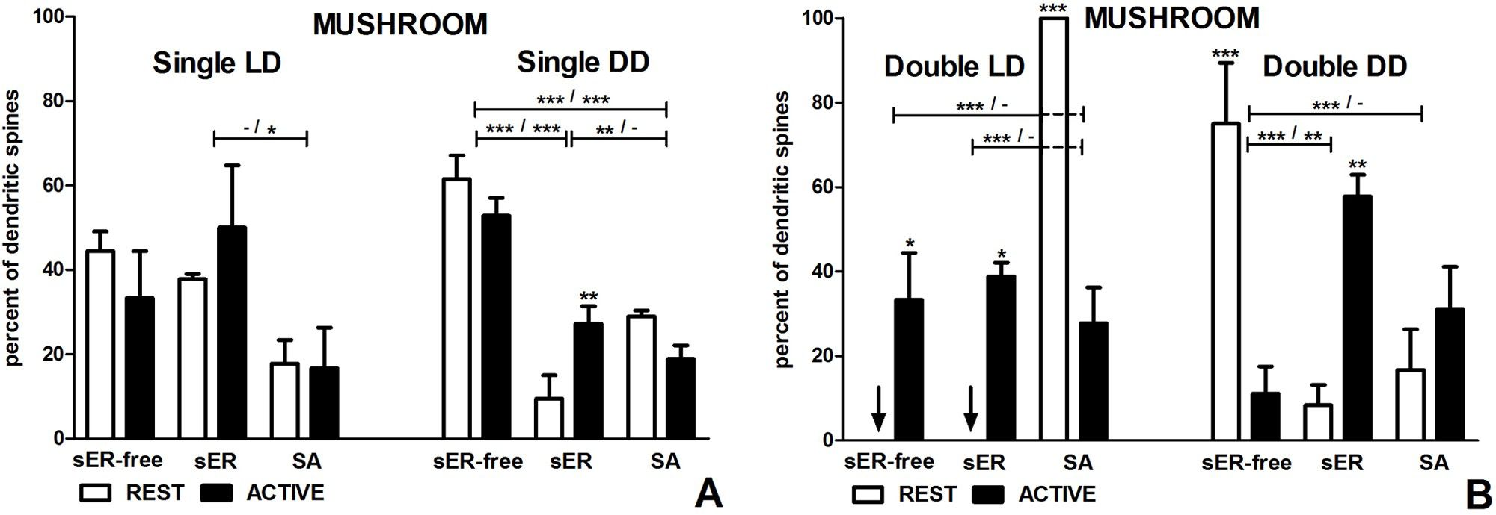

Circadian clock and dendritic spines
5A). It was due to the absence of thin single-synapse spines containing sER in the activity
phase (Fig 5A).
In the DD group, no single-synapse spines containing sER were found in the subgroup
REST, therefore thin sER-free single-synapse spines as well as thin single-synapse spines con-
taining SA were significantly more numerous in that subgroup (sER-free: t = 2.777, p < 0.05;
SA: t = 2.777, p < 0.05; F(2,18) = 5.99, p = 0.010, two-way ANOVA; Fig 5A). Consequently,
there was a statistically significant difference in the percentage of thin single-synapse spines
containing sER between the subgroups REST and ACTIVE (t = 2.777, p < 0.05; F(2,18) = 5.99,
p = 0.010, two-way ANOVA; Fig 5A). However, there were no differences between thin single-
synapse spines with different content in the subgroup ACTIVE (F(2,18) = 0.86, p = 0.441, two-
way ANOVA; Fig 5A).
Mushroom spines. In the LD group, there were no differences in mushroom single-syn-
apse spines between the subgroups REST and ACTIVE, irrespective of the spine content (F
- = 1.13, p = 0.346, two-way ANOVA; Figs 2 and 6A). However, mushroom single-syn-
apse spines containing sER were twice more frequent than those containing SA in the sub-
group ACTIVE (t = 3.022, p < 0.05; F(2,18) = 6.61, p = 0.007, two-way ANOVA; Fig 6A).
In the DD group, mushroom sER-free single-synapse spines were more frequent than
mushroom single-synapse spines containing sER (six and two times in the subgroups REST
and ACTIVE, respectively) and spines containing SA (twofold and almost threefold in the sub-
groups REST and ACTIVE, respectively) regardless of the activity phase (REST-sER: t = 9.969,
p < 0.001; SA: t = 6.240, p < 0.001; ACTIVE-sER: t = 4.901, p < 0.001; SA: t = 6.499,
p < 0.001; F(2,18) = 64.66, p < 0.0001, two-way ANOVA; Fig 6A). Moreover, mushroom sin-
gle-synapse spines containing SA were threefold more numerous than mushroom single-syn-
apse spines containing sER in the subgroup REST (t = 3.729, p < 0.01; F(2,18) = 64.66,
p < 0.0001, two-way ANOVA; Fig 6A). The only activity associated difference concerned
mushroom single-synapse spines containing sER which were almost threefold more frequent
in the subgroup ACTIVE when compared with REST (t = 3.394, p < 0.01; F(2,18) = 9.02,
p = 0.0019, two-way ANOVA; Fig 6A).
Fig 6. Content of mushroom spines in groups REST and ACTIVE under LD and DD conditions. Content changes in single- and double-synapse
spines are driven by both, circadian clock and light. (A) Mushroom single-synapse spines. (B) Mushroom double-synapse spines. The graphs show
means ± SEM (two-wayANOVA; *** p < 0.001, ** p < 0.01, * p < 0.05). Arrows indicate the absence of spines. The asterisks above the bars indicate
significant differences in the percentage of spines with the same content between activity phases (REST vs ACTIVE), while the asterisks above lines
show significant differences between spines with different contents for the corresponding REST / ACTIVE phase. sER-free-no membranous structures;
sER-smooth endoplasmic reticulum; SA-spine apparatus.
https://doi.orq/10.1371/journal.pone.0225394.q006
PLOSONE | https://doi.orq/10.1371/iournal.pone.0225394 November15, 2019
11/21

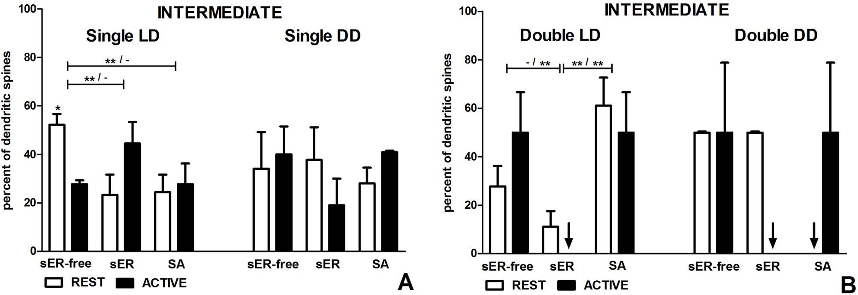

Circadian clock and dendritic spines
Intermediate spines. In the LD group, the most numerous intermediate single-synapse
spines were sER-free spines in the subgroup REST, being more frequent compared to interme-
diate single-synapse spines containing sER (t = 3.359, p < 0.01) and SA (t = 3.230, p < 0.01; F
- = 7.12, p = 0.005, two-way ANOVA; Figs 2 and 7A). Intermediate sER-free single-syn-
apse spines were also almost twice more frequent in the subgroup REST compared to ACTIVE
(t = 2.841, p < 0.05; F(2,18) = 7.12, p = 0.005, two-way ANOVA; Fig 7A). However, there were
no significant differences in intermediate single-synapse spines containing sER and containing
SA between the subgroups REST and ACTIVE (sER: t = 2.454, p > 0.05; SA: t = 0.388,
p > 0.05; F(1, 18) = 0.0000004, p = 0.999, two-way ANOVA; Fig 7A).
In the DD group, there were no differences in the content of intermediate single-synapse
spines between the subgroups REST and ACTIVE (F(2,18) = 1.56, p = 0.237, two-way
ANOVA; Fig 7A). No differences, either, were found between spines containing the particular
type of membranous structures irrespective of the activity phases (F(2,18) = 0.45, p = 0.645,
two-way ANOVA; Fig 7A).

Shape to content relationship in double-synapse spines
Stubby spines. In the LD group, all stubby double-synapse spines in the subgroup REST
contained sER, what resulted in significant differences in the frequency of stubby double-syn-
apse spines containing sER compared to stubby sER-free double-synapse spines and stubby
double-synapse spines containing SA (sER-free: t = 8.486, p < 0.001; SA: t = 8.486, p < 0.001;
F(2,15) = 22.29, p < 0.0001, two-way ANOVA; Figs 2 and 4B). Consequently, stubby double-
synapse spines containing sER were fourfold more numerous in the subgroup REST compared
to ACTIVE (t = 6.804, p < 0.001; F(2,15) = 36.01, p < 0.0001, two-way ANOVA; Fig 4B).
Additionally, stubby sER-free double-synapse spines were significantly more frequent in the
subgroup ACTIVE compared to REST (t = 4.536, p < 0.01; F(2,15) = 36.01, p < 0.0001, two-
way ANOVA; Fig 4B). However, there was no difference between the subgroups REST and
ACTIVE in the percentage of stubby double-synapse spines containing SA (t = 2.268, p > 0.05;
Fig 4B).
Fig 7. Content of intermediate spines in groups REST and ACTIVE under LD and DD conditions. Content of single- and double-synapse spines
does not change between activity phases except for sER-free single-synapse spines. (A) Intermediate single-synapse spines. (B) Intermediate double-
synapse spines. The graphs show means ± SEM (two-way ANOVA; *** p < 0.001, ** p < 0.01, * p < 0.05). Arrows indicate the absence of spines. The
asterisks above the bars indicate significant differences in the percentage of spines with the same content between activity phases (REST vs ACTIVE),
while the asterisks above lines show significant differences between spines with different contents for the corresponding REST / ACTIVE phase. sER-
free-no membranous structures; sER-smooth endoplasmic reticulum; SA-spine apparatus.
https://doi.orq/10.1371/journal.pone.0225394.q007
PLOSONE | https://doi.orq/10.1371/iournal.pone.0225394 November15, 2019
12/21
Circadian clock and dendritic spines
In the DD group, there were no differences in the percentage of stubby double-synapse
spines between the subgroups REST and ACTIVE regardless of the spine content (F(2,12) =
- 131, p = 0.355, two-way ANOVA; Fig 4B). No differences, either, were found between spines
with the particular content type irrespective of the activity phases (F(2,12) = 0.429, p = 0.660,
two-way ANOVA; Fig 4B).
Thin spines. In the LD group, no significant differences were observed in the percentage
of thin double-synapse spines between different activity phases and between spines with the
particular content type (F(2,18) = 2.691, p = 0.055, two-way ANOVA; Figs 2 and 5B).
In the DD group, there were no thin sER-free double-synapse spines and thin double-syn-
apse spines containing sER in the subgroups REST and ACTIVE, respectively (Fig 5B). There-
fore, we observed significant differences in the percentage of thin sER-free double-synapse
spines and thin double-synapse spines containing sER between the subgroups REST and
ACTIVE (sER-free: t = 200, p < 0.001; sER: t = 200, p < 0.001; F(2,10) = 42860, p < 0.0001,
two-way ANOVA; Fig 5B), as well as between thin sER-free double-synapse spines and thin
double-synapse spines containing sER in the subgroups REST (t = 200, p < 0.001) and
ACTIVE (t = 200, p < 0.001; F(2,10) = 14290, p < 0.0001, two-way ANOVA; Fig 5B). More-
over, thin double-synapse spines containing SA were more numerous than thin sER-free dou-
ble-synapse spines and thin double-synapse spines containing sER in the subgroups REST and
ACTIVE, respectively (sER-free: t = 223, p < 0.001, sER: t = 223, p < 0.001; F(2,10) = 14290,
p < 0.0001, two-way ANOVA; Fig 5B).
Mushroom spines. In the LD group, all mushroom double-synapse spines were spines
containing SA in the subgroup REST, while in the subgroup ACTIVE mushroom double-syn-
apse spines were equally divided between all three content types (Figs 2 and 6B). Therefore, sig-
nificant differences between the subgroups REST and ACTIVE were observed in each type of
spines (sER-free: t = 3.097, p < 0.05, sER: t = 3.614, p < 0.05, SA: t = 6.712, p < 0.001; F(2,12) =
33.85, p < 0.0001, two-way ANOVA; Fig 6B). Additionally, mushroom double-synapse spines
containing SA were more numerous than mushroom sER-free double-synapse spines and
mushroom double-synapse spines containing sER in the subgroup REST (sER-free: t = 8.048,
p < 0.001, SA: t = 8.048, p < 0.001; F(2,12) = 24.26, p < 0.0001, two-way ANOVA; Fig 6B).
In the DD group, the most numerous mushroom double-synapse spines were sER-free
spines in the subgroup REST and they were nine- and fourfold more frequent compared to
mushroom double-synapse spines containing sER and containing SA, respectively (sER:
t = 5.379, p < 0.001; SA: t = 4.706, p < 0.001; F(2,15) = 25.06, p < 0.0001,two-way ANOVA;
Fig 6B). Mushroom double-synapse spines containing sER prevailed in the subgroup ACTIVE
and they were fivefold more numerous than mushroom sER-free double-synapse spines
(t = 4.348, p < 0.01; F(2,15) = 25.06, p < 0.0001,two-way ANOVA; Fig 6B). Moreover, mush-
room sER-free double-synapse spines and mushroom double-synapse spines containing sER
were almost sevenfold more numerous in the subgroups REST and ACTIVE respectively, as
compared with the other activity phase (sER-free: t = 5.511, p < 0.001, sER: t = 4.265, p < 0.01;
F(2,15) = 25.06, p < 0.0001,two-way ANOVA; Fig 6B).
Intermediate spines. In the LD group, intermediate double-synapse spines containing
sER were absent in the subgroup ACTIVE, which resulted in significant differences between
these spines and the other types of intermediate double-synapse spines (sER-free: t = 3.530,
p < 0.01; SA: t = 3.530, p < 0.01; F(2,18) = 12.92, p = 0.0003, two-way ANOVA; Figs 2 and
7B). Intermediate double-synapse spines containing SA were fivefold more numerous than
intermediate double-synapse spines containing sER in the subgroup REST (t = 3.530, p < 0.01;
F(2,18) = 12.92, p = 0.0003, two-way ANOVA; Fig 7B). There were no differences in the per-
centage of all intermediate double-synapse spine types between the subgroups REST and
ACTIVE (F(2,18) = 1.85, p = 0.187, two-way ANOVA; Fig 7B).
PLOSONE | https://doi.org/10.1371/iournal.pone.0225394 November 15, 2019
13/21
Circadian clock and dendritic spines
In the DD group, there were no intermediate double-synapse spines containing sER and
containing SA in the subgroups ACTIVE and REST, respectively. Despite that, no significant
differences between the subgroups REST and ACTIVE (F(2,9) = 2.70, p = 0.121, two-way
ANOVA; Fig 7B) were found due to very high standard deviations in the subgroup ACTIVE.

Discussion
The overwhelming number of synapses localized on dendritic spines, as compared to synapses
in the other locations (dendritic shaft, soma), underscores their importance for synaptic trans-
mission. Diurnal structural changes of dendritic spines seem to be a natural consequence of
their high motility [46,47]. Dendritic spines are able to change their shapes very quickly by
activity-dependent and independent mechanisms [48-51]. Morphological modifications of
spines seem to be at least as important as quantitative changes and physiological alterations are
better reflected in morphology than in density of spines [10,52].
Single-synapse spines are the overwhelming population of spines in the somatosensory cor-
tex, while double-synapse spines (with one excitatory and one inhibitory synapse) constitute
only about 10% of spines [53], however, they are the main target of experience-dependent plas-
ticity in this region [42,43,54]. The excitatory synapses are usually located on the heads of dou-
ble-synapse spines, while the inhibitory synapses are placed on the spine necks [53]. The
arrangement of synapses on double-synapse spine allows for easy reduction/regulation of the
excitatory synapse response transmitted through the spine neck to the dendritic shaft [55,56]
and makes double-synapse spines important excitation modifying devices.
The results of this study demonstrate for the first time the circadian rhythmicity of spine
shape changes in mammalian brain. Limitation of this study is the cross-sectional analysis
which provides weaker arguments supporting causal relationships. However, in all chronobio-
logical studies which require collection of brain tissue samples it is the only possible type of
analysis.
Layer IV of mouse somatosensory cortex contains whisker representations in the form of
distinct cytoarchitectonic structures, barrels [57]. The locomotor activity of animals is accom-
panied by stimulation of whiskers, hence its changes directly influence synapses in the barrels.
As the intensity of locomotor activity cyclically changes during 24h period under the influence
of the circadian clock, synapses are cyclically modified. An important source of synaptic
changes in the LD regime is also light which entrains the circadian clock but has not direct
effect on whiskers. The light-stimulated pathway via the retinohypothalamic tract leads to the
suprachiasmatic nucleus, the mammalian clock [58-60], and to brain regions associated with
attention and vigilance [61,62] and may indirectly affect neuronal changes in the somatosen-
sory cortex. Comparison of synaptic modifications in LD and DD conditions allows to deter-
mine whether cyclic plastic changes are driven by the circadian clock, or by light. Changes
between the activity phases observed in constant darkness (DD) are driven exclusively by the
biological clock and changes observed under identical experimental conditions in LD but not
in DD can be attributed to the influence of light. Table 1 summarizes the effects of the circa-
dian clock and light on the morphology of dendritic spines.

Circadian plasticity of single synapse-spines
Under both, LD and DD conditions, the number of single-synapse spines increases during the
day/subjective day, what means the observed changes are endogenous [41]. Comparing mor-
phological spine changes under light/dark regime and in constant darkness we found that the
shape modifications of single-synapse spines are generally driven by the circadian clock and
only in case of mushroom spines they are influenced by light: in LD mainly mushroom single-
PLOSONE | https://doi.org/10.1371/iournal.pone.0225394 November 15, 2019
14/21
Circadian clock and dendritic spines
Table 1. Influence of light and the circadian clock on morphology of single- and double-synapse spines with dif-
ferent content in mouse barrel cortex.
 | Single-synapse spines | Double-synapse spines
Effect of light | Increase in the number of:  stubby spines containing sER*, mushroom  spines (especially containing sER)*,  intermediate sER-free spines | Increase in the number of:  stubby spines containing sER, thin spines  (especially sER-free)*, mushroom spines  containing SA, thin/mushroom spines
Effect of light | Decrease in the number of:  stubby sER-free spines | Decrease in the number of:  stubby sER-free spines,  mushroom spines (especially sER-free)
Effect of  circadian clock/  locomotor  activity  (endogenous  effect) | Increase in the number of:  stubby spines containing sER*, thin spines  containing sER, mushroom spines (especially  containing sER)* | Increase in the number of:  thin sER-free spines*, mushroom spines  containing sER
 | Decrease in the number of:  stubby spines containing SA | Decrease in the number of:  thin spines containing sER, mushroom sER-  free spines
sER, smooth endoplasmic reticulum; SA, spine apparatus.
* Spines influenced by both factors.
https://doi.orq/10.1371/journal.pone.0225394.t001
synapse spines are formed and this process is driven by light. Interestingly, increase in the
number of stubby and mushroom single-synapse spines containing sER is induced by locomo-
tor activity as well as by light. This suggests that an increase in transportation of sER from den-
dritic shafts to spines is independent of the stimulus type.
We found that clock/activity of the animals in DD and light in LD promoted cyclic forma-
tion of mushroom single-synapse spines. Considering a continuum of spine stability based on
spine shapes (stubby-thin-mushroom), this result seems to be especially interesting because
the mushroom spines regarded as very stable [5,10]. However, results reported by some other
authors suggest that thin, stubby and mushroom spines have the same longevity [63]. Since the
observed changes are cyclic, it seems that the formation and degradation of mushroom single-
synapse spines cannot be explained exclusively by formation of new ‘memory spines’.
Stubby single-synapse spines showed the greatest diurnal and circadian variability of their
content, while thin single-synapse spines remained the most stable, as far as their content was
concerned. The source of content alterations in stubby single-synapse spines seems to be more
diverse than in case of the other single-synapse spines: in some spines they were driven by the
circadian clock and in the others by light. Percentage differences of thin and mushroom sin-
gle-synapse spines with the particular content type between the activity phases were observed
only in DD, indicating that the changes were exclusively endogenous. Under both investigated
conditions spines containing SA were the least numerous among mushroom single-synapse
spines. This is in accordance with our expectations, because mushroom spines containing SA
are regarded to be most mature and stable [2,35], therefore their number should not signifi-
cantly change.

Circadian plasticity of double-synapse spines
In contrast to single-synapse spines, the shape changes of double-synapse spines are driven
exclusively by light. The variations in the content of these spines were also different from those
observed in single-synapse spines. In thin double-synapse spines they were endogenous, while
in stubby double-synapse spines they were driven by light and in mushroom double-synapse
spines by both factors. Under LD conditions we observed an unusual situation: during the day
all mushroom double-synapse spines contained SA and all stubby double-synapse spines
PLOSONE j https://doi.orq/10.1371/iournal.pone.0225394 November 15, 2019
15 / 21
Circadian clock and dendritic spines
contained sER, whereas in the night the fractions of all content types of mushroom and stubby
double-synapse spines were similar. Generally, spines containing SA are considered to be the
least variable, regardless of shape [35]. This rule, however, does not seem to apply to mush-
room double-synapse spines, although they are regarded as most mature and stable spines
[2,64].
The total number of double-synapse spines increases during the night/subjective night
under both LD and DD conditions and similarly to single-synapse spines, the changes are
endogenous [41]. The newly formed double-synapse spines are either sER-free or contain sER.
It means that the nascent double-synapse spines are immature spines, as far as their content is
concerned. Newly formed single-synapse spines are thought to contain no organelles [35].
However, as observed during the learning processes, double-synapse spines are formed by
addition of inhibitory synapse to a large and mature single-synapse mushroom spine contain-
ing SA [42,45,53]. This difference suggests that the neuroplasticity observed in the circadian
cycles is exceptional due to the rhythmic nature of the process and short time available for
changes. The light induces transformation of existing double-synapse spines towards the
immature form (sER-free or containing sER), while in darkness all types of double-synapse
spines can be formed with equal probability. However, there seems to be no preference for any
shape of single-synapse spines to attach inhibitory synapses and to convert into double-syn-
apse spines.

Circadian trends of spine transformations and maturation
Intermediate single-synapse spines were twice as numerous as intermediate double-synapse
spines. It could suggest a longer time needed to achieve a specific shape by single-synapse
spines than by double-synapse spines. The other possibility is that single-synapse spines are
generally less stable than double-synapse spines. On the other hand, single-synapse spines are
formed de novo, while formation of new double-synapse spines requires existence of single-
synapse spines [42,43].
The negligible number of stubby/thin and large number of thin/mushroom single- and
double-synapse spines during the light phase (under LD) suggests that light preferentially
inhibits transformation of thin spines into stubby spines. Moreover, the number of mushroom
single-synapse spines increases in the light phase confirming that the light promotes modifica-
tions of spines towards mature ones. Although the number of mushroom double-synapse
spines did not increase during the light phase, all mushroom double-synapse spines were
mature (contained SA).

Influence of stress hormones on dendritic spine changes
It seems that an additional factor that might affect the formation of dendritic spines or their
morphology is the cyclic secretion of glucocorticoids by the adrenal cortex [40,65], subordi-
nated to the hierarchical system referred to as the hypothalamic-pituitary-adrenal (HPA) axis.
Glucocorticoids control various animal functions related to physiology and metabolism, and
are particularly involved in controlling stress response [66-68]. The central clock in the supra-
chiasmatic nucleus is responsible for generating circadian rhythms in peripheral clocks located
in other tissues of the body [69-71]. The peripheral adrenal clock, although coordinated by the
central clock and unable to generate its own rhythm, might influence the other peripheral
oscillators by the rhythmic secretion of glucocorticoids [66,68,72].
In nocturnal animals, the peak of glucocorticoid secretion occurs at the beginning of night
[73,74]. Increase in the level of these hormones leads to an enhanced synapse turnover, includ-
ing both, formation and elimination of synapses [75]. The rhythmic oscillations of
PLOSONE | https://doi.org/10.1371/iournal.pone.0225394 November 15, 2019
16/21
Circadian clock and dendritic spines
glucocorticoids appear to be important for formation or maintenance of nascent spines after
learning [65]. The number of spines with large heads (large spines) in hippocampal CA1 field
neurons in increase at the beginning of the active phase under LD [40]. In the somatosensory
cortex, we observed similar rhythmics of mushroom double-synapse spines, while the number
of mushroom single-synapse spines did not change between day and night in LD. The changes
of mushroom single-synapse spines between the two activity phases were found only in DD.
However, it is difficult to exclude that the changes observed in this study might partly result
from cyclic glucocorticoid secretion.

Functional implications
The observation of mature spine (thin and mushroom) changes leads to an interesting conclu-
sion: thin spines probably act as ‘learning spines’ [2], but only some mushroom spines are
‘write-protected’ spines [2] in the circadian cycle. The cyclic formation and degradation of
mushroom single-synapse spines cannot be explained exclusively by formation of new ‘mem-
ory spines’. Mushroom spines are usually big spines with large heads, characterized by the
presence of large, very effective and strong synapses containing numerous glutamate receptors.
In the active phase, there were fewer single-synapse spines comparing with the rest phase [41],
so it seems that an increase in the strength of synapses resulting from change of the spine
shape into mushroom-shaped might be a more efficient and faster way to achieve enhanced
neurotransmission than a change of spine number. The light is a stressful condition for noc-
turnal rodents and requires not only more synapses to increase the sensitivity to weak stimuli
[41], but also increased strength of excitatory synapses to enhance the effectiveness of neuro-
transmission. Similarly, the presence of only double-synapse spines containing SA in the light
phase indicates more effective regulation of calcium [25,76,77] as well as increased protein
production [3] in the spine, what can also be related to the potentiation of synapses.

Conclusions
Results obtained in the present study demonstrate that in addition to quantitative changes of
spines [41], they also undergo qualitative modifications within 24 h period. Shape alterations
of single-synapse spines are driven by the circadian clock and modified by light, while changes
of double-synapse spines are under the influence of light. Generally, during the light phase
large, mature spines are formed preferentially. It seems to be related more to the increase in
the strength of synapses accompanying large spines than to the significance of the mushroom
spines for memory storage.

Supporting information
- Table. Percentages of single-synapse spines with different shapes in the two phases of
the circadian cycle. Table shows mean ± SD.
(DOCX)
- Table. Percentages of double-synapse spines with different shapes in the two phases of
the circadian cycle. Table shows mean ± SD.
(DOCX)

Author Contributions
Conceptualization: Malgorzata Jasinska, Elzbieta Pyza.
Formal analysis: Malgorzata Jasinska, Ewa Jasek-Gajda, Grzegorz J. Lis.
PLOSONE | https://doi.org/10.1371/iournal.pone.0225394 November 15, 2019
17 / 21
Circadian clock and dendritic spines
Funding acquisition: Malgorzata Jasinska.
Investigation: Malgorzata Jasinska, Olga Woznicka.
Supervision: Elzbieta Pyza, Jan A. Litwin.
Validation: Grzegorz J. Lis, Jan A. Litwin.
Visualization: Malgorzata Jasinska, Ewa Jasek-Gajda.
Writing - original draft: Malgorzata Jasinska.
Writing - review & editing: Elzbieta Pyza, Jan A. Litwin.

References
- Holtmaat AJGDTrachtenberg JT, WilbrechtL, Shepherd GM, Zhang X, KnottGW, etal. Transient and
persistent dendritic spines in the neocortex in vivo. Neuron. 2005; 45: 279-291. https://doi.org/10.1016/
j.neuron.2005.01.003 PMID: 15664179
- Bourne J, Harris KM. Do thin spines learn to be mushroom spines that remember? CurrOpin Neurobiol.
2007; 17: 381-386. https://doi.org/10.1016/j.conb.2007.04.009 PMID: 17498943
- DellerT, Bas Orth C, DelTurco D, Vlachos A, Burbach GJ, DrakewA, etal. A role for synaptopodin and
the spine apparatus in hippocampal synaptic plasticity. Ann Anat. 2007; 189: 5-16. https://doi.org/10.
1016/j.aanat.2006.06.013 PMID: 17319604
- Holbro N, GrunditzA, OertnerTG. Differential distribution of endoplasmic reticulum controls metabotro-
pic signaling and plasticity at hippocampal synapses. Proc Natl Acad Sci. 2009; 106:15055-15060.
https://doi.org/10.1073/pnas.0905110106 PMID: 19706463
- Parajuli LK, Tanaka S, Okabe S. Insights into age-old questions of new dendritic spines: From form to
function. Brain Res Bull. 2017; 129: 3-11. https://doi.org/10.1016/j.brainresbull.2016.07.014 PMID:
27491624
- Ziv NE, Smith SJ. Evidence for a role of dendritic filopodia in synaptogenesis and spine formation. Neu-
ron. 1996; 17: 91-102. https://doi.org/10.1016/S0896-6273100180283-4 PMID: 8755481
- FialaJC, FeinbergM, Popov V, Harris KM. Synaptogenesis via dendritic filopodia in developing hippo-
campal area CA1. J Neurosci. 1998; 18: 8900-11. https://doi.org/10.1523/JNEUROSCI.18-21 -08900.
1998 PMID: 9786995
- Harris K. Structure and plasticity of dendritic spines. Curr Opin Neurobiol. 1999; 9: 343-348. https://doi.
org/10.1016/S0959-4388(99)80050-6 PMID: 10395574
- Harris K, Kater SB. Dendritic Spines: Cellular Specializations Imparting Both Stability and Flexibility to
Synaptic Function. Annu Rev Neurosci. 1994; 17: 341-371. https://doi.org/10.1146/annurev.ne.17.
030194.002013 PMID: 8210179
- van derZee EA. Synapses, spines and kinases in mammalian learning and memory, and the impact of
aging. Neurosci Biobehav Rev. 2015; 50: 77-85. https://doi.org/10.1016/j.neubiorev.2014.06.012
PMID: 24998408
- Kwon H-B, Sabatini BL. Glutamate induces de novo growth of functional spines in developing cortex.
Nature. 2011; 474:100-104. https://doi.org/10.1038/nature09986 PMID: 21552280
- Sorra KE, Harris KM. Overview on the structure, composition, function, development, and plasticity of
hippocampal dendritic spines. Hippocampus. 2000; 10: 501-511. https://doi.org/10.1002/1098-1063
(2000)10:5<501::AID-HIPO1>3.0.CO;2-T PMID: 11075821
- Dumitriu D, Hao J, HaraY, Kaufmann J, Janssen WGM, Lou W, etal. Selective Changes in Thin Spine
Density and Morphology in Monkey Prefrontal Cortex Correlate with Aging-Related Cognitive
Impairment. J Neurosci. 2010; 30: 7507-7515. https://doi.org/10.1523/JNEUROSCI.6410-09.2010
PMID: 20519525
- Matsuzaki M, Ellis-Davies GCR, NemotoT, MiyashitaY, Iino M, Kasai H. Dendritic spine geometry is
critical for AMPA receptor expression in hippocampal CA1 pyramidal neurons. Nat Neurosci. 2001; 4:
1086-1092. https://doi.org/10.1038/nn736 PMID: 11687814
- Bourne JN, Harris KM. Balancing Structure and Funcion at Hippocampal Dendritic Spines. Annu Rev
Neurosci. 2008; 31: 47-67. https://doi.org/10.1146/annurev.neuro.31.060407.125646 PMID: 18284372
- Fischer M, Kaech S, Wagner U, Brinkhaus H, Matus A. Glutamate receptors regulate actin-based plas-
ticity in dendritic spines. Nat Neurosci. 2000; 3: 887-894. https://doi.org/10.1038/78791 PMID:
10966619
PLOSONE | https://doi.org/10.1371/journal.pone.0225394 November 15, 2019
18 / 21
Circadian clock and dendritic spines
- AttardoA, Fitzgerald JE, Schnitzer MJ. Impermanence of dendritic spines in live adult CA1 hippocam-
pus. Nature. 2015; 523: 592-596. https://doi.org/10.1038/nature14467 PMID: 26098371
- YadavA, Gao YZ, Rodriguez A, Dickstein DL, Susan L, Luebke JI, etal. Morphologic Evidence for Spa-
tially Clustered Spines in Apical Dendrites of Monkey Neocortical Pyramidal Cells. J Comp Neurol.
2012; 520: 2888-2902. https://doi.org/10.1002/cne.23070 PMID: 22315181
- Lu J, Zuo Y. Clustered structural and functional plasticity of dendritic spines. Brain Res Bull. 2017;
129:18-22. https://doi.org/10.1016/j.brainresbull.2016.09.008 PMID: 27637453
- Kasai H, Matsuzaki M, Noguchi J, Yasumatsu N, Nakahara H. Structure-stability-function relationships
of dendritic spines. Trends Neurosci. 2003; 26: 360-368. https://doi.org/10.1016/S0166-2236/03)
00162-0 PMID: 12850432
- Matsuzaki M, Honkura N, Ellis-Davies GCR, Kasai H. Structural basis of long-term potentiation in single
dendritic spines. Nature. 2004; 429: 761-766. https://doi.org/10.1038/nature02617 PMID: 15190253
- Gonzalez-Tapia D, Martfnez-Torres NI, Hernandez-Gonzalez M, Guevara MA, Gonzalez-Burgos I.
Plastic changes to dendritic spines on layer V pyramidal neurons are involved in the rectifying role of the
prefrontal cortex during the fast period of motor learning. Behav Brain Res. 2016; 298: 261-267. https://
doi.org/10.1016/j.bbr.2015.11.013 PMID: 26589803
- Gray EG. Electron microscopy of synaptic contacts on dendrite spines of the cerebral cortex. Nature.
1959; 183:1592-1593. https://doi.org/10.1038/1831592a0 PMID: 13666826
- Deller T, Korte M, Chabanis S, DrakewA, Schwegler H, Stefani GG, etal. Synaptopodin-deficient mice
lack a spine apparatus and show deficits in synaptic plasticity. Proc Natl Acad Sci USA. 2003; 100:
10494-10499. https://doi.org/10.1073/pnas.1832384100 PMID: 12928494
- Fifkova E, Markham JA, Delay RJ. Calcium in the spine apparatus of dendritic spines in the dentate
molecular layer. Brain Res. 1983; 266:163-168. https://doi.org/10.1016/0006-8993(83)91322-7 PMID:
6189559
- Vlachos A, Korkotian E, Schonfeld E, Copanaki E, Deller T, Segal M. Synaptopodin regulates plasticity
of dendritic spines in hippocampal neurons. J Neurosci. 2009; 29:1017-1033. https://doi.org/10.1523/
JNEUROSCI.5528-08.2009 PMID: 19176811
- Korkotian E, Segal M. Synaptopodin regulates release of calcium from stores in dendritic spines of cul-
tured hippocampal neurons. J Physiol. 2011; 589: 5987-5995. https://doi.org/10.1113/jphysiol.2011.
217315 PMID: 22025667
- Okubo-Suzuki R, Okada D, Sekiguchi M, Inokuchi K. Synaptopodin maintains the neural activity-depen-
dent enlargement of dendritic spines in hippocampal neurons. Mol Cell Neurosci. 2008; 38: 266-276.
https://doi.org/10.1016/j.mcn.2008.03.001 PMID: 18424168
- Wang L, Dumoulin A, Renner M, Triller A, Specht CG. The role of synaptopodin in membrane protein
diffusion in the dendritic spine neck. PLoS One. 2016; 11: e0148310. https://doi.org/10.1371/journal.
pone.0148310 PMID: 26840625
- Jedlicka P, Deller T. Understanding the role of synaptopodin and the spine apparatus in Hebbian synap-
tic plasticity-New perspectives and the need for computational modeling. Neurobiol Learn Mem. 2017;
138: 21-30. https://doi.org/10.1016/j.nlm.2016.07.023 PMID: 27470091
- Pierce JP, van Leyen K, McCarthy JB. Translocation machinery for synthesis of integral membrane and
secretory proteins in dendritic spines. Nat Neurosci. 2000; 3: 311-313. https://doi.org/10.1038/73868
PMID: 10725917
- Pierce JP, MayerT, McCarthy JB. Evidence for a satellite secretory pathway in neuronal dendritic
spines. Curr Biol. 2001; 11: 351-355. https://doi.org/10.1016/s0960-9822(01)00077-x PMID: 11267872
- Ostroff LE, Cain CK, Bedont J, Monfils MH, LeDoux JE. Fear and safety learning differentially affect
synapse size and dendritic translation in the lateral amygdala. Proc Natl Acad Sci. 2010; 107: 9418-
9423. https://doi.org/10.1073/pnas.0913384107 PMID: 20439732
- Chirillo MA, Waters MS, Lindsey LF, Bourne JN, Harris KM. Local resources of polyribosomes and SER
promote synapse enlargement and spine clustering after long-term potentiation in adult rat hippocam-
pus. Sci Rep.; 2019; 9: 3861. https://doi.org/10.1038/s41598-019-40520-x PMID: 30846859
- Knott GW, Holtmaat A, Wilbrecht L, Welker E, Svoboda K. Spine growth precedes synapse formation in
the adult neocortex in vivo. Nat Neurosci. 2006; 9:1117-1124. https://doi.org/10.1038/nn1747 PMID:
16892056
- Spacek J, Harris KM. Three-dimensional organization of smooth endoplasmic reticulum in hippocampal
CA1 dendrites and dendritic spines of the immature and mature rat. J Neurosci. 1997; 17:190-203.
https://doi.org/10.1523/JNEUROSCI.17-01-00190.1997 PMID: 8987748
- Havekes R, ParkAJ, Tudor JC, Luczak VG, Hansen RT, Ferri SL, etal. Sleep deprivation causes mem-
ory deficits by negatively impacting neuronal connectivity in hippocampal area CA1. Elife. 2016; 5:1-
22. https://doi.org/10.7554/elife.13424 PMID: 27549340
PLOS ONE | https://doi.org/10.1371/journal.pone.0225394 November 15, 2019
19 / 21
Circadian clock and dendritic spines
- de Vivo L, Bellesi M, Marshall W, Bushong EA, Ellisman MH, Tononi G, et al. Ultrastructural Evidence
for Synaptic Scaling Across the Wake/sleep Cycle. Science 2017; 355: 507-510. https://doi.org/10.
1126/science.aah5982 PMID: 28154076
- Frank MG, Cantera R. Sleep, clocks, and synaptic plasticity. Trends Neurosci. 2014; 37: 491-501.
https://doi.org/10.1016/j.tins.2014.06.005 PMID: 25087980
- IkedaM, Hojo Y, Komatsuzaki Y, Okamoto M, Kato A, TakedaT, etal. Hippocampal spine changes
across the sleep-wake cycle: corticosterone and kinases. J Endocrinol. 2015; 226: M13-M27. https://
doi.org/10.1530/JOE-15-0078 PMID: 26034071
- Jasinska M, Grzegorczyk A, Woznicka O, Jasek E, Kossut M, Barbacka-Surowiak G, et al. Circadian
rhythmicity of synapses in mouse somatosensory cortex. Eur J Neurosci. 2015; 42: 2585-2594. https://
doi.org/10.1111/ejn.13045 PMID: 26274013
- Jasinska M, Siucinska E, Cybulska-Klosowicz A, Pyza E, Furness DN, Kossut M, et al. Rapid, Learn-
ing-Induced Inhibitory Synaptogenesis in Murine Barrel Field. J Neurosci. 2010; 30:1176-1184. https://
doi.org/10.1523/JNEUROSCI.2970-09.2010 PMID: 20089926
- Knott GW, Quairiaux C, Genoud C, Welker E. Formation of dendritic spines with GABAergic synapses
induced by whisker stimulation in adult mice. Neuron. 2002; 34: 265-273. https://doi.org/10.1016/
S0896-6273(02)00663-3 PMID: 11970868
- Harris KM, Jensen FE, Tsao B. Three-dimensional structure of dendritic spines and synapses in rat hip-
pocampus (CA1) at postnatal day 15 and adult ages: implications for the maturation of synaptic physiol-
ogy and long-term potentiation. J Neurosci. 1992; 12: 2685-2705. https://doi.org/10.1523/
JNEUROSCI.12-07-02685.1992 PMID: 1613552
- Jasinska M, Siucinska E, Jasek E, Litwin JA, Pyza E, Kossut M. Effect of associative learning on mem-
ory spine formation in mouse barrel cortex. Neural Plast. 2016; 2016:9828517. https://doi.org/10.1155/
2016/9828517 PMID: 26819780
- Perez-CruzC, Simon M, Flugge G, Fuchs E, Czeh B. Diurnal rhythm and stress regulate dendritic archi-
tecture and spine density of pyramidal neurons in the rat infralimbic cortex. Behav Brain Res. 2009;
205: 406-413. https://doi.org/10.1016/j.bbr.2009.07.021 PMID: 19643147
- IkenoT, Weil ZM, Nelson RJ. Photoperiod affects the diurnal rhythm of hippocampal neuronal morphol-
ogy of siberian hamsters. Chronobiol Int. 2013; 30:1089-1100. https://doi.org/10.3109/07420528.
2013.800090 PMID: 23879697
- Matus A. Actin-Based Plasticity in Dendritic Spines. Science. 2000; 754: 754-759. https://doi.org/10.
1126/science.290.5492.754
- Hotulainen P, Hoogenraad CC. Actin in dendritic spines: Connecting dynamics to function. J Cell Biol.
2010; 189: 619-629. https://doi.org/10.1083/jcb.201003008 PMID: 20457765
- Kasai H, Fukuda M, Watanabe S, Hayashi-Takagi A, Noguchi J. Structural dynamics of dendritic spines
in memory and cognition. Trends Neurosci. 2010; 33:121-129. https://doi.org/10.1016/j.tins.2010.01.
001 PMID: 20138375
- Bellot A, Guivernau B, Tajes M, Bosch-Morato M, Valls-Comamala V, Munoz FJ. The structure and
function of actin cytoskeleton in mature glutamatergic dendritic spines. Brain Res. 2014; 1573:1-16.
https://doi.org/10.1016/j.brainres.2014.05.024 PMID: 24854120
- Geinisman Y, Disterhoft JF, Gundersen HJG, Mcechron MD, Persina IS, Power JM, etal. Remodeling
of hippocampal synapses after hippocampus-dependent associative learning. J Comp Neurol. 2000;
417: 49-59. https://doi.org/10.1002/(SICI)1096-9861(20000131)417:1<49::AID-CNE4>3.0.CO;2-3
PMID: 10660887
- Jasińska M, Siucińska E, Głazewski S, Pyza E, Kossut M. Characterization and plasticity of the double
synapse spines in the barrel cortex of the mouse. Acta Neurobiol Exp (Wars). 2006; 66: 99-104.
- Micheva KD, Beaulieu C. An anatomical substrate for experience-dependent plasticity of the rat barrel
field cortex. Proc Natl Acad Sci USA. 1995; 92:11834-11838. https://doi.org/10.1073/pnas.92.25.
11834 PMID: 8524859
- Dehay C, Douglas RJ, Martin KA, Nelson C. Excitation by geniculocortical synapses is not ’vetoed’ at
the level of dendritic spines in cat visual cortex. J Physiol. 1991; 440: 723-734. https://doi.org/10.1113/
jphysiol.1991.sp018732 PMID: 1804984
- Chiu CQ, Lur G, MorseTM, Carnevale NT, Ellis-Davies GC, Higley MJ. Compartmentalization of
GABAergic inhibition by dendritic spines. Science. 2013; 340: 759-762. https://doi.org/10.1126/
science.1234274 PMID: 23661763
- Woolsey T, Van der Loos H. The structural organization of layer IV in the somatosensory region (SI) of
mouse cerebral cortex. The description of a cortical field composed of discrete cytoarchitectonic units.
Brain Res. 1970; 17: 205-242. https://doi.org/10.1016/0006-8993(70)90079-X PMID: 4904874
PLOS ONE | https://doi.org/10.1371/journal.pone.0225394 November 15, 2019
20 /21

Circadian clock and dendritic spines
- Foster R, Hankins M. Non-rod, non-cone photoreception in the vertebrates. Proq Retin Eye Res. 2002;
21: 507-527. https://doi.orq/10.1016/S1350-9462(02)00036-8 PMID: 12433375
- Hattar S, Kumar M, Park A, Tonq P, Tunq J, Yau K-W, etal. Central Proiections of Melanopsin-Express-
inq Retinal Ganqlion Cells in the Mouse. J Comp Neurol. 2006; 497: 326-349. https://doi.orq/10.1002/
cne.20970 PMID: 16736474
- Vandewalle G, Balteau E, Phillips C, DequeldreC, Moreau V, Sterpenich V, etal. Daytime Liqht Expo-
sure Dynamically Enhances Brain Responses. Curr Biol. 2006; 16:1616-1621. https://doi.orq/10.1016/
- cub.2006.06.031 PMID: 16920622
- Gooley JJ, Lu J, Fischer D, Saper CB. A broad role for melanopsin in nonvisual photoreception. J Neu-
rosci. 2003; 23: 7093-106. https://doi.orq/10.1523/JNEUROSCI.23-18-07093.2003 PMID: 12904470
- Chellappa SL, Steiner R, Blattner P, Oelhafen P, Gotz T, Caiochen C. Non-visual effects of liqht on mel-
atonin, alertness and coqnitive performance: Can blue-enriched liqht keep us alert? PLoS One. 2011; 6.
https://doi.orq/10.1371/iournal.pone.0016429 PMID: 21298068
- Haseqawa S, Sakuraqi S, Tominaqa-Yoshino K, OquraA. Dendritic spine dynamics leadinqto spine
elimination after repeated inductions of LTD. Sci Rep. 2015; 5:1-6. https://doi.orq/10.1038/srep07707
PMID: 25573377
- Harris M., Structure development, and plasticity of dendritic spines. CurrOpin Neurobiol. 1999; 9:343-
348. https://doi.orq/10.1016/S0959-4388(99)80050-6 PMID: 10395574
- Liston C, Cichon JM, Jeanneteau F, JiaZ, Chao M V, Gan WB. Circadian qlucocorticoid oscillations pro-
mote learninq-dependent synapse formation and maintenance. Nat Neurosci. 2013; 16: 698-705.
https://doi.orq/10.1038/nn.3387 PMID: 23624512
- DickmeisT. Glucocorticoids and the circadian clock. J Endocrinol. 2009; 200: 3-22. https://doi.orq/10.
1677/JOE-08-0415 PMID: 18971218
- Chrousos GP. Stress and disorders of the stress system. Nat Rev Endocrinol. 2009; 5: 374-381.
https://doi.orq/10.1038/nrendo.2009.106 PMID: 19488073
- Nader N, Chrousos GP, KinoT. Interactions of the circadian CLOCK system and the HPA axis. Trends
Endocrinol Metab.; 2010; 21: 277-286. https://doi.orq/10.1016/i.tem.2009.12.011 PMID: 20106676
- Buiis RM, van Eden CG, Goncharuk VD, KalsbeekA. The bioloqical clock tunes the orqansof the body:
Timinq by hormones and the autonomic nervous system. J Endocrinol. 2003; 177:17-26. https://doi.
orq/10.1677/ioe.0.1770017 PMID: 12697033
- Liu S, Cai Y, Sothern RB, Guan Y, Chan P. Chronobioloqical analysis of circadian patterns in transcrip-
tion of seven key clock qenes in six peripheral tissues in mice. Chronobiol Int. 2007; 24: 793-820.
https://doi.orq/10.1080/07420520701672556 PMID: 17994338
- Koch CE, Leinweber B, Drenqberq BC, Blaum C, Oster H. Interaction between circadian rhythms and
stress. Neurobiol Stress.; 2016; 6: 57-67. https://doi.orq/10.1016/i.ynstr.2016.09.001 PMID: 28229109
- Oster H, Damerow S, Kiesslinq S, Jakubcakova V, Abraham D, Tian J, et al. The circadian rhythm of
qlucocorticoids is requlated by a qatinq mechanism residinq in the adrenal cortical clock. Cell Metab.
2006; 4: 163-173. https://doi.orq/10.1016/i.cmet.2006.07.002 PMID: 16890544
- Cheifetz P. The daily rhythm of the secretion of corticotrophin and corticosterone in rats and mice. J
Endocrinol. 1971; 49: xi-xii.
- Chunq S, Son GH, Kim K. Circadian rhythm of adrenal qlucocorticoid: its requlation and clinical implica-
tions. Biochim Biophys Acta—Mol Basis Dis. 2011; 1812: 581-591. https://doi.orq/10.1016/i.bbadis.
2011.02.003
- Liston C, Gan WB. Glucocorticoids are critical requlators of dendritic spine development and plasticity
in vivo. Proc Natl Acad Sci U SA. 2011; 108: 16074-16079. https://doi.orq/10.1073/pnas.1110444108
PMID: 21911374
- Vlachos A, Korkotian E, Schonfeld E, Copanaki E, Deller T, Seqal M. Synaptopodin Requlates Plasticity
of Dendritic Spines in Hippocampal Neurons. J Neurosci. 2009; 29:1017-1033. https://doi.orq/10.1523/
JNEUROSCI.5528-08.2009 PMID: 19176811
- Korkotian E, Frotscher M, Seqal M. Synaptopodin Requlates Spine Plasticity: Mediation by Calcium
Stores. J Neurosci. 2014; 34:11641-11651. https://doi.orq/10.1523/JNEUROSCI.0381-14.2014PMID:
25164660
PLOS ONE j https://doi.orq/10.1371/iournal.pone.0225394 November 15, 2019
21 /21

