

In vitro fluorescence studies of transcription factor IIB-DNA
interaction*

Andrzej Górecki*, Małgorzata Figiel and Marta Dziedzicka-Wasylewska
Department of Physical Biochemistry, Faculty of Biochemistry, Biophysics and Biotechnology, Jagiellonian University, Kraków, Poland
General transcription factor TFIIB is one of the basal con-
stituents of the preinitiation complex of eukaryotic RNA
polymerase II, acting as a bridge between the preinitia-
tion complex and the polymerase, and binding promot-
er DNA in an asymmetric manner, thereby defining the
direction of the transcription. Methods of fluorescence
spectroscopy together with circular dichroism spectros-
copy were used to observe conformational changes in
the structure of recombinant human TFIIB after binding
to specific DNA sequence. To facilitate the exploration
of the structural changes, several site-directed muta-
tions have been introduced altering the fluorescence
properties of the protein. Our observations showed that
binding of specific DNA sequences changed the protein
structure and dynamics, and TFIIB may exist in two con-
formational states, which can be described by a different
microenvironment of W52. Fluorescence studies using
both intrinsic and exogenous fluorophores showed that
these changes significantly depended on the recognition
sequence and concerned various regions of the protein,
including those interacting with other transcription fac-
tors and RNA polymerase II. DNA binding can cause re-
arrangements in regions of proteins interacting with the
polymerase in a manner dependent on the recognized
sequences, and therefore, influence the gene expression.
Key words: transcription factors, TF2B, TFIIB, fluorescence spectros-
copy, fluorescence quenching, site directed mutagenesis
Received: 14 March, 2015; revised: 20 April, 2015; accepted: 20 May,
2015; available on-line: 18 August, 2015
INTRODUCTION
General transcription factor IIB (TFIIB) is one of the
basal constituents of the preinitiation complex of eukary-
otic RNA polymerase II, which synthesizes mRNAs and
snRNAs. The role of the TFIIB protein is recognition
of specific DNA sequences within the promoter region
as well as recruitment and proper positioning of RNA
polymerase II (RNAPII). As a monomeric protein re-
quiring no post-translational modifications, TFIIB can be
expressed in a prokaryotic system in a fully functional
form (Deng & Roberts, 2007). TFIIB molecule com-
prises two domains of different functions, yet affecting
each other. The N-terminal domain (NTD) contains a
P-sheet and a C3H type zinc finger (Chen et aL, 2000)
that binds to RNAPII near the active site (Kostrewa et
al., 2009). The C-terminal domain (CTD) of TFIIB in-
teracts with promoter DNA, TATA-box binding protein
(TBP) and numerous transcription activators (Deng &
Roberts, 2007). The two DNA-binding motifs are imper-
fect direct repeats of cyclin-like structure (Bagby et aL,
1995; Malik et aL, 1993), that specifically recognize two
promoter fragments, located immediately upstream and
downstream of the TATA box (Lagrange et aL, 1998;
Tsai & Sigler, 2000). The binding is direct (Lagrange et
aL, 1998) but simultaneous interaction at both sites is
enabled only by previous binding of TBP that bends the
DNA molecule about 80o (Lee & Hahn, 1995; Nikolov
et aL, 1995).
TFIIB molecule can exist in several conformations.
Firstly, the orientation of the two cyclin-like repeats is
different for the free CTD NMR structure (Bagby et aL,
1995) and the X-ray structure of the CTD complexed
with TBP and DNA (Nikolov et aL, 1995). Moreover,
the whole protein can adopt either closed or open
form, due to an intra-molecular binding between NTD
and CTD (Grossmann et aL, 2001; Hayashi et aL, 1998;
Roberts & Green, 1994). The equilibrium between those
conformations regulates TFIIB function within the
preinitiation complex (Hawkes et aL, 2000). The closed
conformation has been shown to stabilize TFIIB binding
to TBP and DNA in vitro (Bangur et aL, 1999; Zhang et
aL, 2000), while the open conformation promotes tran-
scriptional activation (Hawkes et aL, 2000) and is stabi-
lized by a number of transcription activators like acidic
activator (Roberts & Green, 1994), VP16 10712906, Vpr
(Agostini et aL, 1999), and Pho4 (Wu & Hampsey, 1999).
Although crucial for proper course of transcription,
the TFIIB-DNA interaction is not yet thoroughly un-
derstood. Therefore we aimed to investigate what struc-
ture changes in TFIIB accompany DNA binding. Two
sequences: adenovirus major late promoter (AdML) and
adenovirus E4 promoter (AdE4), were chosen as exam-
ples for interaction studies. They differ in their agree-
ment with the consensus sequence (Deng & Roberts,
2005; Lagrange et aL, 1998), with AdML being closer to
the consensus. Both sequences are commonly used for
investigating transcription initiation in Eucaryota (Deng
e-mail: andrzej.gorecki@uj.edu.pl
»Preliminary report on the same subject has been presented dur-
ing the 42nd Winter School of Faculty of Biochemistry, Biophysics
and Biotechnology, Zakopane 10-14 February 2015
Abbreviations: AdE4, adenovirus E4 promoter; AdML, adenovirus
major late promoter; ANOVA, analysis of variance; BREu, IIB rec-
ognition element upstream of TATA; BREd, IIB recognition element
downstream of TATA; BSA, bovine serum albumin; CRP, prokaryotic
transcription factor cyclic AMP Receptor Protein from E.coli; CTD,
C-terminal domain; DMSO, dimethyl sulfoxide; DTT, dithiothreitol;
IPTG, isopropyl p-D-1-thiogalactopyranoside; LB, Luria-Bertani me-
dium; MIANS, 2-(4'-maleimidylanilino)naphthalene-6-sulfonic acid,
sodium salt; Ni-NTA, nickel-nitrilotriacetic acid; NTD, N-terminal do-
main; PCR, polymerase chain reaction; PMSF, phenylmethylsulfonyl
fluoride; RCF, relative centrifugal force; RNAPII, RNA polymerase
II; SDS-PAGE, sodium dodecyl sulfate-polyacrylamide gel electro-
phoresis; TBP, TATA-box binding protein; TCEP, tris(2-carboxyethyl)
phosphine; TCSPC, time-correlated single photon counting, TFIIB,
general transcription factor IIB
414
A. Górecki and others
2015
& Roberts, 2005; Elsby et al, 2006; Tran & Gralla, 2008;
Zheng et al, 2004).
MATERIALS AND METHODS
Materials. Agarose was purchased from ABO. IPTG
was from Biosynth AG. Bromophenol blue, DTT,
P-mercaptoethanol, Nonidet P-40, PMSF, TCEP, Zinc
chloride were from Fluka. Bisacrylamide, Coomassie
Brillant Blue, Ethidium bromide, Acrylamide, SDS were
from ICN. Ammonium persulfate, Glycerol, Magnesium
chloride, TEMED were from BioShop. Agar and Tris
were from MP Biomedicals. Ethanol, Methanol, Or-
thophosphoric acid, Potassium chloride, Sodium chlo-
ride, Acetic acid were from POCh. Ampicillin was from
Polfa Tarchomin. Calcium chloride, EDTA, Glycine,
Hepes, Imidazole, PEG8000, Isopropanol were from
Sigma-Aldrich. Yeast extract was from Invitrogen. Un-
stained Protein Ladder, GeneRuler™ 1 kb DNA Ladder,
Pfu polymerase, dNTPs, restriction enzymes: Nhel, Hin-
dlll, Dpnl and proper reaction buffers were purchased
from Fermentas. Ni-NTA His-Bind Resin was from No-
vagen. Clean-Up, Gel-Out and Plasmid Mini kits were
from A&A Biotechnology. All measurements were per-
formed in buffers prepared in water purified with the
Millipore system.
Plasmids. pIIBl encoding open reading frame of hu-
man TFIIB — gift of I. Ha and D. Reinberg (Ha et al,
1991); pET-21a (Novagen) — expression vector.
Primers. See Table 1.
Bacterial strains. E. coli DH5a (Invitrogen) — used in
cloning and for plasmid amplification; E. coli BL21(DE3)
(Invitrogen) — used for TFIIB expression.
Oligonucleotide duplexes containing the DNA se-
quences specifically recognized by the TFIIB protein:
AdML
5'-AGGGGGGCCTATAAAAGGGGGTGGGG-3'
3'-TCCCCCCGGATATTTTCCCCCACCCC-5'
AdE4
5'-TTTTAGTCCTATATATACTCGCTCTG-3'
3'-AAAATCAGGATATATATGAGCGAGAC-5'
Cloning and site directed mutagenesis. The full-
length human TFIIB gene was amplified by polymerase
chain reaction (PCR) from pIIBl using Pfu polymerase
(Fermentas). To create the TFIIB-His6 construct, TF2f
and TF2r primers were used, and the gene was cloned
into NheI and HindIII sites in the pET21a vector (No-
vagen) and sequenced. All cloning steps were performed
using the E. coli DH5a (Novagen) strain. The cloning
protocol included the proteinase K (Sigma-Aldrich, mo-
lecular biology grade) digestion step (Crowe et al., 1991).
For carrying out modification of the TFIIB-His6 con-
struct, QuikChange (Stratagene) directed mutagenesis
technique have been used in standard conditions. W52
residue has been substituted by phenylalanine, tyros-
ine, valine or leucine, using TF2W52Ff & TF2W52Fr;
TF2W52Yf & TF2W52Yr; TF2W52Vf & TF2W52Vr;
TF2W52Lf & TF2W52Lr primers respectively. In case
of substitution of cysteine residues: C181S, C194S or
C223S, TF2C181Sf & TF2C181Sr; TF2C194Sf & TF-
2C194Sr; TF2C223Sf & TF2C223Sr; primers were used
respectively. All cloning steps were performed using
the E. coli DH5a (Novagen) strain. All the obtained
constructs were sequenced and aligned with human
TFIIB sequence from NCBI database (accession code:
NM_001514).
Protein expression and purification. For expression
experiments, the plasmids were freshly transformed into
the E. coli strain BL21(DE3) (Novagen) and were grown
on the LB-agar plates with ampicillin (100 gg/mL) over-
night at 37°C. LB-ampicillin medium (2 mL) was inocu-
lated with a single colony from LB-ampicillin agar plate
and grown for 8 h at 37°C, then this culture was used
to inoculate 30 mL LB-ampicillin medium and grown at
37°C. The overnight culture was added to 2 L of LB-
ampicillin and grown in Erlenmeyer flask in water bath
with 150 RPM shaking at 37°C. Expression was induced
at an O.D. 600 of 0.5-0.6 with 0.1 mM isopropyl ^-D-l-
thiogalactopyranoside (IPTG) overnight at 18°C. At the
time of induction, the cultures were supplemented with
ZnCl2 to a concentration of 0.1 mM. Cells were harvest-
ed by centrifugation at 7000 x g for 15min at 4°C, pel-
leted and stored frozen at -20°C.
The bacterial pellet from the 2 L culture was resus-
pended in 30 mL of buffer A (Hepes 50 mM pH 7.5,
NaCl 200 mM, glycerol 20%); buffer A contained also
DNAse 100 U/mL, CaCl2 5 mM, MgCl2 2.5 mM and
phenylmethylsulfonyl fluoride (PMSF) 1 mM. The sus-
pension was sonicated for six 30-s bursts on ice. The
lysate was cleared by centrifugation (20 krcf (rela-
tive centrifugal force), 60 min, 4°C), and the superna-
tant was loaded onto a 5-mL nickel-nitrilotriacetic acid
(Ni-NTA) gravity-flow column (Novagen), which was
previously equilibrated in buffer A containing also CaCl2
5 mM, MgCl2 2.5 mM, PMSF 1 mM and dithiothreitol
(DTT) 1 mM. The column was washed with 15-20 col-
umn volumes (CV) of buffer A1 (Hepes 50 mM pH 7.5,
NaCl 1 M, glicerol 20%, imidazole 20 mM and PMSF
1 mM) with addition of DTT 1 mM. The protein was
then eluted in buffer A with addition of 300 mM im-
Table 1. Sequences of primers used for cloning and site directed mutagenesis
Primer designation* | forward primers | reverse primers
TF2 | CTAGCTAGCACCAGCCTGTTGG | CCCAAGCT TTAGCTGTGGTAG
TF2W52F | GGATCTGA ATTTCGAACTTTC | GAAAGTT CG AAATTCAGATCC
TF2W52Y | GGATCTGAATATCGAACTTTC | GAAAGTTCG ATATTCAGATCC
TF2W52V | GGAT CTGA AGTGCGAACTTTC | GAAAGTTCG CACTTCAGATCC
TF2W52L | GGATCTGAATTGCGAACTTTC | GAAAGTTCG CAATTCAGATCC
TF2C181S | CATT TAAA GAA ATATCTGCCGTATCACGAATTTC | GAAATTCGT GATACGGCAGATATTTCTTTAAATG
TF2C194S | GAAAGAAA IIGGICGGICIIIIAAACIIAIIIIG | CAAAATAA GTTTAAAAGACCGACCAATTTCTTTC
TF2C223S | GGTTCTGTTCCAACCTTAGCCTTCC | GGAAGGCT AAGGTTGGAACAGAACC
The sequences are given in order from 5' to 3'; *For the primer names used in the text the letters ,,f" and ,,r" were added to denote the forward
and reverse primers, respectively.
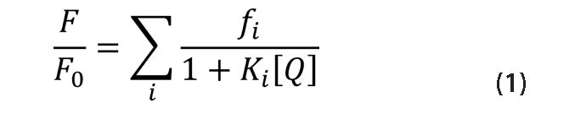
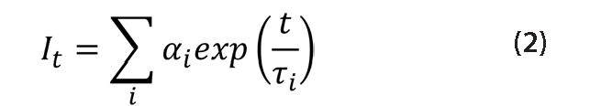
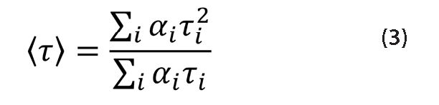
Vol. 62
Fluorescence studies of TFIIB-DNA interaction
415
idazole and 1mM DTT, 1.5 mL fractions were harvest-
ed. In case of samples prepared for fluorescent labeling,
tris(2-carboxyethyl)phosphine (TCEP) substituted DTT
in the last 2CV of A1 wash and in the elution buffer.
The whole purification procedure was carried at 4°C to
decrease protease activity, thereby reducing protein di-
gestion level. The protein concentration was determined
in triplicates with the Bradford assay (Bradford, 1976),
calibrated with bovine serum albumin (BSA) (Sigma-Al-
drich). The purification process was monitored by so-
dium dodecyl sulfate-polyacrylamide gel electrophoresis
(SDS/PAGE) (Laemmli, 1970) in 12% gel. Fractions
containing TFIIB or its variants were pooled and sub-
jected to three-step dialysis at 4°C against buffer A with
addition of DTT 5 mM (1:100 ratio) or buffer B (Hepes
50 mM pH 7.9, NaCl 100 mM, glycerol 10%, DTT 2
mM) and frozen at -80°C.
Fluorescence labeling. In order to covalently label
the sulfhydryl groups of TFIIB or its variants, 2-(4’-ma-
leimidylanilino)naphthalene-6-sulfonic acid (MIANS)
(Molecular probes) was used. The dye stock solution was
prepared in concentration of 20 mM in 100% dimethyl
sulfoxide (DMSO), and kept in darkness to protect the
dye molecules from light. The protein was subjected to
labeling directly after the purification procedure - before
final dialysis. The Dye reagent was added in molar excess
(2:1; 4:1; 6:1; 8:1; 9:1; 11:1), taking care not to exceed
1% DMSO concentration. The mixtures were incubated
for 30 minutes at room temperature in darkness, then
DTT was added to a concentration of 1 mM. The un-
bound fluorescent dye reacted with DTT and was then
removed by the dialysis described above. After the third
dialysis step, the protein labeling degree was calculated
as the ratio of the absorption-determined concentration
of the fluorescent probe, and the concentration of the
protein determined by the Bradford method. The extinc-
tion coefficient used to calculate the concentration of
MIANS according to the Beer-Lambert law was 27 000
M-1cm-1 at 322 nm.
Spectroscopic studies. Circular dichroism measure-
ments were conducted using a J-710 spectropolarimeter
(Jasco) equipped with an F25 temperature control unit
(Julabo) in quarts cuvettes of 0.2 mm path-length (Hell-
ma). The spectra were collected in the range of 190—250
nm with 1 nm data pitch, 10 nm/min scanning speed,
8 s integrating time, and 2 nm bandwidth and averaged
over three acquisitions.. All spectra were corrected for
the effect from the buffer and all measurements were
converted to molar residual ellipticity units as described
elsewhere. The protein concentration were 20 pM.
Fluorescence emission spectra were recorded in buffer
A using spectrofluorimeter Fluorolog-3 equipped with
an F25 temperature control unit (Julabo). Spectra were
measured in thermostated cuvette 3 x 3 mm (Hellma) at
25°C. Spectra were obtained with a 1 nm data pitch, in-
tegration time 0.2 s for every wavelength and averaged
over three acquisitions. In case of the dye fluorescence
measurements excitation wavelength was 320 nm and
range of emission spectrum was 350—500 nm. Slit widths
on excitation and emission monochromators were set at
3 and 2 nm respectively, for TFIIB wt, TFIIB C194S
and TFIIB C194S C223S, or 3 and 3 nm, respectively
for C181S or 4 and 3 nm respectively for C223S mu-
tants. In every case, buffer A spectrum was first mea-
sured and then subtracted from sample measurement
spectrum. The protein concentration was 1 pM, while
ds DNA (AdML or AdE4) concentration was 0.5, 1, 1.5
and 2 pM (if present).
The steady-state fluorescence quenching experiments of
TFIIB intrinsic fluorescence (tryptophan residue W52) were
performed at 25°C in buffer B in a Fluorolog-3 equipped
with an F25 temperature control unit (Julabo). The spectra
were measured in thermostated quartz cuvette 10 x 4 mm
(Hellma) at 25°C. The corrected spectra were recorded in
the range from 305 to 450 nm, with 0.5 nm data pitch, in-
tegration time 0.1 s for every wavelength and averaged over
three acquisitions. The excitation wavelength was 295 nm.
The excitation and emission slits were set at 5 and 5 nm,
respectively. Four molar (4 M) KI solution used as a flu-
orescence quencher contained 0.1 M sodium thiosulfate to
inhibit the formation of I3-. Fluorescence intensities were
corrected for any dilution effects as well as for residual
buffer emission and Raman scattering. The quenching data
were analyzed using the Stern—Volmer equation:
where F0 and F are fluorescence intensities in the ab-
sence and presence of quencher, Q, respectively, K is
the dynamic quenching constant and fi is the fractional
contribution of component i. The quenching rate con-
stant kq was calculated as kq= ^/<x>, where <t> is the
mean fluorescence lifetime in the absence of the quench-
er. The Stern—Volmer equation was fitted to the experi-
mental data by an iterative nonlinear least square method
using Origin 9.1 software. The data were analyzed using
one-way analysis of variance (ANOVA) test (GraphPad
Prism 5.0, USA) with the t-test to compare the statistical
significance between groups. A p-value of less than 0.05
indicated statistically significant results.
Time-correlated single photon counting (TCSPC) mea-
surements were performed on a FluoroCube fluorimeter
(Horiba, France). Tryptophan residue was excited with
pulsed NanoLED diodes at 294 nm (pulse duration of
700 ps) operated with 1 MHz repetition. Maximum num-
ber of photons to be counted was set to 10 000 and in a
200 ns range. To avoid pulse pile-up, the power of the
pulses was adjusted to an appropriate level using a neu-
tral gradient filter. The fluorescence emission was record-
ed using a picosecond detector TBX04 (IBH, JobinYvon,
UK) data station and the DAS 6 (JobinYvon (IBH, UK))
software was used for data acquisition and signal analysis.
All the fluorescence decays were measured in a 10 x 10
mm quartz cuvette, using emitter cut-off filter with trans-
mittance >320 nm (320FG01 glass filter from and An-
dover corp.) The excitation profiles, required for the de-
convolution analysis, were measured without the emitter
filters on a light scattering cuvette. All measurements were
performed at 25°C. Each fluorescence decay was analyzed
with a multi-exponential model given by the equation:
where ai and Ti are the pre-exponential factor and decay
time of component i, respectively. Best fit parameters
were obtained by minimization of reduced y2 value as
well as residual distribution of the experimental data.
The mean lifetime of fluorescence decay was calculated
according to the following equation:
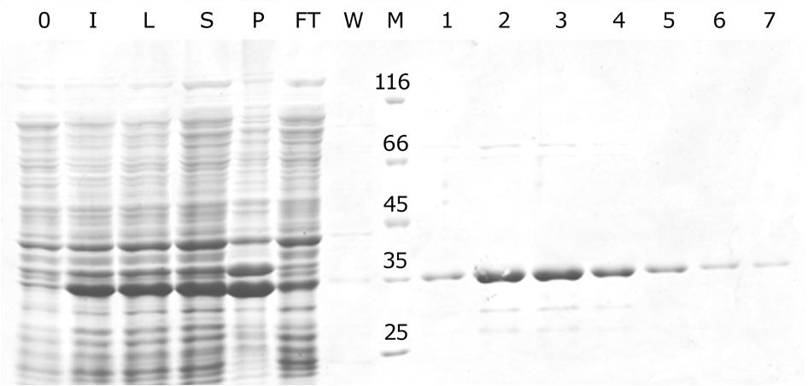
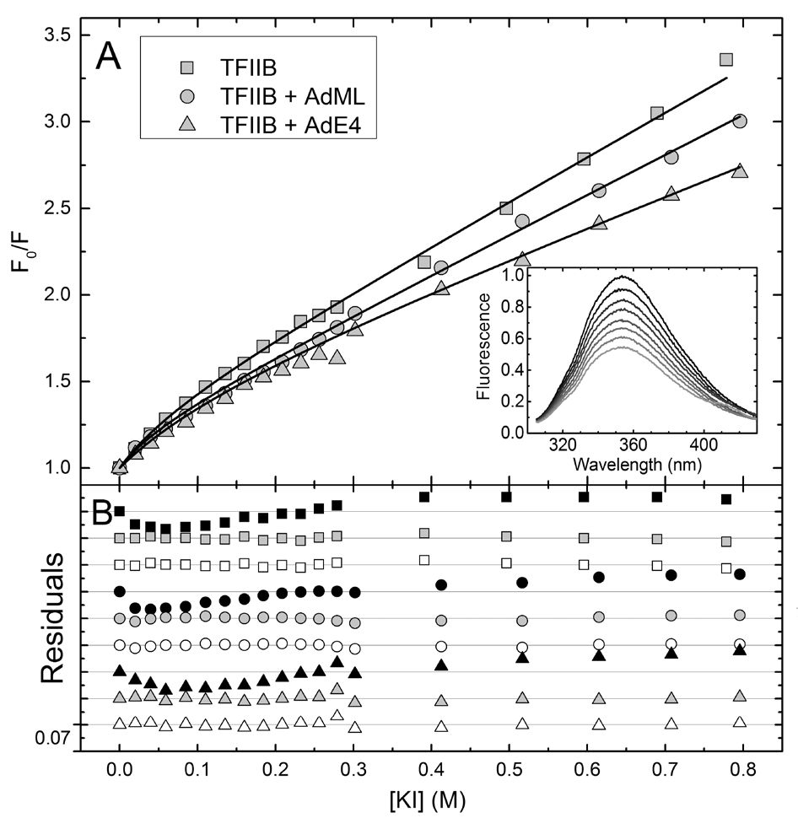
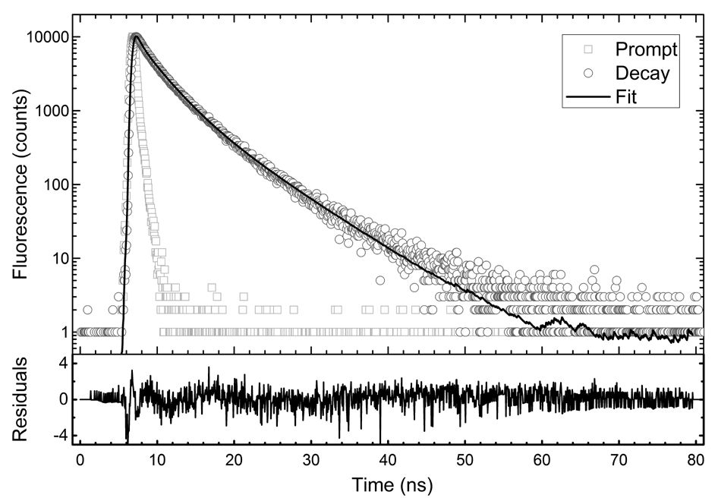
416
A. Górecki and others
2015
Figure 1. SDS/PAGE analysis of TFIIB purification process.
0 — bacterial culture prior to induction; I — bacterial culture after
the induction; L — bacterial cell lysate; S — supernatant obtained
after centrifugation; P — pellet; FT — NiNTA flowthrough; W —
NiNTA wash (20 mM imidazole); M — molecular mass marker; 1-7
— fractions eluted from NiNTA with 300 mM imidazole. The num-
bers on the marker lane indicate protein molecular mass in kD.
RESULTS
Protein expression and purification
Recombinant human TFIIB was produced in pET
expression system with His6-tag at its C-terminus and
constituted the majority of the total protein pool (Fig. 1,
lanes I, L). SDS/PAGE analysis also showed that the
amount of TFIIB in soluble and insoluble fractions (de-
noted as S and P in the Fig. 1) are comparable. The
protein was purified from the soluble fraction to high
homogeneity, above 95%, with use of metal affinity
chromatography (Fig. 1, lanes 1—7). The purity was ad-
equate for structural studies. Similar condition for TFIIB
expression and purification has been reported previously
(Thompson et al, 2009; Thomsen et al., 2001).
Intrinsic fluorescence studies
TFIIB exhibited intrinsic fluorescence due to its single
tryptophan residue, located in the hinge region that con-
nects NTD and CTD. TFIIB fluorescence emission was
susceptible to quenching with iodide.Typical Stern—Vol-
mer plots in the absence and in the presence of specific
DNA are presented in Fig. 2.
In each case the Stern—Volmer plots curved down
and could not be satisfactorily fitted to a single-compo-
nent model, i.e. to Eqn. (1) with n = 1. Addition of a
second component significantly improved the fit, while
addition of a third component did not improve it fur-
ther. In case of the apo protein, the obtained reduced
X2 values were: 1.02x10% 3.00x10-5 and 3.40x10-5 for
the single-, double- and triple-component analysis, for
AdML-ligated TFIIB these values equaled: 9.04x10%
3.38x10% 2.19x10-5 and for AdE4 ligated protein —
1.13x10% 6.01X10-5 and 6.87x10% The x2 values in-
dicated that in each case the triple-component analysis
was not significantly better than the double-component
analysis. Also, in any case the distribution of the resid-
uals was not improved upon the addition of the third
exponent (Fig. 2B). Therefore the fluorescence quench-
ing can be described by a two-component model, in
which one fluorophore class is less accessible for the
quencher and characterized by K1 = 1.83 ± 0.14 M-1
for the apo protein, while the other is more accessible
for iodide with K2 = 16.19 ± 2.77 M% The presence
of the specific DNA sequence changed the value of
the first component slightly if any, to 1.83 ± 0.11 M-1
and 1.12 ± 0.19 M-1 for AdML and AdE4, respectively.
The value of the quenching constant for the second
component varied more significantly in the presence of
a specific DNA and was equal to 21.03 ± 4.56 M-1 and
9.69 ± 1.98 M-1 for AdML and AdE4, respectively.
To further analyze the quenching parameters, time-
resolved measurements were performed. Figure 3 shows
an exemplary TFIIB intrinsic fluorescence decay.
The best fit was obtained for triple exponential de-
cay, giving decay times of 0.50 ± 0.05 ns, 2.86 ± 0.07
ns, 6.53 ± 0.09 ns, with respective contributions: 0.11
± 0.01, 0.55 ± 0.01, 0.34 ± 0.01. The mean fluores-
cence lifetime, calculated from equation 3, was 3.85 ±
Figure 2. Quenching of TFIIB intrinsic fluorescence by iodide.
(Panel A) Stern-Volmer plot for TFIIB alone (squares), and in the
presence of AdML (circles) and AdE4 (triangles). Continuous lines
represent the best fits to the experimental data. Insert: a repre-
sentative set of TFIIB emission spectra in the absence of DNA ob-
tained for KI concentrations: 0.00 M; 0.01 M; 0.03 M; 0.05 M; 0.08
M; 0.11 M; 0.18 M; and 0.23 M. (Panel B) Residual distribution in
term of one-component (black) two-component (gray) and three-
component (open) analysis of Stern-Volmer equation.
Figure 3. Fluorescence lifetime of TFIIB.
(Upper panel) Open circles show the decay of W52 fluorescence
emission (Decay), while solid lines are a triple exponential fit. The
excitation pulse profile, set up at 294 nm is show by the squares
curve (Prompt). (Bottom panel) residual distribution for the fitting
of three exponents.
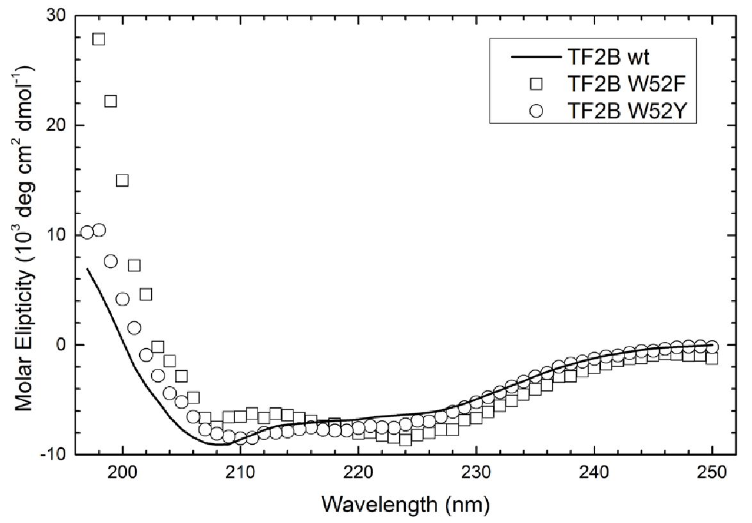
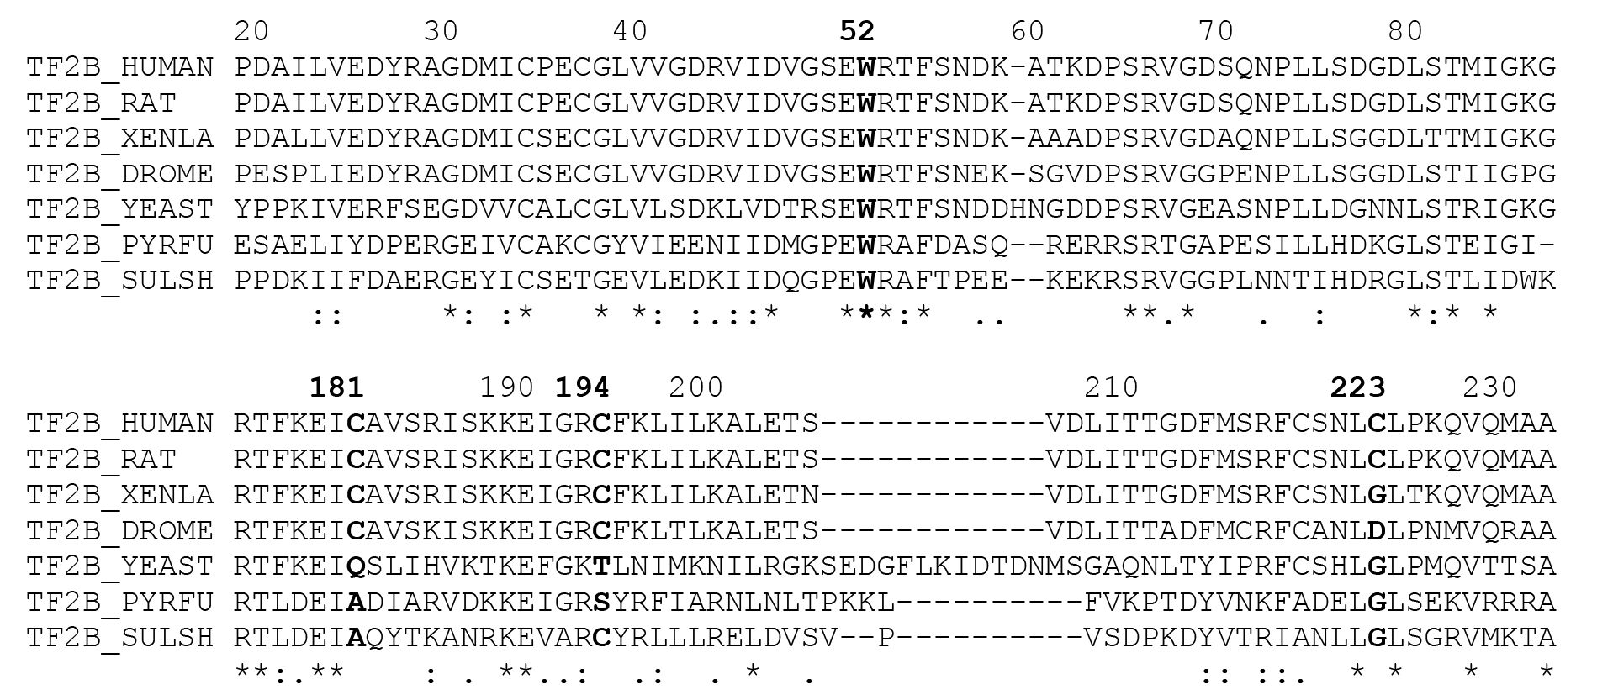
Vol. 62
Fluorescence studies of TFIIB-DNA interaction
417
Table 2. Fluorescence quenching parameters for TFIIB and its
DNA complexes.
species | fi | kq1 (109 M-1s-1) | kq2 (109 M-1s-1)
TFIIB | 0.69±0.04 | 0.48±0.04 | 4.2±0.7
TFIIB + AdML | 0.78±0.03a | 0.48±0.03 | 5.5±1.2
TFIIB + AdE4 | 0.61±0.07b | 0.29±0.05aa, bb | 2.5±0.5a, b
The statistical significance was evaluated using one-way ANOVA, fol-
lowed by T-test comparisons. The following symbols were used:
aP<0.05; aa P<0.01 for the comparison of apo TFIIB with TFIIB ligated
with DNA, bP<0.05; bbP<0.01 for the comparison of TFIIB ligated with
AdML vs ligated with AdE4.
0.02 ns and is typical for tryptophan residues. Quench-
ing rate constants were calculated from the obtained
values and presented in Table 2 with the fractions of
the individual components. One-way ANOVA showed
statistical differences for f1 [F(2.8) = 8.797; P<0.05];
kq1 [F(2.8)= 21.66; P<0.01]; and kq2 [F(2.8)= 9.344;
P<0.05]. T-test was used to compare statistical differ-
ence between the groups.
Statistical analysis showed that the parameters kq1
and kq2 changed in a statistically significant way only for
TFIIB bound to AdE4 sequence. The analysis showed
also a statistically significant change in the parameter f1,
although it concerned only the case when TFIIB was as-
sociated with AdML sequence. Thus, all three param-
eters are different for TFIIB after binding to AdML and
AdE4 promoters.
Changing the fluorescent properties of TFIIB
In order to modify the fluorescent properties of
TFIIB, W52 was replaced with other residues: pheny-
lalanine, tyrosine, leucine, or valine, using site directed
mutagenesis. Despite obtaining the correct genetic
constructs, very low level of protein expression pre-
cluded their purification in the case of substitutions
with leucine and valine (data not shown). Introduction
of aromatic residues in place of W52 did not cause
any significant decrease in the level of expression,
although the circular dichroism spectra of these pro-
teins (Fig. 4) showed that the secondary structure has
been changed.
Figure 4. Circular dichroism spectra of TFIIB mutants with sub-
stitutions of W52 residue.
Solid line — wild-type TFIIB; squares — TFIIB W52F; circles — TFI-
IB W52Y. The obtained results indicate significant structural impor-
tance of W52 residue. An alignment of amino acid sequence of
several TFIIB homologs was conducted using Clustal Omega pro-
gram (Sievers et al., 2011). Fragments of the alignment are shown
in the upper part of Fig. 5.
The result presented above proves the high evolution-
ary conservation of W52 residue. As we were unable to
substitute it without interfering with the protein struc-
ture, we decided to modify the fluorescent properties
of TFIIB by fluorescent labeling. A solvatochromic dye,
MIANS, was used, which covalently binds to sulfhydryl
groups. Due to the presence of three water-accessible
cysteine residues within the cyclin-like repeats of CTD,
a series of TFIIB variants was designed to make the la-
beling more specific. None of these residues is evolu-
tionary conserved, as can be judged by the alignment of
TFIIB homolog sequences presented in the bottom part
of Fig. 5. Therefore each of them was substituted, i.e.,
C181S, C194S, C232S, and additionally a double mutant
C194S C232S was prepared. None of the mutations al-
tered the protein secondary structure (Fig. 6).
Extrinsic fluorescence studies
MIANS emission intensity depends on the polar-
ity of its microenvironment. The emission spectra col-
Figure 5. Alignment of fragments of TFIIB sequence for homologs from: Homo sapiens, Rattus norvegicus, Xenopus leavis, Drosophila
melanogaster, Saccharomyces cerevisiae, Pyrococcus furiosus, and Sulfolobus shibatae.
The last digit of the number in the first line indicates the number of amino acid residue in the human TFIIB. Bold letters indicate amino
acid residues modified in the present study and the corresponding amino acid residues in the homologs. Stars indicate residues that are
conserved among all the species, colon — in most of the species, dot — similar residues. Data was obtained using Clustal Omega pro-
gram (Sievers et al., 2011).

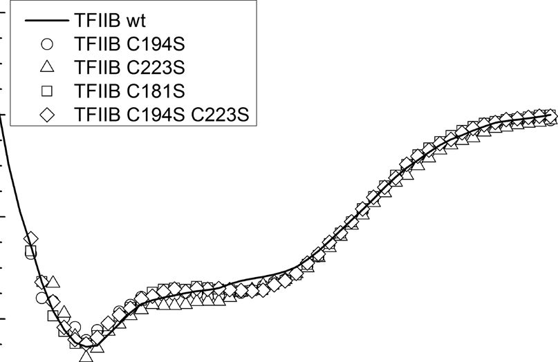
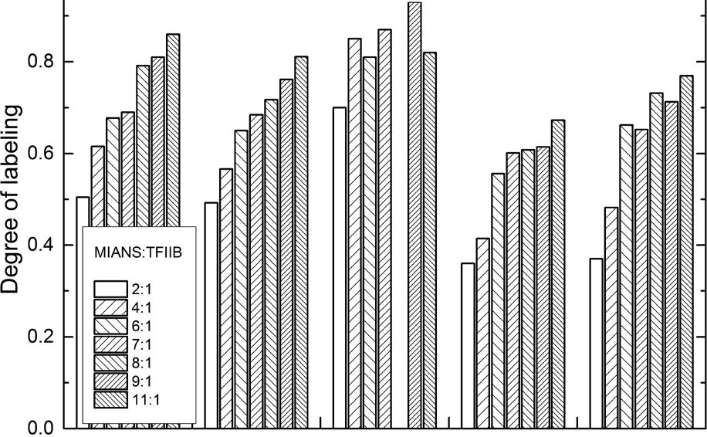
418
A. Górecki and others
2015
- E
■O
§ 0
- 0)
■a
o
¿■-4
o
’S.
Eü
200 210 220 230 240 250
Wavelength (nm)
Figure 6. Circular dichroism spectra of TFIIB mutants with sub-
stitutions of cysteine residues.
Solid line — wild-type TFIIB; circles — TFIIB C194S; triangles
— TFIIB C233S; squares — TFIIB C181S; rhombs — TFIIB C194S
C233S. Labeling with MIANS was performed for the wild-type pro-
tein and the cysteine-depleted mutants, using several amounts of
the dye (Fig. 7).
lected for MIANS-labeled proteins changed in the pres-
ence of AdML and AdE4, and the course of the above-
mentioned changes adopted a shape of a binding curve
(Fig. 8). In case of the wild-type TFIIB, binding to DNA
decreased MIANS fluorescence intensity only slightly,
more significantly for AdE4. For the other protein vari-
ants, the changes were more profound. For C181S mu-
tant, the observed increase in fluorescence intensity was
independent of the recognized sequence, while for the
C194S mutant a change was seen only upon binding to
AdE4. Lack of C232 residue increased MIANS fluores-
cence intensity. The presence of DNA resulted in an in-
crease in fluorescence intensity, higher for AdML than
for AdE4. On the other hand, substitution of C194 resi-
due resulted in a decrease in MIANS fluorescence inten-
sity, which was in turn greater for AdE4 sequence. The
maximum changes in fluorescence intensity for each case
are presented in Table 3. T-test was used to compare the
statistical difference between the groups.
DISCUSSION
Transcription factor IIB belongs to the family of gen-
eral transcription factors and plays a crucial role in RNA
polymerase II preinitiation complex assembly. Its exist-
ence as a monomer in solution, and lack of post-trans-
lational modifications necessary for its activity, makes
TFIIB the only general transcription factor that may be
obtained in the fully functional form in a prokaryotic
expression system (Deng & Roberts, 2007). These fea-
tures make TFIIB especially attractive for studying the
influence of other macromolecules on the protein struc-
ture and its dynamics, especially using fluorescence tech-
niques.
Tryptophan fluorescence has been widely used as a
sensitive probe for studying conformational changes in
protein structure (Lakowicz, 2006). TFIIB exhibits in-
trinsic fluorescence due to W52 residue, located in the
hinge region that connects NTD and CTD (Bangur et
al, 1999). Both, the presence of the only one tryptophan
residue and its location allowed us to monitor possible
changes in TFIIB structure without any additional modi-
fication of the protein. The presence of iodide in the so-
lution decreased the intrinsic fluorescence intensity, due
wt 1 C181S ' C194S 'C194S C223S1 C223S
TFIIB species
Figure 7. Degree of MIANS labeling (a label:protein ratio) for dif-
ferent TFIIB mutants, depending on the initial dye-protein stoi-
chiometry.
Table 3. Relative fluorescence intensity change induced by the
presence of DNA
species | AdML | AdE4
TFIIB wt | -6%±1% | — 12%±1%aa
TFIIB C181S | 17%±4% | 19%±1%
TFIIB C194S | 3%±1% | 26%±4%aaa
TFIIB C223S | 88%±10% | 63%±4%a
TFIIB C194S C223S | -34%±4% | -54%±5%aa
The statistical significance was evaluated using T-test for the com-
parison between AdE4 and AdML. The following symbols were used:
aP<0.05; aaP<0.01; aaaP<0.001.
to effective collisional quenching of tryptophan fluores-
cence by the ion. The effectiveness of the quenching is
determined in general by the extent of tryptophan expo-
sure to the solvent, and typically for a single fluorophore
it is described by linear relationship on the Stern-Volmer
plot. Nevertheless, the graph we obtained was not lin-
ear but curved down, as can be seen in the Figure 2.
The phenomenon can be best described by a two-com-
ponent model, with two fluorophore species differing
in their availability for the quencher. For a single-tryp-
tophan protein, this justifies the existence of two forms
of the protein. This can be interpreted as occurrence of
two conformations of TFIIB, as we verified the protein
sample to be highly pure, stable and homogeneous by
size-exclusion chromatography and thermal denaturation
analysis (results not shown). The obtained result is con-
sistent with the previously observed interaction between
NTD and CTD, leading to coexistence of “open” and
“closed” conformations of the protein in equilibrium
(Elsby & Roberts, 2004; Reese, 2003). The assumption
that reported in the literature conformational states are
identical to the conformational states observed in this
study appears to be reasonable and allows to conclude
that the quenching results indicate that these conforma-
tions differ significantly in W52 exposure to the solvent
and remain in thermodynamic equilibrium.
The presence of DNA changed the quenching param-
eters, as can be seen in the Stern-Volmer plot (Figure 2).
Moreover, AdML and AdE4 differently influenced the
quenching efficiency. Thus the protein structure changed
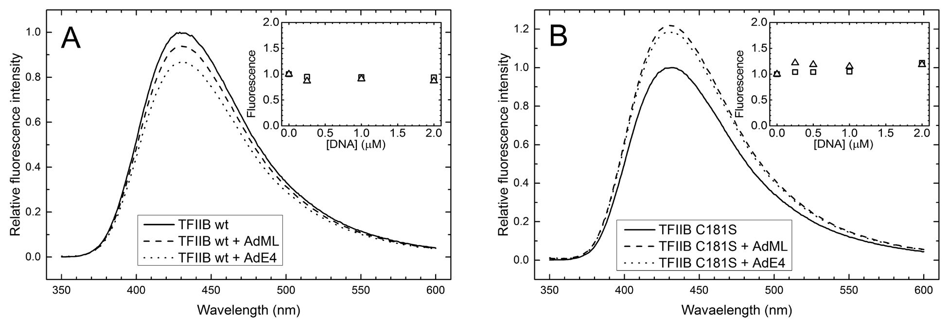
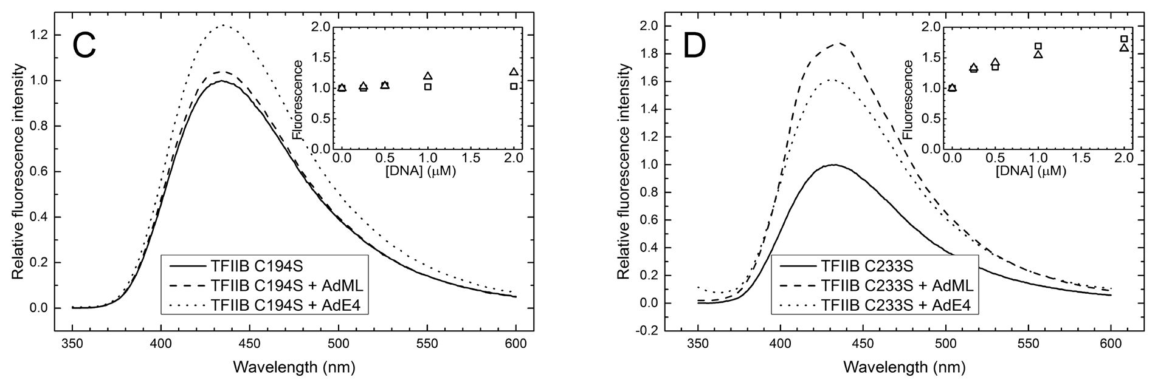
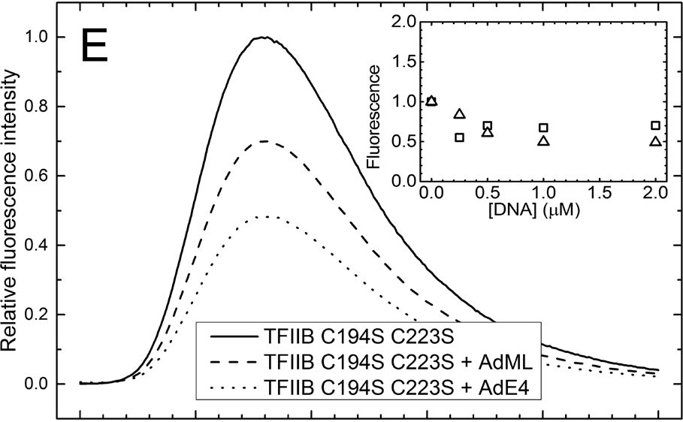
Vol. 62
Fluorescence studies of TFIIB-DNA interaction
419
350 400 450 500 550 600
Wavelength (nm)
upon binding to DNA in a sequence-specific manner.
The average fluorescence lifetime in the absence of the
quencher served to calculate the bimolecular quench-
ing rate constants shown in Table 2. In each case two
fluorophore classes were observed, significantly differing
in their accessibility to the quencher. The value of kq1
indicates some level of fluorophore shielding, while kq2
value is close to the diffusion-controlled limit (Lakowicz,
2006). It is interesting that binding of AdML to TFIIB
does not change any of the quenching rates characteris-
tic for the two states, but only the equilibrium between
the “open” and “closed” form. Therefore the presence
of the DNA does not change the vicinity of W52 in
these forms. Binding of AdML increases the value of the
f1 parameter, indicating greater dominance of the con-
formation with shielded tryptophan residue. In contrast,
binding of AdE4 does not affect significantly the equi-
librium between the two forms, but substantially shields
Figure 8. Emission spectra of MIANS for labeled TFIIB variants:
(A) wild-type; (B) C181S; (C) C194S; (D) C223S; (E) C194S C223S.
Lines represent the spectra obtained for the respective protein
alone (solid lines), and in the presence of AdML (dashed lines) and
AdE4 (dotted lines). The inserts show relative fluorescence inten-
sity depending on the concentration of AdML (squares) or AdE4
(triangles).
the tryptophan residue in both of them. It means that
W52 is more buried, or electrostatic repulsion renders
the fluorophore less accessible to the quencher.
W52 is located in an important fragment of TFIIB
that penetrates RNAPII during the formation of the
preinitiation complex. The obtained results indicate that
the microenvironment of the residue depends on the
recognized promoter, and so is the interaction inter-
face with RNAPII. It seems that TFIIB has the ability
to “read” the sequence and affect the RNAP in a se-
quence-dependent manner.. It seems reasonable to draw
the conclusion that in the transcription initiation process
controlled by TFIIB, the DNA sequence is also impor-
tant, apart from the equilibrium constants for interac-
tions of the various transcription factors and DNA.
During the transcription activation, the transcription
factors interact not only with RNAP, but also with each
other, and therefore we decided to monitor other con-
420
A. Górecki and others
2015
formational changes occurring in TFIIB. Since these in-
teractions include also regions within CTD (i.e. interact-
ing with VP16) we intended to relocate there the trypto-
phan residue as a fluorescent probe. This two-step pro-
cess involved replacing W52 with a similar residue and
introducing a tryptophan residue in the desired location.
Most frequently, tryptophan residues are replaced by
other aromatic or hydrophobic amino acid residues. W52
substitution with other aromatic residues influenced the
protein secondary structure content (Fig. 4), while substi-
tution with hydrophobic residues prevented the efficient
expression. W52 is located within the most conserved
region of TFIIB and is unchanged among eucaryal and
archeal homologs (Fig. 5). The important functional role
of W52 is also indicated by W52A substitution, which
decreased TFIIB affinity to the viral protein Vpr (Ago-
stini et aL, 1999). Since it was impossible to relocate the
tryptophan residue without disrupting the protein struc-
ture, we can assume that this residue plays not only a
functional, but also a structural role, although it is lo-
cated in the hinge region.
Due to the above-mentioned conclusions, the only
possibility to monitor CTD structural changes with
fluorescence measurements was to introduce an exog-
enous fluorophore, MIANS, that binds to sulfhydryl
groups.Human TFIIB contains nine Cys residues, three
of which form the zinc finger and are therefore inac-
cesible to chemical modification. Out of the remaining
six cysteines, three are solvent-exposed: C181, C194,
and C223 (Bagby et al., 1995) and therefore might be
prone to labeling. All the three residues belong to the
DNA-binding motifs but do not contact DNA direct-
ly (Nikolov et al, 1995). We substituted each of those
cysteines with serine to make the labeling more specific,
and to verify if they react with MIANS in the wild-type
protein. The selected residues are not evolutionarily con-
served (Fig. 5), so their substitution may have not af-
fected the protein structure. The actual lack of structural
significance of these residues was confirmed by circular
dichroism spectroscopy (Fig. 6).
The obtained degree of labeling was higher for the
wild-type TFIIB and lower for the mutants, confirming
the initial assumptions concerning the reactivity of the
particular cysteine residues. The degree of labeling corre-
lated with the amount of dye added, but did not exceed
1.0 in any case. Both C194 and C223 seem to react with
the dye, since C194S C223S mutant was modified to a
lesser degree than both C194S and C223S. Labeling of
C181S mutant was similarly effective compared to the
wild-type protein. This suggests that C181 residue does
not bind MIANS in the wild-type protein, although it
might do so in the mutants bearing substitutions of the
more reactive cysteine residues (e.g. C194S C223S). Thus
the labeling was semi-specific and at least some of the
dye was placed within the DNA-binding motifs.
The use of a solvatochromic fluorophore allowed to
monitor structural changes induced by DNA binding in
the vicinity of the dye. The emission spectra collected
for MIANS-labeled proteins changed in the presence of
DNA. The most profound changes were observed for
the mutants lacking C223 (Fig. 8): twofold increase in
MIANS fluorescence intensity was observed for TFIIB
C223S and twofold decrease for TFIIB C194S C223S
(Table 3). The observed signal changes significantly be-
tween the two promoter sequences and the difference
was found statistically significant for all the protein vari-
ants except C181S. This could be explained by a differ-
ent impact of AdML and AdE4 on the microenviron-
ment of MIANS molecule bound to C181, localized
within the BREd-binding domain while C194 and C223
contact BREu more closely. Since the observed changes
varied significantly between the two promoter sequences,
they cannot be attributed simply to the more hydropho-
bic milieu of the DNA major groove, but rather they
manifest an alteration of the protein conformation that
depends on the promoter sequence.
Interestingly, a stronger effect on the fluorescence
intensity was observed for binding to AdE4 than to
AdML — contrary to what could be expected from the
fact that AdML is closer to the consensus sequence. A
similar result was obtained by Zheng et al. in studies em-
ploying FRET between two fluorescent proteins fused to
the ends of TFIIB molecule (Zheng et al, 2004). Dif-
ferent TFIIB epitopes are exposed during binding to
AdML and to AdE4 (Fairley et al, 2002). AdE4 was
also shown to be more sensitive than AdML to TFIIB
mutation (Hawkes & Roberts, 1999). Possibly, this dif-
ference might be caused by an interplay between BREu
and BREd binding by TFIIB. Thus the observed differ-
ences probably reflect sequence-specific TFIIB action
rather than simple difference in its affinity for the two
sequences.
Our findings, which are consistent with the results ob-
tained for prokaryotic transcription factor cAMP recep-
tor protein (Fic et al, 2007), may lead to a more general
conclusion. In the transcription initiation process, subtle
changes in the structure and dynamics of the various
transcription factors, depending on reciprocal interac-
tions, play an important role, apart from the obvious
structural aspects of the interaction between transcrip-
tion factors and the RNAP, leading to suitable geometry
of the complex formation, mutual affinity of the indi-
vidual components or the kinetics of their interactions.
These small changes can lead to significant synergies in
the binding of these factors. Although this work is not
an evident proof of the existence of such a process, it
strongly suggests the possibility and the universality of
its occurrence.
Acknowledgements
The Faculty of Biochemistry, Biophysics and Biotech-
nology is a partner of the Leading National Research
Center (KNOW) supported by the Ministry of Science
and Higher Education.
This research was supported by grant number
3128T>01/2006/31 from the Polish Ministry of Science
and Higher Education.
We would like to thank Ola Kaluzny and Damian
Dawidowski for their help during the preparation of the
plasmid constructs and preliminary studies, and Agata
Faron-Gorecka for her assistance during statistical anal-
ysis.
Declaration of interest
The authors declare no financial or personal interest
with other people or organizations that could bias their
work.
REFERENCES
Agostini I et al. (1999) The HIV-1 Vpr co-activator induces a confor-
mational change in TFIIB. FEBS Lett 450: 235—239.
Bagby S et al. (1995) Solution structure of the C-terminal core domain
of human TFIIB: similarity to cyclin A and interaction with TATA-
binding protein. Cell 82: 857—867.
Bangur CS et al. (1999) An interaction between the N-terminal region
and the core domain of yeast TFIIB promotes the formation of
Vol. 62
Fluorescence studies of TFIIB-DNA interaction
421
TATA-binding protein-TFIIB-DNA complexes. J 274:
23203-23209.
Bradford MM (1976) A rapid and sensitive method for the quantitation
of microgram quantities of protein utilizing the principle of protein-
dye binding. Anal Biochem 72: 248-254.
Chen HT et al. (2000) Structure of a (Cys3His) zinc ribbon, a ubiqui-
tous motif in archaeal and eucaryal transcription. Protein Sci: Publica-
tion of the Protein Society 9: 1743-1752.
Crowe JS et al. (1991) Improved cloning efficiency of polymerase chain
reaction (PCR) products after proteinase K digestion. Nucleic Acids
Res 19: 184.
Deng W, Roberts SG (2005) A core promoter element downstream
of the TATA box that is recognized by TFIIB. Genes Develop 19:
2418-2423.
Deng W, Roberts SG (2007) TFIIB and the regulation of transcription
by RNA polymerase II. Chromosoma 116: 417-429.
Elsby LM et al. (2006) Assembly of transcription factor IIB at a pro-
moter in vivo requires contact with RNA polymerase II. EMBO Re-
ports 7: 898-903.
Elsby LM, Roberts SG (2004) The role of TFIIB conformation in
transcriptional regulation. Biochemi Soc Trans 32: 1098-1099.
Fairley JA et al. (2002) Core promoter-dependent TFIIB conformation
and a role for TFIIB conformation in transcription start site selec-
tion. Mol Cell Biol 22: 6697-6705.
Fic E, Górecki A, Wasylewski Z (2007) Fluorescence quenching stud-
ies of conformational changes induced by cAMP and DNA binding
to heterodimer of cyclic AMP receptor protein from Escherichia coli.
Protein J 26: 457-466.
Grossmann JG et al. (2001) Molecular shapes of transcription factors
TFIIB and VP16 in solution: implications for recognition. Biochem-
istry 40: 6267-6274.
Ha I, Lane WS, Reinberg D (1991) Cloning of a human gene encoding
the general transcription initiation factor IIB. Nature 352: 689-695.
Hawkes NA, Evans R, Roberts SG (2000) The conformation of the
transcription factor TFIIB modulates the response to transcriptional
activators in vivo. Curr Biol: CB 10: 273-276.
Hawkes NA, Roberts SG (1999) The role of human TFIIB in tran-
scription start site selection in vitro and in vivo. J Biol Chem 274:
14337-14343.
Hayashi F et al. (1998) Human general transcription factor TFIIB: con-
formational variability and interaction with VP16 activation domain.
Biochemistry 37: 7941-7951.
Kostrewa D et al. (2009) RNA polymerase II-TFIIB structure and
mechanism of transcription initiation. Nature 462: 323—330.
Laemmli UK (1970) Cleavage of structural proteins during the assem-
bly of the head of bacteriophage T4. Nature 227: 680-685.
Lagrange T et al. (1998) New core promoter element in RNA polymer-
ase II-dependent transcription: sequence-specific DNA binding by
transcription factor IIB. Genes Develop 12: 34^-4.
Lakowicz JR (2006) Principles of Fluorescence Spectroscopy. Springer, New
York.
Lee S, Hahn S (1995) Model for binding of transcription factor TFIIB
to the TBP-DNA complex. Nature 376: 609-612.
Malik S, Lee DK, Roeder RG (1993) Potential RNA polymerase II-
induced interactions of transcription factor TFIIB. Mol Cell Biol 13:
6253-6259.
Nikolov DB et al. (1995) Crystal structure of a TFIIB-TBP-TATA-ele-
ment ternary complex. Nature 377: 119-128.
Reese JC (2003) Basal transcription factors. Curr Opin Genet Ddevel 13:
114—118.
Roberts SG, Green MR (1994) Activator-induced conformational
change in general transcription factor TFIIB. Nature 371: 717-720.
Sievers F et al. (2011) Fast, scalable generation of high-quality protein
multiple sequence alignments using Clustal Omega. Mol Systems Biol
7: 539.
Thompson NE et al. (2009) Minimal promoter systems reveal the im-
portance of conserved residues in the B-finger of human transcrip-
tion factor IIB. J Biol Chem 284: 24754-24766.
Thomsen J et al. (2001) The basal transcription factors TBP and TFB
from the mesophilic archaeon Methanosarcina mazeii: structure and
conformational changes upon interaction with stress-gene promot-
ers. J Mol Biol 309: 589_603.
Tran K, Gralla JD (2008) Control of the timing of promoter escape
and RNA catalysis by the transcription factor IIb fingertip. J Biol
Chem 283: 15665-15671.
Tsai FT, Sigler PB (2000) Structural basis of preinitiation complex as-
sembly on human pol II promoters. EMBO J 19: 25—36.
Wu WH, Hampsey M (1999) An activation-specific role for transcrip-
tion factor TFIIB in vivo. Proc Natl Acad Sci USA 96: 2764—2769.
Zhang DY et al. (2000) Intramolecular interaction of yeast TFIIB in
transcription control. Nucleic Acids Res 28: 1913—1920.
Zheng L et al. (2004) FRET evidence for a conformational change in
TFIIB upon TBP-DNA binding. Eur J Biochem/FEBS J 271: 792—
800.

