Vol. 51 (2020) Acta Physica Polonica B No 1

REVISITING THE CHARGED KAON MASS∗
D. Bosnara, M. Bazzib, M. Cargnellic, A. Clozzab
- Curceanub, R. Del Grandeb,d, C. Guaraldob, M. Iliescub
M. Makeka, J. Martonc, M. Miliuccib, L. De Paolisb
  - Piscicchiad,b, A. Scordob, D.L. Sirghib,e, F. Sirghib,e
    - Skurzokb,f , M. Tüchlerc, J. Zmeskalc, P. Žugeca
a Department of Physics, Faculty of Science, University of Zagreb Zagreb, Croatia
bINFN, Laboratori Nazionali di Frascati, 00044 Frascati (RM), Italy cStefan-Meyer-Institut für Subatomare Physik, 1090 Vienna, Austria dCentro Fermi — Museo Storico della Fisica
e Centro Studi e Ricerche “Enrico Fermi”, Roma, Italy
eHoria Hulubei National Institute of Physics and Nuclear Engineering (IFIN-HH) 077125 Măgurele, Romania
f M. Smoluchowski Institute of Physics, Jagiellonian University Kraków, Poland
(Received October 31, 2019)

The precision of the charged kaon mass is an order of magnitude worse than the precision of the charged pion mass mainly due to two inconsis- tent measurements. We plan to improve this precision by determining the charged kaon mass with the requested accuracy in the measurements of X-ray transitions in kaonic atoms of selected solid targets with the HPGe detector at DAΦNE in Laboratori Nazionali di Frascati, Italy. The mea- surements will be performed in parallel with SIDDHARTA-2 measurements of X-ray transitions in gaseous targets. The status of the preparation of the measurements will be presented.

DOI:10.5506/APhysPolB.51.115

Introduction
The most accurate way to determine the masses of the charged pion and kaon is by using exotic atoms in which one electron is replaced by one of these mesons, and by measuring the energies of X-rays produced in their cascading to the ground state. The masses are then determined by using the comparison of the theoretical calculations in which masses are varied until

∗ Presented at the 3rd Jagiellonian Symposium on Fundamental and Applied Subatomic Physics, Kraków, Poland, June 23–28, 2019.

(115)

the agreement is obtained with the selected measured energies of X-rays. However, the precision of the charged kaon mass is much worse, one order of magnitude, than the precision of the charged pion mass [1]. Besides the interest in the intrinsic value, it is important in the non-perturbative QCD since the uncertainty in the kaon mass has a large influence on the K– N scattering lengths and through them on the kaon–nucleon sigma terms, which reflect the degree of chiral symmetry breaking [2].
The current value of the charged kaon mass, mK = 493.677 0.013 MeV, been obtained as a weighted average of six measurements, which have very different uncertainties, ranging from 7 keV up to 54 keV [1]. Two most recent and precise measurements [3, 4], which largely determine the above value, differ by 60 keV and have uncertainties of approximately 10 keV. To re- solve this discrepancy, a new measurement is highly desirable. It is sufficient that the new measurement has the same precision as the two previously men-
has ±
tioned to substantially improve the precision of the charged kaon mass [5].
We are preparing an experiment at DAΦNE in Laboratori Nazionali di Frascati (LNF), which aims to determine the charged kaon mass with the requested precision by measuring energies of X-rays from transitions in kaonic atoms of the selected solid targets (e.g. Pb and W) by a HPGe detector.
Since DAΦNE is providing kaons of low momenta from the decays of φ mesons produced in e+e− collisions, contrary to previous measurements which were done with energetic kaons, there is no need for a degrader at all or only a thin one is needed to slow down kaons. Moreover, there are no secondary particles in the beam, which is certainly an advantage. However, we expect high Bremsstrahlung close to the e+e− interaction point and also background originating from the kaons absorbed by nuclei. The latter can be determined by using Geant4 simulations for various detector configurations. To determine the beam background, measurements in the hall are necessary, and indeed this background will dictate the performance of the measurement. We have also used Geant4 simulations to determine the detector efficiencies in dependence on the setup configuration and to estimate the approximate time needed for the measurement.
In the second section, we explain briefly the principles of determination of the charged kaon mass, in the third section, the experimental setup is described, in the fourth section, some of the results of the simulations are presented and, in the last section, conclusions and outlook are given.

Principles of determination of the charged kaon mass
There are several ways to determine the charged kaon mass and nowa- days, the most precise way is to measure energies of X-rays from transitions of kaons in kaonic atoms [1].

By replacing one electron with a kaon in an ordinary atom, a hydrogen- like kaonic atom is formed and kaon cascades by emitting X-rays to the ground state, from which is eventually absorbed by the nucleus. Measured energies of these X-rays are then compared with the calculated values for some chosen kaon mass and kaon mass is varied as long as one obtains the agreement. One should choose X-rays from the middle part of the cascad- ing spectra, where the strong interaction between nucleus and kaon can be neglected and where also the screening of the electrons is not contributing significantly. However, there still remain some important corrections which should be included in the calculations such as vacuum polarization correc- tions and corrections for parallel non-circular transitions, see e.g. [3].

Experimental setup at DAΦNE
The measurements of the energies of X-rays from transitions in kaonic atoms of solid targets (we plan to start with Pb) with a HPGe detector will be done in parallel with the SIDDHARTA-2 experiment, which intends to measure X-rays from transitions in gaseous targets [6].
The SIDDHARTA-2 setup is positioned above the interaction point, and the luminometer of the setup which is 80 mm 40 mm 2 mm plastic scintillator placed at 110 mm on the side of the interaction point will be used as a trigger for the HPGe detector. The solid target of the same dimensions as the luminometer will be placed right behind it (approx. 5 mm) and the HPGe detector can be positioned at the minimal distance of 115 mm from it. The maximal possible distance of the HPGe detector is approximately 50 cm from the interaction point. The HPGe detector, produced by Baltic Scientific Instruments, is of p-type and has an active part of cylindrical shape with the base diameter of 59.8 mm and the height of 59.3 mm. From the sides, the active part of the HPGe detector will be shielded by lead bricks, as shown in Fig. 1.
× ×
Momenta of kaons are slightly different toward the inner (boost) and outer (anti-boost) side of the DAΦNE ring due to the non-central collisions of electrons and positrons, and they are 141 MeV/c and 113 MeV/c, respec- tively. The configuration of the setup is identical on the boost and anti-boost side and the real position of the HPGe detector will be determined as a func- tion of the background conditions in the two sites.
The thicknesses of the targets which are sufficient to stop the kaons were determined by Geant4 simulations, and they are 1.1 mm (boost side) and 0.3 mm (anti-boost side) for the lead target. Since some of the X-rays of interest produced in transitions in kaonic atoms of these targets (e.g.
291.6 keV from 9 8 transition in lead, and higher) have sufficient energies to exit the target with acceptable efficiencies (Section 4), we will most likely not use a degrader to slow down the kaons.
→

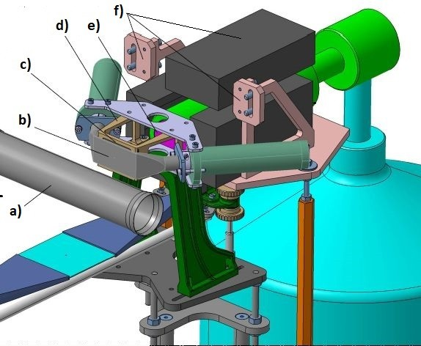
Fig. 1. The layout of the HPGe setup: (a) beam pipe, (b) luminometer, (c) target,
(d) target holder, (e) active part of the HPGe detector, (f) lead shielding with the holder (figure done by C. Capoccia, LNF).

The HPGe detector is equipped with a transistor reset preamplifier (TRP) which is capable of handling higher rates than a HPGe detector with RC preamplifier. We are preparing two data acquisition chains, one with analog amplifier CAEN N968, Canberra Multiport II and Canberra Genius data acquisition software. This system has the capability to accept the rates up to approximately 40 kHz. The other chain includes fast pulse digitizer CAEN Quad digital MCA DT5781 with the appropriate AC coupler for the signals from TRP, and CAEN MC2 Analyser for data acquisition and analysis. It is expected that this system will be capable of the acquisition of rates as high as 150 kHz, with only slight degradation of the resolution, but still sufficient for the determination of kaon mass with the required precision. The actual rate in the experimental hall will determine which data acquisition system will eventually be used.
The resolutions of the HPGe detector measured with low-activity sources,
133Ba and 60Co, activity < 1 µCi, and analog electronics are (FWHM):
0.87 keV at 81 keV, 1.06 keV at 302.9 keV, 1.11 keV at 356 keV and 1.67 keV at 1330 keV. In the data acquisition system with the fast pulse digitizer, the signals from the preamplifier are processed by using a trapezoid filter [7]. The currently achieved resolutions with the above low activity sources are 10– 15% worse than with the analog data acquisition system, but the trapezoid parameters are still being optimized.

Geant4 simulations
The full process of kaon cascading and emissions of X-rays in kaonic atoms is not included in the original Geant4 package (we used 10.2 patch-03 version), and this inclusion is currently being incorporated. We have used

the original Geant4 package to determine the efficiency of the HPGe detector in the dependence on the thickness of the lead target and the distance of the detector from the target. For this, we have randomly generated X-rays of certain energies in the targets of different thicknesses and looked which of them are detected in the active part of the HPGe detector at different distances, as presented in Fig. 2.
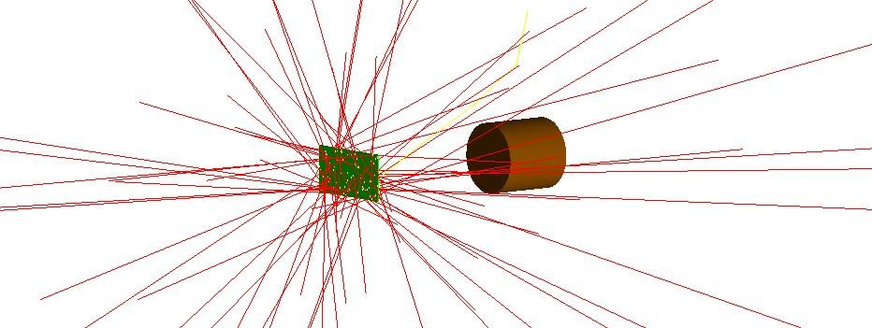
Fig. 2. Determination of the efficiency of the HPGe detector with Geant4 simula- tions.

In the left part of Table I, we show efficiencies of the HPGe detector for the X-rays of interest emitted in the transitions in kaonic lead (values for the X-ray energies are taken from [8]) for one selected distance of 150 mm and for the two thicknesses of the target, appropriate for the anti-boost side (0.3 mm) and boost side (1.1 mm).

TABLE I
Efficiencies of the HPGe detector determined by Geant4 simulations.

E [keV] (trans.) | Eff. [%]  (0.3 mm) | Eff. [%]  (1.1 mm) | d [mm] | Eff. [%]  (0.3 mm) | Eff. [%]  (1.1 mm)
90.9 (13 → 12)  116.9 (12 → 11)  153.9 (11 → 10)  208.2 (10 → 9)  291.6 (9 → 8)  426.2 (8 → 7) | 0.36  0.50  0.64  0.72  0.76  0.76 | 0.11  0.19  0.34  0.51  0.65  0.71 | 110  150  200  300  400  500 | 1.28  0.76  0.45  0.21  0.12  0.07 | 1.09  0.65  0.38  0.18  0.11  0.06

In the right part of Table I, we show efficiencies of the HPGe detector for different distances of the HPGe detector from the target, and for the X-rays of 291.6 keV and two thicknesses of the target (0.3 mm and 1.1 mm).
At maximal distance, the efficiency drops approximately by a factor of 18 in comparison with the efficiency at minimal possible distance. Our esti- mations show that at minimal distance, one requires approximately a week of measurement with the lead target to reach the required precision. That

means that even at the maximal possible distance of the HPGe detector from the target, the measurement is feasible during the whole SIDDHARTA-2 measurement, at least with one solid target (Pb).

Conclusion and outlook
We are preparing the HPGe detector and appropriate electronics for the measurements of X-ray transitions in kaonic atoms of the selected solid targets for the precise determination of the charged kaon mass in parallel with the SIDDHARTA-2 measurement at DAΦNE.
Depending on the beam conditions, we expect that measurements of X-ray transitions, at least with one of the solid targets (Pb), will be possible to perform during the SIDDHARTA-2 measurement and, if necessary, the other measurements with the HPGe detector will be proposed as indepen- dent measurements.

We thank C. Capoccia from LNF-INFN for the contribution in design- ing the holder of the HPGe setup. Part of this work was supported by the Croatian Science Foundation under the project 8570, Austrian Science Fund (FWF), P24756-N20; the Austrian Federal Ministry of Science and Research (BMBWK), 650962/0001 VI/2/2009, Minstero degli Affari Esteri e della Cooperazione Internazionale, Direzione Generale per la Promozione del Sistema Paese (MAECI), Strange Matter Project, the Polish Ministry of Science and Higher Education through grant No. 7150/E-338/M/2018 and the EU STRONG-2020 project (grant agreement No. 824093).

REFERENCES
- M. Tanabashi et al. [Particle Data Group], Phys. Rev. D 98, 030001 (2018).
- R.L. Jaffe et al., Comments Nucl. Part. Phys. 17, 163 (1987).
- K.P. Gall et al., Phys. Rev. Lett. 60, 186 (1988).
- A.S. Denisov et al., JEPT Lett. 54, 558 (1991).
- G. Beer et al., Phys. Lett. B 535, 52 (2002).
- C. Curceanu et al., Rev. Mod. Phys. 91, 025006 (2019).
- V.T. Jordanov et al., Nucl. Instrum. Methods Phys. Res. A 353, 261 (1994).
- S.C. Cheng et al., Nucl. Phys. A 254, 381 (1975).

