Mineralni Slnvaca. .12 (2000). 202-204

Paleotemperatures in the Skole nappe (Outer Carpathians)
inferred from diagenetic evolution of illite/smectite;
the pilot results
TERESA DUDEK¹. ANNA ŚW1ERCZEWSKA¹. WITOI.D ZUCHIEWICZ². WOJCIECH OZIMKOWSKI’
'Institute of Geological Sciences. Polish Academy of Sciences. Senacka 1.31 -002 Kraków. Poland;
e-mail: nddudek@cyf-kr.cdu.pl
-Institute of Geological Sciences. Jagiellonian University. Oleandry 2a. 30-063 Kraków. Poland
'Faculty of Geolog). Warsaw University. Żw irki i Wigury 93. 02-089 Warszawa. Poland
(Received 20 6. 2000)
Abstract
A considerable difference in the degree of illite smectite (I/S) diagencsis has been recorded in the sur-
face samples of cla)stones from the Polish and Ukrainian part of the Skolc nappe. While in Poland
highly smeetitic I/S has been found, in the Ukrainian part of the Skole nappe highly illitic. ordered in-
tcrstratilications dominate. Assuming similar heal flow, these results imply little erosion of the Polish
segment of the Skole nappe, and advanced erosion of the Ukrainian segment.
Keywords: illite/smectite. diagenesis. Skole nappe, paleotemperatures

Introduction
Illite/smeclile (I/S) is a mixed-layer clay mineral which
abundantly occurs in soils and sedimentary rocks, accoun-
ting for about 30 7c of the total mass of the Earth's sedi-
mentary cover. Mixed-layer I/S is a product of progressi-
ve conversion of smectite to illite (a process referred to as
smectite illitization), a diagenetic reaction which is indu-
ced by the increase of temperature most often related to
deep burial of argillaceous sediments. These features ma-
ke I/S a useful mineral indicator of diagenetic evolution
of sedimentary basins. X-ray diffraction studies have
show n that during diagenesis the percentage of smectite
in mixed-layer crystals decreases at the expense of illite
and the degree of structure ordering increases from random
(R = 0) to progressively higher ordered (R > 0) interstrali-
fications (R stands for Reichvveite - an index of ordering).
The degree of diagenesis is usually expressed as 7c sme-
ctite (7c S) in mixed-layer crystallites and the type of or-
dering (R). Illitization of clay stones seems to be controlled
primarily by temperature. The data from the East Slovak
Basin (Sucha et al.. 1993) indicate that the measurable
illitization of randomly interstratified (R = 0) clays com-
posed of 70-90 7c S, begins at about 80 °C. In the tempe-
rature range from 110 to 120 °C, with mixed-layer crys-
tals containing about 35 7c S, a transition from random to
ordered interstratification (R = I) takes place. R > I orde-
ring appears at temperature of about 165 °C. Similar sce-
nario is know n also from other basins (e.g. Jennings and
Thompson, 1986). The above scheme allows us to utilize
I/S as a paleotermometer i.e. to establish the highest pa-
leotemperatures which have affected the basin. One may
also calculate the approximate thickness of the pile of se-
diments eroded after the time of maximum paleotempera-
tures. prov ided that the evolution of geothermal gradient
in the basin is know n (Środoń, 1995). This approach has
been used to study the Skole nappe.
Geological setting
The Skole nappe extends from eastern Poland through
Ukraine to the Romanian Carpathians in Moldova. In Po-
land. the Skole nappe is the outermost nappe of the Outer
Carpathians which overthrusts the Stebnik and Zglobice
Units, and the unfolded Miocene strata of the Carpathian
Foredeep (Fig. I). The Polish part of the Skole nappe has
been subdiv ided into inner and outer parts w hich differ in
style of tectonic deformation (Książkiewicz, 1972). The
rocks of the outer part are folded in tight, asy mmetric
folds and numerous slices. In the inner part, open folds
are common. In Ukraine, the Skole nappe overthrusts the
folds of Boryslav-Pokucie Unit which separates it from
the Sambor Unit and the unfolded Miocene strata of the
Carpathian Foredeep. In the Ukrainian part of the studied
region the Skole nappe is composed of several slices
(Fig. I).
Materials and methods
The studies of I/S diagenesis w ere performed on 29 sur-
face samples of claystones collected both in the Polish
and Ukrainian parts of the Skole nappe. The samples
were collected from the strata that range in age from the
Miocene to late Cretaceous. The sample sites are shown
303
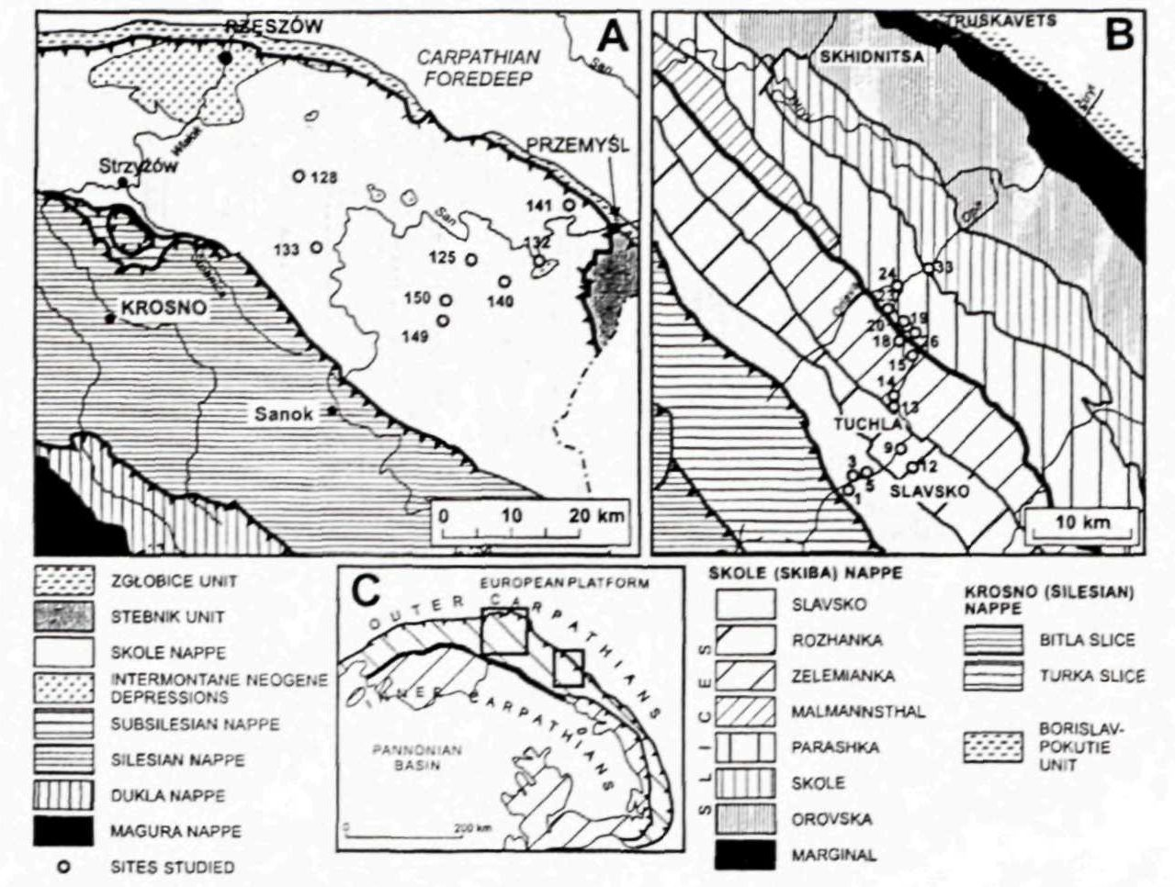
304
Minera ha Slovaca. 32 (2(H)0)
Fig. 1A and B: Geological maps of the study areas
w uh the location of the sample sites; A - Polish part ot
the Skole nappe (after Żytko et al.. 1998): B - Ukrai-
nian segment of the Skole (Skiba) nappe (after Zu-
chiewicz et al.. 1997). Inset shows the location of the
study areas (boxed) within the Carpathian arc
in Fig. 1A and B. In Poland, the majority of the inv esti-
gated samples come from the outer part of the Skole na-
ppe. In Ukraine, samples were collected along the Opor
river. The section is located perpendicular to thrusts and
axes of the map-scale folds.
Illitization of smectite has been studied in the clay fra-
ction (<0.2 Fm) of by X-ray diffraction. Sedimenled pre-
parations were analysed in air-dried and glycolated slates
by the Philips diffractometer equipped with Cu lube and
graphite monochromator and scanned from 2 to .37 °2q
with 0.02°2q step and counting time 5s/step at 45 mA
and 60 kV. The percentage of smectite (7 S) in mixed-
lax er crystals and degree of ordering were identified by
XRD techniques of Środoń (1984).

Results and conclusions
In the Polish part of the Skole nappe, surface samples
contain highly smectitic I/S (71-95 °k S) characterised by
random interstratification. This would imply that the
rocks have nev er been subjected to elevated temperatures
(probably less than 80 °C). The lack of measurable diage-
nesis of I/S in the Polish part of the Skole nappe corres-
ponds to the low degree of diagenesis traced in the bore-
holes down to about 2000 m in the Miocene strata of the
Polish segment of the Carpathian Foredeep (Dudek.
1999). In the Ukrainian part of the Skole nappe, the dia-
genesis of I/S in the surface samples is much more ad-
vanced. I/S in those samples contains 20 7c smectite lay-
ers on average, and is characterised by R > I ordering.
According to the scheme presented in the introduction,
the high degree of diagenesis w ould suggest that the rocks
were subjected to the elevated temperatures, probably ex-
ceeding 160 °C. which could be attained by deep burial.
In conclusion, the presented diversity in the degree of
diagenesis between the two areas suggests no or little ero-
sion in the Polish part of the Skole nappe, and extensive
erosion in Ukraine, assuming that the two regions have
been characterised by similar heat flow. Another explana-
tion of this diversity may be the totally different heat
flow in the two studied areas.
Acknowledgments. The field work has been supported by the Commit-
tee for Scientific Research, grant No. 9TI2B02009 to Antek 1 okarski
We thank Marta Rauch. Andriy and Ihor Bubniak for their help in col-
lecting the samples.

References
Dudek. T.. 1999: Diageneza minerałów ilastych grupy illit/smektyt w
ilowcach miocenu autochtonicznego zapadliska przedkarpackiego.
Prace Patist. Insi. Geni.. I6fi. 125-1.Id.
Jennings. S & Thompson. G. R . 1986: Diagencsis of Plio-Pleistocene
sediments of the Colorado River Delta. Southern California. J sed.
Petrology. 56. 89-98
Książkiewicz. M . 1972 Budowa Geologiczna Polski vol. IV Tektoni-
ka. Karpaty. Wyd Geol. W-wa.
Środoń. J . 1984: X-ray powder diffraction identification of illitic ma-
terials. Clays and Clay Miner. (Men York). 52. 537-549.
Środoń. J.. 1995 Reconstruction of maximum paleotemperatures at
present crosional surface of the Upper Silesia Basin, based on the
composition of illite/smectite in shales. Sind. geol. pol. 108. 9-20.
Śucha. V.. Kraus. I . GerthofferovA. H.. Petes. J. & Serckova. M .
1993: Smectite to iliite conversion in bentonites and shales of the
Hast Slov ak Basin. Clay Miner (Oxfod - Edinburgh). 28. 245-255.
Zuchiewicz. W.. Bubniak. I. M. & Rauch. M Wstępne wyniki badań
nad spękaniami ciosow ymi w jednostce skibow ej (skolskiej) Karpat
Ukraińskich. Przegl. geol. 45. 408-415.
Żytko. K.. Zając. R & Gucik. S.. 1988: Map of the tectonic elements
of the Western Outher Carpathians and their foreland 1:500 000
Paiisl. Inst. Geol.. Warszawa

