Biodiv. Res. Conserv. 41: 11-18, 2016
DOI 10.1515/biorc-2016-0003
BRC
www.brc.amu.edu.pl
Submitted 06.09.2015, Accepted 08.03.2016

Equisetum *moorei Newman (Equisetaceae)
- a ‘new’ nothotaxon in the Polish flora

Paweł Kalinowski1, Elwira Sliwinska2 & Jerzy Kruk3*
1Szczeglacin 42, 08-108 Korczew n/Bug, Poland
laboratory of Molecular Biology and Cytometry, Department of Plant Genetics, Physiology and Biotechnology, UTP University of Science
and Technology, Kaliskiego 7, 85-789 Bydgoszcz, Poland
3Department of Plant Physiology and Biochemistry, Faculty of Biochemistry, Biophysics and Biotechnology, Jagiellonian University, Gro-
nostajowa 7, 30-387 Kraków, Poland
* corresponding author (e-mail: jerzy.kruk@uj.edu.pl)
Abstract: To investigate present and historical distribution of Equisetum ymoorei in Poland and its habitat requirements,
field studies at sites of potential occurrence of this hybrid taxon as well as literature and herbarium search were performed.
As a results of these investigations, E. ymoorei was found at five contemporary and at a few historical localities in the present
territory of Poland. Since the Equisetum populations near Olkusz (S Poland) showed phenotype similar, to some extent, to
triploid hybrid E. yascendens, we performed nuclear DNA content analysis of these populations. However, it turned out that
the investigated individuals belonged to a diploid taxon that can be ascribed to E. ymoorei.
Key words: Central Europe, distribution, Equisetum, flow cytometry, hybrid taxon
1. Introduction
Our knowledge of hybrid taxa in the Equisetum ge-
nus is insufficient, both in Poland and in other European
countries. In Poland, information on the occurrence of
the following Equisetum hybrids: E. xlitorale Kuhlew.
ex Rupr. (E. arvense x E. fluviatile), E. xfont-queri
Rothm. (E. palustre x E. telmateia), E. xrobertsii T. D.
Dines (E. arvense x E. telmateia) and E. xtrachyodon
(A. Br.) W. D. J. Koch (E. hyemale x E. variegatum) was
recently provided (Wróbel 2013a, 2013b), although the
occurrence of E. xrobertsii in Poland requires verifica-
tion. E. xtrachyodon is the only hybrid taxon within
the Hippochaete subgenus found in Poland until now
(Wróbel 2013b).
Besides these nothotaxa, E. xmoorei Newman (E.
ramosissimum x E. hyemale, syn. E. hyemale var.
schleicheri Milde) was mentioned as a component
of Polish flora in the past (Milde 1858; Schube 1903;
Decker 1912). However, these reports were not con-
firmed afterwards (Dostal 1984) and this taxon was
never listed as a component of the Polish flora (Mirek
et al. 2002).
The hybrid between E. ramosissimum and E. hy-
emale was described as a separate taxon by E. Newman
(1854), based on the material collected in Ireland by
a local botanist David Moore, curator of the botanical
garden in Dublin. E. ymoorei is one of six hybrid taxa
within the Hippochaete subgenus found in Europe, be-
sides E. ytrachyodon (A. Br.) W. D. J. Koch (E. hyemale
y E. variegatum), E. ymeridionale (Milde) Chiov. (E.
ramosissimum y E. variegatum), E. yalsaticum (H. P.
Fuchs & Geissert) Philippi (E. hyemale y E. variegatum
y E. hyemale), E. yascendens Lubienski & Bennert (E.
hyemale y E. ramosissimum y E. hyemale) and E. y geis-
sertii Lubienski & Bennert (E. hyemale y E. ramosis-
simum y E. variegatum) (Lubienski 2011). The three
latter taxa are newly described triploid hybrids, reported
so far only from Germany, France and the Netherlands
(Lubienski et al. 2010, 2012; de Winter & Lubienski
2012).
General distribution of E. ymoorei is still insuffi-
ciently known. It is generally given from West and Cen-
tral Europe. Even though the taxon is rather widespread,
it is relatively seldom reported, which is certainly due
to difficulties in its identification. In Western Europe,
©Adam Mickiewicz University in Poznań (Poland), Department of Plant Taxonomy. All rights reserved.
CHOROLOGY
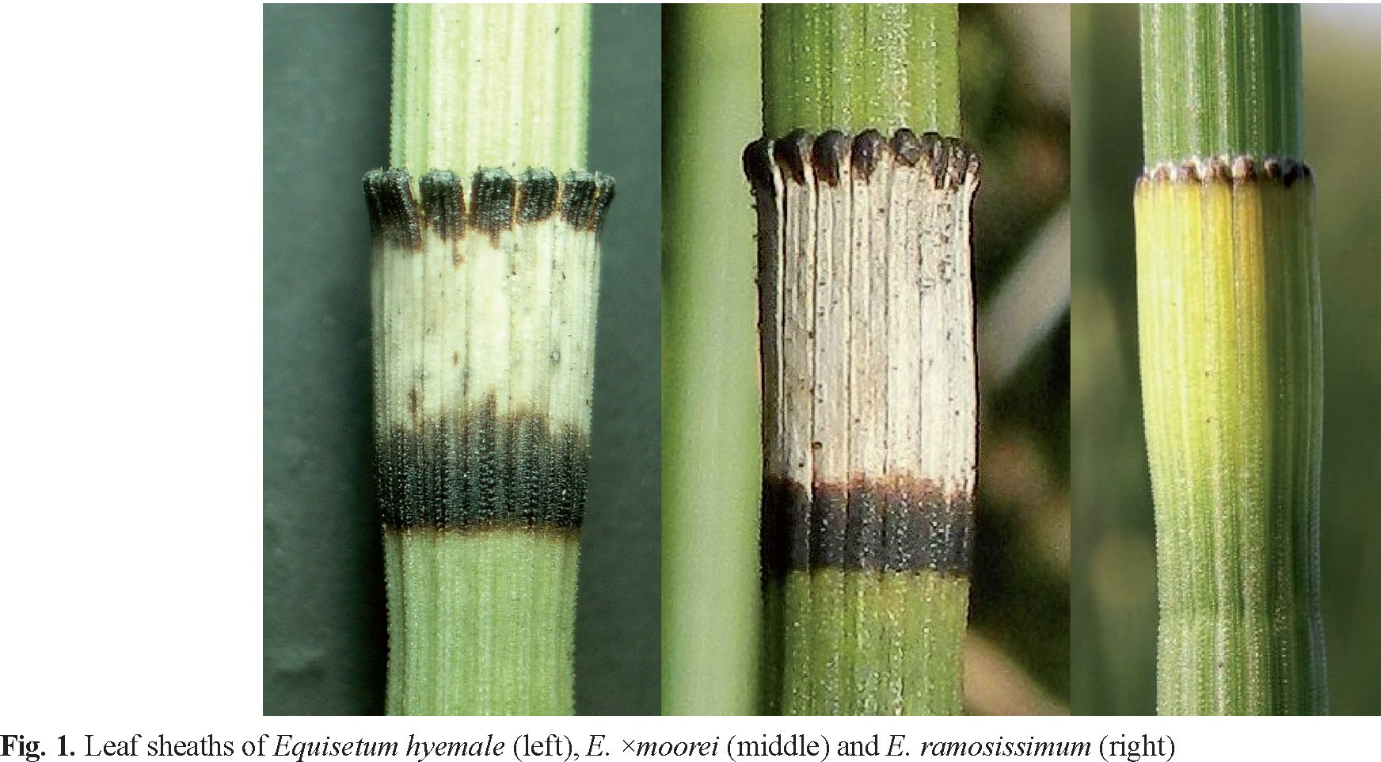
12 Paweł Kalinowski et al.
Equisetum xmoorei Newman (Equisetaceae) - a ‘new’ nothotaxon in the Polish flora
the taxon was reported so far from the British Isles (SE
Ireland and from Surrey, England, as an ephemerophyte)
(Stace 2010; Jepson etal. 2013), France (Dubois-Tylski
& Girerd 1986; Dardaine & Parent 1997; Prelli 2001;
Tison & de Foucault 2014), Spain and Portugal (Prada
1986), Germany (Lubienski 2011), Belgium (Bizot &
Petrement 2010), the Netherlands (de Winter & Lu-
bienski 2012), Luxembourg (Petrement et al. 2012),
as well as from north and central Italy (Prelli 2001;
Marchetti 2008). In Central Europe, it was reported from
the Czech Republic (Hrouda 1997; Kubat et al. 2002),
Slovakia (Futak 1966) and Hungary (Simon 2000). In
the southern part of the continent, E. xmoorei occurs
in Romania (Grintescu 1952) and Bulgaria (Hajek et
al. 2005). To the north, the taxon reaches sea coasts of
Latvia and Estonia (Laasimer et al. 1993) and Swedish
Gotland (Mossberg & Stenberg 2003). The latter site
is historical (Lubienski, pers. comm.). Information on
the isolated localities in the east of the continent (the
Volga region, Russia), and even further east in Asia
(Kazakhstan) (e.g. Milde 1865; Hrouda 1997) was not
confirmed by herbarium specimens (Skvortsov 2008).
Among countries where E. xmoorei occurs, Poland was
also mentioned but no further information was given
(e.g. Prelli 2001). In the Polish literature, this taxon has
not been so far reported either.
According to literature (Dostal 1984), the phenotype
ofE. xmoorei is intermediate between the parental spe-
cies, although very variable, deviating often towards
one of the parents. The most apparent diagnostic char-
acters are those of leaf sheaths (Stace 2010) (preferably
observed in the middle of the shoots): in E. xmoorei the
length/width ratio is 2 or more (up to 2.3) with a narrow
black stripe at the base (Fig. 1), for E. hyemale - the
ratio is ca. 1 (up to 1.5) with the broad stripe, while for
E. ramosissimum - the ratio is ca. 3, the sheaths are
bell-shaped without the black stripe at the base (Fig. 1).
Another, microscopic diagnostic feature is that of warts
on the shoot ribs: in the case of E. hyemale, the warts
are arranged in 2 rows, while in E. ramosissimum, the
warts of neighbouring rows are fused to form perpen-
dicular slats (Haeupler & Muer 2007). E. hyemale is
totally wintergreen, E. ramosissimum is not, while the
hybrid is mostly not completely wintergreen (Lubienski
2011).
To investigate historical and present distribution of
E. xmoorei in Poland and its habitat requirements, lite-
rature and herbarium search was performed, and field
studies at sites of potential occurrence of this hybrid
taxon were carried out. As the result of these investiga-
tions, E. xmoorei was found at five contemporary and
at a few historical sites in the territory of Poland.

2. Material and methods
Field studies were conducted during the years 2005-
2015. Herbarium search was performed in selected
Polish and German herbaria: KRA, KRAM, KTU,
LBL, LOD, TRN, WA, WRSL and MSTR (Münster,
Germany). Geographical coordinates of the locations
were determined with a Garmin Legend HCx and
Spectra Precision Mobile Mapper® 10 GPS receivers.
The plants were documented using Nikon Coolpix P500
and Olympus XZ-1 cameras. A distribution map in the
ATPOL grid (10 x 10 km squares) was prepared using
Gnomon 3.3 software.
Plants used for the 2C measurements were obtained
from the following sites: E. xmoorei - NW of Bolesław
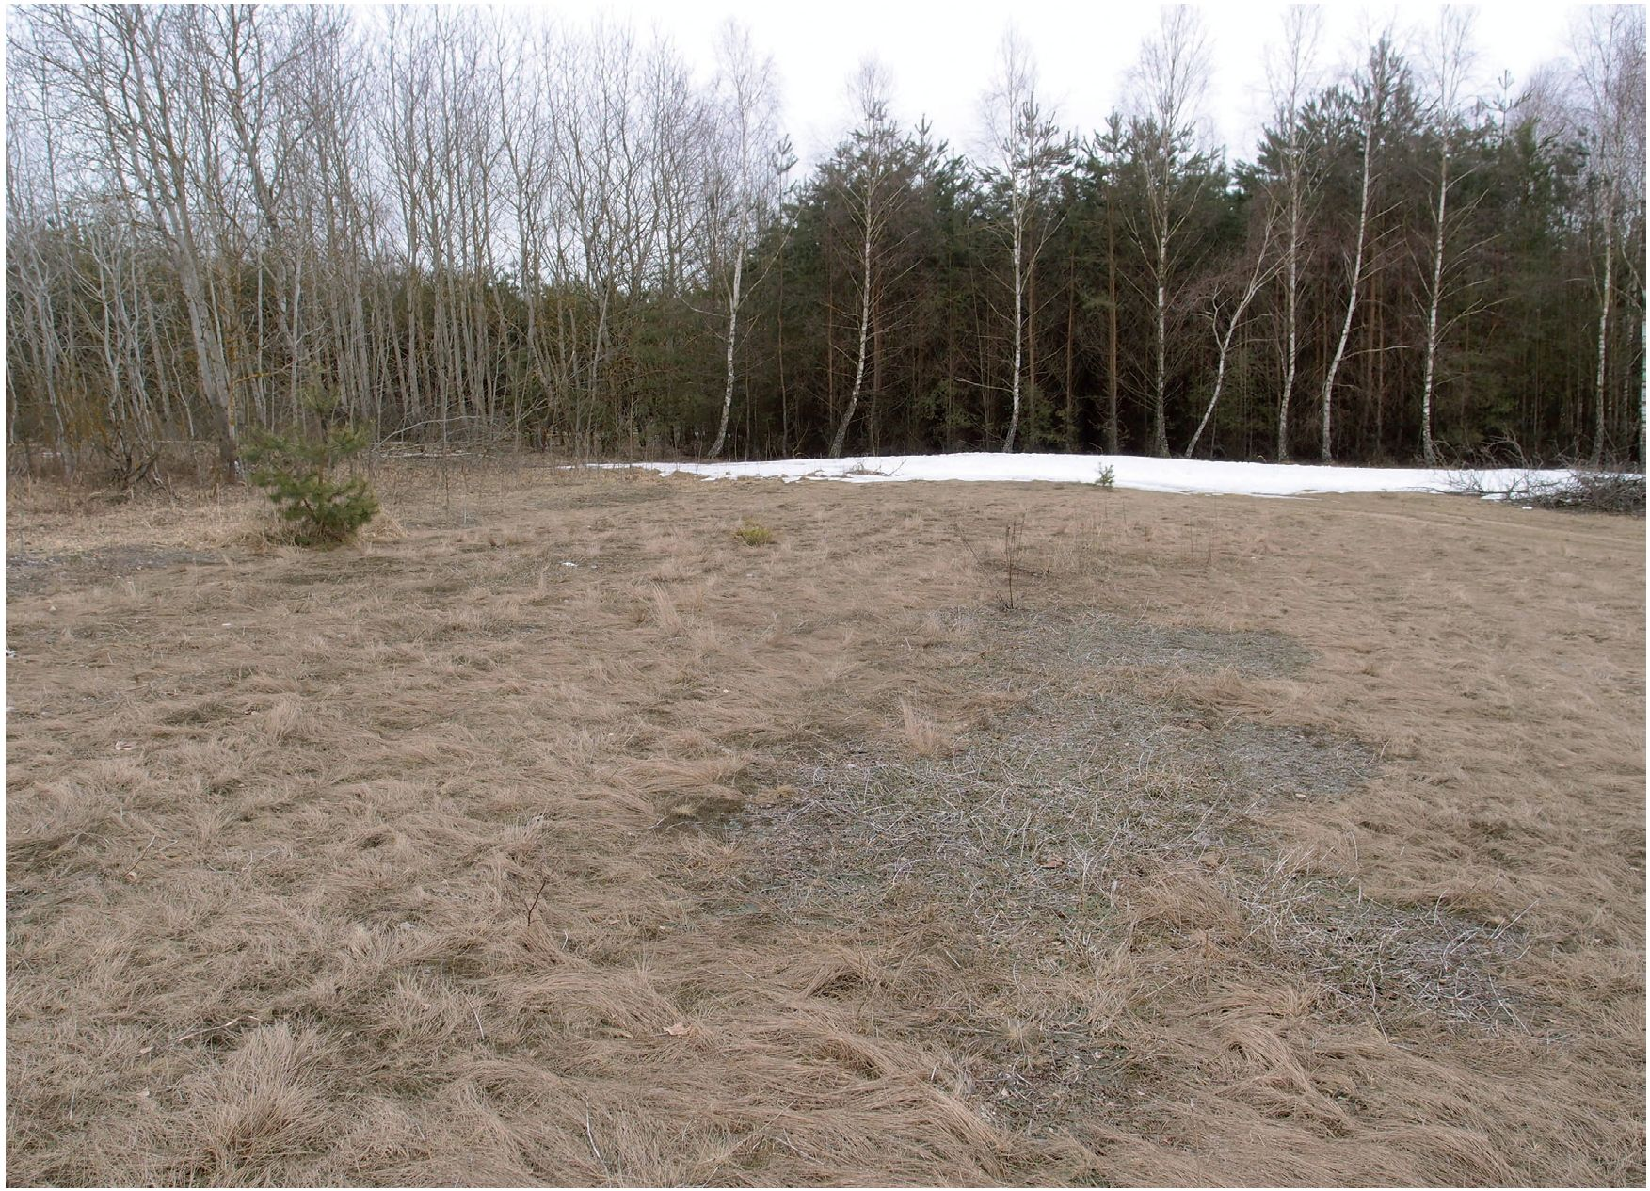
Biodiv. Res. Conserv. 41: 11-18, 2016 13
near Olkusz, E. hyemale - Kobylańska valley near
Kraków, E. ramosissimum - Piekary near Kraków. For
nuclear DNA content estimation, nuclei were released
simultaneously from shoots of a sample species and an
internal standard - Allium cepa ‘Alice’, 34.89 pg/2C
(Dolezel et al. 1998) by chopping in a Petri dish in 1 ml
of nucleus-isolation buffer (0.1 M Tris-HCl, 2.5 mM
MgCl2-6H2O, 85 mM NaCl, 0.1%, v/v, Triton X-100;
pH 7.0), supplemented with propidium iodide (PI; 50
pg cm-3) and ribonuclease A (50 pg-cm-3). The suspen-
sion was passed through a 50-pm mesh nylon filter and
analysed using a CyFlow SL (Partec GmbH, Münster,
Germany) flow cytometer equipped with a high-grade
solid-state laser with green light emission at 532 nm,
long-pass filter RG 590 E, DM 560 A, as well as with
side (SSC) and forward (FSC) scatters. Analyses were
performed on 7-10 individuals of each taxon. For each
sample, DNA content was established in 3000-5000
nuclei. Histograms were analyzed using a FloMax
(Partec GmbH, Münster, Germany) software. Coeffi-
cient of variation (CV) of the G0/G1 peak of Equisetum
sp. ranged between 4.04 and 5.82%. Nuclear DNA
content was calculated using linear relationship between
the ratio of the 2C peak positions Equisetum/Allium on
a histogram of fluorescence intensities.
The nomenclature of vascular plants, Equisetum
hybrids and lichens was according to Mirek et al.
(2002), Lubieński (2011) and Fałtynowicz (2003),
respectively.

3. Results
An atypical population of Equisetum sp. was found
in 2005 in the valley of the middle Bug river, NW of
Góry village, Korczew commune, Mazowieckie prov-
ince (FD07). Originally, it was supposed that the popu-
lation consisted of atypical individuals of E. hyemale.
However, further morphological and phenological re-
search (the individuals were only partially wintergreen)
led to the conclusion that it represented E. ymoorei.
This conclusion was also supported by indirect data, i.e.
occurrence of both parental species in the neighbour-
hood. E. hyemale occurs frequently in the Bug river
valley and the neighbouring hills (Zając & Zając 2001).
The species takes/occupies mostly humid habitats, often
in oak-hornbeam forests. In such conditions, E. hyemale
grows, for example, in forests W of Mężenin (5.75 km
from the E. ymoorei site) and in Bartków (9 km). On
the other hand, E. hyemale was also found at dry places,
on dunes over the Bug river and in pine forests. These
sites were located much closer to that ofE. ymoorei - in
Drohicznyn-Topolina (2.5 km), Zajęczniki-Kozerówka
(4.25 km) and in Leonów forest in the proximity of
Drażniew village (2.5 km). In these cases, the habitat
Fig. 2. Habitat of Equisetum *moorei in Góry (photo by P. Kalinowski, April 2013)
14 Paweł Kalinowski et al.
Equisetum *moorei Newman (Equisetaceae) - a ‘new’ nothotaxon in the Polish flora
of E. hyemale was like that of E. ymoorei. Both taxa
were found on loose, neat riverside sands at very dry
and sunny places. The only, maybe significant, differ-
ence was the occurrence of E. ymoorei in the secondary,
regenerating former agricultural land (Fig. 2), while
E. hyemale was found in more or less natural habitats,
although also affected by anthropopressure. It is worth
mentioning that E. hyemale was reported from similar,
sandy habitats in Belarus, where it is regarded as a rare
species (Parfenov 2009). Besides these natural stands,
E. hyemale in the proximity of E. ymoorei occurred also
at anthropogenic habitats, like railway embankments
in Platerów (12.25 km) and Niemojki (12.50 km).
The other of the parental species of E. ymoorei -
E. ramosissimum - is a rare taxon in Poland, reported
relatively frequently only over middle course of the
Vistula river (Zając & Zając 2001). Furthermore, it
occurs rarely in Lublin Upland, in Małopolska and
Wielkopolska regions and only exceptionally in other
parts of Poland (Zając & Zając 2001). One locality
was reported from the lower Bug valley in Wyszków
(Ciosek 1976, unpublished). In the ATPOL database,
there are no data from the middle Bug valley, although
the species was reported by Głowacki (1984) from
the same Góry village where E. ymoorei occurs. It is
probable that this information refers to one of the two
currently existing subpopulations of E. ramosissimum
in the vicinities of Góry. One of them (small, a few
square meters) takes side of a sandy field road, S of the
village, and partially enters the neighbouring fields (in
2013 these were maize fields). The other (NW of the
village, 600 m apart from the former) is only slightly
bigger and occupies the sandy top of a small, flat hill
together with E. ymoorei.
In 2005, when E. ymoorei was found in Góry, it took
a few square meters at the edge of a young pine forest in
close proximity to a crop cultivation. After the cultiva-
tion was abandoned (ca. 2008-2010), part of the land
was forested and the other part remained fallow land.
Afterwards, fast spreading of the hybrid was observed
in the young forest and in the uncultivated area. Within
a few years, the area covered by E. ymoorei increased
to ca. 6 100 m2. The expansion is especially clearly
observed in N direction, on the fallow surrounded by
a young pine forest. On the other hand, expansion of
E. ramosissimum is not observed at this site. Its small
sheets are evidently dominated by the hybrid and are
difficult to find.
Since phytosociological data are scarce for E.
ymoorei in Europe, we present 3 phytosociological
relevés from the vicinity of Góry:
Relevé 1: N 52° 21’ 54.5”, E 22° 39’ 58.5”, C - 70%,
D - 40%, 5 x 5 m (inclination 0°),
Agrostis capillaris 1, Convolvulus arevnsis +, Conyza
canadensis 1, Corynephorus canescens 1, Elymus
repens 2, Equisetum ymoorei 2, Hieraciumpilosella 4,
Jasione montana 1, Filago minima 1, Setariapumila +,
Cladonia rei 3, Cladonia maclineata 1
Relevé 2: N 52° 21’ 55.7”, E 22° 39’ 55.1”, C - 85%,
D - 40%, 5 x 5 m (inclination 0°),
Artemisia campestris 1, Conyza canadensis 2, Cory-
nephorus canescens 3, Elymus repens 1, Equisetum
ymoorei 3, Festuca rubra 1, Hieracium pilosella 2,
Holcus lanatus 1, Jasione montana 2, Pinus sylvestris +,
Setaria pumila +, Solidago virga-aurea 1, Viola arvensis
+, Cladonia fimbriata +, Cladonia rei 2, Racomitrium
canescens 1
Relevé 3: N 52° 21’ 54.6”, E 22° 39’ 52.1’’, C - 90%,
D - 0%, 5 x 5 m (inclination 0°),
Achillea millefolium 2, Agrostis capillaris 1, Alopecurus
pratensis +, Calamagrostis epigeios +, Convolvulus
arvensis 1, Conyza canadensis 1, Elymus repens 1,
Equisetum ymoorei 2, Equisetum ramosissimum 2,
Festuca rubra 3, Hieracium pilosella 3, Hypochoeris
radicata +, Jasione montana 1, Knautia arvensis 1,
Oenothera sp. +, Peucedanum oreoselinum 1, Poa
pratensis 1, Pyrus communis +, Rumex acetosella 1,
Saponaria officinalis 1, Solidago virga-aurea 2, Ta-
raxacum sp. +, Viola arvensis +
In the south of Poland, E. ymoorei was found in 2013
along one draining ditch (Dąbrówka canal) and edges
of the neighbouring pine forest, NE of Bolesław near
Olkusz (N 50° 18’ 10.1’’, E 19° 29’ 51.0’’) (Małopolska
province, DF36). The locality is situated close to the
Pomorzany zinc-lead mine. The population covered an
area of at least 200 m2 and was composed of erect and
creeping individuals reaching often 1 m or more in height,
mostly wintergreen (Fig. 3). The leaf sheaths of some of
the individuals looked different depending on the season
of the year. During wintertime, they appeared typical
for E. ymoorei (Fig. 3), while during summertime, they
resembled those of E. ramosissimum to some extent.
There were no parental species found together with the
hybrid. Nevertheless, the literature data (Zając et al. 2006)
indicate close proximity of E. hyemale and the nearest
locality of E. ramosissimum is ca. 6 km apart. However,
these sites were not confirmed in the present study.
Since the individuals of E. ymoorei found in the vi-
cinity of Bolesław showed some similarity in phenotype
to the triploid E. yascendens (tall, totally wintergreen
shoots) reported by Lubienski (2011), we performed
flow cytometric analysis of nuclear DNA content (2C)
of the hybrid and the parental species (Table 1). The
obtained data showed that all the investigated popula-
tions had similar 2C DNA (about 54 pg), correspond-
ing to diploid taxa: E. hyemale 52.6 pg/2C and E.
ramossisinum 56.4 pg/2C (Bennert et al. 2005). This
confirmed that the investigated population was diploid
and excluded the possibility that it was represented by
E. yascendens.
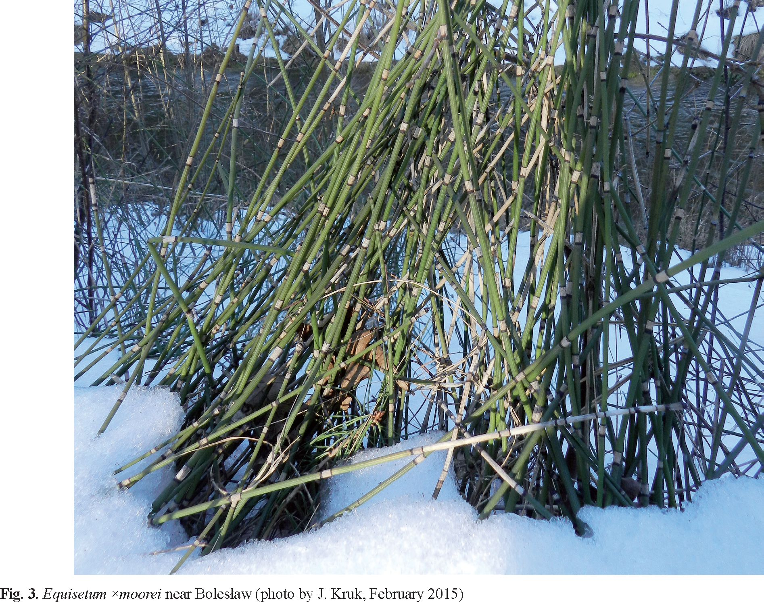
Biodiv. Res. Conserv. 41: 11-18, 2016 15
Table 1. Nuclear DNA content of Equisetum cf. xmoorei, E. hy-
emale and E. ramosissimum. All specimens were collected in the
vicinity of Kraków
Taxon | DNA content (pg/2C ± SD)
Equisetum cf. xmoorei | 54.78 ± 0.35
Equisetum hyemale | 53.36 ± 0.72
Equisetum ramosissimum | 54.56 ± 0.56
In 1998, E. xmoorei was found by Marcus Lubienski
(pers. comm.) in Kartuzy surroundings near Gdańsk,
SW of Przodkowo (CA88). It occurred numerously in
the area of a sand pit, north of the Kartuzy-Wejherowo
road. The photograph of the hybrid from this site was
included in one of the articles of the founder (Lubienski
et al. 2012), however, this finding was not confirmed
formally. It is documented by two herbarium sheets
provided by M. Lubienski (presently in the private col-
lection of J. Kruk). However, during our field studies
in 2015, the presence of E. xmoorei was not confirmed
at this site.
Revision of the collections of the selected herbaria
resulted in the following findings of E. xmoorei:
KTU: DF46, Bukowno, railway station, track-ways,
leg. & det. T. Nowak, 28.08.1992, KTU079638 and
079639 (ut E. hyemale);
LBL: FE32, Kępa Chotecka near Opole Lubelskie, river
dyke, leg. & det. D. Fijałkowski, 3.09.1963, 779 (ut E.
hyemale f. viride); FD77, Borki near Radzyń, pine-oak
forest, leg. & det. D. Fijałkowski, 14.09.1965, 770, 773
& 774 (ut E. hyemale f genuinum);
LOD: FD92, Borowa (Puławy district), humid sand-
bank on the Vistula river, leg. & det. Dobrzeniecka-
Osiak B., 6.09.2001, LOD152159 (ut E. ramosissi-
mum);
TRN: DA81, by the sea behind the Vistula river es-
tuary, leg. E.F. Klinsmann, 1851 (ut E. hyemale var.
schleicheri); CB65, Zdręczno Lake, Tuchola district,
leg. M. Ceynowa, 25.07.1968 (ut E. hyemale);
WA: ED16, Warsaw, slope of a dyke close to
Myśliborska street, leg. E. Korcz, 23.07.1978, WA4081
(ut E. hyemale) - in 2015, the hybrid was not confirmed
at this locality because of strong anthropogenic changes
of the Vistula river banks in this area.
WRSL: BE49, Wrocław-Karłowice, on the old Odra
river, leg. R. Uechtritz, 09.1853, WRSL000385 (ut E.
hyemale schleicheri) - among E. ramosissimum on the
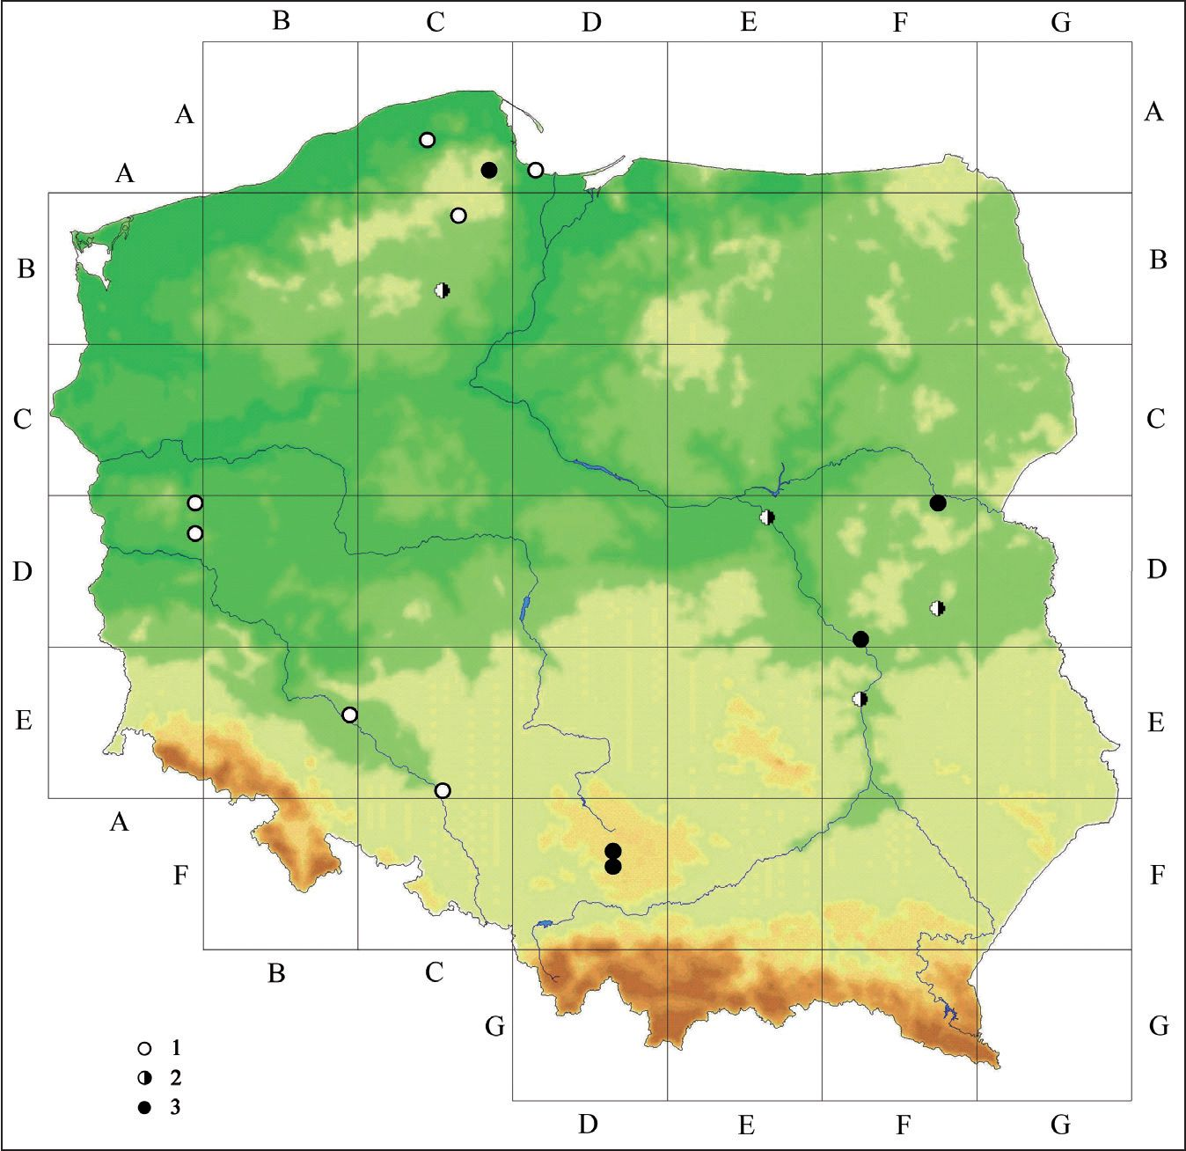
16 Paweł Kalinowski et al.
Equisetum *moorei Newman (Equisetaceae) - a ‘new’ nothotaxon in the Polish flora
Fig. 4. Distribution of Equisetum ^moorei in Poland, in the ATPOL grid, based on the literature, herbarium records and present findings
Explanations: 1 - historical localities before 1945, 2 - localities from the period 1945-1990, 3 - contemporary localities (after 1990)
same sheet; BE49, Wrocław, leg. R. Uechtritz, 09.1853,
WRSL000375 (ut E. hyemale schleicheri); BE49,
Wrocław-Karłowice, not on sands of the old Odra river
but in dense Prunus spinosa-busches at the Odra dyke,
leg. C. G. Baenitz, 15.10.1894, WRSL000376 (ut E.
hyemale schleicheri)
MSTR: (all sheets ut E. hyemale, rev. M. Lubienski);
BE49, near Wrocław, leg. P. Heuser, 18??, 143552;
DA81, Gdańsk: ad mare balticum, Möwenschanze, leg.
C. G. Baenitz, 7.08.1889, 143466 and 143476; BE49,
Wrocław-Karłowice, at the Odra dyke, leg. C. G. Bae-
nitz, 20.10.1896; BE49, Wrocław, leg. C. G. Baenitz,
15.10.1894, 143411 and 143441; DA81, Gdańsk: ad
mare balticum, leg. C. G. Baenitz, 15.07.1877, 143435;
BE49, Wrocław, leg. C. G. Baenitz, 11.07.1895, 143409
and 143412.
Revision of the historical literature (Schube 1903;
Decker 1912), referring to the present territory of
Poland, revealed the following sites of occurrence
of E. xmoorei (present Polish names of the localities
are given): Chociule near Świebodzin: towards Łąkie
(AD29); Jordanowo: road to Nowy Dworek in a pine
forest, frequently (AD09); Wrocław-Dąbie, Wrocław-
Karłowice, Wrocław-Biskupin (all BE49); Opole-
Zakrzów (behind Moritzberg) (CE95). The taxon was
also reported as E. hyemale var. schleicheri from a
range of Silesian and Pomeranian localities by Milde
(1858), most of which, however, were secondary cita-
tions after other German scholars (Caspary, Klinsmann,
Nolte, von Uechtritz) and were mostly not confirmed
afterwards: Kościerzyna (CB16), Gdańsk (DA81),
Lębork (CA64) and Opole (CE95). It seems that only
the locality in Wrocław-Karłowice was known to Milde
himself (well before Schube’s report), but all of them
are fully reliable.

4. Discussion
The present finding of E. xmoorei in the territory of
Poland extends the area of its occurrence in Europe.
The site in Góry is very interesting since it allows
reconstruction of probable mechanisms of the noth-
otaxon genesis, existence and spreading. The stand is a
rare example of the occurrence of E. x moorei together
with both parental species, although not directly with
E. hyemale. Distribution of the nothotaxon in Europe
is only partially due to the occurrence of its parental
species. Many researchers emphasize its independent
distribution of one or both parents and this fact is well
documented at many sites in Europe, from classical Irish
Biodiv. Res. Conserv. 41: 11-18, 2016 17
populations (natural stands of E. ramosissimum in the
British Islands are doubtful) (Jepson et al. 2013) to a
recently described locality in Luxembourg (Petrement
et al. 2012). Also in Central Europe, this hybrid, at least
at some stands, occurs independently of both parents or,
more frequently, only together with E. ramosissimum
(Hrouda 1997). In the case of the Bug riverside locality,
the key factor that led to the hybrid formation could have
been the adaptation of local populations of E. hyemale
to rather extreme conditions for this species, dominating
on sandy dunes. In this way, habitat and spatial boundar-
ies between both parental species of E. xmoorei were
eliminated. Broad distribution of E. xmoorei in Europe
is explained by its ability to reproduce vegetatively,
even from small rhizome fragments. This could favour
spreading and existence of this taxon in areas where one
or both parental species do not occur - in Ireland and in
the Baltic region, for example (Lubienski 2011). This
reproduction mechanism is also observed in Góry, be-
cause it is the only reproduction strategy for E. xmoorei,
since - as a hybrid taxon - it forms only sterile spores.
Until now, however, no distant spreading of this taxon
in the proximity of Góry has been observed.
Information on habitats where E. xmoorei was
found in Europe are rather general. According to Dostal
(1984), typical habitats for this nothotaxon are sandy,
open forests, sandy ‘semi-steppes’, dunes, meadows,
etc. According to Hrouda (1997), it grows in habitats
similar to those of E. ramosissimum (also in secondary
ones), such as sands, pine forests, sandy fields, road and
railway embankments. In Italy, it was found on sands
and in ditches (Marchetti 2008), in an old gravel pit
in Luxembourg (Pétrement et al. 2012), in dry, fresh
forests and on sea coasts in Estonia and Latvia (Kull et
al. 2002; www.latvijasdaba.lv). E. xmoorei occurs also
on sea shores and dunes in Ireland (Stace 2010).
In Poland, E. xmoorei was found in a sand pit (Lu-
bienski, pers. comm.), on river dykes and sea shores, as
well as in a former agricultural land of the Corynepho-
rion canescentis associations, on the borders of young
pine forests, along draining ditches and on edges of pine
forests.
The presented data indicate that E. xmoorei was, and
continues to be a rare nothotaxon dispersed throughout
most of the Polish territory but it is probably more
widespread than the described localities indicate.
Acknowledgements. We are grateful to M. Lubienski for the
information on E. xmoorei site near Kartuzy and herbarium
sheets, the anonymous reviewer for valuable remarks and
information on E. xmoorei in Münster herbarium, curators of
the herbaria listed in the manuscript for access to the collec-
tions, as well as to P. Zaniewski for determination of lichens.
References
Bennert W., Lubienski M., Körner S. & Steinberg M.
2005. Triploidy in Equisetum subgenus Hippochaete
(Equisetaceae, Pteridophyta). Ann. Bot. 95: 807-815.
Bizot A. & Pétrement B. 2010. Equisetum xmoorei Newman,
un nouvel hybride d'Equisetum du subg. Hippochaete,
mis en évidence dans une carrière à Etalle (Province
de Luxembourg, Belgique). Adoxa 64: 1-5.
Dardaine P. & Parent G. H. 1997. Présence en Lorraine
(belge, française et luxembourgeoise) de trois formes
ramifiées de Prêles d'hiver (Equisetum hyemale L. et
E. xmoorei Newman). Bull. Soc. Nat. Luxemb. 98:
53-60.
Decker P. 1912 Beiträge zur Flora der südlichen Neumark
und der Östlichen Niederlausitz. Verh. Bot. Ver. Prov.
Branderburg 53: 87-269.
Dolezel J., Greilhuber J., Lucretti S., Meister A., Lysak
M. A., Nardi L. & Obermayer R. 1998. Plant genome
size estimation by flow cytometry: Inter-laboratory
comparison. Ann. Bot. 82 (suppl. A): 17 - 26.
Dostäl J. 1984. Equisetum. In: G. Hegi (ed.). Illustrierte
Flora von Mitteleuropa, Band I, Teil 1. Pteridophy-
ta. 3rd ed., pp. 55-79. Verlag Paul Parey, Berlin und
Hamburg.
Dubois-Tylski Th. & Girerd B. 1986. Étude comparative de
quelques Equisetum du sous-genre Hippochaete. Bull.
Soc. Bot. France. Lett. Bot. 133: 125-135.
Faltynowicz W. 2003. The lichens, lichenicolous and allied
fungi of Poland. An annotated checklist. In: Z. Mirek
(ed.). Biodiversity of Poland, 6, 435 pp. W. Szafer
Institute of Botany, Polish Academy of Sciences,
Kraków.
Głowacki Z. 1984. Notatki florystyczne z Mazowsza i Pod-
lasia. Zesz. Nauk. Wyż. Szk. Rol.-Ped. Siedlce, Nauki
Przyrodnicze 4: 51-76.
Grintescu Gh. 1952. Equisetum L. In: T. Sävülescü (ed.).
Flora Republicii Romane, pp. 46-73. Acad. Rep. Pop.
Romane, Bucureęti.
Fütäk. J. 1966. Equisetopsida. In: J. Fütäk (ed.). Flóra
Slovenska 2, pp. 47-83. Slov. Akad. Vied, Bratis-
lava.
Haeüpler H. & Muer T. 2007. Bildatlas der Farn- und Blü-
tenpflanzen Deutschlands. 789 pp. Ulmer, Stuttgart.
Häjek M., Häjkövä & Apostolova I. 2005. Notes on the
Bulgarian wetland flora, including new national and
regional records. Phytologia Balcanica 11(2):173-
184.
Hrouda L. 1997. Divisio Equisetophyta - rostliny preslickove.
In: S. Hejny & B. Slavk (eds.). Kvetena Ceske Re-
publiky, 5, 572 pp. Academia, Praha.
Jepson P., Lubienski M., Llewellyn P. & Viane R. 2013.
Hybrids within Equisetum subgenus Hippochaete in
England and Wales. New J. Bot. 3: 47-58.
18 Paweł Kalinowski et al.
Equisetum *moorei Newman (Equisetaceae) - a ‘new’ nothotaxon in the Polish flora
Kubat K., Hroüda L., Ghrtek J. Jun., Kaplan Z., Kirschner
J., StepAnek J. (eds.). 2002. Klicke kvetene Ceske
republiky. 928 pp. Academia, Praha.
Kull T., Kukk T., Leht M., Krall H., Kukk Ü., Kull K. & Ku-
usk V 2002. Distribution trends of rare vascular plants
species in Estonia. Biodiv. Conserv. 11: 171-196.
Laasimer L., Kuusk V. & Tabaka L. (eds.). 1993. Flora of the
Baltic Countries. Compendium of Vascular Plants 1.
362 pp. Estonian Academy od Sciences, Tartu.
Lubieński M. 2011. Die Schachtelhalme (Equisetaceae, Pter-
idophyta) der Flora Deutschlands - ein aktualisierter
Bestimmungsschlüssel. Jahrb. Bochumer Bot. Ver.
2: 68-86.
Lubieński M., Bennert H. W. & Körner S. 2010. Two
new triploid hybrids in Equisetum subgenus Hip-
pochaete for Central Europe and notes on the
taxonomic value of „Equisetum trachyodon forma
Fuchsii“ (Equisetaceae, Pteridophyta). Nova Hed-
wigia 90: 321-341.
Lubieński M., Jäger W. & Bennert H. W. 2012. Equisetum
xascendens Lubienski & Bennert (Subg. Hippochaete,
Equisetaceae), eine neue Schachtelhalm-Sippe für die
Flora Nordrhein-Westfalens. Jahrb. Bochumer Bot.
Ver. 3: 7-20.
Marchetti D. (ed.). 2008. Notule pteridologiche italiche. VI
(134-155). Ann. Mus. Civ. Rov. 23: 205-226.
Milde J. 1858. Monographia Equisetorum. 605 pp. E. Bloch-
mann et Sohn, Dresden.
Mirek Z., Piękoś-Mirkowa H., Zając A. & Zając M. 2002.
Flowering plants and pteridophytes of Poland. A
checklist. In: Z. Mirek (ed.). Biodiversity of Poland, 1,
442 pp. W. Szafer Institute of Botany, Polish Academy
of Sciences, Kraków.
Mossberg B. & Stenberg L. 2003. Den nya nordiska Floran.
928 pp. Wahlström & Widstrand.
Newman E. 1854. New Irish Equisetum. Phytologist 5: 17-20.
Parfenov V I. (ed.). 2009. Flora Belarusi. Sosudistye rastenia.
Tom 1. Lycopodiophyta, Equisetophyta, Polypodio-
phyta, Ginkgophyta, Pinophyta, Gnetophyta. 199 pp.
Beloruska Nauka, Minsk.
Petrement B., Bizot A. & Krippel Y. 2012. Equisetum
xmoorei Newman (Equisetaceae, Pteridophyta), taxon
nouveau pour le Luxembourg. Bull. Soc. Nat. Lux.
113: 83-90.
Prada C. 1986. Equisetum L. In: S. Castroviejo, M. Laînz,
G. López Gonzalez, P. Montserrat, F. Munoz Garme-
dia, J. Pavia & L. Villar (eds.). Flora Iberica: Plantas
Vasculares de la Peninsula Iberica e Islas Baleares.
Vol. 1. Lycopodiaceae - Papaveraceae, pp. 21-29.
Real Jardin Botanico CSIC, Madrid.
Prelli R. 2001. Les Fougères et plantes alliées de France et
d‘Europe occidentale. 432 pp. Belin, Paris.
Schube Th. 1903. Die Verbreitung der Gefässpflanzen in
Schlesien preußischen und österreichischen Anteils.
361 pp. R. Nischowsky Verl., Breslau.
Simon T. 2000. A Magyarorszagi edényes Flóra hatarozója.
Harvasztok - viragos nôvények. 845 pp. Nemzeti
Tankônyvkiadô, Budapest.
Skvortsov V. E. 2008. Rod Equisetum L. v rossiiskoi i miro-
voi flore. Morfologia, ekologia, taksonomia, 258
pp. Moskov. Gosud. Univ. im. M. V Lomonosova,
Moskva.
Stace C. 2010. New flora of the British Isles. 1266 pp. Cam-
bridge University Press, Cambridge.
Tison J. M. & de Foucault B. (eds.). 2014. Flora Gallica.
Flore complète de la France. 1400 pp. Société bota-
nique de France, éd. Biotope.
de Winter W. & Lubienski M. 2012. Equisetum xascendens
Lubienski & Bennert: de eerste triploïde paardenstaar-
tbastaard in Nederland. Gorteria 36: 1-17.
Wróbel D. 2013a. Equisetum xrobertsii T. D. Dines (E. ar-
vense x E. telmateia; Equisetaceae) in Poland. Acta
Bot. Silesiaca 9: 57-66.
Wróbel D. 2013b. Przegląd krajowych mieszańców mię-
dzygatunkowych rodzaju Equisetum L. Acta Bot.
Silesiaca 9: 67-73.
Zając A. & Zając M. (eds.). 2001. Distribution Atlas of
Vascular Plants in Poland. xii+714 pp. Edited by Labo-
ratory of Computer Chorology, Institute of Botany,
Jagiellonian University, Cracow.
Zając M., Zając A. & Zemanek B. (eds.). 2006. Flora Craco-
viensia Secunda. 291 pp. Laboratory of Computer
Chorology, Institute of Botany, Jagiellonian Univer-
sity, Kraków.

