


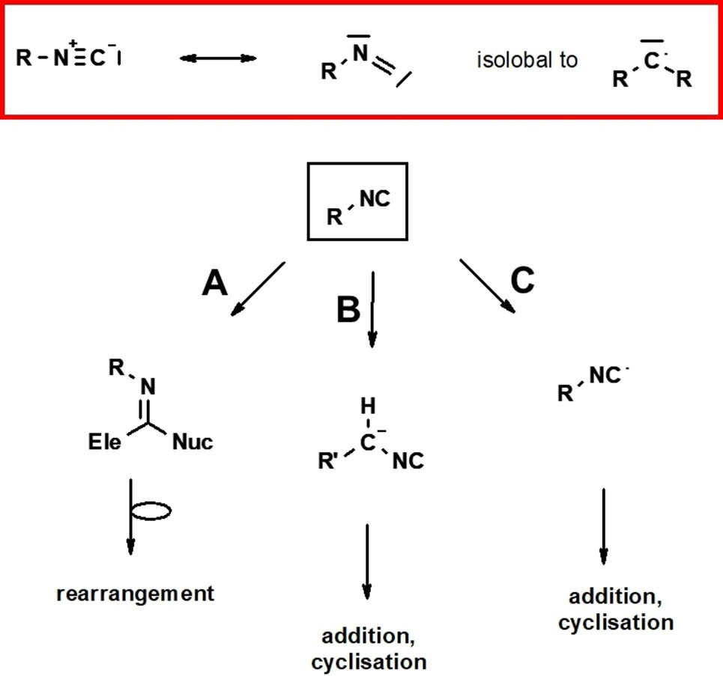



Communications
doi.org/10.1002/ejoc.202101023
www.eurjoc.org
Very Important Paper
SNAr Isocyanide Diversification
Qiang Zheng,[a] Katarzyna Kurpiewska,[b] and Alexander Dömling*[a]
Isocyanides are important building blocks in organic synthesis; however, their synthesis is time and resource consuming and often unpleasant due to their smelly nature. Diversification of isocyanides can be accomplished by de novo synthesis or from already existing isocyanides. In this work, we report for the first- time isocyanide diversification based on nucleophilic aromatic substitution of suitable precursor isocyanides. The mild con- ditions allow for easy access to multiple novel isocyanides useful in organic synthesis. The resulting isocyanides are solid and non-noxious, yet react nicely in multicomponent reactions.
The isocyanide is a functional group in organic synthesis characterized by a-acidity, radical reactions, and a unique reactivity of the terminal carbon with nucleophiles and electro- philes (Figure 1).[1] Hence isocyanides are used in natural product,[2] heterocycle,[3] peptide,[4] macrocycle,[5] or polymer synthesis.[6] The most common isocyanide syntheses are for- mylation of a primary amine followed by dehydration (Ugi method),[7] reductive amidation of aldehydes or ketones followed by dehydration (Leuckart-Wallach),[8] and dichloro carbene addition onto primary amines (Hofmann method)[9]
Figure 1. The isocyanide functional group. Red boxed the valence formula of the isocyanide leading to the three main reactivities of isocyanides, a- addition of electro- and nucleophile (A), a-acidity (B), and radical reactions (C).
more
specialized
methods
such
as
reduction
of
iso(thio)cyanates,[10] nucleophilic substitution reaction with a C- blocked nitrile (Liecke method)[11] or ring-opening reaction of
(SNAr) of a suitable isocyanide precursor. SNAr is a straight forward method in organic synthesis which has been applied multiple times in drug discovery, material science and other fields.[17] Due to the reactivity and often instability of the isocyanide functionality we deemed that the SNAr methodology would be. As a prototype to explore the SNAr, we prepared our recently described 4-fluoro-3-nitro-phenyl isocyanide 1 on a 100 mmol scale starting from commercially available amine 4- fluoro-3-nitroaniline, formylation and dehydration in 87 % yield.[18] The SNAr reaction of activated fluoro aromates usually employs bases to capture the formed HF. This is important since strong acids will destroy the isocyanides and lead to hydrolyzation. Thus, we screened different conditions including solvent, bases, time and temperature for the representative reaction of 1 with cyclopentylamine (SI Table S1). In general, all tested conditions gave the expected product in good to excellent yields ranging from 74 % to 95 %. The optimal condition involved the use of two equivalents of amine in DCM at a concentration of 1 M, at room temperature for 2 h. Encouraged by the good initial results we examined the scope and limitations of the amine components using the optimized conditions. We prepared 20 different 4-amino substituted 3- nitro-phenylisocyanides 3 a–3 t in good to excellent yields between 70 % and 95 % (Scheme 1).
In general, secondary and primary amines seem to react equally good. Small as well as bulky amines reacted well;
epoxides using TMSCN and a suitable Lewis acid (Gassman method)[12] amongst many others.[13] In situ synthesis methods are popular as they avoid isolation of the often smelly and noxious isocyanides.[14] Highly sustainable methods for isocyanide synthesis from mole scale down to parallel synthesis on a 96-well format were described recently.[15] Another interesting strategy for diversification are ‘isocyanides from isocyanide’ aiming to synthesize many new isocyanides from one precursor isocyanide.[16]
Here we introduce a novel ‘isocyanides from isocyanide’ method by using a nucleophilic aromatic substitution reaction

- Q. Zheng, Prof. A. Dömling Department of Drug Design University of Groningen Design
A. Deusinglaan 1, 9713 AV, Groningen, The Netherlands E-mail: a.s.s.domling@rug.nl
[b]
K. Kurpiewska
Department of Crystal Chemistry and Crystal Physics Faculty of Chemistry Jagiellonian University
30-387 Kraków, Poland
Supporting information for this article is available on the WWW under https://doi.org/10.1002/ejoc.202101023
© 2021 The Authors. European Journal of Organic Chemistry published by Wiley-VCH GmbH. This is an open access article under the terms of the Creative Commons Attribution Non-Commercial License, which permits use, distribution and reproduction in any medium, provided the original work is properly cited and is not used for commercial purposes.
Eur. J. Org. Chem. 2022, e202101023 (1 of 3)
© 2021 The Authors. European Journal of Organic Chemistry published by Wiley-VCH GmbH

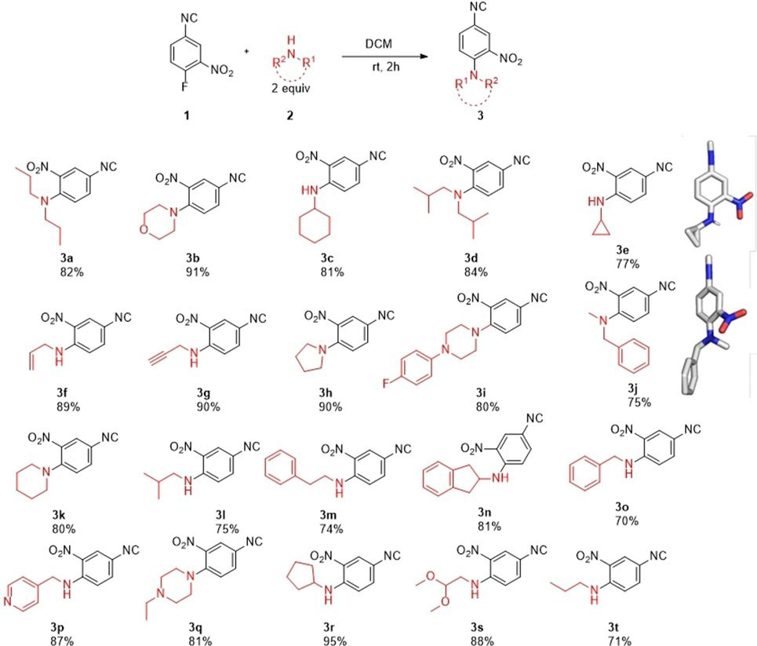
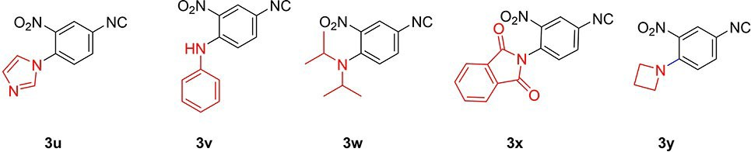
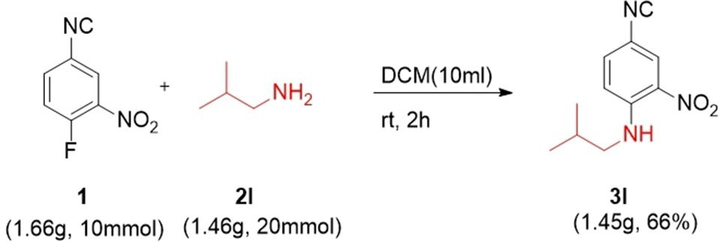
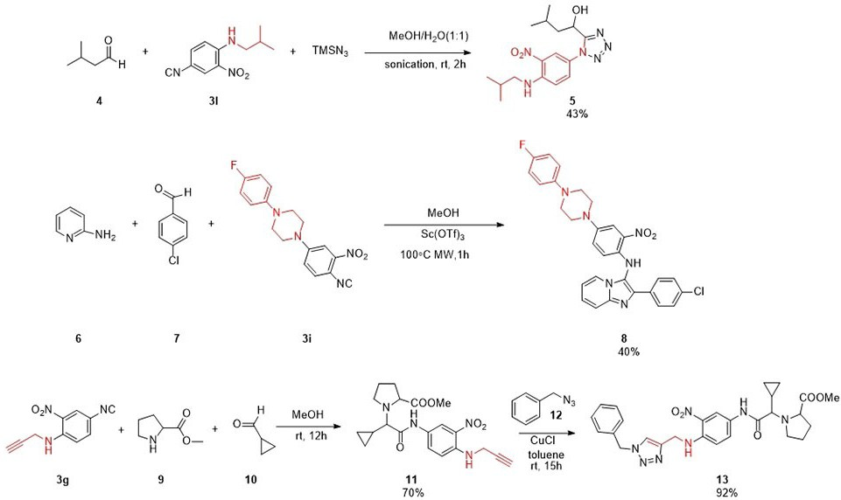
Communications
doi.org/10.1002/ejoc.202101023
Surprisingly, however, aziridine 3 y did also not show any conversion to the product.
Next, we investigated the scalability of the reaction from
0.5 mmol to 10 mmol (Scheme 3). The reaction of 1 with 2 l
yielded 1.4 g of product 3 l in 66 % yield.
We investigated the reactivity of three different isocyanides (Scheme 4). The Passerini tetrazole reaction (PT-3CR) is a rarely used MCR leading to a-hydroxyl methyl tetrazoles. Recently, we elaborated a highly improved PT-3CR featuring the beneficial effect of methanol/water solvent mixtures and sonification.[19] Indeed, reaction of 4, 3 l, and trimethylsilyl azide under sonication resulted in a 43 % product formation of the hydroxymethyl tetrazole 5 (Scheme 4).
The Groebcke-Blackburn-Bienayme reaction (GBB-3CR) is a very popular MCR due to the similarity of its products to marketed drugs.[20] 5- and 6-membered heteroaromatic ami- dines react with aldehydes and isocyanides to afford 5–5 and 5–6 imidazo bis-heterocycles generally under Lewis- or Brønsted acid catalysis. Here we reacted isocyanide 3i, with p- chlorobenzaldehyde 7 and 2-amino pyridine 6 to yield GBB-3CR product 8 in 40 % yield (Scheme 4). We reacted the propargyl- amine bearing isocyanide 3 g in a Ugi three component reaction (U-3CR) with proline methylester 9 and cyclopropylcarbalde- hyde 10 to yield 11 in 70 % yield as a 2.2 : 1 mixture of diastereomers. To test the reactivity of the triple bond we performed a ‘click’ reaction with benzylazide 12 to yield the expected triazole 13 in 92 % yield.
Isocyanides containing primary or secondary amines incor- porated are often not stable because of condensation between the nucleophilic and electrophilic moieties, often through cyclization or polymerization. Therefore, we were surprised by the stability of the isocyanides bearing a secondary amine 3 a, 3 b, 3 d, 3 h, 3 i, 3 j, 3 k, 3 q. In the solid state the isocyanide 3e shows a short hydrogen bonding contact (2 Å) protecting the NH from further reacting with the isocyanide and therefore stabilizing this class of secondary amine containing isocyanides (Figure 2). In summary we have described a valuable ‘isocya- nides from isocyanide’ strategy allowing for the easy access of 4-amino substituted 3-nitro-phenyl isocyanides by a mild SNAr reaction with several primary or secondary aliphatic amines.
Scheme 1. Scope of the isocyanide SnAr diversification. Deposition Numbers 2091123 (for 3 j) and 2091122 (for 3 e) contain the supplementary crystallographic data for this paper. These data are provided free of charge by the joint Cambridge Crystallographic Data Centre and Fachinformations- zentrum Karlsruhe Access Structures service www.ccdc.cam.ac.uk/structures.
heterocyclic pyridine 3 p, pyrrolidines 3 h, 3 n, piperidine 3 k, morpholine 3 b and piperazines 3 i, 3 q gave similar good yields. Allylamine 3 f and propargylamine 3 g also reacted nicely and could be further used synthetically in orthogonal reactions involving the double and triple bond, e. g., cycloadditions such as the click reaction. Also worthwhile to mention is isocyanide 3 s with a protected aldehyde group foreseeably opening up a wide range of further chemistries. We also wish to report failed examples as these are important for chemists for learning and future improvements (Scheme 2). Imidazole 3 u and aniline 3 v did not react under the conditions, likely due to its reduced nucleophilicity. Diisopropylamine did not react to form 3 w presumably due to steric hindrance. Not surprisingly phthali- mide could not be transformed to the expected product 3 x.
Scheme 2. Examples of failed SnAr reactions under same reaction conditions as indicated in scheme 1.
Scheme 4. Examples of the usage of the new isocyanide in secondary transformations: above Passerini tetrazole reaction (PT-3CR), middle GBB- 3CR, below U-3CR followed by a ‘click’ reaction.
Scheme 3. Scalability of the new isocyanide.
Eur. J. Org. Chem. 2022, e202101023 (2 of 3)
© 2021 The Authors. European Journal of Organic Chemistry published by Wiley-VCH GmbH

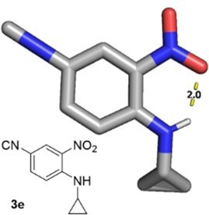
Communications
doi.org/10.1002/ejoc.202101023
- V. Nenajdenko, Isocyanide chemistry: applications in synthesis and material science, John Wiley & Sons, 2012.
- T. M. Vishwanatha, B. Giepmans, S. K. Goda, A. Dömling, Org. Lett. 2020,
22, 5396–5400.
- A. V. Lygin, A. de Meijere, Angew. Chem. Int. Ed. 2010, 49, 9094–9124;
Angew. Chem. 2010, 122, 9280–9311.
- a) X. Wu, J. L. Stockdill, P. K. Park, S. J. Danishefsky, J. Am. Chem. Soc. 2012, 134, 2378–2384; b) Y. Méndez, A. V. Vasco, A. R. Humpierre, B. Westermann, ACS Omega 2020, 5, 25505–25510.
- E. M. Abdelraheem, S. Shaabani, A. Dömling, Synlett. 2018, 29, 1136– 1151.
- S. Javanbakht, A. Shaabani, ACS Appl. Bio Mater. 2019, 3, 156–174. [7] I. Ugi, R. Meyr, Chem. Ber. 1960, 93, 239–248.
- C. G. Neochoritis, T. Zarganes-Tzitzikas, S. Stotani, A. Dömling, E. Herdtweck, K. Khoury, A. Dömling, ACS Comb. Sci. 2015, 17, 493–499.
- W. P. Weber, G. W. Gokel, Tetrahedron Lett. 1972, 13, 1637–1640.
- a) J. Tan, J. J. Grouleff, Y. Jitkova, D. B. Diaz, E. C. Griffith, W. Shao, A. F. Bogdanchikova, G. Poda, A. D. Schimmer, R. E. Lee, J. Med. Chem. 2019, 62, 6377–6390; b) G. A. Molander, Org. React. 2004, 46, 211–367.
- W. Lieke, Justus Liebigs Ann. Chem. 1859, 112, 316–321.
- P. G. Gassman, T. L. Guggenheim, J. Am. Chem. Soc. 1982, 104, 5849– 5850.
- T. Yurino, T. Ohkuma, ACS Omega 2020, 5, 4719–4724.
- a) L. El Kaim, L. Grimaud, A. Schiltz, Org. Biomol. Chem. 2009, 7, 3024– 3026; b) C. G. Neochoritis, S. Stotani, B. Mishra, A. Dömling, Org. Lett. 2015, 17, 2002–2005.
- P. Patil, M. Ahmadian-Moghaddam, A. Dömling, Green Chem. 2020, 22, 6902–6911.
- a) A. Dömling, B. Beck, T. Fuchs, A. Yazbak, J. Comb. Chem. 2006, 8, 872– 880; b) A. Domling, W. Wang, K. Wang, Chem. Rev. 2012, 112, 3083– 3135.
- S. Rohrbach, A. J. Smith, J. H. Pang, D. L. Poole, T. Tuttle, S. Chiba, J. A. Murphy, Angew. Chem. Int. Ed. 2019, 58, 16368–16388; Angew. Chem. 2019, 131, 16518–16540.
- A. Dömling, W. Antuch, B. Beck, V. Schauer-Vukašinović, Bioorg. Med. Chem. Lett. 2008, 18, 4115–4117.
- A. L. Chandgude, A. Dömling, Green Chem. 2016, 18, 3718–3721.
- A. Boltjes, A. Dömling, Eur. J. Org. Chem. 2019, 2019, 7007.
Figure 2. Structure of isocyanide 3e, exhibiting an intramolecular hydrogen bond between the secondary amine and the adjacent nitro group (CCDC 2091122).
The sidechains of the products can be easily varied and a range of functional groups are compatible with the synthesis. The products are solids with essentially none of the unpleasant odor associated with some volatile, low molecular weight isocya- nides. Nonetheless, this novel isocyanide class is very reactive in a number of tested typical multicomponent reactions. It is conceivable that a similar strategy can also lead to other substitution patterns, when starting from different activated phenols.
Acknowledgements
QZ is supported by Chinese Scholarship Council Grant. This project has received funding (to AD) from the NIH (2R01GM097082-05), European Lead Factory (IMI) under Grant Agreement 115489, the Qatar National Research Foundation (NPRP6-065-3-012), the Euro- pean Union’s Horizon 2020 research and innovation program under the Marie Sklodowska-Curie (ITN “Accelerated Early-stage
drug dIScovery”, Grant Agreement 675555; (665250) and PROMINENT (754425)).
Cofunds
ALERT
Conflict of Interest
Manuscript received: August 24, 2021
Revised manuscript received: November 16, 2021
Accepted manuscript online: November 28, 2021
The authors declare no conflict of interest.
Eur. J. Org. Chem. 2022, e202101023 (3 of 3)
© 2021 The Authors. European Journal of Organic Chemistry published by Wiley-VCH GmbH
Keywords: Isocyanide · SNAr · Multicomponent reactions ·
Yields · Synthetic methods

