


Polyhedron 183 (2020) 114530
Synthesis, crystal structure and selected properties of two new peroxidomolybdates
Adrianna Sławin´ ska ª, Paweł Serda ^{b}, Marcin Oszajca ^{b}, Katarzyna Pamin ª, Jan Połtowicz ª,
Wiesław Łasocha ^{a,b,}⇑
a Jerzy Haber Institute of Catalysis and Surface Chemistry, Polish Academy of Sciences, Niezapominajek 8, 30-239 Krakow, Poland
b Faculty of Chemistry, Jagiellonian University, Gronostajowa 2, 30-387 Krakow, Poland
a r t i c l e i n f o
a b s t r a c t
Article history:
Received 6 December 2019
Accepted 23 March 2020
Available online 26 March 2020
Two new oxidoperoxidocompounds with isonicotinic acid N-oxide have been obtained and characterized. Both compounds are oxidodiperoxidomolybdates built with the same isonicotinic acid N-oxide moiety, first one – potassium salt: K(C₆H₄MoNO₈)H₂O (denoted as K-isoO) and the ammonium salt: (NH₄)₂(C₆H₄MoNO₈)₂2H₂O (NH₄-isoO). They were investigated using powder X-ray diffraction (K-isoO) or single crystal (NH₄-isoO) techniques. In addition, they were examined with the use of XRPD versus temperature method, IR spectroscopy and catalytic activity studies. This work is also a continuation of our previous papers and presents a summary of studies of peroxidomolybdates forming inorganic–or- ganic hybrids with pyridine carboxylic acids.
© 2020 The Authors. Published by Elsevier Ltd. This is an open access article under the CC BY-NC-ND license
(http://creativecommons.org/licenses/by-nc-nd/4.0/).
Keywords: Peroxidomolybdates Polyoxocompounds
X-ray crystal structure analysis Thermal decomposition Catalytic oxidation
1. Introduction
activity in terms of cancer cell lines HT29 [9]. In addition, Bijelic et al. [10] published a review article in 2018, where they presented a wide range of different POMs, their antitumor capacity and also proposed mechanisms of the anticancer activity of polyoxometa- lates. In 2017, Wang et al. [11] presented a spectacular article where they claim that pyridinium polyoxometalates work as inhi- bitors against HIV-1 virus and also have a lower toxicity to TZM-bl cells than other currently used methods.
Peroxocompounds are much less known and studied. They pos- sess specific character associated with the properties of one of the substrates, which is hydrogen peroxide. This results in embedding in the structure precursors of reactive forms of oxygen, with the possibility of generating dioxygen in its first excited singlet state (¹O₂), which induces unique properties of materials based on peroxocompounds.
Peroxomolybdates and peroxovanadates have found a wide application in green chemistry as catalysts. Conte and Floris [3] presented a review article about catalytic properties, where they classified peroxocompounds regarding the type of oxidation: oxi- dation of substrates containing sulphur and nitrogen, oxidation of alcohols, oxidation of alkenes. Similar properties were claimed by Dzierbin´ ski et al. [12], where peroxocompounds with Mo, V, W have been used in epoxidation of allyl-alcohol with hydrogen peroxide. In addition, peroxomolybdates have been used in the bleaching process [13]. On the other hand, Nasrin et al. [14] exam- ined peroxomolybdates for metallurgic properties and biological
Peroxidocompounds are
a subgroup of polyoxocompounds
(POMs). POMs are described as clusters of transition metal ions
surrounded by oxygen atoms. Candidates for metal precursors (atoms creating POMs) used should be on the highest degree of oxidation. Metals used the most frequently are tungsten, vana- dium, niobium, tantalum, and molybdenum [1,2]. One way of obtaining peroxocomponds is the reaction of hydrogen peroxide with transition metal precursors [3]. A detailed classification of peroxocompounds was presented by Harald et al. 2007 [4].
There exist many scientific reports on the properties of POMs. They are well known as catalysts, reagents in green chemistry pro- cesses and ingredients of medicines. It has been proven that they possess catalytic properties on olefin epoxidation [5] and oxidation of cyclooctane [6,7]. Interesting biological activity has been found for Keggin-type polyoxometalates containing glycine, where the compound acts as mushroom tyrosinase inhibitors [8]. Moreover, special attention should be given to antitumor capacity, for exam- ple [(C₁₆H₃₃)₂NCONH(CH₂)₃SiNaP₅W₂₉O₁₁₀]¹⁴⁻ hybrid (polyox- ometalate-based organic–inorganic hybrids) have antitumor
⇑ Corresponding author at: Jerzy Haber Institute of Catalysis and Surface
Chemistry, Polish Academy of Sciences, Niezapominajek 8, 30-239 Krakow, Poland.
E-mail address: lasocha@chemia.uj.edu.pl (W. Łasocha).
https://doi.org/10.1016/j.poly.2020.114530
0277-5387/© 2020 The Authors. Published by Elsevier Ltd.
This is an open access article under the CC BY-NC-ND license (http://creativecommons.org/licenses/by-nc-nd/4.0/).
Contents lists available at ScienceDirect

Polyhedron

journal homepage: www.elsevier.com/locate/poly

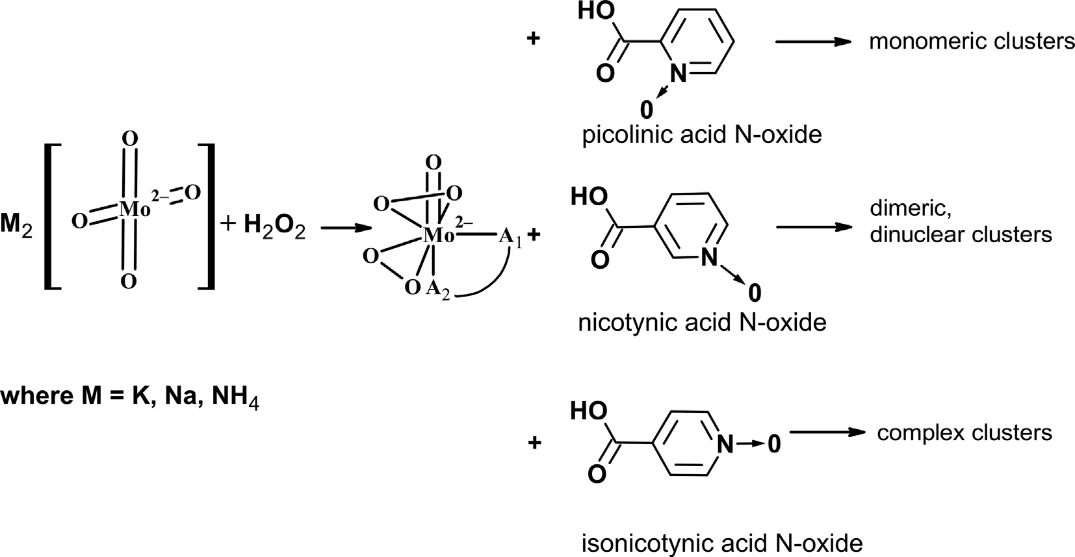
2
A. Sławin´ska et al. / Polyhedron 183 (2020) 114530
activity. Our group also studied catalytic activity and potential of peroxocompounds [7,15–17].
First examinations of oxodiperoxocompounds with pyridine- carboxylic acid were presented in 1988 when Djordjevic et al.
[18] obtained six peroxocompounds based on vanadium(V) and molybdenum(VI) with nicotinic acid and nicotinic acid N-oxide. Our group has conducted similar research for several years now [16]. In particular, we obtained pure phases described by Djordje- vic [18], in the form of single crystals, and we determined their crystal structures [16]. The subsequent goal was to obtain new per- oxomolybdates with different derivatives of pyridine-carboxylic N- oxide acid. Based on our previous work [16,17], we expected that many different peroxidomolybdates can result from the use of var- ious derivatives of pyridine-carboxylic acid.
The main idea of this work is explained in Fig. 1. Starting from an alkaline solution, after relatively mild and quick acidification, we can expect a low degree of polycondensation – the predomi- nance of mono-nuclear or low-nuclear forms – of peroxidomolyb- dates. By adding different pyridine-carboxylic acid isomers, we can expect different forms of inorganic–organic peroxidomolybdates due to the different distances of the potential chelating groups: N (or N ? O) and –COO⁻. In our previous studies we tested com- pounds with picolinic (2-carboxy) or nicotinic (3-carboxy) acid N-oxides (abbreviated as picO and nicO) [16,17], obtaining simple mono-, or cyclic dimeric structures. In the present work we have tested complexes with isonicotinic acid N-oxide (4-carboxy; isoO), expecting more complex dimeric or even polymeric structures.
The purpose of this study is to present two new peroxide-Mo compounds obtained with isonicotinic acid N-oxide, their crystal structure and physicochemical properties based on IR spec- troscopy, thermal decomposition, and their catalytic properties in the reaction of oxidation of cyclooctane. Moreover, this paper will report some general remarks on work already carried out in this area by our group [16,17].
Table 1
Summary of crystal data of the investigated compounds.
Compound code, (XRD technique)
K-isoO (polycrystals)
NH₄-isoO (single crystals)
Chemical formula Chemical formula,
structural* MW (g/mol) T(K)
Wavelength, [Å] Crystal system Cell parameters: a[Å]
b[Å]
c[Å]
a[o]
b[o]
c[o]
V(Å³)
Z, calculated density (g/cm³)
absorption coefficient (mm⁻¹)
F(0 0 0)
theta range limiting indices
C₆H₄K₁Mo₁N₁O₉ K(C₆H₄MoNO₈)H₂O
C6H10Mo1N2O9 (NH₄)₂(C₆H₄MoNO₈)₂2H₂O
369.1
293
CuKa: 1.54184
Monoclinic, P 1 2₁/n 1
350.10
293(2)
CuKa: 1.54184
triclinic, P -1
6.5619(3)
7.1063(3)
12.0469(4)
91.517(3)
96.093(3)
104.610(4)
539.69(4)
1, 2.154
9.2477(3)
19.5475(5)
6.9631(2)
90
111.311(3)
90
1172.65(7)
4, 2.0909
12.775
10.461
720
3.014–74.992
348
3.70–76.98
-7 ::: h ::: 6;
-7 ::: h ::: 8;-8 ::: k ::: 8;
0 ::: k ::: 15; 0 ::: l ::: 5
-15 ::: l ::: 15
reflections collected/ unique
completeness to theta
610
2241/2205
100% (powder sample)
Capillary, calc. for cylindrical sample
n.a. (powder sample)
76.98, 98,2%
absorption correction
Multiscan
maximum and minimum transmission
refinement method data/
5483/38/78
goodness of fit on F2 Final R indices
[I > 2r (I)]
R indices (all data) extinction coefficient Largest difference peak
and hole (eA⁻³) CCDC
1.000; 0.2947
Rietveld
F2 (Fsqd)
restraints/parameters
2241/0/191
3.59
Rp = 4.57, Rwp = 1.59
0.973
R1 = 3.60, wR2 = 10.30
2. Experimental
R_{F} = 6.44
–
–
R1 = 3.55, wR2 = 10.23
None
-1.598; 1.134
1943662
2.1. Materials
1943663
Inorganic chemicals containing molybdenum (K₂MoO₄, (NH₄)₆-
-Mo₇O₂₄-4H₂O – HMA), HCl (conc.), KCl and NH₃aq(conc.) were
*Idealized formula, in K-isoO hydrogen atoms in H₂O were not located.
Fig. 1. The proposed reaction types of oxidodiperoxido-Mo (VI) centers with various pyridine-carboxylic acids N-oxides.

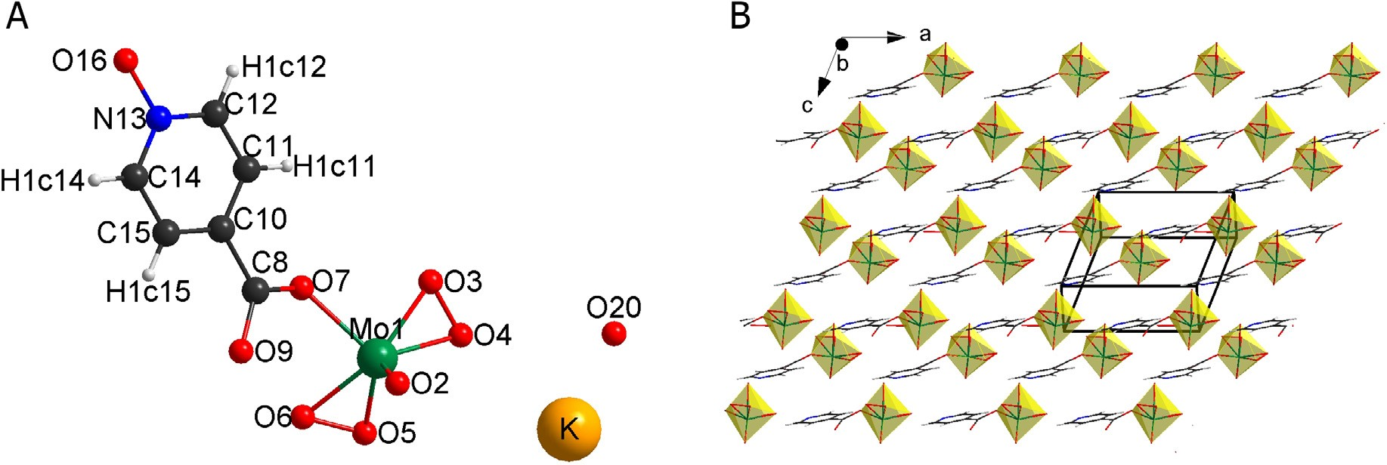
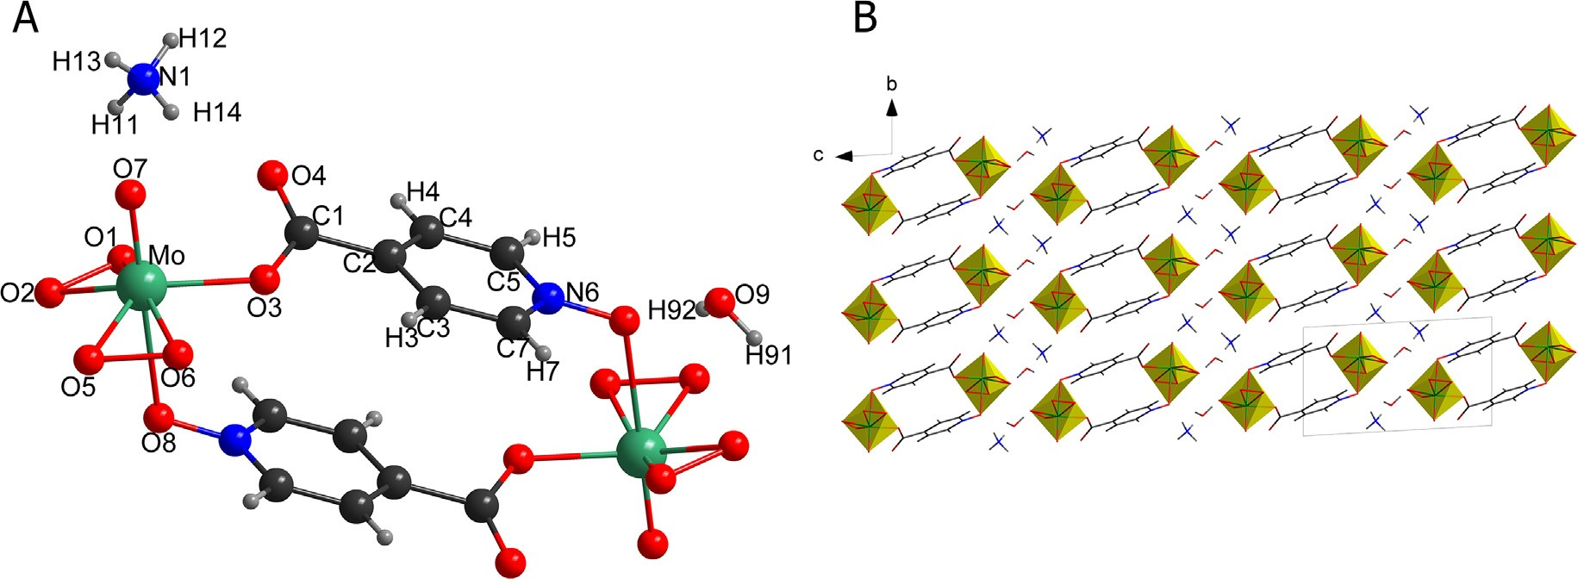
A. Sławin´ska et al. / Polyhedron 183 (2020) 114530
3
purchased from Avantor (formerly POCh Gliwice). Isonicotinic acid N-oxide and H₂O₂ (30%) were purchased from Sigma–Aldrich Corporation.
Potassium [poly-bis(g2-peroxido)oxido-l-(1-oxo-jO-pyridine- 4-carboxylate-jO)]molybdate(VI) hydrate, (K-isoO).
0.02 mol KCl and 0.005 mol K₂MoO₄-H₂O were dissolved in
20 ml of cold H₂O₂. The resulting red solution was acidified by
drops of concentrated HCl until it changed color to yellow. Next
0.005 mol of N-oxide isonicotinic acid was added to the yellow solution which was left for one hour with stirring. Obtained large amount of yellow solid. Yield 94% (1.65 g) C 21.47 (cal. 19.42) H 1.667 (cal. 1.66) N 4.18 (cal. 3.77).
Diammonium [tetrakis(g2-peroxido)dioxido-bis{l-(1-oxo-jO-
pyridine-4-carboxylate-jO)}dimolybdate(VI) dihydrate, (NH₄-isoO).
1.43 mmol HMA was dissolved in 20 ml of cold H₂O₂. To the resulting transparent solution 1 ml of NH₃aq was added. Next, the obtained red solution was acidified by drops of HCl until it changed color to yellow. Subsequent step was the addition of
0.005 mol of N-oxide isonicotinic acid to the solution. Prepared yel- low, transparent solution was left for one hour with stirring. The solution was left to crystallize. Yellow crystals were obtained after 1 week. Yield 87% C 20.42 (cal. 20.58) H 2.844 (cal. 2.88) N 8.22 (cal. 8.00).
2.2. Syntheses
Both compounds were obtained directly during the reaction from water solutions. The first one
K-isoO was obtained immediately (during reaction), while the second one (NH₄-isoO) after ~1 week. Both compounds were syn-
thesized in good yield. Both syntheses were conducted in similar manner as previously described syntheses of similar compounds with nicotinic and picolinic acids [16,17].
Table 2
Selected bond lengths (Å) in the studied compounds.
K-isoO
NH₄-isoO
atom1-atom2
value [Å]
atom1-atom2
value [Å]
Mo—O2 Mo—O3 Mo—O4 Mo—O5 Mo—O6 Mo—O7 Mo—O16 O3—O4 O5—O6 O7—C8 C8—O9 N13—O16
1.629(9)
1.951(15)
2.027(15)
1.918(14)
2.069(13)
2.111(16)
2.51(1)
1.36(2)
1.36(2)
1.39(2)
1.412(19)
1.426(18)
Mo—O7 Mo—O2 Mo—O5 Mo—O1 Mo—O6 Mo—O3
Mo—O8^{i} O2—O1 O5—O6 O4—C1 O3—C1 N6—O8
1.680(3)
1.924(3)
1.940(3)
1.943(3)
1.945(3)
2.059(3)
2.431(3)
1.478(4)
1.479(4)
1.210(5)
1.313(5)
1.333(4)
2.3. X-ray powder/single crystal diffraction data analysis
The X-ray powder diffraction (XRPD) investigations were per- formed for K-isoO and single crystal X-ray diffraction (XRD) for NH₄-isoO. The temperature during measurements was 293(2) K. X-ray powder diffraction data were collected using PANalytical X’Pert Pro MPD diffractometer, and single-crystal data using a
SuperNova (Oxford Diffraction).
High
Score
software
and
the
Fig. 2. (A) The asymmetric unit of K-isoO; (B) packing diagram of K-isoO.
Fig. 3. (A) The asymmetric unit of NH₄-isoO; (B) packing diagram of NH₄-isoO.

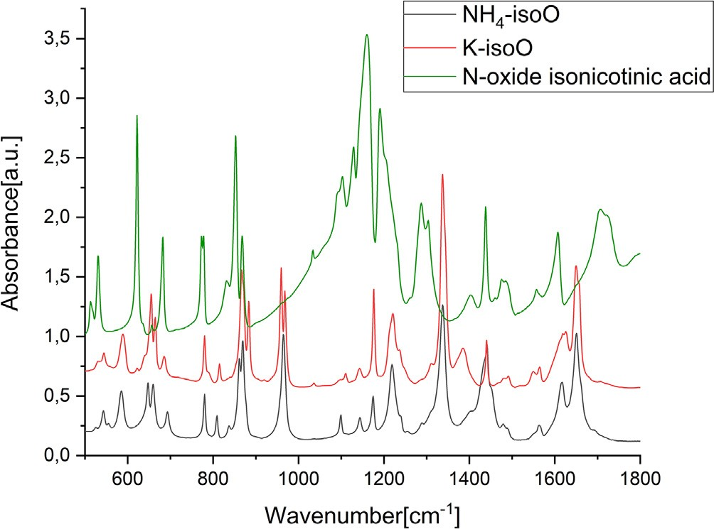
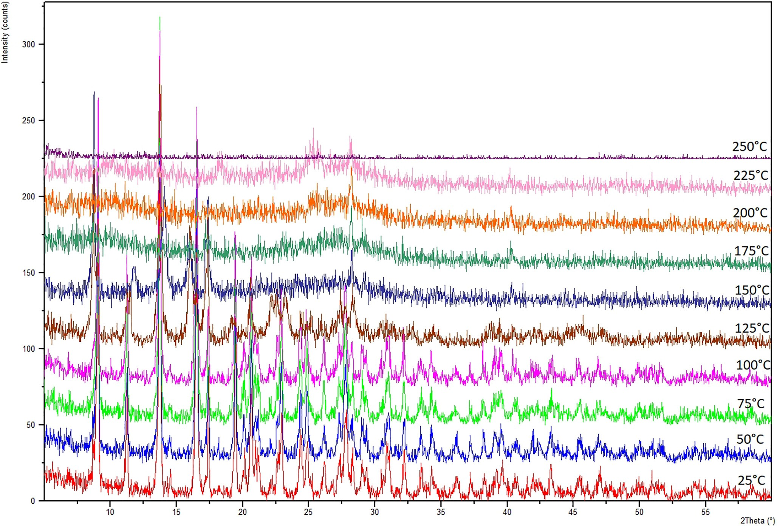
4
A. Sławin´ska et al. / Polyhedron 183 (2020) 114530
Table 3
IR spectra vibrations and band assignments connected with oxodiperomolybdate [15,26] and nicotinic acid N-oxide, picolinic acid N-oxide moiety for compounds [27]. Vs-very strong, s-strong, m-medium, w-weak.
Compound
m(M = O)
msym(OAO)
msym(M-(O)₂)
masym(M-(O)₂)
(N-oxide) vibrations
- K-isoO
- NH₄-isoO
968.03 s, 959.37vs 964.66vs
883.61 s, 867.06vs
869.30vs, 861.43vs, 837.32w
544.27 m
554.97w, 543.16 m, 525.54w
588.72 s,
585.17 s
814.94 m, 484.63w
808.91 m, 485.88w
PDF-4+ [ICDD, 2018] database were used for initial analysis of powder diffraction data.
Structure solution and refinement of NH4-isoO were performed
using SHELXS-97 and SHELXL-2013 programs [19], To find location of hydrogen atoms difference Fourier maps were used. For all non- hydrogen atoms anisotropic refinement was used. Powder diffrac- tion studies were performed using Expo2014 program [20] to locate Mo and K atoms, and FOX [21] to find position and orienta- tion of isonicotinic acid moiety. Finally restrained Rietveld refine- ment was performed with the use of Jana2006 [22]. Detailed crystal structure data for K-isoO and NH₄-isoO are presented in Table 1.
The Diamond [23] and Mercury [24] programs were used for visualization of the crystal structures of the obtained compounds.
2.4. IR measurements
The infrared spectra (IR) were measured on a Bruker VERTEX 70V. Samples were triturated and pressed into the pellets with KBr (1 mg sample for 100 mg KBr). The samples were analyzed
Fig. 4. IR spectra of the compounds NH₄-isoO, K-isoO, and isonicotnic acid N-oxide.
Fig. 5. Thermal decomposition for the compound K-isoO (see text for description).

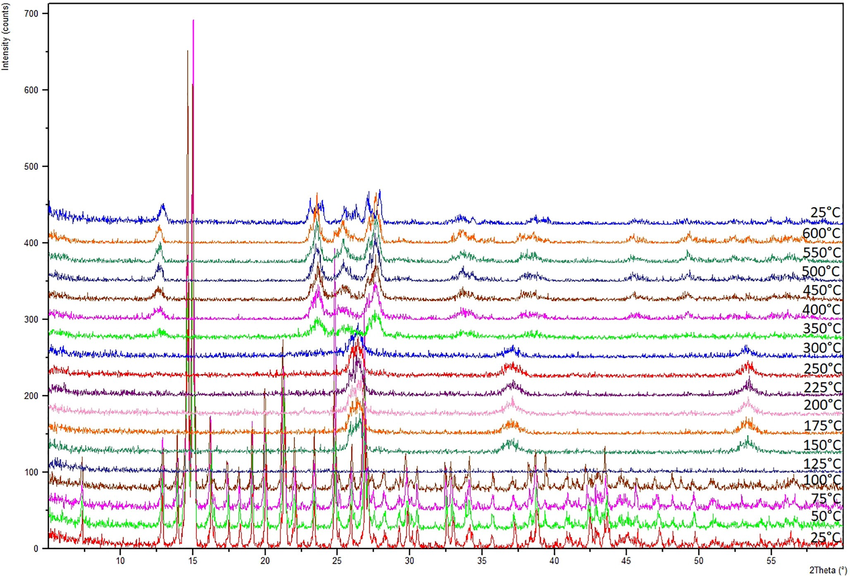
A. Sławin´ska et al. / Polyhedron 183 (2020) 114530
5
at room temperature. The Origin Pro v. 9.1 [25] was used for anal- ysis of IR spectra.
sents selected angles in the investigated
compounds. Rietveld
refinement plots for K-isoO is presented also in SI (Fig. SI-1). K-isoO
structure is presented in Fig. 2 A-B, while NH₄-isoO is shown in
Fig. 3A-B. Both compounds contain the same isonicotinic acid N- oxide building block. Also, both compounds are hydrated potassium and ammonium salts. The essential feature of the first compound is polymeric anion, whereas the second compound is formed by cen- trosymmetric cyclic anions. In both obtained compounds two oxy- gen atoms join the organic part with the inorganic part. The linking oxygen atoms belong to N-oxide group and to carboxylic group (see Fig. 2A and Fig. 3A). In both compounds, pentagonal bipyramids MoO₇ are present. This means that each Mo atom is sur- rounded by seven oxygen atoms. Moreover, two peroxo groups are observed in the equatorial plane of the pentagonal bipyramid. One
apical terminal oxygen atom is observed in each compound (M@O
distance in K-isoO: 1.63(1) Å; in NH₄-isoO: 1.680(3) Å). The Mo atom is moved from the equatorial plane of the pentagonal bipyra- mid by 0.655(3)Å for K-iso and by 0.4228(2) Å for NH₄-iso. The equa- torial plane is twisted with respect to the pyridine ring by 23.9(7)o and 18.38(3)o in compounds K-isoO and NH₄-isoO.
The organic parts are represented by N-oxide-pyridine rings for both cases. p-p interactions are observed for the pyridine frag- ments. The shortest distance between the atoms of neighboring aromatic rings is 3.89(1) Å for K-isoO and 3.269(5) Å for NH₄-isoO. Respectively, distances between centroids of relevant rings are
4.73 and 3.954 Å.
2.5. X-ray thermal decomposition
X-ray thermal decomposition patterns were measured using Philips X’Pert Pro MPD. X-ray data for K-isoO compounds was col- lected at the following temperatures: 25, 50, 75, 100, 125, 150, 175, 200, 225, 250 oC, while for NH₄-isoO the measurements were done at 25, 50, 75, 100, 125, 150, 175, 200, 225, 250, 300, 350, 400, 450,
500, 550, 600 oC and again 25 oC. The 2h range was from 5 to 70o. The heating rate was 5 oC/min, the cooling rate was 10 oC/min.
2.6. Catalytic activity
In this study the oxidation of cyclooctane was performed as pre- viously described [7,16,17]. The experiment was carried out in a stainless steel batch reactor system at 120 oC and under an air pressure of 10 atm. The cyclooctane-to-oxygen molar ratio was set at 6.5. Cooling of the hot reactor took place after 6 h and it stopped the oxidation. The oxidation products cyclooctanone and cyclooctanol were analyzed by an Agilent 6890 N Gas Chro- matograph equipped with an Innowax (30 m) column in the pres- ence of an internal standard (chlorobenzene).
3. Results and discussion
3.1. Crystal structure data
3.2. IR spectra
Detailed crystal data are shown in Table 1. Table 2 presents a list of chosen bond distances, Table SI-1 (Supplementary Material) pre-
The observed IR spectra of both compounds are very similar, especially in the range of <1000 cm⁻¹, which indicates the same
Fig. 6. Thermal decomposition for the compound NH₄-isoO (see text for description).
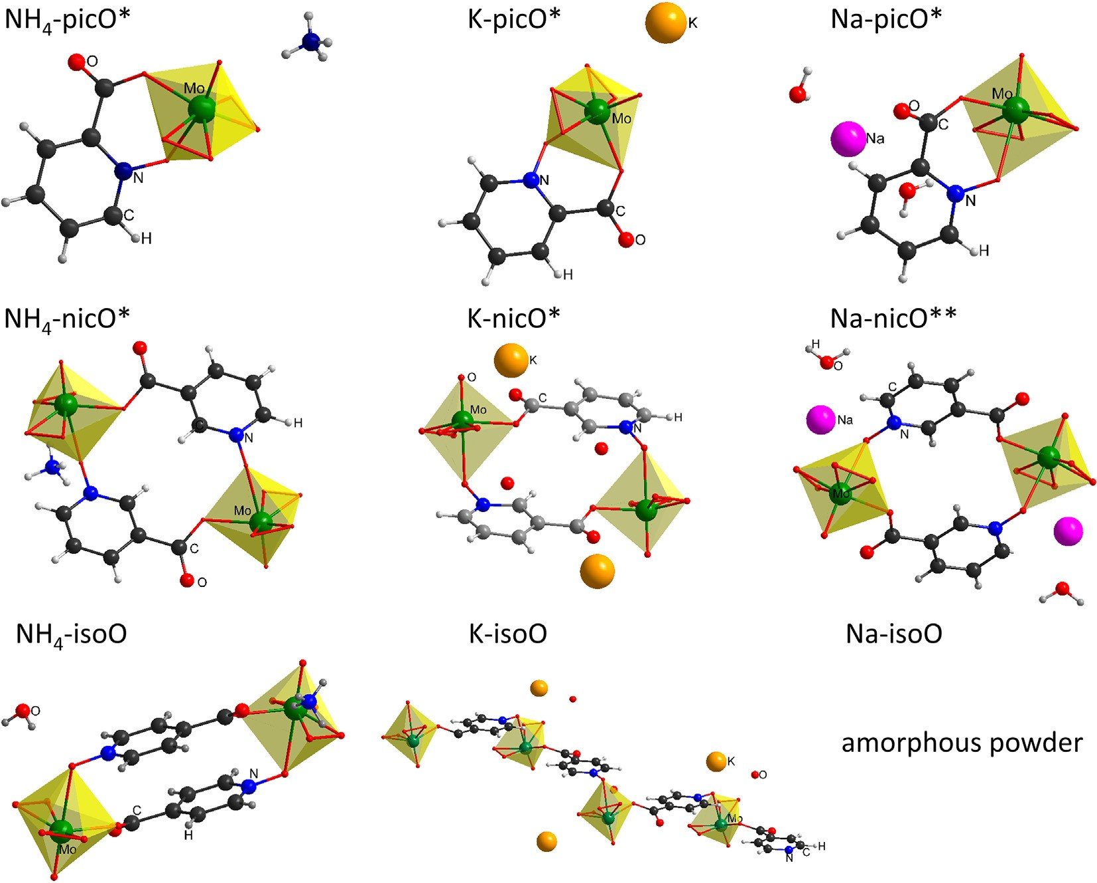
6
A. Sławin´ska et al. / Polyhedron 183 (2020) 114530
structure of the oxidodiperoxido-Mo group Table 3. Some differ- ences, as one can expect, are in the range characteristic for H-bonds. For the sake of comparison, Fig. 4 contains also IR spec- trum of isonicotinic acid N-oxide. Detailed inspection indicates that final products do not contain N-oxide admixtures, though some vibrations are preserved, indicating incorporation of N-oxide moiety into hybrid molecule.
+ 00-032-0671] was formed at 150 oC–300 oC, which finally recrys- tallized into molybdenum trioxide (350 oC–600 oC) [PDF-4+ 04- 004-5433]. This phase (MoO₃) was stable after cooling to 25 oC (Fig. 6). After heating and cooling the sample was a little swollen and a small amount of the sample was lost.
4. Catalytic activity
3.3. Thermal decomposition
In the case of K-isoO, we observed very little catalytic activity. Analogous results were observed for compounds containing Mo
(VI) centers, similar to MoO₃, with a compact structure preventing the penetration of ingredients, not wettable by organic reagents [7]. This may be correlated with the dense polymeric structure of K-isoO. The polymeric structure causes partial blockage of some catalytic centers, they become available only after dissolution of the polymeric material at the compound decomposition step.
NH₄-isoO exhibits relatively high catalytic activity, comparable to the nicotinic acid ammonium complex (NH₄-nicO, see Table 4).
The relation between thermal stability and molecular structure was elaborated on the basis of thermal decomposition investiga- tions. XRPD versus temperature demonstrated the stability of both compounds up to 100 oC. The K-isoO (polymeric structure) decom- posed to new, not identified so far phase ~125 oC. Subsequently, it decomposed to amorphous phase in 250 oC (Fig. 5). After heating and cooling the sample became swollen. The NH₄-isoO (dimeric, without water in Mo coordination sphere) decomposed to the amorphous phase (125 oC), and then molybdenum dioxide [pdf-4
Both
compounds have a very
similar structure, their crystal
Table 4
Oxidation of cyclooctane using molybdenum complexes.
Catalyst number and code
Cyclooctanone [%]
Cyclooctanol [%]
Cyclooctanone + Cyclooctanol
Cyclooctanone/cyclooctanol
- K-isoO
- NH₄-isoO
1.0
29.7
0.8
7.3
1.8
37
1.25
4.07
Examples from previous studies [16,17]
NH₄-nicO K-nicO NH₄-picO K-picO
32.9
5.1
20.2
4.1
18.4
13.6
53.1
9.2
50.4
27.2
1.6
1.2
1.7
1.0
32.0
13.6
Fig. 7. Essential building blocks observed in the family of hybrid oxidodiperoxidomolybdates of pyridine carboxy acids N-oxides. Symbols (*) and (**) indicate results of our earlier investigations: * – [17]; **– [16].

A. Sławin´ska et al. / Polyhedron 183 (2020) 114530
7
structures contain isolated centrosymmetric dimers and two oxidodiperoxido molybdate groups. Very interesting is the high efficiency of the ketone form when NH₄-isoO was used as a catalyst.
An additional conclusion can be formulated as follows: oxi- dodiperoxidomolybdates of ammonium with the same (or closely related) structure as their potassium analogs are much more active in the tested reactions of catalytic oxidation of cyclooctane.
References
- M.T. Pope, Structural chemistry of actinide polyoxometalates, in: Struct. Chem. Inorg. Actin. Compd., Elsevier, 2007, pp. 341–361, doi:10.1016/B978- 044452111-8/50010-7.
- M.H. Dickman, M.T. Pope, ChemInform abstract: peroxo and superoxo complexes of chromium, molybdenum, and tungsten, ChemInform 26 (2010), https://doi.org/10.1002/chin.199505306.
- V. Conte, B. Floris, Vanadium and molybdenum peroxides: Synthesis and catalytic activity in oxidation reactions, Dalt. Trans. 40 (2011) 1419–1436, https://doi.org/10.1039/c0dt00706d.
- H. Jakob, S. Leininger, T. Lehmann, S. Jacobi, S. Gutewort, Peroxo compounds, inorganic, Ullmann’s Encycl. Ind. Chem., Wiley-VCH Verlag GmbH & Co. KGaA, 2007, doi:10.1002/14356007.a19_177.pub2.
- B. Boz_ ek, P. Neves, W. Łasocha, A.A. Valente, Ionic ammonium and anilinium
based polymolybdate hybrid catalysts for olefin epoxidation, Appl. Catal. A Gen. 564 (2018) 13–25, https://doi.org/10.1016/j.apcata.2018.07.001.
- R. Karcz, P. Niemiec, K. Pamin, J. Połtowicz, J. Krys´ciak-Czerwenka, B.D. Napruszewska, A. Michalik-Zym, M. Witko, R. Tokarz-Sobieraj, E.M. Serwicka, Effect of cobalt location in Keggin-type heteropoly catalysts on aerobic oxidation of cyclooctane: Experimental and theoretical study, Appl. Catal. A Gen. 542 (2017) 317–326, https://doi.org/10.1016/j.apcata.2017.05.035.
- A. Szyman´ ska, W. Nitek, M. Oszajca, W. Łasocha, K. Pamin, J. Połtowicz, Molybdenum complexes as catalysts for the oxidation of cycloalkanes with molecular oxygen, Catal. Lett. 146 (2016) 998–1010, https://doi.org/10.1007/ s10562-016-1716-7.
- R. Xing, F. Wang, A. Zheng, L. Wang, D. Fei, Y. Yu, Biological evaluation of two Keggin-type polyoxometalates containing glycine as mushroom tyrosinase inhibitors, Biotechnol. Appl. Biochem. 63 (2016) 746–750, https://doi.org/ 10.1002/bab.1424.
- L. Fu, H. Gao, M. Yan, S. Li, X. Li, Z. Dai, S. Liu, Polyoxometalate-based organic- inorganic hybrids as antitumor drugs, Small 11 (2015) 2938–2945, https://doi. org/10.1002/smll.201500232.
- A. Bijelic, M. Aureliano, A. Rompel, Polyoxometalates as potential next- generation metallodrugs in the combat against cancer, Angew. Chemie - Int. Ed. 58 (2019) 2980–2999, https://doi.org/10.1002/anie.201803868.
- S. Wang, W. Sun, Q. Hu, H. Yan, Y. Zeng, Synthesis and evaluation of pyridinium polyoxometalates as anti-HIV-1 agents, Bioorganic Med. Chem. Lett. 27 (2017) 2357–2359, https://doi.org/10.1016/j.bmcl.2017.04.025.
- A. Dzierbinski, P.J.C. Hausoul, R. Palkovits, V-, Mo-, and W-Containing Peroxometalate-Catalyzed Epoxidation of Allyl Alcohol with Hydrogen Peroxide, Chemie Ing. Tech. 88 (2016) 1387–1387. doi:10.1002/ cite.201650180.
- F. Taube, I. Andersson, I. Toth, A. Bodor, O. Howarth, L. Pettersson, Equilibria and dynamics of some aqueous peroxomolybdate catalysts: A 17O NMR spectroscopic study, J. Chem. Soc. Dalt. Trans. (2002) 4451–4456, https://doi. org/10.1039/b206230e.
- J. Nasrin, M.S. Islam, J. Appl. Sci. 7 (4) (2007) 597, https://doi.org/ 10.3923/jas.2007.597.603.
- M. Grzywa, W. Łasocha, D. Rutkowska-Zbik, Structural investigation of tetraperoxo complexes of Mo(VI) and W(VI). X-ray and theoretical studies, J. Solid State Chem. 182 (2009) 973–982, https://doi.org/10.1016/j. jssc.2009.01.009.
- A. Szyman´ ska, W. Nitek, D. Mucha, R. Karcz, K. Pamin, J. Połtowicz, W. Łasocha, Structural studies and physico-chemical properties of new oxodiperoxomolybdenum complexes with nicotinic acid, Polyhedron. 60 (2013) 39–46, https://doi.org/10.1016/j.poly.2013.05.020.
- A. Sławin´ ska, P. Serda, K. Pamin, J. Połtowicz, W. Łasocha, Synthesis, crystal structure and selected properties of a group of new peroxomolybdates, Polyhedron. 121 (2017) 191–198, https://doi.org/10.1016/j.poly.2016.09.062.
- C. Djordjevic, B.C. Puryear, N. Vuletic, C.J. Abelt, S.J. Sheffield, Preparation, spectroscopic properties, and characterization of novel peroxo complexes of vanadium(V) and molybdenum(VI) with nicotinic acid and nicotinic acid N- oxide, Inorg. Chem. 27 (1988) 2926–2932, https://doi.org/10.1021/ ic00290a007.
- SHEXL-97 Sheldrick G.M., Acta Crystallogr. A64 (2008) 112. SHELXL-2013 (Sheldrick, 2013).
- EXPO2014 [A. Altomare, A. Cuocci, C. Giacovazzo, C. Moliterni, A. Rizzi, R. Corriero N. Falcicchio, A. J. Appl. Cryst. 46 (2013) 1231-1235]
- V. Favre-Nicolin, R.J. Cerny, Appl. Cryst. 35 (2002) 734–743.
- V. Petricek, M. Dusek, L. Palatinus, Z. Kristallogr. 229 (5) (2014) 345–352, https://doi.org/10.1515/zkri-2014-1737.
- K. Brandenburg, Diamond version 3.2g, Crystal Impact GbR, Bonn, Germany, 1997–2001., http://www.crystalimpact.com/diamond.
- Mercury: visualization and analysis of crystal structures, C. F. Macrae, P. R. Edgington, P. McCabe, E. Pidcock, G. P. Shields, R. Taylor, M. Towler and J. van de Streek, J. Appl. Cryst., 39, 453-457, 2006, [doi: 10.1107/ S002188980600731X]
- Origin(Pro), Version 2019b. OriginLab Corporation, Northampton, MA, USA.
- N.M. Gresley, W.P. Griffith, B.C. Parkin, A.J.P. White, D.J. Williams, [NBun,I [(Ph2P02){WO(02)2}21, 0 (1996) 2039–2045.
- A Free Online Spectral Library from Bio-Rad, http://spectrabase.com/ spectrum/1y7LdUsGAgE?a=SPECTRUM_1y7LdUsGAgE (accessed May 14, 2019).
5. Conclusions
To sum up, the knowledge of the family of compounds of pyri- dine carboxy acids with oxidodiperoxido molybdate groups has been extended. In particular, two new oxidodiperoxido molybdate compounds with isonicotinic acid N-oxide were obtained. Their crystal structures were determined from single crystal – NH₄-isoO, and XRPD data – K-isoO. Oxidodiperoxidomolybdenum com- pounds containing isonicotinic acid N-oxide form dimeric cyclic anions – NH₄-isoO, or polymeric structure – K-isoO.
The IR spectra were recorded for both compounds and these examinations have confirmed existing peroxo bonds. The thermal stability has been tested. Both compounds are stable up to 100 oC. The catalytic activities in cyclooctane oxidation reactions were investigated, these activities have been linked to the crystal structure of investigated compounds. The oxidodiperoxidomolyb- dates of ammonium are more active catalysts in comparison with potassium analogs.
All oxidoperoxido molybdate compounds obtained by our group so far are shown in Fig. 7. It can be concluded that COO– and N ? O in ortho positions lead to monomeric complexes, meta position leads to dinuclear complexes and para position leads to either dinuclear or polymeric structures.
Despite many efforts, Na-isoO could not be obtained in crys-
talline form enabling us to perform structural investigations. Fur- ther work aimed at obtaining new oxidodiperoxidomolybdates using pyridine dicarboxy acid blocks is currently in progress.
CRediT authorship contribution statement
Adrianna Sławin´ ska: Conceptualization, Writing - original draft, Investigation, Formal analysis. Paweł Serda: Investigation, Formal analysis. Marcin Oszajca: Investigation, Formal analysis. Katarzyna Pamin: Investigation, Formal analysis. Jan Połtowicz: Investigation, Formal analysis. Wiesław Łasocha: Conceptualiza- tion, Writing - review & editing, Supervision.
Declaration of Competing Interest
The authors declare that they have no known competing finan- cial interests or personal relationships that could have appeared to influence the work reported in this paper.
Acknowledgment
Adrianna Sławin´ ska acknowledges the support of InterDokMed project no. POWR.03.02.00-00-I013/16.
Appendix A. Supplementary data
Supplementary data to this article can be found online at https://doi.org/10.1016/j.poly.2020.114530.

