Revisional notes on the genera Corderopedaliodes Forster and Physcopedaliodes Forster based on adult morphology with the descriptions of new taxa
(Nymphalidae: Satyrinae)
tomasz W. Pyrcz1, Haydon Warren-GasH2 & anna zubek1
1Zoological Museum of the Jagiellonian University, Ingardena 6, 30-060 Kraków, Poland,
298 Over Strand Mansions, Prince of Wales Drive, LondonSW11 4EU, corresponding author: T. Pyrcz, tomasz.pyrcz@uj.edu.pl
abstract. Two genera of Andean satyrine butterflies, Corderopedaliodes Forster and Physcopedaliodes Forster, are reassessed based on a study of adult morphology. Their female genitalia are examined and compared for the first time and their role in providing phylogenetically valuable characters is evaluated. The male genitalia of P. physcoa (HeWitson), the type species of Physcopedaliodes, is re-examined and shown to possess two synapomorphic characters that are unique within the diverse Pedaliodes sensu lato complex, in the form of greatly transformed pedunculus and transtilla. All the species of Corderopedaliodes and Physcopedaliodes are listed and discussed. Pedaliodes symmachus Godman & salvin, previously associated with Corderopedaliodes and Physcopedaliodes, is transferred back to Pedaliodes. Two new species of Corderopedaliodes are described from Colombia and Peru. Pedaliodes pamphos tHieme
n. syn. is considered a subjective junior synonym of Pedaliodes pandates (HeWitson), and the new subspecies C. pandates olivieri n. ssp. is described from the valley of Cosñipata in Cuzco, Peru.
Key words: entomology, taxonomy, Andes, Colombia, Corderopedaliodes buda n. sp., C. lu- zangelae n. sp., C. pandates olivieri n. ssp., ductus bursae, female genitalia, pedunculus, Peru, Physcopedaliodes physcoa, Pronophilina, taxonomy, transtilla.
INTRODUCTION
Genital morphology has played an important role in insect and Lepidoptera tax- onomy in general, and in the Satyrinae subfamily alpha taxonomy in particular for
Genus
Vol. 24(1): 1-28
Wrocław, 30 III 2013
2
TOMASZ W. PyRCZ, HAyDON WARREN-GASH, ANNA ZUbEK
over a hundred years. The importance of male genital structure for the identification of closely related taxa at the specific level has been generally acknowledged, even if some authors have pointed out significant individual variation in some species (Goulson 1993). At the higher subtribe, tribe or subfamily level however, male genital morphology is seldom taken into consideration (miller, 1968). Nonetheless, if used with care, male genitalia structures have proved their value in taxonomical and phylogenetical studies within this subfamily (Pyrcz et al., 2010). Forster (1964) provides a good example of both the benefits and the pitfalls. He relied mostly on male genitalia to identify and describe the characters separating the genera of neotropical Satyrinae and his work remains an important reference for researchers studying this subfamily of butterflies. However the limited scope of his analysis on genital morphology meant that not all the genera he recognised have stood the test of time, leading to several further revisions (eg. adams 1986; Freitas et al. 2006, 2011; viloria 2007).
In contrast, female genitalic characters have proved more significant at higher taxonomical levels, and the three basic morphological ground plans, monotrysian, ditrysian and exoporian, are highly important characters in defining major lepidopteran clades (kristensen, 1999). They are however largely ignored or deliberately omitted in alpha taxonomy, also simply because in many species females remain unknown. Nevertheless, it has been shown, for example for the subtribe Pronophilina, that they are useful in resolving taxonomical and phylogenetical problems (Pyrcz & boyer 2011; Pyrcz et al. 2011a, b).
The genera Corderopedaliodes and Physcopedaliodes belong to the entirely neotropical satyrine subtribe Pronophilina and are two of the many genera separated by Forster (1964) from the diverse genus Pedaliodes butler. They were originally weakly defined based only on adult colour patterns and particularly on some charac- ters of male genital morphology, similarly to other “Forsterian” genera. The lack of supportive characters and errors in the original work of Forster, such as the incorrect drawings of genitalia, made the systematic position of some of his genera extremely difficult to determine (adams & bernard 1977, adams 1986). For example, the genus Steromapedaliodes Forster was described based on male genitalia extracted from an abdomen belonging to a species from a completely unrelated genus, Manerebia staudinGer, glued to the specimen dissected by Forster (viloria & Pyrcz 2002). None- theless, and despite the fact that Forster’s revision had rather weak conceptual basis, many of his generic names were retained by other scientists using more sophisticated phylogenetical methods, including more thorough morphological data (including larval morphology), and cladistic analytical methods (Galindo, unpubl.; viloria, unpubl., 2007; murray & ProWell 2005; marin et al., 2011).
Neither Physcopedaliodes nor Corderopedaliodes have escaped this panorama of systematic turmoil, with the genera being either synonymized, expanded or restricted to an initial monobasic status (lamas et al. 2004). Corderopedaliodes was synonymized with Physcopedaliodes, and Pedaliodes symmachus placed in the latter genus byadams & bernard (1977), based on similarities in male genitalia, in particular the long, thin and uncontorted aedeagus. lamas (2004), based on viloria’s unpublished doctoral dissertation, reinstated Corderopedaliodes as valid genus. Subsequent phylogenetic
3
ON THE GENERA CorderoPedaliodeS AND PhySCoPedaliodeS
studies of Pedaliodes sensu lato (viloria 2007; Galindo unpubl.) confirmed the mono- phyly of this genus but did not clearly resolve the position of Corderopedaliodes or Physcopedaliodes within this generic complex. The two genera were not included by Peña et al. (2006, 2010) in their molecular studies of the Satyrinae phylogeny.
In this article we move a step forward in morphology based taxonomy, providing for the first time a thorough comparative analysis of Corderopedaliodes and Phy- scopedaliodes female genital characters. Thus far, female genitalia of the Pronophi- lina have been relatively poorly studied (Pyrcz 1995; Huertas & arias 2007; Pyrcz & Gareca 2009). This is especially true for the genus Pedaliodes sensu lato, whose female genitalia is s not included in the revisional work by viloria (2007). yet, in the case of the genus daedalma HeWitson, it was demonstrated that the female genitalia of the subtribe Pronophilina provide extremely useful characters also at the infrageneric level (Pyrcz et al. 2011).
The genus Physcopedaliodes is currently considered as monobasic (lamas et al. 2004). The genus Corderopedaliodes hitherto included just three species (lamas et al. 2004), one of which is transferred in this article to Pedaliodes. Here, a third and a fourth species of Corderopedaliodes are described.
MATERIALS AND METHODS
The following abbreviations and collection acronyms were used: FW: forewing; HW: hindwing; V: ventral surface; D: dorsal surface; bMNH: Natural History Museum, London, UK (formerly british Museum (Natural History)) (Ab: Adams bequest, Jb: Joicey bequest, HC: Hewitson Collection, OC: Ockenden Collection; Rb: Rotschild bequest); CPyG: collection of yuvinka Gareca, Santa Cruz, bolivia; HWG: collection of Haydon Warren-Gash, Préssac, France; Ichiro NAKAMURA collection, buffalo, Ny, USA; MbLI: collection of MNaurizio bollino, Lecce, Italy; MHN-UN: Museo de Historia Natural de la Universidad Nacional, bogota, Colombia; MHN-NKM: Museo de Historia Natural Noel Kempff Mercado, Santa Cruz, bolivia; HMNH: Hungarian Natural History Museum, budapest; Mb: collection of Maurizio bollino, Lecce, Italy; USM: Museo de Historia Natural de la Universidad Nacional Mayor de San Marcos, Lima, Peru; MZUJ: Muzeum Zoologiczne Uniwersytetu Jagiellońskiego, Kraków, Poland.; PbF: collection of Pierre boyer, Le Puy Sainte Réparade, France; TWP: collection of tomasz WilHelm Pyrcz, Warsaw, Poland (to be integrated into MZUJ); ZMHb: Zoologisches Museum, Humboldt Universität, berlin, Germany; ZSbS: Zo- ologisches Staatssammlung München, Munchen, Germany. Material studied herein was collected by the first author in Colombia, Venezuela, Ecuador, Peru and bolivia in 1996-2009, and by the second author in Colombia in 2005-2008. Collecting was carried out with entomological nets and Van Someren-Rydon baited traps. Type material was examined in bMNH, ZMHb, MUSM and MZUJ. Additional material was examined in other public and private collections.
Male and female genitalia were dissected according to standard procedures by soaking in a warm 10% KOH solution for 35 min., scales and internal organs were removed in distilled water; genital organs were stained with chlorazole black. Genital
4
TOMASZ W. PyRCZ, HAyDON WARREN-GASH, ANNA ZUbEK
organs were preserved in glycerol vials, and examined, alongside other morphological microstructures, under an Olympus SZX9 stereomicroscope equipped with a Nikon DS-Fi1 digital camera. Adults were photographed with an Olympus E-500 digital camera, and colour plates were composed using Adobe PhotoShop7.0.
SySTEMATIC OVERVIEW
Corderopedaliodes Forster
Corderopedaliodes Forster, 1964: 155 (Type species: Pedaliodes corderoi doGnin, by original designa- tion).
Corderopedaliodes Forster; miller 1968: 114; lamas et al. 2004: 208; Pyrcz 2004: 112; viloria 2007:
9.
Corderopedaliodes Forster; adams & bernard 1977: 277; adams 1986: 308 as synonym of Physcopeda- liodes Forster.
descriPtion: Adults: butterflies of medium size (FW length 25-30 mm) with slight sexual dimorphism, females slightly larger. Antennal club formed gradually. Hairy eyes. Wings: FW subtriangular with rounded tornus and apex, outer margin slightly produced apically, HW oval with outer margin only slightly crenellate, with ocellar elements sometimes present on postdiscal portion of FWV, otherwise entirely absent, postdiscal or submarginal system of conspicuously coloured bands (white or orange); underside wing ripple-patterned. Male genitalia: tegumen regularly domed; uncus robust but always shorter than tegumen; subunci laterally flattened, but well developed; saccus very well developed, relatively thick at base, conical, and longer than tegumen; valvae long, with ampullar process moderately developed near apex, never serrate dorsally; aedeagus (gently curved dorso-ventrally, slightly asymmetrical laterally, broadened at distal extremity). Female genitalia: ductus bursae very long, straight, massive and strongly sclerotized; corpus bursae shorter than ductus without apparent signa; lamella antevaginalis dome like, very wide, entirely covering antrum, papillae anales prominent.
Corderopedaliodes corderoi corderoi (Dognin)
(Figs. 1C, 1D)
[Pronophila porina HeWitson, 1862: 9 (in part misidentification); riley & Gabriel1924: 47].
Pedaliodes corderoi doGnin, 1893: 367-368.Type locality: Riviere Numbala, Ecuador.
Pedaliodes corderoi doGnin; doGnin, 1894: 79, pl. 7, figs. 1, 2; tHieme 1905: 113; d’abrera 1988: 859 (as a synonym of P. porina HeWitson).
Pedaliodes porina (HeWitson) form corderoi doGnin; Weymer 1912: 260, pl. 55, row c.
Pedaliodes porina (HeWitson) var. corderoi doGnin; Gaede 1931: 502.
Pedaliodes porina corderoi doGnin; Gabriel 1932: 13.
Corderopedaliodes corderoi (doGnin); Forster 1964: 155, 156, fig. 194 (male genitalia). Physcopedaliodes corderoi (doGnin); adams 1986: 308 (as a synonym of P. porina HeWitson). Pedaliodes corderio [sic] doGnin; d’abrera 1988: 859.
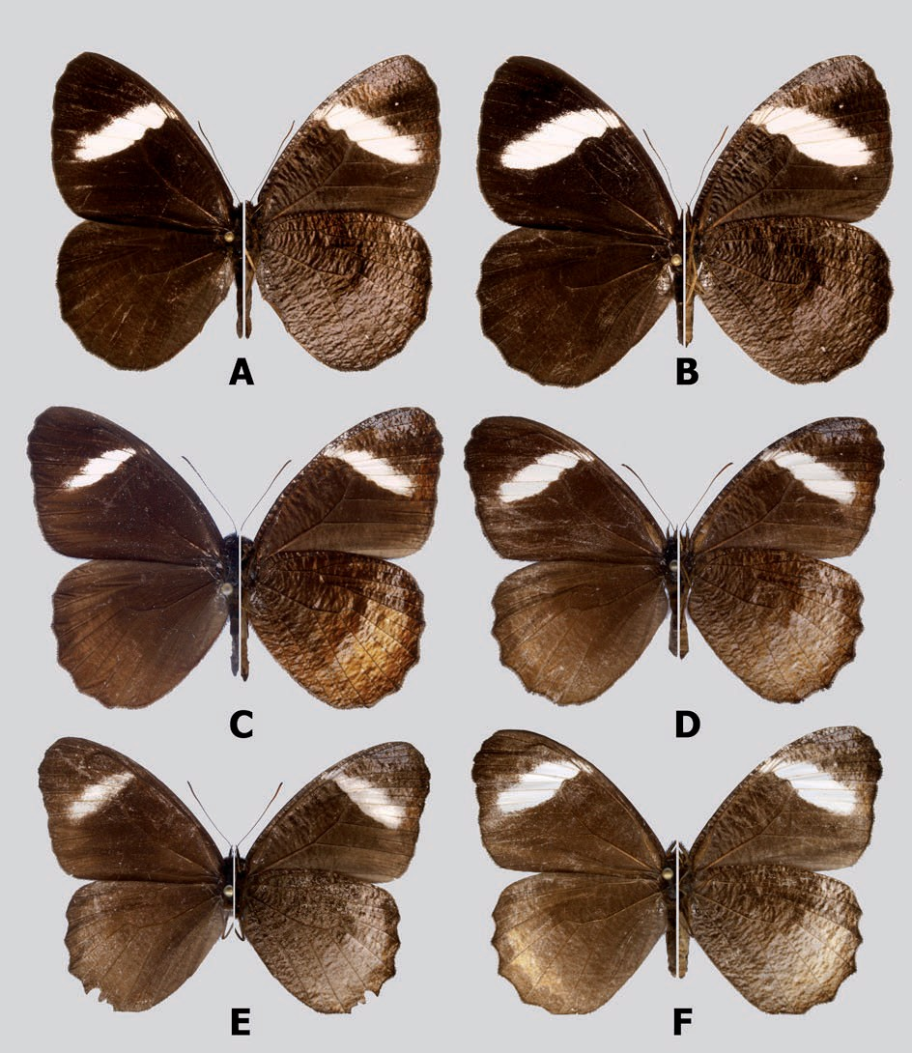
5
ON THE GENERA CorderoPedaliodeS AND PhySCoPedaliodeS
material examined
ECUADOR: 1 ♂ and 1 ♀: Riv. Numbala, 1889, Ex Coll. doGnin 1921, presented by J. J. Joicey, Esq., brit. Mus. 1931-29 [Lectotype and Paralectotype of Pedaliodes corderoi doGnin]; 1 ♂ and 1 ♀: Rivière Numbala, VIII.1885, Abbé Gaujón, Ex Coll. doGnin 1921 [Paralectotypes of P. corderoi doGnin], Jb; 2 ♂ and 1 ♀: [no data], syn- types of Pronophila porina HeWitson, HC; 3 ♂: Ecdr. Ex Grose-smitH 1910, (1 genit. prep. ALV015-96), Joicey bequest; 1 ♀: Cutan, Gomez, G-S; 1 ♀: Ecuador watershed,
1. Adults (left: dorsal; right: ventral): A. Corderopedaliodes luzangelae male, Holotype; b. Corderopedaliodes luzangelae female, Paratype; C. Corderopedaliodes corderoi corderoi male; D. Corderopedaliodes corderoi corderoi femle; E. Corderopedaliodes corderoi exornata male, Holotype; F. Corderopedaliodes corderoi
exornata female, Paratype
6
TOMASZ W. PyRCZ, HAyDON WARREN-GASH, ANNA ZUbEK
Abitagua, 02.X.[19]37; 1 ♂: E. Ecuador, Rio Verde Grande, 5000 ft., I.1912, M. G. Palmer, brit. Mus. 1950-372, BMNH; 1 ♂: Ecuador; 1 ♀: Guacamayas; 1 ♂: Zamora- Chinchipe, Río Sabanilla, 1500-1600 m, 08.XI.1996, A. neild; 1 ♂: Morona-Santiago, Limón-Gualaceo, 1850 m, 03/04.XI.1996, A. neild; 1 ♀: Zamora-Chinchipe, ruta Loja Zamora; 1 ♂: Zamora-Chinchipe, ancienne route Loja-Zamora, 2000 m, 08.II.1993;
b. méry & s. attal; 1 ♂: Vallee du Río Zamora Chinchipe, via El Monje, 1900 m, 13.XII.1996, b. méry & s. attal; 1 ♂ and 1 ♀: [no data]; 1 ♂: Prov. Tungurahua, Río Verde Chico, 2100 m, 24.IX.1995, A. neild; 2 ♂ and 1 female, Prov. Tungura- hua, baños, 1996, local dealer; 1 ♂: Tabaconas, TWP; 1 ♂: Ecuador; 1 ♂: Ecuador, I/II-1873; 1 ♀: Ecuador, “Juanboya” (Huamboya), ZMHb; 1 female, Santa Inés, R. HAENSCH; 5 ♂: Ecuador Or., Napo, Tena, ca. 450 m, VIII.1956, J. Förster, ZSbS; 2
♂ and 1 ♀: Morona-Santiago, Río Abanico, Macas-Riobamba Rd., 1650 m, 28.X.2010,
H. Warren-GasH leg., HWG; 1 ♂: Morona-Santiago, Río Abanico, Macas-Riobamba Rd., 17-18.IX.2011, H. Warren-GasH leg.; 2 ♀: Napo, Cosanga, Las Caucheras track, 2120 m, 10.IX.2011, H. Warren-GasH leg.., HWG; 1 ♀: Morona-Santiago, Macas, 1500 m, 12.XI.1996, H. F. HorsFall, HWG; PERU: 1 ♂: N. Peru, E. slopes of Andes, Charape, vi-1912, Pratt, (wing prep.), Jb; 1 ♂: N. Peru, Manchara, 7000 ft., IX.1912,
A. & E. Pratt, (genit. prep. ALV075-96), Jb, bMNH; 3 ♂ and 2 ♀: N. Peru, River Tabaconas, 6000 ft., 1912, A. E. & F. Pratt, Jb, BMNH; 3 ♂: 12 km W. de La Coipa, CA, 1800 m, 18.III.1985, G. lamas; 1 ♀: same locality, 1700-1900 m, 08.II.1978, G. lamas, MUSM.
remarks
P. corderoi occurs in low to mid-elevation (1400-2100 m) cloud forests from NE Ecuador (and possibly extreme SE Colombia) to N Peru (Pyrcz 2004). Although not uncommon, it is always outnumbered by some of the sympatric Pedaliodes. There is a long history of confusion between this species and Pedaliodes porina (HeWitson) and Pedaliodes paleopolis (HeWitson). All three have a similar upperside pattern marked by an oblique FW subapical white band. However, fresh specimens can eas- ily set from each other apart by the distinctive ripple pattern of the HWV, typical of Corderopedaliodes (adams 1986).
Corderopedaliodes corderoi exornata Pyrcz
(Figs. 1E, 1F)
Corderopedaliodes corderoi exornata Pyrcz, 2004: 112-113, figs. 113, 114, 180. Type locality: Peru, Ama- zonas, Rodríguez de Mendoza, Cedro.
material examined
PERU: 1 ♂ (Holotype): Amazonas, Rodríguez de Mendoza, Cedro, 02.VIII.1998,
b. calderón leg., MUSM; 1 ♀ (Allotype): Peru, Amazonas, Rodríguez de Mendoza, Cedro, 2000-2300 m, VII-VIII.1998, T. Pyrcz leg.; 1 ♂: Peru, Amazonas, Rodríguez de Mendoza, Qda. Pirruro, 28.VIII.1998, T. Pyrcz leg.; 1 ♀: Rodríguez de Mendoza, Cedro, 2200 m, 16.XII.1998, b. calderón; 1 ♀: Rodríguez de Mendoza, Cedro, 2000-
7
ON THE GENERA CorderoPedaliodeS AND PhySCoPedaliodeS
2300 m, VII-VIII.1998, T. Pyrcz leg., TWP; 1 ♀: Qda. Totomal, near Rodríguez de Mendoza, 16.X.1998, b. calderón leg. MBLI (all Paratypes).
remarks
C. corderoi exornata was described from N Peru (Amazonas). It is so far known only from the type locality (Rodríguez de Mendoza) and neighbouring localities, and its distribution remains little known. To the north its limit is defined by the Huanca- bamba – Chamaya valley, however it is unknown how far it extends to the south. To our knowledge, no specimen of C. corderoi has yet been found in the central Peruvian departments of Huánuco and Pasco, even though the elevation band where it flies has been quite well sampled. It is distinguished from the nominotypical subspecies by the smaller oblique subapical white band, suffused with brown scales spreading from the edges towards its central part, and in the female by the yellowish suffusion of the HWD in distal two thirds, not apparent in nominotypical. The male genitalia were illustrated and described in the original description (Pyrcz 2004).
Corderopedaliodes buda Pyrcz, n. sp.
(Figs. 2F, 6b)
tyPe locality
Peru, Chanchamayo.
material examined
PERU: Holotype (male): Peru, Chanchamayo, V.1937, coll. velez, 251/212, prep. genit. T. Pyrcz, HnHm.
diaGnosis
Upperside entirely brown without any trace of FW subapical oblique white band allows its immediate recognition from C. pandates and indeed from C. corderoi, from which it differs also in the light chestnut, glossy shade of FW and HWD, not found in any examined specimen of the latter species HWV pattern similar to C. pandates. Male genitalia more similar to C. corderoi than to C. pandates, particularly in the slender valva, differing only in the more prominent dorsal process on the valva.
descriPtion
Male (Fig. 2F): Head: Antennae reaching one-fifth length of the costa, slender, naked, dorsally brown, ventrally orange brown, club formed gradually, slightly thicker than shaft, composed of 11 segments, dark brown. Eyes chocolate brown, lustrous, covered with dense, black hair. Labial palpi two times longer than the head, covered laterally with longer chestnut and brown and dorsally with shorter sandy yellow hairy scales. Frons with a tuft of long, chestnut hair. Thorax: Dorsally black, patagium, tegulae and prothothorax covered long, black and yellow hairy scales, otherwise mostly naked; ventrally brown; legs brown, tibiae covered with hairy black and yellow hair, femora and tarsi with brown and sparse yellow scales. Abdomen: black, basal segments hairy,
8
TOMASZ W. PyRCZ, HAyDON WARREN-GASH, ANNA ZUbEK
dorsally mostly naked covered with short, and sparse black hairy scales, denser later- ally, ventrally covered with dense chestnut and yellow scales; Wings: FWD (length: 27 mm) uniform chestnut, lustrous, basal and apical areas and along distal margin a shade darker; fringes chestnut; HWD uniform chestnut, lustrous, basal half hairy; fringes chestnut; FWV chestnut overcast with a layer of darker brown ripple pattern except from the area between vein Cu1 to anal margin, a faint lighter area in subapical area made of sparse sandy yellow scales, a suffusion of lilac scales in subapical area along costa, apical area along distal margin darker brown. HWV chestnut with a heavy layer of darker brown ripple pattern, postdiscal to submarginal area noticeably lighter, sandy yellow, and with some magenta scales in subapical area, a minute whitish sub- marginal dot in Cu1-Cu2. Male genitalia (Fig. 6b): Uncus stout, nearly straight with the tip slightly curved downwards, 4/5 the length of tegumen dorsum; subunci stout, approximately half the length of uncus; pedunculus small, as a short tip; valve slender, approximately the length of tegumen+uncus, with a stout but short dorsal process and a blunt apex; saccus deep, one and one-fourth the length of uncus; aedeagus long, ¼ longer than saccus+valve, flattened laterally, slightly arched, not contorted, gradually widening from proximal towards apical ending, proximal opening ¼ the length of aedeagus, apex with a short serrate surface.
Female: Hitherto unknown.
etymoloGy
This species is named after “buda”, one of the cities that originally made up the capital of Hungary, budapest, in recognition of the contribution of the Hungarian Natural History Museum to the research on the subtribe Pronophilina, and because the type of this taxon is deposited in that institute.
remarks
This species is described based on a single individual. It comes from the zsiGmond velez’s collection, who was the curator of the Hungarian Natural History Museum and had his own butterfly collection. There are several reasons to recognize this taxon. The all brown wings upperside and the lighter chestnut is diagnostic and is not found in any of the many examined specimen of C. corderoi from the entire geographic range of this species. Some morphological characters of C. buda are clearly intermediate between
C. corderoi and C. pandates. The HWV colour pattern is reminiscent of C. pandates, whereas the male genitalia relate it to C. corderoi. This agrees with the collecting local- ity of C. buda which fills the distribution gap between C. corderoi found in N Peru and
C. pandates occurring in S Peru. Although the valley fo Chanchamayo has been rather well sampled for butterflies, the fact that no other specimen of this species was collected so far is not surprising because with every collecting expedition more new taxa are being found in this extremely species-rich region of the Andes. Also, C. buda, if it shares the ecological preferences of its congeners, occurs in the lower altitudinal section of cloud forests, which is heavily affected by intensive agriculture in the Chachamayo valley which must affect its habitats, and consequently the size of its population.
9
ON THE GENERA CorderoPedaliodeS AND PhySCoPedaliodeS
Corderopedaliodes luzangelae Pyrcz & Warren-gash, n. sp.
(Figs. 1A, 1b, 6A, 7)
tyPe locality
Colombia, Santander, Corcova.
material examined
COLOMBIA: HOLOTyPE ♂: Santander. La Corcova, 2150 m, 08.VI.2008,
H. Warren-GasH leg., prep. genit. 04/06.08.2008, T. Pyrcz, MZUJ; Paratypes (7♂ and 9 ♀): 1 ♀: Colombia, Santander, La Corcova, 2150 m, 08.VI.2008, H. Warren- GasH leg. MZUJ; 1 ♀: same locality and collector, 16.II.2008, MZUJ, prep. genit. 02/31.03.2008, T. Pyrcz, MZUJ; 2 ♀: same data; 1 ♂: same locality and collector, 2150 m, 08.VI.2008, prep. genit. 08/21.09.2009, T. Pyrcz, MZUJ; 2 ♂: Santander, La belleza, S-M, VIII.1980, ex coll. adams & bernard, bMNH; 1 ♂ and 2 ♀: Santander, Corcova, 2150 m, 08.VI.2008, W. Warren-GasH leg., HWG; 2 ♂ and 3 ♀: same data but 16.II.2008, HWG; 1♂: Cesar, Gonzalez, Vda. San Cayetano, 23.VI.2007, H. Pulido leg., 2064, MHN-UNC.
diaGnosis
Distinguished from P. corderoi by the darker, blackish brown upperside colour, and the larger size of the FW subapical oblique white patch, marginally entering the discal cell, which it does not in P. corderoi.
descriPtion
Male (Fig. 1A): Head: Antennae reaching one-fifth length of the costa, slender, naked, dorsally brown, ventrally orange, terminal segments black, club formed gradu- ally, slightly thicker than shaft, composed of 11 segments. Eyes chocolate brown, lustrous, covered with dense, black hair. Labial palpi two times as long as the head, covered with dark brown and sandy yellow hairy scales, ventrally long, laterally and dorsally short, predominantly sandy yellow. Frons with a tuft of long, dark brown hair. Thorax: Dorsally black, patagium and tegulae covered long, chocolate brown hairy scales, otherwise mostly naked; ventrally brown; legs brown, tibiae and femora covered with brown scales and sparse, yellow hair, tarsi ventrally densely covered with sandy yellow scales. Abdomen: black, covered with dense dark brown black scales and blackish hair, ventrally beige. Wings: FW length 27-28 mm, n=2. FW apex subacute, outer margin concave; HW rounded with gently undulated outer margin. FWD black- ish brown, a 4-5 mm wide oblique postdiscal patch extending from costa to vein Cu1 near outer margin with a sharp, nearly straight inner edge except for a little undulation along discal cell, and a somewhat more diffused but equally straight outer margin. Fringes steely brown. HWD uniform blackish brown, hairy in basal and postbasal area. Fringes steely brown. FWV dark brown, a shade lighter than on the upperside; white postdiscal patch shaped as on the upperside; dusted with ripple pattern made of blackish and milky white scales in discal cell and distally from white patch, some lilac scaling apparent in apical area and along costa; three minute white submarginal dots
10
TOMASZ W. PyRCZ, HAyDON WARREN-GASH, ANNA ZUbEK
in spaces M1-M2, M2-M3 and Cu1-Cu2. HWV milky white overcast over the entire surface with a heavy ripple pattern of brown, denser in median and postdiscal area where forming a diffuse band extending from mid-costa to vein Cu2, marginal area dark brown, a series of minute, barely noticeable white submarignal dots from Rs-M1 to Cu1-Cu2, only the latter being always apparent. Male genitalia (Fig. 6A): Uncus stout, nearly straight with the tip slightly curved downwards, 4/5 the length of tegument dorsum; subunci stout, approximately half the length of uncus; pedunculus small, as a short tip; valve elongated, approximately the length of tegumen+uncus, with a massive, blunt dorsal process and a blunt apex; saccus deep, approximately the length of uncus; aedeagus very long, ¼ longer than saccus+valve, flattened laterally, slightly arched, not contorted, gradually widening from proximal towards apical ending, proximal opening
¼ the length of aedeagus, apex with a short serrate surface.
Female (Fig. 1b): Sexual dimorphism very slight except for the marginally larger size of the female (FW length 30 mm, n=2), its darker HWV ground colour, and the FWV submarginal white dots ringed with black. Female genitalia (Fig. 7): bursa copulatrix rounded, small, without any apparent signa, ductus bursae straight, approximately two times the length of bursa, wide and strongly sclerotized, lamella antevaginalis large, dome like, papillae anales prominent with a broad apophyse posterior (an egg is vis- ible on the photograph).
etymoloGy
This species is dedicated to Luz Angela Galindo, a Colombian entomologist whose Master degree dissertation was concerned with the phylogeny of the Pedaliodes complex.
remarks
Although C. luzangelae is closely allied to C. corderoi it is considered as a sepa- rate species rather than a subspecies of the latter for several reasons. Morphological differences, in both the wing shape and colour pattern are clear cut. The phenotype of
C. luzangelae is stable enough throughout the whole range of the species, and there is no evidence of any cline or intermediate populations. There is a distribution gap between the two species, one being known from the northern part of the Colombian Eastern Cordillera, including its Venezuelan extension, the Tama range, and the Sierra de Perijá, and the other, C. corderoi, as far north as Cosanga in Ecuador, although its possible presence in extreme southern Colombia is not unlikely. Also, the two spe- cies have somewhat different habitat specialization, which is reflected in the covered altitudinal band. All known individuals of C. luzangelae come from elevations above 2000 m, whereas C. corderoi most frequently occurs some 500 m lower.
Corderopedaliodes pandates pandates (heWitson)
(Figs. 2C, 2D, 2E)
Pronophila pandates HeWitson, 1874: pl. 30, figs. 61, 62. Type locality: bolivia
Pronophila pandates HeWitson; HeWitson 1874: 12; kirby 1879: 114; riley & Gabriel 1924: 43; HayWard 1958c: 70 (as a synonym).
11
ON THE GENERA CorderoPedaliodeS AND PhySCoPedaliodeS
Pedaliodes pandates (HeWitson); kirby 1877: 709; tHieme 1905: 128-129; Weymer 1912: 262; Gaede 1931:
493; HayWard 1958: 70, 71, fig. 40 (male genitalia); d’abrera 1988: 864, figs.
Corderopedaliodes pandates (HeWitson); Forster 1964: 156, fig. 193 (male genitalia, erroneous); leWis
1973: 56, 233, fig. 8; lamas et al. 2004: 208.
Physcopedaliodes pandates (HeWitson); adams & bernard 1977: 277; adams 1986: 308. Pedaliodes pamphos tHieme, 1905: 129. new syn. Type locality: yungas de La Paz, 3000 m, bolivia. Pedaliodes pandates (HeWitson) form pamphos tHieme; Weymer 1912: 262, pl. 56, row a.
Pedaliodes pandates (HeWitson) var. pamphos tHieme; Gaede 1931: 493.
Corderopedaliodes pamphos (tHieme); Forster 1964: 157. Physcopedaliodes pamphos (tHieme); adams & bernard 1977: 277. Pedaliodes pamphos tHieme; d’abrera 1988: 864, figs.
material examined
BOLIVIA: 1 ♀: [?], bolivia, HC bMNH type No. Rh. 4022 [Lectotype of Pro- nophila pandates HeWitson, herein designated]; 1 ♂ and ♀: bolivia, [Paralectotypes of Pronophila pandates HeWitson, herein designated], HC; 1 ♂ and 1 ♀: Coroico, 5400 feet, Ab; 1 ♂ and 1 ♀: bolivie, Ex Germain, Ockenden Collection; 1 ♂: bolivia, Ex Grose-smitH 1910, (genit. prep. Angel Luis Viloria 077-96), Jb; 1 ♂: yungas, Ex Grose-smitH 1910, Jb; 2 ♂: Prov. yungas, Rio Songo, II/V.1896, Ex staudinGer, OC; 1 ♂: Prov. yungas, Rio Songo, Rb; 2 ♂: R. Songo to R. Suapi, 1100 m, III/IV.[18]96, GarlePP, Rb; 1 ♂: [no data], Rb; 3 ♂ and 1 ♀: (yunga del Espiritu Santo), Cochabamba, 1888-89, P. Germain, OC; 1 ♂: bolivia, Ex Coll. Ed brabant 1920, bMNH; 2 ♂: Rio Songo, 1895-96; 1 ♂: La Paz [?], Rio Suapi, 1000 m, 1895-6, GarlePP; 1 ♀: Coroico, 1895-6, GarlePP, ZMHb; 1 ♂: yungas del Palmar, 2000 m, 05.V.1948, R. ziscHka; 1 ♀: same data, 1000 m, 05.V.1950; 2 ♂: same locality, XI.1954, R. scHönFelder; 1
♀: same data, IX.1948; 1 ♂: Alto Palmar, Chapare, 1100 m, IV.1959 [ZSbS]; 1 ♂: Depto. Cochabamba, Prov. Carrasco, Villa Tunari – Locotal, 1400-1450 m, 12.II.2009,
T. Pyrcz & y. Gareca, leg., TWP; 1 ♂: Depto. Cochabamba, via Cochabamba, 1270 m, VIII.2000, T. Pyrcz leg., prep. genit. 09/21.09.2009 T. Pyrcz, TWP; 1 ♂: yungas de La Paz, 3000 m [“Lectotype” of Pedaliodes pamphos tHieme, designated by vilo- ria, unpublished PhD thesis], Rb; 1 ♂ and 1 ♀: yungas, Jb; 1 ♂: La Paz, 1000 m, GarlePP, Jb; 1 ♂: bolivia, GarlePP, Jb, bMNH; PERU: 1 ♂ and 1 female: E. Peru, Marcapata, 4500 ft., Rb; 1 ♂: Marcapata, Caradoc, 4000 ft., II.[19]01, (ockenden), (genit. prep. ALV076-96), Rb; 1 ♂: Carabaya, S. Domingo, 6000 ft., v/vi-[19]01, dry s., (G. ockenden), Rb; 1 ♀: same data, VII/VIII.[19]01, bMNH.
remarks
Corderopedaliodes pandates occurs in low elevation cloud forests from Coch- abamba in central bolivia to Cuzco in southern Peru. It is generally uncommon. The female is very rare and only a couple of specimens are known. TWP observed it once along the Villa de Tunari – Cochabamba road at 1150 m sunning itself at 3 m above the ground, after an afternoon shower. It is similar to the male except for being paler on both dorsal and ventral surface. Males come to bait traps alongside much more common Pedaliodes peregrina viloria & Pyrcz and other pedaliodines.
Pedaliodes pamphos tHieme was described as a species on its own right dis- tinguished from P. pandates by the smaller size and orange markings on the FWD.
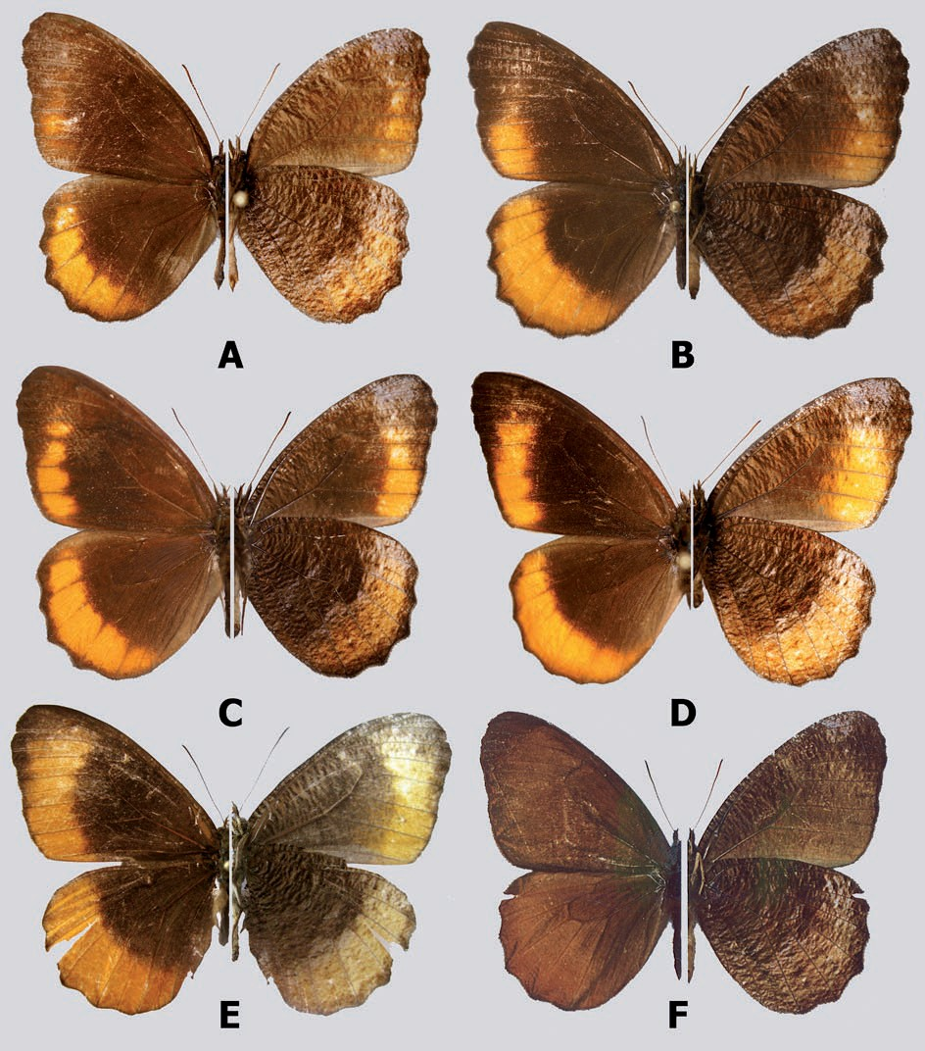
12
TOMASZ W. PyRCZ, HAyDON WARREN-GASH, ANNA ZUbEK
Weymer (1912) was the first author to suggest than pamphos is merely an individual form of P. pandates. This suggestion is strengthened by the fact that pamphos was described from the yungas de La Paz, where also typical, wide banded specimens of
C. pandates occur. Individual variation in the expression of orange markings is actually considerable in C. pandates throughout its range in bolivia and there is an observable geographical clinal pattern towards larger patches in the south of its distribution (south of Cochabamba). Thus, Pedaliodes pamphos n. syn. is herein considered a subjective junior synonym of Pedaliodes pandates HeWitson.
2. Adults (left: dorsal; right: ventral): A. Corderopedaliodes pandates olivieri male, Holotype; b. Cordero- pedaliodes pandates olivieri female, Paratype; C. Corderopedaliodes pandates pandates male; D. Cordero- pedaliodes pandates pandates male; E. Corderopedaliodes pandates pandates female; F. Corderopedaliodes
buda male, Holotype
13
ON THE GENERA CorderoPedaliodeS AND PhySCoPedaliodeS
Corderopedaliodes pandates olivieri Pyrcz, n. ssp.
(Figs. 2A, 2b, 9b)
tyPe locality
Peru, Cuzco, Cosñipata valley.
material examined
PERU: Holotype (♂): Cuzco, Patria vers Acjanaco, Vallée de Cosñipata, 1500-2500 m, 18.VII.2000, O. duviols leg., PbF (to be deposited in MZUJ); 1 paratype ♀: Cuzco, Patria vers Acjanaco, Vallée de Cosñipata, 2000-2500m, 18.IV.2005, O. duviols leg., PbF; 1 ♂: Cusco Region, Rio Cosñipata valley on Rd to Pillcopata, downriver from San Pedro, 1385-1200 m, 13o02’01’’S, 71o31’32’’W, 16.XI.2009, I. & M. NAKAMURA
leg., IMC (to be desposited in Smithsonian Institution, Washington D.C, USA).
diaGnosis
Recognized from the nominate subspecies by the considerably smaller FWD orange patch, restricted to tornal area, and marginally extending into cell M3-Cu1.
descriPtion
Male (Fig. 2A): Head, thorax and abdomen as in the nominate subspecies. Wings: FW length 27 mm. FW apex blunt, outer margin slightly undulated below apex; HW rounded with a gently undulated outer margin. FWD brown, slightly darker in median area; a diffuse orange submarginal patch gradually wider and more intense in colour from M3 to tornus. Fringes brown. HWD brown, hairy in basal and postbasal area; a 4-5 mm wide orange submarginal band extending from apex to tornus, not reaching the darker brown margin. Fringes brown. FWV chestnut, somewhat lighter than on the up- perside; dusted with ripple pattern made of dark brown scales particularly prominent in discal cell and in apical area where suffused with lilac; three minute white submarginal dots in spaces M1-M2, M2-M3 and Cu1-Cu2. HWV chestnut overcast over the entire surface with a heavy ripple pattern of brown, denser in median and postdiscal area; submarginal orange band reflected from the upperside, marginal area darker brown. Male genitalia: not examined.
Female (Fig. 2b): Sexual dimorphism slight except for the slightly larger size (FW length: 29 mm), larger FWD orange patch, wider HWD submarginal band, and darker brown HWV ground colour with less prominent ripple pattern. Female genitalia: not examined.
etymoloGy
This subspecies is dedicated to its collector, a French lepidopterist, olivier du-
viols.
remarks
Even though, as stated above, the shape and the size of the orange patch on the FWD presents considerable individual variation in the examined individuals of C. pan- dates from bolivia, the population occurring in the Cosñipata valley in southern Peru
14
TOMASZ W. PyRCZ, HAyDON WARREN-GASH, ANNA ZUbEK
deserves a separate subspecific status. The subspecies olivieri is the local northernmost population of C. pandates geographically well separated from the bolivian populations and occurring in an area of high endemism (Pyrcz et al. 2010).
The Vilcanota range separating the valleys of Cosñipata and Urubamba has been recognized as an important zoogeographical barrier, in particular for the species of the genus Pedaliodes sensu lato (Pyrcz et al. 2010). So far, no individual belonging to Corderopedaliodes was collected in the wide geographical region of the Andes spreading between the valleys of Urubamba and Apurímac which is probably in part due to the particularly severe destruction of cloud forest areas within the elevational band inhabited by the species of this genus.
Physcopedaliodes Forster
Type species: Pronophila physcoa HeWitson, 1862.
Physcopedaliodes Forster, 1964: 152-153
Physcopedaliodes Forster; miller 1968: 116; adams 1986: 307, 317; FeltWell 1993: 195; viloria & Pyrcz
1994: 347, 349; lamas et al. 2044: 214.
[Corderopedaliodes Forster; adams & bernard 1977: 277; adams 1986: 308 (as a synonym)].
descriPtion: Adults. butterflies of medium size (25-32 mm), with slight sexual dimorphism. Antennal club gradually formed. Eyes hairy. FW subtriangular, with rounded apex, outer margin slightly undulate; hindwing suboval, moderately scallo- ped. Androconial patches restricted to discal area of forewing upperside, very diffuse and difficult to detect without optical magnification. Ocellar elements absent. Single orange marking on posterior half of forewing. Male genitalia: tegumen low domed, below maximum elevation of uncus; uncus thick and strongly curved downwards, although not much longer than tegumen; subunci very small, pedunculus paddle like very prominent; transtilla heavily sclerotised to form a terrace between subunci; sac- cus exceedingly long, thin, straight, and tubular (twice as long as tegumen+uncus); aedeagus even longer than saccus (2x), about same thickness, straight, tubular, but slightly compressed laterally at proximal opening. Female genitalia: bursa copulatrix rounded, only gently elongated, signa present but very short, comma- shaped; ductus bursae strongly sclerotized, very long, 1 and ¼ longer than corpus bursae, slightly flattened and widened before the entering to bursa copulatrix; ductus seminalis opens to the ductus bursae just before corpus bursae; lamella antevaginalis large, dome like; papillae anales prominent.
Physcopedaliodes physcoa physcoa (heWitson)
(Figs. 3A, 3b)
Pronophila physcoa HeWitson, 1862: 5, pl. 3, fig. 17.Type locality: bolivia.
Pronophila physcoa HeWitson; HerricH-scHäFFer 1865: 66; kirby 1879: 113; riley & Gabriel 1924: 46.
Pedaliodes physcoa (HeWitson); butler 1867: 267; 1868: 177; kirby 1871: 105; scudder 1875: 243;
staudinGer 1887: 233, pl. 84; Weeks 1905: 17; tHieme 1905: 126; Weymer 1912: 262; Gaede 1931:
499; leWis 1973: 62, 234, fig. 12; d‘abrera 1984: 129, fig.; 1988: 863, fig.
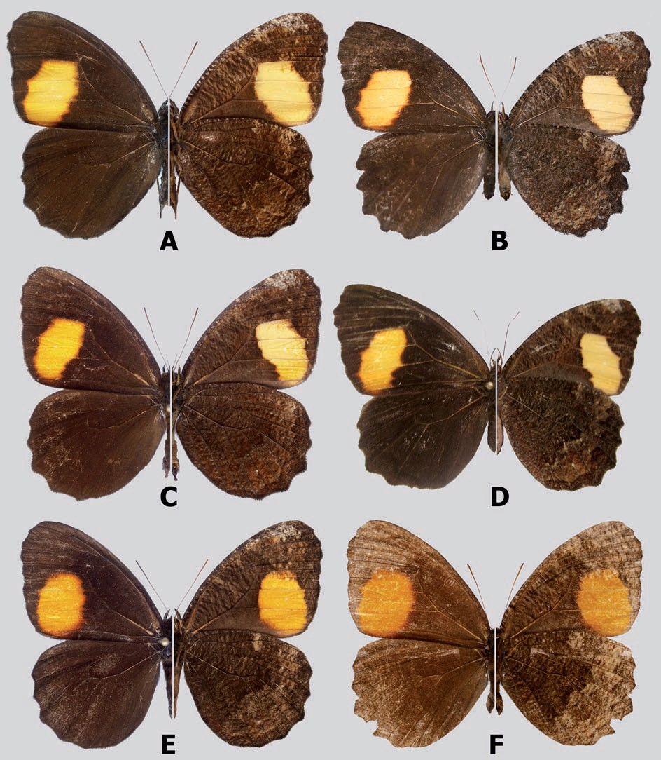
15
ON THE GENERA CorderoPedaliodeS AND PhySCoPedaliodeS
Physcopedaliodes physcoa (HeWitson); Forster 1964: 151, fig. 182 (male genitalia), 153, pl. 35, fig. 5; adams
& bernard 1977: 277; adams 1986: 307; FeltWell 1993: 195, fig., lamas et al. 2004: 214.
material examined
BOLIVIA: 1 ♂: bolivia, pur[chased]. from bridges, bMNH type No. Rh. 4017 [Lectotype of Pronophila physcoa HeWitson, herein designated]; 1 ♂ and 2 ♀: bo- livia [Paralectotype of P. physcoa Hew., herein designated], HC; 2 ♂: bolivia, Ex Grose-smitH 1910, (genit. prep. Angel Luis Viloria 089-96), Jb; 2 ♂: Tanampaya,
3. Adults (left: dorsal; right: ventral) : A. Physcopedaliodes physcoa physcoa, male; b. Physcopedaliodes physcoa physcoa female; C. Physcopedaliodes physcoa micromaculata male; D. Physcopedaliodes physcoa micromaculata female; E. Physcopedaliodes physcoa marulla male; F. Physcopedaliodes physcoa marulla
female
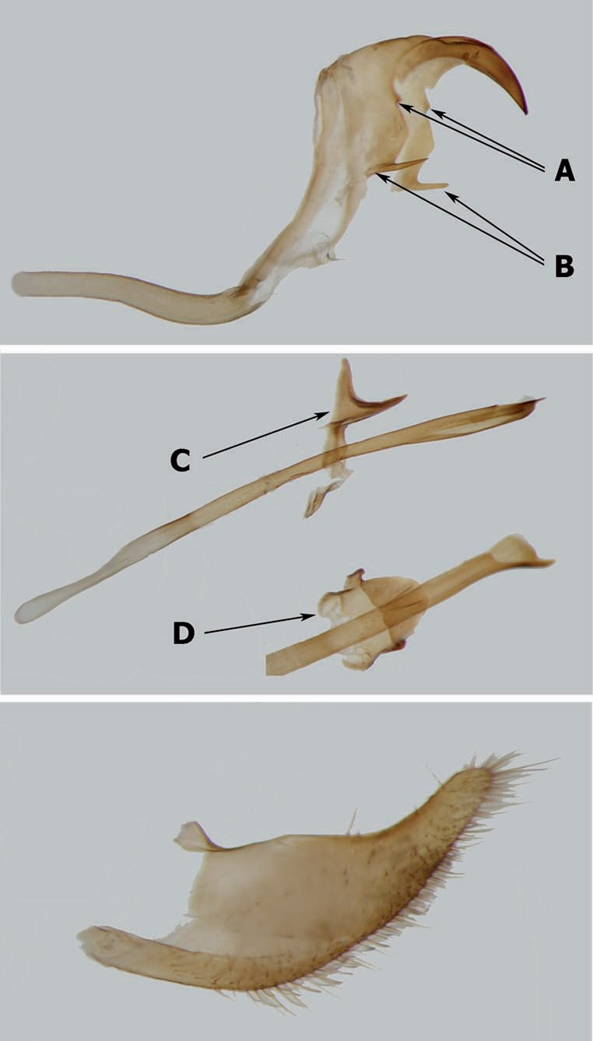
16
TOMASZ W. PyRCZ, HAyDON WARREN-GASH, ANNA ZUbEK
4. Male genitalia (Physcopedaliodes physcoa marulla): A. tegumen, vinculum, saccus, uncus, gnathos (A), pedunculus (b) in lateral view; b. aedeagus, transtilla in lateral view (C), transtilla in dorsal view (D); C.
valva in lateral view
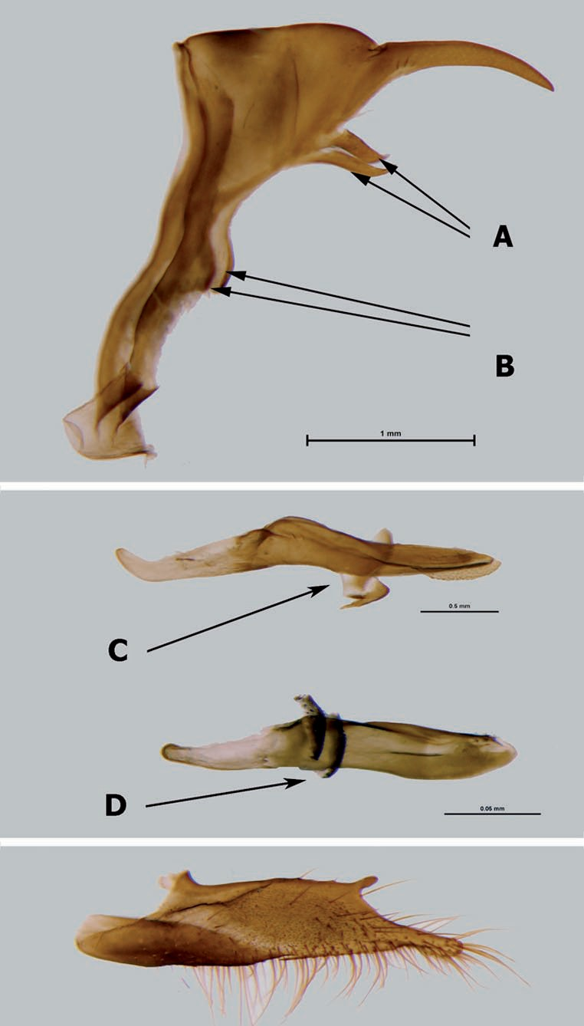
17
ON THE GENERA CorderoPedaliodeS AND PhySCoPedaliodeS
5. Male genitalia: A. Pedaliodes prytanis HeWitson tegumen, vinculum, saccus, uncus, gnathos (A), pedun- culus (b) in lateral view; b. Pedaliodes prytanis aedeagus, transtilla in lateral view (C), Pedaliodes plotina
HeWitson aedeagus, transtilla in lateral view (D); C. Pedaliodes prytanis valva in lateral view
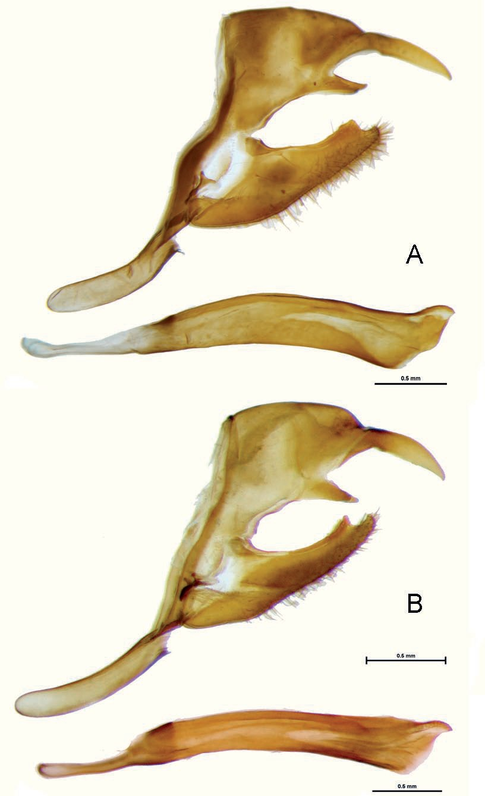
18
TOMASZ W. PyRCZ, HAyDON WARREN-GASH, ANNA ZUbEK
6. Male genitalia (lateral view, aedeagus extracted): A. Corderopedaliodes luzangelae paratype; C. Cord- eropedaliodes buda holotype
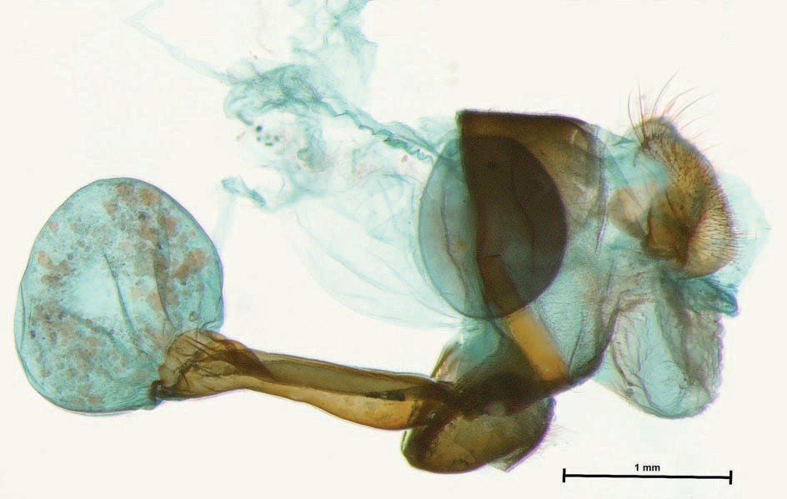
19
ON THE GENERA CorderoPedaliodeS AND PhySCoPedaliodeS
6500-8000 ft., GarlePP, G-S; 1 ♂: Charaplaya, 65° W, 16° S, 1300 m, v-[19]01, some rain, (simons), Rb; 1 ♀: bol.[ivia], GarlePP, OC; 3 ♂: bolivia, Adams bequest; 2 ♂: bolivia, Ex Grose-smitH 1910, Jb; 1 ♂: [no data]; 1 ♂: [no data], Cb; 1 ♂: Songo, GarlePP, OC; 1 ♂: bolivia, GarlePP, Rb; 1 ♂: Coroica [sic], ca. 2000 m, 1895 (2-5), GarlePP; 1 ♂ and 1 ♀: La Paz, Río Tanampaya, 1894, GarlePP, bMNH; 1 ♂ [?], La Paz, Caranavi, 1200 m, II.1989, C. tello, MUSM; 1 ♂: bolivia, ex coll. A. Jasiński; 1
♂: Coroico, X.1993,TWP; 1 ♀: yungas, Río Songo, 1200 m, 1895, GarlePP, ZMHb; 1 ♂: yungas del Palmar, 1000 m, X.1951, R. scHönFelder; 1 ♂: same data, IX.1948; 1
♀: same data, [no date]; 1 ♂: Prov. Cochabamba, region Chapare/yungas, Alto Palmar, 1100 m, XI.1960, coll. baumann; 2 ♂: same locality, IV.1959, ZSbS; 1 ♀: Caranavi, camino a Taipiplaya, 880 m, 04.I.2009. y. Gareca leg., CPyG; 2 ♂: beni, Quiquibey, 600 m, 22.X.2011, y. Gareca & s. reicHle leg., CPyG; 12 ♂ and 14 ♀: La Paz, Los Cocos, 1100 m, 05.X.2005, Proyecto ACb coll., CPyG, MHN-NCM, MHNAD; 2 ♀: yungas, Caranavi, X.2004, HWG.
remarks
P. physcoa was described from an undefined locality in bolivia, presumably in the yungas de La Paz. Indeed, most historical specimens with more accurate locality data come from historical collecting sites in the department of La Paz (Coroico, Zongo). Two individuals were collected further south in the Cochabamba department. Interest- ingly, this subspecies has never been collected in southern Peruvian departments of Cuzco and Puno where it should occur, based on the distributions of taxa with which it occurs in bolivia, possibly because the lower elevations at which it flies have not
7. Female genitalia (lateral view), Corderopedaliodes luzangelae paratype
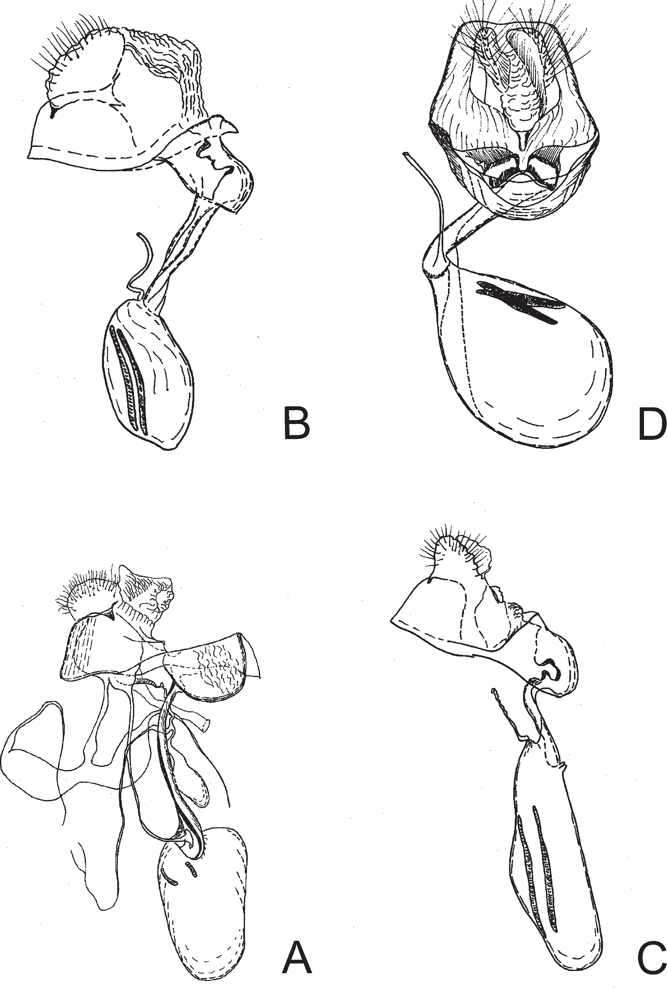
20
TOMASZ W. PyRCZ, HAyDON WARREN-GASH, ANNA ZUbEK
8. Female genitalia (lateral view, except for N. yeyo partly in ventral view): A. Physccopedaliodes physcoa marula Pampa Hermosa, Peru; b. Pedaliodes symmachus via Cerro San Lorenzo, Colombia; C. Neopeda- liodes yeyo Farallones de Citará, Colombia (reproduced from viloria et al. 2008); D. Pedaliodes paneis
Quebrada San Luis, Peru (reproduced from Pyrcz et al. 2010)
21
ON THE GENERA CorderoPedaliodeS AND PhySCoPedaliodeS
been sufficiently sampled for pronophilines. The nominate subspecies of P. physcoa is markedly different from ssp. marulla in the naples yellow colour instead of orange, of the FWD patch and to a lesser degree from micromaculata, which has a wider, less elongated FWD patch.
Physcopedaliodes physcoa micromaculata Forster
(Figs. 3C, 3D)
Physcopedaliodes physcoa micromaculata Forster, 1964: 153, pl. 35, fig. 6. Type locality: Santa Cruz, bolivia.
Physcopedaliodes physcoa micromaculata Forster ; lamas et al. 2004: 214.
material examined
BOLIVIA: 1 ♂: Palitza süd Sta. Cruz, 18.VII.[19]26, D. cHaco Exp., brit. Mus. type No. Rh. 17976, paratype of Physcopedaliodes physcoa micromaculata Fors- ter; 2 ♂ and 1 ♀: Toroebito, GarlePP; 2 ♂: Süd bolivia, Sta. Cruz, H. Rolle berlin SW11, Ex Grose-smitH 1910, Jb; 12 ♂: Prov. Cordillera, Rio Grande, XII.1903, (J. Steinbach), (1 genit. prep. ALV079-96), Rb, bMNH; 2 ♂ and 1 ♀: bolivia Central, bueyes, 18° S, 63° W, 1890, GarlePP, ZMHb; 1 ♂: Santa Cruz, 550 m, 15.II.1956, R. ziscHka, holotypeof P. physcoa micromaculata Forster; 2 ♂: same data; 1 ♂: Santa Cruz, steinbacH; 1 ♂: Santa Cruz, HerzoG; 1 ♂: Süd bolivia, ernst a. bottcHer, berlin, Ex Coll. O. tHieme, all paratypes of P. physcoa micromaculata Forster; 5 ♂: Dept. Santa Cruz, Río Espejo, 400 m, II.1964, ZSbS; 1 ♂: Tarija, Alarachi, 1225 m, 06.II.2009, y.Gareca & t. Pyrcz leg., CPyG; 34 ♂ and 6 ♀: Tarija, El Cajón, 850 m, 12.VIII.2004, Proyecto ACb, MHN-NCM, CPyG; 5 ♂: Cochabamba, Mosetenes, 1150 m, 24.IX.2005, W. aliaGa leg., MHN-NKM; ARGENTINA: 1 ♂: Agua blanca, Prov. Salta, 600 m, 2002, E. Nuńez-Bustos leg., TWP.
remarks
This subspecies differs from the nominate only in the narrower FWD yellow patch, which thus looks more elongated. This character is somewhat variable within populations. P. physcoa micromaculata is distributed between Santa Cruz in bolivia and northern Argentina (Salta, Jujuy) where it occurs in the Andean piedemonte at particularly low elevations (400-600 m). It is apparently confined to pockets of bamboo forests within premontane forests, and is therefore known from very few individuals.
Physcopedaliodes physcoa marulla (thieme)
(Figs. 3E, 3F, 9C, 9D)
Pedaliodes physcoa (HeWitson) var. marulla tHieme, 1905: 126.Type locality: Chanchamayo, Peru.
Pedaliodes physcoa (HeWitson) form marulla tHieme; Weymer 1912: 262, pl. 56, row a; HayWard 1958b: 71, 72, fig. 43 (male genitalia).
Pedaliodes physcoa (HeWitson) var. marulla tHieme; Gaede 1931: 499. Pedaliodes marulla tHieme; Forster 1964: 153; d’abrera 1988: 863, fig. Physcopedaliodes physcoa marulla tHieme; lamas et al. 2004 : 214.
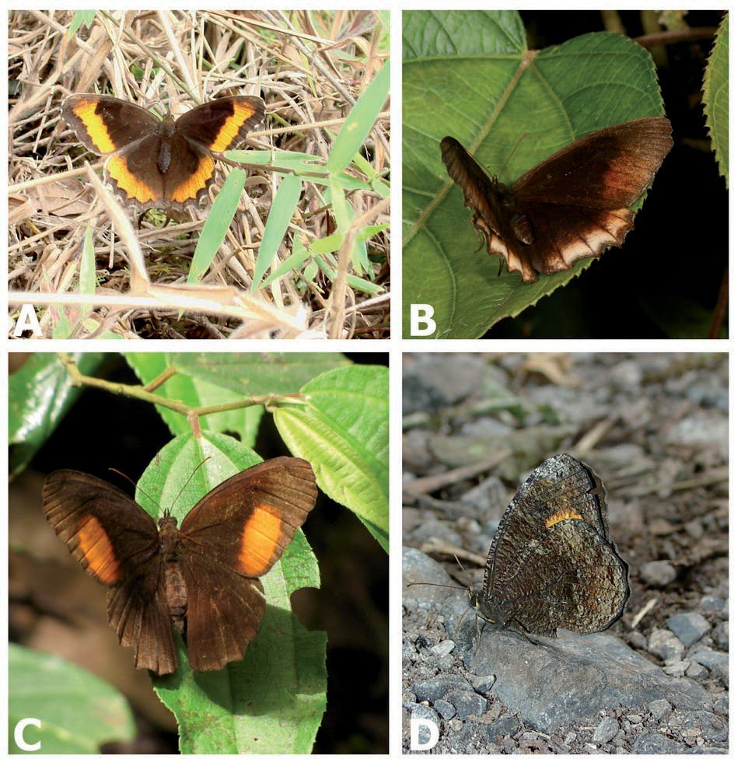
22
TOMASZ W. PyRCZ, HAyDON WARREN-GASH, ANNA ZUbEK
material examined
PERU: 4 ♂: Chanchamayo, I/VIII.[19]01, HoFFmann, Rb; 3 ♂: Chanchamayo, (scHuncke), Rb; 1 ♂: Chanchamayo, 1892, O. scHuncke, OC; 1 ♂: San Ramón [sic], 3000 ft., X.[19]03, Watkins & tomlinson, Ab; 2 ♂: La Merced, 2500 ft., ‘04, Watkins & tomlinson, Ab; 3 ♂ and 1 ♀: Chanchamayo-La Merced, XI.1904, C. O. scHuncke, OC; 1 ♂: Río Colorado, 2500 ft., ‘04, Watkins & tomlinson, Ab; 1 ♂: SE. Peru, Chanchamayo, Ab; 2 ♂: Chanchamayo-La Merced, VI-VII [?], J. younG, Jb; 1 ♂: Río Colorado, 2500 ft., Watkins, Jb; 1 ♂: Chanchamayo, 1912, osWald scHuncke, OC; 7 ♂: C. Peru, La Merced, 2500-3500 ft., X/XI.[19]19, C. Watkins, (1 genit. prep. ALV080-96 + wing prep.); 1 ♀: Pérou Sup., Hillapani, Ex Stgr. 1901, OC; 2 ♂: Chanchamayo, 3-4000 ft., xi/xii-[19]19, C. Watkins, bMNH; 1 ♂: Chanchamayo,
9. Individuals in the field: A. Pedaliodes symmachus female, vía Cerro San Lorenzo, Colombia; b. Cordero- pedaliodes pandates olivieri female, Cosñipata Peru; C. Physcopedaliodes physcoa marulla female, Pampa
Hermosa, Peru; D. Physcopedaliodes physcoa marulla male, Pampa Hermosa, Peru
23
ON THE GENERA CorderoPedaliodeS AND PhySCoPedaliodeS
THAMM, Lectotype of Pedaliodes physcoa var. marulla tHieme, designated by G. lamas, [19]94; 2 ♂: same data, Paralectotypes of P. physcoa var. marulla tHieme, ZMHb; 1 ♂: Chanchamayo, 750 m, VIII.1960, köniG; 2 ♂: same data, V.1962; 1 ♂: same data, VI.1962; 1 ♂: same data, V.1965; 1 ♂: same data, VIII.1965; 1 ♂: same data, I.1966; 1 ♂: same data, 700 m, I.1961; 1 ♂: same data, [no date]; 1 ♂: same data, V.1961, [no collector]; 1 ♂: same data, X.1963, ZSbS; 7 ♂: Junín, Chanchamayo, Pampa Hermosa, 1300-1400 m, 31.V.2002, T. Pyrcz leg.; 2 ♂: Junín, Chanchamayo, Pampa Hermosa, 1350-1400 m, 02.II.2003, T. Pyrcz leg.; 1 ♂: Pampa Hermosa, 1400 m, 07.V.2003, T. Pyrcz leg.; 3 ♂ and 1 ♀: Junín, Pampa Hermosa 24 km N de San Ramón, 1200-1400 m, 28.I.2003, P. boyer leg.; 2 ♂: Junín, Pampa Hermosa 24 km N de San Ramón, 1200-1400 m, 27-30.XI.2003, P. boyer leg.; 1 ♀: Peru, no other data, ex coll. staudinGer & banG-Haas, TWP.
remarks
P. physcoa marulla differs from nominate in the colour, of the FWD patch, which is orange instead of naples yellow, and the shape of this patch, which is regular oval with rather diffuse edges instead of rather elongated with a sharp edge along vein M3. It was described from the valley of Chanchamayo in central Peru (Junín) and indeed, all known individuals have so far been collected exclusively in that area. It is probably the most common pedaliodine in the valley of Pampa Hermosa NW of San Ramón.
DISCUSSION
On close inspection, the characters used by viloria (unpubl. PhD dissertation) to describe the adults of Corderopedaliodes do not provide any reliable generic synapo- morphy distinguishing it from Physcopedaliodes, or indeed from certain other genera of the Pedaliodes complex. The ripple pattern of the HWV, though clearly an important feature of Corderopedaliodes, can also be found in several species of Pedaliodes sensu stricto (Pyrcz 2004). Rather, we would draw attention to the absence of specialized androconial scales on the FWD in Corderopedaliodes. This character state, although not exclusive to Corderopedaliodes, is uncommon among Pedaliodes sensu lato. Apart from Corderopedaliodes, it is found in Physcopedaliodes, and in redonda adams & bernard, dangond adams & bernard and Protopedaliodes – that is to say in mostly small groups of grassland-specialized species.
The male genitalia of Corderopedaliodes are those of a typical representative of Pedaliodes sensu lato. The long, straight aedeagus is also present in such genera as Protopedaliodes viloria & Pyrcz, Praepedaliodes Forster, Parapedaliodes Forster and in some species of Panypapedaliodes Forster. Furthermore, Corderopedaliodes has, typically for Pedaliodes sensu lato, well developed subunci, short pedunculus, weakly sclerotized transtilla and dorsal processes on the valves. The female genitalia of Corderopedaliodes offers characters which can, with some restriction, be designated as generic synapomorphies supporting its validity, in particular the very long and strongly sclerotized ductus bursae, and comparatively small corpus bursae. In Physcopedaliodes and Neopedaliodes viloria, L. miller & J. miller the ductus bursae is also long and
24
TOMASZ W. PyRCZ, HAyDON WARREN-GASH, ANNA ZUbEK
sclerotized, but to a lesser degree. Furthermore the morphology of the ductus bursae could suggest a co-evolution of male and female genitalia, in accordance to the lock- and-key mechanism, as recently summarized by mikkola (2008). Thus its phyletical role should not be overstated. However, and in addition, there are no apparent signa on the corpus bursae in Corderopedaliodes, contrary to most pedaliodine genera, except the loosely related paramo specialists dangond and redonda.
viloria (unpubl. PhD dissertation) stated that in Physcopedaliodes subunci are pre- sent but originate well below base of uncus, and that subscaphium is heavily sclerotized to form a terrace between subunci looking like a “T” from lateral view. Examination of further material suggests that this needs description modification. First of all, the subunci, which are part of sternum A10, are in fact greatly reduced in Physcopedaliodes and present as very short tips just below the base of uncus (Fig. 3A). The paddle-like sclerites, referred to as subunci by viloria, are in fact pedunculi, part of sternum A9, which in other pedaliodines have the shape of a short tooth or hook (Fig. 3b). Secondly, the structure referred to as subscaphium corresponds to the transtilla, which in other pedaliodines is a weakly sclerotized membranous structure deriving from the diaphragm (Fig. 3C, 3D). The role of the transtilla is mechanical and helps maintain the aedeagus in the correct position between the valves. In many loosely related groups of Lepidoptera the transtilla is strongly sclerotized, which enhances its positioning role, in particular when the aedeagus is very long. This is the case of Physcopedaliodes. In some groups of Nymphalidae there are additional strengthening structures, such as the fultura inferior or the hypandrium (attal & crosson du cormier 1996; larsen et al. 2009). On the other hand, in Corderopedaliodes, which also has a long aedeagus, the transtilla is not more noticeably sclerotized than in other genera of Pedaliodes sensu lato.
The modification of the transtilla and pedunculus of Physcopedaliodes are unique not only within Pedaliodes sensu lato but also within the entire sub-tribe Pronophilina. These genital characters, atypical dorsal colour pattern and diffuse, little differentiated androconial FWD scales are strong qualitative synapomorphies of Physcopedaliodes. Available data indicate that Physcopedaliodes is loosely related to other genera of pedaliodines, and possibly it is a sister-clade to Pedaliodes sensu lato. It presents a mixture of strongly specialized and apparently primitive, plesiomorphic characters, particularly the simple ventral patterns, simple valves without dorsal processes and a straight aedeagus, contrary to the contorted aedeagus of most genera of pedaliodines, which is considered as an advanced state (viloria 2007). The female genitalia show some resemblance to Corderopedaliodes with the long and strongly sclerotized ductus bursae.
The generic placement of the species-group name symmachus within the Pedaliodes complex remains unclear. It does not belong either in Physcopedaliodes as suggested by adams & bernard (1977) or in Corderopedaliodes (lamas et al. 2004) because it does not have the genital synapomorphies of either genus as discussed above. On the one hand it lacks the large paddle-like pedunculus and the transformed and strongly sclerotized transtilla of P. physcoa. On the other, it has a long and well sclerotized ductus bursae similar to Physcopedaliodes but its corpus bursae has very long and prominent signa. We therefore transfer back the species group name symmacus to the
25
ON THE GENERA CorderoPedaliodeS AND PhySCoPedaliodeS
genus Pedaliodes until new evidence justifying its possible separate generic status is found, thus Pedaliodes symmachus.
Corderopedaliodes has a wide Andean distribution, but it does not occur on the western slopes of the Cordillera, nor does it cross the two major biogeographic barriers in the northern Andes, the Táchira depression and the Ocaña valley. Physcopedaliodes on the other hand is confined to central and southern tropical Andes. both Corderope- daliodes and Physcopedaliodes are found in lower elevational strata of cloud forests. casner & Pyrcz (2010) argue that the general pattern of speciation of Pronophilina is from lower to higher elevations. Such a distribution pattern may therefore offer an indication of their possible ancestral position within the Pedaliodes complex.
There are no published data on the biology and in particular, the early stages of Physcopedaliodes physcoa. However this species has been reared in Santa Cruz, and its life histories should be published (Gareca, pers. comm.). The novel genital struc- tures of Physcopedaliodes within the extremely species rich (200+) Pedaliodes sensu lato raises interesting questions about the systematic position of this genus and indeed could have important implications for the phylogeny of the Pedaliodes complex and the subtribe Pronophilina.
acknoWledGements
The authors would like to thank Jadwiga lorenc-brudecka and Artur czekaJ (MZUJ, Kraków) for their help with genital preparations and microscopic photography, Gerardo lamas (MUSM, Lima) for the unrestricted access to the collections and insti- tutional support, Angel viloria (IVIC, Caracas), yuvinka Gareca (MHNAD, Cocha- bamba), Zsolt bálint (HMNH, budapest) and Pierre boyer (Le Puy Sainte Réparade), Carlos Prieto (CUAC, Popayán) for additional data and their assistance in the field. Special thanks for Kim GarWood for making available the photographs of butterflies in their natural environment, and Keith Willmott (McGuire Center for Lepidoptera, Gainesville, USA) for valuable comments which greatly improved the quality of this article. Research trips by TW to bolivia (2009) and Colombia (2008) were supported by internal grants of the Institute of Zoology of the Jagiellonian University DS/IZ/bi- NOZ/2009 and DS/IZ/biNOZ/2008.
REFERENCES
adams, m. J., 1986. Pronophiline butterflies (Satyridae) of the three Andean Cordilleras of Colombia.
Zoological Journal of the Linnean Society, 87: 235-320.
adams, M. J. & G. I. bernard, 1974. List of butterfly species taken during the expedition In:Gibson,
c. W. d. & s. m. bunt: Report of the expedition to Sierra Nevada de Santa Marta, Colombia 1973. bulletin of the Oxford University Exploration Club, 22(2): iv + 17-94.
—, 1977. Pronophiline butterflies (Satyridae) of the Sierra Nevada de Santa Marta, Colombia. Systematic Entomology, 2: 263-281.
attal, S. & crosson-du-cormier, A. 1996. The genus Perisama. Lepidoptera Nymphalidae. Venette, Sciences Nat. 149 pp.
butler, A. G., 1867. Revision of the group of lepidopterous insects hitherto included in the genus Pronophila
of WestWood. Annals and Magazine of Natural History, (3) 20 (118): 266-268.
26
TOMASZ W. PyRCZ, HAyDON WARREN-GASH, ANNA ZUbEK
d’abrera, b., 1984. butterflies of South America. Victoria: Hill House, 226 p.
—, 1988. butterflies of the Neotropical Region, part V, Nymphalidae (Concl.) & Satyridae. Hill House.
Victoria, Australia, pp. 680-887, colour plates throughout.
doGnin, P., 1893. Lépidoptéres nouveaux de l’Amerique du Sudprincipalement de Loja et environs (Equateur).
Annales de la Société Entomologique de belgique, 37(7): 367-374.
—, 1894. Lépidoptères de Loja et environs (Équateur). Description d’espèces nouvelles. Paris, F. Levé, 3: 67-99, pls. 7-10.
FeltWell, J., 1993. The illustrated encyclopedia of butterflies. London: blandford, 288 p.
Forster, W., 1964. beiträge zur Kenntnis der Insektenfauna boliviens, XIX. Lepidoptera III. Satyridae.
Veröffentlichungen der Zoologischen Staatssammlung München, 8: 51-188, pls. 27-35.
Freitas, A. V. L. & Peńa, C. 2006. Description of Genus Guaianaza for ‘euptychia’ pronophila (Lepidoptera: Nymphalidae: Satyrinae) with a description of the immature stages. Zootaxa, 1163: 49-59.
Freitas, A. V. L., mielke, O., moser, A., silva-brandao, K. L. & iserHard, C. A. 2011. A new genus and species of Euptychiina (Lepidoptera: Nymphalidae: Satyrinae) from southern brazil. Neotropical Entomology, 40(2): 231-237.
Gabriel, a., G., 1932. Catalogue of the type specimens of Lepidoptera Rhopalocera in the Hill Museum.
London: John bale, Sons & Danielsson Ltd., 40 p.
Gaede, M., 1931. Satyridae II. In E. Strand ed. Lepidopterorum Catalogus, 29(46): 321-544.
Galindo, L. A., 2005. Filogenia de Pedaliodes y géneros relacionados (Lepidoptera, Satyrinae, Pronophilinii) con base en análisis morfológicos y moleculares. Universidad Javeriana, Colombia, unpubl. Master thesis.
Godman, F. du C. & salvin, O.,[1881]. biologia Centrali Americana. Insecta. Lepidoptera-Rhopalocera.
London: Dulau & Co., bernard Quantch, 1, pp. 97-104, pl. 10.
Goulson, D., 1993. Variation in the genitalia of the butterfly Maniola jurtina (Lepidoptera: Satyrinae).
Zoological Journal of the Linnean Society, 107(1): 65-71.
HayWard, K. J., 1958. Dibujos de los genitales masculinos de algunos satíridos Neotropicales (Lep. Rhop.
Satyridae). Acta Zoologica Lilloana, 16: 61-81.
HerricH-scHäFFer, G., 1865. Prodromus systematis lepidopterorum. Versuch einer systematischen anordnung der schmetterlinge. Correspondenzblatt des Zoologisch – Mineralogischen Vereines in Regensburg, 19(5): 63-76.
HeWitson, W. C., 1862. On Pronophila, a genus of diurnal Lepidoptera; with figures on the new species, and reference to all those which have been previously figured or described. Transactions of the Entomological Society of London, 1(3): 1-17, pls. 1-6.
—, 1874. Satyridae. Pronophila VIII and IX. In: Illustrations of new species of exotic butterflies, 5. London, John van Voorst, pp. [53-56], pls. [29-30].
Huertas, b., arias, J. J., 2007. Anew butterfly species from the Colombian Andes and a review of the taxonomy of the genera idioneurula strand, 1932 and Tamania Pyrcz, 1995 (Lepidoptera: Nymphalidae: Satyrinae). Zootaxa, 1652: 27-40.
kirby, W. F., 1871. A synonymic catalogue of diurnal Lepidoptera. London: John van Voorst, vii + 690 p.
—, 1877. A synonymic catalogue of diurnal Lepidoptera. Supplement. London: John van Voorst, pp. i-viii
+ 691-883.
—, 1879. Catalogue of the collection of diurnal Lepidoptera formed by the late William Chapman Hewitson, of Oatlands, Walton-on-Thames; and bequeathed by him to the british Museum. London: John van Voorst, iv + 246 p.
kristensen, N.P.,1999. Lepidoptera: Moths and butterflies. 1. Evolution, Systematics and biogeography. In: Handbook of Zoology, vol. IV. Walter de Gruyter, berlin, Part 35, pp. 263–300.
krüGer, E., 1924. beiträgezur Kenntnis der columbischen Satyriden. Entomologische Rundschau, 41: 23- 24, 27-28, 31-32, 35.
lamas, G., viloria, A. L. & Pyrcz, T. W., 2004. Subtribe Pronophilina, in: E. lamas ed., Atlas of Neotropical Lepidoptera, Checklist: Part 4A, Hesperoidea – Papilionoidea. Association for Tropical Lepidoptera. Gainesville, pp. 206-215.
larsen, T. b., Pyrcz, T. W., saFian, S., & Warren-GasH, H. 2009. Two biogeographically significant new species of euriPHene (boisduval, 1847) from West Africa and Nigeria (Lepidoptera: Nymphalinae: Adoliadini). Metamorphosis, 20: 389-399.
27
ON THE GENERA CorderoPedaliodeS AND PhySCoPedaliodeS
leWis, H. L. 1973. butterflies of the world. London: Follet, xvi + 312 p. [208 pls.].
marin, M. A., Peńa, C, Freitas, A. V.L., WaHlberG, N. & uribe, S. I. 2011. From the Phylogeny of the Satyrinae butterflies to the Systematics of Euptychiina (Lepidoptera: Nymphalidae): History, Progress and Prospects. Neotropical Entomology, 40(1): 1-13.
mikkola, K., 2008The lock-and-key mechanisms of the internal genitalia of the Noctuidae (Lepidoptera): How are they selected for? European Journal of Entomology. 105: 13–25.
miller, L. D., 1968. The higher classification, phylogeny and zoogeography of the Satyridae (Lepidoptera).
Memoirs of the American Entomological Society, 24: 1-174.
murray, D. & ProWell, D. P. 2005. Molecular phylogenetics and evolutionary history of the neotropical Satyrine Subtribe Euptychiina (Nymphalidae: Satyrinae). Molecular Phylogenetics and Evolution, 34(1): 67-80.
Peña, c., nylin, s., Freitas, a.v.l. & WaHlberG, N., 2010. biogeographic history of the butterfly subtribe Euptychiina (Lepidoptera, Nymphalidae, Satyrinae). Zoologica Scripta, 38: 243-258.
Peña, c., n. WaHlberG, e. WeinGartner, u. kodandaramaiaH, s. nylin, a.v.l. Freitas & a.v.z. broWer. 2006. Higher level phylogeny of Satyrinae butterflies (Lepidoptera: Nymphalidae) based on DNA sequence data. Molecular Phylogenetics and Evolution, 40(1): 29-49.
Pyrcz, t. W., 1995. A new genus, Tamania and a new species, Tamania jacquelinae from the Tamá range, Venezuela - Colombia border (Satyridae: Pronophilini). Lambillionea, 95(4): 519-525.
—, 2004. Pronophiline butterflies of the highlands of Chachapoyas in northern Peru: faunal survey, diversity and distribution patterns (Lepidoptera, Nymphalidae, Satyrinae). Genus, Wrocław, 15(4): 455-622.
Pyrcz, t. W. & boyer, P., 2011. New taxa of pronophiline butterflies of the genus lymanopoda Westwood from central Peru (Lepidoptera: Nymphalidae: Satyrinae). Genus, Wrocław, 22(3): 511-521.
Pyrcz, t. W. & Gareca, y., 2009. A new species of eretris tHieme from the Elbow of the Andes region in bolivia (Lepidoptera, Satyrinae). Neotropical Entomology, 38(3):370-375.
Pyrcz, t. W., lorenc, J. & knooP, D. P., 2011. New species of euphaedra Hübner of the ceres group from southwestern Nigeria – with new evidence from female genital morphology (Lepidoptera: Nymphalidae: Limenitidinae). Genus, 22(4): 621-638.
Pyrcz t. W., viloria a. l. & lamas G. M., 2010. Systematics, bionomics and zoogeography of high Andean pedaliodines. Part 13: Description and affinities of a new species from the uppermost forests of the valley of Kosñipata, Cuzco (Lepidoptera: Nymphalidae: Satyrinae). Genus, Wrocław, 21(4): 615- 623.
Pyrcz, t. W., Greeney, H., Willmott, k. & WoJtusiak, J., 2011. Ataxonomic revision of the genus daedalma HeWitson with the descriptions of twenty new taxa and the immature stages of two species (Lepidoptera: Nymphalidae: Satyrinae). Zootaxa, 2898: 1-68.
riley, n. d. & Gabriel, A. G., 1924. Catalogue of the type specimens of Lepidoptera Rhopalocera in the british Museum Part I. Satyridae. Lodon: The Trustees of the british Museum/Oxford University Press, 62 pp.
scudder, S. H., 1875. Historical sketch of the generic names proposed for butterflies. A contribution to systematic nomenclature. Proceedings of the American Academy of Arts and Sciences, 10: 91-293. staudinGer, O., 1887., I. Theil. Exotische Tagfalter in systematischer Reihenfolge mit berücksichtigung neuer Arte. In: staudinGer O. & E. scHatz. 1884-1892. Exotische Schmetterlinge. Fürth: G. Löwensohn,
IX Satyriden. Exotische Tagfalter, 1: 219-237.
takaHasHi, M., 1978. Notes on the tribe Pronophilini (Lepidoptera: Satyridae) from the Sierra Nevada de Santa Marta, Colombia, South America (II). Tyô to Ga, 29(3): 139-148.
tHieme, O., 1905. Monographie der gattung Pedaliodes butl. (Lepidoptera. Rhopalocera. Satyridae). berliner Entomologische Zeitschrift, 50(1/2): 43-141, pls. 1-3.
viloria, A. L., 2007. The Pronophilina: Synopsis of their biology and systematics. Tropical Lepidoptera, (2004) 15(1-2): 1-17.
viloria, a. l. & Pyrcz, t. W.,1994. A new genus, Protopedaliodes and a new species, Protopedaliodes kukenani from the Pantepui, Venezuela (Satyridae: Pronophilini). Lambillionea, 94(3): 345 - 352.
viloria, A., miller, L. D., miller, J., & Pyrcz, T. W. 2008. Reassessment of Parapedaliodes Forster and Neopedaliodes viloria, miller & miller, with descriptions of new taxa (Nymphalidae: Satyrinae). bulletin of the Allyn Museum, 151: 1-43.
28
TOMASZ W. PyRCZ, HAyDON WARREN-GASH, ANNA ZUbEK
Weeks, A. G., 1905. Illustrations of diurnal Lepidoptera with descriptions. boston: The University Press, 1: [1] + xii + 117 p., 45 pls.
Weymer, G., 1890. In Weymer, G. & maassen, P. (ed.). Lepidopteren gesammelt auf einer Reise durch Colombia, Ecuador, Perú, brasilien, Argentinien und bolivien in den Jahren 1868-1877 von Alphons Stübels.berlin: A. Asher& Co., pp. 105-128.

