
OPEN ACCESS
Citation: Labocha MK, Jung S-K, Aleman-Meza B,
Liu Z, Zhong W (2015) WormGender - Open-Source
Software for Automatic Caenorhabditis elegans Sex
Ratio Measurement. PLoS ONE 10(9): e0139724.
doi:10.1371/journal.pone.0139724
Editor: Myon-Hee Lee, East Carolina University,
UNITED STATES
Received: July 13,2015
Accepted: September 16, 2015
Published: September 30,2015
Copyright: © 2015 Labocha et al. This is an open
access article distributed under the terms of the
Creative Commons Attribution License, which permits
unrestricted use, distribution, and reproduction in any
medium, provided the original author and source are
credited.
Data Availability Statement: Data are available at
the open-access website http://QuantWorm.org
Figshare link http://dx.doi.org/10.6084/m9.figshare.
1541248<http://dx.doi.org/10.6084/m9figshare.
1541248>.
Funding: This research was funded by the National
Institutes of Health grants (HG004724 and
DA018341) and by a Searle Scholar grant to WZ.
The funders had no role in study design, data
collection and analysis, decision to publish, or
preparation of the manuscript.
RESEARCH ARTICLE

WormGender - Open-Source Software for
Automatic Caenorhabditis elegans Sex Ratio
Measurement
Marta K. Labocha"®, Sang-Kyu Jung^{e}, Boanerges Aleman-Meza, Zheng Liu,
Weiwei Zhong*
Department of BioSciences, Rice University, Houston, Texas, United States of America
© These authors contributed equally to this work.
a Current address: Institute of Environmental Sciences, Jagiellonian University, Krakow, Poland
* weiwei.zhong@rice.edu

Abstract
Fast and quantitative analysis of animal phenotypes is one of the major challenges of cur-
rent biology. Here we report the WormGender open-source software, which is designed for
accurate quantification of sex ratio in Caenorhabditis elegans. The software functions
include, i) automatic recognition and counting of adult hermaphrodites and males, ii) a man-
ual inspection feature that enables manual correction of errors, and iii) flexibility to use new
training images to optimize the software for different imaging conditions. We evaluated the
performance of our software by comparing manual and automated assessment of sex ratio.
Our data showed that the WormGender software provided overall accurate sex ratio mea-
surements. We further demonstrated the usage of WormGender by quantifying the high
incidence of male (him) phenotype in 27 mutant strains. Mutants of nine genes (brc-1,
C30G12.6, cep-1, coh-3, him-3, him-5, him-8, skr-1, unc-86) showed significant him phe-
notype. The WormGender is written in Java and can be installed and run on both Windows
and Mac platforms. The source code is freely available together with a user manual and
sample data at http://www.QuantWorm.org/. The source code and sample data are also
available at http://dx.doi.org/10.6084/m9.figshare.1541248.

Introduction
One major challenge in modern biology is automation for high-throughput data acquisition
and analysis. Caenorhabditis elegans is one of the model organisms widely used in genetic,
developmental and neurobiological studies [1]. Application of RNA interference (RNAi) by
easy protocols such as feeding [2,3] enabled large-scale inactivation of genes in C. elegans, and
fundamentally reversed the bottleneck of genetics from gene inactivation to phenotyping. Most
early studies relied on manual observation for phenotyping, thus limiting their scopes to quali-
tative and simple phenotypes [4, 5, 6, 7, 8].
Various imagining systems have been developed to enable fast acquisition and quantitative
analysis of multiple C. elegans phenotypes, such as locomotion [9,10,11,12,13,14,15], life-
span [16,17], and embryonic count [18]. One of the most comprehensive C. elegans
PLOS ONE | DOI:10.1371/journal.pone.0139724 September 30, 2015
1/11


Imaging Software to Automatically Measure C. elegans Sex Ratio
Competing Interests: The authors have declared
that no competing interests exist.
phenotyping systems was recently developed in our laboratory, enabling high-throughput anal-
ysis of multiple phenotypes, such as locomotion, lifespan, body size and egg-laying patterns
[19].
One of the C. elegans phenotypes that have been widely studied is abnormal sex ratio. C. ele-
gans have two sexes, hermaphrodites and males. Males are generally very rare in wild-type C.
elegans [20]. They naturally arise as a result of sporadic chromosome-nondisjunction events
during meiosis, and occur at a frequency of less than one male per 500 hermaphrodites under
standard laboratory conditions [21]. There are many known mutations causing the phenotype
of high incidence of males (him). They usually arise due to faulty chromosome segregation, sex
determination, or dosage compensation [21,22]. Mutations leading to the him phenotype are
frequently associated with genes whose human orthologs play a role in important processes
such as cancer development [23]. Therefore, it is crucial to study sex ratio in C. elegans. How-
ever, there is no automatic phenotyping system for such an important phenotype.
Here we present WormGender, an open-source software system designed for accurate and
fast quantification of the him phenotype in C. elegans. We verified the performance of this soft-
ware by comparing manual and automated counts of males and hermaphrodites, demonstrat-
ing that WormGender can provide accurate estimates of male percentage in a population.
WormGender can be downloaded from http://www.quantworm.org/ or http://dx.doi.org/10.
6084/m9.figshare.1541248.

Methods

Animals
The following strains were used: N2 (wild-type), CB1256 [him-3(e1256)], CB1416 [unc-86
(e1416)], CB1489 [him-8(e1489)], CB4088 [him-5(e1490)], CB5380 [fox-1(e2643)], CV138
[sgo-1(tm2443)], DW102 [brc-1(tm1145)], JK3101 [fbf-2(q738)], MH801 [sur-7(ku119)],
MT1080 [sdc-1(n485)], MT1446 [her-1(n695)], MT14851 [set-2(n4589)], MT2244 [sel-10
(n1077)], SP488 [smk-1(mn156)], WWZ239 [gpr-2(ok1179)], WWZ241 [klp-10(ok704)],
WWZ242 [cki-2(ok2105)], WWZ243 [skr-1(ok1696)], WWZ246 [C30G12.6(ok2389)],
WWZ248 [srgp-1(ok300)], WWZ250 [F52H3.4(ok2692)], WWZ251 [T08D2.7(ok431)],
WWZ252 [zhp-3(ok1993)], WWZ255 [hcp-2(ok1757)], WWZ256 [coh-3(gk112)], WWZ258
[ W02D9.3(ok2857)], XY1054 [cep-1(lg12501)]. Strains were obtained from the Caenorhabditis
Genetics Center (CGC) except for WWZ239, WWZ241, WWZ242, WWZ243, WWZ246,
WWZ248, WWZ250, WWZ251, WWZ252, WWZ255, WWZ256, WWZ258, which were cre-
ated by outcrossing six times the CGC strains RB1150, RB866, RB1692, VC1241, RB1846,
RB570, RB2034, RB655, RB1620, RB1492, VC131, RB2143, respectively. Animals were grown
at 20°C on standard nematode growth media (NGM) seeded with the OP50 strain of Escheri-
chia coli as described [24].

Imaging hardware
The imaging hardware included a dissecting microscope (SZ61, Olympus America, Center Val-
ley, PA), motorized XY stage (H105 ProScan, PRIOR Scientific, Rockland, MA), stage control
module (ProScan II Controller, PRIOR Scientific, Rockland, MA), and digital camera (Fire-i
501b, Unibrain, San Ramon, CA).

Image acquisition
For image acquisition, synchronized adult animals were transferred onto 6-well scanning plates
(modified NGM plates that do not contain peptone or cholesterol) using the following method.
PLOS ONE | DOI:10.1371/journal.pone.0139724 September 30, 2015
2/11

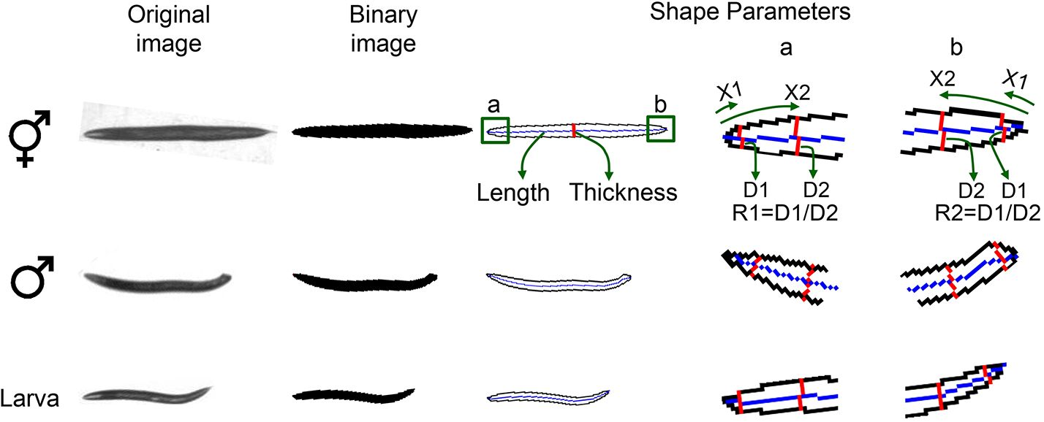
Imaging Software to Automatically Measure C. elegans Sex Ratio
1 ml S Basal solution (0.1M NaCl, 0.05M KH₂PO₄,0.05M K₂HPO₄) was added to each well of
the 6-well plates where animals were cultured. The liquid with animals was transferred to glass
test tubes using Pasteur pipettes. The glass test tubes were placed on ice to let the animals settle
at the bottom. Most of the liquid was then aspirated and the remaining liquid with worms was
dropped with Pasteur pipettes onto scanning plates. The scanning plates were left air dry with-
out lids for about 30 minutes. Animals were then killed by adding 10 pl of 1M sodium azide to
each well. The plates were then scanned using the QuantWorm imaging system [19] to obtain
tiled images of worm plates with magnification set to reach a resolution of 6 to 7 pm/pixel.

Image processing and analysis
A large assembled image is created for each worm plate by stitching multiple tiled photos. The
assembled image is binarized by adaptive local thresholding [25]. Region extraction is then
applied to detect worm objects (Fig 1). Any invalid objects that are not worms are excluded
from further image analysis. For example, tiny objects that are smaller than typical worms are
screened out based on the bounding box size and area. To measure worm length, a skeleton
curve is created from the binary worm image. Worm thickness is obtained by dividing the
worm area (in pixel counts) by the length of the skeleton curve (in pixel counts). Using a
micrometer per pixel ratio, actual length (pm) and worm thickness (pm) are computed. In
addition to length and thickness, WormGender analyzes another two shape parameters, R1
and R2 (Fig 1), which are defined as the ratio of worm diameters (D1 and D2) at two specific
locations (X1 and X2) on the skeleton curve at each end of the worm. X1 and X2 are empiri-
cally determined. After testing our images, we found that the optimal positions to measure
diameter ratio is at 20 pm and 120 pm from the end (i.e., X1 = 20 pm and X2 = 120 pm in Fig
1). R2 is designated to be the larger value. R1 and R2 are used to detect the differences in tail
shape between genders.

Training set
WormGender requires a training set of images with known classifications of hermaphrodites,
males, and larvae. The training set we used was supplied in the package as a default training
set. However, users can replace that with a new one. Our training data set consists of 131 indi-
vidual pictures of worms: 46 hermaphrodites, 46 males, and 39 larvae.

Fig 1. Shape parameters. Original image is binarized and skeletonized. Four shape parameters are
calculated. Worm length is the length of the midline; worm thickness is defined as worm area divided by worm
length; R1 and R2 are the ratios of worm diameters at two specific locations (X1 andX2) near the ends of the
worm. Images labelled a and b are zoomed-in views of worm head and tail, respectively.
doi:10.1371/journal.pone.0139724.g001
PLOSONE | DOI:10.1371/journal.pone.0139724 September 30, 2015
3/11

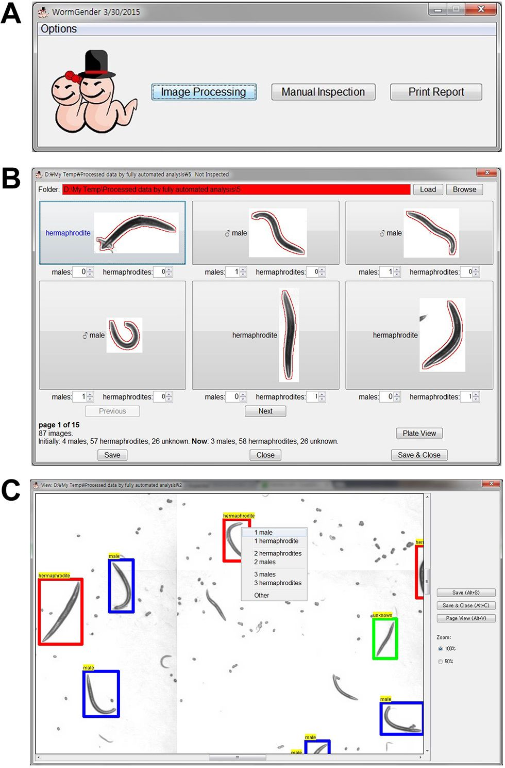

Imaging Software to Automatically Measure C. elegans Sex Ratio

Gender determination
WormGender first determines the shape parameter values from the training set. It then ana-
lyzes the parameter values from a new image, computes the Mahalanobis distance [26] between
the parameter values of the unknown worm and each of the known classes (males, hermaphro-
dites, larvae) in the training set, and assigns the unknown worm to the class with the shortest
Mahalanobis distance.

User interface
A graphic user interface is designed for WormGender (Fig 2). A detailed user manual is avail-
able at http://www.quantworm.org/.

Comparing manual and automatic counts
For data comparing manual and automatic counts, worm populations with different number
of animals and various sex ratios were prepared using either of the following methods. The first

Fig 2. WormGender user interface. (A) WormGender has three command buttons: ‘Image Processing’ to
conduct batch image processing, ‘Manual Inspection’ to review and correct computer analysis, and ‘Print
Report’ to create a summary report file. (B) Clicking the ‘Manual Inspection’ button opens the manual
inspection window, where a user can modify the classification of each worm when needed. (C) A user can
also conduct manual inspection using the plate view.
doi:10.1371/journal.pone.0139724.g002
PLOSONE | DOI:10.1371/journal.pone.0139724 September 30, 2015
4/11

Imaging Software to Automatically Measure C. elegans Sex Ratio
method followed standard culture conditions. CB1256 [him-3(e1256)IV] worms were synchro-
nized by bleaching gravid adults as described [24]. Eggs were cultured in M9 buffer with 5 gg/
ml cholesterol overnight to obtain synchronized L1 larvae. L1s were dropped at the amount of
100, 150, 200,250, 300, and 350 animals per well onto 6-well NGM plates seeded with OP50.
Animals were grown for 3 days at 20°C to reach adulthood.
The second method followed RNAi conditions [27]. RNAi plates (NGM plates with 50gg/
ml Carbenicillin and 1mM IPTG) seeded with the E. coli HT115 were used. Five L4 larvae of
CB1489 [him-8(e1489)IV], or XY1054 [cep-1(lg12501) I] worms were picked onto each well of
6-well plates, cultured at 25°C for 24 hours, and removed. The remaining eggs on the plates
were cultured for two days at 25°C to reach adulthood.
Animals were transferred to scanning plates and scanned. The images were analyzed using
WormGender to obtain automatic counts. The plates were then examined manually under a
dissecting microscope. Manual counts were obtained by aspirating individual worms.
For data on sex-ratio of different worm strains, the RNAi culture condition was used, and
manual counts were conducted on experimental trials independent of automatic counts.

Results and Discussion

Classifying worms based on four shape parameters
Male worms are smaller with blunt tail ends. To capture the morphological differences between
males and hermaphrodites, we used length and thickness to measure animal size, and diameter
ratios at the ends (R1, R2) to measure tail shape (Fig 1).
These four shape parameters, length, thickness, R1 and R2, are sufficient to distinguish
males, hermaphrodites and young larvae. A significant difference was found between every
pairs ofworm classes in length and R2 (p < 0.01, one-way ANOVA and Scheffé post hoc analy-
sis; Fig 3A). Hermaphrodites also showed significant difference from the other two worm clas-
ses in thickness and R1 (p < 0.05, one-way ANOVA and Scheffé post hoc analysis; Fig 3A). A
phenotypic profile using the mean values of these four parameters showed distinctions among
different populations (Fig 3B). While R2 was the most powerful parameter for gender determi-
nation (Fig 3A and3B), including other parameters (e.g., length) improved the accuracy of
classification (Fig 3C).
Because worm length and thickness are used as parameters, mutants with body size defects
such as dumpy worms may not be correctly recognized if the training set is derived from wild-
type worms. Similarly, because WormGender relies on shape measurements, animals with cuti-
cle blisters will not be correctly recognized by the software. In addition, shape parameters can-
not be extracted from clumped animals. Therefore, animals with aggregating behaviours must
be immobilized on the scanning plates before they cluster.
Precise measurements of shape parameters require good image quality. Thick bacterial lawn
with tracks can interfere with the image quality. Transferring worms to scanning plates can
solve this issue. It is also important to use synchronized populations for WormGender. Ideally
the worms should be young adults before they start to lay many eggs. Too many eggs on the
image can interfere with the shape measurement. For example, if eggs are touching a hermaph-
rodite at the end of the body, the program may erroneously recognize the animal as a male.

WormGender performance
To evaluate the performance of WormGender, we examined its speed and its accuracy. Worm-
Gender showed a good image processing speed: It took on average 30 seconds for WormGen-
der to process the image of one well in a 6-well plate.
PLOSONE | DOI:10.1371/journal.pone.0139724 September30, 2015
5/11

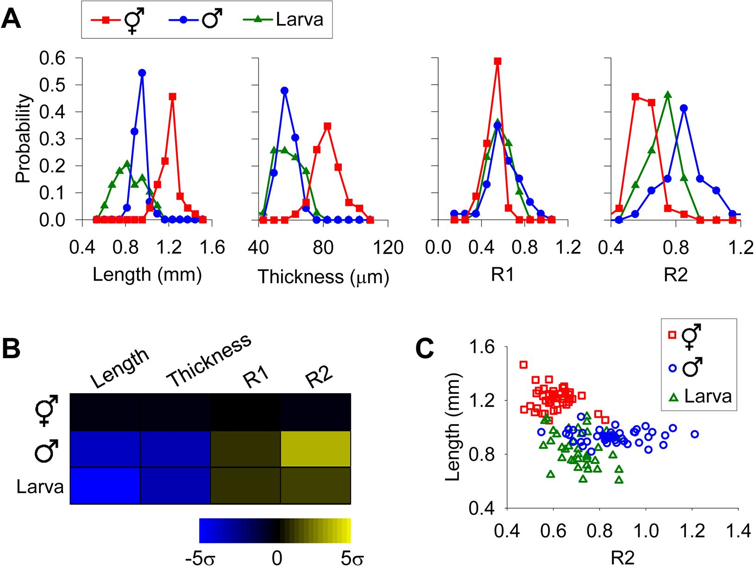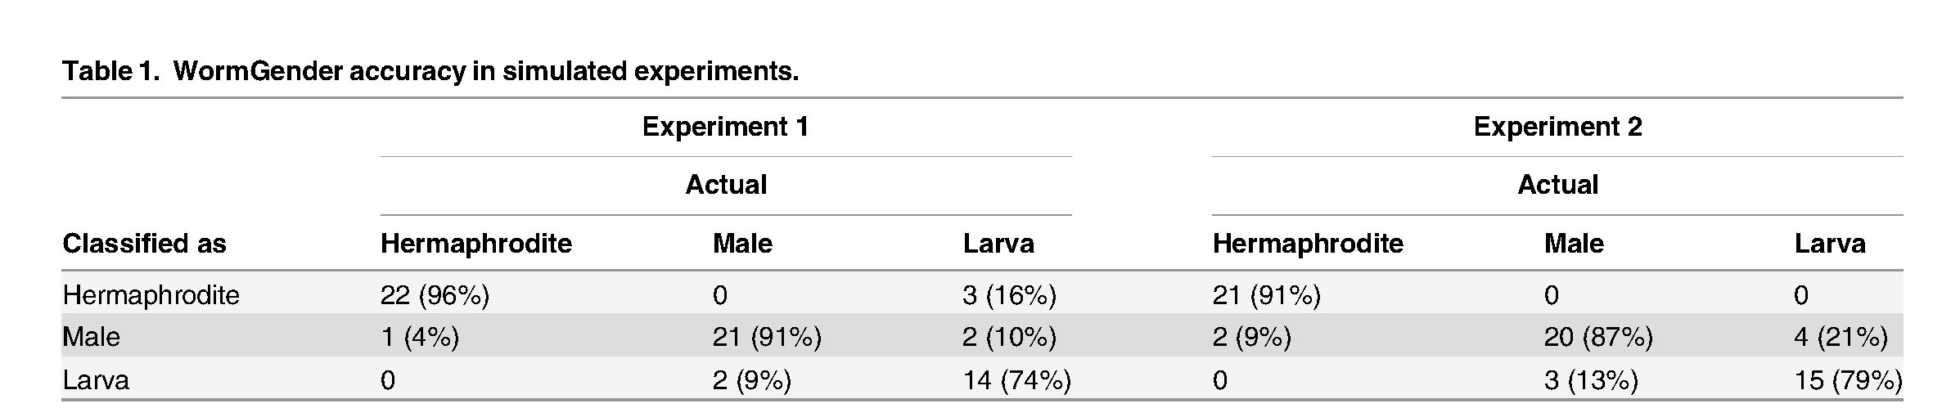

Imaging Software to Automatically Measure C. elegans Sex Ratio

Fig 3. Using shape parameters to distinguish hermaphrodites, males and larvae. Images of 131 worms in three classes (46 hermaphrodites, 46 males,
39 larvae) were analyzed for the shape parameters. Raw data are listed in S1 Table. (A) Distribution of shape parameters in each worm class. (B) Phenotypic
profiles using mean values of shape parameters. Z-scores were used to construct the heat map, displaying differences between mean values from a given
class and hermaphrodites in multiple standard deviations. o, standard deviation. (C) Using length and R2to distinguish three different worm classes.
doi:10.1371/journal.pone.0139724.g003
To evaluate the accuracy of WormGender, we first tested it in a controlled simulation. We
split our training set of 46 hermaphrodites, 46 males and 39 larvae into two groups. We used
one group as training set and the other as testing set (Experiment 1 in Table 1), and then
switched the roles of the two groups and tested again (Experiment 2 in Table 1). In both simu-
lated experiments, WormGender performed better in hermaphrodite and male recognition
than larva recognition (Table 1). The most common WormGender classification errors
included hermaphrodites misclassified as males, males misclassified as larvae, and larvae mis-
classified as either males or hermaphrodites (Table 1).
As most errors involve larvae, it is thus important to use synchronized adult population to
minimize errors. Only L4 larvae were difficult for WormGender to recognize. Younger larvae
doi:10.1371/journal.pone.0139724.t001
PLOS ONE I DOI:10.1371/iournal.pone.0139724 September 30, 2015
6/11

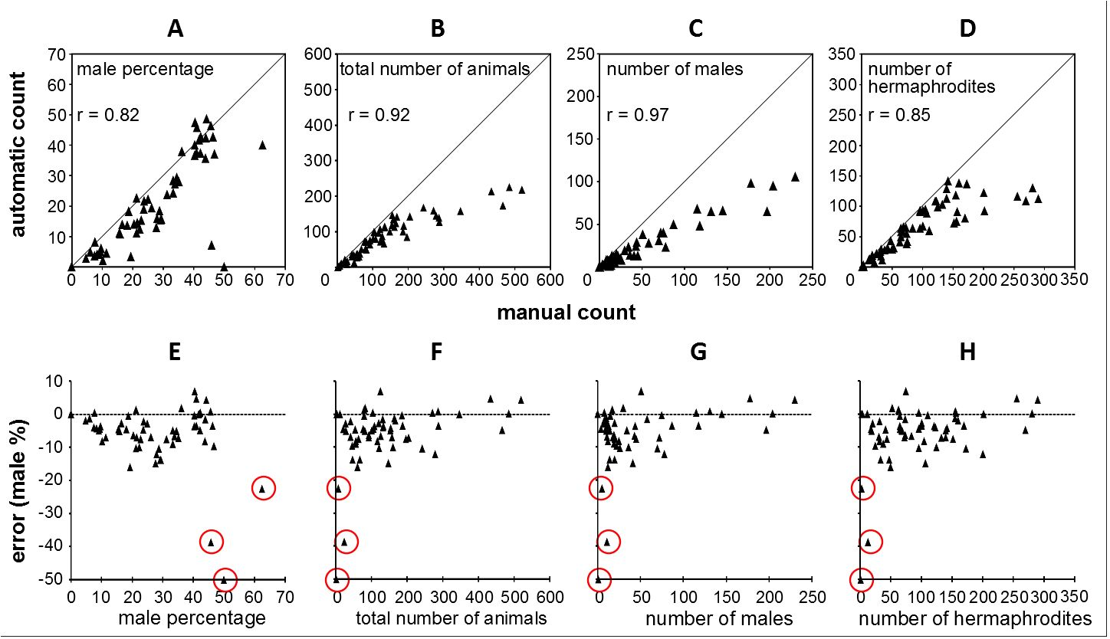

Imaging Software to Automatically Measure C. elegans Sex Ratio

Fig 4. WormGender accuracy. Top, comparison of manual and automatic measurements in male
percentage (A), animal count (B), male count (C) and hermaphrodite count (D). Bottom, error (difference
between male % counted manually and male % counted automatically) distribution in relation to male
percentage (E), animal count (F), male count (G) and hermaphrodite count (H). Raw data are listed in S2
Table.
doi:10.1371/journal.pone.0139724.g004
did not affect WormGender performance because of drastic length differences between these
small larvae and males and hermaphrodites. While using aged adult populations can further
minimize the presence of L4 larvae, the presence of too many eggs produced by the adults can
interfere with image quality. Empirically we found that using day-one adults seemed to reach a
good balance between the two factors for most strains we tested.
To estimate the accuracy of WormGender in real experiments, we prepared worm plates
and analyzed the same plates with both WormGender and manual count. We found that
WormGender provided reliable estimate of C. elegans sex ratio. The sex ratio measured by
WormGender was highly correlated to those measured by manual count (Fig 4A, r = 0.82,
p < 0.001). The absolute error of sex ratio (difference between male percentages calculated
from manual and automatic count) was reasonably small, with over 80% cases having an error
lower than 10% (Fig 4E-4H).
WormGener accuracy was heavily affected by the number of animals on the plate. The abso-
lute error of sex ratio was independent of the male percentage (Fig 4E), if we excluded wells
with fewer than 10 animals (r = 0.04, p = 0.79). However, the absolute error was dependent on
the total number of animals on the plate (r = 0.34, p = 0.01), with higher errors occurring at
low animal counts (Fig 4F). The extreme errors occurred when total number of animals per
well was very small (< 10 animals). For example, if we have only two animals in the well, a sin-
gle missed animal can result in 50% error in sex ratio. Therefore, it is important to use sample
sizes bigger than 10 animals per well.
The effects of too many animals per well were less critical for the accuracy of WormGender
in sex ratio measurement. The number of animals counted automatically by WormGender was
generally lower than the number of animals counted manually for both sexes (Fig 4B-4D). The
undercounting was especially pronounced in cases where total number of animals was higher
than 150 animals per well (on a 6-well plate). In those cases, due to overcrowding, some ani-
mals clustered together and became unrecognizable to the software. However, the sex ratio
measurements remained accurate (Fig 4A) because the recognized worms were randomly
PLOSONE | DOI:10.1371/journal.pone.0139724 September 30, 2015
7/11
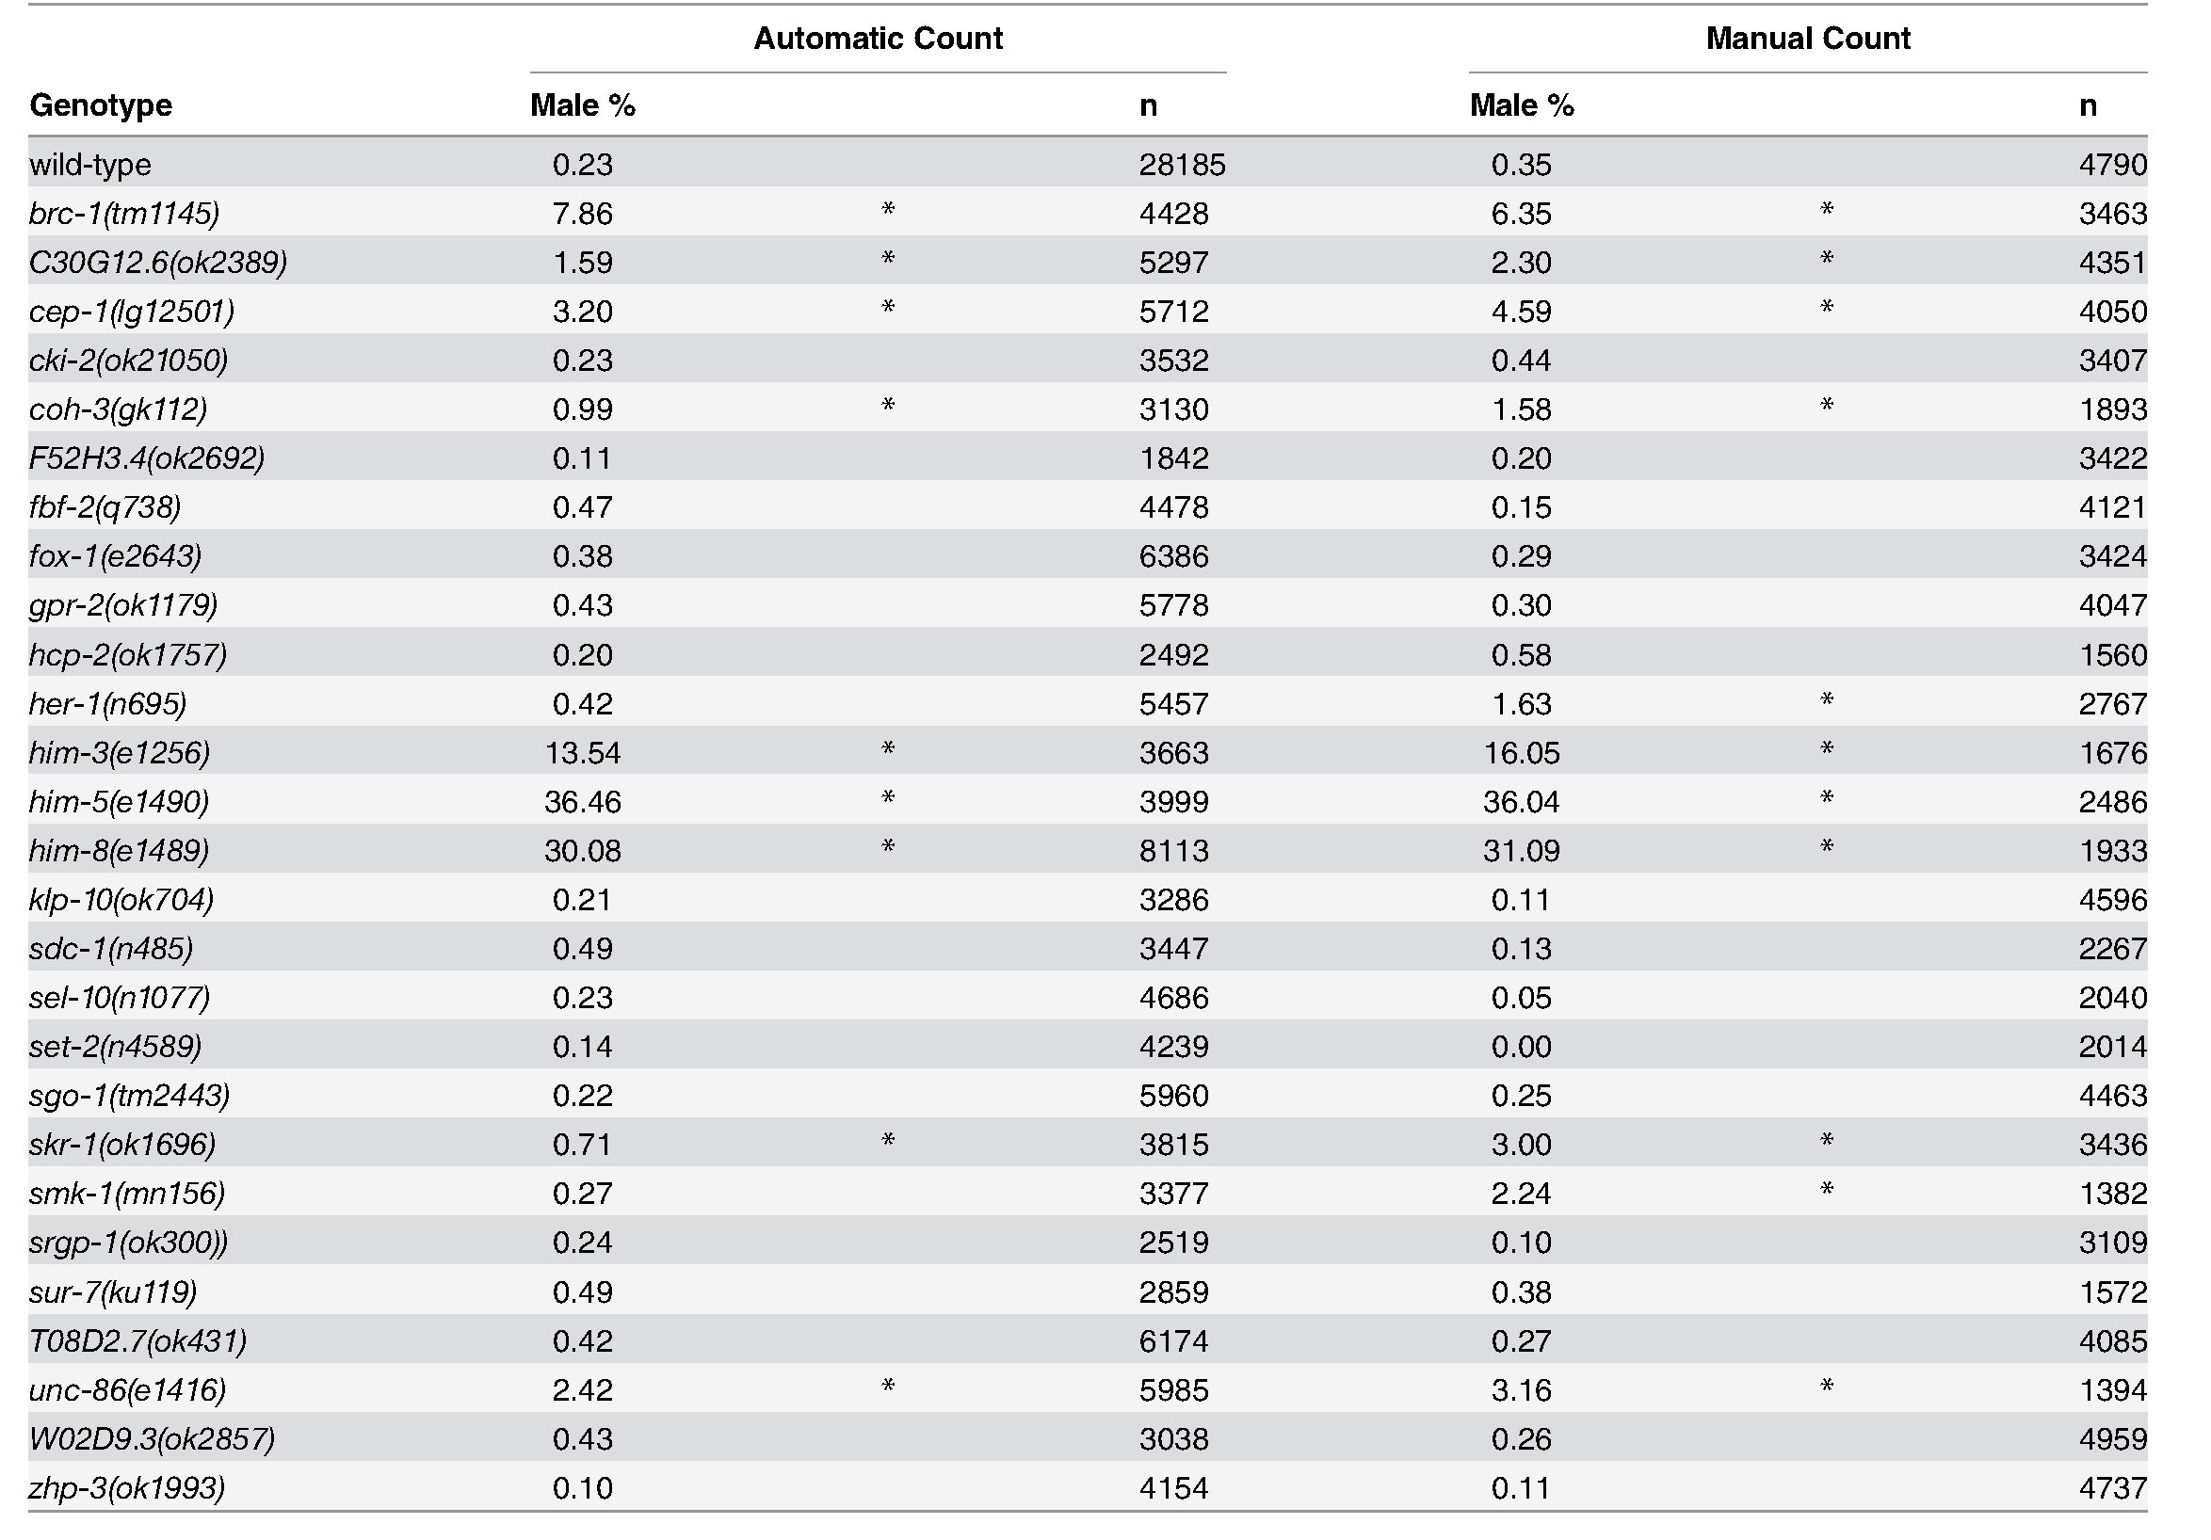
Imaging Software to Automatically Measure C. elegans Sex Ratio
Table 2. Male percentage varies in different mutant strains. Automatic counts were based on pooled data from 6 to 17 independent trials for mutants and
60 trials for wild-type; manual counts were based on pooled data from 4 to 5 independent trials. n, total number of animals.
*, p < 0.0001 in comparison with wild-type male percentage, Chi-square test.
doi:10.1371/journal.pone.0139724.t002
sampled from the population and thus maintained the same sex ratio as the whole population.
That is, although the software undercounted the number of animals, this impact of under-
counting was similar for both male and hermaphrodite counts, therefore the sex ratio calcula-
tion remained correct. Overall, our data suggested that WormGender can accurately measure
sex ratio, however it is not optimized for counting animals.

Quantification of the him phenotype in mutants
It was reported that over 100 genes showed the him phenotype in a genome-wide RNAi screen
based on manual observation [6]. About 30 of these genes have homozygous viable mutants
available at the CGC. To demonstrate the utility of WormGender, we obtained 27 of these
mutants and quantified the severity of their sex ratio phenotypes using WormGender. The
WormGender automatic count data showed that the male percentage of these mutant strains
varied widely from 0.1 to 36.46% (Table 2). Significant difference in male percentage was
PLOSONE I DOI:10.1371/journal.pone.0139724 September 30, 2015
8/11


Imaging Software to Automatically Measure C. elegans Sex Ratio
observed between wild-type and mutants of nine genes: brc-1, C30G12.6, cep-1, coh-3, him-3,
him-5, him-8, skr-1, unc-86 (Table 2).
To confirm the performance of WormGender, we also performed manual count of male
percentage in these strains, although with smaller sample sizes due to the labor-intensive
nature of the assay. The manual results were highly consistent with the automatic counts from
WormGender. Manual counts confirmed the nine strains that were significantly different than
wild-type in WormGender measurements (Table 2). Two additional strains, her-1 and smk-1,
were also found to have significantly higher male percentages than wild-type in manual counts,
although the difference was small in these two cases (less than 2%) (Table 2). The maximum
difference of male percentages measured automatically and manually is 2.5% among all strains
(Table 2). Male percentages from manual and automatic data are highly correlated with a Pear-
son correlation coefficient of0.995.
Our male percentages were slightly higher than previously reported [21] for a few mutants.
For example, him-3(e1256) had 13.54% males in our WormGender assay and 16.05% males in
our manual assay (Table 2), whereas 10.90% males were reported previously [21]. This differ-
ence was likely because our assays were conducted at 25°C and previous reported experiments
[21] were performed at 20°C. Male percentages based on our own manual counts from multiple
independent experiments carried out at 25°C were consistent with those based on automatic
counts performed at the same temperature (Table 2), confirming the utility of WormGender
for sex ratio measurements.

Conclusions
We developed the WormGender software to automatically measure sex ratio in a C. elegans
population. The software measurements were similar to those from manual counts. Therefore,
WormGender can serve as a useful tool for automatic measurement of C. elegans sex ratio.

Supporting Information
- Table. Raw data for Fig 3.
(XLSX)
- Table. Raw data for Fig 4.
(XLSX)

Acknowledgments
We thank Joaquina Nunez and Veronica Rocha for technical assistance. Some strains were pro-
vided by the CGC, which is funded by NIH Office of Research Infrastructure Programs (P40
OD010440). This research was funded by the National Institutes of Health grants (HG004724
and DA018341) and by a Searle Scholar grant to WZ.

Author Contributions
Conceived and designed the experiments: MKL SKJ WZ. Performed the experiments: MKL
SKJ BAM ZL. Analyzed the data: MKL SKJ. Wrote the paper: MKL SKJ WZ.

References
- Riddle DL, BlumenthalT, Meyer BJ, Priess JR. C. elegans II. 2nded. Cold Spring Harbor (NY): Cold
Spring Harbor Laboratory Press; 1997.
PLOSONE I DOI:10.1371/journal.pone.0139724 September 30, 2015
9/11


Imaging Software to Automatically Measure C. elegans Sex Ratio
- Fire A, Xu S, Montgomery MK, Kostas SA, Driver SE, Mello CC. Potent and specific genetic interfer-
ence by double-stranded RNA in Caenorhabditis elegans. Nature 1998; 391: 806-811. PMID:
9486653
- Timmons L, Fire A. Specific interference by ingested dsRNA. Nature 1998; 395: 854. PMID: 9804418
- Fraser AG, Kamath RS, Zipperlen P, Martinez-Campos M, Sohrmann M, Ahringer J. Functional geno-
mic analysis of C. elegans chromosome I by systematic RNA interference. Nature 2000; 408(6810):
325-330. PMID: 11099033
- Kamath RS, Martinez-Campos M, Zipperlen P, Fraser AG, Ahringer J. Effectiveness of specific RNA-
mediated interference through ingested double-stranded RNA in Caenorhabditis elegans. Genome Biol
2000; 2: 1-10.
- Kamath RS, Fraser AG, Dong Y, Poulin G, Durbin R, Gotta M, et al. Systematic functional analysis of
the Caenorhabditis elegans genome using RNAi. Nature 2003; 421: 231-237. PMID: 12529635
- Piano F, Schetter AJ, Morton DG, Gunsalus KC, Reinke V, Kim SK, etal. Gene clustering based on
RNAi phenotypes of ovary-enriched genes in C. elegans. Curr Biol 2002; 12:1959-1965. PMID:
12445391
- Lehner B, Crombie C, Tischler J, Fortunato A, Fraser AG. Systematic mapping of genetic interactions
in Caenorhabditis elegans identifies common modifiers of diverse signaling pathways. Nat Genet 2006;
38: 896-903. PMID: 16845399
- FengZ, Cronin C, Wittig J, Sternberg P, Schafer W. An imaging system for standardized quantitative
analysis of C. elegans behavior. BMC Bioinformatics 2004; 5:115. PMID: 15331023
- Tsibidis GD, Tavernarakis N. Nemo: a computational tool foranalyzing nematode locomotion. BMC
Neurosci. 2007; 8:86. PMID: 17941975
- Ramot D, Johnson BE, Berry TL Jr, Carnell L, Goodman MB. The Parallel Worm Tracker: a platform for
measuring average speed and drug-induced paralysis in nematodes. PLoS One 2008; 3: e2208. doi:
10.1371/iournal.pone.0002208 PMID: 18493300
- Buckingham SD, Sattelle DB. Fast, automated measurement of nematode swimming (thrashing) with-
out morphometry. BMC Neurosci. 2009; 10: 84. doi: 10.1186/1471-2202-10-84 PMID: 19619274
- Swierczek NA, Giles AC, Rankin CH, Kerr RA. High-throughput behavioral analysis in C. elegans. Nat.
Methods 2011; 8: 592-598. doi: 10.1038/nmeth.1625 PMID: 21642964
- Zheng M, Gorelenkova O, Yang J, Feng Z. A liquid phase based C. elegans behavioral analysis system
identifies motor activity loss in a nematode Parkinson's disease model. J Neurosci Methods. 2012; 204
(2): 234-237. doi: 10.1016/i.ineumeth.2011.11.015 PMID: 22108336
- Yu H, Aleman-MezaB, Gharib S, LabochaML, Cronin CJ, Sternberg PW, etal. Systematic profiling of
Caenorhabditis elegans locomotive behaviors reveals additional components in G-protein G-alpha-q
signalling. Proc Natl Acad Sci USA. 2013; 110(29): 11940-11945. doi: 10.1073/pnas.1310468110
PMID: 23818641
- Mathew MD, Mathew ND, Ebert PR. WormScan: A technique for high-throughput phenotypic analysis
of Caenorhabditis elegans. PLoS One 2012; 7: e33483. doi: 10.1371/iournal.pone.0033483 PMID:
22457766
- Stroustrup N, Ulmschneider BE, Nash ZM, Lopez-Moyado IF, Apfeld J, Fontana W. The Caenorhabditis
elegans Lifespan Machine. Nat Methods 2013; 10: 665-670. doi: 10.1038/nmeth.2475 PMID:
23666410
- Mohamed M, Prasad B, Badawy W. High throughput quantification system for egg populations in Cae-
norhabditis elegans. IEEE 2008; 1072-1075. doi: 10.1109/ISCAS.2008.4541607
- Jung S-K, Aleman-Meza B, Riepe C, Zhong W. QuantWorm: A comprehensive software package for
Caenorhabditis elegans phenotypic assays. PLoS One 2014; 9(1):e84830. doi: 10.1371/iournal.pone.
0084830 PMID: 24416295
- Teotónio H, Manoel D, Phillips PC, Galloway L. Genetic variation for outcrossing among Caenorhabdi-
tis elegans isolates. Evolution 2006; 60(6): 1300-1305. PMID: 16892979
- Hodgkin J, Horvitz HR, Brenner S. Nondisiunction Mutants of the Nematode Caenorhabditis elegans.
Genetics1979; 91(1): 67-94. PMID: 17248881
- Meyer BJ. Sex in the worm—counting and compensating X-chromosome dose. Trends Genet. 2000;
16(6): 247-253. PMID: 10827451
- Boulton SJ, Gartner A, Reboul J, Vaglio P, Dyson N, Hill DE, etal. Combined functional genomic maps
of the C. elegans DNA damage response. Science 2002; 295:127-131. PMID: 11778048
- Stiernagle T. Maintenance of C. elegans (February 11, 2006) WormBook, ed. The C. elegans Research
Community, WormBook. Available: http://www.wormbook.org.
- Bradley D, Roth G. Adaptive thresholding using the integral image. J. Graphics Tools 2007; 12:13-21.
PLOS ONE I DOI:10.1371/iournal.pone.0139724 September 30, 2015
10/11

Imaging Software to Automatically Measure C. elegans Sex Ratio
- Mahalanobis PC. On the generalized distance in statistics. Proceedings of the National Institute of Sci-
ences (Calcutta) 1936; 2: 49-55.
- Ahringer J, ed. Reverse genetics (April 6, 2006) WormBook, ed. The C. elegans Research Community,
WormBook. Available: http://www.wormbook.org.
PLOS ONE I DOI:10.1371/iournal.pone.0139724 September 30, 2015
11 /11

