A&A547, A39 (2012)
DOI: 10.1051/0004-6361/201219668
© ESO 2012
Astronomy&
Astrophysics

A dynamical model for the Taffy galaxies UGC 12914/5*
B. Vollmer1, J. Braine2,3, and M. Soida4
- CDS, Observatoire astronomique, UMR 7550, 11 rue de l’universite, 67000 Strasbourg, France
e-mail: bvollmer@astro.u-strasbg.fr
- Univ. Bordeaux, Laboratoire d’Astrophysique de Bordeaux, UMR 5804, 33270 Floirac, France
- CNRS, LAB, UMR 5804, 33270 Floirac, France
- Astronomical Observatory, Jagiellonian University, ul. Orla 171, 30-244 Kraków, Poland
Received 24 May 2012 / Accepted 20 September 2012
ABSTRACT
The spectacular head-on collision of the two gas-rich galaxies of the Taffy system, UGC 12914/15, gives us a unique opportunity
to study the consequences of a direct ISM-ISM collision. To interpret existing multi-wavelength observations, we made dynamical
simulations of the Taffy system including a sticky particle component. To compare simulation snapshots to Hi and CO observations,
we assume that the molecular fraction of the gas depends on the square root of the gas volume density. For the comparison of our
simulations with observations of polarized radio continuum emission, we calculated the evolution of the 3D large-scale magnetic field
for our simulations. The induction equations including the time-dependent gas-velocity fields from the dynamical model were solved
for this purpose. Our simulations reproduce the stellar distribution of the primary galaxy, UGC 12914, the prominent Hi and CO gas
bridge, the offset between the CO and Hi emission in the bridge, the bridge isovelocity vectors parallel to the bridge, the Hi double-line
profiles in the bridge region, the large line-widths (~200 km s-1) in the bridge region, the high field strength of the bridge large-scale
regular magnetic field, the projected magnetic field vectors parallel to the bridge and the strong total power radio continuum emission
from the bridge. The stellar distribution of the secondary model galaxy is more perturbed than observed. The observed distortion of
the Hi envelope of the Taffy system is not reproduced by our simulations which use initially symmetric gas disks. The model allows
us to define the bridge region in three dimensions. We estimate the total bridge gas mass (Hi, warm and cold H2) to be 5 to 6 x 109 M0,
with a molecular fraction MH2 /Mhi of about unity. Despite the enormous mass of molecular gas in the bridge, very little star formation
is present, similar to other systems with extraplanar gas and broad CO lines. The structure of the model gas bridge is bimodal: on
kpc-scales there is a dense (>0.01 M0 pc-3) component with a high velocity dispersion >100 km s-1 and a less dense (~10-3 M0 pc-3)
component with a smaller, but still high, velocity dispersion ~50 km s-1. The synchrotron lifetime of relativistic electrons is only long
enough to be consistent with the existence of the radio continuum bridge for the less dense component. On the other hand, only the
high-density gas undergoes a high enough mechanical energy input to produce the observed strong emission of warm H2. We propose
that, despite the high local gas densities, this high input of mechanical energy drives strong turbulence and quenches star formation
in the bridge gas except for the giant Hii region near UGC 12915. Our model suggests that we observe this galaxy head-on collision
near the time of maximum CO and H2 emission.
Key words. galaxies: interactions - galaxies: ISM - galaxies: kinematics and dynamics

1. Introduction
Galactic evolution is largely due to interactions of various
sorts. We can distinguish tidal encounters, which are essentially
gravitational interactions, from head-on collisions in which the
gaseous components actually hit each other, resulting in fantas-
tic shocks and injection of energy into the gas. A further type
of interaction is the ram-pressure stripping suffered by cluster
galaxies.
We are concerned here with the head-on collisions and focus
on the Taffy galaxies, UGC 12914 and UGC 12915, a spectacu-
lar bridge system first noticed by Condon et al. (1993). In these
collisions, the stellar morphology is determined by the tidal in-
teraction while the morphology of the gaseous component is de-
termined by both gravity and hydrodynamics. While the general
geometry of the system was suggested by Condon et al. (1993),
no numerical simulations of the collision have been made until
now.
* Appendix A is available in electronic form at
http://www.aanda.org
The Taffy system attracted attention through its strong ra-
dio synchrotron bridge, a very unusual feature. The bridge is
HI-rich and was subsequently found to be rich in molecular gas
as well through CO observations (Gao et al. 2003; Braine et al.
2003). Dust appears to be underabundant with respect to gas in
the bridge (Zink et al. 2000; Zhu et al. 2007), presumably due
to grain ablation during the collision. The galaxies themselves
are particularly massive, with rotation velocities of 250 kms-1
or more and some 1.5 x 1010 M0 of Hi and a similar quantity
of molecular gas, dependent on the N(H2)/Ico conversion fac-
tor from CO emission to H2 column density. Some 10-20% of
the gas is in the bridge, making it at least as rich in gas as the
entire Milky Way. Condon et al. (1993) estimate that the galaxy
disks passed through each other about 20 Myr ago with a trans-
verse velocity of about 600 km s-1. The bridge and the counter-
rotating galaxies are seen close to edge-on as the recession ve-
locities of the two galaxies are virtually equal. Figure A.1 shows
the morphology of the system.
The wealth of available data makes the Taffy system
both attractive and challenging to model. We present the
first simulations of the collision, attempting to simultaneously
Article published by EDP Sciences
A39, page 1 of 27
A&A547, A39 (2012)
reproduce (i) the morphologies of the stellar and gaseous compo-
nents; (ii) the relative bridge and galaxy gas masses; (iii) the ve-
locity field including the presence of double peaks in the bridge
spectra; (iv) the magnetic field orientation; and (v) the morphol-
ogy of the polarized and unpolarized radio continuum emission.
A sticky particle code is used in order to enable cloud-cloud col-
lisions to occur.
We are most familiar with the interstellar medium (ISM)
and star formation (SF) in the Milky Way, a quiescent rotat-
ing disk. At the velocities observed in the Milky Way, ISM-ISM
(i.e. hydro) collisions are believed to favor star formation, the
clearest example being the triggered star formation sometimes
found around Hu regions (Zavagno et al. 2010). The impact ve-
locity of the interstellar media of the UGC 12914/5 system is
>800 kms-1, very much greater than can be observed in the
Milky Way. Despite the enormous gas mass and strong CO emis-
sion in the bridge, strikingly little star formation is present
(Braine et al. 2004). Numerically modeling the encounter is
the first step towards understanding the effect of injecting huge
amounts of kinetic energy into the gas found in the bridge.
The UGC 12914/5 system is not the only ISM-ISM colli-
sion known. The so-called Taffy2 system, UGC 813/6 (Condon
et al. 2002), is very similar although the galaxies are some-
what less massive and less gas-rich. Nonetheless, the bridge
is quite spectacular and the geometry quite similar. Stephan’s
Quintet is similar in terms of collision velocity but the veloc-
ity is entirely along the line of sight; the collision is on-going
and involves an intruder galaxy hitting the intra-group medium
of this compact group with a velocity of ~1000 kms-1. The re-
sulting large-scale shock (~40 kpc) emits in X-ray (Trinchieri
et al. 2003) and radio continuum emission (van der Hulst 1981).
Powerful high-velocity dispersion molecular hydrogen is asso-
ciated with the intergalactic shock wave (Appleton et al. 2006;
Guillard et al. 2009). About 5 x 108 M0 of warm H2 spread
over ~480 kpc2 were found in the main shock region (Cluver
et al. 2010). In addition, CO(1-0), (2-1) and (3-2) line emis-
sion have been detected in this region with complex profiles,
spanning a velocity range ~1000 kms-1 (Guillard et al. 2012).
The intra-group material involved has most probably been tidally
stripped by a past galaxy-galaxy interaction (Renaud et al. 2010;
Hwang et al. 2012). Colliding ring galaxies can also have gas
and star bridges. As an example, the Hi bridge between the
two galaxies in Arp 284 (NGC 7714/15) contains 2 x 109 M0
(Smith et al. 1997). Struck & Smith (2003) showed that a fast
(~400 kms-1) off-center (~4 kpc) inclined collision is responsi-
ble for the peculiar morphology of the system. The models sug-
gest that the gas bridge interacts with tidally stripped gas from
an older component.
Head-on collisions of gas-rich galaxies are rare events in the
local Universe. However, galaxy encounters of all types were
more frequent, and galaxies more gas-rich, at earlier epochs. The
Taffy system UGC 12914/15 can thus give insight into how mass
assembled in the early Universe.

2. The model
We used the N-body code described in Vollmer et al. (2001),
which consists of two components: a non-collisional component
that simulates the stellar bulge/disk and the dark halo, and a col-
lisional component that simulates the ISM. The non-collisional
component of each galaxy consists of 81 920 particles, which
simulate the galactic halo, bulge, and disk. The characteristics of
the different galactic components are presented in Table 1. The
first of the two galaxies, the primary, is 2.3 times more massive
Table 1. Pre-collision model galaxy parameters.
Component | Mass  (1010 M0) | N(1) | (2)  rd  (kpc)
Galaxy 1 | Drot = 295 | km s-1
Halo | 64.3 | 32 768 | 10.0
Bulge | 2.2 | 16384 | 0.9
Stellar disk | 11.1 | 32 768 | 4.0
Gas disk | 1.7 | 20 000 | 6.0
Galaxy 2 | »r>  xt-  <N  II  o  dr | km s-1
Halo | 28.2 | 32 768 | 6.3
Bulge | 1.0 | 16384 | 0.6
Stellar disk | 4.9 | 32 768 | 2.5
Gas disk | 0.7 | 20 000 | 3.8
Notes.(1) Number of particles;(2) exponential scale length.
and its disk scalelength is 1.6 times larger than that of the sec-
ondary galaxy. The resulting rotation velocities are ~295 km s-1
and ~245 kms-1, respectively.
We adopted a model where the ISM is simulated as a colli-
sional component, i.e. as discrete particles that possess a mass
and a radius and can have partially inelastic collisions. Since the
ISM is a turbulent and fractal medium (see e.g. Elmegreen &
Falgarone 1996), it is neither continuous nor discrete. The vol-
ume filling factor of the warm and cold phases is smaller than
one. The warm neutral and ionized gas fills about 30-50% of
the volume, whereas cold neutral gas has a volume filling fac-
tor smaller than 10% (Boulares & Cox 1990). It is unclear how
this fraction changes when an external pressure is applied. We
thus do not identify the cloud particles with giant molecular
clouds (GMC) but treat the entire ISM as a collisional medium.
In contrast to smoothed particle hydrodynamics (SPH), which
is a quasi-continuous approach where the particles cannot pene-
trate each other, our approach allows a finite penetration length,
which is given by the mass-radius relation of the particles.
The 20 000 particles of the collisional component in each
galaxy represent gas cloud complexes that evolve in the gravi-
tational potential of the galaxy. The total assumed gas mass of
the two galaxies is 2.4 x 1010 M0. The mass distribution of the
cloud complexes is N(m)dm ^ m-13dm for 2 x 105 M0 < m <
2 x 107 M0. This is close to the mass spectrum of Galactic gi-
ant molecular clouds (m-15; Solomon et al. 1987; Rosolowsky
2005). To each particle, a radius is attributed depending on its
mass:
(1)
We used different values for the cloud size parameter £, which is
not known a priori.
During the disk evolution, the cloud particles can have par-
tially inelastic collisions, the outcome of which (coalescence,
mass exchange, or fragmentation) is simplified following the
geometrical prescriptions of Wiegel (1994). Figure 1 shows the
overlapping mass fraction for a collision of two clouds as a func-
tion of the ratio between the cloud radius rcl and the impact pa-
rameter b. For a collision of clouds of equal mass, the ratio be-
tween the overlapping and the total cloud masses is small for
b ~ 2rcl and rises steeply to ~0.5 for b = rcl. For b < rcl the
mass fraction slowly rises toward unity. For a collision of clouds
with a mass ratio of ten, the shape of the overlapping mass frac-
tion with respect to r1 /b is the same as in the previous case, but
A39, page 2 of 27

r=65\fykk
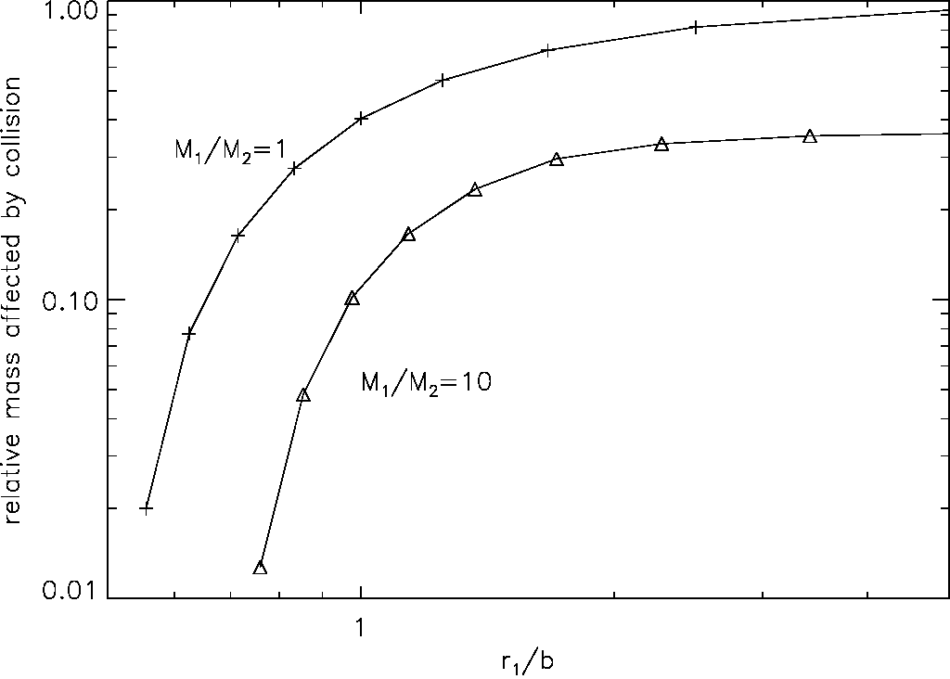
B. Vollmer et al.: A Taffy model
Table 2. Parameters of the first set of Taffy simulations.
(2)
dN 2 N
, — ,— / ^disp
dr a/tF
(3)
Fig. 1. Overlapping cloud mass which is affected by a cloud-cloud col-
lision divided by the total cloud mass as a function of the fraction be-
tween the radius of the massive cloud r and the impact parameter b
(from Wiegel 1994). Crosses: cloud of equal mass M1 = M2. Triangles:
M1 = 10 x M2.
shifted to higher rj /b and lower mass fractions. We conclude
that for rj < b < rj + r2 the mass fraction which is involved in
the cloud-cloud collision is small. Our method which treats the
cloud collisions geometrically is close to that of Olson & Kwan
(1990) and Theis & Hensler (1993). All partially inelastic col-
lisions conserve mass and momentum. The collisions result in
an effective gas viscosity in the disk. Since the code has a max-
imum number of particles of 40 000, mass exchange between
the two colliding gas clouds occurs most frequently. Colliding
clouds can only fragment if cloud coalescence occurred before
elsewhere. During a mass exchange the less massive cloud al-
ways gains and the more massive cloud loses mass. After a large
number of collisions, this leads to steepening of the mass spec-
trum at the high and low-mass ends, and ultimately to a flat mass
spectrum around the mean cloud mass of 6 x 105 M0.
The particle trajectories are integrated using an adaptive
timestep for each particle. This method is described in Springel
et al. (2001). The following criterion for an individual timestep
is applied:
Ta ffy  simulation | xf1 | Inclination(2) | Nmax(3)  -''coll  (Myr-1) | m<4)  1V1 bridge  (109 Mą,)
1 | 1 | 0° | 891 | 1.48
2 |  | 30° | 893 | 1.50
3 |  | 45° | 880 | 1.98
4 | 2 | 0° | 1525 | 1.79
5 | 2 | 30° | 1609 | 1.87
6 | 2 | 45° | 1579 | 2.29
7 | 4 | 0° | 2609 | 2.41
8 | 4 | 30° | 2362 | 2.12
9 | 4 | 45° | 2280 | 2.48
10 | 8 | 0° | 3249 | 2.75
 | 8 | 30° | 3218 | 2.64
12 | 8 | 45° | 2945 | 2.77
13 | 8 | -30° | 3793 | 3.19
14 | 8 | -45° | 4600 | 3.33
15 | 16 | 0° | 5623 | 4.01
16 | 16 | 30° | 5046 | 3.48
17 | 16 | 45° | 4963 | 3.62
where a, is the acceleration of the particle i. The minimum value
of t, defines the global timestep used for the Burlisch-Stoer inte-
grator that integrates the collisional component, and is typically
a few 104 yr.
Since each cloud-cloud collision is resolved in time and
space by the code, the cloud collision rate is physical and follows
the classical equation
where udispii is the 1D velocity dispersion, a, the cross section of
particle i, and n, is the local cloud density around particle i (Theis
& Hensler 1993). Since we use a cloud mass spectrum, the cross
section is a = enr2, with 1 < e < 4, instead of a = 4 nr2
that applies for particles of same size. For the comparison with
the collision rate of the dynamical simulations in Sect. 3, we set
e = 2.
Notes.(1) Parameter of the cloud mass-size relation; (2) inclination an-
gle between the two disks; (3) maximum collision rate between cloud
particles;(4) total gas mass within the bridge region 3 < z < 12 kpc.

3. The simulations
We made two sets of simulations of head-on collisions of two
gas-rich spiral galaxies: (i) a first set with a simplified collision
geometry to determine the cloud size parameter £ and the in-
clination angle , between the two galaxies before the collision
and (ii) a second set of simulations with fixed £ and a fixed
range of inclinations, where we varied the impact parameter
systematically.

3.1. Cloud size parameter and galaxy inclination
In the first set of simulations the more massive (primary) galaxy
is placed in the x-y plane, the second galaxy is placed in a plane
parallel to that of the first one, but offset by 12 kpc along the
z-axis and by 0.5 kpc along the x-axis. The initial velocity of
the less massive galaxy is 500 kms-1 along the z-axis toward
the primary galaxy which is at rest. We varied the inclination
angle between the two galactic disks between -45° and 45° and
the cloud size parameter between 1 < £ < 16 (Table 2).
For the sky projection we used the observed position and
inclination angles of UGC 12914: PA = 160°, , = 30°. The
position angle and inclination of the model primary galaxy de-
fine a plane in three dimensional space. The model galaxy can
then be rotated within this plane by the azimuthal viewing angle
which is chosen such that the secondary galaxy is close to the
observed position of UGC 12915. Figure 2 shows a representa-
tive time evolution of the simulated head-on collision between
two gas-rich galaxies. The galaxies collide1 at t = 0 Myr. The
projected distance between the two galaxies is close to the dis-
tance between UGC 12914 and UGC 12915 at t = 26 Myr. The
head-on collision produces a prominent gas bridge between the
galaxies without a stellar counterpart. At t = 26 Myr the gas
within the bridge forms an X-structure. The outer gas disk of
the primary galaxy is not affected by the collision because of
the small size of the initial gas disk of the secondary galaxy. For
1 We define the collision time as the time of minimum distance
between the galaxy centers.
A39, page 3 of 27
20 kms
A U =
ai
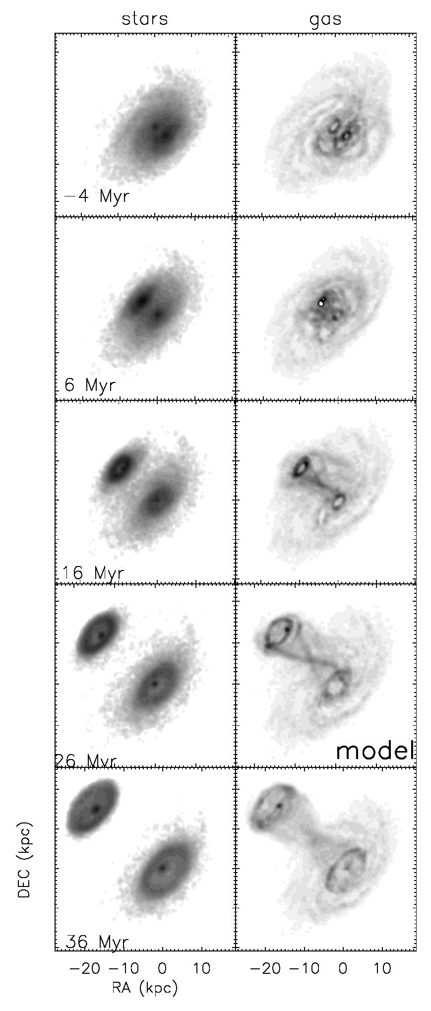
A&A547, A39 (2012)
Fig.2. Time evolution of a Taffy galaxy collision (simulation 10). Left
panels: stellar surface density. The greyscale is logarithmic from 8 to
5600 M0 pc-2. Right panels: total gas surface density. The greyscale
are (1,4,9,16, 25,36,49,..., 400) M0 pc-2. The timestep of interest
(26 Myr) is marked by “model”. The impact parameter is ~3 kpc.
t > 20 Myr both galaxies develop stellar and gaseous ring struc-
tures which are characteristic for head-on galaxy collisions (see,
e.g., the Cartwheel galaxy; Higdon et al. 1995, 1996).
The gas distribution of the bridge displays an X-structure in
all simulations. Since the X-structure is visible at all azimuthal
viewing angles, we conclude that it stems from a 3D hourglass
shape. The X-structure is symmetric for i = 0°, i.e. when the col-
liding disks are parallel. Increasing the inclination angle between
the two disks increases the gas surface density of the upper part
of the X-structure, toward the less massive galaxy leading to a
higher bridge mass. An increase of the cloud size parameter f
leads to an increase of the overall gas surface density in the
bridge region without changing the gas morphology.
The time evolution of the cloud collisions in the whole sys-
tem are presented in Fig. 4. The collision rate of the clouds in
the two galactic disks is constant before the collision. As ex-
pected, its absolute value increases with increasing cloud size
parameter f (from blue to red). During the collision, the cloud
collision rate rises steeply within a few Myr, stays high during
~10 Myr, drops to a minimum at t ~ 40 Myr, and rises again
slightly for t > 40 Myr (Fig. 4). The latter rise is due to the for-
mation of prominent gas rings of high surface densities in both
galaxies. The ratio between the maximum and initial collision
rates mainly depends on the inclination angle between the disks.
This fraction is ~13 for i = 0° and ~22 for i = 30°-45°.
The quantitative relations of the influence of the inclination
angle between the disks i and the cloud size parameter f on the
cloud collision rate during the galaxy collision and the gas mass
in the bridge region are shown in Fig. 5. We define the bridge
region as a cylinder whose base is parallel to the disk plane of
the primary galaxy with an infinite radius and extending from
3 kpc to 12 kpc perpendicular to the plane of the primary galaxy
(UGC 12914). Based on Eq. (3), the collision rate of an ensemble
of particles should be proportional to the cloud size parameter f
(Eq. (1)). The situation changes if the ensemble has an evolving
spectrum of particle sizes. After a large number of collisions, the
mass spectrum steepens at the high end (see Sect. 2). This steep-
ening decreases the number of massive clouds which dominate
the overall collision rate because of their large cross sections.
The local particle density and velocity dispersion is calculated
using the 50 nearest neighbors. As expected for a slight steep-
ening of the cloud mass spectrum with increasing collision rate,
the correlation between the theoretical collision rate of the sys-
tem based on Eq. (3) and the measured model collision rate of
the quiet galaxy system before collision is close to linear with a
slope of 0.8 (upper panel of Fig. 5). The ratio between the max-
imum collision rate counted in bins of 10 Myr and the collision
rate of the quiet system is 5.3 ± 0.6 for all simulations. The cor-
relation between the cloud size parameter f and the maximum
collision rate has a slope of 0.65 (middle panel of Fig. 5), i.e. it
is somewhat shallower than the correlation of the collision rate
of the quiescent system. We ascribe this difference again to the
cloud size spectrum.
The correlation between the bridge gas mass and the max-
imum collision rate is Mbridge ^ (dN/dt)m5x (lower panel of
Fig. 5). This behavior is caused by the geometrical cloud col-
lision scheme (Sect. 2): for a constant impact parameter b, the
ratio between the mass of the colliding clouds that is affected
by the collision mcoll, i.e. the mass included in the geometrical
overlap between the clouds, and the initial masses of the col-
liding clouds mini is small for r\ < b < r\ + r2 and increases
rapidly with increasing cloud radius ri. Only cloud-cloud col-
lisions with b/r1 < 0.7 lead to significant transfer of mass and
momentum. An increase of the cloud radius with increasing f
(Eq. (1)) thus leads to an increase of the collision rate which
is approximately proportional to f. However, many of the new
cloud-cloud collisions do not lead to a significant mass and mo-
mentum transfer. Since the gas bridge is caused by momentum
transfer during cloud-cloud collisions, the bridge gas mass is ex-
pected to increase more slowly than the cloud collision rate, as
observed in our simulations.
With (dN/dt)max ^ f0 65, the correlation between the bridge
gas mass and the cloud size parameter f is Mbridge ^ f0 3. The
maximum collision rate does not depend on the inclination angle
between the disks. The dependence of the bridge mass on the
A39, page 4 of 27
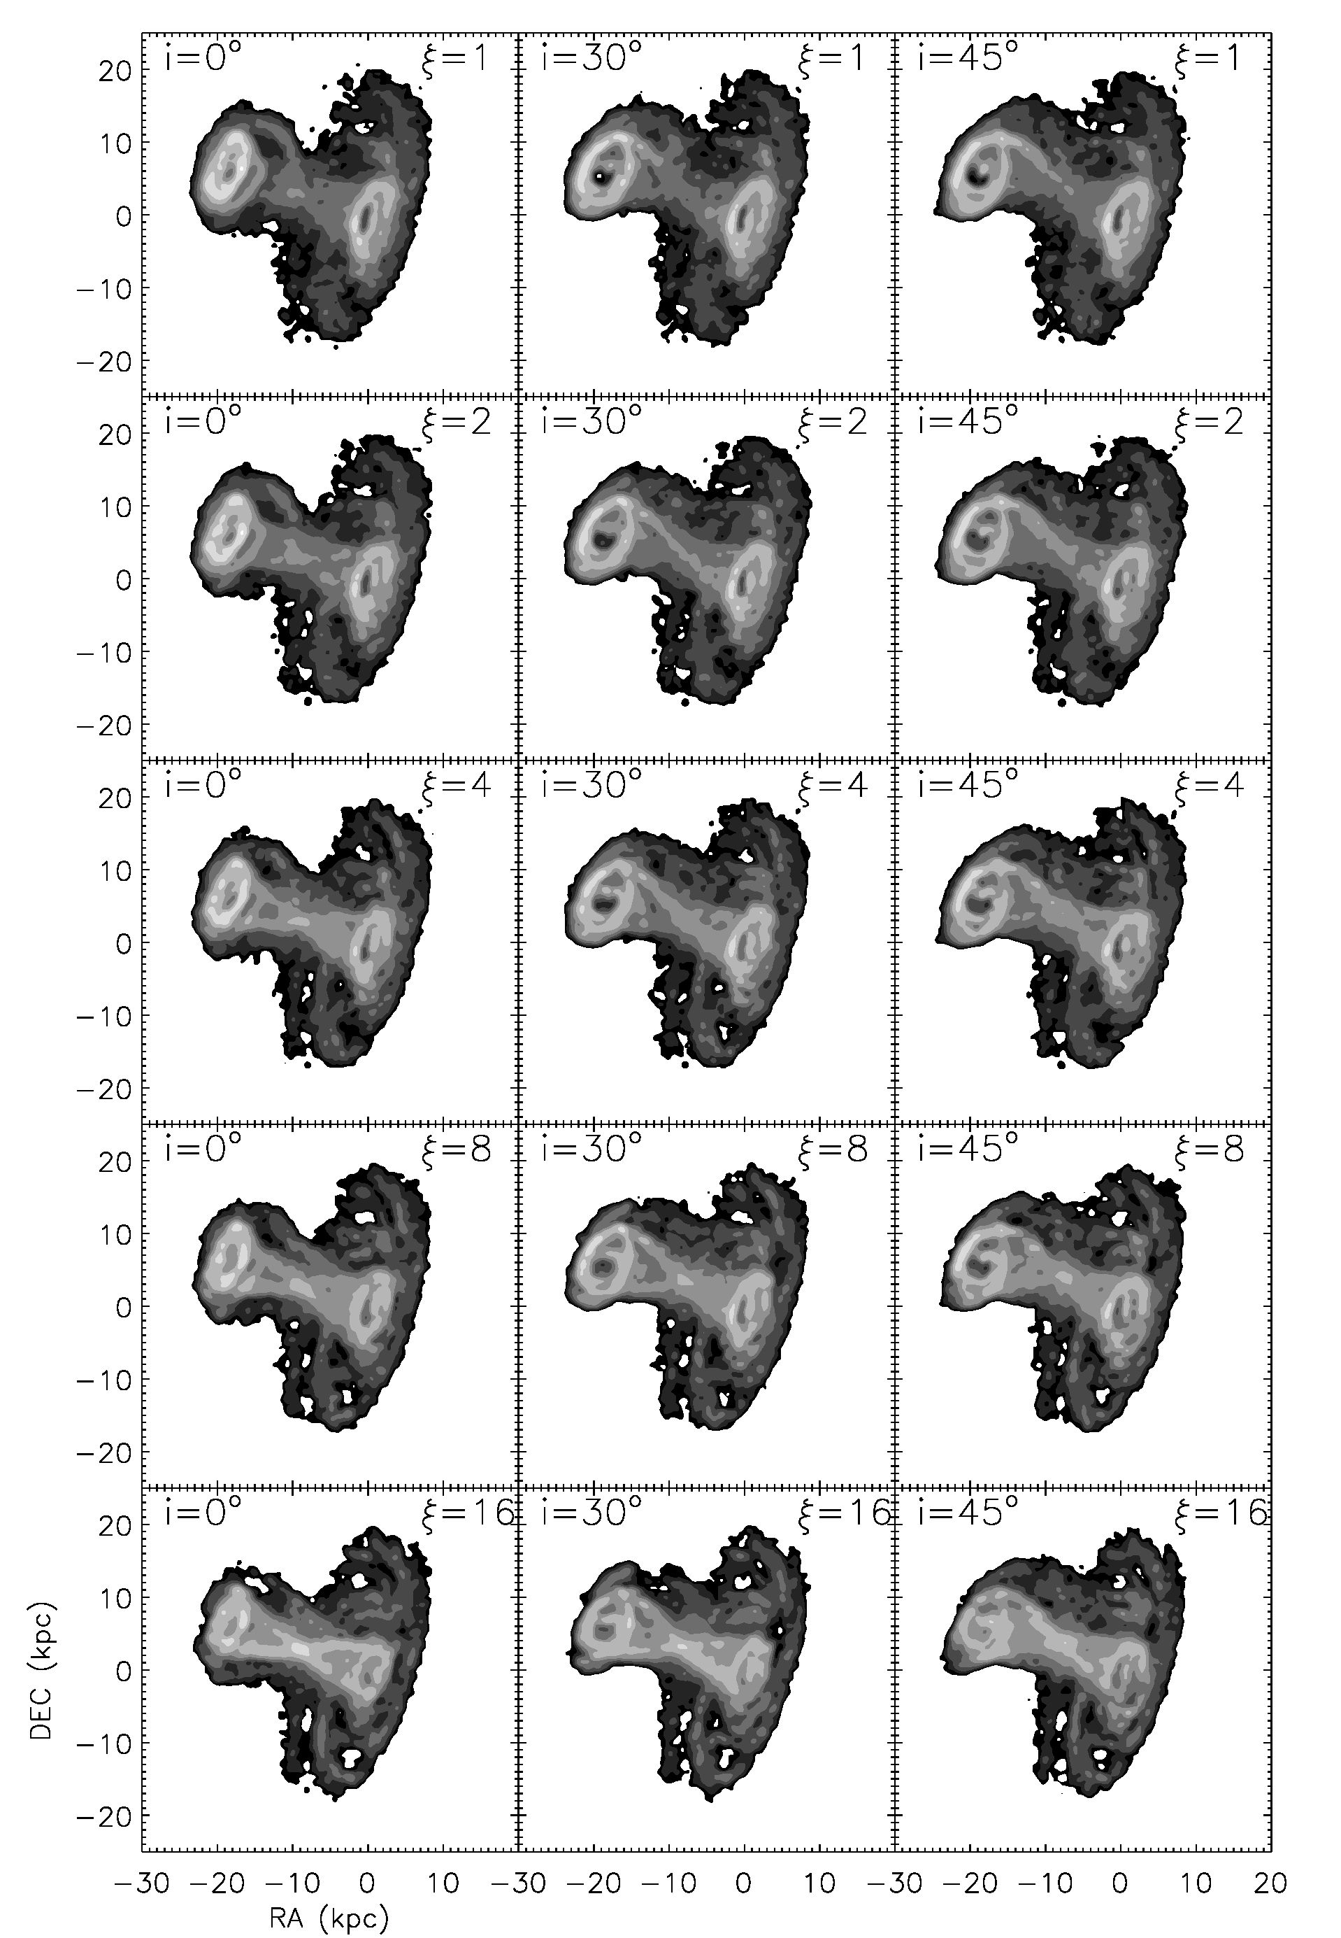
Fig. 3. Snapshots at the time of interest (26 Myr) for simulations with different inclination angles between the disks and different cloud particle
sizes as described in Table 2. Greyscale levels are (2,4,8,16,32,64,128, 256) M0 pc-2.
A39, page 5 of 27
B. Vollmer et al.: A Taffy model
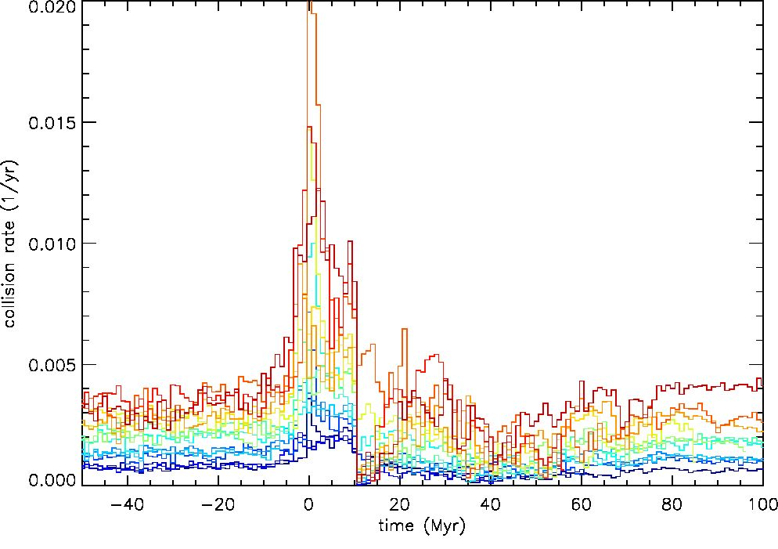
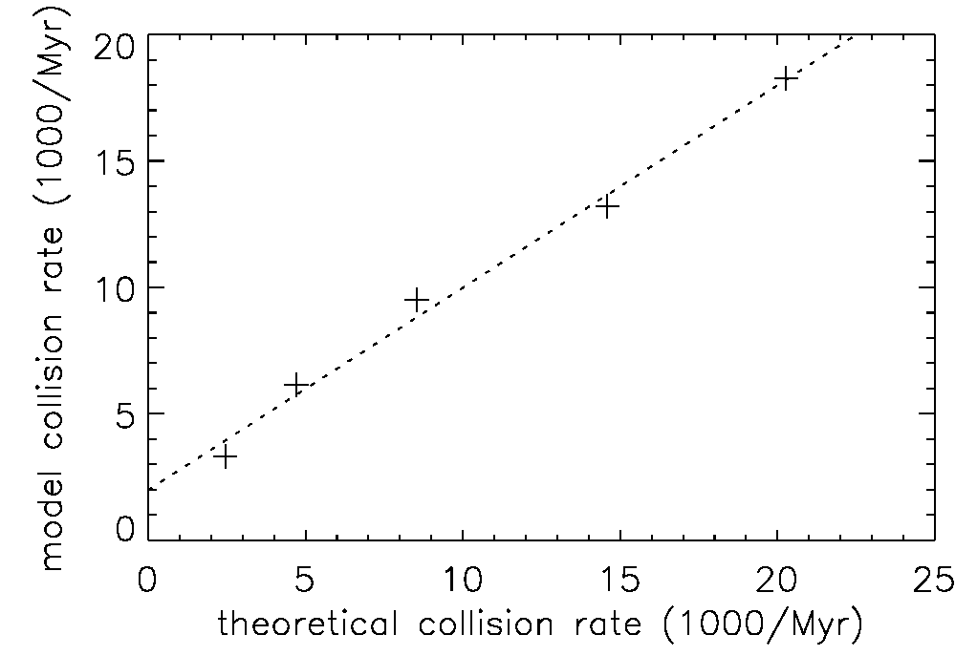
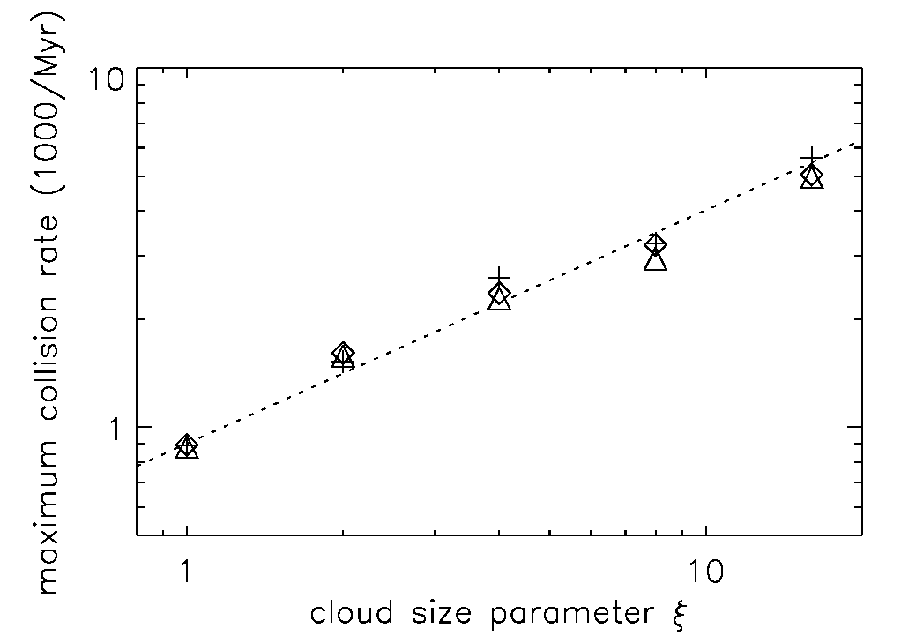
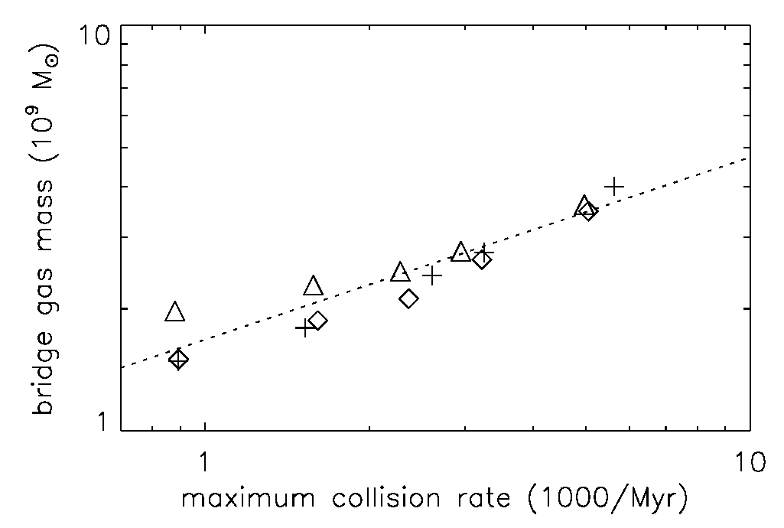
A&A 547, A39 (2012)
Fig. 4. Cloud particle collision rate for the simulations described in
Table 2. The factor of the cloud particle mass-size relation f increases
from blue to red.
inclination angle between the disk is weak compared to that on
the cloud size parameter f (Fig. 5).
For f > 8 the bridge gas mass exceeds 2.7x 109 M0 (Table 2).
This is at the lower end, but comparable to the observed bridge
gas mass of 3-4 x 109 M0. We thus decided to fix the cloud size
parameter at f = 8 for the second set of simulations. Since only
simulations with -30° < i < 0° lead to distributions of stars and
gas that reproduce observations, we restricted the second set of
simulations to this range of inclination angles between the two
disks.
  - Comparison with SPH simulations
The main difference between our collisional model and SPH
simulations of head-on collisions (Struck 1997; Tsuchiya et al.
1998) is the finite penetration length of the collisional particles
compared to the interdiction of penetration in SPH. The impact
generally carves a hole in the primary disk which is filled quite
rapidly (Struck 1997). Since in SPH all particles in the over-
lapping region collide, one expects a much higher momentum
transfer in SPH than in a collisional scheme. Due to the strong
momentum transfer, a less massive (~20% of the primary) com-
panion gas disk is destroyed during the head-on collision (Struck
1997). As in our model, head-on collisions of gas-rich galaxies
form prominent gas bridges in SPH. The SPH bridges also show
high gas column densities, comparable to those found in our
simulations. In contrast with our model, SPH simulations can
include gas heating and cooling. Struck (1997) showed that the
colliding gas is heated to temperatures up to 106 K at the impact.
The bridge gas than cools down to ~105 K after 35 Myr and to
~104 K within less than 100 Myr2. The overall gas distributions
of isothermal SPH simulations compared to SPH simulation in-
cluding heating and cooling are similar. In general, the edges of
the gas distributions are sharper in the isothermal simulations
(Fig. 4 of Struck 1997). We expect that our model simulations
are closer to isothermal SPH simulations of head-on galaxy col-
lisions, but they involve a smaller amount of momentum transfer
between the ISM of the colliding galaxies.
2 A large fraction of the Taffy bridge gas is cooler. Cooling strongly
depends on gas density. SPH models have kpc resolution and do
not resolve dense small-scale structures, which cool on much shorter
timescales.
Fig. 5. Correlation for the simulations described in Table 2. Upper
panel: cloud collision rate of the simulated quiet galaxies before colli-
sion as a function of the theoretical cloud collision rate based on Eq. (3).
Middle panel: maximum collision rate in bins of 10 Myr as a function
of the cloud particle mass-size relation f. Lower panel: total gas mass in
the bridge region as a function of the maximum collision rate. Crosses:
i = 0°; diamonds: i = 30°; triangles: i = 45°.
  - Realistic Taffy galaxy models
In our second set of simulations we set the cloud size parameter
f = 8 and the inclination between the two galaxies i = -30°, 0°.
To test the influence on the impact parameter, we varied the
initial position of the secondary galaxy (-71.5,1.0, -96.5) kpc
by adding 3 kpc-long and 9 kpc-long vectors with directions
A39, page 6 of 27
B. Vollmer et al.: A Taffy model
Table 3. Parameters of the second set of Taffy simulations which are used for comparison with observations.
Ta ffy  simulation |  | Inclination | (kpc) | y  (kpc) | z  (kpc) | Vx  (km s-1) | vy  (km s-1) | Vz  (kms-1) | b  (kpc) | Avmax  (km s-1) | ^max  1 coll  (Myr-1) | ^bridge  (109 M0)
18 | 8 | 0° | -71.5 | 1.0 | -96.5 | 300 | 0 | 405 | 2.0 | 1080 | 4850 | 3.49
19 | 8 | 1  O | -71.5 | 1.0 | -96.5 | 300 | 0 | 405 | 1.0 | 1120 | 4950 | 3.22
20 | 8 | 0° | -71.5 | 4.0 | -96.5 | 300 | 0 | 405 | 2.5 | 1080 | 3548 | 3.21
21 | 8 | 1  O | -71.5 | 4.0 | -96.5 | 300 | 0 | 405 | 1.3 | 1120 | 4973 | 3.23
pointing toward the eight corners and six sides of a cube. From
these 28 simulations we chose those which best fit the observed
CO gas distribution and velocity field. The initial conditions of
these four simulations are presented in Table 3. In the following,
we restrict our discussion on the two “best-fit” models, simula-
tions 19 and 20. These simulations differ in the inclination angle
between the disks, the impact parameter, and the maximum rel-
ative velocity. Whereas the maximum relative velocity between
the two galaxies is between 1080 and 1120 kms-1, it decreases
rapidly after the impact, and is only between 660 and 690 km s-1
at the time of interest, i.e. 23 Myr after the impact. The time evo-
lution of the stellar and gaseous components for are presented in
Fig. 6 (simulation 20) and Fig. 7 (simulation 19). The main dif-
ference between these simulations is that in simulation 19 the
secondary galaxy forms strong tidal tails to the east and west
parallel to the secondary’s trajectory, much stronger than ob-
served. The origin of a part of the gas mass in the bridge region is
the secondary’s western tidal arm. These tails are also formed in
simulation 20, but they are much shorter (3 kpc instead of 10 kpc
for simulation 19).
Both simulations produce prominent gas bridges along the
secondary’s trajectory whose morphologies are very similar to
those of the previous set of simulations with simplified collision
geometries (Fig. 2). Whereas the gas bridge of simulation 20 has
the morphology of a 3D hourglass, the morphology of the gas
bridge of simulation 19 is dominated by a straight filament which
bifurcates toward the secondary galaxy. For both simulations the
high-surface density small-scale structures disperse and disap-
pear ~30 Myr after the galaxy collision. At the same time, the
width of the gas bridge increases. As in the previous set of sim-
ulations, the outer gas disk of the primary galaxy is not affected
by the interaction, because of the relatively small extent of the
secondary’s gas disk. For t > 30 Myr, both galaxies develop
prominent ring stellar and gaseous structures.
The total cloud collision rates of the system for simula-
tions 18-21 are shown in Fig. 8. The shape of the time evo-
lution of the cloud collision rate mainly depends on the incli-
nation angle i between the two disks. In the case of parallel
disks (i = 0°, simulations 18 and 20), the cloud collision rate
abruptly increases during a few Myr. After its peak, it decreases
until 10-15 Myr, rises again slightly until 20-25 Myr, and then
declines slowly until 50 Myr after the impact. The collision rate
shows a different behavior for inclined galactic disks (i = -30°,
simulations 19 and 21): the cloud collision rate slowly rises al-
ready 10 Myr before the impact. At the moment of impact, it
rises abruptly during a few Myr. After the impact, the collision
rate declines until t ~ 7 Myr, increases again to a secondary
maximum at t ~ 10 Myr, and then declines monotonically until
t = 50 Myr. The formation of the secondary maximum is due to
the formation of the prominent tidal tail in the secondary galaxy
(see timestep 10 Myr in Fig. 7). For t > 20 Myr the evolution of
the collision rates are similar for all four simulations.

3.4. The time of impact
The time of interest is chosen to reproduce the main observed
characteristics of the Taffy system: the projected positions of
UGC 12914/15, the high gas column density of the bridge, and
the double-line profile of the spectra of the total gas in the bridge
region. This leads us to choose the timestep 23 Myr after impact.
This timestep of interest is indicated in Figs. 6 and 7
Condon et al. (1993) estimated the time of impact under
the assumption that their orbits are parabolic. Since the sys-
temic velocities of UGC 12914 and UGC 12915 are very close
(Avr = 35 kms-1), the galaxies 3D velocity vectors are located
in the plane of the sky. With the projected distance between the
galaxies (~15 kpc) and galaxy masses, they derived a relative
velocity of 600 km s-1 . This leads to a time since impact of
t ~ 24 Myr which is consistent with the time derived from spec-
tral steepening of the radio bridge (Condon et al. 1993). We thus
confirm this estimate of the collision time.

4. Comparison with observations
To test the goodness of our “best-fit” simulations 19 and 20, we
compare the model results to the following observations of the
Taffy galaxy system UGC 12914/15:
- stellar distribution;
- Hi and CO gas distributions;
- CO velocity field;
- Hi and CO spectra;
- polarized radio continuum emission intensity and projected
direction of the regular magnetic fields;
- radio continuum total power emission.
For the comparison we use a unique projection with the primary
(UGC 12914) seen at PA = 160°, i = 30°, and an azimuthal
viewing angle (rotation around the angular momentum axis of
the primary’s disk; see Fig. 9 of Vollmer et al. 2008a) az = 20°.

4.1. Stellar distribution
The Spitzer 3.6 pm map which traces the stellar mass distri-
bution of the Taffy galaxy system UGC 12914/15 is shown in
the upper panel of Fig. 9. The smaller galaxy, UGC 12915, has
a prominent tidal arm toward the northwest and a faint coun-
terarm to the southeast. The inner disk of UGC 12914 shows
the well-known ring structure at a distance of ~20" = 6 kpc3
from the center. Two spiral arms are visible in the north and
south of the galactic disk. The stellar surface density of the
outer (6-10 kpc) disk is higher in the north than in the south.
Moreover, UGC 12914 shows a low surface density stellar halo
up to a radius of ~80" = 23 kpc. The model stellar distributions
3 We use a distance of 60 Mpc for the Taffy galaxy system.
A39, page 7 of 27
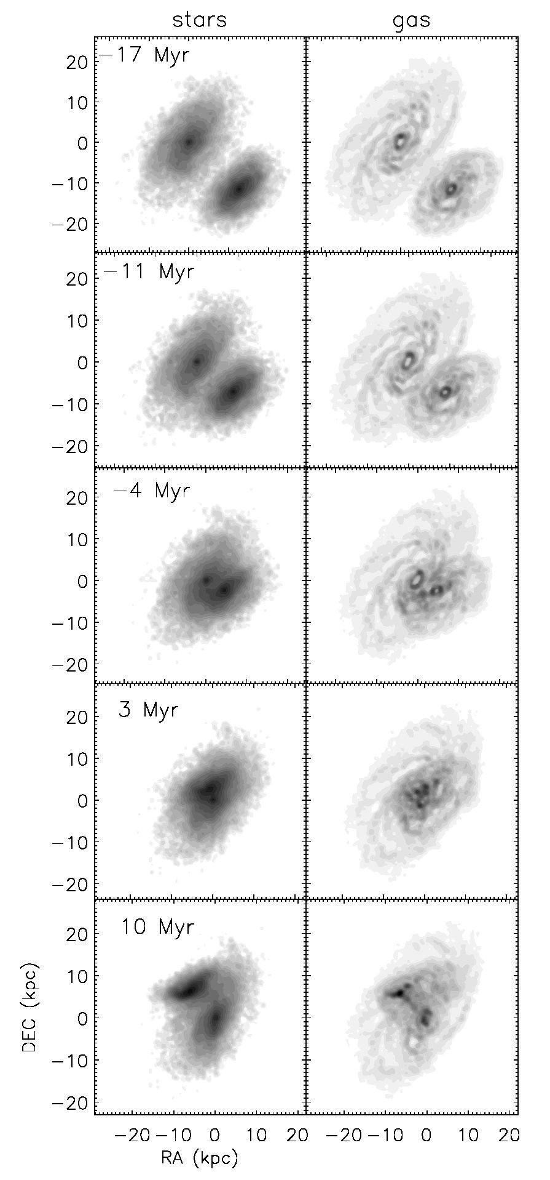
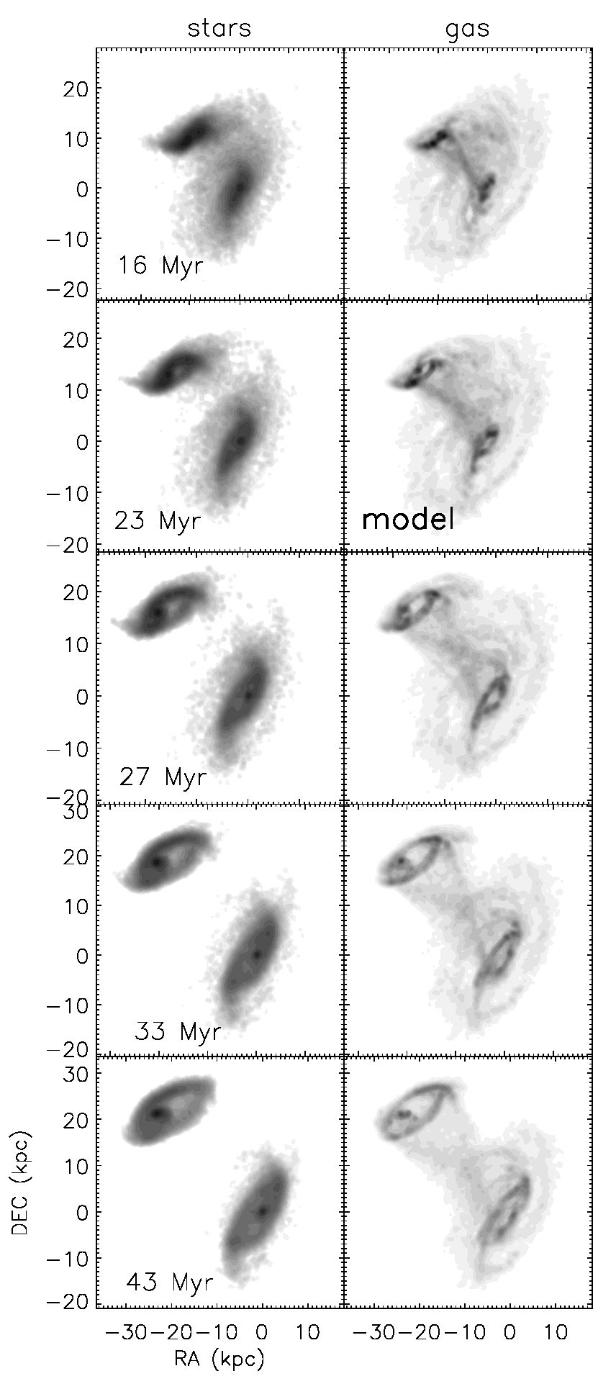
A&A547, A39 (2012)
Fig.6. Time evolution of simulation 20 (i = 0°, Sy = 4 kpc). Left panels: stellar surface density. The greyscale is logarithmic from 8 to
5600 M0 pc-2. Right panels: total gas surface density. The greyscale are (1,4,9,16, 25,36,49,..., 400) M0 pc-2. The timestep of interest (26 Myr)
is marked by “model”.
of simulation 19 and 20 are shown in the lower and middle
panel of Fig. 9. There is rough agreement between simulations
and observations: all secondary galaxies show a tidal distor-
tion along the major axis. However, in both simulations the
secondary galaxy is more distorted than observed. Moreover,
the curvature of the northern tidal arm is stronger than that
of UGC 12915 in both simulations. This is caused by the fact
that the secondary galaxy is not observed exactly edge-on. A
change of the inclination by 10° and the azimuthal viewing an-
gle by 20° of simulation 20 leads to an edge-on projection of the
secondary galaxy which reproduces the observed stellar distri-
bution of UGC 12915 (Fig. 10). We keep the azimuthal viewing
angle of Fig. 9, because the associated projection best repro-
duces the gas distribution and velocity field. As already stated
in Sect. 3.1, the secondary galaxy of simulation 19 shows more
prominent tidal arms than that of simulation 20 or the observa-
tions. Even in the case of an edge-on projection of the secondary
galaxy in simulation 19, the curvature of its northern tidal tail is
much stronger than observed.
The resemblance between simulations and observations is
better for the primary galaxy, UGC 12914. Especially the higher
stellar surface density in the northern outer stellar disk at (-6,
2) kpc is reproduced. This is a direct effect of the passage of
UGC 12915 in this region of the disk of UGC 12914. We con-
clude that simulation 20 better reproduces the stellar mass dis-
tribution of the Taffy galaxy system UGC 12914/15.
- Gas distribution
The model gas clouds represent the ISM as an entity. To
distinguish molecular from atomic gas we use a prescrip-
tion based on the total gas volume density, which has been
successfully applied to the Virgo spiral galaxies NGC 4522
A39, page 8 of 27
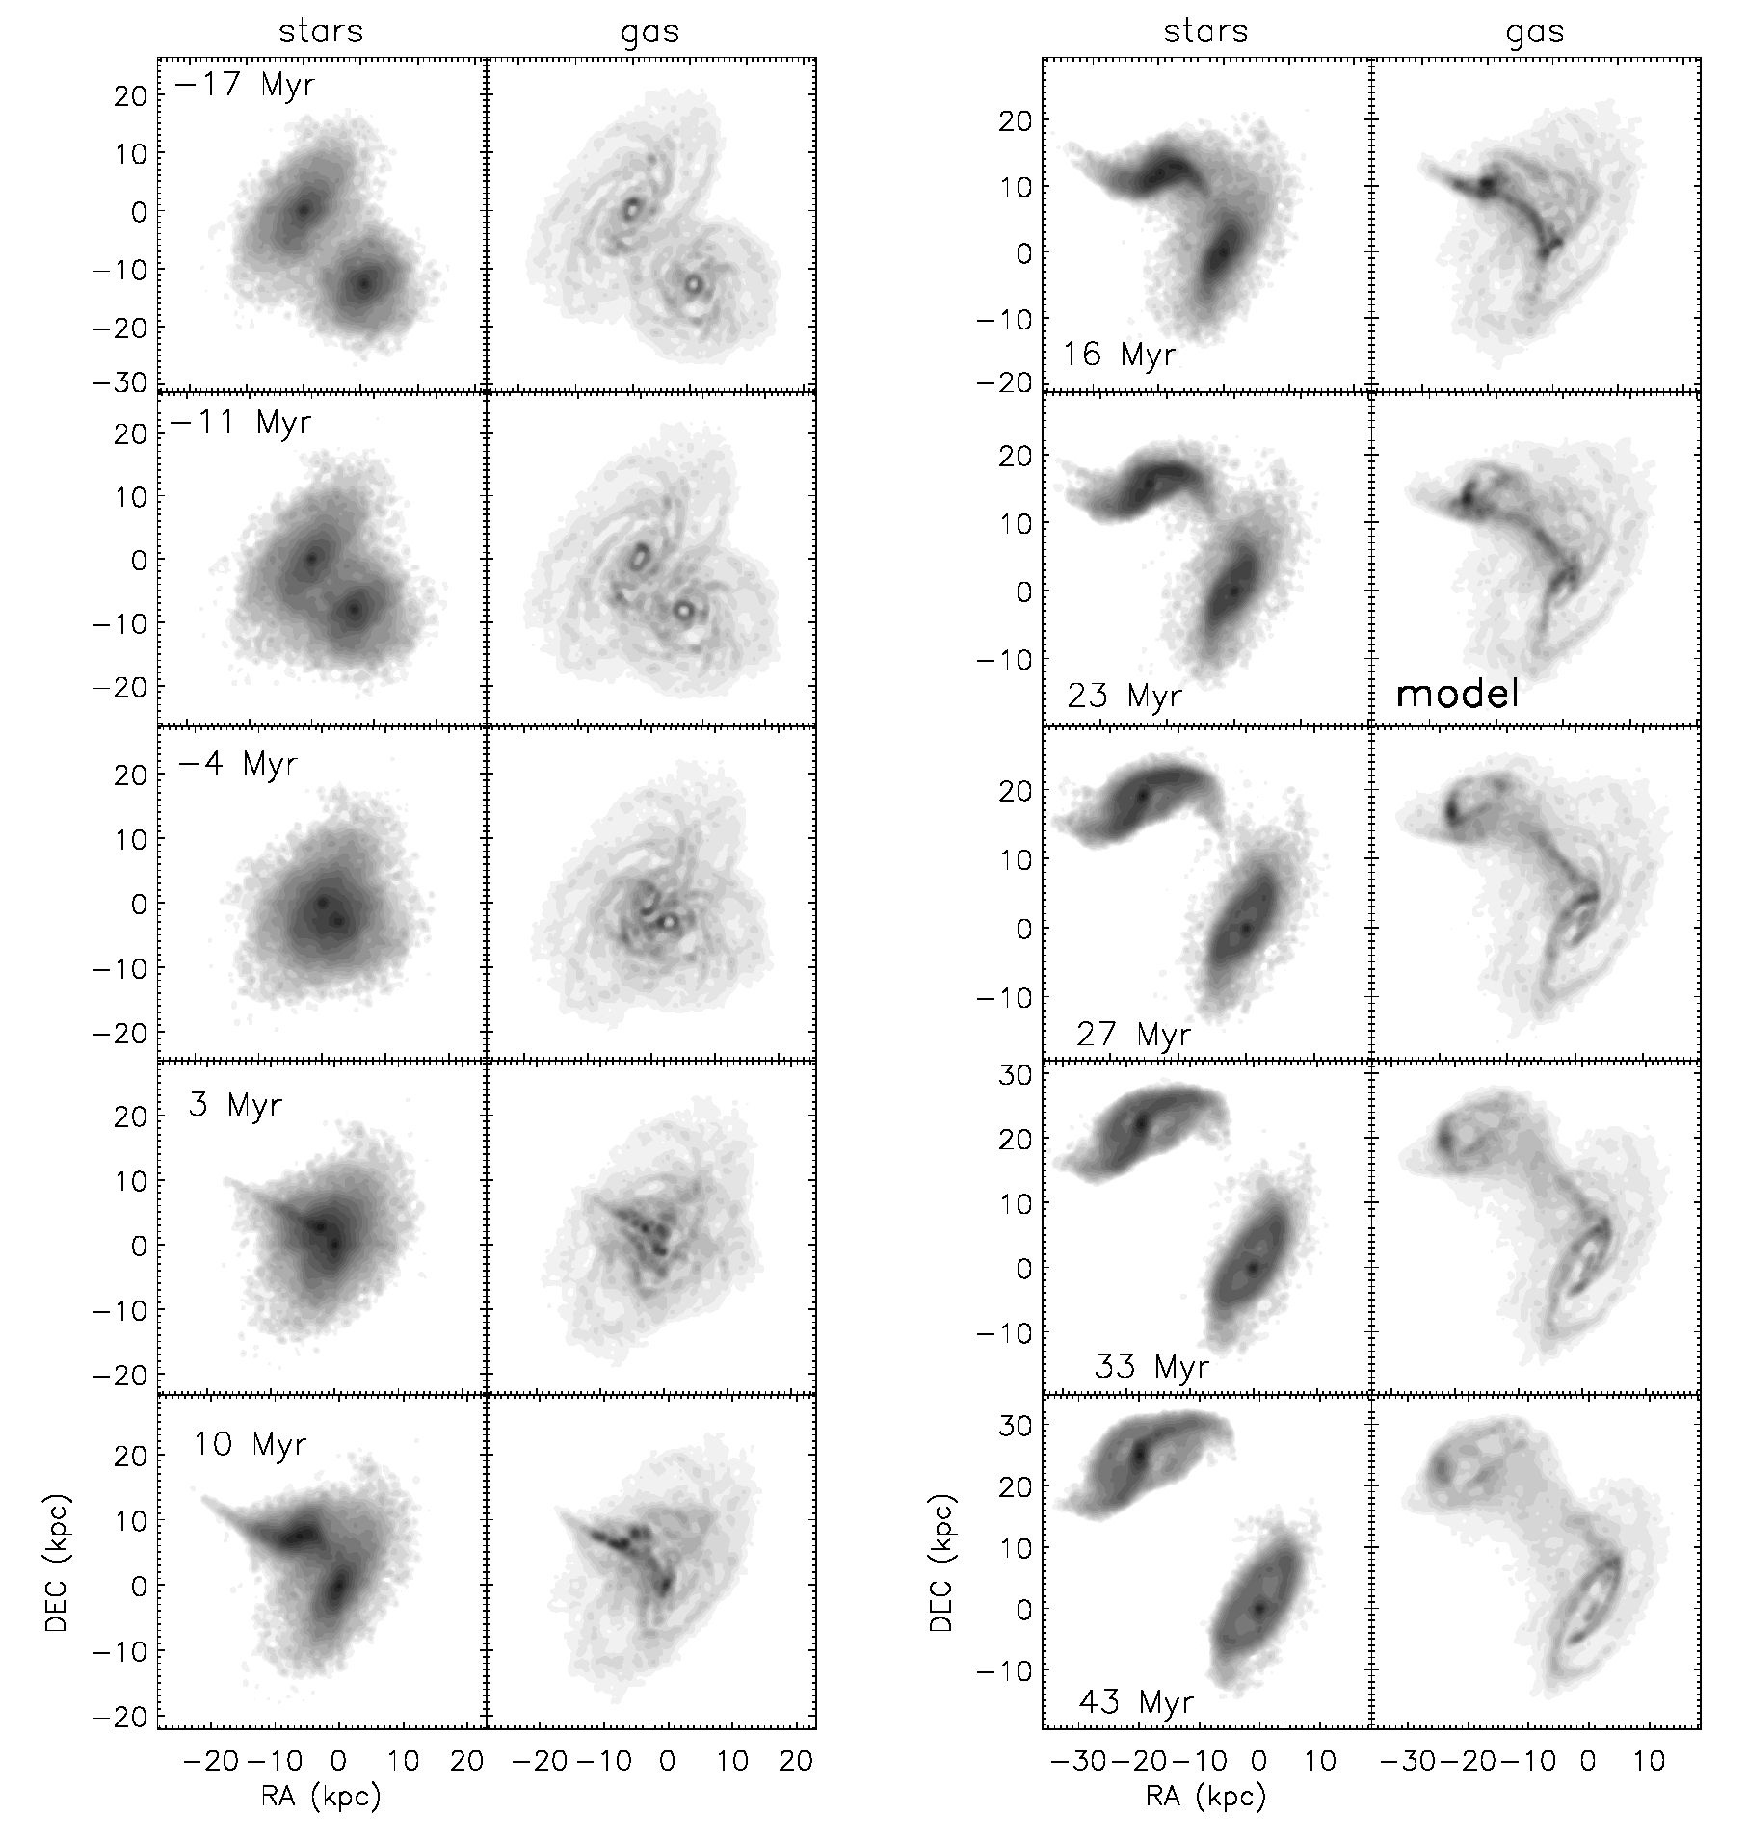
B. Vollmer et al.: A Taffy model
Fig.7. Time evolution of simulation 19 (i = -30°, Sy = 1 kpc). Left panels: stellar surface density. The greyscale is logarithmic from 8 to
5600 M0 pc-2. Right panels: total gas surface density. The greyscale are (1,4,9,16, 25,36,49,..., 400) M0 pc-2. The timestep of interest (26 Myr)
is marked by “model”.
(Vollmer et al. 2008b) and NGC 4330 (Vollmer et al. 2012a):
we assume that the molecular fraction depends linearly on
the square root of the gas density /moi = Mmo\/Mtot =
v/p/(0.03 M©pc-3) and the molecular fraction cannot exceed
unity. A detailed motivation for this prescription is given in
Vollmer et al. (2008b). The atomic and molecular gas surface
density distributions are thus given as 2HI = (1 - fmoi) 2tot and
2¾ = fmol ^tot. The atomic and molecular gas distributions of
the model snapshots of simulation 19 and 20 are shown together
with the CO (Gao et al. 2003) and Hi (Condon et al. 1993) dis-
tributions in Fig. 11.
The outer envelope of the Hi distribution of model primary
galaxies of simulation 19 and 20 are relatively unperturbed. That
of the secondary galaxy follows tidal perturbations visible in
the stellar distribution (Fig. 9). The observed outer Hi envelope
is different, with prominent Hi maxima to the north and south.
In addition, the northern extension of UGC 12914’s gas disk is
entirely missing. The surface density of the observed Hi bridge
is not constant between UGC 12914 and UGC 12915. The maxi-
mum of the Hi bridge is located closer to UGC 12914 and shifted
to the northwest with respect to the line connecting the two
galaxy centers. Contrary to observations, the surface density dis-
tributions of the model Hi bridges are constant along lines con-
necting the two galaxies. As for the observed Hi distribution, the
regions of maximum surface density of the model Hi bridges are
shifted to the northwest with respect to the line connecting the
two galaxy centers. This is a direct consequence of the impact
which occurs northwest of the center of the primary galaxy.
The comparison between the model and observed H2 distri-
butions is always limited by an uncertain conversion factor be-
tween CO surface brightness and H2 surface density. In the Taffy
system, this conversion factor varies significantly between the
disk and bridge regions (Braine et al. 2003; Zhu et al. 2007).
Because of the uncertainty of the local conversion factor, we
A39, page 9 of 27
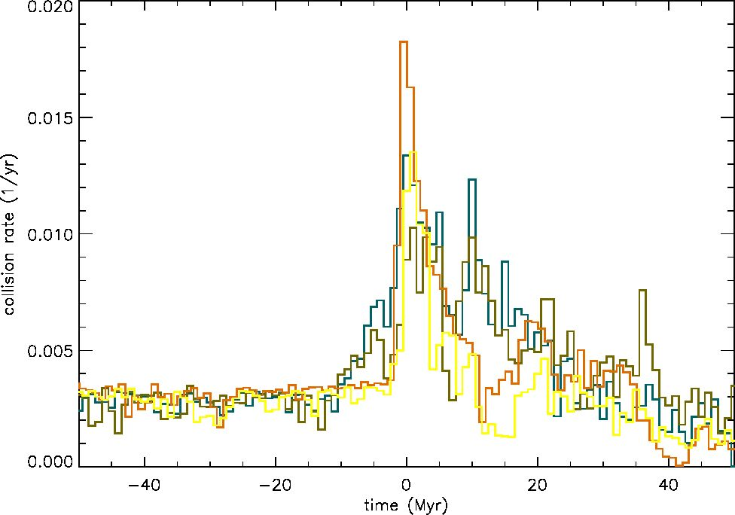
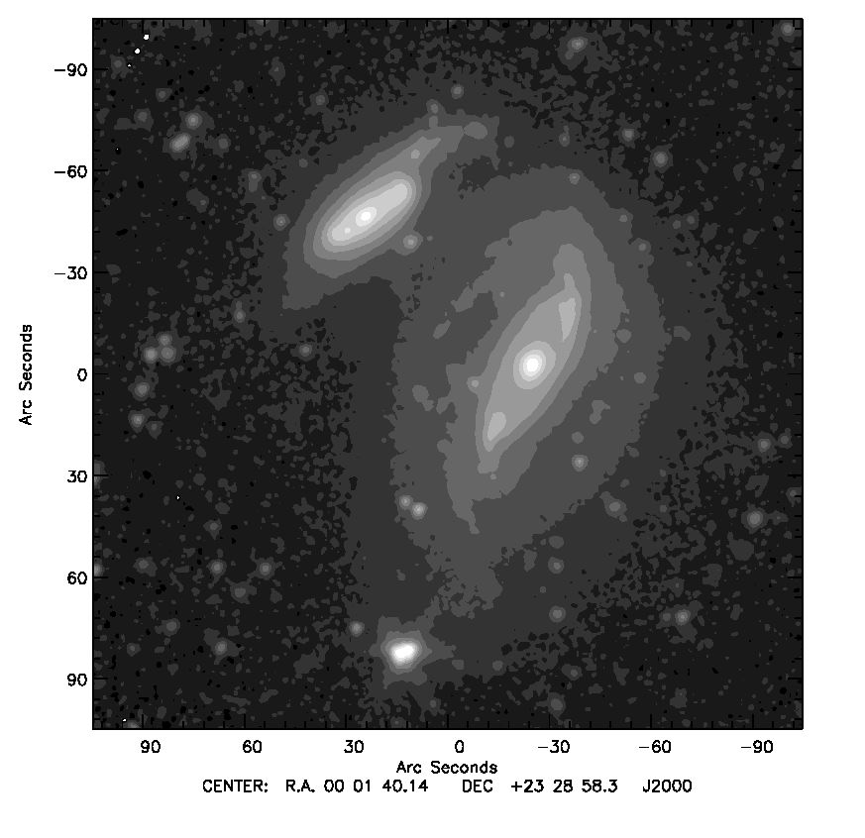
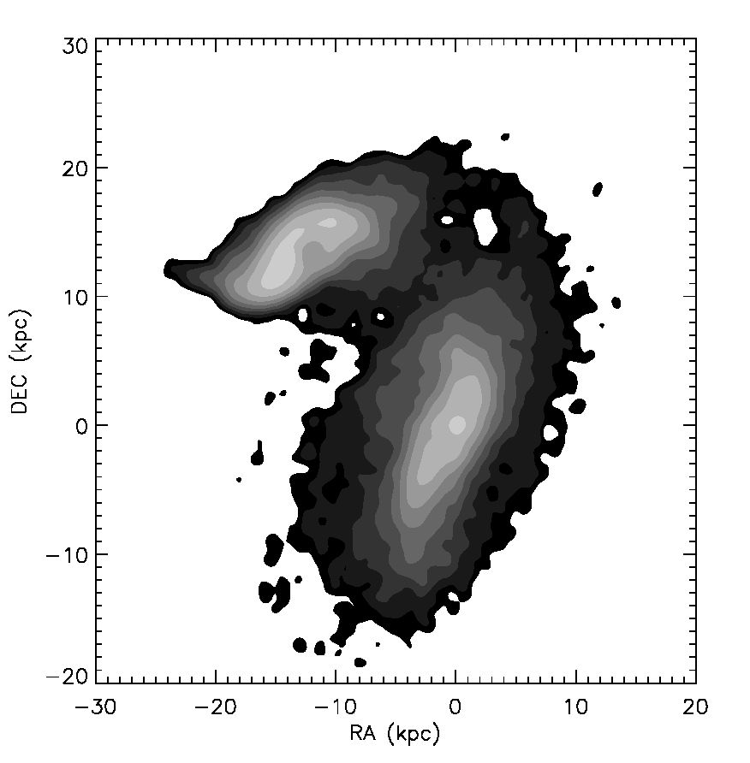
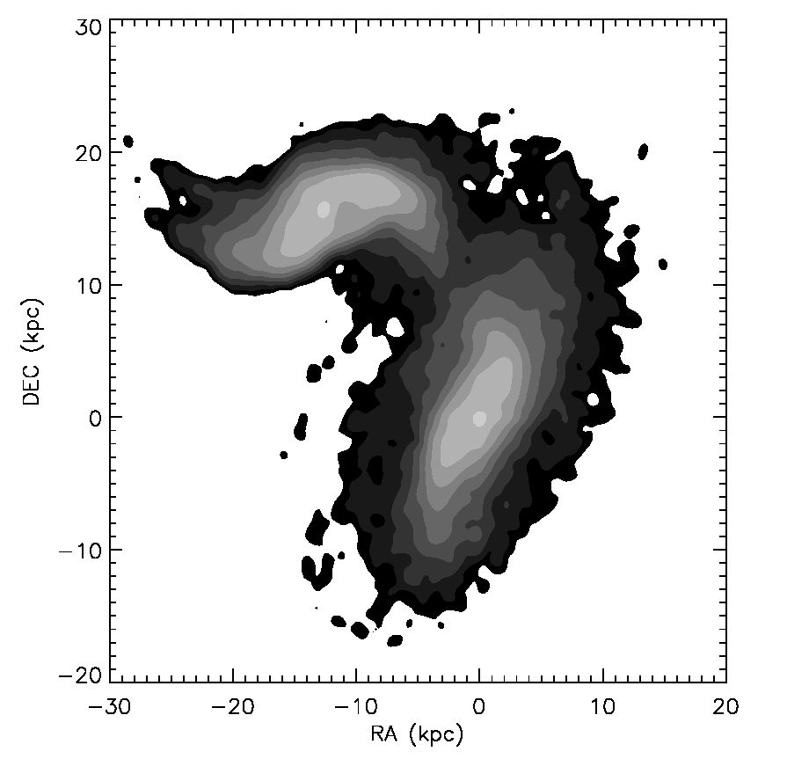
A&A547, A39 (2012)
Fig. 8. Cloud particle collision rate for the simulations described in
Table 3. Red: simulation 18; blue: simulation 19; yellow: simulation 20;
green: simulation 21.
apply a constant Galactic CO-H2 conversion factor N(H2)//Co =
1020 cm-2 (Kkms-1)-1 to the whole Taffy system (Zhu et al.
2007). For this comparison one has to bear in mind that the
CO-H2 conversion factor in the bridge might be several times
lower than that in the galaxy disks (Braine et al. 2003; Zhu et al.
2007).
The maximum CO surface brightness and CO luminosity of
UGC 12915 are higher than those of UGC 12914. The CO emis-
sion distributions of UGC 12914 and UGC 12915 are asymmet-
ric along the major axis: they are more extended to the north
than to the south. The maximum CO emission of the bridge is
observed close to UGC 12915 and harbors a giant Hu region
(Gao et al. 2003; Braine et al. 2003; Zhu et al. 2007). The pro-
jected width of the CO bridge is about half that of the Hi bridge.
The CO bridge is offset toward the southeast with respect to the
Hi bridge.
In the model, the H2 surface density of the two galactic disks
is about the same. Whereas the H2 surface density of the pri-
mary galaxy is more extended to the south in simulation 20, that
of the secondary galaxy is more extended to the northwest. In
simulation 19 the H2 distribution of the primary galaxy is more
symmetric, and that of the secondary is strongly distorted by
the strong tidal fields. The model H2 bridges are more continu-
ous than the observed CO bridge. Whereas there is more bridge
H2 found in the northeast in simulation 20, the opposite trend
is observed in simulation 19. As observed, the widths of the
H2 bridges are about half that of the model Hi bridges, and they
are offset to the southeast with respect to the Hi bridges.

4.3. Molecular gas velocity field
The observed CO velocity field of the Taffy system (Gao et al.
2003) is presented in Fig. 12 together with the model molec-
ular gas velocity fields. The observed CO velocity field of the
galactic disks is quite regular, i.e. the isovelocity contours are
approximately parallel to the disks’ minor axes. The molecular
gas of most of the bridge region has a zero velocity, i.e. that of
UGC 12914. The velocities become positive (~ 150 kms-1) in
the northwestern bridge region toward UGC 12915 and in the
southern bridge region toward UGC 12914. The velocity gradi-
ent of most of the bridge is parallel to that of disk rotation.
Only simulation 20 shows undisturbed disk rotation fields
which reproduce the observations. The isovelocity contours in
Fig. 9. Stellar surface density distribution. Upper panel: based on
Spitzer IRAC 3.6 pm observations. Middle panel: timestep t = 23 Myr
of simulation 20. Lower panel: timestep t = 23 Myr of simula-
tion 19. Contour levels are (1, 2,4, 8,16,32, 64,128, 256,512,1024) x
5 M0 pc-2. Projection parameters are PA = 160°, i = 30°, and az = 20°.
A39, page 10 of 27
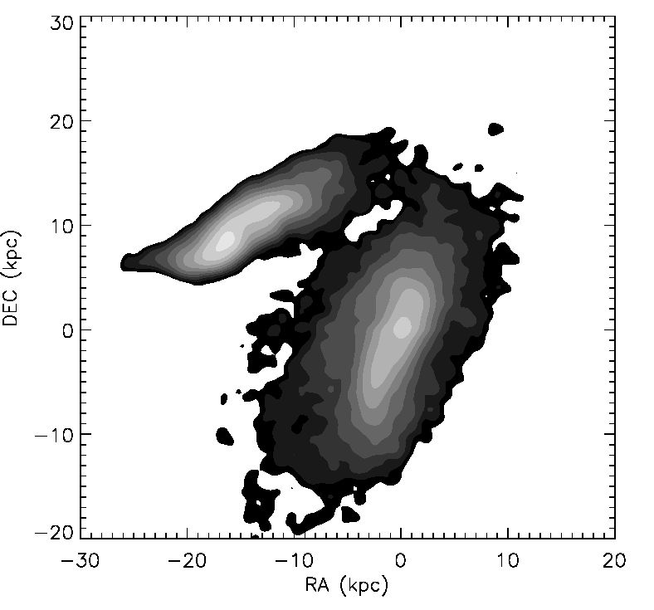
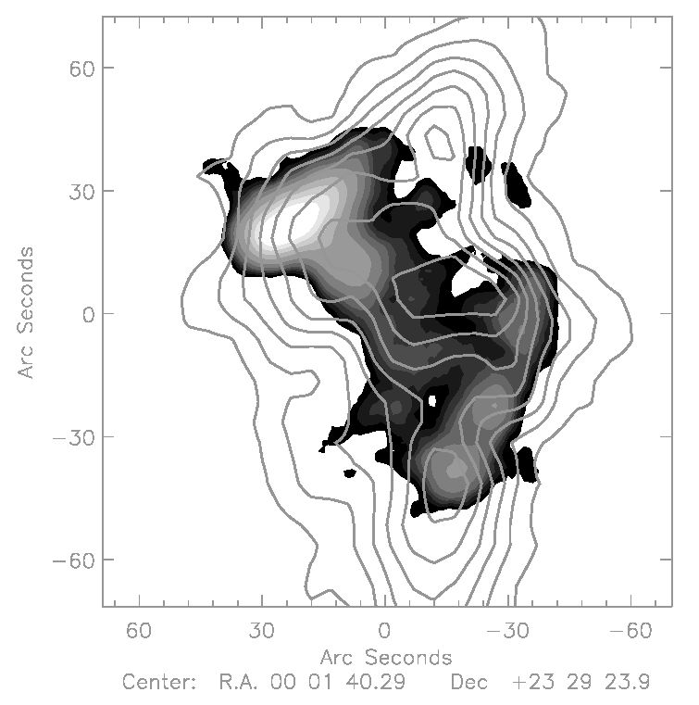
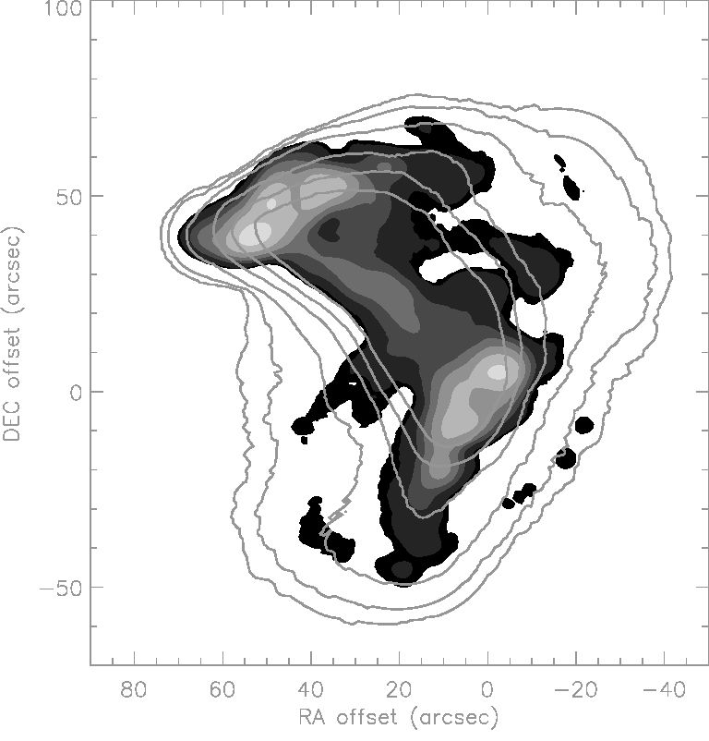
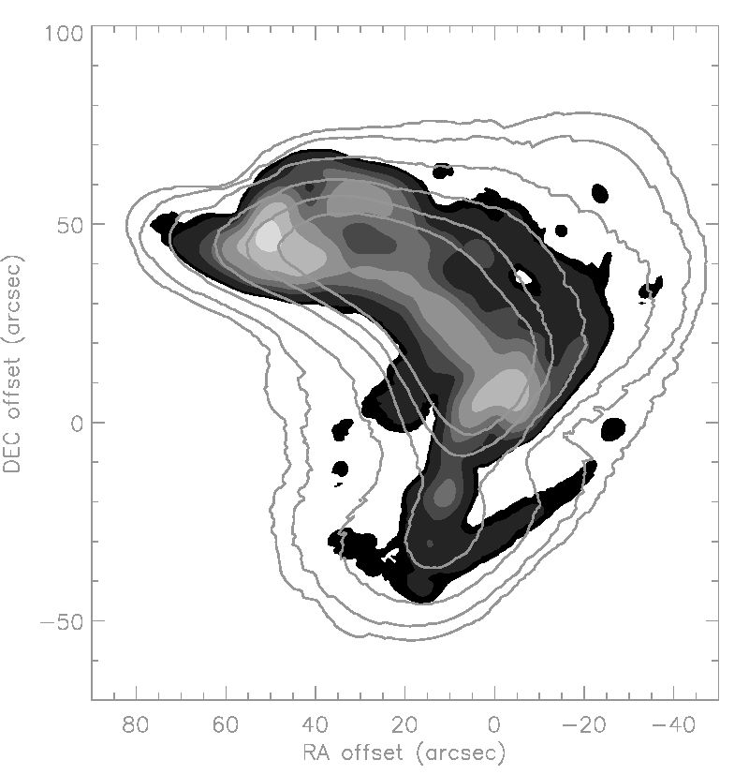
B. Vollmer et al.: A Taffy model
Fig. 10. Stellar surface density distribution of simulation 20 with pro-
jection parameters PA = 160°, i = 20°, and az = 0°. The stellar mor-
phology of UGC 12915 is better reproduced by the model.
the disks of simulation 19 are not parallel to the minor axes, but
bent, as in barred spiral galaxies. In both simulations, most of the
bridge gas is at zero velocity, in agreement with observations.
The positive velocity of the northern receding side of the sec-
ondary galaxy and the southern receding side of the primary
galaxy extend into the bridge region, giving rise to a velocity
gradient which is parallel to that of disk rotation, again, in agree-
ment with observations. The observed CO velocity structure of
the bridge is better reproduced by simulation 19.

4.4. Hi and CO spectra
The CO observations of Gao et al. (2003) presented in the pre-
vious Section were made with the BIMA interferometer. Due to
the lack of very short baselines, the interferometer cannot de-
tect extended structures of molecular gas. This extended molec-
ular gas component is best detected by a single dish telescope,
as the IRAM 30m telescope. In the presence of complex line
shapes, the moment maps contain less information than the in-
dividual spectra. Therefore, we show in Fig. A.1 30 m CO(1-0)
spectra together with VLA Hi spectra of the Taffy system (Fig. 1
of Braine et al. 2003) for the comparison with our simulations.
In the disk regions, where the lines are broad (~700 km s-1),
the CO line follows the Hi line. In the bridge region the Hi spec-
tra show a pronounced double-peaked spectrum. Both peaks
have comparable widths (~200 km s-1) and intensities. They are
separated by ~ 100-300 kms-1. Only the high-velocity part of
the Hi spectra has a CO counterpart. On the western side of
UGC 12914 a double-line profile is observed in Hi, with a CO
counterpart only for the low velocity line. The corresponding
model spectra are presented in Fig. A.2 for simulation 20 and in
Fig. A.3 for simulation 19. The model Hi and CO lines of the pri-
mary galaxy have broad widths in both simulations, comparable
to the observed line widths. Those of the secondary galaxy are
comparable to the observed line widths only in simulation 20,
because the secondary is seen less edge-on in simulation 19.
In the bridge region, both simulations display double-line pro-
files. Both simulations thus reproduce the observed double line
profiles. Moreover, only the low-velocity line has a CO coun-
terpart in the region around (-7,10) kpc for simulation 20 and
around (-3,10) kpc for simulation 19. Although the linewidths
of the two components of the observed double-line profiles in
Fig. 11. HI (contour) on CO (greyscale) surface density. Upper panel:
observations from Condon et al. (1993) and Gao et al. 2003).
Contour levels are (4, 8,12,16, 20, 24, 28,32) M0 pc-2; greyscale lev-
els are (55, 60, 65,70,75, 85,100,125,150, 175, 200) M0 pc-2. Middle
panel: timestep t = 23 Myr of simulation 20. Contour lev-
els are (1,2,4, 8,12,16,32, 64,128) M0 pc-2; greyscale levels are
(1, 2, 8,16,32, 64,128, 256) M0 pc-2. Lower panel: timestep t = 23 Myr
of simulation 19. Contour and greyscale levels are the same as for the
middle panel.
A39, page 11 of 27
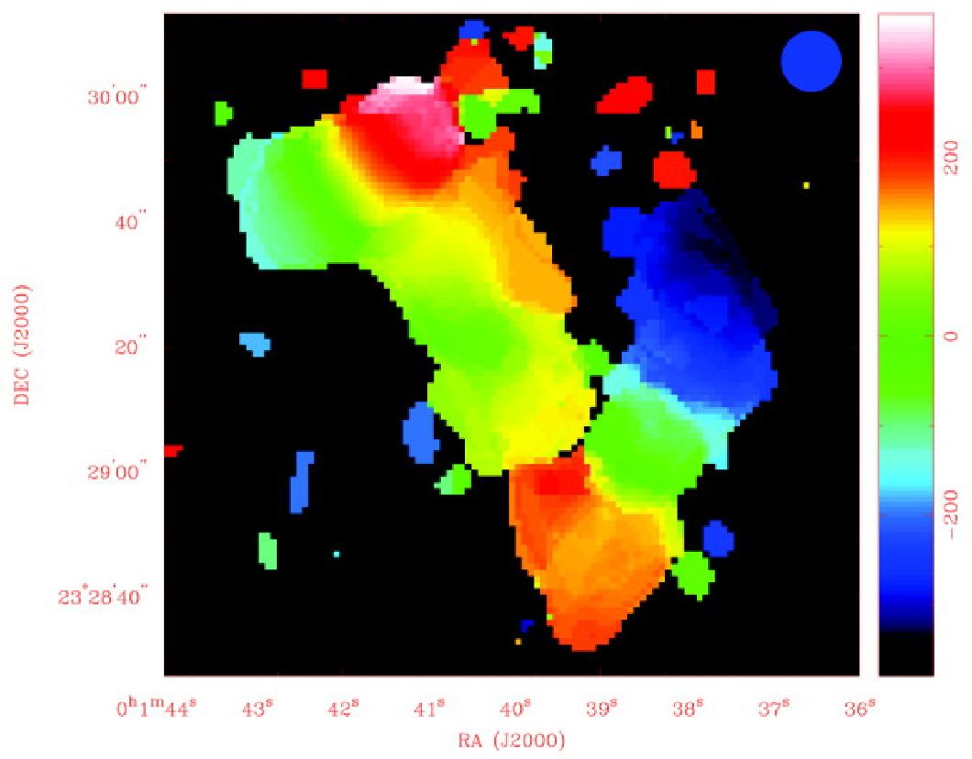
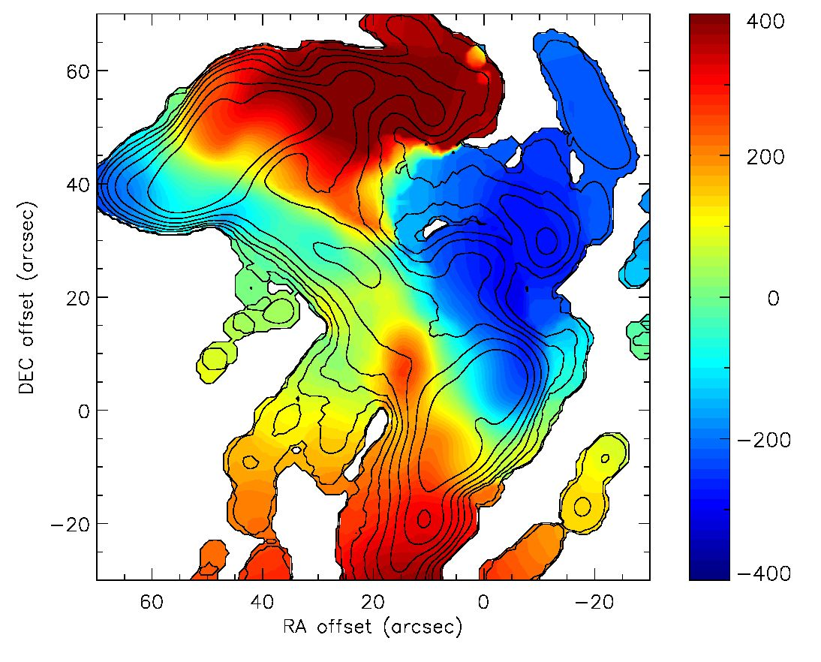
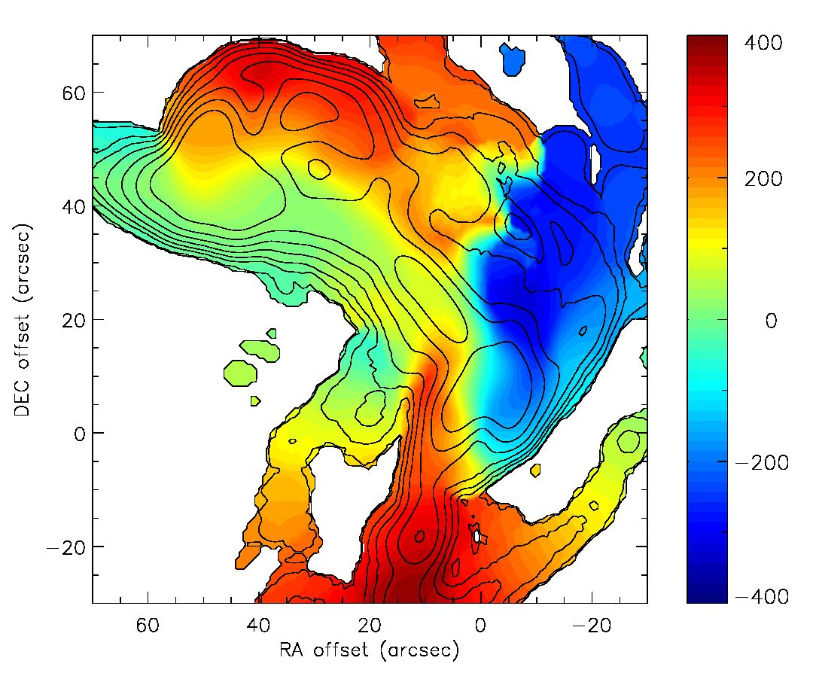
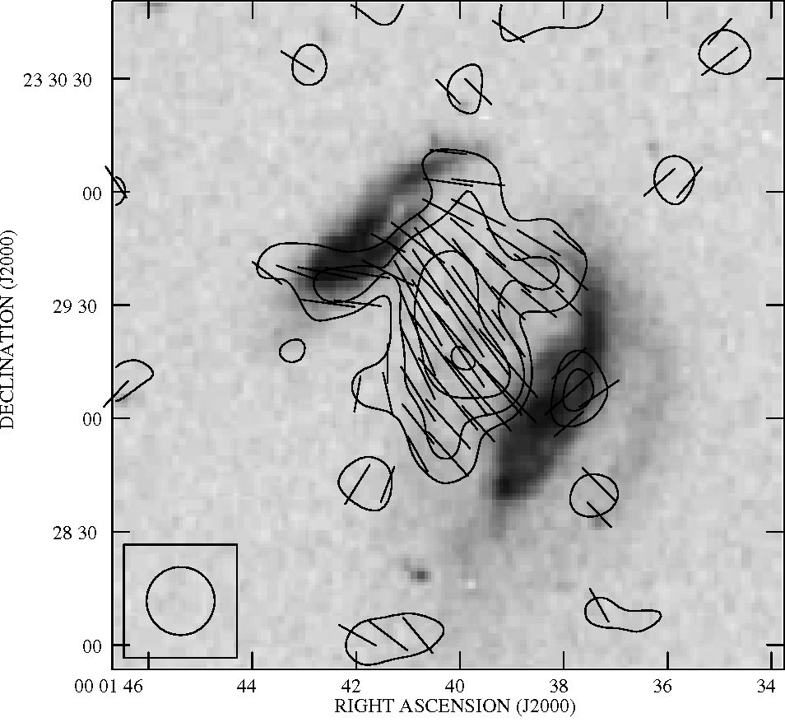
A&A 547, A39 (2012)
taffy 4.86 GHz PI+B-vect.
Fig. 13. Observed 6 cm polarized radio continuum contours and pro-
jected magnetic field vectors (from Condon et al. 1993) on a Digitized
Sky survey image of the UGC 12914/5 system. Contour levels are
(3,5, 8,12, 20,30,50, 80,120, 200,300,500) x 15 J/beam.
the bridge region are well reproduced by simulation 20, their
velocity separation is about twice the observed separation. On
the other hand, simulation 19 reproduces the observed velocity
separation between the lines, but the linewidth of the high-
velocity line is about 1.5 times broader than observed. Both sim-
ulations reproduce the observed double-line profile west of the
center of UGC 12914, with a CO line at low velocities and an
Hi line at high velocities. The causes of the double-line profile
will be discussed in Sect. 5.2.
4.5. Radio continuum
- Observations
We re-reduced archival VLA 6 cm total power and polar-
ized continuum data first published in Condon et al. (1993).
Similar maps of the Taffy system are shown in Drzazga et al.
(2011). Only the bridge region is detected in polarized emis-
sion (Fig. 13). The maximum of polarized intensity is located
in the southern part of the gas bridge. The projected vectors of
the large-scale regular magnetic field are parallel to the bridge or
perpendicular to the galactic disks. The total power emission is
shown in Fig. 14. As shown in Condon et al. (1993) the bridge re-
gion shows strong radio continuum emission at 6 cm. Moreover,
UGC 12915 has a ~4 times higher central surface brightness
than UGC 12914.
- Model
To calculate the large-scale regular magnetic field for our simu-
lations, we apply the same procedure as Otmianowska-Mazur &
Vollmer (2003) and Vollmer et al. (2012a). We solve the induc-
tion equation:
Fig. 12. CO velocity field (colors). Contours: H2 surface density from
Fig. 11. Upper panel: observations from Gao et al. (2003). Middle
panel: timestep t = 23 Myr of simulation 20. Lower panel: timestep
t = 23 Myr of simulation 19.
d_
dt
A = v x (Vx A) + a (Vx A) - n Vx(Vx A)
(4)
where A = Vx B is the magnetic potential, B the magnetic in-
duction, v the large-scale velocity of the gas, and n the coefficient
A39, page 12 of 27
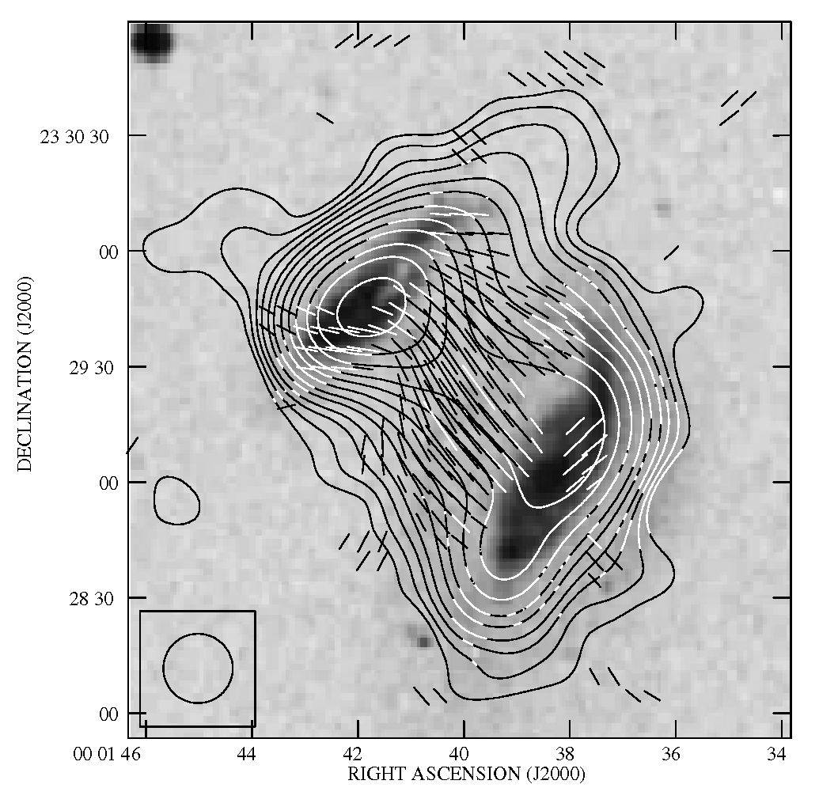
B. Yollmer et al.: A Taffy model
Fig. 14. Observed 6 cm total power radio continuum contours
and projected magnetic field vectors (based on archival VLA
data first published by Condon et al. 1993) on a Digitized Sky
survey image of the UGC 12914/5 system. Contour levels are
(3,5, 8,12, 20,30,50, 80,120, 200,300,500) x 16 J/beam.
of a turbulent diffusion, on a 3D grid (200 x 200 x 250). The cell
size is 300 pc. Time-dependent gas-velocity fields are provided
by the 3D dynamical simulations presented in Sect. 2. The induc-
tion equation is solved using a second order Godunov scheme
with second order upstream partial derivatives together with a
second order Runge-Kutta scheme for the time evolution. This
results in less numerical diffusion than that of the ZEUS 3D
MHD code (Stone & Norman 1992a,b). The 3D velocity field
obtained from the N-body code has a discrete distribution. The
interpolation to a regular 3D grid was done with the Kriging
method (Soida et al. 2006). We assume the magnetic field to be
partially coupled to the gas via the turbulent diffusion process
(Elstner et al. 2000) assuming the magnetic diffusion coefficient
to be n = 3 x 1025 cm2 s-1. We do not implement any dynamo
process (a = 0). The initial magnetic field is purely toroidal with
an exponential distribution with a scalelength of 1 kpc in the
vertical direction. Because very rapidly (~1000 kms-1) evolv-
ing gas particles lead to numerical artifacts in our code, only
the primary galaxy, which is kept at rest, is initially magnetized.
During the galaxy-galaxy collision the magnetic field propagates
into the gas bridge and is then amplified by the dynamics of the
bridge gas. Due to the enormous amount of kinetic energy in the
bridge gas, the final magnetic field configuration is expected to
be independent of the seed field.
The MHD model does not contain a galactic wind. The re-
sulting polarized emission is calculated by assuming a density
of relativistic electrons that is proportional to the model gas den-
sity p. This rather crude approximation is motivated by (i) the
fact that in quiescent galaxies, the density of relativistic elec-
trons is approximately proportional to the star formation den-
sity which depends on p1-17; and (ii) the transport mechanism
of relativistic electrons into the bridge region during the galaxy
collision is unknown. During the collision, the magnetic field
in the bridge region is amplified by shear and compression mo-
tions. The overall morphology of the magnetic field does not
evolve significantly for timesteps around the time of interest
(20-35 Myr).
Since the direction of the projected magnetic field vectors
strongly depends on projection, we show the resulting model
polarized emission together with the model projected B vec-
tors for simulation 19 and 20 for two azimuthal viewing an-
gles az = 0° and 20° in Fig. 15. In all model polarized emis-
sion maps the bridge region is prominent. The model polarized
emission of the bridge is as strong as that of the two galactic
disks. Its maximum is located in the northern/southern part of
the bridge in simulation 19/20. The different azimuthal view-
ing angles do not lead to significant changes for simulation 20,
but do change of the location of the maximum polarized emis-
sion near the secondary galaxy in simulation 19. The width of
the bridge of polarized emission is ~7 kpc in simulation 20 and
~12 kpc in simulation 19.
The model magnetic field vectors are mostly parallel to
the bridge in simulation 20. Only one region close to the
primary galaxy displays an offset by ~45°. In simulation 19 the
southwestern part of the bridge has magnetic field vectors paral-
lel to the bridge, whereas the B vectors of the northeastern part
show an offset of ~30°. The overall resemblance between the ob-
served and model polarized emission is better for simulation 20
with the maximum located in the southern part of the bridge and
the B vectors parallel to the bridge.
Whereas the polarized radio continuum emission depends
on the large-scale (compared to the beam) regular magnetic
field, the total power emission depends mainly on the small-
scale turbulent magnetic field, which dominates the total mag-
netic field strength. Since our MHD model only includes the
regular magnetic field, we have to derive the turbulent mag-
netic field in a different way. For this we assume equipartition
between the magnetic field B and the turbulent motions of the
gas: B2/(8n) = 1/2pv2urb, wherep is the ISM density and vturb its
turbulent velocity dispersion. The total power emission is pro-
portional to the density of relativistic electrons times the square
of the turbulent magnetic field. During the galaxy head-on col-
lision, cosmic ray electrons are dragged into the bridge region.
Since we do not know the mechanisms of the cosmic ray drag,
we approximate the total power emission by the square of the
small-scale turbulent magnetic field (Fig. 16). In both simula-
tion snapshots the total power emission of the bridge region is
as strong as that of the primary galaxy. This is mainly caused by
the high gas velocity dispersion of the bridge gas (Sect. 5). The
model total power emission of the secondary galaxy is higher
than that of the primary. The model thus qualitatively reproduces
the 6 cm total power emission of the Taffy system (Fig. 14).

5. Discussion

5.1. How well does the model reproduce observations?
To assess the goodness of the model, we determined the main ob-
servational characteristics that a galaxy collision model should
reproduce (Table 4). We then checked if these characteristics
are reproduced. In summary, both simulations reproduce the
primary’s stellar distribution, the prominent Hi and CO gas
bridge, the offset between the CO and Hi emission in the
bridge, the bridge isovelocity vectors parallel to the bridge,
the Hi double-line profiles in the bridge region with CO emis-
sion only associated to the high-velocity line, the large line-
widths (100-200 kms-1) in the bridge region (simulation 19:
100-200 kms-1, simulation 20: ~100 kms-1), the high field
strength of the bridge large-scale regular magnetic field, the
A39, page 13 of 27
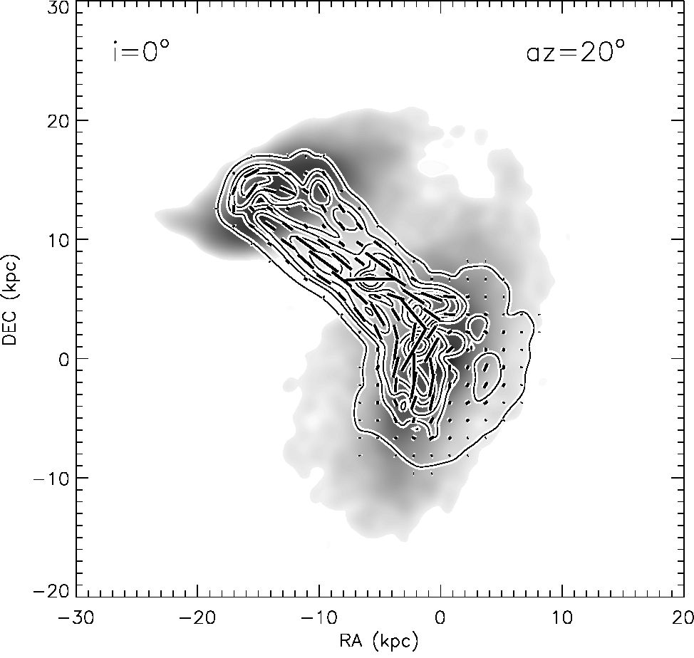
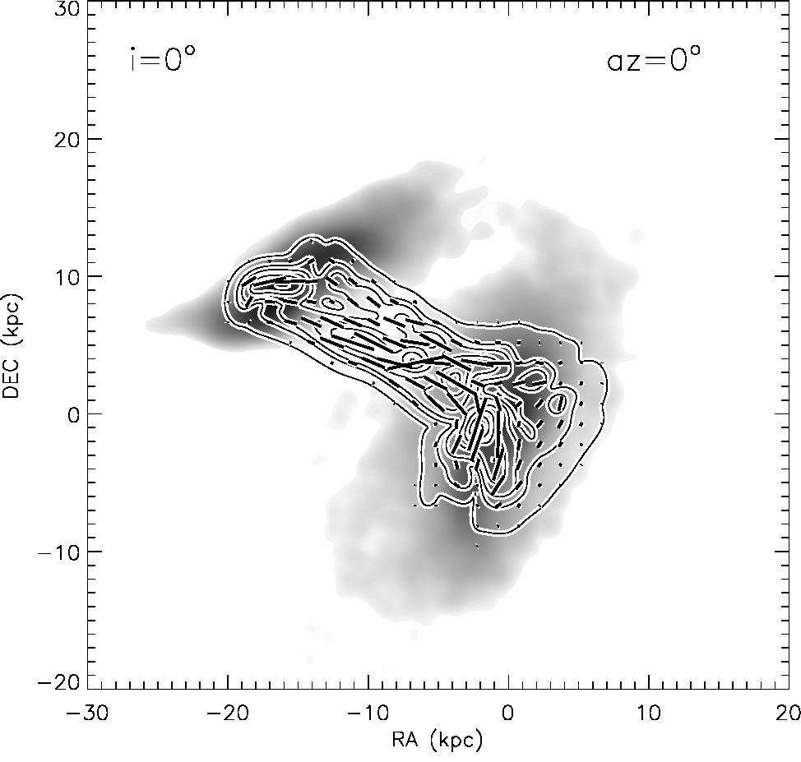
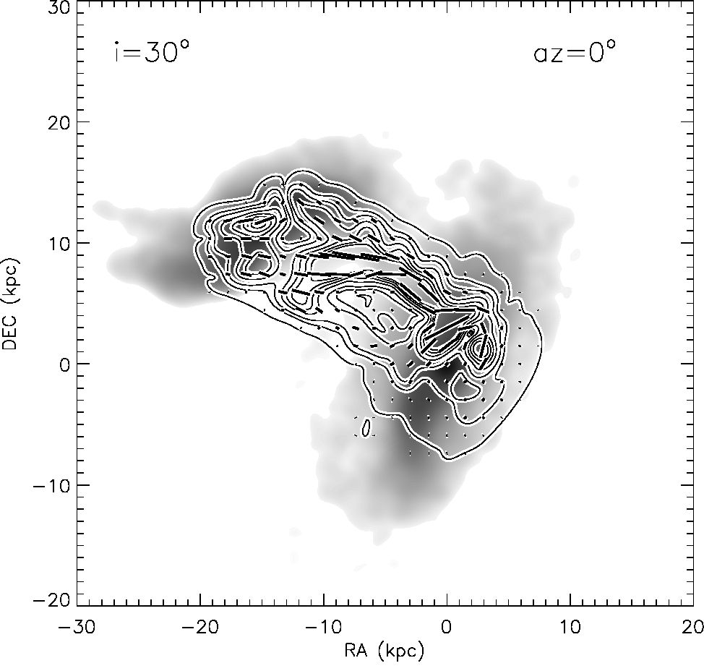
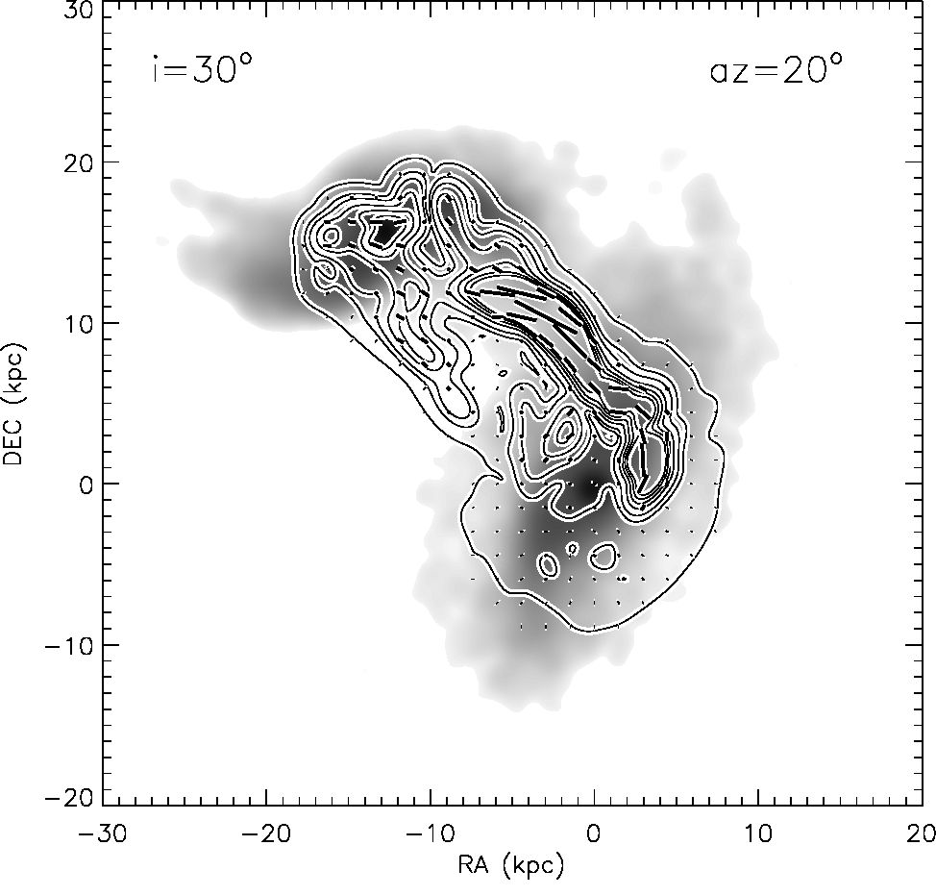
A&A 547, A39 (2012)
Fig. 15. Model 6 cm polarized radio continuum contours and projected magnetic field vectors on the model stellar surface density distribution for
two azimuthal viewing angles. Upper panels: simulation 20; lower panels: simulation 19.
projected magnetic field vectors parallel to the bridge and the
strong total power radio continuum emission from the bridge.
The small separation (~330 kms-1) between the two Hi lines
in the bridge region is only reproduced by simulation 19
(~400 kms-1), whereas the symmetric velocity field in the
galactic disks and the southern maximum of polarized inten-
sity in the bridge region are only reproduced by simulation 20.
The stellar distribution of the secondary galaxy can only be ap-
proximately reproduced by simulation 20 with a somewhat dif-
ferent (20°) projection. The distorted Hi envelope is reproduced
by either simulation. This is probably due to the collisional de-
scription of the model ISM4 In the outer parts of the galac-
tic disks, where the particle density is low, cloud-cloud colli-
sions become rare. In reality, the Hi gas of these regions is in
form of filamentary structures with a possibly higher area filling
4 However, it cannot be excluded that the initial gas disks of the col-
liding galaxies were strongly lopsided.
factor than our clouds. The impact of the galaxy collision on
this gas might thus be stronger than predicted by our model.
For the gas in the outer galactic disks, a continuous descrip-
tion of the ISM (SPH or hydro) might thus be preferable. The
present simulations thus reproduce qualitatively most of the ob-
served multiwavelength characteristics. Simulation 20 better re-
produces observations than simulation 19. Despite the calcula-
tion of 45 models, we were not able to find one single initial
condition and projection that reproduces all observed charac-
teristics. We thus decided to stop our parameter study. We are
confident that the actual interaction parameters of the Taffy sys-
tem UGC 12914/15 are not very far from those used for simula-
tion 19 and 20 (Table 3).
  - The role of collisions
For simulation 19 where the secondary’s disk is initially in-
clined by 30° with respect to the primary’s disk, the disk of the
A39, page 14 of 27
B. Vollmer et al.: A Taffy model
Table 4. Model ability to reproduce observational characteristics.
 | Simulation 19 | Simulation 20
Primary’s stellar distribution | yes | yes
Secondary’s stellar distribution | too distorted | OK with different projection (20°)
Distorted Hi envelop | no | no
Prominent Hi and CO gas bridge | yes | yes
CO bridge emission offset w.r.t. Hi to the south | yes | yes
Symmetric gas velocity fields in the disks | no | yes
Isovelocity contours parallel to the bridge | yes | yes
Hi double-line profile in the bridge region | yes | yes
CO emission only associated with the high-velocity line | yes | yes
Large gas linewidths in the bridge region  (100-200 kms-1) | yes | yes
Small separation between the double lines  (-330 km s-1) | yes | no
High field strength of the bridge regular  magnetic field | yes | yes
Projected B field vectors parallel to the bridge | with offset of -30° | yes
Polarized intensity maximum offset to the south  of the bridge | no | yes
Gas bridge strong in total power radio  continuum emission | due to high turbulent velocity | due to high turbulent velocity
secondary galaxy is strongly distorted by the tidal fields (Fig. 9).
The secondary’s tidal distortion is much less strong in simula-
tion 20, where the two disks are initially parallel.
What is the role of tidal distortions and distortions caused
by the collisional nature of the modelled ISM? To investigate
the role of the cloud-cloud collisions, we re-simulated simula-
tion 19 suppressing the cloud collisions. It is surprising that there
are regions in the bridge that show a double-line profile reminis-
cent of the observed double-line profile (Fig. A.1) with compa-
rable linewidths and line separations. Contrary to observations,
the low-velocity line of the model is most prominent in CO.
Moreover, the model lines in the bridge region are much weaker
than the observed ones. The double-lines in this simulation are
produced by the projection of two spatially different gas flows.
Tidal effects thus can create double-line profiles, but they are not
the main mechanism for the creation of the observed double-line
profiles in the bridge of the Taffy system UGC 12914/15.

5.3. Isolating the bridge region
There is a debate in the literature (Gao et al. 2003; Braine et al.
2003; Zhu et al. 2007) about how much gas is located in the
bridge between UGC 12914 and UGC 12915. This debate has
three aspects: (i) the delimitation of the bridge region; (ii) the
CO-H2 conversion factor of the bridge gas; and (iii) the Hi mass
belonging to the bridge. Our model can help to clarify points (i)
and (iii). For this purpose we have separated the bridge region
in 3D from the disk regions as described in Sect. 3: we define
the bridge region as a vertical cylinder with an infinite radius
extending from 3 kpc to 12 kpc with respect to the disk plane of
the primary galaxy. The model spectra of simulation 19 showing
only the bridge region is presented in Fig. A.4. In the region
of the secondary’s stellar tidal tail a double-line profile is found
with a dominant high-velocity component. The linewidth of this
component is large (~200 kms-1). The 3D bridge region extends
from the eastern border of the primary’s to the western border of
secondary’s high surface brightness disk. Almost all lines from
the bridge region are strong in CO emission. Since our model
Hi/CO separation is based on gas density, this means that the
bridge gas has a relatively high gas density.
We thus conclude that the bridge region delimited by Braine
et al. (2003, Fig. A.1) is somewhat too small. It should ex-
tend until the border of the high surface brightness disk of
UGC 12914. Within the disk, only the high-velocity component
of the double-lines belongs to the bridge. Based on these conclu-
sions we revise the bridge Hi mass to be MHIbridge ~ 3 x 109 M0.
Applying a CO-H2 conversion factor of N(H2)/ICO = 4 x
1019 cm-2 (Kkms-1)-1 (Zhuet al. 2007), the mass of the molec-
ular gas located in the bridge is also MH2bridge ~ 2 x 109 M0. The
recently discovered warm H2 (Peterson et al. 2012) might add
up to 109 M0 to the molecular gas content if the H2-emitting gas
is different from the CO-emitting gas5. The bridge gas thus has
a molecular fraction of MH2 /MHI ~ 1.
5 It is very likely that at least some of the gas detected in warm
H2 emission by Peterson et al. (2012) is the same as what we detect in
CO. While the warm H2 they detect is very different from what is seen
in galactic giant molecular clouds, (i) the 13CO emission is very weak
in the bridge (Braine et al. 2003), such that even the 12CO emission may
be optically thin and (ii) the CO(2-1)/CO(1-0) ratio is compatible with
warm optically thin emission from low-density molecular gas. It would
be very useful to have observations of higher-/ transitions in order to
break this degeneracy.
A39, page 15 of 27
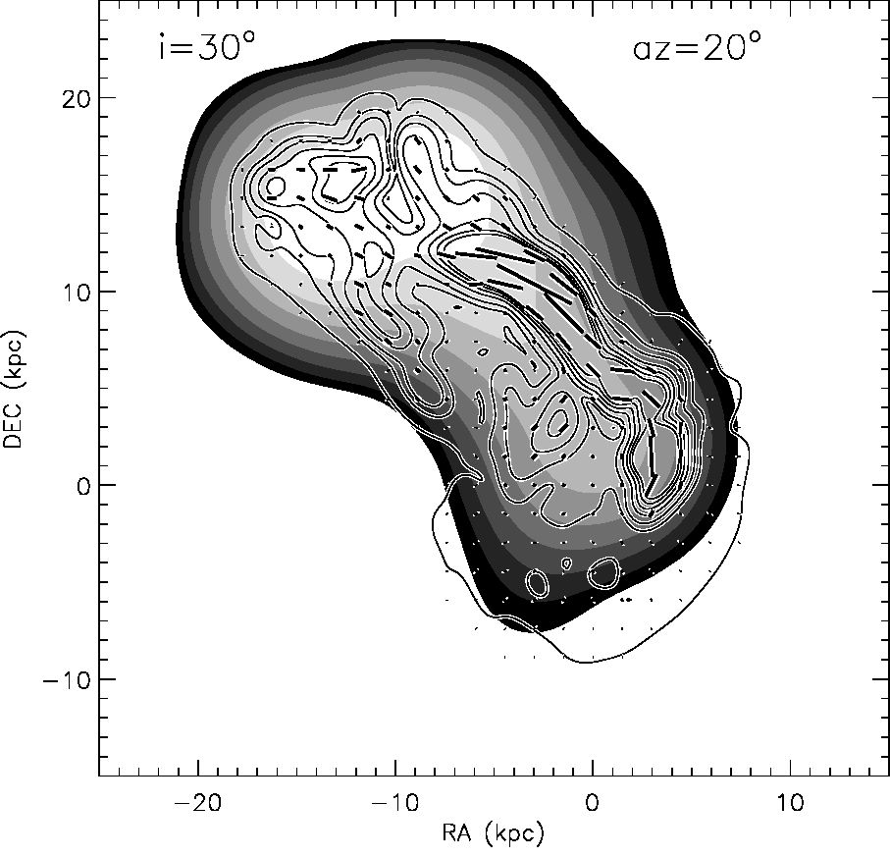
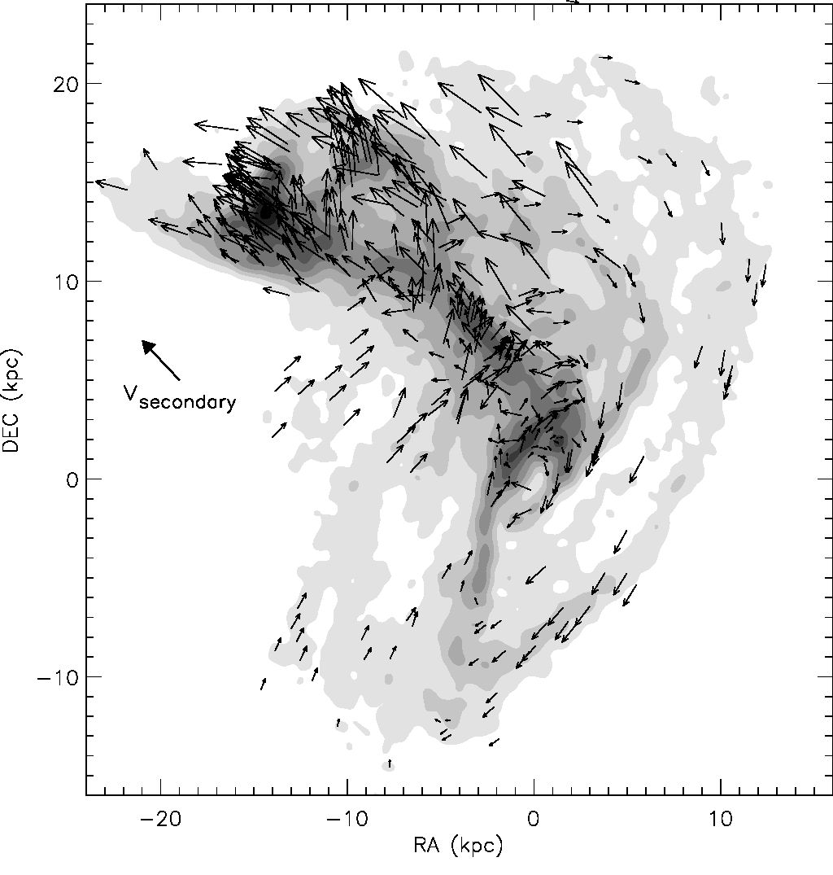
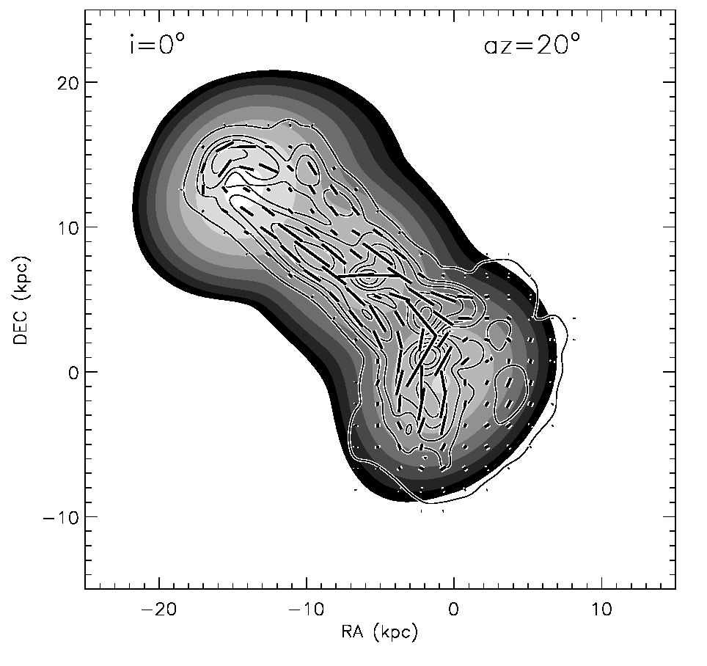
A&A 547, A39 (2012)
Fig. 16. Model 6 cm total polarized radio continuum emission
(contours) and projected magnetic field vectors on the model
6 cm total power radio continuum emission distribution (greyscale:
(1, 2,4,8,16,32,64,128)x an arbitrary value). Upper panel: simula-
tion 20; lower panel: simulation 19.
- Cloud collisions in the gas bridge
The bridge gas has a high surface density (¾ ~ 30 M0 pc-2;
2CO ~ 50 Mq pc-2; see Fig. 11). The bright CO emission of the
disk gas implies high gas densities (~1000 cm-3) of a signifi-
cant portion of the bridge gas. Our model reproduces these find-
ings. However, there is no star formation associated with most
of the bridge gas (Gao et al. 2003; Braine et al. 2003; Zhu et al.
2007). Only the bridge gas of very high surface density close to
UGC 12915 is vigorously forming stars. What makes the bridge
gas not form stars despite its high density? To investigate this
question, we need to have a closer look at the physical proper-
ties of the bridge gas. Figure 17 shows the gas velocities in the
plane of the sky. We identify large-scale colliding flows from
the south of the bridge into the bridge region of highest surface
density around the position (-3,7) kpc. These flows lead to a
compression of the gas and enhances the cloud-cloud collision
rate.
Fig. 17. Transverse gas velocities of simulation 19 on the total gas sur-
face density distribution. The primary galaxy is at rest. The thick arrow
indicates the transverse velocity of the secondary galaxy.
The time evolution of the local cloud-cloud collision rate
of simulation 19 is presented in Fig. 18. As expected, the lo-
cal cloud collision rate generally follows the gas surface density.
Before the galaxy collision most cloud-cloud collisions occur in
the inner galactic disks and in spiral arms where the gas den-
sity is high. This situation does not change significantly until
~10 Myr after the impact. The local cloud collision rate in the
bridge region is as high as in the spiral arms of the unperturbed
disks. After ~ 16 Myr the local collision rate in the portion of the
bridge near the primary galaxy begins to increase. It reaches its
maximum ~23 Myr after the impact. This corresponds exactly
to the timestep of interest. For t > 23 Myr the local cloud colli-
sion rate in the bridge decreases again. The bridge region at the
time of interest is thus in a phase of active compression with a
high input of mechanical energy. For t > 23 Myr ring structures
form in both galactic disk where the local cloud collision rate is
enhanced.
- Gas densities and velocity dispersions in the bridge
To further investigate the physical properties of the disk region,
we present the time evolution of the gas density and 3D velocity
dispersion of simulation 20/19 in Figs. 19 and 20. With our kpc
resolution, the densities of the unperturbed disk range between
10-3 and 1 Mq pc-3, the velocity dispersions between (10 and
30 kms-1). Due to the galaxy collision, the velocity dispersion
increases up to 400 kms-1. The velocity dispersion of most of
the gas located in the bridge is between 100 and 200 kms-1.
In addition, there are regions in the bridge where the velocity
dispersion reaches 200 to 300 kms-1. In simulation 19 these re-
gions are mostly close to the secondary galaxy for t > 23 Myr.
In both simulations, the mean velocity dispersion of the bridge
gas decreases for t > 23 Myr. In simulation 20, the velocity dis-
persion is about constant along the bridge. On the other hand,
in simulation 19 the bridge velocity dispersion increases slowly
A39, page 16 of 27
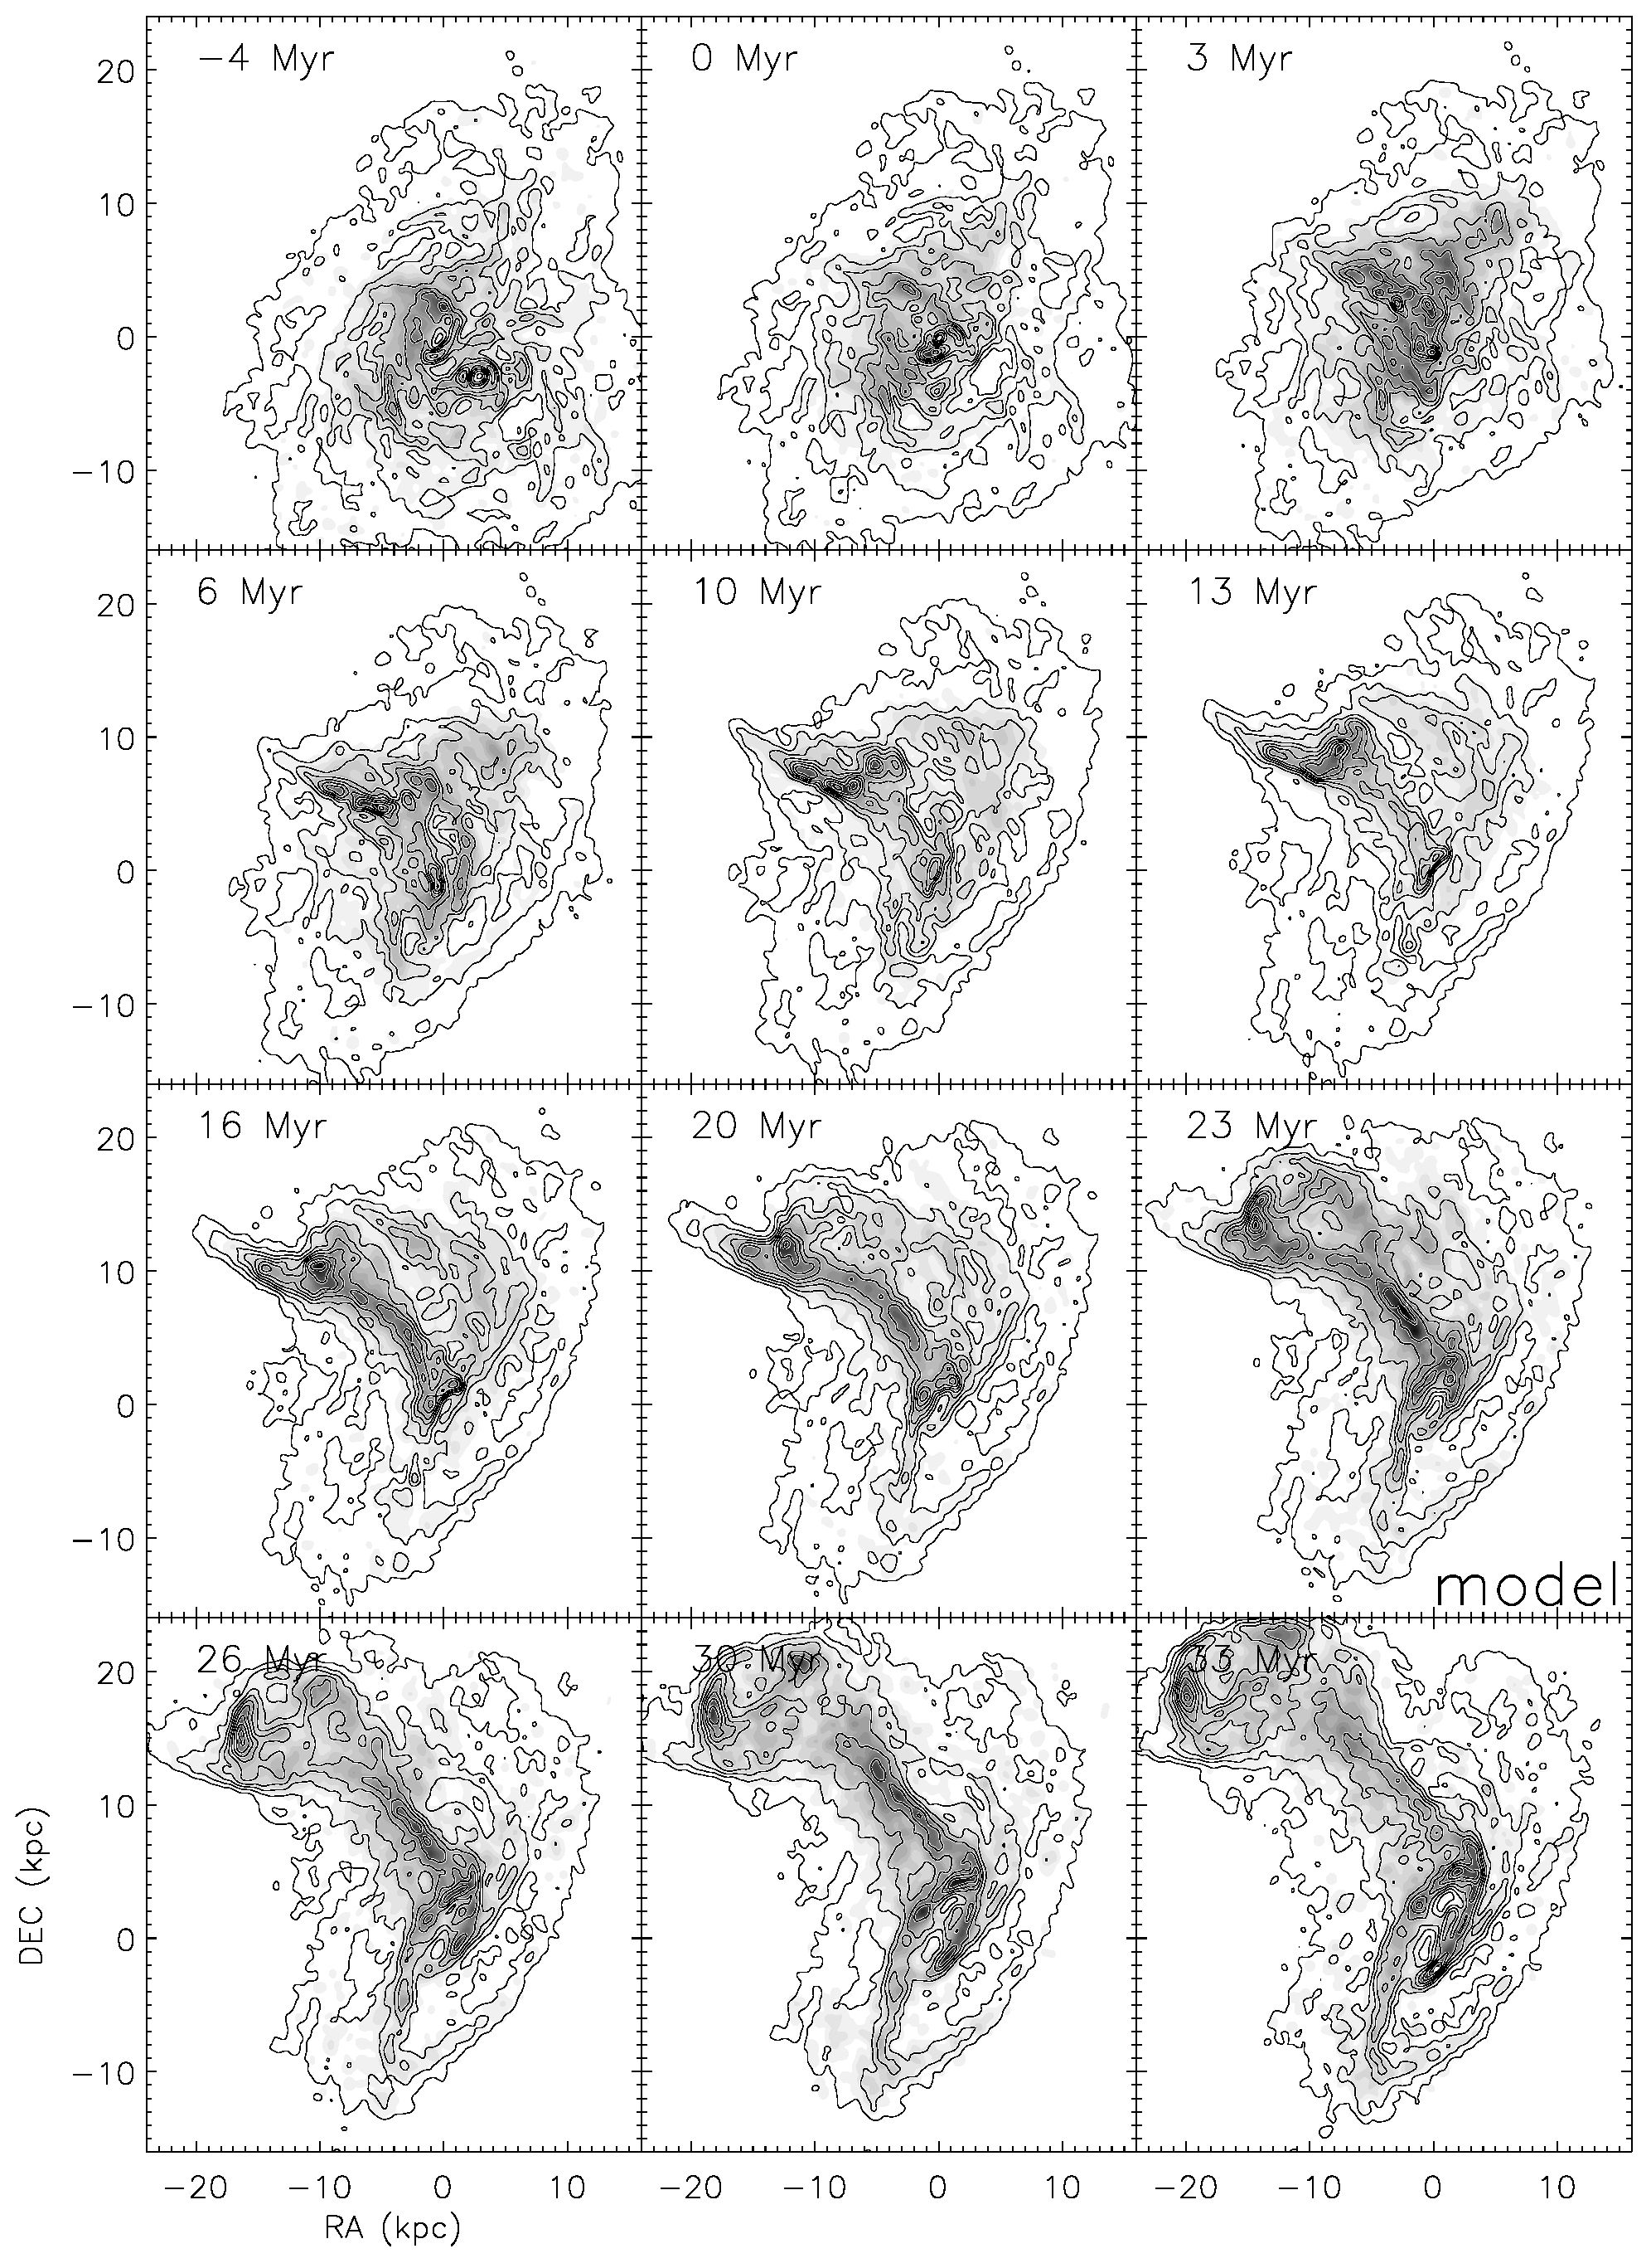
B. Vollmer et al.: A Taffy model
Fig. 18. Simulation 19. Contours of the total gas surface density on the distribution of cloud-cloud collisions (greyscale). The timestep t = 0 Myr
corresponds to the impact.
A39, page 17 of 27
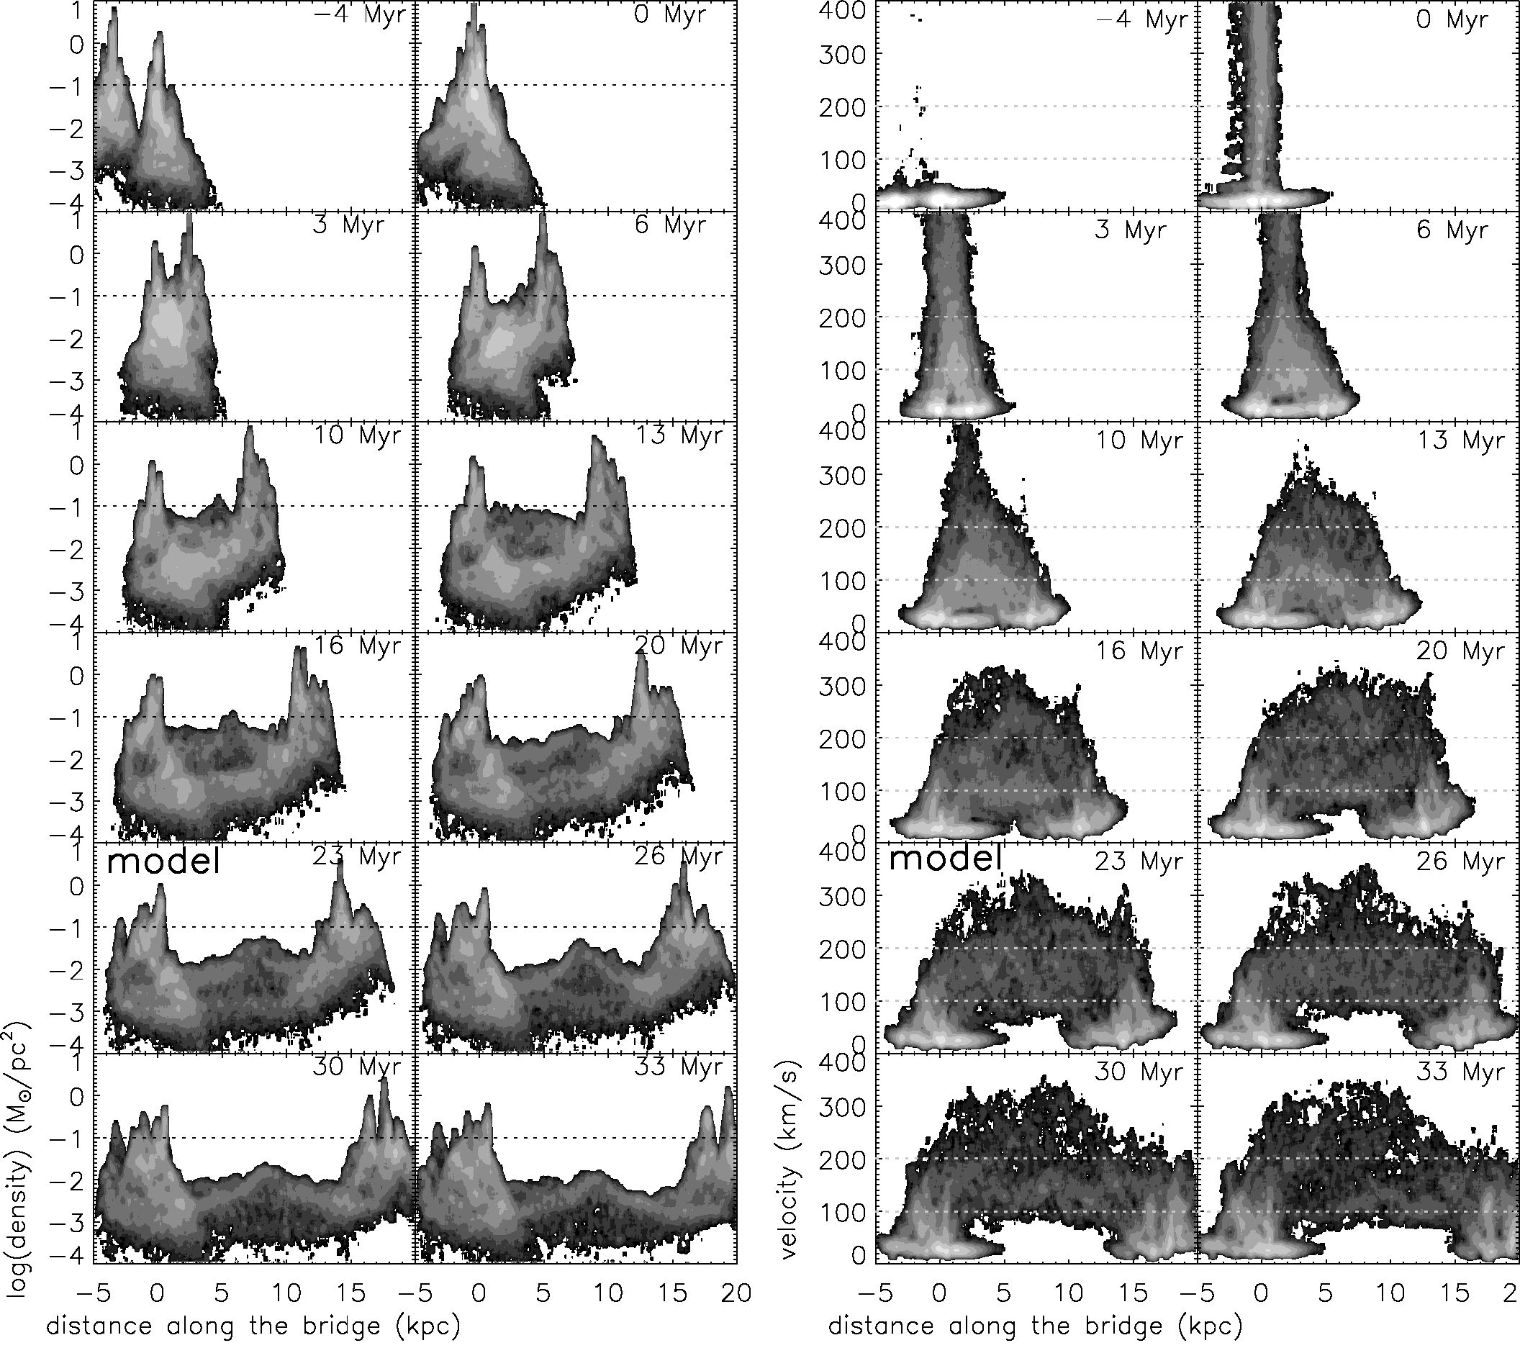
A&A547, A39 (2012)
Fig. 19. Evolution of the bridge gas properties of simulation 20. Left panels: total gas volume density as a function of distance along the bridge.
Right panels: 3D velocity dispersion as a function of distance along the bridge.
from the primary to the secondary galaxy along the bridge. At
t = 30 Myr an X-structure forms.
In both simulations the bridge contains a high-density fil-
ament embedded into low-density regions. The density distri-
bution is not continuous between these extremes. The density
of the high-density filament at the time of interest is of the
order of 10-2 M0 pc-3 in both simulations. Due to the expan-
sion of the bridge region with time, the overall gas density in
the bridge decreases for t > 20 Myr in simulation 20 and for
t > 26 Myr in simulation 19. Whereas the high-density gas has
a velocity dispersion higher than 100 kms-1, the low-density
gas has a velocity dispersion lower than 100 kms-1 in both
simulations. We identify the high-density (10-2 M0 pc-3), high-
velocity-dispersion (>100 kms-1) bridge regions with those
regions emitting in the CO line. The observed large linewidth
(~200 kms-1) of the CO lines in the bridge are thus consistent
with a high intrinsic velocity dispersion of the bridge gas in our
model.
Assuming equipartition between the kinetic and the mag-
netic energy density pv2isp = B2/(8n), a velocity dispersion of
vdisp = 150 kms-1, and a total gas density of p = 0.01 M0pc-3,
we estimate the total magnetic field strength in the high-density
bridge region to be B ~ 65 juG. The total magnetic field
strength in the low-density bridge region (p = 10-3 M0 pc-3,
vdisp = 50 kms-1) is B ~ 7 uG. The latter value is close
to the magnetic field strength derived from the 1.4 GHz spe-
cific intensity assuming equipartition between the energy of
the relativistic electrons and the magnetic field (Condon et al.
1993). The lifetime of synchrotron-emitting electrons is t ~
1(B/1 uG)-1'5(v/1 GHz)-0 5 Gyr, where v is the frequency of
the observation. This lifetime is ~1 Myr for the high-density re-
gions and ~25 Myr for the low-density regions at v = 4.8 GHz.
In the absence of newly injected relativistic electrons produced
in supernova explosions, the radio continuum emission of the
high-density regions drops under the detection limit after a few
Myr. That of the low-density regions persists for several 10 Myr.
A39, page 18 of 27
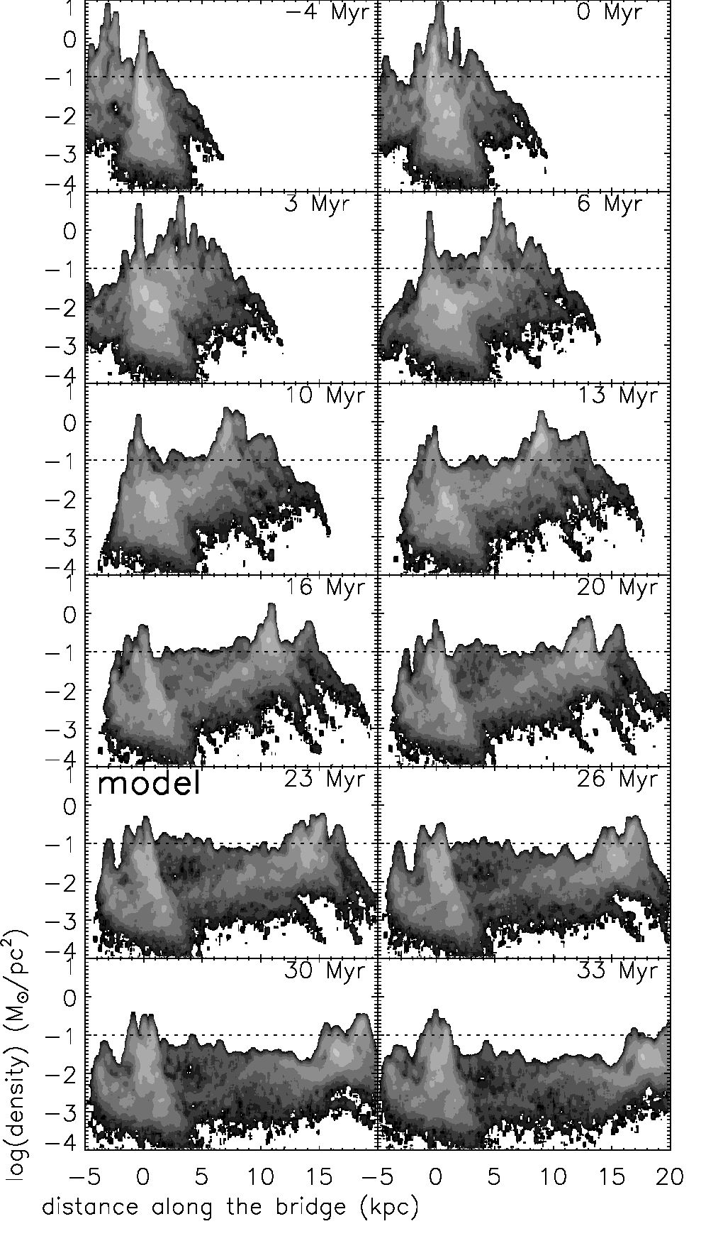
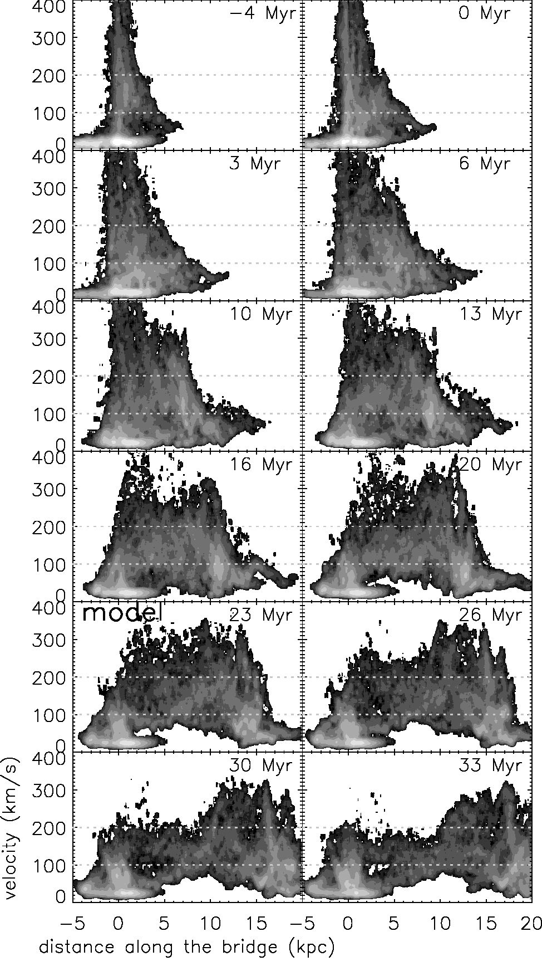
B. Vollmer et al.: A Taffy model
Fig. 20. Evolution of the bridge gas properties of simulation 19. Left panels: total gas volume density as a function of distance along the bridge.
Right panels: 3D velocity dispersion as a function of distance along the bridge.
In the bridge region, star formation only occurs in the giant
Hn region close to UGC 12915. Most of the bridge region is
devoid of star formation and thus devoid of the injection of rela-
tivistic electrons. In this latter region, the high surface brightness
20 cm emission follows the Hi and not the CO distribution (Fig. 8
of Gao et al. 2003), i.e. it follows the low-density atomic gas.
Based on our model, we thus conclude that the observed syn-
chrotron radio continuum emission of the bridge region outside
the giant Hn region near UGC 12915 mainly stems from the low-
density, high-velocity-dispersion bridge gas which is observed in
Hi.
The high mechanical energy input into the bridge region is
consistent with the recent detection of strong, resolved emis-
sion from warm H2 in the bridge of the Taffy galaxy system
UGC 12914/15 (Peterson et al. 2012). The latter authors state
that “since the cooling time of warm H2 is short (~5000 yr),
shocks must be permeating the molecular gas bridge region in
order to continue heating the H2”. Based on our model, we
identify the energy source to be the mechanical energy from
compressive colliding gas flows in the bridge region. Peterson
et al. (2012) estimate the mean surface brightness of warm
H2 emission to be AE/(AAAt) ~ 1.7 x 10 7Wm 2. The mechan-
ical energy input is AE/(AAAt) ~ Pydisp. For the high-density
bridge gas (p = 0.01 M0pc“3, vdisp = 150 kms"1) we obtain
AE/(AAAt) ~ 2.5 x 10“6 W m“2, for the low-density gas (p =
10“3 M0pc“3, vdisp = 50 kms-1) AE/(AAAt) ~ 10“8 Wm“2. We
thus conclude that only the high-density gas undergoes a high
enough mechanical energy input to produce the observed emis-
sion of warm H2. Our model suggests that we observe this galaxy
head-on collision near the time of maximum CO and H2 emis-
sion. The physical properties of the bridge gas are similar to
those of the dense gas in the large-scale shock of Stephan’s
Quintet. There, the molecular gas carries a large fraction of the
gas kinetic energy involved in the collision which has not been
thermalized yet (Guillard et al. 2012).

5.6. The low star formation efficiency in the bridge
The local star formation rate was calculated from the FUV lu-
minosities corrected by the 24 pm IR emission following Leroy
et al. (2008). This method takes into account the UV photons
A39, page 19 of 27
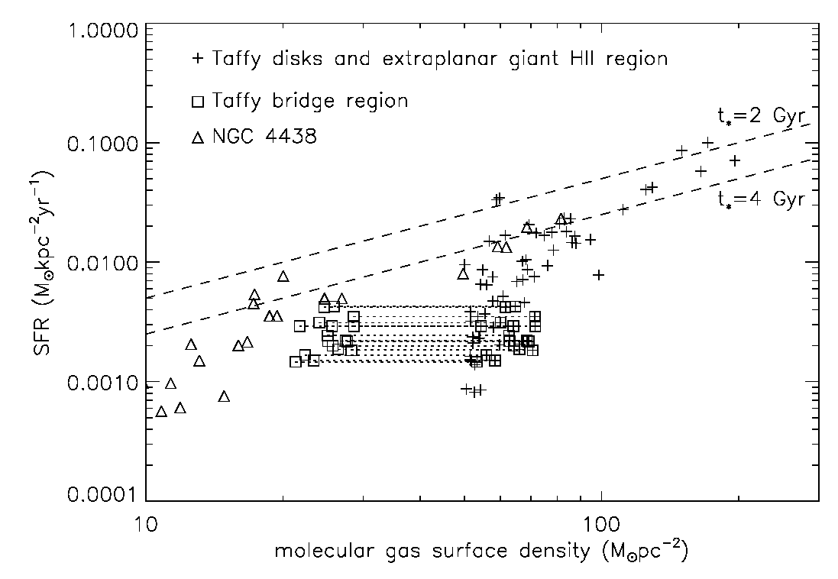
A&A 547, A39 (2012)
Fig. 21. Star formation rate based on the FUV and 24 gm emission as
a function of the molecular gas surface density. The crosses are based
on X = 1020 cm-2 (Kkms-1)-1, which is half of the Galactic value.
The bridge region outside the giant Hii region near UGC 12915 are
marked as squares with crosses. Squares without crosses correspond
to a 2.5 times lower X factor as suggested by Zhu et al. (2007). Data
of NGC 4438 are shown as triangles. The dashed lines correspond to
constant star formation timescales of 2 and 4 Gyr.
from young massive stars which escape the galaxy and those
which are absorbed by dust and re-radiated in the far infrared:
Ś. = 8.1 x 10-2 /(FUV) + 3.2 x 10-31(24 gm), (5)
where /(FUV) is the GALEX far ultraviolet and /(24 gm) the
Spitzer MIPS 24 gm intensity in units of MJysr-1. Ś. has the
units of M0 kpc-2yr-1. Following Helou et al. (2004), we sub-
tracted the stellar continuum from the 24 gm surface bright-
nesses (in MJy sr-1) using
/v(24 gm) = /y(24 gm) - 0.032 /v(3.6 gm). (6)
The full width at half-maximum (FWHM) of the point spread
functions (PSFs), as stated in the Spitzer Observer’s Manual
(Spitzer Science Centre 2006), are 1.7 and 6 arcsec at 3.6 and
24 gm, respectively, that of the CO data is 10". First, the data
are convolved with kernels that match the PSFs of the images in
the 3.6 and 24 gm bands to a common PSF of 12". The CO data
of Gao et al. (2003) were also convolved to the common reso-
lution. Next, the data were re-binned to the common pixel size
of 8.5".
The resulting pixel-by-pixel star formation rate as a function
of the molecular gas surface density is presented in Fig. 21. Since
the CO-to-H2 conversion factor X is uncertain especially in the
bridge region, we show molecular gas surface densities based on
X = 1020 cm-2 (Kkms-1)-1 andX = 4 x 1019 cm-2(Kkms-1)-1
(Zhu et al. 2007). This should cover the expected range. The
mean star formation rate timescale with respect to the molecular
gas (t. ~ 2 Gyr; Bigiel et al. 2011) is shown as a dashed line.
We also show a line with t. = 4 Gyr, which is still in the ex-
pected range. The star formation efficiency with respect to the
molecular gas is normal in the galactic disks, but it is at least a
factor of 2 to 3 lower in the bridge region. This decrease in star
formation efficiency is very similar to what is observed in the
extraplanar gas of the Virgo spiral galaxy NGC 4438 (Vollmer
et al. 2012b) and in the interacting galaxies NGC 3226/27 (re-
gion 2 in Table 1 of Lisenfeld et al. 2008). Whereas this decrease
is observed at low molecular gas surface densities (~10 M0) in
NGC 4438 and NGC 3226/27, it occurs at a 3 to 5 times higher
molecular gas surface density in the Taffy bridge. The quenching
of star formation in the extraplanar gas of NGC 4438 is caused
by a combined tidal and ram pressure interaction (Vollmer et al.
2005).
The detection of CO(1-0) emission from the gas bridge im-
plies high local gas densities of the order of >100 cm-3 =
5 Mqpc-3. With an overall density of 0.01 Mqpc-3 on kpc-
scales, this leads to a volume filling factor of <2 x 10-3. The
CO-emitting dense gas is thus highly clumped, as the disk ISM,
and the clumps have a very low volume filling factor. We suggest
that star formation is quenched by the high velocity dispersion
of the bridge gas caused by mechanical energy input, which pre-
vents the gravitational collapse of the high-density gas clumps.
Obviously, this suggestion does not hold for the giant Hn re-
gion near UGC 12915, where gas clouds do collapse and form
stars. We suggest that this is caused by a higher local gas den-
sity leading to a Jeans length which equals or is smaller than the
extent of the gas. To illustrate this effect, we calculated the local
Jeans length for the gas in our simulations. In Fig. 22 we only
show gas with a Jeans length smaller than 2 kpc. The gas in the
bridges of both simulations has local Jeans lengths exceeding
2 kpc. The gas north of the primary galaxies’ centers with local
Jeans lengths smaller than 2 kpc is mostly located in the disks
of the primary galaxies. Only in simulation 20 is there a region
of high surface density south of the secondary galaxy’s center at
(-12,12) kpc, which has a local Jeans length smaller than 2 kpc.
This region is supposed to form stars and might correspond to
the giant Hn region south of UGC 12915. We do not claim to
reproduce the giant Hn region but we think that Fig. 22 can be
seen as a proof of concept.

6. Conclusions
The Taffy system UGC 12914/15 is a rare case of a head-on col-
lision between two gas-rich spiral galaxies. We made dynamical
simulations of this galaxy collision, in which the gas of both
galaxies collide, using a model which includes a collisionless
(halo and stellar particles) and a collisional (gas) component.
The gaseous component is simulated by a sticky particle scheme
where gas particles undergo partially inelastic collisions. The
collision rate depends on the mass-radius relation of the gas par-
ticles (Eq. (1)). With a first set of simulations with a simplified
collision geometry, we investigated the behavior of the collision
rate as a function of cloud size parameter £. The collision rate
increases with increasing £. Our collision rates are in reason-
able agreement with theoretical expectation. A higher collision
rate leads to more momentum transfer between the cloud parti-
cles during the galaxy collision. A higher collision rate during
impact increases the gas mass of the bridge region between the
two colliding galaxies. We fixed £ to obtain a bridge gas mass
exceeding 3 x 109 Mq .
In a second step, we made a second set of parameters with
fixed inclination angles between the two counter-rotating disks
of 0° and -30° where we varied systematically the position
of impact. We found two simulations, that reproduce the ob-
served main characteristic of the Taffy system. For both sim-
ulations, the relative velocity at impact is ~1000 kms-1. The
transverse velocity at the present time is between 650 km s-1 and
660 km s-1. We confirm the time of impact estimated by Condon
et al. (1993). Our best-fit models place the impact 23 Myr ago.
For times >20 Myr all models develop ring structures character-
istic for galaxy head-on collisions.
To compare simulation snapshots to Hi and CO observa-
tions (Gao et al. 2003; Braine et al. 2003), we assume that the
A39, page 20 of 27
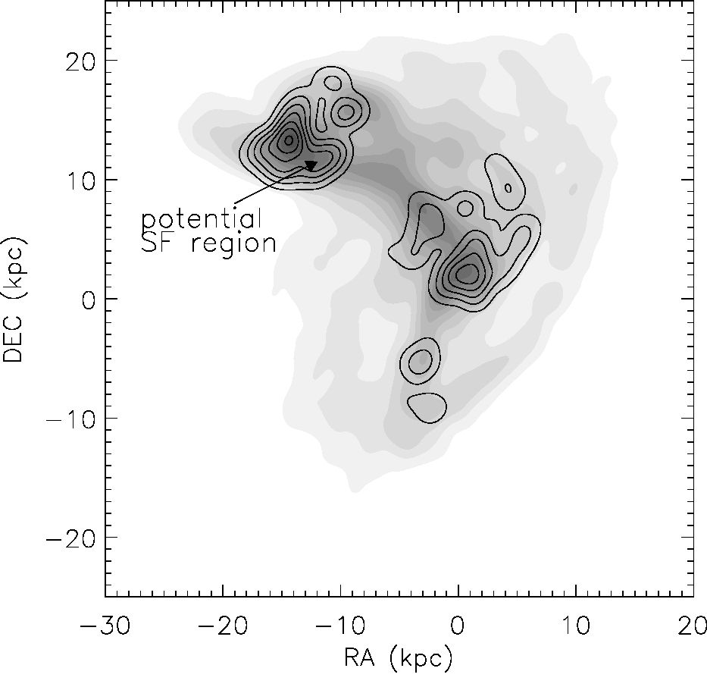
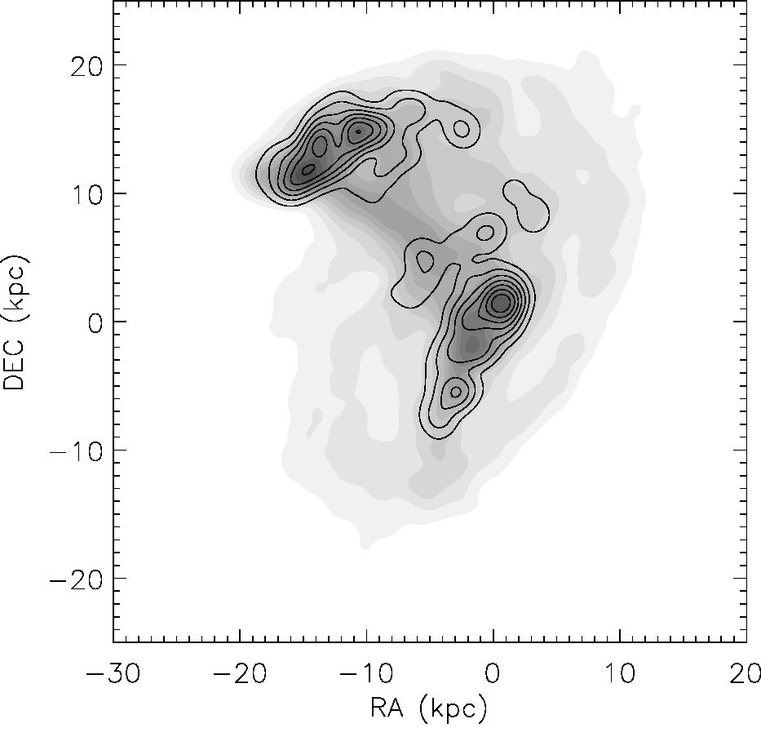
B. Vollmer et al.: A Taffy model
Fig. 22. Potential sites of star formation. Greyscale: total gas surface
density. Contours: surface density of gas with a local Jeans length
smaller than 2 kpc. Upper panel: simulation 20. Lower panel: simu-
lation 19.
molecular fraction of the gas depends on the square root of the
gas volume density. This recipe allows us produce model Hi and
CO cubes. For the comparison of our simulations with obser-
vations of polarized radio continuum emission, we calculated
the evolution of the 3D large-scale magnetic field for our sim-
ulations. The induction equations including the time-dependent
gas-velocity fields from the dynamical model were solved for
this purpose.
Since we could not find a single simulation which reproduces
all observed characteristics, we present two “best-fit” simula-
tions. The first simulation better reproduces the Hi and CO line
profiles of the bridge region (Braine et al. 2003), whereas the
second simulation better reproduces the stellar distribution of
UGC 12915, the symmetric gas velocity fields of the galac-
tic disks, the projected magnetic field vectors in the bridge re-
gion, and the distribution of the 6 cm polarized radio continuum
emission (Condon et al. 1993). The following observational
characteristics can be reproduced by our models:
- The stellar distribution of the Taffy system. The stellar distri-
bution of the model secondary galaxy is more distorted than
that of UGC 12915.
- The prominent Hi and CO gas bridge.
- The offset of the CO emission to the south with respect to
the Hi emission in the bridge region.
- The gas symmetric velocity fields in the galactic disks.
- The isovelocity contours of the CO velocity field which are
parallel to the bridge.
- The Hi double-line profiles in the disk region.
- CO emission is only detected in the high-velocity component
of the double-line.
- The large gas linewidths (100-200 kms-1) in the bridge
region.
- The velocity separation between the double lines
(~330 kms-1).
- The high field strength of the regular magnetic field in the
bridge region.
- The projected magnetic field vectors, which are parallel to
the bridge.
- The offset of the maximum of the 6 cm polarized radio con-
tinuum emission to the south of the bridge.
- The strong total power emission from the disk.
The observed distortion of the Hi envelope of the Taffy system
(Condon et al. 1993) cannot be reproduced by our model. This is
due to an insufficient momentum transfer between the gas parti-
cles located in the outer galactic disks. For this gas a continuous
description of the ISM (SPH or hydro) might be preferable.
The model allows us to redefine the bridge region in three di-
mensions. We estimate the total gas mass (Hi, warm and cold H2)
to be 5 to 6 x 109 M0. Its molecular fraction MH2 /Mhi is about
unity. The structure of the model gas bridge is bimodal. There is
a dense (~0.01 M0 pc-3) component with a high velocity disper-
sion >100 kms-1 and a less dense (~10-3 M0pc-3) component
with a smaller, but still high velocity dispersion ~50 kms-1. The
synchrotron lifetime of relativistic electrons is only long enough
to be consistent with the existence of the radio continuum bridge
(Condon et al. 1993) for the less dense component. This ex-
plains why the radio continuum emission follows the Hi and not
the CO emission of the bridge outside the giant Hn region near
UGC 12915. On the other hand, only the high-density gas un-
dergoes a high enough mechanical energy input to produce the
observed strong emission of warm H2 (Peterson et al. 2012). We
propose that, despite the high local gas densities, this high input
of mechanical energy quenches star formation in the bridge gas
except for the giant Hn region near UGC 12915. Our model sug-
gests that we observe this galaxy head-on collision near the time
of maximum CO and H2 emission.
Acknowledgements. We would like to thank Y. Gao for providing his CO data to
us. This work has been supported by the Polish Ministry of Science and Higher
Education grant No. 2011/03/B/ST9/01859.
References
Appleton, P. N., Xu, K. C., Reach, W., et al. 2006, ApJ, 639, L51
Boulares, A., & Cox, D. P. 1990, ApJ, 365, 544
Bigiel, F., Leroy, A. K., Walter, F., et al. 2011, ApJ, 730, L13
Braine, J., Davoust, E., Zhu, M., et al. 2003, A&A, 408, L13
Braine, J., Lisenfeld, U., Duc, P.-A., et al. 2004, A&A, 418, 419
Cluver, M. E., Appleton, P. N., Boulanger, F., et al. 2010, ApJ, 710, 248
Condon, J. J., Helou, G., Sanders, D. B., & Soifer, B. T. 1993, AJ, 105, 1730
A39, page 21 of 27

A&A547, A39 (2012)
Condon, J. J., Helou, G., & Jarrett, T. H. 2002, AJ, 123, 1881
Drzazga, R. T., Chyży, K. T., Jurusik, W., & Wiórkiewicz, K. 2011, A&A, 533,
A22
Elmegreen, B. G., & Falgarone, E. 1996, ApJ, 471, 816
Elstner, D., Otmianowska-Mazur, K., von Linden, S., & Urbanik, M. 2000,
A&A, 357, 129
Gao, Y., Zhu, M., & Seaquist, E. R. 2003, AJ, 126, 2171
Guillard, P., Boulanger, F., Pineau des Forets, G., et al. 2012, ApJ, 749, 158
Helou, G., Roussel, H., Appleton, P., et al. 2004, ApJS, 154, 253
Higdon, J. L. 1995, ApJ, 455, 524
Higdon, J. L. 1996, ApJ, 467, 241
Hwang, J.-S., Struck, C., Renaud, F., & Appleton, P. N. 2012, MNRAS, 419,
1780
Leroy, A. K., Walter, F., Brinks, E., et al. 2008, AJ, 136, 2782
Lisenfeld, U., Mundell, C. G., Schinnerer, E., Appleton, P. N., & Allsopp, J.
2008, ApJ, 685, 181
Olson, K. M., & Kwan, J. 1990, ApJ, 349, 480
Otmianowska-Mazur, K., & Yollmer, B. 2003, A&A, 402, 879
Peterson, B. W., Appleton, P. N., Helou, G., et al. 2012, ApJ, 751, 11
Renaud, F., Appleton, P. N., & Xu, C. K. 2010, ApJ, 724, 80
Rosolowsky, E. 2005, PASP, 117, 1403
Smith, B. J., Struck, C., & Pogge, R. W. 1997, ApJ, 483, 754
Soida, M., Otmianowska-Mazur, K., Chyzy, K., & Yollmer, B. 2006, A&A, 458,
727
Solomon, P. M., Rivolo, A. R., Barrett, J., & Yahil, A. 1987, ApJ, 319, 730
Springel, V., Yoshida, N., & White, S. D. M. 2001, New Astron., 6, 79
Stone, J. M., & Norman, M. L. 1992a, ApJS, 80, 753
Stone, J. M., & Norman, M. L. 1992b, ApJS, 80, 791
Struck, C. 1997, ApJS, 113, 269
Struck, C., & Smith, B. J. 2003, ApJ, 589, 157
Theis, C., & Hensler, G. 1993, A&A, 280, 85
Trinchieri, G., Sulentic, J., Breitschwerdt, D., & Pietsch, W. 2003, A&A, 401,
173
Trinchieri, G., Sulentic, J., Pietsch, W., & Breitschwerdt, D. 2005, A&A, 444,
697
Tsuchiya, T., Korchagin, V., & Wada, K. 1998, ApJ, 505, 607
van der Hulst, J. M., & Rots, A. H. 1981, AJ, 86, 1775
Yollmer, B., Cayatte, V., Balkowski, C., & Duschl, W. J. 2001, ApJ, 561, 708
Yollmer, B., Braine, J., Combes, F., & Sofue, Y. 2005, A&A, 441, 473
Vollmer, B., Soida, M., Chung, A., et al. 2008a, A&A, 483, 89
Yollmer, B., Braine, J., Pappalardo, C., & Hily-Blant, P. 2008b, A&A, 491, 455
Yollmer, B., Soida, M., Braine, J., et al. 2012a, A&A, 537, A143
Yollmer, B., Wong, O. I., Braine, J., Chung, A., & Kenney, J. D. P. 2012b, A&A,
543, A33
Wiegel W. 1994, Diploma Thesis, University of Heidelberg
Zavagno, A., Anderson, L. D., Russeil, D., et al. 2010, A&A, 518, L101
Zhu, M., Gao, Y., Seaquist, E. R., & Dunne, L. 2007, AJ, 134, 118
Zink, E. C., Lester, D. F., Doppmann, G., & Harvey, P. M. 2000, ApJS, 131, 413
Pages 23 to 27 are available in the electronic edition of the journal at http://www.aanda .org
A39, page 22 of 27
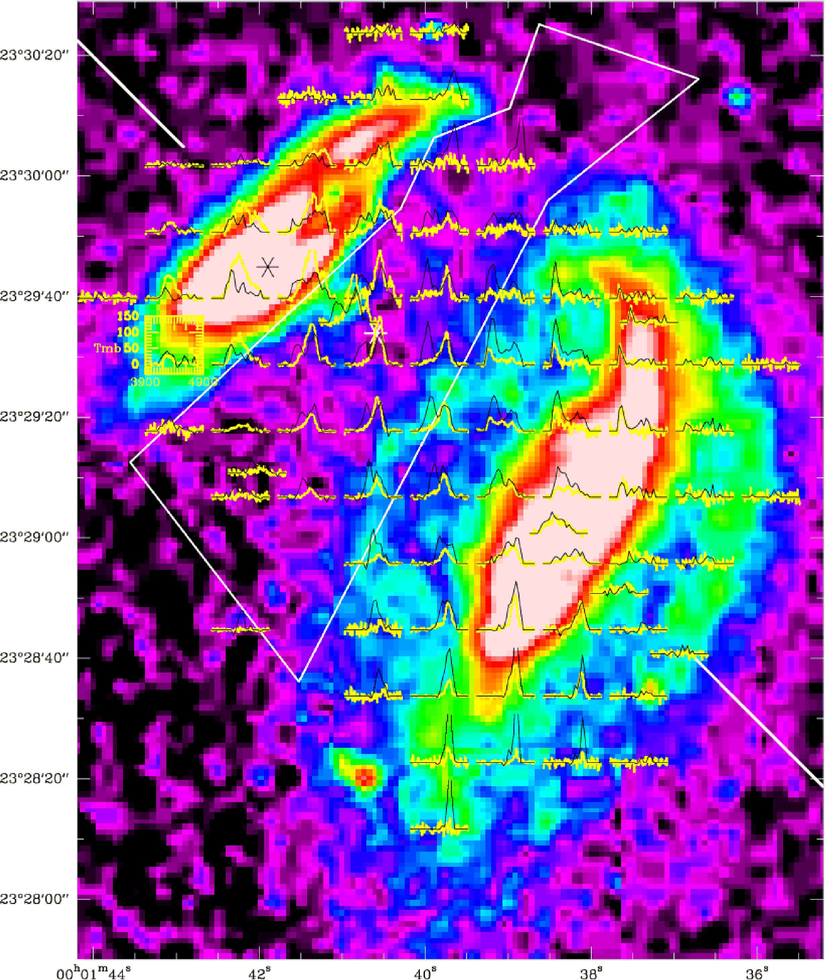
B. Yollmer et al.: A Taffy model

Appendix A: CO and Hi observed and model spectra of the Taffy system UGC 12914/15
For a better readability of this article, we decided to show the CO and Hi observed and model spectra as an appendix.
Fig. A.1. CO(1-0) spectra (yellow line and yellow scale, intensity in milliKelvins) overlaid with Hi spectra (black line) on a Digitized Sky survey
image of the UGC 12914/5 system (from Braine et al. 2003). The center of UGC 12915 is at 00h01m41.9s, 23°29'44.9". The bridge region is
delimited by the white polygon.
A39, page 23 of 27
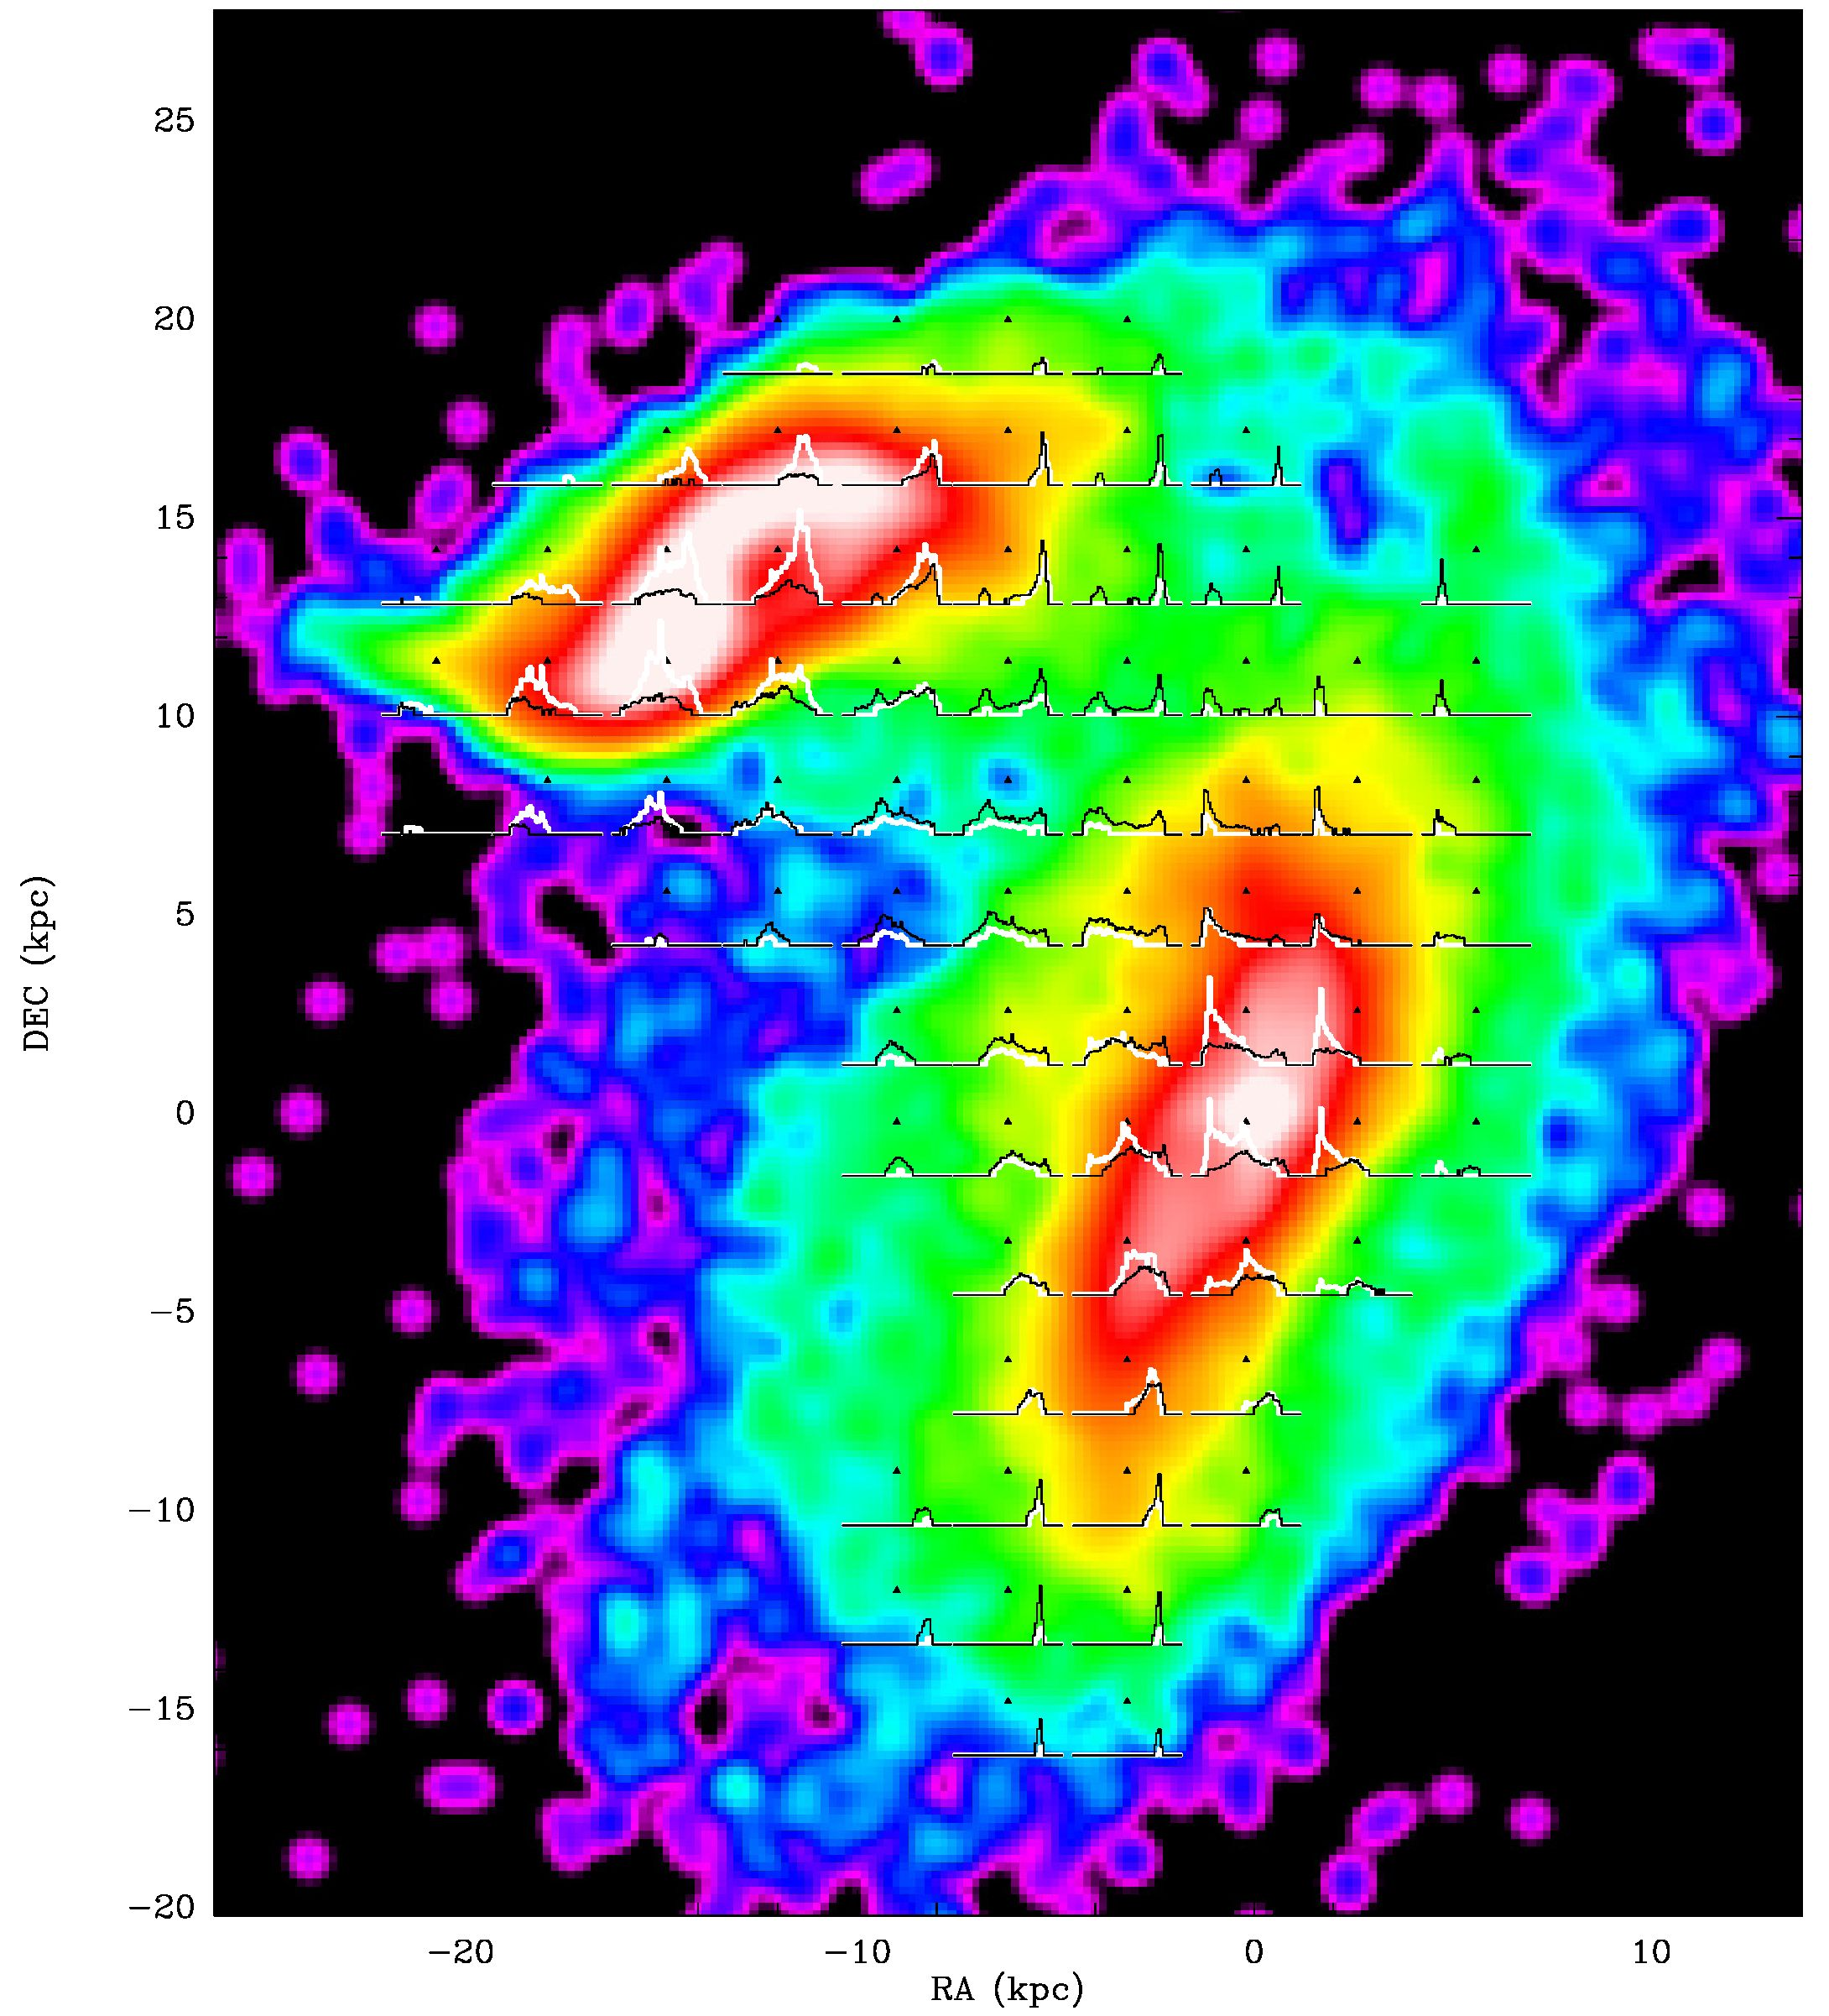
A&A 547, A39 (2012)
Fig. A.2. Simulation 20. CO(1-0) model spectra (white line) overlaid with Hi spectra (black line) on the model stellar surface density distribution.
A39, page 24 of 27
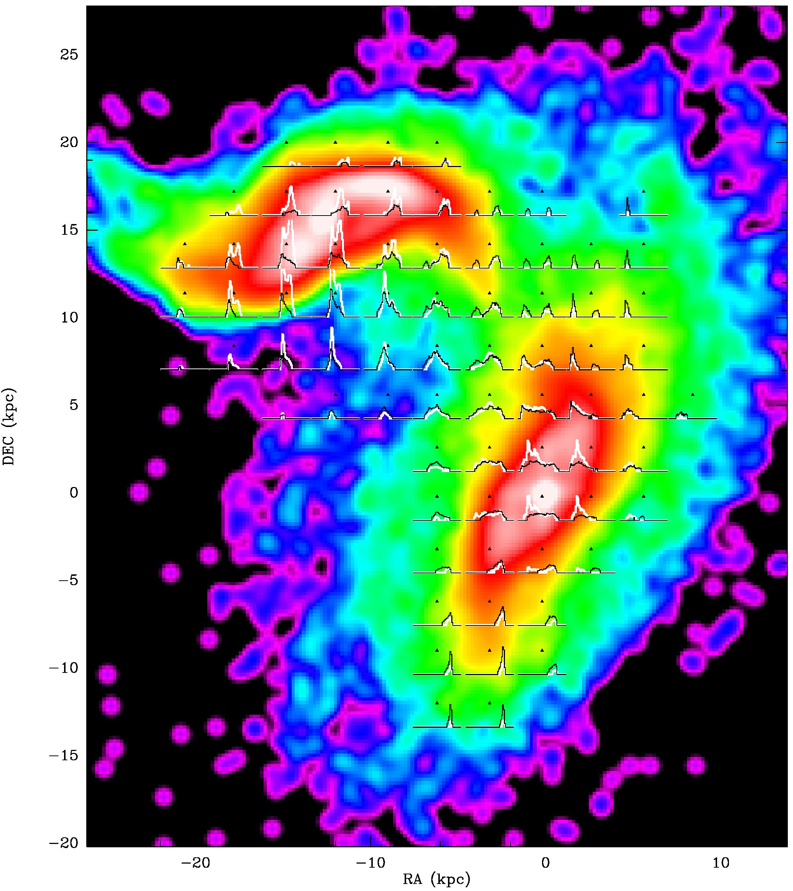
B. Vollmer et al.: A Taffy model
Fig. A.3. Simulation 19. CO(1-0) model spectra (white line) overlaid with Hi spectra (black line) on the model stellar surface density distribution.
A39, page 25 of 27
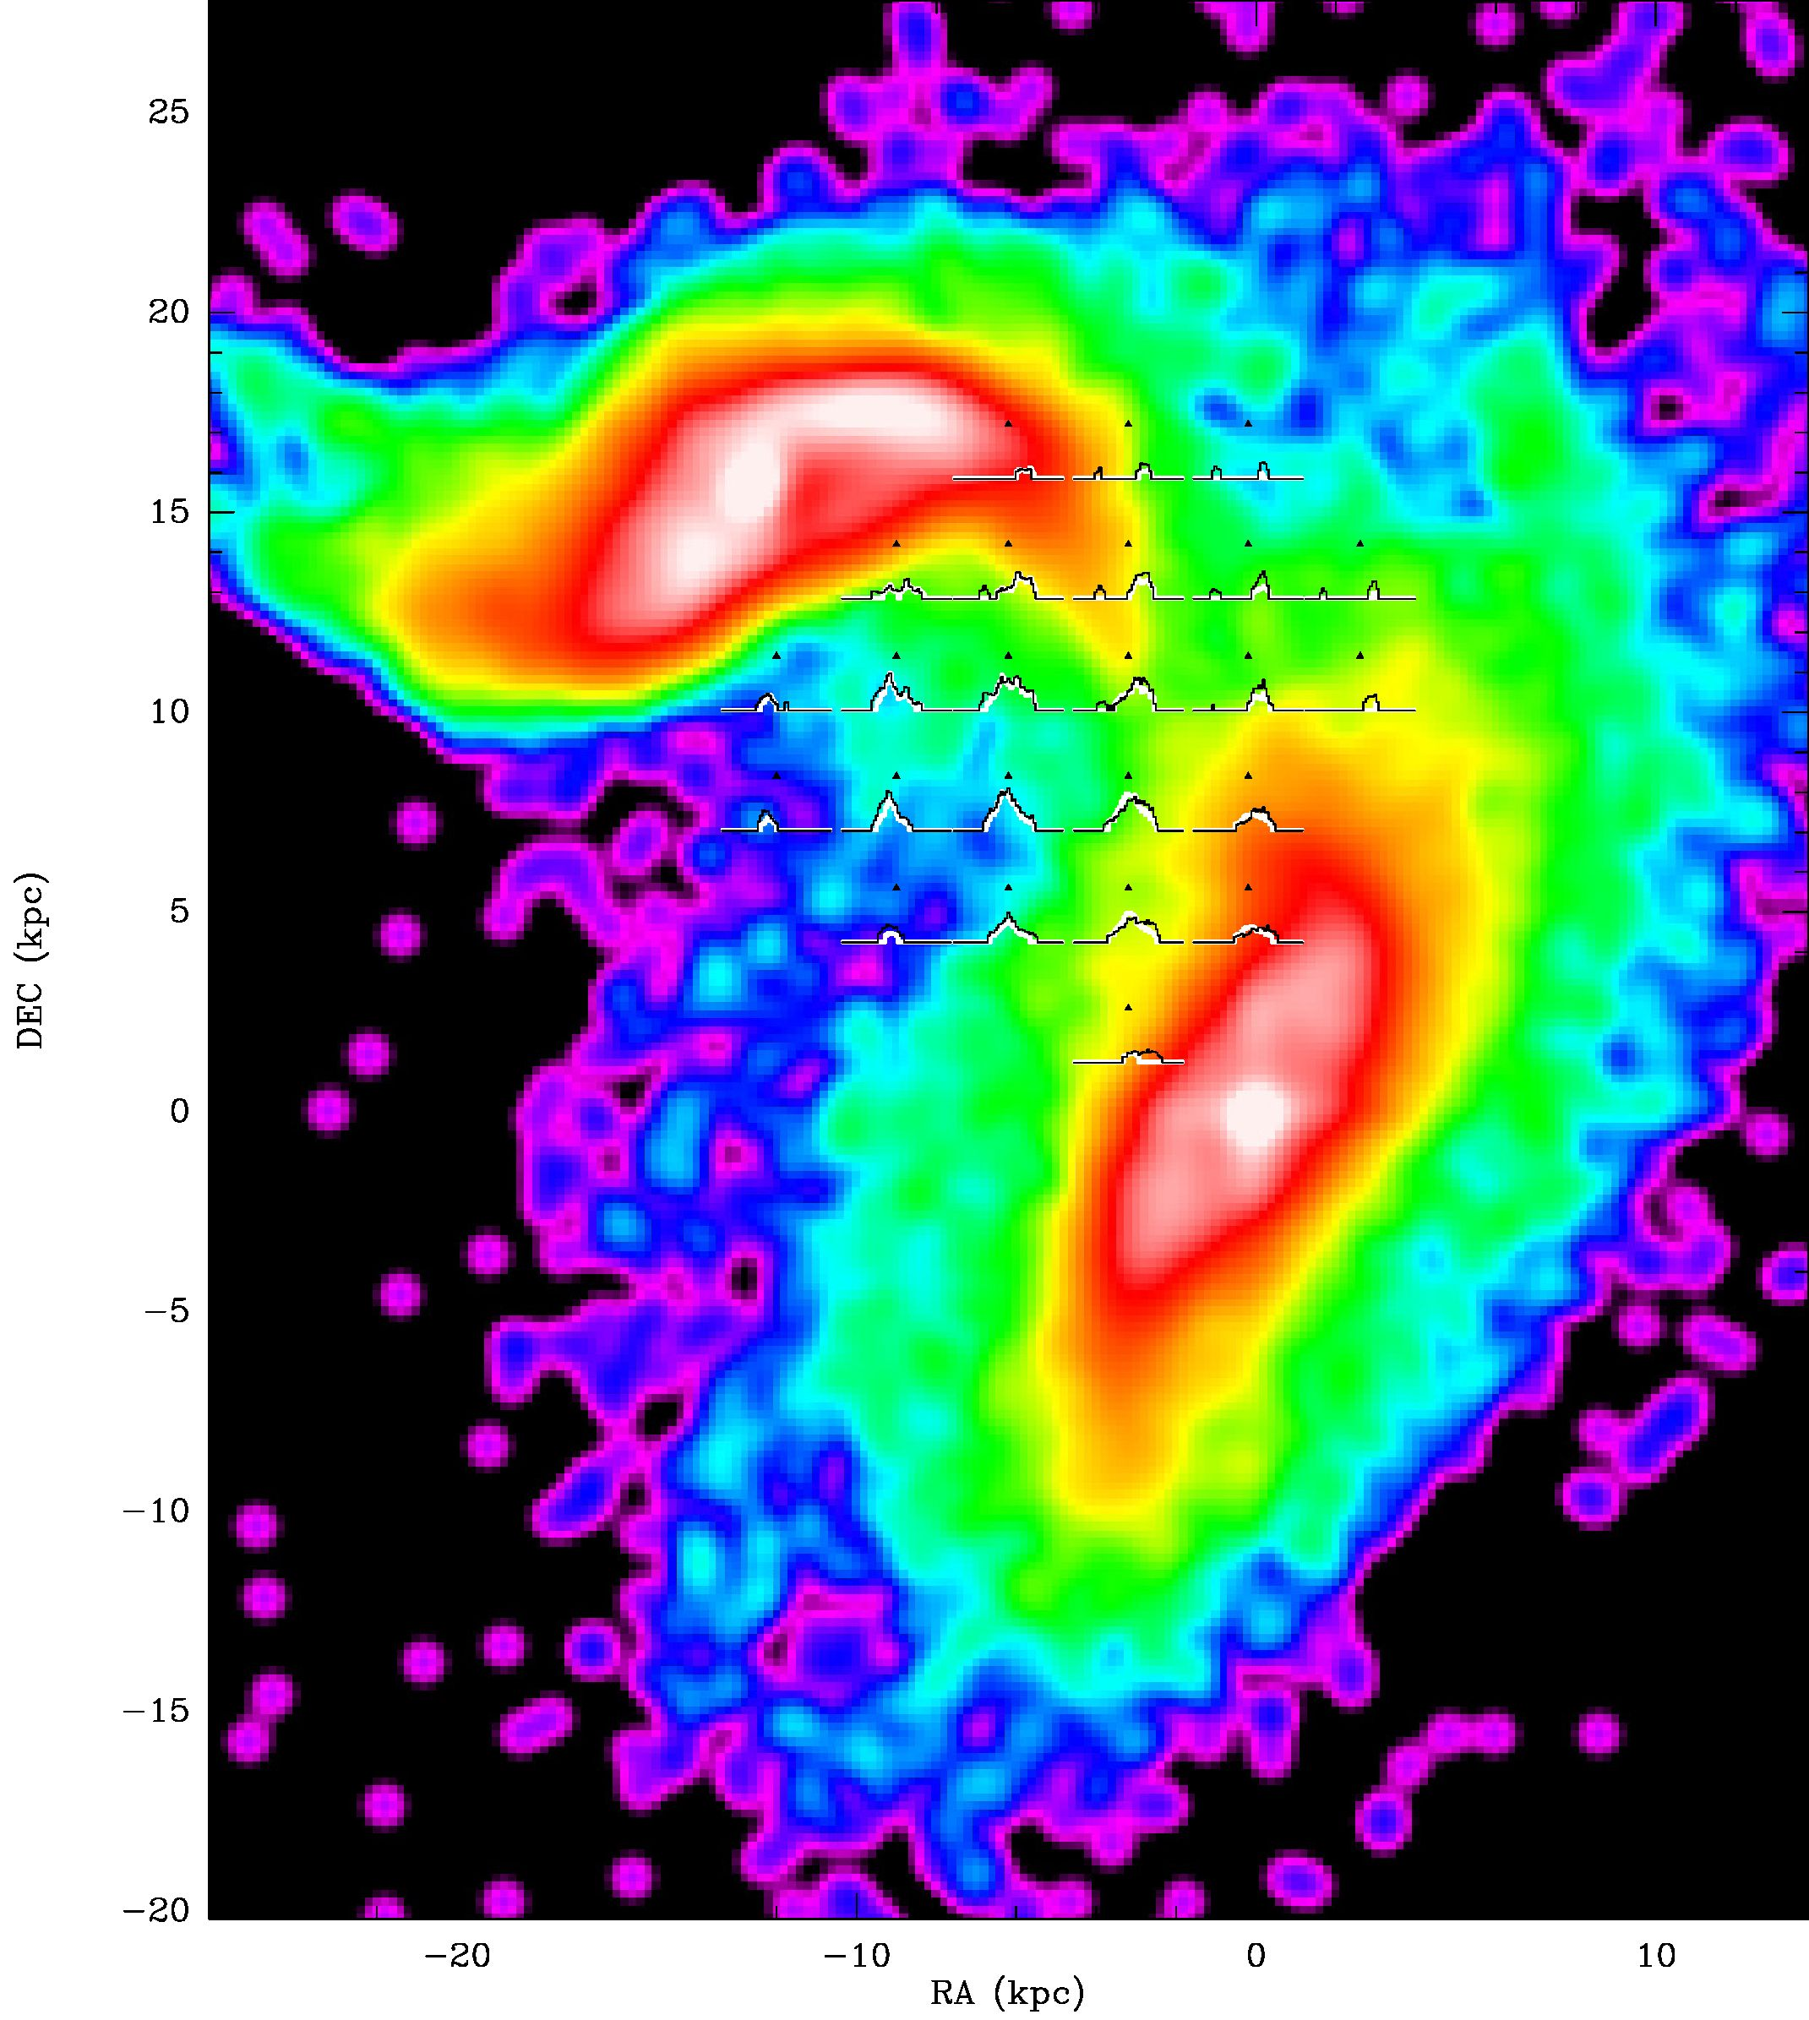
A&A547, A39 (2012)
Fig. A.4. Simulation 19 where the disk gas has been removed. Thus only the gas located in the bridge region is visible. CO(1-0) model spectra
(white line) overlaid with Hi spectra (black line) on the model stellar surface density distribution.
A39, page 26 of 27
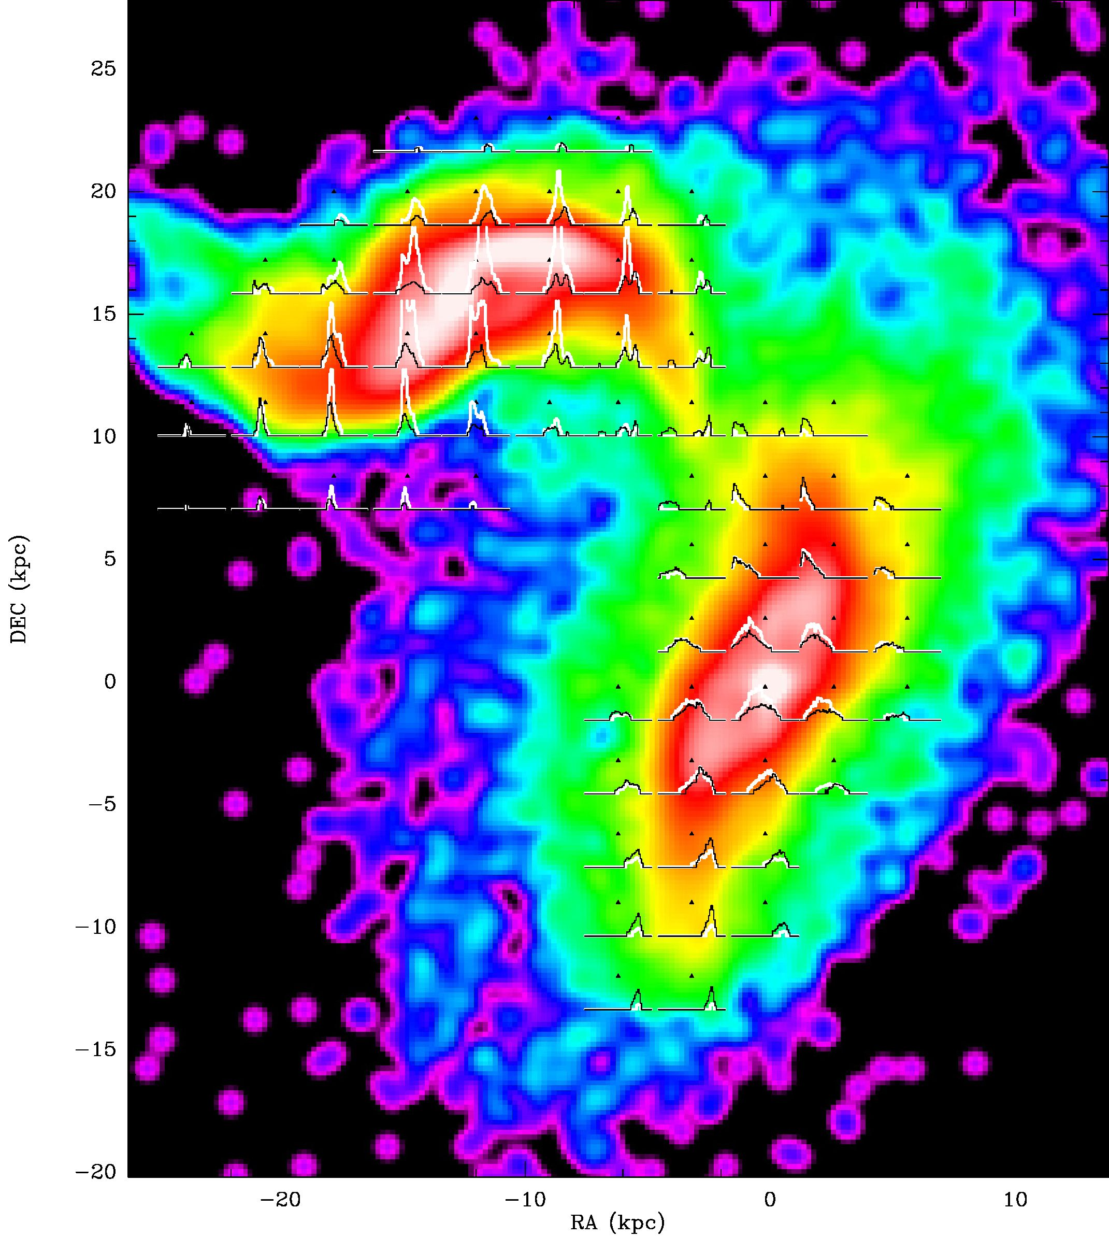
B. Vollmer et al.: A Taffy model
Fig. A.5. Simulation 19 wihout cloud-cloud collisions. CO(1-0) model spectra (white line) overlaid with Hi spectra (black line) on the model
stellar surface density distribution.
A39, page 27 of 27

