
Signature:©PolJRadiol,2011;76(1):7-13
ORIGINALARTICLE
Evaluationof cervicallymph nodes withCT perfusionin
Received:2010.08.13
Accepted:2010.12.06
patientswithhypopharyngealandlaryngealsquamouscellcancer
PiotrTrojanowski1,JanuszKlatka1,AgnieszkaTrojanowska2,TomaszJargiełło3,AndrzejDrop2
1ChairandDepartmentofOtolaryngologyHeadandNeckSurgery,MedicalUniversityofLublin,Lublin,Poland21stDepartmentofGeneralRadiology,MedicalUniversityofLublin,Lublin,Poland
3DepartmentofInterventionalRadiologyandNeuroradiologyMedicalUniversityofLublin,Lublin,Poland

Author’saddress:PiotrTrojanowski,ChairandDepartmentofOtolaryngologyHeadandNeckSurgery,MedicalUniversityofLublin,Jaczewskiego8St.,20-954Lublin,Poland,e-mail:troja23@yahoo.com
Sourceofsupport:Financialdisclosure:studyfinancedbytheStateCommitteeofScientificResearchgrantnr:NN403130933
Summary
Inpatientswithheadandnecksquamouscellcancer,metastasesincervicallymphnodesstillremainthesinglemostimportantnegativepredictingfactor.Theirpresencereducesoverall5-yearsurvivalby50%.
Theaimofthestudywastoevaluatetheroleofcomputedtomographyperfusion(CTP)fordifferentiationbetweenmetastaticandnon-metastaticcervicallymphnodesinpatientswithsquamouscellcancerofhypopharynxandlarynx.
Thiswasaprospectivesingle center studyof18consecutive patients. Eleven patientswithsquamouscellcancerofthehypopharynxandsevenpatientswithlaryngealcancerunderwentCTexaminationoftheneckfollowedbyCTP.GroupII,III,andVoflymphnodeswereevaluated.Perfusionmapsofbasicparameters(bloodflow[BF],bloodvolume[BV],meantransittime[MTT]andpermeabilitysurface[PS])werereconstructedforallpatients.Inallpatientsresectionofprimarytumouralongwithneckdissectionwasperformed.Lymphnodesunderwenthistopathologicalexaminationsforpresenceofmetastases.CTPparameterswererelatedwithhistologicalanalysisofresectednodes.
CTPand histological findings of 65 nodes were correlated. 24 ofthem were metastatic and 41 werenon-metastatic.Metastaticnodesshowedsignificanthyperperfusion,comparingtonon-metastaticones.AnaveragevalueofBFinmetastaticnodeswas136.4ml/100g/min,BVwas7.7ml/100g,MTTwas4.4sandPSwas19.4ml/100g/min.Theaveragevaluesfornon-metastaticnodeswere:BFwas80.7ml/100g/min,BVwas4.7ml/100g,MTTwas5.6sandPSwas12.8ml/100g/min.ThedifferencesweresignificantlyhigherforBF,BVandPSvalues(p<0.05).
CTPmaybeusefulindifferentiationbetweenmetastaticandnon-metastaticlymphnodes,basedonevaluationofthevalueofBF,BVandPS.
Background:
Material/Methods:
Results:
Conclusions:
Keywords:
CTperfusion•squamouscellcancer•laryngealcancer•lymphnodes
PDFfile:
http://www.polradiol.com/fulltxt.php?ICID=881403
7

OriginalArticle
©PolJRadiol,2011;76(1):7-13
Background
Aim
Metastasesincervicallymphnodesarecommoninheadandneckcancer,especiallyinsupraglotticandhypo-pharyngealmanifestationofthedisease.Thepresenceofametastaticnodeononesideoftheneckreducesthe5-yearsurvivalrateby50%,andthepresenceofameta-staticnodeonbothsidesoftheneckreducesthesurvivalratebyfurther25%[1,2].Therefore,evaluationofcervi-callymphadenopathyiscrucialforpatientswithheadandneckcancerasithelpsintheassessmentofpatientprog-nosisandtheselectionofappropriatetreatmentmethod.Evaluationofthemorphologyofthelymphnodeinordertodetectpossiblemetastaticinvolvementrepresentsoneofthemostchallengingproblemsforsurgeonsandradiolo-gists[3–5].
Theaimofthestudywastoevaluatetheusefulnessofcomputedtomographyperfusionexaminationforthedif-ferentiationbetweenmetastaticandnon-metastaticcer-vicallymphnodesinpatientswithhypopharyngealandlaryngealsquamouscellcancer.
MaterialandMethods
Thiswasaprospectivesingle-centerstudy.Thestudygroupincluded18consecutivepatients,previouslyuntreat-ed,withhypopharyngealor/andlaryngealsquamouscellcancerconfirmedonbiopsy.
Therewere14menand4women,meanagewas52years.Elevenpatientshadhypopharyngealcancerandsevenhadlaryngealcancer.Adetailedclinicalcharacteristicsofthegroupispresentedin(Table1).
Twomostfrequentlyusedimagingmethods,contrast-enhancedcomputedtomography(CT)andmagneticreso-nance(MR)allowdetectionofenlargednodesoftenwithnecrosisandextracapsularspread[6],butneithermethodcanaccuratelydifferentiatenon-metastaticfrommetastat-ic,non-enlargedlymphnodes[7].
Priortosurgeryallpatientsunderwentstandardcontrast-enhancedCTimagingoftheneckfollowedbyperfusionexaminationattheleveloftumor.Theexaminationwasperformedusinga64-rowspiralCTunit,VCT(GEMedicalSystems).
Ultrasound(US)andUS-guidedfine-needleaspirationcytology(FNAC)havebeenextensivelyusedformanyyears,theirsensitivityandspecificityareveryhigh[8,9],butthosetechniquesareoperator-dependent.FNACisaninvasivemethodandthereisariskoffalsenegativeresultsarisingfromaspirationofthewrongnodeoritsnecroticpart.
First,CTexaminationwasperformedfromthelevelofskullbasetothoracicinlet,in1.25mmslices(125kV,automaticallymodulatedmA),beforeandaftercontrastmedium(iodineconcentrationof320mg/dl(Visipaque,GEHealthcare,USA))administration(80ml+20mlofsalineflush,flow–1ml/s,with100sdelay),usingsofttissueandbonereconstructionkernels.
Metabolic imaging with singlephoton emission CT (SPECT)andpositronemissiontomography(PET)canhelpinthisdifferentiation,buttheyareexpensive,lessreadilyavail-ableandmostimportanthavelowspecificity[10].
Afterwords(7–10minutes),CTPacquisitionwasperformedaccordingtosofttissuetumorprotocol.Thescanningrangewas8cmandinallcasesitwasenoughtoincludethewholetumorandlymphnodesfromII,IIIandVgroup(accordingtoMemorialSloan-KetteringCancerCenterguidelines).
Sincediagnosisofmetastaticlymphnodeshasanimpor-tantclinicalimpact,newfunctionalimagingtechnologies,CTPandmagneticresonancediffusionstudies(DWI-MRI)arebeingemployed[11–13].
Sixteen5-mmCTsectionsofcontinuous(cine)scanning(80kV,190mA)wereobtained,withatotalacquisitiontimeof45
s.CTwasinitiated4saftertheintravenousinfusion(injec-tionrateof4.5ml/s)ofiodinatedcontrastmediumwithaniodineconcentrationof320mg/dl(Visipaque,GEHealthcare,USA).Thecontrastagentwasinjectedintoanantecubitalveinwithapowerinjector(Medrad,Pittsburgh,USA).
Diffusion-weightedMRIallowsvisualisationofBrownianmotionofwatermolecules(moleculardiffusion)inexam-inedtissue.Cancermetastasistothelymphnodesusual-lyareassociatedwithdecreaseinwaterdiffusivitythusresultinginlowersignalattenuation[14,15].
CTPisatechniquethatallowsquickqualitativeandquan-titativeevaluationoftissuebloodperfusionbygeneratingmapsofbloodflow(BF),bloodvolume(BV),andmeantran-sittime(MTT).CTPhasbeenfoundtobeusefulfornon-invasivediagnosisofmanydiseaseslikecerebralischemiaandinfarction,tumoralneo-angiogenesis,differentiationbetweenmalignantandbenignprocessandforevaluationoftumorresponsetoradio-andchemotherapeutictreat-ment[16,17].
BF(ml/min/100gtissue),BV(ml/100gtissue),MTT(s)andPS(ml/min/100gtissue)mapsweregeneratedusingcommerciallyavailablesoftware(Perfusion3,AW4.2,GEHealthcare,Millwaukee,USA).Thisalgorithmallowsdeconvolutionoftheparenchymaltime-concentrationcurvesbyareferencearterial-curve.Theregionofinter-est(ROI)wasplacedincommoncarotidartery.ThevenousoutflowROIwasmanuallyselected.Ineachevalu-atedlymphnodeROIwasplacedcentrallytoincludetheentirenodeandtailoredtominimisepartialvolumeeffectartifacts.
Recentstudies,basedondopplerultrasoundimagingoftumorvascularizationshowedthatCTperfusionparam-etersmayprovidevalidinformationonangiogenicactivityinducedbyneoplasticcellsinvasionoflymphnodes[18].
Nodessmallerthan4mminlongaxiswereexcludedfromthestudyduetoincreasedpartialvolumeeffecterrors.
8

©PolJRadiol,2011;76(1):7-13
TrojanowskiPetal–EvaluationofcervicallymphnodeswithCTperfusion…
Table1.Locationandstagingofprimarytumourandnumberoflymphnodesevaluatedinindividualpatients.
Patient
Primarysiteofcancer
TNM
Numberoflymphnodesevaluated
1
Hypopharynx–pyriformsinus
T3N1M0
3
2
Hypopharynx–pyriformsinus
T4N2cM0
4
3
Hypopharynx–pyriformsinus
T4N2bM0
4
4
Hypopharynx–pyriformsinus
T4N2cM0
3
5
Hypopharynx–pyriformsinus
T4N2cM0
5
6
Hypopharynx–pyriformsinus
T3N2aM0
2
7
Hypopharynx–pyriformsinus
T3N1M0
2
8
Hypopharynx–pyriformsinus
T1N2bM0
4
9
Hypopharynx–pyriformsinus
T4N2bM0
6
10
Hypopharynx–pyriformsinus
T4N2cM0
4
11
Hypopharynx–postcricoid
T4N2bM0
2
12
Larynx–supraglottic
T3N1M0
3
13
Larynx–supraglottic
T3N2cM0
6
14
Larynx–supraglottic
T4N2cM0
3
15
Larynx–supraglottic
T4N2cM0
4
16
Larynx–glottic
T4N1M0
5
17
Larynx–glottic
T3N1M0
3
18
Larynx–subglottic
T4N1M0
2
Nodes with centralnecrosis visible inCTexaminationweredirectlydiagnosedasharbouringmetastasesandwerealsoexcludedsincenecrosishasalmostnovascularityhenceverylowperfusion.
Theaverageperfusionvaluesfornon-metastaticnodes(n=41)were:BFwas80.7ml/100g/min,BVwas4.7ml/100g,MTTwas5.6sandPSwas12.8ml/100g/min(Figure2).
DifferencesbetweenthevaluesofBF,BVandPSbetweenmetastaticandnon-metastaticnodeswereproventobestatisticallysignificantwithp<0.05(Figure3).
Thevalueofeachperfusionparameterwascalculatedforeverynodeseparately.
Discussion
Allpatientsunderwentsurgeryforresectionofprimarytumouralongwithunilateralorbilateralselectiveorradi-calmodifiedneckdissection.Nodeslocatedinsurgicallyeasilyidentifiableplacesi.e.carotidbifurcation,facialveinjunction,immediateproximityofsubmandibulargland,hyoidbonewereindividuallyresectedandsentforpatho-logicalexaminationinseparatemarkedcontainers.Allspecimensunderwentstandardhistopathologicalexamina-tionsforpresenceofmetastases.Pathologicalresultswererelatedtoperfusionparametersineachnode.Resultswereanalysedusingtwo-sampleindependentt-test.
Theroleofimaginginheadandneckcanceristodeterminetheextentoftheprimarytumoraswellasinvolvementofcervicallymphaticsystem.
Adeterminantofparamountimportanceindiagnosticuse-fulnessofanimagingmodalityisanabilitytodetectthepresenceofmetastaticlymphnodes,particularlywherethisisnotclinicallyevidentortherearedoubtsbasedonphysicalexamination.
Results
PerfusionCTisknowntoofferquantitativeassessmentoftissuehemodynamics,nevertheless,theexaminationofarestrictedslaboftissueandtheuseofionisingradiationandiodinatedcontrastagentaresomedrawbacksofthemethod[19,20].
Allresectedprimarytumorswereconfirmedtobesqua-mouscellcancers.
Histologicallyconfirmedmetastaticnodes(n=24)revealedthefollowingaverageperfusionvalues:BFwas136.4ml/100g/min,BVwas7.7ml/100g,MTTwas4.4sandPSwas19.4ml/100g/min(Figure1).
DynamicCTandperfusionparametersmirrortissuevas-cularizationandmightreflectangiogenicactivityandthus,theoretically,maybeabletodifferentiateneoplasticfromnon-neoplastictissue.
9

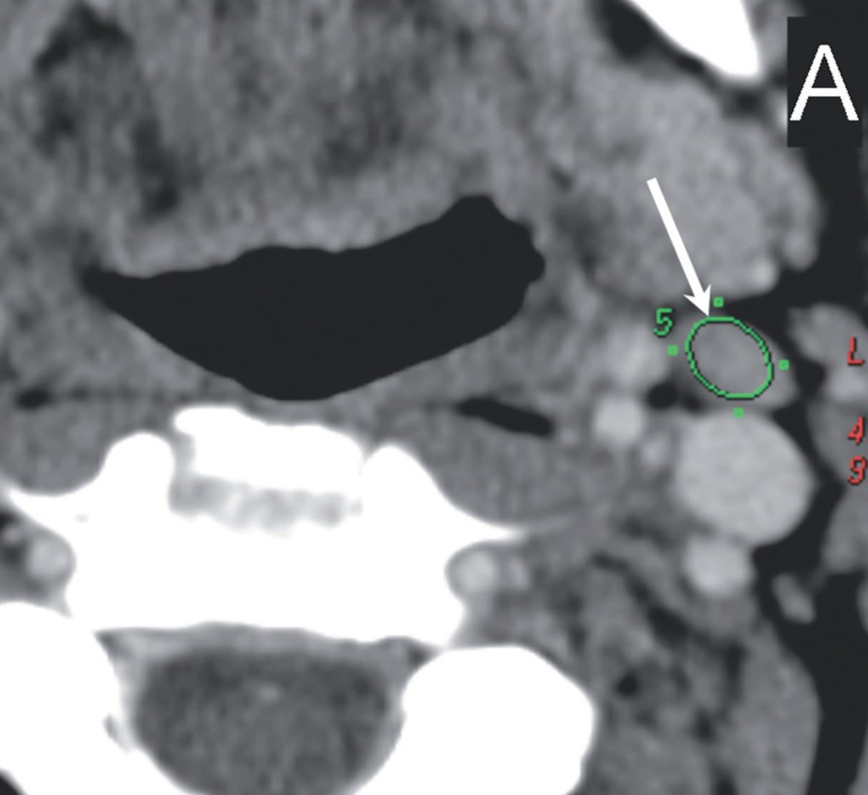
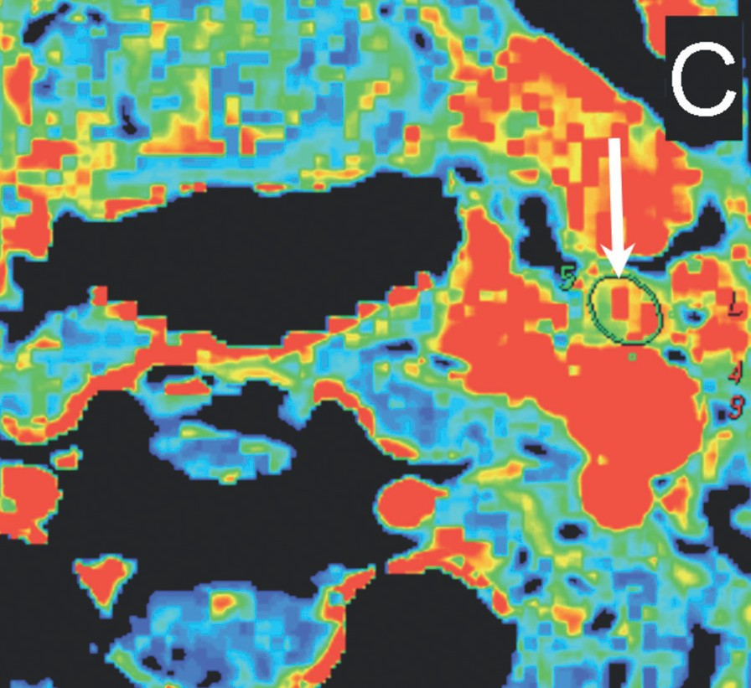
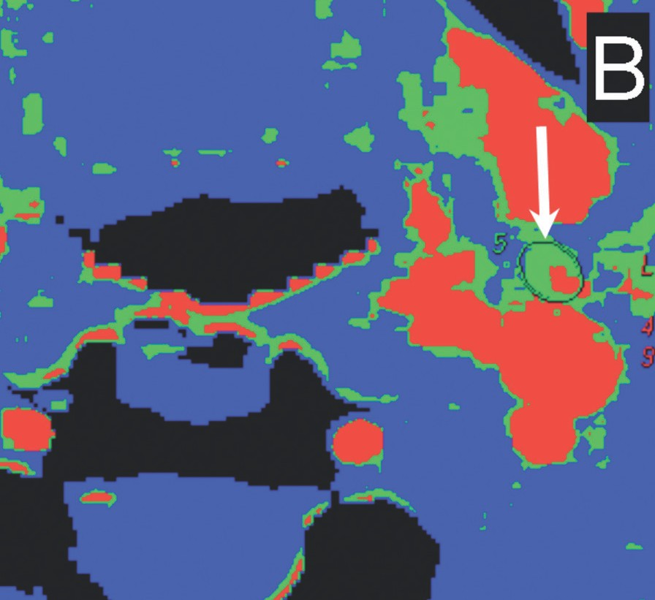
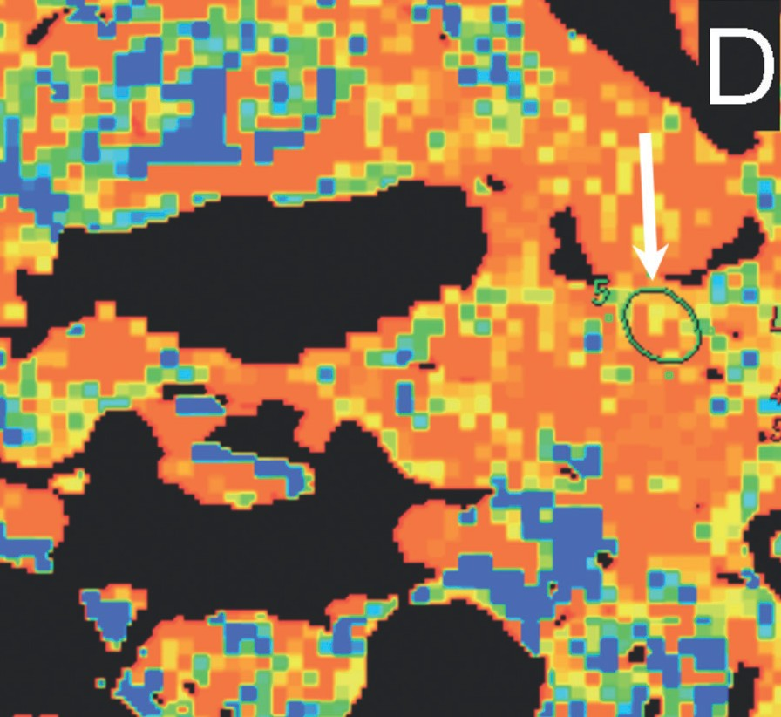
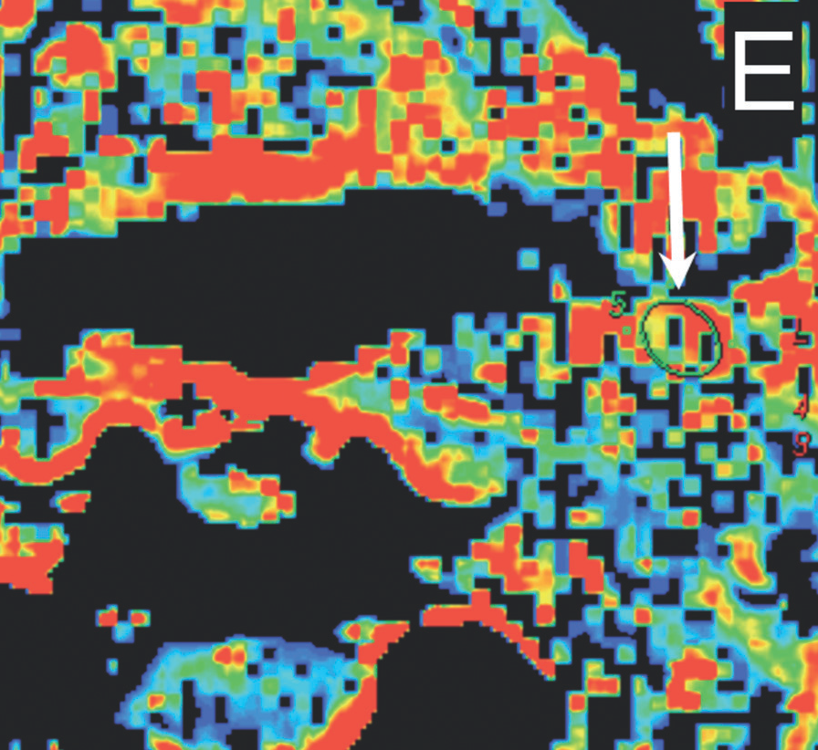
OriginalArticle
©PolJRadiol,2011;76(1):7-13
Figure1.Lymphnodesinpatientwithlaryngealcancer.Thereisonenodelaterallytothecarotidbifurcation,ontheleftside(groupII).Highvaluesofbloodflowandbloodvolumeweresuggestiveformetastaticcharacter.Thisnodeonhistologicalexaminationwasproventobemetastatic.
(A)ROIisplacedoverthenode;(B)bloodflowmap(BF).BF152ml/100g/min;(C)bloodvolumemap(BV).BV8,07ml/100g;(D)meantransittimemap(MTT).MTT3,77s;
(E)permeabilitysurfacemap(PS).PS16,96ml/100g/min.
may be due to the effect ofcytokines, whichprovokesvaso-dilatationandincreasesendothelialpermeability,butnotatsuchhighlevelsasneoplastictissue,whereangiogenesisplaysanimportantrole[21].
TheresultsobtainedinthisstudyshowanalmostdoublevalueofBFinmetastaticversusnon-metastaticcervi-callymphnodes.TherewasalsoasignificantincreaseinBVandPS,exceptforMTTvalue.Similarrelationswerereportedinaxillarynodeswithbreastcancermetastases[22].PSreflectstherateofiodinatedcontrastmediumleak-agefromvesselstoextracellularspaceandMTTreflectsitstransittimethroughthenodalvascularbed.InmetastaticnodesBFisincreasedbynewlydevelopedvessels,whileMTTisusuallyincreasedbythepresenceofpathologic
ArecentpaperbyKapseandcolleaguesdemonstratedthattheinflammationoftheintestinalwallischaracterisedbyhigherperfusionparametersthannormaltissue,butbylowerperfusionparametersthanneoplastictissue.Theincreasedperfusionandpermeabilityofinflamedtissue
10

D

E

A

B

C

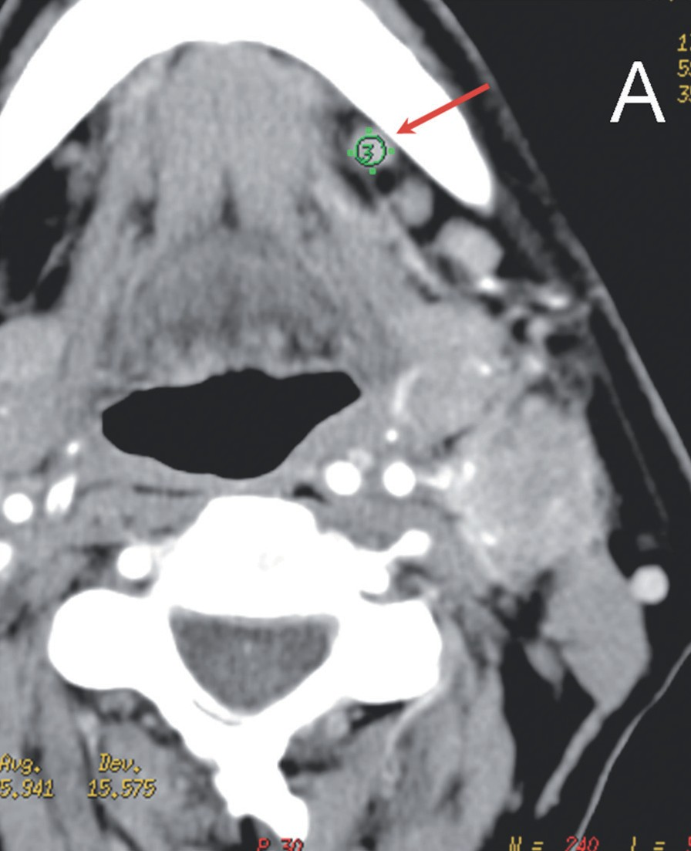
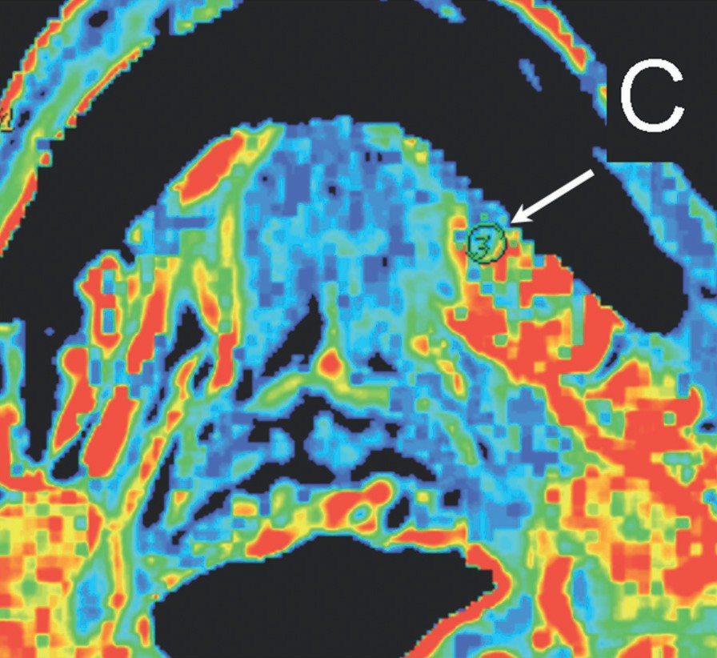
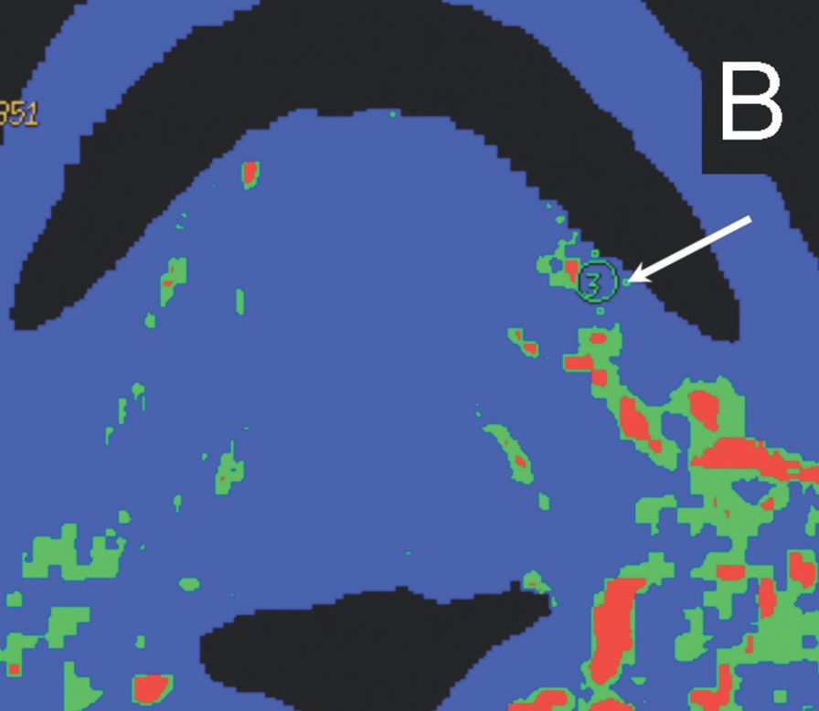
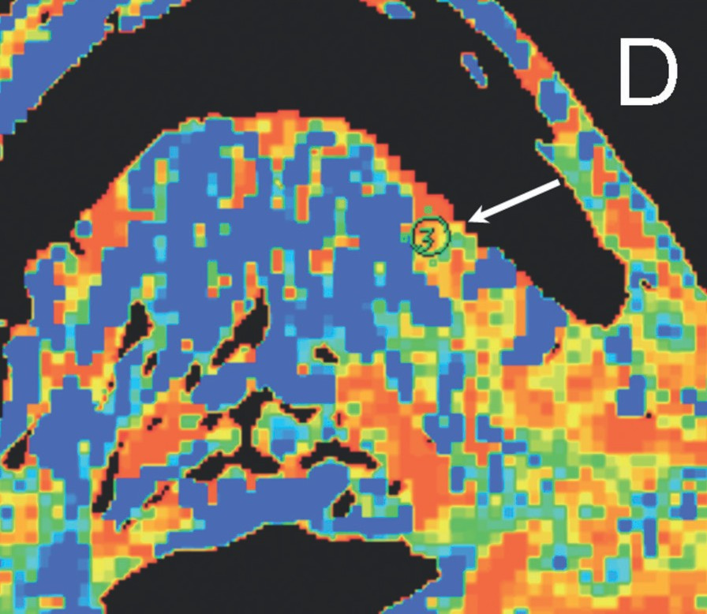
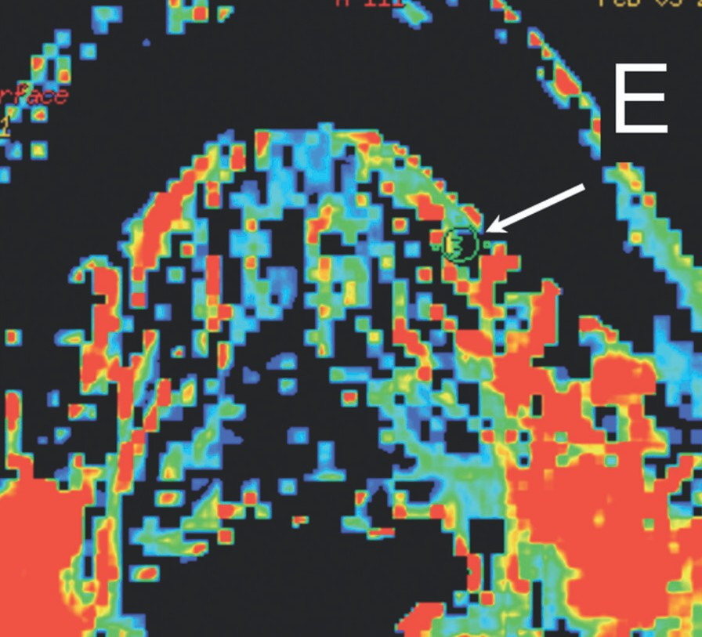
©PolJRadiol,2011;76(1):7-13
TrojanowskiPetal–EvaluationofcervicallymphnodeswithCTperfusion…
Figure2.Lymphnodesinpatientwithhypopharyngealcancer.Thereareseveralsmallroundsubmandibularnodes(groupIB)
ontheleftside.ValueofCTPparametersspeaksfortheirnon-metastaticcharacter.Allthesenodeswereproventobenon-metastaticonhistologicalexamination.(A)ROIisplacedoversmall5mmnode;(B)bloodflowmap(BF).
BF35ml/100g/min;(C)bloodvolumemap(BV).BV4,06ml/100g;(D)meantransittimemap(MTT).MTT3,95s;(E)permeabilitysurfacemap(PS).PS4,15ml/100g/min.
arterio-venousshunts.Changesinvascularendotheliumandinthefunctionofvesselsinducedbyneo-angiogene-sisandbycytokine-mediatedinflammationelevatethePSvalue.BVwasalsoincreasedinmetastaticnodesas aresultofvasodilatationandneovascularistion.
ArecentpaperbyBisdasandcolleaguesreportsnosignifi-cantdifferenceinCTPparametersbetweennormalandmetastaticnodesinpatientswithoropharyngealcancer[18].Thismayresultfrominclusionofallmetastaticnodeseventhosewithsignsofcentralnecrosischaracterisedbyverylowperfusionvalues.
ResultsofthisstudyareinkeepingwiththeobservationsbyYuenandcolleagues,whodescribedahigherCTcon-trastenhancementofmetastaticaxillarynodesthanthatof
11

D

E

A

B

C

OriginalArticle
©PolJRadiol,2011;76(1):7-13
beenalsosuccessfullyutilisedtodistinguishmetastaticfrom non-metastaticlymphnodesinsquamouscellcarcino-maoftheheadandneck.Lackofabsoluteperfusionquanti-fication,unlikeintheCTP,aswellasthedependenceonthesequenceparameters,andthelackofevidence-based repro-
Besidesconventionalcontrast-enhancedMR,muchefforthasbeenexertedindetectingnodalmetastasesusingdif-fusion-weightedimaging(DWI).Cancermetastasestotheregionallymphnodesareassociatedwithalterationsinwaterdiffusivityandmicrocirculationinthenode.HighsignalintensityintheDWI(inb-values³150s/mm2)thatcorrespondstolowADC(apparentdiffusioncoefficient)valuesreflectsthechangesintheproportionofextracel-lulartointracellularwaterprotonsmobilityexpectedinthenodalmetastases.Therefore,ADCmapsprovidehelp-fulinformationonthenecroticareasandhelpdifferentiatemetastaticfromnon-metastaticnodes[13,27].Cut-offval-uesofADCformetastaticnodesof1.38×10–3mm2/syield-ed96%accuracy,98%sensitivity,and88%specificityinastudybyHermans[28],whileotherauthorssuggestlowercut-offvalues[29].
Figure3.Perfusionparametersformetastaticandnon-metastaticlymphnodes.
non-metastaticones[23].Theearlyenhancementshownintheirseriesofmetastaticnodesprobablyreflectsthehigherbloodvolumeduetoangiogenesis,evenifthesimpleprotocolusedwasunabletostudythecontrastandblooddynamics.
AsspeculatedbyLurieandcolleaguesthecontrastenhancementinlymphnodesstartsinthesubcapsularcor-ticalsinusandprogressestothemedullarspace.Bothneo-plasticandinflammatoryinfiltrationmainlyoccurinsub-capsularsinus andthe enlargementof thisarea maybe oneofthefactorsresponsibleforanincreasedblooduptake,mirroredbyanincreaseofBFinthefirstplace[22].
ThereportedsensitivityofMRIforlymphnodemetasta-sesdetectionrangesfrom64to92%,whereasthereportedspecificityrangesfrom40to81%[28,29].
FDG-PET/CTmayalsodetectsmallmetastasesinlymphnodes.Howeverithasresolutionlimitations.Aninflamma-tioninthenon-metastaticnodesmaybemisinterpretedasmetastatis.Nodalnecrosismaycausefalse-negativediag-nosesonPETbecauseofthelowglycolyticactivityofthenecroticarea.Falseresultsalsomaybeanchoredinthevisualorsemi-quantitativeoperatordependentPET/CTevaluation.AstudybyBisdasshowedthatROC(regionofcontrast)curvesofSUV(standarduptakevalue)of3.25yieldedsatisfactorysensitivityandspecificitybutdidnotsurpassthephysician’sperformancewithvisualinterpre-tation[24].LimitationsofPET/CTinnodalstaginghasbeenamongothersattributedtothealmostequaltraceruptakeinreactivenodesasthatinmetastaticlesions[25].
AccordingtotherecentstudyofLiaoetal.124patientswithSCCAoftheoralcavitythespecificityofPETalonewas93%andtogetherwithCT/MRIwas94.5%[30].
Conclusions
BloodFlow,BloodVolumeandPermeabilitySurfaceinComputedTomographyPerfusion(CTP)havesignificantlyincreasedvaluesinmetastaticcervicallymphnodesincomparison to non-metastatic nodesin patients with hypo-pharyngeal/laryngealsquamouscellcancer.
ComputedTomographyPerfusionmightbeusefulindiffer-entiationbetweenmetastaticandnon-metastaticcervicallymphnodeshoweverthisrequiresfurthervalidation.
Dynamiccontrast-enhancedMRimaginghasbeenappliedinprimarycancersoftheheadandneckdiagnosisandhas
References:
- CastelijnsJA,vandenBrekelMWM:Imagingoflymphadenopathyintheneck.EurRadiol,2002;12:727–38
- LevendagP,SessionsR,VikramB:Theproblemofneckrelapseinearlystagesupraglotticlarynxcancer.Cancer,1989;63:345–48
- WeissMH,HarrisonLB,IsaacsRS:UseofdecisionanalysisinplanningamanagementstrategyforthestageN0neck.ArchOtolaryngolHeadNeckSurg,1994;120:699–702
- SomPM:Detectionofmetastasisincervicallymphnodes:CTandMRcriteriaanddifferentialdiagnosis.AJR,1992;158:961–69
- StevensMH,HarnsbergerR,MancusoAAetal:Computedtomographyofcervicallymphnodes;stagingandmanagementofheadandneckcancer.ArchOtolaryngol,1985;11:735–39
- DonDM,AnzaiY,LufkinRBetal:Evaluation ofcervicallymphnodemetastasesinsquamouscellcarcinomaoftheheadandneck.Laryngoscope,1995;105:728–33
- SumiM,VanCeuterenM,NakamuraT:MRMicroimagingofbenignandmalignantnodesintheneck.AJR,2006;186:749–57
- AhujaA,YingM,KingWetal:Apracticalapproachtoultrasoundofcervicallymphnodes.JLaryngolOtol,1997;111:245–56
- vandenBrekelMWM,ReitsmaLC,SnowGBetal:Theoutcomeofawaitandseepolicyfortheneckafternegativeultrasoundguided
cytologyresultsandfollow-upwithultrasoundguidedcytology.BrJCancer,1998;77:201
- SchroederU,DietleinM,WittekindtCetal:IsthereaneedforpositronemissiontomographyimagingtostagetheN0neckinT1-T2squamouscellcarcinomaoftheoralcavityororopharynx?AnnOtolRhinolLaryngal,2008;117(11):854–63
- GandhiD,HoeffnerEG,CarlosRCetal:Computedtomographyperfusionofsquamouscellcarcinomaoftheupperaerodigestivetract.Initialresults.JComputAssistTomogr,2003;27(5):687–93
- VandecaveyeV,DeKeyzerF,HermansR:Diffusion-weightedmagneticresonanceimaginginnecklymphadenopathy.CancerImaging, 2008;8:173–80
- VandecaveyeV,DeKeyzerF,VanderPoortenVetal:Headandnecksquamouscellcarcinoma:valueofdiffusion-weightedMRimagingfornodalstaging.Radiology,2009;251(1):134–46
- SumiM,SakihamaN,SumiTetal:Discriminationofmetastaticcervicallymphnodeswithdiffusion-weightedMRimaginginpatientswithheadandneckcancer.AJNR,2003;24:1627–34
12
200
136.4 Non-metastatic
150 Metastatic
100 80.7
50 19.4
4.77.7 5.64.4 12.8
0 BF BV MTT PS

©PolJRadiol,2011;76(1):7-13
TrojanowskiPetal–EvaluationofcervicallymphnodeswithCTperfusion…
- AbdelRazekAAK,SolimanNY,ElkhamarySetal:Roleofdiffusion-weightedMRimagingincervicallymphadenopathy.EurRadiol,2006;16:1468–77
- BisdasS,NguyenSA,AnandSKetal:Outcomepredictionaftersurgeryandchemoradiationofsquamouscellcarcinomaintheoralcavity,oropharynx,andhypopharynx:useofbaselineperfusionCTmicrocirculatoryparametersvs.tumorvolume.IntJRadiatOncolBiolPhys,2009;73(5):1313–18
- BisdasS,BaghiM,WagenblastJetal:Differentiationofbenignandmalignantparotidtumorsusingdeconvolution-basedperfusionCTimaging:feasibilityofthemethodandinitialresults.EurJRadiol,2007;64(2):258–65
- BisdasS,BaghiM,SmolarzAetal:Quantitativemeasurementsofperfusionandpermeabilityoforopharyngealandoralcavitycancer,recurrentdisease,andassociatedlymphnodesusingfirst-passcontrast-enhancedcomputedtomographystudies.InvestRadiol,2007;42(3):172–79
- GandhiD,ChepehaDB,MillerTetal:Correlationbetweeninitialandearlyfollow-upCTperfusionparameterswithendoscopictumorresponseinpatientswithadvancedsquamouscellcarcinomasoftheoropharynxtreatedwithorgan-preservationtherapy.AJNR,2006;27(1):101–6
- BisdasS,KonstantinouGN,LeePSetal:Dynamiccontrast-enhancedCTofheadandnecktumors:perfusionmeasurementsusingadistributed-parametertracerkineticmodel.Initialresultsandcomparisonwithdeconvolution-basedanalysis.PhysMedBoil,2007;52(20):6181–96
- KapseN,GohV:Functionalimagingofcolorectalcancer:positronemissiontomography,magneticresonanceimaging,andcomputedtomography.Clin ColorectalCancer,2009;8(2): 77–87
- LiuY,BellomiM,GattiGetal:Accuracyofcomputedtomographyperfusioninassessingmetastaticinvolvementofenlargedaxillarylymphnodesinpatientswithbreastcancer.BreastCancerRes,2007;9(4):R40
- YuenS,YamadaK,GotoMetal:CT-basedevaluationofaxillarysentinellymphnodestatusinbreastcancer:valueofaddedcontrast-enhancedstudy.ActaRadiol,2004;45(7):730–37
- BisdasS,SpicerK,RumboldtZ:Whole-tumorperfusionCTparametersandglucosemetabolismmeasurementsinheadandnecksquamouscellcarcinomas:apilotstudyusingcombinedpositron-emissiontomography/CTimaging.AJNR,2008;29(7):1376–81
- BentivegnaE,UzanC,GouySetal:Correlationbetween[18f]fluorodeoxyglucosepositron-emissiontomographyscanandhistologyofpelvicnodesinearly-stagecervicalcancer.AnticancerRes,2010;30(3):1029–32
- VandecaveyeV,DeKeyzerF,NuytsSetal:DetectionofheadandnecksquamouscellcarcinomawithdiffusionweightedMRIafter(chemo)radiotherapy:correlationbetweenradiologicand
histopathologicfindings.IntJRadiatOncolBiolPhys,2007;67(4):960–71
- AbdelRazekAAK,MegahedAS,DenewerAetal:Roleofdiffusion-weightedmagneticresonanceimagingindifferentiationbetweentheviableandnecroticpartsofheadandnecktumors.ActaRadiol,2008;49(3):364–70
- HermansR,VandecaveyeV:Diffusion-weightedMRIinheadandneckcancer.JBR-BTR,2007;90(4):264–67
- SumiM,SakihamaN,SumiTetal:Discriminationofmetastaticcervicallymphnodeswithdiffusion-weightedMRimaginginpatientswithheadandneckcancer.AJNR,2003;24(8):1627–34
- LiaoCT,WangHM, ChangJT etal: Influenceof pathologicalnodalstatusandmaximalstandardizeduptakevalueoftheprimarytumorandregionallymphnodesontreatmentplansinpatientswithadvancedoralcavitysquamouscellcarcinoma.IntJRadiatOncolBiolPhys,2010;77(2):421–29
13

