
OPEN 3 ACCESS Freely available online
PLPS PATHOGENS

Unique Structure and Stability of HmuY, a Novel Heme-
Binding Protein of Porphyromonas gingiva Us

Halina Wojtowicz1", Tibisay Guevara2", Cynthia Tallant2, Mariusz Olczak1, Aneta Sroka3, Jan Potempa3,4,
Maria Sola5, Teresa Olczak1*, F. Xavier Gomis-RUth2*
1 Laboratory of Biochemistry, Faculty of Biotechnology, University of Wroclaw, Wroclaw, Poland, 2 Proteolysis Lab, Department of Structural Biology, Molecular Biology
Institute of Barcelona, CSIC, Barcelona, Spain, 3 Laboratory of Microbiology, Faculty of Biochemistry, Biophysics and Biotechnology, Jagiellonian University, Krakow,
Poland, 4 Department of Periodontics, University of Louisville School of Dentistry, Louisville, Kentucky, United States of America, 5 Structural MitoLab, Department of
Structural Biology, Molecular Biology Institute of Barcelona, CSIC, Barcelona, Spain

Abstract
Infection, survival, and proliferation of pathogenic bacteria in humans depend on their capacity to impair host responses
and acquire nutrients in a hostile environment. Among such nutrients is heme, a co-factor for oxygen storage, electron
transport, photosynthesis, and redox biochemistry, which is indispensable for life. Porphyromonas gingivalis is the major
human bacterial pathogen responsible for severe periodontitis. It recruits heme through HmuY, which sequesters heme
from host carriers and delivers it to its cognate outer-membrane transporter, the TonB-dependent receptor HmuR. Here we
report that heme binding does not significantly affect the secondary structure of HmuY. The crystal structure of heme-
bound HmuY reveals a new all-b fold mimicking a right hand. The thumb and fingers pinch heme iron through two apical
histidine residues, giving rise to highly symmetric octahedral iron co-ordination. The tetrameric quaternary arrangement of
the protein found in the crystal structure is consistent with experiments in solution. It shows that thumbs and fingertips,
and, by extension, the bound heme groups, are shielded from competing heme-binding proteins from the host. This may
also facilitate heme transport to HmuR for internalization. HmuY, both in its apo- and in its heme-bound forms, is resistant
to proteolytic digestion by trypsin and the major secreted proteases of P. gingivalis, gingipains K and R. It is also stable
against thermal and chemical denaturation. In conclusion, these studies reveal novel molecular properties of HmuY that are
consistent with its role as a putative virulence factor during bacterial infection.
Citation: Wojtowicz H, Guevara T, Tallant C, Olczak M, Sroka A, et al. (2009) Unique Structure and Stability of HmuY, a Novel Heme-Binding Protein of
Porphyromonas gingivalis. PLoS Pathog 5(5): e1000419. doi:10.1371/journal.ppat.1000419
Editor: C. Erec Stebbins, The Rockefeller University, United States of America
Received February 5, 2009; Accepted April 7, 2009; Published May 8, 2009
Copyright: © 2009 Wojtowicz et al. This is an open-access article distributed under the terms of the Creative Commons Attribution License, which permits
unrestricted use, distribution, and reproduction in any medium, provided the original author and source are credited.
Funding: This study was supported by grants from Spanish ministries (BIO2006-02668, BFU2006-09593, BIO2009-XXXXX, PSE-010000-2007-1, and CONSOLIDER-
INGENIO 2010 Project ''La Factoría de Cristalización" (CSD2006-00015)) and by grant 2005SGR00280 from the Generalitat de Catalunya. Additional funding was
obtained from grants N401 029 32/0742 and 1642/B/P01/2008/35 from the Department of Scientific Research, Polish Ministry of Science and Higher Education;
from US National Institutes of Health grant DE 09761; and from the European Union through EU FP6 Strep Project LSHG-2006-018830 ''CAMP'' and EU FP7
Collaborative Project 223101 ''AntiPathoGN''. Further funding was provided by ESRF (http://www.esrf.eu/) for data collection. The funders had no role in study
design, data collection and analysis, decision to publish, or preparation of the manuscript.
Competing Interests: The authors have declared that no competing interests exist.
* E-mail: Teresa.Olczak@biotech.uni.wroc.pl (TO); fxgr@ibmb.csic.es (FXG-R)
" These authors contributed equally to this study and share first authorship.

Introduction
Periodontitis causes chronic inflammation of the gums and it
affects 10-15% of adults worldwide, potentially leading to tissue
destruction and tooth loss, and Porphyromonas gingivalis is its main
etiological agent [1,2]. In addition, P. gingivalis, an anaerobic black-
pigmented, Gram-negative bacterium, has been implicated in
cardiovascular diseases, respiratory diseases, diabetes, osteoporo-
sis, and pre-term low birth-weight [3-5]. The pathogen cannot
synthesize protoporphyrin IX but acquires exogenous heme
(‘‘heme’’ is here used to refer indistinctly to either Fe2+- or Fe3+-
protoporphyrin IX), an excess of which is stored in the
characteristic black pigment on the bacterial cell surface [6-8].
The co-factor is obtained from hemoglobin, haptoglobin-hemo-
globin, myoglobin, hemopexin, serum albumin, lactoperoxidase,
cytochrome c, and catalase by the action of hemolysins and
proteases [9-12]. In addition, P. gingivalis and other Gram-negative
bacteria possess systems to bind locally liberated heme such as
secreted heme-binding proteins and hemophores [13,14]. One
such hemophore is HasA, employed by Serratia mercescens to
scavenge host heme in order to deliver it to the receptor, HasR, for
internalization [15]. Similarly, hemophores have been described in
Haemophilus influenzae, Yersinia enterocolitica, Pseudomonas aeruginosa,
and Bacillus anthracis [13,16-20]. Further heme is transported into
the cell through outer-membrane receptors [21].
In P. gingivalis, heme is primarily imported by heme-binding
protein, HmuY, and its cognate outer-membrane receptor, HmuR
- . The latter is involved in heme transport through the outer
membrane and probably depends on the interaction with protein
TonB, which is needed to transduce energy for the passage of
heme and other ligands into the periplasm in most Gram-negative
pathogens [11,14,22,23]. The two Hmu proteins are encoded in
tandem by the hmu operon, which comprises six genes in total,
hmuYRSTUV. The locus is regulated by iron [23] and by a
transcriptional repressor encoded by gene pg1237 [24], and its
disruption leads to a 70% decrease in heme binding and a 45%
PLoS Pathogens | www.plospathogens.org
May 2009 | Volume 5 | Issue 5 | e1000419

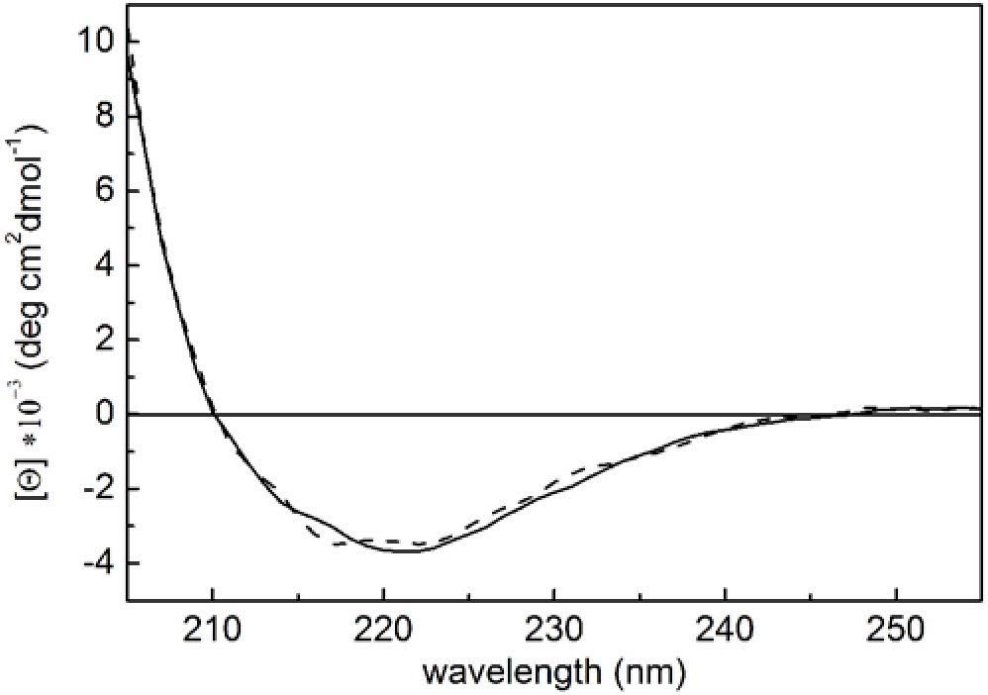
Molecular Determinants of P. gingivalis HmuY

Author Summary
Pathogenic bacteria cause infection in humans as found in
periodontitis, which is a chronic inflammation of the gums
caused by Porphyromonas gingivalis. As part of the
infective process, bacteria must acquire nutrients to
survive and multiply at the infection site, and among such
nutrients is heme. This is an iron-dependent co-factor of
several indispensable enzymes and proteins. P. gingivalis
liberates heme from host heme-binding proteins through
the action of proteases and arranges its transport to the
bacterial cell through two proteins, HmuY and HmuR. They
grab free heme and transport it across the bacterial
membrane into the cell, respectively. This function poses
stringent conditions on these proteins regarding stability
and resistance toward the host immune system. We report
here that HmuY is very stable and that it displays a novel
protein fold, which consists only of b-strands. It reminds us
of a right hand, whose fingers trap heme. Once heme is
bound, HmuY forms tetramers, which have the four heme-
binding sites buried and thus protected from competing
host heme-binding proteins. This feature also facilitates
heme transport to HmuR and into the bacterial cell. All
these data may help to develop new antibacterial agents
at times in which resistance toward antibiotics, both at
intensive healthcare stations and in the community, poses
serious challenges to human health.
decrease in heme uptake [25]. Potential protein pairs with high
sequence similarity to HmuY and HmuR have been identified on
contiguous genes in other bacteroidetes (Microscilla marina, Prevotella
intermedia, and Bacteroides from the species vulgatus, fragilis, ovatus,
thetaiotaomicron, caccae, stercori, and coprocola), proteobacteria (Plesio-
cystis pacifica, Stigmatella aurantica, and Myxococcus xanthus), spiro-
chaetes (Leptospira biflexa), and chlorobi (Chloroherpeton thalassium).
This suggests a widespread mechanism for heme uptake (our
unpublished data; [23,25]). HmuY is an outer-membrane-
associated lipoprotein, which is identical in sequence to a P.
gingivalis envelope protein designated fibroblast activating factor
[26]. This factor induces proliferation and protein synthesis in
normal human gingival fibroblasts, indicating an additional role
for HmuY in the host immune response. The hmuY gene encodes a
23-kDa protein, with no significant sequence similarity to any
other protein, whose 25 first residues are not present in the
purified protein. This stretch comprises a leader sequence, a lipid-
binding site, and a potential protease cleavage site [23,25]. The
protein is functional as a dimer in its heme-depleted form and as a
tetramer once heme is bound [23]. Heme bound to HmuY, with a
midpoint potential of 136 mV, displays a low-spin six-fold Fe3+ co-
ordination sphere with the participation of residues His134 and
His166, as revealed by point mutation studies [27].
In order to shed light on the mechanisms of heme binding and
transport through HmuY, we set out to assess the folding and
stability properties of HmuY in its heme-depleted (apo-HmuY) and
heme-complexed (holo-HmuY) forms, as well as its susceptibility to
proteolysis by trypsin and gingipains K (Kgp) and R (RgpA and
RgpB). In addition, we solved the X-ray crystal structure of holo-
HmuY. Taken together, these data enabled us to propose a
mechanism for Hmu-mediated heme uptake by P. gingivalis.

Results/Discussion

Conformational stability of HmuY
Assessment of the biophysical response of apo- and holo-HmuY
to thermal and chemical denaturation may contribute to unravel
Figure 1. Far-UV CD analysis of P. gingivalis apo- and holo-
HmuY. Spectra were recorded for purified HmuY (solid line) and the
HmuY-heme complex at a 1:1 molar ratio (dashed line).
doi:10.1371/journal.ppat.1000419.g001
heme binding and transport at the infection site. Previously, a far-
UV CD spectrum of native apo-HmuY had shown that the protein
has mainly a b structure [23]. Here we found that heme binding
did not affect the spectrum, indicating absence of significant
structural changes of the secondary structure (Figure 1). In
unfolding studies (Figure 2), far-UV CD spectroscopy revealed that
thermal denaturation of HmuY (encompassing the sequence of the
purified natural protein; Asp26-Lys216) was irreversible, leading
to protein precipitation (data not shown). In contrast, guanidinium
hydrochloride (GdnHCl)-induced chemical denaturation was
reversible and no significant difference in the equilibrium
unfolding profiles of apo- and holo-HmuY was observed
(Figure 2C). Both forms tended to follow one-step unfolding
process with a calculated free energy of denaturation (AGd£n) of
34.1 ± 12.4 kJ/mol. To obtain information on local changes of the
tertiary structure of HmuY and the heme cavity, we further
studied thermal and chemical denaturation by intrinsic tryptophan
fluorescence spectroscopy. Thermal denaturation is reversible and
gives rise to sigmoidal unfolding curves for both HmuY forms
(Figure 2A and 2B). However, the initial part of the curves,
especially that of holo-HmuY, deviates from the one-step reverse-
unfolding mechanism. Exposure of apo-HmuY to increasing
concentrations of GdnHCl reduced fluorescence intensity, giving a
sigmoidal shape to the unfolding curve (Figure 2D). In contrast,
the unfolding profile of holo-HmuY (Figure 2E) does not account
for a typical one-step reverse-mechanism transition unless the
reference wavelength is far away from the heme-binding
maximum (323 nm). This suggests that holo-HmuY may exhibit
local differences in the tertiary structure when compared with apo-
HmuY similar to HasA and HasAp [18,28,29]. Simultaneously,
we examined heme loss by holo-HmuY by absorbance change in
the Soret region (Figure 2F and 2I). Holo-HmuY retained ~70%
of the bound heme up to 3 M GdnHCl, and even in the presence
of 4 or 5 M GdnHCl, it remained partially loaded with the co-
factor. An interesting feature can be observed at intermediate
GdnHCl concentrations (3.6 M) and at ~50°C. Although the
overall fluorescence spectra are similar, thus indicating that the
conformations are related (Figure 2G and 2H), the possibility of
intermediate species should not be excluded. Changes in the
fluorescence spectra in the pre-transitional region may indicate
differences in local conformation of HmuY upon heme binding
and tetramer formation. This corresponds to the end of the pre-
PLoS Pathogens | www.plospathogens.org
May 2009 | Volume 5 | Issue 5 | e1000419
2
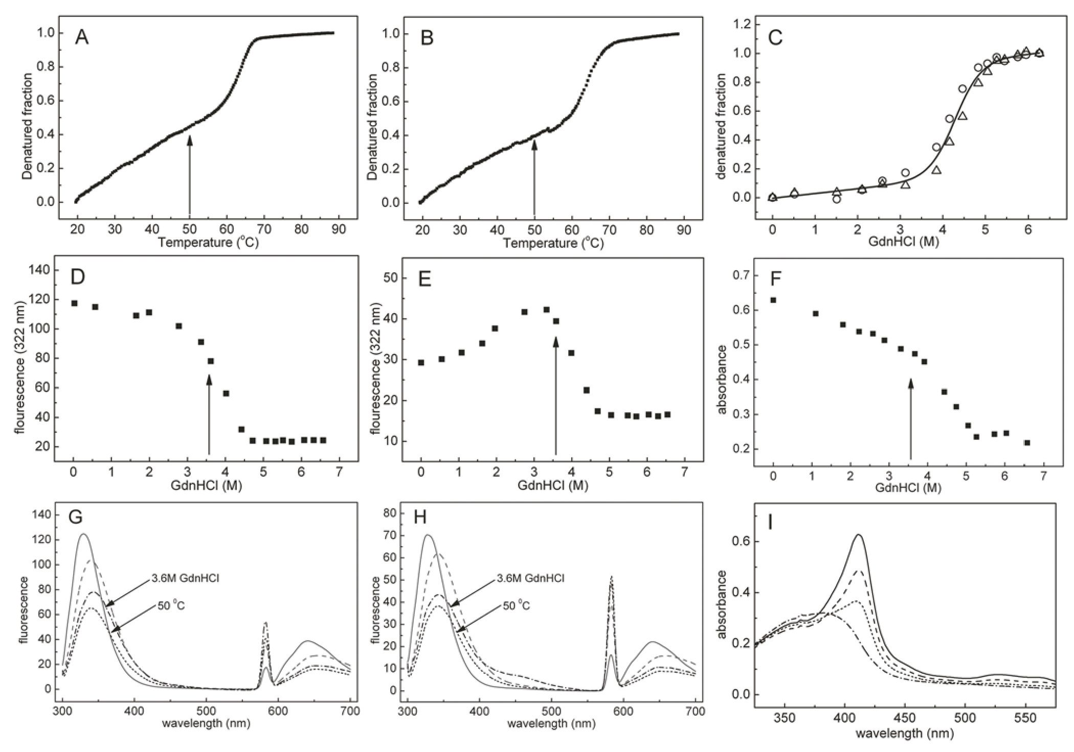
Molecular Determinants of P. gingivalis HmuY
Figure 2. Thermal and chemical unfolding studies. Unfolding transition curves of apo-HmuY (A) and holo-HmuY (B) as a function of
temperature measured by tryptophan intrinsic fluorescence. Unfolding transition curves as a function of GdnHCl concentration measured by CD
ellipticity at 225 nm (C) for apo-HmuY (circles) and holo-HmuY (triangles). The solid line shows the goodness-of-fit assuming a two-state reverse
transition model. Unfolding transition curves as a function of GdnHCl concentration measured by tryptophan intrinsic fluorescence for apo-HmuY (D)
and holo-HmuY (E). Heme dissociation from holo-HmuY (F) measured by absorption spectroscopy in the Soret region. Fluorescence spectra of apo-
HmuY (G) and holo-HmuY (H): HmuY in 20 mM sodium phosphate, 1 M GdnHCl, pH 6.5 at 20°C before (solid lines), after thermal denaturation and
cooling to 20°C (dashed lines), and at 50°C (dotted lines); HmuY in 20 mM sodium phosphate, 20 mM NaCl, 3.6 M GdnHCl, pH 7.4 at 20°C (dashed-
dotted lines). (I) Soret region spectra of HmuY-heme: 20 mM sodium phosphate, 20 mM NaCl, pH 7.4 without GdnHCl (solid line), with 3 M (dashed
line), 4 M (dotted line), and 6 M (dashed-dotted line) GdnHCl at 20°C.
doi:10.1371/journal.ppat.1000419.g002
transitional region regardless of the technique used, as indicated by
arrows in Figure 2A, 2B, 2D, 2E, and 2F. It may be easier to see
the intermediates when heme is bound to HmuY (Figure 2E), since
the co-factor modulates the fluorescence characteristics of HmuY
tryptophans. We conclude that the first step of the HmuY-heme
complex unfolding is a tetramer-to-dimer transition, subsequently
leading to heme loss. Posterior dimer dissociation and protein
denaturation are probably the limiting steps in this process. Taking
all together, HmuY stability against heat and GdnHCl-induced
denaturation is similar to or higher than that of other stable
proteins bound to heme [30]. However, in contrast to the latter,
both apo- and holo-HmuY show comparable resistance to
denaturation, although some local changes in the tertiary structure
may occur upon heme binding.

Resistance of HmuY to proteolytic digestion
Ligand binding may enhance resistance to proteolysis [31], so
trypsin was assayed as a degrading agent against HmuY. In
addition, response to the cysteine proteases Kgp, RgpA, and RgpB
was examined, as these are secreted by P. gingivalis upon infection
and target host hemoproteins [12]. Both apo- and holo-HmuY
were fully resistant to digestion by trypsin and gingipains in their
native state under the conditions assayed (Figure 3). In contrast,
protein samples previously subjected to thermal denaturation were
completely degraded. These data strongly suggest that HmuY is
very stable and compactly folded, regardless of the bound co-
factor, and insensitive against endogenous proteases.

Protomeric structure of holo-HmuY
The structure of HmuY is asymmetric, with maximal
dimensions of ~55x40x35 A, and it resembles a right hand
(Figure 4A). It consists of a roughly globular nucleus reminiscent of
a palm, out of which protruding segments mimicking thumb and
fingers emerge (Figure 4A, 4B, and 4C). As anticipated by CD
spectroscopy (see above and [23]), HmuY is an all b-protein
constituted by 15 b-strands. Both the N- and C-terminus are
located on the protein surface corresponding to the palm and they
point toward the wrist (following the analogy with a hand). They
precede and succeed, respectively, two b-strands that participate in
a twisted b-sandwich or laterally open b-barrel made up of two
PLoS Pathogens | www.plospathogens.org
3
May 2009 | Volume 5 | Issue 5 | e1000419
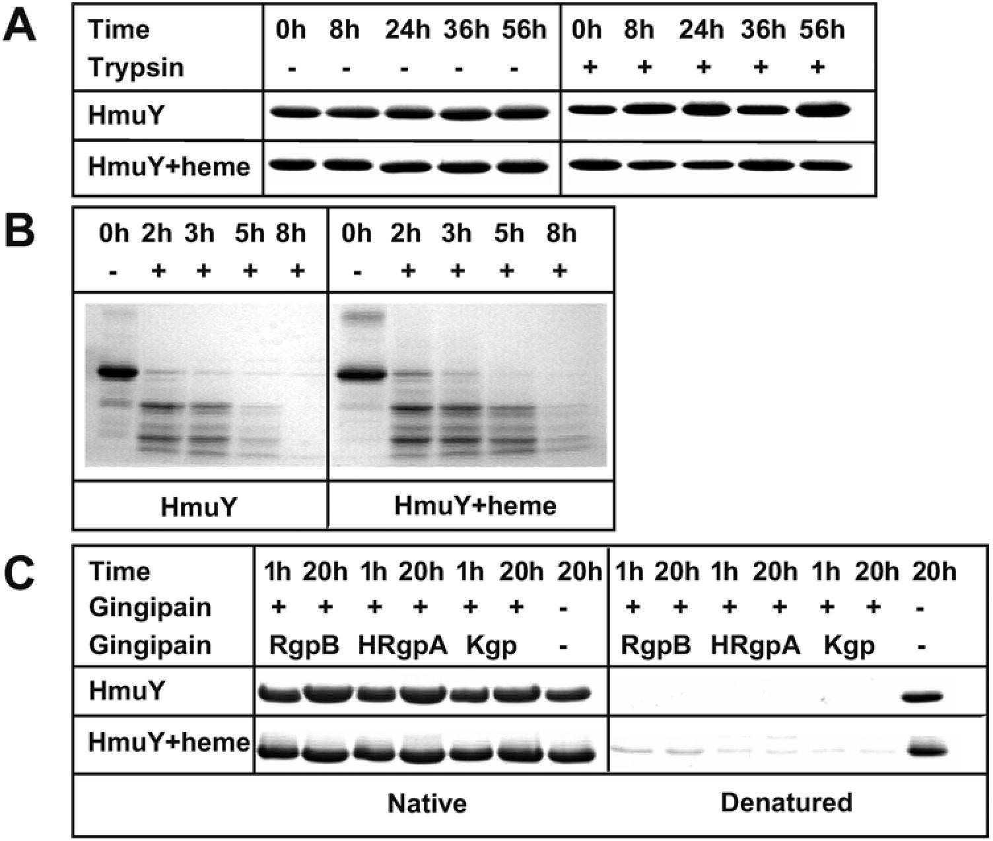
Molecular Determinants of P. gingivalis HmuY
Figure 3. Limited proteolysis experiments. Proteolytic susceptibility of apo- and holo-HmuY (A) in their native states and (B) after thermal
dénaturation (incubation at 95°C for 10 min) toward trypsin and (C) Kgp, RgpA, and RgpB.
doi:10.1371/journal.ppat.1000419.g003
antiparallel P-sheets of, respectively, five (sheet I; strands
P1+P6+P13 — P15; connectivity +4x, —1, —1, —1) and four (sheet
II; strands P2 —P5; connectivity — 1, +2x, +1) strands (Figure 4B
and 4C). A large twisted and curled P-ribbon (p7P8) is inserted
into the front of the palm mimicking a thumb and two further
ribbons are found on the back resembling a pinky (strand P12), a
ring finger (P11), a middle finger (P10), and an index finger (P9)
(top to bottom in Figure 4C). Sheet I is curled toward sheet II and
twisted for ~95°, while sheet II is arched away from sheet I and
twisted for ~85°. This gives rise to a large hydrophobic cavity at
the interface between sheets, which is the core of the protein and
contributes to most of the palm. It is created by side chains from
strands P1 and P2, the loop connecting ¿2 with ¿3 (LP2P3), and
strands P3 —P6 and P13 — P15. In addition, hydrophobic residues
provided by LP6P7, LP8P9, and LP10P11 close the P-sandwich on
the flank bordered by P5 (sheet II) and P6 (sheet I) (Figure 4C).
Two smaller hydrophobic cores are observed on the convex side of
either sheet by side chains provided by P6, P13 — P15, and LP6P7,
which folds back on top of the sheet (sheet I), and LP3P4 plus
LP5P6 (sheet II). All together, these hydrophobic clusters give rise
to a molecule, which provides a structural explanation for its high
stability and resistance toward denaturation and proteolysis.

Heme binding in holo-HmuY
Together with the finger-proximal lateral wall of the central
hydrophobic core, thumb and fingers give rise to the heme-binding
cavity, which is radically different in structure and location within the
molecule from those found in any other heme-binding protein
described. The cavity occupies a volume of 2,136 A3 and is made up
by 37 residues, including 29 hydrophobic or neutral residues and
eight charged residues (Figure 4D). A single Fe3+-chelating heme b
molecule (hemin) is inserted laterally like a wedge into the cavity,
curiously with its charged propionate substituents pointing toward
the palm and the hydrophobic methyl and vinyl substituents pointing
toward the exterior (Figure 4C and 4D). The protein:heme complex
is characterized by an interaction surface of 532 A2, which is 61 % of
the total accessible surface of the co-factor (868 A2). This value is
rather low if compared with other heme-protein complexes [32] but
can be explained in terms of the quaternary arrangement (see below).
Complex interactions are mainly hydrophobic and entail three
hydrogen bonds, one salt bridge, and van-der-Waals interactions
between 13 protein residues (Table 1 and Figure 4D). Further
noteworthy are a salt-bridge of Arg79 Ng2 and two hydrogen bonds
of Tyr80 Og and Tyr13 Og with the carboxylate oxygen atoms of
the propionate substituent of pyrrol ring a, as well as a hydrogen
bond between Thr124 Oy1 and the propionate of ring d. However,
the most relevant contacts are the metallo-organic bonds established
between the heme iron and the Ne2 atoms of His134 (2.04 A away),
provided by thumb-strand P8, and His 166 (2.09 A), from ring-
finger-strand P11. These two ligands occupy the apical positions of
an octahedral iron co-ordination sphere, whose equatorial ligands
are the four porphyrin nitrogen atoms (at 2.03-2.06 A). Accordingly,
ion co-ordination is exerted by six nearly equivalent and equidistant
sp2-hybridized nitrogen atoms and is thus highly symmetrical, which
should redound to a very stable complex. In addition, both protein
histidine side chains are in hydrophobic environments: His134 is
surrounded by Tyr127, Met129, Met136, and Pro168 (from a vicinal
complex; see next chapter) and His166 by Phe 156, Phe 164, Pro171,
and the methyl and vinyl groups from an adjacent complex.
PLoS Pathogens | www.plospathogens.org
May 2009 | Volume 5 | Issue 5 | e1000419
4
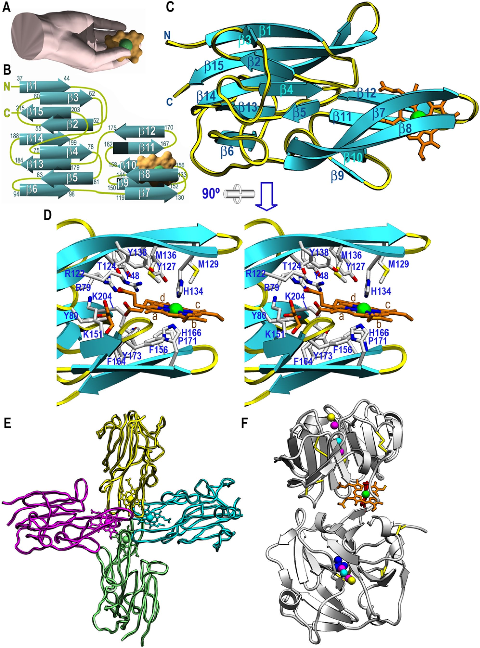
Molecular Determinants of P. gingivalis HmuY
PLoS Pathogens j www.plospathogens.org
S
May 2009 j Volume S j Issue S j e1000419

Molecular Determinants of P. gingivalis HmuY
Figure 4. Structure of holo-HmuY. (A) The protein mimics a right hand, whose thumb and fingers trap the heme co-factor (surface model in
orange with an inserted green sphere for the iron ion). (B) Topology scheme of HmuY, which consists of 15 b-strands, each labeled with the protein
residues it spans. The heme group is shown as in (A). (C) Richardson plot of holo-HmuY Glu35-Lys216 with the bound heme as an orange stick model
and an inserted sphere for the iron. The view was chosen to match (A). (D) Close-up view in stereo of (C) after a horizontal 90° rotation. Protein
residue side chains engaged in shaping the heme-binding cavity and in interactions with the co-factor are shown and labeled. The four pyrrole rings
of the protoporphyrin IX moiety are also labeled (a-d). (E) Tetrameric quaternary arrangement of holo-HmuY. Each constituting heme/HmuY complex
is shown in one color. (F) Richardson plot of rabbit serum hemopexin (PDB access code 1QHU; [32]). The two hemopexin-like b-propeller domains
contain central channels to bind ions (colored spheres), and the heme-binding site is at the domain intersection.
doi:10.1371/journal.ppat.1000419.g004

Quaternary arrangement of holo-HmuY
The quaternary structure of holo-HmuY is a cross-like tetramer
of complexes, ~95 A in diameter, created by the combination of a
local and a crystallographic two-fold axis (Figure 4E). This finding
fits well with analytical size-exclusion chromatography studies
showing that, upon addition of heme, HmuY eluted as a tetramer
- . The tetramer is made up by interactions between thumb and
finger tips and includes b-hairpins b7b8, b9b10, b11P12, and
b 14b 15 of each of the four complexes, which contribute through a
surface of 1148-1174 A2 to the oligomer. This is within the range
reported for interaction surfaces usually found in protein
complexes [33]. All contacts between vicinal complexes (e.g. the
magenta and yellow ones in Figure 4E) are symmetric and include
eight hydrogen bonds, two salt bridges and four hydrophobic
interactions, two hydrophobic protein-heme and one hydrophobic
inter-heme contacts (Table 1). Fewer contacts are observed
between opposite complexes (e.g. the magenta and cyan ones in
Figure 4E); they just include three symmetric hydrophobic
interactions established by Ala169, Asp132, and the vinyl
substituents of heme pyrrol rings b (Table 1). The overall
arrangement entails that the four heme groups are in direct
contact with each other in the center of the tetramer. Each co-
factor molecule has a buried surface of 636-639 A2, 74% of its
total area. The inter-iron distances are 13 A (vicinal monomers)
and 17 A (opposite monomers), within the range of values
observed in electron-transport proteins such as cytochrome c (9-
18 A; [34,35]), although no function of HmuY in redox
biochemistry or electron transport has been postulated. As a
result of this packing the four heme groups are buried and thus
protected from competing heme-binders.

Structural aspects of related heme-binding proteins
Structure similarity searches following a variety of algorithms
failed to identify significant matches extending beyond selected
parts of the central b-sandwich, so we conclude that HmuY
conforms to a novel all b-fold. Among structurally characterized
Table 1. Protein:co-factor and protein tetramerization contacts.
HmuY:heme contacts3 | Hydrogen bonds and polar interactions and metallo-organic  bonds (in A) |  |  | Van-der-Waals interactions performed by protein  residues
 | Arg79 Ng2 | Hem301 O1A | 2.81 | Tyr80 | Thr124 | Tyr127
 | Tyr80 Og | Hem301 O2A | 2.59 | Met129 | Met136 | Gly155
 | Thr124 Oy1 | Hem301 O1D | 2.70 | Phe156 | Phe164 | Ala169
 | His134 Ne2 | Hem301 FE | 2.04 | Gly170 | Pro171 | Tyr173
 | His166 Ne2 | Hem301 FE | 2.09 | Lys204
 | Tyr173 Og | Hem301 O2A | 2.60
Contacts between
contiguous monomers  (molecules 1-2)a,b | Hydrogen bonds and polar interactions (in A) |  |  | Van-der-Waals interactions (in A)
 | Glu128 Oe1 | Lys204 Nf | 2.99/2.97 | Met129 Cp | Hem301 CMA | 3.59/3.60
 | Pro131 O | Ala169 N | 2.86/2.86 | Pro131 Cp | Thr172 Cy2 | 3.64/3.64
 | Pro131 N | Pro171 O | 3.40/3.39 | Asp132 C | Ala169 CP | 3.90/3.88
 | Gly133 N | Ala169 O | 3.06/3.05 | Hem301 CBB | Hem301 CBB | 3.55
 | Pro168 N | Pro131 O | 3.38/3.38
Contacts between
opposite monomers  (molecules 1-3)c |  |  |  | Van-der-Waals interactions (in A)
Ala169Cb Ala169Cp 3.28
Asp132 Cy Asp132 Cy 4.00
Hem301 CBBb Hem301 CBBb 3.99
aAtom CBB is the terminal vinyl methylene carbon of pyrrole ring b, and atom CMA is the methyl carbon of pyrrole ring a (see Figure 4D for pyrrole naming within the
heme protoporphyrin ring). Atoms O1A, O2A, and O1D are carboxylate oxygens of the propionate substituents of rings a and d, respectively.
bAll the interactions between molecule 1 and molecule 2 are symmetric. Distances 1-2 and 2-1 are given separated by a slash.
cAll the interactions between molecule 1 and molecule 3 are symmetric and made by identical atoms.
doi:10.1371/journal.ppat.1000419.t001
PLoS Pathogens | www.plospathogens.org
May 2009 | Volume 5 | Issue 5 | e1000419
6
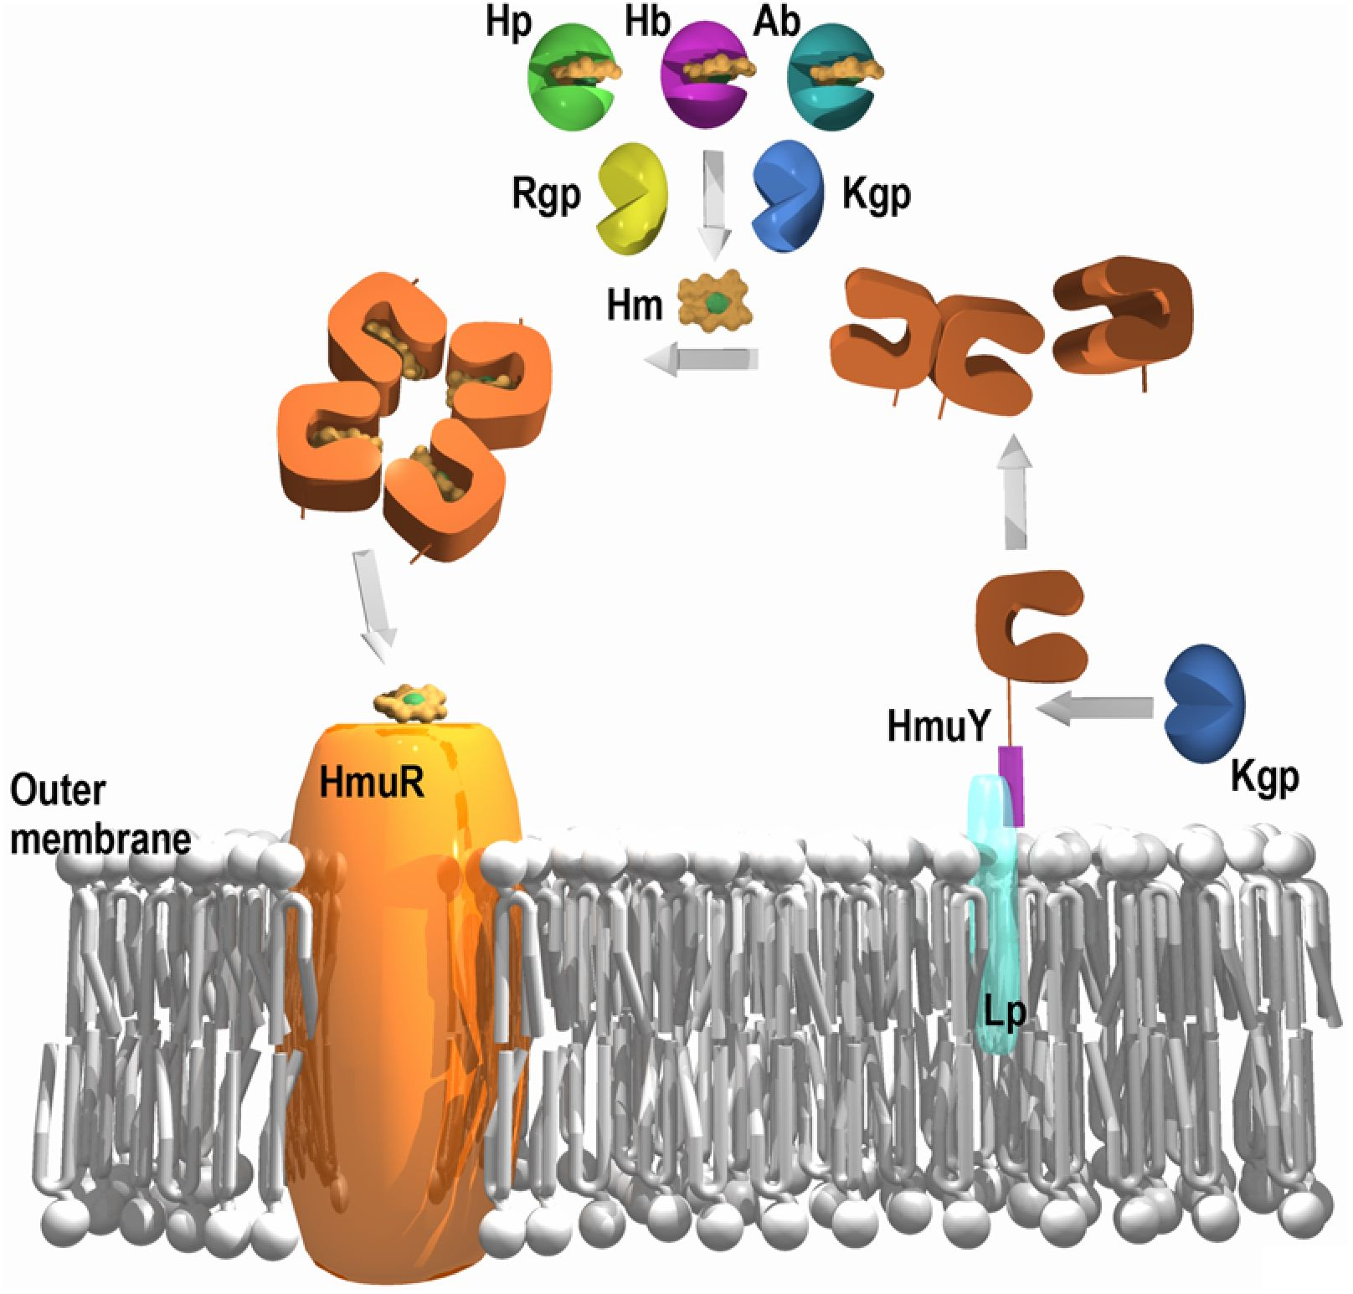
Molecular Determinants of P. gingivalis HmuY
Figure 5. Proposed working mechanism for the extracellular hmu components. HmuY and HmuR are shown with their proposed roles in
heme uptake, as well as the other suggested players. Hb stands for hemoglobin; Hp for hemopexin; Ab for serum albumin; Rgp for gingipains R types
A and B; Kgp for gingipain K; Lp for lipid; and Hm for heme (represented as in Figure 4A).
doi:10.1371/journal.ppat.1000419.g005
heme-binding proteins participating in iron storage and transport
are the archetypes hemoglobin and myoglobin, which like related
globins and serum albumin, are all-a class proteins [36-38]. With
respect to functional analogs of HmuY, only the closely-related
hemophores HasA and HasAp from S. marcescens and P. aeruginosa,
respectively, have been reported for their structure [18,28]. They
consist of a two layer a/b-sandwich with a meander fold
characterized by a twisted antiparallel six-stranded b-sheet with
four helices on its concave side. The overall shape of the molecules
is reminiscent of a fish, which traps a heme in its mouth. Here, the
iron is octahedrally co-ordinated by an apical histidine and a
tyrosine. Like HmuY, HasA and HasAp do not undergo major
structural rearrangement upon heme binding.
The only other structurally characterized all-b-structure en-
gaged in heme transport and storage is serum hemopexin [32,39].
It consists of two tandem ~200-residue fourfold b-propeller
domains, which are thick discs consisting of four blades arranged
around a central channel. Each blade is made up of a twisted four-
stranded antiparallel b-sheet [39]. The functionally relevant
oligomerization state is a monomer, and heme binding correlates
with major structural rearrangement [32]. In the heme-bound
complex, the two hemopexin domains are roughly perpendicular
to each other and connected by a partially flexible 20-residue
linker (Figure 4F). The heme-binding site resides at the interface
between domains, which is covered by a cluster of conserved
aromatic residues. As in HmuY, heme binding is exerted by two
histidine residues, one provided by the linker, which bind the iron
on its two apical positions, and a cluster of basic residues and
tyrosines that bind the heme propionate groups [32]. Further as in
HmuY, the heme propionate groups are buried in the molecule
and the hydrophobic substituents of heme rings b and c likewise
point toward the exterior of the molecule. However, beyond these
very detailed features and a generally apolar environment of the
heme-binding cavity, there is no further structural similarity
between holo-hemopexin and holo-HmuY.

Proposed working mechanism for the Hmu system
Accumulating biochemical and genetic evidence [13,14,22-
25,40,41], as well as the present data, suggest the following
mechanism for Hmu-mediated heme uptake in P. gingivalis and, by
extension, in other related bacteria (Figure 5). HmuY is
synthesized and exported to the outer membrane, where it would
be anchored to a lipid through an attachment site typical for
prokaryotic lipoproteins [42]. Location of HmuY at the outer
membrane of intact P. gingivalis cells and to outer-membrane
vesicles has been shown [23,25,26]. In addition, the existence of a
PLoS Pathogens | www.plospathogens.org
May 2009 | Volume 5 | Issue 5 | e1000419
7
Molecular Determinants of P. gingivalis HmuY
membrane-attached HmuY species was substantiated by experi-
ments in Escherichia coli cells [43]. From the surface, HmuY would
be shed by Kgp to enter the inflamed periodontal tissue at the site
of infection. This step is backed by N-terminal sequencing of
HmuY purified from the culture medium, which revealed that the
protein starts with residue Asp26, and that recombinant HmuY
comprising five additional upstream residues of the gene-encoded
sequence, i.e. starting with Met21-Gly-Lys-Lys-Lys-Asp26, was
cleaved at bond Lys25-Asp26 by Kgp in vitro (data not shown).
Moreover, mRNA encoding HmuY was much more highly
expressed than any of the other hmu-operon encoded proteins (7-
20 times and several orders of magnitude more transcription than
HmuR and HmuS-V, respectively [23,25]). This observation, as
well as our results demonstrating high stability against denatur-
ation and proteolysis, is consistent with the idea of a protein that is
targeted for secretion as a virulence factor during infection. One of
the virulence mechanisms in P. gingivalis is biofilm formation,
which facilitates the long term survival of the bacterium and
induces an inflammatory reaction in the host. A recent report
showed that HmuY is found predominantly in the biofilm [44].
Furthermore, it was demonstrated that the P. gingivalis hmuY-
knockout mutant cannot grow in the presence of human serum as
a sole heme source, confirming that this protein is necessary for
growth of bacteria under low iron/heme conditions, as found in
deep biofilm layers [23,45].
Host hemoproteins are present in significant concentrations in the
gingival crevice [46], but HmuY would not be able to compete with
them for heme binding due to its much lower affinity for the co-
factor (Kt~3 gM, our unpublished data; hemopexin and hemoglo-
bin, Kt<1 pM, [47,48]; haptoglobin/hemoglobin complex,
Kd<fM, [49]; serum albumin, Kd~10 nM, [50]). However,
gingipains, the major proteases produced and secreted by P.
gingivalis, as well as other secreted proteases, can efficiently cleave
hemoglobin, haptoglobin, and hemopexin, thus liberating heme
[10,51-54]. In contrast, we have shown here that HmuY is resistant
to proteolysis by gingipains. In an alternative or complementary
fashion, release of heme from these hemoproteins could occur
spontaneously, as this is a low-energy event [14], or through
conformational changes induced in the host hemoproteins that
would make the co-factor accessible. In any case, HmuY would take
up heme, and this would lead to tetramerization under occlusion of
the heme binding sites. Tetrameric HmuY would protect heme from
host scavengers and shepherd it to HmuR. At this point, heme
transfer to the latter encounters two obstacles: the receptor has ten
times lower affinity for heme than HmuY (Kd = 24 gM; [21,40,41])
and the heme groups are inaccessible within the holo-HmuY
tetramer. Accordingly, this step would probably entail a rupture of
the tetramer triggered by the HmuY-HmuR interaction to expose
heme. Similarly, disruption of a tight heme/carrier complex to
enable heme uptake by a receptor have been reported for the S.
marcescens HasA-HasR system [15] and for hemopexin-hemopexin
receptor [32]. On the basis of our mutational analysis of HmuY
heme ligands [27], an initial step in heme transfer could involve
disruption of only one of the two axial histidine ligands as found for
HasA [15,27]. At this point, a Fe(III)-to-Fe(II) transition is
conceivable [27]. Once bound by HmuR, heme would be
translocated across the outer membrane into the periplasm. In the
absence of the HmuR receptor, heme cannot be efficiently
transported into the cells, which retards growth of the hmuR-
knockout mutant [43]. In addition, this mutant becomes more
pigmented, indicating that HmuY binds and stores the accumulating
excess of heme on the bacterial cell surface as a result of the broken
pipeline. Therefore, HmuY, especially in the form associated with
the outer membrane, may also store heme and protect the bacterial
cell from damage induced by free heme. A phenotype of P. gingivalis
hmuY- and hmuY/hmuR-knockout mutants confirms this hypothesis
since both strains are less pigmented than the wild-type [23]. Heme
translocation by HmuR putatively occurs under assistance of TonB
[11,14]. The pernicious oxidative potential of free heme would also
require the presence of binding proteins to escort it across the
periplasm to the cytoplasm [21]. This step might be performed by
the other hmu operon proteins, which would be required in much less
amount than HmuY: HmuS, which displays sequence similarity with
cobN/Mg chelatase; HmuT and HmuU, which are similar in
sequence to permeases; and HmuV, annotated as an ATP-binding
protein engaged in hemin import [25]. Further studies, e.g. of the
HmuY/HmuR interaction, are necessary to understand this novel
heme transfer mechanism for bacterial survival.

Conclusions
Pathogenic bacteria have evolved sophisticated mechanisms in
response to the changing environment and the host antimicrobial
defense systems. The multiprotein system possibly encoded by the
hmu operon in proteobacteria, bacteroidetes, spirochaetes, and
chlorobi, contributes to heme uptake and utilization for bacterial
survival and infection. As pathogenic bacteria continue to develop
resistance to antibiotics, targeting nutrient uptake systems may offer
novel strategies to combat microorganisms such as P. gingivalis, a
formidable pathogen. In this context, these data on structure and
function of the hmu-encoded heme-binding protein, HmuY, which
may have also a role in the host immune response and in interaction
with host cells, may lead to the development of novel therapeutic
approaches to pathogen incapacitation. The high stability of HmuY
given by its unique structure makes it a suitable candidate for
biotechnological and biomedical applications.

Materials and Methods

Protein production and purification
P. gingivalis apo-HmuY lacking the first 25 residues of the DNA-
derived protein sequence (NCBI accession number CAM 31898)
and a variant lacking the first 21 residues but containing a C-
terminal HSV and His8-tag, were expressed using plasmids
pHmuY11 or pDB and E. coli ER2566 (New England Biolabs)
cells, and purified as previously reported [23,43]. A protein variant
incorporating selenomethionine instead of methionine was pre-
pared using plasmid pHmuY11 and the same cells, which were
added to 500 mL of minimal medium lacking methionine and
implemented with 25 mg of selenomethionine (Sigma) 30 min
before induction [55]. Holo-HmuY was reconstituted from heme
and apo-HmuY by incubating 1 equivalent of protein with 1
equivalent of heme (ICN Biomedicals) at room temperature.
Excess heme was removed by gel filtration through a PD-10
desalting column (Amersham Pharmacia). To purify HmuY from
culture media, P. gingivalis cells were cultured anaerobically on
blood-agar plates and then in basal medium supplemented with
hemin or dipirydyl as described previously [23]. Cultures were
centrifuged at 20,000 xg for 20 min at 4°C, supernatants filtered
using membranes with a pore size of 0.22 gm, dialyzed against
50 mM Tris/HCl buffer, 25 mM NaCl, pH 7.6, and concentrated
using 10-kDa cut-off membranes (Amicon). Concentrated media
were further ultracentrifuged (Beckman) at 100,000xg for 2 h at
4°C and supernatants were used to purify HmuY.

UV-Vis absorption, circular dichroism (CD), and intrinsic
fluorescence spectroscopies
UV-Vis spectra were recorded with an Agilent 8453E UV-Vis
spectrophotometer (Agilent Technologies). Far-UV CD spectros-
PLoS Pathogens | www.plospathogens.org
8
May 2009 | Volume 5 | Issue 5 | e1000419
Molecular Determinants of P. gingivalis HmuY
copy (205-255 nm) was carried out using a Jasco J-810
spectropolarimeter and 10-mm-path-length cuvettes. For thermal
denaturation experiments, CD spectra were recorded from 210 to
250 nm. The CD signals at 225 nm were monitored as a function
of temperature from 20 to 80°C. Protein samples were examined
in 20 mM sodium phosphate, 20 mM NaCl, pH 7.4 or 20 mM
sodium phosphate, 1 M GdnHCl, pH 6.5.
GdnHCl unfolding experiments were performed according to
standard protocols [56]. A stock of 6 M GdnHCl (MP Biochem-
icals) was used to prepare solutions in 20 mM sodium phosphate,
20 mM NaCl, pH 7.4 and variable GdnHCl concentrations (0 to
6 M). Subsequently, concentrations of GdnHCl solutions were
determined through measurement of their refractive index at 25°C
using a Zeiss refractometer. Apo- and holo-HmuY (protein:co-
factor ratio 1:1) were added to each sample at 2 p,M final
concentration and incubated at 25°C for 18 h. GdnHCl-induced
chemical denaturation was monitored at 20°C by CD using a
Jasco J-810 spectropolarimeter and by intrinsic tryptophan
fluorescence using a Jasco FP-750 spectrofluorometer. Samples
were excited at 295 nm for fluorescence measurements and the
emission spectra from 300 to 700 nm were recorded (slit width
5 nm). CD and fluorescence data were transformed to yield the
relative fraction of unfolded protein and to determine the free
energy of denaturation.

Susceptibility to proteolysis
HmuY was subjected to proteolysis by trypsin, Kgp, RgpA, and
RgpB. For tryptic digestion, two reactions with HmuY in 100 mM
Tris/HCl, 20 mM CaCl2, pH 8.0 at 1:50 protease:substrate molar
ratio were conducted in the presence (1:1 molar ratio) and absence
of heme. Fresh portions of trypsin were added every 1 h during the
first 12 h, and then every 12 h. For assays with gingipains,
proteases were pre-incubated in 200 mM HEPES, 10 mM
cysteine, pH 7.6 for 15 min at 37°C prior to addition of HmuY
purified from E. coli cells or P. gingivalis culture medium (1:20
protease:substrate molar ratio) and further incubation for 1 or
20 h at 37°C. Aliquots were taken from the reaction mixtures at
given time points, and the reaction was inhibited by addition of a
protease-inhibitor cocktail (Roche) and through boiling in SDS-
PAGE sample buffer. Control reactions were performed in the
absence of protease. HmuY samples previously subjected to
thermal denaturation (95°C, 10 min) were also assayed for
proteolytic susceptibility. All samples were examined by 15%-
Tris/glycine SDS-PAGE and Coomassie Brilliant Blue G-250
staining.

Crystallization and diffraction data collection
Crystallization assays were performed following the sitting-drop
vapor diffusion method. Reservoir solutions were prepared by a
Tecan robot and 200-nL crystallization drops were dispensed on
96x2-well MRC plates (Wilden/Innovadyne) by a Cartesian
nanodrop robot (Genomic Solutions) at the joint IBMB-CSIC/
IRB/Barcelona Science Park High-Throughput Crystallography
Platform (PAC). Best crystals as thin reddish prisms appeared in a
Bruker steady-temperature crystal farm at 20°C using protein
solution (26 mg/mL in 5 mM Tris/HCl, pH 8.0) and 2.4 M
(NH4)2SO4, 0.1 M MES, pH 6.0 as reservoir solution and D(+)-
glucose monohydrate as additive (relative volumetric ratios
1:1:0.35). These conditions were successfully scaled up to the
microliter range with Cryschem crystallization dishes (Hampton
Research). Crystals of selenomethionine-derivatized protein were
obtained under similar conditions. Cryoprotection of protein
crystals for diffraction data collection was achieved through
harvesting with 3.0 M (NH4)2SO4, 0.1 M MES, pH 6.0 and
subsequent stepwise replacement of the mother liquor with 3.0 M
(NH4)2SO4, 25% glycerol, 0.1 M MES, pH 6.0. Complete
diffraction datasets were collected at 100 K from a single flash-
cryo-cooled (Oxford Cryosystems) native crystal (at l = 1.0000 A)
and from a derivatized crystal (at l = 0.9792 A; absorption peak
for selenium determined through a fluorescence scan performed
with a Si-drift chamber detector (Rontec)) on an ADSC Q315R
CCD detector at beam line ID23-1 of the European Synchrotron
Radiation Facility (ESRF, Grenoble, France) within the Block
Allocation Group ‘‘BAG Barcelona’’. Crystals were tetragonal and
harbored one dimer per asymmetric unit (VM = 2.5 A3/Da; 58%
solvent contents). Diffraction data were integrated, scaled, merged,
and reduced with programs XDS [57] and SCALA within the
CCP4 suite [58] (see Table 2).

Structure solution and refinement
The structure was solved by SIRAS by using native and
selenomethionine-derivative diffraction data and programs
SHELXD/E under phase extension to 1.8 A [59]. The phases
obtained were subjected to a density modification step with
program DM within CCP4 and an electron density map was
computed. Subsequently, manual model building on a Silicon-
Graphics workstation using program TURBO-Frodo alternated
with crystallographic refinement with REFMAC5 within the
CCP4 suite until completion of the model (see Table 2). This
model contained protein residues Glu35 to Lys216 plus a heme co-
factor for each of the two protein chains within the crystal
asymmetric unit (molecules A and B). The ten N-terminal residues
of the protein were flexible and were not traced. Both molecules
were equivalent in practice (rms deviation for all atoms equaled
0.57 A), so discussion of the structure considered only molecule A
unless otherwise stated.

Miscellaneous
Figures were prepared with programs SETOR [60] and
Carrara 4. Structural similarity searches were performed with
programs DALI (http://ekhidna.biocenter.helsinki.fi/ dali_ser-
ver), SSM (http://www.ebi.ac.uk/msd-srv/ssm), VAST (http://
www.ncbi.nlm.nih.gov/Structure/VAST/vast.shtml), and the
CATHEDRAL server (http://www.cathdb.info/). Cavity volumes
were computed with program PDBsum (http://www.ebi.ac.uk/
pdbsum). The final co-ordinates of holo-HmuY have been
deposited with the PDB at www.pdb.org (access code 3H8T).
Inter- and intra-molecular close contacts (<4 A) and contact
surfaces (with a rolling sphere of 1.4 A) were determined with
program CNS [61]. The value of interaction surfaces was
estimated taking the half of the difference between the sum of
the individual molecular surfaces and the total complex surface.

Acknowledgments
We acknowledge the help provided by EMBL and ESRF synchrotron local
contacts and thank Robin Rycroft for helpful suggestions to the
manuscript.

Author Contributions
Conceived and designed the experiments: HW MO JP TO FXGR.
Performed the experiments: HW TG CT AS MS FXGR. Analyzed the
data: CT MS FXGR. Contributed reagents/materials/analysis tools: TG
MO TO FXGR. Wrote the paper: JP MS FXGR.
PLoS Pathogens | www.plospathogens.org
9
May 2009 | Volume 5 | Issue 5 | e1000419

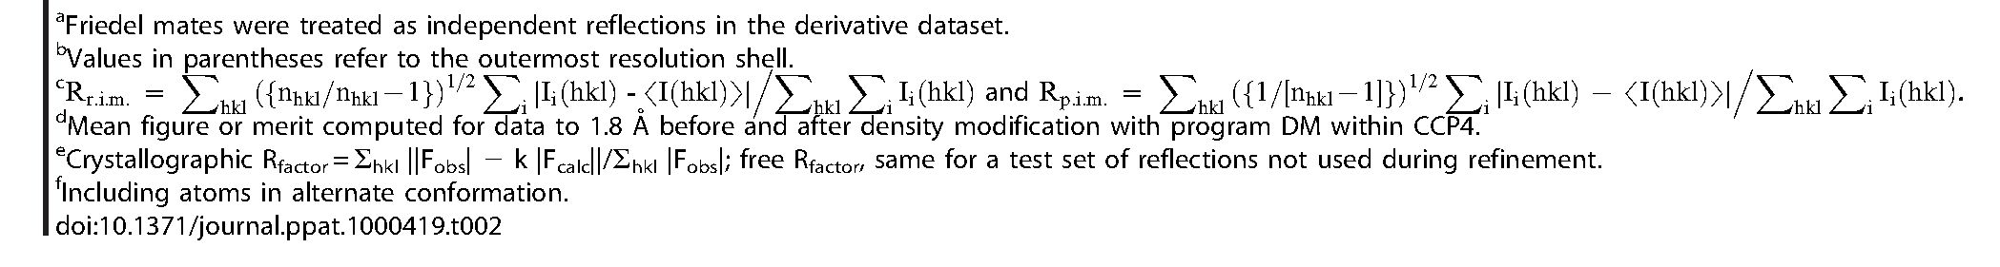
Molecular Determinants of P. gingivalis HmuY
Table 2. Crystallographic data.
Dataset | Native | Seleno-Methionine Derivative
Space group/cell constants (a and c, in A) | P42212/93.74; 113.73 | P422t2/93.64; 113.77
Number of measurements/unique reflections | 613,987/47,568 | 32Q,816/29,379
Resolution range (A) (outermost shell) | 48.6-1.8Q (1.9Q-1.8Q) | 48.6-2.11 (2.22-2.11)
Completeness (%) | 1QQ.Q (99.9) | 98.4 (89.2)
Rr.i.m. (=Rmeas)/Rp.i.ma'b'c | Q.1Q1(Q.696)/Q.Q28(Q.19Q) | Q.Q81(Q.224)/Q.Q27(Q.Q89)
Average intensity over st. dev. (<[<I>/s(<I>)]>) | 23.Q (4.2) | 23.9 (7.3)
B-factor (Wilson) (A2)/average multiplicity | 17.6/12.9 (13.1) | 21.Q/1Q.9 (5.9)
Heavy-atom sites used for phasing/fomd |  | 9/Q.68, Q.84
Resolution range used for refinement (A) | 48.6-1.8Q
Number of reflections used (test set) | 46,847 (72Q)
Crystallographic Rfactor (free Rfactor)e | Q.16Q (Q.187)
No. of protein atomsf/solvent molecules/ligands/ions | 2,87Q/432/2 heme (with Fe3+); 6 glycerols/5 SO42-
Rmsd from target values
bonds (A)/angles (°) | Q.Q12/1.31
bonded B-factors (main chain/side chain) (/A2) | Q.7Q/2.19
Average B-factors for protein atoms (/A2) | 14.1
Main-chain conformational angle analysis for residues in favored  regions/outliers/all residues | 349/Q/36Q

References
- Fox CH (1992) New considerations in the prevalence of periodontal disease.
Curr Opin Dent 2: 5-11.
- Cutler CW, Kalmar JR, Genco CA (1995) Pathogenic strategies of the oral
anaerobe, Porphyromonas gingivalis. Trends Microbiol 3: 45-51.
- Meurman JH, Sanz M, Janket SJ (2004) Oral health, atherosclerosis, and
cardiovascular disease. Crit Rev Oral Biol Med 15: 403-413.
- Rosenstein ED, Greenwald RA, Kushner LJ, Weissmann G (2004) Hypothesis:
The humoral immune response to oral bacteria provides a stimulus for the
development of rheumatoid arthritis. Inflammation 28: 311-318.
- Lin D, Moss K, Beck JD, Hefti A, Offenbacher S (2007) Persistently high levels
of periodontal pathogens associated with preterm pregnancy outcome.
J Periodontol 78: 833-841.
- Schifferle RE, Shostad SA, Bayers-Thering MT, Dyer DW, Neiders ME (1996)
Effect of protoporphyrin IX limitation on Porphyromonas gingivalis. J Endod 22:
352-355.
- Smalley JW, Birss AJ, Silver J (2000) The periodontal pathogen Porphyromonas
gingivalis harnesses the chemistry of the jr-oxo bishaem of iron protoporphyrin IX
to protect against hydrogen peroxide. FEMS Microbiol Lett 183: 159-164.
- Nelson KE, Fleischmann RD, DeBoy RT, Paulsen IT, Fouts DE, et al. (2003)
Complete genome sequence of the oral pathogenic bacterium Porphyromonas
gingivalis strain W83. J Bacteriol 185: 5591-5601.
- Bramanti TE, Holt SC (1991) Roles of porphyrins and host iron transport
proteins in regulation of growth of Porphyromonas gingivalis W50. J Bacteriol 173:
7330-7339.
- Sroka A, Sztukowska M, Potempa J, Travis J, Genco CA (2001) Degradation of
host heme proteins by lysine- and arginine-specific cysteine proteinases
(gingipains) of Porphyromonas gingivalis. J Bacteriol 183: 5609-5616.
- Braun V (1995) Energy-coupled transport and signal transduction through the
gram-negative outer membrane via TonB-ExbB-ExbD-dependent receptor
proteins. FEMS Microbiol Rev 16: 295-307.
- Potempa J, Sroka A, Imamura T, Travis J (2003) Gingipains, the major cysteine
proteinases and virulence factors of Porphyromonas gingivalis: Structure, function
and assembly of multidomain protein complexes. Curr Protein Pept Sci 4:
397-407.
- Wandersman C, Delepelaire P (2004) Bacterial iron sources: From siderophores
to hemophores. Annu Rev Microbiol 58: 611-647.
- Lee BC (1995) Quelling the red menace: Haem capture by bacteria. Mol
Microbiol 18: 383-390.
- Krieg S, Huche F, Diederichs K, Izadi-Pruneyre N, Lecroisey A, et al. (2009)
Heme uptake across the outer membrane as revealed by crystal structures of the
receptor-hemophore complex. Proc Natl Acad Sci U S A 106: 1045-1050.
- Hanson MS, Pelzel SE, Latimer J, Muller-Eberhard U, Hansen EJ (1992)
Identification of a genetic locus ofHaemophilus influenzae type b necessary for the
binding and utilization of heme bound to human hemopexin. Proc Natl Acad
Sci U S A 89: 1973-1977.
- Letoffe S, Redeker V, Wandersman C (1998) Isolation and characterization of
an extracellular haem-binding protein from Pseudomonas aeruginosa that shares
function and sequence similarities with the Serratia marcescens HasA haemophore.
Mol Microbiol 28: 1223-1234.
- Arnoux P, Haser R, Izadi N, Lecroisey A, Delepierre M, et al. (1999) The crystal
structure of HasA, a hemophore secreted by Serratia marcescens. Nat Struct Mol
Biol 6: 516-520.
- Rossi MS, Fetherston JD, Letoffe S, Carniel E, Perry RD, et al. (2001)
Identification and characterization of the hemophore-dependent heme acqui-
sition system of Yersinia pestis. Infect Immun 69: 6707-6717.
- Maresso AW, Garufi G, Schneewind O (2008) Bacillus anthracis secretes
proteins that mediate heme acquisition from hemoglobin. PLoS Pathog 4:
e1000132. doi:10.1371 /journal.ppat. 1000132.
- Genco CA, Dixon DW (2001) Emerging strategies in microbial haem capture.
Mol Microbiol 39: 1-11.
- Olczak T, Simpson W, Liu X, Genco CA (2005) Iron and heme utilization in
Porphyromonas gingivalis. FEMS Microbiol Rev 29: 119-144.
- Olczak T, Sroka A, Potempa J, Olczak M (2008) Porphyromonas gingivalis HmuY
and HmuR: Further characterization of a novel mechanism of heme utilization.
Arch Microbiol 189: 197-210.
- Wu J, Lin X, Xie H (2009) Regulation of hemin binding proteins by a novel
transcriptional activator in Porphyromonas gingivalis. J Bacteriol 191: 115-122.
- Lewis JP, Plata K, Yu F, Rosato A, Anaya C (2006) Transcriptional
organization, regulation and role of the Porphyromonas gingivalis W83 hmu
haemin-uptake locus. Microbiology 152: 3367-3382.
- Mihara J, Holt SC (1993) Purification and characterization of fibroblast-
activating factor isolated from Porphyromonas gingivalis W50. Infect Immun 61:
588-595.
PLoS Pathogens | www.plospathogens.org
1Q
May 2QQ9 | Volume 5 | Issue 5 | e1QQQ419
Molecular Determinants of P. gingivalis HmuY
- Wojtowicz H, Wojaczynski J, Olczak M, Kroliczewski J, Latos-Grazynski L, et
al. (2009) Characterization of the heme environment in Porphyromonas gingivalis
HmuY heme-binding protein. Biochem Biophys Res Commun 383: 178—182.
- Alontaga AY, Rodriguez JC, Schonbrunn E, Becker A, Funke T, et al. (2009)
Structural characterization of the hemophore HasAp from Pseudomonas aeruginosa:
NMR spectroscopy reveals protein-protein interactions between Holo-HasAp
and hemoglobin. Biochemistry 48: 96—109.
- Wolff N, Izadi-Pruneyre N, Couprie J, Habeck M, Linge J, et al. (2008)
Comparative analysis of structural and dynamic properties of the loaded and
unloaded hemophore HasA: Functional implications. J Mol Biol 376: 517—525.
- Landfried DA, Vuletich DA, Pond MP, Lecomte JT (2007) Structural and
thermodynamic consequences of b heme binding for monomeric apoglobins and
other apoproteins. Gene 398: 12—28.
- Petsko GA, Ringe D (2003) Protein structure and function. London: New
Science Press (Sinauer Associated & Blackwell).
- Paoli M, Anderson BF, Baker HM, Morgan WT, Smith A, et al. (1999) Crystal
structure of hemopexin reveals a novel high-affinity heme site formed between
two ß-propeller domains. Nat Struct Biol 6: 926—931.
- Lo Conte L, Chothia C, Janin J (1999) The atomic structure of protein-protein
recognition sites. J Mol Biol 285: 2177-2198.
- Iverson TM, Hendrich MP, Arciero DM, Hooper AB, Rees DC (2001)
Cytochrome c554. In: Messerschmidt A, Huber R, Poulos T, Wieghardt K, eds
(2001) Handbook of metalloproteins. Chichester (UK): John Wiley & Sons, Ltd.
pp 136-146.
- Carrondo MA, Doares CM, Matias PM (2001) Nine-heme cytochrome c. In:
Messerschmidt A, Huber R, Poulos T, Wieghardt K, eds (2001) Handbook of
metalloproteins. Chichester (UK): John Wiley & Sons, Ltd. pp 147-158.
- Phillips GN Jr (2001) Myoglobin. In: Messerschmidt A, Huber R, Poulos T,
Wieghardt K, eds (2001) Handbook of metalloproteins. Chichester (UK): John
Wiley & Sons, Ltd. pp 5-15.
- Paoli M, Nagai K (2001) Hemoglobin. In: Messerschmidt A, Huber R, Poulos T,
Wieghardt K, eds (2001) Handbook of metalloproteins. Chichester (UK): John
Wiley & Sons, Ltd. pp 16-30.
- Wardell M, Wang Z, Ho JX, Robert J, Ruker F, et al. (2002) The atomic
structure of human methemalbumin at 1.9 A. Biochem Biophys Res Commun
291: 813-819.
- Gomis-Ruth FX (2004) Hemopexin domains. In: Messerschmidt A, Bode W,
Cygler M, eds (2004) Handbook of metalloproteins. Chichester (UK): John
Wiley & Sons, Ltd. pp 631-646.
- Olczak T, Dixon DW, Genco CA (2001) Binding specificity of the Porphyromonas
gingivalis heme and hemoglobin receptor HmuR, gingipain K, and gingipain R1
for heme, porphyrins, and metalloporphyrins. J Bacteriol 183: 5599-5608.
- Liu X, Olczak T, Guo HC, Dixon DW, Genco CA (2006) Identification of
amino acid residues involved in heme binding and hemoprotein utilization in the
Porphyromonas gingivalis heme receptor HmuR. Infect Immun 74: 1222-1232.
- Hayashi S, Wu HC (1990) Lipoproteins in bacteria. J Bioenerg Biomembr 22:
451-471.
- Olczak T, Siudeja K, Olczak M (2006) Purification and initial characterization
of a novel Porphyromonas gingivalis HmuY protein expressed in Escherichia coli and
insect cells. Protein Expr Purif 49: 299-306.
- Ang CS, Veith PD, Dashper SG, Reynolds EC (2008) Application of O/ O
reverse proteolytic labeling to determine the effect of biofilm culture on the cell
envelope proteome of Porphyromonas gingivalis W50. Proteomics 8: 1645-1660.
- Dashper SG, Ang CS, Veith PD, Mitchell HL, Lo AW, et al. (2009) Response of
Porphyromonas gingivalis to heme limitation in continuous culture. J Bacteriol 191:
1044-1055.
- Tollefsen T, Saltvedt E (1980) Comparative analysis of gingival fluid and plasma
by crossed immunoelectrophoresis. J Periodontal Res 15: 96-106.
- Hrkal Z, Vodrazka Z, Kalousek I (1974) Transfer of heme from ferrihemoglobin
and ferrihemoglobin isolated chains to hemopexin. Eur J Biochem 43: 73-78.
- Hargrove MS, Barrick D, Olson JS (1996) The association rate constant for
heme binding to globin is independent of protein structure. Biochemistry 35:
11293-11299.
- Hwang PK, Greer J (1980) Interaction between hemoglobin subunits in the
hemoglobin. haptoglobin complex. J Biol Chem 255: 3038-3041.
- Beaven GH, Chen SH, d’Albis A, Gratzer WB (1974) A spectroscopic study of
the haemin-human-serum-albumin system. Eur J Biochem 41: 539-546.
- Smalley JW, Birss AJ, Szmigielski B, Potempa J (2008) Mechanism of
methaemoglobin breakdown by the lysine-specific gingipain of the periodontal
pathogen Porphyromonas gingivalis. Biol Chem 389: 1235-1238.
- Smalley JW, Birss AJ, Szmigielski B, Potempa J (2007) Sequential action of R-
and K-specific gingipains ofPorphyromonas gingivalis in the generation ofthe haem-
containing pigment from oxyhaemoglobin. Arch Biochem Biophys 465: 44-49.
- Carlsson J, Hofling JF, Sundqvist GK (1984) Degradation of albumin,
haemopexin, haptoglobin and transferrin, by black-pigmented Bacteroides species.
J Med Microbiol 18: 39-46.
- Tompkins GR, Wood DP, Birchmeier KR (1997) Detection and comparison of
specific hemin binding by Porphyromonas gingivalis and Prevotella intermedia.
J Bacteriol 179: 620-626.
- Hendrickson WA, Horton JR, LeMaster DM (1990) Selenomethionyl proteins
produced for analysis by multiwavelength anomalous diffraction (MAD): A
vehicle for direct determination of three-dimensional structure. EMBO J 9:
1665-1672.
- Pace CN (1986) Determination and analysis of urea and guanidine hydrochlo-
ride denaturation curves. Meth Enzymol 131: 266-280.
- Kabsch W (2001) Chapter 25.2.9: XDS. In: Rossmann MG, Arnold E, eds
(2001) International Tables for Crystallography Volume F: Crystallography of
Biological Macromolecules. 1st ed. Dordrecht (The Netherlands): Kluwer
Academic Publishers (for The International Union of Crystallography). pp
730-734.
- CCP4 (1994) The CCP4 suite: Programs for protein crystallography. Acta
Crystallogr Sect D 50: 760-763.
- Sheldrick GM (2008) A short history ofSHELX. Acta Cryst sect A 64: 112-122.
- Evans SV (1993) SETOR: Hardware lighted three-dimensional solid model
representations of macromolecules. J Mol Graphics 11: 134-138.
- Brünger AT, Adams PD, Clore GM, DeLano WL, Gros P, et al. (1998)
Crystallography & NMR System: A new software suite for macromolecular
structure determination. Acta Crystallogr Sect D 54: 905-921.
PLoS Pathogens | www.plospathogens.org
11
May 2009 | Volume 5 | Issue 5 | e1000419

