INVESTIGATION

Heterosis Is Prevalent Among Domesticated but
not Wild Strains of Saccharomyces cerevisiae
Marcin Plech,*1 J. Arjan G. M. de Visser/ and Ryszard Korona*'1
*Institute of Environmental Sciences, Jagiellonian University, 30-387 Krakow, Poland and laboratory of Genetics,
Wageningen University, Wageningen, the Netherlands
ABSTRACT Crosses between inbred but unrelated individuals often result in an increased fitness of the
progeny. This phenomenon is known as heterosis and has been reported for wild and domesticated
populations of plants and animals. Analysis of heterosis is often hindered by the fact that the genetic
relatedness between analyzed organisms is only approximately known. We studied a collection of Saccha-
romyces cerevisiae isolates from wild and human-created habitats whose genomes were sequenced and
thus their relatedness was fully known. We reasoned that if these strains accumulated different deleterious
mutations at an approximately constant rate, then heterosis should be most visible in F1 heterozygotes from
the least related parents. We found that heterosis was substantial and positively correlated with sequence
divergence, but only in domesticated strains. More than 80% of the heterozygous hybrids were more fit than
expected from the mean of their homozygous parents, and approximately three-quarters of those exceeded
even the fittest parent. Our results support the notion that domestication brings about relaxation of selection and
accumulation of deleterious mutations. However, other factors may have contributed as well. In particular, the
observed build-up of genetic load might be facilitated by a decrease, and not increase, in the rate of inbreeding.
KEYWORDS
genetic load
heterosis
sequence
divergence
Inbreeding depression, the loss of fitness of inbred individuals
when compared to outbred ones, is observed across different taxa
(Charlesworth and Charlesworth 1987). A cross between two inbred
but unrelated organisms often helps to improve fitness of progeny.
This phenomenon is known as heterosis and is ascribed either to
creation of superior (overdominant) heterozygous loci or to reciprocal
complementation of harmful mutations. Genuine and informative
examples of overdominance have been found (Krieger et al. 2010;
Johnston et al. 2013), but their frequency appears rather low given
how ubiquitous heterosis is (Hedrick 2012). Much, and probably most,
of heterosis is caused by complementation of deleterious mutations
present in one parent by functional alleles contributed by the other
(Charlesworth and Willis 2009). Therefore, the extent of heterosis will
Copyright © 2014 Plech et al.
doi: 10.1534/g3.113.009381
Manuscript received November 11, 2013; accepted for publication December 11,
2013; published Early Online December 16, 2013.
This is an open-access article distributed under the terms of the Creative
Commons Attribution Unported License (http://creativecommons.org/licenses/
by/3.0/), which permits unrestricted use, distribution, and reproduction in any
medium, provided the originalwork is properly cited.
Supporting information is available online at http://www.g3journal.org/lookup/
suppl/doi:10.1534/g3.113.009381/-/DC1.
1Corresponding author: Institute of Environmental Sciences, Jagiellonian University,
Gronostajowa 7, 30-387 Krakow, Poland. E-mail: ryszard.korona@uj.edu.pl
ultimately depend on the genetic load of populations, that is, their
total decline in fitness if compared to an ideal population free of
harmful mutations (Haldane 1937). Accumulation of the load is
governed by several factors, including the rate and fitness effects of
mutations, their dominance status, the size and structure of the
population, and the prevalent mode of reproduction (Wang et al.
1999; Whitlock 2002; Glemin et al. 2003). Although it is straight-
forward to postulate that mutations will accumulate most easily
when their effects are small and recessive and when populations
are small or highly structured, the role of the mode of reproduction
is more subtle. In sexual species, increasing the rate of outbreeding
can actually inflate the load of mutations because they become less
frequently exposed to selection in homozygotes (Bataillon and
Kirkpatrick 2000; Whitlock et al. 2000). Similarly, switching to an
asexual mode of reproduction can lead to hiding mutations in hete-
rozygous loci and a significant enlargement of the genetic load
(Haag and Roze 2007). It should also be mentioned that the location
of deleterious mutations is not the only possible difference between
unrelated organisms. A cross between such organisms may reveal
any existing genetic incompatibilities and result in low fitness of
hybrids, that is, outbreeding depression (Lynch 1991).
The organism studied here, Saccharomyces cerevisiae or the
budding yeast, is a unicellular and typically diploid organism.
Under so-called vegetative growth, it reproduces asexually
through mitotic cell division. Deprived of nutrients, it undergoes
ÄG3 •Genes | Genomes | Genetics
Volume 4 I February 2014 I 315
meiosis and produces haploid spores that normally mate soon
after germination and re-establish a diploid cell. For its closest
relative, Saccharomyces paradoxus, it has been estimated that
a meiotic division occurs approximately every 1000 mitotic divi-
sions, and when this happens selfing is approximately 100-times
more frequent than outcrossing (Tsai et al. 2008). Outcrossing is
also rare in S. cerevisiae. An analysis of the S. cerevisiae genome
sequence suggests that after the split with S. paradoxus, outcross-
ing occurred only once every 50,000 generations (Ruderfer et al.
2006). The effective size of the entire population S. cerevisiae is
likely large, assuming that it is comparable to that of S. para-
doxus, which was estimated at 8.6 X 106 (Tsai et al. 2008). Thus, it
appears that the genetic load of the budding yeast was, for a long
time, controlled by selection acting on an effectively large pop-
ulation of diploid strains reproducing primarily through mitotic
divisions with occasional sexual cycles involving self-fertilization.
It used to be speculated that S. cerevisiae isolates found in nature
could be just refugees from human-associated cultures (Mortimer
2000). However, it has been recently established that S. cerevisiae
is a true “wild” species and that its domesticated lineages derive
from the wild ones (Fay and Benavides 2005; Legras et al. 2007;
Libkind et al. 2011; Wang et al. 2012). There are several reasons
to believe that domestication was associated with the relaxation
of selection and accumulation of deleterious mutations. First, the
domesticated lines were likely to go through large reductions of
population size and adaptation to new environments (Liti et al.
2009; Schacherer et al. 2009; Hyma et al. 2011). Small population
size makes selection against deleterious mutations less effective,
but so does linkage between deleterious and adaptive alleles (Hill
and Robertson 1966). Furthermore, natural niches are probably
more diverse and thus test more genes than those created by
humans. In a new environment, the unused genes become vul-
nerable to mutational erosion (Kawecki et al. 1997). It is also
possible that even those genes that remain required are generally
less intensely purged of mutations if one accepts that selection
weakens when habitat becomes less variable and especially less
stressful (Hoffmann and Parsons 1991). Finally, the regime of
frequent selfing was likely violated or even abandoned, thus pre-
venting the exposure of deleterious mutations in the haploid
phase. Many laboratory and industrial strains are kept under
conditions that are prohibitive for sporulation. These strains
are often difficult or impossible to sporulate, which suggests that
the ability to undergo sexual cycle degenerates in human-made
environments (Johnston 1994). An example of a likely joint ac-
tion of these factors—smaller population size, benign and specific
environment, possible adaptation, and asexual reproduction—
has been provided by a study in which a laboratory strain of
confirmed history of “domestication” was found to undergo an
accelerated rate of molecular evolution, demonstrating consider-
able relaxation of the purifying selection (Gu et al. 2005).
In this study, we used a collection of natural isolates of S. cerevisiae
that were formerly subject to whole-genome analysis, and thus their
phylogenetic distances (measured by the number of nucleotide sub-
stitutions) are known (Liti et al. 2009). Genetic diversity and pheno-
typic diversity present in these strains are remarkably high,
encouraging their further use in genetic and ecological studies. A
subset of these strains was utilized in an extensive mapping of quan-
titative trait loci for fitness-related traits in different environmental
conditions (Cubillos et al. 2011; Warringer et al. 2011). Another sub-
set was used in a study of dominance and found that heterosis was
present but limited in this sense that average progeny fitness almost
never exceeded that of the best parent (Zorgo et al. 2012). We sought
to expand the latter analysis. Our sample involved approximately
twice as many parental strains from the collection of Liti et al.
(2009) and about six times more unique hybrid strains. Crucially,
the large sample allowed us to compare two major groups, those
found in environments associated with humans (collectively called
“domesticated”) and the rest which were isolated from natural habitats
(“wild”). We found that heterosis was present among domesticated,
but not among wild, strains. Heterosis among domesticated strains
was positively correlated with the phylogenetic distance between pa-
rental strains, suggesting that multiple mutations accumulated during
domestication were responsible.

MATERIALS AND METHODS
Strains
We used a formerly described collection of strains that had been
subject to whole-genome sequencing (Liti et al. 2009). Each originally
diploid strain was sporulated and the resulting tetrads of haploid
spores were dissected (Cubillos et al. 2009). Because the spore cell
contained an active allele of the HO gene, cells descending from it
switched the mating types, mated, and formed homozygous diploids,
except for the MAT locus. Subsequent replacement of HO by the
hphMX4 cassette (coding for resistance to hygromycin B), followed
by sporulation and tetrad dissection, produced isogenic haploids of
stable a or a mating type. Another gene in these strains, URA3, had
been substituted with the kanMX4 cassette coding for selectable
marker resistance to kanamycin (Cubillos et al. 2009). We replaced
the hphMX4 with natMX4 cassette in the a strains. We then mated
the a and a haploids in all possible combinations either in isogenic or
nonisogenic pairs. An important consequence of the described pro-
cedure is that the strains we prepared to work with were not genet-
ically intact isolates. The original wild strains were diploids, but some
of their loci were possibly heterozygous. We used haploid genotypes
derived from particular wild isolates to make either homozygous or
heterozygous diploids (the marker loci were ho::hphMX4/ho::natMX4
and ura3::kanMX4/ura3::kanMX4 in all strains).
We originally intended to use all available strains but could not use
a few because of difficulties in mating or strong aggregation in liquid
cultures, which made estimation of growth rate unreliable. We worked
with 22 strains, 9 of which were “wild,” originating from natural
habitats, and the remaining 13 were “domesticated,” coming from
laboratories, agriculture, industry, or human patients (Figure 1). The
distinction between domesticated and wild strains was made by the
authors of the original study (Liti et al. 2009). After completing all
possible matings, we obtained 22 homozygous diploid strains and 231
heterozygous diploid strains representing all possible combinations
among the 22 strains.

Liquid cultures
Fitness was estimated in two ways. First, we measured the maximum
growth rate in liquid culture. We used the nutritionally rich YPD
medium with glucose in most fitness assays. It served as a base
environment in which single chemicals were added or physical factors
were modified to create test environments. In addition to the broth-
based media, we used typical minimal medium (synthetic dextrose).
While selecting test environments, we attempted to create conditions
known to induce a range of phenotypes known to differ in the
expression of a large number of genes (Hampsey 1997).
Fresh medium was dispensed into aliquots of 200 ml contained in
wells of a standard flat-bottom titration plate. Microcultures were
316 | M. Plech, J. A. G. M. de Visser, and R. Korona
"£G3 •Genes | Genomes | Genetics
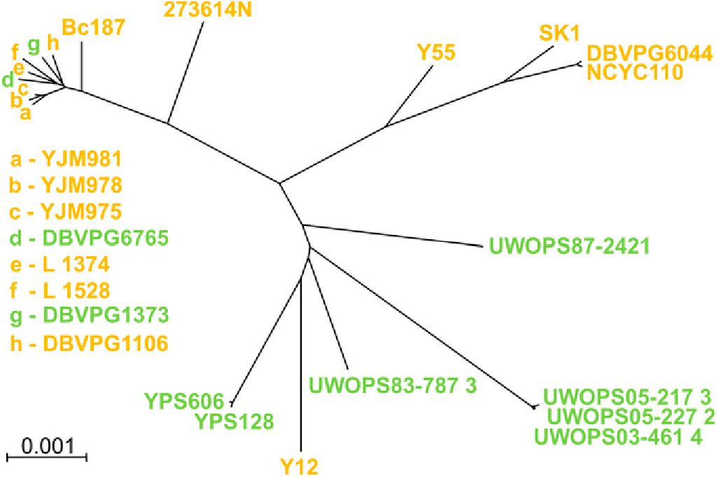
Figure 1 Phylogenetic relations between strains used in this study.
Colors indicate domesticated (yellow) and wild (green) yeasts. Phylo-
genetic distances are based on differences in the number of nucleotide
substitutions as in the study by Liti et al. (2009).
initiated by inoculating each aliquot with 1 ml of an overnight culture
of each strain. The plates were incubated with agitation of 1250 rpm
and wide-band optical density (OD) readouts were measured every
20-60 min with the Infinite m200 Microplate Reader (Tecan). The
OD readouts were corrected for background effects, log-transformed,
and used to determine the range of exponential growth. This was
performed by finding lower and upper limits of OD, between which
the Pearson r was highest when averaged over all cultures in the same
test environment. This usually yielded regressions based on no less
than five time points and an r of 0.999, with rare cases of an r < 0.99.
Maximum growth rate (MGR) was then estimated from the slope of
the linear regression of Log OD vs. time. Every strain was assayed
independently several times (heterozygotes were usually assayed four
times; homozygotes were usually assayed six times). For nine of the 11
test environments, the temperature was set at 30°. These included
synthetic dextrose (synthetic medium with 2% glucose supplemented
with uracil), YPG (nutrient-rich medium with 3% glycerol as a source
of carbon), YPGal (nutrient-rich with 2% galactose), and YPD (nutrient-
rich with 2% glucose). The remaining five media were based on YPD
with the following supplements added: benomyl (40 mg/ml); DMSO
(6%); NaCl (2%); salicylate (2%); and ZnSO4 (0.5 mg/ml). There were
also two environments with no supplements but altered temperatures,
YPD 20° and YPD 35°.
Agar cultures
Using increasing doses of NaCl, ZnSO4, and salicylate, we created
gradients of stresses up to a point at which some strains stopped
growing. We detected a number of strains that made no more than
approximately three cell doublings, even though other patches con-
tinued to grow. We decided to classify patches showing, on average,
no more than three cell doublings as nongrowing and set their fitness
to zero. We reasoned that because the cells used for inoculation were
raised under benign conditions, their initial growth possibly resulted
from carry-over effects from these pregrowth conditions. We divided
the strains into “growers” and “nongrowers;” growers were those that
had at least one positive fitness score out of three trials.
We measured the ability to grow under extreme stress
conditions on agar plates. In these harsh environments, measur-
ing the maximum growth rate in liquid culture was not feasible.
Assays were started by inoculating agar surfaces with 1.5 ml drops
of stationary phase cultures that were highly synchronized by
a strictly parallel regime of inoculation and overnight incubation
in YPD. After drying out, the drops left round patches of yeast
cells that were immediately photographed, transferred to 30°, and
then photographed again at the end of incubation. The duration
of incubation varied depending on particular stress conditions as
follows: NaCl 2% (48 hr), 8% (72 hr), 9% (96 hr), and 10% (120
hr); Na-salicylate 2.5% (24 hr), 3.5% (24 hr), 4% (48 hr), and 5%
(72 hr); ZnSO4 0.5 mg/ml (24 hr), 2 mg/ml (48 hr), 2.5 mg/ml (72
hr), and 2.75 mg/ml (120 hr). The photographs were analyzed
with the Colonyzer 2.0 computer program (Lawless et al. 2010),
which returns estimates of “intensity,” which is a measure of light
reflected by yeast patches. To calibrate the intensity scores, we
carved out a random sample of 40 patches and counted the num-
ber of cells within each of them. The relation between the two
scores turned out to be linear and significantly correlated (r =
0.986) over the entire range of patch sizes that were analyzed
(Supporting Information, Figure S1). As a measure of fitness,
we used the log ratio of final and initial cell numbers divided
by the time of incubation. This parameter signified the mean
growth rate per hour over the entire period of incubation and
included an initial lag phase followed by a phase of growth in
which the rate of cell doubling was decelerating.
RESULTS
Determinants of variation in fitness
We used MGR measured in liquid culture as a proxy for fitness. The
estimates are listed in Table S1. Individual strains were measured
four times in every environment; the intraclass correlation coeffi-
cient (ICC) was 0.920 when averaged over all 11 environments.
MGRs varied widely among environments. This was expected be-
cause they represented different suboptimal conditions. More rele-
vant was the question whether MGR of heterozygotes was on
average higher than that of homozygotes (it was, as shown in Figure
2A). The 231 hybrids were more fit than the 22 homozygotes from
which they were derived (F = 95.35; df = 1 and 251; P < 0.0001;
ANOVA, aov function in R-base). Considering only the domesti-
cated strains, we again found that the 78 heterozygotes had a higher
mean MGR than the 13 homozygotes (F = 125.9; df = 1 and 89; P <
0.0001), but there was no such difference when the 9 homozygotes
and 36 heterozygotes derived from the wild isolates were compared
(F = 1E—04; df = 1 and 43; P = 0.9914). These observations could
suggest that the domesticated and wild strains were much different
in their average MGR. However, this was not the case; respective
means (homozygote fitness averaged across all media) were 0.4337
and 0.4222 for wild and domesticated strains, and the difference
was not significant (t = 1.6165, df = 1279.34; P = 0.9469).
Í&G3 •Genes | Genomes | Genetics
Volume 4 February 2014 | Heterosis in Domesticated and Wild Yeast | 317
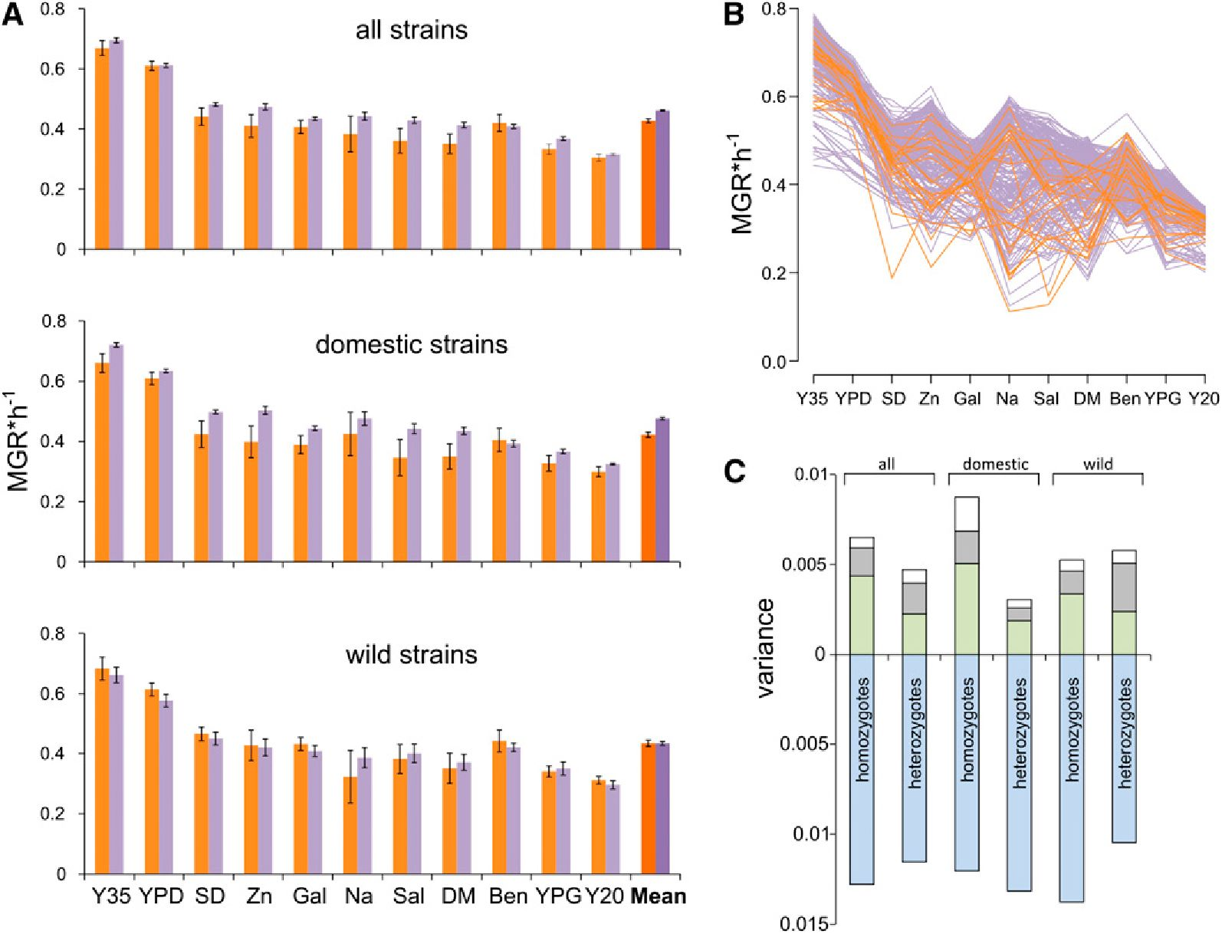
We then asked to what extent MGR was determined by the
environment, genes, and interactions between these two factors. Figure
2B shows that MGR of individual strains fluctuated between the test
environments. To quantify these effects, we calculated components of
variance as defined in standard ANOVA models (R’s Imer function of
lme4 library). Figure 2C shows that, as expected, most variation can be
attributed to differences between environments; in favorable environ-
ments all strains grew well and in unfavorable ones all performed poorly.
More interestingly, genotype-environment interaction had a generally
higher impact on fitness variation than the genotype of the strain. This
result was important because it confirmed that the environments used in
this study were indeed sufficiently diverse to uncover different compo-
nents of the genetic variation. Another striking finding is that the impact
of strains and that of genotype-environment interaction was considerably
smaller among heterozygotes than among homozygotes for the domes-
ticated strains; these strains were phenotypically more homogeneous after
hybridization. A general conclusion emerging from these comparisons is
that the average fitness of heterozygous strains was higher than that of
homozygous strains only in domesticated, but not wild, strains.

Mid-parent and best-parent heterosis
For every heterozygous stain, we calculated the mid-parent heterosis
(MPH) as the difference between its MGR and the average MGR of its
parental homozygous strains. Best-parent heterosis (BPH) was
calculated by subtracting MGR of a heterozygote from MGR of its
most fit parental homozygote. Figure 3 shows that MPH was frequent
within, but differed between, three groups of heterozygotes derived
from crosses: between two domesticated strains, between domesticated
and wild strain (“mixed”), and between two wild strains. There is
a regular pattern with domesticated heterozygotes showing the largest
heterosis, mixed hybrids showing intermediate heterosis, and wild
hybrids showing no heterosis. Averaged over 11 environments, MPHs
of the three groups were 0.055,0.032, and —0.003, respectively. Differ-
ences between averages were significant globally (F = 92.653; df =2
and 254; P < 0.001) and for all three in-pair comparisons (not
shown). Heterosis was especially apparent for the domesticated het-
erozygotes; as many as 82% of them were better than predicted by
their parental averages. The wild strains were approximately equally
better than (51%) and worse than expected (49%). BPH was less
frequent than MPH, but again was most pronounced among the
domesticated strains. The scatterplot distributions presented in Figure
3 and the aforementioned statistical comparison point to the domes-
ticated and wild heterozygotes as two groups that clearly differ in the
extent of heterosis. Several of our subsequent analyses will focus on
this intriguing difference.
In a previous study of heterosis, six domesticated strains and three
wild strains were used (Zorgo et al. 2012). The study reported fre-
quencies of MPH for each of the nine strains (pooled over all its
crosses and all tests environments). The scores for wild and domes-
ticated strains were intermixed, and thus no significant difference
between the two groups could be found. We could not find statistically
significant differences in our data if only these nine strains were taken
into account average MPHs for the wild and domestic strains over 11
test environments were 0.045 and 0.059 (t = 0.988; df = 20; P = 0.335).
Thus, our expansion of the sample size was critical to find differences
in heterosis between the wild and domesticated strains.
Figure 2 Determinants of phe-
notypic variation. Fitness was
estimated as the maximum
growth rate (MGR) in 11 test
environments, here ordered
according to descending aver-
age MGRs of heterozygote
strains. (A) Mean MGRs in 11
environments calculated for all
strains as well as for domesti-
cated and wild strains sepa-
rately. Colors are used to
distinguish between homozy-
gous (orange) and heterozy-
gous (violet) strains. (B) MGRs
of individual strains in particular
environments. Colors are indic-
ative as already noted. (C) Com-
ponents of variance (absolute
values of s2 estimates) attribut-
able to the effect of environ-
ment (blue), genotype (gray),
genotype-environment interac-
tion (green), and error term
(white). In this and other figures,
SD is an abbreviation for mini-
mal glucose medium. Other
media include plain YPD at 30°
(YPD) and its modifications as
follows: 35° (Y35); ZnSO4 (Zn);
galactose (Gal); NaCl (Na), salic-
ylate (Sal); DMSO (DM); benomyl
(Ben); glycerol (YPG); and 20°
(Y20).
318 | M. Plech, J. A. G. M. de Visser, and R. Korona
Í-ÍLG3 •Genes | Genomes | Genetics
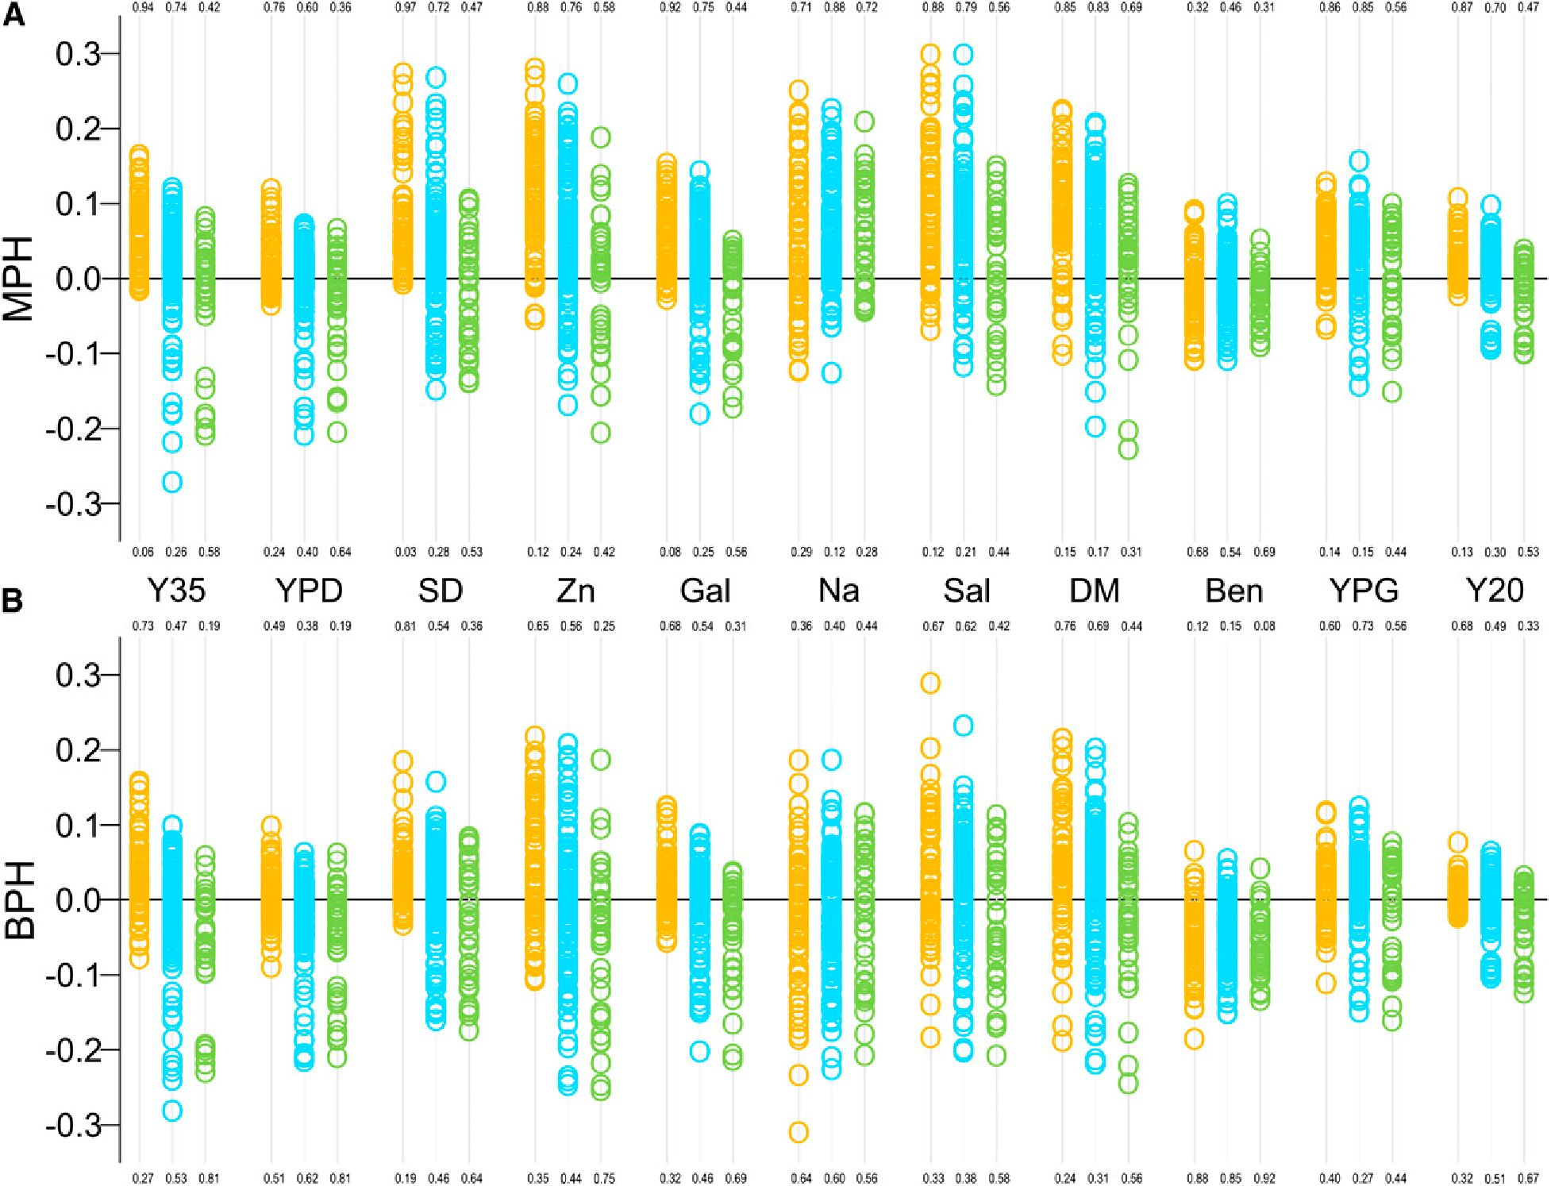

Sequence divergence and heterosis
Figure 1 shows the sequence divergence between our strains based on
differences in the number of nucleotide substitutions (Liti et al. 2009).
We reasoned that the more distant parents are, the higher the number
of different accumulated mutations and therefore the more likely
heterosis is by reciprocal compensation. Figures S2, Figure S3, and
Figure S4 show how phylogenetic distance correlated with one of three
measures of heterozygote fitness, absolute MGR and the two indexes
of heterosis, MPH and BPH. This analysis is summarized in the main
text in the form of Pearson correlation coefficients presented in Figure
4. Not surprisingly, the three measures of hybrid fitness often, al-
though not always, followed similar patterns. Pearson correlations
with the distance were weak and either positive or negative when all
strains or only the wild strains were inspected. Crucially, correlations
became much stronger and generally positive when only the domes-
ticated strains were considered.

Heterozygotes and homozygotes under extreme stress
In the test environments described, growth was slowed when compared
with YPD (Figure 1), but all homozygotes and heterozygotes were able
to grow. We extended our tests of heterosis under more stressful con-
ditions when growth ceases for some strains. Table S2 lists strains that
were not able to grow and estimates of the growth rate for those that did
grow. The rate of growth estimated on agar plates was not the same as
MGR measured in liquid cultures (see Materials and Methods). Figure 5
shows that strains able to grow were generally more frequent among
heterozygotes than among homozygotes. An opposite tendency was
noted only for the wild strains in the ZnSO4 gradient, but in this case
both homozygous and heterozygous strains were affected little and the
difference in the fraction of growers was small.
We then asked whether fitness of a heterozygous strain depended on
the phylogenetic distance between parental strains. To this end, growth
rates attained under each of the three stresses were correlated with the
sequence divergence between their parents. In contrast to the benign
conditions (Figure 4), no statistically significant correlations with se-
quence divergence were observed for any stress, irrespective of whether
they were calculated for domesticated or wild strains (not shown).
We hypothesized that some strains could be more resilient to any
extreme environments and that others could be more affected by
unusual environmental pressures. In such instances, we would observe
overrepresentation of lines not growing or growing very well in all
three stressful environments. However, the obtained distribution had
four modal peaks, reflecting the fact that some strains did not grow in
any of the tested environments whereas others grew well in one, two,
or three of them. To obtain an expected distribution for growth rates
that were uncorrelated across stress environments, we drew at random
Figure 3 Mid-parent heterosis (A) and best-parent heterosis (B). Plots illustrate distributions and numbers show proportions of positive and
negative scores of MPH or BPH. Colors refer to crosses between two domesticated (yellow), domesticated and wild (blue), and two wild strains
(green).
;t£G3 •Genes | Genomes | Genetics
Volume 4 February 2014 | Heterosis in Domesticated and Wild Yeast | 319
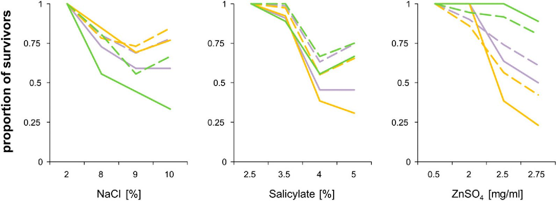
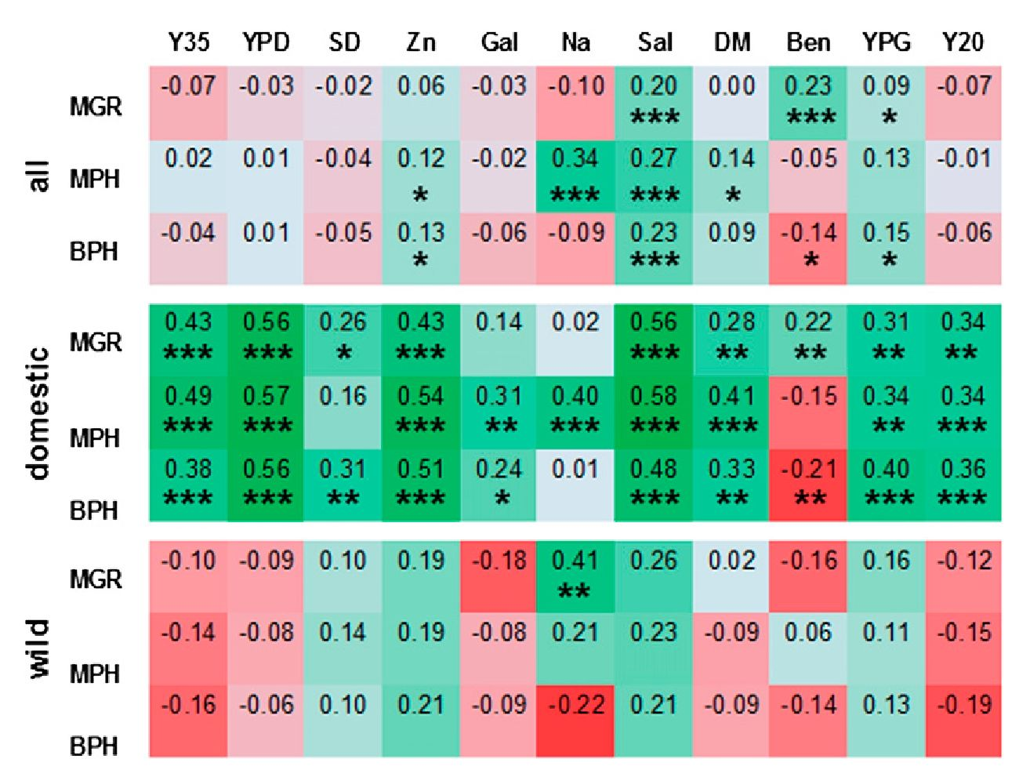
Figure 4 Correlations between hybrid fitness and the
sequence divergence between parents. Fitness is
expressed as absolute values of hybrid MGRs or as
parameters related to parental maximum growth rate
(MPH and BPH). Color intensities indicate strength of
correlations, either positive (green) or negative (red).
Statistical significance of the calculated Pearson r coef-
ficients is indicated by asterisks as follows: *0.05; **0.01;
and ***0.001.
(10,000 times) a fitness estimate from each of the three environments
and calculated the average. The empirical and expected distributions
were strikingly alike (Figure 6) and there was no statistically sig-
nificant difference between them (Kolgomorov-Smirnov test; D =
0.0756; P = 0.15). It thus appears that being (un)fit under some
extreme conditions is not predictive for performance in other harsh
environments.
We conclude that there were signs of heterosis under strong
environmental stress, because heterozygotes were more likely to
sustain it than were homozygotes. Unlike that observed in less
stressful conditions, the fitness of heterozygotes did not depend on the
genetic divergence between their parents. There was not any visible
tendency of some strains to perform better than others in all three
extreme environments (Figure 6), whereas there was a substantial
“strain” component in the less stressful environments (Figure 2C).
We explain these differences in the Discussion.

DISCUSSION
The beneficial effect of heterozygosity was evident only for strains of
domestic origin. In these strains, heterosis was strong (with hetero-
zygote fitness often higher than that of the fittest parent), evident in
multiple environments, and positively correlated with the sequence
divergence between parental strains. In striking contrast, no average
advantage of heterozygotes over homozygotes was observed among
the wild isolates, nor was there a significant relation between heterosis
and sequence divergence in these strains. Thus, we conclude that
domestication of the budding yeast was associated with accumulation
of deleterious mutations similar to that in plants and animals (Eyre-
Walker et al. 1998; Diamond 2002; Doebley et al. 2006; Lu et al. 2006;
Cruz et al. 2008). A universal factor facilitating accumulation of
slightly deleterious mutations is reduction of the effective population
size. Although it appears reasonable to assume that the effective size of
domestic populations decreased as they experienced passing through
small numbers of cells in laboratory and industrial propagation or
during infections, actual estimates are lacking. Neither the genetic
variation within nor the migration rate between local population
can be compared for domesticated and wild yeast. This is because,
typically, a single strain from a place of isolation is further studied,
carrying only a fraction of genetic variance present in the population
of its origin. It is likely, however, that local yeast populations will soon
be sampled for multiple clones and that whole-genome comparisons
within and between populations will be used to derive required
parameters. There is more evidence for another potential factor pro-
moting accumulation of genetic load, namely, a decrease in the rate of
selfing, which is typical for wild yeast and makes selection more
effective by combining recessive deleterious mutations to homozy-
gotes (Zeyl 2009; Masel and Lyttle 2011). Recent studies have found
that domesticated strains do have higher proportions of heterozygous
Figure 5 Viability under in-
creasing stress. The proportion
of survivors among homozygous
(solid lines) and heterozygous
strains (dashed lines) is shown.
Colors refer to all (violet), do-
mesticated (yellow), and wild
(green) strains.
320 | M. Plech, J. A. G. M. de Visser, and R. Korona
Í-ÍLG3 •Genes | Genomes | Genetics
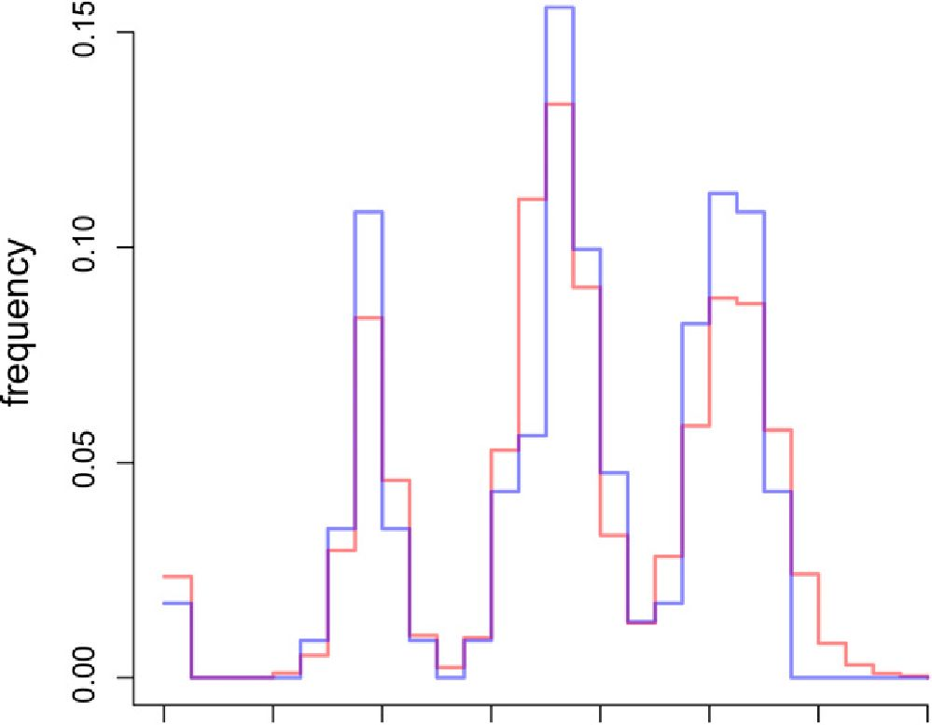
0.0 0.2 0.4 0.6 0.8 1.0 1.2 1.4

average fitness
Figure 6 Distribution of fitness averaged over the three most extreme
stresses. Fitness was normalized by dividing individual growth rates by
the stress-specific median growth rate of viable strains. An empirical
distribution (blue) is confronted with the expected one (red).
loci than the wild ones (Diezmann and Dietrich 2009; Magwene et al.
2011; Wang et al. 2012). Heterozygous loci can arise through muta-
tions that appear and persist in lineages reproducing asexually (mi-
totically). Another study involving whole-genome sequencing has
demonstrated, however, that domesticated strains may also undergo
more frequent outcrossing and recombination (Magwene et al. 2011).
Whether and how much selfing is replaced by outcrossing and
whether and how much sexual reproduction is replaced by asexual
reproduction in domesticated strains are likely to be tested more
thoroughly as genomic studies proliferate.
Domesticated populations would be less intensely purged of
mutations if selection coefficients were generally lower. This could occur
if human-made habitats were generally more benign than the wild ones.
There is abundant literature postulating that phenotypic effects of many
mutations are dampened when the environment is benign and amplified
when it is stressful (de Visser et al. 2003). If this is universally true, then
the pattern observed by us under benign and lightly stressful environ-
ments should be repeated and possibly enlarged under extreme stress.
However, whereas heterosis was seen under strong stress, it was not
larger for domesticated strains and there was no correlation between
heterosis and the phylogenetic distance between parents. One possible
explanation is that in both human-made and wild habitats, semi-lethal
conditions are rare and thus the effect of selection is scarce, or it could be
that the harsh stresses actually experienced by yeast are different from
those tested here. Alternatively, selection seems strong enough for neither
domesticated nor wild strains to accumulate sizable amounts of stress-
dependent mutations. More formally, selection coefficients of mutations
exposed by stress are much larger than the reciprocal of the effective
population sizes typical for most habitats, both wild and domesticated. If
so, then the observed genetic variation would be caused by relatively few
and recent mutations and thus the correlation between heterosis and
phylogenetic distance would not develop. It is also possible that the
mutational effects pertinent to moderately and extremely difficult con-
ditions are substantially different. The observed decreases in the growth
rate under benign conditions were likely caused by malfunctioning of
specific enzymes. Damages hampering metabolic fluxes are effectively
compensated in heterozygotes, guaranteeing an emergence of heterosis if
the compensation is reciprocal (Kacser and Burns 1981). In contrast,
when growth is barely possible, it is possible that an overall burden of
damages matters, rather than single mutations, and the phenotypic re-
action may be more threshold-like than incremental. Although these
interpretations are hypothetical, our results are in accordance with
the emerging consensus that the effect of stress does not lead to the
simple amplification of phenotypes observed under benign conditions
(McGuigan and Sgro 2009; Agrawal and Whitlock 2010). Moreover,
our results are in accordance with those obtained in a former study in
which 16 strains belonging to the same collection as our strains were
used in media supplemented with high doses of alcohol or maintained
at extreme temperatures. Hybrids were only moderately, and not
universally, better than parental strains (Timberlake et al. 2011).
Our claim that most of the observed heterosis results from
complementation of deleterious mutations would be most convinc-
ingly supported by pointing to actual deleterious substitutions or, at
least, by estimating how numerous such substitutions can be. The
number of nonsynonymous substitutions can be very large, and it was
originally estimated at 24,418 for the whole collection (Liti et al. 2009).
Substitutions that contributed to the phenotypic variation observed in
our assays were possibly much fewer. Some of the strains used here
have been recently reanalyzed with an accuracy that allowed listing of
individual substitutions reliably. Mutations causing a likely loss of
function (LOF), such as frame-shifts and premature stop codons, were
scored and the data were kindly provided to us (A. Bergström and G.
Liti, personal communication). In four wild stains used by us, there
were 89.3 ± 21.3 LOF mutations (mean ± SD). A very close score,
93.5 ± 4.4, was obtained for 11 of the domesticated strains we used.
Differences were not larger if we restricted our comparisons to verified
ORFs or essential genes (the latter were very sparse). These results
suggest that the observed heterosis cannot be explained by comple-
mentation of LOF mutations. However, this claim is not strong be-
cause it could be that only some of the detected LOF mutations matter
while most of the others have little effect. Even essential genes can
differ; in two of the compared strains of S. cerevisiae, 894 were com-
monbut 57 were strain-specific (Dowell et al. 2010). Furthermore, the
detected LOF mutations constitute only a small fraction of all non-
synonymous changes. The remaining ones can code for a variety of
defects, including complete or partial LOF, and also for adaptive or
Í&G3 •Genes | Genomes | Genetics
Volume 4 February 2014 | Heterosis in Domesticated and Wild Yeast | 321
compensatory effects. In sum, it is straightforward to use whole-
genome sequences to infer phylogenetic trees but much less so to
identify phenotypically meaningful genetic polymorphisms.
We note that neither domesticated nor wild populations
showed signs of significant outbreeding depression. Outbreeding
depression has been found in a study involving crosses between
yeast strains that formerly adapted to stressful conditions in the
laboratory (Dettman et al. 2007). In our experiment, only in one
test environment was progeny less fit than the parents. The agent
applied there, benomyl, is not normally met in human-made
habitats and is met even less in nature. It is unreasonable to
expect that both parents adapted to it but in discordant ways.
A recent review has confirmed that the depression is frequently
caused by incompatibilities in the architecture of chromosomes
(Frankham et al. 2011). Perhaps it is not incidental that in our
experiment it was seen only when benomyl was present. This
agent causes microtubule depolymerization and thus distracts
mitosis, which could inflate the negative effect of any chromo-
somal discrepancies. Adaptations to different environments, if
present and relevant to our test environments, were perhaps
not conflicting. They also could have been lost when haploid
strains were derived from the original diploid isolates (see Mate-
rials and Methods), especially if their effects depended on inter-
actions within and between loci.

ACKNOWLEDGMENTS
We thank Conor Lawless for his kind help with image analyses of
growing yeast patches. Financial support was provided by the
Foundation for Polish Science “International PhD Projects” (grant
no. MPD/2009-3/5) and a grant from the Institute of Environmental
Sciences (no. DS/WBiNoZ/INoS/762/2012).

LITERATURE CITED
Agrawal, A. F., and M. C. Whitlock, 2010 Environmental duress and
epistasis: how does stress affect the strength of selection on new muta-
tions? Trends Ecol. Evol. 25: 450-458.
Bataillon, T., and M. Kirkpatrick, 2000 Inbreeding depression due to mildly
deleterious mutations in finite populations: size does matter. Genet. Res.
75: 75-81.
Charlesworth, D., and B. Charlesworth, 1987 Inbreeding depression and its
evolutionary consequences. Annu. Rev. Ecol. Syst. 18: 237-268.
Charlesworth, D., and J. H. Willis, 2009 The genetics of inbreeding de-
pression. Nat. Rev. Genet. 10: 783-796.
Cruz, F., C. Vila, and M. T. Webster, 2008 The legacy of domestication:
accumulation of deleterious mutations in the dog genome. Mol. Biol.
Evol. 25: 2331-2336.
Cubillos, F. A., E. J. Louis, and G. Liti, 2009 Generation of a large set of
genetically tractable haploid and diploid Saccharomyces strains. FEMS
Yeast Res. 9: 1217-1225.
Cubillos, F. A., E. Billi, E. Zorgo, L. Parts, P. Fargier et al., 2011 Assessing
the complex architecture of polygenic traits in diverged yeast populations.
Mol. Ecol. 20: 1401-1413.
de Visser, J. A., J. Hermisson, G. P. Wagner, L. Ancel Meyers, H. Bagheri-
Chaichian et al., 2003 Perspective: Evolution and detection of genetic
robustness. Evolution Int J Org Evolution 57: 1959-1972.
Dettman, J. R., C. Sirjusingh, L. M. Kohn, and J. B. Anderson,
2007 Incipient speciation by divergent adaptation and antagonistic
epistasis in yeast. Nature 447: 585-588.
Diamond, J., 2002 Evolution, consequences and future of plant and animal
domestication. Nature 418: 700-707.
Diezmann, S., and F. S. Dietrich, 2009 Saccharomyces cerevisiae: popula-
tion divergence and resistance to oxidative stress in clinical, domesticated
and wild isolates. PLoS ONE 4: e5317.
Doebley, J. F., B. S. Gaut, and B. D. Smith, 2006 The molecular genetics of
crop domestication. Cell 127: 1309-1321.
Dowell, R. D., O. Ryan, A. Jansen, D. Cheung, S. Agarwala et al.,
- Genotype to phenotype: a complex problem. Science 328: 469.
Eyre-Walker, A., R. L. Gaut, H. Hilton, D. L. Feldman, and B. S. Gaut,
1998 Investigation of the bottleneck leading to the domestication of
maize. Proc. Natl. Acad. Sci. USA 95: 4441-4446.
Fay, J. C., and J. A. Benavides, 2005 Evidence for domesticated and wild
populations of Saccharomyces cerevisiae. PLoS Genet. 1: 66-71.
Frankham, R., J. D. Ballou, M. D. Eldridge, R. C. Lacy, K. Ralls et al.,
- Predicting the probability of outbreeding depression. Conserv.
Biol. 25: 465-475.
Glemin, S., J. Ronfort, and T. Bataillon, 2003 Patterns of inbreeding de-
pression and architecture of the load in subdivided populations. Genetics
165: 2193-2212.
Gu, Z., L. David, D. Petrov, T. Jones, R. W. Davis et al., 2005 Elevated
evolutionary rates in the laboratory strain of Saccharomyces cerevisiae.
Proc. Natl. Acad. Sci. USA 102: 1092-1097.
Haag, C. R., and D. Roze, 2007 Genetic load in sexual and asexual diploids:
segregation, dominance and genetic drift. Genetics 176: 1663-1678.
Haldane, J. B. S., 1937 The effect of variation on fitness. Am. Nat. 71: 337-349.
Hampsey, M., 1997 A review of phenotypes in Saccharomyces cerevisiae.
Yeast 13: 1099-1133.
Hedrick, P. W., 2012 What is the evidence for heterozygote advantage
selection? Trends Ecol. Evol. 27: 698-704.
Hill, W., and A. Robertson, 1966 The effect of linkage on limits to artificial
selection. Genet. Res. 8: 269-294.
Hoffmann, A. A., and P. A. Parsons, 1991 Evolutionary genetics and envi-
ronmental stress, Oxford University Press, Oxford.
Hyma, K. E., S. M. Saerens, K. J. Verstrepen, and J. C. Fay, 2011 Divergence
in wine characteristics produced by wild and domesticated strains of
Saccharomyces cerevisiae. FEMS Yeast Res. 11: 540-551.
Johnston, J. R., 1994 Molecular genetics of yeast, Oxford University Press, Oxford.
Johnston, S. E., J. Gratten, C. Berenos, J. G. Pilkington, T. H. Clutton-Brock
et al., 2013 Life history trade-offs at a single locus maintain sexually
selected genetic variation. Nature 502: 93-95.
Kacser, H., and J. A. Burns, 1981 The molecular basis of dominance. Ge-
netics 97: 639-666.
Kawecki, T. J., N. H. Barton, and J. D. Fry, 1997 Mutational collapse of
fitness in marginal habitats and the evolution of ecological specialisation.
J. Evol. Biol. 10: 407-429.
Krieger, U., Z. B. Lippman, and D. Zamir, 2010 The flowering gene
SINGLE FLOWER TRUSS drives heterosis for yield in tomato. Nat.
Genet. 42: 459-463.
Lawless, C., D. J. Wilkinson, A. Young, S. G. Addinall, and D. A. Lydall,
- Colonyzer: automated quantification of micro-organism growth
characteristics on solid agar. BMC Bioinformatics 11: 287.
Legras, J. L., D. Merdinoglu, J. M. Cornuet, and F. Karst, 2007 Bread, beer
and wine: Saccharomyces cerevisiae diversity reflects human history. Mol.
Ecol. 16: 2091-2102.
Libkind, D., C. T. Hittinger, E. Valerio, C. Goncalves, J. Dover et al.,
- Microbe domestication and the identification of the wild genetic
stock of lager-brewing yeast. Proc. Natl. Acad. Sci. USA 108: 14539-14544.
Liti, G., D. M. Carter, A. M. Moses, J. Warringer, L. Parts et al., 2009 Population
genomics of domestic and wild yeasts. Nature 458: 337-341.
Lu, J., T. Tang, H. Tang, J. Huang, S. Shi et al., 2006 The accumulation of
deleterious mutations in rice genomes: a hypothesis on the cost of do-
mestication. Trends Genet. 22: 126-131.
Lynch, M., 1991 The genetic interpretation of inbreeding depression and
outbreeding depression. Evolution 45: 622-629.
Magwene, P. M., O. Kayikci, J. A. Granek, J. M. Reininga, Z. Scholl et al.,
2011 Outcrossing, mitotic recombination, and life-history trade-offs
shape genome evolution in Saccharomyces cerevisiae. Proc. Natl. Acad.
Sci. USA 108: 1987-1992.
Masel, J., and D. N. Lyttle, 2011 The consequences of rare sexual repro-
duction by means of selfing in an otherwise clonally reproducing species.
Theor. Popul. Biol. 80: 317-322.
322 | M. Plech, J. A. G. M. de Visser, and R. Korona
J£G 3 •Genes | Genomes | Genetics
McGuigan, K., and C. M. Sgro, 2009 Evolutionary consequences of cryptic
genetic variation. Trends Ecol. Evol. 24: 305-311.
Mortimer, R. K., 2000 Evolution and variation of the yeast (Saccharomyces)
genome. Genome Res. 10: 403-409.
Ruderfer, D. M., S. C. Pratt, H. S. Seidel, and L. Kruglyak, 2006 Population
genomic analysis of outcrossing and recombination in yeast. Nat. Genet.
38: 1077-1081.
Schacherer, J., J. A. Shapiro, D. M. Ruderfer, and L. Kruglyak,
2009 Comprehensive polymorphism survey elucidates population
structure of Saccharomyces cerevisiae. Nature 458: 342-345.
Timberlake, W. E., M. A. Frizzell, K. D. Richards, and R. C. Gardner, 2011 A
new yeast genetic resource for analysis and breeding. Yeast 28: 63-80.
Tsai, I. J., D. Bensasson, A. Burt, and V. Koufopanou, 2008 Population
genomics of the wild yeast Saccharomyces paradoxus: Quantifying the life
cycle. Proc. Natl. Acad. Sci. USA 105: 4957-4962.
Wang, J., W. G. Hill, D. Charlesworth, and B. Charlesworth, 1999 Dynamics
of inbreeding depression due to deleterious mutations in small populations:
mutation parameters and inbreeding rate. Genet. Res. 74: 165-178.
Wang, Q. M., W. Q. Liu, G. Liti, S. A. Wang, and F. Y. Bai, 2012 Surprisingly
diverged populations of Saccharomyces cerevisiae in natural environments
remote from human activity. Mol. Ecol. 21: 5404-5417.
Warringer, J., E. Zorgo, F. A. Cubillos, A. Zia, A. Gjuvsland et al.,
2011 Trait variation in yeast is defined by population history. PLoS
Genet. 7: e1002111.
Whitlock, M. C., 2002 Selection, load and inbreeding depression in a large
metapopulation. Genetics 160: 1191-1202.
Whitlock, M. C., P. K. Ingvarsson, and T. Hatfield, 2000 Local drift load
and the heterosis of interconnected populations. Heredity (Edinb)
84(Pt 4): 452-457.
Zeyl, C., 2009 The role of sex in fungal evolution. Curr. Opin. Microbiol.
12: 592-598.
Zorgo, E., A. Gjuvsland, F. A. Cubillos, E. J. Louis, G. Liti et al, 2012 Life
history shapes trait heredity by accumulation of loss-of-function alleles in
yeast. Mol. Biol. Evol. 29: 1781-1789.
Communicating editor: G. J. David
r&G 3 •Genes | Genomes | Genetics
Volume 4 February 2014 | Heterosis in Domesticated and Wild Yeast | 323

