

Published for SISSA by 43 Springer
Received: May 11, 2019
Revised: December 19, 2019
Accepted: January 20, 2020
Published: February 5, 2020

Constraints on flavor-diagonal non-standard neutrino interactions from Borexino Phase-II

The Borexino collaboration
S.K. Agarwalla,1,2,3 M. Agostini,4 K. AltenmUller,4 S. Appel,4 V. Atroshchenko,5 Z. Bagdasarian,6 D. Basilico,7 G. Bellini,7 J. Benziger,8 D. Bick,9 G. Bonfini,10 D. Bravo,7" B. Caccianiga,7 F. Calaprice,11 A. Caminata,12 L. Cappelli,10 P. Cavalcante,13,b F. Cavanna,12 A. Chepurnov,14 K. Choi,15 D. D’Angelo,7 S. Davini,12 A. Derbin,16 A. Di Giacinto,10 V. Di Marcello,10 X.F. Ding,17,10 A. Di Ludovico,11 L. Di Noto,12 I. Drachnev,16 K. Fomenko,18 A. Formozov,18,7,14
- Franco,19 F. Gabriele,10 C. Galbiati,11 M. Gschwender,20 C. Ghiano,10
M. Giammarchi,7 A. Goretti,11,33 M. Gromov,14,18 D. Guffanti,26 C. Hagner,9
- Hungerford,21 Aldo lanni,10 Andrea lanni,11 A. Jany,22 D. Jeschke,4
S. Kumaran,6,23 V. Kobychev,24 G. Korga,21,c T. Lachenmaier,20 M. Laubenstein,10 E. Litvinovich,5,25 P. Lombardi,7 L. Ludhova,6,23 G. Lukyanchenko,5 L. Lukyanchenko,5 I. Machulin,5,25 G. Manuzio,12 S. Marcocci,17,d J. Maricic,15 J. Martyn,26 E. Meroni,7 M. Meyer,27 L. Miramonti,7 M. Misiaszek,22 V.Muratova,16 B. Neumair,4 M. Nieslony,26 L. Oberauer,4 V. Orekhov,5,26 F. Ortica,28 M. Pallavicini,12 L. Papp,4 O. Penek,6,23 L. Pietrofaccia,11 N. Pilipenko,16 A. Pocar,29 G. Raikov,5 G. Ranucci,7 A. Razeto,10 A. Re,7 M. Redchuk,6,23 A. Romani,28 N. Rossi,10,e S. Rottenanger,20 S. Schonert,4 D. Semenov,16 M. Skorokhvatov,5,25 O. Smirnov,18 A. Sotnikov,18 C. Sun,30,31 Y. Suvorov,5,10,f T. Takeuchi,13 R. Tartaglia,10 G. Testera,12 J. Thurn,27 E. Unzhakov,16 A. Vishneva,18 R.B. Vogelaar,13 F. von Feilitzsch,4 M. Wojcik,22 M. Wurm,26 O. Zaimidoroga,18 S. Zavatarelli,12 K. Zuber27 and G. Zuzel22
aPresent address: Universidad Autónoma de Madrid, Ciudad Universitaria de Cantoblanco,
28049 Madrid, Spain.
bPresent address: INFN Laboratori Nazionali del Gran Sasso, 67010 Assergi (AQ), Italy. cAlso at: MTA-Wigner Research Centre for Physics, Department of Space Physics and Space Technology, Konkoly-Thege Miklós ut 29-33, 1121 Budapest, Hungary
dPresent address: Fermilab National Accelerato Laboratory (FNAL), Batavia, IL 60510, U.S.A.. ePresent address: Dipartimento di Fisica, Sapienza Universita di Roma e INFN, 00185 Roma, Italy. fPresent address: Dipartimento di Fisica, Universita degli Studi Federico II e INFN, 80126 Napoli, Italy.
Open Access, © The Authors. Article funded by SCOAP3.
https://doi.org/10.1007/JHEP02(2020)038
JHEP02(2020)038
1 Institute of Physics, Sachivalaya Marg, Sainik School Post, Bhubaneswar 751005, India 2Homi Bhabha National Institute, Training School Complex,
Anushakti Nagar, Mumbai 400085, India 3International Centre for Theoretical Physics, Strada Costiera 11, Trieste 34151, Italy 4Physik-Department and Excellence Cluster Universe, Technische Universitat Munchen,
85748 Garching, Germany 5National Research Centre Kurchatov Institute, 123182 Moscow, Russia 6Institut fur Kernphysik, Forschungszentrum Jiilich, 52425 Julich, Germany 7 Dipartimento di Fisica, Universita, degli Studi e INFN, 20133 Milano, Italy 8Chemical Engineering Department, Princeton University, Princeton, NJ 08544, U.S.A.
9Institut fur Experimentalphysik, Universitat Hamburg, 22761 Hamburg, Germany 10INFN Laboratori Nazionali del Gran Sasso, 67010 Assergi (AQ), Italy 11Physics Department, Princeton University, Princeton, NJ 08544, U.S.A.
12Dipartimento di Fisica, Universita, degli Studi e INFN, 16146 Genova, Italy 13Physics Department, Virginia Polytechnic Institute and State University,
Blacksburg, VA 24 061, U.S.A.
14Lomonosov Moscow State University Skobeltsyn Institute of Nuclear Physics,
119234 Moscow, Russia,
15 Department of Physics and Astronomy, University of Hawaii, Honolulu, HI 96822, U.S.A.
16St. Petersburg Nuclear Physics Institute NRC Kurchatov Institute, 188350 Gatchina, Russia
- Gran Sasso Science Institute, 67100 L’Aquila, Italy
- Joint Institute for Nuclear Research, 141980 Dubna, Russia
19AstroParticule et Cosmologie, Universite Paris Diderot, CNRS/IN2P3, CEA/IRFU, Observatoire de Paris, Sorbonne Paris Cite, 75205 Paris Cedex 13, France 20Kepler Center for Astro and Particle Physics, Universitat Tubingen, 72076 Tubingen, Germany 21 Department of Physics, University of Houston, Houston, TX 77204, U.S.A.
22M. Smoluchowski Institute of Physics, Jagiellonian University, 30348 Krakow, Poland
23RWTH Aachen University, 52062 Aachen, Germany
24Institute for Nuclear Research of NAS Ukraine, 03028 Kiev, Ukraine
25National Research Nuclear University MEPhI (Moscow Engineering Physics Institute),
115409 Moscow, Russia
26Institute of Physics and Excellence Cluster PRISMA+, Johannes Gutenberg-Universitat Mainz, 55099 Mainz, Germany 27Department of Physics, Technische Universitat Dresden, 01062 Dresden, Germany 28Dipartimento di Chimica, Biologia e Biotecnologie, Universita, degli Studi e INFN,
06123 Perugia, Italy 29Amherst Center for Fundamental Interactions and Physics Department,
University of Massachusetts, Amherst, MA 01003, U.S.A.
- CAS Key Laboratory of Theoretical Physics, Institute of Theoretical Physics,
Chinese Academy of Sciences, Beijing 100190, P.R. China
- Department of Physics, Brown University, Providence, RI 02912 U.S.A.
E-mail: spokesperson-borex@lngs.infn.it
JHEP02(2020)038
Abstract: The Borexino detector measures solar neutrino fluxes via neutrino-electron elastic scattering. Observed spectra are determined by the solar-ve survival probability Pee(E), and the chiral couplings of the neutrino and electron. Some theories of physics beyond the Standard Model postulate the existence of Non-Standard Interactions (NSI’s) which modify the chiral couplings and Pee(E). In this paper, we search for such NSI’s, in particular, flavor-diagonal neutral current interactions that modify the vee and vTe couplings using Borexino Phase II data. Standard Solar Model predictions of the solar neutrino fluxes for both high- and low-metallicity assumptions are considered. No indication of new physics is found at the level of sensitivity of the detector and constraints on the parameters of the NSI’s are placed. In addition, with the same dataset the value of sin2 9W is obtained with a precision comparable to that achieved in reactor antineutrino experiments.
Keywords: Neutrino Physics, Beyond Standard Model
ArXiv ePrint: 1905.03512
JHEP02(2020)038
Contents
1 | Introduction | 1
2 | ve elastic scattering | 2
 | 2.1 Standard Model interactions | 2
 | 2.2 Radiative corrections | 4
 | 2.3 Non-Standard Interactions (NSI’s) | 4
3 | Analysis | 7
 | 3.1 Overview | 7
 | 3.2 Detector model and choice of parameters | 9
 | 3.3 Backgrounds | 11
 | 3.4 Fit procedure | 12
4 | Results | 13
 | 4.1 Bounds on NSI parameters | 13
 | 4.2 Evaluation of sin2 9W | 18
5 | Summary and concluding remarks | 19
A | Derivation of the matter effect potential in the presence of NSI’s | 20
1 | Introduction
The study of solar neutrinos is relevant not only for probing our understanding of the Sun but also for investigating neutrino properties. Solar neutrino experiments, primarily SNO [1] and Super-Kamiokande [2], together with KamLAND [3-5], have resolved the solar neutrino problem with the large mixing angle (LMA) MSW flavor conversion effect [6-9]. Improved experimental precision may reveal the effects of physics beyond the Standard Model, such as sterile neutrinos, particle dark matter or non-standard interactions (NSI’s) of the neutrino [10-13]. In this article, we present the latest sensitivity of Borexino to study the latter.
The Borexino experiment at the Laboratori Nazionali del Gran Sasso (LNGS) [14] detects solar neutrinos through the neutrino-electron elastic scattering interaction on a ^280 ton liquid scintillator target with (3.307 ± 0.003) x 1031 electrons per 100 ton of the mass. During the Phase-I period (May 16, 2007-May 8, 2010) Borexino had 740.7 live days of data taking [15, 16]. Following Phase-I, an extensive scintillator purification campaign was conducted resulting in significant reductions of radioactive contaminants. Uranium-238 and Thorium-232 levels were reduced to 238U < 9.4 x 10-20 g/g (95% C.L.) and 232Th < 5.7x10-19 g/g (95% C.L.). 85Kr and 210Bi concentrations were reduced by factors ~ 4.6 and ~ 2.3, respectively [17]. The Phase-II data, analyzed in this paper, were collected from December 14, 2011 until May 21, 2016, corresponding to 1291.51 days x 71.3 t
- 1 -
JHEP02(2020)038
(252.1 ton-years) of fiducial exposure. Reduction of the background, longer exposure, and better understanding of the detector response allowed for fits to be performed in a wider energy range (0.19 MeV <T < 2.93 MeV, where T is the recoil-electron kinetic energy) to include pp, 7Be, pep, and CNO electron-recoil spectra [18].1 Taking advantage of these improvements, this paper uses the Phase-II data to investigate the parameters of non-standard interactions (NSI’s) of the neutrino with increased sensitivity.
Solar neutrinos can be used to probe for physics beyond the SM that affect neutrino interactions with the charged leptons and quarks. In this paper, we restrict our analysis to the neutrino-flavor-diagonal NSI’s that affect vee and vTe interactions to which Borexino is particularly sensitive. We do not consider NSI’s that affect the v^e interaction, which are strongly constrained by the v^e scattering CHARM II experiment [19].
Using Borexino to constrain NSI’s was originally discussed by Berezhiani, Raghavan, and Rossi in refs. [20, 21]. They argued that the monochromatic nature of 7Be solar neutrinos results in an electron recoil spectrum whose Compton-like shape is more sensitive to the ve couplings than that from a continuous neutrino energy spectrum. Following refs. [20, 21], a purely phenomenological analysis based on Borexino Phase-I results [22] was carried out in ref. [23], in which the roles of the main backgrounds were analyzed and bounds on vee and vTe NSI’s obtained.
However, the analysis considered the effects of the NSI’s at detection only. High solar metallicity (HZ) was also assumed as input to the Standard Solar Model (SSM) [24-27] to predict the 7Be solar neutrino flux.
This paper updates and improves upon the analysis of ref. [23] by using the Phase-II data set with the full arsenal of improved analysis tools developed by the Borexino collaboration. NSI effects are included in both propagation and detection. At production the NSI’s affect the solar-neutrino spectrum only below the Borexino threshold of ~50keV [18, 28], and are therefore neglected. To account for the effect of solar metallicity, analyses are performed for both high- (HZ) and low-metallicity (LZ) solar models.
This paper is organized as follows. In section 2, we review the neutrino-electron interactions in the SM and with additional effects due to NSI’s, and introduce the notation. Section 3 provides an outline of the analysis strategy and, in particular, how backgrounds and uncertainties are handled. Results and their discussion are presented in section 4. A summary of the main findings is presented in section 5.
2 ve elastic scattering

2.1 Standard Model interactions
Within the SM, the elastic scattering of va (a = e, p, t) on electrons proceeds via Z- exchange (Neutral Current, NC) and, for ve, also via W-exchange (Charged Current, CC).
1The energy spectra of pp and CNO neutrinos are continuous and extend up to 0.42 MeV and 1.74 MeV, respectively. 7Be (E = 0.384 MeV and 0.862 MeV) and pep (E = 1.44 MeV) neutrinos are monoenergetic.
In ref. [18], a high-energy region of 3.2 < T < 16 MeV was also considered to measure 8B neutrinos with a continuous energy spectrum extending up to about 16.5 MeV.
-2-
JHEP02(2020)038
At momentum transfers relevant for Borexino (Q2 ^ MW, ), the CC and NC processes
are well approximated by the point interaction:
-Lcc = Ve7^ (1 - 75) e e7^ (1 - 75) v- =2^2 GF V-lY^-l eL^eL , (2.1) -Lnc = ^ VaY^1 - Y5) e7^(gLv - Ola!5) e
= 2^2 Gf vahlFvaL gLL (£lY^l) + gLR (ArY^r) , (2.2)
where we have used the Fierz transformation [29, 30] to rewrite the CC interaction into NC form, and we follow the notation of the Review of Particle Physics [31] for the NC coupling constants. The tree-level values of these couplings are
qLv = — 2 +2 sin2 ,
9vla = - 2 ,
9vll = 2 (gVe/ + gV<A) = - 2 + sin2 0w ,
gVLR = 2 (gVe/ - QLa) = sin2 0w . (2.3)
Combining (2.1) and (2.2) we have
- Lv“e = 2^2 Gf VlY^Vl gaL (AlY^l)+ gaR (ArY^r) , (2.4)
with
{gVL + 1 for a = e,
9ll for a = g,r,
gaR = gLR for a = e,g, t. (2.5)
For a monochromatic neutrino of energy E and flavor a scattering off an electron at rest, the interaction (2.4) predicts the spectrum of the kinetic energy T of the recoiling electrons to be [24, 32]
d&a(E, T) _ 2 ^2 _ 2,2 /1 T A meT ,0 „n
dT = ^ me gaL + gar(1 - e) - gaLgaR~E^ , (2.6)
where neutrino masses have been neglected and T is constrained as:
0 < T < Tmax = Eme . (2.7)
1+
+ 2E
-3-
JHEP02(2020)038
2.2 Radiative corrections
The tree-level expression for the cross section given in eq. (2.6) is modified by radiative corrections [33-38]. In the present analysis, these corrections are accounted for following the 1995 paper of Bahcall, Kamionkowski, and Sirlin [37] with parameters updated to reflect the more recently available experimental data, e.g. the Higgs mass, and s| = 0.23129.2 Borexino does not distinguish between muon- and tau-neutrinos, and the difference in radiative corrections for the two flavors is consequently ignored: the radiative corrections to vT were set to be the same as those for the v^. The sizes of these radiative corrections are generally small compared to the experimental precision of Borexino with the exception of the recent 2.7% measurement of the 7Be solar neutrino flux [18]. The effect of radiative corrections has a comparable magnitude, resulting in a ~2% reduction of the total cross section for ve, and a 1.2% increase for v^/T [37]. Nevertheless, they have little impact on the present analysis.

2.3 Non-Standard Interactions (NSI’s)
In addition to the SM interactions presented above, many models of physics beyond the Standard Model (BSM) predict new interactions of the neutrinos with the other SM fermions [41-51]. Phenomenologically, such non-standard interactions (NSI’s) of the NC type are described by the Lagrangian density [52, 53]
- lnc-nsi = 2^2Gf efaf C {pul^pL){Iy^Pc f') , (2.8)
a,p
where a, fi = e,^,r label the neutrino flavor, f and f' are leptons or quarks of the same charge but not necessarily the same flavor, C is the chirality of the ff' current (L or R),
f f ’ C
and is a dimensionless coupling parametrizing the strength of the NSI interaction
normalized to GF. Allowing a = fi and f = f' in (2.8) accounts for possible flavor-changing NSI’s. Hermiticity of the interaction demands
ff'C f fC* nx
f = f , (2.9)
where the asterisk denotes complex conjugation. In the current analysis, however, we restrict our attention to the flavor-diagonal case f = f' = e and a = fi, and denote £<C = . Borexino, relying on neutrino-electron elastic scattering, is particularly sensitive
to this type. A discussion on BSM models which may produce such NSI’s can be found in refs. [52, 54-56].3
2s| denotes the MS value of sin2 8W at the Z-mass scale. The value of sZZ = 0.23129 ± 0.00005 is from the 2016 Review of Particle Physics [39]. It has subsequently been updated to s| = 0.23122 ± 0.00003 in the 2018 Review of Particle Physics [31, 40], but this difference is too small to be of relevance to the analysis of this paper.
3Before the confirmation of neutrino oscillations by the KamLAND experiment, NSI’s with massless
neutrinos had also been invoked to address the solar neutrino anomaly. See refs. [57-62].
-4-
JHEP02(2020)038
NSI’s can affect neutrino production, detection, and propagation. Inside the Sun, the flavor diagonal NSI’s under consideration contribute to the production of same-flavor vv pairs via photo-production (Ye ^ evv), vv-Bremsstrahlung (the photon leg in Ye ^ evv is anchored on an ion or another electron), etc. [28]. However, the energies of the neutrinos and anti-neutrinos produced by these processes are expected to be in the few keV range, well below the ~50keV detection threshold of Borexino [18].
L/R
At detection, ej (a = e, ^, t) shift the coupling constants that appear in the expression for the differential cross section, eq. (2.6):
gaR ^ gaR = gaR + eR , (2.10)
9aL ^ gaL = 9aL + . (2.11)
Strong bounds on eLJR had already been obtained by the v^e scattering experiment CHARM II [19], namely -0.025 < eL < 0.03 and -0.027 < eR < 0.03 at 90% C.L. [54].4 Therefore, we restrict our attention to the remaining four parameters: e^/R and £Ig/R. We
L/R
do not consider the full 4-dimensional space ea' (a = e,T): such a detailed description
is not necessary at the current level of sensitivity to NSI’s. Instead, we investigate the e^/R and eIg/R cases separately, even though — as it will become evident later with (2.13) and (3.1) — these groups of parameters cannot be decoupled with Borexino.
The description of how NSI’s affect neutrino propagation can be found in refs. [10, 56, 63, 64]. Let us discuss in some detail what we should expect from their inclusion. Neutrino
propagation in matter is only sensitive to the vectorial combinations eR = £^ + eR. They
modify the matter-effect potential in the flavor basis to
 | 100 |  | 1 + eV | 0 | 0
V (x) | 0 0 0 | ^ V (x) | 0 | 0 | 0
 | 000 |  | 0 | 0 | £V  T
where V(x) = \/2GFNe(x), and Ne(x) is the electron density at location x. From a practical point of view, = + eR and = eL + eR can be introduced as a shift in the
matter-effect potential V(x) in two-flavor oscillation analysis:
V(x) ^ V'(x) = (1 - £)V(x), (2.13)
where £ = sin2 Q23 — eR [63]. The derivation of this effective potential is given in appendix A, assuming |Am3J » 2EV(x), where E is the neutrino energy. There, it is also shown that the first oscillation resonance occurs at 2EV1 (x)c\3 = 2E(1 — e')V(x)cf3 w Am^ cos2012.
4These are one-parameter-at-a-time bounds. One-parameter projections of two-parameter bounds at 90% C.L. are given as -0.033 < < 0.055 and -0.040 < eR < 0.053 in ref. [55].
- 5 -
JHEP02(2020)038
For neutrinos coming from the center of the Sun, where the SSM predicts N°(r = 0) w 102Na = 6 x 1025/cm3 [25, 26], the resonance energy is
EgJ0) w AmTco^ ^ w 2MW ,
(1 - £')272GfN°(0)c?3 (1 - e') ’
where for Am^j cos 20j2 and c23 = 1 - s23 we have used the central values of the global averages from ref. [65].
As the electron density N°(r) decreases towards the surface of the Sun, r ^ R°, the resonance energy E°s(r) will increase. The presence of non-zero e' will also shift the resonance energy: positive e' to higher values and negative e' to lower values.
The MSW effect [6-9] in the energy range E > E°s(r) ensures a well-defined electron
neutrino survival probability Pee(E). For lower energies, neutrino oscillates in a vacuum
regime, with a smooth Pee(E) change in the transition region between the two regimes of oscillations. Since the energy ranges of pp, 7Be, and pep neutrinos are below the resonance, the influence of matter effect for those components is small compared to that for 8B neutrinos.
The mass density at the center of the Earth according to the Preliminary Reference Earth Model (PREM) [66] is p(r = 0) w 13g/cm3, which gives us an estimate of the electron density there as N®(r = 0) w Na p(r = 0)/2 = 4 x 1024/cm3. So the resonance energy of the neutrinos at the Earth’s center is
E&(0) w Am2ic<>s2fe 2 w ITTT ■ (2.15)
(1 - e')272GFNe®(0)c23 (1 - e') ’ V ;
and E®s(r) will grow larger as the electron density decreases toward the surface of the Earth, r ^ R®. From this, one can expect matter effects due to the Earth to be small for all solar neutrino components.5 Indeed, the day-night asymmetry at Borexino for the e' = 0 case has been predicted to be a mere fraction of a percent [73, 74], and Borexino reports ABe = 0.001 ± 0.012(stat) ± 0.007(syst) in ref. [75]. A negative value of e' could, of course, lower the resonance energy and affect this prediction but due to the difference in the energy scales of eqs. (2.14) and (2.15), one expects the effect of e' would appear in the Sun first.
Figure 1 illustrates the effect of LMA-MSW on Pee(E) for several representative values of e'. NSI’s with e' > 0 enhance Pee(E). For e' < 0 case, Pee(E) is reduced. According to eq. (2.13), as e' ^ 1, the matter effect potential vanishes and the Pee(E) tends to Vacuum- LMA scenario that assumes all solar neutrinos are oscillating in the vacuum regime. For the range between e' = -0.5 and e' = 0.5, the theoretically predicted shift of Pee(E) is within the error bars of the experimentally determined values of Borexino. The 90% C.L. contours obtained in the present analysis are located almost entirely in this range (see figures 6 and 7). Therefore, the effects of NSI’s at propagation are not particularly strong, and the sensitivity to NSI’s is almost entirely provided at detection.
5For 8B neutrinos, the day-night asymmetry for LMA-MSW has been predicted to be a few
percent [67, 68], and this has been confirmed experimentally by Super-Kamiokande [69, 70] and SNO [71, 72].
The sensitivity of Borexino is insufficient to detect this day-night asymmetry.
-6-
JHEP02(2020)038
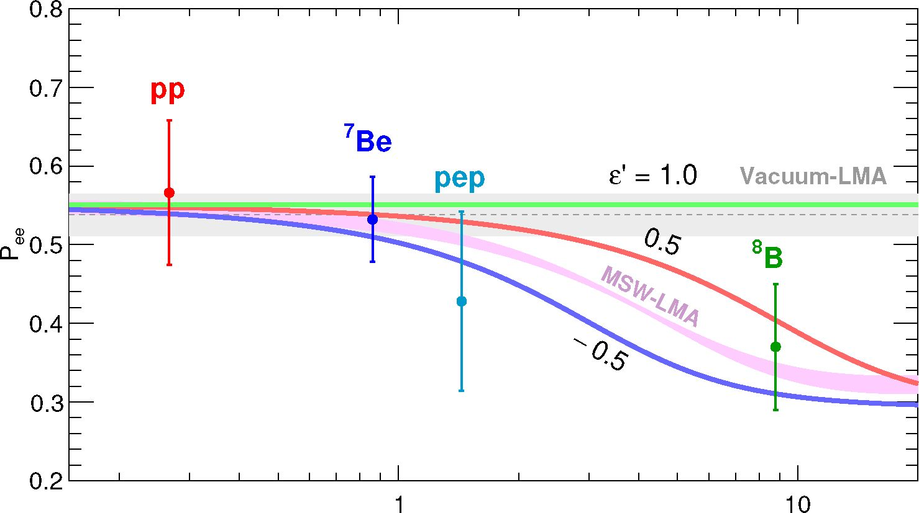
Neutrino energy [MeV]
Figure 1. Electron neutrino survival probability Pee(E) as a function of neutrino energy for LMA- MSW solution with uncertainties of oscillation parameters taken into account (pink band), and LMA-MSW + NSI solutions for e' = -0.5,0.5,1.0 and average values of oscillation parameters. Vacuum oscillations scenario with LMA parameters is also shown (grey band). To illustrate the capability of the detector to sense NSI’s at propagation, experimental points for Pee(E) shown for Borexino under the HZ-SSM assumption are also provided (ref. [18]). 8B and pp data points are set at the mean energy of neutrinos that produce scattered electrons above the detection threshold. The error bars include experimental and theoretical uncertainties.

3 Analysis
  - Overview
The objective of this analysis is to investigate the sensitivity of Borexino to the NSI parameters e^/R and e^/R. In contrast to the analysis of ref. [18], in which the ve couplings were fixed to those of the SM and the count rates of pp, 7Be, and pep neutrinos were fit to the data, we allow the couplings to float, assuming the SSM neutrino fluxes with either the HZ- or LZ-SSM values (table 1).
We have argued in the previous section that e^/R and e^/R affect neutrino propagation and detection: (i) the propagation through a shift in the matter-effect potential, eq. (2.13), leading to a modification in the expected ve survival probability Pee (E), and (ii) the detection through shifts in the effective chiral coupling constants, eqs. (2.10) and (2.11), leading to modifications in the electron recoil spectra daa/dT (a = e,t), eq. (2.6).
Four solar neutrino components are considered in this analysis: pp, 7Be, pep, and CNO.6 The SSM [24-27] predicts the energy spectra and fluxes of these neutrinos, which we denote as d\v/dE and , where the subscript v labels the neutrino component.
6In the present analysis, we look for deviations from the SSM + LMA-MSW predictions, so the CNO neutrino flux, together with the other three component fluxes, are simply fixed to those predicted by either the HZ- or LZ-SSM.
-7-
JHEP02(2020)038
Flux, | B16(GS98)-HZ | B16(AGSS09met)-LZ
pp  pep  7Be  CNO | 5.98(1 ± 0.006) 1.44(1 ± 0.01) 4.93(1 ± 0.06) 4.88(1 ± 0.11) | 6.03(1 ± 0.005) 1.46(1 ± 0.009) 4.50(1 ± 0.06) 3.51(1 ± 0.10)
Table 1. The fluxes predicted by HZ- and LZ-SSM’s (ref. [27]) and used in this analysis. Units are: 1010 (pp), 109 (7Be), 108 (pep, CNO) cm-2s-1.
The monochromatic 7Be-component plays a fundamental role in this analysis. Both the shape and the normalization of the electron-recoil spectrum is well-constrained in the fit. Together with the 6%-uncertainty in the theoretical 7Be neutrino flux, it provides the highest sensitivity to NSI’s among all the neutrino components. We do not use 8B neutrinos to place bounds on NSI’s. The rate of 8B neutrino events cannot be determined with the spectral fit used in this analysis, being small and hidden by backgrounds in the energy region considered. Moreover, the relatively large 12%-uncertainty on the 8B neutrino flux predicted by the SSM limits its utility for this work.
Taking into account the oscillations of ve into and vT, the recoil spectrum for each solar neutrino component is given by
7F = ^ / dV [£^ + (4% + *2»^) (1 - ))] . (3.1)
Here, Ne is the number of electrons in the fiducial volume of the detector, = sin2 d23, and c23 = cos2 d23. is the expected total flux of solar neutrino component v at the Earth, and dAv/dE is the corresponding differential neutrino energy spectrum. Pee(E) is the solar- ve survival probability to which NSI effects at propagation have been added. The effect of the NSI’s at detection is included in the differential cross sections doy/dT and doy/dT, with the e^/R and eL/R parameters always combined in the recoil spectrum of eq. (3.1).
The dependence of the 7Be electron recoil spectrum dRBe7/dT on the NSI’s for several values of eR and eLL is illustrated in figure 2. Note that eLL mostly modifies the normalization of the spectrum, while eR modifies its slope. eIL and eR require much larger magnitudes to achieve the same effects due to the smaller contribution of vT to dRBe7/dT.
Integrating eq. (3.1), one obtains a relation between the total experimental event rate Rv, the solar neutrino flux , and the total cross section (oy):
Rv = j ddRV dT = Ne$v(ov). (3.2)
NSI effects at propagation and detection are both included in the total cross section (ov). Denoting the total cross section in the absence of NSI’s as (oy)sm, we plot the change in the ratio (oy)/(oy)SM for the 7Be neutrinos due to the presence of and eR in figure 3. Again, we see that eLL affects the normalization of the cross section, while eR does not. Thus eLL is mostly constrained by the normalization of the cross section, while eR is mostly constrained by the shape of the recoil spectrum.
-8-
JHEP02(2020)038
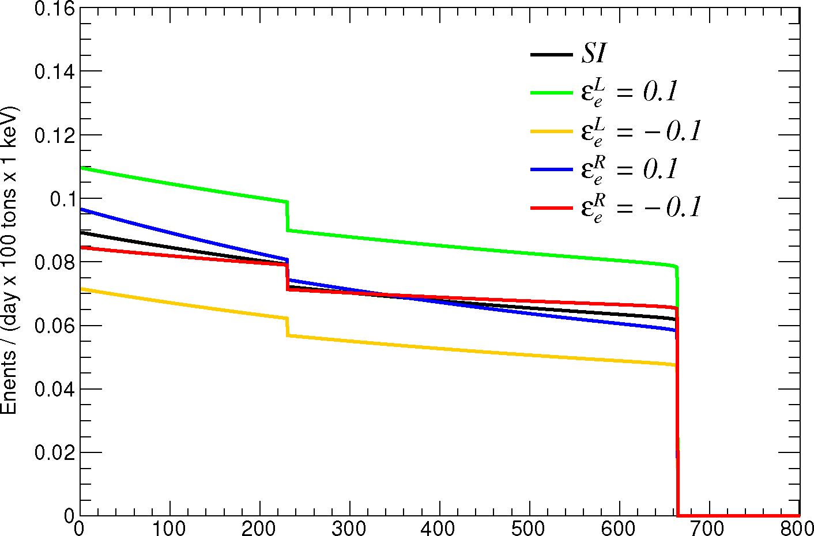
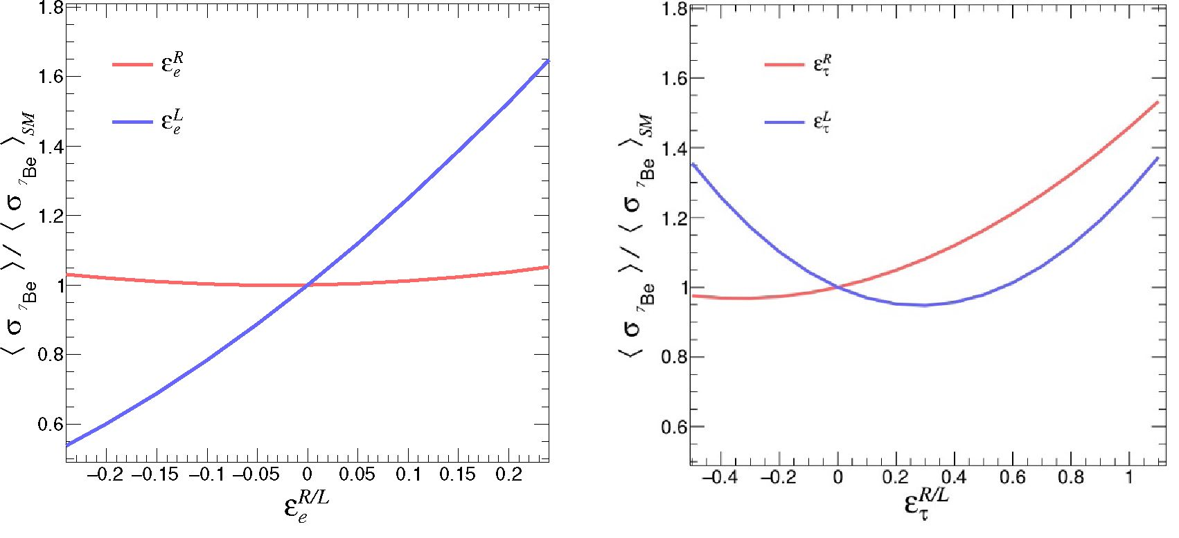
Energy [keV]
Figure 2. The distortion of the electron recoil spectrum, eq. (3.1), for the two monochromatic 7Be solar neutrino lines (E = 0.384 MeV and 0.862 MeV) due to non-zero values of and eR. The
effect of the finite energy resolution of the detector is not included.
Figure 3. The relative change of the total cross section ratio (ovBe}/(<77Be}sM as function of eR/L (left panel) and eR/L (right panel).

3.2 Detector model and choice of parameters
We performed the selection of the events according to ref. [18], using a spherical fiducial volume to which the top and bottom polar regions are cut off: R < 2.8 m, and -1.8 m < z < 2.2 m. To model the detector response, we use the analytical model of the Borexino detector discussed in detail in ref. [17]. The model uses the number of triggered PMT’s, Npdtl, within a fixed time interval dtj = 230 ns as the estimator of the electron
-9-
JHEP02(2020)038
recoil energy T. Various model parameters have been fixed utilizing independent measurements, or tuned using the Borexino Monte Carlo [76] and calibrations [77], while some have been left free to float in the fit. The floating parameters include (i) the light yield, which determines the energy scale, (ii) two parameters for energy resolution, (iii) two parameters for the position and the width of the 210Po-a peak, and (iv) one parameter for the starting point of the 11C ++-spectrum. The detector response function convoluted with the cross section dRv/dT provides the functional form to be fit to the data.
Throughout the minimization procedure, the neutrino oscillation parameters are fixed to the central values of the global fit to all oscillation data given in ref. [65].7 Their uncertainties are directly propagated as the uncertainties of predicted neutrino rates. More details on how the uncertainties are treated can be found in section 3.4.
For the eR/R analysis, we only need
Am21 = m2 — ml = 7.50++19 x 10-5 (3.3)
sin2 012 = 0.306+0.012 , (3.4)
sin2 013 = 0.02 1 66+0.00077 , (3.5)
which are valid for any choice of neutrino mass hierarchy.
It is worthwhile to mention that the measurements of 012 and Am21 from the global oscillation data may be altered if we consider NSI’s in the fit. The solar neutrino experiments such as Super-Kamiokande and SNO provide crucial information on 012 and Am^, and at the same time they are sensitive to the same NSI’s in propagation and detection
that we consider in this paper. However, the reactor experiment KamLAND is unaffected
by flavor-diagonal neutral current NSI’s involving neutrinos and electrons. Therefore, when we consider the KamLAND data along with the solar neutrino data mostly coming from Super-Kamiokande and SNO, the solar oscillation parameters 012, Am^ remain robust even in the presence the NSI’s discussed in this paper. In fact, it was shown in ref. [63] that Super-Kamiokande and SNO can place competitive constraints on e+ and eR with the help of KamLAND data which provides NSI-independent measurement of 012 and Am^. Note also that for the eR/R analysis da^/dT = daT/dT when e+/R = 0, and Borexino is insensitive to the value of 023.
For the e+/R analysis, we also need to specify 023. The 1a ranges given in ref. [65] for Normal and Inverted Hierarchies are
f 0 441+0.027 NH
■2a I 0 +0.021 NH n\
sin 023 = < +n09n (3.6)
I 0.587+0.020 IH
It is easy to see that sin2 023 is included linearly in expression (3.1), and the sensitivity to e+/R is proportional to its value. To obtain a conservative limit, we fix sin2 023 to the NH value and propagate its uncertainty into systematic error together with other oscillation parameters.
7Strictly speaking, to use the Borexino data to constrain possible new physics effects we should not be comparing the data to the global average of ref. [65], which includes both Borexino Phase-I and Phase-II data in its fit.However, the numerical difference from the global average of ref. [78], which includes neither Borexino Phase I nor Phase II data, is small and does not affect the present analysis.
- 10 -
JHEP02(2020)038
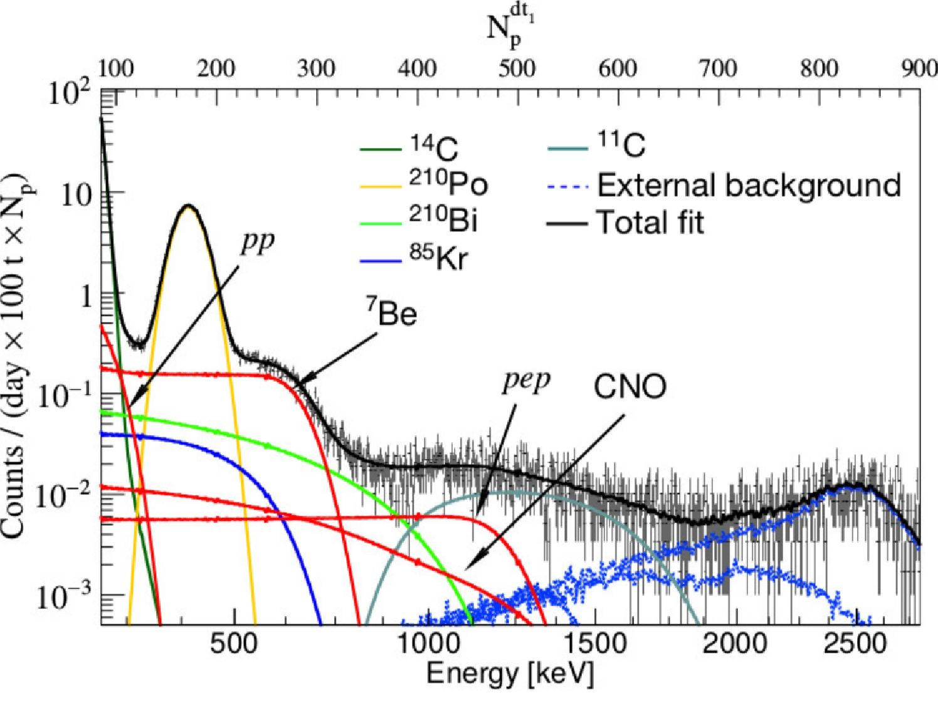
Figure 4. Example of fit of the Borexino energy spectrum. The fit was performed using the Npłl energy estimator. The bottom horizontal axis has been converted from N4tl into units of energy; Np is a number of photoelectrons in the acquisition time window.

3.3 Backgrounds
Radioactive contaminants lead to backgrounds that must be clearly understood to extract unambiguous conclusions from the Borexino data. The most recent fit of signal+background to the observed electron recoil spectrum can be found in ref. [18], where the SM couplings were assumed and the event rates of three solar neutrino components (pp, 7Be, and pep) were allowed to float. An example fit to the experimental spectrum is shown in figure 4. A full description of the Borexino spectral components and backgrounds is found in ref. [15]. Here, we focus on the components which are the most relevant for the current analysis:
- At low-energies the ^-emitter 14C with Q = 156 keV is the main background for pp neutrinos (Tmax = 261 keV).
The 14C contribution is constrained in the fit with an independent measurement by selection of events with low energy threshold. Since the rate of 14C is high compared to the other components, pile-up events need to be taken into account. The detailed data selection and analysis procedures are found in ref. [16].
- Decays of 85Kr (d-, Q = 687keV), 210Bi (d-, Q = 1160keV), and 210Po (a, E = 5.3 MeV) are the main backgrounds for the detection of the electron recoil spectra from the two mono-energetic 7Be solar neutrino lines (E = 384 keV and 862 keV).
- 11 -
JHEP02(2020)038
The 210Po a-decay peak (E = 5.3 MeV) appears at ^400 keV due to ionization quenching effects in the liquid scintillator. While very intense with respect to the other spectral components, the shape of the polonium peak is very distinct, well understood, and easily separable in the fit.
The P spectra of 210Bi and 85Kr overlap with the 7Be electron-recoil spectrum leading to a modification of its shape. This reduces the sensitivity to the right-handed NSI parameter eR. The background from 85Kr is quite serious since the shape of its P-spectrum and its end-point are close to the step-like spectrum of 7Be.
• Other backgrounds necessary to the fit of the experimental spectrum are cosmogenic P+ emitter 11C, and 7-rays from 208Tl, 214Bi, and 40K from components of the detector external to the scintillator.

3.4 Fit procedure
The fitting procedure consists of the multivariate maximization of the composite likelihood function L(k|e,0), specifically developed to be able to detect pep, and CNO neutrinos hidden by the cosmogenic P+ 11C and external backgrounds:
L(k |e, 0) = LTFC(k |e, 0) ■ LtTaFgC(k |e, 0) ■ Lp(k |0) ■ Lp(k |0). (3.7)
Here, e is the NSI parameter we would like to constrain, and the vector 0 collectively represents all the other model parameters of the fit, including the rates of the four solar neutrino components Rv, the intensities of the backgrounds, detector response parameters, etc., and k denotes the set of experimental data.
In order to deal with 11C background, the dataset was divided into two parts by
the so-called three-fold coincidence (TFC) technique (refs. [15, 17]). The method tags
events correlated in space and time with a parent muon and one or several neutrons often produced together with 11C. The division is based on the probability for an event to be 11C and results in 11C-depleted (TFC-subtracted) and 11C-enriched (TFC-tagged) data samples. The first and the second factors of eq. (3.7) represent two separate likelihoods for TFC-subtracted and TFC-tagged experimental spectra, respectively. They are a standard Poisson likelihood:
LTFCtag(k |e, 0) = n Ai(e,0)kie (3.8)
i=1
where is the number of energy bins, Ape,0) is the expected number of events in the i-th bin for a given set of parameters e and 0, and k is the measured number of events in the i-th bin.
The residual events from 11C in the TFC-subtracted spectrum can be discriminated by the algorithm incorporated into Lp(k |0). To account for external backgrounds which penetrate into the fiducial volume, the fit of the spatial radial distribution of events is incorporated by LR(k |0). The more detailed description of the likelihood function and the fitting procedure can be found in section XXI of ref. [15], and in ref. [17].
- 12 -
JHEP02(2020)038
We add penalty factors to L(k \e,d) to constrain the four neutrino rates to the SSM prediction [24-27]:
_ „ [ k - RSSM(e))2
L(k\e,0) ^ L(k \e,0) • ]^[ exp — — , (3.9)
V 2 (^rssm (e))
where dV represents the floating value of RV. RSSM(e) is the expected rate calculated
by (3.2) from the prediction of the SSM with either the HZ or LZ assumption and for
a given set of NSI parameters e, and oscillation parameters fixed to their central values.
óRssm (e) is its uncertainty stemming from theoretical uncertainties of the SSM and system-
atic uncertainties on the estimated number of target electrons Ne, on the fiducial volume,
and on the oscillation parameters.
Performing a series of fits for different values of e, one can obtain a likelihood proba-
bility distribution
(e) = L(k\e,^max(e))
p / de L(k \ e, Omax(e)) ,
(3.10)
where °max(e) is the set of values of 0 that maximizes the likelihood for a particular value of e. The upper eup and lower eiow bounds for a given confidence level (C.L.) can be numerically obtained by integrating the tails of the following distribution:
re low r ™ 1 _ C.L.
dep(e) = dep(e) = 2 .
J — OO isup 2
(3.11)
For the two dimensional case when two parameters (ei,e2) are under investigation, the confidence region is formed by the isocontour p0 = const, defined though the integral over the excluded region:
JJ deide2 p(e 1, e2) = 1 — C.L.,
p(si,S2)<po
where p(e1,e2) < p0 stands for the region outside of the isocontour p0.
(3.12)

4 Results
4.1 Bounds on NSI parameters
In this section, we present our results. Left panels of figure 5 shows the one-dimensional log-likelihood profiles for eR (red curve) and eR (blue curve) assuming HZ- (top panel) and LZ-SSM (bottom panel). Right panels of figure 5 portrays the same for eR (red curve) and eR (blue curve).
Let us first discuss the HZ-SSM case (top panels). One can see that the sensitivity of Borexino to the NSI parameter eR is more pronounced as compared to its sensitivity to eR (see top left panel of figure 5). The main reason behind this is that the normalization of neutrino events is well determined by the fit, which in turn provides competitive constraints for eR. In contrast, the fit still permits quite a wide range for eR, since the possible
- 13 -
JHEP02(2020)038

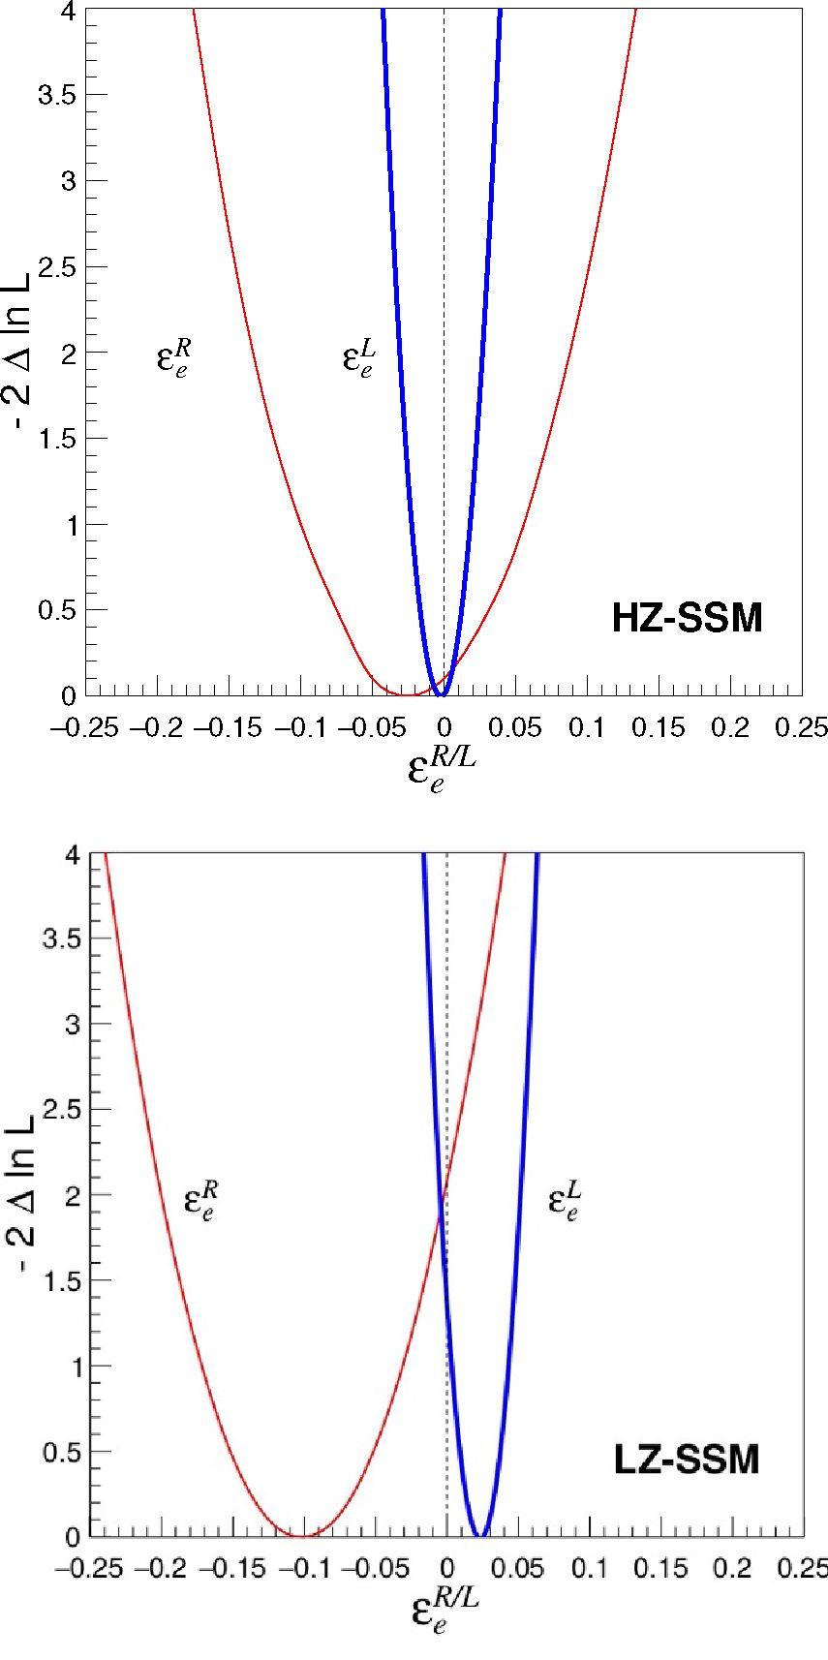
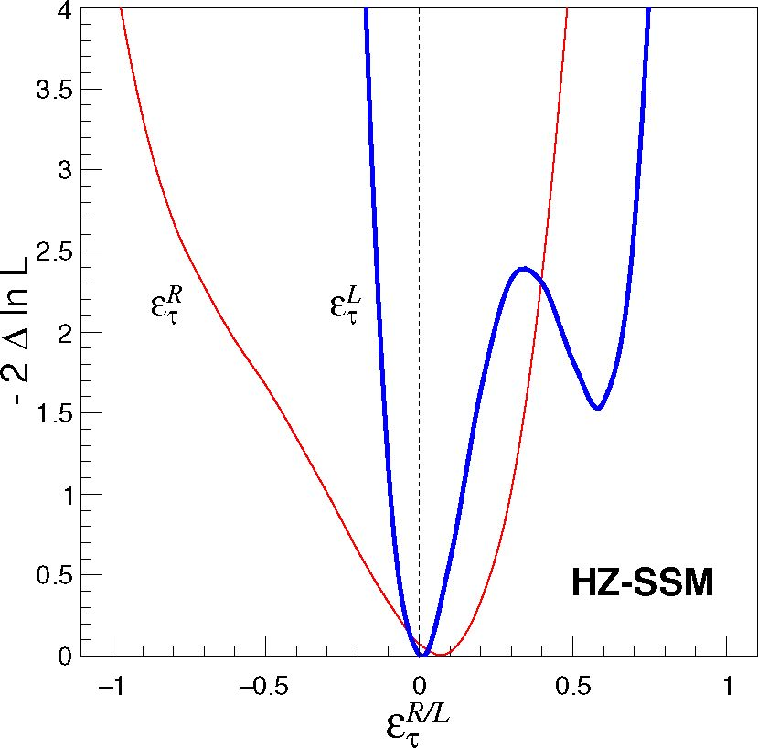
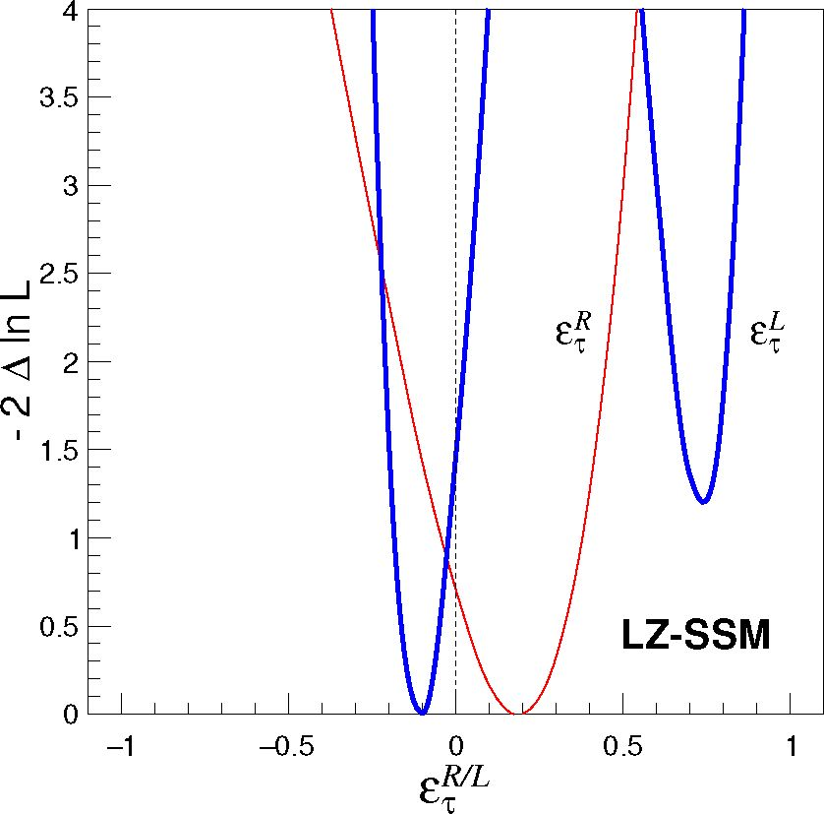
Figure 5. Left panels show the log-likelihood profiles for the NSI parameter eR (red line) and eR (blue line) assuming HZ (top panel) and LZ (bottom panel) SSM’s. Right panels depict the same for eR (red line) and eR (blue line). The profiles were obtained considering one NSI parameter at-a-time, while remaining NSI parameters were fixed to zero.
modification in the shape of the event spectra due to non-zero eR can be easily mimicked by the principle background components (mainly 85Kr) discussed above. Note that the minima of the one-dimensional log-likelihood profiles for eR (red line in left panel) and eR (red line in right panel) are slightly deviated from zero, but, needless to mention that these deviations are statistically insignificant.
The one-dimensional log-likelihood profiles for both eR and eR look non-parabolic in the top right panel of figure 5. In particular, eR demonstrates one extra minimum around eR w 0.6, which is slightly disfavored at A%2 = —2AlnL w 1.5 as compared to the global minimum at eR = 0. This minimum originates due to the approximate gaR o — gaR symmetry that eq. (2.6) possesses, since the first term in eq. (2.6) dominates over the third
- 14 -
JHEP02(2020)038
 | HZ-SSM | LZ-SSM | Ref. [23] | Ref. [55]
£R  °e | [-0.15, +0.11 ] | [-0.20, +0.03 ] | [-0.21, +0.16 ] | [0.004, +0.151 ]
£L  °e | [-0.035, +0.032 ] | [-0.013, +0.052 ] | [-0.046, +0.053 ] | [-0.03, +0.08 ]
£R  T | [-0.83, +0.36 ] | [-0.42, +0.43 ] | [-0.98, +0.73 ] | [-0.3, +0.4 ]
£L  T | [-0.11, +0.67 ] | [-0.19, +0.79 ] | [-0.23, +0.87 ] | [-0.5, +0.2 ]
Table 2. The first column shows the limits on the flavor-diagonal NSI parameters eR, e^, eR, and as obtained in the present work using the Borexino Phase-II data and considering HZ-SSM for the neutrino fluxes. The second column displays the same considering LZ-SSM. These constraints are obtained varying only one NSI parameter at-a-time, while the remaining three NSI parameters are fixed to zero. The third column contains the bounds using Borexino Phase-I results as obtained in ref. [23] (for HZ-SSM case only). For the sake of comparison, we present the global bounds from ref. [55] in the forth column. All limits are 90% C.L. (1 d.o.f.).
term [63]. Because of this symmetry, the value of = (grL + e^)2 is the same for e^ = 0 and e^ = -2grL 0.54, and therefore, one may expect a local minimum in vicinity of the second point. The presence of the third term in eq. (2.6) shifts the position of this local minimum slightly upward to e^ w 0.64.
The profiles for the LZ-SSM case (figure 5, bottom panels) are clearly shifted from zero and with respect to the HZ-SSM ones. The main reason for this is that LZ-SSM predicts smaller $7Be compared to HZ-SSM. The smaller flux requires a bigger cross section (^7Be) for a given observed experimental rate R7Be (see eq. (3.2)). As figure 3 illustrates, the total cross section linearly depends on e^. Therefore, the minimum for LZ-SSM should be shifted in positive direction of e^. For e^ the minima go in opposite directions due to the same reason. The only difference is that the cross section increases when e^ goes in negative direction for the first minimum and when e^ goes up for the second one (see figure 3, right panel). Aforementioned shifts for e^ and e^ profiles induce the shifts for £r and eR as well. This will be easy to see later on considering two dimensional profiles (figures 6 and 7).
The 90% C.L. (1 d.o.f.) bounds on the flavor-diagonal NSI parameters obtained using the Borexino Phase-II data are listed in table 2. The first column shows the constraints assuming HZ-SSM for the neutrino fluxes. The second column presents the same considering LZ-SSM. These constraints are obtained varying only one NSI parameter at-a-time, while the remaining three NSI parameters are fixed to zero.
The third column exhibits the bounds obtained by phenomenological analysis with Borexino Phase-I data in ref. [23]. All experimental limits from Borexino Phase-II are better than those previously obtained from the Borexino Phase-I data in ref. [23]. For the sake of comparison, in the forth column, we present the global bounds from ref. [55], where the authors analyzed the data from the Large Electron-Positron Collider (LEP) experiment, LSND and CHARM II accelerator experiments, and Irvine, MUNU, and Rovno reactor experiments. The bounds found in the present analysis are quite comparable to the global ones. One may note that the best up-to-date bound for e^ was obtained in this work.
- 15 -
JHEP02(2020)038
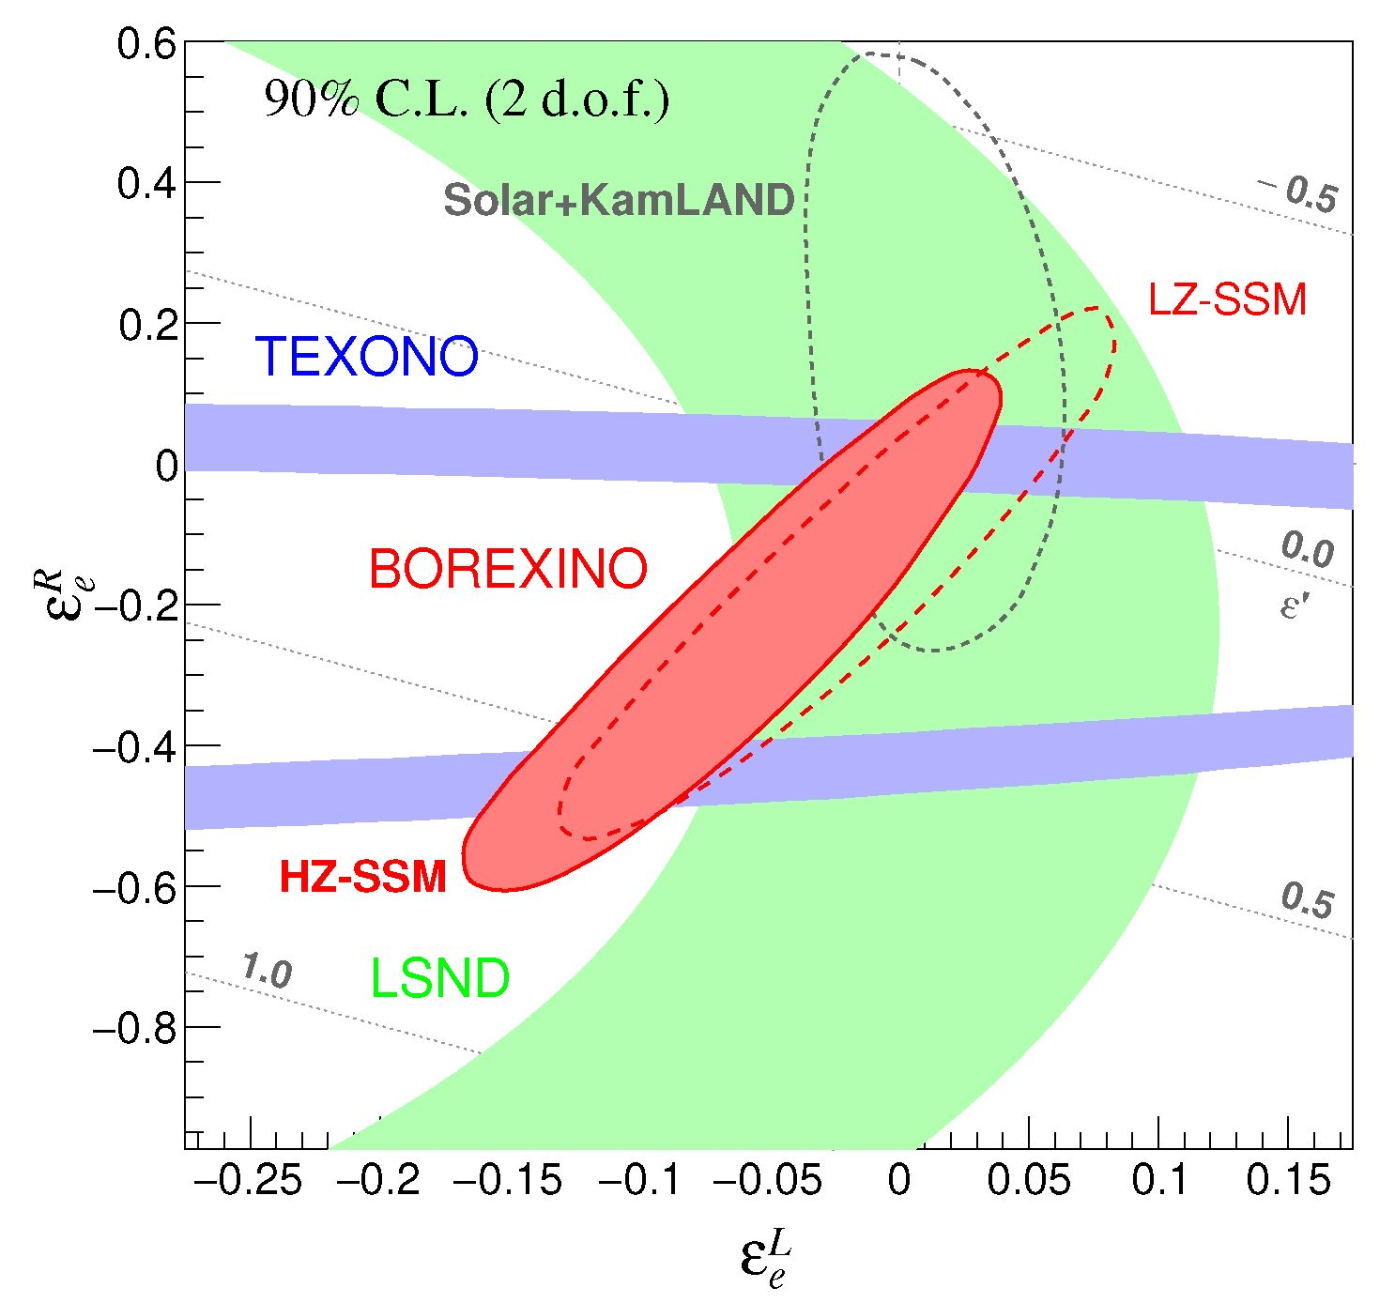
L/R
Figure 6. Allowed region for NSI parameters in ee' plane obtained in the present work. The parameters eL and eR are fixed to zero. Both HZ- (filled red) and LZ- (dashed red) SSM’s were assumed. The bounds from LSND [54, 79] and TEXONO [80] are provided for comparison. Besides, the contour obtained from the global analysis of solar neutrino experiments is presented by dashed black line (ref. [63], NSI’s are included in detection and propagation). All contours correspond to 90% C.L. (2 d.o.f.). The dotted gray lines represent the corresponding range of e' parameter, relevant for NSI’s at propagation.
We have considered above the sensitivity of the Borexino Phase II data to NSI’s applying the SSM-constraint on the neutrino fluxes. Remarkably, Borexino detector is sensitive to the modification of the shape of 7Be electron recoil spectra even if the neutrino fluxes are not constrained by SSM model. Such analysis provides a limit:
- 1.14 <eR < 0.10 (90% C.L..) (4.1)
As one may see the limit is highly asymmetric, with a large extension for the negative values of eR. Such a small sensitivity is induced by backgrounds (mostly 85Kr) which can easily compensate the modification of electron-recoil spectra.
Now let us consider the two-dimensional case when the allowed region for NSI parameters is plotted while and eR are fixed to zero (figure 6). Two contours for HZ- (filled) and LZ-SSM (dashed) were obtained. Compared with other experiments sensitive to the same NSI’s, the allowed contours for Borexino in the e,P-eR plane have a distinct
- 16 -
JHEP02(2020)038
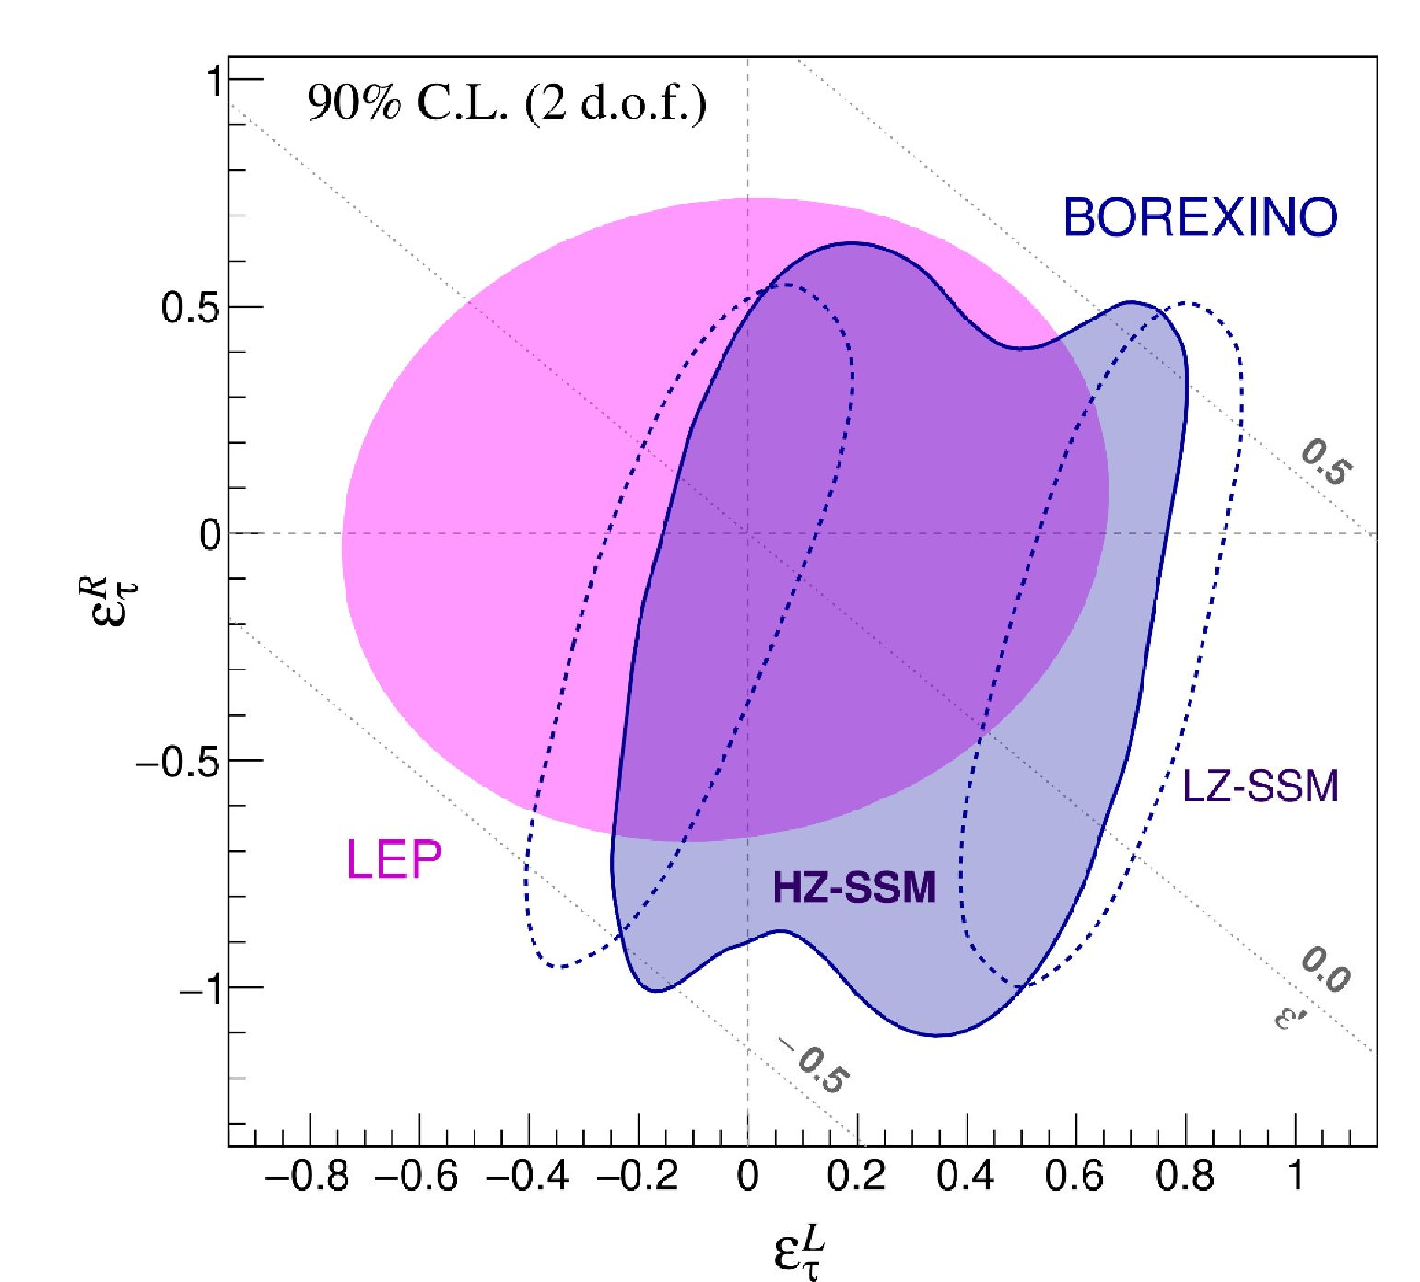
Figure 7. Allowed region for NSI parameters in ef/R plane obtained in the present work. The parameters e^ and eR are fixed to zero. Both HZ- (filled dark blue) and LZ- (dashed dark blue) SSM’s were assumed. The contour from LEP [55] is provided for comparison. Both contours correspond to 90% C.L. (2 d.o.f.). The dotted gray lines represent the corresponding range of e' parameter, relevant for NSI’s at propagation.
orientation, cf. figure 6. The TEXONO experiment [80] is mostly sensitive to eR, while LSND [54, 79] is mostly sensitive to . Borexino’s contour intersects the allowed regions for both experiments at a certain angle, and the three experiments complement each other. In principle, the overlap of Borexino with TEXONO results in two allowed regions. To exclude the second intersection, the incorporation of the LSND result is necessary.
As it was already explained in the analysis of one-dimensional profiles, the contours for HZ- and LZ-SSM’s are shifted along e,P-axis. Considering two-dimensional case it is evident that such a shift in e^ has to produce also the displacement for eR.
The contour for Borexino is extended in the direction of negative eR and e^ due to the presence of backgrounds, especially 85Kr. The shift of the contour for LZ-case with respect to HZ one is due to the change of rate of the backgrounds because of the spectral correlations.
For both HZ- and LZ-SSM cases, the bounds on the left parameter are stronger than the result from LSND. TEXONO [80] is a reactor antineutrino experiment and its bounds
-17-
JHEP02(2020)038
are obtained from vee scattering. For anti-neutrinos the roles of cjeL and geR are reversed, leading to a stronger bound on eR. Due to the approximate symmetry o —in the anti-neutrino scattering cross section, two separate contours form the allowed region of TEXONO around eR = 0 and eR = -2geR = -2 sin2 w -0.5.
The contour obtained in ref. [63] is presented by a dashed black line. In this work, the global analysis of several solar neutrino experiments together with KamLAND result was conducted. NSI’s were considered in both detection and propagation. The very first results of Borexino were also included [22, 81, 82]. Though, as the authors underlined, they did not contribute much in overall sensitivity to NSI’s. As one may see, the present Borexino results are quite complementary to this contour.
The result of Borexino in the e^-e^ plane is shown in figure 7. It is similar to that of LEP [55] in excluded area, but it occupies a slightly different region, favoring positive eR and negative ef. NSI’s comparable with the SM neutral current interactions are still allowed.
The result for LZ-SSM is of particular interest. The shift of the minima discussed above and observed in figure 5 (bottom right) transforms the allowed contour (figure 7, dashed dark blue) into two separate regions, one of which is already almost completely excluded by LEP data. So, the remaining allowed region, in this case, is relatively small.
The dotted gray lines in figures 6 and 7 indicate the range for the parameter e' relevant for NSI’s at propagation. The contours are almost entirely located between e' = -0.5 and e' = 0.5. As it was previously shown in section 2.3 (see figure 1), NSI’s at propagation are not very pronounced for these magnitudes of e' compare to the precision of the measurements. Thus, the sensitivity of the detector is mostly determined by NSI’s at detection.

4.2 Evaluation of sin2 Qw
In addition to the analysis of NSI’s, we use the same data and analysis approach to constrain the value of sin2 . Instead of introducing NSI’s, we simply allow sin2 in the SM
couplings (2.3) to vary. The sensitivity of the analysis to sin2 is mostly dominated by gf, while contributions of the other five coupling constants are almost negligible. For the HZ-SSM case, the analysis of a likelihood profile results in
which is consistent with theoretical expectations [31] and comparable in precision with the value found by the reactor vee scattering experiment TEXONO [80]:
The most accurate determination of sin2 by neutrino-electron scattering is from the v^e
scattering experiment CHARM II [19]:
sin2 = 0.229 ± 0.026 (stat+syst),
(4.2)
sin2 = 0.251 ± 0.031 (stat) ± 0.024 (syst).
(4.3)
sin2 6W = 0.2324 ± 0.0058 (stat) ± 0.0059 (syst).
(4.4)
- 18 -
JHEP02(2020)038

5 Summary and concluding remarks
In the present work, we search for Non-Standard Interactions (NSI’s) of the neutrino using Borexino Phase-II data. The NSI’s considered are those of the flavor-diagonal neutral current type that modify the vee and vTe couplings while preserving their chiral and flavor structures.
Such NSI’s can affect solar neutrinos at production, propagation, and detection. Neutrino production in the Sun can be affected via processes such as ye ^ vve, but the expected modification in the neutrino spectrum is at energies well below the detection threshold of Borexino (^50 keV), so this effect does not need to be included. The NSI’s considered also modify the solar neutrino survival probability Pee(E) via the LMA-MSW effect as the neutrinos propagate through dense solar matter. This effect is strong at 8B neutrino energies but not particularly large at 7Be neutrino energies, limiting the sensitivity of Borexino to such deviations. The effect of the NSI’s to which Borexino is most sensitive is at detection, where the shape of the electron-recoil spectrum is affected by changes in the vee and vTe couplings.
The solar neutrino fluxes were constrained to the prediction of the Standard Solar Model (SSM) with the LMA-MSW oscillation mechanism. SSM’s with both high- (HZ) and low-metallicity (LZ) were considered. Systematic effects related to the characterization of the target mass of the detector and the choice of oscillation parameters were taken into account.
The modifications to the vee and vTe couplings are quantified by parameters
T/R
and eT/ . The bounds to all four parameters were obtained in this analysis, and they all show marked improvement compared to the Borexino Phase-I analysis [23], regardless of the choice of metallicity in the SSM, cf. table 2. The bounds are quite comparable to the global ones. In particular, the best constraint to-date on was obtained.
The log-likelihood profiles and corresponding bounds for HZ- and LZ-SSM’s are shifted with respect to each other due to different expected neutrino detection rates. The minima of HZ-profiles are less shifted from zero as a result of better agreement between the measured neutrino rates and HZ-SSM. For LZ-SSM, the deviations of the minima of the profiles from zero are more pronounced but still statistically insignificant. The allowed contour of Borexino in the eT/R-plane is quite distinct with respect to other ve or ve scattering experiments, also sensitive to the same NSI’s, such as TEXONO and LSND. Borexino is sensitive to both eR and eT parameters while TEXONO and LSND mostly constrain eR or eT, respectively. Notably, in the case of eT/R two local minima are observed. The distance between the minima is larger for LZ-SSM, resulting in the splitting of the 90% C.L. allowed contour into two contours in the eT/R-plane.
An important sensitivity-limiting factor is the presence of backgrounds, especially 85Kr, whose forbidden fi-spectrum can mimic the spectral modifications induced by NSI’s.
T/R
The smaller, conservative, NH-value for was chosen for the eT' -analysis. Should
the neutrino mass hierarchy be identified as inverted in future experiments, the contribution
T/R
of the t-neutrino to the cross section would be larger and the bounds for eT' would be slightly improved. The most important factor which determines the sensitivity of this study
- 19 -
JHEP02(2020)038
is the uncertainty on the v-fluxes predicted by the SSM (currently 6% for $7Be). Their improvement would directly refine the bounds on NSI’s presented here.
The detector is sensitive to eR, even without constraining the solar neutrino fluxes to those of the SSM, purely via the modification to the electron-recoil spectral shape. However, it was found that background greatly reduce the ideal sensitivity by compensating for the modification to the spectra, especially for negative eR.
The same dataset and approach, but without any NSI’s assumed, was used to constrain sin2 . The resulting value is comparable in precision to that measured in reactor
antineutrino experiments.

Acknowledgments
The Borexino program is made possible by funding from INFN (Italy), NSF (U.S.A.), BMBF, DFG, HGF and MPG (Germany), RFBR (grants 19-02-0097A, 16-29-13014ofi-m, 17-02-00305A, 16-02-01026), RSF (grant 17-12-01009) (Russia), and NCN (grant number UMO 2017/26/M/ST 2/00915) (Poland).
We acknowledge also the computing services of the Bologna INFN-CNAF data centre and LNGS Computing and Network Service (Italy), of Julich Supercomputing Centre at FZJ (Germany), of ACK Cyfronet AGH Cracow (Poland), and of HybriLIT (Russia). We acknowledge the hospitality and support of the Laboratori Nazionali del Gran Sasso (Italy).
We are thankful to Zurab Berezhiani for the discussion at the initial stage of the research. S.K.A. would like to thank A. Smirnov and A. De Gouvea for useful discussions. S.K.A. acknowledges the support from DST/INSPIRE Research Grant [IFA- PH-12], Department of Science and Technology, India and the Young Scientist Project [INSA/SP/YSP/144/2017/1578] from the Indian National Science Academy. A.F. acknowledges the support provided by the University of Hamburg. T.T. is supported in part by NSF Grant 1413031 and DOE Grant DE-SC0020262. C.S. is supported in part by the International Postdoctoral Fellowship funded by China Postdoctoral Science Foundation, and NASA grant 80NSSC18K1010.

A Derivation of the matter effect potential in the presence of NSI’s
The Hamiltonian which governs the propagation of neutrinos in matter in the presence of the NSI’s eV = ef + eR and ejf = e;/ + eR is given by
H = — U 2E
0 | 0 | 0 |  | '1 + eV | 0 | 0
0 Am21 |  | 0 | Uf + V (x) | 0 | 0 | 0
0 | 0 | Amii_ |  | 0 | 0 | £V  °r
(A.1)
where V(x) = a/2GfNe(x), and Ne(x) is the electron density at location x. This expression is in the flavor basis in which the rows and columns are labelled by neutrino-flavor in the
- 20 -
JHEP02(2020)038
order (e,^,r). The Pontecorvo-Maki-Nakagawa-Sakata (PMNS) matrix U is given by
10 0 ci3 0 si3e-iS C12 *12 0
U = 0 C23 S23 0 1 0 — Si2 Ci2 0 . (A.2)
0 —S23 C23 — Si3eiS 0 C13 0 0 1
' * '' * '' * '
R23 R13 R12
Performing the R23 and R13 rotations on both sides of eq. (A.1), we find
H' = R13 R23HR23R13
1 ’00 0 " "1+eV 0 0 "
= R12 0 Am21 0 R^ + V(x) r13r23 0 0 0 R23R13
0 0 Am21 0 0 e^
1 Am^s^ Am21si2Ci2 0
= 2E Am2iSi2Ci2 Am2iC22 0
0 0 Am31
(1 — £/)c?3 + eV(c23 — s23)s23 e^S23C23Si3e-i5 {(1+eV) — c23} Si3Ci3e-i5
+ V (x) eV S23C23Si3ei5 0 —eV S23C23C13
_{(1 + eV) —eV4?} s13C13e^ —eVs23c23c13 4(c23 — s23)c23 + (1 — e')s13 _
+ V(x) e^s23 x (unit matrix), (A.3)
where we have set
e' = eVs23 — e,T . (A.4)
In the energy range where \Am31\ ^ 2EV(x), the off-diagonal terms in the third row
and third column can be neglected and we can treat H' as already partially diagonalized. Concentrating on the 2 x 2 upper-left block, we drop the third row and third column and obtain
H' Am2iS22 Am2iSi2Ci2
2E Am21 s12c12 Am^c^
+ V(x) [(1 — e')C23 + eV(c23 — s23)s23 4s23C23s13e-i5
+ V (x) „ C „ eiS 0
eT S23C23Si3e 0
Am21s12 Am21S12C12 + V (x) (1 — e')c13 4 s23C23s13e-i5 (A5)
~ 2E Am2iSi2Ci2 Am2iCi2 e^S23C23Si3ei<5 0 , .
where we have used s23 ~ c23 and s23 ^ 1 to simplify the expression for the (1,1) element. The resonance condition is achieved when the (1,1) and (2,2) elements of this matrix are equal:
Am^s^ + 2EV'(x) c23 = Am21cf2 ^ 2EV'(x) c23 = Am^ cos 2012 , (A.6)
where
V'(x) = V(x) (1 — e'). (A.7)
See, e.g., refs. [83, 84] and references therein.
- 21 -
JHEP02(2020)038
Open Access. This article is distributed under the terms of the Creative Commons
Attribution License (CC-BY 4.0), which permits any use, distribution and reproduction in
any medium, provided the original author(s) and source are credited.

References
- SNO collaboration, Direct evidence for neutrino flavor transformation from neutral current interactions in the Sudbury Neutrino Observatory, Phys. Rev. Lett. 89 (2002) 011301 [nucl-ex/0204008] [inSPIRE].
- SUPER-KAMIOKANDE collaboration, Solar Neutrino Measurements in Super-Kamiokande-IV, Phys. Rev. D 94 (2016) 052010 [arXiv:1606.07538] [inSPIRE].
- KamLAND collaboration, First results from KamLAND: Evidence for reactor anti-neutrino disappearance, Phys. Rev. Lett. 90 (2003) 021802 [hep-ex/0212021] [inSPIRE].
- KamLAND collaboration, Measurement of neutrino oscillation with KamLAND: Evidence of spectra! distortion, Phys. Rev. Lett. 94 (2005) 081801 [hep-ex/0406035] [inSPIRE].
- KamLAND collaboration, Precision Measurement of Neutrino Oscillation Parameters with KamLAND, Phys. Rev. Lett. 100 (2008) 221803 [arXiv:0801.4589] [inSPIRE].
- L. Wolfenstein, Neutrino Oscillations in Matter, Phys. Rev. D 17 (1978) 2369 [inSPIRE].
- L. Wolfenstein, Neutrino Oscillations and Stellar Collapse, Phys. Rev. D 20 (1979) 2634 [inSPIRE].
- S.P. Mikheyev and A.Yu. Smirnov, Resonance Amplification of Oscillations in Matter and Spectroscopy of Solar Neutrinos, Sov. J. Nucl. Phys. 42 (1985) 913 [inSPIRE].
- S.P. Mikheev and A.Yu. Smirnov, Resonant amplification of neutrino oscillations in matter and solar neutrino spectroscopy, Nuovo Cim. C 9 (1986) 17 [inSPIRE].
- M. Maltoni and A.Yu. Smirnov, Solar neutrinos and neutrino physics, Eur. Phys. J. A 52
- 87 [arXiv:1507.05287] [inSPIRE].
- BOREXINO-SOX collaboration, Solar neutrino detectors as sterile neutrino hunters, J. Phys. Conf. Ser. 888 (2017) 012018 [inSPIRE].
- F. Capozzi, I.M. Shoemaker and L. Vecchi, Solar Neutrinos as a Probe of Dark Matter-Neutrino Interactions, JCAP 07 (2017) 021 [arXiv:1702.08464] [inSPIRE].
- R. Essig, M. Sholapurkar and T.-T. Yu, Solar Neutrinos as a Signal and Background in Direct-Detection Experiments Searching for Sub-GeV Dark Matter With Electron Recoils, Phys. Rev. D 97 (2018) 095029 [arXiv:1801.10159] [inSPIRE].
- Borexino collaboration, The Borexino detector at the Laboratori Nazionali del Gran Sasso, Nucl. Instrum. Meth. A 600 (2009) 568 [arXiv:0806.2400] [inSPIRE].
- BOREXINO collaboration, Final results of Borexino Phase-I on low energy solar neutrino spectroscopy, Phys. Rev. D 89 (2014) 112007 [arXiv:1308.0443] [inSPIRE].
- BOREXINO collaboration, Neutrinos from the primary proton-proton fusion process in the Sun, Nature 512 (2014) 383 [inSPIRE].
- BOREXINO collaboration, First Simultaneous Precision Spectroscopy of pp, 7 Be and pep Solar Neutrinos with Borexino Phase-II, Phys. Rev. D 100 (2019) 082004 [arXiv:1707.09279] [inSPIRE].
- 22 -
JHEP02(2020)038
- Borexino collaboration, Comprehensive measurement of pp-chain solar neutrinos, Nature 562 (2018) 505 [inSPIRE].
- CHARM-II collaboration, Precision measurement of electroweak parameters from the scattering of muon-neutrinos on electrons, Phys. Lett. B 335 (1994) 246 [inSPIRE].
- Z.G. Berezhiani and A. Rossi, Vacuum oscillation solution to the solar neutrino problem in standard and nonstandard pictures, Phys. Rev. D 51 (1995) 5229 [hep-ph/9409464] [inSPIRE].
- Z. Berezhiani, R.S. Raghavan and A. Rossi, Probing nonstandard couplings of neutrinos at the Borexino detector, Nucl. Phys. B 638 (2002) 62 [hep-ph/0111138] [inSPIRE].
- Borexino collaboration, Direct Measurement of the Be-7 Solar Neutrino Flux with 192 Days of Borexino Data, Phys. Rev. Lett. 101 (2008) 091302 [arXiv:0805.3843] [inSPIRE].
- S.K. Agarwalla, F. Lombardi and T. Takeuchi, Constraining Non-Standard Interactions of the Neutrino with Borexino, JHEP 12 (2012) 079 [arXiv:1207.3492] [inSPIRE].
- J.N. Bahcall, Neutrino-Electron Scattering and Solar Neutrino Experiments, Rev. Mod. Phys. 59 (1987) 505 [inSPIRE].
- J.N. Bahcall and R.K. Ulrich, Solar Models, Neutrino Experiments and Helioseismology, Rev. Mod. Phys. 60 (1988) 297 [inSPIRE].
- J.N. Bahcall, M.H. Pinsonneault and S. Basu, Solar models: Current epoch and time dependences, neutrinos and helioseismological properties, Astrophys. J. 555 (2001) 990 [astro-ph/0010346] [inSPIRE].
- N. Vinyoles et al., A new Generation of Standard Solar Models, Astrophys. J. 835 (2017) 202 [arXiv:1611.09867] [inSPIRE].
- E. Vitagliano, J. Redondo and G. Raffelt, Solar neutrino flux at keV energies, JCAP 12
- 010 [arXiv:1708.02248] [inSPIRE].
- M. Fierz, Zur fermi sohen theorie des (3-zerfalls, Z. Phys. 104 (1937) 553.
- J.F. Nieves and P.B. Pal, Generalized Fierz identities, Am. J. Phys. 72 (2004) 1100 [hep-ph/0306087] [inSPIRE].
- J. Erler and A. Freitas, Electroweak Model and Constraints on New Physics, http://pdg.lbl.gov/2019/reviews/rpp2018-rev-standard-model.pdf (2018).
- G. ’t Hooft, Predictions for neutrino-electron cross-sections in Weinberg’s model of weak interactions, Phys. Lett. 37B (1971) 195 [inSPIRE].
- M. Ram, Inner Bremsstrahlung in Low-Energy Electron-Neutrino (Antineutrino) Scattering, Phys. Rev. 155 (1967) 1539 [inSPIRE].
- W.J. Marciano and A. Sirlin, Radiative Corrections to Neutrino Induced Neutral Current Phenomena in the SU(2)L x U(1) Theory, Phys. Rev. D 22 (1980) 2695 [Erratum ibid. D 31 (1985) 213] [inSPIRE].
- S. Sarantakos, A. Sirlin and W.J. Marciano, Radiative Corrections to Neutrino-Lepton Scattering in the SU(2)l x U(1) Theory, Nucl. Phys. B 217 (1983) 84 [inSPIRE].
- J.F. Wheater and C.H. Llewellyn Smith, Electroweak Radiative Corrections to Neutrino and Electron Scattering and the Value of sin2 Ow, Nucl. Phys. B 208 (1982) 27 [Erratum ibid. B 226 (1983) 547] [inSPIRE].
- 23 -
JHEP02(2020)038
- J.N. Bahcall, M. Kamionkowski and A. Sirlin, Solar neutrinos: Radiative corrections in neutrino-electron scattering experiments, Phys. Rev. D 51 (1995) 6146 [astro-ph/9502003] [inSPIRE].
- M. Passera, QED corrections to neutrino electron scattering, Phys. Rev. D 64 (2001) 113002 [hep-ph/0011190] [inSPIRE].
- Particle Data Group collaboration, Review of Particle Physics, Chin. Phys. C 40 (2016) 100001 [inSPIRE].
- Particle Data Group collaboration, Review of Particle Physics, Phys. Rev. D 98 (2018) 030001 [inSPIRE].
- S. Antusch, J.P. Baumann and E. Fernandez-Martinez, Non-Standard Neutrino Interactions with Matter from Physics Beyond the Standard Model, Nucl. Phys. B 810 (2009) 369 [arXiv:0807.1003] [inSPIRE].
- M.B. Gavela, D. Hernandez, T. Ota and W. Winter, Large gauge invariant non-standard neutrino interactions, Phys. Rev. D 79 (2009) 013007 [arXiv:0809.3451] [inSPIRE].
- M. Malinsky, T. Ohlsson and H. Zhang, Non-Standard Neutrino Interactions from a Triplet Seesaw Model, Phys. Rev. D 79 (2009) 011301 [arXiv:0811.3346] [inSPIRE].
- T. Ohlsson, T. Schwetz and H. Zhang, Non-standard neutrino interactions in the Zee-Babu model, Phys. Lett. B 681 (2009) 269 [arXiv:0909.0455] [inSPIRE].
- M. Medina and P.C. de Holanda, Non-Standard Neutrinos Interactions in A 331 Model with Minimum Higgs Sector, Adv. High Energy Phys. 2012 (2012) 763829 [arXiv:1108.5228] [inSPIRE].
- Y. Farzan, A model for large non-standard interactions of neutrinos leading to the LMA-Dark solution, Phys. Lett. B 748 (2015) 311 [arXiv:1505.06906] [inSPIRE].
- Y. Farzan and I.M. Shoemaker, Lepton Flavor Violating Non-Standard Interactions via Light Mediators, JHEP 07 (2016) 033 [arXiv:1512.09147] [inSPIRE].
- Y. Farzan and J. Heeck, Neutrinophilic nonstandard interactions, Phys. Rev. D 94 ( 2016) 053010 [arXiv:1607.07616] [inSPIRE].
- M. Blennow, P. Coloma, E. Fernandez-Martinez, J. Hernandez-Garcia and J. Lopez-Pavon, Non-Unitarity, sterile neutrinos and Non-Standard neutrino Interactions, JHEP 04 (2017) 153 [arXiv:1609.08637] [inSPIRE].
- B. Sevda et al., Constraints on nonstandard intermediate boson exchange models from neutrino-electron scattering, Phys. Rev. D 96 (2017) 035017 [arXiv:1702.02353] [inSPIRE].
- M. Pospelov and Y.-D. Tsai, Light scalars and dark photons in Borexino and LSND experiments, Phys. Lett. B 785 (2018) 288 [arXiv:1706.00424] [inSPIRE].
- Z. Berezhiani and A. Rossi, Limits on the nonstandard interactions of neutrinos from e+e- colliders, Phys. Lett. B 535 (2002) 207 [hep-ph/0111137] [inSPIRE].
- T. Ohlsson, Status of non-standard neutrino interactions, Rept. Prog. Phys. 76 (2013)
044201 [arXiv:1209.2710] [inSPIRE].
- S. Davidson, C. Pena-Garay, N. Rius and A. Santamaria, Present and future bounds on nonstandard neutrino interactions, JHEP 03 (2003) 011 [hep-ph/0302093] [inSPIRE].
- J. Barranco, O.G. Miranda, C.A. Moura and J.W.F. Valle, Constraining non-standard neutrino-electron interactions, Phys. Rev. D 77 (2008) 093014 [arXiv:0711.0698] [inSPIRE].
- 24 -
JHEP02(2020)038
- Y. Farzan and M. Tortola, Neutrino oscillations and Non-Standard Interactions, Front.
Phys. 6 (2018) 10 [arXiv:1710.09360] [inSPIRE].
- M.M. Guzzo, A. Masiero and S.T. Petcov, On the MSW effect with massless neutrinos and no mixing in the vacuum, Phys. Lett. B 260 (1991) 154 [inSPIRE].
- M.M. Guzzo and S.T. Petcov, On the matter enhanced transitions of solar neutrinos in the absence of neutrino mixing in vacuum, Phys. Lett. B 271 (1991) 172 [inSPIRE].
- J.W.F. Valle, Resonant Oscillations of Massless Neutrinos in Matter, Phys. Lett. B 199 (1987) 432 [inSPIRE].
- E. Roulet, MSW effect with flavor changing neutrino interactions, Phys. Rev. D 44 (1991) R935 [inSPIRE].
- V.D. Barger, R.J.N. Phillips and K. Whisnant, Solar neutrino solutions with matter enhanced flavor changing neutral current scattering, Phys. Rev. D 44 (1991) 1629 [inSPIRE].
- M. Guzzo, P.C. de Holanda, M. Maltoni, H. Nunokawa, M.A. Tortola and J.W.F. Valle, Status of a hybrid three neutrino interpretation of neutrino data, Nucl. Phys. B 629 (2002) 479 [hep-ph/0112310] [inSPIRE].
- A. Bolanos, O.G. Miranda, A. Palazzo, M.A. Tortola and J.W.F. Valle, Probing non-standard neutrino-electron interactions with solar and reactor neutrinos, Phys. Rev. D 79 (2009) 113012 [arXiv:0812.4417] [inSPIRE].
- A. Friedland, C. Lunardini and C. Pena-Garay, Solar neutrinos as probes of neutrino matter interactions, Phys. Lett. B 594 (2004) 347 [hep-ph/0402266] [inSPIRE].
- I. Esteban, M.C. Gonzalez-Garcia, M. Maltoni, I. Martinez-Soler and T. Schwetz, Updated fit to three neutrino mixing: exploring the accelerator-reactor complementarity, JHEP 01 (2017) 087 [arXiv:1611.01514] [inSPIRE].
- A.M. Dziewonski and D.L. Anderson, Preliminary reference Earth model, Phys. Earth Planet. In. 25 (1981) 297.
- A. de Gouvea, A. Friedland and H. Murayama, Earth matter effect in Be-7 solar neutrino experiments, JHEP 03 (2001) 009 [hep-ph/9910286] [inSPIRE].
- J.N. Bahcall, M.C. Gonzalez-Garcia and C. Pena-Garay, Robust signatures of solar neutrino oscillation solutions, JHEP 04 (2002) 007 [hep-ph/0111150] [inSPIRE].
- SUPER-KAMIOKANDE collaboration, Constraints on neutrino oscillation parameters from the measurement of day night solar neutrino fluxes at Super-Kamiokande, Phys. Rev. Lett. 82 (1999) 1810 [hep-ex/9812009] [inSPIRE].
- SUPER-KAMIOKANDE collaboration, Precise measurement of the solar neutrino day/night and seasonal variation in Super-Kamiokande-1, Phys. Rev. D 69 (2004) 011104 [hep-ex/0309011] [inSPIRE].
- SNO collaboration, Measurement of day and night neutrino energy spectra at SNO and constraints on neutrino mixing parameters, Phys. Rev. Lett. 89 (2002) 011302 [nucl-ex/0204009] [inSPIRE].
- SNO collaboration, Electron energy spectra, fluxes and day-night asymmetries of B-8 solar neutrinos from measurements with NaCl dissolved in the heavy-water detector at the Sudbury Neutrino Observatory, Phys. Rev. C 72 (2005) 055502 [nucl-ex/0502021] [inSPIRE].
- 25 -
JHEP02(2020)038
- S.S. Aleshin, O.G. Kharlanov and A.E. Lobanov, Analytical treatment of long-term observations of the day-night asymmetry for solar neutrinos, Phys. Rev. D 87 (2013) 045025 [arXiv:1302.7201] [inSPIRE].
- A.N. Ioannisian, A.Yu. Smirnov and D. Wyler, Oscillations of the 7Be solar neutrinos inside the Earth, Phys. Rev. D 92 (2015) 013014 [arXiv:1503.02183] [inSPIRE].
- Borexino collaboration, Absence of day-night asymmetry of 862keV 7Be solar neutrino rate in Borexino and MSW oscillation parameters, Phys. Lett. B 707 (2012) 22 [arXiv:1104.2150] [inSPIRE].
- Borexino collaboration, The Monte Carlo simulation of the Borexino detector, Astropart. Phys. 97 (2018) 136 [arXiv:1704.02291] [inSPIRE].
- Borexino collaboration, Borexino calibrations: Hardware, Methods and Results, 2012 JINST 7 P10018 [arXiv:1207.4816] [inSPIRE].
- F. Capozzi, E. Lisi, A. Marrone, D. Montanino and A. Palazzo, Neutrino masses and mixings: Status of known and unknown 3v parameters, Nucl. Phys. B 908 (2016) 218 [arXiv:1601.07777] [inSPIRE].
- LSND collaboration, Measurement of electron-neutrino electron elastic scattering, Phys.
Rev. D 63 (2001) 112001 [hep-ex/0101039] [inSPIRE].
- TEXONO collaboration, Constraints on Non-Standard Neutrino Interactions and Unparticle Physics with Neutrino-Electron Scattering at the Kuo-Sheng Nuclear Power Reactor, Phys. Rev. D 82 (2010) 033004 [arXiv:1006.1947] [inSPIRE].
- Borexino collaboration, First real time detection of 7Be solar neutrinos by Borexino, Phys. Lett. B 658 (2008) 101 [arXiv:0708.2251] [inSPIRE].
- Borexino collaboration, Measurement of the solar 8B neutrino rate with a liquid scintillator target and 3MeV energy threshold in the Borexino detector, Phys. Rev. D 82 (2010) 033006 [arXiv:0808.2868] [inSPIRE].
- S.K. Agarwalla, Y. Kao and T. Takeuchi, Analytical approximation of the neutrino oscillation matter effects at large O13, JHEP 04 (2014) 047 [arXiv:1302.6773] [inSPIRE].
- S.K. Agarwalla, Y. Kao, D. Saha and T. Takeuchi, Running of Oscillation Parameters in Matter with Flavor-Diagonal Non-Standard Interactions of the Neutrino, JHEP 11 (2015) 035 [arXiv:1506.08464] [inSPIRE].
- 26 -
JHEP02(2020)038

